

Help to quit smoking

New laws mean your cigarette will look and feel less appealing to help make it easier for you to quit.

# There’s now more support than ever to help you quit:

**Ask your health worker, doctor or chemist for advice**. They can talk to you about different choices, like medicines that can help with cravings and feeling restless.

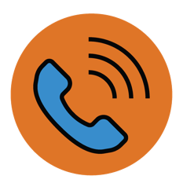**Call Quitline on 13 7848** and ask to yarn with an Aboriginal or Torres Strait Islander counsellor or get a call back.

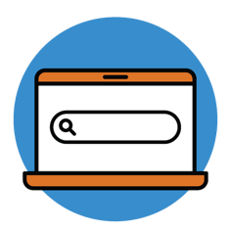**Check quit.org.au** for ways to quit and tips for dealing with how you feel while you’re quitting.

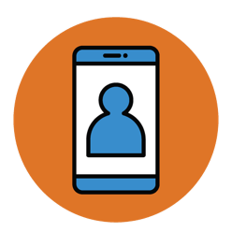**Download the free My QuitBuddy app on your phone**. It helps you set your own goals and motivations to quit, track your progress and see how much money you’re saving by quitting.

[health.gov.au/tobacco-changes](https://www.health.gov.au/tobacco-changes)

[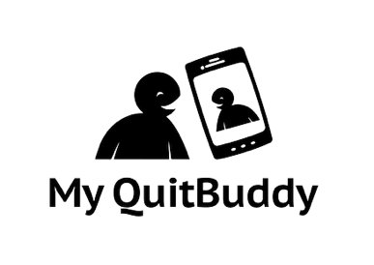](https://www.health.gov.au/resources/apps-and-tools/my-quitbuddy-app) **[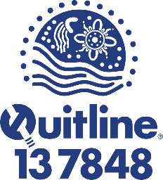](https://www.aql.org.au/)**