

# GUIDE TO HEALTH WARNINGS

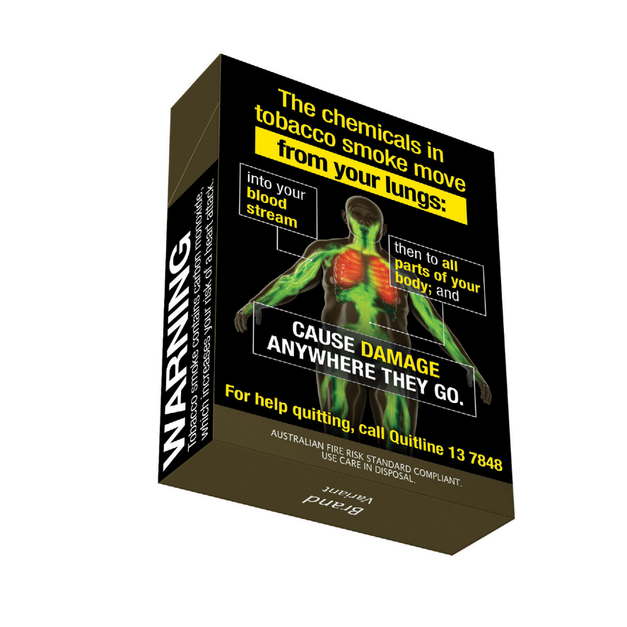

ISBN: 978-1-76007-443-2

Online ISBN: 978-1-76007-444-9

**Copyright**

© 2024 Commonwealth of Australia as represented by the Department of Health and Aged Care

This work is copyright. You may copy, print, download, display and reproduce the whole or part of this work in unaltered form for your own personal use or, if you are part of an organisation, for internal use within your organisation, but only if you or your organisation:

1. do not use the copy or reproduction for any commercial purpose; and
2. retain this copyright notice and all disclaimer notices as part of that copy or reproduction.

Apart from rights as permitted by the Copyright Act 1968 (Cth) or allowed by this copyright notice, all other rights are reserved, including (but not limited to) all commercial rights.

Requests and inquiries concerning reproduction and other rights to use are to be sent to the Communication Branch, Department of Health and Aged Care, GPO Box 9848, Canberra ACT 2601, or via e-mail to [copyright@health.gov.au](mailto:copyright@health.gov.au).

**DISCLAIMER**

All manufacturers, packagers, suppliers and retailers (including importers and wholesalers) of tobacco and e-cigarette products should ensure they understand all of the requirements in the *Public Health (Tobacco and Other Products) Act 2023* and Public Health (Tobacco and Other Products) Regulations 2024.

This guide does not itemise all of the requirements under the Public Health (Tobacco and Other Products) legislation. The requirements that are not itemised in this guide are not any less important or significant than those that are displayed.

The guide does not provide legal advice and is not to be relied upon as a source of legal advice. It is provided for general information and as such any person reading this guide should rely upon their own judgement and make their own inquiries seeking relevant professional advice.

There are additional requirements under the Commonwealth Public Health (Tobacco and Other Products) legislation for tobacco products and packaging. Anyone who possesses, manufactures, packages, purchases, sells or supplies (including import, wholesale and retail), tobacco products or tobacco product accessories in Australia, must ensure they comply with these requirements. There are some limited exceptions for personal use or export out of Australia of tobacco products and tobacco accessories.

Nothing in this guide should be taken in any way to replace the provisions of the *Public Health (Tobacco and Other Products) Act 2023* and Public Health (Tobacco and Other Products) Regulations 2024.

The Department of Health and Aged Care (the department) does not certify compliance with any tobacco legislation. The department does not undertake a review or approval scheme for tobacco packaging and the associated health warnings, tobacco product safety, tobacco advertising, or any other tobacco legislation issues.

For complete requirements refer to the legislation available at <http://www.legislation.gov.au>.

## Contents

**Introduction 5**

Purpose of the guide 5

**Health warnings for tobacco product packaging 6**

Health warnings to be displayed on retail packaging 7

Requirements for displaying health warnings on retail packaging 8

Application of health warnings 13

Distortion and/or cropping of health warnings 13

Other requirements 13

**Illustrative layouts 14**

**How to access images 26**

**Enforcing the Public Health (Tobacco and Other Products) legislation 26**

## Introduction

### Purpose of the guide

The Australian Government Department of Health and Aged Care (the **department**) has produced this guide to help the public understand the Commonwealth *Public Health (Tobacco and Other Products) Act 2023* (the **Act**) and the Public Health (Tobacco and Other Products) Regulations 2024 (the **Regulations**), specifically the requirements for health warnings. This guide is not intended to comprehensively cover all health warning requirements. The images in this guide are an example of how the health warnings may look.

This guide does not contain tobacco product requirements, tobacco packaging requirements, or the requirements relating to health promotion inserts (**HPIs**) or advertising and sponsorship. Other guides available include:

* [Guide to Tobacco Product Requirements](https://www.health.gov.au/resources/publications/guide-to-tobacco-product-requirements?language=en)
* [Guide to Tobacco Packaging Requirements](https://www.health.gov.au/resources/publications/guide-to-tobacco-packaging-requirements)
* [Guide to Health Promotion Inserts](https://www.health.gov.au/resources/publications/guide-to-health-promotion-inserts?language=en)
* [Guide to Advertising and Sponsorship Prohibitions](https://www.health.gov.au/resources/publications/guide-to-advertising-and-sponsorship-prohibitions)
* [Guide to Online Point-of-Sale Advertising Requirements](https://www.health.gov.au/resources/publications/guide-to-online-point-of-sale-advertising-requirements?language=en)

All of these resources will be available from <https://www.health.gov.au/>.

You are encouraged to download an up-to-date version of the Act and Regulations from the Federal Register of legislation website ([www.legislation.gov.au](http://www.legislation.gov.au)).

### Definitions

‘**Public Health (Tobacco and Other Products) legislation’** means the Public Health (Tobacco and Other Products) Act 2023 and the Public Health (Tobacco and Other Products) Regulations 2024.

‘**Tobacco product**’ means the following designed or intended for human consumption or use:

1. processed tobacco in any form;
2. a product that contains tobacco as an ingredient.

The definitions used in the Public Health (Tobacco and Other Products) legislation can be viewed in section 8 of the Act, and section 5 of the Regulations. The above definitions are provided to assist in understanding this guide.

## Health warnings for tobacco product packaging

Health warnings are images and messages that provide information to increase consumer knowledge and understanding of the health effects and consequences of smoking and to encourage people who smoke to quit. Health warnings are required to be displayed on the retail packaging of all tobacco products sold and supplied in Australia.

* From 1 July 2025[1], all tobacco products and retail packaging must comply with the requirements in the Public Health (Tobacco and Other Products) legislation.
* A health warning series is specified in the Regulations for each different tobacco product type.
* Health warning images will be distributed to entities who are involved in the packaging of tobacco products in retail packaging, upon request.
* Health warning images are supplied in vertical, horizontal and square formats, depending on the tobacco product and type of packaging.
* There are a number of requirements on how health warnings must be displayed, which are outlined below.

### Health warnings to be displayed on retail packaging

The retail packaging of a tobacco product that is sold or supplied, or offered for sale or supply, in Australia must display a health warning from the health warning series for that tobacco product. Schedules 2 to 7 of the Regulations identify the specific health warning series to be applied for each tobacco product type.

All health warnings in a health warning series are to be displayed as nearly as possible in equal numbers. For example, if in any random sample of 4 cartons of cigarettes, the same health warning appears on no more than 2 cigarette packs within a carton, this would be considered to be displayed as nearly as possible in equal numbers.

Health warnings series are prescribed in the Regulations for the following kinds of tobacco products:

| Tobacco product type | Schedule containing health warning series for each tobacco product | Number of health warning images in the health warning series |
| --- | --- | --- |
| Cigarettes and tobacco products other than cigars, pipe tobacco, shisha tobacco and bidis | Refer to Schedule 2 | 10 health warnings |
| Cigars packaged in cigar tubes | Refer to Schedule 3 | 5 health warnings |
| Cigars other than those packaged in cigar tubes | Refer to Schedule 4 | 5 health warnings |
| Pipe tobacco | Refer to Schedule 5 | 5 health warnings |
| Shisha tobacco | Refer to Schedule 6 | 5 health warnings |
| Bidis | Refer to Schedule 7 | 5 health warnings |

There are separate health warning requirements for websites containing online point-of-sale advertising. Please refer to the [Guide to Online Point-of-Sale Advertising Requirements](https://www.health.gov.au/resources/publications/guide-to-online-point-of-sale-advertising-requirements?language=en) for further information.

### Requirements for displaying health warnings on retail packaging

The Regulations prescribe the requirements on where and how health warnings must be displayed on different types of retail packaging. This includes the size of the warnings required on each surface and how the health warnings are displayed depending on the packaging type, shape, orientation and size.

The table below provides a summary of these requirements. Illustrative layouts of each item in the table below are provided at pages 12–24 of this guide.

| Figure | Retail packaging type | Outer surface to display health warning image/s | Description of outer surface | Minimum coverage (total surface area to be covered by health warning and other notes) | Illustrative layout (page reference) |
| --- | --- | --- | --- | --- | --- |
| 1 and 2 | Cigarette packs (vertical) | Front | The outer surface that includes the front of the flip-top lid | 75% | Page 12 |
|  |  | Back | The outer surface directly opposite the front surface | 90% |  |
|  |  | Side | One of the 2 longest of the outer surfaces other than the front surface or the back surface | Cover the total area from the base of the pack to a notional line that is:   * Parallel to the top edge of the side outer surface; and * A continuation of the line of the bottom of the flip-top lid on the front outer surface |  |
| 3 and 4 | Cigarette cartons (vertical or horizontal) | Front | One of the largest outer surfaces | 75% | Page 13 |
|  | Back | The outer surface directly opposite the front surface | 90% |  |
|  |  | Side | One of the 2 longest of the outer surfaces other than the front surface or the back surface | 25% of one side outer surface |  |
| 5, 6 and 7 | Pouch (vertical or horizontal) | Front | The largest outer surface that is not overlapped by the flap of the pouch | 75% | Pages 14–15 |
|  |  | Back | The outer surfaces directly opposite the front surface, being:   * the outer surface of the flap of the pouch; and * the part of the outer surface of the pouch that is covered by the flap when the flap is closed | 75% of each back outer surface |  |
|  |  | Hidden flap | The surface of the flap of the pouch that faces the back outer surface of the pouch mentioned in paragraph (b) when the flap is closed | Must be printed within a rectangle measuring at least 80mm by 25mm that is positioned in the centre of the surface of the hidden flap |  |
| 8 and 9 | Large cylinder (i.e. a cylinder of at least 41mm in height) | Front | A part of the curved outer surface that extends one-third of the circumference of the cylinder | 75% | Page 16 |
|  |  | Back | The part of the curved outer surface that extends one-third of the circumference of the cylinder directly opposite the front surface | 75% |  |
|  |  | Base | The outer surface of the base | 50% |  |
| 10 and 11 | Small cylinder  (i.e. a cylinder of less than 41mm in height) | Front | The outer surface of the lid | 60% | Page 17 |
|  | Back | The outer surface of the base | 60% |  |
| 12, 13, 14 and 15 | Retail packaging for cigars, other than a cigar tube:  If the packaging is not cylindrical (e.g. vertical or horizontal) | Front | One of the largest outer surfaces | 75%  OR for packaging with a front outer surface area more than 250cm2, the health warning must cover 188cm2 | Pages 18–19 |
|  | Back | The outer surface directly opposite the front surface | 75%  OR for packaging with a back outer surface area more than 250cm2, the health warning must cover 188cm2 |  |
| 16 and 17 | Retail packaging for cigars, other than a cigar tube:  If the packaging is cylindrical | Front | A part of the curved outer surface that extends one-third of the circumference of the cylinder | 75%  OR for packaging with an area of front outer surface area more than 250cm2, the health warning must cover 188cm2 | Page 20 |
|  | Back | The part of the curved outer surface that extends one-third of the circumference of the cylinder directly opposite the front surface | 75%  OR for packaging with a back outer surface area more than 250cm2, the health warning must cover 188cm2 |  |
| 18 | Cigar tube | Front | The outer surface of the tube | At least 95% of the total length of the outer surface  Must be positioned lengthwise along the cigar tube  Must extend to at least 60% of the circumference of the outer surface | Page 21 |
| 19 | Retail packaging for bidis (e.g. vertical or horizontal) | Front | One of the largest outer surfaces | 75% | Page 22 |
| 20, 21, 22 and 23 | Other retail packaging not mentioned in this table if:   * The retail packaging has more than 2 outer surfaces and * The second largest outer surface has a minimum surface area of 2400mm2 | Front | One of the largest surfaces | 75% | Pages 23–24 |
|  | Back | The outer surface directly opposite the front surface | 75% |  |
|  | Side | The second largest surface | 50% |  |

To meet the requirements for different retail packaging types, health warning images are available in vertical, horizontal and square formats. These images are intended to be scalable and can be cropped to support minor adaptations of the health warning image to suit the surface area.

### Application of health warnings

For cigarette packs and cartons, health warnings must be printed directly onto the pack or the carton. For all other tobacco products, health warnings can either:

* be printed directly onto retail packaging; **or**
* be printed on an adhesive label that is affixed to the retail packaging.

When using adhesive labels to apply the health warnings to the retail packaging of tobacco products, the labels must:

* be affixed to the outer surface of the retail packaging where the image would otherwise be required to be printed; **and**
* be firmly attached to the retail packaging so as not to be easily removable.

An adhesive label is easily removable if it is unlikely to stay attached to the outer surface during the expected life of the retail packaging, or if it can be removed without damaging the retail packaging.

### Distortion and/or cropping of health warnings

Health warning images that are printed on retail packaging (other than small cylinders) should be printed to the surface edge of the packaging. This means that the outer edges of the image are the edges of the outer surface of the packaging.

Health warnings must not be distorted, but may be subject to minor cropping if:

* it is necessary to fit the health warning on to the retail packaging; and
* neither the overall effect, nor the readability, of the health warning is affected by the cropping.

### Other requirements

Health warnings on retail packaging must not be obscured or obliterated in any way at the time of sale or supply, including for example, by a plastic or other wrapper. In addition, health warnings displayed on the retail packaging of a tobacco product (other than a cigarette carton or cigar tube) must not be likely to be obliterated, removed or rendered permanently unreadable when the packaging is opened in the normal way.

Tear strips on retail packaging that comply with the tobacco packaging requirements will not be considered to obscure or obliterate a health warning. Further information on the tobacco packaging requirements relating to tear strips is contained in the [Guide to Tobacco Packaging Requirements](https://www.health.gov.au/resources/publications/guide-to-tobacco-packaging-requirements).

A health warning on the front outer surface of cigarette packs and general vertical retail packaging must cover the whole of the flip-top lid (if any) and no part of the health warning is to be obscured when the flip-top lid (if any) is closed.

## Illustrative layouts

The following images (not to scale) are provided, for guidance only, in relation to the intended location of prescribed health warnings on the surfaces of tobacco products available on the Australian market.

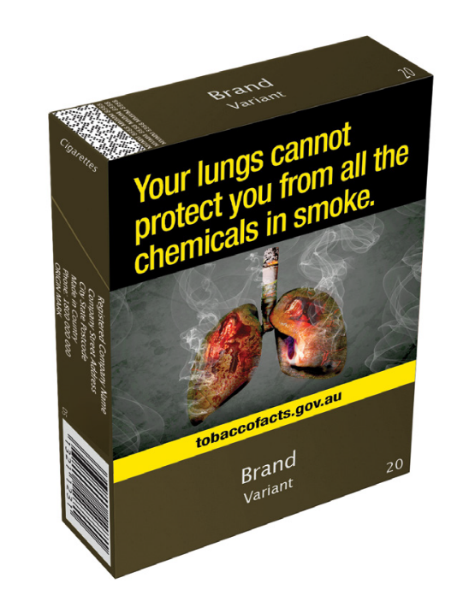

### FRONT OUTER SURFACE

* Minimum coverage 75% of total surface area

Figure 1: Image of front, side and top of cigarette pack

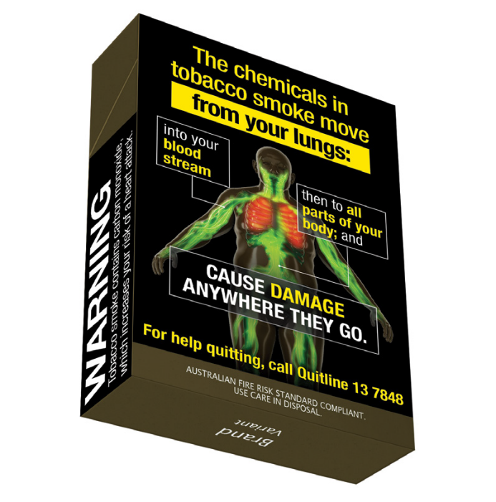

### BACK OUTER SURFACE

* Minimum coverage 90% of total surface area.

### SIDE OUTER SURFACE

* Must be displayed on at least one side outer surface.
* Must cover total area from the base of the pack to a notional line that is:
* Parallel to the top edge of the side outer surface; and
* A continuation of the line of the bottom of the flip-top lid on the front outer surface.

Figure 2: mage of back, side and bottom of cigarette pack

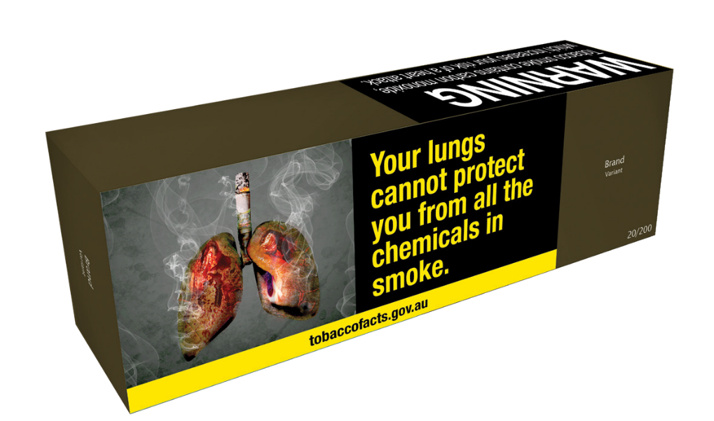

### FRONT OUTER SURFACE

* Minimum coverage 75% of total surface area.

### SIDE OUTER SURFACE

* Must be displayed on at least one side outer surface.
* Minimum coverage 25% of total surface area.

Figure 3: Image of front, side and top of cigarette carton

**Note:** This image illustrates only one layout option for this packaging type. Alternate layouts that satisfy the minimum coverage requirements and do not involve major cropping or distortion of the health warnings are also permitted. Figure 4 illustrates the back outer surface of a cigarette carton, where the health warning on the side outer surface appears on the side that is not visible.

* Horizontal cigarette cartons may also display the health warning image on the front outer surface using this alternative layout:

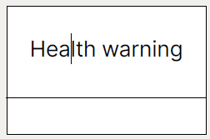

* Vertical cigarette cartons may also display the health warning image on the front outer surface using this alternative layout:

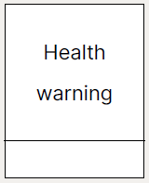

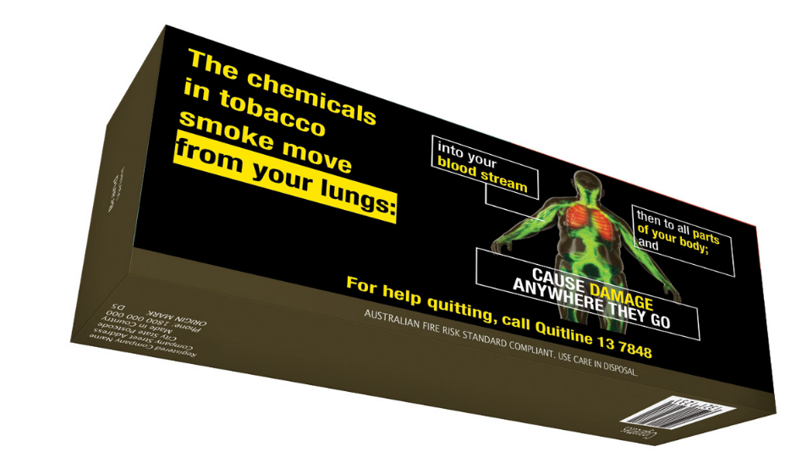

### BACK OUTER SURFACE

* Minimum coverage 90% of total surface area.

Figure 4: Image of back, side and bottom of cigarette carton

### FRONT OUTER SURFACE

* Minimum coverage 75% of total surface area.

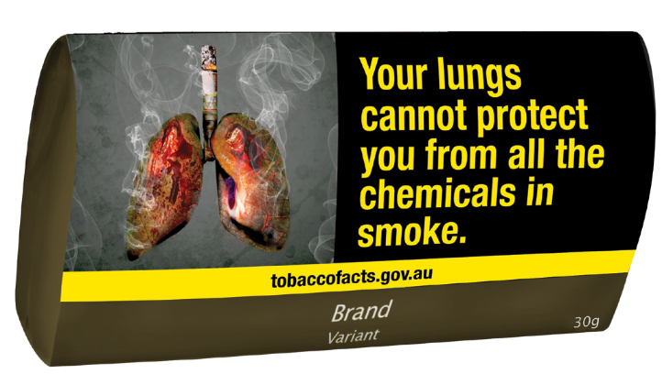

Figure 5: Image of front of loose tobacco pouch

**Note:** This image illustrates only one layout option for this packaging type. Alternate layouts that satisfy the minimum coverage requirements and do not involve major cropping or distortion of the health warnings are also permitted. Figure 5 illustrates the front outer surface of a loose tobacco pouch, where the flap of the pouch is on the side that is not visible.

* Horizontal pouches may also display the health warning image on the front outer surface using this alternative layout:

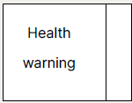

* Vertical pouches may also display the health warning image on the front outer surface using this alternative layout:

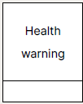

### BACK OUTER SURFACE

Minimum coverage 75% of each surface area.

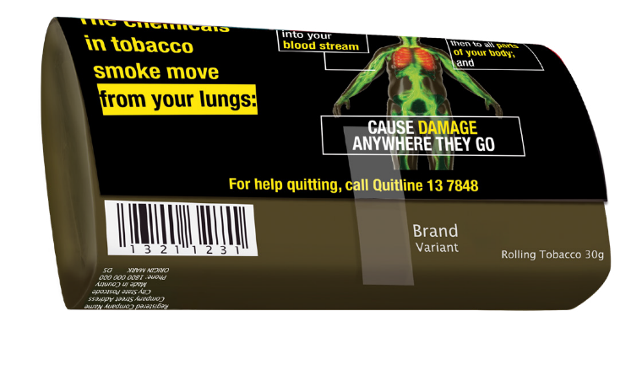

Figure 6: Image of back of loose tobacco pouch

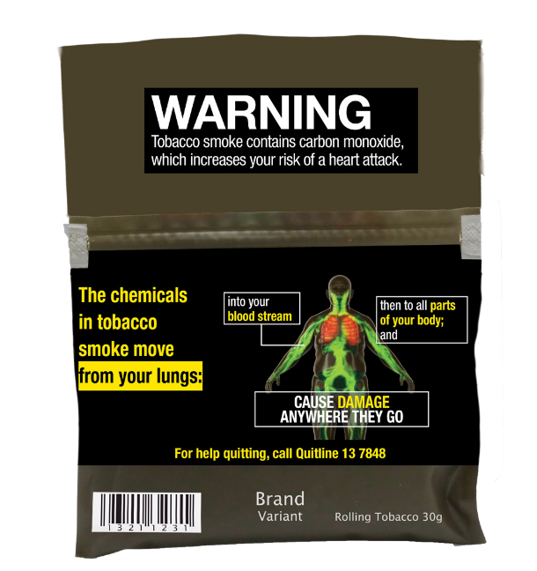

### HIDDEN FLAP

* Must be printed within a rectangle measuring at least 80mm by 25mm that is positioned in the centre of the surface of the hidden flap.

### BACK OUTER SURFACE

* Minimum coverage 75% of each surface area (this is an example of (b) in the table on page 9).

Figure 7: Image of back of loose tobacco pouch with hidden flap open

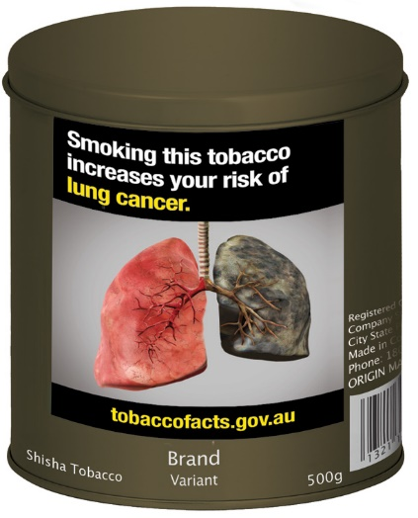

### FRONT OUTER SURFACE

* Minimum coverage 75% of total surface area.

Figure 8: Image of front and top of large shisha tobacco cylinder



### BACK OUTER SURFACE

* Minimum coverage 75% of total surface area.

Figure 9: Image of back and top of large shisha tobacco cylinder

**Note:** The base surface of this retail packaging must display a health warning. The health warning must have a minimum coverage of 50% of the total base surface area.

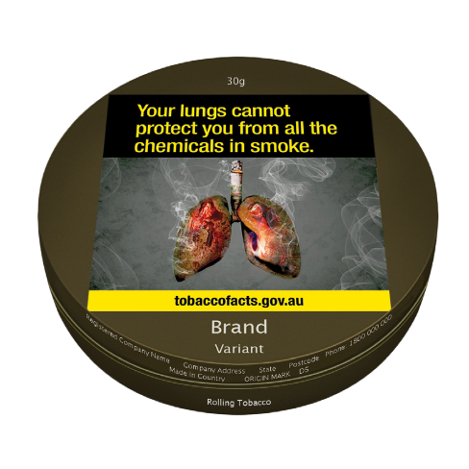

### FRONT OUTER SURFACE

* Minimum coverage 60% of total surface area.

Figure 10: Image of front and top of small tobacco cylinder

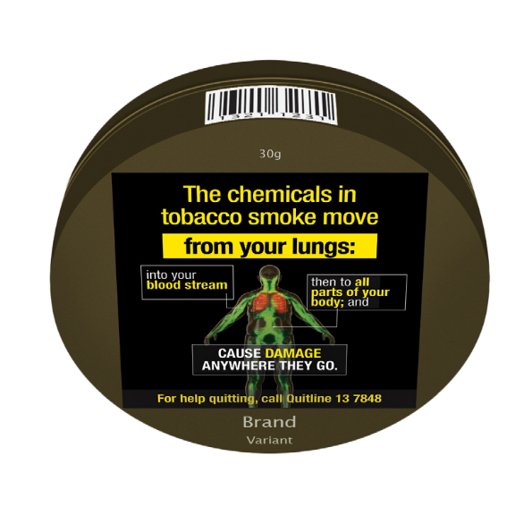

### BACK OUTER SURFACE

* Minimum coverage 60% of total surface area.

Figure 11: Image of back and bottom of small tobacco cylinder

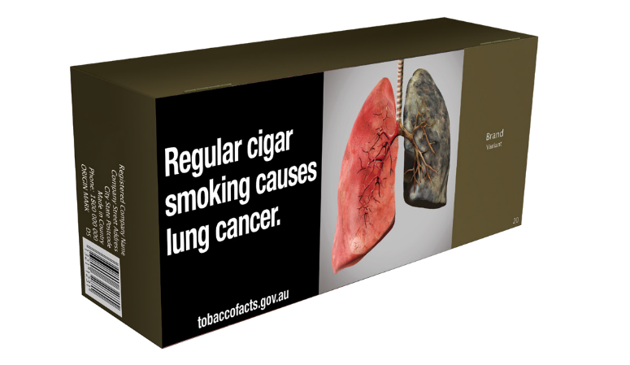

### FRONT OUTER SURFACE

* Minimum coverage 75% of total surface area or for packaging with a front outer surface area more than 250cm2, the health warning must cover 188cm2.

Figure 12: Image of front, side and top of cigar box

**Note:** This image illustrates only one layout option for this packaging type. Alternate layouts that satisfy the minimum coverage requirements and do not involve major cropping or distortion of the health warnings are also permitted.

* Horizontal cigar boxes may also display the health warning image on the front outer surface using this alternative layout:

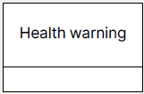

* Vertical cigar boxes may also display the health warning image on the front outer surface using this alternative layout:

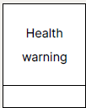



### BACK OUTER SURFACE

* Minimum coverage 75% of total surface area or for packaging with a front outer surface area more than 250cm2, the health warning must cover 188cm2.

Figure 13: Image of back, side and bottom of cigar box

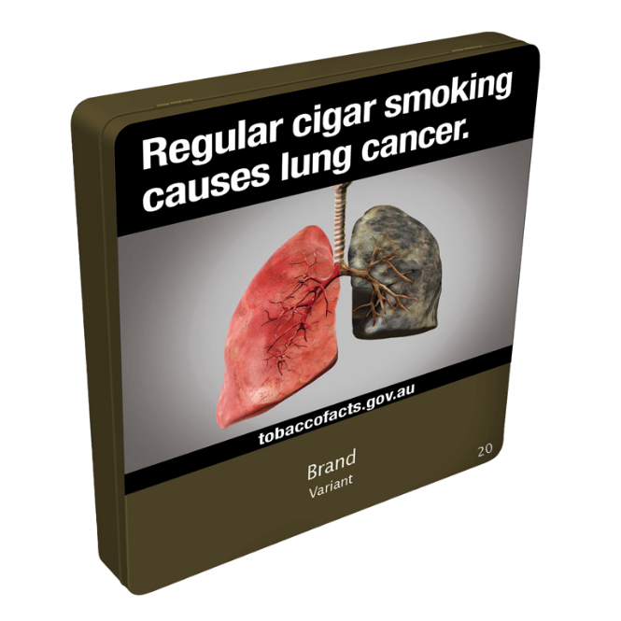

### FRONT OUTER SURFACE

* Minimum coverage 75% of total surface area or for packaging with a front outer surface area more than 250cm2, the health warning must cover 188cm2.

Figure 14: Image of front, side and top of little cigar tin

**Note:** This image illustrates only one layout option for this packaging type. Alternate layouts that satisfy the minimum coverage requirements and do not involve major cropping or distortion of the health warnings are also permitted.

* Cigar tins may also display the health warning image on the front outer surface using this alternative layout:

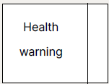



### BACK OUTER SURFACE

* Minimum coverage 75% of total surface area or for packaging with a front outer surface area more than 250cm2, the health warning must cover 188cm2.

Figure 15: Image of back, side and bottom of little cigar tin

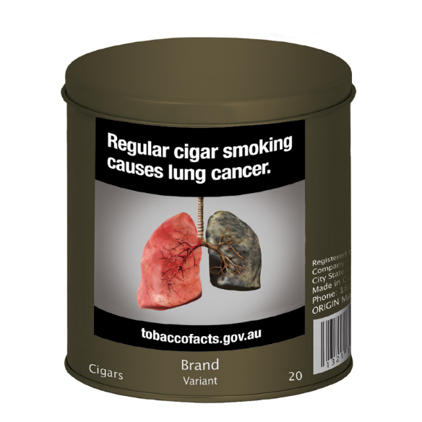

### FRONT OUTER SURFACE

* Minimum coverage 75% of total surface area or for packaging with an area of front outer surface area more than 250cm2, the health warning must cover 188cm2.

Figure 16: Image of front and top of large cigar cylinder



### BACK OUTER SURFACE

* Minimum coverage 75% of total surface area or for packaging with an area of front outer surface area more than 250cm2, the health warning must cover 188cm2.

Figure 17: Image of back and top of large cigar cylinder

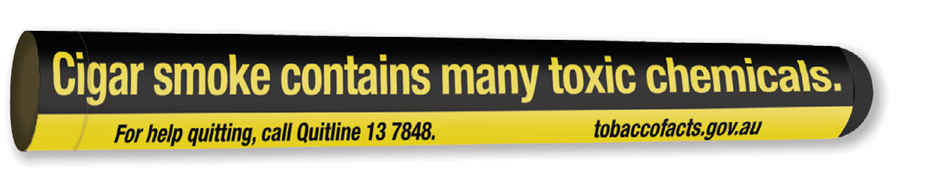

### FRONT OUTER SURFACE

* Must be positioned lengthwise on tube.
* Must extend to at least 60% of the circumference of outer surface.
* Must cover at least 95% of the total length of outer surface.

Figure 18: Image of front of cigar tube

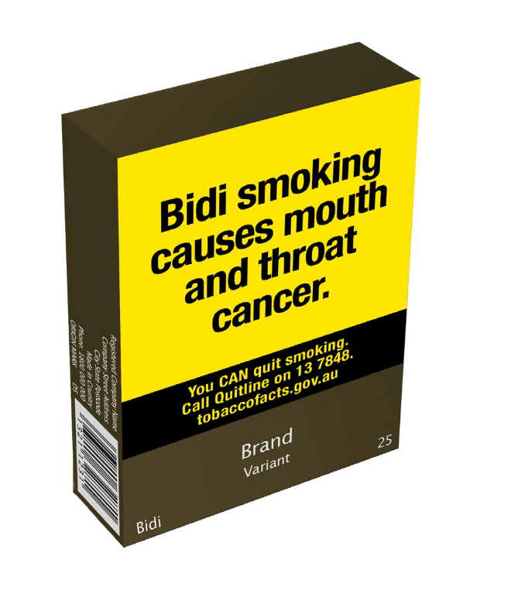

### FRONT OUTER SURFACE

* Minimum coverage 75% of total surface area.

Figure 19: Image of front, side and top of bidi box

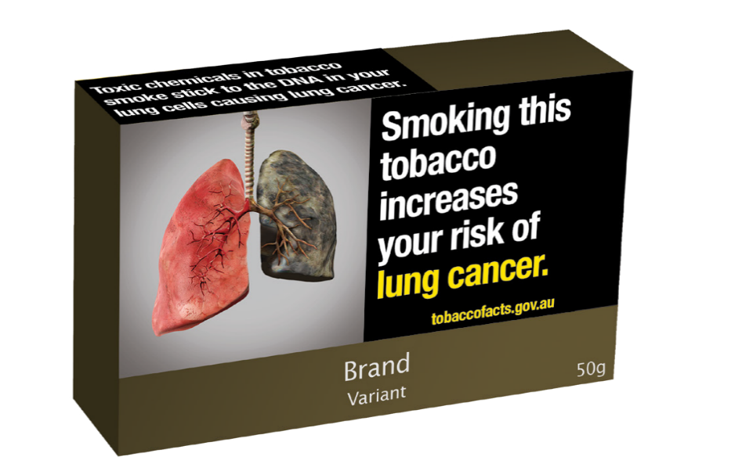

### FRONT OUTER SURFACE

* Minimum coverage 75% of total surface area.

### SIDE OUTER SURFACE

* Must cover at least 50% of total side surface area.

Figure 20: Image of front, side and top of shisha tobacco box



### BACK OUTER SURFACE

* Minimum coverage 75% of total surface area.

Figure 21: Image of back, side and bottom of shisha tobacco box

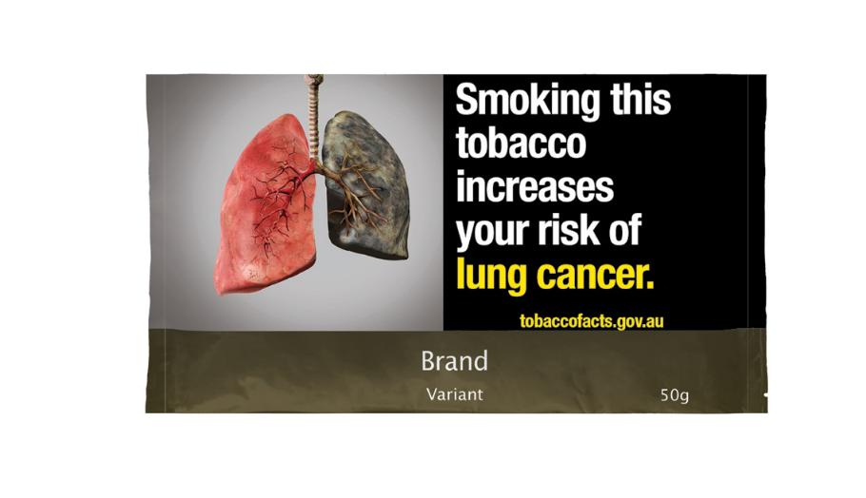

### FRONT OUTER SURFACE

* Minimum coverage 75% of total surface area.

Figure 22: Image of front of shisha tobacco foil

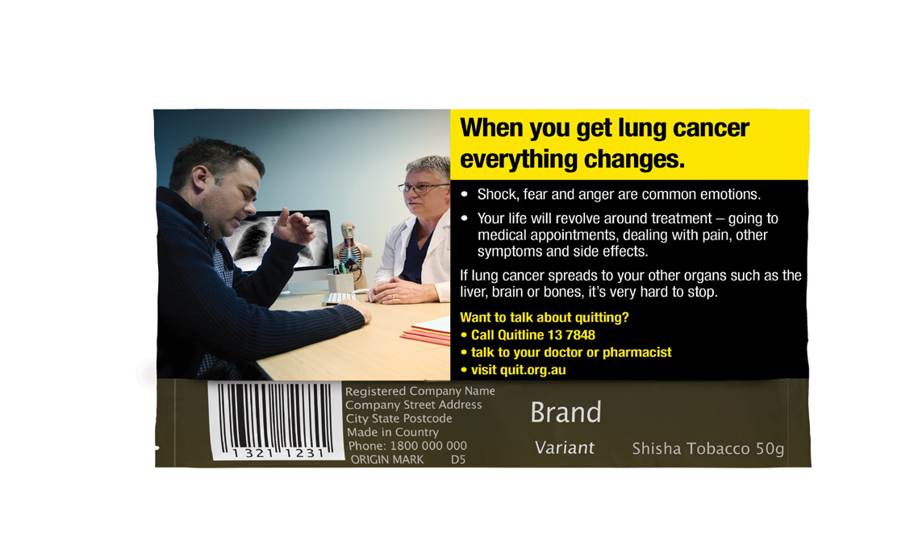

### BACK OUTER SURFACE

* Minimum coverage 75% of total surface area.

Figure 23: Image of back of shisha tobacco foil

## How to access images

Electronic files containing health warning images are available on request, free of charge, for people involved in packaging tobacco products in retail packaging or the retail sale of regulated tobacco items. A copy of the files containing health warning images can be requested from the department by completing the webform available on the [department’s website](https://www.health.gov.au/topics/smoking-vaping-and-tobacco/tobacco-control/health-warnings/request-form).

## Enforcing the Public Health (Tobacco and Other Products) legislation

The Government takes breaches of the Act seriously. The department is responsible for investigating reported breaches of the Public Health (Tobacco and Other Products) legislation. The department’s [Tobacco Control Enforcement Policy](https://www.health.gov.au/resources/publications/tobacco-control-enforcement-policy) outlines the principles used to guide the department’s decisions and actions in enforcing these laws.

Any person who possesses, manufactures, packages, purchases, sells or supplies (including import, wholesale and retail) tobacco products in Australia which do not comply with the Public Health (Tobacco and Other Products) legislation may face significant criminal or civil penalties. A range of options are available to enforce the Public Health (Tobacco and Other Products) legislation, including issuing infringement notices, seeking enforceable undertakings or injunctions, or referring the matter to the Australian Federal Police who may, in turn, refer the matter to the Commonwealth Director of Public Prosecutions.

As at publication, the maximum penalty for contravening the tobacco product requirements is 2,000 penalty units ($660,000) for individuals and 20,000 penalty units ($6.6 million) for bodies corporate.[2]

If you wish to report a potential breach of the Public Health (Tobacco and Other Products) legislation, please contact the department. Reports of breaches can be submitted in writing through the [make a complaint](https://www.health.gov.au/topics/smoking-vaping-and-tobacco/tobacco-control/plain-packaging/complaints-form) link on the department’s website or by emailing [TobaccoCompliance@health.gov.au](mailto:TobaccoCompliance@health.gov.au). Please include sufficient information to enable the department to investigate the alleged breach, including images or document copies demonstrating the allegation where possible.

[www.health.gov.au](http://www.health.gov.au/)

11890 NOV 2024

1. Transitional arrangements are in place from 1 April 2024 to 31 March 2025, whereby retail packaging that previously complied with provisions of the *Tobacco Plain Packaging Act 2011* (Cth) is taken to comply with the requirements of the *Public Health (Tobacco and Other Products) Act 2023* (Cth) and the Public Health (Tobacco and Other Products) Regulations 2024 (Cth). The Public Health (Tobacco and Other Products) (Consequential Amendments and Transitional Provisions) Rules 2024 allow for health promotion inserts to be inserted in retail packaging during the main transition period as well as for retailers to sell through regulated tobacco items that were compliant with the *Tobacco Plain Packaging Act 2011* (Cth). For more information on transition periods, see [Transition Periods Fact Sheet](https://www.health.gov.au/resources/publications/information-on-transition-periods-for-manufacturers-importers-wholesalers-and-retailers).
2. Since 7 November 2024, the value of one penalty unit is $330.00. This amount may be subject to increase in the future.