Communicating risks to health from environmental hazards -

General guidance for environmental public health professionals

October 2024

Environmental Health Standing Committee (enHealth)

**Table of Contents**

Acknowledgements 1

Purpose and Scope 2

1. Introduction 2

enHealth principles and RCAT 3

2. Understanding risk and risk assessment in environmental health 4

What is a hazard? 4

What is exposure? 4

How risk is assessed 6

Level of risk 6

Short-term versus long-term exposure and health effects 7

Variable and cumulative exposure and chronic disease risk 8

Hazards with known and unknown safe levels 8

Chemical mixtures and unknown hazards 9

3. How risk is expressed (qualitatively and quantitatively) 10

Health-based guidance values 10

Limitations, uncertainties, and assumptions 11

4. Communicating the risk 11

Risk perception 12

When to communicate 12

Appendix A - Risk assessment process and risk management i

Risk assessment process i

Risk management i

Appendix B - Key issues to consider when communicating risk iii

Appendix C - Making risk communication comparisons iv

Appendix D – Exposure to a carcinogenic hazard and cancer development v

# Acknowledgements

This guidance was prepared by the Risk Communication National Working Group for the Environmental Health Standing Committee (enHealth), a standing committee of the Australian Health Protection Committee (AHPC).

The Working Group was comprised of Sandra Falconer and Julie Eichner (Project leads, Department of Health, Victoria); Pierina Otness and Lindy Nield (Department of Health, Western Australia); David Simon (Department for Health and Wellbeing, South Australia), Jennifer Muscat (National Health & Medical Research Council (NHMRC); and Desiree Lennox (Commonwealth Department of Health and Aged Care).

Secretariat support was provided by Peter Clark and Marilyn Rechtman (Commonwealth Department of Health and Aged Care).

The review and contributions from representatives of the following are also gratefully acknowledged: enHealth Expert Reference Panel on Environmental Health; Health Departments of Australian States; Commonwealth Department of Health and Aged Care; the Western Australian Department of Water and Environmental Regulation; Environment Protection Authority, Victoria; and the National Public Health Service, Health New Zealand.

# Purpose and Scope

This general guidance aims to assist environmental public health practitioners[1] to facilitate community and stakeholder understanding about risks to human health from environmental hazards. The introduction provides a description of risk communication and its application in environmental health and is followed by sections on understanding risk and how risks to health are assessed, expressed and communicated.

The guidance focuses on chemical hazards, however, the concepts can be applied to a wider range of environmental hazards, such as biological and physical hazards including noise, odours and light.

# Introduction

‘Our ability to explain a situation and the risk someone is facing clearly, succinctly, and with empathy can make the difference of whether or not they are able to make the best choices for themselves and their family.’[2]

Risk communication provides the community with information about the potential for harm (hazard and magnitude) from an activity or event. Typically, communication about risks to human health from environmental hazards conveys potential adverse outcomes, the likelihood those outcomes will occur under a set of specific circumstances and strategies to mitigate risk. Circumstances typically include:

* the nature and extent of the hazard
* exposure routes, pathways, and duration of exposure
* people’s perception and understanding of the risk and human behaviour
* sensitive and vulnerable groups that may be affected.

Risk communication is used to:

* provide available accurate information to help people understand what is currently known about the risk, prevent complacency, avoid unnecessary distress and facilitate proportionate responses. Accurate information helps to:
  + allocate resources
  + build credibility, demonstrate accountability, and increase public trust
  + develop effective mitigation strategies and emergency preparedness plans.
* empower people to make informed decisions about actions to protect their health, for example:
  + using a licensed removalist to remove and dispose of asbestos
  + seeking health advice from a medical practitioner when experiencing signs and symptoms of health effects.

In explaining environmental health risks, it is important to understand what makes the risk communication process effective. It is not as simple as relaying the characterised risk that has been assessed and described by those making the assessment, or saying, ‘it will be OK’. Effective risk communication is a two-way discussion that requires listening to community concerns, being honest and transparent, accurately representing the risk and any uncertainties, and recommending actions. Public participation, understanding, and acceptance are significantly influenced by the effectiveness of communication activities.

To clearly communicate a risk to stakeholders, including the general public, it is critical for environmental public health practitioners to understand the risk, how it has been represented, and how it may be perceived. When describing risk, it is important to include the identified hazard, the information used to assess the risk and acknowledge any uncertainty surrounding it.

Communicating complex issues can be difficult, especially if the public’s outrage factor[3] is high, or if children, pregnant women or other sensitive or vulnerable groups are affected.

Whether it is a simple or complex situation, risk communication is part of risk management and encompasses the whole assessment process, from when an issue is identified, through to each stage of the risk assessment. This is also the case for stakeholder engagement and community consultation.

There may be a need to interpret health risks for persons who are unfamiliar with the risk assessment process. This document provides information about the risk assessment process that can be used in communicating risk. For more technical information on undertaking a risk assessment, see the enHealth [Environmental Health Risk Assessment – Guidelines for assessing human health risks from environmental hazards](https://www.health.gov.au/sites/default/files/documents/2022/07/enhealth-guidance-guidelines-for-assessing-human-health-risks-from-environmental-hazards.pdf)*.* These Guidelines outline an evidence-based approach for assessing human health risks from environmental hazards and includes further information on community engagement.

Information on how individuals and communities may perceive and react to risks is provided in the [enHealth Risk Communication Assessment Tool & Guidance (RCAT) and RCATi spreadsheet](https://www.health.gov.au/resources/publications/enhealth-risk-communication-assessment-tool-rcat-and-guidance-and-interactive-rcati?language=en), which are described in the section below.

## enHealth principles and RCAT

This general guidance supports the [enHealth guidance – Risk Communication Principles](https://www.health.gov.au/sites/default/files/documents/2022/07/enhealth-guidance-risk-communication-principles.pdf), which introduce the relationship between ‘Hazard’ and ‘Outrage’[4], how this relationship influences risk, the need to consider the ‘hazard’ that is creating the risk and people’s responses that lead to the ‘outrage’. The Risk Communication Principles provide overarching principles for all forms of risk communication, including outrage management, crisis communication, precaution advocacy, as well as the in-between or ‘sweet spot’[5]. The Guidance also provides tailored principles for each of these forms of risk communication.

The risk communication principles aim to address anxiety, fear and the lack of understanding that people may experience when faced with risks associated with a high outrage factor, resulting in better listening, understanding, acceptance and willingness to follow public health advice.

The companion [enHealth Risk Communication Assessment Tool & Guidance (RCAT)](https://www.health.gov.au/resources/publications/enhealth-risk-communication-assessment-tool-rcat-and-guidance-and-interactive-rcati?language=en) is designed to help identify the approach to risk communication for any given situation potentially impacting the community, especially where outrage may occur. [RCATi](https://www.health.gov.au/resources/publications/enhealth-risk-communication-assessment-tool-rcat-and-guidance-and-interactive-rcati?language=en) is an interactive spreadsheet that allows users to input the characteristics of the issue. The spreadsheet then applies a simple formula to indicate the type of outrage likely to be encountered.

# Understanding risk and risk assessment in environmental health

This section describes risk assessment in environmental health in a less technical manner that can be adapted and used in risk communication. For more technical detail on risk assessments, refer to the enHealth [Environmental Health Risk Assessment – Guidelines for assessing human health risks from environmental hazards](https://www.health.gov.au/sites/default/files/documents/2022/07/enhealth-guidance-guidelines-for-assessing-human-health-risks-from-environmental-hazards.pdf)*.*

**There are many factors** that are considered when **understanding what a risk to health might be**. Standard practice is represented in the diagram below.

**RISK to Health is about HAZARD *AND* EXPOSURE**

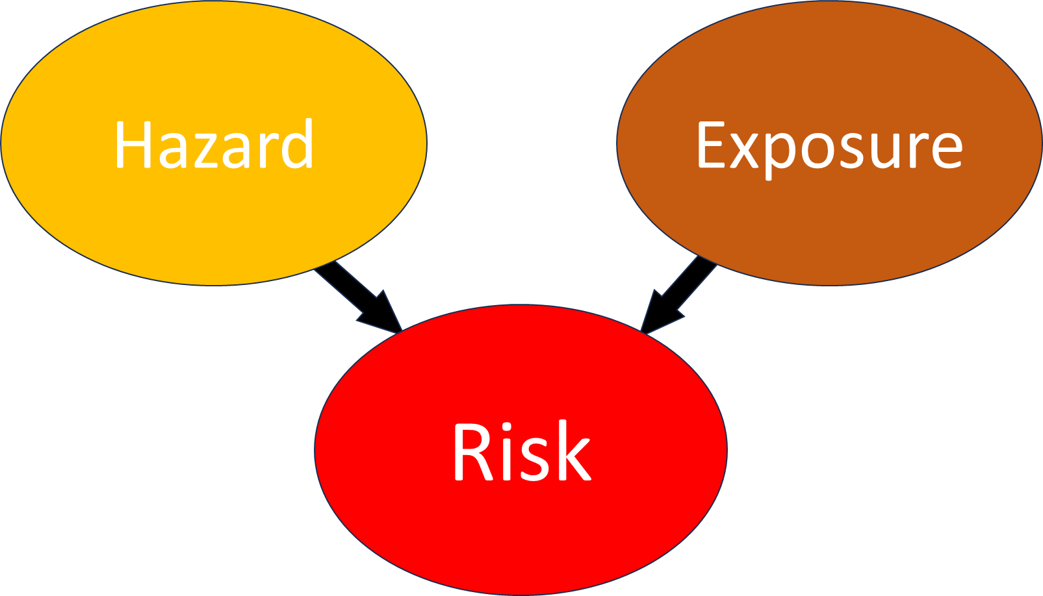

When describing this to an individual or community, it is important to convey that assessing the level of risk is not just about the hazard, it is also about the exposure. Assessing exposure involves understanding how and where the exposure occurred, whether the hazard had to be breathed in, swallowed or absorbed through the skin to be harmful, the concentration, amount, duration and frequency of the exposure (how much, how long and how often), and also the sensitivity of individuals and communities exposed (e.g. age, pregnancy, pre-existing health conditions). These are explained in more detail in ‘What is exposure?’.

## What is a hazard?

A hazard is a chemical, biological or physical agent or action that has the potential to cause harm, danger or an adverse health effect. Environmental health hazards include dusts and other fine particles (such as in smoke from fires), harmful metals and minerals, chemicals, radiation, noise, moulds, pathogens, pollen and other biological agents.

## What is exposure?

Exposure refers to how an individual might have contact with the hazard and involves:

* **Exposure pathway:** The way in which a hazard might find its way to an individual (e.g. drinking water, food, air).
* **Exposure route:** specifies the way the hazard enters or interacts with the human body (e.g. inhalation, ingestion, skin contact).
* **Amount:** The quantity or concentration of a hazard to which individuals are exposed.
* **Frequency:** How often exposure occurs.
* **Duration:** The length of time individuals or systems are exposed during each instance of exposure.

The image below shows that a risk to a person’s health depends on their exposure to a hazard.

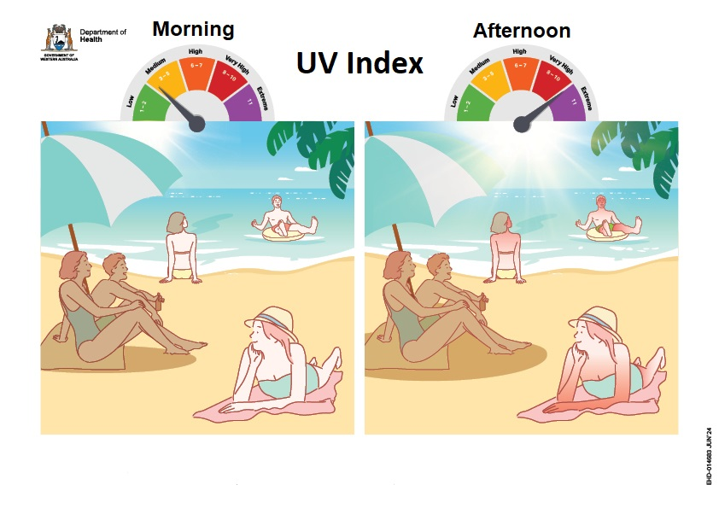**RISK to health is about HAZARD *AND* EXPOSURE**

The image shows the UV radiation from the sun as the hazard and that by taking preventive measures such as seeking shade, the risk of sunburn is minimised. The hazard (the sun’s UV rays) is potentially harmful especially at a high UV index, but ***it is the exposure to the hazard that is important in determining the level of risk***. If there is reduced exposure, the risk is reduced. If there is no exposure, then there is no risk, despite the hazard still being present.

The following example is a typical scenario illustrating how the level of risk depends on the hazard and the exposure:

**Hazard:** A contaminant (hazard), such as lead, is found in the backyard soil of a family’s home at a concentration above the Health Investigation Level (HIL)*[6]* for lead in that setting. The family is concerned about the risk to their child’s health from playing in the yard.

**Exposure**: Lead is found 30 cm below the soil’s surface and the ground has well-maintained lawn. The family’s two-year-old child plays in the yard but is not exposed to the hazard as they do not come into contact with it. The deeper the contamination, the less likely exposure is to occur, especially if the ground is very hard.*[7]*

***Risk****: As no exposure is occurring, the hazard (lead) poses no risk to health.*

*Different circumstances may change the level of risk. For example, if digging occurs in the backyard to a depth of 30 cm, the likelihood for exposure (e.g. especially when access and dust are not managed) and therefore the risk, increases (e.g. especially if children eat the contaminated soil).[8] The risk of developing adverse health effects will be determined by the extent of exposure to the hazard.*

***Risk management:*** *In some cases, remediation, such as replacement of contaminated soil in a residential backyard, may be advised as a long-term sustainable and precautionary measure. To avoid confusion, it is important to communicate the reasons for remediating soils after concluding that there is no immediate risk.*

## How risk is assessed

A risk assessment is an established scientific process that evaluates the potential for harm or adverse health effects to occur over a given time frame, resulting from exposure to a chemical, physical, biological, or psychosocial hazard. A risk assessment may be simple and straightforward, or detailed and complex.

A simple risk assessment might include reviewing the available information about the hazard and the means of mitigating or controlling exposure. An example is using a product label or safety data sheet to assess risk.

Experts may complete/review detailed and complex risk assessments and interpret technical information about the hazard(s), the possible health effects and people’s exposure. These risk assessments are used to address gaps in knowledge associated with harm to health, exposure factors or sensitivity in people exposed (for example age, pre-existing health conditions).

A risk assessment is important as it informs risk management, the process of evaluating alternative actions, selecting options, and implementing them to protect human health.[9]

## Level of risk

The level of risk depends on the following:

* The magnitude of the hazard
  + distribution and quantity/amount of the substances (hazards) found
  + the level of danger or toxicity of the hazard (e.g. chemical), its form and how bio-available it is (how readily it is taken up by the body).
* Whether there is a way for people to be exposed to the hazard and its potential effects (e.g. if it can cause harm by inhalation, is there a way for the hazard to enter the breathing zone of an individual).
* How longand how frequently people are exposed to the hazard at levels that have the potential to cause harm.
* How the hazard affects the human body (e.g. how it is absorbed, distributed, metabolised, and eliminated by the body).
* Who is likely to be exposed and whether there are people more sensitive to the effects of the hazard (e.g., the age of the people exposed – younger and older people).
* Whether measures are in place (or are able to be put in place) to reduce or prevent exposure (e.g., placing of a barrier such as rubber matting or restricting access to certain areas for contaminated soil, or advising people to stay indoors with windows and doors closed when air quality is poor).

The diagram below describes risk as a relationship between the hazard, its toxicity or danger, and exposure factors i.e. dose, frequency and duration, and individual susceptibilities such as age, pregnancy, health status and genetics.

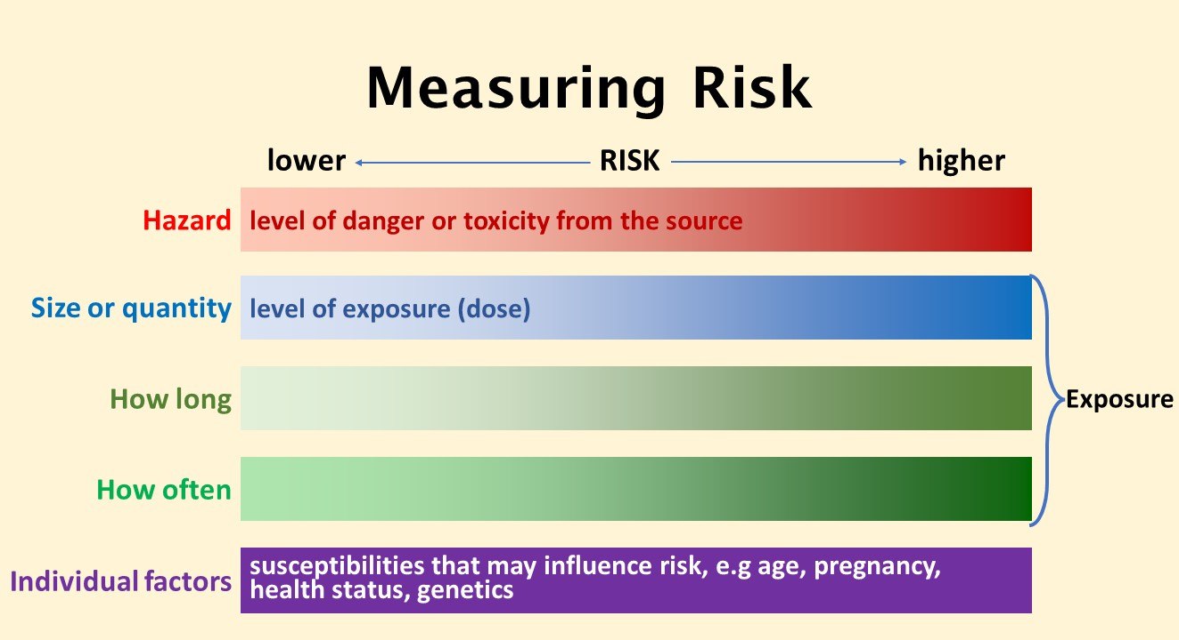

## Short-term versus long-term exposure and health effects

**Short-term exposure** is when contact occurs with an agent (hazard) over a short period of time, from minutes or hours to days or weeks.

**Long-term exposure** is when contact occurs with an agent (hazard) on a continuous or repeated basis over months to years.

**Short-term (or immediate) health effects** from a hazard describes acute symptoms that generally occur shortly following exposure to the hazard. They are usually temporary. Short-term health effects may range from minor to severe or may even be fatal, e.g. eye, nose or throat irritation from dust, a corrosive burn from an acid, systemic effects from a virus, or death from poisoning.

**Longer term (or chronic) health effects** generally develop after a reasonable time following exposure and are experienced over a long period (months to years). Examples include adverse neurological effects, developmental or reproductive effects, or cancer. Chronic health effects from exposure to a chemical often develop as a result of long-term, or prolonged exposure.

Chronic health effects can occur from acute exposure, e.g. allergic sensitisation. For some hazards there may be a delayed effect following exposure.

In general, regardless of health impact, the controls applied for avoiding or minimising exposure are the same for both acute and chronic health effects.

## Variable and cumulative exposure and chronic disease risk

Evaluating risk from chronic exposure at an individual or small population level is difficult. Much of the information about how much exposure is needed for chronic disease impacts to occur is collected from large populations and/or circumstances involving prolonged high exposure to substances (e.g. occupational exposure studies).

Individual exposure to hazards may fluctuate or change over time and there may be other individual factors or sensitivities that affect the risk. That is, the risk varies depending on the specific circumstances or conditions at a particular moment acting on a particular person. We often do not know how much and how frequently people may have individually been exposed over time. Individual risk may be influenced by a combination of factors including how their body responded to the exposure (defence mechanisms), how much recovery time they had between each exposure, and whether this mitigates disease risk. Therefore, having an accurate picture of the (averaged) risk over a long period of time (e.g. lifetime) is very difficult.

Additionally, it is not easy to attribute a single or occasional exposure to a hazard, or hazardous event, such as a fire, to a specific health outcome[10]. An individual is exposed to multiple variables and/or insults to their body during their life and each of these may compound or influence the likelihood of developing long-term health effects or chronic disease. The diagram in Appendix D demonstrates this, by illustrating the multi-stage process needed for cancer to develop following exposure to a carcinogenic hazard.

## Hazards with known and unknown safe levels

For some hazards it is possible to identify a level below which there is no apparent harm, but once that level is crossed, harmful effects are possible. These hazards are described as having a threshold effect level. Some examples are carbon monoxide (e.g. exhaust fumes from a car will become dangerous when levels build up in an enclosed space), chlorine (e.g. used in low doses as a pool disinfectant is not harmful however high concentrations of the chemical are corrosive and exposure can cause burns), and salt (e.g. used in food but too much can cause chronic health effects). See the section below on *Health-based guidance values*, for more information on determining a safe amount for people to be exposed.

Some things are not thought of as hazardous but can become a risk to health in certain situations, a simple example of which is water. Water is essential to life but can become hazardous if consumed in excess (*too much of a good thing*), causing a threshold effect (i.e. electrolyte imbalance) which has the potential to result in serious health consequences. This demonstrates that even what may be perceived as harmless or good for you, can also become a health risk under certain circumstances.

Some hazards have a non-threshold effect (no known safe level), also known as a non-threshold dose-response relationship. This means it is not known at what level harmful effects can start to occur and, for these hazards, the risk often increases with increased exposure (i.e. dose, frequency and/or duration). A common example of this is UV radiation in sunlight. Even brief exposure could start to trigger a skin response, with increasing time in the sun being associated with increased likelihood of effects including sunburn. Consistent exposure and repeat sunburn episodes can increase the likelihood of irreversible sun damage, including the risk of skin cancer. However, sunlight remains important for vitamin D synthesis and so sunlight exposure has some benefit. Finding a balance between benefits and averting potential harm means applying some cautionary measures that allow for beneficial exposure while minimising UV exposure (e.g. avoiding being out for long periods of time when the UV index is high, using sunscreen, long sleeve UV protection clothing etc.). Another example is UV radiation exposure from solaria (or sunbeds). Solaria emit UV levels up to 6 times stronger than the midday sun and substantially increase the risk of developing skin cancer, hence their commercial ban in Australia, and in New Zealand (for under-18s).

Particulate matter (PM)2.5[11]in air pollution (e.g. in smoke) is another example of a non-threshold hazard. There is no level of PM2.5 identified where there is no risk of adverse health effects, so public health advice is to minimise exposure where possible (e.g. staying indoors with windows and doors closed when outdoor air quality is poor, using air cleaners with a HEPA filter, or wearing a P2 mask).

Many hazards do not have a known effect/no effect cut-off level. This does not mean that any exposure (e.g. one off or occasional) increases the risk of an adverse health effect. For example, the body may be able to deal with occasional small exposures or there just may be insufficient data available to determine a cut-off level or threshold. For very toxic substances (e.g. carcinogens) the approach is to minimise risks to health by reducing exposure to as low as reasonably practicable or achievable (ALARP or ALARA).

## Chemical mixtures and unknown hazards

The occurrence of an adverse health effect from exposure to a hazard can also be influenced by concurrent exposures to other hazards, e.g., tobacco smoke from smoking cigarettes.

Chemical mixtures as hazards are challenging to assess and speak about, but they include the most common pollutants people are exposed to, such as smoke from fires, road-traffic emissions, industrial emissions and indoor air. This can make communication challenging, as a key principle of effective communication is to limit the number of messages requiring specific actions, to prevent confusion.

Although for individual pollutants the evidence may be well developed, the interaction of the various components of a mixture on the human body is not well understood. Therefore, it is not always known whether one pollutant adds to, or increases, the toxicity of another. Where mixtures are present, the [precautionary principle](https://www.health.gov.au/sites/default/files/documents/2022/07/enhealth-guidance-guidelines-for-assessing-human-health-risks-from-environmental-hazards.pdf) may be applied more strictly compared to when there is more certainty about the risk from exposure to any one component of the mixture. In general:

* Focus risk communication on the most important pollutant for health risk – either by exposure or toxicity. For example, fine particles in bushfire smoke. Or in the case of site contamination, refer to the hazardous substance likely to present the greatest risk to health.
* Some chemicals or substances that present a lower risk to health may be associated with a high level of concern (e.g. emerging chemicals of concern, previously unknown hazards) and these may need to be targeted in risk communication.
* Where there is low confidence in health risk assessment, the message of avoiding or minimising exposure is most important, e.g., to the polluted air, contaminated soil, ground water or surface water.
* Be prepared to speak about a limited understanding of mixtures or emerging contaminants of concern.
* Use the name of a group of chemicals as a general descriptor, rather than naming every pollutant. The following chemical group descriptions are often used: PFAS, PAHs, dioxins, organochlorine pesticides, aldehydes and volatile organic compounds.
* Be clear about focusing data on certain chemicals or substances. For example, some chemicals are more readily measured or more likely to be present in measurable quantities and reducing exposure to one pollutant in the mixture will reduce exposure to all pollutants in the mixture. Using an example of a lead smelter, lead could be used as a surrogate for public exposures to other chemicals associated with the industrial process. The assessment and monitoring of lead as a focus, and actions that minimise lead exposure to the public will typically minimise exposure to the other chemicals.

Further detailed information on the risk assessment of chemical mixtures can be found in Chapter 12 of the enHealth [Environmental Health Risk Assessment – Guidelines for assessing human health risks from environmental hazards](https://www.health.gov.au/sites/default/files/documents/2022/07/enhealth-guidance-guidelines-for-assessing-human-health-risks-from-environmental-hazards.pdf).

# How risk is expressed (qualitatively and quantitatively)

The level of risk can be described either:

* **qualitatively:** characterising the risk based on what is already known about the hazard, exposure circumstances and means of mitigating the risk
* **quantitatively:** measuring or estimating the level of risk such as through quantifying exposure and comparing it to guideline or statutory levels, or with known levels of health impacts.

For quantitative risk estimates of chemicals with a non-threshold dose-response assessment, sometimes risk assessors and professionals use ‘*acceptable risk*’ levels that have been agreed nationally or internationally. For example, Australia uses the U.S. EPA risk estimate of *one in a million* (1 × 10-6) for cancer outcomes as a benchmark for regulatory decision making. Explaining risk using an estimate of the probability of an adverse effect, such as cancer, can become complicated, as the perception of acceptable probability of cancer risk will vary greatly based on individual perception and experience.

An example of qualitative risk conclusions is in the [enHealth Guidance for the human health risk assessment of volatile chlorinated hydrocarbon vapour intrusion document](https://www.health.gov.au/sites/default/files/2023-12/enhealth-guidance-the-human-health-risk-assessment-of-volatile-chlorinated-hydrocarbon-vapour-intrusion.pdf).

Current risk assessment methods do not enable accurate quantitative estimates of risk for low levels of exposure to environmental hazards. Numerical estimates of risks can be presented but caution must be exercised in assigning strict meaning to the numbers. This is because the accuracy of these estimates may be limited by the quality of data, complexity of exposure conditions, variability in the environmental agents and exposed populations, and any inherent limitations in toxicological data. Focus risk communication on the interpretation or judgement of the risk - based on all the available information.

## Health-based guidance values

Guidance values are made on a conservative basis. When communicating measured results against guidance values such as health investigation levels (HILs), or Australian Drinking Water Guidelines, it may be helpful to explain that guidance values already have safety factors incorporated into them to protect human health. Safety factors generally range from a factor of 10 to 1000, depending on the quality and amount of evidence of adverse health effects in animals and humans and whether there are any sensitive populations of people. If environmental sampling results are slightly elevated (when making a comparison to a guidance value), depending on the hazard and exposure factors, the results may not accurately reflect the risk to health[12].

To establish health-based guidance values for chemicals in water, food, air, soil or surfaces, toxicologists will take into account relevant exposure amounts and durations from all routes of exposure. This might include how much water a person might reasonably drink in a day, how much of a certain food they consume, or how much air they breathe. For example, to assess exposure to a chemical in drinking water, we usually assume that the average adult drinks 2 litres of water per day and the average child drinks 1 litre per day. Once the safe amount a person can be exposed to per day is established, a calculation is undertaken to set the safe level in water at the amount that would be in 2 litres of water (for adults). The same approach is used for food and air[13].

## Limitations, uncertainties, and assumptions

Before communicating risk, there should be a clear understanding of the strengths, assumptions, and uncertainties of the risk assessment process. The risk assessor can explain the confidence in their assessment by clearly delineating factors such as data quality, assumptions made about exposure, or strength of evidence of health effects. It should be noted that it is important that all uncertainties are reflected in the assessment outcome.

# Communicating the risk

The risk assessor/professional provides key information about the characterised risk for use in communication. If the risk is expressed numerically, it should be decided how this information is best presented to the community or relevant stakeholder.

Risk communication does not need to depend on risk estimate numbers to be useful. Ordinary language may be used to indicate the level of risk. A finely divided ranking system (e.g. negligible, very low, low, medium, medium high, high, very high, extreme) can provide a relatively good indication of the level of risk without using numbers.

A simple numerical estimate of risk – portrayed as the ‘real risk’ – ignores the subjectivity and multiple dimensions of risk [(Thomas and Hrudey 1997](https://www.health.gov.au/sites/default/files/documents/2022/07/enhealth-guidance-guidelines-for-assessing-human-health-risks-from-environmental-hazards.pdf)). Stakeholders may struggle to grasp or relate the numerical estimate to a tangible level of risk, as they tend to view risk as multi-dimensional and judge risk on its characteristics and context. For example, concerns around risk will generally be greater where they:

* affect vulnerable and/or sensitive populations
* are involuntary or synthetic/manufactured (human-made)
* require scientific understanding
* cause dreaded health effects, such as cancer (as opposed to temporary health effects)
* are contradicted by other agencies or the media.

Care should be taken when using risk comparisons (e.g. comparing involuntary vs voluntary risks) as people have differing perceptions of these types of risks. Appendix C provides some detail on risk comparisons.

When explaining risk to the community, wherever possible use a descriptive approach that explains the hazard and exposure relationship

## Risk perception

There are three perspectives to ‘risk’ – actual, estimated and perceived. The outcome of a risk assessment, with its uncertainties, is the estimated risk. The actual level of risk may never be accurately known, especially if mitigation measures are applied to minimise risk. All risk assessors, specialists and other stakeholders will also have their own perception of risk. Good risk communication aims to align perceived risks with the (estimation of) the actual risk.

The way the community generally perceive risk partly depends on:

* the actual measure of risk
* public perception of that risk
* the nature of the hazard
* who is likely to be exposed.

For example, a spillage of a 100 L drum of fuel will generally drive less concern than spillage of a fuel delivery vehicle tank, carrying 10,000 L of fuel on a road next to a primary school.The RCAT provides further information on outrage factors that can contribute to either low or high-risk perceptions.

**When explaining risk:**

Consider the outrage factors (refer to [enHealth’s RCAT](https://www.health.gov.au/resources/publications/enhealth-risk-communication-assessment-tool-rcat-and-guidance-and-interactive-rcati?language=en)).

Provide adequate background information when explaining assessments and results and ensure accuracy. Appendix A explains the risk assessment process.

Interpret and explain technical issues in an easily understood format; this is imperative, especially for more complex issues or where there is heightened concern.

Explain risk completely and clearly; remember delivery and tone can have more impact than the actual message (refer to Appendix B).

Collaborate with other agencies and stakeholders.

Take care when comparing environmental health risks to other risks (refer to Appendix C).

Explain the cautious approach (for example, safety factors) built into setting government standards and guidelines (e.g., HILs).

Ask whether you have made yourself clear – don’t assume that you have been fully understood. Also provide an avenue where people can obtain further information.

Recognise that communities determine what is acceptable to them. Providing people with options on actions that they can take promotes a sense of control.

## When to communicate

Ensuring early communication of results of both preliminary and detailed stages of assessments, together with any planned/recommended measures to reduce exposure helps build trust, as does providing regular and timely information at all stages of risk assessment and risk management.

It is easier to explain the results once an investigation is complete, a final report is available, and risks have been established along with any mitigation measures. However, if people request information at an early stage, it should be provided along with a simple interpretation and information on any relevant precautionary or interim mitigation actions (noting further information will be made available later) even though the risk may not yet be established. This helps to avoid misunderstandings and minimise the chance of concerns heightening and developing into significant issues, therefore allowing people’s perception of risk to be more closely aligned with the estimation of the actual risk. The longer information is held back, the less trusting people will be.

It is important to note that advice might change between preliminary and final assessments, and even over time as the science/evidence changes; and as such, practitioners need to understand that a community’s perception of risk and level of outrage can also change.

Provision of regular updates that summarise information in a straightforward way, should occur at each stage of an assessment wherever possible. Consultation with relevant parties (e.g. peers, consultants, and/or other agencies) is important to ensure accuracy of content.

The types and levels of substances found during, or as a result of an assessment, should be put into context, including information on ambient/typical/baseline concentrations of the substance (if available) is important as it can help put a situation into perspective. For example, elevated levels of lead can be common in inner urban soil environments, as are elevated levels of arsenic in gold mining regions.

# Appendix A - Risk assessment process and risk management

## Risk assessment process

A quantitative risk assessment involves using real data and/or mathematical models to estimate exposure and/or the level of adverse effect it might have on a person.

In contrast, qualitative risk assessment relies on information that is already known about the hazard, the probable amount of exposure, exposure pathways and routes and the known adverse effects and uses descriptive or categorical methods to evaluate risks like using the terms low, moderate, or high to describe the risk levels.

Some parts of the risk assessment process, such as data collection or the exposure assessment, may be (at least in part) quantitative.

The risk assessment process typically involves the following steps:

**Hazard Identification:** Identifying and characterising the hazard, including its nature, properties, and potential for harm. For a simple example, ‘chemical X can cause severe stomach pain’.

**Exposure Assessment:** Evaluating (qualitatively or quantitatively) the amount, frequency, duration, and route of exposure to the hazard. This step also involves gathering data on the population at risk (including identifying if there are any more sensitive groups) and their activities.

**Dose-Response Assessment:** Examining the (quantitative) relationship between the level of exposure and the likelihood and severity of adverse effects. This helps establish a scientific dose-response curve. Expanding on the above simple example: ‘chemical X causes severe stomach pain if more than Y amount is ingested over Z amount of time’.

**Risk Characterisation:** Integrating information from the previous steps to describe the risk. This includes considering uncertainties and variability in the data.

Risk management

The ultimate goal of risk assessment is to inform decision-making processes, allowing for the development of effective risk management strategies that mitigate or control the risk to protect human health, the environment, and other valuable assets. It is an interdisciplinary process that often involves collaboration between scientists, engineers, public health professionals, policy makers, media and communications, and other advisors.

Risk management often involves comprehensive measures beyond the apparent risk assessment to ensure compliance with regulations and policies, available means of controlling risks or to meet community expectations regarding remediation of contamination (thereby requiring value judgements, e.g., tolerability and reasonableness of costs).

In instances where risk management strategies exceed minimum health protection requirements, it is important to transparently describe the rationale behind decision-making processes to prevent the potential for suspicion and distrust in the risk assessment.

In communicating selection of risk management control measures, the use of the hierarchy of control and Swiss cheese models may be useful, as depicted below. The Swiss cheese model is a multi–barrier approach that in essence, uses multiple barriers against risk to provide a greater level of protection in case a barrier fails; an example of where this approach is used, is in the protection of safe drinking water supplies from ‘[catchment to tap](https://www.health.vic.gov.au/sites/default/files/migrated/files/collections/policies-and-guidelines/p/protect-our-waters-final-web-version---pdf.pdf)’.

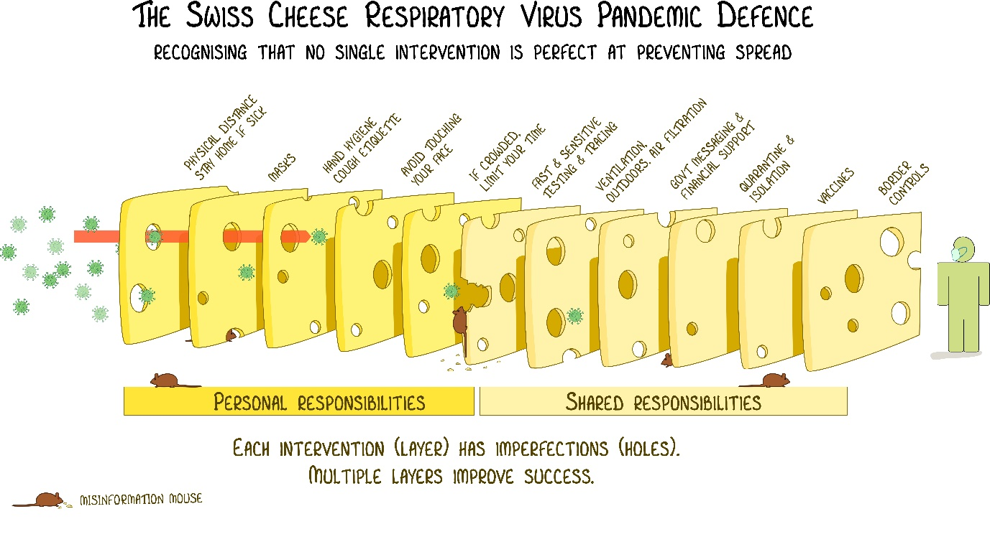

James Reason’s Swiss Cheese model adapted by Dr Ian Mackay

[The Swiss cheese infographic that went viral - Virology Down Under](https://virologydownunder.com/the-swiss-cheese-infographic-that-went-viral/)

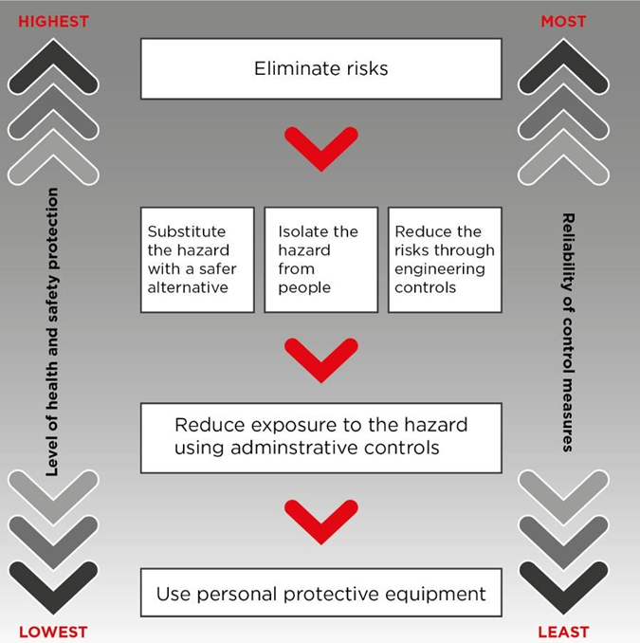

Figure from <https://www.safeworkaustralia.gov.au/safety-topic/managing-health-and-safety/identify-assess-and-control-hazards/managing-risks>

# Appendix B - Key issues to consider when communicating risk

Building trust with the community is a legitimate task that is fundamental to risk communication, which to be effective, is a collaborative process. This can take time, but it is better to invest in this as early as possible to avoid greater outrage later, which requires more time and resources to manage. Once lost, trust is very difficult to regain. Viewing people’s outrage as a real problem to be addressed, will help demonstrate your understanding and receptivity of their outrage and ability to be empathetic to their concerns, worries, stresses and losses.

Further to having awareness of the risk communication principles as outlined in the [enHealth guidance](https://www.health.gov.au/sites/default/files/documents/2022/07/enhealth-guidance-risk-communication-principles.pdf), and understanding how people’s perception of risk can be influenced, the following reinforces important key points for consideration when communicating risk.

* **LISTEN to the community’s or other stakeholders’ concerns**

When listening to people’s concerns, do not assume what people know, think, or feel. In addition, the level of technical knowledge held by community individuals must never be underestimated. Everyone who has an interest in the issue at hand should be allowed an opportunity to be heard including the ability to come back later and ask questions or provide feedback. Empathy should be shown when listening; the community’s concerns may be understood more easily if it is imagined that you are the concerned parent or individual.

* **Be HONEST and OPEN and FIRST**

Honesty and openness are important, and it is essential that the risk is not exaggerated or minimised. If people request information on a risk assessment, it should be provided to them. Lack of information will result in some people assuming the worst-case scenario and getting their information elsewhere. From this, rumours and misinformation may start that will take a lot of time and resources to correct, especially once they reach the media. Generally, the greater the uncertainty about an issue, the greater the concern, and the more open your organisation should be. As a rule of thumb, it is better to share more, not less information, early.

Questions from the community need to be answered quickly, otherwise the information will be sought elsewhere (including journalists). If your organisation does not have all the answers, commit to getting back to people with answers in a given timeframe.

* **Be CLEAR and show RESPECT and COMPASSION**

When describing risk, it is important to remember that delivery and tone can have more impact than the actual content. Body language, tone, eye contact, listening skills, what is said and what is not said – all have an impact on the way risk is perceived.

In communicating risk, use language that is simple to understand and avoid technical jargon. Acknowledge and respond to emotions expressed by the community – including anger, fear, outrage, and helplessness. Discuss what you (or your organisation) can do, will do, and can’t do. It is imperative that you do whatever is promised.

# Appendix C - Making risk communication comparisons

*Adapted from:* [*ATSDR Primer on Health Risk Communication*](https://www.atsdr.cdc.gov/risk/riskprimer/presentation.html#urc)

This appendix provides information on explaining risk data. Also refer to the sections ‘*How risk is expressed’* and ‘*Communicating the risk’*.

Remember:

* comparisons can help put risk in perspective
* benefits should not be used to justify risks
* irrelevant or misleading comparisons can harm trust and credibility
* the ‘outrage factors’[14] that people use in their perception of risk. The more a comparison disregards these factors, the more ineffective the comparison!

Guidelines for risk comparisons – acceptability to the audienceWhen making risk comparisons:

|  |  |
| --- | --- |
| Most acceptable comparison | * of the same risk at two different times * with a standard * with different estimates of the same risk. |
| Less desirable comparison | * of the risk of doing something, versus not doing it * of alternative solutions to the same problem * with the same risk experienced in other places. |
| Even less desirable comparison | * of average risk with peak risk at a particular time or location * of the risk from one course of an adverse effect with the risk from all sources of the same effect. |
| Barely acceptable comparison | * with cost; or one cost/risk ratio with another * of risk with benefit * of occupational risk with environmental risk * with other risks from the same source * with other specific causes of the same disease, illness, or injury. |
| **Rarely acceptable––use with extreme caution!** | * of unrelated risks (for example, smoking, driving a car, lightning). |

# Appendix D – Exposure to a carcinogenic hazard and cancer development

This diagram shows the multi-stage process for how cancer could occur following exposure to a carcinogenic hazard.

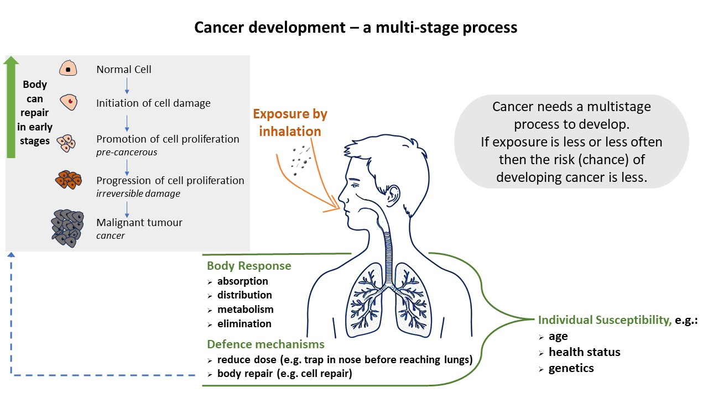

Original image courtesy of the Victorian Department of Health

**Note that health status is influenced by lifestyle choices.**

Choosing to lead a healthy lifestyle leads to better health outcomes and helps reduce cancer risk*. Reducing the risk of cancer can be achieved by taking action that is known to help prevent cancers, including for example, preventing exposures to carcinogens (such as tobacco smoke) and having a healthy, balanced diet and regular exercise.

*Refer to [Cancer Council Australia](https://www.cancer.org.au/about-us/how-we-help/prevention) and [Cancer Society New Zealand](https://www.cancer.org.nz/cancer/reduce-your-risk-of-cancer/) websites for further information. They encourage and empower people from Australia and New Zealand to lead healthier lifestyles to help reduce their cancer risk.

1. Including environmental health, public health and occupational health professionals who deal with environmental public health issues.
2. *R*isk Communication for Environmental Health Practitioners (Siegel 2020). <https://www.ncbi.nlm.nih.gov/pmc/articles/PMC7437971/>
3. Refer to [enHealth RCAT](https://www.health.gov.au/resources/publications/enhealth-risk-communication-assessment-tool-rcat-and-guidance-and-interactive-rcati?language=en) for further information on outrage factors (and how it influences people’s perception of risk).
4. For the purposes of risk communication, ‘*hazard*’ is the ‘actual harm’ – e.g. mortality or morbidity, as described in the [enHealth Principles](https://www.health.gov.au/sites/default/files/documents/2022/07/enhealth-guidance-risk-communication-principles.pdf) and RCAT. To risk experts broadly, the risk is the level of consequence and probability of an event or something occurring. In a science-related setting, the assessment of risk to human health is a function of hazard and exposure. In terms of risk communication, it is a function of hazard and outrage. Risk management includes all of these.
5. These forms of risk communication are described in the [enHealth guidance – Risk Communication Principles](https://www.health.gov.au/sites/default/files/documents/2022/07/enhealth-guidance-risk-communication-principles.pdf)
6. [HILs](https://www.legislation.gov.au/F2008B00713/latest/text) are scientifically based, generic assessment criteria designed to be used in the first stage of an assessment of potential risks to human health from chronic exposure to contaminants. They are intentionally conservative and are based on a reasonable worst-case scenario for (four) generic land use settings.
7. If the contamination is deeper than the first 30 cm of soil, then it is a reasonable assumption that, in general, a child will not dig beyond that depth. This could be different in a sandpit, as it is much easier to dig. However, a child would need to dig down past the sand to reach the soil layer. Note that if an intact barrier between the sand and soil exists, exposure to the soil will be minimised.
8. In many cases, the level of risk will only be significant if a young child eats many handfuls of soil; this is uncommon except when a child has a condition known as ‘pica’.
9. Refer to the videos ‘[*human health risk assessments explained*](https://www.health.vic.gov.au/environmental-health/human-health-risk-assessments)’ and ‘[*example of a human health risk assessment*](https://www.health.vic.gov.au/environmental-health/human-health-risk-assessments)’ by the Victorian Department of Health, and to Appendix A for an outline of the process.
10. [Transcript of the Inquiry into recycling and waste management. Legislative Council Environment and Planning Committee. Witness: Dr Angie Bone, Melbourne Friday 3 May 2019](https://www.parliament.vic.gov.au/490fde/contentassets/5537cbd0af63476c8b1f7e35f4ce9266/3.-final---cho.pdf) (page 6).
11. PM2.5 is fine particulate matter with a diameter of 2.5 micro metres (microns) in diameter.
12. For example, results exceeding a [HIL](https://www.legislation.gov.au/F2008B00713/latest/text/12) signal that further investigation is needed, and not ‘risk is present, clean up required’. HILs are based on many assumptions about the people exposed and the types of exposure situations. Levels in excess of HILs do not imply unacceptability or that a significant health risk is likely to be present. Therefore, they should not be described as ‘safe’ levels or accepted ‘standards’ and are not intended to be ‘clean-up’ levels.
13. [How Toxicologists Establish Safe Doses of Chemicals - Toxicology Education Foundation (toxedfoundation.org)](https://toxedfoundation.org/how-toxicologists-establish-safe-doses/) – This link provides an explanation on how much of a hazard people can be exposed to and still be safe.
14. Refer to [enHealth’s RCAT](https://www.health.gov.au/resources/publications/enhealth-risk-communication-assessment-tool-rcat-and-guidance-and-interactive-rcati?language=en).