

**The Hon Sam Rae MP**

Minister for Aged Care and Seniors

Dear aged care providers

I am honoured to be your new federal Minister for Aged Care and Seniors.

I have spent my first three weeks as your Minister listening to older people, their families and carers, aged care providers, workers and others in the sector who have generously shared their views and feedback with me. I am privileged to be taking on an immensely important job.

You have told us you need more time to prepare your clients, support your workers and get your systems ready for the transition to the new Aged Care Act.

In order to deliver on the intent of these reforms and following careful consideration, the Australian Government has decided to briefly defer the start of the new Act from 1 July 2025 to 1 November 2025.

We will use this extra time to work with you to:

* help prepare older people for the changes
* finalise key operational and digital processes
* produce implementation guidance and training.

The brief deferral will ensure older people accessing home care services continue to receive safe, quality care and have the time to understand the Support at Home changes, including:

* service agreements and care plans
* service lists, prices and contributions to non-clinical services.

It will also allow for Parliament to consider an amendment Bill that will set up the final details of the Aged Care Rules and enable effective operation of the new Act.

We share a commitment to getting these once-in-a-generation reforms right to build a   
high-quality, sustainable and world-class aged care system for all Australians.

I will work hand-in-hand with you, your workers and older people to get the new Act implementation right for all.

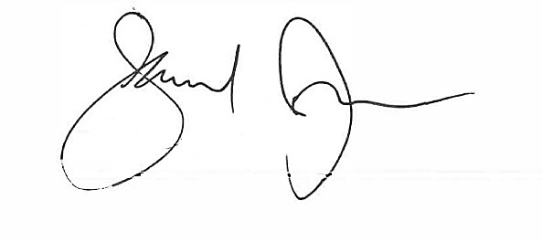Yours sincerely

Sam Rae

4 June 2025