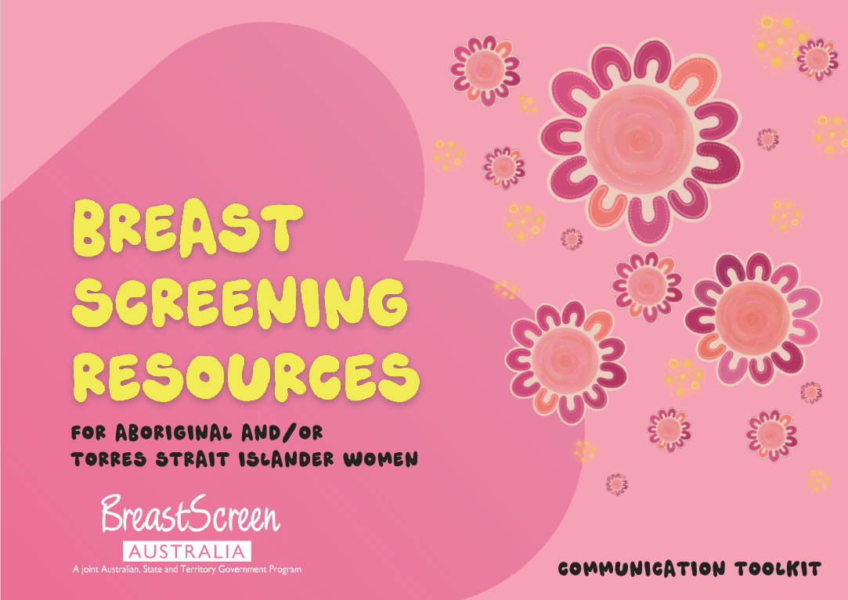

**SCREEN WITH YOUR SISTAS - COMMUNICATION TOOLKIT FOR**

**ABORIGINAL AND/OR TORRES STRAIT ISLANDER WOMEN**

**WE ACKNOWLEDGE THE WISDOM, RESILIENCE AND STRENGTH OF ABORIGINAL AND TORRES STRAIT ISLANDER PEOPLE AND PAY OUR RESPECTS TO ELDERS PAST AND PRESENT. WE ESPECIALLY HONOUR THE MOTHERS, AUNTIES, SISTERS AND COUSINS IN OUR COMMUNITIES AS LEADERS, CAREGIVERS AND CUSTODIANS OF KNOWLEDGE. FROM THE OCEAN TO THE OUTBACK, WE THANK THEM FOR THE ESSENTIAL ROLE THEY PLAY IN OUR CULTURES.**

All artwork by Caitlin Trindall, proud Gomeroi woman.

**Contents**

About BreastScreen Australia 4

About these resources 4

Resources 4

Why create these resources? 5

Get the word out 5

Key messages – public 5

Key messages – health sector 7

Social media tiles 7

Social media content - public 8

Social media content – health sector 8

Newsletter and eDM content 9

Useful info and links 9

# About BreastScreen Australia

BreastScreen Australia is a joint initiative of the Australian and state and territory governments to reduce illness and death from breast cancer by detecting the disease early.

Women over 40 can have a free breast screen every 2 years, and we actively invite women aged 50 to 74 to screen.

# About these resources

The Department of Health, Disability and Ageing has developed new resources to increase First Nations women’s awareness of, and participation in, breast screening through BreastScreen Australia.

We worked with Wayarang and state and territories to develop culturally sensitive, purposeful, and meaningful resources.

Each resource has been developed in consultation with First Nations women to ensure the messaging will be the most effective to increase breast screening participation.

## Resources include:

* Posters
* A flipbook
* Brochures
* Factsheets
* Video explainers

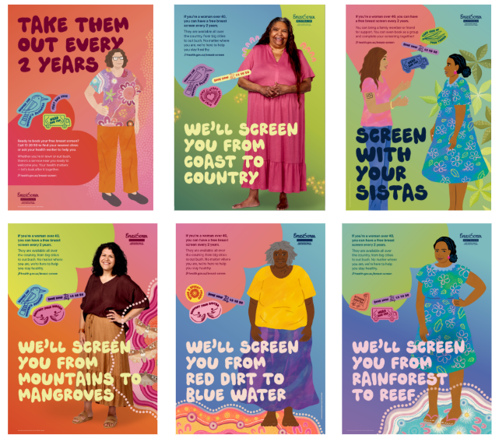 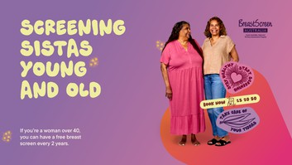 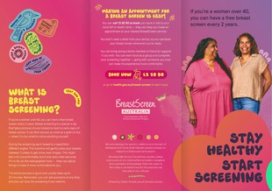 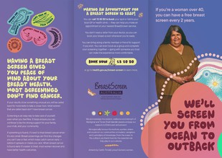 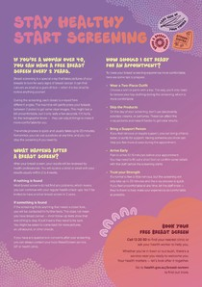

**You can find the resources for downloading at** [**www.health.gov.au/breast-screen**](http://www.health.gov.au/breast-screen). **Some of the resources can also be ordered.**

## Why create these resources?

Breast screening rates among First Nations women are much lower than the national average (38% vs 50%).

These resources are culturally sensitive and provide tailored messaging for First Nations women.

These resources can be used to encourage more First Nations women to do their breast screening.

# Get the word out

We kindly ask you to promote these resources through your channels to help encourage First Nations women to get screened and increase awareness of the free breast screening program. **We have provided some suggested wording and images you can use.**

## Key messages – public

* Breast cancer can develop if there are bad cells in the breast that start to grow too much. If these cells are not found early, they can make you very sick. There are different kinds of breast cancer, and there are many ways to treat it.
* Sometimes, women might have breast cancer but not notice any changes or signs. If you're a woman over 40, you can have a free breast screen every 2 years. Screening is an easy way to take care of yourself, even when you feel fine.
* Breast screening is a special x-ray that takes pictures of your breasts to look for early signs of breast cancer. A breast screen can find cancers as small as a grain of rice - when it is too small to notice anything yourself.
* During the screening, each breast is x-rayed from different angles. The machine will gently press your breasts between 2 plates to get some clear images. The whole process is quick and usually takes up to 20 minutes.
* You can ask questions at any time, and you can stop the screening if you need to.
* Finding breast cancer early makes treatment easier and helps you stay healthy for yourself, your mob and your community.
* Having a breast screen gives you peace of mind about your breast health. Most screenings don't find cancer- if your results show something unusual you will be called back for more tests to take a closer look. Most women that are called back don't have breast cancer.

### Where can I get a breast screen?

**Local Clinics:** Each state and territory have local BreastScreen services, with clinics available in many towns and cities. These clinics are designed to help you feel comfortable and safe.

**Mobile Screening Trucks:** For women in rural and remote areas, a mobile screening truck visits communities. This makes it easier for you to get screened without needing to travel far. But if you do need a hand getting to your appointment, some services can help with transport - just ask!

**Finding a Clinic**: To find your nearest breast screen clinic or to check when a mobile screening truck is coming near you, you can call 13 20 50 or talk to your health care worker. They'll make sure you get the information and support you need to look after your health.

### How do I make an appointment?

* Making an appointment for a breast screen is easy! You can call 13 20 50 to book your spot or talk to your local GP or health clinic - they can help you make an appointment at your nearest BreastScreen service.
* You don't need a letter from your doctor, so you can book your breast screen whenever you're ready. You can bring along a family member or friend for support if you wish. You can even book as a group and complete your screening together - going with someone you trust can make the experience more comfortable.

### Make an Appointment

Give yourself peace of mind - book your breast screen today! Call 13 20 50 or talk to your local health worker. It's an important step towards staying healthy for you and your mob.

### Get Support

If you're not sure where to start, reach out. You can yarn with your local GP, health worker, a trusted friend or call 13 20 50. We're here to support you - we'll make sure you feel confident and comfortable for your screening.

### Free Breast Screens

If you're a woman over 40, you can have a free breast screen every 2 years. They are available all over the country, from big cities to out bush. No matter where you are, we're here to help you stay healthy.

### Call 13 20 50 to Find a Service Near You

Ready to book your breast screen? Call 13 20 50 to find your nearest clinic or ask your health worker to help you. Whether you're in town or out bush, there's a service near you ready to welcome you. Your health matters - let's look after it together.

## Key messages – health sector

* Did you know breast screening rates among First Nations women are lower than the national average (37% vs 50%)?
* These resources have been created by First Nations change agency Wayarang, in close consultation with state and territory jurisdictions, NACCHO and First Nations women across the country.
* The Department of Health and Aged Care has developed new BreastScreen Australia resources encouraging Aboriginal and Torres Strait Islander women to do their breast screening.
* Design of the resources aimed to ensure the messaging is clear, respectful and resonates with community.
* Bespoke artwork ‘Breast and Beyond’ by proud Gomeroi artist Caitlin Trindall sits at the heart of the resources. This artwork reflects our values and acknowledges our diverse communities across Australia.
* Visit the ‘[Screen With Your Sistas](http://www.health.gov.au/breast-screen)’ website to download and/or print the new resources: [**www.health.gov.au/breast-screen**](http://www.health.gov.au/breast-screen)
* We encourage you to use these resources to raise awareness of breast screening in your community.

## Social media tiles

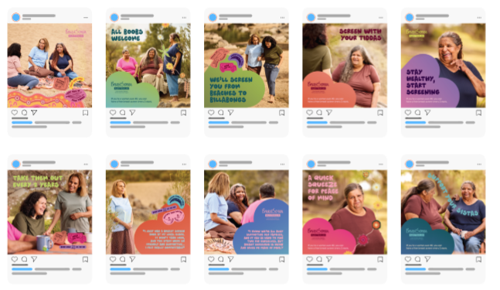

## Social media content - public

Visit [**www.health.gov.au/breast-screen**](http://www.health.gov.au/breast-screen)to find out more.

#BreastScreenAustralia #BreastScreen #BreastScreening #Mammogram #BreastCancer #CancerScreeningSavesLives

* Do you know what happens during a breast screen? When you get a breast screen, your breast will be placed on the x-ray machine where 2 plates will gently press down on it to take pictures. While it may feel uncomfortable it shouldn’t hurt. You can always ask questions or take a break any time you need. Call 13 20 50 to find your nearest clinic and make an appointment.
* Ready to book your free breast screen? Call 13 20 50 to find your nearest clinic or ask your health worker to help you. Whether you’re in town or out bush, there’s a service near you ready to welcome you. Your health matters — let’s look after it together.
* If you're a woman over 40, you can have a free breast screen every 2 years. They are available all over the country, from big cities to out bush. No matter where you are, we're here to help you stay healthy.
* Give yourself peace of mind - book your free breast screen today! Call 13 20 50 or talk to your local health worker. It's an important step towards staying healthy for you and your mob.

## Social media content – health sector

* Healthcare providers and health workers can give information and confidence to Aboriginal and/or Torres Strait Islander patients who don’t know about breast screening or avoid getting it done. You can use new BreastScreen resources to help your patients understand:
* the benefits and limitation of screening mammograms
* the importance of routine breast screening every 2 years
* breast cancer symptoms
* treatment options.

Access digital resources, including posters, factsheets and brochures, on our website [www.health.gov.au/breast-screen](https://www.health.gov.au/breast-screen)

* BreastScreen Australia has new resources available to encourage and support First Nations women to book in for their regular breast screen. Access digital resources, including posters, factsheets and brochures, on our website [www.health.gov.au/breast-screen](https://www.health.gov.au/breast-screen)
* Breast screen participation rates among First Nations women is significantly lower than the national average. A range of culturally sensitive, purposeful, and meaningful resources have been developed to empower First Nations women to participate in breast screening through BreastScreen Australia. Digital resources include posters, brochures, fact sheets and social media tiles. Digital versions of the resources are available to download at [www.health.gov.au/breast-screen](https://www.health.gov.au/breast-screen)

## Newsletter and eDM content

**New BreastScreen Australia resources for First Nations women**

Breast screening participation rates among First Nations women remain significantly lower

than the national average.

To increase participation a range of culturally sensitive, purposeful, and meaningful resources have been developed to encourage breast screening among First Nations women.

These resources have been created in close consultation with state and territory jurisdictions, NACCHO and First Nations women across the country to help ensure they resonate with community.

The resources will be used to encourage more First Nations women to do their breast screening.

You can find out more about the BreastScreen Australia program and view the [Screen with your sistas](http://www.health.gov.au/breast-screen) resources at [www.health.gov.au/breast-screen](http://www.health.gov.au/breast-screen).

If you’re due for a breast screen, call 13 20 50 to make an appointment.

# Useful info and links

[www.health.gov.au/breast-screen](http://www.health.gov.au/breast-screen) - Screen with your Sistas

[www.health.gov.au/bsa](http://www.health.gov.au/bsa) - Breastscreen Australia

**State and Territory BreastScreen services**

[www.canberrahealthservices.act.gov.au/services-and-clinics/services/breastscreen-act](http://www.canberrahealthservices.act.gov.au/services-and-clinics/services/breastscreen-act)

[www.breastscreen.nsw.gov.au](http://www.breastscreen.nsw.gov.au)

[www.](http://www.)[nt.gov.au/wellbeing/cancer-services/breastscreenn](https://nt.gov.au/wellbeing/cancer-services/breastscreennt)t

[www.breastscreen.qld.gov.au/](http://www.breastscreen.qld.gov.au/)

[www.breastscreen.sa.gov.au](http://www.breastscreen.sa.gov.au)

[www.health.tas.gov.au/health-topics/cancer-screening/breast-screening/breastscreen-tasmania](http://www.health.tas.gov.au/health-topics/cancer-screening/breast-screening/breastscreen-tasmania)

[www.breastscreen.health.wa.gov.au](http://www.breastscreen.health.wa.gov.au/)

[www.breastscreen.org.au](http://www.breastscreen.org.au) (VIC)