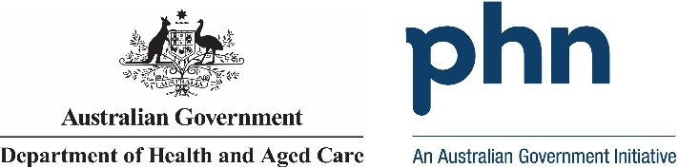

## Northern Sydney

## PHN Fact sheet 2024

### Snapshot:

Northern Sydney PHN has a total population of 926857 people. Of this total, 5073 are First Nations people. The total population growth from 2016 to 2022 was 1.21%. The population aged 65 years and over equates to 160657 people. Population growth for this age group from 2016 to 2022 was 12.85%. The PHN covers 889.799 square kilometres. Snapshot information is based on data published by the Public Health Information Development Unit (PHIDU) at Torrens University, from the Social Health Atlas of Australia by Primary Health Network, December 2023. Population data for 2016 is sourced from the PHIDU Social Health Atlas of Australia by Primary Health Network, December 2017, which is used to calculate population growth.

### Key Information:

Northern Sydney PHN has 3.95% of its population who require assistance for core activities due to a disability. The unemployment rate for the labour force is 2.57%. People who use another language and who do not speak English well account for 3.12% of people, while 1.15% do not speak English at all. Unemployment rate is based on the PHIDU Social Health Atlas of Australia by Primary Health Network, December 2023. Need for assistance due to disability and English language proficiency are based on the Australian Bureau of Statistics Census of Population and Housing 2021.

### Demographics:

Northern Sydney PHN has a male population of 452749 people, which equates to 48.85% of the total population. Females account for 474108 people. That is 51.15% of the total population. Demographics information is based on PHIDU Social Health Atlas of Australia by Primary Health Network, December 2023.

### Age:

Northern Sydney PHN has the following age distribution: Zero to fourteen year olds account for 164637 people. 15- to 24-year-olds account for 110524 people. 25- to 44-year-olds account for 253554 people. 45- to 64-year-olds account for 237485 people. 65- to 84-year-olds account for 136091 people. Lastly those aged 85 years and above account for 24567 people. This data is sourced from the PHIDU Social Health Atlas of Australia by Primary Health Network, December 2023.

Data has been obtained from a range of publicly available sources, and the Department of Health and Aged Care does not take responsibility for data quality. Last Updated: March 2025