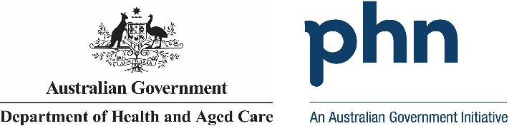

## North Western Melbourne

## PHN Fact sheet 2024

### Snapshot:

North Western Melbourne PHN has a total population of 1887653 people. Of this total, 16711 are First Nations people. The total population growth from 2016 to 2022 was 10.56%. The population aged 65 years and over equates to 219900 people. Population growth for this age group from 2016 to 2022 was 16%. The PHN covers 3212.53 square kilometres. Snapshot information is based on data published by the Public Health Information Development Unit (PHIDU) at Torrens University, from the Social Health Atlas of Australia by Primary Health Network, December 2023. Population data for 2016 is sourced from the PHIDU Social Health Atlas of Australia by Primary Health Network, December 2017, which is used to calculate population growth.

### Key Information:

North Western Melbourne PHN has 5.6% of its population who require assistance for core activities due to a disability. The unemployment rate for the labour force is 4.6%. People who use another language and who do not speak English well account for 4.9% of people, while 1.51% do not speak English at all. Unemployment rate is based on the PHIDU Social Health Atlas of Australia by Primary Health Network, December 2023. Need for assistance due to disability and English language proficiency are based on the Australian Bureau of Statistics Census of Population and Housing 2021.

### Demographics:

North Western Melbourne PHN has a male population of 940359 people, which equates to 49.82% of the total population. Females account for 947294 people. That is 50.18% of the total population. Demographics information is based on PHIDU Social Health Atlas of Australia by Primary Health Network, December 2023.

### Age:

North Western Melbourne PHN has the following age distribution: Zero to fourteen year olds account for 346963 people. 15- to 24-year-olds account for 242409 people. 25- to 44-year-olds account for 679462 people. 45- to 64-year-olds account for 398919 people. 65- to 84-year-olds account for 191787 people. Lastly those aged 85 years and above account for 28113 people. This data is sourced from the PHIDU Social Health Atlas of Australia by Primary Health Network, December 2023.

Data has been obtained from a range of publicly available sources, and the Department of Health and Aged Care does not take responsibility for data quality. Last Updated: March 2025