NLCSP Participation Model

Instructions for macro-disabled version

Notes
- The model outputs report the number of additional lung cancers expected to be diagnosed following the introduction of the national lung cancer screening program, i.e., in addition to the number of lung cancers that would have been diagnosed if the screening program had not been implemented.​
- Around 15,000 people are diagnosed with lung cancer each year. In the first year of the screening program, we estimate screening will detect an additional 1500 cases (assuming 70% attendance in year 1).

Macro-disabled version
- The instructions below are for the macro-disabled version of the model.
- The input parameters and population of interest can be varied.
- The summary of the outputs will be captured in a table by year and age cohort for the population of interest.

Varying input parameters (see following slides)
INPUTS
- “Inputs Population”
- Copy & paste the jurisdiction of interest data from the relevant row into row 14
- “Inputs General”
- Distribution of screening over two years: adjust cell C15
- Uptake of screening: adjust cell C27
RESULTS
- “Tables by year cohort Base”
- ‘Live Version’ updates as variables are changed
- Copy & paste the updated cell values
- View updated results in the ‘Data with two-year distribution’ table

Inputs Population
Copy & paste data for the jurisdiction of interest to row 14
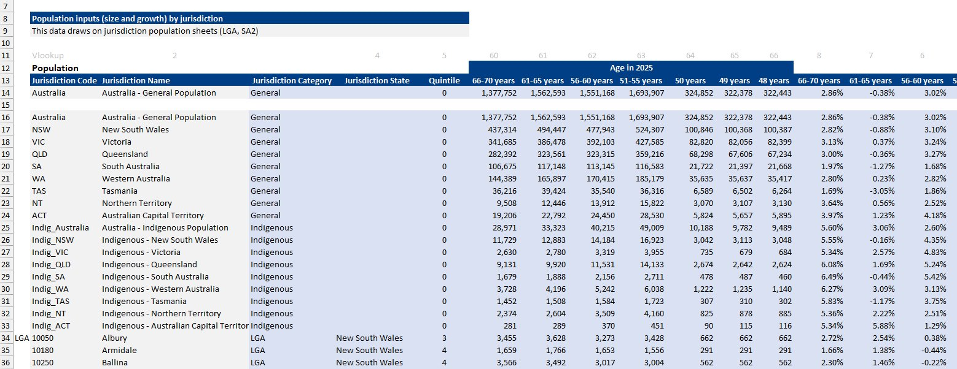

Inputs General
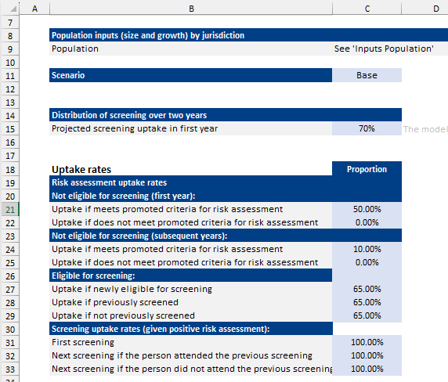

Vary these parameters

Results - Tables by year cohort Base
Live version changes as Input
Population and Uptake Rate changes.
Copy the cells in the Red box.

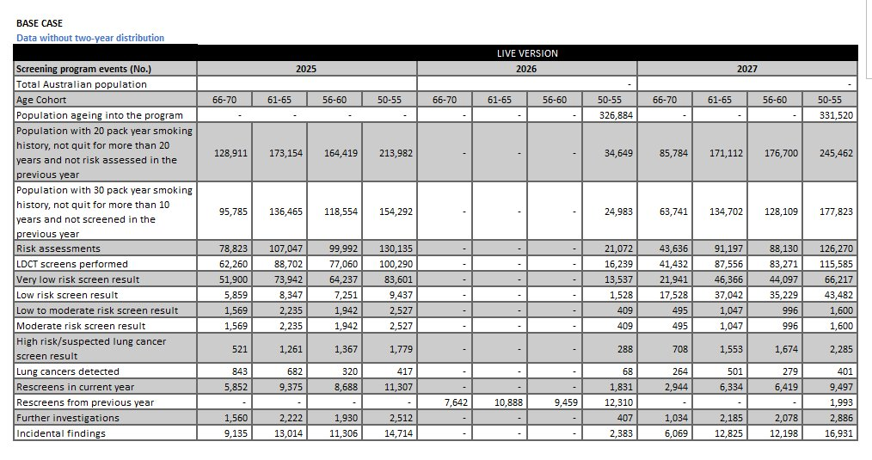

Results
This table assumes 100% attendance in year 1. ​
Paste the values of the copied data (not the formulae) from the last slide into the Red box
This table distributes participation across the multiple years based on the input variable – value in C15

