Participation volume for a national lung cancer screening program

**Final report**

4 November 2024

Flinders University

Jacqueline Roseleur, PhD1

Professor Jonathan Karnon, PhD1

and

Erasmus MC-University Medical Centre Rotterdam

Assistant Professor Kevin ten Haaf, PhD2

1 Flinders Health and Medical Research Institute, Flinders University, Adelaide, Australia

2 Department of Public Health, Erasmus MC-University Medical Center Rotterdam, The Netherlands

# Executive Summary

This report describes the methods and results of modelling work undertaken to estimate the expected numbers of risk assessments, LDCT scans and further investigations associated with the implementation of the national lung cancer screening program in Australia. Estimates are generated over the first three years of the operation of the screening program, in 2025, 2026 and 2027.

A decision tree model is used to represent the expected pathways of Australian adults aged 50 to 70 years with respect to risk assessment for lung cancer screening, uptake of screening and follow-up scans in 2025, 2026 and 2027. The tree represents separate pathways for individuals who do and do not meet the defined eligibility criteria for lung cancer screening. Non-eligible individuals may be risk assessed, mis-identified as eligible for screening and receive an LDCT screen. The current model does not represent screening outcomes and possible interval scans for non-eligible individuals who are screened.

For screening eligible individuals, the model represents the uptake of risk assessment and the subsequent uptake of screening. Following screening, the model represents screening outcomes: very low risk, low risk, low to moderate risk, moderate risk, high risk/suspected lung cancer and detected lung cancer. For each screening outcome, sub-trees are used to represent follow-up pathways, including the timing and frequency of interval scans and referrals for further investigation.

The numbers of individuals who meet the eligibility criteria for screening are estimated using the same microsimulation model that was used to inform the assessment of the cost-effectiveness of lung cancer screening that informed the decision to implement a national lung cancer screening program.

In addition to people meeting the screening criteria (people aged 50 to 70 years with 30 pack years of smoking and less than 10 years since quitting), the model allows for a proportion of people aged 50 to 70 years with a smoking history of 20 pack years and less than 20 years since quitting to be risk assessed. The model also allows for the mis-identification of risk assessed people aged 50 to 70 years with a smoking history of 20 pack years and less than 20 years since quitting as being eligible for screening, and for these mis-identified individuals to be screened.

The base case analysis assumes 65% of people meeting the screening eligibility criteria will be risk assessed and screened. It also assumes that 50% of people with a smoking history of 20 pack years and less than 20 years since quitting who do not meet the screening criteria will be risk assessed, but not screened. Within the population of Australian 50 to 70 years olds in 2025, this analysis estimates 291,198 people will be risk assessed and 229,818 people will be screened. However, we assume 30% of these people will delay their risk assessment and screening to 2026.

An alternative scenario analysis assumes 65% of people with a smoking history of 20 pack years and less than 20 years since quitting will be risk assessed and screened, resulting in 309,612 of Australian adults aged between 50 and 70 years in 2025 being risk assessed and screened.

Contents

Executive Summary 2

Background 4

Model structure 4

Model Inputs 9

Population 9

Estimation of individuals meeting screening eligibility criteria 10

Uptake rates 10

Screening Outcomes 11

Distribution of screening over two-year screening period 12

Incidental findings 12

Distribution of Statistical Area Level 2 (SA2) to Modified Monash Model (MMM) 12

Costs 13

Model Analysis 13

Sensitivity Analyses 14

Model Outputs 14

Sensitivity Analyses 19

Costs 21

Comparison of alternative approaches to estimating eligibility for lung cancer screening in Australia 28

References 35

# Background

MSAC has recommended the funding of a national biennial lung cancer screening program, with eligibility defined as individuals aged between 50 and 70 years old, with 30 pack-years of smoking, who have not quit for more than 10 years.

To inform the planning for the implementation of the program, the Commonwealth Department of Health and Ageing have requested a more granular understanding of participation numbers than reflected in the budget impact analysis undertaken to inform the MSAC recommendation.

This report describes the structure and input parameter values and associated data sources of an Excel-based decision tree model that was developed to estimate the requested participation numbers and associated costs over the first three years of an implemented national lung cancer screening program. Separate models were populated for each of the three years (2025-26 to 2027-28) and for each requested jurisdiction (national, states and territories, local government areas (LGAs), statistical area level 2 (SA2s), primary health networks (PHNs) and Aboriginal and Torres Strait Islander people). For each defined population, the model represents the

* size of the population,
* numbers undergoing risk assessment (differentiating between those eligible and not eligible for screening and those previously and not previously risk assessed),
* numbers undergoing screening (differentiating between those previously and not previously screened),
* numbers receiving alternative screening results.

The model has been populated and outputs are presented for a selected range of scenarios testing alternative values for key input parameters for which there is high uncertainty around their true value, but users can test additional alternative parameter values.

The report also contains a detailed review and comparison of alternative approaches to estimating the number of Australians who will meet the defined eligibility criteria for the national lung cancer screening program.

# Model structure

Figure 1 presents the model structure, which represents screening pathways for defined populations. The population of interest is defined at the lefthand side of the model, which is then allocated to three ‘screening eligibility’ branches:

* Not eligible for screening
* Newly eligible for screening and
* Repeat eligible for screening, within the three-year time horizon of the model these are people who were eligible for screening in 2025/26 who remain eligible in 2027/28.

For the population who are not eligible for screening, the tree splits the population into those with and without a smoking history of more than 20 pack years of smoking and who have not quit smoking for more than 20 years. Alternative probabilities of being risk assessed can be defined for these two groups.

Figure 1: Lung cancer screening participation model structure

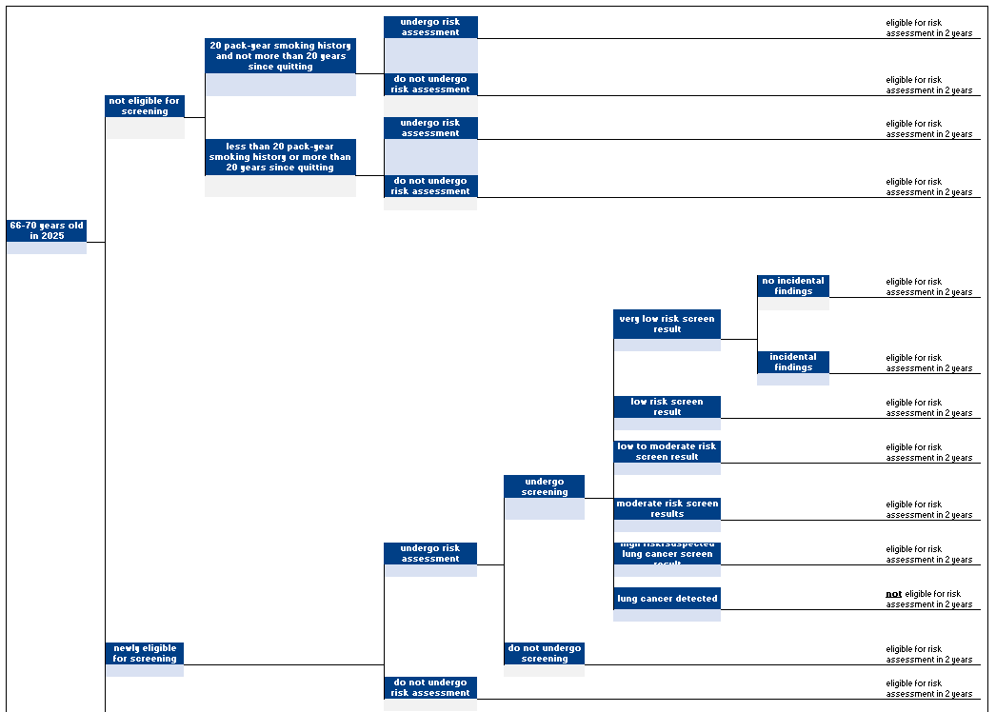

*Figure 1 Lung cancer screening participation model structure (continued)*

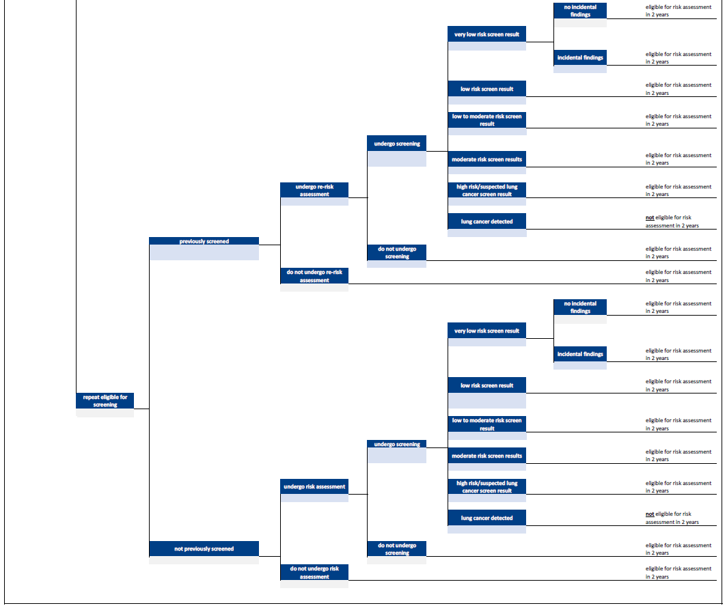

In the base case, it is assumed there are no false positive risk assessments, i.e., no individual who is not eligible for screening will be referred for low-dose CT (LDCT) screening.

In a scenario analysis, the defined LDCT screening uptake rate for people who meet the screening eligibility criteria is also applied to people with 20 pack years of smoking, who have not quit for more than 20 years.

For the population who are newly eligible for screening, the tree splits the population into those who undergo risk assessment and those who do not. It is assumed there are no false negative risk assessments, i.e., no individual who is eligible for screening is not referred for screening. For those who are referred for screening, the tree allows for them to attend and not to attend for screening.

For those undergoing screening, the tree describes six screening outcomes:

* Very low risk
* Low risk
* Low to moderate risk
* Moderate risk
* High risk / suspected lung cancer
* Lung cancer detected

The population of individuals with ‘repeat eligibility for screening’ include individuals without a prior lung cancer detected who were eligible for screening at a prior screening round. This population is split into those who have and have not been screened previously. Beyond those branches the tree has the same structure as for the population who are newly eligible for screening. The only difference is the likelihood of the alternative screening outcomes reflecting the intended use of the PanCan classification for individuals’ first screen and the LungRADS classification for individuals’ second plus screen.

For each defined population for a defined year, the number of people traversing each pathway through the model are defined at the right-hand side of the model. The numbers of people traversing pathways in which a risk assessment or an LDCT screen were undertaken are summed to estimate the aggregate numbers of risk assessments and LDCT screens for the defined population in the defined year, respectively.

In addition, a separate decision tree is used to estimate the number of LDCT screens undertaken to follow-up individuals with very low, low, low to moderate, moderate and high risk /suspected lung cancer screening outcomes, as outlined in the nodule management pathway and in Figure 2.

The required number of repeat screens following incomplete screens were also estimated. The numbers of initial, follow-up and repeat LDCT screens in each year are summed to estimate the final estimate of the numbers of LDCT screens in each year.

Separate models are populated for different age groups of the Australian population, based on the birth cohort groups represented in the cost-effectiveness model:

* the 1955-59 birth cohort are 66 to 70 years old in 2025
* the 1960-64 birth cohort are 61 to 65 years old in 2025
* the 1965-69 birth cohort are 56 to 60 years old in 2025
* the 1970-74 birth cohort are 51 to 55 years old in 2025
* the 1975 birth cohort are 50 years old in 2025
* the 1976 birth cohort are 50 years old in 2026
* the 1977 birth cohort are 50 years old in 2027

This approach is required because outputs from the cost-effectiveness model include the estimated proportions of newly and repeat eligible individuals in each year, but the cost-effectiveness model did not run birth cohorts beyond 1969. It is assumed that people born in 1970 and beyond who become eligible for screening by 2027 have the same age-specific smoking history as the birth cohort 1965-69.

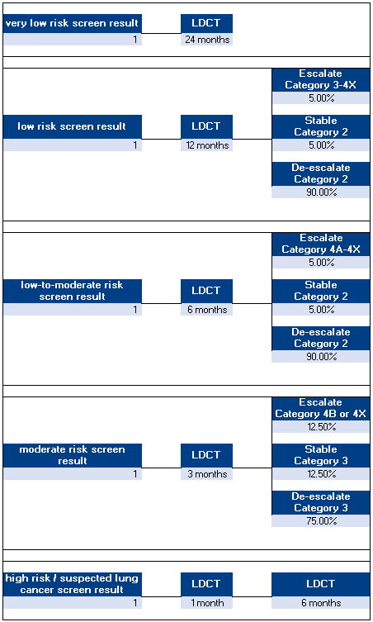

Figure 2: Interval LDCT scans

# Model Inputs

The following sections describe the data used to estimate the input parameters represented in the Inputs worksheets:

## Population

The population model inputs reflect the age-specific populations for each jurisdiction in 2025. The following jurisdictions were included:

* Total Australian population
* States and Territories
* Indigenous population, total and by state and territory
* Local Government Areas (LGA)
* Statistical Area Level 2 (SA2)
* Primary Health Networks (PHNs)

For national and states and territory estimates, the population projections from the ABS were used for the population in 2025 (1, 2). An average growth rate was calculated using the population projections for 2026 and 2027 from the same source and applied to each year, using the ABS-defined medium level assumptions. A similar approach was used for the Indigenous population overall and by state (3).

For LGAs and SA2s, population estimates were available from the ABS for 2023 (4). The population growth estimates by jurisdiction were calculated by taking the average annual population growth between 2014 and 2023. These population growth rates were applied to estimate population size in 2025, 2026 and 2027.

For both approaches, the population growth includes natural increase (births and deaths), net interstate migration and net overseas migration. As such, migration and other mortality were not separately considered.

The outputs generated by PHNs were based on SA2 population estimates using the ABS concordance files to map SA2s to PHNs (5).

Table 1 presents the general population numbers in each jurisdiction aged 50 to 55, 56 to 60, 61 to 65 and 66-70 years old in 2025.

Table 1: General population numbers in age range 50-70 years by location

|  |  |  |  |  |
| --- | --- | --- | --- | --- |
| **Jurisdiction** | **50-55 years** | **56-60 years** | **61-65 years** | **66-70 years** |
| Australia | 2,018,759 | 1,551,168 | 1,562,593 | 1,377,752 |
| New South Wales | 625,153 | 477,943 | 494,447 | 437,314 |
| Victoria | 510,405 | 392,103 | 386,478 | 341,685 |
| Queensland | 427,514 | 323,315 | 323,561 | 282,392 |
| South Australia | 138,305 | 113,145 | 117,148 | 106,675 |
| Western Australia | 220,814 | 170,415 | 165,897 | 144,389 |
| Tasmania | 42,905 | 35,540 | 39,424 | 36,216 |
| Northern Territory | 18,892 | 13,912 | 12,446 | 9,508 |
| Australian Capital Territory | 34,354 | 24,450 | 22,792 | 19,206 |

Table 2 presents the Indigenous population numbers in Australia and in each state and territory aged 50 to 55, 56 to 60, 61 to 65 and 66-70 years old in 2025.

Table 2: Indigenous population numbers in age range 50-70 years by location

|  |  |  |  |  |
| --- | --- | --- | --- | --- |
| **Jurisdiction** | **50-55 years** | **56-60 years** | **61-65 years** | **66-70 years** |
| Australia | 59,197 | 40,215 | 33,323 | 28,971 |
| New South Wales | 19,965 | 14,184 | 12,883 | 11,729 |
| Victoria | 4,690 | 3,319 | 2,780 | 2,630 |
| Queensland | 16,807 | 11,531 | 9,920 | 9,131 |
| South Australia | 3,189 | 2,156 | 1,888 | 1,679 |
| Western Australia | 7,260 | 5,242 | 4,196 | 3,728 |
| Tasmania | 2,030 | 1,584 | 1,508 | 1,452 |
| Northern Territory | 4,985 | 3,509 | 2,604 | 2,374 |
| Australian Capital Territory | 541 | 370 | 289 | 281 |

## Estimation of individuals meeting screening eligibility criteria

Outputs from the cost-effectiveness model estimate the percentages of the 1955-59, 1960-64 and 1965-69 birth cohorts who:

* meet two alternative criteria for undergoing a risk assessment in each year (2025 to 2027): smokers with 30 pack-years and less than 10 years since quitting and smokers with 20 packyears and less than 20 years since quitting,
* are newly and repeat eligible for screening in each year (2025 to 2027).

The estimated birth cohort-specific percentages are then adjusted to reflect expected differences in birth cohort-specific smoking histories between different LGAs and SA2s. To do this, socioeconomic quintiles are used as a proxy for smoking history severity categories. Using reported smoking rates by socioeconomic quintile, relative risks of being a smoker were estimated against quintile 5 (least disadvantaged) for quintiles 1 to 4, which were used as proxies for the relative risk of meeting the screening eligibility criteria. For the Australian population, an eligibility proportion was specified for quintile 5 to which the respective relative risks for the other quintiles was applied to estimate the eligibility proportions in those quintiles. The eligibility proportion for quintile 5 was calibrated such that the weighted sum of the eligibility proportions across the quintiles equalled the aggregate proportion of eligible Australians. The calibration can be found in the spreadsheet: “DoH Planning - SEIFA Calibration V1”

## Uptake rates

In the base case, uptake rates of risk assessment for the first screening round for individuals with 20 pack years of smoking who have not quit smoking for 20 or more years, but do not meet the screening criteria (30 pack years who have not quit smoking for 10 or more years) were assumed to be 50%. This was informed by the Yorkshire Lung Screening Trial, in which individuals aged 55-80 years, identified as ever smokers were invited to a telephone-based risk assessment (6). The reported uptake rate was 50%. Uptake rates in subsequent screening rounds was assumed to be 10%.

Uptake rates of risk assessment for individuals with less than 20 pack years of smoking or who quit 20 plus years ago are assumed to be 0% in the base case analyses, but this value can be varied in sensitivity analyses.

In the base case, a constant risk assessment uptake rate of 65% was assumed for individuals who are eligible for screening, with 100% of those risk assessed individuals going on to be screened.

## Screening Outcomes

For those undergoing screening, the tree describes six screening outcomes:

* Very low risk
* Low risk
* Low to moderate risk
* Moderate risk
* High risk / suspected lung cancer
* Lung cancer detected

The proportions of screened individuals experiencing each of the above-defined screening outcomes were also outputs from the cost-effectiveness model, representing the mean proportions by year since first screen, e.g., Year 1 proportions represent the proportions of individuals being screened for the first time who experience each screening outcome (Tables 3 and 4). The cost-effectiveness model does not provide outcomes for low to moderate risk, therefore, the proportion for moderate risk was divided equally between the two categories. This assumption can be changed in the model.

Table 3: Screen outcomes as per MISCAN-Lung - General Population

|  |  |  |  |
| --- | --- | --- | --- |
| **Screen outcomes** | **Year 1** | **Year 2** | **Year 3** |
| No significant findings | 83.36% | 83.36% | 52.96% |
| Low risk | 9.41% | 9.41% | 42.31% |
| Low to moderate risk | 2.52% | 2.52% | 1.20% |
| Moderate risk* | 2.52% | 2.52% | 1.20% |
| High risk and suspected lung cancer | 2.19% | 2.19% | 2.35% |
|  | **66-70 years** | **61-65 years** | **56-60 years** |
| Lung cancer detected by birth cohort for newly eligible | 1.35% | 0.77% | 0.42% |
| Lung cancer detected by birth cohort for repeat eligible | 0.63% | 0.57% | 0.33% |

* Moderate risk has been split equally between low to moderate and moderate risk to account for additional low to moderate risk screen result

Table 4: Screen outcomes as per MISCAN-Lung - Indigenous Population^

|  |  |  |  |
| --- | --- | --- | --- |
| **Screen outcomes** | **Year 1** | **Year 2** | **Year 3** |
| No significant findings | 77.84% | 77.84% | 49.19% |
| Low risk | 8.79% | 8.79% | 39.30% |
| Low to moderate risk | 2.35% | 2.35% | 1.11% |
| Moderate risk* | 2.35% | 2.35% | 1.11% |
| High risk and suspected lung cancer | 8.67% | 8.67% | 9.29% |
|  | **66-70 years** | **61-65 years** | **56-60 years** |
| Lung cancer detected by birth cohort for newly eligible | 2.65% | 1.75% | 0.84% |
| Lung cancer detected by birth cohort for repeat eligible | 1.26% | 1.33% | 0.73% |

* Moderate risk has been split equally between low to moderate and moderate risk to account for additional low to moderate risk screen result

^ As screen outcomes are unavailable for the Indigenous population and would likely be underestimated if the general population screen outcomes are applied, a multiplier based on the ratio of expected numbers of lung cancers in the Indigenous population to the full Australian population was applied to the expected number of high risk and suspected lung cancer cases in the full Australian population

The draft nodule management pathway describes the timing of follow-up screens that vary according to the screening outcome, e.g., low risk outcomes are followed up at 12 months, whilst moderate risk outcomes are followed up at 3 months.

Subsequent follow-up screens are dependent on the results of the initial follow-up screen, which have not been published. Our estimates were informed by personally reported estimates provided by a radiologist.

The only literature available on the proportion of incomplete scans comes from Lahey Hospital in Massachusetts, USA. They found only 0.04% of scans were incomplete (7). This value can be varied in sensitivity analyses.

## Distribution of screening over two-year screening period

It is possible that individuals eligible for screening may delay being risk assessed and undergoing screening, as such, a proportion of individuals who are eligible to be screened in 2025 will not be screened until 2026. In the base case, we assume that 70% of screened individuals undergo screening in the year in which they are eligible to be screened and 30% delay screening to the subsequent year. This value can be varied in sensitivity analyses.

## Incidental findings

The effects of incidental findings are assumed to be the same regardless of screening outcome. To reduce the complexity of the model the percentage of very low risk screened people with incidental findings is calibrated to represent the estimated total percentage of patients experiencing incidental findings. The Cleveland Clinic study found that 15% of those screened had a clinically significant incidental finding requiring further investigation (8). We used this proportion in the base case. This value can be varied in sensitivity analyses.

## Distribution of Statistical Area Level 2 (SA2) to Modified Monash Model (MMM)

Each SA2 was mapped to an MMM classification using the 2019 Modified Monash Model (9). As the 2019 MMM uses 2016 census data, 309 SA2s had missing data. We used the average distribution across the seven MMM classifications by state for those SA2s with missing data.

## Costs

The costs in Table 5 were applied to the risk assessments and LDCT screens.

Table 5: Costs for Risk assessments and LDCT screens

|  |  |  |
| --- | --- | --- |
| **MBS items** | **Cost** | **Notes** |
| LDCT screen (MSAC MBS item) | $302.10 |  |
| LDCT screen | $420.00 |  |
| MBS item 23 | $42.85 | GP consult lasting at least 6 minutes and less than 20 minutes |
| MBS item 36 | $82.90 | GP consult lasting at least 20 minutes |
| % RA only consults | 50% | Assign Item 23 cost |
| % RA added to existing consult | 50% | Assign difference between item 36 and item 23 |

# Model Analysis

The model analysis involves running the model for each of the 3019 jurisdiction populations. For each population and for each year, the Outputs sheet describes annual expected numbers and associated costs of lung cancer screening related:

* Risk assessments
* LDCT screens
* Rescreens in current year
* Rescreens from previous year
* Further investigations
* Lung cancers detected
* Individuals with incidental finding

The model outputs are generated in the three spreadsheets ‘2025’, ‘2026’ and ‘2027’, in which the main decision tree model are represented. Separate trees are populated for each year, but also for different birth cohorts of the population aged between 50 and 70 years in each year. Model outputs (numbers of risk assessments, LDCT screens and further investigations) are collected for each birth cohort in each year. For each year, the model outputs are summed across the relevant birth cohorts and presented at the bottom of the decision tree (rows 767 to 787). These model outputs are the model outputs associated with the currently defined model inputs on spreadsheet ‘Inputs General’ for the currently defined population defined in row 14 of spreadsheet ‘Inputs Population’.

The model outputs in spreadsheet ‘Outputs’ and ‘Output_Summary’ represent the outputs generated from the last time the model was run to generate outputs for the different populations for which the model generates outputs: Australian, state, territory, PHN, SA2 and LGA populations. The model outputs in the ‘Base’ and ‘Scen1’ spreadsheets represent the outputs for the different populations for the defined base case and scenario 1 sets of input parameter values, respectively.

When opening the model, ensure that Macros have been enabled. To run the model, a two-step process is required:

1. Click the relevant buttons on the “Outputs” worksheet to generate outputs for the jurisdiction of interest (Overall Populations, LGAs, SA2s).
2. Click the relevant buttons on the “Outputs Summary” worksheet to generate a summary of the Overall Populations, a summary of States & Territories by LGA, a summary of States & Territories by SA2 and a summary by Primary Health Networks.

A comparison of the Overall Population with the summaries generated by LGA and SA reflects the effect of socio-economic distribution across States & Territories.

Separate buttons were created as generating outputs by SA2 and Primary Health Networks can take between 10 and 30 minutes.

## Sensitivity Analyses

Several sensitivity analyses were undertaken for the total Australian population, States and Territories and the Indigenous population for the base case:

* Uptake of LDCT screening: 30%, 40%, 50%
* Distribution of screening over two-year screening period: 50%, 90%

# Model Outputs

The full set of model outputs for all 3019 jurisdictions are presented in the Excel model. Here, results for the full Australian population, and the Indigenous Australian population are presented. For both populations, the base case and the scenario 1 results are presented

Table 6 presents the model outputs for the specified base case analysis for the whole Australian population:

* Uptake of risk assessment by individuals with more than 20 pack years and less than 20 years since quitting who do not meet screening criteria: 50%
* Uptake of risk assessment by individuals who meet screening criteria: 65%
* Uptake of LDCT screening by individuals with more than 20 pack years and less than 20 years since quitting who do not meet screening criteria: 0%
* Uptake of LDCT screening by risk-assessed individuals who meet screening criteria: 100%
* Distribution of screening over two-year screening period: 70% of those eligible for screening will attend in the first year

Table 6: Base case outputs for the aggregate Australian population

|  |  |  |  |
| --- | --- | --- | --- |
| **Screening program events (No.)** | **2025** | **2026** | **2027** |
| Total Australian population aged 50 to 70 years | 6,510,272 | 0 | 0 |
| Population ageing into the program | 0 | 326,884 | 331,52 |
| Population with 20 pack year smoking history, not quit for more than 20 years and not risk assessed in the previous year | 476,326 | 238,788 | 475,340 |
| Population with 30 pack year smoking history, not quit for more than 10 years and not screened in the previous year | 353,567 | 176,512 | 353,063 |
| Risk assessments | 291,198^ | 145,871 | 244,463 |
| LDCT screens performed | 229,818 | 114,733 | 229,491 |
| Very low risk screen result | 191,577 | 95,641 | 125,035 |
| Low risk screen result | 21,626 | 10,796 | 93,296 |
| Low to moderate risk screen result | 5,791 | 2,891 | 2,897 |
| Moderate risk screen result | 5,791 | 2,891 | 2,897 |
| High risk/suspected lung cancer screen result | 3,450 | 1,767 | 4,354 |
| Lung cancers detected | 1,583 | 746 | 1,012 |
| Rescreens in current year | 24,655 | 12,397 | 17,636 |
| Rescreens from previous year | - | 40,299 | 1,395 |
| Further investigations* | 5,757 | 2,874 | 5,729 |
| Incidental findings | 33,718 | 16,833 | 33,616 |

^Risk assessments are calculated as follows: 65% of those with 30 pack year smoking history, not quit for more than 10 years, plus 50% of those with 20 pack year smoking history, not quit for more than 20 years who do not meet the 30 pack year smoking history, not quit for more than 10 years criteria (353,567 x 65% + (476,326-353,567) x 50%).

*Further investigations include high-risk and suspected cancer, lung cancer detected and follow-up for escalation of moderate risk screen results.

Table 7 presents the model outputs for the specified scenario 1 analysis for the whole Australian population:

* Uptake of risk assessment by individuals with 20 pack years and less than 20 years since quitting: 65%
* Uptake of LDCT screening by individuals with 20 pack years and less than 20 years since quitting: 100%
* Distribution of screening over two-year screening period: 70% of those eligible for screening will attend in the first year

Table 7: Scenario 1 outputs for the aggregate Australian population

|  |  |  |  |
| --- | --- | --- | --- |
| **Screening program events (No.)** | **2025** | **2026** | **2027** |
| Total Australian population aged 50 to 70 years | 6,510,272 | 0 | 0 |
| Population ageing into the program | 0 | 326,884 | 331,520 |
| Population with 20 pack year smoking history, not quit for more than 20 years and not risk assessed in the previous year | 476,326 | 238,788 | 471,663 |
| Population with 20 pack year smoking history, not quit for more than 20 years and not screened in the previous year | 476,326 | 238,788 | 471,663 |
| Risk assessments | 309,612^ | 155,212 | 306,581 |
| LDCT screens performed | 309,612 | 155,212 | 306,581 |
| Very low risk screen result | 258,092 | 129,385 | 167,215 |
| Low risk screen result | 29,134 | 14,605 | 124,442 |
| Low to moderate risk screen result | 7,802 | 3,911 | 3,878 |
| Moderate risk screen result | 7,802 | 3,911 | 3,878 |
| High risk/suspected lung cancer screen result | 4,665 | 2,399 | 5,829 |
| Lung cancers detected | 2,115 | 1,000 | 1,340 |
| Rescreens in current year | 33,251 | 16,790 | 23,607 |
| Rescreens from previous year | - | 54,290 | 1,935 |
| Further investigations* | 7,756 | 3,888 | 7,653 |
| Incidental findings | 45,425 | 22,772 | 44,908 |

^Risk assessments are calculated as follows: 65% of those with 20 pack year smoking history, not quit for more than 20 years (476,326 x 65%).

*Further investigations include high-risk and suspected cancer, lung cancer detected and follow-up for escalation of moderate risk screen results.

Table 8 presents the model outputs for the specified base case analysis for the Indigenous Australian population.

Table 8: Base case outputs for the Indigenous Australian population

|  |  |  |  |
| --- | --- | --- | --- |
| **Screening program events (No.)** | **2025** | **2026** | **2027** |
| Total Australian population aged 50 to 70 years | 161,706 | 0 | 0 |
| Population ageing into the program | 0 | 9,644 | 9,223 |
| Population with 20 pack year smoking history, not quit for more than 20 years and not risk assessed in the previous year | 31,720 | 16,607 | 33,329 |
| Population with 30 pack year smoking history, not quit for more than 10 years and not screened in the previous year | 24,140 | 12,585 | 25,097 |
| Risk assessments | 19,481^ | 10,191 | 17,343 |
| LDCT screens performed | 15,691 | 8,180 | 16,313 |
| Very low risk screen result | 12,214 | 6,367 | 8,304 |
| Low risk screen result | 1,379 | 719 | 6,113 |
| Low to moderate risk screen result | 369 | 192 | 193 |
| Moderate risk screen result | 369 | 192 | 193 |
| High risk/suspected lung cancer screen result | 1,163 | 612 | 1,361 |
| Lung cancers detected | 198 | 97 | 148 |
| Rescreens in current year | 3,458 | 1,815 | 3,319 |
| Rescreens from previous year | - | 2,569 | 117 |
| Further investigations* | 1,407 | 733 | 1,534 |
| Incidental findings | 2,302 | 1,200 | 2,390 |

^Risk assessments are calculated as follows: 65% of those with 30 pack year smoking history, not quit for more than 10 years, plus 50% of those with 20 pack year smoking history, not quit for more than 20 years who do not meet the 30 pack year smoking history, not quit for more than 10 years criteria (24,140 x 65% + (31,720-24,140) x 50%).

*Further investigations include high-risk and suspected cancer, lung cancer detected and follow-up for escalation of moderate risk screen results.

Table 9 presents the model outputs for the specified scenario 1 analysis for the Indigenous Australian population.

Table 9: Scenario 1 outputs for the Indigenous Australian population

|  |  |  |  |
| --- | --- | --- | --- |
| **Screening program events (No.)** | **2025** | **2026** | **2027** |
| Total Australian population aged 50 to 70 years | 161,706 | 0 | 0 |
| Population ageing into the program | 0 | 9,644 | 9,223 |
| Population with 20 pack year smoking history, not quit for more than 20 years and not risk assessed in the previous year | 31,720 | 16,607 | 33,259 |
| Population with 20 pack year smoking history, not quit for more than 20 years and not screened in the previous year | 31,720 | 16,607 | 33,259 |
| Risk assessments | 20,618^ | 10,794 | 21,618 |
| LDCT screens performed | 20,618 | 10,794 | 21,618 |
| Very low risk screen result | 16,048 | 8,402 | 11,010 |
| Low risk screen result | 1,812 | 948 | 8,096 |
| Low to moderate risk screen result | 485 | 254 | 256 |
| Moderate risk screen result | 485 | 254 | 256 |
| High risk/suspected lung cancer screen result | 1,535 | 811 | 1,806 |
| Lung cancers detected | 253 | 125 | 195 |
| Rescreens in current year | 4,558 | 2,401 | 4,402 |
| Rescreens from previous year | - | 3,376 | 157 |
| Further investigations* | 1,848 | 968 | 2,032 |
| Incidental findings | 3,025 | 1,584 | 3,167 |

^Risk assessments are calculated as follows: 65% of those with 20 pack year smoking history, not quit for more than 20 years (20,618 x 65%).

*Further investigations include high-risk and suspected cancer, lung cancer detected and follow-up for escalation of moderate risk screen results.

The model generates state and territory outputs using aggregate population estimates that do not reflect differences in socioeconomic classifications, and by aggregating LGA and SA2 populations for each state and territory, which do reflect socioeconomic classifications as a proxy for differences in smoking rates and lung cancer screening eligibility. Figure 3 compares the estimated number of LDCT screens in each state and territory in 2025 using the different methods. For states such as New South Wales and Victoria, the difference with and without adjustment for socioeconomic status is small, whereas the difference is greater for South Australia and Tasmania due to a larger number of more disadvantaged LGAs and SA2s.

Figure 3: LDCT screens by State and Territory using total state and territory populations and aggregating LGA and SA2 in 2025

## Sensitivity Analyses

Several sensitivity analyses were conducted. Table 10 shows the effect on the model outputs for 2025 of varying the uptake rate of LDCT screening by individuals who meet the eligibility criteria across the full Australian population.

Table 10: Sensitivity analysis of base case varying the uptake rate of LDCT screening for the Australian population in 2025

|  |  |  |  |  |
| --- | --- | --- | --- | --- |
| **Screening program events (No.)** | **30%** | **40%** | **50%** | **65%** |
| Risk assessments | 167,449 | 202,806 | 238,163 | 291,198 |
| LDCT screens | 106,070 | 141,427 | 176,783 | 229,818 |
| Rescreens in current year | 11,379 | 15,172 | 18,966 | 24,655 |
| Rescreens from previous year | - | - | - | - |
| Further investigations* | 2,657 | 3,543 | 4,428 | 5,757 |
| Lung cancer detected | 731 | 974 | 1,218 | 1,583 |
| Incidental findings | 15,562 | 20,749 | 25,937 | 33,718 |

*Further investigations include high-risk and suspected cancer, lung cancer detected and follow-up for escalation of moderate risk screen results.

Table 11 presents the lower and upper estimates for the distribution of screening over two-year period. In the first analysis, it is assumed that 50% of individuals undergoing screening are screened in the first year in which they become eligible and 50% in the subsequent year. In the second analysis, it is assumed that 90% of individuals undergoing screening are screened in the first year in which they become eligible and 10% in the subsequent year.

Table 11: Sensitivity analysis of base case for the Australian population assuming 50% and 90% of those eligible for screening will present for screening in the first year

|  |  |  |  |  |  |  |
| --- | --- | --- | --- | --- | --- | --- |
|  | **50% attend in year 1** | | | **90% attend in year 1** | | |
| **Screening program events (No.)** | **2025** | **2026** | **2027** | **2025** | **2026** | **2027** |
| Risk assessments | 207,998 | 229,070 | 174,617 | 374,397 | 62,672 | 314,310 |
| LDCT screens | 164,156 | 180,395 | 163,922 | 295,481 | 49,070 | 295,060 |
| Rescreens in current year | 17,611 | 19,442 | 12,597 | 31,700 | 5,353 | 22,675 |
| Rescreens from previous year | - | 40,299 | 997 | - | 40,299 | 1,794 |
| Further investigations* | 4,112 | 4,519 | 4,092 | 7,402 | 1,229 | 7,366 |
| Lung cancer detected | 1,131 | 1,198 | 723 | 2,036 | 294 | 1,301 |
| Incidental findings | 24,084 | 26,467 | 24,011 | 43,351 | 7,199 | 43,220 |

*Further investigations include high-risk and suspected cancer, lung cancer detected and follow-up for escalation of moderate risk screen results.

A multivariate sensitivity analysis compares the scenario with the fewest individuals undergoing risk assessment and screening to the scenario with the highest number of individuals receiving these services (Table 12). The scenario with the lowest number of screening events assumed the following:

* Uptake of risk assessment by individuals with more than 20 pack years and less than 20 years since quitting who do not meet screening criteria: 50%
* Uptake of risk assessment by individuals who meet screening criteria: 30%
* Uptake of LDCT screening by individuals with more than 20 pack years and less than 20 years since quitting who do not meet screening criteria: 0%
* Uptake of LDCT screening by risk-assessed individuals who meet screening criteria: 100%
* Distribution of screening over two-year screening period: 50% of those eligible for screening will attend in the first year

The sensitivity analysis with the highest number of screening events assumed:

* Uptake of risk assessment by individuals with 20 pack years and less than 20 years since quitting: 65%
* Uptake of LDCT screening by individuals with 20 pack years and less than 20 years since quitting: 100%
* Distribution of screening over two-year screening period: 90% of those eligible for screening will attend in the first year

Table 12: Multivariate sensitivity analysis

|  |  |  |  |
| --- | --- | --- | --- |
| **Screening program events (No.)** | **Lowest** | **Base Case** | **Highest** |
| Risk assessments | 119,607 | 291,198 | 398,072 |
| LDCT screens | 75,764 | 229,818 | 398,072 |
| Rescreens in current year | 8,128 | 24,655 | 42,751 |
| Rescreens from previous year | 0 | 0 | 0 |
| Further investigations* | 1,898 | 5,757 | 9,972 |
| Lung cancer detected | 522 | 1,583 | 2,720 |
| Incidental findings | 11,116 | 33,718 | 58,403 |

*Further investigations include high-risk and suspected cancer, lung cancer detected and follow-up for escalation of moderate risk screen results.

Further model analyses can be undertaken to explore the sensitivity of the model outputs to variation in alternative input parameter values.

## Costs

Table 13 and Table 14 present the number of events and the costs for the base case and scenario 1 for the overall populations using the MSAC recommended MBS Item fee, respectively.

Table 13: Risk assessment and LDCT screen costs for base case – MSAC recommended MBS Item fee

|  |  |  |  |  |  |  |  |  |  |  |  |  |  |
| --- | --- | --- | --- | --- | --- | --- | --- | --- | --- | --- | --- | --- | --- |
|  | 2025 | | | | 2026 | | | | | 2027 | | | |
| Overall Populations | **Risk assessments (RAs): Number** | **Risk assessments (RAs): Cost** | **LDCT screens: Number** | **LDCT screens: Cost** | **Risk assessments (RAs): Number** | **Risk assessments (RAs): Cost** | **LDCT screens: Number** | **LDCT screens: Cost** | **Risk assessments (RAs): Number** | | **Risk assessments (RAs): Cost** | **LDCT screens: Number** | **LDCT screens: Cost** |
| Australia - General Population | 291,198 | $12,070,148 | 254,474 | $76,876,508 | 145,871 | $6,046,348 | 167,429 | $50,580,288 | 244,463 | | $10,133,000 | 248,522 | $75,078,505 |
| New South Wales | 91,000 | $3,771,960 | 79,543 | $24,029,903 | 45,561 | $1,888,522 | 52,314 | $15,804,010 | 76,137 | | $3,155,874 | 77,402 | $23,383,201 |
| Victoria | 72,942 | $3,023,431 | 63,728 | $19,252,202 | 36,658 | $1,519,481 | 42,032 | $12,697,876 | 61,903 | | $2,565,890 | 62,920 | $19,008,205 |
| Queensland | 60,706 | $2,516,247 | 53,042 | $16,024,096 | 30,404 | $1,260,264 | 34,894 | $10,541,608 | 50,988 | | $2,113,463 | 51,841 | $15,661,021 |
| South Australia | 21,236 | $880,242 | 18,569 | $5,609,593 | 10,488 | $434,725 | 12,088 | $3,651,908 | 17,344 | | $718,893 | 17,638 | $5,328,454 |
| Western Australia | 31,392 | $1,301,185 | 27,424 | $8,284,939 | 15,786 | $654,329 | 18,096 | $5,466,792 | 26,481 | | $1,097,648 | 26,919 | $8,132,337 |
| Tasmania | 6,881 | $285,203 | 6,021 | $1,818,918 | 3,372 | $139,773 | 3,897 | $1,177,364 | 5,484 | | $227,326 | 5,581 | $1,685,946 |
| Northern Territory | 2,458 | $101,878 | 2,145 | $648,077 | 1,258 | $52,148 | 1,434 | $433,346 | 2,121 | | $87,925 | 2,155 | $650,922 |
| Australian Capital Territory | 4,516 | $187,171 | 3,942 | $1,190,727 | 2,310 | $95,743 | 2,634 | $795,843 | 3,953 | | $163,856 | 4,014 | $1,212,618 |
| Australia - Indigenous Population | 19,481 | $807,481 | 19,149 | $5,784,842 | 10,191 | $422,419 | 12,564 | $3,795,552 | 17,343 | | $718,886 | 19,749 | $5,966,097 |
| Indigenous - New South Wales | 6,999 | $290,109 | 6,892 | $2,082,177 | 3,587 | $148,690 | 4,450 | $1,344,244 | 6,004 | | $248,872 | 6,841 | $2,066,607 |
| Indigenous - Victoria | 1,603 | $66,463 | 1,579 | $476,966 | 820 | $33,988 | 1,017 | $307,373 | 1,395 | | $57,828 | 1,589 | $479,918 |
| Indigenous - Queensland | 5,670 | $235,027 | 5,581 | $1,685,997 | 2,932 | $121,541 | 3,628 | $1,096,125 | 4,995 | | $207,042 | 5,689 | $1,718,570 |
| Indigenous - South Australia | 1,068 | $44,273 | 1,051 | $317,438 | 550 | $22,791 | 681 | $205,653 | 922 | | $38,206 | 1,050 | $317,339 |
| Indigenous - Western Australia | 2,457 | $101,841 | 2,416 | $729,864 | 1,293 | $53,614 | 1,593 | $481,252 | 2,161 | | $89,554 | 2,460 | $743,248 |
| Indigenous - Tasmania | 774 | $32,088 | 764 | $230,768 | 393 | $16,309 | 490 | $147,994 | 659 | | $27,332 | 751 | $226,967 |
| Indigenous - Northern Territory | 1,628 | $67,468 | 1,600 | $483,337 | 867 | $35,947 | 1,065 | $321,725 | 1,458 | | $60,449 | 1,659 | $501,112 |
| Indigenous - Australian Capital Territory | 178 | $7,368 | 175 | $52,858 | 97 | $4,037 | 119 | $35,963 | 169 | | $7,009 | 192 | $58,109 |

Table 14: Risk assessment and LDCT screen costs for Scenario 1

|  |  |  |  |  |  |  |  |  |  |  |  |  |  |
| --- | --- | --- | --- | --- | --- | --- | --- | --- | --- | --- | --- | --- | --- |
|  | 2025 | | | | 2026 | | | | | 2027 | | | |
| Overall Populations | **Risk assessments (RAs): Number** | **Risk assessments (RAs): Cost** | **LDCT screens: Number** | **LDCT screens: Cost** | **Risk assessments (RAs): Number** | **Risk assessments (RAs): Cost** | **LDCT screens: Number** | **LDCT screens: Cost** | **Risk assessments (RAs): Number** | | **Risk assessments (RAs): Cost** | **LDCT screens: Number** | **LDCT screens: Cost** |
| Australia - General Population | 309,612 | $12,833,400 | 342,863 | $103,578,814 | 155,212 | $6,433,549 | 226,292 | $68,362,926 | 306,581 | | $12,707,785 | 332,123 | $100,334,350 |
| New South Wales | 96,748 | $4,010,202 | 107,131 | $32,364,178 | 48,476 | $2,009,337 | 70,681 | $21,352,831 | 95,473 | | $3,957,368 | 103,425 | $31,244,784 |
| Victoria | 77,559 | $3,214,820 | 85,893 | $25,948,287 | 39,008 | $1,616,897 | 56,831 | $17,168,494 | 77,625 | | $3,217,546 | 84,102 | $25,407,316 |
| Queensland | 64,547 | $2,675,483 | 71,484 | $21,595,322 | 32,353 | $1,341,021 | 47,173 | $14,250,883 | 63,961 | | $2,651,176 | 69,288 | $20,931,979 |
| South Australia | 22,575 | $935,734 | 24,993 | $7,550,497 | 11,157 | $462,462 | 16,319 | $4,930,019 | 21,754 | | $901,688 | 23,551 | $7,114,796 |
| Western Australia | 33,380 | $1,383,593 | 36,969 | $11,168,307 | 16,799 | $696,298 | 24,471 | $7,392,657 | 33,210 | | $1,376,537 | 35,983 | $10,870,498 |
| Tasmania | 7,313 | $303,117 | 8,094 | $2,445,307 | 3,586 | $148,658 | 5,255 | $1,587,440 | 6,881 | | $285,215 | 7,447 | $2,249,610 |
| Northern Territory | 2,614 | $108,366 | 2,897 | $875,222 | 1,339 | $55,513 | 1,944 | $587,144 | 2,659 | | $110,232 | 2,884 | $871,331 |
| Australian Capital Territory | 4,803 | $199,078 | 5,321 | $1,607,440 | 2,459 | $101,914 | 3,568 | $1,077,913 | 4,954 | | $205,359 | 5,373 | $1,623,058 |
| Australia - Indigenous Population | 20,618 | $854,605 | 25,176 | $7,605,537 | 10,794 | $447,425 | 16,571 | $5,006,223 | 21,618 | | $896,084 | 26,177 | $7,908,151 |
| Indigenous - New South Wales | 7,403 | $306,861 | 9,034 | $2,729,133 | 3,797 | $157,404 | 5,851 | $1,767,693 | 7,473 | | $309,738 | 9,042 | $2,731,464 |
| Indigenous - Victoria | 1,696 | $70,306 | 2,070 | $625,455 | 868 | $35,982 | 1,338 | $404,345 | 1,737 | | $71,988 | 2,101 | $634,809 |
| Indigenous - Queensland | 5,999 | $248,645 | 7,322 | $2,212,060 | 3,105 | $128,689 | 4,776 | $1,442,897 | 6,218 | | $257,743 | 7,526 | $2,273,683 |
| Indigenous - South Australia | 1,130 | $46,845 | 1,380 | $416,774 | 582 | $24,134 | 897 | $270,857 | 1,148 | | $47,590 | 1,390 | $419,784 |
| Indigenous - Western Australia | 2,600 | $107,774 | 3,175 | $959,075 | 1,370 | $56,785 | 2,100 | $634,536 | 2,690 | | $111,505 | 3,258 | $984,330 |
| Indigenous - Tasmania | 818 | $33,919 | 998 | $301,476 | 416 | $17,255 | 642 | $194,020 | 819 | | $33,940 | 990 | $299,172 |
| Indigenous - Northern Territory | 1,723 | $71,410 | 2,104 | $635,675 | 919 | $38,079 | 1,405 | $424,590 | 1,815 | | $75,218 | 2,199 | $664,459 |
| Indigenous - Australian Capital Territory | 188 | $7,796 | 230 | $69,375 | 103 | $4,275 | 157 | $47,401 | 210 | | $8,715 | 255 | $77,028 |

# Comparison of alternative approaches to estimating eligibility for lung cancer screening in Australia

Four alternative approaches to estimating how many of the Australian population are expected to be eligible for lung cancer screening (aged between 50 and 70 years old with a smoking history of 30 or more pack years who have not quit smoking for more than 10 years) are discussed: the WA, NSW, Daffodil Centre and Flinders/Erasmus approaches. Table 15 reports the screening eligibility numbers estimated by the different approaches.

Table 15: Lung cancer screening eligibility estimates

|  |  |  |  |
| --- | --- | --- | --- |
|  | **National** | **WA** | **NSW** |
| Flinders/Erasmus | 505,095  (7.76%) | 54,428 | 157,893 |
| WA |  | 123,223 |  |
| NSW |  |  | 291,836 |
| Daffodil Centre | 930,500  (12.8 – 14.1%) | 111,300 | 251,400 |

In the WA model, an Annette McWilliams study is used to estimate eligibility for screening in ever smokers (37%), where the study population was patients with diagnosed lung cancer – we would expect there to be some upward bias as ever smokers who develop lung cancer are likely to smoke more heavily than ever smokers who have not developed lung cancer.

The spreadsheet refers to validation against the ILST data, which we think will be the Weber study that NSW used, which reported 28.5% eligibility for 55- to 74-year-olds with a PLCOm2012>1.51. The Weber paper does not describe how ‘former smoker’ was defined, but another 45 and up study (10) states that “past smokers were those who indicated that they had ever been a regular smoker but who indicated that they were not a smoker now”.

Weber presents 25.2% eligibility for age 55–74, 30 pack-years, 15 years since quitting for people born between 1935 and 1954:

* The equivalent eligibility % for 50- to 70-year-olds would be expected to be significantly lower as there is 5 years less smoking.
* 15 years since quitting would exclude fewer former smokers but we expect that to have less effect than the 5 years less smoking.
* Lower smoking in later birth cohorts would reduce the eligibility %

Our eligibility estimates, as a % of the whole population of the original birth cohorts, not just ever smokers, are 9.44% for 55–74 year, 30 pack-years, 15 years since quitting and 6.94% for 50–70, 30 pack-years, 10 years since quitting: a 25% reduction in eligibility, which implies an eligibility of 19% (0.75 x 25.2%) in ever smokers.

The WA model applies the 37% screening eligibility to ever smokers data from the 2022–23 National Drug Strategy Household Survey, defined as “*Smoked more than 100 cigarettes” –* estimated at around 47% of 50 to 70-year-olds, it also includes weekly or less than weekly current smokers – would these people self identify as regular smokers (as asked in the 45 and up study)?

The NSW model applies a 29% screening eligibility to ever smokers from the NSW Population Health Survey 2022 including Daily Smoker, Occasional Smoker, Don’t smoke now but used to, I have tried but was not a regular smoker *–* estimated at 52%.

We think the general method of estimating eligibility in ever smokers and applying to estimated percentage of ever smokers is reasonable, but there is likely upward bias in the selected parameter estimates.

To get a more conservative estimate, we would suggest estimating:

* Ever smokers using the NSW Population Health Survey 2022 including the “Daily Smoker” and “Don’t smoke now but used to” responses as an estimate of ‘ever regular smokers’ to correspond with the 45 and up survey, this results in 41.3% ever smokers for 55- to 64-year-olds
* Screening eligibility in smokers as 19% based on the above

Using these parameter estimates generates a screening eligibility rate of 7.8%, which is equal to Flinders/Erasmus estimate of 7.76% (see below for critique of the Flinders/Erasmus methods).

The Daffodil Centre use a quite different method, using imputation methods to estimate missing data. They estimate that “12.8-14.1% of the Australian population aged 50-70 years were estimated to meet the National Lung Cancer Screening Program age and smoking criteria in the first 5 years of the program (30-33% of those with a history of smoking)” and that “26-30% of those eligible will have quit smoking”.

Using the 2019 National Drug Strategy Household Survey, respondents were categorised as having ‘never smoked’ (daily), having ‘formerly smoked’, or ‘currently smoke, implying that ever smokers are people who smoke daily now or have smoked daily in the past, which seems to align with the 45 and up restriction to regular smokers.

Key limitations include the absence of data on:

* Numbers of cigarettes smoked by former smokers, which are imputed using numbers of cigarettes smoked currently by current smokers.
* The duration of daily smoking for former smokers (it is assumed that they smoked daily between the ages of starting and stopping smoking)

As an extreme sensitivity analysis, if we exclude the 30% of eligible former smokers from the lower (12.8%) estimate of eligibility, eligibility is 8.96% (0.7 x 12.8%), which is higher than our estimate of 7.76%

Other potential contributors to the divergent estimates include:

* Age started smoking was censored for 60.6%
* Assuming a constant number of cigarettes smoked per day between 30 and 60 years of age, using longitudinal data, we estimate declining numbers of cigarettes smoked per day between 30 and 60 years of age.

Unlike the WA and NSW estimates, the lack of a clear rationale for why the Daffodil Centre screening eligibility estimates are so much higher than the Flinders/Erasmus estimates is due to the use of a more complex statistical methodology, the mechanics of which are hidden from view.

The Flinders/Erasmus estimates of screening eligibility use the following repeated cross-sectional data:

* Patterns of tobacco smoking in Australia: 1975, 1977, 1982, 1983, 1988, 1989
* Commonwealth Department of Health Social Issues in Australia 1985
* National Campaign Against Drug Abuse (NCADA) Social Issues Survey 1988, 1991, 1993
* National Drug Strategy Household Survey 1998, 2001, 2004, 2008, 2010, 2013, 2015, 2016

Age, gender and birth cohort specific smoking initiation probabilities determine whether an individual initiates smoking and the age of smoking initiation. Exponential functions were calibrated to observed age- and sex-specific prevalence of ever-smoking for each birth cohort at age 30 years:

* Assumption: no-one initiates smoking above age 30 yrs
* Assumption: persons can initiate smoking from ages 8 to 29 yrs; smoking initiation probabilities increase with age until age 17 and then decrease

Upon smoking initiation, persons enter one of five smoking intensity categories based on age, gender and birth cohort, for which the estimated smoking intensities are illustrated below.

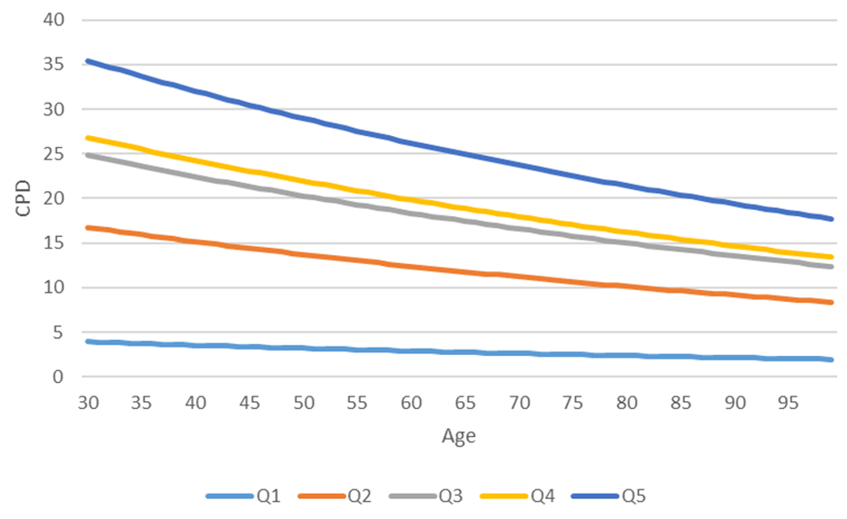

Figure 4: Average number of cigarettes per day by age for men 1945-1949 (average numbers of CPD per quintile were calculated for ages 30, 40, 50, 60 and 70 years)

Age, gender and birth cohort specific smoking cessation probabilities determine whether an individual ceases smoking and the age of smoking cessation. These probabilities were calibrated to match observed age- and sex-specific estimates of the prevalence of current-, former- and never-smokers for each birth cohort

* Assumption: Former smokers are defined as smokers who reported having quit for at least two years (high probability of relapse within first two years)

Non-lung cancer mortality probabilities were based on the person’s smoking history, age, gender and birth cohort. The resulting cumulative mortality probabilities are illustrated below.

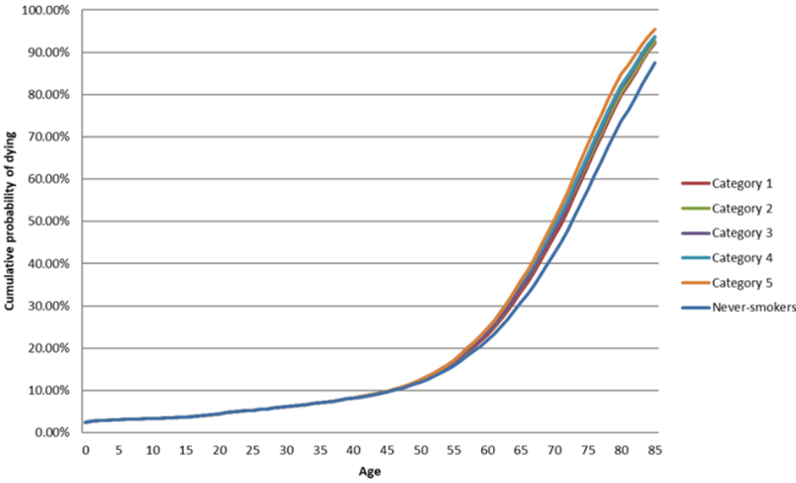

Figure 5: Cumulative mortality probabilities from causes other than lung cancer for never smokers and ever smokers (by smoking quintile) for men born in 1957

Lung cancer incidence is a function of age, gender and smoking history was calibrated to data from the Nurses’ Health Study and the Health Professionals Follow-up Study.

The initially specified model under-predicted observed lung cancer incidence. The following adjustments were made:

Comparing self-reported smoking and cigarette duties, 18% to 33% underreporting of smoking behaviours è reported cigarettes per day increased by 15%.

Background lung cancer risk increased by 25% for men and 40% for women to account for increased respiratory disease and risk factor exposure compared to study population of nurses and other health professionals.

The adjusted model predicted observed lung cancer incidence rates well for both men and women:

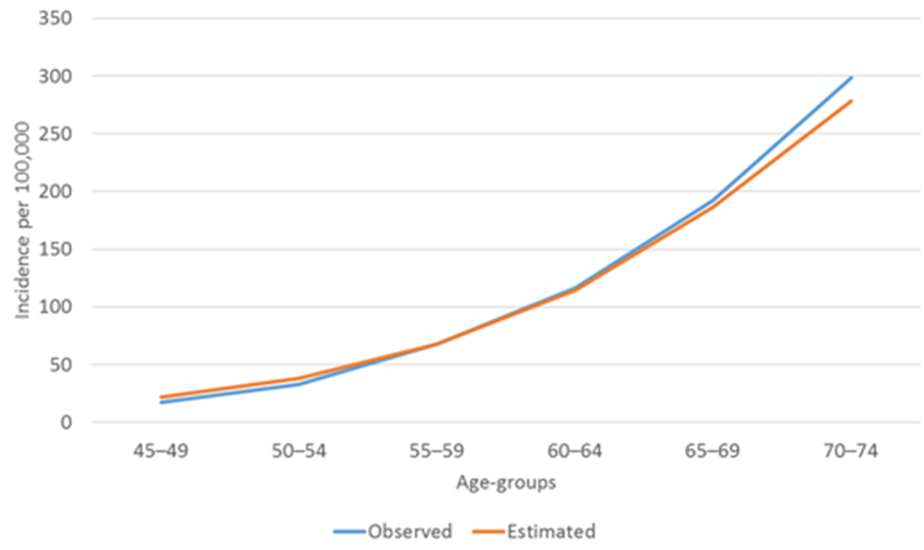

Figure 6: Observed and predicted lung cancer incidence per 100,000 aged 45-74 years in 2015 (men)

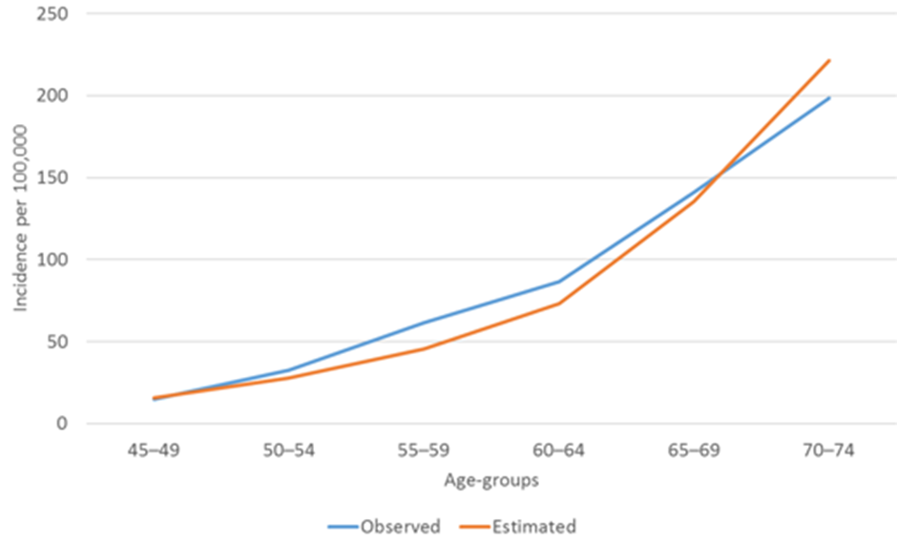

Figure 7: Observed and predicted lung cancer incidence per 100,000 aged 45-74 years in 2015 (women)

The Flinders/Erasmus method was the only one to:

* use cross-sectional smoking data at multiple timepoints to better inform smoking histories
* calibrate inputs such that predicted output parameters matched observed data, including lung cancer incidence

The main area of uncertainty relates to the estimation of lung cancer incidence as a function of age, gender and smoking history, which was calibrated to data from the Nurses’ Health Study and the Health Professionals Follow-up Study:

* Nurses Health Study (NHS) was established in 1976. The cohort consists of 121,700 nurses aged 30–55 at the beginning of follow-up. Average follow-up 23.15 years.
* The Health Professionals Follow-up (HPFS) study was established in 1986. The cohort consists of 51,529 men in the health professions aged 40–75 at the beginning of follow-up. Average follow-up 14.93 years.

As noted above, in calibrating to Australian lung cancer incidence data, smoking intensity was increased by 15% and background (non-smoking) lung cancer risk was increased by 25% for men and 40% for women to account for increased respiratory disease and risk factor exposure compared to the study populations. Instead of increasing background risk to match observed lung cancer incidence, we could have further increased smoking rates. The figures below show that lung cancer incidence in never smokers is around 5% of the incidence in current smokers and so the applied increases in background risk would have had minor effects on lung cancer incidence. This implies that relatively low further increases in smoking rates would be required to achieve the same increases in lung cancer incidence, which would not increase screening eligibility significantly.

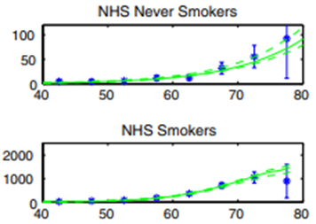

Figure 8: Age-specific lung cancer incidence per 100,000 for never smokers and current smokers

In summary, the WA, NSW and Daffodil Centre approaches to estimating the proportion of screen eligible individuals used cross-sectional data collected at a single timepoint. This required choices and assumptions with respect to the use of the data, in particular data reported by former smokers. For the WA and NSW analyses, the main issue was around whether former smokers included non-regular smokers. The application of alternative choices and assumptions with respect to the analysis of ever smokers data resulted in similar screening eligibility estimates to those produced by the Flinders/Erasmus team.

For the Daffodil Centre analysis, the main issue was around the imputation of large amounts of missing data, in particular, the smoking intensity of former smokers.

In using cross-sectional data collected at multiple timepoints, the Flinders/Erasmus team only used current smoker data. The current smoker data from the multiple cross-sectional studies were analysed to describe the current smoking profile of different birth cohorts over time, age-, gender- and birth cohort-specific:

* Probabilities of initiating and ceasing smoking were calibrated to match the observed proportions of smokers at different ages,
* Intensities of smoking were calculated (not calibrated) using reported intensities of smoking at different ages.

No choices or assumptions were required with respect to how to use former smoker data. The main uncertainty relates to the effects of increasing the background (non-smoking) contribution to lung cancer incidence in order to match predicted to observed lung cancer incidence rates, but this is hypothesised to have a relatively minor effect on screening eligibility rates.

We suggest the Flinders/Erasmus estimates are the most robust, and note that assumptions relating to the uptake of screening by individuals eligible for screening, and by individuals who are not eligible for screening are more important sources of uncertainty relating to expected participation rates.

# References

1. Australian Bureau of Statistics. Population Projections, Australia, 2022-2071 [cited Sep 2024. Available from: [https://explore.data.abs.gov.au/vis?fs[0]=People%2C1%7CPopulation%23POPULATION%23%7CPopulation%20Projections%23POP_PROJ%23&pg=0&fc=People&df[ds]=PEOPLE_TOPICS&df[id]=POP_PROJ&df[ag]=ABS&df[vs]=1.0.0&pd=2025%2C2027&dq=0.3.70%2B69%2B68%2B67%2B66%2B65%2B64%2B63%2B62%2B61%2B60%2B59%2B58%2B57%2B56%2B55%2B54%2B53%2B52%2B51%2B50%2B49%2B48%2BTT.2.2.2.A&ly[rw]=TIME_PERIOD&ly[cl]=AGE](https://explore.data.abs.gov.au/vis?fs%5b0%5d=People%2C1%7CPopulation%23POPULATION%23%7CPopulation%20Projections%23POP_PROJ%23&pg=0&fc=People&df%5bds%5d=PEOPLE_TOPICS&df%5bid%5d=POP_PROJ&df%5bag%5d=ABS&df%5bvs%5d=1.0.0&pd=2025%2C2027&dq=0.3.70%2B69%2B68%2B67%2B66%2B65%2B64%2B63%2B62%2B61%2B60%2B59%2B58%2B57%2B56%2B55%2B54%2B53%2B52%2B51%2B50%2B49%2B48%2BTT.2.2.2.A&ly%5brw%5d=TIME_PERIOD&ly%5bcl%5d=AGE).

2. Australian Bureau of Statistics. Population Projections by Region, 2022-2071 [cited Sep 2024. Available from: [https://explore.data.abs.gov.au/vis?fs[0]=People%2C1%7CPopulation%23POPULATION%23%7CPopulation%20Projections%23POP_PROJ%23&pg=0&fc=People&df[ds]=PEOPLE_TOPICS&df[id]=POP_PROJ_REGION&df[ag]=ABS&df[vs]=1.0.0&pd=2025%2C2027&dq=8%2B7%2B6%2B5%2B4%2B3%2B2%2B1.3.52%2B53%2B54%2B55%2B56%2B57%2B58%2B59%2B60%2B61%2B62%2B63%2B64%2B65%2B66%2B67%2B68%2B69%2B70%2B51%2B50%2B49%2B48.2.2.2.2.A&ly[rs]=REGION&ly[rw]=TIME_PERIOD&ly[cl]=AGE](https://explore.data.abs.gov.au/vis?fs%5b0%5d=People%2C1%7CPopulation%23POPULATION%23%7CPopulation%20Projections%23POP_PROJ%23&pg=0&fc=People&df%5bds%5d=PEOPLE_TOPICS&df%5bid%5d=POP_PROJ_REGION&df%5bag%5d=ABS&df%5bvs%5d=1.0.0&pd=2025%2C2027&dq=8%2B7%2B6%2B5%2B4%2B3%2B2%2B1.3.52%2B53%2B54%2B55%2B56%2B57%2B58%2B59%2B60%2B61%2B62%2B63%2B64%2B65%2B66%2B67%2B68%2B69%2B70%2B51%2B50%2B49%2B48.2.2.2.2.A&ly%5brs%5d=REGION&ly%5brw%5d=TIME_PERIOD&ly%5bcl%5d=AGE).

3. Australian Bureau of Statistics. Estimates and projections of the Aboriginal and Torres Strait Islander population for 2011 to 2031. 2024 [cited Sep 2024. Available from: <https://www.abs.gov.au/statistics/people/aboriginal-and-torres-strait-islander-peoples/estimates-and-projections-aboriginal-and-torres-strait-islander-australians/2011-2031#data-downloads>.

4. Australian Bureau of Statistics. Regional population by age and sex 2023 [cited Sep 2024. Available from: <https://www.abs.gov.au/statistics/people/population/regional-population-age-and-sex/latest-release#data-downloads>.

5. Australian Bureau of Statistics. Primary Health Networks (PHN) (2017) – concordance files – Australian Statistical Geography Standards (2021) - Statistical Area Level 2 2023 [cited Sep 2024. Available from: <https://www.health.gov.au/resources/publications/primary-health-networks-phn-2017-concordance-files-australian-statistical-geography-standards-2021-statistical-area-level-2?language=en>.

6. Crosbie PAJ, Gabe R, Simmonds I, Hancock N, Alexandris P, Kennedy M, et al. Participation in community-based lung cancer screening: the Yorkshire Lung Screening Trial. Eur Respir J. 2022;60(5).

7. Regis SM, Borondy-Kitts A, McKee AB, Rieger-Christ K, Sands J, Afnan J, et al. Outcomes of Positive and Suspicious Findings in Clinical Computed Tomography Lung Cancer Screening and the Road Ahead. Ann Am Thorac Soc. 2022;19(8):1371-8.

8. Morgan L, Choi H, Reid M, Khawaja A, Mazzone PJ. Frequency of Incidental Findings and Subsequent Evaluation in Low-Dose Computed Tomographic Scans for Lung Cancer Screening. Ann Am Thorac Soc. 2017;14(9):1450-6.

9. Department of Health and Aged Care. Modified Monash Model (MMM) 2019 [Available from: <https://data.gov.au/data/dataset/modified-monash-model-mmm-2019>.

10. Banks E, Joshy G, Weber MF, Liu B, Grenfell R, Egger S, et al. Tobacco smoking and all-cause mortality in a large Australian cohort study: findings from a mature epidemic with current low smoking prevalence. BMC Medicine. 2015;13(1):38.