National **Health and Medical Research** Strategy – Webinar 2

**Ms Rosemary Huxtable AO PSM**

Chair, National Health and Medical Research Strategy

**Ms Natasha Ploenges**

CEO, Health and Medical Research Office

**Prof Steve Wesselingh**

CEO, National Health and Medical Research Council

# Development of a National Health and Medical Research Strategy

Development of a National Health and Medical Research Strategy Chair (National Strategy) announced May 2024

Consistent calls from the health and medical research sector for a strategy of this kind

Intent of the National Strategy:

* Cover the entire sector and include all levels of government, industry, philanthropy, academia and consumers.
* Strengthen Australia’s world-leading health and medical research capability.
* Foster a strong research workforce.
* Create an attractive investment environment from discovery and innovation to translation and commercialisation, improving the health of Australians.

# Role of the National Strategy Chair

Work with the Department of Health and Aged Care (department) and the National Health and Medical Research Council (NHMRC) to lead the development of the National Strategy for the Minister for Health and Aged Care.

Provide objective and relevant advice to the department in the National Strategy development process.

Lead the consultation process with the health and medical research sector.

# Webinar 1 - Recap

The first webinar, held by the Chair on 5 December 2024, provided an overview of:

* The approach for development of the National Strategy.
* The Australian Health and Medical Research Workforce Audit (commissioned report).
* Next steps.
* Ways in which you can get involved.

Post-webinar survey.

## Webinar 1 - Survey Outcomes

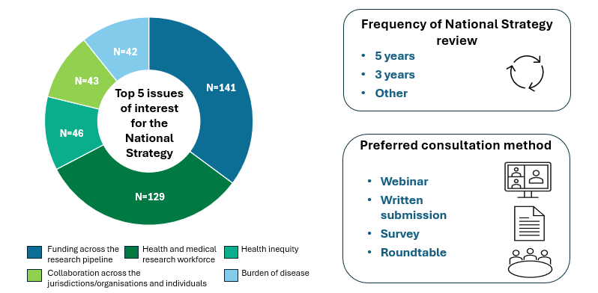

# Webinar 2 - Overview

Recap from Webinar One, including:

* Health and Medical Research Workforce Audit

Progress since (December 2024 to March 2025):

* Themes emerging from early consultations
* Update on commissioned report:
  + Health and Medical Research Community Focus Groups
* Internal development work (research impacts, commercialisation, international strategies)

Next steps

Q&As

## National Strategy Development Process

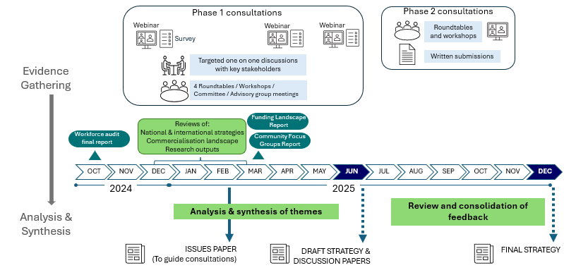

## Consultations – Completed and Upcoming

Completed tasks between Oct 2024 and Feb 2025: 1st webinar; 1st survey; 29 one-on-one discussions with key stakeholders; and 4 roundtables /workshops/ committee  and advisory group meetings.
Upcoming activities between March 2025 and June 2025: a June webinar; follow-up surveys; 10 one-on-one discussions; and 5 roundtables/ workshops/ committee  and advisory group meetings.

***Who have we heard from?***

Whole of sector through webinars and surveys

Thought leaders from the health and medical research sector across the research ecosystem

Commonwealth representatives and advisory groups

State and territory advisory groups (HCEF)

Peak bodies and advocacy groups (ASMR, AAMRI, AAHMS, Universities Australia, Research Australia, AusBioTech)

Biotech and industry representatives

Community and consumer representatives

## What are the current challenges?

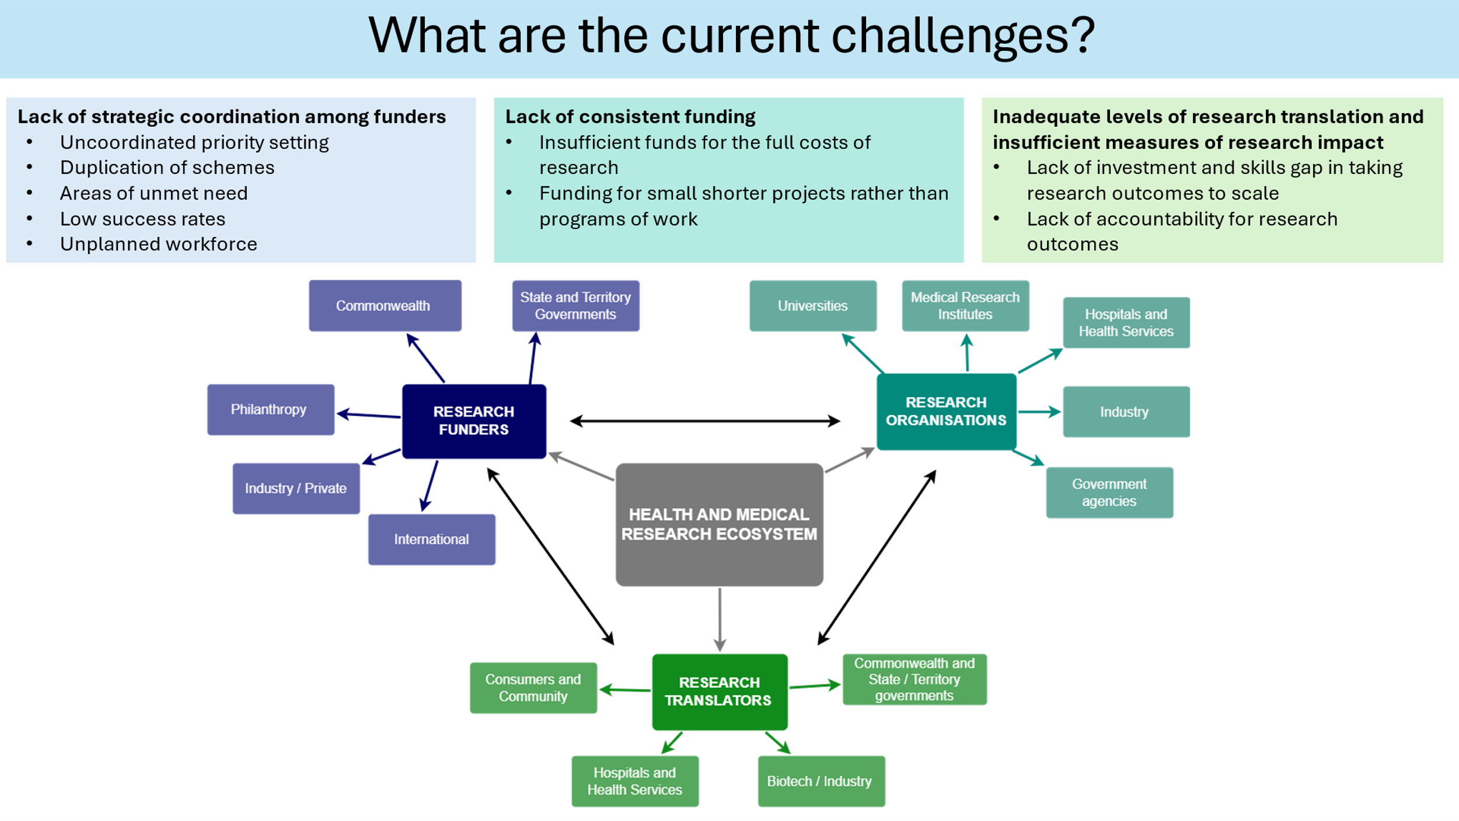

## What we are hearing a Strategy should aspire to

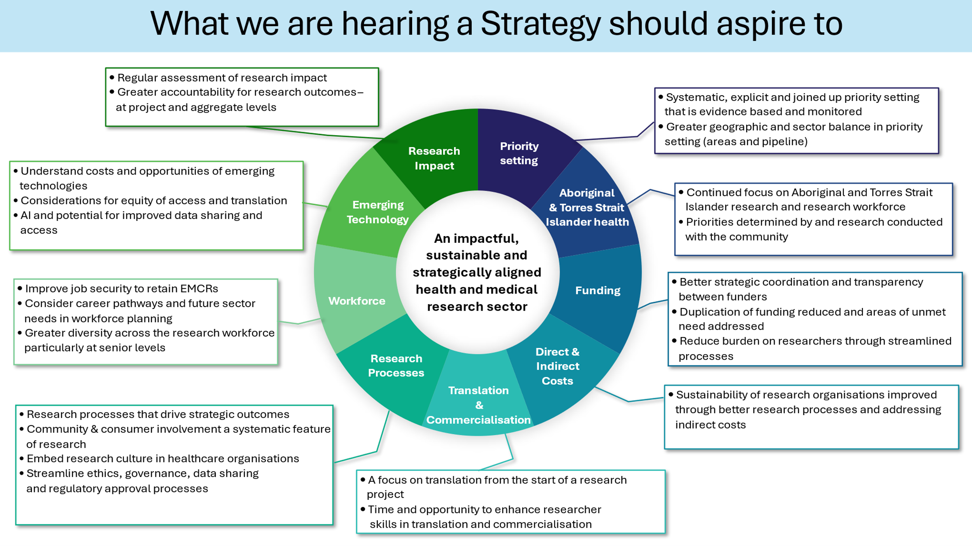

## Potential aims of a National Strategy

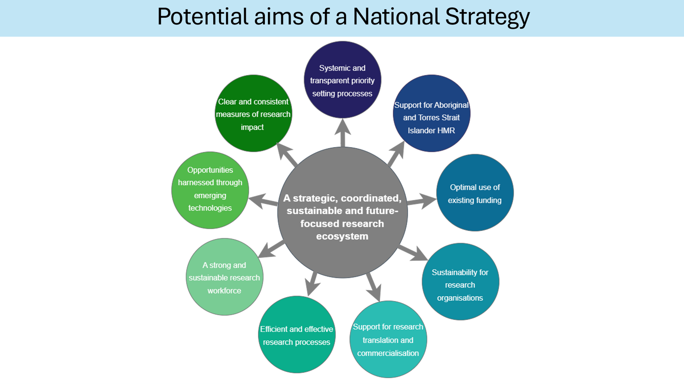

## Community Focus Groups

### Perceptions of health and medical research

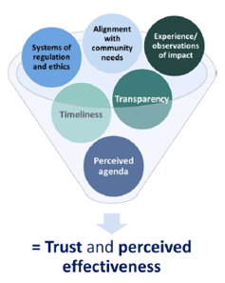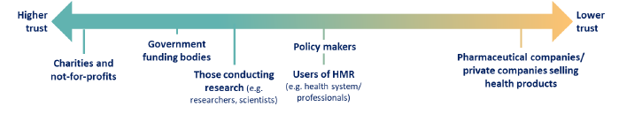

## Community Focus Groups

### Involvement in health and medical research

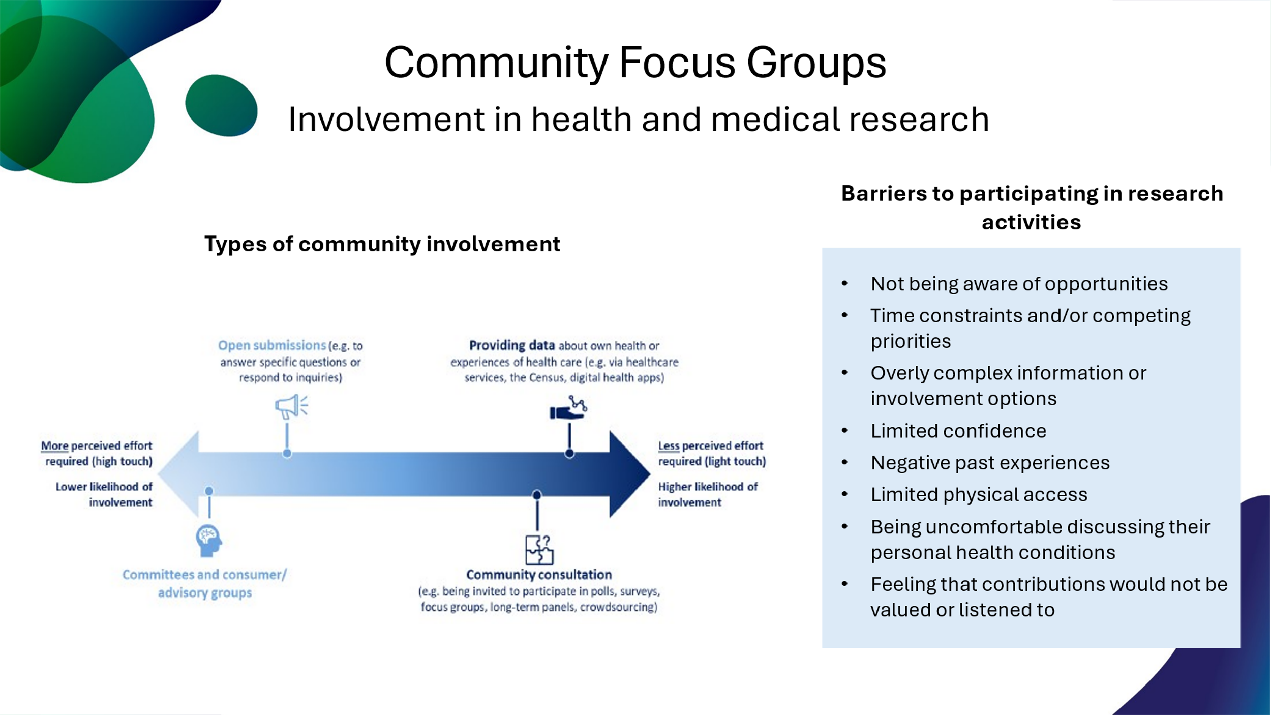

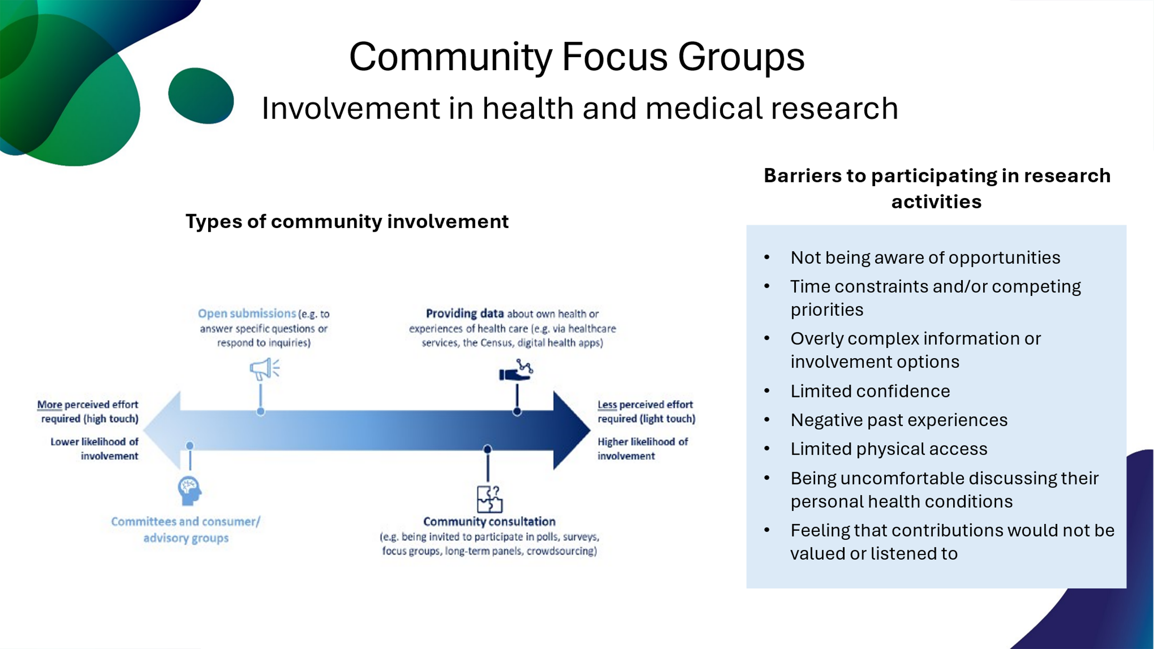

## Community Focus Groups

### Priority Setting

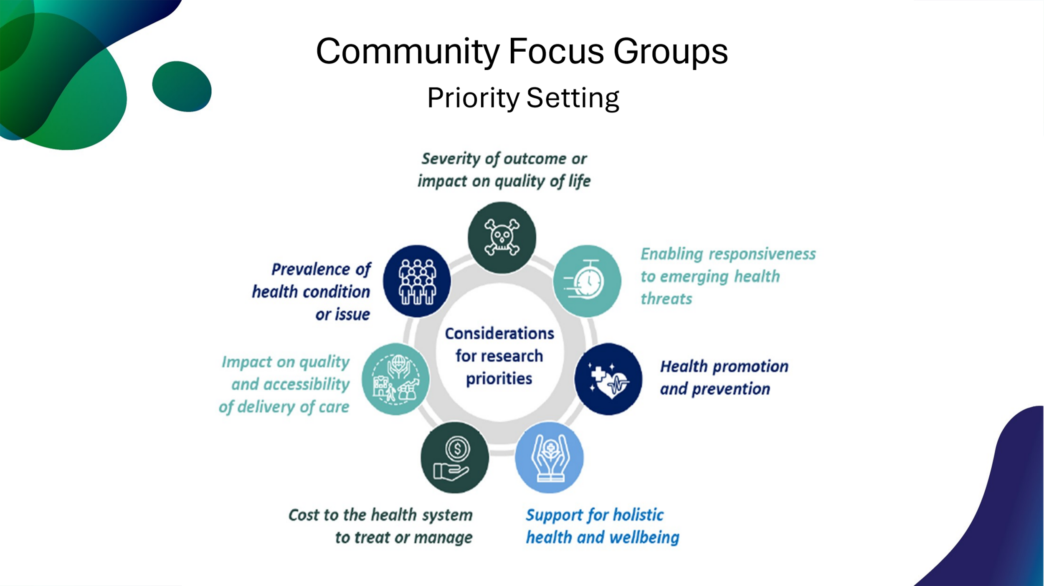

|  |  |  |
| --- | --- | --- |
| **ISSUE** | **CHALLENGE** | **OPPORTUNITY** |
| **1. Fragmentation and lack of coordination of commercialisation programs and support** | High level of fragmentation and a lack of coordination leading to little connection between initiatives | Develop a route map through programs and services, to assist with improving fragmentation and coordination |
| **2. Changing landscape of commercialisation programs and support** | Confusing or poorly communicated changes post-launch of large-scale programs and strategic plans | Consistent, clear and accurate communication and promotion of programs that are current or upcoming |
| **3. Researcher capacity and capabilities gaps** | Difficult for time-poor researchers to commit the resources needed for commercialisation | Addressing the gap in commercialisation skills capability and capacity |
| **4. Complex regulatory processes to support commercialisation** | Securing approval and listings for reimbursements can be considered too slow and too high-risk for a relatively small domestic market | Evaluation of how Health Technology Assessment (HTA) reforms currently underway impact the system and products considered |

## Research Commercialisation Landscape

## What are the current challenges in measuring Research Impact?

* Approximately 17 years is required to translate research outcomes at a clinical and community level1
* In our current system, it is difficult to identify which projects are succeeding and which ones are not
* There is a view that incentives are skewed to publications, bibliometric impact factors and further grant success, rather than research translation and the generation of wider ‘impact’



ISSUES IDENTIFIED

***What key indicators should be used to measure the success and impact of health and medical research in Australia and what tools are available to do this efficiently and effectively?***



KEY QUESTION

1Morris ZS (2011) JRSM Vol. 104 (12)

## International Health and Medical Research Strategies

**Canada, United Kingdom, New Zealand** and **Japan**

**Establishing overarching coordination agencies**

* UK Research and Innovation
* Japan Agency for Medical Research and Development (AMED)
* Canadian Institutes of Health Research



**Embedding clear benchmarks, mechanisms and responsibilities for prioritisation, delivery and measurement of impact**

* Canada: The Plan is supported by a performance measurement framework and annual monitoring and reporting mechanism
* The specificity of priorities is important (impact can only be measured with clear objectives)



**Prioritising national need**

* New Zealand: Research prioritisation done through a lens of ‘Why NZ?’



## Alignment with other Strategic Initiatives

|  |  |  |  |  |  |  |  |
| --- | --- | --- | --- | --- | --- | --- | --- |
|  | Priority  Setting | Funding | Translation & Commercialisation | Research processes | Emerging technology | Workforce | Measuring Impact |
| National Science and Research Priorities |  |  | **✓** | **✓** |  | **✓** |  |
| Strategic Examination of Research and Development | **✓** | **✓** | **✓** |  | **✓** | **✓** |  |
| Australian Digital Health Strategy |  |  |  |  | **✓** | **✓** | **✓** |
| Health Technology Assessment Review |  |  | **✓** |  | **✓** | **✓** |  |
| National Health Reform Agreement Negotiations | **✓** |  | **✓** |  |  |  |  |
| Clinical Trials One Stop Shop |  |  | **✓** | **✓** | **✓** | **✓** |  |
| MRFF / MREA Alignment |  | **✓** |  | **✓** |  |  |  |
| State and Territory Strategies | **✓** | **✓** | **✓** | **✓** |  | **✓** | **✓** |

## Next Steps

**Wide sector consultation process across Commonwealth and States & Territories**

## Common questions submitted so far

Scope/priority setting

Involving Aboriginal and Torres Strait Islander people and communities

Grant application and assessment processes

Linkages with other key strategic pieces of work concurrently underway

Workforce

Consumer and community involvement

## Questions with solid fillInternet with solid fillNational Strategy – stay connected and involved





Send any questions on the National Health and Medical Research Strategy to

**HMRStrategy@health.gov.au**

Check out the National Health and Medical Research Strategy Website

**www.health.gov.au/our-work/national-health-and-medical-research-strategy**

Give us your feedback through the National Strategy sector survey.

Opens 7 April 2025

Closes 12 May 2025

# Questions and discussion