**Interim Evaluation #1 of the Prescribed List Reforms**

Australian Government Department of Health, Disability and Ageing

2 November 2024

****Nous Group** acknowledges Aboriginal and Torres Strait Islander peoples as the First Australians and the Traditional Custodians of country throughout Australia. We pay our respect to Elders past, present and emerging, who maintain their culture, country and spiritual connection to the land, sea and community.

This artwork was developed by Marcus Lee Design to reflect Nous Group’s Reconciliation Action Plan and our aspirations for respectful and productive engagement with Aboriginal and Torres Strait Islander peoples and communities.

*Disclaimer:*

*Nous Group (****Nous****) has prepared this report for the benefit of the Department of Health and Aged Care (the* ***Client****).*

*The report should not be used or relied upon for any purpose other than as an expression of the conclusions and recommendations of Nous to the Client as to the matters within the scope of the report. Nous and its officers and employees expressly disclaim any liability to any person other than the Client who relies or purports to rely on the report for any other purpose.*

*Nous has prepared the report with care and diligence. The conclusions and recommendations given by Nous in the report are given in good faith and in the reasonable belief that they are correct and not misleading. The report has been prepared by Nous based on information provided by the Client and by other persons. Nous has relied on that information and has not independently verified or audited that information.*

© Nous Group

Contents

List of Abbreviations 1

Executive Summary 2

1 Introduction 4

1.1 The evaluation context 4

1.2 Purpose and structure of this report 4

2 Interim findings 5

2.1 Current state of the reforms 5

2.2 Stakeholder engagement 8

2.3 Objective 1: Improve the alignment of the scheduled benefits of the PL with the prices paid in more competitive markets 9

2.3.1 The reforms successfully reduced benefits across 51% of PL items 9

2.3.2 Overall savings to date from benefits reductions are between $282 million and $291 million 11

2.3.3 There is a smaller gap between PL benefits and public hospital prices 12

2.3.4 The reductions methodology was pragmatic and broadly accepted 15

2.3.5 The reforms handled CIED items separately 17

2.3.6 PL benefits are also better aligned with some international markets 19

2.4 Objective 2: Maintain no additional out-of-pocket costs associated with the PL devices for consumers 19

2.4.1 The reforms maintained minimal out-of-pocket costs for PL items 20

2.5 Objective 3: Maintain clinician choice of appropriate prostheses for their patients 22

2.5.1 Clinicians continue to have choice of medical devices and human tissue products 23

2.6 Objective 4: Improve the affordability and value of PHI for privately insured Australians 24

2.6.1 PHI premiums continue to rise 24

2.6.2 PHI coverage is rising slowly 28

2.6.3 Despite lower PL benefits, higher usage is driving up the overall cost of prostheses 29

2.7 Objective 5: Clarify the purpose, definition and scope of the PL in legislation 31

2.7.1 The reforms have brought about legislative changes 31

2.7.2 The definition, purpose and scope of the PL is more clearly defined in the legislation, however more work is required 32

2.7.3 Progress towards regrouping the PL has been paused 34

2.7.4 Lack of agreement to alternative funding arrangements has resulted in GUIs being retained on the PL 37

2.8 Objective 6: Implement new PL assessment pathways aligned to Health Technology Assessment principles and streamline the application process through simple and robust IT infrastructure 40

2.8.1 New assessment pathways and governance processes are in place 40

2.8.2 Assessment processes post-reform have improved alignment with HTA principles 44

2.9 Objective 7: Develop and implement PL listing reviews and PL compliance frameworks to safeguard the PL Reforms 46

2.9.1 A new post-listing review framework has guided four pilot reviews 46

2.9.2 The Department has established a new compliance strategy 49

2.10 Objective 8: Ensure ongoing financial sustainability of PL administration through effective and efficient cost recovery arrangements that are compliant with the AGCF 53

2.10.1 The reforms have updated the PL’s cost recovery arrangements 54

2.10.2 There is improvement in the financial sustainability of PL administration 55

2.10.3 In addition to cost recovery, the Department should ensure it has sufficient resource capacity to administer the PL 56

Appendix A Methodology 58

A.1 Purpose and key objectives 58

A.2 Evaluation plan and theory of change 58

A.3 Overall approach and KEQs 62

A.4 Approach to data collection and engagement 67

Appendix B Measures detail 68

B.1 Indicator 1: Reduction in benefits 68

B.2 Indicator 2: Change in the size of the gap between PL benefits and prices paid in more competitive markets 69

B.3 Indicator 3: Change in out-of-pocket expenses related to PL items 74

B.4 Indicator 5: Change in utilisation of PL items 75

B.5 Indicator 7: Change in PHI coverage and for whom 77

B.6 Indicator 9: Implementation of PL regrouping 78

# List of Abbreviations

|  |  |
| --- | --- |
| Term | Definition |
| ACCC | Australian Competition and Consumer Commission |
| CAG | Clinical Advisory Group |
| CIED | Cardiac Implantable Electronic Device |
| CIRG | Clinical Implementation Reference Group |
| GUI | General Use Item |
| HT | Hospital Treatment (Private Health Insurance) |
| IHACPA | Independent Hospital and Aged Care Pricing Authority |
| KEQ | Key Evaluation Question |
| LPP | Liste des Produits et Prestations |
| MOU | Memorandum of Understanding |
| MDHTAC | Medical Devices and Human Tissue Advisory Committee |
| MSAC | Medical Services Advisory Committee |
| MTAA | Medical Technology Association of Australia |
| PHI | Private Health Insurance |
| PL | Prescribed List of Medical Devices and Human Tissue Products |
| PLAC | Prostheses List Advisory Committee |
| PLRT | Prescribed List Reform Taskforce |
| SBV | Single Benefit Value |

*Following the commencement of the reforms, the Prostheses List has been renamed the Prescribed List of Medical Devices and Human Tissue Products. This report still refers to the 'Prostheses List' in instances where original terminology remains applicable, such as in references to the Prostheses List Advisory Committee. Unless otherwise specified, the terms ‘prostheses,’ ‘items,’ and ‘devices’ refer to the medical devices and human tissue products listed on the Prescribed List.*

# Executive Summary

The Prescribed List of Medical Devices and Human Tissue Products (PL) reform program has involved a substantial investment of time and effort from the Australian Government, the Department of Health and Aged Care (the Department), Independent Hospital and Aged Care Pricing Authority (IHACPA) and stakeholders across private health insurance (PHI), the medical device industry, consumers and clinicians. While holding a range of divergent views, their collaboration has generated significant estimated savings of between $282 million and $291 million for the Australian health system over the past two years[1], ultimately putting downward pressure on PHI premiums. This has resulted in lower premiums than there otherwise would have been.

A key component of the reforms was a planned series of reductions to PL benefits. To date these have been achieved within the original timeframes set out by Government, following an agreed methodology implemented by IHACPA. As agreed early in the reform program, reductions to benefits for Cardiac Implantable Medical Device (CIED) items were deferred to allow for deliberations on technical support services funded by the CIED benefits. The decision to defer CIED benefit reductions by one year is estimated to result in $94 million in forgone savings over the five-year period from July 2022 to June 2027[2], noting that this time allowed for the Medical Services Advisory Committee (MSAC) to provide additional advice to inform how CIED benefit reductions should be calculated.

The original vision for a more tightly defined, clinically ordered, and manageable PL has not to date been realised. The program of work to define the scope of the PL in legislation was completed, however the subsequent decision to retain General Use Items (GUIs) on the PL will necessitate further legislative work.

The project to regroup the PL along clinical lines, independent of benefit, to create a transparent and practical grouping structure is currently paused. Detailed work was undertaken with clinical advice and input to group PL items by clinical use. However, the Department encountered challenges related to mixed-benefit PL groupings when applying the proposed structure, with stakeholders expressing differing opinions on the most appropriate method to implement this. Consequently, the previous PL structure remains in place, and the clinical regrouping project is on hold.

Considerable effort was invested in pursuing an alternative funding arrangement for GUIs to facilitate their removal from the PL. While a significant amount of work went into consultation and producing an alternative funding model, stakeholders ultimately did not reach consensus on proposed arrangements, leading to the Government deciding to retain GUIs on the PL. Reasons cited for this decision included strong stakeholder feedback regarding unresolved implementation challenges that could lead to adverse impacts, current financial pressures on the private hospital sector, and the absence of an agreed alternative funding arrangement. It is difficult to quantify the financial impact of the Government’s decision to retain GUIs on the PL, as the original commitment anticipated an alternative funding model. While there was an expectation of reduced activity through the PL, these costs would have been addressed through other means. It is estimated that between $228 million and $240 million in benefits for GUIs were funded through the PL in FY24.[3]

There are some elements of the reform program which are progressing more slowly than originally anticipated or are yet to be sufficiently implemented to assess their impact. The Department has implemented revised assessment pathways, with a new application tier allowing for appropriate applications to have more focused assessments and others to have more comprehensive assessments. While these tiered pathways are operational (supported by the newly adopted Health Products Portal), it is too early to assess the overall effectiveness of this reform project. While the scope of assessment is narrowed for some applications, the tiered approach shows early indications of being more time-consuming and more resource-intensive than the Department originally modelled.

The reform project looking at compliance has not yet progressed sufficiently to evaluate its impact. While the Department has established a compliance strategy, a significant amount of work is still required before it can be put into action. Although there is a process in place to assess items on a case-by-case basis when issues are raised with the Department, this process is slow, and stakeholders claim many outstanding errors in the PL reported to the Department have yet to be addressed. Achieving best practice assurance and compliance will require additional dedicated resources to ensure timely consideration of these issues.

The Department has implemented the reform program in a highly consultative and methodical way. Extensive investment in discussion papers, webinars, consultation documents, regular stakeholder meetings, and clinician-led reviews has supported the rollout of the reforms. Although this approach has been resource-intensive, it has proven valuable in light of divergent stakeholder views and the financial impact of the decisions made.

The PL reforms have delivered benefits to consumers by improving the affordability of PHI while maintaining the policy settings for clinician choice and minimal out-of-pocket costs. While PHI premiums are lower than they otherwise would have been, the contribution the PL reforms have made towards containing PHI costs can only ever be proportional to upward pressure on PHI premiums from elsewhere.

# Introduction

## The evaluation context

This interim evaluation report covers the period from May 2021 to June 2024.[4],[5]

Announced on 11 May 2021 in the Australian Federal Budget, the PL reforms commenced at a time when the health system was recovering from the COVID-19 pandemic. Australia had experienced a period of unusual hospital activity levels and health care patterns including restrictions to elective surgery, workforce challenges and a re-orientation towards pandemic response activities. This environment sets the backdrop of a continued focus on reforms to health financing arrangements and consumer access to private health care, including elective surgery and health system reform.

PHI affordability was topical in May 2021, and remains so, with PHI premiums rising annually. By better aligning PL benefits with the costs of devices in the public sector, the reforms were aimed at placing downward pressure on rising PHI premiums. This was to be achieved by reducing costs for private health insurers in reimbursing medical devices and human tissue products used in private hospital care. The success (or otherwise) of this element of the reform program is assessed within this broader context.

Additionally, the growth of new and novel medical technologies continues. For this evaluation, benefit settings for devices incorporating a service component required specific attention, as did decisions around the benefits of GUIs. As new technologies continue to emerge, further challenges for the PL are likely, necessitating close consideration of its scope, purpose and existing legal framework.

Structural trends in PHI usage and the types of medical procedures being undertaken in private hospitals have been a longer-term force at play since the announcement of the reforms. Changes in these use patterns, including an older cohort accessing their PHI and an increased volume of PL-listed items per procedure, are contributing to pressure on the financial sustainability of private healthcare under current policy settings. The dialogue surrounding the financial challenges faced by private hospitals provides an important context for the reforms, including the decision to retain GUIs on the PL.

## Purpose and structure of this report

The Department commissioned Nous to evaluate the PL reforms using the Prostheses List Evaluation Framework (see Appendix A.2). Building on an evaluation plan and baseline evaluation report, this first interim evaluation report documents how the reforms’ implementation tracks against its original program and draws some initial conclusions about its impact.

This report follows the same structure as the baseline report. It follows the stated reform objectives from the original Evaluation Framework alongside a series of reform projects the Department has identified to achieve them.

There are three key evaluation questions (KEQs) this evaluation is considering:

1. Is the PL reform program being implemented as intended?
2. Is the PL reform program achieving the expected outcomes?
3. What are the ongoing and future directions, opportunities and priorities for the PL reforms?

This interim report is focused primarily on KEQ 1 and, where possible, KEQ 2. While there are some initial reflections on KEQ 3, there will be greater focus on this evaluation question in subsequent reports.

# Interim findings

## Current state of the reforms

Table 1 | Overview of reform objectives, their baseline position and current progress

|  |  |  |  |  |  |  |
| --- | --- | --- | --- | --- | --- | --- |
| Reform objective | Baseline state | Rationale for objective | How it is intended to be achieved | Progress status | Progress against reform timetable | Impact of reform objective |
| 1. Improve the alignment of the scheduled benefits of the PL with the prices paid in more competitive markets | PL benefits are significantly higher than prices in comparable markets. | High PL benefits contribute to PHI costs and issues of affordability. | PL benefits to be reduced incrementally over reform period in reference to IHACPA’s public benchmark prices (by 80% of the gap or within a 7% floor for most items). | Tick outline | On track – First two rounds of reductions completed, with remainder scheduled. | Benefits have been reduced across eligible sections of the PL.  Benefits are more closely aligned with prices in Australian public hospitals.  Case studies comparing PL benefits with prices paid for the same products in New Zealand and France indicate a closer alignment with international markets. However, the case studies also indicate the gap in prices remains substantial in some instances. |
| 2. Maintain no additional out-of-pocket costs associated with the PL devices for consumers | Out-of-pocket costs for devices are charged in <1% of episodes. | Minimising out-of-pocket expenses is important for maintaining access to devices. | Maintaining minimal out-of-pocket costs establishes guardrails for the benefit reduction exercise and other policy decisions. | Tick outline | On track – Policy settings that drive ‘no out-of-pocket costs’ have been maintained. | Out-of-pocket costs for devices continue to be charged in <1% of episodes. |
| 3. Maintain clinician choice of appropriate prostheses for their patients | Clinicians have a choice of PL-listed items. | Ensuring clinician choice is a core principle of the PL design. | Maintain policy position enabling clinician choice of appropriate prostheses. | Tick outline | On track – Policy settings that embed clinician choice have been maintained. | There is no indication that clinicians’ choice of devices listed on the PL has been systemically impacted by the reforms. |
| 4. Improve the affordability and value of PHI for privately insured Australians | PHI affordability is currently an issue of concern, participation rates are decreasing and risk profiles increasing. | Low PHI participation places strain on the rest of the health system. | Reduction in PL benefits while maintaining device availability and access. | Tick outline | On track – Progress achieved through objectives 1-3. | Savings gained through benefit reductions have placed downward pressure on PHI premiums for consumers.  Despite this, the proportion of PHI hospital treatment benefits paid for prostheses has increased due to higher utilisation. This stems both from an aging membership and higher prostheses utilisation per member across age cohorts.  The rate of PHI premium growth has also increased.  The value of PHI in relation to PL access has been maintained for consumers. |
| 5. Clarify the purpose, definition and scope of the PL in legislation | Only high-level definition of PL in legislation.  Expanding PL scope over time is seen as a major driver of costs.  PL structure has become complex and difficult to navigate. | Lack of clarity and complex structure leads to reduced effectiveness and unwanted outcomes. | Establishment of new legislation regarding the PL.  PL groups to be reviewed and restructured.  General use items (GUIs) to be removed from the PL. | Horizontal dash outline  Cross outline | Ongoing – Legislation addressing purpose, definition and scope has been amended. The decision to retain GUIs, and the final position on services attached to CIEDs, will, however, likely require further legislative changes.  At risk / not achieved – Regrouping has been delayed indefinitely, and GUIs will not be removed from the PL. | Legislated changes have incorporated new terminology and definitions of PL scope. However, the decision to retain GUIs on the PL has diluted the impact of this change.  Complexity of mixed benefits arising from the proposed PL regrouping framework has complicated regrouping. The expected benefits of reduced complexity and increased alignment with clinical use have not been achieved.  GUIs will remain on the PL and will not be part of the reforms’ aim to clarify the PL scope. |
| 6. Implement new PL assessment pathways aligned to Health Technology Assessment principles and streamline the application process through simple and robust IT infrastructure | No distinct assessment pathways based on complexity.  Assessment process has mixed alignment with HTA principles. | Effective and efficient assessment crucial to maintain integrity of the PL. | Multi-tiered application process to be established.  Changes to assessment governance processes. | Horizontal dash outline | Ongoing – New governance arrangements are in action and new pathways have been implemented in a transitional capacity. | New PL assessment pathways have been implemented and the transition with sponsors is underway. New governance arrangements have been stood up, with the creation of the MDHTAC and its revised supporting expert clinical advisory groups.  The new assessment pathways and application process are yet to demonstrate the expected outcomes. |
| 7. Develop and implement PL listing reviews and PL compliance frameworks to safeguard the PL Reform | No formal compliance strategy.  No formal post-listing review framework. | Effective compliance crucial to safeguard the PL reform.  Post-listing review mechanisms important to maintaining the integrity of the PL. | Development of formal compliance strategy and associated functions.  Development of post-listing review framework and completion of pilots. | Horizontal dash outline | Ongoing – A compliance strategy and framework was developed, with planned legislative changes to increase compliance powers.  A post listing review framework and two of the four pilot-post listing reviews have been completed. | Implementation of compliance measures has not progressed sufficiently to assess impact.  Lessons learned from the pilot post-listing reviews are not yet available. The evaluation will consider how these findings can contribute to the ongoing reform once they are available. |
| 8. Ensure ongoing financial sustainability of PL administration through effective and efficient cost recovery arrangements that are compliant with the Australian Government Charging Framework | Historically established cost recovery arrangements are non-sustainable and misaligned with Australian Government Charging Framework. | PL administration should be cost-neutral to Government. | Cost recovery arrangements to be revised. | Horizontal dash outline | Ongoing – Revised cost recovery arrangements have been designed and mostly implemented.  The remaining component to be implemented is the PL Levy. | The Department’s revised cost recovery arrangements appear to be fit-for-purpose and are aligned with the modernised PL and the Australian Government Charging Framework. |

## Stakeholder engagement

#### The Department has implemented the reforms with a high level of stakeholder input and engagement

Stakeholder engagement is vital to any reform program, especially when competing perspectives and financial imperatives are at stake. This is particularly true for the PL reforms, where each decision has varying impacts on industry groups, as well as potential consequences for clinicians and consumers. In some instances, reform actions have clear financial winners and losers. This interim report addresses these issues and emphasises the importance of process, transparency, and the pace of the reform program.

While the PL serves as part of the financing mechanism for private sector healthcare delivery, decisions made in this context can significantly influence behaviour across the sector. Changes to the PL can affect the availability and cost of certain types of surgery, ultimately impacting the costs consumers bear through PHI products and other channels. Therefore, it is critically important to have an active consumer voice in the policy design, implementation, and assessment of impacts to maintain this perspective.

This reform program has been advanced by the Department in a transparent manner, allowing engagement from all stakeholders. Feedback from stakeholders through the evaluation indicates strong support for the reforms’ approach to consultation and engagement in most cases. While some stakeholders noted instances where timelines for input were shortened or engagement opportunities limited, overall, the substantial effort the Department has invested in consultation and engagement has been acknowledged and appreciated.[6]

The Department has utilised a range of consultation and engagement tools throughout the reform program including:

discussion papers

regular forums and direct stakeholder engagements

webinars on key topics

PHI circulars

clinical advisory and reference groups.

Extensive stakeholder engagement requires significant resources but aligns with principles of good governance and transparent decision-making. As the reforms progress, the Department will need to carefully target its engagement efforts according to its remaining implementation priorities.

## Objective 1: Improve the alignment of the scheduled benefits of the PL with the prices paid in more competitive markets

*This section considers the PL reforms’ reduction of benefits and the resulting change in the size of the gap between PL benefits and prices paid in more competitive markets. It also considers the benefit reduction methodology, estimates the overall savings associated with benefit reductions and summarises stakeholder perspectives on the remaining gap between PL benefits and more competitive markets.*

Figure 1 | Reform projects related to reform objective 1

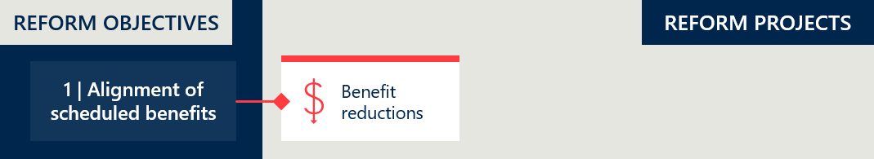

### The reforms successfully reduced benefits across 51% of PL items

#### The reforms adhered to the agreed schedule of reductions

The reforms established three main rounds of benefit reductions. In line with the reductions schedule documented in the Memorandum of Understanding (MOU) between the then Minister and the Medical Technology Association of Australia (MTAA), the Department and IHACPA conducted the first two rounds of benefit reductions on 1 July 2022 and 1 July 2023. As planned, GUIs were subject to accelerated reductions and CIED items had their first round of reductions on 1 July 2023. Figure 2 summarises the timeline of benefit reductions.

Figure 2 | Timeline of benefit reductions

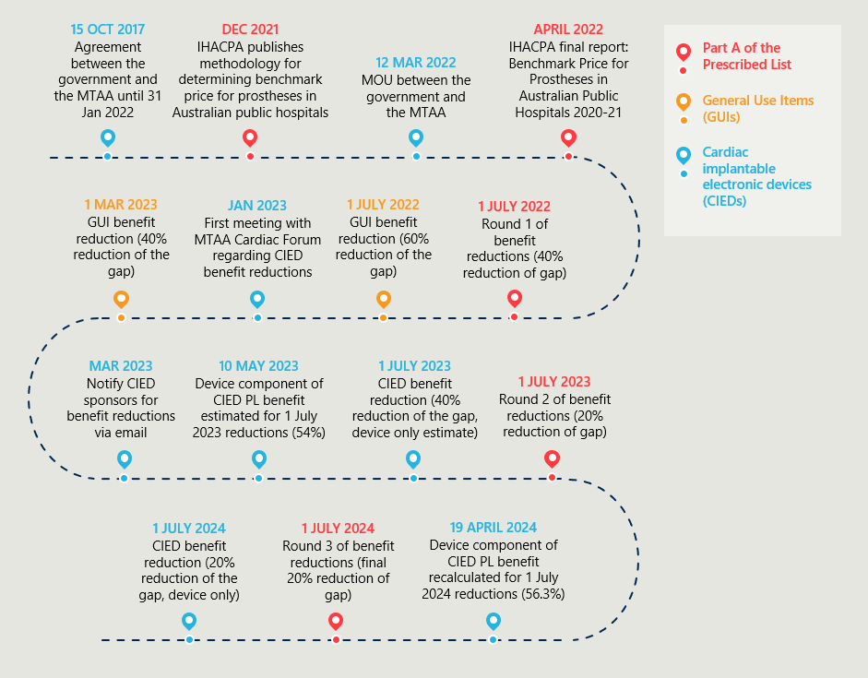

In overall terms, 51% of all items on Parts A, C and D had their benefits reduced in the first two rounds of reductions.[7] This represents a significant reduction of the PL items with benefits higher than prices in the public sector. Around 1% of items were from Part C and not in scope, leaving an estimated 48% of items being at or below the 7% price floor established by the MoU, and therefore not subject to reductions.[8] Figure 3 shows the breakdown of items subject to reductions by PL category.

Figure 3 | PL items subject to reform reductions (Parts A and D, excluding CIED items)[9]

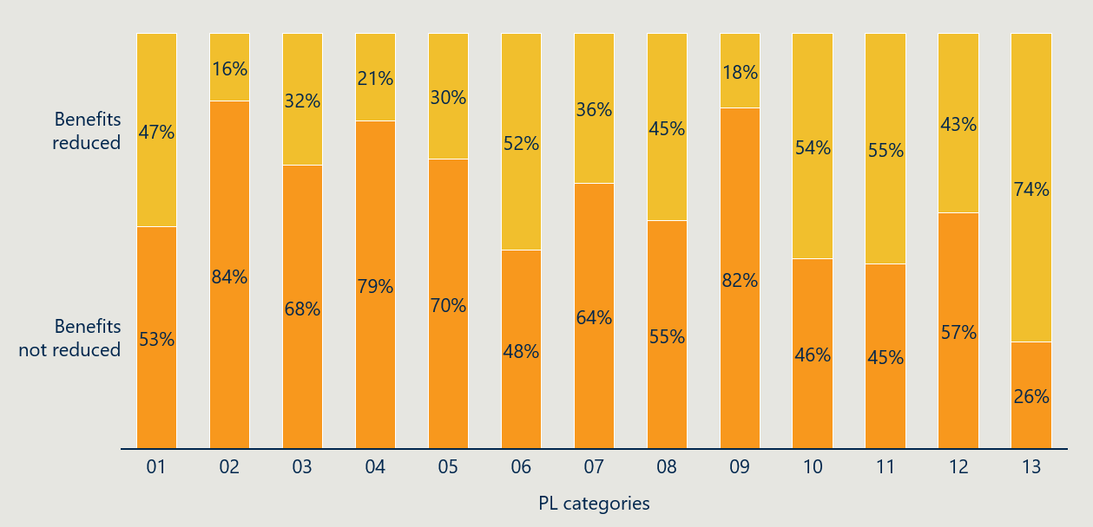

*See Table 28 in Appendix B.6 for a list of the 13 PL categories.*

#### Part C items were excluded from benefit reductions

The 133 items on Part C of the November 2023 PL have the same benefits as they did (or would have had) on the March 2022 PL. IHACPA included Part C items in their public benchmarking exercise, however, no additional documentation citing an intention to apply (or not apply) benefit reductions to Part C has been sourced.

It is likely that Part C was not included in the benefit reductions as these items have already been subject to more considerable rigour in the assessment of their clinical efficacy, and are more likely to have undergone a Medical Services Advisory Committee (MSAC) appraisal in the determination of their benefits.[10] While Nous has not been provided any data about the gap between PL benefits and public benchmarks for Part C items to verify, it is the Department’s opinion that these items are already more aligned to their market value than other parts of the PL.

### Overall savings to date from benefits reductions are between $282 million and $291 million

#### The reforms have generated significant savings to date

Benefit reductions implemented through the PL reforms are estimated to have generated between $282 million and $291 million in savings between July 2022 and June 2024.[11] These savings represent lower insurance benefits paid for medical devices accessed by consumers in private hospitals. Consequently, consumers are benefitting from PHI premiums that are lower than they would have been without the reforms.

For the five years from July 2022 to June 2027, the reforms are estimated to generate between $1,040 million and $1,170 million in projected savings.[12] These additional savings include the final round of benefit reductions for Part A of the PL and further reductions for CIEDs. Overall, the benefit reductions are achieving the desired effect of sustained lower benefit levels for items across the PL.

In the aggregate, these estimates of overall savings are broadly consistent with IHACPA’s initial estimates of overall savings[13] conducted earlier in the reforms. See Appendix B.2 for further detail.

#### Delays to reform actions impacted the savings achieved

An MOU between the then Australian Government and the MTAA in March 2022 determined that benefit reductions to CIEDs would be deferred by one year to allow time to seek advice on technical support services that are being by funded by the PL benefit.[14] The MSAC undertook work in consultation with the MTAA and provided the Department advice of the proportions of the PL benefit that represent the device component and technical support services component (see section 2.3.2). The first round of CIED benefit reductions then occurred on 1 July 2023.

The decision to defer benefit reductions of CIEDs by one year is projected to result in an estimated $94 million in forgone savings over the five-year period from July 2022 to June 2027.[15]

The Australian Government and MTAA agreement to defer CIED reductions allowed the Department to seek industry consultation and independent advice on the value of technical support services associated with CIED items, thereby avoiding disruption to consumer access to these services. However, this delay also postponed any action to reduce the *device component* of CIED benefits. A portion of the estimated $94 million in forgone savings could have been realised if the reforms instead took a cautious approach to reducing CIED benefits in the first round (based on a conservative estimate of the device component representing 50% of total benefit, for example), while seeking further advice on the technical support services component in tandem.

### There is a smaller gap between PL benefits and public hospital prices

#### The median gap of items with benefits above their public benchmarks fell from $177 to $61, while the median gap for all items fell from $24 to $12

A smaller gap between PL items’ benefits and public benchmarks (Weighted Average Prices compiled by IHACPA) across the board indicates the benefit reductions are achieving the stated objective of improving the alignment of PL benefits with more competitive markets. Figure 4 shows that the median gap for all items fell from $24 to $12 after benefit reductions in July 2022 and July 2023. Looking at the items where a gap was present for reduction (approximately half of all PL items), the median gap fell from $177 to $61.[16]

Figure 4 | Median gap with public benchmark prices (Parts A and D, excluding CIEDs)[17]

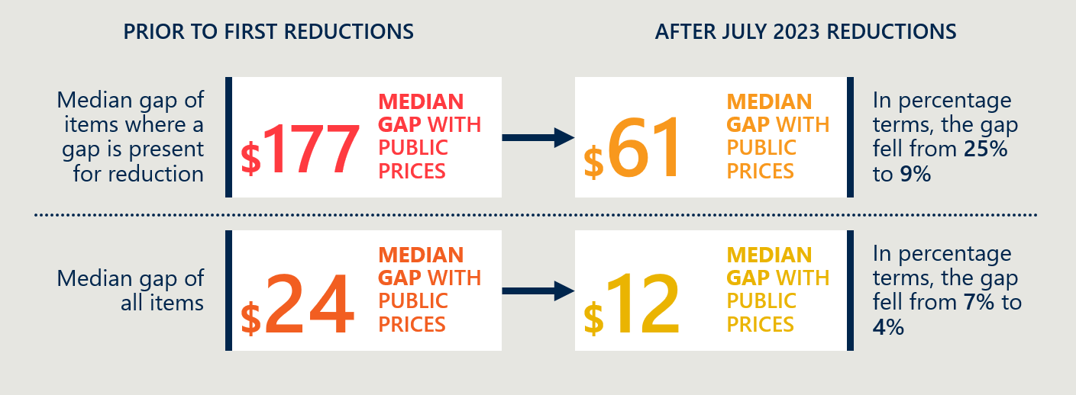

Table 2 shows that there is a closer alignment of benefits with public hospital prices across all PL categories. The median gap (for items where a gap is present for reduction) has fallen below 15% for all categories except for the cardiac category (CIEDs excluded). For non-CIED cardiac items, there remains a median gap of 81% ($628) after two rounds of reductions.

Table 2 | Gap between PL benefits and public benchmark prices for items where a gap is present for reduction (Parts A and D, excluding CIEDs)[18]

|  |  |  |  |  |
| --- | --- | --- | --- | --- |
| Categories | Median gap $ | Gap $ change | Median gap % | Gap % change |
| 01 - Ophthalmic | $33 | -$25 | 13% | -14% |
| 02 - Ear, Nose & Throat | $24 | -$21 | 12% | -6% |
| 03 - General Miscellaneous | $4 | -$25 | 3% | -9% |
| 04 - Neurosurgical | $57 | -$161 | 9% | -12% |
| 05 - Urogenital | $22 | -$22 | 13% | -18% |
| 06 - Specialist Orthopaedic | $48 | -$117 | 13% | -30% |
| 07 - Plastic and Reconstructive | $48 | -$92 | 13% | -15% |
| 08 - Cardiac (excluding CIEDs) | $628 | -$869 | 81% | -106% |
| 09 - Cardiothoracic | $138 | -$518 | 5% | -18% |
| 10 - Vascular | $96 | -$177 | 14% | -31% |
| 11 - Hip | $89 | -$125 | 8% | -7% |
| 12 - Knee | $103 | -$129 | 8% | -3% |
| 13 - Spinal | $65 | -$174 | 7% | -11% |
| Total | $61 | -$116 | 9% | -16% |

Figure 5 shows the distribution of item gaps after the July 2023 reductions compared to baseline. The dark blue areas on the right hand side of the figure show the reforms have significantly reduced the items with large gaps. Compared to baseline, 432 fewer PL items have a gap greater than 91% and 1,916 new PL items have a reduced gap of less than 7%.[19]

Figure 5 | Percentage gap between PL benefits and public benchmark prices as at the November 2023 PL update (excluding CIED items)[20]

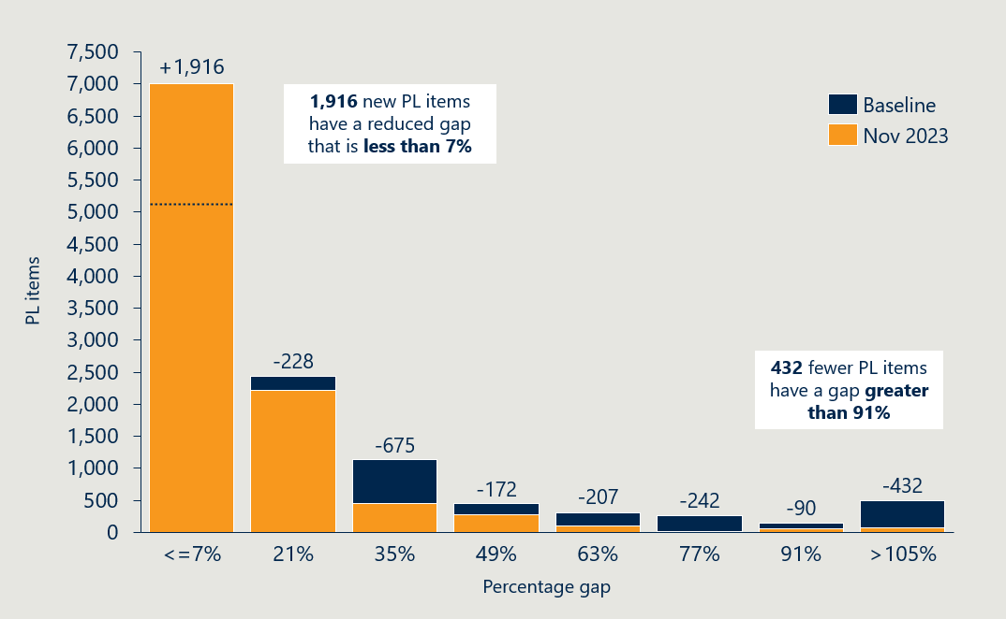

#### Stakeholders expressed varying opinions about the current gap between the public and private sector

Parameters around methodology for calculating benefit reductions under the reforms were set out in a MOU between the then Australian Government and the MTAA signed on 12 March 2022.[21] This included the requirement to not reduce devices with a current gap between prices paid in the public hospital system and PL of less than 7%.

The Australian Competition and Consumer Commission (ACCC) has stated that the floor imposed by the MOU on benefit reductions will likely have a distortionary impact on the price of devices in the private sector and lead to some PL benefits remaining inflated compared to prices in the public system.[22]

This perspective is shared by private health insurance providers who are not satisfied with the remaining gap between PL and public hospital prices post benefit reductions, and are of the view that the reforms has been held back by the 7% floor set out in the MOU. However, sponsors maintain the 7% floor is justified to account for differences between the operation of public and private markets.

Further stakeholder perspectives on the remaining gap are set out in Table 3.

Table 3 | Stakeholder perspectives on the current gap between the PL and public hospital prices

|  |  |  |
| --- | --- | --- |
| Stakeholder group | | Perspectives on reform project |
|  | Private healthcare providers | * The improvements to align pricing has improved consumer position to access PL items, as the key purpose of the PL. * There is anecdotal evidence that sponsors are introducing additional charges for associated products and services to recoup losses, which could dilute the positive impact of the reform. |
|  | Private health insurance providers | * The PL benefit amounts are still considered potentially higher than what may be generated under competitive market mechanisms, including manufacturing scale being achieved, efficiency, new market entrants. * The ‘the artificial floor’ of 7% for eligibility for benefit reductions and the condition that benefits should only be reduced by a maximum of 80% of the gap should be removed. |
| *Icon of a microscope* | Medical technology companies | * The benefit reductions proceeded in line with the MOU. * The PL benefits are now objectively better aligned; however, some reductions have been bluntly applied resulting in the benefits of some groupings falling below the public sector price. |
| Icon of a person with a stethoscope | Clinician representative | * The progression of benefit reductions has been satisfactory. Seeking the lowest prices possible for prostheses is desirable so long as these prices remain financially viable for medical device companies. * It was reasonable to implement a PL price floor as lower pricing arrangements are possible in the public hospitals, achieved by public hospitals being able to guarantee a higher volume of purchased devices. * CIEDs have the biggest discrepancy in price between public and private sectors. This necessitates these devices to undergo a review and be re-negotiated. |

### The reductions methodology was pragmatic and broadly accepted

#### The Department and IHACPA developed a methodology with stakeholders

In December 2021, IHACPA published the methodology to determine a benchmark price for prostheses in Australian public hospitals.[23] These public sector Weighted Average Prices allowed the Department and IHACPA to determine the gap between the PL benefits and their public benchmarks, establishing a benchmark for calculating and applying benefit reductions. A final report was complete in March 2022,[24] following consultation with stakeholders.

#### Reductions were made with reference to prices in the Australian public sector

Determining reductions through reference to the Australian public sector enabled the Department and IHACPA to adopt a standard calculation that could be applied to items broadly across the PL. Though stakeholders have pointed to market differences across the private and public sectors,[25] the large overlap of devices used in Australian private and public hospitals enabled IHACPA to perform benchmarking for all benefit groups on Parts A and C of the PL with the assistance of the MTAA and sponsors.[26]

While Australian public sector prices are a suitable reference for the reforms to achieve its objective of improving the alignment of PL benefits with more competitive markets, it should be noted that public sector prices and PL benefits are not independent of each other, and the ‘competitive’ market price is likely lower than the public reference price for most PL items. It is common practice for sponsors to use PL benefits as their ‘list prices’ for public hospitals; the default price from which discounts are negotiated, sometimes through volume and market share agreements. This is reinforced by government procurement agencies commonly requesting that MedTech companies provide PL benefits as a reference alongside their tendered prices during procurement processes and requiring that the tendered price be below or equal to the PL benefit. This has an anchoring effect on public sector price negotiations for medical devices. International pricing that is significantly lower than Australian pricing is another indication that the Australian market could sustain benefits levels lower than the public benchmarks.

However, IHACPA considers Australian jurisdictions to have sufficiently competitive procurement processes to be a suitable reference for the purposes of the reforms.[27] With a lack of feasible alternative options,[28] and in a complex stakeholder environment where cooperation with industry is required, establishing public sector reference prices has enabled the Department to successfully improve the alignment of PL benefits with more competitive markets across a large proportion of items.

#### Stakeholders have expressed varied perspectives on the methodology

Stakeholders have expressed different views about reductions methodology. Broadly accepting of the decision to benchmark against the public sector (though not exclusively), stakeholders disagreed about the inclusion of a 7% price floor. Private health insurers note that the approach is deficient in terms of generating the greatest quantum of value to consumers.[29] Medical device manufacturers argued that the contracting arrangements between public and private settings vary and maintained the position that it would not be appropriate for prices on the PL to perfectly align with the prices on the public market. Private healthcare providers expressed that the 7% price floor was a useful compromise to progress the reforms.

Table 4 | Stakeholder perspectives on the benefit reductions methodology

|  |  |  |
| --- | --- | --- |
| Stakeholder group | | Perspectives on reform project |
|  | Private healthcare providers | * Benchmarking the PL against the Australian public sector was a positive and robust methodology, and it has produced material savings for the sector. * The use of a 7% floor was a useful compromise to achieve overall reform. * The phasing of reductions was generally appropriate and provided industry with sufficient time to adapt to the new prices. Were appreciative of Department attempts to provide additional forward notice of reduction announcements to hospitals, noting that 10 business days is not generally enough time. |
|  | Private health insurance providers | * The methodology was constrained due to limited access to the lowest available public prices, and reliance on device company figures, resulting in insufficient benefit reductions. * The decision not to compare benefits internationally was flawed, as larger savings would have been feasible if benefits had been benchmarked to comparable overseas markets. * The rationale for accepting a 7% floor and the condition that benefits should only be reduced by 80% of the gap was not transparent and has ensured PL device benefits remain at inflated levels well above public sector benchmarks. * Phasing of reduction over years not months, including delays to CIEDs, did not have a sound economic grounding, as inventory cycles do not operate on a multi-year basis. * CIEDs on the PL are still considered overpriced and benefit amounts deemed attributable to their technical support service coverage is inflated. |
| *Icon of a microscope* | Medical technology companies | * The public hospital market was the most appropriate comparison. * The remaining gaps between the PL and the public prices are reflective of the public market’s use of guaranteed volume to lower price, which would limit choice in the private market. * The scope of products included in reductions was appropriate. * The lack of independence between the two markets, as some jurisdictions have clauses that require prices to match PL benefits if the PL benefit is lower, creating circular pressure that impacts suppliers. * Handling of CIED reductions was considered reasonable and appropriate and recognised the impact of drastic cuts to patient services. |
| Icon of a person with a stethoscope | Clinician representative | * The use of Australia’s public hospital system as the comparator for medical device benchmarking was appropriate and the best comparator available. * Comparison to other countries is less helpful as there are substantial contextual differences that may not be captured, including who holds device inventory, and what services are provided with the device. * If international comparators are used, the most appropriate items to compare would be high cost and high use medical devices such as cataracts and hip and knee devices. |

### The reforms handled CIED items separately

The reforms considered a technical support services component of CIED benefits

At the outset of the reforms, it was recognised that additional work was required to establish benefit reductions on Cardiac Implantable Electronic Devices (CIEDs). For patients in private hospitals, the benefit for CIEDs covers both the cost of the device and the cost of the technical services that come with managing the devices after implantation. While these two components are not separately identified on the PL, sponsors advise that CIED benefits are at a level that enabled them to employ cardiac technicians to ensure CIEDs are functioning correctly and review any alerts sent by these devices at no additional cost to the consumer. To ensure the battery powered electronic devices work optimally and for as long as possible, they are checked regularly by these technicians (1–4 times a year) as well as when the patient experiences medical issues including possible heart problems.[30]

Industry raised concerns that the schedule of benefit reductions would impact on their ability to provide these services to CIED patients, and the proposed benefit reductions would have implications for both the private and public sector.[31] Industry states that CIED benefit amounts enable sponsors to provide technical support services to private patients free of charge and to cross-subsidise the provision of similar services to public patients. They have estimated that up to 17% of all services provided by private cardiac technicians are performed in a public hospital.[32] Medical device technicians are not reimbursed for providing CIED technical services in the public system and some public hospitals rely heavily on this support, especially for out-of-hours and more complex cases. This meant that industry did not believe it was appropriate to benchmark CIED benefits to public prices, as these represent the public hospital market value for the CIED device only, and no associated technical services are reimbursable in the public system.

#### Benefit reductions were deferred for CIEDs to allow for MSAC to consider the value of technical support services

The then Minister had agreed to an alternative schedule of benefit reductions for CIEDs to allow for consideration by MSAC on the value of CIED technical support services, as outlined in the March 2022 MOU with MTAA. The first price reduction for CIEDs was deferred by 12 months and reductions were scheduled to take place on 1 July 2023 (40%), 1 July 2024 (20%) and 1 July 2025 (20%) respectively.[33]

In May 2023, the Department announced via a PHI circular that an estimate-based reduction approach to CIEDs would be used to enable the first reduction to occur on 1 July 2023. This was done to not disrupt existing CIED service arrangements while the work of the MSAC was ongoing to provide advice on the reasonable cost of technical support services of CIEDs. This first benefit reduction of 40% of the gap applied only to an estimate of the amount that corresponded to the actual device component of the benefit, which was estimated as 54%.[34] The device component of CIEDs was later re-calculated as 56.3% of the total benefit following correction of certification costs provided by industry.[35] The Department announced it would use this updated figure to calculate the second reduction of 20% of the gap on 1 July 2024. This was implemented in a way where the 2.3% difference between the initial estimate and subsequent re-calculation was accounted for.[36]

Stakeholder consultation about CIEDs is ongoing following the finalisation of the MSAC assessment.

The MSAC provided advice to the Minister in July 2023 following their assessment of the MTAA Cardiac Forum’s application (No. 1724 – Cardiac technical support services provided by industry employed technicians)*.* A redacted public summary document for this application was published online on 16 April 2024.[37] In their advice, MSAC provided advice on how to calculate the reasonable cost of cardiac technical support services and noted it may be reasonable to include some services that are provided to public hospital patients until longer-term reform can address how these services are funded. Ultimately, MSAC has stated that funding the follow-up cardiac support services for public and private patients through the PL results in a lack of transparency in how these services are provided and funded. Their advice notes that preferably the benefit should be limited to the cost of the principal CIED and associated per-implantation costs only. However, in order not to compromise the current care of patients with CIEDs or inadvertently increase any out-of-pocket costs associated with the receipt of these services, the MSAC advised that the costs for these follow-up services be excluded from the current staged PL benefit reductions. MSAC also noted that further consideration of alternative models of care for patients with CIEDs and how funding of these services can be transitioned out of the PL benefit amount should be pursued.[38] The Department has subsequently announced it will be conducting public consultation on how to implement the MSAC advice.[39]

#### The current gap between CIED PL benefits and public prices are unknown to this evaluation

Nous has not been provided data showing the gap between PL benefits and public prices for CIED items. CIED items were additionally excluded from aggregated gap analysis provided to Nous for the evaluation (see Table 2). As a result, progress towards aligning CIED benefits with more competitive markets cannot be quantified.

The evaluation is also unable to accurately estimate the current gap as the delayed schedule of reductions and determination of the technical services component makes it difficult to perform a backcalculation using only the published PL schedules. However, 243 of the 273 CIED items on the November 2023 PL have lower benefits than prior PLs, indicating the prevalence of items with a gap is higher for CIED items (after controlling for the technical services component) than all 13 PL categories. At baseline, prior to reductions, the evaluation team estimated the median gap of CIED devices to be approximately $19,600 (188% gap) and no less than $17,600 (144% gap).[40]

### PL benefits are also better aligned with some international markets

Objective 1 of the reforms is to “Improve the alignment of the scheduled benefits of the PL with the prices paid *in more competitive markets*”. In addition to comparisons with the Australian public sector, the evaluation has taken a case study approach to comparing PL benefits with prices in international markets (see methodology in Appendix B, indicator 2).

#### PL benefits declined while prices in New Zealand and France held steady

Three case studies indicate that the reforms have better aligned PL benefits with international markets (see Appendix B, indicator 2). All three of the benefit group case studies chosen at the baseline evaluation were subject to reductions, declining by 36%, 8% and 1% respectively from July 2021 to July 2023. During this time, New Zealand Pharmac prices increased slightly (an average of 1.1% across the 13 products) while French Liste des Produits et Prestations (LPP) prices did not change. The resulting smaller gaps across all three case studies indicate the reforms are thus far achieving their intended objective.

#### However, the reforms have had mixed success in meaningfully addressing the absolute gap with the French market

Despite some improvement in alignment across the board, it is worth noting that the case studies suggest the magnitude of the gap between PL benefits and prices listed on the French LPP remains substantial, and the reforms have had mixed success in meaningfully decreasing this in absolute terms:

A case study of knee implants (12.08.01 PL benefit group; see Figure 30 in Appendix B) shows the reforms have decreased the gap between the French and Australian markets from $321 (158% gap) in 2021 to $182 (90%) in 2023—a significant improvement in alignment.

On the other hand, a case study of spinal fusion cages (13.10.01.02 PL benefit group; see Figure 32 in Appendix B) shows the PL benefit remains around six times the LPP price, despite a benefit reduction in July 2022 and again in July 2023.

## Objective 2: Maintain no additional out-of-pocket costs associated with the PL devices for consumers

*This section considers any change in out-of-pocket costs related to PL items. It examines the prevalence of a gap payment for PL items and the average gap payment for PL-listed items.*

Figure 6 | Reform projects related to reform objective 2

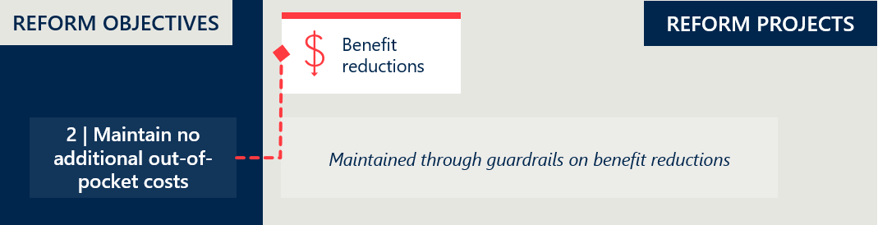

### The reforms maintained minimal out-of-pocket costs for PL items

The introduction of the PL reforms has maintained low out-of-pocket costs for consumers and achieved the reform objective of no additional out-of-pocket costs.

Data shows changes in the frequency and the average amount of gap payments,[41] yet there is no clear evidence linking these changes to the PL reforms, considering the variations are within historical norms. While there has been an uptick in the frequency of gap payments, the average payment amount has declined, a trend consistent with the period before the reforms were implemented.

Continued monitoring of these metrics is necessary, despite the current stability in out-of-pocket costs, to determine if the changes in gap payment frequency and average amounts deviate from historical trends in subsequent years.

The prevalence of gap payments for PL items was less than 1%

Figure 7 shows a low prevalence of gap payments across the PL, with only 0.65% of all PL items used in FY23 resulting in gap payments exceeding $1. Table 25 (see Appendix B, indicator 3) indicates that this minor increase in prevalence is consistent across most Part A PL categories. During FY23, the year following the initial round of benefit reductions, there is a noted rise in gap payment prevalence. Nevertheless, this increase remains within the historically normal range, as evidenced by a 0.66% prevalence recorded in FY19, well before the implementation of the PL reforms.

The persistently low prevalence of gap payments indicates that the PL reforms are largely achieving their aim of minimising out-of-pocket expenses. However, should the prevalence continue to increase following subsequent benefit reductions, a more detailed analysis may be warranted.

Figure 7 | Prevalence of gap payments greater than $1[42]

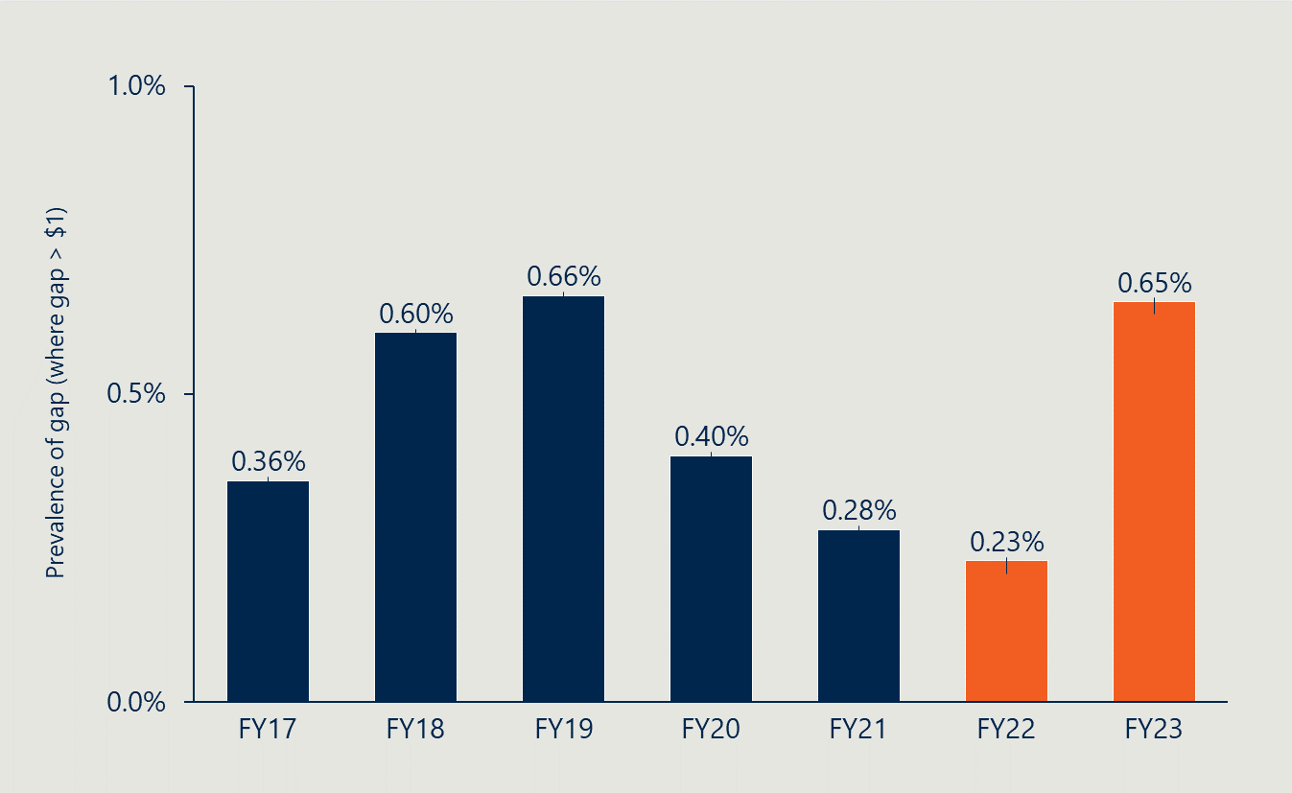

The average gap payment for PL-listed items was $123

Figure 8 shows that since baseline, there has been a significant decrease in the average gap payment for items listed on the PL where a gap payment is made. The average gap payment for such items in FY23 was $123, down from $270 in FY21. Table 26 (see Appendix B, indicator 3) reveals that this decrease spans all categories within Part A of the PL. However, as with changes in prevalence, the average gap payment falls within historical norms, as indicated by a comparable average of $129 in FY18 and $92 in FY19.

The recent trends in both the average prevalence of gap payments and their corresponding values align with established historical patterns, where a rise in the prevalence of gap payments typically coincides with a reduction in their average value.

Figure 8 | Average gap payment when gap payment is greater than $1[43]

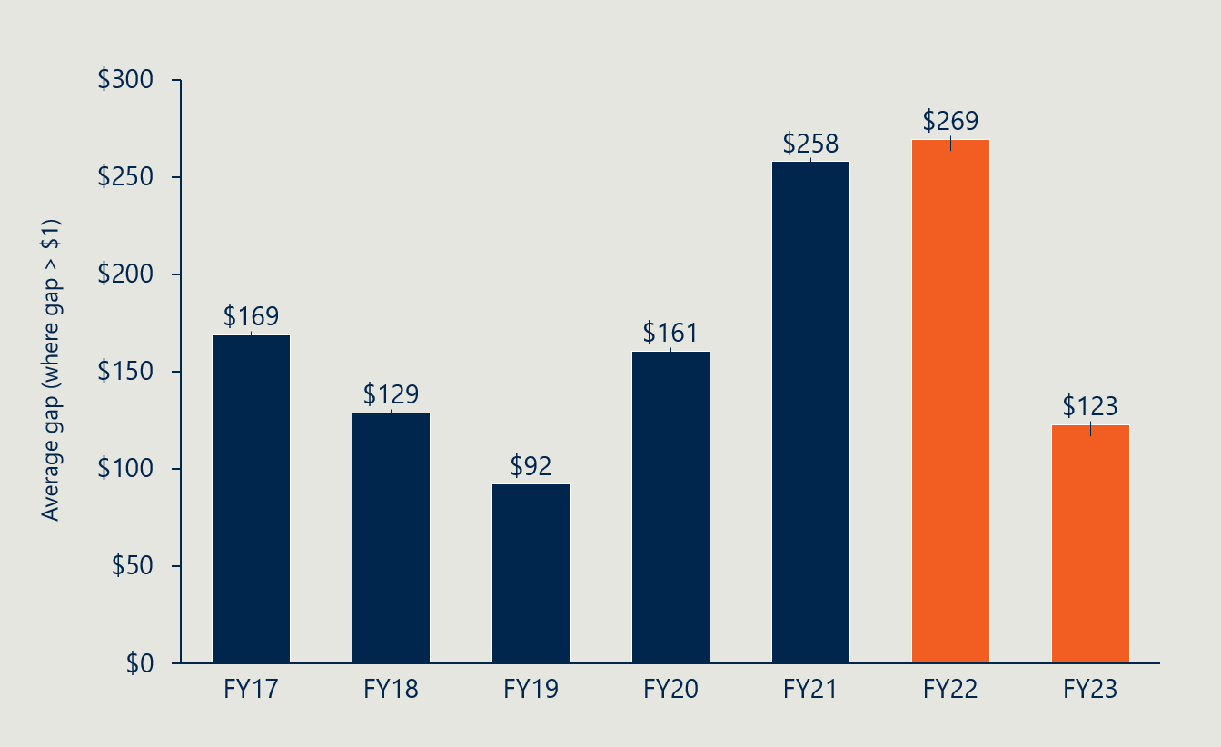

## Objective 3: Maintain clinician choice of appropriate prostheses for their patients

*This section focuses on examining any change in clinicians’ experience of choosing prostheses, while considering changes in consumer access because of the reforms more broadly. It also considers changes in the utilisation of PL items as a potential indicator for changes in clinician choice, consumer access and clinical outcomes.*

Figure 9 | Reform projects related to reform objective 3

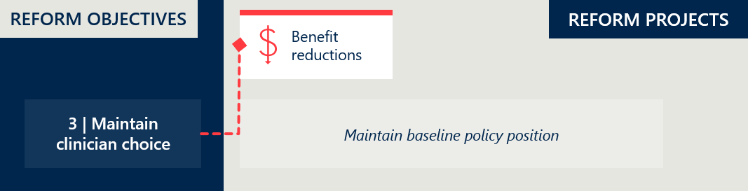

### Clinicians continue to have choice of medical devices and human tissue products

#### The policy setting supporting clinician choice has remained constant

One of the principles underpinning the reforms is the maintenance of clinician choice. The ability for clinicians to have uninhibited choice of device is a key principle of the PL in providing privately insured Australians guaranteed access to appropriate medical devices and human tissue products.[44] This principle is expressed in the application requirements for the PL where any item on the list is available for clinicians to access for a procedure in a private hospital, subject to it satisfying the tests outlined in the PL Guide.[45]

Throughout the reforms, the policy setting supporting clinician choice has not changed. Recent changes to maintain listing of GUIs on the PL has also meant that these products remain available for use by clinicians and reimbursable by PHI.

#### Utilisation data indicates that benefit reductions are not reducing access to certain devices

Analysis of PL device utilisation data indicates that benefit reductions are not associated with reduced device usage, suggesting the reforms are not reducing access to certain devices in a systemic way. Summarised in Table 27 in Appendix B, regression analysis was undertaken to determine whether there is a relationship between the change in item benefits and the change in item utilisation at the benefit group level. No statistically significant relationship could be found looking at all the benefit groups subject to reductions. When including only the benefit groups with annual volumes over 100, a statistically significant relationship was found, however the model explained a very small amount of the variance in utilisation (R2 = 0.01). Even so, the relationship was negative (decline in benefits explains an increase in utilisation), suggesting this relationship is more likely the result of other factors or noise in the data. Focusing the regression only on benefit groups which have had a large benefit reduction (>10%) also does not yield any significant results. At a systemic level, the evaluation cannot find evidence supporting a reduction in access (or even use) or certain PL devices because of benefit reductions. It is still possible that there are specific outlier cases where listed products have been impacted. The evaluation will continue to monitor this measure, both in engagement with stakeholders and future data analysis as results become available.

#### Stakeholders have reported service withdrawal because of a post-listing review outcome

On 18 October 2023, a new condition was applied for PL reimbursement on billing codes for surgical guides and biomodels. This followed the outcome of a post-listing review stating that a maximum of 3 surgical guides and/or 3 biomodels would be eligible for reimbursement for a craniomaxillofacial procedure (a surgical procedure with single admission to theatre for a patient).[46] A stakeholder suggested that as a result some hospitals have withdrawn from the provision of services that use these surgical guides and biomodels because they were no longer viable.[47] This is an example of the complex interaction between clinical settings driving quality of care, price and access. While businesses will make decisions based on the market, it is important that clinician choice is understood in the context of access to products in line with their clinical efficacy. This example shows the ability of the PL reforms to reset clinical settings through post market reviews as new evidence emerges.

#### Ongoing monitoring of the PL is required to examine any unintended consequences of the reform on clinician choice

In evaluating these reforms over the longer term, it is important to examine any potential unintended effects on device choice for clinicians due to the impact of benefit reductions in combination with the impact of the new annual cost recovery levy per PL item on the market. For example, medical device sponsors might withdraw some products from the PL if they deem it not cost effective to maintain offerings with low utilisation or low profit margins, which increases their inventory risk. A clinician consulted in the evaluation described the recent removal of an orthopaedic device occasionally used in surgery for patients with a specific anatomy from the PL, presumably because the sponsor was sensitive to the item’s low usage rate. This highlights the need for ongoing monitoring of PL device listing data throughout the evaluation. Future data should be examined for signs of any narrowing of product offerings by sponsors, or if the range of products on the PL is diminishing compared to the public system, which could devalue private health insurance and private hospital surgery for patients.

Overall, stakeholders have noted that it may be too early to assess the impact of the reforms on clinician choice and patient access. Stakeholders have also expressed concern that clinician choice will be impacted by the Department’s current approach towards GUIs which permits sponsors to only list new GUIs under current PL groupings, which is further discussed in section 2.7.4.[48] This evaluation will continue to engage stakeholders and seek other information to monitor clinician choice as the reform program progresses. Of particular importance will be continuing to engage with clinicians directly, to understand their perceptions of choice and how, if at all, this has changed.

## Objective 4: Improve the affordability and value of PHI for privately insured Australians

*Foundational to the reforms is the objective to improve the affordability and value of PHI. This section considers changes in PHI premium increases to examine the affordability of PHI. It looks at premium price changes over time and any changes in PHI premiums that can be related to PL expenditure. This section also considers changes in PHI coverage and for whom to examine the value of PHI. It looks at coverage by demographic group and utilisation of PL items.*

Figure 10 | Reform projects related to reform objective 4

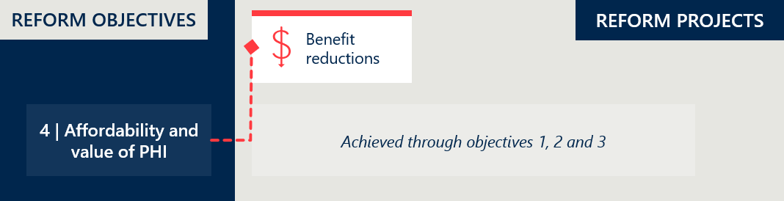

### PHI premiums continue to rise

#### Annual premium prices are rising at an increasing rate after a period of smaller increases

Australian PHI premiums increased by an average of 2.7% in 2022, followed by 2.9% in 2023, as shown in Figure 11. Between 2016 and 2023, PHI premiums have increased by an average of 3.6% annually (0.7% above the Consumer Price Index, which increased by an average of 2.8% in the same period).[49] The 2023 premium increase is the first in recent years to be higher than the year prior, as PHI premiums increased but at a steadily declining rate between 2016 and 2022.

Figure 11 | Average year-on-year insurance premium changes (as % of prior year premiums)[50]

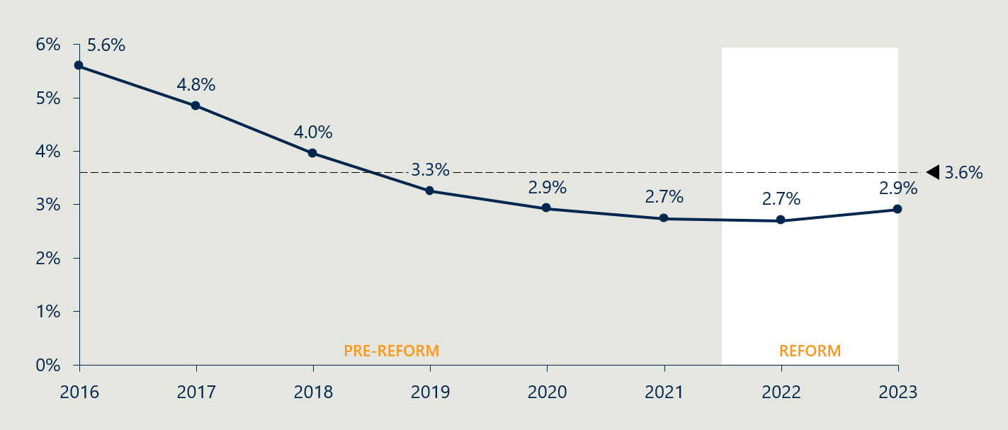

#### While the reforms have lowered the unit price, total prostheses benefits still make up a similar proportion of overall PHI expenditure

A reduction in the total benefits paid for prostheses is the main way in which the PL reforms seek to improve affordability. Examining the percentage of prostheses benefits paid as a proportion of all hospital treatment (HT) benefit payments can assist in isolating the impact of the PL reforms from other changes to PHI that have occurred simultaneously. Figure 12 below shows that the proportion of prostheses benefits to total HT benefits decreased slightly to 13% in FY22 but has increased to 14% in FY23. This is the highest proportion since FY17 but remains within a historic range of 12.5% – 14.5%.

Total prostheses benefits paid by a PHI are a function of the benefit levels listed on the PL and the volume of PL items used. Objective 1 (section 2.3) has established that the reforms have successfully conducted the first two rounds of benefit reductions of PL items, and that the resulting benefit levels are more closely aligned with other markets. This indicates the volume of protheses benefits paid (item utilisation) has increased relative to other HT benefits paid (see section 2.6.3).

Though reduced PL benefits logically mean the premium increases are smaller than they otherwise would have been, the impact of the reforms on the affordability of PHI is difficult to observe in the aggregate. Overall, the impact of the reforms’ downward pressure on PHI costs has been muted by upward pressure on PHI costs from elsewhere.

Figure 12 | Prostheses benefits paid as a percentage of total HT benefits[51]

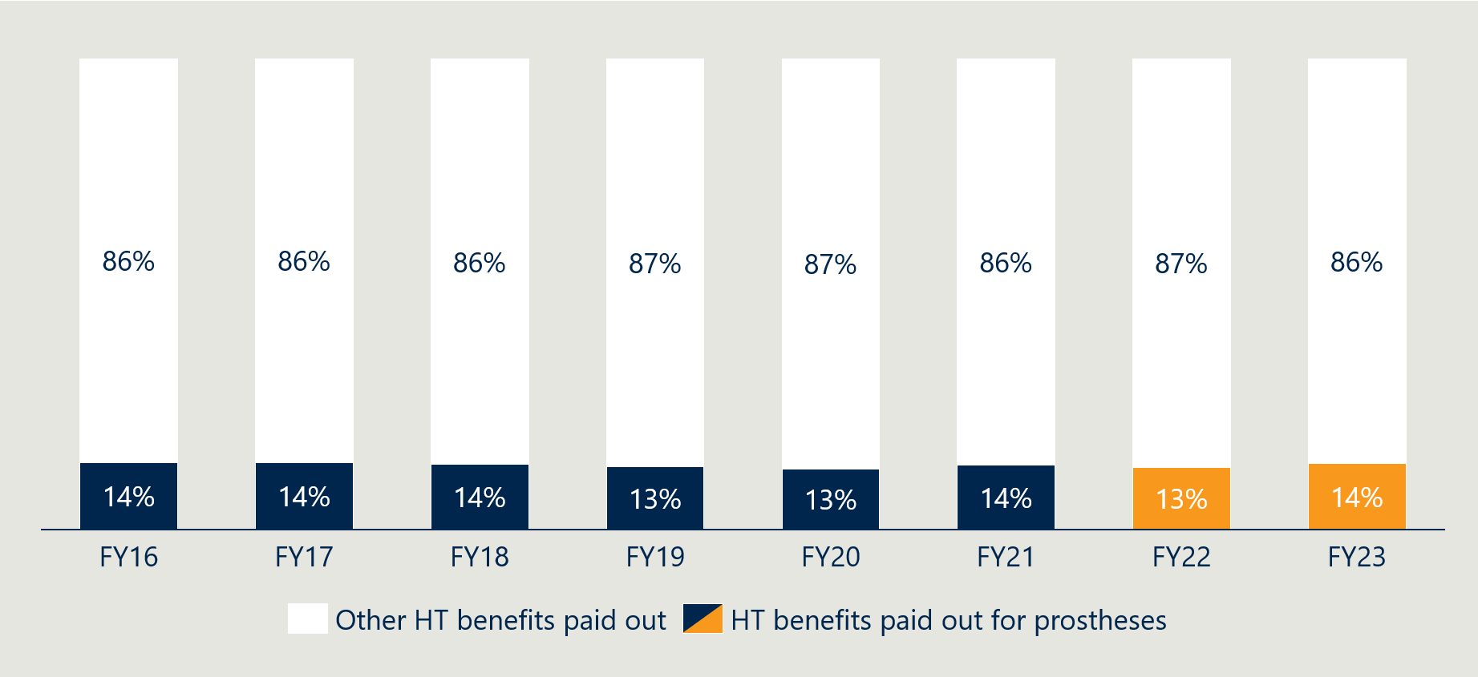

#### While the PL remains a pressure on PHI costs, other system changes are driving overall PHI premiums

If PL reforms are achieving their objective of improving PHI affordability, we would expect premiums to increase at a lower rate than they would have otherwise. However, there are other significant factors that have also impacted PHI premiums increases in recent years, including COVID-19. Average premium increases in 2021-22 were the lowest since 2001 as some insurers did not pass on premium increases to policy holders, instead choosing to defer them in order not to profit from the COVID-19 pandemic.[52] While the average 2023 PHI premium increase of 2.9% was more substantial than in prior years, the increase was lower than the rises in inflation, wages and social security payments in the same year.[53] This can be taken to mean that, in general, the most recent PHI premium increases had a relatively smaller burden on Australians than other costs. However, the ACCC has anticipated that current inflationary pressures may lead to higher premium increases in the future.[54] This evaluation will continue to monitor PHI premium changes when more data becomes available for 2024 and 2025.

The impact of COVID-19 on the broader PHI landscape can similarly be seen in Figure 13 below. This graph depicts the year-on-year premium revenue changes per policy and per person for Hospital Treatment (HT) policies, which includes policies covering PL items. HT premium revenue has been gradually increasing at a decreasing rate prior to the commencement of the PL reform program, however experienced a large spike in FY21-22. This pattern corresponds to elective surgery restrictions implemented in several Australian jurisdictions in response to the Omicron wave, which substantially reduced the levels of HT benefits paid out by insurers, resulting in increased revenue for insurers.

Figure 13 | Average year-on-year premium revenue changes for HT PHI per policy and person (as % of prior year)[55]

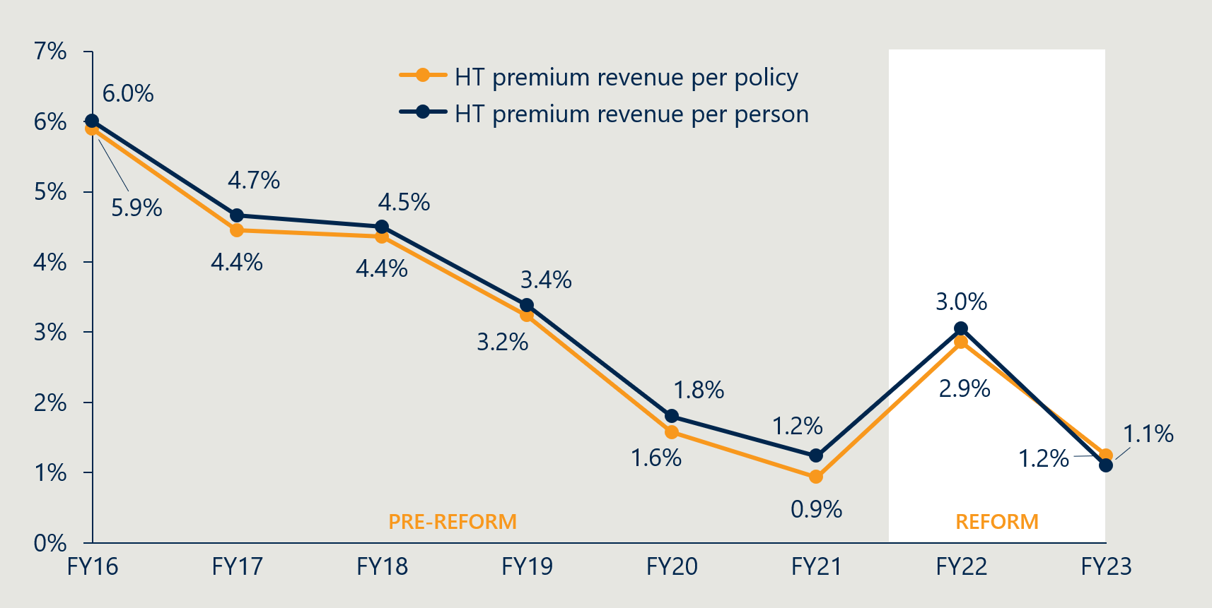

#### Insurers argue that PL costs continue to be high and contribute to greater overall premiums

While there is broad agreement that reductions to PL benefits have been a positive attempt to constrain PHI premium increases, there are mixed perspectives about the key drivers of premium changes. Insurers believe that the reforms have not gone far enough to ensure PL-related savings, and that overpriced and overused medical PL devices continue to affect premiums. Meanwhile, medical technology stakeholders and private hospitals point to increased insurer profit and management fees as a key driver of insurance premiums and state it is unclear whether savings from the PL reforms have been passed on to consumers. Stakeholder perspectives are further outlined in Table 5 below.

Table 5 | Stakeholder perspectives on the drivers of change in PHI premiums and PHI coverage

|  |  |  |
| --- | --- | --- |
| Stakeholder group | | Perspectives on reform project |
|  | Private healthcare providers | The overall cost pressures across the private hospital sector have increased more rapidly than PHI premium increases, and considering this, it appears that premium increases have constrained.  The most significant drivers of insurance premiums in recent years are management expenses and net insurance profit.  It has been a missed opportunity of the reforms not to link cost savings from PL reform to PHI premiums and/or service coverage through regulation or legislation, and believe it is unclear whether savings from these measures have been passed on to customers as either benefits or premium reductions. |
|  | Private health insurance providers | The cost of PL-listed devices remain a material driver of claim costs and premium increases despite the reforms.  The reforms have failed to deliver real savings, constrain unwarranted volume growth and wastage, or ensure cost effectiveness and outcome focused value. |
| *Icon of a microscope* | Medical technology companies | The reductions to PL benefits since 2017 have delivered savings of $4.7 billion to insurers (adjusted for inflation) and PL benefit reductions are the only factor contributing downward pressure on premiums to enable them to rise at historical lows.   * The PL benefits have reduced as percentage of total premium revenue since 2017, while insurers’ profit and management fees have increased from across the same period, taking this to mean that the PL cannot be responsible for upward pressure on premiums. |
| Icon of a person with a stethoscope | Clinician representative | It is sensible to support the pursuit of prices on the PL to be as low as reasonable, but overall prostheses costs are not the largest contributor to costs that drive the affordability and value of private health insurance. |

### PHI coverage is rising slowly

#### PHI coverage has increased by 0.3% since the start of the reforms

15% of Australians dropped or reduced their cover during the pandemic, with younger people more likely to abandon their memberships.[56] PHI coverage numbers indicate changes in consumer perceptions of the value of having PHI. The pandemic exacerbated an ongoing downward trend in PHI membership among young people, as young people tend to get less value of their private health insurance.[57]

The percentage of the Australian population with HT PHI coverage is shown in Figure 14 below. PHI coverage in Australia has increased by 0.3% to 44.8% in June 2023 from June 2021 at baseline. Overall, there has been a steady increase in HT PHI coverage since the lowest coverage in June 2020.

Figure 14 | Percentage of Australian population with Hospital Treatment PHI[58]

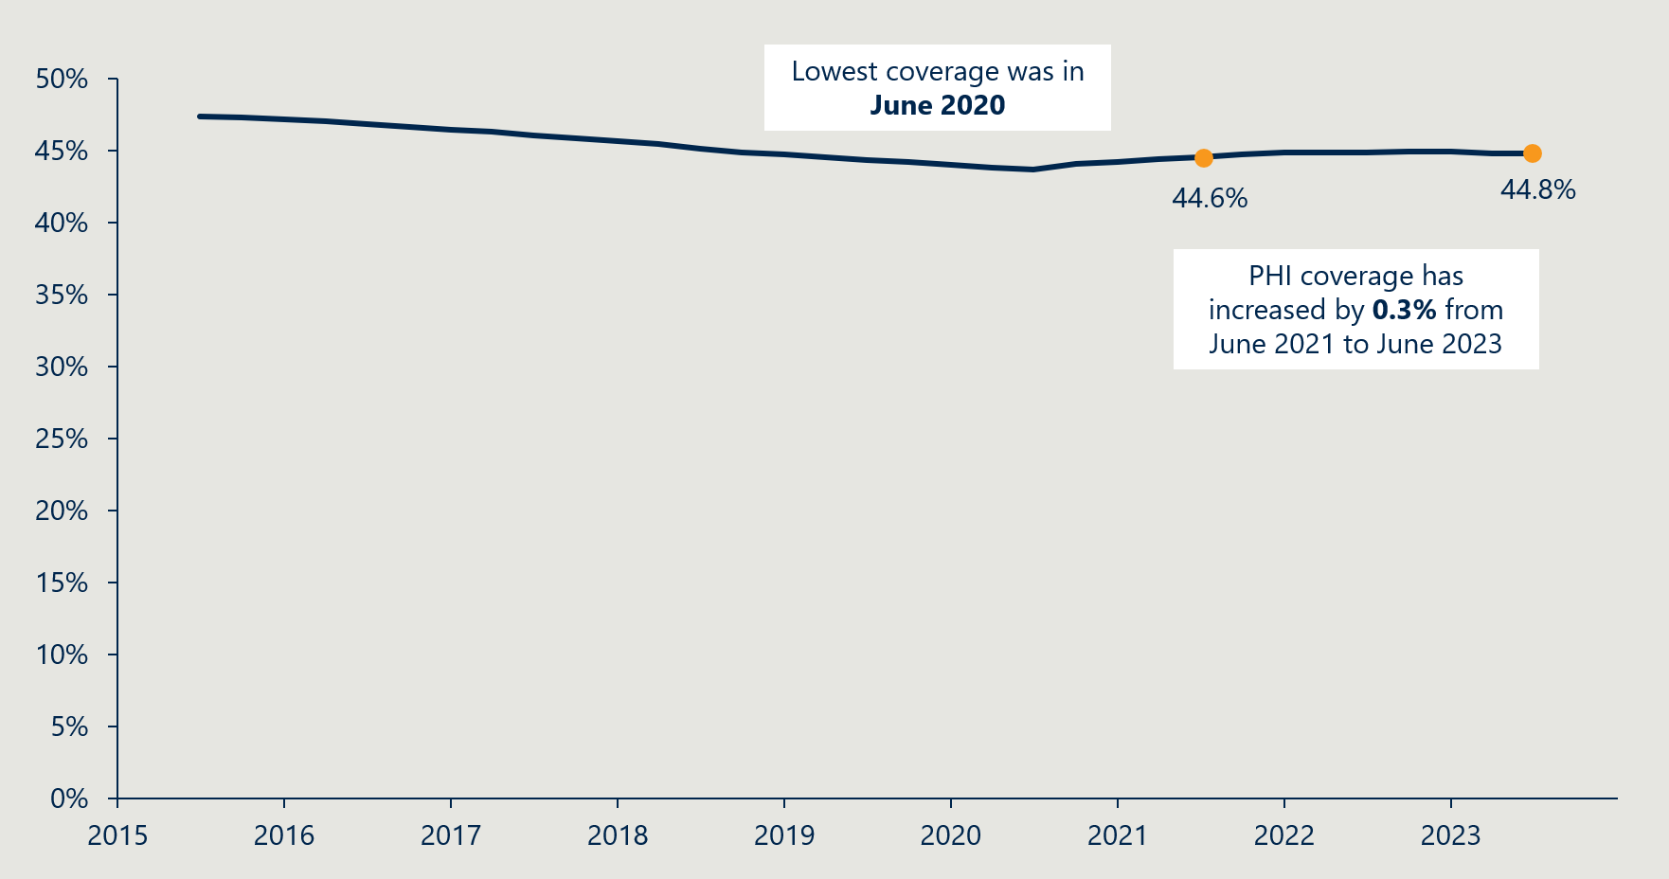

#### Some stakeholders believe increased PHI coverage is primarily driven by growing concern about strain on public hospital post-COVID-19 but is complemented by lower premium rises

Some stakeholders have pointed to ongoing health system pressures as the reason for an increased number of people taking out private health insurance since COVID-19, following a long period of decrease. They state that while lower premium rises may have assisted supporting people to maintain their PHI cover, they believe that consumer concerns about access to public hospitals post-COVID-19 is the greatest driver of increased coverage. Meanwhile, private health insurers continue to be concerned about coverage in Australia and maintain that increased PHI premiums are the main driver of Australians choosing to discontinue or downgrade their health insurance.

### Despite lower PL benefits, higher usage is driving up the overall cost of prostheses

#### The total cost of prostheses benefits has increased from baseline

The total benefits paid by insurers for PL-listed products has increased year-on-year from FY16 to FY21, as can be seen in Figure 15. This expenditure on PL-listed products adds pressure to private health insurers and a contributing factor to increased PHI premiums.

Between FY21 and FY22, prostheses benefits paid by PHI held decreased to $2.2 billon, coinciding with PL reforms and associated benefit reduction activities. However, prostheses benefit expenditure has since increased to $2.3 billion in FY23, which is the highest spend in recent years leading up to baseline. The compound annual growth rate from since the reforms’ baseline is 1.3%. This is lower than the 2.3% growth rate in the five years prior to the reforms and indicates that expenditure on prostheses is growing at a slower pace than it was prior to reforms.

Figure 15 | Total prostheses benefits paid ($'000)[59]

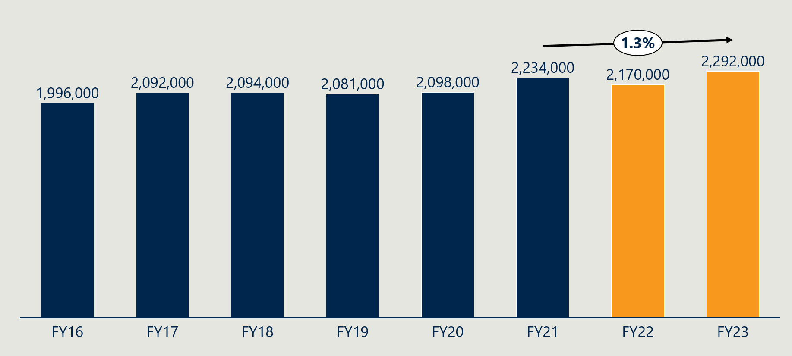

#### Prostheses utilisation is increasing, especially among older Australians

Australians are accessing a higher volume of PL-listed devices, and this is sustaining overall prostheses costs despite lower PL benefit levels. Figure 16 shows that prostheses utilisation per 1000 HT PHI members has continued to follow the growth trend leading up to the reforms, with the exception of a dip in FY22.

Figure 16 | Prostheses utilisation per 1000 HT PHI members by PL category[60]

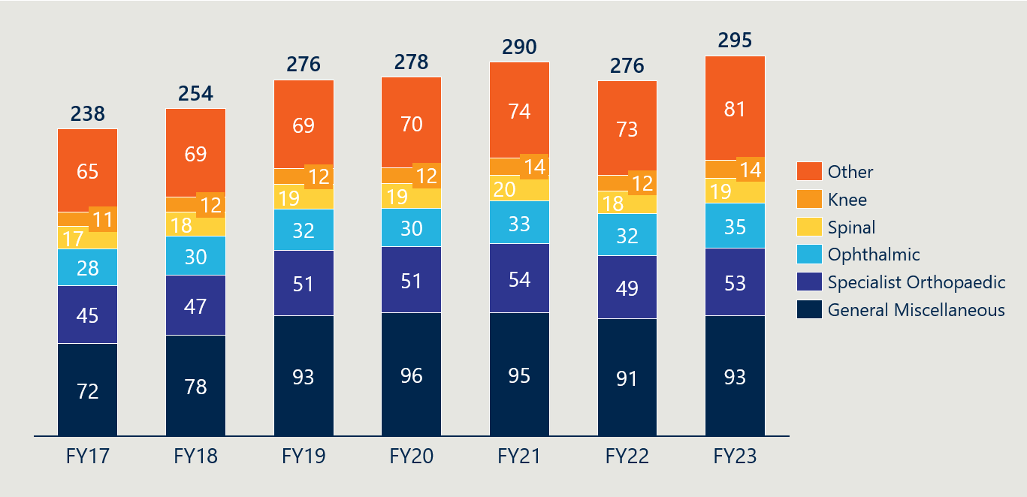

Figure 17 below shows that there has been increased growth in use of prostheses across all age groups between FY17 to FY23, indicating increased demand for prostheses. Whilst there has been greater relative growth in prostheses utilisation in younger age groups (40% increase for ages 0-19 and 44% increase for ages 20-34), prostheses utilisation overall continues to be driven by high use amongst older age groups. In FY23, over 82% of all prostheses usage was by PHI members older than 50.

Figure 17 | Average prostheses utilisation per 1000 HT PHI members by age[61]

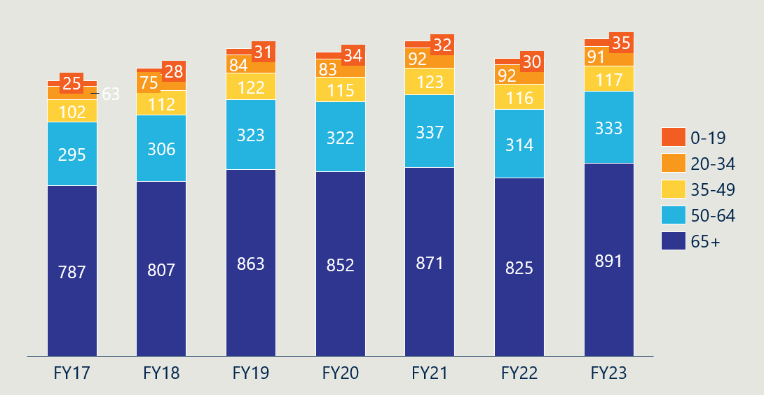

## Objective 5: Clarify the purpose, definition and scope of the PL in legislation

*This section considers legislative changes in support of the PL’s defined purpose and scope, implementation of new grouping structure and implementation of changes to GUIs. It describes progress towards these reform projects and summarises stakeholder perspectives on them.*

Figure 18 | Reform projects related to reform objective 5

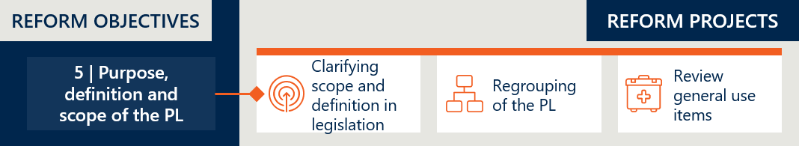

### The reforms have brought about legislative changes

#### Legislative amendments were made to update the PL purpose, definition and scope

The *Private Health Insurance Act 2007* (PHI Act) establishes the Private Health Insurance Rules to specify the minimum and maximum benefits that private health insurers are required to pay for items that are included on the PL.[62] These benefits are paid to a hospital when items included on the PL are provided to someone with eligible private health insurance as part of hospital or hospital substitute treatment and where there is a Medicare benefit payable for a service associated with the use of the item.[63]

The Australian Government sought to make legislative changes to the PHI Act to support the PL reforms, specifically related to clarifying the purpose, definition and scope of the PL. This was driven by the cost of prostheses being identified as a factor in the rising price of PHI premiums and unclear scope resulting in increased complexity and size of the list over time. Critically, the PL lacked a legislative definition of a ‘prostheses’ resulting in items being listed on the PL that could be better funded by other means.[64]

The first tranche of legislative changes was circulated to stakeholders for a formal round of feedback in November 2022, and then introduced into Parliament on 1 December 2022. These bills were passed in March 2023 and made several important changes to terminology and definitions. A second tranche of legislation updated the listing criteria in the newly renamed *Private Health Insurance (Medical Device and Human Tissue Product) Rules*, to further clarify what products are eligible for inclusion on the PL and what is ineligible. A detailed timeline is outlined Figure 19 below.

Figure 19 | Timeline of legislative changes

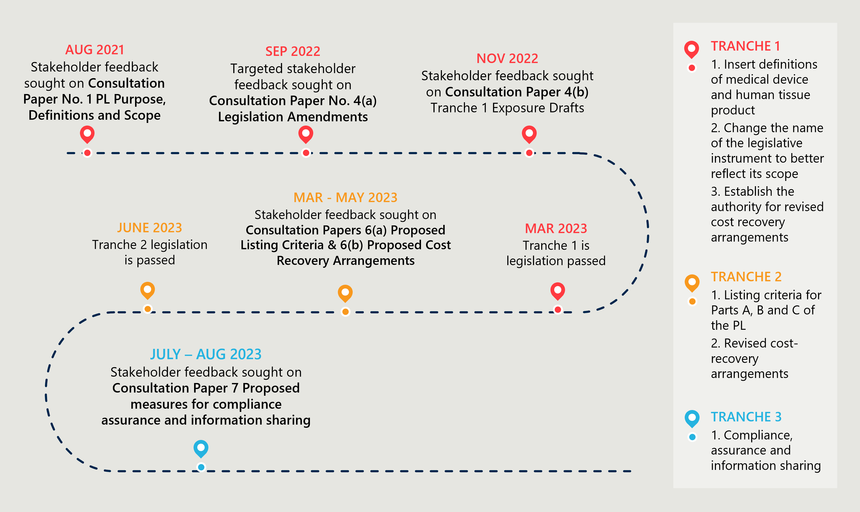

As a result of these changes, the *Private Health Insurance Act 2007* has been updated to replace the term ‘prostheses’ with the more contemporary terminology of ‘medical devices’ and ‘human tissue products’ and has inserted definitions for these new terms in section 72-12 of the Act. A list of these terminology changes is summarised in Table 6 below.

Table 6 | Updated PL terminology and definitions in legislation[65]

|  |  |
| --- | --- |
| Old terms | Updated terms in legislation |
| Prostheses or prosthesis | Medical device or human tissue product |
| Private Health Insurance (Prostheses) Rules (Prostheses Rules) | Private Health Insurance (Medical Devices and Human Tissue Products) Rules (the MDHTP Rules) |
| Prostheses List (Schedule to the Prostheses Rules) | The Prescribed List of Medical Devices and Human Tissue Products (Prescribed List) (Schedule to the MDHTP Rules) |
| Listed prostheses (a kind of prosthesis listed in the schedule to the Prostheses Rules). | Listed device or product (a kind of medical device or human tissue product listed in the Schedule to the MDHTP Rules). |

### The definition, purpose and scope of the PL is more clearly defined in the legislation, however more work is required

The inclusion of definitions in legislation has further defined the scope of the PL however ambiguity on boundary products remain

The amendments to legislation progressed in line with the intentions of the reforms. The Department has succeeded in inserting new definitions and updated listing criteria into the Act as parameters that should provide better clarity around what products are eligible for inclusion on the PL. As anticipated, updated legislation has precluded items that were currently funded on the PL, such as GUIs and medicines from the PL.

However, there are still ongoing concerns about the ambiguity of the PL’s scope. This includes ‘boundary products’, which are defined as therapeutic goods with attributes that make it challenging to determine whether they belong to the category of medical device or medicine, or both.[66] Similarly, the question of whether the PL should include non-device related components (such as the technical servicing component of CIEDs, discussed previously in section 2.3.5) is another critical issue that will have implications for the scope of the PL. As medical device technology advances, it is anticipated that issues around scope and eligibility for the PL will become more prevalent. Additionally, the Department will have to consider what action needs to be taken to retrospectively apply the new definitions in the PL to existing items where they are now found to be ineligible.

The decision to retain GUIs on the PL is likely to require the reversal of some changes

GUIs were scheduled to be removed from the PL list, with support to be provided to the private sector to establish alternative arrangements for the payment of benefits for these items. However, this outcome of the reforms has been diluted since the Minister’s subsequent announcement in May 2024 that benefits for GUIs will continue to be paid using the PL. This will likely necessitate further legislative updates to ensure the medical device and human tissue product definitions and PL listing criteria are consistent with this decision. The decision to retain GUIs on the PL is further discussed in section 2.7.4.

Stakeholders continue to dispute the scope of what should be included on the PL

Stakeholder feedback on exposure drafts on Tranche 1 of legislation was overall supportive of the measures included in the bills.[67] While stakeholders have disparate views on whether GUIs should be funded through the PL, all stakeholders who responded to consultation agreed that legislative amendments have not provided sufficient clarity about the scope of the PL in the context of recent GUIs decisions, and that further work is required.

Table 7 | Stakeholder perspectives on the definition, purpose and scope of the PL

|  |  |  |
| --- | --- | --- |
| Stakeholder group | | Perspectives on reform project |
|  | Private healthcare providers | The definitions under the PL are still in dispute regarding clarity and being considered fit-for-purpose, as they were drafted with the presumption that Part D would be removed.  This makes the Department’s position that medicines do not belong on the PL a contestable position. |
|  | Private health insurance providers | The revised PL definition and listing criteria in legislation does not apply to GUIs in Part D of the PL.  It is recommended that the Department develops specialised listing criteria, applications and assessments to ensure there is full evaluation of the comparative clinical and cost effectiveness GUIs. |
| *Icon of a microscope* | Medical technology companies | There is not much additional clarity that has arisen from legislative changes.  The exclusion of registered medicines will impact products recognised as ‘boundary products’ on border between devices and medicines that are used like devices and listed on PL as best mechanism for funding.  Consultation did occur for listing criteria for Part C, but these remain untransparent without clear basis for decision making. |
| Icon of a person with a stethoscope | Clinician representative | Generally comfortable with the changes, however generally calling it a ‘medical device list’ limits advancements by its name. We do now know what technology may arise next, could be a software.  GUIs now stick out as not aligning to the new definition and scope. |

### Progress towards regrouping the PL has been paused

Regrouping commenced with a clinical lens, agnostic of product benefit

Regrouping of the PL was intended to provide transparency around PL items and increase the PL’s ease of use.[68] This was in response to the PL being considered unwieldy, alongside a notion that this made the PL more difficult to administer, driving cost and unnecessary complexity. As of 2021, the PL contained 11,600 billing codes and 1,700 unique groupings.[69] Regrouping the PL was viewed as a complementary measure to the legislative work the clarify the scope and purpose of the PL. Some stakeholders believe the current PL item groupings contribute to a variety of issues that result in some PL items being overpriced, such as:

Inclusion of items in sections of the PL inconsistent with their actual or intended use

Differences in benefit amounts that are not explainable by clinically relevant product differences

The use of inappropriate comparator products, or reclassification of existing products into higher benefit subgroups or suffix groupings, which is viewed to be evidence of gaming.[70]

The 12 March 2022 MOU between the Government and the MTAA informed how this project was undertaken, as it specified that “the new grouping structure is not to be an additional source of savings on top of the overall reference price savings”. To ensure this, the regrouping project sought to align its structure to the clinical application of items, agnostic of item benefits. A large portion of the regrouping project was completed in 2022, led by external consultancy company hereco and guided by the Clinical Implementation Reference Group (CIRG), chaired by then AMA President Omar Khorshid. The regrouping adhered to the following principles[71]:

Grouping like-for-like products together with new groups based on clinical care, not product features

Use of a hierarchical classification structure

A consistent approach across product categories.

In December 2022, hereco released a guide to the proposed structure for Part A of the PL. It was intended that the final PL structure would be published ahead of the round of PL device applications in September 2023[72], however, as of July 2024, the original PL structure continues to be in use. The Department discovered that the multitude of products considered to comprise a “mixed benefit group” from the proposed structure added significant complexity to regrouping, as further discussed below. As a result, the Department has not proceeded with finalising the proposed regrouped PL structure recommended by hereco, and this project has been paused.

Figure 20 | Timeline of regrouping changes

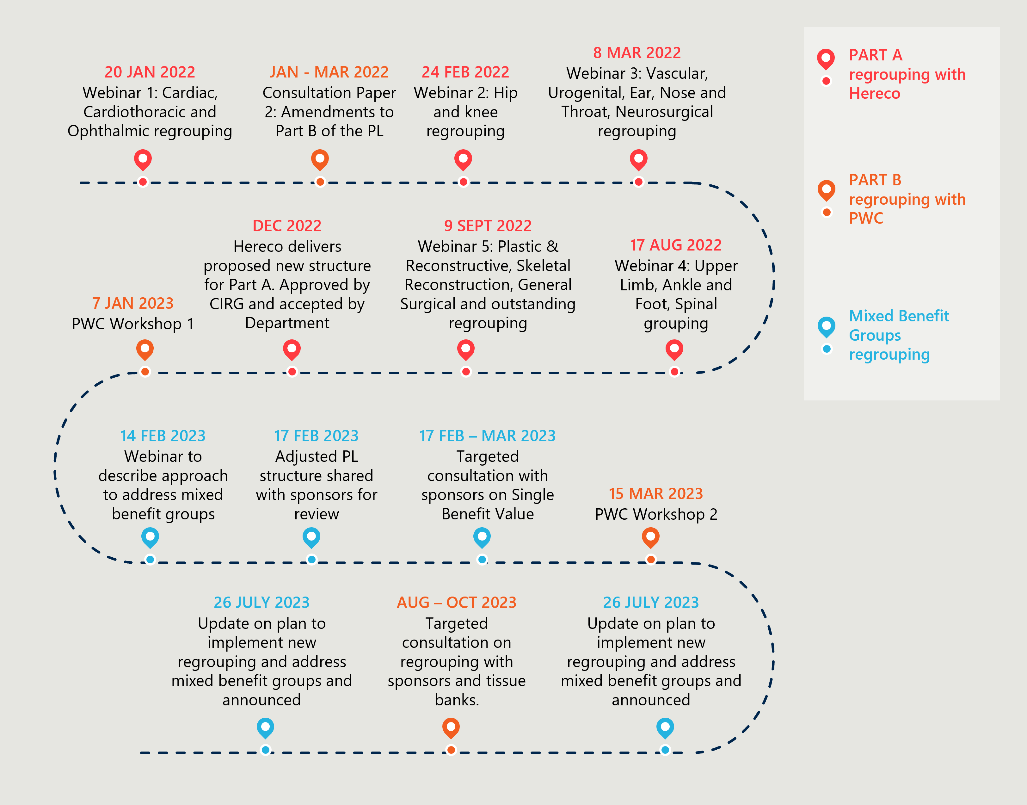

Unresolved challenges with mixed benefit groups are a barrier to finalising the regrouping

Under hereco’s regrouping work, clinically similar or ‘like-for like’ devices were brought together under a single group/subgroup. However, this clinical lens did not apply to all tiers of the PL with features such as suffixes and size remaining below the clinical groupings. The initial regrouping exercise was linked to clinical use only, with no cost-benefit issues in scope and considered “off-limits” due to the MOU. The resulting proposed structure appeared to have reduced complexity than the original with one less tier in the classification hierarchy.

The ideal outcome of the new PL structure was for groups/subgroups to have a single benefit value (SBV) assigned to all the items in the group. However, some groups/subgroups in the proposed PL structure had a large variation in the benefit amount for items within the group/subgroup, which was termed a ‘mixed benefit group’. The Department worked to develop an approach to addressing mixed benefit groups. This approach identified subgroups with benefit amount variance and applied a serious of threshold tests to decide what action was required. For some groups, they intended to assign a weighted average benefit as the single benefit for the subgroup, but for others the Department intended to perform manual intervention to lower the variance across items. Of the approximately 500 subgroups identified, approximately 200 would require manual intervention.[73] The regrouping activity reached a point where it was appeared unfeasible to proceed without re-assessing every single mixed benefit group.

This issue was never resolved and as a result, the reform has not been implemented as intended, with the regrouping project currently paused and the previous PL adopted into the technology platform. The Department has cited that methodological decisions and Departmental capacity issues are major contributing factors to regrouping being stalled.

Additional consideration of clinical care and cost of items would have bolstered the reform project from the outset

The work in this project attempted to streamline the PL through a starting lens of clinical use only. It has now been discovered that mixed benefit groups are too complex to resolve fully whilst also avoiding unintentionally creating any benefit savings, as agreed by the then Minister in the MOU. In hindsight, considering both the use of items and their cost is critical. Further work to progress re-grouping the PL would need to take both together as a starting point.

Some stakeholders believe the MOU was responsible for halting progress of regrouping the PL, while others maintain there were options to resolve regrouping challenges that were not pursued by the Department

The unfinished regrouping project has been critiqued by various stakeholders. Insurers believe that the MOU is responsible for limiting the effectiveness of the regrouping work and has made it unfeasible to devise a list that is both clinically consistent and reasonably priced for consumers. Meanwhile, medical device companies instead maintain there are options to resolve regrouping if the Department wanted to persist with regrouping by clinical use only.

Table 8 | Stakeholder perspectives on regrouping[74]

|  |  |  |
| --- | --- | --- |
| Stakeholder group | | Perspectives on reform project |
|  | Private healthcare providers | There should be further clarity in benefit rules when devices are used outside their prescribed list groupings. |
|  | Private health insurance providers | The MOU has limited the effectiveness of the regrouping work, as many items are currently grouped in a way that results in them being overpriced.  The organising principles used in the regrouping work (patient-centred, similar intended use or outcomes, not splitting individual components) are supported. |
| *Icon of a microscope* | Medical technology companies | The alignment of groupings with clinical usage was strange criteria, as different types of technology need to be costed differently.  The groupings have not changed despite long consultations and asserts that industry has offered concrete solutions to simplify groupings without breaching the MOU requirement not to incur additional savings. |
| Icon of a person with a stethoscope | Clinician representative | Regrouping has culminated in wasted time and effort by the CIRG due to the key missing step of involving industry in regrouping.  It was misguided to approach regrouping without considering commercial viability as the groups on the PL relate to how much is paid for an item. For example, clinicians do not know the cost implications of a metal vs ceramic version of a device.  Regrouping is largely irrelevant to clinicians who generally only interact with the PL to make sure the device they want is listed. Most clinicians have never heard of a PL group as it relates to how much is paid and they do not have a direct financial interest to the device used. |

### Lack of agreement to alternative funding arrangements has resulted in GUIs being retained on the PL

The removal of GUIs was delayed in an attempt to facilitate bundling arrangements for stakeholders

The original stated intention of the reform was for GUIs to be removed from the PL by 1 March 2022 however, this process was delayed, providing the Clinical Implementation Reference Group (CIRG) time to review the potential impacts of the removal of these items.82

In the interim, a gradual reduction of the difference between the benefit and the public Weighted Average Price was to be put in place, followed by a revised date for removal of the items of 1 July 2023. This was subsequently delayed again to 1 July 2024. Prior to the intended removal of GUIs in July 2024, the Department announced in June 2023 that they would no longer be accepting new applications for listing GUIs on the PL, as the timeframes to consider applications prior to their removal would be impractical.[75] In the lead-up to this removal date, the Minister announced that GUIs would be retained on the PL.[76]

The schedule of these changes are as follows:

Removal from the PL on 1 March 2022 (delayed)

Reduction of 60% of the difference between the PL benefit and the weighted average price from 1 July 2022 (completed)

Reduction of 40% of the difference between the PL benefit and the weighted average price from 1 March 2023 (completed)

Removal from the PL on 1 July 2023 (delayed)

Removal from the PL on 1 July 2024 (dropped)

At the time of reporting, GUIs are to remain indefinitely on the PL.

Alternative arrangements were pursued but ultimately unsuccessful

There were ongoing concerns about the high utilisation of certain groups of products in the General Miscellaneous category of PL and elsewhere, and whether these items met the PL list criteria.[77] The Department identified a group of over 500 general use and consumable products for removal from the PL. These identified products either did not meet the pre-reform criteria for listing or would not meet the new definition or listing criteria agreed throughout the reforms.

During the implementation of the PL reforms, the priority for Department was streamlining the PL’s scope and range of products and put downward pressure on PHIs by taking cost out of the system. The Department sought the views of the then Clinical Implementation Reference Group (CIRG) who advised that products could be removed from the PL with no clinical implications or adverse outcomes if the products are still available for use by doctors under an alternative funding agreement.[78]

Figure 21 | Timeline of actions related to GUIs

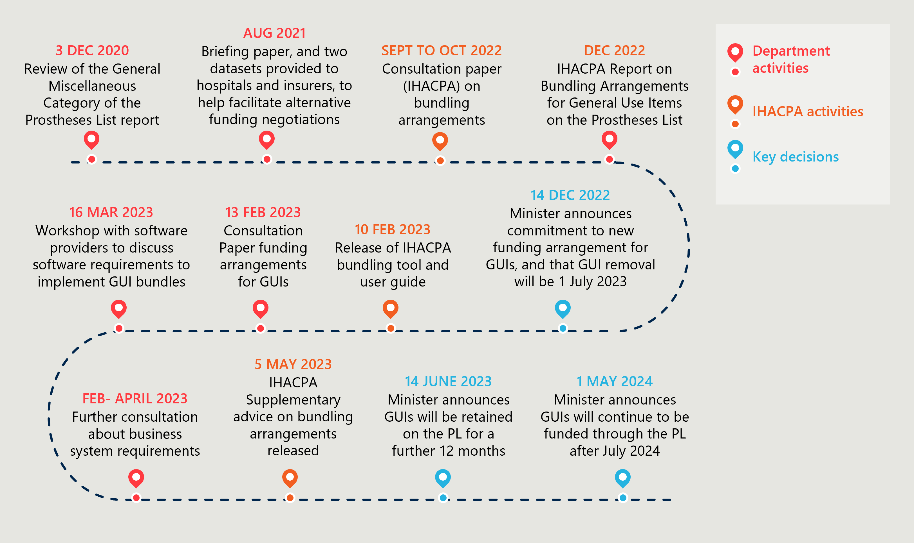

The Department endeavoured to facilitate alternative funding negotiations between insurers and hospitals. IHACPA was commissioned to assist these stakeholders, releasing a consultation paper and final report on potential bunding arrangements in late 2022. On 14 December 2022, the Department committed to a non-PL based method of funding, and IHACPA was tasked with the methodology for the bundling arrangements. Stakeholders were then invited from 13 February 2023 to 27 March 2023 to provide feedback on the subsequent GUI bundling tool made by IHACPA and the bundling of benefits for GUIs.

An agreement about bundling arrangements did not come to fruition, although private health insurers had committed to the alternative funding arrangement. Some stakeholders continued raising issues with negotiating alternative funding arrangements for GUIs, and raised the negative clinical implications and potential adverse outcomes to patients should PL GUI funding cease. Hospitals also had concerns about the compatibility of the proposed funding arrangements with their existing data systems, and whether they would be financially worse off under new arrangements. The removal of GUIs was delayed by 12 months until 1 July 2024 to allow the sector to make necessary arrangements and ensure no adverse impacts to patients.

On 1 May 2024, the Minister announced that GUIs would continue to be listed and funded through the PL after 1 July 2024, retaining 475 billing codes that were scheduled for removal, citing that careful consideration of stakeholder feedback led to this decision. In this announcement the Minister flagged that the draft Private Health Insurance (Medical Devices and Human Tissue Products) Rules and Prescribed List Guide will be updated to reflect this retention of GUIs, and that the intent of the GUI listing criteria will be to maintain the existing scope of the Part D grouping scheme.[79]

The decision to retain GUIs illustrates the complexity of balancing clearer PL scope with minimising administrative burdens of these reforms on industry

The decision to not proceed with the reform indicates that health policy priorities and settings have shifted since the commencement of the reforms in 2021. This included feedback and concern from hospital stakeholders that they would not be financially viable without assured funding for GUIs through the existing mechanism of the PL. The ministerial announcement cited stakeholder concerns regarding alternative funding arrangements for GUIs and potential negative clinical implications or adverse outcomes to patients should GUI funding cease through the PL without alternative arrangements settled.[80]

Additionally, through IHACPA’s modelling, it became clear that changing processes would also have a high administrative burden, especially requiring additional contract arrangements between players. Issues like this, brought into focus that the original intention of the reform was to reduce cost and pressure, and not to remove the GUIs from the system overall, just from the PL with an alternative funding arrangement in place. Removing GUIs without alternative arrangements could have either required additional contracting impost placed onto private hospitals and/or potentially shifting these costs onto consumers.

The original scope of the PL reforms in this area were in part predicated on making the PL more defined and tighter in scope. The mechanics and administrative burden of implementing revised arrangements were perhaps underestimated along with the cumulative impact of having these items not captured by the PHI rules and arrangements.

Overall, the reductions in benefits for GUIs on the PL decreased overall system costs without imposing additional administrative burdens on private providers. If the Government intends for GUIs to be funded by PHI, then the PL currently serves as the mechanism for this. Though not achieving greater clarity on purpose and scope (and having facilitated a resource-intensive engagement process), the reforms still achieved sought-after reductions at a system level.

#### Stakeholders continue to express varied opinions about the validity of GUIs on the PL but agree that the reform failure was costly in terms of resources expended and associated consequences

In general, the retention of GUIs on the PL is supported by private hospital operators, clinicians and sponsors, while insurers maintain that GUIs are out of scope, as set out in the original intentions to clarify and streamline the list. One insurer has estimated that the ‘last minute’ decision to abandon the GUI removal has cost its members over $250,000 in development costs that cannot be recovered.[81] Insurer representatives also have ongoing concerns about the volume of GUI use as a result of them remaining on the PL.

Conversely, sponsors have raised concerns that clinician choice surrounding GUIs will be affected if the Department does not allow for the creation of new benefit groups in Part D. Since the announcement that GUIs will remain on the PL, the Department has advised sponsors can apply to list a GUI if a comparator already exists on Part D. [82] These applications will be considered by the Department from the November 2024 PL onwards. It is unclear whether this condition for GUI listings on the PL will remain going forward and this approach can be considered further in future evaluation reports.

Table 9 | Stakeholder perspectives on GUIs

|  |  |  |
| --- | --- | --- |
| Stakeholder group | | Perspectives on reform project |
|  | Private healthcare providers | The retention of GUIs on the PL to provide surety of service availability is supported, as their removal would be immensely disruptive to the sector, disproportionately impacting rural and regional hospitals.  The negative impact of this proposed reform should have been foreseen by the Department earlier, and the reform was driven by inequitable preference towards insurers in consultation and co-design. |
|  | Private health insurance providers | Reversal of GUI decision is a significant failure of probity, as the evidence base for the decision to cancel this reform has not been transparent.  Insurers have made significant investments in co-designing alternative GUI funding arrangements in good faith, incurring large, non-recoverable costs, resulting in members bearing the cost of reform failure. |
| *Icon of a microscope* | Medical technology companies | GUIs were not managed well due to misunderstanding by Department about impact of removing them.  Retention was the right decision at the expense of large amounts of effort and resources.  The current decision to not allow new groupings for GUIs is flawed, as it creates a grandfathering instrument rather than a working list. |
| Icon of a person with a stethoscope | Clinician representative | The AMA acknowledges the justification to pursue removal of GUIs as part of the reform, as GUIs are not aligned with PL scope and definition  However, the AMA has always maintained that GUIs are not an optional extra, are part of modern surgery and require funding.  This reform project failed due to lack of trust within the system, especially between insurers and hospitals.  The AMA believes that the establishment of an independent body is required in this space to bring stakeholders in the sector together and achieve consensus on reforms. Without this, reform will ‘continue to be piecemeal and limited at best’[83], as played out in the GUI reform decision. |

## Objective 6: Implement new PL assessment pathways aligned to Health Technology Assessment principles and streamline the application process through simple and robust IT infrastructure

*This section considers the implementation of new applications pathways and governance processes involved in their assessment. It describes the changed arrangements, documents the volume of PL application by tier and outlines stakeholder perspectives on the assessment pathways and listing processes.*

Figure 22 | Reform projects related to reform objective 6

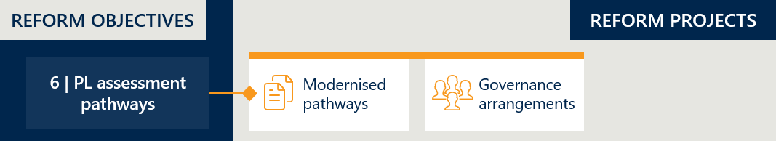

### New assessment pathways and governance processes are in place

The reform program includes the review of two key components of the assessment process: the pathways by which applications are submitted for assessment, and the governance processes that drive the assessment of medical devices. As part of this reform program, the Department has completed independent reviews of each of these components and implementing changes to both the PL application assessment pathways and PL governance.

#### The Department has implemented tiered assessment pathways

The Department released a consultation paper between 11 January 2022 to 4 March 2022 to gather stakeholder perspectives on changes to modernise listing pathways. This was proposed to be done by aligning to Health Technology Assessment Principles (HTA). It would allow for applications of differing complexity to be dealt with via different pathways.[84]

The updated assessment pathways are organised into three tiers with evidence requirements tailored for each pathway, can be seen in Table 10 below. These pathways cover new listing, amendment, compression and expansion applications. Applications may be made for listing medical devices on Part A or Part C, and human tissue products on Part B on the PL. At the time of new pathway design, listing arrangements for Part D (GUIs) were not considered due to their scheduled removal from the PL in July 2024. Following the decision to keep the GUIs on the list.

Table 10 | Tiered assessment pathways for PL devices

|  |  |
| --- | --- |
| Tier 1: Departmental Assessment Pathway | Assessment pathway for devices with well-established technology with proven records of satisfactory safety and performance  The device must be listed in an existing PL grouping, and sponsors cannot change billing code groupings for amendment applications submitted to this tier. |
| Tier 2: Clinical / Focused HTA Assessment Pathway  2a: Clinical Assessment Only  2b: Clinical and economic assessment | Assessment pathway for devices that are not suitable for assessment via the Tier 1 Pathway that require clinical assessment by the respective ECAG, and in some cases HTA. All applications made via Tier 2 are considered by MDHTAC. Tier 2 includes:   * + Part A applications that are not well-established technology and/or have high variability in design and characteristics, and/or the sponsor claims novel features, characteristics and functionality   + Listing applications that require new groupings or amendment applications that request to change the grouping   + Part C applications. |
| Tier 3: Full HTA Assessment Pathway – MSAC Assessment | Assessment pathway for devices that meet any of the following conditions:   * + The device is novel or first-in-class technology and/or there are no appropriate comparators on the PL.   + There is no relevant MBS item associated with the use of the device, requiring a new MBS item or an MBS descriptor to be modified.   + Where listing the device will cause significant financial impact on overall PL expenditure and therefore warrants detailed financial assessment. |

#### Sponsors are primarily applying for the tier 1 pathway

Since operationalising the new tier structure, the Department has received a much larger volume of applications being submitted as Tier 1 that should have been submitted to be assessed under Tier 2. This is shown in Table 11 below.

Table 11 | Applications by tier between September 2023 and April 2024 (Part A and C)[85]

|  |  |  |  |
| --- | --- | --- | --- |
|  | Tier 1 | Tier 2 | Tier 3 |
| New | 282 | 239 | 0 |
| Amend | 199 | 47 | 0 |
| Expansion | 19 | 5 | N/A |
| Total | 500 | 291 | 0 |

One contributing factor to this may be the transitional tiered assessment application arrangements for sponsors that the Department has established. The draft PL Guide states it is the responsibility of sponsors to select the appropriate tier for their device application and if their application is rejected from a lower tier, the applicant is required to resubmit under the more applicable pathway and is subject to further application and assessment fees.[86] Currently, PL device applications are operating under interim arrangements where sponsors are still required to apply to the appropriate tier based on the provided guidelines, however the Department will action in the correct pathway without any additional cost to re-submit if the incorrect pathway is chosen.

While these interim arrangements may result in additional administrative burden for the Department, as incorrectly submitted applications do not attract additional cost recovery, they may equally assist in alleviating the administrative burden of sponsors learning to navigate the new pathways and system. Attuned to emerging application volumes, the Department should carefully consider when to move onto the standard arrangements outlined in the draft PL Guide.

#### Governance arrangements were reviewed and underwent changes

The Department intended reforms to governance arrangements surrounding the processing of applications to increase the effectiveness and efficiency of its assessments. This would affect the role, function and membership of the Prostheses List Advisory Committee (PLAC), and its subcommittees. The reforms set out to ensure there was the right level of clinical expertise available for the consideration of each application and to enhance collaboration and knowledge sharing within groups involved in the assessment process.

On 17 January 2023, the Minister announced new PL governance arrangements to transition the PLAC to the Medical Devices and Human Tissue Advisory Committee (MDHTAC), following two reviews into governance arrangements and application assessment pathways of the PL. This timeline of changes to these processes are set out further in Figure 23 below.

Figure 23 | Timeline of changes to governance arrangements and application assessment pathways

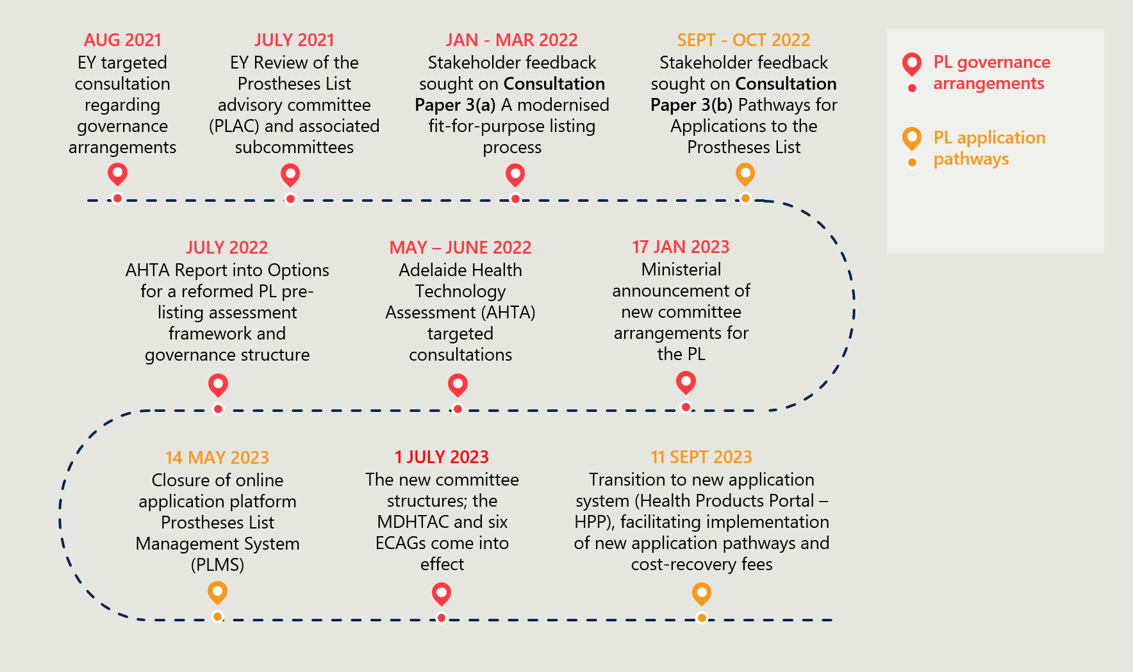

The MDHTAC commenced on 1 July 2023 and meets three times per year. The primary role of the MDHTAC is consistent with the previous PLAC, in that it exists to make recommendations and advice to the Minister about the comparative clinical effectiveness and cost effectiveness of medical devices and human tissue products on the Prescribed List, and the benefits payable by private health insurers.

The modernised structure of the MDHTAC was intended to include a larger number of clinical experts to strengthen advice provided to Government.[87] The committee is ministerially appointed, consisting of a Chair, six chairs of newly restructured Expert Clinical Advisory Groups (ECAGs), up to two independent members with expertise in the medical technology and/or HTA, who are not members of any of the ECAGs, and a consumer member. MDHTAC deliberations and recommendations are recorded in Minutes, however they are not published as the information considered by the MDHTAC and its subcommittees is commercial-in-confidence.

The ECAGs function as a sub-committee of the MDHTAC, with membership intended to be reflective of a broad cross section of clinical practice in Australia. ECAG Chairs provide a connection between the MDHTAC and the respective ECAG, with each Chair leading matters of discussion related to their ECAG.

Under the updated governance structure, there are six ECAGs, organised by areas of specialty:

Specialist Orthopaedic (shoulder, ankle, upper limb and skeletal reconstruction)

Hip and Knee

Ophthalmic

Spinal and Neurosurgical

Cardiovascular (cardiac, cardiothoracic and vascular)

General Surgery (ear, nose and throat, plastic and reconstructive, urogenital and all other general surgery devices).

A key change from the PLAC to the MDHTAC was the removal of industry representation from the committee. Previously, the PLAC structure allowed for attendance by industry advisors from the private health insurance, private hospital and medical device industries.[88]

### Assessment processes post-reform have improved alignment with HTA principles

The Department is guided by a set of Health Technology Assessment (HTA) principles that define the way that assessment processes like this should occur. The report *Review of health technology assessment in Australia* established the principles that should guide HTAs in Australia.[89] These principles are:

1. Sustainable
2. Transparent, accountable and independent
3. Consultative and reflective of Australian community values
4. Administratively efficient
5. Flexible and fit for purpose
6. Informed by robust and relevant evidence.[90]

Across the board there has been improvement in the alignment of PL assessment processes post-reform to the HTA principles, including for the principles of *sustainable, independent, reflective of Australian community values, flexible and fit for purpose,* and *informed by robust and relevant evidence*. The level of alignment for the principles of *accountable* and *consultative* has not changed substantially, remaining at similar level to the previous arrangements.

Some stakeholders have raised concerns that transparency over PL decision making has decreased due to their removal from any governance committees. This change appears to reflect the reform’s focus increasing the independence of the MDHTAC as a priority. The Department has also flagged *administrative efficiency* as one principle that may be at risk of reduced alignment post-reform and should be monitored as the new assessment pathways become established. A more detailed analysis of the alignment of the post-reform assessment processes to HTA principles is summarised in Table 12.

Table 12 | Description of reformed PL listing pathways and governance as aligned to HTA principles

| Principle | Description |
| --- | --- |
| Sustainable | * It is anticipated that revised cost-recovery fees for PL application assessments that are aligned to the anticipated complexity of each assessment will be a positive improvement for the PL’s sustainability.   *A formal review of the economic sustainability of the PL (and its components) is not in scope for this evaluation. Separate from this evaluation, an independent review is being conducted of the cost recovery arrangements associated with the application process.* |
| Transparent, accountable and independent | * Transparent: The level of transparency of the new MDHTAC and associated ECAGs sub-committees is equivalent to previous PL governance arrangements. Deliberations and recommendations of both bodies are recorded as minutes; however, they are not published as this information is considered commercial-in-confidence. At this stage, public summary documents are not available. As the MDHTAC often makes decisions that are relevant to sponsors in addition to the party making the application, expressing a new precedent or policy, it would be relevant for the Department to publish a summary of these decisions for the information of affected stakeholders. In terms of assessment pathways, insurers object to the removal of payor scrutiny in the new Tier 1 abbreviated pathway as they claim this will reduce transparency for more than half the volume of PL applications.[91] * Independent: The new PL governance has improved their independence from industry. Unlike the previous PLAC, the MDHTAC does not permit any advisory representation from medical device companies, insurers or hospitals, which had previously been critiqued for opening up the PLAC to real or perceived conflict of interests.[92] Instead, the MDHTAC includes one consumer representative, and up to two clinical or health technology assessment experts, who are required to declare potential, perceived or actual conflicts for each meeting being considered. This change has been criticised by the MTAA who predict this removal risks reducing sector transparency and result in inconsistent decision making in the assessment process. It is too soon to evaluate the effects of removing these advisors. * Accountable: As with the previous governance arrangements, there are no formal mechanisms by which members of the MDHTAC or its ECAGs are accountable for the listing of devices on the PL. Advice from these governance bodies is independent of the Department, however their recommendations do not need to be taken, and ultimate responsibility for the PL rests with the Minister. |
| Consultative and reflective of Australian community values | * Consultative: Internal discussion within the MDHTAC and ECAGs represents the extent to which the PL assessment process involves consultation. Some stakeholders have argued that their exclusion from these discussions will negatively affect the quality and completeness of information available to inform decision-making. * Reflective of Australian community values: The MDHTAC includes one consumer representative, which can be taken as an attempt to ensure that the perspective and interests of the Australian community is also considered in PL assessment decision making. |
| Administratively efficient | * While the introduction of tiered assessment pathways is viewed as a positive reform, the Department has also noted they anticipate that having four distinct tiers of PL applications will result in more administrative effort. * Currently, transitional arrangements are in place for the new tiered pathways wherein sponsors are not charged for an incorrect choice of assessment tier. When applications are received and are unsuitable for a specific assessment tier, they are re-directed to the more appropriate tier manually by the Department. This has culminated in a large volume of unsuitable Tier 1 applications that have had to be manually re-directed by the Department.[93] * Stakeholders and the Department have noted that challenges associated with the rollout of the new Health Products Portal (HPP) may have also impacted the efficiency of the new pathways. The HPP is not in scope for this evaluation. |
| Flexible and fit for purpose | * In previous arrangements all PL applications underwent the same overall assessment process, described as not fit-for-purpose with feedback suggesting it is inefficient, ineffective, and requires improvements.[94] Use of tiered pathways provides the Department with a more consistent and fit-for-purpose approach to assessing device applications. The new PL assessment process considers the level of complexity that each application requires, with greater flexibility to channel effort where it is most required. |
| Informed by robust and relevant evidence | * Evidence requirements vary for each assessment pathway tier and have been tailored to be responsive to the requested PL benefit group and the degree of novelty of the device. * Medical device companies have claimed that the new evidence requirements for listing, resulting in new technologies being rejected for listing and delays to patient access. * Decision making by the MDHTAC draws on expert advice from the relevant ECAG and it is important that the number and balance of expert coverage is correct. One stakeholder referred to the fact that orthopaedics is a substantial portion of the PL, and that the hips and knee specialties should be split into distinct ECAGs, or at least have an equal amount of hip surgeon representation to ensure voting is not influenced by members without significant expertise in an area. |

## Objective 7: Develop and implement PL listing reviews and PL compliance frameworks to safeguard the PL Reforms

*This section considers developments related to post-listing reviews, including the implementation of a guiding framework and pilot reviews. This section also considers the implementation of a compliance strategy and associated compliance activities. It documents the types of compliance activities conducted and summarises stakeholder perspectives on the reform project.*

Figure 24 | Reform projects related to reform objective 7



### A new post-listing review framework has guided four pilot reviews

#### The Department has developed a working version of the post-listing review framework

The Department released a post-listing review framework on 1 July 2022. The intent of the framework was to improve post-listing processes and carry out post-market reviews. The framework outlines the post-listing review process for commencing, conducting and implementing a review. The Department has primary responsibility for post-listing reviews, however, relies on affected sponsors to provide key information and data to enable the review.

Figure 25 | Timeline of post-listing review reform project

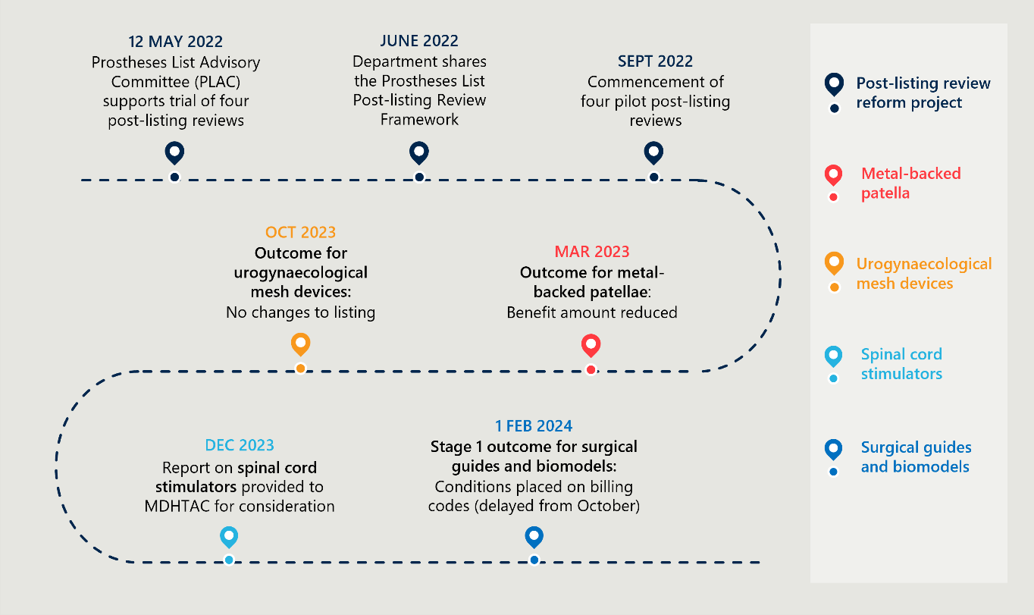

#### Two out of four reviews have been finalised

The Department has undertaken four pilot reviews on various devices. The anticipated duration of a post-listing review is between 3 – 12 months, depending on its complexity.[95] Two out of the four pilot reviews have been able to be achieved in this timeframe. The number of parties involved in the review (including sponsors, clinical committees, other stakeholders) and sources of evidence and data (including clinical evidence, guidelines, utilisation data, expert advice, compliance data, economic analysis, HTA reports, TGA review) contributes to the complexity and increased timeframes for conducting a post-listing review.

Table 13 | Pilot post-listing reviews to date

|  |  |  |  |  |  |
| --- | --- | --- | --- | --- | --- |
| Review | Collection of evidence commenced | Types of reviews conducted | Key milestones | Review recommendation and outcome achieved | Duration |
| Metal-backed patellae (MBP) | Aug 2022 | Internal review | February 2023 – Notified sponsors of outcome  March 2023 – Internal review finalised | March 2023 – Reduced PL benefit for MBP to same amount as an equivalent device; all-polyethylene patellae (APP)[96] | 7 months |
| Surgical guides and biomodels | Sep 2022 | Full Health Technology Assessment (HTA)  Utilisation review | March 2023 – External report provided  Sept 2023 – Provided to MDHTAC for recommendations | November 2023 - Conditions applied to PL reimbursement to limit use to craniomaxillofacial procedures and to restrict the number of surgical guides and biomodels used in a procedure[97] | Ongoing |
| Spinal cord stimulators | Sep 2022 | Focused HTA through an external provider | December 2023 – Report provided to MDHTAC  November 2023 – Report provided to Spinal and Neurosurgical Expert Clinical Advisory Group | No outcome released at this stage. | Ongoing[98] |
| Urogynaecological mesh devices (mid urethral sling) | Feb 2023 | Focused HTA through an external provider | October 2023 – Outcomes implemented | No change to PL listing[99] | 8 months |

#### Stakeholders agree that post-listing reviews are time and resource intensive and further questions have been raised about what conditions should trigger a review

Multiple stakeholders have noted the substantial administrative load created by post-listing reviews and the time taken by the Department to finalise the associated outcomes. Others have questioned the lack of transparency around conditions for initiating a post-listing review, with concerns that this may become a means to submit ‘unwarranted claims about devices’. Stakeholder perspectives on the current state of post-listing reviews in outlined further in Table 14 below.

It is anticipated that the PL post-listing review framework will be updated following the conclusion of the four pilot reviews, and procedure is updated and streamlined based on the lessons learned from these pilot reviews. For post-listing reviews to play a part in the compliance and assurance safeguarding the PL list the Department will need to ensure there is sufficient allocation of time and resources in this area. Going forward, the Department should also attempt to prioritise clear and timely stakeholder communication about both the initiation and outcomes of these reviews.

Table 14 | Stakeholder perspectives on post-listing reviews

|  |  |  |
| --- | --- | --- |
| Stakeholder group | | Perspectives on reform project |
|  | Private healthcare providers | Each pilot review was unique and had different challenges.  The findings and conditions imposed following the review of surgical guides and bio models were problematic due to inadequate planning and consultation about implementation. Overriding initial changes and reintroduction of conditions were required due to this confusion, and disputes are ongoing.  There is a risk that the post-listing review process can be misappropriated with the intent to challenge items on the list without due cause. |
|  | Private health insurance providers | * Post-listing reviews have not been prioritised, especially when compared to the activity to manage new listings. * Departmental resources are insufficient and unbalanced, leading to post-listing reviews being long and drawn-out.   The Department can improve the way results and recommendations of post-listing reviews are communicated.  The review of spinal cord stimulators does not appear to have produced anything to help address the existing issues. |
| *Icon of a microscope* | Medical technology companies | Post-listing reviews are very time intensive for industry, especially as industry is charged for post-listing review costs.  Post-listing reviews may result in unwarranted claims about devices, especially from insurers.  Providing an opportunity for sponsors to comment on the validity of a proposed review prior to it being commenced, or the publication of a forward program of upcoming post-listing reviews, will enable more time for evidence gathering and development. |
| Icon of a person with a stethoscope | Clinician representative | There needs to be consideration given to clinical practice and expertise when determining the outcomes of post-listing reviews.  For the review of surgical guides and bio models, 3D cutting guides approved for maxillofacial surgery are often used in orthopaedic surgery. Whilst this may not be appropriate, there needs to be a way to fund these cutting guides if it’s providing better results for the patient, and they are available to be used in the public hospitals.  Generally, awareness of post-listing reviews among clinicians is low and these could be better communicated by the Department. |

### The Department has established a new compliance strategy

#### Some progress has been made by the Department in articulating a PL compliance approach

At the outset of the reforms, it was determined that the establishment of a compliance program was essential for safeguarding the integrity of the PL. This would ensure there are arrangements in place to ensure robust administration of the PL, limit opportunities for gaming, and have power to address types of non-compliance actions and make compliance decisions. In May 2023, the Department released Prescribed List Compliance Strategy (The Strategy), which incorporated stakeholder feedback on the draft strategy that was open for consultation in September and October 2022.[100]

The Strategy sets out the compliance approach according to a responsive enforcement model, with steps the Department may take when there are concerns about non-complaint practices. The compliance model recognises four tiers of non-compliance and incorporates both deterrent and cooperative approaches to encourage compliance, including a strong focus on increasing education about the PL program to achieve compliance objectives. This was followed by Consultation Paper 7 – proposed measures for compliance assurance and information sharing which was open for consultation with stakeholders between July and August 2023.[101]

#### Many of the proposed measures for compliance, assurance and information sharing will require legislative amendments

The proposed measures for compliance, assurance and information in Consultation Paper 7 set out the proposed obligations of various stakeholders in relation to the PL, including sponsors, health providers and insurers. It also outlines the proposed changes to legislation under the Private Health Insurance Act 2007 required to provide policy authority for the Department. Without this, it would be challenging to compel stakeholders to perform these proposed obligations and enable enforcement of identified non-compliance. A summary of these proposed measures and the required legislative changes are set out in Table 15 below. The Department has also proposed additional measures since the release of Consultation Paper 7, including a proposed amendment to the PHI Act to align the amount charged for the supply of a PL item, with the corresponding PL benefit in Consultation Paper 8b.[102] Currently, the PHI Act does not restrict medical device sponsors from charging more than the PL benefit to supply an item creating potential for an out-of-pocket cost that would be required to be borne by either the hospital or the patient. The Department is currently in the discovery phase of this measure and has consulted with stakeholders to ensure the proposed measure will be fit for purpose and reduces any unintended consequences. The PL evaluation will examine this element of the compliance project when the Department makes more information available.

Table 15 | Proposed measures for PL compliance from Consultation Paper 7

|  |  |  |
| --- | --- | --- |
| Proposed Measures | Example of compliance action | Requirement for legislative amendment |
| 1. Proposed measures for sponsors | Introduce new record keeping and notification obligations for sponsors, to be specified in the MDHTP Rules | Yes – Amendment to PHI Act |
| 2. Proposed measures for hospitals | Introduce new record keeping obligations for hospitals, to be specified in the Private Health Insurance (Health Insurance Business) Rules | Yes – Amendment to PHI Act |
| 3. Proposed measures for insurers | Specify record keeping and notifications requirements relevant for insurers, to be specified in the Private Health Insurance (Complying Product) Rules | Yes – Amendment to PHI Act |
| 4. Specific offences applicable to insurers and health care providers | Requirements for provision of information or corrected information, or offense not exceeding 20 penalty units for refusal or failure to comply | Yes – Amendment to PHI Act |
| 5. Administrative sanctions for health care providers | A declaration for a hospital may be revoked if there is refusal or failure to comply with record keeping and notification obligations in Proposed Measure 2 | Yes – Amendment to PHI Act |
| 6. False or misleading information – administrative sanctions. | Apply sanctions such as the removal of a listed device or product from the MDHTP Rules | Yes – Amendment to the PHI Act |
| 7. False or misleading information – criminal sanctions | Issue 1000 penalty units for an aggravated offence, 300 penalty units for an underlying offense (proposed) | Yes – Amendment to the PHI Act to include offences for providing false or misleading information |
| 8. Information gathering about listed devices and products | Issue a ‘notice to provide or attend’, allowing an agency to require a person to produce information or appear at a hearing | Yes – Amendment to PHI Act |
| 9. Disclosure of Information sharing measures | Extend authority to authorise disclosure of protected information to relevant government authorities to enable regulation or compliance action | Yes – Amendment to extend authority in Division 323 of the PHI Act |
| 10. Public Summary Documents | Completed by the applicants as part of the form for certain applications to include a device or product in the MDHTP Rules | May not require legislative amendment |

While there are some existing legislative instruments that sit outside the *Private Health Insurance Act* that the Department can draw on to perform more stringent compliance action, a lot of the proposed compliance mechanisms relies on amendments to the PHI to enable assurance and information gathering. Progressing this part of the reform will be critical to safeguard the PL going forward.

There is still a significant amount of work to be done to ensure the PL is safeguarded through an established compliance program

The Department is working towards 30June 2025 as the date for full implementation of the proposed compliance strategy and program. This aligns with the policy authority for compliance cost recovery which occurs from 1July 2025. The Department made progress towards defining the PL compliance program, however current compliance and assurance activities are still in early stages. Largely the current compliance activities being performed by the Department sits in realm of education, support and assurance. Table 16 below summarises the current compliance activities being performed by the Department.

Table 16 | Compliance activities being performed by the Department

|  |  |
| --- | --- |
| Education and Guidance | Provision of advice to Private Health Insurance Ombudsman (the Ombudsman) to assist resolution of disputes between hospitals and insurers  Provision of standard words for the Ombudsman to send to stakeholder regarding common issues  Development of a guidance document on MBS item usage when claiming a benefit on the PL (to be released) |
| Data analysis of usage patterns | Requested and analysed usage data on multiple occasions in relation to reported alleged non-compliance cases of inappropriate PL benefit claiming. |
| Investigations, referrals and case management | Compliance email inbox to receive alleged non-compliance reports and PL queries  Compliance and monitoring tracker to record incoming cases of alleged non-compliance  Preparation of case reports about assessment and resolution of compliance issues  Analysis of queries to identify areas that require further education |
| Collaboration with other compliance areas and regulatory authorities | Discussion with internal compliance areas and TGA about proposed PL compliance legislation, the effectiveness of their powers and their recommendations for developing PL compliance  Liaised with the Ombudsman on multiple occasions to assist insurer and hospital disputes |
| Assurance | Staff members systematically examining several hundred PL items to see if products are listed appropriately, at the correct benefit level and that product claims can be verified. A manual process of individual assessment and if required, gathering of clinical input.  Pilot post-listing reviews |

Departmental capacity is a critical element required to ensure an effective and sustainable compliance program for the PL.

At this point in the reform process the planned compliance program is delayed and is not yet sufficient to ensure active compliance across the PL. While the Department does undertake some assurance activities, they have communicated that only externally reported breaches are currently being actioned under the current assurance model. These are considered when they are raised with the Department by other parties, rather than identified through an internally driven proactive process. A more proactive approach would either: a) automatically check a proportion of items or b) products are flagged if they are not used for a period of time and/or c) items are flagged if their use changes by a set percentage. Of externally reported PL issues, there is a large backlog of potentially incorrect listings, definitions or suffixes that need to be examined and Departmental progress to resolve these has been slow. This demonstrates that further resources are needed to support compliance and assurance activities in order to safeguard the integrity of the reforms.

Likewise, some stakeholders believe that PL compliance activities will result in a significant increase of administrative burden for the Department, with flow-on costs to the sector. While a number of the proposed compliance measures are directed at hospitals and insurers, cost recovery for the compliance program is planned to be secured through a levy applied to medical device sponsors only. Under the Australian Government Charging Framework, where an identifiable group creates extra or specific demand for a regulatory activity, they should be charged for the activity. Other stakeholders have expressed concern about the Department’s capacity to implement the proposed compliance mechanisms by the agreed timeframes and/or effectively enforce the proposed measures.

Table 17 | Stakeholder perspectives on PL compliance measures

|  |  |  |
| --- | --- | --- |
| Stakeholder group | | Perspectives on reform project |
|  | Private healthcare providers | Ensuring proportionality and assessment of unintended consequences of the proposed compliance measures will be critical.  The proposed compliance framework does not include any mechanisms to hold insurers accountable for meeting their obligations to pay claims promptly.  There will be dramatic increase in administrative burden for the Department as it takes on the compliance role, and this will come at a cost to providers and eventually, consumers. |
|  | Private health insurance providers | Strong measures to improve compliance and increase accountability for the PL are required and supported.  The Department needs to invest more resources in correcting known listing errors and there is a lack of scrutiny over the indicated vs actual use of a device.  Current compliance is inadequate and insufficient, noting that substantive PL compliance backed by legislation will not come into effect until at least mid-2025.  The Department may lack the required capability and capacity to implement and enforce the proposed strategy and framework successfully. Strengthening this should be a focus to achieve the desired behavioural change. |
| *Icon of a microscope* | Medical technology companies | It is unclear what compliance activity the Department has completed to date, but it appears the Department favours insurers in the proposed measures, such as the substantial administrative burden created over unsubstantiated claims of PL item misuse.  The proposed compliance measures for sponsors seem to imply that sponsors are indefinitely responsibly for the status and use of their products.  Consultation Paper 8b (Alignment of amount charged for supply of a device with corresponding PL benefit) inappropriately proposes to impose controls on a private market. |
| Icon of a person with a stethoscope | Clinician representative | Compliance is intended to minimise misuse of the system and funding, however there are barriers to reliably tracking misuse. For example, actual vs reported GUI usage in hospitals. Without the Department having access of all ordering data, it remains possible that GUIs can be overbilled. If insurers view this as an ongoing issue, it may be better handled between hospitals and insurers themselves.  If the Department is to act as an independent manager of this sector it need to become more effective with strong regulation and improved internal capability. It is a critical role as the viability of the public hospital system is intertwined with the private one. |

## Objective 8: Ensure ongoing financial sustainability of PL administration through effective and efficient cost recovery arrangements that are compliant with the AGCF

*This section considers the implementation of cost recovery arrangements at a high level, noting a formal assessment of this project is out of scope for the evaluation. This section also considers the financial sustainability of the PL’s administration, outlining any change in PL administrative effort and documenting stakeholders perspectives on its resulting financial sustainability.*

Figure 26 | Reform projects related to reform objective 8



### The reforms have updated the PL’s cost recovery arrangements

The Department has passed legislation to update the cost recovery arrangements of the PL to help improve the ongoing financial sustainability of the PL. The Department has consulted on the draft *Cost Recovery Implementation Statement for the Administration of the Prescribed List of Benefits for Medical Devices and Human Tissue Products 1 July 2023 to 30 June 2024* and the required legislative amendments to provide authority for the revised cost recovery arrangements were passed in March 2023. The revised cost recovery model commenced on 1 July 2024 and introduces an annual cost recovery levy per PL listing for sponsors, and well as updated cost recovery fees for PL applications.[103]

The new PL cost recovery levy charges industry sponsors who have items listed on the PL for costs which cannot be assigned to a specific sponsor. Once implemented,the levy will be payable once annually for each item (billing code) that a sponsor has listed on the Prescribed List.[104]The levy amount has not been determined; however, it is anticipated to be $350 to $450 per listed item. Costs in scope for this levy include PL administration costs and depreciation of the IT system. From 1 July 2025, the levy will also cover compliance activities and post-listing review costs. The payment date for first levy fee (2024-25) is expected to occur in early 2025.[105]

The updated PL cost recovery fees for PL listings include a standard application fee, and any additional payable fees required, depending on which assessment pathway (tier) is relevant for the medical device or product application. Table 18 outlines the cost recovery fees payable for an application in each tier.

Table 18 | Updated fees payable for each fee category by application[106]

|  |  |  |  |
| --- | --- | --- | --- |
| Assessment pathway (tier) | Standard application fee | Additional fee(s) | Total |
| Tier 1 | $1,420 | NA | $1,420 | |
| Tier 2a | $1,420 | Clinical assessment fee: $3,970 | $5,390 | |
| Tier 2b | $1,420 | Clinical assessment fee: $3,970  Economic evaluation fee:  $9,250 (simple  $17,680 (complex)  $28,920 (other) | $14,640 (simple)  $23,070 (complex)  $34,310 (other) | |
| Tier 3 | $1,420 | Full HTA (MSAC) Pathway Assessment fee: $2,990 | $4,410 | |

### There is improvement in the financial sustainability of PL administration

#### In updating its cost recovery arrangements, the Department has made steps towards improving the financial sustainability of the PL’s administration

Prior to these reforms the PL recovery arrangements had been unchanged since 2009.[107] Critically, the previous arrangements did not align with the Australian Government Charging Framework (AGCF), as they were not adequately reflective of the size and complexity of the Department’s administration activities related to the PL.[108]

To inform the updated cost recovery fee and levy amounts, the Department performed an activity-based costing estimate to ensure that the new figures cover the true cost of PL administration, including identified administrative costs that are not directly related to the processing of PL applications. These revised cost-recovery arrangements bring the PL administration in line with the AGCF, and fees are now proportional to the amount of administrative effort it takes to assess an application, based on the relevant assessment pathway. It is expected that these arrangements will be more effective at ensuring financial sustainability of the PL than the previous arrangements.

The Department has committed to commissioning an independent review of the PL cost recovery arrangements 18-24 months after implementation (by 1 July 2025). Industrywill be kept informed as the review is progressed and consulted on the outcomes including through the annual CRIS process.[109]

#### Stakeholders have broadly accepted the new arrangements, although medical technology companies note that their costs have increased significantly

Stakeholder feedback acknowledged the need for updated cost recovery arrangements to better reflect the administrative effort and cost borne by the Department as they oversee the PL.[110] Nonetheless, private health insurers have suggested that more rigorous accountability mechanisms should complement these arrangements to ensure value for money, while medical technology companies warn that effective management processes should be prioritised to prevent further externalising of the cost of administrative burden onto industry.[111]

Table 19 | Stakeholder perspectives on PL cost recovery arrangements[112]

|  |  |  |
| --- | --- | --- |
| Stakeholder group | | Perspectives on reform project |
|  | Private healthcare providers | In the absence of more substantial reform, it is sensible for the Government to play a role in ensuring the PL is delivered properly and that this includes cost recovery measures to mitigate the Department’s costs. |
|  | Private health insurance providers | Current cost recovery arrangements do not go far enough to ensuring the PL is financially sustainable.  Rigorous accountability mechanisms should be introduced for sponsors to ensure the PL becomes and remains financially sustainable and provides value for money. |
| *Icon of a microscope* | Medical technology companies | Listing costs are substantially higher under the new arrangements, which may act as a disincentive to apply to list a device.   * The cost to maintain the PL have increased dramatically. The Department should develop processes for effective management of the listing cycle to not further externalise the burden onto industry and ensure ongoing financial sustainability of the PL.   Staff resourcing of the PL Taskforce within the Department appears to be a consistent challenge. |
| Icon of a person with a stethoscope | Clinician representative | The PL needs someone that ensures that all listed items are up to date and providing good value, however it is a large and expensive undertaking, and it is not government money at stake. |

### In addition to cost recovery, the Department should ensure it has sufficient resource capacity to administer the PL

#### The Department has estimated it takes 6056 days per year to administer the PL

Table 20 provides the projected FY23 administrative effort, forecasted using FY22 data during the early stages of PL reform. Using these figures, PL compliance, Departmental application assessment and Tier 2 application assessment respectively are the workload areas anticipated to require the most administrative resources and time. As the Department has based their cost-recovery revisions on estimated administrative effort, there remains a risk that the updated cost-recovery estimates won’t be sustainable if effort required to administer the PL increases because of the reforms or other requirements. At this stage, any change in the PL administrative effort because of reform activities is unknown to the evaluation. The evaluation will report on this in future reporting as data is made available.

Table 20 | Estimate of PL administrative effort in FY23 in days

|  |  |  |  |
| --- | --- | --- | --- |
|  | Executive & SES Days | APS Days | Total Days |
| Department assessment | 851 | 650 | 1501 |
| Tier 2 assessment | 281 | 373 | 654 |
| Tier 3 assessment | 36 | 6 | 42 |
| Transfer applications | 7 | 45 | 52 |
| Deletions applications | 20 | 127 | 147 |
| Granting decision | 92 | 167 | 259 |
| Invoicing | 133 | 534 | 667 |
| CAG meetings | 104 | 226 | 330 |
| PLAC meetings | 39 | 50 | 89 |
| Prostheses Rules | 14 | 5 | 19 |
| Compliance | 959 | 639 | 1598 |
| Stakeholder engagement | 299 | 218 | 516 |
| General administration | 73 | 110 | 184 |
| Total | 2906 | 3150 | 6056 |

#### Stakeholders and the Department have acknowledged limited internal resourcing as a potential risk for continued implementation of the reform and ongoing administration of the PL

Ensuring sufficient Departmental staffing levels is important for sustaining the PL’s administration. Stakeholders have expressed concern over the Department’s capacity to deliver the PL reform, specifically drawing attention to the time it has taken to undertake the pilot post-listing reviews and other delays to milestones throughout the reform. Medical device companies have also provided feedback that it can be challenging to get in contact with the Department with listing queries and receive timely feedback, noting that the listing guide available is still not final.[113]

Stakeholders also have expressed that they believe the proposed compliance measures will significantly increase administrative burden for the Department.[114] The Department has also acknowledged the challenge of attracting and maintaining appropriate staff within this area of the Department as an additional constraint on delivering reform projects and maintaining the PL. One critical implication of this is that insufficient resourcing may limit the number of additional actions able to be performed by the team, such as compliance actions and additional post-listing reviews. As a result, there is potential for the reform measures to safeguard the PL becoming diluted. Ensuring sufficient internal resourcing must be a focus for the Department going forward.

1. Methodology
   1. Purpose and key objectives

#### The evaluation seeks to understand the extent to which PL reform activities have delivered the objectives of the reform

The purpose of the evaluation is to understand the extent to which PL reform activities have delivered the objectives and provide formative insight into their delivery. The key objectives of the evaluation are:

* Documenting the implementation of PL reform activities, enabling and constraining factors, and the degree to which the PL reform is implemented as intended.
* Determining whether PL reform activities are achieving their intended objectives, and where possible, indicating the extent to which the desired outcomes have been achieved.
* Identifying unintended consequences of reform activities and provide insight into how negative unintended consequences can be mitigated.
* Providing ongoing insight into additional activities to support the objectives of the program and findings to inform the future direction of PL management.
  1. Evaluation plan and theory of change

#### Nous planned the PL evaluation using the Department’s framework

The Department established the Prostheses List Evaluation Framework in 2021 to inform a consistent monitoring and evaluation approach that is applicable from the conceptualisation of the PL reforms through to its implementation and beyond. Nous was commissioned to evaluate the PL reforms using the evaluation framework. Nous has independently reviewed the Department’s evaluation framework and the evaluation team is satisfied it outlines an appropriate structure by which the reforms should be evaluated.

Nous delivered its evaluation plan to the Department on 14 August 2023, detailing the evaluation context, objectives, approach, methodology and project plan. This is summarised in sub-appendices A.3 and A.4 below. The evaluation plan maintained the Framework’s overarching program logic and key evaluation questions (KEQs), while developing an explicit theory of change, and including its own evaluation activities, sub-research questions, indicators and measures.

The program logic and theory of change outline the reasoning between completion of evaluation activities and measurable changes in outcomes.

The Federal Government has allocated $22 million and provided additional resources, including the establishment of the Prescribed List Taskforce within the Department, to drive the successful implementation of the reform program. The reform utilises various inputs such as PL data, reference pricing, clinical data, technological systems, and existing research, which support a series of targeted activities designed to refine documentation, engage stakeholders, enhance systems, and create a robust monitoring and evaluation framework.

Activities conducted are expected to lead to distinct outcomes in the short term (e.g., reduced pricing disparities, legislative clarity, streamlined processes), medium term (e.g., improved compliance activities, transparent administration), and long term (e.g., better access to cost-effective prostheses, more affordable private health insurance). The program logic diagram depicted in Figure 27 provides a summary of the reform program as described above

The theory of change posits that cost reduction in PL-listed items and PL administration will translate into better value for the public, with no adverse effects on patients' clinical outcomes, aligning spending on more valuable initiatives and improving value-for-money in private health cover. The activities, outcomes, and long-term objectives of the reform are linked causally, with these relationships detailed in the causal logic diagram in Figure 28 and encapsulated within the broader theory of change:

*If costs associated with the purchase of PL-listed items and with the administration of the PL are reduced, then this value will be passed to the public in the form of improved allocation of tax revenue to other valuable initiatives, reduced private health insurance premiums, or otherwise improved value-for-money in private health insurance. These cost reductions can be achieved without any negative impacts to consumers and their clinical outcomes.*

Figure 27 | Prescribed List Reform Program Logic

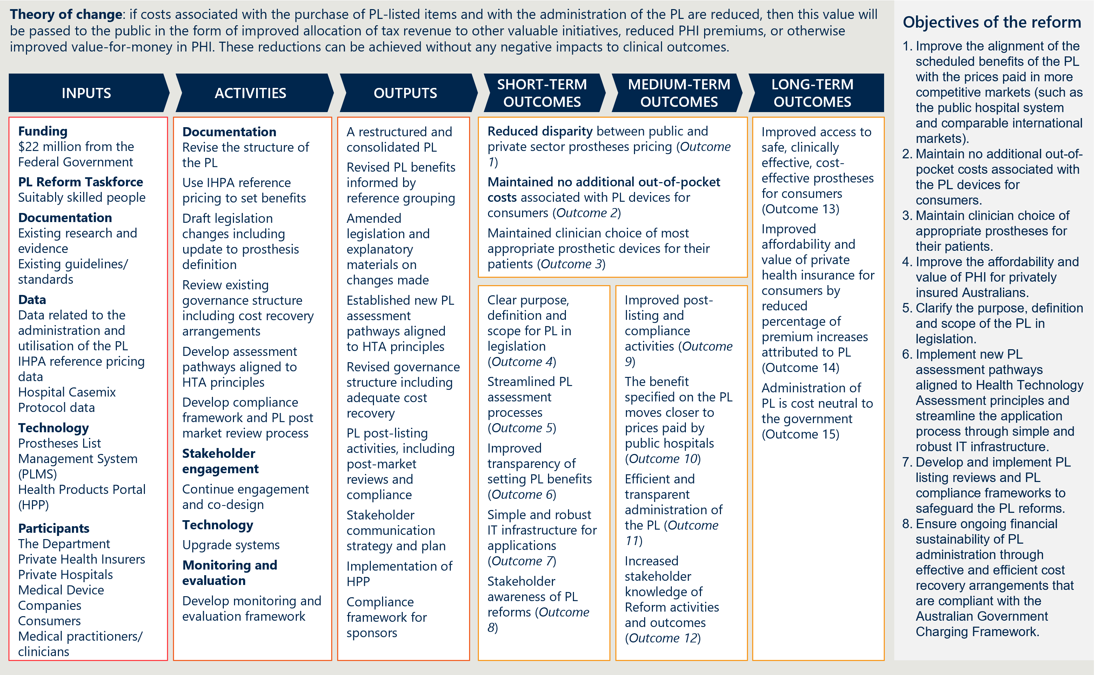

Figure 28 | Causal logic diagram

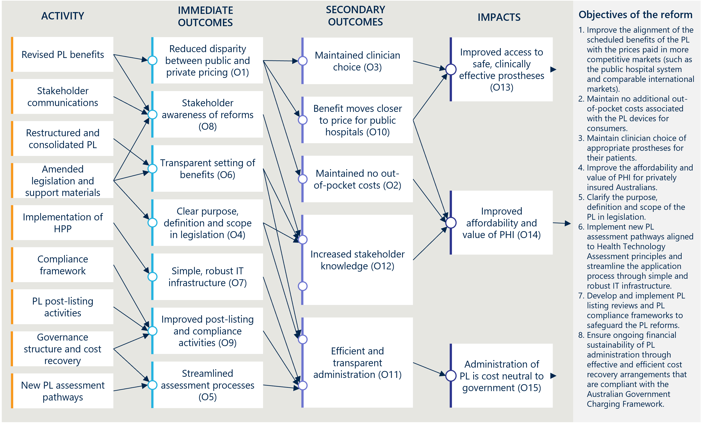

The scope of this evaluation is informed by both a formative and summative evaluation approach

The evaluation consists of three components – a baseline report, interim reports and a final report. Each of the reports that the evaluation produces will have a distinct purpose. This first interim report is a key milestone in the progress monitoring stage of the evaluation. As the evaluation is occurring at a time where PL reform activities are ongoing and where some outcomes are yet to be realised, Nous will share ongoing findings with the Department. These formative aspects of the evaluation are in the interest of improving PL reform activities and outputs to achieve the desired outcomes and mitigate against any unintended negative consequences.

The evaluation will also have summative components to understand the actions that have already been done (and will be done) and to assess early outcomes. This report contains some summative analysis of early activities, and the final evaluation report will provide more substantial summative analysis of the PL Reforms. The evaluation will also consider the extent to which the reform activities have been implemented as planned at completion and will distil lessons learned from the implementation experience to inform ongoing monitoring and evaluation of the PL itself.

Key elements of the evaluation’s scope are outlined below in Table 21.

Table 21 | Scope of the evaluation

|  |  |
| --- | --- |
| In-scope aspects of the evaluation | * PL reform implementation, effectiveness and impact (extent to which intended outcomes were achieved) * Unintended positive or negative consequences beyond the expected outcomes * Experiences of consumers, private health insurers, private hospitals, public hospitals, medical device sponsors and clinicians |
| Out-of-scope aspects of the evaluation | * Full cost-benefit analysis and/or economic evaluation, beyond that required to establish the suitability/sustainability of cost recovery efforts * Evaluation of the Department’s wider PHI reforms * Evaluation or analysis of PL components not impacted by the scope of the reforms |
| Any context or related activities that need to be considered | * Understanding of the Government’s PHI reforms and policy agenda * Understanding of stakeholder consultations and input to the PL Reforms that have already taken place and how reform activities have changed as a result of these |

* 1. Overall approach and KEQs

#### The evaluation is guided by three KEQs

There are three key evaluation questions (KEQs) for the evaluation:

1. Is the PL reform program being implemented as intended?
2. Is the PL reform program achieving the expected outcomes?
3. What are the ongoing and future directions, opportunities and priorities for the PL reforms?

The focus of this first interim report is to bring the evaluation up to the present day, introducing findings around the key projects of the PL reforms up to 30 June 2024 (i.e., reporting on KEQ 1 and KEQ 2 as the reforms stand). Subsequent reports will then have a greater emphasis on the ongoing and future directions, opportunities and priorities of the PL (i.e., KEQ 3).

#### Nous has structured the evaluation by the eight objectives of the PL reforms

The evaluation team developed a structure for the ongoing reporting of the evaluation that is adapted to the evolving projects and priorities of the reform program, while still aligning with the KEQs and evaluation plan. The structure is centred around the eight objectives of the PL reforms established by the Department’s PL Evaluation Framework, with nine key projects summarising the primary actions of the reforms.

Figure 29 | PL reform objectives and reform projects

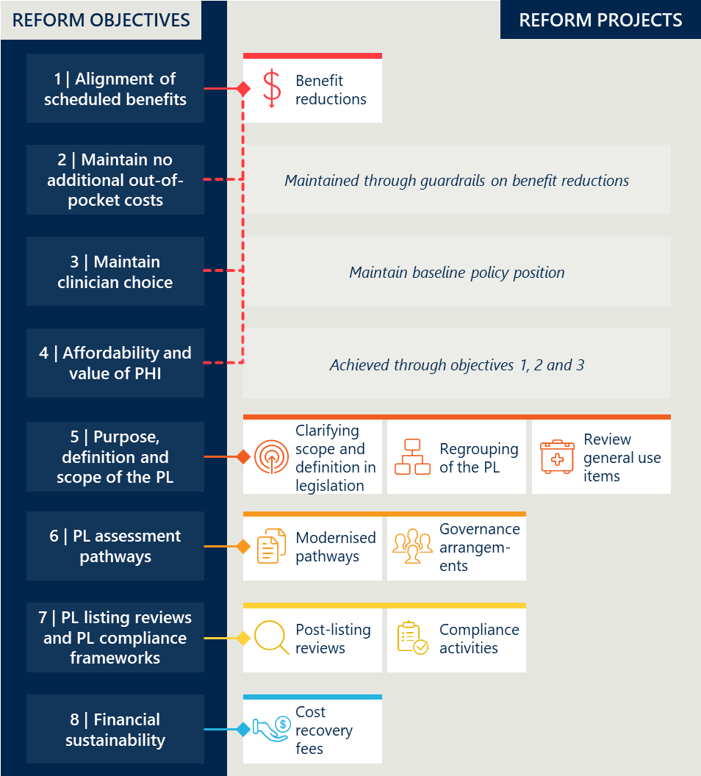

#### A set of indicators and measures guide the data collection, analysis and reporting

The evaluation team developed a set of indicators and measures that sit under each of the eight objectives of the PL reforms (see Table 22 overleaf). The indicators and measures cover KEQ 1 and KEQ 2 and resemble the key evaluation sub-questions introduced in the Department’s PL Evaluation Framework. Since the Baseline Evaluation, the indicators and measures have guided the evaluation team’s data collection, analysis and reporting. Appendix B holds more detailed information on the measures not captured in the body of the report.

Table 22 | Overview of indicators and measures

|  |  |  |  |
| --- | --- | --- | --- |
| Objective | KEQ | Indicators | Key evaluation sub-questions |
| 1. Improve alignment of the scheduled benefits of the PL with the prices paid in more competitive markets such as the public hospital system and comparable international markets | 1 | Indicator 1: Reduction in benefits | * Measure 1.1: Change in PL benefits * Measure 1.2: Benefit reduction methodology |
| 2 | Indicator 2: Change in the size of the gap between PL benefits and prices paid in more competitive markets | * Measure 2.1: Overall savings associated with benefit reductions * Measure 2.2: Gap between PL benefits and prices in Australian public hospitals * Measure 2.3: Gap between PL benefits and prices on the Liste des Produits et Prestations (LPP) and Pharmac Hospital Medical Devices Schedule * Measure 2.4: Stakeholder perspectives on the gap between PL benefits and prices in more competitive markets |
| 2. Maintain no additional out-of-pocket costs associated with the PL devices for consumers | 1 | *No activity directly associated* |  |
| 2 | Indicator 3: Change in out-of-pocket expenses related to PL items | * Measure 3.1: Prevalence of a gap payment for PL items * Measure 3.2: Average gap payment for PL-listed items |
| 3. Maintain clinician choice of appropriate prostheses for their patients | 1 | *No activity directly associated* |  |
| 2 | Indicator 4: Change in clinician experience of choosing prostheses | * Measure 4.1: Clinician perspectives on the level of clinician choice |
| Indicator 5: Change in utilisation of PL items | * Measure 5.1: Utilisation of PL items |
| 4. Improve the affordability and value of private health insurance for privately insured Australians | 1 | *No activity directly associated* |  |
| 2 | Indicator 6: Change in PHI premium increases | * Measure 6.1: PHI premium price changes over time * Measure 6.2: Change in PHI premiums related to PL item expenditure * Measure 6.3: Stakeholder perspectives on the drivers of change in PHI premiums |
| Indicator 7: Change in PHI coverage and for whom | * Measure 7.1: PHI coverage by demographic group * Measure 7.2: Utilisation of PL items by privately insured patients * Measure 7.3: Stakeholder perspectives on the drivers of change in PHI coverage |
| 5. Clarify the purpose, definition, and scope of the PL in legislation | 1 | Indicator 8: Legislative changes to the PL | * Measure 8.1: Description of the PL's purpose, definition and scope in legislation |
| Indicator 9: Implementation of PL regrouping | * Measure 9.1: Changes made to the PL grouping structure and PL item categorisation * Measure 9.2: Number of PL items and benefit groups |
| Indicator 10: Implementation of changes to general use items | * Measure 10.1: Description of changes to general use items |
| 2 | Indicator 11: Assessment of legislative changes to the PL | * Measure 11.1: Stakeholder perspectives on the level of clarity in the PL's purpose, definition and scope |
| Indicator 12: Assessment of PL regrouping | * Measure 12.1: Stakeholder perspectives on PL regrouping |
| Indicator 13: Assessment of changes to general use items | * Measure 13.1: Stakeholder perspectives on changes to general use items |
| 6. Implement new PL assessment pathways aligned to Health Technology Assessment Policy Branch principles and streamline application process through simple and robust IT infrastructure | 1 | Indicator 14: Implementation of new assessment processes | * Measure 14.1: Description of assessment pathways * Measure 14.2: Description of governance processes |
| 2 | Indicator 15: Assessment of new assessment processes | * Measure 15.1: Volume of PL applications per tier * Measure 15.2: Stakeholder perspectives on the assessment pathways and listing process |
| 7. Develop and implement PL listing review and PL compliance frameworks to safeguard the PL reforms | 1 | Indicator 16: Change in listing review and compliance frameworks | * Measure 16.1: Description of post-listing review framework * Measure 16.2: Description of compliance strategy |
| 2 | Indicator 17: Assessment of listing review and compliance frameworks | * Measure 17.1: Description of post-listing reviews conducted * Measure 17.2: Stakeholder perspectives on post-listing reviews * Measure 17.3: Description of compliance activities conducted * Measure 17.4: Stakeholder perspectives on PL compliance |
| 8. Ensure ongoing financial sustainability of PL administration through effective and efficient cost recovery arrangements that are compliant with the AGCF | 1 | Indicator 18: Implementation of cost recovery arrangements | * Measure 18.1: Description of cost recovery arrangements |
| 2 | Indicator 19: Financial sustainability of PL administration | * Measure 19.1: Change in PL administrative effort * Measure 19.2: Stakeholder perspectives on the financial sustainability of PL administration |

* 1. Approach to data collection and engagement

#### The evaluation is using a ‘mixed methods’ approach

Evaluating the PL reforms involves a large and diverse group of stakeholders, a nuanced prostheses market, intertwined reform initiatives, and several intangible outcomes. To address this complexity, this evaluation is using a principles-based approach with KEQ and a program logic to focus the evaluation on the intentions of the reform.

This interim report uses a ‘mixed methods’ approach, collecting both qualitative and quantitative data from interviews, focus groups, desktop research, surveys and existing datasets. Data analysis has involved thematic, descriptive, and inferential techniques with triangulation of findings from various sources to validate the evidence.

#### Quantitative analysis is informing an assessment of reforms’ outcomes

The performance of the PL reforms is being assessed through an analysis of a range of quantitative indicators. This involved compiling and assessing relevant descriptive statistics to develop hypotheses related to the sub-research questions and categorised under the indicators and measures. Where feasible, inferential methods, such as regression models are also being used to add rigour to the analysis and support efforts to attribute changes to the reforms. As part of this, graphs have been included to visualise, develop, and convey important findings and analysis.

#### Qualitative analysis is crucial to answering the evaluation’s research questions

On its own, quantitative analysis is unable to satisfactorily answer all the evaluation’s sub-research questions. In many circumstances, quantitative data is missing or is of inadequate quality, requiring a qualitative approach that allows the evaluation team to hear directly from stakeholders. In circumstances where sufficient quantitative data has been available, qualitative evidence bolsters the evidence base underpinning the evaluation’s findings, by allowing insights to be triangulated from different sources of information.

Qualitative research methods – including surveys, interviews and workshops – are also ideal for understanding individual stakeholder perspectives, experiences and sensitivities in depth, especially in relation to the “how” and “why” elements of our KEQs which cannot be adequately answered with reference to quantitative data. This process also continues to help to build buy-in for the evaluation’s findings and recommendations, by facilitating forums for those impacted by the reforms to have their perspective heard.

The evaluation has drawn on several different qualitative data sources including Departmental documentation and PL planning documentation, published stakeholder submissions and perspectives, stakeholder interviews and stakeholder information requests.

1. Measures detail
   1. Indicator 1: Reduction in benefits

#### Measure 1.1: Change in PL benefits

Table 23 | Benefit groups[115] and items subject to reform reductions (Parts A and D, excluding CIED items)[116]

|  |  |  |
| --- | --- | --- |
| Categories | Benefits groups subject to reductions | Items subject to reductions |
| 01 - Ophthalmic | 23 | 162 |
| 02 - Ear, Nose & Throat | 6 | 26 |
| 03 - General Miscellaneous | 66 | 234 |
| 04 - Neurosurgical | 24 | 98 |
| 05 - Urogenital | 10 | 55 |
| 06 - Specialist Orthopaedic | 173 | 1840 |
| 07 - Plastic and Reconstructive | 74 | 275 |
| 08 - Cardiac | 3 | 23 |
| 09 - Cardiothoracic | 8 | 17 |
| 10 - Vascular | 36 | 208 |
| 11 - Hip | 43 | 396 |
| 12 - Knee | 20 | 331 |
| 13 - Spinal | 51 | 1474 |
| Total | 537 | 5139 |

* 1. Indicator 2: Change in the size of the gap between PL benefits and prices paid in more competitive markets

#### Measure 2.1: Overall savings associated with benefit reductions

##### Data used for this measure

Estimates of overall savings used to report against this measure have been derived solely from analysis conducted by IHACPA and provided to the evaluation team by the Department.

Following the MOU between the then Australian Government and the MTAA on 12 March 2022 that set the policy parameters for the reform’s benefit reductions,[117] the Department requested IHACPA calculate estimates of the projected benefits and savings over the four-year PL reform period.[118] The Department presented this analysis at a roundtable with key stakeholders on 12 October 2022.[119] Later, the Department requested IHACPA provide updated estimates of project benefits and savings, and IHACPA delivered this on 13 December 2023.[120] The evaluation team anticipates that the Department and IHACPA will provide stakeholders a further update to these estimates in the future to incorporate more recent utilisation data, to reflect changes to benefit reduction parameters (e.g., for CIED items) and to adjust for errors in previous estimates.[121]

##### How the estimates were calculated

The estimates of the projected benefits were calculated by multiplying the baseline and future PL benefits by item utilisation volumes recorded in HCP data.[122] The December 2023 estimates used the 1 November 2023 PL and item utilisation from FY23 (grossed up to align with 2023 APRA figures[123]). These volumes were scaled uniformly to account for utilisation growth over the following four-year period. The associated savings were then calculated by comparing to PL scheduled benefits in place prior to the reforms.[124]

##### Differences between the initial estimates and updated estimates

A comparison of the projected savings from the October 2022 and December 2023 estimates are shown in Table 24 below. Savings to date (July 2022 to June 2024) and five-year projected savings (July 2022 to June 2027) are compared for all items and all items excluding CIEDs. The lower estimates for each category are based on 0% annual utilisation growth and the upper estimates are based on a 5% annual utilisation growth.

The initial October 2022 estimates used FY21 HCP utilisation data, while the updated December 2023 estimates used FY23 HCP utilisation data (grossed up to align with 2023 APRA figures[125]) giving more accurate projected savings.[126] There are three other reasons the updated estimates differ from the initial estimates:

1. Different future PL scheduled benefits – While the policy parameters guiding the benefit reductions have remained largely unchanged since the commencement of the reforms, a revised set of future scheduled benefits was used for the updated estimates to capture any benefit reduction changes and clarifications since the initial estimates. This most notably applied to CIED items:
   1. The October 2022 estimates applied the standard reduction parameters on the full CIED benefit, with the first reduction commencing with the 1 July 2023 PL update.
   2. The December 2023 estimates applied two phases of reductions to CIEDs, reflecting a revised benefit reduction approach. The first was applying 40%/20%/20% reductions of the gap between the device component of the CIED benefit (either 54% or 56.3% of the total benefit) and the full public benchmark price, commencing with the 1 July 2023 PL update. The second was applying 40%/30%/30% reductions of the gap between the technical support services component of the CIED benefits (assumed to be 46% or 43.7% of the total benefit) and an estimate of reasonable costs for technical support services advised by MSAC[127], commencing with the 1 July 2024 PL update.
2. Different base year for annual utilisation change rate calculations – The October 2022 estimates have a base year for annual utilisation growth calculations (FY21) that is two years before the first year of savings. Conversely, the December 2023 estimates’ base year for annual utilisation growth calculations is the same as the first year of savings (FY23). This means the October 2022 estimates for benefits and savings effectively have two years of compounding growth prior to the first year of savings presented (FY23). While the differing methods were appropriate and necessary given the data available at each point in time, this skews the difference in benefits and savings when comparing between the two sets of estimates. For example, looking at estimated savings for the 01 – Ophthalmic category in FY23, the October 2022 figures estimate $5.0 million for a 0% annual utilisation growth and $5.5 million for a 5% annual utilisation growth, while the December 2023 figures estimate $5.6 million for both the 0% and 5% annual utilisation growth assumptions.
3. Miscellaneous adjustments – Additionally, the Department included adjustments in its instructions and advice provided to IHACPA to account for additional factors. These included historical billing code changes, corrections to an error on the August 2022 PL update (~$1.6 million adjustment), and corrections to fix some date-related errors.[128] The parameters or details of these adjustments were not included with the published estimates.

Table 24 | Comparison of projected savings – initial and updated estimates[129]

|  |  |  |  |  |  |  |  |
| --- | --- | --- | --- | --- | --- | --- | --- |
| Scope of PL items | Savings period | | October 2022 estimate  (0% to 5% annual growth) | December 2023 estimate  (0% to 5% annual growth) | | Difference | |
| All items | Savings to date (July 2022 to June 2024) | $274 million to $312 million | | | $282 million to $291 million | | -$21 million to +$9 million |
| Five-year projected savings (July 2022 to June 2027)[130] | $1,045 million to $1,299 million | | | $1,042 million to $1,173 million | | -$125 million to -$3 million |
| All items excluding CIEDs | Savings to date (July 2022 to June 2024) | $218 million to $248 million | | | $256 million to $263 million | | +$16 million to +$38 million |
| Five-year projected savings (July 2022 to June 2027) | $685 million to $844 million | | | $782 million to $873 million | | +$29 million to +$97 million |

##### Validation of these estimates

The Nous evaluation team has relied on the work of IHACPA in calculating these estimates based on advice provided by the Department. IHACPA notes that, “The future PL scheduled benefits used in the calculations are based on advice from the Department, and are consistent with the policy parameters of the MoU”.[131] The evaluation team has not been able to independently validate these estimates through analysis of the same data sources following only the policy parameters of the MoU, as we have not been given access to the same advice and adjustments provided to IHACPA.

The 12 December 2023 estimates include projected savings from reducing the technical support services component of CIED benefits, including a projected reduction on 1 July 2024, which did not occur. The reforms’ approach to reducing the technical support services component of CIED benefits has not been announced at the time of this evaluation report. The parameters of these future CIED reductions included in the estimates are redacted in the document provided to the evaluation team. Note that CIED reductions account for 24-25% of the five-year projected savings from the reforms in these estimates.[132]

#### Measure 2.3: Gap between PL benefits and prices on the Liste des Produits et Prestations (LPP) and Pharmac Hospital Medical Devices Schedule

This measure contributes to an understanding of the extent to which the reforms are achieving objective 1, to “Improve the alignment of the scheduled benefits of the PL with the prices paid *in more competitive markets*”.

##### Methodology

The evaluation team has chosen three PL benefit groups as case studies to compare with the same products on the Liste des Produits et Prestations (LPP)[133] and the Pharmac Hospital Medical Devices Schedule (Pharmac).[134] Given limitations in accessing and comparing products across international markets, a case study approach allows us to isolate the scenarios in which we can reasonably ensure a direct comparison. The case studies were selected based on four criteria:

1. Data availability – at least three products within the PL benefit group can be found in the LPP and Pharmac schedule
2. Matching certainty – evidence that products are a true comparison by cross-referencing sponsor product information, model numbers, sizes and other details (noting that there is no unique identifier that is common to the lists)
3. Volume – avoiding low-volume benefit groups that could be price/benefit outliers
4. Pricing history – products with multiple years of pricing history to provide meaningful comparisons.

The three case studies comparing the PL to the French and New Zealand markets are:

Case study 1 – A sample of four products from the 12.08.01 PL category (knee implant – patellar component, cemented, all polyethylene) found on the LPP and Pharmac lists.

Case study 2 – A sample of six products from the 12.08.01 PL category (hip joint implant – femoral head, conventional, >32mm, ceramic) found on the LPP and Pharmac lists.

Case study 3 – A sample of four products from the 13.10.01.02 PL category (spinal fusion cage – interbody, integral fixation, thoracolumbar) found on the LPP and Pharmac lists.

Nous selected these case studies at baseline before observing any difference in price and without determining how they would be affected by the reforms. The evaluation team does not claim the three benefit groups selected as international comparison case studies are representative of the overall or average gap between the selected markets.

##### Analysis

Case study 1 in Figure 30 shows the benefit and pricing history of four products from the 12.08.01 PL benefit group from 2016 to 2023. The PL benefit saw some gradual reduction in the years prior to 2021, followed by substantial reduction in the first two tranches of the reforms. While the Pharmac series (median price) shows movement as products were introduced to the list, the price of each of the four constituent products did not change until July 2023, where two of the products saw a marginal increase.

Figure 30 | International case study 1 (knee implant) – Benefit group comparison over time[135]

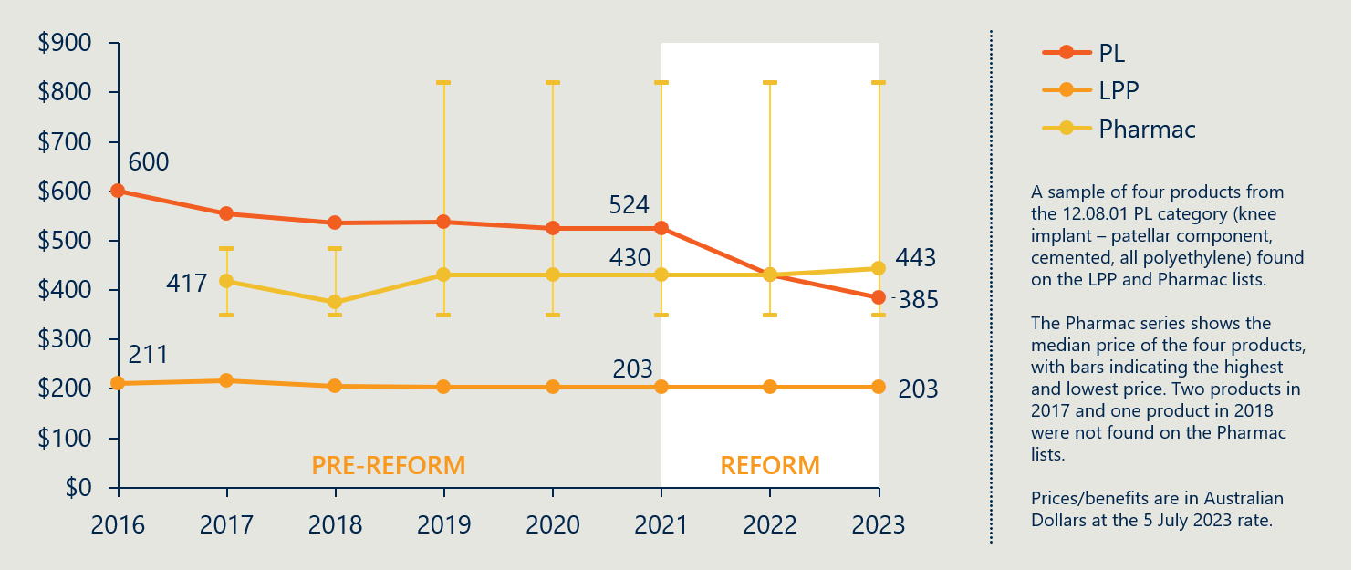

Figure 31 introduces case study 2, six hip joint implants from the 11.02.02.05 PL benefit group. Prior to the reforms, the PL benefit was higher than the LPP and Pharmac category prices on average, though lower than some Pharmac products. Following substantial benefit reductions in July 2022 and July 2023, the PL benefit is currently lower than five of the six Pharmac products but remains higher than the LPP price.

Figure 31 | International case study 2 (hip joint implant) – Benefit group comparison over time[136]

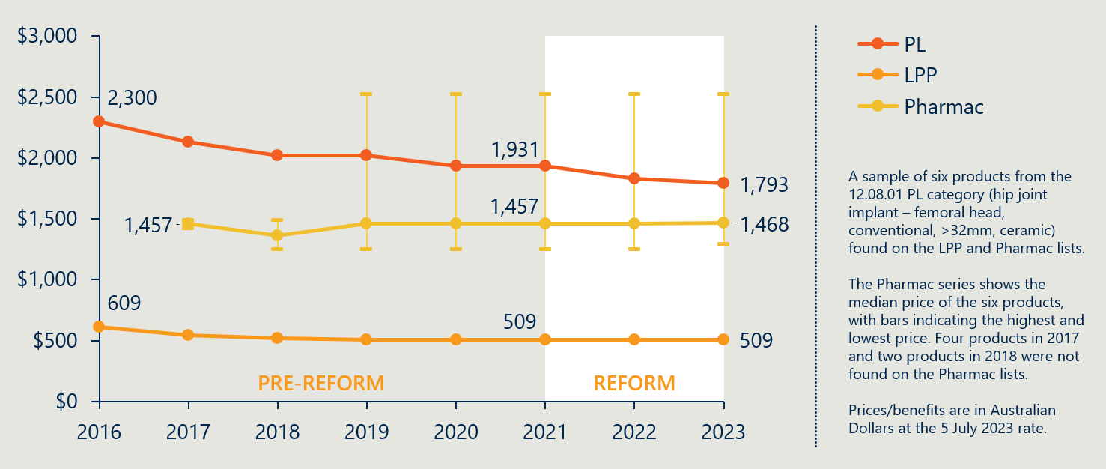

Case study 3, in Figure 32 below, relates to four products from the 13.10.01.02 PL benefit group. Prices vary across the Pharmac products, but all comparison products remain under the PL benefit. Though the reforms reduced the PL benefit in July 2022 and again in July 2023, the benefit remains around six times the LPP price.

Figure 32 | International case study 3 (spinal fusion cage) – Benefit group comparison over time[137]

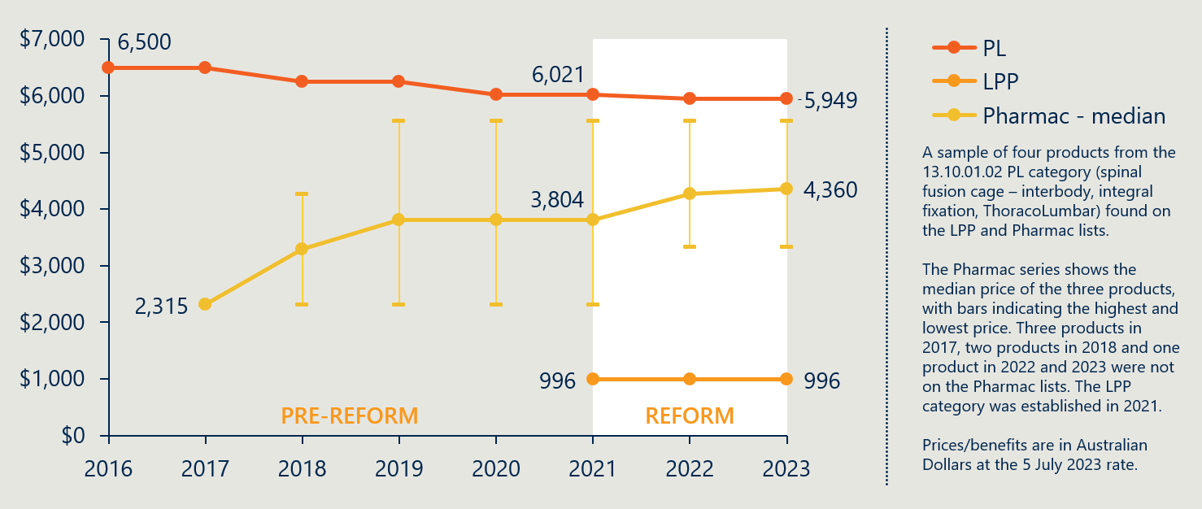

* 1. Indicator 3: Change in out-of-pocket expenses related to PL items

#### Measure 3.1: Prevalence of a gap payment for PL items

Table 25 | Prevalence of gap by PL category for items in Part A[138]

|  |  |  |  |  |  |  |  |
| --- | --- | --- | --- | --- | --- | --- | --- |
|  | FY22 | | | FY23 | | |  |
| Categories | # of items | # of items with a gap | Rate of gap | # of items | # of items with a gap | Rate of gap | Change in rate of gap |
| 01 - Ophthalmic | 345764 | 1193 | 0.35% | 355893 | 3745 | 1.05% | 0.71% |
| 02 - Ear; Nose & Throat | 26925 | 25 | 0.09% | 37978 | 21 | 0.06% | -0.04% |
| 03 - General Miscellaneous | 109990 | 140 | 0.13% | 123124 | 185 | 0.15% | 0.02% |
| 04 - Neurosurgical | 22371 | 36 | 0.16% | 21957 | 83 | 0.38% | 0.22% |
| 05 - Urogenital | 40567 | 105 | 0.26% | 40564 | 132 | 0.33% | 0.07% |
| 06 - Specialist Orthopaedic | 576636 | 518 | 0.09% | 603234 | 2389 | 0.40% | 0.31% |
| 07 - Plastic and Reconstructive | 112710 | 259 | 0.23% | 124658 | 492 | 0.39% | 0.16% |
| 08 - Cardiac | 72199 | 588 | 0.81% | 71339 | 817 | 1.15% | 0.33% |
| 09 - Cardiothoracic | 8091 | 198 | 2.45% | 8208 | 181 | 2.21% | -0.24% |
| 10 - Vascular | 33744 | 72 | 0.21% | 33106 | 57 | 0.17% | -0.04% |
| 11 - Hip | 131688 | 58 | 0.04% | 139250 | 280 | 0.20% | 0.16% |
| 12 - Knee | 146135 | 118 | 0.08% | 168835 | 494 | 0.29% | 0.21% |
| 13 - Spinal | 135788 | 101 | 0.07% | 135373 | 237 | 0.18% | 0.10% |

#### Measure 3.2: Average gap payment for PL-listed items

Table 26 | Value of gap by Part A categories[139]

|  |  |  |  |  |  |  |  |
| --- | --- | --- | --- | --- | --- | --- | --- |
|  | FY22 | | | FY23 | | |  |
| Categories | Avg benefit | Avg gap where gap was paid | Avg gap relative to avg benefit | Avg benefit | Avg gap where gap was paid | Avg gap relative to avg benefit | Change in avg gap to avg benefit |
| 01 - Ophthalmic | $300 | $100 | 33% | $290 | $40 | 14% | -20% |
| 02 - Ear; Nose & Throat | $730 | $50 | 7% | $660 | $10 | 2% | -5% |
| 03 - General Miscellaneous | $340 | $100 | 29% | $310 | $30 | 10% | -20% |
| 04 - Neurosurgical | $2,500 | $1,600 | 64% | $2,600 | $880 | 34% | -30% |
| 05 - Urogenital | $740 | $180 | 24% | $770 | $140 | 18% | -6% |
| 06 - Specialist Orthopaedic | $380 | $210 | 55% | $370 | $80 | 22% | -34% |
| 07 - Plastic and Reconstructive | $410 | $780 | 190% | $370 | $440 | 119% | -71% |
| 08 - Cardiac | $4,700 | $540 | 11% | $4,600 | $470 | 10% | -1% |
| 09 - Cardiothoracic | $2,300 | $1,000 | 43% | $2,400 | $410 | 17% | -26% |
| 10 - Vascular | $1,300 | $640 | 49% | $1,300 | $530 | 41% | -8% |
| 11 - Hip | $1,700 | $850 | 50% | $1,600 | $280 | 18% | -33% |
| 12 - Knee | $1,800 | $900 | 50% | $1,700 | $540 | 32% | -18% |
| 13 - Spinal | $900 | $610 | 68% | $850 | $260 | 31% | -37% |

* 1. Indicator 5: Change in utilisation of PL items

#### Measure 5.1: Utilisation of PL items

This measure examines the volume of PL items used by clinicians and funded by PHI, in relation to building an evidence base for specific lines of enquiry. The primary research question this relates to is: *Have the reforms had any impact on the selection and utilisation of products, and has this change generated any changes in clinical outcomes?* (research sub-question 2.4). The baseline evaluation report established the evaluation’s approach to this research: where we observe any significant shift in the utilisation of a benefit group, the evaluation team will take a case study approach to investigate whether this has resulted in a decline in clinical outcomes. This would involve consultation with clinicians, supplemented by analysis of clinical metrics in HCP1 data.

The evaluation did not consider it necessary to include any case studies under this measure for this reporting period for two reasons:

1. While the evaluation team observed some instances of large changes in the utilisation of benefit groups (>20% relative to the product category it belongs to), we could not establish a statistically significant relationship between utilisation change and benefit reductions (see Table 27 below). Utilisation swings for specific item types are common (particularly for devices with low volumes) and can occur for multiple reasons unrelated to the reforms.
2. Stakeholders did not present to the evaluation team anecdotal evidence of sub-optimal clinical outcomes as a result of a change in the selection and utilisation of products.

##### Analysis of relationship between benefit reductions and utilisation

Regression analysis was undertaken to determine whether there is a relationship between the change in item benefits and the change in item utilisation at the benefit group level. The evaluation considered this a prerequisite requirement to including case studies investigating any changes in clinical outcomes as a result of a change in the selection and utilisation of products attributable to the PL reforms.

The benefit changes were calculated as the % change between the March 2022 PL and the July 2022 PL for each benefit group. These PL editions were chosen to isolate the impact of the first round of reductions (July 2022) on item utilisation over the next year (FY23). An adjustment was applied to make this relative to the overall category utilisation change as a way to control for macro health/technology/demographic trends that affect a whole category.[140] The utilisation changes were calculated as the % change between FY23 and FY22 item utilisation (billing codes grouped at the benefit group level) using HCP1 data.

Table 27 below summarises the results of three regression analyses on PL benefit groups. The regressions included benefit groups across Parts A, C and D of the PL with any benefit reduction in July 2022. No statistically significant relationship could be found in the base case. When removing benefit groups with less than or equal to 100 utilisation in each of FY22 and FY23, the regression showed statistically significant results. However, this model explained a very small amount of the variance in utilisation (R2 = 0.01), and moreover, it showed an unexpected negative relationship (decline in benefits explains an increase in utilisation). A third regression additionally filtered the data to only include benefit groups which had a large reduction in benefits (>10%), however this did not yield statistically significant results.

Overall, these results indicate that it is unlikely there is a systemic relationship between the change in item benefits and the change in item utilisation at this stage in the reforms. As a result, the evaluation team did not consider it necessary to proceed with further investigation of changes in clinical outcomes. We will continue to monitor this measure throughout the evaluation.

Table 27 | Summary of utilisation regression analysis

|  |  |  |  |
| --- | --- | --- | --- |
| Benefit groups included | Variables | R2 | Key findings |
| Benefit groups with a benefit reduction (n = 475) | * Y = % utilisation change (relative to category % utilisation change) * X = % benefit change | <0.01 | No statistically significant relationship found (P > 0.05) |
| Benefit groups with a benefit reduction and with utilisation >100 in FY22 and FY23 (n = 271) | * Y = % utilisation change (relative to category % utilisation change) * X = % benefit change | 0.01 | Statistically significant relationship found (P = 0.048) |
| Benefit groups with a benefit reduction >10% and with utilisation >100 in FY22 and FY23 (n = 103) | * Y = % utilisation change (relative to category % utilisation change) * X = % benefit change | 0.03 | No statistically significant relationship found (P > 0.05) |

* 1. Indicator 7: Change in PHI coverage and for whom

#### Measure 7.1: PHI coverage by demographic group

Figure 33 | Percentage of Australian population with Hospital Treatment PHI by state and territory[141]

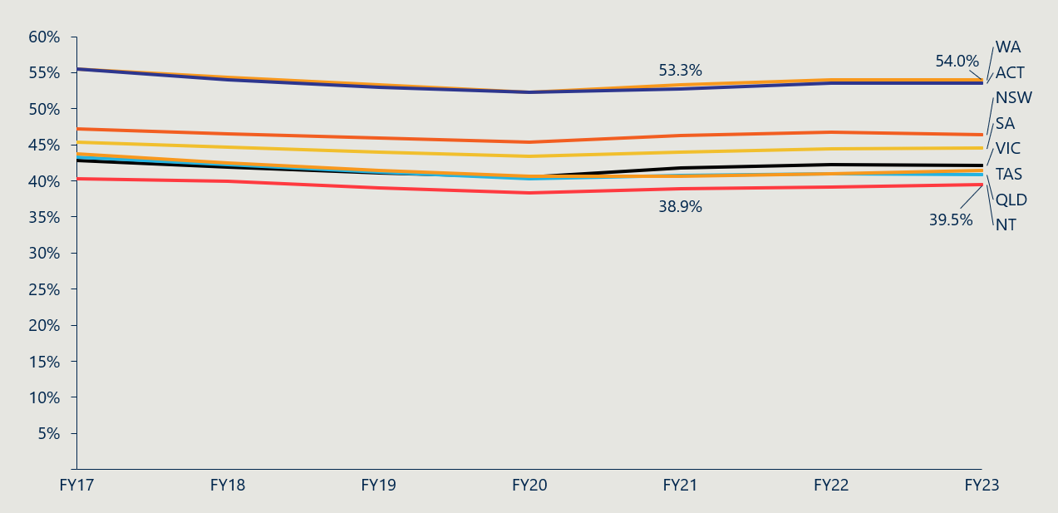

Figure 34 | Percentage of Australian population with Hospital Treatment PHI by age[142]

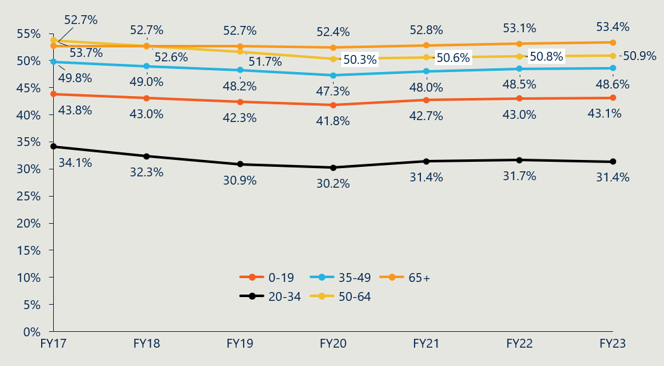

#### Measure 7.2: Utilisation of PL items by privately insured patients

Figure 35 | Average prostheses utilisation per 1000 HT PHI members by gender[143]

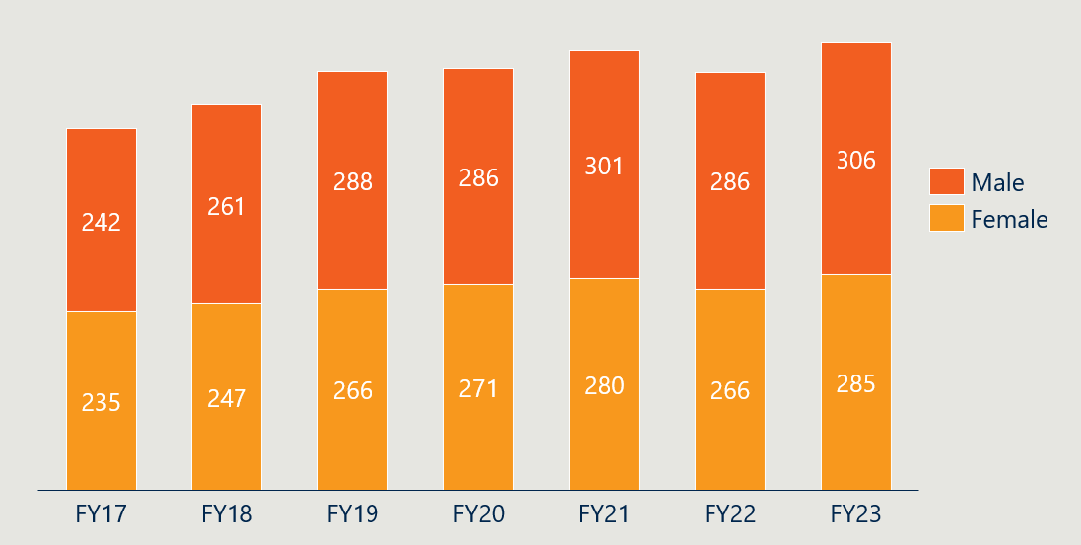

* 1. Indicator 9: Implementation of PL regrouping

#### Measure 9.2: Number of PL items and benefit groups

Table 28 below summarises the number of items per category in the July 2023 PL. The overall number of items declined from the July 2021 PL (see Figure 36), and this was reflected across all parts of the PL.

Table 28 | Number of items per category in the July 2023 PL[144]

|  |  |  |  |  |  |  |
| --- | --- | --- | --- | --- | --- | --- |
|  | Category | Part A | Part B | Part C | Part D | Total |
| Parts A, C and D | 01 - Ophthalmic | 337 | - | - | - | 337 |
| 02 - Ear, Nose & Throat | 158 | - | - | - | 158 |
| 03 - General Miscellaneous | 331 | - | 11 | 404 | 746 |
| 04 - Neurosurgical | 458 | - | - | 6 | 464 |
| 05 - Urogenital | 169 | - | - | - | 169 |
| 06 - Specialist Orthopaedic | 3417 | - | - | - | 3417 |
| 07 - Plastic and Reconstructive | 747 | - | - | - | 747 |
| 08 - Cardiac | 322 | - | 89 | - | 411 |
| 09 - Cardiothoracic | 95 | - | 14 | - | 109 |
| 10 - Vascular | 318 | - | 2 | 65 | 385 |
| 11 - Hip | 706 | - | - | - | 706 |
| 12 - Knee | 767 | - | - | - | 767 |
| 13 - Spinal | 1958 | - | - | - | 1958 |
| Part B | 01 - Cardio-thoracic | - | 18 | - | - | 18 |
| 02 - Ophthalmic | - | 20 | - | - | 20 |
| 03 - Orthopaedic | - | 629 | - | - | 629 |
| 04 - Dermatologic | - | 12 | - | - | 12 |
|  | Total | 9783 | 679 | 116 | 475 | 11053 |

Figure 36 | Number of PL items (Parts A, C and D)

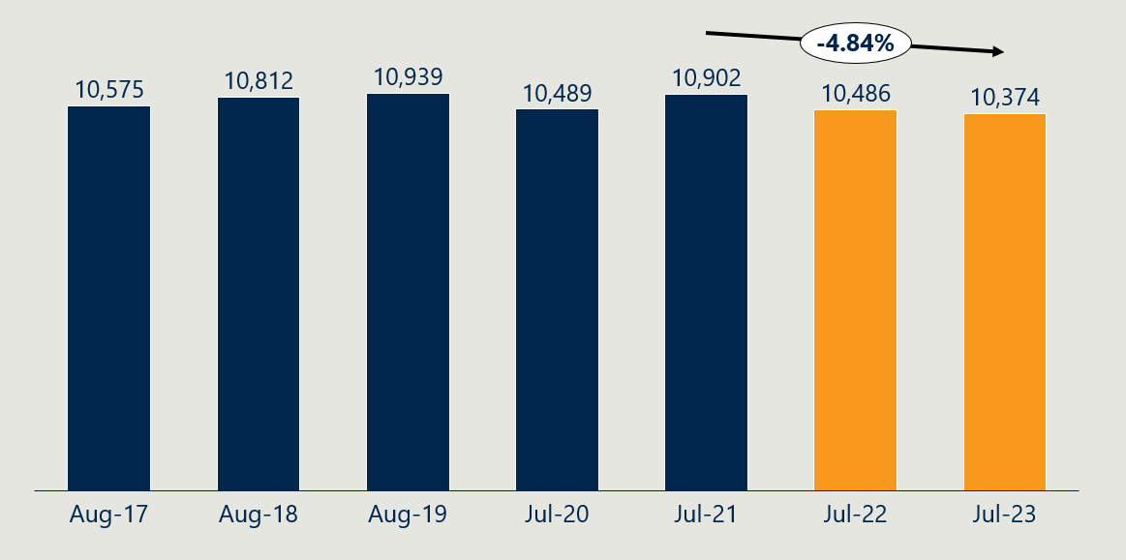

Figure 36 shows that the number of PL items in Parts A, C and D declined by 4.84% from the July 2021 PL to the July 2023 PL. This reflects a reversal of the trend in the 10 years preceding the July 2021 baseline, where the number of items increased by 1.09% per annum.

Figure 37 | Number of benefit groups[145] (Parts A, C and D)

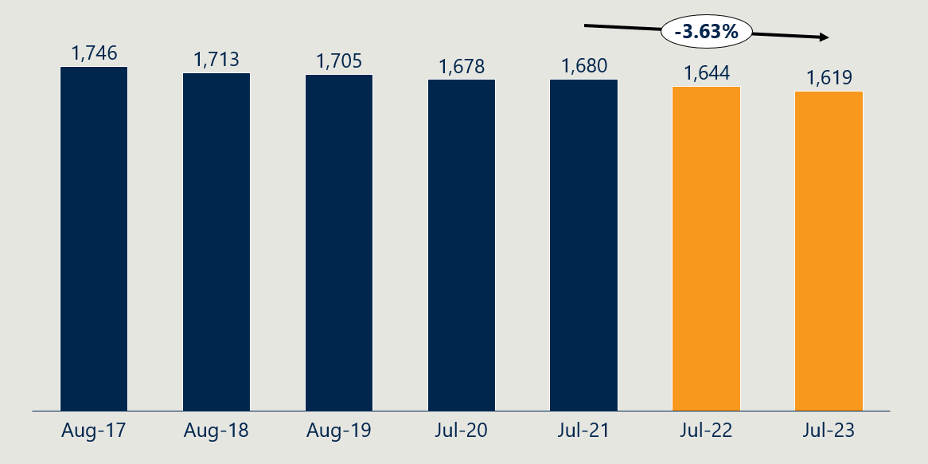

Likewise, Figure 37 shows that the number of benefit groups declined by 3.64% from the July 2021 PL to the July 2023 PL.

Figure 38 | Average items per benefit group[146] (Parts A, C and D)

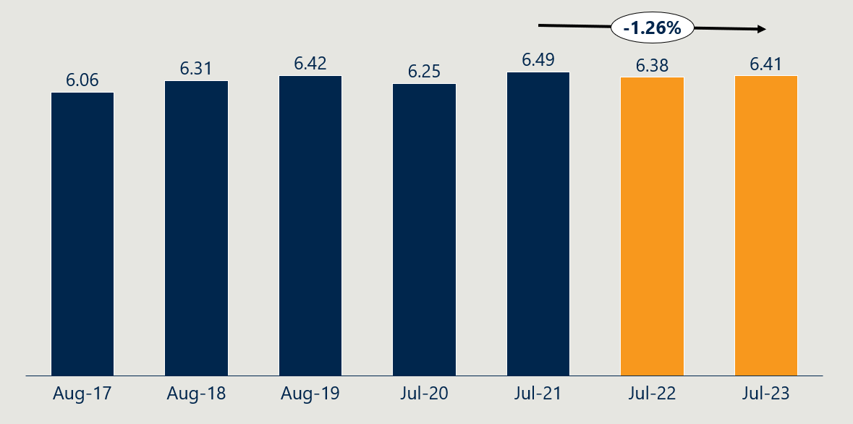

Figure 38 shows that the average items per benefit group also declined, from 6.49 in July 2021 to 6.41 in July 2023.

1. Independent Health and Aged Care Pricing Authority, Updated estimates of projected benefits and savings associated with Prescribed List reforms, 13 December 2023. Estimated projected savings from July 2022 to June 2024. Lower value assumes 0% utilisation growth from FY23 to FY24 and upper value assumes 5% utilisation growth from FY23 to FY24. See Appendix B.3 for further detail.
2. Independent Health and Aged Care Pricing Authority, Updated estimates of projected benefits and savings associated with Prescribed List reforms, 13 December 2023.
3. Ibid.
4. The evaluation takes 10 May 2024 as its baseline date in order to establish the state of all measures and understanding of the PL itself prior to any possible behaviour changes from stakeholders anticipating the reforms. Note that the Department commenced its reform program on 1 July 2021.
5. The benefit reductions that occurred on 1 July 2024 are not covered in this interim evaluation report and will be covered in the next evaluation report.
6. Response to stakeholder information request for this evaluation, 2024.
7. Based on data provided by the Department on 9/05/2024 that excluded Part C and CIED items. Nous supplemented this data with the amount of Part C and CIED items with November 2023 benefits lower than their March 2022 benefits to calculate this total.
8. While Nous is unable to verify whether every item with a benefit above 7% of its public benchmark was reduced (or above 0% for GUIs), the 50.8% figure aligns with other aggregate data provided to us by the Department of the prevalence of gaps between PL benefits and public benchmarks.
9. Data supplied by the Department, 9/05/2024.
10. Interview with the Department, May 2024.
11. Independent Health and Aged Care Pricing Authority, Updated estimates of projected benefits and savings associated with Prescribed List reforms, 13 December 2023. Lower value assumes 0% utilisation growth from FY23 to FY24 and upper value assumes 5% utilisation growth from FY23 to FY24. See Appendix B.3 for further detail.
12. Ibid.
13. Independent Health and Aged Care Pricing Authority, Estimates of projected benefits and savings associated with Prostheses List reforms, 12 October 2022.
14. The Honourable Greg Hunt MP & the Medical Technology Association of Australia Limited, Memorandum of Understanding for the policy parameters of the Prostheses List Reforms, 2022.
15. Independent Health and Aged Care Pricing Authority, Updated estimates of projected benefits and savings associated with Prescribed List reforms, 13 December 2023. See Appendix B.3 for further detail.
16. Analysis of data supplied by the Department, 9/05/2024. For clarity, ‘items where a gap was present for reduction’ refers to items with a gap above the price floor used for the benefit reductions: 0% for GUIs and 7% for all others.
17. Data supplied by the Department, 9/05/2024 and 17/06/2024.
18. Data supplied by the Department, 9/05/2024. Comparison made to baseline figures.
19. Analysis of the gap between Weighted Average Prices and November 2023 PL, supplied by the Department on 9/05/2024.
20. Ibid.
21. The Honourable Greg Hunt MP & the Medical Technology Association of Australia Limited, Memorandum of Understanding for the policy parameters of the Prostheses List Reforms, 2022.
22. Australian Competition & Consumer Commission, Report to the Australian Senate: On anti-competitive and other practices by health insurers and provider in relation to private health insurance, 2022.
23. IHACPA, Methodology for Determining the Benchmark Price for Prostheses in Australian Public Hospitals, 2021
24. IHACPA, Benchmark Price for Prostheses in Australian Public Hospitals 2020-21, 2022
25. IHACPA, Methodology for Determining the Benchmark Price for Prostheses in Australian Public Hospitals, 2021
26. IHACPA additionally verified industry-supplied data with a sample of public hospital data provided by health jurisdictions.
27. Interview with IHACPA, 2024.
28. IHACPA, Methodology for Determining the Benchmark Price for Prostheses in Australian Public Hospitals, 2021
29. Members Health Fund Alliance response to stakeholder information request for this evaluation, 2024.
30. Medical Services Advisory Committee (MSAC), Public Summary Document Application No. 1724 – Cardiac technical support services provided by industry employed technicians, 2023.
31. Ibid.
32. Ibid.
33. [Department](https://www.health.gov.au/news/phi-circulars/phi-2122-prostheses-list-reform-schedule-of-prostheses-list-price-reductions?language=en) of Health and Aged Care, PHI Circular 21/22 Prostheses List Reform – Schedule of Prostheses List Price Reductions, 2022.
34. D[epartment](https://www.health.gov.au/news/phi-circulars/phi-2122-prostheses-list-reform-schedule-of-prostheses-list-price-reductions?language=en) of Health and Aged Care, PHI Circular 29/23 Benefit reductions to Cardiac Implantable Electronic Devices, 2023.
35. D[epartment](https://www.health.gov.au/news/phi-circulars/phi-2122-prostheses-list-reform-schedule-of-prostheses-list-price-reductions?language=en) of Health and Aged Care, PHI Circular 27/24 Benefit reductions to Cardiac Implantable Electronic Devices, 2024.
36. Communication with the Department, 2024.
37. Medical Services Advisory Committee (MSAC), Public Summary Document Application No. 1724 – Cardiac technical support services provided by industry employed technicians, 2023.
38. Ibid.
39. D[epartment](https://www.health.gov.au/news/phi-circulars/phi-2122-prostheses-list-reform-schedule-of-prostheses-list-price-reductions?language=en) of Health and Aged Care, PHI Circular 27/24 Benefit reductions to Cardiac Implantable Electronic Devices, 2024
40. The evaluation team approximated thebaseline gap of CIED devices by backcalculating the public benchmark prices for the 226 out of 259 CIED items on the November 2021 PL that were subject to reductions and were not removed by July 2023. The analysis assumed the device component was 54% of the PL benefit. Nous estimated the median gap for these items to be $19,611 and the median gap % to be 188%. The lower bound of the approximation was $17,557 (144% gap) and the upper bound was $21,655 (235%).
41. Note that the incidence of gap payments cannot always be equated with out-of-pocket charges. In some instances, third parties, such as the Department of Veterans' Affairs, workers' compensation insurers, or motor vehicle insurance providers, cover the gap for consumers (therefore, not representing an ‘out-of-pocket’ cost). Conversely, there are out-of-pocket charges related to PL-listed items that are not included in these gap payments. As the HCP1 data set is from PHI reporting, it does not capture instances where consumers are charged out-of-pocket for PL-listed items as a result of a surgery or procedure not being uncovered under their policy.
42. Department of Health and Aged Care, Hospital Casemix Protocol Dataset, 2024.
43. Department of Health and Aged Care, Hospital Casemix Protocol Dataset, 2024. Note that there is a significant number of cases in which very small gap payments are charged and so a fuzz factor has been applied so that gap payments are only counted when gaps are greater than $1. Average gap payments are calculated by taking a weighted average of the monthly averages in the financial year.
44. Menzies Centre for Health Policy & University of Sydney, Options for a revised framework for setting and reviewing benefits for the Prostheses List, 2020.
45. Department of Health and Aged Care, The Prescribed List of Medical Devices and Human Tissue Products Guide (Draft), 2023.
46. Department of Health and Aged Care, PHI Circular 86/23 Surgical guides and Bio models – Frequently asked questions, 2023.
47. Response to stakeholder information request for this evaluation, 2024.
48. Ibid.
49. Australian Bureau of Statistics, Consumer Price Index, Australia March Quarter 2016 to Dec Quarter 2023.
50. Department of Health and Aged Care, List of historical premium price changes by insurer for 2023, 2023.
51. Australian Prudential Regulation Authority, Operations of Private Health Insurers Annual Report, 2015-16 to 2022-23; Australian Prudential Regulation Authority, Quarterly Private Health Insurance Statistics Prostheses, June 2023.
52. Australian Competition & Consumer Commission, Report to the Australian Senate: On anti-competitive and other practices by health insurers and provider in relation to private health insurance, 2022.
53. The Hon Mark Butler MP, Private health insurance premiums rise less than wages, pensions and inflation (media release), 2024.
54. Australian Competition & Consumer Commission, Report to the Australian Senate: On anti-competitive and other practices by health insurers and provider in relation to private health insurance, 2022.
55. Australian Prudential Regulation Authority, Operations of Private Health Insurers Annual Report, 2015-16 to 2022-23.
56. Melbourne Institute, Taking the Pulse of the Nation: Melbourne Institute’s survey of the impact of COVID-19 in Australia19-23 Oct 2020, 2020.
57. Melbourne Institute, Research Insights: Who is ditching private health insurance during the pandemic, 2020.
58. Australian Prudential Regulation Authority, Quarterly Private Health Insurance Statistics Membership Trends, June 2023.
59. Ibid.
60. Australian Prudential Regulation Authority, Quarterly Private Health Insurance Prostheses, June 2023; Australian Prudential Regulation Authority, Quarterly Private Health Insurance Membership Coverage, June 2023.
61. Australian Prudential Regulation Authority, Quarterly Private Health Membership and Benefits, June 2023; Australian Prudential Regulation Authority, Quarterly Private Health Insurance Prostheses, June 2023; Australian Prudential Regulation Authority, Quarterly Private Health Insurance Statistics Membership Trends, June 2023. Note: Utilisation is calculated here by dividing HT prostheses benefits of each category by the average prostheses benefit across all categories for the given financial year (as APRA does not publish prostheses utilisation by age and gender). HT population coverage for each age bracket (or gender) are then divided by the utilisation to get the average.
62. House of Representatives, Explanatory Memorandum, Private Health Insurance Legislation Amendment (Medical Device And Human Tissue Product List And Cost Recovery) Bill 2022, 2022.
63. Ibid.
64. Ibid.
65. Department of Health and Aged Care, Prostheses List Reforms - Consultation Paper 7 Proposed measures for compliance, assurance and information sharing, 2023.
66. Therapeutic Goods Administration, Guidance on boundary and combination products, 203.
67. Department of Health and Aged Care, Prostheses List Reform Consultation Paper 4(a) and 4(b) – Stakeholder Feedback Report, 2023.
68. Department of Health and Aged Care, Prostheses List Compliance Strategy, 2022.
69. House of Representatives, Explanatory Memorandum, Private Health Insurance Legislation Amendment (Medical Device And Human Tissue Product List And Cost Recovery) Bill 2022, 2022.
70. Response to stakeholder information request for this evaluation, 2024.
71. Department of Health and Aged Care, Prostheses List Reform - Approach to address mixed benefit groups, 2023.
72. Ibid.
73. Ibid.
74. Response to stakeholder information request for this evaluation, 2024.
75. Department of Health and Aged Care, PHI Circular 37/23 Removal of General Use Items from the Prostheses List, 2023
76. The Hon Mark Butler MP, Ensuring lower surgery costs and continued access to healthcare through general use items (media release), 2024.
77. Department of Health, Historical background of the 2021-2025 Prostheses List reform, 2022.
78. IHACPA, Consultation Paper on Bundling Arrangements for the General Use Items on the Prostheses List, 2022.
79. The Hon Mark Butler MP, Ensuring lower surgery costs and continued access to healthcare through general use items (media release), 2024.
80. The Hon Mark Butler MP, Ensuring lower surgery costs and continued access to healthcare through general use items (media release), 2024.
81. Response to stakeholder information request for this evaluation, 2024.
82. Department of Health and Aged Care, General use items on the Prescribed List, 2024. https://www.health.gov.au/our-work/general-use-items-on-the-prescribed-list (accessed August 2024).
83. Australian Medical Association, Reform of private health sector and new independent authority proposed by AMA, 2022.
84. Department of Health and Aged Care, Prostheses List Reforms - Consultation Paper 3 - A modernised fit-for-purpose listing process, 2022.
85. HPP applications data. Applications to delist and transfer not included.
86. Department of Health and Aged Care, The Prescribed List of Medical Devices and Human Tissue Products Guide (Draft), 2023.
87. The Hon Mark Butler MP, Modernising the prostheses list committee process (media release), 2023.
88. Department of Health and Aged Care, Prostheses List Reforms – Pre-Listing Assessment Framework and Governance Structure, 2022.
89. Department of Health and Aged Care, ‘Health Technology Assessments’, 2022.
90. Department of Health and Ageing, Review of health technology assessment in Australia, 2009.
91. Response to stakeholder information request for this evaluation, 2024.
92. Tamblyn, D, Parsons, J, Salinger, K & Merlin, T, Options for a Reformed Prostheses List Pre-Listing Assessment Framework and Governance Structure, 2022.
93. Response to stakeholder information request for this evaluation, 2024.
94. Department of Health and Aged Care, Prostheses List Reforms – Consultation Paper No 3(b) – Pathways for Application to the Prostheses List, 2022.
95. Department of Health and Aged Care, The Prescribed List of Medical Devices and Human Tissue Products Guide (Draft), 2023.
96. Department of Health and Aged Care, Metal-backed patellae – Prescribed List post-listing review, accessed July 2024.
97. Department of Health and Aged Care, PHI Circular 74/23 Prescribed List – Private Health Insurance (Medical Devices and Human Tissue Products) Amendment Rules (No. 2) 2023, 2023.
98. Department of Health and Aged Care, Spinal cord stimulators – Prescribed List post-listing review, 2024. accessed July 2024.
99. Department of Health and Aged Care, Urogynaecological mesh devices (mid-urethral slings) – Prescribed List post-listing review, accessed July 2024.
100. Department of Health and Aged Care, Prostheses List Compliance Strategy, 2023.
101. Department of Health and Aged Care, PHI Circular 49/23 Consultation on proposed measures for compliance, assurance and information sharing, 2023.
102. Department of Health and Aged Care, Prescribed List Reforms – Consultation Paper 8b – Alignment of amount charged for supply of a device with corresponding PL benefit, 2024.
103. Department of Health and Aged Care, Cost Recovery Implementation Statement Administration of the Prescribed List of Benefits for Medical Devices and Human Tissue Products 1 July 2023 to 30 June 2024, 2023.
104. Ibid.
105. Ibid.
106. Ibid.
107. Conn, Private Health Insurance (Prostheses Application and Listing Fees) Amendment (Cost Recovery) Bill 2022 [and associated bills], 2023.
108. Department of Health, Regulation Impact Statement (RIS): Improving the Private Health Insurance Prostheses List, 2021.
109. Department of Health and Aged Care, Cost Recovery Implementation Statement Administration of the Prescribed List of Benefits for Medical Devices and Human Tissue Products 1 July 2024 to 30 June 2025, 2024.
110. Response to stakeholder information request for this evaluation, 2024.
111. Ibid.
112. Ibid.
113. Response to stakeholder information request for this evaluation, 2024.
114. Ibid.
115. For indicators 1 and 2, the evaluation has used ‘benefit groups’ to refer to all items within a category, sub-category, group and sub-group that share the same benefit, within $2 (e.g., two items in A.01.01.01.01 with a benefit of $100 are considered as being in one benefit group, even if they have different suffix values). This is to align with IHACPA’s methodology for calculating the Weighted Average Prices and benefit reductions.
116. Data supplied by the Department on 9/05/2024.
117. The Honourable Greg Hunt MP & the Medical Technology Association of Australia Limited, Memorandum of Understanding for the policy parameters of the Prostheses List Reforms, 2022.
118. Independent Health and Aged Care Pricing Authority, Estimates of projected benefits and savings associated with Prostheses List reforms, 12 October 2022.
119. Ibid.
120. Independent Health and Aged Care Pricing Authority, Updated estimates of projected benefits and savings associated with Prescribed List reforms, 13 December 2023.
121. Evaluation team conversations with the Department, 2024.
122. Independent Health and Aged Care Pricing Authority, Updated estimates of projected benefits and savings associated with Prescribed List reforms, 13 December 2023.
123. Australian Prudential Regulation Authority, Quarterly Private Health Insurance Prostheses, June 2023.
124. Independent Health and Aged Care Pricing Authority, Updated estimates of projected benefits and savings associated with Prescribed List reforms, 13 December 2023.
125. Australian Prudential Regulation Authority, Quarterly Private Health Insurance Prostheses, June 2023.
126. As at 3 November 2023, the Department reported that HCP data had 91.5% estimated completeness for prostheses items in FY21 and 75.5% estimated completeness for prostheses items in FY23.
127. It should be noted there was no reduction of the technical support services component of CIED benefits included in the 1 July 2024 PL update, and the parameters of this reduction were redacted in the estimates provided to the evaluation team.
128. Evaluation team conversations with the Department, 2024.
129. Independent Health and Aged Care Pricing Authority, Estimates of projected benefits and savings associated with Prostheses List reforms, 12 October 2022; Independent Health and Aged Care Pricing Authority, Updated estimates of projected benefits and savings associated with Prescribed List reforms, 13 December 2023.
130. The October 2022 estimates only projected four years of savings. To compare to five years of accumulated savings from the December 2023 estimate, a fifth year of benefits and savings was extrapolated by applying the same annual change rate methodology to the October 2022 estimates.
131. Independent Health and Aged Care Pricing Authority, Updated estimates of projected benefits and savings associated with Prescribed List reforms, 13 December 2023.
132. Independent Health and Aged Care Pricing Authority, Updated estimates of projected benefits and savings associated with Prescribed List reforms, 13 December 2023.
133. l'Assurance Maladie, Liste des Produits et Prestations, http://www.codage.ext.cnamts.fr/codif/tips/index.php?p_site=AMELI. The Liste des Produits et Prestations (LPP) is a list of medical device and human tissue products that guides reimbursement for the French national health insurance system. It has a comparable scope to the PL and it prices products at a higher level of grouping than the PL.
134. Pharmac, Hospital Medical Devices Schedule, July 2016, July 2017, July 2018, July 2019, July 2020 and July 2021 editions. The Pharmac Hospital Medical Devices Schedule (Pharmac) is a list of contracted medical devices products for New Zealand public hospitals. It has a narrower scope than the PL at baseline—noting it is in the process of being expanded—and it prices products on an individual basis, not in concert with equivalent products within a group like the PL and LPP.
135. Department of Health and Aged Care, Prostheses List Part A (Prostheses), August 2016, August 2017, August 2018, August 2019, July 2020, July 2021, July 2022 and July 2023 editions; Pharmac, Hospital Medical Devices Schedule, July 2016, July 2017, July 2018, July 2019, July 2020, July 2021, July 2022 and July 2023 editions; l'Assurance Maladie, Liste des Produits et Prestations, http://www.codage.ext.cnamts.fr/codif/tips/index.php?p_site=AMELI.
136. Department of Health and Aged Care, Prostheses List Part A (Prostheses), August 2016, August 2017, August 2018, August 2019, July 2020, July 2021, July 2022 and July 2023 editions; Pharmac, Hospital Medical Devices Schedule, July 2016, July 2017, July 2018, July 2019, July 2020, July 2021, July 2022 and July 2023 editions; l'Assurance Maladie, Liste des Produits et Prestations, http://www.codage.ext.cnamts.fr/codif/tips/index.php?p_site=AMELI.
137. Department of Health and Aged Care, Prostheses List Part A (Prostheses), August 2016, August 2017, August 2018, August 2019, July 2020, July 2021, July 2022 and July 2023 editions; Pharmac, Hospital Medical Devices Schedule, July 2016, July 2017, July 2018, July 2019, July 2020, July 2021, July 2022 and July 2023 editions; l'Assurance Maladie, Liste des Produits et Prestations, http://www.codage.ext.cnamts.fr/codif/tips/index.php?p_site=AMELI.
138. Department of Health and Aged Care, Hospital Casemix Protocol Dataset, 2024.
139. Department of Health and Aged Care, Hospital Casemix Protocol Dataset, 2024.
140. This adjustment was not applied in instances where categories had less than or equal to 10 benefit groups (e.g., smaller categories in Part C and D). Note that the adjustment was determined to be applied before any of the analyses were undertaken and it so happened that the adjustment did not meaningfully alter the results or key findings.
141. Australian Prudential Regulation Authority, Quarterly Private Health Insurance Statistics Membership Trends, June 2023.
142. Australian Prudential Regulation Authority, Quarterly Private Health Insurance Statistics Membership Trends, June 2023; Australia Bureau of Statistics, Quarterly Population Estimates (ERP), by State/Territory, Sex and Age.
143. Ibid.
144. Department of Health and Aged Care, Prostheses List Part A (Prostheses), Part B (Human Tissue), Part C (Other), and Part D (General Use Items), July 2023 edition.
145. The evaluation has used ‘benefit groups’ here to refer to all items within a category, sub-category, group and sub-group that share the same benefit.
146. The evaluation has used ‘benefit groups’ here to refer to all items within a category, sub-category, group and sub-group that share the same benefit.