# The National Immunisation Program

The National Immunisation Program provides free vaccines against certain diseases, to increase national immunisation rates and reduce vaccine preventable disease. The program offers vaccines from when you're born all the way through to adulthood, including during pregnancy.

# Vaccinations during pregnancy

All Aboriginal and Torres Strait Islander people can be vaccinated for free under the National Immunisation Program. All you need is your Medicare card.

Pregnant women are encouraged to get vaccinated against the flu, whooping cough and respiratory syncytial virus (RSV) while they are pregnant. These vaccines are safe to get at the same time and you can also get the COVID-19 vaccine if it’s recommended for you.

# How vaccination during pregnancy helps your baby

When a mother gets vaccinated against the flu, whooping cough and RSV during pregnancy, it helps protect the baby. Just like food and oxygen, mum passes on her vaccine protection to bub. This means the baby is safer right from birth, especially in their first few months, when they’re most at risk of getting sick but can’t get vaccinated themselves yet.

# Vaccines are safe

There is a lot of evidence showing that vaccines given during pregnancy are safe for both mum and bub. Studies show that there’s no harm to babies when mothers get these vaccines while pregnant.

All vaccines used in Australia are checked and approved by the Therapeutic Goods Administration (TGA). The TGA makes sure vaccines are safe, effective and of good quality. Before any vaccine is approved, it’s tested carefully. The benefits of the vaccine must be stronger than any risks, meaning getting vaccinated is safer than catching the disease.

## Influenza (flu) and pregnancy

The flu is a virus that spreads easily when someone who is sick coughs or sneezes. The flu can make you really sick and cause serious problems like pneumonia, or damage to the heart and other organs.

* When you're pregnant, changes in your body can make it easier for the flu to make you really sick.
* Even if you’re healthy, the flu can still cause serious problems and life-threatening illness. It can also lead to early labour or stillbirth.
* For babies, the flu can cause pneumonia and can even lead to death.
* Babies under 6 months are more likely to end up in the hospital if they catch the flu than any other age group.

Getting the flu vaccine every year can help protect you from new types of the virus. It also helps stop the flu from spreading to your bub. If you get the flu vaccine while you’re pregnant, your baby is much less likely to catch the flu and need to go to the hospital during their first 6 months of life.

## Pertussis (whooping cough)

Whooping cough is a serious infection caused by bacteria. It spreads when someone who is sick coughs or sneezes. It affects the lungs and airways, making it hard to breathe and causing bad coughing fits.

* Whooping cough can be very dangerous for babies. It can lead to serious problems like brain damage, pneumonia, or even death.
* Babies under 6 months are most at risk of getting sick and having serious problems if they catch whooping cough.
* Babies under 6 weeks old are too young to get the whooping cough vaccine.

Getting the whooping cough vaccine during every pregnancy will help stop your bub from catching the illness. Your baby will still need to get the whooping cough vaccine when they’re older, according to the National Immunisation Program childhood immunisation schedule.

## Respiratory syncytial virus (RSV)

RSV is a common virus that spreads easily and affects the airways and lungs. It can cause serious illnesses like bronchiolitis and pneumonia. The virus spreads when a sick person coughs or sneezes and the tiny droplets can land on surfaces or be breathed in by others.

* Almost every child will get RSV in their first 2 years of life.
* RSV is one of the main reasons babies under 6 months end up in the hospital.
* Even healthy children can get very sick from RSV and may need to go to the hospital.

Getting vaccinated against RSV during pregnancy helps protect your bub against RSV from birth and in their first few months of life. It lowers the risk of serious illness.

# Side effects are mild

After getting a vaccine, you might feel some mild side effects. These usually don’t last more than a couple of days and are just your immune system reacting to the vaccine.

Common reactions include:

* pain, swelling, or redness where you got the injection
* feeling tired
* muscle aches
* a mild fever.

These side effects happen to pregnant women just like they do to non-pregnant women. Serious reactions to vaccines are very rare. If you think you’ve had a serious or unexpected reaction, see a doctor or health worker straight away.

# Where to get vaccinated

You can get your vaccines from these places:

* Aboriginal health services
* your midwife or obstetrician
* local doctors or general practices
* local council immunisation clinics (in some areas)
* community health centres
* pharmacies that offer vaccinations.

Vaccines are free, but some places might charge a small fee for the visit or the consultation. It’s a good idea to check when you book your appointment.

# Vaccination records

When you get a vaccine, the person who gives it to you will record it on the Australian Immunisation Register (AIR). This keeps a record of all the vaccines you’ve had. You can check your Immunisation History Statement on the AIR by:

* going to my.gov.au and signing in to your Medicare account, or using the Express Plus Medicare mobile app
* calling Services Australia on 1800 653 809 to ask for a copy
* asking the person who gave you the vaccine to print a copy for you.

# National Immunisation Program schedule

The National Immunisation Program schedule (maternal) shows the vaccines that are recommended and available for free during pregnancy.

|  |  |
| --- | --- |
| Stage of pregnancy | Disease |
| Recommended anytime during pregnancy | Influenza (flu) |
| Recommended during second or third trimester | Pertussis (whooping cough)^ |
| Recommended during final trimester | Respiratory syncytial virus (RSV)† |

^ Pertussis vaccine is combined with diphtheria and tetanus. † Abrysvo® is the only RSV vaccine approved for use in pregnant women.

# Want to know more?

* Have a yarn to your midwife, health worker or vaccination provider.
* Visit [health.gov.au/maternalvaccinations](https://www.health.gov.au/maternalvaccinations)
* Contact your state or territory health department.

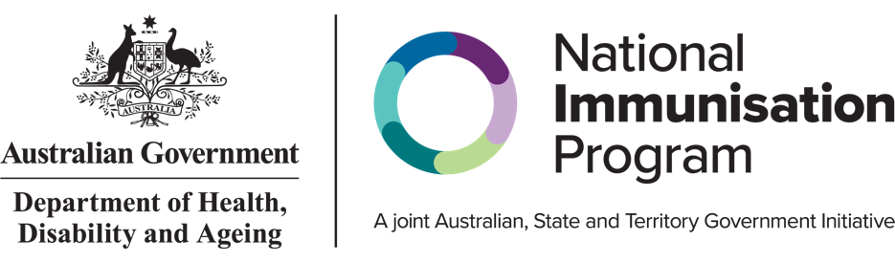

All information in this fact sheet is correct as of April 2025.