Data Exchange Toolkit – Stage 1

Commonwealth Home Support Program



# 

# 1. Introduction

DEX is changing. Stage 1 of DEX changes will start on 1 July 2025. Providers will need to:

* Update their outlets with new program activities. This should be done at the first opportunity, as the DEX Helpdesk will need to approve all updates.
* Create new cases.
* Update their third-party systems.

This toolkit only applies to Stage 1 of the DEX changes.

This is version 1.0 and was published April 2025. To ensure you are using the latest version of this document, regularly check the [CHSP Reforms](https://www.health.gov.au/our-work/chsp/reforms) website.

## About this Toolkit

This toolkit provides information and guidance to Commonwealth Home Support Program (CHSP) providers. It outlines the actions providers should take to prepare for changes in their Data Exchange (DEX) reporting requirements, in accordance with the new *Aged Care Act 2024* (Aged Care Act) from 1 July 2025.

From 1 July 2025, DEX reporting requirements are changing to ensure services align to the new CHSP service list under the new Act. The changes will require system updates by providers, and providers will need to change the way they collect and report data.

This toolkit should be read in conjunction with:

* Department of Social Services (DSS) [DEX Portal - the e-Learning modules](https://dex.dss.gov.au/training)
* [Data Exchange Dictionary](https://www.health.gov.au/our-work/chsp/reforms)
* [Proposed changes to Commonwealth Home Support Programme (CHSP) Data Exchange from 1 July 2025 – Fact sheet](https://www.health.gov.au/resources/publications/proposed-changes-to-commonwealth-home-support-programme-chsp-data-exchange-from-1-july-2025-fact-sheet?language=en)
* [CHSP 2025-27 Manual](https://www.health.gov.au/our-work/chsp/reforms)
* [CHSP 2025-27 extension resources](https://www.health.gov.au/resources/collections/chsp-2025-27-extension-resources?language=en).

Providers will continue to have three options available to submit their DEX reports:

1. A manual,web-based portal;
2. A system-to-system transfer; and
3. XML bulk upload, for providers with a compatible client management system.

If your organisation uses bulk upload or system-to-system transfer as your data entry mechanism, please provide a copy of this toolkit to your organisation’s in-house software development team or software vendor.

## Staged implementation of DEX changes

The development and implementation of the necessary Information and Communication Technology (ICT) changes to DEX will occur in multiple stages. This means that not all the new reporting requirements will be available in DEX from 1 July 2025.

This toolkit will be updated as each stage is completed.

This version of the toolkit reflects the planned changes for Stage 1 implementation from July 2025.

| Stage | Timeline | Reporting Change | Details |
| --- | --- | --- | --- |
| Stage 1 | 1 July 2025 | **Service Type** (recorded in DEX as Program Activity) | * Service delivery against the Activity Work Plan aligned to the new CHSP Service List. * Provide service delivery information for all funded activities. * Home modifications will have some extra items to record. |
| My Aged Care ID (MAC ID) | * The DEX changes to submit MAC ID will **NOT be implemented in Stage 1**. Providers need to record this information in their own client management systems until this functionality is available through DEX reporting. |
|  |  |  |  |
| Future changes | To be confirmed | MAC ID | * Report client level data (including MAC ID). |
| Service-specific information | * Additional session-level data fields for more detailed reporting for particular activity types. * Identifying and separating hidden costs (e.g. no shows). |
| Social Capital | * Additional metrics to capture the extra benefits (e.g. time spent with clients as part of a meal delivery or transport service). |

2. Changes to DEX

## General information

CHSP service providers must provide activity and performance data in line with their CHSP Grant Agreement and Activity Work Plan. Monthly performance reports containing client and service delivery information are submitted via DEX in accordance with the [DEX Protocols](https://dex.dss.gov.au/data-exchange-protocols). Refer to [DEX Training Resources](https://dex.dss.gov.au/training) for general assistance. Please refer to the [Commonwealth Home Support Programme (CHSP) Manual](https://www.health.gov.au/resources/publications/chsp-manual) for an overview of the CHSP service types and requirements for delivering those services.

## The new CHSP service list

The new CHSP service list has a different organisational structure and has slightly different naming conventions from the old CHSP service list. This is because it is aligned with the new Aged Care Act and the Support at Home service list. As with the previous service list, the organisational structure in DEX is also represented differently. Note the example in italics, in the chart below.

**Unless otherwise specified, this toolkit will use the terminology as shown in DEX.**

The CHSP Service List is available in the [**CHSP service catalogue 2025-27**](https://www.health.gov.au/resources/publications/chsp-service-catalogue-2025-27)**.**

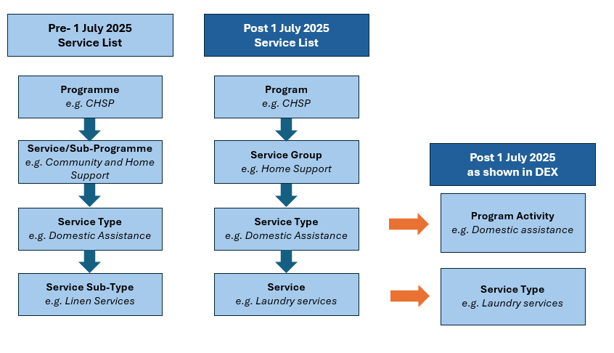

Note that there are 4 services (as defined in the Post 1 July 2025 Service List) that are exceptions to the above structure. These are defined in DEX as both Program Activities and Service Types. These are:

* Meal delivery
* Meal preparation
* Individual social support
* Group social support.

## Explanation of the DEX structure

DEX has its own organisational structure. Section 3 of this toolkit explains the steps for creating, updating, and recording the items in this structure. The DEX structure is explained below:

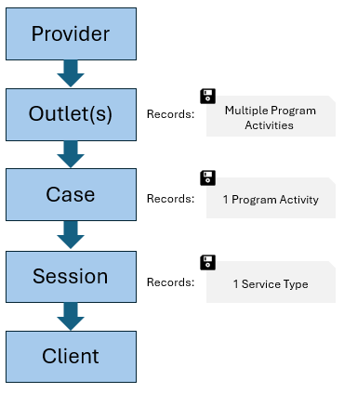

A **provider** delivers services from a single or multiple outlet(s).

An **outlet** is thephysical location from where a service is primarily delivered.

A **case** is like a folder and contains sessions. The sessions in a case must all be of the same program activity and delivered from the same outlet.

A **session** records the **service** **type** (e.g. laundry services) delivered to a **client**. Sessions can only have one service type. That service type must be part of the program activity as recorded in the case.

### What do providers need to do to prepare to report services delivered from 1 July 2025 with the Stage 1 changes?

#### Performance reporting against CHSP Service List

From 1 July 2025, when a provider uses the DEX Portal, system-to-system, or XML bulk upload function to record the services they have provided to clients, they must report as follows:

| IF the service was provided to clients… | THEN the provider must report against the ... |
| --- | --- |
| On or before 30 June 2025 | Pre-existing CHSP service list (non-Aged Care Act aligned) |
| On or after 1 July 2025 | New CHSP Service List aligned to the Aged Care Act |

After 1 July 2025 previously created outlets and cases will continue to be available. Providers will be able to record services that were delivered before 1 July 2025 in these outlets and cases using the old program activities. However, the system will restrict them from recording activities dated after 30 June 2025 against these program activities.

### The testing Stage 1 environment

#### When will new CHSP Program Activities be available in the Staging Environment for my organisation’s system developers or third party software vendors to review?

Your organisation’s software developers or third party software vendors will already have access to the DEX Staging environment if they have developed your current XML upload or System-to-System capability.

**Please note: No new fields are being implemented in DEX for Stage 1 i.e. there are no schema changes developers need to allow for, in order for your organisation to report into DEX from 1 July.**

However, the configuration associated with the new Act-aligned DEX Program Activities is available for developers to review before the changes go live on 1 July 2025.

Any records, including outlets, cases, clients and sessions developers create in the testing environment will not transfer over to the DEX (production) environment. When creating records in the testing environment, it is expected developers use “dummy data” and not real client or service details.

Software developers/providers will be able to login to the testing environment using their existing Staging environment username and password.

As there are no new fields being implemented in Stage 1, developers will only get an indication of which Program Activity reference data will need to be configured in your organisation’s system/s i.e. new Program Activity Names and related DEX service types.

### Actions for providers

#### Providers who use the DEX Portal

Familiarise relevant staff with the changes in the [new CHSP Service List](https://www.health.gov.au/resources/collections/chsp-2025-27-extension-resources?language=en). Refer to the Fact Sheets for the full list.

Please note that in DEX Stage 1, providers will report against 17 Program Activities (previously, in the DEX there were only 3). Refer to Appendix A in this Toolkit for the list of Service list reporting in DEX Stage 1.

Ensure you understand the processes to report for your new grant/s as described in this toolkit and in the various task cards on the DSS website.

#### Providers who use a third-party application or have in-house software developers

Ensure a copy of this document is provided to your organisation’s relevant team or vendor.

The new Program Activities and their associated service types and questions (i.e. Quantity, fees charged etc) will be added to the testing environment for software providers/developers to review and test against the Stage 1 reporting before 1 July 2025.

Ensure your IT developers and administrators regularly update and validate their systems in line with the new service list using the new XML codes, as described in this Toolkit. Familiarise relevant staff with the new service list.

Your systems will need to prepare XML files of web service data transfers that align with the new program activity names, service types etc. Organisations are responsible for downloading these reference data and using them in the XML file uploaded, or data transferred to DEX.

## When will my organisation be able to start reporting services delivered under our new CHSP grant/s?

Providers will be able to report services delivered under their new grants from 1 July 2025. Providers will only be able to report against Program Activities (CHSP service types) that they are approved for.

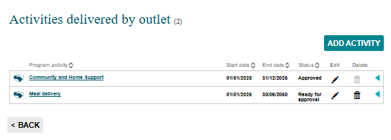

All records existing in DEX on 30 June 2025 will continue to exist in DEX from 1 July 2025, including:

* Provider organisation information
* Outlets
* Cases
* Clients.

However, because cases are associated with Program Activities, new cases will need to be created to associate with the new Program Activities.

3. DEX Portal user instructions

## Introduction

This section of the Toolkit outlines steps for data entry using the DEX portal. The System-to-System and Bulk XML procedure is different, and instructions for these is provided separately in Section 4 of this Toolkit.

Rather than providing detailed DEX instructions, this Toolkit concentrates on differences in DEX Stage 1 implementation. For more detailed information and Step-by-Step instructions, refer to [DSS task cards](https://dex.dss.gov.au/training/task-cards).

### Best practice data entry

DEX is a very versatile tool that allows users to enter the information in various sequences. The detail of each step is explained further in this section. Although a user can enter the information in their preferred manner, there is a logical sequence of data entry required.

* Setting up the Provider – the organisation, with its outlets and service types (DEX program activities) each outlet offers.
* Setting up the Case – used as a container for each session/client detail.
* Setting up the Session – with detailed information what service (DEX service type) was provided.

### Initial DSS DEX login

Navigate to the DEX login page by clicking [DEX landing page](https://dex.dss.gov.au/).

It is recommended to refer to DEX [Quick Start Guide](https://dex.dss.gov.au/document/46) for details how to login and all initial requirements to gain access.

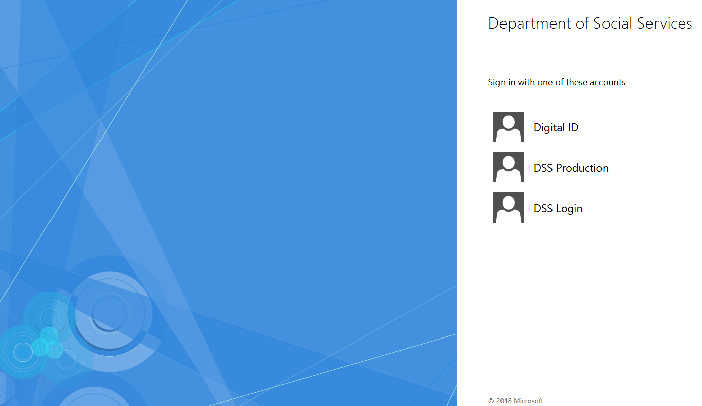

DSS DEX Login screen

After login, DEX displays the **MyDEX Dashboard**. This is the main screen with interfaces to all its functions.

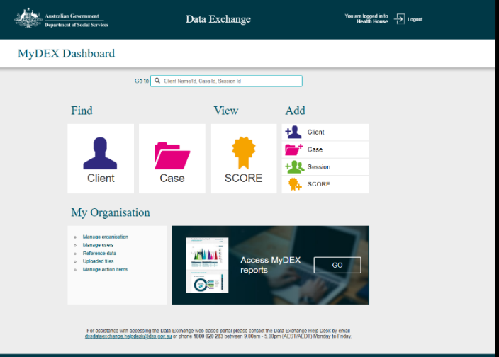

DSS DEX Welcome screen (MyDEX Dashboard)

### Editing outlets with new Program Activities

From 1 July 2025 providers must add the new Program Activities (CHSP Service Types) to their outlets before they are able to record activities occurring post 1 July 2025. The new Program Activities will automatically be available in DEX from 1 July 2025, based on the Program Activities providers are approved for in their grant agreement.

It is recommended that providers add the new Program Activities to their outlets as soon as possible. This is because the DEX Helpdesk needs to approve these updates. Please note that outlet approvals during this time may take longer than expected due to the volume associated with the new grants.

Outlets need to be approved before new cases can be created and before new organisation data files can be generated for configuring systems where XML or web services (System-to-System) are used as the data entry mechanism.

The detailed process to set up or edit the organisation information is explained in [DEX Overview Organisation](https://dex.dss.gov.au/document/266) task card. The detailed process to add or edit an outlet is provided in the [DEX Manage outlets](https://dex.dss.gov.au/document/271) task card.

#### Step 1: Login and navigate to Organisation Information from the MyDEX Dashboard (Main Menu)

After logging into DEX, navigate to Organisation Information.

#### Step 2: Select an outlet to edit

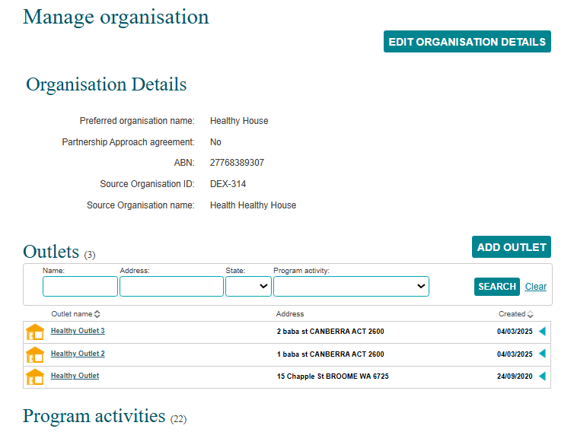

DSS DEX Provider Organisation details

From Manage organisation, click on the outlet.

#### Step 3: Add activity

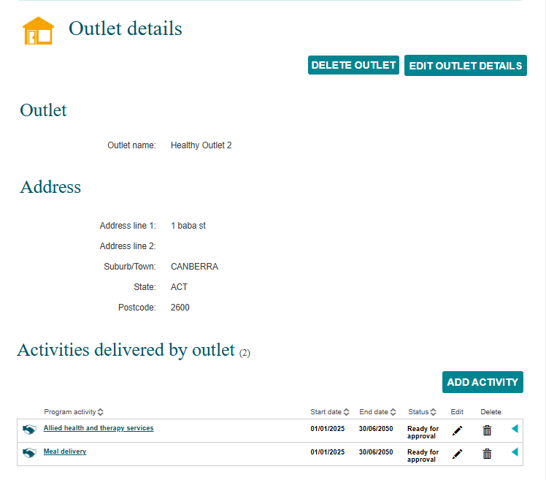



DSS DEX Provider Organisation outlet information

From Outlet details, click add activity.

#### Step 4: Add Program Activities

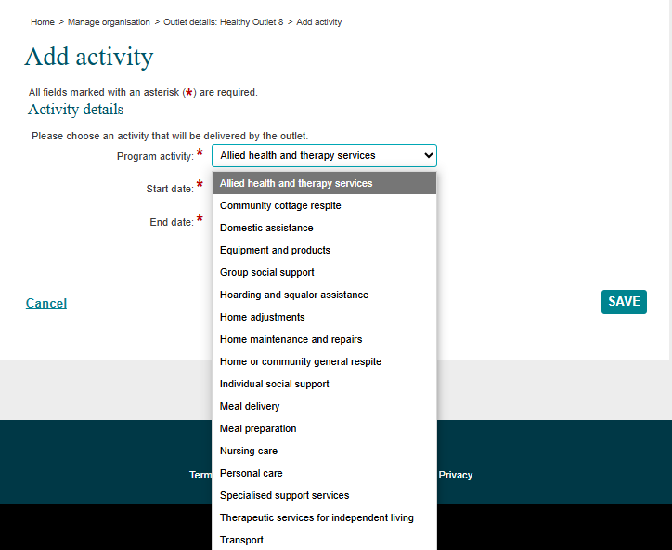

DSS DEX Provider Organisation Outlet Program Activity

Select a Program Activity from the drop-down menu. You will select from the new list of program activities. The list of Program Activities is automatically filtered based on the Provider’s Grant Agreement. Note that in the testing environment, this list will be unfiltered.

The start and end date should be automatically populated to align with your grant agreement. If you notice any discrepancies, contact your [Funding Arrangement Manager](https://www.health.gov.au/contacts/state-funding-arrangement-managers-for-the-commonwealth-home-support-programme) (FAM). Hit save, and you will be returned to the outlet details page.

#### Step 5: DEX Helpdesk approves the program activity

After the program activities have been added to the outlet, the DEX Helpdesk will approve the update. Once the Helpdesk has approved, the Program Activity’s status will change to “Active.”

**This approval process may initially take up to 15 business days.**

### Creating cases with a new Program Activity

New cases will need to be created and configured with a program activity from the new service list.

#### Step 1: Login and navigate to Add Case from the MyDEX Dashboard (Main Menu)

From the Dashboard, click on Case in the “Add” column. The icon can be distinguished by the + sign.

#### Step 2: Add case details

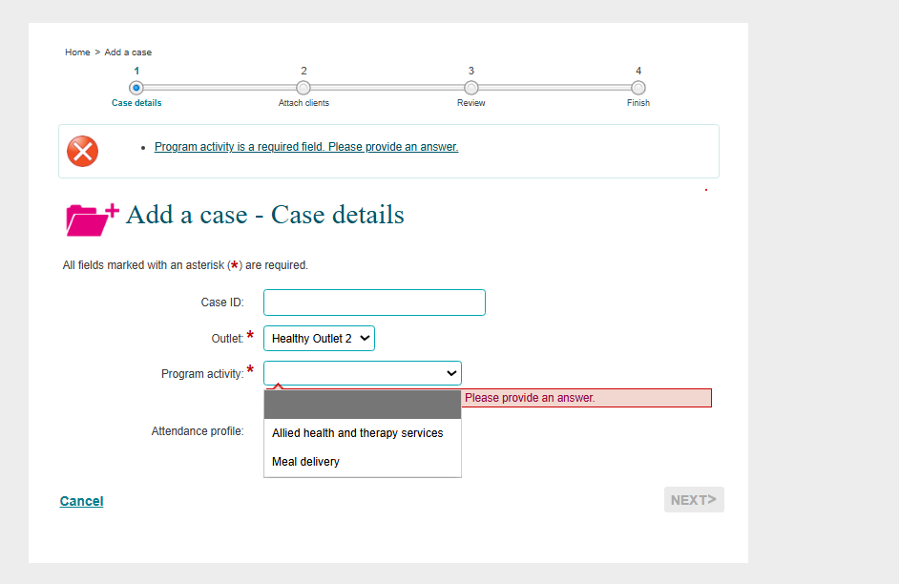

DSS DEX Case details

Create a Case ID for ease of reference (optional). Select an outlet from the outlets created in the previous section.

Select a program activity from the list. This list will already be filtered and will only show program activities associated with that outlet. Click Next.

#### Step 3: Attach a client to the case

Attach a client to the case. Clients must be associated with the Case before they can be added to a Session linked to the Case. Click Next.

You will have the option to review what you entered prior to submitting. Click Submit when you are done.

Depending on the service type there may be a need to add case specific client information. For the detail configuring the client information refer to [DSS DEX Task card](https://dex.dss.gov.au/document/326).

### Creating and entering Session details

The process for entering Session details remains the same. Detailed information on entering Session details can be found in the [Add a session](https://dex.dss.gov.au/document/346) task card.

However, from 1 July 2025 note that:

* When attaching a session to a case, ensure that you are attaching it to one of the new cases, or you will not be able to select from the new DEX service task list.
* In some cases, the name of the program activity and the DEX service type are the same.
* The details to be entered per Session in DEX Stage 1 are listed in Appendix A of this Toolkit.
* Depending on the service type, there might be different details that need to be entered. Refer also to the DEX Data Dictionary and the [CHSP 2025-27 Manual](https://www.health.gov.au/our-work/chsp/reforms).
* There will be more significant changes to the required Session details in later DEX changes.

A typical Session details page, with mandatory fields indicated by *

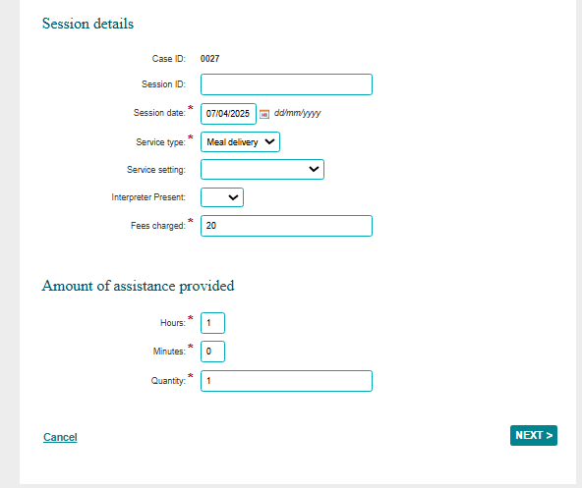

### Home modifications

Please note home modifications will have some extra items to record as per the screenshot below:

* Toileting products
* Bathroom products
* Light fixtures
* Supporting handrails and grab bars
* Construction elements in homes
* Vertical accessibility
* Safety equipment for homes and other premises
* Furniture for storage
* Mechanical products for operation and controlling devices
* Gate, door, window and curtain openers/closers
* Electronic products for operation and controlling devices.

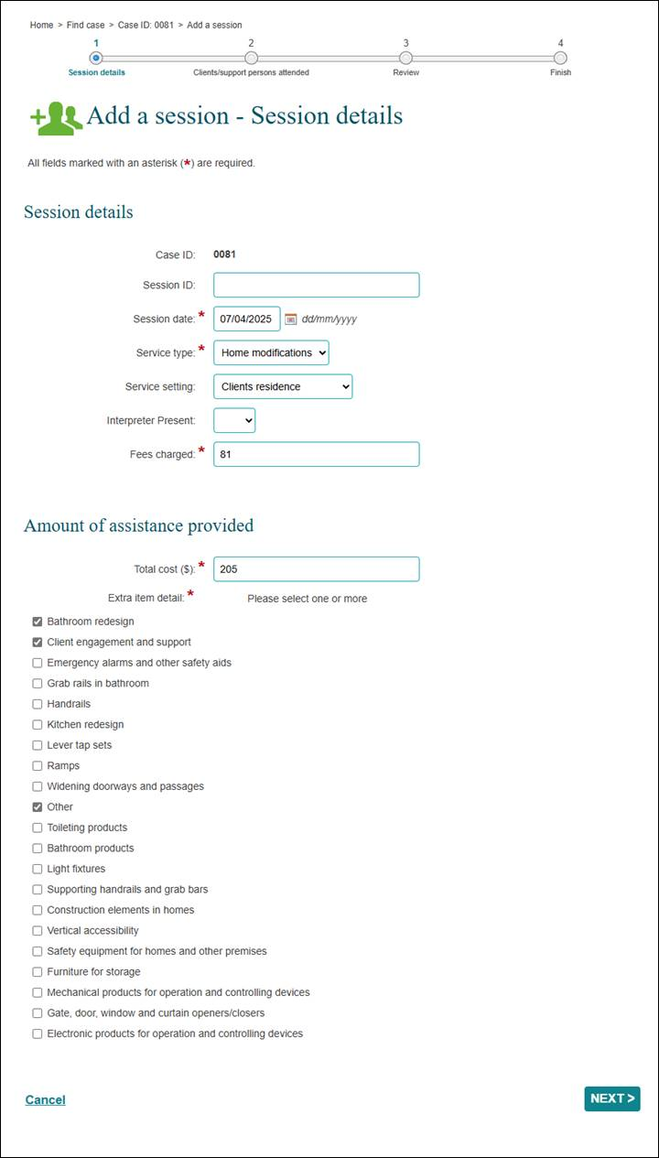

### Creating and entering client details

Detailed information on entering client details can be found in the [DEX Add client Task card](https://dex.dss.gov.au/document/326).

**Note that the changes to MAC ID requirements will NOT be implemented in DEX Stage 1.** Providers will still need to prepare their third-party systems for MAC ID and collect the information, for later integration with DEX. If manual DEX data entry is used, providers need to keep MAC ID manually for future reference.

For more information on changes around MAC ID reporting, see the [Extension factsheet.](https://www.health.gov.au/sites/default/files/2025-01/commonwealth-home-support-programme-chsp-2025-27-extension-provider-update.pdf)

4. XML Bulk Uploads and Web Services

## About XML bulk uploads and web services

In addition to using the DEX Portal, providers also have the option of using:

* a manual XML bulk upload, or
* using a web services, system-to-system transfer

Software providers who develop solutions for either of these options will be able to get an indication of the changes to the program configuration in the DEX Staging Environment using their existing credentials prior to 1 July 2025.

The [Bulk file upload technical specifications](https://dex.dss.gov.au/document/131) are not being updated ahead of 1 July 2025 as Stage 1 does not include the addition of any new fields (elements) that would result in a schema change.

The [Bulk file upload technical specifications](https://dex.dss.gov.au/document/131) will be updated ahead of the later changes to DEX reporting requirements that will introduce new fields such as MAC ID (not included in DEX Stage 1 implementation).

Similarly with System-to-System, the [Web Services Technical Specifications](https://dex.dss.gov.au/document/126) are not updated before 1 July 2025 and will be updated ahead of later changes to DEX.

Software providers will be able to download the Reference Data (as described below) to see the new example field codes for the Extra Items question for the home modifications service. There will be a short period from 1 July 2025 where the list will include the values available to report for services delivered up to 30 June 2025 and the new values that are expected to be used from 1 July 2025.

Providers should also download organisation and outlet data, referring to the relevant sections relating to the new CHSP Program Activities.

Software developers/testers will be able to submit test XML files, or submit data via web services using ‘dummy data’ to validate that their systems can generate files utilising new Organisation Activity IDs, Outlet Activity IDs, new DEX service types etc.

For web services, providers can use their systems to utilise the *GetReferenceData*, *GetOrganisationActivities*, *GetOutletActivities* services etc to retrieve the same information they could manually download via the Portal.

Please note the results may be different between the test environment to those that are currently in Production.

Please note the organisation activity and outlet data codes generated in the testing environment are indicative and will not correspond to the final codes that you will download from the live DEX environment. While the changes to DEX are ongoing, it is strongly recommended that providers periodically check for format updates and validate any changes, as described in the process below.

Providers will be able to download the organisation activity and outlet data for the CHSP Program Activities that you are funded for once your grant/s is executed.

This should be done after you have added the new Program Activities to your outlets, and they have been approved (Active) by the DEX Helpdesk.

## Process to validate XML file format

The process to validate XML file formatting is described below.

1. Navigate to the Reference data page from MyDEX Dashboard
2. Download the reference data by clicking on each download link: DEX XML
   1. DEXReferenceData.xml: Contains data codes for standard field values common across all programs (clients, cases, sessions, SCORE)
   2. OrganisationData.xml: Organisation activity and outlet data – organisation specific data activity codes that the provider will need to align to in order to submit data against the new programs.
3. Configure and cross check the codes from the downloaded files with the organisation’s system.
4. Generate an updated XML file.
5. Upload the updated XML file to the testing environment to confirm accuracy and check for errors. See [Upload methods Task card](https://dex.dss.gov.au/document/311) for details.

Please note, there are no schema changes in scope for DEX Stage 1, so providers do not need to re-download the XML schema file.

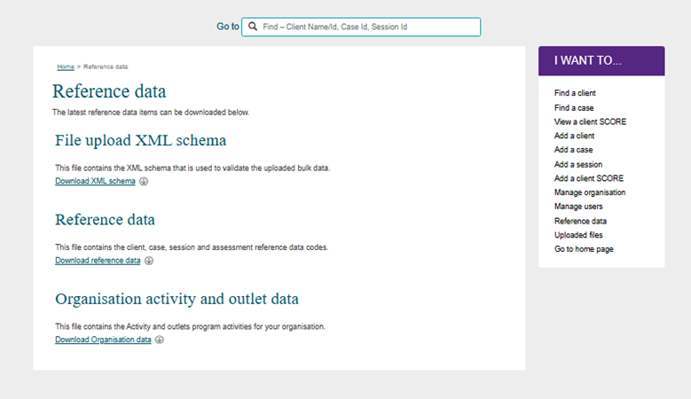

DSS DEX XML Reference file menu

## Process to validate Web services functions

The management and validation of codes for the Web services will follow the same process as per [Web Services Technical Specifications](https://dex.dss.gov.au/document/126).

Appendices

## Appendix A: Stage 1 CHSP DEX System Reporting Requirements

From 1 July 2025, DEX Stage 1 changes will require providers to report similar data fields to previous requirements, against the new service list. Mandatory reporting is service dependent across four fields – total cost; time; quantity; and fees collected. Mandatory reporting against those fields is as shown in the table below for each Service Type.

| Program activity (CHSP Service Type) | Service Type (CHSP Service) | Mandatory reporting required | | | |
| --- | --- | --- | --- | --- | --- |
| Total Cost $ | Hours and Minutes (Time) | Quantity | Fees Charged** |
| Allied health and therapy services | Aboriginal and Torres Strait Islander health practitioner assistance |  | Yes |  | Yes |
| Aboriginal and Torres Strait Islander health worker assistance |  | Yes |  | Yes |
| Allied health assistance |  | Yes |  | Yes |
| Counselling or psychotherapy |  | Yes |  | Yes |
| Diet or nutrition |  | Yes |  | Yes |
| Exercise physiology |  | Yes |  | Yes |
| Music therapy |  | Yes |  | Yes |
| Occupational therapy |  | Yes |  | Yes |
| Physiotherapy |  | Yes |  | Yes |
| Podiatry |  | Yes |  | Yes |
| Psychology |  | Yes |  | Yes |
| Social work |  | Yes |  | Yes |
| Speech pathology |  | Yes |  | Yes |
| Community cottage respite | Cottage respite |  | Yes |  | Yes |
| Domestic Assistance | General house cleaning |  | Yes |  | Yes |
| Laundry services |  | Yes |  | Yes |
| Shopping assistance |  | Yes |  | Yes |
| Equipment and products | Communication and information management products | Yes |  | Yes | Yes |
| Domestic life products | Yes |  | Yes | Yes |
| Managing body functions | Yes |  | Yes | Yes |
| Mobility products | Yes |  | Yes | Yes |
| Self-care products | Yes |  | Yes | Yes |
| Group social support | Accompanied activities |  | Yes |  | Yes |
| Cultural support |  | Yes |  | Yes |
| Digital education and support |  | Yes |  | Yes |
| Group Social Support |  | Yes |  | Yes |
| Hoarding and squalor assistance | Hoarding and squalor supports |  | Yes |  | Yes |
| Home adjustments | Home modifications * | Yes |  |  | Yes |
| Home maintenance and repairs | Assistance with home maintenance and repairs | Yes | Yes |  | Yes |
| Gardening |  | Yes |  | Yes |
| Home or community general respite | Community and centre-based respite |  | Yes |  | Yes |
| Flexible respite |  | Yes |  | Yes |
| Individual social support | Accompanied activities |  | Yes |  | Yes |
| Assistance to maintain personal affairs |  | Yes |  | Yes |
| Cultural support |  | Yes |  | Yes |
| Digital education and support |  | Yes |  | Yes |
| Individual Social Support |  | Yes |  | Yes |
| Meal delivery | Meal delivery |  | Yes | Yes | Yes |
| Meal preparation | Meal preparation |  | Yes | Yes | Yes |
| Nursing care | Enrolled nurse |  | Yes |  | Yes |
| Nursing assistant |  | Yes |  | Yes |
| Registered nurse |  | Yes |  | Yes |
| Personal care | Assistance with self-care and activities of daily living |  | Yes |  | Yes |
| Assistance with the self-administration of medication |  | Yes |  | Yes |
| Continence management (non-clinical) |  | Yes |  | Yes |
| Specialised Support Services | Client advocacy | Yes | Yes |  | Yes |
| Continence advisory services | Yes | Yes |  | Yes |
| Dementia advisory services | Yes | Yes |  | Yes |
| Hearing advisory services | Yes | Yes |  | Yes |
| Other clinical advisory services | Yes | Yes |  | Yes |
| Vision advisory services | Yes | Yes |  | Yes |
| Therapeutic services for independent living | Acupuncture |  | Yes |  | Yes |
| Art therapy |  | Yes |  | Yes |
| Chiropractics |  | Yes |  | Yes |
| Diversional therapy |  | Yes |  | Yes |
| Osteopathy |  | Yes |  | Yes |
| Remedial massage |  | Yes |  | Yes |
| Transport | Direct transport |  | Yes | Yes | Yes |
| Indirect transport |  | Yes | Yes | Yes |

**Where the Fees Charged is not applicable, providers can enter a zero value (ie Hoarding and squalor).

*Please note that Home modifications will have some extra items to record. See screenshot in Creating and entering sessions

Phone **1800 200 422** (My Aged Care’s free call phone line)



Visit <agedcareengagement.health.gov.au>



For translating and interpreting services, call **131 450** and ask for My Aged Care on **1800 200 422**.

To use the National Relay Service, visit **nrschat.nrscall.gov.au/nrs** or call **1800 555 660**.