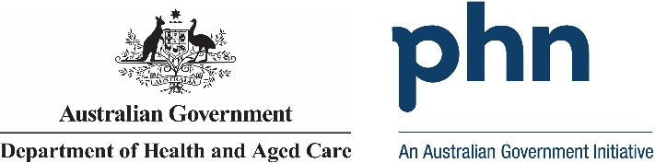

## Central and Eastern Sydney

## PHN Fact sheet 2024

### Snapshot:

Central and Eastern Sydney PHN has a total population of 1553825 people. Of this total, 19419 are First Nations people. The total population growth from 2016 to 2022 was -0.92%. The population aged 65 years and over equates to 232496 people. Population growth for this age group from 2016 to 2022 was 11.22%. The PHN covers 626.909 square kilometres. Snapshot information is based on data published by the Public Health Information Development Unit (PHIDU) at Torrens University, from the Social Health Atlas of Australia by Primary Health Network, December 2023. Population data for 2016 is sourced from the PHIDU Social Health Atlas of Australia by Primary Health Network, December 2017, which is used to calculate population growth.

### Key Information:

Central and Eastern Sydney PHN has 4.48% of its population who require assistance for core activities due to a disability. The unemployment rate for the labour force is 3.02%. People who use another language and who do not speak English well account for 4.83% of people, while 1.46% do not speak English at all. Unemployment rate is based on the PHIDU Social Health Atlas of Australia by Primary Health Network, December 2023. Need for assistance due to disability and English language proficiency are based on the Australian Bureau of Statistics Census of Population and Housing 2021.

### Demographics:

Central and Eastern Sydney PHN has a male population of 775651 people, which equates to 49.92% of the total population. Females account for 778174 people. That is 50.08% of the total population. Demographics information is based on PHIDU Social Health Atlas of Australia by Primary Health Network, December 2023.

### Age:

Central and Eastern Sydney PHN has the following age distribution: Zero to fourteen year olds account for 229028 people. 15- to 24-year-olds account for 193970 people. 25- to 44-year-olds account for 542416 people. 45- to 64-year-olds account for 355915 people. 65- to 84-year-olds account for 197984 people. Lastly those aged 85 years and above account for 34512 people. This data is sourced from the PHIDU Social Health Atlas of Australia by Primary Health Network, December 2023.

Data has been obtained from a range of publicly available sources, and Department of Health and Aged Care does not take responsibility for data quality. Last Updated: March 2025