Communication toolkit

2025 Residents’ Experience Survey

This toolkit provides materials to help residential aged care providers and consumer peak bodies communicate with residents, their families and carers about the Residents’ Experience Survey.

## What’s in this toolkit

* Key messages
* Editorial content
* Booklet
* Video

## Audience

* Aged care residents, their families and carers
* Aged care workers and providers

## Call to action

We recommend including the following call to action in communication materials:

* If you have questions about the Residents’ Experience Survey, please ask the staff at your aged care home or the survey team.
* To find out more, [read the Residents’ Experience Survey: A guide for older people in residential aged care booklet](https://www.health.gov.au/resources/publications/residents-experience-survey-a-guide-for-older-people-in-residential-aged-care?language=en) or [watch the video](https://www.health.gov.au/resources/videos/residents-experience-survey-a-guide-for-older-people-in-residential-aged-care).

## Key messages

### Guidance

Use these key messages communicate with residents, their families and carers and answer their questions about the Residents’ Experience Survey.

* The Australian Government undertakes the Residents’ Experience Survey each year to understand what residents feel is working well and where providers might need to improve.
* The 2025 Residents’ Experience Survey round is underway at aged care homes across Australia.
* The survey is an opportunity for you to share your views on the care you receive at your aged care home.
* Your views and experiences are important. Each year, residents are randomly chosen to take part in the survey. This means your satisfaction can be measured and monitored over time and your home can improve their service.
* The survey is run by an independent and experienced survey team. This ensures that people feel more comfortable to give honest feedback.
* In 2025, staff from Access Care Network Australia (ACNA) will visit your aged care home to conduct the survey.
* From **<insert date>** to **<insert date>,** staff from Access Care Network Australia(ACNA) will visit **<insert name of your aged care home>** to conduct the survey.
* The independent survey team is trained and experienced in talking with older people, including those with dementia, and conducting surveys in a safe manner.
* The survey team is trained and experienced in engaging with people form diverse backgrounds including Aboriginal and Torres Strait Islander people, culturally and linguistically diverse, veterans, care leavers, LGBTIQ+, people living with disability and those who have experienced homelessness and forced adoption.
* Survey team members have had a National Police Check, Working with Vulnerable People check and are vaccinated against COVID-19 and influenza.
* If you are invited to do the survey, the survey team will ask for your consent to take part. Taking part is voluntary.
* To respect your comfort and right to anonymity, workers will not be present when the survey is carried out.
* Your name will not be connected to your responses. No one at your aged care home or the government will be informed of your participation or the answers you give.
* To respect your privacy, the survey takes place in private where the conversation cannot be overheard.
* You can have someone you trust on hand during this survey if you wish, such as a family member or friend. The survey team can arrange an interpreter and other supports to help you participate.
* The survey takes between 10 and 30 minutes to complete and includes 14 questions. Topics include food, staff knowledge, how residents feel they are treated, what’s good and any suggestions for improvement.
* The survey team will collate de-identified responses into a detailed report for your home. This report helps your provider understand what is going well and where they need to improve.
* The survey results also inform the Star Ratings for your home through the Residents’ Experience rating. Resident feedback accounts for 33 per cent of the overall Star Rating for each home.
* You can view the survey results for aged care homes using the [Find a provider tool](https://www.myagedcare.gov.au/find-a-provider/) on the My Aged Care website.
* The annual survey aims to involve around 20 per cent of Australia’s aged care residents each year.

## Editorial content

### Guidance

This suggested content can be used in a newsletter or other publication for your residents.

## 2025 Residents’ Experience Survey

From **<insert date>** to **<insert date>**, staff from Access Care Network Australia (ACNA) will visit **<insert name of your aged care home>** to conduct the annual Residents’ Experience Survey.

The survey team is trained and experienced in talking to older people with diverse needs and backgrounds, including those with dementia.

The survey is an opportunity for you to share your views on the care you receive at your aged care home.

The survey takes between 10 and 30 minutes to complete and includes 14 questions. Topics include food, staff knowledge, how residents feel they are treated, what’s good and suggestions for improvement.

Residents are randomly selected to take part. If you are invited to do the survey, the survey team will ask for your consent. Taking part is voluntary.

The survey team will give a report to your home. This report helps your provider understand what is going well and where they need to improve.

Your name will not be connected to your responses. No one at your aged care home or the government will be informed of your participation or the answers you give.

If you have any questions, please ask our staff or the survey team for more information.

## Booklet

### Guidance

You can give this booklet to your residents, their families and carers, and staff to help them understand what to expect.

The booklet is available in 19 languages.

[Residents’ Experience Survey: A guide for older people in residential aged care](https://www.health.gov.au/resources/publications/residents-experience-survey-a-guide-for-older-people-in-residential-aged-care?language=en)

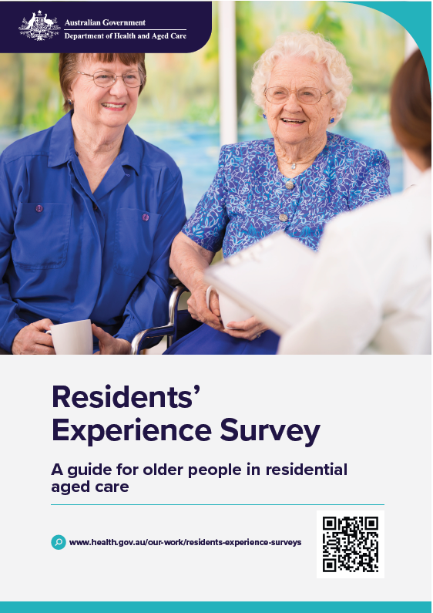

## Video

### Guidance

You can show this video to your residents, their families and carers, and staff to help them understand what to expect.

The video has subtitles in 19 languages.

Watch or download:

[Residents’ Experience Survey: A guide for older people in residential aged care](https://www.youtube.com/watch?v=IA7Q3maxfa8)

