Support at Home User Guide – submitting claims to the Aged Care Provider Portal

Applicable from 1 July 2025

**Note**: System development and testing is in progress. This guide may be updated prior to the 1 July 2025 release

Contents

1 Purpose 3

1.1 Overview 3

1.2 Viewing the user guide 3

2 Portal access 4

2.1 PRODA registration 4

2.2 Aged Care Provider Portal (ACPP) 4

2.3 Service provider budget summary screen 5

3 Claim process overview 5

4 Making a claim 6

4.1 Submit an individual invoice item 6

4.2 Submit/import bulk invoices 6

4.3 Create Invoice Screen 7

4.4 Submit claim 9

*4.4.1* Claim invoices screen 9

5 Terms and meaning 10

6 Further information 10

# Purpose

This document is a guide for providers of the Support at Home program to submit claims through the Services Australia Aged Care Provider Portal (ACPP).

This guide applies to Support at Home claims submitted from 1 July 2025.

## Overview

The ACPP claims user guide explains how providers can submit Support at Home payment claims through the Services Australia Aged Care Provider Portal (ACPP).

The user guide complements other resources available to providers on the Services Australia website, including:

* [general ACPP user resources](https://hpe.servicesaustralia.gov.au/ACPP_general.html)
* [access the Aged Care Provider Portal](https://hpe.servicesaustralia.gov.au/INFO/ACPP/ACPPM01INFO1.pdf).

Additional [Support at Home provider resources](https://www.health.gov.au/our-work/support-at-home/resources?sort_by=field_h_resource_date_value&sort_order=DESC) are available on the Department of Health and Aged Care website, including:

* [Support at Home Program Manual](https://www.health.gov.au/resources/publications/support-at-home-program-manual-a-guide-for-registered-providers) to help providers understand and comply with the Support at Home program rules, procedures and obligations
* [Support at Home claims and payments](https://www.health.gov.au/resources/publications/support-at-home-claims-and-payments-business-rules-guidance?language=en) [business rules guidance](https://www.health.gov.au/resources/publications/support-at-home-claims-and-payments-business-rules-guidance) to understand claims and processing under the new program

## Viewing the user guide

The user guide has been designed to be viewed in Microsoft Word, and as a PDF.

If a hard copy is required, it should be printed in colour. It will be difficult to read and accurately follow this guide if printed in black and white.

Printed copies are only accurate at the time of printing. It is recommended that you check the online edition regularly to ensure you are using the most up-to-date information.

# Portal access

The ACPP is a secure place for providers to access online services. The portal offers a user-friendly navigation menu and self-service features that allows you to manage users and claims for payment.

## PRODA registration

To gain access to the portal, you must register for an individual Provider Digital Access (PRODA) account and link it to the ACPP. The steps are:

1. Register for a PRODA account at [PRODA (Provider Digital Access) - Services Australia](https://www.servicesaustralia.gov.au/proda-provider-digital-access).
2. If you have never had an ‘A’ number before, you will need to request access. This can be done by your provider’s administrator online, by following step 4 in the [Organisation administrator tips & tricks in the ACPP](https://hpe.servicesaustralia.gov.au/INFO/ACPP/ACPPM06INFO1.pdf)
3. Log into your PRODA account.
4. ‘A’ users are prompted to link their ‘A’ number to PRODA to get access to the ACPP.
5. ‘A’ users must select the ACPP tile to go to thelanding page.

**Note:** If you have previously received an ‘A’ number you do not need to apply for a new one. Provide your ‘A’ number to your organisation administrator for them to link you to your provider/s in the portal.

## Aged Care Provider Portal (ACPP)

Once logged into the portal you will be on the ACPP landing page.

From this page you can navigate to different screens by using the menu button. Menu options are:

* quick find search bar
* quick links
* notifications
* claim
* payment summaries
* care recipient panels.

If you are lodging claims for multiple providers, you will be able to select the relevant provider from the drop-down bar at the top of the screen.

**Note:** If you have access to multiple providers in the ACPP, be sure to select the correct provider before managing any events or updates.

## Service provider budget summary screen

The provider budget summary screen gives an overview of all the care recipients managed by a provider, and their available budgets. Knowing the level of funding a care recipient has helps you manage their claims.

**Figure 1:** Provider budget summary screen

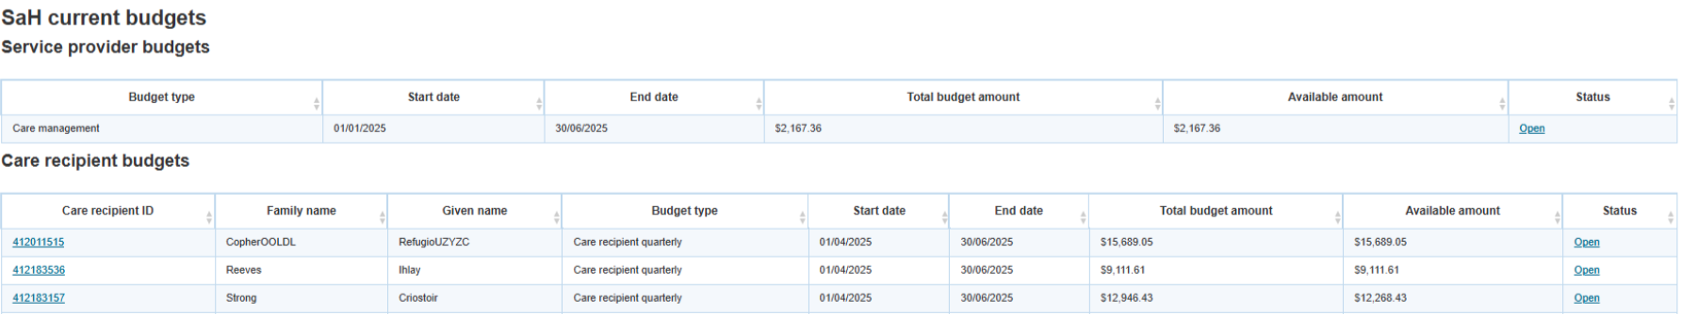

Selecting a blue hyperlink from the ‘Status’ column shows the provider specific details of the budget selected.

# Claim process overview

The following chart provides an overview of the claims process.

**Figure 2:** Claims process

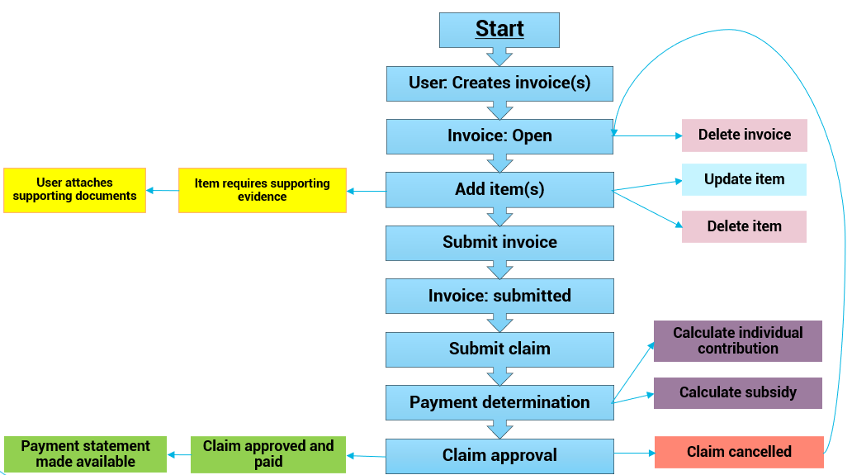

# Making a claim

There are 2 ways to submit invoice items for care recipients:

1. Submit an invoice item for one or more care recipients.
2. Import bulk invoice items using a CSV file and the bulk file import.

## Submit an individual invoice item

The following steps outline how to submit an individual invoice item:

1. Navigate to the Create Invoice Screen (Figure 3).
2. Select ‘Add item’ and enter invoice details in the required fields (e.g. service delivery date, service type, service and service unit price).
3. Once invoice details are completed, select ‘Add’.
4. Repeat the above steps to add multiple invoice items for an individual or multiple care recipients.
5. Once all invoice items have been added, select ‘Submit’.

## Submit/import bulk invoices

The Create Invoice Screen provides the option to add invoice items for individual or multiple care recipients in bulk via CSV upload.

The following steps outline how to use a CSV to upload bulk invoice items:

1. Navigate to the Create Invoice Screen (Figure 3).
2. Select ‘Download CSV’.
3. Enter invoice details for individual or multiple care recipients in the CSV file.
4. Select ‘Choose File’ to upload CSV file.
5. Once all items have been added, select ‘Submit’.

The format of the CSV will be provided by Services Australia at a later date.

## Create Invoice Screen

The Create Invoice Screen displays each line item added against a specific care recipient.

**Figure 3:** Create Invoice screen

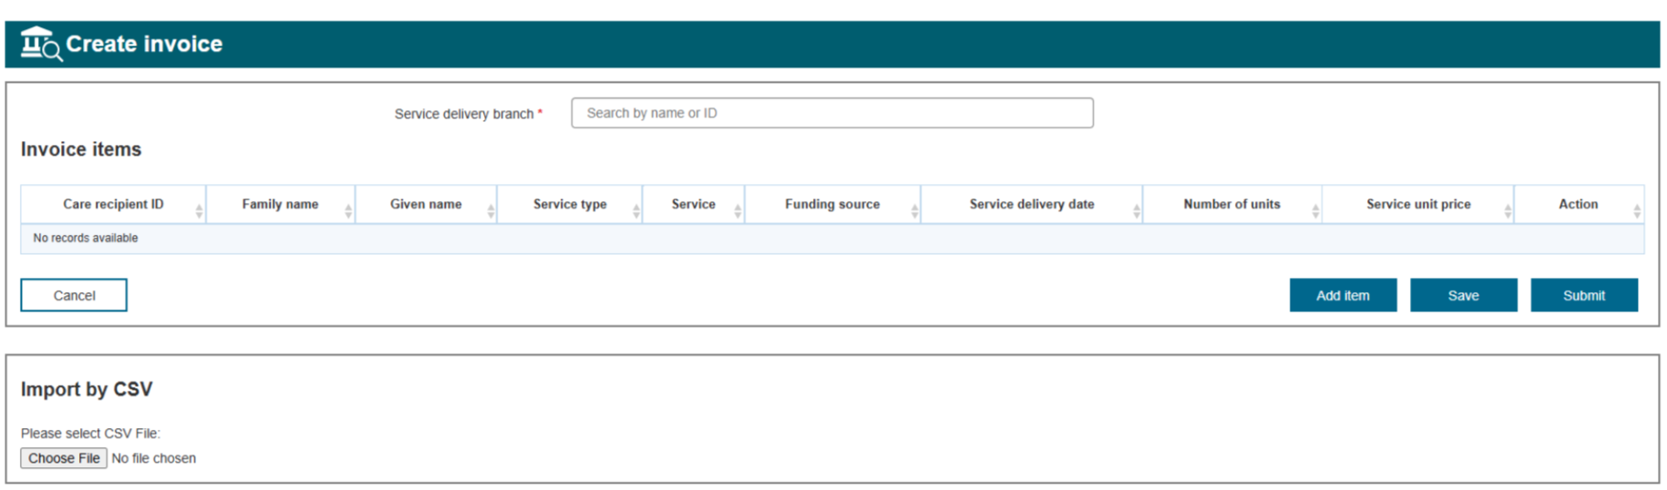

Initially this screen will be blank if no items have been submitted for claiming.

Clicking the ‘Add Item’ button will then show the add item screen. This provides the capability to add services per care recipient.

**Figure 4:** Add item screen

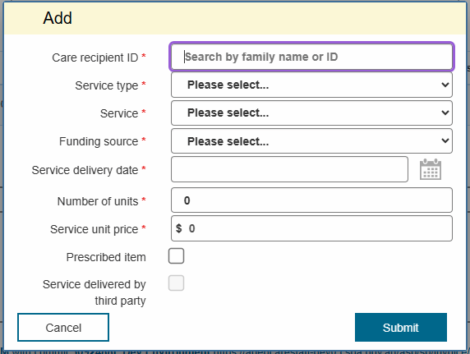

Mandatory fields include:

* Care Recipient ID
* Service type
* Service
* Funding source
* Service Delivery Date
* Number of units
* Service unit price.

Optional fields may include ‘Prescribed Item’ and ‘Service delivered by third party’.

The fields requiring input will vary depending on service type and service selected. The available service types and services will reflect the provider’s registered categories only.

Once an item is added, via the ‘Add Item’ button, the Create Invoice Screen will show:

**Figure 5:** Create Invoice Screen

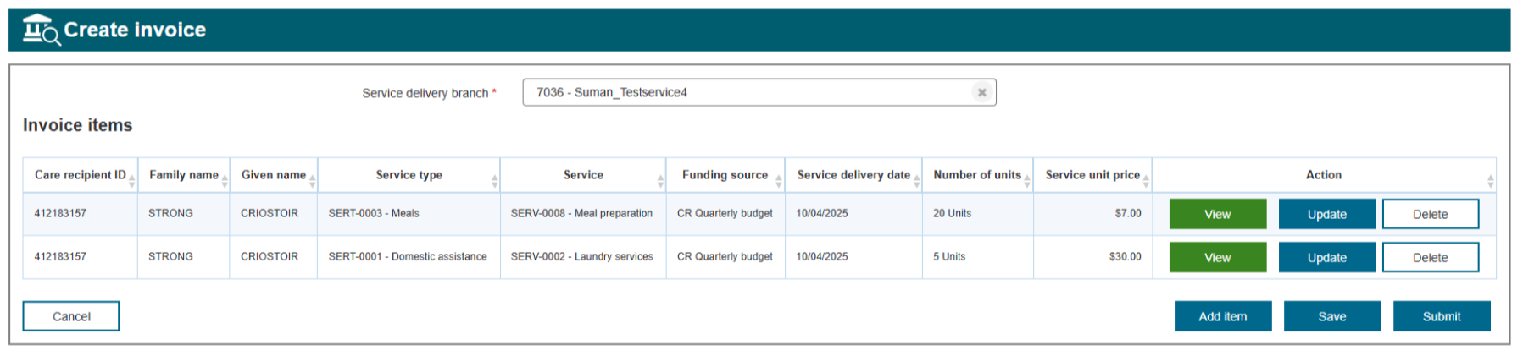

From this screen, a line item can be viewed or updated, which will show the Add item screen again. A line item can also be deleted if required.

An invoice item can be added for each service delivered to a care recipient.

Additional care recipients and the service delivered can be added as required.

The CSV upload can also import multiple care recipients and their respective services.

**Figure 6:** Select document to upload



Invoice items that require supporting evidence will need documents uploaded before they can be submitted.

**Figure 7**: Invoices requiring documented evidence



If the information on this screen is correct and ready for submission, then clicking the ‘Submit’ button will create a submitted invoice in the system to be claimed.

## Submit claim

### Claim invoices screen

The claim invoices screen displays all submitted invoices.

**Figure 8**: Claim invoices

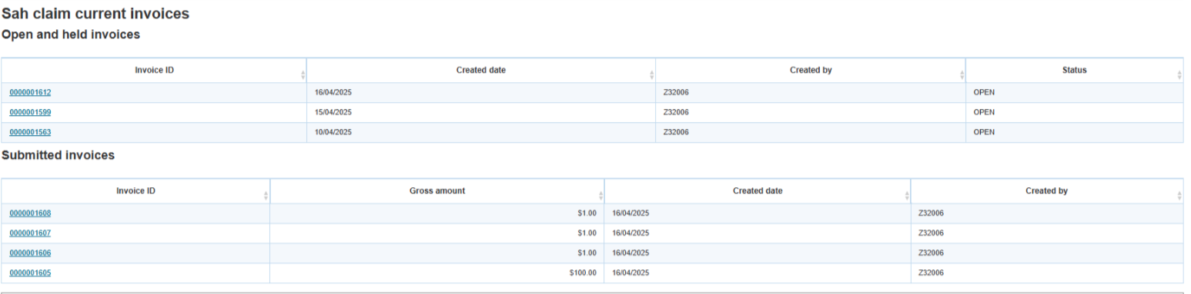

The invoice ID, the ‘Created at ‘and the ‘Created by’ columns are shown for auditing purposes.

The screen will also display the following mandatory claim confirmation box:

**Figure 9**: Claim confirmation screen

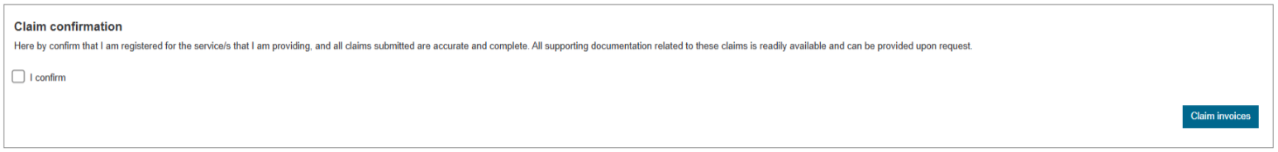

Check the ‘I confirm’ box if the services you are claiming are accurate and complete.

Click the ‘Claim invoices’ button to submit all invoices for Services Australia to approve before payment can be made to your account.

# Terms and meaning

| **Term** | **Meaning** |
| --- | --- |
| A user | An authorised user of the Aged Care Provider Portal (ACPP), once registered for an individual Provider Digital Access (PRODA) Account. |
| Claim | Authorised ‘A’ providers, when satisfied that all created invoice data is correct, will submit the invoice items. The submitted invoice items will be packaged as a claim that is submitted to Services Australia for approval. |
| Invoice | Authorised providers will create invoice items for each service delivered to a care recipient. Multiple invoice items can be created for one or multiple care recipients. When the provider is satisfied that the invoice item data created is correct, they will submit the invoice items. The submitted invoice items will be packaged for claiming with Services Australia. |
| Provider | An organisation that delivers Commonwealth funded aged care services under the Support at Home program to care recipients in their care |

# Further information

For more information, visit

* [Support at Home program - Department of Health and Aged Care](https://www.health.gov.au/our-work/support-at-home)
* [ACPP Health Professional Education Resources - Services Australia](https://hpe.servicesaustralia.gov.au/aged-care-provider-portal.html).

To stay up to date, [subscribe](https://www.health.gov.au/using-our-websites/subscriptions/subscribe-to-aged-care-newsletters-and-alerts) to the department’s newsletter for the aged care sector.