WHY AM I CURRENTLY NOT ELIGIBLE FOR LUNG CANCER SCREENING?
The National Lung Cancer Screening Program is for people who meet the age and smoking history criteria below and do not have symptoms, aiming to find lung cancer at an early stage. Research has found that screening most benefits people who:

Are aged 50 to 70 years
AND
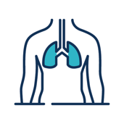
Have no symptoms or signs that suggest lung cancer (for example, unexplained persistent cough, coughing up blood, shortness of breath for no reason).
AND

Smoke tobacco cigarettes or have a history of cigarette smoking (having quit within 10 years)
AND

Have a history of tobacco cigarette smoking of at least 30 pack-years (for example, a pack a day for 30 years, or 2 packs a day for 15 years)

What should I do if I am not eligible but still have concerns?
- If you are not 50 years of age yet, visit your doctor for an eligibility check once you turn 50. Discuss other options with your doctor to look after your lung health outside the program.
- If you are over 70 years of age, discuss other options with your doctor to look after your lung health outside the program.
- If you have any of these signs or symptoms, then screening is not right for you:
- A new or changed cough
- Coughing up blood
- Being short of breath for no reason
- Getting very tired
- Unexplained weight loss
- Chest or shoulder pain that does not go away
If you have any of these symptoms, please talk to your doctor right away. If you have any signs or symptoms, your doctor can refer you for a scan outside the program.
- If you are not eligible because of your cigarette smoking history, you could become eligible in the future. Visit your doctor to discuss your smoking history and check regularly with them to see if you are eligible for the program.
- You may be eligible for the program but not be able to have a low-dose CT scan at the moment due to other medical reasons. Your doctor will discuss these reasons with you.

If you’re not eligible now you may still be at risk
If you are not eligible for the program now because of your age or smoking history, you could become eligible in the future. Check regularly with your doctor to see if you are eligible for lung cancer screening under the program.
You could still be at risk even if you are not eligible for screening. Please speak to your doctor about your risks and for support to quit smoking.

Quitting smoking and staying smoke-free greatly improves your health
While you do not need to quit smoking to participate in lung cancer screening, your body can start to feel better very quickly after you quit smoking. It is never too late to quit. Quitting smoking is the best thing you can do to improve and protect your health even if you are not eligible for lung cancer screening. Nicotine dependence is a clinical condition that can be treated. The National Cessation Platform (quit.org.au) and MyQuitBuddy App and MyQuitBuddy App (https://www.quit.org.au/articles/national-cessation-platform-stakeholder-toolkit) can help you get started .
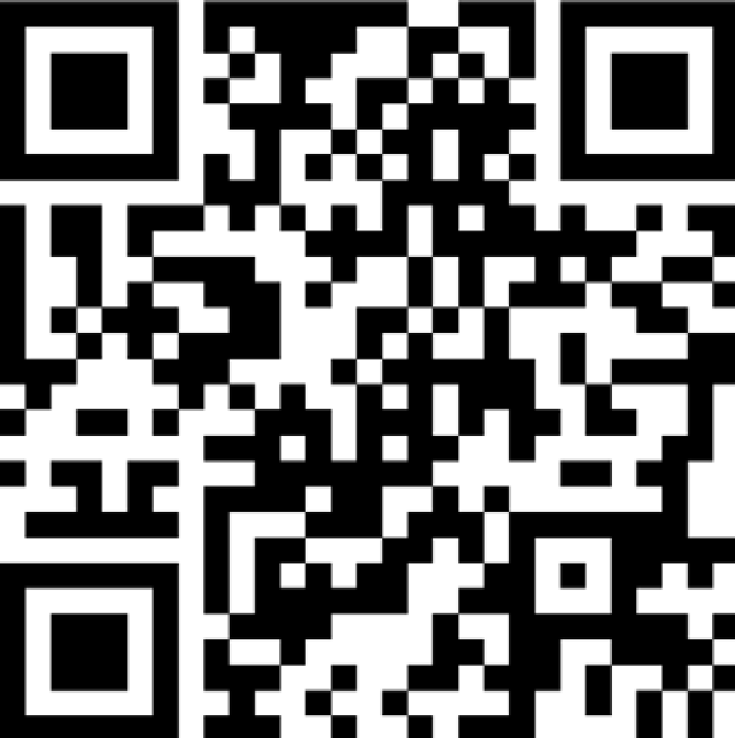  For more information about the National Lung Cancer Screening Program: www.health.gov.au/nlcsp |   For help to quit smoking: www.quit.org.au

