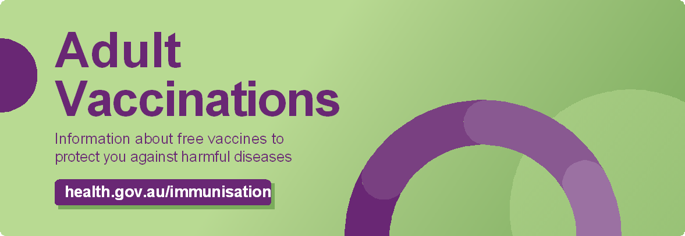

# Routine vaccinations for adults

The National Immunisation Schedule outlines recommended vaccines that are available free under the National Immunisation Program.

Adults can receive **free** vaccines as long as they have a Medicare Card or are eligible for one.

Extra vaccines may be available free under State and Territory Government programs.

## Missed vaccinations

People who missed their childhood vaccines can catch up for free up until they turn 20 or up to age 26 for the HPV vaccine. Speak to your health professional.

# Adults with eligible medical conditions

Adults with eligible medical conditions may also receive additional vaccines for free such as pneumococcal and meningococcal. Talk to your health professional to see if you are recommended to get these vaccines.

# Refugees or humanitarian entrants

If you are a refugee or humanitarian entrant of any age, you can catch up on missed childhood vaccines for free. Speak to your health professional.

# Vaccines are safe

All vaccines available in Australia have been assessed by the Therapeutic Goods Administration to ensure they are safe and effective before they are approved for use. Their safety continues to be monitored once in use.

All vaccines in use in Australia provide benefits that far outweigh any risks. It is safer to be vaccinated than get the disease.

National Immunisation Schedule (Adult)

|  |  |
| --- | --- |
| Age/risk condition | Disease |
| 70 years or over  50 years or over for Aboriginal or Torres Strait Islander people | * Pneumococcal |
| 65 years or over  50 years or over for Aboriginal or Torres Strait Islander people  People with an eligible medical condition | * Shingles (Shingrix®), 2 doses |
| 65 years or over  Aboriginal or Torres Strait Islander people  People with an eligible medical condition | * Influenza annually |
| Pregnant women* | * Influenza * Pertussis (whooping cough) * Respiratory syncytial virus (RSV) |

*See Maternal vaccinations brochure.

# Booster vaccines

You may need a booster dose of a vaccine you have had before such as tetanus and whooping cough. Talk to your health professional for advice. Booster doses are not available for free.

Adult Vaccinations



# Pneumococcal

Pneumococcal disease is a bacterial infection. It can cause pneumonia, bloodstream infection and meningitis (inflammation of the membranes around the brain). It can be more serious for older people and those who have an existing medical condition. Pneumococcal vaccines prevent infection from the strains that commonly cause the most disease.

# Shingles

Shingles is a painful blistering rash caused by reactivation of the chickenpox virus. It can also cause severe nerve pain that can last for months. Without vaccination, about 1 in 3 people will get shingles in their lifetime. Shingles usually affects older people.

If you get shingles, the risk of getting serious disease increases as you get older.

Two doses of the shingles vaccine are provided for free under the NIP for eligible people. The vaccine is effective at preventing shingles and its complications and is safe for people who are immunocompromised.

# Where to get vaccinated

* local general practices
* pharmacies in some states or territories
* community health or local council clinics in some areas
* Aboriginal community health services.

While vaccines are free, your health professional may charge a consultation or administration fee for the visit. Check when you make your appointment.

# Side effects

You may experience mild side effects following vaccination. Most side effects last no more than a couple of days and are part of the immune system’s natural response to the vaccine.

## Common reactions include:

* Pain, swelling or redness at the injection site  headaches, fatigue
* mild fever
* decreased appetite
* feeling faint and fainting
* muscle / body aches.

Serious reactions to vaccines are rare. If you have a reaction you think is severe or unexpected, seek medical advice straight away.

# Pertussis (whooping cough)

Whooping cough can cause serious complications including brain damage, pneumonia and sometimes death.

Pregnant women are recommended to receive pertussis vaccine during every pregnancy to protect young babies from whooping cough. Babies under six weeks of age are too young to get vaccinated against whooping cough themselves.

Partners, grandparents, carers and other adults who have contact with babies should also have the whooping cough vaccine to protect the baby from infection. This is not available for free.

# Influenza (Flu)

Flu is a very contagious infection of the airways. It is especially serious for older people. It can cause serious illness and even death in otherwise healthy people.

The strains of the influenza virus can change from year to year, so the vaccines may be updated from one season to the next.

That’s why it’s important for people to get the vaccine every year. There is an enhanced vaccine available for people who are 65 years and older.

# Vaccination records

Your health professional will record your vaccinations on the Australian Immunisation Register (AIR).

You can get your Immunisation History Statement from the AIR by:

* going to my.gov.au and signing in to access your Medicare online account or using the Express Plus Medicare mobile app
* calling Services Australia on 1800 653 809 to request a copy
* asking your vaccination provider to print a copy for you.

