# My Aged Care Hospital Portal – Organisation Administrator User Guide

Purpose of this guide

The My Aged Care Organisation Administrator User Guide (Administrator User Guide) outlines how hospital-based discharge planning staff nominated as the Organisation Administrator (Org Admin) role (you) will interact with the My Aged Care hospital portal (the hospital portal).

The Administrator User Guide provides an overview of the hospital portal and describes the functions that an individual can perform in the portal with the user access role of Org Admin.

This includes:

* Managing hospital outlet information.
* Creating and maintaining staff user accounts.

The Administrator User Guide does not cover detailed instructions on how to set up organisations in the Relationship Authorisation Manager (RAM) that can be found on the [RAM website.](https://info.authorisationmanager.gov.au/)

**This guide contains the following topics:**

1. Introduction to using the hospital portal 2

2. Hospital portal log in access 2

3. Organisation configuration in the hospital portal 3

4. Staff roles in the hospital portal 3

4.1 Homepage views by user role type 4

4.2 Key functions by role type 5

4.3 Create new staff accounts and assign roles 6

4.4 Deactivate a staff account 8

4.5 Removing a staff account 8

4.6 Edit a staff account 10

4.7 Reports 12

|  |  |
| --- | --- |
| **!** | Document Key  This symbol is used to highlight important information that is relevant to hospital staff. |

|  |  |
| --- | --- |
| **!** | Privacy Requirements  Hospital Organisations are required to comply with the legislative requirements under the *Privacy Act 1988* (Cth) (Privacy Act), including the Australian Privacy Principles when using the My Aged Care hospital portal.  The Privacy Act regulates the handling of personal information about individuals, including the collection, use, storage and disclosure of personal information, and access to and correction of that information.  Hospital staff are also required to comply with the *Aged Care Act 1997* (Cth) when using the My Aged Care hospital portal. |

|  |  |
| --- | --- |
| **!** | How to log into the Hospital Portal  Log into the hospital portal using the following link:  [https://myagedcare-hospitalportal.health.gov.au](https://myagedcare-hospitalportal.health.gov.au/) |

## 1. Introduction to using the hospital portal

The hospital portal is accessed by hospital-based discharge planning staff to:

* search for a patient record in My Aged Care
* view a summary of their aged care assessment information
* view their support network of relationships, organisations and representatives add notes and attachments to their My Aged Care record such as a hospital discharge summary
* update information about a client’s deceased status
* manage hospital-based staff user access (Org Admin function).

## 2. Hospital portal log in access

To access the hospital portal, each staff member must have a My Aged Care portal user account linked to a supported third-party authentication service such as myID/ RAM or VANguard Federated Authentication Service single sign-on (VANguard FAS).

**myID/RAM**   
For access to the hospital portal using myID/RAM, each staff member must have an individual myID linked to their organisation via RAM with an email address and be authorised to act on behalf of their organisation through the Relationship Authorisation Manager (RAM) service.

**VANguard Federated Authentication Service** (VANguard FAS) single sign-on is an alternative authentication login option for staff accessing the hospital portal for organisations with a corporate network structure that includes a Single Sign on System (e.g. Active Directory Federation Service).

If a staff member requires access to multiple organisations in the portal, they will require a separate portal account with a unique email address for each My Aged Care portal. They could use their organisations’ email address in this instance.

If a person belonging to the same organisation requires access to multiple My Aged Care portals(e.g. Assessor, Service and Support or Hospital portal) they are unable to use the same email address and must use a separate work email address for each portal to do so. A different authentication method is also required for accessing two different My Aged Care portals.

For more information regarding setting up users and logging into the system please refer to [Logging in to Aged Care Systems](https://www.health.gov.au/resources/publications/logging-in-to-the-aged-care-systems).

## 3. Organisation configuration in the hospital portal

Generally, the role of the hospital portal Organisation Administrator (Org Admin) should be staff from the hospital organisation executive team who do not require access to patient records. The Org Admin user role in the hospital portal is responsible for ensuring that the information about the hospital organisation and outlet is accurate. It should be noted that the Org Admin **does not** have access to client records in the portal.

The Departmental sets up all hospital Administrator roles at the organisation level in the hospital portal and will set up the initial hospital Org Admin/s who are the initial user/s to be given access to the portal.

Requests for additional hospital Org Admins must be sent to the Department by emailing [MyAgedCare.Assessment@health.gov.au](mailto:MyAgedCare.Assessment@health.gov.au)

The set up of new hospital outlets in the portal is the responsibility of the Department, including any outlet name change or ABN changes. For adding new hospital outlets to your organisation contact the Department by emailing this request to [MyAgedCare.Assessment@health.gov.au](mailto:MyAgedCare.Assessment@health.gov.au).

## 4. Staff roles in the hospital portal

The person nominated by your organisation as the Org Admin will be the first person from your organisation to log into the hospital portal initially.

The Org Admin will be responsible for assigning roles to other staff. This includes assigning staff to the hospital administrator role at each of the hospital outlets to help set up, maintain and remove staff user roles in the hospital outlet, including help train staff in using the portal.

Please note, additional Org Admin roles need to be requested by emailing the Department at MyAgedCare.Assessment@health.gov.au

Roles should be assigned in accordance with the duties the person performs within your organisation and following completion of all required training.

|  |  |
| --- | --- |
| **!** | If you are assigned more than one role, this access will apply across all hospital outlets you have been assigned access to in the hospital portal. |

### 4.1 Homepage views by user role type

The options displayed on the landing page of the hospital portal vary depending on your user role/s. The Org Admin has access to the ‘administration’ tab only on the landing page. The Org Admin role does **not** have access to client records in the portal.

|  |  |
| --- | --- |
| **!** | If you are assigned both the hospital administrator role at the outlet level and hospital staff user role (Super User), the landing page will show both options (**ADMINISTRATION** and **FIND MY CLIENT**) displayed. |

Picture of welcome screen for a staff member assigned both Org Admin and Hospital Staff roles. It has 2 buttons - Administration, and Find My Client


#### 4.1.1 Administrator homepage

##### Organisation Administrator

People assigned an Org Admin role at an organisation level in the hospital portal can view and manage information for all outlets assigned to that organisation.

to set up the hospital administrator user roles and hospital staff user accounts.

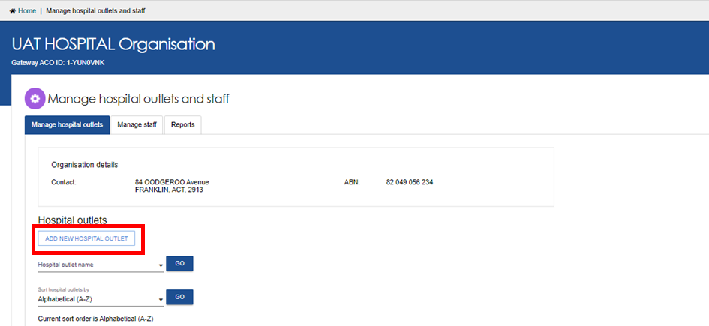

##### Hospital Outlet Administrator

People assigned an Hospital Admin user role at the hospital outlet level for one or more outlet/s in the organisation is able to view and manage information for those outlet/s they are assigned to.

An hospital administrator assigned to an hospital outlet can add and manage staff at those hospital outlets.

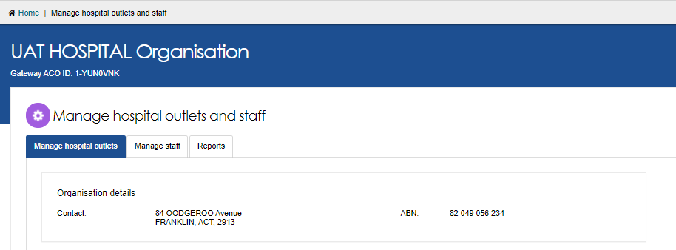

#### 4.1.2 Staff homepage

If you log in to the hospital portal as a hospital staff user, only the **Find my client** landing page will display to search for a client.

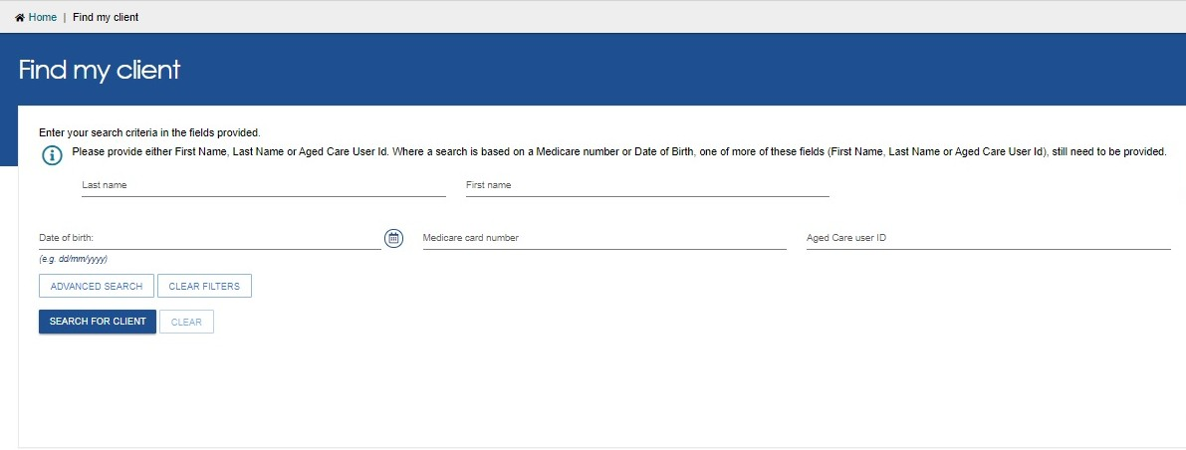

#### 4.1.3 Super-user homepage

People assigned both hospital admin and staff user roles (known as Super-user) at the hospital outlet level will see the following home page displayed:

Picture of welcome screen for a staff member assigned both Org Admin and Hospital Staff roles. It has 2 buttons - Administration, and Find My Client


### 4.2 Key functions by role type

The Administrator user roles will create and maintain staff accounts in the hospital portal.

A person can have both admin and staff roles if needed.

The table below outlines the key functions for roles within the hospital portal. It includes both client focused and organisation focused tasks.

|  |  |  |  |
| --- | --- | --- | --- |
| **Key Functions** | | **Administrator Role** | **Staff Role** |
| C **Client Focussed** | Search for and view a client record |  |  |
| Change status of a client to deceased |  |  |
| **Organisation Focussed** | Manage outlets |  |  |
| Manage staff accounts: add, edit, deactivate and remove |  |  |

### 4.3 Create new staff accounts and assign roles

The steps to create a new staff account are outlined below.

**1.** From the **Manage Staff** tab in the **Manage hospital outlets and staff** page, select   
**ADD NEW STAFF**.

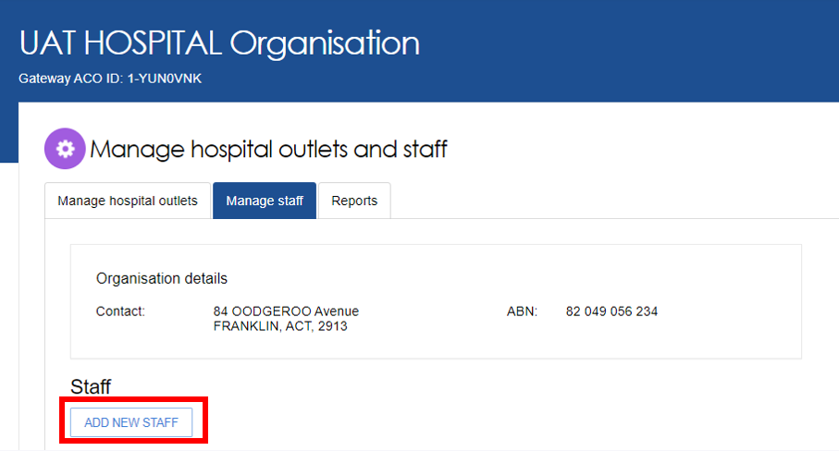

**2.** Add staff member

* Enter staff details (title, first name, last name, job title, email address and a contact number) then assign role(s) to staff and assign staff to hospital outlets.
* Select **Create staff member**.

**Notes:**

**3.** Select the role/s to be assigned to this staff member then select **NEXT**.

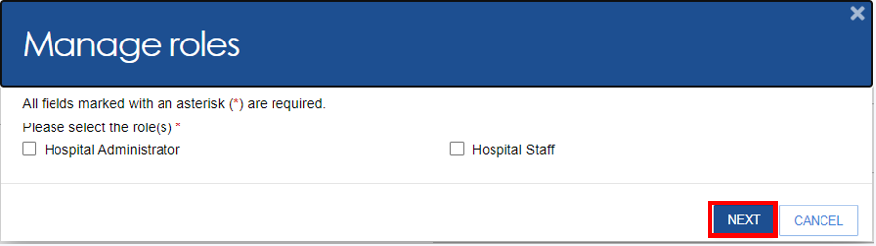

**4.** Select the hospital outlet to be assigned to this staff member and select **Save Roles**

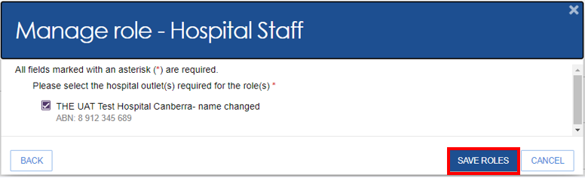

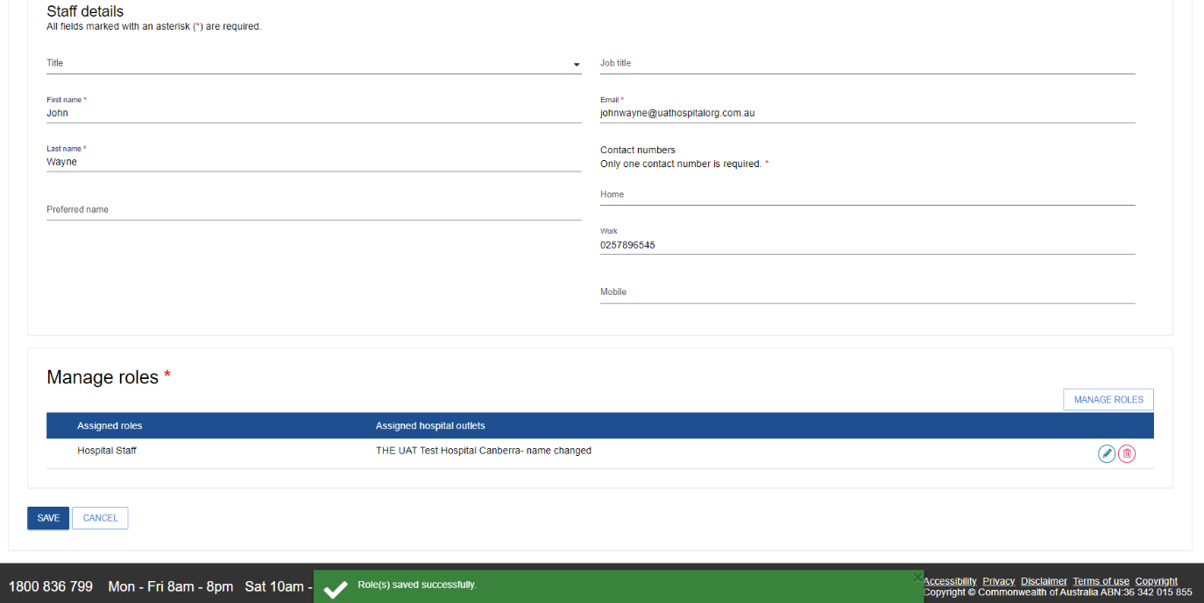**5.** The following screen will display. Confirm all details are correct and select **Save**. A **Roles saved successfully** message will be displayed.

**6.** A message **Employee successfully added** will display.



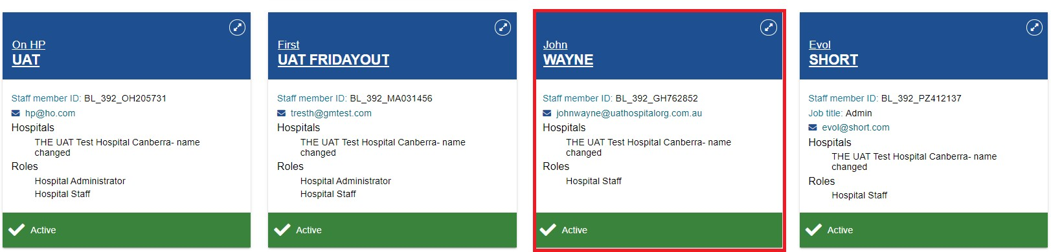

The first time each staff member logs into the hospital portal, they will need to follow the steps outlined in the user guide below found on the Department of Health and Aged Care website: [Logging in to the Aged Care Systems](https://www.health.gov.au/resources/publications/logging-in-to-the-aged-care-systems.)

### 4.4 Deactivate a staff account

The steps to deactivate a staff account are outlined below.

**1.** From the **Manage staff** tab on the **Manage hospital outlets and staff** page select the name of the staff member on the staff card that you want to deactivate.

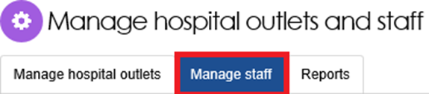

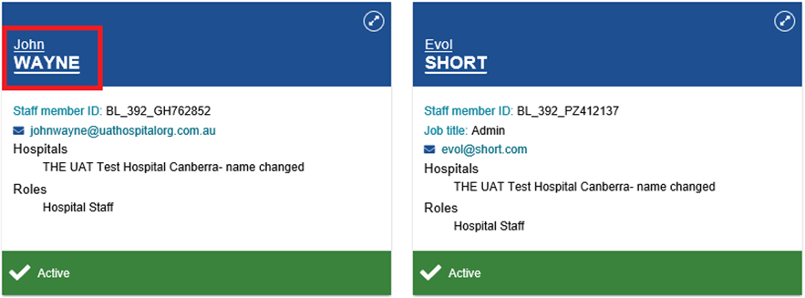

**2.** From the **View staff member** page select **DEACTIVATE**.

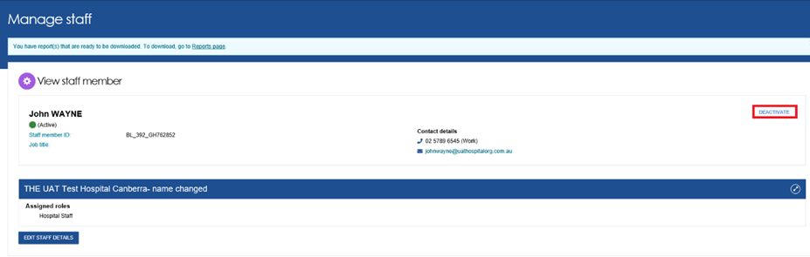

**3.** Select **DEACTIVATE ACCOUNT** to confirm.

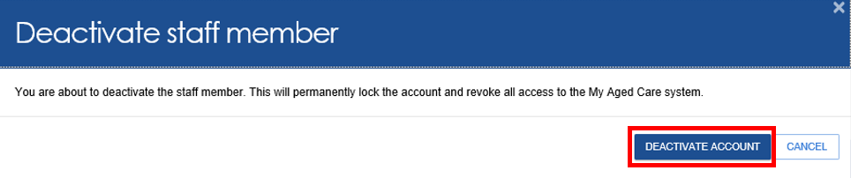

**4.** Confirmation message will be displayed as per below:



### 4.5 Removing a staff account

Inactive staff (that have previously been deactivated) can be removed from organisations and outlets and will no longer display in the hospital portal.

**1.** From the **Manage staff** tab of the **Manage hospital outlets and staff** page select **Inactive** from the **Status** drop-down menu to view inactive staff then select **Filter**. The card view will display **staff is inactive** for staff member.

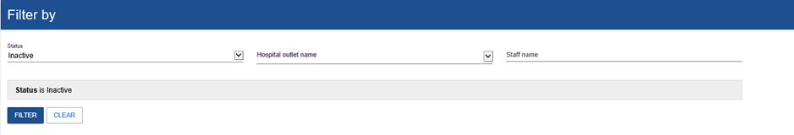

**2.** From the staff cardselect the name of the staff member you wish to remove.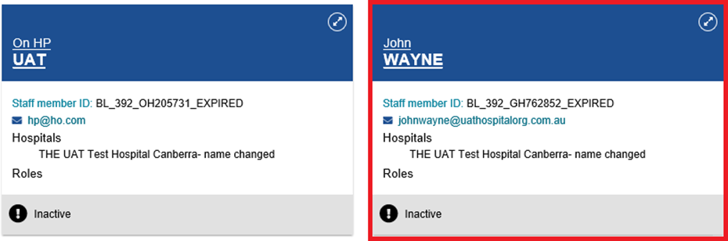

**3.** From the **View staff member** page select **REMOVE**.

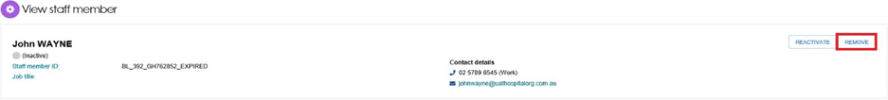

**4.** Select **REMOVE** to remove the staff member from your staff list.

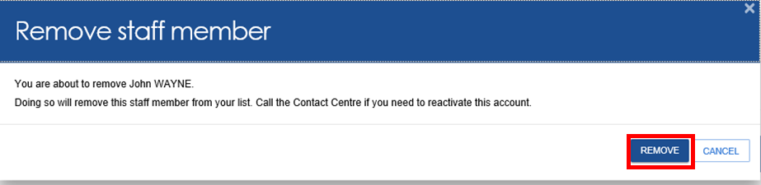

|  |  |
| --- | --- |
| **!** | To restore access for a staff member who’s been removed call the My Aged Care contact centre for assistance. You cannot re-create a portal user account using the same email address and myID. |

**5.** Once a staff account has been removeda confirmation message will be displayed.

Success message with text "<Staff member's account has been removed"

### 4.6 Edit a staff account

The steps to edit a staff account are outlined below:

**1.** From the **Manage staff** tab on the **Manage hospital outlets and staff** page select the name of the staff member on the staff card that you want to edit.



**2.** From the **View staff member** page select **EDIT STAFF DETAILS**.

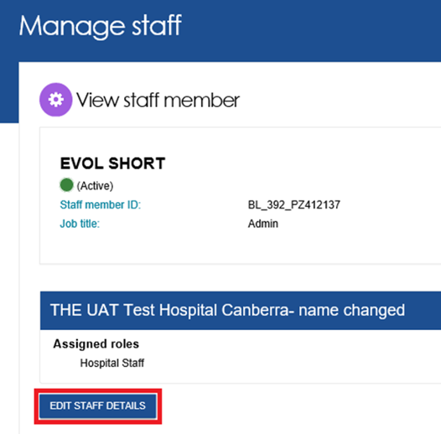

**3.** Edit **Staff details** and select **SAVE** changes.

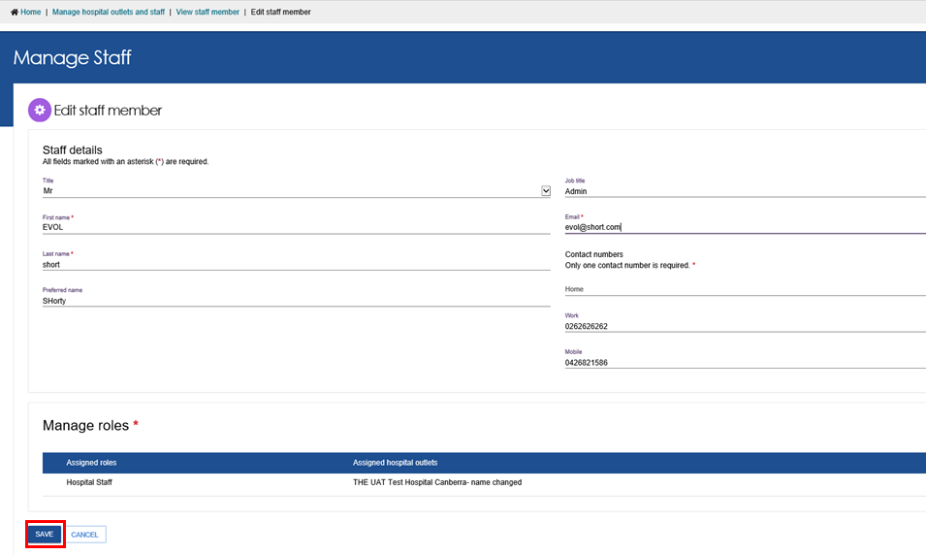

**4.** An **Employee successfully updated** confirmation message will be displayed.



### 4.7 Reports

An Hospital Org Admin or Hospital Outlet Admin user can generate a report to see a list of all the admin/staff that has access to the hospital portal.

**1.** Select the report name (under Reports List) from the **Reports** tab.

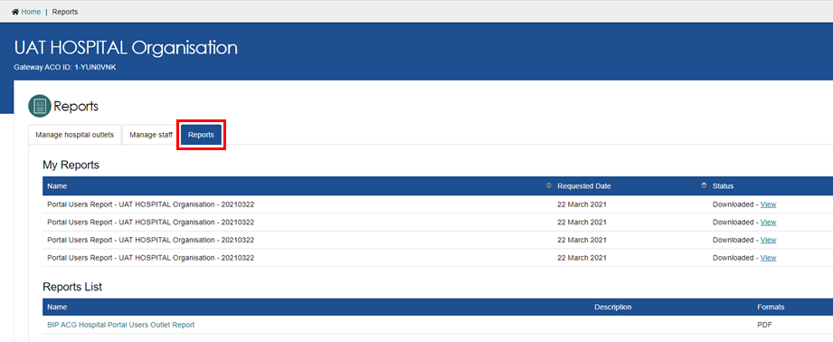

**2.** Enter the hospital outlet name then select output type as PDF then **REQUEST REPORT**.

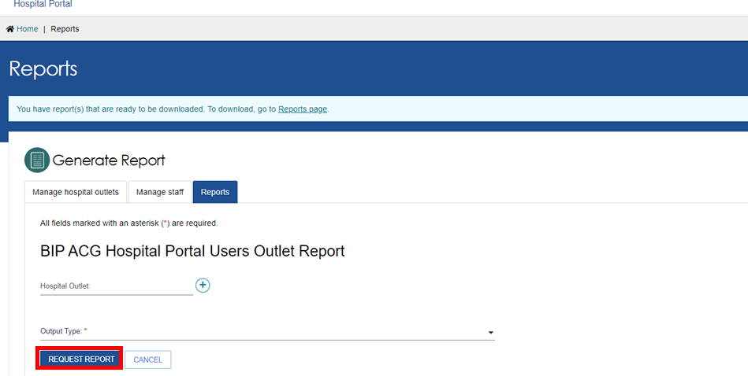

**3.** A message will be displayed as per screenshot below:

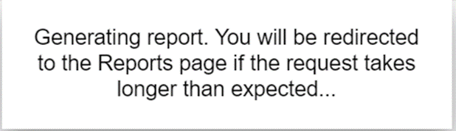

**4.** A row will appear with the report **Name** and **Requested Date** with status set to **Processing**.

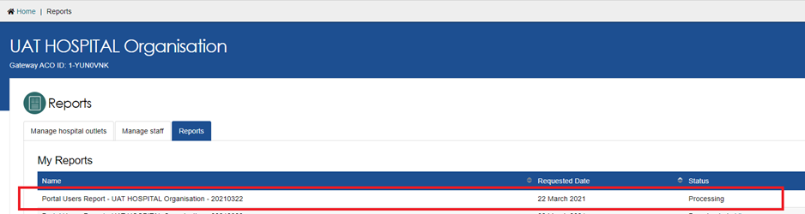

**5.** Once the report status is set to **Ready** then select **View**.

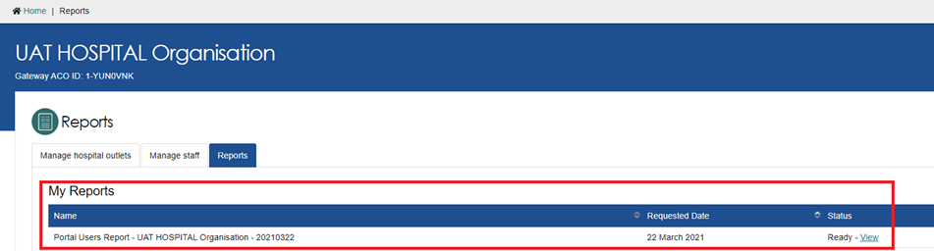

**6.** You can **Save** or **Open** the PDF report. Report will open in a new window  
(see example below) noting there are 3 outlets under the organisation **UAT Hospital Organisation**.

