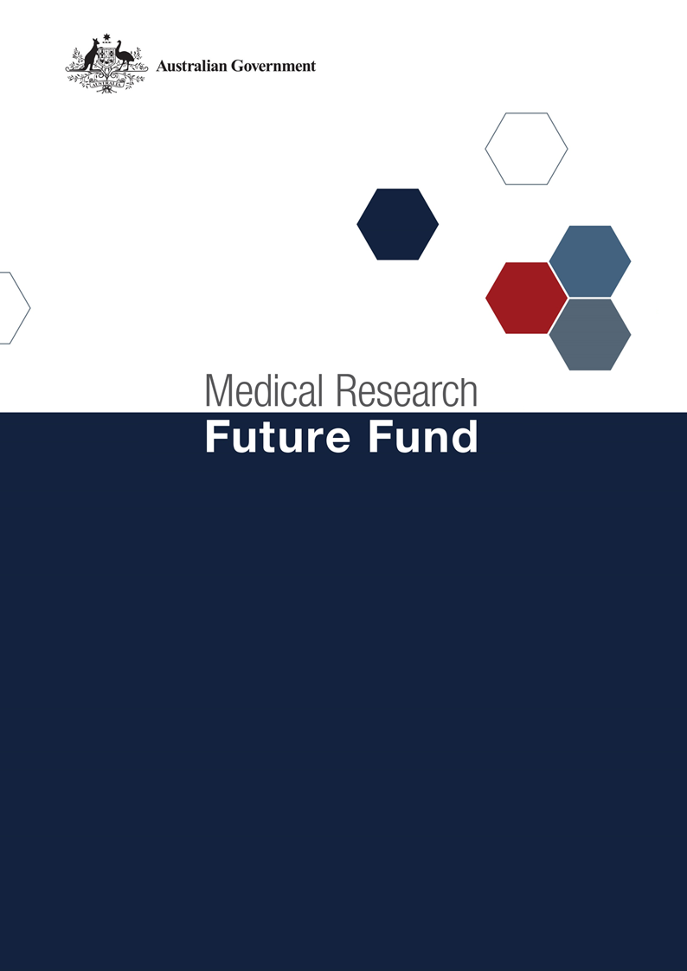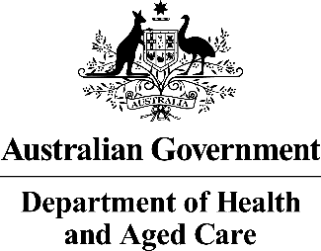

**MRFF Traumatic Brain Injury Mission Roadmap and Implementation Plan Refresh National Consultation Report  
  
March 2025**

Table of Contents

Introduction 2

Community participation and submissions 3

Responses to national consultation submissions 4

# Introduction

The Medical Research Future Fund (MRFF) is a $22 billion long-term investment supporting Australian health and medical research. The MRFF aims to transform health and medical research and innovation to improve lives, build the economy and contribute to health system sustainability. The Traumatic Brain Injury Mission (the Mission) is providing $50 million over 10 years under the MRFF to support research designed to improve the lives of all Australians who experience traumatic brain injury (TBI).

An Expert Advisory Panel was appointed in April 2024 to provide advice to the Minister for Health and Aged Care on the strategic priorities for research investment through the Mission. As per the [MRFF Mission Governance document](https://www.health.gov.au/resources/publications/mrff-mission-governance), the Expert Advisory Panel provides advice on strategic priorities for research investment through the Mission, by refreshing the existing Roadmap and creating a new Implementation Plan.

The Mission’s Roadmap is a high-level strategic document that includes the aim, vision, goal and priorities for investment for the Mission. To support the Roadmap, the Implementation Plan outlines the priorities for investment (short, medium and long term), evaluation approaches and measures, supporting activities, and collaborative opportunities. The Roadmap and Implementation Plan will be used by the Department of Health and Aged Care to design and implement the Mission’s investments via Grant Opportunities promoted through GrantConnect ([grants.gov.au](https://www.grants.gov.au/)).

A draft refreshed Roadmap and Implementation Plan developed by the Expert Advisory Panel underwent a national public consultation which opened on 8 January 2025 and closed on 10 February 2025. Submissions were accepted through the Department’s [consultation hub](https://consultations.health.gov.au/health-economics-and-research-division/medical-research-future-fund-tbi/). This national consultation sought feedback from the community on the Mission’s draft refreshed Roadmap and Implementation Plan. Additional submissions were also received through email.

The following questions were provided on the consultation hub to guide submissions:

1. Are the priority areas for investment identified in the Implementation Plan the most effective way for delivering on the Traumatic Brain Injury Mission's goal and aims?
2. Are there existing research activities which could be utilised to contribute to the Traumatic Brain Injury Mission refreshed Roadmap and Implementation Plan aims and priority areas for investment? How can these be leveraged?
3. Are the 'Evaluation approach and measures' appropriate for assessing and monitoring progress towards the Traumatic Brain Injury Mission's goal and aims?

This report summarises the written submissions received via the national consultation.

## Community participation and submissions

At the close of the consultation period, 14 written submissions were received via the consultation hub and via email, representing universities, medical research institutes, and national and state-based consumer organisations.

The Expert Advisory Panel considered all responses from the national consultation, and where relevant, revised the Roadmap and Implementation Plan. A summary of the feedback from the submissions and the Expert Advisory Panel’s responses are outlined below.

# Responses to national consultation submissions

| Consultation Question | Submission Feedback / Themes | Action by Expert Advisory Panel (The Panel) |
| --- | --- | --- |
| **Are the priority areas for investment identified in the Implementation Plan the most effective way for delivering on the Traumatic Brain Injury Mission's goal and aims?** | Increased focus on and funding of research relating to veterans/military populations across all aspects is required. | The roadmap has been updated to state more clearly the intent that the military and veterans should be considered as a priority population.  Specific reference to models that include, and confounding health conditions that affect, the military and veteran populations have been added to the Implementation Plan. |
| Increased funding is required for development of potential treatments, specifically secondary injury associated with TBI. | The implementation plan for the Mission allows for applicants to propose research that includes a holistic consideration of the impacts of TBI. This could include research into secondary injury associated with TBI. |
| Increased focus on and funding of research relating to rural Australians across all aspects is required. | The EAP considered the importance of equitable access when setting the priorities for investment.  Applications to several of the grant opportunities forecast under the implementation plan are required to describe how they will include multiple geographies, which would include rural areas. |
| Increased focus on and funding of research relating to older Australians across all aspects is required. | The EAP considered the importance of equitable access when setting the priorities for investment.  Wording has been updated to enable many aspects for older Australians to be included and to remove the implication that TBI in older Australian is only connected to falls. |
| Increased focus on post-injury care and management. | Priority area 2 focuses on improving the lives of people with TBI by using better interventions. There is $16M assigned to this priority in the implementation plan and $4.9M has previously been previously invested in this priority under the Mission (see appendix A of the implementation plan). |
|  | | |
| **Are there existing research activities which could be utilised to contribute to the Traumatic Brain Injury Mission refreshed Roadmap and Implementation Plan aims and priority areas for investment? How can these be leveraged?** | Leverage existing:  - national research networks  - previously funded researchers and groups to ensure findings are progressed through to implementation  - peak bodies and industry partners to ensure integration across Australia's health system  - linkages with existing TBI networks. | The implementation plan encourages applicants to leverage existing work in the TBI field, both nationally and internationally and provides several examples of relevant organisations. |
| Create registries for long-term data collection. | Priority area 3.2 focuses on the long-term outcomes of TBI and includes establishing a registry.  Outside of the MRFF, the department currently has a National Clinical Quality Registry Program which includes funding streams to support existing national clinical quality registries. |
|  | | |
| **Are the 'Evaluation approach and measures' appropriate for assessing and monitoring progress towards the Traumatic Brain Injury Mission's goal and aims?** | The evaluation should consider priority populations, including veterans/military, rural Australians and older people. | The measures of success for the MRFF Monitoring, Evaluation and Learning strategy includes increased focus of research on areas of unmet need so these groups could be considered in the evaluation of the Mission. |
| Wider stakeholder engagement and collaboration should be considered when creating evaluation measures. | The MRFF Monitoring, Evaluation and Learning strategy states that monitoring and evaluation of funded projects, programs and initiatives within the MRFF will be inclusive of consumers and stakeholders. |