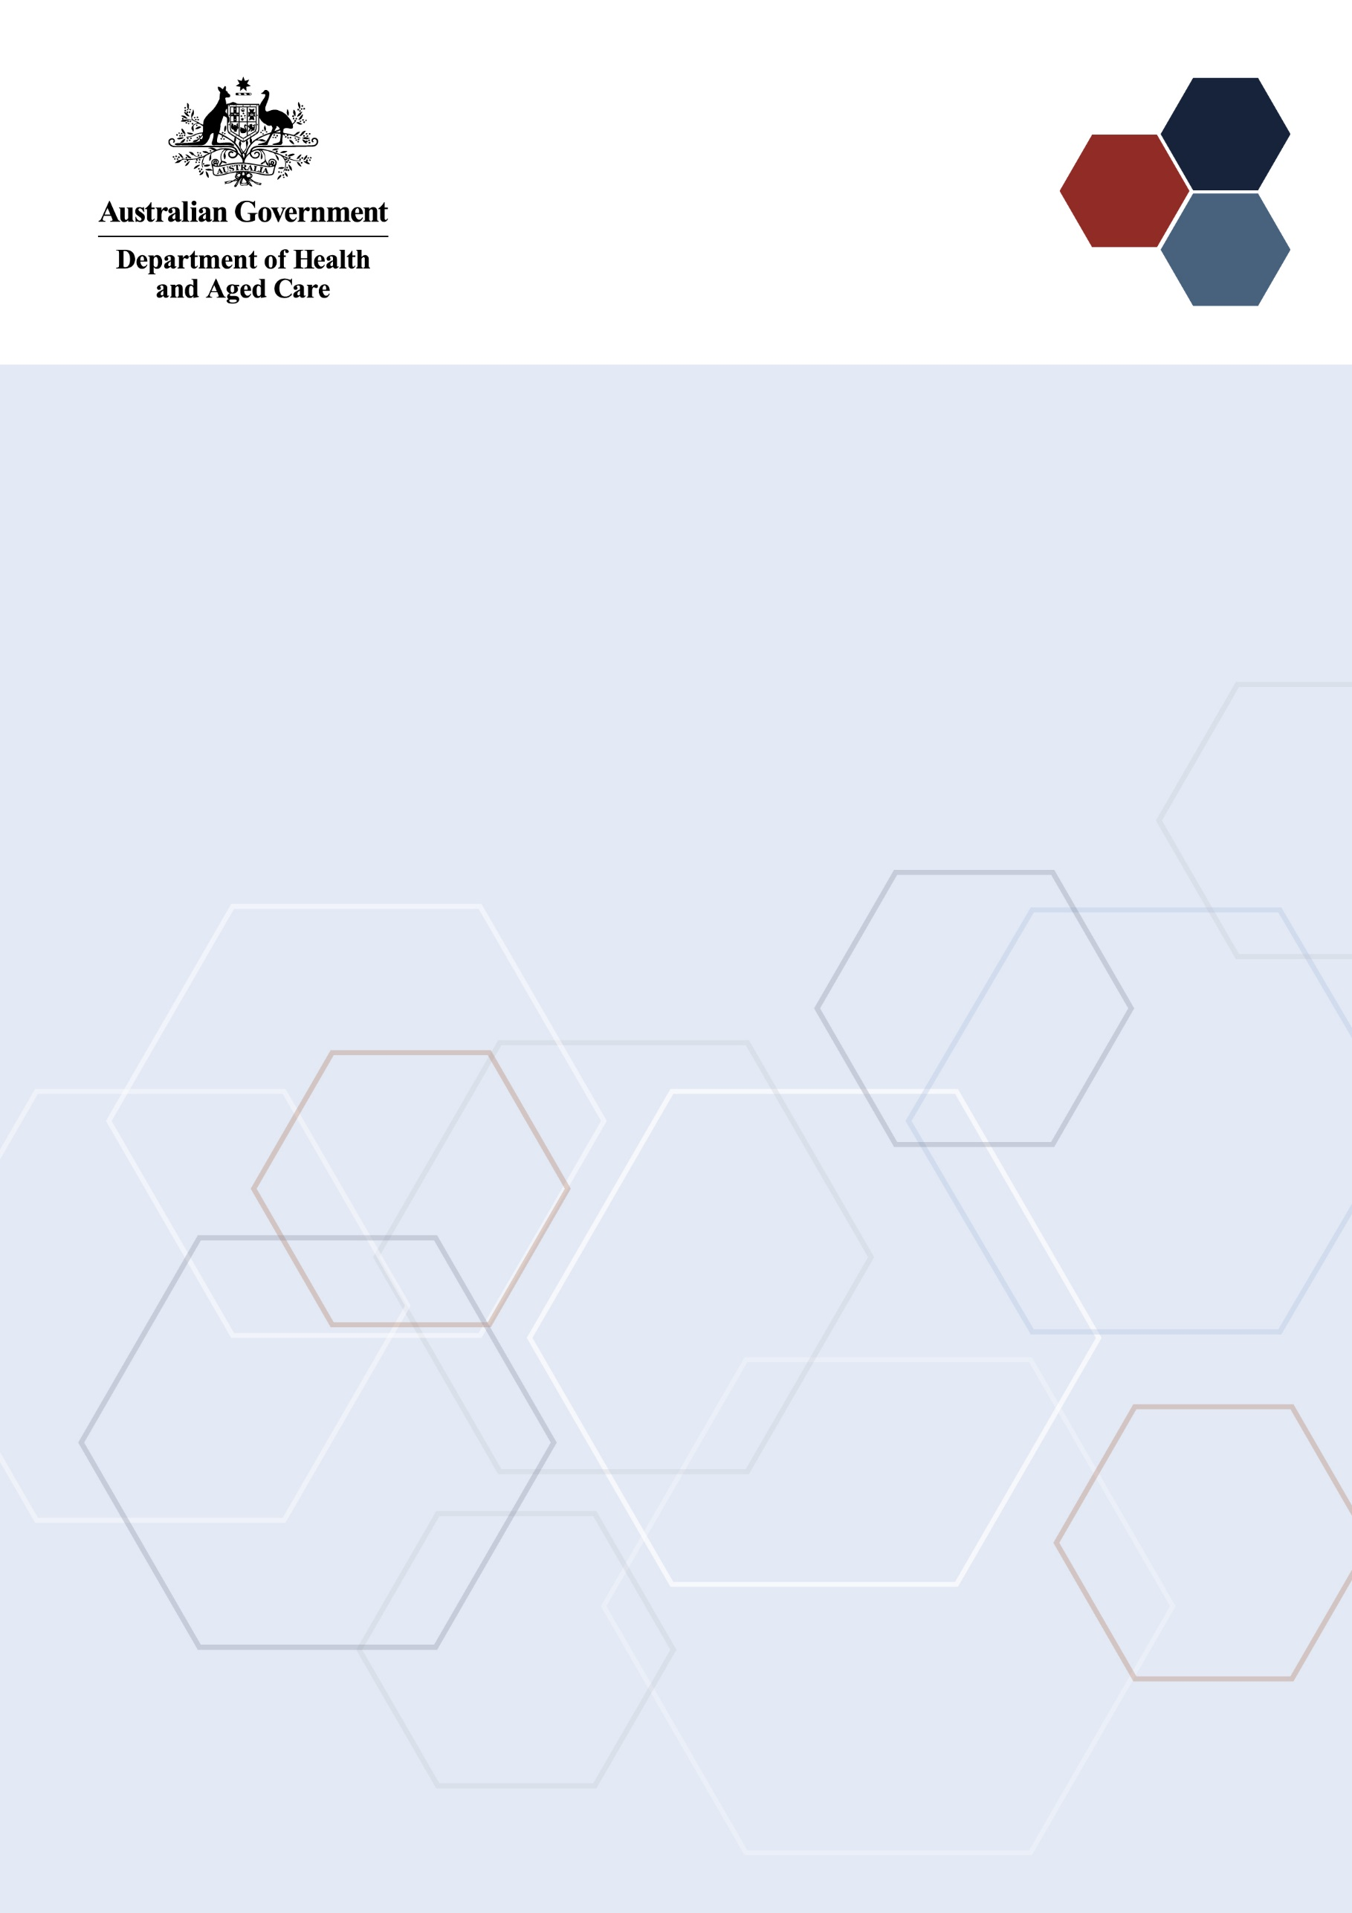Medical Research  
Future Fund

Traumatic Brain Injury Mission International Review of the Roadmap and Implementation Plan

6 February 2025

# Introduction

The Medical Research Future Fund (MRFF) is a $22 billion long-term investment supporting Australian health and medical research. The MRFF aims to transform health and medical research and innovation to improve lives, build the economy and contribute to health system sustainability.

The Traumatic Brain Injury Mission (the Mission) is providing $50 million over 10 years under the MRFF to support research designed to improve the lives of all Australians who experience traumatic brain injury (TBI).

## Traumatic Brain Injury Mission Expert Advisory Panel

A TBI Expert Advisory Panel (EAP) was established in 2020 to advise the Minister for Health on the strategic priorities for research investment through the Mission.

The Mission’s Roadmap and Implementation Plan were published in September 2021. These strategic documents outlined the goals and investment priorities of the Mission. The investment priorities as outlined in the Implementation Plan were then used to design the Mission’s first grant opportunity, that opened in January 2020.

The TBI EAP’s role is to define evidence and knowledge gaps that should be addressed through the Mission’s research funding to help transform health care and health outcomes for individuals and communities. This role includes defining key research questions that — if answered — will deliver meaningful change to patients through the translation of research.

A refresh of the Mission’s Roadmap and Implementation Plan was commenced in 2024 by a secondary EAP to ensure the Mission accounts for emerging evidence and is consistent with the Government’s responses to the Senate Inquiry into concussions and repeated head trauma in contact sport and the Inquiry into family, domestic and sexual violence. The refresh allowed consideration of recent policy frameworks such as the National Plan to end Violence against Women and Children 2022-2032, and relevant action plans such as the Aboriginal and Torres Strait Islander Action Plan 2023–2025.

|  |
| --- |
| OUR MISSION  To accelerate Australian TBI research that develops and delivers evidence that informs innovative and effective treatments, that substantially and equitably optimize and improve outcomes for people who experience TBI, in partnership with people with TBI, their families and other community support networks.  OUR GOAL  To better predict recovery outcomes after a TBI, identify the most effective care and treatments and reduce barriers to support people to live their best possible life after TBI. |

The TBI EAP developed the Roadmap and Implementation Plan to advise the Minister on the priorities for research investment through the Mission.

The Roadmap includes:

* the Mission statement and goal
* possible themes and priorities for investment

The Implementation Plan includes:

* 3 aims that outline how the Mission will benefit Australians
* priorities for investment in the short, medium and long term
* opportunities for leveraging additional investment
* activities needed to support the mission’s outcomes and facilitate their implementation

TBI EAP members will consult and engage with other researchers, industry, and consumer and patient groups, and participate in media and public activities to build awareness of, and facilitate interaction with, the Mission and with other MRFF-funded research.

## Traumatic Brain Injury Mission International Review Panel

The TBI International Review Panel’s role was to provide expert feedback and experiential advice in the context of relevant activities occurring internationally, which can inform the strategic direction of the TBI Mission’s Roadmap and Implementation Plan.

The TBI International Review Panel members were first asked to provide their views on the Mission, its impact to date, and where the Mission sits within the International TBI research funding landscape:

1. Any significant achievements or impact from the MRFF Traumatic Brain Injury Mission, or from any specific research projects funded by the Mission or the MRFF related to traumatic brain injury.
2. What are Australia’s key strengths and capability gaps in traumatic brain injury research, and how these sit within the international landscape, e.g. whether they are unique to Australia, or common internationally.

With regards to the Roadmap and Implementation Plan, the TBI International Review Panel members were asked to:

1. Advise on the applicability of the Mission’s goals to the international context, specifically whether the goals duplicate or contribute to international research activities.
2. Advise on the likely efficacy of the research priorities (including their sequencing) to achieve the goals.
3. Provide learnings from international research activities in the field.
4. Identify opportunities for leveraging and complementing international research activities to achieve the Mission’s goals.
5. Advise on the appropriateness of the proposed measures for evaluating progress towards meeting the goals.
6. Advise on opportunities to improve translation and impact of TBI-funded research.

The TBI International Review Panel comprised 4 members representing expertise in a variety of clinical and scientific research areas:

* Ms Imelda Lynch (Chair) – Current member of the Australian Medical Research Advisory Board and the former CEO of the Heart Foundation South Australia/Northern Territory. Ms Lynch’s career has included acute health care nursing and working in human research ethics.
* Dr Amanda Rabinowitz – Associate Director, Jefferson Moss Rehabilitation Research Institute. Dr Rabinowitz’s research focuses on the psychosocial elements that promote resilience following TBI, particularly emphasising self-regulation as a crucial factor.
* Dr Carrie Esopenko – Associate Professor in the Department of Rehabilitation and Human Performance, Icahn School of Medicine at Mount Sinai Hospital. Dr Esopenko’s research explores the effects of TBI and repetitive head trauma on cognitive, neural and psychological health in women exposed to intimate partner violence, sexual trauma, and military blast-related injuries.
* Dr Grant Iverson – Director, Massachusetts General Hospital for Children Sports. Dr Iverson leads a globally recognised research program on the outcomes of mild TBI in athletes, civilians, military personnel and veterans. Dr Iverson was also part of the international review panel when the TBI Mission was first established.

# Consultation discussion

The TBI International Review Panel met on Thursday 6 February 2025 to discuss the Mission’s Roadmap and Implementation Plan.

All participants at the meeting were required to declare any conflicts of interest and relevant collaborations. None of the declared interests were considered material to the meeting.

|  |
| --- |
| KEY POINTS   * The Panel agreed with the priorities and sequencing of the Mission Roadmap, however wished to emphasise the importance of implementation research especially for underrepresented and underserved populations. * The Mission is unique internationally in the way it recognises, *via* a concerted funding effort, the complexity of TBI and fosters multi-disciplinary research to address the clinical, psychosocial and rehabilitation needs of people with TBI. * Australia has historically had greatest international impact in the research areas of TBI prognosis and treatment. * Gaps exist around health equity and social determinants of health, including how they interact with TBI diagnosis, treatment and outcomes. * There are opportunities for Australia to establish international leadership in research to understand when, where, why and for whom a particular treatment or intervention will work. * Consider requiring grantees to share data to an appropriate data repository * Evaluation measures listed in the implementation plan are long-term in nature. It is advisable to develop interim measures that will improve evaluation and better inform the path of the Mission as it works towards long-term goals. |

## Comparison to international funding for TBI research

Panel members supported the MRFF's dedicated funding for TBI research, noting that few countries have similar programs. The Mission’s goals are unique internationally in the way they support multidisciplinary research that recognises the complexity of the injury, varying severities and outcomes, and the need for multi-modal approaches to treatment and rehabilitation. They believed that this point of difference creates a favourable environment for the comprehensive research that many TBI researchers do, placing Australia in a very strong position to advance knowledge and improve care. In other countries, TBI research funding tends to be distributed across many programs, with narrower focus (for example, on mechanisms of injury or mental health outcomes).

## International perspectives on Australia’s TBI research

Panel members were familiar with Australia's output of TBI research including research pre-dating the Mission, though the funding source (whether the Mission, other MRFF or other funders) was not always clear. The Panel noted that MRFF-funded TBI research is generally still in early stages and outcomes are not yet widely publicised.

Australian TBI research has had greatest international impact in the areas of prognosis and treatment. Due to differences (including fragmentation) in healthcare systems, countries differ in how efficiently they can conduct TBI research. Australia's healthcare system provides a unique opportunity to recruit study participants in Emergency Rooms and follow them over time, a method considered robust.

Gaps in Australia's TBI research are similar internationally and include health equity and social determinants of health and their relevance to assessment, treatment, and rehabilitation. The Panel noted that underserved and underrepresented populations are harder to reach and require more funding due to research complexity. Emphasis was placed on populations that often do not seek treatment and are therefore missed by research and healthcare systems.

## Leveraging international research findings

The Panel emphasised the importance of connecting Australian researchers with large consortia and world-leading research effort in United States, Canada and Europe as there is an opportunity for the translation of new knowledge from these consortia to the Australian context. New knowledge about the mechanisms and phenomenon of TBI, and the types of treatments that are effective, is generalisable across the world.

However, Australia must understand the needs of our population and how treatments could be implemented within our community and our healthcare system. The Panel noted the focus of the Mission on improving clinical care for Australians; the similarities between Canada and Australia (in health care system and in geographic distribution of the population) creates a unique opportunity for Australia to learn from the Canadian experience in implementation strategies. For example, the Panel suggested consideration of the Consolidated Framework for Implementation Research (CFIR) to help with identifying barriers and facilitators for different populations and settings. There could also be opportunities for learning from the US experience with the Veteran Affairs healthcare system in terms of implementation in unique populations with specific needs.

The Panel agreed that it would be advantageous for Australian researchers to be involved in strategy meetings, gap analysis and future direction analysis with their international counterparts.

The Mission would benefit from getting involved in or supporting researchers in joining international consortia that have attracted considerable investment in areas such as sport-related concussion.

## Reflections on the Roadmap and Implementation Plan

The Panel generally agreed with the priorities and logic laid out in the Mission Roadmap, however wished to emphasise the importance of implementation research especially for underrepresented and underserved populations. There are also opportunities for thoughtful replication work that seeks to understand when, where, why and for who a particular treatment or intervention will work in the Australian healthcare system. The knowledge generated from this research activity could be compared to as well as inform similar research internationally, enabling a more comprehensive understanding of the types of treatments and rehabilitation methods that work (acutely and over a longer term), and in which context.

The Panel suggested that personalisation of care should be culturally sensitive and tailored to individual circumstances, incorporating common sense approaches that are not solely focused on high-tech innovations.

The Panel appreciated the broad scope of the aims and priorities, and their clinical relevance. While some might argue that these priorities are too general and lack specific guidance, the Panel believed this approach fosters creativity among researchers, allowing them to develop innovative methods to achieve the stated objectives. They felt this would keep the priorities relevant at the end of the Mission in five years, as demonstrated by the relevance of priorities set at the start of the Mission 5 years ago.

It was noted that whilst having a funding stream dedicated to TBI research places Australia in a strong position for funding and completing this research, having complementary inter-disease funding mechanisms is also important. This would allow for a holistic approach to research that both recognised the complexity of the disease and recognised its association with other conditions.

The panel identified implementing TBI research into mixed-model healthcare systems as an area where Australia could lead, especially in supporting countries transitioning from fully public or private systems. They highlighted the need for more evidence in rehabilitation provision, especially regarding the length of in-patient rehabilitation and appropriate funding levels.

The panel agreed with the sequencing of the aims and priorities.

## Data sharing

The panel queried whether MRFF requires researchers to make their data publicly available to other researchers, commenting that this is common practice for public funders in the USA. They emphasized that this practice allows for future research to be done highly effectively and at low cost due to the increased availability of high quality, relevant data, thereby increasing the rate of future innovation. It was noted that Australia has experience creating these large public databases as it is already done with several government run, census style data projects.

## Evaluation measures

The Panel considered the evaluation measures to be long-term, and some would be difficult to measure and connect to individual projects. They recommended intermediate measures of progress towards these long-term goals, especially where long-term goals may not be fully achieved within the timeframe of the Mission.

They suggested that evaluations should measure health and healthcare outcomes and consider MRFF's direct actions, such as the number and diversity of funded researchers, capacity building, and project diversity. They suggested that this would allow for more diagnostic evaluation of how and why certain long-term goals were or were not achieved.

They also highlighted that outcomes of the Mission may be pathways towards achieving the stated goals rather than the achievement of the goals themselves.

# Recommendations

* Leverage international research effort by encouraging collaboration between Australian researchers and international counterparts.
* Address gaps in research into social determinants of health and health inequity, including how to reach and best serve underrepresented groups.
* Implement intermediary measures of progress towards long-term objectives.
* Support the implementation of TBI research into the Australian healthcare context to guide future research strategies.

Health.gov.au

All information in this publication is correct as of February 2025