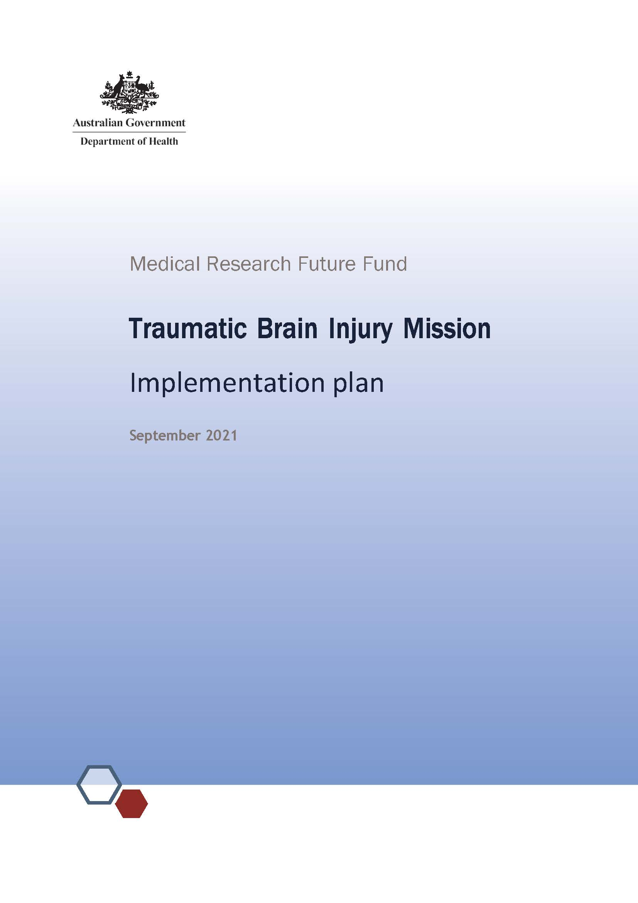

# Background

Traumatic brain injury (TBI) encompasses a spectrum of severity from concussion to severe injury. It can lead to dramatic, often long-lasting, negative consequences for patients, their families and caregivers. The TBI Mission aims to build the evidence base, optimise care and innovate new strategies for treatment, rehabilitation and community integration for people who have experienced TBI. The mission aims to accelerate Australian-led TBI research to develop and deliver innovative and effective treatments that substantially and equitably optimise and improve health outcomes, in partnership with people with TBI and carers. The mission will make transformative improvements to the lives of people affected by TBI through:

personalising care after TBI to achieve the best possible outcomes

developing and implementing innovative treatments for people with TBI

identifying how to reduce social, geographical and economic barriers to enable people to live their best possible life after TBI.

This plan supports the implementation of the TBI Mission roadmap and establishes a strategic plan to address the mission’s goals within the context of the Medical Research Future Fund 10-year plan. This implementation plan should be read in the context of the mission roadmap, which describes the mission’s scope, goals and principles.

# Overview

To target activities to achieve the objectives of the mission within the 10-year plan, the following aims and priority areas for research investment have been identified.

| Aim | Priority areas for investment |
| --- | --- |
| **1.** Personalising care after TBI to achieve the best possible outcomes | **1.1** Developing personalised care for moderate to severe TBI in all care settings that is facilitated by evidence and information |
| **1.2** Improving care pathways and outcomes for moderate to severe TBI through predictive modelling using novel approaches to data and informatics |
| **1.3** Helping to ensure that patients consistently receive best-practice treatment and care for moderate to severe TBI |
| **2.** Improving the lives of people with TBI by using better interventions | **2.1** Improving care in acute care settings by identifying and implementing new treatments and care applications for moderate to severe TBI |
| **2.2** Improving outcomes for moderate to severe TBI through enhanced rehabilitation |
| **2.3** Helping to ensure that patients consistently receive best-practice treatments and care for mild TBI |
| **3.** Identifying how to reduce barriers to support people to live their best possible life after TBI | **3.1** Understanding the impact of community awareness on the health and psychosocial outcomes of people living with TBI |
| **3.2** Reducing inequalities in TBI treatment and care |
| **3.3** Assessing the cost-effectiveness of TBI treatments and pathways |

# Implementation strategy

The implementation strategy has been developed to guide research investment over the life of the mission. Investment aims to build capability and knowledge, as well as facilitate translation of advancements to clinical practice, to achieve the mission’s objectives. The implementation strategy is intended to make the research purpose and direction transparent, and provide certainty to stakeholders. It also establishes how the outcomes of each focus area will be evaluated in terms of benefit to Australian patients, which will help to clarify the intended outcome and facilitate tracking of the mission’s progress towards its objectives.

Priority areas for investment are allocated across short, medium and long-term timeframes. Priority areas are designed to integrate with each other and form parts of a cohesive whole. National collaborations will be required to ensure key inputs for individual projects are available. Integration of priority areas is designed to maximise data collection and linkage among funded projects, within and between priority areas.

Research activities will be, or contribute to, large programs of work of national strategic importance that are informed by the key priority areas outlined in this implementation plan. The research activities are expected to foster collaboration and harness resources across the system to deliver improved health outcomes for Australians.

The [MRFF Monitoring, evaluation and learning strategy](https://www.health.gov.au/resources/publications/mrff-monitoring-evaluation-and-learning-strategy-2020-21-to-2023-24) is an overarching framework for assessing the performance of the MRFF, focused on individual grants, grant opportunities, initiatives (eg the Traumatic Brain Injury Mission) and the entire program. The strategy sets out the principles and approach used to monitor and evaluate the MRFF. It outlines the need for evaluations to be independent and impartial. The strategy aims to be transparent in process and outcomes and agile to the needs of the MRFF, its consumers and stakeholders (such as the health and medical research industry). The Traumatic Brain Injury Mission and grants funded under this initiative will be evaluated against the strategy.

# Aim 1: Personalising care after TBI to achieve the best possible outcomes

## Priority area 1.1

**Developing personalised care for moderate to severe TBI in all care settings that is facilitated by evidence and information**

| Research to begin in the … | Priorities for investment (research questions and objectives) |
| --- | --- |
| short term (1–2 years) | Improving care for moderate to severe TBI by designing optimised informatics approaches that gather nationally representative data. Common data elements to be determined by a competitively selected national consortium will include social, biological, health, clinical, intervention and outcome aspects that are of value to people with lived experience of TBI.  Conduct a small-scale development project to establish feasible, evidence- based approaches that:   * cover the entire trajectory of people’s journeys, from injury to integration back into their communities * encompass all states and territories and demographics * encompass the diversity of presentations of people with moderate to severe TBI * include a broad range of consensus-derived indicators and outcomes * facilitate access to nationally consistent, high-quality linked information that improves care pathways and decision making |
| medium term (2–5 years) | Improving care for moderate to severe TBI by optimising informatics approaches that gather nationally representative data. Common data elements gathered by a competitively selected national consortium will include social, biological, health, clinical, intervention and outcome aspects that are of value to people with lived experience of TBI.  An overarching competitively selected national consortium will conduct and continue to oversee a large-scale project to implement optimal informatics approaches nationally that maximise ongoing data collection and linkage, to facilitate personalisation of care and improved outcomes. This will encompass the diversity of moderate to severe TBI, across all states and territories and demographics. Data collection and access must adhere to all best-practice principles.  Key inputs for this project include:   * approaches and outcomes from the development project (see 1.1 short term). |

## Priority area 1.2

**Improving care pathways and outcomes for moderate to severe TBI through predictive modelling using novel approaches to data and informatics**

| Research to begin in the … | Priorities for investment (research questions and objectives) |
| --- | --- |
| short term (1–2 years) | Conduct a small-scale development project to identify opportunities to enhance consistency of care and improve outcomes. This will use existing resources (e.g. data) that:   * cover the entire trajectory of people’s journeys, from injury to integration back into their communities * encompass all states and territories and demographics |
| medium term (2–5 years) | Conduct a large-scale project to implement optimal prognostic and predictive approaches nationally for moderate to severe TBI that:   * enable personalised care to enhance treatment and care pathways * encompass improved understanding of barriers and enablers to recovery and integration into the community * use novel approaches such as new assessment techniques and artificial intelligence   Key inputs for this project include:   * outcomes (including data) from the optimal informatics approaches (see 1.1 medium term). |
| long term (6–10 years) | Conduct implementation research to support effective national adoption and best-practice use of prognostic and predictive approaches for moderate to severe TBI to address barriers to implementation, and assess and address inequalities among:   * Aboriginal and Torres Strait Islander people * rural, regional and remote populations * culturally and linguistically diverse populations   Key inputs for this project include:   * outcomes from reducing inequalities (see 3.2 medium term). |

## Priority area 1.3

**Helping to ensure that patients consistently receive best-practice treatment and care for moderate to severe TBI**

| Research to begin in the … | Priorities for investment (research questions and objectives) |
| --- | --- |
| short term (1–2 years) | Conduct a small-scale project to identify best-practice evidence-based care for moderate to severe TBI and facilitate consistent implementation by developing clinical guidelines and protocols.  Guidelines and protocols must:   * cover the entire trajectory of people’s journeys, from injury to integration back into their communities * account for national variations in care pathways (eg in rural, regional and remote settings) * encompass all states and territories and demographics |
| medium term (2–5 years) | Conduct implementation research to support effective national adoption and best-practice use of clinical guidelines and protocols for moderate to severe TBI, including assessing and addressing barriers to implementation and inequalities among:   * Aboriginal and Torres Strait Islander people * rural, regional and remote populations * culturally and linguistically diverse populations   Key inputs for this project include:   * development of clinical guidelines and protocols (see 1.3 short term). |
| long term (6–10 years) | Review and enhance the effectiveness of clinical guidelines and protocols for moderate to severe TBI by:   * using the outcomes of optimal informatics approaches to improve understanding of the use of treatments and care pathways, and their outcomes * assessing the outcomes of integration of prognostic and predictive approaches into clinical guidelines and protocols   Key inputs for this project include:   * understanding of the barriers to implementation of clinical guidelines and protocols (see 1.3 short term and 1.3 medium term) * outcomes (including data) from the optimal informatics approaches (see 1.1 medium term) * development of predictive/prognostic approaches (see 1.2 medium term) |

## Evaluation approach and measures

Informatics approaches developed, implemented and in use nationally that facilitate improved care outcomes for moderate to severe TBI across all population groups

Predictive and prognostic approaches developed, implemented and in use nationally that improve treatment and care pathways for people with moderate to severe TBI

Evidence-based clinical guidelines and protocols developed, implemented and in use nationally for moderate to severe TBI

# Aim 2: Improving the lives of people with TBI by using better interventions

## Priority area 2.1

**Improving care in acute care settings by identifying and implementing new treatments and care applications for moderate to severe TBI**

| Research to begin in the … | Priorities for investment (research questions and objectives) |
| --- | --- |
| short term (1–2 years) | Identify treatments, clinical indicators and interventions to improve the effectiveness of acute care for moderate to severe TBI by reviewing existing knowledge and building research evidence. |
| medium term (2–5 years) | Test the efficacy of novel treatments, clinical indicators and interventions for moderate to severe TBI in reducing time spent in acute care and improving long-term patient outcomes:   * building on nationally integrated informatics approaches that facilitate personalisation of care * encompassing the diversity of TBI * of relevance to all states and territories and demographics   Key inputs for this project include:   * identification of novel treatments and care (see 2.1 short term) * optimal informatics approaches (see 1.1 medium term)   Continue identifying novel treatments, clinical indicators and interventions for moderate to severe TBI (building on 2.1 short term). |
| long term (6–10 years) | Test the efficacy of novel treatments, clinical indicators and interventions for moderate to severe TBI in reducing time spent in acute care and improving long-term patient outcomes:   * building on nationally integrated informatics approaches that facilitate personalisation of care * encompassing the diversity of TBI * of relevance to all states and territories and demographics   Key inputs for this project include:   * identification of novel treatments and care (see 2.1 medium term) * test the efficacy of novel treatments (see 2.1 medium term) * optimal informatics approaches (see 1.1 medium term)   Assess and refine novel treatments and care implemented through 2.1 medium term for moderate to severe TBI. |

## Priority area 2.2

**Improving outcomes for moderate to severe TBI through enhanced rehabilitation**

| Research to begin in the … | Priorities for investment (research questions and objectives) |
| --- | --- |
| short term (1–2 years) | Conduct implementation research to test the effectiveness of the national rollout of best-practice care models for moderate to severe TBI focused on psychosocial outcomes to support individuals to integrate into the community. The research must:   * be of relevance to all states and territories and demographics * encompass the diversity of TBI   Key inputs for this project include:   * outcomes from clinical guidelines and protocols (see 1.3 short term). |
| medium term (2–5 years) | Identify and test novel rehabilitation models and approaches for moderate to severe TBI that improve psychosocial outcomes and support integration into the community. The models and approaches must:   * include focus on priority populations such as Aboriginal and Torres Strait Islander people and those living in rural, regional and remote areas * build on nationally integrated informatics approaches that facilitate personalisation of care * encompass the diversity of TBI across the lifespan of the individual   Key inputs for this project include:   * optimal informatics approaches (see 1.1 medium term). |
| long term (6–10 years) | Test the efficacy of novel rehabilitation models and approaches for moderate to severe TBI in improving long-term patient outcomes that:   * build on nationally integrated informatics approaches that facilitate personalisation of care * encompass the diversity of TBI * are relevant to all states and territories   Assess and refine novel rehabilitation models and approaches implemented through 2.2 medium term.  Key inputs for this project include:   * identification of novel rehabilitation models and approaches (see 2.2 medium term) * test the efficacy of novel treatments (see 2.2 medium term) * optimal informatics approaches (see 1.1 medium term) |

## Priority area 2.3

**Helping to ensure that patients consistently receive best-practice treatments and care for mild TBI**

| Research to begin in the … | Priorities for investment (research questions and objectives) |
| --- | --- |
| short term (1–2 years) | Conduct a small-scale project to identify best-practice, evidence-based care for mild TBI across the lifespan and facilitate consistent implementation through clinical guidelines and through protocols that are accessible for community use.  Guidelines and protocols must:   * cover the entire lifespan * cover the entire trajectory of people’s journeys, from injury to integration back into their communities * account for national variations in care pathways (e.g. in rural, regional and remote settings) |
| medium term (2–5 years) | A competitively selected national consortium will improve care for mild TBI by designing and implementing informatics approaches that gather nationally representative social, biological, health, clinical, intervention and outcome data of value to people with lived experience of TBI. The national consortium for mild TBI will conduct and continue to oversee a large-scale project to implement prognostic and predictive approaches nationally that:   * enable personalised care to enhance treatment and care pathways * use novel approaches such as new assessment techniques and artificial intelligence * encompass all states and territories and demographics * include a broad range of consensus-derived indicators and outcomes * maximise ongoing data collection and linkage |
| long term (6–10 years) | Conduct research to support effective national adoption and best‑practice use of clinical guidelines and protocols for mild TBI, including integration of prognostic and predictive approaches, and assessing and addressing barriers to implementation and inequalities among:   * Aboriginal and Torres Strait Islander people * rural, regional and remote populations * culturally and linguistically diverse populations   Key inputs for this project include:   * clinical guidelines and protocols (see 2.3 short term) * development of predictive/prognostic approaches (see 2.3 medium term)   Assess the efficacy and effectiveness of treatments and interventions for mild TBI on long-term psychosocial and neurocognitive outcomes. Assessments will:   * consider confounding health conditions * build on informatics approaches that facilitate personalisation of care   Key inputs for this project include:   * optimal informatics approaches (see 2.3 medium term) * development of predictive/prognostic approaches (see 2.3 medium term) |

## Evaluation approach and measures

New treatments and care applications for moderate to severe TBI developed, implemented and in use in acute care and rehabilitation settings

Evidence-based clinical guidelines and protocols for mild TBI developed, implemented and in use nationally, including predictive and prognostic tools

Reduction in average length of acute care stay for moderate to severe TBI

# Aim 3: Identifying how to reduce barriers to support people to live their best possible life after TBI

## Priority area 3.1

**Understanding the impact of community awareness on the health and psychosocial outcomes of people living with TBI**

| Research to begin in the … | Priorities for investment (research questions and objectives) |
| --- | --- |
| short term (1–2 years) | Improve health and wellbeing for people with TBI by identifying and addressing the gaps in awareness that are leading to poor outcomes. The research must:   * be relevant to all states and territories and demographics * cover the entire trajectory of people’s journeys, from injury to integration back into their communities * cover mild and moderate to severe TBI |

## Priority area 3.2

**Reducing inequalities in TBI treatment and care**

| Research to begin in the … | Priorities for investment (research questions and objectives) |
| --- | --- |
| medium term (2–5 years) | Identify and quantify variations in access to effective TBI treatment and care for mild and moderate to severe TBI. The approaches must include focus on vulnerable populations, including but not limited to:   * Aboriginal and Torres Strait Islander people * people living in rural, regional and remote areas * under-recognised groups with TBI, such as people with drug and alcohol dependency, people experiencing family and intimate partner violence, other victims of violence, elderly people, people from culturally and linguistically diverse backgrounds, people with sports concussion, prisoners, and others   Key inputs for this project include:  optimal informatics approaches (see 1.1 medium term). |
| long term (6–10 years) | Conduct research to address:   * barriers driving variations in treatment and care for mild and moderate to severe TBI * enablers that can be used to mitigate these barriers   Key inputs for this project include:   * optimal informatics approaches (see 1.1 medium term and 2.3 medium term) * development of predictive/prognostic approaches (see 1.2 medium term and 2.3 medium term) * development and national implementation of clinical guidelines and protocols (see 1.3 short term, 1.3 medium term, 2.3 short term and 3.2 medium term) |

## Priority area 3.3

Assessing the cost-effectiveness of TBI treatments and pathways

| Research to begin in the … | Priorities for investment (research questions and objectives) |
| --- | --- |
| medium term (2–5 years) | Quantify the economic impact of TBI in Australia. The approaches must:   * include the health, productivity and opportunity costs associated with living with TBI * cover the entire trajectory of people’s journeys, from injury to integration back into their communities * encompass all states and territories and demographics * cover mild and moderate to severe TBI   Key inputs for this project include:   * optimal informatics approaches (see 1.1 medium term and 2.3 medium term). |
| long term (6–10 years) | Evaluate the cost-effectiveness of TBI treatments and care pathways for mild and moderate to severe TBI, including among priority populations.  Key inputs for this project include:   * optimal informatics approaches (see 1.1 medium term and 2.3 medium term) * development of predictive/prognostic approaches (see 1.2 medium term and 2.3 medium term) * development and national implementation of clinical guidelines and protocols (see 1.3 short term and 2.3 short term) * development of novel treatments, clinical indicators and interventions (see 2.1 medium term and 2.2 medium term) |

## Evaluation approach and measures

Inequalities in access to TBI treatment and care for mild and moderate to severe TBI, measured and reduced over time

Cost-effectiveness of TBI treatments and care pathways for mild and moderate to severe TBI quantified

### Opportunities to use additional investment and other research to support the priority areas include, but are not limited to, the following

Engagement with Connectivity – Traumatic Brain Injury Australia, National Disability Insurance Agency, motor accident insurance commissions, and the Advanced Health Research and Translation Centres

Connectivity will support and enhance the outcomes of the TBI Mission by increasing implementation and translation of TBI Mission research findings. Connectivity is a not-for-profit company limited by guarantee, and governance is separate from the TBI Mission. Communication to facilitate the dual purpose and prevent duplication will be achieved through individuals with joint membership of Executive bodies for Connectivity and the TBI Mission

* Other MRFF initiatives and Australian Government initiatives, such as:
* National Critical Research Infrastructure Strategy
* National Health and Medical Research Council
* Australian Research Council

Australian Commission on Safety and Quality in Health Care

Private and philanthropic funding opportunities

* International collaborations to:
* enhance data analytics, especially for artificial intelligence
* support development of guidelines and protocols
* enhance research to test the efficacy of novel treatments and care applications
* enhance research to assess the impact of TBI awareness on outcomes

support investigation of variations in treatment and care, and their underlying causes

### Activities required to support the research and facilitate long-term implementation include, but are not limited to, the following

Existing literature and research activities

* Collaborative, interdisciplinary network of all stakeholders, including established consumer representative groups, to:
* identify research needs
* develop research capability in a coordinated way

co-design research with people with lived experience of TBI

National multidisciplinary clinical and care networks to support trials and share expertise

Data analytics capability, such as data linkage and artificial intelligence

* Ethical and data governance frameworks to support the design, development and implementation of:
* health informatics approaches

predictive or prognostic approaches

Recruitment and support for early and mid-career researchers to conduct TBI-related research in line with TBI Mission objectives

* Training to support:
* clinicians and other caregivers to adopt guidelines and protocols
* acute care clinicians to adopt novel treatments and care applications

rehabilitation workers to adopt new approaches

Collaboration with organisations that have developed national strategies for a population with similar needs (e.g. Cerebral Palsy Australia) or that provide support to similar populations (e.g. Australasian Rehabilitation Outcomes Centre)