# Innovative Models of Care (IMOC) Program - Interdisciplinary Clinical Support package

Geriatric Care Australia will deliver the Interdisciplinary Clinical Support package: an aged care training model, upskilling General Practitioners (GPs), allied health professionals, carers, and nurses to help identify risk factors related to complex age-related health problems.

**Round 5: Strengthening Regional Healthcare** improving workforce capacity of teams caring for older people.  
**Location:** NSW – Maclean (MM5); QLD – Bowen (MM4), Collinsville (MM6); and Vic – Lakes Entrance (MM4). Co-design of an Interdisciplinary Clinical Support package in July 2024 with services start date in April 2025.  
**Funding**: $1.6 million over 4 years from 2024

**Contact Details:**

Geriatric Care Australia (GCA)

James Britton, CEO

info@geriatriccareaustralia.com.au

(02) 9160 0079

Australian Association of Gerontology (AAG)

Renu Borst, CEO

enquiries@aag.asn.au

(03) 8506 0525

The activity will fund Interdisciplinary Clinical Support in regional areas via the Geriatric Care Australia Model of Care (GCA-MOC). The model aims to support and upskill General Practitioners (GPs), allied health professionals, carers, and nurses to help identify risk factors of complex age-related health problems. The GCA-MOC will address the lack of geriatric specialist services in regional areas by providing Interdisciplinary Clinical Support with the local healthcare workforce, and to improve outcomes for older people.

Figure 1: Interdisciplinary Clinical Support delivered by GCA

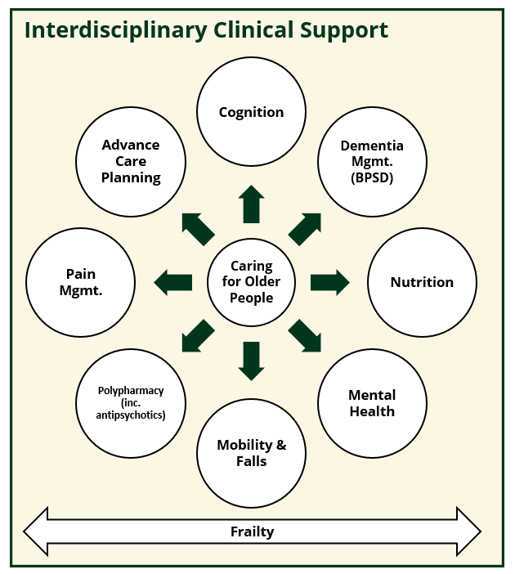

The GCA geriatricians and care coordinators will also conduct bulk-billed comprehensive reviews. These assess patients for cognition, falls, functional capacity, mood, polypharmacy, sleep, social support, and advance care planning. Geriatricians will work alongside local regional and metropolitan care teams to coordinate and support treatment plans for patients with complex co-morbidity. Program outcomes data to date show that combining upskilling staff and regular geriatric assessments leads to reduced hospital admissions, falls and use of medications.

The funding will allow GCA and partners (Australian Association of Gerontology, and local health services) to recruit program leads to help co-design and implement the project. They will also organise community and stakeholder consultation and a steering group. The project will engage with GPs, nurses, care teams, specialists, other aged care workforce and stakeholders/consumers of health services.

Iterative co-design sessions will generate the local needs for the Interdisciplinary Clinical Support, how to deliver that training and support package, and how to best measure the success of the initiative. Project deliverables include delivery of fit-for-purpose training for each location, a documented evaluation framework, and a program user guide. The project will also deliver a robust Community of Practice in each of the trial locations.

A final report including policy recommendations will be delivered at the conclusion of the project. This effectiveness-implementation project explores the elements of the GCA-MOC that can be successfully scaled-up across locations, for community-dwelling cohorts and for remote workforce capacity building.