# Innovative Models of Care (IMOC) Program – Age Well Community Centre

Southern Cross Care Ltd will deliver the Age Well Community Centre: a one-stop-shop to provide a range of aged care and health services.

**Round 4: Southern Cross Care QLD** Age Well Community Centre  
**Location:** Chinchilla, QLD (MM5)  
**Funding:** $1.4 million over 4 years from 2024

**Contact Details:**

Matt Martin  
Matthew.Martin@sccqld.com.au  
07 3340 3262 or 07 3340 3200

The activity will support implementation of the Age Well Community Centre a one-stop-shop to provide a range of aged care and health services. This includes allied health, exercise physiology, massage therapy, home visits, mobile transport service, day respite, education, virtual services and social connection to the community in Chinchilla, QLD and smaller communities in the Western Downs region in QLD.

The Community Centre will work closely with co-located indigenous health specialists Goondir Health, the Southern Cross Home Care team, the day respite centre, and the 81-bed retirement aged care home.

The IMOC grant will fund a small team to lead and coordinate the community primary care hub with responsibility for managing and administering the trial. They will develop sustainable procedures, utilise ongoing research with existing research partners, liaise with local communities, and ensure appropriate staffing for the trial.

This will result in:

* improving rural health outcomes using Multidisciplinary Care Teams;
* improved relationships with local providers and stakeholders;
* improved transport to medical services for members within the community;
* increased amount of staff accommodation, increased student placements; and
* expanded student services to encompass more than just aged care.

The evaluation process is focussed on establishing suitable governance structures and reporting mechanisms between service providers. Additionally it will establish evidence of a health care shortage in the region, determine whether services delivered are improving local health outcomes and satisfy local demand for health services.

Trial activities commenced January 2024.

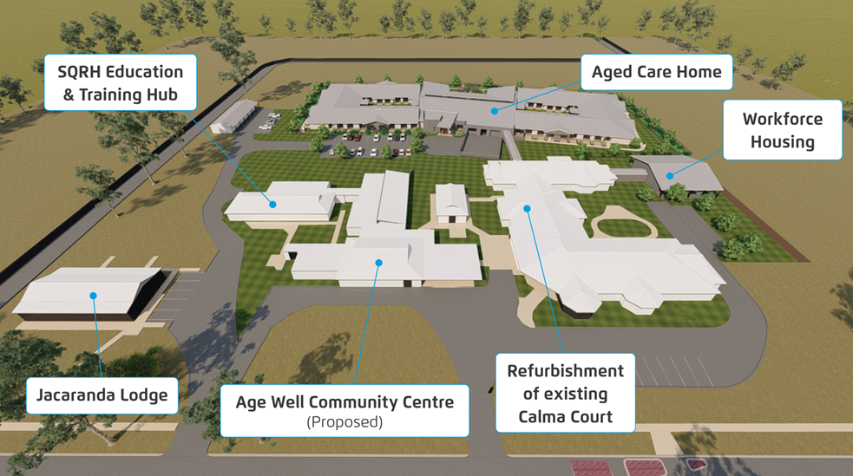

For more information visit: [Redevelopment and expansion at Chinchilla](https://sccqld.com.au/about-us/illoura-project/)