**Evaluation of translating and interpreting services for Primary Health Network funded mental health services**

Mental Health

25 February 2025

**Nous Group** acknowledges Aboriginal and Torres Strait Islander peoples as the First Australians and the Traditional Custodians of country throughout Australia. We pay our respect to Elders past, present and emerging, who maintain their culture, country and spiritual connection to the land, sea and community.

This artwork was developed by Marcus Lee Design to reflect Nous Group’s Reconciliation Action Plan and our aspirations for respectful and productive engagement with Aboriginal and Torres Strait Islander peoples and communities

*Disclaimer:*

*Nous Group (****Nous****) has prepared this report for the benefit of Department of Health and Aged Care (the* ***Client****).*

*The report should not be used or relied upon for any purpose other than as an expression of the conclusions and recommendations of Nous to the Client as to the matters within the scope of the report. Nous and its officers and employees expressly disclaim any liability to any person other than the Client who relies or purports to rely on the report for any other purpose.*

*Nous has prepared the report with care and diligence. The conclusions and recommendations given by Nous in the report are given in good faith and in the reasonable belief that they are correct and not misleading. The report has been prepared by Nous based on information provided by the Client and by other persons. Nous has relied on that information and has not independently verified or audited that information.*

© Nous Group

Contents

1 Executive summary 1

1.1 Background 1

1.2 Methodology 1

1.3 Findings 2

1.4 Recommendations 8

2 Background 10

2.1 Australia is a multicultural country with shifting demographics 10

2.2 The department funded TIS National to provide interpreting services to PHN-funded mental health services 11

2.3 Recent reviews note the need to improve access to mental health services for individuals from CALD backgrounds 12

3 Methodology 14

3.1 A set of good practice principles underpinned the evaluation 14

3.2 An evaluation framework guided the evaluation 14

3.3 There are some limitations to the evaluation’s findings 20

4 Findings 22

4.1 People from CALD backgrounds have unique mental health needs 22

4.2 Interpreting services should be available to everyone with limited English proficiency requiring mental health services 10

4.3 TIS National is being used by many PHN-commissioned mental health services 16

4.4 TIS National enables more people to access mental health services, but barriers remain 34

4.5 There could be more efficient funding approaches 38

5 Recommendations 41

5.1 Recommendations should be implemented over different time periods 41

5.2 Immediate actions to improve access to translation and interpreting in mental health settings 42

5.3 Medium-term actions to improve access to and the quality of mental health services provided to people with limited English proficiency 44

5.4 Broader actions to improve access to and the quality of mental health services for people from CALD backgrounds 51

Appendix A Description of language groups 60

# Executive summary

## Background

Australia is one of the most diverse countries in the world. In 2021, over half the population was either born overseas or had at least one parent that was born overseas. According to the 2021 Census, 5.8 million (22.8 per cent) Australian residents speak a language other than English at home and 872,000 (3.4 per cent) could not speak English well or not at all. [1]

In 2021-22, the Department of Health and Aged Care (the department) funded Translating and Interpreting Service (TIS) National to provide interpreting services to Primary Health Network (PHN) funded mental health services to facilitate equitable access to services.

The funding for this investment is due to end in June 2024-25 and the department is seeking to understand its impact through this evaluation to inform decisions about future funding.

## Methodology

The evaluation has been guided by five key evaluation questions (KEQs) covering context, appropriateness, implementation, effectiveness and efficiency. In answering these KEQs, the evaluation team collected and analysed information and data across qualitative and quantitative sources, including a review of available literature and policy documents, engagement with stakeholders, and analysis of quantitative data from the department, PHNs, and Australian Bureau of Statistics (ABS) data.

The evaluation engaged over 200 individuals including mental health service providers, PHNs, carers and consumers, interpreters, and other multicultural and mental health experts.

Some limitations to the evaluation have impacted the findings:

* Limited outcomes data is available. Qualitative information has been used to assess effectiveness.
* Only a small number of consumers and carers were interviewed. This was complemented with insights from other stakeholders including peak bodies, multicultural mental health experts, and service providers who represented or conveyed the consumer voice.
* Some self-selection bias may have been introduced because recruitment required people to opt-in. Data was triangulated from several sources to validate qualitative insights and minimise bias.

## Findings

This evaluation has made several findings about the availability of interpreting services and the impact of the Commonwealth Government’s recent investment. Figure 1 provides an overview of these findings.

Figure 1 | Key factors impacting access, experience and outcomes

A consumer journey for individuals with limited English proficiency in accessing mental health services and the role of interpreting services
[Detailed image description:
Overview
This flowchart provides a visual representation of the journey that individuals with limited English proficiency experience when accessing mental health services. It also highlights the importance of interpreting services in this process.
Consumer Journey
The journey begins with the consumer who experiences mental illness or psychological distress. Five steps are outlined:
1. The consumer experiences mental illness or psychological distress.
2. The consumer becomes aware of available mental health services and interpreting services.
3. They access the mental health service.
4. The individual experiences the mental health service provided.
5. The consumer experiences the best possible mental wellbeing as a result of the services received.
Service interactions
At steps 4 and 5, the consumer interacts with the Mental Health Service. This includes administrative, triage or service staff when accessing the service, and the clinician, therapist or counsellor when experiencing or receiving the service.
The Mental Health Service interacts with TIS National to support the consumer at these steps. This includes TIS National’s operator or administrative staff, and the interpreter.
Key findings from the report are highlighted across the journey
Cultural factors and past experiences impact people’s experience of mental health and mental health services.
Interpreting services are essential for the delivery of mental healthcare.
Other approaches cannot replace professional interpreting but may complement them.
Several factors influence the achievement of outcomes in the mental health services provided.
TIS National is mentioned as having helped more people access mental health services.
Interpreting supports people with limited English proficiency to benefit from mental health services at the point of accessing the service.
It is indicated that there are barriers to using TIS National’s interpreting services.
It is also indicated that most mental health service providers are satisfied with the quality of interpreting.
End of image description]



**People from culturally and linguistically diverse (CALD) backgrounds have unique needs that may not currently be met.**

Some data sources indicate a lower prevalence of mental illness among people from CALD backgrounds while other sources suggest a higher prevalence. Regardless, people from multicultural and migrant backgrounds experience higher risk factors for mental illness including racial discrimination and social isolation. Asylum seekers and refugees can experience greater socioeconomic disadvantage and significant trauma. People from CALD backgrounds can also experience protective factors that promote mental wellbeing including greater social support in some communities.

People from CALD backgrounds use fewer mental health services but are over-represented in acute admissions. People living in Australia that speak a language other than English accessed fewer Medicare Benefits Schedule (MBS) subsidised mental health services and fewer Pharmaceutical Benefits Scheme (PBS) mental health medications according to 2011 data from the ABS.[2] Not accessing these mental health services may be resulting in more people being involuntarily admitted to mental health inpatient units.[3]

It appears there is substantial unmet demand for interpreting services in mental health settings (Figure 2). It is estimated 150,000 people in Australia require the use of an interpreter when accessing mental health services each year. This includes any mental health service in Australia of which PHN-funded mental health services are just a small proportion. Of the people requiring any mental health service, approximately 10,000 people would be expected to use PHN-funded mental health services. Between June 2019 and June 2024, only 8,000 people accessing PHN-funded mental health services used an interpreter, or 1,600 per year on average. The assumptions for these calculations are described in Section 3.1.1.

Figure 2 | Number of people that do not speak English well that are expected to use mental health services in any one year[4][5][6][7][8]

Expected use of all mental health services: 150,000
Expected PHN-funded mental health service use: 10,000
Average annual number of people using PHN-funded mental health services: 1,600


**Interpreting services should be available to everyone with limited English proficiency requiring mental health services.**

Without access to interpreting services, many mental health services may not be able to provide care to people with limited English proficiency. Interpreting services are essential for them to book an appointment, be assessed, understand their treatment plan, and receive mental health treatment. People that speak English as a second language may struggle to express their emotions or thoughts in another language particularly when they are stressed or anxious.

Government funded and delivered services have an obligation to ensure accessibility for clients with limited English skills by providing language services, as outlined in the Whole of Government Access and Equity strategy[9] and the Australian Government Language Services Guidelines.[10] Ensuring access to interpreting services also supports recent government reviews and policy recommendations, including the Multicultural Framework Review.

There are other approaches available, but none adequately replace professional interpreting. Using family members to interpret is convenient, however this can place unnecessary burden on children, or result in inaccurate interpreting stemming from their own biases, experiences and perspectives, particularly in a sensitive mental health context. Technology can support simple translation, but rarer languages may not be available, and translation can be inaccurate.

**TIS National is being used by many PHN-commissioned mental health services.**

The use of TIS has increased but there are gaps. PHN-funded mental health services are using interpreting services around 400 times per month. Gaps remain with more than 100 requests for interpreting each month not being able to be met, mostly because no interpreter is available.

Barriers to using TIS National’s interpreting service include:

* finding an interpreter for rare or emerging languages, or languages not offered by TIS National
* finding an interpreter to attend in-person, which is preferred by some service providers and customers
* confidentiality concerns, particularly in small communities, where the consumer might know the interpreter
* consumers being matched with an interpreter who may be inappropriate for their context particularly in a sensitive mental health setting, for example, of a different gender, cultural or national background, or a speaker of a different dialect of the language
* preferring not to have a third person in the room for sensitive conversations.

Most service providers are satisfied with the quality of interpreting. More than 70 per cent of mental health service staff that responded to a survey run for this evaluation indicated that both they and the consumers they worked with were satisfied with the interpreting service provided. Some providers reported instances of encountering unprofessional behaviour and a lack of mental health knowledge from interpreters, which had a negative impact on consumers and the service they were delivering.

**TIS National enables more people to access mental health services, but barriers remain.**

Between February 2023 and September 2024, there were 7,000 interactions with TIS National interpreters for the purposes of delivering PHN-funded mental health services, according to TIS National data. These interactions may have been for a service contact with a mental health service, or they may have been for the purpose of booking an appointment.

There has been an increase in PHN-funded mental health service contacts involving an interpreter since the free TIS service was introduced in February 2023 (Figure 3) according to the Primary Mental Health Care – Minimum Data Set (PHMH-MDS). It is not possible to attribute this change directly to the TIS service but it is likely it contributed.

Figure 3 | Proportion of service contacts involving an interpreter[11] [12]

The proportion of total PHN-funded mental health service contacts involving an interpreter almost doubled following the introduction of free TIS for PHN-funded mental health services, from 1.4% of service contacts between 1 February 2022 and 31 January 2023 to 2.5% of service contacts between 1 February 2023 and 31 January 2024.


Prior to February 2023 PHN-funded mental health services were not using TIS National’s interpreting service. However, services were likely paying to use other interpreting services out of their funding available for service delivery. Many people could not have accessed mental health services without free interpreting.

As seen in Figure 1, interpreting on its own is not enough to remove access barriers for people from CALD backgrounds. Additional barriers in the consumer journey include:

* not knowing what services are available or how to access them
* not seeking help for reasons such as stigma about mental health in their community and confidentiality concerns
* previous negative experiences with a service including encountering discrimination or receiving culturally unsafe care leading to someone not going back to the service.

The skills and knowledge of clinicians and interpreters can impact mental health outcomes. Some mental health service providers are not familiar with working with an interpreter, or with someone from a different cultural background. Being able to access skilled interpreters who understand the mental health context also impacts the quality of care delivered.

**There could be more efficient funding approaches.**

It was not possible to estimate the cost effectiveness of the investment because there was no quantitative data on outcomes. The evaluation team considered the costs of TIS National’s service, which are similar to other interpreting services.

## Recommendations

Recommendations are grouped by their proposed implementation timing. Some recommendations can and should be implemented within three to six months by the department and TIS National. Others require more planning and should be implemented in the following six to 24 months.

The evaluation team has also provided two broader actions for the department to consider. These actions are outside the direct scope of the evaluation but are critical for continuing to improve access to and the quality of mental health services for people from CALD backgrounds.

**Overview of recommendations**

Short term recommendations (over 3-6 months) – prioritise ‘quick wins’ the improve access to interpreting services:

* Recommendation 1 – provide ongoing funding for interpreting services in mental health setting (department led)
* Recommendation 2 – increase funding flexibility to enable TIS to better meet needs in mental health service settings (department led)
* Recommendation 3 – improve awareness of TIS National’s interpreting service (DHA and PHN led).

Medium term recommendations (over 6-24 months) – improve consistency and quality of interpreting services:

* Recommendation 4 – improve the quality of the interpreting services provided (department and DHA led)
* Recommendation 5 – improve understanding of mental health among interpreters and understanding of cultural considerations among mental health services (department and DHA led).

Broader actions – improve access to and the quality of mental health services for people from CALD background:

* Broader action 1 – improve access to mental health information, resources and services for people from CALD background (department and PHN led)
* Broader action 2 – improve the quality of mental health services for people from CALD backgrounds (department and DHA led).

# Background

## Australia is a multicultural country with shifting demographics

**Australia is one of the most diverse countries in the world.**

Over half the population was either born overseas or had at least one parent that was born overseas. According to the 2021 Census, 5.8 million (22.8 per cent) Australian residents speak a language other than English at home and 872,000 (3.4 per cent) could not speak English well or not at all.[13]

Figure 4 | Overview of Australia's cultural and linguistic diversity

3.4% of Australian residents speak English not well or not at all.
Top five most common language other than English are Mandarin, Arabic, Vietnamese, Cantonese and Punjabi.
Top languages spoken by people with low English proficiency are Khmer, Vietnamese, Hazarghi, Chaldean Neo-Aramic and Korean.

**Migration patterns have changed overtime.**

There has been a significant increase in the number of immigrants arriving from non-English speaking countries.[14] As shown in Figure 5, over the last 15 years there has been a substantial increase in the number of people in Australia that are born in India and China. These changes have been as a result of policies to support Australia’s continued economic growth and prosperity.

Figure 5 | Number of people born in the top five countries of birth other than Australia, 1971 to 2021[15]

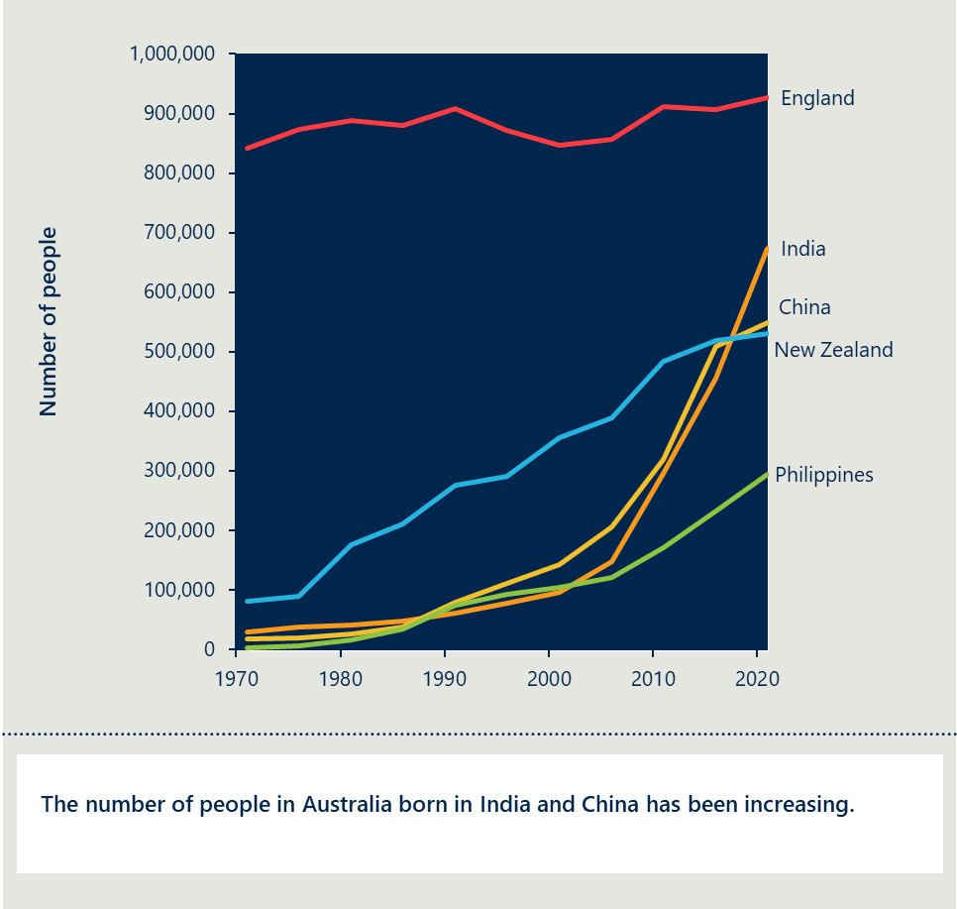

These changing demographics necessitate effective, accurate and accessible interpreting services to support the increasingly multicultural population.

## The department funded TIS National to provide interpreting services to PHN-funded mental health services

In 2022-23, the Australian Government committed $7.8 million through the department to make interpreting services available to PHN-funded mental health services for free. This investment aims to remove barriers to accessing mental health services for people with limited English proficiency. The funding was initially for two years but has been extended to three.

TIS National is providing this interpreting service. TIS National is delivered by the Department of Home Affairs (DHA) and provides a range of interpreting services. The following services are available to PHN-funded mental health services and consumers of these services:

* immediate phone interpreting 24 hours a day, seven days a week
* automated telephone interpreting services
* pre-booked phone interpreting
* on-site or in-person interpreting
* virtual or video interpreting.

The department’s investment in TIS National for PHN-commissioned mental health services will expire at the end of 24/25.

## Recent reviews note the need to improve access to mental health services for individuals from CALD backgrounds

**The Multicultural Framework Review highlights barriers to mental health support.**

In 2023 the Australian Government announced a review into multiculturalism in Australia. The review was delivered by a panel of three eminent Australians. It provides a whole-of-government and community reform agenda to realise a vision for a multicultural Australia.

The final report of the review provides 29 recommendations to help Australia adapt to the present social, economic and political landscape and continue to realise the benefits of multiculturalism. It notes the importance of data, research and evaluation to underpin future work, and its recommendations emerge from fundamental themes such as connection, identity and belonging, and inclusion.[16]

Findings from the Review relevant to this evaluation include:

* Services funded by PHNs are currently ill-equipped to meet the needs of humanitarian entrants due to language barriers and a lack of culturally appropriate information.
* Navigating the healthcare system can be daunting particularly for those with limited English proficiency but even for migrants who speak English well, emphasising the need for simplified procedures, in-language information and access to culturally competent staff and interpreters.
* There are many barriers to people from CALD backgrounds accessing mental health services. Developing tailored services, collaborating with community leaders, and improving the cultural competency and knowledge of mental health professionals can reduce barriers.[17]

**Other reviews recognise the need to improve access to mental health services for people from CALD backgrounds.**

Several recent reviews have made recommendations to improve mental health services for people from CALD backgrounds. These include the following:

* Royal Commission into Victoria’s Mental Health: The Royal Commission noted mental health services must respond to the needs of people from different cultural backgrounds.6F[18] It recommended the development of tailored mental health services that consider the specific needs of CALD communities.
* Productivity Commission's Mental Health Inquiry: The Productivity Commission highlighted the critical role of translation and interpretation services in equitable access to mental health care.7F[19] It emphasises strengthened services to ensure individuals from CALD backgrounds receive timely and effective care.
* National Mental Health Workforce Strategy 2022-32: The strategy recognises the need for a culturally competent workforce and emphasises training mental health professionals appropriately.8F[20] It also calls for improving the quality of mental health services to better serve CALD populations.

# Methodology

## A set of good practice principles underpinned the evaluation

These principles guided the way the evaluation team planned, engaged with stakeholders, and generated insights and recommendations.

**Principles underpinning the evaluation**

Principles for planning and engagement:

* Transparent – The evaluation process and methodology was shared with all key stakeholders to ensure trust and credibility.
* Consultative – The evaluation conducted extensive engagement with key stakeholders from all parts of the system, including service providers, consumer representative groups for CALD communities, those with limited English proficiency who required mental health services, and families and carers.
* Respectful and culturally sensitive – The evaluation designed, conducted and reported activities in a manner that respects the rights, dignity, entitlements and knowledge of different stakeholder groups. Critically, this included respect for different cultural backgrounds of participants, and appropriately addressing cultural considerations in engagements.

Principles for generating insights and recommendations:

* Informed by lived experience – The evaluation is informed by the experiences of those delivering and receiving interpreting services and mental health services. This ensures that findings reflect an understanding of day-to-day experiences and practices and that proposed recommendations are feasible and appropriate for the various stakeholders involved.
* Balanced, practical and robust – The evaluation balances, feasibility, appropriateness and rigour to ensure evaluation activities are designed with consideration for practical constraints and available information while still delivering insightful findings and actionable recommendations.

## An evaluation framework guided the evaluation

This section provides an overview of the approach to the evaluation, the conceptual approach to the evaluation, the program logic, and KEQs.

**Overview of the evaluation approach.**

The evaluation requires a rigorous design approach:

* Program logic and theory of change – Used to identify evidence that would ensure strategic alignment and measure outcome achievement.

The evaluation focuses on five key evaluation questions

1. Context – What are the unique needs of people from CALD backgrounds in the context of mental health?
2. Appropriateness – Are interpreting services the right response to remove barriers for people with limited English proficiency in accessing mental health support?
3. Implementation – How well is TIS National being delivered in PHN-commissioned mental health services?
4. Effectiveness – What difference is TIS National in PHN-Commissioned mental health services making for people with limited English proficiency?
5. Efficiency – How cost effective is funding TIS National in PHN-commissioned mental health services to achieve the intended outcome?

Evaluation plan to collect data via three streams of work:

* Literature and policy:
  + Review academic and grey literature
  + Review available policy documentation on the program.
* Stakeholder engagement:
  + PHNs
  + PHN-commissioned mental health services
  + Consumers and carers from CALD backgrounds
  + DHA staff, including TIS National interpreters
  + Other relevant stakeholders, including peak bodies.
* Data analytics:
  + Service activity data
  + Census data
  + PHN data.

The evaluation will help the department:

* understand the appropriateness, implementation, effectiveness and efficiency of the investment
* understand the unique needs of people with low English proficiency requiring mental health services
* make policy and funding changes to improve access to mental health services for people with low English proficiency.

### A theory of change and program logic illustrate intended outcomes

To evaluate the service, the evaluation team first needs an understanding of how it seeks to achieve its intended purpose. This is articulated through a theory of change and program logic.

A theory of change describes how a program intends to contribute to its intended outcomes.

**Theory of change.**

* If funding is provided to TIS National to give PHN-Commissioned mental health services access to free interpreting services.
* Then mental health services will be able to provide services to people with limited English proficiency.
* Contributing to more people with limited English proficiency accessing mental health services at the right time and receiving appropriate care.
* Resulting in improved mental health and wellbeing for people with limited English proficiency while reducing demand on acute care through timely access to early interventions.

**Program logic.**

The program logic provides more detail to the theory of change. A program logic outlines the connections between a program's activities, outputs, outcomes, and impacts. It shows how the program's resources and activities are expected to lead to desired outcomes and create the positive impact outlined in the theory of change.

Table 1 | Revised program logic

|  |  |  |  |  |  |
| --- | --- | --- | --- | --- | --- |
| Context | Inputs | Activities / outputs | Immediate outcomes | Longer-term outcomes | Impact |
| Australia has seen a growth in culturally linguistically diverse populations | $7.8 million for TIS to be delivered in PHN-commissioned mental health services | Access to interpreters in more than 150 languages | Provided a high-quality experience of mental health services for people with limited English proficiency | People with limited English proficiency access mental health services when they need them | People with limited English proficiency receive high quality mental health services that address their needs |
| People from CALD backgrounds may experience or understand mental health differently | Policies and practice guidance available through TIS National, as well as department guidance for PHNs on the use of TIS | Immediate phone interpreting 24 hours a day, seven days a week | Improve access to mental health services for people with limited English proficiency | Increased number of people with limited English proficiency accessing mental health services | Improved mental health outcomes for people with limited English proficiency |
| Lower utilisation of mental health services by people from CALD backgrounds due to multiple barriers | Data and information systems of TIS National | Automated telephone interpreting services | Mental health service providers feel more confident to provide treatment, care and support to people with limited proficiency | Culturally appropriate and safe mental health services for people with limited English proficiency |  |
| Multicultural Framework Review | TIS National online booking system | Pre-booked phone interpreting |  |  |  |
| Review of TIS more broadly |  | On-site interpreting |  |  |  |
| Free TIS for allied health professionals |  | Video interpreting |  |  |  |

### Key evaluation questions have guided the evaluation

Five KEQs guided data collection and analysis for this evaluation. Detailed KEQs are presented in Table 2.

Table 2 | KEQs

|  |  |  |
| --- | --- | --- |
| Category | Key evaluation question | Research questions |
| Context | What are the unique needs of people from CALD backgrounds in the context of mental health? | * How many people in Australia require mental health services and the use of an interpreter? * What are the unique needs of people from CALD backgrounds when accessing mental health services? * What are the barriers to accessing mental health services for people from CALD backgrounds? |
| Appropriateness | Are interpreting services in PHN-commissioned mental health services the right response to remove barriers for people with limited English proficiency in accessing mental health support? | * Are interpreting services appropriate in PHN-commissioned mental health settings or is there a more appropriate model? * How does this measure support findings from recent government reviews, including the Multicultural Framework Review and Language Review undertaken by DHA? * Are there any gaps or areas of duplication? |
| Implementation | How well is TIS National being delivered in PHN-commissioned mental health services? | * To what extent are consumers with low English proficiency and PHN-commissioned mental health services using TIS National? * How satisfied are consumers and PHN-commissioned mental health services with TIS National? * If PHN-commissioned mental health services are not utilising TIS National, what are the barriers preventing their use? * What barriers and enablers are there for consumers to access TIS National? |
| Effectiveness | What difference is TIS National in PHN-commissioned mental health services making for people with limited English proficiency? | * Has using TIS National improved access to PHN-commissioned mental health services for people with limited English proficiency? * Has using TIS National improved mental health outcomes for people with limited English proficiency accessing PHN commissioned mental health services? * What factors have enabled or inhibited achievement of the outcomes? |
| Efficiency | How cost effective is funding TIS National in PHN-commissioned mental health services to achieve the intended outcome? | * How efficiently have resources been utilised to deliver TIS National in PHN-commissioned mental health services? Can this be improved? * Is this approach cost effective to achieve the intended outcome, or are there alternative approaches to improve language services for people with limited English proficiency, removing barriers to accessing care? |

### Data from a variety of sources have been collected and analysed

To answer these KEQs, the evaluation team used a number of data sources. The data sources included:

* A review of academic literature and policy documents: The literature review explored the experience of mental illness and mental health services in CALD communities, and the barriers to accessing mental health services. The literature review also explored the factors that impact the effectiveness of interpreting services, and what alternative options exist.
* Engagement with stakeholders: A substantial amount of information was generated through stakeholder engagements (see Figure 6).There were five broad groups of stakeholders engaged, including PHNs; PHN-commissioned mental health services; people from CALD backgrounds including people with limited English proficiency; DHA staff, including interpreters from TIS National; and other relevant stakeholders who represented multicultural mental health perspectives including Embrace Mental Health and the Federation of Ethnic Communities’ Councils of Australia (FECCA).
* Analysis of available quantitative data: The evaluation team analysed data from TIS National about the interpreting services provided to PHN-funded mental health services. The evaluation team also analysed data from a survey of PHN-funded mental health services. Census from the ABS and the Primary Mental Health Care – Minimum Data Set (PMHC-MDS) were used.

The team triangulated data across sources and used thematic analysis to answer the KEQs. This ensured robustness of findings and recommendations and helped mitigate limitations, which are outlined in the next section.

Figure 6 | Overview of stakeholder engagement

Infographic capturing stakeholder engagements.
[Detailed image description:
67 engagements including with carers and consumers, interpreters, government agencies and TIS National.
20 focus groups with 44 mental health services.
16 interviews with PHN representatives
17 interviews with peak bodies
9 interviews with CALD consumers and/or carers
82 survey responses from service providers
End of image description]


## There are some limitations to the evaluation’s findings

**There was limited access to outcomes data. Qualitative information has been used to assess effectiveness.**

The evaluation team was unable to quantify the investment’s outcomes or establish a causal link as outcomes data is not collected by TIS National, the department or PHNs. There was no way to measure whether more people accessed mental health services as a result of the department’s investment. There was also no data on outcomes for consumers who received interpreting services and no available comparison that would have allowed analysis of a causal link. The lack of data on outcomes meant a synthetic comparison could not be used as an estimate.

Qualitative information has been used instead to assess effectiveness. The evaluation team completed a substantial amount of engagement as described in Section 2.2.3. Information from this engagement and a review of the available literature review was used to assess whether the investment in TIS National had achieved its intended objectives.

**Only a small number of consumers and carers were interviewed. This was complemented by insights from other stakeholders who have insight into the consumer perspective.**

The evaluation team was only able to engage with a small number of consumers and carers. Those who were engaged did not cover the range of languages and cultures in Australia. It was particularly difficult to reach people who did not speak English well and had used an interpreter in a mental health setting. The recruitment strategy for the project planned to engage consumers and carers through PHN and mental health service advisory groups. However, the team found that not many existed and those that did had very limited or no multicultural representation. The only exception was the Embrace Multicultural Mental Health Lived Experience Group. The evaluation team engaged with this group as part of stakeholder consultations.

Recruiting consumers from multicultural backgrounds is challenging for several reasons. Only a small number access mental health services as is discussed in this report. Barriers that limit their interactions with service systems also impact ability to recruit them for engagement. Many people in this group do not speak English well and do not engage with government webpages, and other mainstream sources of information. There is stigma associated with mental illness in many communities, which can increase hesitation to disclose experiences.

Information from service providers and expert multicultural stakeholders was used to address these gaps. The evaluation team spoke to several service providers and stakeholders who worked closely with, represented or advocated for consumers or shared consumer feedback they had noted. While nothing replaces the consumer voice, these other stakeholders provided valuable insights.

**All engagement required people to opt in, which may have introduced some selection bias.**

Engagement with interpreters, and consumers and carers required participants to opt-in to participate. This approach introduces the risk of self-selection bias. Often people who participate are either very satisfied or very dissatisfied and not representative of the general population group.

The evaluation team triangulated data from multiple sources to reduce the risk of bias. This was done by balancing insights from different stakeholder groups, findings from the literature and the data analysis.

**PMHC-MDS data was only available at the aggregate level.**

The data available to the evaluation team from the PMHC-MDS was an aggregate dataset. There were four tables, a breakdown of people using PHN-funded mental health service by PHNs and English proficiency, by language and English proficiency, and by state and English proficiency. A fourth table provided the number of service contacts and whether the interaction involved an interpreter by time period. Where cell sizes were lower than six, data was suppressed to protect privacy.

The evaluation team could only access aggregate level data because the project was not governed by an ethics agreement from a Human Research Ethics Committee. The evaluation was not designed to include an ethics application.

# Findings

## People from CALD backgrounds have unique mental health needs

|  |
| --- |
| This section answers the KEQ:  **What are the unique needs of people from CALD backgrounds in the context of mental health?**   * How many people in Australia require mental health services and the use of an interpreter? * What are the unique needs of people from CALD backgrounds when accessing mental health services? * What are the barriers to accessing mental health services for people from CALD backgrounds?   The key findings are:   * An estimated 150,000 people in Australia require the use of an interpreter when accessing mental health services each year * Cultural factors and past experiences impact people’s experience of mental health and mental health services |

### An estimated 150,000 people in Australia require an interpreter when accessing mental health services each year

**An estimated 10,000 people require interpreters each year when accessing PHN-funded mental health services**

Approximately 150,000 people who do not speak English well will use mental health services in any one year (Figure 7). 872,000 people living in Australia do not speak English well according to Census data from the ABS.[21] The National Study of Mental Health and Wellbeing undertaken from 2020 to 2022 estimates 17.4 per cent of Australians aged 16-85 years use mental health services in any one year. This includes all mental health services, not just PHN-funded mental health services.[22]

It is estimated approximately 10,000 people that do not speak English well will use PHN-funded mental health services. This is based on the data published in the Productivity Commission’s Inquiry into Mental Health that PHN-funded mental health services comprise about 7 per cent of total mental health service funding.[23] One person may use mental health services multiple times.

This calculation makes several assumptions and may not reflect actual service use for reasons previously described. However, it provides the department and the evaluation a useful reference point to compare actual service use.

Figure 7 | Number of people that do not speak English well and are expected to use mental health services in any one year[24][25][26]

A graph illustrating number of people that do not speak English well.
Total population: 872,000
Expected mental health service use: 150,000
Expected PHN-funded mental health service use: 10,000

**Less than 8,000 people receiving PHN-funded mental health services used an interpreter over the five years to June 2024.**

Only 7,900 people that used PHN-funded mental health services between June 2019 and June 2024 used an interpreter (Figure 8). This is 1,600 people per year on average. More than 80,000 people used PHN-funded mental health services during this period. Another 7,700 people that did not speak English well also used PHN-funded mental health services but they did not use an interpreter.

There are some limitations in this data. It is possible there may be some underreporting of interpreter use as there are 700 people that used PHN-funded mental health services that did not speak English well and it was not known if they used an interpreter.

It is likely that there were people who required interpreters but did not have access to any. The 8,000 people that used PHN-funded mental health services over five years are well below the 10,000 people that are expected to use PHN-funded mental health services in a year even when considering the underreporting of interpreter use.

Discussed further in Section 3.4.1, it is likely fewer people who did not speak English well used interpreting services before the introduction of the TIS National service for PHN-funded mental health services.

Figure 8 | PHN-funded mental health service interactions, 2019-20 to 2023-24

Chart showing only 7,882 people that used PHN-funded mental health services between June 2019 and June 2024 received interpreting services.


**Interpreter use and potential unmet need varies by area and language.**

Across all language groups, there are people with language difficulties that do not have access to interpreters (Figure 9). People who spoke Eastern Asian languages, including Chinese, Japanese, and Korean languages, were most likely to not have an interpreter. People who spoken Northern European languages, which include Celtic, German, Dutch and Scandinavian languages, were more likely to be able to find an interpreter although the number of people who did not speak English well in this group was lower. A description of each of language group can be found in Table 8.

The differences between language groups are likely because for some language groups the number of people accessing PHN-funded mental health services that did not speak English well was greater than the number of available interpreters. It is not possible to know the reasons behind these differences based on the available data.

Figure 9 | Proportion of PHN-funded mental health service users that used an interpreter by PHN, 2019-20 to 2023-24[27]

Chart showing Eastern Asian languages, which include Chinese, Japanese and Korean languages have the highest proportion of service interactions without an interpreter where the person had difficulties with English.


There was a substantial proportion of people that did not speak English well in every PHN region that did not have access to an interpreter (Figure 10). Gippsland and Northern Sydney PHN regions had the highest proportion of unmet need, noting the number of service interactions involving people that did not speak English well in Gippsland were low.

Figure 10 | Number of people using a PHN-funded mental health service that used an interpreter by PHN, 2019-20 to 2023-24[28],[29],[30],[31]

Bar chart showing the of the 27 cities/regions, Gippsland and Northern Sydney were the two PHNs with the highest proportion of people that did not speak English well that did not have access to an interpreter. 


### Cultural factors and past experiences impact people’s experience of mental health and mental health services

#### People from CALD backgrounds can experience mental health differently.

**Mental health can be understood and experienced differently across cultures.**

People from CALD backgrounds are not one homogenous group. Experiences and understanding of mental health, wellbeing and mental illness vary across cultures. Every individual has a different understanding about mental health and mental illness shaped by their unique knowledge and experiences.

Much of the theory and practice of mental health are based on Western traditions which comprised a dualist, biomedical approach, separating the mind and body. An article published in the Frontiers of Public Health by Narayan Gopalkrishnan describes examples of many cultures that take a holistic approach to health, treating the individual as a whole. The same article notes many cultures see religion and spirituality as a key part of mental health and mental health care.[32]

Language can influence the way people understand mental health. Some languages do not have words for mental health or the words have stigmatising meanings. Stakeholders consulted as part of this evaluation mentioned the word mental illness directly translates to ‘going crazy’ in some languages and the term depression translates to simple ‘feeling sad’.

Mental illness can present differently in people from different cultural backgrounds. Transcultural mental health experts engaged as part of this evaluation described the way a person’s culture may change their presentation or communication when they are experiencing mental illness. People from some cultures may be more or less expressive.

**There are conflicting views about the prevalence of mental illness among people from CALD backgrounds.**

According to the recent ABS National Study of Mental Health and Wellbeing, the prevalence of mental illness is significantly lower amongst CALD communities.[33] As shown in Table 3 and Table 4, 13.9 per cent of people born overseas had a 12-month mental disorder compared to 25.3 per cent of people born in Australia. Similarly, 10.1 per cent of people speaking an Asian language and 12.9 per cent of people speaking a European language other than English has a 12-month mental disorder compared to 23.5 per cent of people that spoke English.

The survey measures prevalence by asking survey respondents about their symptoms. It uses the responses to these questions to determine whether the person meets the definition of having a mental illness. As such, it is considered a better measure of prevalence than surveys that rely on people self-reporting illness because there is evidence that mental illness is frequently underreported.

Table 3 | Prevalence of mental health disorders among different groups, 2020 to 2022 - place of birth

|  |  |
| --- | --- |
| **Place of birth** | **Any 12-month mental health disorder** |
| Born in Australia | 25.3 |
| Total born overseas | 13.9 |
| Born overseas and arrived over 10 years ago | 13.9 |
| Born overseas and arrived in the last 10 years | 13.1 |

Table 4 | Prevalence of mental health disorders among different groups, 2020 to 2022 -language spoken

|  |  |
| --- | --- |
| **Language spoken** | **Any 12-month mental health disorder** |
| English | 23.5 |
| European languages - excluding English | 12.9 |
| Asian languages | 10.1 |

Despite this data, many experts believe people from CALD backgrounds experience mental illness more frequently. A report by the World Health Organisation on the health of refugees and migrants noted the prevalence of depression and anxiety can be higher among refugees and migrants at different stages of their migration experience.[34]

**People from CALD backgrounds often experience higher risk factors for mental illness.**

The experience of mental illness is moderated by a range of protective factors and risk factors. These are different for everyone, and everyone responds to them differently.

Figure 11 provides an overview of the common risk factors experienced by people from CALD backgrounds based on the literature.

Figure 11 | Risk factors for people from CALD backgrounds experiencing mental illness

Migration journey: life in country of origin, leaving home country, life in transit, resettlement
Risk factors for experiencing mental illness: racial discrimination, socioeconomic disadvantage, acculturative stress, poorer living conditions, language barriers, employment challenges, social isolation, experiences of trauma.
Life stages: birth, childhood, adolescence, early adulthood, midlife, old age.


Mental Health Australia published a framework for the Multicultural Mental Health Project which notes several risk factors commonly experienced by people from CALD backgrounds. These include racial discrimination, acculturative stress, language barriers and other factors leading to social isolation, and the experience of stressful situations through migration processes.[35]

**Refugees and migrants can experience greater socioeconomic disadvantage and trauma.**

Refugees and migrants often experience greater socioeconomic disadvantage, a known risk factor for mental illness. A review by the World Health Organisation found that migrants in less advantaged neighbourhoods in Canada were more likely to experience mood and anxiety disorders. The review also found that not having a job or being underemployed was linked to increased levels of anxiety and depression. Migrants who could not find similar roles to those they had in their home countries often had to accept lower-status jobs, the downward shift in social standing frequently leading to mental health issues.[36]

Refugees and asylum seekers are more likely to experience mental illness. Analysis of the first wave of data from the ‘Building a New Life in Australia’ longitudinal study exploring the experiences of refugees suggest there is a higher prevalence of mental illness among recently arrived refugees on permanent humanitarian visas. The data indicates 31 per cent were suffering from post-traumatic stress disorder (PTSD) compared to 12 per cent of the Australian population across their lifetime.[37]

The experiences of refugees can vary widely. It can include witnessing or experiencing violence, abuse, imprisonment and torture. Refugees may face hazardous journeys, life in refugee camps and loss of, or separation from, family members.[38] The World Health Organisation’s review found among refugees and forcibly displaced populations, exposure to two, three or four potentially traumatic events was associated with a five-fold, 20-fold or 30-fold increase in PTSD risk. Among resettled refugee children, previous exposure to violence was strongly associated with subsequent risk of psychological disturbance.[39]

Submissions to the Multicultural Framework Review also highlight the impact of complex visa and citizenship processes on mental wellbeing. Delays, rejections, and language limitations can create significant stress and anxiety, particularly for vulnerable cohorts such as refugees and humanitarian entrants.[40]

**There are also a number of protective factors that promote mental wellbeing.**

As seen in Figure 12 there are also a number of protective factors that promote wellbeing. The Framework for Mental Health in Multicultural Australia notes that strong protective factors seen in CALD communities include robust family and community support, connection to one's culture and faith, proficiency in English, educational achievements, and access to employment and economic opportunities.[41]

A review focused on CALD communities in Western Australia identified that these communities often use support systems such as family, elders, and religious leaders to manage mental health issues. The same review highlighted factors like self-esteem, personal efficacy, language abilities, social support (particularly from one’s own ethnic group), gainful employment, a balance of cultural engagement and preservation, and youth serve as protective measures for humanitarian entrants.[42]

An international study comparing migrant and non-migrant youth found that, in the context of trauma, migrant youth (especially those who had migrated internationally) exhibited higher resilience than their non-migrant counterparts. This indicates a strong response to adversity amongst migrant youth, notably when they encounter trauma or severe difficulties.[43]

Figure 12 | Protective factors that promote wellbeing for people from CALD backgrounds

Migration journey: life in country of origin, leaving home country, life in transit, resettlement
Protective factors for experiencing mental illness: family and community support, connection to culture, religion and faith, English proficiency, economic opportunities, educational achievements and access to employment.
Life stages: birth, childhood, adolescence, early adulthood, midlife, old age.


### People from CALD backgrounds interact differently with mental health services

**People from CALD backgrounds use fewer mental health services but are over-represented in acute admissions.**

The most recent ABS data available about mental health service and medication use in Australia is from 2011. It indicates that people from CALD backgrounds use fewer mental health services (Figure 13) and people that do not speak English at home use fewer medications (Figure 14).[44]

This lower primary health service use may be resulting in people from CALD backgrounds presenting at a point of crisis. People from CALD backgrounds may not be accessing primary mental health services, resulting in a greater risk of acute mental health leading to higher costs to the system and poorer mental health outcomes. According to the Framework for Mental Health in Multicultural Australia, people from CALD backgrounds are over-represented in involuntary admissions and acute inpatient units and are more likely to be exposed to quality and safety risks.[45]

Figure 13 | Proportion of people that accessed MBS subsidised mental health-related services in 2011[46]

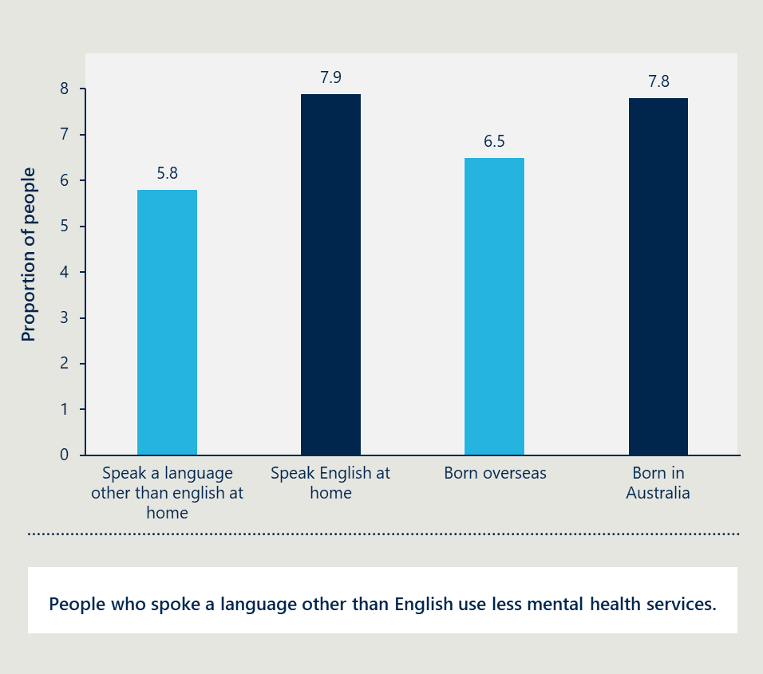

Figure 14 | Proportion of people that accessed PBS subsidised mental health-related medications in 2011[47]

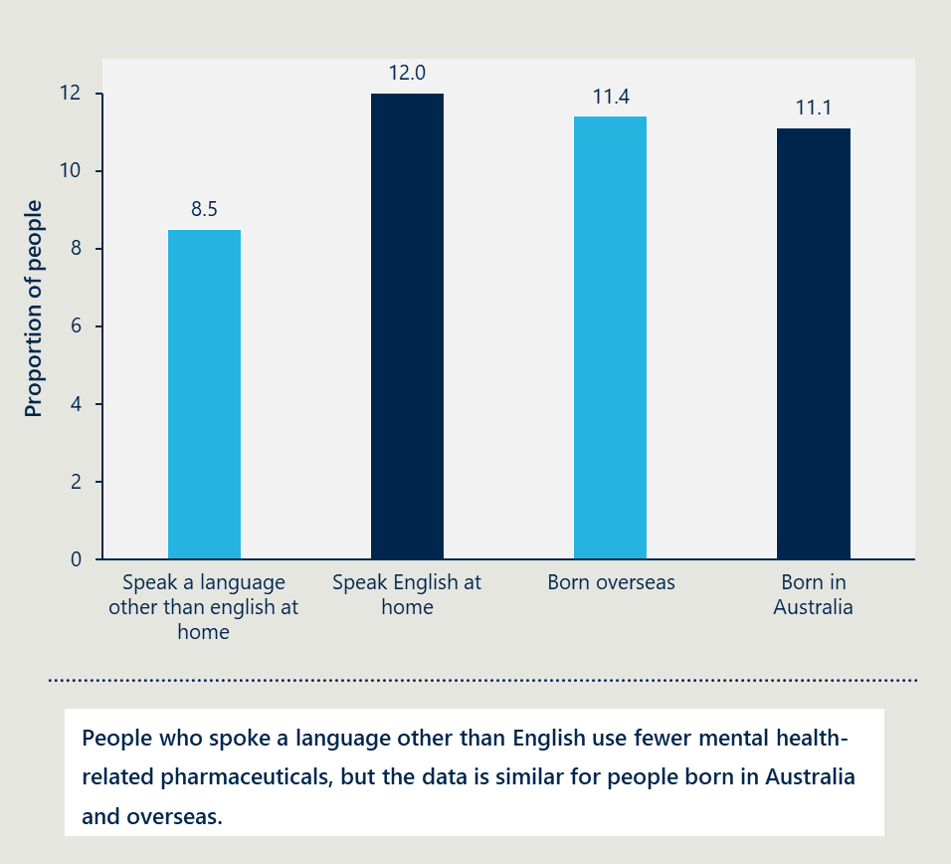

**There are multiple factors that may explain lower service use.**

Not speaking English well can prevent people receiving care. A review by the World Health Organisation noted it was difficult for refugees and migrants to understand mental health terminology even among those able to speak the local language.[48] Language barriers can also interfere with participants receiving mental health counselling services and community-based health programs.[49]

People do not always know what services are available. A study on the perspectives of mental health for people from CALD backgrounds in Victoria found there was a lack of knowledge about mental health services. The authors noted some people may be concerned their entitlements, including welfare payments and access to the National Disability Insurance Scheme, will be reduced if they access mental health services.[50]

People from CALD backgrounds can experience stigma and have concerns about confidentiality. A review of the experience of mental illness by people from CALD communities in Western Australia observed stigma among people from some backgrounds.[51] A Victorian study noted stigma may discourage individuals from seeking assistance particularly when they are worried about the confidentiality of their health information.[52]

Culturally appropriate services may not be available. A review on mental health support for younger people from CALD backgrounds indicated that mental health services often lack practitioners from different cultural backgrounds. The authors found many mental health practitioners did not understand the history, sociocultural environment, ethnic and religious identities of younger people from CALD backgrounds and how this impacted their mental health and experience of mental health services. This included a lack of understanding about the impact of trauma experienced through a settlement or resettlement process on a person’s mental health.[53]

## Interpreting services should be available to everyone with limited English proficiency requiring mental health services

|  |
| --- |
| This section answers the KEQ:  Are interpreting services in PHN-commissioned mental health services the right response to remove barriers for people with limited English proficiency in accessing mental health support?   * Are interpreting services appropriate in PHN-commissioned mental health settings or is there a more appropriate model? * How does this measure support findings from recent government reviews, including the Multicultural Framework Review and Language Review undertaken by DHA?   The key findings are:   * Interpreting services are essential for the delivery of mental health care * Other approaches cannot replace professional interpreting but may complement them * Ensuring access to interpreting services supports recent government reviews and policy recommendations. |

### Interpreting services are essential for the delivery of mental health care

Interpreting is essential for someone who requires mental health services and does not speak English well. It may be required for someone to book an appointment, be assessed, understand their treatment plan, and receive mental health treatment as shown in Figure 15.

Figure 15 | Overview of the way interpreting may be required in mental health settings

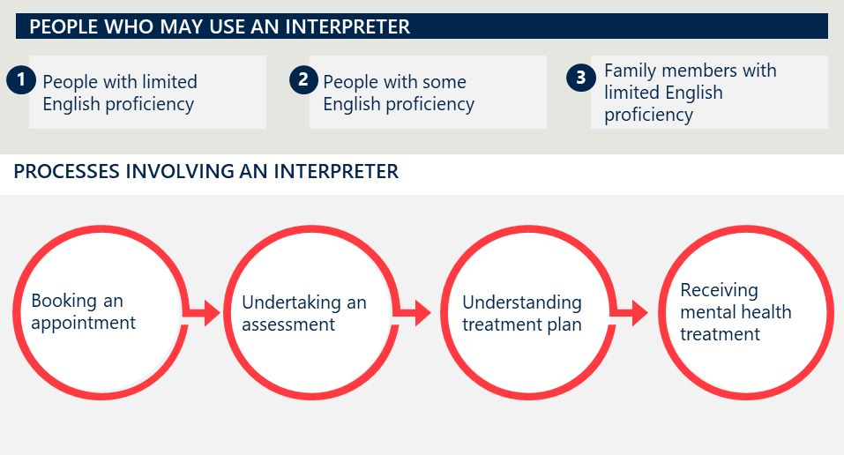

All stakeholders consulted agreed interpreting services were essential for providing mental health care to people with limited English proficiency. One mental health service provider noted they had to turn away a client when there was no interpreter available who spoke the client’s language.

Interpreting services can also be required for people that speak some English. Some stakeholders mentioned that people who speak English as a second language may struggle to express their emotions or thoughts in another language particularly when they are stressed or anxious.

### Other approaches cannot replace professional interpreting but may complement them

**Family members can help but are not always appropriate.**

Some people from CALD backgrounds may use family members to interpret instead of a professional interpreter. These interpreters are sometimes known as relational interpreters.

Many service providers and expert stakeholders note that using children to interpret for a parent who does not speak English well can place unnecessary burden on the child. The evaluation team heard that this could occur where the younger person is seeking help, or their parent is seeking help.

Using relational interpreters can also result in inaccurate interpreting stemming from the family members own biases, experiences and perspectives. A systematic review by Morton Heath and colleagues identified instances of overt omissions, gatekeeping or agenda-setting when family members were used to interpret for people experiencing mental illness.[54] Many mental health service providers told the evaluation team that relational interpreters can add their own opinion when interpreting rather than playing an independent role.

Despite these challenges, using a family member as an interpreter can be convenient and effective. This is particularly the case where the interpreting involves logistics like booking an appointment. Many stakeholders noted it is common for relational interpreters to assist in booking appointments, and this was much simpler than engaging a professional interpreter.

A relational interpreter may also support the person with mental illness when engaging with a mental health professional. The review by Morton Heath and colleagues found relational interpreters were more likely to support the perspective of the patient while professional interpreters were more likely to advocate for the health service. The authors also indicated that patients have a higher degree of trust in relational interpreters compared to professional interpreters[55] but the evaluation team has heard many mental health services do not always trust relational interpreters.

**Technology can assist but is not always accurate or available.**

Technology can support simple translation. Many service providers mentioned using Google Translate as a back-up to communicate with patients when an interpreter is unavailable, especially for simpler interactions like booking an appointment. However the evaluation team heard that rarer languages may not be available, and translation can be inaccurate. Service providers also mentioned using Chat GPT, Gemini, and Polaron.

A report on translation and interpreting technologies and their impact on the industry was recently prepared for the National Accreditation Authority for Translators and Interpreters (NAATI). Key findings for interpreting technology included:

* The so-called third technological wave is underway. The first wave occurred when international organisations adopted audio technology to provide simultaneous interpretations with interpreters working from booths and no longer ‘in’ the room with participants; the second was triggered by web technologies allowing easy access to content needed by interpreters; the third consists of remote/distance interpreting on one hand, and of natural language processing used to support or even replace interpreters, on the other.
* Remote/distance interpreting and Automatic Speech Recognition tools (voice recognition software that processes human speech and turns it into text) are gaining popularity. However, there is less evidence on the impact of technology on interpreting compared to translation practices.
* Despite the advancements of digital technologies within interpreting practices, human interventions continue to play a crucial role, particularly for high-stakes and complex tasks, such as in mental health settings. The prospect of machines replacing human interpreters in all areas of practice remains distant as they cannot yet emulate the skills and expertise of human practitioners.
* Future programs should focus on the development of augmented translation and interpreting skills, and the ability to leverage technological support to overcome human limitations to provide more effective language services.[56]

**Bicultural workers can complement the use of interpreters depending on the model.**

There are multiple different models of bicultural workers that are outlined in Table 5.

Table 5 | Overview of different bicultural worker service models

|  |  |  |  |  |
| --- | --- | --- | --- | --- |
|  | Bilingual therapist | Bicultural therapist | Bicultural peer support worker | Bicultural community workers |
| Advantages | * Speaks the same language, making the service more efficient * Understands the context, improving treatment outcomes * Provides therapy directly, eliminating the need for a third party. | * May come from a different cultural background but understands cultural contexts, improving treatment outcomes * Provides therapy directly, eliminating the need for a third party. | * Understands cultural contexts, improving treatment outcomes * Helps consumers navigate the service system, potentially supporting continuity of care. | * Understands cultural contexts and community groups * Employed to conduct community outreach. |
| Advantage and limitation |  | * May speak the same language, making the service more efficient. | * May bring lived experience, creating cultural safety. * May speak the same language, or be NAATI certified, replacing the need for interpreters. |  |
| Limitation | * Not professionally trained to provide interpreting services * May not be able to match consumers to a therapist who speaks their language. | * May not be able to match consumers to a therapist who understands their cultural background * Not professionally trained to provide interpreting services. | * May not be able to match consumers to a peer support worker who speaks their language, therefore they may need to work alongside an interpreter and clinician. | * Are not trained to provide mental health treatment or interpreting services. |

Bilingual therapists may replace interpreters, but they only exist in a small number of languages. Some providers prefer using bilingual or bicultural therapists over interpreters because they are often more effective and efficient. They address the challenges of having a third party in the room, are more likely to understand the consumer’s cultural background and experiences, and can translate mental health terms effectively into language that the consumer understands. Bilingual and bicultural therapists are not always available, particularly for rarer languages and smaller community groups.

Bicultural peer support workers can improve the experience of consumers from CALD backgrounds, but they may still require an interpreter. One mental health service told the evaluation team their bicultural peer support workers are helping consumers navigate the service system and supporting the service to provide more culturally appropriate mental health care. They may do some interpreting but mostly work alongside interpreters.

Bicultural community workers can help improve access to mental health services but do not replace interpreters. Stakeholders mentioned the value of the role bicultural community workers play in connecting with communities and increasing the number of people from CALD backgrounds accessing mental health services. These community workers may support some interpreting when it comes to booking appointments but are not appropriate to interpret in a therapeutic context because they are members of the community, and it is important to maintain people’s privacy.

### Ensuring access to interpreting services supports recent government reviews and policy recommendations

The Multicultural Framework Review highlighted that language services are a critical pillar of an equitable multicultural society enabling people to engage confidently with government services and other essential services. The review noted not being able to speak English well should never be a barrier to accessing or receiving high-quality and effective services in Australia.[57]

The review noted that many communities struggle to find a translator or interpreter in their language. The use of non-professionals, such as family, friends or other bilingual but not NAATI-credentialled persons, for interpreting presents risks to accurate information exchange, as well as around coercion, consent and agency for clients of services.

In response to several challenges facing the language services sector, the Multicultural Framework Review provided several recommendations. These are shown in Figure 16.

The department’s investment in providing free interpreting services to PHN-funded mental health services supports recommendations from the Multicultural Framework Review. The Review highlighted the need for a coordinated Commonwealth-level approach to language services, and the funding for PHN-commissioned mental health services ensures people with limited English proficiency can engage interpreting and translating services in a timely fashion.

Figure 16 | Recommendations about language services from the Multicultural Framework Review

|  |
| --- |
| **Leveraging Australia’s diversity of languages to support our economic prosperity through a revitalised language policy led by the Australian Government:** This recommendation builds on previous attempts to establish such a policy, but with a renewed vigour and contemporary focus, including incorporating technology. The recommendation suggests the Australian Government commit to developing a language strategy as part of the 2024–25 Budget allocation, factoring in considerations such as ensuring all points of service delivery and information can accommodate people’s preferred language.  **Ensuring the sustainability and quality of language services (interpreting and translating):** This recommendation includes establishing a dedicated entity to achieve a coordinated Commonwealth-level approach to language services policy, procurement and delivery of functions, ensuring all individuals can engage in a timely fashion with high-quality interpreting and translating services, and setting consistent baselines across the Australian Government for the renumeration of interpreters and translators and uniform quality assurance of service delivery.  **Establishing a fully funded TIS National capacity within the existing business unit: This** recommendation suggests the Australian Government establish a fully funded capacity within the existing TIS National business unit, to deliver general interpreting and translation services. A dedicated in-house arrangement, with a core workforce of NAATI-credentialled APS staff, would enable all Commonwealth agencies and Commonwealth-funded services to access interpreters and translators in a range of languages to be determined by an analysis of community demand and interpreter and translator supply. This capacity would help to set a remuneration and quality standard for the whole sector.  **Boosting NAATI funding:** This recommendation suggests the Australian Government, with state and territory government contributions, should provide additional funding to the NAATI, to address critical workforce quality and gaps. Funding should also be provided to NAATI to promote the expanded communications and engagement capacity available to Commonwealth entities, essential services, community organisations, businesses (as appropriate) and, crucially, to individuals, ensuring greater awareness and uptake of language services. |

The Australian Government’s Multicultural Access and Equity Policy requires all departments and agencies to ensure their services meet the needs of all Australians, regardless of their cultural and linguistic backgrounds.[58] Its guidance includes:

* considering a range of communication techniques to engage with clients from different backgrounds, including the use of information in languages other than English
* setting clear guidelines for when and how staff should use translating and interpreting services
* considering a community language allowance for staff who can communicate in languages other than English and who work in roles where their language skills can be used to help clients
* specifying multicultural access and equity accountabilities in funding partnerships, contracts, grant agreements and related guidance materials, if the delivery of programmes or services is outsourced.

The department partially addresses the requirements of this policy through investment in TIS National interpreting services. The funding encourages PHN-funded mental health service providers to access TIS National, ensuring all Australians can access their programmes and services, though the evaluation team notes that this does not extend to other mental health services that are not currently PHN-commissioned.

## TIS National is being used by many PHN-commissioned mental health services

|  |
| --- |
| This section answers the KEQ:  **How well is TIS National being delivered in PHN-commissioned mental health services?**   * To extent are consumers with low English proficiency and PHN-commissioned mental health services using TIS National? * What are the barriers preventing the use of TIS National’s interpreting service? * Are there any gaps or areas of duplication? * How satisfied are consumers and PHN-commissioned mental health services with TIS National?   **The key findings are:**   * The use of TIS National has increased but there are still gaps * There are barriers to using TIS National’s interpreting services * These barriers may be resulting in some mental health providers using alternatives to TIS National * Most service providers are satisfied with the quality of interpreting |

### The use of TIS National has increased but there are still gaps

**Interpreting service use has steadily increased since the introduction of the funding.**

There was low interpreting service use in the first six months of available data (Figure 17). This has increased since and TIS National is now providing over 400 interpreting sessions a month to PHN-funded mental health services.

Figure 17 | TIS National use from February 2023 to September 2024[59]

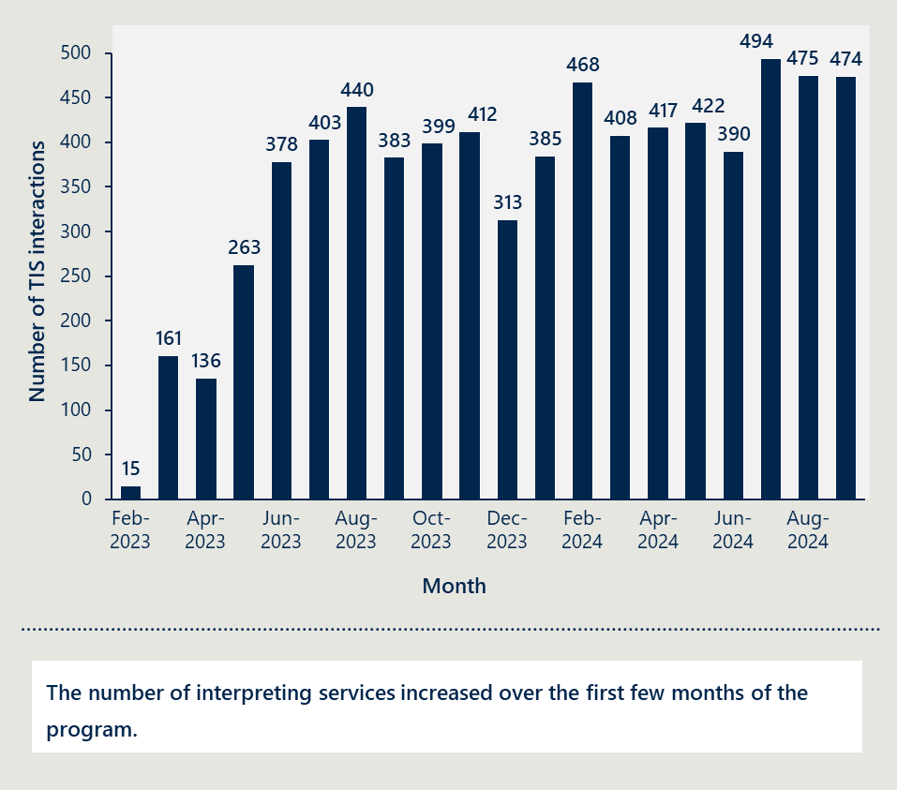

Almost all PHN-commissioned mental health services the evaluation team engaged with have used TIS National (Figure 18). A few PHN-commissioned mental health services have not used TIS National because they do not encounter patients from CALD backgrounds and have not required interpreting services. Some services in Victoria, South Australia and Western Australia do not use TIS National because they use local services instead.

Figure 18 | TIS National use by PHN, February 2023 to September 2024[60]

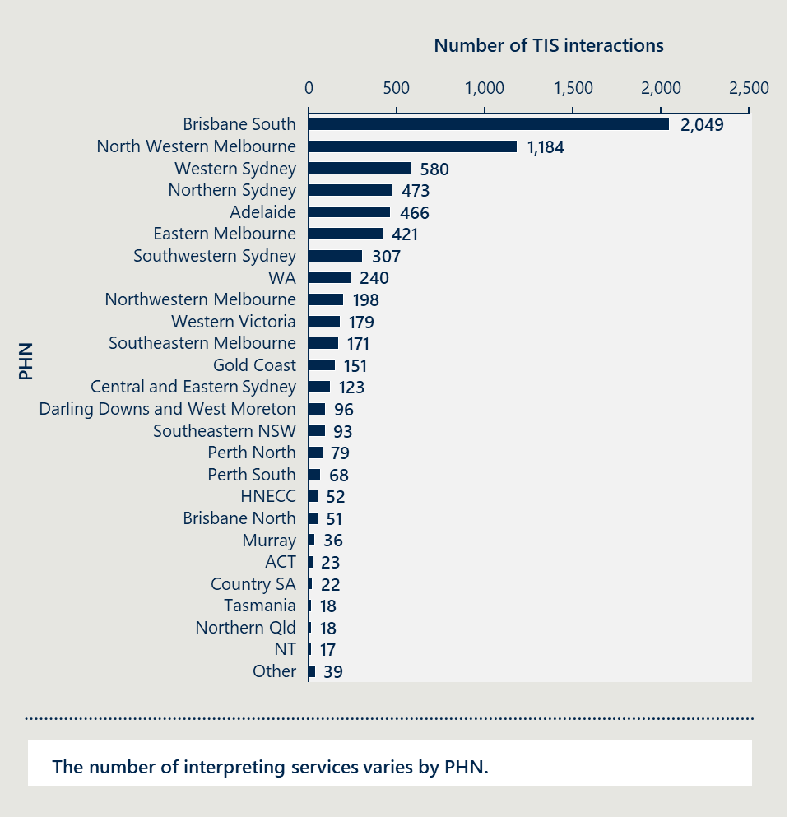

TIS National has provided interpreting for mental health consumers for more than 70 languages (Figure 19). The most common languages were Farsi, Arabic and Dari. Less common languages included Tetun, Uyghur and Bosnian.

Figure 19 | TIS National use by language, February 2023 to September 2024[61]

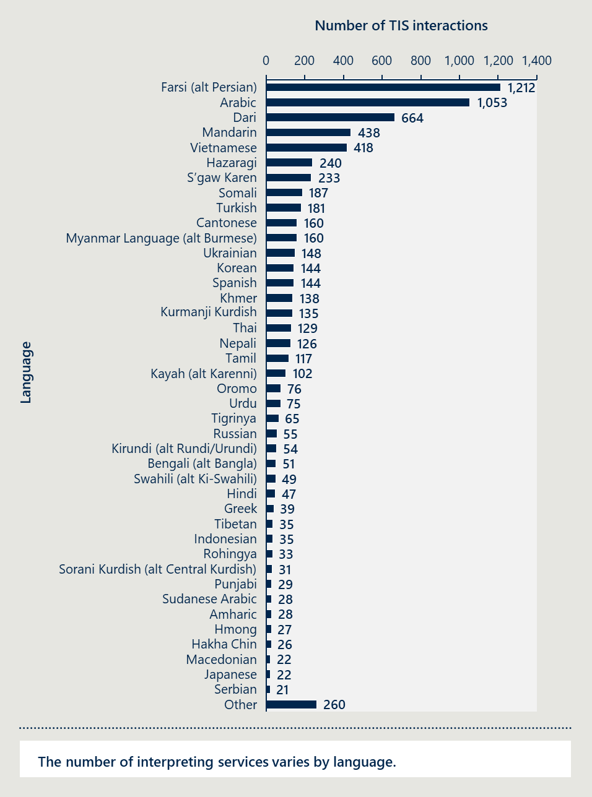

**There are likely gaps in access to interpreter services or access to mental health services.**

It is difficult to assess whether there are gaps in the interpreting services available or whether there are gaps in the number of people who do not speak English well accessing mental health services.

There are large variations in the number of TIS National interactions per non-English speaking population in each PHN. Western Australia Primary Health Alliance and Brisbane South PHN provide 90 and 46 TIS National interactions per 1,000 population (Figure 20). This compares to Gippsland, Murrumbidgee and Central and Eastern Sydney PHN which have less than one TIS National interaction per 1,000 population.

These differences likely indicate unmet demand although there are multiple factors that could explain them. There could be differences in the type of and number of mental health services provided in each region. There could also be services in these areas that do not think they are eligible for TIS National or use an alternative interpreting service.

Figure 20 | TIS National interactions per 1,000 population with limited English proficiency by PHN, February 2023 to September 2024[62]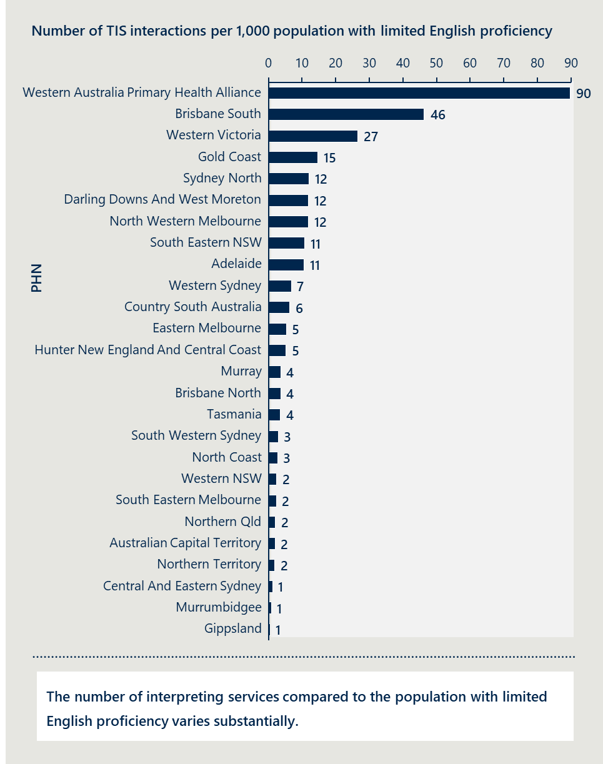

There are also large variations in the number of TIS National interactions per non-English speaking population by language (Figure 21). Ukrainian and Farsi have 233 and 116 interactions per 1,000 people that do not speak English. Meanwhile Italian, Punjabi and Greek have only one interaction per 1,000 people.

The variation in the number of people of interpreting services compared to the population with limited English proficiency suggests there is also some unmet demand for some languages. It also suggests more could be done to engage people from language groups with lower interactions in mental health services.

Figure 21 | TIS National interactions per 1,000 population with limited English proficiency by language, February 2023 to September 2024[63]

Bar chart showing Interpreting sessions are highest for Ukrainian and Farsi when standardised for populations that do not speak English well.


TIS National is not able to meet every request for interpreting services from PHN-funded mental health services. There are more than 100 requests each month that TIS National is not able to meet (Figure 22).

Figure 22 | Number of requests for interpreting services that are not met, February 2023 to September 2024[64]

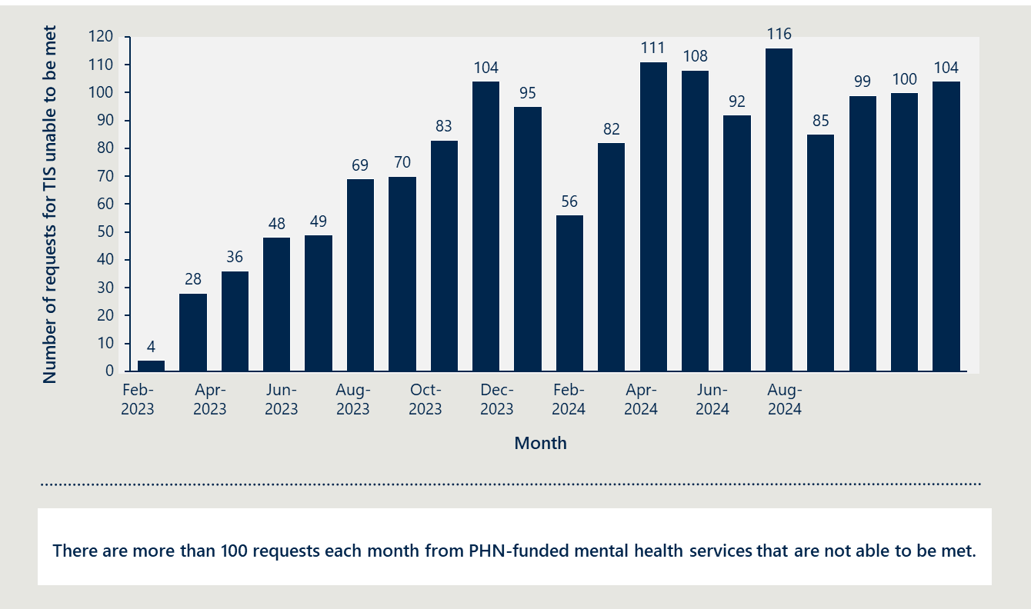

Most of the requests that are not able to be met are because an interpreter is not available (Figure 23, Figure 24 and Figure 25). There are also several requests that are cancelled by the service or interpreter.

The highest numbers where requests are not met are in areas with substantial numbers of people who do not speak English well. This includes North Western Melbourne and Brisbane South PHN areas. The most common languages where requests are not able to be met are Arabic, Spanish, Dari, Kayah and Farsi.

Most requests for interpreters are unable to be met due to an interpreter not being available. The highest numbers are in areas and languages that use the most TIS.

Figure 23 | Number of requests for interpreting services that are not met by reason, PHN and language, February 2023 to September 2024 – reason for cancellation[65]

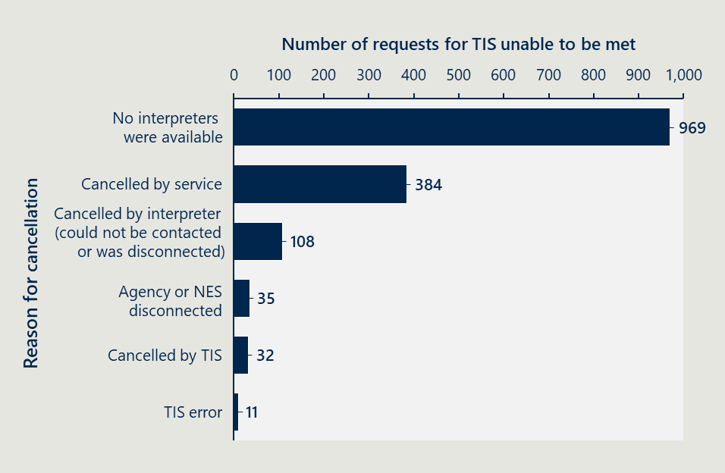

Figure 24 | Number of requests for interpreting services that are not met by reason, PHN and language, February 2023 to September 2024 - top 5 PHNs[66]

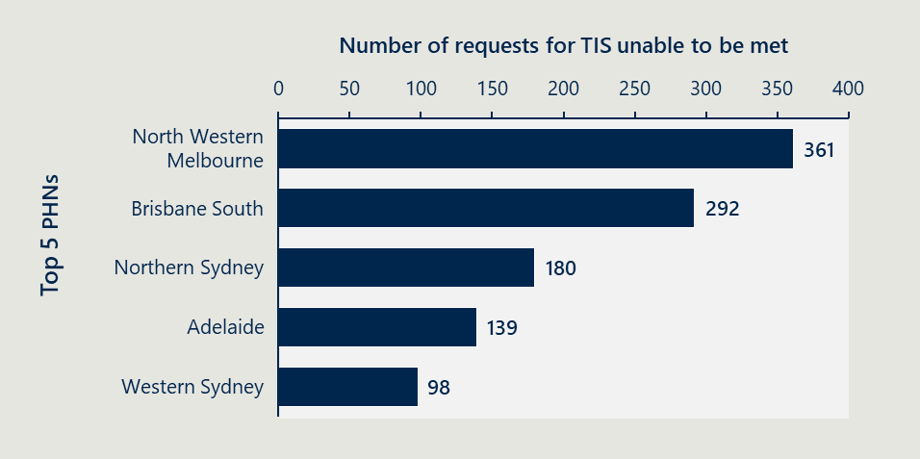

Figure 25 | Number of requests for interpreting services that are not met by reason, PHN and language, February 2023 to September 2024 - top 5 languages[67]

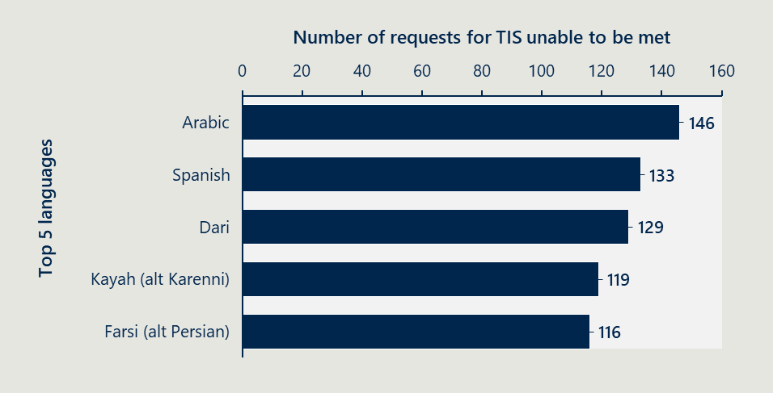

### There are barriers to using TIS National’s interpreting services

Mental health service providers may not use TIS National’s free interpreting service if they cannot find an interpreter that meets their needs or the needs of the consumer. The evaluation team heard that this could lead to providers or consumers making the decision to proceed with limited English rather than use an interpreter.

The evaluation team heard anecdotally from a number of providers about the challenges to finding an appropriate interpreter. These challenges included:

* finding an interpreter for rare or emerging languages, or languages not offered by TIS National
* finding an interpreter to attend in-person, which is preferred by some service providers and customers
* confidentiality concerns, particularly in small communities, where the consumer might know the interpreter
* consumers being matched with an interpreter who may be inappropriate for their context particularly in a sensitive mental health setting, for example, of a different gender, cultural or national background, or a speaker of a different dialect of the language
* preferring not to have a third person in the room for sensitive conversations.

Many providers and consumers were not aware of the free TIS National service. Some mental health service providers interviewed by the evaluation team were not aware they had access to TIS National’s free interpreting service and were instead using alternative interpreting services at a cost. The evaluation team also heard from service providers, PHNs and peak bodies that consumers are not always aware they can access interpreting services for free.

Some mental health services were confused about their eligibility or had difficulties setting up an account. A few PHNs and mental health service providers noted confusion about whether mental health services that were subcontracted by PHN-funded services were eligible for the interpreting service. Many also told the evaluation team they experienced technical and administrative difficulties signing up for an account with TIS National.

Mental health services may not use TIS National’s interpreters because of the additional time and effort required to organise an interpreter. A PHN and a mental health service provider noted using interpreters can impact providers’ ability to achieve key performance indicators as the extra time it takes for providers to use an interpreter means they are not able to see as many patients.

There were also a number of administrative challenges with TIS National’s service that providers raised. A common issue was TIS National’s booking system did not allow services to re-book the same interpreter which can help provide continuity of care and relationship building in a mental health context. Some mental health services also noted challenges re-connecting to an interpreter if they were disconnected.

### These barriers may be resulting in some mental health providers using alternatives to TIS National

Some mental health service providers are using alternative interpreting services. Table 6, below, provides an overview of alternative interpreting services.

Table 6 | Overview of other interpreting services

|  |  |  |
| --- | --- | --- |
| Service | Details | Advantages compared to TIS |
| VITS Language Loop | * Used to be known as Victorian Interpreting and Translating Service, operating as a Victorian Government Business Enterprise | * Providers are more familiar with using this service * Availability of specialist mental health interpreter * Ability to book the same interpreter |
| Western Australia Interpreters | * One of the biggest interpreting and translating agencies in Perth | * Easier access to in-person interpreters * Ability to request the same interpreter, even from interactions with other services |
| On Call | * Australia’s largest language service provider offering interpreters specialised in a wide range of service areas | * Easier access to rarer languages |
| ABC Multilingual | * South Australia’s leading privately-owned language service provider | * Easier access to rarer languages |

### Most service providers are satisfied with the quality of interpreting

**Stakeholders were generally satisfied with having access to TIS National’s free interpreting service.**

The evaluation team heard positive feedback around TIS National’s interpreting services. As seen in Figure 26, 70 per cent of respondents were satisfied with interpreting services provided by TIS National, and felt the consumers they worked with were also satisfied with the service.

Figure 26 | Survey results: satisfaction with TIS National[68]

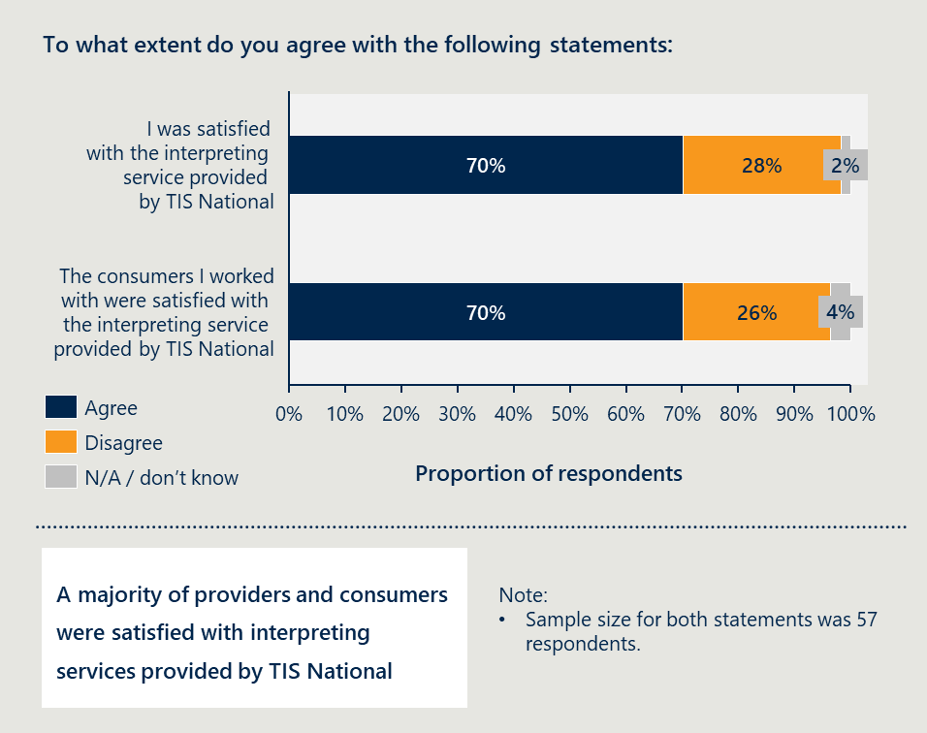

Providers valued the flexibility to choose between pre-booked and ad hoc interpreters, as well as over the phone and in person interpreters. They also noted that while it is difficult to assess the quality of interpreting as they do not understand the language being interpreted, they are generally satisfied with the experience. Some found the service easy to use, and have used it for many years across roles.

Providing TIS National’s interpreting service for free to all PHN-commissioned mental health services has supported increased uptake of the service. Many mental health service providers told the evaluation team they valued it being free as they were previously paying for the service. Other services said the cost was previously too much of a barrier to provide mental health services to some people who did not speak English well.

The department has also helped reduce administrative burden on mental health services and PHNs by managing payments to TIS National. The department directly funds TIS National for the provision of interpreting services to PHN-funded mental health services. This has removed the need for services or PHNs to pay interpreting providers, reducing administrative barriers and improved efficiency.

**Some service providers reported encountering unprofessional behaviour and a lack of essential mental health knowledge among interpreters.**

Many service providers expressed frustration with the quality of interpreting service they received from TIS National interpreters. Some had started using alternative interpreting service providers even if it cost the mental health service. Others told the evaluation team about making multiple complaints to TIS National without receiving any information about action taken.

Some interpreters exhibit unprofessional behaviour when interpreting for mental health services. Multiple mental health service providers told the evaluation team about being able to hear interpreters doing other activities or being in a location where another person can hear. Service providers also noted examples where interpreters would take a side in the discussion rather than remaining neutral. Others shared instances of client confidentiality being breached.

The evaluation team heard that many interpreters are not familiar or comfortable with interpreting in a mental health setting. Service providers shared examples of interpreters incorrectly interpreting some mental health terminology leading to confusion. Other providers reflected that not everything the consumer said would be interpreted verbatim which is essential in a counselling setting where the clinician needs to assess everything that is being said. There were also examples of interpreters not being trauma-informed in their approach, which is critical when working in a mental health setting.

It should be noted not all these factors reflect the individual performance of interpreters. Interpreters are not provided with specific mental health training. Often there is no opportunity for a pre-brief to occur between the clinician and interpreter which could also help set-up the session and clearly set expectations.

**Stakeholder feedback about the quality of TIS National’s interpreting service.**

* “On occasions, interpreters would bring their own bias and opinions into the situation.”
* “A lot of people who access our services are at breaking point … but my sense is that interpreters aren't trained in this field. The way an interpreter gathers information can feel very confronting, like you are being questioned by authorities. This can retraumatise the patient and is detrimental for clients seeking mental health support.”
* “It’s really important to remember that people coming from different backgrounds have different language and frameworks to describe mental health. The ideal would be to have interpreters who have the capacity to understand the cultural nuance that may come into mental health discussions.”
* “We are finding them unprofessional, unethical … and sometimes inappropriate.”
* “Telephone interpreting services from TIS have been very disappointing … there is no cognisance that this is a professional session, we often hear noises in the background, washing dishes, children coming in and the interpreter talking to the child, these kinds of environments are not conducive.”
* “We have found clients ceasing services early, and we find out later it is because of the interpreter … they were told to go back to their abusive husband or to suck it up by the interpreter.”
* “Some interpreters have been really shocked, not expecting conversations around these really difficult topics. They didn't even realise they were coming into a counselling session in the first place.”

**Several factors impact the quality of interpreting services.**

There are other factors that can impact the quality of interpreting services provided. As part of a survey of mental health services for this evaluation, providers were asked to what extent various factors contributed to the quality of interpreting services on a scale of 1 to 5, with 1 being no impact and 5 being substantial impact.

Figure 27 presents the factors in order of average rating from highest to lowest. The top three factors identified by providers were:

1. cultural competence of the mental health practitioner
2. patient's cultural background and its influence on their conception of mental health
3. interpreter's knowledge and understanding of mental health terms and language used by practitioners.

Figure 27 | The extent to which certain factors contribute to the quality of interpreting services[69]

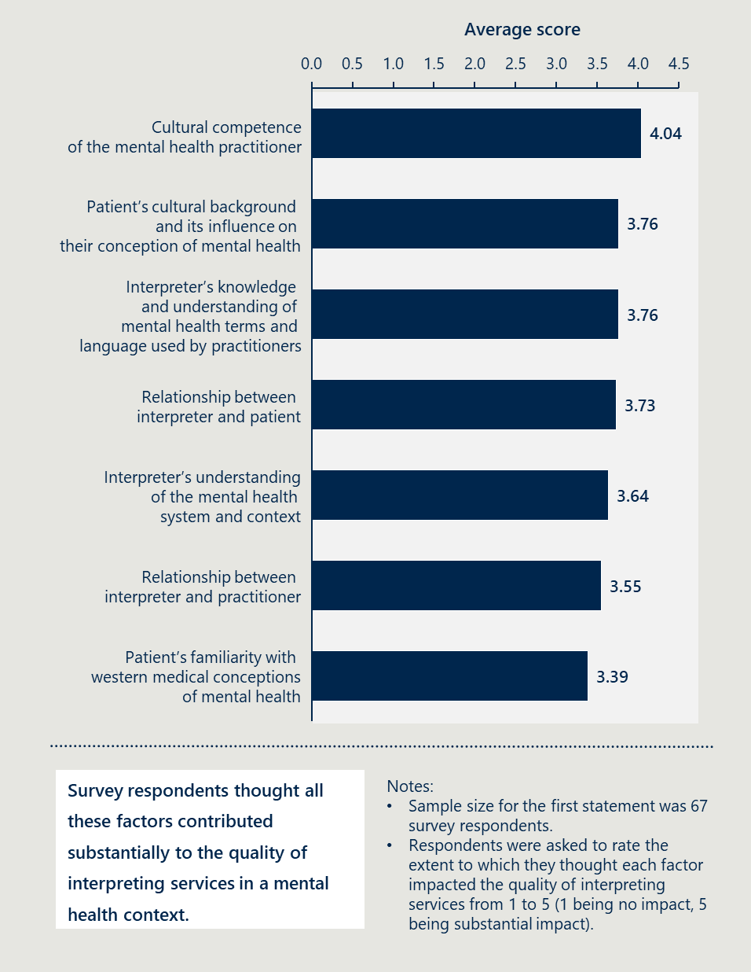

## TIS National enables more people to access mental health services, but barriers remain

|  |
| --- |
| This section answers the KEQ:  **What difference is TIS National in PHN-commissioned mental health services making for people with limited English proficiency?**   * Has using TIS National improved access to PHN-commissioned mental health services for people with limited English proficiency? * Has using TIS National improved mental health outcomes for people with limited English proficiency accessing PHN commissioned mental health services? * What factors have enabled or inhibited achievement of the outcomes?   The key findings are:   * TIS National has likely helped more people access mental health services * Interpreting supports people with limited English proficiency to benefit from mental health services * Several factors influence achievement of outcomes |

### TIS National has likely helped more people access mental health services

**TIS National has supported over 7,000 people to receive mental health services.**

Between February 2023 and September 2024, which is the period that TIS National data is available for, TIS National has provided interpreting services for more than 7,000 PHN-funded mental health service interactions.

PHN-funded mental health service interactions involving an interpreter have increased since the free TIS service was introduced in February 2023. As shown in Figure 28, the proportion of service interactions involving an interpreter has increased from 1.4 per cent in the 12 months to January 2023 to 2.5 per cent in the 12 months to January 2024.

It is not possible to attribute this observed increase directly to the introduction of the free TIS service although it is likely it had some impact. The service interactions using an interpreter increased by almost 20,000 while only 8,000 TIS interactions have been reported under the program.

Figure 28 | Proportion of service interactions involving an interpreter

The proportion of total PHN-funded mental health service contacts involving an interpreter almost doubled following the introduction of free TIS for PHN-funded mental health services, from 1.4% of service contacts between 1 February 2022 and 31 January 2023 to 2.5% of service contacts between 1 February 2023 and 31 January 2024.


**Many people could not have accessed mental health services without free interpreting.**

It can be reasonably assumed that these people would not have been able to receive mental health services to the same extent without this interpreting service. There are no direct substitutes for professional interpreting in a mental health context, as discussed in Section 4.2.2.

It is difficult to establish a causal relationship between people using TIS National and accessing mental health services. However, in the survey of mental health services for this evaluation, 75 per cent of respondents agreed that interpreting services provided by TIS National improved access to mental health services for people with limited English proficiency (Figure 29).

Figure 29 | Survey results: impact of TIS National on access to mental health services[70]

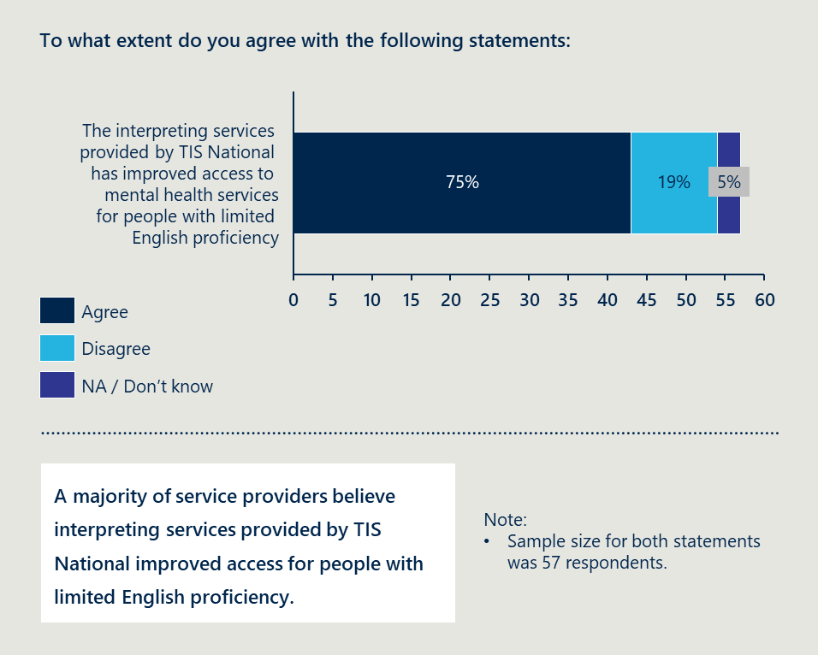

It is likely that many people who do not speak English well would not have received PHN-funded mental health services without the free interpreting service. The evaluation team heard from almost all providers and PHNs that many consumers would not have been able to receive services without interpreters. A few providers had turned people away when there was no free interpreting service available.

### Interpreting supports people with limited English proficiency to benefit from mental health services

Measuring the impact of TIS National interpreting on mental health outcomes is mostly based on feedback from mental health service providers. There is no collection of outcomes data from either the PHN-commissioned mental health services or the TIS National interpreting service. The evaluation team was only able to speak to a small number of consumers or carers.

Service providers noted that interpreting services have improved mental health outcomes indirectly. This is because they enable people with limited English proficiency access to the service in the first place. Service providers said interpreting services allow them to communicate with people with limited English proficiency and identify their needs. Service providers and some other stakeholders also noted that interpreting services gave consumers and carers ‘a voice’ and allowed them to express themselves and be heard when they may otherwise be socially isolated.

### Several factors influence the achievement of outcomes

**Interpreting is not enough on its own to remove access barriers.**

There are factors other than language that impact whether or not someone with limited English proficiency accesses mental health services. These factors are described in detail in Section 4.1.2 and include:

* not knowing what services are available or how to access them
* previous negative experiences with a service including encountering stigma leading to someone not going back to the service
* being concerned about confidentiality leading someone not to seek help
* culturally appropriate services not being available.

**The skills and knowledge of clinicians and interpreters can impact mental health outcomes.**

Some mental health service providers are not familiar with working with an interpreter. Working with an interpreter in a mental health setting requires some skill. Providers shared key considerations like room set-up, the importance of pre-briefing and debriefing, and regularly reminding the interpreter to interpret verbatim what the consumer has said.

Some providers do not have the skills or knowledge to support someone from a CALD background experiencing mental illness. As discussed in Section 4.1.2 there are cultural factors that impact someone’s experience of mental health and mental illness. Many stakeholders told the evaluation team not all mental health clinicians understand the different factors influencing the experience of mental health among people from a CALD background. This included the importance of having an interpreter of the same gender, and there not being equivalent mental health terminology in some languages.

Access to high quality interpreting can also impact mental health outcomes for people with limited English proficiency. The evaluation team received feedback from several mental health services about poor interpreting which has been discussed in Section 4.3.4. A number of other factors impact the supply of suitably qualified and skilled interpreters including finding interpreters for rare or emerging languages, the casual employment model which can inhibit the timely availability of interpreters if they have other conflicting work commitments and a lack of support or incentives for upskilling.

## There could be more efficient funding approaches

|  |
| --- |
| This section answers the KEQ:  **How cost effective is funding TIS National in PHN-commissioned mental health services to achieve the intended outcome?**   * How efficiently have resources been utilised to deliver TIS National in PHN-commissioned mental health services? Can this be improved? * Is this approach cost effective to achieve the intended outcome, or are there alternative approaches to improve language services for people with limited English proficiency, removing barriers to accessing care?   The key findings are:   * Quantifying cost effectiveness is difficult without quantitative data * There are no alternatives to language services. |

### Quantifying cost effectiveness is difficult without quantitative data

##### It is not possible to estimate efficiency, but TIS National’s costs are similar to other services.

It is difficult to estimate the efficiency or cost-effectiveness of the initiative without quantitative data on outcomes. This investment aimed to achieve the outcomes of increasing the number of people with limited English proficiency accessing mental health services and improve the outcomes they achieve through PHN-commissioned mental health services. Quantitative data or a comparison is not available to quantitatively measure the outcomes of the investment as discussed in Section 4.4.

There is some information suggesting that the cost of TIS National’s interpreting service is similar to other interpreting providers. As seen in Table 7, the cost of each service mostly falls between $110 to $130 per hour for interpreting.[71]

Table 7 | Cost of interpreting services

|  |  |  |  |
| --- | --- | --- | --- |
|  | TIS National | On call Language Services[72] | LanguageLoop[73] |
| Telephone interpreting (pre-booked) | $125.49 per hour  ($66.99 for first 30 minutes, $9.79 for each additional 5 minutes or part thereof) | $117.12 per hour  ($36.75 for first 15 minutes, $8.93 for each additional 5 minutes or part thereof) | $83.93 per hour*  ($125.89 for first 90 minutes, $15.81 for each additional 5 minutes or part thereof) |
| Standard on-site interpreting | $118.65 per hour  ($177.98 for the first 90 minutes or part thereof) | $123.20 per hour  ($184.80 for the first 90 minutes or part thereof) | $86.08 per hour*  ($129.12 for the first 90 minutes or part thereof) |

There are likely cost efficiencies to having a large, national interpreting provider although it is not possible to quantify. A national provider allows more scope to employ interpreters, even those that speak rare and emerging languages. It also has a greater geographic reach and reduces the risk that an interpreter is from the same community as a consumer. Being a large provider also likely provides efficiencies in terms of economies of scale when it comes to administration of the service.

##### It is not possible to reduce cost, but effectiveness of interpreting outcomes could be improved to increase cost effectiveness.

There are limited opportunities to reduce the costs of this investment. TIS National’s fees are set, and the department has few levers to influence these.

There are opportunities to improve the effectiveness of interpreting services to increase the cost-effectiveness of the investment. These opportunities principally hinge on improving quality and access to interpreting services.

The quality of interpreting services could be improved, which may improve the mental health outcomes of people with limited English proficiency. There is variation in the level of satisfaction with interpreting services as discussed in Section 3.3.4. Potential improvements are discussed further in Section 4 but could include:

* time for the interpreter and mental health worker to pre-brief and debrief before and after a session
* adjusting TIS National’s booking processes to allow mental health service providers to choose the types of interpreters they need
* introducing an approach to continuously improve the quality of interpreting services
* increase the reimbursement for interpreters working in a mental health setting.

Other actions could be taken to enhance access to mental health services for people with limited English proficiency. Several factors other than language impact access to mental health services for people that do not speak English as discussed in Section 3.1.2 and Section 3.4.3. Section 4 provides some ways the department could reduce these barriers including:

* educating people from CALD backgrounds about mental health and mental health services in Australia
* developing tailored information materials on mental health services for people from CALD backgrounds
* promoting the bicultural community worker model
* strengthen connections between multicultural services and mental health services.

### There are no alternatives to language services

Interpreting services are essential for people that do not speak English well to access mental health services. This is discussed in Section 3.2.1. There are no direct substitutes for language services.

There are other approaches that can complement language services that may increase access to mental health services. These are discussed in Section 3.2.2. Section 4 Recommendations details initiatives that could be implemented to increase the number of people with limited English proficiency to access mental health services. These would be funded alongside interpreting services.

# Recommendations

## Recommendations should be implemented over different time periods

The recommendations have been grouped around the time period they should be implemented. Some recommendations should be implemented immediately by the department and TIS National. Others should be implemented in the following six to 24 months.

This section also presents further opportunities for the department to improve access and quality of mental health services for people from CALD backgrounds. These are not directly within scope of the questions the evaluation set out to answer and will require work to determine feasibility but the evaluation team believe that they are important, worth exploring further and will enable the delivery of a world-leading mental health experience for people from multicultural communities.

Below provides an overview of the recommendations. The following sections describe the recommendations in more detail including who is responsible and what should be considered as part of implementation.

**Overview of recommendations**

Short term recommendations (over 3-6 months) – prioritise ‘quick wins’ the improve access to interpreting services:

* Recommendation 1 – provide ongoing funding for interpreting services in mental health setting (department led)
* Recommendation 2 – increase funding flexibility to enable TIS to better meet needs in mental health service settings (department led)
* Recommendation 3 – improve awareness of TIS National’s interpreting service (DHA and PHN led).

Medium term recommendations (over 6-24 months) – improve consistency and quality of interpreting services:

* Recommendation 4 – improve the quality of the interpreting services provided (department and DHA led)
* Recommendation 5 – improve understanding of mental health among interpreters and understanding of cultural considerations among mental health services (department and DHA led).

Broader actions – improve access to and the quality of mental health services for people from CALD background:

* Broader action 1 – improve access to mental health information, resources and services for people from CALD background (department and PHN led)
* Broader action 2 – improve the quality of mental health services for people from CALD backgrounds (department and DHA led).

## Immediate actions to improve access to translation and interpreting in mental health settings

|  |
| --- |
| Recommendation 1 |
| Provide ongoing funding for interpreting services in mental health settings. |

The department should seek ongoing funding for free TIS National for PHN-commissioned mental health services. This would allow services to continue to offer an essential service to people with limited English proficiency.

The department should also consider providing access to free interpreting for all Commonwealth Government-funded mental health services. There is currently confusion about eligibility for different programs and gaps for some mental health service providers. There is evidence to suggest everyone that needs mental health support in Australia that does not speak English well should have access to interpreting services.

**Impact: ensures mental health services can access free interpreting services so people with limited English proficiency can receive mental health support when using Commonwealth Government-funded mental health services.**

|  |  |  |
| --- | --- | --- |
| Responsible party | Working with | Links to other opportunities |
| The department | DHA | Recommendations 2, 3 and 4 require this to happen first. |

**Considerations for implementation:**

* Consider any relevant recommendations arising from DHA’s recent evaluation of Free Interpreting Service, the Multicultural Framework Review, and other recent reviews or evaluations undertaken by the department or DHA.
* Consider addressing complexities around eligibility for TIS National by providing free TIS National to all mental health services in Australia.

|  |
| --- |
| Recommendation 2 |
| Increase funding flexibility to enable TIS National to better meet needs in mental health service settings. |

**Recommendation 2.1: Increase funding flexibility to allow mental health service providers to use other interpreting services if a TIS National service cannot meet their need.**

The department should allow mental health service providers to choose an alternative interpreting service when there is no interpreter available through TIS National or they are not available to attend face-to-face appointments, if required. The alternative service must offer NAATI credentialled interpreters.

**Impact: Increases the likelihood of mental health services accessing an interpreter when one is required.**

|  |  |  |
| --- | --- | --- |
| Responsible party | Working with | Links to other opportunities |
| The department | PHNs and service providers to identify a list of alternative providers. | Works alongside Recommendation 4 to improve the quality of interpreting. |

Considerations for implementation:

The department will need to:

* establish new payment arrangements to reimburse alternative interpreting services used by mental health services.
* communicate clearly the circumstances under which other interpreting services could be used
* consider how to monitor and evaluate impacts of funding invested in alternative services.

**Recommendation 2.2: Allow mental health services to use TIS National to translate materials.**

The department should work with DHA to allow mental health services to use TIS National to translate mental health materials into required languages.

This adjustment to funding arrangements will need to be supported by clear information dissemination to PHNs and service providers so they are aware of changes to funding arrangements and service eligibility. It will also need TIS National to support providers with initial set up, accessing and using translators.

Impact: enables mental health services to translate materials that increase people’s access to written information about their appointments, assessment, and care plans, as well as improve their awareness of mental health and the services available.

|  |  |  |
| --- | --- | --- |
| Responsible party | Working with | Links to other opportunities |
| The department | DHA and TIS National, PHNs, and service providers. | Lays a foundation for Broader action 1.2. |

**Considerations for implementation:**

* The department will need to support standardisation and minimise duplication by encouraging service providers to share existing translated resources with PHNs and the department for wider dissemination.

|  |
| --- |
| Recommendation 3 |
| Improve awareness of TIS National’s interpreting service. |

DHA should work with the department and PHNs to promote the availability and benefits of TIS National’s interpreting services for PHN-funded mental health services. Promotion should target both mental health service providers and consumers. Information must be developed in accessible formats that suit the range of community’s information needs, including but not limited to:

* content presented in English and the community language
* using multi-media visual content formats including infographics, visuals, videos and other interactive content snippets, supplemented by simple jargon-free language
* disseminated through multiple channels like posters and flyers at service provider sites, social media, interactive digital formats accessible through QR codes.

**Impact: improves awareness of TIS National’s interpreting service, and increases the number of mental health services using interpreters, and improves the community’s access to mental health services.**

|  |  |  |
| --- | --- | --- |
| Responsible party | Working with | Links to other opportunities |
| DHA and PHNs. | The department. | Works alongside Broader action 1 to improve access to mental health services for people from CALD backgrounds. |

**Considerations for implementation:**

* Mental health service providers are typically aware of service availability but may need information or education on the value of interpreting services, when, and how to use them appropriately.
* Awareness for consumers may be improved through information, materials and processes used by service providers.

## Medium-term actions to improve access to and the quality of mental health services provided to people with limited English proficiency

|  |
| --- |
| Recommendation 4 |
| Improve the quality of the interpreting services provided. |

**Recommendation 4.1: Encourage mental health services to have a pre-briefing and debriefing session with the interpreter.**

The department should work with DHA to provide guidance that mental health interpreting services should involve a pre-brief and debrief with an interpreter.

This should involve having a prompt in the online booking system that says to the service provider a mental health-related interpreting session should include time for a pre-briefing and debriefing session between the clinician and interpreter and time should be allowed for this in the booking. The same prompt could be given verbally for bookings made over the phone.

The department should also provide this advice to mental health services through PHNs. This may involve working with service providers to extend their sessions with consumers who require an interpreter and ensuring funding arrangements do not create a perverse incentive from doing this.

There are substantial benefits to the consumer, mental health service and interpreter of having a pre-brief and debrief. A pre-brief allows the mental health service to prepare the interpreter for the session, helps them understand the context, what will be covered in the session and the role the clinician would like the interpreter to play. A debrief allows a mental health service to check-in on an interpreter in the event that the session involved sensitive or traumatic materials which could impact the interpreter’s mental health.

**Impact: supports interpreters to understand the person’s context and provide a more effective service.**

|  |  |  |
| --- | --- | --- |
| Responsible party | Working with | Links to other opportunities |
| The department, DHA and mental health service providers. | DHA/TIS National, PHNs. | Works alongside Recommendation 4.5 to support interpreters working in mental health settings. |

Considerations for implementation:

* Pre-briefing and debriefing sessions require additional time before and after each appointment, which may impact a service’s ability to meet key performance indicators or targets. Mental health service providers and PHNs will need to consider this impact in the way they monitor performance.
* Education may be needed among mental health service providers on the importance of these sessions.

**Recommendation 4.2: Review, streamline and increase the flexibility of TIS National booking processes to allow providers to choose the types of interpreters they need.**

DHA should work with TIS National to change booking processes to allow mental health services more flexibility to choose the interpreters they need. This would include the specific interpreter they want if it is a follow-up booking, their location, gender, country of origin, and language or specific dialogue. Other improvements could include making it easier to reconnect to the same interpreter if the line gets disconnected.

DHA should also work with TIS National, the department, PHNs and mental health services to streamline the registration process. Many mental health service providers told the evaluation team this initial registration process was burdensome and difficult. DHA may be able to find opportunities to make this process simpler.

**Impact: makes it easier for mental health service providers to get an interpreter that meets their needs.**

|  |  |  |
| --- | --- | --- |
| Responsible party | Working with | Links to other opportunities |
| DHA | The department, PHNs and service providers. | Works alongside Recommendation 4.3 to improve the quality of interpreting. |

**Considerations for implementation:**

* DHA will need to address and overcome potential concerns about discrimination to provide consumers with choice and flexibility.

**Recommendation 4.3: Address interpreter performance with an appropriate feedback and continuous improvement approach.**

DHA should work with TIS National to implement an appropriate feedback process for interpreters working in a mental health context. This would include a process with the following steps.

* Mental health service providers provide feedback about an interpreter through the online portal or over the phone.
* TIS National works with interpreter to discuss the feedback and any required action.
* TIS National monitors the feedback through an appropriate system.
* TIS National responds to the person or service providing feedback about the action taken.

This should be part of a broader continuous improvement process to ensure high quality interpreting services are being consistently provided.

The department should receive regular reports from TIS National on the feedback received from mental health services and the action taken to address issues.

**Impact: Improves quality and consistency of interpreters over time through continuous feedback and by measuring outcomes data in mental health settings.**

|  |  |  |
| --- | --- | --- |
| Responsible party | Working with | Links to other opportunities |
| DHA | The department, PHNs and mental health services. | Works alongside Recommendation 4.5 to support interpreters working in mental health settings. |

**Considerations for implementation:**

* DHA may consider whether this is something that is done just for interpreters working in a mental health setting or for all interpreters.

**Recommendation 4.4: Measure outcomes data to understand the impact of interpreting on mental health outcomes.**

The department should analyse outcomes data from the PMHC-MDS annually to understand whether people that are using interpreters are achieving equitable outcomes and whether this is changing over time.

One way this could be done is by reviewing data collected through the Kessler Psychological Distress Scale (K10) for people that had an interpreter to understand whether their symptoms had improved. This could be compared to K10 scores for people that did not have an interpreter to provide further information about whether people that did speak English had even better or similar improvements in symptoms. While other factors may impact the achievement of outcomes, this will provide a starting point for the department to understand the impact of interpreting services on outcomes and to explore other contributing factors.

There are challenges with this data, but it would provide the department with important insight that they could explore further with TIS National. The K10 is not an ideal tool for using with people that do not speak English well, however it is the only outcomes data currently collected through the PMHC-MDS. The department will also be required to set up specific additional reports to review this data.

**Impact: improves quality and consistency of interpreters by measuring outcomes data in mental health settings and using this to work with DHA to address potential issues.**

|  |  |  |
| --- | --- | --- |
| Responsible party | Working with | Links to other opportunities |
| The department | PHNs, mental health services and DHA. | Works alongside Recommendation 4.4 to support interpreters working in mental health settings. |

**Considerations for implementation:**

* DHA may consider whether this is something that is done just for interpreters working in a mental health setting or for all interpreters.

**Recommendation 4.5: Increase interpreter reimbursement for mental health sessions.**

The department should work with DHA to reimburse interpreters working in mental health setting at a higher rate.

This would address challenges identifying interpreters willing to work in this setting. It would also acknowledge the additional complexity of interpreting in mental health settings. This funding arrangement adjustment will need to be supported by communications to interpreters on increased rates.

**Impact: increases the number of interpreters available for and willing to work in mental health service settings.**

|  |  |  |
| --- | --- | --- |
| Responsible party | Working with | Links to other opportunities |
| The department | DHA | Works alongside Recommendations 4.5 to support interpreters working in mental health settings and Broader action 2.4 to consider a mental health specific credential. |

**Considerations for implementation:**

* The evaluation team understands interpreters working in a court setting receive a higher reimbursement. This would be consistent with that precedent.

**Recommendation 4.6: Provide mental health self-care resources for interpreters.**

DHA should provide interpreters working in a mental health setting with resources and tools to maintain their own mental health and wellbeing. This would include self-care resources and vicarious trauma resources, as well as providing access to vicarious trauma training, and counselling and debrief services.

**Impact: supports the wellbeing of interpreters working in potentially stressful or traumatic mental health settings.**

|  |  |  |
| --- | --- | --- |
| Responsible party | Working with | Links to other opportunities |
| DHA | The department | Works alongside Recommendation 4.1 to ensure interpreters have access to debriefing after a mental health service. |

|  |
| --- |
| Recommendation 5 |
| Improve understanding of mental health among interpreters and understanding of cultural considerations among mental health services. |

Recommendation 5.1: Collate and develop resources for mental health service providers, interpreters and consumers and carers to support interpreting in mental health.

The department should begin by collating relevant materials that have already been developed. This includes materials developed by experts in transcultural mental health, Embrace and in other countries.

The department should develop further materials that are required once existing materials have been collated. This would be done in consultation with key multicultural mental health stakeholders. Part of this will be helping interpreters understand when to interpret what consumer and carers say verbatim to the clinician, and when providing clinicians with some information about the cultural context or meaning of certain words is helpful.

The materials would fall into three categories:

1. materials to support interpreters to work effectively and safely in a mental health setting
2. materials to support mental health services to work with people with limited English proficiency including evidence on best practices for working with interpreters
3. materials to support consumers and carers with limited English proficiency to understand mental health and key mental health terms, as well as the mental health system and available services in Australia.

The department would then disseminate these materials through DHA/TIS National, NAATI, PHNs and service providers. This would include making the materials for consumers and carers available in different languages.

Impact: Improves the quality of interpreting services and mental health services for people from CALD backgrounds.

|  |  |  |
| --- | --- | --- |
| Responsible party | Working with | Links to other opportunities |
| The department | Interpreters, translators, multicultural mental health experts, PHNs and service providers. | Works alongside Recommendation 4 to improve the quality of interpreters working in mental health settings. |

Considerations for implementation:

* Ensure that any materials that are produced are co-designed with the right stakeholders including: credentialled interpreters and translators, multicultural mental health experts, service providers, and tested and refined with consumers.

Recommendation 5.2: Subsidise training for interpreters working in mental health settings.

DHA should subsidise training for interpreters working in mental health settings to complete specialist mental health training. Training could include specialist courses on interpreting in a mental health context including clinical terminology, concepts and screening or diagnostic tools that may be raised in the mental health service setting, or basic mental health training including mental health first aid, trauma informed care, and professionalism including privacy considerations.

DHA would advertise the availability of this subsidy. Interpreters working in a mental health setting would be encouraged to complete training.

Impact: improves the quality of interpreting in a mental health setting through appropriate training.

|  |  |  |
| --- | --- | --- |
| Responsible party | Working with | Links to other opportunities |
| DHA | Accredited training providers, NAATI. | Works alongside Recommendation 4 to improve the quality of interpreting available in mental health settings. |

Considerations for implementation:

* DHA and TIS National would need to clearly define which types of training would be subsidised.

Recommendation 5.3: Fund training for PHN-commissioned mental health service workers who interact with consumers from multicultural backgrounds.

The department should fund training to support PHN-funded mental health services that work with clients from multicultural backgrounds to use interpreters. Training should be available to all staff who interact with consumers and carers directly from clinicians to administrative staff that support booking processes.

The training would focus on how to work with interpreters especially in a mental health context. It could also touch on cultural safety, different cultural perspectives on mental health and trauma-informed care.

Impact: Improves the quality of mental health services provided to people from CALD backgrounds.

|  |  |  |
| --- | --- | --- |
| Responsible party | Working with | Links to other opportunities |
| The department | Training providers, PHNs and service providers. | This could be considered alongside training discussed as part of Broader action 2. |

Considerations for implementation:

* Explore the development of a standardised set of training, resources and tools that are for the mental health context but have potential to be applied to the broader health context to improve overall safety and quality of care.

## Broader actions to improve access to and the quality of mental health services for people from CALD backgrounds

|  |
| --- |
| The evaluation team, recognising the interconnected nature of the system, has included broader actions for the department in this section. These actions support improved mental health outcomes for people from CALD backgrounds despite being outside the direct scope of the evaluation questions. |

This evaluation’s focus was the Australian Government’s investment in providing free TIS National services for PHN-funded mental health services but many stakeholders, service providers and service users told the evaluation team about other ways access to and the quality of mental health services could be improved.

Several alternative initiatives have been trialled with the aim of increasing the use of mental health services and improving mental health outcomes for individuals from CALD backgrounds. Embrace Multicultural Mental Health has put together a list of examples of services in Australia that they consider are best practice.[74] There is currently limited information available about their effectiveness, but more evaluations are being completed, which will help inform future decision-making.

|  |
| --- |
| Broader action 1 |
| Improve access to mental health information, resources and services for people from CALD backgrounds. |

Broader action 1.1: Educate people from CALD backgrounds about mental health.

The department should consider funding mental health education for people from CALD backgrounds. The education provided should include informing people how they can access TIS National interpreting services when they are using or trying to book an appointment with a PHN-funded mental health service.

An example of an initiative that does this is Mental Health First Aid (MHFA) training for young people in CALD communities. This program educates young people and adult mentors on how to understand and address mental health challenges in adolescents. It involves integrating culturally relevant materials into the MHFA curriculum, aiming to enhance mental health literacy. Evidence from a recent study indicates that this tailored approach to MHFA training is effective in boosting mental health literacy and promoting help-seeking behaviours among participants, demonstrating its utility in ethnically diverse communities.[75]

Impact: improves awareness and understanding of mental health for people from CALD backgrounds.

|  |  |  |
| --- | --- | --- |
| Responsible party | Working with | Links to other opportunities |
| The department | PHNs, mental health service providers and people from CALD communities. | N/A |

Considerations for implementation:

* These initiatives should be co-designed with people from CALD communities.
* To identify and engage with mental health consumers from CALD communities, particularly those that do not speak English well, the department should work with organisations that work directly with these communities and those that specialise in paid participant recruitment for engagement.

Broader action 1.2: Collate and develop information materials on mental health services for people from CALD backgrounds.

This would involve the department initially collating all existing information on mental health services for people from CALD backgrounds. Once this collation is complete there may be a need to develop additional materials to fill any gaps.

The department would then work with PHNs to help them with distribution. The information should be made available in multiple languages. An important part of this will be including information about how TIS National services can be accessed.

The evaluation team has been made aware about a range of materials that already exist, but these are not widely available or known about. Multiple stakeholder groups and service providers described materials about transcultural mental health and interpreting in a mental health context. These materials would help people from CALD backgrounds understand mental health, and mental health services better understand the impact of culture on mental health. The evaluation team also heard that many mental health services were not aware of these materials. There is further work to make more people aware of these materials and make them available.

The department could also explore considering appropriate processes and tools for people that do not speak English well or are from CALD backgrounds. This would include exploring validated outcome measurement tools as alternatives to K10 that can be used for people that do not speak English well or are from other cultures.

An example of a government funded project that helps provide these kinds of materials is Embrace Multicultural Mental Health run by Mental Health Australia (the Embrace Project). The Embrace Project provides access to resources, links to services and information to multicultural communities and Australian mental health services. Information is provided in a culturally accessible format and is available in 31 languages.[76]

Impact: improves awareness and understanding of mental health and available services and resources among people from CALD backgrounds.

|  |  |  |
| --- | --- | --- |
| Responsible party | Working with | Links to other opportunities |
| The department | PHNs, mental health service providers, multicultural mental health experts and people from CALD communities. | Include any resources developed in Recommendations 2.2 and 5.1. |

Considerations for implementation:

* Materials should be co-designed with people from CALD backgrounds. This would ensure that key mental health terms are appropriately translated, and the materials capture the unique experiences and understanding of mental health in different cultures and languages.
* To identify and engage with mental health consumers from CALD communities, particularly those that do not speak English well, the department should work with organisations that work directly with these communities and those that specialise in paid participant recruitment for engagement.

Broader action 1.3: Promote the bicultural community worker model.

The department should work with PHNs to encourage mental health service providers to implement a bicultural community worker model. Information could be gathered from other service providers who have implemented this model on the benefits and opportunities for improving access to mental health services among CALD communities.

Partners in Wellbeing is a Victorian Government initiative focused on delivering short-term support to individuals facing distress or anxiety, particularly due to COVID-19's impact. Aiming to engage people from CALD backgrounds, the program employs CALD Engagement Workers and has formed a CALD Advisory Group with diverse community representatives. These advisors utilise cultural insights to improve communication between the service and communities, ensuring information is shared in relevant languages and culturally appropriate ways.

Evidence of the program's effectiveness includes expanded outreach efforts through collaboration with local councils, enhanced social media presence, and active participation in community hubs and events. Activities such as reducing language barriers, confronting mental health stigma, and delivering tailored social programs have led to increased engagement and improved access to mental health services for CALD communities.

Multiple mental health services engaged as part of this evaluation described how they used bicultural community workers. Many of the services employed these community workers who were embedded within their cultural communities. They helped increase understanding of mental health in their communities and create a link between the community and the mental health service. Mental health service providers said this has helped increase the number of people from these communities accessing their services.

Service models involving bicultural community workers should be designed in consultation with CALD communities to meet their individual and unique needs. This would ensure the right people are working in those roles, the privacy and autonomy of community members is respected, and the service delivers improved outcomes.

Impact: improves access to mental health services for people from CALD backgrounds.

|  |  |  |
| --- | --- | --- |
| Responsible party | Working with | Links to other opportunities |
| The department | PHNs, mental health service providers and people from CALD communities. | N/A |

Considerations for implementation:

* Service models involving bicultural community workers should be designed in consultation with CALD communities. This would ensure the right people are working in those roles, the privacy and autonomy of community members is respected, and the service delivers improved outcomes.
* This model may be appropriate only for certain settings (i.e. where community is sufficiently large).
* To identify and engage with mental health consumers from CALD communities, particularly those that do not speak English well, the department should work with organisations that work directly with these communities and those that specialise in paid participant recruitment for engagement.

Broader action 1.4: Strengthen connections between multicultural services and mental health services.

The department can actively encourage mental health services through PHNs to create and strengthen referral pathways between specialist health services that are designed to cater to multicultural community clients and mental health services. PHNs will lead this work in partnership with state and territory health services but the department has an important coordination and advocacy role. The department’s role will include providing information to PHNs, advocating for stronger collaboration across health services, and monitoring action undertaken.

Multiple mental health services and PHNs told the evaluation team about the benefits of developing strong relationships or referral pathways between mental health services and multicultural services. Multicultural services refers broadly to services specifically designed or targeted toward people from CALD backgrounds. They might include settlement services, refugee support services, or other specialist services for people from CALD backgrounds. A common example was creating referral pathways with settlement services. The evaluation team also heard about links to CALD community groups where people visit, and mental health concerns could be identified. This might include exercise classes or religious places.

One example of strong links between services is the Program of Assistance for Survivors of Torture and Trauma. The program is funded by the department and was designed specifically to help people who experienced trauma and torture before they moved to Australia. The program provides a range of services including counselling, referrals to other services, education and training on health and support services, community capacity building, and outreach into rural, regional and remote communities. The service is well established and has built strong links with communities and other service providers to facilitate referrals.[77]

Impact: improves access to mental health services for people CALD backgrounds who need it.

|  |  |  |
| --- | --- | --- |
| Responsible party | Working with | Links to other opportunities |
| The department, state and territory health services, and PHNs. | Mental health service providers and multicultural community organisations. | N/A |

Considerations for implementation:

* These initiatives should be co-designed with people from CALD communities.
* To identify and engage with mental health consumers from CALD communities, particularly those that do not speak English well, the department should work with organisations that work directly with these communities and those that specialise in paid participant recruitment for engagement.

|  |
| --- |
| Broader action 2 |
| Consider other opportunities to improve the quality of mental health services for people from CALD backgrounds. |

**Broader action 2.1: Educate mental health workers on providing culturally appropriate care.**

The department should consider funding education for mental health workers on culturally appropriate care.

A number of reviews consider the effectiveness of cultural competency training of mental health services but there is limited evidence of its impact on access to mental health services. A systematic review by Mary Catherine Beach and colleagues noted there was good evidence that training can improve the knowledge, attitude and skills of health professionals, and some evidence of improved patient satisfaction.[78] Other studies have observed a lack of high-quality studies on the impact of patients.[79]

**Impact: improves the quality of mental health services provided to people from CALD backgrounds**

|  |  |  |
| --- | --- | --- |
| Responsible party | Working with | Links to other opportunities |
| The department | PHNs, mental health service providers and people from CALD communities. | N/A |

**Considerations for implementation:**

* The type of training offered should be co-designed with people from CALD communities and multicultural mental health experts.
* To identify and engage with mental health consumers from CALD communities, particularly those that do not speak English well, the department should work with organisations that work directly with these communities and those that specialise in paid participant recruitment for engagement.

**Broader action 2.2: Design more specific services for people from CALD backgrounds.**

The department can actively encourage PHNs and mental health service providers to design specific services for people from CALD backgrounds with the flexible funding that the department already makes available to them.

Many studies and reviews have suggested designing mental health services that are specifically targeted at people from CALD backgrounds. The Productivity Commission’s Inquiry into Mental Health noted in its final report that many participants in the inquiry supported the introduction of supported online treatment options for people from CALD backgrounds.[80]

One example is a local health service and PHN launching the CALD Mindfulness Program originating from a bilingual psychologist's recognition of the need for mindfulness resources for Arabic-speaking clients. The program offers interventions aimed at destigmatisation, coping skill enhancement, and improved access to professional mental health services when required. Over a span of 5.5 years, the program engaged almost 500 adults. One of the aims of the program was to increase the number of people accessing mental health services and 21.6 per cent of adults were subsequently referred for further care.[81]

**Impact: Improves the quality of mental health services provided to people from CALD backgrounds.**

|  |  |  |
| --- | --- | --- |
| Responsible party | Working with | Links to other opportunities |
| The department | PHNs, mental health service providers and people from CALD communities. | N/A |

**Considerations for implementation:**

* This should be done in consultation with people from CALD backgrounds. Service designers should seek to understand what this consumer group needs and adapt the service to best meet their needs.
* To identify and engage with mental health consumers from CALD communities, particularly those that do not speak English well, the department should work with organisations that work directly with these communities and those that specialise in paid participant recruitment for engagement.

**Broader action 2.3: Invest in technology tool development, starting with a horizon scan of existing potential innovation and solutions.**

The department should explore investing in trialling technological tools to support interpreting in a mental health setting.

There are already several emerging technologies that could support interpreting in a mental health setting. The department could complete a horizon scan of existing technology solutions before investing in development. This would involve identifying all relevant existing technologies, some of which are described in Section 3.2.2.

The department could then invest in developing and piloting a technological solution that could be used in a mental health setting.

**Impact: improves the quality of interpreting services, reduces the Australian Government’s costs, and helps understand and leverage current technological capability in service delivery.**

|  |  |  |
| --- | --- | --- |
| Responsible party | Working with | Links to other opportunities |
| The department. | Mental health service providers, people from CALD communities and multicultural mental health stakeholders. | N/A |

**Considerations for implementation:**

* This would be co-designed with people from CALD backgrounds to make sure it met their needs.
* To identify and engage with mental health consumers from CALD communities, particularly those that do not speak English well, the department should work with organisations that work directly with these communities and those that specialise in paid participant recruitment for engagement.
* Draw on work that is already underway across the Australian Government.

**Broader action 2.4: Develop a specialist mental health NAATI credential for interpreters.**

The department, DHA and NAATI should work together to explore developing a specific NAATI credential for mental health. This would recognise interpreters that have developed additional skills to interpret in a mental health context.

Interpreters would need to complete additional, approved mental health interpreting training. There is already various training available that could be recognised.

This would not be a requirement to interpret in a mental health setting in the short-term. It will take a substantial amount of time for enough interpreters to complete this training and gain this credential before this could be the case. Interpreters with this credential could be remunerated at a higher rate.

**Impact: improves the quality of interpreting in a mental health setting.**

|  |  |  |
| --- | --- | --- |
| Responsible party | Working with | Links to other opportunities |
| The department, DHA and NAATI. | Mental health service providers. | This could be considered alongside remuneration for interpreters working in a mental health setting in Recommendation 4.4 and training for training for interpreters discussed in Recommendation 5.2. |

**Considerations for implementation:**

* The training required to become credentialled and the remuneration for credentialled interpreters would need to be considered to ensure there was an incentive to gain the specialist qualification.

1. Description of language groups

Table 8 | Australian Standard Classification of Languages 2016[82]

|  |  |
| --- | --- |
| Language group | Languages included |
| Northern European languages | * Celtic * English * German and related languages * Dutch and related languages * Scandinavian * Finnish and related languages |
| Southern European languages | * French * Greek * Iberian Romance * Italian * Maltese * Other Southern European languages |
| Eastern European languages | * Baltic * Hungarian * East Slavic * South Slavic * West Slavic * Other Eastern European languages |
| Southwest and Central Asian languages | * Iranic * Middle Eastern Semitic languages * Turkic * Other Southwest and Central Asian languages |
| Southern Asian languages | * Dravidian * Indo-Aryan * Other Southern Asian languages |
| Southeast Asian languages | * Burmese and related languages * Hmong-Mien * Mon-Khmer * Tai * Southeast Asian Austronesian languages * Other Southeast Asian languages |
| Eastern Asian languages | * Chinese * Japanese * Korean * Other Eastern Asian languages |
| Other languages | * American Languages * African Languages * Pacific Austronesian languages * Oceanian Pidgins and Creoles * Papua New Guinea languages * Invented languages * Sign languages |

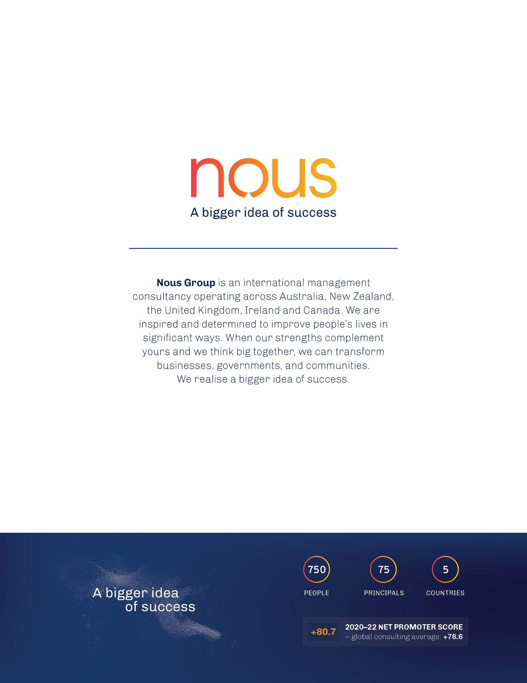

1. ABS, Cultural diversity of Australia, 20 September 2024 (accessed 1 December 2024) <https://www.abs.gov.au/articles/cultural-diversity-australia#language>
2. Australian Bureau of Statistics, *Cultural and linguistic characteristics of people using mental health services and prescription medications,* 2011.<https://www.abs.gov.au/statistics/health/mental-health/cultural-and-linguistic-characteristics-people-using-mental-health-services-and-prescription-medications/latest-release>
3. Mental Health in Multicultural Australia, *Framework for Mental Health in Multicultural Australia: Towards culturally inclusive service delivery,* n.d.<https://www.mentalhealthcommission.gov.au/sites/default/files/2024-03/framework-for-mental-health-in-multicultural-australia---towards-culturally-inclusive-service-delivery.pdf>
4. ABS, Cultural Diversity of Australia, 20 September 2022 (accessed 4 December 2024) <https://www.abs.gov.au/articles/cultural-diversity-australia#language>
5. ABS, National Study of Mental Health and Wellbeing, 2 October 2023 (accessed 4 December 2024) <https://www.abs.gov.au/statistics/health/mental-health/national-study-mental-health-and-wellbeing/latest-release#use-of-services>
6. Productivity Commission, Inquiry into Mental Health, Supporting material (appendices B-K), 30 June 2020 (accessed 30 November 2024), pp. 138, 150. <https://www.pc.gov.au/inquiries/completed/mental-health/report/mental-health-appendices.pdf>
7. Department of Health, PMHC-MDS, 2021 to 2024.
8. Note: The PMHC-MDS does not have a unique personal identifier across providers. There could be individuals counted twice if they received care from two different PHN-funded mental health service providers.
9. Department of Home Affairs, *The Multicultural Access and Equity Policy Guide For Australian Government departments and agencies*, 2018. <https://www.homeaffairs.gov.au/mca/PDFs/multicultural-access-equity-policy-guide.pdf>
10. Department of Home Affairs, *Australian Government Language Services Guidelines,* 2019, <https://immi.homeaffairs.gov.au/settlement-services-subsite/files/language-services-guidelines.pdf>
11. Department of Health, PMHC-MDS, 2021 to 2024.
12.
13. ABS, Cultural diversity of Australia, 20 September 2024 (accessed 1 December 2024) <https://www.abs.gov.au/articles/cultural-diversity-australia#language>
14. Mental Health in Multicultural Australia*, Framework for Mental Health in Multicultural Australia: Towards culturally inclusive service delivery,* n.d. <https://www.mentalhealthcommission.gov.au/sites/default/files/2024-03/framework-for-mental-health-in-multicultural-australia---towards-culturally-inclusive-service-delivery.pdf>
15. Australian Bureau of Statistics, Cultural diversity of Australia, 20 September 2022. <https://www.abs.gov.au/articles/cultural-diversity-australia#language>
16. Department of Home Affairs, *Multicultural Framework Review*, 8 August 2024. <https://www.homeaffairs.gov.au/about-us/our-portfolios/multicultural-framework-review>
17. Ibid.
18. State of Victoria, *Royal Commission into Victoria’s Mental Health System*, February 2021. <https://www.vic.gov.au/royal-commission-victorias-mental-health-system-final-report>
19. Productivity Commission, *Mental Health Inquiry Report*, 16 November 2020. <https://www.pc.gov.au/inquiries/completed/mental-health/report>
20. Department of Health Victoria, *National Mental Health Workforce Strategy 2022–2032*, 10 October 2023. <https://www.health.gov.au/our-work/national-mental-health-workforce-strategy-2022-2032>
21. ABS, Cultural Diversity of Australia, 20 September 2022 (accessed 4 December 2024) <https://www.abs.gov.au/articles/cultural-diversity-australia#language>
22. ABS, National Study of Mental Health and Wellbeing, 2 October 2023 (accessed 4 December 2024) <https://www.abs.gov.au/statistics/health/mental-health/national-study-mental-health-and-wellbeing/latest-release#use-of-services>
23. Productivity Commission, Inquiry into Mental Health, Supporting material (appendices B-K), 30 June 2020 (accessed 30 November 2024), pp. 138, 150. <https://www.pc.gov.au/inquiries/completed/mental-health/report/mental-health-appendices.pdf>
24. ABS, Cultural Diversity of Australia, 20 September 2022 (accessed 4 December 2024) <https://www.abs.gov.au/articles/cultural-diversity-australia#language>
25. ABS, National Study of Mental Health and Wellbeing, 2 October 2023 (accessed 4 December 2024) <https://www.abs.gov.au/statistics/health/mental-health/national-study-mental-health-and-wellbeing/latest-release#use-of-services>
26. Productivity Commission, Inquiry into Mental Health, Supporting material (appendices B-K), 30 June 2020 (accessed 30 November 2024), pp. 138, 150. <https://www.pc.gov.au/inquiries/completed/mental-health/report/mental-health-appendices.pdf>
27. Primary Mental Health Care Minimum Data Set, June 2019-24
28. Primary Mental Health Care Minimum Data Set, June 2019-24
29. Tasmania, Western NSW, Darling Downs and West Moreton, Western Queensland, and Country WA were excluded because they had only a small sample size. Unknown values under 6 were excluded. This was done to avoid identifying people where cell sizes were small.
30. The PMHC-MDS does not have a unique personal identifier across providers. There could be individuals counted twice if they received care from two different PHN-funded mental health service providers.
31. Gippsland and Northern Sydney were the two PHNs with the highest proportion of people that did not speak English well that did not have access to an interpreter.
32. Gopalkrishnan, N., Cultural Diversity and Mental Health: Considerations for Policy and Practice, *Frontiers in Public Health*, 6 (179), 2018. doi: [10.3389/fpubh.2018.00179](https://doi.org/10.3389%2Ffpubh.2018.00179)
33. Australian Bureau of Statistics, *National Study of Mental Health and Wellbeing,* 2023.<https://www.abs.gov.au/statistics/health/mental-health/national-study-mental-health-and-wellbeing/latest-release#cite-window1>
34. World Health Organisation, Mental health of refugees and migrants: risk and protective factors and access to care. *Global Evidence Review on Health and Migration (GEHM) series*, 2023. <https://www.who.int/publications/i/item/9789240081840>
35. Mental Health in Multicultural Australia, *Framework for Mental Health in Multicultural Australia: Towards culturally inclusive service delivery,* n.d.<https://www.mentalhealthcommission.gov.au/sites/default/files/2024-03/framework-for-mental-health-in-multicultural-australia---towards-culturally-inclusive-service-delivery.pdf>
36. World Health Organisation, Mental health of refugees and migrants: risk and protective factors and access to care. *Global Evidence Review on Health and Migration (GEHM) series*, 2023. <https://www.who.int/publications/i/item/9789240081840>
37. Chen, W., et al., Pre-migration and post-migration factors associated with mental health in humanitarian migrants in Australia and the moderation effect of post-migration stressors: Findings from the first wave data of the BNLA Cohort Study. *The Lancet Psychiatry*, 4(3), pp. 218–229, 2017. <https://www.thelancet.com/journals/lanpsy/article/PIIS2215-0366(17)30032-9/abstract>
38. Mental Health in Multicultural Australia, *Framework for Mental Health in Multicultural Australia: Towards culturally inclusive service delivery,* n.d.<https://www.mentalhealthcommission.gov.au/sites/default/files/2024-03/framework-for-mental-health-in-multicultural-australia---towards-culturally-inclusive-service-delivery.pdf>
39. World Health Organisation, Mental health of refugees and migrants: risk and protective factors and access to care. *Global Evidence Review on Health and Migration (GEHM) series*, 2023. <https://www.who.int/publications/i/item/9789240081840>
40. Australian Government, *Towards Fairness: A multicultural Australia for all,* pp. 107, 2024. <https://www.homeaffairs.gov.au/multicultural-framework-review/Documents/report-summary/multicultural-framework-review-report-english.pdf>
41. Mental Health in Multicultural Australia, *Framework for Mental Health in Multicultural Australia: Towards culturally inclusive service delivery,* 2024.<https://www.mentalhealthcommission.gov.au/sites/default/files/2024-03/framework-for-mental-health-in-multicultural-australia---towards-culturally-inclusive-service-delivery.pdf>
42. Fozdar, F, Salter, S., A review of mental ill health for culturally and linguistically diverse communities in Western Australia, *The University of Western Australia,* 2019*.* <https://www.mhc.wa.gov.au/media/3411/201016-mhc20-31952-mental-health-cald-literature-review-attachment-3.pdf>
43. Gatt, J.M., et al., Trauma, resilience, and mental health in migrant and Non-Migrant Youth: An international cross-sectional study across six countries*, Frontiers in Psychiatry*, 10, 2020.doi:10.3389/fpsyt.2019.00997.
44. Australian Bureau of Statistics, *Cultural and linguistic characteristics of people using mental health services and prescription medications,* 2021.<https://www.abs.gov.au/statistics/health/mental-health/cultural-and-linguistic-characteristics-people-using-mental-health-services-and-prescription-medications/latest-release>
45. Mental Health in Multicultural Australia, *Framework for Mental Health in Multicultural Australia: Towards culturally inclusive service delivery,* n.d*.* <https://www.mentalhealthcommission.gov.au/sites/default/files/2024-03/framework-for-mental-health-in-multicultural-australia---towards-culturally-inclusive-service-delivery.pdf>
46. Australian Bureau of Statistics. (2011). *Cultural and linguistic characteristics of people using mental health services and prescription medications.* <https://www.abs.gov.au/statistics/health/mental-health/cultural-and-linguistic-characteristics-people-using-mental-health-services-and-prescription-medications/latest-release>
47. Australian Bureau of Statistics. (2011). *Cultural and linguistic characteristics of people using mental health services and prescription medications.* <https://www.abs.gov.au/statistics/health/mental-health/cultural-and-linguistic-characteristics-people-using-mental-health-services-and-prescription-medications/latest-release>
48. World Health Organisation, Mental health of refugees and migrants: risk and protective factors and access to care. *Global Evidence Review on Health and Migration (GEHM) series*, 2023. <https://www.who.int/publications/i/item/9789240081840>
49. DeSa, S., Gebremeskel, A.T., Omonaiye, O. et al., Barriers and facilitators to access mental health services among refugee women in high-income countries: a systematic review, *Systematic Reviews,* 11, 62, 2022. <https://doi.org/10.1186/s13643-022-01936-1>
50. Radhamony, R., Cross, W. M., Townsin, L., & Banik, B., Perspectives of culturally and linguistically diverse (CALD) community members regarding mental health services: A qualitative analysis. *Journal of Psychiatric and Mental Health Nursing*, 00, 1–15, 2023. <https://pubmed.ncbi.nlm.nih.gov/36947100/>
51. Fozdar, F, Salter, S., A review of mental ill health for culturally and linguistically diverse communities in Western Australia, *The University of Western Australia,* 2019*.* <https://www.mhc.wa.gov.au/media/3411/201016-mhc20-31952-mental-health-cald-literature-review-attachment-3.pdf>
52. Radhamony, R., Cross, W. M., Townsin, L., & Banik, B., Perspectives of culturally and linguistically diverse (CALD) community members regarding mental health services: A qualitative analysis. *Journal of Psychiatric and Mental Health Nursing*, 00, 1–15, 2023. <https://pubmed.ncbi.nlm.nih.gov/36947100/>
53. Luu, B., Fox, L., McVeigh, M., & Ravulo, J, Effectively supporting Culturally and Linguistically Diverse (CALD) young people with their mental health and wellbeing – does this matter or exist in Australia?, *Social Work in Mental Health*, 2023. <https://doi.org/10.1080/15332985.2023.2273227>
54. Heath M, Hvass AMF, Wejse CM., Interpreter services and effect on healthcare - a systematic review of the impact of different types of interpreters on patient outcome*, Journal of Migration and Health*, 2023, <https://pmc.ncbi.nlm.nih.gov/articles/PMC9932446/>
55. Heath M, Hvass AMF, Wejse CM., Interpreter services and effect on healthcare - a systematic review of the impact of different types of interpreters on patient outcome*, Journal of Migration and Health*, 2023, <https://pmc.ncbi.nlm.nih.gov/articles/PMC9932446/>
56. Orlando M, Kruger J, Liao S., Translation and Interpreting technologies and their impact on the industry, *Department of Linguistics, Faculty of Medicine, Health, and Human Sciences, Macquarie University, February 2024,* <https://researchers.mq.edu.au/files/357248528/357055278.pdf>
57. Department of Home Affairs, *Multicultural Framework Review*, 8 August 2024. <https://www.homeaffairs.gov.au/about-us/our-portfolios/multicultural-framework-review>
58. Department of Home Affairs, *The Multicultural Access and Equity Policy Guide For Australian Government departments and agencies,* 2018. <https://www.homeaffairs.gov.au/mca/PDFs/multicultural-access-equity-policy-guide.pdf>
59. TIS report.
60. TIS report.
61. TIS report.
62. TIS report. ABS Census data 2021.
63. TIS report and ABS Census of Population and Housing, 2021.
64. TIS report.
65. TIS report.
66. Ibid.
67. TIS report.
68. Survey data collected from September to November from PHNs and PHN-commissioned service providers.
69. Survey data collected from September to November from PHNs and PHN-commissioned service providers.
70. Survey data collected from September to November from PHNs and PHN-commissioned service providers.
71. On call Interpreters, *Booking interpreting services,* n.d.<https://www.oncallinterpreters.com.au/booking-interpreting/>
72. On call Interpreters, *Booking interpreting services,* n.d.<https://www.oncallinterpreters.com.au/booking-interpreting/>

    *\**LanguageLoop requires a minimum booking time of 90 minutes
73. LanguageLoop, *Our services, 2024.* [*https://languageloop.com.au/services/*](https://languageloop.com.au/services/)
74. Embrace Multicultural Mental Health, *Examples of best practice.* (accessed 7 August 2024) <https://embracementalhealth.org.au/sites/default/files/inline-files/Embrace%20best%20practice%20fact%20sheet.pdf>
75. Uribe Guajardo, M.G., Kelly, C., Bond, K. *et al.* (2019). *An evaluation of the teen and Youth Mental Health First Aid training with a CALD focus: an uncontrolled pilot study with adolescents and adults in Australia.* Int J Ment Health Syst 13, 73. <https://doi.org/10.1186/s13033-019-0329-0>
76. Embrace Multicultural Mental Health, *About us*. (accessed 7 August 2024) <https://embracementalhealth.org.au/about-us>
77. Australian Government Department of Health and Aged Care, Program of Assistance for Survivors of Torture and Trauma, 2 June 2023 (accessed 23 December 2024) <https://www.health.gov.au/our-work/program-of-assistance-for-survivors-of-torture-and-trauma>
78. Beach, M., Price, E., Gary, T., Robinson, K., Gozu, A., Palacio, A., Smarth, C., Jenckes, M., Feuerstein, C., Bass, E., Powe, N., and Cooper, L. (2005) *A Systematic Review of Health Care Provider Educational Interventions*. Medical Care 43(4):p 356-373, DOI: 10.1097/01.mlr.0000156861.58905.96
79. Chu, W., Wippold, G., and Becker, K. (2022) *A systematic review of cultural competence trainings for mental health providers.* Prof Psychol Res Pr. doi: [10.1037/pro0000469](https://doi.org/10.1037%2Fpro0000469)
80. Productivity Commission, Mental Health Inquiry Report. 30 June 2020. <https://www.pc.gov.au/inquiries/completed/mental-health/report>
81. Blignault I, Saab H, Woodland L, Giourgas K, Baddah H. (2022). *Promoting Mental Health and Wellbeing in Multicultural Australia: A Collaborative Regional Approach*. Int J Environ Res Public Health. doi: 10.3390/ijerph19052723. PMID: 35270415; PMCID: PMC8910043.
82. Australian Bureau of Statistics, *Australian Standard Classification of Languages, 2016,* 2017.