COVID-19 outbreaks in Australian residential aged care homes

National snapshot
As at 8:00 am 10 April 2025, there are 402 active COVID-19 cases reported in 70 active outbreaks in residential aged care homes (RACHs) across Australia. There have been 40 new outbreaks, 2 new resident deaths and 338 combined new resident and staff cases reported since 3 April 2025.
Table 1: Aged Care COVID-19 data as at 8.00am 10 April 2025
Category | Active | Change in active (7 days) | Cumulative  Total | Cumulative increase (7 days)
Outbreaks | 70 | 14 | 25,336 | 40
RACHs affected | 70 | 14 | 2,912 | 1
Resident cases | 261 | 23 | 243,014 | 226
Resident deaths | N/A | N/A | 7,342 | 2
Staff cases | 141 | 48 | 128,019 | 112
Residential aged care homes with active outbreaks are included in Appendix.
Data collected from 31 March 2020 including retrospective data on outbreaks and cases from 18 February 2020.
Table 2: Overview of active outbreaks in Australia
 | ACT | NSW | NT | QLD | SA | TAS | VIC | WA | Total
Total RACHs with outbreaks | 1 | 20 | 0 | 12 | 4 | 2 | 23 | 8 | 70
Total number of active resident cases | 3 | 66 | 0 | 58 | 9 | 6 | 93 | 26 | 261
Total number of active staff cases | 0 | 28 | 0 | 51 | 6 | 0 | 41 | 15 | 141
Total outbreaks opened in previous 7 days | 1 | 12 | 0 | 7 | 2 | 1 | 12 | 5 | 40
Total outbreaks closed in previous 7 days | 0 | 7 | 0 | 2 | 0 | 0 | 8 | 8 | 25
Figure 1: National outbreak trends in aged care – December 2021 to present
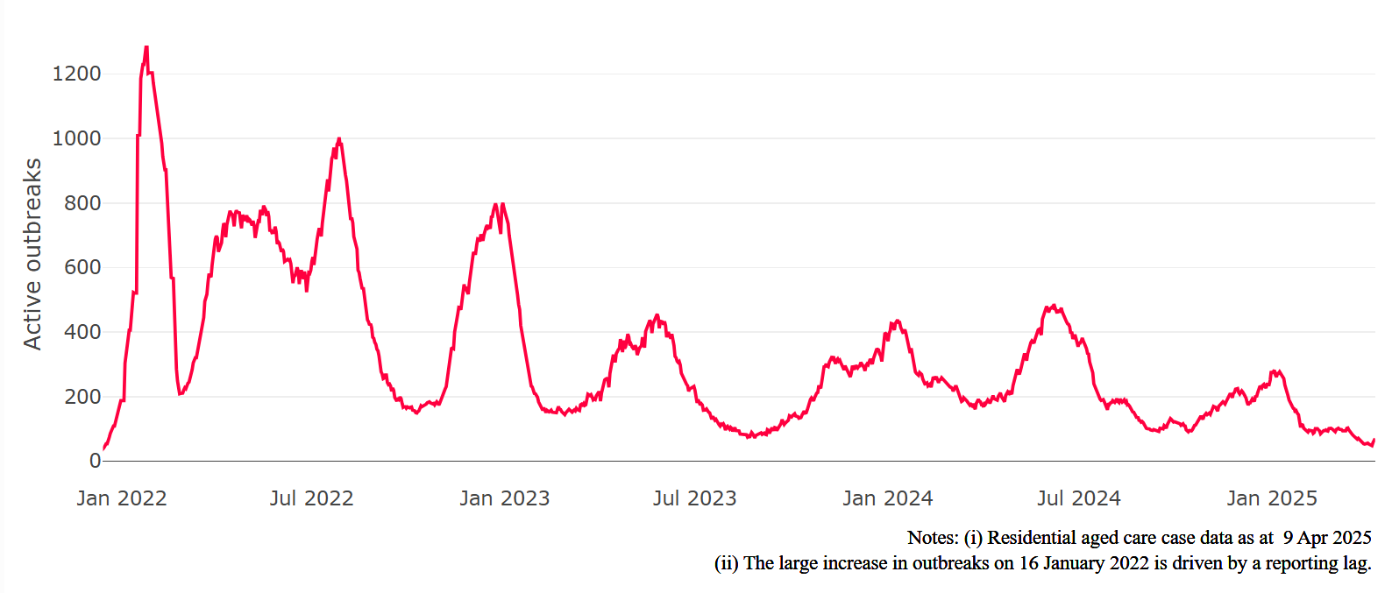
Figure 2: Trends in aged care cases – December 2021 to present
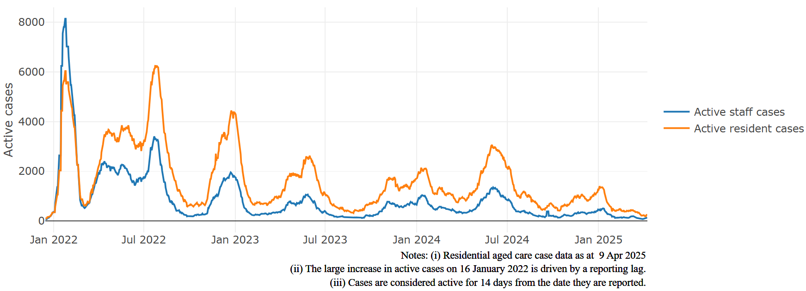

Mortality
For the period of 1 January 2025 to 10 April 2025, COVID-19 is recorded as the cause of death in 0.8% of all deaths in permanent residents in aged care homes.
Since the beginning of the Omicron outbreak in mid-December 2021, there have been 203,240 deaths in residential aged care from all causes (report period from 15 December 2021 to 3 April 2025). COVID-19 deaths account for 3.2% of this figure.
There has been a decrease year on year for the rate of case fatality, from a 33% case fatality rate in resident COVID-19 cases in 2020 to 3.3% in 2022 and 1.5% in 2025.
Over the course of the pandemic, all-cause excess mortality in residential aged care was below expected numbers in 2020, and within expected range in 2021. In the first half of 2022, all-cause excess mortality in residential aged care was above the expected range. Excess mortality for the second half of the 2022 is yet to be finalised.
Figure 3: COVID-19 deaths in RACHs overlaid with community deaths
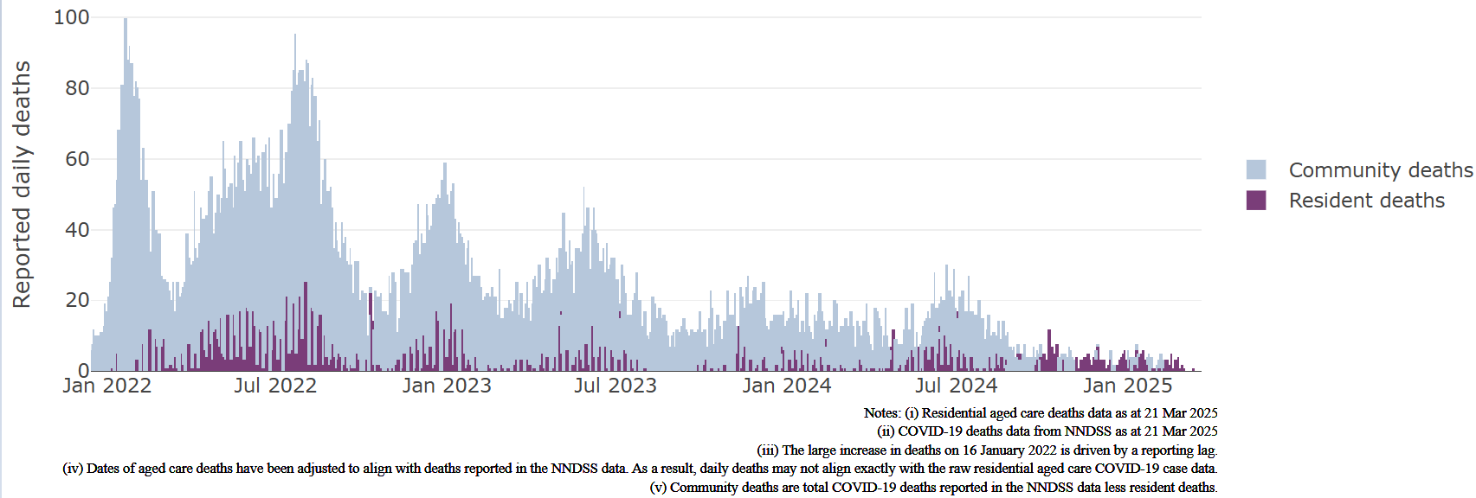

Workforce in active residential aged care outbreaks
As at 9 April 2025, surge workforce providers report a total of 200,713 shifts delivered in aged care services impacted by COVID-19. These shifts include roles for GPs, nurses, care workers, allied health workers, executive and ancillary staff. In the past week surge workforce providers have reported assisting 0 residential aged care home(s) and filled 0 shifts in aged care services.
Table 3: Workforce resources supplied to RACHs
Workforce provider | Total shifts | Previous 7 days
Aspen Medical⁸ | 33,115 | 37
HealthX⁹ | 37,738 | 0
Randstad¹⁰ | 1,116 | 0
Previous contracted providers¹¹ | 128,744 | N/A
Total | 200,713 | 37
⁸Aspen Medical shift data as at 9 April 2025, reported fortnightly.
⁹HealthX shift data as at 9 April 2025, reported weekly.
¹⁰Randstad shift data as at 9 April 2025, reported weekly.
¹¹Previous contracted providers include RCSA, HealthCare Australia, Mable and Torrens.

Oral antiviral treatments
Distribution of the oral anti-viral Lagevrio (Molnupiravir) commenced on 6 February 2022 to all RACHs with outbreak sites prioritised for delivery. The National Medical Stockpile has deployed 48,269 treatment courses of Lagevrio (Molnupiravir) to RACHs.
156,046 prescriptions for Lagevrio (Molnupiravir) have been issued to residents in RACHs, with a further 22,823 prescriptions for Paxlovid (nirmatrelvir + ritonavir) also issued since 28 February 2022 and up to 31 March 2025.
*Note: Oral antiviral data is only being updated monthly.

Vaccination in RACHs
On 27 March 2025, recommendations for 2025 COVID-19 vaccinations were released. Recommended doses for the program are based on an individual's age and level of severe immunocompromise.
Those aged 75 years and over are recommended to get a COVID-19 vaccine dose every 6 months. Those aged over 65 years of age, and adults with severe immunocompromise are recommended to receive a COVID-19 vaccine dose every 12 months and are eligible to receive a COVID-19 vaccine dose every 6 months based on individual risk-benefit assessments. All other adults can receive a single dose this year.
Recommendations can be found on the Department of Health and Aged Care (department) website at: ATAGI statement on the administration of COVID-19 vaccines in 2025
People are encouraged to seek vaccination advice from their healthcare providers, specific to their circumstances.
People living in residential aged care are a high priority for the Government’s COVID-19 vaccination program.
Older age remains the biggest risk factor for severe COVID-19 disease. Vaccination reduces the risk of severe disease and death from COVID-19.
The department is working with both the aged care and primary care sectors to ensure residents have access to the COVID-19 vaccine. The department continues to target support for RACHs to arrange COVID-19 vaccinations with local primary care providers such as GPs, community pharmacists and Aboriginal Community Controlled Health Services.
As at 9 April 2025:
- 70.3% of aged care residents have received a booster dose in the last 12 months.
- For residents over the age of 75:
  - 80,597 (47.2%) aged care residents received a booster dose in the last 6 months.
- 13,073 aged care residents have received a vaccination in the last 28 days (compared to 21,613 in the 28 days prior).

Table 4: Aged care COVID-19 Booster Doses (data as at 9 April 2025)
Jurisdiction | 75+ with booster in last 6 months
 | Residents vaccinated | % of residents vaccinated
National | 80,597 | 47.2%
NSW | 26,591 | 48.3%
VIC | 22,519 | 50.9%
QLD | 22,538 | 38.6%
WA | 13,199 | 49.5%
SA | 7,832 | 48.4%
TAS | 7,146 | 51.4%
ACT | 1,971 | 55.5%
NT | <200 | 23.5%
Data in this report is sourced from Australian Immunisation Register (AIR) data of residents in permanent residential aged care homes.
An updated data methodology was implemented on 14 March 2025. Aged Care AIR data as at 9 April 2025; Matched AIR data uses a snapshot of permanent residents in residential aged care homes as at 31 January 2025. The Residential Aged Care Home {RACH) Recipient ID to Medicare PIN linkage file was loaded into Health Enterprise Data Warehouse on
13 March 2025 which linked Medicare Consumer Directory data as at 11 October 2023 and RACH recipient data as at
31 October 2024.
Note: Booster doses in this report refer to any dose 2 or above administered to an individual.

Infection control and audit
The Aged Care Quality and Safety Commission (Commission) conducts site audits and assessment contacts (site and non-site) to monitor and assess residential aged care services against the Aged Care Quality Standards (see Table 5 below). This may include conducting infection control monitoring (ICM) spot checks.
An ICM spot check involves an on-site visit to residential aged care services, without an outbreak, to observe infection control practices, to ensure that staff, management, and visitors are adhering to safe personal protective equipment protocols and to safe infection control arrangements, as required under the Quality Standards.
As at 9 April 2025, the Commission had conducted 6,067 ICM spot checks to observe infection control practices and PPE protocols in RACHs.
Table 5: Total quality assessment and monitoring activities with residential services (including IPC), by type and month 1 March 2020 to 9 April 2025
Regulatory Activities | 2019-20  (1 Mar - 30 Jun 2020) | 2020-21 | 2021-22 | 2022-23 | 2023-24 | 2024-25  (to 10 Apr 2025) | Total
Site visits | 318 | 3,452 | 1,732 | 3,814 | 2,840 | 1,382 | 13,538
Non-site activities | 3,704 | 8,396 | 6,665 | 1,413 | 487 | 591 | 21,256
Total activities | 4,022 | 11,848 | 8,397 | 5,227 | 3,327 | 1,973 | 34,794

Appendix: National residential aged care homes (RACHs) with active outbreaks COVID-19
Please note, information reported in this table has been directly reported to the department by RACHs.
‘Total cases’ refers to all staff and resident cases associated with the active outbreak and may not reflect the count of currently active cases. Where numbers have been incorrectly reported, RACHs are able to correct these in the COVID-19 Support Portal through My Aged Care.
Where a RACH is reporting less than six resident or staff cases or less than six deaths, data has been suppressed to protect the privacy of affected individuals (note that “n/p” indicates data is not provided to protect privacy).
Data below for individual services is as at 10 April 2025.
Service Name | State | Resident Deaths | Resident Cases | Staff  Cases | Total Cases
Allawah Lodge | New South Wales | 0 | <6 | <6 | <6
Bolton Clarke Bayside (PKA - Bayside Residential Aged Care Facility) | New South Wales | 0 | 24 | 13 | 37
Bupa Pottsville Beach | New South Wales | 0 | 6 | 0 | 6
Bupa Sutherland | New South Wales | 0 | <6 | 0 | <6
Calvary The Brelsford | New South Wales | 0 | <6 | <6 | <6
Catholic Healthcare Maranatha Lodge | New South Wales | 0 | 37 | 16 | 53
Glenmore Park Care Community | New South Wales | 0 | 8 | <6 | n/p
Katoomba Views Care Community | New South Wales | 0 | 20 | 7 | 27
Manly Hillside Care Community | New South Wales | 0 | 9 | <6 | n/p
RFBI Raleigh Urunga Masonic Village | New South Wales | 0 | 14 | 16 | 30
St Annes Nursing Home | New South Wales | 0 | 9 | 17 | 26
St Elizabeth Home | New South Wales | <6 | <6 | <6 | 6
St Vincent's Care Services Heathcote | New South Wales | 0 | 9 | <6 | n/p
Yallambee Village | New South Wales | 0 | <6 | 0 | <6
Ashmore Gardens Care Community | Queensland | 0 | 11 | <6 | n/p
Bolton Clarke Chelsea | Queensland | 0 | <6 | <6 | <6
Bolton Clarke Inverpine | Queensland | 0 | <6 | <6 | 7
Bolton Clarke The Terraces | Queensland | 0 | <6 | <6 | <6
Regis Magnolia | Queensland | 0 | 6 | 0 | 6
Sir Leslie Morshead Manor | Australian Capital Territory | 0 | <6 | 0 | <6
Allawah Lodge | New South Wales | 0 | <6 | <6 | <6
Anglicare Mary Andrews Village | New South Wales | 0 | <6 | 0 | <6
Bolton Clarke Bayside (PKA - Bayside Residential Aged Care Facility) | New South Wales | 0 | 26 | 13 | 39
Bolton Clarke Cabrini | New South Wales | 0 | <6 | 0 | <6
Bolton Clarke Gosling Creek | New South Wales | 0 | 0 | 6 | 6
Bowral House Nursing Home | New South Wales | 0 | <6 | <6 | <6
Bupa Pottsville Beach | New South Wales | 0 | 6 | 0 | 6
Bupa Sutherland | New South Wales | 0 | <6 | 0 | <6
Calvary The Brelsford | New South Wales | 0 | 14 | 9 | 23
Catholic Healthcare Percy Miles Villa | New South Wales | 0 | <6 | <6 | 8
Durham Green Lodge Memory Care | New South Wales | 0 | <6 | 0 | <6
Glenmore Park Care Community | New South Wales | 0 | 8 | <6 | n/p
Manly Hillside Care Community | New South Wales | 0 | 15 | <6 | n/p
St Agnes Site | New South Wales | 0 | <6 | 0 | <6
St Andrew's Village Byron Bay | New South Wales | 0 | <6 | <6 | 6
St Annes Nursing Home | New South Wales | 0 | 9 | 19 | 28
St Elizabeth Home | New South Wales | <6 | 11 | <6 | n/p
St Hedwig Village | New South Wales | 0 | <6 | 0 | <6
St Ives House | New South Wales | 0 | <6 | 0 | <6
Uniting Wontama Orange | New South Wales | 0 | <6 | 0 | <6
Ashmore Gardens Care Community | Queensland | 0 | 18 | 10 | 28
Blue Care Gladstone Edenvale Aged Care Facility | Queensland | 0 | <6 | 11 | n/p
Blue Care Mareeba Aged Care Facility | Queensland | 0 | 17 | 13 | 30
Bolton Clarke Chelsea | Queensland | 0 | <6 | <6 | <6
Bolton Clarke Inverpine | Queensland | 0 | 18 | 9 | 27
Bolton Clarke Moreton Shores | Queensland | 0 | <6 | <6 | <6
Bolton Clarke The Terraces | Queensland | 0 | <6 | <6 | <6
Estia Health Southport | Queensland | 0 | <6 | <6 | <6
Infinite Care Ashmore | Queensland | 0 | <6 | <6 | n/p
Infinite Care Edmonton Gardens | Queensland | 0 | <6 | <6 | <6
Ozcare Bakhita Villa Aged Care Facility | Queensland | 0 | <6 | 0 | <6
Southern Cross Care Tara - Tarcoola | Queensland | <6 | 8 | <6 | n/p
ACH Group Residential Care - Milpara | South Australia | 0 | 27 | <6 | n/p
Eldercare Allambi | South Australia | 0 | <6 | 0 | <6
Estia Health Encounter Bay | South Australia | 0 | 11 | 9 | 20
Jamestown Hospital and Health Service | South Australia | 0 | <6 | <6 | <6
Glenview Community Services Inc. | Tasmania | 0 | <6 | 0 | <6
Regis Tasmania - Eastern Shore | Tasmania | 0 | <6 | 0 | <6
Baptcare Wyndham Lodge Community | Victoria | 0 | 7 | <6 | n/p
BlueCross The Gables | Victoria | <6 | 10 | 8 | 18
BlueCross Western Gardens | Victoria | 0 | <6 | 0 | <6
Bolton Clarke Newmans on the Park | Victoria | 0 | 10 | <6 | n/p
Bupa Templestowe | Victoria | 0 | 13 | 6 | 19
Calvary Goonawarra | Victoria | <6 | 10 | <6 | n/p
Calvary Kelaston | Victoria | 0 | <6 | <6 | <6
Creswick District Nursing Home | Victoria | 0 | <6 | <6 | <6
Epping Gardens | Victoria | 0 | <6 | 0 | <6
Estia Health Grovedale | Victoria | 0 | 15 | 0 | 15
Grandview Lodge | Victoria | 0 | <6 | <6 | <6
Holmwood Aged Care | Victoria | 0 | <6 | <6 | <6
Latrobe Regional Hospital Nursing Home | Victoria | 0 | <6 | 8 | n/p
mecwacare Annie's Court | Victoria | 0 | 10 | <6 | n/p
Mercy Place Montrose | Victoria | 0 | <6 | <6 | <6
Mercy Place Rice Village | Victoria | 0 | <6 | <6 | <6
Moran Roxburgh Park | Victoria | 0 | 9 | <6 | n/p
San Carlo Homes for the Aged | Victoria | 0 | 8 | <6 | n/p
Sea Views Manor | Victoria | 0 | <6 | 0 | <6
Tabulam & Templer Home for the Aged | Victoria | 0 | 21 | <6 | n/p
The Alba Aged Care Suites | Victoria | 0 | <6 | 0 | <6
Water Gardens | Victoria | 0 | <6 | 0 | <6
Westmont Homestead | Victoria | 0 | 9 | <6 | n/p
Aegis Woodlake | Western Australia | 0 | <6 | <6 | 6
Applecross Shore Care Community | Western Australia | 0 | <6 | 0 | <6
Armadale Place Care Community | Western Australia | 0 | <6 | 0 | <6
Brightwater The Cove | Western Australia | 0 | 0 | <6 | <6
Melville Parkside Care Community | Western Australia | 0 | <6 | 0 | <6
Murdoch Gardens Care Community | Western Australia | 0 | 23 | 7 | 30
Victoria Park Hostel | Western Australia | 0 | <6 | <6 | 7
Victoria Park Nursing Home | Western Australia | 0 | 15 | <6 | n/p

Outbreak opening and closure includes changes in the status of exposure sites to outbreaks (and vice versa), which are applied retrospectively to facility records. New case information can also change the status of a recovered site back to an active outbreak site. As a result, changes in active outbreak status may not align with day-on-day variations to active totals. These adjustments will also affect the number of cases in staff and residents reported each week.
Active residents and staff cases are the total currently positive cases in active outbreaks.
An outbreak is considered to be active pending advice from the relevant Public Health Unit. An outbreak is defined as at least 1 (one) positive case in a resident or 2+ cases in staff.
The Omicron outbreak start date has been redefined from late November 2021 to mid-December 2021. Changes have been made to align reporting with the start date of Omicron published in the department’s external facing Epidemiology report.
The department is now accessing aged care deaths data from the SIEBEL dataset. Figures are live and subject to change. Source: Department of Health and Aged Care unpublished data / SIEBEL dataset.
Case fatality calculated as total reported resident COVID-19 deaths divided by total resident COVID-19 cases.

