Australian Respiratory Surveillance Report

# Key messages

This report presents a national epidemiological update for acute respiratory infections, including coronavirus disease 2019 (COVID-19), influenza and respiratory syncytial virus (RSV), with a focus on the current reporting period (7 April to 20 April 2025) and earlier severity reporting periods (up to 6 April 2025).

**In the community:** Respiratory illness activity (self-reported new fever and cough symptoms) remains lower than observed at the same time in previous years. Slightly fewer participants reported new fever and cough symptoms compared to the previous fortnight and fewer people reported taking time off work due to respiratory illness (self-reported new fever and cough symptoms). The number of COVID-19 cases remains low this fortnight. The number of influenza cases this fortnight remains relatively low and consistent with the number of cases seen in the same time in previous years. The number of RSV cases this fortnight is moderate and approximately consistent with the previous fortnight. The current trends in acute respiratory cases are likely influenced by decreased social mixing during the school holiday period.

**In general practice:** There were slightly more influenza-like-illness (new fever and cough symptoms) consultations at sentinel surveillance sites this fortnight, compared with the last fortnight. Influenza-like-illness rates this fortnight were similar to the rates observed in 2024; however, have been slightly higher than observed rates at the same time in previous years and the five-year average.

**In hospitals:** Sentinel hospital-based surveillance shows the number of patients admitted with severe acute respiratory infections has remained low and stable this severity reporting period. Most of these patients were admitted with influenza or RSV. The length of hospital stay continues to vary only slightly between illnesses and the proportion of those patients who were admitted directly to intensive care at a sentinel hospital site has remained low. More children (those aged 16 years and younger) were admitted with RSV or influenza than with COVID-19 at sentinel hospitals, while more adults were admitted with COVID-19 compared to influenza or RSV. Sentinel intensive care surveillance shows the overall number of patients with severe acute respiratory infections has remained low and stable this year. The duration of intensive care stay varies slightly between illnesses. Most patients were admitted to sentinel intensive care with rhinovirus / enterovirus, followed by COVID-19. This fortnight, the average number of COVID-19 cases and average number of intensive care staff unavailable due to COVID-19 illness or exposure has decreased.

**Deaths:** There are more deaths *due to* COVID-19 and influenza than deaths *with* COVID-19 and influenza across 2023–2025. In contrast, there are substantially more people who died *with* RSV than *due to* RSV across 2023–2025. COVID-19 has been the leading cause of acute respiratory infection mortality across 2023–2025. Please note, the latest release of the Provisional Mortality Statistics is 31 March 2025, as such the mortality surveillance data presented here have not been updated since the previous report.

**In laboratories:** Test positivity for SARS-CoV-2 remained low this fortnight, while a slight increase in influenza and RSV test positivity was observed. The recombinant lineage XEC is the dominant SARS-CoV-2 variant in Australia. On 24 January 2025, the World Health Organization designated LP.8.1 as a variant under monitoring. The proportion of LP.8.1 sequences is growing rapidly compared to co-circulating variants; however, there is no significant increase in case numbers associated with LP.8.1 infections, and there are no reports to suggest that the associated disease severity is higher compared to other circulating variants. Small numbers of LP.8.1 sub-lineage sequences have been observed in Australia.

**Vaccine coverage, effectiveness and match:** Nationally, fewer adults have received a COVID-19 vaccine in the past 12 months than in the 12 months prior. It is too early to assess or report vaccine coverage or effectiveness data for influenza or RSV in 2025. Of influenza isolates characterised in 2025 thus far, over 98% have been a good match to the corresponding 2025 vaccine components.

# Australian Respiratory Surveillance Report

This report was prepared by Ash Donovan, Lauren Welsh, Jenna Hassall and Caitlin Trenorden on behalf of the interim Australian Centre for Disease Control. We thank the staff and participants from the surveillance systems who contribute data for acute respiratory illness surveillance across Australia.

The report presents a national overview of acute respiratory infections in Australia, drawing information from several different surveillance systems. These surveillance systems help us to understand the distribution of acute respiratory illnesses in the community, the severity of infections including which populations might be at risk, and the impact of acute respiratory illnesses on the community and health system in Australia.

Surveillance indicators presented in this report are based on the [Australian National Surveillance Plan for COVID-19, Influenza, and RSV](https://www.health.gov.au/resources/publications/australian-national-disease-surveillance-plan-for-covid-19-influenza-and-rsv). Please refer to the [Technical Supplement – Australian Respiratory Surveillance Report](https://www.health.gov.au/resources/publications/technical-supplement-australian-respiratory-surveillance-report) for information on our surveillance sources and data considerations, including the considerable impact of the COVID-19 pandemic on acute respiratory infection surveillance in Australia. A summary of data considerations for this report are provided below:

* Due to the dynamic nature of the surveillance systems used in this report, surveillance data are considered preliminary and subject to change as updates are received, with the most recent weeks considered particularly incomplete. Data in this report may vary from data reported in other national reports and reports by states and territories.
* Data in this report are presented by date of event (diagnosis, admission or death) or by the International Organization for Standardization (ISO) week date system, with weeks defined as seven-day periods which begin on a Monday and end on a Sunday. The ISO week date system is used to support trends comparisons over time more effectively. The current reporting period this fortnight includes 7 April to 20 April 2025 and where comparisons to the previous fortnight are made this includes 24 March to 6 April 2025.
* In Australia, states and territories (the Australian Capital Territory [ACT], New South Wales [NSW], the Northern Territory [NT], Queensland [Qld], South Australia [SA], Tasmania [Tas], Victoria [Vic], and Western Australia [WA]) report notified cases to the **National Notifiable Diseases Surveillance System (NNDSS)** based on the [Australian national surveillance case definitions](https://www.health.gov.au/resources/collections/cdna-surveillance-case-definitions). NNDSS data are analysed and reported based on diagnosis date, which is the true onset date of a case if known, otherwise it is the earliest of the specimen date, the notification date, or the notification received date. The NNDSS data for this report were extracted on 23 April 2025.
* To account for the lag in collection and provision of severity data from some surveillance systems, and for the time delay between illness onset and the development of severe disease outcomes, cases with an admission date or a diagnosis date in the last two weeks are excluded from severity analyses for hospitalisations and intensive care admissions. As such, the severity reporting periods are two weeks behind the end of the current reporting period. For this report, severity reporting includes data from 24 March to 6 April 2025 unless specified otherwise. Where comparisons to the previous severity fortnight are made this includes 10 March to 23 March 2025.
* Death registrations from the Australian Bureau of Statistics (ABS) Provisional Mortality Statistics are now used as the primary data source for measuring acute respiratory infection associated deaths. The ABS mortality data is sourced from the Registry of Births, Deaths and Marriages and is separate from the NNDSS. Registration-based mortality data needs time to be received and processed. For this reason, mortality statistics in this report may lag by at least two months.
* Analysis and reporting outputs were produced using R Statistical Software v4.3.1. While every care has been taken in preparing this report, the Australian Government Department of Health and Aged Care does not accept liability for any injury or loss or damage arising from the use of, or reliance upon, the content of the report or Technical Supplement. For further information about this report refer to the [Technical Supplement – Australian Respiratory Surveillance Report](https://www.health.gov.au/resources/publications/technical-supplement-australian-respiratory-surveillance-report) or contact [respiratory.surveillance@health.gov.au](mailto:respiratory.surveillance@health.gov.au).

# Community surveillance

Community surveillance monitors respiratory illnesses in the community, providing information on the number of people reporting respiratory symptoms, testing practices, and the impact of respiratory illnesses. Community surveillance includes notification data obtained from laboratory tests for infections. Infections that are diagnosed and notified are only a subset of the total number of infections occurring in the community.

* Community surveys via FluTracking indicate respiratory illness symptoms and test positivity remain low and stable this fortnight, and lower than the trends observed at the same time in previous years.
* This fortnight (7 April to 20 April 2025), slightly fewer survey participants reported new fever and cough symptoms (1.1%), than in the previous fortnight (1.2%) (Figure 1).
* This fortnight, more survey participants with new fever and cough symptoms used a rapid antigen test (RAT) (47.9%; 312/652) than a polymerase chain reaction (PCR) test (8.7%; 57/652) to test for severe acute respiratory syndrome coronavirus 2 (SARS-CoV-2).
  + Self-reported SARS-CoV-2 RAT positivity was slightly lower this fortnight (18.6%; 58/312) than in the previous fortnight (19.4%; 77/397), while self-reported SARS-CoV-2 PCR positivity was slightly higher this fortnight (12.3%; 7/57) than in the previous fortnight (11.8%; 8/68).
* This fortnight, 7.5% (49/652) of survey participants with new fever and cough symptoms used a PCR test to test for influenza. Self-reported influenza PCR positivity was lower this fortnight (26.5%; 13/49), than in the previous fortnight (31.6%; 18/57).
* This fortnight, fewer survey participants reported taking three or more days off work or normal duties due to fever and cough symptoms (39.6%; 258/652), than in the previous fortnight (46.3%; 338/730).
* From January to early March 2025, the weekly proportion of survey participants with new fever and cough symptoms was relatively consistent with the proportions observed at the same time in 2022–2024. Since mid-March, the weekly proportion has been lower than observed at the same time in 2022–2024 (Figure 1).

**Figure 1: Age standardised proportion of survey participants reporting new fever and cough symptoms compared with the five-year average* by year and week of report, Australia, 2022 to 20 April 2025**

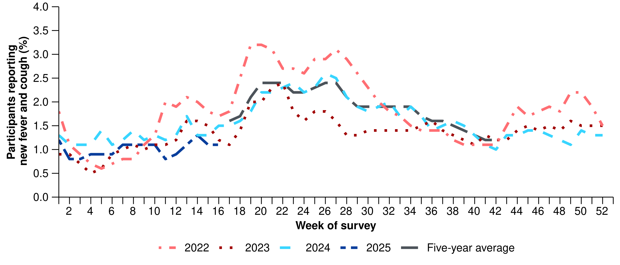

Source: FluTracking  
* From 2020, FluTracking expanded their data capture period to year-round. Data before May and after October for any year before 2020 are not available for historical comparisons. The years 2020 and 2021 are excluded when comparing the current season to historical periods when influenza virus has circulated without public health restrictions. As such, the five-year average includes the years 2018 to 2019 and 2022 to 2024. Please refer to the [Technical Supplement](https://www.health.gov.au/resources/publications/technical-supplement-australian-respiratory-surveillance-report) for interpretation of the five-year average.

* This fortnight (7 April to 20 April 2025), there was a 15.5% decrease in COVID-19 cases, an 8.5% decrease in influenza cases, and a 1.4% increase in RSV cases.
* The current trends in acute respiratory cases are likely influenced by decreased social mixing during the school holiday period.

**Table 1: Notified cases and notification rate per 100,000 population by disease, five-year age group, and jurisdiction*†, Australia, 1 January to 20 April 2025**

|  | **COVID-19** | | | **Influenza** | | | **RSV** | | |
| --- | --- | --- | --- | --- | --- | --- | --- | --- | --- |
|  | **Reporting period (n)** | **Year to date (n)** | **Year to  date (rate)** | **Reporting period (n)** | **Year to date (n)** | **Year to date (rate)** | **Reporting period (n)** | **Year to date (n)** | **Year to date (rate)** |
| **Age group (years)** | | | | | | | | | |
| 0–4 | 405 | 5,457 | 362 | 1,179 | 6,794 | 450 | 4,070 | 18,074 | 1,198 |
| 5–9 | 82 | 1,343 | 83 | 1,471 | 7,695 | 478 | 424 | 2,034 | 126 |
| 10–14 | 68 | 1,460 | 87 | 803 | 4,889 | 292 | 151 | 905 | 54 |
| 15–19 | 128 | 1,860 | 112 | 421 | 3,319 | 200 | 108 | 660 | 40 |
| 20–24 | 133 | 1,877 | 105 | 298 | 2,419 | 135 | 97 | 587 | 33 |
| 25–29 | 157 | 2,250 | 113 | 353 | 2,443 | 122 | 131 | 711 | 36 |
| 30–34 | 195 | 2,690 | 132 | 444 | 3,159 | 155 | 174 | 887 | 43 |
| 35–39 | 230 | 3,078 | 155 | 578 | 3,992 | 201 | 179 | 829 | 42 |
| 40–44 | 186 | 2,890 | 156 | 602 | 4,030 | 218 | 158 | 724 | 39 |
| 45–49 | 180 | 2,639 | 162 | 450 | 3,389 | 208 | 110 | 682 | 42 |
| 50–54 | 190 | 2,660 | 157 | 471 | 3,388 | 200 | 154 | 870 | 51 |
| 55–59 | 198 | 2,524 | 165 | 432 | 3,068 | 200 | 172 | 971 | 63 |
| 60–64 | 239 | 2,811 | 183 | 472 | 3,157 | 206 | 215 | 1,038 | 68 |
| 65–69 | 228 | 2,906 | 214 | 441 | 2,818 | 207 | 229 | 1,122 | 83 |
| 70+ | 1,439 | 17,269 | 517 | 1,403 | 8,560 | 256 | 899 | 4,511 | 135 |
| **Jurisdiction** | | | | | | | | | |
| ACT | 69 | 723 | 152 | 104 | 712 | 150 | 54 | 303 | 64 |
| NSW | 2,048 | 23,498 | 277 | 4,207 | 24,584 | 290 | 4,613 | 18,989 | 224 |
| NT | 30 | 560 | 220 | 211 | 1,186 | 465 | 38 | 242 | 95 |
| Qld | 825 | 13,254 | 237 | 2,926 | 14,770 | 264 | 1,668 | 9,173 | 164 |
| SA | 402 | 3,378 | 180 | 582 | 3,463 | 184 | 210 | 1,033 | 55 |
| Tas | 41 | 710 | 123 | 96 | 774 | 135 | 27 | 201 | 35 |
| Vic | 442 | 8,364 | 120 | 1,138 | 12,360 | 177 | 513 | 3,590 | 51 |
| WA | 210 | 3,258 | 110 | 554 | 5,284 | 178 | 149 | 1,078 | 36 |
| **Total** | **4,067** | **53,745** | **198** | **9,818** | **63,133** | **232** | **7,272** | **34,609** | **127** |

Source: National Notifiable Diseases Surveillance System (NNDSS). Notification data are unavailable for the NT from 18 April 2025 and for Tas from 15 April 2025 for COVID-19 notifications, 14 April 2025 for influenza notifications and 16 April 2025 for RSV notifications.  
* Rate per 100,000 population for the given time period. Population data are based on the Australian Bureau of Statistics (ABS) [Estimated Resident Population (ERP) for the reference period June 2024, released 12 December 2024](https://www.abs.gov.au/statistics/people/population/national-state-and-territory-population/jun-2024).  
† Total includes cases with missing age.

* This fortnight, the number of COVID-19 cases are low. Following an increase in COVID-19 cases in late 2024 and early January 2025, an overall decreasing trend was observed in the past three months. Despite a small, unsustained increase in early February, the number of COVID-19 cases this fortnight is about half of the number of cases reported at the same time last year (Figure 2).
  + The current decreasing trends in COVID-19 cases is likely influenced by decreased social mixing during the school holiday period.
* This fortnight, SA was the only jurisdiction where COVID-19 notification rates increased, although this increase was small and notification rates remain low. Most other jurisdictions continued to experience week-on-week decreases in COVID-19 notification rates; however, notification data are unavailable for the NT from 18 April 2025 and for Tas from 15 April 2025 (Figure 3).
* In the year to date, COVID-19 notification rates remain highest in people aged 70 years or over, likely due to higher case ascertainment from targeted testing strategies for populations at-risk of severe disease or who live in a high-risk setting such as a residential aged care home (Table 1).
* In the year to date, COVID-19 notification rates remain highest in in NSW and Qld, and lowest in WA (Table 1).

**Figure 2: Notified COVID-19 cases (laboratory-confirmed only) by year and week of diagnosis, Australia, 2022 to 20 April 2025**

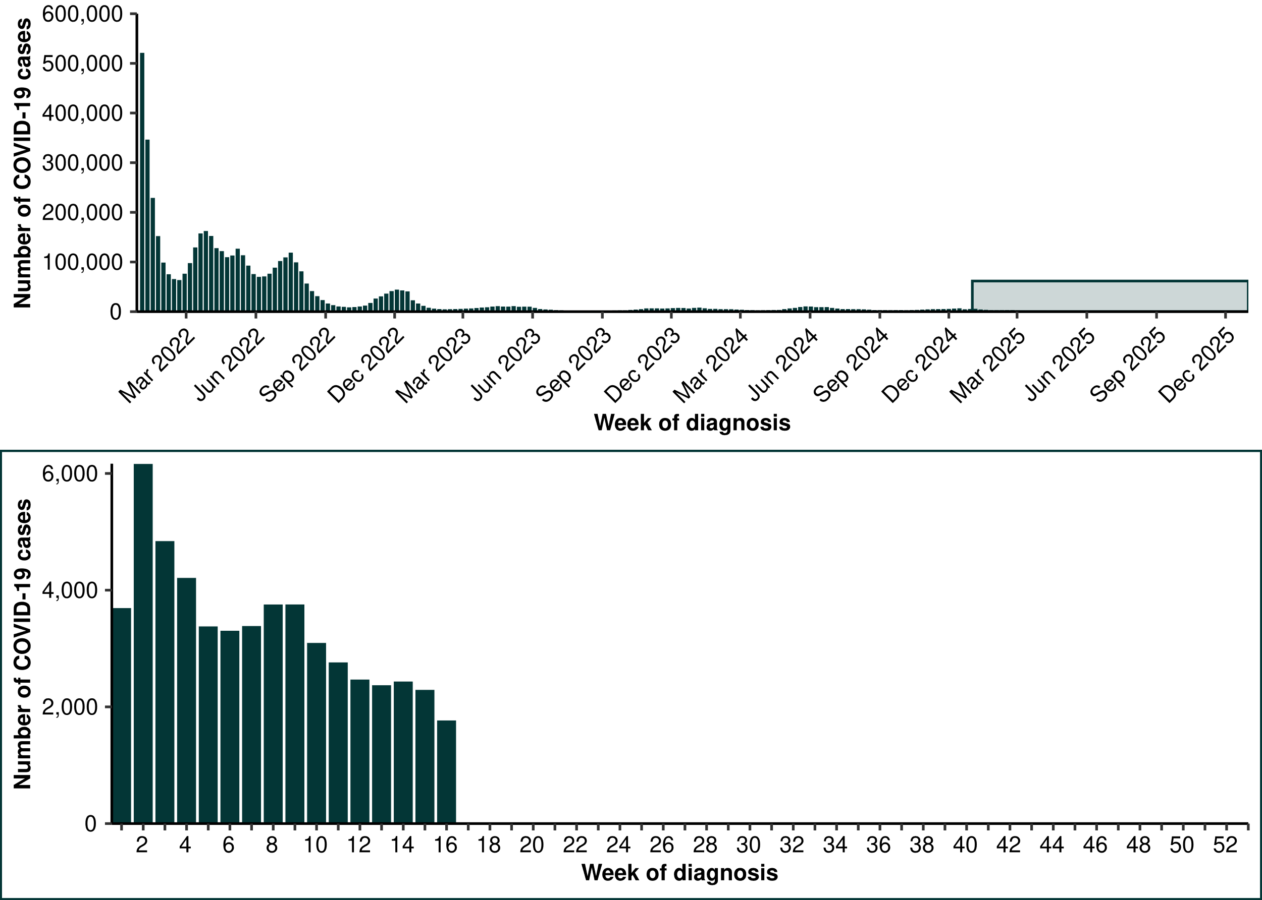

Source: National Notifiable Diseases Surveillance System (NNDSS). Notification data are unavailable for the NT from 18 April 2025 and for Tas from 15 April 2025 for COVID-19.

**Figure 3: Notification rates* per 100,000 population for COVID-19 cases by state or territory and week of diagnosis, Australia, 1 January to 20 April 2025**

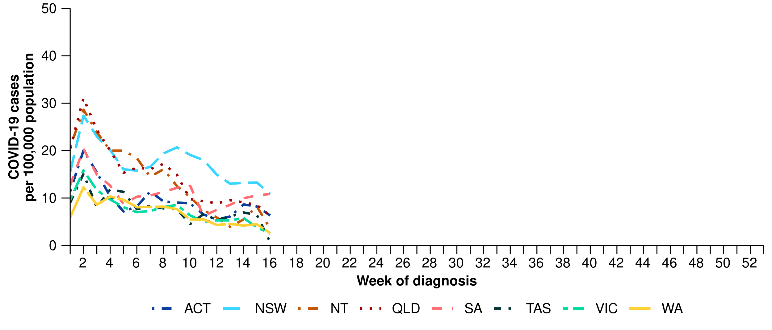

Source: National Notifiable Diseases Surveillance System (NNDSS). Notification data are unavailable for the NT from 17 April 2025 and for Tas from 14 April 2025 for COVID-19.   
* Rate per 100,000 population for the given time period. Population data are based on the Australian Bureau of Statistics (ABS) [Estimated Resident Population (ERP) for the reference period June 2024, released 12 December 2024](https://www.abs.gov.au/statistics/people/population/national-state-and-territory-population/jun-2024)

**Figure 4: Notified influenza cases and five-year average* by year and week of diagnosis, Australia, 2022 to 20 April 2025**

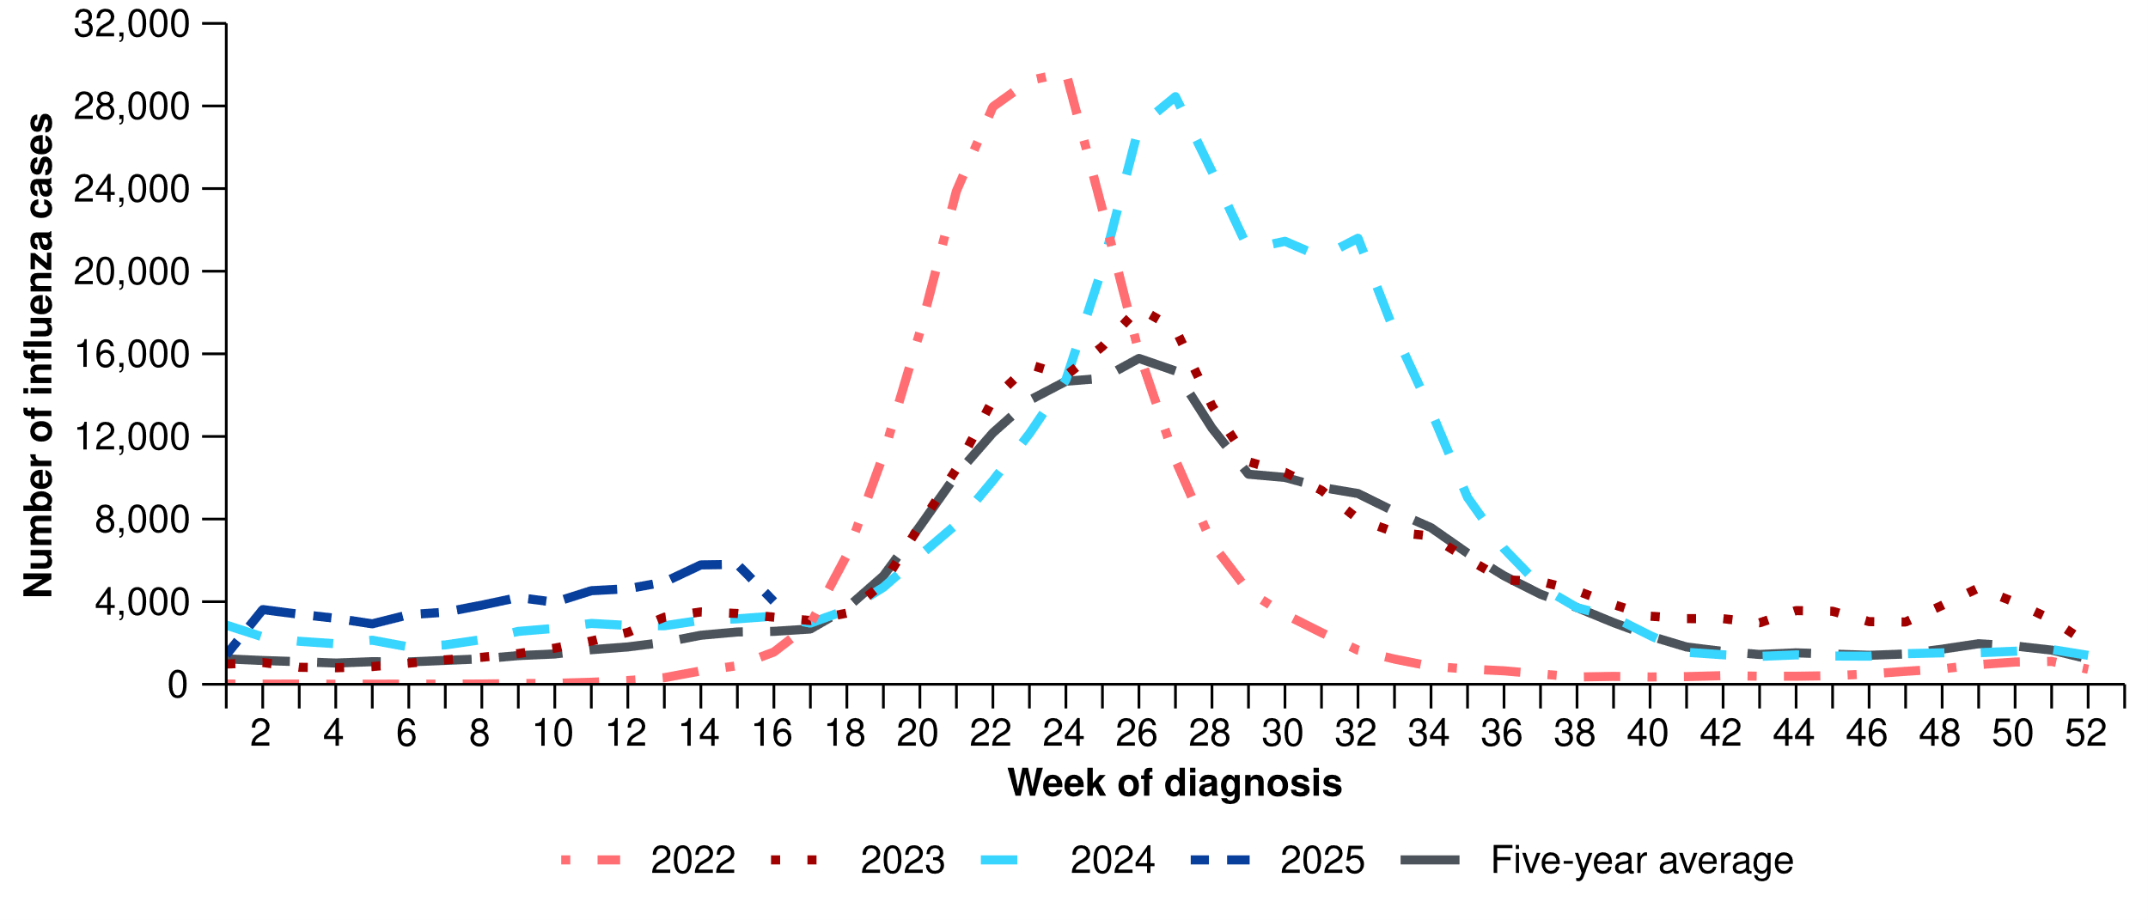

Source: National Notifiable Diseases Surveillance System (NNDSS). Notification data are unavailable for the NT from 18 April 2025 and for Tas from 14 April 2025 for influenza.  
* The years 2020 and 2021 are excluded when comparing the current season to historical periods when influenza virus has circulated without public health restrictions. As such, the five-year average includes the years 2018 to 2019 and 2022 to 2024. Please refer to the [Technical Supplement](https://www.health.gov.au/resources/publications/technical-supplement-australian-respiratory-surveillance-report) for interpretation of the five-year average.

* This fortnight, the number of influenza cases remain relatively low. Following higher than previously experienced influenza case numbers from January to mid-April, influenza cases decreased this fortnight to be consistent with case numbers observed in previous years and the five-year average (Figure 5).
  + The current decreasing trends in influenza cases is likely influenced by decreased social mixing during the school holiday period.
  + Though the number of influenza cases from January to mid-April have been higher than in the past, the slow increasing trend in the number of cases over this time is consistent with trends observed in previous interseasonal periods (Figure 5).
  + The slow increasing trend in the number of cases this fortnight could be due to increased influenza circulating in the community, perhaps driven in part by travellers to the northern hemisphere returning with influenza infections. However, it could also be influenced by changes in health-seeking behaviour (increased testing) associated with increases in respiratory virus circulation (especially COVID-19) in the summer period.
* This fortnight, influenza notification rates decreased across most jurisdictions, except the ACT where a small increase compared to the previous fortnight was observed. Decreases in notification rates this fortnight were most pronounced in Qld, Vic, and WA. Notification data are unavailable for the NT from 18 April 2025 and for Tas from 14 April 2025 (Figure 6).
* In the year to date, influenza notification rates remain highest in children aged 5–9 years and children aged 0–4 years (Table 1).
* In the year to date, influenza notification rates remain highest in the NT and NSW, and lowest in the ACT and Tas (Table 1).

**Figure 5: Notification rates* per 100,000 population for influenza cases by state or territory and week of diagnosis, Australia, 1 January to 20 April 2025**

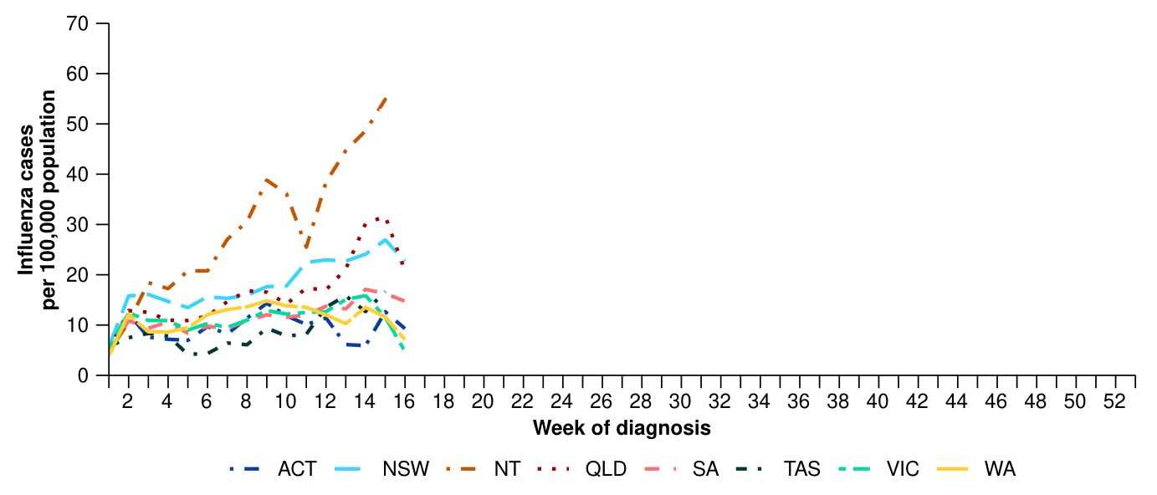 Source: National Notifiable Diseases Surveillance System (NNDSS). Notification data are unavailable for the Northern Territory from 17 April 2025 and for Tasmania from 14 April 2025 for influenza.  
* Rate per 100,000 population for the given time period. Population data are based on the Australian Bureau of Statistics (ABS) [Estimated Resident Population (ERP) for the reference period June 2024, released 12 December 2024](https://www.abs.gov.au/statistics/people/population/national-state-and-territory-population/jun-2024).

* This fortnight, most influenza notifications were influenza A(Unsubtyped) (74.7%; 7,330/9,818), followed by influenza B (23.1%; 2,269/9,818), then influenza A(H1N1) (1.7%; 162/9,818). This fortnight, there have been five influenza A&B co-detections (Figure 6).
* In the year to date, influenza A(Unsubtyped) has accounted for most cases across all age groups, followed by influenza B. The proportion of influenza B is closest to the proportion of influenza A in the 5–19 years age group. There has been a small number of influenza A(H1N1) and influenza A(H3N2) cases across all age groups (Figure 6).
  + There is likely to be a comparatively higher proportion of influenza B cases this season than observed in 2024. While influenza B is often a good match with the seasonal influenza vaccine strain, influenza B can result in more severe infections in children.
* In the year to date, influenza A(Unsubtyped) has accounted for the majority of influenza cases across all jurisdictions. Many jurisdictions have been experiencing increasing numbers of influenza B cases; however, the comparative proportion of influenza B and influenza A varies each week (Figure 7). Influenza A(H1N1) and influenza A(H3N2) cases were most commonly observed in Qld, Tas and WA (Figure 7); however, trends in influenza subtypes should be interpreted with caution as there are jurisdictional differences in the proportion and selection of influenza samples that undergo typing.

**Figure 6: Notified influenza cases by influenza subtype, age group*, and week of diagnosis, Australia, 1 January to 20 April 2025**

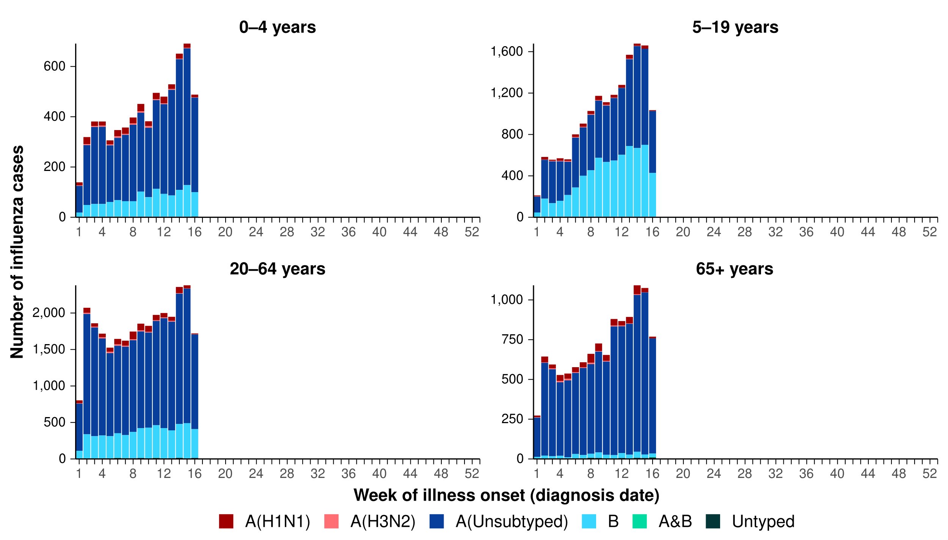

Source: National Notifiable Diseases Surveillance System (NNDSS). Notification data are unavailable for the Northern Territory from 18 April 2025 and for Tasmania from 14 April 2025 for influenza.  
* Axis varies between age groups.

**Figure 7: Notified influenza cases by influenza subtype, jurisdiction*, and week of diagnosis, Australia, 1 January to 20 April 2025**

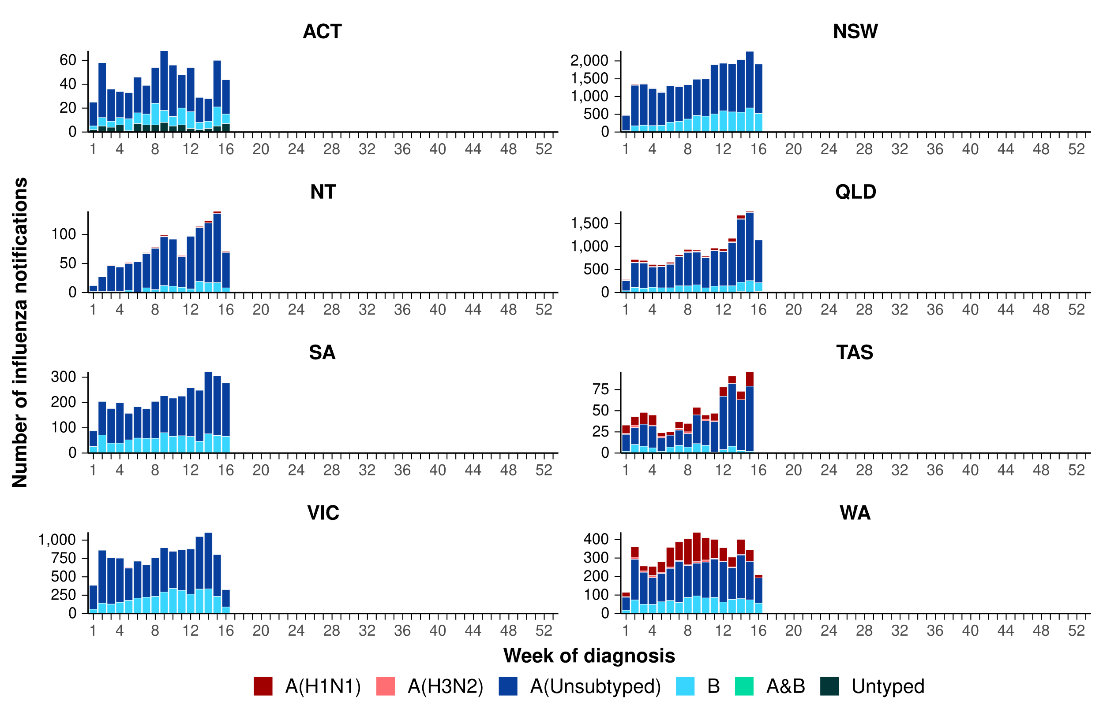

Source: National Notifiable Diseases Surveillance System (NNDSS). Notification data are unavailable for the Northern Territory from 18 April 2025 and for Tasmania from 14 April 2025 for influenza.  
* Axis varies between jurisdictions.

* This fortnight, the number of RSV cases are moderate and approximately consistent with the previous fortnight. The current trend, largely driven by high case numbers in New South Wales and Queensland, may signal the start of the RSV season nationally; however, this steadily increasing trend has not been observed in all jurisdictions (Figure 8).
  + Though the number of RSV cases was steadily increasing until mid-April, in the first week of this fortnight case numbers did not increase by the same proportion as in previous weeks and in the second week of this fortnight case numbers decreased, likely due to decreased social mixing as a result of school holidays (Figure 8).
* This fortnight, RSV notification rates decreased in NSW, Qld and Vic, while remaining relatively low and stable in other jurisdictions, except for the ACT where a small increase was observed. Notification data are unavailable for the NT from 18 April 2025 and for Tas from 16 April 2025 (Figure 9).
* In the year to date, RSV notification rates remain considerably higher in children aged 0–4 years than in other age groups (Table 1).
* In the year to date, RSV notification rates remain highest in NSW and Qld, and lowest in Tas and WA (Table 1).

**Figure 8: Notified RSV cases by year and week of diagnosis*, Australia, 2023 to 20 April 2025**

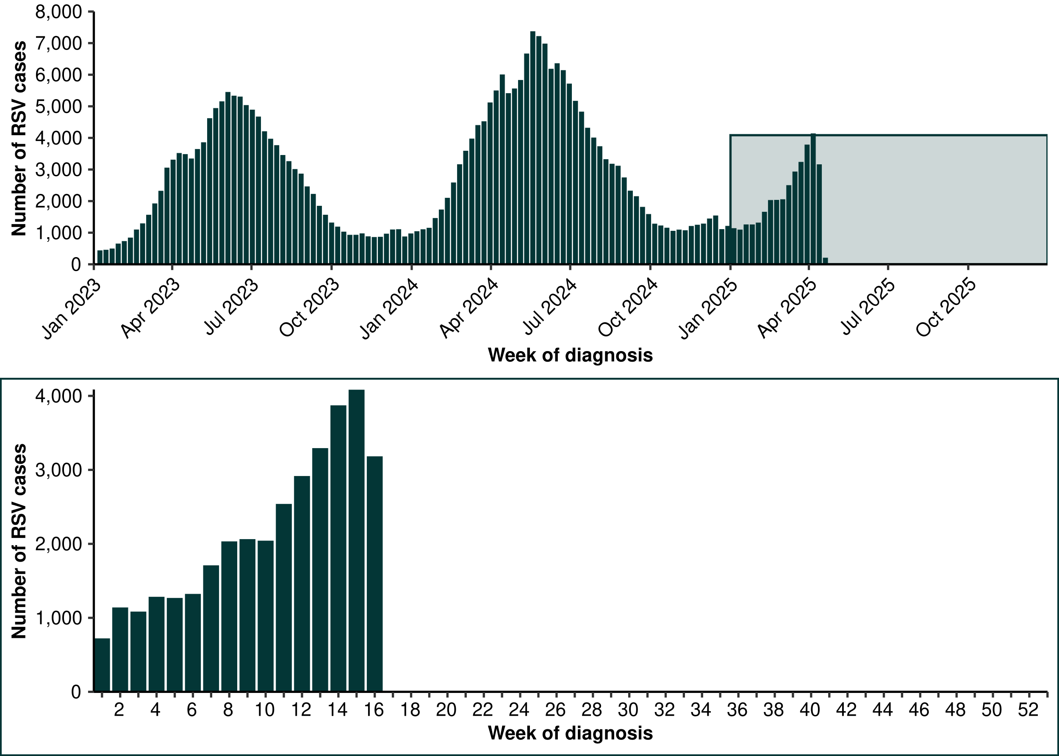

Source: National Notifiable Diseases Surveillance System (NNDSS). Please note, RSV became notifiable in all states and territories on 1 September 2022 and comprehensive national notification data became available after this point. For this reason, RSV notification trends are only presented from 1 January 2023. In addition, notification data are unavailable for the NT from 18 April 2025 and for Tas from 16 April 2025 for RSV.

**Figure 9: Notification rates* per 100,000 population for RSV cases by state or territory and week of diagnosis, Australia, 1 January to 20 April 2025**

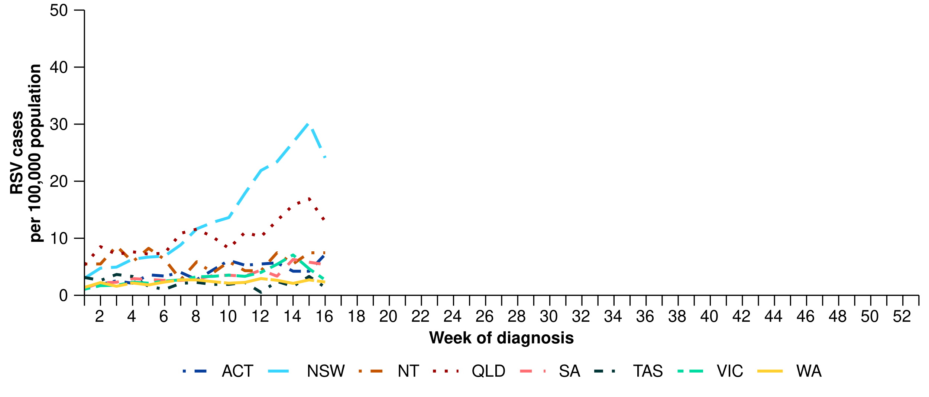

Source: National Notifiable Diseases Surveillance System (NNDSS). Notification data are unavailable for the NT from 17 April 2025 and for Tas from 16 April 2025 for RSV.  
* Rate per 100,000 population for the given time period. Population data are based on the Australian Bureau of Statistics (ABS) [Estimated Resident Population (ERP) for the reference period June 2024, released 12 December 2024](https://www.abs.gov.au/statistics/people/population/national-state-and-territory-population/jun-2024).

# Primary care surveillance

Primary care surveillance monitors the number and characteristics of people who have presented to their general practitioner with influenza-like-illness and provides insight on the different respiratory pathogens that are causing illness in the community.

* Sentinel general practice surveillance indicates medical attendance for respiratory illness is beginning to increase again following a period of low influenza-like-illness rates from mid-January to late March 2025.
* This fortnight (7 April to 20 April 2025), there were more general practice consultations for influenza-like illness (4.6 notifications per 1,000 consultations per fortnight) than in the previous fortnight (4.0 notifications per 1,000 consultations per fortnight) (Figure 10).
* In early January 2025, influenza-like-illness rates were slightly higher than observed rates at the same period in previous years and the five-year average. Since mid-January, influenza-like-illness rates have been relatively consistent with observed rates in 2024; however, have been slightly higher than observed rates at the same period in previous years and the five-year average (Figure 10).

**Figure 10: Rate of influenza-like-illness per 1,000 consultations per week with sentinel general practice sites compared with the five-year average by year and week of consultation*†, Australia, 2022 to 20 April 2025**

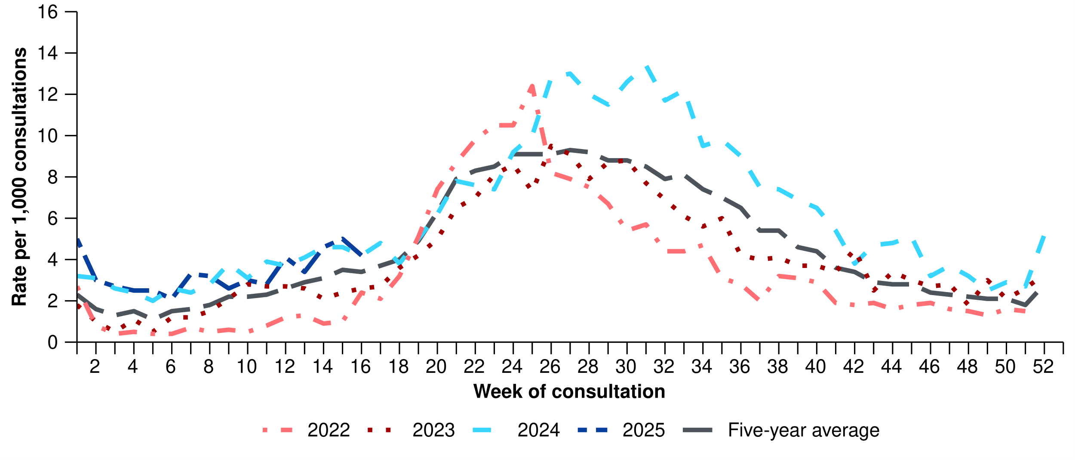

Source: Australian Sentinel Practice Research Network (ASPREN)  
* The years 2020 and 2021 are excluded when comparing the current season to historical periods when influenza virus has circulated without public health restrictions. As such, the five-year average includes the years 2018 to 2019 and 2022 to 2024. Please refer to the [Technical Supplement](https://www.health.gov.au/resources/publications/technical-supplement-australian-respiratory-surveillance-report) for interpretation of the five-year average.  
† Please refer to the [Technical Supplement](https://www.health.gov.au/resources/publications/technical-supplement-australian-respiratory-surveillance-report) for notes on impact of COVID-19 on ASPREN data.

* In the year to date, 61.0% (304/498) of people attending general practice with influenza-like-illness who were tested have then tested positive for a respiratory pathogen.
* In the year to date, rhinovirus (45.1%; 137/304) has been the most commonly detected pathogen, followed by influenza (17.4%; 53/304), SARS-CoV-2 (12.2%; 37/304), RSV (6.9%; 21/304), and human metapneumovirus (hMPV) (6.2%; 19/304) (Figure 11).

**Figure 11: Number of samples tested for respiratory pathogens among people with influenza-like-illness attending sentinel general practice sites by respiratory pathogen and week of specimen collection, Australia, 1 January to 20 April 2025**

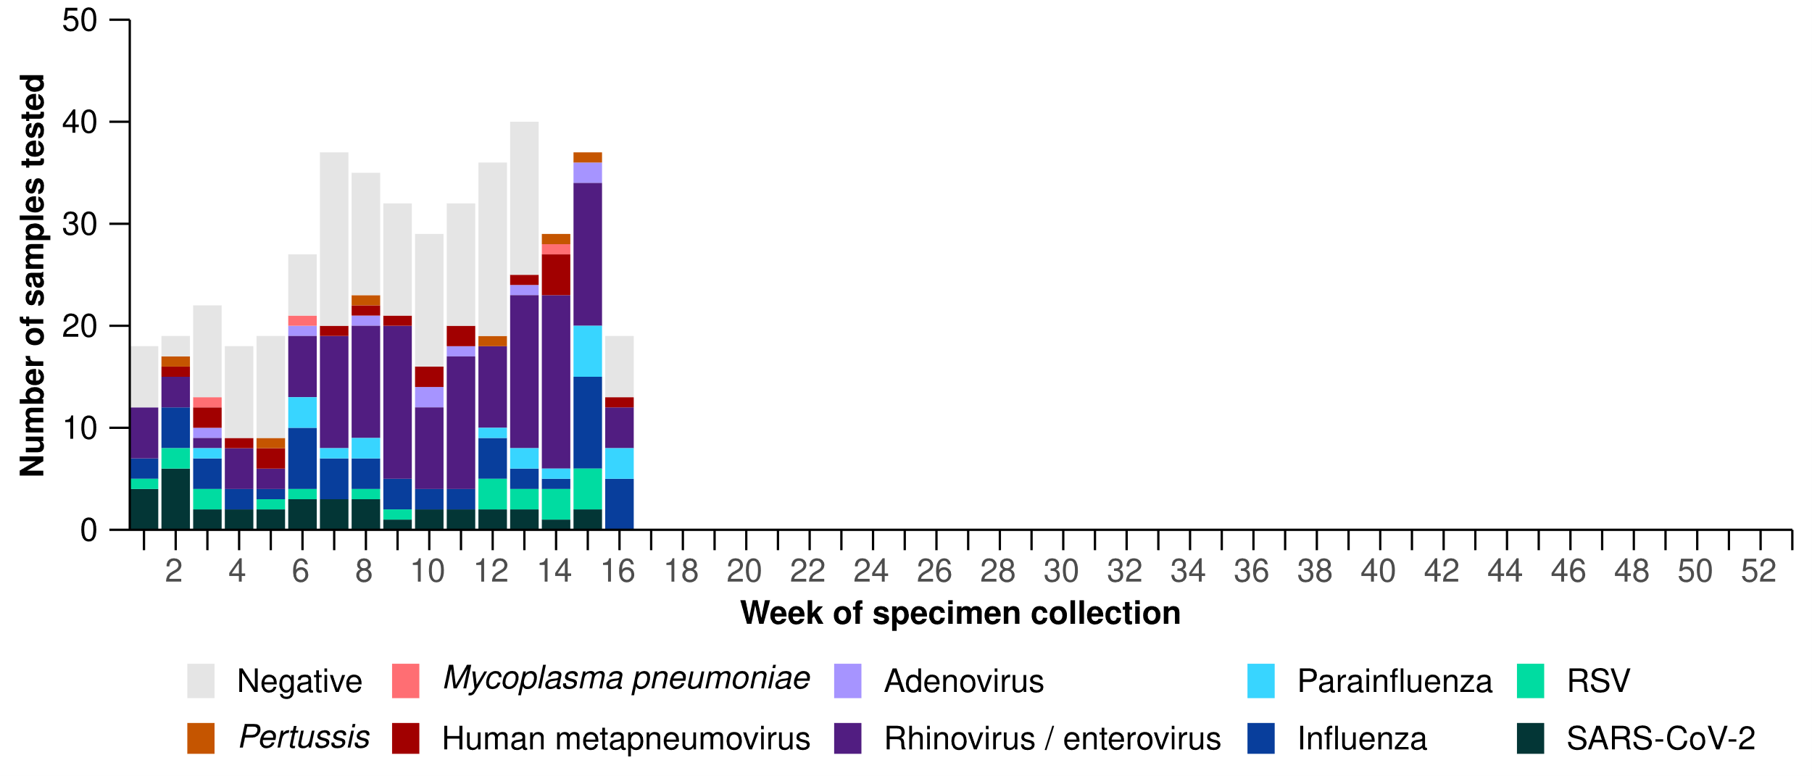

Source: Australian Sentinel Practice Research Network (ASPREN)  
Note: All ASPREN swab samples are transported to the SA Pathology laboratory in Adelaide to be tested for viral and bacterial respiratory pathogens via a multiplex real-time reverse transcription polymerase chain reaction (RT-PCR) assay using in-house primers.

# Hospital-based surveillance

Hospital-based surveillance monitors persons with more severe illness who have been admitted to hospital for their respiratory illness (severe acute respiratory infections). Hospital-based surveillance also measures the ability of the health system to cope with the number of severe acute respiratory infection admissions to ensure delivery of safe, timely and quality health care.

* Sentinel hospital-based surveillance from the Influenza Complications Alert Network (FluCAN) shows the number of patients admitted with severe acute respiratory infections has remained low and stable overall. The length of hospital stay continues to vary only slightly between illnesses and the proportion of patients with a severe acute respiratory infection who were admitted directly to an intensive care has remained low.
* In this severity reporting period (24 March to 6 April 2025), more patients were admitted to a sentinel hospital with a severe acute respiratory infection (n = 313), than in the previous severity reporting period (n = 287).
  + In this severity reporting period, at sentinel hospitals there was a 3.4% increase in admissions with COVID-19 (from 58 to 60), a minor increase in admissions with influenza (from 127 to 128), and a 22.5% increase in admissions with RSV (from 102 to 125), compared to the previous severity reporting period.
* In the year to date for severity reporting (1 January to 6 April 2025), most patients with a severe acute respiratory infection were admitted with COVID-19; however, the weekly number of influenza and RSV admissions have been increasing recently compared with COVID-19 admissions (Figure 12).
* Patients admitted to sentinel hospitals with influenza have mostly been admitted with influenza A 80.9% (626/774), while 19.0% (147/774) were admitted with influenza B.
  + Most hospital admissions with influenza A have been with influenza A(Unsubtyped) (85.9%; 538/626), followed by influenza A(H1N1) (11.3%; 71/626), and then influenza A(H3N2) (2.7%; 17/626).

**Figure 12: Total number of patients (children and adults) admitted with a severe acute respiratory infection to sentinel hospitals by disease and week of admission*†‡, Australia, 1 January to 6 April 2025**

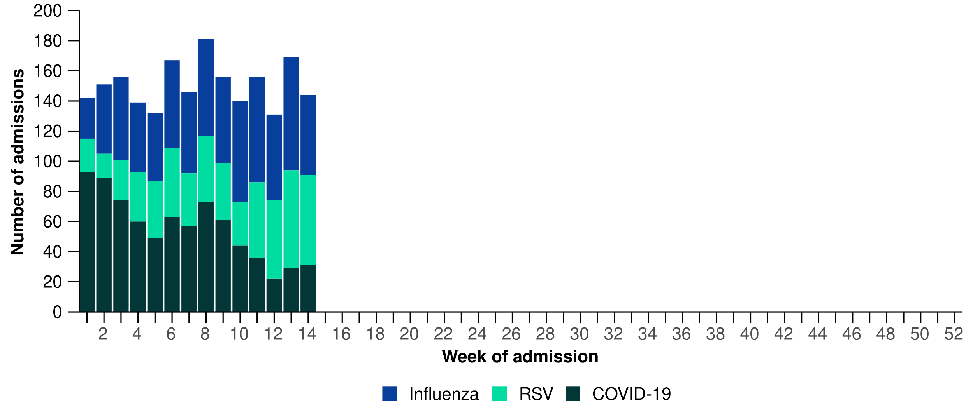

Source: Influenza Complications Alert Network (FluCAN)

* In the year to date for severity reporting, influenza A was most commonly detected in children in all age groups (the <6 months, 6 months–4 years, and 5–16 years age groups) and in adults in all age groups (17–64 years and 65 years and over). Of note, the proportion of influenza B compared with influenza A was highest in school aged children (5-16 years) (Figure 13).
  + While influenza B is often a good match with the seasonal influenza vaccine strain, influenza B can result in more severe infections in children.

**Figure 13: Number of patients admitted with influenza to sentinel hospitals by influenza subtype, age group, and week of admission*, Australia, 1 January to 6 April 2025**

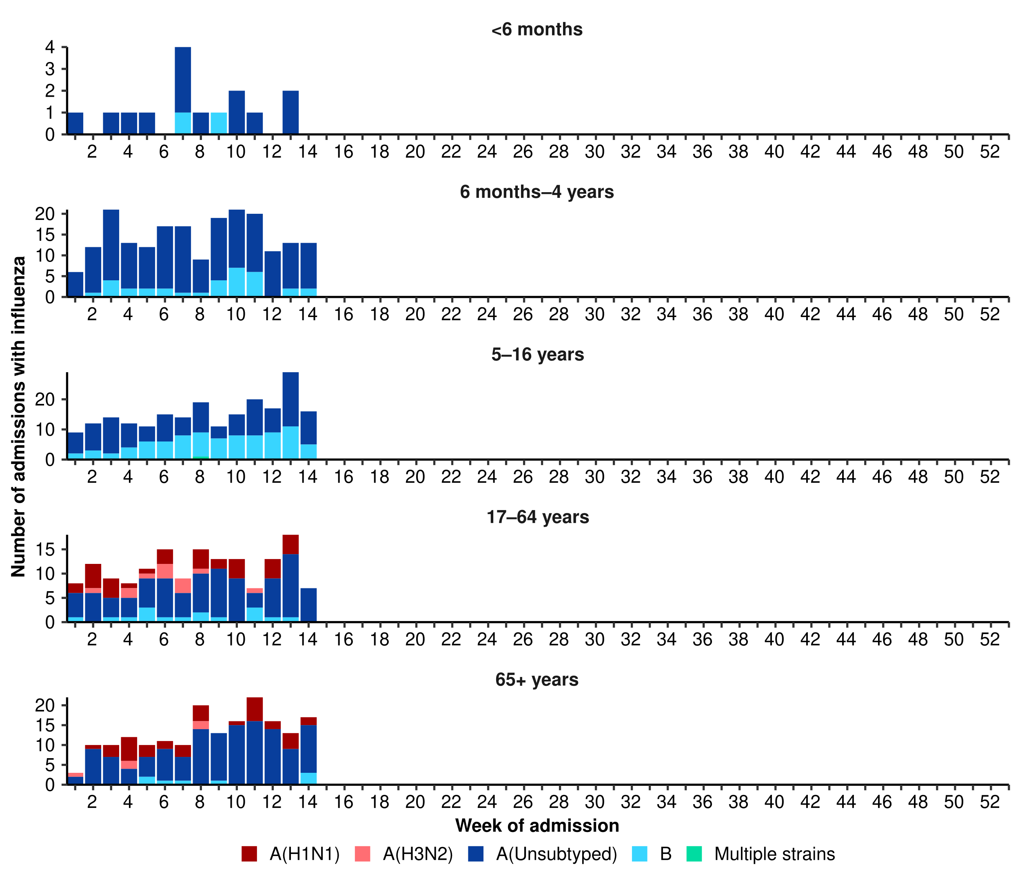

Source: Influenza Complications Alert Network (FluCAN)  
* Axis varies between age groups. The age distribution of admissions with influenza may not reflect the age distribution of all patients.

* In the year to date for severity reporting, children (those aged 16 years and younger) were more commonly admitted with influenza or RSV than with COVID-19 at sentinel hospitals (Table 2a).
* Children admitted to sentinel hospitals with influenza tended to be older than children admitted with COVID-19 or RSV (Table 2a).
* Children admitted to sentinel hospitals with RSV had a slightly longer length of hospital stay compared to children with influenza or COVID-19; however, the difference in the length of stay was minor. A higher proportion of children admitted with COVID-19 were admitted directly to intensive care, compared to children admitted with influenza or RSV (Table 2a).

**Table 2a: Demographic characteristics and outcomes for children admitted with a severe acute respiratory infection to a sentinel hospital by disease, Australia, 1 January to 6 April 2025**

|  | **COVID-19** | **Influenza** | **RSV** |
| --- | --- | --- | --- |
|  | **Year to date for severity reporting  (n=279)** | **Year to date for severity reporting  (n=433)** | **Year to date for severity reporting  (n=460)** |
| **Age (years)** | | | |
| Median [IQR] | 1 [0–3] | 4 [2–8] | 1 [0–2] |
| **Age group (years)** | | | |
| < 6 months | 94 (33.7%) | 15 (3.5%) | 104 (22.6%) |
| 6 months – 4 years | 130 (46.6%) | 204 (47.1%) | 324 (70.4%) |
| 5–16 years | 55 (19.7%) | 214 (49.4%) | 32 (7.0%) |
| **Indigenous status** | | | |
| Aboriginal and Torres Strait Islander | 30 (10.8%) | 33 (7.6%) | 32 (7.0%) |
| **Length of hospital stay (days)†** | | | |
| Median [IQR] | 1 [1–3] | 1 [1–2] | 2 [1–3] |
| **Patient admission location‡** | | | |
| Admitted to hospital ward | 261 (93.5%) | 414 (95.6%) | 443 (96.3%) |
| Admitted to intensive care directly | 18 (6.5%) | 19 (4.4%) | 17 (3.7%) |
| **Discharge status†** | | | |
| Alive | 229 (82.1%) | 377 (87.1%) | 355 (77.2%) |
| Died | – | – | – |
| Incomplete/missing | 50 (17.9%) | 56 (12.9%) | 105 (22.8%) |

Source: Influenza Complications Alert Network (FluCAN)  
* Does not include patients with missing age; therefore, the sum of age-specific totals above may not equal the total number of patients.  
† For patients who are still in hospital data may not be complete; therefore, these data are not included in the length of stay or discharge status. In addition, length of stay data excludes patients that acquired their infection in hospital.  
‡ Admission location reflects the initial admission ward. Some patients may be initially admitted to general ward then later admitted to an intensive care and this is not reflected here. Does not include patients with missing admission location; therefore, the sum of admission location specific totals above may not equal the total number of patients.

The Paediatric Active Enhanced Disease Surveillance (PAEDS) network carries out enhanced sentinel hospital surveillance for some acute respiratory infections or conditions in children. PAEDS data for acute respiratory infections in children are presented in the Australian Respiratory Surveillance Reports in the sentinel hospital data from FluCAN. For additional information on [COVID-19 in children](https://paeds.org.au/covid-19/paediatric-covid-19-australia), [Paediatric Inflammatory Multisystem Syndrome (PIMS-TS) following COVID-19](https://paeds.org.au/pims-ts/paeds-pims-ts-case-data), [influenza in children](https://paeds.org.au/influenza/paediatric-influenza-australia), or [RSV in children](https://paeds.org.au/respiratory-syncytial-virus-rsv/paediatric-rsv-australia) please visit the [PAEDS](https://paeds.org.au/) webpages and dashboards.

* Adults aged 17–64 years were more commonly admitted with COVID-19 than with either influenza or RSV at sentinel hospitals (Table 2b).
* Adults admitted to sentinel hospitals with COVID-19 or RSV were predominately 65 years and over, whereas the proportion of admissions with influenza was similar across the 17–64 years and 65 years and over age groups (Table 2b).
* Adults admitted to sentinel hospitals with COVID-19 had a slightly longer length of hospital stay compared to adults with influenza or RSV; however, the difference in the length of stay was relatively minor. A higher proportion of adults with influenza or RSV were admitted directly to intensive care, compared to adults admitted with COVID-19 (Table 2b).
* Sadly, there have been a small number of adults admitted with a severe acute respiratory infections who have died in hospital (Table 2b).

**Table 2b: Demographic characteristics and outcomes for adults admitted with a severe acute respiratory infection to a sentinel hospital by disease, Australia, 1 January to 6 April 2025**

|  | **COVID-19** | **Influenza** | **RSV** |
| --- | --- | --- | --- |
|  | **Year to date for severity reporting  (n=502)** | **Year to date for severity reporting  (n=341)** | **Year to date for severity reporting  (n=95)** |
| **Age (years)** | | | |
| Median [IQR] | 75 [60–83] | 67 [51–78] | 75 [59–81] |
| **Age group (years)** | | | |
| 17–64 years | 155 (30.9%) | 158 (46.3%) | 30 (31.6%) |
| 65 years and over | 347 (69.1%) | 183 (53.7%) | 65 (68.4%) |
| **Indigenous status** | | | |
| Aboriginal and Torres Strait Islander | 37 (7.4%) | 22 (6.5%) | 10 (10.5%) |
| **Length of hospital stay (days)†** | | | |
| Median [IQR] | 5 [2–8] | 3 [2–6] | 4 [2–8] |
| **Patient admission location‡** | | | |
| Admitted to hospital ward | 469 (93.4%) | 306 (89.7%) | 86 (90.5%) |
| Admitted to intensive care directly | 33 (6.6%) | 35 (10.3%) | 9 (9.5%) |
| **Discharge status†** | | | |
| Alive | 403 (80.3%) | 256 (75.1%) | 54 (56.8%) |
| Died | 16 (3.2%) | 6 (1.8%) | 4 (4.2%) |
| Incomplete/missing | 83 (16.5%) | 79 (23.2%) | 37 (38.9%) |

Source: Influenza Complications Alert Network (FluCAN)  
* Does not include patients with missing age; therefore, the sum of age-specific totals above may not equal the total number of patients.  
† For patients who are still in hospital data may not be complete; therefore, these data are not included in the length of stay or discharge status. In addition, length of stay data excludes patients that acquired their infection in hospital.  
‡ Admission location reflects the initial admission ward. Some patients may be initially admitted to general ward then later admitted to an intensive care and this is not reflected here. Does not include patients with missing admission location; therefore, the sum of admission location specific totals above may not equal the total number of patients.

* Sentinel intensive care surveillance shows the number of patients admitted to intensive care with severe acute respiratory infections has remained low and stable this year.
* In this severity reporting period (10 March to 6 April 2025), more patients have been admitted to a sentinel intensive care with a severe acute respiratory infection (n=179), than in the previous severity reporting period (n=172) (Figure 14).
* In the year to date for severity reporting (1 January to 6 April 2025), most patients were admitted to sentinel intensive care with rhinovirus / enterovirus, followed by COVID-19 (Figure 14; Table 3).

**Figure 14: Number of patients admitted with severe acute respiratory infections to a sentinel intensive care by disease and week of admission, Australia, 1 January to 6 April 2025**

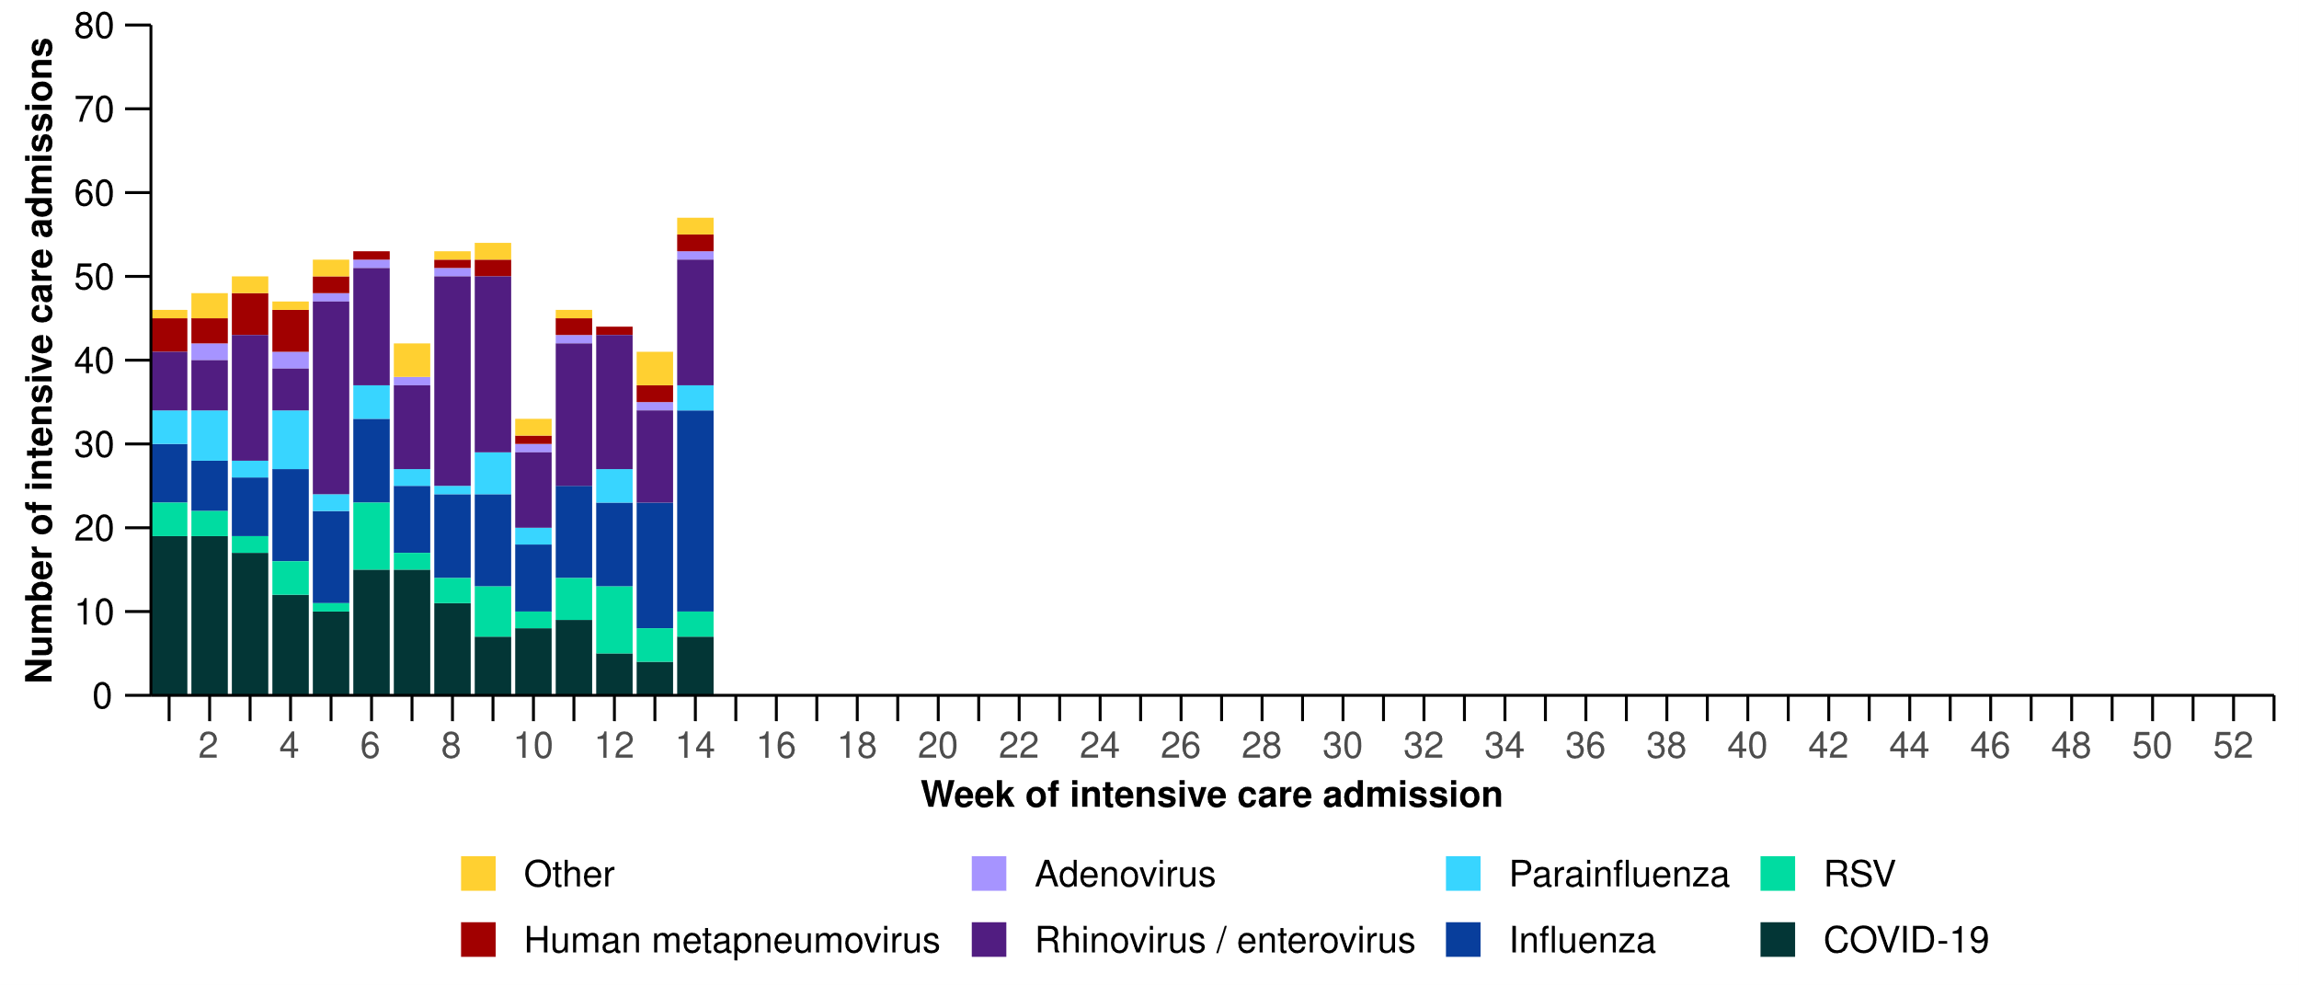

Source: Short Period Incidence Study of Severe Acute Respiratory Infection (SPRINT-SARI) Australia  
Note: A range of diagnostic testing procedures are utilised across hospitals in Australia. SPRINT-SARI does not specify which diagnostic testing method should be utilised as this is the domain of the hospital and treating clinicians. Therefore, virological data from SPRINT-SARI should be interpreted with care.

**Figure 15: Number of patients admitted with severe acute respiratory infections to a sentinel intensive care by disease and age group*, Australia, 1 January to 6 April 2025**

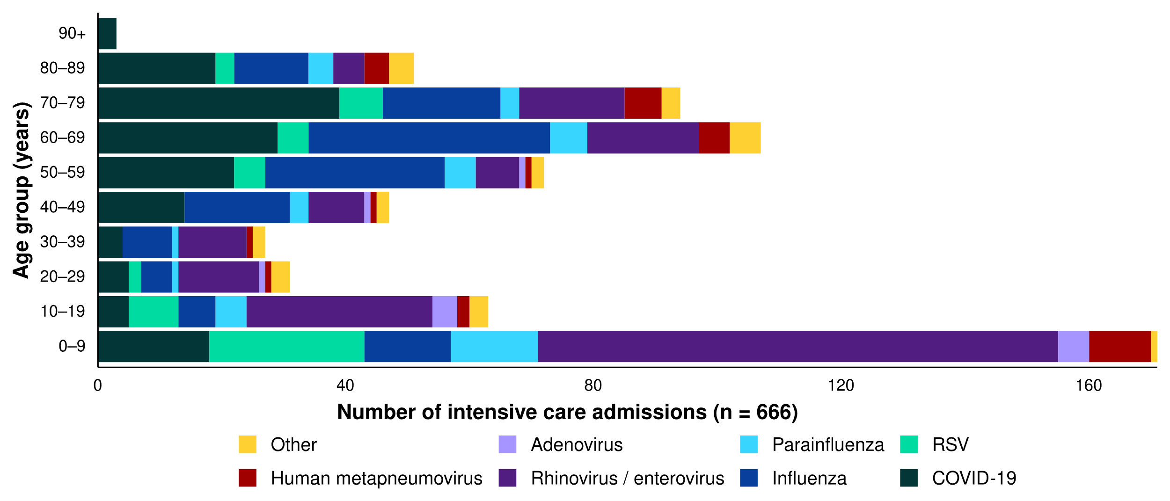

Source: Short Period Incidence Study of Severe Acute Respiratory Infection (SPRINT-SARI) Australia  
Note: 4.9% (31/632) of patients had co-infections of respiratory pathogens; therefore, the sum of pathogen-specific totals above may not equal the total number of severe acute respiratory infection patients.  
* The age distribution of severe acute respiratory infection intensive care admissions may not reflect the age distribution of all patients.

* Admissions to a sentinel intensive care with COVID-19, hMPV, or influenza have been generally among older people. In contrast, admissions to a sentinel intensive care with rhinovirus or RSV have been among younger people, primarily those aged 0–9 years old (Figure 15; Table 3).
* A higher proportion of patients with COVID-19, hMPV, influenza, and parainfluenza required invasive mechanical ventilation, and the length of ventilation was highest among those with hMPV and influenza. The length of intensive care stay was relatively similar across diseases (Table 3).
* Most patients admitted to a sentinel intensive care with a severe acute respiratory infection have been discharged home. Sadly, a small number of patients have died in hospital (Table 3).

**Table 3: Demographic characteristics and outcomes of patients admitted with a severe acute respiratory infection to a sentinel intensive care by disease*†, Australia, 1 January to 6 April 2025**

|  | **COVID-19** | **hMPV** | **Influenza** | **Parainfluenza** | **Rhinovirus** | **RSV** | **Other** |
| --- | --- | --- | --- | --- | --- | --- | --- |
|  | **Year to date for severity reporting   (n=158)** | **Year to date for severity reporting   (n=31)** | **Year to date for severity reporting   (n=149)** | **Year to date  for severity reporting   (n=42)** | **Year to date  for severity reporting   (n=194)** | **Year to date for severity reporting   (n=55)** | **Year to date for severity reporting   (n=37)** |
| **Age (years)** | | | | | | | |
| Median [IQR] | 65  [47–75] | 59  [4–72] | 58  [42–68] | 36  [5–67] | 13  [4–45] | 11  [3–62] | 35  [17–65] |
| **Indigenous status** | | | | | | | |
| Aboriginal and Torres Strait Islander | 20  (12.7%) | 3  (9.7%) | 21  (14.1%) | 4  (9.5%) | 24  (12.4%) | 5  (9.1%) | 5  (13.5%) |
| Non-Indigenous | 138  (87.3%) | 28  (90.3%) | 128  (85.9%) | 38  (90.5%) | 170  (87.6%) | 50  (90.9%) | 32  (86.5%) |
| **Received invasive mechanical ventilation** | | | | | | | |
| Number (%) | 49  (31.0%) | 8  (25.8%) | 51  (34.2%) | 17  (40.5%) | 37  (19.1%) | 10  (18.2%) | 13  (35.1%) |
| **Length of invasive mechanical ventilation (days)\*** | | | | | | | |
| Median [IQR] | 3 [1–6] | 4 [2–9] | 5 [1–11] | 4 [1–14] | 2 [1–6] | 2 [1–4] | 2 [0–4] |
| **Length of intensive care stay (days)\*** | | | | | | | |
| Median [IQR] | 3 [2–5] | 4 [2–6] | 3 [2–6] | 2 [1–6] | 2 [1–5] | 2 [1–5] | 3 [1–7] |
| **Length of hospital stay (days)\*** | | | | | | | |
| Median [IQR] | 8 [4–15] | 9 [6–14] | 8 [5–13] | 6 [3–12] | 4 [2–10] | 5 [3–10] | 8 [4–18] |
| **Patient outcome†** | | | | | | | |
| Ongoing care in intensive care | 9  (5.7%) | 2  (6.5%) | 12  (8.1%) | 1  (2.4%) | 11  (5.7%) | 1  (1.8%) | 2  (5.4%) |
| Ongoing care in hospital ward | 6  (3.8%) | 1  (3.2%) | 8  (5.4%) | 1  (2.4%) | 13  (6.7%) | 4  (7.3%) | 1  (2.7%) |
| Transfer to other hospital / facility | 29  (18.4%) | 2  (6.5%) | 19  (12.8%) | 5  (11.9%) | 12  (6.2%) | 4  (7.3%) | 5  (13.5%) |
| Discharged home | 85  (53.8%) | 24  (77.4%) | 95  (63.8%) | 32  (76.2%) | 146  (75.3%) | 42  (76.4%) | 23  (62.2%) |
| Died in hospital | 28  (17.7%) | 2  (6.5%) | 14  (9.4%) | 2  (4.8%) | 12  (6.2%) | 4  (7.3%) | 6  (16.2%) |

Source: Short Period Incidence Study of Severe Acute Respiratory Infection (SPRINT-SARI) Australia  
Note: 4.9% (31/632) of patients had co-infections of respiratory pathogens; therefore, the sum of pathogen-specific totals above may not equal the total number of severe acute respiratory infection patients.  
* For patients receiving ongoing care in intensive care data may not be complete; therefore, data are not included in the length of ventilation or stay.  
† Patients who have been admitted with no discharge information for less than 90 days have been assumed to have ongoing care in the hospital. Patients who have no outcome entered or have been admitted for more than 90 days with no discharge information have been treated as missing.

* This fortnight (7 April to 20 April 2025), there has been fewer COVID-19 cases in intensive care across Australia than in the previous fortnight (Figure 16).
* This fortnight, there have been fewer intensive care staff unavailable to work due to COVID-19 exposure or illness across Australia than in the previous fortnight (Figure 16).

**Figure 16: Average number of COVID-19 cases in intensive care and the average number of intensive care staff unavailable to work due to COVID-19 exposure or illness by week of report*†, Australia, 1 January to 20 April 2025** 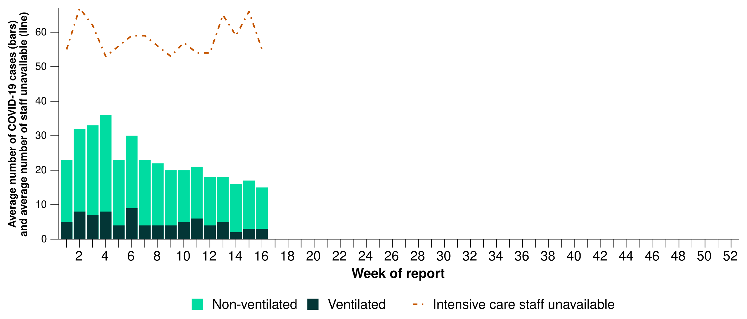

Source: Critical Health Resource Information System (CHRIS)  
* Average number of ventilated and non-ventilated COVID-19 cases in intensive care includes only active COVID-19 cases (those in isolation) and does not include cleared COVID-19 cases.  
† Intensive care staff include both medical and nursing staff. Staff unavailability will be underestimated in NSW as most public hospitals in NSW do not report staff unavailability.

* This fortnight, COVID-19 cases in intensive care have remained stable in most jurisdictions, except in Vic where a decrease was observed compared with the previous fortnight (Figure 17).
* This fortnight, the number of intensive care staff unavailable to work due to COVID-19 exposure or illness have increased in NSW and Qld, decreased in Vic and the ACT, and remained stable in all other jurisdictions compared with the previous fortnight (Figure 17).

**Figure 17: Average number of COVID-19 cases in intensive care and the average number of intensive care staff unavailable to work due to COVID-19 exposure or illness by jurisdiction and week of report*†‡, Australia, 1 January to 20 April 2025**

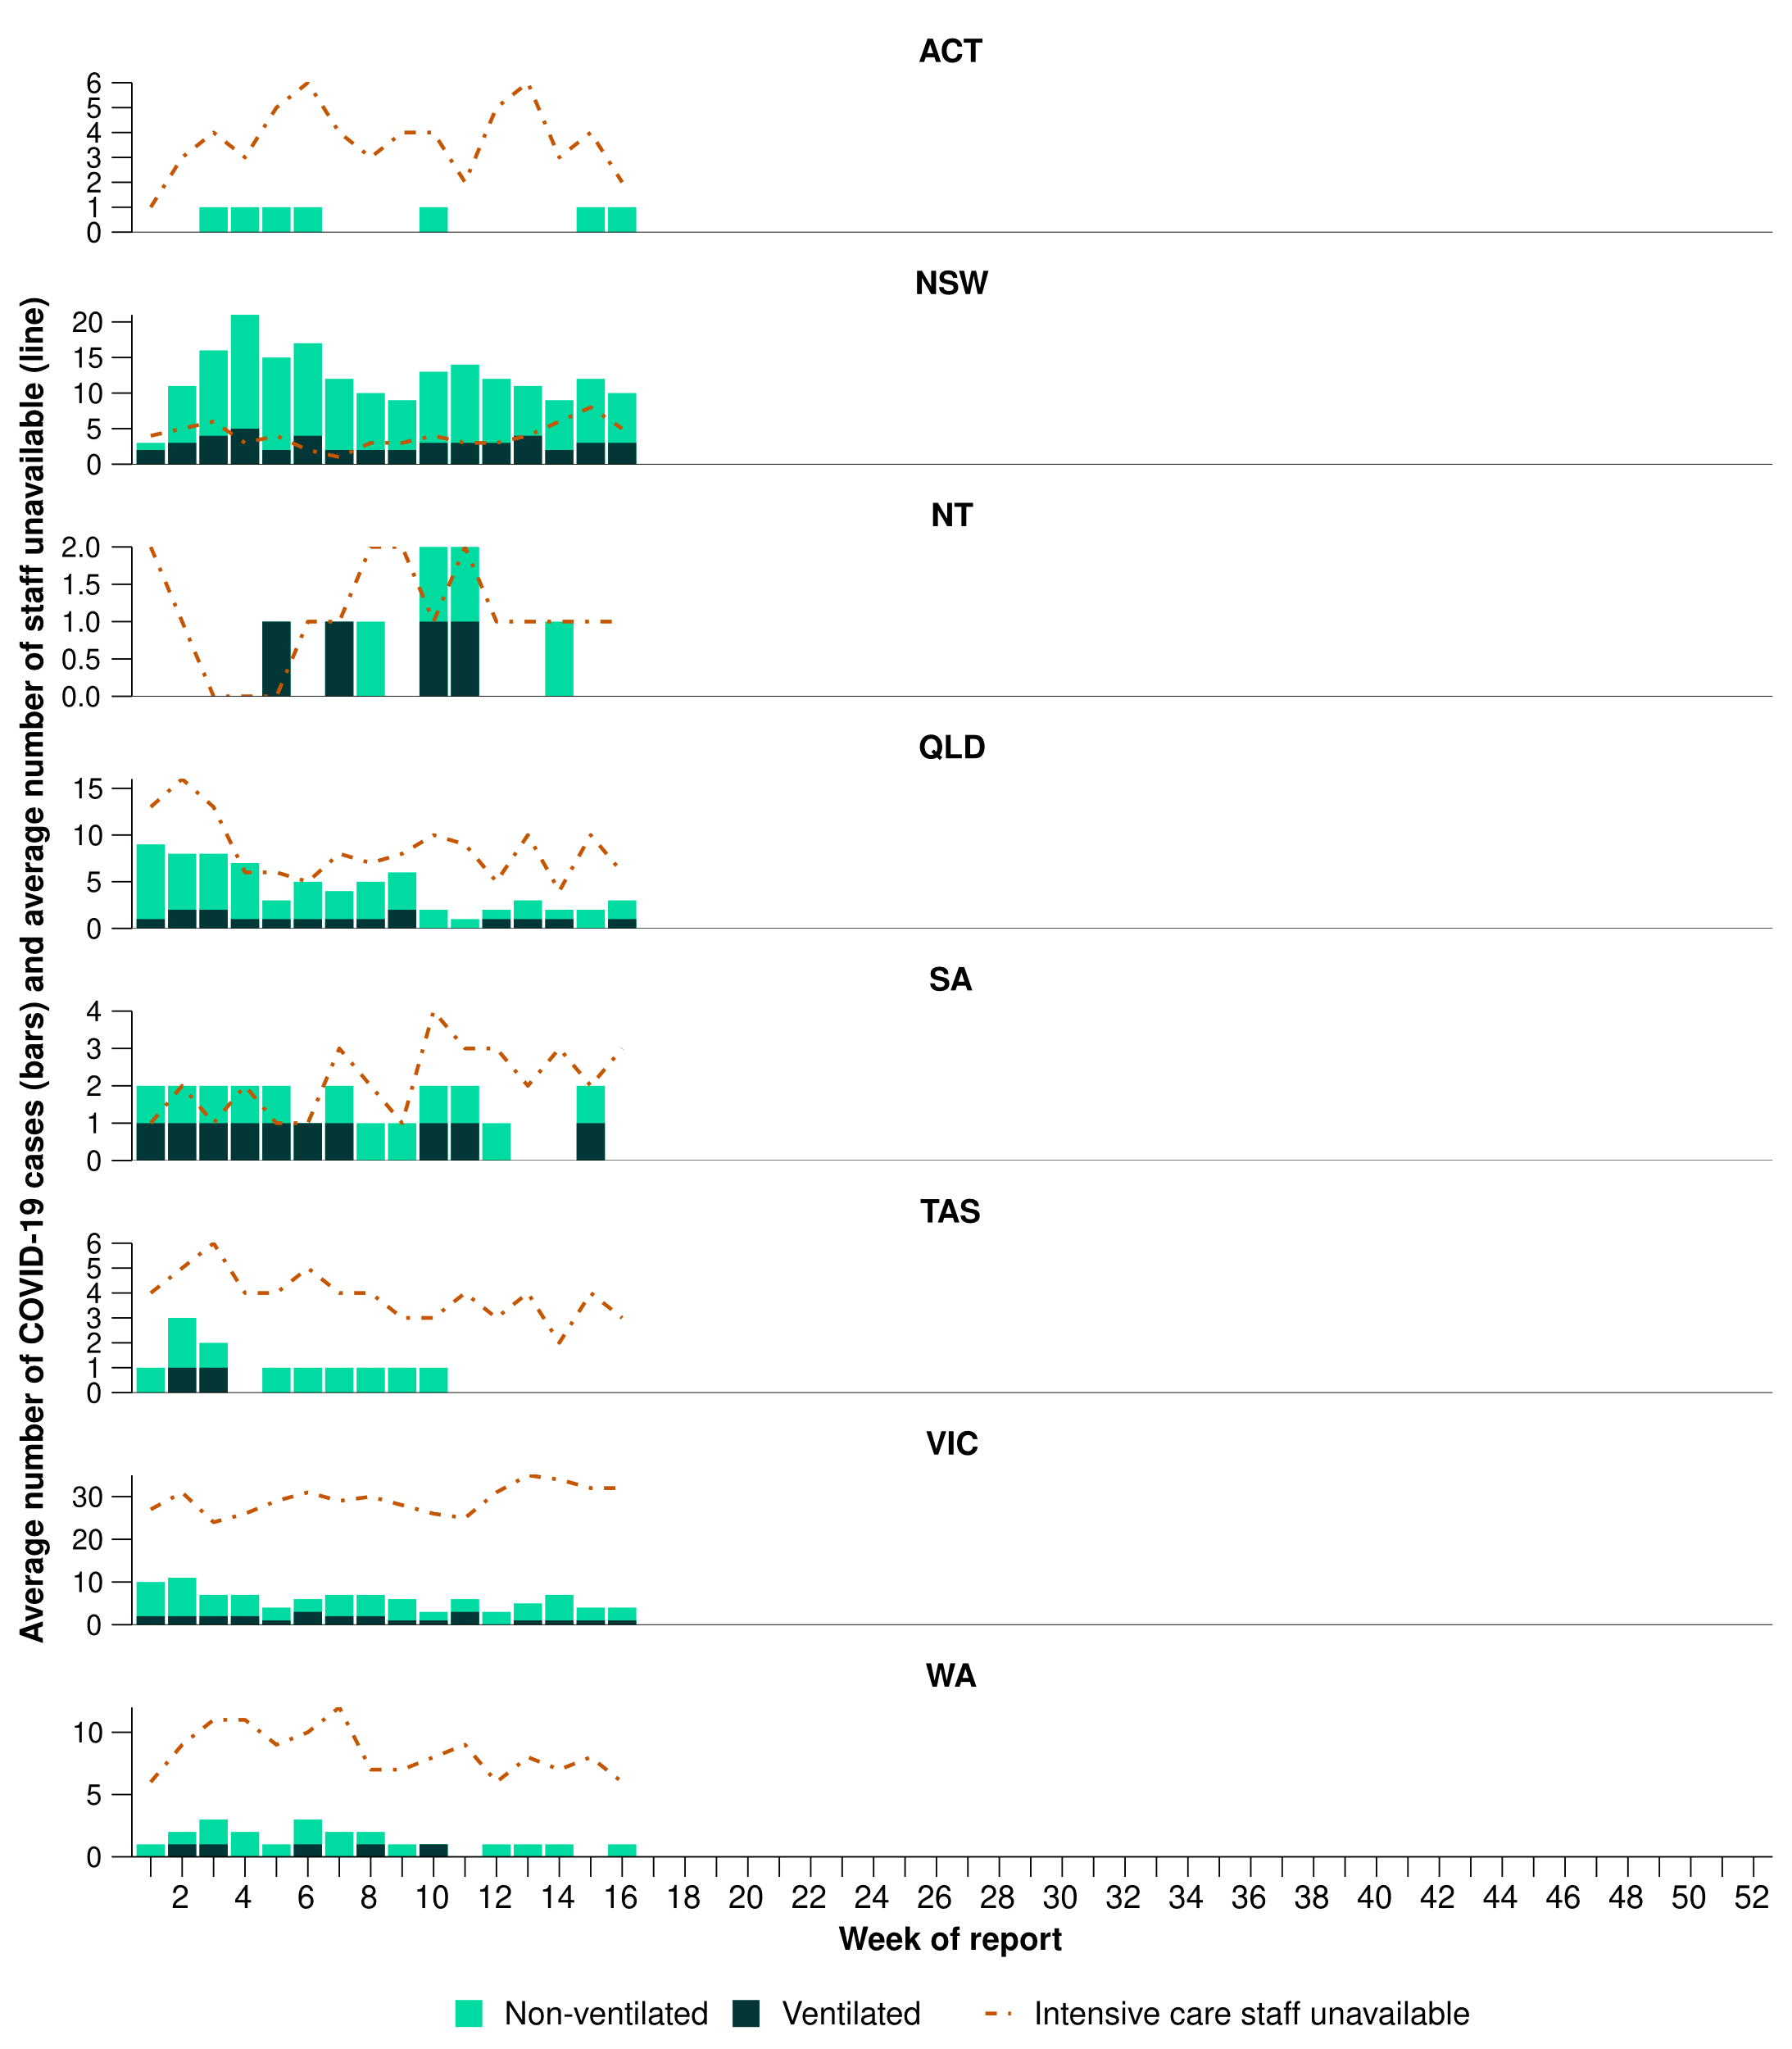

Source: Critical Health Resource Information System (CHRIS)  
* Axis varies between jurisdictions.  
† Average number of ventilated and non-ventilated COVID-19 cases in intensive care includes only active COVID-19 cases (those in isolation) and does not include cleared COVID-19 cases.  
‡ Intensive care staff include both medical and nursing staff. Staff unavailability will be underestimated in NSW as most public hospitals in NSW do not report staff unavailability.

# Mortality surveillance

Death registrations can provide information on the scale and severity of disease associated with acute respiratory infections. Please note, this report presents Provisional Mortality Statistics by number of deaths *due to* and deaths *with* acute respiratory infection. For more information on death registrations, including completeness, timeliness, and definitions of deaths *due to* and *with* acute respiratory infections, refer to the [Technical Supplement](https://www.health.gov.au/resources/publications/technical-supplement-australian-respiratory-surveillance-report) for more information.

Please note, the latest release of the Provisional Mortality Statistics is 31 March 2025, as such the mortality surveillance data presented here have not been updated since the previous report.

* There are more deaths *due to* COVID-19 and influenza than deaths *with* COVID-19 and influenza across 2023–2025. In contrast, there are substantially more people who died *with* RSV than *due to* RSV across 2023–2025.
* There were 228 deaths due to COVID-19 in January 2025, an increase since the low recorded in October 2024 (140 deaths); however, the number of deaths *due to* COVID-19 in January 2025 remains well below the number of deaths *due to* COVID-19 at the same time in previous years.
* There were 26 deaths *due to* influenza in January 2025, up from 12 deaths in December. This is comparable to January 2024 (27 deaths) though well above January 2023 (8 deaths).
* There were 10 deaths *with* RSV in January 2025, comparable to the 8 deaths in January 2024.

**Figure 18: Provisional numbers of deaths *due to* (left) or deaths *with* (right) acute respiratory infection*†‡ by month, year, and disease, Australia, 1 January 2023 to 28 February 2025**

A set of six line graphs comparing the number of deaths due to (where the disease started the chain of events leading to death and is listed as the underlying cause of death on the medical certificate cause of death ) or deaths with acute respiratory infection (where a person has died from another cause, but the viral respiratory infection contributed to death) by month, year and respiratory infection in Australia, from January 2023 to March 2025. The y-axis (left) for each graph represents the number of deaths, and the x-axis (horizontal) for each graph represents month of death from January to December. 

The top two graphs show the number of deaths due to COVID-19 (left), and the number of deaths with COVID-19 (right). The middle two graphs show the number of deaths due to influenza (left), and the number of deaths with influenza (right). The bottom two graphs show the number of deaths due to RSV (left), and the number of deaths with RSV (right).

Source: Australian Bureau of Statistics, [Provisional Mortality Statistics, Jan - Dec 2024](https://www.abs.gov.au/statistics/health/causes-death/provisional-mortality-statistics/jan-dec-2024), released 31 Mar 2025.  
* Axis varies between acute respiratory infections, and by deaths *due to* or *with* an acute respiratory infection.  
† Data is provisional and subject to change. It can take several weeks for death registrations to be reported, processed, coded, validated, and tabulated. Therefore, the data shown here may be incomplete, and will likely not include all deaths that occurred during a given time. Additionally, data for some months were not published by the ABS due to small counts, and therefore data for these months are not reported in Figure 18. Data includes all deaths (both doctor and coroner certified) that occurred and were registered by 28 February 2025.  
‡ All deaths due to/with COVID-19 in this report have been coded to ICD-10 codes U07.1-U07.2, U10.9. All deaths due to/with influenza have been coded to J09-J11. All deaths due to/with RSV have been coded to J12.1, J20.5, J21.0, B34.8 with B97.4.

# Laboratory surveillance

Sentinel laboratory surveillance monitors and characterises respiratory pathogens to provide information on what pathogens are circulating, potential changes in the pathogens that might affect their infectiousness, severity, ability to evade vaccine and/or infection-acquired immunity, or resistance to antivirals.

* This fortnight (7 April to 20 April 2025), SARS-CoV-2 test positivity has slightly decreased to 2.6% (325/12,489), influenza positivity has slightly increased to 5.3% (790/14,851), and RSV positivity has slightly increased to 2.2% (281/12,489) (Figure 19).
  + SARS-CoV-2 data are unavailable from WA for this fortnight due to technical issues.

**Figure 19: Number of tests positive (bars) and test positivity (line) for SARS-CoV-2, influenza or RSV of those specimens tested by sentinel laboratories by week of report*†, Australia, 1 January to 20 April 2025**

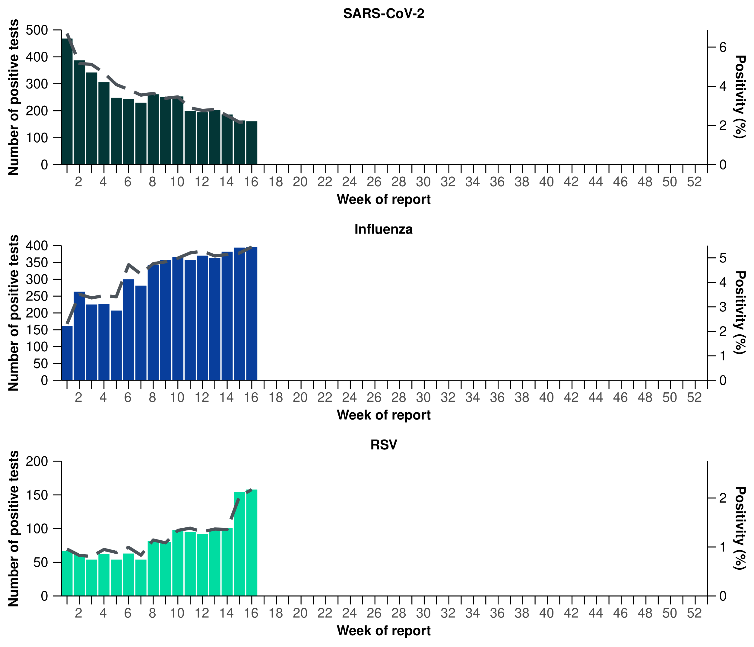

Source: Sentinel laboratories, including National Influenza Centres  
* Number of specimens tested excludes data from WA as testing denominator data are different for the three pathogens in WA. SARS-CoV-2 data are unavailable from WA for this fortnight due to technical issues.   
† A small minority of total samples from Vic are tested only by respiratory panel (influenza, parainfluenza, adenovirus, human metapneumovirus, seasonal coronaviruses, RSV, and some picornaviruses) but not for SARS-CoV-2. These minority samples include only forensic materials; all other samples are tested by respiratory panel and SARS-CoV-2 assay.

* There were 289 SARS-CoV-2 sequences uploaded to AusTrakka with dates of collection in the past 28 days (24 March to 20 April 2025). These sequences were from NSW, Qld, SA, Tas, and WA, with the most recent collection date 6 April 2025.
* All sequences were assigned to the BA.2.86 sub-lineage within B.1.1.529 (Omicron) or recombinants consisting of one or more Omicron sub-lineages (Figure 20). There were no BA.1, BA.3, BA.4, BA.5 or other BA.2 sub-sub-lineage sequences. In the past 28 days (24 March to 20 April 2025):
  + 38.8% (112/289) of sequences were from the sub-sub-lineages JN.1 (BA.2.86.1.1), including KP.3 (56/289). No sequences were identified from KP.2.
  + 61.2% (177/289) of sequences were recombinant or recombinant sub-lineages, including XEC, a recombinant between KS.1.1 (JN.1.13.1.1.1) and KP.3.3.
* XEC is now the dominant sublineage identified in AusTrakka among sequences with dates of collection in the past 28 days (Figure 20a).
* The World Health Organization (WHO) have identified certain sub-sub-lineages and recombinants as variants under monitoring (VUM) or variants of interest (VOI) because of their epidemiological, pathological, or immunological features of concern. A select number of designated VUM or VOI are highlighted below due to their relevance in the Australian context:
  + There are 380 LP.8.1 sequences in AusTrakka, with 36 collected in the past 28 days. LP.8.1 was designated as a VUM as of 24 January 2025. The [February WHO Risk Evaluation](https://www.who.int/publications/m/item/risk-evaluation-for-sars-cov-2-variant-under-monitoring-lp81), noted the proportion of LP.8.1 sequences is growing rapidly compared to co-circulating variants; however, there is no significant increase in case numbers associated with LP.8.1 infections, and there are no reports to suggest that the associated disease severity is higher.
  + There are 2,892 XEC sequences in AusTrakka, including 159 collected in past 28 days.
  + There are 353 LB.1 sequences in AusTrakka, with four sequences identified in the past 28 days.
  + There are 2,710 KP.3.1.1 sequences in AusTrakka, with 52 sequences identified in the past 28 days.

**Figure 20a: SARS-CoV-2 Omicron sub-lineage* sequences by sample collection date, showing the proportions of sequences per week^†, Australia, 1 January to 20 April 2025**

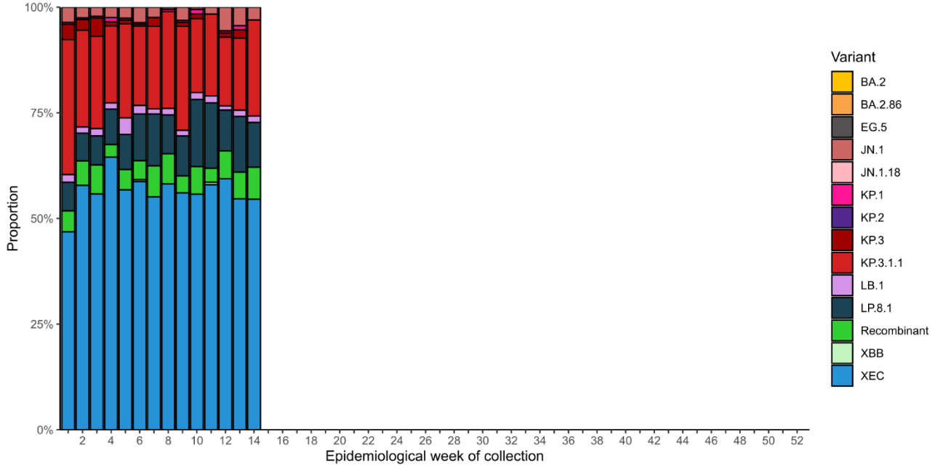

Source: AusTrakka  
* Some sub-sublineages are shown alongside their parent lineage, but not included in the parent lineage totals. For instance, KP.2 and KP.3 are sub-sub lineages of JN.1, so the total of JN.1 sequences will be higher than shown in the corresponding colour alone, and should include the KP.2 and KP.3 totals.  
^ Sequences in AusTrakka aggregated by week and reported based on date of sample collection, not date of sequencing.  
† Proportions in Figure 20a may not be representative when sequence numbers are small; refer to Figure 20b. Data for earlier weeks may change between reporting periods as sequences with older collection dates are uploaded. These numbers are not equivalent to number of cases, as there are many cases which may not be sequenced. Non-VOI and non-VUM Omicron sub-lineages have been collapsed into parent lineages BA.1, BA.2, BA.3, BA.4 and BA.5.

**Figure 20b: SARS-CoV-2 Omicron sub-lineage* sequences by sample collection date, showing the count of sequences per week^†, Australia, 1 January to 20 April 2025**

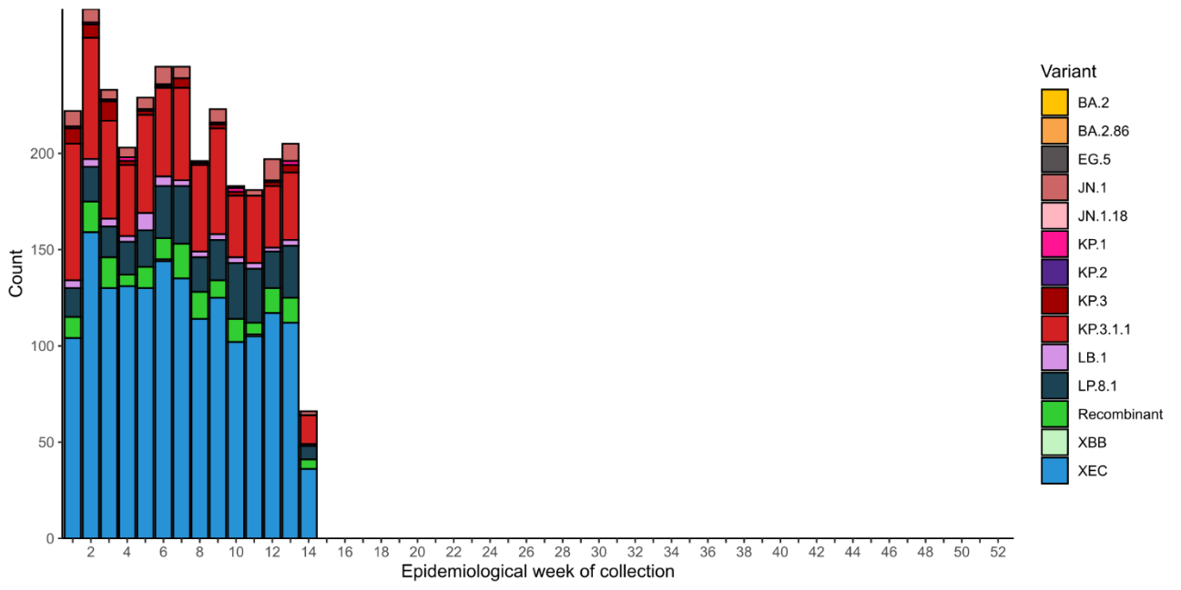

Source: AusTrakka  
* Some sub-sublineages are shown alongside their parent lineage, but not included in the parent lineage totals. For instance, KP.2 and KP.3 are sub-sub lineages of JN.1, so the total of JN.1 sequences will be higher than shown in the corresponding colour alone, and should include the KP.2 and KP.3 totals.  
^ Sequences in AusTrakka aggregated by week and reported based on date of sample collection, not date of sequencing.  
† Data for earlier weeks may change between reporting periods as sequences with older collection dates are uploaded. These numbers are not equivalent to number of cases, as there are many cases which may not be sequenced. Non-VOI and non-VUM Omicron sub-lineages have been collapsed into parent lineages BA.1, BA.2, BA.3, BA.4 and BA.5.

* In the year to date, the WHO Collaborating Centre for Reference and Research on Influenza has antigenically characterised 917 influenza viruses from Australia (Table 4), of which:
  + 66.4% (609/917) have been influenza A(H1N1)
  + 19.0% (174/917) have been influenza A(H3N2)
  + 14.6% (134/917) have been influenza B/Victoria.
* There continue to be no influenza B/Yamagata viruses characterised (Table 4). The last influenza B/Yamagata virus characterised in Australia was in a sample from 2020.
* Of the influenza A(H1N1) samples tested for neuraminidase inhibitor resistance, 0.3% (1/294) demonstrated highly reduced inhibition to Oseltamivir. None of the influenza A(H3N2) samples tested for neuraminidase inhibitor resistance demonstrated highly reduced inhibition to Oseltamivir.
* None of the samples tested demonstrated highly reduced inhibition to Zanamivir.

**Table 4: Australian influenza viruses typed by haemagglutination inhibition assay and jurisdiction*†, 1 January to 20 April 2025**

| **Strain** | **ACT** | **NSW** | **NT** | **Qld** | **SA** | **Tas** | **Vic** | **WA** | **Total** |
| --- | --- | --- | --- | --- | --- | --- | --- | --- | --- |
| A(H1N1) | 107 | 53 | 193 | 15 | 16 | 73 | 148 | 4 | **609** |
| A(H3N2) | 10 | 15 | 78 | 5 | 2 | 9 | 53 | 2 | **174** |
| B/Victoria lineage | 23 | 15 | 20 | 1 | 6 | 15 | 48 | 6 | **134** |
| B/Yamagata lineage | 0 | 0 | 0 | 0 | 0 | 0 | 0 | 0 | **0** |
| **Total** | **140** | **83** | **291** | **21** | **24** | **97** | **249** | **12** | **917** |

Source: World Health Organization (WHO) Collaborating Centre for Reference and Research on Influenza  
*Viruses tested by the WHO Collaborating Centre for Reference and Research on Influenza are not necessarily a random sample of all those in the community and early-year data may be based on limited samples received. There may be up to a month delay on reporting of samples.  
† Jurisdiction indicates the residential location for the individual tested, not the submitting laboratory.

# Vaccine coverage, effectiveness and match

Vaccine coverage, effectiveness and match for acute respiratory infections are monitored from several data sources in Australia. Refer to the [Technical Supplement](https://www.health.gov.au/resources/publications/technical-supplement-australian-respiratory-surveillance-report) for more information.

### Vaccine coverage

* In Australia, regular COVID-19 vaccinations are the best way to maintain protection against severe disease and death from COVID-19. Most adults should receive a COVID-19 vaccine each year to stay protected against severe illness, hospitalisation, and death. Adults aged 75 years and over should get vaccinated every six months.
  + Information on COVID-19 vaccination in Australia is available [here](https://www.health.gov.au/our-work/covid-19-vaccines/getting-your-vaccination) and [here](https://ncirs.org.au/public/covid-19-vaccines).
* Nationally, fewer adults (aged 18 years or over) have received a COVID-19 vaccine in the past 12 months (10.0%; Table 5), compared to the 12 months prior (18.1% in 17 April 2023 to 14 April 2024).
  + Coverage decreased in all age groups, with the largest decrease seen in 65–74 years age group (from 41.8% in the 12 months prior to 23.5% in the past 12 months).
* In the past 12 months, there was not substantial variation in coverage across jurisdictions, ranging from 16.8% in Tas to 4.0% in the NT (Table 5).

**Table 5: COVID-19 vaccine coverage*†‡** **by age group and jurisdiction, Australia, 15 April 2024 to 20 April 2025**

| **Age group** | **ACT** | **NSW** | **NT** | **Qld** | **SA** | **Tas** | **Vic** | **WA** | **Total** |
| --- | --- | --- | --- | --- | --- | --- | --- | --- | --- |
| **Past 12 months (15 April 2024 to 20 April 2025)** | | | | | | | | | |
| 18–64 years | 9.4 | 3.9 | 2.1 | 4.1 | 4.4 | 7.8 | 5.0 | 3.9 | 4.4 |
| 65–74 years | 41.0 | 22.1 | 13.9 | 22.0 | 24.3 | 34.2 | 24.5 | 23.0 | 23.5 |
| ≥ 75 years | 58.8 | 36.3 | 24.9 | 35.6 | 37.9 | 50.7 | 38.2 | 38.0 | 37.9 |
| All persons (18 years or over) | 16.3 | 9.4 | 4.0 | 9.3 | 11.0 | 16.8 | 10.4 | 9.3 | 10.0 |
| **Past 6 months (21 October 2024 to 20 April 2025)** | | | | | | | | | |
| 18–64 years | 3.6 | 1.5 | 0.8 | 1.7 | 1.7 | 3.0 | 1.8 | 1.2 | 1.7 |
| 65–74 years | 21.9 | 10.5 | 6.1 | 11.9 | 13.3 | 17.5 | 11.9 | 10.6 | 11.7 |
| ≥ 75 years | 36.7 | 20.9 | 11.9 | 22.1 | 23.6 | 30.7 | 22.4 | 21.5 | 22.4 |
| All persons (18 years or over) | 8.0 | 4.6 | 1.7 | 4.9 | 5.8 | 8.5 | 5.0 | 4.2 | 4.9 |

Source: Australian Immunisation Register (AIR) as at 20 April 2025  
* COVID-19 vaccine coverage uses the Australian Bureau of Statistics June 2023 Estimated Resident Population (ERP) as denominator.  
† COVID-19 vaccination uptake and coverage are influenced by changes in COVID-19 vaccine recommendations and eligibility criteria. For this reason, caution should be used when comparing coverage rates in the current 12 month period to previous 12 month periods.  
‡ Jurisdiction is based on the state or territory in which a vaccine was administered and may differ from a person’s residential. Population denominator data used to calculate COVID-19 vaccine coverage are based on an individual’s residential address.

* Influenza and RSV vaccine coverage are not yet available; however, will be included in future reports.

### Vaccine effectiveness

* It is too early to assess vaccine effectiveness for the 2025 influenza season.

### Vaccine match

* Refer to the [Technical Supplement](https://www.health.gov.au/resources/publications/technical-supplement-australian-respiratory-surveillance-report) for information on the 2025 southern hemisphere influenza vaccines composition.
* In the year to date, 98.4% (599/609) of influenza A(H1N1) isolates, 100% (174/174) of influenza A(H3N2) isolates and 100% (134/134) of influenza B/Victoria lineage isolates characterised have been antigenically similar to the corresponding 2025 vaccine components.