Australian Respiratory Surveillance Report

# Key messages

This report presents a national epidemiological update for acute respiratory infections, including coronavirus disease 2019 (COVID-19), influenza and respiratory syncytial virus (RSV), with a focus on the current reporting period (30 December 2024 to 26 January 2025) and earlier severity reporting periods (up to 12 January 2025).

**In the community:** Respiratory illness activity (self-reported new fever and cough symptoms) is currently lower than observed at the same time in previous years. Fewer people reported taking time off work due to respiratory illness (self-reported new fever and cough symptoms) this month, compared with the previous month. This month the number of COVID-19 cases remains low. The number of influenza cases this month is slightly higher than the five-year average and the number of cases seen in the same period in previous years; however, influenza case numbers remain at low interseasonal levels. This month, the number of RSV cases remains low and is consistent with the number of cases seen in the same interseasonal period in previous years.

**In general practice:** There were slightly fewer influenza-like-illness (new fever and cough symptoms) consultations in sentinel surveillance sites this month; however, similar to 2024, influenza-like-illness rates this month remain slightly higher than observed at the same time in previous years and than the five-year average.

**In hospitals:** Sentinel hospital-based surveillance shows the proportion of patients with severe acute respiratory infections has remained low and stable this severity reporting period. Most patients were admitted with COVID-19. The length of hospital stay varies only slightly between illnesses. The proportion of those patients with a severe acute respiratory infection who were admitted directly to a sentinel surveillance intensive care has remained low. More children (those aged 16 years and younger) were admitted with COVID-19 and influenza than with RSV at sentinel hospitals, while more adults were admitted with COVID-19 compared to influenza or RSV. Sentinel intensive care surveillance shows the overall number of patients with severe acute respiratory infections has decreased. The duration of intensive care varies slightly between illnesses. The average number of COVID-19 cases in intensive care has increased this month (though this may be driven by artefacts, such as technical issues leading to the underreporting of case numbers), while the average number of intensive care staff unavailable due to COVID-19 illness or exposure has decreased.

**Deaths:** COVID-19 has been the leading cause of acute respiratory infection mortality across 2022-2024. All three acute respiratory infections (COVID-19, influenza and RSV) under surveillance are more likely to cause death in older age groups than younger age groups. Please note, the Australian Bureau of Statistics acute respiratory infection mortality reporting provides data up to 30 November 2024 only.

**In laboratories:** Test positivity for SARS-CoV-2, influenza and RSV remained low and stable this month, though a slight increase in influenza test positivity was observed. The recombinant lineage XEC is now the dominant SARS-CoV-2 variant in Australia, outnumbering JN.1 sub-lineage sequences for the first time. On 24 January 2025, the World Health Organization designated LP.8.1 as a variant under monitoring. There is currently limited information available about the risk posed by LP.8.1 as this variant is still being characterised. Small numbers of LP.8.1 sub-lineage sequences have been observed in Australia.

**Vaccine coverage, effectiveness and match:** It is too early to assess or report vaccine data for 2025.

# Australian Respiratory Surveillance Report

This report was prepared by Gizem Bilgin, Nga Nguyen, Jenna Hassall, and Siobhan St George on behalf of the interim Australian Centre for Disease Control. We thank the staff and participants from the surveillance systems who contribute data for acute respiratory illness surveillance across Australia.

The report presents a national overview of acute respiratory infections in Australia, drawing information from several different surveillance systems. These surveillance systems help us to understand the distribution of acute respiratory illnesses in the community, the severity of infections including which populations might be at risk, and the impact of acute respiratory illnesses on the community and health system in Australia.

Surveillance indicators presented in this report are based on the [Australian National Surveillance Plan for COVID-19, Influenza, and RSV](https://www.health.gov.au/resources/publications/australian-national-disease-surveillance-plan-for-covid-19-influenza-and-rsv). Please refer to the [Technical Supplement – Australian Respiratory Surveillance Report](https://www.health.gov.au/resources/publications/technical-supplement-australian-respiratory-surveillance-report) for information on our surveillance sources and data considerations, including the considerable impact of the COVID-19 pandemic on acute respiratory infection surveillance in Australia. A summary of data considerations for this report are provided below:

* Due to the dynamic nature of the surveillance systems used in this report, surveillance data are considered preliminary and subject to change as updates are received, with the most recent weeks considered particularly incomplete. Data in this report may vary from data reported in other national reports and reports by states and territories.
* Data in this report are presented by date of event (diagnosis, admission or death) or by the International Organization for Standardization (ISO) week date system, with weeks defined as seven-day periods which begin on a Monday and end on a Sunday. The ISO week date system is used to support trends comparisons over time more effectively. The current reporting period this month includes 30 December to 26 January 2025 and where comparisons to the previous month are made this includes 2 December to 29 December 2024.
* In Australia, states and territories report notified cases to the National Notifiable Diseases Surveillance System (NNDSS) based on the [Australian national surveillance case definitions](https://www.health.gov.au/resources/collections/cdna-surveillance-case-definitions). NNDSS data are analysed and reported based on diagnosis date, which is the true onset date of a case if known, otherwise it is the earliest of the specimen date, the notification date, or the notification received date. The NNDSS data for this report were extracted on 29 January 2025.
* To account for the lag in collection and provision of severity data from some surveillance systems, and for the time delay between illness onset and the development of severe disease outcomes, cases with an admission date or a diagnosis date in the last two weeks are excluded from severity analyses for hospitalisations and intensive care admissions. As such, the severity reporting periods are two weeks behind the end of the current reporting period. For this report, severity reporting includes data from 16 December 2024 to 12 January 2025 and where comparisons to the previous severity month are made this includes 18 November to 15 December 2024.
* Death registrations from the Australian Bureau of Statistics (ABS) Provisional Mortality Statistics are now used as the primary data source for measuring acute respiratory infection associated deaths. The ABS mortality data is sourced from the Registry of Births, Deaths and Marriages and is separate from the NNDSS. Registration-based mortality data needs time to be received and processed. For this reason, mortality statistics in this report may lag by at least two months.
* While every care has been taken in preparing this report, the Australian Government Department of Health and Aged Care does not accept liability for any injury or loss or damage arising from the use of, or reliance upon, the content of the report or Technical Supplement. For further information about this report refer to the [Technical Supplement – Australian Respiratory Surveillance Report](https://www.health.gov.au/resources/publications/technical-supplement-australian-respiratory-surveillance-report) or contact [respiratory.surveillance@health.gov.au](mailto:respiratory.surveillance@health.gov.au).

# Community surveillance

Community surveillance monitors respiratory illnesses in the community, providing information on the number of people reporting respiratory symptoms, testing practices, and the impact of respiratory illnesses. Community surveillance also includes notification data obtained from laboratory tests for infections. Infections that are diagnosed and notified are only a subset of the total number of infections occurring in the community.

* Community surveys indicate respiratory illness symptoms and test positivity remain low and stable this month, consistent with interseasonal levels in previous years.
* This month (30 December to 26 January 2025), fewer survey participants reported new fever and cough symptoms (0.9%), than in the previous month (1.3%) (Figure 1).
* This month, more survey participants with new fever and cough symptoms used a rapid antigen test (RAT) (65.1%; 536/823) than a polymerase chain reaction (PCR) test (14.8%; 122/823) to test for severe acute respiratory syndrome coronavirus 2 (SARS-CoV-2).
  + Self-reported SARS-CoV-2 RAT positivity was slightly higher this month (41.6%; 223/536) than in the previous month (40.3%; 317/786), while self-reported SARS-CoV-2 PCR positivity was lower this month (21.3%; 26/122) than in the previous month (24.3%; 45/185).
* This month, 18.2% (150/823) of survey participants with new fever and cough symptoms used a PCR test to test for influenza.
  + Self-reported influenza PCR positivity was higher this month (18.7%; 28/150), than in the previous month (11.5%; 33/286).
* In the year to date, the proportion of survey participants with new fever and cough symptoms has been lower than the same time in previous years (Figure 1).

**Figure 1: Age standardised percentage of survey participants reporting new fever and cough symptoms compared with the five-year average* by year and week of report, Australia, 2022 to 26 January 2025**

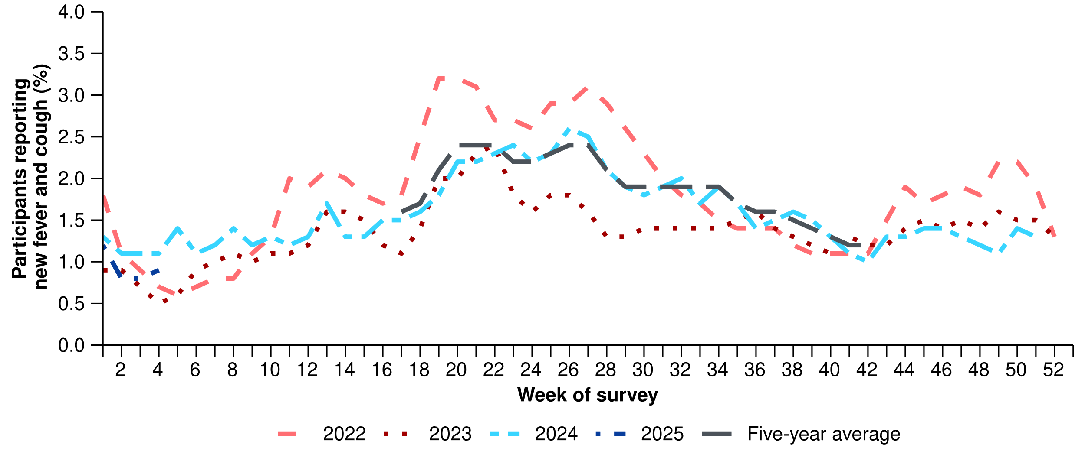

Source: FluTracking  
* From 2020, FluTracking expanded their data capture period to year-round. Data before May and after October for any year before 2020 are not available for historical comparisons. The years 2020 and 2021 are excluded when comparing the current season to historical periods when influenza virus has circulated without public health restrictions. As such, the five-year average includes the years 2018 to 2019 and 2022 to 2024. Please refer to the [Technical Supplement](https://www.health.gov.au/resources/publications/technical-supplement-australian-respiratory-surveillance-report) for interpretation of the five-year average.

* This month, fewer survey participants reported taking three or more days off work or normal duties due to fever and cough symptoms (45.6%; 375/823), than in the previous month (47.8%; 240/502).
* This month (30 December to 26 January 2025), there was a 18.9% decrease in COVID-19 notifications, a 92.7% increase in influenza notifications (described further below), and a 15.4% decrease in RSV notifications.

**Table 1: Notified COVID-19, influenza and RSV cases and notification rate per 100,000 population by disease, five-year age group, and jurisdiction*†, Australia, 30 December 2024 to 26 January 2025**

|  | **COVID-19** | | | **Influenza** | | | **RSV** | | |
| --- | --- | --- | --- | --- | --- | --- | --- | --- | --- |
|  | **Reporting period (n)** | **Year to date (n)** | **Year to  date (rate)** | **Reporting period (n)** | **Year to date (n)** | **Year to date (rate)** | **Reporting period (n)** | **Year to date (n)** | **Year to date (rate)** |
| **Age group (years)** | | | | | | | | | |
| 0–4 | 2,011 | 1,794 | 119 | 1,220 | 1,148 | 76 | 1,821 | 1,642 | 109 |
| 5–9 | 324 | 293 | 18 | 923 | 875 | 54 | 192 | 171 | 11 |
| 10–14 | 282 | 246 | 15 | 526 | 489 | 29 | 115 | 108 | 6 |
| 15–19 | 479 | 444 | 27 | 552 | 524 | 32 | 95 | 85 | 5 |
| 20–24 | 722 | 659 | 37 | 539 | 518 | 29 | 108 | 100 | 6 |
| 25–29 | 852 | 783 | 39 | 588 | 565 | 28 | 132 | 119 | 6 |
| 30–34 | 1,038 | 933 | 46 | 773 | 735 | 36 | 138 | 126 | 6 |
| 35–39 | 1,130 | 1,049 | 53 | 857 | 824 | 42 | 143 | 137 | 7 |
| 40–44 | 996 | 917 | 50 | 843 | 803 | 43 | 100 | 91 | 5 |
| 45–49 | 948 | 861 | 53 | 851 | 810 | 50 | 133 | 118 | 7 |
| 50–54 | 1,021 | 933 | 55 | 826 | 782 | 46 | 173 | 154 | 9 |
| 55–59 | 1,013 | 916 | 60 | 707 | 671 | 44 | 184 | 164 | 11 |
| 60–64 | 1,130 | 1,008 | 66 | 621 | 589 | 38 | 187 | 166 | 11 |
| 65–69 | 1,180 | 1,065 | 78 | 536 | 509 | 37 | 193 | 177 | 13 |
| 70+ | 7,574 | 6,653 | 199 | 1,596 | 1,499 | 45 | 922 | 811 | 24 |
| **Jurisdiction** | | | | | | | | | |
| ACT | 294 | 273 | 58 | 155 | 152 | 32 | 41 | 36 | 8 |
| NSW | 7,816 | 7,081 | 83 | 4,571 | 4,369 | 51 | 1,757 | 1,587 | 19 |
| NT | 248 | 225 | 88 | 123 | 121 | 47 | 76 | 62 | 24 |
| Qld | 6,032 | 5,335 | 96 | 2,438 | 2,302 | 41 | 1,808 | 1,594 | 29 |
| SA | 1,275 | 1,138 | 61 | 697 | 664 | 35 | 174 | 162 | 9 |
| Tas. | 253 | 228 | 40 | 169 | 159 | 28 | 75 | 68 | 12 |
| Vic. | 3,575 | 3,198 | 46 | 2,798 | 2,622 | 38 | 480 | 447 | 6 |
| WA | 1,213 | 1,081 | 36 | 1,007 | 952 | 32 | 225 | 213 | 7 |
| **Total** | **20,706** | **18,559** | **68** | **11,958** | **11,341** | **42** | **4,636** | **4,169** | **15** |

**Please note, the current reporting period (30 December 2024 to 26 January 2025) will contain more case notifications than the year to date period (1 January to 1 January 2025).**  
Source: National Notifiable Diseases Surveillance System (NNDSS). Notification data are unavailable for the Northern Territory from 25 January 2025 and for Tasmania from 24 January 2025.   
* Rate per 100,000 population for the given time period. Population data are based on the Australian Bureau of Statistics (ABS) [Estimated Resident Population (ERP) for the reference period June 2024, released 12 December 2024](https://www.abs.gov.au/statistics/people/population/national-state-and-territory-population/jun-2024).  
† Total includes cases with missing age.

* This month the number of COVID-19 cases remains low. The number of COVID-19 cases this month is lower than the number of cases at the same time last year and less than half the number of cases reported in the June 2024 peak (Figure 2).
* In the year to date, COVID-19 notification rates remain highest in people aged 70 years or over, likely due to higher case ascertainment from targeted testing strategies for populations at-risk of severe disease or who live in a high-risk setting such as a residential aged care home (Table 1).
* In the year to date, COVID-19 notification rates are highest in Queensland, the Northern Territory and New South Wales and lowest in Western Australia (Table 1; Figure 3).

**Figure 2: Notified COVID-19 cases (laboratory-confirmed only) by year and week of diagnosis, Australia, 2022 to 26 January 2025**

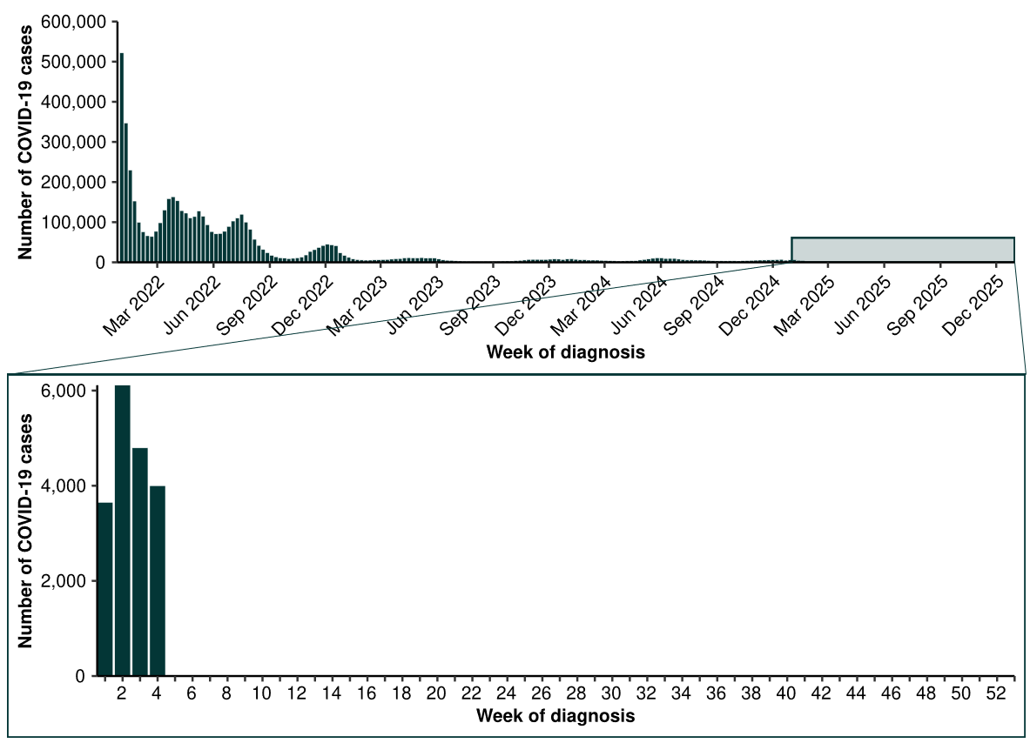

Source: National Notifiable Diseases Surveillance System (NNDSS). Notification data are unavailable for the Northern Territory from 25 January 2025 and for Tasmania from 24 January 2025.

**Figure 3: Notification rates* per 100,000 population for COVID-19 cases by state or territory and week of diagnosis, Australia, 1 January to 26 January 2025**

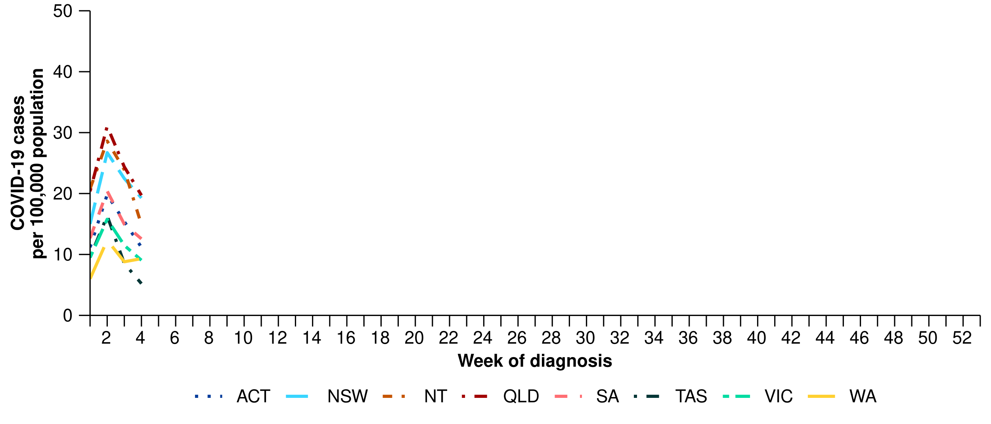

Source: National Notifiable Diseases Surveillance System (NNDSS). Notification data are unavailable for the Northern Territory from 25 January 2025 and for Tasmania from 24 January 2025.  
* Rate per 100,000 population for the given time period. Population data are based on the Australian Bureau of Statistics (ABS) [Estimated Resident Population (ERP) for the reference period June 2024, released 12 December 2024](https://www.abs.gov.au/statistics/people/population/national-state-and-territory-population/jun-2024)

* This month, the number of influenza cases remains low. The number of influenza cases this month is slightly higher than the five-year average and the number of cases seen in the same period in previous years; however, case numbers remain at low interseasonal levels (Figure 4a; Figure 4b).
  + The increase in the number of influenza cases this month is consistent with increases observed in previous summer periods (Figure 4a; Figure 4b).This increase could be due to increased influenza circulating in the community; however, could also be influenced by a number of factors:
    - changes in health-seeking behaviour (increased testing) associated with increases in COVID-19 circulation in the summer period.
    - changes in health-seeking behaviour (increased testing) as a result of public concern over media reports from early January about [human metapneumovirus (hMPV) cases](https://www.cdc.gov.au/newsroom/news-and-articles/australia-monitoring-international-increases-human-metapneumovirus-hmpv#:~:text=Incidence%20of%20hMPV%20in%20Australia,a%20respiratory%20pathogen%2C%20had%20hMPV.) in China.
* In the year to date, influenza notification rates are highest in children aged 0–4 years and 5–9 years (Table 1).
* In the year to date, influenza notification rates are highest in New South Wales and the Northern Territory and lowest in the Australian Capital Territory and Western Australia (Table 1; Figure 5).

**Figure 4a: Notified influenza cases and five-year average* by influenza subtype, year, week of diagnosis, Australia, 2022 to 26 January 2025**

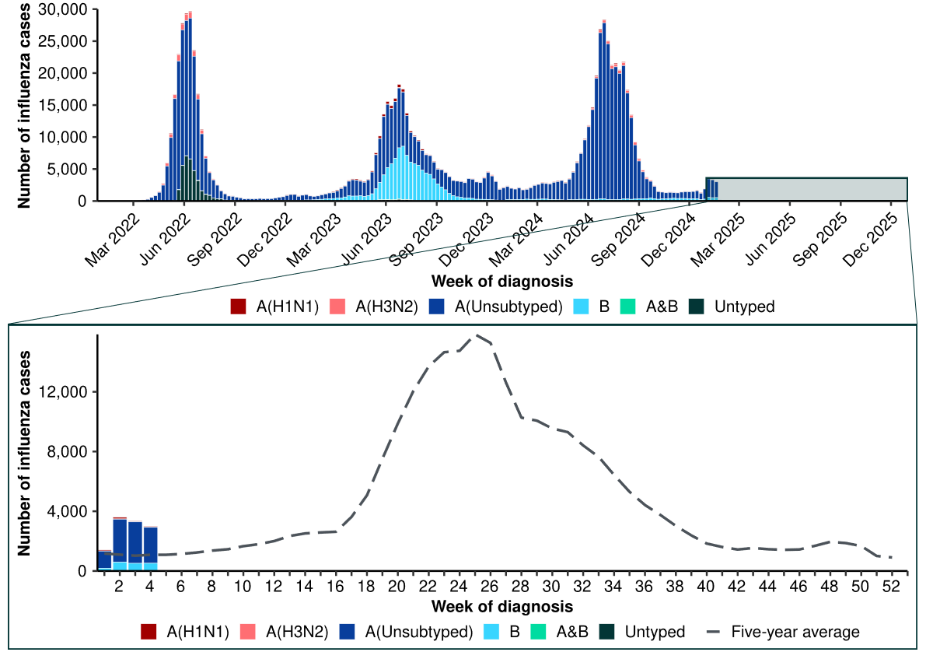  
Source: National Notifiable Diseases Surveillance System (NNDSS). Notification data are unavailable for the Northern Territory from 25 January 2025 and for Tasmania from 24 January 2025.  
* The years 2020 and 2021 are excluded when comparing the current season to historical periods when influenza virus has circulated without public health restrictions. As such, the five-year average includes the years 2018 to 2019 and 2022 to 2024. Please refer to the [Technical Supplement](https://www.health.gov.au/resources/publications/technical-supplement-australian-respiratory-surveillance-report) for interpretation of the five-year average.

**Figure 4b: Notified influenza cases by year and week of diagnosis, Australia, 2022 to 26 January 2025**

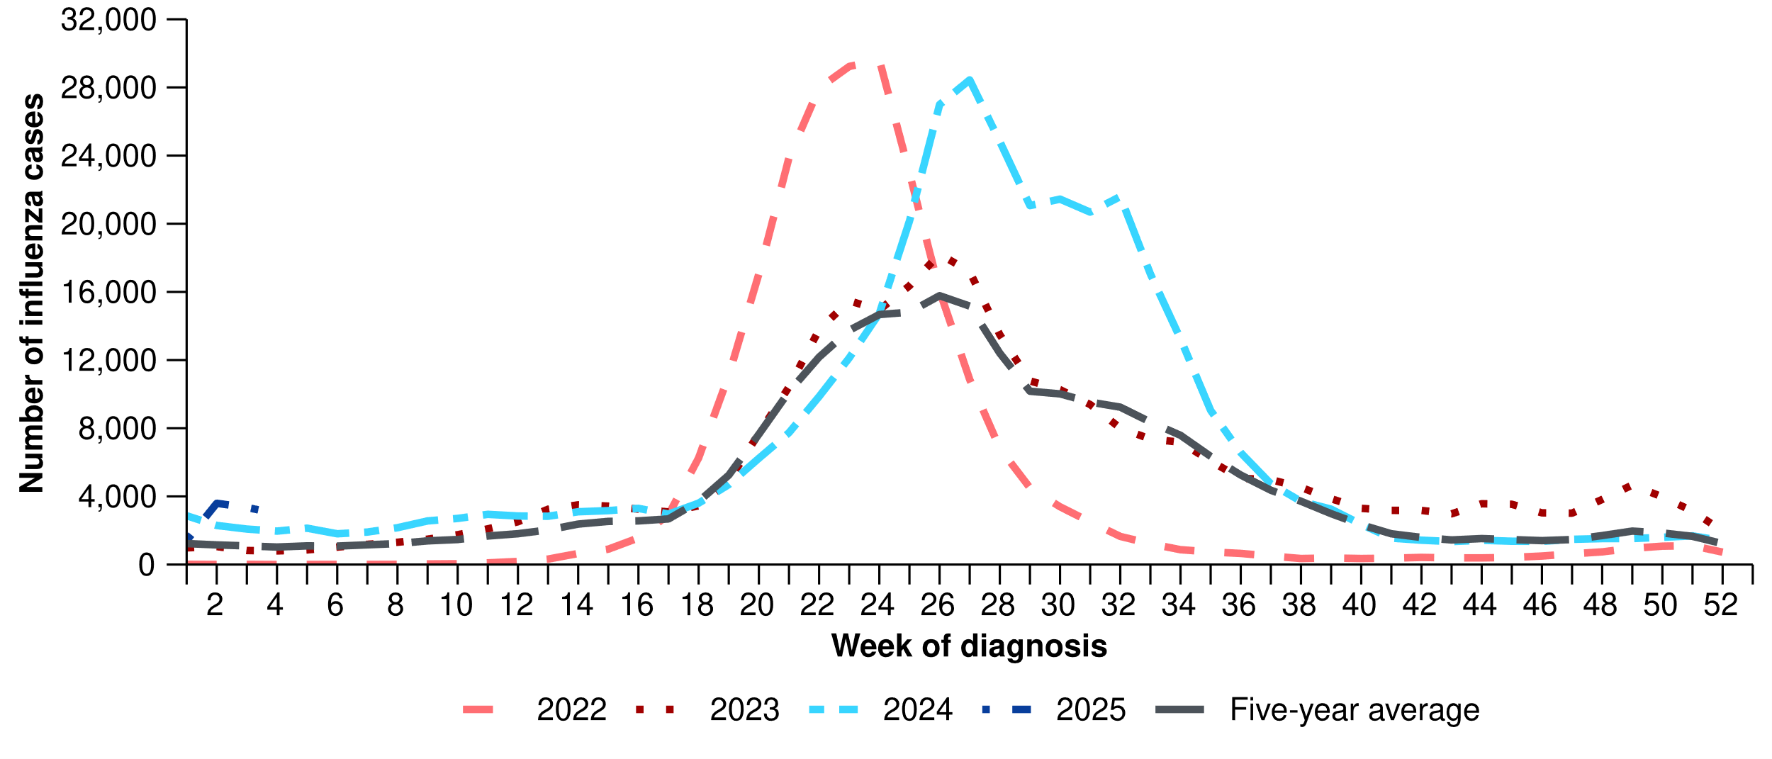

Source: National Notifiable Diseases Surveillance System (NNDSS). Notification data are unavailable for the Northern Territory from 25 January 2025 and for Tasmania from 24 January 2025.  
* The years 2020 and 2021 are excluded when comparing the current season to historical periods when influenza virus has circulated without public health restrictions. As such, the five-year average includes the years 2018 to 2019 and 2022 to 2024. Please refer to the [Technical Supplement](https://www.health.gov.au/resources/publications/technical-supplement-australian-respiratory-surveillance-report) for interpretation of the five-year average.

* This month, most influenza notifications were influenza A(Unsubtyped) (81.1%; 9,692/11,958), followed by influenza B (15.6%; 1,867/11,958) and there were seven influenza A&B co-detections (Figure 5).
  + Of the influenza A notifications that have been further subtyped, 86.4% (285/330) were influenza A(H1N1) and 21.8% (72/330) were influenza A(H3N2).
* In the year to date, influenza A has accounted for the majority of influenza notifications across all jurisdictions (Figure 5).

**Figure 5: Notified influenza cases by influenza subtype, jurisdiction and week of diagnosis, Australia, 1 January to 26 January 2025**

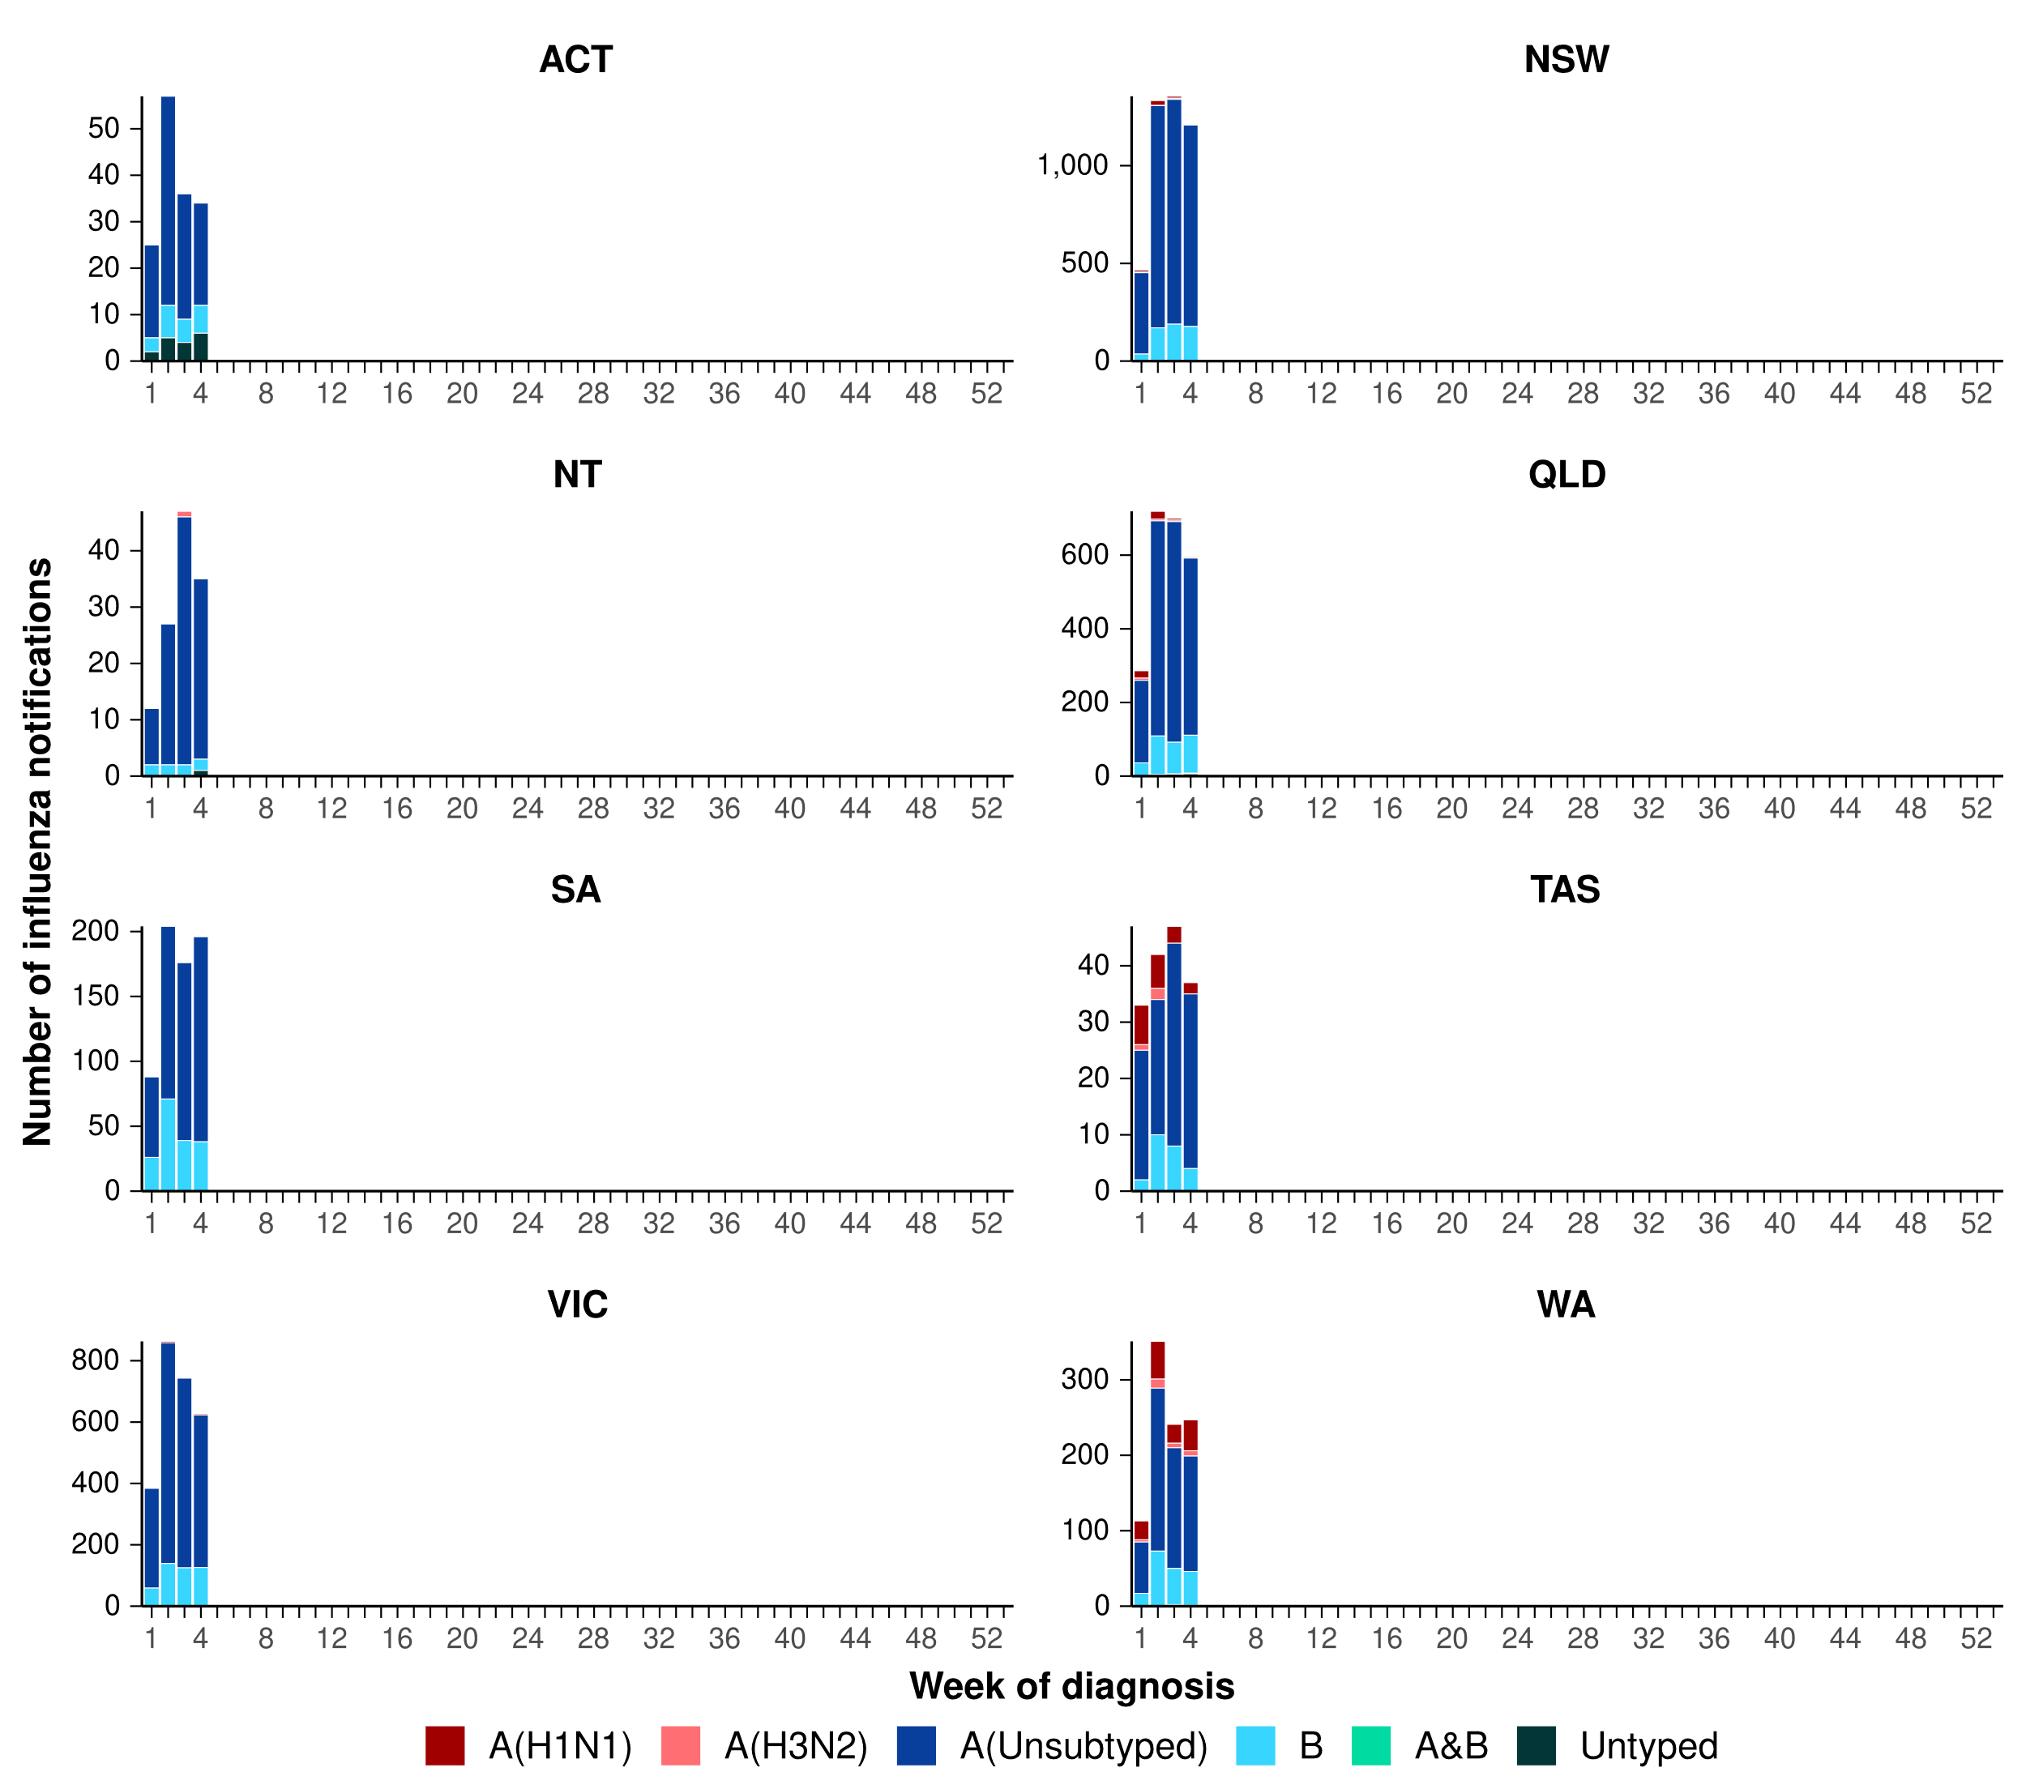

Source: National Notifiable Diseases Surveillance System (NNDSS). Notification data are unavailable for the Northern Territory from 25 January 2025 and for Tasmania from 24 January 2025.

**Figure 6: Notification rates* per 100,000 population for influenza cases by state or territory and week of diagnosis, Australia, 1 January to 26 January 2025**

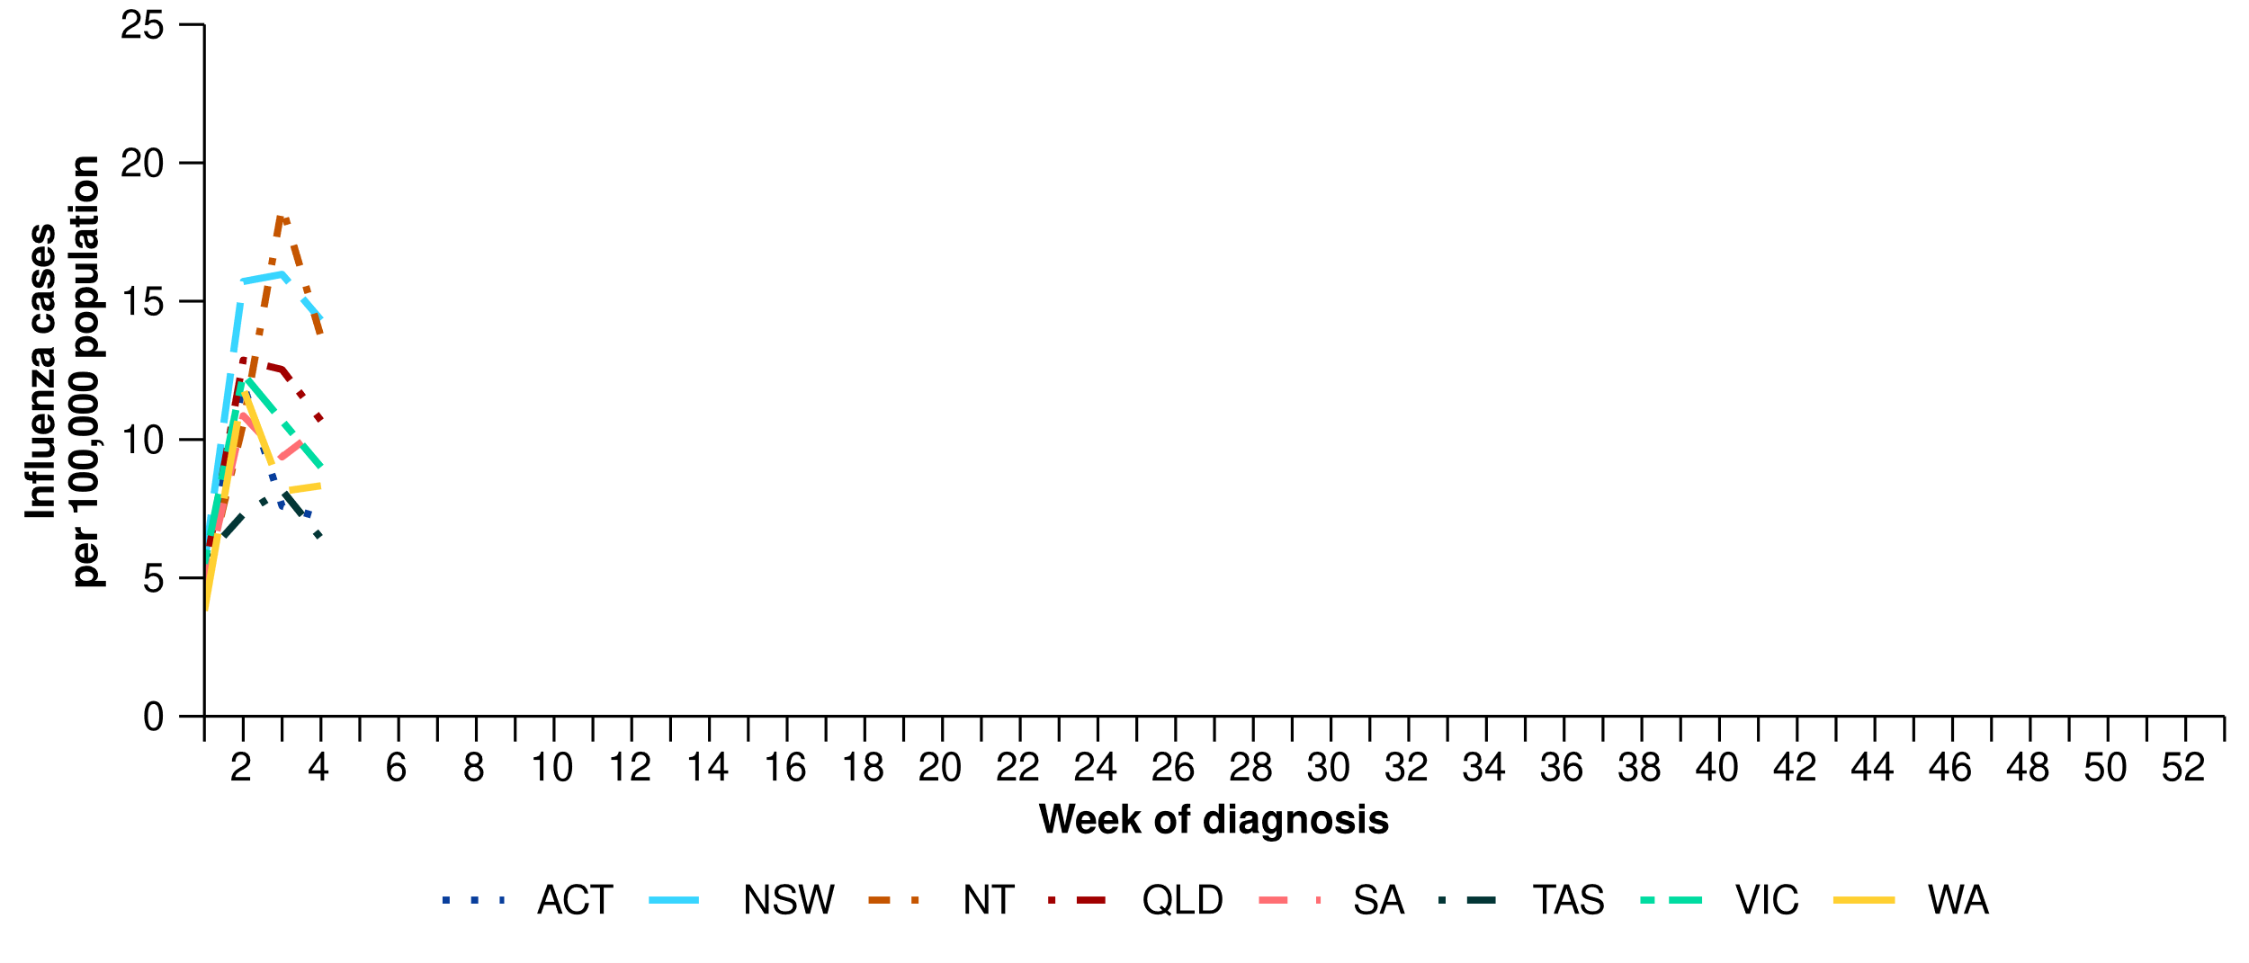

Source: National Notifiable Diseases Surveillance System (NNDSS). Notification data are unavailable for the Northern Territory from 25 January 2025 and for Tasmania from 24 January 2025.  
* Rate per 100,000 population for the given time period. Population data are based on the Australian Bureau of Statistics (ABS) [Estimated Resident Population (ERP) for the reference period June 2024, released 12 December 2024](https://www.abs.gov.au/statistics/people/population/national-state-and-territory-population/jun-2024).

* This month, the number of RSV cases remains low and consistent with the number of cases seen in the same interseasonal period in previous years. The number of RSV cases decreased this month, compared with the previous month where a small increase in RSV case numbers occurred; however, RSV cases numbers are beginning to trend upward overall (Figure 7).
  + Similar to influenza notification trends, the recent increase in RSV cases could be due to increased RSV circulating in the community; however, could also be influenced by the changes in health-seeking behaviour (increased testing) described above.
* In the year to date, RSV notification rates remain considerably higher in children aged 0–4 years than in other age groups (Table 1).
* In the year to date, RSV notification rates are highest in Queensland and the Northern Territory and lowest in Victoria and Western Australia (Table 1; Figure 8).

**Figure 7: Notified RSV cases by year and week of diagnosis*, Australia, 2023 to 26 January 2025**

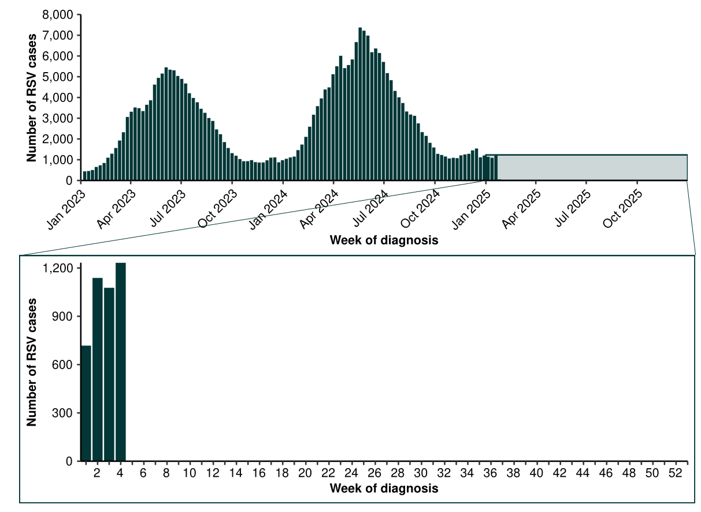

Source: National Notifiable Diseases Surveillance System (NNDSS). Notification data are unavailable for the Northern Territory from 25 January 2025 and for Tasmania from 24 January 2025. Please note, RSV became notifiable in all states and territories on 1 September 2022 and comprehensive national notification data became available after this point. For this reason, RSV notification trends are only presented from 1 January 2023.

**Figure 8: Notification rates* per 100,000 population for RSV cases by state or territory and week of diagnosis, Australia, 1 January to 26 January 2025**

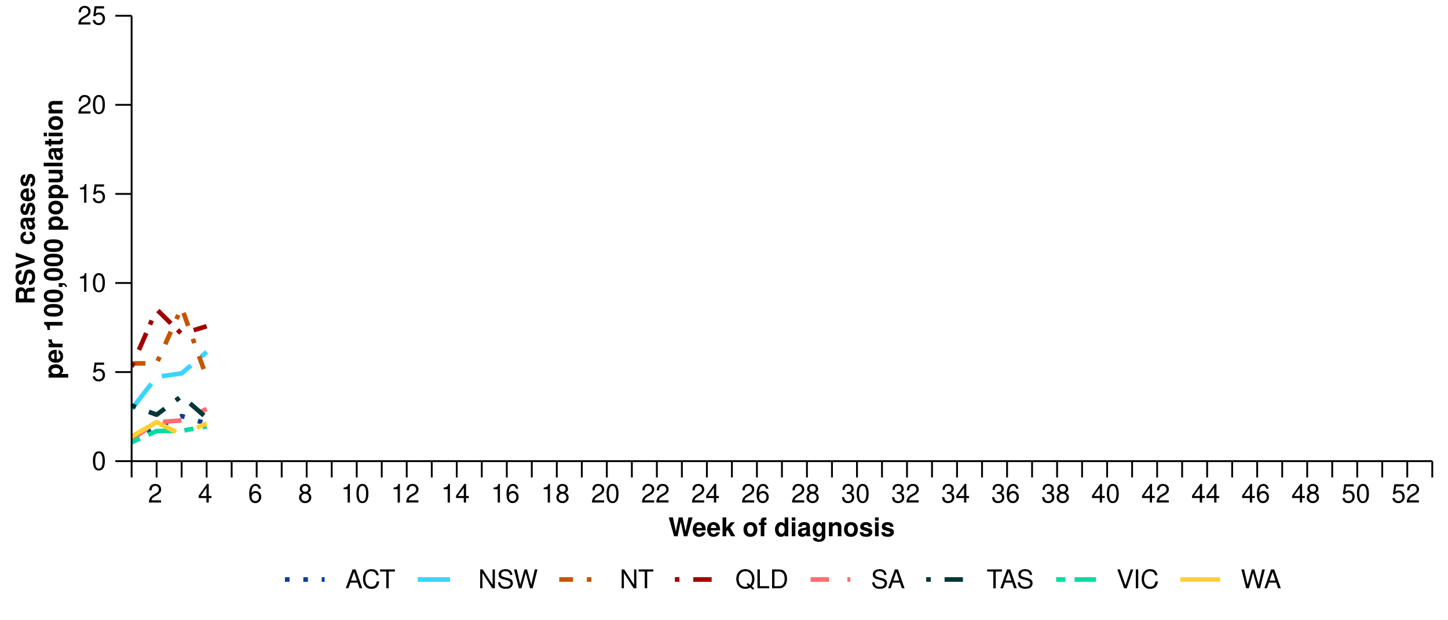

Source: National Notifiable Diseases Surveillance System (NNDSS). Notification data are unavailable for the Northern Territory from 25 January 2025 and for Tasmania from 24 January 2025.  
* Rate per 100,000 population for the given time period. Population data are based on the Australian Bureau of Statistics (ABS) [Estimated Resident Population (ERP) for the reference period June 2024, released 12 December 2024](https://www.abs.gov.au/statistics/people/population/national-state-and-territory-population/jun-2024).

# Primary care surveillance

Primary care surveillance monitors the number and characteristics of people who have presented to their general practitioner with influenza-like-illness and provides insight on the different respiratory pathogens that are causing illness in the community.

* Sentinel general practice surveillance indicates medical attendance for respiratory illness has decreased this month, though a variety of respiratory pathogens continue to circulate in the community, with SARS-CoV-2 and rhinovirus being the most common.
* This month (30 December to 26 January 2025), there were slightly fewer general practice consultations for influenza-like-illness (3.4 per 1,000 consultations per reporting period) than in the previous month (3.8 per 1,000 consultations per reporting period) (Figure 9).
* Late in 2024 rates of influenza-like-illness began to increase above the levels observed in previous years and the five-year average. The rate of influenza-like-illness was above 4 per 1,000 consultations in the first weeks of 2025; however, has since decreased and is now consistent with the rate of influenza-like-illness observed at the same time last year (Figure 9).
* Like the same period in 2024, influenza-like-illness rates this month remain slightly higher than observed in at the same time in previous years and the five-year average (Figure 9).

**Figure 9: Rate of influenza-like-illness per 1,000 consultations per week with sentinel general practice sites compared with the five-year average by year and week of consultation*†, Australia, 2022 to 26 January 2025**

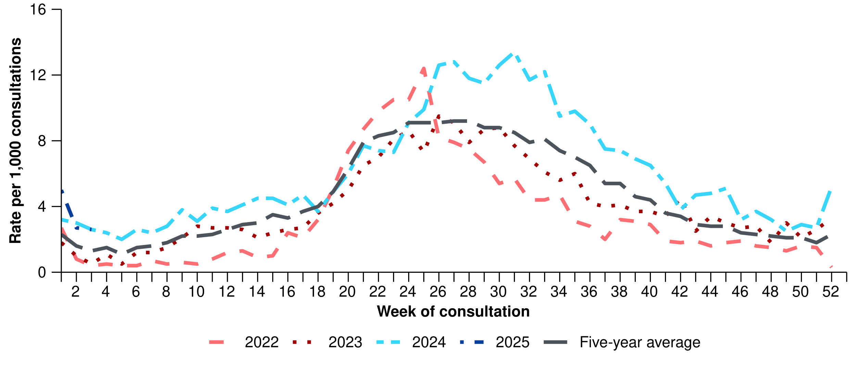

Source: Australian Sentinel Practice Research Network (ASPREN)  
* The years 2020 and 2021 are excluded when comparing the current season to historical periods when influenza virus has circulated without public health restrictions. As such, the five-year average includes the years 2018 to 2019 and 2022 to 2024. Please refer to the [Technical Supplement](https://www.health.gov.au/resources/publications/technical-supplement-australian-respiratory-surveillance-report) for interpretation of the five-year average.  
† Please refer to the [Technical Supplement](https://www.health.gov.au/resources/publications/technical-supplement-australian-respiratory-surveillance-report) for notes on impact of COVID-19 on ASPREN data.

* In the year to date, 68.2% (45/66) of people attending general practice with influenza-like-illness have then tested positive for a respiratory pathogen. SARS-CoV-2 (26.7%; 12/45) was the most commonly detected, followed by rhinovirus (24.4%; 11/45), influenza (22.2%; 10/45), RSV (11.1%; 5/45), and human metapneumovirus (6.7%; 3/45) (Figure 10).

**Figure 10: Number of samples tested for respiratory pathogens among people with influenza-like-illness attending sentinel general practice sites by respiratory pathogen and week of specimen collection, Australia, 1 January to 26 January 2025**

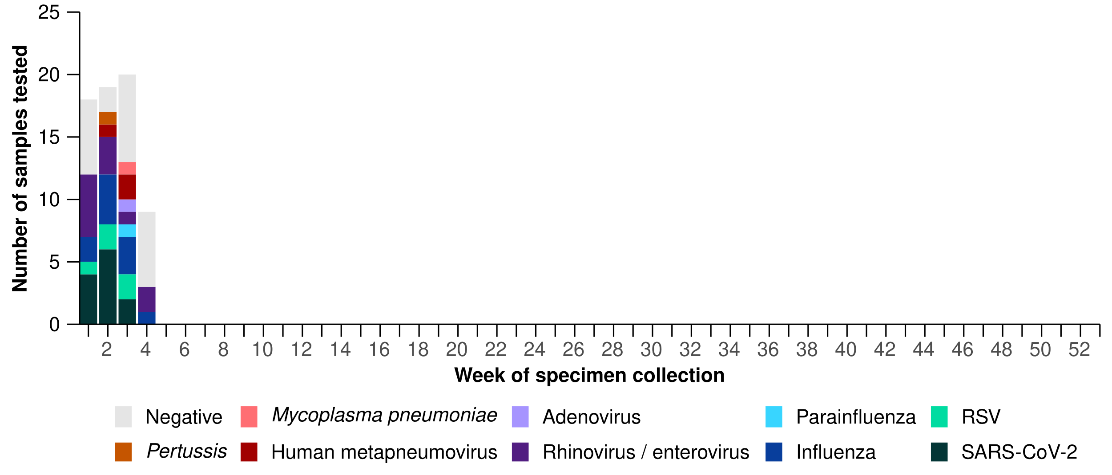

Source: Australian Sentinel Practice Research Network (ASPREN)

# Hospital-based surveillance

Hospital-based surveillance monitors persons with more severe illness who have been admitted to hospital for their respiratory illness (severe acute respiratory infections). Hospital-based surveillance also measures the ability of the health system to cope with the number of severe acute respiratory infection admissions to ensure delivery of safe, timely and quality health care.

* Sentinel hospital-based surveillance shows the number of patients admitted with severe acute respiratory infections has remained low and stable this severity reporting period. The length of hospital stay varies only slightly between illnesses and the proportion of patients with a severe acute respiratory infection who were admitted directly to an intensive care has remained low.
* In this severity reporting period (16 December to 12 January 2025), fewer patients were admitted to a sentinel hospital with a severe acute respiratory infection (n = 500), than in the previous severity reporting period (n = 590).
* In the year to date for severity reporting (1 January to 12 January 2025), most patients with a severe acute respiratory infection were admitted with COVID-19 (Figure 11). Patients admitted to sentinel hospitals with influenza have mostly been admitted with influenza A (89.4%; 42/47), while 10.6% (5/47) were admitted with influenza B.
  + Most hospital admissions with influenza A have been with influenza A(Unsubtyped) (90.5%; 38/42), followed by influenza A(H1N1) (7.1%; 3/42) and influenza A(H3N2) (2.4%; 1/42).

**Figure 11: Total number of patients (children and adults) admitted with a severe acute respiratory infection to sentinel hospitals by disease and week of admission*†‡, Australia, 1 January to 12 January 2025**

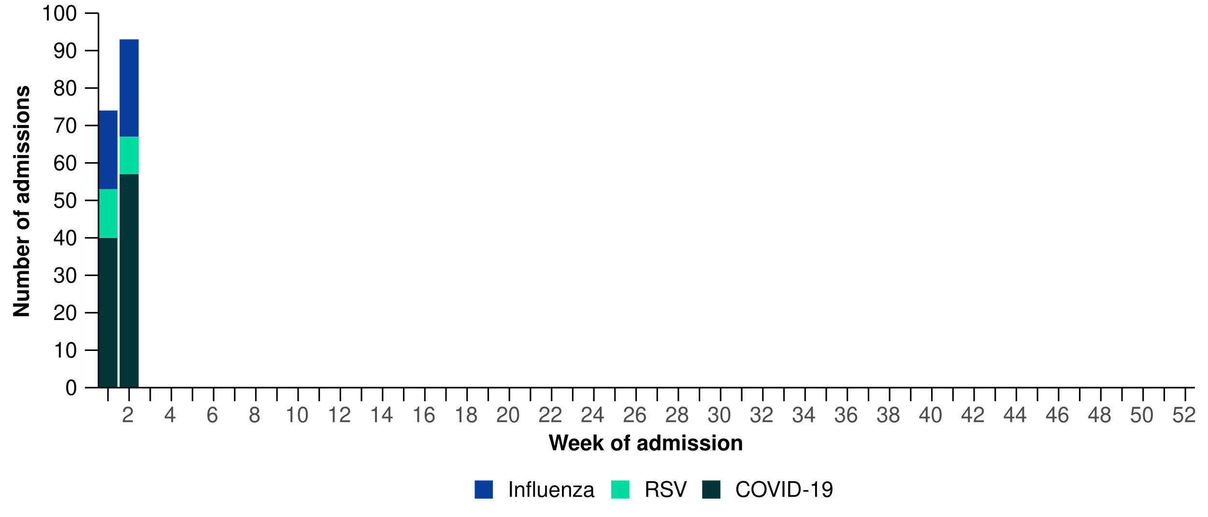

Source: Influenza Complications Alert Network (FluCAN)

* In the year to date for severity reporting, more children (those aged 16 years and younger) were admitted with COVID-19 and influenza than with RSV at sentinel hospitals (Table 2a).
* Children admitted to sentinel hospitals with influenza tended to be older than children admitted with COVID-19 or RSV who were predominately aged 4 years or younger (Table 2a).
* There was no notable difference in the length of stay or admission location (general ward or intensive care) between children admitted with COVID-19, influenza and RSV (Table 2a).

**Table 2a: Demographic characteristics and outcomes for children admitted with a severe acute respiratory infection to a sentinel hospital by disease, Australia, 1 January to 12 January 2025**

|  | **COVID-19** | **Influenza** | **RSV** |
| --- | --- | --- | --- |
|  | **Year to date for severity reporting (n=35)** | **Year to date for severity reporting (n=30)** | **Year to date for severity reporting (n=18)** |
| **Age (years)** | | | |
| Median [IQR] | 0 [0–1] | 5 [1–8] | 0 [0–1] |
| **Age group (years)** | | | |
| < 6 months | 12 (34.3%) | 1 (3.3%) | 6 (33.3%) |
| 6 months – 4 years | 18 (51.4%) | 12 (40.0%) | 12 (66.7%) |
| 5–16 years | 5 (14.3%) | 17 (56.7%) | – |
| **Indigenous status** | | | |
| Aboriginal and Torres Strait Islander | 7 (20.0%) | 2 (6.7%) | 3 (16.7%) |
| **Length of hospital stay (days)** | | | |
| Median [IQR] | 2 [1–4] | 1 [1–2] | 2 [1–7] |
| **Patient admission location** | | | |
| Admitted to hospital ward | 34 (97.1%) | 30 (100.0%) | 18 (100.0%) |
| Admitted to intensive care directly† | 1 (2.9%) | – | – |
| **Discharge status** | | | |
| Alive | 24 (68.6%) | 20 (66.7%) | 10 (55.6%) |
| Died | – | – | – |

Source: Influenza Complications Alert Network (FluCAN)  
Note: For patients who are still in hospital data may not be complete; therefore, these data are not included in the length of stay or discharge status. In addition, length of stay data excludes patients that acquired their infection in hospital.  
* Does not include patients with missing age; therefore, the sum of age-specific totals above may not equal the total number of patients.  
† Admission location reflects the initial admission ward. Some patients may be initially admitted to general ward then later admitted to an intensive care and this is not reflected here. Does not include patients with missing admission location; therefore, the sum of admission location specific totals above may not equal the total number of patients.

The Paediatric Active Enhanced Disease Surveillance (PAEDS) network carries out enhanced sentinel hospital surveillance for some acute respiratory infections or conditions in children. For more information on [COVID-19 in children](https://paeds.org.au/covid-19/paediatric-covid-19-australia), [Paediatric Inflammatory Multisystem Syndrome (PIMS-TS) following COVID-19](https://paeds.org.au/pims-ts/paeds-pims-ts-case-data), or [influenza in children](https://paeds.org.au/influenza/paediatric-influenza-australia) please visit the [PAEDS](https://paeds.org.au/) webpages.

* In the year to date for severity reporting, the number of adults (those aged 16 years and over) admitted with COVID-19 to sentinel hospitals was much higher than for either influenza or RSV (Table 2b).
* Adults admitted to sentinel hospitals with COVID-19 tended to be older than adults admitted with influenza or RSV who were predominately aged 17–64 years (Table 2b).
* Adults with COVID-19 and influenza admitted to sentinel hospitals were more unwell than adults with RSV. The length of stay for adults admitted with COVID-19 and influenza was longer than for RSV, and the proportion of adults admitted directly to an intensive care was higher for COVID-19 and influenza (Table 2b).
  + As the severity reporting period for the year to date only includes 12 days, it is too early in 2025 to make a definitive assessment of illness severity trends, so the trends presented here should be interpreted with caution.

**Table 2b: Demographic characteristics and outcomes for adults admitted with a severe acute respiratory infection to a sentinel hospital by disease, Australia, 1 January to 12 January 2025**

|  | **COVID-19** | **Influenza** | **RSV** |
| --- | --- | --- | --- |
|  | **Year to date for severity reporting (n=62)** | **Year to date for severity reporting (n=17)** | **Year to date for severity reporting (n=5)** |
| **Age (years)** | | | |
| Median [IQR] | 70 [59–80] | 55 [51–64] | 56 [51–66] |
| **Age group (years)** | | | |
| 17–64 years | 21 (33.9%) | 13 (76.5%) | 3 (60.0%) |
| 65 years and over | 41 (66.1%) | 4 (23.5%) | 2 (40.0%) |
| **Indigenous status** | | | |
| Aboriginal and Torres Strait Islander | 3 (4.8%) | 1 (5.9%) | – |
| **Length of hospital stay (days)** | | | |
| Median [IQR] | 3 [1–4] | 3 [3–4] | 1 [1–2] |
| **Patient admission location** | | | |
| Admitted to hospital ward | 58 (93.5%) | 15 (88.2%) | 5 (100.0%) |
| Admitted to intensive care directly† | 4 (6.5%) | 2 (11.8%) | – |
| **Discharge status** | | | |
| Alive | 34 (54.8%) | 12 (70.6%) | 3 (60.0%) |
| Dead | 2 (3.2%) | – | – |

Source: Influenza Complications Alert Network (FluCAN)  
Note: For patients who are still in hospital data may not be complete; therefore, these data are not included in the length of stay or discharge status. In addition, length of stay data excludes patients that acquired their infection in hospital.  
* Does not include patients with missing age; therefore, the sum of age-specific totals above may not equal the total number of patients.  
† Admission location reflects the initial admission ward. Some patients may be initially admitted to general ward then later admitted to an intensive care and this is not reflected here. Does not include patients with missing admission location; therefore, the sum of admission location specific totals above may not equal the total number of patients.

* Sentinel intensive care surveillance shows the number of patients with severe acute respiratory infections has decreased this reporting period. The duration of intensive care stay varies slightly between illnesses.
* In this severity reporting period (16 December to 12 January 2025), fewer patients have been admitted to a sentinel intensive care with a severe acute respiratory infection (n=177), than in the previous severity reporting period (n=209) (Figure 12).
* In the year to date for severity reporting (1 January to 12 January 2025), most patients were admitted to a sentinel intensive care with COVID-19 (Figure 12; Table 3). Some patients (3.2%; 2/62) had co-infections of multiple respiratory pathogens; therefore, the sum of pathogen-specific totals may not equal the total number of patients (Figure 12; Table 3).

**Figure 12: Number of patients admitted with severe acute respiratory infections to a sentinel intensive care by pathogen and week of admission, Australia, 1 January to 12 January 2025**

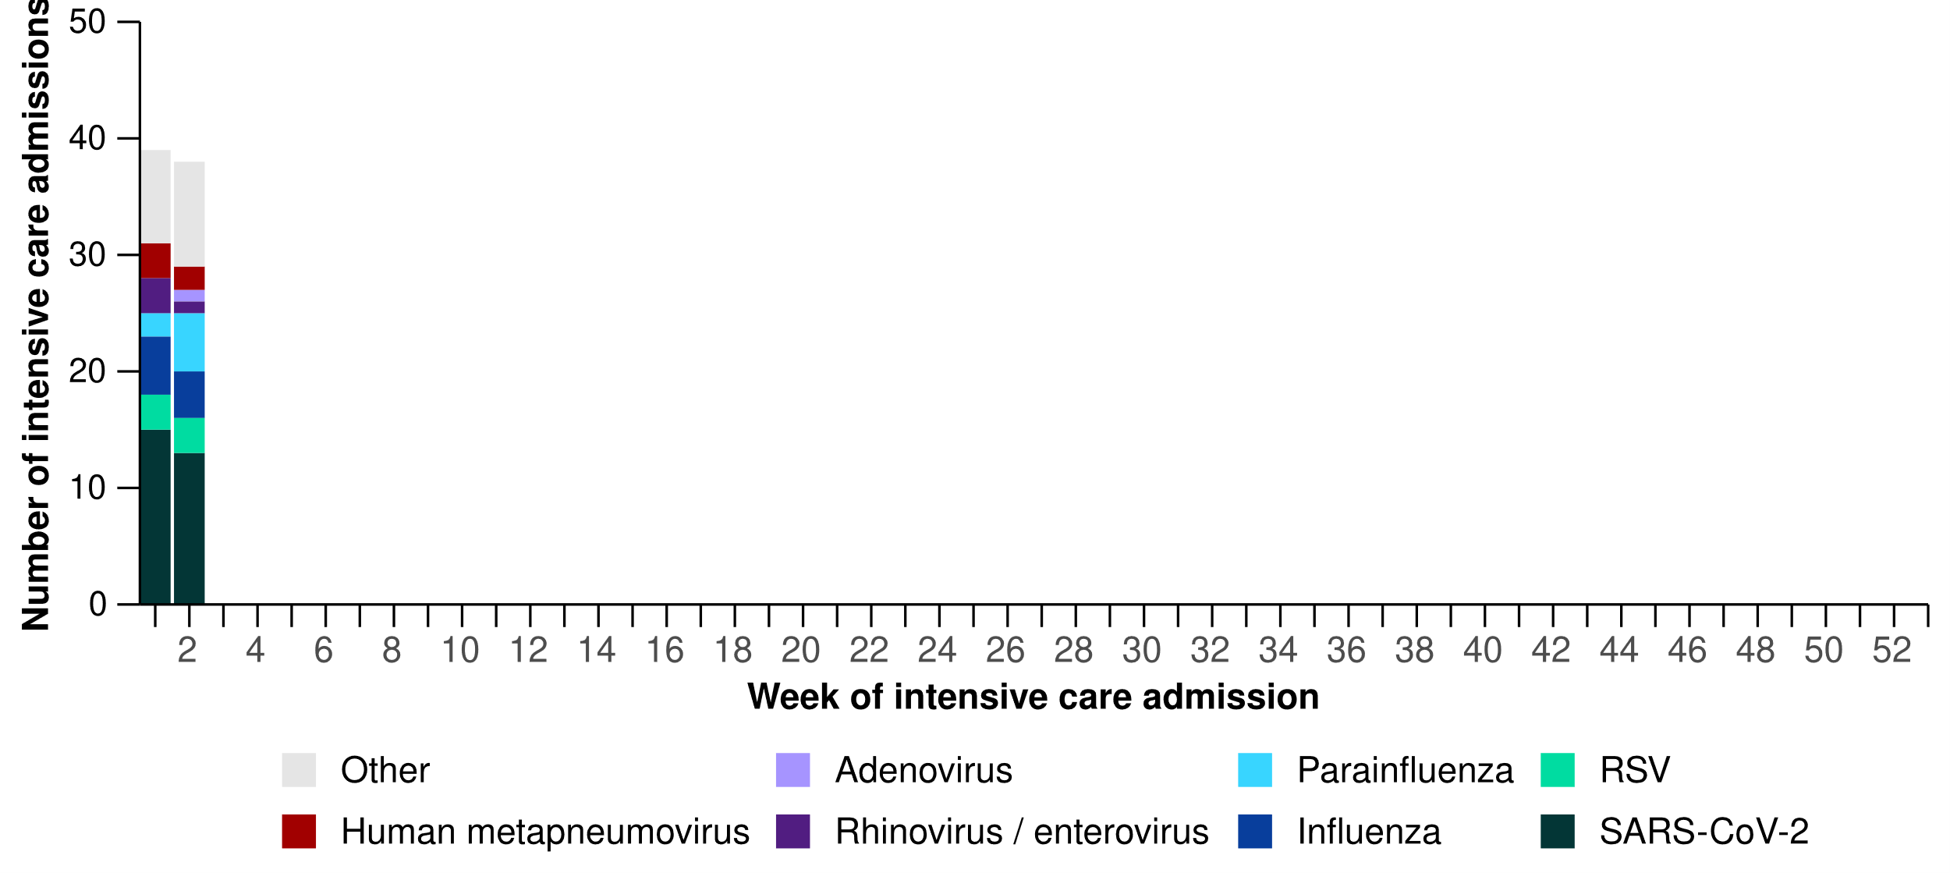

Source: Short Period Incidence Study of Severe Acute Respiratory Infection (SPRINT-SARI) Australia

* In the year to date for severity reporting, older adults were admitted to a sentinel intensive care with COVID-19 and influenza more often, while younger people, particularly children, were more often admitted with human metapneumovirus, rhinovirus or RSV (Table 3).
* The length of intensive care stay for people admitted to a sentinel intensive care was similar across pathogens, though was slightly higher for influenza and parainfluenza (Table 3).
  + As the severity reporting period for the year to date only includes 12 days, it is too early in 2025 to make a definitive assessment of illness severity trends, so the trends presented here should be interpreted with caution.
* Most patients admitted to a sentinel intensive care with a severe acute respiratory infection have been discharged home. Unfortunately, a small number of patients admitted to a sentinel intensive care with a severe acute respiratory infection have died in hospital (Table 3).

**Table 3: Demographic characteristics and outcomes of patients admitted with a severe acute respiratory infection to a sentinel intensive care by disease, Australia, 1 January to 12 January 2025**

|  | **COVID-19** | **hMPV** | **Influenza** | **Parainfluenza** | **Rhinovirus** | **RSV** | **Other** |
| --- | --- | --- | --- | --- | --- | --- | --- |
|  | **Year to date for severity reporting   (n=28)** | **Year to date for severity reporting   (n=5)** | **Year to date for severity reporting   (n=9)** | **Year to date for severity reporting   (n=7)** | **Year to date for severity reporting   (n=4)** | **Year to date for severity reporting   (n=6)** | **Year to date for severity reporting   (n=5)** |
| **Age (years)** | | | | | | | |
| Median [IQR] | 56  [44–74] | 3  [1–4] | 51  [41–65] | 42  [14–48] | 8  [2–24] | 38  [9–57] | 65  [47–68] |
| **Indigenous status** | | | | | | | |
| Aboriginal and Torres Strait Islander | 4  (14.3%) | – | 1  (11.1%) | – | – | – | – |
| Non-Indigenous | 24  (85.7%) | 5  (100.0%) | 8  (88.9%) | 7  (100.0%) | 4  (100.0%) | 6  (100.0%) | 5  (100.0%) |
| **Received invasive mechanical ventilation** | | | | | | | |
| Number (%) | 10  (35.7%) | 1  (20.0%) | 2  (22.2%) | 5  (71.4%) | 2  (50.0%) | – | 1  (20.0%) |
| **Duration of invasive mechanical ventilation (days)\*** | | | | | | | |
| Median [IQR] | 4  [1–6] | 2  [2–2] | 5  [2–7] | 3  [0–4] | 0  [0–1] | – | 2  [2–2] |
| **Length of intensive care stay (days)\*** | | | | | | | |
| Median [IQR] | 3  [2–5] | 1  [1–2] | 4  [2–5] | 7  [1–7] | 2  [2–2] | 3  [1–7] | 7  [3–8] |
| **Length of hospital stay (days)\*** | | | | | | | |
| Median [IQR] | 5  [4–8] | 9  [6–11] | 7  [5–12] | 5  [4–7] | 2  [2–2] | 9  [6–11] | 12  [8–16] |
| **Patient outcome†** | | | | | | | |
| Ongoing care in intensive care | 3  (10.7%) | – | 1  (11.1%) | 2  (28.6%) | 1  (25.0%) | – | – |
| Ongoing care in hospital ward* | 4  (14.3%) | – | 1  (11.1%) | 1  (14.3%) | – | – | 2  (40.0%) |
| Transfer to other hospital or facility, including rehabilitation | 1  (3.6%) | – | – | – | – | – | – |
| Discharged home | 13  (46.4%) | 5  (100.0%) | 7  (77.8%) | 3  (42.9%) | 3  (75.0%) | 6  (100.0%) | 2  (40.0%) |
| Died in hospital | 7  (25.0%) | – | – | 1  (14.3%) | – | – | 1  (20.0%) |

Source: Short Period Incidence Study of Severe Acute Respiratory Infection (SPRINT-SARI) Australia  
Note: Multiple patients had co-infections of respiratory pathogens; therefore, the sum of pathogen-specific totals above may not equal the total number of severe acute respiratory infection patients. For patients whom are still receiving treatment in intensive care data may not be complete; therefore, data are not included in the duration of ventilation or length of intensive care stay.  
* Patients who have been admitted in intensive care/hospital wards with no discharge information for less than 90 days have been assumed to have ongoing care in the hospital.  
† Patients who have no outcome entered or have been admitted for more than 90 days with no discharge information have been treated as missing.

* This month, there has been more COVID-19 cases in intensive care across Australia than in the previous month, largely driven by increases in New South Wales and Queensland (Figure 13).
* This month, the number of intensive care staff unavailable to work due to COVID-19 exposure or illness across Australia has decreased compared with the previous month (Figure 13).

**Figure 13: Mean number of COVID-19 cases in intensive care and the mean number of intensive care staff unavailable to work due to COVID-19 exposure or illness by week of report*†, Australia, 1 January to 26 January 2025**

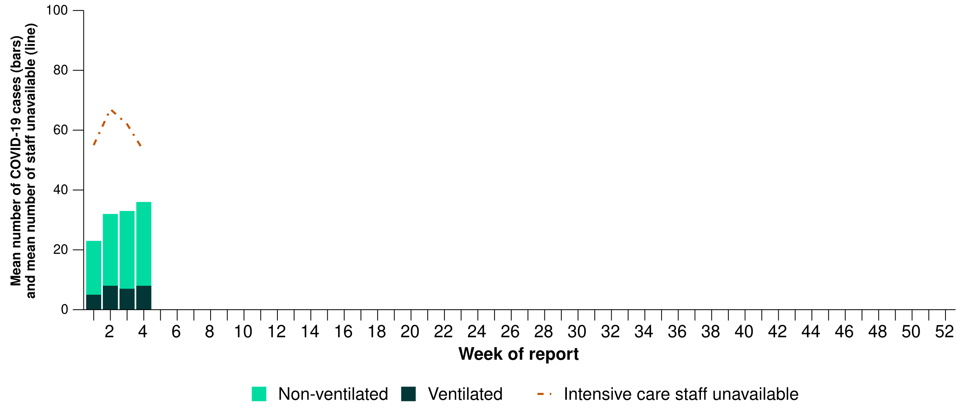

Source: Critical Health Resource Information System (CHRIS). Data for COVID-19 case numbers from New South Wales was affected by transmission issues from 11 December 2024 to 8 January 2025 and is likely to be an underestimate during this time.  
* Mean number of ventilated and non-ventilated COVID-19 cases in intensive care includes only active COVID-19 cases (those in isolation) and does not include cleared COVID-19 cases.  
† Intensive care staff include both medical and nursing staff.

* This month, COVID-19 cases in intensive care have increased in New South Wales and Queensland, decreased in Victoria and remained stable in all other jurisdictions (Figure 14).
  + New South Wales experienced technical issues reporting their COVID-19 case data from 11 December 2024 to 8 January 2025. COVID-19 cases in intensive care during this time are likely to be underestimated from New South Wales and therefore the increasing trend may be due to either a true increase or as a result of artefact such as technical issues leading to the underreporting of case numbers in earlier periods.
* This month, the number of intensive care staff unavailable to work due to COVID-19 exposure or illness decreased across all jurisdictions except Tasmania and Western Australia where minor increases compared with the previous month were observed (Figure 14).

**Figure 14: Mean number of COVID-19 cases in intensive care and the mean number of intensive care staff unavailable to work due to COVID-19 exposure or illness by jurisdiction and week of report*†‡, Australia, 1 January to 26 January 2025**

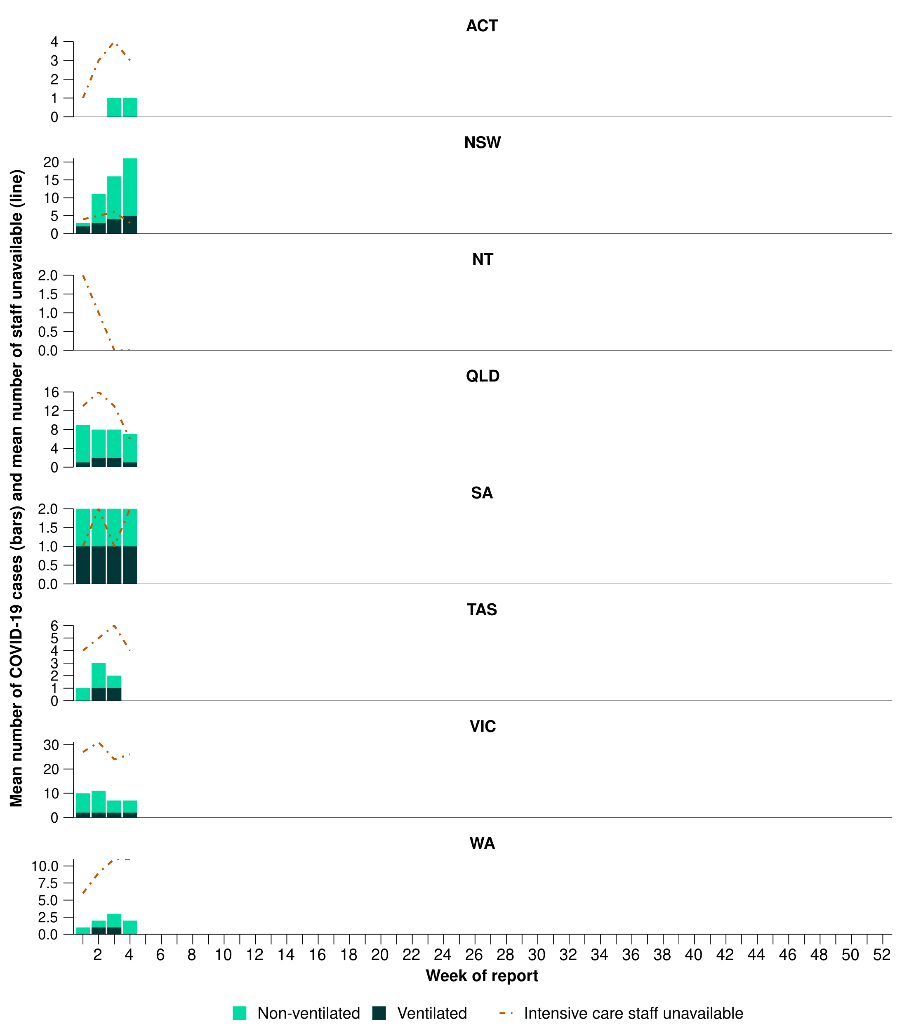

Source: Critical Health Resource Information System (CHRIS). Data for COVID-19 case numbers from New South Wales was affected by transmission issues from 11 December 2024 to 8 January 2025 and is likely to be an underestimate during this time.  
* Axis varies between jurisdictions.  
† Mean number of ventilated and non-ventilated COVID-19 cases in intensive care includes only active COVID-19 cases (those in isolation) and does not include cleared COVID-19 cases.  
‡ Intensive care staff include both medical and nursing staff.

# Mortality surveillance

Death registrations reported to the Australian Bureau of Statistics can provide information on the scale and severity of disease associated with acute respiratory infections. For more information on death registrations, including completeness and timeliness, refer to the [Technical Supplement](https://www.health.gov.au/resources/publications/technical-supplement-australian-respiratory-surveillance-report).

* COVID-19 has been the leading cause of acute respiratory infection mortality across 2022-2024.
* Deaths involving COVID-19 have fallen from the June peak of 857 deaths to 195 deaths in September 2024 (Figure 15).
* Deaths involving influenza dropped from their peak in July and August (258 and 259 deaths respectively) to 72 deaths in September 2024 (Figure 15).
* Deaths involving RSV have been at comparable levels to those recorded in 2022 and 2023 since July 2024 (Figure 15).
* All three of these acute respiratory infections are more likely to cause death in older age groups than younger age groups.

**Figure 15: Provisional numbers of acute respiratory infection associated deaths*†‡ by month, year and respiratory infection, Australia, 2022 – November 2024**

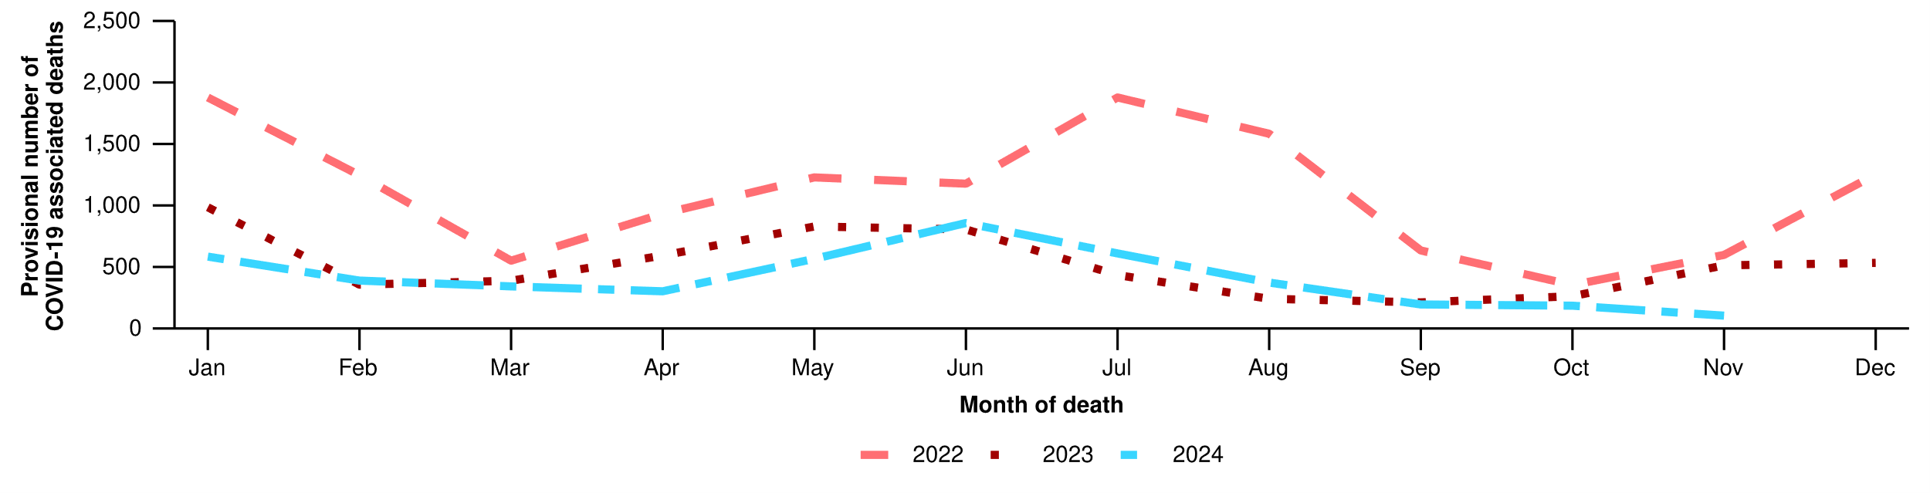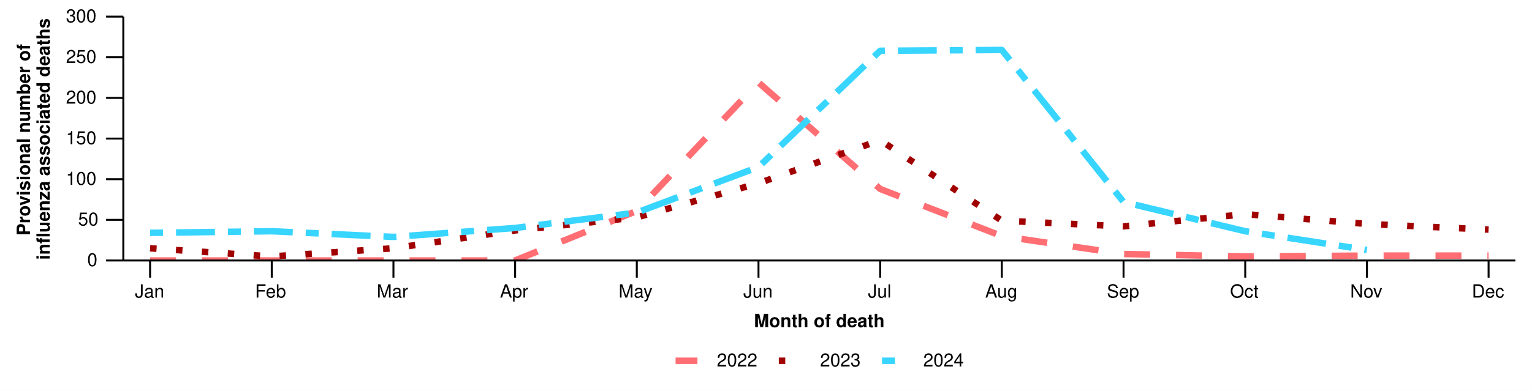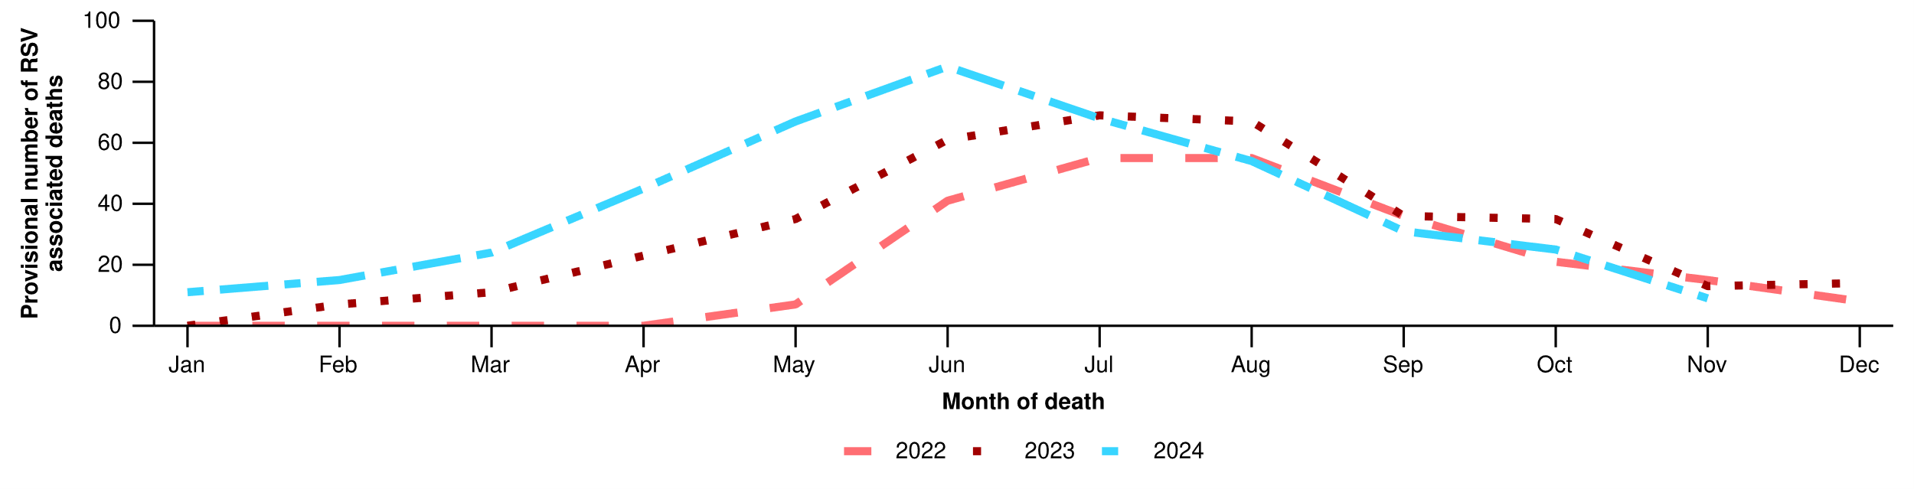

Source: Australian Bureau of Statistics, [Provisional Mortality Statistics, Jan - Sep 2024](https://www.abs.gov.au/statistics/health/causes-death/provisional-mortality-statistics/jan-sep-2024), released 18 Dec 2024.  
* An acute respiratory associated death is one where the viral disease has either directly caused the death or the person has died with the virus (a person has died from another cause but the viral illness still contributed significantly to death). Includes acute respiratory disease death registrations only.  
† Data is provisional and subject to change. It can take several weeks for death registrations to be reported, processed, coded, validated, and tabulated. Therefore, the data shown here may be incomplete, and will likely not include all deaths that occurred during a given time. Data includes all deaths (both doctor and coroner certified) that occurred and were registered by 30 November 2024. Please refer to the [Technical Supplement](https://www.health.gov.au/resources/publications/technical-supplement-australian-respiratory-surveillance-report) for more information.  
‡ All deaths involving COVID-19 in this report have been coded to ICD-10 codes U07.1-U07.2, U10.9 or U09.9. All deaths involving influenza have been coded to J09-J11. All deaths involving RSV have been coded to J12.1, J20.5, J21.0, B97.4.

# Laboratory surveillance

Sentinel laboratory surveillance monitors and characterises respiratory pathogens to provide information on what pathogens are circulating, potential changes in the pathogens that might affect their infectiousness, severity, ability to evade vaccine and/or infection-acquired immunity, or resistance to antivirals.

* This month (30 December to 26 January 2025), SARS-CoV-2 test positivity has decreased to 5.3% (1,217/23,042), influenza positivity has increased slightly to 3.2% (873/27,656), and RSV positivity has remained stable at 0.8% (187/23,042) (Figure 16).

**Figure 16: Number of tests positive (bars) and test positivity (line) for SARS-CoV-2, influenza or RSV of those specimens tested by sentinel laboratories by week of report*†, Australia, 1 January to 26 January 2025**

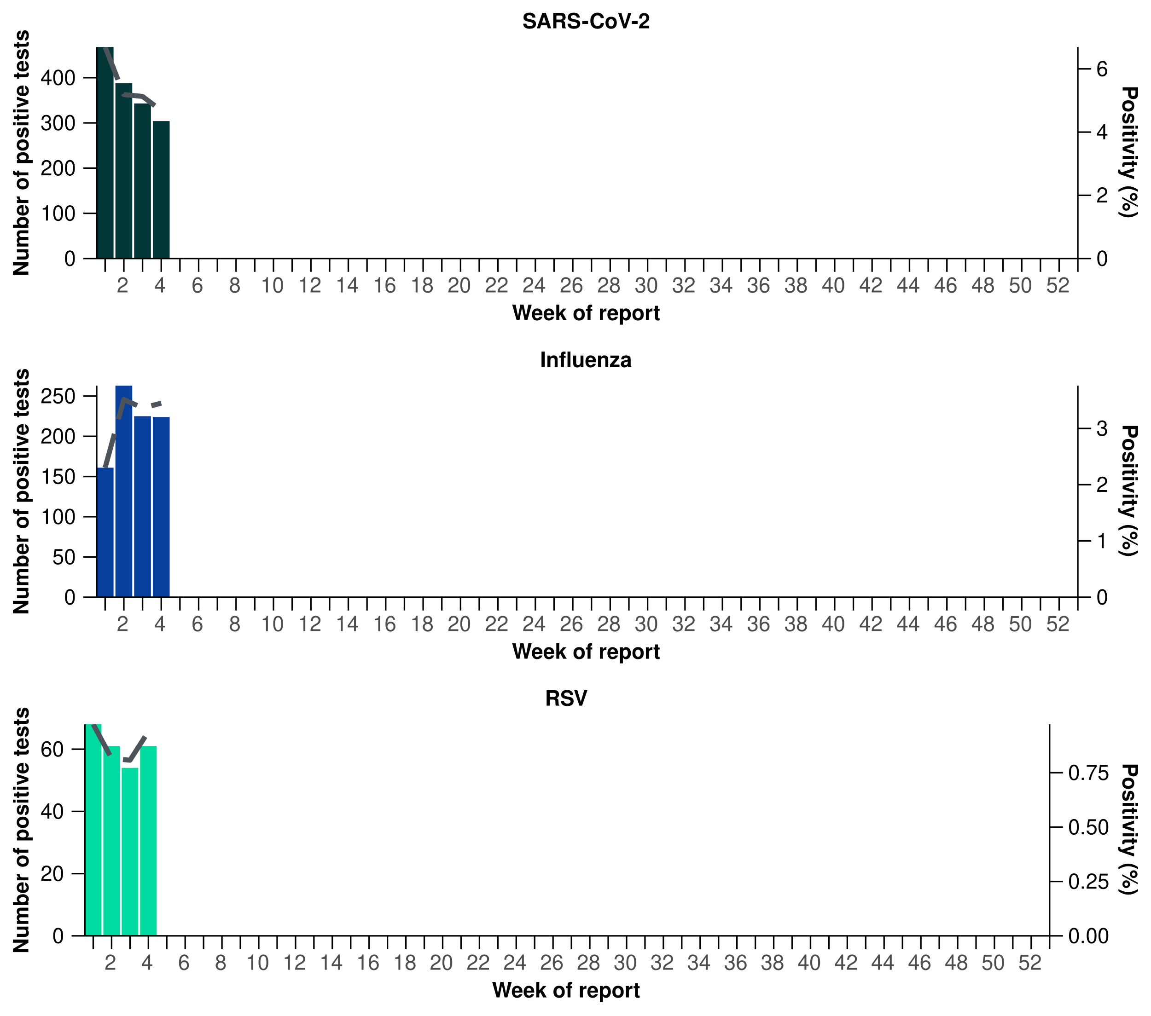

Source: Sentinel laboratories, including National Influenza Centres  
* Number of specimens tested excludes data from Western Australia as testing denominator data are different for the three pathogens in Western Australia.  
† A small minority of total samples from Victoria are tested only by respiratory panel (influenza, parainfluenza, adenovirus, human metapneumovirus, seasonal coronaviruses, RSV, and some picornaviruses) but not for SARS-CoV-2. These minority samples include only forensic materials; all other samples are tested by respiratory panel and SARS-CoV-2 assay.

* There were 281 sequences uploaded to AusTrakka with dates of collection in the past 28 days (30 December to 26 January 2025). These sequences were from New South Wales, Queensland, South Australia, Tasmania, and Western Australia, with the most recent collection date 13 January 2025.
* All sequences were assigned to the BA.2.86 sub-lineage within B.1.1.529 (Omicron) or recombinants consisting of one or more Omicron sub-lineages (Figure 17). There were no BA.1, BA.3, BA.4, BA.5 or other BA.2 sub-sub-lineage sequences. In the past 28 days:
  + 40.9% (115/281) of sequences were from the sub-sub-lineages JN.1 (BA.2.86.1.1), including from KP.3 (78/115)
  + 59.3% (166/281) of sequences were recombinant or recombinant sub-lineages, including XEC, a recombinant between KS.1.1 (JN.1.13.1.1.1) and KP.3.3
* XEC is now the dominant variant, followed by JN.1 and associated sub-lineages (Figure 17).
* The World Health Organization (WHO) have identified certain sub-sub-lineages and recombinants as variants under monitoring (VUM) or variants of interest (VOI) because of their epidemiological, pathological, or immunological features of concern. A select number of designated VUM or VOI are highlighted below due to their relevance in the Australian context:
  + LP.8.1 has been designated as a VUM as of 24 January 2025. There is currently limited information available about the risk posed by LP.8.1 as this variant is still being characterised. The WHO have not yet released a risk evaluation for LP.8.1. There are 104 LP.8.1 sequences in AusTrakka, with 19 collected in the past 28 days.
  + 1,383 XEC lineages have been identified in AusTrakka, including 157 collected in past 28 days.
  + 305 sequences of LB.1 have been identified in AusTrakka, with eight sequences identified in the past 28 days.
  + 2,304 sequences of KP.3.1.1 have been identified in AusTrakka, with 70 sequences identified in the past 28 days.

**Figure 17a: Omicron sub-lineage* sequences by sample collection date, showing the proportions of sequences per week^†, Australia, 1 January to 26 January 2025**

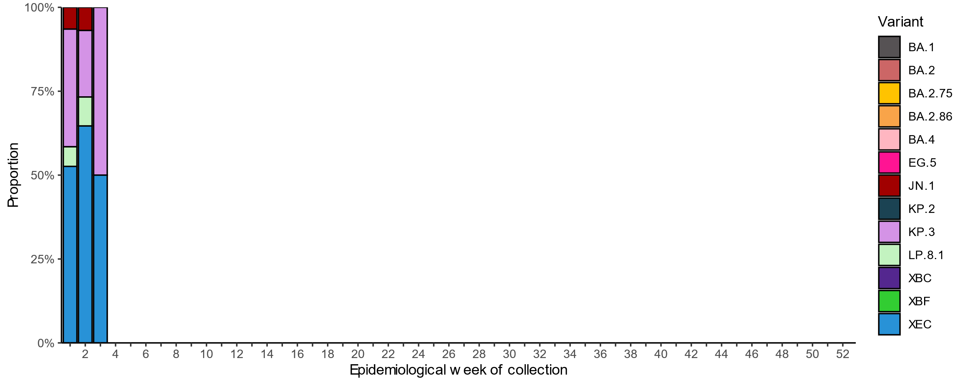

Source: AusTrakka  
* Some sub-sublineages are shown alongside their parent lineage, but not included in the parent lineage totals. For instance, KP.2 and KP.3 are sub-sub lineages of JN.1, so the total of JN.1 sequences will be higher than shown in the corresponding colour alone, and should include the KP.2 and KP.3 totals.  
^ Sequences in AusTrakka aggregated by week and reported based on date of sample collection, not date of sequencing.  
† Proportions in Figure 17a may not be representative when sequence numbers are small; refer to Figure 17b. Data for earlier weeks may change between reporting periods as sequences with older collection dates are uploaded. These numbers are not equivalent to number of cases, as there are many cases which may not be sequenced. Non-VOI and non-VUM Omicron sub-lineages have been collapsed into parent lineages BA.1, BA.2, BA.3, BA.4 and BA.5.

**Figure 17b: Omicron sub-lineage* sequences by sample collection date, showing the count of sequences per week^†, Australia, 1 January to 26 January 2025**

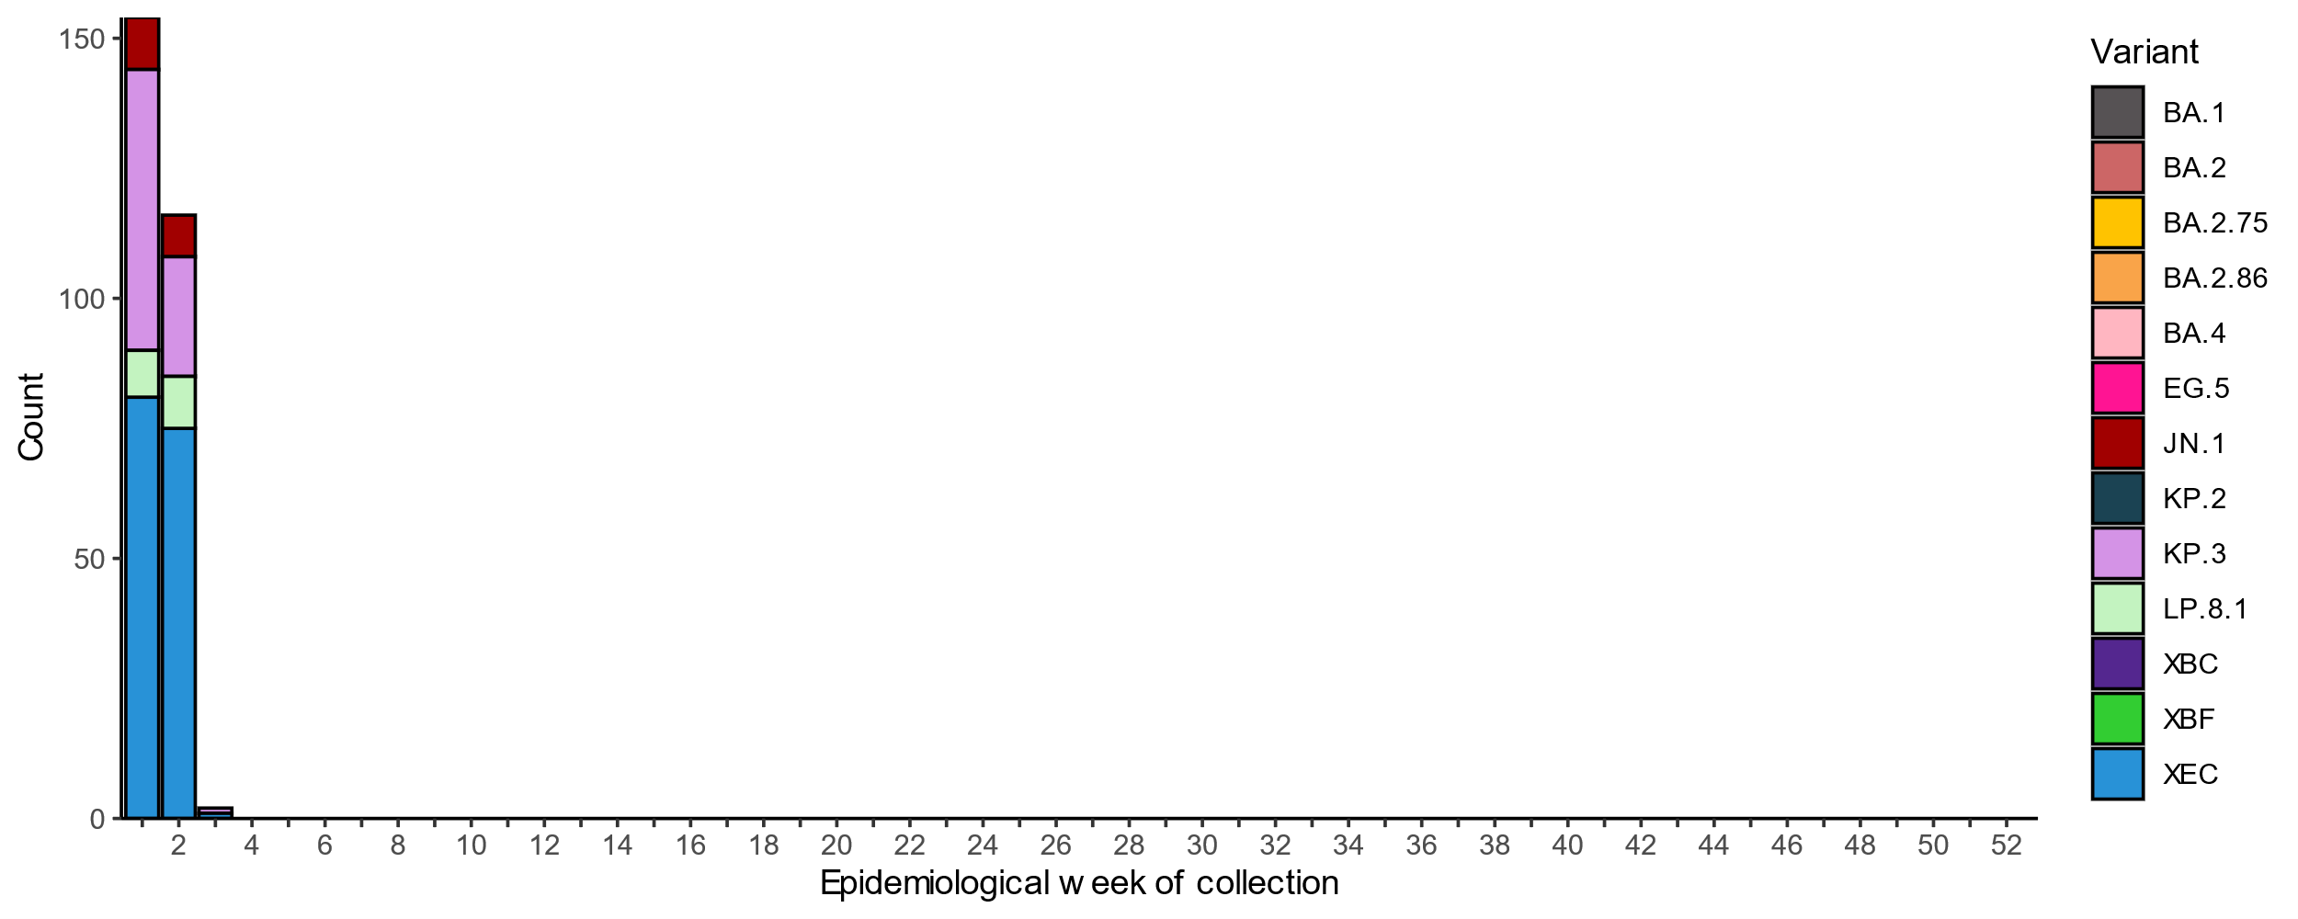

Source: AusTrakka  
* Some sub-sublineages are shown alongside their parent lineage, but not included in the parent lineage totals. For instance, KP.2 and KP.3 are sub-sub lineages of JN.1, so the total of JN.1 sequences will be higher than shown in the corresponding colour alone, and should include the KP.2 and KP.3 totals.  
^ Sequences in AusTrakka aggregated by week and reported based on date of sample collection, not date of sequencing.  
† Proportions in Figure 17A may not be representative when sequence numbers are small; refer to Figure 17B. Data for earlier weeks may change between reporting periods as sequences with older collection dates are uploaded. These numbers are not equivalent to number of cases, as there are many cases which may not be sequenced. Non-VOI and non-VUM Omicron sub-lineages have been collapsed into parent lineages BA.1, BA.2, BA.3, BA.4 and BA.5.

* In the year to date, 86.2% (50/58) of influenza viruses characterised by the World Health Organization (WHO) Collaborating Centre for Reference and Research on Influenza have been influenza A(H1N1) and 13.8% (8/58) have been influenza A(H3N2). There have been no influenza B viruses characterised (Table 4).
* Currently, no samples have been tested yet for neuraminidase inhibitor resistance to Oseltamivir or Zanamivir.

**Table 4: Australian influenza viruses typed by haemagglutination inhibition assay and jurisdiction*†, 1 January to 26 January 2025**

| **Strain** | **ACT** | **NSW** | **NT** | **Qld** | **SA** | **Tas.** | **Vic.** | **WA** | **Total** |
| --- | --- | --- | --- | --- | --- | --- | --- | --- | --- |
| A(H1N1) | 35 | 2 | 5 | 0 | 0 | 2 | 6 | 0 | **50** |
| A(H3N2) | 2 | 1 | 3 | 0 | 0 | 0 | 2 | 0 | **8** |
| B/Victoria lineage | 0 | 0 | 0 | 0 | 0 | 0 | 0 | 0 | **0** |
| B/Yamagata lineage | 0 | 0 | 0 | 0 | 0 | 0 | 0 | 0 | **0** |
| **Total** | **37** | **3** | **8** | **0** | **0** | **2** | **8** | **0** | **58** |

Source: World Health Organization (WHO) Collaborating Centre for Reference and Research on Influenza  
*Viruses tested by the WHO Collaborating Centre for Reference and Research on Influenza are not necessarily a random sample of all those in the community and early-year data may be based on limited samples received. There may be up to a month delay on reporting of samples.  
† Jurisdiction indicates the residential location for the individual tested, not the submitting laboratory.

# Vaccine coverage, effectiveness and match

Vaccine coverage, effectiveness and match for acute respiratory infections are monitored from several data sources in Australia. Refer to the [Technical Supplement](https://www.health.gov.au/resources/publications/technical-supplement-australian-respiratory-surveillance-report) for more information.

## Vaccine coverage

* Data on vaccine coverage is currently unavailable, but will be included in future reports.

## Vaccine effectiveness

* It is too early to assess vaccine effectiveness for the 2025 influenza season.

## Vaccine match

* Refer to the [Technical Supplement](https://www.health.gov.au/resources/publications/technical-supplement-australian-respiratory-surveillance-report) for information on the 2025 southern hemisphere influenza vaccines composition.
* In the year to date, 98.0% (49/50) of influenza A(H1N1) isolates and 100% (8/8) of influenza A(H3N2) isolates characterised have been antigenically similar to the corresponding 2025 vaccine components.