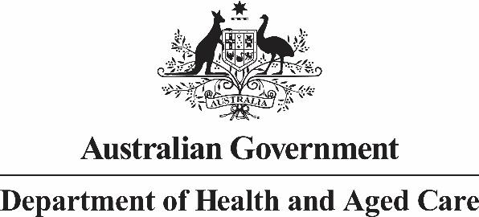

Allied Health Industry Reference Group

Meeting Thirteen: 4 March 2025 - Summary of Outcomes

The Australian Government Chief Allied Health Office (CAHO) convened the 13th Allied Health Industry Reference Group (AHIRG) meeting on 4 March 2025. This meeting was attended by core members only and was held virtually.

**Topics discussed:**

* The CAHO indicated any current meetings planned with stakeholders will need to be rescheduled if Caretaker period commences.
* Bronwyn Morris-Donovan (CEO, Allied Health Professions Australia (AHPA)) presented findings from the Allied Health Digital Transformation Survey Report, February 2025
* This survey was conducted by the Australian Digital Health Agency in collaboration with AHPA in March-April 2024.
* The purpose of the survey was to understand the awareness, use and readiness to use three key digital products.
* Members discussed findings and considerations in the context of current reforms.
* The CAHO provided an update on the [Review of MBS allied health chronic disease management services](https://www.health.gov.au/our-work/review-of-mbs-allied-health-chronic-disease-management-services)
  + The review is structured around four questions, these are on the department’s website.
  + The working group has been established, and membership is detailed on the department’s website.
  + Two working group meetings have been held, with a third scheduled for early April 2025.
  + It is anticipated that the review process will include a rapid review of the evidence base, and qualitative research of peak, provider and patient views and experiences – the department will commission this work externally
    - Allied health professional organisations that are currently eligible for the first three questions will be consulted by the researchers as part of the rapid review and qualitative components.
    - There will be targeted and public consultation opportunities – these will be flagged well in advance – individuals and organisations can write to [MRACAlliedHealth@health.gov.au](mailto:MRACAlliedHealth@health.gov.au) to register interest.
  + It is anticipated that the review will be completed in the first half of 2026.
* Update on the National Allied Health Workforce Strategy:
  + Public consultation of the draft Strategy has now closed. Public consultation was open from 20 January to 3 March 2025.
  + Over 240 responses received via the Consultation Hub and offline.
  + Feedback is currently being considered and edits to the draft Strategy will be made under guidance of the Strategy Steering Group and Strategy Advisory Group.
  + The next phase is finalising Strategy and considering implementation planning.
* The CAHO and Mr Richard Nankervis (PHN Cooperative) led a discussion on the future engagement between Primary Health Networks and Allied Health Peak bodies
  + Members reflected upon previous meetings and discussed whether the current format was fit for purpose.
  + Members reported this forum was an important mechanism to engage with each other as it provided a consistent touch point. Members were supportive of the current format considering the current reforms and budget measure requiring close collaboration between the groups.
* The CAHO sought input from members on multidisciplinary team (MDT) models to help shape considerations of future workforce and health care policy
  + Members raised issues to consider including the importance of flexibility of funding, funding care coordination, MDT structure will vary according to location/professionals available/health needs of the client, the role of PHNs and current reviews and reforms.
* The Terms of Reference and memberships at the end of their 3-year term are due to be reviewed.

**Actions Register**

|  |  |  |  |
| --- | --- | --- | --- |
| **Meeting** | **Action** | **Action Officer** | **Status** |
| M13, 04/03/25 | The Department of Health & Aged Care will consider rescheduling the meeting that is open to members and the broader allied health sector. | Commonwealth CAHO | Pending |
| M13, 04/03/25 | The Department of Health & Aged Care will contact members regarding the update to the Terms of Reference. | Commonwealth CAHO | Pending |
| M12, 03/12/24 | Attendees to provide case histories and videos to showcase allied health professions on the Department of Health and Aged Care’s intranet. | Members and professional association representatives | Pending |