The Aged Care Council of Elders is a group of older people from diverse backgrounds with lived experiences of ageing and aged care. Find out more about each of the members in their Council profile
Aged Care Council of Elders | Description and Experience of the Aged Care Council of Elders
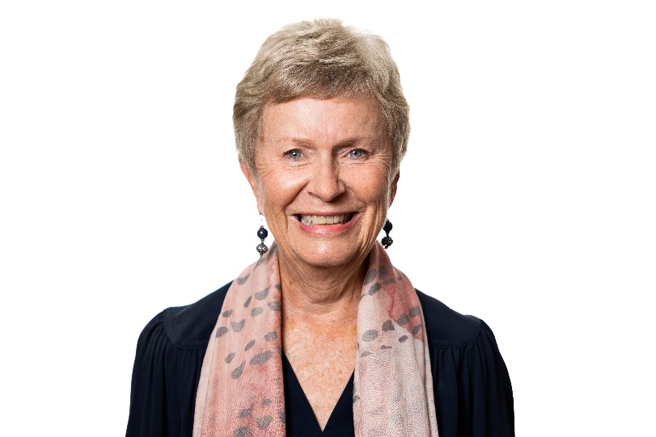 | Anne Burgess AM  Anne is the Chair of the Council of Elders.  Anne is passionate about ageing well. She is currently Deputy Chair of Council on the Ageing South Australia and Chair of its policy council, Deputy Chair of the Older Persons Advocacy Network and Chair of Aged Rights Advocacy Service.  Anne was also appointed by the Australian Government as Chair of the Aged Care Transition Taskforce and a member of the National Aged Care Advisory Council.  Anne has more than 40 years’ experience leading areas of government focused on social justice and has a particular interest in community engagement. She brings experience to the role of Chair from her career as a senior public servant in South Australia. This included roles as Director of Office for Women and Director of Mental Health and a two-year term as Acting Commissioner for Equal Opportunity South Australia.  In 2021, Anne was appointed as a Member of the Order of Australia (AM) for significant service to mental health, gender equality and older people.  Anne wants to ensure that the voices and lived experiences of older people are valued and respected in the planning and delivery of aged care reforms.
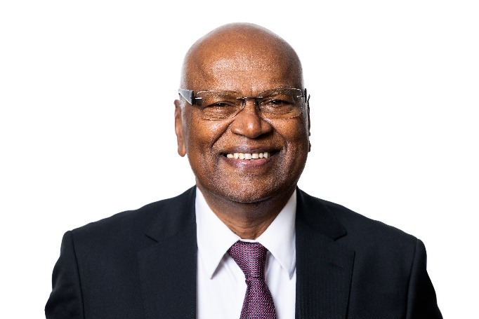 | Professor Ponniah Anandajayasekeram  Dr Ananda is a retired Agricultural Economist with more than 4 decades of professional experience in research, training, development, and advocacy work, mostly in international settings.  He is a Melbourne-based member of the culturally and linguistically diverse community and is the Board Chair of the Southern Migrant and Refugee Centre in Victoria. He is also a member of the Darebin Council’s Welcoming Cities Reference Group and Policy Development Group, COTA Victoria.  Dr Ananda was the past president of the Tamil Senior Citizens Fellowship (VIC) Inc, a member of the Regional Advisory Council of the Victoria Multicultural Commission, and a member of the Healthy Ageing Advisory Committee of the Federation of Ethnic Communities Council of Victoria.  Dr. Ananda volunteers at several organisations which help older people to partner with multicultural groups and organisations to address community-based issues, especially healthy ageing. He strongly believes that everyone deserves a healthy and dignified life at every stage.
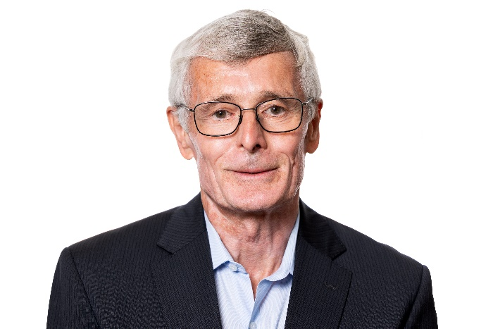 | Associate Professor John Cullen AM  Associate Professor John Cullen AM is a practising geriatrician based in Sydney’s inner west and has 40 years’ experience developing, managing and delivering health services for older people in hospital, community and residential aged care settings.  John has been the Clinical Director for Aged Health, Rehabilitation and Chronic Care with the Sydney Local Health District since 1997, and has provided clinical support to the Aged Care Assessment Program since its establishment in the mid-1980s.  John has particular interests in delivering aged health services to regional and remote communities via telehealth and outreach services, community aged health services and the transitions between hospital and community care, dementia support and management programs, and inreach health services to people in residential aged care.  In 2024, John was appointed as a Member of the Order of Australia (AM) for contributions to geriatric medicine as a clinician, researcher, innovator and advocate.
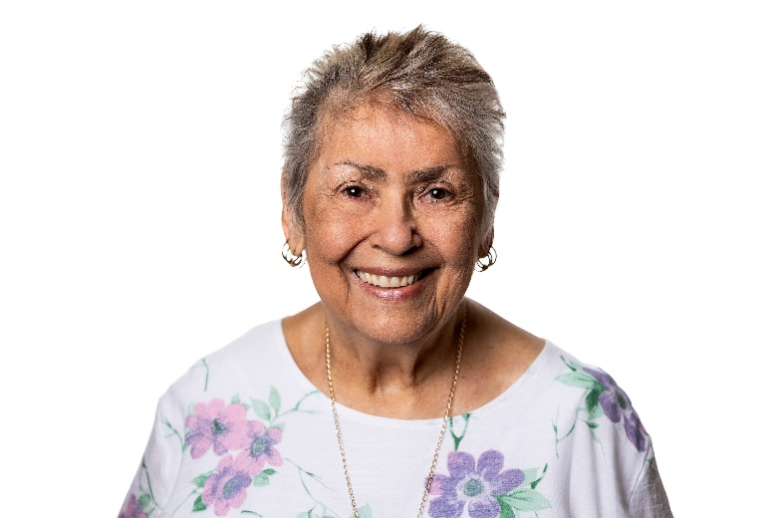 | Aunty Lyn Cullinane  Aunty Lyn is a proud Munanjali woman who has deep connections extending across the Mibany language groups and the Yugambeh-Bundjalung society.  Aunty Lyn has a strong understanding of the complex issues experienced by First Nations people gained during her 50-year career in both public and private sectors in Queensland and NSW, and her involvement in the Aboriginal and Torres Strait Islander community in Brisbane.  Aunty Lyn has held positions across different fields including aged care, corrections, domestic violence, child protection and health. It is through this knowledge that she continues to advocate for the advancement of First Nations people across many levels.  Aunty Lyn has delivered papers on aged care and corrections in the USA and Canada and has been a member of several taskforces including Family Violence in Remote Communities in Qld, and child protection regarding The Aboriginal and Torres Strait Islander Child Placement Principle.
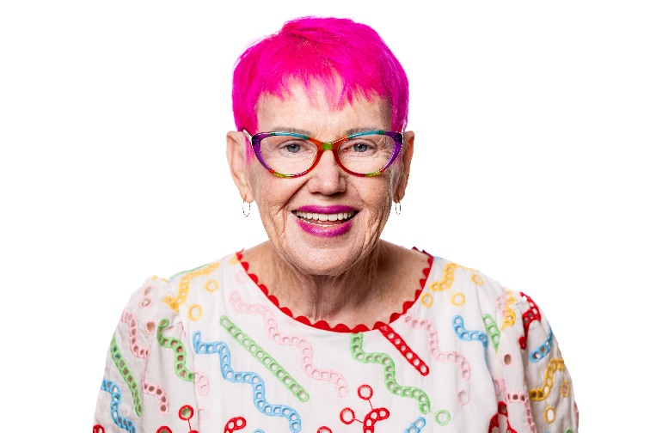 | Gwenda Darling  Gwenda, a great grandmother, is a Palawa woman descendent from the Tebrikuna tribe. She lives a full life advocating for people to age well in their own homes, and for aged care that provides choice, control and meets the needs of all people.  By being open about the impact of her own dementia diagnosis and encouraging discussion, Gwenda hopes to destigmatise dementia and raise awareness and acceptance. She is determined to live the best life she can and not allow her diagnosis to define her. Gwenda works to make aged care better for all people and is always ready to listen and support community members, with her assistance dog Redleigh by her side.  Gwenda has had personal experience with the aged care system since 2014 and gave evidence at the Royal Commission into Aged Care Quality and Safety, where she advocated for change. She has seen firsthand the need for culturally safe, respectful and trauma-informed care for Aboriginal and Torres Strait Islander peoples.  enda has been a member of the Council of Elders since 2022 and is a member of the National Older Persons Reference Group, Dementia Australia Advisory Committee, and AdNET Registry Steering Committee. Participating in research projects with universities is another way Gwenda hopes to create a better life for ageing Australians.
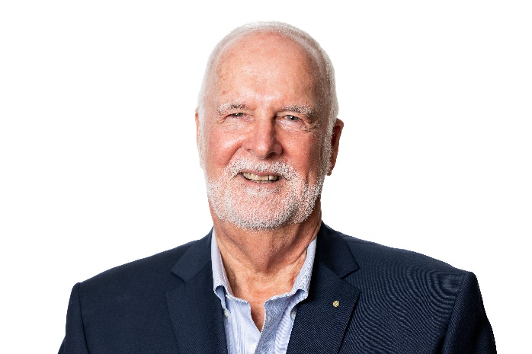 | Dr John Davis  Based in Victoria, although born and raised in South Australia, John's background is as a teacher, historian, author, and Anglican priest for 45 years.  John is a strong advocate in the areas of palliative and aged care and for LGBTIQA+ communities. He has academic qualifications in Arts, Education and Theology, with a doctorate in Church History.  John offers valuable insight through his lived experience of navigating health, ageing, and the aged care system, both as an older person living in regional Australia and as carer for his late husband.
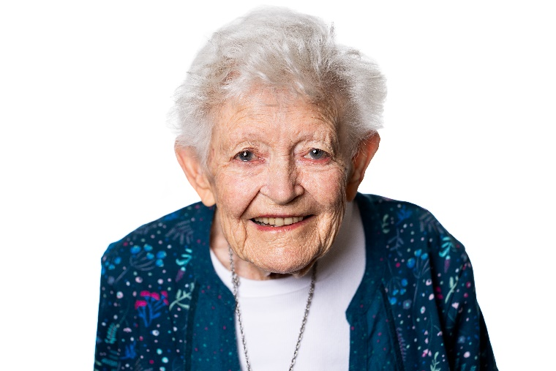 | Val Fell OAM  Val describes herself as a ‘retired mathematics teacher and statistician who worked in many fields including economics, media and advertising’.  Val joined Alzheimer's NSW in 2006 and became a dementia advocate. She founded the Corrimal Dementia Carers Group in 2011 and the Annual Public Illawarra Dementia Forum in 2012 to raise awareness of dementia and improve access to information and resources for people living with dementia, their carers, and the general public.  Val was awarded the City of Wollongong Senior Citizen of the Year award in 2020 for her volunteering work, including with Dementia Australia and Council on the Ageing. She was awarded the Medal of the Order of Australia (OAM) in 2022 for her service to people with dementia.  Val is the 8th child in a family with 11 children and over the years has watched family members and her husband enter aged care homes. Val works tirelessly as an advocate with the Council on the Ageing and the Older Persons Advocacy Network to improve aged care services for all older people.
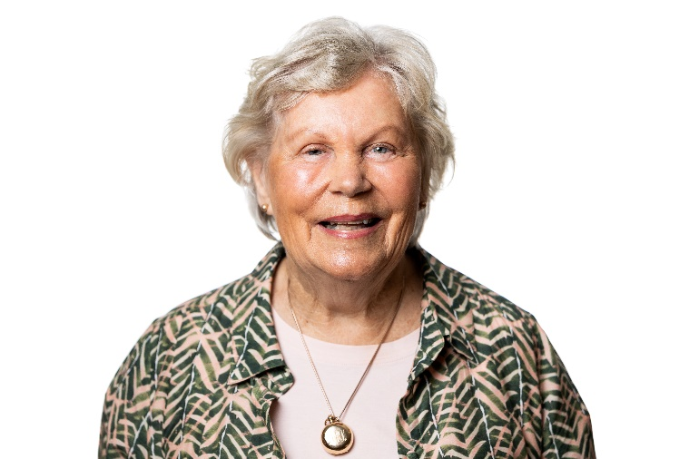 | Gillian Groom AO  Gillian was an occupational therapist for 50 years before establishing a career in elder and succession law. She received her law degree from the University of Tasmania, 3 weeks before turning 70.  Gillian has lived and worked in Tasmania for most of her life. She has extensive experience in community engagement through her involvement with a wide range of groups, including those that represent First Nations peoples, people from culturally and linguistically diverse backgrounds and people living with disability.  In 2022, Gillian was appointed as an Officer of the Order of Australia (AO) for distinguished service to the community through healthcare, medical research, social welfare organisations, and to the law.  As a parent of 6 adult children and 17 grandchildren, Gillian is particularly focused on the future of ageing in Australia and wants to ensure all people have access to safe and high-quality care.
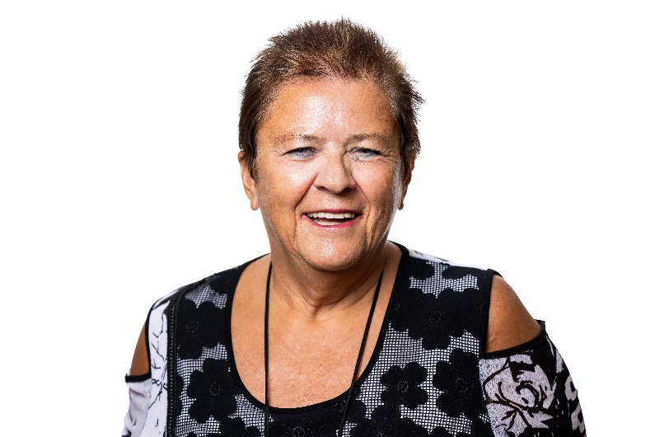 | Anna Maria Harrison AM JP  Anna has dedicated her professional life to advocating for people from Western Australia, particularly older people from culturally and linguistically diverse backgrounds and those identifying as LGBTIQA+.  Anna is multilingual, which has helped her to connect and engage with older people from diverse communities. She founded and is President of the Board of the Umbrella Multicultural Community Care organisation, which supports older people from culturally diverse backgrounds to remain in their own homes and maintain independence as they age.  She is a member of WA Ministerial Multicultural Advisory Council and was on the Positive CALD Ageing Network Ministerial Advisory Committee for Federation of Ethnic Communities Councils Australia.  Anna was appointed as a Member of the Order of Australia (AM)in 2023 for significant service to aged care and multiculturalism in WA and continues to advocate for a better aged care system for all.
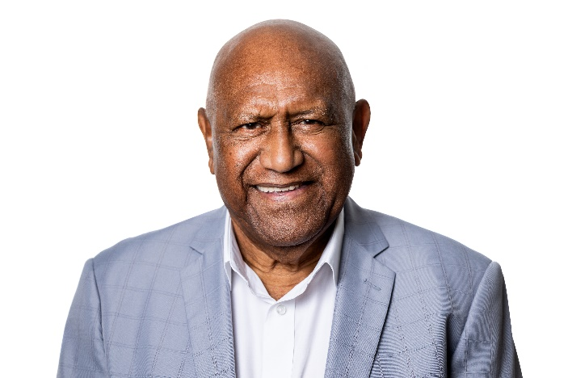 | Mr William (Uncle Benny) Hodges  Uncle Benny Hodges is blessed with both Aboriginal (Waanyi – Garawa heritage) and Torres Strait Islander heritage (Bam Le - Kulkalgal heritage) and is a respected aged person living in the ACT (Ngunnawal – Ngambri Country). Born and bred on Gimwoy Wulunbara Yidinji Country (Cairns in Far North Queensland), one of his cultural obligations is to always look after and respect his Elders.  Uncle Benny has more than 30 years’ experience in engagement in Aboriginal and Torres Strait Islander affairs, and was recently named ACT NAIDOC 2024 Elder of the Year.  Uncle Benny is passionate about the health and well-being of older Aboriginal and Torres Strait Islander peoples and all older Australians. He is newly appointed to the Council of Elders and is keen to continue advocating and supporting the Council’s work to date.
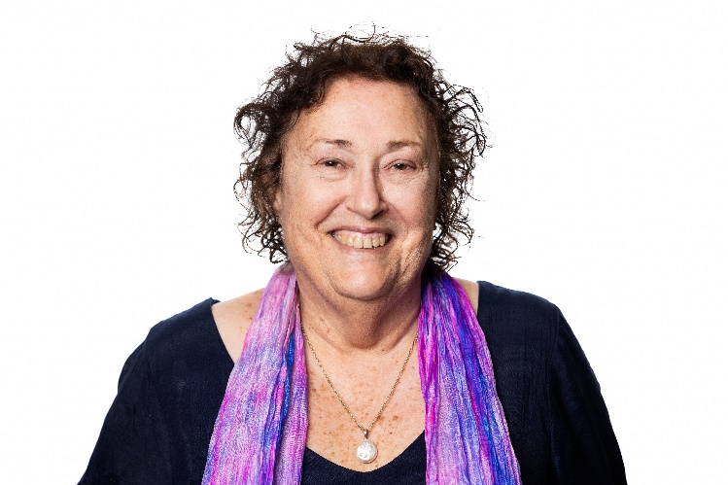 | Juliet Rankin  Juliet (Julie) has more than 40 years’ experience as an occupational therapist working across urban and remote areas of Western Australia and the Northern Territory.  Julie is a current member of Palliative Care NT and has held positions at Carers NT, the Australian Association of Occupational Therapy and Carers Australia. Julie has worked with clients in acute, community, residential and palliative care settings.  Julie is a member of the Council on the Ageing and is connected to people with disability, people from culturally and linguistically diverse backgrounds and First Nations peoples.  Julie is passionate about enabling people to live independently in their homes as they age for as long as possible.
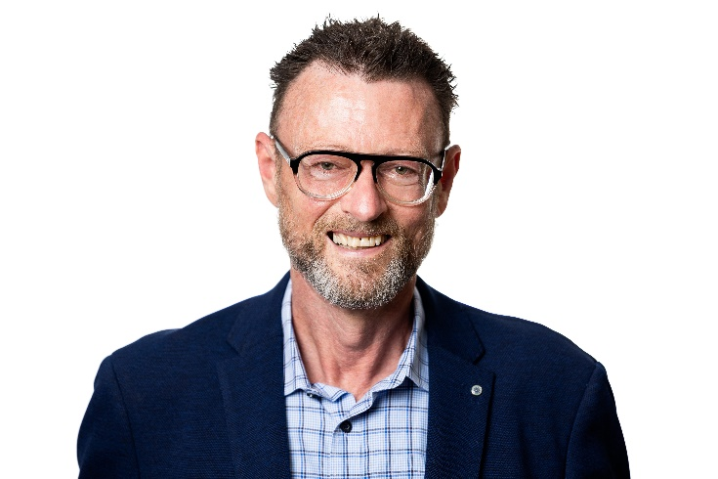 | Mr Russell Westacott  Russell resides in rural NSW and is a human rights advocate with 40 years’ experience working with vulnerable and marginalised individuals and communities.  In the mid-1980s, he worked at the grassroots level providing outreach and counselling to those impacted by HIV, particularly vulnerable and at risk men living on the streets of Sydney. In the early 2000s he worked at New York’s largest HIV community based organisation and contributed to policy and lobbying efforts at city, state and US federal levels. Rusell returned to Australia as Director of Client Services at the AIDS Council of NSW.  As Chief Executive Officer of Seniors Rights Service for a decade from 2011, Russell was instrumental in growing the organisation’s reach and was active in developing the Older Person’s Advocacy Network. He contributed to the development of an international convention for the rights of older people and participated in the United Nations Open-ended Working Group on Ageing. Russell actively advocated for aged care policy change and was one of the founding members of the peak cross-sector body, Elder Abuse Action Australia.  In recent years Russell played a primary caring role for his husband who sadly passed away in November 2024, and continues to be the primary carer of his ageing mother who is an aged care recipient.
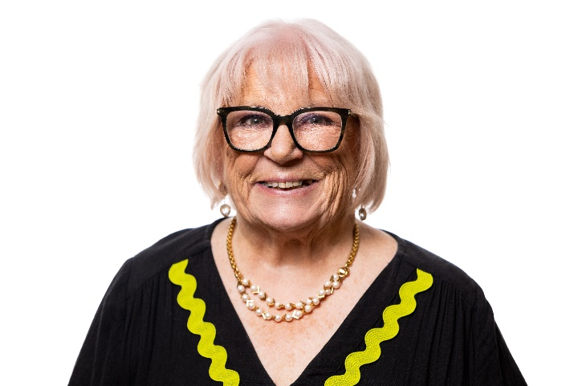 | Lyn Whiteway  Lyn resides in a retirement village in South Australia and is a home care package recipient. She has experience as a full-time carer for her husband who is living with dementia. Her responsibilities have recently changed as her husband has moved to residential aged care.  Through her volunteer work with Dementia Australia, ECH (an aged care service provider), Sepsis Australia and the Council on the Ageing, Lyn is closely connected to older people in her community. She has been a consumer advocate for more than 20 years in roles in the public and private sectors of the health system.  Lyn is involved in sepsis research as a member of Sepsis Australia and is a consumer advisor on a global steering committee for a clinical trial on Staph. She was recently appointed to an Australian Commission on Safety and Quality in Health Care committee designing a new Clinical Care Standard for older people requiring emergency laparotomy, which very often leads to sepsis.

