Systematic review of evidence on the clinical effectiveness of reflexology

Appendix D – additional results and citations for included studies

14 November 2024

Contents

Additional results 3

Study characteristics 3

Risk of bias assessments 3

D1 Pain 3

D2 Sleep 5

D3 Fatigue 6

D4 Emotional functioning and mental health 8

D5 Health-related quality of life (HR-QoL) 10

D6 Physical function 12

D7 Global symptoms 14

D8 References to included studies 17

# Additional results

### Study characteristics

Study characteristics (including eligible and included participants, and the interventions evaluated) and the outcomes measured and selected from each study for inclusion in the meta-analysis are reported in Appendix E1. Details of funding, ethics approval and any other declarations of interest for each study are in Appendix E2.

### Risk of bias assessments

The overall risk of bias rating for each study included for meta-analysis is reported in the forest plots (main report). The complete risk of bias assessment for each study is reported in Appendix F. Assessments are grouped by study design (parallel-randomised trials, crossover trials, and cluster-randomised trials), then ordered alphabetically within each design by study ID. For each study, a separate risk of bias assessment was made for all comparisons and outcomes contributing to meta-analysis. If the assessment was the same for different comparisons/outcomes, only one assessment is reported (See Appendix F for details).

## D1 Pain

Results presented in this section are for the subgroup analysis, sensitivity analysis, and analyses to examine the risk of bias due to missing results.

For the outcome pain, 46 studies were included in the meta-analysis that compared reflexology to an inactive control (usual care, no intervention, sham, co-intervention given in both groups).

#### Results of subgroup analysis by population group

A subgroup analysis was performed to investigate whether there were differences in the effects between population groups (i.e. surgery, procedures, labour and childbirth, other acute pain, cancer or advanced disease, chronic musculoskeletal conditions, other chronic pain). Primarily, these were planned to explore possible explanations for any inconsistent effects if observed across studies (statistical heterogeneity).

*Assessment of heterogeneity:* While there are differences in the size of the estimated intervention effect across studies for this comparison and outcome, the effect estimate for the majority of studies in the overall analysis was above the threshold for an important improvement in pain (i.e. an SMD < -0.2). As such, the observed inconsistency is considered unimportant as it does not alter the interpretation of findings for this outcome (noting that there were serious concerns about inconsistency within some subgroups because of the higher proportion of inconsistent results).

The subgroup analyses did not explain any observed differences across studies in the direction or size of the observed effect. Results for this analysis are presented in the main report (Section 4.2, Figure 4.2.1). The test for subgroup differences was not statistically significant (P = 0.44) and the combined estimate of effect indicated an important improvement in pain for each of the population groups. Overall, there is evidence that the effects are consistent across population groups (all showing important benefit, despite variation in the magnitude of benefit).

#### Results of sensitivity analyses

**Table D1.1** presents results for the original analysis (all studies, random effects model) and two sensitivity analyses. These sensitivity analyses investigate:

1. whether the combined estimate is sensitive to the assumptions that were made to enable inclusion of results in the meta-analysis, specifically transforming or imputing statistics, and including change scores (change from baseline) when post-intervention (final) values (and their standard deviations) were unavailable; and
2. whether the combined effect differs when estimated from a fixed effect model, providing evidence of small study effects (which may be due to true differences in the effects in small studies or may suggest non-reporting bias).

The combined estimate of effect was similar in the original analysis and the sensitivity analyses removing studies for which transforming / imputing statistics or using change scores was necessary. This indicates that the result was robust to the assumptions required to include these results.

**Table D1.1. Sensitivity analyses for pain outcome**

|  |  |  |  |  |  |
| --- | --- | --- | --- | --- | --- |
| Sensitivity analysis | Purpose of sensitivity analysis | No trials | Original effect (95% CI) | No trials | Sensitivity analysis effect |
| No imputation, transformations or change scores 1 | Investigate robustness of MA effect | 46 | SMD -1.02(-1.26 to  -0.78); I2 = 89% | 36 | SMD -1.09 (-1.38 to -0.81); I2 = 90% |
| Fixed effect analysis | Investigate small study effects (bias due to missing results) |  |  | 46 | SMD -0.82 (-0.89 to -0.75); I2 = 88% |

1 This analysis was limited to trials that (a) reported i) means and standard deviations, ii) means and standard errors, or iii) mean differences and their confidence intervals, and (b) had post-intervention (final) values available.

*Abbreviations*. MA = meta-analysis; SMD = standardised mean difference; CI = confidence interval

#### Bias due to missing results from the meta-analysis

The combined effect estimated from the fixed effect model (SMD -0.82) was smaller than from the random effects model (SMD -1.02) (Table D1.1), which may suggest small study effects arising from selective non-reporting of unfavourable results (Table D1.1). The contour-enhanced funnel plot in Figure D1.1 suggests that there could be missing studies that show effects favouring the control, and nonsignificant effects in general (i.e. the plot is asymmetric, missing studies to the right of the line of no effect (SMD 0) where we would expect results for some small studies, most notably in the darker grey shaded areas where nonsignificant results appear; in addition only a minority of studies to the left of the line of no effect are non-significant).

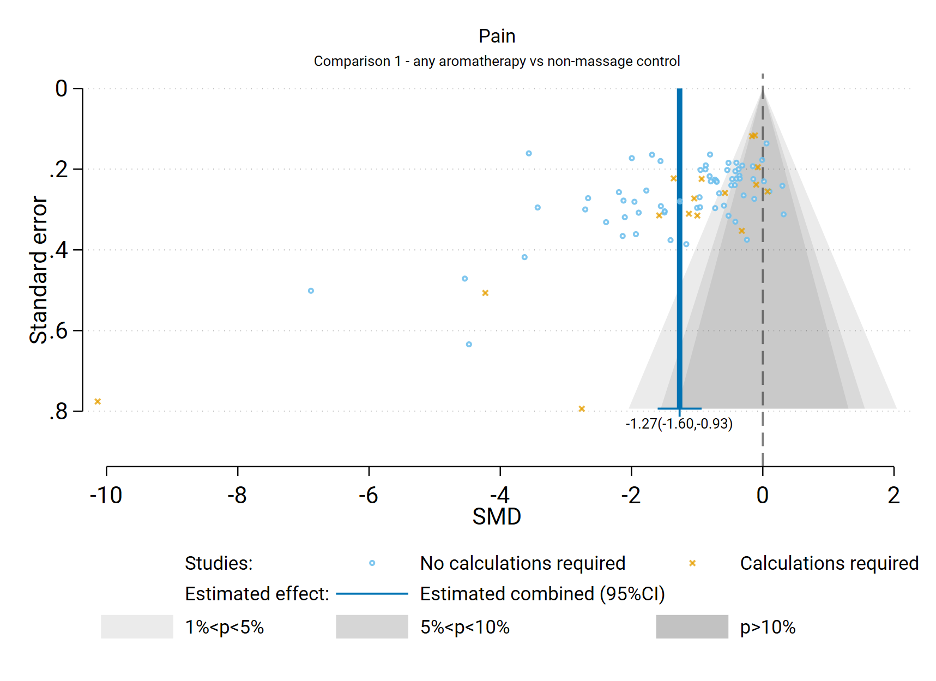

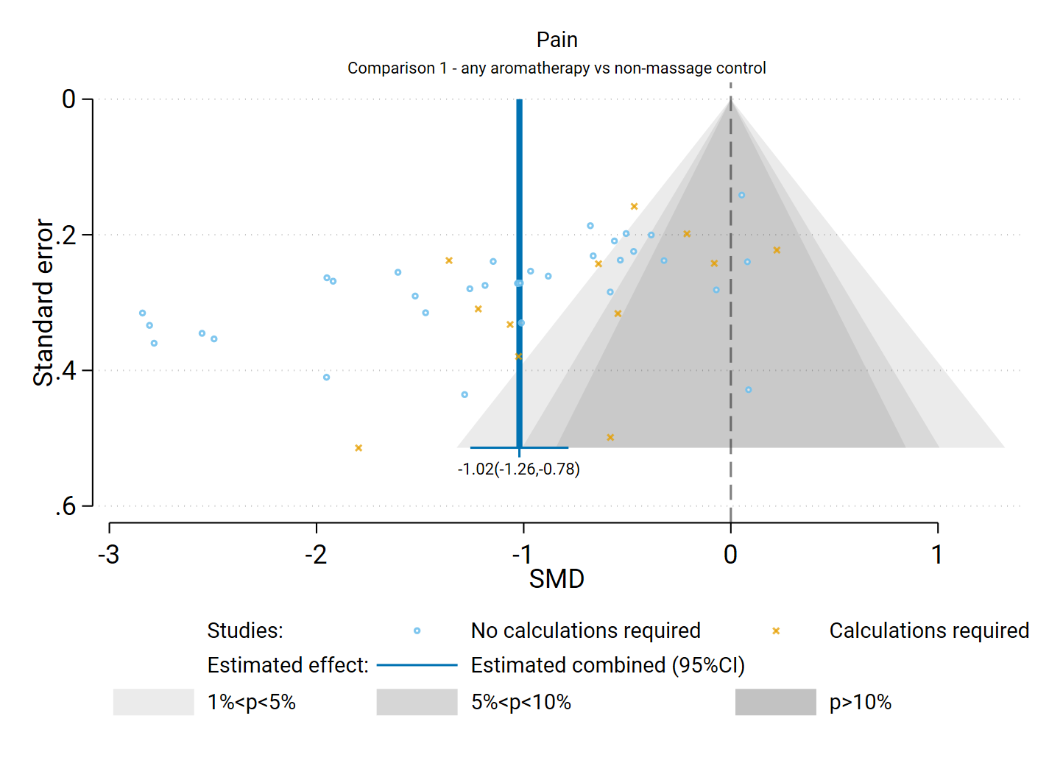

**Fig D1.1** | Contour enhanced funnel plot of estimates of SMD versus their standard errors for comparison of the effect of reflexology (any mode) versus inactive control (usual care, no intervention, sham, co-intervention given in both groups) on pain. Shaded regions represent different categories of conventional milestone levels of statistical significance. SMD = standardised mean difference. Blue line shows the combined estimate from random effects model.

## D2 Sleep

Results presented in this section are for the subgroup analysis, sensitivity analysis, and analyses to examine the risk of bias due to missing results.

For the outcome sleep, 12 studies were included in the meta-analysis that compared reflexology to an inactive control (usual care, no intervention, sham, co-intervention given in both groups).

#### Results of subgroup analysis by population group

A subgroup analysis was performed to investigate whether there were differences in the effects between population groups (i.e. surgery, hospitalisation, sleep disruption, cancer and advanced disease). Primarily, these were planned to explore possible explanations for any inconsistent effects if observed across studies (statistical heterogeneity).

*Assessment of heterogeneity:* While there are differences in the size of the estimated intervention effect across studies for this comparison and outcome, the effect estimate for all 12 studies was above the threshold for an important improvement in sleep quality (i.e. an SMD > 0.2). As such, the observed inconsistency is considered unimportant as it does not alter the interpretation of findings for this outcome.

The subgroup analyses may explain some of the observed differences across studies in the direction or size of the observed effect. Results for this analysis are presented in the main report (Section 4.4, Figure 4.4.1). The test for subgroup differences was statistically significant (P = 0.045), but the combined estimate of effect indicated an important improvement in sleep for each of the population groups. Overall, there is evidence that the effects are consistent across population groups (all showing important benefit, despite variation in the magnitude of benefit).

#### Results of sensitivity analyses

**Table D2.1** presents results for the original analysis (all studies, random effects model) and two sensitivity analyses. These sensitivity analyses investigate:

1. whether the combined estimate is sensitive to the assumptions that were made to enable inclusion of results in the meta-analysis, specifically transforming or imputing statistics, and including change scores (change from baseline) when post-intervention (final) values (and their standard deviations) were unavailable; and
2. whether the combined effect differs when estimated from a fixed effect model, providing evidence of small study effects (which may be due to true differences in the effects in small studies or may suggest non-reporting bias).

The first sensitivity analysis was not required because we did not need to calculate / impute statistics or use change scores for any studies in this meta-analysis.

**Table D2.1. Sensitivity analyses for sleep outcome**

|  |  |  |  |  |  |
| --- | --- | --- | --- | --- | --- |
| Sensitivity analysis | Purpose of sensitivity analysis | No trials | Original effect (95% CI) | No trials | Sensitivity analysis effect |
| No imputation, transformations or change scores 1 | Investigate robustness of MA effect | 12 | SMD 1.37 (0.88 to  1.87); I2 = 87% |  | Not required (no imputation, transformation, or change scores) |
| Fixed effect analysis | Investigate small study effects (bias due to missing results) |  |  | 12 | SMD 1.21 (1.06 to 1.37); I2 = 85% |

1 This analysis was limited to trials that (a) reported i) means and standard deviations, ii) means and standard errors, or iii) mean differences and their confidence intervals, and (b) had post-intervention (final) values available.

*Abbreviations*. MA = meta-analysis; SMD = standardised mean difference; CI = confidence interval

#### Bias due to missing results from the meta-analysis

The combined effect estimated from the fixed effect model (SMD 1.21) was similar to that from the random effects model (SMD 1.37) (Table D2.1); both indicated an improvement in sleep quality greater than the threshold for an important effect. The contour-enhanced funnel plot in Figure D2.1 suggests that there could be missing studies which show effects favouring the control, and nonsignificant effects in general (i.e. the plot is asymmetric, missing studies to the left of the line of no effect (SMD 0) where we would expect results for some small studies, most notably in the darker grey shaded areas where nonsignificant results appear; in addition only a minority of studies to the right of the line of no effect are non-significant).

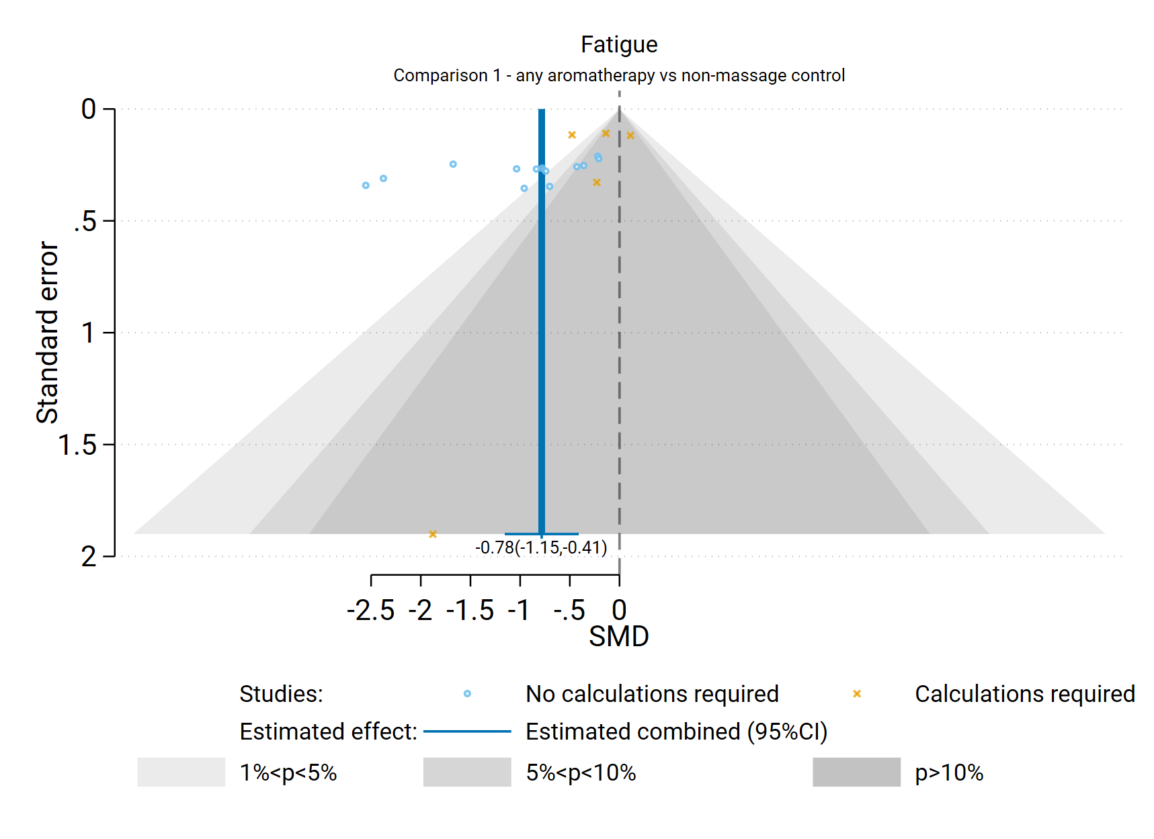

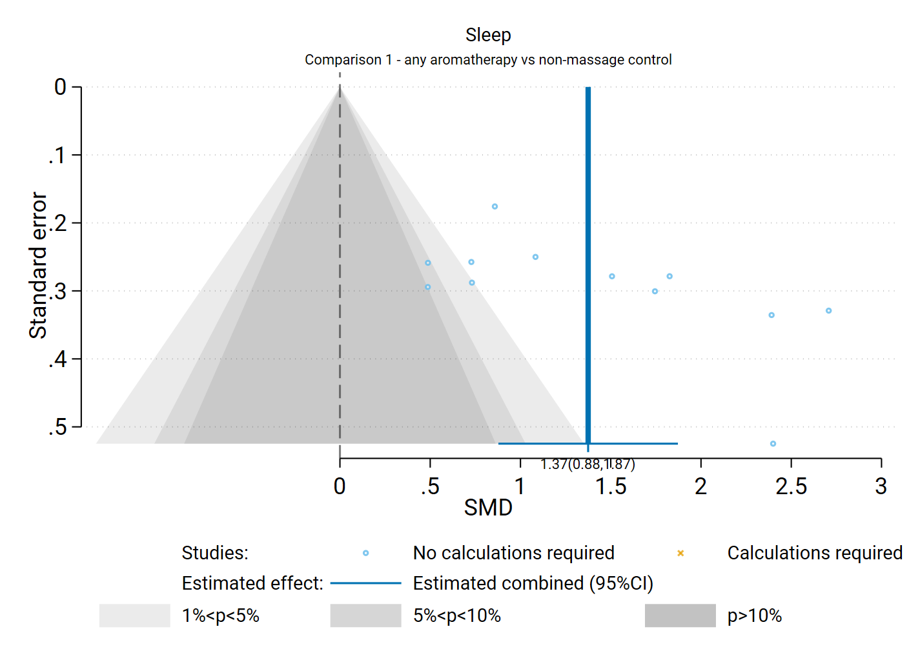**Fig D2.1** | Contour enhanced funnel plot of estimates of SMD versus their standard errors for comparison of the effect of reflexology versus inactive control (usual care, no intervention, placebo) on sleep quality. Shaded regions represent different categories of conventional milestone levels of statistical significance. SMD = standardised mean difference. Blue line shows the combined estimate from random effects model.

## D3 Fatigue

Results presented in this section are for the subgroup analysis, sensitivity analysis, and analyses to examine the risk of bias due to missing results.

For the outcome fatigue, 19 studies were included in the meta-analysis that compared reflexology to an inactive control (usual care, no intervention, sham, co-intervention given in both groups).

#### Results of subgroup analysis by population group

A subgroup analysis was performed to investigate whether there were differences in the effects between population groups (i.e. cancer and advanced disease, chronic musculoskeletal conditions, other chronic conditions, pregnancy). Primarily, these were planned to explore possible explanations for any inconsistent effects if observed across studies (statistical heterogeneity).

*Assessment of heterogeneity:* There are differences in the size of the estimated intervention effect across studies for this comparison and outcome that suggest inconsistent effects. While the effect estimate for the majority of studies was above the threshold for an important improvement in fatigue (i.e. an SMD < - 0.2), about ¼ of studies in the analysis showed trivial effects (an SMD between -0.2 and 0.2). As such, the observed inconsistency is considered serious for the overall analysis and requires explanation to understand the factors that may influence whether reflexology has a beneficial or trivial effect.

The subgroup analyses did not explain the observed differences across studies in the direction or size of the observed effect. Results for this analysis are presented in the main report (Section 4.4, Figure 4.4.1). The test for subgroup differences was not statistically significant (P = 0.254) and there was inconsistency in the effects observed across studies within all population groups, which we considered serious for two groups (chronic musculoskeletal conditions, pregnancy). Overall, there is evidence that the effects are inconsistent across population groups (some showing important benefit, others showing trivial effects).

#### Results of sensitivity analyses

**Table D3.1** presents results for the original analysis (all studies, random effects model) and two sensitivity analyses. These sensitivity analyses investigate:

1. whether the combined estimate is sensitive to the assumptions that were made to enable inclusion of results in the meta-analysis, specifically transforming or imputing statistics, and including change scores (change from baseline) when post-intervention (final) values (and their standard deviations) were unavailable; and
2. whether the combined effect differs when estimated from a fixed effect model, providing evidence of small study effects (which may be due to true differences in the effects in small studies or may suggest non-reporting bias).

The combined estimate of effect was similar in the original analysis and the sensitivity analyses removing studies for which transforming / imputing statistics or using change scores was necessary. This indicates that the result was robust to the assumptions required to include these results.

**Table D3.1. Sensitivity analyses for fatigue outcome**

|  |  |  |  |  |  |
| --- | --- | --- | --- | --- | --- |
| Sensitivity analysis | Purpose of sensitivity analysis | No trials | Original effect (95% CI) | No trials | Sensitivity analysis effect |
| No imputation, transformations or change scores 1 | Investigate robustness of MA effect | 19 | SMD -0.85 (-1.20 to  -0.50); I2 = 89% | 17 | SMD -0.85 (-1.25 to -0.45); I2 = 91% |
| Fixed effect analysis | Investigate small study effects (bias due to missing results) |  |  | 20 | SMD -0.61 (-0.72 to -0.51); I2 = 87% |

1 This analysis was limited to trials that (a) reported i) means and standard deviations, ii) means and standard errors, or iii) mean differences and their confidence intervals, and (b) had post-intervention (final) values available.

*Abbreviations*. MA = meta-analysis; SMD = standardised mean difference; CI = confidence interval

#### Bias due to missing results from the meta-analysis

The combined effect estimated from the fixed effect model (SMD -0.61) was smaller than from the random effects model (SMD -0.85) (Table D3.1), which may suggest small study effects arising from selective non-reporting of unfavourable results (Table D3.1). The contour-enhanced funnel plot in Figure D3.1 suggests that there could be missing studies which show effects favouring the control, and nonsignificant effects in general (i.e. the plot is asymmetric, missing studies to the right of the line of no effect (SMD 0) where we would expect results for some small studies, most notably in the darker grey shaded areas where nonsignificant results appear; in addition only a minority of studies to the left of the line of no effect are non-significant).



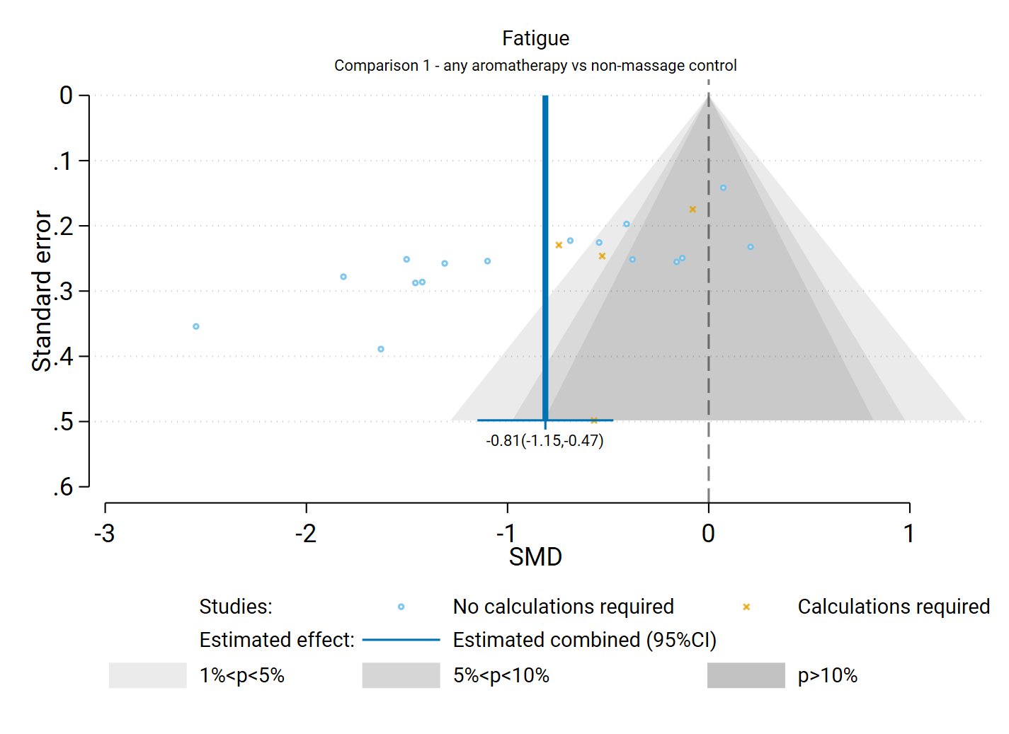**Fig D3.1** | Contour enhanced funnel plot of estimates of SMD versus their standard errors for the comparison of the effect of reflexology versus inactive control (usual care, no intervention, placebo) on fatigue. Shaded regions represent different categories of conventional milestone levels of statistical significance. SMD = standardised mean difference. Blue line shows the combined estimate from random effects model.

## D4 Emotional functioning and mental health

Results presented in this section are for the subgroup analysis, sensitivity analysis, and analyses to examine the risk of bias due to missing results.

For the outcome emotional functioning and mental health, 40 studies were included in the meta-analysis that compared reflexology to an inactive control (usual care, no intervention, sham, co-intervention given in both groups).

#### Results of subgroup analysis by population group

A subgroup analysis was performed to investigate whether there were differences in the effects between population groups (i.e. surgery, procedures, hospitalisation, labour and childbirth, mental distress, cancer and advanced disease, mental disorders, dementia). Primarily, these were planned to explore possible explanations for any inconsistent effects if observed across studies (statistical heterogeneity).

*Assessment of heterogeneity:* There are differences in the size of the estimated intervention effect across studies for this comparison and outcome that suggest inconsistent effects. While the effect estimate for the majority of studies was above the threshold for an important improvement in emotional functioning and mental health (i.e. an SMD < - 0.2), more than ¼ of studies in the analysis showed trivial effects (an SMD between -0.2 and 0.2) or effects favouring the control. As such, the observed inconsistency is considered serious for the overall analysis and requires explanation to understand the factors that may influence whether reflexology has a beneficial or trivial effect.

The subgroup analyses did not explain the observed differences across studies in the direction or size of the observed effect. Results for this analysis are presented in the main report (Section 4.5, Figure 4.5.1). The test for subgroup differences was not statistically significant (P = 0.1) and there was inconsistency in the effects observed across studies within the majority population groups, which we considered serious for one group (cancer and advanced disease). Overall, there is evidence that the effects are inconsistent across population groups (some showing important benefit, others showing trivial effects).

#### Results of sensitivity analyses

**Table D4.1** presents results for the original analysis (all studies, random effects model) and two sensitivity analyses. These sensitivity analyses investigate:

1. whether the combined estimate is sensitive to the assumptions that were made to enable inclusion of results in the meta-analysis, specifically transforming or imputing statistics, and including change scores (change from baseline) when post-intervention (final) values (and their standard deviations) were unavailable; and
2. whether the combined effect differs when estimated from a fixed effect model, providing evidence of small study effects (which may be due to true differences in the effects in small studies or may suggest non-reporting bias).

The combined estimate of effect was similar in the original analysis and the sensitivity analyses removing studies for which transforming / imputing statistics or using change scores was necessary. This indicates that the result was robust to the assumptions required to include these results.

**Table D4.1. Sensitivity analyses for emotional functioning and mental health outcome**

|  |  |  |  |  |  |
| --- | --- | --- | --- | --- | --- |
| Sensitivity analysis | Purpose of sensitivity analysis | No trials | Original effect (95% CI) | No trials | Sensitivity analysis effect |
| No imputation, transformations or change scores 1 | Investigate robustness of MA effect | 40 | SMD -0.69 (-0.93 to  -0.44); I2 = 91% | 31 | SMD -0.62 (-0.90 to -0.35); I2 = 89% |
| Fixed effect analysis | Investigate small study effects (bias due to missing results) |  |  | 40 | SMD -0.57 (-0.64 to -0.50); I2 = % |

1 This analysis was limited to trials that (a) reported i) means and standard deviations, ii) means and standard errors, or iii) mean differences and their confidence intervals, and (b) had post-intervention (final) values available.

*Abbreviations*. MA = meta-analysis; SMD = standardised mean difference; CI = confidence interval

#### Bias due to missing results from the meta-analysis

The combined effect estimated from the fixed effect model (SMD -0.57) was smaller than from the random effects model (SMD -0.69) (Table D4.1), which may suggest small study effects arising from selective non-reporting of unfavourable results (Table D4.1). The contour-enhanced funnel plot in Figure D5.1 suggests that there could be missing studies which show effects favouring the control, especially nonsignificant effects (i.e. the plot is asymmetric, missing studies to the right of the line of no effect (SMD 0) where we would expect results for some small studies, most notably in the darker grey shaded areas where nonsignificant results appear; in addition only a minority of studies to the left of the line of no effect are non-significant).



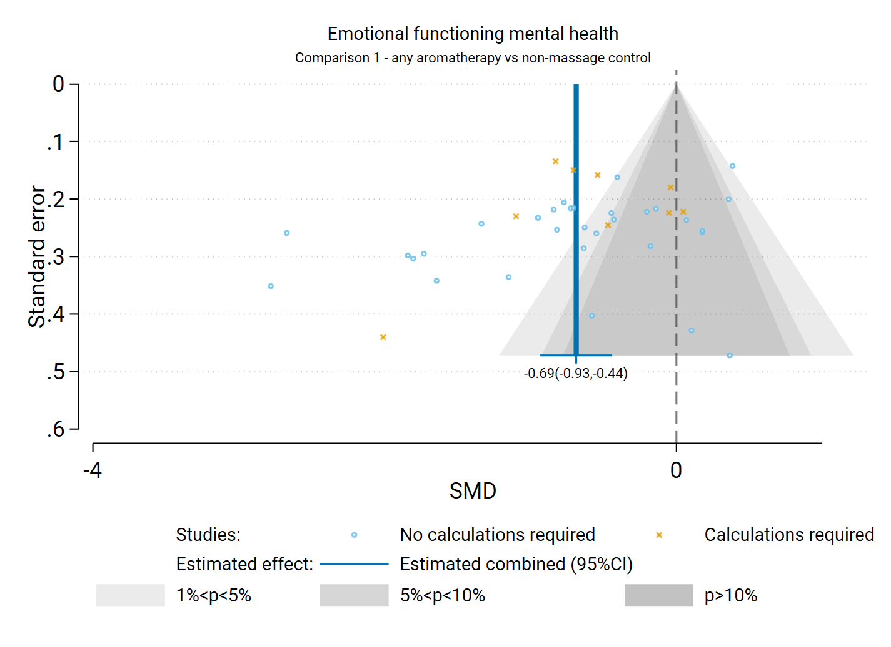**Fig D4.1** | Contour enhanced funnel plot of estimates of SMD versus their standard errors for comparison of the effect of reflexology versus inactive control (usual care, no intervention, placebo) on emotional functioning and mental health. Shaded regions represent different categories of conventional milestone levels of statistical significance. SMD = standardised mean difference. Blue line shows the combined estimate from random effects model.

## D5 Health-related quality of life (HR-QoL)

Results presented in this section are for the subgroup analysis, sensitivity analysis, and analyses to examine the risk of bias due to missing results.

For the outcome health-related quality of life, 20 studies were included in the meta-analysis that compared reflexology to an inactive control (usual care, no intervention, sham, co-intervention given in both groups).

#### Results of subgroup analysis by population group

A subgroup analysis was performed to investigate whether there were differences in the effects between population groups (i.e. cancer and advanced disease, other chronic conditions). Primarily, these were planned to explore possible explanations for any inconsistent effects if observed across studies (statistical heterogeneity).

*Assessment of heterogeneity:* There are differences in the size of the estimated intervention effect across studies for this comparison and outcome that suggest inconsistent effects. Effect estimate vary importantly with about half the studies showing an effect above the threshold for an important improvement in health-related quality of life (i.e. an SMD > 0.2), while the other studies in the analysis showed trivial effects (an SMD between -0.2 and 0.2). As such, the observed inconsistency is considered serious for the overall analysis and requires explanation to understand the factors that may influence whether reflexology has a beneficial or trivial effect.

The subgroup analyses did not explain the observed differences across studies in the direction or size of the observed effect (see Figure 4.6.1). Results for this analysis are presented in the main report (Section 4.6, Figure 4.6.1). The test for subgroup differences was not statistically significant (P = 0.95) and there was serious inconsistency in the effects observed across studies within the both population groups, which we considered serious for one group (cancer and advanced disease). Overall, there is evidence that the effects are inconsistent across population groups (some showing important benefit, others showing trivial effects).

#### Results of sensitivity analyses

**Table D5.1** presents results for the original analysis (all studies, random effects model) and two sensitivity analyses. These sensitivity analyses investigate:

1. whether the combined estimate is sensitive to the assumptions that were made to enable inclusion of results in the meta-analysis, specifically transforming or imputing statistics, and including change scores (change from baseline) when post-intervention (final) values (and their standard deviations) were unavailable; and
2. whether the combined effect differs when estimated from a fixed effect model, providing evidence of small study effects (which may be due to true differences in the effects in small studies or may suggest non-reporting bias).

The combined estimate of effect was similar in the original analysis and the sensitivity analyses removing studies for which transforming / imputing statistics or using change scores was necessary. This indicates that the result was robust to the assumptions required to include these results.

**Table D5.1. Sensitivity analyses for HR-QoL outcome**

|  |  |  |  |  |  |
| --- | --- | --- | --- | --- | --- |
| Sensitivity analysis | Purpose of sensitivity analysis | No trials | Original effect (95% CI) | No trials | Sensitivity analysis effect |
| No imputation, transformations or change scores 1 | Investigate robustness of MA effect | 20 | SMD 0.53 (0.19 to  0.86); I2 = 88% | 15 | SMD 0.58 (0.16 to 1.01); I2 = 90% |
| Fixed effect analysis | Investigate small study effects (bias due to missing results) |  |  | 20 | SMD 0.33 (0.23 to 0.44); I2 = 84% |

1 This analysis was limited to trials that (a) reported i) means and standard deviations, ii) means and standard errors, or iii) mean differences and their confidence intervals, and (b) had post-intervention (final) values available.

*Abbreviations*. MA = meta-analysis; SMD = standardised mean difference; CI = confidence interval

#### Bias due to missing results from the meta-analysis

The combined effect estimated from the fixed effect model (SMD 0.33) was smaller than from the random effects model (SMD 0.53) (Table D5.1), which may suggest small study effects arising from selective non-reporting of unfavourable results. The contour-enhanced funnel plot in Figure D5.1 suggests that there could be missing studies which show effects favouring the control, especially nonsignificant effects (i.e. the plot is asymmetric, missing studies to the left of the line of no effect (SMD 0) where we would expect results for some small studies, most notably in the darker grey shaded areas where nonsignificant results appear).



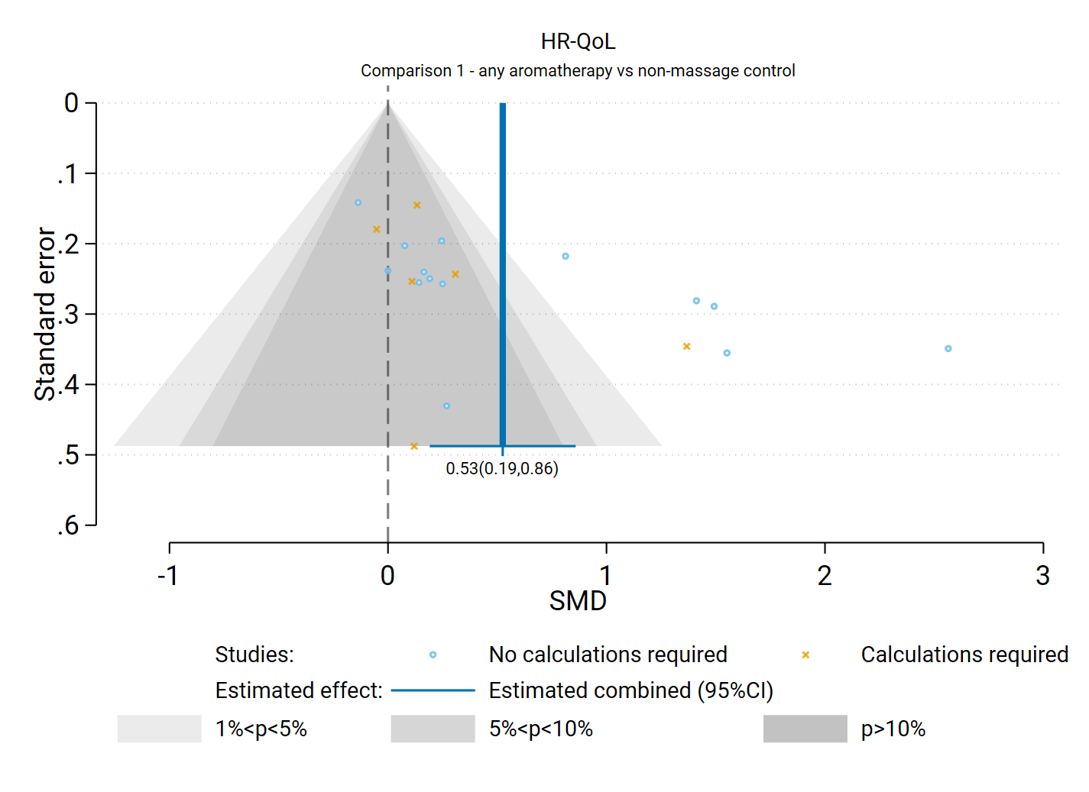**Fig D5.1** | Contour enhanced funnel plot of estimates of SMD versus their standard errors for comparison of the effect of reflexology versus inactive control (usual care, no intervention, placebo) on HR-QoL. Shaded regions represent different categories of conventional milestone levels of statistical significance. SMD = standardised mean difference. Blue line shows the combined estimate from random effects model.

## D6 Physical function

Results presented in this section are for the subgroup analysis, sensitivity analysis, and analyses to examine the risk of bias due to missing results.

For the outcome physical function, 10 studies were included in the meta-analysis that compared reflexology to an inactive control (usual care, no intervention, sham, co-intervention given in both groups).

#### Results of subgroup analysis by population group

A subgroup analysis was performed to investigate whether there were differences in the effects between population groups (i.e. cancer and advanced disease, chronic musculoskeletal conditions, other chronic conditions). Primarily, these were planned to explore possible explanations for any inconsistent effects if observed across studies (statistical heterogeneity).

*Assessment of heterogeneity:* While there are differences in the size of the estimated intervention effect across studies for this comparison and outcome, the confidence intervals for the majority of studies were overlapping suggesting that effects across studies were compatible. As such, the observed inconsistency is considered not serious as it does not alter the interpretation of findings for this outcome (the confidence interval for most studies indicated results compatible with benefit and little to no difference/harm).

The subgroup analyses did not explain any observed differences across studies in the direction or size of the observed effect. Results for this analysis are presented in the main report (Section 4.7, Figure 4.7.1). The test for subgroup differences was not statistically significant (P = 0.68) and effects within the population groups were inconsistent (serious for cancer and advanced disease).

#### Results of sensitivity analyses

**Table D6.1** presents results for the original analysis (all studies, random effects model) and two sensitivity analyses. These sensitivity analyses investigate:

1. whether the combined estimate is sensitive to the assumptions that were made to enable inclusion of results in the meta-analysis, specifically transforming or imputing statistics, and including change scores (change from baseline) when post-intervention (final) values (and their standard deviations) were unavailable; and
2. whether the combined effect differs when estimated from a fixed effect model, providing evidence of small study effects (which may be due to true differences in the effects in small studies or may suggest non-reporting bias).

The combined estimate of effect was smaller in the original analysis (SMD 0.60) compared to the sensitivity analyses removing studies for which transforming / imputing statistics or using change scores was necessary, however both indicated effects above the threshold for an important improvement in physical function. This indicates that the result was robust to the assumptions required to include these results.

**Table D6.1. Sensitivity analyses for physical function outcome**

|  |  |  |  |  |  |
| --- | --- | --- | --- | --- | --- |
| Sensitivity analysis | Purpose of sensitivity analysis | No trials | Original effect (95% CI) | No trials | Sensitivity analysis effect |
| No imputation, transformations or change scores 1 | Investigate robustness of MA effect | 10 | SMD 0.60 (-0.02 to  1.22); I2 = 92% | 7 | SMD 0.74 (-0.19 to 1.68); I2 = 94% |
| Fixed effect analysis | Investigate small study effects (bias due to missing results) |  |  | 10 | SMD 0.34 (0.20 to 0.48); I2 = % |

1 This analysis was limited to trials that (a) reported i) means and standard deviations, ii) means and standard errors, or iii) mean differences and their confidence intervals, and (b) had post-intervention (final) values available.

*Abbreviations*. MA = meta-analysis; SMD = standardised mean difference; CI = confidence interval

#### Bias due to missing results from the meta-analysis

The combined effect estimated from the fixed effect model (SMD 0.34) was smaller than from the random effects model (SMD 0.60) (Table D6.1). While the fixed effect estimate is still above threshold for an important difference in physical function, this may suggest small study effects arising from selective non-reporting of unfavourable results. The contour-enhanced funnel plot in Figure D6.1 suggests that there could be missing studies which show effects favouring the control (i.e. the plot is asymmetric, missing studies to the left of the line of no effect (SMD 0) where we would expect results for some small studies, most notably in the darker grey shaded areas where nonsignificant results appear). However, there are a comparatively small number of studies in this analysis.



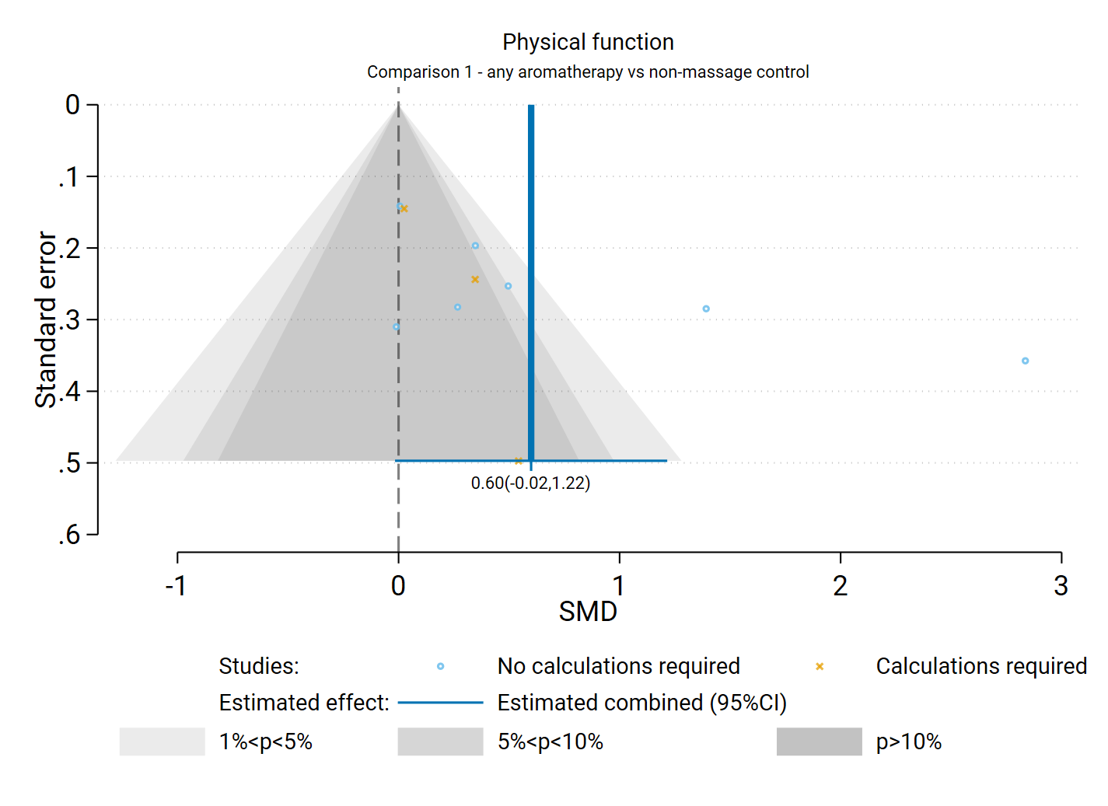**Fig D6.1**| Contour enhanced funnel plot of estimates of SMD versus their standard errors for comparison of the effect of reflexology versus inactive control (usual care, no intervention, sham, co-intervention given in both groups) on physical function. Shaded regions represent different categories of conventional milestone levels of statistical significance. SMD = standardised mean difference. Blue line shows the combined estimate from random effects model.

## D7 Global symptoms

Results presented in this section are for the subgroup analysis, sensitivity analyses, and analyses to examine the risk of bias due to missing results.

For the outcome global symptoms, 18 studies were included in the meta-analysis for the comparison of reflexology to an inactive control (usual care, no intervention, sham, co-intervention given in both groups).

#### Results of subgroup analysis by population group

A subgroup analysis was performed to investigate whether there were differences in the effects between population groups (i.e. cancer and advanced disease, other chronic conditions, chronic respiratory conditions). Primarily, these were planned to explore possible explanations for any inconsistent effects if observed across studies (statistical heterogeneity).

*Assessment of heterogeneity:* There are differences in the size of the estimated intervention effect across studies for this comparison and outcome that suggest inconsistent effects. Effect estimate vary importantly with the majority of studies showing an effect above the threshold for an important improvement in global symptoms (i.e. an SMD < - 0.2), while the other studies in the analysis showed trivial effects (an SMD between -0.2 and 0.2). As such, the observed inconsistency is considered serious for the overall analysis and requires explanation to understand the factors that may influence whether reflexology has a beneficial or trivial effect.

The subgroup analyses suggested the population group may explain some of the observed differences across studies in the size of the observed effect (see Figure 4.8.1). Results for this analysis are presented in the main report (Section 4.8, Figure 4.8.1). The test for subgroup differences was statistically significant (P = 0.014) which was most likely due to the very large effects observed in the ‘other chronic conditions’ subgroup. However, there was inconsistency in the effects observed across studies within the population groups (although not rated as serious).

#### Results of sensitivity analyses

**Table D7.1** presents results for the original analysis (all studies, random effects model) and two sensitivity analyses. These sensitivity analyses investigate:

1. whether the combined estimate is sensitive to the assumptions that were made to enable inclusion of results in the meta-analysis, specifically transforming or imputing statistics, and including change scores (change from baseline) when post-intervention (final) values (and their standard deviations) were unavailable; and
2. whether the combined effect differs when estimated from a fixed effect model, providing evidence of small study effects (which may be due to true differences in the effects in small studies or may suggest non-reporting bias).

The combined estimate of effect was similar in the original analysis and the sensitivity analyses removing studies for which transforming / imputing statistics or using change scores was necessary. This indicates that the result was robust to the assumptions required to include these results.

**Table D7.1. Sensitivity analyses for global symptoms outcome**

|  |  |  |  |  |  |
| --- | --- | --- | --- | --- | --- |
| Sensitivity analysis | Purpose of sensitivity analysis | No trials | Original effect (95% CI) | No trials | Sensitivity analysis effect |
| No imputation, transformations or change scores 1 | Investigate robustness of MA effect | 18 | SMD -0.96 (-1.37 to  -0.55); I2 = 89% | 15 | SMD -1.02 (-1.49 to -0.55); I2 = 89% |
| Fixed effect analysis | Investigate small study effects (bias due to missing results) |  |  |  | SMD -0.73 (-0.86 to -0.61); I2 = 88% |

1 This analysis was limited to trials that (a) reported i) means and standard deviations, ii) means and standard errors, or iii) mean differences and their confidence intervals, and (b) had post-intervention (final) values available.

*Abbreviations*. MA = meta-analysis; SMD = standardised mean difference; CI = confidence interval

#### Bias due to missing results from the meta-analysis

The combined effect estimated from the fixed effect model (SMD -0.73) was smaller than from the random effects model (SMD -0.96) (Table D7.1), which may suggest small study effects arising from selective non-reporting of unfavourable results. The contour-enhanced funnel plot in Figure D7.1 suggests that there could be missing studies which show effects favouring the control (i.e. the plot is asymmetric, missing studies to the left of the line of no effect (SMD 0) where we would expect results for some small studies, most notably in the darker grey shaded areas where nonsignificant results appear).



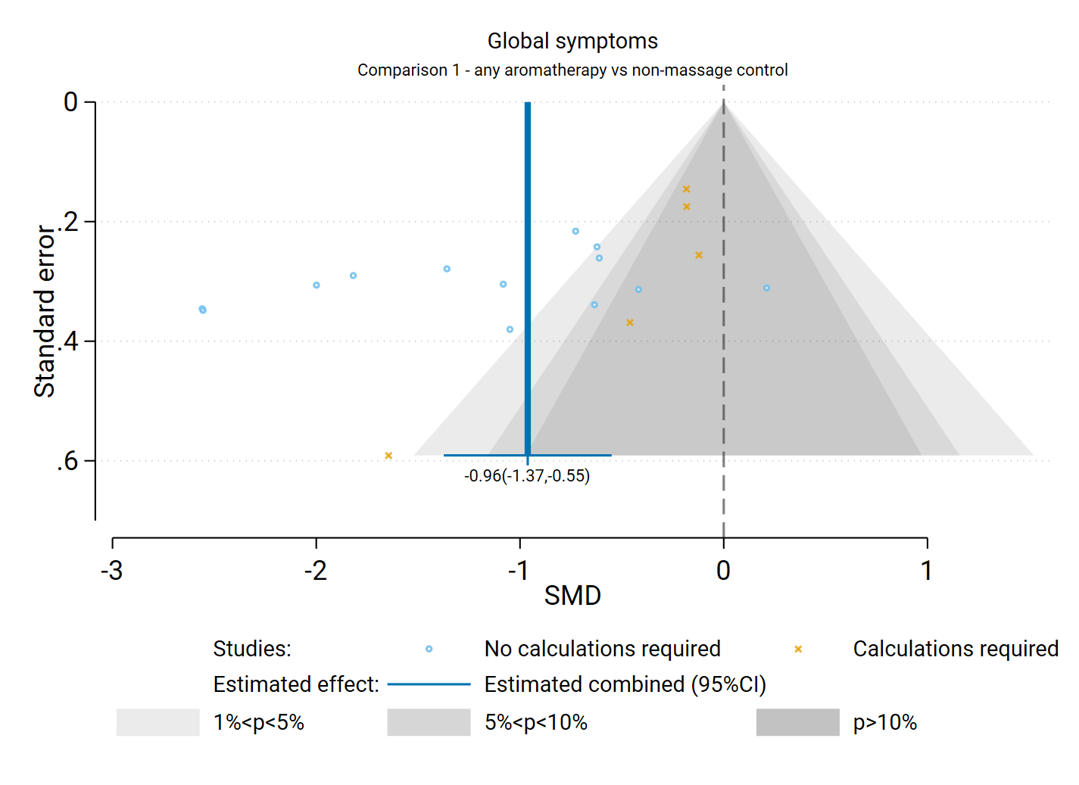**Fig D7.1** | Contour enhanced funnel plot of estimates of SMD versus their standard errors for comparison of the effect of reflexology versus an inactive control (usual care, no intervention, sham, co-intervention given in both groups) on physical function. Shaded regions represent different categories of conventional milestone levels of statistical significance. SMD = standardised mean difference. Blue line shows the combined estimate from random effects model.

## D8 References to included studies

If multiple reports, the first citation is the index paper

|  |  |
| --- | --- |
| **Abedini 2022** | Abedini, B.; Ilkhani, M.; Gholamzadeh, H.; Ameri, A.; Shakeri, N.; Abadi, A. M. Effect of Reflexology on the Quality of Sleep in Colorectal Cancer Patients: A Clinical Trial Study. Evidence Based Care Journal. 2022; 12(1) 31-39. https://dx.doi.org/10.22038/EBCJ.2022.61896.2607 |
| **Akkoz Cevik 2021** | Akkoz Cevik, S.; Incedal, I. The effect of reflexology on labor pain, anxiety, labor duration, and birth satisfaction in primiparous pregnant women: a randomized controlled trial. Health Care for Women International. 2021; 42(45081) 710-725. https://dx.doi.org/10.1080/07399332.2020.1800014 |
| **Aliashraf Jodat 2021** | Aliashraf Jodat, M.; Alilu, L.; Ahangarzadeh Rezayee, S.; Gharaaghaji Asl, R. Effects of Reflexology on the Pain Intensity among Patients with Depression after Receiving Electroconvulsive Therapy: A Randomized Clinical Trial. J Caring Sci. 2021; 10(3) 129-136. doi: 10.34172/jcs.2021.007 |
| **Alinia-najjar 2020** | Alinia-najjar, R.; Bagheri-Nesami, M.; Shorofi, S. A.; Mousavinasab, S. N.; Saatchi, K. The effect of foot reflexology massage on burn-specific pain anxiety and sleep quality and quantity of patients hospitalized in the burn intensive care unit (ICU). Burns. 2020; 46(8) 1942-1951. doi: 10.1016/j.burns.2020.04.035 |
| **Alsharaway 2021** | Alsharaway, L. A.; Elyazed, T. I. A.; Helmy, N. A. Effect of new reflexology maneuver on lung function and functional ability of chronic obstructive pulmonary disease patients in pulmonary rehabilitation program: A randomized control trial. Fizjoterapia Polska. 2021; 21(5) 160-165. doi: https://doi.org/10.56984/8ZG209F33 |
| **Anderson 2021** | Anderson, H. K. D.; Downey, M. Foot reflexology an intervention for pain and nausea among inpatients with cancer. Clinical Journal of Oncology Nursing. 2021; 25(5) 539-545. doi: 10.1188/21.CJON.539-545 |
| **Aslan 2022** | Aslan, G.; Kilic, D. The Effect of Reflexology based on Watson's Caring Model on Lombalgia and Quality of Life in Older Adults. Ageing International. 2022; 47() 596-616. doi: 10.1007/s12126-021-09480-4 |
| **Attias 2016** | Attias, S.; Keinan Boker, L.; Arnon, Z.; Ben-Arye, E.; Bar'Am, A.; Sroka, G.; Matter, I.; Somri, M.; Schiff, E. Effectiveness of integrating individualized and generic complementary medicine treatments with standard care versus standard care alone for reducing preoperative anxiety. Journal of Clinical Anesthesia. 2016; 29() 54-64. doi: 10.1016/j.jclinane.2015.10.017 |
| **Attias 2018** | Attias, S.; Sivan, K.; Avneri, O.; Sagee, A.; Ben-Arye, E.; Grinberg, O.; Sroka, G.; Matter, I.; Schiff, E. Analgesic effects of reflexology in patients undergoing surgical procedures: A randomized controlled trial. Journal of Alternative and Complementary Medicine. 2018; 24(8) 809-815. doi: 10.1089/acm.2017.0167  Attias, S.; Keinan-Boker, L.; Sroka, G.; Matter, I.; Arnon, Z.; Schiff, E. The effectiveness of a generic guided imagery CD compared with individualized complementary therapies and standard of care for reducing preoperative anxiety: preliminary results. Journal of alternative and complementary medicine (New York, N.Y.). 2014; 20(5) A137. doi: 10.1089/acm.2014.5368 |
| **Aydin 2021** | Aydin, L. Z.; Yigitalp, G. The effect of reflexology on sleep quality and fatigue in postmenopausal women: a randomized control trial. European Journal of Integrative Medicine. 2021; 43() 101281. doi: 10.1016/j.eujim.2020.101281 |
| **Azima 2015** | Azima, S.; Bakhshayesh, H. R.; Mousavi, S.; Ashrafizaveh, A. Comparison of the effects of reflexology and massage therapy on primary dysmenorrhea. Biomedical research (india). 2015; 26(3) 471-476. doi: |
| **Babazadeh 2020** | Babazadeh, R.; Asadollahi, F.; Abdi, H.; Esmaily, H. The Effect of foot sole reflexology on the fatigue in the first half of pregnancy: a randomized clinical trial. Journal of midwifery & reproductive health. 2020; 8(2) 2164-2176. doi: 10.22038/jmrh.2020.39757.1443 |
| **Bagheri-Nesami 2014** | Bagheri-Nesami, M.; Shorofi, S. A.; Zargar, N.; Sohrabi, M.; Gholipour-Baradari, A.; Khalilian, A. The effects of foot reflexology massage on anxiety in patients following coronary artery bypass graft surgery: A randomized controlled trial. Complementary Therapies in Clinical Practice. 2014; 20(1) 42-47. doi: http://dx.doi.org/10.1016/j.ctcp.2013.10.006  Bagheri-Nesami, M.; Zargar, N.; Gholipour-Baradari, A.; Khalilian, A. The effects of foot reflexology massage on pain and fatigue of patients after coronary artery bypass graft. Journal of Mazandaran University of Medical Sciences. 2012; 22(92) 51-62. |
| **Baglama 2019** | Baglama, S. S.; Bakir, E. Caregiver-Delivered Foot Reflexology: Effects on Patients and Caregivers. Holistic Nursing Practice. 2019; 33(6) 338-345. doi: 10.1097/HNP.0000000000000351 |
| **Bahrami 2018** | Bahrami, T.; Rejeh, N.; Heravi-Karimooi, M.; Vaismoradi, M.; Tadrisi, S. D.; Sieloff, C. L. Aromatherapy massage versus reflexology on female elderly with acute coronary syndrome. Nursing in Critical Care. 2018; 23(5) 229-236. doi: 10.1111/nicc.12302  Bahrami, T.; Rejeh, N.; Heravi- Karimooi, M.; Vaismoradi, M.; Tadrisi, S. D.; Sieloff, C. Effect of aromatherapy massage on anxiety, depression, and physiologic parameters in older patients with the acute coronary syndrome: A randomized clinical trial. International Journal of Nursing Practice. 2017; 23(6) e12601. doi: https://dx.doi.org/10.1111/ijn.12601  Bahrami, T.; Rejeh, N.; Heravi-Karimooi, M.; Davood Tadrisi, S.; Vaismoradi, M. The Effect of Foot Reflexology on Hospital Anxiety and Depression in Female Older Adults: a Randomized Controlled Trial. International Journal of Therapeutic Massage & Bodywork. 2019; 12(3) 16-21. doi: 10.3822/ijtmb.v12i3.429  Bahrami, T.; Rejeh, N.; Heravi-Karimooi, M.; Davood Tadrisi, S.; Vaismoradi, M. Reflexology versus Aromatherapy Massage for Relieving Anxiety and Depression in Hospitalized Older Women: a Randomized Clinical Trial. International Journal of Caring Sciences. 2020; 13(1) 610-618 |
| **Bakhshi 2022** | Bakhshi, Mahmoud; Ranjbar, Hossein; Rostami, Ommolbanin; Chamanzari, Hamid; Bahrami-Taghanaki, Hamidreza Effect of Foot Reflexology and Gentle Stretching Exercises on Pain Intensity in Patients after Spine Surgery: A Randomized Controlled Trial. Journal of Evidence-based Care. 2022; 12(2) 32-40. doi: 10.22038/EBCJ.2022.61714.2602 |
| **Bakir 2018** | Bakir, E.; Baglama, S. S.; Gursoy, S. The effects of reflexology on pain and sleep deprivation in patients with rheumatoid arthritis: A randomized controlled trial. Complementary Therapies in Clinical Practice. 2018; 31() 315-319. doi: https://dx.doi.org/10.1016/j.ctcp.2018.02.017 |
| **Brygge 2001** | Brygge, T.; Heinig, J. H.; Collins, P.; Ronborg, S.; Gehrchen, P. M.; Hilden, J.; Heegaard, S.; Poulsen, L. K. Reflexology and bronchial asthma. Respiratory Medicine. 2001; 95(3) 173-179. doi: 10.1053/rmed.2000.0975  Brygge, T.; Heinig, J. H.; Collins, P.; Rønborg, S. M.; Gehrchen, P. M.; Hilden, J.; Heegaard, S.; Poulsen, L. K. Zone therapy and asthma. Ugeskrift for laeger. 2002; 164(18) 2405-2410 |
| **Chen 2011** | Chen, S. C.; Li, C. Y.; Gau, M. L.; Huang, C. M. Randomised controlled trial of the effectiveness of using foot reflexology to improve quality of sleep amongst Taiwanese postpartum women. Midwifery. 2011; 27(2) 181-186. doi: 10.1016/j.midw.2009.04.005 |
| **Cicek 2021** | Cicek, S. C.; Demir, S.; Yilmaz, D.; Yildiz, S. Effect of reflexology on ankle brachial index, diabetic peripheral neuropathy, and glycemic control in older adults with diabetes: A randomized controlled trial. Complementary Therapies in Clinical Practice. 2021; 44() 101437-. doi: 10.1016/j.ctcp.2021.101437 |
| **Close 2016.1** | Close, C.; Sinclair, M.; Cullough, J. M.; Liddle, D.; Hughes, C. A pilot randomised controlled trial (RCT) investigating the effectiveness of reflexology for managing pregnancy low back and/or pelvic pain. Complementary Therapies in Clinical Practice. 2016; 23() 117-124. doi: 10.1016/j.ctcp.2015.05.002  McCullough, J. E. M.; Liddle, S. D.; Close, C.; Sinclair, M.; Hughes, C. M. Reflexology: A randomised controlled trial investigating the effects on beta-endorphin, cortisol and pregnancy related stress. Complementary Therapies in Clinical Practice. 2018; 31() 76-84. doi: https://dx.doi.org/10.1016/j.ctcp.2018.01.018  McCullough, J. E.; Close, C.; Liddle, S. D.; Sinclair, M.; Hughes, C. M. A pilot randomised controlled trial exploring the effects of antenatal reflexology on labour outcomes. Midwifery. 2017; 55() 137-144. doi: https://dx.doi.org/10.1016/j.midw.2017.09.006  Close, C.; Sinclair, M.; Liddle, D.; Cullough, J. M.; Hughes, C. Women's experience of low back and/or pelvic pain (LBPP) during pregnancy. Midwifery. 2016; 37() 45139. doi: 10.1016/j.midw.2016.03.013 |
| **Dashti 2016** | Dashti, S.; Shahmari, M.; Mirzaaghazadeh, A.; Mirzaaghazadeh, M. Effect of Foot Reflexology and Olive Oil Foot Massageon Asthma Control. Global journal of health science. 2016; 8(12) 53-59. doi: 10.5539/gjhs.v8n12p53 |
| **Davodabady 2021** | Davodabady, F.; Naseri-Salahshour, V.; Sajadi, M.; Mohtarami, A.; Rafiei, F. Randomized controlled trial of the foot reflexology on pain and anxiety severity during dressing change in burn patients. Burns. 2021; 47(1) 215-221. doi: 10.1016/j.burns.2020.06.035 |
| **de Oliveira 2017** | de Oliveira, B. H.; da Silva, A. Q. A.; Ludtke, D. D.; Madeira, F.; Medeiros, Gmds; Parreira, R. B.; Salgado, A. S. I.; Belmonte, L. A. O.; Cidral-Filho, F. J.; Martins, D. F. Foot Reflexotherapy Induces Analgesia in Elderly Individuals with Low Back Pain: A Randomized, Double-Blind, Controlled Pilot Study. Evid Based Complement Alternat Med. 2017; 2017() 2378973. doi: 10.1155/2017/2378973 |
| **Dehghanmehr 2019** | Dehghanmehr, S.; Sargazi, G. H.; Biabani, A.; Nooraein, S.; Allahyari, J. Comparing the Effect of Acupressure and Foot Reflexology on Anxiety and Depression in Hemodialysis Patients: a Clinical Trial. Medical-Surgical Nursing Journal. 2019; 8(4) 45078. doi: 10.5812/msnj.100386 |
| **Dehghanmehr 2018** | Dehghanmehr, S.; Sheikh, G.; Siyasari, A.; Sheikh, A.; Nooraien, S.; Salarzaei, M. The impact of foot reflexology massage on anxiety caused by blood transfusion in children with thalassemia. International journal of pharmaceutical sciences and research. 2018; 9(5) 2053-2057. doi: 10.13040/IJPSR.0975-8232.9%285%29.2053-57 |
| **Deniz 2021** | Deniz, A. O.; Acikgoz, A. A Randomized Controlled Trial: The Effect of Acupressure and Foot Reflexology on Pain During Heel-Lancing in Neonates. Clinical Nursing Research. 2021; 32(2) 306-312. doi: https://dx.doi.org/10.1177/10547738211061815 |
| **Dikmen 2019** | Dikmen, H. A.; Terzioglu, F. Effects of Reflexology and Progressive Muscle Relaxation on Pain, Fatigue, and Quality of Life during Chemotherapy in Gynecologic Cancer Patients. Pain Management Nursing. 2019; 20(1) 47-53. doi: https://dx.doi.org/10.1016/j.pmn.2018.03.001 |
| **Dilek Dogan 2021** | Dilek Dogan, H.; Tan, M. Effects of Reflexology on Pain, Fatigue, and Quality of Life in Multiple Sclerosis Patients: a Clinical Study. Alternative Therapies in Health and Medicine. 2021; 27(5) 14-22. doi: |
| **Doğru 2021** | Doğru, B. V.; ŞenuzunAykar, F.; Yıldırım, Y.; Yavuzgil, O.; Sözmen, E.; Memmedov, H. The Effect of Foot Reflexology Applied Before Coronary Angiography and Percutaneous Transluminal Coronary Angioplasty on Anxiety, Stress, and Cortisol Levels of Individuals: a Randomized Controlled Trial. Journal of Cardiovascular Nursing. 2021; 36(5) 461-469. doi: 10.1097/JCN.0000000000000700 |
| **Dolatian 2011** | Dolatian, M.; Hasanpour, A.; Montazeri, Sh; Heshmat, R.; Alavi Majd, H. The effect of reflexology on pain intensity and duration of labor on primiparas. Iran Red Crescent Med J. 2011; 13(7) 475-9.  Dolatian, M.; Hasanpour, A.; Heshmat, R.; Alavi Majd, H. The effect of reflexology on pain intensity of labor. Journal of zanjan university of medical sciences and health services. 2010; 18(72) 52-61. |
| **Duymaz 2020** | Duymaz, T. The effectiveness of reflexology in children with cerebral palsy with constipation. Annals of clinical and analytical medicine. 2020; 11(2) 120-124. doi: 10.4328/ACAM.6173 |
| **Elbasan 2018** | Elbasan, B.; Bezgin, S. The effects of reflexology on constipation and motor functions in children with cerebral palsy. Pediatrics and neonatology. 2018; 59(1) 42-47. doi: 10.1016/j.pedneo.2017.01.005  Elbasan, B.; Bezgin, S. The investigation of the effects of reflexology with neurodevelopmental treatment approach on gross motor function and quality of life children with cerebral palsy. Fizyoterapi rehabilitasyon. 2015; 26(2) S24-S25.  Bezgin, S.; Elbasan, B. The investigation of the effects of reflexology with neurodevelopmental treatment approach on gross motor function and constipation children with cerebral palsy. Fizyoterapi rehabilitasyon. 2015; 26(3) S15-S16. |
| **Fazlollah 2021** | Fazlollah, A.; Babatabar Darzi, H.; Heidaranlu, E.; Moradian, S. T. The effect of foot reflexology massage on delirium and sleep quality following cardiac surgery: A randomized clinical trial. Complementary Therapies in Medicine. 2021; 60() 102738-. doi: 10.1016/j.ctim.2021.102738 |
| **Ghaljaei 2021** | Ghaljaei, F.; Jalalodini, A. The effects of foot reflexology on pain and physiological indicators in children with leukemia under chemotherapy: a clinical trial study. Rep Pract Oncol Radiother. 2021; 26(6) 955-961. doi: 10.5603/RPOR.a2021.0116 |
| **Ghanbari 2022** | Ghanbari, Alireza; Mangolian Shahrbabaki, Parvin; Dehghan, Mahlagha; Mardanparvar, Hossein; Dowlat Abadi, Esmaeil Kargar; Emami, Asghar; Sarikhani-Khorrami, Esmaeil Comparison of the Effect of Reflexology and Swedish Massage on Restless Legs Syndrome and Sleep Quality in Patients Undergoing Hemodialysis: a Randomized Clinical Trial. International Journal of Therapeutic Massage & Bodywork. 2022; 15(2) 41275. doi: 10.3822/ijtmb.v15i2.705 |
| **Ghasemi 2021** | Ghasemi, M.; Rejeh, N.; Bahrami, T.; Heravi-Karimooi, M.; Tadrisi, S. D.; Vaismoradi, M. Aromatherapy Massage vs. Foot Reflexology on the Severity of Restless Legs Syndrome in Female Patients Undergoing Hemodialysis. Geriatrics (Basel). 2021; 6(99) . doi: 10.3390/geriatrics6040099 |
| **Gok Metin 2016** | Gok Metin, Z.; Ozdemir, L. The Effects of Aromatherapy Massage and Reflexology on Pain and Fatigue in Patients with Rheumatoid Arthritis: A Randomized Controlled Trial. Pain Management Nursing. 2016; 17(2) 140-149. doi: https://dx.doi.org/10.1016/j.pmn.2016.01.004 |
| **Gol 2021** | Gol, M. K.; Aghamohamadi, D. Effects of foot reflexology on severity of pain and opioid dosage administered to patients undergoing a discectomy: a randomized clinical trial. Crescent journal of medical and biological sciences. 2021; 8(3) 209-214. |
| **Göral Türkcü 2021** | Goral Turkcu, S.; Ozkan, S. The effects of reflexology on anxiety, depression and quality of life in patients with gynecological cancers with reference to Watson's theory of human caring. Complementary Therapies in Clinical Practice. 2021; 44() 101428-. doi: https://dx.doi.org/10.1016/j.ctcp.2021.101428 |
| **Hashemzadeh 2019** | Hashemzadeh, K.; Dehdilani, M.; Gol, M. K. Effects of foot reflexology on post-sternotomy hemodynamic status and pain in patients undergoing coronary artery bypass graft: a randomized clinical trial. Crescent journal of medical and biological sciences. 2019; 6(4) 517-522. doi: |
| **Heidari 2017** | Heidari, F.; Rejeh, N.; Heravi-Karimooi, M.; Tadrisi, S. D.; Vaismoradi, M. Effect of short-term hand reflexology on anxiety in patients before coronary angiography: A randomized placebo controlled trial. European Journal of Integrative Medicine. 2017; 16() 45108. doi: https://dx.doi.org/10.1016/j.eujim.2017.09.010 |
| **Hesami 2019** | Hesami, M.; Kalhor, M.; Roshani, D.; Fathi, M. The effect of reflexology on fatigue in cancer patients receiving chemotherapy: a randomized controlled trial. Crescent journal of medical and biological sciences. 2019; 6(2) 151-157. doi: |
| **Hodgson 2000** | Hodgson, H. Does reflexology impact on cancer patients' quality of life?. Nursing standard. 2000; 14(31) 33-38. doi: |
| **Hodgson 2008** | Hodgson, N. A.; Andersen, S. The clinical efficacy of reflexology in nursing home residents with dementia. Journal of Alternative and Complementary Medicine. 2008; 14(3) 269-275. doi: 10.1089/acm.2007.0577 |
| **Hudson 2015** | Hudson, B. F.; Davidson, J.; Whiteley, M. S. The impact of hand reflexology on pain, anxiety and satisfaction during minimally invasive surgery under local anaesthetic: A randomised controlled trial. International Journal of Nursing Studies. 2015; 52(12) 1789-1797. doi: https://dx.doi.org/10.1016/j.ijnurstu.2015.07.009 |
| **Hughes 2009** | Hughes, C. M.; Smyth, S.; Lowe-Strong, A. S. Reflexology for the treatment of pain in people with multiple sclerosis: a double-blind randomised sham-controlled clinical trial. Multiple sclerosis. 2009; 15(11) 1329-1338. doi: 10.1177/1352458509345916 |
| **Icke 2018** | Icke, S.; Genc, R. Effect of Reflexology on Infantile Colic. Journal of Alternative and Complementary Medicine. 2018; 24(6) 584-588. doi: 10.1089/acm.2017.0315 |
| **Imani 2018** | Imani, N.; Shams, S. A.; Radfar, M.; Ghavami, H.; Khalkhali, H. R. Effect of applying reflexology massage on nitroglycerin-induced migraine-type headache: a placebo-controlled clinical trial. Agri : Agri (Algoloji) Dernegi'nin Yayin organidir [Journal of the Turkish Society of Algology]. 2018; 30(3) 116-122. doi: 10.5505/agri.2018.43815 |
| **Inkaya 2020** | Inkaya, B.; Tuzer, H. Effect of Reflexology on the Constipation Status of Elderly People. Yonago Acta Med. 2020; 63(2) 115-121. doi: 10.33160/yam.2020.05.007 |
| **Jahani 2018** | Jahani, S.; Salari, F.; Elahi, N.; Cheraghian, B. The effect of reflexology in intensity of pain and anxiety among patients suffering from metastatic cancer in adults' hematology ward. Asian journal of pharmaceutical and clinical research. 2018; 11(6) 401-405. doi: 10.22159/ajpcr.2018.v11i6.25212 |
| **Jameei-Moghaddam 2021** | Jameei-Moghaddam, M.; Goljaryan, S.; Mohammad Alizadeh Charandabi, S.; Taghavi, S.; Mirghafourvand, M. Effect of plantar reflexology on labor pain and childbirth experience: a randomized controlled clinical trial. Journal of obstetrics and gynaecology research. 2021; 47(6) 2082-2092. doi: 10.1111/jog.14755 |
| **Jijimole 2018.1** | Jijimole, M.; Jaleel Abdul, A.; Vijayaraghavan, R.; Susila, C. Comparison of the effect of control, presence of a skilled birth attendant and reflexotherapy on labour outcomes in terms of pain, duration of labour and birth satisfaction among primigravid women-a pilot study. Biomedical research (india). 2018; 29(17) 3292-3302. doi: 10.4066/biomedicalresearch.29-18-637  Jijimole, M.; Abdul, A. J.; Vijayaraghavan, R.; Susila, C. Comparison of the effectiveness of reflexotherapy with skilled birth attendant on labor outcomes in terms of psychophysiological variables among primigravid women - a pilot study. National journal of physiology, pharmacy and pharmacology. 2018; 8(8) 1179-1187. doi: 10.5455/njppp.2018.8.0415628042018 |
| **Kabuk 2022** | Kabuk, A.; Sendir, M.; Filinte, G. The effect of reflexology massage and passive music therapy intervention before burn dressing on pain, anxiety level and sleep quality. Burns. 2022; 48(7) 1743-1752. doi: https://dx.doi.org/10.1016/j.burns.2021.10.012 |
| **Kapikiran 2022** | Kapikiran, G.; Bulbuloglu, S.; Gunes, H.; Saritas, S.; Demir, B. A randomized controlled trial of reflexology effect after abdominal surgery on patient satisfaction, pain and vital signs. Explore (New York, N.Y.). 2022; 19(4) 565-570. doi: 10.1016/j.explore.2022.10.017 |
| **Kapikiran 2021** | Kapikiran, G.; Ozkan, M. The effect of foot reflexology on pain, comfort and beta endorphin levels in patients with liver transplantation: A randomized control trial. European Journal of Integrative Medicine. 2021; 45() 101344. doi: https://dx.doi.org/10.1016/j.eujim.2021.101344 |
| **Kaplan 2021** | Kaplan, E.; Cevik, S. The effect of guided imagery and reflexology on pain intensity, duration of labor and birth satisfaction in primiparas: randomized controlled trial. Health Care for Women International. 2021; 42(4-6) 691-709. doi: https://dx.doi.org/10.1080/07399332.2021.1880411 |
| **Karatas 2021** | Karatas, N.; Isler Dalgic, A. Is foot reflexology effective in reducing colic symptoms in infants: A randomized placebo-controlled trial. Complementary Therapies in Medicine. 2021; 59() 102732. doi: 10.1016/j.ctim.2021.102732 |
| **Kardan 2020** | Kardan, M.; Zarei, B.; BahramiTaghanaki, H.; Vagharseyyedin, S. A.; Azdaki, N. The effects of foot reflexology on back pain after coronary angiography: A randomized controlled trial. Complementary Therapies in Clinical Practice. 2020; 38() 101068. doi: https://dx.doi.org/10.1016/j.ctcp.2019.101068 |
| **Khaledifar 2017** | Khaledifar, A.; Nasiri, M.; Khaledifar, B.; Khaledifar, A.; Mokhtari, A. The effect of reflexotherapy and massage therapy on vital signs and stress before coronary angiography: An open-label clinical trial. ARYA Atheroscler. 2017; 13(2) 50-55. doi: |
| **Khorsand 2015** | Khorsand, A.; Tadayonfar, M. A.; Badiee, S.; Aghaee, M. A.; Azizi, H.; Baghani, S. Evaluation of the Effect of Reflexology on Pain Control and Analgesic Consumption After Appendectomy. Journal of alternative and complementary medicine (New York, N.Y.). 2015; 21(12) 774-780. doi: 10.1089/acm.2014.0270 |
| **Koc 2015** | Koc, T.; Gozen, D. The Effect of Foot Reflexology on Acute Pain in Infants: A Randomized Controlled Trial. Worldviews on Evidence-Based Nursing. 2015; 12(5) 289-296. doi: https://dx.doi.org/10.1111/wvn.12099 |
| **Kurt 2018** | Kurt, S.; Can, G. Reflexology in the management of chemotherapy induced peripheral neuropathy: A pilot randomized controlled trial. European Journal of Oncology Nursing. 2018; 32() 43800-. doi: 10.1016/j.ejon.2017.11.001 |
| **Levy 2020** | Levy, I.; Attias, S.; Stern Lavee, T.; Avneri, O.; Cohen, G.; Balachsan, S.; Sagi, S.; Schiff, E. The effectiveness of foot reflexology in reducing anxiety and duration of labor in primiparas: An open-label randomized controlled trial. Complementary Therapies in Clinical Practice. 2020; 38() 101085. doi: 10.1016/j.ctcp.2019.101085 |
| **Mahdavipour 2019** | Mahdavipour, F.; Rahemi, Z.; Sadat, Z.; Ajorpaz, N. M. The effects of foot reflexology on depression during menopause: A randomized controlled clinical trial. Complementary Therapies in Medicine. 2019; 47() 102195-. doi: https://dx.doi.org/10.1016/j.ctim.2019.102195 |
| **Mahdavipour 2022** | Mahdavipour, Fatemeh; Sadat, Zohreh; Mirbagher-Ajorpaz, Neda; Kafaei-Atrian, Mahboobeh The Effect of Foot Reflexology on the Quality of Life of Postmenopausal Women. Journal of Client Centered Nursing Care. 2022; 8(3) 191-198. doi: 10.32598/JCCNC.8.3.435.1 |
| **Mak 2007** | Mak, H. L.; Cheon, W. C.; Wong, T.; Liu, Y. S.; Tong, W. M. Randomized controlled trial of foot reflexology for patients with symptomatic idiopathic detrusor overactivity. International urogynecology journal and pelvic floor dysfunction. 2007; 18(6) 653-658. doi: 10.1007/s00192-006-0222-7 |
| **Miller 2013** | Miller, L.; McIntee, E.; Mattison, P. Evaluation of the effects of reflexology on quality of life and symptomatic relief in multiple sclerosis patients with moderate to severe disability; A pilot study. Clinical Rehabilitation. 2013; 27(7) 591-598. doi: 10.1177/0269215512469383 |
| **Mobini-Bidgoli 2017** | Mobini-Bidgoli, M.; Taghadosi, M.; Gilasi, H.; Farokhian, A. The effect of hand reflexology on anxiety in patients undergoing coronary angiography: A single-blind randomized controlled trial. Complementary Therapies in Clinical Practice. 2017; 27() 31-36. doi: 10.1016/j.ctcp.2017.01.002 |
| **Molavi Vardanjani 2013** | Molavi Vardanjani, M.; Masoudi Alavi, N.; Razavi, N. S.; Aghajani, M.; Azizi-Fini, E.; Vaghefi, S. M. A randomized-controlled trial examining the effects of reflexology on anxiety of patients undergoing coronary angiography. Nurs Midwifery Stud. 2013; 2(3) 45172-. doi: 10.5812/nms.12167 |
| **Murat-Ringot 2021** | Murat-Ringot, A.; Souquet, P. J.; Subtil, F.; Boutitie, F.; Preau, M.; Piriou, V. The Effect of Foot Reflexology on Chemotherapy-Induced Nausea and Vomiting in Patients With Digestive or Lung Cancer: Randomized Controlled Trial. JMIR Cancer. 2021; 7(4) e25648-. doi: 10.2196/25648  Murat-Ringot, A.; Souquet, P. J.; Chauvenet, M.; Rentler, C.; Subtil, F.; Schott, A. M.; Preau, M.; Piriou, V. The Effects of Foot Reflexology on Chemotherapy-Induced Nausea and Vomiting in Patients with Digestive System or Lung Cancer: Protocol for a Randomized Controlled Trial. JMIR Res Protoc. 2020; 9(7) e17232. doi: 10.2196/17232 |
| **Nasiri 2020** | Nasiri, M.; Ranjkesh, F.; Mafi, M.; Senmar, M.; Hosseinigolafshani, S. Z. The effect of foot reflexology on sleep quality among high risk pregnant women: A randomized controlled trial. Sleep and Hypnosis. 2020; 21(4) 293-301. doi: 10.37133/Sleep.Hypn.2019.21.0198 |
| **Navaee 2020** | Navaee, M.; Khayat, S.; Abed, Z. G. Effect of pre-cesarean foot reflexology massage on anxiety of primiparous women. Journal of Complementary and Integrative Medicine. 2020; 17(3) -. doi: 10.1515/jcim-2019-0229 |
| **Norheim 2023** | Norheim, A. J.; Fønnebø, V. M.; Lindeland, J. P.; Varpe, T.; Stub, T.; Bigset, C.; Kristoffersen, A. E. Reflexology for acute rhinosinusitis - Results from a blinded, early-phase comparative trial. Explore (NY). 2023; 19(1) 36-41. doi: 10.1016/j.explore.2022.08.002 |
| **Nourmohammadi 2019** | Nourmohammadi, H.; Motaghi, M.; Borji, M.; Tarjoman, A.; Soltany, B. The effects of reflexology on fatigue severity of patients with cancer. Asian Pacific Journal of Cancer Prevention. 2019; 20(2) 391-394. doi: 10.31557/APJCP.2019.20.2.391 |
| **Oleson 1993** | Oleson, T.; Flocco, W. Randomized controlled study of premenstrual symptoms treated with ear, hand, and foot reflexology. Obstetrics and gynecology. 1993; 82(6) 906-911. doi: |
| **Ozdelikara 2017** | Ozdelikara, A.; Tan, M. The effect of reflexology on the quality of life with breast cancer patients. Complementary Therapies in Clinical Practice. 2017; 29() 122-129. doi: 10.1016/j.ctcp.2017.09.004 |
| **Ozdemir 2013** | Ozdemir, G.; Ovayolu, N.; Ovayolu, O. The effect of reflexology applied on haemodialysis patients with fatigue, pain and cramps. International Journal of Nursing Practice. 2013; 19(3) 265-273. doi: 10.1111/ijn.12066 |
| **Ozkan 2017** | Ozkan, F.; Zincir, H. The effect of reflexology upon spasticity and function among children with cerebral palsy who received physiotherapy: Three group randomised trial. Applied Nursing Research. 2017; 36() 128-134. doi: 10.1016/j.apnr.2017.05.011 |
| **Öztürk 2018** | Ozturk, R.; Sevil, U.; Sargin, A.; Yucebilgin, M. S. The effects of reflexology on anxiety and pain in patients after abdominal hysterectomy: A randomised controlled trial. Complementary Therapies in Medicine. 2018; 36() 107-112. doi: https://dx.doi.org/10.1016/j.ctim.2017.12.005 |
| **Polat 2017** | Polat, H.; Erguney, S. The effect of reflexology applied to patients with chronic obstructive pulmonary disease on dyspnea and fatigue. Rehabilitation Nursing. 2017; 42(1) 14-21. doi: 10.1002/rnj.266 |
| **Poole 2007** | Poole, H.; Glenn, S.; Murphy, P. A randomised controlled study of reflexology for the management of chronic low back pain. European journal of pain. 2007; 11(8) 878-887. doi: 10.1016/j.ejpain.2007.01.006 |
| **Quinn 2008** | Quinn, F.; Hughes, C. M.; Baxter, G. D. Reflexology in the management of low back pain: A pilot randomised controlled trial. Complementary Therapies in Medicine. 2008; 16(1) 45141-. doi: 10.1016/j.ctim.2007.05.001  Quinn, F.; Baxter, D.; Hughes, C. Reflexology in the treatment of low back pain: a pilot RCT. Focus on alternative & complementary therapies. 2005; 10(suppl 1) 44. |
| **Rahmani 2016** | Rahmani, A.; Naseri, M.; Salaree, M. M.; Nehrir, B. Comparing the Effect of Foot Reflexology Massage, Foot Bath and Their Combination on Quality of Sleep in Patients with Acute Coronary Syndrome. J Caring Sci. 2016; 5(4) 299-306. doi: 10.15171/jcs.2016.031 |
| **Rahmani Vasokolaei 2019** | Rahmani Vasokolaei, Z.; Rejeh, N.; Heravi-Karimooi, M.; Tadrisi, S. D.; Saatchi, K.; Poshtchaman, Z.; Sieloff, C.; Vaismoradi, M. Comparison of the Effects of Hand Reflexology versus Acupressure on Anxiety and Vital Signs in Female Patients with Coronary Artery Diseases. Healthcare (Basel). 2019; 7(1) -. doi: 10.3390/healthcare7010026 |
| **Rambod 2019** | Rambod, M.; Pasyar, N.; Shamsadini, M. The effect of foot reflexology on fatigue, pain, and sleep quality in lymphoma patients: A clinical trial. European Journal of Oncology Nursing. 2019; 43() 101678-. doi: <https://dx.doi.org/10.1016/j.ejon.2019.101678> |
| **Ramezanibadr 2018** | Ramezanibadr, F.; Amini, K.; Hossaingholipor, K.; Faghihzadeh, S. The impacts of foot reflexology on anxiety among male candidates for coronary angiography: A three-group single-blind randomized clinical trial. Complement Ther Clin Pract. 2018; 32() 200-204. doi: 10.1016/j.ctcp.2018.07.005 |
| **Razavi 2022** | Razavi, S. F.; Farshbaf-Khalil, A.; Goljarian, S.; Khosroshahi, H. T.; Gholipour, M.; Seyedrasooli, A. Effect of Foot Reflexology on Arteriovenous Fistula Access Pain: A Randomized Clinical Trial. Evidence Based Care Journal. 2022; 12(1) 23-30. doi: 10.22038/EBCJ.2022.62166.2621 |
| **Rejeh 2020** | Rejeh, N.; Tadrisi, S. D.; Yazdani, S.; Saatchi, K.; Vaismoradi, M. The Effect of Hand Reflexology Massage on Pain and Fatigue in Patients after Coronary Angiography: A Randomized Controlled Clinical Trial. Nurs Res Pract. 2020; 2020() 8386167-. doi: 10.1155/2020/8386167 |
| **Rezaei 2022** | Rezaei, M.; Naseri-Salahshour, V.; Rafiei, F.; Mohagheghi, F.; Sajadi, M. Effect of Foot Reflexology on Anxiety in Women with Breast Cancer: A Randomized-controlled Trial. Evidence Based Care Journal. 2022; 11(4) 33-39. doi: 10.22038/EBCJ.2021.59779.2550 |
| **Ross 2002** | Ross, C. S.; Hamilton, J.; Macrae, G.; Docherty, C.; Gould, A.; Cornbleet, M. A. A pilot study to evaluate the effect of reflexology on mood and symptom rating of advanced cancer patients. Palliative Medicine. 2002; 16(6) 544-5. doi: |
| **Sajadi 2020a** | Sajadi, M.; Davodabady, F.; Ebrahimi-Monfared, M. The effect of foot reflexology on fatigue, sleep quality and anxiety in patients with multiple sclerosis: a randomized controlled trial. Archives of neuroscience. 2020; 7(3) 45139-. doi: 10.5812/ans.102591 |
| **Sajadi 2020b** | Sajadi, M.; Davodabady, F.; Naseri-Salahshour, V.; Harorani, M.; Ebrahimi-monfared, M. The effect of foot reflexology on constipation and quality of life in patients with multiple sclerosis. A randomized controlled trial. Complementary Therapies in Medicine. 2020; 48() 102270-. doi: 10.1016/j.ctim.2019.102270 |
| **Samarehfekri 2020** | Samarehfekri, A.; Dehghan, M.; Arab, M.; Ebadzadeh, M. R. Effect of Foot Reflexology on Pain, Fatigue, and Quality of Sleep after Kidney Transplantation Surgery: A Parallel Randomized Controlled Trial. Evid Based Complement Alternat Med. 2020; 2020() 5095071-. doi: 10.1155/2020/5095071 |
| **Sayari 2021.1** | Sayari, S.; Nobahar, M.; Ghorbani, R. Effect of foot reflexology on chest pain and anxiety in patients with acute myocardial infarction: A double blind randomized clinical trial. Complementary Therapies in Clinical Practice. 2021; 42() 101296-. doi: https://dx.doi.org/10.1016/j.ctcp.2020.101296  Sayari, S.; Nobahar, M.; Ghorbani, R. Effect of foot reflexology on sleep quality and severity of fatigue in patients with acute myocardial infarction: a double-blind randomized clinical trial. Koomesh. 2021; 23(3) 327‐337. doi: 10.29252/koomesh.23.3.327  Sayari, S.; Nobahar, M.; Ghorbani, R. Effect of foot reflexology massage on physiological indices in patients with acute myocardial infarction. Koomesh. 2018; 20(3) 469‐477. |
| **Sehhatti 2020** | Sehhatti, F.; Hughes, C.; Mirghafourvand, M.; Azari, Z. A. The effect of short-term foot reflexology in improving constipation symptoms during pregnancy: A two-armed, randomized controlled trial. International Journal of Women's Health and Reproduction Sciences. 2020; 8(3) 303-310. doi: 10.15296/ijwhr.2020.49 |
| **Shaermoghadam 2016** | Shaermoghadam, S.; Shahdadi, H.; Khorsandvakilzadeh, A.; Afshari, M.; Badakhsh, M. Comparison of the effects of foot and hand reflexology massages on stress and anxiety in candidate patients undergoing upper gastrointestinal endoscopy. International journal of pharmaceutical and clinical research. 2016; 8(8) 1254-1259. doi: |
| **Shahgholian 2016** | Shahgholian, N.; Jazi, S. K.; Karimian, J.; Valiani, M. The effects of two methods of reflexology and stretching exercises on the severity of restless leg syndrome among hemodialysis patients. Iran J Nurs Midwifery Res. 2016; 21(3) 219-24. doi: 10.4103/1735-9066.180381 |
| **Shahriari 2021** | Shahriari, A.; Sarani, H.; Sheikh, S.; Arbabisarjou, A. The effect of foot reflexology massage on pruritus in hemodialysis patients. J Educ Health Promot. 2021; 10() 81-. doi: 10.4103/jehp.jehp_494_20 |
| **Shahsavari 2017** | Shahsavari, H.; Abad, M. E. E.; Yekaninejad, M. S. The effects of foot reflexology on anxiety and physiological parameters among candidates for bronchoscopy: A randomized controlled trial. European Journal of Integrative Medicine. 2017; 12() 177-181. doi: https://dx.doi.org/10.1016/j.eujim.2017.05.008 |
| **Sharifi 2022** | Sharifi, N.; Bahri, N.; Hadizadeh-Talasaz, F.; Azizi, H.; Nezami, H.; Tohidinik, H. R. A randomized clinical trial on the effect of foot reflexology performed in the fourth stage of labor on uterine afterpain. BMC Pregnancy and Childbirth. 2022; 22(1) 57-. doi: 10.1186/s12884-022-04376-w  Sharifi, N.; Bahri, N.; Hadizadeh-Talasaz, F.; Azizi, H.; Nezami, H. The effect of foot reflexology in the fourth stage of labor on postpartum hemorrhage and after pain: Study protocol for a randomized controlled trial. Advances in Integrative Medicine. 2021; 8(1) 63-67. doi: https://dx.doi.org/10.1016/j.aimed.2020.06.004 |
| **Sharp 2010.1** | Sharp, D. M.; Walker, M. B.; Chaturvedi, A.; Upadhyay, S.; Hamid, A.; Walker, A. A.; Bateman, J. S.; Braid, F.; Ellwood, K.; Hebblewhite, C.; et al., A randomised, controlled trial of the psychological effects of reflexology in early breast cancer. European journal of cancer (Oxford, England : 1990). 2010; 46(2) 312-322. doi: 10.1016/j.ejca.2009.10.006  Sharp, D. M.; Walker, M. B.; Chaturvedi, A.; Upadhyay, S.; Hamid, A.; Walker, A. A.; Bateman, J.; Braid, F.; Ellwood, K.; Hebblewhite, C.; et al., A randomised controlled trial of the psychoneuroimmunological effects of reflexology in women with early-stage breast cancer. Breast cancer research. 2010; 12() S9. doi: 10.1186/bcr2523   Green, V.; Greenman, J.; Alexandropolou, A.; Walker, A. A.; Walker, L. G.; Sharp, D. M. The endocrine and immunological effects of reflexology in women with early breast cancer: a randomised controlled trial. Psycho-Oncology. 2009; 18() S141-S142. doi: 10.1002/pon.1594  Green, V. L.; Alexandropoulou, A.; Walker, M. B.; Walker, A. A.; Sharp, D. M.; Walker, L. G.; Greenman, J. Alterations in the Th1/Th2 balance in breast cancer patients using reflexology and scalp massage. Exp Ther Med. 2010; 1(1) 97-108. doi: 10.3892/etm_00000018 |
| **Shobeiri 2017** | Shobeiri, F.; Manoucheri, B.; Parsa, P.; Roshanaei, G. Effects of Counselling and Sole Reflexology on Fatigue in Pregnant Women: A Randomized Clinical Trial. J Clin Diagn Res. 2017; 11(6) Qc01-qc04. doi: 10.7860/jcdr/2017/22681.9972 |
| **Shokrollahi 2022** | Shokrollahi, Paymaneh; Farahi, Farzaneh Comparison of the Effects of Foot Trigger Reflexology with Aromatherapy on Anxiety, Pain, and Outcomes of Pregnancy in Women: A Randomized Controlled Trial. Women's Health Bulletin. 2022; 9(4) 191-199. doi: 10.30476/WHB.2022.96397.1191 |
| **Şimşek 2022** | Simsek, N. Y.; Nacir, B.; Demir, A. Determining the Effect of Reflexology on Nausea, Vomiting and Anxiety in Patients with Breast Cancer Receiving Chemotherapy: A Randomized Controlled Study. Complementary Medicine Research. 2022; 29(5) 382-392. doi: https://dx.doi.org/10.1159/000525034 |
| **Soheili 2017** | Soheili, M.; Nazari, F.; Shaygannejad, V.; Valiani, M. A comparison the effects of reflexology and relaxation on the psychological symptoms in women with multiple sclerosis. J Educ Health Promot. 2017; 6() 11-. doi: 10.4103/jehp.jehp_166_14 |
| **Stephenson 2007** | Stephenson, N. L.; Swanson, M.; Dalton, J.; Keefe, F. J.; Engelke, M. Partner-delivered reflexology: effects on cancer pain and anxiety. Oncology Nursing Forum. 2007; 34(1) 127-132. doi: https://dx.doi.org/10.1188/07.ONF.127-132 |
| **Stephenson 2000** | Stephenson, N. L.; Weinrich, S. P.; Tavakoli, A. S. The effects of foot reflexology on anxiety and pain in patients with breast and lung cancer. Oncology Nursing Forum. 2000; 27(1) 67-72. doi: |
| **Tan 2014** | Tan, R. D. G. Hand reflexology's effect on level of pain among postpartum mothers. Philippine Journal of Nursing. 2014; 84(1) 61-67. doi: |
| **Toygar 2020** | Toygar, İ; Yeşilbalkan, ÖU; Malseven, Y. G.; Sönmez, E. Effect of reflexology on anxiety and sleep of informal cancer caregiver: randomized controlled trial. Complementary Therapies in Clinical Practice. 2020; 39() 101143. doi: 10.1016/j.ctcp.2020.101143 |
| **Tsay 2008** | Tsay, S. L.; Chen, H. L.; Chen, S. C.; Lin, H. R.; Lin, K. C. Effects of reflexotherapy on acute postoperative pain and anxiety among patients with digestive cancer. Cancer Nursing. 2008; 31(2) 109-115. doi: https://dx.doi.org/10.1097/01.NCC.0000305694.74754.7b |
| **Uguryol 2022** | Uguryol, M.; Donmez, A. The effect of reflexology treatment on anxiety. Journal of Psychiatric Nursing. 2022; 13(1) 24-30. doi: https://dx.doi.org/10.14744/phd.2021.05579 |
| **Unal 2016** | Unal, K. S.; Balci Akpinar, R. The effect of foot reflexology and back massage on hemodialysis patients' fatigue and sleep quality. Complementary Therapies in Clinical Practice. 2016; 24() 139-144. doi: 10.1016/j.ctcp.2016.06.004 |
| **Us 2022** | Us, M. C.; Saran, M. G.; Cebeci, B.; Akkuş, E.; Şeker, E.; Aybar, ŞSŞ A Randomized Comparative Effectiveness Study of Reflexology, Sucrose, and Other Treatments for Needle Procedures in Newborns. Pediatr Neurol. 2022; 140() 47-54. doi: 10.1016/j.pediatrneurol.2022.11.019 |
| **Uysal 2017** | Uysal, N.; Kutluturkan, S.; Ugur, I. Effects of foot massage applied in two different methods on symptom control in colorectal cancer patients: Randomised control trial. International Journal of Nursing Practice. 2017; 23(3) e12532. doi: 10.1111/ijn.12532 |
| **Valizadeh 2015** | Valizadeh, L.; Seyyedrasooli, A.; Zamanazadeh, V.; Nasiri, K. Comparing the Effects of Reflexology and Footbath on Sleep Quality in the Elderly: A Controlled Clinical Trial. Iran Red Crescent Med J. 2015; 17(11) e20111. doi: 10.5812/ircmj.20111 |
| **Wilkinson 2006** | Wilkinson, I. S.; Prigmore, S.; Rayner, C. F. A randomised-controlled trail examining the effects of reflexology of patients with chronic obstructive pulmonary disease (COPD). Complement Ther Clin Pract. 2006; 12(2) 141-7. doi: 0.1016/j.ctcp.2005.10.004 |
| **Williamson 2002** | Williamson, J.; White, A.; Hart, A.; Ernst, E. Randomised controlled trial of reflexology for menopausal symptoms. BJOG: An International Journal of Obstetrics and Gynaecology. 2002; 109(9) 1050-1055. doi: 10.1016/S1470-0328%2802%2901504-5 |
| **Wyatt 2021** | Wyatt, G.; Lehto, R.; Guha-Niyogi, P.; Brewer, S.; Victorson, D.; Pace, T.; Badger, T.; Sikorskii, A. Reflexology and meditative practices for symptom management among people with cancer: Results from a sequential multiple assignment randomized trial. Research in Nursing and Health. 2021; 44() 796-810. doi: 10.1002/nur.22169 |
| **Wyatt 2012.1** | Wyatt, G.; Sikorskii, A.; Rahbar, M. H.; Victorson, D.; You, M. Health-related quality-of-life outcomes: A reflexology trial with patients with advanced-stage breast cancer. Oncology Nursing Forum. 2012; 39(6) 568-77.  Wyatt, G.; Sikorskii, A.; Rahbar, M. H.; Victorson, D. Reflexology improves self reported physical functioning in advanced breast cancer: results from an NCI-funded randomized controlled trial. Psycho-Oncology. 2011; 20(1) 45082. doi: 10.1111/j.1755-148X.2011.01915.x  Wyatt, G.; Sikorskii, A.; Tamkus, D.; You, M. Quality of life among advanced breast cancer patients with and without metastasis. Psycho-Oncology. 2012; 21() 96-97. doi: 10.1111/j.1099-1611.2011.03029_1.x  Wyatt, G.; Sikorskii, A.; Tamkus, D.; You, M. Quality of life among advanced breast cancer patients with and without distant metastasis. European Journal of Cancer Care. 2013; 22(2) 272-280. doi: https://dx.doi.org/10.1111/ecc.12028  Sikorskii, A.; Wyatt, G. K.; Siddiqi, A. E.; Tamkus, D. Recruitment and early retention of women with advanced breast cancer in a complementary and alternative medicine trial. Evid Based Complement Alternat Med. 2011; 2011() 734517. doi: 10.1093/ecam/nep051  Wyatt, G.; Sikorskii, A. Treatment interruptions and associated factors. Psycho-Oncology. 2014; 23() 104-105. doi: 10.1002/pon.3478  Wyatt, G.; Sikorskii, A.; Tesnjak, I.; Victorson, D.; Srkalovic, G. Chemotherapy interruptions in relation to symptom severity in advanced breast cancer. Supportive Care in Cancer. 2015; 23(11) 3183-3191. doi: https://dx.doi.org/10.1007/s00520-015-2698-5  Rahbar, M. H.; Wyatt G Fau - Sikorskii, Alla; Sikorskii A Fau - Victorson, David; Victorson D Fau - Ardjomand-Hessabi, Manouchehr; Ardjomand-Hessabi, M.; Contemp Clin, Trials Coordination and management of multisite complementary and alternative medicine (CAM) therapies: experience from a multisite reflexology intervention trial. Contemp Clin Trials. 2011; 32(1559-2030 (Electronic)) .  Wyatt, G.; Sikorskii, A.; You, M. Self-reported use of complementary and alternative medicine therapies in a reflexology randomized clinical trial. Alternative Therapies in Health and Medicine. 2013; 19(5) 45138.  Wyatt, G.; Sikorskii, A.; Rahbar, M. H.; Victorson, D.; Adams, L. Intervention fidelity: Aspects of complementary and alternative medicine research. Cancer Nursing. 2010; 33(5) 331-342. doi: <https://dx.doi.org/10.1097/NCC.0b013e3181d0b4b7> |
| **Wyatt 2017.1** | Wyatt, G.; Sikorskii, A.; Tesnjak, I.; Frambes, D.; Holmstrom, A.; Luo, Z.; Victorson, D.; Tamkus, D. A Randomized Clinical Trial of Caregiver-Delivered Reflexology for Symptom Management During Breast Cancer Treatment. Journal of Pain and Symptom Management. 2017; 54(5) 670-679. doi: 10.1016/j.jpainsymman.2017.07.037  Miller, M.; Xu, D.; Lehto, R.; Moser, J.; Wu, H. S.; Wyatt, G. Pain and spirituality outcomes among women with advanced breast cancer participating in a foot reflexology trial. Oncology Nursing Forum. 2021; 48(1) 31-43. doi: https://dx.doi.org/10.1188/21.ONF.31-43   Sikorskii, A.; Niyogi, P. G.; Victorson, D.; Tamkus, D.; Wyatt, G. Symptom response analysis of a randomized controlled trial of reflexology for symptom management among women with advanced breast cancer. Supportive Care in Cancer. 2020; 28(3) 1395-1404. doi: https://dx.doi.org/10.1007/s00520-019-04959-y  Sikorskii, A.; Niyogi, P. G.; Victorson, D.; Tamkus, D.; Wyatt, G. Managing symptoms via home-based caregiver-delivered reflexology: symptom response analysis of a randomized controlled trial. Psycho-Oncology. 2019; 28() 12. doi: 10.1002/pon.4986   Frambes, D.; Sikorskii, A.; Tesnjak, I.; Wyatt, G.; Lehto, R.; Given, B. Caregiver-reported health outcomes: Effects of providing reflexology for symptom management to women with advanced breast cancer. Oncology Nursing Forum. 2017; 44(5) 596-605. doi: https://dx.doi.org/10.1188/17.ONF.596-605  Frambes, D. Intervention fidelity: promoting health-related quality of life in a reflexology randomized control trial using lay-providers. Psycho-Oncology. 2014; 23() 118-119. doi: 10.1002/pon.3478  Frambes, D.; Lehto, R.; Sikorskii, A.; Tesnjak, I.; Given, B.; Wyatt, G. Fidelity scorecard: evaluation of a caregiver-delivered symptom management intervention. Journal of Advanced Nursing. 2017; 73(8) 2012-2021. doi: https://dx.doi.org/10.1111/jan.13266  Holmstrom, A. J.; Wyatt, G. K.; Sikorskii, A.; Musatics, C.; Stolz, E.; Havener, N. Dyadic recruitment in complementary therapy studies: Experience from a clinical trial of caregiver-delivered reflexology. Applied Nursing Research. 2016; 29() 136-139. doi: https://dx.doi.org/10.1016/j.apnr.2015.05.019  Wyatt, G.; Sikorskii, A.; Tesnjak, I.; Frambes, D.; Holmstrom, A.; Luo, Z. Psychosocial outcomes of a caregiverdelivered intervention. Psycho-Oncology. 2017; 26() 99. doi: 10.1002/pon.4354  Sikorskii, A.; Wyatt, G.; Rottman, B.; Crane, T. The role of expectancy in supportive care therapy use and symptom outcomes among women with advanced breast cancer. Psycho-Oncology. 2018; 27() 89. doi: 10.1002/pon.4623  Sikorskii, A.; Victorson, D.; O'Connor, P.; Hankin, V.; Safikhani, A.; Crane, T.; Badger, T.; Wyatt, G. PROMIS and legacy measures compared in a supportive care intervention for breast cancer patients and caregivers: Experience from a randomized trial. Psycho-Oncology. 2018; 27(9) 2265-2273. doi: https://dx.doi.org/10.1002/pon.4825  Luo, Z.; Wang, L.; Sikorskii, A.; Wyatt, G. Healthcare service utilization and work-related productivity in reflexology intervention for advanced breast cancer women. Supportive Care in Cancer. 2019; 27(8) 2837-2847. doi: https://dx.doi.org/10.1007/s00520-018-4592-4  Rottman, B. M.; Wyatt, G.; Crane, T. E.; Sikorskii, A. Expectancy and Utilisation of Reflexology among Women with Advanced Breast Cancer. Applied Psychology: Health and Well-Being. 2020; 12(2) 493-512. doi: https://dx.doi.org/10.1111/aphw.12194  Sikorskii, A. Patient reported outcomes: promis and legacy measures. Psycho-Oncology. 2013; 22() 21. doi: 10.10002/pon.3245  Wyatt, G.; Sikorskii, A.; Tesnjak, I.; Frambes, D.; Holmstrom, A.; Luo, Z. Psychosocial care: caregiver involvement in symptom management. Psycho-Oncology. 2016; 25() 103. doi: 10.1002/pon.4272 |
| **Yılar Erkek 2018** | Yılar Erkek, Z.; Aktas, S. The Effect of Foot Reflexology on the Anxiety Levels of Women in Labor. Journal of alternative and complementary medicine (New York, N.Y.). 2018; 24(4) 352-360. doi: 10.1089/acm.2017.0263 |
| **Topcu 2020.1** | Topcu, A.; Løkke, A.; Eriksen, L.; Nielsen, L. P.; Dahl, R. Evaluating the effect on asthma quality of life of added reflexology or homeopathy to conventional asthma management - an investigator-blinded, randomised, controlled parallel group study. Eur Clin Respir J. 2020; 7(1) 1793526. doi: 10.1080/20018525.2020.1793526  Topcu, A.; Løkke, A.; Eriksen, L.; Nielsen, L. P.; Dahl, R. The impact of reflexology and homeopathy added to conventional asthma treatment on markers of airway inflammation - a randomised study. Eur Clin Respir J. 2020; 7(1) 1726153. doi: 10.1080/20018525.2020.1726153  Topcu, A.; Ottesen, A. L.; Eriksen, L.; Nielsen, L. P.; Dahl, R. The Impact of Reflexology and Homeopathy Added to Conventional ASTHMA Treatment on Markers of Airway Inflammation - A Randomised Study. European respiratory journal. 2020; 56() . doi: 10.1183/13993003.congress-2020.2620 |