Contents

Introduction 2

Notes on using the portal 2

Register as a user of the Registry for the first time 2

The physician dashboard 3

Notify a new patient 5

Run reports 16

Patient notification questions 16

Patient privacy and consent 17

View and edit your details 17

View and edit patient details and notification 18

Authorise someone to act on your behalf 19

Registry help desk details 21

# Introduction

This user guide is intended to guide you through the key steps involved in registering as a user of the National Occupational Respiratory Disease Registry (the Registry) portal, and using the Registry to notify diagnoses of occupationally caused or exacerbated silicosis or other respiratory diseases.

# Notes on using the portal

## myID

In order to register as a user of the Registry, you must have a myID. For security reasons, you will need to hold a “standard”” or “strong” strength myID in order to access the NORDR portal. A “standard” myID requires 100 points of identification. If you attempt to register with a “basic” strength myID, you will be denied access to the portal and shown a message asking you to upgrade to “standard” strength.

Please visit the [myID website](https://url.au.m.mimecastprotect.com/s/jExyCMwGv1U7Gw8Hwtl4N?domain=mygovid.gov.au/) for more information.

## Mandatory information

When using the Registry to enter your details and patient notification details, you will notice many fields are marked with a red asterisk (*). This signifies that the field is mandatory, and a response must be entered. If a response is not entered for a mandatory field, then you will receive an error message prompting you to enter the required information before the information entered can be submitted.

# Register as a user of the Registry for the first time

## 1. Login to the Registry using your myID

Use this link to login to the Registry: [https://nordr.health.gov.au/](https://url.au.m.mimecastprotect.com/s/pKIWCq71BZf2mRphZzK0t?domain=nordr.health.gov.au/)

## 2. Enter your details

The first time you login to the Registry, you are presented with the **My details** screen.

Your first name, family name and myID email address are sourced from myID and will populate these fields. You are then required to enter the following information:

* Medical speciality*
* Organisation or practice name*
* A contact number (either landline or mobile) *
* Email address*

This is the email address that the Registry will send all communications to. This should be your work or business email address.

The email address you provide here *should* differ from your myID email address, which is likely to be a personal email address.

* Physical address of business*

Once you start typing the address into the Physical address of business field, the address should display. You can select this address and the following address fields will automatically populate. If your address does not come up in the search, you can enter it manually in the relevant address fields. This field is mandatory because physician notification requirements are different in some jurisdictions.

* State/territory*
* Country*

# The physician dashboard

The home screen for physicians is the physician dashboard. There are 4 parts to the dashboard:

1. Select a service
2. View registry news
3. Patient list
4. Act on my behalf.

## 1. Select a service

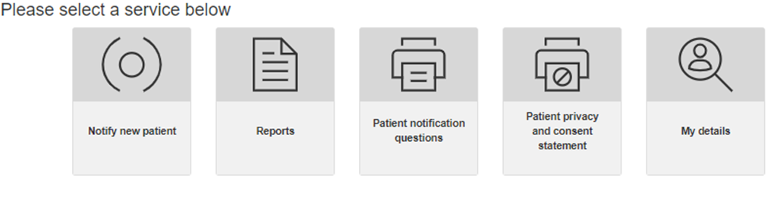

From this part of the dashboard, you can access these Registry functions:

* Notify a new patient
* View reports containing National Registry data
* Download and print the notification questions to hand to the patient to complete
* Download and print the patient privacy and consent statement
* View and edit your own details.

Further information about each of these functions is provided in later sections of this user guide.

## 2. Registry news

A screenshot of a login box

Under the Registry news heading on the dashboard, you will see a list of articles that have been published to the Registry by the Registry Operator. The articles can be sorted by the date the article was published or the topic column can be sorted alphabetically, by clicking on the headings “Topic” or “Date Published”.

## 3. Patient list

The patient list has two tabs:

* Draft notifications

This shows a list of patients for whom you have unsubmitted draft notifications awaiting completion.

* Patients

This shows a list of patients for whom a notification has been submitted to the Registry.

These patient lists can be sorted on any of the headings. For example, by clicking on **First name**, the list will sort in descending order (indicated by a ). If you click on First name again, it will then sort in ascending order.

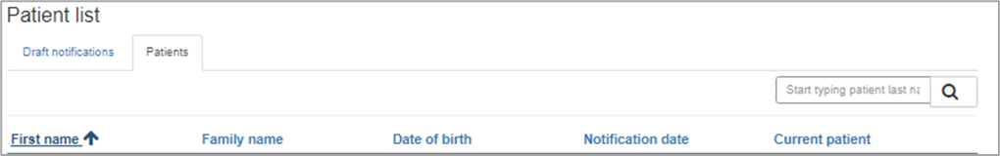

From your Patient list you can view/edit a patient’s details in the Registry, including viewing saved medical test reports or adding new medical reports.

## 4. Act on my behalf

You can authorise someone to act on your behalf to make notifications to the Registry (see the later section “Authorise someone to act on your behalf” for more detail about this).

On the dashboard, you can view a list of agents who are currently authorised to act on your behalf (current agents), a list of agents who have not yet accepted your invitation to act on your behalf (pending agents) and agents who are no longer authorised to act on your behalf (previous agents)

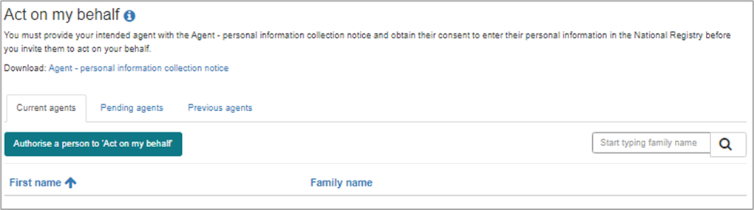

# Notify a new patient

To notify a new patient, select the **Notify new patient** tile in the physician dashboard.

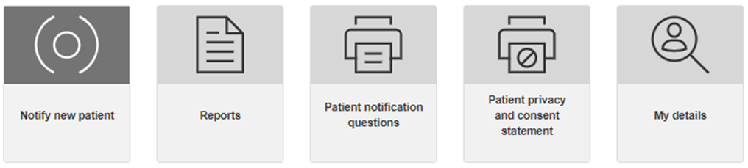

There are 5 main parts to making a notification:

1. Identify patient
2. Patient details
3. Disease and exposure details
4. Additional information
5. Research consent
6. Submit notification.

Each of the above parts to making a notification is covered below.

## 1. Identify patient

You will first need to identify the patient, by entering either their Medicare, DVA or IHI number. Once this information is entered, and you click on **Next**, you will be taken to the **Patient details** screen.

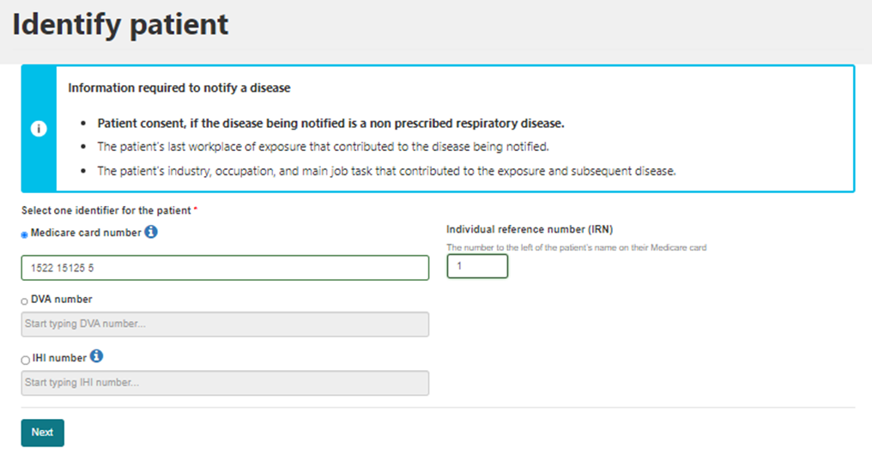

## 2. Patient details



On the **Patient details** screen you will be required to enter patient (demographic) details and contact details. Note that on this screen, the patient’s Medicare, IHI or DVA number will be pre-populated.

### i. Patient details

The patient demographic details to be entered are listed below. Note that fields marked with a * mean that a valid response must be provided in order to submit the notification.

* First name*
* Family name*
* Date of birth* – you can enter a date in DD/MM/YYYY format or use the date picker to select the date
* Date of death
* Gender*
* Indigenous status*
* Country of birth*

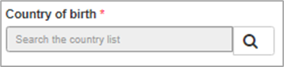

You cannot type the name of a country in this field and will need to search the country list as follows:

* + click on the magnifying glass symbol. A lookup records box will pop up (see screenshot below)
  + select one of the countries on the list that pops up by placing a tick next to it; or
  + use the search field in the popup box to find a country and select it by placing a tick next to it.

Once a country is selected by placing a tick next to it, you will need to click on the **Select** button to register this entry.

A red oval with black background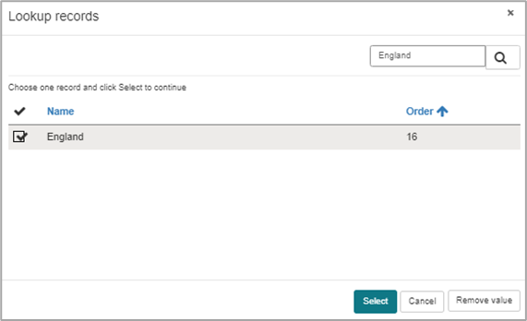

* Language spoken at home*

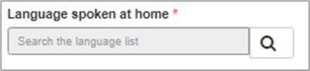

You cannot type the language into this field. You will need to search the language list as follows:

* + click on the magnifying glass symbol. A lookup records box will pop up
  + select one of the languages on the list that pops up by placing a tick next to it; or
  + use the search field in the pop-up box to find the required language and select it by placing a tick next to it.

Once the language is selected by placing a tick next to it, you will need to click on the **Select** button to register this entry.

* The date you became the treating/diagnosing physician for this patient (in the DD/MM/YYYY format)*.

### ii. Contact details

The contact and address details that are to be entered for the patient are listed below. Please note that fields marked with a * mean that a valid entry must be made in order to submit the information.

* Mobile, Landline or Email address*

The details for at least one of these contact methods must be provided.

Mobile numbers must be provided in the format using Australia’s country code (+61) rather than starting with 0, for example **+61** 409 XYZ XYZ

* Postal address*

Start typing the patient’s postal address and the address should display.

If it does not display, then enter the address manually in the following address fields: Address line 1, Address line 2, Suburb, State/Territory, Postcode, Country.

If the patient’s postal address is outside of Australia, then mark the box next to “Or, address is outside of Australia”.

Once all patient details and contact and address details are entered, then click on the **Save and next** button. You will be taken to the **Disease and exposure details** screen.

## 3. Disease and exposure details

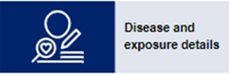

The first section on the **Disease and exposure details** screen asks you to enter Pre-Bronchodilator lung function values. You are also asked to upload the lung function medical test file if available.

Accepted file formats include documents (.doc, .docs, .txt) .pdf and images (.jpg, .jpeg and .png) and the maximum file size is 25MB.

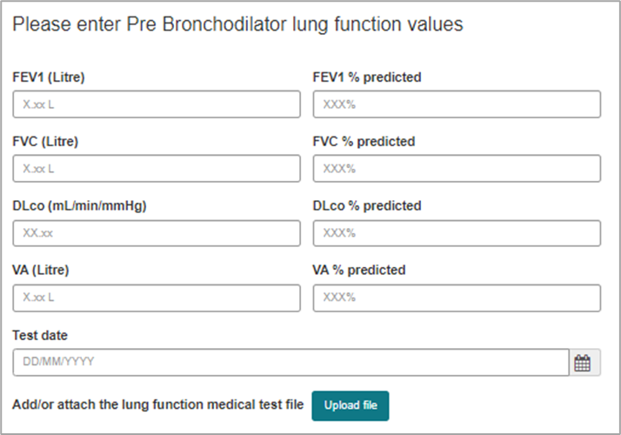

When a medical test file is uploaded, then it will display in the Medical test grid that shows on the **Disease and exposure details** screen.

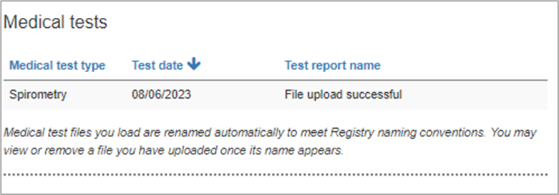

The third section on the **Disease and exposures details** screen is Patient’s respiratory diseases.

To add a new respiratory disease, click on the **Add respiratory disease** button.

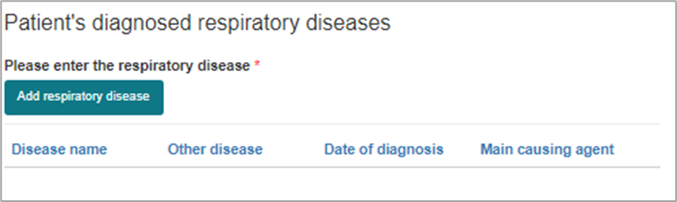

An **Add respiratory disease and exposure details** modal will display.

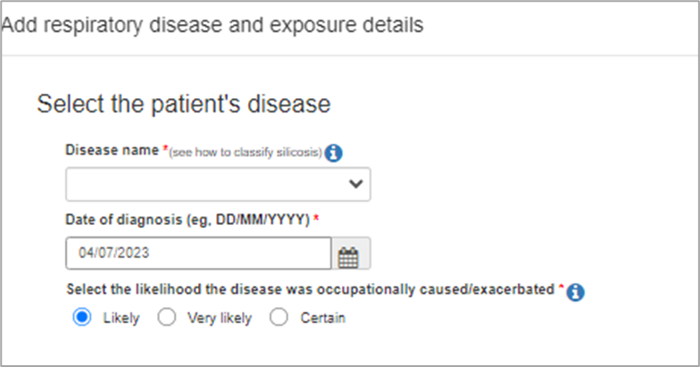

The modal will ask you to enter details of the patient’s respiratory disease and diagnosis.

How this information is entered differs slightly for silicosis (all types) compared to other respiratory diseases, as described below.

### i. Silicosis

* Disease name*
* Date of diagnosis*
* The likelihood the disease was occupationally caused/exacerbated*
* Main causing agent*

For any type of silicosis, silica dust will be the default value selected here.

* Select one or more tests used to make the diagnosis*

For any type of silicosis, CT scan will be automatically selected as a diagnostic test. Other medical tests can be selected in addition to CT scan.

For any type of silicosis diagnosis, a CT scan file must be uploaded.

First, enter the date of the CT scan, then upload the CT scan file

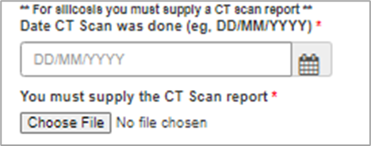

* Diagnosis confirmed by a multidisciplinary team*

### ii. Other respiratory disease

* Disease name*
* Date of diagnosis*
* The likelihood the disease was occupationally caused/exacerbated*
* Main causing agent*

The list of disease-causing agents displayed will depend on the Disease name that has been entered.

* Select one or more tests used to make the diagnosis*

Note that there is no requirement to upload these medical tests. They may be uploaded in the Additional information section of the notification, if the patient consents to you providing Additional Information to the Registry.

* Diagnosis confirmed by a multidisciplinary team*

Once the above sections are complete, then the modal window will expand to display fields to record Exposure details, as follows:

* Total years of exposure*
* Timeframe since last exposure*
* What industry was the patient working in when the exposure occurred?*

To search for the patient’s industry, click on the magnifying glass symbol.

In the window that pops up, type the industry into the search field in the top right-hand side of the pop-up and select the desired value. If you are unable to find an appropriate value, you may select “other” and type in the industry.

Note that the values displayed in the search results are from the ABS Australian and New Zealand Standard Industrial Classification (ANZSIC). [Click here](https://www.abs.gov.au/statistics/classifications/anzsco-australian-and-new-zealand-standard-classification-occupations/latest-release) for further information about classifying a patient’s industry according to the ANZSIC classification that is used in the Registry.

* What was the main job task causing the exposure?*
* Was the last workplace of exposure in Australia?*

If the last workplace of exposure was in Australia, then you will be asked to enter the following details of the workplace:

* + Business name (or tick business name not known)*
  + Landline number
  + Email address
  + Physical address of last workplace of exposure
  + State/Territory of this workplace*
  + Is the patient still working at this workplace?*
* Was the last exposure also the main exposure that is thought to have caused the disease?*

If **No** is selected, then you will be asked to enter the details of the main exposure.

If you do not provide information in the fields marked as mandatory (*) in the **Add respiratory disease and exposure details** modal window, you will not be able save the information you have entered.

If you do not complete all fields and click on the **Save disease details** button, then the partially completed information will be lost when you click cancel or navigate away from the popup.

Once the disease and exposure details are correctly entered and saved, then the disease will appear on the list of the patient’s diagnosed respiratory diseases that displays on the **Disease and exposure details** screen.

It is from here that you can view, edit or remove a notified disease.

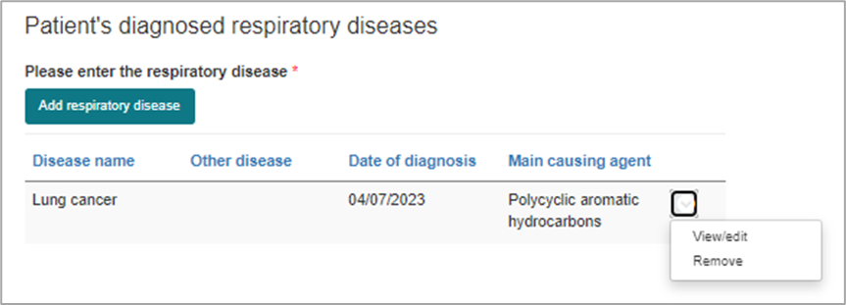

To move onto the next step in the notification - Additional information - click on **Save and next** at the bottom of the screen.

## 4. Additional information

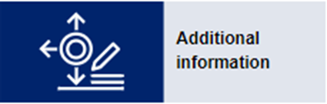

There are 4 collapsible modules that may be completed on the **Additional information** screen:

i. Patient consent – must be completed

ii. Medical tests – optional

iii. Demographic and lifestyle details – optional

iv. Occupational history of exposure – optional

### i. Patient consent

You must indicate whether the patient consents to you collecting additional information.

If **No** is selected, then it is not possible to expand the medical test, demographic and lifestyle details, and occupational history of exposure modules.

If **Yes** is selected, then you will be able to provide the information requested in those modules.

### ii. Medical tests

Here you can upload medical tests relevant to the diagnosis and management of the patient’s occupationally caused or exacerbated respiratory disease.

Click on the **Add medical tests** button in the Medical test module

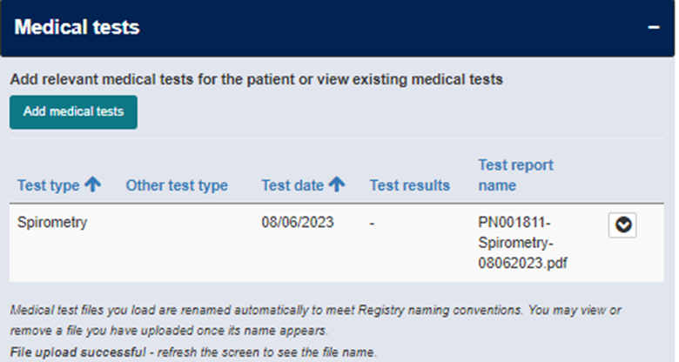

An **Add medical test** modal will then display, where you select the medical test type and date of the medical test.

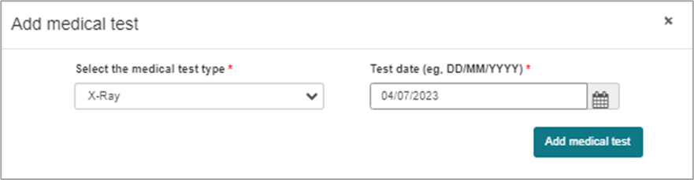

After clicking the **Add medical test** button, you will be prompted to attach the medical test file by clicking on **Upload file**.

Select the required file when prompted. When prompted, click **Save**.

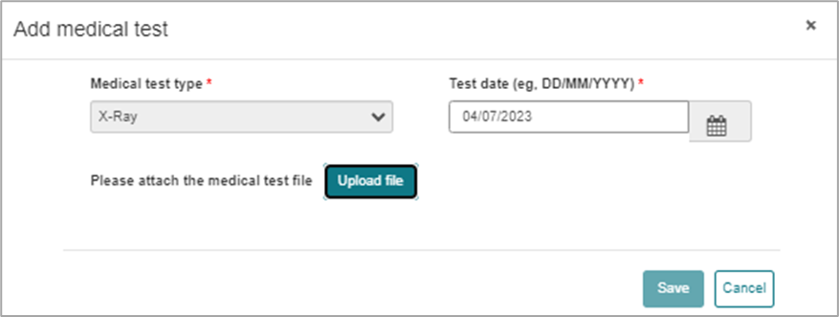

Note that when you upload a medical test file, the Registry system will rename the file.

This means that when the medical test displays in the medical test grid, the file name will be different to what you had named the file prior to uploading it.

### iii. Demographic and lifestyle details

The details you enter here reflect the patient when the first respiratory disease was diagnosed and should only be updated if incorrectly entered or the values were not previously entered.

You will be prompted to enter details about the patient’s:

* Height
* Weight
* Smoking history

The questions that display will depend on whether the patient is a non-smoker, current smoker or former smoker of cigarettes.

* Employment status

You only need to complete either:

* + current job title (if employed) OR
  + date of last employment and last job title (if not employed).

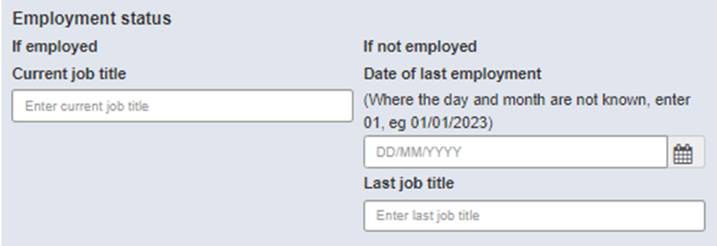

In order to save any partial responses in the Demographic and lifestyle details modal, ensure you click on **Save as a draft** at the bottom of the **Additional information** screen.

### iv. Occupational history of exposure

To add a job to the patient’s occupational history of exposure, click on **Add work history**.

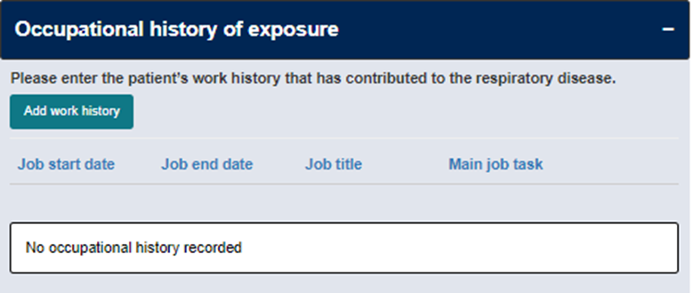

An **Add work history** modal will display. You will be asked to enter the following details. Bolded items marked with a * are required and constitute the *minimum information* needed to count as a valid exposure.

* **Job title**\*
* Occupation
* Industry
* Job start date
* Is the person still working in this job? (if no, then enter the date they finished at this job)
* **Main causing agent**\*
* Secondary causing agent
* Main exposure site
* Average hours worked per week
* **Main job task**\*
* Was RPE used?
* What type of ventilation/control measures were there in the work area?

The information provided here will include the exposures (last and main exposures) reported under Disease and exposure details in the minimum notification. This information will need to be entered separately under the Occupational history of exposure in the additional information.

Once you click **Save** on the Exposure details, then the job will be added to the patient’s occupational history of exposure. From here, you can view, edit, or remove the job from the patient’s occupational history of exposure.

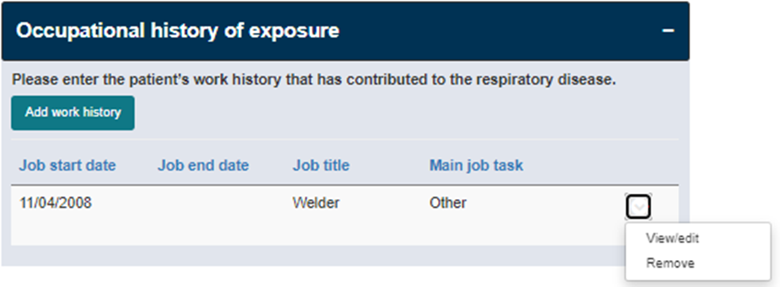

When you have entered the additional information that you are able to or wish to enter, then click on **Save and next**. You will be taken to the next screen, **Research consent**.

## 5. Research consent



The Department of Health and Aged Care seeks patient’s consent to share their personal information with researchers to support research into the prevention of occupational respiratory disease like silicosis, and harmful workplace exposures.

There are two questions that must be completed in the research consent section:

* Does the patient consent to:
  + the Department sharing their information in the National Registry with people conducting research into occupational respiratory diseases?
  + the Department sharing their contact details with researchers seeking their participation in future studies about occupational respiratory diseases, including clinical trials?

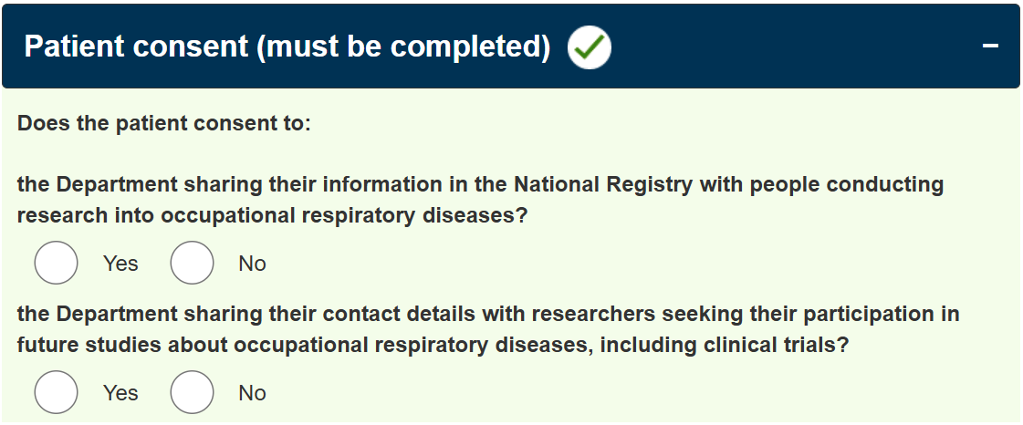

When you have selected a response to each question, click on **Save and next**. You will then be taken to the next screen, **Submit notification**.

## 6. Submit notification

As you work through the different parts of the notification, the panel down the left side of the screen will show which parts of the notification have been completed (green); which are in progress (blue); and which are yet to be completed (grey).

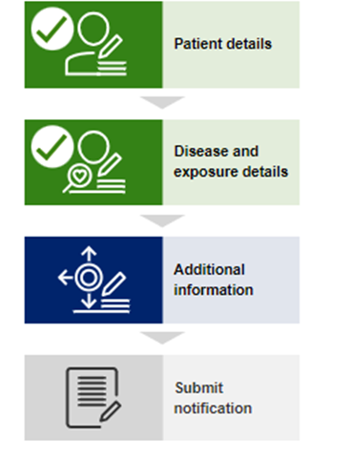

When you reach the Submit notification screen you can either click **Save as a draft,** allowing you to save the notification as a draft, or you can submit the notification by clicking **Submit** (see screenshot below)**.**

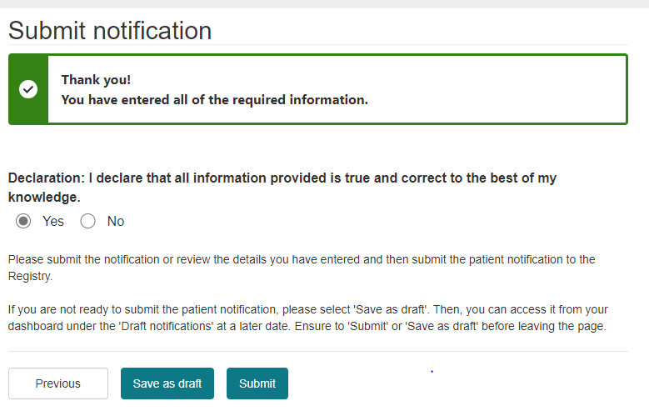

# Run reports

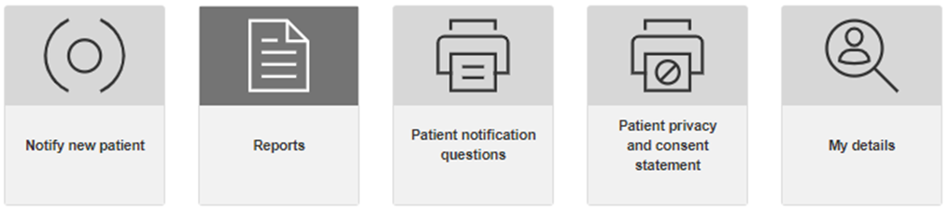

When you click on the **Reports** tile in the Physician dashboard, a Report window will display at the bottom of the screen. This shows a PowerBI report on the number of notifications received, broken down as follows:

* Respiratory diseases by State/Territory
* Respiratory diseases by contributing occupation
* Disease causing agent identified by the occupation of exposure.

You can select the date range to filter these reports by, and you can also select whether the reports include last exposure data or main exposure data.

If the dates appear to be displaying in the MM/DD/YYYY format rather than the DD/MM/YYYY format please be aware that this can be amended by changing your browser settings for date display. How this is done will vary by browser.

Alternatively, you can use the date picker to ensure you select the correct desired date range.

# Patient notification questions

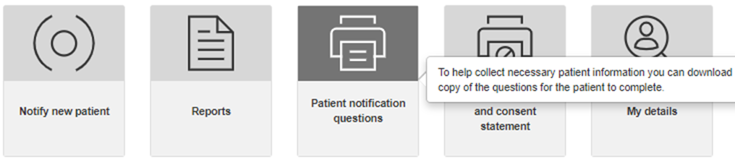

When you click on this tile, a fillable PDF will download which can be provided to, and completed by, your patient digitally or in paper form.

The form is designed to assist with the collection of additional information; however, it does contain most of the information fields needed to make a notification to the Registry. You, or someone acting on your behalf, will then need to enter the patient’s responses to these questions into the Registry.

The form does not provide fields to record:

* A patient identifier (e.g., Medicare card number)
* Date of death
* Mobile, Landline or Email address
* Postal address
* The date you became the treating/diagnosing physician for this patient (in the DD/MM/YYYY format)
* Medical test results
* Patient consent (when required).

# Patient privacy and consent

Patient consent is required in order to notify:

* a disease that was diagnosed prior to the Registry commencing
* an occupational respiratory disease that is not mandatory to notify
* additional information (such as the patient’s height, weight, smoking history and employment status; their occupational history of exposure, and relevant medical test reports).

To support physicians in capturing patient consent, the Registry provides a patient consent statement that can be downloaded and printed for the patient to read and sign. A physician may also read the verbal consent script to the patient rather than obtaining written consent.

The statement available to download provides further details about obtaining consent.

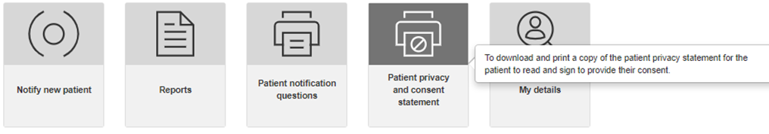

The Registry will also prompt you during the notification process when patient consent is required so that you can indicate that the patient has provided consent.

# View and edit your details

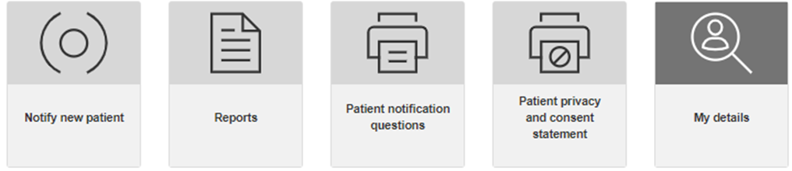

You can update your details at any time by selecting the **My details** tile on the Physician dashboard screen.

If you change your myID email address you cannot update this on the **My details** screen. Instead, you will need to contact the Registry Operator who can update your myID email. Fields that are grey cannot be edited.

# View and edit patient details and notification

How you view and edit patient details will depend on whether the notification is in draft, or has been submitted.

## Draft notification

Before the notification is submitted, you can navigate through the sections of the notification (patient details, disease and exposure details, additional information) using the **previous**, and **save and next buttons** that appear at the bottom of each screen.

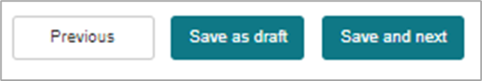

You can then view and edit all responses you have entered.

Once a draft notification has been saved, you can locate the draft notification in the Patient list on the physician home page.

## Submitted notification

If the notification has been submitted, you will need to find the patient in the Patient list on your dashboard. You will need to navigate back to the Patient list on the physician’s home page.

Once the patient is located (by searching their family name for example), then click on the arrow to the right of the record, and click on **View/edit**.

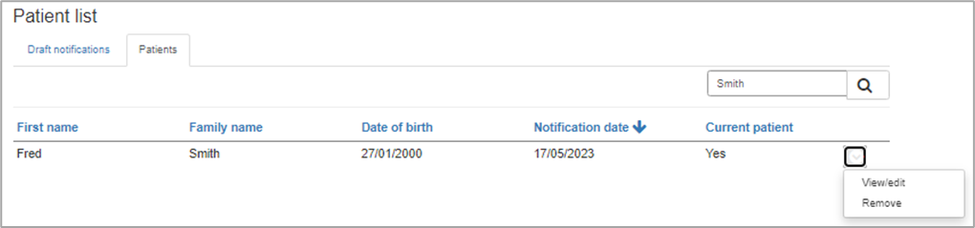

# Authorise someone to act on your behalf

To authorise someone to act on your behalf (your agent), you must first obtain the intended agent’s consent to provide their personal information to the Registry. You should do this by providing the intended agent with an **Agent - personal information collection notice**.

You must also ensure that the intended agent has a “standard” or “strong” strength myID.

Once this consent is obtained and you have confirmed that the intended agent has the appropriate myID, in the physician portal select the **Authorise a person to Act on my behalf** button**.**

A black and red rectangle with a red border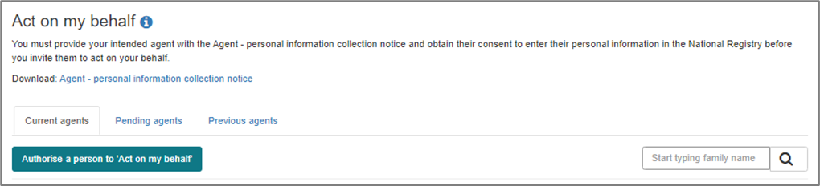

An **Act on my behalf** modal window will display.

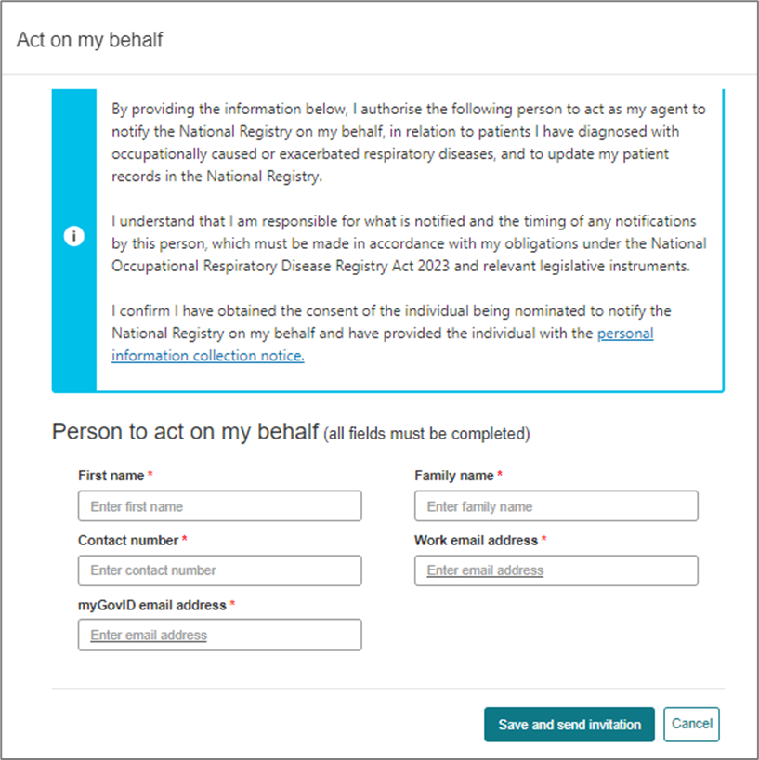

You will then enter the required details for the agent (first name, family name, contact number, work email address and myID email address).

Please note: an agent is required to have a myID email address.

When you select **Save and send invitation**, then an email will be automatically sent to the work email address of the intended agent.

To act on a physician’s behalf, the intended agent must select the **redeem registry invitation link** in the email which will then ask them to sign on to the Registry using their myID email address.

Once successfully logged on they are taken to a **Welcome to the National Registry** screen and asked to accept or reject the physician’s invitation to act on their behalf.

A separate portal user guide for agents is available.

## Remove agent access

An agent’s ability to act on your behalf will be granted indefinitely, until you remove their access (for example, if they are no longer employed by your organisation).

To remove an agent’s access, you will locate the agent in the “current agents” list, then click on the arrow to right of the grid and select “remove”.

A red oval with black backgroundA red oval with black background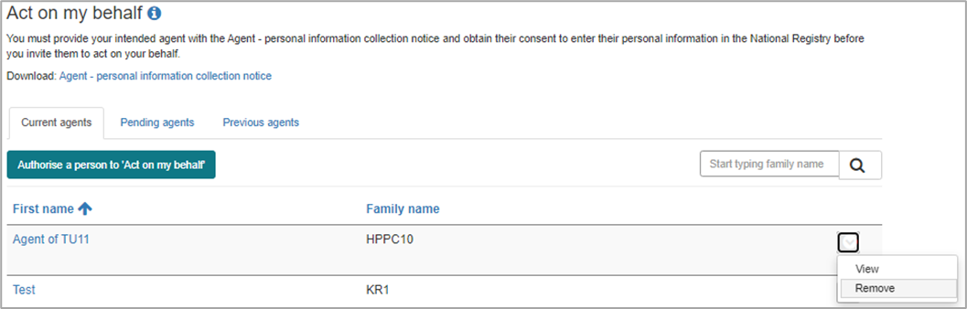

You will then be prompted to confirm that you wish to remove the agent’s access, or you can click on **Cancel** if you wish to cancel this action.

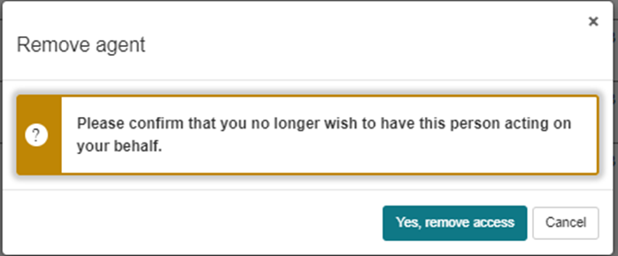

# Registry help desk details

You can contact the help desk for assistance with any queries related to using the portal.

The help desk operates Monday to Friday, 9am to 5pm Australian Eastern Standard Time, excluding national and Victorian public holidays.

Please phone 1300 293 202 or email helpdesk@NORDR.au