Systematic review of evidence on the clinical effectiveness of Feldenkrais

Report prepared by

Cochrane Australia

4 November 2024

Contents

Plain language summary 6

What was the aim of the review? 6

Key messages 6

What was studied in the review? 6

What were the main results of the review? 7

Implications for health policy and research 8

How up-to-date is the review? 8

Executive summary 9

Background 9

Objectives 9

Methods 9

Criteria for including studies in the review 9

Search methods 10

Analytic framework for synthesis and prioritisation process 10

Data collection and analysis 10

Main results 10

Effects of Feldenkrais 11

Limitations 11

Of the evidence contributing to the review 11

Of the review process 12

Conclusions 12

Implications for health policy 12

Implications for future research 12

1. Background 14

1.1 Description of the intervention 14

1.2 How Feldenkrais might work 14

1.3 Description of conditions for which Feldenkrais is used 15

1.4 Why it is important to do this review 15

2. Objectives 16

Primary objective was to answer the following question 16

Secondary objectives 16

3. Summary of methods 17

3.1 Criteria for considering studies for this review 17

3.1.1 Types of studies 17

3.1.2 Types of participants 17

3.1.3 Types of interventions 17

3.1.4 Types of outcomes 18

3.2 Search methods for identification of studies 18

3.3 Selection of studies 18

3.4 Prioritisation of outcomes for the synthesis 19

3.5 Final framework: synthesis questions and criteria for including studies in each synthesis 19

3.6 Data extraction and management 20

3.6.1 Data extraction 20

3.6.2 Assessment of risk of bias in individual studies 20

3.6.3 Measures and interpretation of treatment effect 20

3.7 Data synthesis 20

3.7.1 Meta-analysis 20

3.7.2 Summary of findings tables and assessment of certainty of the body of evidence 20

3.7.3 Interpretation of findings (evidence statements) 21

4. Results 22

4.1 Results of the search 22

Included studies 23

Excluded studies 23

Studies awaiting classification 23

Ongoing and unpublished studies 24

Public submissions 24

4.2 Chronic musculoskeletal conditions 25

4.2.1 Main comparison: Feldenkrais compared to inactive control 25

4.3 Conditions that affect mobility and falls risk 32

4.3.1 Main comparison: Feldenkrais compared to inactive control 32

5. Discussion 44

Summary of the main results 44

Comparability of these findings with other systematic reviews 44

Overall completeness and applicability of evidence 44

Certainty of the evidence 45

Potential biases in the review process 45

6. Conclusions 46

Implications for health policy 46

Implications for future research 46

7. Author contributions and declaration of interest 47

Declarations of interest 47

Acknowledgements 47

Funding 47

8. References 48

In November 2020 Cochrane Australia was contracted by the National Health and Medical Research Council (NHMRC) to design and undertake the systematic review described in this report. This systematic review is one of several independent contracted evidence evaluations being undertaken to update the evidence underpinning the 2015 *Review of the Australian Government Rebate on Natural Therapies for Private Health Insurance* (2015 Review) by the Department of Health (Department). The design and conduct of the review were done in collaboration with the Office of NHMRC (ONHMRC), NHMRC’s Natural Therapies Working Committee (NTWC) and the Department of Health and Aged Care’s Natural Therapies Review Expert Advisory Panel (NTREAP). This report was endorsed by NTWC on 20 November 2024.

Copyright

© Commonwealth of Australia 2024

All material presented in this publication is under a Creative Commons Attribution 4.0 International licence (www.creativecommons.org.au), with the exception of the Commonwealth Coat of Arms, NHMRC logo and content identified as being owned by third parties. The details of the relevant licence conditions are available on the Creative Commons website (www.creativecommons.org.au), as is the full legal code for the CC BY 4.0 International licence.

Attribution

Creative Commons Attribution 4.0 International Licence is a standard form licence agreement that allows you to copy, distribute, transmit and adapt this publication provided that you attribute the work. NHMRC preference is that you attribute this publication (and any material sourced from it) using the following wording:

Source: Murano, M.; Turner, S.; McDonald, S.; McKenzie, J. and Brennan, S. for National Health and Medical Research Council.

Use of images

Unless otherwise stated, all images (including background images, icons and illustrations) are copyrighted by their original owners.

Contact

To obtain information regarding NHMRC publications or submit a copyright request, contact:

[communications@nhmrc.gov.au](mailto:communications@nhmrc.gov.au).

Acknowledgments

Thanks to the members of the Department’s NTREAP and NHMRC’s NTWC for their advice and comments throughout the creation of this document.

Membership and other details of the Panel and Committee can be found at:

<https://www.health.gov.au/committees-and-groups/natural-therapies-review-expert-advisory-panel>

<https://www.nhmrc.gov.au/about-us/leadership-and-governance/committees/natural-therapies-working-committee>

# 

# Plain language summary

## What was the aim of the review?

The aim of this review was to examine the effects of the Feldenkrais Method® (“Feldenkrais”) in preventing and/or treating injury, disease, medical conditions or preclinical conditions. The Feldenkrais Method® is an approach for (re)learning more efficient and effective ways of moving and breathing, through guided lessons delivered verbally or through precise touch, with the overall aim being to increase self-awareness and therefore function.

This review was targeted for the Australian Government Department of Health and Aged Care (formally Department of Health) to assist in their Natural Therapies Review, which was designed to determine whether certain natural therapies, including Feldenkrais, have enough evidence of effectiveness to be considered re-eligible for private health insurance rebates. This review was not designed to be a complete review of all published studies that have evaluated the effects of Feldenkrais, nor is it intended to inform decisions about whether an individual or practitioner should use Feldenkrais.

## Key messages

* We found 10 studies evaluating the Feldenkrais Method® which compared effects among people who were allocated to Feldenkrais to the effects among people who were not allocated to Feldenkrais and contained useable data on prioritised outcomes for the synthesis (4 trials on chronic musculoskeletal conditions and 6 on mobility and falls risk). Studies comparing Feldenkrais to other therapies are listed in an appendix.
* The evidence is very uncertain about whether Feldenkrais improves critical or important outcomes for people with chronic musculoskeletal conditions and people with conditions that affect mobility or people at risk of falls.
* There were no studies among people with other conditions, such as other chronic pain, or stress, anxiety and mood disorders.

## What was studied in the review?

We looked for evidence from randomised trials and non-randomised studies to study the effect of Feldenkrais on conditions and outcomes for which Feldenkrais is commonly sought or prescribed in Australia. Accordingly, we planned a synthesis of evidence for the following population groups. These groups address the conditions for which Feldenkrais is commonly sought or prescribed (1 through 4) [1]; and others of relevance to the Australian context (5).

1. Chronic musculoskeletal pain (e.g. low back pain, neck pain)
2. Other chronic pain
3. Mobility and falls prevention (e.g. multiple sclerosis, older adults, people with intellectual disability)
4. Stress, anxiety and mood disorders
5. Other conditions relevant to the Australian context if evidence was available

We were interested in the effects on outcomes broadly categorised as:

* pain
* falls (rate of falls; risk of falling)
* physical function
* health-related quality of life
* overall disease status (e.g. motor and non-motor symptoms of Parkinson’s disease)
* emotional functioning and mental health

The specific outcomes and measures selected for the synthesis were agreed through an independent prioritisation process, in which decisions were made without knowledge of the studies or study findings. Assessments of cost-effectiveness, safety and studies of healthy populations were not included in this review.

We were able to examine the effects of Feldenkrais for all conditions and populations for which there were studies that compared Feldenkrais to no Feldenkrais (no intervention, sham, placebo, wait list control, or a co-intervention offered to both groups, or continuation of usual care). A secondary objective was to compare the effects of Feldenkrais with other evidence-based treatments. These were to be synthesised only where there were at least two low risk of bias studies with comparable population, evidence-based comparator and outcomes.

We applied methods in the Cochrane Handbook for Systematic Reviews of Interventions [2] to search for, collate, appraise, and synthesise evidence. We then applied methods from the Grading of Recommendations Assessment, Development and Evaluation (GRADE) working group to interpret the synthesis results in a systematic and transparent way. GRADE is a method used to assess and describe how confident (or certain) we can be that the estimates of the effect (calculated by combining results from multiple studies or from single studies if that is the only evidence) reflect the true effects of the intervention. In deciding on our certainty (or confidence) in each result, we considered all relevant information collected in the review.

We use four levels to describe our certainty in the evidence.

|  |  |
| --- | --- |
| **High certainty** | We are very confident that the true effect lies close to that of the estimate of the effect. |
| **Moderate certainty** | We are moderately confident that the true effect is probably close to the estimate of the effect, but there is a possibility that it is substantially different. |
| **Low certainty** | Our confidence in the effect estimate is limited: the true effect may be substantially different from the estimate of the effect. |
| **Very low certainty** | We have very little confidence in the estimate and the true effect is likely to be markedly different from the estimated effect. The evidence is too uncertain to provide an interpretation of the result. |

Our methods were pre-specified in a publicly available protocol (PROSPERO ID [CRD42023467191](https://www.crd.york.ac.uk/prospero/display_record.php?RecordID=467191)) that underwent independent review by methods specialists and was endorsed by the National Health Medical Research Council’s Natural Therapies Working Committee. The review is reported in accordance with the PRISMA 2020 statement [3, 4].

## What were the main results of the review?

Following screening of 408 unique citations from database searches, 40 reports were retrieved from the searches and other sources, from which we included 21 trials in the review. Of these, 10 trials compared Feldenkrais to an inactive comparator and contributed results to at least one summary or synthesis of evidence. No eligible non-randomised studies were identified. The 10 trials were among people with chronic musculoskeletal conditions (2 studies among people with low back pain, and 2 studies among people with neck and shoulder pain), and people with conditions that affect mobility or at risk of falls (3 studies among older adults, 2 studies among people with multiple sclerosis and one study among people with intellectual disability). An additional study in older adults did not contribute to the summary or synthesis due to incomplete and ambiguous reporting. Ten further trials could not be included in the synthesis. Nine of these trials each compared Feldenkrais to a different active comparator (e.g. physiotherapy, Pilates, neck exercises, pulmonary rehabilitation) and could not be combined in a synthesis. One of the 10 trials did not measure any eligible outcomes. Characteristics of these studies are reported in an appendix.

For people with **chronic musculoskeletal conditions** the evidence was very uncertain about the effects of Feldenkrais on:

* pain (4 trials, 154 people with low back or neck and shoulder pain)
* function (disability) (1 trial, 51 people with neck and shoulder pain)
* emotional functioning and mental health (1 trial, 26 people with low back pain)
* breathing patterns (1 trial, 34 people with low back pain).

For people with **conditions that affect mobility and falls risk** the evidence was very uncertain about the effects of Feldenkrais on:

* falls (falls rate and falls efficacy) (3 trials, 114 older adults and people with multiple sclerosis)
* function (disability) (3 trials, 107 older adults and people with multiple sclerosis)
* function (mobility) (5 trials, 205 older adults and people with multiple sclerosis or intellectual disability)
* health-related quality of life (3 trials, 133 older adults at risk of falls)
* emotional functioning and mental health (2 trials, 87 older adults and people with multiple sclerosis)
* fatigue (1 trial, 40 participants people with multiple sclerosis)

We did not identify any studies that reported on overall disease status. We did not identify any studies examining the effects of Feldenkrais on other conditions, such as other chronic pain, or stress, anxiety and mood disorders.

The effects of Feldenkrais compared to other active comparators was not examined, as pre-specified criteria for synthesis were not met (i.e. no two studies at low risk of bias evaluated the same evidence-based treatment). Studies that only contributed active comparators are listed in an inventory (Appendix C3 and E3).

## Implications for health policy and research

This review assessed the available evidence on Feldenkrais to inform the Australian Government about health policy decisions for private health insurance rebates. The review did not cover all the reasons that people use Feldenkrais, or the reasons practitioners prescribe Feldenkrais and was not intended to inform individual choices about using Feldenkrais.

There is very little evidence on the effects of Feldenkrais, including as an adjunct therapy. The evidence base comprises 10 small randomised trials (12 to 124 participants, most trials had less than 55 participants) that contributed results to at least one summary or synthesis. An additional study in older adults did not contribute to the summary or synthesis due to incomplete and ambiguous reporting. The evidence is very uncertain about whether Feldenkrais improves the critical outcomes of pain or physical function (disability) for people with chronic musculoskeletal conditions compared to inactive controls. The evidence is also very uncertain about whether Feldenkrais improves the critical outcomes of falls, physical function (disability and mobility) and health-related quality of life for people with conditions that affect mobility or at risk of falls compared to inactive controls. These findings differ slightly from two other reviews, however both included studies with active comparators and neither assessed the certainty of the evidence using GRADE.

There were no studies with inactive controls that reported on function (mobility) or health-related quality of life in people with chronic musculoskeletal conditions. There were also no studies with inactive controls among people with other common chronic musculoskeletal conditions, such as arthritis. There were no studies with inactive controls among people with other conditions for which Feldenkrais is commonly sought or prescribed, such as stress, anxiety and mood disorders, acute musculoskeletal conditions (e.g. injury) and movement diseases (e.g. Parkinson’s disease). This review listed, but did not assess studies that compared the effects of Feldenkrais to other interventions, so no conclusions can be drawn on whether Feldenkrais is as effective as other exercises or interventions. Studies published in a language other than English were listed, but not included in the assessment. There was a lot of variability in the period over which Feldenkrais was delivered, ranging from 5 sessions a day for 2 days to weekly sessions for 30 weeks. Most studies generally involved one to 3 sessions per week and ran for more than 5 weeks. Longer-term effects were generally not reported and, as such, were not examined in the review so it is unknown whether any effects are sustained.

Future research on the effectiveness of Feldenkrais could be improved by ensuring the choice of comparators facilitates synthesis; either by including inactive controls (e.g. usual care delivered to both groups, sham interventions) or standardised active comparators. In designing trials, attention should be given to the power of the trial, implementing study design features that minimise the risk of bias, measuring outcomes that are well established and patient-relevant (e.g. as identified in consensus-based core outcome sets), reporting all measured outcomes, and ensuring trials are registered and reported in accordance with relevant reporting guidelines.

## How up-to-date is the review?

Searches were conducted from the earliest date included in the databases until 06 October 2023. Studies published after this date are not included in this review.

# Executive summary

## Background

The Feldenkrais Method® (“Feldenkrais”) is an approach for (re)learning more efficient and effective ways of moving and breathing, through guided lessons delivered verbally or through precise touch, with the overall aim being to increase self-awareness and therefore function. The Australian Government Department of Health and Aged Care (via the National Health and Medical Research Council) commissioned a suite of independent evidence evaluations to inform the 2019-20 Review of the Australian Government Rebate on Private Health Insurance for Natural Therapies. This report is for one of the evaluations; a systematic review of randomised trials and non-randomised studies examining the effectiveness of Feldenkrais in preventing and/or treating injury, disease, medical conditions or preclinical conditions. In 2015, an overview of systematic reviews conducted for the Australian Government found there was no clear scientific evidence that Feldenkrais was effective. The current systematic review considered primary evidence and a wider range of publication dates.

This information will be used by the Australian Government in deciding whether to reinclude Feldenkrais as eligible for private health insurance rebates, after Feldenkrais was excluded in 2019. This review was not designed to assess all the reasons that people use Feldenkrais, or the reasons practitioners prescribe Feldenkrais and was not intended to inform individual choices about using Feldenkrais.

## Objectives

Primary objective was to answer the following question:

1. What is the effect of *Feldenkrais* compared to an inactive control (no intervention, sham, placebo, wait list control, or a co-intervention offered to both groups, or continuation of usual care) on outcomes for each underlying condition, pre-condition, injury or risk factor?

Secondary objectives related to the following questions:

1. What is the effect of *Feldenkrais* compared to evidence-based treatments (active comparators) on outcomes for each underlying condition, pre-condition, injury or risk factor?
2. What evidence exists examining the effects of *Feldenkrais* compared to other active comparators? (for inclusion in evidence inventory only, not the synthesis)

As per protocol, to be included in synthesis for objective 2, there must be studies suitable for conducting a synthesis. That is, at least two low risk of bias studies with comparable population, evidence-based comparator and outcomes. Where the criteria are not met, studies will be included in the inventory.

## Methods

This review was prospectively registered on the international prospective register of systematic reviews (PROSPERO ID [CRD42023467191](https://www.crd.york.ac.uk/prospero/display_record.php?RecordID=467191)) and the methods pre-specified in a protocol published on the register. The methods were based on the Cochrane Handbook for Systematic Reviews of Interventions [2]. The Grading of Recommendations Assessment, Development and Evaluation (GRADE) approach was used to summarise and assess the certainty of evidence arising from this review [5-7]. The review is reported in accordance with the PRISMA 2020 statement [3, 4] which has been adopted by Cochrane.

The population groups and outcomes considered in the synthesis are identified in the final framework for the review that was agreed through the prioritisation process (see 3.5 Final framework).

## Criteria for including studies in the review

Broad eligibility criteria were defined for including studies in the review, as summarised below.

* ***Types of study designs and comparisons***. Eligible studies were randomised controlled trials (RCTs) and non-randomised studies of interventions (NRSIs) comparing Feldenkrais to (1) inactive controls (no intervention, sham, placebo, wait list control, or a co-intervention offered to both groups, or continuation of usual care) or (2) active comparators. Any co-intervention was eligible (i.e. pharmacological or non-pharmacological). Usual care comparators were eligible if there was an explicit statement that indicated that participants could continue to access their routine care or therapy (including self-care). Where a comparator labelled as ‘usual care’ involved a defined intervention (i.e. specific treatments and processes selected by the researchers), this was deemed to be either an active intervention (if restricted to the comparator group) or a co-intervention (if able to be accessed by both groups, e.g. continuation of a specific medication).
* ***Types of populations***. Any condition, pre-condition, injury or risk factor (excluding healthy participants without clearly identified risk factors for the condition Feldenkrais was used to prevent).
* ***Types of outcomes***. Any patient-important outcome for which Feldenkrais is indicated was eligible for the review. Outcome domains of interest were pain, falls, physical function, health-related quality of life, overall disease status, and emotional functioning and mental health. Outcomes and measures for inclusion in the synthesis for each condition were agreed through the prioritisation process.
* ***Other criteria***. Studies in languages other than English were not eligible for synthesis but were listed in an appendix.

## Search methods

We searched the Cochrane Central Register of Controlled Trials (Cochrane Library, Issue 10, 2023), MEDLINE, Embase, Emcare, AMED, CINAHL, Europe PMC, ClinicalTrials.gov and WHO International Clinical Trials Registry Platform on 6 October 2023. Searches were not limited by language, year of publication or publication status. The public was also invited by the Department to submit references for published research evidence.

## Analytic framework for synthesis and prioritisation process

A staged process, designed to minimise bias in the review, was agreed *a priori* for determining which of the studies eligible for the review would be included in the synthesis (see Summary of methods, Figure 3.1). Through this process, The National Health and Medical Research Council’s Natural Therapies Working Committee (NTWC) with input from the Department’s Natural Therapy Review Expert Advisory Panel (NTREAP), prioritised outcomes and confirmed the grouping of conditions within the population groups proposed for the synthesis. A framework for the synthesis was finalised prior to commencing data extraction. This framework defined the scope of the evidence synthesis and specified the synthesis questions and associated PICO (populations, interventions, comparators, outcomes) criteria for including studies in each synthesis (see Summary of methods, Figure 3.5.1).

## Data collection and analysis

Screening of citations and full text reports was completed by two authors, independently. Data extraction and risk of bias assessment (ROB 2.0) was piloted for the suite of natural therapies studies by two authors to ensure consistency between reviewers, then completed by a single author and checked by a second.

Comparisons were based on the population groups and outcome domains (e.g. pain, falls, physical function (disability and mobility), health-related quality of life, and emotional functioning and mental health) specified in the analytic framework (Figure 3.5.1). For some populations (e.g. mobility and falls risk), we present both an overall analysis and analyses stratified by more specific subpopulations or conditions (e.g. falls risk, multiple sclerosis). Meta-analysis methods were used to combine results across studies with results suitable for meta-analysis.

GRADE methods were used to assess certainty of evidence and summarise findings. For all results an interpretation was made about whether the observed effect was important (or not) and how certain we were about the finding (high, moderate, low or very low). Certainty accounted for concerns about bias (arising from studies included in and missing from the synthesis), how precisely the effect was estimated, important unexplained inconsistency in the results across studies, and how directly the studies in each synthesis addressed the synthesis question defined in the analytic framework.

## Main results

Following screening of 408 citations from database searchers, 40 reports were retrieved from searches and other sources, from which a total of 21 studies were included in the review. Eleven (11) studies were eligible for the evidence synthesis (12 reports), of which ten (10) contributed to at least one meta-analysis. The eleventh did not contribute to any of the meta-analyses for which it was eligible because the required data were uninterpretable. The other 10 trials contributed to the evidence inventory (see Appendix E3 for characteristics and Appendix C2 for references). One trial did not report any eligible outcomes, and 9 trials compared Feldenkrais to another treatment. Five (5) studies were listed as awaiting classification, of which 4 were studies retrieved in languages other than English, three with unclear eligibility and one likely eligible (see Appendix C3). Four (4) studies were listed as ongoing or unpublished (see Appendix C4). No citations were received from the public call for evidence.

### Effects of Feldenkrais

For people with chronic musculoskeletal conditions and people with conditions that affect mobility or people at risk of falls, the evidence is very uncertain overall about the effects of Feldenkrais compared to an inactive control.

For people with **chronic musculoskeletal conditions** the evidence was very uncertain about the effects of Feldenkrais on:

* pain (4 trials, 154 people with low back or neck and shoulder pain)
* function (disability) (1 trial, 51 people with neck and shoulder pain)
* emotional functioning and mental health (1 trial, 26 people with low back pain)
* breathing patterns (1 trial, 34 people with low back pain).

For people with **conditions that affect mobility or at risk of falls** the evidence was very uncertain about the effects of Feldenkrais on:

* falls (falls rate and falls efficacy) (3 trials, 114 older adults and people with multiple sclerosis)
* function (disability) (3 trials, 107 older adults and people with multiple sclerosis)
* function (mobility) (5 trials, 205 older adults and people with multiple sclerosis or intellectual disability)
* health-related quality of life (3 trials, 133 older adults)
* emotional functioning and mental health among (2 trials, 87 older adults and people with multiple sclerosis)
* fatigue (1 trial, 40 people with multiple sclerosis)

There were no studies comparing Feldenkrais to no Feldenkrais among people with other conditions such as other chronic pain, or stress, anxiety and mood disorders.

The effects of Feldenkrais compared to other active comparators was not examined, as pre-specified criteria for synthesis were not met (i.e. no two studies at low risk of bias evaluated the same evidence-based treatment). Studies that only contributed active comparators are listed in an inventory (Appendix C3 and E3).

## Limitations

### Of the evidence contributing to the review

Limitations of the evidence were considered when interpreting each result by applying the GRADE approach. The overriding limitation is that there are only 10 small trials (12 to 124 participants, with most having less than 55 participants), comparing inactive controls on prioritised outcomes which contributed to the meta-analyses. An additional trial did not contribute to the two meta-analyses for which it was eligible because the results were uninterpretable due to incomplete and ambiguous reporting. Most of the outcomes for which results were available had only a small number of participants contributing data, which led to imprecise effect estimates. In some cases, the imprecision was extreme, meaning that the result was compatible with both important benefit and important harm. There were also inconsistent results across studies (some showing benefit, others showing little or no effect). We were also concerned about the methodological limitations of the studies contributing to the synthesis, with 15/20 (75%) of the outcomes contributing to the syntheses judged to be at high risk of bias, and 4/20 (20%) with some concerns. There were no concerns about non-reporting of outcomes or results in the studies included in the meta-analysis. For results derived from one or two small trials that show important benefit, selective non-reporting of unfavourable results (null or favouring control) could importantly change the result. We were unable to use graphical methods to investigate whether studies showing different effects (favouring control, trivial effects) may be missing from the analyses. As such, we judged that publication bias was a concern. There was a lot of variability in the period over which Feldenkrais was delivered, ranging from 5 sessions a day for 2 days to weekly sessions for 30 weeks. Most studies generally involved one to 3 sessions per week and ran for more than 5 weeks. Longer-term effects were generally not reported and, as such, were not examined in the review so it is unknown whether any effects are sustained.

### Of the review process

In this review steps were taken to address potential limitations. We applied methods recommended in the Cochrane handbook for systematic reviews of interventions and the GRADE approach, as per the detailed protocol that was prospectively registered on PROSPERO after undergoing independent methodological review. The synthesis questions could not be fully specified at protocol stage; however, the final list of outcomes eligible for the review and questions to be addressed in meta-analyses were determined through a pre-specified prioritisation process, performed by NTWC with input from NTREAP and without knowledge of the included studies or results of those studies. An initial analytic framework for the review was included in the protocol to inform these decisions and propose a structure for the synthesis.

While data extraction for each study was performed by a single reviewer, the selection of outcomes and coding of studies for inclusion in meta-analyses was performed independently by a second experienced review author. All data were checked by a second experienced author, with input from a biostatistician, and all data manipulation and analyses were performed by a biostatistician. These steps minimised the risk of errors or misinterpretation. Risk of bias assessments were performed for each study by a single reviewer following detailed guidance developed for the review and training in the assessment of design features relevant to this review. Checks were performed by a second experienced reviewer.

While we endeavoured to include all available studies in the analyses (applying all suggested methods from the Cochrane Handbook), one study reported data that could not be interpreted. Consistent with the protocol and the approach taken in other natural therapies reviews, we did not contact trialists for additional information.

Assessments of cost-effectiveness, safety and studies of healthy populations were out of scope.

## Conclusions

### Implications for health policy

There is very little evidence on the effects of Feldenkrais including as an adjunct therapy. The evidence base comprises 10 small randomised trials (12 to 124 participants, most trials had less than 55 participants) that contributed results to at least one summary or synthesis. An additional study in older adults did not contribute to the summary or synthesis due to incomplete and ambiguous reporting. The evidence is very uncertain about whether Feldenkrais improves the critical outcomes of pain or physical function (disability) for people with chronic musculoskeletal conditions compared to inactive controls. The evidence is also very uncertain about whether Feldenkrais improves the critical outcomes of falls, physical function (disability and mobility) and health-related quality of life for people with conditions that affect mobility or at risk of falls compared to inactive controls. These findings differ slightly from two other reviews, however both included studies with active comparators and neither assessed the certainty of the evidence using GRADE.

There were no studies with inactive controls that reported on function (mobility) or health-related quality of life in people with chronic musculoskeletal conditions. There were also no studies with inactive controls among people with other common chronic musculoskeletal conditions, such as arthritis. There were no studies with inactive controls among people with other conditions for which Feldenkrais is commonly sought or prescribed, such as stress, anxiety and mood disorders, acute musculoskeletal conditions (e.g. injury) and movement diseases (e.g. Parkinson’s disease). This review listed, but did not assess studies that compared the effects of Feldenkrais to other interventions, so no conclusions can be drawn on whether Feldenkrais is as effective as other interventions. Studies published in a language other than English were listed, but not included in the evaluation.

### Implications for future research

Future research on the effectiveness of Feldenkrais could be improved by ensuring the choice of comparators facilitates synthesis; either by including inactive controls (e.g. usual care delivered to both groups, sham interventions) or standardised active comparators. In designing trials, attention should be given to the power of the trial, adequately describing all trial arms, implementing study design features that minimise the risk of bias, measuring outcomes that are well established and patient-relevant (e.g. as identified in consensus-based core outcome sets), reporting all measured outcomes, and ensuring trials are registered and reported in accordance with relevant reporting guidelines.

# 1. Background

In 2015, the Australian Government conducted a *Review of the Australian Government Rebate on Natural Therapies for Private Health Insurance (2015 Review).* Underpinned by systematic reviews of evidence for each natural therapy, one of the findings from the 2015 Review was that there was no clear scientific evidence that Feldenkrais was effective. The National Health and Medical Research Council (NHMRC) has been engaged by the Department of Health and Aged Care (Department) to update the evidence underpinning the 2015 Review. This evidence evaluation of Feldenkrais is one of a suite of independent contracted systematic reviews that will inform the *Review of the Australian Government Rebate on Private Health Insurance for Natural Therapies 2019-20* (2019-20 Review) [8].

The Feldenkrais Method® (“Feldenkrais”), developed by Moshe Feldenkrais in the mid-20th Century, aims to develop awareness of physical functioning by exploring movement, posture and breathing through verbal guidance or precise touch. The complementary therapy is used by performers and athletes, as well as by those living with and recovering from a range of illnesses and injuries [8, 9]. In Australia, the main source of information about the rates of consultation with complementary medicine practitioners is a cross-sectional survey conducted as part of the Practitioner Research and Collaborative Initiative (PRACI) [10]. The 2017 PRACI survey of Australian adults found that about a third of all respondents (36%; 726/2025 respondents) had consulted at least one complementary practitioner in the last 12 months. Feldenkrais was not among the therapies examined, and data are lacking on the prevalence and frequency of consultation with teachers of the method or routine use.

## 1.1 Description of the intervention

Feldenkrais is described as a universal method for improving human life through better movement, sensation, posture and breathing [8]. Trained practitioners use “touch, movement, guided imagery, and mindful body awareness with the aim of stimulating the brain to make useful and lasting improvements to movement and posture” [1].

***Mode of administration and dose***

Feldenkrais practitioners deliver two types of movement lessons [8]. Awareness Through Movement® is a planned sequence of verbally guided movement explorations usually delivered in a group or class setting, with each session lasting 30-60 minutes. Functional Integration® comprises individual sessions where the practitioner physically guides the person’s body through effortless movement and uses precise touch to bring awareness into the body, and are delivered with the person lying or sitting, comfortably clothed, on a low padded table [1, 8].

***Practitioners of Feldenkrais and regulation***

The practice and teaching of the Feldenkrais Method is not regulated by the Australian Health Practitioner Regulation National Law, which means there is no requirement for professional registration of practitioners of the Feldenkrais Method [11]. The Australian Feldenkrais Guild (AFG) is a non-profit membership organisation that promotes the Feldenkrais Method in Australia, verifies and maintains training standards, and represents its members in liaison with Feldenkrais Guilds throughout the world.

Certified Feldenkrais practitioners must complete an accredited training program. According to the Australian Feldenkrais Guild, training normally takes 3–4 years to complete, with students required to participate in 800 hours of training delivered in several face-to-face components each year with home-based practice and learning in between. The Australasian Training and Accreditation Board—a standing committee of the AFG—is responsible for reviewing and accrediting all professional training programs in the Asia-Pacific region. It accredits both professional Feldenkrais Method teacher-training programs and educational personnel (trainers and assistant trainers). Standards for training are agreed internationally and are recognised throughout the world. The AFG seeks to protect the integrity and quality of the Feldenkrais Method through a Code of Professional Conduct and Standards of Practice [12].

## 1.2 How Feldenkrais might work

According to the International Feldenkrais Federation, the method is based on principles of physics, biomechanics, and an empirical understanding of learning and human development [1, 8], and was informed by Moshe Feldenkrais’ own observation that by paying closer attention to what he was doing he performed better. Feldenkrais is characterised as a learning process, rather than a massage or bodywork technique. The two parallel forms of the Feldenkrais Method—Awareness Through Movement and Functional Integration—emerged from two ideas: how a person uses their body (sensing effort and sensing ease) and responding to feedback to improve the performance of an action or task [13].

A person learns to use movements that may have been forgotten or excluded from their routine actions – these movement sequences enable individuals to understand how their whole body responds harmoniously in any movement. It is believed that by acquiring this learning, including learning how the body can adjust performance based on feedback, people can “live their lives more fully, efficiently and comfortably”, with improved physical functioning a desired outcome, together with a broader enhancement of one’s environment and life [14].

## 1.3 Description of conditions for which Feldenkrais is used

A review of the effectiveness of Feldenkrais from 2015 identified 20 randomised trials covering diverse populations [15], most commonly people with musculoskeletal pain and people for whom problems with balance, coordination or motor function have a potentially important health impact. The review found an equally diverse range of outcomes measured, mostly related to physical function (e.g. balance or dexterity), symptoms (e.g. pain or mood) or quality of life.

The Australian Feldenkrais Guild website suggests that Feldenkrais may be used for pain management, children with disability, injury prevention and recovery, and neurological conditions that affect movement [1]. The use of Feldenkrais to improve wellbeing and performance among healthy populations (e.g. for healthy ageing, sports and peak performers) falls outside the scope of this review.

## 1.4 Why it is important to do this review

This systematic review will inform the Australian Government’s Natural Therapies Review 2019-20, which is evaluating evidence of the clinical effectiveness of 16 therapies (including Feldenkrais). The conclusion from the evidence evaluation conducted on Feldenkrais for the *2015 Review* was that “the improvement of health outcomes in people with any clinical condition is uncertain. […] Significant research gaps exist and there is no solid evidence base on which to make recommendations” [16]. The evidence evaluation used overview methods, synthesising results from 5 systematic reviews published up to September 2013. The three randomised controlled trials included in these reviews evaluated the treatment of musculoskeletal conditions and elderly people at risk of falling.

Since the completion of the original evidence evaluation, there have been additional published trials of Feldenkrais, although the number remains small. In contrast to the 2015 Feldenkrais evidence evaluation, which was limited to evidence from randomised trials included in existing systematic reviews, this review examined evidence from eligible primary studies (i.e. randomised trials and non-randomised studies of interventions).

# 2. Objectives

The overall objective of this systematic review was to examine the evidence for the clinical effectiveness of Feldenkrais in preventing and/or treating injury, disease, medical conditions or preclinical conditions [8]. The review focused on outcomes (and underlying conditions) for which Feldenkrais is commonly sought or prescribed in Australia, and to inform are relevant to the 2019-20 Review of the Private Health Insurance rebate.

The questions for the review follow (framed as primary and secondary objectives).

## Primary objective was to answer the following question

1. What is the effect of *Feldenkrais* compared to an inactive control (no intervention, sham, placebo, wait list control, or a co-intervention offered to both groups, or continuation of usual care) on outcomes for each underlying condition, pre-condition, injury or risk factor?

## Secondary objectives

1. What is the effect of *Feldenkrais* compared to evidence-based treatments (active comparators) on outcomes for each underlying condition, pre-condition, injury or risk factor?
2. What evidence exists examining the effects of *Feldenkrais* compared to other active comparators? (for inclusion in evidence inventory only, not the synthesis)

As per protocol, to be included in synthesis for objective 2, there must be studies suitable for conducting a synthesis. That is, at least two low risk of bias studies with comparable population, evidence-based comparator and outcomes. Where the criteria are not met, studies will be included in the inventory.

Decisions about the final synthesis questions and criteria for including studies in each synthesis were made through a staged process (described in section 3.4). The staged process aimed to align the questions addressed with priorities for the 2019-20 Review, ensure a consistent approach across the evidence evaluations of natural therapies (where appropriate), and make best use of available evidence. The outcomes considered in the synthesis are identified in the final framework for the review that was agreed through the prioritisation process (section 3.4). The final synthesis questions and criteria for including studies in each synthesis are presented in Figure 3.5.1.

# 3. Summary of methods

This review followed methods pre-specified in the protocol endorsed by NTWC with input from NTREAP. The protocol was prospectively registered on the International prospective register of systematic reviews (PROSPERO ID [CRD42023467191](https://www.crd.york.ac.uk/prospero/display_record.php?RecordID=467191)). The methods were based on the Cochrane Handbook for Systematic Reviews of Interventions [2]. The Grading of Recommendations Assessment, Development and Evaluation (GRADE) approach was used to summarise and assess the certainty of evidence arising from this review [6, 7]. The review is reported in accordance with the PRISMA 2020 statement [3, 4].

A staged approach was taken to developing the questions and criteria for including studies in the synthesis (Figure 3.1). A summary of each stage is described in the methods that follow (see Appendices A and B for a complete description of methods; Appendix I for Abbreviations used in the report). The framework for the synthesis was finalised prior to commencing data extraction (Figure 3.1, panel 4). It defines the scope of the evidence synthesis and specifies the synthesis questions and associated PICO (population, intervention, comparator, outcome) criteria for including studies in each synthesis.

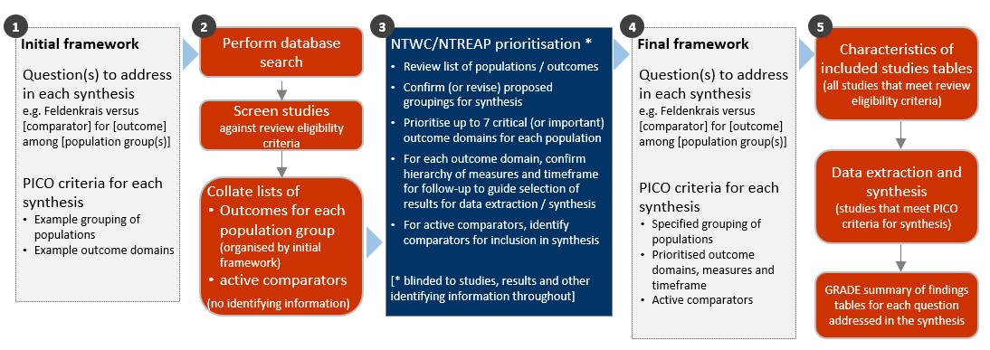

**Fig 3.1** | Staged approach for developing the questions and analytic framework for this review.

## 3.1 Criteria for considering studies for this review

### 3.1.1 Types of studies

We included randomised controlled trials (RCTs) (including individually and cluster randomised, and cross-over trials) and controlled trials where there was an attempt to have some kind of ‘randomisation’ to groups (e.g. sequence generation based on alternation, dates (of birth or attendance at a clinic) and patient record numbers) [17]. Non-randomised studies of interventions (NRSIs) with certain design features were eligible (see Appendix A1.1.1). Historical case control, uncontrolled before-after studies, cross-sectional studies and case-control studies were ineligible.

***Date and language restrictions.*** There were no restrictions on publication date. Potentially eligible studies published in languages other than English were eligible for the review but not the synthesis.

### 3.1.2 Types of participants

Studies involving participants with any disease, medical condition, injury, or preclinical condition were eligible for the review. This included healthy participants with clearly identified risk factors for a condition (evident from study eligibility criteria or baseline data) that Feldenkrais was administered to prevent. There were no restrictions on age. Healthy populations seeking health improvement were excluded.

### 3.1.3 Types of interventions

Feldenkrais was defined as a method that “… develops a functional awareness of the self in the environment…expands their repertoire of movements, enhances awareness, improves function and enables people to express themselves more fully” [14]. Because of the potential challenge of distinguishing components of Feldenkrais from related modalities, and the likelihood of identifying studies in which the defining techniques and principles of Feldenkrais are incompletely reported, studies were included if the therapy was described as Feldenkrais (including the Feldenkrais Method, Awareness Through Movement® or Functional Integration®). Studies that failed to mention or describe the intervention as Feldenkrais (or other synonyms) were excluded. Feldenkrais interventions were eligible irrespective of the training or qualifications of the practitioner, the setting in which Feldenkrais was used, and the dose and duration of treatment.

#### Comparisons

1. Feldenkrais *versus* any inactive comparator (no intervention, sham, placebo, wait list control, a co-intervention offered to both groups, or continuation of usual care).
2. Feldenkrais *versus* evidence-based treatment(s) (active comparators) on outcomes for each underlying condition, pre-condition, injury or risk factor?
3. Feldenkrais *versus* any active comparator (for inclusion in evidence inventory only, not the synthesis).

As per protocol, to be included in synthesis for objective 2, there must be studies suitable for conducting a synthesis. That is, at least two low risk of bias studies with comparable population, evidence-based comparator and outcomes. Where the criteria are not met, studies will be included in the inventory.

Any co-intervention was eligible (i.e. pharmacological or non-pharmacological). Usual care comparators were eligible if there was an explicit statement that indicated that participants could continue to access their routine care or therapy (including self-care). If a comparator labelled as ‘usual care’ involved a defined intervention (i.e. specific treatments and processes selected by the researchers), this was deemed to be either an active intervention (if restricted to the comparator group) or a co-intervention (if able to be accessed by both groups, e.g. continuation of a specific medication).

We excluded head-to-head comparisons of Feldenkrais (e.g. comparison of different frequencies, durations or schedules; comparison of specialist Feldenkrais practitioner versus other health professional delivering Feldenkrais).

### 3.1.4 Types of outcomes

Any patient-important outcome that aligned with the reasons why Feldenkrais is sought by patients and prescribed by practitioners was eligible. Studies were included in the review irrespective of the outcome(s) measured, but the synthesis was limited to outcomes considered to be critical or important for each population group (see 3.4 for prioritisation of outcomes and 3.5 for final framework). Experience of care (e.g. satisfaction), safety, quality, and economic outcomes were excluded.

From each study, we selected one outcome per outcome domain for data extraction (results), risk of bias assessment and inclusion in the synthesis. In selecting outcomes for synthesis, we considered the outcome measure (any measure was eligible but a pre-specified hierarchy was applied to select the most relevant measure if multiple measures were available), timing of outcome measurement (first measure after end of Feldenkrais intervention period) and suitability of data for meta-analysis.

## 3.2 Search methods for identification of studies

We searched the Cochrane Central Register of Controlled Trials (Cochrane Library, Issue 10, 2023), MEDLINE (Ovid), Embase (Ovid), Emcare (Ovid), AMED (Ovid), CINAHL (EBSCOhost), Europe PMC, ClinicalTrials.gov and WHO International Clinical Trials Registry Platform on 6 October 2023. Searches were not limited by language, year of publication or publication status. We also searched Google Scholar (first 10 pages) and conducted a forward citation search on all studies that met the inclusion criteria.

## 3.3 Selection of studies

Two reviewers piloted guidance for title and abstract screening on a sample of 50 records to ensure the review eligibility criteria were applied consistently. All records were screened independently by two reviewers at both the title and abstract screening and full-text review stages. Disagreements at either stage of screening were resolved by consensus among members of the review team. We documented the flow of studies through the review in a PRISMA diagram (Figure 4.1.1). Studies that did not meet the review eligibility criteria were excluded and the reason for exclusion was recorded at full-text screening.

## 3.4 Prioritisation of outcomes for the synthesis

Decisions about the final synthesis questions and criteria for including studies in each synthesis were made through the prioritisation process in Figure 3.1. The process was designed to minimise bias in the selection of results for inclusion in the synthesis while ensuring coverage of relevant populations and outcomes.

In brief, we screened studies against the review eligibility criteria and collated deidentified information about the populations and outcomes addressed in included studies (no bibliographic information, titles, details about the number of studies, participants, methodological quality or results). For each condition, NTWC, with input from NTREAP, rated outcome domains as critical, important or of limited importance. Within each outcome domain, NTWC ranked the listed outcomes/measures for each domain to enable selection of the most relevant result from each study.

## 3.5 Final framework: synthesis questions and criteria for including studies in each synthesis

Figure 3.5.1, panel A shows the final analytic framework for the evidence summary and synthesis. The framework provides a guide to the structure of the synthesis and reporting of results (see caption for details).

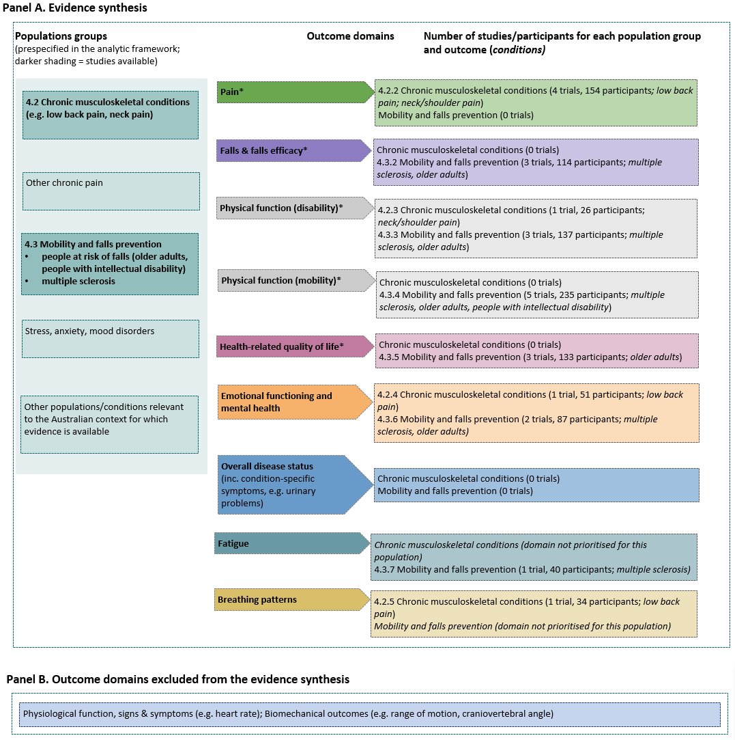

**Fig 3.5.1 |** Final analytic framework for the review as agreed through the prioritisation process (Appendix A5).   
Panel A, columns 1 and 2 show the populations and outcome domains eligible for the evidence synthesis. Column 3 shows the populations *(conditions)* and outcome domains for which studies were available. Results are reported for each population group in the section indicated in column 1. Study-level data and meta-analyses are presented for the main comparison in the forest plot indicated in column 3. Panel B shows outcome domains rated as of limited importance. * Outcome domain prioritised as critical for at least one population group.

## 3.6 Data extraction and management

### 3.6.1 Data extraction

Study data were collected and managed using REDCap electronic data capture tools [18, 19]. A two-step data extraction process was implemented wherein a senior author (MM) coded the study PICO to allocate studies for analysis according to the analytic framework and selected the outcome (result) for inclusion in each synthesis using pre-specified decision rules. Any queries from this stage were sent to the second senior author (SB) to review, with any disagreement resolved through consensus discussion. A senior author (MM) extracted study characteristics and quantitative data. A second senior author (SB) independently verified the study allocation for analysis and outcome selection, as well as the data. Steps taken to ensure the completeness, accuracy and consistency of data included pretesting the form and providing coding guidance, training, and feedback for data extractors. Quantitative data were reviewed by a biostatistician when queries arose.

### 3.6.2 Assessment of risk of bias in individual studies

We assessed the risk of bias in included studies using the revised Cochrane ‘Risk of Bias’ tools (RoB 2) for randomised trials [17, 20]. After piloting of the tool by senior authors (SB, MM, SM), we developed review-specific guidance for the suite of natural therapies reviews to ensure consistency between reviewers. This guidance had been used by the author team to assess over 200 natural therapies studies prior to application in the current review. One review author (MM) applied the tool to the selected results from each study following the RoB 2 guidance [17], and a second author (SM, SB) checked assessments. Supporting information and justifications for judgements for each domain (low, some concerns, high risk of bias) was recorded. We derived an overall summary of the risk of bias from each assessment, following the algorithm in the RoB 2 guidance as implemented in the Excel assessment tool [17].

### 3.6.3 Measures and interpretation of treatment effect

We anticipated that many of the outcomes would be continuous (e.g. pain, function), and that varying measurement instruments would be used to measure the same underlying construct across the studies. For this reason, we quantified the effects of Feldenkrais using the standardised mean difference (SMD).

Our interpretation was based on whether there was an important effect or not [5, 21], with an SMD of 0.2 standard units set as the threshold for an important difference. If the SMD fell within the pre-specified range of -0.2 to 0.2 (i.e. within both thresholds), the effect of Feldenkrais was considered to be no different from control. An SMD above 0.2 or below -0.2 was interpreted as an important effect. We opted to use the most intuitive interpretation of effect estimates for each outcome, so positive values indicate benefit for some outcomes (an increase in physical function) and harm for other outcomes (an increase in pain).

## 3.7 Data synthesis

### 3.7.1 Meta-analysis

Separate comparisons were set up for each population group and outcome domains agreed in the final framework (see Figure 3.5.1). Some comparisons were stratified by more specific populations (with an overall estimate for each population group and estimate for each specific population presented). Forest plots were used to visually depict the intervention effect estimates and their confidence intervals. Forest plots are stratified by specific population and risk of bias (within population group). For completeness, results for all studies for which an effect estimate (SMD) could be calculated are presented on the forest plot, including where a single study contributed to the comparison. Studies that had missing or uninterpretable results, or for which an effect estimate (SMD) could not be calculated, are not depicted on the plot.

### 3.7.2 Summary of findings tables and assessment of certainty of the body of evidence

For each result, one author (MM) used the GRADE approach to assess our certainty in whether there is an important effect (or not). In accordance with GRADE guidance [6, 21, 22], an overall GRADE of high, moderate, low or very low certainty is reported for each result based on whether there are serious, very serious, extremely serious or no concerns in relation to each of the following domains [5].

* **Risk of bias**. whether the studies contributing to each synthesis have methodological limitations that might lead to over (or under) estimation of the effect
* **Imprecision**. whether the confidence interval for the synthesised result crosses one or both of the thresholds for an important effect (an SMD of 0.2 or -0.2) meaning that the result is compatible with different interpretations (e.g. the upper bound of the interval lies above 0.2 indicating ‘an important effect’ whereas the lower bound lies between -0.2 and 0.2 indicating ‘little or no effect’)
* **Inconsistency**. whether there is important, unexplained inconsistency in results across studies
* **Indirectness**. whether there are important differences between the characteristics of studies included in each synthesis and the question we were seeking to address, such that the effects observed may not apply to our question (i.e. the applicability of the evidence).
* **Publication bias**. whether results missing from each analysis may bias the effect estimate because of selective non-reporting of results (or studies) that showed unfavourable effects

A summary of findings is tabulated for each comparison. These summary of findings tables include:

* estimates of the effects of Feldenkrais reported as standardised mean differences
* the overall GRADE (rating of certainty) and an explanation of the reason(s) for rating down (or borderline decisions) [23].
* the study design(s), number of studies and number of participants contributing data
* a plain language statement interpreting the evidence for each comparison and outcome, following GRADE guidance for writing informative statements (see 3.7.3 interpretation of findings) [24].

### 3.7.3 Interpretation of findings (evidence statements)

When interpreting results, we followed GRADE guidance for writing informative statements [24]. All interpretations are based on where the point estimate lies in relation to the pre-specified thresholds for an important effect (an important effect or not) and the direction of effect (beneficial or harmful). The certainty of evidence is communicated by qualifying the interpretation of effect (e.g. ‘may’ improve for low certainty). For example, ‘Feldenkrais may improve physical function’ indicates that the point estimate lies above the threshold for important benefit (an SMD >0.2) and that the evidence is of low certainty. For very low certainty evidence, we do not provide an interpretation of the result except to state ‘The evidence is very uncertain about the effect of Feldenkrais on outcome’. This is one of two options that GRADE provides for interpreting findings based on very low certainty of evidence. The decision not to interpret very low certainty results was made independently by the NTWC to ensure a consistent and clear interpretation of findings across Natural Therapy Review reports.

# 4. Results

## 4.1 Results of the search

The flow of studies through the review is summarised in Figure 4.1.1, the PRISMA flowchart.

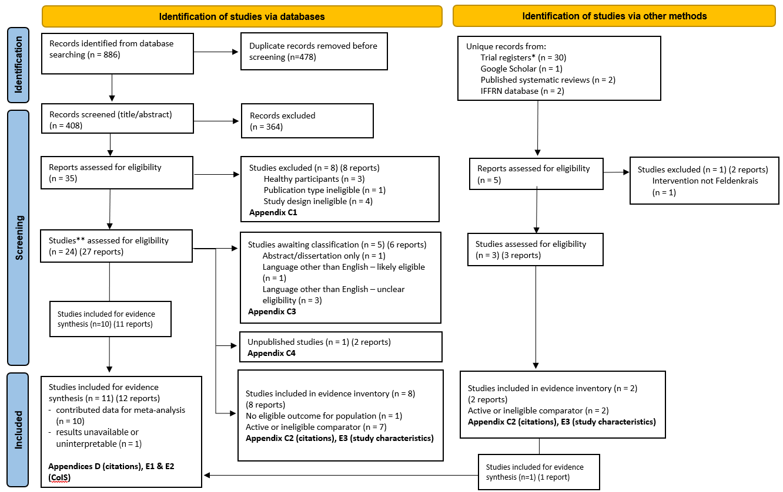

**Fig. 4.1.1** | PRISMA diagram showing the flow of studies through the review. **Studies are the unit of interest in the review. Each study could have multiple reports.   
CoIS: characteristics of included studies. *see results section ‘Ongoing and unpublished studies’

### Included studies

Following screening of 408 citations from the database searches, we retrieved 35 full text reports from which 18 studies were included. A further 3 studies were included, one from Google Scholar and 2 from published systematic reviews for a total of 21 studies included in this review.

#### Studies included for the evidence synthesis (inactive comparators)

Ten (10) studies were included for the evidence synthesis [25-35]. Four (4) of these studies were trials that examined the effects of Feldenkrais on outcomes for people with chronic musculoskeletal conditions (low back or neck/shoulder pain). Six (6) of these studies were trials that examined the effects of Feldenkrais on outcomes for people with conditions that affect mobility or at risk of falls (mainly older people and people with multiple sclerosis). An additional study in older people at risk of falls was eligible for this evidence synthesis, however results could not be included in the analysis due to incomplete and ambiguous reporting.

For the comparison of Feldenkrais versus inactive control (no intervention, sham, placebo, wait list control, or a co-intervention offered to both groups, or continuation of usual care), studies could contribute to the synthesis for one or more of 9 outcome domains prioritised by NTWC:

*Critical outcome domains*

* pain
* falls
* physical function (disability)
* physical function (mobility)
* health related quality of life (HR-QoL)

*Important outcome domains*

* overall disease status/symptoms
* emotional functioning and mental health
* fatigue
* breathing patterns

#### Studies included in the evidence inventory

Of the 21 studies included in this review, 10 were included in the evidence inventory but not the evidence syntheses. Reasons for excluding these studies from the synthesis are summarised in Figure 4.1.1, study characteristics are reported per study in Appendix E3 and references are in Appendix C2.

In brief, 9 of ten studies had an active comparator (e.g. back school, balance classes) that could not be combined in a meta-analysis, or another natural therapy (Pilates, one study), and the remaining study did not report an outcome from any of the prioritised outcome domains (see Appendix E3).

### Excluded studies

After full-text screening, 9 studies (10 reports) were excluded from the review (Figure 4.1.1, Appendix C1 for list of excluded studies).

### Studies awaiting classification

Following screening, one study was categorised as awaiting classification because results were reported as a dissertation and abstract only (Figure 4.1.1, Appendix C3 for study awaiting classification).

#### Studies in languages other than English

Of the 4 studies in languages other than English, one was judged likely to be eligible based on the title and abstract, and for 3 the judgement was unclear (listed in Appendix C3). Because study design and characteristics tend to be incompletely reported in abstracts (especially the outcomes measured), the proportion of these studies eligible for the review and the evidence synthesis is unknown. For these reasons, a full analysis of the impact of these studies on each of the meta-analyses was not possible. However, there is no reason to believe that, on average, the results from studies in languages other than English would differ systematically from studies included in our analysis. Given this, non-inclusion of these studies is unlikely to change the results or conclusions for each outcome.

### Ongoing and unpublished studies

In total, we identified 8 studies eligible for the review from trial registry entries and the database searches. Of these 8 studies, 4 were linked to completed studies included in the review, 1was judged likely to be ongoing and 3 likely to be unpublished.

From our database searches, 2 citations were for a study among older people for which we found a protocol, published both in full [36] and as an abstract [37]. This trial was terminated in 2019 due to issues with ethics approvals. Baseline assessments had been done and the interventions delivered in one of two planned cohorts, however outcome assessment had not been performed at the time of trial termination. We have categorised this trial as an unpublished study.

From trial registry entries (CENTRAL, ClinicalTrials.gov and WHO ICTRP) we identified 30 unique records, of which 7 appeared potentially eligible for the review. Of the potentially eligible records:

* four (4) were for completed studies already included in the review: 2 were for studies reported on the evidence inventory [38, 39], and 2 were for studies included in the evidence synthesis [40, 41].
* one study was registered in 2022 and considered likely to be ongoing. This study compares Feldenkrais to an active comparator (acupuncture plus stretching), and would therefore not contribute results to any of our syntheses.
* two (2) studies commenced enrolment in in 2016 and 2017 respectively and were, therefore, assessed to be missing studies. The study registered in 2016 compared Feldenkrais to an inactive control (foot care intervention + usual care as a co-intervention given to both groups) for people with diabetic polyneuropathy. The study registered in 2017 compared Feldenkrais to no intervention (continuation of usual activity) for people with knee osteoarthritis.

Characteristics of ongoing and unpublished studies are reported in Appendix C4. Brief details are reported in the results section for the comparison for which the study is eligible.

### Public submissions

No citations were received via the Department’s public call for evidence.

## 4.2 Chronic musculoskeletal conditions

The four (4) studies included in the evidence synthesis for people with musculoskeletal conditions were among people with low back pain (2 studies) and people neck/shoulder pain (2 studies).

Prioritised outcome domains for people with chronic musculoskeletal conditions were:

*Critical outcome domains*

* pain
* physical function (disability)
* physical function (mobility)
* health related quality of life (HR-QoL)

*Important outcome domains*

* falls
* overall disease status/symptoms
* emotional functioning and mental health
* breathing patterns

No studies reported outcomes in the domains of physical function (mobility), health-related quality of life, falls or overall disease status/symptoms. Throughout the text, tables and plots, the outcomes are presented in the order above.

### 4.2.1 Main comparison: Feldenkrais compared to inactive control

#### Characteristics of included studies

Brief characteristics of studies that compared Feldenkrais to an inactive control in people with chronic musculoskeletal conditions are summarised in Table 4.2.1. The outcome measure from which data were included for meta-analysis is reported for each trial in the forest plots (column 2, Figures 4.2.2 to 4.2.5). For all results, the outcome selected for analysis was measured at the end of the intervention period (see Table 4.2.1). Full characteristics are reported for each study in Appendix E1 (including a list of all outcome measures, details of which outcome was selected when multiple were available for an outcome domain, and the timing of outcome measurement in relation to intervention), and Appendix E2 (funding, conflicts of interest and ethics).

**Table 4.2.1** Brief characteristics of studies comparing Feldenkrais to an inactive control for people with chronic musculoskeletal conditions.

| **Study** | **Population: condition (ICD-11 code)\*** | **Intervention** | | | **Comparator** | **Outcome domains** | | | | |
| --- | --- | --- | --- | --- | --- | --- | --- | --- | --- | --- |
| **Intervention period** | **Frequency** | **No. sessions & duration** | **Pain** | **Function (disability)** | **EFMH** | **Breathing patterns** | **Measured** |
| **Chronic musculoskeletal conditions** | | | | | | | | | | |
| **Lundblad 1999**  Sweden | 65 adults with neck/shoulder pain  (MG30.02 Chronic primary musculoskeletal pain) | 16 weeks  Feldenkrais | weekly | 16 x 50 mins (4 x FI, 12 x ATM) | wait list control | **X** |  |  |  | week 22 |
| **Lundqvist 2014**  Sweden | 61 adults with neck/shoulder pain in vision impairment (MG30.02 Chronic primary musculoskeletal pain; 9D9Z Vision impairment) | 12 weeks  Feldenkrais | weekly | 12 x 120 mins | wait list control | **X** ⱡ | **X** ⱡ |  |  | week 12 |
| **Mohan 2020**  country NR | 40 adults with low back pain (MG30.02 Chronic primary low back pain) | 8 weeks  Feldenkrais + routine physiotherapy | 4 sessions/ week (1 supervised, 3 home-based) | 32 x 60 mins | routine physio- therapy** | **X** |  |  | **X** | week 8 |
| **Smith 2001**  Australia | 28 adults with low back pain (MG30.02 Chronic primary low back pain) | single session  Feldenkrais delivered via audiotape | once | 1 x 30 mins | audiotape of story (no intervention)** | **X** |  | **X** |  | immediate |

*number of participants is the number from eligible groups (randomised); **schedule as per Feldenkrais group; ⱡ outcomes confirmed as measured in registry entry

#### Risk of bias in included trials

A summary of the judgements for risk of bias domains and overall for each study outcome is presented in Figure 4.2.1 and the overall risk of bias judgement for each study is reported in the forest plots (each outcome from a study was assessed separately). The complete assessments and judgements are reported in Appendix F.

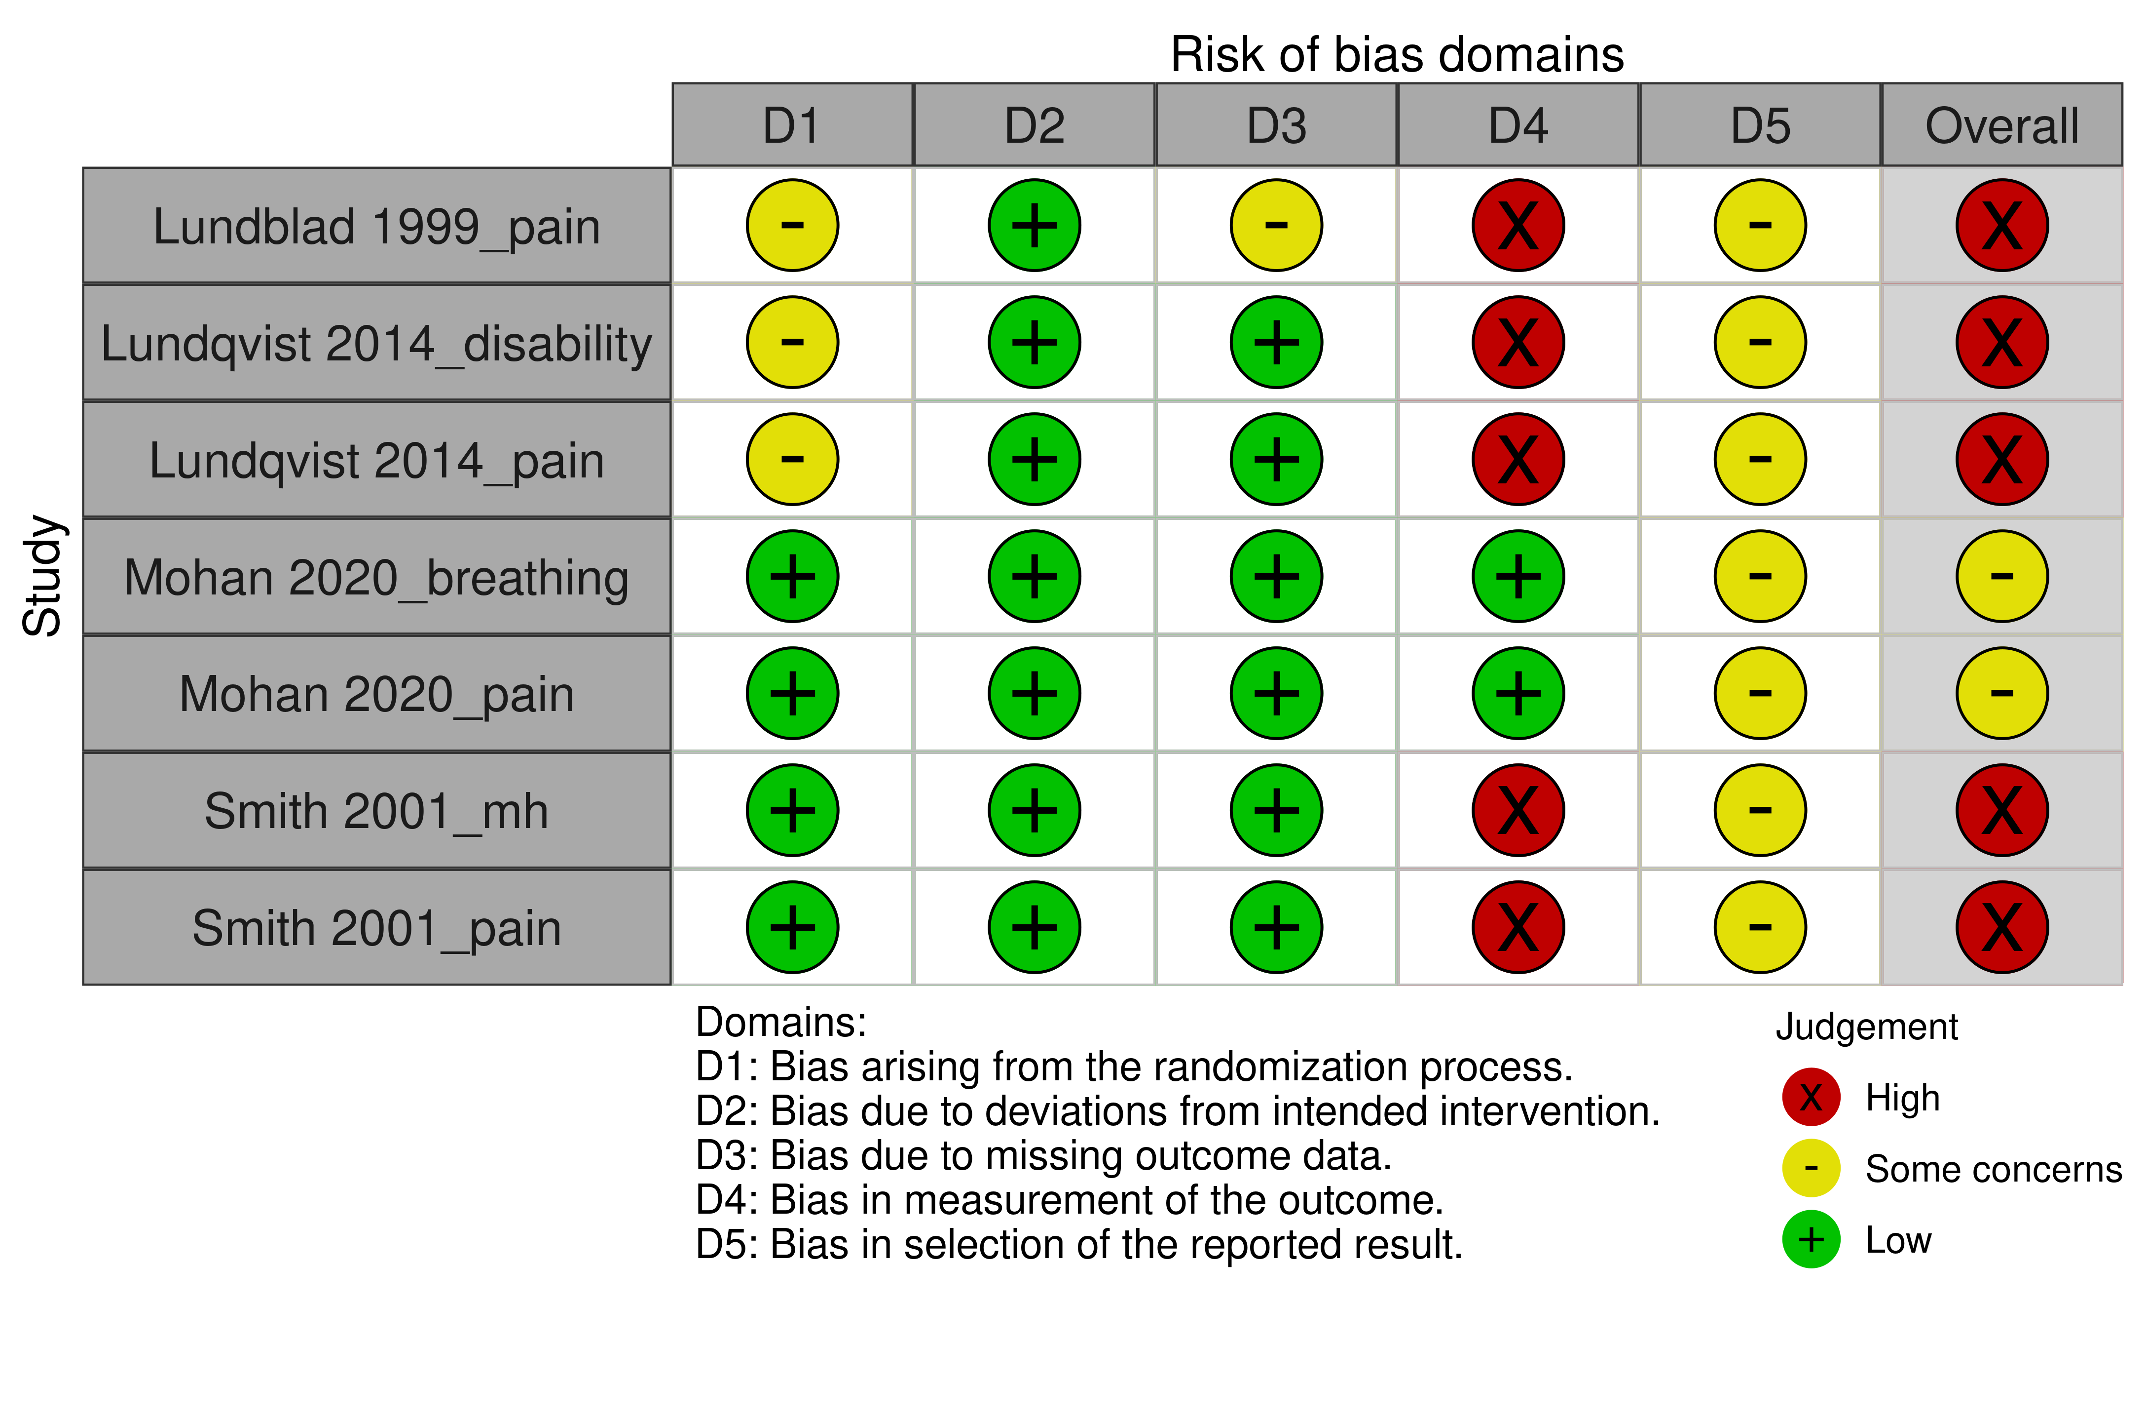

**Fig 4.2.1** | Summary of the risk of bias assessments for studies contributing to the comparison of Feldenkrais versus inactive control (no intervention, wait list, a co-intervention offered to both groups) in people with chronic musculoskeletal conditions. Each outcome for which the study contributed results was assessed separately. Full details of each assessment, including the rationale for judgements, are reported in Appendix F. The overall risk of bias judgement for each study is reported in the forest plots.

#### Effects of Feldenkrais compared to inactive control

The effects of Feldenkrais compared to an inactive control in people with chronic musculoskeletal conditions are presented in Table 4.2.2. The certainty of evidence and factors that influenced our certainty in the evidence are presented and explained in the GRADE summary of findings tables. Study level and meta-analytic results are presented in forest plots (Figures 4.2.2 to 4.2.5).

***Pain*** *(Figure 4.2.2)*

* *Included studies*. Four (4) studies (Mohan 2020, Lundblad 1999, Lundqvist 2014 and Smith 2001; 154 participants with low back and neck/shoulder pain) contributed to the analysis
* *Missing results*. One small unpublished trial registered in 2017 aiming to recruit 15 people with knee osteoarthritis and measure health-related quality of life may contribute to this analysis. Trials that measure HR-QoL may report results from a subscale that measures bodily pain.
* *Ongoing studies*. There are no ongoing studies of Feldenkrais versus an inactive control in people with chronic musculoskeletal conditions.

The evidence about the effect of Feldenkrais on pain for people with chronic musculoskeletal conditions is of very low certainty due to study design limitations, indirectness, imprecision and publication bias (4 studies, 154 participants with low back pain or neck/shoulder pain; Figure 4.2.2).

***Physical function (disability)*** *(Figure 4.2.3)*

* *Included studies*. One (1) study (Lundqvist 2014; 51 participants with neck/shoulder pain) contributed to the analysis.
* *Missing results*. One small unpublished trial registered in 2017 aiming to recruit 15 people with knee osteoarthritis and measure physical function (disability and mobility) is eligible for this analysis
* *Ongoing studies*. There are no ongoing studies of Feldenkrais versus an inactive control in people with chronic musculoskeletal conditions.

The evidence about the effect of Feldenkrais on physical function (disability) for people with chronic musculoskeletal conditions is of very low certainty due to study design limitations, indirectness, imprecision and publication bias (1 study, 51 participants with neck/shoulder pain; Figure 4.2.3).

**Emotional functioning and mental health (mental distress)** *(Figure 4.2.4)*

* *Included studies*. One (1) study (Smith 2001; 26 participants with low back pain) contributed to the analysis.
* *Missing results*. One small unpublished trial registered in 2017 aiming to recruit 15 people with knee osteoarthritis and measure health-related quality of life may be eligible for this analysis. Trials that measure HR-QoL commonly report results from a subscale that measures emotional wellbeing.
* *Ongoing studies*. There are no ongoing studies of Feldenkrais versus an inactive control in people with chronic musculoskeletal conditions.

The evidence about the effect of Feldenkrais on emotional functioning and mental health (mental distress) for people with chronic musculoskeletal conditions is of very low certainty due to study design limitations, indirectness, imprecision and publication bias (1 study, 26 participants with low back pain; Figure 4.2.4).

**Breathing patterns** *(Figure 4.2.5)*

* *Included studies*. One (1) study (Mohan 2020; 34 participants with low back pain) contributed to the analysis.
* *Missing results*. There were no unpublished trials identified from registry entries or other sources for this analysis.
* *Ongoing studies*. There are no ongoing studies of Feldenkrais versus an inactive control in people with chronic musculoskeletal conditions.

The evidence about the effect of Feldenkrais on breathing patterns for people with chronic musculoskeletal conditions is of very low certainty due to indirectness, imprecision and publication bias (1 study, 34 participants with low back pain; Figure 4.2.5).

**Table 4.2.2** Summary of findings for the effect of Feldenkrais versus inactive control (no intervention, wait list control, or a co-intervention offered to both groups in all included studies) for chronic musculoskeletal conditions.

| Outcomes  (main population(s) in included studies) | **Anticipated absolute effects\*** (95% CI) | | Relative effect (95% CI) | № of participants (studies) contributing to the analysis | Certainty of the evidence (GRADE) | Interpretation (evidence statement) |
| --- | --- | --- | --- | --- | --- | --- |
| **With inactive control** | **With Feldenkrais** |
| Pain (people with low back & neck/shoulder pain) (follow-up immediate to 22 weeks)a,b | - | SMD **0.3 SD lower** (1.3 lower to 0.7 higher) | - | 154 (4 RCTs) | ⨁◯◯◯ Very lowc,d,e,f,g | The evidence is very uncertain about the effect of Feldenkrais on pain for people with chronic musculoskeletal conditions (low back & neck/shoulder pain). |
| Physical function - disability (people with neck/shoulder pain) (follow-up 12 weeks)a,b | - | SMD **0.1 SD higher** (0.44 lower to 0.64 higher) | - | 51 (1 RCT) | ⨁◯◯◯ Very lowh,i,j,k,l | The evidence is very uncertain about the effect of Feldenkrais on physical function (disability) for people with chronic musculoskeletal conditions (neck/shoulder pain). |
| Emotional functioning & mental health - mental distress (people with low back pain) (immediate follow-up)b | - | SMD **0.56 SD higher** (0.21 lower to 1.32 higher) | - | 26 (1 RCT) | ⨁◯◯◯ Very lowh,i,m,n,o | The evidence is very uncertain about the effect of Feldenkrais on emotional functioning and mental health (mental distress) for people with chronic musculoskeletal conditions (low back pain). |
| Breathing patterns (people with low back pain) (follow-up 8 weeks)b | - | SMD **0 SD**  (2.19 lower to 2.19 higher) | - | 34 (1 RCT) | ⨁◯◯◯ Very lowi,m,o,p,q | The evidence is very uncertain about the effect of Feldenkrais on breathing patterns for people with chronic musculoskeletal conditions (low back pain). |
| Other critical outcomes |  | |  | (0 studies) | - | No studies reported on the critical outcomes of physical function - mobility or health-related quality of life for people with chronic musculoskeletal conditions. |
| Other important outcomes |  | |  | (0 studies) | - | No studies reported on the important outcomes of falls or overall disease status for people with chronic musculoskeletal conditions. |
| \***The risk in the intervention group** (and its 95% confidence interval) is based on the assumed risk in the comparison group and the **relative effect** of the intervention (and its 95% CI). **CI:** confidence interval; **SMD:** standardised mean difference The threshold for an important difference was an SMD of 0.2 (used for interpreting point estimates and confidence intervals). For pain, emotional functioning and mental health, and breathing patterns, the resulting interpretation is: < -0.2 is beneficial, -0.2 to 0.2 is trivial or unimportant ("little or no difference" between treatments), > 0.2 is harmful. For physical function, the resulting interpretation is: < -0.2 is harmful, -0.2 to 0.2 is trivial or unimportant ("little or no difference" between treatments), > 0.2 is beneficial. | | | | | | |
| **GRADE Working Group grades of evidence** **High certainty:** we are very confident that the true effect lies close to that of the estimate of the effect. **Moderate certainty:** we are moderately confident in the effect estimate: the true effect is likely to be close to the estimate of the effect, but there is a possibility that it is substantially different. **Low certainty:** our confidence in the effect estimate is limited: the true effect may be substantially different from the estimate of the effect. **Very low certainty:** we have very little confidence in the effect estimate: the true effect is likely to be substantially different from the estimate of effect.  **Explanations** are provided for domains for which there is a downgrade or a borderline judgment. In line with GRADE guidance, we do not explain that there are no limitations unless the judgment was challenging (<https://pubmed.ncbi.nlm.nih.gov/26796947/> ) | | | | | | |

#### Explanations

a. Critical outcome domain for this population

b. Measures varied. Pain: NRS, SF-36 bodily pain subscale, SF-MPQ evaluative measure, VAS; Physical function - disability: VMBC - muscular complaints subscale; EFMH: STAI-state; Breathing patterns: TFBS

c. Very serious risk of bias (-2). 76% of data in the analysis comes from 3 studies at high risk of bias.

d. No important inconsistency. 95% CIs overlap for all studies (with so few studies, there is substantial uncertainty in I squared and Tau squared, and low power to detect heterogeneity using the Chi squared test).

e. Serious indirectness (-1). Evidence from four small studies among people with low back or neck/shoulder pain. Uncertain whether results apply to chronic musculoskeletal conditions more generally.

f. Extremely serious imprecision (-3). The 95% confidence interval crosses the threshold for both small but important benefit (SMD -0.2) and small but important harm (SMD 0.2), and is too wide for the result to be interpretable (SMD -1.30 indicating large benefit to 0.7 indicating large harm).

g. Publication bias strongly suspected (-1). The meta-analysis is based on 4 small studies with two showing large effects, so selective non-reporting of unfavourable results (null or favouring control) could importantly change the combined estimate. This is a concern because of evidence of selective non-reporting of unfavourable/uninteresting results in general, and from trials of natural therapies in particular. No missing outcomes from studies included in the review, and one missing study in people with knee osteoarthritis identified from registry entries.

h. Very serious RoB (-2). Single study at high risk of bias.

i. Inconsistency not assessed: single study

j. Serious indirectness (-1). Evidence from one small study among people with neck/shoulder pain. Uncertain whether results apply to chronic musculoskeletal conditions more generally.

k. Very serious imprecision (-2). The 95% confidence interval crosses two thresholds for a small but important effect (SMD of 0.2 and -0.2), so the result is compatible with important harm (SMD 0.44 lower) and important benefit (SMD 1.64 higher).

l. Publication bias strongly suspected (-1). The meta-analysis is based on one small study, so selective non-reporting of unfavourable results (null or favouring control) could importantly change the combined estimate. This is a concern because of evidence of selective non-reporting of unfavourable/uninteresting results in general, and from trials of natural therapies in particular. One missing study in people with knee osteoarthritis was identified from registry entries. No missing outcomes from studies included in the review

m. Serious indirectness (-1). Evidence from one small study among people with low back pain. Uncertain whether results apply to chronic musculoskeletal conditions more generally.

n. Very serious imprecision (-2). The 95% confidence interval crosses two thresholds for a small but important effect (SMD of 0.2 and -0.2), so the result is compatible with important benefit (SMD 0.21 lower) and important harm (SMD 1.32 higher).

o. Publication bias strongly suspected (-1). The meta-analysis is based on one small study, so selective non-reporting of unfavourable results (null or favouring control) could importantly change the combined estimate. This is a concern because of evidence of selective non-reporting of unfavourable/uninteresting results in general, and from trials of natural therapies in particular.. No missing outcomes from studies included in the review, and no missing studies identified from registry entries or protocols.

p. No serious risk of bias. 100% of data in the analysis comes from a single study at some risk of bias, but there is no effect on the outcome.

q. Extremely serious imprecision (-3). The 95% confidence interval crosses the threshold for both small but important benefit (SMD -0.2) and small but important harm (SMD 0.2), and is too wide for the result to be interpretable (SMD -2.19 indicating very large benefit to 2.19 indicating very large harm).

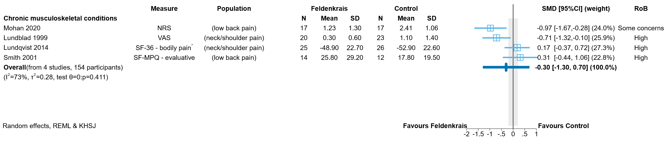

**Fig 4.2.2** | Forest plot for main comparison. The effect of Feldenkrais versus inactive control (no intervention, wait list control, or a co-intervention offered to both groups in included studies) on pain for people with chronic musculoskeletal conditions. SMD = standardised mean difference. Blue lines show 95% confidence intervals (CI). The shaded grey area indicates the pre-specified range where the effect of Feldenkrais is considered to be no different from control (SMD -0.2 to 0.2 standard units). * Denotes studies for which the direction of effect was changed to match the overall plot (negative numbers are beneficial).



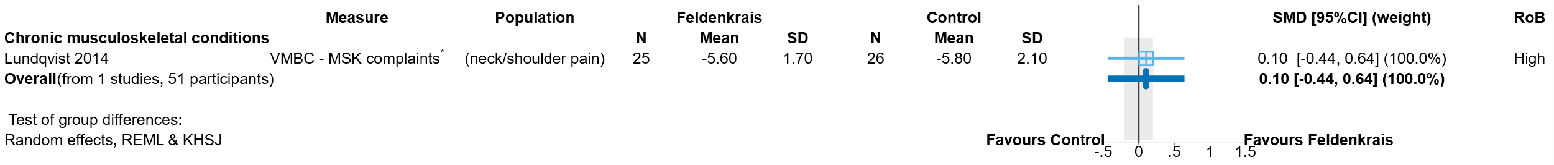

**Fig 4.2.3** | Forest plot for main comparison. The effect of Feldenkrais versus inactive control (no intervention, wait list control, or a co-intervention offered to both groups in included studies) on physical function (disability) for people with chronic musculoskeletal conditions. SMD = standardised mean difference. Blue lines show 95% confidence intervals (CI). The shaded grey area indicates the pre-specified range where the effect of Feldenkrais is considered to be no different from control (SMD -0.2 to 0.2 standard units). * Denotes studies for which the direction of effect was changed to match the overall plot (positive numbers are beneficial).



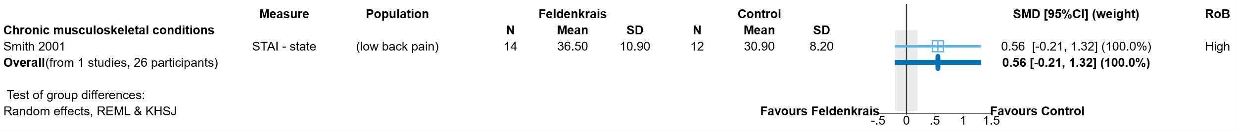

**Fig 4.2.4** | Forest plot for main comparison. The effect of Feldenkrais versus inactive control (no intervention, wait list control, or a co-intervention offered to both groups in included studies) on emotional functioning and mental health for people with chronic musculoskeletal conditions. SMD = standardised mean difference. Blue lines show 95% confidence intervals (CI). The shaded grey area indicates the pre-specified range where the effect of Feldenkrais is considered to be no different from control (SMD -0.2 to 0.2 standard units). Negative numbers are beneficial as most of the measures relate to symptoms of anxiety, depression, stress etc.



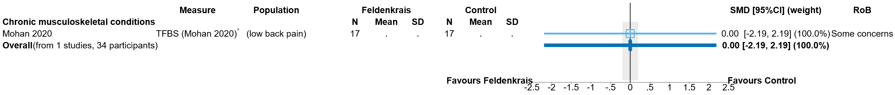

**Fig 4.2.5** | Forest plot for main comparison. The effect of Feldenkrais versus inactive control (no intervention, wait list control, or a co-intervention offered to both groups in included studies) on breathing patterns for people with chronic musculoskeletal conditions. SMD = standardised mean difference. Blue lines show 95% confidence intervals (CI). The shaded grey area indicates the pre-specified range where the effect of Feldenkrais is considered to be no different from control (SMD -0.2 to 0.2 standard units). ^ indicates studies for which data transformation or imputation was required to include the result in the meta-analysis.

**Table 4.2.3.** Unpublished studies comparing Feldenkrais to an inactive control for people with chronic musculoskeletal conditions

|  |  |  |  | **Comparison** | |  | |
| --- | --- | --- | --- | --- | --- | --- | --- |
| **Study** | **Year started** | **No.** | **Population (ICD-11 code)** | **Inactive** | **Active** | **Pain** | **HR-QoL** | | **Function (disability** | **Function (mobility)** | **EFMH** |  |  |
| ACTRN12618000234213 | **2017** | 15 | Chronic musculoskeletal conditions (FA01.0 Primary osteoarthritis of knee) | no intervention (continue usual activity) |  | **X** | **X** | | **X** | **X** | **X** |  |  |

## 4.3 Conditions that affect mobility and falls risk

The 6 studies included in the evidence synthesis for people with conditions that affect mobility or at risk of falls were among older people (3 studies), people with multiple sclerosis (2 studies), and people with intellectual disability (one study). Ageing and associated functional problems may have an earlier onset in people with intellectual disability. The loss of movement and balance skills can lead to an increased risk of falls [33]. A seventh study (Palmer 2017, 124 older adults) was eligible for this synthesis, however results could not be included due to incomplete and ambiguous reporting. There were no studies in people with movement disorders (e.g. Parkinson’s disease) eligible for the evidence synthesis.  
Prioritised outcome domains for people with conditions that affect mobility or at risk of falls were:

*Critical outcome domains*

* falls
* physical function (disability)
* physical function (mobility)
* health related quality of life (HR-QoL)

*Important outcome domains*

* overall disease status/symptoms
* emotional functioning and mental health
* fatigue
* pain

No studies reported outcomes in the domains of overall disease status/symptoms or pain. Throughout the text, tables and plots, the outcomes are presented in the above order.

### 4.3.1 Main comparison: Feldenkrais compared to inactive control

#### Characteristics of included studies

Brief characteristics of studies that compared Feldenkrais to an inactive control in people with conditions that affect mobility or at risk of falls are summarised in Table 4.3.1. The outcome measure from which data were included for meta-analysis is reported for each trial in the forest plot (column 2, Figures 4.3.2 to 4.3.7). For all results, the outcome selected for analysis was measured at the end of the intervention period (see Table 4.3.1). Full characteristics are reported for each study in Appendix E1 (including a list of all outcome measures, details of which outcome was selected when multiple were available for an outcome domain, and the timing of outcome measurement in relation to intervention), and Appendix E2 (funding, conflicts of interest and ethics).

**Table 4.3.1.** Brief characteristics of studies comparing Feldenkrais to an inactive control for people with conditions that affect mobility or at risk of falls.

| **Study** | **Population: condition (ICD-11 code)** | **Intervention** | | | **Comparator** | **Outcome domains** | | | | | | |
| --- | --- | --- | --- | --- | --- | --- | --- | --- | --- | --- | --- | --- |
| **Intervention period** | **Frequency** | **No. sessions & duration** | **Falls** | **HR-QoL** | **Function (disability)** | **Function (mobility)** | **Fatigue** | **EFMH** | **Measured** | |
| **Falls risk** | | | | | | | | | | | | | | |
| **Palmer 2017#**  USA | 124 adults with (older adults) (Older population at risk of falls [median age 76 years]) | 6-7 weeks (8/9 centres); 12 weeks (1 centre)  Feldenkrais | 2 sessions/ week (8/9 centres); weekly (1/9 centres) | 12-14 x 60 mins | wait list control |  |  | **X**† | **X**† |  |  | week 7 | |
| **Stephens 2005**  USA | 32 adults with (older adults) (Older population at risk of falls [mean age 78 years]) | 2 days  Feldenkrais | 5 lessons per day | 10 x 45 mins | no intervention |  | **X** |  | **X** |  |  | day 5 | |
| **Torres-Unda 2017**  Spain | 41 adults with intellectual disability (6A00 Disorders of intellectual development (mild to moderate)) | 30 weeks  Feldenkrais | weekly | 30 x 60 mins | no intervention |  |  |  | **X**ⱡ |  |  | week 30 | |
| **Ullmann 2010**  USA | 47 adults with (older adults) (Older population at risk of falls [mean age 76 years]) | 5 weeks  Feldenkrais | 3 sessions/week | 15 x 60 mins | wait list control | **X** | **X** |  | **X** |  | **X** | week 5 | |
| **Vrantsidis 2009**  Australia | 62 adults with (older adults) (Older population with history of falls and/or min. one functional impairment [mean age 75 years]) | 8 weeks  Feldenkrais | 2 sessions/week | 16 x 40 or 60 mins | no intervention | **X** | **X** | **X** | **X** |  |  | week 10-11 | |
| **Multiple sclerosis** | | | | | | | | | | | | | | |
| **Johnson 1999**  USA | 20 adults with (multiple sclerosis) (8A40 Multiple sclerosis) | 8 weeks  Feldenkrais | 1 session/week | 8 x 60 mins | sham** |  |  | **X** | **X** | **X** | **X** | week 8 | |
| **Stephens 2001**  USA | 12 adults with (multiple sclerosis) (8A40 Multiple sclerosis (definitive or probable)) | 10 weeks  Feldenkrais | weekly | 8 x 120 or 240 mins | no intervention (general MS education) 4 x 90 mins | **X** |  | **X** |  |  |  | week 10 | |

*number of participants is the number from eligible groups (randomised); ** Schedule as per Feldenkrais group; † Results unsuitable for meta-analysis or uninterpretable; ⱡ outcomes confirmed as measured in registry entry; # Palmer 2017 was eligible for synthesis, however results could not be included due to incomplete and ambiguous reporting.

#### Risk of bias in included trials

A summary of the judgements for risk of bias domains and overall for each study outcome is presented in Figure 4.3.1 and the overall risk of bias judgement for each study is reported in the forest plots (each outcome from a study was assessed separately). The complete assessments and judgements are reported in Appendix F.

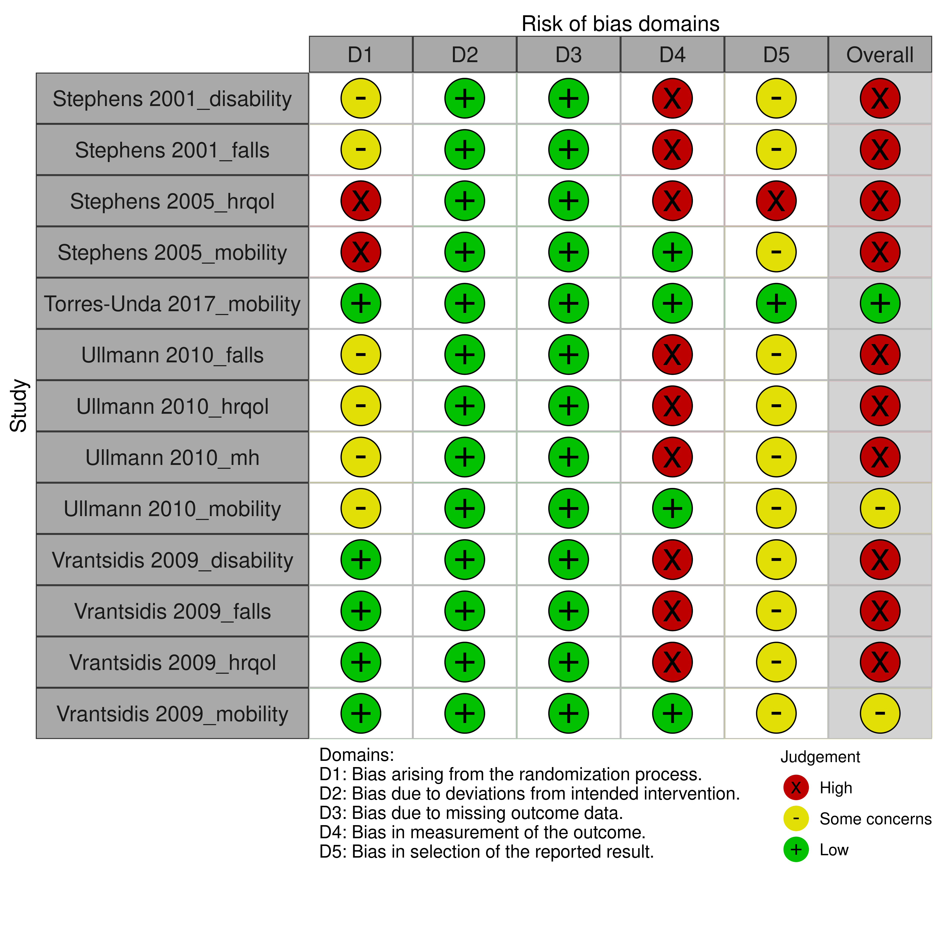

**Fig 4.3.1** | Summary of the risk of bias assessments for studies contributing to the comparison of Feldenkrais versus inactive control (no intervention, sham, or wait list control) in people with conditions that affect mobility or at risk of falls. Each outcome for which the study contributed results was assessed separately. Full details of each assessment, including the rationale for judgements, are reported in Appendix F. The overall risk of bias judgement for each study is reported in the forest plots.

#### Effects of Feldenkrais compared to inactive control

The effects of Feldenkrais compared to an inactive control in people with conditions that affect mobility or at risk of falls are presented in Table 4.3.2. The certainty of evidence and factors that influenced our certainty in the evidence are presented and explained in the GRADE summary of findings tables. Study level and meta-analytic results are presented in forest plots (Figures 4.3.2 to 4.3.7).

***Conditions that affect mobility and falls risk overall***

**Falls** (*Figure 4.3.2*)

* *Included studies*. Three studies (Stephens 2001, Ullmann 2010 and Vrantsidis 2009; 114 participants) contribute to the comparison of Feldenkrais versus an inactive control (Figure 4.3.2).
* *Missing results*. One study (full protocol published in 2021) among 108 older people (age range 65 to 85 years) is eligible for this analysis [42]. This trial was terminated in 2019 due to issues with ethics approvals. As the trial was terminated prior to collection of outcome data, we did not have concerns about bias due to missing results for this study.
* *Ongoing studies.* There are no ongoing studies of Feldenkrais versus an inactive control in people with conditions that affect mobility or at risk of falls.

The evidence about the effect of Feldenkrais on falls for people with conditions that affect mobility or at risk of falls is of very low certainty due to study design limitations, indirectness, imprecision and publication bias (3 studies, 114 older adults and people with multiple sclerosis; Figure 4.3.2).

**Physical function (disability)** (*Figure 4.3.3*)

* *Included studies*. Three studies (Johnson 1999, Stephens 2001, and Vrantsidis 2009; 107 participants) contribute to the comparison of Feldenkrais versus an inactive control (Figure 4.3.3).
* *Missing results*. One study among 124 older adults (Palmer 2017) is eligible for this analysis. However, it was not clear if the reported result was for the entire sample, or one of the groups. We considered selective non-reporting of results from this study when judging publication bias in the GRADE assessment. One further study (full protocol published in 2021) among 108 older people (age range 65 to 85 years) is also eligible for this analysis [42]. This trial was terminated in 2019 due to issues with ethics approvals. As the trial was terminated prior to collection of outcome data, we did not have concerns about bias due to missing results for this study.
* *Ongoing studies.* There are no ongoing studies of Feldenkrais versus an inactive control in people with conditions that affect mobility or at risk of falls.

The evidence about the effect of Feldenkrais on physical function (disability) for people with conditions that affect mobility or at risk of falls is of very low certainty due to study design limitations, indirectness, imprecision and publication bias (3 studies, 107 older adults and people with multiple sclerosis; Figure 4.3.3).

**Physical function (mobility)** (*Figure 4.3.4*)

* *Included studies*. Five studies (Johnson 1999, Stephens 2005, Torres-Unda 2017, Ullmann 2010 and Vrantsidis 2009; 205 participants) contribute to the comparison of Feldenkrais versus an inactive control (Figure 4.3.4).
* *Missing results*. One study among 124 older adults is eligible for this analysis (Palmer 2017). However, it was not clear if the reported result was for the entire sample, or one of the groups. We considered selective non-reporting of results from this study when judging publication bias in the GRADE assessment. One further study (full protocol published in 2021) among 108 older people (age range 65 to 85 years) is also eligible for this analysis [42]. This trial was terminated in 2019 due to issues with ethics approvals. As the trial was terminated prior to collection of outcome data, we did not have concerns about bias due to missing results for this study.
* *Ongoing studies.* There are no ongoing studies of Feldenkrais versus an inactive control in people with conditions that affect mobility or at risk of falls.

The evidence about the effect of Feldenkrais on physical function (mobility) for people with conditions that affect mobility or at risk of falls is of very low certainty due to study design limitations, indirectness, imprecision and publication bias (5 studies, 205 older adults and people with multiple sclerosis or intellectual disability; Figure 4.3.4).

**Emotional functioning and mental health** (*Figure 4.3.6*)

* *Included studies*. Two studies (Johnson 1999 and Ullmann 2010; 87 participants) contribute to the comparison of Feldenkrais versus an inactive control (Figure 4.3.6).
* *Missing results*. One study (full protocol published in 2021) among 108 older people (age range 65 to 85 years) is also eligible for this analysis [42]. This trial was terminated in 2019 due to issues with ethics approvals. As the trial was terminated prior to collection of outcome data, we did not have concerns about bias due to missing results for this study.
* *Ongoing studies.* There are no ongoing studies of Feldenkrais versus an inactive control in people with conditions that affect mobility or at risk of falls.

The evidence about the effect of Feldenkrais on emotional functioning and mental health for people with conditions that affect mobility or at risk of falls is of very low certainty due to study design limitations, indirectness, imprecision and publication bias (2 studies, 87 older adults and people with multiple sclerosis; Figure 4.3.6).

***People at risk of falls***

**Falls** (*Figure 4.3.2*)

* *Included studies*. Two studies (Ullmann 2010 and Vrantsidis 2009; 102 participants) contribute to the comparison of Feldenkrais versus an inactive control (Figure 4.3.2).
* *Missing results*. One study (full protocol published in 2021) among 108 older people (age range 65 to 85 years) is eligible for this analysis [42]. This trial was terminated in 2019 due to issues with ethics approvals. As the trial was terminated prior to collection of outcome data, we did not have concerns about bias due to missing results for this study.
* *Ongoing studies.* There are no ongoing studies of Feldenkrais versus an inactive control in people with conditions that affect mobility or at risk of falls.

The evidence about the effect of Feldenkrais on falls for people at risk of falls is of very low certainty due to study design limitations, indirectness, imprecision and publication bias (2 studies, 102 older adults; Figure 4.3.2).

**Physical function (disability)** (*Figure 4.3.3*)

* *Included studies*. One study (Vrantsidis 2009; 55 participants) contributes to the comparison of Feldenkrais versus an inactive control (Figure 4.3.3).
* *Missing results*. One study among 124 older adults (Palmer 2017) is eligible for this analysis. However, it was not clear if the reported result was for the entire sample, or one of the groups. We considered selective non-reporting of results from this study when judging publication bias in the GRADE assessment.
* *Ongoing studies.* There are no ongoing studies of Feldenkrais versus an inactive control in people at risk of falls.

The evidence about the effect of Feldenkrais on physical function (disability) for people at risk of falls is of very low certainty due to study design limitations, indirectness, imprecision and publication bias (1 study, 55 older adults; Figure 4.3.3).

**Physical function (mobility)** (*Figure 4.3.4*)

* *Included studies*. Four studies (Stephens 2005, Torres-Unda 2017, Ullmann 2010 and Vrantsidis 2009; 165 participants) contribute to the comparison of Feldenkrais versus an inactive control (Figure 4.3.4).
* *Missing results*. One study among 124 older adults is eligible for this analysis (Palmer 2017). However, it was not clear if the reported result was for the entire sample, or one of the groups. We considered selective non-reporting of results from this study when judging publication bias in the GRADE assessment. One further study (full protocol published in 2021) among 108 older people (age range 65 to 85 years) is also eligible for this analysis [42]. This trial was terminated in 2019 due to issues with ethics approvals. As the trial was terminated prior to collection of outcome data, we did not have concerns about bias due to missing results for this study.
* *Ongoing studies.* There are no ongoing studies of Feldenkrais versus an inactive control in people at risk of falls.

The evidence about the effect of Feldenkrais on physical function (mobility) for people at risk of falls is of very low certainty due to study design limitations, indirectness, imprecision and publication bias (4 studies, 165 older adults and people with intellectual disability; Figure 4.3.4).

**Health-related quality of life** (*Figure 4.3.5*)

* *Included studies*. Three studies (Stephens 2005, Ullmann 2010 and Vrantsidis 2009; 133 participants) contribute to the comparison of Feldenkrais versus an inactive control (Figure 4.3.5).
* *Missing results*. We did not identify any missing results for this analysis, either from included studies or from registry entries.
* *Ongoing studies.* There are no ongoing studies of Feldenkrais versus an inactive control in people at risk of falls.

The evidence about the effect of Feldenkrais on health-related quality of life for people at risk of falls is of very low certainty due to study design limitations, indirectness, imprecision and publication bias (3 studies, 133 older adults; Figure 4.3.5).

**Emotional functioning and mental health** (*Figure 4.3.6*)

* *Included studies*. One study (Ullmann 2010; 47 participants) contributes to the comparison of Feldenkrais versus an inactive control (Figure 4.3.6).
* *Missing results*. One study (full protocol published in 2021) among 108 older people (age range 65 to 85 years) is also eligible for this analysis [42]. This trial was terminated in 2019 due to issues with ethics approvals. As the trial was terminated prior to collection of outcome data, we did not have concerns about bias due to missing results for this study.
* *Ongoing studies.* There are no ongoing studies of Feldenkrais versus an inactive control in people at risk of falls.

The evidence about the effect of Feldenkrais on emotional functioning and mental health for people at risk of falls is of very low certainty due to study design limitations, indirectness, imprecision and publication bias (1 study, 47 older adults; Figure 4.3.6).

***Multiple sclerosis***

**Falls** (*Figure 4.3.2*)

* *Included studies*. One study (Stephens 2001; 12 participants) contribute to the comparison of Feldenkrais versus an inactive control (Figure 4.3.2).
* *Missing results*. We did not identify any missing results for this analysis, either from included studies or from registry entries.
* *Ongoing studies.* There are no ongoing studies of Feldenkrais versus an inactive control in people with multiple sclerosis.

The evidence about the effect of Feldenkrais on falls for people with people with multiple sclerosis is of very low certainty due to study design limitations, indirectness, imprecision and publication bias (1 study, 12 participants; Figure 4.3.2).

**Physical function (disability)** (*Figure 4.3.3*)

* *Included studies*. Two studies (Johnson 1999 and Stephens 2001; 52 participants) contribute to the comparison of Feldenkrais versus an inactive control (Figure 4.3.3).
* *Missing results*. We did not identify any missing results for this analysis, either from included studies or from registry entries.
* *Ongoing studies.* There are no ongoing studies of Feldenkrais versus an inactive control in people with multiple sclerosis.

The evidence about the effect of Feldenkrais on physical function (disability) for people with multiple sclerosis is of very low certainty due to study design limitations, indirectness, imprecision and publication bias (1 study, 52 participants; Figure 4.3.3).

**Physical function (mobility)** (*Figure 4.3.4*)

* *Included studies*. One study (Johnson 1999; 40 participants) contributes to the comparison of Feldenkrais versus an inactive control (Figure 4.3.4).
* *Missing results*. We did not identify any missing results for this analysis, either from included studies or from registry entries.
* *Ongoing studies.* There are no ongoing studies of Feldenkrais versus an inactive control in people with multiple sclerosis.

The evidence about the effect of Feldenkrais on physical function (mobility) for people with multiple sclerosis is of very low certainty due to study design limitations, indirectness and imprecision (1 study, 40 participants; Figure 4.3.4).

**Fatigue** (*Figure 4.3.7*)

* *Included studies*. One study (Johnson 1999; 40 participants) contributes to the comparison of Feldenkrais versus an inactive control (Figure 4.3.7).
* *Missing results*. We did not identify any missing results for this analysis, either from included studies or from registry entries.
* *Ongoing studies.* There are no ongoing studies of Feldenkrais versus an inactive control in people with multiple sclerosis.

The evidence about the effect of Feldenkrais on fatigue for people with multiple sclerosis is of very low certainty due to study design limitations, indirectness and imprecision (1 study, 40 participants; Figure 4.3.7).

**Emotional functioning and mental health** (*Figure 4.3.6*)

* *Included studies*. One study (Johnson 1999; 40 participants) contributes to the comparison of Feldenkrais versus an inactive control (Figure 4.3.6).
* *Missing results*. We did not identify any missing results for this analysis, either from included studies or from registry entries.
* *Ongoing studies.* There are no ongoing studies of Feldenkrais versus an inactive control in people with multiple sclerosis.

The evidence about the effect of Feldenkrais on emotional functioning and mental health for people with multiple sclerosis is of very low certainty due to study design limitations, indirectness and imprecision (1 study, 40 participants; Figure 4.3.6).

**Table 4.3.2** Summary of findings for the effect of Feldenkrais versus an inactive comparator (no intervention, sham, or wait list control) for people with conditions that affect mobility or at risk of falls

| Outcomes (main population(s) in  included studies) | **Anticipated absolute effects\*** (95% CI) | | Relative effect (95% CI) | № of participants (studies) contributing to the analysis | Certainty of the evidence (GRADE) | Interpretation (evidence statement) |
| --- | --- | --- | --- | --- | --- | --- |
| **With inactive control** | **With Feldenkrais** |
| **Mobility and falls risk (overall analysis)** | | | | | | |
| Falls (older adults & people with multiple sclerosis) (follow-up 5 to 11 weeks)a,b | - | SMD **0.37 SD lower** (0.77 lower to 0.03 higher) | - | 114 (3 RCTs) | ⨁◯◯◯ Very lowc,d,e,f,g | The evidence is very uncertain about the effect of Feldenkrais on falls for people with conditions that affect mobility or at risk of falls (older adults & people with multiple sclerosis). |
| Physical function - disability (older adults & people with multiple sclerosis) (follow-up 8 to 11 weeks)a,b | - | SMD **0.12 SD higher** (0.18 lower to 0.41 higher) | - | 107 (3 RCTs)h | ⨁◯◯◯ Very lowc,d,e,i,j | The evidence is very uncertain about the effect of Feldenkrais on physical function (disability) for people with conditions that affect mobility or at risk of falls (older adults & people with multiple sclerosis). |
| Physical function - mobility (mainly older adults & people with multiple sclerosis) (follow-up 5 days to 30 weeks)a,b | - | SMD **0.08 SD higher** (0.36 lower to 0.51 higher) | - | 205 (5 RCTs)h | ⨁◯◯◯ Very lowd,k,l,m,n | The evidence is very uncertain about the effect of Feldenkrais on physical function (mobility) for people with conditions that affect mobility or at risk of falls (mainly older adults & people with multiple sclerosis). |
| Emotional functioning & mental health - symptoms of depression (older adults & people with multiple sclerosis) (follow-up 5 to 8 weeks)b | - | SMD **0.03 SD lower** (1.65 lower to 1.6 higher) | - | 87 (2 RCTs) | ⨁◯◯◯ Very lowc,d,o,p,q | The evidence is very uncertain about the effect of Feldenkrais on emotional functioning and mental health (symptoms of depression) for people with conditions that affect mobility or at risk of falls (older adults & people with multiple sclerosis). |
| **Falls risk** | | | | | | |
| Falls (older adults) (follow-up 5 to 11 weeks)a,b | - | SMD **0.37 SD lower** (2.15 lower to 1.41 higher) | - | 102 (2 RCTs) | ⨁◯◯◯ Very lowc,d,r,s,t | The evidence is very uncertain about the effect of Feldenkrais on falls for people risk of falls (older adults). |
| Physical function - disability (older adults) (follow-up 11 weeks)a,b | - | SMD **0.26 SD higher** (0.27 lower to 0.78 higher) | - | 55 (1 RCT)h | ⨁◯◯◯ Very lowu,v,w,x,y | The evidence is very uncertain about the effect of Feldenkrais on physical function (disability) for people risk of falls (older adults). |
| Physical function - mobility (mainly older adults) (follow-up 5 days to 30 weeks)a,b,z | - | SMD **0.1 SD higher** (0.6 lower to 0.81 higher) | - | 165 (4 RCTs)h | ⨁◯◯◯ Very lowaa,ab,ac,ad,d | The evidence is very uncertain about the effect of Feldenkrais on physical function (mobility) for people at risk of falls (mainly older adults). |
| Health-related quality of life (older adults) (follow-up 5 days to 11 weeks)a,b | - | SMD **0.16 SD higher** (0.58 lower to 0.89 higher) | - | 133 (3 RCTs) | ⨁◯◯◯ Very lowae,af,c,d,j | The evidence is very uncertain about the effect of Feldenkrais on health-related quality of life for people at risk of falls (older adults). |
| Emotional functioning & mental health - symptoms of depression (older adults) (follow-up 5 weeks)b | - | SMD **0.26 SD lower** (0.83 lower to 0.31 higher) | - | 47 (1 RCT) | ⨁◯◯◯ Very lowag,u,v,w,y | The evidence is very uncertain about the effect of Feldenkrais on emotional functioning and mental health (symptoms of depression) for people at risk of falls (older adults). |
| Other important outcomes |  | |  | (0 studies) | - | No studies reported on the important outcomes of overall disease status, pain or fatigue for people at risk of falls. |
| **Multiple sclerosis** | | | | | | |
| Falls (follow-up 10 weeks)a,b | - | SMD **0.34 SD lower** (1.39 lower to 0.71 higher) | - | 12 (1 RCT) | ⨁◯◯◯ Very lowah,ai,u,v,y | The evidence is very uncertain about the effect of Feldenkrais on falls for people with multiple sclerosis. |
| Physical function - disability (follow-up 8 to 10 weeks)a,b | - | SMD **0.07 SD higher** (0.74 lower to 0.89 higher) | - | 52 (2 RCTs) | ⨁◯◯◯ Very lowaj,ak,al,c,d | The evidence is very uncertain about the effect of Feldenkrais on physical function (disability) for people with multiple sclerosis. |
| Physical function - mobility (follow-up 8 weeks)a,b | - | SMD **0 SD**  (0.31 lower to 0.31 higher) | - | 40 (1 RCT) | ⨁◯◯◯ Very lowah,am,an,u,v | The evidence is very uncertain about the effect of Feldenkrais on physical function (mobility) for people with multiple sclerosis. |
| Fatigue (follow-up 8 weeks)b | - | SMD **0.08 SD lower** (0.39 lower to 0.23 higher) | - | 40 (1 RCT) | ⨁◯◯◯ Very lowah,an,ao,u,v | The evidence is very uncertain about the effect of Feldenkrais on fatigue for people with multiple sclerosis. |
| Emotional functioning & mental health - symptoms of depression (follow-up 8 weeks)b | - | SMD **0.04 SD higher** (0.27 lower to 0.35 higher) | - | 40 (1 RCT) | ⨁◯◯◯ Very lowah,an,ap,u,v | The evidence is very uncertain about the effect of Feldenkrais on emotional functioning and mental health (symptoms of depression) for people with multiple sclerosis. |
| Other critical outcomes |  | |  | (0 RCTs) | - | No studies reported on the critical outcome of health-related quality of life for people multiple sclerosis. |
| Other important outcomes |  | |  | (0 RCTs) | - | No studies reported on the important outcomes of overall disease status or pain for people with multiple sclerosis. |
| **The risk in the intervention group** (and its 95% confidence interval) is based on the assumed risk in the comparison group and the **relative effect** of the intervention (and its 95% CI). **CI:** confidence interval; **SMD:** standardised mean difference  The threshold for an important difference was an SMD of 0.2 (used for interpreting point estimates and confidence intervals). For falls, pain, fatigue and emotional functioning and mental health, the resulting interpretation is: < -0.2 is beneficial, -0.2 to 0.2 is trivial or unimportant ("little or no difference" between treatments), > 0.2 is harmful. For HR-QoL and physical function (disability and mobility), the resulting interpretation is: < -0.2 is harmful, -0.2 to 0.2 is trivial or unimportant ("little or no difference" between treatments), > 0.2 is beneficial. | | | | | | |
| **GRADE Working Group grades of evidence** **High certainty:** we are very confident that the true effect lies close to that of the estimate of the effect. **Moderate certainty:** we are moderately confident in the effect estimate: the true effect is likely to be close to the estimate of the effect, but there is a possibility that it is substantially different. **Low certainty:** our confidence in the effect estimate is limited: the true effect may be substantially different from the estimate of the effect. **Very low certainty:** we have very little confidence in the effect estimate: the true effect is likely to be substantially different from the estimate of effect.  **Explanations** are provided for domains for which there is a downgrade or a borderline judgment. In line with GRADE guidance, we do not explain that there are no limitations unless the judgment was challenging (<https://pubmed.ncbi.nlm.nih.gov/26796947/> ) | | | | | | |

#### Explanations

a. Critical outcome domain for this population

b. Measures varied. Falls: no. of falls per person, falls efficacy (FES, MFES); Physical function - disability: MSSES function subscale, VMBC muscular complaints subscale, FAI; Physical function - mobility: MS Performance Scales (mobility), supine to stand, SPPB total, timed up-and-go; HR-QoL: AQOL, CDC HR-QOL-4, SF-36 emotional well-being scale; EFMH: HADS depression, CES-D.

c. Very serious RoB (-2). 100% of the data in the analysis comes from studies at high risk of bias

d. No important inconsistency. 95% CIs overlap for all studies (heterogeneity statistics support this, however, with so few studies, there is substantial uncertainty in I squared and Tau squared, and low power to detect heterogeneity using the Chi squared test)

e. Serious indirectness (-1). Evidence from 3 small studies among older adults and people with multiple sclerosis. Uncertain whether results apply more generally to populations with conditions that affect mobility or at risk of falls (e.g. Parkinson disease).

f. Serious imprecision (-1). The 95% confidence interval crosses the threshold for a small but important effect (SMD of -0.2), so the result is compatible with little or no difference (SMD 0.03 higher) and important benefit (SMD 0.77 lower).

g. Publication bias strongly suspected (-1). The meta-analysis is based on three small studies all showing benefit, so selective non-reporting of unfavourable results (null or favouring control) could importantly change the combined estimate. This is a concern because of evidence of selective non-reporting of unfavourable/uninteresting results in general, and from trials of natural therapies in particular. No missing outcomes from studies included in the review, and no missing studies identified from registry entries or protocols.

h. 1 study with 124 participants did not contribute any data to the analysis (uninterpretable)

i. Serious imprecision (-1). The 95% confidence interval crosses the threshold for a small but important effect (SMD of 0.2), so the result is compatible with little or no difference (SMD 0.18 lower) and important benefit (SMD 0.41 higher).

j. Publication bias not detected. The meta-analysis is based on 3 small studies. While selective non-reporting of unfavourable results (null or favouring control) is a concern when the available evidence is from a small number of small trials, the combined estimate suggests little to no effect. No missing outcomes from studies included in the review, and no missing studies identified from registry entries or protocols.

k. Serious RoB (-1) 48% of the data in the analysis comes from two studies at high risk of bias.

l. Serious indirectness (-1). Evidence from 5 small studies among older adults and people with multiple sclerosis or intellectual disability. Uncertain whether results apply to more generally to populations with conditions that affect mobility or at risk of falls (e.g. Parkinson disease).

m. Very serious imprecision (-2). The 95% confidence interval crosses two thresholds for a small but important effect (SMD of 0.2 and -0.2), so the result is compatible with important harm (SMD 0.36 lower) and important benefit (SMD 0.51 higher).

n. Publication bias not detected. The meta-analysis is based on 5 small studies. While selective non-reporting of unfavourable results (null or favouring control) is a concern when the available evidence is from a small number of small trials, the combined estimate suggests little to no effect. No missing outcomes from studies included in the review, and no missing studies identified from registry entries or protocols.

o. Serious indirectness (-1). Evidence from 2 small studies among older adults and people with multiple sclerosis. Uncertain whether results apply to more generally to populations with conditions that affect mobility or at risk of falls (e.g. Parkinson disease).

p. Extremely serious imprecision (-3). The 95% confidence interval crosses the threshold for both small but important benefit (SMD -0.2) and small but important harm (SMD 0.2), and is too wide for the result to be interpretable (SMD -1.65 indicating large benefit to SMD 1.60 indicating large harm).

q. Publication bias not detected. The meta-analysis is based on 2 small studies. While selective non-reporting of unfavourable results (null or favouring control) is a concern when the available evidence is from a small number of small trials, the combined estimate suggests little to no effect. No missing outcomes from studies included in the review, and no missing studies identified from registry entries or protocols.

r. Serious indirectness (-1). Evidence from 2 small studies among older adults. Uncertain whether results apply to more generally to populations at risk of falls.

s. Extremely serious imprecision (-3). The 95% confidence interval crosses the threshold for both small but important benefit (SMD -0.2) and small but important harm (SMD 0.2), and is too wide for the result to be interpretable (SMD -2.15 indicating large benefit to SMD 1.41 indicating large harm).

t. Publication bias strongly suspected (-1). The meta-analysis is based on 2 small studies, both showing benefit, so selective non-reporting of unfavourable results (null or favouring control) could importantly change the combined estimate. This is a concern because of evidence of selective non-reporting of unfavourable/uninteresting results in general, and from trials of natural therapies in particular. No missing outcomes from studies included in the review, and no missing studies identified from registry entries or protocols.

u. Very serious RoB (-2). Single study at high risk of bias.

v. Inconsistency not assessed: single study

w. Serious indirectness (-1). Evidence from 1 small study among older adults. Uncertain whether results apply to more generally to populations at risk of falls.

x. Very serious imprecision (-2). The 95% confidence interval crosses two thresholds for a small but important effect (SMD of 0.2 and -0.2), so the result is compatible with important harm (SMD 0.27 lower) and important benefit (SMD 0.78 higher).

y. Publication bias strongly suspected (-1). The meta-analysis is based on 1 small study showing benefit, so selective non-reporting of unfavourable results (null or favouring control) could importantly change the combined estimate. This is a concern because of evidence of selective non-reporting of unfavourable/uninteresting results in general, and from trials of natural therapies in particular. No missing outcomes from studies included in the review, and no missing studies identified from registry entries or protocols.

z. Studies in populations of older adults and people with intellectual disability

aa. Serious RoB (-1). 80% of the data in the analysis from studies with some concerns or high risk of bias.

ab. Serious indirectness (-1). Evidence from 3 small studies among older adults and 1 small study among people with intellectual disability. Uncertain whether results apply to more generally to populations at risk of falls.

ac. Very serious imprecision (-2). The 95% confidence interval crosses two thresholds for a small but important effect (SMD of 0.2 and -0.2), so the result is compatible with important harm (SMD 0.60 lower) and important benefit (SMD 0.81 higher).

ad. Publication bias not detected. The meta-analysis is based on 4 small studies While selective non-reporting of unfavourable results (null or favouring control) is a concern when the available evidence is from a small number of small trials, the combined estimate suggests little to no effect. No missing outcomes from studies included in the review, and no missing studies identified from registry entries or protocols.

ae. Serious indirectness (-1). Evidence from 3 small studies among older adults. Uncertain whether results apply to more generally to populations at risk of falls.

af. Very serious imprecision (-2). The 95% confidence interval crosses two thresholds for a small but important effect (SMD of 0.2 and -0.2), so the result is compatible with important harm (SMD 0.58 lower) and important benefit (SMD 0.89 higher).

ag. Very serious imprecision (-2). The 95% confidence interval crosses two thresholds for a small but important effect (SMD of 0.2 and -0.2), so the result is compatible with important benefit (SMD 0.83 lower) and important harm (SMD 0.31 higher).

ah. Serious indirectness (-1). Evidence from 1 small study among people with multiple sclerosis. Uncertain whether results apply to more generally to populations with multiple sclerosis.

ai. Extremely serious imprecision (-3). The 95% confidence interval crosses the threshold for both small but important benefit (SMD -0.2) and small but important harm (SMD 0.2), and is too wide for the result to be interpretable (SMD -1.39 indicating large benefit to SMD 0.71 indicating large harm).

aj. Serious indirectness (-1). Evidence from 2 small studies among people with multiple sclerosis. Uncertain whether results apply to more generally to populations with multiple sclerosis.

ak. Very serious imprecision (-2). The 95% confidence interval crosses two thresholds for a small but important effect (SMD of 0.2 and -0.2), so the result is compatible with important harm (SMD 0.74 lower) and important benefit (SMD 0.89 higher).

al. Publication not detected. The meta-analysis is based on 2 small studies. While selective non-reporting of unfavourable results (null or favouring control) is a concern when the available evidence is from a small number of small trials, the combined estimate suggests little to no effect. No missing outcomes from studies included in the review, and no missing studies identified from registry entries or protocols.

am. Very serious imprecision (-2). The 95% confidence interval crosses two thresholds for a small but important effect (SMD of 0.2 and -0.2), so the result is compatible with important harm (SMD 0.31 lower) and important benefit (SMD 0.31 higher).

an. Publication bias not detected. The meta-analysis is based on 1 small study showing little to no effect. No missing outcomes from studies included in the review, and no missing studies identified from registry entries or protocols.

ao. Very serious imprecision (-2). The 95% confidence interval crosses two thresholds for a small but important effect (SMD of 0.2 and -0.2), so the result is compatible with important benefit (SMD 0.39 lower) and important harm (SMD 0.23 higher).

ap. Serious imprecision (-2). The 95% confidence interval crosses two thresholds for a small but important effect (SMD of 0.2 and -0.2), so the result is compatible with important benefit (SMD 0.27 lower) and important harm (SMD 0.35 higher).

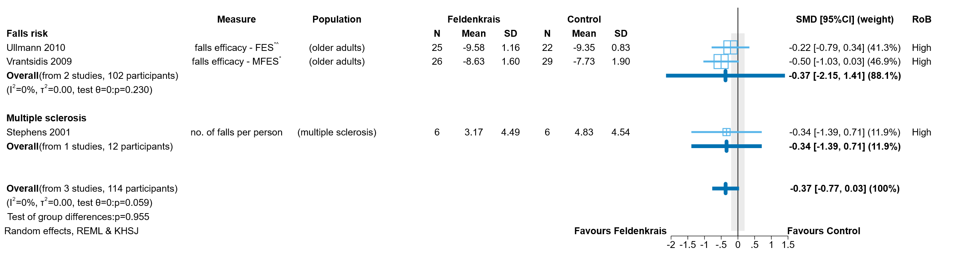

**Fig 4.3.2** | Forest plot comparing the effect of Feldenkrais versus an inactive control (no intervention, sham, or wait list control in included studies) on falls for people with conditions that affect mobility or at risk of falls. SMD = standardised mean difference. Blue lines show 95% confidence intervals (CI). The shaded grey area indicates the pre-specified range where the effect of Feldenkrais is considered to be no different from control (SMD -0.2 to 0.2 standard units). ^ indicates studies for which data transformation or imputation was required to include the result in the meta-analysis. * Denotes studies for which the direction of effect was changed to match the overall plot (negative numbers are beneficial).

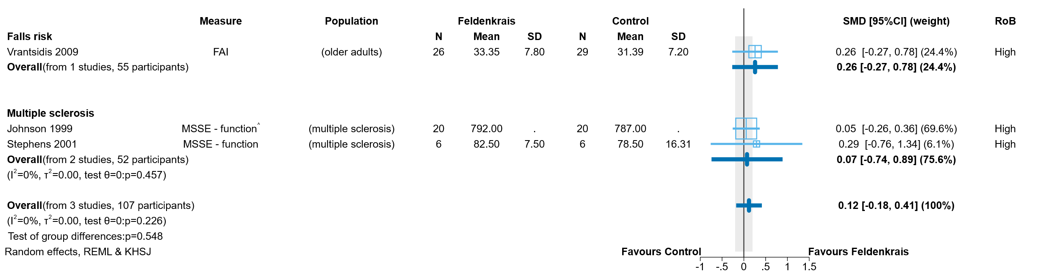

**Fig 4.3.3** | Forest plot comparing the effect of Feldenkrais versus an inactive control (no intervention, sham, or wait list control in included studies) on physical function (disability) for people with conditions that affect mobility or at risk of falls. SMD = standardised mean difference. Blue lines show 95% confidence intervals (CI). The shaded grey area indicates the pre-specified range where the effect of Feldenkrais is considered to be no different from control (SMD -0.2 to 0.2 standard units). ^ indicates studies for which data transformation or imputation was required to include the result in the meta-analysis.



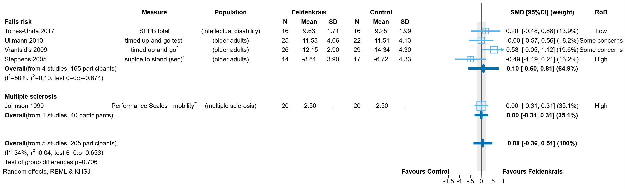

**Fig 4.3.4** | Forest plot comparing the effect of Feldenkrais versus an inactive control (no intervention, sham, or wait list control in included studies) on physical function (mobility) for people with conditions that affect mobility or at risk of falls. SMD = standardised mean difference. Blue lines show 95% confidence intervals (CI). The shaded grey area indicates the pre-specified range where the effect of Feldenkrais is considered to be no different from control (SMD -0.2 to 0.2 standard units). ^ indicates studies for which data transformation or imputation was required to include the result in the meta-analysis. * Denotes studies for which the direction of effect was changed to match the overall plot (positive numbers are beneficial).



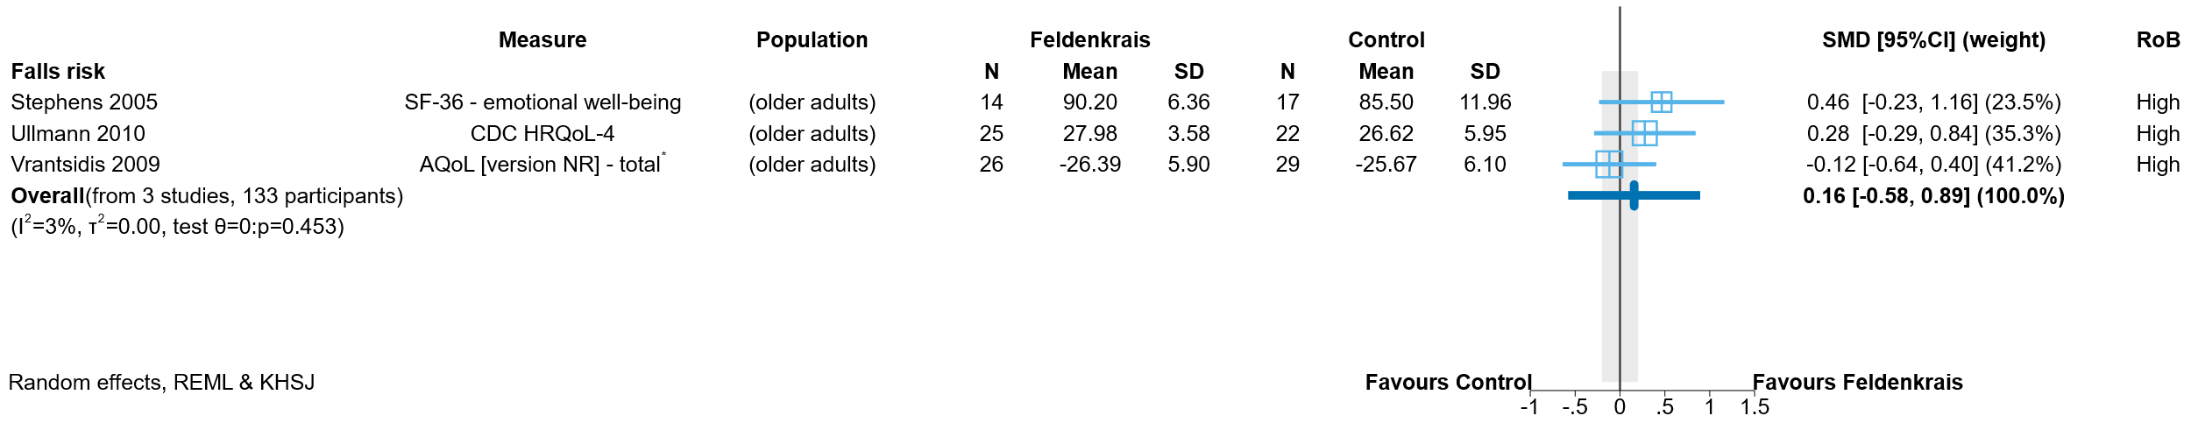

**Fig 4.3.5** | Forest plot comparing the effect of Feldenkrais versus an inactive control (no intervention, sham, or wait list control in included studies) on health-related quality of life for people with conditions that affect mobility or at risk of falls. SMD = standardised mean difference. Blue lines show 95% confidence intervals (CI). The shaded grey area indicates the pre-specified range where the effect of Feldenkrais is considered to be no different from control (SMD -0.2 to 0.2 standard units). * Denotes studies for which the direction of effect was changed to match the overall plot (positive numbers are beneficial).

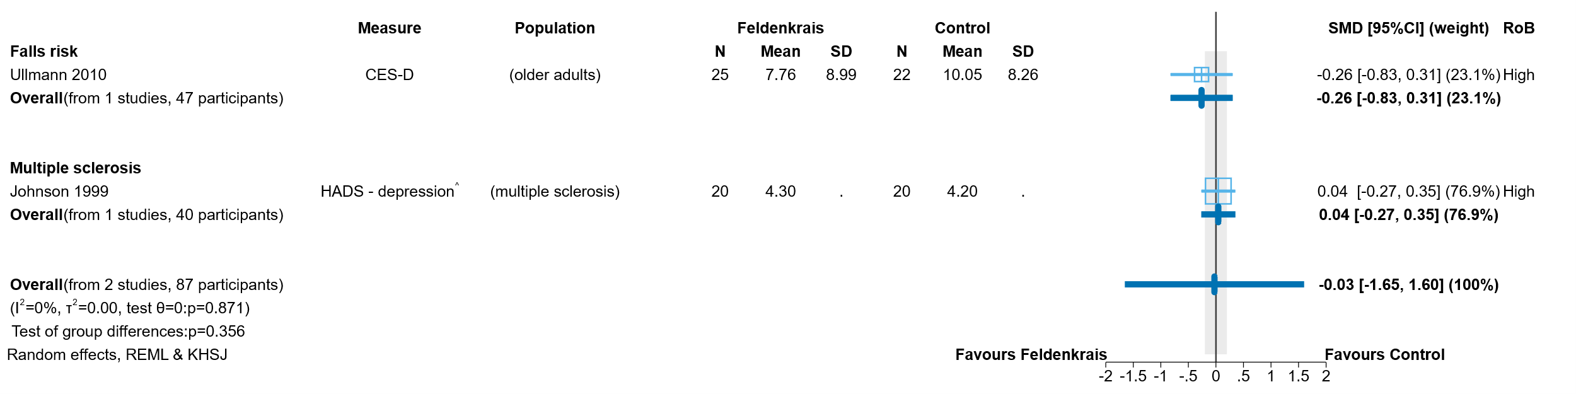

**Fig 4.3.6** | Forest plot comparing the effect of Feldenkrais versus an inactive control (no intervention, sham, or wait list control in included studies) on emotional functioning and mental health for people with conditions that affect mobility or at risk of falls. SMD = standardised mean difference. Blue lines show 95% confidence intervals (CI). The shaded grey area indicates the pre-specified range where the effect of Feldenkrais is considered to be no different from control (SMD -0.2 to 0.2 standard units). ^ indicates studies for which data transformation or imputation was required to include the result in the meta-analysis. Negative numbers are beneficial as most of the measures relate to symptoms of anxiety, depression, stress etc.



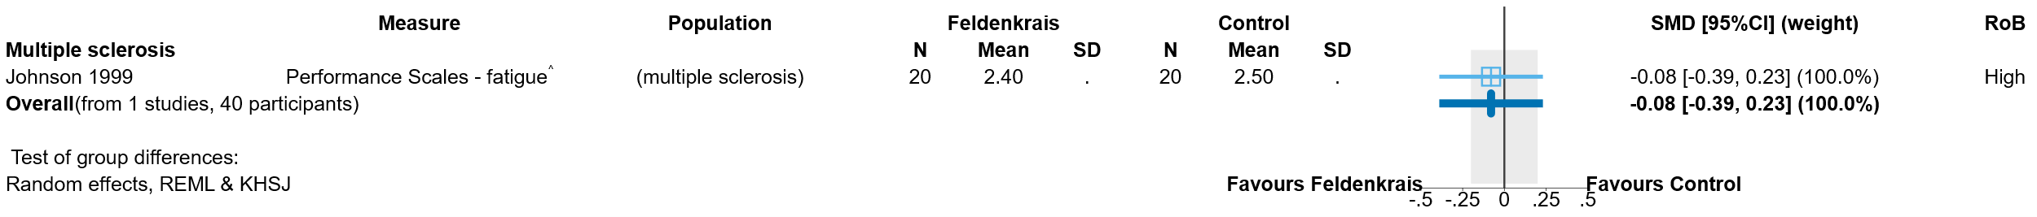

**Fig 4.3.7** | Forest plot comparing the effect of Feldenkrais versus an inactive control (no intervention, sham, or wait list control in included studies) on fatigue for people with conditions that affect mobility or at risk of falls. SMD = standardised mean difference. Blue lines show 95% confidence intervals (CI). The shaded grey area indicates the pre-specified range where the effect of Feldenkrais is considered to be no different from control (SMD -0.2 to 0.2 standard units). ^ indicates studies for which data transformation or imputation was required to include the result in the meta-analysis.

# 5. Discussion

## Summary of the main results

This review assessed the available evidence on Feldenkrais to inform the Australian Government about health policy decisions for private health insurance rebates. This review was not designed to assess all the reasons that people use Feldenkrais, or the reasons practitioners prescribe Feldenkrais and was not intended to inform individual choices about using Feldenkrais.

We found 10 studies with an inactive control evaluating the effects of Feldenkrais among people with musculoskeletal conditions, people with conditions that affect mobility or people at risk of falls that were included in the evidence synthesis.

Four (4) trials (154 participants) compared Feldenkrais to an inactive control in people with chronic musculoskeletal conditions (2 trials on low back pain and 2 on neck/shoulder pain).

* Based on these 4 studies, the effect of Feldenkrais on pain, function (disability), emotional functioning and mental health, and breathing patterns among people with chronic musculoskeletal conditions is very uncertain.

Six (6) trials (214 participants) compared Feldenkrais to an inactive control in people with conditions that affect mobility or at risk of falls (3 trials in older adults, 2 trials in people with multiple sclerosis and one in people with intellectual disability).

* Based on these 6 studies, the effect of Feldenkrais on falls, function (disability and mobility), health-related quality of life, emotional functioning and mental health, and fatigue among people with conditions that affect mobility or at risk of falls is very uncertain.

One additional study compared Feldenkrais to an inactive control in people with conditions that affect mobility or at risk of falls but did not report results in enough detail to interpret (124 older adult participants could not be included in our meta-analyses).

There were no studies with inactive controls among people with other conditions for which Feldenkrais is commonly sought or prescribed, such as stress, anxiety and mood disorders, acute musculoskeletal conditions (e.g. injury) and movement diseases (e.g. Parkinson’s disease). There were also no studies with inactive controls among people with other common chronic musculoskeletal conditions, such as arthritis.

The effects of Feldenkrais compared to other active comparators was not examined, as pre-specified criteria for synthesis were not met (i.e. no two studies at low risk of bias evaluated the same evidence-based treatment). Studies that only contributed active comparators are listed in an inventory (Appendix C3 and E3).

## Comparability of these findings with other systematic reviews

We identified 2 systematic reviews of Feldenkrais published in the last ten years. A review by Hillier in 2015 included 20 studies, 10 of which were not eligible for this review (conducted in healthy participants, non-randomised studies, study in language other than English) [43]. A more recent review by Berland published in 2022 included 16 studies, all of which were included in this review [44]. Based on several studies that overlap with our review for 2 domains, both Hillier and Berland found that Feldenkrais may improve balance in people at risk of falls and may reduce pain and discomfort in people with musculoskeletal conditions. However, both reviews included studies with active comparators (which were not included in the synthesis for this review) and neither assessed the evidence using GRADE. Both these factors account for the different interpretation of the evidence between the reviews.

## Overall completeness and applicability of evidence

Evidence evaluating the effects of Feldenkrais is sparse, and with no coverage of some of the conditions for which Feldenkrais is commonly sought or prescribed [1, 5]. Five broad population groups were included in our analytic framework to cover commonly treated conditions: (1) chronic musculoskeletal pain, (2) other chronic pain, (3) movement disorders (e.g. Parkinson’s disease), (4) injury and falls prevention and (5) stress, anxiety and mood disorders. We found 10 randomised trials comparing Feldenkrais to inactive control among people with chronic musculoskeletal conditions and people with conditions that affect mobility or at risk of falls (older adults, people with multiple sclerosis and people with intellectual disability) that contributed to synthesis. Studies examining the effects of Feldenkrais for any other condition relevant to the Australian condition were eligible, but no other studies were found.

Of the 4 studies among people with chronic musculoskeletal conditions, 2 were on low back pain, and 2 were on neck/shoulder pain. All of these studies measured pain, but only one study reported the critical outcome of physical function (disability), and no studies reported the critical outcomes of physical function (mobility) and health-related quality of life.

Of the 6 studies among people with conditions that affect mobility or at risk of falls, 3 were among older adults, 2 among people with multiple sclerosis, and one among people with intellectual disability. One additional study comparing Feldenkrais to inactive control among older adults did not contribute results to the summary or synthesis due to incomplete and ambiguous reporting of results. All but one these studies measured physical function (mobility), but only 3 studies reported the critical outcomes of falls and physical function (disability), and health-related quality of life.

The 2 ongoing trials are among people with chronic neck pain (comparing Feldenkrais to another treatment), and older adults.

Studies included in the analysis were conducted in Australia (2 trials), Spain (one trial), Sweden (2 trials) and the USA (4 trials). The location of the other trial could not be determined. Four (4) of the studies were conducted in community-based settings (e.g. community centre for older people), 5 in other settings (e.g. universities, supported employment company), and one in an outpatient setting. The practice of Feldenkrais in the other countries in which it has been studied is similar to that in Australia. Overall, while the evidence evaluating the effects of Feldenkrais compared to inactive controls may be applicable, it is far from complete.

## Certainty of the evidence

Limitations of the evidence were considered when interpreting each result by applying the GRADE approach. The overriding limitation is that there are only 10 small trials (12 to 124 participants) contributing to meta-analyses, plus one which did not contribute to the 2 meta-analyses for which it was eligible because the results were uninterpretable due to incomplete and ambiguous reporting. Most of the outcomes for which results were available had only a small number of participants contributing data, which led to imprecise effect estimates. In some cases, the imprecision was extreme, meaning that the result was compatible with both important benefit and important harm. There were also inconsistent results across studies (some showing benefit, others showing little or no effect). We were also concerned about the methodological limitations of the studies contributing to the synthesis, with 15/20 (75%) of the outcomes contributing to the syntheses judged to be at high risk of bias, and 4/20 (20%) with some concerns. There were no concerns about non-reporting of outcomes or results in the studies included in the meta-analysis. However, there is previous evidence documenting the presence of reporting bias in trials of natural therapies, such that selective non-reporting cannot be ruled out.

## Potential biases in the review process

In this review steps were taken to address potential limitations. We applied methods recommended in the Cochrane handbook for systematic reviews of interventions and the GRADE approach, as per the detailed protocol that was prospectively registered on PROSPERO after undergoing independent methodological review. The synthesis questions could not be fully specified at protocol stage; however, the final list of outcomes eligible for the review and questions to be addressed in meta-analyses were determined through a pre-specified prioritisation process, performed by NTWC, with input from NTREAP and without knowledge of the included studies or results of those studies. An initial analytic framework for the review was included in the protocol to inform these decisions and propose a structure for the synthesis.

While data extraction for each study was performed by a single reviewer, the selection of outcomes and coding of studies for inclusion in meta-analyses was performed independently by a second experienced review author. All data were checked by a second experienced author, with input from a biostatistician, and all data manipulation and analyses were performed by a biostatistician. These steps minimised the risk of errors or misinterpretation. Risk of bias assessments were performed for each study by a single reviewer following detailed guidance developed for the review and training in the assessment of design features relevant to this review. Checks were performed by a second experience reviewer.

While we endeavoured to include all available studies in the analyses (applying all suggested methods from the Cochrane Handbook), one study reported data that could not be interpreted. Consistent with the protocol and the approach taken in other natural therapies reviews, we did not contact trialists for additional information.

# 6. Conclusions

## Implications for health policy

There is very little evidence on the effects of Feldenkrais including as an adjunct therapy. The evidence base comprises 10 small randomised trials (12 to 124 participants, most trials had less than 55 participants) that contributed results to at least one summary or synthesis. An additional study in older adults did not contribute to the summary or synthesis due to incomplete and ambiguous reporting. The evidence is very uncertain about whether Feldenkrais improves the critical outcomes of pain or physical function (disability) for people with chronic musculoskeletal conditions compared to inactive controls. The evidence is also very uncertain about whether Feldenkrais improves the critical outcomes of falls, physical function (disability and mobility) and health-related quality of life for people with conditions that affect mobility or at risk of falls compared to inactive controls. These findings differ slightly from two other reviews, however both included studies with active comparators and neither assessed the certainty of the evidence using GRADE.

There were no studies with inactive controls that reported on function (mobility) or health-related quality of life in people with chronic musculoskeletal conditions. There were also no studies with inactive controls among people with other common chronic musculoskeletal conditions, such as arthritis. There were no studies with inactive controls among people with other conditions for which Feldenkrais is commonly sought or prescribed, such as stress, anxiety and mood disorders, acute musculoskeletal conditions (e.g. injury) and movement diseases (e.g. Parkinson’s disease). This review listed, but did not assess studies that compared the effects of Feldenkrais to other interventions, so no conclusions can be drawn on whether Feldenkrais is as effective as other interventions. Studies published in a language other than English were listed, but not included in the assessment. There was a lot of variability in the period over which Feldenkrais was delivered, ranging from 5 sessions a day for 2 days to weekly sessions for 30 weeks. Most studies generally involved one to 3 sessions per week and ran for more than 5 weeks. Longer-term effects were generally not reported and, as such, were not examined in the review so it is unknown whether any effects are sustained.

## Implications for future research

Future research on the effectiveness of Feldenkrais could be improved by ensuring the choice of comparators facilitates synthesis; either by including inactive controls (e.g. usual care delivered to both groups, sham interventions) or standardised active comparators. In designing trials, attention should be given to the power of the trial, adequately describing all trial arms, implementing study design features that minimise the risk of bias, measuring outcomes that are well established and patient-relevant (e.g. as identified in consensus-based core outcome sets), reporting all measured outcomes, and ensuring trials are registered and reported in accordance with relevant reporting guidelines.

# 7. Author contributions and declaration of interest

|  |  |
| --- | --- |
| Max Murano1 | Implemented and managed electronic systems for screening studies and data extraction, and associated work processes. Managed and coordinated study selection, selected studies, conducted data extraction and risk of bias assessments. Prepared material for the report and technical appendices, and led writing of the report and methods Appendix with other contributors (as described). |
| Simon Turner2 | Provided advice on extraction of results data, prepared the data set for meta-analysis (including transformations and manipulations required to include results in analysis), conducted all meta-analyses (including sensitivity and subgroup analyses), prepared figures and results tables for the report. |
| Steve McDonald1 | Developed, wrote and implemented the search strategy. Screened studies for inclusion in the review and piloted data collection and risk of bias methods. Performed quantitative data checking of extracted studies. Prepared material for the report and technical appendices. Wrote the search methods and results, study selection methods and *Comparability with other systematic reviews* section. |
| Joanne McKenzie2 | Wrote the analysis plan and method for reporting treatment effects. Wrote the section on *Assessment of biases due to missing results*. Designed the data collection form for quantitative results data. Provided statistical advice on risk of bias assessment, data extraction/transformation/manipulations and interpretation. Provided oversight for the conduct and interpretation of the analysis. |
| Sue Brennan1*  [sue.brennan@monash.edu](mailto:sue.brennan@monash.edu)  *(contact author) | Senior Evidence Officer responsible for oversight of the review. Led the design of the review and data extraction systems, and the implementation of risk of bias assessment. Performed data checking of extracted studies and cleaned data. Contributed to writing of the review report and methods Appendix. |

1 Cochrane Australia, Evidence Synthesis Qualitative & Implementation Methods Unit, School of Public Health and Preventive Medicine, Monash University

2 Methods in Evidence Synthesis Unit, School of Public Health and Preventive Medicine, Monash University

## Declarations of interest

All authors declare they have no financial, personal or professional interests that could be construed to influence the conduct or results of this systematic review.

## Acknowledgements

Phoebe Nguyen2, Kimberley Jones3 and Annie Synnot1 contributed to the development of the data extraction tool and review-specific risk of bias guidance through application in the first natural therapies review of aromatherapy (>200 studies).

3 Indigenous Health Equity Unit, Melbourne School of Population and Global Health, University of Melbourne

## Funding

This review is funded by the Australian Government Department of Health and Aged Care via the NHMRC, under Official Order 2021-22C021.

# References

1. Australian Feldenkrais Guild - Home. [Internet] Caloundra, QLD: Australian Feldenkrais Guild. <https://www.feldenkrais.org.au/> (2020). Accessed 2023 Jan 16.

2. Higgins JPT, Thomas J, Chandler J, Cumpston M, Li T, Page M, et al, editors. Cochrane Handbook for Systematic Reviews of Interventions version 6.1 (updated September 2020). Cochrane. Available from [www.training.cochrane.org/handbook](../www.training.cochrane.org/handbook); 2020.

3. Page MJ, McKenzie JE, Bossuyt PM, Boutron I, Hoffmann TC, Mulrow CD, et al. The PRISMA 2020 statement: an updated guideline for reporting systematic reviews. BMJ 2021;372:n71. doi:10.1136/bmj.n71.

4. Page MJ, Moher D, Bossuyt PM, Boutron I, Hoffmann TC, Mulrow CD, et al. PRISMA 2020 explanation and elaboration: updated guidance and exemplars for reporting systematic reviews. BMJ 2021;372:n160. doi:10.1136/bmj.n160.

5. Brennan SE, Johnston RV. Research Note: Interpreting findings of a systematic review using GRADE methods. Journal of Physiotherapy 2023. doi:<https://doi.org/10.1016/j.jphys.2023.05.012>.

6. Schünemann HJ, Higgins J, Vist GE, Glasziou P, Akl EA, Skoetz N, et al. Chapter 14: Completing ‘Summary of findings’ tables and grading the certainty of the evidence. In: Higgins J, Thomas J, Chandler J, Cumpston M, Li T, Welch V, editors. Cochrane Handbook for Systematic Reviews of Interventions. 2nd ed. Chichester (UK): John Wiley & Sons; 2019.

7. Schünemann HJ, Vist GE, Higgins J, Santesso N, Deeks JJ, Glasziou P, et al. Chapter 15: Interpreting results and drawing conclusions. In: Higgins J, Thomas J, Chandler J, Cumpston M, Li T, Welch V, editors. Cochrane Handbook for Systematic Reviews of Interventions. 2nd ed. Chichester (UK): John Wiley & Sons; 2019.

8. National Health and Medical Research Council. Statement of requirement: Evidence evaluations for review of natural therapies (tranche two). 2020

9. Hillier S. Explainer: the Feldenkrais Method. The Conversation (Australia). 2014. [cited 2014 Dec 30]. <https://theconversation.com/explainer-the-feldenkrais-method-34007>.

10. Steel A, McIntyre E, Harnett J, Foley H, Adams J, Sibbritt D, et al. Complementary medicine use in the Australian population: Results of a nationally-representative cross-sectional survey. Sci Rep 2018;8(1):17325. doi:10.1038/s41598-018-35508-y.

11. Australian Health Practitioner Regulatory Association. Public consultation on clearer regulation of medical practitioners who provide complementary and unconventional medicine and emerging treatments. Available from: <https://www.ahpra.gov.au/> Access date: 4 February 2021 2021;

12. Become a Practitioner. [Internet] Caloundra, QLD: Australian Feldenkrais Guild. <https://www.feldenkrais.org.au/become-a-practitioner> (2020). Accessed 2023 Jan 16.

13. The Feldenkrais Method®. [Internet] Wakefield, MA: International Feldenkrais Federation (IFF). <https://feldenkrais-method.org/archive/feldenkrais-method/> (n.d.). Accessed 2022 Jan 16.

14. Standards of Practice. [Internet] Caloundra, QLD: Australian Feldenkrais Guild. <https://www.feldenkrais.org.au/standards-of-practice> (2020). Accessed 2023 Jan 16.

15. Hillier S, Worley A. The effectiveness of the feldenkrais method: a systematic review of the evidence. Evid Based Complement Alternat Med 2015;2015:752160. doi:10.1155/2015/752160.

16. Australian Government Department of Health. Review of the Australian Government Rebate on Natural Therapies for Private Health Insurance. 2015.

17. Higgins JPT, Savovic J, Page MJ, Sterne JAC. Revised Cochrane risk-of-bias tool for randomized trials (RoB 2). Available from <https://www.riskofbias.info/welcome/rob-2-0-tool/current-version-of-rob-2>. Access date: 8 February 2021. 2019;

18. Harris PA, Taylor R, Minor BL, Elliott V, Fernandez M, O'Neal L, et al. The REDCap consortium: Building an international community of software platform partners. J Biomed Inform 2019;95:103208. doi:10.1016/j.jbi.2019.103208.

19. Harris PA, Taylor R, Thielke R, Payne J, Gonzalez N, Conde JG. Research electronic data capture (REDCap)—A metadata-driven methodology and workflow process for providing translational research informatics support. J Biomed Inform 2009;42(2):377-81. doi:10.1016/j.jbi.2008.08.010.

20. Sterne JAC, Savovic J, Page MJ, Elbers RG, Blencowe NS, Boutron I, et al. RoB 2: a revised tool for assessing risk of bias in randomised trials. BMJ 2019;366:l4898. doi:10.1136/bmj.l4898.

21. Zeng L, Brignardello-Petersen R, Hultcrantz M, Siemieniuk RAC, Santesso N, Traversy G, et al. GRADE guidelines 32: GRADE offers guidance on choosing targets of GRADE certainty of evidence ratings. Journal of clinical epidemiology 2021;137:163-75. doi:10.1016/j.jclinepi.2021.03.026.

22. Schunemann HJ, Brozek J, Guyatt G, Oxman AD, editors. Handbook for grading the quality of evidence and the strength of recommendations using the GRADE approach. Hamilton, Canada: McMaster University; 2013.

23. Santesso N, Carrasco-Labra A, Langendam M, Brignardello-Petersen R, Mustafa RA, Heus P, et al. Improving GRADE Evidence Tables part 3: Guidance for useful GRADE certainty in the evidence judgments through explanatory footnotes. Journal of clinical epidemiology 2016. doi:10.1016/j.jclinepi.2015.12.006.

24. Santesso N, Glenton C, Dahm P, Garner P, Akl EA, Alper B, et al. GRADE guidelines: 26. informative statements to communicate the findings of systematic reviews of interventions. Journal of clinical epidemiology 2019. doi:<https://doi.org/10.1016/j.jclinepi.2019.10.014>.

25. Johnson SK, Frederick J, Kaufman M, Mountjoy B. A controlled investigation of bodywork in multiple sclerosis. Journal of alternative and complementary medicine (New York, NY) 1999;5(3):237-43.

26. Lundblad I, Elert J, Gerdle B. Randomized controlled trial of physiotherapy and Feldenkrais interventions in female workers with neck-shoulder complaints. Journal of Occupational Rehabilitation 1999;9(3):179-94. doi:<https://dx.doi.org/10.1023/A:1021301801292>.

27. Lundqvist L-O, Zetterlund C, Richter HO. Effects of Feldenkrais method on chronic neck/scapular pain in people with visual impairment: a randomized controlled trial with one-year follow-up. Archives of physical medicine and rehabilitation 2014;95(9):1656-61. doi:<https://dx.doi.org/10.1016/j.apmr.2014.05.013>.

28. Mohan V, Paungmali A, Sitilertpisan P, Joseph L, Ramlan A, Ramlan SA. Improved respiratory characteristics in non-specific low back pain: Comparison of Feldenkrais method versus routine physiotherapy. Physiotherapy Practice and Research 2020;41(2):99-107. doi:<https://dx.doi.org/10.3233/PPR-190382>.

29. Palmer CF. Feldenkrais Movement Lessons Improve Older Adults' Awareness, Comfort, and Function. Gerontology & geriatric medicine. 2017; doi:10.1177/2333721417724014

30. Smith AL, Kolt GS, McConville JC. The effect of the Feldenkrais Method on pain and anxiety in people experiencing chronic low back pain. New Zealand Journal of Physiotherapy 2001;29(1):6-14.

31. Stephens J, DuShuttle D, Hatcher C, Shmunes J, Slaninka C. Use of awareness through movement improves balance and balance confidence in people with multiple sclerosis: a randomized controlled study. Neurology Report 2001;25(2):39-49. doi:10.1097/01253086-200125020-00002.

32. Stephens J, Pendergast C, Roller BA, Weiskittel RS. Learning to improve mobility and quality of life in a well elderly population: The benefits of Awareness Through Movement. Feldenkrais Research Journal 2005.

33. Torres-Unda J, Polo V, Dunabeitia I, Bidaurrazaga-Letona I, García-Gil M, Rodriguez-Larrad A, et al. The Feldenkrais Method improves functioning and body balance in people with intellectual disability in supported employment: A randomized clinical trial. Research in developmental disabilities 2017;70:104-12. doi:10.1016/j.ridd.2017.08.012.

34. Ullmann G, Williams HG, Hussey J, Durstine JL, McClenaghan BA. Effects of Feldenkrais exercises on balance, mobility, balance confidence, and gait performance in community-dwelling adults age 65 and older. Journal of alternative and complementary medicine (New York, NY) 2010;16(1):97-105. doi:<https://dx.doi.org/10.1089/acm.2008.0612>.

35. Vrantsidis F, Hill KD, Moore K, Webb R, Hunt S, Dowson L. Getting grounded gracefully©: Effectiveness and acceptability of feldenkrais in improving balance. Journal of Aging and Physical Activity 2009;17(1):57-76. doi:<http://dx.doi.org/10.1123/japa.17.1.57>.

36. Ullmann G, Li Y, Ray MA, Lee ST. Study protocol of a randomized intervention study to explore effects of a pure physical training and a mind–body exercise on cognitive executive function in independent living adults age 65–85. Aging Clinical and Experimental Research 2021;33(5):1259-66. doi:10.1007/s40520-020-01633-w.

37. Ullmann G, Li Y, Ray M. Effects of Mindful Feldenkrais Exercises and Strength Training on Cognitive Executive Function in Older Adults. Innov Aging 2019;3(Suppl 1):S649. doi 10.1093/geroni/igz038.2410. eCollection 019 Nov.

38. Ahmadi H, Adib H, Selk-Ghaffari M, Shafizad M, Moradi S, Madani Z, et al. Comparison of the effects of the Feldenkrais method versus core stability exercise in the management of chronic low back pain: a randomised control trial. Clinical rehabilitation 2020;34(12):1449-57. doi:<https://dx.doi.org/10.1177/0269215520947069>.

39. Paolucci T, Zangrando F, Iosa M, De Angelis S, Marzoli C, Piccinini G, et al. Improved interoceptive awareness in chronic low back pain: a comparison of Back school versus Feldenkrais method. Disability and rehabilitation 2017;39(10):994-1001. doi:<https://dx.doi.org/10.1080/09638288.2016.1175035>.

40. Lundqvist L-O, Zetterlund C, Richter HO. Effects of Feldenkrais Method on Chronic Neck/Scapular Pain in People With Visual Impairment: A Randomized Controlled Trial With One-Year Follow-Up. Archives of Physical Medicine and Rehabilitation 2014;95(9):1656-61. doi:10.1016/j.apmr.2014.05.013.

41. Torres-Unda J, Polo V, Dunabeitia I, Bidaurrazaga-Letona I, García-Gil M, Rodriguez-Larrad A, et al. The Feldenkrais Method improves functioning and body balance in people with intellectual disability in supported employment: A randomized clinical trial. 2017.

42. Ullmann G, Li Y, Ray MA, Lee ST. Study protocol of a randomized intervention study to explore effects of a pure physical training and a mind–body exercise on cognitive executive function in independent living adults age 65–85. Aging clinical and experimental research 2021;33(5):1259‐66. doi:10.1007/s40520-020-01633-w.

43. Hillier S, Worley A. The effectiveness of the feldenkrais method: a systematic review of the evidence. Evidence‐Based Complementary and Alternative Medicine 2015;2015(1):752160.

44. Berland R, Marques-Sule E, Marín-Mateo JL, Moreno-Segura N, López-Ridaura A, Sentandreu-Mañó T. Effects of the Feldenkrais method as a physiotherapy tool: a systematic review and meta-analysis of randomized controlled trials. International Journal of Environmental Research and Public Health 2022;19(21):13734.