Systematic review of evidence on the clinical effectiveness of Buteyko

Report prepared by

Cochrane Australia

18 November 2024

Contents

Plain language summary 6

What was the aim of the review? 6

Key messages 6

What was studied in the review? 6

What were the main results of the review? 7

Respiratory conditions 7

Cardiovascular conditions 8

Conditions affecting the middle ear 8

Implications for health policy and research 8

How up-to-date is the review? 9

Executive summary 10

Background 10

Objectives 10

Methods 10

Criteria for including studies in the review 10

Search methods 11

Analytic framework for synthesis and prioritisation process 11

Data collection and analysis 11

Main results 11

Effects of the Buteyko Method 12

Respiratory conditions 12

Cardiovascular conditions 12

Conditions affecting the middle ear 12

Limitations 13

Of the review process 13

Conclusions 14

Implications for health policy 14

Implications for future research 14

1. Background 15

1.1 Description of the intervention 15

1.2 How the Buteyko Method might work 16

1.3 Description of conditions for which the Buteyko Method is used 16

1.4 Why it is important to do this review 16

2. Objectives 17

Primary objective was to answer the following question 17

Secondary objective 17

3. Summary of methods 18

3.1 Criteria for considering studies for this review 18

3.1.1 Types of studies 18

3.1.2 Types of participants 18

3.1.3 Types of interventions 18

3.1.4 Types of outcomes 19

3.2 Search methods for identification of studies 20

3.3 Selection of studies 20

3.4 Prioritisation of outcomes for the synthesis 20

3.5 Final framework: synthesis questions and criteria for including studies in each synthesis 20

3.6 Data extraction and management 22

3.6.1 Data extraction 22

3.6.2 Assessment of risk of bias in individual studies 22

3.6.3 Measures and interpretation of treatment effect 22

3.7 Data synthesis 22

3.7.1 Meta-analysis 22

3.7.2 Summary of findings tables and assessment of certainty of the body of evidence 22

3.7.3 Interpretation of findings (evidence statements) 23

4. Results 24

4.1 Results of the search 24

Included studies 25

Excluded studies 27

Studies awaiting classification 27

Ongoing and unpublished studies 27

Public submissions 27

4.2 Chronic respiratory conditions 28

4.2.1 Buteyko compared to inactive control 28

4.3 Cardiovascular conditions 40

4.3.1 The Buteyko Method compared to inactive control 40

4.4 Eustachian tube dysfunction 45

4.4.1 Buteyko compared to inactive control 45

5. Discussion 48

Summary of the main results 48

Comparability of these findings with other systematic reviews 49

Overall completeness and applicability of evidence 49

Certainty of the evidence 50

Potential biases in the review process 50

6. Conclusions 51

Implications for health policy 51

Implications for future research 51

7. Author contributions and declaration of interest 52

Declarations of interest 52

Acknowledgements 52

Funding 52

8. References 53

In November 2020 Cochrane Australia was contracted by the National Health and Medical Research Council (NHMRC) to design and undertake the systematic review described in this report. This systematic review is one of several independent contracted evidence evaluations being undertaken to update the evidence underpinning the 2015 *Review of the Australian Government Rebate on Natural Therapies for Private Health Insurance* (2015 Review) by the Department of Health (Department). The design and conduct of the review were done in collaboration with the Office of NHMRC (ONHMRC), NHMRC’s Natural Therapies Working Committee (NTWC) and the Department of Health and Aged Care’s Natural Therapies Review Expert Advisory Panel (NTREAP). This report was endorsed by NTWC on 20 November 2024.

Copyright

© Commonwealth of Australia 2024

All material presented in this publication is under a Creative Commons Attribution 4.0 International licence (www.creativecommons.org.au), with the exception of the Commonwealth Coat of Arms, NHMRC logo and content identified as being owned by third parties. The details of the relevant licence conditions are available on the Creative Commons website (www.creativecommons.org.au), as is the full legal code for the CC BY 4.0 International licence.

Attribution

Creative Commons Attribution 4.0 International Licence is a standard form licence agreement that allows you to copy, distribute, transmit and adapt this publication provided that you attribute the work. NHMRC preference is that you attribute this publication (and any material sourced from it) using the following wording:

Source: Brennan, S.; Murano, M.; Turner, S.; McDonald, S. and McKenzie, J. for National Health and Medical Research Council.

Use of images

Unless otherwise stated, all images (including background images, icons and illustrations) are copyrighted by their original owners.

Contact

To obtain information regarding NHMRC publications or submit a copyright request, contact:

[communications@nhmrc.gov.au](mailto:communications@nhmrc.gov.au).

Acknowledgments

Thanks to the members of the Department’s Natural Therapies Review Expert Advisory Panel and National Health and Medical Research Council’s Natural Therapies Working Committee for their advice and comments throughout the creation of this document.

Membership and other details of the Panel and Committee can be found at:

<https://www.health.gov.au/committees-and-groups/natural-therapies-review-expert-advisory-panel>

<https://www.nhmrc.gov.au/about-us/leadership-and-governance/committees/natural-therapies-working-committee>

# 

# Plain language summary

## What was the aim of the review?

The aim of this review was to examine the effects of The Buteyko Method of Breathing Retraining (“the Buteyko Method”) in preventing and/or treating injury, disease, medical conditions or preclinical conditions. The Buteyko Method is a breathing education approach which typically includes a structured set of daily breathing retraining exercises focused on beneficial posture, “reduced-volume” breathing (relaxed diaphragm breathing), breath-holding techniques (control pause) and nasal breathing (inspiration and exhalation).

This review was targeted for the Australian Government Department of Health and Aged Care (formally Department of Health) to assist in their Natural Therapies Review, which was designed to determine whether certain natural therapies, including the Buteyko Method, have enough evidence of effectiveness to be considered re-eligible for private health insurance rebates. This review was not designed to be a complete review of all published studies that have evaluated the effects of the Buteyko Method, nor is it intended to inform decisions about whether an individual or practitioner should use the Buteyko Method.

## Key messages

* We found 11 trials evaluating the effects of the Buteyko Method which compared effects among people who were allocated to the Buteyko Method to people who were not allocated to the Buteyko Method and measured outcomes prioritised for the synthesis (six trials on asthma, one on chronic obstructive pulmonary disease, three on cardiovascular conditions, and one on a middle ear condition). Studies comparing the Buteyko Method to other therapies are listed in an appendix.
* For people with asthma, we found evidence from six small trials that the Buteyko Method may reduce asthma symptoms, but effects on other critical outcomes such as health-related quality of life and physical function (activity limitations) are very uncertain.
* For other conditions examined, effects on critical and important outcomes such as health-related quality of life, symptoms and physical function are either very uncertain (because there are only a few small trials with important design limitations) or unknown (because the outcome has not been measured in any study).
* We found no studies among people with other conditions for which the Buteyko Method may be used, including breathing abnormalities (e.g. dysfunctional breathing), sleep disorders (e.g. sleep apnoea). One study on anxiety was found after completion of the review. It was not included in the synthesis. This study provides very low-certainty evidence and its inclusion in the report would not change the overall conclusion.

## What was studied in the review?

We looked for evidence from randomised trials and non-randomised studies to study the effect of Buteyko on conditions and outcomes for which the Buteyko Method is commonly sought or prescribed in Australia. Accordingly, we planned a synthesis of evidence for the following population groups:

1. Chronic respiratory conditions (e.g. asthma, chronic obstructive pulmonary diseases [COPD])
2. Other respiratory disorders (e.g. allergies affecting the respiratory system, acute sinusitis, breathing abnormalities such as chronic mouth breathing in children)
3. Sleep related breathing disorders (e.g. sleep apnoea)
4. Stress, anxiety and mood disorders
5. Diseases of the middle ear (eustachian tube dysfunction)
6. Other conditions relevant to the Australian context if evidence was available

We were interested in the effects on outcomes broadly categorised as:

* health-related quality of life (HR-QoL)
* global symptoms / overall disease status
* physical function (activity limitations)
* lung function (where relevant for the condition)
* emotional functioning and mental health
* breathing patterns, respiration and physiological signs and symptoms (e.g. blood pressure)
* healthcare resource use (including exacerbations requiring an emergency department visit, medication use)
* pain (where relevant for the condition).

The specific outcomes and measures selected for the synthesis were agreed through an independent prioritisation process, in which decisions were made without knowledge of the studies or study findings. Assessments of cost-effectiveness, safety and studies of healthy populations were not included in this review.

We were able to examine the effects of the Buteyko Method for all conditions and populations for which there were studies that compared the Buteyko Method to no Buteyko Method (no intervention, sham, placebo, wait list control, or a co-intervention offered to both groups, or continuation of usual care). A secondary objective was to compare the effects of the Buteyko Method with evidence-based treatments. These were to be synthesised only where there were at least two low risk of bias studies with comparable population, evidence-based comparator and outcomes.

We applied methods in the *Cochrane Handbook for Systematic Reviews of Interventions* [1] to search for, collate, appraise, and synthesise evidence. We then applied methods from the Grading of Recommendations Assessment, Development and Evaluation (GRADE) working group to interpret the synthesis results in a systematic and transparent way [2-4]. GRADE is a method used to assess and describe how confident (or certain) we can be that the estimates of the effect (calculated by combining results from multiple studies or from single studies if that is the only evidence) reflect the true effects of the intervention. In deciding on our certainty (or confidence) in each result, we considered all relevant information collected in the review.

We use four levels to describe our certainty in the evidence.

|  |  |
| --- | --- |
| **High certainty** | We are very confident that the true effect lies close to that of the estimate of the effect. |
| **Moderate certainty** | We are moderately confident that the true effect is probably close to the estimate of the effect, but there is a possibility that it is substantially different. |
| **Low certainty** | Our confidence in the effect estimate is limited: the true effect may be substantially different from the estimate of the effect. |
| **Very low certainty** | We have very little confidence in the estimate and the true effect is likely to be markedly different from the estimated effect. The evidence is too uncertain to provide an interpretation of the result. |

Our methods were pre-specified in a publicly available protocol (PROSPERO ID CRD42023409494) that underwent independent review by methods specialists and was endorsed by the National Health and Medical Research Council’s Natural Therapies Working Committee. The review is reported in accordance with the PRISMA 2020 statement [5, 6].

## What were the main results of the review?

Following screening of 296 citations from databases searches, and 67 reports were retrieved from searches and other sources, from which we found 32 eligible studies (all randomised trials), 12 that compared the Buteyko Method to an inactive comparator. The other 20 trials compared the Buteyko Method to another treatment (mostly other breathing techniques). With the exception of pranayama (a breathing technique used in yoga, not considered to be an evidence-based treatment), no other two trials compared the Buteyko Method to the same treatment in the same population, so we did not synthesise evidence about the effects of the Buteyko Method compared to other treatments and these are listed in an appendix. Of the 12 studies with an inactive comparator, one did not report any eligible outcomes. The remaining 11 studies contributed to the evidence synthesis for three population groups: chronic respiratory conditions (6 randomised trials on asthma, 1 on chronic obstructive pulmonary disorder), cardiovascular conditions (2 trials on hypertension, 1 after coronary artery bypass graft surgery), and conditions affecting the middle ear (1 trial on eustachian tube dysfunction). Results from these syntheses are as follows.

### Respiratory conditions

For people with **asthma**,

* There is low certainty evidence that the Buteyko Method may reduce symptoms (6 trials, 339 adults and children),
* The Buteyko Method has very uncertain effects on
  + health-related quality of life (2 trials, 115 adults),
  + physical function – activity limitations (2 trials, 239 adults and children),
  + lung function (3 trials, 151 adults and children),
  + emotional functioning and mental health (2 trials, 115 adults), and
* The Buteyko Method has unknown effects on breathing patterns/ventilation because no studies reported on these outcomes. Medication use was reported under symptoms where possible and no additional studies were found.

For people with **chronic obstructive pulmonary diseases (COPD)**,

* The Buteyko Method has very uncertain effects on
  + physical function - activity limitations (1 trial, 25 people),
  + lung function (1 trial, 25 people), and
* The Buteyko Method has unknown effects on HR-QoL, symptoms (e.g. shortness of breath), emotional functioning and mental health, breathing patterns/ventilation (eligible outcomes) or healthcare resource use because no studies reported on these outcomes.

### Cardiovascular conditions

For people with **hypertension or recovering from coronary artery bypass grafting (CABG) surgery**,

* The Buteyko Method has very uncertain effects on
  + physical function - activity limitations (2 trials, 110 people with hypertension or after CABG surgery, very low certainty evidence),
  + emotional functioning and mental health (1 trial, 44 people after CABG surgery, very low certainty evidence),
  + physiological signs and symptoms (1 trial, 66 people with hypertension, very low certainty evidence), and
* The Buteyko Method has unknown effects on health-related quality of life, symptoms, lung function, breathing patterns and ventilation, or pain because no studies reported on these outcomes.

No studies examined effects among people with other cardiovascular conditions.

### Conditions affecting the middle ear

For people with **eustachian tube dysfunction**,

* The Buteyko Method has very uncertain effects on symptoms (1 trial, 51 people)
* The Buteyko Method has unknown effects on HR-QoL, physical function – hearing, physical function – balance, emotional functioning and mental health, or pain because no studies reported on these outcomes.

No studies examined effects among other conditions for which the Buteyko Method may be used. These conditions include dysfunctional breathing (hyperventilation syndrome), sleep disorders (especially sleep apnoea), allergies affecting the respiratory system, sinusitis, and breathing abnormalities (e.g. chronic mouth breathing in children).

The effects of the Buteyko Method compared to other active comparators was not examined, as pre-specified criteria for synthesis were not met (i.e. no two studies evaluated the same evidence-based treatment in the same population). Studies that only contributed active comparators are listed in an inventory (Appendix C3 and E3).

## Implications for health policy and research

This review assessed the available evidence on the Buteyko Method to inform the Australian Government about health policy decisions for private health insurance rebates. The review did not cover all the reasons that people use the Buteyko Method, or the reasons practitioners prescribe the Buteyko Method and was not intended to inform individual choices about using the Buteyko Method.

We found 11 trials that evaluated the effects of the Buteyko Method compared to usual care or no intervention on prioritised outcomes. All are small trials (28 to 100 participants) mostly among adults or children with asthma. There are serious limitations in the design of these trials, in addition to concerns that multiple unpublished trials may show different effects from the studies included in the review. In combination, these factors mean that we are very uncertain about the effects of the Buteyko Method on most critical and important outcomes for people with asthma. We found evidence from six trials that the Buteyko Method may reduce symptoms for people with asthma. For other conditions, including COPD, hypertension and eustachian tube dysfunction, effects on critical and important outcomes such as health-related quality of life, symptoms and physical function are very uncertain or unknown. There are no studies involving people with other conditions for which the Buteyko Method may be used, such as dysfunctional breathing (hyperventilation syndrome) and sleep disorders (especially sleep apnoea). This review listed, but did not assess studies that compared the effects of the Buteyko Method to other interventions, so no conclusions can be drawn on whether the Buteyko Method is as effective as other exercises or other interventions. Studies published in a language other than English were to be listed, but not included in the evaluation, however none were found. Studies generally involved 20-60 min sessions over 3 days to 6 weeks with a health professional, followed by daily practice at home for 1 to 3 months. The effects of longer-term practice of the Buteyko Method are unknown.

Future research on the effectiveness of the Buteyko Method could be improved by ensuring the choice of comparators facilitates synthesis; either by including inactive controls (e.g. usual care delivered to both groups, sham interventions) or standardised active comparators. In designing trials, attention should be given to the power of the trial, implementing study design features that minimise the risk of bias, measuring outcomes that are well established and patient relevant (e.g. as identified in consensus-based core outcome sets), reporting all measured outcomes and ensuring trials are registered and reported in accordance with relevant reporting guidelines.

## How up-to-date is the review?

Searches were conducted from the earliest date included in the databases until 06 October 2023. Studies published after this date are not included in this review.

# Executive summary

## Background

The Buteyko Method of Breathing Retraining (“the Buteyko Method”) is a breathing education approach which typically includes a structured set of daily breathing retraining exercises focused on beneficial posture, “reduced-volume” breathing (relaxed diaphragm breathing), breath-holding techniques (control pause) and nasal breathing (inspiration and exhalation). The Australian Government Department of Health and Aged Care (via the National Health and Medical Research Council) commissioned a suite of independent evidence evaluations to inform the 2019-20 Review of the Australian Government Rebate on Private Health Insurance for Natural Therapies. This report is for one of the evaluations; a systematic review of randomised trials and non-randomised studies examining the effectiveness of the Buteyko Method in preventing and/or treating injury, disease, medical conditions or preclinical conditions. In 2015, an overview of systematic reviews conducted for the Australian Government found there was insufficient scientific evidence that the Buteyko Method was effective. The current systematic review considered primary evidence and a wider range of publication dates.

## Objectives

Primary objective was to answer the following question

1. What is the effect of *the Buteyko Method* compared to inactive control(no intervention, sham, placebo, wait list control, or a co-intervention offered to both groups, or continuation of usual care) on outcomes for each underlying condition, pre-condition, injury or risk factor?

Secondary objectives related to the following questions:

1. What is the effect of *the Buteyko Method* compared to evidence-based treatments (active comparators) on outcomes for each underlying condition, pre-condition, injury or risk factor?
2. What evidence exists examining the effects of *the Buteyko Method* compared to other active comparators? (for inclusion in evidence inventory only, not the synthesis)

As per protocol, for objective 2, pre-specified criteria needed to be met to proceed with synthesis. That is, at least two low risk of bias studies with comparable population, evidence-based comparator and outcomes. Where the criteria were not met, studies that only contributed an active comparator were included in the inventory.

The population groups and outcomes considered in the synthesis are identified in the final framework for the review that was agreed through the prioritisation process (see 3.5 Final framework).

This information will be used by the Australian Government in deciding whether to reinclude the Buteyko Method as eligible for private health insurance rebates, after Buteyko was excluded in 2019. This review was not designed to assess all the reasons that people use the Buteyko Method, or the reasons practitioners prescribe the Buteyko Method and was not intended to inform individual choices about using the Buteyko Method.

## Methods

This review was prospectively registered on the international prospective register of systematic reviews (PROSPERO ID [CRD42023467144](https://www.crd.york.ac.uk/prospero/display_record.php?RecordID=467144)) and the methods pre-specified in a protocol published on the register. The methods were based on the Cochrane Handbook for Systematic Reviews of Interventions [1]. The Grading of Recommendations Assessment, Development and Evaluation (GRADE) approach was used to summarise and assess the certainty of evidence arising from this review [2-4]. The review is reported in accordance with the PRISMA 2020 statement [5, 6] which has been adopted by Cochrane.

### Criteria for including studies in the review

Broad eligibility criteria were defined for including studies in the review, as summarised below.

* ***Types of study designs and comparisons***. Eligible studies were randomised controlled trials (RCTs) and non-randomised studies of interventions (NRSIs) comparing the Buteyko Method to (1) inactive controls (no intervention, sham, placebo, wait list control, or a co-intervention offered to both groups, or continuation of usual care) or (2) active comparators. Any co-intervention was eligible (e.g. a pharmacological or non-pharmacological cointervention). Usual care comparators were eligible if there was an explicit statement that indicated that participants could continue to access their routine care or therapy (including self-care). Where a comparator labelled as ‘usual care’ involved a defined intervention (i.e. specific treatments and processes selected by the researchers), this was deemed to be either an active intervention (if restricted to the comparator group) or a co-intervention (if able to be accessed by both groups, e.g. continuation of a specific medication).
* ***Types of populations***. Any condition, pre-condition, injury or risk factor (excluding healthy participants without clearly identified risk factors for the condition the Buteyko Method was used to prevent).
* ***Types of outcomes***. Any patient-important outcome for which the Buteyko Method is indicated was eligible for the review. Outcome domains of interest were health-related quality of life, global symptoms, physical function, lung function, emotional functioning and mental health, breathing patterns and ventilation, physiological signs and symptoms, healthcare resource use (including medication use), and pain. Outcomes and measures for inclusion in the synthesis for each condition were agreed through the prioritisation process.
* ***Other criteria***. Studies in languages other than English were not eligible for synthesis but were to be listed in an appendix.

## Search methods

We searched the Cochrane Central Register of Controlled Trials (Cochrane Library, Issue 10, 2023), MEDLINE (Ovid), Embase (Ovid), Emcare (Ovid), AMED (Ovid), CINAHL (EBSCOhost), Europe PMC, ClinicalTrials.gov and WHO International Clinical Trials Registry Platform on 6 October 2023. Searches were not limited by language, year of publication or publication status.

## Analytic framework for synthesis and prioritisation process

A staged process, designed to minimise bias in the review, was agreed *a priori* for determining which of the studies eligible for the review would be included in the synthesis (see Summary of methods, Figure 3.1). Through this process, The National Health and Medical Research Council’s Natural Therapies Working Committee with input from the Department of Health and Aged Care’s Natural Therapy Review Expert Advisory Panel prioritised outcomes and confirmed the population groups proposed for the synthesis. A framework for the synthesis was finalised prior to commencing data extraction. This framework defined the scope of the evidence synthesis and specified the synthesis questions and associated PICO (populations, interventions, comparators, outcomes) criteria for including studies in each synthesis (see Summary of methods, Figure 3.5.1).

## Data collection and analysis

Screening of citations and full text reports was completed by two authors, independently. Data extraction and risk of bias assessment (ROB 2.0) was piloted for the suite of natural therapies studies by two authors to ensure consistency between reviewers, then completed by a single author and checked by a second.

Comparisons were based on the population groups and outcome domains (e.g. pain, health-related quality of life, symptoms, emotional functioning and mental health) specified in the analytic framework (Figure 3.5.1). Meta-analysis methods were used to combine results across studies with results suitable for meta-analysis.

GRADE methods were used to assess certainty of evidence and summarise findings. For all results an interpretation was made about whether the observed effect was important (or not) and how certain we were about the finding (high, moderate, low or very low). Certainty accounted for concerns about bias (arising from studies included in and missing from the synthesis), how precisely the effect was estimated, important unexplained inconsistency in the results across studies, and how directly the studies in each synthesis addressed the synthesis question defined in the analytic framework.

## Main results

Following screening of 296 citations from databases searches and 30 reports from other sources a total of 32 studies were included in the review. Eleven (11) of the 32 were included in the evidence synthesis. The other 21 trials contributed to the evidence inventory (one did not report any eligible outcomes, 20 compared to another treatment - mostly other breathing techniques). With the exception of pranayama (a breathing technique used in yoga, not considered to be an evidence-based treatment), no two trials compared the Buteyko Method to the same treatment in the same population, so we did not synthesise evidence about the effects of the Buteyko Method compared to other treatments. Nineteen (19) ongoing or unpublished studies were identified, and 10 studies are awaiting classification (5 published in abstracts only, one for which eligibility could not be determined, and 4 for which the full text could not be retrieved).

The 11 studies that contributed to the evidence synthesis addressed 3 population groups: chronic respiratory conditions (6 randomised trials on asthma, 1 on chronic obstructive pulmonary disorder), cardiovascular conditions (2 trials on hypertension, 1 after coronary artery bypass graft surgery), and conditions affecting the middle ear (1 trial on eustachian tube dysfunction). Results from these syntheses are as follows.

### Effects of the Buteyko Method

### Respiratory conditions

For people with **asthma**,

* There is low certainty evidence that the Buteyko Method may reduce symptoms (6 trials, 339 adults and children),
* The Buteyko Method has very uncertain effects on
  + health-related quality of life (2 trials, 115 adults, very low certainty evidence),
  + physical function - activity limitations (2 trials, 239 adults and children, very low certainty evidence),
  + lung function (3 trials, 151 adults and children, very low certainty evidence)
  + emotional functioning and mental health (2 trials, 115 adults, very low certainty evidence)
* The Buteyko Method has unknown effects on breathing patterns/ventilation, and healthcare resource use (except medication use) because no studies reported on these outcomes. Medication use was reported under symptoms where possible and no additional studies were found.

For people with **chronic obstructive pulmonary diseases (COPD)**,

* The Buteyko Method has very uncertain effects on
  + physical function - activity limitations (1 trial, 25 people, very low certainty evidence),
  + lung function (1 trial, 25 people, very low certainty evidence)
* The Buteyko Method has unknown effects on HR-QoL, symptoms (e.g. dyspnoea), emotional functioning and mental health, breathing patterns/ventilation (eligible outcomes) or healthcare resource use because no studies reported on these outcomes.

### Cardiovascular conditions

For people with **hypertension or recovering from CABG surgery**,

* The Buteyko Method has very uncertain effects on
  + physical function - activity limitations (2 trials, 110 people with hypertension or after CABG surgery, very low certainty evidence),
  + emotional functioning and mental health (1 trial, 44 people after CABG surgery, very low certainty evidence),
  + physiological signs and symptoms (1 trial, 66 people with hypertension, very low certainty evidence)
* The Buteyko Method has unknown effects on HR-QoL, symptoms, lung function, breathing patterns and ventilation, or pain because no studies reported on these outcomes.

No studies examined effects among people with other cardiovascular conditions.

### Conditions affecting the middle ear

For people with **eustachian tube dysfunction**,

* The Buteyko Method has very uncertain effects on symptoms (1 trial, 51 people, very low certainty evidence)
* The Buteyko Method has unknown effects on HR-QoL, physical function – hearing, physical function – balance, emotional functioning and mental health, or pain because no studies reported on these outcomes.

No studies examined effects among other conditions for which the Buteyko Method may be used. These conditions include dysfunctional breathing (hyperventilation syndrome), sleep disorders (especially sleep apnoea), allergies affecting the respiratory system, sinusitis, and breathing abnormalities (e.g. chronic mouth breathing in children).

The effects of the Buteyko Method compared to other active comparators was not examined, as pre-specified criteria for synthesis were not met (i.e. no two studies at low risk of bias evaluated the same evidence-based treatment in the same population). Studies that only contributed active comparators are listed in an inventory (Appendix C3 and E3).

## Limitations

### Of the evidence contributing to the review

Limitations of the evidence were considered when interpreting each result by applying the GRADE approach. The overriding limitation is that most analyses included very few trials; the largest – examining the effects of the Buteyko Method on asthma symptoms - included 6 small trials (28 to 100 participants). For most outcomes, there was only a small number of participants contributing data, which led to imprecise effect estimates (compatible with benefit and little to no effect). In some cases, the imprecision was extreme, meaning that the result was compatible with both important benefit and important harm. In addition, all the trials included in the review were rated at high risk of bias or some concerns because of important and mostly preventable limitations in their study design. The comparatively large number of unpublished trials and the large effects observed in those trials with results available for analysis, raises concern that trials (and outcomes within trials) have been selectively reported based on the observed effects. In particular, we are concerned that studies with less favourable results may remain unpublished. In addition to factors addressed in the GRADE assessment, there were problems with the completeness and accuracy of reporting in most studies. This had implications for the assessment of risk of bias, but also precluded inclusion of data from 2 studies in at least one of the meta-analyses for which they were eligible. Studies generally involved 20-60 min sessions over 3 days to 6 weeks with a health professional, followed by daily practice at home for 1 to 3 months. The effects of longer-term use or practice of the Buteyko Method are unknown.

### Of the review process

In this review steps were taken to address potential limitations. We applied methods recommended in the Cochrane handbook for systematic reviews of interventions and the GRADE approach, as per the detailed protocol that was prospectively registered on PROSPERO after undergoing independent methodological review. The synthesis questions could not be fully specified at protocol stage; however, the final list of outcomes eligible for the review and questions to be addressed in meta-analyses were determined through a pre-specified prioritisation process, performed by NTWC with input from NTREAP and without knowledge of the included studies or results of those studies. An initial analytic framework for the review was included in the protocol to inform these decisions and propose a structure for the synthesis.

While data extraction for each study was performed by a single reviewer, the selection of outcomes and quantitative data extraction were checked by a second experienced review author. All quantitative data were checked prior to analysis by a biostatistician, and all data manipulation and analyses were performed by a biostatistician. These steps minimised the risk of errors or misinterpretation. Risk of bias assessments were performed for each study by a single reviewer who was an experienced biostatistician and followed detailed guidance developed for the natural therapy’s reviews. Checks were performed by a second experienced reviewer.

While we endeavoured to include all available studies in the analyses (applying all suggested methods from the Cochrane Handbook), several studies reported data that required manipulation or imputation for inclusion in analyses. We were unable to perform sensitivity analyses to examine the impact of these calculations or decisions because of the small number of studies. However, effects were consistent with those reported in included studies. Consistent with the protocol and the approach taken in other natural therapies reviews, we did not contact trialists for additional information.

Assessments of cost-effectiveness, safety and studies of healthy populations were out of scope.

## Conclusions

### Implications for health policy

We found 11 trials that evaluated the effects of the Buteyko Method compared to usual care or no intervention on prioritised outcomes. All are small trials (28 to 100 participants), with most among adults or children with asthma. There are serious limitations in the design of these trials, in addition to concerns that multiple unpublished trials may show different effects from the studies included in the review. In combination, these factors mean that we are very uncertain about the effects of the Buteyko Method on most critical and important outcomes for people with asthma. We found evidence from six trials that the Buteyko Method may reduce symptoms for people with asthma. For other conditions, including COPD, hypertension and eustachian tube dysfunction, effects on critical and important outcomes such as health-related quality of life, symptoms and physical function are very uncertain or unknown. Although there are other systematic reviews that include the Buteyko Method, the findings cannot be compared because other reviews combine studies of the Buteyko Method with other breathing techniques. There are no studies involving people with other conditions for which the Buteyko Method may be used, such as dysfunctional breathing (hyperventilation syndrome), and sleep disorders (especially sleep apnoea). This review listed, but did not assess studies that compared the effects of the Buteyko Method to other interventions, so no conclusions can be drawn on whether the Buteyko Method is as effective as other interventions. Studies published in a language other than English were to be listed, but not included in the evaluation, however none were found.

### Implications for future research

Future research on the effectiveness of the Buteyko Method could be improved by ensuring the choice of comparators facilitates synthesis; either by including inactive controls (e.g. usual care delivered to both groups, sham interventions) or standardised active comparators. In designing trials, attention should be given to the power of the trial, adequately describing all trial arms, implementing study design features that minimise the risk of bias, measuring outcomes that are well established and patient relevant (e.g. as identified in consensus-based core outcome sets), reporting all measured outcomes and ensuring trials are registered and reported in accordance with relevant reporting guidelines.

# 1. Background

In 2015, the Australian Government conducted a *Review of the Australian Government Rebate on Natural Therapies for Private Health Insurance (2015 Review).* Underpinned by systematic reviews of evidence for each natural therapy, one of the findings from the 2015 Review was that there was no clear scientific evidence that the Buteyko Method was effective. The National Health and Medical Research Council (NHMRC) has been engaged by the Department of Health and Aged Care (Department) to update the evidence underpinning the 2015 Review. This evidence evaluation of the Buteyko Method is one of a suite of independent contracted systematic reviews that will inform the Review of the Australian Government Rebate on Private Health Insurance for Natural Therapies 2019-20 (2019-20 Review) [7].

The Buteyko Method of Breathing Retraining (“the Buteyko Method”) is one of a number of systematised breathing interventions used to improve respiratory health and related conditions [8-10]. These systematised breathing interventions include specific breathing techniques (nasal breathing, pursed-lips breathing, deep breathing) and approaches that combine multiple techniques such as the Buteyko Method, yoga (which uses pranayama breathing exercises), the Papworth technique (which uses diaphragmatic breathing exercises), and breathing gymnastics [8, 9]. Breathing techniques (or exercises) and retraining are widely used to treat breathing pattern disorders, especially as part of non-pharmacological care for hyperventilation (overbreathing) and dysfunctional breathing [9-12]. The Buteyko Method is one such approach devised in the 1950s by Konstantin Buteyko and introduced in Australia in the early 1990s [13] and later in the decade to other Western countries.

Australian data are lacking on the prevalence and frequency of consultation with Buteyko Method practitioners or routine use of the technique. The main source of information about the rates of consultation with complementary medicine practitioners in Australia is a cross-sectional survey conducted as part of the Practitioner Research and Collaborative Initiative (PRACI) [14]. The 2017 PRACI survey of Australian adults found that about a third of all respondents (36%; 726/2025 respondents) had consulted at least one complementary therapist in the last 12-months, however the Buteyko Method was not among the therapies examined.

## 1.1 Description of the intervention

The Buteyko Method has been described as a health education program involving breathing techniques, posture, health and lifestyle guidelines, with the aim of returning breathing to an optimal pattern [15, 16]. It may include relatively conventional breathing techniques (e.g. nasal breathing / inspiration) alongside techniques for which the scientific basis and safety for some groups has been questioned (e.g. mouth taping, long breath holds) [8]. While the choice of specific breathing techniques differs between practitioners, and is usually individualised to the patient, the Buteyko Method typically involves a structured set of daily exercises focused on “reduced-volume” breathing (relaxed diaphragm breathing), breath-holding techniques and nasal breathing (inspiration and exhalation) [13, 17]. Reduced breathing exercises focus on reducing tidal volume (breath size in both the inhalation and exhalation phases). Breath-holding techniques include the control pause (used at the beginning and end of the exercises to assess breathing) and if appropriate, an individually tailored “extended” pause (to progressively increase the time the patient can hold their breath), which may be used as a symptom relief and/or breathing retraining tool. Patients may be taught to clear the nasal passages with breath-holding techniques and are encouraged to nasal breathe at all times, including during sleep and exercise [13, 17]. Mouth taping has been advocated by some as a way of ensuring nasal breathing while sleeping [8].

***Mode of administration and dose***

The Buteyko Method is usually taught over several sessions by practitioners trained in the technique [18]. In Australia, learning the Buteyko Method typically involves patients attending a minimum of five sessions with a trained Buteyko Method practitioner [16, 19]. Sessions may be offered online, face-to-face, individually or in small groups [16, 20]. Self-directed online courses are also available [21]; however, the Buteyko Institute recommends against self-instruction [16]. Patients are initially encouraged to practice the Buteyko Method breathing techniques daily, with a typical exercise routine lasting 30 minutes with the aim to retrain a normal breathing pattern.

Thereafter, the techniques are used as needed for symptom control during rest, sleeping, exercising, speaking, eating and performing daily activities [7, 13, 16, 22].

***Practitioners of the Buteyko Method and regulation***

The Buteyko Method education is delivered by trained Buteyko practitioners. Training for practitioners varies from short, intensive courses targeted to health professionals (e.g. physiotherapists and nurses), to several month courses for people who are not health professionals [13, 18, 19]. The practice and teaching of Buteyko is not regulated by the Australian Health Practitioner Regulation National Law, which means there is no requirement for professional registration of Buteyko Method practitioners [23]. In Australia, the Buteyko Institute of Breathing & Health conducts Buteyko Method practitioner training and provides registration and accreditation for practitioner members of the Institute [19], but it is unclear what proportion of Australian Buteyko Method practitioners this covers.

## 1.2 How the Buteyko Method might work

The Buteyko Method aims to address dysfunctional breathing patterns and hyperventilation (breathing that is too fast or deep), restoring a more natural pattern [17, 18]. Konstantin Buteyko theorised that hyperventilation, or over-breathing, was the main underlying cause of many diseases, including asthma and sleep disorders. He suggested that this hyperventilation leads to hypocapnia (a decrease in blood carbon dioxide levels), triggering bronchospasm in the case of people with asthma. As such, the breathing exercises he devised focus on reducing over-breathing, and on under-breathing if appropriate, with the goal of raising carbon dioxide levels and achieving bronchodilation without medication [17, 24]. The underlying premise that low carbon dioxide levels are a primary cause of respiratory symptoms lacks supporting evidence, and evidence to the contrary exists for some aspects of the mechanism proposed by Buteyko [8].

A number of additional mechanisms of action for the Buteyko Method have been proposed. These include improved breathing biomechanics, altering respiratory muscle and nerve functioning, and psychophysiological effects, such as disrupting the feedback loop between anxiety and shortness of breath [13, 22].

## 1.3 Description of conditions for which the Buteyko Method is used

The Buteyko Method is primarily suggested as a treatment for respiratory conditions, especially chronic conditions like asthma, dysfunctional breathing (hyperventilation syndrome), and chronic obstructive pulmonary disease (COPD) [9, 10, 22, 25]. Other conditions for which breathing techniques are suggested by Buteyko Method therapists as having potential to relieve symptoms include those where an underlying pattern of abnormal breathing may be a contributing factor. These conditions include sleep disorders (especially sleep apnoea), allergies affecting the respiratory system, sinusitis, breathing abnormalities (e.g. chronic mouth breathing in children), and anxiety disorders [13, 18]. Although the Buteyko Method has been used to treat other conditions such as diabetes, attention deficit hyperactivity disorder and dental disorders, the appropriateness of such uses has been questioned [8, 22]. Data are lacking about the conditions most frequently treated using the Buteyko Method in Australia.

The British Thoracic Society’s guideline for the management of asthma includes a recommendation that breathing exercise programs (including face-to-face physiotherapist taught) may be offered as an adjuvant to pharmacological treatment for adults [26]. While the recommendation is based on evidence from trials of several different systematised breathing interventions, the Buteyko Method was among the treatments evaluated. This recommendation contrasts with the Australian Asthma Handbook which lists the Buteyko Method as a complementary therapy with ‘insufficient or conflicting evidence’ to recommend it as an effective therapy for people with asthma [27].

## 1.4 Why it is important to do this review

This systematic review will inform the Australian Government’s Natural Therapies Review 2019-20, which is evaluating evidence of the clinical effectiveness of 16 therapies (including the Buteyko Method). The conclusion from the evidence evaluation conducted on the Buteyko Method for the 2015 Review was that “[i]n people with asthma, Buteyko breathing technique may potentially reduce bronchodilator use compared with inactive control but has no consistent significant effect on pulmonary function, asthma symptoms or quality of life...there is insufficient evidence to support the clinical use of Buteyko breathing technique for the management of asthma.

Conclusions from the 2015 Review were unable to be drawn about the effectiveness of Buteyko breathing technique for conditions other than asthma” [28](pp 54-55).

The 2015 evidence evaluation used overview methods, synthesising results from two systematic reviews published between 2008 and June 2013. All the primary studies (N = 7) included in these systematic reviews were published before 2008. Since the completion of the original evidence evaluation, there have been additional published trials of Buteyko although the number of trials remains small. In contrast to the 2015 Buteyko evidence evaluation, which was limited to evidence from randomised trials included in existing systematic reviews, this review will examine evidence from eligible primary studies (randomised trials and non-randomised studies) published from database inception until the date of the last search for this systematic review.

# 2. Objectives

The overall objective of this systematic review is to examine the evidence for the clinical effectiveness of Buteyko in preventing and/or treating injury, disease, medical conditions or preclinical conditions [7]. The review will focus on outcomes (and underlying conditions) for which the Buteyko Method is commonly sought or prescribed in Australia, to inform the 2019-20 Review of the Private Health Insurance rebate.

The questions for the review follow (framed as primary and secondary objectives).

## Primary objective was to answer the following question

1. What is the effect of *the Buteyko Method* compared to *inactive control* (no intervention, sham, placebo, wait list control, or a co-intervention offered to both groups, or continuation of usual care) on outcomes for each underlying condition, pre-condition, injury or risk factor?

## Secondary objective

Secondary objectives related to the following questions:

1. What is the effect of the Buteyko Method compared to evidence-based treatments (active comparators) on outcomes for each underlying condition, pre-condition, injury or risk factor?
2. What evidence exists examining the effects of the Buteyko Method compared to other active comparators? (for inclusion in evidence inventory only, not the synthesis)

As per protocol, for objective 2, pre-specified criteria needed to be met to proceed with synthesis. That is, at least two low risk of bias studies with comparable population, evidence-based comparator and outcomes. Where the criteria were not met, studies were included in the inventory.

Decisions about the final synthesis questions and criteria for including studies in each synthesis were made through a staged prioritisation process (described in Section 3.4). The prioritisation process aimed to align the questions addressed with priorities for the 2019-20 Review, ensure a consistent approach across the evidence evaluations of natural therapies (where appropriate), and make best use of available evidence.

The outcomes considered in the synthesis are identified in the final framework for the review that was agreed through the prioritisation process (Section 3.4). The final synthesis questions and criteria for including studies in each synthesis are presented in Figure 3.5.1.

# 3. Summary of methods

This review followed methods pre-specified in the protocol endorsed by NTWC with input from NTREAP. The protocol was prospectively registered on the International prospective register of systematic reviews (PROSPERO ID [CRD42023466774](https://www.crd.york.ac.uk/prospero/display_record.php?RecordID=466774)). The methods were based on the Cochrane Handbook for Systematic Reviews of Interventions [1]. The Grading of Recommendations Assessment, Development and Evaluation (GRADE) approach was used to summarise and assess the certainty of evidence arising from this review [2, 3]. The review is reported in accordance with the PRISMA 2020 statement [5, 6].

A staged approach was taken to developing the questions and criteria for including studies in the synthesis (Figure 3.1). A summary of each stage is described in the methods that follow (see Appendices A and B for a complete description of methods; Appendix I for Abbreviations used in the report). The framework for the synthesis was finalised prior to commencing data extraction (Figure 3.1, panel 4). It defines the scope of the evidence synthesis and specifies the synthesis questions and associated PICO (population, intervention, comparator, outcome) criteria for including studies in each synthesis.

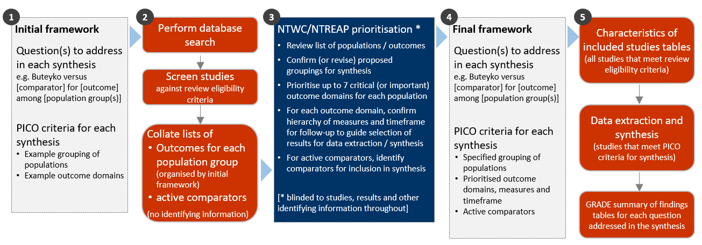

**Fig 3.1** | Staged approach for developing the questions and analytic framework for this review.

## 3.1 Criteria for considering studies for this review

### 3.1.1 Types of studies

We included randomised controlled trials (RCTs) (including individually and cluster randomised, and cross-over trials) and controlled trials where there was an attempt to have some kind of ‘randomisation’ to groups (e.g. sequence generation based on alternation, dates (of birth or attendance at a clinic) and patient record numbers) [29]. Non-randomised studies of interventions (NRSIs) with certain design features were eligible (see Appendix A1.1.1). Historical case control, uncontrolled before-after studies, cross-sectional studies and case-control studies were ineligible.

***Date and language restrictions.*** There were no restrictions on publication date. Potentially eligible studies published in languages other than English were to be listed but not included in the synthesis.

### 3.1.2 Types of participants

Studies involving participants with any disease, medical condition, injury, or preclinical condition were eligible for the review. This included healthy participants with clearly identified risk factors for a condition (evident from study eligibility criteria or baseline data) that the Buteyko Method was administered to prevent. There were no restrictions on age. Healthy populations seeking health improvement were excluded.

### 3.1.3 Types of interventions

For the purpose of this review, the Buteyko Method was defined as a “breathing retraining technique that may include a range of specific breathing techniques taught by a therapist…with the aim of returning breathing to normal physiological levels [and providing] relief and prevention of symptoms” [15].

Because of the potential challenge of distinguishing components of the Buteyko Method from related modalities (especially other systematised breathing interventions that use similar techniques to the Buteyko Method), and the likelihood of identifying studies where the defining techniques and principles of the Buteyko Method are incompletely reported, studies were included if:

* the therapy was described as the Buteyko Method, or
* it was implicit that the therapy was the Buteyko Method (e.g. a Buteyko Method therapist teaches the breathing techniques).

It was expected that the majority of studies would involve participants undertaking education in Buteyko techniques. Except for the specific exclusions below, the Buteyko Method interventions were eligible irrespective of:

* whether the study examines the effects of undertaking a series of educational sessions or the routine use of the Buteyko Method,
* the specific breathing techniques used by the therapist,
* mode of delivery (individual or group; face-to-face or virtual),
* whether the intervention was guided by a teacher or self-directed (the latter possible when trained individuals use the Buteyko Method in daily life),
* the training or qualifications of the teacher or practitioner,
* the setting in which the Buteyko Method is taught or used,
* the dose and duration of treatment, or
* whether or not the therapy includes posture and lifestyle interventions (if identified in the trial as ‘usual practice’).

#### Comparisons

1. The Buteyko Method *versus* any inactive comparator (no intervention, sham, placebo, wait list control, or a co-intervention that was offered to both groups, or continuation of usual care).
2. The Buteyko Method *versus* evidence-based treatment(s) (active comparators)
3. The Buteyko Method *versus* any active comparator (for inclusion in evidence inventory only, not the synthesis – See below).

As per protocol, for objective 2, pre-specified criteria needed to be met to proceed with synthesis. That is, at least two low risk of bias studies with comparable population, evidence-based comparator and outcomes. Where the criteria were not met, studies that only contributed active comparators were included in the inventory.

Any co-intervention was eligible (i.e. pharmacological or non-pharmacological). Usual care comparators were eligible if there was an explicit statement that indicated that participants could continue to access their routine care or therapy (including self-care). If a comparator labelled as ‘usual care’ involved a defined intervention (i.e. specific treatments and processes selected by the researchers), this was deemed to be either an active intervention (if restricted to the comparator group) or a co-intervention (if able to be accessed by both groups, e.g. continuation of a specific medication).

We excluded head-to-head comparisons of the Buteyko Method (e.g. comparison of different frequencies, durations or schedules; comparison of differently qualified people teaching the Buteyko Method.

### 3.1.4 Types of outcomes

Any patient-important outcome that aligned with the reasons why the Buteyko Method is sought by patients and prescribed by practitioners was eligible. Studies were included in the review irrespective of the outcome(s) measured, but the synthesis was limited to outcomes considered to be critical or important for each population group (see 3.4 for prioritisation of outcomes and 3.5 for final framework). Experience of care (e.g. satisfaction), safety, quality, and economic outcomes were excluded.

From each study, we selected one outcome per outcome domain for data extraction (results), risk of bias assessment and inclusion in the synthesis. In selecting outcomes for synthesis, we considered the outcome measure (any measure was eligible, but a pre-specified hierarchy was applied to select the most relevant measure if multiple measures were available), timing of outcome measurement (first measure after end of the Buteyko Method intervention period) and suitability of data for meta-analysis.

## 3.2 Search methods for identification of studies

We searched the Cochrane Central Register of Controlled Trials (Cochrane Library, Issue 10, 2023), MEDLINE (Ovid), Embase (Ovid), Emcare (Ovid), AMED (Ovid), CINAHL (EBSCOhost), Europe PMC, ClinicalTrials.gov and WHO International Clinical Trials Registry Platform on 6 October 2023. Searches were not limited by language, year of publication or publication status.

## 3.3 Selection of studies

All records were screened independently by two reviewers at both the title and abstract screening and full-text review stages. Disagreements at either stage of screening were resolved by consensus among members of the review team. We documented the flow of studies through the review in a PRISMA flow diagram (Figure 4.1.1).

No additional citations were received from the public call for evidence, NTREAP or the Committee. No studies in languages other than English were identified.

## 3.4 Prioritisation of outcomes for the synthesis

Decisions about the final synthesis questions and criteria for including studies in each synthesis were made through the prioritisation process in Figure 3.1. The process was designed to minimise bias in the selection of results for inclusion in the synthesis while ensuring coverage of relevant populations and outcomes.

In brief, we screened studies against the review eligibility criteria and collated deidentified information about the populations and outcomes addressed in included studies (no bibliographic information, titles, details about the number of studies, participants, methodological quality or results). For each condition, NTWC, with input from NTREAP, rated outcome domains as critical, important or of limited importance. Within each outcome domain, NTWC ranked the listed outcomes/measures for each domain to enable selection of the most relevant result from each study.

## 3.5 Final framework: synthesis questions and criteria for including studies in each synthesis

Figure 3.5.1, panel A shows the final analytic framework for the evidence summary and synthesis. The framework provides a guide to the structure of the synthesis and reporting of results (see caption for details).

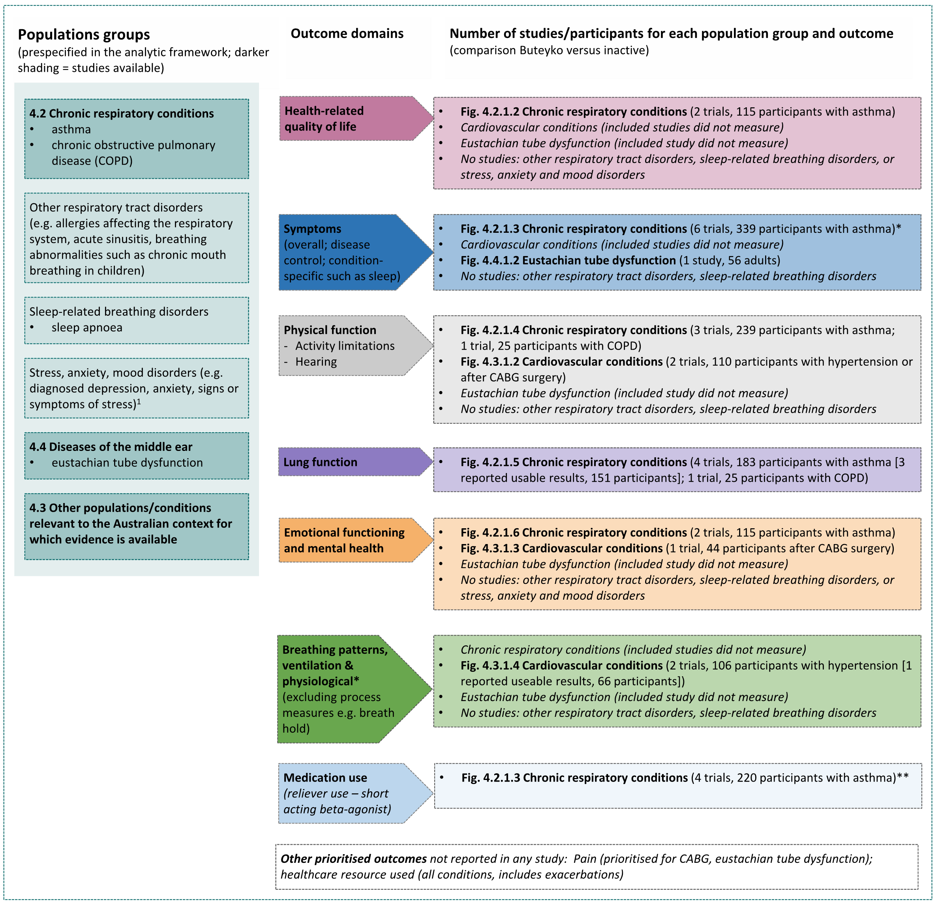

**Fig 3.5.1** | Final analytic framework for the review as agreed through the prioritisation process (Appendix A5).   
Panel A, columns 1 to 3 show the populations, and outcome domains eligible for each comparison in the evidence synthesis. Column 3 also shows the number of studies and participants available to address each synthesis question (as defined by the PICO). Results are reported for each population group in the section indicated in column 1[1]. Study-level data and meta-analyses are presented in the forest plot indicated in column 3. Population groups are those identified from various sources as treated with the Buteyko Method (as per Background); no PRACI data for this therapy. *Outcome domains combined for presentation in framework (not analysis) because similar measures were listed within (e.g. respiration rate). ** Medication use (reliever use – short acting beta-agonist) was included in the symptoms domain to avoid double counting data from 3 of the 4 trials that reported medication use based on a scale in the same measure used for overall asthma symptoms.

## 3.6 Data extraction and management

### 3.6.1 Data extraction

Study data were collected and managed using REDCap electronic data capture tools [30, 31]. A two-step data extraction process was implemented wherein a senior author (MM) coded the study PICO to allocate studies to the evidence inventory according to the analytic framework or include for the synthesis. Any queries from this stage were sent to the second senior author (SB) to review, with any disagreement resolved through consensus discussion. A senior author then selected the outcome (result) for inclusion in each synthesis using pre-specified decision rules and extracted study characteristics and quantitative data. A second senior author (MM) independently verified the study allocation for analysis and outcome selection, as well as the quantitative data. The form and data extraction process had previously been applied to a large number of studies (>200) in other natural therapies reviews undertaken by our team. Steps taken to ensure the completeness, accuracy and consistency of data in these reviews included pretesting the form and providing coding guidance, training, and feedback for data extractors. Quantitative data were reviewed by a biostatistician when queries arose.

### 3.6.2 Assessment of risk of bias in individual studies

We assessed the risk of bias in included studies using the revised Cochrane ‘Risk of Bias’ tools (RoB 2) for randomised trials [29, 32]. After piloting of the tool by senior authors (SB, MM, SM), we developed review-specific guidance for the suite of natural therapies reviews to ensure consistency between reviewers. This guidance had been used by the author team to assess over 200 natural therapies studies prior to application in the current review. One review author (JM or SB) applied the tool to the selected results from each study following the RoB 2 guidance [29], and a second author (SB or MM) checked a subset of assessments. Supporting information and justifications for judgements for each domain (low, some concerns, high risk of bias) were recorded. We derived an overall summary of the risk of bias from each assessment, following the algorithm in the RoB 2 guidance as implemented in the Excel assessment tool [29]. Where we judged that there was a material risk of bias (or the converse) not reflected by the proposed judgement in the algorithm, we changed the judgement and provided a rationale.

### 3.6.3 Measures and interpretation of treatment effect

We anticipated that many of the outcomes would be continuous (e.g. HR-QoL, asthma symptoms, lung function), and that varying measurement instruments would be used to measure the same underlying construct across the studies. For this reason, we quantified the effects of the Buteyko Method using the standardised mean difference (SMD).

Our interpretation was based on whether there was an important effect or not [4, 33], with an SMD of 0.2 standard units set as the threshold for an important difference. If the SMD fell within the pre-specified range of -0.2 to 0.2 (i.e. within both thresholds), the effect of the Buteyko Method was considered to be no different from control. An SMD above 0.2 or below -0.2 was interpreted as an important effect. We opted to use the most intuitive interpretation of effect estimates for each outcome, so positive values indicate benefit for some outcomes (an increase in physical function) and harm for other outcomes (an increase in asthma symptoms).

## 3.7 Data synthesis

### 3.7.1 Meta-analysis

Separate comparisons were set up for each population group and outcome domains agreed in the final framework (see Figure 3.5.1). Some comparisons were stratified by more specific conditions (with an overall estimate and estimate for each condition presented). Forest plots were used to visually depict the intervention effect estimates and their confidence intervals. Forest plots are stratified by condition and risk of bias (within population group). For completeness, results for all studies for which an effect estimate (SMD) could be calculated are presented on the Forest plot, including where a single study contributed to the comparison. Studies confirmed as measuring an outcome for which results were not reported, are also depicted on the plot.

### 3.7.2 Summary of findings tables and assessment of certainty of the body of evidence

For each result, one author (SB) used the GRADE approach to assess our certainty in whether there is an important effect (or not). In accordance with GRADE guidance [2, 33, 34], an overall GRADE of high, moderate, low or very low certainty is reported for each result based on whether there are serious, very serious, extremely serious or no concerns in relation to each of the following domains [4].

* **Risk of bias**. whether the studies contributing to each synthesis have methodological limitations that might lead to over (or under) estimation of the effect.
* **Imprecision**. whether the confidence interval for the synthesised result crosses one or both of the thresholds for an important effect (an SMD of 0.2 or -0.2 or equivalent thresholds for falls rate) meaning that the result is compatible with different interpretations (e.g. the upper bound of the interval lies above 0.2 indicating ‘an important effect’ whereas the lower bound lies between -0.2 and 0.2 indicating ‘little or no effect’).
* **Inconsistency**. whether there is important, unexplained inconsistency in results across studies.
* **Indirectness**. whether there are important differences between the characteristics of studies included in each synthesis and the question we were seeking to address, such that the effects observed may not apply to our question (i.e. the applicability of the evidence).
* **Publication bias**. whether results missing from each analysis may bias the effect estimate because of selective non-reporting of results (or studies) that showed unfavourable effects.

A summary of findings is tabulated for each comparison. These summary of findings tables include:

* estimates of the effects of the Buteyko Method reported as standardised mean differences.
* the overall GRADE (rating of certainty) and an explanation of the reason(s) for rating down (or borderline decisions) [35].
* the study design(s), number of studies and number of participants contributing data.
* a plain language statement interpreting the evidence for each comparison and outcome, following GRADE guidance for writing informative statements (see 3.7.3 interpretation of findings) [36].

### 3.7.3 Interpretation of findings (evidence statements)

When interpreting results, we followed GRADE guidance for writing informative statements [37]. All interpretations are based on where the point estimate lies in relation to the pre-specified thresholds for an important effect (an important effect or not) and the direction of effect (beneficial or harmful). The certainty of evidence is communicated by qualifying the interpretation of effect (e.g. ‘may’ improve for low certainty). For example, ‘Buteyko may improve physical function’ indicates that the point estimate lies above the threshold for important benefit (an SMD >0.2) and that the evidence is of low certainty. For very low certainty evidence, we do not provide an interpretation of the result except to state ‘The evidence is very uncertain about the effect of Buteyko on outcome’. This is one of two options that GRADE provides for interpreting findings based on very low certainty of evidence. The decision not to interpret very low certainty results was made independently by NTWC to ensure a consistent and clear interpretation of findings across Natural Therapy Review reports.

# 4. Results

## 4.1 Results of the search

The flow of studies through the review is summarised in Figure 4.1.1, the PRISMA flowchart.

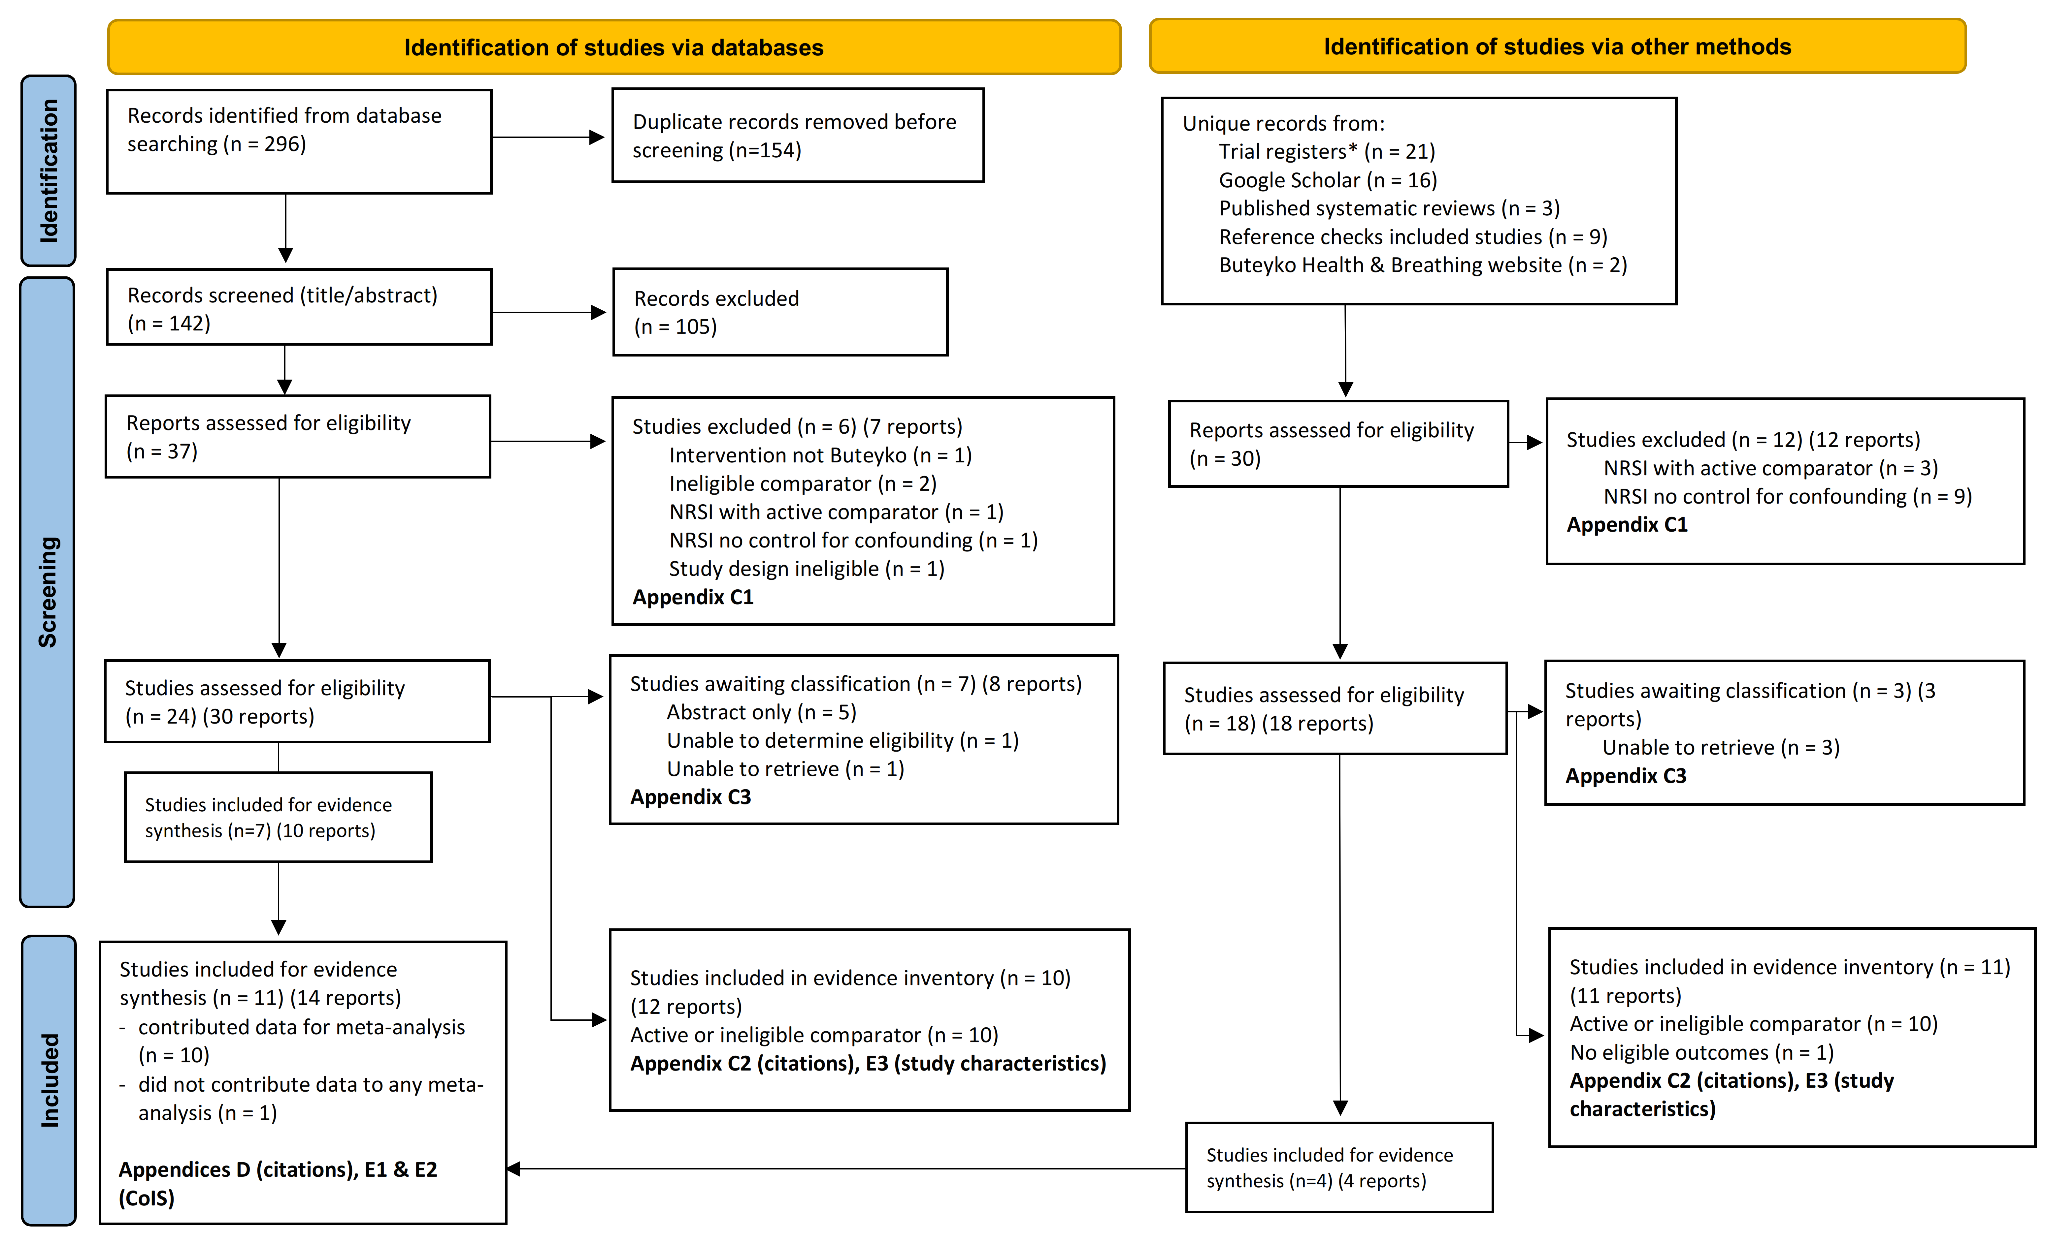

**Fig. 4.1.1** | PRISMA diagram showing the flow of studies through the review. Studies are the unit of interest in the review. Each study could have multiple reports. CoIS: characteristics of included studies. *see results section ‘Ongoing and unpublished studies’. No submissions were received via the Department’s public call for evidence.

### Included studies

Following screening of 296 citations from the database searches, we retrieved 37 full text reports from which 24 studies (30 reports) were potentially eligible. Seven (7) of these studies (10 reports) were included in the evidence synthesis and 10 studies (12 reports) contributed to the evidence inventory (all 10 had active comparators). A further 18 full text reports were assessed from other sources, from which 4 additional studies (4 reports) were included in the evidence synthesis and 11 studies (11 reports) were included in the evidence inventory (10 with active comparators, one that did not measure an eligible outcome). We did not identify any non-randomised studies with an eligible study design (See Appendix A1.1.1 for criteria).

Of the 11 randomised trials that examined the effects of the Buteyko Method compared to an inactive control:

* 7 trials were among people with **respiratory conditions** (6 asthma, 1 COPD)
* 3 trials were among people with **cardiovascular conditions** (1 hypertension, 1 CABG surgery, 1 hypertension with a history of CABG surgery)
* one trial was among people with **eustachian tube dysfunction**.

The summary and synthesis of these studies is reported in sections 4.2, 4.3 and 4.4 of the report respectively.

One additional trial compared the Buteyko Method to an inactive control for rehabilitation after CABG surgery, however the study did not measure any eligible outcomes (it reported breath hold time). The references and brief characteristics of this study, and the other 20 studies reported in the evidence inventory (which had active comparators – see below), are in Appendices C3 and E3 respectively.

There were no studies that compared the Buteyko Method to an inactive control among people with other conditions for which the Buteyko Method may be used. Specifically, there were no studies among people with dysfunctional breathing (hyperventilation syndrome), sleep disorders (especially sleep apnoea), allergies affecting the respiratory system, sinusitis, breathing abnormalities (e.g. chronic mouth breathing in children), and anxiety disorders.

#### Trials with active comparators (listed but not included in the evidence synthesis)

The characteristics of trials that compared the Buteyko Method to an active intervention are compared in Table 4.1.

With the exception of pranayama (a breathing technique used in yoga, not considered to be an evidence-based treatment), no two trials compared the Buteyko Method to the same active intervention in the same population (a pre-specified criterion for synthesis). In brief, 19 different active comparators were included in trials of the Buteyko Method. Of these, 14 involved breathing techniques used alone or in a multi-component intervention:

1. Pranayama breathing (a component of yoga; 4 trials all on asthma)
2. Pursed lip breathing (alone in 2 trials, 2 different conditions; combined with other interventions in 2 trials)
3. Diaphragmatic breathing (alone in 2 trials, 2 different conditions; combined with other interventions in 2 trials)
4. Other breathing techniques (single trials of abdominal breathing, active cycle breathing, deep breathing relaxation, breathing exercise instruction, Papworth technique, pink city lung exerciser, stacked breathing)

Other active comparators were:

1. Asthma education (1 trial)
2. Inhaled corticosteroids (1 trial)
3. Mobility exercises (1 trial)
4. Osteopathy – thoracic lymphatic pump technique (1 trial)
5. Incentive spirometry (2 trials; no eligible outcomes)

For these reasons, we did not include comparisons of the Buteyko Method with active comparators in the synthesis. Details of each trial are reported in Appendices E1 (for trials that also contribute an inactive comparison for the synthesis) or E3 (for studies that only reported an active comparison).

**Table 4.1** Characteristics of randomised trials comparing the Buteyko Method to an active intervention

|  |  |  |  |  |  |  |  |  |  |
| --- | --- | --- | --- | --- | --- | --- | --- | --- | --- |
|  |  |  | **Outcomes\*\*** | | | | | |  |
| **Comparator - type** | **Comparator – details** | **No. trials with comparator** | **HR-QoL** | **Symptoms** | **Physical function** | **Lung function** | **EFMH** | **Ineligible only** | **Study** |
| **Asthma** |  |  |  |  |  |  |  |  |  |
| Breathing technique | Pranayama | 4 | 1 | **2** | 1 | **3** | 1 |  | Azab 2017, Mohamed 2022†, Prem 2013†, Swathi 2012 |
|  | Diaphragmatic breathing  (alone in 1 trial; + relaxation in 1 trial)* | 2 |  | **2** |  | 1 |  |  | Abd Elmawla Elsaid 2023;  El-Nahas 2019 |
|  | Pursed lips breathing  (alone in 1 trial; + exercise in 1 trial)* | 2 |  | 1 |  | **2** |  |  | Abdurrasyid (date NR); Chavda 2016 |
|  | Diaphragmatic breathing + pursed lips breathing (physiotherapist delivered) | 1 |  |  |  | 1 |  |  | Narwal 2012 |
|  | Abdominal breathing + education + relaxation | 1 | 1 | 1 |  | 1 | 1 |  | Bowler 1998 |
|  | Active cycle of breathing | 1 |  | 1 |  | 1 |  |  | Elnaggar 2016 |
|  | Breathing exercise instruction (slow controlled exhalation; paced breathing - physiotherapist delivered) | 1 | 1 | 1 | 1 | 1 |  |  | Cowie 2008 |
|  | Deep breathing relaxation | 1 |  |  |  |  |  | 1 | Endiyono 2022 |
|  | Papworth technique (breathing from diaphragm – physiotherapist delivered) | 1 | 1 |  | 1 | 1 |  |  | Zaryyab 2021 |
|  | Pink city lung exerciser (mimics pranayama) | 1 | 1 |  | 1 | 1 | 1 |  | Cooper 2003 |
|  | Pink city lung placebo | 1 | 1 |  | 1 | 1 | 1 |  | Cooper 2003 |
|  | Stacked breathing | 1 |  | 1 |  | 1 |  |  | David 2022 |
| Other | Asthma education, relaxation | 1 |  | 1 |  | 1 |  |  | McHugh 2003 |
|  | Inhaled corticosteroids | 1 |  | 1 |  | 1 |  |  | Prasanna 2015 |
|  | Mobility exercises | 1 | 1 | 1 | 1 | 1 | 1 |  | Slader 2006 |
|  | Osteopathy (thoracic lymphatic pump) | 1 |  | 1 |  | 1 |  |  | Elnaggar 2016 |
| **COPD** |  |  |  |  |  |  |  |  |  |
| Breathing technique | Pursed lips breathing | 1 | 1 | 1 | 1 | 1 |  |  | Sharma 2019 |
| **Dialysis** |  |  |  |  |  |  |  |  |  |
| Breathing technique | Diaphragmatic breathing  (physiotherapist delivered) | 1 |  | 1 |  |  |  |  | Zaher 2020 |
| **CABG - postoperative** |  |  |  |  |  |  |  |  |  |
| Other | Incentive spirometry | 2 |  |  |  |  |  | 2ⱡ | Afshan 2020; Mohamed 2016 |

* trials of the same breathing technique are grouped for efficient reporting, but each trial has different components in the comparator group; **shading indicates outcomes reported in more than one study; only the pranayama and incentive spirometry interventions were directly comparable; outcome data have not been checked to confirm they are usable for meta-analysis nor has the risk of bias been assessed for the comparison/outcome; † study also contributes an inactive comparison considered in the evidence synthesis; ⱡ the only outcome reported was breath holding time, which NTWC advised was a process measure and therefore ineligible**.** Abbreviations: NR=not reported

### Excluded studies

After full-text screening, 18 studies (19 reports) were excluded from the review (Figure 4.1.1, Appendix C1 for list of excluded studies). Of these, 14 were non-randomised studies that did not have an eligible study design.

### Studies awaiting classification

Following screening, 10 studies were categorised as awaiting classification because results were reported in an abstract only (5 studies), we were unable to determine eligibility from the information reported (1 study), or the full text could not be retrieved (4 studies) (Figure 4.1.1, Appendix C4 for studies awaiting classification).

#### Studies in languages other than English

Our searches did not identify any studies published in a language other than English that was judged likely to be eligible for the review.

### Ongoing and unpublished studies

From trial registry entries (CENTRAL, ClinicalTrials.gov and WHO ICTRP), after removing duplicates we identified 21 potentially eligible trials for the review. Of these:

* 2 records were linked to trials included in the review (Jain 2023; Vagedes 2021)
* One was a trial published after the end date of the search (<https://clinicaltrials.gov/study/NCT03098849>)
* 13 were trials that we judged likely to be ongoing or in the publication process (registered 2020 or later)[2]
* 5 were registered prior to 2020 and were assessed as potentially missing studies.

Characteristics of ongoing and unpublished studies are reported in Appendix C4. Brief details are reported in the results section for the comparison for which the study is eligible.

### Public submissions

No submissions were received via the Department’s public call for evidence.

## 4.2 Chronic respiratory conditions

Seven (7) trials evaluated the effects of the Buteyko Method for people with chronic respiratory conditions. All 7 contribute to the synthesis (6 on asthma, 1 on COPD).

***Prioritised outcome domains*** for this population were:

* HR-QoL (critical for decision making)
* symptoms (critical for decision making)
* physical function - activity limitations (critical for COPD; important for asthma)
* lung function (important but not critical for decision making)
* emotional functioning and mental health (EFMH) (important but not critical for decision making)
* breathing patterns and ventilation (critical for decision making)
* healthcare resource use (including medication use) (important but not critical for decision making)

Only some measures of breathing patterns / ventilation were prioritised (respiration rate, oxygen saturation). Others were considered to be process measures (such as breath hold) and are not clinically accepted outcomes so were rated as of limited importance in the GRADE outcomes. See Appendix E1 for trials included in the synthesis that also reported ineligible outcomes.

Four studies measured medication use, which was an eligible outcome under healthcare resource use (Mohamed 2019 and 2022, Opat 2000, Vagedes 2021). In all four studies, the measure of asthma symptoms or asthma control included medication use (reliever use - short acting beta-agonist). To avoid double counting of the same data, we included medication use in the analysis of symptoms either by including the overall asthma symptom/control score (three trials) or by including a separate measure of medication use (one trial, where the symptom score data was not suitable for meta-analysis). For this reason, we do not present results for the stand-alone outcome domain of ‘medication use’.

### 4.2.1 Buteyko compared to inactive control

#### Characteristics of included studies

Brief characteristics of studies that compared the Buteyko Method to an inactive control are summarised in Table 4.2.1.1 and full details are in Appendix E1. The outcome measure from which data were included for meta-analysis is reported for each trial in the forest plots (column 2, Figures 4.2.1.2 to 4.2.1.5). For all results, the outcome selected for analysis was measured at the end of the intervention period (or close to) (see Table 4.2.1.1). Full details are reported in Appendix E1 for each study, including a list of all outcome measures, details of which outcome was selected when multiple were available for an outcome domain, and the timing of outcome measurement in relation to intervention.

**Table 4.2.1.1** Characteristics of studies comparing the Buteyko Method to an inactive control for people with respiratory conditions.

| **Study** | **Population* (ICD-11 code)** | **Intervention** | | | **Comparator** | **Outcome domains ⱡ** | | | | | |
| --- | --- | --- | --- | --- | --- | --- | --- | --- | --- | --- | --- |
| **Content** | **Provider** | **No. sessions, duration & frequency** | **HR-QoL** | **Symptoms** | **Function - activity** | **Lung function** | **EFMH** | **Measured** |
| **Asthma** | | | | | | | | | | | |
| **Hassan 2012** India | 40 adults (~41 yrs) with asthma (CA23.32 Unspecified asthma, uncomplicated) | **Training**: 'control pause' and 'shallow breathing'  **Practise**: 4 cycles of control pause (2 minutes), reduced breathing (4 minutes), rest (2 minutes). | NR | 14 x 20-minute sessions over 6 weeks (4 per week, then 2 per week) | Usual care - prescribed medications (both groups) |  | **X** |  | **X** |  | end of week 6 |
| **Mohamed 2019** Egypt | 100 adults (~49 yrs) with asthma (CA23.32 Unspecified asthma, uncomplicated) | **Training**: 'control pause' and 'shallow breathing'  **Practise**: 4 cycles of control pause, reduced breathing (4 minutes), rest (2 minutes). Advice to practise at home. | NR | 4 x 30-minute theory sessions 6 x 50-minute practical sessions (timeframe NR);  **At home**: 2 x per day over 1 month | Usual care - prescribed medications (both groups) |  | **X** | **X** |  |  | end of week 4 |
| **Mohamed 2022** Egypt | 90 children (~8 yrs) with asthma (CA23.32 Unspecified asthma, uncomplicated) | **Training**: 'control pause' and 'shallow breathing'  **Practise**: 2 cycles of reduced breathing (4 minutes), rest (2 minutes), control pause. Advice to practise at home. | NR | 60-minute sessions per day over 3 to 5 days; **At home**: 2 x 15 minutes per day over 3 months | Usual care (both groups) |  | **X** | **X** |  |  | end of week 12 |
| **Opat 2000** Australia | 36 adults (~32 yrs) with asthma (CA23.32 Unspecified asthma, uncomplicated) | **Training**: theory and practical via video. **Practise**: short periods of shallow-breathing (reduced breathing then breath holding (control pause) | self-guided by video | **At home**: 2 x 20 minutes video-guided sessions per day over 4 weeks | Sham video (nature images + music, same length and frequency) | **X** | **X** |  | **X**† | **X** | end of week 4;  daily symptm. |
| **Prem 2013** India | 80 adults (~40 yrs) with asthma (CA23.32 Unspecified asthma, uncomplicated) | **Training/practise**: breath holding (control pause) interspersed with periods of shallow breath; accompanied by physical activity.  Advice to practise at home. | NR | 1 x 60-minute training session per day for 3-5 days **At home**: 2 x 15 minutes per day over 3 months. | Usual care (both groups) | **X** | **X** | **X** | **X** | **X** | end of week 12 |
| **Vagedes 2021**  Germany | 32 children (~10 yrs) with asthma (CA23.32 Unspecified asthma, uncomplicated) | **Training**: breath holding (control pause), deliberate hypoventilation exercises. Children and parents trained independently. **Practise**: control pause, succession of reduced breathing, extended and maximum pauses (also practised during activities) | Buteyko qualified trainer | 5 x 90-minute sessions over 5 days, 1 x booster session in the following week;  **At home**: 2 x 15 minutes per day over 3 months | Usual care (both groups) |  | **X** |  | **X** |  | end of week 12 |
| **Chronic obstructive pulmonary disease (COPD)** | | | | | | | | | | | |
| **Arora 2019** India | 28 adults (~48 yrs) with COPD  (CA22 Chronic obstructive pulmonary disease) | **Training**: breath holding (control pause), nasal breathing **Practise**: cycles of nasal breathing, control pause, rest (30-120 seconds) supervised at clinic. Advice to practise at home. | NR  video guided (NR if for use in clinic, at home or both) | 2 to 3 sessions of instruction;  3 x 20 minutes practise per week at physiotherapy clinic;  **At home**: duration and frequency NR over 4 weeks | conventional chest physiotherapy (co-intervention) |  |  | **X** | **X** |  | end of week 4 |

*number of participants is the number from eligible groups (randomised if reported, otherwise number at follow-up); X results included in meta-analysis; X† outcome reported as measured in results paper, but results unavailable for meta-analysis (not reported, incompletely reported or uninterpretable); Xⱡ outcomes reported as measured in registry entry (not mentioned elsewhere)**.** Abbreviations: NR=not reported, yrs=years, symptm=symptoms

#### Risk of bias in included trials

A summary of the risk of bias assessments for this comparison is presented in Figure 4.2.1.1). The complete assessments and judgements are reported in Appendix F. We do not report assessments for studies that do not have results contributing to a meta-analysis because these studies have no influence over the effect estimate and, hence, are not considered when judging the overall risk of bias in the GRADE assessment of the synthesis results.

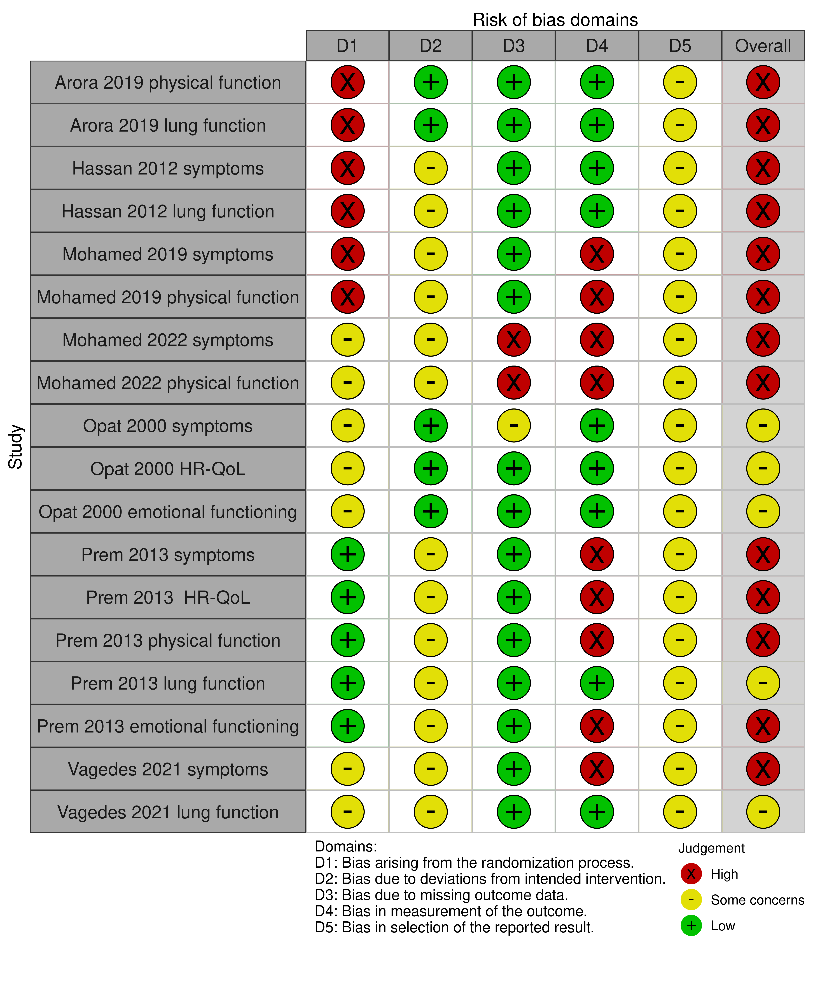

**Fig 4.2.1.1** | Summary of the risk of bias assessments for studies contributing to the comparisons of the Buteyko Method versus inactive control (sham or usual care given as a co-intervention to both groups). Each outcome for which the study contributed results was assessed separately. The full assessments, with the rationale for judgements, are reported in Appendix F. The overall risk of bias judgement for each study is reported in the forest plots.

#### Effects of the Buteyko Method compared to inactive control

The effects of the Buteyko Method compared to an inactive control are presented in Table 4.2.1.2, the GRADE summary of findings tables. The certainty of evidence, and factors that influenced our certainty, are presented and explained in these tables. Study level and meta-analytic results are presented in forest plots (Figures 4.2.1.2 to 4.2.1.6). Although results for asthma and COPD are presented in the same summary of findings table and forest plots for efficiency, results were not combined and are reported separately in the text below.

#### Asthma

***Health related quality of life (HR-QoL)*** *(Figure 4.2.1.2)*

* *Included studies*. Two (2) trials involving 115 adults contributed to the analysis.
* *Missing results*. Two unpublished trials (registered 2018, 2019) involving 90 participants with asthma are eligible for this analysis.
* *Ongoing studies*. Two ongoing trials (registered 2020, 2023) and one trial published after the search date (Vagedes 2024) involving 168 participants with asthma are eligible for this analysis.

The evidence about the effect of the Buteyko Method on HR-QoL for adults with asthma is of very low certainty due to study design limitations, imprecision and publication bias (2 trials, 115 adults with asthma; Figure 4.2.1.2). No studies examined the effect of Buteyko on HR-QoL for children with asthma.

***Symptoms*** *(Figure 4.2.1.3)*

* *Included studies*. Six (6) trials involving 339 adults and children with asthma contributed to the analysis.
* *Missing results*. Two unpublished trials (registered 2016, 2018) involving 95 participants with asthma are eligible for this analysis.
* *Ongoing studies*. One ongoing trial (registered 2023) and one trial published after the search date (Vagedes 2024) involving 108 participants with asthma are eligible for this analysis.

There was low certainty evidence, due to study design limitations and publication bias, that the Buteyko Method may reduce symptoms for adults and children with asthma when compared to an inactive control (SMD 0.84 lower, 95% CI 1.48 lower to 0.2 lower; 6 studies, 339 participants; Figure 4.2.1.3).

***Physical function – activity limitations*** *(Figure 4.2.1.4)*

* *Included studies*. Three (3) trials involving 239 adults and children with asthma contributed to the analysis.
* *Missing results*. One unpublished trial (registered 2018) involving 60 children with asthma is eligible for this analysis. In addition, the unpublished trials that measured HR-QoL or symptoms may contribute to this analysis (see next point).
* *Ongoing studies*. There were no ongoing trials identified from registry entries or other sources for this analysis; however, trials that measure HR-QoL or symptoms commonly report results from a subscale that measures activity limitations, so the 3 trials listed above (168 participants) may provide data for this analysis.

The evidence about the effect of the Buteyko Method on physical function (activity limitations) for people with asthma is of very low certainty due to study design limitations, imprecision and publication bias (2 trials, 239 adults and children with asthma; Figure 4.2.1.4).

***Lung function*** *(Figure 4.2.1.5)*

* *Included studies*. Three (3) trials involving 151 adults and children with asthma contributed to the analysis.
* *Missing results*. Three (3) trials (registered 2016, 2018, 2019) involving 125 adults and children with asthma are eligible for this analysis.
* *Ongoing studies*. One trial published after the search date (Vagedes 2024) involving 63 adults with asthma is eligible for this analysis.

The evidence about the effect of the Buteyko Method on lung function for people with asthma is of very low certainty due to study design limitations, inconsistent effects, imprecision and publication bias (3 trials, 151 adults and children with asthma; Figure 4.2.1.5).

***Emotional functioning and mental health*** *(Figure 4.2.1.6)*

* *Included studies*. Two trials involving 115 adults with asthma contributed to the analysis.
* *Missing results*. There were no unpublished trials identified from registry entries or other sources for this analysis; however, trials that measure HR-QoL or symptoms commonly report results from a subscale that measures emotional wellbeing, so the three trials listed above (125 participants) may provide data for this analysis.
* *Ongoing studies*. One trial published after the search date (Vagedes 2024) involving 63 adults with asthma is eligible for this analysis. In additional the three trials (168 participants) that measure HR-QoL may provide data for this analysis.

The evidence about the effect of the Buteyko Method on emotional functioning and mental health for adults with asthma is of very low certainty due to study design limitations, inconsistent effects, imprecision and publication bias (2 trials, 115 adults with asthma; Figure 4.2.1.6). No studies examined the effect of Buteyko on emotional functioning and mental health for children with asthma.

***Breathing patterns and ventilation***

* *Included studies*. Not measured in any of the included studies
* *Missing results*. One unpublished trial (registered 2018) involving 60 children with asthma is eligible for this analysis.
* *Ongoing studies*. One trial published after the search date (Vagedes 2024) involving 63 adults with asthma is eligible for this analysis.

***Healthcare resource use (including medication use)***

* *Included studies*. One study reported on reliever use (short acting beta-agonists) (Opat 2000), which is commonly included in measures of asthma symptoms / control. This was the only measure of symptoms for which there was data for inclusion in the meta-analysis of symptoms from this study, so was included in the analysis examining effects on symptoms to maximise use of available data. For the other three studies that reported medication use, data were included from the overall symptom score so we did not extract or analyse data on medication use separately (Mohamed 2019; Mohamed 2022; Vagades 2021).
* *Missing results*. One unpublished trial (registered 2016) involving 35 children with asthma is eligible for this analysis.
* *Ongoing studies*. One trial published after the search date (Vagedes 2024) involving 63 adults with asthma is eligible for this analysis.

#### COPD

***Physical function – activity limitations*** *(Figure 4.2.1.4)*

* *Included studies*. One trial involving 25 people with COPD contributed to the analysis.
* *Missing results*. There were no missing studies identified from registry entries or other sources for this analysis.
* *Ongoing studies*. There were no ongoing trials eligible for this analysis.

The evidence about the effect of the Buteyko Method on physical function (activity limitations) for people with COPD is of very low certainty due to study design limitations, indirectness and publication bias (1 trial, 25 people with COPD; Figure 4.2.1.4).

***Lung function*** *(Figure 4.2.1.5)*

* *Included studies*. One trial involving 25 people with COPD contributed to the analysis.
* *Missing results*. There were no missing studies identified from registry entries or other sources for this analysis.
* *Ongoing studies*. There is one ongoing trial (registered 2023) involving 60 people eligible for this analysis.

The evidence about the effect of the Buteyko Method on lung function for people with COPD is of very low certainty due to study design limitations, indirectness and publication bias (1 trial, 25 people with COPD; Figure 4.2.1.5).

***Other outcomes***

No studies reported effects of the Buteyko Method on HR-QoL, symptoms (e.g. dyspnoea), emotional functioning and mental health, breathing patterns/ventilation (eligible outcomes) or healthcare resource use for people with COPD. There were no missing results or ongoing studies identified from registry entries or other sources for these analyses.

#### Table 4.2.1.2 | Summary of findings for the effect of the Buteyko Method versus inactive control (sham or usual care given to both groups) for chronic respiratory conditions.

|  | | | | | | |
| --- | --- | --- | --- | --- | --- | --- |
| Outcomes (populations represented in meta-analysis) | **Anticipated absolute effects\*** (95% CI) | | Relative effect (95% CI) | № of participants (studies)  contributing to meta-analysis | Certainty of the evidence (GRADE) | Interpretation (evidence statement) |
| **Risk with inactive control** | **Risk with Buteyko** |
| **Asthma** | | | | | | |
| HR-QoL (adults with asthma)  (follow up 4 to 12 weeks)a | - | SMD 0.96 SD higher (0.08 lower to 1.99 higher) | - | 115 (2 RCTs) | ⨁◯◯◯ Very lowb,c,d | The evidence is very uncertain about the effect of Buteyko on HR-QoL for adults with asthma. No studies examined effects on children with asthma. |
| Symptoms (adults and children with asthma)  (follow up 4 to 12 weeks)e | - | SMD 0.84 SD lower (1.48 lower to 0.20 lower) | - | 339 (6 RCTs) | ⨁⨁◯◯ Lowf,g | Buteyko may reduce asthma symptoms for adults and children with asthma. |
| Physical function -activity limitations (adults and children with asthma)  (follow up 4 to 12 weeks)h | - | SMD 1.04 SD higher (0.11 lower to 2.19 higher) | - | 239 (3 RCTs) | ⨁◯◯◯ Very lowg,i,j | The evidence is very uncertain about the effect of Buteyko on physical function (activity limitations) for adults and children with asthma. |
| Lung function (adults and children with asthma)  (follow up 4 to 12 weeks)k | - | SMD 0.09 SD higher (1.96 lower to 2.14 higher) | - | 151 (3 RCTs)l | ⨁◯◯◯ Very lowm,n,o,p | The evidence is very uncertain about the effect of Buteyko on lung function for adults and children with asthma. |
| Emotional functioning and mental health (adults with asthma)  (follow up 4 to 12 weeks)q | - | SMD 0.78 SD lower (2.83 lower to 1.27 higher) | - | 115 (2 RCTs) | ⨁◯◯◯ Very lowr,s,t | The evidence is very uncertain about the effect of Buteyko on emotional wellbeing (mood disturbance) for adults with asthma. No studies examined effects on emotional functioning and mental health for children with asthma. |
| Other outcomes - not reported | - | - | - | - | - | No studies reported on breathing patterns/ventilation (eligible outcomes) or healthcare resource e use for adults or children with chronic asthma. |
| **Chronic obstructive pulmonary disease (COPD)** | | | | | | |
| Physical function -activity limitations (COPD)  (follow up 4 weeks)h | - | SMD 1.83 SD higher (0.92 higher to 2.74 higher) | - | 25 (1 RCT) | ⨁◯◯◯ Very lowu,v,w | The evidence is very uncertain about the effect of Buteyko on physical function (activity limitations) for people with COPD. |
| Lung function (COPD)  (follow up 4 weeks)k | - | SMD 0.06 SD higher (0.7 lower to 0.81 higher) | - | 25 (1 RCT) | ⨁◯◯◯ Very lowv,x,y,z | The evidence is very uncertain about the effect of Buteyko on lung function for people with COPD. |
| Other outcomes - not reported - not reportedaa | - | - | - | - | - | No studies reported on HR-QoL, symptoms (e.g. dyspnoea), EFMH, breathing patterns/ventilation (eligible outcomes) or healthcare resource use for people with chronic obstructive pulmonary diseases (COPD). |
| \***The risk in the intervention group** (and its 95% confidence interval) is based on the assumed risk in the comparison group and the **relative effect** of the intervention (and its 95% CI). **CI:** confidence interval; **SMD:** standardised mean difference  The threshold for an important difference was an SMD of 0.2 (used for interpreting point estimates and confidence intervals). The resulting interpretations are as follows.   * For HR-QoL: > 0.2 is beneficial, -0.2 to 0.2 is trivial or unimportant ("little or no difference" between treatments), < -0.2 is harmful * For symptoms: < -0.2 is beneficial, -0.2 to 0.2 is trivial or unimportant ("little or no difference" between treatments), > 0.2 is harmful * For physical function (activity limitations): > 0.2 is beneficial, -0.2 to 0.2 is trivial or unimportant ("little or no difference" between treatments), < -0.2 is harmful * For lung function: > 0.2 is beneficial, -0.2 to 0.2 is trivial or unimportant ("little or no difference" between treatments), < -0.2 is harmful * For emotional functioning and mental health: < -0.2 is beneficial, -0.2 to 0.2 is trivial or unimportant ("little or no difference" between treatments), > 0.2 is harmful | | | | | | |
| **GRADE Working Group grades of evidence** **High certainty:** we are very confident that the true effect lies close to that of the estimate of the effect. **Moderate certainty:** we are moderately confident in the effect estimate: the true effect is likely to be close to the estimate of the effect, but there is a possibility that it is substantially different. **Low certainty:** our confidence in the effect estimate is limited: the true effect may be substantially different from the estimate of the effect. **Very low certainty:** we have very little confidence in the effect estimate: the true effect is likely to be substantially different from the estimate of effect.  **Explanations** are provided for domains for which there is a downgrade or a borderline judgment. In line with GRADE guidance, we do not explain that there are no limitations unless the judgment was challenging (<https://pubmed.ncbi.nlm.nih.gov/26796947/> ) | | | | | | |

#### Explanations

a. HR-QoL measures. (Marks)(AQLQ)- overall; (AQLQ) (Juniper) - overall

b. Serious risk of bias (-1). One study at high risk of bias (60% of weight in analysis) and one with some concerns (32% of weight) such that the observed benefit may be overestimated.

c. Serious imprecision (-1). The 95% confidence interval (CI) crosses the threshold for a small but important effect (SMD of 0.2), so the result is compatible with important benefit (SMD 1.99 higher) and little to no difference (SMD 0.08 lower).

d. Publication bias strongly suspected (-1). Small number of trials and large effects, so selective non-reporting of unfavourable results (null or favouring control) could importantly change the combined estimate. This is a concern because of evidence of selective non-reporting of unfavourable/uninteresting results in general, and from trials of natural therapies in particular.

e. Symptom measures. Asthma symptom control questionnaire (ACQ) - overall; Global Initiative for Asthma, assessment of asthma control (ASC GINA) - overall; asthma medication intake - reliever used, short acting beta-agonist (salbutamol equivalent, mg To avoid double counting, medication use is addressed in the symptom domain and not reported separately.

f. Serious risk of bias (-1). Most studies at high risk of bias and one with some concerns, such that the observed benefit may be overestimated. Rated down one level because bias is unlikely to fully explain the observed effects.

g. Publication bias strongly suspected (-1). Small trials, all showing moderate to large effects, so selective non-reporting of unfavourable results (null or favouring control) could importantly change the combined estimate. This is a concern because of evidence of selective non-reporting of unfavourable/uninteresting results in general, and from trials of natural therapies in particular.

h. Physical function (activity limitations) measures. National Asthma Education and Prevention Program (NAEPP), patient self-assessment of asthma symptom severity (NAEPP - interference item); Asthma quality of life questionnaire (AQLQ), Juniper - activities; 6-minute walk test, % predicted value (6 min walk, %PV)

i. Very serious risk of bias (-2). All at high risk of bias, such that the observed benefit may be overestimated.

j. Serious imprecision (-1). The 95% confidence interval (CI) crosses the threshold for a small but important effect (SMD of 0.2), so the result is compatible with important benefit (SMD 2.19 higher) and little to no difference (SMD 0.11 lower).

k. Lung function measures. Peak Expiratory Flow Rate (PEFR); Peak expiratory flow (PEF); Forced expiratory volume (FEV1, L/s)

l. A fourth study (Opat 2000) measured lung function in 28 adults, but reported results incompletely (no measure of variance) so could not be included in the meta-analysis.

m. Serious risk of bias (-1). Two studies at high risk of bias (~70% of weight) and one with some concerns (30% of weight), however the combined estimate indicates little to no effect, so rated down one level (not two).

n. Serious inconsistency (-1): Confidence interval for the one study has no overlap with the other two studies and point estimate indicates an effect in the opposite direction to the other two studies.

o. Very serious imprecision (-2). The 95% confidence interval crosses two thresholds for a small but important effect (SMD of 0.2 and -0.2), so the result is compatible with important benefit (SMD 2.14 higher) and important harm (SMD 1.96 lower). In part, this is due to the inconsistent effects, therefore we have rated down two levels (not three).

p. Publication bias not detected. While selective non-reporting of unfavourable results (null or favouring control) is a concern when the available evidence is from a small number of small trials, the combined estimate suggests little to no effect. It was judged unlikely that unpublished studies would have results that would change this interpretation.

q. EFMH measures. Asthma quality of life questionnaire (AQLQ), Marks - mood disturbance subscale; Asthma quality of life questionnaire, Juniper (AQLQ) - emotion subscale

r. Very serious risk of bias (-2). One studies at high risk of bias (~70% of weight) and one with some concerns (30% of weight), such that the observed benefit may be overestimated.

s. Serious imprecision (-1). The 95% confidence interval crosses two thresholds for a small but important effect (SMD of 0.2 and -0.2), so the result is compatible with important benefit (SMD 2.83 lower) and important harm (SMD 1.27 higher). However, neither study has a CI that indicates important harm and the CI for the combined estimate has been calculated using a conservative method, so we rated down once only.

t. Publication bias strongly suspected (-1). Small trials showing moderate to large effects, so selective non-reporting of unfavourable results (null or favouring control) could importantly change the combined estimate. This is a concern because of evidence of selective non-reporting of unfavourable/uninteresting results in general, and from trials of natural therapies in particular.

u. Very serious risk of bias (-2). Single study at high risk of bias showing a very large effect, raising concern that the observed benefit may be overestimated.

v. Serious indirectness (-1): Evidence from one small study among people with COPD. Uncertain whether results can be generalised to others with COPD.

w. Publication bias strongly suspected (-1). Single small trial showing a large effect, so selective non-reporting of unfavourable results (null or favouring control) could importantly change the combined estimate. This is a concern because of evidence of selective non-reporting of unfavourable/uninteresting results in general, and from trials of natural therapies in particular.

x. Serious risk of bias (-1). Single study at high risk of bias, however the result suggests little to no effect so rated down one level (not two).

y. Extremely serious imprecision (-3). The 95% confidence interval crosses two thresholds for a small but important effect (SMD of 0.2 and -0.2), so the result is compatible with important benefit (SMD 0.81 higher) and important harm (SMD 0.70 lower) which is considered too wide to interpret the result.

z. Publication bias not detected. While selective non-reporting of unfavourable results (null or favouring control) is a concern when the available evidence is from a single small trial, the estimate suggests little to no effect. It was judged unlikely that unpublished studies would have results that would change this interpretation.

aa. One study of COPD reported physical function and lung function, but not HR-QoL, symptoms, EFMH or other outcomes. No registry entry or protocol, so cannot confirm if all measured outcomes were reported.

#### Forest plots and analysis results

**Fig 4.2.1.2** | Forest plot for main comparison. The effect of the Buteyko Method versus inactive control (sham or usual care given to both groups) on health-related quality of life (HR-QoL) for people with chronic respiratory conditions. SMD=standardised mean difference. Blue lines show 95% confidence intervals (CI). The shaded grey area indicates the pre-specified range where the effect of the Buteyko Method is considered to be no different from control (SMD -0.2 to 0.2 standard units). ^ indicates studies for which data transformation or imputation was required to include the result in the meta-analysis. For studies with results not reported (NR), the data required for transformation were missing or the result was uninterpretable.* Denotes studies for which the direction of effect was changed to match the overall plot (positive numbers are beneficial).

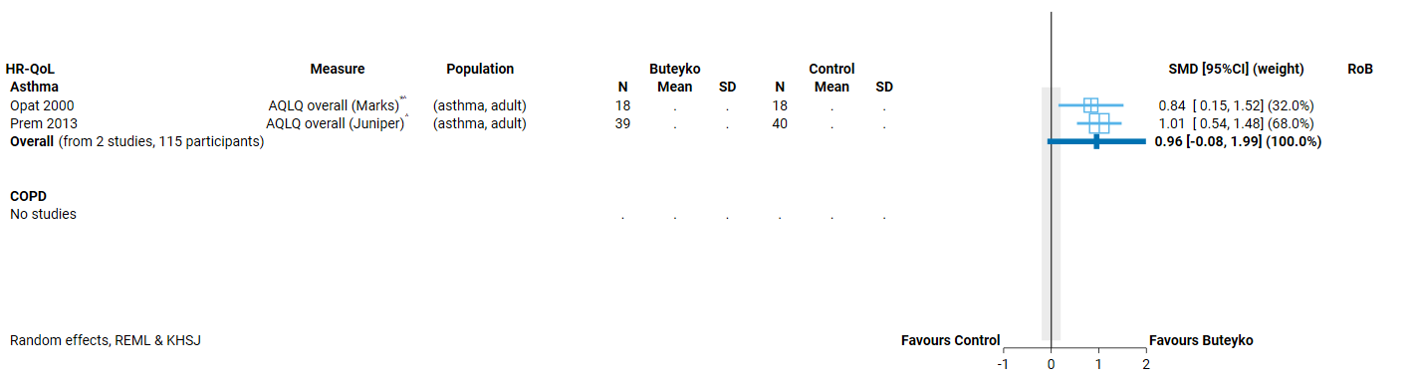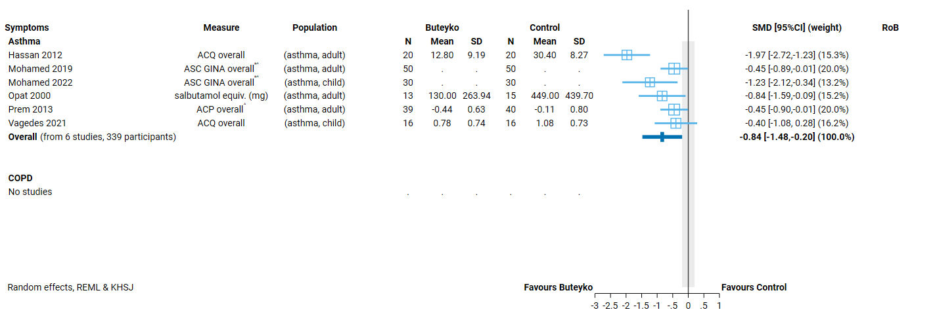

**Fig 4.2.1.3** | Forest plot for main comparison. The effect of the Buteyko Method versus inactive control (sham or usual care given to both groups) on symptoms for people with chronic respiratory conditions. SMD=standardised mean difference. Blue lines show 95% confidence intervals (CI). The shaded grey area indicates the pre-specified range where the effect of the Buteyko Method is considered to be no different from control (SMD -0.2 to 0.2 standard units). ^ indicates studies for which data transformation or imputation was required to include the result in the meta-analysis. For studies with results not reported (NR), the data required for transformation were missing or the result was uninterpretable.* Denotes studies for which the direction of effect was changed to match the overall plot (negative numbers are beneficial).

**Fig 4.2.1.4** | Forest plot for main comparison. The effect of the Buteyko Method versus inactive control (sham or usual care given to both groups) on physical function (activity limitations) for people with chronic respiratory conditions. SMD=standardised mean difference. Blue lines show 95% confidence intervals (CI). The shaded grey area indicates the pre-specified range where the effect of the Buteyko Method is considered to be no different from control (SMD -0.2 to 0.2 standard units). ^ indicates studies for which data transformation or imputation was required to include the result in the meta-analysis. For studies with results not reported (NR), the data required for transformation were missing or the result was uninterpretable

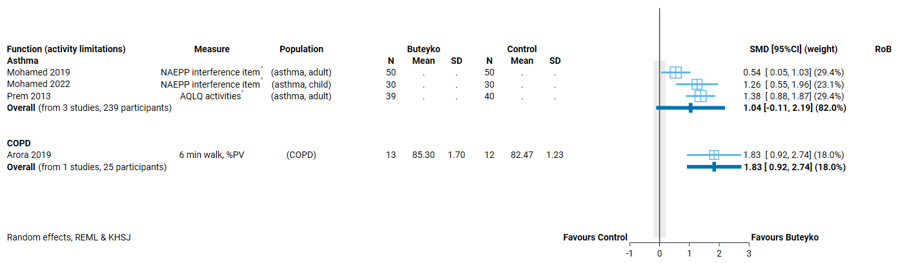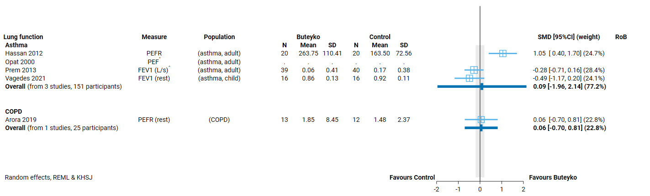

**Fig 4.2.1.5** | Forest plot for main comparison. The effect of the Buteyko Method versus inactive control (sham or usual care given to both groups) on lung function for people with chronic respiratory conditions. SMD=standardised mean difference. Blue lines show 95% confidence intervals (CI). The shaded grey area indicates the pre-specified range where the effect of the Buteyko Method is considered to be no different from control (SMD -0.2 to 0.2 standard units). ^ indicates studies for which data transformation or imputation was required to include the result in the meta-analysis. For studies with results not reported (NR), the data required for transformation were missing or the result was uninterpretable.

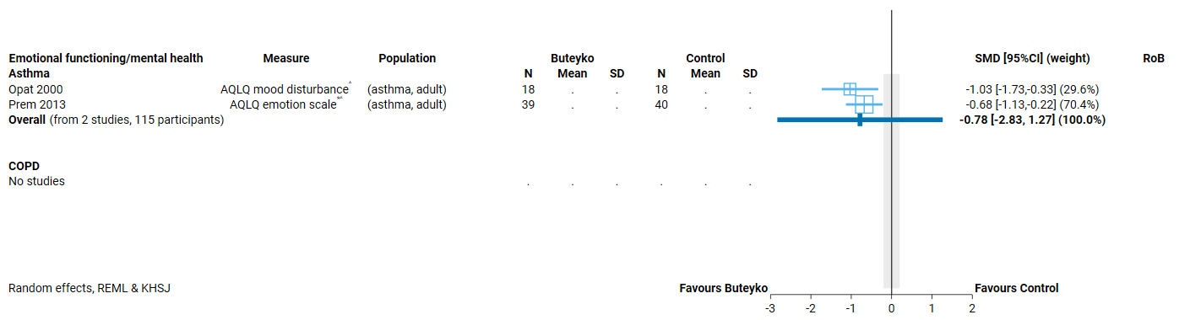

**Fig 4.2.1.6** | Forest plot for main comparison. The effect of the Buteyko Method versus inactive control (sham or usual care given to both groups) on emotional functioning and mental health for people with chronic respiratory conditions. SMD=standardised mean difference. Blue lines show 95% confidence intervals (CI). The shaded grey area indicates the pre-specified range where the effect of the Buteyko Method is considered to be no different from control (SMD -0.2 to 0.2 standard units). ^ indicates studies for which data transformation or imputation was required to include the result in the meta-analysis. For studies with results not reported (NR), the data required for transformation were missing or the result was uninterpretable. * Denotes studies for which the direction of effect was changed to match the overall plot (negative numbers are beneficial).

## 4.3 Cardiovascular conditions

Four (4) trials evaluated the effects of the Buteyko Method for people with cardiovascular conditions. Three (3) of the 4 contributed to the synthesis (one on hypertension, one on CABG, one on hypertension with history of CABG) and one is reported on the evidence inventory (Appendix E3; reported no eligible outcomes in a study of CABG).

***Prioritised outcome domains*** for this population were:

* HR-QoL (critical for decision making)
* Symptoms (critical for decision making)
* physical function - limitations (important but not critical for decision making)
* emotional functioning and mental health (EFMH) (critical for decision making)
* breathing patterns, ventilation, physiological (physiological critical, others important)
* pain (important but not critical for CABG)

Only some measures of breathing patterns / ventilation and physiological parameters were prioritised (blood pressure, respiration rate, oxygen saturation). Others were considered to be process measures (such as breath hold) and were rated as of limited importance because they are not clinically accepted outcome measures. See Appendix E1 for trials included in the synthesis that also reported ineligible outcomes, and Appendix E3 for a trial among people with asthma that only reported breath hold as an outcome (Mohamed 2016).

### 4.3.1 The Buteyko Method compared to inactive control

#### Characteristics of included studies

Brief characteristics of studies that compared the Buteyko Method to an inactive control are summarised in Table 4.3.1.1 and full details are in Appendix E1. The outcome measure from which data were included for meta-analysis is reported for each trial in the forest plots (column 2, Figures 4.3.1.2 to 4.3.1.6). For all results, the outcome selected for analysis was measured at the end of the intervention period (or close to) (see Table 4.3.1.1). Full details are reported in Appendix E1 for each study, including a list of all outcome measures, details of which outcome was selected when multiple were available for an outcome domain, and the timing of outcome measurement in relation to intervention.

**Table 4.3.1.1** Characteristics of studies comparing the Buteyko Method to an inactive control for people with cardiovascular conditions.

| **Study** | **Population* (ICD-11 code)** | **Intervention** | | | **Comparator** | **Outcome domains ⱡ** | | | | | |
| --- | --- | --- | --- | --- | --- | --- | --- | --- | --- | --- | --- |
| **Content** | **Provider** | **No. sessions, duration & frequency** | **HR-QoL** | **Symptoms** | **Function - activity** | **Physiologic.** | **EFMH** | **Measured** |
| **Hypertension, CABG or both** | | | | | | | | | | | |
| Arora 2022 India | 66 adults (age NR) with primary hypertension (BA00 Essential hypertension) | **Training**: 'control pause' (breath hold) and ‘slow’ breathing'  **Practise**: 2 x 5 sets of control pause, slow breathing (3 minutes), rest (2 minutes) in a supervised session. Advice to practise at home. | NR  video guided | 1 x 30-minute session per week over 4 weeks **At home.** daily | Usual care (both groups) |  |  | **X** | **X** |  | week 4 |
| Jain 2023 India | 44 adults after CABG surgery, signs of anxiety or depression (BA8Z Diseases of coronary artery, unspecified) | **Training**: 'control pause' (breath hold) and ‘shallow’ breathing'  **Practise**: 3-4 cycles of control pause, shallow breathing (duration NR) in a supervised session. | NR | 2 x 20 minutes sessions per day over 2 weeks (until or after discharge) | Usual care (both groups) - cardiac rehabilitation program |  |  | **X** |  | **X** | week 2 |
| Sathe 2020 India | 42 adults (age NR) with hypertension and history of CABG (BA00 Essential hypertension) | **Training**: 'control pause' (breath hold) and ‘shallow’ breathing'  **Practise**: ~6 cycles of control pause, shallow breathing (duration NR). | NR | 1 x session, length of session NR | No intervention |  |  |  | **X**† |  | day 1 |

*number of participants is the number from eligible groups (randomised if reported, otherwise number at follow-up); X results included in meta-analysis; X† outcome reported as measured in results paper, but results unavailable for meta-analysis (not reported, incompletely reported or uninterpretable); Xⱡ outcomes reported as measured in registry entry (not mentioned elsewhere)Abbreviations: NR=not reported, yrs=years, CABG =coronary artery bypass graft

#### Risk of bias in included trials

A summary of the risk of bias assessments for this comparison is presented in Figure 4.3.1.1 and the overall risk of bias judgement for each study is reported in the forest plots (each outcome from a study was assessed separately). The complete assessments and judgements are reported in Appendix F. We do not report assessments for studies that do not have results contributing to a meta-analysis because these studies have no influence over the effect estimate and, hence, are not considered when judging the overall risk of bias in the GRADE assessment of the synthesis results.

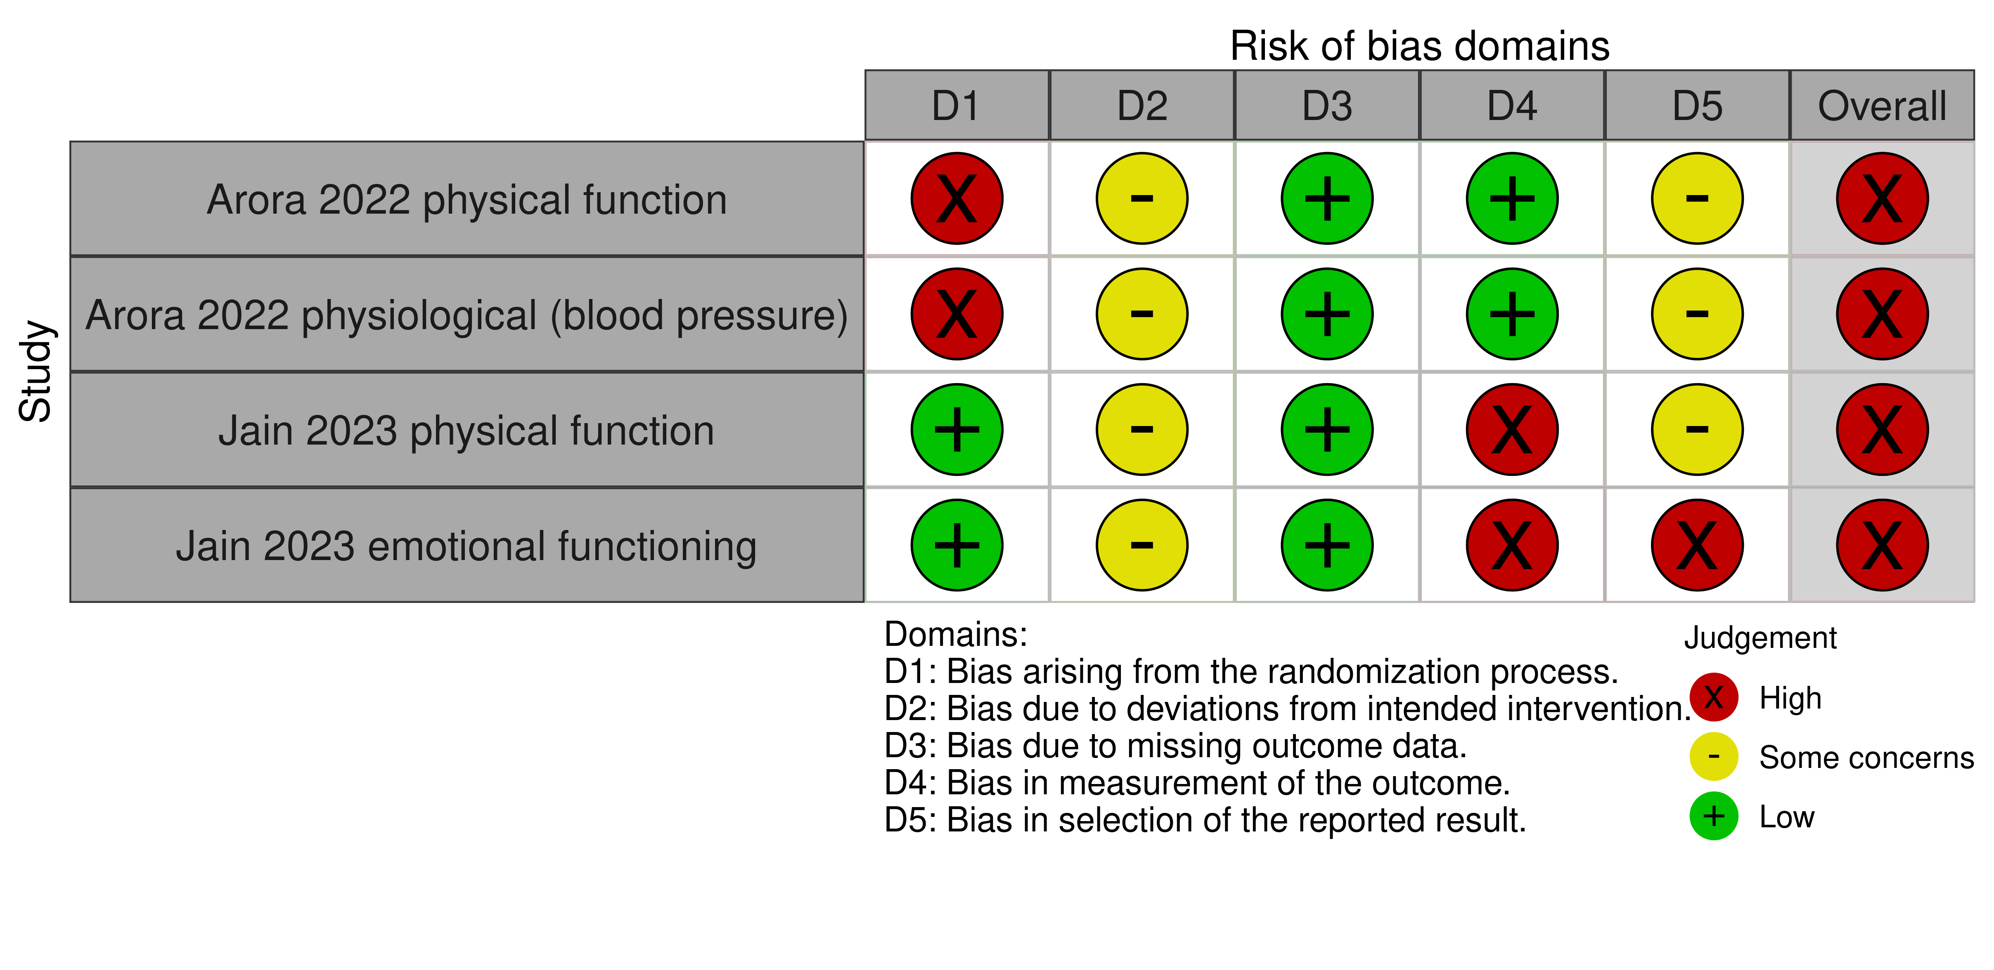

**Fig 4.3.1.1** | Summary of the risk of bias assessments for studies contributing to the comparisons of the Buteyko Method versus inactive control (no intervention or usual care given to both groups). Each outcome for which the study contributed results was assessed separately. The full assessments, with the rationale for judgements, are reported in Appendix F. The overall risk of bias judgement for each study is reported in the forest plots.

#### Effects of the Buteyko Method compared to inactive control

The effects of the Buteyko Method compared to an inactive control are presented in Table 4.3.1.2, the GRADE summary of findings tables. The certainty of evidence, and factors that influenced our certainty, are presented and explained in these tables. Study level and meta-analytic results are presented in forest plots (Figures 4.3.1.2 to 4.3.1.4).

#### Cardiovascular conditions

***Physical function – activity limitations*** *(Figure 4.3.1.2)*

* *Included studies*. One trial involving 66 people with hypertension and one trial involving 44 people in the two-week period after coronary artery bypass graft (CABG) surgery contributed to the analysis.
* *Missing results*. There were no missing studies identified from registry entries or other sources for this analysis.
* *Ongoing studies*. There were no ongoing trials eligible for this analysis.

The evidence about the effect of the Buteyko Method on physical function (activity limitations) for people with cardiovascular conditions is of very low certainty due to study design limitations and imprecision (2 trials, 110 people with hypertension or after CABG surgery; Figure 4.3.1.2).

***Emotional functioning and mental health*** *(Figure 4.3.1.3)*

* *Included studies*. One trial involving 44 people in the two-week period after coronary artery bypass graft (CABG) surgery contributed to the analysis.
* *Missing results*. There were no missing studies identified from registry entries or other sources for this analysis.
* *Ongoing studies*. There were no ongoing trials eligible for this analysis.

The evidence about the effect of the Buteyko Method on emotional functioning and mental health for people with cardiovascular conditions is of very low certainty due to study design limitations, indirectness and publication bias (1 trial, 44 people after CABG surgery; Figure 4.3.1.3).

***Physiological signs and symptoms*** *(Figure 4.3.1.4)*

* *Included studies*. One trial involving 66 people with hypertension contributed to the analysis.
* *Missing results*. One trial involving 42 people with hypertension and history of CABG measured an outcome eligible for this analysis, but there were multiple errors in the reported results, so the study did not contribute to the analysis. One unpublished trial (registered 2018) involving 20 people after CABG surgery is eligible for this analysis.
* *Ongoing studies*. There were no ongoing trials eligible for this analysis.

The evidence about the effect of the Buteyko Method on physiological signs and symptoms (systolic blood pressure) for people with cardiovascular conditions is of very low certainty due to study design limitations, indirectness and publication bias (1 trial, 66 people with hypertension; Figure 4.3.1.4).

***Other outcomes***

No studies reported effects of the Buteyko Method on HR-QoL, symptoms, lung function, breathing patterns and ventilation, or pain for people with cardiovascular conditions. There were no missing results or ongoing studies identified from registry entries or other sources for these analyses, except for lung function (1 ongoing trial, registered 2023, involving 70 people after CABG surgery).

#### Table 4.3.1.2 Summary of findings for the effect of the Buteyko Method versus inactive control (no intervention or usual care given to both groups) for people with cardiovascular conditions.

|  | | | | | | |
| --- | --- | --- | --- | --- | --- | --- |
| Outcomes (populations represented in meta-analysis) | **Anticipated absolute effects\*** (95% CI) | | Relative effect (95% CI) | № of participants (studies)  contributing to meta-analysis | Certainty of the evidence (GRADE) | Interpretation (evidence statement) |
| **Risk with inactive control** | **Risk with Buteyko** |
| Physical function - activity limitations (people with hypertension or after CABG surgery)  (follow up 2 to 4 weeks)a | - | SMD **0.27 SD higher** (2.78 lower to 3.32 higher) | - | 110 (2 RCTs) | ⨁◯◯◯ Very lowb,c,d | The evidence is very uncertain about the effect of Buteyko on physical function (activity limitations) for people with cardiovascular conditions. |
| Emotional functioning and mental health (after CABG surgery)  (follow up 2 weeks)e | - | SMD **2.9 SD lower** (3.73 lower to 2.06 lower) | - | 44 (1 RCT)f | ⨁◯◯◯ Very lowg,h,i | The evidence is very uncertain about the effect of Buteyko on emotional functioning and mental health (anxiety and depression) for people with cardiovascular conditions. |
| Physiological signs and symptoms - systolic blood pressure  (people with hypertension) | - | SMD **1.12 SD lower** (1.63 lower to 0.61 lower) | - | 66 (1 RCT) | ⨁◯◯◯ Very lowg,h,j | The evidence is very uncertain about the effect of Buteyko on physiological signs and symptoms (including blood pressure) for people with cardiovascular conditions. |
| Other outcomes - not reported - not measured | - | - | - | - | - | No studies reported on HR-QoL, symptoms, or pain for people with cardiovascular conditions. |
| \***The risk in the intervention group** (and its 95% confidence interval) is based on the assumed risk in the comparison group and the **relative effect** of the intervention (and its 95% CI). **CI:** confidence interval; **SMD:** standardised mean difference  The threshold for an important difference was an SMD of 0.2 (used for interpreting point estimates and confidence intervals). The resulting interpretations are as follows.   * For physical function (activity limitations): > 0.2 is beneficial, -0.2 to 0.2 is trivial or unimportant ("little or no difference" between treatments), < -0.2 is harmful * For emotional functioning and mental health: < -0.2 is beneficial, -0.2 to 0.2 is trivial or unimportant ("little or no difference" between treatments), > 0.2 is harmful * For physiological signs and symptoms: < -0.2 is beneficial, -0.2 to 0.2 is trivial or unimportant ("little or no difference" between treatments), > 0.2 is harmful | | | | | | |
| **GRADE Working Group grades of evidence** **High certainty:** we are very confident that the true effect lies close to that of the estimate of the effect. **Moderate certainty:** we are moderately confident in the effect estimate: the true effect is likely to be close to the estimate of the effect, but there is a possibility that it is substantially different. **Low certainty:** our confidence in the effect estimate is limited: the true effect may be substantially different from the estimate of the effect. **Very low certainty:** we have very little confidence in the effect estimate: the true effect is likely to be substantially different from the estimate of effect.  **Explanations** are provided for domains for which there is a downgrade or a borderline judgment. In line with GRADE guidance, we do not explain that there are no limitations unless the judgment was challenging (<https://pubmed.ncbi.nlm.nih.gov/26796947/> ) | | | | | | |

#### Explanations

a. Physical function (activity limitations) measures. 6 minute walk test, % predicted value (6 min walk, %PV); Borg rate of perceived exertion (RPE) scale

b. Very serious risk of bias (-2). Two studies at high risk of bias (100% of weight in analysis), and combined effect estimate suggests borderline benefit which could be accounted for by bias.

c. Very serious imprecision (-2). The 95% confidence interval crosses two thresholds for a small but important effect (SMD of 0.2 and -0.2), so the result is compatible with important benefit (SMD 3.32 higher) and important harm (SMD 2.78 lower). However, the CI for the combined estimate has been calculated using a conservative method, so we rated down twice only (i.e. not by -3 as might be indicated by interpreting the CI for the combined estimate alone).

d. Publication bias not detected. While selective non-reporting of unfavourable results (null or favouring control) is a concern when the available evidence is from a small number of small trials, the combined estimate suggests is small and one study indicates little to no effect. It was judged unlikely that unpublished studies would have results that would change this interpretation.

e. EFMH measures. General anxiety disorder 7-item (GAD-7)

f. A second study (Sathe 2000) measured systolic blood pressure in 42 adults, but the reported results from this study contained multiple errors, and the correct results could not be determined, so could not be included in the meta-analysis.

g. Very serious risk of bias (-2). One study at high risk of bias (large effect, 100% of weight in analysis), such that the observed effect may be over estimated.

h. Serious indirectness (-1): Evidence from one small study among people who have undergone CABG Uncertain whether results can be generalised to others with cardiovascular disease

i. Publication bias strongly suspected (-1). Single small trials showing very large effect, so selective non-reporting of unfavourable results (null or favouring control) could importantly change the combined estimate. This is a concern because of evidence of selective non-reporting of unfavourable/uninteresting results in general, and from trials of natural therapies in particular.

j. Publication bias strongly suspected (-1). Single small trials showing very large effect, so selective non-reporting of unfavourable results (null or favouring control) could importantly change the combined estimate. Second small study could not be included because of multiple errors in reported results. This is a concern because of evidence of selective non-reporting of unfavourable/uninteresting results in general, and from trials of natural therapies in particular.

#### Forest plots and analysis

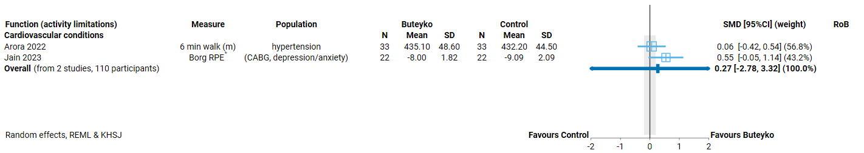

**Fig 4.3.1.2** | Forest plot for main comparison. The effect of the Buteyko Method versus inactive control (no intervention or usual care given to both groups) on physical function (activity limitations) for people with cardiovascular conditions. SMD=standardised mean difference. Blue lines show 95% confidence intervals (CI). The shaded grey area indicates the pre-specified range where the effect of the Buteyko Method is considered to be no different from control (SMD -0.2 to 0.2 standard units). * Denotes studies for which the direction of effect was changed to match the overall plot (positive numbers are beneficial).

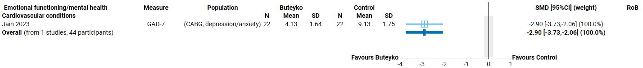

**Fig 4.3.1.3** | Forest plot for main comparison. The effect of the Buteyko Method versus inactive control no intervention or usual care given to both groups) on emotional functioning and mental health for people with cardiovascular conditions. SMD=standardised mean difference. Blue lines show 95% confidence intervals (CI). The shaded grey area indicates the pre-specified range where the effect of the Buteyko Method is considered to be no different from control (SMD -0.2 to 0.2 standard units).

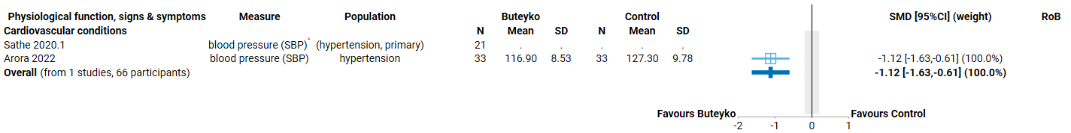

**Fig 4.3.1.4** | Forest plot for main comparison. The effect of the Buteyko Method versus inactive control (no intervention or usual care given to both groups) on physiological signs and symptoms for people with cardiovascular conditions. SMD=standardised mean difference. Blue lines show 95% confidence intervals (CI). The shaded grey area indicates the pre-specified range where the effect of the Buteyko Method is considered to be no different from control (SMD -0.2 to 0.2 standard units). ^ indicates studies for which data transformation or imputation was required to include the result in the meta-analysis. For studies with results not reported (NR), the data required for transformation were missing or the result was uninterpretable

## **4.4 Eustachian tube dysfunction**

One trial evaluated the effects of the Buteyko Method for people with eustachian tube dysfunction. The trial contributed a result for a single outcome.

***Prioritised outcome domains*** for this population were:

* HR-QoL (critical for decision making)
* Symptoms (critical for decision making)
* Physical function - hearing (critical for decision making)
* Physical function - balance (important but not critical for decision making)
* Emotional functioning and mental health (EFMH) (important but not critical for decision making)
* Pain (important but not critical for decision making)

### 4.4.1 Buteyko compared to inactive control

#### Characteristics of included studies

Brief characteristics of the single study that compared the Buteyko Method to an inactive control are summarised in Table 4.4.1.1 and full details are in Appendix E1. The outcome measure from which data were included is reported for the single contributing trial in the forest plot (column 2, Figure 4.4.1.2). For all results, the outcome selected for analysis was measured at the end of the intervention period (or close to) (see Table 4.4.1.1). Full details are reported in Appendix E1 for each study, including a list of all outcome measures, details of which outcome was selected when multiple were available for an outcome domain, and the timing of outcome measurement in relation to intervention.

**Table 4.4.1** Characteristics of studies comparing the Buteyko Method to an inactive control for people with eustachian tube dysfunction.

| **Study** | **Population* (ICD-11 code)** | **Intervention** | | | **Comparator** | **Outcome domains ⱡ** | | | | | |
| --- | --- | --- | --- | --- | --- | --- | --- | --- | --- | --- | --- |
| **Content** | **Provider** | **No. sessions, duration & frequency** | **HR-QoL** | **Symptoms** | **Function - hearing** | **Function - balance** | **EFMH\*** | **Measured** |
| **Eustachian tube dysfunction** | | | | | | | | | | | |
| **Zeng 2019** China | 56 adults (~40 years) with obstructive eustachian tube dysfunction > 3 months (AB10 Disorders of Eustachian tube) | **Training**: on Buteyko breathing techniques to reduce depth and frequency of breathing (details NR) **Practise**: details NR. Advice to practise at home. | Buteyko qualified trainer | Number, duration and frequency of sessions NR.  **At home:** throughout day (frequency NR; assumed over 12 weeks based on follow up) | Usual care (both groups) - nasal steroid (2 x sprays per nostril 1 x per day of budesonide, 256 μg total) |  | **X** |  |  |  | end week 12 |

*number of participants is the number from eligible groups (randomised if reported, otherwise number at follow-up); X results included in meta-analysis; X† outcome reported as measured in results paper, but results unavailable for meta-analysis (not reported, incompletely reported or uninterpretable); Xⱡ outcomes reported as measured in registry entry (not mentioned elsewhere)Abbreviations: NR=not reported, yrs=years

#### Risk of bias in included trials

A summary of the risk of bias assessments for this comparison is presented in Figure 4.2.1.1 and the overall risk of bias judgement for each study is reported in the forest plots (each outcome from a study was assessed separately). The complete assessments and judgements are reported in Appendix F. We do not report assessments for studies that do not have results contributing to a meta-analysis because these studies have no influence over the effect estimate and, hence, are not considered when judging the overall risk of bias in the GRADE assessment of the synthesis results.

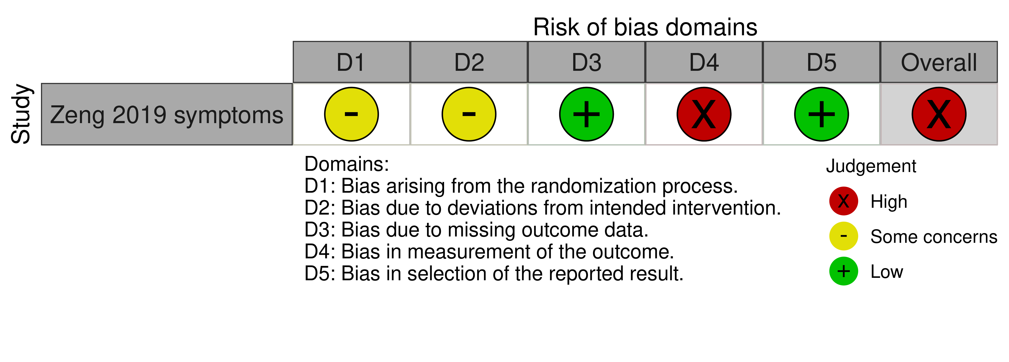

**Fig 4.4.1.1** | Summary of the risk of bias assessments for studies contributing to the comparisons of the Buteyko Method versus inactive control (usual care given to both groups). The full assessments, with the rationale for judgements, are reported in Appendix F. The overall risk of bias judgement for each study is reported in the forest plots.

#### Effects of the Buteyko Method compared to inactive control

The effects of the Buteyko Method compared to an inactive control are presented in Table 4.4.1.2, the GRADE summary of findings tables. The certainty of evidence, and factors that influenced our certainty, are presented and explained in this table. The study level result for symptoms from the single trial is presented in a forest plot (Figure 4.4.1.2).

***Symptoms*** *(Figure 4.4.1.2)*

* *Included studies*. One trial involving 51 people with eustachian tube dysfunction contributed to the analysis.
* *Missing results*. There were no missing studies identified from registry entries or other sources for this analysis.
* *Ongoing studies*. There were no ongoing trials eligible for this analysis.

The evidence about the effect of the Buteyko Method on symptoms for people with eustachian tube dysfunction is of very low certainty due to study design limitations, indirectness and imprecision (1 trial, 51 people with eustachian tube dysfunction; Figure 4.4.1.2).

***Other outcomes***

No studies reported effects of the Buteyko Method on HR-QoL, physical function – hearing, physical function – balance, emotional functioning and mental health, or pain for people with eustachian tube dysfunction. There were no missing results or ongoing studies identified from registry entries or other sources for these analyses.

#### Table 4.4.1.2 Summary of findings for the effect of the Buteyko Method versus inactive control (usual care given to both groups) for people with Eustachian tube dysfunction.

| **The Buteyko Method compared to inactive control for eustachian tube dysfunction** | | | | | | |
| --- | --- | --- | --- | --- | --- | --- |
| Outcomes (populations represented in meta-analysis) | **Anticipated absolute effects\*** (95% CI) | | Relative effect (95% CI) | № of participants (studies)  contributing to meta-analysis | Certainty of the evidence (GRADE) | Interpretation (evidence statement) |
| **Risk with inactive control** | **Risk with Buteyko** |
| Symptoms  (follow up 4 weeks)a | - | SMD **0.75 SD lower** (1.62 lower to 0.11 higher) | - | 51 (1 RCT) | ⨁◯◯◯ Very lowb,c,d,e | The evidence is very uncertain about the effect of Buteyko on symptoms for people with eustachian tube dysfunction. |
| Other outcomes - not reported - not reported | - | - | - | - | - | No studies reported on HR-QoL, physical function - hearing, physical function - balance, emotional functioning and mental health, or pain for people with eustachian tube dysfunction. |
| \***The risk in the intervention group** (and its 95% confidence interval) is based on the assumed risk in the comparison group and the **relative effect** of the intervention (and its 95% CI). **CI:** confidence interval; **SMD:** standardised mean difference  The threshold for an important difference was an SMD of 0.2 (used for interpreting point estimates and confidence intervals). The resulting interpretations are as follows.   * For symptoms: < -0.2 is beneficial, -0.2 to 0.2 is trivial or unimportant ("little or no difference" between treatments), > 0.2 is harmful | | | | | | |
| **GRADE Working Group grades of evidence** **High certainty:** we are very confident that the true effect lies close to that of the estimate of the effect. **Moderate certainty:** we are moderately confident in the effect estimate: the true effect is likely to be close to the estimate of the effect, but there is a possibility that it is substantially different. **Low certainty:** our confidence in the effect estimate is limited: the true effect may be substantially different from the estimate of the effect. **Very low certainty:** we have very little confidence in the effect estimate: the true effect is likely to be substantially different from the estimate of effect.  **Explanations** are provided for domains for which there is a downgrade or a borderline judgment. In line with GRADE guidance, we do not explain that there are no limitations unless the judgment was challenging (<https://pubmed.ncbi.nlm.nih.gov/26796947/> ) | | | | | | |

#### Explanations

a. Symptom measures. Eustachian tube dysfunction (ETDQ-7) questionnaire

b. Serious risk of bias (-1). One study at high risk of bias. Rated down one level (not two) because bias is unlikely to fully account for the observed benefit.

c. Serious indirectness (-1): Evidence from one small study among people with eustachian tube dysfunction. Uncertain if results would be generalisable to others with eustachian tube dysfunction.

d. Serious imprecision (-1). The 95% confidence interval (CI) crosses the threshold for a small but important effect (SMD of 0.2), so the result is compatible with important benefit (SMD 1.62 lower) and little to no difference (SMD 0.11 higher).

e. Publication bias not detected. While selective non-reporting of unfavourable results (null or favouring control) is a concern when the available evidence is from a single small trial, it was judged unlikely that other studies on this condition would be available but not reported.

#### Forest plots and analysis

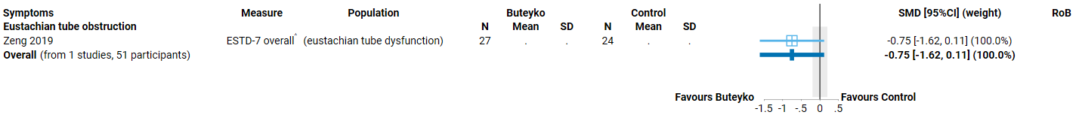

**Fig 4.4.1.2** | Forest plot for main comparison. The effect of the Buteyko Method versus inactive control (usual care given to both groups) on symptoms for people with Eustachian tube dysfunction. SMD=standardised mean difference. Blue lines show 95% confidence intervals (CI). The shaded grey area indicates the pre-specified range where the effect of the Buteyko Method is considered to be no different from control (SMD -0.2 to 0.2 standard units). ^ indicates studies for which data transformation or imputation was required to include the result in the meta-analysis. For studies with results not reported (NR), the data required for transformation were missing or the result was uninterpretable

# 5. Discussion

## Summary of the main results

This review assessed the available evidence on the Buteyko Method to inform the Australian Government about health policy decisions for private health insurance rebates. This review was not designed to assess all the reasons that people use the Buteyko Method, or the reasons practitioners prescribe the Buteyko Method and was not intended to inform individual choices about using the Buteyko Method.

We found 32 eligible studies (all randomised trials) of which 12 compared the Buteyko Method to an inactive comparator (e.g. usual care, no treatment; one did not measure any eligible outcomes). The other 20 trials compared the Buteyko Method to another treatment (mostly other breathing techniques). With the exception of pranayama (a breathing technique used in yoga which is not evidence-based), no 2 trials compared the Buteyko Method to the same treatment in the same population (the prespecified criteria for synthesis of evidence-based ‘gold standard’ treatments), so we did not synthesise evidence about the effects of the Buteyko Method compared to other treatments.

The 11 studies that compared **the Buteyko Method to an inactive control** involved people with chronic respiratory conditions (6 randomised trials on asthma, 1 on chronic obstructive pulmonary disorder), cardiovascular conditions (2 trials on hypertension, 1 after coronary artery bypass graft surgery), and conditions affecting the middle ear (1 trial on eustachian tube dysfunction). Results from these syntheses are as follows.

For people with **asthma**,

* There is low certainty evidence that the Buteyko Method may reduce symptoms (6 trials, 339 adults and children),
* The Buteyko Method has very uncertain effects on health-related quality of life, physical function - activity limitations, lung function, and emotional functioning and mental health, and
* The Buteyko Method has unknown effects on breathing patterns/ventilation because no studies reported on these outcomes. Medication use was reported under symptoms where possible and no additional studies were found.

For people with **chronic obstructive pulmonary diseases (COPD)**,

* The Buteyko Method has very uncertain effects on physical function - activity limitations and lung function, and
* The Buteyko Method has unknown effects on HR-QoL, symptoms (e.g. dyspnoea), emotional functioning and mental health, breathing patterns/ventilation (eligible outcomes) or healthcare resource use because no studies reported on these outcomes.

For people with **hypertension or recovering from CABG surgery**,

* The Buteyko Method has very uncertain effects on physical function – activity limitations, emotional functioning and mental health, and physiological signs and symptoms, and
* The Buteyko Method has unknown effects on HR-QoL, symptoms, lung function, breathing patterns and ventilation, or pain because no studies reported on these outcomes.

For people with **eustachian tube dysfunction**,

* The Buteyko Method has very uncertain effects on symptoms, and
* The Buteyko Method has unknown effects on HR-QoL, physical function – hearing, physical function – balance, emotional functioning and mental health, or pain because no studies reported on these outcomes.

No studies examined effects among other conditions for which the Buteyko Method may be used.

The effects of the Buteyko Method compared to other active comparators was not examined, as pre-specified criteria for synthesis were not met (i.e. no two studies at low risk of bias evaluated the same evidence-based treatment in the same population). Studies that only contributed active comparators are listed in an inventory (Appendix C3 and E3).

### Comparability of these findings with other systematic reviews

There are Cochrane systematic reviews on the effects of breathing techniques for asthma management [9], chronic obstructive pulmonary disease [12], and dysfunctional breathing (hyperventilation syndrome) among adults [10] and children [38]. The Buteyko Method was an eligible intervention for all of these reviews. Consistent with our review, no trials of the Buteyko Method were found for either review of dysfunctional breathing or for the review of COPD (the only study we found of the Buteyko Method for COPD post-dated the Cochrane review). The review of breathing techniques for asthma management included two trials of the Buteyko Method (both included in our review), with similar results for HR-QoL, symptoms and lung function from the single trial contributing data for analysis (Prem 2013) but conclusions of the review were based on overall findings for all breathing techniques. An older review conducted for the Agency for Health Research and Quality (AHRQ) on breathing exercises and/or retraining for asthma included three trials of the Buteyko Method in comparisons of ‘comprehensive hyperventilation reduction training’ to inactive comparators [39]. Of these three trials, one was included in our analysis (Opat 2000), one was included on the evidence inventory (comparator was a placebo ‘pink city lung’ device) and a third is a trial we list as awaiting classification (reported only in an abstract McGowen 2003, Appendix C3). This unpublished and unregistered trial is reported as involving 600 people; data from the 244 remaining at follow-up suggested very large effects on asthma symptoms according to the AHRQ review (based on email correspondence with the trialist). The trial remains unpublished, and so these results cannot be verified. None of the reviews limited their synthesis to the Buteyko Method, and they did not draw separate conclusions for the Buteyko Method, so it is not possible to compare the findings directly.

## Overall completeness and applicability of evidence

Evidence evaluating the effects of the Buteyko Method is limited to a small number of trials among people with chronic respiratory conditions (mainly asthma), those with cardiovascular risk factors or conditions (hypertension or having undergone CABG surgery), and eustachian tube dysfunction[3]. There are no studies examining effects on other conditions for which the Buteyko Method has been suggested, including dysfunctional breathing (hyperventilation syndrome), sleep disorders (especially sleep apnoea), allergies affecting the respiratory system, sinusitis, and breathing abnormalities (e.g. chronic mouth breathing in children). Five (5) small ongoing trials and one recently published trial (after the last search date) may provide some limited additional evidence for people with asthma.

Of the 6 studies that compared the Buteyko Method to an inactive comparator for asthma, all measured asthma symptoms and at least one other outcome rated as critical for decision making. With the exception of symptoms, coverage of critical outcome domains recommended in core outcome sets was patchy. For example, only 2 trials that evaluated the Buteyko Method for asthma measured health-related quality of life. In most cases, evidence for different outcome domains could only be reported by including multiple results from the same instrument (e.g. overall health-related quality of life scores and the subscale for activity limitations), which indicates the sparsity of evidence. Most studies on asthma used well-validated measurement methods, recommended in core outcome sets or similar sources. There was very limited coverage of core outcomes for other conditions.

Studies included in the analysis were conducted in India (6 trials), Egypt (2 trials), Australia, Germany and China (one trial each). Most were set in hospital outpatient clinics. It is unclear whether evidence from outside Australia is applicable to the Australian context. Studies generally involved 20-60 min sessions over 3 days to 6 weeks, followed by daily practice at home for 1 to 3 months. The effects of longer-term use or practice of the Buteyko Method are unknown.

## Certainty of the evidence

Limitations of the evidence were considered when interpreting each result by applying the GRADE approach. The overriding limitation is that most analyses included very few trials; the largest – examining the effects of the Buteyko Method on asthma symptoms included 6 small trials (28 to 100 participants). For most outcomes, there was only a small number of participants contributing data, which led to imprecise effect estimates (compatible with benefit and little to no effect). In some cases, the imprecision was extreme, meaning that the result was compatible with both important benefit and important harm. In addition, all of the trials included in the review were rated at high risk of bias or some concerns because of important and mostly preventable limitations in their study design.

The comparatively large number of unpublished trials and the large effects observed in those trials with results available for analysis, raises concern that trials (and outcomes within trials) have been selectively reported based on the observed effects. In particular, we are concerned that studies with less favourable results may remain unpublished. For results derived from one or 2 small trials that show important benefit, selective non-reporting of unfavourable results (null or favouring control) could importantly change the result. We were unable to use graphical methods to investigate whether studies showing different effects (favouring control, trivial effects) may be missing from the analyses and, as such, we judged that publication bias was a concern for some results.

In addition to factors addressed in the GRADE assessment, there were problems with the completeness and accuracy of reporting in most studies. This had implications for the assessment of risk of bias, for example, at least 4 trials used the term ‘randomised’ but without any description to confirm that a genuine attempt to randomise participants to treatment groups had been made. Incomplete and inaccurate reporting of results also precluded inclusion of data from 2 studies in at least one of the meta-analyses for which they were eligible.

## Potential biases in the review process

In this review we applied methods recommended in *the Cochrane Handbook for Systematic Reviews of Interventions* and the GRADE approach, as per the detailed protocol that was prospectively registered on PROSPERO after undergoing independent methodological review. The final synthesis questions and list of outcomes prioritised for the synthesis were determined through a pre-specified process, performed by NTWC, with input from NTREAP, without knowledge of the included studies or results of those studies. NTWC, with input from NTREAP, also clarified inclusion based on the intervention. An initial analytic framework for the review was included in the protocol to inform these decisions and propose a structure for the synthesis.

While data extraction for each study was performed by a single reviewer, the selection of outcomes and quantitative data extraction were checked by a second experienced review author. All quantitative data were checked prior to analysis by a biostatistician, and all data manipulation and analyses were performed by a biostatistician. These steps minimised the risk of errors or misinterpretation. Risk of bias assessments were performed for each study by a single reviewer who is an experienced biostatistician and followed detailed guidance developed for the natural therapies reviews to ensure consistency across reviewers. Checks were performed by a second experienced reviewer.

While we endeavoured to include all available studies in the analyses (applying all suggested methods from the Cochrane Handbook), several studies reported data that required manipulation or imputation for inclusion in analyses. We were unable to perform sensitivity analyses to examine the impact of these calculations or decisions because of the small number of studies. However, effects were consistent with those reported in included studies. Consistent with the protocol and the approach taken in other natural therapies reviews, we did not contact trialists for additional information.

# 6. Conclusions

## Implications for health policy

We found 11 trials that evaluated the effects of the Buteyko Method compared to usual care or no intervention on prioritised outcomes. All are small trials (28 to 100 participants) mostly among adults or children with asthma. There are serious limitations in the design of these trials, in addition to concerns that multiple unpublished trials may show different effects from the studies included in the review. In combination, these factors mean that we are very uncertain about the effects of the Buteyko Method on most critical and important outcomes for people with asthma. We found evidence from six trials that the Buteyko Method may reduce symptoms for people with asthma. For other conditions, including COPD, hypertension and eustachian tube dysfunction, effects on critical and important outcomes such as health-related quality of life, symptoms and physical function are very uncertain or unknown. Although there are other systematic reviews that include the Buteyko Method, the findings cannot be compared because other reviews combine studies of the Buteyko Method with other breathing techniques. There are no studies involving people with other conditions for which the Buteyko Method may be used, such as dysfunctional breathing (hyperventilation syndrome) and sleep disorders (especially sleep apnoea). This review listed, but did not assess studies that compared the effects of the Buteyko Method to other interventions, so no conclusions can be drawn on whether the Buteyko Method is as effective as other interventions. Studies published in a language other than English were to be listed, but not included in the evaluation, however none were found. Studies generally involved 20-60 min sessions over 3 days to 6 weeks with a health professional, followed by daily practice at home for 1 to 3 months. The effects of longer-term practice of the Buteyko Method are unknown.

## Implications for future research

Future research on the effectiveness of the Buteyko Method could be improved by ensuring the choice of comparators facilitates synthesis; either by including inactive controls (e.g. usual care delivered to both groups, sham interventions) or standardised active comparators. In designing studies, attention should be given to the power of the trial, adequately describing all trial arms, implementing study design features that minimise the risk of bias, measuring outcomes that are well established and patient relevant (e.g. as identified in consensus-based core outcome sets), reporting all measured outcomes and ensuring trials are registered and reported in accordance with relevant reporting guidelines.

# 7. Author contributions and declaration of interest

|  |  |
| --- | --- |
| Sue Brennan1*  [sue.brennan@monash.edu](mailto:sue.brennan@monash.edu)  *(contact author) | Senior Evidence Officer responsible for oversight of the review. Led the design of the review and data extraction systems, and the implementation of risk of bias assessment across natural therapies reviews conducted by Cochrane Australia. Extracted data and assessed risk of bias. Led writing of the review report and methods appendix with other contributors (as described). |
| Max Murano1 | Implemented and managed electronic systems for screening studies and data extraction, and associated work processes. Managed and coordinated study selection, selected studies, and performed data checking. Prepared material for the report and technical appendices, and contributed to writing of the report, including methods and results for search, study selection and data collection. |
| Simon Turner2 | Provided advice on extraction of results data, prepared the data set for meta-analysis (including transformations and manipulations required to include results in analysis), conducted all meta-analyses and prepared forest plots for the report. |
| Steve McDonald1 | Developed, wrote and implemented the search strategy. Screened studies for inclusion in the review and piloted data collection and risk of bias methods. Prepared material for the report and technical appendices. Wrote the search methods and results, and study selection. |
| Joanne McKenzie2 | Wrote the analysis plan and method for reporting treatment effects. Wrote the section on *Assessment of biases due to missing results*. Designed the data collection form for quantitative results data. Conducted risk of bias assessments. Provided statistical advice on risk of bias assessment, data extraction/transformation/manipulations and interpretation. Provided oversight for the conduct and interpretation of the analysis. |

1 Cochrane Australia, Evidence Synthesis Qualitative & Implementation Methods Unit, School of Public Health and Preventive Medicine, Monash University

2 Methods in Evidence Synthesis Unit, School of Public Health and Preventive Medicine, Monash University

## Declarations of interest

All authors declare they have no financial, personal or professional interests that could be construed to influence the conduct or results of this systematic review.

## Acknowledgements

Phoebe Nguyen2, Kimberley Jones3 and Annie Synnot1 contributed to the development of the data extraction tool and review-specific risk of bias guidance through application in the first natural therapies review of aromatherapy (>200 studies)

3 Indigenous Health Equity Unit, Melbourne School of Population and Global Health, University of Melbourne

## Funding

This review is funded by the Australian Government Department of Health and Aged Care via the NHMRC, under Official Order 2021-22C021.

# References

1. Higgins JPT, Thomas J, Chandler J, Cumpston M, Li T, Page M, Welch V (Eds.): **Cochrane Handbook for Systematic Reviews of Interventions version 6.1 (updated September 2020). Cochrane. Available from** **www.training.cochrane.org/handbook**; 2020.

2. Schünemann HJ, Higgins J, Vist GE, Glasziou P, Akl EA, Skoetz N, Guyatt GH, On behalf of the Cochrane GRADEing Methods Group (formerly Applicability and Recommendations Methods Group) and the Cochrane Statistical Methods Group: **Chapter 14: Completing ‘Summary of findings’ tables and grading the certainty of the evidence.** In *Cochrane Handbook for Systematic Reviews of Interventions.* 2nd edition. Edited by Higgins J, Thomas J, Chandler J, Cumpston M, Li T, Welch V. Chichester (UK): John Wiley & Sons; 2019

3. Schünemann HJ, Vist GE, Higgins J, Santesso N, Deeks JJ, Glasziou P, Akl EA, Guyatt GH, On behalf of the Cochrane GRADEing Methods Group: **Chapter 15: Interpreting results and drawing conclusions.** In *Cochrane Handbook for Systematic Reviews of Interventions.* 2nd edition. Edited by Higgins J, Thomas J, Chandler J, Cumpston M, Li T, Welch V. Chichester (UK): John Wiley & Sons; 2019

4. Brennan SE, Johnston RV: **Research Note: Interpreting findings of a systematic review using GRADE methods.** *Journal of Physiotherapy* 2023.

5. Page MJ, McKenzie JE, Bossuyt PM, Boutron I, Hoffmann TC, Mulrow CD, Shamseer L, Tetzlaff JM, Akl EA, Brennan SE, et al: **The PRISMA 2020 statement: an updated guideline for reporting systematic reviews.** *BMJ* 2021, **372:**n71.

6. Page MJ, Moher D, Bossuyt PM, Boutron I, Hoffmann TC, Mulrow CD, Shamseer L, Tetzlaff JM, Akl EA, Brennan SE, et al: **PRISMA 2020 explanation and elaboration: updated guidance and exemplars for reporting systematic reviews.** *BMJ* 2021, **372:**n160.

7. National Health and Medical Research Council: **Statement of requirement: Evidence evaluations for review of natural therapies (tranche two).** 2020.

8. Illidi C, Romer L, Johnson M, Williams N, Rossiter H, Casaburi R, Tiller N: **Distinguishing science from pseudoscience in commercial respiratory interventions: an evidence-based guide for health and exercise professionals.** *European Journal of Applied Physiology* 2023.

9. Santino TA, Chaves GSS, Freitas DA, Fregonezi GAF, Mendonça K: **Breathing exercises for adults with asthma.** *Cochrane Database of Systematic Reviews* 2020.

10. Jones M, Harvey A, Marston L, O'Connell NE: **Breathing exercises for dysfunctional breathing/hyperventilation syndrome in adults.** *Cochrane Database of Systematic Reviews* 2013.

11. Bott J, Blumenthal S, Buxton M, Ellum S, Falconer C, Garrod R, Harvey A, Hughes T, Lincoln M, Mikelsons C, et al: **Guidelines for the physiotherapy management of the adult, medical, spontaneously breathing patient.** *Thorax* 2009, **64:**i1-i52.

12. Holland AE, Hill CJ, Jones AY, McDonald CF: **Breathing exercises for chronic obstructive pulmonary disease.** *Cochrane Database of Systematic Reviews* 2012.

13. Courtney R: **Buteyko breathing method.** In *Recognising and treating breathing disorders: A multidisciplinary approach.* 2nd edition. Edited by Chaitow L, Bradley D, Gilbert G: Churchill Livingstone; 2014: 241-247

14. Steel A, McIntyre E, Harnett J, Foley H, Adams J, Sibbritt D, Wardle J, Frawley J: **Complementary medicine use in the Australian population: Results of a nationally-representative cross-sectional survey.** *Sci Rep* 2018, **8:**17325.

15. National Health and Medical Research Council: **Buteyko description developed in conversation with the National Health and Medical Research Council’s Natural Therapies Working Committee Chair and the Department of Health’s Natural Therapies Review Expert Advisory Panel (February 2020).** 2020.

16. **Buteyko Institute Method** [<https://buteyko.info/buteyko-method/>]

17. Bruton A, Lewith GT: **The Buteyko breathing technique for asthma: a review.** *Complementary therapies in medicine* 2005, **13:**41-46.

18. Austin G: **Buteyko technique use to control asthma symptoms.** *Nursing Times* 2013, **109:**16-17.

19. **Practitioner training** [<https://buteyko.info/practitioner-training/>]

20. **Course Schedule** [<https://buteykoairways.com.au/learn-buteyko/course-schedule/>]

21. **[Buteyko] Self study online courses** [<https://buteykoclinic.com/buteyko-clinic-online-courses/>]

22. Courtney R: **Strengths, weaknesses, and possibilities of the Buteyko breathing method.** *Biofeedback* 2008, **36:**59-63.

23. Australian Health Practitioner Regulatory Association: **Public consultation on clearer regulation of medical practitioners who provide complementary and unconventional medicine and emerging treatments. Available from:** [**https://www.ahpra.gov.au/**](https://www.ahpra.gov.au/) **Access date: 4 February 2021** 2021.

24. Burgess J, Ekanayake B, Lowe A, Dunt D, Thien F, Dharmage SC: **Systematic review of the effectiveness of breathing retraining in asthma management.** *Expert review of respiratory medicine* 2011, **5:**789-807.

25. Mendonça K, Collins S, Santos TZ, Chaves G, Leite S, Santino TA, Monteiro KS: **Buteyko method for people with asthma: a protocol for a systematic review and meta-analysis.** *BMJ Open* 2021, **11:**e049213.

26. Scottish Intercollegiate Guidelines Network, British Thoracic Society: **British guideline on the management of asthma.** Edinburgh (UK): Healthcare Improvement Scotland; 2019 (revised).

27. **Australian Asthma Handbook** [www.asthmahandbook.org.au]

28. Australian Government Department of Health: **Review of the Australian Government Rebate on Natural Therapies for Private Health Insurance.** 2015.

29. Higgins JPT, Savovic J, Page MJ, Sterne JAC: **Revised Cochrane risk-of-bias tool for randomized trials (RoB 2). Available from** [**https://www.riskofbias.info/welcome/rob-2-0-tool/current-version-of-rob-2**](https://www.riskofbias.info/welcome/rob-2-0-tool/current-version-of-rob-2)**. Access date: 8 February 2021.** 2019.

30. Harris PA, Taylor R, Minor BL, Elliott V, Fernandez M, O'Neal L, McLeod L, Delacqua G, Delacqua F, Kirby J, Duda SN: **The REDCap consortium: Building an international community of software platform partners.** *J Biomed Inform* 2019, **95:**103208.

31. Harris PA, Taylor R, Thielke R, Payne J, Gonzalez N, Conde JG: **Research electronic data capture (REDCap)—A metadata-driven methodology and workflow process for providing translational research informatics support.** *J Biomed Inform* 2009, **42:**377-381.

32. Sterne JAC, Savovic J, Page MJ, Elbers RG, Blencowe NS, Boutron I, Cates CJ, Cheng HY, Corbett MS, Eldridge SM, et al: **RoB 2: a revised tool for assessing risk of bias in randomised trials.** *BMJ* 2019, **366:**l4898.

33. Zeng L, Brignardello-Petersen R, Hultcrantz M, Siemieniuk RAC, Santesso N, Traversy G, Izcovich A, Sadeghirad B, Alexander PE, Devji T, et al: **GRADE guidelines 32: GRADE offers guidance on choosing targets of GRADE certainty of evidence ratings.** *J Clin Epidemiol* 2021, **137:**163-175.

34. Schunemann HJ, Brozek J, Guyatt G, Oxman AD (Eds.): **Handbook for grading the quality of evidence and the strength of recommendations using the GRADE approach**. Hamilton, Canada: McMaster University; 2013.

35. Santesso N, Carrasco-Labra A, Langendam M, Brignardello-Petersen R, Mustafa RA, Heus P, Lasserson T, Opiyo N, Kunnamo I, Sinclair D, et al: **Improving GRADE Evidence Tables part 3: Guidance for useful GRADE certainty in the evidence judgments through explanatory footnotes.** *J Clin Epidemiol* 2016.

36. Santesso N, Glenton C, Dahm P, Garner P, Akl EA, Alper B, Brignardello-Petersen R, Carrasco-Labra A, De Beer H, Hultcrantz M, et al: **GRADE guidelines: 26. informative statements to communicate the findings of systematic reviews of interventions.** *Journal of Clinical Epidemiology* 2019.

37. Piggott T, Morgan RL, Cuello-Garcia CA, Santesso N, Mustafa RA, Meerpohl JJ, Schünemann HJ: **Grading of Recommendations Assessment, Development, and Evaluations (GRADE) notes: extremely serious, GRADE's terminology for rating down by three levels.** *Journal of Clinical Epidemiology* 2020, **120:**116-120.

38. Barker NJ, Jones M, O'Connell NE, Everard ML: **Breathing exercises for dysfunctional breathing/hyperventilation syndrome in children.** *Cochrane Database of Systematic Reviews* 2013.

39. O’Connor E, Patnode CD, Burda BU, Buckley DI, Whitlock EP: **Breathing Exercises and/or Retraining Techniques in the Treatment of Asthma: Comparative Effectiveness: .** In *AHRQ Comparative Effectiveness Reviews.* Rockville (MD): Agency for Healthcare Research and Quality (US); 2012

1. Following completion of the review, a registered trial of the Buteyko Method for anxiety was identified as having been published. The trial did not include the word Buteyko in the title, abstract or keywords. The trial has not been integrated in the results, but results are presented in a summary of findings table in Appendix J.
2. Following completion of the review, a registered trial of the Buteyko Method for anxiety was identified as having been published. The trial did not include the word Buteyko in the title, abstract or keywords. The trial has not been integrated in the results, but the evidence was of very low certainty and therefore did not change the overall conclusion of the review. A summary of findings table reporting the results and assessment of certainty is in Appendix J.
3. Following completion of the review, a registered trial of the Buteyko Method for anxiety was identified as having been published. The trial did not include the word Buteyko in the title, abstract or keywords. The trial has not been integrated in the results however the evidence was very low certainty and therefore does not change the overall conclusion of the review. A summary of findings table reporting the results and assessment of certainty is in Appendix J.