Systematic review of evidence on the clinical effectiveness of Bowen therapy

Report prepared by

Cochrane Australia

4 November 2024

Contents

Plain language summary 6

What was the aim of the review? 6

Key messages 6

What was studied in the review? 6

What were the main results of the review? 7

Implications for health policy and research 8

How up-to-date is the review? 8

Executive summary 9

Background 9

Objectives 9

Methods 9

Criteria for including studies in the review 9

Search methods 10

Analytic framework for synthesis and prioritisation process 10

Data collection and analysis 10

Main results 10

Effects of Bowen therapy 11

Limitations 11

Of the evidence contributing to the review 11

Of the review process 12

Conclusions 12

Implications for health policy 12

Implications for future research 12

1. Background 13

1.1 Description of the intervention 13

1.2 How Bowen therapy might work 13

1.3 Description of conditions for which Bowen therapy is used 14

1.4 Why it is important to do this review 14

2. Objectives 15

Primary objective was to answer the following question 15

Secondary objectives 15

3. Summary of methods 16

3.1 Criteria for considering studies for this review 16

3.1.1 Types of studies 16

3.1.2 Types of participants 16

3.1.3 Types of interventions 16

3.1.4 Types of outcomes 17

3.2 Search methods for identification of studies 17

3.3 Selection of studies 17

3.4 Prioritisation of outcomes for the synthesis 18

3.5 Final framework: synthesis questions and criteria for including studies in each synthesis 18

3.6 Data extraction and management 20

3.6.1 Data extraction 20

3.6.2 Assessment of risk of bias in individual studies 20

3.6.3 Measures and interpretation of treatment effect 20

3.7 Data synthesis 20

3.7.1 Meta-analysis 20

3.7.2 Summary of findings tables and assessment of certainty of the body of evidence 20

3.7.3 Interpretation of findings (evidence statements) 21

4. Results 22

4.1 Results of the search 22

Included studies 23

Excluded studies 23

Studies awaiting classification 23

Ongoing and unpublished studies 23

4.2 Pain conditions 25

4.2.1 Main comparison: Bowen therapy compared to inactive control 25

4.2.2 Bowen therapy compared to active controls 36

5. Discussion 41

Summary of the main results 41

Comparability of these findings with other systematic reviews 41

Overall completeness and applicability of evidence 41

Certainty of the evidence 42

Potential biases in the review process 42

6. Conclusions 42

Implications for health policy 43

Implications for future research 43

7. Author contributions and declaration of interest 44

Declarations of interest 44

Acknowledgements 44

Funding 44

8. References 45

In November 2020 Cochrane Australia was contracted by the National Health and Medical Research Council (NHMRC) to design and undertake the systematic review described in this report. This systematic review is one of several independent contracted evidence evaluations being undertaken to update the evidence underpinning the 2015 *Review of the Australian Government Rebate on Natural Therapies for Private Health Insurance* (2015 Review) by the Department of Health (Department). The design and conduct of the review were done in collaboration with the Office of NHMRC (ONHMRC), NHMRC’s Natural Therapies Working Committee (NTWC) and the Department of Health and Aged Care’s Natural Therapies Review Expert Advisory Panel (NTREAP). This report was endorsed by NTWC on 20 November 2024.

Copyright

© Commonwealth of Australia 2024

All material presented in this publication is under a Creative Commons Attribution 4.0 International licence (www.creativecommons.org.au), with the exception of the Commonwealth Coat of Arms, NHMRC logo and content identified as being owned by third parties. The details of the relevant licence conditions are available on the Creative Commons website (www.creativecommons.org.au), as is the full legal code for the CC BY 4.0 International licence.

Attribution

Creative Commons Attribution 4.0 International Licence is a standard form licence agreement that allows you to copy, distribute, transmit and adapt this publication provided that you attribute the work. NHMRC preference is that you attribute this publication (and any material sourced from it) using the following wording:

Source: Murano, M.; Turner, S.; McDonald, S.; McKenzie, J. and Brennan, S. for National Health and Medical Research Council.

Use of images

Unless otherwise stated, all images (including background images, icons and illustrations) are copyrighted by their original owners.

Contact

To obtain information regarding NHMRC publications or submit a copyright request, contact:

[communications@nhmrc.gov.au](mailto:communications@nhmrc.gov.au).

Acknowledgments

Thanks to the members of the Department’s NTREAP and NHMRC’s NTWC for their advice and comments throughout the creation of this document. PRACI data was provided by Dr Amie Steel at UTS.

Membership and other details of the Panel and Committee can be found at:

<https://www.health.gov.au/committees-and-groups/natural-therapies-review-expert-advisory-panel>

<https://www.nhmrc.gov.au/about-us/leadership-and-governance/committees/natural-therapies-working-committee>

# 

# Plain language summary

## What was the aim of the review?

The aim of this review was to examine the effects of Bowen therapy in preventing and/or treating injury, disease, medical conditions or preclinical conditions. Bowen Therapy is a remedial, hands-on technique based on the use of gentle pressure and release of the soft connective tissue (fascia) of the body. The technique involves a sequence of light, cross-fibre movements of varying pressure at specific sites on the body using thumbs and fingers in a specific manner.

This review was targeted for the Australian Government Department of Health and Aged Care (formally Department of Health) to assist in their Natural Therapies Review, which was designed to determine whether certain natural therapies, including Bowen therapy, have enough evidence of effectiveness to be considered re-eligible for private health insurance rebates. This review was not designed to be a complete review of all published studies that have evaluated the effects of Bowen therapy, nor is it intended to inform decisions about whether an individual or practitioner should use Bowen therapy.

## Key messages

* We found 6 studies evaluating Bowen therapy, all among people with pain conditions.
* Four small studies compared effects among people who were allocated to Bowen therapy to the effects among people who were not allocated to Bowen therapy and measured outcomes prioritised for the synthesis. Two studies compared Bowen to another therapy and are listed in the main report.
* A single small trial found Bowen therapy may improve health-related quality of life and mental health among people with neck pain.
* The evidence is very uncertain about whether Bowen therapy improves critical outcomes for people with pain conditions, such as pain or physical function. (Results from the study of headache were not fully reported so could not be interpreted.)
* There were no studies among people with other conditions reported by Bowen therapists as often treated, such as stress, anxiety and mood disorders, insomnia, and other common pain conditions (e.g. sciatica, knee pain, low back pain).

## What was studied in the review?

We looked for evidence from randomised trials and non-randomised studies to study the effect of Bowen therapy on conditions and outcomes for which Bowen therapy is commonly sought or prescribed in Australia. Accordingly, we planned a synthesis of evidence for the following population groups. These address the conditions that Bowen therapists report treating most often (1 through 4) [1, 2]; and others of relevance to the Australian context (5 and 6).

1. Stress, anxiety and mood disorders
2. Pain conditions
   * Chronic musculoskeletal pain (e.g. neck, low back, arthritis, injury)
   * Headache and migraine
   * Other chronic pain
   * Other acute pain
3. Sleep disruption
4. Cancer and advanced disease (care for any condition not amenable to cure)
5. Perinatal care (pregnancy, labour and childbirth, postnatal)
6. Other conditions relevant to the Australian context if evidence was available

We were interested in the effects on outcomes broadly categorised as:

* pain
* sleep quality
* fatigue
* emotional functioning and mental health
* health-related quality of life
* physical function (including disability and mobility)
* global symptoms

The specific outcomes and measures selected for the synthesis were agreed through an independent prioritisation process, in which decisions were made without knowledge of the studies or study findings. Assessments of cost-effectiveness, safety and studies of healthy populations were not included in this review.

We were able to examine the effects of Bowen therapy for all conditions and populations for which there were studies. The main objective was to compare the effects of Bowen therapy to no Bowen therapy (no intervention, sham, placebo, wait list control, or a co-intervention offered to both groups, or continuation of usual care). A secondary aim was to compare the effects of Bowen therapy with other evidence-based treatments. As there were very few studies, we included these in the main report.

We applied methods in the Cochrane Handbook for Systematic Reviews of Interventions [3] to search for, collate, appraise, and synthesise evidence. We then applied methods from the Grading of Recommendations Assessment, Development and Evaluation (GRADE) working group to interpret the synthesis results in a systematic and transparent way. GRADE is a method used to assess and describe how confident (or certain) we can be that the estimates of the effect (calculated by combining results from multiple studies or from single studies if that is the only evidence) reflect the true effects of the intervention. In deciding on our certainty (or confidence) in each result, we considered all relevant information collected in the review.

We use four levels to describe our certainty in the evidence.

|  |  |
| --- | --- |
| **High certainty** | We are very confident that the true effect lies close to that of the estimate of the effect. |
| **Moderate certainty** | We are moderately confident that the true effect is probably close to the estimate of the effect, but there is a possibility that it is substantially different |
| **Low certainty** | Our confidence in the effect estimate is limited: the true effect may be substantially different from the estimate of the effect. |
| **Very low certainty** | We have very little confidence in the estimate and the true effect is likely to be markedly different from the estimated effect. The evidence is too uncertain to provide an interpretation of the result. |

Our methods were pre-specified in a publicly available protocol (PROSPERO ID [CRD42023467144](https://www.crd.york.ac.uk/prospero/display_record.php?RecordID=467144)) that underwent independent review by methods specialists and was endorsed by the National Health and Medical Research Council’s Natural Therapies Working Committee. The review is reported in accordance with the PRISMA 2020 statement [4, 5].

## What were the main results of the review?

Following screening of 158 citations from databases, 10 reports were retrieved from which we included 6 randomised controlled trials in the review. Of these 4 trials contributed results to at least one summary or synthesis of evidence. No eligible non-randomised studies were identified. All 6 trials were among people living with pain conditions, including chronic musculoskeletal conditions (3 studies among people with neck pain), headache or migraine (one study of tension-type headache), other chronic pain (one study among people with multisite pain involving both upper and lower body), and other acute pain (one study on neck pain). The study of tension type-headache and one study of neck pain did not contribute to the summary or synthesis due to incomplete reporting.

Four (4) of the 6 trials compared Bowen therapy to an inactive control (sham, usual care, or a co-intervention that was offered to both groups).

* There was low certainty evidence that Bowen therapy
  + may improve mental health slightly in people with chronic musculoskeletal pain (one trial, 84 people with neck pain and mild symptoms of depression)
  + may increase health-related quality of life in people with chronic musculoskeletal pain (one trial, 84 people with neck pain).
* The evidence was very uncertain about the effects of Bowen therapy on:
  + pain among people with pain conditions (3 trials, 135 people with chronic neck pain or chronic multisite pain involving upper and lower body), and
  + function among people with pain conditions (3 trials, 135 people with chronic neck pain or chronic multisite pain involving upper and lower body).

One of the 6 trials compared Bowen to 2 different active interventions.

* The evidence is very uncertain about the effects of Bowen therapy compared with other active treatments.

We did not identify any studies examining the effects of Bowen therapy on other conditions, including those conditions that Bowen therapists in Australia report as treating most often.

## Implications for health policy and research

This review assessed the available evidence on Bowen therapy to inform the Australian Government about health policy decisions for private health insurance rebates. The review did not cover all the reasons that people use Bowen therapy, or the reasons practitioners prescribe Bowen therapy and was not intended to inform individual choices about using Bowen therapy.

There is very little evidence on the effects of Bowen therapy. The evidence base is comprised of small randomised trials (22 to 90 participants). Four (4) are among people with neck pain, a condition reported as often treated by Bowen therapists in Australia. The evidence is very uncertain about whether Bowen therapy improves critical outcomes for people with neck pain, such as pain or physical function, although a single small trial (84 participants) found Bowen therapy may improve health-related quality of life and emotional functioning. Headache is also reported to be a commonly treated condition; however, the single study among people with headache did not fully report results so could not be interpreted. One Australian study in people with non-Hodgkin’s lymphoma did not report any results for a comparison eligible for this review. We could not identify any systematic reviews with studies eligible for this review with which to compare these findings. We did not find any studies among people with other conditions reported by Bowen therapists as often treated, such as stress, anxiety and mood disorders, insomnia, and common musculoskeletal and pain conditions (e.g. sciatica, knee pain). Studies published in a language other than English were to be listed, but not included in the assessment, however none were found. There was a lot of variability in the period over which Bowen was delivered, most studies had 1 or more sessions per week for 2-12 weeks. Longer-term effects were generally not reported and, as such, were not examined in the review so it is unknown whether any effects are sustained.

Future research on the effectiveness of Bowen therapy could be improved by ensuring the choice of comparators facilitates synthesis; either by including inactive controls (e.g. usual care delivered to both groups, sham interventions) or standardised active comparators. In designing trials, attention should be given to the power of the trial, implementing study design features that minimise the risk of bias, measuring outcomes that are well established and patient relevant (e.g. as identified in consensus-based core outcome sets), reporting all measured outcomes, and ensuring trials are registered and reported in accordance with relevant reporting guidelines.

## How up-to-date is the review?

Searches were conducted from the earliest date included in the databases until 05 October 2023. Studies published after this date are not included in this review.

# Executive summary

## Background

Bowen Therapy is a remedial, hands-on technique based on the use of gentle pressure and release of the soft connective tissue (fascia) of the body. The technique involves a sequence of light, cross-fibre movements of varying pressure at specific sites on the body using thumbs and fingers in a specific manner. The Australian Government Department of Health and Aged Care (via the National Health and Medical Research Council) commissioned a suite of independent evidence evaluations to inform the 2019-20 Review of the Australian Government Rebate on Private Health Insurance for Natural Therapies. This report is for one of the evaluations; a systematic review of randomised trials and non-randomised studies examining the effectiveness of Bowen therapy in preventing and/or treating injury, disease, medical conditions or preclinical conditions. In 2015, an overview of systematic reviews conducted for the Australian Government found there was insufficient scientific evidence that Bowen therapy was effective. The current systematic review considered primary evidence and a wider range of publication dates.

This information will be used by the Australian Government in deciding whether to reinclude Bowen therapy as eligible for private health insurance rebates, after Bowen therapy was excluded in 2019. This review was not designed to assess all the reasons that people use Bowen therapy, or the reasons practitioners prescribe Bowen therapy and was not intended to inform individual choices about using Bowen therapy.

## Objectives

Primary objective was to answer the following question:

1. What is the effect of *Bowen therapy* compared to an inactive control (no intervention, sham, placebo, wait list control, or a co-intervention offered to both groups, or continuation of usual care) on outcomes for each underlying condition, pre-condition, injury or risk factor?

Secondary objectives related to the following questions:

1. What is the effect of *Bowen therapy* compared to evidence-based treatments (active comparators) on outcomes for each underlying condition, pre-condition, injury or risk factor?
2. What evidence exists examining the effects of *Bowen therapy* compared to other active comparators?

Given the very small number of studies in the review, we report on the effects of Bowen therapy compared to any active comparator (i.e. not limited to “evidence-based treatments”).

## Methods

This review was prospectively registered on the international prospective register of systematic reviews (PROSPERO ID [CRD42023467144](https://www.crd.york.ac.uk/prospero/display_record.php?RecordID=467144)) and the methods pre-specified in a protocol published on the register. The methods were based on the Cochrane Handbook for Systematic Reviews of Interventions [3]. The Grading of Recommendations Assessment, Development and Evaluation (GRADE) approach was used to summarise and assess the certainty of evidence arising from this review [6-8]. The review is reported in accordance with the PRISMA 2020 statement [4, 5] which has been adopted by Cochrane.

The population groups and outcomes considered in the synthesis are identified in the final framework for the review that was agreed through the prioritisation process (see 3.5 Final framework).

## Criteria for including studies in the review

Broad eligibility criteria were defined for including studies in the review, as summarised below.

* ***Types of study designs and comparisons***. Eligible studies were randomised controlled trials (RCTs) and non-randomised studies of interventions (NRSIs) comparing Bowen therapy to (1) inactive controls (no intervention, sham, placebo, wait list control, or a co-intervention offered to both groups, or continuation of usual care) or (2) active comparators. Any co-intervention was eligible (i.e. pharmacological or non-pharmacological). Usual care comparators were eligible if there was an explicit statement that indicated that participants could continue to access their routine care or therapy (including self-care). Where a comparator labelled as ‘usual care’ involved a defined intervention (i.e. specific treatments and processes selected by the researchers), this was deemed to be either an active intervention (if restricted to the comparator group) or a co-intervention (if able to be accessed by both groups, e.g. continuation of a specific medication).
* ***Types of populations***. Any condition, pre-condition, injury or risk factor (excluding healthy participants without clearly identified risk factors for the condition Bowen therapy was used to prevent).
* ***Types of outcomes***. Any patient-important outcome for which Bowen therapy is indicated was eligible for the review. Outcome domains of interest were pain, sleep quality, fatigue, emotional functioning and mental health, health-related quality of life, physical function and global symptoms. Outcomes and measures for inclusion in the synthesis for each condition were agreed through the prioritisation process.
* ***Other criteria***. Studies in languages other than English were not eligible for synthesis but were to be listed in an appendix.

## Search methods

We searched the Cochrane Central Register of Controlled Trials (Cochrane Library, Issue 10, 2023), MEDLINE, Embase, Emcare, AMED, CINAHL, Europe PMC, ClinicalTrials.gov and WHO International Clinical Trials Registry Platform on 5 October 2023. Searches were not limited by language, year of publication or publication status. The public was also invited by the Department to submit references for published research evidence.

## Analytic framework for synthesis and prioritisation process

A staged process, designed to minimise bias in the review, was agreed *a priori* for determining which of the studies eligible for the review would be included in the synthesis (see Summary of methods, Figure 3.1). Through this process, The National Health and Medical Research Council’s Natural Therapies Working Committee (NTWC), with input from The Department’s Natural Therapy Review Expert Advisory Panel (NTREAP), prioritised outcomes and confirmed the grouping of conditions within the population groups proposed for the synthesis. A framework for the synthesis was finalised prior to commencing data extraction. This framework defined the scope of the evidence synthesis and specified the synthesis questions and associated PICO (populations, interventions, comparators, outcomes) criteria for including studies in each synthesis (see Summary of methods, Figure 3.5.1).

## Data collection and analysis

Screening of citations and full text reports was completed by two authors, independently. Data extraction and risk of bias assessment (ROB 2.0) was piloted for the suite of natural therapies studies by two authors to ensure consistency between reviewers, then completed by a single author and checked by a second.

Comparisons were based on the population groups and outcome domains (e.g. pain, emotional functioning and mental health, health-related quality of life, physical function) specified in the analytic framework (Figure 3.5.1). For some populations (e.g. pain conditions), we present both an overall analysis and analyses stratified by more specific conditions (e.g. chronic musculoskeletal pain, headache). Meta-analysis methods were used to combine results across studies with results suitable for meta-analysis.

GRADE methods were used to assess certainty of evidence and summarise findings. For all results an interpretation was made about whether the observed effect was important (or not) and how certain we were about the finding (high, moderate, low or very low). Certainty accounted for concerns about bias (arising from studies included in and missing from the synthesis), how precisely the effect was estimated, important unexplained inconsistency in the results across studies, and how directly the studies in each synthesis addressed the synthesis question defined in the analytic framework.

## Main results

Following screening of 158 citations from databases, 10 reports were retrieved from which a total of 6 randomised controlled trials were included in the review. No eligible non-randomised studies were identified. All 6 studies were eligible for the evidence synthesis, of which 4 contributed to at least one meta-analysis. Two (2) of the 6 studies did not contribute to any of the meta-analyses for which they were eligible because the required data were not available (could not be calculated, imputed, were not reported, or were uninterpretable). One study was listed as awaiting classification (published as an abstract only) and 16 studies were listed as ongoing. There were no studies retrieved in languages other than English. Ten (10) unique citations were not retrieved in the database searches received from the public call for evidence. Five (5) of the 10 citations were added to Covidence for screening, and the remaining 5 were ineligible for inclusion based on type of publication (see Appendix C2).

### Effects of Bowen therapy

For people with pain conditions, the evidence is very uncertain overall about the effects of Bowen therapy compared to an inactive control or any other treatment.

Four (4) of the 6 trials compared Bowen therapy to an inactive control (sham, usual care, or co-intervention).

* There was low certainty evidence that Bowen therapy
  + may improve emotional functioning and mental health (slightly reducing depression symptoms) in people with chronic musculoskeletal pain (1 trial, 84 people with neck pain and mild symptoms of depression)
  + may increase health-related quality of life in people with chronic musculoskeletal pain (1 trial, 84 people with neck pain).
* The evidence was very uncertain about the effects of Bowen therapy on:
  + pain among people with pain conditions (3 trials, 135 people with chronic neck pain or chronic multisite pain involving upper and lower body),
  + function among people with pain conditions (3 trials, 135 people with chronic neck pain or chronic multisite pain involving upper and lower body).
* Effects on pain among people with headache and migraine are unknown (1 trial, 44 people with tension type headache could not be interpreted because results were incompletely reported).

Two (2) trials compared Bowen to 3 other treatments.

* The evidence is very uncertain about the effects of Bowen therapy compared to ischaemic compression or myofascial release on:
  + Function among people with acute pain (1 trial, 32 people with acute neck pain)
* Effects on pain among people with pain conditions are unknown (1 trial, 32 people with acute neck pain could not be interpreted because results were incompletely reported; 1 trial, 38 people with chronic neck pain reported results that could not be interpreted).

## Limitations

### Of the evidence contributing to the review

Limitations of the evidence were considered when interpreting each result by applying the GRADE approach. The overriding limitation is that there are only 6 small trials (22 to 90 participants), including two which did not contribute to the summary or synthesis because the results were incompletely reported or uninterpretable. Most of the outcomes for which results were available had only a small number of participants contributing data, which led to imprecise effect estimates. In some case, the imprecision was extreme, meaning that the result was compatible with both important benefit and important harm. These small studies consistently showed large effects (based on an interpretation of the point estimate in relation to a standardised mean difference of 0.8, which is commonly used threshold for a large effect). When small studies consistently show large effects, this raises concern that trials (and outcomes within trials) have been selectively reported based on the observed effects. Specifically, there is concern that more favourable results are reported whereas studies and results that are unfavourable to the intervention remain unpublished. In this case, there were no concerns about non-reporting of outcomes or results in the studies included in the meta-analysis. However, the size of the observed benefit, and high proportion of statistically significant findings, suggests that studies with less favourable results may remain unpublished.

In addition to factors addressed in the GRADE assessment, there were problems with the completeness and accuracy of reporting in 3 of the included studies. Incomplete and ambiguous reporting precluded inclusion of data from 3 of the 6 studies in at least one of the meta-analyses for which they were eligible. There was a lot of variability in the period over which Bowen was delivered, most studies had 1 or more sessions per week for 2-12 weeks. Longer-term effects were generally not reported and, as such, were not examined in the review so it is unknown whether any effects are sustained.

### Of the review process

In this review steps were taken to address potential limitations. We applied methods recommended in the Cochrane handbook for systematic reviews of interventions and the GRADE approach, as per the detailed protocol that was prospectively registered on PROSPERO after undergoing independent methodological review. The synthesis questions could not be fully specified at protocol stage. However, the final list of outcomes eligible for the review and questions to be addressed in the meta-analyses were determined through a pre-specified prioritisation process, performed by NTWC with input from NTREAP and without knowledge of the included studies or results of those studies. An initial analytic framework for the review was included in the protocol to inform these decisions and propose a structure for the synthesis.

While data extraction for each study was performed by a single reviewer, the selection of outcomes and coding of studies for inclusion in meta-analyses was performed independently by a second experienced review author. All data were checked by a second experienced author, with input from a biostatistician, and all data manipulation and analyses were performed by a biostatistician. These steps minimised the risk of errors or misinterpretation. Risk of bias assessments were performed for each study by a single reviewer following detailed guidance developed for the review and training in the assessment of design features relevant to this review. Checks were performed by a second experience reviewer.

While we endeavoured to include all available studies in the analyses (applying all suggested methods from the Cochrane Handbook), several studies reported data that could not be interpreted or from which the required statistics could not be calculated or imputed. Consistent with the protocol and the approach taken in other natural therapies reviews, we did not contact trialists for additional information.

Assessments of cost-effectiveness, safety and studies of healthy populations were out of scope.

## Conclusions

### Implications for health policy

There is very little evidence on the effects of Bowen therapy. The evidence base is comprised of small randomised trials (22 to 90 participants). Four (4) are among people with neck pain, a condition reported as often treated by Bowen therapists in Australia. The evidence is very uncertain about whether Bowen therapy improves critical outcomes for people with neck pain, such as pain or physical function, although a single small trial (84 participants with chronic neck pain) found Bowen therapy may improve health-related quality of life and emotional functioning. Headache is also reported to be a commonly treated condition; however, the single study among people with headache did not fully report results so could not be interpreted. One Australian study in people with non-Hodgkin’s lymphoma did not report any results for a comparison eligible for this review. We did not find any studies among people with other conditions reported by Bowen therapists as often treated, such as stress, anxiety and mood disorders, insomnia, and common musculoskeletal and pain conditions (e.g. sciatica, knee pain). We could not identify any systematic reviews with studies eligible for this review with which to compare these findings. Studies published in a language other than English were to be listed, but not included in the assessment, however none were found.

### Implications for future research

Future research on the effectiveness of Bowen therapy could be improved by ensuring the choice of comparators facilitates synthesis; either by including inactive controls (e.g. usual care delivered to both groups, sham interventions) or standardised active comparators. In designing trials, attention should be given to the power of the trial, adequately describing all trial arms, implementing study design features that minimise the risk of bias, measuring outcomes that are well established and patient relevant (e.g. as identified in consensus-based core outcome sets), reporting all measured outcomes, and ensuring trials are registered and reported in accordance with relevant reporting guidelines.

# 1. Background

In 2015, the Australian Government conducted a *Review of the Australian Government Rebate on Natural Therapies for Private Health Insurance (2015 Review).* Underpinned by systematic reviews of evidence for each natural therapy, one of the findings from the 2015 Review was that there was insufficient scientific evidence that Bowen therapy was effective. The National Health and Medical Research Council (NHMRC) has been engaged by the Department of Health and Aged Care (Department) to update the evidence underpinning the 2015 Review. This evidence evaluation of Bowen therapy is one of a suite of independent contracted systematic reviews that will inform the *Review of the Australian Government Rebate on Private Health Insurance for Natural Therapies 2019-20* (2019-20 Review) [9].

Developed in Australia by Thomas Bowen in the 1950’s, Bowen therapy (also known as Bowen, Bowen Technique, Bowenwork® or Bowtech®) is a non-invasive form of bodywork with a primary focus on the myofascia. Bowen therapy is used for a wide range of conditions and injuries in over 30 countries [10]. In Australia, the main source of information about the rates of consultation with complementary medicine practitioners is a cross-sectional survey conducted as part of the Practitioner Research and Collaborative Initiative (PRACI) [11]. The 2017 PRACI survey of Australian adults found that about a third of all respondents (36%; 726/2025 respondents) had consulted at least one complementary therapist in the last 12 months. Respondents were not asked whether they had consulted a Bowen therapist.

## 1.1 Description of the intervention

In a Bowen therapy session, therapists use their thumbs and fingers to apply gentle rolling movements over muscle, ligament, tendon and other connective tissues according to each patient’s presentation [12]. Each set of hand movements is interspersed with rest times of a few minutes to allow for integration and adaptation by muscles, fascia and nervous system. Adequate patient hydration before, during and after treatment is considered an important aspect of Bowen therapy [10].

***Mode of administration and dose***

Treatment can be received through a light layer of clothing, with sessions typically ranging from 30 minutes to one hour [13]. In the Bowen Workforce Survey 2012 undertaken by the Bowen Association of Australia (369 respondents), therapists reported that 60% of their patients receive one to 3 treatments for each presentation [14].

***Practitioners of Bowen therapy and regulation***

In Australia, Bowen therapy is delivered by a trained Bowen therapy practitioner. Bowen therapy training is provided by Bowen Training Australia [15], a Registered Training Organisation licensed by the Bowen Therapy Academy of Australia [16] to provide nationally recognised Bowtech® training at either Certificate IV or Diploma level, as well as continuing education workshops. Graduates of the Certificate IV course can register as full members of the Bowen Association of Australia (BAA), while graduates of the Diploma course register with BAA as accredited members. The BAA provides professional guidance and support for Australian Bowen therapists through its Code of Conduct and Code of Ethics, certifying that members hold professional indemnity insurance and current certificates in Advanced First Aid, and administering continuing education units (CEUs) [2, 17]. The Bowen Therapists Federation of Australia (BTFA) is the peak industry association that sets training and professional development standards for Bowen therapists (minimum 500 hours clinical practice and Diploma-level qualifications) and Bowen practitioners (minimum 100 hours clinical practice and Certificate-level qualifications), and also provides membership services similar to the BAA [2, 18].

Bowen practitioners can also register with the Australian Traditional-Medicine Society (ATMS) if they fulfil the minimum requirements (at least Certificate IV level qualifications), adhere to the ATMS Code of Professional Ethics and Code of Conduct, and meet minimum annual continuing professional requirements [19]. The practice and teaching of the Bowen therapy is not regulated by the Australian Health Practitioner Regulation National Law [2, 20].

## 1.2 How Bowen therapy might work

How Bowen therapy might work has to date been based on clinical observation. The Bowen Therapy Association Australia suggests that Bowen therapy promotes healing by stimulating the body’s nervous, endocrine and connective tissue (fascial) systems [14]. It is theorised that specific sets of movements across the soft connective tissue stimulate the autonomic nervous system, central to the stable regulation of conditions within the body. It is thought these movements lead to a shift in dominance from the sympathetic system (governing stress, or ‘fight-or-flight’ responses) to the parasympathetic system (which regulates ‘rest and digest’ functions) [21, 22]. This is said by proponents to allow for the release of emotional and physical tension, bringing the whole body into balance [10, 21].

## 1.3 Description of conditions for which Bowen therapy is used

Bowen therapy is used as a treatment or as supportive care for many health conditions, particularly musculoskeletal pain and ‘imbalances’ that may relate to the musculoskeletal system [2]. In an Australian survey of practitioners with a qualification in Bowen therapy, respondents (60/80; 75%) reported ‘often’ treating conditions such as: stress (85% of practitioners), neck pain (75%), sciatica (66%), headache/migraine (59%), knee pain (55%) and sports-related injury (42%), arthritis (42%), mental illness (depression/anxiety) (53%), insomnia/sleeping disorders (45%), foot problems (31%), diabetes (17%), cancer/oncology patients (14%), and palliative care (7%) [2].

Bowen Association Australia and Bowen Training Australia suggest Bowen therapy as a treatment for chronic conditions, mental distress, musculoskeletal conditions, respiratory conditions, migraine and headache, sports injuries, menstrual/hormonal issues and for physical support during pregnancy. Bowen Association and Bowen Training Australia also recommend Bowen for retaining or increasing flexibility and movement in older people [23, 24].

## 1.4 Why it is important to do this review

This systematic review will inform the Australian Government’s Natural Therapies Review 2019-20, which is evaluating evidence of the clinical effectiveness of 16 therapies (including Bowen therapy). The conclusion from the evidence evaluation conducted on Bowen therapy for the 2015 Review was that “the included systematic reviews did not identify any evidence of sufficiently high quality to evaluate the effects of Bowen therapy” and therefore “[t]here is currently insufficient evidence from systematic reviews within this field to reach any conclusion regarding the effectiveness, safety, quality or cost-effectiveness of Bowen therapy” [25]. The 2015 evidence evaluation used overview methods to search for systematic reviews published between 2008 and 2013, identifying two systematic reviews. One of the systematic reviews identified 15 studies, however only one of these studies met the study design criteria for the overview, which was limited to results from randomised trials. This randomised trial was undertaken in a healthy population, and was therefore not eligible for consideration in the overview. The second systematic review searched for randomised trials or controlled studies investigating the effectiveness of complementary and alternative medicine (CAM) therapies for patients with cancer-related fatigue, however did not identify any studies of Bowen therapy in this population [25].

Since the completion of the original evidence evaluation, additional primary studies of Bowen therapy have been published. In contrast to the 2015 Bowen therapy evidence evaluation, this review examined evidence from eligible primary studies published from database inception until the date of the last search for this systematic review.

# 2. Objectives

The overall objective of this systematic review was to examine the evidence for the clinical effectiveness of Bowen therapy in preventing and/or treating injury, disease, medical conditions or preclinical conditions [9]. The review focused on outcomes (and underlying conditions) for which Bowen therapy is commonly sought or prescribed in Australia, to inform the 2019-20 Review of the Private Health Insurance rebate.

The questions for the review follow (framed as primary and secondary objectives).

## Primary objective was to answer the following question

1. What is the effect of *Bowen therapy* compared to an inactive control (no intervention, sham, placebo, wait list control, or a co-intervention offered to both groups, or continuation of usual care) on outcomes for each underlying condition, pre-condition, injury or risk factor?

## Secondary objectives

1. What is the effect of *Bowen therapy* compared to evidence-based treatments (active comparators) on outcomes for each underlying condition, pre-condition, injury or risk factor?
2. What evidence exists examining the effects of *Bowen therapy* compared to other active comparators?

Given the very small number of studies in the review, we report on the effects of Bowen therapy compared to any active comparator (i.e. not limited to “evidence-based treatments”).

Decisions about the final synthesis questions and criteria for including studies in each synthesis were made through a staged process (described in section 3.4). The staged process aimed to align the questions addressed with priorities for the 2019-20 Review, ensure a consistent approach across the evidence evaluations of natural therapies (where appropriate), and make best use of available evidence.

The outcomes considered in the synthesis are identified in the final framework for the review that was agreed through the prioritisation process (section 3.4). The final synthesis questions and criteria for including studies in each synthesis are presented in Figure 3.5.1.

# 3. Summary of methods

This review followed methods pre-specified in the protocol endorsed by NTWC with input from NTREAP. The protocol was prospectively registered on the International prospective register of systematic reviews (PROSPERO ID [CRD42023467144](https://www.crd.york.ac.uk/prospero/display_record.php?RecordID=467144)). The methods were based on the Cochrane Handbook for Systematic Reviews of Interventions [3]. The Grading of Recommendations Assessment, Development and Evaluation (GRADE) approach was used to summarise and assess the certainty of evidence arising from this review [7, 8]. The review is reported in accordance with the PRISMA 2020 statement [4, 5].

A staged approach was taken to developing the questions and criteria for including studies in the synthesis (Figure 3.1). A summary of each stage is described in the methods that follow (see Appendices A and B for a complete description of methods; Appendix I for Abbreviations used in the report). The framework for the synthesis was finalised prior to commencing data extraction (Figure 3.1, panel 4). It defines the scope of the evidence synthesis and specifies the synthesis questions and associated PICO (population, intervention, comparator, outcome) criteria for including studies in each synthesis.

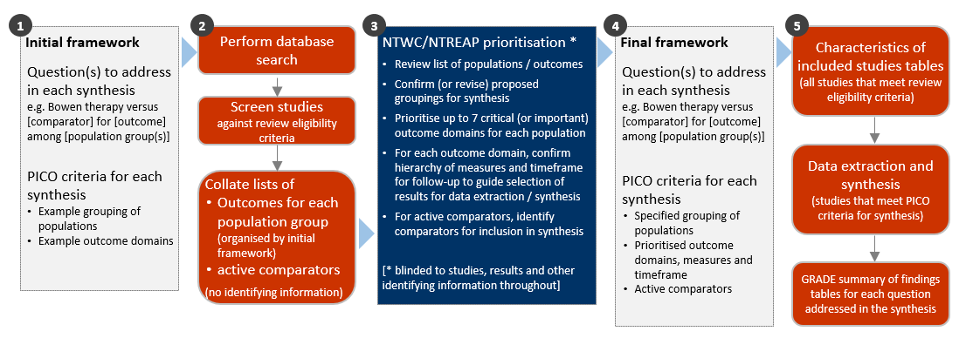

**Fig 3.1** | Staged approach for developing the questions and analytic framework for this review. Due to the small number of studies eligible for the review all studies with active comparators were included in the evidence synthesis.

## 3.1 Criteria for considering studies for this review

### 3.1.1 Types of studies

We included randomised controlled trials (RCTs) (including individually and cluster randomised, and cross-over trials) and controlled trials where there was an attempt to have some kind of ‘randomisation’ to groups (e.g. sequence generation based on alternation, dates (of birth or attendance at a clinic) and patient record numbers) [26]. Non-randomised studies of interventions (NRSIs) with certain design features were eligible (see Appendix A1.1.1). Historical case control, uncontrolled before-after studies, cross-sectional studies and case-control studies were ineligible.

***Date and language restrictions.*** There were no restrictions on publication date. Potentially eligible studies published in languages other than English were to be listed but not included in the synthesis.

### 3.1.2 Types of participants

Studies involving participants with any disease, medical condition, injury, or preclinical condition were eligible for the review. This included healthy participants with clearly identified risk factors for a condition (evident from study eligibility criteria or baseline data) that Bowen therapy was administered to prevent. There were no restrictions on age. Healthy populations seeking health improvement were excluded.

### 3.1.3 Types of interventions

Bowen therapy was defined as “a remedial hands-on technique based on the use of gentle pressure and release of the soft connective tissue (fascia) of the body” [excerpt from [27]]. Because of the potential challenge of distinguishing Bowen therapy from related modalities, such as connective tissue manipulation (CTM), and the likelihood of identifying studies in which the defining techniques and principles of the Bowen therapy were incompletely reported, studies were included if the therapy was described as Bowen therapy (or other synonyms). Studies that failed to mention or describe the intervention as Bowen therapy (or other synonyms) were excluded. Bowen therapy interventions were eligible irrespective of the training or qualifications of the practitioner, the setting in which Bowen therapy was used, and the dose and duration of treatment.

#### Comparisons

1. Bowen therapy *versus* any inactive comparator (no intervention, sham, placebo, wait list control, or a co-intervention offered to both groups, or continuation of usual care).
2. Bowen therapy *versus* evidence-based treatment(s) (active comparators) on outcomes for each underlying condition, pre-condition, injury or risk factor?
3. Bowen therapy *versus* any active comparator (separated by type of comparator).

Given the very small number of studies in the review, we report on the effects of Bowen therapy compared to any active comparator (i.e. not limited to “evidence-based treatments”).

Any co-intervention was eligible (i.e. pharmacological or non-pharmacological). Usual care comparators were eligible if there was an explicit statement that indicated that participants could continue to access their routine care or therapy (including self-care). If a comparator labelled as ‘usual care’ involved a defined intervention (i.e. specific treatments and processes selected by the researchers), this was deemed to be either an active intervention (if restricted to the comparator group) or a co-intervention (if able to be accessed by both groups, e.g. continuation of a specific medication).

We excluded head-to-head comparisons of Bowen therapy (e.g. comparison of different frequencies, durations or schedules; comparison of specialist Bowen therapist versus other health professional delivering Bowen therapy).

### 3.1.4 Types of outcomes

Any patient-important outcome that aligned with the reasons why Bowen therapy is sought by patients and prescribed by practitioners was eligible. Studies were included in the review irrespective of the outcome(s) measured, but the synthesis was limited to outcomes considered to be critical or important for each population group (see 3.4 for prioritisation of outcomes and 3.5 for final framework). Experience of care (e.g. satisfaction), safety, quality, and economic outcomes were excluded.

From each study, we selected one outcome per outcome domain for data extraction (results), risk of bias assessment and inclusion in the synthesis. In selecting outcomes for synthesis, we considered the outcome measure (any measure was eligible but a pre-specified hierarchy was applied to select the most relevant measure if multiple measures were available), timing of outcome measurement (first measure after end of Bowen therapy intervention period) and suitability of data for meta-analysis.

## 3.2 Search methods for identification of studies

We searched the Cochrane Central Register of Controlled Trials (Cochrane Library, Issue 10, 2023), MEDLINE (Ovid), Embase (Ovid), Emcare (Ovid), AMED (Ovid), CINAHL (EBSCOhost), Europe PMC, ClinicalTrials.gov and WHO International Clinical Trials Registry Platform on 5 October 2023. Searches were not limited by language, year of publication or publication status. We also searched Google Scholar (first 10 pages) and conducted a forward citation search on all studies that met the inclusion criteria.

## 3.3 Selection of studies

Two reviewers piloted guidance for title and abstract screening on a sample of 50 records to ensure the review eligibility criteria were applied consistently. All records were screened independently by two reviewers at both the title and abstract screening and full-text review stages. Disagreements at either stage of screening were resolved by consensus among members of the review team. We documented the flow of studies through the review in a PRISMA diagram (Figure 4.1.1).

Studies that did not meet the review eligibility criteria were excluded and the reason for exclusion was recorded at full-text screening. For studies that originated from the call for evidence, we recorded and reported exclusion decisions irrespective of whether the study was excluded during title and abstract screening or full text review.

## 3.4 Prioritisation of outcomes for the synthesis

Decisions about the final synthesis questions and criteria for including studies in each synthesis were made through the prioritisation process in Figure 3.1. The process was designed to minimise bias in the selection of results for inclusion in the synthesis while ensuring coverage of relevant populations and outcomes.

In brief, we screened studies against the review eligibility criteria and collated deidentified information about the populations and outcomes addressed in included studies (no bibliographic information, titles, details about the number of studies, participants, methodological quality or results). For each condition, NTWC, with input from NTREAP, rated outcome domains as critical, important or of limited importance. Within each outcome domain, NTWC ranked the listed outcomes/measures for each domain to enable selection of the most relevant result from each study.

## 3.5 Final framework: synthesis questions and criteria for including studies in each synthesis

Figure 3.5.1, panel A shows the final analytic framework for the evidence summary and synthesis. The framework provides a guide to the structure of the synthesis and reporting of results (see caption for details).

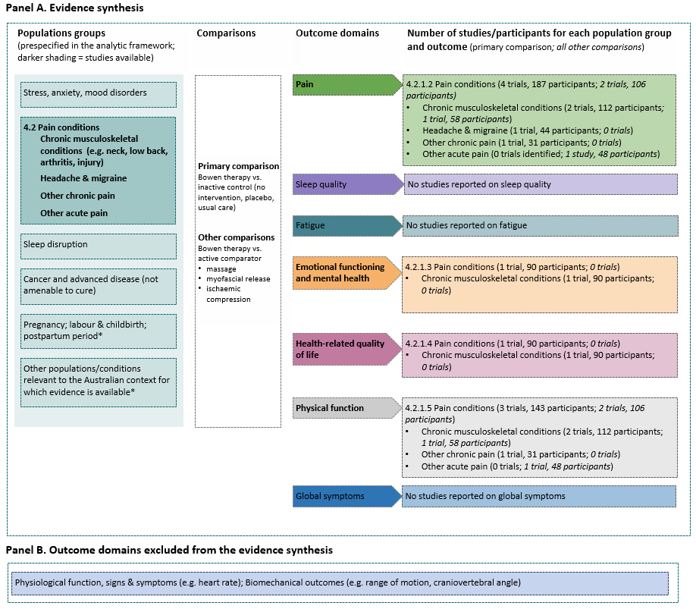

**Fig 3.5.1** | Final analytic framework for the review as agreed through the prioritisation process (Appendix A5).   
Panel A, columns 1 to 3 show the populations, comparisons and outcome domains eligible for the evidence synthesis. Column 4 shows the populations, comparisons and outcome domains for which studies were available. Results are reported for each population group in the section indicated in column 1. Study-level data and meta-analyses are presented for the primary comparison in the forest plot indicated in column 4. Panel B shows outcome domains rated as of limited importance. Population groups are those reported by Bowen therapists as often treated [2] except those marked *.

## 3.6 Data extraction and management

### 3.6.1 Data extraction

Study data were collected and managed using REDCap electronic data capture tools [28, 29]. A two-step data extraction process was implemented wherein a senior author (MM) coded the study PICO to allocate studies for analysis according to the analytic framework and selected the outcome (result) for inclusion in each synthesis using pre-specified decision rules. Any queries from this stage were sent to the second senior author (SB) to review, with any disagreement resolved through consensus discussion. A senior author (MM) extracted study characteristics and quantitative data. A second senior author (SB) independently verified the study allocation for analysis and outcome selection, as well as the data. Steps taken to ensure the completeness, accuracy and consistency of data included pretesting the form and providing coding guidance, training, and feedback for data extractors. Quantitative data were reviewed by a biostatistician when queries arose.

### 3.6.2 Assessment of risk of bias in individual studies

We assessed the risk of bias in included studies using the revised Cochrane ‘Risk of Bias’ tools (RoB 2) for randomised trials [26, 30]. After piloting of the tool by senior authors (SB, MM, SM), we developed review-specific guidance for the suite of natural therapies reviews to ensure consistency between reviewers. This guidance had been used by the author team to assess over 200 natural therapies studies prior to application in the current review. One review author (MM) applied the tool to the selected results from each study following the RoB 2 guidance [26], and a second author (SB) checked assessments. Supporting information and justifications for judgements for each domain (low, some concerns, high risk of bias) was recorded. We derived an overall summary of the risk of bias from each assessment, following the algorithm in the RoB 2 guidance as implemented in the Excel assessment tool [26].

### 3.6.3 Measures and interpretation of treatment effect

We anticipated that many of the outcomes would be continuous (e.g. pain, function), and that varying measurement instruments would be used to measure the same underlying construct across the studies. For this reason, we quantified the effects of Bowen therapy using the standardised mean difference (SMD).

Our interpretation was based on whether there was an important effect or not [6, 31], with an SMD of 0.2 standard units set as the threshold for an important difference. If the SMD fell within the pre-specified range of -0.2 to 0.2 (i.e. within both thresholds), the effect of Bowen therapy was considered to be no different from control. An SMD above 0.2 or below -0.2 was interpreted as an important effect. We opted to use the most intuitive interpretation of effect estimates for each outcome, so positive values indicate benefit for some outcomes (an increase in physical function) and harm for other outcomes (an increase in pain).

## 3.7 Data synthesis

### 3.7.1 Meta-analysis

Separate comparisons were set up for each population group and outcome domains agreed in the final framework (see Figure 3.5.1). Some comparisons were stratified by more specific conditions (with an overall estimate and estimate for each condition presented). Forest plots were used to visually depict the intervention effect estimates and their confidence intervals. Forest plots are stratified by condition and risk of bias (within population group). For completeness, results for all studies for which an effect estimate (SMD) could be calculated are presented on the forest plot, including where a single study contributed to the comparison. Studies that had missing or uninterpretable results, or for which an effect estimate (SMD) could not be calculated, are also depicted on the plot.

### 3.7.2 Summary of findings tables and assessment of certainty of the body of evidence

For each result, two authors (MM, SB) used the GRADE approach to assess our certainty in whether there is an important effect (or not). Disagreements were resolved through discussion. In accordance with GRADE guidance [7, 31, 32], an overall GRADE of high, moderate, low or very low certainty is reported for each result based on whether there are serious, very serious, extremely serious or no concerns in relation to each of the following domains [6].

* **Risk of bias**. whether the studies contributing to each synthesis have methodological limitations that might lead to over (or under) estimation of the effect
* **Imprecision**. whether the confidence interval for the synthesised result crosses one or both of the thresholds for an important effect (an SMD of 0.2 or -0.2) meaning that the result is compatible with different interpretations (e.g. the upper bound of the interval lies above 0.2 indicating ‘an important effect’ whereas the lower bound lies between -0.2 and 0.2 indicating ‘little or no effect’)
* **Inconsistency**. whether there is important, unexplained inconsistency in results across studies
* **Indirectness**. whether there are important differences between the characteristics of studies included in each synthesis and the question we were seeking to address, such that the effects observed may not apply to our question (i.e. the applicability of the evidence)
* **Publication bias**. whether results missing from each analysis may bias the effect estimate because of selective non-reporting of results (or studies) that showed unfavourable effects.

A summary of findings is tabulated for each comparison. These summary of findings tables include:

* estimates of the effects of Bowen therapy reported as standardised mean differences
* the overall GRADE (rating of certainty) and an explanation of the reason(s) for rating down (or borderline decisions) [33]
* the study design(s), number of studies and number of participants contributing data
* a plain language statement interpreting the evidence for each comparison and outcome, following GRADE guidance for writing informative statements (see 3.7.3 interpretation of findings) [34].

### 3.7.3 Interpretation of findings (evidence statements)

When interpreting results, we followed GRADE guidance for writing informative statements [34]. All interpretations are based on where the point estimate lies in relation to the pre-specified thresholds for an important effect (an important effect or not) and the direction of effect (beneficial or harmful). The certainty of evidence is communicated by qualifying the interpretation of effect (e.g. ‘may’ improve for low certainty). For example, ‘Bowen therapy may improve physical function’ indicates that the point estimate lies above the threshold for important benefit (an SMD >0.2) and that the evidence is of low certainty. For very low certainty evidence, we do not provide an interpretation of the result except to state ‘The evidence is very uncertain about the effect of Bowen therapy on outcome’. This is one of two options that GRADE provides for interpreting findings based on very low certainty of evidence. The decision not to interpret very low certainty results was made independently by NTWC to ensure a consistent and clear interpretation of findings across Natural Therapy Review reports.

# 4. Results

## 4.1 Results of the search

The flow of studies through the review is summarised in Figure 4.1.1, the PRISMA flowchart.

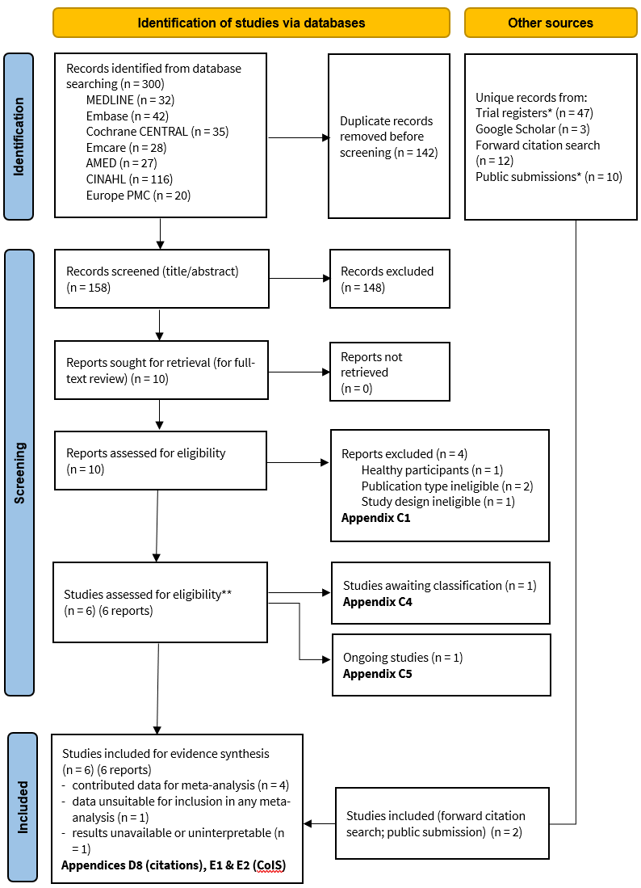

**Fig. 4.1.1** | PRISMA diagram showing the flow of studies through the review. Studies are the unit of interest in the review. Each study could have multiple reports. CoIS: characteristics of included studies.  
*see results sections ‘Ongoing and unpublished studies’ and ‘Public submissions’

### Included studies

Following screening of 158 citations from the database searches, we retrieved 10 full text reports from which 4 studies were included in the review. A further two studies were included, one from the forward citation search and one from the public submissions.

All 6 studies were randomised trials that examined the effects of Bowen therapy on outcomes for people with pain conditions [35-40]. Four (4) of these studies compared Bowen therapy to an inactive control, and two studies compared Bowen to another intervention. While neither of the active interventions were evidence-based treatments (a pre-requisite for synthesis stipulated in the protocol), the studies were included in the review due to the very sparse evidence base.

We identified one randomised trial in people with non-Hodgkin lymphoma from registry searches that included a Bowen therapy intervention arm, a best-practice exercise arm, and a wait-list control arm [41]. The published study report for this trial does not mention the Bowen therapy intervention arm in the methods or results (and was therefore not identified during our database searches) [42]. It is unclear if the Bowen therapy intervention arm was not implemented, or if the Bowen therapy intervention arm was implemented and results excluded from the study report. The study publication does not report a comparison that is eligible for this review. No other studies among people with cancer or advanced disease were identified, hence the missing results do not bias any of the effects reported in this review.

The conditions covered were as follows.

* **Studies of Bowen therapy versus an inactive control** were among people with chronic musculoskeletal conditions (2 studies, both of neck pain), headache or migraine (1 study), and other chronic pain (1 study of any multisite pain).
* **Studies of Bowen therapy versus active intervention** were among people with a chronic musculoskeletal condition (1 study of neck pain) or acute pain (1 study of neck pain).

The summary and synthesis of these studies is reported in sections 4.2.1. and 4.2.2 of the report respectively.

There were no studies of Bowen therapy for people with other conditions reported as often treated by Bowen therapies. Specifically, there were no studies among people with stress, anxiety or mood disorders, sleep disruption. There were also no studies of Bowen therapy for perinatal care, nor were there studies among people with other conditions or at risk of a condition (i.e. all eligible studies were included).

### Excluded studies

After full-text screening, 5 studies (5 reports) were excluded from the review (Figure 4.1.1, Appendix C1 for list of excluded studies).

### Studies awaiting classification

Following screening, one study was categorised as awaiting classification because results were reported in an abstract only (Figure 4.1.1, Appendix C4 for study awaiting classification).

#### Studies in languages other than English

Our searches did not identify any studies published in languages other than English.

### Ongoing and unpublished studies

In total, we identified 16 unpublished studies eligible for the review from trial registry entries and other sources. Of these 16 studies, all were judged likely to be ongoing.

From trial registry entries (CENTRAL, ClinicalTrials.gov and WHO ICTRP) we identified 47 unique records, of which 20 appeared potentially eligible for the review. Of the potentially eligible records:

* 3 were for completed studies already included in the review [38, 39, 43]
* one was for a completed study that could not be included in the review (Bowen therapy intervention arm not reported) [42]
* one was for a study among people with fibromyalgia for which we had found a protocol but no report of results (judged to be ongoing) [44]
* 15 were unique studies, of which all were registered in the last 4 years (2020 onward) and considered likely to be ongoing

Characteristics of ongoing studies are reported in Appendix C4. Brief details are reported in the results section for the comparison for which the study is eligible.

**Public submissions**

Twenty-nine (29) citations were received from the public and key stakeholders (via the Department). Of these, 6 were duplicates, 13 were retrieved by our search, 5 were added to Covidence for screening and 5 were excluded (one duplicate registry entry; one master’s thesis; two unpublished conference abstracts; one systematic review). Eligibility decisions for the 23 unique records are reported in Appendix C2. One of the submission references (Dalal 2020) was included in the review.

## 4.2 Pain conditions

All 6 studies included in the review were among people with pain conditions. Four (4) of the 6 studies compared Bowen therapy to an inactive control and two of the studies compared Bowen therapy to another (active) intervention.

Due to the sparsity of data we report characteristics and results for all 6 studies in this section, presenting the main comparison of Bowen therapy versus inactive control first, followed by other active comparisons (i.e. other treatments). Throughout the text, tables and plots, the conditions/populations are presented in the following order.

1. Chronic musculoskeletal conditions
2. Headache or migraine
3. Other chronic pain
4. Other acute pain

Prioritised outcome domains were pain, emotional functioning and mental health, HR-QoL and physical function (disability). No studies reported outcomes in the domains of sleep quality, fatigue or other symptoms.

### 4.2.1 Main comparison: Bowen therapy compared to inactive control

#### Characteristics of included studies

Brief characteristics of studies that compared Bowen therapy to an inactive control are summarised in Table 4.2.1.1 and full details are in Appendix E1. The outcome measure from which data were included for meta-analysis is reported for each trial in the forest plots (column 2, Figures 4.2.1.2 to 4.2.1.5). For all results, the outcome selected for analysis was measured at the end of the intervention period (see Table 4.2.1.1). Full details are reported in Appendix E1 for each study, including a list of all outcome measures, details of which outcome was selected when multiple were available for an outcome domain, and the timing of outcome measurement in relation to intervention.

**Table 4.2.1.1** Characteristics of studies comparing Bowen therapy to an inactive control for people with pain conditions.

| **Study** | **Population: condition (ICD-11 code)** | **Intervention** | | | **Comparator(s)** | **Outcome domains ⱡ** | | | | |
| --- | --- | --- | --- | --- | --- | --- | --- | --- | --- | --- |
| **Intervention period** | **Frequency** | **No. sessions & duration** | **Pain** | **EFMH** | **HR-QoL** | **Function** | **Measured** |
| **Chronic musculoskeletal conditions** | | | | | | | | | | |
| **Chee 2023**  Hong Kong | 90 adults with subacute or chronic myofascial neck pain >6 weeks (ME84.0 Cervical spine pain) | 12 weeks  Bowen + usual medications | weekly for 4 weeks, then every 2 weeks for 8 weeks | 8 x 15-30 mins | any usual care (incl. physical therapies) + neck care information | **X** | **X** | **X** | **X** | week 12 |
| **Seemal 2022**  Pakistan | 22 adults with text neck syndrome (ME84.0 Cervical spine pain) | 6 weeks  Bowen + MET | ~3 sessions/ week | ~18 x 15-20 mins | muscle energy technique* (MET) | **X** |  |  | **X** | week 6 |
| **Headache or migraine (chronic or episodic)** | | | | | | | | | | |
| **Qamar 2023**  Pakistan | 44 adults with tension-type headache (8A81.2 Chronic tension-type headache) | 2 weeks  Bowen | 3 sessions/ week | 6 x 15-20 mins | sham treatment* | **X**† |  |  |  | week 2 |
| **Other chronic pain conditions** | | | | | | | | | | |
| **Lee 2020**  New Zealand | 31 adults with multisite pain: mainly chronic MSK pain, fibromyalgia, postsurgical pain, arthritis (MG30.0 Chronic primary pain) | 9 weeks  Bowen | weekly for 3 weeks, then every 2 weeks for 6 weeks | 6 x 45-60 mins | sham treatment* | **X** |  |  | **X** | week 10 |
| **Other acute pain** | | | | | | | | | | |
| No studies | | | | | | | | | | |

*schedule as per Bowen therapy group; †results unsuitable for meta-analysis or uninterpretable; ⱡ outcomes confirmed as measured in registry entry

#### Risk of bias on included trials (both comparisons)

A summary of the risk of bias assessments for both comparisons is presented in Figure 4.2.1.1 and the overall risk of bias judgement for each study is reported in the forest plots (each comparison and outcome from a study was assessed separately). The complete assessments and judgements are reported in Appendix F. We do not report assessments for studies that do not have results contributing to a meta-analysis (e.g. Qamar 2023) because these studies have no influence over the effect estimate and, hence, are not considered when judging the overall risk of bias for any of the reported results.

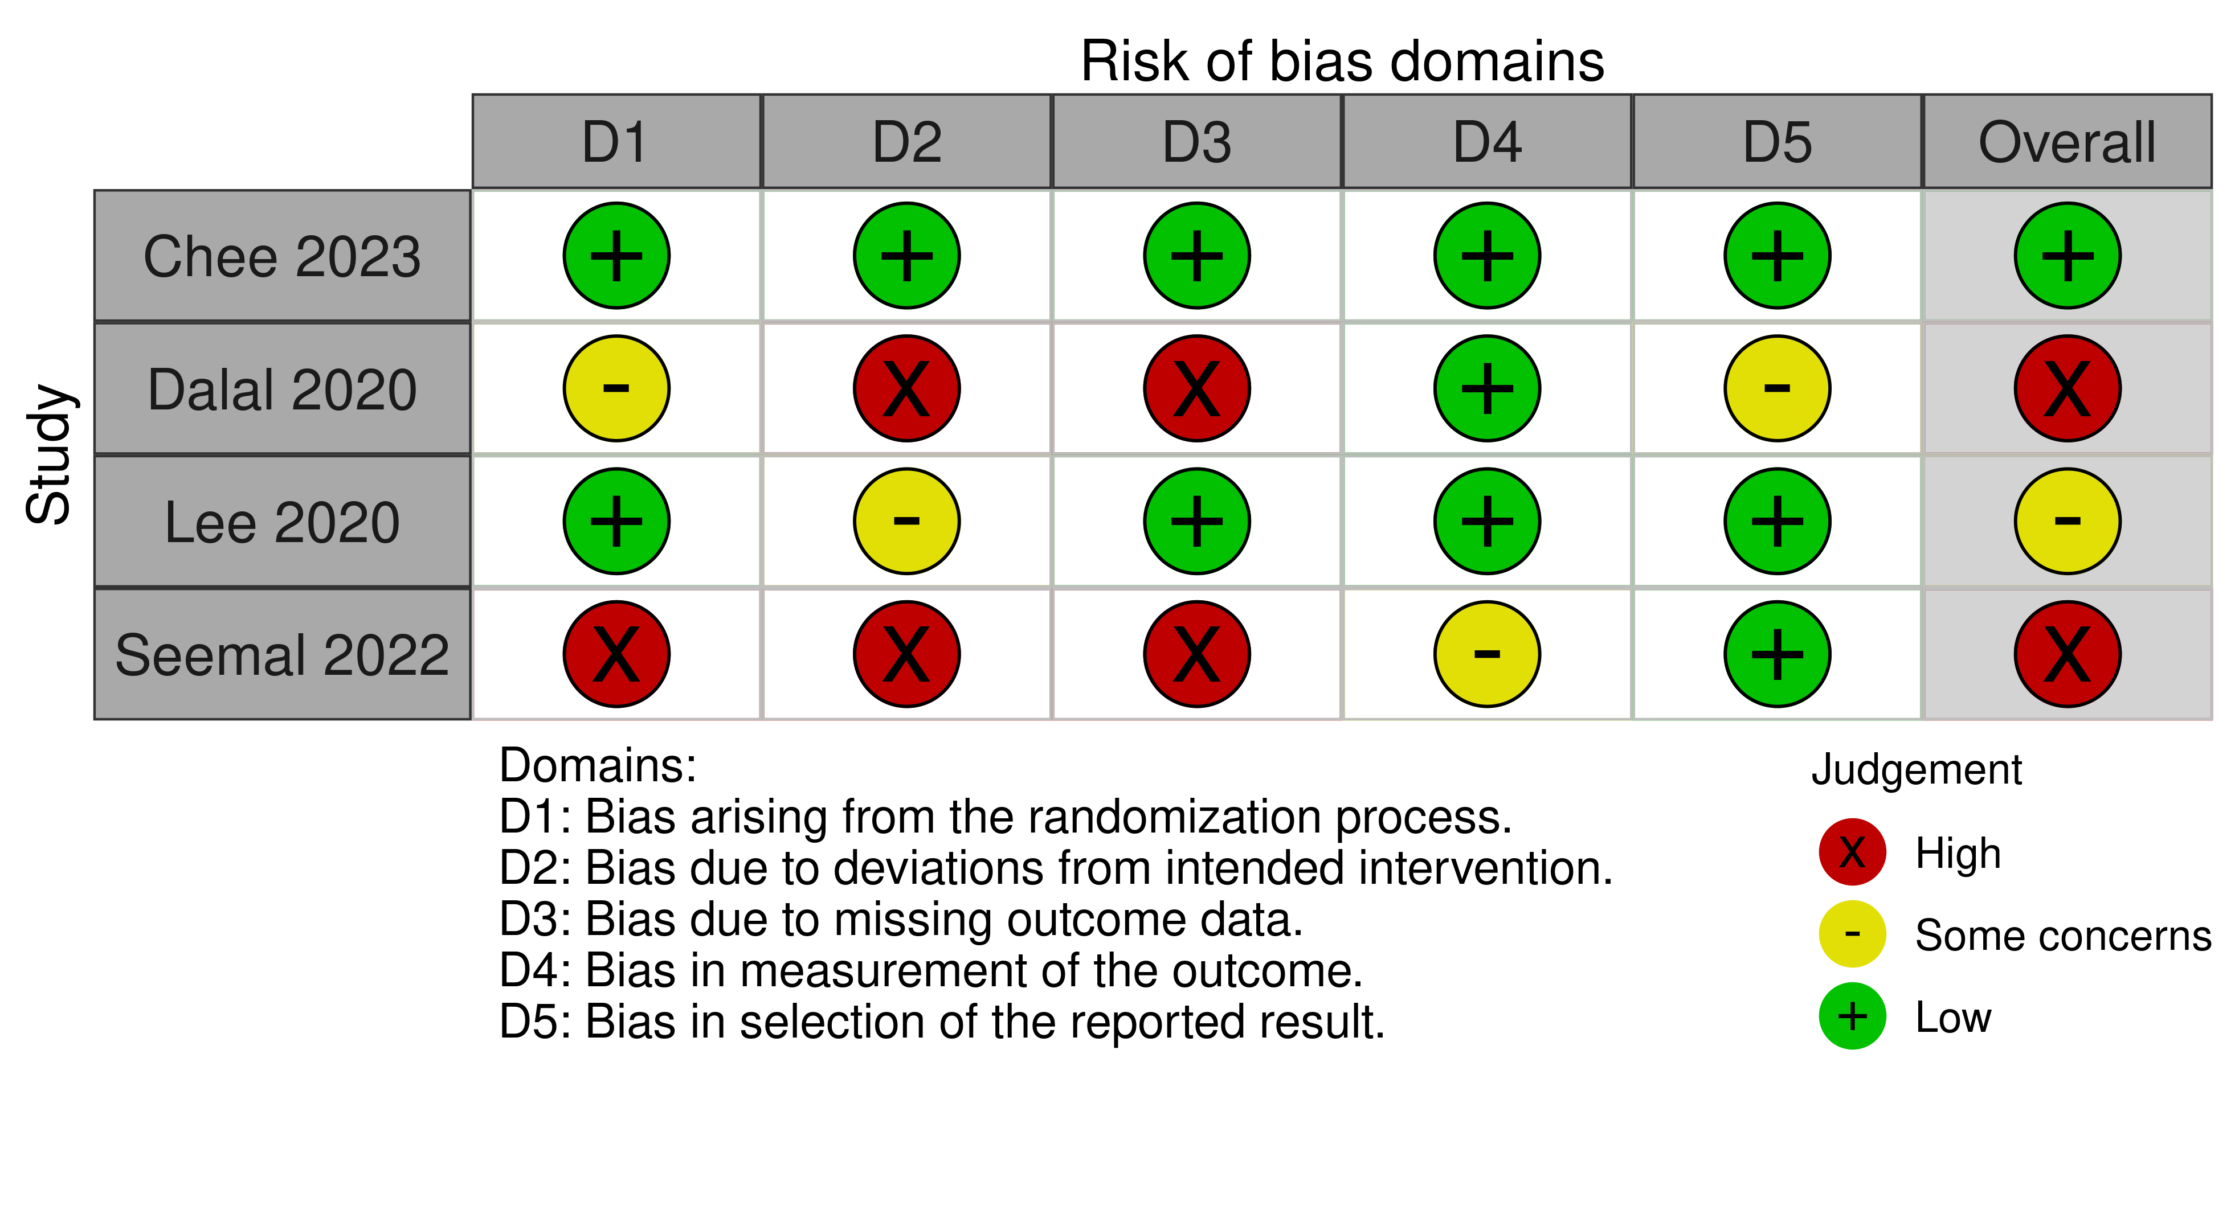

**Fig 4.2.1.1** | Summary of the risk of bias assessments for studies contributing to the comparisons of Bowen therapy versus inactive control (sham, a co-intervention that was offered to both groups, or continuing usual care) and Bowen therapy versus active comparators (other treatments). Each outcome for which the study contributed results was assessed separately. For these studies, the domain-level and overall risk of bias were judged to be the same for all outcomes. Full details of each assessment, including the rationale for judgements, are reported in Appendix F. The overall risk of bias judgement for each study is reported in the forest plots.

#### Effects of Bowen therapy compared to inactive control

The effects of Bowen therapy compared to an inactive control are presented in Table 4.2.1.2. The certainty of evidence, and factors that influenced our certainty in the evidence, are presented and explained in the GRADE summary of findings tables. Study level and meta-analytic results are presented in forest plots (Figures 4.2.1.2 to 4.2.1.5).

**Pain conditions overall**

***Pain*** *(Figure 4.2.1.2)*

* *Included studies*. Three (3) studies (Chee 2023, Lee 2020, Seemal 2022; 135 participants) contribute to the comparison of Bowen therapy versus an inactive control (Figure 4.2.1.2).
* *Missing results*. One additional trial (Qamar 2023; 44 participants) was eligible for this comparison, but reported results that were unsuitable for meta-analysis because the required statistics were unavailable and could not be calculated or imputed (available data presented in Figure 4.2.1.2). The study is considered in the assessment of missing results (see footnote to Table 4.2.1.2 explaining publication bias judgement).
* *Ongoing studies*. One ongoing study (registered 2021) among 46 people with non-specific chronic low back pain is eligible for the meta-analyses of effects on pain (Table 4.2.1.3).

The evidence about the effect of Bowen therapy on pain for people with pain conditions is of very low certainty due to study design limitations, indirectness, imprecision and publication bias (3 studies, 135 participants; Figure 4.2.1.2)

***Physical function (disability)*** *(Figure 4.2.1.5)*

* *Included studies*. Three (3) studies (Chee 2023, Lee 2020, Seemal 2022; 135 participants) contribute to the comparison of Bowen therapy versus an inactive control (Figure 4.2.1.5).
* *Missing results*. We did not identify any missing results for this analysis, either from included studies or from registry entries.
* *Ongoing studies*. One ongoing study (registered 2021) among 46 people with non-specific chronic low back pain is eligible for the meta-analyses of effects on physical function (disability) (Table 4.2.1.3).

The evidence about the effect of Bowen therapy on physical function (disability) for people with pain conditions is of very low certainty due to study design limitations, indirectness, imprecision and publication bias (3 studies, 135 participants; Figure 4.2.1.5)

**Chronic musculoskeletal pain**

***Pain*** *(Figure 4.2.1.2)*

* *Included studies*. Two (2) studies (Chee 2023, Seemal 2022; 106 participants) contribute to the comparison of Bowen therapy versus an inactive control (Figure 4.2.1.2).
* *Missing results*. We did not identify any missing results for this analysis, either from included studies or from registry entries.
* *Ongoing studies*. One ongoing study (registered 2021) among 46 people with non-specific chronic low back pain is eligible for the meta-analyses of effects on pain (Table 4.2.1.3).

The evidence about the effect of Bowen therapy on pain for people with chronic musculoskeletal pain is of very low certainty due to study design limitations, indirectness, imprecision and publication bias (2 studies, 106 participants; Figure 4.2.1.2)

***Emotional functioning and mental health*** *(Figure 4.2.1.3)*

* *Included studies*. One (1) study (Chee 2023; 84 participants) contributes to the comparison of Bowen therapy versus an inactive control (Figure 4.2.1.3).
* *Missing results*. We did not identify any missing results for this analysis, either from included studies or from registry entries.
* *Ongoing studies*. There were no ongoing trials identified from registry entries or other sources for this analysis.

There was low certainty evidence, due to indirectness and publication bias, that Bowen therapy may improve emotional functioning and mental health (slightly reducing depression symptoms) in adults with chronic musculoskeletal pain and mild symptoms of depression when compared to an inactive control (SMD 0.93 lower, 95% CI 1.38 lower to 0.49 lower; 1 study, 84 participants; Figure 4.2.1.3).

***Health-related quality of life*** *(Figure 4.2.1.4)*

* *Included studies*. One (1) study (Chee 2023; 84 participants) contributes to the comparison of Bowen therapy versus an inactive control (Figure 4.2.1.4).
* *Missing results*. We did not identify any missing results for this analysis, either from included studies or from registry entries.
* *Ongoing studies*. There were no ongoing trials identified from registry entries or other sources for this analysis.

There was low certainty evidence, due to indirectness and publication bias, that Bowen therapy may improve health-related quality of life in adults with chronic musculoskeletal pain when compared to an inactive control (SMD 0.7 higher, 95% CI 0.27 higher to 1.14 higher; 1 study, 84 participants; low certainty, Figure 4.2.1.4).

***Physical function (disability)*** *(Figure 4.2.1.5)*

* *Included studies*. Two (2) studies (Chee 2023, Seemal 2022; 106 participants) contribute to the comparison of Bowen therapy versus an inactive control (Figure 4.2.1.5).
* *Missing results*. We did not identify any missing results for this analysis, either from included studies or from registry entries.
* *Ongoing studies*. One ongoing study (registered 2021) among 46 people with non-specific chronic low back pain is eligible for the meta-analyses of effects on physical function (disability) (Table 4.2.1.3).

The evidence about the effect of Bowen therapy on physical function (disability) for people with chronic musculoskeletal pain is of very low certainty due to study design limitations, indirectness, imprecision and publication bias (2 studies, 106 participants with neck pain; Figure 4.2.1.5)

**Headache and migraine**

Effects of Bowen therapy on pain among people with headache and migraine are unknown (1 trial, 44 participants with tension-type headache could not be interpreted because results were incompletely reported, Figure 4.2.1.2).

**Other chronic pain**

***Pain*** *(Figure 4.2.1.2)*

* *Included studies*. One (1) study (Lee 2020; 29 participants) contributes to the comparison of Bowen therapy versus an inactive control (Figure 4.2.1.2).
* *Missing results*. We did not identify any missing results for this analysis, either from included studies or from registry entries.
* *Ongoing studies*. There were no ongoing trials identified from registry entries or other sources for this analysis.

The evidence about the effect of Bowen therapy on pain in with chronic multisite pain involving both the upper and lower body is of very low certainty due to study design limitations, indirectness and publication bias (1 study, 29 participants; Figure 4.2.1.2).

***Physical function (disability)*** *(Figure 4.2.1.5)*

* *Included studies*. One (1) study (Lee 2020; 29 participants) contributes to the comparison of Bowen therapy versus an inactive control (Figure 4.2.1.5).
* *Missing results*. We did not identify any missing results for this analysis, either from included studies or from registry entries.
* *Ongoing studies*. There were no ongoing trials identified from registry entries or other sources for this analysis.

The evidence about the effect of Bowen therapy on physical function (disability) for people with chronic multisite pain involving both the upper and lower body is of very low certainty due to indirectness and imprecision (1 study, 29 participants; Figure 4.2.1.5).

**Other acute pain**

No studies examined the effect of Bowen therapy versus an inactive control in people with acute pain.

**Table 4.2.1.2** Summary of findings for the effect of Bowen therapy versus inactive control (sham, a co-intervention that was offered to both groups, or continuing usual care in all included studies) for pain conditions.

| Outcomes  (populations represented in meta-analysis) | **Anticipated absolute effects\*** (95% CI) | | Relative effect (95% CI) | № of participants (studies) contributing to the analysis | Certainty of the evidence (GRADE) | Interpretation (evidence statement) |
| --- | --- | --- | --- | --- | --- | --- |
| **With inactive control** | **With Bowen therapy** |
| **Any pain condition (overall analysis)** | | | | | | |
| Pain (mainly people with neck pain)a,b (follow up 6 to 12 weeks) | - | SMD **1.04 SD lower** (1.88 lower to 0.2 lower) | - | 135 (3 RCTs) | ⨁◯◯◯ Very lowc,d,e,f,g | The evidence is very uncertain about the effect of Bowen therapy on pain in people with pain conditions (mainly people with chronic neck pain). |
| Physical function (mainly people with neck pain)a,b (follow up 6 to 12 weeks) | - | SMD **0.62 SD lower** (0.72 lower to 1.95 higher) | - | 135 (3 RCTs) | ⨁◯◯◯ Very lowc,d,e,h,i | The evidence is very uncertain about the effect of Bowen therapy on physical function in people with pain conditions (mainly people with chronic neck pain). |
| Other outcomes |  | |  | (0 studies) | - | No studies reported on sleep quality, fatigue or global symptoms. Single studies reported on emotional functioning/mental health and HR-QoL (results below). |
| **Chronic musculoskeletal pain** | | | | | | |
| Pain (people with neck pain)b (follow up 6 to 12 weeks) | - | SMD **1.03 SD lower** (5.07 lower to 3.01 higher) | - | 106 (2 RCTs) | ⨁◯◯◯ Very lowd,j,k,l,m | The evidence is very uncertain about the effect of Bowen therapy on chronic musculoskeletal pain (neck pain). |
| Emotional functioning and mental health - depression symptoms (people with neck pain)b (follow up 12 weeks) | - | SMD **0.93 SD lower** (1.38 lower to 0.49 lower) | - | 84 (1 RCT) | ⨁⨁◯◯ Lown,o,p,q,r | Bowen therapy may reduce symptoms of depression among people with chronic musculoskeletal pain (neck pain and mild depression). |
| Health-related quality of life (people with neck painb (follow up 12 weeks) | - | SMD **0.7 SD higher** (0.27 higher to 1.14 higher) | - | 84 (1 RCT) | ⨁⨁◯◯ Lown,o,p,s,t | Bowen therapy may increase health-related quality of life among people with chronic musculoskeletal pain (neck pain). |
| Physical function (people with neck pain)b (follow up 6 to 12 weeks) | - | SMD **0.8 SD lower** (1.85 lower to 3.45 higher) | - | (2 RCTs) | ⨁◯◯◯ Very lowd,j,k,u,v | The evidence is very uncertain about the effect of Bowen therapy on physical function in people with chronic musculoskeletal pain (neck pain). |
| Other outcomes |  | |  | (0 studies) | - | No studies reported on sleep quality, fatigue or global symptoms for people with chronic musculoskeletal pain. |
| **Headache & migraine** | | | | | | |
| Pain (people with chronic tension-type headache)b (follow up 2 weeks) |  | |  | 44 (1 RCT) | - | One study (44 participants) could not be included in the MA (see Appendix E3). The mean pain score was 1.7 points lower (VAS 0-10, lower is better) with Bowen therapy compared to sham treatment. |
| Other outcomes |  | |  | (0 studies) | - | No studies reported on sleep quality, fatigue, emotional functioning/mental health, HR-QoL, physical function or global symptoms for people with headache or migraine. |
| **Other chronic pain conditions** | | | | | | |
| Pain (people with multisite chronic pain)b (follow up 10 weeks) | - | SMD **1.23 SD lower** (2.01 lower to 0.46 lower) | - | 29 (1 RCT) | ⨁◯◯◯ Very lowo,r,w,x,y | The evidence is very uncertain about the effect of Bowen therapy on pain in people with other chronic pain conditions (multisite pain involving both upper and lower body). |
| Physical function (people with multisite chronic pain)b (follow up 10 weeks) | - | SMD **0.04 SD lower** (0.67 lower to 0.75 higher) | - | 29 (1 RCT) | ⨁◯◯◯ Very lowaa,ab,o,x,z | The evidence is very uncertain about the effect of Bowen therapy on physical function in people with other chronic pain conditions (multisite pain involving both upper and lower body). |
| Other outcomes |  | |  | (0 studies) | - | No studies reported on sleep quality, fatigue, emotional functioning/mental health, HR-QoL or global symptoms for people with other chronic pain conditions. |
| **Other acute pain** | | | | | | |
| Other outcomes |  | |  | (0 studies) | - | No studies reported on any of the framework outcome domains. |
| \***The risk in the intervention group** (and its 95% confidence interval) is based on the assumed risk in the comparison group and the **relative effect** of the intervention (and its 95% CI). **CI:** confidence interval; **SMD:** standardised mean difference  The threshold for an important difference was an SMD of 0.2 (used for interpreting point estimates and confidence intervals). For pain and emotional functioning and mental health, the resulting interpretation is: < -0.2 is beneficial, -0.2 to 0.2 is trivial or unimportant ("little or no difference" between treatments), > 0.2 is harmful. For HR-QoL and physical function, the resulting interpretation is: < -0.2 is harmful, -0.2 to 0.2 is trivial or unimportant ("little or no difference" between treatments), > 0.2 is beneficial. | | | | | | |
| **GRADE Working Group grades of evidence** **High certainty:** we are very confident that the true effect lies close to that of the estimate of the effect. **Moderate certainty:** we are moderately confident in the effect estimate: the true effect is likely to be close to the estimate of the effect, but there is a possibility that it is substantially different. **Low certainty:** our confidence in the effect estimate is limited: the true effect may be substantially different from the estimate of the effect. **Very low certainty:** we have very little confidence in the effect estimate: the true effect is likely to be substantially different from the estimate of effect.  **Explanations** are provided for domains for which there is a downgrade or a borderline judgment. In line with GRADE guidance, we do not explain that there are no limitations unless the judgment was challenging (<https://pubmed.ncbi.nlm.nih.gov/26796947/> ) | | | | | | |

#### Explanations

a. Studies included people with chronic neck pain and multisite chronic pain (mainly musculoskeletal)

b. Measures varied. Pain: VAS, NRS and NPRS; EMFH: PHQ-9; HR-QoL: SF-12 mental component; Physical function: LLTQ, NDI. Follow-up is end of intervention period, so generally reflects the length of the intervention or close to (Table 4.2.1.1 for details).

c. Serious risk of bias (-1). 25% of data in the analysis comes from studies at high risk of bias or some concerns, all suggesting large effects. This raises concerns that the observed benefit may be overestimated.

d. No important inconsistency. 95% CIs overlap for all studies (heterogeneity statistics support this, however, with so few studies, there is substantial uncertainty in I squared and Tau squared, and low power to detect heterogeneity using the Chi squared test)

e. Serious indirectness (-1). Evidence from 3 small studies mainly among people with neck pain. Uncertain whether results apply to pain conditions more generally.

f. Serious imprecision (-1). 95% CI is on the threshold for a small effect but is likely to be poorly estimated due to the small number of studies with small sample size (hence, imprecision is a concern)

g. Publication bias strongly suspected (-1). The meta-analysis is based on 3 small studies showing large effects, so selective non-reporting of unfavourable results (null or favouring control) could importantly change the combined estimate. This is a concern because of evidence of selective non-reporting of unfavourable/uninteresting results in general, and from trials of natural therapies in particular. Incompletely reported outcome data from one study (Qamar) suggested effects consistent with included studies. No missing outcomes from studies included in the reviews and no missing studies identified from registry entries or protocols.

h. Extremely serious imprecision (-3). The 95% confidence interval crosses the threshold for both small but important benefit (SMD -0.2) and small but important harm (SMD 0.2), and is too wide for the result to be interpretable (SMD -0.72 indicating large harm to 1.95 indicating large benefit).

i. Publication bias strongly suspected (-1). The meta-analysis is based on 3 small studies, with two showing moderate to large effects, so selective non-reporting of unfavourable results (null or favouring control) could importantly change the combined estimate. This is a concern because of evidence of selective non-reporting of unfavourable/uninteresting results in general, and from trials of natural therapies in particular. No missing outcomes from studies included in the reviews and no missing studies identified from registry entries or protocols.

j. Serious RoB (-1). One of the two studies in the analysis is at high risk of bias, such that the observed benefit may be overestimated.

k. Serious indirectness (-1). Evidence from two small studies among people with chronic neck pain. Uncertain whether results apply to populations with chronic musculoskeletal conditions more generally.

l. Extremely serious imprecision (-3). The 95% confidence interval crosses the threshold for both small but important benefit (SMD -0.2) and small but important harm (SMD 0.2), and is too wide for the result to be interpretable (SMD -5.07 indicating large benefit to 3.01 indicating large harm).

m. Publication bias strongly suspected (-1). The meta-analysis is based on 2 small studies showing large effects, so selective non-reporting of unfavourable results (null or favouring control) could importantly change the combined estimate. This is a concern because of evidence of selective non-reporting of unfavourable/uninteresting results in general, and from trials of natural therapies in particular. No missing outcomes from studies included in the reviews and no missing studies identified from registry entries or protocols.

n. No serious RoB. Single study at low risk of bias.

o. Inconsistency not assessed: single study

p. Serious indirectness (-1). Evidence from single study among people with chronic neck pain. Uncertain whether results apply to pain conditions or chronic musculoskeletal pain more generally.

q. No serious imprecision. Both the upper and lower limits of the 95% confidence interval (SMD -1.38 to -0.49) are compatible with an important reduction in depression symptoms (SMD < -0.2)

r. Publication bias strongly suspected (-1). The meta-analysis is based on 1 small study showing a large effect, so selective non-reporting of unfavourable results (null or favouring control) could importantly change the combined estimate. This is a concern because of evidence of selective non-reporting of unfavourable/uninteresting results in general, and from trials of natural therapies in particular. No missing outcomes from studies included in the reviews and no missing studies identified from registry entries or protocols.

s. No serious imprecision. Both the upper and lower limits of the 95% confidence interval (SMD 0.27 to 1.14) are compatible with an important improvement in HR-QoL (SMD < -0.2)

t. Publication bias strongly suspected (-1). The meta-analysis is based on 1 small study showing a moderate effect, so selective non-reporting of unfavourable results (null or favouring control) could importantly change the combined estimate. This is a concern because of evidence of selective non-reporting of unfavourable/uninteresting results in general, and from trials of natural therapies in particular. No missing outcomes from studies included in the reviews and no missing studies identified from registry entries or protocols.

u. Extremely serious imprecision (-3). The 95% confidence interval crosses the threshold for both small but important benefit (SMD -0.2) and small but important harm (SMD 0.2), and is too wide for the result to be interpretable (SMD -1.85 indicating large harm to 3.45 indicating large benefit).

v. Publication bias strongly suspected (-1). The meta-analysis is based on 2 small studies showing moderate to large effects, so selective non-reporting of unfavourable results (null or favouring control) could importantly change the combined estimate. This is a concern because of evidence of selective non-reporting of unfavourable/uninteresting results in general, and from trials of natural therapies in particular. No missing outcomes from studies included in the reviews and no missing studies identified from registry entries or protocols.

w. Serious risk of bias (-1) 100% of data in the analysis comes from a single study at some risk of bias, showing a large effect. This raises concerns that the observed benefit may be overestimated.

x. Serious indirectness (-1). Evidence from one small study. Uncertain whether results apply to chronic pain conditions more generally.

y. No serious imprecision. Both the upper and lower limits of the 95% confidence interval (SMD -2.01 to -0.46) are compatible with an important reduction in pain (SMD < -0.2)

z. No serious risk of bias. 100% of data in the analysis comes from a single study at some risk of bias, but there is little to no effect on the outcome.

aa. Extremely serious imprecision (-3). The 95% confidence interval crosses the threshold for both small but important benefit (SMD -0.2) and small but important harm (SMD 0.2), and is too wide for the result to be interpretable (SMD -0.67 indicating large harm to 0.75 indicating large benefit).

ab. Publication bias undetected. Although there is previous evidence documenting the presence of reporting bias in trials of natural therapies, this single study shows little to no effect. No missing outcomes from studies included in the reviews and no missing studies identified from registry entries or protocols.

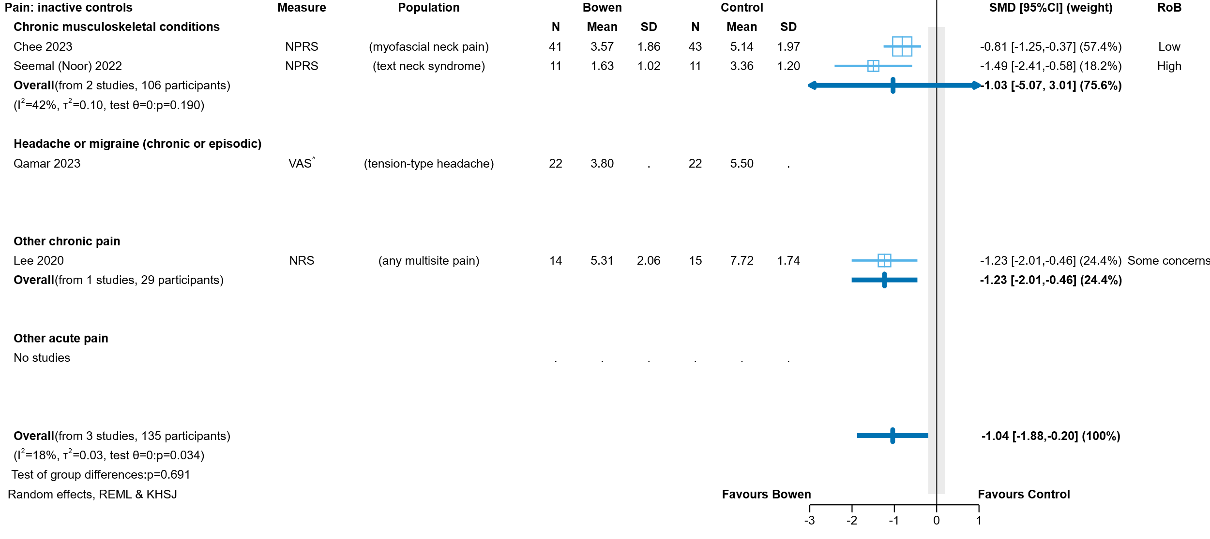

**Fig 4.2.1.2** | Forest plot for main comparison. The effect of Bowen therapy versus inactive control (sham, a co-intervention that was offered to both groups, or continuing usual care in all included studies) on pain for people with pain conditions. SMD=standardised mean difference. Blue lines show 95% confidence intervals (CI). The shaded grey area indicates the pre-specified range where the effect of Bowen therapy is considered to be no different from control (SMD -0.2 to 0.2 standard units). ^ indicates studies for which results were unsuitable for meta-analysis or uninterpretable.

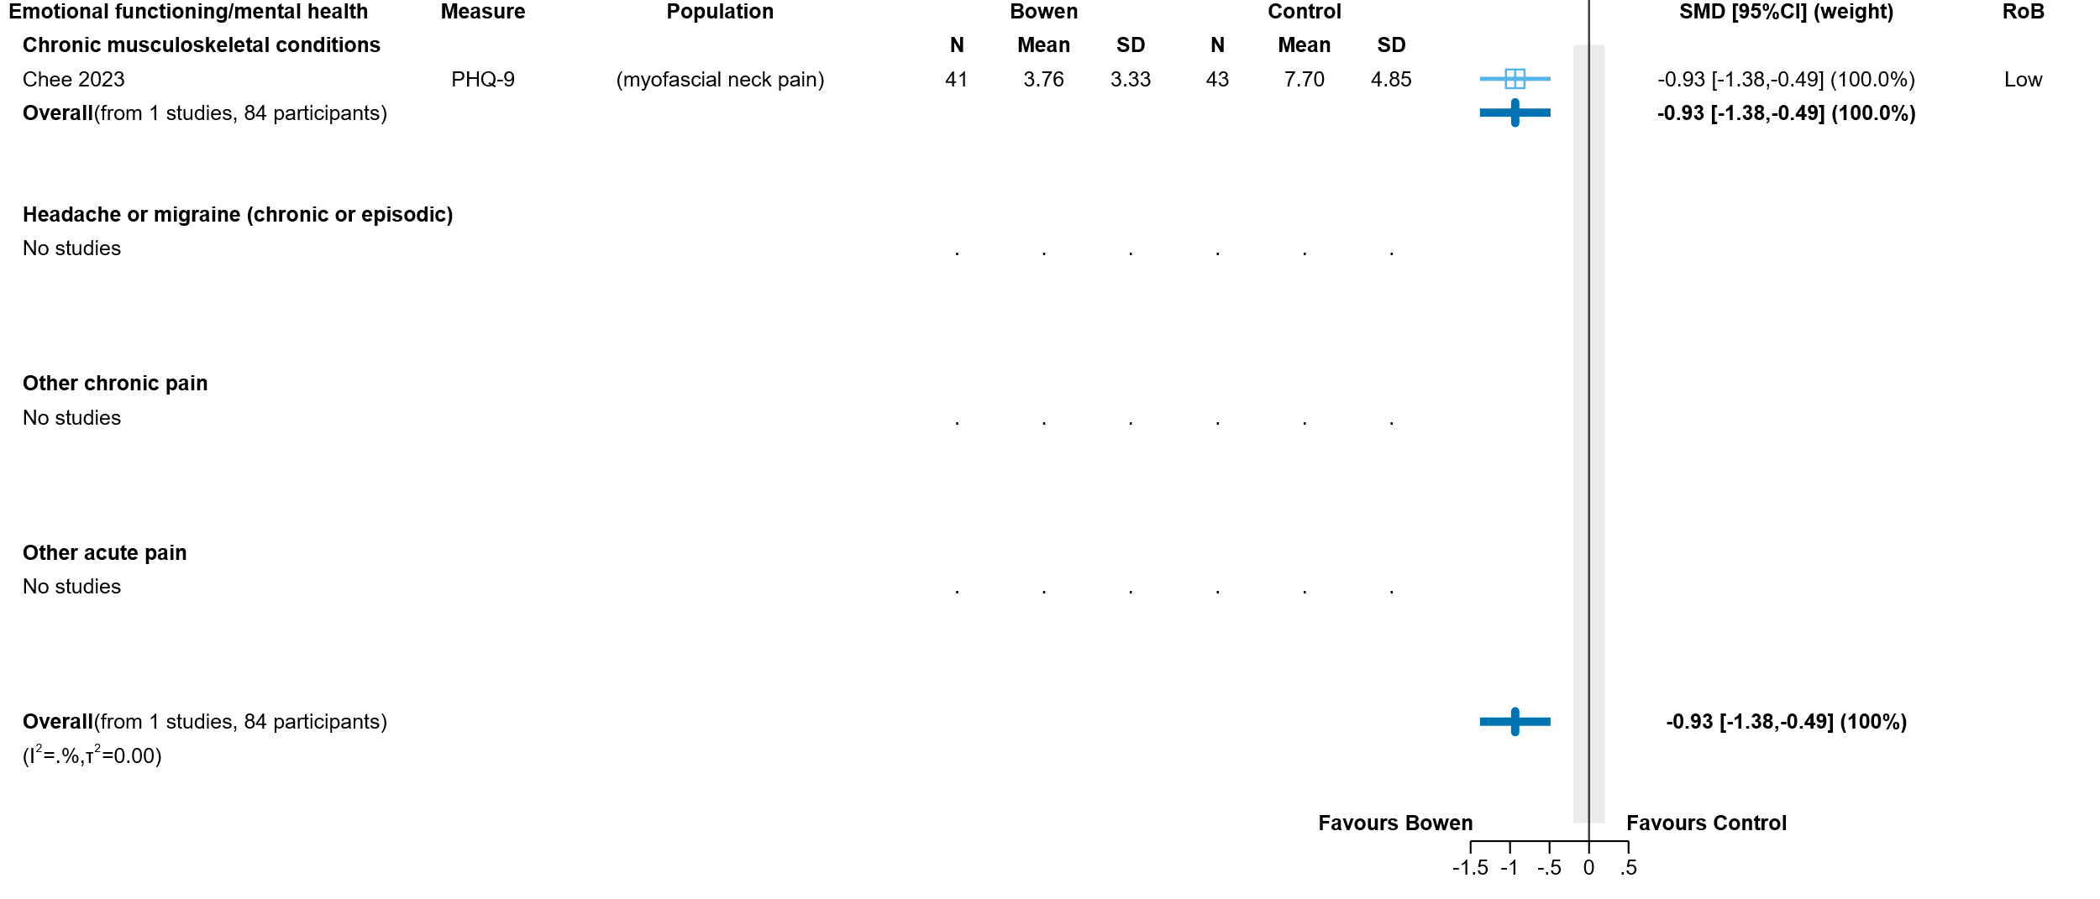

**Fig 4.2.1.3** | Forest plot for main comparison. The effect of Bowen therapy versus inactive control (sham, a co-intervention that was offered to both groups, or continuing usual care in all included studies) on emotional functioning and mental health for people with pain conditions. SMD=standardised mean difference. Blue lines show 95% confidence intervals (CI). The shaded grey area indicates the pre-specified range where the effect of Bowen therapy is considered to be no different from control (SMD -0.2 to 0.2 standard units). Negative numbers are beneficial as most of the measures relate to symptoms of anxiety, depression, stress etc.

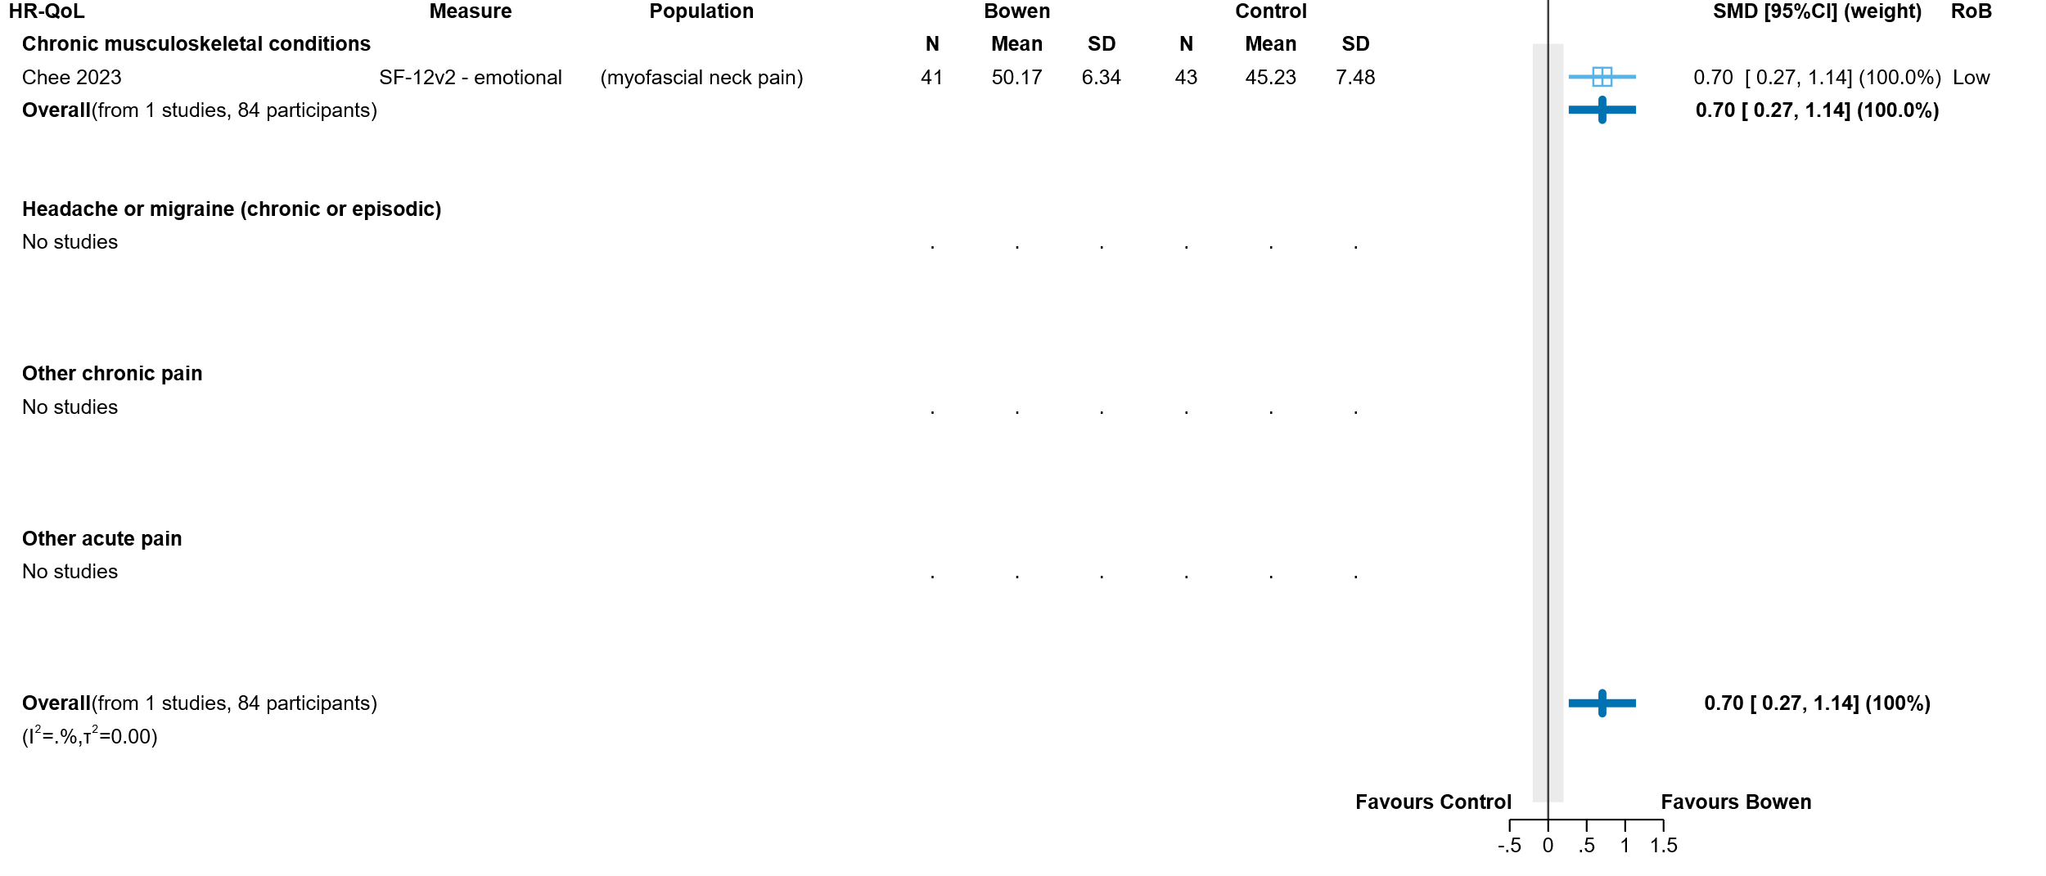

**Fig 4.2.1.4** | Forest plot for main comparison. The effect of Bowen therapy versus inactive control (sham, a co-intervention that was offered to both groups, or continuing usual care in all included studies) on health-related quality of life (HR-QoL) for people with pain conditions. SMD=standardised mean difference. Blue lines show 95% confidence intervals (CI). The shaded grey area indicates the pre-specified range where the effect of Bowen therapy is considered to be no different from control (SMD -0.2 to 0.2 standard units).

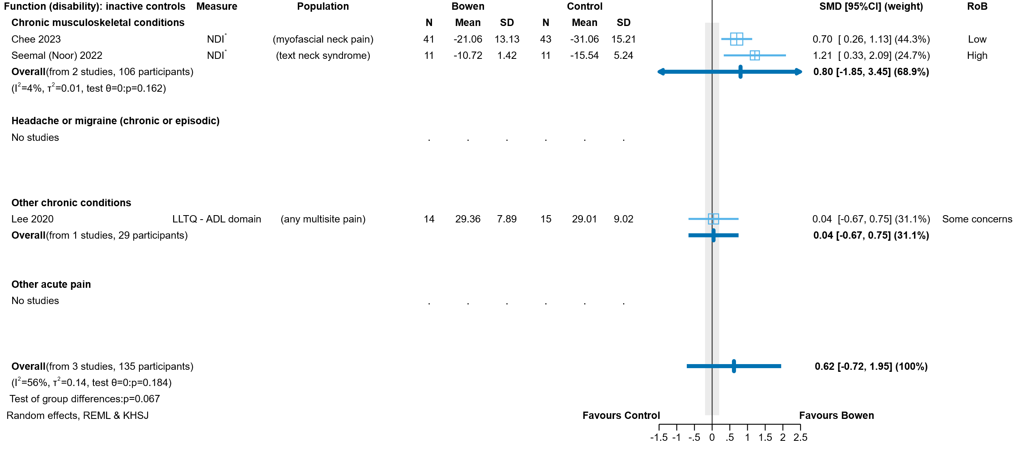

**Fig 4.2.1.5** | Forest plot for main comparison. The effect of Bowen therapy versus inactive control (sham, a co-intervention that was offered to both groups, or continuing usual care in all included studies) on physical function for people with pain conditions. SMD=standardised mean difference. Blue lines show 95% confidence intervals (CI). The shaded grey area indicates the pre-specified range where the effect of Bowen therapy is considered to be no different from control (SMD -0.2 to 0.2 standard units). * Denotes studies for which the direction of effect was changed to match the overall plot (positive numbers are beneficial).

**Table 4.2.1.3.** Ongoing studies comparing Bowen therapy to an inactive control for people with pain conditions

|  |  |  |  | **Comparison** | | **Outcome domains** | | | | | | |
| --- | --- | --- | --- | --- | --- | --- | --- | --- | --- | --- | --- | --- |
| **Study** | **Year started** | **No.** | **Population (ICD-11 code)** | **Inactive** | **Active** | **Pain** | **Sleep** | **Fatigue** | **EFMH** | **HR-QoL** | **Function** | **Symptoms** |
| **Pain conditions** | | | | | | | | | | | | |
| NCT04861129 Hong Kong | **2021** | 46 | MG30.02 Non-specific chronic low back pain | sham | n/a | X |  |  |  |  | X |  |

### 4.2.2 Bowen therapy compared to active controls

#### Characteristics of included studies

Brief characteristics of studies that compared Bowen therapy to an active control are summarised in Table 4.2.2.1 and full details are in Appendix E1. The outcome measure from which data were included for meta-analysis is reported for each trial in the forest plot (column 2, Figure 4.2.2.1). For all results, the outcome selected for analysis was measured at the end of the intervention period (see Table 4.2.2.1). A list of all available measures for each outcome domain is reported for each study in Appendix E1.

#### Risk of bias on included trials (both comparisons)

A summary of the risk of bias assessments for both comparisons is presented in Figure 4.2.1.1 and the overall risk of bias judgement for each study is reported in the forest plots (each comparison and outcome from a study was assessed separately). The complete assessments and judgements are reported in Appendix F. We do not report assessments for studies that do not have results contributing to a meta-analysis (e.g. Aslam 2023) because these studies have no influence over the effect estimate and, hence, are not considered when judging the overall risk of bias for any of the reported results.

**Table 4.2.2.1.** Characteristics of studies comparing Bowen therapy to an active control for people with pain conditions

| **Study** | **Population: condition (ICD-11 code)** | **Intervention** | | | **Comparator(s)** | **Outcome domains ⱡ** | | | | |
| --- | --- | --- | --- | --- | --- | --- | --- | --- | --- | --- |
| **Intervention period** | **Frequency** | **No. sessions & duration** | **Pain** | **EFMH** | **HR-QoL** | **Function** | **Measured** |
| **Chronic musculoskeletal conditions** | | | | | | | | | | |
| **Aslam 2023**  Pakistan | 58 adults with chronic neck pain (MG30.02 Chronic primary cervical pain) | 15 mins TENS** + moist heat, followed by single session of Bowen | n/a | 1 x duration not reported | 15 mins TENS** + moist heat, followed by single session of massage* (likely myofascial release, but not named) | **X†** |  |  | **X†** | NR |
| **Other acute pain** | | | | | | | | | | |
| **Dalal 2020**  India | 48 adults with non-specific, acute neck pain  (ME84.0 Cervical spine pain) | 1 week of Bowen | alternate days | 4 x 20 minutes | ischaemic compression  (7 x 10-minute sessions) | **X†** |  |  | **X** | week 1 |
|  |  |  |  |  | myofascial release  (7 x 15-minute sessions) |  |  |  |  |  |

* schedule as per Bowen therapy group; ** transcutaneous electrical nerve stimulation (TENS) ; † results unsuitable for meta-analysis or uninterpretable; ⱡ outcomes confirmed as measured in registry entry

#### Effects of Bowen therapy compared to active control

The effects of Bowen therapy compared to active control are presented in Table 4.2.2.2. The certainty of evidence, and factors that influenced our certainty in the evidence, are presented and explained in the GRADE summary of findings tables. Study level and meta-analytic results are presented in forest plots (Figure 4.2.2.1).

As there was only a single study in other acute pain that reported results suitable for meta-analysis, we did not undertake an overall analysis of Bowen therapy versus an active comparator for all pain conditions.

**Chronic musculoskeletal pain**

***Pain***

* *Included studies*. There were no eligible trials with results suitable for analysis.
* *Missing results*. One trial (Aslam 2023; 58 participants) was eligible for this comparison, but reported results that could not be interpreted due to ambiguous reporting.
* *Ongoing studies*. There were no ongoing trials identified from registry entries or other sources for this analysis.

The effects of Bowen therapy compared to massage on pain among people with chronic musculoskeletal pain are unknown (1 trial, Aslam 2023; 58 participants with neck pain; results could not be interpreted because the statistics were ambiguously reported, see Table 4.2.2.1).

***Physical function (disability)***

* *Included studies*. There were no eligible trials with results suitable for analysis.
* *Missing results*. One trial (Aslam 2023; 58 participants) was eligible for this comparison, but reported results that could not be interpreted due to ambiguous reporting.
* *Ongoing studies*. There were no ongoing trials identified from registry entries or other sources for this analysis.

The effects of Bowen therapy compared to massage on physical function (disability) among people with chronic musculoskeletal pain are unknown (1 trial, Aslam 2023; 58 participants with neck pain; results could not be interpreted because the statistics were ambiguously reported, see Table 4.2.2.1 and Figure 4.2.2.1).

**Headache and migraine**

No studies were eligible for the comparison of Bowen therapy versus an active control in this population.

**Other chronic pain**

No studies were eligible for the comparison of Bowen therapy versus an active control in this population.

**Other acute pain**

***Pain***

* *Included studies*. There were no eligible trials with results suitable for analysis.
* *Missing results*. One trial (Dalal 2020; 48 participants) was eligible for this comparison, but reported results that could not be interpreted due to an error in the trial report.
* *Ongoing studies*. There were no ongoing trials identified from registry entries or other sources for this analysis.

The effects of Bowen therapy compared to ischaemic compression or myofascial release on pain among people with acute pain are unknown (1 study, 48 participants with acute neck pain could not be interpreted because of an error in the trial report).

***Physical function (disability)*** *(Figure 4.2.2.1)*

* *Included studies*. One (1) trial (Dalal 2020; 48 participants with acute neck pain) examined the effects of Bowen therapy compared to two different active comparators (ischaemic compression and myofascial release).
* *Missing results*. We did not identify any missing results for this analysis, either from included studies or from registry entries.
* *Ongoing studies*. There were no ongoing trials identified from registry entries or other sources for this analysis.

The evidence about the effects of Bowen therapy compared to ischaemic compression or myofascial release on pain for people with acute pain is of very low certainty due to study design limitations, indirectness and imprecision (1 study, 48 participants with acute neck pain; Figure 4.2.2.1)

**Table 4.2.2.2** Summary of findings for the effect of Bowen therapy versus an active comparator for pain conditions

| Outcomes  (populations represented in meta-analysis) | **Anticipated absolute effects\*** (95% CI) | | Relative effect (95% CI) | № of participants (studies) contributing to the anlaysis | Certainty of the evidence (GRADE) | Interpretation (evidence statement) | |
| --- | --- | --- | --- | --- | --- | --- | --- |
| **With an active comparator** | **With Bowen therapy** |
| **Chronic musculoskeletal pain:** Bowen therapy versus massage [TENS co-intervention in both arms] | | | | | | | |
| Pain (people with neck pain)a |  | |  |  | - | One study (58 participants) did not contribute to the analysis. The reported results were uninterpretable (see Appendix E3). | |
| Physical function (people with neck pain)a |  | |  |  | - | One study (58 participants) did not contribute to the analysis. The reported results were uninterpretable (see Appendix E3). | |
| Other outcomes |  | |  |  | - | No studies reported on sleep quality, fatigue, emotional functioning/mental health, HR-QoL or global symptoms for people with chronic musculoskeletal pain. | |
| **Headache and migraine, other chronic pain: no studies** | | | | | | | |
| **Other acute pain:** Bowen therapy versus ischaemic compression | | | | | | | |
| Pain (people with neck pain)a,b |  | |  |  | - | One study (24 participants) did not contribute to the analysis. The reported result was uninterpretable (see Appendix E3). | |
| Physical function (people with neck pain)a,b (follow up 1 week) | - | SMD **0.01 SD lower** (0.83 lower to 0.81 higher) | - | 24 (1 RCT) | ⨁◯◯◯ Very lowc,d,e,f,g | The evidence is very uncertain about the effect of Bowen therapy on physical function in people with other acute pain (neck pain). | |
| Other outcomes |  | |  |  | - | No studies reported on sleep quality, fatigue, emotional functioning/mental health, HR-QoL or global symptoms for people with other acute pain. | |
| **Other acute pain:** Bowen therapy versus myofascial release | | | | | | | |
| Pain (people with neck pain)a,b |  | |  |  | - | One study (24 participants) did not contribute to the analysis. The reported results were uninterpretable (see Appendix E3). | |
| Physical function (people with neck pain)a,b (follow up 1 week) | - | SMD **0.26 SD lower** (1.08 lower to 0.56 higher) | - | 24 (1 RCT) | ⨁◯◯◯ Very lowc,d,e,g,h | The evidence is very uncertain about the effect of Bowen therapy on physical function in people with other acute pain (neck pain). | |
| Other outcomes |  | |  |  | - | No studies reported on sleep quality, fatigue, emotional functioning/mental health, HR-QoL or global symptoms for people with other acute pain. | |
| \***The risk in the intervention group** (and its 95% confidence interval) is based on the assumed risk in the comparison group and the **relative effect** of the intervention (and its 95% CI). **CI:** confidence interval; **SMD:** standardised mean difference  The threshold for an important difference was an SMD of 0.2 (used for interpreting point estimates and confidence intervals). For pain, the resulting interpretation is: < -0.2 is beneficial, -0.2 to 0.2 is trivial or unimportant ("little or no difference" between treatments), > 0.2 is harmful. For physical function, the resulting interpretation is: < -0.2 is harmful, -0.2 to 0.2 is trivial or unimportant ("little or no difference" between treatments), > 0.2 is beneficial. | | | | | | |
| **GRADE Working Group grades of evidence** **High certainty:** we are very confident that the true effect lies close to that of the estimate of the effect. **Moderate certainty:** we are moderately confident in the effect estimate: the true effect is likely to be close to the estimate of the effect, but there is a possibility that it is substantially different. **Low certainty:** our confidence in the effect estimate is limited: the true effect may be substantially different from the estimate of the effect. **Very low certainty:** we have very little confidence in the effect estimate: the true effect is likely to be substantially different from the estimate of effect.  **Explanations** are provided for domains for which there is a downgrade or a borderline judgment. In line with GRADE guidance, we do not explain that there are no limitations unless the judgment was challenging (<https://pubmed.ncbi.nlm.nih.gov/26796947/> ) | | | | | | | |

#### Explanations

a. Measures varied. Pain: NPRS, VAS; Physical function: NDI

b. Both active comparator arms from Dalal 2020.

c. Very serious RoB (-2). 100% of data in the analysis comes from a study at high risk of bias

d. Inconsistency not assessed: single study

e. Serious indirectness (-1). Evidence from single study among people with acute neck pain. Uncertain whether results apply more generally to those with this condition, or pain conditions more generally.

f. Extremely serious imprecision (-3). The 95% confidence interval crosses the threshold for both small but important benefit (SMD -0.2) and small but important harm (SMD 0.2), and is too wide for the result to be interpretable (SMD -0.83 indicating large harm to 0.81 indicating large benefit).

g. Publication bias not detected. Although there is previous evidence documenting the presence of reporting bias in trials of natural therapies, the meta-analysis is based on 1 small study that shows little to no effect. No missing outcomes from studies included in the reviews and no missing studies identified from registry entries or protocols.

h. Extremely serious imprecision (-3). The 95% confidence interval crosses the threshold for both small but important benefit (SMD -0.2) and small but important harm (SMD 0.2), and is too wide for the result to be interpretable (SMD -1.08 indicating large harm to 0.56 indicating large benefit).

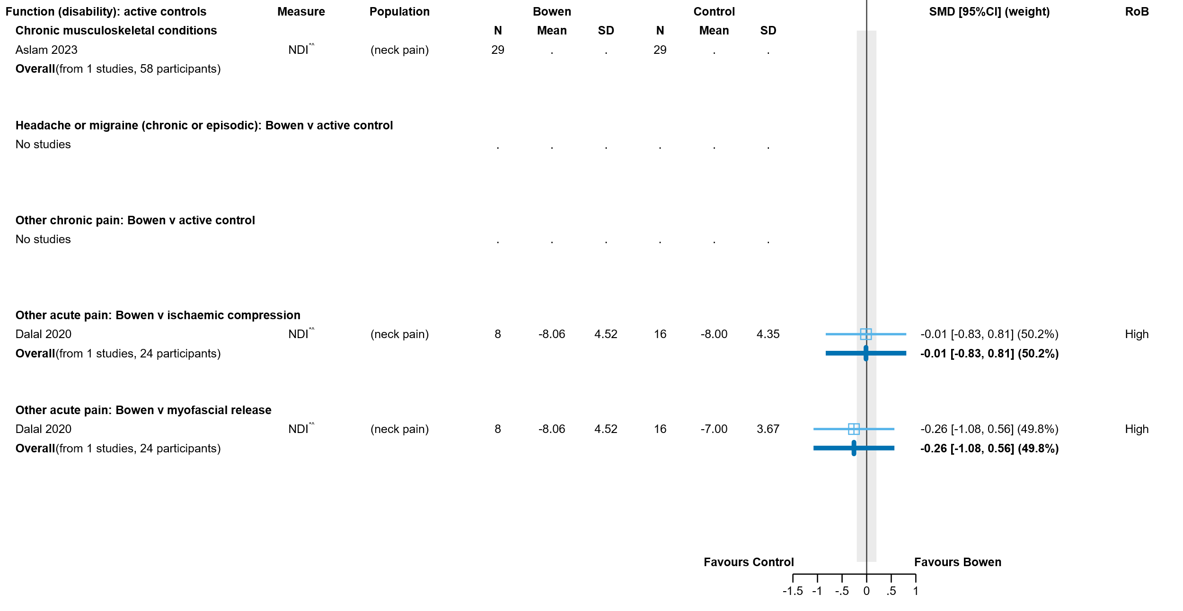

**Fig 4.2.2.1** | Forest plot comparing the effect of Bowen therapy versus an active control (other treatments) on physical function for people with pain conditions. SMD = standardised mean difference. Blue lines show 95% confidence intervals (CI). The shaded grey area indicates the pre-specified range where the effect of Bowen therapy is considered to be no different from control (SMD -0.2 to 0.2 standard units). ^ indicates studies for which results were unsuitable for meta-analysis or uninterpretable. * Denotes studies for which the direction of effect was changed to match the overall plot (positive numbers are beneficial).

**Table 4.2.2.3.** Ongoing studies comparing Bowen therapy to an active control for people with pain conditions

|  |  |  |  | **Comparison** | | **Outcome domains** | | | | | | |
| --- | --- | --- | --- | --- | --- | --- | --- | --- | --- | --- | --- | --- |
| **Study** | **Year started** | **No.** | **Population (ICD-11 code)** | **Inactive** | **Active** | **Pain** | **Sleep** | **Fatigue** | **EFMH** | **HR-QoL** | **Function** | **Symptoms** |
| **Pain conditions** | | | | | | | | | | | | |
| NCT05392049 India | **2022** | 24 | DA0E.8 Temporomandibular joint disorder | n/a | post isometric relaxation | X |  |  |  |  | X |  |
| NCT05723029 India | **2023** | 20 | FA01.0 Primary osteoarthritis of knee | n/a | post isometric relaxation | X |  |  |  |  | X |  |
| NCT04852939 India | **2020** | 74 | FB53.0 Adhesive capsulitis of shoulder | n/a | physical therapy | X |  |  |  |  | X |  |
| NCT04852913  Pakistan | **2020** | 58 | ME84.0 Cervical spine pain | n/a | conventional physical therapy (myofascial release + active RoM exercises) | X |  |  |  |  | X |  |
| NCT05751070 India | **2023** | 26 | ME84.0 Cervical spine pain (myofascial) | n/a | Graston technique | X |  |  |  |  | X |  |
| IRCT20190717044238N7 Pakistan | **2023** | 30 | ME84.1 Thoracic pain myofascial | n/a | tennis ball technique | X |  |  |  |  | X |  |
| IRCT20230426057994N1 Pakistan | **2023** | 31 | MG30.02 Chronic primary low back pain | n/a | muscle energy technique | X |  |  |  |  | X |  |
| CTRI/2023/01/049120 India | **2023** | NR | MG30.02 Non-specific chronic low back pain | n/a | Mulligan Bent Leg Raise | X |  |  |  |  | X |  |
| NCT04745858 India | **2021** | 24 | MG30.02 Non-specific chronic low back pain | n/a | Muscle energy technique | X |  |  |  |  | X |  |
| NCT05935163 Pakistan | **2023** | 42 | MG30.02 Non-specific chronic low back pain | n/a | physical therapy + dynamic soft tissue mobilisation | X |  |  |  |  | X |  |
| NCT05074641 India | **2021** | 30 | MG30.02 Non-specific chronic neck pain | n/a | myosfascial release | X |  |  |  |  | X |  |
| NCT05125484 India | **2021** | 66 | NA61.0 Strain or sprain of muscle, fascia or tendon at neck level (trapezitis) | n/a | myofascial release technique | X |  |  |  |  | X |  |
| NCT05969912 India | **2023** | 32 | MG30.01 Chronic widespread pain; MG30.02 Non-specific chronic low back pain | n/a | Graston technique (instrument-assisted soft tissue mobilisation) | X |  |  | X | X | X |  |
| CTRI/2020/04/024551 India | **2020** | 132 | MG30.01 Chronic widespread pain | n/a | craniosacral therapy; static touch; standard exercise program | X | X | X |  | X | X |  |
| NCT04554784 Hong Kong | **2022** | 80 | MG30.01 Chronic widespread pain | n/a | conventional treatments | X | X |  | X | X | X |  |

# 5. Discussion

## Summary of the main results

This review assessed the available evidence on Bowen therapy to inform the Australian Government about health policy decisions for private health insurance rebates. This review was not designed to assess all the reasons that people use Bowen therapy, or the reasons practitioners prescribe Bowen therapy and was not intended to inform individual choices about using Bowen therapy.

We found 6 studies evaluating the effects of Bowen therapy, all among people with pain conditions.

Four (4) trials (177 participants) compared Bowen therapy to an inactive treatment (two trials on neck pain, one on headache, and one on chronic multisite pain).

* One study (84 participants) provided low certainty evidence that health-related quality of life and mental health may improve slightly for people with neck pain when they receive Bowen therapy.
* The study on headache did not report results in enough detail to interpret (44 participants could not be included in our meta-analyses) (see Appendix E3).
* Based on the other 3 studies, the effect of Bowen therapy on pain and function among people with pain conditions is very uncertain.

Two trials (106 participants) compared Bowen to 3 other active treatments (one trial on chronic neck pain, one on acute neck pain).

* Both trials reported on pain and function, but results were unusable in one trial and in the other there was an error in reporting results for pain (see Appendix E3).
* Based on the single trial that provided data, the effect of Bowen therapy compared with other active treatments on physical function among people with pain conditions is very uncertain.

### Comparability of these findings with other systematic reviews

The only other systematic reviews of Bowen therapy that we could identify were those included in the overview conducted for the previous Australian Government review of Natural Therapies [25]. One of these reviews evaluated effects of various natural therapies of which Bowen was one, but identified no eligible studies on Bowen therapy. The other review included 15 studies, of which none were eligible for this review (14 because of the study design, and one because it was a trial of hamstring flexibility among healthy participants). We could identify no other reviews with which to compare the findings.

## Overall completeness and applicability of evidence

Evidence evaluating the effects of Bowen therapy is very sparse, with no coverage of the majority of conditions that Bowen therapists report treating most often.

Four (4) broad population groups were included in our analytic framework to cover commonly treated conditions (1) stress, anxiety and mood disorders, (2) pain conditions (including chronic musculoskeletal pain, headache and migraine, and other chronic or acute pain), (3) sleep disruption and (4) cancer and advanced disease. We found 6 randomised trials among people living with pain conditions, one study in people with non-Hodgkin’s lymphoma that did not report any results for a comparison eligible for this review, and no studies among people in any of the other population groups. Studies examining the effects of Bowen in the perinatal period (e.g. during pregnancy) or for any other condition relevant to the Australian setting were eligible, but no other studies were found.

Of the studies among people with pain conditions, 4 were on neck pain (3 chronic and one acute), one was on tension-type headache, and the other was on multisite pain involving both upper and lower body. The study of tension type-headache and one study of neck pain did not contribute to the summary or synthesis due to incomplete reporting of results (see Appendix E3). All of these studies measured pain, and most measured physical function, but only one study reported other prioritised outcomes. The evidence is further split by comparator; two of the 6 studies compared Bowen therapy to another treatment. The 16 ongoing trials are exclusively among people with pain conditions, 15 of these compare Bowen to another treatment.

Studies included in the analysis were conducted in Pakistan (3 trials), Hong Kong (one trial), India (one trial) and New Zealand (one trial). Five (5) of the 6 studies were conducted in an outpatient setting, and one at a university campus. It is unclear whether the practice of Bowen therapy in the countries in which it has been studied is similar to that in Australia. There was a lot of variability in duration and dose of the intervention, most studies had 1 or more sessions per week for 2-12 weeks. The effects of duration and the effects of stopping versus continuing to use Bowen are unknown. Overall, while the evidence may be applicable, it is far from complete.

## Certainty of the evidence

Limitations of the evidence were considered when interpreting each result by applying the GRADE approach. The overriding limitation is that there are only 6 small trials, including two which did not contribute to the summary or synthesis because the results were incompletely reported or uninterpretable. Most of the outcomes for which results were available had only a small number of participants contributing data, which led to imprecise effect estimates. In some cases, the imprecision was extreme, meaning that the result was compatible with both important benefit and important harm. These small studies consistently showed large effects (based on an interpretation of the point estimate in relation to a standardised mean difference of 0.8, which is commonly used threshold for a large effect). When small studies consistently show large effects, this raises concern that trials (and outcomes within trials) have been selectively reported based on the observed effects. Specifically, there is concern that more favourable results are reported whereas studies and results that are unfavourable to the intervention remain unpublished. In this case, there were no concerns about non-reporting of outcomes or results in the studies included in the meta-analysis. However, the size of the observed benefit, and high proportion of statistically significant findings, suggests that studies with less favourable results may remain unpublished.

In addition to factors addressed in the GRADE assessment, there were problems with the completeness and accuracy of reporting in 3 of included studies. Incomplete and ambiguous reporting precluded inclusion of data from 3 of the 6 studies in at least one of the meta-analyses for which they were eligible.

## Potential biases in the review process

In this review steps were taken to address potential limitations. We applied methods recommended in the Cochrane handbook for systematic reviews of interventions and the GRADE approach, as per the detailed protocol that was prospectively registered on PROSPERO after undergoing independent methodological review. The synthesis questions could not be fully specified at protocol stage; however, the final list of outcomes eligible for the review and questions to be addressed in meta-analyses were determined through a pre-specified prioritisation process, performed by NTWC with input from NTREAP and without knowledge of the included studies or results of those studies. An initial analytic framework for the review was included in the protocol to inform these decisions and propose a structure for the synthesis.

While data extraction for each study was performed by a single reviewer, the selection of outcomes and coding of studies for inclusion in meta-analyses was performed independently by a second experienced review author. All data were checked by a second experienced author, with input from a biostatistician, and all data manipulation and analyses were performed by a biostatistician. These steps minimised the risk of errors or misinterpretation. Risk of bias assessments were performed for each study by a single reviewer following detailed guidance developed for the review and training in the assessment of design features relevant to this review. Checks were performed by a second experience reviewer.

While we endeavoured to include all available studies in the analyses (applying all suggested methods from the Cochrane Handbook), several studies reported data that could not be interpreted or from which the required statistics could not be calculated or imputed. Consistent with the protocol and the approach taken in other natural therapies reviews, we did not contact trialists for additional information.

# 6. Conclusions

## Implications for health policy

There is very little evidence on the effects of Bowen therapy. The evidence base is comprised of 6 small randomised trials (22 to 90 participants). Four (4) are among people with neck pain, a condition reported as often treated by Bowen therapists in Australia. The evidence is very uncertain about whether Bowen therapy improves critical outcomes for people with neck pain, such as pain or physical function, although a single small trial found Bowen therapy may improve health-related quality of life and mental health. Headache is also reported to be a commonly treated condition; however, the single study among people with headache did not fully report results so could not be interpreted. One Australian study in people with non-Hodgkin’s lymphoma did not report any results for a comparison eligible for this review. We could not identify any systematic reviews with studies eligible for this review with which to compare these findings. We did not find any studies among people with other conditions reported by Bowen therapists as often treated, such as stress, anxiety and mood disorders, insomnia, and common musculoskeletal and pain conditions (e.g. sciatica, knee pain). Studies published in a language other than English were to be listed, but not included in the assessment, however none were found. There was a lot of variability in the period over which Bowen was delivered, most studies had 1 or more sessions per week for 2-12 weeks. Longer-term effects were generally not reported and, as such, were not examined in the review so it is unknown whether any effects are sustained.

## Implications for future research

Future research on the effectiveness of Bowen therapy could be improved by ensuring the choice of comparators facilitates synthesis; either by including inactive controls (e.g. usual care delivered to both groups, sham interventions) or standardised active comparators. In designing trials, attention should be given to the power of the trial, adequately describing all trial arms, implementing study design features that minimise the risk of bias, measuring outcomes that are well established and patient relevant (e.g. as identified in consensus-based core outcome sets), reporting all measured outcomes, and ensuring trials are registered and reported in accordance with relevant reporting guidelines.

# 7. Author contributions and declaration of interest

|  |  |
| --- | --- |
| Max Murano1 | Implemented and managed electronic systems for screening studies and data extraction, and associated work processes. Managed and coordinated study selection, selected studies, conducted data extraction and risk of bias assessments. Prepared material for the report and technical appendices, and co-led writing of the report with SB and other contributors (as described). |
| Simon Turner2 | Provided advice on extraction of results data, prepared the data set for meta-analysis (including transformations and manipulations required to include results in analysis), conducted all meta-analyses (including sensitivity and subgroup analyses), prepared figures and results tables for the report. |
| Steve McDonald1 | Developed, wrote and implemented the search strategy. Screened studies for inclusion in the review and piloted data collection and risk of bias methods. Prepared material for the report and technical appendices. Wrote the search methods and results, and study selection. |
| Joanne McKenzie2 | Wrote the analysis plan and method for reporting treatment effects. Wrote the section on *Assessment of biases due to missing results*. Designed the data collection form for quantitative results data. Provided statistical advice on risk of bias assessment, data extraction/transformation/manipulations and interpretation. Provided oversight for the conduct and interpretation of the analysis. |
| Sue Brennan1*  [sue.brennan@monash.edu](mailto:sue.brennan@monash.edu)  *(contact author) | Senior Evidence Officer responsible for oversight of the review. Led the design of the review and data extraction systems, and the implementation of risk of bias assessment. Performed data checking of extracted studies and cleaned data. Co-led writing of the review report with MM and other contributors (as described). Led the writing of the methods Appendix. |

1 Cochrane Australia, Evidence Synthesis Qualitative & Implementation Methods Unit, School of Public Health and Preventive Medicine, Monash University

2 Methods in Evidence Synthesis Unit, School of Public Health and Preventive Medicine, Monash University

## Declarations of interest

All authors declare they have no financial, personal or professional interests that could be construed to influence the conduct or results of this systematic review.

## Acknowledgements

Phoebe Nguyen2, Kimberley Jones3 and Annie Synnot1 contributed to the development of the data extraction tool and review-specific risk of bias guidance through application in the first natural therapies review of aromatherapy (>200 studies)

3 Indigenous Health Equity Unit, Melbourne School of Population and Global Health, University of Melbourne

## Funding

This review is funded by the Australian Government Department of Health and Aged Care via the NHMRC, under Official Order 2021-22C021.

# References

1. Steel A. PRACI Study: unpublished data. 2021.

2. Steel A, Beacham B, Oyston E, Adams J. Characteristics of bowen therapy practitioners and practice in Australia: An exploratorysecondary analysis of the practitioner research and collaboration initiative (PRACI) practice-based research network. Journal of Bodywork and Movement Therapies 2024;38:459-63. doi:<https://doi.org/10.1016/j.jbmt.2023.12.008>.

3. Higgins JPT, Thomas J, Chandler J, Cumpston M, Li T, Page M, et al, editors. Cochrane Handbook for Systematic Reviews of Interventions version 6.1 (updated September 2020). Cochrane. Available from [www.training.cochrane.org/handbook](../www.training.cochrane.org/handbook); 2020.

4. Page MJ, McKenzie JE, Bossuyt PM, Boutron I, Hoffmann TC, Mulrow CD, et al. The PRISMA 2020 statement: an updated guideline for reporting systematic reviews. Bmj 2021;372:n71. doi:10.1136/bmj.n71.

5. Page MJ, Moher D, Bossuyt PM, Boutron I, Hoffmann TC, Mulrow CD, et al. PRISMA 2020 explanation and elaboration: updated guidance and exemplars for reporting systematic reviews. Bmj 2021;372:n160. doi:10.1136/bmj.n160.

6. Brennan SE, Johnston RV. Research Note: Interpreting findings of a systematic review using GRADE methods. Journal of Physiotherapy 2023. doi:<https://doi.org/10.1016/j.jphys.2023.05.012>.

7. Schünemann HJ, Higgins J, Vist GE, Glasziou P, Akl EA, Skoetz N, et al. Chapter 14: Completing ‘Summary of findings’ tables and grading the certainty of the evidence. In: Higgins J, Thomas J, Chandler J, Cumpston M, Li T, Welch V, editors. Cochrane Handbook for Systematic Reviews of Interventions. 2nd ed. Chichester (UK): John Wiley & Sons; 2019.

8. Schünemann HJ, Vist GE, Higgins J, Santesso N, Deeks JJ, Glasziou P, et al. Chapter 15: Interpreting results and drawing conclusions. In: Higgins J, Thomas J, Chandler J, Cumpston M, Li T, Welch V, editors. Cochrane Handbook for Systematic Reviews of Interventions. 2nd ed. Chichester (UK): John Wiley & Sons; 2019.

9. National Health and Medical Research Council. Statement of requirement: Evidence evaluations for review of natural therapies (tranche two). 2020

10. Hansen C, Taylor-Piliae RE. What is Bowenwork®? A systematic review. J Altern Complement Med 2011;17(11):1001-6. doi:10.1089/acm.2010.0023.

11. Steel A, McIntyre E, Harnett J, Foley H, Adams J, Sibbritt D, et al. Complementary medicine use in the Australian population: Results of a nationally-representative cross-sectional survey. Sci Rep 2018;8(1):17325. doi:10.1038/s41598-018-35508-y.

12. Marr M, Lambon N, Baker J. Effects of The Bowen Technique on Flexibility Levels: Implications for Fascial Plasticity. Journal of Bodywork and Movement Therapies 2008;12(4):388. doi:<https://doi.org/10.1016/j.jbmt.2008.04.006>.

13. Better Health Channel. Bowen therapy. [Internet] Melbourne, VIC: Dept of Health, Victoria State Government. <https://www.betterhealth.vic.gov.au/health/conditionsandtreatments/bowen-therapy> (2022). Accessed 2022 Mar 09.

14. Submisson to the Reivew of the Australian Government Rebate on Private Health Insurance for Natural Therapies. Mortdale, NSW: Bowen Association Australia. 2013. <https://www1.health.gov.au/internet/main/publishing.nsf/Content/phi-natural-therapies-submissions-containerpage/%24file/Bowen%20Association%20of%20Australia.pdf>. Accessed 2023 Mar 09

15. Bowen Training Australia. [Internet] Margate, NSW: BowenTraining Australia. <https://bowentraining.com.au/> (2023). Accessed 2023 Mar 09.

16. BOWTECH: Bowen Therapy Training. [Internet] Hamilton, VIC: Bowtech Pty Ltd. <http://www.bowtech.com/WebsiteProj/Pages/Learn/Overview.aspx> (2009). Accessed 2023 Mar 09.

17. About Us. [Internet] Mortdale, NSW: Bowen Association Australia. <https://www.bowen.org.au/about-baa/> (2023). Accessed 2023 Mar 09.

18. Bowen Therapy Training. [Internet] Kilkenny, SA: Bowen Therapists Federation of Australia. <https://bowen.asn.au/training/> (2023). Accessed 2023 Mar 09.

19. Accredited Practitioner Membership. [Internet] Meadowbank, NSW: Australian Traditional-Medicine Society. <https://www.atms.com.au/membership/accredited-practitioner-membership/> (2023). Accessed 2023 Mar 09.

20. National health practitioner boards. [Internet] Melbourne, VIC: Australian Health Practitioner Regulation Agency. <https://www.ahpra.gov.au/> (2023). Accessed 2023 Mar 09.

21. Shapiro G. The Bowen Technique for Pain Relief. Positive Health Online 2004(106).

22. McCorry LK. Physiology of the autonomic nervous system. Am J Pharm Educ 2007;71(4):78. doi:10.5688/aj710478.

23. Benefits of Bowen Therapy. [Internet] Mortdale, NSW: Bowen Association Australia. <https://www.bowen.org.au/benefits/> (2023). Accessed 2023 Mar 09.

24. What is Bowen Therapy? [Internet] Margate, NSW: BowenTraining Australia. <https://bowentraining.com.au/about/> (2023). Accessed 2023 Mar 09.

25. Australian Government Department of Health. Review of the Australian Government Rebate on Natural Therapies for Private Health Insurance. 2015.

26. Higgins JPT, Savovic J, Page MJ, Sterne JAC. Revised Cochrane risk-of-bias tool for randomized trials (RoB 2). Available from <https://www.riskofbias.info/welcome/rob-2-0-tool/current-version-of-rob-2>. Access date: 8 February 2021. 2019;

27. National Health and Medical Research Council. Bowen therapy description developed in conversation with the National Health and Medical Research Council’s Natural Therapies Working Committee Chair and the Department of Health’s Natural Therapies Review Expert Advisory Panel (February 2020). 2020

28. Harris PA, Taylor R, Minor BL, Elliott V, Fernandez M, O'Neal L, et al. The REDCap consortium: Building an international community of software platform partners. J Biomed Inform 2019;95:103208. doi:10.1016/j.jbi.2019.103208.

29. Harris PA, Taylor R, Thielke R, Payne J, Gonzalez N, Conde JG. Research electronic data capture (REDCap)—A metadata-driven methodology and workflow process for providing translational research informatics support. J Biomed Inform 2009;42(2):377-81. doi:10.1016/j.jbi.2008.08.010.

30. Sterne JAC, Savovic J, Page MJ, Elbers RG, Blencowe NS, Boutron I, et al. RoB 2: a revised tool for assessing risk of bias in randomised trials. Bmj 2019;366:l4898. doi:10.1136/bmj.l4898.

31. Zeng L, Brignardello-Petersen R, Hultcrantz M, Siemieniuk RAC, Santesso N, Traversy G, et al. GRADE guidelines 32: GRADE offers guidance on choosing targets of GRADE certainty of evidence ratings. J Clin Epidemiol 2021;137:163-75. doi:10.1016/j.jclinepi.2021.03.026.

32. Schunemann HJ, Brozek J, Guyatt G, Oxman AD, editors. Handbook for grading the quality of evidence and the strength of recommendations using the GRADE approach. Hamilton, Canada: McMaster University; 2013.

33. Santesso N, Carrasco-Labra A, Langendam M, Brignardello-Petersen R, Mustafa RA, Heus P, et al. Improving GRADE Evidence Tables part 3: Guidance for useful GRADE certainty in the evidence judgments through explanatory footnotes. J Clin Epidemiol 2016. doi:10.1016/j.jclinepi.2015.12.006.

34. Santesso N, Glenton C, Dahm P, Garner P, Akl EA, Alper B, et al. GRADE guidelines: 26. informative statements to communicate the findings of systematic reviews of interventions. Journal of Clinical Epidemiology 2019. doi:<https://doi.org/10.1016/j.jclinepi.2019.10.014>.

35. Aslam N, Kazmi Y, Maqbool A, Khalid MU, Hassan M, Mansha H. Effects of bowen technique in postural neck pain among dentists. Pakistan Journal of Medical & Health Sciences 2023;17(01):14-. doi:10.53350/pjmhs202317114.

36. Chee (Ying) LA, Lee TMA, Chen PY, Samy W, Au LYF, Siu CHD. The Effect of ISBT-Bowen Therapy in the Treatment of Myofascial Neck Pain-a Randomized, Single-Blinded Clinical Trial. Int J Ther Massage Bodywork 2023;16(2):29-38. doi:10.3822/ijtmb.v16i2.801.

37. Dalal P, Kage V. Comparison of Ischaemic Compression, Myofascial Release and Bowens Technique In Non Specific Neck Pain-A Randomized Clinical Trial. Indian Journal of Applied Research 2020;10(1):25-8.

38. Lee K, Lewis GN. Short term relief of multisite chronicpain with Bowen Therapy: A double-blind, randomized controlled trial. Journal of Bodywork and Movement Therapies 2020;24(4):271-9. doi:10.1016/j.jbmt.2020.06.025.

39. Seemal P, Noor R, Riaz S, Afzal H, Anwaar S, Niaz M, et al. Effects of Muscle Energy Technique with and without Bowen Therapy in Text Neck Syndrome. Pakistan Journal of Medical & Health Sciences 2022;16(06):164-. doi:10.53350/pjmhs22166164.

40. Qamar MM, Basharat A, Kiran Q. Effects of bowen therapy in patients with tension-type headache: a randomized controlled trial. Pakistan Journal of Rehabilitation 2023;12(1):28-34. doi:10.36283/pjr.zu.12.1/005.

41. THRIVING: A randomised controlled trial assessing the efficacy of exercise versus a complementary therapy on the physical and psychosocial outcomes in haematological cancers post treatment. Australian New Zealand Clinical Trials Registry. <https://www.anzctr.org.au/Trial/Registration/TrialReview.aspx?id=83955> (2009). Accessed 2024 Oct 2.

42. Furzer BJ, Ackland TR, Wallman KE, Petterson AS, Gordon SM, Wright KE, et al. A randomised controlled trial comparing the effects of a 12-week supervised exercise versus usual care on outcomes in haematological cancer patients. Supportive Care in Cancer 2016;24(4):1697-707. doi:10.1007/s00520-015-2955-7.

43. Chee (Ying) L, Lee TM, Chen PY, Samy W, Au LY, Siu CH. The effect of isbt-bowen therapy in the treatment of myofascial neck pain—a randomized, single-blinded clinical trial. International Journal of Therapeutic Massage & Bodywork 2023;16(2):29.

44. Ughreja RA, Venkatesan P, Gopalakrishna DB, Singh YP. Effectiveness of Craniosacral therapy, Bowen therapy, static touch, and standard exercise program on sleep quality in fibromyalgia syndrome: A protocol for a randomized controlled trial. European Journal of Integrative Medicine 2023;60:102254. doi:<https://doi.org/10.1016/j.eujim.2023.102254>.