Systematic review of evidence on the clinical effectiveness of Alexander Technique

Report prepared by

Cochrane Australia

4 November 2024

Contents

Plain language summary 6

What was the aim of the review? 6

Key messages 6

What was studied in the review? 6

What were the main results of the review? 7

Implications for health policy and research 8

How up-to-date is the review? 8

Executive summary 9

Background 9

Objectives 9

Methods 9

Criteria for including studies in the review 9

Search methods 10

Analytic framework for synthesis and prioritisation process 10

Data collection and analysis 10

Main results 10

Effects of Alexander Technique 11

Limitations 11

Of the evidence contributing to the review 11

Of the review process 12

Conclusions 12

Implications for health policy 12

Implications for future research 13

1. Background 14

1.1 Description of the intervention 14

1.2 How Alexander Technique might work 15

1.3 Description of conditions for which Alexander Technique is used 15

1.4 Why it is important to do this review 16

2. Objectives 16

Primary objective was to answer the following question 16

Secondary objective 16

3. Summary of methods 17

3.1 Criteria for considering studies for this review 17

3.1.1 Types of studies 17

3.1.2 Types of participants 17

3.1.3 Types of interventions 18

3.1.4 Types of outcomes 18

3.2 Search methods for identification of studies 19

3.3 Selection of studies 19

3.4 Prioritisation of outcomes for the synthesis 19

3.5 Final framework: synthesis questions and criteria for including studies in each synthesis 19

3.6 Data extraction and management 21

3.6.1 Data extraction 21

3.6.2 Assessment of risk of bias in individual studies 21

3.6.3 Measures and interpretation of treatment effect 21

3.7 Data synthesis 21

3.7.1 Meta-analysis 21

3.7.2 Summary of findings tables and assessment of certainty of the body of evidence 21

3.7.3 Interpretation of findings (evidence statements) 22

4. Results 23

4.1 Results of the search 23

Included studies 24

Excluded studies 24

Studies awaiting classification 24

Ongoing and unpublished studies 24

Public submissions 24

4.2 Chronic musculoskeletal conditions 25

4.2.1 Alexander Technique compared to inactive control 25

4.3 Mobility limitations and risk of falls 33

4.3.2 Alexander Technique compared to inactive control 33

5. Discussion 41

Summary of the main results 41

Comparability of these findings with other systematic reviews 41

Overall completeness and applicability of evidence 42

Certainty of the evidence 42

Potential biases in the review process 43

6. Conclusions 43

Implications for health policy 43

Implications for future research 43

7. Author contributions and declaration of interest 45

Declarations of interest 45

Acknowledgements 45

Funding 45

8. References 46

In November 2020 Cochrane Australia was contracted by the National Health and Medical Research Council (NHMRC) to design and undertake the systematic review described in this report. This systematic review is one of several independent contracted evidence evaluations being undertaken to update the evidence underpinning the 2015 *Review of the Australian Government Rebate on Natural Therapies for Private Health Insurance* (2015 Review) by the Department of Health and Aged Care (Department). The design and conduct of the review were done in collaboration with the Office of NHMRC (ONHMRC), NHMRC’s Natural Therapies Working Committee (NTWC) and the Department of Health and Aged Care’s Natural Therapies Review Expert Advisory Panel (NTREAP). This report was endorsed by NTWC on 20 November 2024.

Copyright

© Commonwealth of Australia 2024

All material presented in this publication is under a Creative Commons Attribution 4.0 International licence (www.creativecommons.org.au), with the exception of the Commonwealth Coat of Arms, NHMRC logo and content identified as being owned by third parties. The details of the relevant licence conditions are available on the Creative Commons website (www.creativecommons.org.au), as is the full legal code for the CC BY 4.0 International licence.

Attribution

Creative Commons Attribution 4.0 International Licence is a standard form licence agreement that allows you to copy, distribute, transmit and adapt this publication provided that you attribute the work. NHMRC preference is that you attribute this publication (and any material sourced from it) using the following wording:

Source: Brennan, S.; Murano, M.; Turner, S.; McDonald, S. and McKenzie, J. for National Health and Medical Research Council.

Use of images

Unless otherwise stated, all images (including background images, icons and illustrations) are copyrighted by their original owners.

Contact

To obtain information regarding NHMRC publications or submit a copyright request, contact:

[communications@nhmrc.gov.au](mailto:communications@nhmrc.gov.au).

Acknowledgments

Thanks to the members of the Department’s Natural Therapies Review Expert Advisory Panel and National Health Medical Research Council’s Natural Therapies Working Committee for their advice and comments throughout the creation of this document.

Membership and other details of the Panel and Committee can be found at:

<https://www.health.gov.au/committees-and-groups/natural-therapies-review-expert-advisory-panel>

<https://www.nhmrc.gov.au/about-us/leadership-and-governance/committees/natural-therapies-working-committee>

# 

# Plain language summary

## What was the aim of the review?

The aim of this review was to examine the effects of the Alexander Technique in preventing and/or treating injury, disease, medical conditions or preclinical conditions. The Alexander Technique is an education approach in which verbal instruction, gentle hand contact, and feedback guide participants in making subtle changes to their movement or action. The aim is to promote or restore beneficial posture, coordination, balance, movement, breathing patterns and function by raising awareness of previously unnoticed habitual patterns that proponents suggest may underlie common musculoskeletal conditions and affect mobility.

This review was targeted for the Australian Government Department of Health and Aged Care (formally Department of Health) to assist in their Natural Therapies Review, which was designed to determine whether certain natural therapies, including the Alexander Technique, have enough evidence of effectiveness to be considered re-eligible for private health insurance rebates. This review was not designed to be a complete review of all published studies that have evaluated the effects of the Alexander Technique, nor is it intended to inform decisions about whether an individual or practitioner should use the Alexander Technique.

## Key messages

* We found 7 studies evaluating the Alexander Technique which compared effects among people who were allocated to the Alexander Technique to effects among people who were not allocated to Alexander Technique and measured outcomes prioritised for the synthesis (4 trials on chronic musculoskeletal conditions and 3 on mobility and risk of falls). Studies comparing the Alexander technique to other therapies are listed in an appendix.
* For people with chronic musculoskeletal pain (low back or neck), we found evidence that the Alexander Technique probably reduces disability and may reduce pain, but may make little difference to quality of life or emotional well-being.
* For people with mobility limitations or at risk of falls, we found evidence that the Alexander Technique may improve mobility, but effects on other critical outcomes, such as falls, disability and quality of life, are very uncertain.
* There are no studies involving people with other conditions for which the Alexander Technique may be used, including other musculoskeletal conditions or other groups with mobility limitations or risk factors for falls.

## What was studied in the review?

We looked for evidence from randomised trials and non-randomised studies to study the effect of the Alexander Technique on conditions and outcomes for which the Alexander Technique is commonly sought or prescribed in Australia. Accordingly, we planned a synthesis of evidence for the following population groups.

1. Chronic musculoskeletal conditions (e.g. neck, low back, arthritis, injury)
2. Mobility limitations and risk of falls (including Parkinson’s disease)
3. Stress, anxiety and mood disorders
4. Perinatal care (pregnancy, labour and childbirth, postnatal)
5. Other chronic conditions (including chronic pain, respiratory conditions)
6. Other conditions relevant to the Australian context if evidence was available

We were interested in the effects on outcomes broadly categorised as:

* pain
* health-related quality of life
* physical function (including disability and mobility)
* falls
* emotional functioning and mental health
* global symptoms / overall disease status

The specific outcomes and measures selected for the synthesis were agreed through an independent prioritisation process, in which decisions were made without knowledge of the studies or study findings. Assessments of cost-effectiveness, safety and studies of healthy populations were not included in this review.

We were able to examine the effects of the Alexander Technique for all conditions and populations for which there were studies that compared the Alexander Technique to no Alexander Technique (no intervention, sham, placebo, wait list control, or a co-intervention offered to both groups, or continuation of usual care). A secondary objective was to compare the effects of Alexander Technique with evidence-based treatments. These were to be synthesised only where there were at least two low risk of bias studies with comparable population, evidence-based comparator and outcomes.

We applied methods in the Cochrane Handbook for Systematic Reviews of Interventions [1] to search for, collate, appraise, and synthesise evidence. We then applied methods from the Grading of Recommendations Assessment, Development and Evaluation (GRADE) working group to interpret the synthesis results in a systematic and transparent way. GRADE is a method used to assess and describe how confident (or certain) we can be that the estimates of the effect (calculated by combining results from multiple studies or from single studies if that is the only evidence) reflect the true effects of the intervention. In deciding on our certainty (or confidence) in each result, we considered all relevant information collected in the review.

We use four levels to describe our certainty in the evidence.

|  |  |
| --- | --- |
| **High certainty** | We are very confident that the true effect lies close to that of the estimate of the effect. |
| **Moderate certainty** | We are moderately confident that the true effect is probably close to the estimate of the effect, but there is a possibility that it is substantially different. |
| **Low certainty** | Our confidence in the effect estimate is limited: the true effect may be substantially different from the estimate of the effect. |
| **Very low certainty** | We have very little confidence in the estimate and the true effect is likely to be markedly different from the estimated effect. The evidence is too uncertain to provide an interpretation of the result. |

Our methods were pre-specified in a publicly available protocol (PROSPERO ID CRD42023409494) that underwent independent review by methods specialists and was endorsed by the National Health and Medical Research Council’s Natural Therapies Working Committee. The review is reported in accordance with the PRISMA 2020 statement [2, 3].

## What were the main results of the review?

Following screening of 427 citations from databases searches, 50 reports were retrieved from the searches and other sources, from which we found 11 eligible studies evaluating the effects of Alexander Technique, 9 that included at least one inactive comparator. Of these 9 studies, 2 did not report any eligible outcomes. The remaining 7 studies contributed to the evidence synthesis for 2 population groups: chronic musculoskeletal conditions (4 randomised trials) and mobility limitations and falls risk (3 randomised trials). Results from these syntheses are as follows.

For people with **chronic musculoskeletal conditions** involving low back pain or neck pain

* There was moderate certainty that the Alexander Technique:
  + probably improves physical function (disability) (3 trials, 611 participants),
* There was low certainty that the Alexander Technique:
  + may reduce pain (4 trials, 611 participants),
  + may make little to no difference to health-related quality of life (2 trials, 679 participants),
  + may make little to no difference to emotional wellbeing and stress (4 trials, 655 participants), and

The Alexander Technique has unknown effects on physical function (mobility) and global symptoms/overall disease status because no studies reported on these outcomes.

No studies examined effects among people with other chronic musculoskeletal conditions.

For people with **mobility limitations or at risk of falls** (including low vision and Parkinson’s disease):

* There was low certainty that the Alexander Technique:
  + may improve physical function (mobility) (2 trials, 139 older people with low vision or Parkinson’s disease)
* The Alexander Technique has very uncertain effects on:
  + health-related quality of life (1 trial, 113 older people with low vision),
  + physical function (disability) (1 trial, 59 people at risk of falls due to Parkinson’s disease),
  + rate of falls (1 trial, 138 older people with low vision), and
  + emotional wellbeing (3 trials, 198 older people with low vision or Parkinson’s disease).

The Alexander Technique has unknown effects on global symptoms/overall disease status because no studies reported on these outcomes.

No studies examined effects among people with other mobility limitations or risk factors for falls.

The effects of Alexander technique compared to other active comparators was not examined, as pre-specified criteria for synthesis were not met (i.e. no two studies at low risk of bias evaluated the same evidence-based treatment). Studies that only contributed active comparators are listed in an inventory (Appendix C3 and E3).

## Implications for health policy and research

This review assessed the available evidence for the Alexander Technique to inform the Australian Government about health policy decisions for private health insurance rebates. The review did not cover all the reasons that people use the Alexander Technique, or the reasons practitioners prescribe the Alexander Technique and was not intended to inform individual choices about using the Alexander Technique.

We found 7 trials that evaluated the effects of the Alexander Technique compared to usual care or no intervention. Although the evidence base is small, it includes several well-designed trials that contribute importantly to findings of this systematic review. Two (2) of these trials are among people with chronic low back pain and one chronic neck pain - both conditions that are reported as often treated by teachers of the Alexander Technique. We found evidence from these trials that the Alexander Technique probably reduces disability and may reduce pain for people with chronic musculoskeletal pain (low back or neck), but may make little difference to their quality of life or emotional well-being. Effects on mobility and for people with other musculoskeletal conditions have not been investigated in trials. For people with mobility limitations or at risk of falls, the Alexander Technique may improve mobility but effects are very uncertain on other critical outcomes such as falls, disability and quality of life. These findings are similar to those of other systematic reviews. There are no studies involving people with other conditions for which the Alexander Technique may be used. This review listed, but did not assess studies that compared the effects of the Alexander Technique to other interventions, so no conclusions can be drawn on whether the Alexander Technique is as effective as other exercises or other interventions. Studies published in a language other than English were listed, but not included in the evaluation. Studies generally involved weekly sessions and ranged from 4 weeks to 5 months. Longer-term effects were generally not reported and, as such, were not examined in the review so it is unknown whether any effects are sustained.

Future research on the effectiveness of the Alexander Technique could be improved by ensuring the choice of comparators facilitates synthesis; either by including inactive controls (e.g. usual care delivered to both groups, sham interventions) or standardised active comparators. In designing trials, attention should be given to the power of the trial, implementing study design features that minimise the risk of bias, measuring outcomes that are well established and patient-relevant (e.g. as identified in consensus-based core outcome sets), reporting all measured outcomes, and ensuring trials are registered and reported in accordance with relevant reporting guidelines.

## How up-to-date is the review?

Searches were conducted from the earliest date included in the databases until 06 April 2023. Studies published after this date are not included in this review.

# Executive summary

## Background

The Alexander Technique is an education approach in which verbal instruction, gentle hand contact, and feedback guide participants in making subtle changes to their movement or action [4-7]. The aim is to promote or restore beneficial posture, coordination, balance, movement, breathing patterns and function by raising awareness of previously unnoticed habitual patterns that proponents suggest may underlie common musculoskeletal conditions and affect mobility. The Australian Government Department of Health and Aged Care (via the National Health and Medical Research Council) commissioned a suite of independent evidence evaluations to inform the 2019-20 Review of the Australian Government Rebate on Private Health Insurance for Natural Therapies. This report is for one of the evaluations; a systematic review of randomised trials and non-randomised studies examining the effectiveness of the Alexander Technique in preventing and/or treating injury, disease, medical conditions or preclinical conditions. In 2015, an overview of systematic reviews conducted for the Australian Government found there was insufficient scientific evidence that the Alexander Technique was effective. The current systematic review considered primary evidence and a wider range of publication dates.

This information will be used by the Australian Government in deciding whether to reinclude Alexander Technique as eligible for private health insurance rebates, after the Alexander Technique was excluded in 2019. This review was not designed to assess all the reasons that people use the Alexander Technique, or the reasons practitioners prescribe Alexander Technique and was not intended to inform individual choices about using the Alexander Technique.

## Objectives

Primary objective was to answer the following question:

1. What is the effect of *the* *Alexander Technique* compared to an inactive control (no intervention, sham, placebo, wait list control or a co-intervention offered to both groups, or continuation of usual care) on outcomes for each underlying condition, pre-condition, injury or risk factor?

Secondary objectives related to the following questions:

1. What is the effect of *the* *Alexander Technique* compared to evidence-based treatments (active comparators) on outcomes for each underlying condition, pre-condition, injury or risk factor?
2. What evidence exists examining the effects of *the* *Alexander Technique* compared to other active comparators? (for inclusion in evidence inventory only, not the synthesis)

As per protocol, to be included in synthesis for objective 2, there must be studies suitable for conducting a synthesis. That is, at least two low risk of bias studies with comparable population, evidence-based comparator and outcomes. Where the criteria are not met, studies will be included in the inventory.

## Methods

This review was prospectively registered on the international prospective register of systematic reviews (PROSPERO ID [CRD42023467144](https://www.crd.york.ac.uk/prospero/display_record.php?RecordID=467144)) and the methods pre-specified in a protocol published on the register. The methods were based on the Cochrane Handbook for Systematic Reviews of Interventions [1]. The Grading of Recommendations Assessment, Development and Evaluation (GRADE) approach was used to summarise and assess the certainty of evidence arising from this review [8-10]. The review is reported in accordance with the PRISMA 2020 statement [2, 3] which has been adopted by Cochrane.

The population groups and outcomes considered in the synthesis are identified in the final framework for the review that was agreed through the prioritisation process (see 3.5 Final framework).

### Criteria for including studies in the review

Broad eligibility criteria were defined for including studies in the review, as summarised below.

* ***Types of study designs and comparisons***. Eligible studies were randomised controlled trials (RCTs) and non-randomised studies of interventions (NRSIs) comparing the Alexander Technique to (1) inactive controls (no intervention, sham, placebo, wait list control, or a co-intervention that was offered to both groups, or continuation of usual care) or (2) active comparators. Any co-intervention was eligible (i.e. pharmacological or non-pharmacological). Usual care comparators were eligible if there was an explicit statement that indicated that participants could continue to access their routine care or therapy (including self-care). Where a comparator labelled as ‘usual care’ involved a defined intervention (i.e. specific treatments and processes selected by the researchers), this was deemed to be either an active intervention (if restricted to the comparator group) or a co-intervention (if able to be accessed by both groups, e.g. continuation of a specific medication).
* ***Types of populations***. Any condition, pre-condition, injury or risk factor (excluding healthy participants without clearly identified risk factors for the condition the Alexander Technique was used to prevent).
* ***Types of outcomes***. Any patient-important outcome for which the Alexander Technique is indicated was eligible for the review. Outcome domains of interest were pain, sleep quality, fatigue, emotional functioning and mental health, health-related quality of life, physical function and global symptoms. Outcomes and measures for inclusion in the synthesis for each condition were agreed through the prioritisation process.
* ***Other criteria***. Studies in languages other than English were not eligible for synthesis but were to be listed in an appendix.

## Search methods

We searched the Cochrane Central Register of Controlled Trials (Cochrane Library, Issue 4, 2023), MEDLINE, Embase, Emcare, AMED, CINAHL, Europe PMC, ClinicalTrials.gov and WHO International Clinical Trials Registry Platform on 6 April 2023. Searches were not limited by language, year of publication or publication status. The public was also invited by the Department to submit references for published research evidence.

## Analytic framework for synthesis and prioritisation process

A staged process, designed to minimise bias in the review, was agreed *a priori* for determining which of the studies eligible for the review would be included in the synthesis (see Summary of methods, Figure 3.1). Through this process, The National Health and Medical Research Council’s Natural Therapies Working Committee (NTWC) with input from NTREAP prioritised outcomes and confirmed the grouping of conditions within the population groups proposed for the synthesis. A framework for the synthesis was finalised prior to commencing data extraction. This framework defined the scope of the evidence synthesis and specified the synthesis questions and associated PICO (populations, interventions, comparators, outcomes) criteria for including studies in each synthesis (see Summary of methods, Figure 3.5.1).

## Data collection and analysis

Screening of citations and full text reports was completed by two authors, independently. Data extraction and risk of bias assessment (ROB 2.0) was piloted for the suite of natural therapies studies by two authors to ensure consistency between reviewers, then completed by a single author and checked by a second.

Comparisons were based on the population groups and outcome domains (e.g. pain, health-related quality of life, physical function, emotional functioning and mental health) specified in the analytic framework (Figure 3.5.1). Meta-analysis methods were used to combine results across studies with results suitable for meta-analysis.

GRADE methods were used to assess certainty of evidence and summarise findings. For all results an interpretation was made about whether the observed effect was important (or not) and how certain we were about the finding (high, moderate, low or very low). Certainty accounted for concerns about bias (arising from studies included in and missing from the synthesis), how precisely the effect was estimated, important unexplained inconsistency in the results across studies, and how directly the studies in each synthesis addressed the synthesis question defined in the analytic framework.

## Main results

Following screening of 427 citations from databases searches, 50 reports were retrieved from the searches and other sources from which a total of 11 studies were included in the review. Seven (7) of these studies (18 reports) were included in the evidence synthesis comparing the Alexander Technique to an inactive comparator. The other 4 studies contributed to the evidence inventory (2 with active comparators, 2 that did not measure an eligible outcome). Three (3) ongoing studies were identified, and 13 studies are awaiting classification (9 published in abstracts only, one in a language other than English, and 3 for which the full text could not be retrieved).

### Effects of Alexander Technique

For people with **chronic musculoskeletal conditions** involving low back pain or neck pain

* There was moderate certainty evidence that the Alexander Technique
  + probably improves physical function (disability) (3 trials, 611 participants),
* There was low certainty evidence that the Alexander Technique
  + may reduce pain (4 trials, 611 participants),
  + may make little to no difference to health-related quality of life (2 trials, 679 participants),
  + may make little to no difference to emotional wellbeing and stress (4 trials, 655 participants), and

The Alexander Technique has unknown effects on physical function (mobility) and global symptoms/overall disease status because no studies reported on these outcomes.

No studies examined effects among people with other chronic musculoskeletal conditions.

For people with **mobility limitations or at risk of falls** (including low vision and Parkinson’s disease):

* There was low certainty evidence that the Alexander Technique
  + may improve physical function (mobility) (2 trials, 139 older people with low vision or Parkinson’s disease, low certainty evidence), and

The Alexander Technique has very uncertain effects on

* health-related quality of life (1 trial, 113 older people with low vision),
* physical function (disability) (1 trial, 59 people at risk of falls due to Parkinson’s disease),
* rate of falls (1 trial, 138 older people with low vision), and
* emotional wellbeing (3 trials, 198 older people with low vision or Parkinson’s disease).

The Alexander Technique has unknown effects on global symptoms/overall disease status because no studies reported on these outcomes.

No studies examined effects among people with other mobility limitations or risk factors for falls.

The effects of Alexander technique compared to other active comparators was not examined, as pre-specified criteria for synthesis were not met (i.e. no two studies at low risk of bias evaluated the same evidence-based treatment). Studies that only contributed active comparators are listed in an inventory (Appendix C3 and E3).

## Limitations

### Of the evidence contributing to the review

Limitations of the evidence were considered when interpreting each result by applying the GRADE approach. The overriding limitation is that only 7 trials contribute to the evidence base. This limitation is offset to some extent, because most of the data in analyses comes from 4 trials that were well designed and generally well reported.

For people with chronic musculoskeletal conditions, the number of studies is small, but there were two large well-designed and reported trials that had consistent results judged to be at low risk of bias for multiple outcomes. There was concern that study limitations may have led to biased effect estimates for some outcomes such that benefits were overestimated, and that selective non-reporting of unfavourable results (i.e. from missing studies or missing outcomes from included studies) could have influenced some findings, especially those for which available studies reported beneficial effects. Studies generally involved weekly sessions and ranged from 4 weeks to 5 months. Longer-term effects were generally not reported and, as such, were not examined in the review so it is unknown whether any effects are sustained. For people with mobility limitations or at risk of falls, results for all but one outcome were of very low certainty. This is primarily because results for most outcomes were from single trials with a small number of participants. This led to imprecise effect estimates, such that the results were compatible with both important benefit and important harm. The lack of replication also raises concern that results may not be generalisable to people with other mobility limitations or risk factors for falls. Finally, for results derived from one or two small trials that show important benefit, selective non-reporting of unfavourable results (null or favouring control) could importantly change the result. We were unable to use graphical methods to investigate whether studies showing different effects (favouring control, trivial effects) may be missing from the analyses. As such, we judged that publication bias was a concern for some results.

### Of the review process

In this review steps were taken to address potential limitations. We applied methods recommended in the Cochrane handbook for systematic reviews of interventions and the GRADE approach, as per the detailed protocol that was prospectively registered on PROSPERO after undergoing independent methodological review. The synthesis questions could not be fully specified at protocol stage; however, the final list of outcomes eligible for the review and questions to be addressed in meta-analyses were determined through a pre-specified prioritisation process, performed by NTWC with input from NTREAP and without knowledge of the included studies or results of those studies. An initial analytic framework for the review was included in the protocol to inform these decisions and propose a structure for the synthesis.

While data extraction for each study was performed by a single reviewer, the selection of outcomes and coding of studies for inclusion in meta-analyses was performed independently by a second experienced review author. All quantitative data were checked by a second experienced author, with input from a biostatistician, and all data manipulation and analyses were performed by a biostatistician. These steps minimised the risk of errors or misinterpretation. Risk of bias assessments were performed for each study by a single reviewer following detailed guidance developed for the review and training in the assessment of design features relevant to this review. Checks were performed by a second experience reviewer.

While we endeavoured to include all available studies in the analyses (applying all suggested methods from the Cochrane Handbook), several studies reported data that required manipulation or imputation for inclusion in analyses. We were unable to perform sensitivity analyses to examine the impact of these calculations or decisions because of the small number of studies. However, effects were consistent with those reported in included studies. Consistent with the protocol and the approach taken in other natural therapies reviews, we did not contact trialists for additional information.

Assessments of cost-effectiveness, safety and studies of healthy populations were out of scope.

## Conclusions

### Implications for health policy

We found 7 trials that evaluated the effects of the Alexander Technique compared to usual care or no intervention. Although the evidence base is small, it includes several well-designed trials that contribute importantly to the findings of this systematic review. Two (2) of these trials are among people with chronic low back pain and one chronic neck pain - both conditions that are reported as often treated by teachers of the Alexander Technique. We found evidence from these trials that the Alexander Technique probably reduces disability and may reduce pain for people with chronic musculoskeletal pain (low back or neck), but may make little difference to their quality of life or emotional well-being. Effects on mobility and for people with other musculoskeletal conditions have not been investigated in trials. For people with mobility limitations or at risk of falls, the Alexander Technique may improve mobility but effects are very uncertain on other critical outcomes such as falls, disability and quality of life. These findings are similar to those of other systematic reviews. There are no studies involving people with other conditions for which the Alexander Technique may be used. This review listed, but did not assess studies that compared the effects of the Alexander Technique to other interventions, so no conclusions can be drawn on whether the Alexander Technique is as effective as other interventions. Studies published in a language other than English were listed, but not included in the evaluation.

### Implications for future research

Future research on the effectiveness of the Alexander Technique could be improved by ensuring the choice of comparators facilitates synthesis; either by including inactive controls (e.g. usual care delivered to both groups, sham interventions) or standardised active comparators. In designing trials, attention should be given to the power of the trial, adequately describing all trial arms, implementing study design features that minimise the risk of bias, measuring outcomes that are well established and patient-relevant (e.g. as identified in consensus-based core outcome sets), reporting all measured outcomes, and ensuring trials are registered and reported in accordance with relevant reporting guidelines.

# 1. Background

In 2015, the Australian Government conducted a *Review of the Australian Government Rebate on Natural Therapies for Private Health Insurance (2015 Review).* Underpinned by systematic reviews of evidence for each natural therapy, one of the findings from the 2015 Review was that there was no clear scientific evidence that the Alexander Technique was effective. The National Health and Medical Research Council (NHMRC) has been engaged by the Department of Health and Aged Care (Department) to update the evidence underpinning the 2015 Review. This evidence evaluation of Alexander Technique is one of a suite of independent contracted systematic reviews that will inform the *Review of the Australian Government Rebate on Private Health Insurance for Natural Therapies 2019-20* (2019-20 Review) [11].

Developed in Australia by Frederick M Alexander between the 1890’s and early 1900’s to improve his own vocal performance, the Alexander Technique has evolved into one of a diverse range of approaches known as mind and body (or mind-body) practices that are taught in Western countries by trained practitioners or teachers [12]. A 2013 cross-sectional survey of 871 members of the United Kingdom's (UK) three main Alexander Technique professional associations estimated that approximately 400,000 Alexander Technique lessons were provided each year in the UK [13]. In Australia, the main source of information about the rates of consultation with complementary medicine practitioners is a cross-sectional survey conducted as part of the Practitioner Research and Collaborative Initiative (PRACI) [14]. The 2017 PRACI survey of Australian adults found that about a third of all respondents (36%; 726/2025 respondents) had consulted at least one complementary therapist in the last 12 months. The Alexander Technique was not among the therapies examined, and data are lacking on the prevalence and frequency of consultation with teachers of the method or routine use.

## 1.1 Description of the intervention

The Alexander Technique has been described as a “method for improving the manner in which we go about daily activities (such as sitting, standing, walking, and speaking)” [6]. The Technique aims to promote or restore beneficial posture, coordination, balance, movement, breathing patterns and function. Those wanting to use the Alexander Technique begin by learning about the relationship of the head, neck and spine, and developing an awareness of posture and movement in order to identify and address habits that may cause unnecessary tension and contribute to pain and other stress [4, 6, 7, 12, 15]. This process of consciously working to restore what are believed to be more functional patterns of posture, coordination and movement, is sometimes described as “re-educating” the “muscular coordination patterns” that underlie day-to-day activities [16].

Learning the Alexander Technique typically involves attending lessons in which participants (referred to as ‘students’) learn the principles and skills needed to apply the Technique in daily life. In these lessons, students perform everyday movements within the normal range, such as walking and rising to standing from a seated position [4, 7]. Techniques to increase awareness of posture and muscle tension are practised at rest, when preparing to move and during movement [4]. Teachers of the Alexander Technique may use gentle hand contact to guide participants in making subtle changes to their movement or action, although learning is done primarily through verbal instruction, feedback and dialogue [4-7]. The use of manual guidance lessens as participants increase their knowledge and skill, and become accustomed to applying the techniques in their everyday activities. Daily practise of specific techniques is encouraged, such as lying semi-supine for 15-20 minutes to focus on “the Alexander thoughts and directions” [6].

***Mode of administration and dose***

The Alexander Technique is usually taught in individual lessons tailored to meet the needs of the participant, and sometimes in introductory group classes or as intensive workshops. The number and duration of lessons undertaken varies. A cross-sectional survey of Alexander Technique teachers in the United Kingdom (response rate 534/871) found that 38% of their clients took more than 25 lessons, with a median lesson duration of 45 minutes. A typical lesson pattern was weekly lessons initially, with a reduction in frequency over time [13]. The Australian Society of Teachers of the Alexander Technique (AUSTAT) recommends a minimum of six lessons, but suggests that 12-24 lessons may lead to increased and sustained benefits [17].

Unlike many physical therapies that are delivered in classes, the purpose of Alexander Technique lessons is to equip participants with a set of skills that enable self-observation, self-awareness and application of the Technique in their daily lives [6].

***Practitioners of Alexander Technique and regulation***

In Australia, the Alexander Technique is usually taught by teachers who have attended an accredited Alexander Technique teacher training course. Accredited courses must provide for a minimum of 1600 contact hours over three years. AUSTAT has accredited four teacher training schools that meet its standards. The Alexander Technique Education (ATE) professional association is based on the specific teaching methods of Walter Carrington, has one teacher training school and is a sister organisation of ATE UK [18, 19].

The practice and teaching of the Alexander Technique is not regulated by the Australian Health Practitioner Regulation National Law, which means there is no requirement for professional registration of practitioners of the Alexander Technique [14, 20]. The AUSTAT professional society has procedures for the management of complaints and misconduct, has developed a Code of Professional Conduct for its members and coordinates professional development for its members. AUSTAT is also a member of Alexander Technique Affiliated Societies (ATAS) that maintains "minimum common standards for the training and professional conduct of Alexander Technique Teachers around the world." [17].

## 1.2 How Alexander Technique might work

The Alexander Technique arose from the practical experience of F.M. Alexander who observed that the vocal problems he experienced as an actor appeared to be associated with particular postures and movement that he attributed to tension in his body. He developed techniques to change these (self-described) ‘maladaptive habitual patterns’ and taught these techniques to others through an educational program and books from which the Alexander Technique originated [12, 21]. While the techniques and principles lacked a formal scientific basis, they are evident in prevailing descriptions of the mechanism by which the Alexander Technique works.

Underpinning the Alexander Technique is a belief that there is an optimal relationship between the head, neck and spine (the central body axis) that supports coordination, balance, regulation of postural tone (maintaining the position of the body to counteract gravitational pull) and pain-free activity. When movement involves “maladaptive” habits, the resulting excessive muscle tension is believed to interfere with the optimal relationship between the head, neck and spine contributing to pain and stress-related health effects. Proponents of the Alexander Technique posit that becoming aware of habitual movement patterns and adopting patterns that maintain spinal length and reduce excessive skeletal muscle activity will improve postural tone and ease of movement, and in turn may improve coordination, relieve pain, reduce stress and prevent injury [4, 16, 22-25].

The notion that correcting aberrant posture and movement may reduce chronic musculoskeletal pain aligns with some mainstream approaches to pain management (see for example [26-29]). There is a considerable body of empirical research investigating mechanisms that underpin these mainstream approaches, although there are many areas of contention and complexity which is reflected in multifactorial models of pain [28, 30]. Researchers of the Alexander Technique have recently attempted to identify and articulate a neurophysiological model for the mechanism of action that captures the interaction between physical and cognitive processes (such as those that influence awareness and control of posture) [4].

## 1.3 Description of conditions for which Alexander Technique is used

The Alexander Technique is most commonly suggested as a treatment for musculoskeletal pain conditions [5, 6, 31-35]. Some National Health Service trusts in the UK offer Alexander Technique lessons as part of outpatient pain management [33, 36]. The Technique has also been used among populations for whom problems with balance, coordination or motor function have a potentially important health impact. These include older populations at risk of falls [37, 38] and those with Parkinson’s disease [23, 24, 39] for whom UK national guidelines suggest considering the Technique for balance or motor functions problems [40]. There has also been interest in the use of the Alexander Technique for respiratory conditions such as asthma [7, 41].

While data from Australia about the use of the Alexander Technique are lacking, findings from a 2013 cross-sectional survey of Alexander Technique teachers in the UK (781 respondents) found that the most common reasons for clients seeking consultation were musculoskeletal (e.g. back, neck or shoulder pain) (62%), general interest and well-being (18%), vocal, musical or sporting performance-related reasons (10%), psychological reasons (e.g. stress, anxiety, low mood) (5%) and neurological reasons (e.g. headache/migraine, Parkinson's disease, multiple sclerosis) (3%)[13]. While the Alexander Technique was developed and is widely recognised as a method for improving performance skills, reducing performance-related anxiety and enhancing general well-being [15], its application among healthy populations is outside the scope of this review.

## 1.4 Why it is important to do this review

This systematic review will inform the Australian Government’s Natural Therapies Review 2019-20, which is evaluating evidence of the clinical effectiveness of 16 therapies (including the Alexander Technique). The conclusion from the evidence evaluation conducted on the Alexander Technique for the *2015 Review* was that it “may improve short-term pain and disability in people with low back pain, but the longer-term effects remain uncertain. For all other clinical conditions, the effectiveness of the Alexander Technique was deemed to be uncertain, due to insufficient evidence” [42]. The evidence evaluation used overview methods, synthesising results from nine systematic reviews published up to September 2013. All the primary studies included in these systematic reviews (N=3) were published before 2010. Since the completion of the original evidence evaluation, there has been additional published trials of the Alexander Technique although the number of trials remains small. In contrast to the 2015 Alexander Technique evidence evaluation, this review will examine evidence from eligible primary studies published from database inception until the date of the last search for this systematic review.

# 2. Objectives

The overall objective of this systematic review is to examine the evidence for the clinical effectiveness of the Alexander Technique in preventing and/or treating injury, disease, medical conditions or preclinical conditions [11]. The review will focus on outcomes (and underlying conditions) for which the Alexander Technique is commonly sought or prescribed in Australia, and to inform the 2019-20 Review of the Private Health Insurance rebate.

The questions for the review follow (framed as primary and secondary objectives).

## Primary objective was to answer the following question

1. What is the effect of *the* *Alexander Technique* compared to aninactive control (no intervention, sham, placebo, wait list control, or a co-intervention that was offered to both groups, or continuation of usual care) on outcomes for each underlying condition, pre-condition, injury or risk factor?

## Secondary objective

Secondary objectives related to the following questions:

1. What is the effect of *the* *Alexander Technique* compared to evidence-based treatments (active comparators) on outcomes for each underlying condition, pre-condition, injury or risk factor?
2. What evidence exists examining the effects of *the Alexander Technique* compared to other active comparators? (for inclusion in evidence inventory only, not the synthesis)

As per protocol, to be included in synthesis for objective 2, there must be studies suitable for conducting a synthesis. That is, at least two low risk of bias studies with comparable population, evidence-based comparator and outcomes. Where the criteria are not met, studies will be included in the inventory.

Decisions about the final synthesis questions and criteria for including studies in each synthesis were made through a staged process (described in section 3.4). The staged process aimed to align the questions addressed with priorities for the 2019-20 Review, ensure a consistent approach across the evidence evaluations of natural therapies (where appropriate), and make best use of available evidence.

The population groups and outcomes considered in the synthesis are identified in the final framework for the review that was agreed through the prioritisation process (section 3.4). The final synthesis questions and criteria for including studies in each synthesis are presented in Figure 3.5.1.

# 3. Summary of methods

This review followed methods pre-specified in the protocol endorsed by NTWC with input from NTREAP. The protocol was prospectively registered on the International prospective register of systematic reviews (PROSPERO ID [CRD42023467144](https://www.crd.york.ac.uk/prospero/display_record.php?RecordID=467144)). The methods were based on the Cochrane Handbook for Systematic Reviews of Interventions [1]. The Grading of Recommendations Assessment, Development and Evaluation (GRADE) approach was used to summarise and assess the certainty of evidence arising from this review [9, 10]. The review is reported in accordance with the PRISMA 2020 statement [2, 3].

A staged approach was taken to developing the questions and criteria for including studies in the synthesis (Figure 3.1). A summary of each stage is described in the methods that follow (see Appendices A and B for a complete description of methods; Appendix I for Abbreviations used in the report). The framework for the synthesis was finalised prior to commencing data extraction (Figure 3.1, panel 4). It defines the scope of the evidence synthesis and specifies the synthesis questions and associated PICO (population, intervention, comparator, outcome) criteria for including studies in each synthesis.

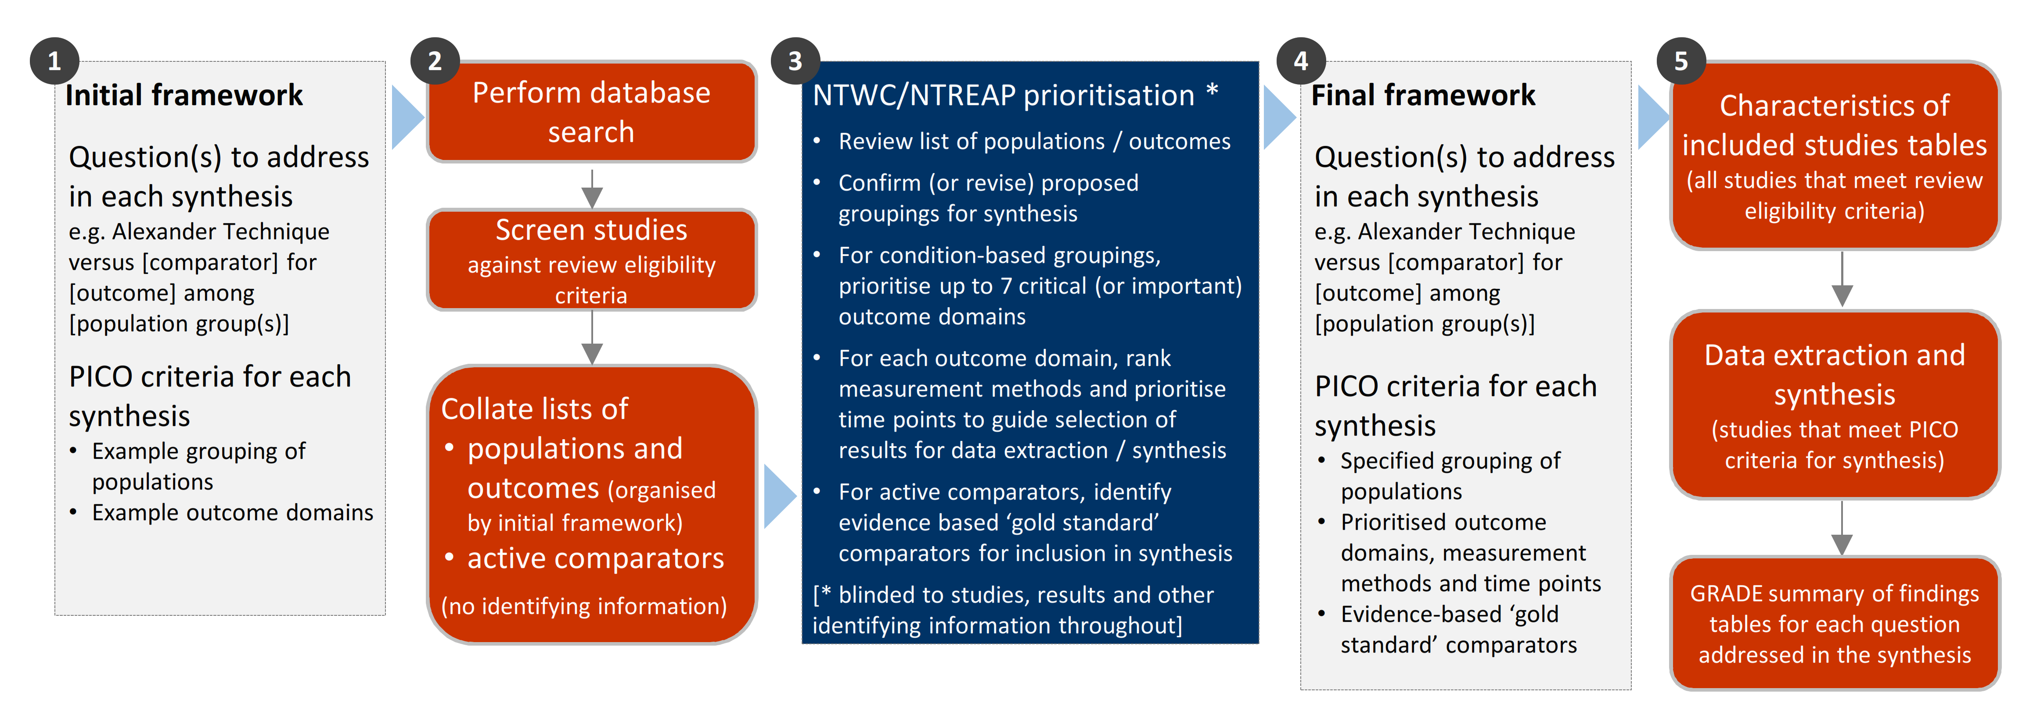

**Fig 3.1** | Staged approach for developing the questions and analytic framework for this review.

## 3.1 Criteria for considering studies for this review

### 3.1.1 Types of studies

We included randomised controlled trials (RCTs) (including individually and cluster randomised, and cross-over trials) and controlled trials where there was an attempt to have some kind of ‘randomisation’ to groups (e.g. sequence generation based on alternation, dates (of birth or attendance at a clinic) and patient record numbers) [43]. Non-randomised studies of interventions (NRSIs) with certain design features were eligible (see Appendix A1.1.1). Historical case control, uncontrolled before-after studies, cross-sectional studies and case-control studies were ineligible.

***Date and language restrictions.*** There were no restrictions on publication date. Potentially eligible studies published in languages other than English were to be listed but not included in the synthesis.

### 3.1.2 Types of participants

Studies involving participants with any disease, medical condition, injury, or preclinical condition were eligible for the review. This included healthy participants with clearly identified risk factors for a condition (evident from study eligibility criteria or baseline data) that the Alexander Technique was administered to prevent. There were no restrictions on age. Healthy populations seeking health improvement were excluded. This includes healthy participants using the Alexander Technique to improve performance skills and enhance general well-being. Criteria for screening such studies were refined by asking the NTWC to adjudicate on examples. Study PICO, aims and potential risk factors reported by the trialists were provided, without results or information that would identify the study.

### 3.1.3 Types of interventions

The Alexander Technique was defined as a method that aims to:

* “… retrain habitual patterns of movement, [and] improve postural support and coordination … by consciously altering automatic responses and tonic muscular activity,
* re-educate basic muscular co-ordination patterns underlying all activity,
* reduce excessive and maladaptive tension …,
* and improve functional movement patterns in work and everyday life.” [excerpt from [16]]

Because of the potential challenge of distinguishing the Alexander Technique from related modalities, and the likelihood of identifying studies in which the defining Techniques and principles of the Alexander Technique were incompletely reported, studies were included if the therapy was described as the Alexander Technique (or other synonyms). Studies that failed to mention or describe the intervention as the Alexander Technique (or other synonyms) were excluded. The Alexander Technique interventions were eligible irrespective of the training or qualifications of the practitioner, the setting in which the Alexander Technique was used, and the dose and duration of treatment.

#### Comparisons

1. The Alexander Technique *versus* any inactive comparator (no intervention, sham, placebo, wait list control, or a co-intervention that was offered to both groups, or continuation of usual care).
2. The Alexander Technique *versus* evidence-based gold standard treatment(s)
3. The Alexander Technique *versus* any active comparator (for inclusion in evidence inventory only, not the synthesis).

As per protocol, to be included in synthesis for objective 2, there must be studies suitable for conducting a synthesis. That is, at least two low risk of bias studies with comparable population, evidence-based comparator and outcomes. Where the criteria are not met, studies will be included in the inventory.

Any co-intervention was eligible (i.e. pharmacological or non-pharmacological). Usual care comparators were eligible if there was an explicit statement that indicated that participants could continue to access their routine care or therapy (including self-care). If a comparator labelled as ‘usual care’ involved a defined intervention (i.e. specific treatments and processes selected by the researchers), this was deemed to be either an active intervention (if restricted to the comparator group) or a co-intervention (if able to be accessed by both groups, e.g. continuation of a specific medication).

We excluded head-to-head comparisons of the Alexander Technique (e.g. comparison of different frequencies, durations or schedules; comparison of differently qualified people teaching the Alexander Technique).

### 3.1.4 Types of outcomes

Any patient-important outcome that aligned with the reasons why the Alexander Technique is sought by patients and prescribed by practitioners was eligible. Studies were included in the review irrespective of the outcome(s) measured, but the synthesis was limited to outcomes considered to be critical or important for each population group (see 3.4 for prioritisation of outcomes and 3.5 for final framework). Experience of care (e.g. satisfaction), safety, quality, and economic outcomes were excluded.

From each study, we selected one outcome per outcome domain for data extraction (results), risk of bias assessment and inclusion in the synthesis. In selecting outcomes for synthesis, we considered the outcome measure (any measure was eligible but a pre-specified hierarchy was applied to select the most relevant measure if multiple measures were available), timing of outcome measurement (first measure after end of the Alexander Technique intervention period) and suitability of data for meta-analysis.

## 3.2 Search methods for identification of studies

We searched the Cochrane Central Register of Controlled Trials (Cochrane Library, Issue 4, 2023), MEDLINE (Ovid), Embase (Ovid), Emcare (Ovid), AMED (Ovid), CINAHL (EBSCOhost), Europe PMC, ClinicalTrials.gov and WHO International Clinical Trials Registry Platform on 6 April 2023. Searches were not limited by language, year of publication or publication status. We also searched Google Scholar (first 10 pages) and conducted a forward citation search on all studies that met the inclusion criteria.

## 3.3 Selection of studies

Two reviewers piloted guidance for title and abstract screening on a sample of 50 records to ensure the review eligibility criteria were applied consistently. All records were screened independently by two reviewers at both the title and abstract screening and full-text review stages. Disagreements at either stage of screening were resolved by consensus among members of the review team. We documented the flow of studies through the review in a PRISMA diagram (Figure 4.1.1).

Studies that did not meet the review eligibility criteria were excluded and the reason for exclusion was recorded at full-text screening. For studies that originated from the call for evidence, NTREAP, or the Committee, we recorded and reported exclusion decisions irrespective of whether the study was excluded during title and abstract screening or full text review.

## 3.4 Prioritisation of outcomes for the synthesis

Decisions about the final synthesis questions and criteria for including studies in each synthesis were made through the prioritisation process in Figure 3.1. The process was designed to minimise bias in the selection of results for inclusion in the synthesis while ensuring coverage of relevant populations and outcomes.

In brief, we screened studies against the review eligibility criteria and collated deidentified information about the populations and outcomes addressed in included studies (no bibliographic information, titles, details about the number of studies, participants, methodological quality or results). For each condition, NTWC, with input from NTREAP, rated outcome domains as critical, important or of limited importance. Within each outcome domain, NTWC ranked the listed outcomes/measures for each domain to enable selection of the most relevant result from each study.

## 3.5 Final framework: synthesis questions and criteria for including studies in each synthesis

Figure 3.5.1, shows the final analytic framework for the evidence summary and synthesis. The framework provides a guide to the structure of the synthesis and reporting of results (see caption for details).

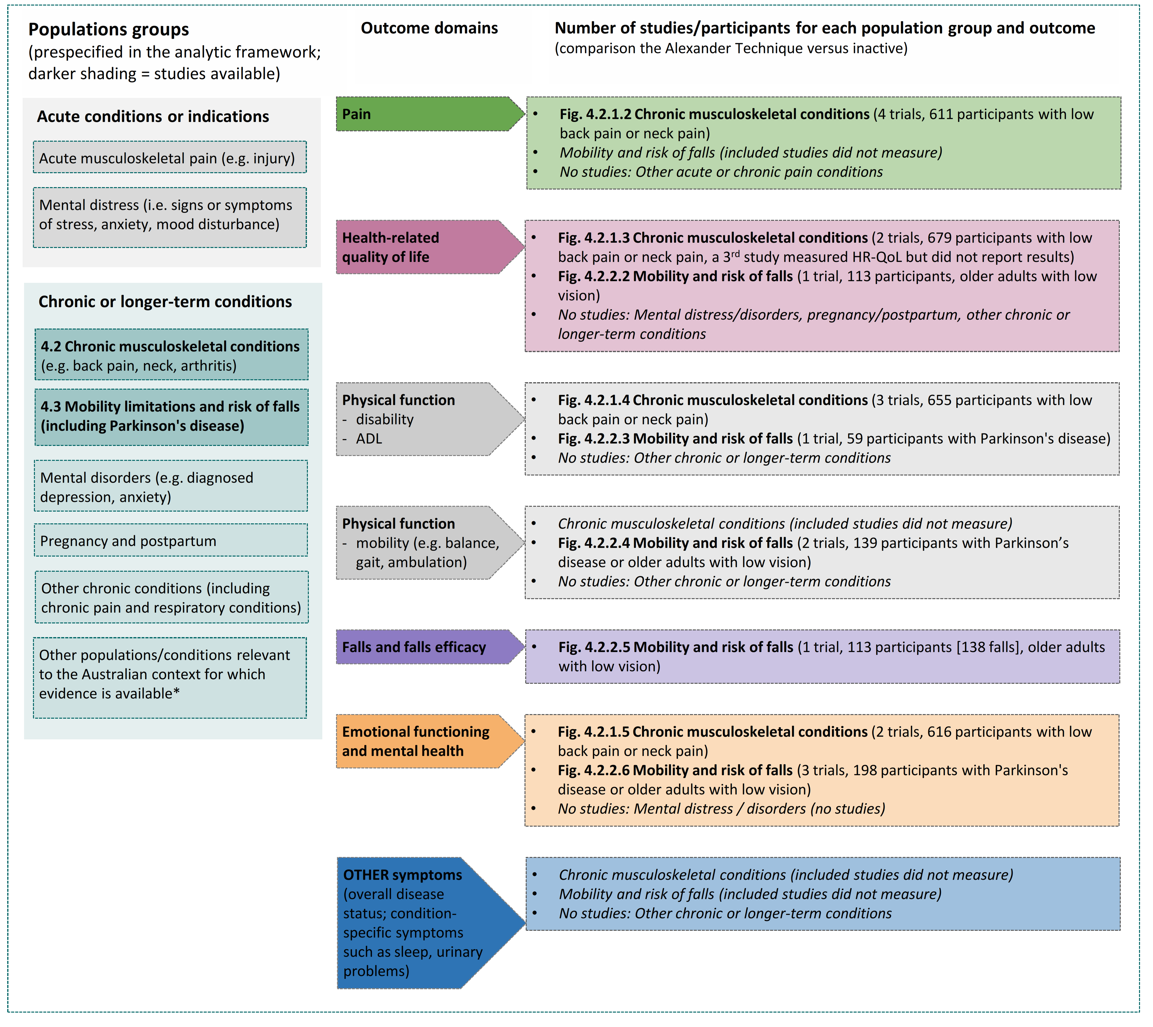

**Fig 3.5.1** | Final analytic framework for the review as agreed through the prioritisation process (Appendix A5).   
Panel A, columns 1 to 2 show the populations and outcome domains for the evidence synthesis. Column 3 shows the populations and outcome domains for which studies were available for the comparison of the Alexander Technique vs. inactive control. Results are reported for each population group in the section indicated in column 1. Study-level data and meta-analyses are presented in the forest plot indicated in column 3. Population groups are those reported as often treated by teachers of the Alexander Technique (UK data) except those marked * [44].

## 3.6 Data extraction and management

### 3.6.1 Data extraction

Study data were collected and managed using REDCap electronic data capture tools [45, 46]. A two-step data extraction process was implemented wherein a senior author (MM) coded the study PICO to allocate studies for analysis according to the analytic framework and selected the outcome (result) for inclusion in each synthesis using pre-specified decision rules. Any queries from this stage were sent to the second senior author (SB) to review, with any disagreement resolved through consensus discussion. A senior author (MM or SB) extracted study characteristics and quantitative data. A second senior author (SB or MM) independently verified the study allocation for analysis and outcome selection, as well as the data. The form and data extraction process had previously been applied to a large number of studies (>200) in other natural therapies reviews undertaken by our team. Steps taken to ensure the completeness, accuracy and consistency of data in these reviews included pretesting the form and providing coding guidance, training, and feedback for data extractors. Quantitative data were reviewed by a biostatistician when queries arose.

### 3.6.2 Assessment of risk of bias in individual studies

We assessed the risk of bias in included studies using the revised Cochrane ‘Risk of Bias’ tools (RoB 2) for randomised trials [43, 47]. After piloting of the tool by senior authors (SB, MM, SM), we developed review-specific guidance for the suite of natural therapies reviews to ensure consistency between reviewers. This guidance had been used by the author team to assess over 200 natural therapies studies prior to application in the current review. One review author (MM or SB) applied the tool to the selected results from each study following the RoB 2 guidance [43], and a second author (SB) checked a subset of assessments. Supporting information and justifications for judgements for each domain (low, some concerns, high risk of bias) were recorded. We derived an overall summary of the risk of bias from each assessment, following the algorithm in the RoB 2 guidance as implemented in the Excel assessment tool [43]. Where we judged that there was a material risk of bias (or the converse) not reflected by the proposed judgement in the algorithm, we changed the judgement and provided a rationale.

### 3.6.3 Measures and interpretation of treatment effect

We anticipated that many of the outcomes would be continuous (e.g. pain, function), and that varying measurement instruments would be used to measure the same underlying construct across the studies. For this reason, we quantified the effects of the Alexander Technique using the standardised mean difference (SMD).

Our interpretation was based on whether there was an important effect or not [8, 48], with an SMD of 0.2 standard units set as the threshold for an important difference. If the SMD fell within the pre-specified range of -0.2 to 0.2 (i.e. within both thresholds), the effect of the Alexander Technique was considered to be no different from control. An SMD above 0.2 or below -0.2 was interpreted as an important effect. We opted to use the most intuitive interpretation of effect estimates for each outcome, so positive values indicate benefit for some outcomes (an increase in physical function) and harm for other outcomes (an increase in pain). For the rate of falls, we used a threshold of 5% (50 fewer falls per 1000 people over 1 year)[1].

## 3.7 Data synthesis

### 3.7.1 Meta-analysis

Separate comparisons were set up for each population group and outcome domains agreed in the final framework (see Figure 3.5.1). Some comparisons were stratified by more specific conditions (with an overall estimate and estimate for each condition presented). Forest plots were used to visually depict the intervention effect estimates and their confidence intervals. Forest plots are stratified by condition and risk of bias (within population group). For completeness, results for all studies for which an effect estimate (SMD) could be calculated are presented on the forest plot, including where a single study contributed to the comparison. Studies confirmed as measuring an outcome for which results were not reported, are also depicted on the plot.

### 3.7.2 Summary of findings tables and assessment of certainty of the body of evidence

For each result, one author (SB) used the GRADE approach to assess our certainty in whether there is an important effect (or not). In accordance with GRADE guidance [9, 48, 49], an overall GRADE of high, moderate, low or very low certainty is reported for each result based on whether there are serious, very serious, extremely serious or no concerns in relation to each of the following domains [8].

* **Risk of bias**. whether the studies contributing to each synthesis have methodological limitations that might lead to over (or under) estimation of the effect.
* **Imprecision**. whether the confidence interval for the synthesised result crosses one or both of the thresholds for an important effect (an SMD of 0.2 or -0.2 or equivalent thresholds for falls rate) meaning that the result is compatible with different interpretations (e.g. the upper bound of the interval lies above 0.2 indicating ‘an important effect’ whereas the lower bound lies between -0.2 and 0.2 indicating ‘little or no effect’)
* **Inconsistency**. whether there is important, unexplained inconsistency in results across studies
* **Indirectness**. whether there are important differences between the characteristics of studies included in each synthesis and the question we were seeking to address, such that the effects observed may not apply to our question (i.e. the applicability of the evidence).
* **Publication bias**. whether results missing from each analysis may bias the effect estimate because of selective non-reporting of results (or studies) that showed unfavourable effects.

A summary of findings is tabulated for each comparison. These summary of findings tables include:

* estimates of the effects of the Alexander Technique reported as standardised mean differences.
* the overall GRADE (rating of certainty) and an explanation of the reason(s) for rating down (or borderline decisions) [50]
* the study design(s), number of studies and number of participants contributing data.
* a plain language statement interpreting the evidence for each comparison and outcome, following GRADE guidance for writing informative statements (see 3.7.3 interpretation of findings) [51].

### 3.7.3 Interpretation of findings (evidence statements)

When interpreting results, we followed GRADE guidance for writing informative statements [52]. All interpretations are based on where the point estimate lies in relation to the pre-specified thresholds for an important effect (an important effect or not) and the direction of effect (beneficial or harmful). The certainty of evidence is communicated by qualifying the interpretation of effect (e.g. ‘may’ improve for low certainty). For example, ‘the Alexander Technique may improve physical function’ indicates that the point estimate lies above the threshold for important benefit (an SMD >0.2) and that the evidence is of low certainty. For very low certainty evidence, we do not provide an interpretation of the result except to state ‘The evidence is very uncertain about the effect of the Alexander Technique on outcome’. This is one of two options that GRADE provides for interpreting findings based on very low certainty of evidence. The decision not to interpret very low certainty results was made independently by NTWC to ensure a consistent and clear interpretation of findings across Natural Therapy Review reports.

# 4. Results

## 4.1 Results of the search

The flow of studies through the review is summarised in Figure 4.1.1, the PRISMA flowchart.

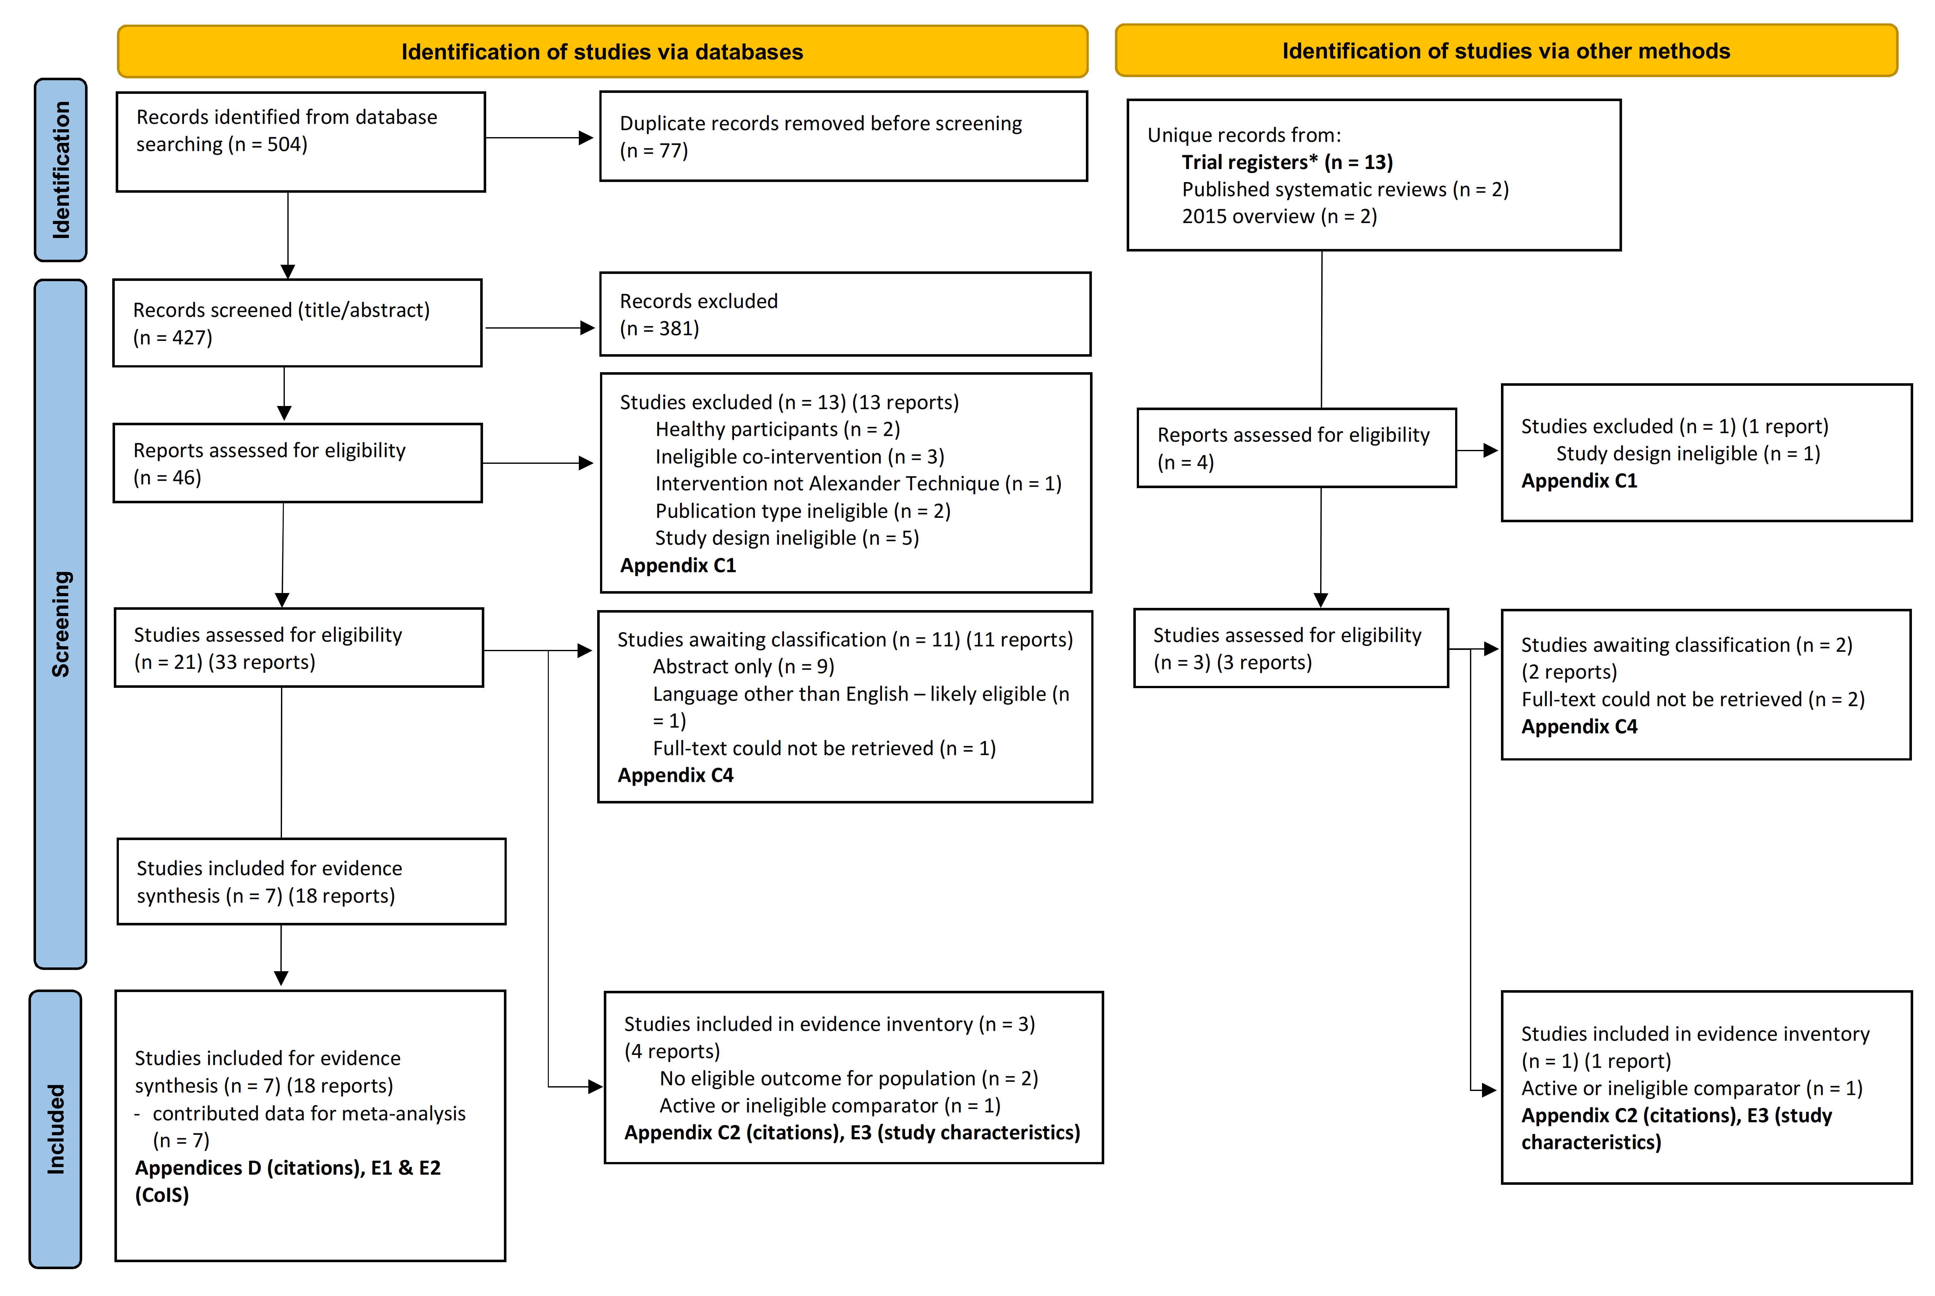

**Fig. 4.1.1** | PRISMA diagram showing the flow of studies through the review. Studies are the unit of interest in the review. Each study could have multiple reports.

CoIS: characteristics of included studies. There were no unique records identified from Public submissions (see results section ‘Public submissions’) *see results section ‘Ongoing and unpublished studies’’

### Included studies

Following screening of 427 citations from the database searches, we retrieved 46 full text reports from which 21 studies (33 reports) were potentially eligible. Seven (7) of these studies (18 reports) were included in the evidence synthesis and 3 studies (4 reports) contributed to the evidence inventory (2 with active comparators, 2 that did not measure an eligible outcome). A further 4 full text reports were assessed from other sources, from which one additional study was included in the evidence inventory (a study that did not measure an eligible outcome). We did not identify any non-randomised studies with an eligible study design.

Of the 7 randomised trials that examined the effects of the Alexander Technique compared to an inactive control

* 4 trials were among people with **chronic musculoskeletal conditions** (3 low back pain, 1 neck pain) and
* 3 were among people with **mobility limitations or at risk of falls** (1 older people with low vision or blindness, 2 Parkinson’s disease).

The summary and synthesis of these studies is reported in sections 4.2.1. and 4.2.2 of the report respectively.

One trial compared the Alexander Technique to an inactive control for pregnancy/perinatal care, however the study did not measure any eligible outcomes (it reported study specific measures of maternal satisfaction and confidence, enjoyment of the experience of childbirth). The references and brief characteristics of this study, and the other 3 studies reported in the evidence inventory, are in Appendices C3 and E3 respectively.

There were no studies of the Alexander Techniquefor people with other conditions reported as often treated by using the Alexander Technique. Specifically, there were no studies among people with acute musculoskeletal pain, other chronic conditions (including other pain conditions, such as headache and migraine), respiratory conditions, or stress, anxiety and mood disorders.

### Excluded studies

After full-text screening, 14 studies (14 reports) were excluded from the review (Figure 4.1.1, Appendix C1 for list of excluded studies).

### Studies awaiting classification

Following screening, 13 studies were categorised as awaiting classification because results were reported in an abstract only (9 studies), the study was in a language other than English (see next), or the full text could not be retrieved (3 studies) (Figure 4.1.1, Appendix C4 for studies awaiting classification).

#### Studies in languages other than English

Our searches identified one study published in a language other than English that was judged likely to be eligible for the review.

### Ongoing and unpublished studies

The search of ClinicalTrials.gov and WHO ICTRP retrieved 26 records, of which 13 were duplicates. Of the 13 unique records screened, 1 was ineligible and 12 eligible. Nine (9) of the eligible records are linked to the studies included in the review and 3 are unpublished (see Appendix C5). All of the unpublished studies were registered within the last 4 years (of 2024). As such, these 3 studies were judged likely to be ongoing.

Two (2) of these studies are among people with chronic musculoskeletal conditions. Details are reported in relations to results for that population. The third study is among 80 people with stroke, and hence will not contribute additional evidence to syntheses for which evidence already exists.

### Public submissions

Sixteen (16) citations were received from the public via the Department’s call for evidence. Of these, all 16 were duplicates retrieved by our search. Eligibility decisions for these records are reported in Appendix C2. Six (6) of the submission studies were included in the review.

## 4.2 Chronic musculoskeletal conditions

Six (6) trials evaluated the effects of the Alexander Technique for people with chronic musculoskeletal conditions. Four (4) contribute to the synthesis and 2 are reported on the evidence inventory (Appendix E3; one compared the Alexander Technique to active interventions and the other reported no eligible outcomes).

***Prioritised outcome domains*** for this population with evidence were:

* pain (critical for decision making)
* HR-QoL (critical for decision making)
* physical function (disability) (critical for decision making)
* emotional functioning and mental health (EFMH) (important but not critical for decision making)

In our initial analytic framework for the review, and in other natural therapies reviews, physical function (mobility) and symptoms (such as sleep and fatigue) had been identified as potentially important outcome domains. None of the included studies measured outcomes in these domains. For completeness, these domains are retained in the final framework and noted as evidence gaps in the summary of findings tables.

Biomechanical outcomes (measured in one study) were rated as of limited importance, and therefore not included in the synthesis. See Appendix E1 for trials included in the synthesis that also reported biomechanical outcomes, and Appendix E3 for a trial among people with low back pain that only reported biomechanical outcomes (Cacciatore 2011).

***Comparators*.** All four of the trials included for synthesis compared the Alexander Technique to usual care. Three of the four trials also had an active comparator group. One additional trial only included active comparators (Lauche 2014; reported on the evidence inventory). No two studies evaluated the same active comparator, which were as follows.

1. Massage (Little 2008)
2. Exercise (Little 2008)
3. Physiotherapy (Little 2014)
4. Acupuncture (MacPherson 2015)
5. Guided imagery (Lauche 2014)
6. Heat (Lauche 2014)

### 4.2.1 Alexander Technique compared to inactive control

#### Characteristics of included studies

Brief characteristics of studies that compared the Alexander Technique to an inactive control are summarised in Table 4.2.1.1 and full details are in Appendix E1. The outcome measure from which data were included for meta-analysis is reported for each trial in the forest plots (column 2, Figures 4.2.1.2 to 4.2.1.5). For all results, the outcome selected for analysis was measured at the end of the intervention period (or close to) (see Table 4.2.1.1). Full details are reported in Appendix E1 for each study, including a list of all outcome measures, details of which outcome was selected when multiple were available for an outcome domain, and the timing of outcome measurement in relation to intervention.

***Alexander Technique interventions***. Studies varied in how completely the intervention was described; some provided detailed protocols, but most trialists gave background on the concepts and techniques used in the Alexander Technique without full description of what was implemented in the trial. All reported that a series of lessons were delivered by a teacher of the Alexander Technique, most STAT accredited. Lessons typically involved demonstration, along with verbal and hands-on guidance while performing ‘everyday activities’ (e.g. walking, moving from sitting to standing). The lessons were delivered over a period ranging from 4 weeks to 5 months (with two booster sessions in later months in one trial). Most trials reported that participants were encouraged to practise at home. Other reported content included teaching principles of international inhibition and direction to release unwanted tension, and time lying semi-supine (especially during practise at home). In most studies, usual care could be continued (including other physical therapies).

**Table 4.2.1.1** Characteristics of studies comparing the Alexander Technique to an inactive control for people with chronic musculoskeletal conditions.

| **Study** | **Population (ICD-11 code)\*** | **Intervention** | | | **Comparator** | **Outcome domains** | | | | |
| --- | --- | --- | --- | --- | --- | --- | --- | --- | --- | --- |
| **Lesson content** | **Provider** | **No. sessions, frequency & duration** | **Pain** | **HR-QoL** | **Function - disability** | **EFMH** | **Measured** |
| **Low back pain (chronic or recurrent)** | | | | | | | | | | |
| **Hafezi 2022**  Iran | 80 adults (~45 yrs) with low back pain ≥3 months (MG30.02 Chronic primary low back pain) | Manual and verbal guidance during exercises performing everyday activities. | Accreditation NR (Alexander teacher) | 3 x 60-minute sessions per week for 12 weeks | usual care (not described) | **X** | **X**ⱡ |  |  | 3 months |
| **Little 2008**  UK | 432 adults (~45 yrs) with low back pain ≥3 months (MG30.02 Chronic primary low back pain) | Assessment of habitual musculoskeletal use, release of unwanted tension, manual and verbal guidance during exercises performing everyday activities | STAT accredited teacher | Grp 1. 6 x 30-40 minute lessons over 4 weeks  Grp 2. 24 x 30-40 minute lessons over 9 months (20 in 1st 20 weeks) | usual care  (not described) | **X** | **X** | **X** | **X** | 3 months |
| **Little 2014**  UK | 34 adults (~47 yrs) with low back pain ≥3 weeks, either recurrent or chronic (MG30.02 Chronic primary low back pain) | Assessment of habitual musculoskeletal use, release of unwanted tension, manual and verbal guidance during exercises performing everyday activities | STAT accredited teacher | 10 x 30-40 minute lessons over 8 weeks | usual care  (unrestricted access to their usual GP care) | **X** | **X**† | **X** |  | 3 months |
| **Neck pain (chronic)** | | | | | | | | | | |
| **MacPherson 2015**  UK | 344 adults (~54 yrs) with neck pain ≥3 months (MG30.02 Chronic primary neck pain) | Manual and verbal guidance during exercises performing everyday activities; principles of intentional inhibition and direction, time lying semi-supine. | STAT accredited teacher; 3 years teaching experience | 20 x 30 minute lessons over a maximum of 5 months (typically weekly but varied) | usual care for neck-pain (unrestricted access to their usual care e.g. medication, visits to physical therapists) | **X** | **X** | **X** | **X** | 6 months |

*number of participants is the number from eligible groups (randomised if reported, otherwise number at follow-up);

X results included in meta-analysis; X† outcome reported as measured in results paper, but results unavailable for meta-analysis (not reported, incompletely reported or uninterpretable); Xⱡ outcomes reported as measured in registry entry (not mentioned elsewhere)

Abbreviations: UK=United Kingdom, STAT= Society of Teachers of the Alexander Technique, AUSTAT= Australian Society of Teachers of the Alexander Technique

#### Risk of bias in included trials

A summary of the risk of bias assessments for this comparison is presented in Figure 4.2.1.1 and the overall risk of bias judgement for each study is reported in the forest plots (each outcome from a study was assessed separately). The complete assessments and judgements are reported in Appendix F. We do not report assessments for studies that do not have results contributing to a meta-analysis because these studies have no influence over the effect estimate and, hence, are not considered when judging the overall risk of bias in the GRADE assessment of the synthesis results.

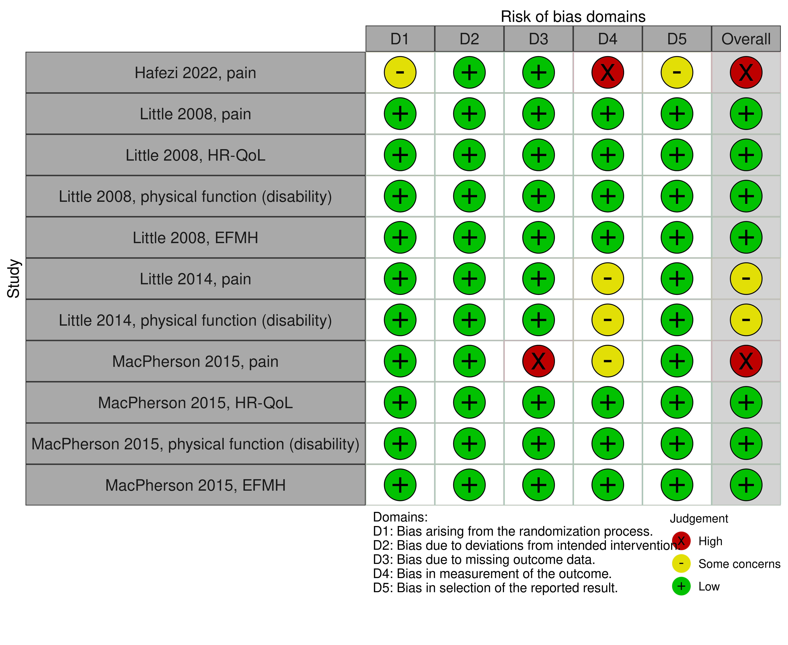

**Fig 4.2.1.1** | Summary of the risk of bias assessments for studies contributing to the comparisons of the Alexander Technique versus inactive control (usual care in all included studies). Each outcome for which the study contributed results was assessed separately. The full assessments, with the rationale for judgements, are reported in Appendix F. The overall risk of bias judgement for each study is reported in the forest plots.

#### Effects of the Alexander Technique compared to inactive control

The effects of the Alexander Technique compared to an inactive control are presented in Table 4.2.1.2, the GRADE summary of findings tables. The certainty of evidence, and factors that influenced our certainty, are presented and explained in these tables. Study level and meta-analytic results are presented in forest plots (Figures 4.2.1.2 to 4.2.1.5).

***Pain*** *(Figure 4.2.1.2)*

* *Included studies*. Four (4) trials, 3 on low back pain (Hafezi 2022, Little 2008, Little 2014) and one of neck pain (MacPherson 2015) contributed to the analysis.
* *Missing results*. There were no missing studies identified from registry entries or other sources for this analysis.
* *Ongoing studies*. One ongoing trial (registered 2020), involving 84 people with neck pain is eligible for this analysis.

There was low certainty evidence, due to risk of bias and imprecision, that the Alexander Technique may reduce pain for people with low back pain or neck pain when compared to an inactive control (SMD 0.69 lower, 95% CI 1.69 lower to 0.39 higher; 4 studies, 611 participants; Figure 4.2.1.2). No studies examined the effect on pain among people with other chronic musculoskeletal conditions.

***Health related quality of life (HR-QoL)*** *(Figure 4.2.1.3)*

* *Included studies*. Two (2) trials, one on low back pain (Little 2008) and one of neck pain (MacPherson 2015) contributed to the analysis.
* *Missing results*. One trial on low back pain (Little 2014) reported measuring HR-QoL but did not report the results. A second study on low back pain (Hafezi 2022) listed HR-QoL as an outcome to be measured in their trial registry entry, but did not report whether the outcome was measured. These studies are considered in the assessment of missing results for the HR-QoL outcome (see footnote to Table 4.2.1.2 explaining publication bias judgement). No other unpublished studies were identified from registry entries or other sources.
* *Ongoing studies*. One ongoing trial (registered 2022), involving 80 people with a herniated disk is eligible for this analysis.

There was low certainty evidence, due to very serious imprecision, that the Alexander Technique may make little to no difference to HR-QoL for people with low back pain or neck pain when compared to an inactive control (SMD 0.20 lower, 95% CI 1.82 lower to 2.21 higher; 2 studies, 679 participants; Figure 4.2.1.3). No studies examined the effect on pain among people with other chronic musculoskeletal conditions.

***Physical function - disability*** *(Figure 4.2.1.4)*

* *Included studies*. Three (3) trials, 2 on low back pain (Little 2008, Little 2014) and one of neck pain (MacPherson 2015) contributed to the analysis.
* *Missing results*. There were no missing studies identified from registry entries or other sources for this analysis.
* *Ongoing studies*. One ongoing trial (registered 2020), involving 84 people with neck pain is eligible for this analysis.

There was moderate certainty evidence, due to publication bias, that the Alexander Technique may improve physical function (disability) for people with low back pain or neck pain when compared to an inactive control (SMD 0.39 higher, 95% CI 0.32 higher to 0.47 higher; 3 studies, 655 participants; Figure 4.2.1.3). No studies examined the effect on pain among people with other chronic musculoskeletal conditions.

***Emotional functioning and mental health*** *(Figure 4.2.1.5)*

* *Included studies*. Two (2) trials, one on low back pain (Little 2008) and one of neck pain (MacPherson 2015) contributed to the analysis.
* *Missing results*. There were no missing studies identified from registry entries or other sources for this analysis.
* *Ongoing studies*. No ongoing trials were identified for this analysis.

There was low certainty evidence, due to very serious imprecision, that the Alexander Technique may make little or no difference to emotional wellbeing or stress for people with low back pain or neck pain when compared to an inactive control (SMD 0.11 lower, 95% CI 1.00 lower to 0.78 higher; 2 studies, 616 participants; Figure 4.2.1.5). No studies examined the effect on pain among people with other chronic musculoskeletal conditions.

**Table 4.2.1.2** Summary of findings for the effect of the Alexander Technique versus inactive control (usual care in all included studies) for chronic musculoskeletal conditions.

| Outcomes | | **Anticipated absolute effects\*** (95% CI) | | Relative effect (95% CI) | № of participants (studies) | Certainty of the evidence (GRADE) | Interpretation (evidence statement) | |
| --- | --- | --- | --- | --- | --- | --- | --- | --- |
| **Risk with inactive control** | **Risk with Alexander Technique** |
| Pain (people with low back pain or neck pain) (follow up 3 to 6 months)a,b | | - | SMD **0.69 SD lower** (1.69 lower to 0.39 higher) | - | 611 (4 RCTs) | ⨁⨁◯◯ Lowc,d,e,f | Alexander Technique may reduce pain for people with low back pain or neck pain. No studies examined effects among people with other chronic musculoskeletal conditions. | |
| HR-QoL (people with low back pain or neck pain) (follow up 3 to 6 months)b,g | | - | SMD **0.2 SD higher** (1.82 lower to 2.21 higher) | - | 679 (2 RCTs) | ⨁⨁◯◯ Lowh,i | Alexander Technique may make little to no difference to HR-QoL for people with low back pain or neck pain. No studies examined effects among people with other chronic musculoskeletal conditions. | |
| Physical function - disability (people with low back pain or neck pain) (follow up 3 to 6 months)b,j | | - | SMD **0.39 SD higher** (0.32 higher to 0.47 higher) | - | 655 (3 RCTs) | ⨁⨁⨁◯ Moderatek | Alexander Technique probably improves physical function (disability) for people with low back pain or neck pain. No studies examined effects among people with other chronic musculoskeletal conditions. | |
| Emotional functioning and mental health (people with low back pain or neck pain) (follow up 3 to 6 months)b,l | | - | SMD **0.11 SD lower** (1 lower to 0.78 higher) | - | 616 (2 RCTs) | ⨁⨁◯◯ Lowm | Alexander Technique may make little to no difference to emotional wellbeing for people with low back pain or neck pain. No studies examined effects among people with other chronic musculoskeletal conditions. | |
| Other outcomes - not reported | | - | - | - | - | - | No studies reported on physical function - mobility or global symptoms/overall disease status for people with chronic musculoskeletal conditions. | |
| \***The risk in the intervention group** (and its 95% confidence interval) is based on the assumed risk in the comparison group and the **relative effect** of the intervention (and its 95% CI). **CI:** confidence interval; **SMD:** standardised mean difference  The threshold for an important difference was an SMD of 0.2 (used for interpreting point estimates and confidence intervals). The resulting interpretations are as follows.   * For pain: < -0.2 is beneficial, -0.2 to 0.2 is trivial or unimportant ("little or no difference" between treatments), > 0.2 is harmful * For HR-QoL: > 0.2 is beneficial, -0.2 to 0.2 is trivial or unimportant ("little or no difference" between treatments), < -0.2 is harmful * For physical function (disability or mobility): > 0.2 is beneficial, -0.2 to 0.2 is trivial or unimportant ("little or no difference" between treatments), < -0.2 is harmful * For emotional functioning and mental health: < -0.2 is beneficial, -0.2 to 0.2 is trivial or unimportant ("little or no difference" between treatments), > 0.2 is harmful | | | | | | |
| **GRADE Working Group grades of evidence** **High certainty:** we are very confident that the true effect lies close to that of the estimate of the effect. **Moderate certainty:** we are moderately confident in the effect estimate: the true effect is likely to be close to the estimate of the effect, but there is a possibility that it is substantially different. **Low certainty:** our confidence in the effect estimate is limited: the true effect may be substantially different from the estimate of the effect. **Very low certainty:** we have very little confidence in the effect estimate: the true effect is likely to be substantially different from the estimate of effect.  **Explanations** are provided for domains for which there is a downgrade or a borderline judgment. In line with GRADE guidance, we do not explain that there are no limitations unless the judgment was challenging (<https://pubmed.ncbi.nlm.nih.gov/26796947/> ) | | | | | | | | |

**Explanations**

a. Pain measures. Graded chronic pain scale (GCPS) - pain subscale; visual analogue scale (VAS, 0 to 10); pain intensity rating (0 to 8; fortnightly by text message)

b. Selected timeframe is the first follow-up after the end of the intervention period

c. Serious risk of bias (-1). High proportion of data in the analysis is from studies at high risk of bias or some concerns, such that the observed benefit may be overestimated.

d. Inconsistency. All effect estimates lie to one side of the threshold for an important effect (SMD of -0.2), so not rated down for inconsistency.

e. Serious imprecision (-1). The 95% confidence interval (CI) crosses two thresholds for a small by important effect (SMD of 0.2 and -0.2), so the result is compatible with important benefit (SMD -1.69 lower) and important harm (SMD 0.31 higher). However, we rated down once only because the extent to which the upper bound of the CI crosses the threshold is modest, all effects favour the Alexander Technique, and the CI for the combined estimate has been calculated using a conservative method (restricted maximum likelihood estimator (REML) of between trial heterogeneity variance and the Hartung-Knapp-Sidik-Jonkman confidence interval method).

f. Publication bias undetected. While, selective non-reporting of unfavourable results (null or favouring control) is possible, we did not find any additional studies that had not reported the results for this outcome. The pooled estimate from 4 studies indicates a moderate effect and it was judged unlikely that an unfavourable results would importantly change the estimate.

g. HR-QoL measures: SF-36 - physical dimension, SF-12 - physical dimension. Studies that did not report results measured HR-QoL with SF-36 and EQ-5D

h. Very serious imprecision (-2). The 95% confidence interval crosses two thresholds for a small by important effect (SMD of 0.2 and -0.2), so the result is compatible with important benefit (SMD 2.21 higher) and important harm (SMD 1.82 lower). However, neither study has a CI that indicates important harm and the CI for the combined estimate has been calculated using a conservative method, so we rated down twice only (i.e. not by -3 as might be indicated by interpreting the CI for the combined estimate alone).

i. Publication bias not detected. Two additional studies report measuring HR-QoL in trial registry (Hafezi 2022) or results report (Little 2014), but did not report results. It is unclear whether this is due to selective non-reporting of unfavourable results. Given the available studies found little to no effect on HR-QoL compared to inactive control, we have not rated down for non-reporting bias.

j. Physical function (disability) measures: Roland Morris disability questionnaire (RMDQ); Neck pain questionnaire (NPQ)

k. Publication bias strongly suspected (-1). Given the small number of trials, and small to moderate effects, selective non-reporting of unfavourable results (null or favouring control) could importantly change the combined estimate. This is a concern because of evidence of selective non-reporting of unfavourable/uninteresting results in general, and from trials of natural therapies in particular.

l. EFMH measures: SF-36 - emotional dimension, Perceived Stress Scale (PSS). SF-12v2 (for which SF-12 - mental dimension had been prioritised for selection, but the study reported results incompletely).

m. Very serious imprecision (-2). The 95% confidence interval crosses two thresholds for a small by important effect (SMD of 0.2 and -0.2), so the result is compatible with important benefit (SMD 1.00 lower) and important harm (SMD 0.78 higher). However, neither study has a CI that indicates important harm and the CI for the combined estimate has been calculated using a conservative method (restricted maximum likelihood estimator (REML) of between trial heterogeneity variance and the Hartung-Knapp-Sidik-Jonkman confidence interval method) so we rated down twice only (i.e. not by -3 as might be indicated by interpreting the CI for the combined estimate alone).

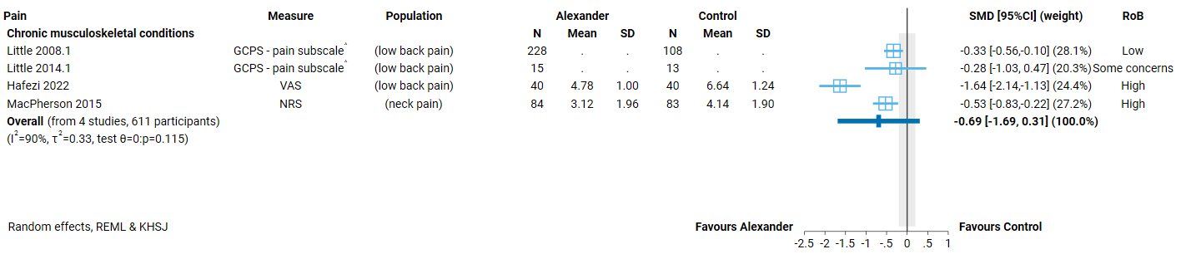

**Fig 4.2.1.2** | Forest plot for main comparison. The effect of the Alexander Technique versus inactive control (usual care in all included studies) on pain for people with chronic musculoskeletal conditions. SMD=standardised mean difference. Blue lines show 95% confidence intervals (CI). The shaded grey area indicates the pre-specified range where the effect of the Alexander Technique is considered to be no different from control (SMD -0.2 to 0.2 standard units). ^ indicates studies for which data transformation or imputation was required to include the result in the meta-analysis. For studies with results not reported (NR), the data required for transformation were missing or the result was uninterpretable

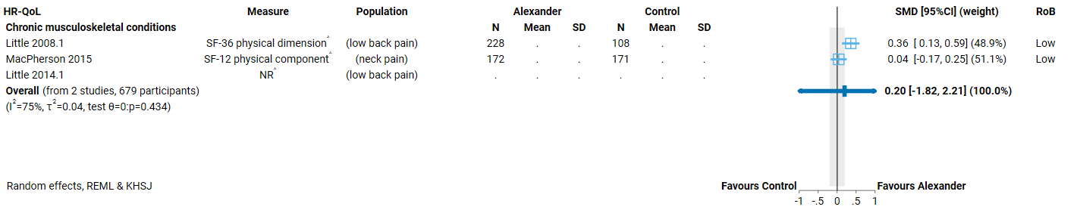

**Fig 4.2.1.3** | Forest plot for main comparison. The effect of the Alexander Technique versus inactive control (usual care in all included studies) on health-related quality of life (HR-QoL) for people with chronic musculoskeletal conditions. SMD=standardised mean difference. Blue lines show 95% confidence intervals (CI). The shaded grey area indicates the pre-specified range where the effect of the Alexander Technique is considered to be no different from control (SMD -0.2 to 0.2 standard units). ^ indicates studies for which data transformation or imputation was required to include the result in the meta-analysis. For studies with results not reported (NR), the data required for transformation were missing or the result was uninterpretable.

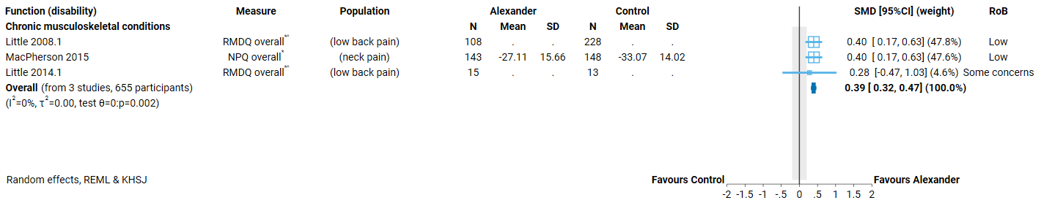

**Fig 4.2.1.4** | Forest plot for main comparison. The effect of the Alexander Technique versus inactive control (usual care in all included studies) on physical function (disability) for people with chronic musculoskeletal conditions. SMD=standardised mean difference. Blue lines show 95% confidence intervals (CI). The shaded grey area indicates the pre-specified range where the effect of the Alexander Technique is considered to be no different from control (SMD -0.2 to 0.2 standard units). ^ indicates studies for which data transformation or imputation was required to include the result in the meta-analysis. For studies with results not reported (NR), the data required for transformation were missing or the result was uninterpretable.* Denotes studies for which the direction of effect was changed to match the overall plot (positive numbers are beneficial).

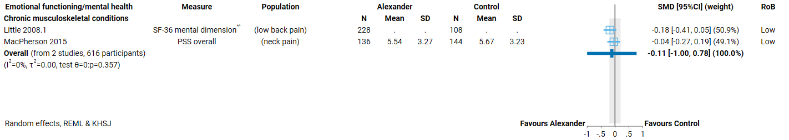

**Fig 4.2.1.5** | Forest plot for main comparison. The effect of the Alexander Technique versus inactive control (usual care in all included studies) on emotional functioning and mental health for people with chronic musculoskeletal conditions. SMD=standardised mean difference. Blue lines show 95% confidence intervals (CI). The shaded grey area indicates the pre-specified range where the effect of the Alexander Technique is considered to be no different from control (SMD -0.2 to 0.2 standard units). ^ indicates studies for which data transformation or imputation was required to include the result in the meta-analysis. For studies with results not reported (NR), the data required for transformation were missing or the result was uninterpretable. * Denotes studies for which the direction of effect was changed to match the overall plot (negative numbers are beneficial as most of the measures relate to symptoms of anxiety, depression, stress etc.).

## 4.3 Mobility limitations and risk of falls

Four (4) trials evaluated the effects of the Alexander Technique for people with mobility limitations or at risk of falls. Three (3) contribute to the synthesis and one is reported on the evidence inventory (Appendix E3; the study compared Alexander Technique to an active intervention).

***Prioritised outcome domains*** for this population were:

* pain (important but not critical for decision making)
* HR-QoL (critical for decision making)
* physical function (disability) (critical for decision making)
* physical function (disability) (critical for decision making)
* falls (critical for decision making)
* emotional functioning and mental health (EFMH) (critical for decision making)

In our initial analytic framework for the review, and in other natural therapies reviews, global symptoms (including non-motor function symptoms that affect people with Parkinson’s disease, such as sleep, urinary problems) had been identified as potentially important outcome domains. None of the included studies measured outcomes in this domain. For completeness, these domains are retained in the final framework and noted as evidence gaps in the summary of findings tables.

Biomechanical outcomes (measured in one study) were rated as of limited importance, and therefore not included in the synthesis. See Appendix E1 for trials included in the synthesis that also reported biomechanical outcomes.

***Comparators*.** Two (2) of the trials included for synthesis compared the Alexander Technique to usual care and one reported the comparator as ‘no intervention’. One of the 3 trials also had an active comparator group. One additional trial only included active comparators (Pour Kamali 2018; reported on the evidence inventory). No 2 studies evaluated the same active comparator, which were as follows.

1. Massage plus advice to perform mobility exercises (Stallibrass 2002)
2. Dohsa-hou (Japanese psychorehabilitation method) (Pour Kamali 2018)

### 4.3.2 Alexander Technique compared to inactive control

#### Characteristics of included studies

Brief characteristics of studies that compared the Alexander Technique to an inactive control are summarised in Table 4.3.2.1 and full details are in Appendix E1. The outcome measure from which data were included for meta-analysis is reported for each trial in the forest plots (column 2, Figures 4.3.2.2 to 4.3.2.6). For all results, the outcome selected for analysis was measured at the end of the intervention period (or close to) (see Table 4.3.2.1). Full details are reported in Appendix E1 for each study, including a list of all outcome measures, details of which outcome was selected when multiple were available for an outcome domain, and the timing of outcome measurement in relation to intervention.

***Alexander Technique interventions***. Studies varied in how completely the intervention was described, as was the case for chronic musculoskeletal conditions, and the content of lessons and Techniques covered were similar to those in studies evaluating the Alexander Technique for chronic musculoskeletal conditions (see 4.2.1).

**Table 4.3.2.1** Characteristics of studies comparing the Alexander Technique to an inactive control for people with mobility limitations or at risk of falls.

| **Study** | **Population* (ICD-11 code)** | **Intervention** | | | **Comparator** | **Outcome domains** | | | | | |
| --- | --- | --- | --- | --- | --- | --- | --- | --- | --- | --- | --- |
| **Lesson content** | **Provider** | **No. sessions, frequency & duration** | **HR-QoL** | **Function - disability** | **Function - mobility** | **Falls** | **EFMH** | **Measured** |
| **Mobility limitations or falls risk** | | | | | | | | | | | |
| **Gleeson 2015**  Australia | 120 adults (~ 75 yrs) with low vision or blindness (QF23 - Difficulty or need for assistance with mobility - vision-related) | Manual and verbal guidance during exercises performing everyday activities (walking, sitting, getting to/from floor etc). Delivered in participants’ homes. | AUSTAT accredited teacher | 1 x 30-minute lesson per week for 12 weeks | usual care (access to orientation & mobility programs, Guide Dogs NSW/ACT) | **X** |  | **X** | **X** | **X** | 3 months;  12 months for falls |
| **Parkinson’s disease** | | | | | | | | | | | |
| **Sedaghati 2018**  Iran | 26 adults (~64 yrs) with idiopathic Parkinson’s history of falls (last 6 months) (8A00.0 Parkinson disease) | Alexander-based postural realignment program involving corrective exercises based on everyday activities (walking, static and dynamic marching, other daily activities) | Accreditation NR | 3 x 60-minute sessions per week for 8 weeks | no intervention (unclear if access to usual care was restricted) |  |  | **X** |  | **X** | 2 months |
| **Stallibrass 2002**  UK | 62 adults (~65 yrs) with idiopathic Parkinson’s  (8A00.0 Parkinson disease) | Guided exercises moving from sitting to standing/standing to sitting, walking, inhibiting/directing to reduce tension, lying in semi-supine position | STAT accredited teacher | 2 x 40-minute lessons per week for 12 weeks | usual care (medications; committed not to change medication during study) |  | **X** |  |  | **X** | 3 months |

* number of participants is the number from eligible groups (randomised if reported, otherwise number at follow-up); X results included in meta-analysis

Abbreviations: UK=United Kingdom, STAT= Society of Teachers of the Alexander Technique, AUSTAT= Australian Society of Teachers of the Alexander Technique

#### Risk of bias in included trials

A summary of the risk of bias assessments for this comparison is presented in Figure 4.3.1.1 and the overall risk of bias judgement for each study is reported in the forest plots (each outcome from a study was assessed separately). The complete assessments and judgements are reported in Appendix F. We do not report assessments for studies that do not have results contributing to a meta-analysis because these studies have no influence over the effect estimate and, hence, are not considered when judging the overall risk of bias in the GRADE assessment of the synthesis results.

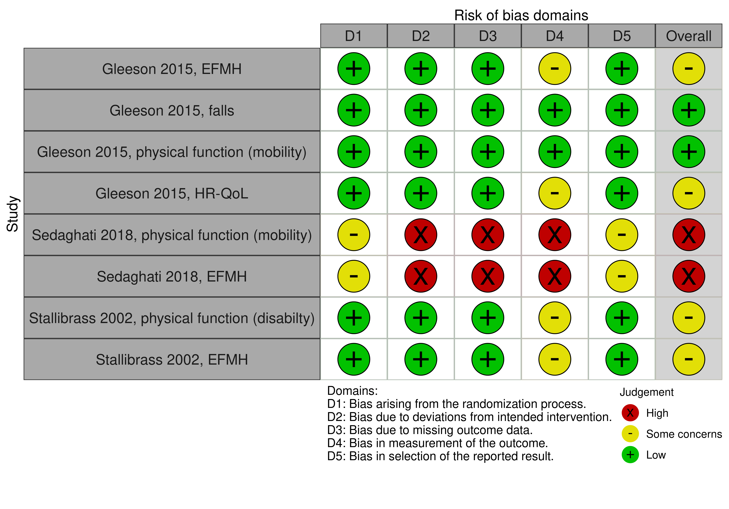

**Fig 4.3.2.1** | Summary of the risk of bias assessments for studies contributing to the comparisons of the Alexander Technique versus inactive control (no intervention or continuation of usual care). Each outcome for which the study contributed results was assessed separately. The full assessments, with the rationale for judgements, are reported in Appendix F. The overall risk of bias judgement for each study is reported in the forest plots.

#### Effects of Alexander Technique compared to inactive control

The effects of the Alexander Technique compared to an inactive control are presented in Table 4.3.2.2, the GRADE summary of findings tables. The certainty of evidence, and factors that influenced our certainty, are presented and explained in these tables. Study level and meta-analytic results are presented in forest plots (Figures 4.3.2.2 to 4.3.2.6).

***Pain***

* *Included studies*. Not measured in any of the included studies
* *Missing results*. There were no missing studies identified from registry entries or other sources for this analysis.
* *Ongoing studies*. No ongoing trials eligible for this analysis.

***Health related quality of life (HR-QoL)*** *(Figure 4.3.2.2)*

* *Included studies*. One trials, among older people with low vision (Gleeson 2015) contributed to the analysis.
* *Missing results*. There were no missing studies identified from registry entries or other sources for this analysis.
* *Ongoing studies*. No ongoing trials eligible for this analysis.

The evidence about the effect of the Alexander Technique on HR-QoL for older people at risk of falls due to low vision is of very low certainty due to risk of bias, indirectness and imprecision (1 trial, 113 participants; Figure 4.3.2.2). No studies examined effects among people with other mobility limitations or risk factors for falls (including Parkinson's disease).

***Physical function - disability*** *(Figure 4.3.2.3)*

* *Included studies*. One trial among people with Parkinson’s disease (Stallibrass 2002) contributed to the analysis.
* *Missing results*. There were no missing studies identified from registry entries or other sources for this analysis.
* *Ongoing studies*. No ongoing trials eligible for this analysis.

The evidence about the effect of the Alexander Technique on physical function (disability) for people with Parkinson’s disease is of very low certainty due to risk of bias, indirectness, imprecision and publication bias (1 trial, 59 participants; Figure 4.3.2.3). No studies examined effects among people with other mobility limitations or risk factors for falls.

***Physical function - mobility*** *(Figure 4.3.2.4)*

* *Included studies*. Two (2) trials, one among older people with low vision (Gleeson 2015) and one among people with a history of falls and Parkinson’s disease (Sedaghati 2018) contributed to the analysis.
* *Missing results*. There were no missing studies identified from registry entries or other sources for this analysis.
* *Ongoing studies*. No ongoing trials eligible for this analysis.

There was low certainty evidence, due to imprecision and publication bias, that the Alexander Technique may improve physical function (mobility) for people at risk of falls due low vision or Parkinson's disease when compared to an inactive control (SMD 0.39 higher, 95% CI 0.45 lower to 1.23 higher; 2 studies, 139 participants; Figure 4.3.2.4). No studies examined the effect on physical function (mobility) people with other mobility limitations or risk factors for falls.

***Falls*** *(Figure 4.3.2.5)*

* *Included studies*. One trial, among older people with low vision (Gleeson 2015) contributed to the analysis.
* *Missing results*. There were no missing studies identified from registry entries or other sources for this analysis.
* *Ongoing studies*. No ongoing trials eligible for this analysis.

The evidence about the effect of the Alexander Technique on the rate of falls among older people at risk of falls due to low vision is of very low certainty due to extremely serious imprecision and publication bias (1 trial, 59 participants; Figure 4.3.2.5). No studies examined effects among people with other mobility limitations or risk factors for falls.

***Emotional functioning and mental health*** *(Figure 4.3.2.6)*

* *Included studies*. Three (3) trials, one among older people with low vision (Gleeson 2015) and 2 among people with Parkinson’s disease (Sedaghati 2018, Stallibrass 2002) contributed to the analysis.
* *Missing results*. There were no missing studies identified from registry entries or other sources for this analysis.
* *Ongoing studies*. No ongoing trials eligible for this analysis.

The evidence about the effect of the Alexander Technique on emotional wellbeing among older people at risk of falls due to low vision or Parkinson’s disease is of very low certainty due to risk of bias, imprecision and inconsistent effects (3 trials, 198 participants; Figure 4.3.2.6). No studies examined effects among people with other mobility limitations or risk factors for falls.

**Table 4.3.2.2** Summary of findings for the effect of the Alexander Technique versus inactive control (no intervention or usual care in all included studies ) for people with mobility limitations and at risk of falls.

| Outcomes | | **Anticipated absolute effects\*** (95% CI) | | Relative effect (95% CI) | № of participants (studies) | Certainty of the evidence (GRADE) | Comments |
| --- | --- | --- | --- | --- | --- | --- | --- |
| **Risk with inactive control** | **Risk with Alexander Technique** |
| HR-QoL (people at risk of falls due to low vision) (follow up 3 months)a,b | | - | SMD **0.16 SD higher** (0.21 lower to 0.52 higher) | - | 113 (1 RCT) | ⨁◯◯◯ Very lowc,d,e,f | The evidence is very uncertain about the effect of Alexander Technique on HR-QoL for people at risk of falls due to low vision.  No studies examined effects among people with other mobility limitations or risk factors for falls (including Parkinson's disease). |
| Physical function - disability (people at risk of falls due to Parkinson's disease) (follow up 3 months)b,g | | - | SMD **0.38 SD higher** (0.13 lower to 0.88 higher) | - | 59 (1 RCT) | ⨁◯◯◯ Very lowc,h,i,j | The evidence is very uncertain about the effect of Alexander Technique on physical function (disability) for people at risk of falls due to Parkinson's disease.  No studies examined effects among people with other mobility limitations or risk factors for falls. |
| Physical function - mobility (people at risk of falls due low vision or Parkinson's disease) (follow up 2 to 3 months)k | | - | SMD **0.39 SD higher** (0.45 lower to 1.23 higher) | - | 139 (2 RCTs) | ⨁⨁◯◯ Lowj,l,m | Alexander Technique may improve physical function - mobility for people at risk of falls due to low vision or Parkinson's disease.  No studies examined effects among people with other mobility limitations or risk factors for falls. |
| Rate of falls (falls per person-years; people at risk of falls due to low vision) (follow up 12 months) | | 1,486 per 1,000n | **996 per 1,000** (535 to 1,873) | **Rate ratio 0.67** (0.36 to 1.26) | 138 falls (1 RCT, 113 participants) | ⨁◯◯◯ Very lowo,p | The evidence is very uncertain about the effect of Alexander Technique on the rate of falls for people at risk of falls due to low vision.  No studies examined effects among people with other mobility limitations or risk factors for falls.  Guide to interpreting the data: If 1000 people were followed for 1 year, the number of falls would be 996 (95% CI: 535 to 1,873) in the group receiving Alexander technique compared to 1,486 falls in the group receiving usual care. |
| Emotional functioning and mental health (people at risk of falls due low vision or Parkinson's disease) (follow up 2 to 3 months)b,q | | - | SMD **0.47 SD lower** (2.31 lower to 1.38 higher) | - | 198 (3 RCTs) | ⨁◯◯◯ Very lowr,s,t | The evidence is very uncertain about the effect of Alexander Technique on emotional wellbeing for people at risk of falls due low vision or Parkinson's disease.  No studies examined effects among people with other mobility limitations or risk factors for falls. |
| Other outcomes - not reported | | - | - | - | - | - | No studies reported on symptoms (non-motor function) for people with Parkinson's disease. |
| \***The risk in the intervention group** (and its 95% confidence interval) is based on the assumed risk in the comparison group and the **relative effect** of the intervention (and its 95% CI).  **CI:** confidence interval; **SMD:** standardised mean difference | | | | | | | |
| \***The risk in the intervention group** (and its 95% confidence interval) is based on the assumed risk in the comparison group and the **relative effect** of the intervention (and its 95% CI). **CI:** confidence interval; **SMD:** standardised mean difference  The threshold for an important difference was an SMD of 0.2 (used for interpreting point estimates and confidence intervals). The resulting interpretations are as follows.   * For HR-QoL: > 0.2 is beneficial, -0.2 to 0.2 is trivial or unimportant ("little or no difference" between treatments), < -0.2 is harmful * For physical function (disability or mobility): > 0.2 is beneficial, -0.2 to 0.2 is trivial or unimportant ("little or no difference" between treatments), < -0.2 is harmful * For emotional functioning and mental health: < -0.2 is beneficial, -0.2 to 0.2 is trivial or unimportant ("little or no difference" between treatments), > 0.2 is harmful   For the rate of falls, we used a threshold of 5% (50 fewer falls per 1000 people over 1 year). The resulting interpretation is that a reduction in falls of more than 50 per 1000 people per year is beneficial, an increase in falls of more than 50 per 1000 people per year is harmful, and between 50 fewer and 50 more falls per 1000 people per year is trivial or unimportant ("little or no difference" between treatments). The choice of threshold was informed by the interpretation of effects in Cochrane Systematic reviews of falls prevention interventions (e.g. <https://www.cochranelibrary.com/cdsr/doi/10.1002/14651858.CD013258.pub2/full> ) | | | | | | |
| **GRADE Working Group grades of evidence** **High certainty:** we are very confident that the true effect lies close to that of the estimate of the effect. **Moderate certainty:** we are moderately confident in the effect estimate: the true effect is likely to be close to the estimate of the effect, but there is a possibility that it is substantially different. **Low certainty:** our confidence in the effect estimate is limited: the true effect may be substantially different from the estimate of the effect. **Very low certainty:** we have very little confidence in the effect estimate: the true effect is likely to be substantially different from the estimate of effect.  **Explanations** are provided for domains for which there is a downgrade or a borderline judgment. In line with GRADE guidance, we do not explain that there are no limitations unless the judgment was challenging (<https://pubmed.ncbi.nlm.nih.gov/26796947/> ) | | | | | | | |

**Explanations**

a. HR-QoL measures: Impact of vision impairment (IVI) Profile - emotional well-being scale

b. Selected timeframe is the first follow-up after the end of the intervention period

c. Serious risk of bias (-1). The single study in the analysis is at some risk of bias, such that the observed effect may be over- or under-estimated.

d. Serious indirectness (-1): Evidence from one small study among people who have low vision or are blind. Uncertain whether results apply to other populations with mobility limitations or at risk of falls (including those with low vision).

e. Serious imprecision (-1). The 95% confidence interval crosses two thresholds for a small by important effect (SMD of 0.2 and -0.2), so the result is compatible with important benefit (SMD 0.52 higher) and important harm (SMD 0.21 lower). However, the extent to which the lower bound of the CI crosses the threshold is modest and the CI for the combined estimate has been calculated using a conservative method, so we rated down once only.

f. Publication bias not detected. While selective non-reporting of unfavourable results (null or favouring control) is a concern when the available evidence is from a single small trial, this study shows little to no effect. It was judged unlikely that unpublished studies would have results that would change this interpretation.

g. Physical function (disability) measures: Parkinson’s disease disability scale (SPDDS) - at worst

h. Serious indirectness (-1): Evidence from one small study among people who with Parkinson's disease. Uncertain whether results apply to other populations with mobility limitations or at risk of falls (including other people with Parkinson's disease).

i. Serious imprecision (-1). The 95% confidence interval (CI) crosses the threshold for a small by important effect (SMD of 0.2), so the result is compatible with important benefit (SMD 0.88 higher) and little to no difference (SMD 0.13 lower).

j. Publication bias strongly suspected (-1). Single small trial showing important benefit, so selective non-reporting of unfavourable results (null or favouring control) could importantly change this result and the interpretation.

k. Physical function (mobility) measures: gait freeze (FOG); Short physical performance battery (SPPB) - total score

l. Risk of bias not serious: One study at high risk of bias, however the other low risk of bias study has most of the weight in the meta-analysis (80%) and both studies have results indicating beneficial effects with Alexander technique.

m. Serious imprecision (-1). The 95% confidence interval crosses two thresholds for a small but important effect (SMD of 0.2 and -0.2), so the result is compatible with important benefit (SMD 1.23 higher) and important harm (SMD 0.45 lower). However, neither study has a CI that indicates important harm and the CI for the combined estimate has been calculated using a conservative method, so we rated down once only.

n. We calculated the risk in the control group using the mean falls per person-year (82 falls in 55.17 person-years).

o. Extremely serious imprecision (-3). Using a threshold for an important effect of 5% (50 fewer falls per 1000 people over 1 year), the 95% confidence interval is extremely wide and compatible with an important reduction in falls (951 fewer per 1000 people over 1 year) and an important increase (387 more falls per 1000 people over 1 year).

p. Publication bias not detected. While selective non-reporting of unfavourable results (null or favouring control) is a concern when the available evidence is from a single small trial, falls rate requires longer term follow-up and it was judged unlikely that there would be unpublished studies reporting this outcome.

q. EFMH measures: Geriatric Depression Scale (GDS-5), Falls efficacy scale-international (FES-I) - fear of falling, Beck depression inventory (BDI)

r. Serious risk of bias (-1). One study at high risk of bias (large effect, 28% of weight in analysis) and two studies at some risk of bias, such that the observed effect may be over estimated.

s. Serious inconsistency (-1): Confidence interval for the single high risk of bias study does not overlap with the other two studies and point estimate has an importantly different interpretation from the other two studies.

t. Very serious imprecision (-2). The 95% confidence interval crosses two thresholds for a small but important effect (SMD of 0.2 and -0.2), so the result is compatible with important benefit (SMD -2.31 lower) and important harm (SMD 1.38 higher). In part, this is due to the inconsistent effects, therefore we have rated down two levels (not three).

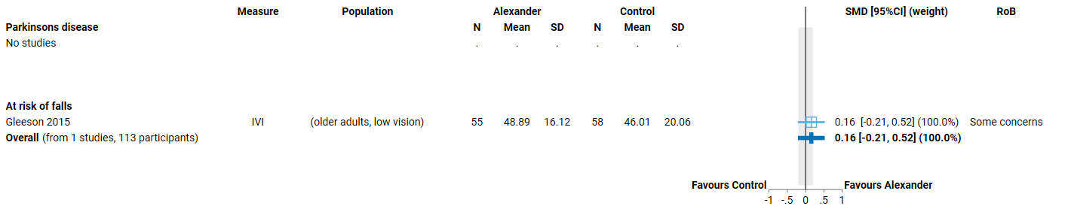

**Fig 4.3.2.2** | Forest plot for main comparison. The effect of the Alexander Technique versus inactive control (no intervention or usual care in included studies) on health-related quality of life (HR-QoL) for people with mobility limitations or at risk of falls. SMD=standardised mean difference. Blue lines show 95% confidence intervals (CI). The shaded grey area indicates the pre-specified range where the effect of the Alexander Technique is considered to be no different from control (SMD -0.2 to 0.2 standard units). For studies with results not reported (NR), the data required for transformation were missing or the result was uninterpretable.

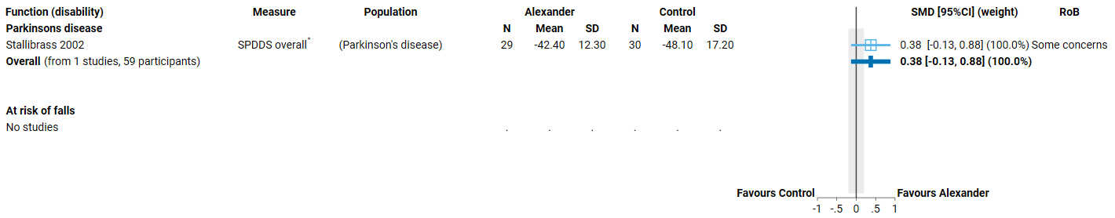

**Fig 4.3.2.3** | Forest plot for main comparison. The effect of the Alexander Technique versus inactive control (no intervention or usual care in included studies) on physical function (disability) for people with mobility limitations or at risk of falls. SMD=standardised mean difference. Blue lines show 95% confidence intervals (CI). The shaded grey area indicates the pre-specified range where the effect of the Alexander Technique is considered to be no different from control (SMD -0.2 to 0.2 standard units). For studies with results not reported (NR), the data required for transformation were missing or the result was uninterpretable. * Denotes studies for which the direction of effect was changed to match the overall plot (positive numbers are beneficial).

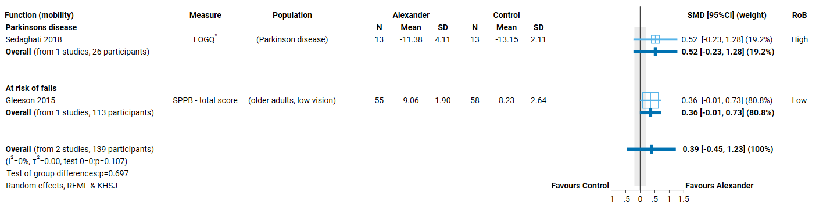

**Fig 4.3.2.4** | Forest plot for main comparison. The effect of the Alexander Technique versus inactive control (no intervention or usual care in included studies) on physical function (mobility) for people with mobility limitations or at risk of falls. SMD=standardised mean difference. Blue lines show 95% confidence intervals (CI). The shaded grey area indicates the pre-specified range where the effect of the Alexander Technique is considered to be no different from control (SMD -0.2 to 0.2 standard units). For studies with results not reported (NR), the data required for transformation were missing or the result was uninterpretable. * Denotes studies for which the direction of effect was changed to match the overall plot (positive numbers are beneficial).

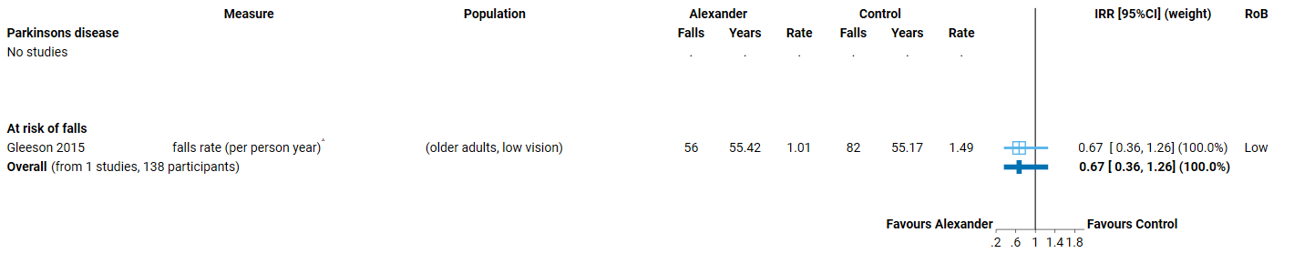

**Fig 4.3.2.5** | Forest plot for main comparison. The effect of the Alexander Technique versus inactive control (no intervention or usual care in included studies) for preventing falls among people with mobility limitations or at risk of falls. IRR= incident rate ratio. Blue lines show 95% confidence intervals (CI). ^ indicates studies for which data transformation or imputation was required to include the result in the meta-analysis. For studies with results not reported (NR), the data required for transformation were missing or the result was uninterpretable.

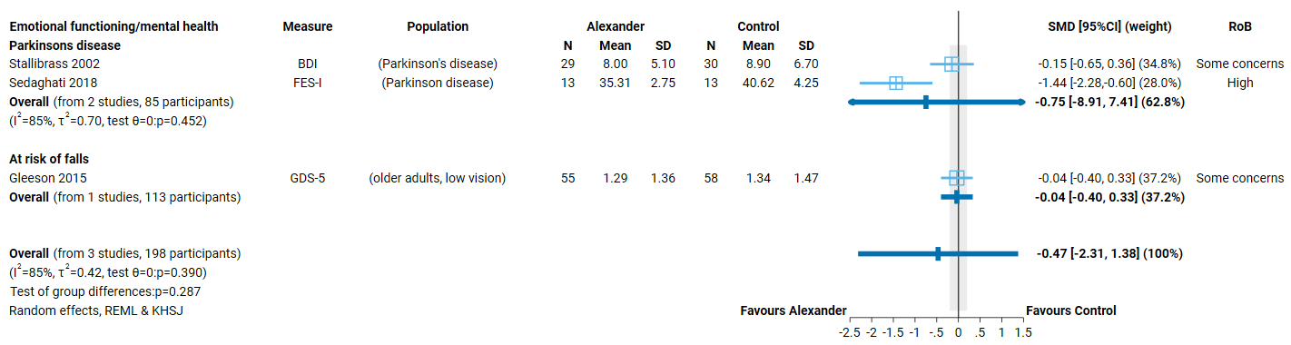

**Fig 4.3.2.6** | Forest plot for main comparison. The effect of the Alexander Technique versus inactive control (no intervention or usual care in included studies) on emotional functioning and mental health for people with mobility limitations or at risk of falls. SMD=standardised mean difference. Blue lines show 95% confidence intervals (CI). The shaded grey area indicates the pre-specified range where the effect of the Alexander Technique is considered to be no different from control (SMD -0.2 to 0.2 standard units). Negative numbers are beneficial as most of the measures relate to symptoms of anxiety, depression, stress etc.

# 5. Discussion

## Summary of the main results

This review assessed the available evidence on the Alexander Technique to inform the Australian Government about health policy decisions for private health insurance rebates. This review was not designed to assess all the reasons that people use the Alexander Technique, or the reasons practitioners prescribe the Alexander Technique and was not intended to inform individual choices about using the Alexander Technique.

We found 11 eligible studies evaluating the effects of the Alexander Technique, 9 that included at least one inactive comparator. Of these 9 studies, 2 did not report any eligible outcomes. The remaining 7 studies contributed to the evidence synthesis for 2 population groups: chronic musculoskeletal conditions (4 trials) and mobility limitations and falls risk (3 trials). Results from these syntheses are as follows.

For people with **chronic musculoskeletal conditions** involving low back pain or neck pain

* There is moderate certainty evidence that the Alexander Technique
  + probably improves physical function (disability) (3 trials, 611 participants),
* There is low certainty evidence that the Alexander Technique
  + may reduce pain (4 trials, 611 participants, low certainty evidence),
  + may make little to no difference to health-related quality of life (2 trials, 679 participants),
  + may make little to no difference to emotional wellbeing and stress (4 trials, 655 participants), and

The Alexander Technique has unknown effects on physical function (mobility) and global symptoms/overall disease status because no studies reported on these outcomes.

No studies examined effects among people with other chronic musculoskeletal conditions.

For people with **mobility limitations or at risk of falls** (including low vision and Parkinson’s disease)

There is low certainty evidence that the Alexander Technique

* may improve physical function (mobility) (2 trials, 139 older people with low vision or Parkinson’s disease)

The Alexander Technique has very uncertain effects on

* health-related quality of life (1 trial, 113 older people with low vision),
* physical function (disability) (1 trial, 59 people at risk of falls due to Parkinson’s disease),
* rate of falls (1 trial, 138 older people with low vision), and
* emotional wellbeing (3 trials, 198 older people with low vision or Parkinson’s disease).

The Alexander Technique has unknown effects on global symptoms/overall disease status because no studies reported on these outcomes.

No studies examined effects among people with other mobility limitations or risk factors for falls.

The effects of Alexander technique compared to other active comparators was not examined, as pre-specified criteria for synthesis were not met (i.e. no two studies at low risk of bias evaluated the same evidence-based treatment). Studies that only contributed active comparators are listed in an inventory (Appendix C3 and E3).

### Comparability of these findings with other systematic reviews

From our systematic and pragmatic searches, we identified 5 systematic reviews of the Alexander Technique. Of these, a 2012 systematic review by Woodman et al remains the most comprehensive being the only review we identified that included any health-related condition [14]. Similar to our findings, the review authors concluded that the Alexander Technique may lead to “reductions in back pain and incapacity caused by chronic back pain”. Their conclusion about effects on outcomes for people with Parkinson’s was more definitive, but GRADE methods were not used to interpret results. A 2023 systematic review of the Alexander Technique for neck pain which is published only as a preprint [53], suggested “significant improvement in neck pain”, a finding that is also reported in a 2020 review of non-pharmacological treatments for chronic pain, that was conducted for the United States Agency for Health Research and Quality [54]. These findings are consistent with our findings in this review.

## Overall completeness and applicability of evidence

Evidence evaluating the effects of the Alexander Technique is limited to a small number of trials among people with chronic musculoskeletal conditions (low back pain and neck pain) and those with mobility limitations or at risk of falls (older people with low vision or Parkinson’s disease). There are no studies examining effects on other conditions for which the Alexander Technique has been suggested, including other musculoskeletal conditions (e.g. acute conditions, shoulder pain), mental health (including stress, anxiety and low mood) or other conditions related to the nervous system (e.g. headache/migraine, multiple sclerosis). Three (3) small ongoing trials will provide some limited additional evidence for people with neck pain, disc herniation, and stroke.

Of the 9 studies that compared the Alexander Technique to an inactive comparator, all but two measured at least one of the critical outcome domains. Nonetheless, coverage of outcomes recommended in core outcome sets (including domains prioritised for the review) was patchy. For example, only one of the 3 trials evaluating the Alexander Technique for mobility and falls prevention measured falls as an outcome. While this is likely due to the length of follow-up required for falls, falls-related outcomes are critical for decision-making. Similarly, health related quality of life is included in all core outcomes sets for the populations included in this review, yet was reported by only 3 of the 7 trials. At least one measure of physical function (whether disability or mobility-related) was included in all but one study and all used well-validated measurement methods.

Studies included in the analysis were conducted in the United Kingdom (4 trials), Australia (one trial), and Iran (2 trials). Three (3) of studies in the United Kingdom and the one in Australia were larger trials, contributing the majority of data to analyses. They were set in community-based clinics or settings typical of where the Alexander Technique would be practised in Australia, indicating that the evidence is applicable to the Australian context. Studies generally involved weekly sessions and ranged from 4 weeks to 5 months, so it is difficult to conclude the effects for longer durations. The effects of stopping versus continuing to practice the Alexander technique are also unknown.

## Certainty of the evidence

Limitations of the evidence were considered when interpreting each result by applying the GRADE approach. The overriding limitation is that only 7 trials contribute to the evidence base. This limitation is offset to some extent, because most of the data in analyses comes from 4 trials that are well designed and generally well reported. The study limitations that may bias some results from these trials are difficult to address (such as loss to follow up or imprecision that arises when effects on some outcomes are small).

For people with chronic musculoskeletal conditions, the number of studies is small, but there were 2 large well-designed and reported trials that had consistent results judged to be at low risk of bias for multiple outcomes. The results from these 2 trials – one on low back pain and the other on neck pain – increased the certainty of evidence, such that there is low certainty evidence for several outcomes and moderate certainty for physical function (disability). There was concern that study limitations may bias estimates for some outcomes such that benefits were overestimated, and that selective non-reporting of unfavourable results could change the interpretation of some results indicating benefit.

For people with mobility limitations or at risk of falls, results for all but one outcome were of very low certainty. This is primarily because results for most outcomes were from single trials with a small number of participants. This led to imprecise effect estimates, such that the results were compatible with both important benefit and important harm. The lack of replication also raises concern that results may not be generalisable to people with other mobility limitations or risk factors for falls. Finally, for results derived from one or 2 small trials that show important benefit, selective non-reporting of unfavourable results (null or favouring control) could importantly change the result. We were unable to use graphical methods to investigate whether studies showing different effects (favouring control, trivial effects) may be missing from the analyses and, as such, we judged that publication bias was a concern for some results.

## Potential biases in the review process

In this review steps were taken to address potential limitations. We applied methods recommended in the Cochrane handbook for systematic reviews of interventions and the GRADE approach, as per the detailed protocol that was prospectively registered on PROSPERO after undergoing independent methodological review. The synthesis questions could not be fully specified at protocol stage; however, the final list of outcomes eligible for the review and questions to be addressed in meta-analyses were determined through a pre-specified prioritisation process, performed by NTWC with input from NTREAP and without knowledge of the included studies or results of those studies. An initial analytic framework for the review was included in the protocol to inform these decisions and propose a structure for the synthesis.

While data extraction for each study was performed by a single reviewer, the selection of outcomes and coding of studies for inclusion in meta-analyses was performed independently by a second experienced review author. All quantitative data was checked by a second experienced author, with input from a biostatistician, and all data manipulation and analyses were performed by a biostatistician. These steps minimised the risk of errors or misinterpretation. Risk of bias assessments were performed for each study by a single reviewer following detailed guidance developed for the review and training in the assessment of design features relevant to this review. Checks were performed on a subset of assessments by a second experience reviewer.

While we endeavoured to include all available studies in the analyses (applying all suggested methods from the Cochrane Handbook), several studies reported data that required manipulation or imputation for inclusion in analyses. We were unable to perform sensitivity analyses to examine the impact of these calculations or decision because of the small number of studies. However, effects were consistent with those reported in included studies. Consistent with the protocol and the approach taken in other natural therapies reviews, we did not contact trialists for additional information.

# 6. Conclusions

### Implications for health policy

We found 7 trials that evaluated the effects of the Alexander Technique compared to usual care or no intervention. Although the evidence base is small, it includes several well-designed trials that contribute importantly to the findings of this systematic review. Two (2) of these trials are among people with chronic low back pain and one chronic neck pain - both conditions that are reported as often treated by teachers of the Alexander Technique. We found evidence from these trials that the Alexander Technique probably reduces disability and may reduce pain for people with chronic musculoskeletal pain (low back or neck), but may make little difference to their quality of life or emotional well-being. Effects on mobility and for people with other musculoskeletal conditions have not been investigated in trials. For people with mobility limitations or at risk of falls, the Alexander Technique may improve mobility but effects are very uncertain on other critical outcomes such as falls, disability and quality of life. These findings are similar to those of other systematic reviews. There are no studies involving people with other conditions for which the Alexander Technique may be used. This review listed, but did not assess studies that compared the effects of Alexander Technique to other interventions, so no conclusions can be drawn on whether the Alexander Technique is as effective as other interventions. Studies published in a language other than English were listed, but not included in the evaluation. Studies generally involved weekly sessions and ranged from 4 weeks to 5 months. Longer-term effects were generally not reported and, as such, were not examined in the review so it is unknown whether any effects are sustained..

### Implications for future research

Future research on the effectiveness of the Alexander Technique could be improved by ensuring the choice of comparators facilitates synthesis; either by including inactive controls (e.g. usual care delivered to both groups, sham interventions) or standardised active comparators so results could be combined. In designing trials, attention should be given to the power of the trial, adequately describing all trial arms, implementing study design features that minimise the risk of bias, measuring outcomes that are well established and patient-relevant (e.g. as identified in consensus-based core outcome sets), reporting all measured outcomes, and ensuring trials are registered and reported in accordance with relevant reporting guidelines.

# 7. Author contributions and declaration of interest

|  |  |
| --- | --- |
| Sue Brennan1*  [sue.brennan@monash.edu](mailto:sue.brennan@monash.edu)  *(contact author) | Senior Evidence Officer responsible for oversight of the review. Led the design of the review and data extraction systems, and the implementation of risk of bias assessment. Performed data checking of extracted studies and cleaned data. Led writing of the review report with other contributors (as described). Led the writing of the methods Appendix. |
| Max Murano1 | Implemented and managed electronic systems for screening studies and data extraction, and associated work processes. Managed and coordinated study selection, selected studies, conducted data extraction and risk of bias assessments. Prepared material for the report and technical appendices, and contributed to writing methods and results for search, study selection and data collection. |
| Simon Turner2 | Provided advice on extraction of results data, prepared the data set for meta-analysis (including transformations and manipulations required to include results in analysis), conducted all meta-analyses and prepared forest plots for the report. |
| Steve McDonald1 | Developed, wrote and implemented the search strategy. Screened studies for inclusion in the review and piloted data collection and risk of bias methods. Prepared material for the report and technical appendices. Wrote the search methods and results, and study selection. |
| Joanne McKenzie2 | Wrote the analysis plan and method for reporting treatment effects. Wrote the section on *Assessment of biases due to missing results*. Designed the data collection form for quantitative results data. Provided statistical advice on risk of bias assessment, data extraction/transformation/manipulations and interpretation. Provided oversight for the conduct and interpretation of the analysis. |

1 Cochrane Australia, Evidence Synthesis Qualitative & Implementation Methods Unit, School of Public Health and Preventive Medicine, Monash University

2 Methods in Evidence Synthesis Unit, School of Public Health and Preventive Medicine, Monash University

## Declarations of interest

All authors declare they have no financial, personal or professional interests that could be construed to influence the conduct or results of this systematic review.

## Acknowledgements

Phoebe Nguyen2, Kimberley Jones3 and Annie Synnot1 contributed to the development of the data extraction tool and review-specific risk of bias guidance through application in the first natural therapies review of aromatherapy (>200 studies)

3 Indigenous Health Equity Unit, Melbourne School of Population and Global Health, University of Melbourne

## Funding

This review is funded by the Australian Government Department of Health and Aged Care via the NHMRC, under Official Order 2021-22C021.

# References

1. Higgins JPT, Thomas J, Chandler J, Cumpston M, Li T, Page M, Welch V (Eds.): **Cochrane Handbook for Systematic Reviews of Interventions version 6.1 (updated September 2020). Cochrane. Available from** [**www.training.cochrane.org/handbook**](../www.training.cochrane.org/handbook); 2020.

2. Page MJ, McKenzie JE, Bossuyt PM, Boutron I, Hoffmann TC, Mulrow CD, Shamseer L, Tetzlaff JM, Akl EA, Brennan SE, et al: **The PRISMA 2020 statement: an updated guideline for reporting systematic reviews.** *BMJ* 2021, **372:**n71.

3. Page MJ, Moher D, Bossuyt PM, Boutron I, Hoffmann TC, Mulrow CD, Shamseer L, Tetzlaff JM, Akl EA, Brennan SE, et al: **PRISMA 2020 explanation and elaboration: updated guidance and exemplars for reporting systematic reviews.** *BMJ* 2021, **372:**n160.

4. Cacciatore TW, Johnson PM, Cohen RG: **Potential Mechanisms of the Alexander Technique: Toward a Comprehensive Neurophysiological Model.** *Kinesiology review (Champaign, Ill)* 2020, **9:**199-213.

5. Little P, Lewith G, Webley F, Evans M, Beattie A, Middleton K, Barnett J, Ballard K, Oxford F, Smith P, et al: **Randomised controlled trial of Alexander technique lessons, exercise, and massage (ATEAM) for chronic and recurrent back pain.** *Bmj* 2008, **337:**a884.

6. MacPherson H, Tilbrook H, Richmond S, Woodman J, Ballard K, Atkin K, Bland M, Eldred J, Essex H, Hewitt C, et al: **Alexander Technique Lessons or Acupuncture Sessions for Persons With Chronic Neck Pain: A Randomized Trial.** *Ann Intern Med* 2015, **163:**653-662.

7. Woodman JP, Moore NR: **Evidence for the effectiveness of Alexander Technique lessons in medical and health-related conditions: a systematic review.** *International Journal of Clinical Practice* 2012, **66:**98-112.

8. Brennan SE, Johnston RV: **Research Note: Interpreting findings of a systematic review using GRADE methods.** *Journal of Physiotherapy* 2023.

9. Schünemann HJ, Higgins J, Vist GE, Glasziou P, Akl EA, Skoetz N, Guyatt GH, On behalf of the Cochrane GRADEing Methods Group (formerly Applicability and Recommendations Methods Group) and the Cochrane Statistical Methods Group: **Chapter 14: Completing ‘Summary of findings’ tables and grading the certainty of the evidence.** In *Cochrane Handbook for Systematic Reviews of Interventions.* 2nd edition. Edited by Higgins J, Thomas J, Chandler J, Cumpston M, Li T, Welch V. Chichester (UK): John Wiley & Sons; 2019

10. Schünemann HJ, Vist GE, Higgins J, Santesso N, Deeks JJ, Glasziou P, Akl EA, Guyatt GH, On behalf of the Cochrane GRADEing Methods Group: **Chapter 15: Interpreting results and drawing conclusions.** In *Cochrane Handbook for Systematic Reviews of Interventions.* 2nd edition. Edited by Higgins J, Thomas J, Chandler J, Cumpston M, Li T, Welch V. Chichester (UK): John Wiley & Sons; 2019

11. National Health and Medical Research Council: **Statement of requirement: Evidence evaluations for review of natural therapies (tranche two).** 2020.

12. Ernst E: *Alternative Medicine: A Critical Assessment of 150 Modalities.* Cham: Cham: Springer International Publishing AG; 2019.

13. Eldred J, Hopton A, Donnison E, Woodman J, MacPherson H: **Teachers of the Alexander Technique in the UK and the people who take their lessons: A national cross-sectional survey.** *Complementary Therapies in Medicine* 2015, **23:**451-461.

14. Steel A, Leach M, Wardle J, Sibbritt D, Schloss J, Diezel H, Adams J: **The Australian Complementary Medicine Workforce: A Profile of 1,306 Practitioners from the PRACI Study.** *J Altern Complement Med* 2018, **24:**385-394.

15. Klein SD, Bayard C, Wolf U: **The Alexander Technique and musicians: a systematic review of controlled trials.** *BMC Complementary and Alternative Medicine* 2014, **14:**414.

16. National Health and Medical Research Council: **Alexander Technique description developed in conversation with the National Health and Medical Research Council’s Natural Therapies Working Committee Chair and the Department of Health’s Natural Therapies Review Expert Advisory Panel (February 2020).** 2020.

17. **The Alexander Technique. [**[**https://www.austat.org.au/the-alexander-technique/**](https://www.austat.org.au/the-alexander-technique/)**] accessed 7 September 2022**

18. **Alexander Technique education. [**[**https://ate.org.au/**](https://ate.org.au/)**] accessed 9 September 2022**

19. **Alexander Technique Education UK - Home. [**[**http://www.alexandertechniqueeducation.co.uk/**](http://www.alexandertechniqueeducation.co.uk/)**] accessed 9 September 2022**

20. Australian Health Practitioner Regulatory Association: **Public consultation on clearer regulation of medical practitioners who provide complementary and unconventional medicine and emerging treatments. Available from:** [**https://www.ahpra.gov.au/**](https://www.ahpra.gov.au/) **Access date: 4 February 2021** 2021.

21. **The Society of Teachers of the Alexander Technique - hompage. [** [**https://alexandertechnique.co.uk/**](https://alexandertechnique.co.uk/)**] accessed 7 September 2022**

22. Cacciatore TW, Gurfinkel VS, Horak FB, Cordo PJ, Ames KE: **Increased dynamic regulation of postural tone through Alexander Technique training.** *Hum Mov Sci* 2011, **30:**74-89.

23. Cohen RG, Baer JL, Ravichandra R, Kral D, McGowan C, Cacciatore TW: **Lighten Up! Postural Instructions Affect Static and Dynamic Balance in Healthy Older Adults.** *Innovation in aging* 2020, **4:**igz056-igz056.

24. Cohen RG, Gurfinkel VS, Kwak E, Warden AC, Horak FB: **Lighten Up: Specific Postural Instructions Affect Axial Rigidity and Step Initiation in Patients With Parkinson's Disease.** *Neurorehabilitation and neural repair* 2015, **29:**878-888.

25. Harer JB, Munden S: *The Alexander technique resource book : a reference guide.* Lanham, MD: Scarecrow Press; 2009.

26. Balthillaya GM, Parsekar SS, Gangavelli R, Prabhu N, Bhat SN, Rao BK: **Effectiveness of posture-correction interventions for mechanical neck pain and posture among people with forward head posture: protocol for a systematic review.** *BMJ Open* 2022, **12:**e054691.

27. Cramer H, Mehling WE, Saha FJ, Dobos G, Lauche R: **Postural awareness and its relation to pain: validation of an innovative instrument measuring awareness of body posture in patients with chronic pain.** *BMC musculoskeletal disorders* 2018, **19:**109-109.

28. Fernández-de-las-Peñas Cs, Cleland J, Dommerholt J, ProQuest: *Manual therapy for musculoskeletal pain syndromes : an evidence- and clinical-informed approach.* First edition. edn: Kidlington, Oxford? : Elsevier; 2016.

29. Laird RA, Gilbert J, Kent P, Keating JL: **Comparing lumbo-pelvic kinematics in people with and without back pain: a systematic review and meta-analysis.** *BMC Musculoskelet Disord* 2014, **15:**229.

30. Hassed C: **Mind-body therapies.** *Australian Journal for General Practitioners* 2013, **42:**112-117.

31. Hafezi M, Rahemi Z, Ajorpaz NM, Izadi FS: **The effect of the Alexander Technique on pain intensity in patients with chronic low back pain: A randomized controlled trial.** *Journal of bodywork and movement therapies* 2022, **29:**54-59.

32. Lauche R, Schuth M, Schwickert M, Lüdtke R, Musial F, Michalsen A, Dobos G, Choi KE: **Efficacy of the Alexander Technique in treating chronic non-specific neck pain: a randomized controlled trial.** *Clin Rehabil* 2016, **30:**247-258.

33. McClean S, Brilleman S, Wye L: **What is the perceived impact of Alexander technique lessons on health status, costs and pain management in the real life setting of an English hospital? The results of a mixed methods evaluation of an Alexander technique service for those with chronic back pain.** *BMC Health Serv Res* 2015, **15:**293.

34. Woodman J, Ballard K, Hewitt C, MacPherson H: **Self-efficacy and self-care-related outcomes following Alexander Technique lessons for people with chronic neck pain in the ATLAS randomised, controlled trial.** *Eur J Integr Med* 2018, **17:**64-71.

35. Preece SJ, Jones RK, Brown CA, Cacciatore TW, Jones AKP: **Reductions in co-contraction following neuromuscular re-education in people with knee osteoarthritis.** *BMC Musculoskelet Disord* 2016, **17:**372-372.

36. **Alexander Technique.** [**https://www.nhs.uk/conditions/alexander-technique**](https://www.nhs.uk/conditions/alexander-technique) **accessed 7 September 2022** [<https://www.nhs.uk/conditions/alexander-technique>]

37. Gleeson M, Sherrington C, Lo S, Auld R, Keay L: **Impact of the Alexander technique on well-being: a randomised controlled trial involving older adults with visual impairment.** *Clinical & experimental optometry* 2017, **100:**633-641.

38. Ketcham C, Anderson D, Hamel KA: **Alexander Technique practitioners: improvide postural control compared to age-matched older adults.** *Innovation in Aging* 2017, **1:**899-899.

39. Stallibrass C, Sissons P, Chalmers C: **Randomized controlled trial of the Alexander technique for idiopathic Parkinson's disease.** *Clin Rehabil* 2002, **16:**695-708.

40. **Parkinsons disease in adults: Non-pharmacological management of motor and non-motor symptoms. [**[**https://www.nice.org.uk/guidance/ng71**](https://www.nice.org.uk/guidance/ng71)**] Accessed 7 September 2022**

41. Dennis JA, Cates CJ: **Alexander technique for chronic asthma.** *Cochrane Database of Systematic Reviews* 2012.

42. Australian Government Department of Health: **Review of the Australian Government Rebate on Natural Therapies for Private Health Insurance.** 2015.

43. Higgins JPT, Savovic J, Page MJ, Sterne JAC: **Revised Cochrane risk-of-bias tool for randomized trials (RoB 2). Available from** [**https://www.riskofbias.info/welcome/rob-2-0-tool/current-version-of-rob-2**](https://www.riskofbias.info/welcome/rob-2-0-tool/current-version-of-rob-2)**. Access date: 8 February 2021.** 2019.

44. Steel A, Beacham B, Oyston E, Adams J: **Characteristics of bowen therapy practitioners and practice in Australia: An exploratorysecondary analysis of the practitioner research and collaboration initiative (PRACI) practice-based research network.** *Journal of Bodywork and Movement Therapies* 2024, **38:**459-463.

45. Harris PA, Taylor R, Minor BL, Elliott V, Fernandez M, O'Neal L, McLeod L, Delacqua G, Delacqua F, Kirby J, Duda SN: **The REDCap consortium: Building an international community of software platform partners.** *J Biomed Inform* 2019, **95:**103208.

46. Harris PA, Taylor R, Thielke R, Payne J, Gonzalez N, Conde JG: **Research electronic data capture (REDCap)—A metadata-driven methodology and workflow process for providing translational research informatics support.** *J Biomed Inform* 2009, **42:**377-381.

47. Sterne JAC, Savovic J, Page MJ, Elbers RG, Blencowe NS, Boutron I, Cates CJ, Cheng HY, Corbett MS, Eldridge SM, et al: **RoB 2: a revised tool for assessing risk of bias in randomised trials.** *BMJ* 2019, **366:**l4898.

48. Zeng L, Brignardello-Petersen R, Hultcrantz M, Siemieniuk RAC, Santesso N, Traversy G, Izcovich A, Sadeghirad B, Alexander PE, Devji T, et al: **GRADE guidelines 32: GRADE offers guidance on choosing targets of GRADE certainty of evidence ratings.** *J Clin Epidemiol* 2021, **137:**163-175.

49. Schunemann HJ, Brozek J, Guyatt G, Oxman AD (Eds.): **Handbook for grading the quality of evidence and the strength of recommendations using the GRADE approach**. Hamilton, Canada: McMaster University; 2013.

50. Santesso N, Carrasco-Labra A, Langendam M, Brignardello-Petersen R, Mustafa RA, Heus P, Lasserson T, Opiyo N, Kunnamo I, Sinclair D, et al: **Improving GRADE Evidence Tables part 3: Guidance for useful GRADE certainty in the evidence judgments through explanatory footnotes.** *J Clin Epidemiol* 2016.

51. Santesso N, Glenton C, Dahm P, Garner P, Akl EA, Alper B, Brignardello-Petersen R, Carrasco-Labra A, De Beer H, Hultcrantz M, et al: **GRADE guidelines: 26. informative statements to communicate the findings of systematic reviews of interventions.** *Journal of Clinical Epidemiology* 2019.

52. Piggott T, Morgan RL, Cuello-Garcia CA, Santesso N, Mustafa RA, Meerpohl JJ, Schünemann HJ: **Grading of Recommendations Assessment, Development, and Evaluations (GRADE) notes: extremely serious, GRADE's terminology for rating down by three levels.** *Journal of Clinical Epidemiology* 2020, **120:**116-120.

53. Qin D, Qin Yx, Xue L, Wang Yd, Peng Y: **The effects of the Alexander Technique on Chronic Non-specific Neck Pain: A Systematic Review and Meta-analysis.** *Research Square* 2023.

54. Skelly AC, Chou R, Dettori JR, Turner JA, Friedly JL, Rundell SD, Fu R, Brodt ED, Wasson N, Kantner S, Ferguson AJR: **AHRQ Comparative Effectiveness Reviews.** In *Noninvasive Nonpharmacological Treatment for Chronic Pain: A Systematic Review Update.* Rockville (MD): Agency for Healthcare Research and Quality (US); 2020

1. The choice of threshold was informed by the interpretation of effects in Cochrane Systematic reviews of falls prevention interventions (e.g. <https://www.cochranelibrary.com/cdsr/doi/10.1002/14651858.CD013258.pub2/full> )