National Aged Care Design Principles and Guidelines

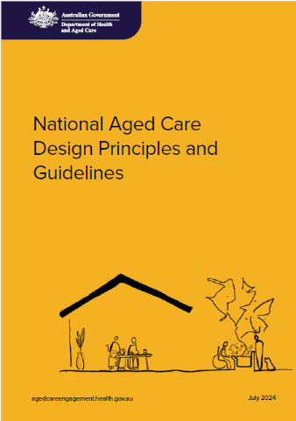Summary

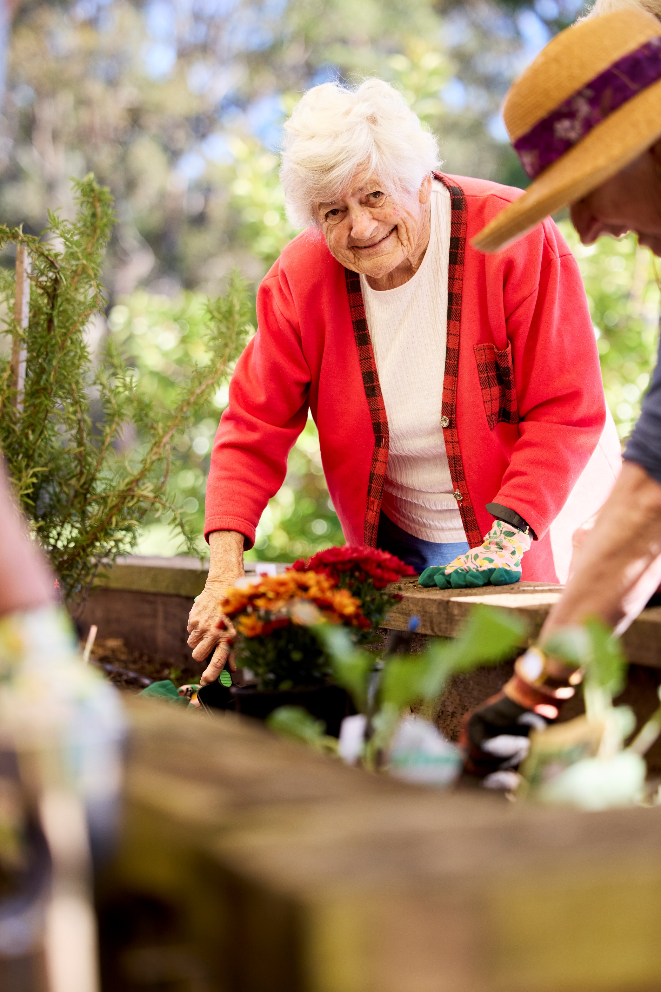

Contents

Overview 4

What are the Principles and Guidelines? 4

Principle 1 – Enable the Person 6

Principle 2 – Cultivate a Home 8

Principle 3 – Access the Outdoors 10

Principle 4 – Connect with Community 12

# Overview

Results from the Royal Commission into Aged Care Quality and Safety show that we need to change how aged care homes are designed. By changing the design, we can make sure aged care homes are more accessible and dementia-friendly.

The Department of Health and Aged Care has worked with many different groups, including older people, their families and carers, the aged care sector and design experts to develop the National Aged Care Design Principles and Guidelines (the Principles and Guidelines).

The Principles and Guidelines help support aged care homes to be safe and comfortable so that people living there can be more independent, function better and enjoy themselves. They also aim to make workplaces safer for staff to provide high quality care.

These design changes will help make aged care homes feel less like hospitals and clinics and more like places where residents can feel at home.

# What are the Principles and Guidelines?

The Principle and Guidelines are made up of four main principles:

* **Principle 1**: Enable the Person
  + Help people live in a place that looks after their health, wellbeing and sense of identity.
* **Principle 2**: Cultivate a Home
  + Create a familiar space where people have privacy, control and feel they belong.
* **Principle 3**: Access the Outdoors
  + Support people seeing and spending time outdoors in nature.
* **Principle 4:** Connect with Community
  + Encourage people to connect with their family, friends and community and to stay involved in meaningful activities.

The principles start by focusing on a person’s immediate environment (Principle 1) and then expand to their broader living environment (Principle 2). Next, they cover engaging with the outdoors (Principle 3) and finally, engaging with the community (Principle 4). 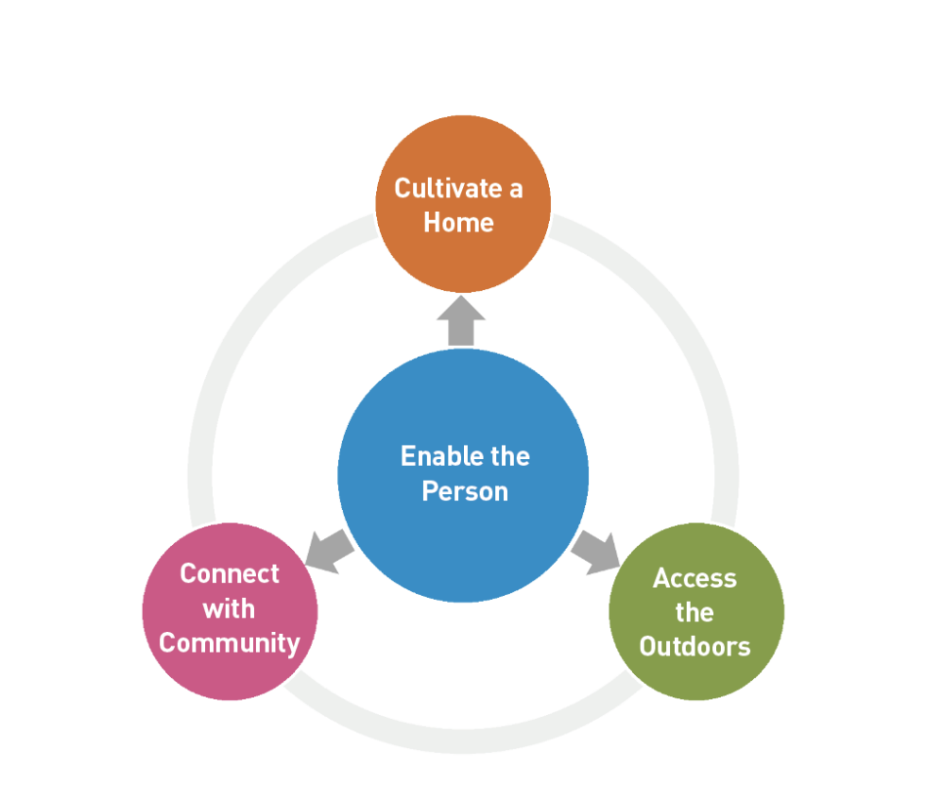

The focus is on promoting the rights of older people, valuing care staff, and encouraging positive relationships between residents, families and staff.

Each principle has a set of guidelines that focus on specific design challenges, looking at key concerns and potential solutions. There are a total of 31 guidelines.

Each guideline has a checklist of practical changes that is supported with evidence. The checklists consider cultural diversity, supporting the workforce, environmental sustainability, infection and prevention control and using enabling technology. There are also dedicated sections at the end of the document about environmental sustainability, enabling technology, infection prevention and control and wayfinding signs.

A group of icons with text
The guidelines use fictional characters to help you understand the needs, experiences, behaviour and goals of different residents and staff and how their experience relates to a guideline.

The Principles and Guidelines will be reviewed and updated regularly, to make sure the guidance stays up to date.

# Principle 1 – Enable the Person

This principle is about helping people live in a place that supports their health, wellbeing and identity.

Thoughtful design can make it easier for aged care residents to adjust to changes in their physical, mental and emotional wellbeing.

The guidelines under this principle are for all areas of an aged care home. They build on design requirements that are already in place and promote design elements that are known to have many benefits for older people.

The guidelines will help design spaces that are supportive, feel home-like and can adapt to meet residents’ changing needs over time.

**The design guidelines for Principle 1 include:**

* Reduce visual clutter and remove or store things that aren’t needed.
* Keep spaces quiet as needed and make sure light levels are designed for older people.
* Use contrasting colour tones to mark key surfaces, such as walls and floors, and low contrast for objects that should not stand out (e.g. staff doors).
* Keep the layout simple and easy to move through without signs. Make sure the flooring is safe with level access and provide comfortable and supportive seating where possible.
* Make sure toilets are easy to find and use from main common spaces and are of a good size.
* Monitor the air quality, making sure there is enough fresh air and that temperatures are comfortable for residents in all seasons. Assess devices and cleaning products to see their impact on air quality.
* Design for ‘nature indoors’ to connect people to nature and pets while they are inside.

Before: The noise, clutter and busyness of the nurses’ station and the lack of clear signs make this space confusing and stressful for residents.

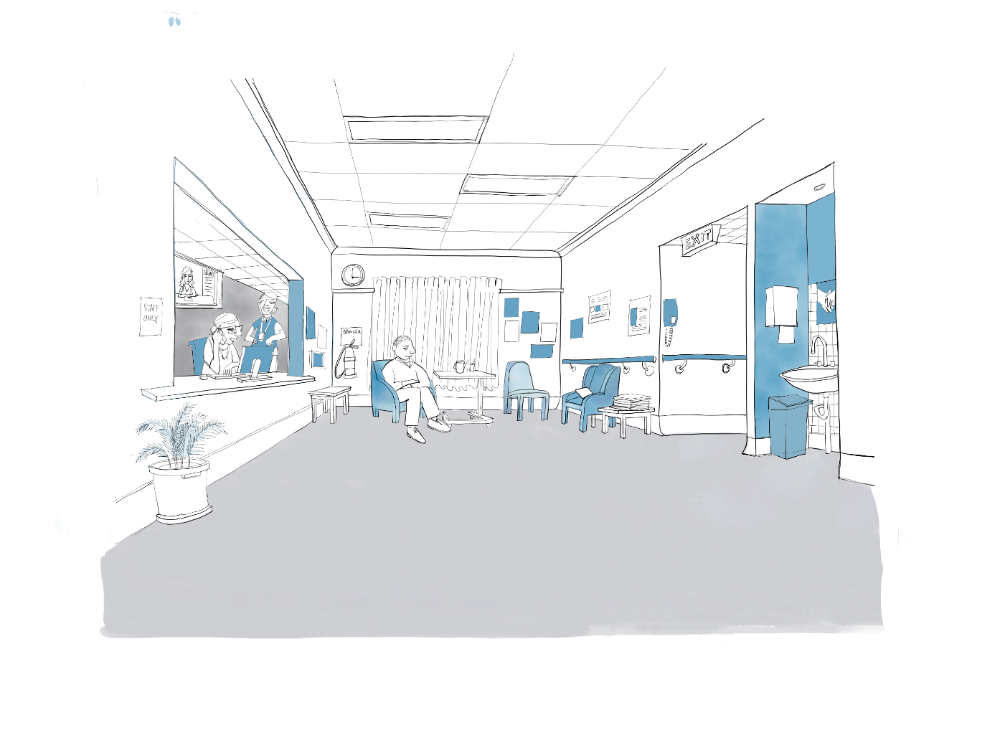

After: The same setting changed to be a more comfortable, peaceful, and less like a hospital, with the nurses’ station removed and basin area tucked away to encourage more social activity.

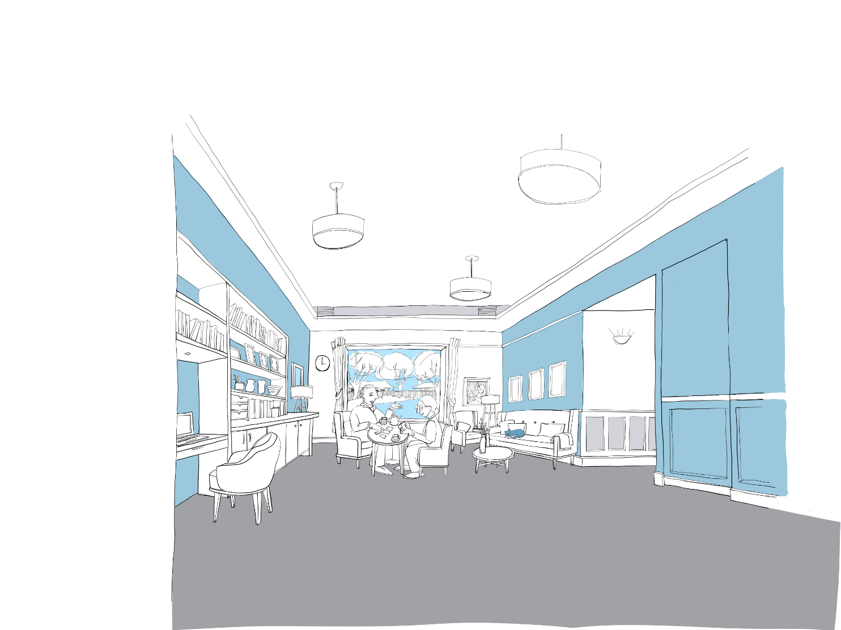

# Principle 2 – Cultivate a Home

This principle is about creating a familiar space where people have privacy, control and feel they belong. It is based on evidence about the benefits of small household models, like less stress and agitation and improved social interaction and health.

Principle 2 encourages organisations to consider moving towards small household models. Evidence suggests the best health and wellbeing outcomes are achieved in living arrangements that have 15 or fewer residents.

**The design guidelines for Principle 2 include:**

* Furnish bedrooms and living areas with items from people's lives, with each resident having their own bedroom and private bathroom.
* Consider moving towards the small household model and create a place that looks and feels like ‘home’, where people live in groups of no more than 15 supported by safe staffing levels.
* Ensure each household has its own private entry and exits to outdoor areas so there aren’t too many unwanted interruptions.
* Provide a central kitchen next to the dining area that residents and their visitors in each household can use.
* Set up areas for activities related to residents’ cultures and preferences that are clearly identified through its design.
* Make sure corridors are shorter than 20m and minimise the use of handrails by having enough seating, landmarks and good quality lighting.
* Use furniture that looks like it would be found in a home and is functional.
* Provide enough handwashing stations, equipment storage and other clinical supports close to where they are needed. Make sure they are accessible but not in the way.
* Have a comfortable place for staff breaks, located away from resident areas.

Before: This space is set up for people to be together in large numbers which limits the activities people can do

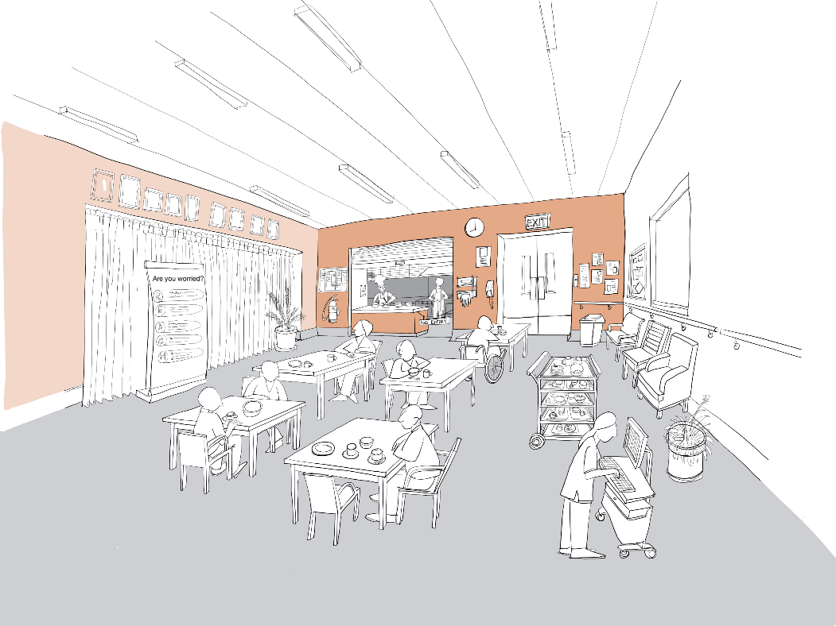

After: The same space is now set up to encourage smaller groups and social activities giving people choice as to how they spend their day

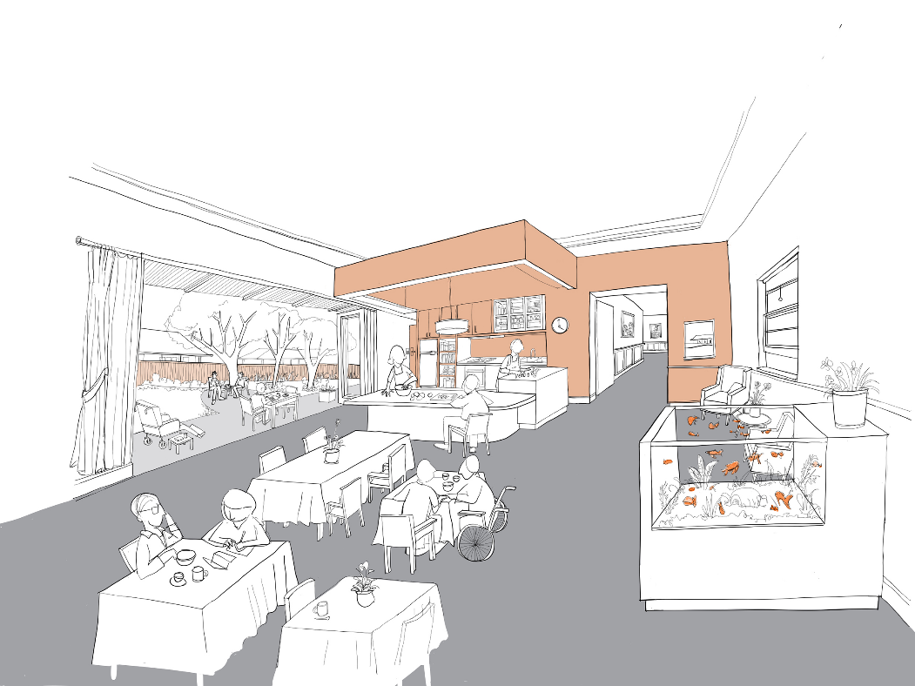

# Principle 3 – Access the Outdoors

Principle 3 is about people seeing and spending time outdoors in contact with nature. It’s also about creating outdoor spaces that are easy to use. Evidence shows that access to the outdoors has a range of health, psychological and social benefits that may not be found anywhere else.

Concerns about safety are often why gardens are not used, but the benefits of spending time outdoors outweigh the risk. The way a physical space is designed can either help or stop someone accessing the outdoors. It’s important to design outdoor areas that help staff and residents to feel safe and comfortable about spending time outside.

**The design guidelines for Principle 3 include:**

* Provide a garden or balcony for residents’ living areas that is safe, accessible and has opportunities for meaningful engagement.
* Make sure residents can easily see and go outside if they want to, and that staff and managers understand that being outdoors supports wellbeing and how they can keep residents safe when spending time outside.
* Provide different outdoor spaces where residents can do meaningful activities that they enjoy. Make sure areas immediately outside doors are sheltered and are large enough for a small group sitting together around a table.
* Make sure garden paths are simple and clear, have seating and are wide enough for different levels of mobility.

Before: This garden is decorative and doesn’t have safe, comfortable spaces for people to do different activities

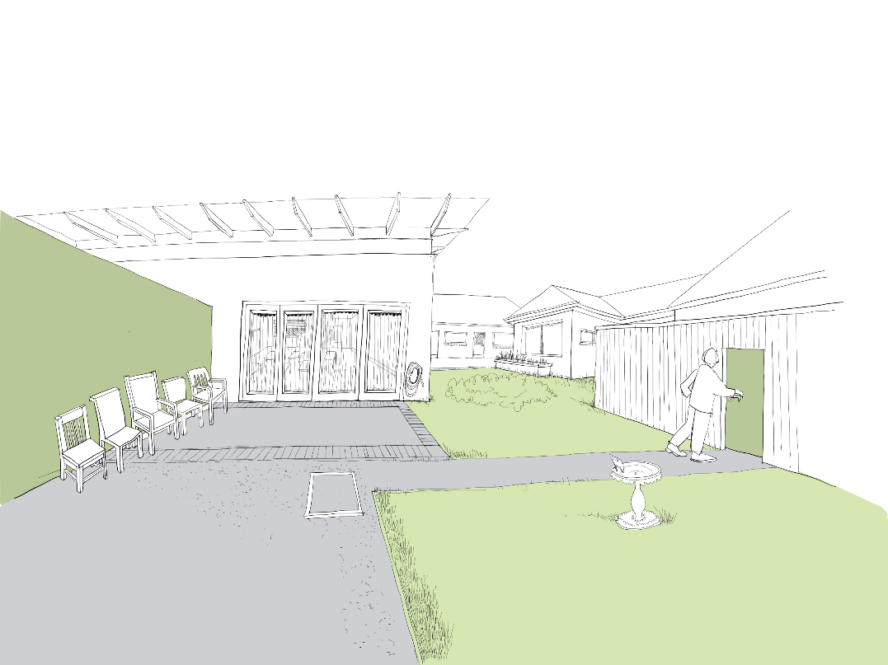

After: The garden has been improved by shaded areas, plants, better pathways, connection to living spaces, and access to outdoor activities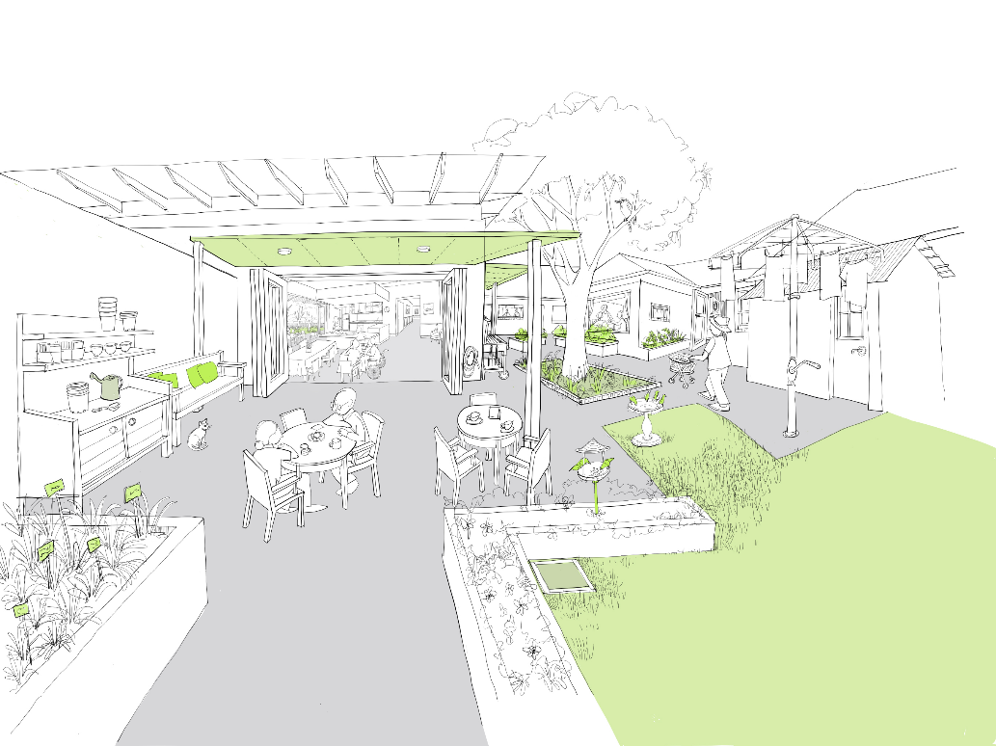

# Principle 4 – Connect with Community

This principle is about encouraging people to connect with family, friends and community and continuing to be involved in meaningful activities.

People living in aged care homes can become lonely and isolated when there aren’t many visitors and the community has negative views about ageing and dementia.

Helping residents to connect with each other and with family, friends and the broader community is extremely important for their wellbeing.

Principle 4 suggests building new homes near neighbourhood centres or other amenities. If an aged care home is in an isolated place, creating community hubs where residents can connect with local community members can help.

**The design guidelines for Principle 4 include:**

* Build the aged care home near a neighbourhood centre or other community hub and consider ways to support social connections through technology.
* Create public amenities inside or near to the home and make these visible from the street and resident areas (e.g. shops, cafes, places of worship, social clubs and childcare centres).
* Create easy-to-follow routes between households and places in the home that residents like to visit. Have familiar landmarks and signs in places where navigation is more complex.
* Design the building so it looks like it fits into the local neighbourhood.

Before: This care home looks more like a hotel and is not welcoming to locals.

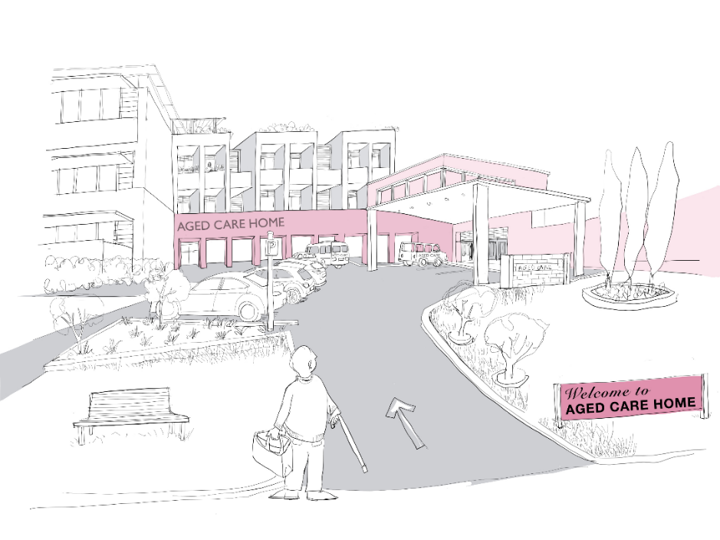

After: Changes to the building have made it more welcoming to the wider community.

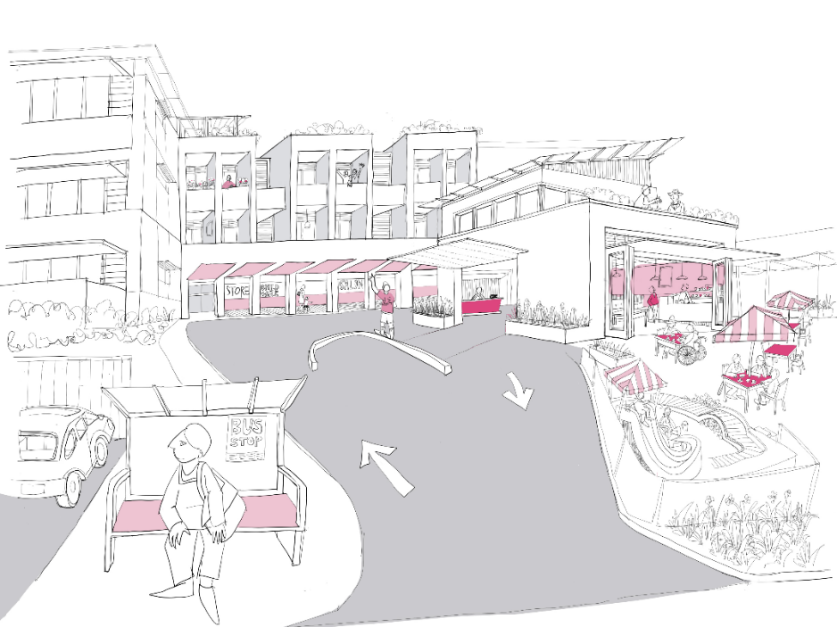

**Let’s change aged care together**

We invite Australians to continue to have their say about the aged care reforms.

Visit **agedcareengagement.health.gov.au**

Phone **1800 318 209** (Aged care reform free-call phone line)

For translating and interpreting services, call 131 450 and ask for 1800 318 209.   
To use the National Relay Service, visit nrschat.nrscall.gov.au/nrs to choose your preferred access point on their website, or call the NRS Helpdesk on 1800 555 660.

