**Sport Horizon**

National Sport Strategy 2024- 2034

© Commonwealth of Australia as represented by the Department of Health and Aged Care 2024

Title: *Sport Horizon*, National Sport Strategy 2024-2034

Print: ISBN: 978-1-76007-402-9

Digital: ISBN: 978-1-74186-097-9

Copyright

© 2024 Commonwealth of Australia as represented by the Department of Health and Aged Care

This work is copyright. You may copy, print, download, display and reproduce the whole or part of this work in unaltered form for your own personal use or, if you are part of an organisation, for internal use within your organisation, but only if you or your organisation:

1. do not use the copy or reproduction for any commercial purpose; and
2. retain this copyright notice and all disclaimer notices as part of that copy or reproduction.

Apart from rights as permitted by the Copyright Act 1968 (Cth) or allowed by this copyright notice, all other rights are reserved, including (but not limited to) all commercial rights.

Requests and inquiries concerning reproduction and other rights to use are to be sent to the Communication Branch, Department of Health and Aged Care, GPO Box 9848, Canberra ACT 2601,or via e-mail to copyright@health.gov.au.

Creative Commons Licence

Creative Commons License

Creative Commons License

This publication is licensed under the Creative Commons Attribution 4.0 International Public License available from <https://creativecommons.org/licenses/by/4.0/legalcode> (“Licence”). You must read and understand the Licence before using any material from this publication.

**Restrictions**

The Licence may not give you all the permissions necessary for your intended use. For example, other rights (such as publicity, privacy and moral rights) may limit how you use the material found in this publication.

The Licence does not cover, and there is no permission given for, use of any of the following material found in this publication:

* the Commonwealth Coat of Arms. (by way of information, the terms under which the Coat of Arms may be used can be found on the Department of Prime Minister and Cabinet website <https://www.pmc.gov.au/honours-and-symbols/commonwealth-coat-arms>);
* any logos and trademarks;
* any photographs and images;
* any signatures; and
* any material belonging to third parties (images as referenced).

**Attribution**

Without limiting your obligations under the Licence, the Department of Health and Aged Care requests that you attribute this publication in your work. Any reasonable form of words may be used provided that you:

* include a reference to this publication and where, practicable, the relevant page numbers;
* make it clear that you have permission to use the material under the Creative Commons Attribution 4.0 International Public License;
* make it clear whether or not you have changed the material used from this publication;
* include a copyright notice in relation to the material used. In the case of no change to the material, the words “© Commonwealth of Australia (Department of Health and Aged Care) 20XX” may be used. In the case where the material has been changed or adapted, the words: “Based on Commonwealth of Australia (Department of Health and Aged Care) material” may be used; and
* do not suggest that the Department of Health and Aged Care endorses you or your use of the material.

**Enquiries**

Enquiries regarding any other use of this publication should be addressed to the Branch Manager, Communication Branch, Department of Health and Aged Care, GPO Box 9848, Canberra ACT 2601, or via e-mail to [copyright@health.gov.au](mailto:copyright@health.gov.au).

# ACKNOWLEDGEMENT OF COUNTRY

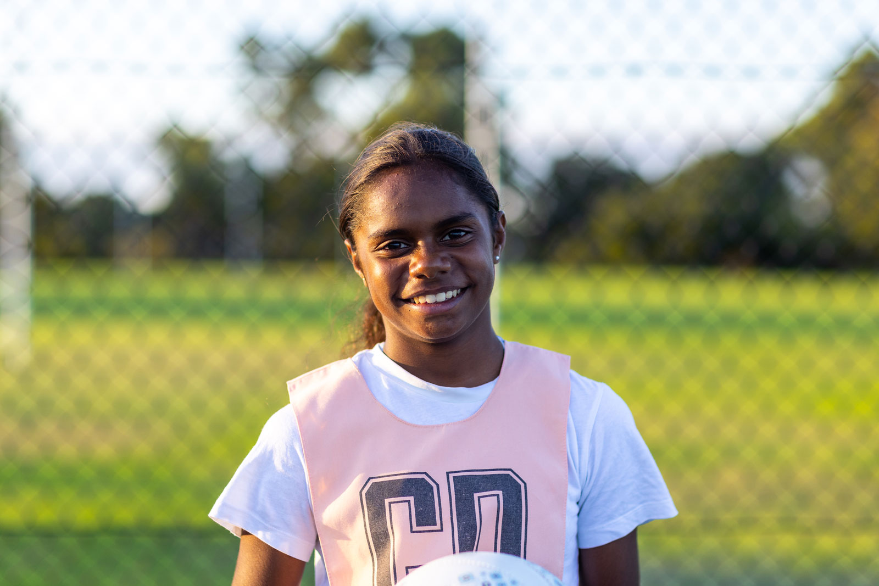

In the spirit of reconciliation, we acknowledge the Traditional Custodians of Country throughout Australia and their connections to land, sea, and community.

We pay our respect to their Elders past and present and extend that respect to all Aboriginal and Torres Strait Islander peoples.

Together we stand on the shoulders of 1,600 generations of Aboriginal and Torres Strait Islander people and that is our shared history.

We refl­ect on the immense contribution of Aboriginal and Torres Strait Islander people to sport, and their role as sporting leaders, across this nation.

# MINISTER’S FOREWORD

Sport is the lifeblood of Australia. The Brisbane 2032 Olympic and Paralympic Games creates a unique opportunity to unite communities through sport, create healthier lives through sport, promote our beautiful country through sport and ensure more Australians from more diverse backgrounds are more active.

*Sport Horizon* is Australia’s new national sport strategy. It sets the direction and aspiration for the Commonwealth, state and territory governments, communities, and sporting organisations to create thriving systems.

*Sport Horizon* will ensure more people play and enjoy sport in safer environments. It will create world-leading pathways for our most talented people, better support weekend warriors and the volunteers who turn events into celebrations.

It will also drive gender equity throughout Australian society. It’s time to create more environments for women that propel them to greatness, more pathways for female leadership and more incentives for girls to pursue sporting passions.

I would like to thank everyone involved in the consultation and development of *Sport Horizon*. I would also like to thank Australia’s state and territory Sport Ministers for their support in contributing to and welcoming this strategy.

From playground to podium, *Sport Horizon* will bind us with a strategy to help all Australians live healthier lives.

I look forward to continuing to work with the dedicated individuals, communities and organisations that make sport the lifeblood of our great country.



**The Hon Anika Wells MP**

Minster for Aged Care

Minister for Sport

Image

The Hon Anika Wells MP's signature

CONTENTS

OUR VISION 1

STATE OF PLAY 2

THE NEW HORIZON 3

A Focus on Sport 3

Key Policy Settings 4

Partnership and Collaboration 4

OUR GAME PLAN 5

Vision 5

Guiding Principles 5

Our Priorities 5

Measuring Success: 6

GUIDING PRINCIPLES 7

OUR PRIORITIES 8

Inclusion 9

Participation 11

High Performance 13

Safety 15

International Engagement 17

Economy and Environment 18

MOVING FORWARD TOGETHER 20

MEASURING SUCCESS 22

# REFERENCES

## Statistics References

**1** AusPlay Data Portal: Volunteers in non-playing roles, Australian Sports Commission (2022-23)

**2** Community Perceptions Monitor Annual Report 2022-2023, Australian Sports Commission (September 2023)

**3** AusPlay Data Portal: Sport-related participation – Frequency of participation, Australian Sports Commission (2022-23)

**4** Sourced via Sport Integrity Australia (February, 2024)

**5** Intergenerational Review of Australian Sport 2017, Boston Consulting Group (2017)

**6** Sourced via Australian Sports Commission (May, 2024)

**7** Brisbane 2032 Olympic and Paralympic Games Preliminary Economic Social and Environmental Analysis Summary Report, KPMG (2021)

**8** Australian Burden of Disease Study: Impact and causes of illness and death in Australia 2018, Australian Institute of Health and Welfare

## Acronyms

**ASC** - Australian Sports Commission

**DFAT** - Department of Foreign Affairs and Trade

**DOHAC** - Department of Health and Aged Care

**DSS** - Department of Social Services

**NIAA** - National Indigenous Australians Agency

**PM&C** - Department of the Prime Minister and Cabinet

**SIA** - Sport Integrity Australia

## Image Credits

**Cover** – Richard Heathcote / Getty Images Sport via Getty Images

**Iii** - Image 000208403 © [2023 Caro Telfer], used under license from Austockphoto

**Page 1, 2** - Photo by Chris Hyde - FIFA via Getty Images

**Page 3** - Cricket Australia

**Page 6** - Cameron Spencer / Getty Images Sport via Getty Images

**Page 8 -** Anthony Dibon / Icon Sport via Getty Images

**Page 9, 10** - Mark Metcalfe / Getty Images Sport via Getty Images

**Page 11** - Touch Football Australia and Pride in Sport

**Page 13** - FatCamera / E+ via Getty Images

**Page 15** - Gregory Shamus / Getty Images Sport via Getty Images

**Page 17** - Rob Palmer, Surf Lifesaving Australia

**Page 19** - PacificAus Sports

**Page 21** - Clive Brunskill / Getty Images Sport via Getty Images

**Page 23** - Al Bello / Getty Images Sport via Getty Images

**Page 25** - Seb Daly / Sportsfile via Getty Images

# OUR VISION

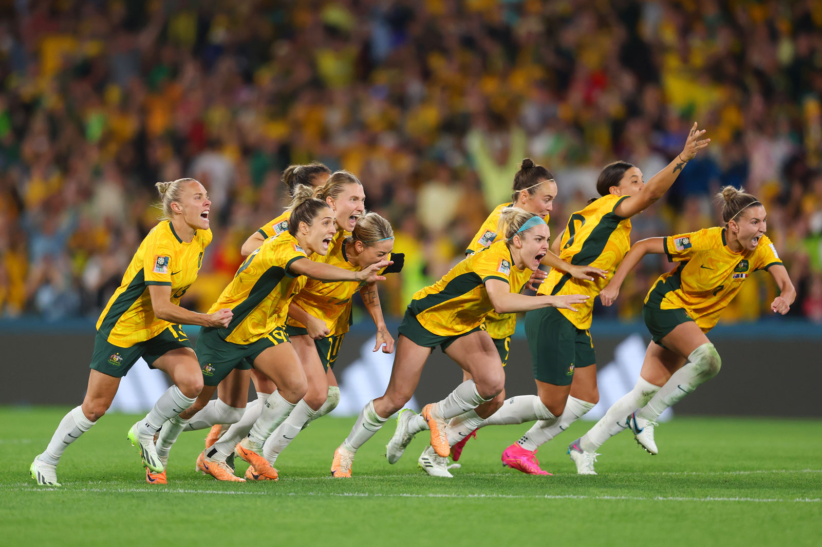

## AN INSPIRING HORIZON

Building healthy, active, connected communities and a thriving sport system.

The decade of major sporting events leading up to, and including the Brisbane 2032 Olympic and Paralympic Games, creates a window of opportunity to reimagine Australian sport and bring about unprecedented cooperation and alignment of the sport sector. Working together we will harness the power of sport for healthy, active and connected communities, to create positive, meaningful change.

# STATE OF PLAY

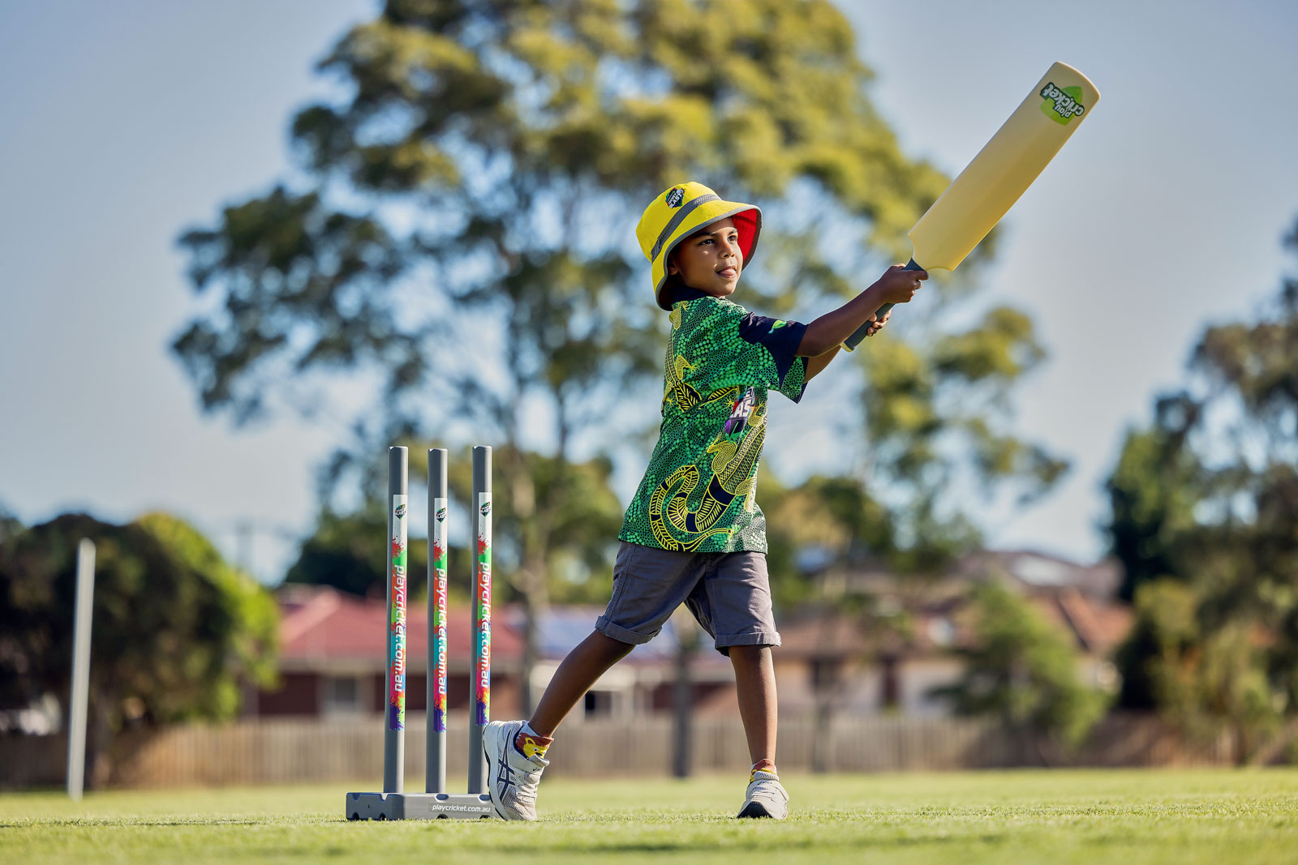

Over 3 million Australians volunteer annually.1

88% of Australians believe sport is good for bringing their communities together.2

40% of people (aged 15+) participate in a sport-related activity at least once a week.3

100% of Australian Sports Commission recognised sports have signed up to the National Integrity Framework or are working to meet best practice standards.4

Sport delivers $83 billion in combined economic, health and education benefits to Australia annually.5

2,800 categorised athletes are supported by Australia’s high performance Sport System at any one time, across Olympic, Paralympic and Commonwealth Games sports.6

The Brisbane 2032 Olympic and Paralympic Games will deliver $17.6 billion in economic, social and environmental benefits to Australia.7

Physical inactivity is the 9th leading preventable cause of ill health and premature death, responsible for 2.5% of total disease burden in Australia (in 2018).8

# THE NEW HORIZON

Over the next decade, Australia will host some of the world’s largest sporting events culminating in the Brisbane 2032 Olympic and Paralympic Games.

We have an unprecedented opportunity to leverage the ‘green and gold decade’ of events to reshape the future direction of sport in Australia – to promote inclusion through safe and welcoming environments, inspire and motivate participation, support our athletes to compete with integrity and perform at their best, grow our presence internationally, and achieve positive economic, social, and environmental outcomes.

To harness this opportunity, we need to understand how the sporting landscape and the ways we engage in sport are being transformed by new technologies, shifting societal values and expectations, and the changing environment. We must continue to be adaptable and responsive to the challenges these changes present to fully realise the benefits of sport, such as improved health and wellbeing, strengthened social connections, and increased productivity.

## A Focus on Sport

*Sport Horizon* has been developed with, and for, the Australian sport sector. It sets a collective vision and priorities for sport in Australia over the next decade.

The focus of the Strategy is on sport, including organised sport, development pathways and high performance. Given the health and wellbeing benefits of an active lifestyle and emerging pathways into sport, the Strategy also seeks to leverage opportunities created through active recreation and physical activity in schools and the community. Whilst critical to the health of our nation, activities of daily living and active travel are beyond the scope of the Strategy.

Figure 1 – A Focus on Sport diagram

The diagram titled "Figure 1 – A Focus on Sport" features a vertical scale labelled "in scope" at the top and "out of scope" at the bottom. It has three tiers indicating different focuses of sport activities: 

Top Tier (In Scope): 

High Performance and Development Pathways e.g. supporting systems and feeder programs through to high performance 

Organised Sport structured, community level sport, governed by rules and regulations e.g. club sport, cricket, football, basketball 

 

In the Middle Tier between In-Scope and Out of-Scope: 

Schools and the Community focuses on education, skill acquisition and development e.g. school sport, active play, health profession led programs, non-organised sport 

Active Recreation facilitated or self-directed activity e.g. gym class, park run, yoga, walking 

Bottom Tier (Out of Scope of the National Sport Plan): 

Activities of Daily Living e.g. gardening, housework, shopping 

Active Travel e.g. walking or cycling from place to place 

## Key Policy Settings

*Sport Horizon* acknowledges the significant work already underway across the sector. It brings together key strategies, including Australia’s *National Sport Participation Strategy – Play Well, Australia’s 2032+ High Performance Sport Strategy – Win Well,* and *state and territory strategies and plans.*

Sport Horizon also acknowledges the role of sport in achieving outcomes in line with other national agreements and strategies, such as the National Agreement on Closing the Gap, National Strategy to Prevent and Respond to Child Sexual Abuse 2021-2030, National Preventive Health Strategy 2021-2030, Working for Women: A Strategy for Gender Equality and Australia’s Disability Strategy 2021-2031.

## Partnership and Collaboration

*Sport Horizon* provides a framework to align our focus, efforts and resources, and garner the expertise needed to drive improvements across the sector and outcomes for sport.

We must work together with renewed focus to achieve the aspirations set out in *Sport Horizon*. All levels of government and the sport sector have important roles in delivering policies, programs, community infrastructure and services needed to build healthy, active, connected communities and a thriving sport system.

We need to continue to be innovative and think differently. This will require collaborating and partnering with different sectors, such as media, technology, and data, to enable a digitally connected, data driven, and sustainable Australian sport ecosystem. Improved data sharing, data quality, research and evaluation will boost the evidence-base and shape further action needed to make impactful change.

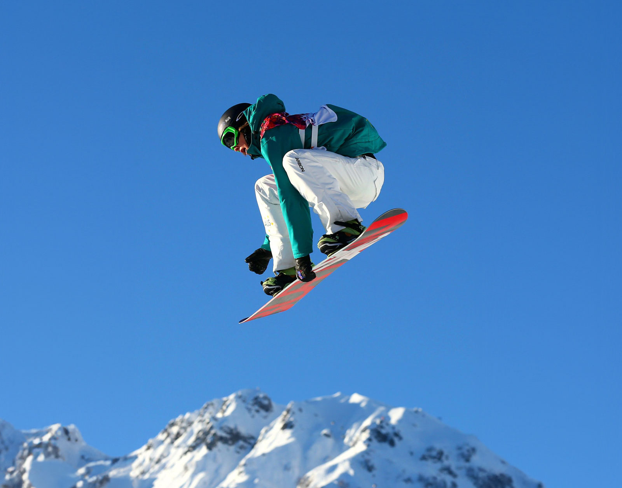

# OUR GAME PLAN

## Vision

Healthy, active, connected communities and a thriving sport system

## Guiding Principles

To guide the implementation of priority areas and decision making

|  |  |
| --- | --- |
|  | Leadership |
|  | Diversity, Equity, Inclusion |
|  | Integrity |
|  | Education and Development |
|  | Sustainability |

## Our Priorities

Areas of focus for the Strategy, aligned with the immediate priorities of the sport sector

|  |  |
| --- | --- |
| Inclusion | Promote inclusive practices and environments that are safe and encourage participation, involvement, and leadership across diverse cohorts. |
| Participation | Increase rates of participation and involvement in sport, and maximise access and quality of experiences. |
| High Performance | Enhance Australia’s reputation as a fair, successful and leading edge sporting nation with opportunities and development pathways for high performance athletes, coaches and officials to thrive. |
| Safety | Instil safe sporting environments through a genuine culture of respect and integrity at all levels of sport. |
| International Engagement | Leverage the power of sport to bring people together, project Australia’s values and identity, and promote Australia’s international priorities. |
| Economy and Environment | Enable the sport sector to prosper at all levels. Leverage the significant investments in sport, including infrastructure and facilities. Promote sustainable practices and environmental leadership. |

## Measuring Success:

|  |  |
| --- | --- |
|  | Everyone has a place in sport |
|  | We win well to inspire Australians |
|  | A sustainable Australian sport system |
|  | Australia remains a global leader in sport |

**

# GUIDING PRINCIPLES

*Sport Horizon* is guided by five principles that reflect our commitment to achieving positive, meaningful change. These principles are woven throughout *Sport Horizon* and the related strategy documents and will guide implementation and decision making to ensure *Sport Horizon* remains agile and achieves its objectives.

|  |  |
| --- | --- |
|  | Leadership  A capable sport sector committed to uplifting governance and creating diverse, inclusive, ethical and gender-balanced leadership across the sport sector that re­flects the community. |
|  | Diversity, Equity, Inclusion  A sport sector which embraces everyone and celebrates diversity, so everyone feels valued and has an opportunity to participate, contribute and reach their full potential. |
|  | Integrity  A fair and honest sport sector that builds community confidence in sport, by demonstrating ethics and values that promote safe environments and enhance sport overall. |
|  | Education and Development  Sport and physical activity contributes to personal growth, physical and health literacy, and the development of skills across the life course. |
|  | Sustainability  An innovative, resilient and sustainable sport sector that builds capacity and capability and works collaboratively to achieve strategic outcomes, such as ensuring the efficient use of resources to maintain and grow involvement in sport at all levels and locations. |

# OUR PRIORITIES

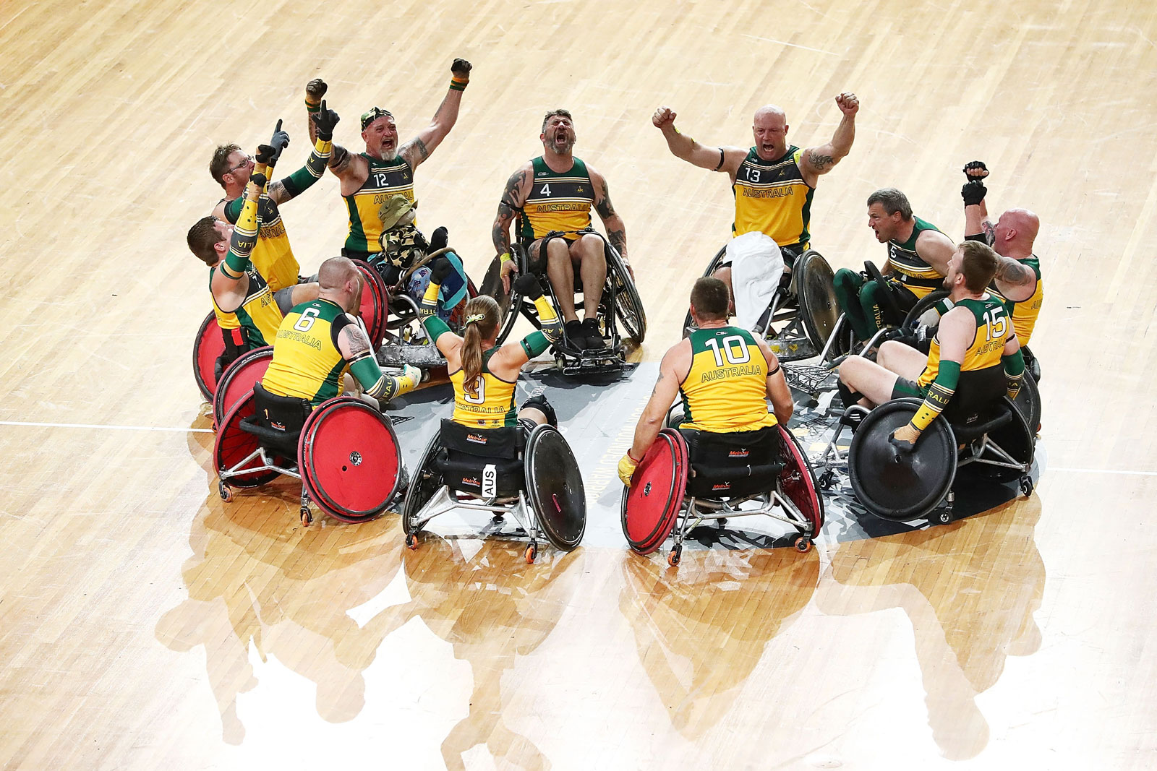

## Inclusion

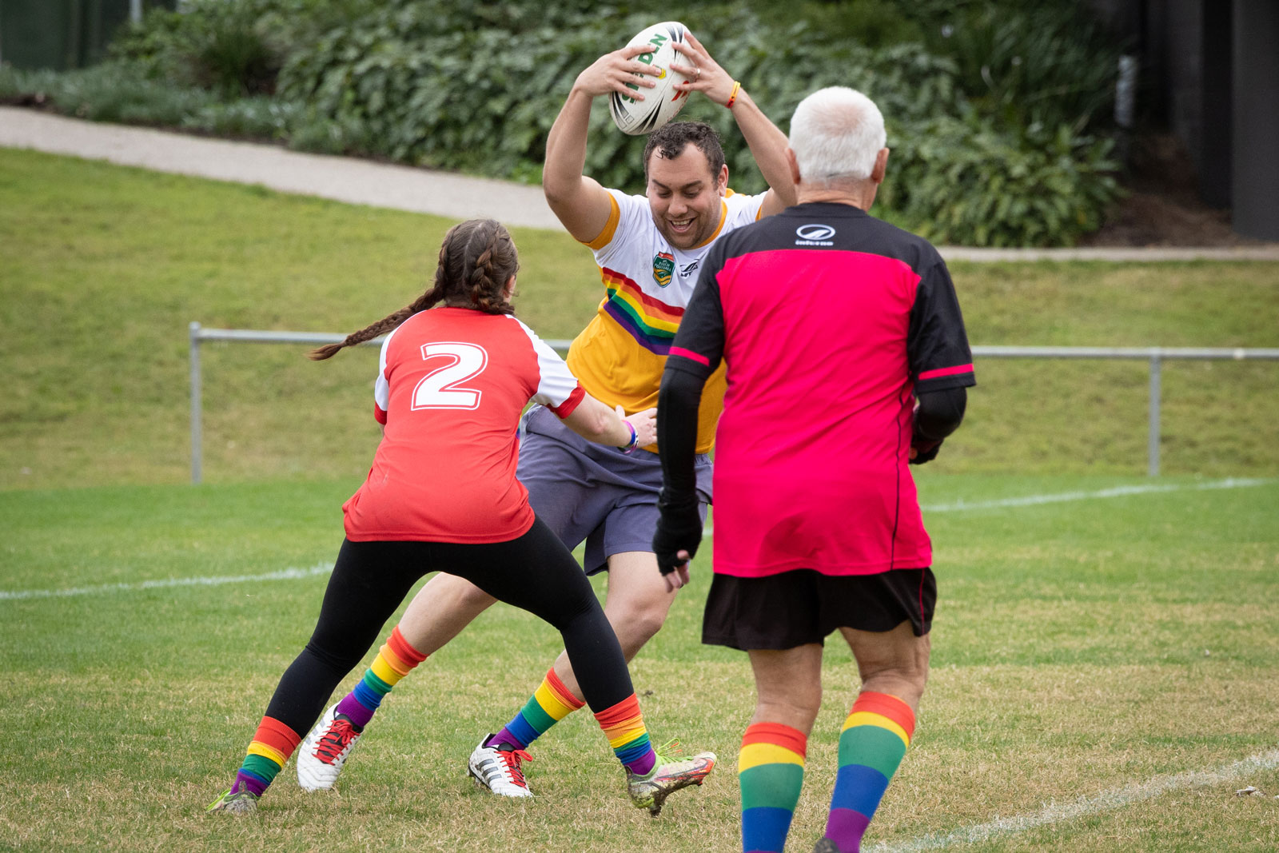

Everyone should have the opportunity to be active and engage in sport, and feel safe to do so. We must embed inclusive practices to give people choice and control. At every level of sport, we have the power to challenge and change stereotypes, build connections, celebrate diversity, raise awareness of social issues, overcome cultural barriers and create places of belonging.

**We will:**

promote safe and welcoming environments that encourage participation, involvement and leadership of First Nations people; women and girls; LGBTIQA+; people with disability; older people; people living in rural, regional and remote areas; people experiencing socioeconomic disadvantage; people living with mental illness; migrants; and culturally and linguistically diverse communities.

promote the benefits of inclusion, such as stronger, better connected sporting communities, increased participation and volunteering, to ensure the long-term sustainability of the sector.

contribute to the National Agreement on Closing the Gap through improved health and wellbeing of First Nations people through increased involvement in sport.

grow diverse representation in a range of roles, such as athletes, coaches, administrators, officials, volunteers and journalists so individuals see themselves represented and feel a sense of belonging.

embed inclusivity in design by involving those with lived experience in the development and implementation of policies and programs.

**Activated through:**

Play Well

Win Well

Sport Volunteer Coalition Action Plan 2022-2026

National Integrity Framework

Major Sporting Events Legacy Framework

State and territory sport and recreation plans and programs.

**Contributes to priorities and objectives related to:**

National Agreement on Closing the Gap

Australia’s Disability Strategy 2021-2031

Working for Women: A Strategy for Gender Equality

Multicultural policies.

## Participation

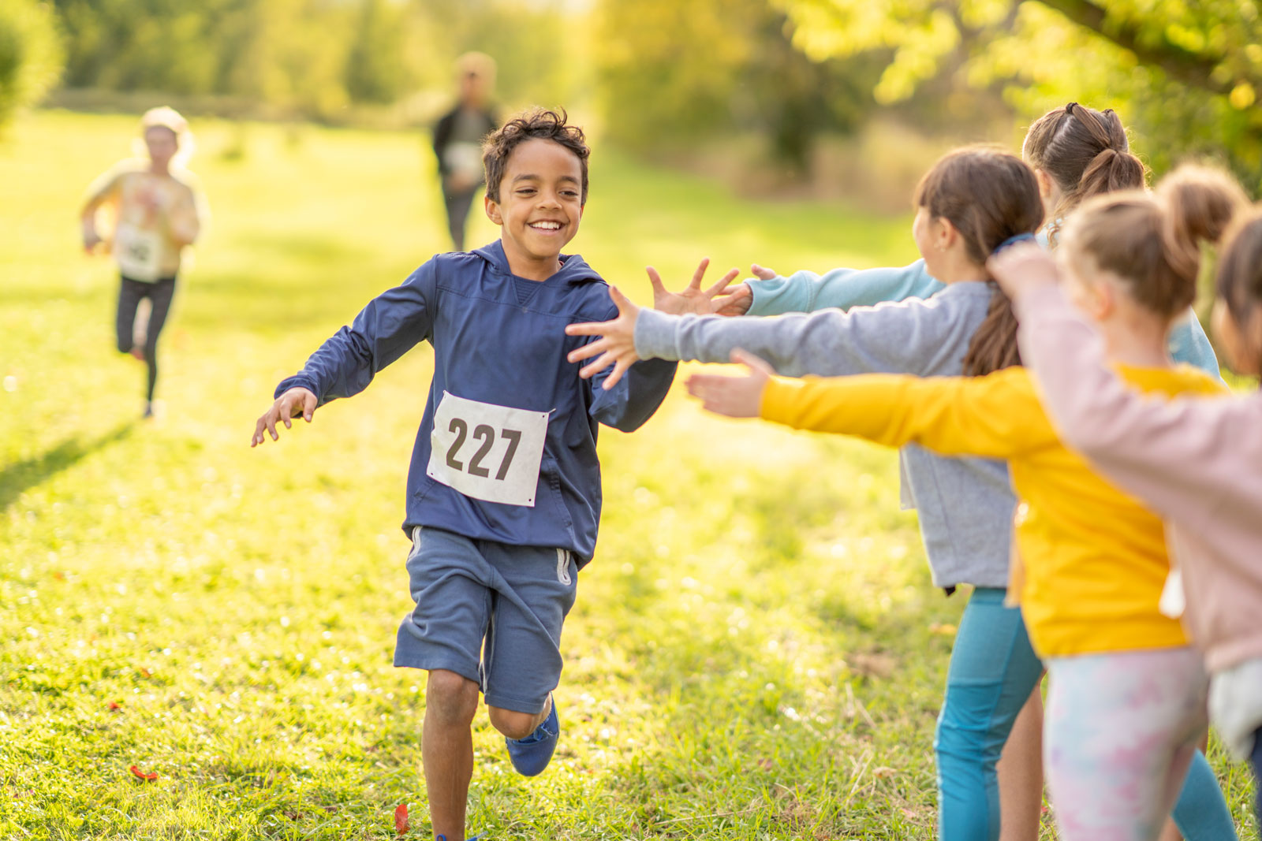

Participating in sport provides a range of benefits for individuals, families, and communities. But participation is about much more than turning up to play. To maximise participation we need the people, programs, partners, places and spaces to optimise experiences, and ensure opportunities are available for people of all ages.

**We will:**

encourage fun, safe, and enriching experiences, particularly for children and young people, so they enjoy being active and learn skills that allow for their lifelong involvement.

break down individual, social and economic barriers that prevent participation, such as cost, geographic location and physical literacy levels, to empower individuals to engage with, and connect through, sport.

celebrate, support and recognise the contributions of those who volunteer and work in the sector, including coaches, administrators and officials.

increase rates of participation and other involvement in sport for all age groups (including coaching, officiating and volunteering) to promote population wide health, social and community benefits, including physical literacy and skills development.

unlock alternative and non-traditional spaces for community use to ensure opportunities are accessible and available to all.

**Activated through:**

Play Well

Sport Volunteer Coalition Action Plan 2022-2026

Major Sporting Events Legacy Framework

National Integrity Framework

State and territory sport and recreation plans and programs.

**Contributes to priorities and objectives related to:**

National Preventive Health Strategy 2021-2030

National Obesity Strategy 2022-2032

Working for Women: A Strategy for Gender Equality.

## High Performance

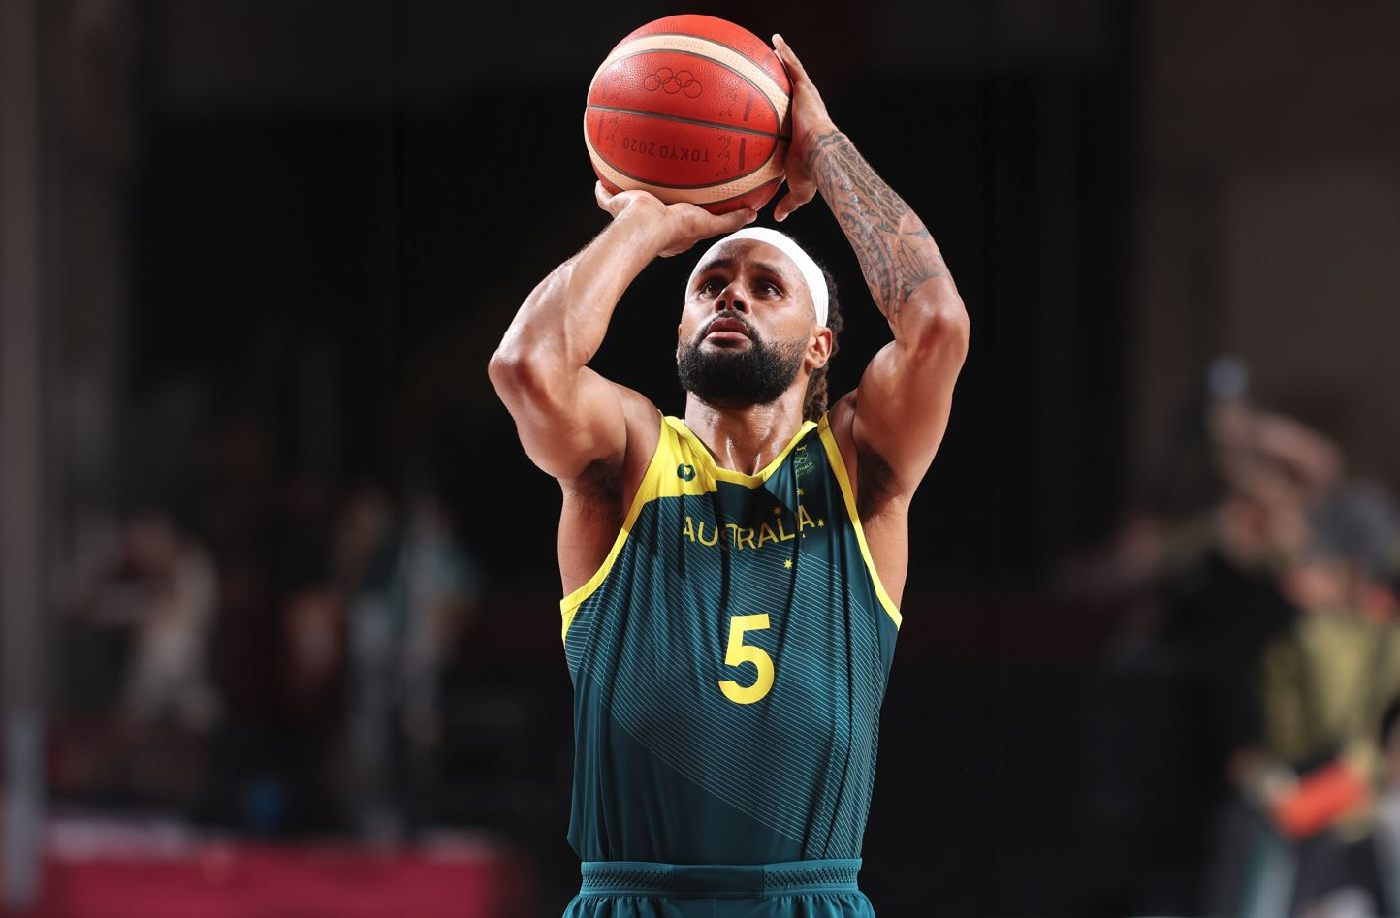

We have a long, successful sporting history, domestically and on the global stage. Through Australia’s high performance sport system and in professional sport, we support athlete development pathways, from foundational skills through to talent identification and mastery. When we host major sporting events, athletes have the opportunity to fulfil their dreams of competing in front of a home crowd. Across the ‘green and gold decade’, our athletes and teams will inspire Australians and proudly embody the Australian spirit by competing fairly, passionately and fiercely.

**We will:**

focus on competing with integrity and sportsmanship.

look beyond winning to deliver benefits for performance delivery and athlete performance pathways while building capable organisations and a workforce that utilises world-leading knowledge and practice.

unite in our pursuit to build an inclusive and sustainable sporting system that is performance driven, athlete focused, exceptionally led and purposefully collaborative.

identify and address barriers to entry and progression for athletes from under-represented communities and ensure supportive pathways prioritise wellbeing for both emerging and established athletes, including those transitioning to life after sport.

continue to empower and support coaches, officials, other staff and volunteers to access development and training opportunities and increase capability to support their athletes and teams.

remain a leading-edge sporting nation through research and innovation to advance coaching, science, medicine, engineering, and technology and retain our competitive advantage.

**Activated through:**

Win Well

Major Sporting Events Legacy Framework

National Integrity Framework

Sport Volunteer Coalition Action Plan 2022-2026

State and territory sport and recreation plans and programs.

## Safety

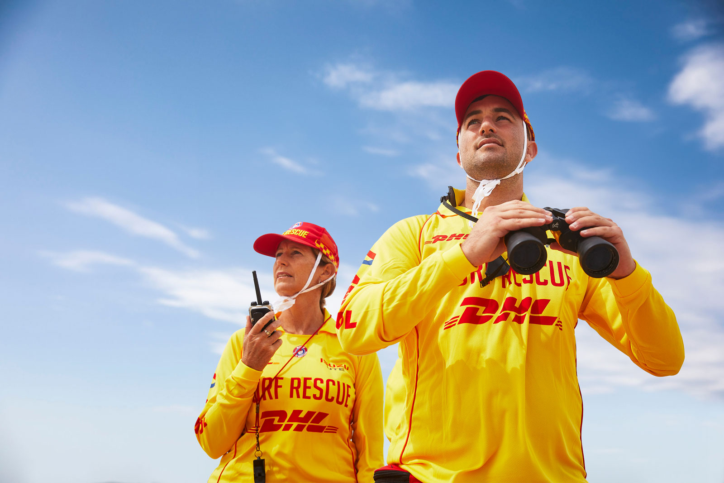

Prioritising safety to support clean, fair and ethical conduct and competition is integral to ensuring integrity in sport.

The prioritisation of safety alongside effective mechanisms to handle complaints, independent dispute resolution, and disciplinary action, is essential for protecting people involved in sport and the sports ecosystem from:

● abuse, bullying, intimidation, discrimination, or harassment

● improper use of drugs and medicine

● manipulation of sporting competitions.

Safety in sport and physical activity is paramount. We must actively prevent and respond to individual threats across different dimensions of safety, including physical, psychological, cultural, and online safety. We must protect the health, wellbeing, and rights of everyone involved.

**We will:**

adopt culturally inclusive practices and instil safe environments through a genuine culture of integrity and respect at all levels of sport. This involves education, prevention and action to address harmful behaviours that threaten sports integrity, including abuse, bullying, harassment, discrimination, gendered or other violence relating to children and all members of sport.

at a system level, continue to advance our ability to prevent, detect, disrupt and address safety threats through education, intelligence and regulation; efficient, independent dispute resolution; and continuous improvement to remain contemporary and keep pace with technological and other advances.

ensure facilities and equipment are safe, and rules and practices minimise the occurrence and impact of injuries, e.g. concussion.

uplift capability at an organisational level to enhance safety, governance, and compliance protocols, and equip organisations to prevent, detect and respond to safety risks and incidents.

**Activated through:**

National Integrity Framework

National Sports Tribunal

Sport Governance Principles

Play Well

Major Sporting Events Legacy Framework

Sport Volunteer Coalition Action Plan 2022-2026

State and territory sport and recreation plans and programs.

**Contributes to priorities and objectives related to:**

National Plan to End Violence against Women and Children 2022-2032

National Strategy to Prevent and Respond to Child Sexual Abuse 2021-2030

Working for Women: a Strategy for Gender Equality.

## International Engagement

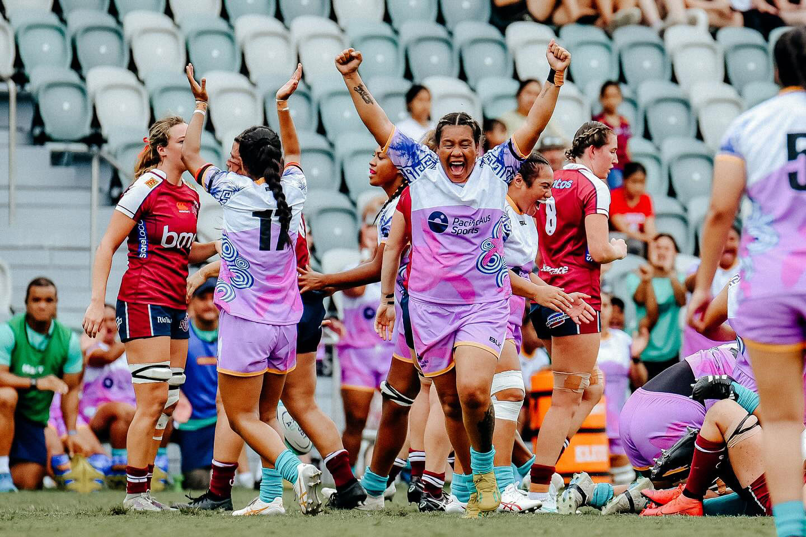

The ‘green and gold decade’ provides Australia with an unparalleled opportunity for international engagement through sport. Sport provides a platform for advancing our national interests on the global stage. It can build networks that foster business, economic and investment opportunities. To maximise outcomes over this the next decade we require engagement by, and strong partnerships between governments, the sport sector and business.

**We will:**

through major events, build international recognition and promote Indigenous, historic and natural heritage, and showcase Australian values, excellence and expertise.

enhance our ties, presence, standing and in­fluence across the Indo-Pacific and beyond, as we work with our neighbours to advance participation, development and leadership pathways in sport.

continue to leverage our diplomatic network to connect Australia to global markets and trade and investment opportunities in sport.

**Activated through:**

Australia’s Sports Diplomacy Strategy 2032+

Major Sporting Events Legacy Framework

Sport Volunteer Coalition Action Plan 2022-2026

State and territory sport and recreation plans and programs.

## Economy and Environment

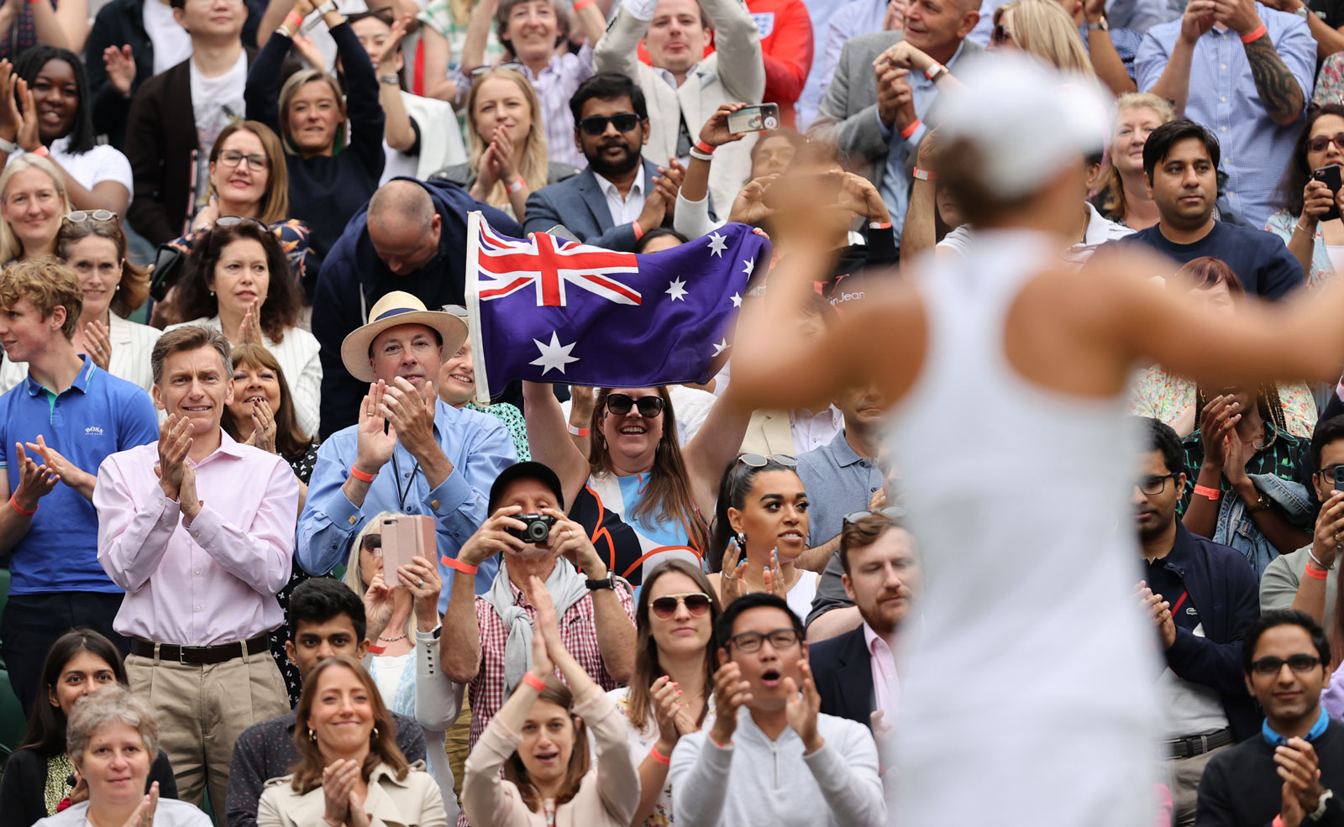

Sport is a major contributor to, and a valuable part of, our nation’s economy. The ‘green and gold decade’ has incredible potential to stimulate trade, investment, and employment opportunities. To maximise these opportunities, we need a coordinated approach and partnerships to use our resources wisely and grow participation. To support collective action to address emerging challenges, including those resulting from the changing climate, we need adaptable, innovative and resilient solutions that promote sustainability and environmental leadership, and consider the impacts of sport on the environment and the environment on sport.

**We will:**

promote meaningful career pathways, access to learning and development opportunities and recognise the economic and societal value of volunteers, to help sustain a strong, capable and diverse workforce and support the ongoing viability of the sector.

embrace an evidence-based approach to policy, championing data driven insights and translating research to practice.

harness emerging digital and technological solutions to help the system drive innovation and remain current and competitive.

support sector and organisational sustainability through opportunities that promote effective governance and the efficient use of resources, to remain contemporary and maintain and grow participation and involvement in sport.

encourage partnership arrangements and philanthropy as tools to improve the financial sustainability of all sports, particularly those outside of the major codes, emerging sports, and sports tailored for diverse cohorts.

encourage an aligned and coordinated approach to sport infrastructure.

promote and encourage the implementation of sustainable practices and environmental leadership across the sport sector.

leverage the significant investment in sport (including infrastructure and facilities) and maximise returns to the economy to achieve health, social and environmental outcomes.

**Activated through:**

Play Well

Win Well

Major Sporting Events Legacy Framework

Sport Volunteer Coalition Action Plan 2022-2026

Australian Sports Foundation

State and territory sport and recreation plans and programs.

**Contributes to priorities and objectives related to:**

National Visitor Economy Strategy (THRIVE 2030)

National Agreement on Closing the Gap.

# MOVING FORWARD TOGETHER

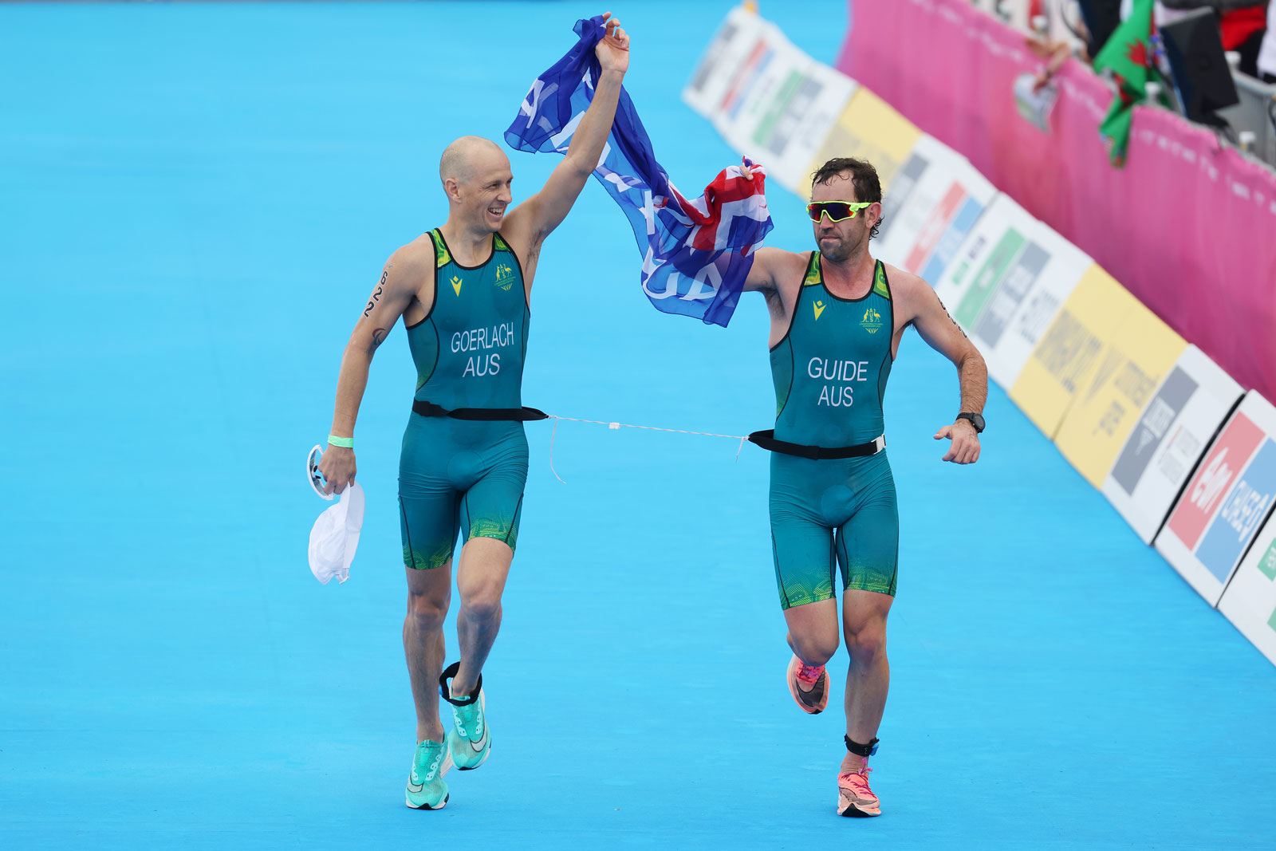

Activation of the priorities in *Sport Horizon* will occur through national sport-related strategy documents. State and territory strategy documents will contribute to achieving the outcomes of the Strategy. *Sport Horizon* will also contribute to the objectives of non-sport related strategies and policies.

A chart of different colored squares


# MEASURING SUCCESS

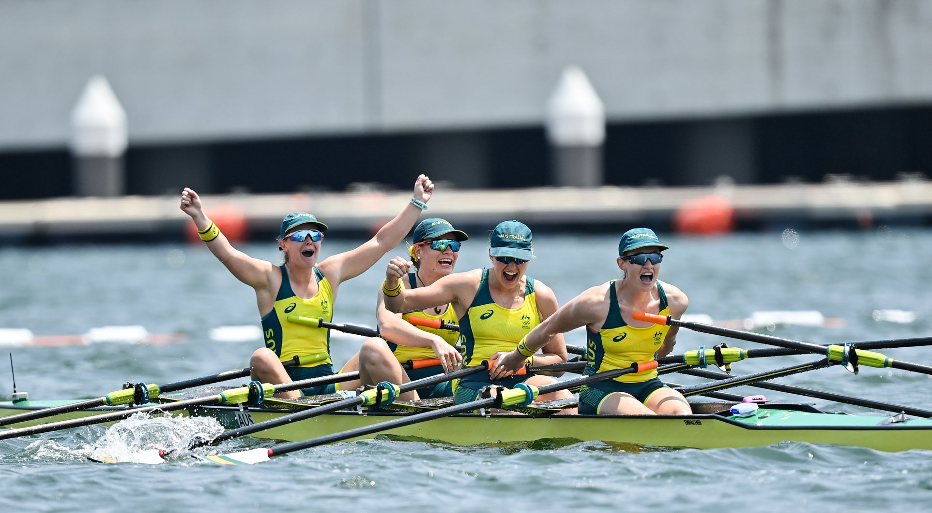

Measuring success requires access to reliable, high-quality data, and consistency and integrity in data collection. Progress will be measured and reported across four outcome groups that draw on measures related to the interconnected principles and priorities of *Sport Horizon*. Indicators will be informed by relevant strategies, such as *Play Well* and *Win Well*\*.

Monitoring and evaluation of the Strategy will be undertaken in a staged approach. The Department of Health and Aged Care will develop a robust monitoring and evaluation framework in partnership with key stakeholders. The framework will build on the proposed themes identified below to provide detailed interim and longer-term indicators and outcomes, including baseline data and targets.

**Everyone has a place in sport:**

Participation in sport (participants, coaches, officials, administrators, and volunteers, stratified by diversity groups, such as First Nations people).

Health and wellbeing outcomes (e.g. sports injury, reducing physical inactivity).

Community perceptions of sport, including participant experience.

Community sport infrastructure and facilities.

Safety and integrity threats in sport, and independent dispute resolution.

**We win well to inspire Australians:**

Performance at Summer and Winter Pinnacle Events.

Wellbeing measures across all high performance sport system environments.

Diversity and inclusion in high performance.

Perceptions of the Australian community.

Broadcast and engagement rates at sporting events.

**A sustainable Australian sport system:**

Organisational outcomes, such as financial viability, participant registration, governance and philanthropy.

Employment and workforce opportunities.

Governance principles and standards, including diversity in leadership and gender equality.

Economic benefits associated with major sporting events.

Economic impacts of sport on health.

**Australian remains a global leader in sport:**

Successful delivery of major events.

International infl­uence, particularly in the region.

Australian advances in innovation and technology in sport.

Fit-for-purpose facilities.

Environmental leadership achieved through sport.

* Where applicable, the measures of success and supporting indicators will be directly linked to the aims and targets of relevant strategies, including Australia’s National Participation Strategy – Play Well and Australia’s 2032+ High Performance Strategy – Win Well.

# ACKNOWLEDGEMENTS

Many individuals and organisations have given their time and expertise to support the development of *Sport Horizon.*

We would like to acknowledge members of the steering committee, working group, state and territory officials, and representatives who attended the targeted consultation and roundtable, whose experience and expertise were invaluable in developing the Strategy.

We would also like to thank those who through the public consultation shared why sport matters to them and their views on how we can best shape the future of sport in Australia.

For more information on the National Sport Strategy, contact

[**NationalSportStrategy@health.gov.au**](mailto:NationalSportStrategy@health.gov.au)

