# National Occupational Respiratory Disease Registry update (March 2025)

The National Occupational Respiratory Disease Registry (National Registry) was updated on 21 March 2025.

## What has changed?

### Research consent

A key objective of the National Registry is to support research into occupational respiratory diseases in Australia.

The Department of Health and Aged Care now seeks patient’s consent to share their personal information with researchers.

To obtain this consent from the patient, an additional question has been included in the National Registry online form. The question is as follows:

Does the patient consent to:

* the Department sharing their information in the National Registry with people conducting research into occupational respiratory diseases?
* the Department sharing their contact details with researchers seeking their participation in future studies about occupational respiratory diseases, including clinical trials?

The patient can respond to each part of this question with either ‘yes’ or ‘no’.

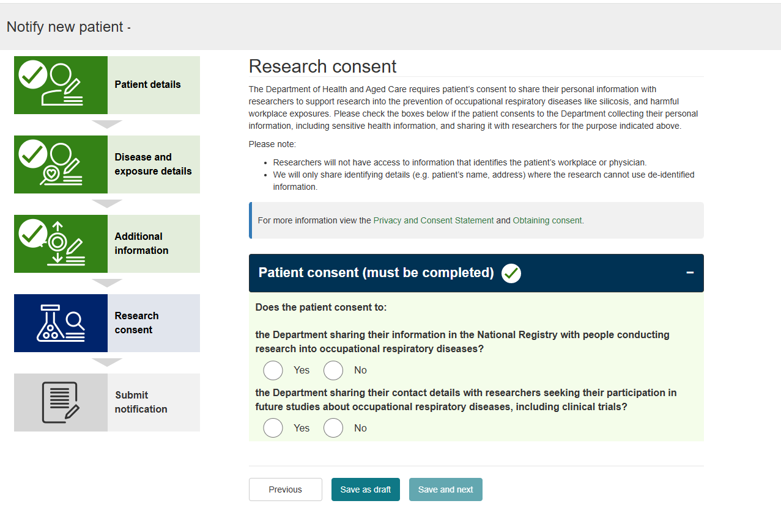

### Other changes include:

* Adding Registry news long form content
* Allowing disease names to be modified in a draft notification
* New National Registry reports
* Bug fixes