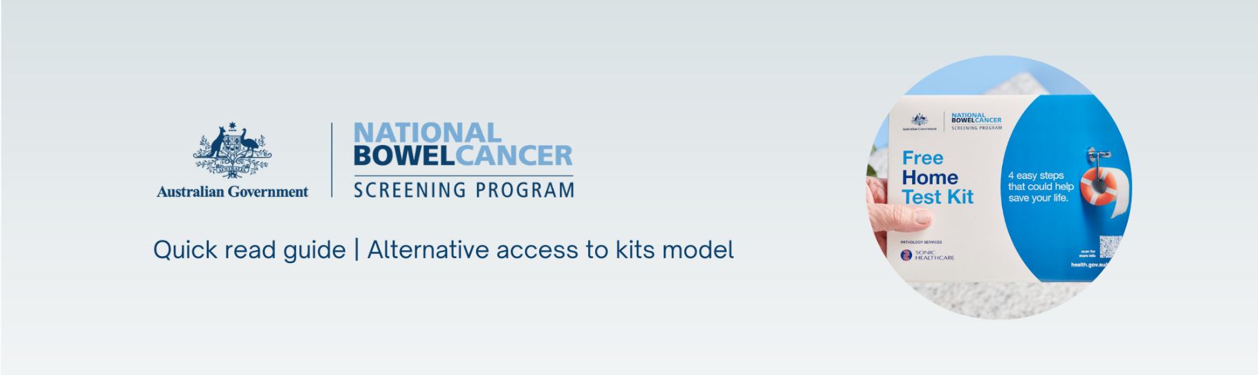

Healthcare providers can order free bowel screening test kits (called an iFOBT) in bulk through the National Cancer Screening Register (NCSR) to give directly to eligible patients via the alternative access to kits model.

Operating in addition to the mail-out model, this alternative way of giving kits to patients aims to improve access to and awareness of bowel screening, and will help remove barriers that prevent some people from participating in the [National Bowel Cancer Screening Program](https://www.health.gov.au/our-work/national-bowel-cancer-screening-program).

Patients are more likely to do the bowel screening test when it has been discussed with a trusted health professional who can explain how to do the test and why it is important.

**This quick read guide describes how to:**

1. Order bowel screening kits in bulk: using the NCSR Healthcare Provider Portal.
2. Record that a kit has been issued: ensuring the samples will be tested and the result sent to your patient and their nominated healthcare provider.
3. Monitor kit completion: check if your patient’s samples have been tested and if not, you can follow up and encourage test completion.
4. Find more information.

Aboriginal Community Controlled Health Organisations (ACCHOs) should contact the National Aboriginal Community Controlled Health Organisation (NACCHO) for culturally appropriate training at <https://www.naccho.org.au/programs-projects/bowel-cancer-screening>.

# 1. Order kits for your practice

|  |  |
| --- | --- |
| Badge Tick1 with solid fill | Bulk orders of kits are made via the NCSR Healthcare provider portal at [www.NCSR.gov.au/hcp-portal](http://www.NCSR.gov.au/hcp-portal) or by phoning 1800 627 701. |

* Login to the Healthcare Provider Portal

Click on **iFOBT Bulk Order** tab at the top of the screen, then **Start Order**.

**Need help?** Visit [www.NCSR.gov.au/ProviderPortal](http://www.NCSR.gov.au/ProviderPortal) for detailed instructions on how to access and use the Portal.

* Enter your delivery address and contact information

The form will pre-populate several fields; however, you will need to enter your clinic name and phone number.

You can enter a different delivery address if you wish. This won’t change the address held in Medicare—it will just be for this order.

* Select the number of kits you would like to order

It is recommended to order no more than 30 kits in a single order. More kits can be ordered for practices with a large eligible patient base. However, the kits have an expiry of around 7 months.

For orders of more than 100 kits, please contact the NCSR on **1800 627 701**.

This assists with stock management and helps us understand how large orders of kits will be used.

* Submit your order

Once an order is submitted, a confirmation message will appear.

A tracking number will display on the **iFOBT Bulk Order** page within 10 business days.

# Issuing kits – things you need to know

|  |  |
| --- | --- |
| Badge Tick1 with solid fill | You must record you have issued a kit to a patient using the Portal or your integrated clinical software. |

This process generates a **pre-populated participant details form** and ensures the samples will be tested and the result sent to the patient and their nominated healthcare provider.

* Search for your patient using the Portal or your integrated clinical software

Confirm they haven't screened in the last 2 years and are eligible to receive a kit.

Check their personal details are correct and make any changes before proceeding.

* Complete the form: NBCSP – Bowel Kit Issued by Healthcare Provider

|  |  |
| --- | --- |
| Warning with solid fill | This form will not appear if your patient is not due to screen. |

**Select a reason for issuing a kit. Then, decide if your patient should be issued a kit if they live in a hotter part of Australia:**

* The system identifies by postcode whether your patient lives in a region where the average monthly temperature is currently over 30 degrees Celsius.
* Samples need to be kept cool for as long as possible as heat can impact the performance of the completed kits.
* It’s recommended to offer the test kit to patients during cooler months, but this can be a judgement call by the issuing healthcare provider if they see a clinical benefit.

**You will then be asked to provide:**

* The date you issued the kit, including the expiry date (found on the back of the kit envelope)
* Nominated healthcare provider details (they will also receive a copy of the patient’s results)
* Confirmation that your patient has given consent to receive this kit from you.

**Next, review the form:**

If any details need to be changed you can do this by clicking **Edit**.

Once the details are correct, click **Submit**.

* Print the pre-populated participant details form for your patient

**Remind your patient to:**

* Complete the dates the samples were taken
* Sign the form
* Include it in the reply-paid envelope when they send back their samples.

# Notifications and patient follow up

|  |  |
| --- | --- |
| A hand holding a envelope | This icon will display on the patient’s bowel record once you submit the form. |

This icon shows anyone with access to this patient’s record, that this patient has received a kit via the alternative access to kits model for this screening round.

You can also **re-print the pre-populated participant details form**, if your patient has misplaced the one you provided with their kit.

* To assist with patient follow-up:

If you are a patient's nominated healthcare provider, you will receive the test result direct to your practice from the laboratory. You can also check for their result under the **Forms** section in the Portal or **NCSR History** in your integrated clinical software.

* **Track incomplete tests:** If no result is displaying, it may indicate your patient has not completed the test kit – this an opportunity to contact the patient and encourage them to complete the test.
* **Inconclusive results:** If your patient’s test result is inconclusive, a replacement kit will automatically be mailed to their address recorded in the NCSR.
* **Next screening round:** View the **Next Screening Action** section to see when your patient is due to screen again and will be issued a kit in the mail.

# Find more information

For detailed information on implementing and promoting bowel screening in your practice, visit the alternative access to kits training guide at[www.health.gov.au/nbcsp-kit-access-training](http://www.health.gov.au/nbcsp-kit-access-training).

**National Cancer Screening Register:**

* [www.NCSR.gov.au](http://www.NCSR.gov.au) or call 1800 627 701
* Healthcare Provider Portal: [www.NCSR.gov.au/ProviderPortal](http://www.NCSR.gov.au/ProviderPortal)
* Clinical software integration: [www.NCSR.gov.au/integrations](http://www.NCSR.gov.au/integrations)

**National Bowel Cancer Screening Program:**

* [www.Health.gov.au/NBCSP](http://www.Health.gov.au/NBCSP) or email [cancerscreening@health.gov.au](mailto:cancerscreening@health.gov.au)