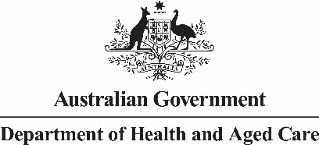

National Aged Care Mandatory Quality Indicator Program (QI Program) Manual 4.0 – Part B

National Aged Care Mandatory Quality Indicator Program Manual Part B – 4.0
This publication is published by the Australian Government Department of Health and Aged Care as a manual to support the National Aged Care Mandatory Quality Indicator Program (QI Program).
Copyright Notice
© 2022 Commonwealth of Australia as represented by the Department of Health and Aged Care.
This work is copyright. You may copy, print, download, display and reproduce the whole or part of this work in unaltered form for your own personal use or, if you are part of an organisation, for internal use within your organisation, but only if you or your organisation:
- do not use the copy or reproduction for any commercial purpose; and
- retain this copyright notice and disclaimer as part of that copy or reproduction.
Apart from rights as permitted by the Copyright Act 1968 (Cth), or allowed by this copyright notice, all other rights are reserved, including (but not limited to) all commercial rights. Unauthorised use of a copy or reproduction is strictly prohibited.
This licence does not cover, and there is no permission given for, use of the Commonwealth Coat of Arms or any logos and trademarks (including the logo of the Department of Health and Aged Care) contained within this publication.
Disclaimer
The information in this manual does not constitute, and must not be relied upon as, medical or clinical advice. Any medical questions must be referred to, and obtained from, an independent medical or clinical adviser.
Assistance
For further assistance, please contact the My Aged Care provider and assessor helpline on 1800 836 799. The helpline will be available between 8am and 8pm Monday to Friday, and between 10am and 2pm on Saturday local time across Australia, except for public holidays.
Acknowledgements

The Commonwealth would like to acknowledge the work undertaken by the Victorian Department of Health from 2006 to 2021 which assisted the Commonwealth to establish the National Aged Care Mandatory Quality Indicator Program.
Contents
1.0 Introduction to the National Aged Care Mandatory Quality Indicator Program 3
2.0 Introduction to quality improvement 7
3.0 Pressure injuries 12
4.0 Restrictive Practices (formerly physical restraint) 19
5.0 Unplanned weight loss 25
6.0 Falls and major injury 33
7.0 Medication management — polypharmacy 41
8.0 Medication management — antipsychotics 49
9.0 Activities of daily living 57
10.0 Incontinence care 67
11.0 Hospitalisation 76
12.0 Workforce 83
13.0 Consumer experience 89
14.0 Quality of life 96
15.0 Enrolled Nursing 105
16.0 Allied Health 109
17.0 Lifestyle Officer 115
Endnotes 120

Introduction to the National Aged Care Mandatory Quality Indicator Program
Participation in the National Aged Care Mandatory Quality Indicator Program (QI Program) has been a requirement for all approved providers of residential care services since 1 July 2019. The QI Program requires quarterly reporting against 14 quality indicators across crucial care areas. These areas are: pressure injuries, restrictive practices, unplanned weight loss, falls and major injury, medication management, activities of daily living, continence, hospitalisation, workforce, consumer experience, quality of life, enrolled nursing, allied health and lifestyle officer.

QI Program objectives
The objectives of the QI Program are:
- for providers to have robust, valid data to measure and monitor their performance. To also support continuous quality improvement in the care they give to aged care recipients
- to give older Australians, care recipients and the community transparent information about quality in aged care to support decision-making; and
- for government to have system-level measures of quality in aged care and an evidence base to inform policy and regulation.
FIGURE 1: SUMMARY OF QI PROGRAM OBJECTIVES
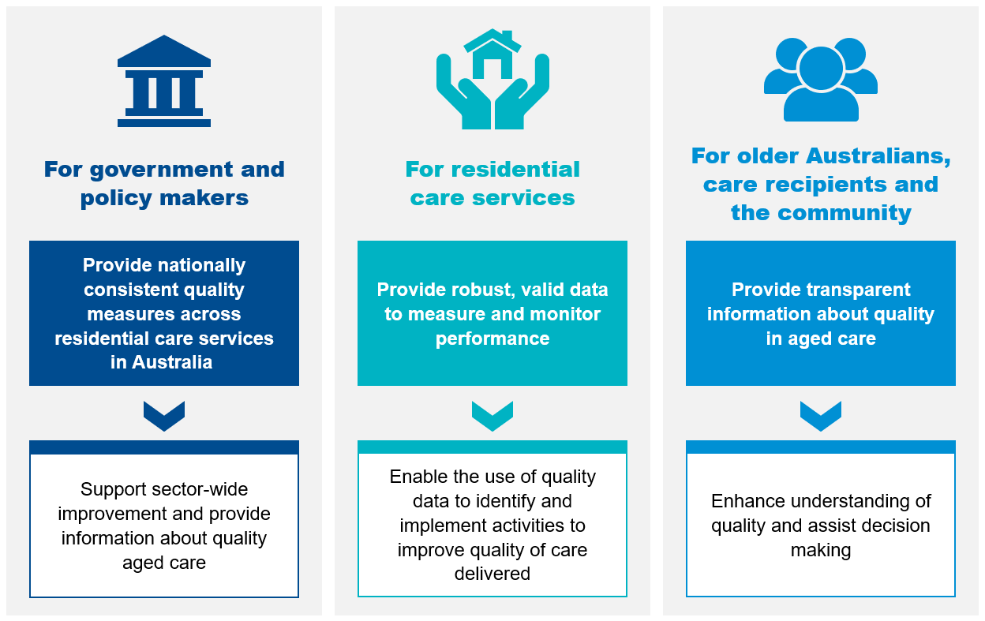

Quality indicators in the QI Program
The QI Program requires the collection and reporting of quality indicators that relate to the main aspects of quality of care across 14 crucial care areas. Residential aged care providers (approved providers) collect data for each quality indicator through measurements and assessments in each of the categories set out in Figure 2. Residential aged care providers then compile or derive the information and provide it to the Secretary of the Australian Government Department of Health and Aged Care (Secretary), or the Secretary’s delegate, in accordance with legislative requirements.
The Aged Care Quality and Safety Commission (Commission) is responsible for QI Program compliance. The Commission uses QI Program data reported by approved providers, to guide their regulatory activities. The Commission’s Compliance and Enforcement Policy details the approach to non-reporting of information.
All approved providers must collect data across the 14 quality indicators outlined in Figure 2.
FIGURE 2: SUMMARY OF QI PROGRAM QUALITY INDICATORS
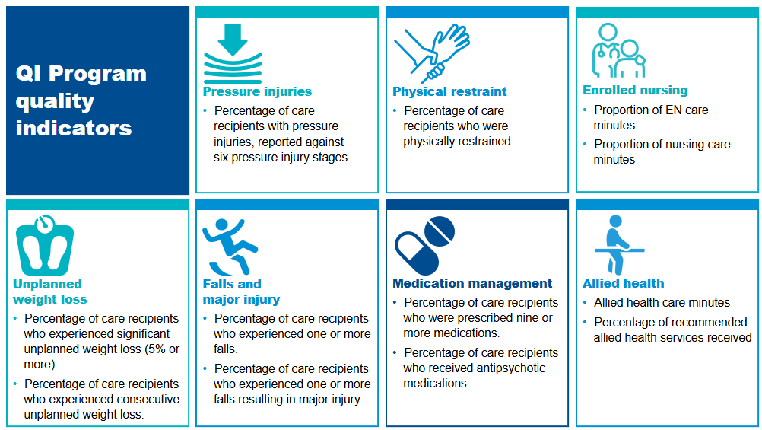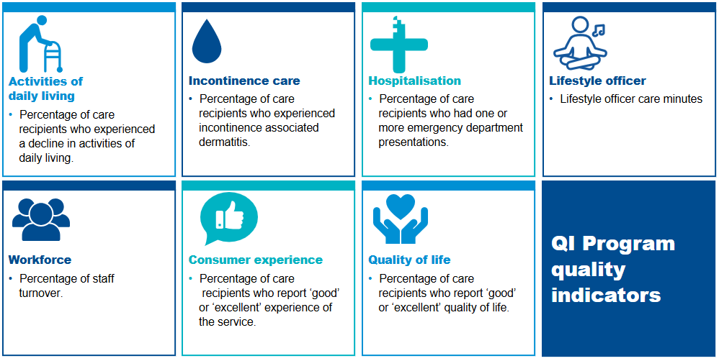

The QI Program Manual 4.0
The QI Program Manual 4.0 consists of three parts, all available on the Department of Health and Aged Care website. QI Program Manual 4.0 – Part A (Part A) provides legislated requirements for collecting, recording and submitting data in addition to definitions of each quality indicator
QI Program Manual 4.0 – Part B (this document) aims to support providers with tools and resources to support continuous quality improvement across each quality indicator. Part B is not legislated.
The Government Provider Management System User Guide: Quality Indicators application is a guide for approved providers to access and use the Quality Indicators application in the Government Provider Management System (GPMS) as well as submit quality indicator data and access QI Program reports.


Introduction to quality improvement

Quality improvement leads to improvements in the quality and experience of care, as well as improving outcomes for care recipients. Quality improvement is an important part of everyone’s job and should be understood and accepted by all levels of management and staff.0F The QI Program aims to support approved providers of aged care to understand and use quality indicator data to be able to continuously improve quality of care and services.

What is quality improvement?

Quality improvement is a systematic, coordinated and ongoing effort to improve the quality of care and services.
Quality is described as care that is effective and safe, and provides a positive experience by being caring, responsive and person-centred.

Quality improvement works to identify how well systems are working and to understand the quality of care and services being delivered to improve outcomes for aged care recipients.1F
Providers should aim to answer three main questions throughout the quality improvement process:
- What are we trying to accomplish?
- How will we know that a change is an improvement?
- What changes can we make that will lead to improvement?
An understanding of quality improvement is important for anyone who delivers or manages care. It can lead to improvements in the quality, experience, productivity and outcomes of care and services.

Supporting a culture of quality improvement
Building a culture of improvement is critical in supporting quality improvement in your organisation. Leadership and management play a crucial role in establishing an improvement culture, helping staff understand the importance of quality improvement, and ensuring that they feel safe and able to raise issues about the quality of services or care. It is also important that clear governance arrangements are established so there is a consistent approach to identifying quality issues and engaging in quality improvement activities.

FIGURE 3: QUALITY IMPROVEMENT BENEFITS
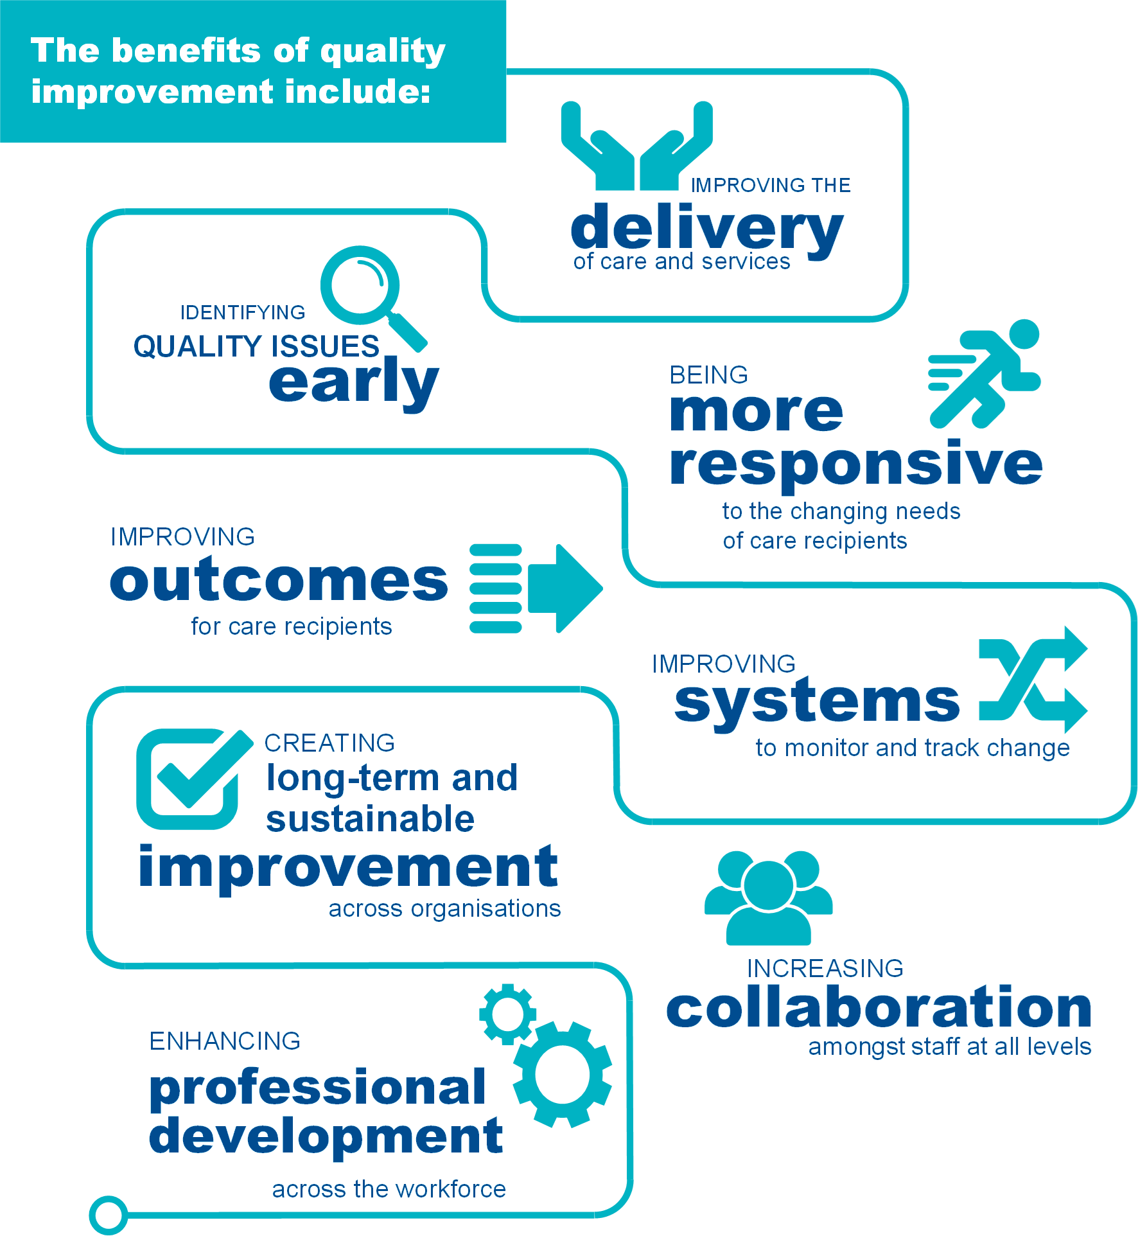

When should quality improvement be undertaken?
Quality improvement is ongoing and aims to make a difference to care recipients by improving the safety, effectiveness and experience of care and services.
QI Program data and reports assist approved providers in understanding the quality of services and help to identify opportunities to continuously improve the care they deliver.
FIGURE 4: STEPS TO ENABLE QUALITY IMPROVEMENT
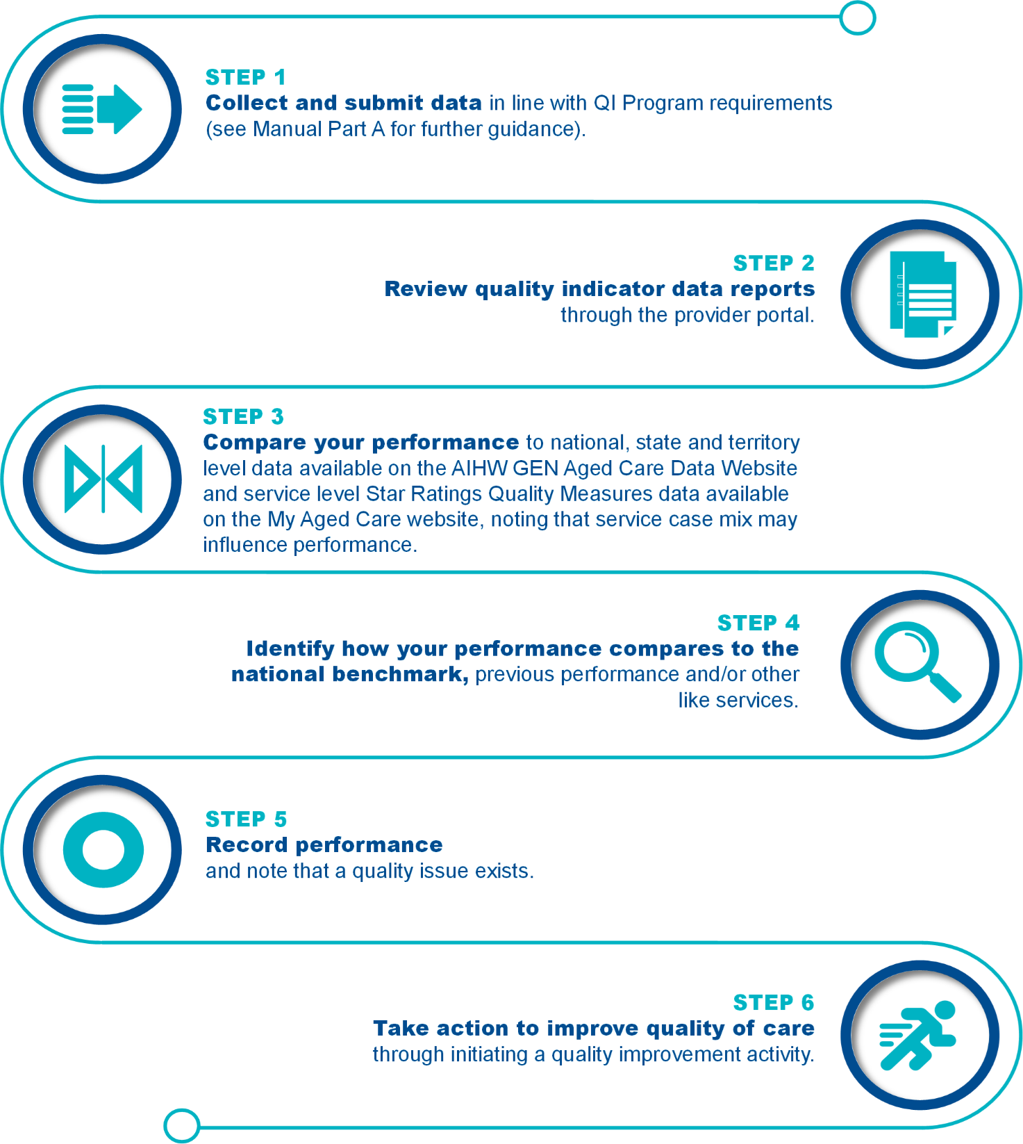
It is important to note that quality improvement should be an ongoing focus for all approved providers of aged care services, regardless of performance.

How to undertake quality improvement in aged care
Quality improvement approaches can help aged care services to improve the quality of care for care recipients.

Quality improvement approaches
There are a range of different approaches to quality improvement. One option is the Plan-Do-Check-Act tool which uses evidence to help organisations deliver quality improvement activities through four steps. The Plan-Do-Check-Act tool allows organisations to identify quality issues and trial a quality improvement activity at a small scale. This helps organisations to understand if the activity works before implementing the activity across the entire system.
The Plan-Do-Check-Act tool can be used across all eleven quality indicators in order to make improvements in the delivery of care. Examples of how the Plan-Do-Check-Act tool can be used across each quality indicator are outlined in this Manual.
FIGURE 5: PLAN-DO-CHECK-ACT TOOL
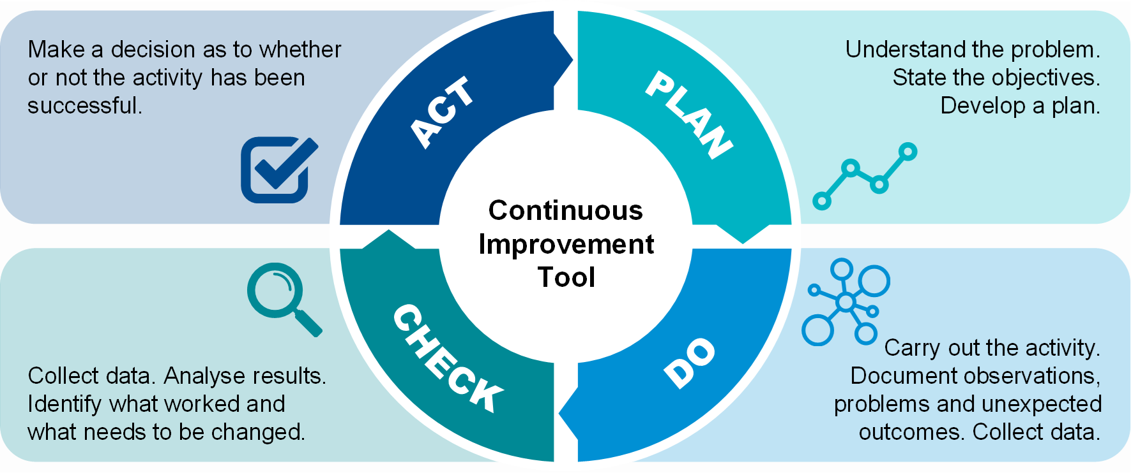

PLANNING is an important first step in quality improvement.
- Gather information to understand the current situation and identify what is causing the quality issue. This includes reviewing quality indicator data and may also include collecting additional data.
- Establish goals for your quality improvement activity. Goals should be measurable and have a set timeframe to be achieved.
Make a plan for how the quality improvement activity will be carried out. This process should be collaborative and include different levels of staff, as well as care recipients where possible. The plan should be detailed, define who is affected by the activity, outline the tasks required and who is required to deliver them.
DOING focuses on implementing and delivering the quality improvement activities you have planned.
- Allocate resources to deliver the quality improvement activity.
- Test the activity at a small scale and adjust as needed.
- Inform stakeholders.
- Document observations, including any decisions made while delivering the activity and if any changes are made to the plan.
Collect data based on the measures agreed in the planning phase.
CHECKING involves evaluating what you are doing to check if it is working using qualitative and quantitative information.
- Qualitative information involves asking questions to understand what did and did not work well, and how further improvement can occur.
- Quantitative information involves collecting data to measure outcomes from a quality improvement activity. A validated quality improvement tool is a helpful way to collect this data.
Once information and data has been collected, the results should be analysed to understand if any changes should be made to your plan.
ACTING involves making a decision to decide if a quality improvement activity has been successful.
- If the activity is successful, organisations should work to embed the new activity at a larger scale. This includes training and educating staff, updating policies and procedures, and informing stakeholders.
- If the activity is not successful, it is important to identify why this might be and what can be done differently. The PlanDoCheckAct tool should be used again, but this time with a different quality improvement activity.


Pressure injuries
Pressure injuries are a major and prevalent health concern for older Australians, with evidence demonstrating that pressure injuries are an important and recognised issue in residential aged care.

Overview of pressure injuries
Figure 6 below provides an overview of the prevalence of pressure injuries in residential aged care services. The data and references have been reviewed March 2025.
FIGURE 6: PRESSURE INJURIES IN RESIDENTIAL AGED CARE SERVICES 2F 3F 4F 5F 6F 7F
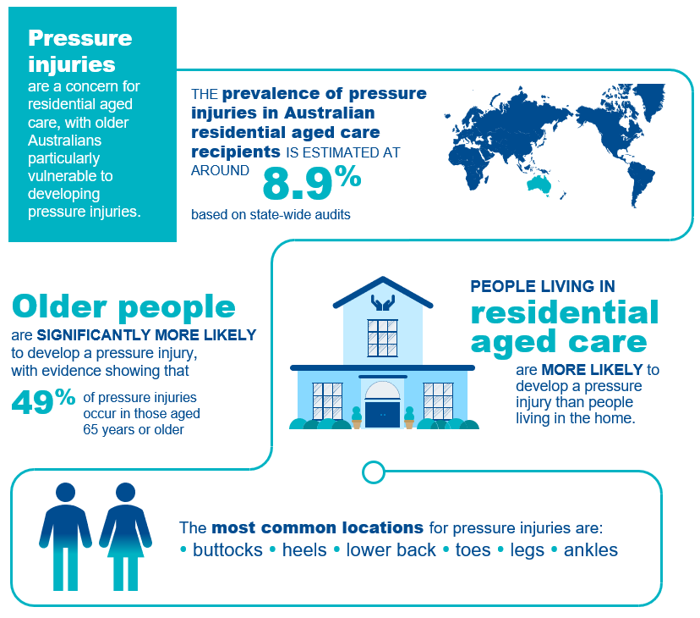

Pressure injuries in residential aged care
A pressure injury is an injury to the skin and/or underlying tissue caused by unrelieved pressure, friction or shearing.8F Pressure injuries usually occur over a bony prominence but may also be caused by an object, such as a medical device.9F
The ICD 10 Australian Modified (AM) pressure injury classification system outlined in the Prevention and Treatment of Pressure Ulcers/Injuries: Clinical Practice Guideline 201910F includes the following six pressure injury stages:
- Stage 1 Pressure Injury
- Stage 2 Pressure Injury
- Stage 3 Pressure Injury
- Stage 4 Pressure Injury
- Unstageable Pressure Injury
- Suspected Deep Tissue Injury
Details of the collection and reporting requirements for the pressure injuries quality indicator can be found in Part A.

Causes of pressure injuries
Pressure injuries may occur when an area of skin and the tissues underneath it is damaged by being under enough pressure that the blood supply is reduced.11F Pressure injuries have three core causes:12F 13F 14F
- Pressure: the force of a person’s body weight or an external object compressing on the skin for a period of time, causing a wound to form. This commonly occurs in people with poor mobility who are unable to easily shift their weight to relieve pressure.
- Friction: when two surfaces rub against each other, causing a wound to develop. This may occur when a person is pulled across bed linen. Moisture also increases friction.
- Shearing: downward pressure or sliding that creates friction and causes a wound to develop. This may occur when a person is positioned upright in bed and they slide downward.

Adverse clinical events and pressure injuries
Pressure injuries can have long and short-term impacts on care recipients’ health and wellbeing, including reduced quality of life, increased disability and even death.15F 16F 17F They can take many months to heal and, in some cases, may never heal completely. Common complications associated with pressure injuries include:18F 19F 20F 21F 22F
- pain and discomfort
- infection and sepsis
- stress, anxiety and depression
- reduced physical and social functioning
- limb-threatening injuries, including amputation.
Pressure injuries are also expensive to manage and cause a financial burden to residential aged care services.23F

Risk factors for pressure injuries
Older Australians are significantly more vulnerable to developing a pressure injury due to age-related issues. Figure 7 describes the key risk factors for developing pressure injuries in residential aged care. Having a strong understanding of the risk factors is crucial to identify care recipients who are at risk of developing pressure injuries.
FIGURE 7: RISK FACTORS AND RELEVANCE TO PRESSURE INJURY DEVELOPMENT AND RESIDENTIAL AGED CARE24F 25F 26F 27F 28F 29F 30F 31F 32F 33F 34F 35F 36F 37F 38F 39F 40F 41F 42F
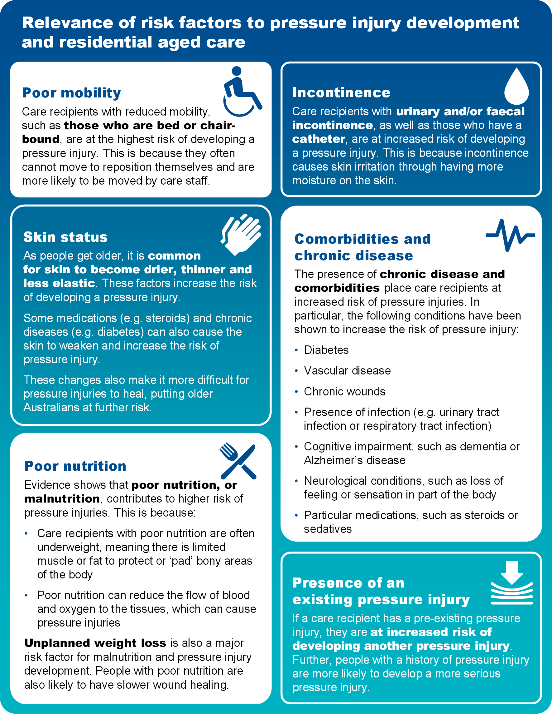

Prevention and management of pressure injuries
Awareness of risk factors and some simple steps can reduce the chance of pressure injuries occurring. Figure 8 below outlines some important aspects of care that can be considered to prevent and manage pressure injuries.
FIGURE 8: PRESSURE INJURY PREVENTION AND MANAGEMENT
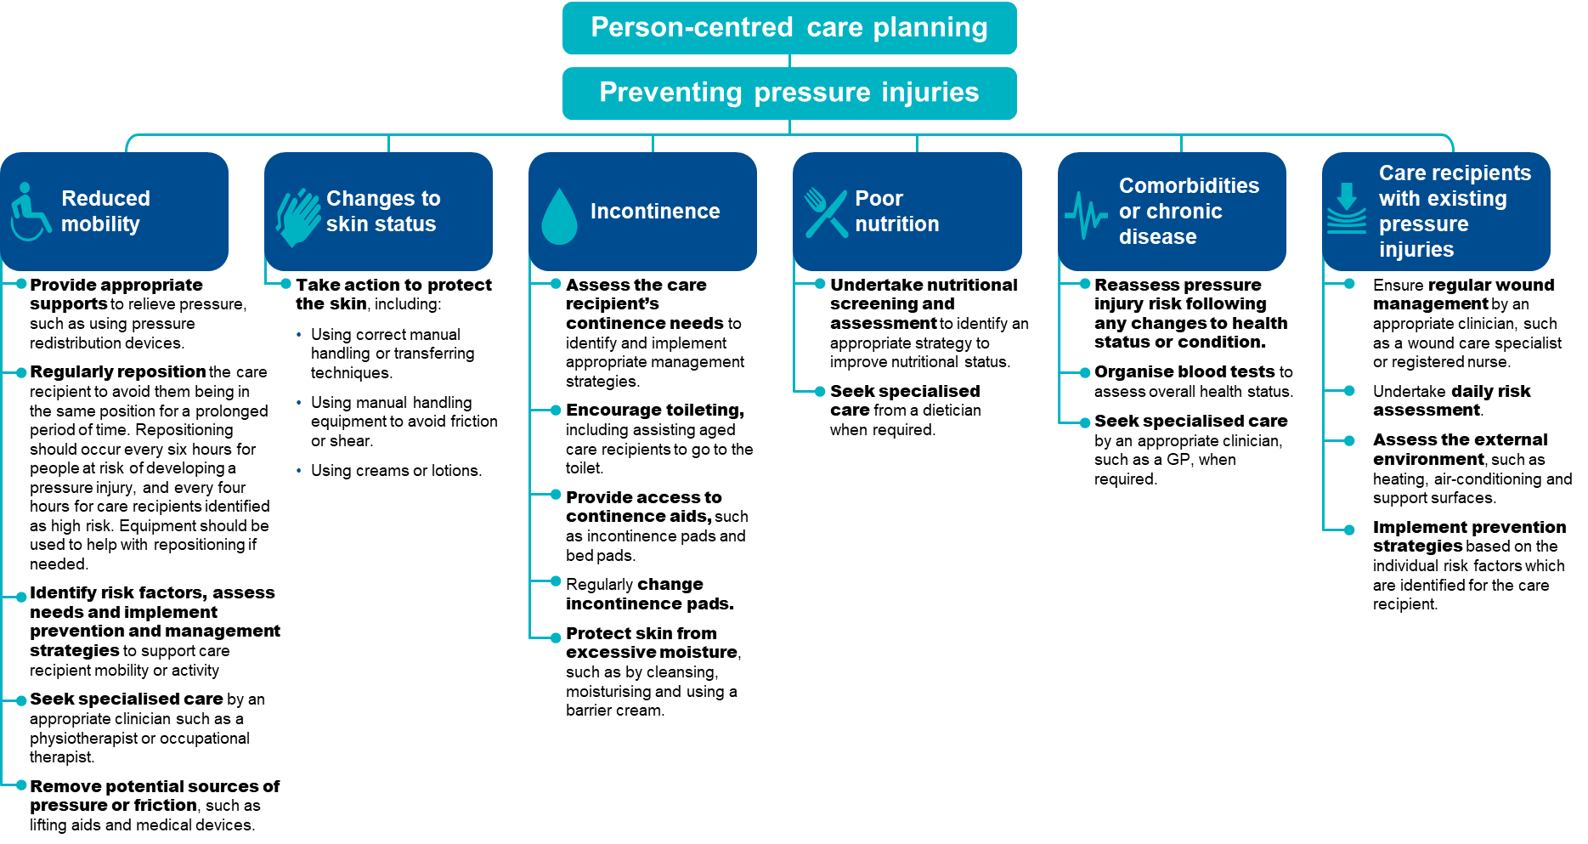
The checklist below will help assess care recipients who are at risk of pressure injuries and identify prevention strategies to reduce the risk of pressure injuries occurring.
FIGURE 9: CHECKLIST FOR THE PREVENTION OF PRESSURE INJURIES

Checklist for the prevention of pressure injuries


Conduct a skin assessment
- A head-to-toe assessment with a focus on skin at bony prominences.
- Examine for any changes in skin colour, including redness, blanching and inflammation.
- Assess for:
- dryness, changes and thinning of the skin
- moist skin such as from sweating or incontinence


- areas of localised pain.
Undertake pressure injury risk assessments regularly
- When a care recipient is first admitted to a residential aged care service.
- When a care recipient returns from a different care setting, such as a hospital or rehabilitation service.

- If a care recipient’s health or condition changes, such as change in mobility, nutrition status, continence status, medication or increased frailty.
- Following surgery, other medical procedures or investigation.
- On a daily basis for care recipients considered to be high risk and those who have an existing pressure injury.
Document findings in a care plan
- Activities to be undertaken to prevent a pressure injury developing.
- Frequency and timing of prevention activities.
- Preferences, including ability of care recipient to reposition themselves.
- Risk factors, including comorbidities and mobility status.
Implement appropriate prevention strategy
Focus on key risk factors, such as:
- Reduced mobility
- Changes to skin status
- Incontinence
- Poor nutrition
- Comorbidities or chronic disease
- Care recipients with existing pressure injuries.
Undertake frequent reassessment
- Perform regular reassessment to monitor risk and check for early signs of pressure damage.
- Reassess prevention strategies to adjust care plans.

Quality improvement for pressure injuries
Quality improvement can help providers increase the quality of care for care recipients at risk of developing pressure injuries.43F Quality improvement activities should be ongoing and part of business-as-usual for approved providers.
The QI Program will help prompt when a specific quality improvement activity should be undertaken. It is important to review QI Program data reports through GPMS and compare against national averages and other services to understand where quality improvement activities should be focussed.
The Plan-Do-Check-Act tool (section 2.3) is a useful tool to plan, deliver and monitor quality improvement activities focused on preventing and reducing pressure injuries.44F 45F

Example tools, guidance and resources to
support continuous quality improvement
- Prevention and Treatment of Pressure Ulcers/Injuries: Clinical Practice Guideline and Quick Reference Guide — the International Guideline 2019 and new 2025 guidelines.
- Waterlow Pressure Ulcer Scale — available online on the New South Wales Agency for Clinical Innovation website
- Braden Scale for Predicting Pressure Sore Risk — available online in the AN-ACC Reference Manual on the Australian Department of Health and Aged Care website, or this example from SA Health
- Pressure injuries: Standardised care process — an evidence-based approach in the assessment, management and prevention of pressure injury wounds for older people who live in a residential aged care setting — Victorian Department of Health and Human Services
- Assessment and Management of Pressure Injuries — provides an online learning module on the assessment and management of pressure injuries — Wound Innovations
- Preventing pressure ulcers — accessible article detailing interventions to prevent pressure ulcers — Institute for Quality and Efficiency in Health Care
Some tools, guidance and resources may be updated over time; it is important to ensure you are looking at the most recent version.

Restrictive Practices (formerly physical restraint)
There are significant concerns about the overuse of restrictive practices for older Australians. While restrictive practices are used with the intention of supporting the safety of care recipients and others it can be associated with negative impacts and outcomes for care recipients. The use of restrictive practices needs to be considered on a case-by-case basis, used as a last resort and for the shortest time possible.

Overview of Restrictive practices
Figure 10 below provides an overview of physical restraint in residential aged care. The data and references have been reviewed March 2025.
FIGURE 10: PHYSICAL RESTRAINT IN RESIDENTIAL AGED CARE SERVICES46F
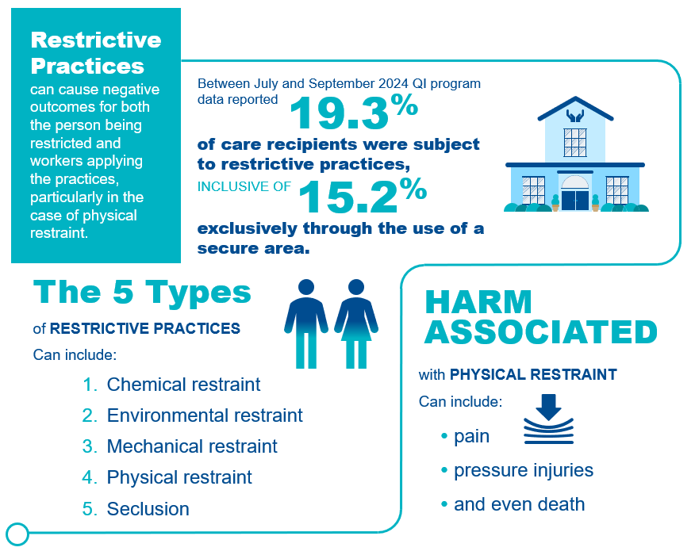

Restrictive practices in residential aged care
The Quality of Care Principles 2014 (Quality of Care Principles) define restrictive practices as any practice or intervention that has the effect of restricting the rights or freedom of movement of a care recipient.
- For the purposes of the QI Program, restrictive practices includes all forms of restrictive practice, excluding chemical restraint, as follows: Mechanical restraint is a practice or intervention that is, or that involves, the use of a device to prevent, restrict or subdue a care recipient’s movement for the primary purpose of influencing the care recipient’s behaviour, but does not include the use of a device for therapeutic or non-behavioural purposes in relation to the care recipient.
- Physical restraint is a practice or intervention that:
- Is or involves the use of physical force to prevent, restrict or subdue movement of a care recipient’s body, or part of a care recipient’s body, for the primary purpose of influencing the care recipient’s behaviour.
- Does not include the use of a hands-on technique in a reflexive way to guide or redirect the care recipient away from potential harm or injury if it is consistent with what could reasonably be considered to be the exercise of care towards the care recipient.
- Environmental restraint is a practice or intervention that restricts, or that involves restricting, a care recipient’s free access to all parts of the care recipient’s environment (including items and activities) for the primary purpose of influencing the care recipient’s behaviour.
- Seclusion is a practice or intervention that is, or that involves, the solitary confinement of a care recipient in a room or a physical space at any hour of the day or night where:
- Voluntary exit is prevented or not facilitated
- It is implied that voluntary exit is not permitted
- for the primary purpose of influencing the care recipient’s behaviour.
For the purposes of the QI Program, restraint through the use of a secure area includes only environmental restraint, as defined above.
All listed forms of restrictive practice, including instances the care recipient or their representative instigate or request the restrictive practice, are considered restrictive practices for the purposes of the QI Program. Details of the collection and reporting requirements for the restrictive practices quality indicator can be found in Part A.

Adverse clinical events and restrictive practices
Restrictive practices can cause physical and psychological harm and can have a significant impact on the quality of life of care recipients. These include:
- Psychological consequences, such as fear, shame, anxiety, anger, loneliness, boredom, loss of dignity, agitation, depression, and lower cognitive performance.
- Physical consequences, such as bruising, direct skin injuries, pressure injuries, contractures, respiratory complications, urinary and faecal incontinence and constipation, undernutrition, reduced mobility and increased dependence in activities of daily living, impaired muscle strength and balance, reduced cardiovascular endurance, serious injury and death.
Physical restraint can also result in death, for example physical restraint applied for falls prevention may lead to neck compression and entrapment causing asphyxia.47F

Prevention and management of restrictive practices
The Quality of Care Principles 2014 outline that restrictive practices in aged care services should only be used as a last resort and only when necessary to protect the care recipient or another person. Restrictive practices can be used only if:
- an approved health practitioner with day-to-day knowledge of the care recipient has assessed the care recipient as posing a risk of harm to themselves or others and assessed that the use of restrictive practice is necessary
- the requirement to have a behaviour support plan in place for every care recipient who has restrictive practices considered, applied or used as part of their care has been fulfilled
- best practice alternatives have been used to the extent possible and alternative strategies that have been considered or used have been documented in the care recipient’s behaviour support plan
- the restraint used is the least restrictive form and for the shortest time needed
- informed consent has been obtained from the care recipient or, if they do not have capacity to consent, their restrictive practices substitute decision maker.
FIGURE 11: PREVENTING RESTRICTIVE PRACTICES48F
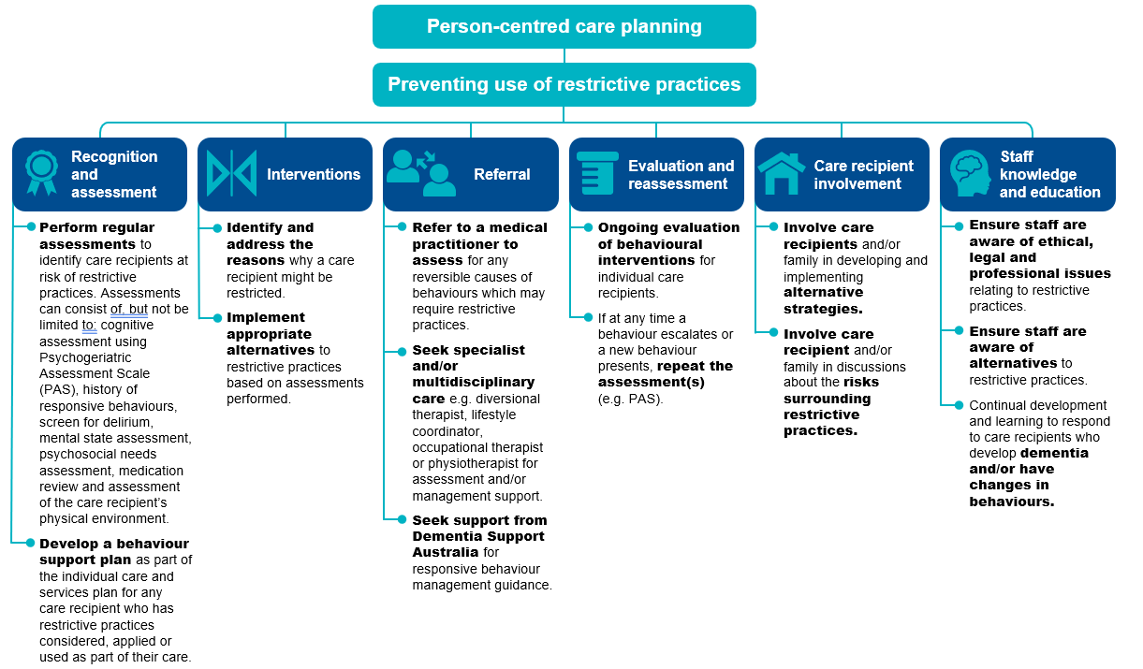

Providers can reduce the need for restrictive practices in an aged care setting. The checklist below outlines steps that providers can undertake to help identify alternatives to physical restraint. 49F
FIGURE 12: CHECKLIST FOR THE PREVENTION OF RESTRICTIVE PRACTICES50F
Checklist for the prevention of restrictive practices

Assess environmental factors
- Reduce the risk of physical trauma to the care recipient, such as using non-slip flooring, non-slip footwear, improved lighting, appropriate bed and seating for comfort, mobility aids
- Reduce environmental noise, for example where a care recipient becomes agitated due to the TV volume in a common area, guide the care recipient away from the area or turn the TV volume down.
- Alter the layout of the residential aged care service to support ease of navigation for care recipients, such as having a straight hallway from the bedroom to a recreational area.
Assess psychosocial factors
- Ensure familiar staff engage with care recipients.
- Foster companionship for care recipients with staff and other care recipients.
- Encourage participation in activities with care recipients that they enjoy or are meaningful to them.
- Identify opportunities for engagement with familiar loved ones and friends through visits and phone calls.
Assess care approach factors
- Ensure individualised routines to meet specific needs of care recipients.
- Increase supervision and staff interaction.
- Evaluate and monitor conditions affecting behaviour.
- Ensure staff liaise with family or care recipient representative and seek professional assistance to guide responses as needed.
Assess physiological factors
- Review medications, in particular for medications that may contribute to worsening cognitive function, restlessness and agitation.
- Manage nutrition and hydration.
- Manage pain and / or infection, for example urinary tract infections or viral infections can often cause agitation.
- If restrictive practices is used in a residential aged care service, it is important that staff review this checklist and reflect on factors that were not appropriately managed and may have contributed to the use of physical restraint.

Quality improvement for restrictive practices
Quality improvement can help providers increase the quality of care for care recipients at risk of restrictive practices.51F Quality improvement activities should be ongoing and part of business-as-usual for approved providers.
The QI Program will help prompt when a specific quality improvement activity should be undertaken. It is important to review QI Program data reports through GPMS and compare against national averages and other services to understand where quality improvement activities should be focussed.
The Plan-Do-Check-Act tool (section 2.3) is a useful tool to plan, deliver and monitor quality improvement activities focused on preventing and reducing restrictive practices.52F 53F

Example tools, guidance and resources to support continuous quality improvement
- Cognitive Decline Scale — this scale is part of the Psychogeriatric Assessment Scales (PAS) and is suitable for use to test cognitive impairment in residential aged care — available on the Department of Health and Aged Care website
- Minimising the use of restrictive practices — Information on restrictive practices, behaviour support plans and consent – Aged Care Quality and Safety Commission
- Restrictive practices provider resources — Factsheets, tools, videos and other resources for providers – Aged Care Quality and Safety Commission
- Reportable incidents: inappropriate use of restrictive practices — Factsheet designed to inform providers about identifying and reporting the inappropriate use of restrictive practices to the Serious Incident Response Scheme (SIRS)
- Severe Behaviour Response Teams (SBRT) — 24/7 contact with a Dementia Consultant on 1800 699 799 to access SBRT service — Dementia Support Australia
- Dementia Behaviour Management Advisory Service (DBMAS) — 24/7 contact with a Dementia Consultant on 1800 699 799 for advice or to make a referral — Dementia Support Australia
- Behaviour support plan resources — a toolkit of resources to support residential aged care services to meet new behaviour support plan requirements aimed at minimising the use of restraints in residential aged care — Dementia Support Australia
Some tools, guidance and resources may be updated over time; it is important to ensure you are looking at the most recent version.

Unplanned weight loss
Unplanned weight loss is common among care recipients, with approximately half either being malnourished or at risk of malnutrition. It is important to understand and recognise where care recipients are experiencing unplanned weight loss, and to respond with actions to minimise or eliminate the cause.

Overview of unplanned weight loss
Figure 13 below provides an overview of unplanned weight loss in residential aged care. The data and references have been reviewed March 2025.
FIGURE 13: UNPLANNED WEIGHT LOSS IN RESIDENTIAL AGED CARE SERVICES 54F 55F, 56F
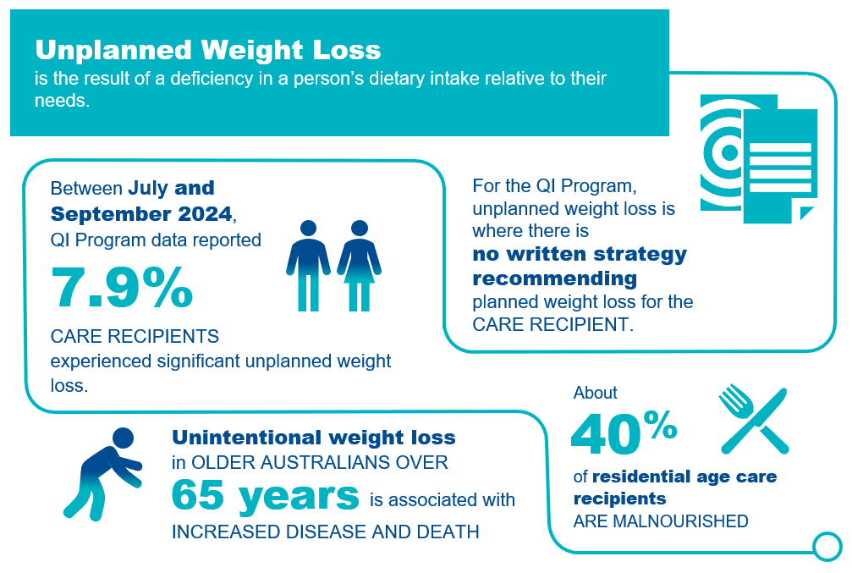

Unplanned weight loss in residential aged care
For the purposes of the QI Program, unplanned weight loss is where weight loss occurs but there is no written strategy from a medical doctor or dietitian, or ongoing record recommending planned weight loss for the care recipient.
Note: If a care recipient has a written record from a medical doctor or dietitian, which includes a plan for intentional weight loss (for example, body fat or fluid), this will not be counted as unplanned weight loss. Where no such record exists, all weight loss must be considered unplanned regardless of the body size or any other characteristic of the care recipient.
There are two categories of unplanned weight loss:57F
- Significant unplanned weight loss is weight loss equal to or greater than 5 per cent of body weight over a three-month period.
- Consecutive unplanned weight loss is weight loss of any amount of weight every month over three consecutive months.
Details of the collection and reporting requirements for the unplanned weight loss quality indicator can be found in Part A.

Causes and risk factors of unplanned weight loss
There are many causes of unplanned weight loss in adults over the age of 65, including food choice and quality, negative dining experiences, limited staff training and support, difficulty eating, poor appetite and mood. Care recipients may experience multiple causes, which may be curable or treatable.
Risk factors for unplanned weight loss may be due to a range of causes, including social, physical, psychological, emotional or the care setting, as described in Figure 14.58F 59F 60F 61F
FIGURE 14: RISK FACTORS FOR UNPLANNED WEIGHT LOSS AND MALNUTRITION
SOCIAL CAUSES | PHYSICAL CAUSES | PSYCHOLOGICAL AND EMOTIONAL CAUSES | CARE SETTING CAUSES
Reduced social engagement  Loss of choice, social withdrawal, eating alone, limited communication  Cultural factors  Different life experiences of food and the mealtime environment, dining in institutional settings  Dining experience  Lighting, sound and smell, social interaction, staff activity, task-focussed service | Disease related  Acute illness, cancer, pain, pressure injury, constipation, and increased nutritional requirements  Medication related  Cardiac, neurologic, polypharmacy, nausea  Functional issues  Dexterity, mobility impairment, vision, chewing and swallowing, eating support needs  Reduced intake  Food quality, oral health, dentition/dentures, appetite, changes in taste or smell, restricted diets (e.g. texture modified), early satiety | Mood disorders  Anxiety, depression  Cognitive impairment  Alzheimer’s disease, Lewy body dementia, stroke  Bereavement  Grief, loss  Other  Loss of enjoyment | Staff  Limited staff to assist with eating, limited skills to identify and respond to weight loss, task focussed, workload  Food service mode  Limited food choices, mealtime requirements, plating and service approach  Food preparation  Inadequate nutritional content, insufficiently enriched foods

Adverse clinical events and unplanned weight loss
Unplanned weight loss is a sign of malnutrition, which affects every system in the body and results in increased vulnerability to illness, loss of independence, frailty, increased complications, higher risk of hospital admissions and, in extreme cases, even death.62F 63F 64F 65F It contributes to a reduced quality of life.
FIGURE 15: IMPACT OF UNPLANNED WEIGHT LOSS
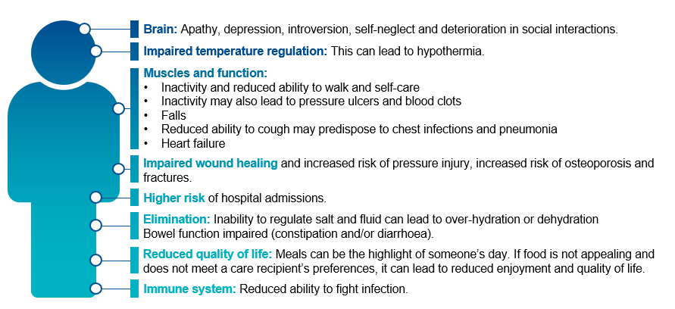

Prevention and management of unplanned weight loss
Preventing unplanned weight loss in care recipients requires a tiered approach, recognising and responding to the needs, preferences, and cultural requirements of each care recipient:66F 67F 68F
There are three core methods to address unplanned weight loss through primary prevention, secondary prevention and tertiary prevention.

Primary prevention of unplanned weight loss
Primary prevention seeks to reduce health risks before they occur. This means ensuring each aged care recipient has the opportunity and support to maintain appropriate nutritional intake using a food-first approach. The food-first approach helps to support nutritional intake through using every-day nourishing foods and drinks that each consumer likes, and ensuring they are actually consumed.69F 70F 71F
To support a food-first approach, and deliver a positive mealtime environment, it is important that different professionals come together to create a multidisciplinary nutrition policy in the context of the individual’s preferences, choices and cultural factors. This should include assessment of why appetite is poor or food is not being eaten, and considering food, nutrition, and a mealtime experience all together to help care recipients maintain a healthy weight.72F

Secondary prevention of unplanned weight loss
Secondary prevention seeks to reduce the impact of risk or threats to health. For unplanned weight loss, this means ensuring staff have the right training, care recipients are screened for early identification of causes of poor intake, weight loss and implementing strategies that improve health and day-to-day life. All care recipients should be routinely screened for malnutrition using a validated malnutrition screening tool (see page 30 for examples).

Tertiary prevention of unplanned weight loss
Tertiary prevention seeks to minimise the impact of ongoing threats to health. This may involve strategies that reduce the risk of the negative effects of unplanned weight loss, such as minimising the risk of acquiring pressure injuries and discomfort.
Care recipients experiencing unplanned weight loss should be under the care of an appropriately skilled team of health professionals including a Dietitian. Care should include a robust, monitored individualised nutrition care plan, completion of appropriate risk assessments, and the development and implementation of plans to manage the adverse consequences of unplanned weight loss.

Prevention strategies for unplanned weight loss
The checklists below provide strategies that may be used to prevent unplanned weight loss.
FIGURE 16: CHECKLIST FOR THE PREVENTION OF UNPLANNED WEIGHT LOSS
Checklist for the prevention of unplanned weight loss

Primary prevention of unplanned weight loss and malnutrition
- Taking a food-first approach
- Developing and implementing an integrated food and nutrition policy that covers hospitality, allied health, clinical care and quality professionals
- Consider the mealtime environment, including understanding if:
- the dining area is clean, tidy, and well-lit
- the dining area is arranged in a communal or family-like way
- care recipients who require meal-time support are provided this support
- care recipients have enough time to eat at a time and pace of their choosing
- snacks are provided when care recipients need to eat more frequent smaller meals
- Care recipients are provided with tailored advice and information on maintaining a healthy weight
- The provider uses and acts on a holistic food, nutrition, and meal-time experience tool
- A mechanism to monitor and detect when sufficient food is not consumed, and to respond early
- Ongoing consultation and feedback from each care recipient about their food and eating experience and responding to issues identified
Secondary prevention of unplanned weight loss and malnutrition
- Care recipients are screened for risk of malnutrition using a validated screening tool at assessment prior to entry, at the beginning of care, and on a regular basis
- Care recipients who are malnourished, or at risk of malnutrition, have a multidisciplinary management care plan that aims to meet their needs using a food-first approach
- Each care recipient who is screened for malnutrition (or their family or representative) have their results and nutrition support goals documented in writing
- Care recipients have their nutrition support goals and needs reviewed at planned intervals
- Care recipients who manage their own artificial feeding support or those caring for them have training to manage their nutrition needs
- Staff receive annual training on identifying and managing risk of malnutrition and malnutrition using a validated tool
- Policies and guidelines support compliance with aged care standards, and governance processes monitor this compliance
Tertiary prevention of unplanned weight loss and malnutrition
- Care recipients experiencing negative effects of unplanned weight loss are under the care of an appropriately skilled, multidisciplinary team of health professionals including a Dietitian.
- Care recipients are receiving treatment for the adverse consequences of unplanned weight loss

FIGURE 17: PREVENTION STRATEGIES FOR UNPLANNED WEIGHT LOSS73F
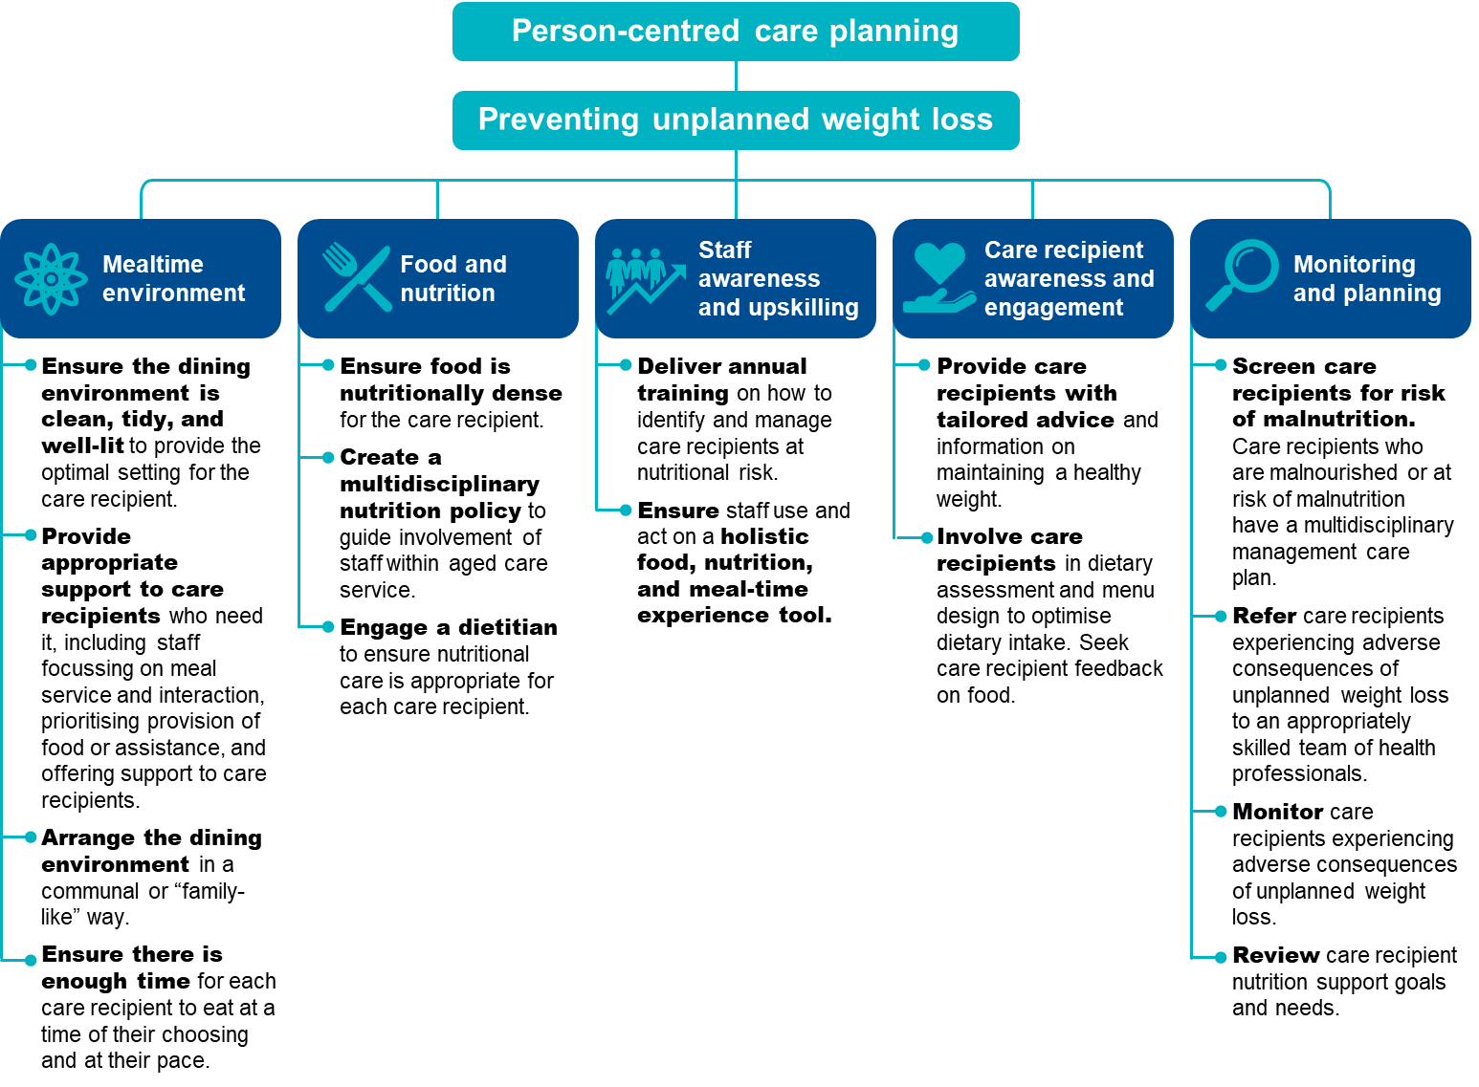

Quality improvement mechanisms
Quality improvement can help providers reduce the risk of care recipients experiencing unplanned weight loss and malnutrition.
Quality improvement activities should be ongoing and part of business-as-usual for approved providers. QI Program data can help prompt when a specific quality improvement activity should be undertaken. It is important to review QI Program data reports through GPMS and compare against national averages and other services to understand if unplanned weight loss and malnutrition is an issue within your organisation.
The Plan-Do-Check-Act tool (section 2.3) is a useful tool to plan, deliver and monitor quality improvement activities focused on unplanned weight loss.

Example tools, guidance and resources to support continuous quality improvement
Validated malnutrition screening tools and guidance
- The Malnutrition Universal Screening Tool (MUST) — Bapen
- Mini Nutritional Assessment — Short Form (MNA®-SF) — Nestle
- Validated Malnutrition Screening and Assessment Tools: Comparison Guide — Queensland Health
- Malnutrition Universal Screening Tool Calculator — calculator used to establish nutritional risk using objective measurements to obtain a score and a risk category — Bapen
- AutoMal research paper – study describing the development and internal validation of an automated malnutrition screening tool for use in residential aged care
- Additional food and nutrition tools and guidance
- Food, nutrition & dining information for providers - Aged Care Quality and Safety Commission – includes a range of reference guides, tools and discussion papers. Includes a flyer listing all the Commission’s food, nutrition and dining resources
- Malnutrition in Aged Care — position statement — Dietitians Australia
- The Lantern Project — an online community seeking to improve food and the meal-time experience for care recipients in residential aged care settings
- Best Practice Food and Nutrition Manual for Aged Care — manual providing guidance on best practice food and nutrition for residential aged care — New South Wales Central Coast Local Health District
- Eating well: A Nutrition Resources for Older People and their Carers — short book providing simple advice on provide good nutrition — New South Wales Central Coast Local Health District
- Online training to help older people eat well — two free online training packages with videos, interactive activities and practical tips — Tasmanian Department of Health
- An evidence-based guide for the identification and nutritional management of malnutrition and frailty in the Australian and New Zealand community — evidence-based guide providing practical guidance for healthcare professionals to identify and manage malnutrition and frailty among adults in the community setting — Griffith University
Some tools, guidance and resources may be updated over time; it is important to ensure you are looking at the most recent version.

Falls and major injury
Falls are currently the leading cause of unintentional injury in older Australians. While not all falls can be prevented, there is strong evidence to suggest that falls can be reduced through screening, monitoring and prevention activities.

Overview of falls and major injury
Figure 18 below provides an overview of falls and major injury in residential aged care. The data and references have been reviewed March 2025.
FIGURE 18: FALLS AND MAJOR INJURY IN RESIDENTIAL AGED CARE SERVICES74F 75F 76F 77F 78F 79F 80F
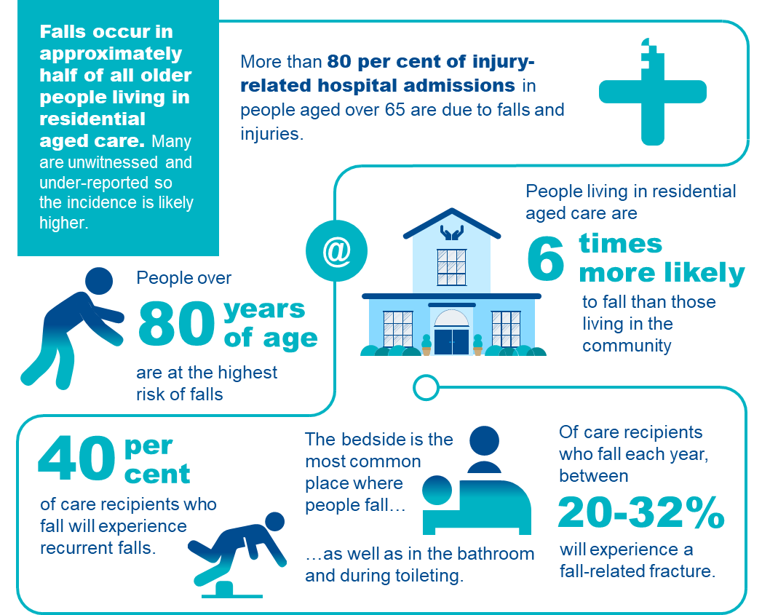

Understanding falls and major injury in residential aged care
Consistent with the World Health Organization’s definition of a fall, the QI Program defines a fall as an event that results in a person coming to rest inadvertently on the ground or floor or other lower level81F This includes falls from a low bed and onto a crash mat.82F Under the QI Program, a fall resulting in major injury is a fall that meets the definition above and results in one or more of the following:
- bone fractures
- joint dislocation
- closed head injuries with altered consciousness
- subdural haematoma.83F
Falls commonly occur as a result of a person tripping, slipping or stumbling.84F
Details of the collection and reporting requirements for the falls and major injury quality indicator can be found in Part A.

Adverse clinical events associated with falls and major injury
Falls and major injury are a significant safety and quality risk across residential aged care.
There are many negative consequences of falls, including minor and major injury, pain, reduced physical functioning, decreased independence, psychological impacts, and occasionally death.94 Figure 19 below outlines the common complications associated with falls in residential aged care.
FIGURE 19: COMMON COMPLICATIONS OF FALLS85F 86F 87F
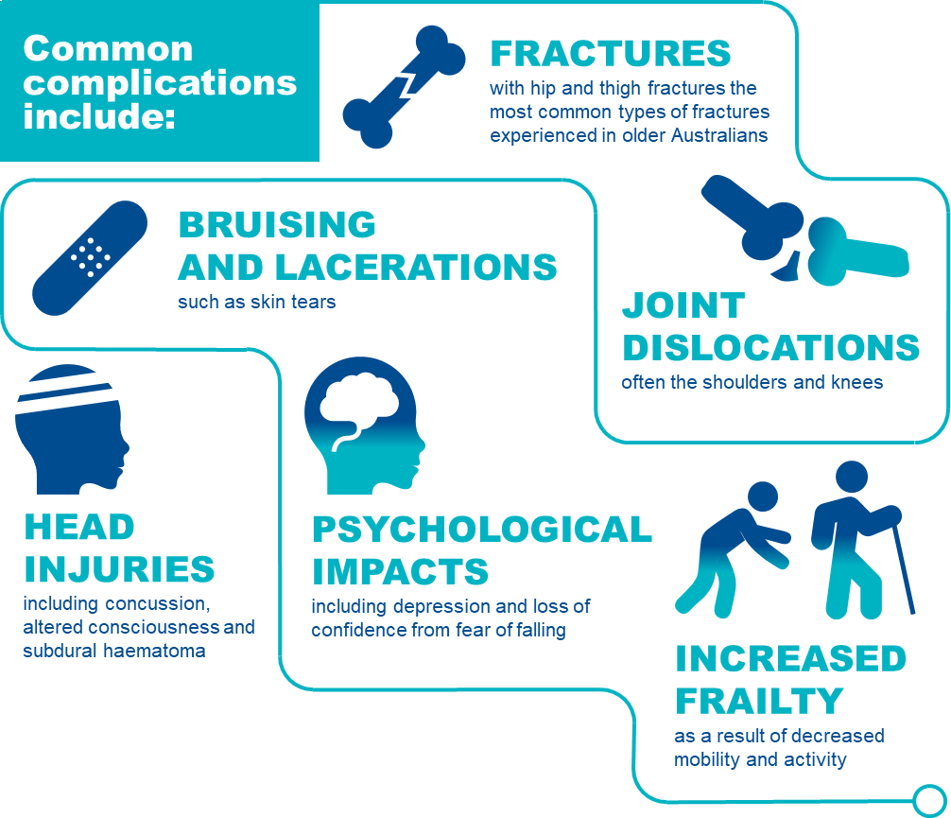

Risk factors of falls and major injury
Older Australians are at increased risk of falls and are also more likely to suffer an injury as a result of a fall. This is due to increased frailty, reduced mobility and muscle tone, as well as conditions commonly associated with older age, such as osteoporosis and osteopenia, which weaken bones and increase the risk of injuries occurring from a fall.88F Poor nutrition also increases the risk of falls and major injury.89F 94
There is a range of risk factors that place care recipients at increased risk of falling (see Figure 20 below).90F 91F 92F 93F 94F Having a strong understanding of the risk factors is crucial to identify care recipients who are at risk of falling.
FIGURE 20: PERSONAL RISK FACTORS THAT INCREASE A CARE RECIPIENT’S RISK OF FALLING
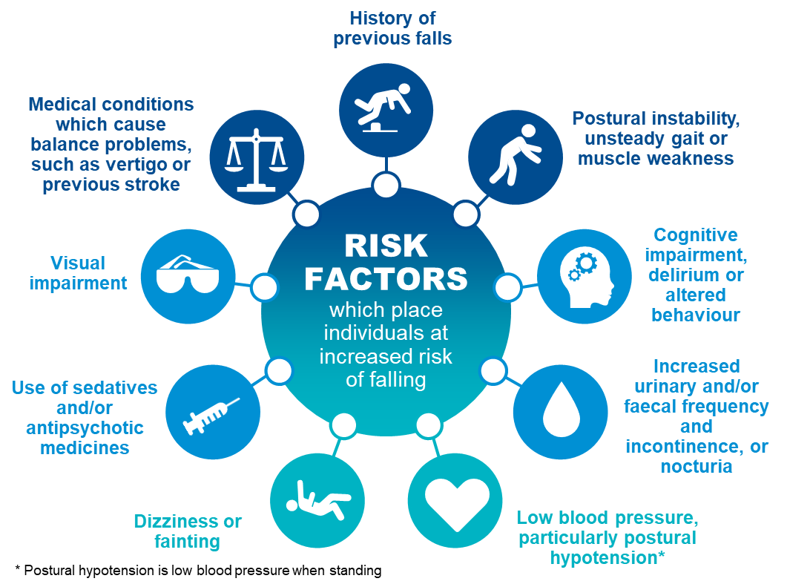

Prevention and management of falls and major injury, including prevention checklist
While not all falls (with and without injury) can be prevented, awareness of risk factors and some simple steps can reduce the risk of falling and an injury occurring.
There are three key focuses of falls prevention:
- To assess an individual’s risk of falling through identifying specific risk factors.
- To implement specific prevention programs or interventions to target these specific risk factors.
- To prevent injuries in those people who do fall.
There are important aspects of care that can be considered to prevent and manage falls and injuries. Figure 21 on the following page provides simple steps to identifying a care recipient’s falls risk and preventing falls and injuries from occurring.

FIGURE 21: RISK FACTORS AND PREVENTION AND MANAGEMENT STRATEGIES FOR FALLS
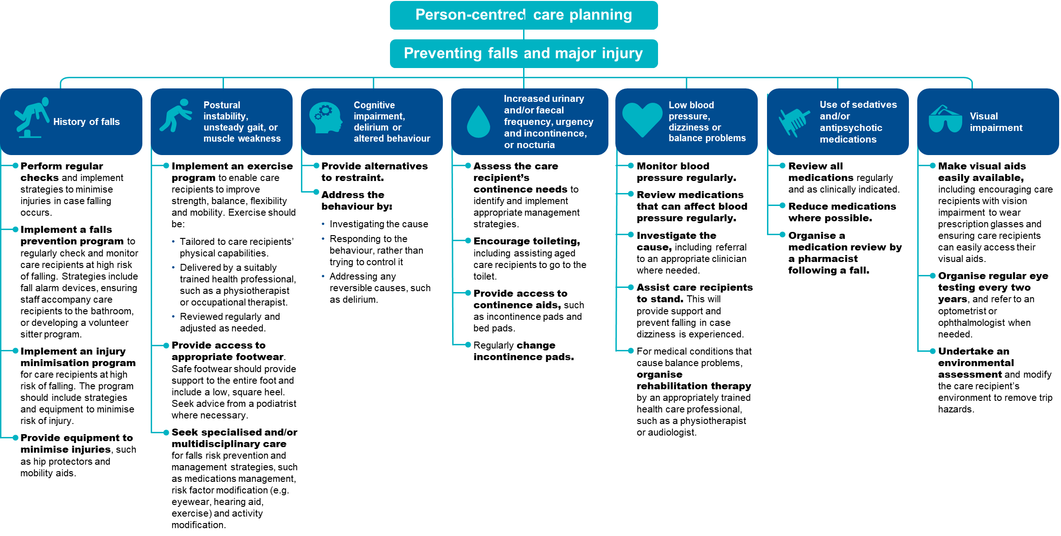

The checklist below will help to assess care recipients who are at risk of falls and major injury and identify prevention strategies to reduce the risk of falls and major injury occurring.
FIGURE 22: CHECKLIST FOR THE PREVENTION OF FALLS AND MAJOR INJURY
Checklist for the prevention of falls and major injury
Undertake an environmental review and modify as needed
- Conduct a quarterly environmental review at the service level (e.g. in common areas or hallways).
- Conduct a quarterly review at the individual level (e.g. in bedrooms and bathrooms).
- Make modifications where hazards are identified.
Undertake a falls risk assessment using a validated tool
- When a care recipient is first admitted to a residential aged care service.
- After a care recipient has a fall.
- After a change in health status.
- On an annual basis for all care recipients.
Document findings in a care plan
- Outline the activities that will be undertaken to reduce the care recipient’s risk of falling.
- Document risk factors, including comorbidities and mobility status.
- Consider the care recipient’s personal preferences.
Implement an appropriate prevention strategy based on the care recipient’s risk factors
- Previous or history of falls: Implementing a falls surveillance program and/or injury minimisation program.
- Postural instability, unsteady gait or muscle weakness: Implement exercise programs and provide access to appropriate footwear.
- Cognitive impairment, delirium or altered behaviour: Provide alternatives to restraint and address the behaviour.
- Urinary and/or faecal frequency, urgency and incontinence, or nocturia assess continence needs to identify and implement appropriate management strategies, support toileting, provide continence aids and change incontinence pads regularly.
- Low blood pressure and postural hypotension: Regularly monitor and manage blood pressure.
- Dizziness or fainting: Assist with standing and seek advice from GP.
- Use of sedative and/or antipsychotic medications: Regularly review and reduce medications, including seeking advice from a pharmacist or GP. Reducing psychotropic use and polypharmacy
- Visual impairment: Provide access to visual aids and undertake regular environmental assessment.
- Medical conditions and medications which impair balance: Provide access to rehabilitation therapy.
Undertake frequent reassessment to monitor risk
- When new or changing risk factors are evident.
- Following any change to health status or wellbeing.
- After a care recipient has a fall.
- At least annually for all care recipients.
- Reassess prevention strategies and adjust care plans as needed.

Quality improvement mechanisms
Quality improvement can help providers increase the quality of care for care recipients at risk of falling.95F Quality improvement activities should be ongoing and part of business-as-usual for approved providers.
The QI Program will help prompt when a specific quality improvement activity should be undertaken. It is important to review QI Program data reports through GPMS and compare against national averages and other services to understand where quality improvement activities should be focused.
The Plan-Do-Check-Act tool (section 2.3) is a useful tool to plan, deliver and monitor quality improvement activities focused on preventing falls and minimising injuries.

Example tools, guidance and resources to support
continuous quality improvement
- Preventing Falls and Harm from Falls in Older People - Best practice guidelines — guidelines for managing the various risk factors that make older Australians in residential aged care services vulnerable to falling — Australian Commission on Safety and Quality in Health Care (2025 update)
- Don’t fall for it. Falls can be prevented! — a booklet detailing ways to prevent falls — Australian Government Department of Health and Aged Care
- Falls: Standardised care process — an evidence-based approach in the prevention of falls for older people who live in a residential aged care setting — Victorian Department of Health and Human Services
- Falls risk assessment tools, Victorian Department of Health — range of assessment tools aimed at falls prevention — available online on the Victorian Department of Health website
- Falls Prevention Online Workshops — online learning modules for GPs and health professionals featuring evidence-based processes to help health professionals prevent falls in older people — Integrated SOLutions for Sustainable Fall PreVEntion - iSOLVE
- World guidelines for falls prevention and management for older adults: a global initiative — a journal article providing a set of evidence and expert consensus-based falls prevention and management recommendations and guidelines — Journal of Age and Ageing
Some tools, guidance and resources may be updated over time; it is important to ensure you are looking at the most recent version.

Medication management — polypharmacy
Medication management plays a critical role in achieving quality of care for older Australians in aged care and hospital settings. The two categories within this quality indicator are:
- Medication management — polypharmacy (this section), and
- Medication management — antipsychotics (see Section 8 of this manual).

Overview of polypharmacy
In residential aged care, polypharmacy describes when care recipients are taking more medications than can be practically and safely consumed. Polypharmacy in older Australians can increase negative health outcomes. The data and references in Figure 23 have been reviewed March 2025.
FIGURE 23: POLYPHARMACY IN RESIDENTIAL AGED CARE SERVICES96F 97F

Polypharmacy in residential aged care
Medication is defined as a chemical substance given with the intention of preventing, diagnosing, curing, controlling or alleviating disease or otherwise enhancing the physical and/or mental welfare of people. For the QI Program, it includes prescription and nonprescription medicines, despite the administered route.
The QI Program defines polypharmacy as the prescription of nine or more medications to a care recipient.
For the QI Program, any medication with an active ingredient is counted in the polypharmacy quality indicator. Except for those listed below which must not be included in the count of medications:
- Lotions, creams or ointments used in skin and wound care;
- Dietary supplements, including those containing vitamins;
- Short-term medications, such as antibiotics or temporary eye drops; and
- PRN medications.
Approved providers must not count different dosages of the same medicine as different medications.
Details of the collection and reporting requirements for the polypharmacy category of the medication management quality indicator can be found in Part A.

Causes of polypharmacy
Polypharmacy is an increasing concern amongst care recipients in residential aged care services, and elderly people in general. Older Australians are often prescribed several medications to manage comorbidities and extend life, but there is evidence that the prevalence of polypharmacy is increasing amongst older Australians.

FIGURE 24: RISK FACTORS ASSOCIATED TO POLYPHARMACY98F
Older Australians are at risk of polypharmacy for a variety of reasons:
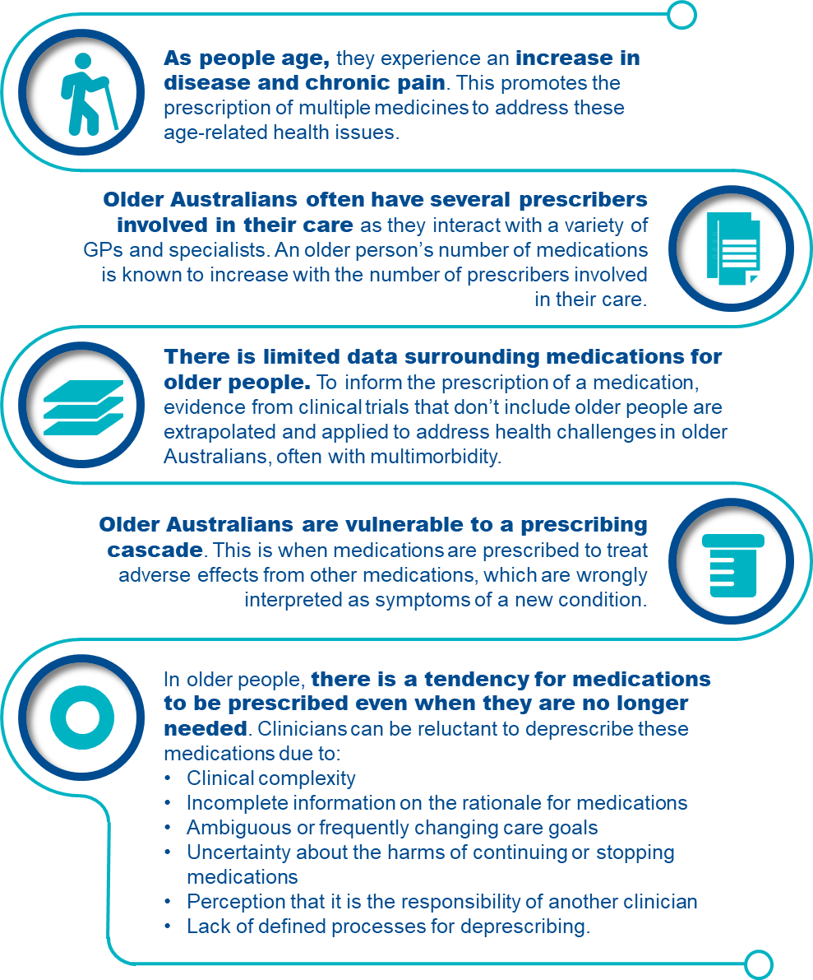

Adverse clinical events of polypharmacy
As people age, they are more sensitive to the effects of medication. This is exacerbated when they are prescribed multiple medications. Older Australians have an increased risk of experiencing adverse drug reactions (ADRs) due to physiological changes impacting how medicine is adsorbed, distributed, metabolised and eliminated. An older person’s risk of an ADR increases with the number of medications they are prescribed.
FIGURE 25: COMMON COMPLICATIONS ASSOCIATED WITH POLYPHARMACY
7.5 Prevention and management of polypharmacy, including prevention checklist
The prescription, supply and administration of medicines is strictly regulated for safety and quality of care. Various health professionals are involved in this process to promote safe and quality use of medicines in residential aged care services. Care recipients should understand and be involved in their own medication management and consent.
Figure 26 below discusses strategies to manage and prevent polypharmacy.
FIGURE 26: PREVENTION STRATEGIES FOR POLYPHARMACY
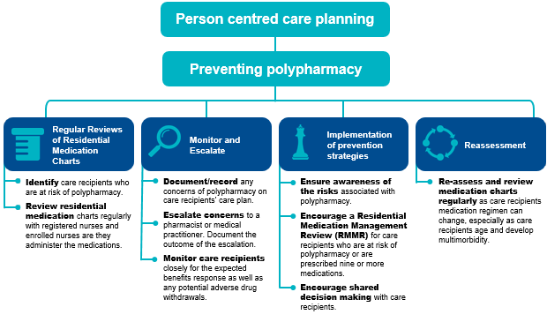

The checklist below will help to assess and involve care recipients who are at risk of polypharmacy and identify prevention strategies to reduce the risk of polypharmacy from occurring.
FIGURE 27: CHECKLIST FOR THE PREVENTION OF POLYPHARMACY
Checklist for the prevention of polypharmacy

Complete regular reviews of residential medication charts
- Aged care service staff are key to identifying care recipients who are at risk of polypharmacy or are already prescribed nine or more medications.
- Regular review of residential medication charts by registered nurses and enrolled nurses as they administer medications. Escalate to pharmacist or medical practitioner where appropriate.
- Review care recipient’s medication charts for medication changes upon return from hospital admissions.
Document, monitor and escalate instances of polypharmacy
- Document/record concerns of polypharmacy on a care recipient’s care plan and escalate to a pharmacist or medical practitioner. The outcome of this escalation should also be documented and planned for in the care recipient’s care plan.
- Monitor the care recipient closely for the expected benefits response as well as potential adverse drug withdrawals. A carer or enrolled nurse should discuss concerns of polypharmacy with the registered nurse so the escalation process to the pharmacist or medical practitioner is initiated for review.
Implement prevention strategies
Educate staff and promote awareness about polypharmacy
- Remain aware of the risks associated with polypharmacy. Programs supporting awareness and understanding of deprescribing and polypharmacy are effective in promoting safer medication regimens as staff play an active role in monitoring care recipients’ residential medication charts.
Encourage Residential Medication Management Reviews (refer to “Example tools, guidance and resources to support continuous quality improvement”)
- Encourage a Residential Medication Management Review (RMMR) for care recipients who are at risk of polypharmacy or are prescribed nine or more medications.
- Collaborate with medical practitioners and pharmacists to perform a RMMR for a care recipient. These medication management services are subsidised by Medicare.
Encourage shared decision making with care recipients
- Discuss medication needs with the care recipient to understand their perspective and support their participation in making decisions (where possible).
Escalate concerns of polypharmacy for consideration of deprescribing (where appropriate)
- Escalate concerns of polypharmacy to a pharmacist or medical practitioner. The purpose of this is to target medications no longer beneficial to the care recipient, reduce complexity in their medication regime and prevent consequences of a high-risk medication.
- Deprescribing can only be actioned by a medical practitioner and must be reflected in the care recipient’s medication chart.
Undertake frequent reassessment of residential medication charts
- Re-assess and review regularly as a care recipient’s medication regimen can change regularly, especially as care recipients age and develop multimorbidity.

Quality improvement for polypharmacy
Quality improvement can help providers increase the quality of care for care recipients at risk of polypharmacy. Quality improvement activities should be ongoing and part of business-as-usual for approved providers.
The QI Program will help prompt when a specific quality improvement activity should be undertaken.
It is important to review QI Program data reports through GPMS and compare against national averages and other services to understand where quality improvement activities should be focussed.
The Plan-Do-Check-Act tool (section 2.3) is a useful tool to plan, deliver and monitor quality improvement activities focused on preventing and reducing polypharmacy.

Example tools, guidance and resources to support
continuous quality improvement

- Australian Medicines Handbook — online resource providing information on current medications used in Australia
- Monthly Index of Medical Specialties (MIMS) Australia — online resource providing Australian medications information
- The Fourth Australian Atlas of Healthcare Variation: Polypharmacy, 75 years and over — chapter explores the effects of polypharmacy in older Australians — Australian Commission on Safety and Quality in Health Care
- Handbook of tools to support medicine management in multimorbidity and polypharmacy – developed by the University of SA for the Department of Health and Aged Care
- Medications it’s your choice — video providing information about the rights and responsibilities of older people about their care, including their medication — Older Persons Advocacy Network
Some tools, guidance and resources may be updated over time; it is important to ensure you are looking at the most recent version.

Medication management — antipsychotics
Medication management plays a critical role in achieving quality of care for older Australians in aged care and hospital settings. The two categories within this quality indicator are:
- Medication management — polypharmacy (see Section 7 of this manual); and
- Medication management — antipsychotics (this section).

Overview of antipsychotics
Medication management is critical for residential aged care as older Australians are often prescribed several medications to manage comorbidities and extend life, being particularly vulnerable to the significant risks of antipsychotics. The data and references in Figure 28 have been reviewed March 2025.
FIGURE 28: ANTIPSYCHOTICS IN RESIDENTIAL AGED CARE SERVICES99F 100F
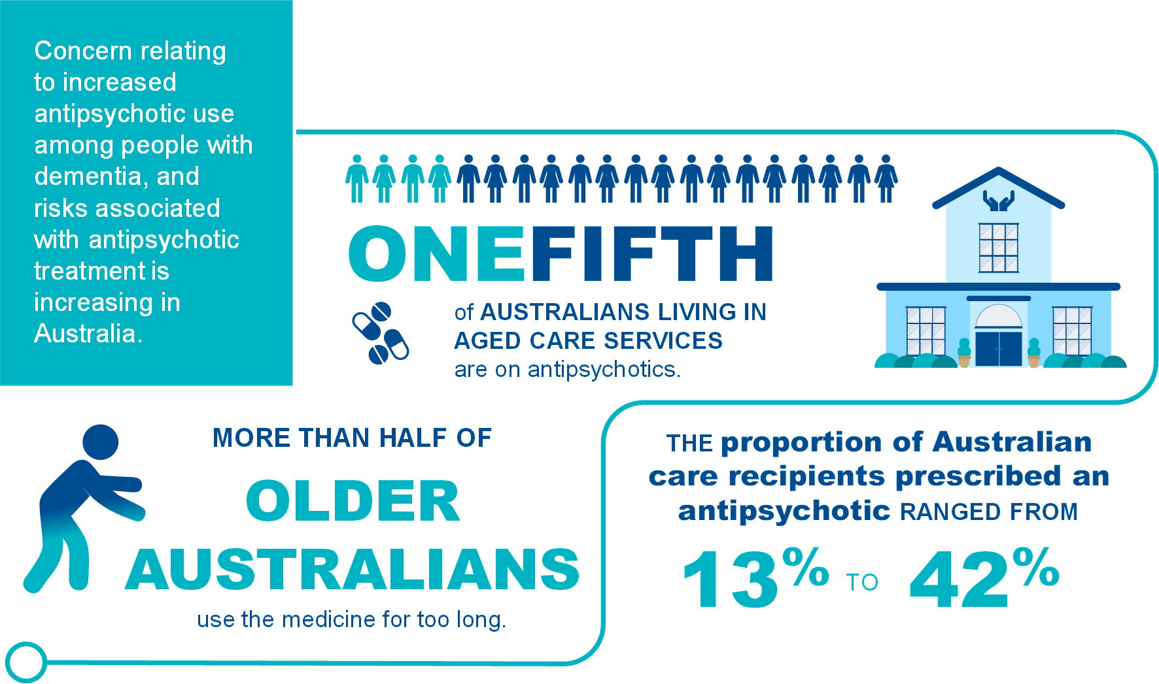

Antipsychotic use in residential aged care
Antipsychotics are medications prescribed for the treatment of a diagnosed condition of psychosis. Antipsychotic medication is often prescribed to older Australians to manage the behavioural and psychological symptoms of dementia.
The following is a non-exhaustive list of antipsychotics:

- Amisulpride
- Aripiprazole
- Asenapine
- Brexpiprazole
- Cariprazine
- Chlorpromazine
- Clozapine
- Droperidol
- Flupentixol
- Haloperidol
- Lurasidone
- Olanzapine
- Paliperidone
- Periciazine
- Quetiapine
- Risperidone
- Trifluoperazine
- Ziprasidone
- Zuclopenthixol.

* List of antipsychotics approved for use in Australia can be updated at any time so reviewing the list alongside updated evidence-based sources is advised.
Regular monitoring of the use of antipsychotics is important because the inappropriate use of certain medication classes, such as antipsychotics, has been shown to be associated with poor health outcomes.
Details of the collection and reporting requirements for the antipsychotics category of the medication management quality indicator can be found in Part A.

Adverse clinical events of antipsychotics
The adverse effects of antipsychotic medications range from those that are relatively minor to others that are very unpleasant, painful, disfiguring or life-threatening. Figure 29 below explores the adverse clinical effects of antipsychotic use.
FIGURE 29: SIGNIFICANT ADVERSE EFFECTS OF ANTIPSYCHOTICS
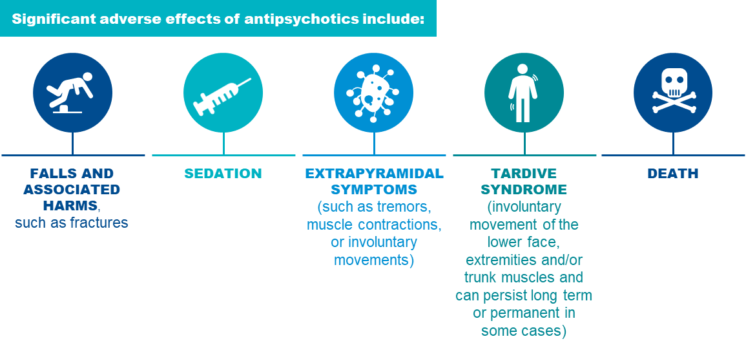
Research suggests that antipsychotic medications are frequently prescribed off-label for the behavioural and psychological symptoms of dementia.101F 102F However, antipsychotics that are not beneficial or are not required should be discontinued.

Risk factors of antipsychotic use
Older Australians are significantly more vulnerable to the significant risks associated with antipsychotic use due to age-related issues. Having a strong understanding of the risk factors is crucial to identify care recipients who are particularly at risk with antipsychotic use. The risk factors associated with the use of antipsychotics in residential aged care services are explored in Figure 30 below.
FIGURE 30: RISK FACTORS ASSOCIATED WITH ANTIPSYCHOTIC USE IN RESIDENTIAL AGED CARE SERVICES103F 104F 105F 106F 107F 108F
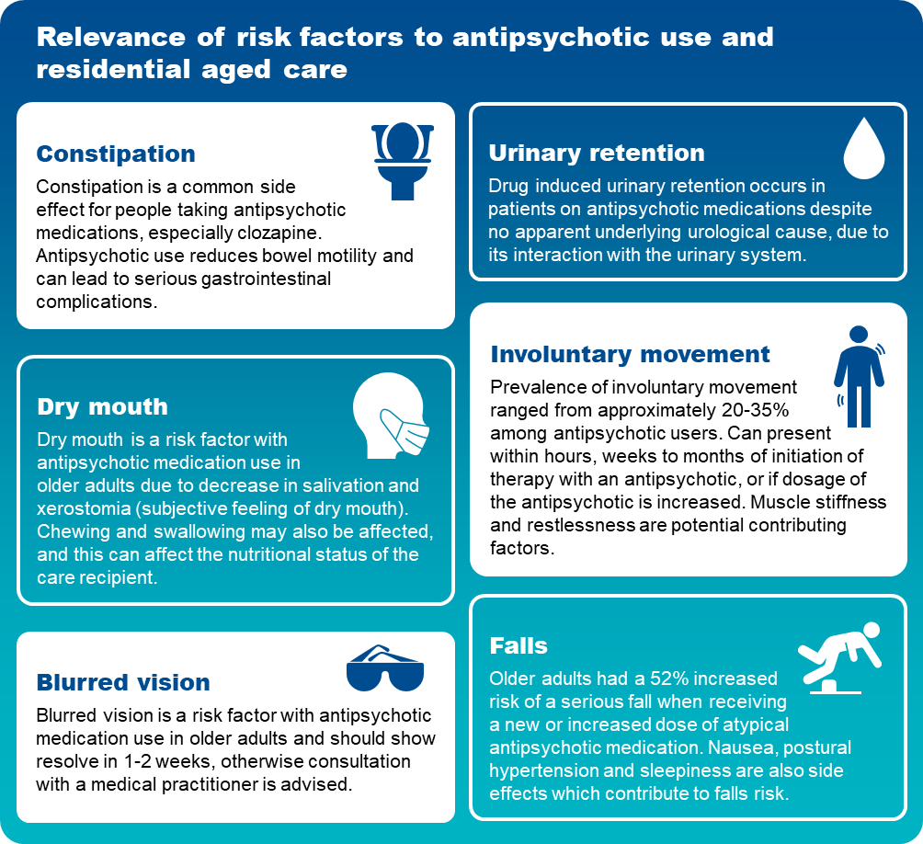

Prevention and management of antipsychotic use, including prevention checklist
Antipsychotic prescribing increases markedly once a person is admitted into residential aged care, and there is evidence that up to 42 per cent of older Australians in residential aged care services are regularly prescribed an antipsychotic.109F 110F
Figure 31 below explores strategies for managing antipsychotics use.
FIGURE 31: PREVENTION STRATEGIES FOR ANTIPSYCHOTICS USE
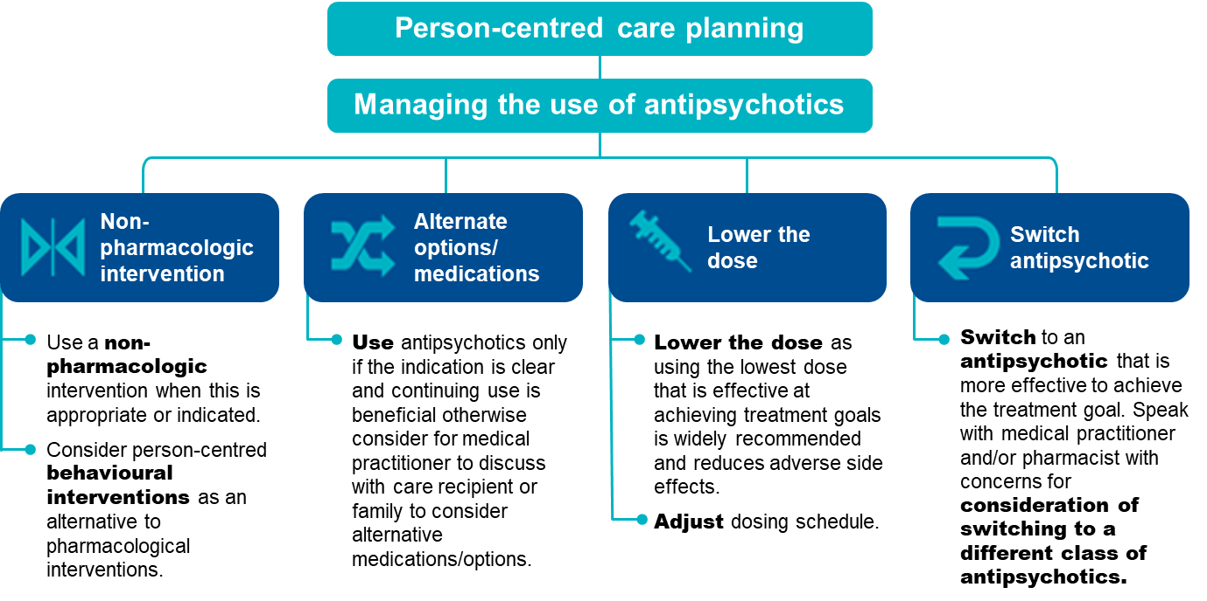
Complications from antipsychotics are treatment dependent. Complications can arise from the choice of antipsychotic, the dose used, the duration of exposure, the other medications the person is taking and the particular sensitivity of the individual to complications.
If the intended use of antipsychotics is for chemical restraint, providers are required to have a behaviour support plan in place. Section 4 of this Manual provides further information about restrictive practices.
The checklist overleaf will help to assess care recipients who are at risk of antipsychotic use and identify prevention strategies to reduce the risk of antipsychotic use from occurring:
FIGURE 32: CHECKLIST FOR THE PREVENTION OF ANTIPSYCHOTIC USE
Checklist for the prevention of antipsychotic use
Complete regular reviews of residential medication charts
- Identify care recipients who are taking antipsychotic medications.
- Regular review of care recipient medication charts by registered nurses and enrolled nurses as they administer medications. Escalate to pharmacist or medical practitioner where appropriate.
- Ensure care recipients’ medication charts are reviewed upon returning from the hospital as there could be significant medication changes.
Document, monitor and escalate instances of antipsychotic use
- Document/record concerns of antipsychotic use on a care recipient’s care plan and escalate to a pharmacist or medical practitioner. The outcome of this escalation should also be documented and planned for in the care recipient’s care plan.
- Monitor the care recipient closely for changes in behaviour. A carer or enrolled nurse should discuss concerns of antipsychotic use with the registered nurse so the escalation process to the pharmacist or medical practitioner is initiated for review.
Implement prevention strategies
Educate staff and promote awareness about antipsychotic use
- Remain aware of the risks associated with antipsychotic use. Programs supporting awareness and understanding of antipsychotic use are effective in promoting safer medication regimens as staff play an active role in monitoring care recipients’ residential medication charts.
Encourage Residential Medication Management Reviews (refer to “Example tools, guidance and resources to support continuous quality improvement”)
- Encourage a Residential Medication Management Review (RMMR) for care recipients who are at risk with antipsychotic use.
- Collaborate with medical practitioners and pharmacists to perform a RMMR for a care recipient of residential aged care. These medication management services are subsidised by Medicare.
Encourage shared decision making with care recipients
- Discuss antipsychotic needs with the care recipient to understand their perspective and support their participation in making decisions (where possible).
Escalate concerns of antipsychotic use for consideration of deprescribing or change in medication (where appropriate)
- Escalate concerns of antipsychotic use to a pharmacist or medical practitioner. The purpose of this is to assess if the antipsychotic medication is no longer beneficial to the care recipient, reduce complexity in their medication regime and prevent consequences of a high risk medication.
- Deprescribing and change in medications can only be actioned by a medical practitioner or nurse practitioner and must be reflected in the care recipient’s medication chart.
Undertake frequent reassessment of residential medication charts
- Re-assess and review regularly care recipient’s medication charts as regimen can change regularly, especially as care recipients age and develop multimorbidity.

Quality improvement for antipsychotic use
Quality improvement can help providers increase the quality of care for care recipients at risk of antipsychotic use. Quality improvement activities should be ongoing and part of business-as-usual for approved providers.
The QI Program will help prompt when a specific quality improvement activity should be undertaken. It is important to review QI Program data reports through GPMS and compare against national averages and other services to understand where quality improvement activities should be focussed.
The Plan-Do-Check-Act tool (section 2.3) is a useful tool to plan, deliver and monitor quality improvement activities focused on preventing and reducing antipsychotic use.

Example tools, guidance and resources to support
continuous quality improvement
- Deprescribing guide for antipsychotics for treatment of behavioural and psychological symptoms of dementia — a guide providing information to support deprescribing of antipsychotics — Northern Sydney Local Health District, New South Wales Government
- Antipsychotic Tracking Tool — a tool to monitor antipsychotic usage in aged care settings — Dementia Training Australia
- Six steps for safe prescribing antipsychotics and benzodiazepines in residential aged care — poster providing guidance on managing behaviours and psychological symptoms of dementia — Aged care Quality and Safety Commission
- Australian Medicines Handbook — online resource providing information on current medications used in Australia
- Monthly Index of Medical Specialties (MIMS) Australia — online resource providing Australian medications information
- Severe Behaviour Response Teams (SBRT) — 24/7 contact with a Dementia Consultant on 1800 699 799 to access SBRT service — Dementia Support Australia
- Dementia Behaviour Management Advisory Service (DBMAS) — 24/7 contact with a Dementia Consultant on 1800 699 799 for advice or to make a referral — Dementia Support Australia
- Downloadable behaviour resources — a variety of resources to both inform and assist healthcare professionals and family members who are supporting a person living with dementia — Dementia Support Australia
Some tools, guidance and resources may be updated over time; it is important to ensure you are looking at the most recent version.

Activities of daily living

Activities of daily living (ADLs) can be used to measure people’s ability to move and care for themselves. ADLs are essential, routine tasks such as personal hygiene, dressing, going to the toilet and eating. ADLs are important to maintain independence, health status and quality of life. Screening, monitoring and prevention activities may reduce decline in ADLs and improve independence.

Overview of activities of daily living
Figure 33 below provides an overview of the activities of daily living in residential aged care. The data and references have been reviewed March 2025.
FIGURE 33: ACTIVITIES OF DAILY LIVING IN RESIDENTIAL AGED CARE111F 112F
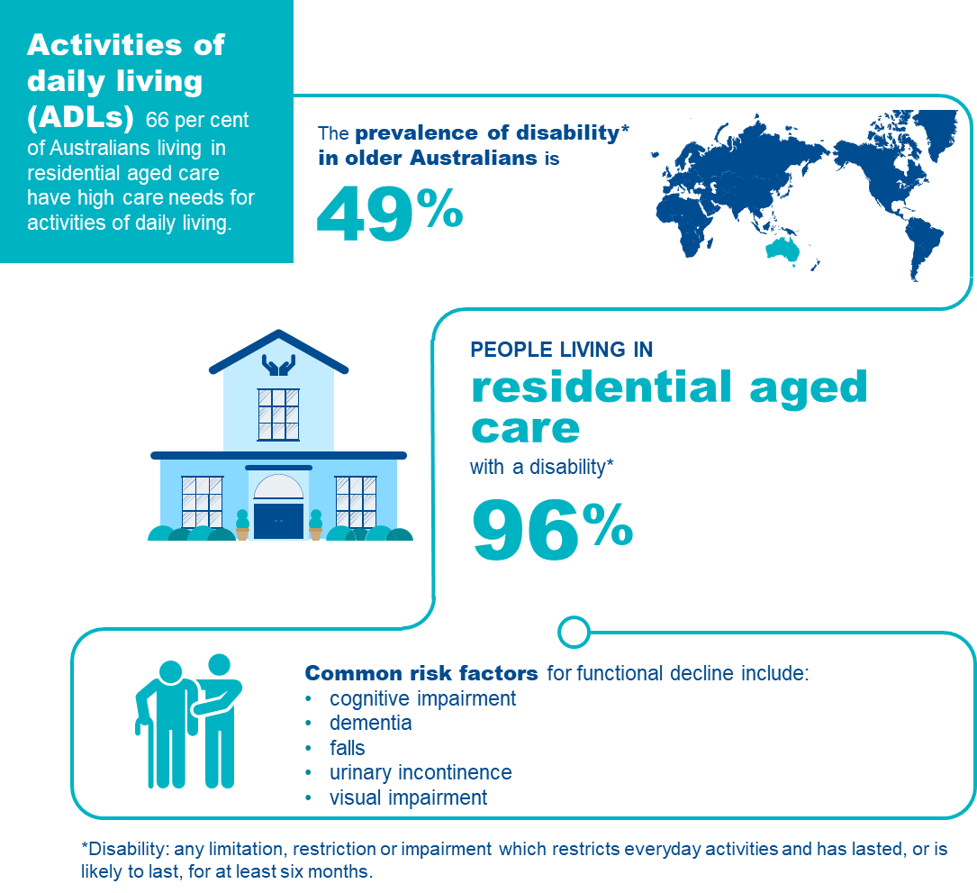

Activities of daily living in residential aged care
ADLs are self-care activities such as managing personal hygiene, dressing, toileting and eating. ADLs are important to maintain independence, health status and quality of life. Aged care services can assist care recipients to actively participate in these activities to improve or maintain function or slow the rate of decline.
ADLs are categorised under two sub-groups:113F

Basic
- ambulating (walking/moving around)
- eating
- dressing
- personal hygiene (oral, hair & skin care)
- continence
- toileting

Instrumental
- transport
- shopping
- managing finances
- meal preparation
- house cleaning
- home maintenance
- communication
- managing medications.
A number of conditions (e.g. dementia and Parkinson’s disease) experienced by care recipients can cause a decline in their ability to perform ADLs.114F However, a decline in a care recipient’s function should not be considered inevitable. It is important to appreciate that poor quality care can accelerate the rate of decline, and that a good program of care will help to maintain or potentially improve independent function.115F 116F 117F
Basic ADLs are most relevant to residential aged care, as care recipients in residential aged care generally do not maintain responsibility for many of the instrumental ADLs such as grocery shopping, meal preparation or house cleaning. Care recipients should be encouraged to contribute to these activities, even when they are only partially able to do so.
The focus of this quality indicator is on basic ADLs.
Details of collection and reporting requirements for the activities of daily living quality indicator can be found in Part A.

Causes of decline in activities of daily living
ADL decline is usually associated with illness that may occur suddenly (e.g. stroke or fractures) or progressively (e.g. dementia or Parkinson’s disease).118F While many of these illnesses are associated with gradual loss of ADL function, the rate of change may be prevented or slowed by good care and therapy.119F An important goal of care should be to improve function, to stabilise or to slow decline.
Where there has been a sudden decline in ADL function, due to an acute illness or injury, care recipients should be supported to recover as much as possible. This might involve a rehabilitation or restorative care program, within the residential aged care service, or in some cases, in a rehabilitation facility.

Risk factors for decline in activities of daily living
The majority of care recipients in residential aged care have limitations in their ADL function.120F Many have conditions associated with progressive decline. Some experience incidents that lead to abrupt loss of ADL function.
However, decline in ADLs is not inevitable, and the rate of decline can be influenced by good care.121F By reducing or slowing decline, care recipients are likely to enjoy a greater proportion of their lives as ‘good days’. Knowing the risk factors will help identify care recipients who are most likely to experience decline in ADLs. Risk factors associated with decline in ADLs in residential aged care services are explored in Figure 304.
FIGURE 34: RISK FACTORS FOR DECLINE IN ACTIVITIES OF DAILY LIVING122F 123F
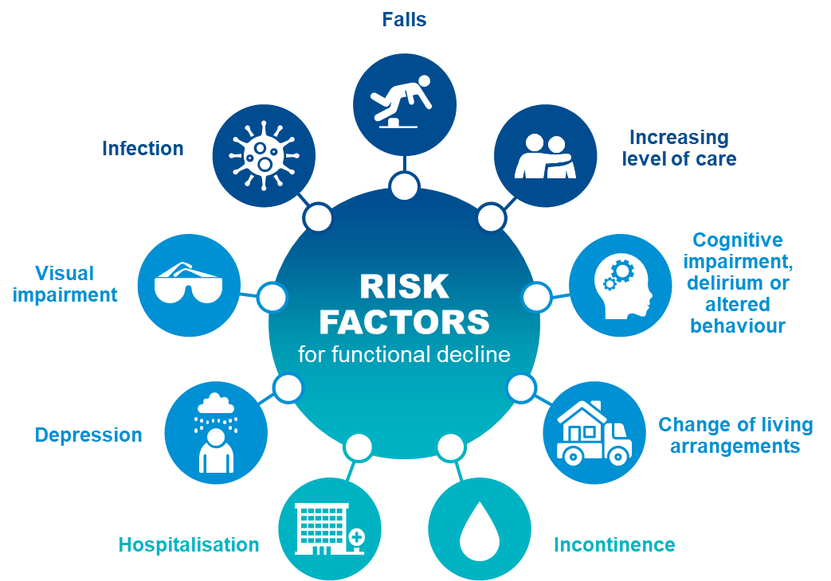

Adverse clinical events and activities of daily living
ADL decline has a complex impact on wellbeing and is associated with a loss of independence. This may result in increased reliance on people or technology to maintain quality of life, wellbeing, and safety. Early detection of decline in ADLs leads to improved outcomes, slowing, stopping, or reversing progression, and avoiding consequences such as:
- loss of mobility
- confusion and discomfort with change of living environments
- increasing level of care needs
- increased hospitalisation
- depression, withdrawal, and social isolation
- delirium
- malnutrition
- incontinence.

Prevention and management of decline in activities of daily living
ADL decline can evolve in two ways:
- Gradual loss: independence is lost progressively, usually due to one or several degenerative disorders (e.g. dementia or osteoarthritis)
- Sudden loss: a major health event results in a loss of ADL function often with only partial recovery (e.g. stroke, falls or pneumonia).
Awareness of risk factors and some simple steps can slow ADL decline and improve quality of life. ADL performance should be closely monitored and recorded. Review should occur regularly each time the person’s care plan is reviewed and when their health status changes, e.g. following a serious illness or injury. Any change in ADL performance should prompt consideration of strategies to slow decline and/or promote recovery. In the case of sudden ADL decline, there is a need for careful assessment and prescription of rehabilitative strategies for recovery.124F
Specific interventions targeted at encouraging mobility and promoting independence can improve outcomes, including:
- Physical rehabilitation and reablement:125F Rehabilitation can restore ADL function and minimise adverse events. Interventions should be designed according to current best-practice for maximum sustainability, cost-effectiveness and suitability. Rehabilitation is critically important for care recipients who sustain an injury or experience a major medical illness.
- Specialist care:126F Consultation with geriatricians or other external specialists will inform ongoing care, preventive programs and recovery programs.
- Early identification and assessment:127F Careful consideration of the likely trajectory of function, and the extent to which this can be influenced requires a multidisciplinary perspective that should be offered at entry to residential aged care and periodically with individual care plan review. These assessments can be enhanced by the use of formal assessment tools to help define, measure, and monitor ADL function, which may assist in outcome prediction. Examples include frailty assessment, cognitive assessment, nutritional evaluation, mobility assessment, continence assessment and functional activity assessment.
- Targeted intervention and care planning:128F Proactive prevention of ADL decline may improve cost-effectiveness of care provision and improve independence. Targeting interventions to assessment findings and using collaborative care planning can improve care appropriateness and care outcomes. Examples include prescription of assistive devices, physical activity, falls prevention strategies, toileting programs and nutritional interventions.
- An enabling environment:129F 130FA service level program should be in place that is designed to promote and preserve ADL independence. This might include group approaches (e.g. exercise classes) or individual level approaches (e.g. ensuring that care recipients are supported to retain mobility or dress themselves as much as possible).
- Workforce planning and professional development:131F Education and training programs designed for carers and staff can significantly improve care recipient function. Examples include training in reablement and ADL preservation, depression and apathy management, manual handling, and continence assessment, management and care. Programs for care recipients run by trained staff can improve ADLs with a lasting effect (changes sustained over six months).
Figure 35 outlines important aspects of care that can improve or maintain function.
FIGURE 35: ACTIVITIES OF DAILY LIVING IMPROVEMENT FRAMEWORK132F 133F 134F 135F 136F 137F 138F
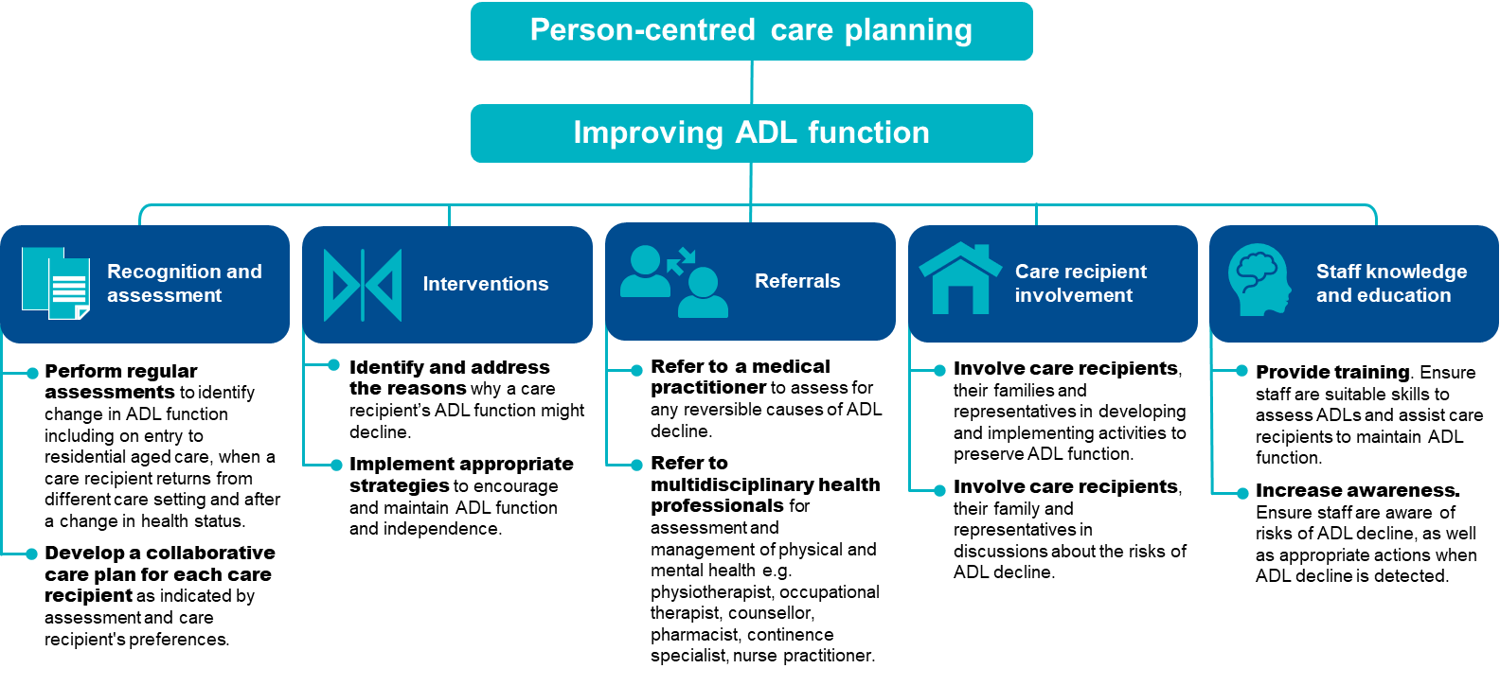

The checklist below will help assess care recipients who are at risk of ADL decline and identify support and prevention strategies to reduce ADL decline and mitigate consequences.
FIGURE 36: CHECKLIST FOR THE PREVENTION OF ACTIVITIES OF DAILY LIVING DECLINE
Checklist for the prevention of activities of daily living decline
Undertake ADL assessments regularly
- Conduct ADL assessments at least quarterly, or more frequently in response to changes, including:
- on entry to a residential aged care service
- when a care recipient returns from different care setting
- after a change in health status.
- Identify any recent changes in ADL function.
- Identify and assess any risk factors for future ADL decline, such as:
- cognition
- nutrition
- mobility
- continence.
Document findings in a care plan
- Document the findings from the care recipient’s ADL assessment in their care plan, including any changes.
- Identify and document suitable prevention strategies, including their proposed frequency and timing.
- Undertake collaborative care planning, ensuring alignment with the care recipient’s preferences for management.
- Document goals for improving or maintaining ADL function.
- Monitor for risk factors of ADL decline.
Implement appropriate support strategies that prevent ADL decline
- Undertake collaborative care planning.
- Promote autonomy in routine day to day activities.
- Provide therapy and deliver interventions where required, for example:
- occupational therapy, physiotherapy, nutrition, continence professional and dietetics
- exercise and physical activity
- prescription of assistive devices
- medication management.
- Implement restorative interventions following acute illness or deterioration.
Ongoing monitoring between ADL assessments
- Monitor ADL function.
- Monitor risk factors.
- Assess appropriateness of current strategies to maintain ADLs and quality of life.

Quality improvement for activities of daily living
Quality improvement can help providers increase quality of care for care recipients experiencing ADL decline. Quality improvement activities should be ongoing and part of business-as-usual for approved providers.
The QI Program will help prompt when a specific quality improvement activity should be undertaken. It is important to review the QI Program data reports through GPMS and compare against national averages and other services to understand where quality improvement activities should be focused.
The Plan-Do-Check-Act tool (section 2.3) is a useful tool to plan, deliver and monitor quality improvement activities focused on preserving ADL function.

Example tools, guidance and resources to support continuous quality improvement
- Barthel Index — an ordinal scale used to measure performance in activities of daily living, and the selected assessment tool that must be used in the QI Program — available in Part A: Appendix Why is helping residents with Activities of Daily Living (ADLs) so important?
- AN-ACC Reference Manual — provides additional ADL related assessment tools including the Resource Utilisation Groups — Activities of Daily Living (RUG-ADL), Rockwood Clinical Frailty Scale, Australia-modified Karnofsky Performance Status (AKPS), De Morton Mobility Index (DEMMI) and the Australian Functional Measure, available online in the ANACC Reference Manual on the Australian Department of Health and Aged Care website
- About rehabilitation, reablement and restorative care — overview of terminology and references from Aged Care Research & Industry Innovation Australia
- Services and supports for daily living: Standard 4 — provides guidance and resources relating to services and supports for daily living — Aged Care Quality and Safety Commission
Some tools, guidance and resources may be updated over time; it is important to ensure you are looking at the most recent version.

Incontinence care
Incontinence is the loss of bladder and bowel control, which can impact independence, health and quality of life. Incontinence Associated Dermatitis (IAD) is an irritant contact dermatitis associated with incontinence. Aged care providers can ensure access to treatment and care to support continence and deliver appropriate incontinence care.

Overview of incontinence care
Figure 37 below provides an overview of incontinence in residential aged care services. The data and references have been reviewed March 2025.
FIGURE 37: INCONTINENCE IN RESIDENTIAL AGED CARE139F 140F
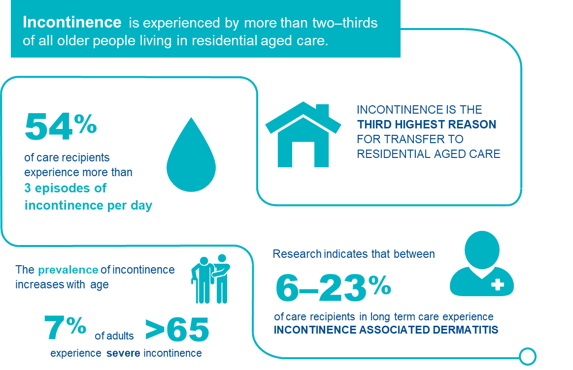

Understanding incontinence in residential aged care
For the purposes of the QI Program, incontinence is any accidental or involuntary loss of urine from the bladder (urinary incontinence) or faeces from the bowel (faecal incontinence). Incontinence can range in severity from a small leak to complete loss of bladder or bowel control. Under the QI Program, a care recipient has incontinence if bladder incontinence occurs more than once a day or bowel incontinence more than once a week, or if they require urinary catheters for passing urine.
IAD is a type of irritant contact dermatitis arising primarily from inadequate incontinence management.
Aged care providers can ensure people have access to the right treatments and support to assist bladder and bowel control and reduce risk factors for the development of IAD.
Incontinence is the third highest reason for transfer to residential aged care.141F Inappropriate management of incontinence consistently ranks amongst the top ten consumer complaints made to the Aged Care Quality and Safety Commission (ACQSC), a clear indication that incontinence management in residential aged care can be improved.142F
Prevalence of incontinence in Australian residential aged care is estimated between 75 and 81 per cent.143F In 2009, 67 per cent of care recipients in residential aged care required care for urinary incontinence, and 55 per cent were reported to require care for faecal incontinence.144F Prevalence of IAD in Australian residential aged care is currently unknown, however is likely to be similar to pressure injuries.145F A review of the literature on prevalence estimates of IAD in residential aged care settings varies, but has been reported between 6 and 23 per cent.146F The frequency of IAD with good continence management and skin care can be reduced.
Reliable quality indicators that measure the outcomes of incontinence care are not available. However, quality of incontinence care may be measured by the prevalence of poor outcomes. IAD can be reliably measured and is suitable as an indirect measure of incontinence care quality.
Factors that drive the frequency of IAD also affect the rate of pressure injury — incontinence management and skin care.
Details of collection and reporting requirements for the incontinence care quality indicator can be found in Part A.

Causes of incontinence
There are a wide variety of causes of incontinence, including general health, neurological conditions, and muscular dysfunction. For many care recipients, the cause of their incontinence is multi-dimensional.
Commonly associated conditions are:147F
- pelvic floor weakness/dysfunction/damage
- rectal dysfunction/damage
- pregnancy and childbirth
- menopause
- prostate enlargement
- urinary or faecal obstruction
- neurological disorders
- pain
- cognitive impairment
- mobility and functional impairment.

Risk factors for incontinence
There are many risk factors for incontinence in older adults, including social, physical, psychological, emotional, and environmental (the care facility), as described in Figure 38.148F
FIGURE 38: RISK FACTORS FOR INCONTINENCE
SOCIAL CAUSES | PHYSICAL RISK FACTORS | COGNITIVE, PSYCHOLOGICAL AND EMOTIONAL RISK FACTORS | CARE SETTING RISK FACTORS
Cultural factors  Around condition, sensitivity seeking help, support from carers of a different gender, or deficient cultural safety | Physiological changes of ageing  Comorbidities  Acute illness, cancer, pain, constipation  Medication related  Polypharmacy, diuretic medicines, analgesics  Functional issues  Dexterity, mobility impairment, vision  Communication issues  Deafness, aphasia | Mood disorders  Anxiety, depression  Cognitive impairment  Alzheimer’s disease, Lewy body dementia, vascular dementia, stroke | Staff  Limited staff to assist with toileting, limited skills to identify and respond to incontinence, limited access to specialist continence care, deficient cultural safety  Continence aids  Limited choices or access

Adverse clinical events associated with incontinence
Incontinence exposes care recipients to complications that can have significant impact on health and wellbeing, including:149F
- decreased quality of life
- social withdrawal and depression
- increased falls risk
- functional decline from disuse atrophy
- skin and tissue breakdown (e.g. pressure injury and incontinence associated dermatitis)
- urinary tract infections.

Prevention and management of incontinence
Care recipients should be assessed for incontinence regularly, including risk factors and effectiveness of current incontinence care. These assessments should be carried out by trained staff as part of the care recipient’s routine personal care.
Quality incontinence care is achieved through a systems approach with consideration of service level factors and a care recipient’s individual circumstances. A range of active and passive continence management strategies should be discussed in consultation with care recipients to ensure a person-centric management strategy is implemented that meets care recipient needs without compromising physical, emotional or social wellbeing. Examples of incontinence care interventions include:150F
- Active treatment
- lifestyle interventions (e.g. fluid and dietary modifications)
- physical therapies (e.g. pelvic floor exercises)
- behavioural therapies (e.g. bladder training, toileting regimes, double voiding)
- assistive devices (e.g. commodes, female and male urinals, vaginal pessaries, electrical stimulators, biofeedback devices)
- medication (e.g. those that regulate stool form, hormones, overactive bladder)
- surgical or interventional procedures.
- Containment
- absorbent continence aids (e.g. pads and absorbent underwear)
- catheters (e.g. supra-pubic catheter, indwelling urethral catheter and intermittent catheter)
- external urinary drainage (e.g. condom catheter)
- bed or surface protection.
Figure 39 outlines important aspects of high quality incontinence care in residential aged care.

FIGURE 39: INCONTINENCE MANAGEMENT151F 152F 153F 154F 155F 156F 157F 158F
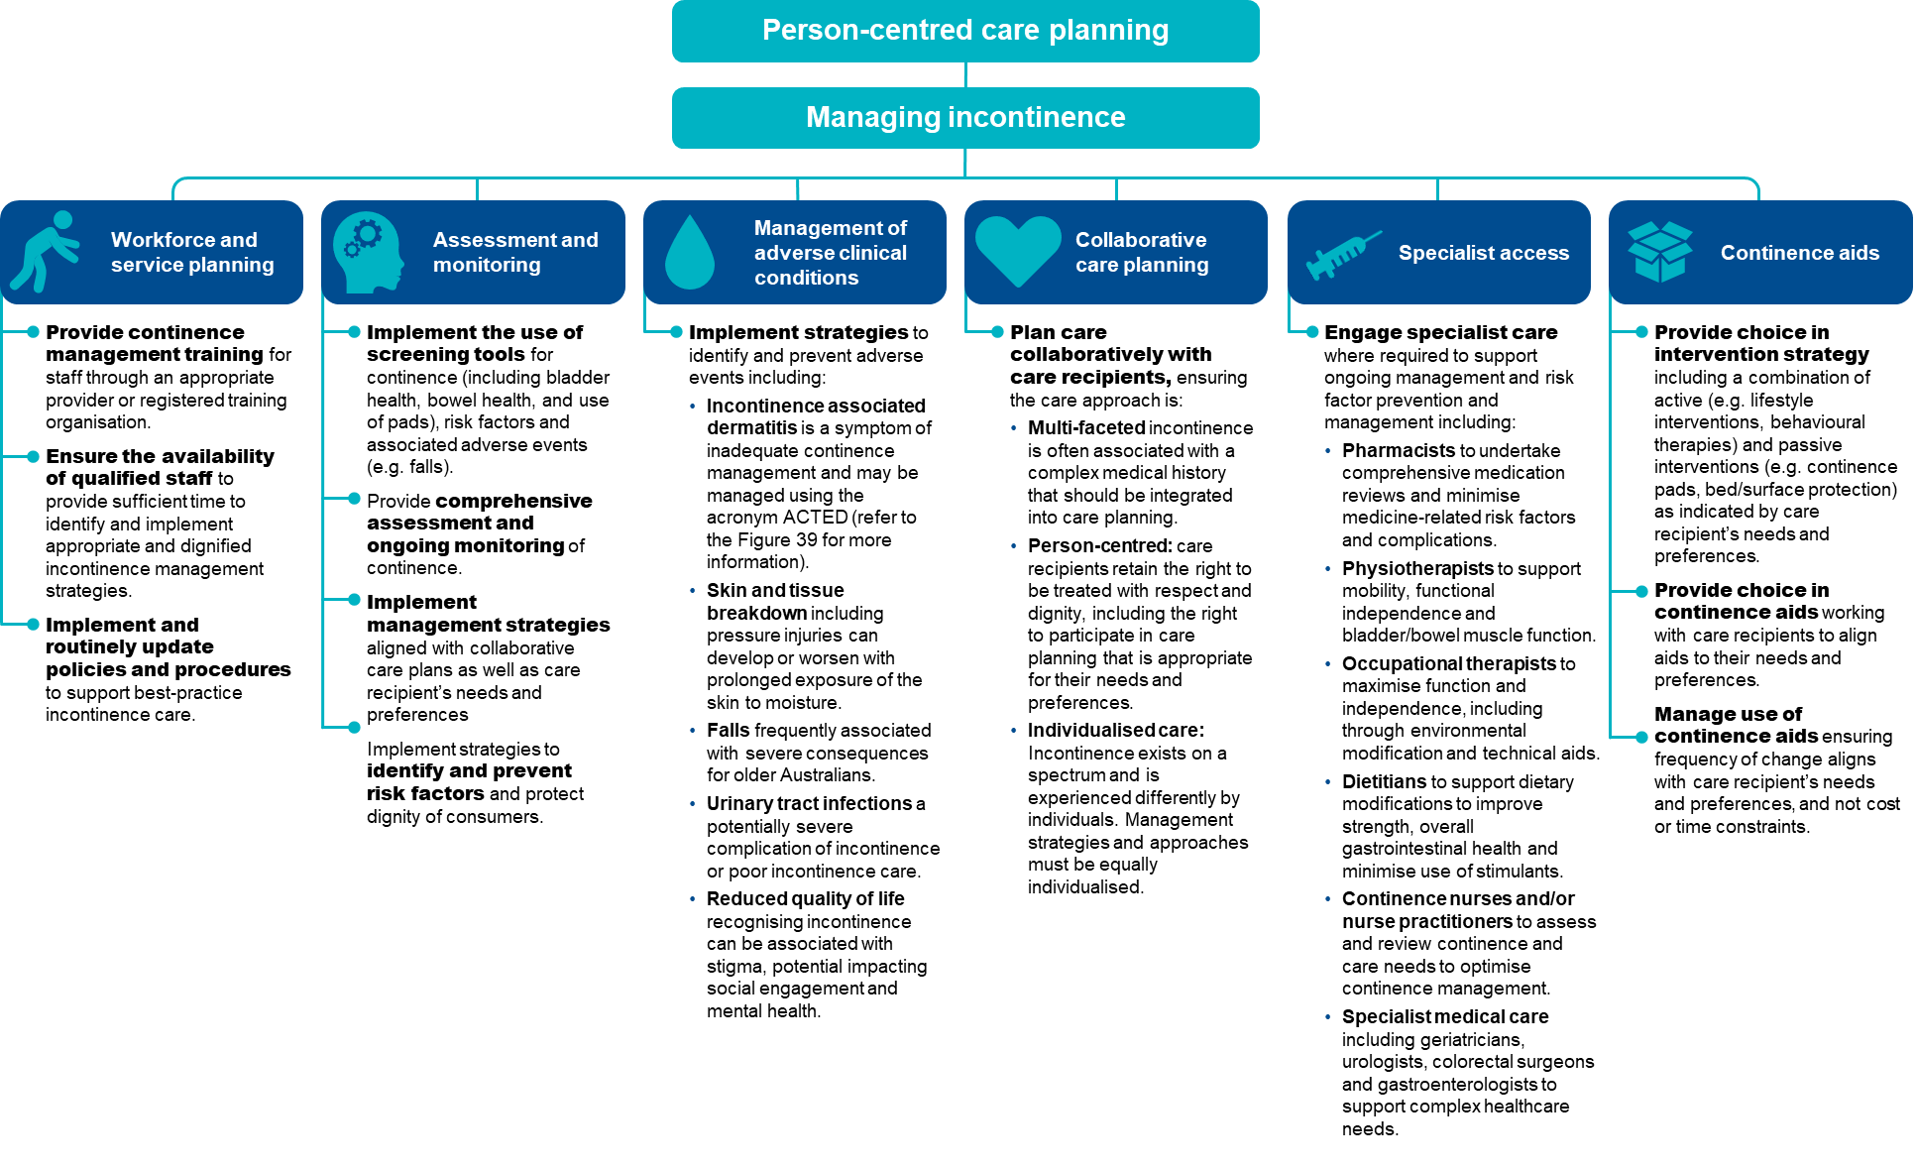
FIGURE 40: INCONTINENCE ASSOCIATED DERMATITIS MANAGEMENT USING THE ACTED FRAMEWORK159F
Incontinence associated dermatitis (IAD) is defined as a specific type of irritant contact dermatitis characterised by erythema and oedema of the peri-anal or genital skin. In some cases, IAD is accompanied by bullae, erosion or secondary cutaneous infection. IAD is often associated with poor quality incontinence care, often as a result of prolonged exposure to soiled pads. For the purposes of the QI Program, it must be evaluated using the Ghent Global IAD Categorisation Tool. IAD may be managed using the ACTED framework.
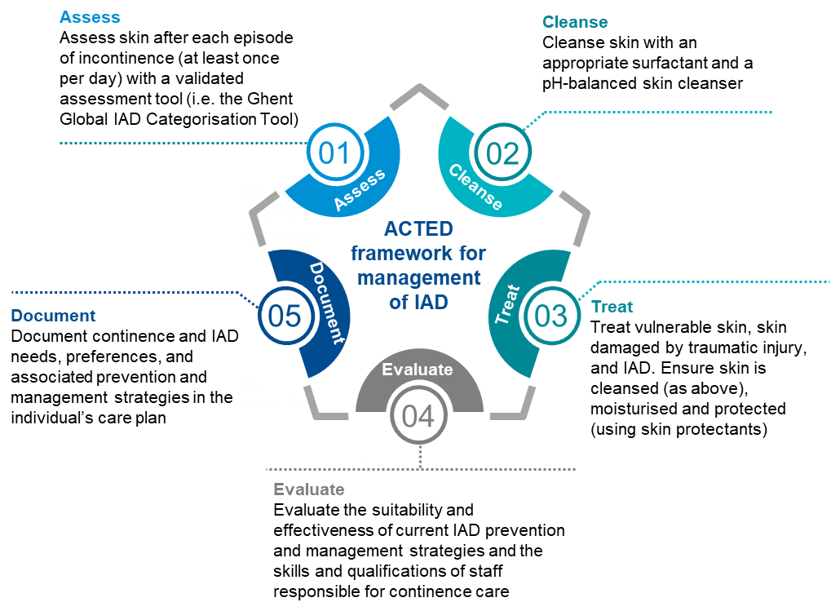

The checklist below will help assess care recipients who are at risk of incontinence and identify support and prevention strategies.
FIGURE 41: CHECKLIST FOR THE MANAGEMENT OF INCONTINENCE AND PREVENTION OF IAD
Checklist for the management of incontinence and prevention of IAD

Undertake a baseline assessment
- Assess incontinence using a suitable assessment tool.
- Identify any changes in continence and note the specific area of change.
- Identify any risk factors for incontinence (e.g. comorbidities, medications, mobility issues).
Undertake ongoing screening and comprehensive assessment
- Screen care recipients regularly and provide comprehensive assessment in response to changes, including:
- when first admitted to a residential aged care service (full assessment)
- at pad change or when emptying bladder/bowels (assess skin integrity, assess frequency of incontinence e.g. daily, greater than 3 times)
- after a change in health status
- on return from a different care setting (e.g. following hospital admission or homestay).
Document findings in care record and undertake collaborative care planning
- Document care recipient’s assessment findings in their care record (e.g. changes in continence, mobility, cognition, other adverse clinical events).
- Document risk factors for incontinence.
- Undertake collaborative care planning, ensuring alignment with care recipient’s needs and preferences for management.
- Identify and document suitable prevention strategies.
Implement appropriate multi-faceted strategies aligned with care recipient’s need and preferences
- Implement a continence management strategy including toileting regime/plan
- Select suitable continence aids and management strategy, considering
- skin integrity
- frequency of changes
- severity and type of incontinence
- level of independence, mobility and dexterity
- care recipient’s abilities and preferences.
- Engage appropriate clinical care:
- pharmacist
- physiotherapist
- occupational therapist
- dietitian
- continence nurse
- geriatrician
- urologist/colorectal surgeon.
Recognise and manage adverse clinical events associated with incontinence
- Skin and tissue breakdown (e.g. pressure injury and incontinence associated dermatitis).
- Falls.
- Activity of daily living decline.
- Infection.
- Social withdrawal.
- Reduced quality of life.

Quality improvement for incontinence
Quality improvement can help providers increase quality of care for care recipients experiencing incontinence and/or IAD. Quality improvement activities should be ongoing and part of business-as-usual for approved providers. The QI Program will help prompt when a specific quality improvement activity should be undertaken. It is important to review the QI Program data reports through GPMS and compare against national averages and other services to understand where quality improvement activities should be focused.
The Plan-Do-Check-Act tool (section 2.3) is a useful tool to plan, deliver and monitor quality improvement activities focused on managing incontinence.

Example tools, guidance and resources to support continuous quality improvement
- Ghent Global IAD Categorisation Tool — provides standardised approach to IAD recognition, management, documentation and is the selected IAD assessment tool that must be used in the QI Program — Ghent University — available in Part A: Appendix B
- Model of Continence Care (previously Continence SMART Care) — an evidence-based, person centred, clinically informed practice model of continence care for aged care — National Aging Research Institute
- Incontinence-associated dermatitis: Moving prevention forward: Addressing evidence gaps for best practice — practical guidance on how to assess, prevent and manage IAD based on available evidence and expert opinion — Wounds International
- Incontinence Associated Dermatitis Best Practice Principles — best practice principles providing information about IAD risk factors, recognition, assessment, prevention and management — New South Wales Health Clinical Excellence Commission
- Incontinence in Australia — report providing background information and prevalence of incontinence in Australia, as well as hospital and residential aged care admissions relating to continence — Australian Institute of Health and Welfare
- Literature Review of Incontinence Associated Dermatitis — journal article discussing best practice strategies for managing IAD — Advances in Skin & Wound Care
- National Continence Helpline — a free confidential hotline providing information, advice and support from continence nurses — call 1800 33 00 66 Monday to Friday 8am-8pm AEST/AEDT— Continence Foundation of Australia
- Continence Resources for Aged Care — free resources to help guide best practice continence assessment and management — Continence Foundation of Australia
- Continence Support Now — a free pocket guide for disability and aged care workers providing bladder and bowel support — Continence Foundation of Australia
- Continence Learning — courses and information to support learning in relation to continence — Continence Foundation of Australia
Some tools, guidance and resources may be updated over time; it is important to ensure you are looking at the most recent version.

Hospitalisation
Many emergency department presentations or admissions to hospital are avoidable if care recipients have timely access to appropriate healthcare services. Excessive transfers of care recipients to the emergency department may indicate poor care quality or access.

Overview of hospitalisation
Care recipients are often transferred to a hospital to receive care that may not be available in the residential aged care service. Some of these transfers are considered avoidable, either through prevention of the illness that results in the need for transfer, or by management of the problem locally at the residential aged care service.
FIGURE 42: HOSPITALISATION IN RESIDENTIAL AGED CARE160F 161F 162F 163F
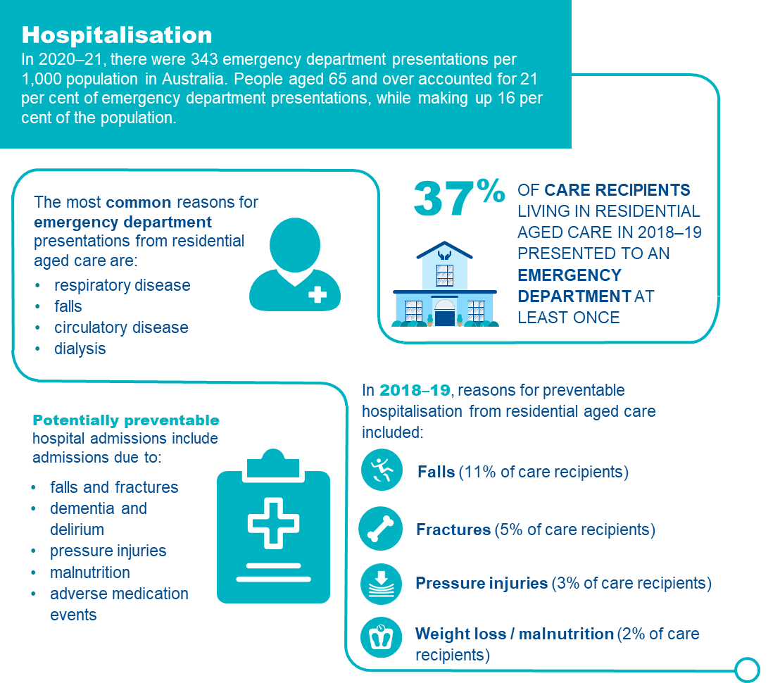

Hospitalisation in residential aged care
Many emergency department presentations and admissions to hospital are avoidable if care recipients have timely access to appropriate care. Excessive transfers to hospital may indicate poor care quality and access.
Hospitalisation is recognised as an important and necessary channel of care, including for older Australians. Aged care services should never avoid or prevent hospital transfer or emergency department presentation if it is required.164F
To support quality of care, it is important to identify and monitor emergency department presentations that could be avoided with appropriate care. There are two circumstances that give rise to inappropriate hospitalisations:165F
- Inadequate expertise and/or resources at the residential aged care service: Many illnesses or incidents are best managed at the residential aged care service. This includes conditions that are relatively minor, where transfer to hospital is inconsistent with the care recipient’s preferences, or where hospital care offers limited value, or
- Avoidable illnesses or injuries: This occurs when the condition results from inadequate provision of care or services (e.g. falls resulting in injury, poorly maintained vaccination program, or development of a pressure injury).
Details of collection and reporting requirements for the hospitalisation quality indicator can be found in QI Program Manual Part A.

Causes of hospitalisation
Hospitalisation is necessary when:166F 167F
- there is a requirement for investigation or treatment available exclusively at the hospital
- the appropriate type and/or standard of care is not available at the residential aged care service
- hospitalisation is the preference of the care recipient or surrogate decision makers and is appropriate.
Common causes of emergency department presentation or unplanned hospitalisation from residential aged care are:168F
- cognitive decline
- dementia and delirium
- activity of daily living decline
- falls
- fractures
- reduced mobility
- malnutrition
- medication mismanagement
- inadequate ambulatory care
- inadequate assistance with activities of daily living
- chronic conditions that are not adequately monitored or managed.

Risk factors for hospitalisation
Individual risk factors
Rates of hospitalisation are influenced by the characteristics of the care recipient, the residential aged care service, access to and provision of timely healthcare services, and the broader health system.169F
In Australia, the strongest predictors of unplanned hospitalisation or emergency department presentation from residential aged care at the individual care recipient level are:170F
- Care recipient needs and attributes — being male, higher age, history of delirium, higher activity of daily living needs, complex behaviour and complex care needs
- Healthcare support — number and recency of healthcare use (including hospital and general practitioner attendance)
- Medication — use of a high sedative load or polypharmacy.
Service risk factors
Risk factors at the organisational level include poor access to specialist medical and nursing expertise, poor contingency planning for minor acute illnesses and lack of ongoing coordination with local specialist services and hospitals.
Of these risk factors, several may be measured, monitored and/or influenced by services, at both the organisational and individual care recipient level, and these should be the focus of risk mitigation.

Adverse clinical events and hospitalisation
Hospitalisation exposes care recipients to hospital-acquired complications.171F These can have significant impacts on the care recipient, and their subsequent independence and care requirements. Common hospital acquired complications include:
- infection
- malnutrition
- cardiac complications
- delirium
- depression
- deconditioning
- falls
- reduced independence and mobility.

Prevention and management of hospitalisation
Emergency department presentations and admissions to hospital can be reduced with a systematic, person-centred approach. This includes focusing on access to resources to provide appropriate care such as skilled staff; primary, specialist and preventive healthcare; and practices to identify, manage, monitor and escalate care needs. Care planning and management should align with care recipient preferences, including for end-of-life care.
The rates of avoidable hospitalisations can be minimised by strategies at two levels:
- organisation level to ensure that expertise, resources and systems are available to manage minor conditions within the facility.
- care delivery level to ensure that illnesses and incidents that require hospitalisation are minimised.
Strategies to minimise avoidable hospitalisations at a care delivery level may include:
- Early identification of risk factors: Unmet healthcare needs are cited as the underlying factor for emergency department presentations. Identifying health and care needs and providing interventions before conditions deteriorate can reduce both cost and burden of care.172F This is supported by understanding which care recipients have the strongest predictors for unplanned hospitalisation or emergency department presentation. For example, this could include care recipients that are higher age, have a history of delirium, higher activity of daily living needs, have recently required healthcare and who use high sedative load or polypharmacy.
- Monitoring care recipient progress: Early identification of risk factors and changes in health status guides decisions about further monitoring requirements, facilitates communication with primary care providers, identifies appropriate hospital transfer requirements and informs management strategies to maintain quality care.173F
- Care provision by appropriately skilled providers: Access to skilled carers, nurses and other healthcare providers with appropriate education and training, combined with skilled staff to provide appropriate interventions, is associated with lower hospitalisation rates.174F 175F
- Using multidisciplinary teams coordinated by residential aged care staff: Access to primary and specialist care networks to provide care specific to individual care needs (communication channels, telehealth, transport to outpatient appointments) can prevent the requirement for hospitalisation.176F Trained staff provide guidance to embed changes in daily practices and improve care outcomes.
- Support with appropriate resources: Including appropriately integrated communication systems such as:
- Health information technology improves communication and outcomes, offering access to care staff that facilitate effective early identification and continued monitoring of care recipient’s health condition, leading to improvements in safety and reduced hospitalisation.177F 178F
- In-reach and outreach specialist care teams to optimise access to care and care integration.
- Telehealth provides expanded access to care and addresses coverage gaps, particularly in rural/remote areas, reducing staff burnout and costs, providing timely access to specialist input and improving outcomes.179F 180F 181F
- Collaborative care planning, including advance care planning: Completion of advanced care planning with care recipients, their families or representatives is associated with reduced hospitalisation and care provision that aligns with care recipient preferences.182F 183F 184F 185F
FIGURE 43: PREVENTING AVOIDABLE HOSPITALISATION
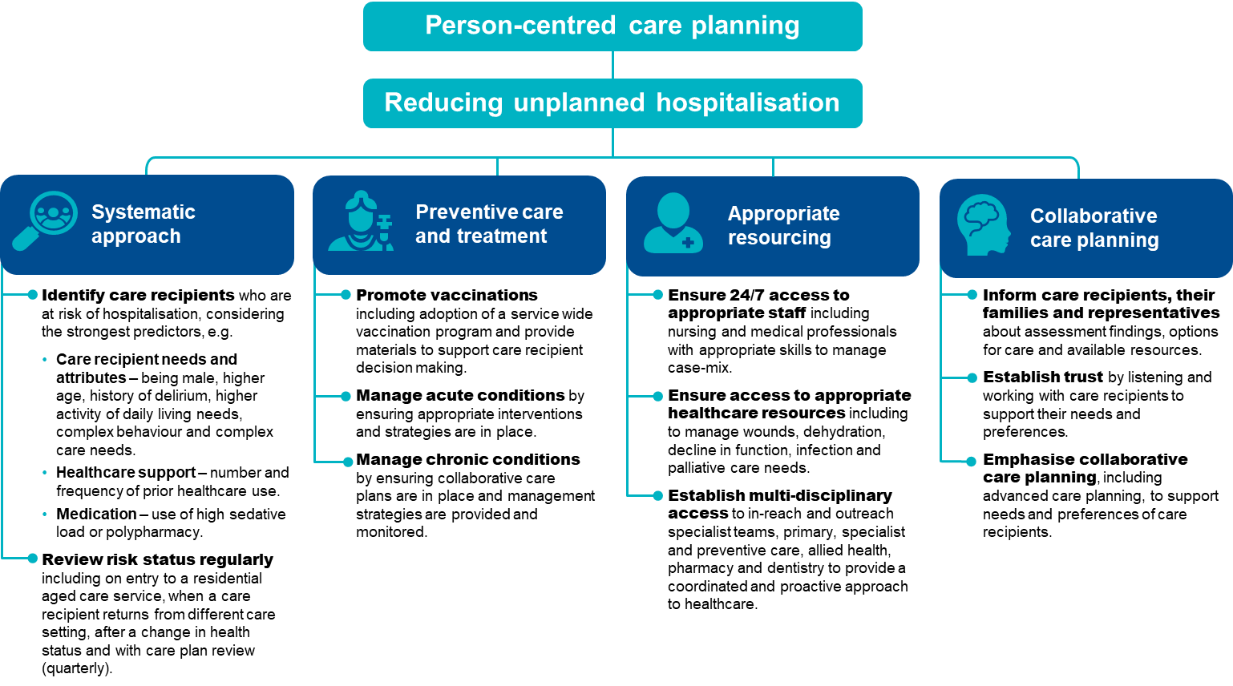

The checklist below will help assess care recipients who are at risk of hospitalisation and identify support and prevention strategies to reduce the risk of avoidable hospitalisation.
FIGURE 44: CHECKLIST FOR THE PREVENTION OF AVOIDABLE HOSPITALISATION
Checklist for the prevention of avoidable hospitalisation
Use a systems approach
- Routinely check and monitor risk factors for hospitalisation.
- Ensure appropriate management strategies are in place to optimise health and wellbeing.
- Provide collaborative multidisciplinary care.
- Use integrated health information technology systems for improved communication and information sharing.
Deliver preventive care and treatment
- Coordinate timely vaccination.
- Ensure preventive measures are in place to avoid acute episodes.
- Provide evidence-based care for chronic health conditions.
- Undertake collaborative care planning ensuring alignment with care recipient’s needs and preferences for management.
Provide appropriate resourcing
- Enable access to skilled staff at appropriate times.
- Ensure appropriate equipment and resources are available.
- Establish suitable programs to access hospital in-reach/outreach services.
- Develop and use collaborative networks using local primary healthcare providers.
- Provide access to relevant specialist care, including via outpatient services and telehealth.
Undertake collaborative care planning
- Document all relevant information clearly in an individual care plan, providing clarity for all care providers and decision makers.
- Provide care and documented interventions as per care plan to meet care needs.
- Regularly review (quarterly or when health status changes) care plan with care recipient, their family or representative.
- Identify and document service and care recipient expectations.

Quality improvement for hospitalisation
Quality improvement can help providers increase the quality of care for care recipients who are at elevated risk of avoidable hospitalisation. Quality improvement activities should be ongoing and part of business-as-usual activities for providers.
The QI Program will help prompt when a specific quality improvement activity should be undertaken. It is important to review the QI Program data reports through GPMS and compare against national averages and other services to understand where quality improvement activities should be focused.
The Plan-Do-Check-Act tool (section 2.3) is a useful tool to plan, deliver and monitor quality improvement activities focused on reducing avoidable hospital admissions.

Example tools, guidance and resources to support continuous quality improvement
- Engage with your local health service and/or Primary Health Network to participate in suitable programs e.g. hospital in the home, aged care rapid response teams, in-reach/outreach specialist services, integrated care programs, paramedic extended care options, falls prevention programs. Examples include, Aged Care Emergency (ACE) pilot program for the provision of Extended Care Paramedic (ECP) responses to Residential Aged Care Facilities.
- Engage with your Primary Health Network for support to develop afterhours care plans
- Looking at how to reduce hospitalisation in aged care facilities by improving aged care support services — news article providing six areas to review when trying to reduce hospitalisation in aged care — Aged Care Prepare
- Agency for Healthcare Research and Quality — online training modules for improving patient safety in long term care facilities (USA based)
- Advance care planning resources — planning documents, training and education resources are available at Advanced Care Planning Australia or End of Life Directions for Aged Care
- Study identifies how to minimise resident infection-related hospitalisations — news article describing Monash University study on prevention of infection related hospitalisations — Australian Ageing Agenda
- A guide to the potentially preventable hospitalisations indicator in Australia — guide providing information on potentially preventable hospital admissions — Australian Commission on Safety and Quality in Health Care
- Disparities in potentially preventable hospitalisations across Australia, 2020-21 to 2021-22 — report providing information and data on hospital admissions and differences between demographic groups — Australian Institute of Health and Welfare
Some tools, guidance and resources may be updated over time; it is important to ensure you are looking at the most recent version.

Workforce
The aged care workforce is critical to providing quality services to meet the needs of older Australians. There are well established links between the capacity of aged care staff and the quality of care provided. Many older Australians, their families and representatives have reported that continuity of care is the critical element for care recipient wellbeing in residential aged care.

Overview of workforce
Commonwealth-subsidised residential aged care services are expected to have ‘a workforce that is sufficient, and is skilled and qualified, to provide safe, respectful and quality care and services’.186F
The Royal Commission into Aged care Quality and Safety highlighted the significance of workforce continuity and stability to deliver high-quality, person-centred care.187F
The aged care workforce is a vast network of people who work together to deliver a continuum of care to older Australians.188F
In 2020, there were over 208,903 direct care workers or 129,151 full time equivalent positions employed in residential aged care.
FIGURE 45: WORKFORCE IN RESIDENTIAL AGED CARE189F 190F
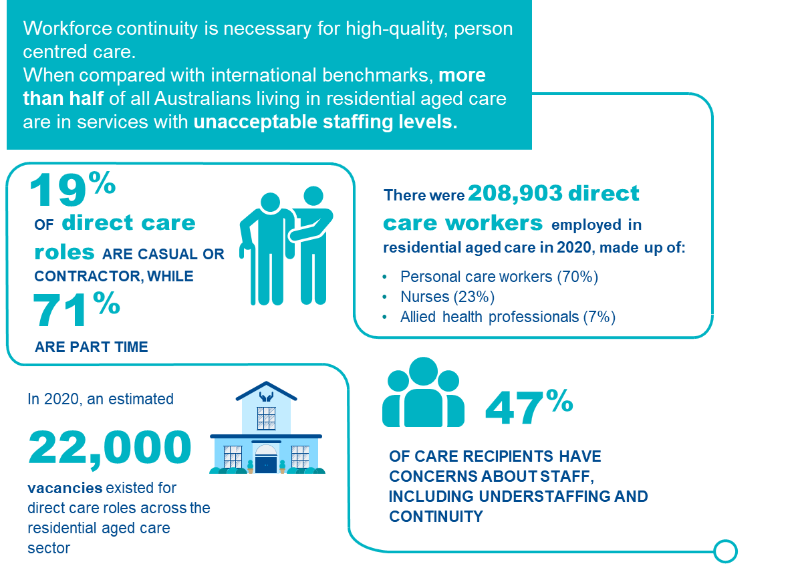

The residential aged care workforce
For the purposes of the QI Program, workforce turnover measures employed staff who stopped working during the quarter.
While many dedicated and compassionate people work in aged care, it is recognised that systemic workforce issues exist, reducing capacity to provide quality care. Seventy per cent of submissions to the Royal Commission into Aged Care Quality and Safety identified staff shortages as the principal barrier to having care recipient care needs met, the consequences of which can be serious or fatal.
Workforce shortages and other factors contribute to higher staff turnover, which subsequently exacerbates workforce shortages and disrupts continuity of care, filtering down to impact on quality of care and quality of life due to workers’ reduced familiarity with care recipients.
Details of collection and reporting requirements for the workforce quality indicator can be found in Part A.

Causes of workforce shortages
Factors that impact workforce shortages and increase staff turnover are multi-faceted and diverse. Common workplace features associated with high staff turnover include:
- organisational funding and design
- insufficient staff numbers
- misalignment of care recipients’ needs and staff skill-mix
- shortage of professional clinical staff (e.g. registered nurses and allied health)
- undervalued and underpaid staff
- inadequate staff training and professional development.

Risk factors for high staff turnover
The main risk factors for staff turnover result from staff feeling unsupported or undervalued at work. These feelings and perceptions can arise from multiple factors, including:
- inadequate leadership
- poor workplace culture
- staff shortages
- inadequate time to complete tasks
- inadequate training
- absence of career framework or opportunities for progression
- lack of professional development.

Adverse clinical events and workforce
There are well established links between the capacity of aged care staff, both in sufficiency and skill, and the quality of care provided. To provide high quality care, staff must feel supported, valued and fairly remunerated. If staff needs are not met, disengagement, inattention and low motivation is likely to occur. Staffing shortages and misaligned skill-mix can lead to poor care and unmet care needs. Standard 7 of the Aged Care Quality Standards requires care recipients to receive quality care and services by a skilled and qualified workforce who are knowledgeable, capable and caring.191F

Prevention and management of workforce turnover
Aged care is reliant upon appropriately trained and engaged staff who feel valued and supported in their role, and who are given sufficient time to provide effective care.
Specific areas that can be targeted to improve staff retention and care continuity can be understood through worker satisfaction surveys and by ensuring information is encouraged to be shared across all levels in the organisation, providing opportunities for staff to raise concerns. Interventions to support workforce retention could include establishing both formal and informal forums where staff can provide regular feedback, enabling participation in mentoring programs or providing staff with access to training programs (both internal and external), preferably during working hours.
Examples of areas where management could focus and where interventions may be required to mitigate workforce turnover include:192F 193F 194F
- Working conditions: Staff must be appropriately remunerated, valued and invested in. The workforce must be sufficient and suitably skilled to provide quality care.
- Job satisfaction: Staff who are satisfied with their work and feel valued, supported and empowered will generally stay active and engaged, improving care quality along with staff and care recipient wellbeing.
- Supportive and visionary management: Staff shortages may require investment and innovation to improve working conditions, and identify alternative approaches to deliver care e.g. through optimised use of line management structures and incorporation of supportive technologies such as health information technology (HIT).
- Supervision and mentorship: Supervision and mentorship can support skill development and practice. It can improve working conditions, resulting in improved performance and overall wellbeing of staff.
- Empowering work culture: Staff who feel empowered have higher levels of self-worth, greater wellbeing and are more invested in their work.
- Collaborative teams: Involvement in team structures and care planning has a beneficial effect on team output, leading to efficiencies in resource use.
- High quality and relevant education: Professional development ensures the right training for the right staff at the right time that leads to provision of high-quality care. Service-wide investment in professional development affords opportunities for staff to develop capacity, feelings of belonging, and value as well as providing currency and relevancy to skill sets.

The checklist below will help assess risk of staff turnover and assist in identification, reporting and mediation of workforce issues.
FIGURE 46: CHECKLIST FOR DEVELOPING A POSITIVE WORKPLACE CULTURE
Checklist for developing a positive workforce culture

Provide focused leadership
- Develop collaborative service goals and articulate roles and responsibilities to achieve them.
- Support staff to work towards service goals.
- Monitor, evaluate and share progress towards service goals.
- Use management frameworks to structure reporting activities.
- Ensure appropriate staff supervision and mentorship.
Create a positive work environment
- Promote staff engagement.
- Collaborate with staff to develop and achieve service goals.
- Establish community and professional networks (e.g. with local services or professionals).
- Implement processes allowing for the escalation of staffing issues by any staff member e.g. reporting of shortages to professional line managers if and as they arise.
- Proactively seek assistance to resolve any workplace issues.
- Consider new and innovative ways of mitigating challenges.
- Ensure frequent, honest and fair communication between staff and management.
Ensure enough of the right staff in the right roles
- Ensure staff have the training and skills to meet the needs and preferences of care recipients including relevance to individual and organisational scope of practice.
- Seek support and assistance from trained professionals whenever there is uncertainty.
- Maintain a flexible and balanced approach to rostering that considers the case-mix and appropriate skill mix required.
- Where possible, adopt an approach to rostering that supports care continuity allowing care recipients to become more familiar with staff.
Prioritise education and training
- Identify areas of need or knowledge gaps and arrange appropriate training.
- Undertake professional development planning with staff, including career planning.
- Collaborate with staff and line managers to identify areas for professional development investment.
- Ensure relevant registrations, qualifications and competencies associated with staff roles are maintained and recorded.
Promote job satisfaction
- Promote staff engagement through team building and social activities.
- Create a safe space to discuss workplace concerns without fear of retribution or punishment.
- Prioritise staff culture and values.

Quality improvement for workforce
Quality improvement can help services reduce staff turnover and improve continuity of care. Quality improvement activities should be ongoing and part of business-as-usual for approved providers.
The QI Program will help prompt when a specific quality improvement activity should be undertaken. It is important to review the QI Program data reports through GPMS and compare against national averages and other services to understand where quality improvement activities should be focused.
The Plan-Do-Check-Act tool (section 2.3) is a useful tool to plan, deliver and monitor quality improvement activities focused on workforce.

Example tools, guidance and resources to
support continuous quality improvement
- Workforce Advisory Service —free, independent and confidential advice for residential aged care service providers to improve workforce planning — Department of Health and Aged Care
- Equip Aged Care Learning Packages — free online learning modules for anyone interested in the aged care sector, including personal care workers, nurses, allied health professionals, volunteers and families — Department of Health and Aged Care
- Aged Care Transition to Practice Program (ACTTP) — mentoring, training and support for new aged care nurses — Department of Health and Aged Care
- Aged Care Nursing and Allied Health Scholarships – provides funding for a range of scholarship opportunities for nurses, personal care workers and allied health workers. Preference is given to applicants living and working in rural, regional and remote areas – Department of Health and Aged Care
- Research Paper 1: How Australian residential aged care staffing levels compare with international and national benchmarks — research paper investigating international and national staffing profiles for residential aged care services in order to better understand how staffing can be improved in Australia — Royal Commission into Aged Care Quality and Safety
- Aged Care Quality and Safety Commission — educational resources and workshops for aged care providers, new workforce entrants and pre-existing staff — Aged Care Quality and Safety Commission
- Nursing guidelines for continuing professional development — guidelines providing information for nurses regarding the expectations and requirements of the Nursing and Midwifery Board Australia — AHPRA
- Aged Care Award — Fair Work Commission (previously fair work Australia)
- The national imperative to improve nursing home quality: Honoring our commitment to residents, families and staff — e-book discusses relevant workforce issues including administration, leadership, licensing, professional development, health and wellbeing of care workers and different types of care workers — National Academies of Sciences, Engineering and Medicine, USA
Some tools, guidance and resources may be updated over time; it is important to ensure you are looking at the most recent version.

Consumer experience

Consumer experience is crucial in capturing the consumer voice of older Australians. Consumer experience represents the perspective of care recipients, or their proxies, to support services tailor and improve quality of care.

Overview of consumer experience
Figure 47 provides an overview of consumer experience in residential aged care services. The data and references have been reviewed March 2025.
FIGURE 47: CONSUMER EXPERIENCE IN RESIDENTIAL AGED CARE195F 196F 197F
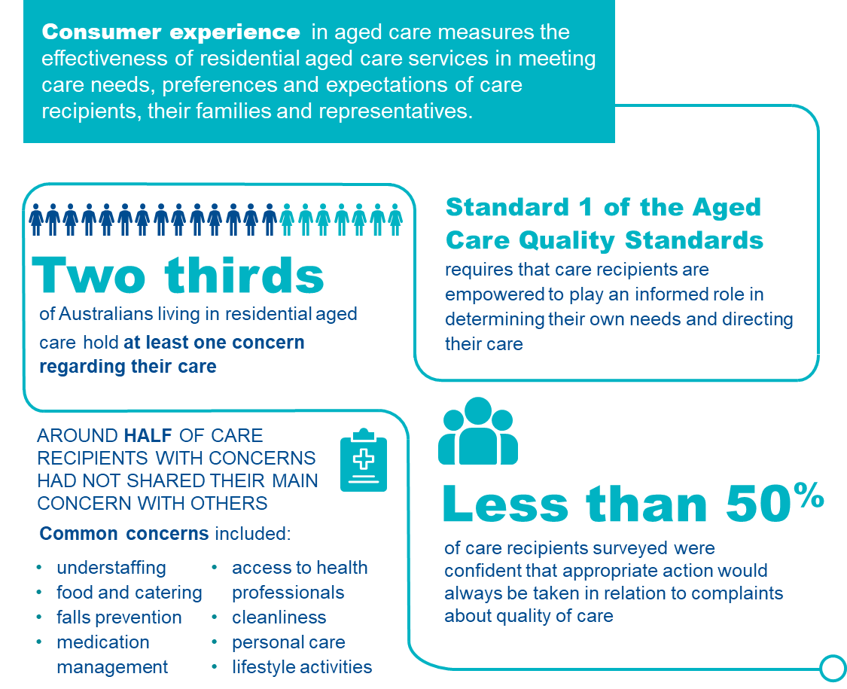

Consumer experience in residential aged care
Collecting, monitoring and responding to consumer experience is necessary to appropriately listen to the voice of care recipients and understand the effectiveness of aged care. For the purposes of the QI Program, six elements of consumer experience are sought from care recipients, or their families and representatives, these are:198F
- Being treated with respect and dignity
- Support to make decisions about care
- Care and support provided by staff with appropriate skills and training
- Services and supports for daily living positively impact on overall health and wellbeing
- Support and encouragement to maintain social relationships and community connections
- Comfort in lodging complaints, with confidence that issues will be appropriately addressed.
Details of collection and reporting requirements for the consumer experience quality indicator can be found in Part A.

Risk factors affecting consumer experience
In residential aged care, consumer experience is negatively impacted when:199F 200F
- transparent processes are not in place for feedback or complaints
- care recipients are afraid of negative consequences if they complain or speak
- care recipients feel their opinion is not listened to or valued
- information sharing is not collaborative
- care does not feel personalised or culturally appropriate
- care recipients feel inferior to their carers
- opportunities to participate in community-based activities are not available.

Adverse clinical events and consumer experience
Negative experiences of residential aged care can lead to a range of physical, psychological and social issues for care recipients, their families and representatives, including:201F
- reduced engagement/withdrawal
- resentment
- loss of autonomy
- distrust
- withholding constructive feedback for fear of retribution
- depression
- neglect
- abuse.

Management of consumer experience
Awareness of factors that contribute to poor consumer experience reduces the risk of adverse clinical events and improves quality of life. Measurement and reporting by service providers can prompt recognition and management of consumer experience and assist with promoting and monitoring the progress of service-wide quality improvement.202F

Families and representatives
Some care recipients may require a proxy to complete consumer experience assessments.203F This includes care recipients who have severe cognitive or communication issues impacting their ability to express their wishes and feelings. The proxy should know the care recipient well and see them regularly. When completing the consumer experience assessment, the proxy should respond based on their own knowledge of the care recipient and their quality of care experience at the time of completion, noting:
- Every attempt should be made to elicit the wishes and opinions of the care recipient, recognising these may differ to the proxy. Care recipients may communicate in non-verbal ways, and their feelings may be elicited by observing their responses to care and various recreational and social activities. These responses form part of collaborative care planning and should be documented following service procedures.
- Proxies, including family and representatives such as substitute decision makers, are often highly sensitive to the needs of care recipients. Their needs may be closely aligned with those of the care recipient. Recognition of the views and needs of these proxies should form part of the program of the service, ensuring that they are welcome, can participate in the life of the care recipient, and that their voice is heard in arranging care.
Figure 48 outlines important aspects of care that optimise consumer experience.
FIGURE 48: MANAGING CONSUMER EXPERIENCE204F 205F 206F 207F
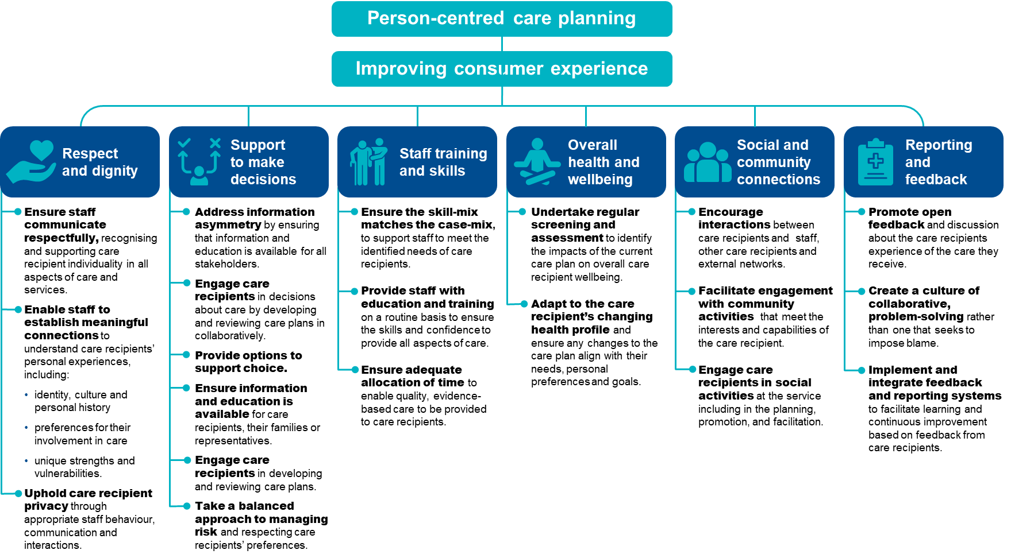

The checklist below will help assess care recipients who are at risk of poor or declining consumer experience and identify support and prevention strategies:
FIGURE 49: CHECKLIST FOR IMPROVING CONSUMER EXPERIENCE
Checklist for improving consumer experience

Educate staff about consumer experience
- Explore opportunities for advancing staff skills and knowledge.
- Ensure alignment of staff skill-mix and case-mix.
Assessment and reassessment using QCE-ACC tool
- Assess with the QCE-ACC assessment tool.
- Identify any baseline indications of diminished consumer experience.
- Identify any risk factors for future deterioration of consumer experience.
Support active participation of care recipient in care planning

- Foster trust and open communication about care recipient needs, preferences and goals.
- Provide options and information to support care recipient choice.
- Encourage and respect care recipient participation in care planning.
- Incorporate collaborative care planning principles into workplace policies and procedures.
Broaden opportunities for care recipients’ involvement in activities
- Explore opportunities for care recipients to contribute to activity program development.
- Provide relevant, timely information about available activities and services.
- Maximise level of care recipient participation, including through use of proxy or advocacy where indicated.
- Adjust activities to suit care recipient health profiles.
Strengthen community culture
- Adapt service specific engagement strategies.
- Encourage social interaction between care recipients, staff and the outside community.
- Include care recipients in plans for community engagement activities.
Create enabling and supportive environments to improve health and wellbeing
- Promote open disclosure and encourage sharing of any health and wellbeing challenges.
- Promote feedback systems, including informing care recipients of follow up actions and outcomes when complaints are handled.
- Integrate systems to facilitate seamless monitoring, identification and management of poor quality care, as evidenced by low quality indicator performance.

Quality improvement for consumer experience
Quality improvement can help providers increase quality of care experience for older Australians in residential aged care. Quality improvement activities should be ongoing and part of business-as-usual for approved providers.
The QI Program will help prompt when a specific quality improvement activity should be undertaken. It is important to review the QI Program data reports through GPMS and compare against national averages and other services to understand where quality improvement activities should be focused.
The Plan-Do-Check-Act tool (section 2.3) is a useful tool to plan, deliver and monitor quality improvement activities focused on optimising consumer experience.

Example tools, guidance and resources to
support continuous quality improvement
- QCE-ACC Quality of Care Experience Aged Care Consumers© — measure identifying aspects of care most important to senior Australians, and the selected assessment tool that must be used in the QI Program — available in Part A: Appendix C
- Care that is right for me: A resource for working with aged care consumers — resource has been designed to support providers of aged care to partner and engage with consumers to drive the delivery of consumer-centred care — Aged Care Quality and Safety Commission
- Research Paper 20: The quality of care experience and community expectations — research paper investigating understanding of older Australian’s experience of aged care and provides guidance on monitoring care recipient’s satisfaction with overall care provided — Royal Commission into Aged Care Quality and Safety
- Guidance and resources for providers to support the Aged Care Quality Standards — online guidance and resources to support aged care providers with implementation of the Aged Care Quality Standards — Aged Care Quality and Safety Commission
- Aged Care Quality Standards consumer outcomes A2 poster — poster describing the consumer outcomes for the Aged Care Quality Standards — Aged Care Quality and Safety Commission
- Quality of Care — information and resources to support provision of high quality healthcare, including strategies on consumer engagement — World Health Organization
Some tools, guidance and resources may be updated over time; it is important to ensure you are looking at the most recent version.

Quality of life
The Royal Commission into Aged Care Quality and Safety noted quality of life should be the constant and predominant aim of aged care. Although the care needs of older Australians may change over time, the desire for a good quality of life does not diminish. Regular monitoring of quality of life is an important part of routine care supporting quality.

Overview of quality of life
Figure 50 provides an overview of quality of life in residential aged care services. The data and references have been reviewed March 2025.
FIGURE 50: QUALITY OF LIFE IN RESIDENTIAL AGED CARE208F 209F
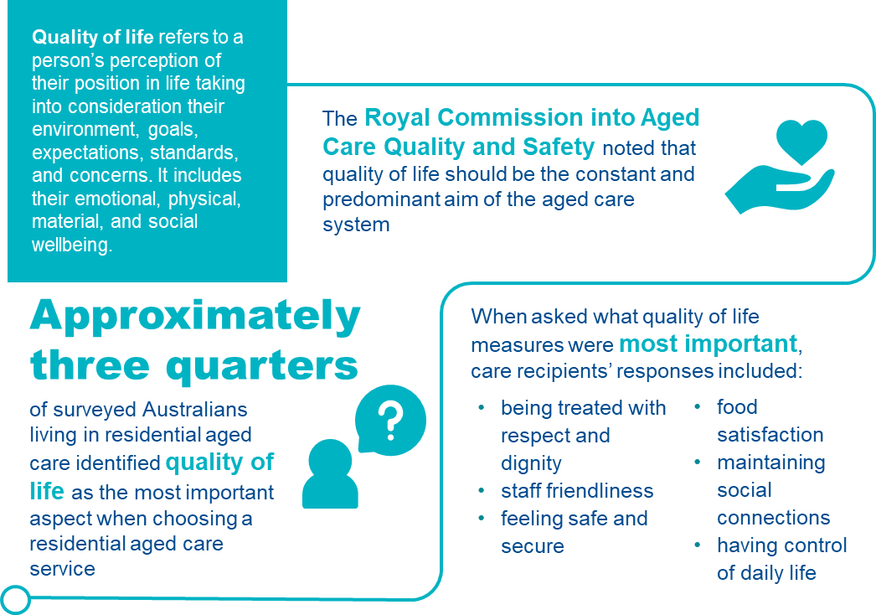

Quality of life in residential aged care
For the purposes of the QI program, quality of life is defined by a person’s perception of their position and purpose, including emotional, physical, material and social wellbeing. It is an important element of aged care, providing consideration for the environment, goals, expectations, standards, and concerns that care recipients may have. The Royal Commission into Aged Care Quality and Safety identified large deficits in the collection of quality of life information and recommended implementation of a quality of life measure.210F
Quality of life is linked to aspects of an individual’s care and experience; including physically, mentally, emotionally, and environmentally.211F Tools to measure quality of life recognise that values change over the life course, and older people, while valuing health, also value independence, safety and control.212F 213F
Optimal quality of life is perceived when care and services promote:214F
- enjoyment
- participation
- expression and creative activities
- maximum physical, mental and psychological function
- ongoing opportunities, stimulation and rehabilitation
- mitigation of displeasure, anxiety and boredom
- creation of legacy and life review
- expression of spirituality and religious practices.
Details of collection and reporting requirements for the quality of life quality indicator can be found in Part A.

Predictors of quality of life
- There are both modifiable and non-modifiable factors that contribute to quality of life. Predisposing predictors of quality of life include:215F
- demographic factors (such as age, gender, geographic location, socio-economic status)
- social factors (such as marital status and social participation)
- individual factors (such as mobility, independence, health and healthcare requirements).
- Modifiable factors can be influenced by services and staff through collaborative care planning, appropriate care provision and access to healthcare.

Risk factors for diminishing quality of life
There are many risk factors for diminishing quality of life across physical, mental and social domains, including:216F
- Physical
- functional decline and mobility loss
- hearing and vision loss
- oral health
- continence
- pain.
- Mental
- depression
- cognitive impairment
- dementia.
- Social
- inadequate financial resources
- social isolation
- boredom
- anxiety.
The majority of risk factors are able to be influenced by the provision of high-quality care in residential aged care services. Factors identified by older Australians in a survey conducted in 2018 as being important to quality of life are illustrated in Figure 51.
FIGURE 51: RELATIVE IMPORTANCE TO QUALITY OF LIFE IN RESIDENTIAL AGED CARE217F
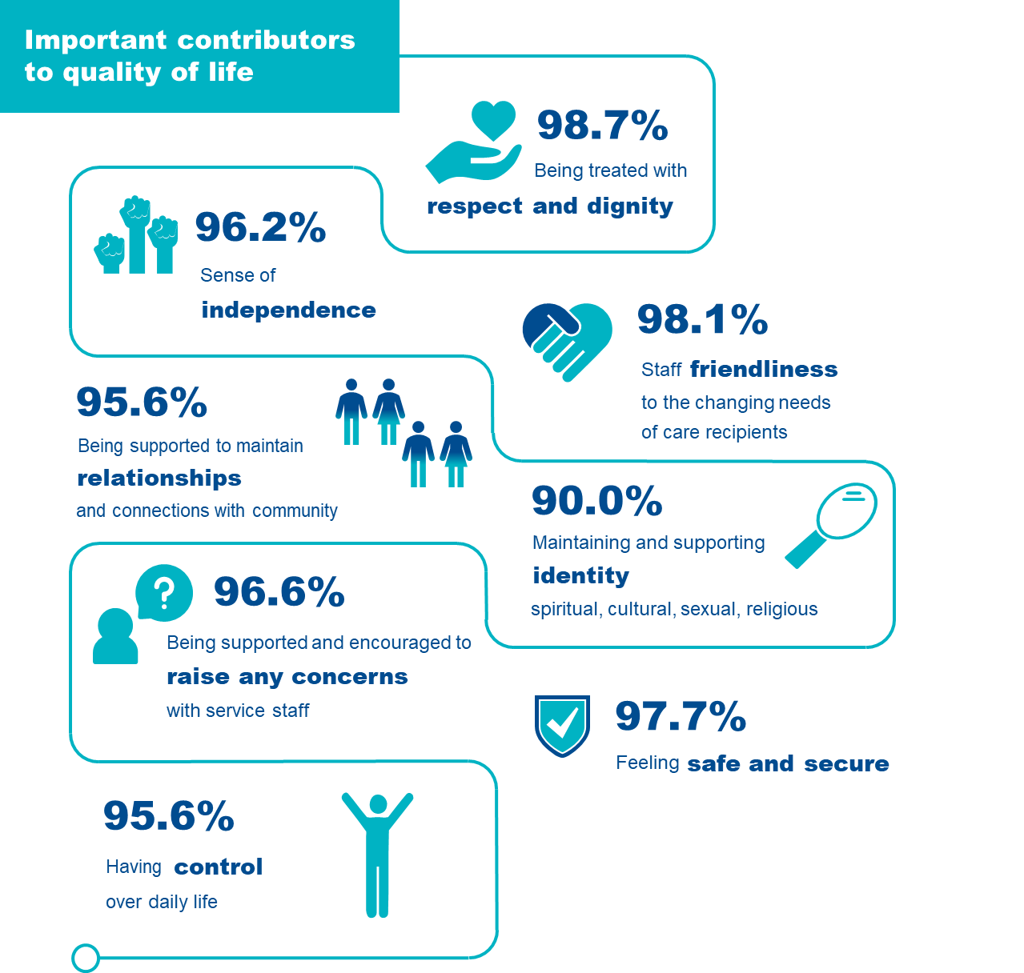

Adverse clinical events and quality of life
Poor quality of life is associated with depression and can impact a care recipient’s ability to respond to life circumstances.218F Reduced quality of life and general dissatisfaction can deepen depressive states and reduce resilience. While improvements in quality of life can improve attitudes and behaviours associated with overall wellbeing, reducing healthcare burden and associated costs.

Improvement and maintenance of quality of life
Awareness of contributors to quality of life can reduce the risk of adverse clinical outcomes and improve overall wellbeing.
Common areas of need influencing quality of life as identified in residential aged care include:
- hearing and vision
- oral health
- continence
- functional ability
- pain
- psychological health
- cultural preferences
- spirituality.
These needs should be incorporated into a comprehensive, collaborative care plan.219F
Physical activity has been shown to reduce depression, improve or maintain functional ability and improve quality of life.220F Reducing loneliness without the need for physical activity has also shown improvements in overall quality of life, including therapies such as:221F
- reminiscence therapy
- laughter
- horticulture
- videoconferencing family and friends
- robotics and artificial intelligence interaction
- logotherapy (a form of psychotherapy encouraging participation through doing, creating, experiencing and attitude modulation)
- pet therapy.
Multi-targeted strategies have shown improvements in global and executive function as well as memory in persons with dementia, including combinations of:222F
- exercise
- cognitive training
- ADL practice
- activity interventions.
Activities allowing expression can include:223F
- wellness (e.g. tai-chi and yoga)
- physical activity
- art
- recreational strategies and activities that assist care recipients to socialise with others
- music therapy
- observance of cultural and religious practices.
Figure 52 outlines important aspects of care that maximise quality of life for older Australians living in residential aged care.

FIGURE 52: MANAGEMENT OF QUALITY OF LIFE224F
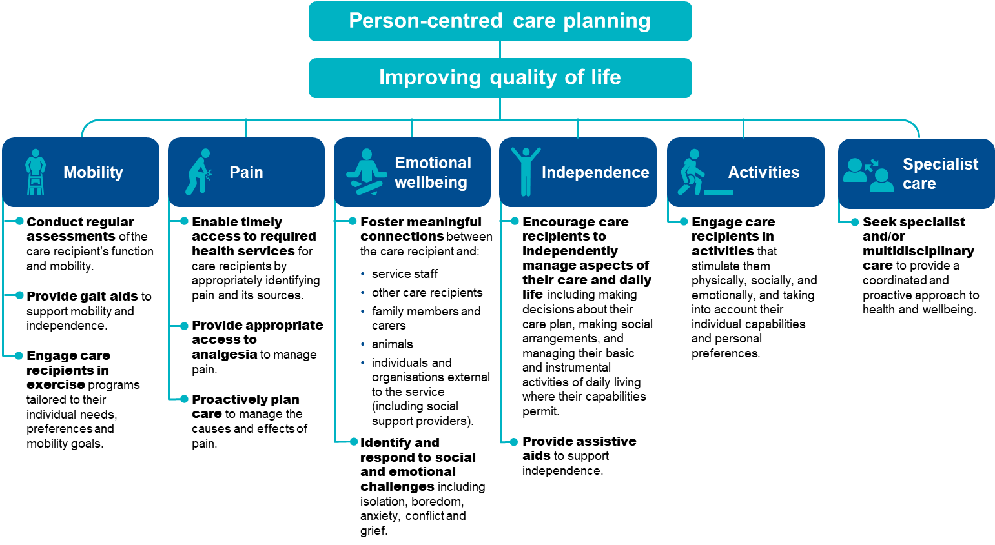

The checklist below will help assess care recipients who are at risk of reduced quality of life and identify support and prevention strategies.
FIGURE 53: CHECKLIST FOR IMPROVING QUALITY OF LIFE
Checklist for improving quality of life
Assessment and reassessment using QOL-ACC tool
- Assess with the QOL-ACC assessment tool.
- Identify any baseline indications of diminished quality of life.
- Identify any risk factors for future deterioration of quality of life.
Review the care plan
- Review and document in the care plan:
- care recipient’s preferences for care and care goals
- care recipient’s current health status
- identified risk factors for reduced quality of life
- quality of life improvement strategies
- undertake collaborative care planning.
- Frequency and timing of improvement strategies.
Implement enabling strategies with a focus on strategies to prevent diminished quality of life such as:
- Ensure involvement of the care recipient in decision-making about their circumstances.
- Promote appropriate and timely access to health-related interventions, analgesia, medication reviews etc.
- Use appropriate and individualised exercise and activity plans.
- Encourage care recipient engagement in available activities that match identified interests.
- Foster community interactions and engagement.
Action items identified in assessment
- Check for withdrawal, increase in disruptive behaviours or expression of dissatisfaction.
- Assess appropriateness of current strategies to maintain quality of life.

Quality improvement for quality of life
Quality improvement can help providers improve quality of life for older Australians in residential aged care. Quality improvement activities should be ongoing and part of business-as-usual for approved providers.
The QI Program will help prompt when a specific activity should be undertaken. It is important to review the QI Program data reports through GPMS and compare against national averages and other services to understand where quality improvement activities should be focused.
The Plan-Do-Check-Act tool is a useful tool to plan, deliver and monitor quality improvement activities focused on relevant quality of life aspects.

Example tools, guidance and resources to support continuous quality improvement
- QOL-ACC Quality of Life Aged Care Consumers© — measure identifying aspects of quality of life most important to senior Australians, and the selected quality of life assessment tool that must be used in the QI Program — available in Part A: Appendix D
- Good Spirit Good Life — is a quality of life assessment tool and framework for use by health and aged care services to identify and enhance the quality of life of older Aboriginal Australians — Aboriginal Ageing Well Research
- The integration of mixed methods data to develop the Quality of Life – Aged Care Consumers (QOL-ACC) instrument — journal article describing the collection and integration of mixed methods data to facilitate the final selection of items for the QOL-ACC
- Services and supports for daily living: Standard 4 — provides guidance and resources relating to services and supports for daily living — Aged Care Quality and Safety Commission
- Measurement tools for assessing quality of life, consumer satisfaction and consumer experience across residential and in-home aged care: a summary report — evidence review of validated tools to measure quality of life, consumer experience or consumer satisfaction — Caring Futures Institute, Flinders University
- Quality of life tools to support measurement of aged care quality — research paper evaluating quality of life tools to support and measure aged care quality — Deeble Institute for Health Policy Research
- What does quality of life mean to older adults? A thematic synthesis — journal article providing a systematic reviews qualitative studies exploring the meaning of quality of life for older adults
- Quality of life factors for older Australians — a news article describing what factors are important for good quality of life factors from the perspective of the older Australian — Aged Care Guide
- Health Related Quality of Life Page — website with links to tools, guidance and resources that support quality of life improvement — Centers for Disease Control and Prevention
- GEN Aged Care Data —repository of information about aged care, including capacity and activity in aged care with a focus on people, assessments and services — Australian Institute of Health and Welfare
Some tools, guidance and resources may be updated over time; it is important to ensure you are looking at the most recent version.

Enrolled Nursing

Overview of Enrolled Nursing
FIGURE 54: ENROLLED NURSING IN RESIDENTIAL AGED CARE225F 226F 227F
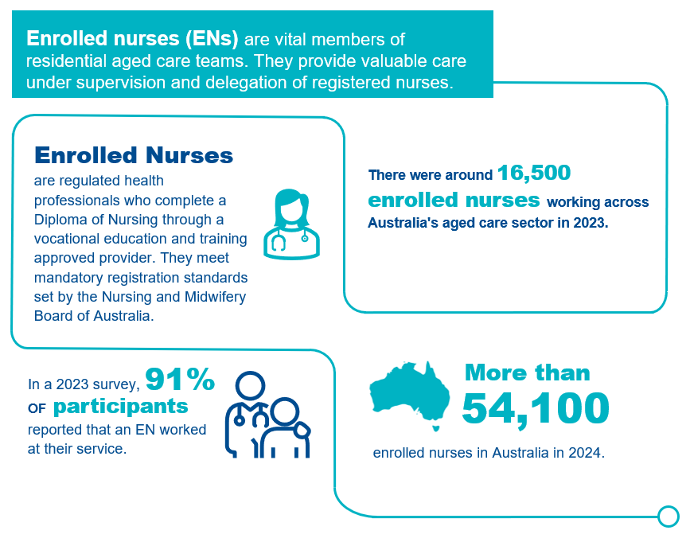

Enrolled Nursing in residential aged care
Enrolled nurses (ENs) provide nursing care under the supervision of a Registered Nurse (RN) or Nurse Practitioner (NP)228F. ENs have the knowledge and skills to:
- provide physical and emotional care,
- engage in reflective and analytical practice,
- administer medication,
- maintain infection prevention and control,
- perform clinical assessments, and;
- contribute to care planning.
ENs are essential members of the aged care team, providing valuable contributions to the care of older people. They collaborate closely with other healthcare workers and provide important clinical expertise, working under the supervision of RNs and within multidisciplinary teams.

Adverse clinical events and insufficient enrolled nursing staff
There are well established links between the capacity of aged care staff and the quality of care provided. Standard 7 of the Aged Care Quality Standards requires care recipients to receive quality care and services by a skilled and qualified workforce who are knowledgeable, capable and caring. The main duties of an EN encompass direct care, clinical care, and care coordination. Therefore, the loss of ENs in aged care can negatively impact both the safety of care recipients and other aged care staff.
Reducing EN staffing in favour of other care staff such as Personal care workers (PCWs) can pose risks for clinical safety and quality of care229F. Most PCWs in aged care have an entry level Certificate III, but the quality of training can be variable. Providing safe, high quality, person-centred care for older people involves the ability to:
- respond to an older person’s preferences and needs,
- work closely with other health professionals,
- accurately assess, plan, treat and respond,
- identify and respond to signs of physical and psychological deterioration, and;
- appropriately escalate concerns230F.
The lack of effective surveillance of older people’s health and wellbeing contributes to poor outcomes when those needs are not promptly addressed, possibly leading to avoidable hospital admissions or further loss of independence.
Preventing insufficient enrolled nursing staff in aged care
FIGURE 55: CHECKLIST FOR PROMOTING ADEQUATE ENROLLED NURSING STAFFING
Checklist for promoting adequate enrolled nursing staffing
 | Create a collaborative work environment  - Collaborate with nursing staff to develop and achieve service goals.  - Ensure appropriate nursing staff supervision and mentorship.  - Develop collaborative service goals and articulate roles and responsibilities to achieve them.  - Establish nursing professional networks (e.g. with local services or professionals).  - Promote staff engagement through team building and social activities.  Monitor care minutes delivery according to staffing category  - Track the proportion of care minutes delivered by RNs, ENs and PCWs as a proportion of the total workforce and evaluate how the staffing and skills mix continues to meet assessed care needs of residents. Reflect on how this fits case-mix.  - Meet up to 10% of service-level RN minutes targets with care time provided by EN, where possible. |  | Act on staff and resident concerns about nursing care capacity and quality  - Create a safe space to discuss workplace concerns without fear of retribution or punishment.  - Implement processes allowing for the escalation of staffing issues by any staff member, resident or representative e.g. reporting of staff shortages to line managers if they arise.  - Ensure frequent, honest and fair communication between staff and management, including concerns such as staff working outside scope of practice.  - Conduct surveillance of resident concerns relating to nursing care capacity and quality by monitoring themes from resident experience and quality of life surveys.  - Monitor nursing staff burnout and workforce turnover.  - Provide access to Employee Assistance Programs to assist staff wellbeing.

Quality improvement for enrolled nursing staffing
Quality improvement can help services provide optimal enrolled nursing staffing and improve continuity of care. Quality improvement activities should be ongoing and part of business-as-usual for approved providers.
The QI Program will help prompt when quality improvement activities may be needed. It is important to review all QI Program data reports through GPMS and compare against national averages and other services to understand where quality improvement activities should be focused.
The Plan-Do-Check-Act tool (section 2.3) is a useful tool to plan, deliver and monitor quality improvement activities focused on workforce.

Example tools, guidance and resources to support continuous quality improvement
- Nursing and Midwifery Board of Australia - Fact sheet: Scope of practice and capabilities of nurses (nursingmidwiferyboard.gov.au) – includes full description of all capabilities and scope of practice for enrolled nurses, registered nurses and nurse practitioners.
- Nursing and Midwifery Board of Australia - Fact sheet: What do nurses and midwives do? (nursingmidwiferyboard.gov.au) - provides an overview of the varying roles and core activities of midwives, registered nurses, enrolled nurses and nurse practitioners.
- Nursing and Midwifery Board of Australia - Fact sheet: Enrolled nurse standards for practice (nursingmidwiferyboard.gov.au) – outlines the core practice standards that provide the framework for assessing EN practice.
- Nursing and Midwifery Board of Australia - Registered nurse standards for practice (nursingmidwiferyboard.gov.au) - registered nurse standards for practice in full which includes delegation to enrolled nurses and others (6.3)
- Nursing and Midwifery Board of Australia – Decision Making Framework (DMF) -– The DMF supports nurses and midwives to make decisions in practice, particularly about scope of practice and delegation.
- Nursing and Midwifery Board of Australia - Professional standards (nursingmidwiferyboard.gov.au) – includes all nursing divisions codes of conduct and practice standards.
- Nursing and Midwifery Board of Australia - Continuing professional development (nursingmidwiferyboard.gov.au) – guidelines and resources on continuing professional development for nurses.
- Education and training for workers | Aged Care Quality and Safety Commission – includes learning content for aged care providers and workers via the ‘ALIS’ platform.
- Nursing and allied health scholarships | Australian Government Department of Health and Aged Care - outlines funded scholarship opportunities through the Australian College of Nursing.

Allied Health

Overview of allied health
Figure 56 below provides an overview of lifestyle in residential aged care. The data and references have been reviewed March 2025.
FIGURE 56: ALLIED HEALTH STAFFING IN RESIDENTIAL AGED CARE231F 232F 233F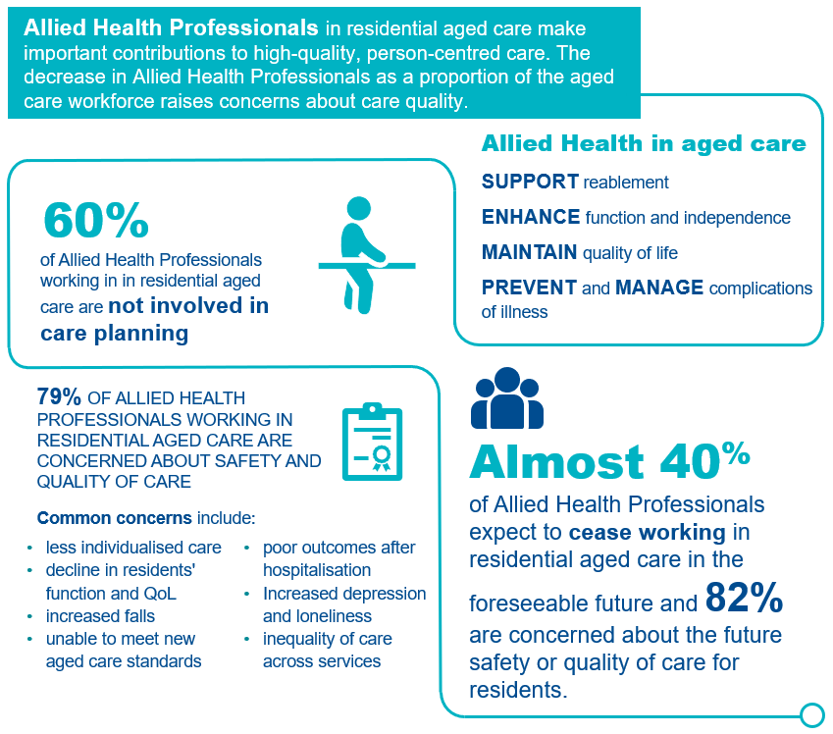

Allied health in residential aged care
Allied health professionals play a critical role in enhancing functional health and quality of life for people living in residential aged care. They use specialised knowledge and skills to enable older people to function well physically, socially and emotionally. In residential aged care allied health professionals apply knowledge, skills and expertise to:
- prevent and manage common issues (e.g. swallowing issues, falls, malnutrition, chronic pain, wounds)
- support reablement to enhance function and independence
- help maintain care recipients’ quality of life,
- educate and upskill the aged care workforce.
For the purposes of the QI program, allied health includes the following professions in line with current definitions from the Quarterly Financial Report (QFR)234F:
- occupational therapy,
- speech pathology,
- podiatry,
- dietetics,
- allied health assistant,
- ‘other’ allied health, including:
- art therapists,
- audiologists,
- chiropractors,
- counsellors,
- diabetes educators,
- exercise physiologists,
- music therapists,
- osteopaths,
- psychologists,
- social workers.
Allied health assistants (AHAs) perform a valuable role in aged care. Benefits of an AHA service may include:
- increasing clinical capacity and allowing allied health professionals to focus on more high-level tasks,
- providing improved access and continuity of service to care recipients235F.
However, AHAs are not always qualified allied health professionals. They must work under the supervision of allied health professionals and be subject to a delegation framework. Employing AHAs without these checks in place may have negative implications for quality and safety236F.
The allied health quality indicators measure allied health care minutes per resident per day, and the percentage of recommended allied health services received. Details of the collection and reporting requirements for the allied health quality indicator can be found in Part A.

Allied health staffing in residential aged care
In Australia and internationally, the delivery of allied health services is highly variable in residential aged care. Service delivery is impacted by many factors - including funding, facility size, rurality, service demand, and health status of care recipients. Overall, data quality on allied health staffing and the relationship with outcomes for care recipients in Australia is limited.

Consequences of insufficient allied health staff in aged care
The Royal Commission concluded that allied health service provision is essential for reablement. Under-provision and undervaluing of allied health care negatively impacts morbidity, mortality and quality of life237F. Due to incidents such as falls, or simply because of the ageing process, older people can experience loss of capacity. Reablement is about preventing such losses where possible. Allied health practitioners provide clinical care with a focus on preventing functional decline, along with early intervention and treatment to support function and quality of life.
Increased allied health staffing levels are linked with positive outcomes for older people in residential aged care. Examples from international studies include the following positive outcomes associated with increased hours per resident per day of physiotherapy and occupational therapy staffing238F:
- improved performance in activities of daily living;
- decreased frequency of falls; and
- increased care quality.
Additionally, higher levels of dietitian staffing have also been linked to improved nutritional outcomes, meal satisfaction and quality of life239F240F241F.
Inappropriately assigning allied health clinical roles and duties to unqualified staff may have negative implications for care quality and safety242F. Examples include the replacement of individual care by group sessions, and the inability of a reduced workforce to provide in-depth care, including time for care planning and restorative approaches. Limits on providing high quality care for care recipients also contributes to lower morale of allied health professionals and could compound the decision to stop working in aged care.
To improve care quality in residential aged care, health systems need to collect data on allied health service provision and identify links to care quality and outcomes for older people.

Adverse clinical events and insufficient allied health services
The Royal Commission received numerous submissions identifying unmet needs of people living in residential aged care, including nutritional, physical, social, cognitive, and communication needs243F. Only 2% of people were reported to be living in homes that provided the 22 minutes of allied health services per day recommended to the Royal Commission as best practice internationally244F.
Failure to adhere to evidence-based clinical practice can result in unsafe care for people living in residential aged care245F. Concerns about how reduced allied health staffing and care provision impact care quality and safety were highlighted in a 2023 survey of allied health professionals246F, including:
- lack of involvement of allied health professionals in care planning resulting in less individualised services provided,
- increases in pain and frequency of falls,
- poor outcomes following hospitalisation post-surgery, stroke or falls, and;
- reduced quality of life and increased loss of function.

Management of allied health staffing
FIGURE 57: ALLIED HEALTH STAFF247F ,248F 249F
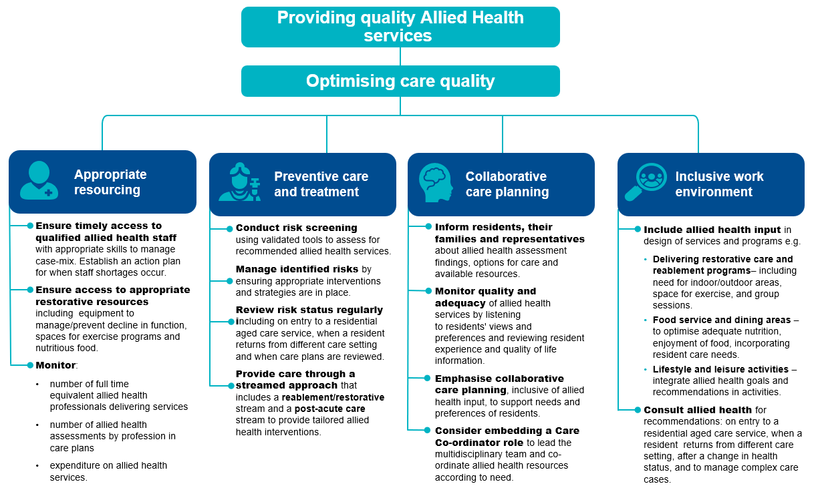

Quality improvement for allied health
Quality improvement can help services provide optimal allied health services and improve continuity of care. Quality improvement activities should be ongoing and part of business-as-usual for approved providers.
The QI Program will help prompt when quality improvement activities may be needed. It is important to review all QI Program data reports through GPMS and compare against national averages and other services to understand where quality improvement activities should be focused.
The Plan-Do-Check-Act tool (section 2.3) is a useful tool to plan, deliver and monitor quality improvement activities focused on workforce.

Example tools, guidance and resources to support continuous quality improvement
- Allied health professions - Allied Health Professions Australia – information about allied health professions and what they do.
- Enabling Clinical Education Skills - ClinEdAus – resources to support high quality clinical placement experiences for allied health students and supervisors through the provision of open access, contemporary, evidence-based clinical education resources.
- Australian Health Practitioner Regulation Agency - About registration – Includes information about registration for health professionals, including allied health practitioners.
- National Alliance of Self Regulating Health Professions (NASRHP) – supports member organisations of self-regulating health professions (over 60% of allied health professions are self-regulating).
- Who can provide allied health care | Australian Government Department of Health and Aged Care – information about regulation of allied health care, the professional organisations involved and allied health in each state and territory.
- Aged Care - Allied Health Professions Australia – includes an overview of how allied health professionals can help improve the health and wellbeing of older people living in residential aged care.

Lifestyle Officer

Overview of lifestyle services
Figure 58 below provides an overview of lifestyle in residential aged care. The data and references have been reviewed March 2025.
FIGURE 58: LIFESTYLE OFFICER SERVICES IN RESIDENTIAL AGED CARE250F 251F 252F
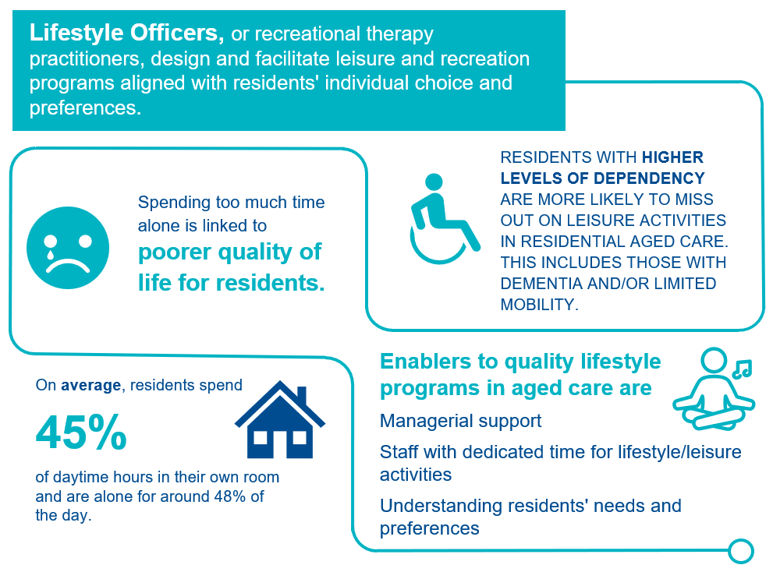

Lifestyle officers and recreational therapy in residential aged care
Lifestyle officers, or recreational therapy practitioners, work with people of all ages and abilities to design and facilitate leisure and recreation programs. Activities are designed to support, challenge and enhance individuals' psychological, spiritual, social, emotional and physical wellbeing. Lifestyle and leisure, or recreational therapy, in residential aged care recognises the right of all individuals to access and engage in leisure and recreational experiences of their choosing.
The lifestyle officer quality indicator measures lifestyle officer care minutes per resident per day, using the labour hours data of diversional/lifestyle/recreation/activities staff submitted through the Quarterly Financial Report (QFR). Details of the collection and reporting requirements for the lifestyle officer quality indicator can be found in Part A.

Benefits of lifestyle and recreational therapy services in aged care
Australian data indicates that aged care recipients spend a large part of daytime hours sitting alone in their rooms, often engaging in limited social interactions and little activity253F. In a 2022 survey254F, the aged care workforce nominated ‘meaningful lifestyle activities’ as a priority concern for the sector. Evidence on the benefits of meaningful lifestyle activities in aged care exists for specific interventions. Meaningful lifestyle activities may be ones that older people:
- are familiar with,
- have participated in previously, and;
- align with their personal preferences and identity.
Lifestyle and recreational therapy programs may offer resident benefits in terms of improving mobility and depression, and provide more benefit when individualised to specific interests and physical and cognitive abilities. Providing meaningful or individualized activities for people with dementia living in residential aged care may improve behavioural issues associated with dementia and enhance quality of life255F.
Enablers to leisure provision in residential aged care include256F:
- managerial support,
- availability of staff with dedicated time for lifestyle/leisure activities,
- ability of staff to identify opportunities to implement person-centred leisure activities, and;
- staff having a good understanding of care recipients’ individual needs and preferences.
Barriers to leisure provision in residential aged care include:
- lack of appropriate staff,
- competing role demands, and;
- prioritisation of clinical over physical and social aspects of care.
Additionally, significant cognitive impairment is often considered a barrier to leisure participation, and care recipients requiring significant physical assistance to join activities are more likely to miss out.
Where competing work demands are a barrier, facilitating leisure in a more informal way may create opportunities for more person-centred approaches. This requires staff to adopt a broad understanding of what activities may be considered leisure, in consideration of individual preferences257F.
Checklist for lifestyle and leisure services in aged care
FIGURE 59: CHECKLIST FOR LIFESTYLE AND LEISURE SERVICES IN AGED CARE
Checklist for lifestyle and leisure services in aged care
 | Educate staff about lifestyle and leisure activities and practice  - Provide lifestyle and leisure education internally to all staff, including managers.  - Ensure lifestyle and leisure education includes best practice approaches and considers psychological, spiritual, social, emotional and physical wellbeing domains.  - Ensure alignment of staff skill-mix and case-mix, to include dedicated time for lifestyle and leisure programs. |  | Assessment and reassessment of lifestyle and leisure needs  - Assess for resident needs, preferences and goals in psychological, spiritual, social, emotional and physical wellbeing domains.  - Reassess at regular intervals, adhering to best practice recommendations.  - Identify any risk factors for limited participation.
 | Support active participation of residents in planning lifestyle and leisure programs  - Explore opportunities for residents to contribute to lifestyle and leisure program development.  - Provide relevant, timely information about available activities and services.  - Provide options and information to support residents’ choices.  - Maximise level of resident participation in planning, including through use of proxy or advocacy where indicated. |  | Strengthen links between the service and the community  - Adapt service specific engagement strategies.  - Encourage social interaction between residents, staff and the outside community.  - Include residents in plans for community engagement activities.
Create enabling environments to improve participation in lifestyle and leisure activities
- Adjust activities to suit resident health profiles.
- Regularly update care plans to include mitigation of any barriers to activity attendance.
- Promote open disclosure and encourage sharing of any health and wellbeing challenges.
- Consider available space, equipment and design to remove physical barriers to participation.

Quality improvement for lifestyle officer staffing
Quality improvement can help services provide optimal lifestyle officer services and improve continuity of care. Quality improvement activities should be ongoing and part of business-as-usual for approved providers.
The QI Program will help prompt when quality improvement activities may be needed. It is important to review all QI Program data reports through GPMS and compare against national averages and other services to understand where quality improvement activities should be focused.
The Plan-Do-Check-Act tool (section 2.3)) is a useful tool to plan, deliver and monitor quality improvement activities focused on workforce.

Example tools, guidance and resources to support continuous quality improvement
- Australian Recreational Therapy Association [ARTA] – website of Australia’s peak membership body supporting recreational therapy practice.
- Barriers and enablers to leisure provision in residential aged care: personal care attendant perspectives | Ageing & Society | Cambridge Core – a descriptive study investigating barriers and enablers to the provision of leisure activities for people living in three Australian RACFs.
- Social interactions and quality of life of residents in aged care facilities: A multi-methods study | PLOS ONE – a multi methods study focusing on the frequency and duration of interpersonal interactions among residents in RACFs
- Meaningful Lifestyle Activities | Aged Care Research and Industry Innovation Australia – The ARIIA Knowledge and Implementation Hub has brought together the research evidence on meaningful lifestyle activities in aged care with Australian online learning, practice tools and resources.

Health.gov.au
All information in this publication is correct as at March 2025

Endnotes

Batalden PB and Davidoff F. What is “quality improvement” and how can it transform healthcare? BMJ Quality & Safety 2007; 16(2-3).
Aged Care Quality and Safety Commission. 2021. Continuous improvement. Sourced. https://www.agedcarequality.gov.au/providers/assessment-processes/continuous-improvement
Bogaisky M, Dezieck L. Early hospital readmission of nursing home care recipients and community-dwelling elderly adults discharged from the geriatrics service of an Urban teaching hospital: Patterns and risk factors. J Am Geriatr Soc, 2015; 63(3): 548-552.
Jeon Y-H, Casey A-N, Fethney J, Poole B, Vo K, Rogers K. Associations between clinical indicators of quality and aged-care care recipients' needs and consumer and staff satisfaction: the first Australian study. Aust Health Rev. 2019;43(2):133-41.
Ferguson C, Prentice J, Crouchley K, Ling A, Mason L. Pressure injury point prevalence: state-wide survey to identify variability in Western Australia hospitals. Australian Journal of Advanced Nursing, 2019; 36(4): 31.
Stevenson R, Collinson M, Henderson V, Wilson L, Dealey C, McGinnis E, Briggs M, Nelson EA, Stubbs N, Coleman S, Nixon J. The prevalence of pressure ulcers in community settings: An observational study. Int J Nurs Stud, 2013.
Clinical Excellence Commission. 2018 NSW Pressure Injury Point Prevalence Survey Report, 2019; Sydney: 9.
Jorgensen M, Siette J, Georgiou A, Westbrook J. Longitudinal variation in pressure injury incidence among long-term aged care facilities. International Journal for Quality in Health Care, 2018; 30(9): 684-691.
Australian Commission on Safety and Quality in Health Care. National Safety and Quality Health Service Standards. 2nd ed. – version 2. Sydney: ACSQHC; 2021
European Pressure Ulcer Advisory Panel, National Pressure Injury Advisory Panel and Pan Pacific Pressure Injury Alliance. Prevention and Treatment of Pressure Ulcers/Injuries: Clinical Practice Guideline. The International Guideline. Emily Haesler (Ed.). EPUAP/NPIAP/PPPIA: 2019.
Prevention and Treatment of Pressure Ulcers/Injuries: Clinical Practice Guideline 2019.
National Institute for Healthcare Excellence, 2018. Quick guide: Helping to prevent pressure ulcers. Sourced: https://www.nice.org.uk/about/nice-communities/social-care/quick-guides/helping-to-prevent-pressure-ulcers.
Baharestani MM, Ratcliff CR. Pressure ulcers in neonates and children: an NPUAP white paper. Adv Skin Wound Care, 2007; 20(4): 208.
Shaked E, Gefen A. Modeling the effects of moisture-related skin-support friction on the risk for superficial pressure ulcers during patient repositioning in bed. Front Bioeng Biotechnol, 2013; 14(1): 9.
Royal Children’s Hospital. Clinical Guidelines (Nursing). Nursing Clinical Effectiveness Committee. 2019; Melbourne.
Jackson DE, Durrant LA, Hutchinson M, Ballard CA, Neville S, Usher K. Living with multiple losses: Insights from patients living with pressure injury. Collegian, 2017.
Gorecki C, Brown JM, Nelson EA et al (2009) Impact of pressure ulcers on quality of life in older patients: a systematic review. J Am Geriatr Soc 57:1175–1183.
Black JM, Berke CT. Deep Tissue Pressure Injuries: Identification, Treatment, and Outcomes Among Critical Care Patients. Crit Care Nurs Clin North Am. 2020; 32(4): 563-572.
Labeau SO, Afonso E, Benbenishty J, et al. Prevalence, associated factors and outcomes of pressure injuries in adult intensive care unit patients: the DecubICUs study. Intensive Care Med. 2021;47(2):160-169. doi:10.1007/s00134-020-06234-9.
Haesler E, Cuddigan J, Kottner J, Carville K. Guideline Governance Group, International consumer engagement in pressure injury/ulcer guideline development: Global survey of patient care goals and information needs, in National Pressure Ulcer Advisory Panel 2019 Annual Conference. 2019: St Louis.
A pressure injury can provide an inlet for bacteria to enter the body and cause osteomyelitis. Osteomyelitis is an infection of the bone and may be acute or chronic.
Galhardo VAC, Magalhaes MG, Blanes L, Juliano Y, Ferreira LM. Health-related quality of life and depression in older patients with pressure ulcers. Wounds: A Compendium of Clinical Research & Practice, 2010; 22(1): 20-26.
Essex HN, Clark M, Sims J, Warriner A, Cullum N. Health-related quality of life in hospital inpatients with pressure ulceration: assessment using generic health-related quality of life measures. Wound Repair and Regeneration, 2009; 17(6): 797-805.
Nguyen BEcon, MEcon, PhD K-H, Chaboyer RN, PhD W, Whitty BPharm, GradDipClinPharm, PhD JA. Pressure injury in Australian public hospitals: a cost-of-illness study. Aust Heal Rev. 2015;39(3):329-336.
Perneger T, Gaspoz J, Borst F, Vitek O. Screening for pressure ulcer risk in an acute care hospital: development of a brief bedside scale. J Clin Epidemiol, 2002; 55(5): 498-504.
Tescher AN, Branda ME, Byrne TJ, Naessens JM. All at-risk patients are not created equal: Analysis of Baden pressure ulcer risk scores to identify specific risks. J Wound Ostomy Continence Nurs, 2012; 39(3): 282-291.
Braden B, Bergstrom N. A conceptual schema for the study of the etiology of pressure sores. Rehabil Nurs, 1987; 12(1): 8-12.
Lin S, Hey HWD, Lau ETC, Tan KA, Thambiah JS, Lau LL, Kumar N, Liu KPG, Wong HK. Prevalence and predictors of pressure injuries from spine surgery in the prone position. Spine (Phila Pa 1976), 2017; 42(22): 1730-1736.
Smith IL, Brown S, McGinnis E, Briggs M, Coleman S, Dealey C, Muir D, Nelson EA, Stevenson R, Stubbs N, Wilson L, Brown JM, Nixon J. Exploring the role of pain as an early predictor of category 2 pressure ulcers: A prospective cohort study. BMJ Open, 2017; 7(1): e013623.
Dobos F, Gefen A, Blume-Peytavi U, Kottner J. Weight-bearing-induced changes in the microtopography and structural stiffness of human skin in vivo following immobility periods. Wound Repair Regen, 2015; 23(1): 37-43.
Verbrugghe M, Beeckman D, Van Hecke A, Vanderwee K, Van Herck K, Clays E, Bocquaert I, Derycke H, Geurden B, Verharghe S. Malnutrition and associated factors in nursing home care recipients: A cross sectional, multi-centre study. Clin Nutr, 201; 32(3): 438-443.
White J. Consensus Statement: AND and ASPEN: Characteristics recommended for the identification and documentation of adult malnutrition (undernutrition). J Acad Nutr Diet, 2012; 112(5): 730-738.
Saghaleini SH, Dehghan K, Shadvar K, Sanaie S, Mahmoodpoo A, Ostadi Z. Pressure ulcer and nutrition. Indian J Crit Care Med, 2018; 22(4): 283-289.
Unplanned weight loss is defined as weight loss equal to or greater than 5 per cent over a three-month period, or weight loss of any amount every month over three consecutive months.
Dorner B, Posthauer ME, Thomas D; National Pressure Ulcer Advisory Panel. The role of nutrition in pressure ulcer prevention and treatment: National Pressure Ulcer Advisory Panel white paper. Adv Skin Wound Care 2009; 22:212-21.
Vilhena L, Ramalho A. Friction of human skin against different fabrics for medical use. Lubricants, 2016; 4(1): doi.org/10.3390/lubricants4010006.
Klaassen M, Schipper D, Masen M. Influence of the relative humidity and the temperature on the in-vivo friction behaviour of human skin. Biotribology, 2016; 6: 21-28.
Nassaji M, Askari Z, Ghorbani R. Cigarette smoking and risk of pressure ulcer in adult intensive care unit patients. Int J Nurs Pract, 2014; 20(4): 418-23.
Nixon J, Nelson EA, Cranny G, Iglesias CP, Hawkins K, Cullum NA, Phillips A, Spilsbury K, Torgerson DJ, Mason S, PRESSURE Trial Group. Pressure relieving support surfaces: a randomised evaluation. Health Technol Assess, 2006; 10(22): iii-x, 1.
Ranzani OT, Simpson ES, Japiassu AM, Noritomi DT, Amil Critical Care G. The challenge of predicting pressure ulcers in critically ill patients. A multicentre cohort study. Annals of the American Thoracic Society, 2016; 13(10): 1775-1783.
de Souza D, de Gouveia SV. Incidence of pressure ulcers in the institutionalized elderly. Journal of Wound, Ostomoy and Continence Nursing: Official Publication of the Wound, Ostomy and Continence Nurses Society / WOCN, 2010; 37(3): 272-276.
Smith IL, Brown S, McGinnis E, Briggs M, Coleman S, Dealey C, Muir D, Nelson EA, Stevenson R, Stubbs N, Wilson L, Brown JM, Nixon J. Exploring the role of pain as an early predictor of category 2 pressure ulcers: A prospective cohort study. BMJ Open, 2017; 7(1): e013623.
Nixon J, Nelson EA, Cranny G, Iglesias CP, Hawkins K, Cullum NA, Phillips A, Spilsbury K, Torgerson DJ, Mason S, PRESSURE Trial Group. Pressure relieving support surfaces: a randomised evaluation. Health Technol Assess, 2006; 10(22): iii-x, 1.
Abrampah NM, Syed SB, Hirschhorn LR, Nambiar B, Iqbal U, Garcia-Elorrio E, Chattu VK, Devnani M, Kelley E. Quality improvement and emerging global health priorities. International Journal for Quality in Health Care, 2018; 30(1): 5-9.
Nelson EC, Batalden PB, Godfrey MM. Quality by design. San Francisco, CA: Jossey-Bass; 2007.
Institute for Healthcare Improvement. How to improve, 2021. Sourced at http://www.ihi.org/resources/Pages/HowtoImprove/default.aspx.
Family and Community Services. Restrictive Practices Guidance Physical Restraint. Sourced at Restrictive Practices Resources physical restraint guidance (nsw.gov.au).
Bellenger E, Ibrahim JE, Bugeja L, Kennedy B. Physical restraint deaths in a 13-year national cohort of nursing home care recipients. Oxford Academic, 2017, 46(4): 688-693.
Victoria State Government Health and Human Services. Physical restraint standardised care process, 2018. Sourced at https://www.health.vic.gov.au/residential-aged-care/standardised-care-processes.
Department of Veterans’ Affairs, 2019, Veterans’ Mates—Helping your patients with cognitive impairment to live well at home. Sourced https://www.veteransmates.net.au/topic-54-therapeutic-brief.
Burns K, Jayasinha R, Tsang R, Brodaty H. Behaviour Management: A Guide to Good Practice Managing Behavioural and Psychological Symptoms of Dementia (BPSD). 2012, Dementia Collaborative Research Centre: Kensington, NSW.
Abrampah NM, Syed SB, Hirschhorn LR, Nambiar B, Iqbal U, Garcia-Elorrio E, Chattu VK, Devnani M, Kelley E. Quality improvement and emerging global health priorities. International Journal for Quality in Health Care, 2018; 30(1): 5-9.
Nelson EC, Batalden PB, Godfrey MM. Quality by design. San Francisco, CA: Jossey-Bass; 2007.
Institute for Healthcare Improvement. How to improve, 2021. Sourced at http://www.ihi.org/resources/Pages/HowtoImprove/default.aspx.
O’Shea M-C, Bauer J, Barrett C, Corones-Watkins K, Kellett U, Maloney S, Williams LT, Osadnik C, Foo J. Malnutrition Prevalence in Australian Residential Aged Care Facilities: A Cross-Sectional Study. Healthcare. 2024; 12(13):1296. https://doi.org/10.3390/healthcare12131296
Mayo Clinic. Senior health: How to prevent and detect malnutrition, 2019. Sourced at https://www.mayoclinic.org/healthy-lifestyle/caregivers/in-depth/senior-health/art-20044699.
Hugo C, Isenring E, Sinclair D, Agarwal E. What does it cost to feed aged care care recipients?. Nutrition and Dietetics, 2018, 75: 6-10.
Flanagan D, Fisher T, Murray M, Visvanathan R, Charlton K, Thesing C, Quigley G, Walther K. Managing undernutrition in the elderly Australian Family Physician. Australian Family Physician, 2012, 41(9): 695-699.
Huffman GB. Evaluating and treating unintentional weight loss in the elderly. American Family Physician, 2002, 65(4): 640-50.
Mayo Clinic. Senior health: How to prevent and detect malnutrition, 2019. Sourced at https://www.mayoclinic.org/healthy-lifestyle/caregivers/in-depth/senior-health/art-20044699.
Hugo C, Isenring E, Sinclair D, Agarwal E. What does it cost to feed aged care care recipients?. Nutrition and Dietetics, 2018, 75: 6-10.
Agarwal E, Marshall S, Miller M, Isenring E. Optimising nutrition in residential aged care: A narrative review. Maturitas, 2016, 92: 70-78.
Huffman GB. Evaluating and treating unintentional weight loss in the elderly. American Family Physician, 2002, 65(4): 640-50.
Mayo Clinic. Senior health: How to prevent and detect malnutrition, 2019. Sourced at https://www.mayoclinic.org/healthy-lifestyle/caregivers/in-depth/senior-health/art-20044699.
Hugo C, Isenring E, Sinclair D, Agarwal E. What does it cost to feed aged care care recipients?. Nutrition and Dietetics, 2018, 75: 6-10.
Agarwal E, Marshall S, Miller M, Isenring E. Optimising nutrition in residential aged care: A narrative review. Maturitas, 2016, 92: 70-78.
Wang D, Everett B, Brunero S, Northall T. Perspectives of care recipients and staff regarding food choices in residential aged care. Journal of Clinical Nursing, 2019, 29(3-4): 626-37.
Health and Human Services (Victoria). Unplanned weight loss, 2016. Sourced at https://www2.health.vic.gov.au/ageing-and-aged-care/residential-aged-care/safety-and-quality/participating-with-consumers.
Agarwal E, Marshall S, Miller M, Isenring E. Optimising nutrition in residential aged care: A narrative review. Maturitas, 2016, 92: 70-78.
Wang D, Everett B, Brunero S, Northall T. Perspectives of care recipients and staff regarding food choices in residential aged care. Journal of Clinical Nursing, 2019, 29(3-4): 626-37.
Health and Human Services (Victoria). Unplanned weight loss, 2016. Sourced at https://www2.health.vic.gov.au/ageing-and-aged-care/residential-aged-care/safety-and-quality/participating-with-consumers.
Agarwal E, Marshall S, Miller M, Isenring E. Optimising nutrition in residential aged care: A narrative review. Maturitas, 2016, 92: 70-78.
Bauer J, Biolo G, Cederholm T, Cesari M, Cruz-Jentoft AJ, Morley JE, Phillips S, Sieber C, Stehle P, Teta D, Visvanathan R, Volpi E, Boirie Y. Evidence-based recommendations for optimal dietary protein intake in older people: a position paper from the PROT-AGE Study Group. J Am Med Dir Assoc. 2013,14(8):542-59.
Agarwal E, Marshall S, Miller M, Isenring E. Optimising nutrition in residential aged care: A narrative review. Maturitas, 2016, 92: 70-78.
Victorian Department of Health and Human Services. Quality indicators in public sector residential aged care services: Resource materials. Victoria: State Government; 2015.
Nasir Wabe, Karla L Seaman, Amy D Nguyen, Joyce Siette, Magdalena Z Raban, Peter Hibbert, Jacqueline C T Close, Stephen R Lord, Johanna I Westbrook, Epidemiology of falls in 25 Australian residential aged care facilities: a retrospective longitudinal cohort study using routinely collected data, International Journal for Quality in Health Care, Volume 34, Issue 3, 2022, mzac050, https://doi.org/10.1093/intqhc/mzac050
Butler M, Kerse N and Todd M (2004). Circumstances and consequences of falls in residential care: the New Zealand story. The New Zealand Medical Journal 117(1202):1076–1088.
Johannson E, Jonsson H, Dahlberg R. The efficacy of multifactorial falls-prevention programme, implemented in primary health care. British Journal of Occupational Therapy; 2018.
Synergia. Reducing Harm from Falls Programme Evaluation: A report for the Health Quality & Safety Commission. New Zealand. 2016.
Hitcho E, Krauss M, Birge S, Dunagan W, Fischer I, Johnson S, Nast P, Costantinou E and Fraser V (2004). Characteristics and circumstances of falls in a hospital setting: a prospective analysis. Journal of Geriatric Internal Medicine 19(7):732–739.
National Institute for Health and Care Excellence. NICE impacts falls and fragility fractures. United Kingdom; 2018.
World Health Organisation (2007), WHO global report on falls prevention in older age, WHO, France.
World Health Organisation (2007), WHO global report on falls prevention in older age.
RTI International. MDS 3.0 Quality Measures USER’S MANUAL. RTI International; 2019; Xu D, Kane R, Arling G. Relationship between nursing home quality indicators and potentially preventable hospitalisation. BMJ Qual Saf. 2019;28(7):524-33.
Australian Commission on Safety and Quality in Health Care (ACSQHC) 2009, Preventing falls and harm from falls in older people. Best practice guidelines for Australian residential aged care facilities, ACSQHC, Sydney.
Synergia. Reducing Harm from Falls Programme Evaluation: A report for the Health Quality & Safety Commission. New Zealand. 2016.
World Health Organization (WHO) 2007, WHO global report on falls prevention in older age, WHO, Geneva.
AIHW (Australian Institute of Health and Welfare) (2008). Hospitalisations due to falls by older people, Australia 2005-06, Australian Institute of Health and Welfare, Australian Government, Canberra.
National Institute for Health and Care Excellence. NICE impacts falls and fragility fractures. United Kingdom; 2018.
Commonwealth of Australia. Royal Commission into Aged Care Quality and Safety, 2021.
Falls prevention | Australian Commission on Safety and Quality in Health Care.
Hshieh TT, Yue J, Oh E, Puelle M, Dowal S, Travison T, et al. Effectiveness of multi-component non-pharmacologic delirium interventions: a meta-analysis. JAMA Intern Med 2015;175(4):512–20.
Huang SCC, Forster AJ. Adverse events and falls. Medication-Related Falls in Older People. 2016, 75-89.
AIHW (Australian Institute of Health and Welfare) (2008). A Picture of Osteoporosis in Australia, Australian Institute of Health and Welfare, Australian Government, Canberra.
NARI (National Ageing and Research Institute) (2004). An Analysis of Research on Preventing Falls and Falls Injury in Older People: Community, Residential Care and Hospital Settings (2004 update), Australian Government Department of Health and Ageing, Department of Health and Ageing, Injury Prevention Section, Canberra.
Abrampah NM, Syed SB, Hirschhorn LR, Nambiar B, Iqbal U, Garcia-Elorrio E, Chattu VK, Devnani M, Kelley E. Quality improvement and emerging global health priorities. International Journal for Quality in Health Care, 2018; 30(1): 5-9.
Page AT, Falster MO, Litchfield M, Pearson SA and Etherton-Beer C. Polypharmacy among older Australians, 2006-2017: a population-based study. Medical Journal of Australia. 2019; 211(2): 71-75.
Hoel RW, Giddings Connolly RM and Takahashi PY. Polypharmacy in Management in Older Patients. Thematic Review on Aging. 2021; 96(1): 242-256.
Halli-Tierney AD, Scarbrough C and Carroll D. Polypharmacy: Evaluating Risks and Deprescribing. American Family Phycian. 2019, 100: 32-38.
Westaway K, Sluggett J, Alderman C, Moffat A, Procter N and Roughhead E. The extent of antipsychotic use in Australian residential aged care facilities and interventions shown to be effective in reducing antipsychotic use: a literature review. Dementia. 2018, 1-14.
Philpott L. AJP. The Aged Care Dementia, 2020. Sourced at https://ajp.com.au/features/the-aged-care-dilemma-2/.
Macfarlane S, Cunningham C. Limiting antipsychotic drugs in dementia. Aust Prescriber. 2021, 44: 8-11.
Westaway K, Sluggett J, Alderman C, Moffat A. The extent of antipsychotic use in Australian residential aged care facilities and interventions shown to be effective in reducing antipsychotic use: A literature review. Dementia. 2018, 0(0): 1-14.
Cochrane. Drug treatment for constipation caused by antipsychotic medications, 2017. Sourced at https://www.cochrane.org/CD011128/SCHIZ_drug-treatments-constipation-caused-antipsychotic-medications.
Walker NF, Brinchmann K and Batura D. Linking the evidence between urinary retention and antipsychotic or antidepressant drugs: a systematic review. Neurourol Urodyn. 2016, 35: 866-874
Tan ECK, Lexomboon D, Sandborgh-Englund G, Haasum Y and Johnell K. Medictions that cause dry mouth as an adverse effect in older people: a systematic review and metaanalysis. Journal of the American Geriatrics Society. 2017, 66: 76-84.
Sydney and South Western Sydney LHD Mental Health Services. Antipsychotic Medications. 2008. Sourced at https://www.dhi.health.nsw.gov.au/ArticleDocuments/304/Antipsychotic_Medications2013.pdf.aspx.
Ward KM and Citrome L. Antipsychotic-related movement disorders: drug-induced parkinsonism vs. tardive dyskinesia – key differences in pathophysiology and clinical management. Neurology and therapy. 2018, 7: 233-248.
Fraser LA, Liu K, Naylor KL et Al. Falls and fractures with atypical antipsychotic medication use. JAMA Internal Medicine. 2015, 175: 450-452.
Macfarlane S, Cunningham C. Limiting antipsychotic drugs in dementia. Aust Prescriber. 2021, 44: 8-11.
Westaway K, Sluggett J, Alderman C, Moffat A. The extent of antipsychotic use in Australian residential aged care facilities and interventions shown to be effective in reducing antipsychotic use: A literature review. Dementia. 2018, 0(0): 1-14.
Australian Institute to Health and Welfare. People’s care needs in aged care. https://www.gen-agedcaredata.gov.au/Topics/Care-needs-in-aged-care#:~:text=Most%20people%20in%20permanent%20residential,people%20for%20complex%20health%20care.
Australian Bureau of Statistics. (2018). Disability, Ageing and Carers, Australia: Summary of Findings. https://www.abs.gov.au/statistics/health/disability/disability-ageing-and-carers-australia-summary-findings/latest-release.
Edemekong PF, Bomgaars DL, Sukumaran S, Levy SB. Activities of Daily Living. In: StatPearls [Internet]. Treasure Island (FL): StatPearls Publishing; 2022 [cited 2022 Jun 1]. Available from: http://www.ncbi.nlm.nih.gov/books/NBK470404/
Edemekong PF, Bomgaars DL, Sukumaran S, Levy SB. Activities of Daily Living. In: StatPearls [Internet]. Treasure Island (FL): StatPearls Publishing; 2022 [cited 2022 Jun 1]. Available from: http://www.ncbi.nlm.nih.gov/books/NBK470404.
Lewis, L. K., Henwood, T., Boylan, J., Hunter, S., Lange, B., Lawless, M., Milte, R., & Petersen, J. (2021). Re-thinking reablement strategies for older adults in residential aged care: A scoping review. BMC Geriatrics, 21(1), 667. https://doi.org/10.1186/s12877-021-02627-7.
Jerez-Roig, J., de Brito Macedo Ferreira, L. M., Torres de Araújo, J. R., & Costa Lima, K. (2017). Functional decline in nursing home residents: A prognostic study. PLoS ONE, 12(5), e0177353. https://doi.org/10.1371/journal.pone.0177353.
Palese, A., Menegazzi, G., Tullio, A., Zigotti Fuso, M., Hayter, M., & Watson, R. (2016). Functional Decline in Residents Living in Nursing Homes: A Systematic Review of the Literature. Journal of the American Medical Directors Association, 17(8), 694–705. https://doi.org/10.1016/j.jamda.2016.04.002.
Edemekong PF, Bomgaars DL, Sukumaran S, Levy SB. Activities of Daily Living. In: StatPearls [Internet]. Treasure Island (FL): StatPearls Publishing; 2022 [cited 2022 Jun 1]. Available from: http://www.ncbi.nlm.nih.gov/books/NBK470404.
Lewis LK, Henwood T, Boylan J, Hunter S, Lange B, Lawless M, et al. Re-thinking reablement strategies for older adults in residential aged care: a scoping review. BMC Geriatr. 2021 Dec;21(1):667.
Australian Institute to Health and Welfare. People’s care needs in aged care. https://www.gen-agedcaredata.gov.au/Topics/Care-needs-in-aged-care#:~:text=Most%20people%20in%20permanent%20residential,people%20for%20complex%20health%20care.
Jerez-Roig J, de Brito Macedo Ferreira LM, Torres de Araújo JR, Costa Lima K. Functional decline in nursing home residents: A prognostic study. PLoS ONE. 2017 May 11;12(5): e0177353.
Palese, A., Menegazzi, G., Tullio, A., Zigotti Fuso, M., Hayter, M., & Watson, R. (2016). Functional Decline in Residents Living in Nursing Homes: A Systematic Review of the Literature. Journal of the American Medical Directors Association, 17(8), 694–705. https://doi.org/10.1016/j.jamda.2016.04.002
Fedecostante, M., Onder, G., Eusebi, P., Dell’Aquila, G., Zengarini, E., Carrieri, B., Manes Gravina, E., Falsiroli, C., Corsonello, A., Luzi, R., Lattanzio, F., Bernabei, R., & Cherubini, A. (2020). Predictors of Functional Decline in Nursing Home Residents: The Shelter Project. The Journals of Gerontology: Series A, 75(8), 1600–1605. https://doi.org/10.1093/gerona/glz296.
Crocker T, Forster A, Young J, Brown L, Ozer S, Smith J, et al. Physical rehabilitation for older people in long-term care. Cochrane Stroke Group, editor. Cochrane Database Syst Rev [Internet]. 2013 Feb 28 [cited 2022 May 4]; Available from: https://doi.wiley.com/10.1002/14651858.CD004294.pub3.
Lewis LK, Henwood T, Boylan J, Hunter S, Lange B, Lawless M, et al. Re-thinking reablement strategies for older adults in residential aged care: a scoping review. BMC Geriatr. 2021 Dec;21(1):667.
Fedecostante M, Onder G, Eusebi P, Dell’Aquila G, Zengarini E, Carrieri B, et al. Predictors of Functional Decline in Nursing Home Residents: The Shelter Project. Newman A, editor. J Gerontol Ser A. 2020 Jul 13;75(8):1600.
Laffon de Mazières C, Morley JE, Levy C, Agenes F, Barbagallo M, Cesari M, et al. Prevention of Functional Decline by Reframing the Role of Nursing Homes? J Am Med Dir Assoc. 2017 Feb;18(2):105–10.
Laffon de Mazières C, Morley JE, Levy C, Agenes F, Barbagallo M, Cesari M, et al. Prevention of Functional Decline by Reframing the Role of Nursing Homes? J Am Med Dir Assoc. 2017 Feb;18(2):105–10.
Palese, A., Menegazzi, G., Tullio, A., Zigotti Fuso, M., Hayter, M., & Watson, R. (2016). Functional Decline in Residents Living in Nursing Homes: A Systematic Review of the Literature. Journal of the American Medical Directors Association, 17(8), 694–705. https://doi.org/10.1016/j.jamda.2016.04.002.
Poulos, C. J., & Poulos, R.G. (2019). Primary care for older people with functional decline. Australian Journal of General Practice, 48(7), 434–439.
Bauer, M., Fetherstonhaugh, D., Haesler, E., Beattie, E., Hill, K. D., & Poulos, C. J. (2018). The impact of nurse and care staff education on the functional ability and quality of life of people living with dementia in aged care: A systematic review. Nurse Education Today, 67, 27–45. https://doi.org/10.1016/j.nedt.2018.04.019.
Lewis LK, Henwood T, Boylan J, Hunter S, Lange B, Lawless M, et al. Re-thinking reablement strategies for older adults in residential aged care: a scoping review. BMC Geriatr. 2021 Dec;21(1):667.
Fedecostante M, Onder G, Eusebi P, Dell’Aquila G, Zengarini E, Carrieri B, et al. Predictors of Functional Decline in Nursing Home Residents: The Shelter Project. Newman A, editor. J Gerontol Ser A. 2020 Jul 13;75(8):1600.
Laffon de Mazières C, Morley JE, Levy C, Agenes F, Barbagallo M, Cesari M, et al. Prevention of Functional Decline by Reframing the Role of Nursing Homes? J Am Med Dir Assoc. 2017 Feb;18(2):105–10.
Laffon de Mazières C, Morley JE, Levy C, Agenes F, Barbagallo M, Cesari M, et al. Prevention of Functional Decline by Reframing the Role of Nursing Homes? J Am Med Dir Assoc. 2017 Feb;18(2):105–10.
Palese, A., Menegazzi, G., Tullio, A., Zigotti Fuso, M., Hayter, M., & Watson, R. (2016). Functional Decline in Residents Living in Nursing Homes: A Systematic Review of the Literature. Journal of the American Medical Directors Association, 17(8), 694–705. https://doi.org/10.1016/j.jamda.2016.04.002.
Poulos, C. J., & Poulos, R.G. (2019). Primary care for older people with functional decline. Australian Journal of General Practice, 48(7), 434–439.
Bauer, M., Fetherstonhaugh, D., Haesler, E., Beattie, E., Hill, K. D., & Poulos, C. J. (2018). The impact of nurse and care staff education on the functional ability and quality of life of people living with dementia in aged care: A systematic review. Nurse Education Today, 67, 27–45. https://doi.org/10.1016/j.nedt.2018.04.019.
Lim DS. 2016. Management of urinary incontinence in residential care. Australian Family Physician. Vol 45. no.7; p498-508.
Continence Foundation of Australia. Key statistics on incontinence. https://www.continence.org.au/about-us/our-work/key-statitics-incontinence.
Incontinence in Australia, Summary [Internet]. Australian Institute of Health and Welfare. [cited 2022 Apr 18]. Available from: https://www.aihw.gov.au/reports/disability/incontinence-in-australia/summary.
Michael John Murray. Statement of Michael John Murray [Internet]. Royal Commission into Aged Care Quality and Safety; 2019 [cited 2022 May 9]. Available from: https://agedcare.royalcommission.gov.au/system/files/2020-06/WIT.0273.0001.0001.pdf.
Hibbert PD, Wiles LK, Cameron ID, Kitson A, Reed RL, Georgiou A, Gray L, Westbrook J, Augustsson H, Molloy CJ, Arnolda G, Ting HP, Mitchell R, Rapport F, Gordon SJ, Runciman WB, Braithwaite J. CareTrack Aged: the appropriateness of care delivered to Australians living in residential aged care facilities: a study protocol, BMJ Open, 2019. http://dx.doi.org/10.1136/bmjopen-2019-030988.
Continence Foundation of Australia. Understanding incontinence. https://www.continence.org.au/incontinence/understanding-incontinence.
Beeckman, Dimitri, et al. Towards an international language for incontinence‐associated dermatitis (IAD): design and evaluation of psychometric properties of the Ghent Global IAD Categorization Tool (GLOBIAD) in 30 countries. British Journal of Dermatology 178.6 (2018): 1331-1340.
Kayser SA, Phipps L, VanGilder CA, Lachenbruch C. Examining Prevalence and Risk Factors of Incontinence-Associated Dermatitis Using the International Pressure Ulcer Prevalence Survey. Journal of Wound, Ostomy, and Continence Nursing. 2019 Jul/Aug;46(4):285-290.
INCONTINENCE 6TH EDITION - EBOOK [Internet]. ICS. [cited 2022 Apr 18]. Available from: https://www.ics.org/news/887
INCONTINENCE 6TH EDITION - EBOOK [Internet]. ICS. [cited 2022 Apr 18]. Available from: https://www.ics.org/news/887
Australian Department of Health. (2019). Royal Commission into Aged Care Quality and Safety—Statement of Michael John Murray. Australian Department of Health. Retrieved 13 April 2022, from https://agedcare.royalcommission.gov.au/royal-commission-aged-care-quality-and-safety.
Lim, D. S. (2016). Management of urinary incontinence in residential care. 45(7), 498–502.
McNichol LL, Ayello EA, Phearman LA, Pezzella PA, Culver EA. Incontinence-Associated Dermatitis: State of the Science and Knowledge Translation. Adv Skin Wound Care. 2018 Nov;31(11):502–13.
Wu ML (Winnie), Pu L, Grealish L, Jones C, Moyle W. The effectiveness of nurse-led interventions for preventing urinary tract infections in older adults in residential aged care facilities: A systematic review. J Clin Nurs. 2020;29(9–10):1432–44.
Van den Bussche K, Verhaeghe S, Van Hecke A, Beeckman D. The Ghent Global IAD Monitoring Tool (GLOBIAD-M) to monitor the healing of incontinence-associated dermatitis (IAD): Design and reliability study. Int Wound J. 2018;15(4):555–64.
Wagg AS. 106 - Urinary Incontinence. In: Brocklehurst’s Textbook of Geriatric Medicine and Gerontology. 8th ed. Netherlands: Elsevier; p. 895–903.
INCONTINENCE 6TH EDITION - EBOOK [Internet]. ICS. [cited 2022 Apr 18]. Available from: https://www.ics.org/news/887.
National Academies of Sciences E. The National Imperative to Improve Nursing Home Quality: Honoring Our Commitment to Residents, Families, and Staff [Internet]. 2022 [cited 2022 May 5]. Available from: https://nap.nationalacademies.org/catalog/26526/the-national-imperative-to-improve-nursing-home-quality-honoring-our
Academic resources [Internet]. Continence Foundation of Australia. [cited 2022 Apr 18]. Available from: https://www.continence.org.au/professionals/academic-resources.
Michael John Murray. Statement of Michael John Murray [Internet]. Royal Commission into Aged Care Quality and Safety; 2019 [cited 2022 May 9]. Available from: https://agedcare.royalcommission.gov.au/system/files/2020-06/WIT.0273.0001.0001.pdf.
McNichol LL, Ayello EA, Phearman LA, Pezzella PA, Culver EA. Incontinence-Associated Dermatitis: State of the Science and Knowledge Translation. Adv Skin Wound Care. 2018 Nov;31(11):502–13.
Australian Institute of Health and Welfare. Emergency department care [Internet]. 2021; Available from: https://www.aihw.gov.au/reports-data/myhospitals/sectors/emergency-department-care.
Research Paper 18 – Hospitalisations in Australian Aged Care: 2014/15–2018/19 [Internet]. Royal Commission into Aged Care Quality and Safety. [cited 2022 Apr 22]. Available from: https://agedcare.royalcommission.gov.au/publications/research-paper-18-hospitalisations-australian-aged-care-201415-201819.v
AIHW. Potentially preventable hospitalisations in Australia by age groups and small geographic areas, 2017–18, Overview [Internet]. Australian Institute of Health and Welfare. [cited 2022 Apr 13]. Available from: https://www.aihw.gov.au/reports/primary-health-care/potentially-preventable-hospitalisations/contents/overview.
Registry of Senior Australians (ROSA), South Australian Health and Medical Research Institute. 2022. Scoping study on best practice multidisciplinary models of care in Residential Aged Care Facilities: ROSA data analysis report. Report prepared for the Australian Government, Department of Health, Allied Health and Service Integration Branch. May 16, 2022.
Falster M & Jorm L 2017. A guide to the potentially preventable hospitalisations indicator in Australia. Centre for Big Data Research in Health, University of New South Wales in consultation with Australian Commission on Safety and Quality in Health Care and Australian Institute of Health and Welfare: Sydney.
Falster M & Jorm L 2017. A guide to the potentially preventable hospitalisations indicator in Australia. Centre for Big Data Research in Health, University of New South Wales in consultation with Australian Commission on Safety and Quality in Health Care and Australian Institute of Health and Welfare: Sydney.
Research Paper 18 – Hospitalisations in Australian Aged Care: 2014/15–2018/19 [Internet]. Royal Commission into Aged Care Quality and Safety. [cited 2022 Apr 22]. Available from: https://agedcare.royalcommission.gov.au/publications/research-paper-18-hospitalisations-australian-aged-care-201415-201819.
Australian Institute Of Health And Welfare. (2020). Australia’s hospitals at a glance 2018-19. https://doi.org/10.25816/EB1N-RN89.
Research Paper 18 – Hospitalisations in Australian Aged Care: 2014/15–2018/19. (2020). Royal Commission into Aged Care Quality and Safety. Retrieved 22 April 2022, from https://agedcare.royalcommission.gov.au/publications/research-paper-18-hospitalisations-australian-aged-care-201415-201819.
Australian Institute Of Health And Welfare. Australia’s hospitals at a glance 2018-19. 2020 [cited 2022 Apr 22]; Available from: https://www.aihw.gov.au/reports/hospitals/australias-hospitals-at-a-glance-2018-19/summary.
Inacio MC, Jorissen RN, Wesselingh S STAAR-SA Study Collaborators, et al. Predictors of hospitalisations and emergency department presentations shortly after entering a residential aged care facility in Australia: a retrospective cohort study. BMJ Open 2021;11.
Australian Institute Of Health And Welfare. Australia’s hospitals at a glance 2018-19. 2020 [cited 2022 Apr 22]; Available from: https://www.aihw.gov.au/reports/hospitals/australias-hospitals-at-a-glance-2018-19/summary.
National Academies of Sciences E. The National Imperative to Improve Nursing Home Quality: Honoring Our Commitment to Residents, Families, and Staff [Internet]. 2022 [cited 2022 May 5]. Available from: https://nap.nationalacademies.org/catalog/26526/the-national-imperative-to-improve-nursing-home-quality-honoring-our.
Huckfeldt PJ, Kane RL, Yang Z, Engstrom G, Tappen R, Rojido C, et al. Degree of Implementation of the Interventions to Reduce Acute Care Transfers (INTERACT) Quality Improvement Program Associated with Number of Hospitalizations. J Am Geriatr Soc. 2018;66(9):1830–7.
National Academies of Sciences E. The National Imperative to Improve Nursing Home Quality: Honoring Our Commitment to Residents, Families, and Staff [Internet]. 2022 [cited 2022 May 5]. Available from: https://nap.nationalacademies.org/catalog/26526/the-national-imperative-to-improve-nursing-home-quality-honoring-our.
Laffon de Mazières C, Morley JE, Levy C, Agenes F, Barbagallo M, Cesari M, et al. Prevention of functional decline by reframing the role of nursing homes? J Nurs Home Res Sci [Internet]. 2017 [cited 2022 Apr 15]; Available from: https://www.jnursinghomeresearch.com/all-issues.html?article=125.
Grabowski DC, O’Malley AJ. THE CARE SPAN: Use Of Telemedicine Can Reduce Hospitalizations Of Nursing Home Residents And Generate Savings For Medicare. Health Aff (Millwood). 2014 Feb;33(2):244–50.
National Academies of Sciences E. The National Imperative to Improve Nursing Home Quality: Honoring Our Commitment to Residents, Families, and Staff [Internet]. 2022 [cited 2022 May 5]. Available from: https://nap.nationalacademies.org/catalog/26526/the-national-imperative-to-improve-nursing-home-quality-honoring-our.
Mileski, M., Pannu, U., Payne, B., Sterling, E., & McClay, R. (2020). The Impact of Nurse Practitioners on Hospitalizations and Discharges from Long-term Nursing Facilities: A Systematic Review. Healthcare, 8(2), 114. http://dx.doi.org/10.3390/healthcare8020114.
National Academies of Sciences E. The National Imperative to Improve Nursing Home Quality: Honoring Our Commitment to Residents, Families, and Staff [Internet]. 2022 [cited 2022 May 5]. Available from: https://nap.nationalacademies.org/catalog/26526/the-national-imperative-to-improve-nursing-home-quality-honoring-our.
Kaambwa B, Ratcliffe J, Shulver W, Killington M, Taylor A, Crotty M, et al. Investigating the preferences of older people for telehealth as a new model of health care service delivery: A discrete choice experiment. J Telemed Telecare. 2016;23(2):301–13.
Grabowski DC, O’Malley AJ. THE CARE SPAN: Use Of Telemedicine Can Reduce Hospitalizations Of Nursing Home Residents And Generate Savings For Medicare. Health Aff (Millwood). 2014 Feb;33(2):244–50.
National Academies of Sciences E. The National Imperative to Improve Nursing Home Quality: Honoring Our Commitment to Residents, Families, and Staff [Internet]. 2022 [cited 2022 May 5]. Available from: https://nap.nationalacademies.org/catalog/26526/the-national-imperative-to-improve-nursing-home-quality-honoring-our.
Ingber M, Zhanlian Feng, Galina Khatutsky, Joyce M. Wang, Lawren E. Bercaw, Nan Tracy Zheng, et al. Initiative To Reduce Avoidable Hospitalizations Among Nursing Facility Residents Shows Promising Results [Internet]. [cited 2022 May 5]. Available from: https://www.healthaffairs.org/doi/epdf/10.1377/hlthaff.2016.1310.
Bennett M, Treuer K, McCabe MP, Beattie E, Karantzas G, Mellor D, et al. Resident perceptions of opportunity for communication and contribution to care planning in residential aged care. Int J Older People Nurs. 2020;15(1).
Vogelsmeier A, Popejoy L, Canada K, Galambos C, Petroski G, Crecelius C, et al. Results of the Missouri Quality Initiative in Sustaining Changes in Nursing Home Care: Six-Year Trends of Reducing Hospitalizations of Nursing Home Residents. J Nutr Health Aging. 2021 Jan 1;25(1):5–12.
Standard 7, Aged Care Accreditation Standards, Australian Government Department of Health 2019.
Royal Commission into Aged Care Quality and Safety Counsel Assisting’s Submission on Workforce. Available from https://agedcare.royalcommission.gov.au/sites/default/files/2020-03/submissions-by-counsel-assisting.pdf.
Australia, Royal Commission into Aged Care Quality and Safety, Pagone, T., & Briggs, L. (2021). Section 3a, Chapter 12 Workforce. In Final report: Care, dignity and respect.
The Ageing and Aged Care Workforce. 2020 Aged Care Workforce Census Report. Available from: https://www.health.gov.au/sites/default/files/documents/2021/10/2020-aged-care-workforce-census.pdf.
Centre for Health Service Development. How Australian Residential Aged Care Staffing Levels Compare with International and National Benchmarks. A research study commissioned by the Royal Commission into Aged Care Quality and Safety. Available from: https://agedcare.royalcommission.gov.au/sites/default/files/2019-12/research-paper-1.pdf.
Aged Care Quality and Safety Commission, Aged Care Quality Standards, 2018. Available from: https://www.agedcarequality.gov.au/providers/standards.
Australia, Royal Commission into Aged Care Quality and Safety, Pagone, T., & Briggs, L. (2021). Section 3a, Chapter 12 Workforce. In Final report: Care, dignity and respect;
Mavromaras, K., Knight, G., Isherwood, L., & Flavel, J. (2017). The 2016 National Aged Care Census and Survey—The Aged Care Workforce, 2016.
National Academies of Sciences, E. (2022). The National Imperative to Improve Nursing Home Quality: Honoring Our Commitment to Residents, Families, and Staff. https://doi.org/10.17226/26526.
J Ratcliffe, G Chen, J Khadka, S Kumaran, C Hutchinson, R Milte, et al. Research Paper 20 – The quality of care experience and community expectations [Internet]. Royal Commission into Aged Care Quality and Safety. 2021 [cited 2022 Apr 24]. Available from: https://agedcare.royalcommission.gov.au/publications/research-paper-20-quality-care-experience-and-community-expectations.
Batchelor, F., Savvas, S., Dang, C., Goh, A., Levinger, P., Peck, A., Katz, I., Dow, B., Australia, Royal Commission into Aged Care Quality and Safety, & National Ageing Research Institute (Australia). (2020). Inside the system: Aged care residents’ perspectives. https://agedcare.royalcommission.gov.au/sites/default/files/2020-10/research-paper-13.pdf.
COTA. (2018). Quality-and-Choice-in-Aged-Care-Project-Report-FINAL-Feb-2018.pdf. https://www.cota.org.au/wp-content/uploads/2018/09/Quality-and-Choice-in-Aged-Care-Project-Report-FINAL-Feb-2018.pdf.
Khadka, J., Ratcliffe, J., Chen, G., Kumaran, S., Hutchinson, C., Milte, R., Savvas, S., Batchelor, F., Australia, & Royal Commission into Aged Care Quality and Safety. (2021). A new measure of quality of care experience in aged care: Psychometric assessment and validation of the Quality of care experience (QCE) questionnaire. https://agedcare.royalcommission.gov.au/sites/default/files/2021-02/qce-and-community-expectatons.pdf.
World Health Organisation. (n.d.). WHOQOL - Measuring Quality of Life| The World Health Organization. Retrieved 5 May 2022, from https://www.who.int/tools/whoqol.
Batchelor F, Savvas S, Dang C, Goh A, Levinger P, Peck A, et al. Inside the system: aged care residents’ perspectives. 2020.
Batchelor, F., Savvas, S., Dang, C., Goh, A., Levinger, P., Peck, A., Katz, I., Dow, B., Australia, Royal Commission into Aged Care Quality and Safety, & National Ageing Research Institute (Australia). (2020). Inside the system: Aged care residents’ perspectives. https://agedcare.royalcommission.gov.au/sites/default/files/2020-10/research-paper-14.pdf.
J Ratcliffe, G Chen, J Khadka, S Kumaran, C Hutchinson, R Milte, S Savvas, & F Batchelor. (2021, February 16). Research Paper 20 – The quality of care experience and community expectations. Royal Commission into Aged Care Quality and Safety. https://agedcare.royalcommission.gov.au/publications/research-paper-20-quality-care-experience-and-community-expectations.
D’Cruz, M. J., & Kini, R. B. (2008). The Effect of Information Asymmetry on Consumer Driven Health Plans. In W. Wang, Y. Li, Z. Duan, L. Yan, H. Li, & X. Yang (Eds.), Integration and Innovation Orient to E-Society Volume 1 (Vol. 251, pp. 353–362). Springer US. https://doi.org/10.1007/978-0-387-75466-6_40.
Khadka J, Ratcliffe J, Chen G, Kumaran S, Hutchinson C, Milte R, et al. A new measure of quality of care experience in aged care: psychometric assessment and validation of the Quality of care experience (QCE) questionnaire. 2021.
D’Cruz MJ, Kini RB. The Effect of Information Asymmetry on Consumer Driven Health Plans. In: Wang W, Li Y, Duan Z, Yan L, Li H, Yang X, editors. Integration and Innovation Orient to E-Society Volume 1 [Internet]. Boston, MA: Springer US; 2008 [cited 2022 May 10]. p. 353–62. (IFIP — The International Federation for Information Processing; vol. 251). Available from: http://link.springer.com/10.1007/978-0-387-75466-6_40.
J Ratcliffe, G Chen, J Khadka, S Kumaran, C Hutchinson, R Milte, S Savvas, & F Batchelor. (2021, February 16). Research Paper 20 – The quality of care experience and community expectations. Royal Commission into Aged Care Quality and Safety. https://agedcare.royalcommission.gov.au/publications/research-paper-20-quality-care-experience-and-community-expectations.
D’Cruz, M. J., & Kini, R. B. (2008). The Effect of Information Asymmetry on Consumer Driven Health Plans. In W. Wang, Y. Li, Z. Duan, L. Yan, H. Li, & X. Yang (Eds.), Integration and Innovation Orient to E-Society Volume 1 (Vol. 251, pp. 353–362). Springer US. https://doi.org/10.1007/978-0-387-75466-6_40.
Australian Department of Health. Royal Commission into Aged Care Quality and Safety [Internet]. Royal Commission into Aged Care Quality and Safety. [cited 2022 Apr 13]. Available from: https://agedcare.royalcommission.gov.au/royal-commission-aged-care-quality-and-safety.
COTA. (2018). Quality-and-Choice-in-Aged-Care-Project-Report-FINAL-Feb-2018.pdf. https://www.cota.org.au/wp-content/uploads/2018/09/Quality-and-Choice-in-Aged-Care-Project-Report-FINAL-Feb-2018.pdf.
Australian Department of Health. Royal Commission into Aged Care Quality and Safety [Internet]. Royal Commission into Aged Care Quality and Safety. [cited 2022 Apr 13]. Available from: https://agedcare.royalcommission.gov.au/royal-commission-aged-care-quality-and-safety.
Ratcliffe J, Cameron I, Lancsar E, Walker R, Milte R, Hutchinson CL, et al. Developing a new quality of life instrument with older people for economic evaluation in aged care: study protocol. BMJ Open. 2019;9(5): e028647–e028647.
Hutchinson C, Ratcliffe J, Cleland J, Walker R, Milte R, McBain C, et al. The integration of mixed methods data to develop the quality of life – aged care consumers (QOL-ACC) instrument. BMC Geriatr. 2021 Dec;21(1):702.
Hutchinson, C., Cleland, J., McBain, C., Walker, R., Milte, R., Swaffer, K. & Ratcliffe, J. (2022). What quality of life dimensions are most important to older people in residential care? Journal of Aging and Social Policy. Published online 17 Oct 2022. doi: 10.1080/08959420.2022.2134691.
National Academies of Sciences E. The National Imperative to Improve Nursing Home Quality: Honoring Our Commitment to Residents, Families, and Staff [Internet]. 2022 [cited 2022 May 5]. Available from: https://nap.nationalacademies.org/catalog/26526/the-national-imperative-to-improve-nursing-home-quality-honoring-our.
Siette J, Jorgensen ML, Georgiou A, Dodds L, McClean T, Westbrook JI. Quality of life measurement in community-based aged care – understanding variation between clients and between care service providers. BMC Geriatr. 2021 Dec;21(1):390.
Siette J, Knaggs GT, Zurynski Y, et al. Systematic review of 29 self-report instruments for assessing quality of life in older adults receiving aged care services. BMJ Open 2021;11: e050892. doi:10.1136/ bmjopen-2021-050892.
COTA. Quality-and-Choice-in-Aged-Care-Project-Report-FINAL-Feb-2018.pdf [Internet]. 2018 [cited 2022 May 5]. Available from: https://www.cota.org.au/wp-content/uploads/2018/09/Quality-and-Choice-in-Aged-Care-Project-Report-FINAL-Feb-2018.pdf.
Siette JK Gilbert; Zurynski, Yvonne; Ratcliffe, Julie; Dodds, Laura; Westbrook, Johanna I. Systematic review of 29 self-report instruments for assessing quality of life in older adults receiving aged care services. BMJ Open. 2021;11(11):1–17.
Laffon de Mazières C, Morley JE, Levy C, Agenes F, Barbagallo M, Cesari M, et al. PREVENTION OF FUNCTIONAL DECLINE BY REFRAMING THE ROLE OF NURSING HOMES? J Nurs Home Res Sci [Internet]. 2017 [cited 2022 Apr 15]; Available from: https://www.jnursinghomeresearch.com/all-issues.html?article=125.
Lok, N., Lok, S., & Canbaz, M. (2017). The effect of physical activity on depressive symptoms and quality of life among elderly nursing home residents: Randomized controlled trial. Archives of Gerontology and Geriatrics, 70, 92–98. https://doi.org/10.1016/j.archger.2017.01.008.
Quan, N. G., Lohman, M. C., Resciniti, N. V., & Friedman, D. B. (2020). A systematic review of interventions for loneliness among older adults living in long-term care facilities. Aging & Mental Health, 24(12), 1945–1955.
Bennett, M., von Treuer, K., McCabe, M. P., Beattie, E., Karantzas, G., Mellor, D., Sanders, K., Busija, L., Goodenough, B., & Byers, J. (2020). Resident perceptions of opportunity for communication and contribution to care planning in residential aged care. International Journal of Older People Nursing, 15(1), e12276. https://doi.org/10.1111/opn.12276.
Heid, A. R., Van Haitsma, K., Kleban, M., Rovine, M. J., & Abbott, K. M. (2017). Examining Clinical Predictors of Change in Recreational Preference Congruence Among Nursing Home Residents Over Time. Journal of Applied Gerontology, 36(11), 1351–1369. https://doi.org/10.1177/0733464815617288.
National Academies of Sciences E. The National Imperative to Improve Nursing Home Quality: Honoring Our Commitment to Residents, Families, and Staff [Internet]. 2022 [cited 2022 May 5]. Available from: https://nap.nationalacademies.org/catalog/26526/the-national-imperative-to-improve-nursing-home-quality-honoring-our.
Australian Nursing and Midwifery Federation. (2023). ANMF National Aged Care Survey 2023 - Enrolled Nurses in Aged Care: Report anmf_aged_care_worker_survey_report_2023.pdf
Australian Government Department of Health. (2020) Aged care workforce census report. 2020 Aged Care Workforce Census | Australian Government Department of Health and Aged Care
Australian Government Department of Health and Aged Care. Health Workforce data factsheets. Accessed February 2025. FactsheetsProd | Tableau Public
Nursing and Midwifery Board Australia. (2024) Enrolled nursing standards of practice. Nursing and Midwifery Board of Australia - Enrolled nurse standards for practice
Wise, S. (2020). Staffing policy in aged care must look beyond the numbers. Australian Health Review, 44, 829-830. https://doi.org/10.1071/AH20312
Wise, S. (2020). Staffing policy in aged care must look beyond the numbers. Australian Health Review, 44, 829-830. https://doi.org/10.1071/AH20312
Data extract from the Quarterly Financial Snapshot reports of the aged care sector | Australian Government Department of Health and Aged Care
Allied Health Professions Australia. December 2022. The state of allied health in residential aged care – survey results. AHPA-Brief-State-of-Allied-Health-in-Residential-Aged-Care-Survey-Results-December-2022.pdf
Allied Health Professions Australia. October 2023. The state of allied health in residential aged care – survey results. https://www.ahpa.com.au/news-updates/summary-of-results-from-survey-of-allied-health-workforce-in-residential-aged-care-2023
Quarterly financial report data definitions template, Quarter 1, July to September 2024. QFR data definitions template
Victorian Government Department of Health (2023) Supervision and delegation framework for allied health assistants. Supervision and delegation framework for allied health assistants | health.vic.gov.au
Victorian Government Department of Health (2023) Supervision and delegation framework for allied health assistants. Supervision and delegation framework for allied health assistants | health.vic.gov.au
Royal Commission into Aged Care Quality and Safety, Final Report Volume 2 The current system, 2021, 83; and Recommendations 35–37
Meulenbroeks, I., Raban, M.Z., Seaman, K., & Westbrook, J. (2022). Therapy-based allied health delivery in residential aged care, trends, factors, and outcomes: a systematic review. BMC Geriatrics 22:712. https://doi.org/10.1186/s12877-022-03386-9
Meulenbroeks, I., Raban, M.Z., Seaman, K., & Westbrook, J. (2022). Therapy-based allied health delivery in residential aged care, trends, factors, and outcomes: a systematic review. BMC Geriatrics 22:712. https://doi.org/10.1186/s12877-022-03386-9
Skinnars Josefsson M, Nydahl M, Persson I, Mattsson SY. Quality indicators of nutritional care practice in elderly care. J Nutr Health Aging. 2017; 21(9): 1057-1064. doi:10.1007/s12603-017-0970-8
Beck AM, Christensen A, Hansen BS, Damsbo-Svendsen S, Kreinfeldt Skovgaard Møller T. Multidisciplinary nutritional support for undernutrition in nursing home and home-care: a cluster randomized controlled trial. Nutrition. 2016; 32(2): 199-205. doi:10.1016/j.nut.2015.08.009
https://ahpa.com.au/advocacy/summary-of-results-from-survey-of-allied-health-workforce-in-residential-aged-care-2023/.
Gibson, D. & Isbel, S. (2023). Reform and reverberation: Australian aged care policy changes and the unintended consequences for allied health.
Eagar, K., Westera, A.B., Snoek, M., Kobel, C., & Loggie, C.L. (2019). How Australian residential aged care staffing levels compare with international and national benchmarks. Centre for Health Service Development, AHSRI, University of Wollongong.
The quality of care delivered to residents in long-term care in Australia: an indicator-based review of resident records (CareTrack Aged study) | BMC Medicine | Full Text
Allied Health Professions Australia. October 2023. The state of allied health in residential aged care – survey results. https://www.ahpa.com.au/news-updates/summary-of-results-from-survey-of-allied-health-workforce-in-residential-aged-care-2023
Meulenbroeks, I., Raban, M.Z., Seaman, K., & Westbrook, J. (2022). Therapy-based allied health delivery in residential aged care, trends, factors, and outcomes: a systematic review. BMC Geriatrics 22:712. https://doi.org/10.1186/s12877-022-03386-9
Gibson, D. & Isbel, S. (2023). Reform and reverberation: Australian aged care policy changes and the unintended consequences for allied health.
Australian Government Department of Health and Aged Care (2022). Scoping study on multidisciplinary models of care in residential aged care homes – Summary. Scoping study on multidisciplinary models of care in residential aged care homes – Summary | Australian Government Department of Health and Aged Care
Stoddart, S.R, Courtney-Pratt, H., & Andrews, S. (2024). Barriers and enablers to leisure provision in residential aged care: personal care attendant perspectives. Ageing & Society, 44, 1308-328. doi:10.1017/S0144686X2200071X
Aged Care Research and Industry Innovation Australia, Knowledge and Implementation Hub. ‘Meaningful lifestyle activities. Meaningful Lifestyle Activities | ARIIA
Data extract from the Quarterly Financial Snapshot reports of the aged care sector | Australian Government Department of Health and Aged Care
Siette J, Dodds L, Surian D, Prgomet M, Dunn A, Westbrook J (2022) Social interactions and quality of life of residents in aged care facilities: A multi-methods study. PLoS ONE 17(8): e0273412. https://doi.org/10.1371/journal. pone.0273412
Aged Care Research and Industry Innovation Australia, Knowledge and Implementation Hub. ‘Meaningful lifestyle activities. Meaningful Lifestyle Activities | ARIIA
Lam MHS, Chow B, Cheung S, et al. (2017), A Systematic Review of Recreation Therapy for Depression in Older Adults. Journal of Psychology & Psychotherapy. doi:10.4172/2161-0487.1000298
Stoddart, S.R, Courtney-Pratt, H., & Andrews, S. (2024). Barriers and enablers to leisure provision in residential aged care: personal care attendant perspectives. Ageing & Society, 44, 1308-328. doi:10.1017/S0144686X2200071X
Stoddart, S.R, Courtney-Pratt, H., & Andrews, S. (2024). Barriers and enablers to leisure provision in residential aged care: personal care attendant perspectives. Ageing & Society, 44, 1308-328. doi:10.1017/S0144686X2200071X

