# Assessor Portal User Guide 4 – Navigating and updating the client record

This guide outlines the contents and functions of the client record at a high level. Client records grant aged care needs assessors (assessors), providers, and My Aged Care staff with a single point of reference for client information.

The client record is also a valuable tool for easily setting up emergency contacts, disseminating important information between client stakeholders, and facilitating the assessment of clients.

After a client and/or their support network has provided consent to enable their personal details to be appropriately recorded in My Aged Care and shared with assessors and Aged Care service providers, you will be able to interact with the many tabs of the client record elements as described in this guide.

If the client and/or their carer request a call back from Carer Gateway and/or the National Dementia Helpline, assessors will need to obtain further consent in the relevant area in the assessor portal.

This guide contains the following topics:

Accessing the client record 2

Accessing a Sensitive Client Record 4

Accessing the client record of a client assigned to me. 4

The Client Summary tab 7

The Client Details tab 9

Notifying My Aged Care that the client is deceased 12

The Support Network tab. 13

Notifying My Aged Care that a person in the support network is deceased 14

The Approvals tab 15

The Attachments tab 17

The Services tab 20

The My Aged Care interactions tab 20

The Notes tab 21

Note Types 22

Adding client notes 23

Viewing and editing client notes 24

The Tasks and Notifications tab 26

The Residential Funding Classifications tab (clinical needs assessors) 26

More Information 27

## Accessing the client record

The Find a client function enables assessment organisations to search for all clients registered with My Aged Care. Assessment Organisations can **only** search for clients who have been referred to, and accepted by, their organisation.

1. Log in to the My Aged Care assessor portal.
2. From the home screen of the My Aged Care assessor portal, select the **Find a client** tile.

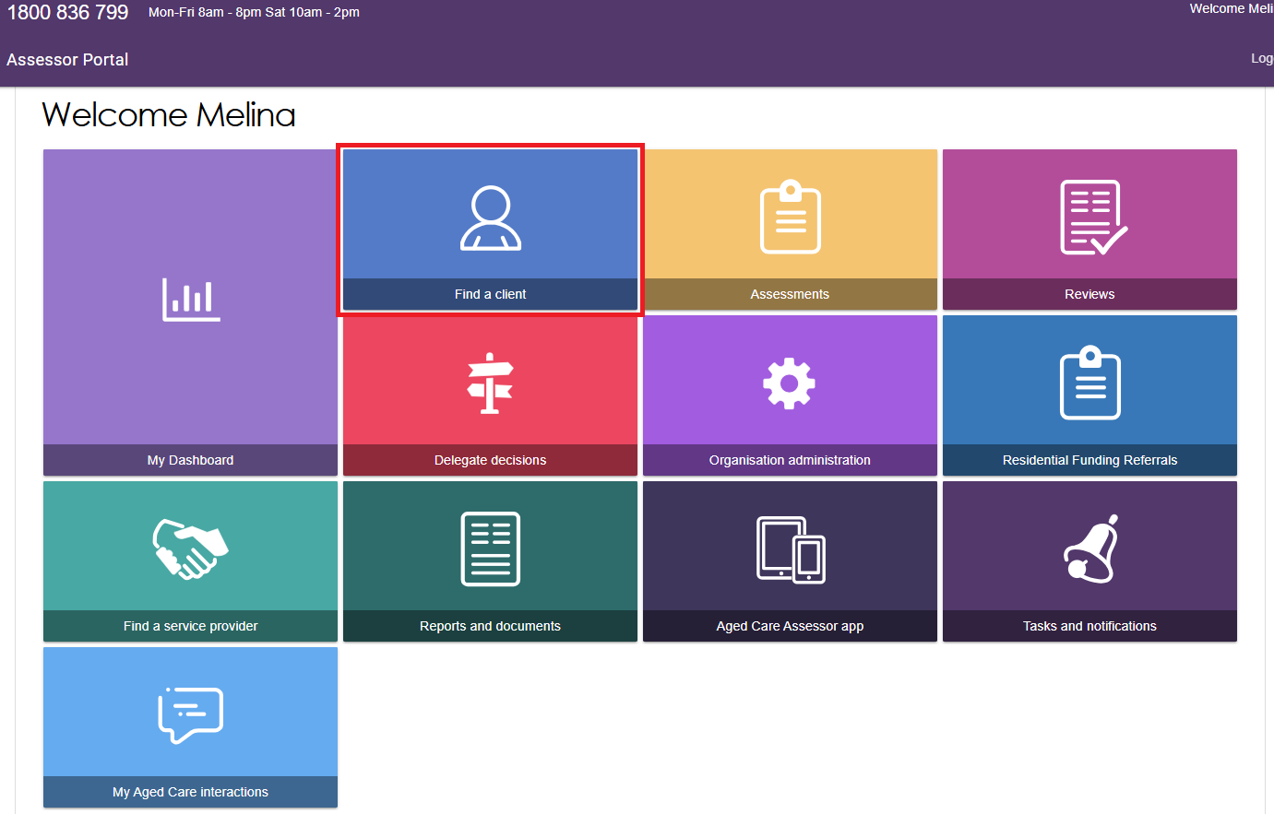

1. You can do a basic search by entering the **First Name**, **Last Name**, or **Aged Care User** **ID** into the fields, and then selecting the **SEARCH** button.

To go directly to a recently viewed client, use the links under **Recently Viewed Persons** heading on the right.

You can also switch how the results display between **CARD** view and **LIST** view by selecting the appropriate button at the right.

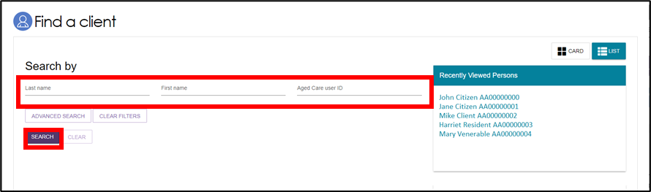

|  |  |
| --- | --- |
| ! | The **Find a client** function enables assessment organisations to search for all clients registered with My Aged Care. Service providers can only search for clients who have been referred to, and accepted by, their organisation. |

Alternatively, you can do an advanced search. Advanced search works by applying filters to the list of clients. These filters include options such as **First Name**, **Home Contact Number**, **Postcode** etc. By adding multiple filters together, specific groups of clients can be found.

1. Select the **ADVANCED SEARCH** button. A pop-up window will open. Use the drop-down arrow to choose the kind of filter you wish to add. Then, select the **ADD FILTER** button to reveal the input field for that filter.

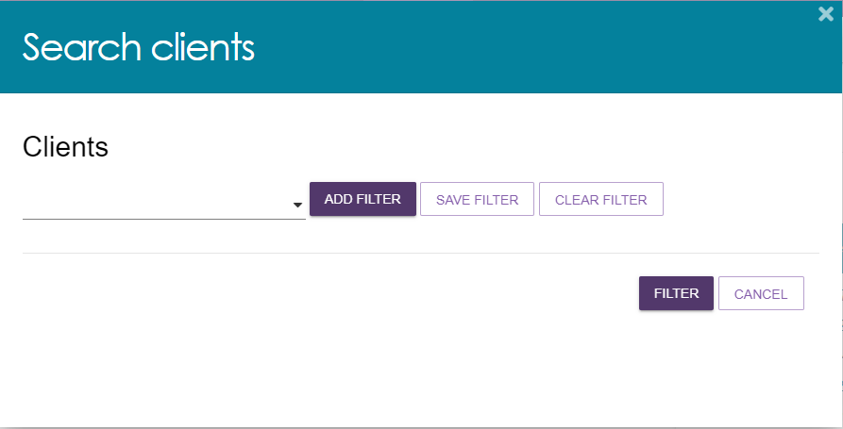

1. Fill in the input field with the information required. You can repeat the process above to add additional filters to the advanced search. A maximum of 7 filters can be applied at once. Once you have finished adding filters, select the **FILTER** button to begin your advanced search.

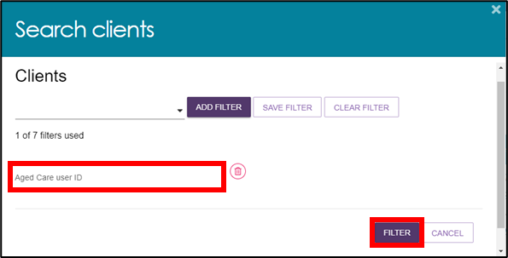

1. Select the name of your chosen client to proceed to their client record.

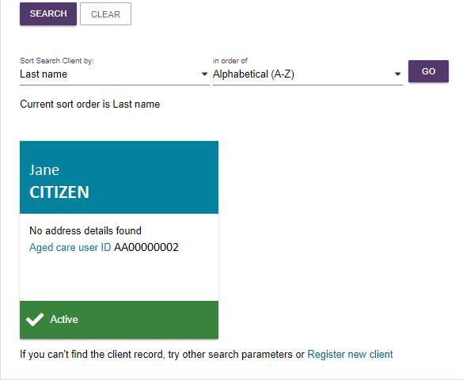

## Accessing a Sensitive Client Record

A sensitive client record may contain one or more:

* Sensitive attachment
* Sensitive client status
* Sensitive notes.

In the Client Record, the client details banner will have wording to this effect underneath the client’s address, to identify that this record contains sensitive information.

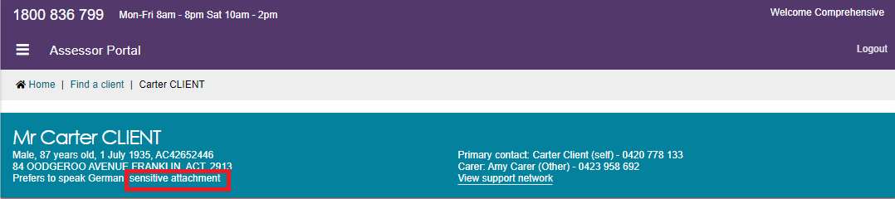

To access the sensitive information, refer to The Attachments Tab and The Notes Tab for more details.

## Accessing the client record of a client assigned to me.

1. Log in to the My Aged Care assessor portal.
2. From the home screen of the My Aged Care assessor portal, select the **Assessments** tile.

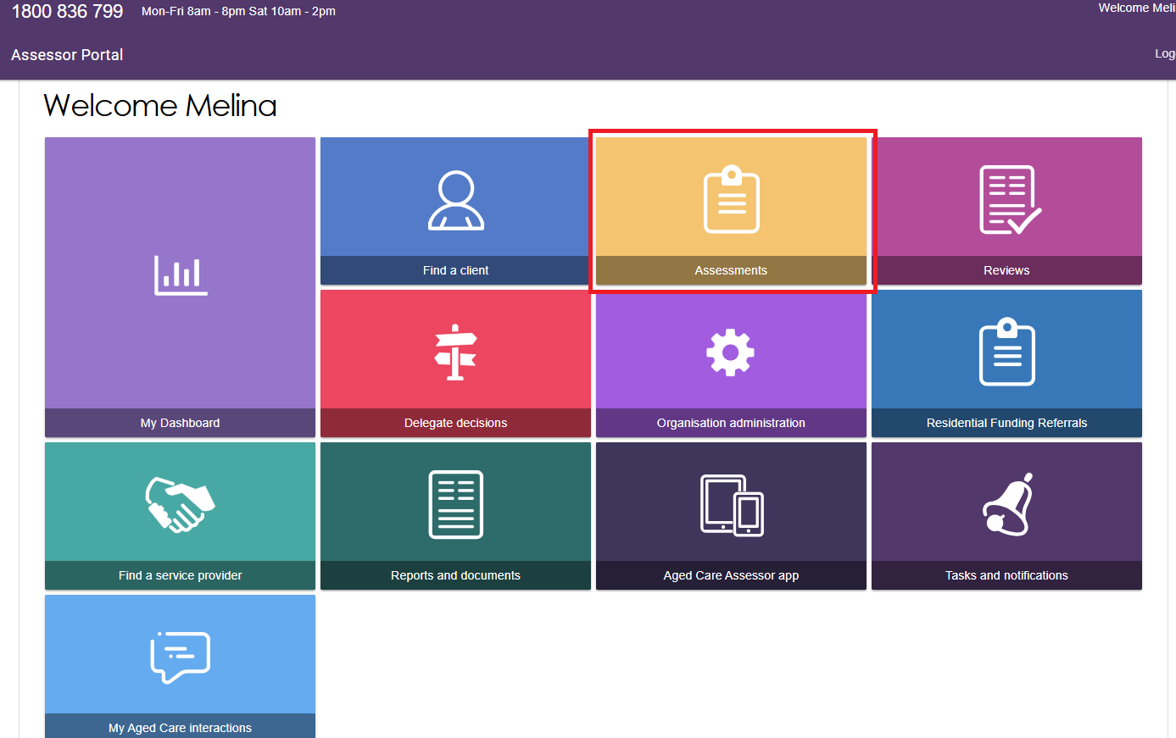

1. You will be prompted to select your assessment outlet. Use the drop-down list to choose an assessment outlet, then click **SELECT** **OUTLET** to proceed.

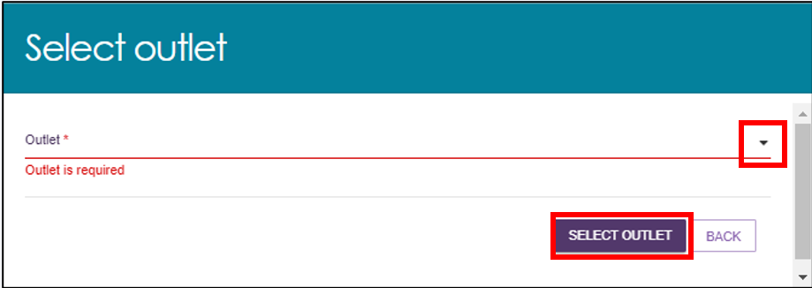

1. Using the filter headings to sort your assigned clients by **Last Name**, **Aged Care ID**, **Locality** etc. Once you have found the appropriate client, use the expand button on the left to see more details.

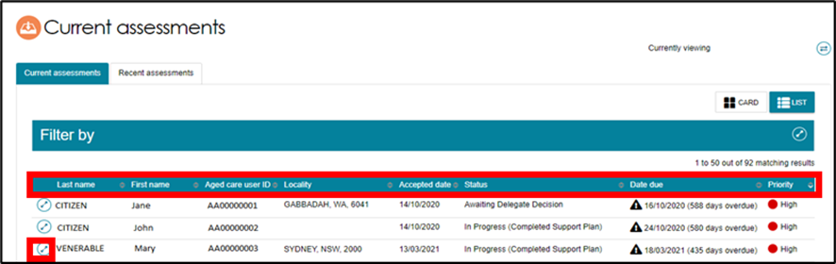

1. A pop-up will then display with expanded details for that client.

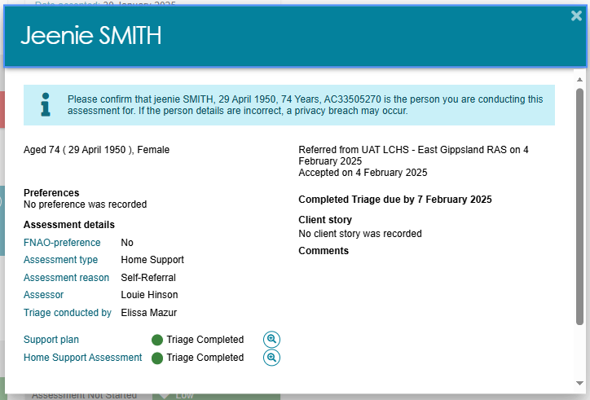

From this pop-up you can:

* View completed triage information by selecting the magnifying glass next to **Triage Completed**.

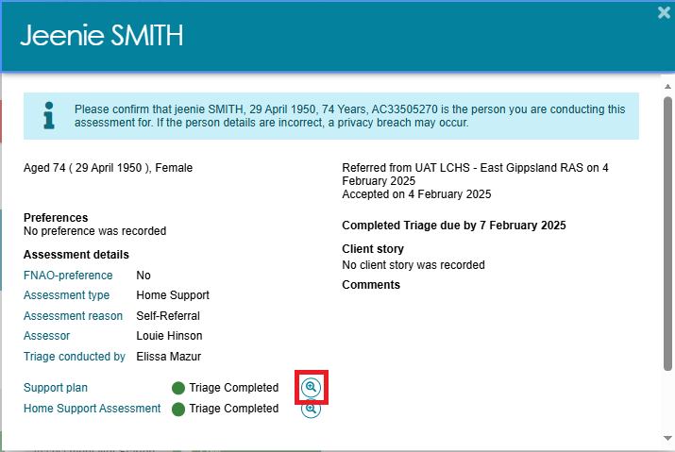

* You can view **Cohabitant details** if applicable. A cohabitant refers to another aged care client who lives at the same address as the client undergoing assessment and has a recorded active relationship with the client. Up to two cohabitants will be listed under this heading. Use the **VIEW MORE COHABITANT DETAILS** button to reveal additional cohabitants.

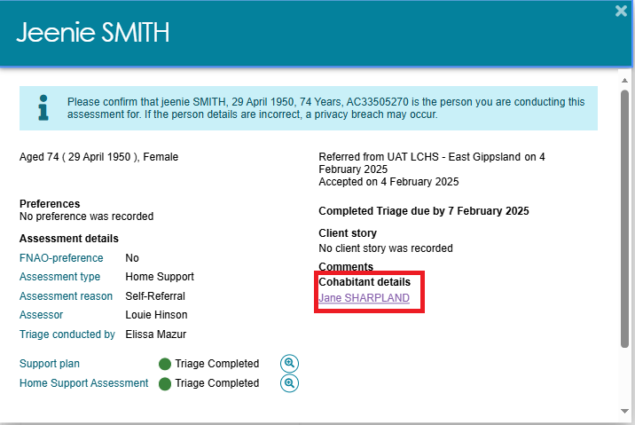

1. Select the **VIEW FULL CLIENT RECORD** button to navigate to the client record page.

Additionally, a summary PDF report of the client record containing client details, support network details, notes, assessment history, care approvals, and the client’s interactions with My Aged Care, can be generated without needing to navigate to the client record page.

1. Select the **VIEW CLIENT REPORT** button to generate this summary report.

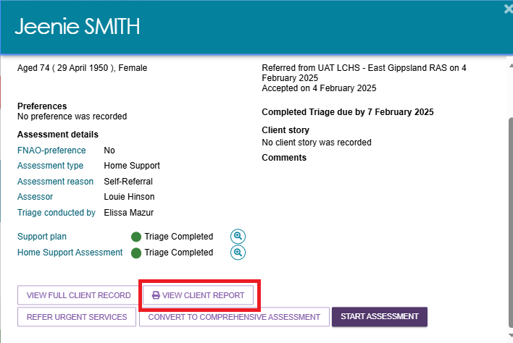

## The Client Summary tab

1. Select the **Client summary** tab to navigate to the client summary page of the client record.

The Client summary tab contains a real-time client journey tracker (Client tracker) and a dashboard of key information (Client summary) about the client’s interactions with My Aged Care.

The client tracker and the client summary can be viewed by selecting the expand buttons.

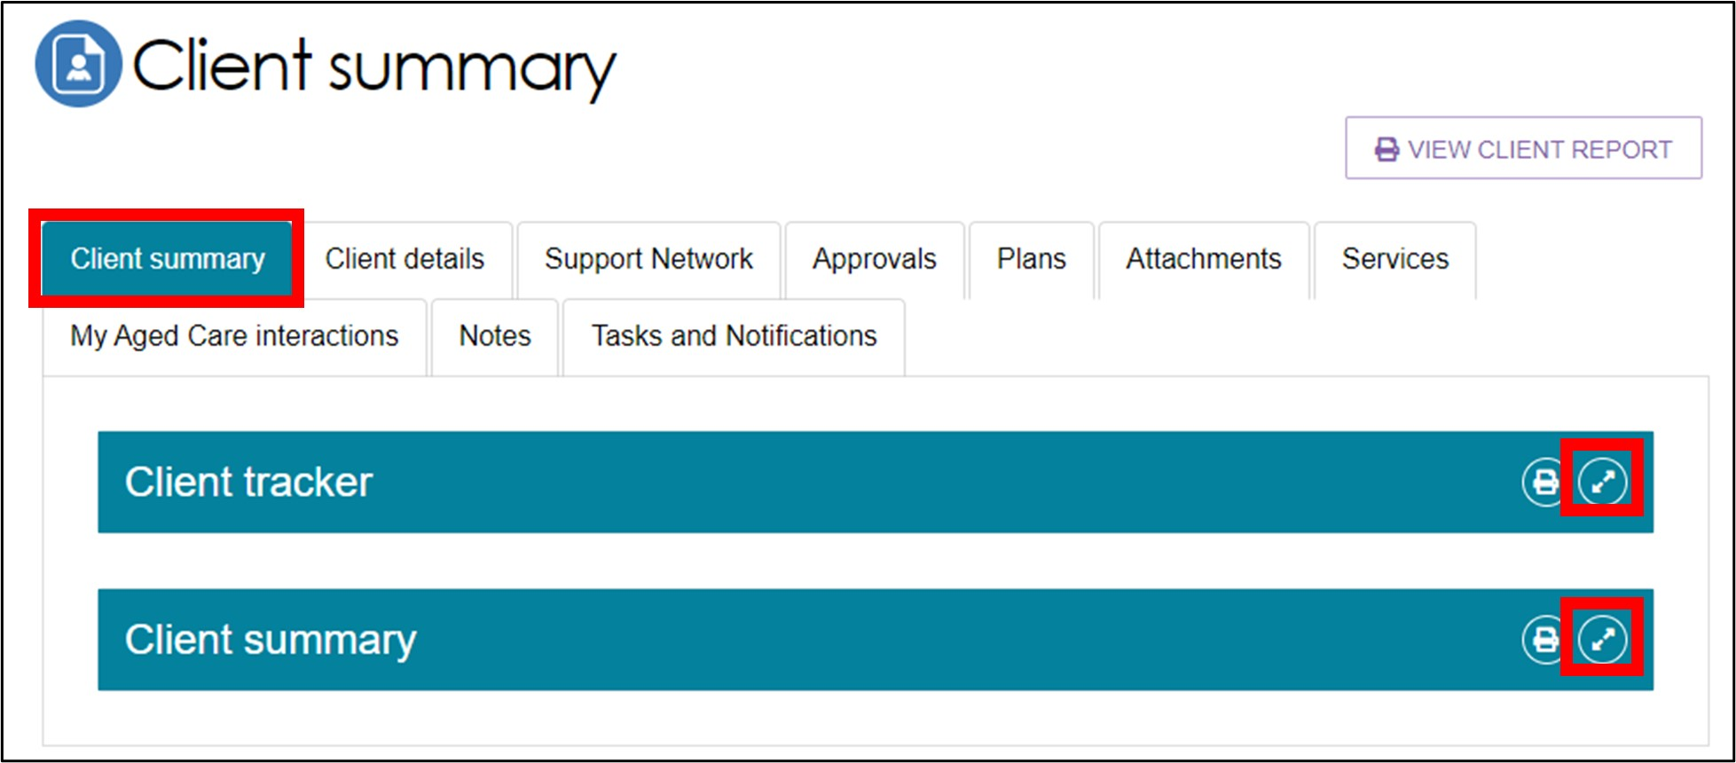

1. The **Client tracker** section is a visual display of what stage a client is at in their My Aged Care journey, including the client’s current position and any next steps that need to be taken by the client.

The stages of the tracker are:

* Registered (client has been registered with My Aged Care)
* Assessment (client has had an assessment or is having an assessment to determine their care needs)
* Waiting for services (client has had an assessment and has been recommended for services)
* Receiving services (a provider has accepted the clients service referral and commenced services)
* Support Plan Review (client is undergoing review by an assessor)

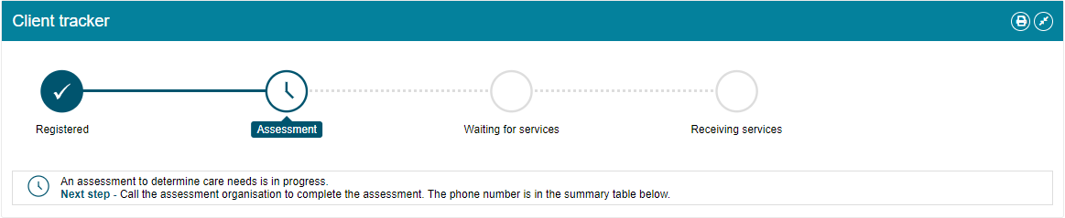

1. The **Client summary** section provides information about the client’s interactions with My Aged Care, including:

* Assessments
* Approvals
* Service recommendations
* Service delivery status
* Client concerns
* Client goals
* Reablement and linking support periods (where available)

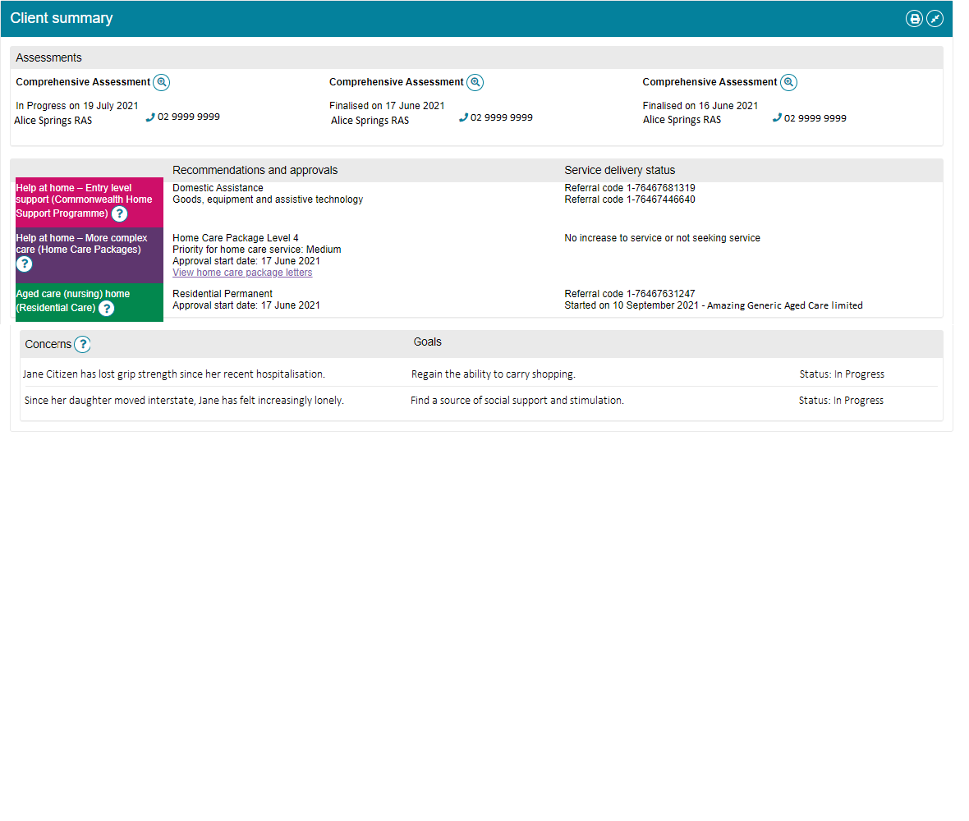

1. The Client tracker and Client summary information can be printed by using the **Print Page** button on the right-hand side of each heading.

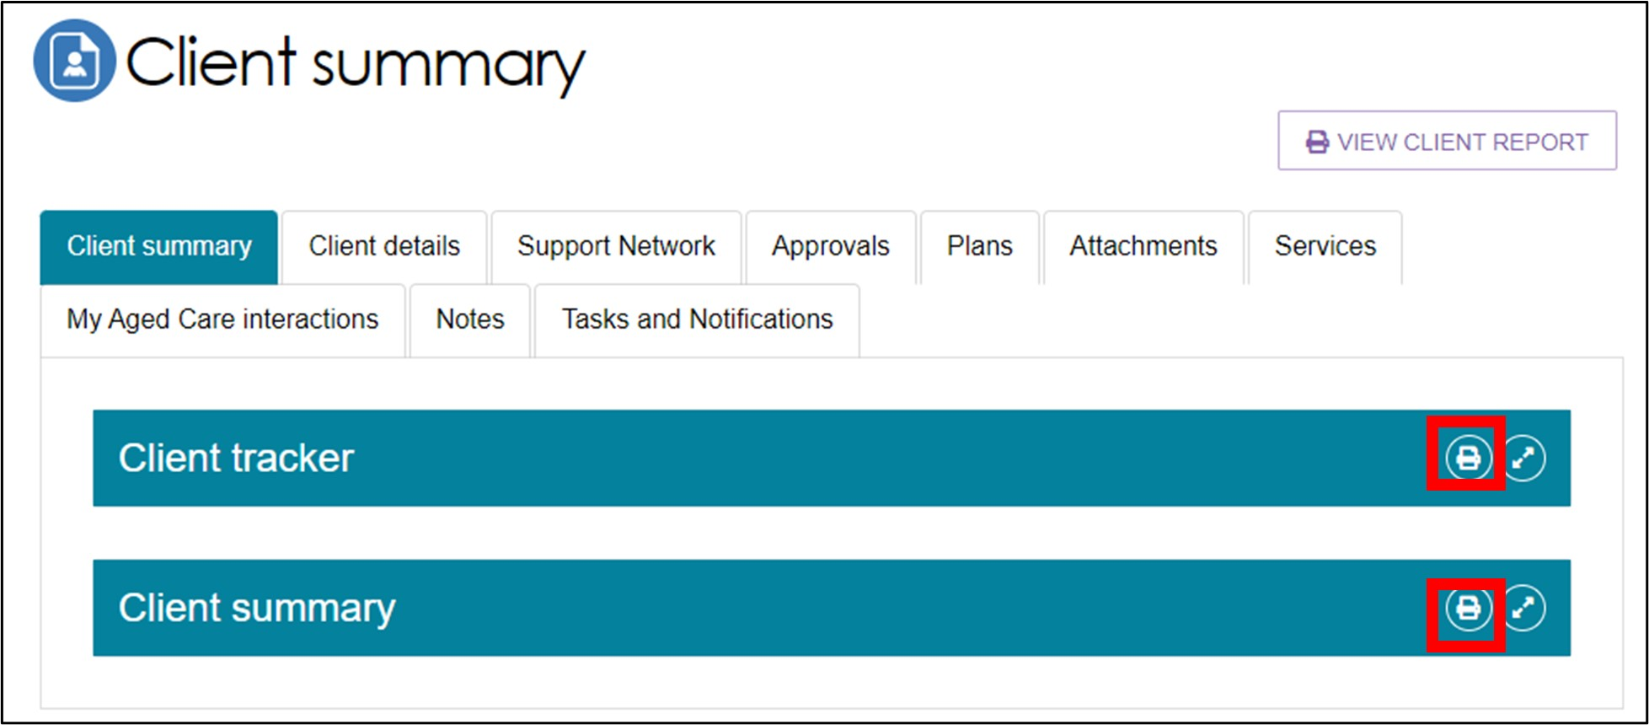

## The Client Details tab

1. Select the **Client details** tab to navigate to the client details page of the client record.

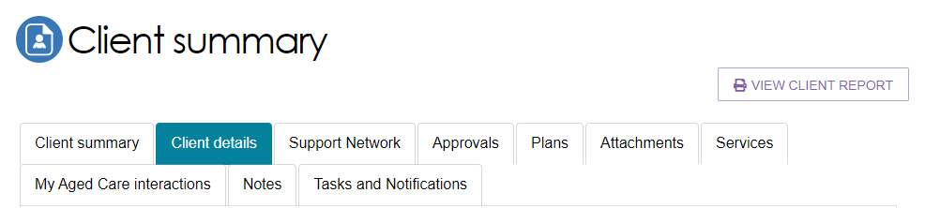

The Client details page contains basic demographic and contact information about the client. It is where you can view high level details about any active support plans, services, current notes, consent approvals, the clients primary contact details, if the client has a preference for a First Nation Assessment Organisation to do their assessment (if available).

The page also contains an option to notify My Aged Care when the client is deceased. See Notifying My Aged Care that the client is deceased for more information.

1. The **Primary Contact** can be nominated by the client or a person in their support network. This information allows assessors, My Aged Care contact centre staff and service providers to identify the key contact details for a client. This field does not impact on any system generated mail correspondence that the client may receive in relation to their care.

To update the Primary Contact, or any other client details, select the **Edit** (pencil) icon.

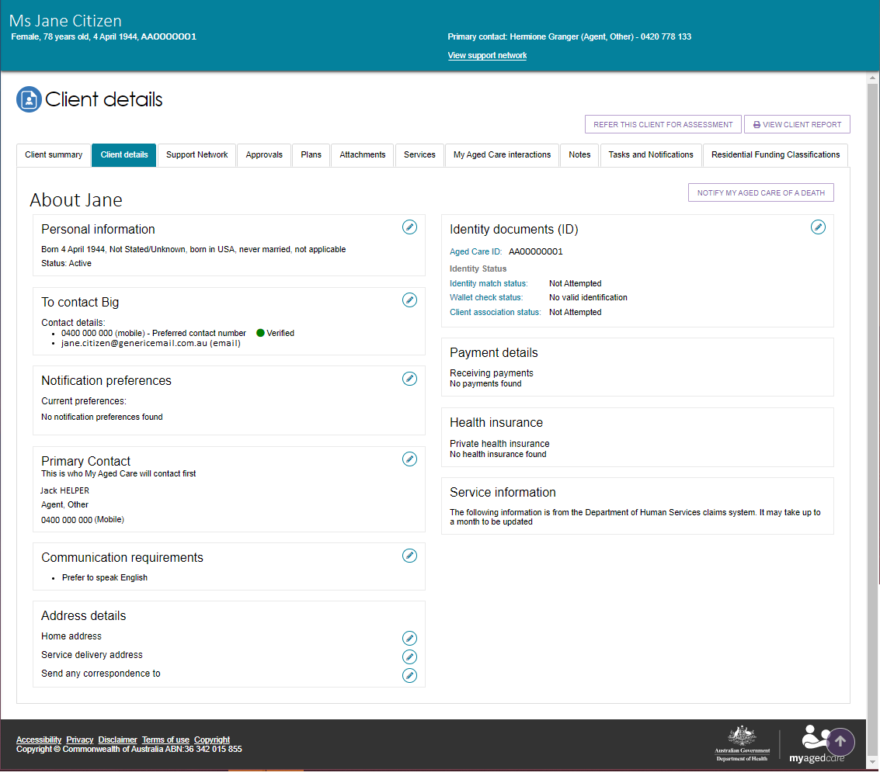

|  |  |
| --- | --- |
| ! | The Find a Client function enables assessment organisations to search for all clients registered with My Aged Care. Service providers can only search for clients who have been referred to, and accepted by, their organisation.  When adding or editing address details, it is important to validate the address by selecting the **VALIDATE THIS ADDRESS** button prior to saving. This ensures that the client and their support network can receive communication from the My Aged Care system.  Titled "Edit clients home address details" the tile "validate this address" has been highlighted in red |

My Aged Care clients and their support network can also receive email and/or SMS notifications when a client reaches the following key stages of their My Aged Care journey:

* Client registration is complete.
* The client’s assessment is finalised.
* The client is approved for care after a Comprehensive assessment.
* A client is assigned a Home Care Package (HCP), and at any stage that a HCP letter is generated for a client such as an assignment letter or withdrawal letter.
* A Support Plan Review request has been submitted.
* A support relationship is activated, declined, inactivated or expiring, and the submission or actioning of documents relating to support relationships.

For more information about setting up and configuring notifications for clients and/or their support network, refer to [My Aged Care – Assessor Portal User Guide 2 – Registering support people and adding relationships](https://www.health.gov.au/resources/publications/my-aged-care-assessor-portal-user-guide-2-registering-support-people-and-adding-relationships).

Within the client details tab, you can also view and update the client’s consent status to share information with My Health Record via the **Consent** section.

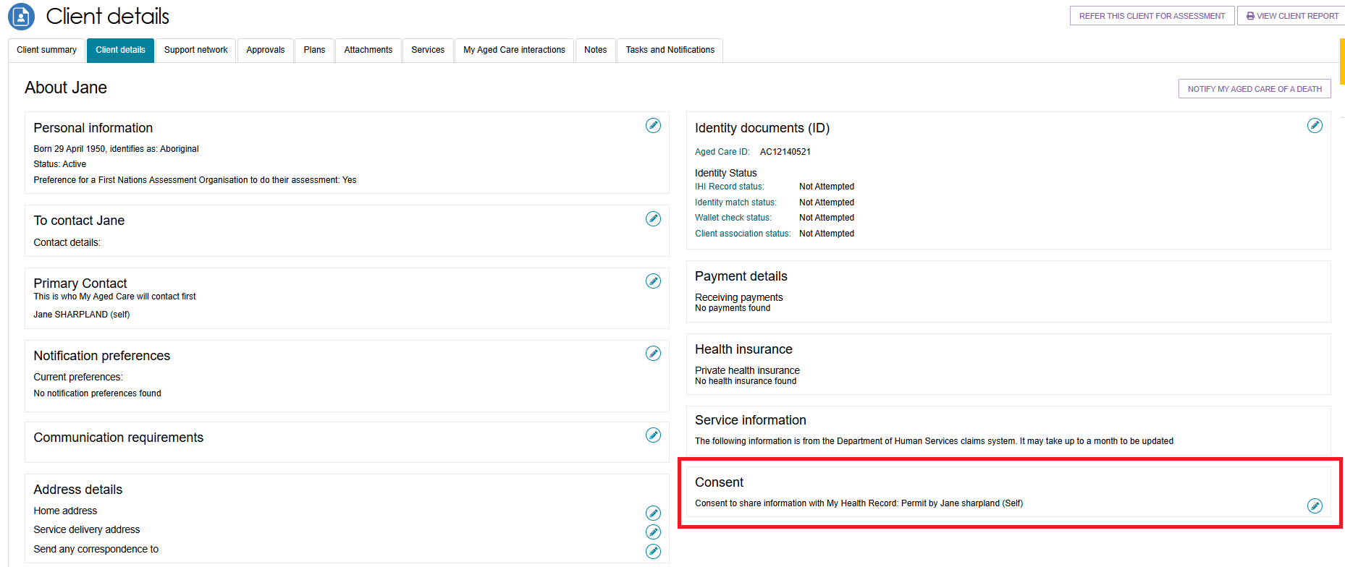

To update a client’s consent, select the edit (pencil) button.

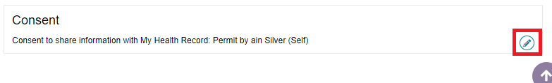

A pop-up will the display. If the client consent’s to sharing their information with My Health Record select **Yes** and click **SAVE.**

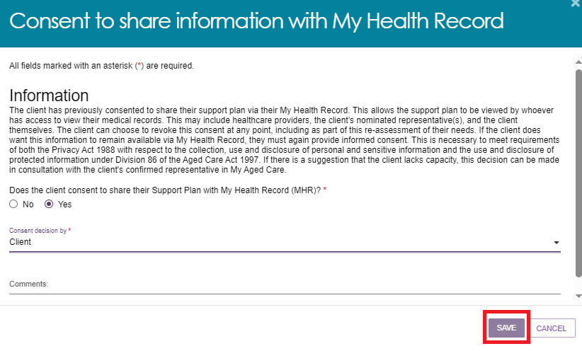

If you select **No** and the client is withdrawing their consent, then any previously shared support plan details will be removed from the client’s My Health Record. Select a consent denial reason from the drop-down list and then click **SAVE**.

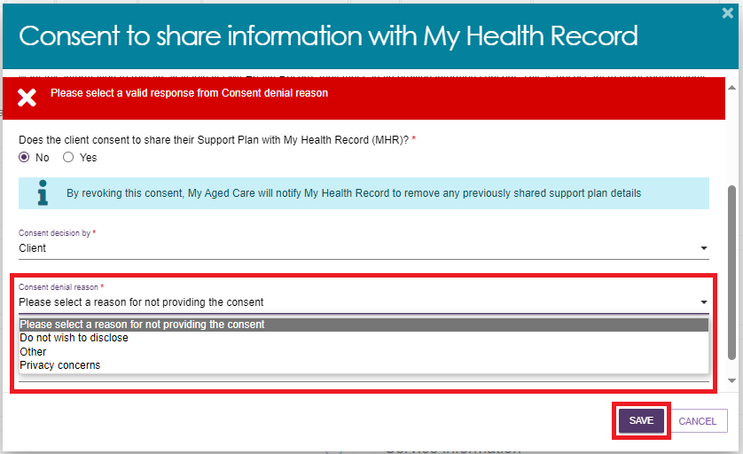

Please note, if the consent decision has been made by a representative then you will be required to enter the representatives first name before proceeding.

## Notifying My Aged Care that the client is deceased

If a client’s status is **Deceased**, the clients record will be read-only, and you will not be able to edit any client information. Once this status is updated in My Aged Care, the clients support network will no longer have access to the clients’ record. A notification will be sent to the client’s assessor and provider advising them to close or finalise any in-progress tasks. Additional notes and attachments can be attached to the client record and assessments can be finalised after the status is changed.

A banner will be displayed on all tabs of the client record. If the client’s status is incorrect, please contact the service provider and assessor helpline on 1800 836 799.



1. Select the **NOTIFY MY AGED CARE OF DEATH** button in the **Client Details** page of the client record.

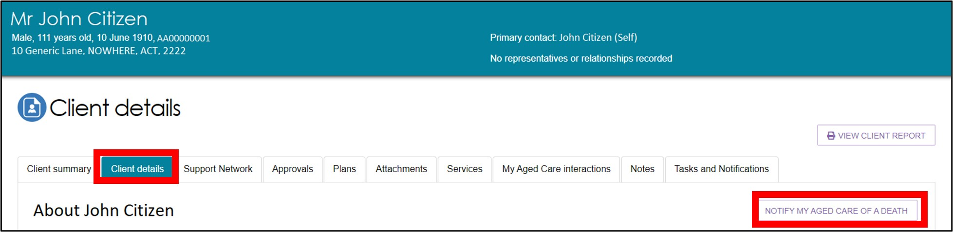

1. A pop-up box will prompt you to input the following information:

* Who, when and how you were informed that this person is deceased?   
  For example, "Mrs. Smith rang to inform us that Mr. Smith passed away on Saturday".
* Date of death (if known)
* Add Attachments (if available)  
  For example: Death certificate, hospital discharge documents.

After inputting details and attachments, select the **SAVE** button to submit your notification.

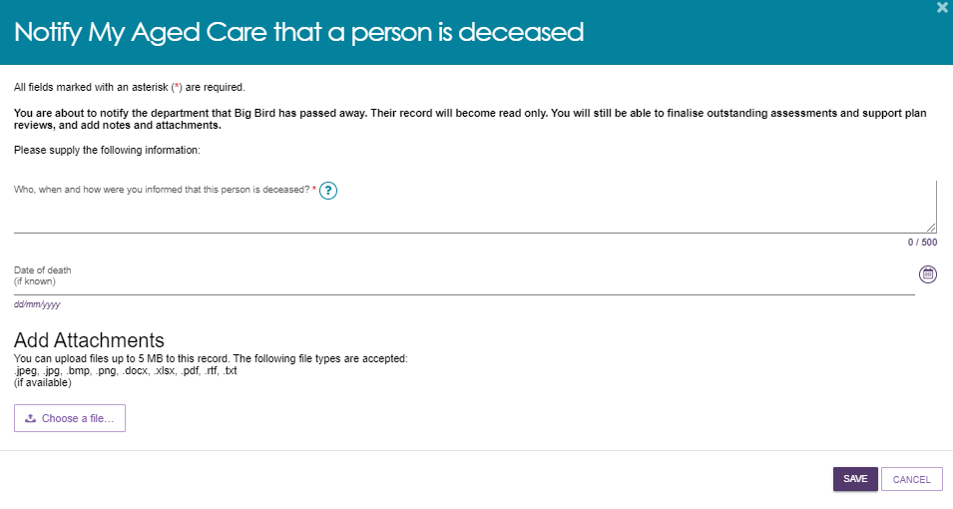

1. If you have an in-progress assessment or had commenced services for the deceased client, you will receive a notification (along with the associated provider) advising you to close or finalise the in-progress tasks.

## The Support Network tab.

1. Select the **Support network** tab to navigate to the support network page of the client record.

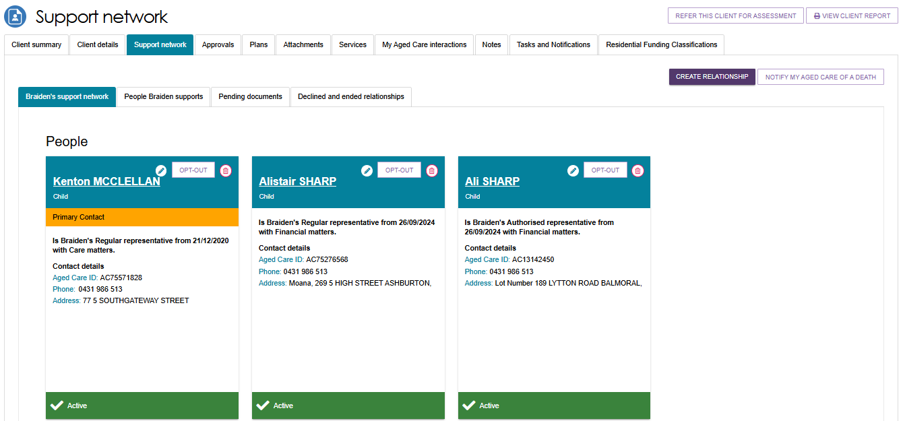

The **Support Network** tab contains information about current, past, and pending relationships between the client and people who assist them in their aged care journey.

The relationships that could be considered part of a clients **Support Network** are as follows:

* Regular Representatives (individuals and organisations)
* Authorised Representatives (individuals and organisations)
* Agents (individuals and organisations)
* Carers
* Emergency Contacts
* GPs
* Support Persons

1. In addition to viewing relationships, the **Support Network** tab also enables assessors to create new relationships, request a call back on behalf of clients and their carers to the [Carer Gateway](https://www.carergateway.gov.au/) and the [National Dementia Helpline](https://www.dementia.org.au/helpline), and notify My Aged Care of the death of a person with a listed relationship with the client.

Creating and managing relationships is covered in the guide: [My Aged Care – Assessor Portal User Guide 2 – Registering support people and adding relationships](https://www.health.gov.au/resources/publications/my-aged-care-assessor-portal-user-guide-2-registering-support-people-and-adding-relationships).

## Notifying My Aged Care that a person in the support network is deceased

A banner will be displayed on all tabs of the client record. If the client’s status is incorrect, please contact the My Aged Care service provider and assessor helpline on 1800 836 799.

1. Navigate to the **Support network** tab of the client record and select the **NOTIFY MY AGED CARE OF DEATH** button on the right-hand side of the page.

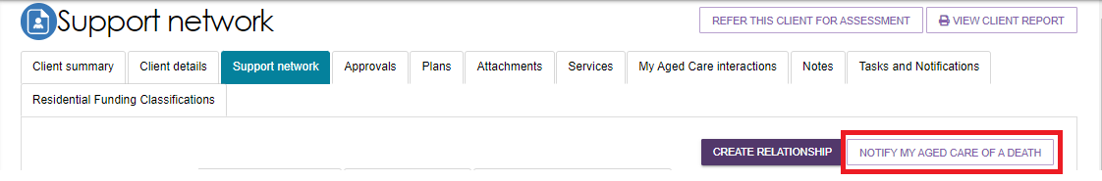

1. A pop-up box will prompt you to input the following information:

* Specify the deceased person using the radio buttons at the top of the prompt.
* Who, when and how you were informed that this person is deceased?   
  For example, "Mrs. Smith rang to inform us that Mr. Smith passed away on Saturday".
* Date of death (if known)
* Add Attachments (if available)  
  For example: Death certificate, hospital discharge documents

After inputting details and attachments, select the **SAVE** button to submit your notification.



## The Approvals tab

1. Select the **Approvals** tab to navigate to the approvals page of the client record.

The Approvals tab lists the client’s current approvals for aged care services under the *Aged Care Act (1997)*, including the approvals created prior to the start of My Aged Care (shown under previous care approvals).

Additional approval details can be viewed by selecting the expand buttons next to each approval.

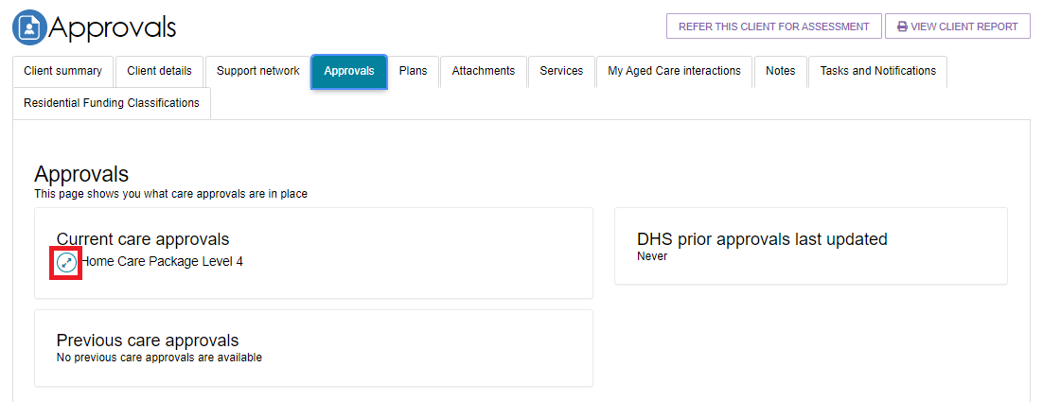

1. HCP approval information is displayed under the **Home care** section of the **Approvals** tab.

To change the clients HCP seeking status (that is, whether the client is seeking HCP services) select the dynamic button on the bottom left that says **Seeking Services** or **Not Seeking Services**.

One person from an assessment outlet may nominate to receive notifications of any HCP correspondence received by a client from the Department. This is particularly important for clients who may be considered vulnerable or in need of additional assistance to access care. Select the pencil icon under the **Notify of home care correspondence** to start or stop notifications and nominate a receiver.

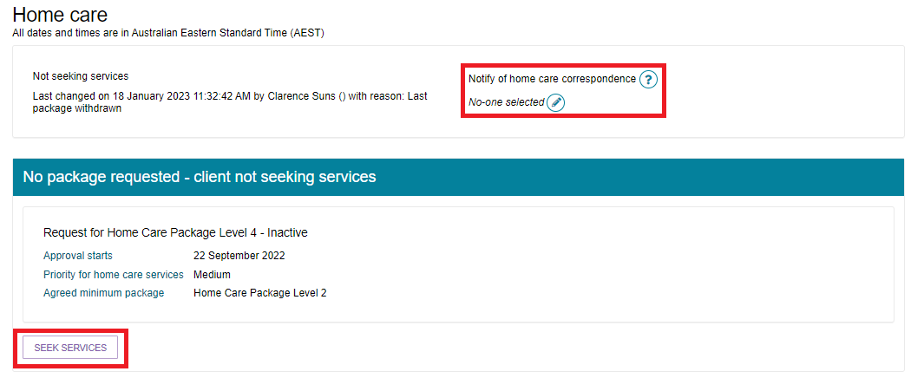

1. The **Assessment** Tab also displays HCP approval details for both Pending HCPs and Assigned HCPs

Pending HCPs (not assigned) include information on:

* Priority for home care services
* Interim package information

|  |  |
| --- | --- |
| ! | Please note, that interim packages are not available and should not be used. |

Assigned HCPs include information on:

* Date package assigned
* Take-up deadline
* Status of assigned package
* History of the HCP

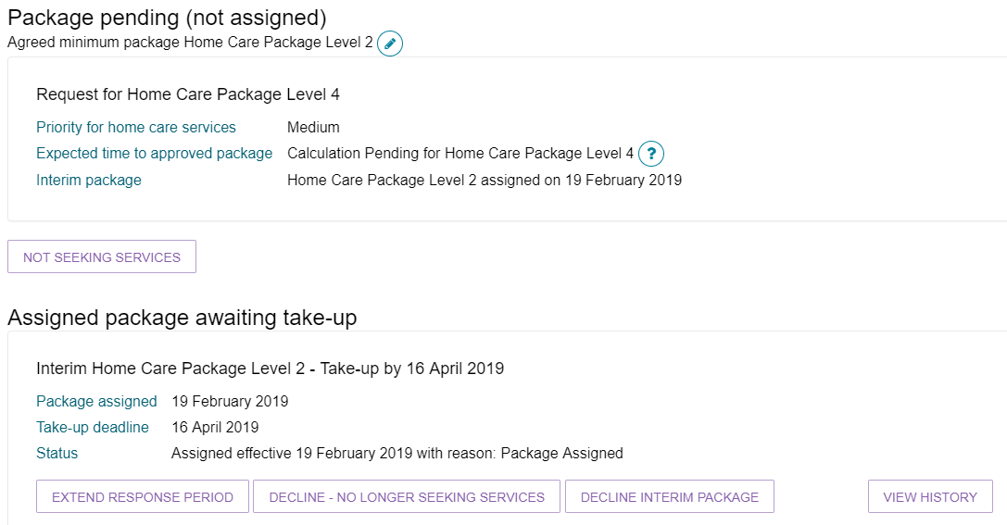

1. If no pending or assigned packages are displayed, depending on the eligibility of the client, HCPs can be sought by selecting the **SEEK SERVICES** button near the bottom of the page.

For more information about HCPs in My Aged Care, see [My Aged Care – Assessor Portal User Guide 13 – Management of Home Care Packages](https://www.health.gov.au/resources/publications/my-aged-care-assessor-portal-user-guide-13-management-of-home-care-packages), available on the Departments website.

The Plans tab

1. Select the **Plans** tab to navigate to the plans page of the client record.

The Plans tab contains any previous screening and assessment information for the client, including:

* The Support Plan(s)
* The assessment outlet and assessor who undertook the client’s assessment (including details of first intervention of a clinical nature)
* Detailed information about a client’s assessment history, including read-only versions of previous assessments and screenings
* Upcoming and historic review information
* Reablement and linking support history.

1. Additional assessment details can be viewed by selecting the expand buttons next to each item under the **Assessment history** header.

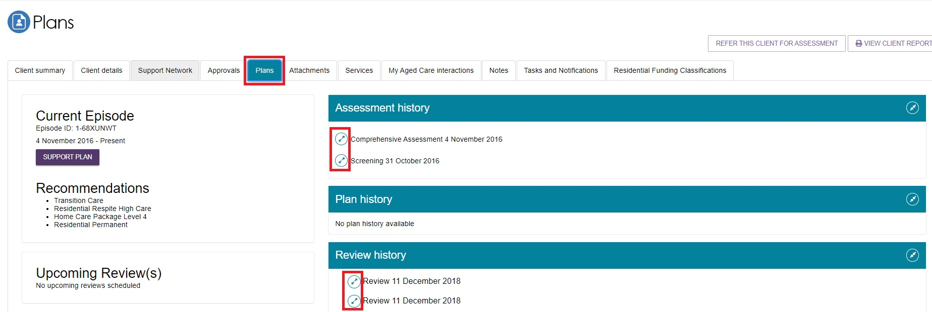

## The Attachments tab

1. Select the **Attachments** tab to navigate to the attachments page of the client record.

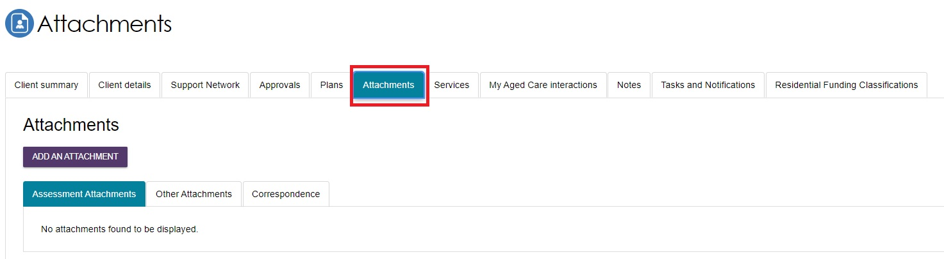

The **Attachments** tab contains documents that have been attached to the client record, including attachments that have been uploaded using the Aged Care Assessor App. This is also where assessors can add an attachment to the client record.

**Assessment Attachments** are any documents that are relevant to the client’s assessment, for example, clinical notes or a discharge summary.

**Other Attachments** are documents that relate to the clients’ general circumstances, for instance, documents related to the establishment of a support relationship (including legal documentation), Occupational Therapist drawings used in home modifications.

**Correspondence** are documents/letters that are generated in My Aged Care, related to HCPs. There are a number of letters sent to clients related to their HCP at different stages. Copies of these letters will also be sent to their support person(s).

**Sensitive Attachments** are documents that contain client information of a sensitive nature. For example, documents about a client’s financial situation, safety concerns and legal issues that may impact provision of services.

1. To add an attachment, select the **ADD ATTACHMENT** button.

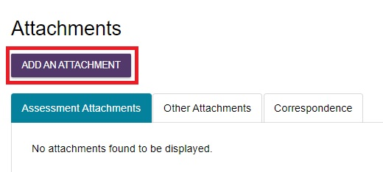

1. A pop-up window will appear, prompting you to find and upload the desired attachment.

Search your computer for the document you wish to attach by selecting the **Choose file** button.

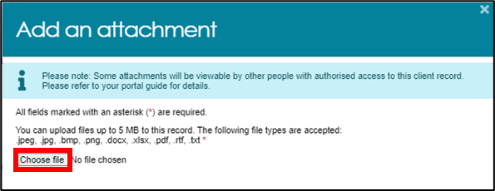

1. Provide additional details by inputting the **Name of the attachment**, choosing the **Type of attachment** from the drop-down lists, and providing a **short description**. Finally, select the **UPLOAD** button to save your attachment to the client record.

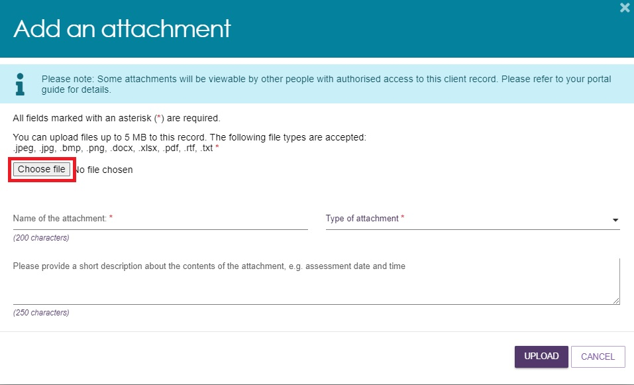

|  |  |
| --- | --- |
| ! | Where a client record has a Sensitive Attachment and the client is referred for service provision, service provider(s) will be notified that a Sensitive Attachment exists for the client. Service providers cannot view sensitive attachments; they will be directed to contact the assessor who conducted the last assessment, or the My Aged Care Service Provider and assessor helpline to access information within the Sensitive Attachment.  Sensitive attachments are not visible through the My Aged Care online account and will be visible only to assessors and My Aged Care contact centre staff. |

1. Your attachment will appear in the **Assessment Attachment** tab, or the **Correspondence** tab.

Titled "attachment"

the tile "assessment attachments" is expanded to view the attachments.

Sensitive attachments will appear in the **Other Attachments** tab.

Titled "attachment"

the tile "other attachments" is expanded to view the attachments.

## The Services tab

1. Select the **Services** tab to navigate to the services page of the client record.

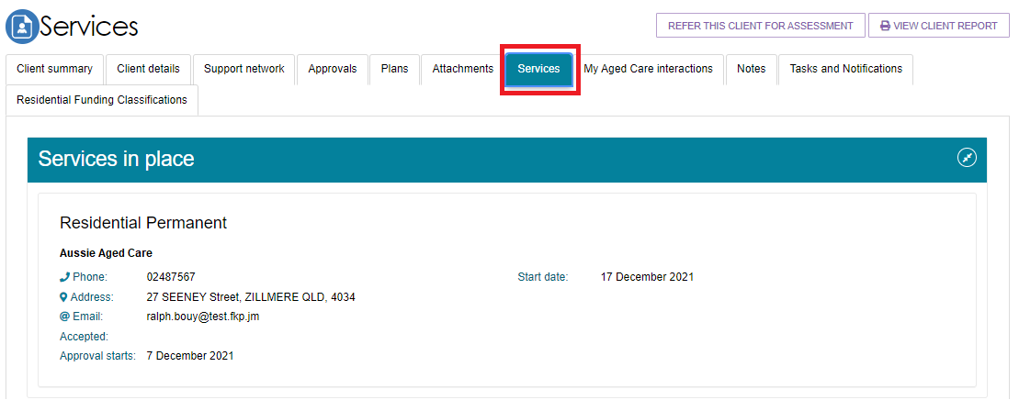

1. The **Services** tab contains sections which host the following service records:

* Previous services a client may have received (from other systems)
* Services that are not yet in place
* Services that are currently in place.

Sections which do not contain any records will not be displayed. Select the expand buttons on the right-hand side of each section header to display the records.

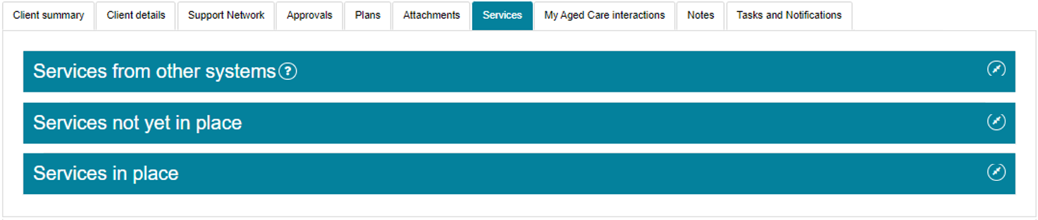

## The My Aged Care interactions tab

The **My Aged Care Interactions** tab displays the client’s history of interactions with My Aged Care. This includes face-to-face appointments with Aged Care Specialist Officers, phone calls with My Aged Care Contact Centre staff, and capturing of consent for call back requests to be sent to Carer Gateway and/or National Dementia Helpline.

For more information about the Carer Gateway and National Dementia Helpline referrals, go to [My Aged Care – Assessor Portal User Guide 2 – Registering support people and adding relationships](https://www.health.gov.au/resources/publications/my-aged-care-assessor-portal-user-guide-2-registering-support-people-and-adding-relationships).

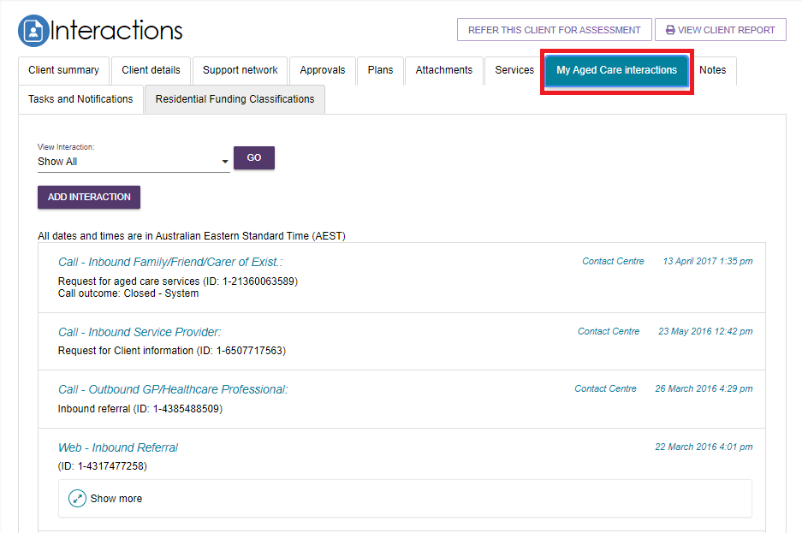

## The Notes tab

|  |  |
| --- | --- |
| ! | Department staff can transfer client records linked to an inactive assessment outlet to an active assessment outlet in the same assessment organisation or to another assessment organisation. This means that you may see client records that were transferred from another assessment outlet. You will see a note of the transfer in the clients My Aged Care record. |

1. Select the **Notes** tab to navigate to the notes page of the client record.

The **Notes** tab contains notes that have been created about the client. Assessors can add new notes about the client from this tab.

|  |  |
| --- | --- |
| ! | It is recommended that Triage Delegates review the notes tab prior to completing the triage process as not all information captured from screening is pre-populated. |

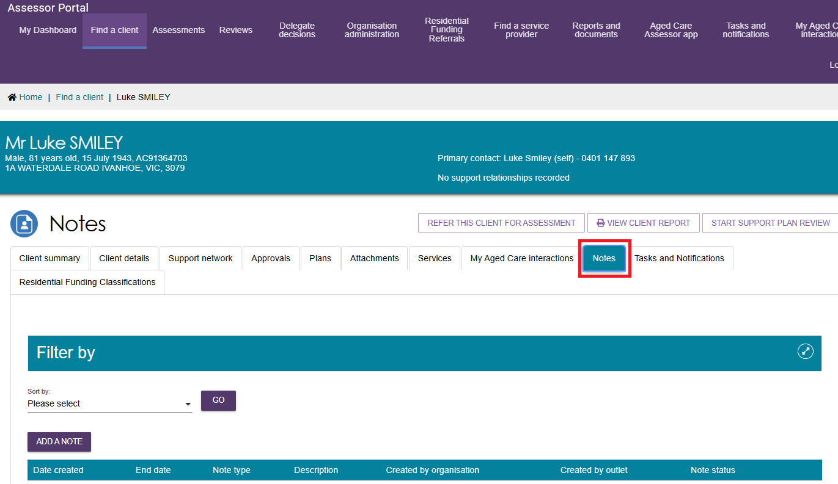

|  |  |
| --- | --- |
| ! | All notes will be subject to Freedom of Information legislation. |

1. My Aged Care contact centre staff, Aged Care Specialist Officers, assessors and service providers can view and add different types of notes about clients through the My Aged Care portals. Assessors can also view and add these notes in the Aged Care Assessor App. Refer to the following tables for information about note types and permissions according to role.

### Note Types

|  |  |  |
| --- | --- | --- |
| Note type | Description | Examples |
| Client story | A summary of the client’s current circumstances. Assessors, My Aged Care contact centre, service providers and clients can view these notes. | Mrs Jones has just been discharged from hospital and is seeking help at home. She lives with husband and has early onset dementia. |
| Sensitive notes | Information of a sensitive nature about the client that needs to be available for assessment or provision of some services. A sensitive note will display a flag on the portal for the service provider against the client. They may contact the My Aged Care contact centre or assessor for additional information, which will only be provided to them if relevant to their service provision. **This note will not be displayed to service providers or clients in their portals.** | Mr Smith is HIV positive.  Mrs Johns has an abusive relationship with son. |
| Preference | Clients stated service provision preferences. Assessors and My Aged Care contact centre staff can view these notes. | Mrs Marten would prefer a Catholic provider.  Mr Dobruk is affiliated with the Croatian community. |
| Observations | Observations from service provider and/or assessor’s interactions with the client. Assessors, My Aged Care contact centre staff and service providers can view these notes. | There is a dog on the property.  Mrs Shean seems more energetic than she did during my last visit. |
| Referral Note | Notes accompanying a client’s referral. This can be an initial referral, subsequent referral or referral from one assessment outlet to another. | This client record has now been transferred from Outlet A to Outlet B on 01/01/2024. |
| Other | Additional information about the client. Assessors, My Aged Care contact centre staff, service providers and clients can view these notes.  Examples of other notes include: Client Story - Returned mail, Cultural/Religious, History of Experiences, Gender Identity/Sexual Pref notes. | Mrs Jones has planned respite on 01/08/2017. |

**Note Add & View permissions**

|  |  |  |
| --- | --- | --- |
| Role | Add Note Types | View Note Types |
| Assessors | All | All |
| Service Providers | Observations Other | Other Client Story Observations Sensitive (Flag only, no content) |
| Clients (and their support network) | Other | Other Client Story |
| My Aged Care Contact Centre Staff | Client Story, Sensitive Notes, Preference, all “Other” notes except Observations. | All |
| Aged Care Specialist Officers (Face to face support in Services Australia centres) | All | All |

|  |  |
| --- | --- |
| ! | When My Aged Care contact centre staff or assessors add a **sensitive** note about a client, all service providers who are sent a referral will see a flag informing them that there is a sensitive note about the client and instruct them to call the My Aged Care contact centre or the assessor for more information. |

### Adding client notes

The following section outlines how to add client notes using the assessor portal. For instructions on how to add notes in the Aged Care Assessor App, please see the [Aged Care Assessor App User Guide](https://www.health.gov.au/resources/publications/aged-care-assessor-application-user-guide).

1. Select the **Notes** tab to navigate to the notes page of the client record. Then, select the **ADD NOTE** button to start creating a new note.

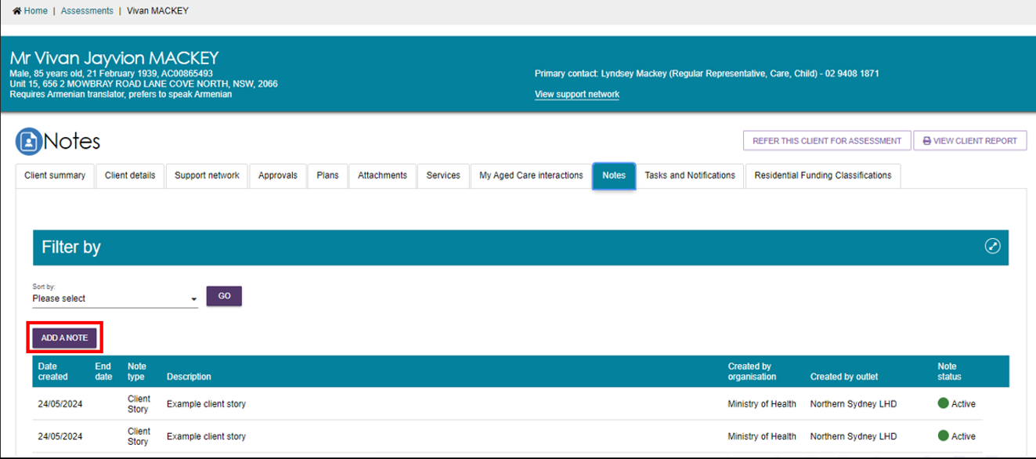

1. A pop-up box will appear. Select the Type of the note you wish to add using the drop-down list, and input the Description (i.e., the content of the note itself).

You can hover over the help icon A common help icon, stylized as a blue question mark inside a white circle. Such icons indicate that more information can be provided by interacting with the icon. in the pop-up box for additional information about the different types of notes. If you are unsure which category is most appropriate, please refer to the information in the help icon.

Then, select **SAVE** to finish your note.

|  |  |
| --- | --- |
| ! | You cannot delete a note once saved. Quality check that the information is correct before saving. |

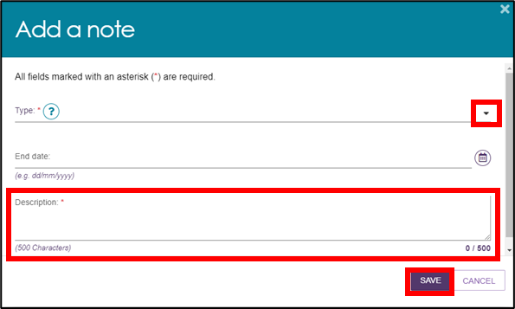

## Viewing and editing client notes

The following section outlines how to view and edit client notes using the assessor portal. For instructions on how to view and edit notes in the Aged Care Assessor App, please see the [Aged Care Assessor App User Guide](https://www.health.gov.au/resources/publications/aged-care-assessor-application-user-guide).

1. Select the **Notes** tab to navigate to the notes page of the client record.

Then, select the **Edit** (pencil) icon to the right of the note you wish to edit. Note that there is no Edit icon available for Client Story notes.

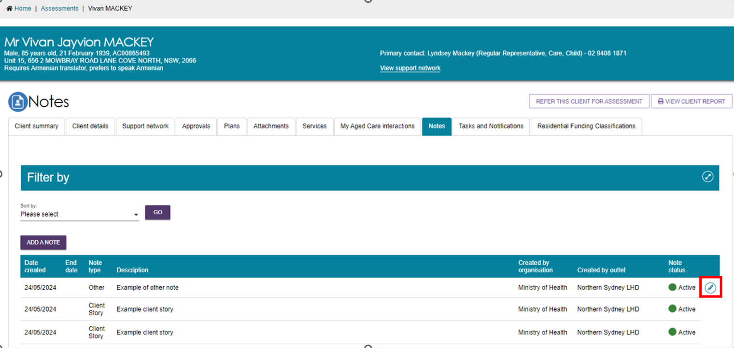

1. A pop-up box will appear. To make a note **Active** or **Inactive**, use the drop-down list to select the desired status. Then, select **SAVE** to finish your note.

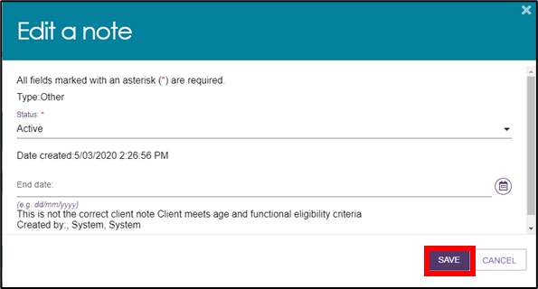

Assessors can create or edit **other notes,** and these can be used for general purpose notes.

1. Client **Story notes** can also be viewed by assessors in the **Assessments** section of the assessor portal. Select the link to the **Assessments** section of the assessor portal at the very top the page. Then, select expand a client summary using the expand icon on the left of the row.

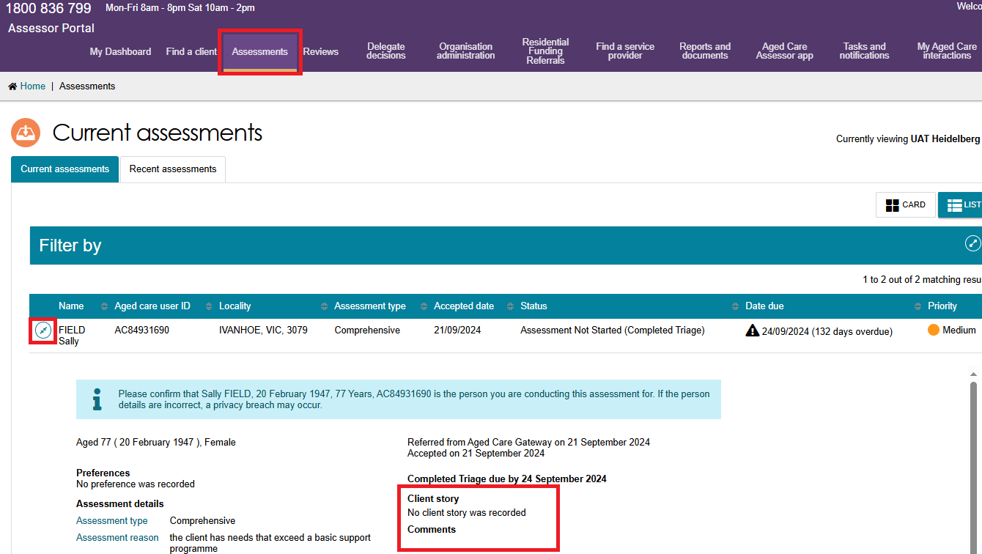

|  |  |
| --- | --- |
| ! | In order to ensure records are never lost, assessors and providers cannot edit the contents of a **client story** note once it is created. Instead, assessors and providers can make the original note **Inactive** and create a new one in its place.  If there are errors in the information which you are concerned about being on the records, contact the My Aged Care service provider and assessor helpline on 1800 836 799. |

## The Tasks and Notifications tab

Select the **Tasks and Notifications** tab to navigate to the interactions page of the client record.

All tasks and notifications relevant to the client will be displayed in this tab. Assessors will be able to see all tasks and notifications relevant to the client. Providers will only see tasks or notifications that are associated to their assessment outlet, for clients that they are providing services to.

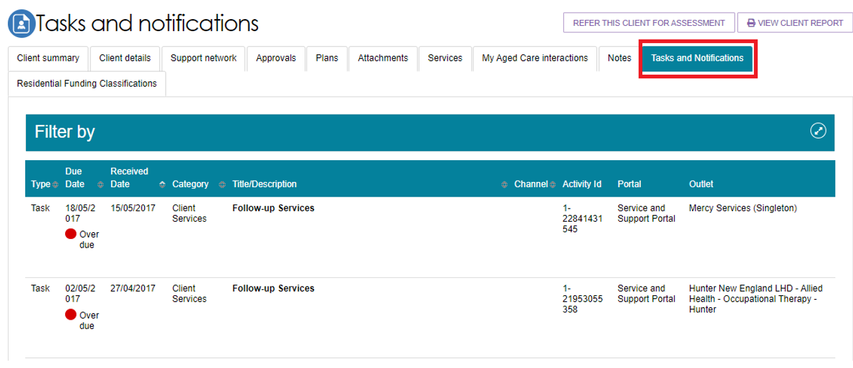

## The Residential Funding Classifications tab (clinical needs assessors)

Select the **Residential Funding Classifications** tab to navigate to the classifications page of the client record.

Residential Funding Classifications are part of the Australian National Aged Care Classification (AN-ACC) system, designed to replace the Aged Care Funding Instrument (ACFI) for the purposes of allocating government funding for residential aged care.

Clinical needs assessors can view the clients current AN-ACC classification, and classification history using this tab.

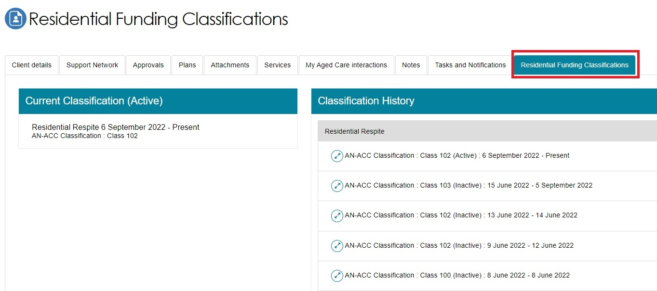

For more information about the Residential Funding Classifications see the [residential aged care funding reform page](https://www.health.gov.au/health-topics/aged-care/aged-care-reforms-and-reviews/residential-aged-care-funding-reform) on the Departments website.

## More Information

For further assistance, you can call the My Aged Care service provider and assessor helpline on 1800 836 799.