Assessor Portal User Guide 3 – Managing referrals for assessment and Support Plan Reviews

Referrals for assessment from My Aged Care are managed by the person(s) assigned the Team Leader or Triage Delegate role in the My Aged Care assessor portal (assessor portal).

This guide is intended to help staff manage assessment referrals as well as distinguish what functions sit within each role.

Team leaders can accept or reject assessment referrals. After accepting an assessment referral Triage Delegates are able to assign and complete triage. Following this Triage Delegates and Team Leaders can assign the referral to an aged care needs assessor (assessor). Team Leaders can reassign or unassign the triaged referrals as required.

Team leaders can also transfer incoming and accepted (but not yet commenced) referrals to other assessment organisations. Before accepting referrals, team leaders can change the priority of assessment referrals.

This guide contains the following topics:

Team Leader and Triage Delegate functions 2

Viewing incoming assessment referrals and client information 3

Accepting incoming assessment referrals and changing the priority 7

Assigning Triage 10

Completing Triage 13

Triage Pre-population options 15

Viewing triage information 18

Referring for urgent services 19

Converting Assessment 20

Assigning an assessment referral to an assessor 21

Unassigning or reassigning an assessment referral 23

Rejecting an assessment referral 25

Rejecting an assessment with the reason of Client deceased 26

Transferring an assessment referral to another outlet or organisation 27

Client records from inactive outlets 31

Residential Funding Referrals 32

Support Plan Reviews 33

Viewing Support Plan Reviews 34

Assigning a Support Plan Review 35

Transferring a Support Plan Review 36

Reassigning a Support Plan Review 37

Cancelling a Support Plan Review 39

Cancelling a Support Plan Review with the reason of Client deceased 40

Change priority for a Support Plan Review 41

Changing the Support Plan Review priority after being assigned 42

## Team Leader and Triage Delegate functions

This guide will provide guidance for various functions that both Triage Delegates and Team Leaders can perform, please see the table below for specific functions:

| **Function** | **Team Leader** | **Triage Delegate** |
| --- | --- | --- |
| Viewing incoming, accepted and assigned assessment referrals | ü |  |
| Viewing triaged assessment referrals | ü | ü |
| Accept an incoming assessment referral | ü |  |
| Reject or transfer an incoming, accepted or triaged assessment referral | ü |  |
| Assign an accepted assessment referral to myself (if a triage delegate) or another triage delegate for triage |  | ü |
| Complete triage |  | ü |
| Reassign an accepted assessment referral or an assessment while triage is in progress |  | ü |
| Refer a client for urgent services before starting triage and once triage is completed |  | ü |
| Convert the assessment between Home Support and Comprehensive |  | ü |
| Assign an assessment to an assessor once triage is completed | ü | ü |
| Reassign or unassign triaged assessment referrals. | ü |  |

## Viewing incoming assessment referrals and client information

Team Leaders can follow the steps below to view incoming referrals for clients assigned to the outlet.

1. Select **My Dashboard** from the home page. You can also select **Assessment referrals** on the homepage.

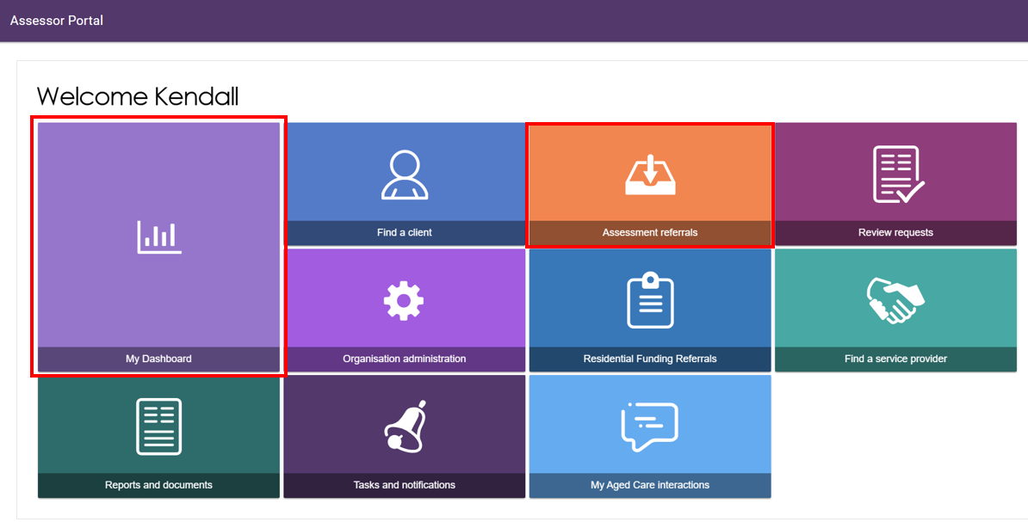

Alternatively, select **Assessment referrals** from the tool bar at the top right-hand corner of the portal.



1. Select the **Assessment referrals** in the **My Dashboard** page.

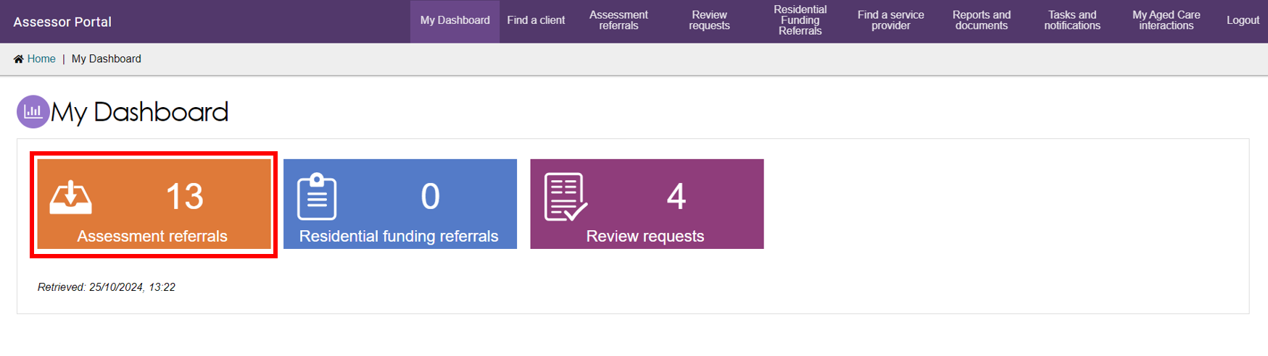

1. You can view referrals depending on your assigned role. Select the hyperlink corresponding to the referral origin to view more details.

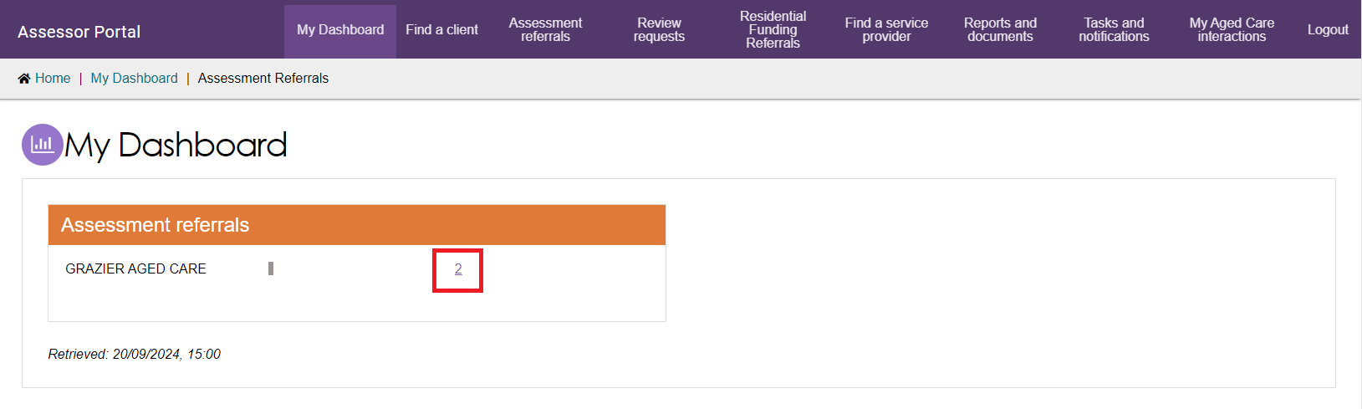

1. The **Incoming referrals** and **Unassigned** assessment referrals will be displayed.

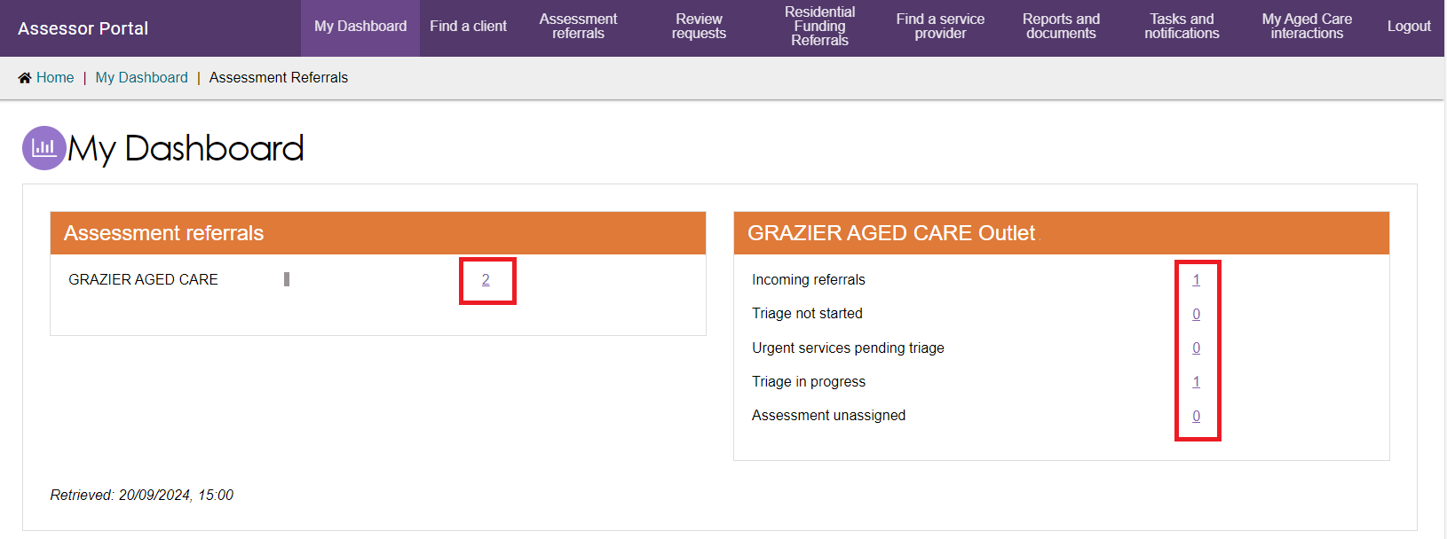

|  |  |
| --- | --- |
| ! | A warning notification will be displayed if there are referrals that have not been actioned within the priority timeframes.Example of the overdue warning notification |

1. To view referrals, select the **Incoming referrals** tab under the **Assessment referrals** page. You can select to view assessment referrals in a card or list view by selecting the card or list icon. Your selection will be retained for the next time you log in to the portal.

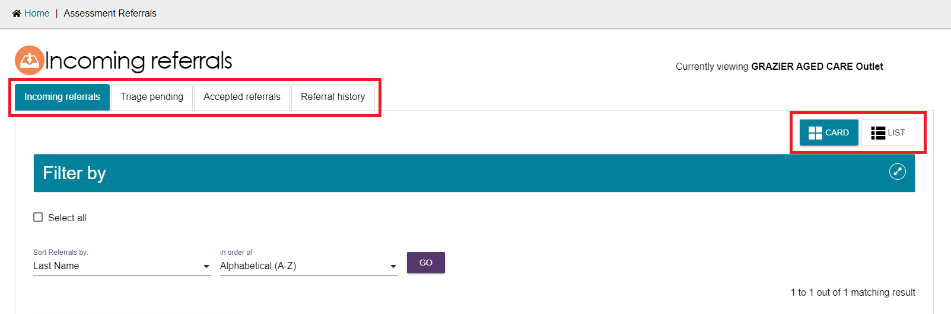

1. In the card view, referrals can be filtered or sorted by **Last name**, **First name** or **Aged Care user ID**.

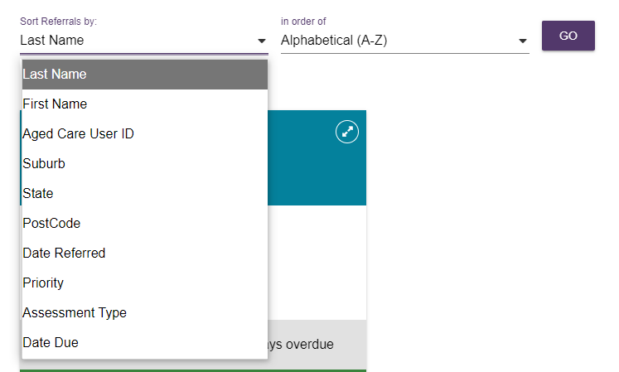

1. You can view more information on the referred client, including client notes and assessment history by selecting the double arrow icon example of the double arrow icon  on the top right-hand corner of the client card.
2. To view a client record, select **VIEW FULL CLIENT RECORD** from the expanded card view.

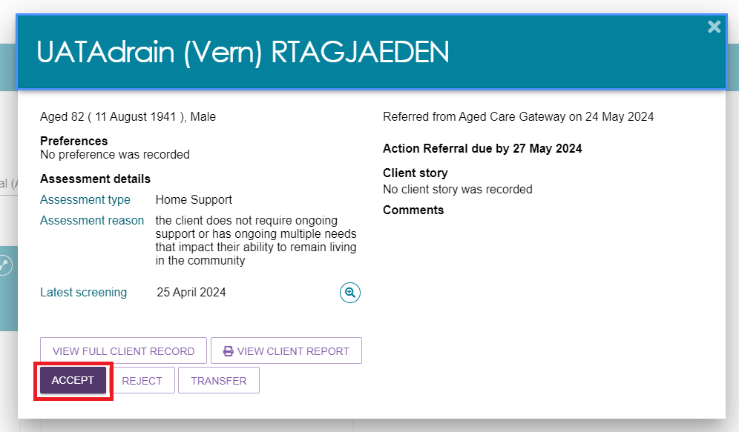

1. The same referral and client information is available in list view. Select the double arrow icon example of the double arrow icon  to the left of the client’s name to expand the view.

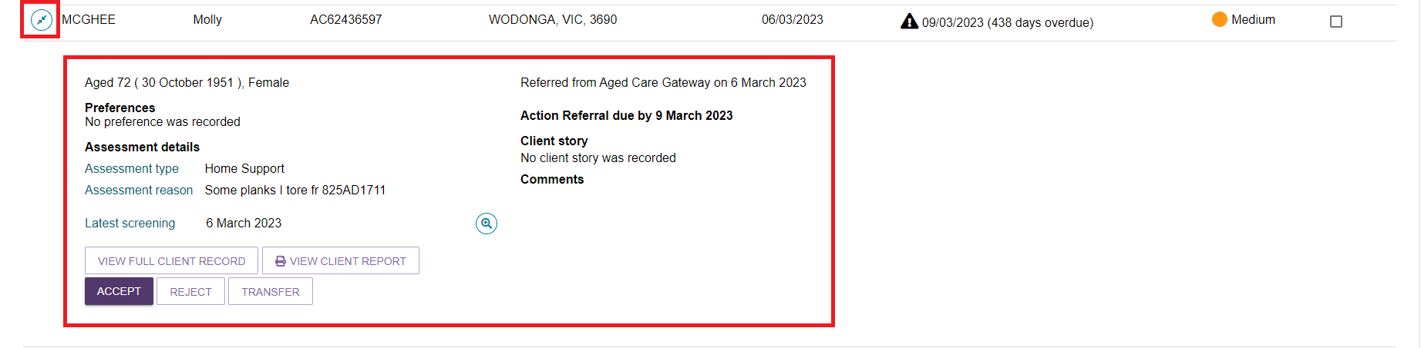

|  |  |
| --- | --- |
| ! | A banner will be displayed on the referral if additional attachments have been added to the client’s record as part of an inbound referral. |
| ! | If the client has pending support relationships, a banner will be displayed on the referral. Team Leaders and Triage Delegates are able to confirm pending support relationships for clients  The process is described in [My Aged Care - Assessor Portal User Guide 2 - Registering support people and adding relationships](https://www.health.gov.au/resources/publications/my-aged-care-assessor-portal-user-guide-2-registering-support-people-and-adding-relationships).  A banner will be displayed on the referral if it was issued as a **Direct referral**.  Note: Direct referrals have the same key performance indicators as regular referrals. The word ‘direct’, indicates that the client did not receive a Support Plan Review before being referred.  Image of Banner highlighted on the  client's referral. |

1. If you want to view the information available in the client record you can either go back on your internet browser to return to the **Incoming referrals** page or choose the **Incoming referrals** option from the tool bar.

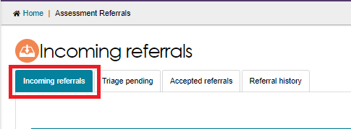

## Accepting incoming assessment referrals and changing the priority

Once a Team Leader has viewed the client record, they can accept or reject the referral. Follow the steps below to accept a referral and change the priority of a referral if required.

1. Select **ACCEPT** from the expanded card or list view.

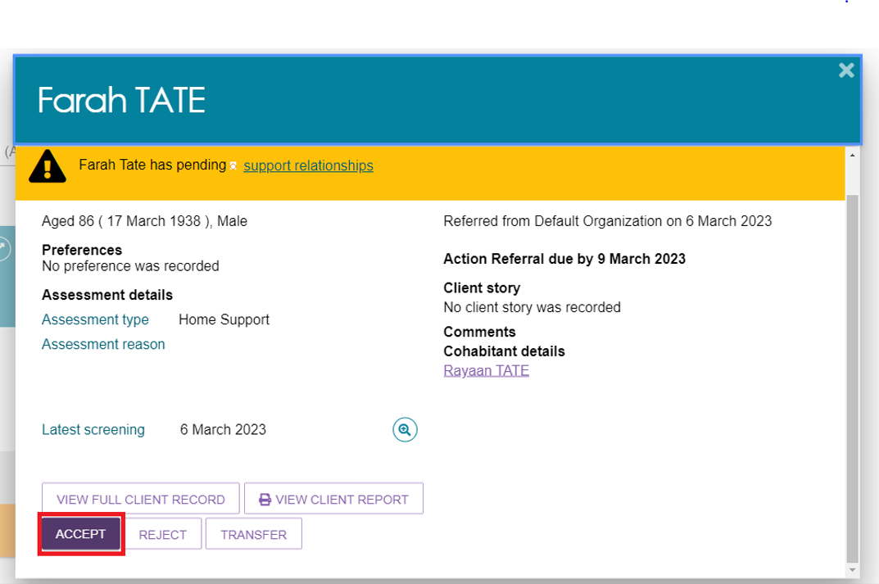

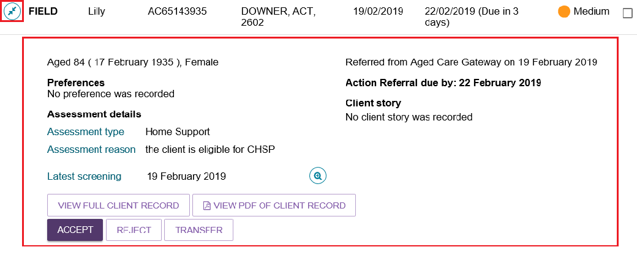

|  |  |
| --- | --- |
| ! | Team Leaders can bulk-accept assessment referrals by selecting the tick box next to each client they would like to accept, or by using **SELECT ALL** for all client referrals assigned to their outlet.  The bulk-accepting function defaults the clients’ priority to medium.  Team leaders will be unable to change the priority when bulk-accepting referrals.  Bulk-accepting will default assessment setting to **Non-Hospital**. Team Leaders can then change the setting to **Hospital** as required. |

1. Confirm that the priority of the assessment referral is correct and select the **Assessment setting**. To change the assessment priority, choose from the options provided in the drop down.

|  |  |
| --- | --- |
| ! | When accepting a referral, team leaders can add a free text information into the **Triage category**. Once the referral has been accepted, the information can be used to assist with finding referrals via the search function. This free text option is not to be confused with the triage process that is a required process for accepting referrals. |

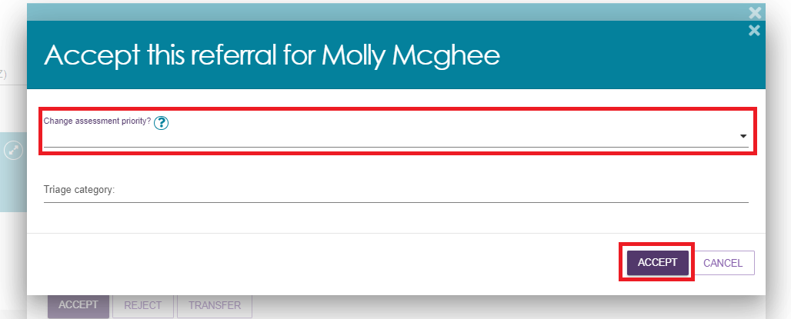

1. Team leaders can change the assessment priority for the referral. When doing this, a reason for changing the priority will need to be provided and a reason provided in the free text box. If the assessment priority is changed, a new priority timeframe will be calculated and applied to the referral.

|  |  |
| --- | --- |
| ! | Direct referrals priority default to being high when issued. Team leaders can change the priority of direct referrals when accepting if they determine the client can safely access the assessment at a lower priority level. |

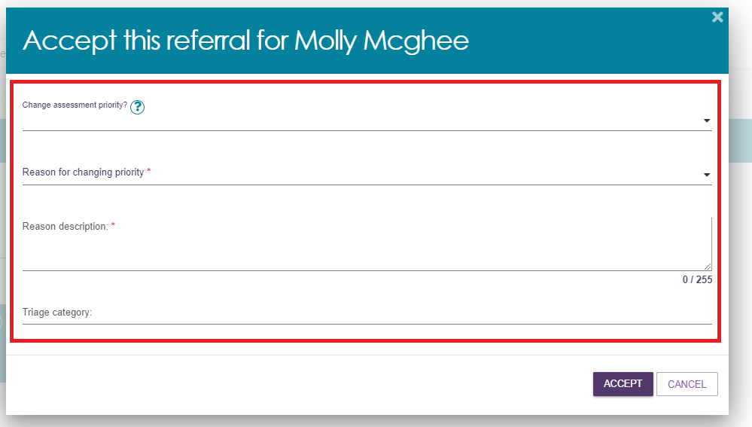

Note: The timeframe will continue to be calculated from the date the referral was issued, not the date the priority was changed.

|  |  |
| --- | --- |
| ! | As part of the Single Assessment System Program contract, key performance indicators will consider the setting in which the interaction with the client takes place, specifically a non-Hospital or Hospital setting.  Team leaders can select the assessment setting while accepting the referral.  Note: Before commencing the assessment, assessors should verify the information entered by the team leader, noting that the assessment setting may have changed since between the time of the acceptance of the referral and when the assessment takes place.  You can update the assessment setting by selecting **Edit Assessment Setting** in the expanded client card, depending on your role:   * the team leader on the **accepted referrals** view, or * the assessor on the **current work** view.   Image is of an assessment setting, options are provided and highlighted in a red text box. The save button is highlighted in a red box. |

|  |  |
| --- | --- |
| ! | When the assessment is finalised, the **Assessment setting** field on the expanded client card or list view must align with the type of assessment setting recorded within the Intergrated Assessment Tool (IAT). Assessment setting fields can be edited if required, until the Support Plan is completed.  Image of client's referral with Assessment setting highlighted. |

1. Once the referral has been accepted, the referral will move into the **Triage pending** tab under **Unassigned**.

## Assigning Triage

|  |  |
| --- | --- |
| ! | Triage must be completed by a clinical staff member who holds the Triage Delegate role in the My Aged Care assessor portal.  For further information on the Triage Delegate role, visit Assessor Portal User Guide 12 - Managing Delegate Roles. |

Once an assessment referral has been accepted, it will display with a Triage pending status. A Triage Delegate will then need to assign the referral to themselves or to another Triage Delegate for triage.

Once an assessment has been assigned to a Triage Delegate, they can proceed with the triage, reassign the triage to another Triage Delegate or unassign themselves and place the accepted referral back into the triage pending queue.

1. To access triage pending referrals, select the **Triage pending** tab.

Note: If the Triage delegate has access to multiple outlets, one will need to be selected before continuing with triage.

Once a referral has been accepted it will be under **Triage pending** and unassigned. You will have to filter the **Assigned to** drop down and select **unassigned**, then select **FILTER**.

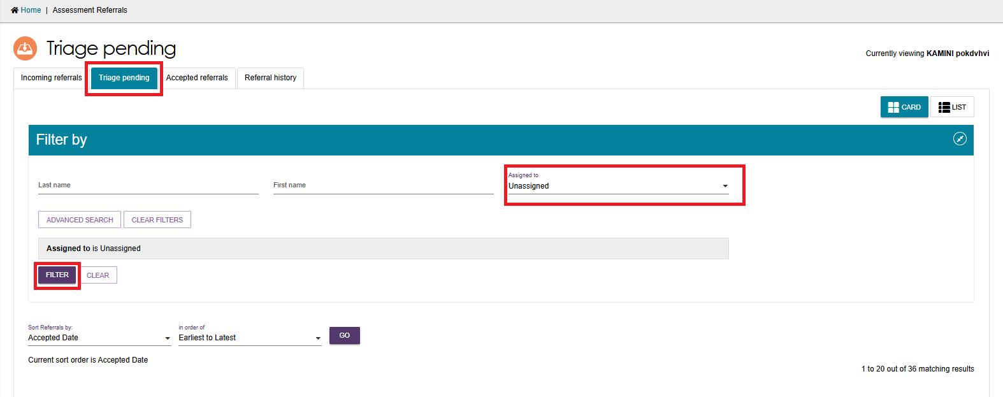

1. Expand the client card which you would like to assign triage for. To assign to yourself or another Triage Delegate for action select **ASSIGN.**

To transfer the referral to another outlet for triage select **TRANSFER,** for further information on transferring a referral see the sectionTransferring an assessment referral to another outlet or organisation.

To reject the referral, select **REJECT**. For further information on rejecting a referral see the section Rejecting an assessment referral.

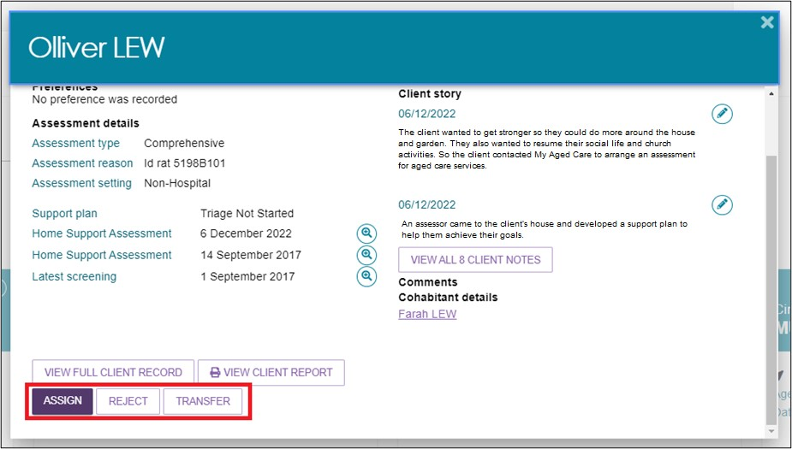

1. When selecting **ASSIGN** a pop up will appear. From this you will be able to assign the triage decision for the client either to yourself or other Triage Delegates from the selected outlet. Once this has been selected, select **ASSIGN**.

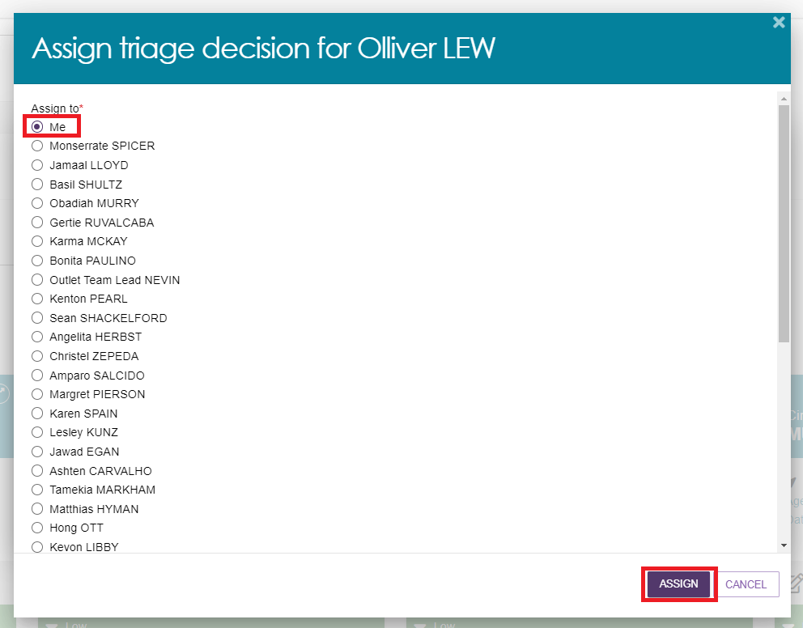

1. Once the triage has been assigned, the client card will appear under the **Triage pending** tab., Ensure that the **Assigned** filter is set to **Assigned to me** so that clients assigned to you can be found under the **Triage Not Started** heading. The expanded client card will have the options to:

* Start triage
* Reassign, for further information on reassigning a referral see Unassign or reassign referral to an assessor.
* Refer to urgent services, for further information on referring for urgent services see Referring for urgent services.
* Transfer, for further information on transferring a referral see Transferring an assessment referral to another outlet or organisation.
* Reject, for further information on rejecting a referral see Rejecting an assessment referral.

When selecting **REASSIGN**, alternative Triage Delegates will be provided as well as the option to **Place back in the delegate queue** this will place the client back into a **Triage pending** status and in the queue for allocation.

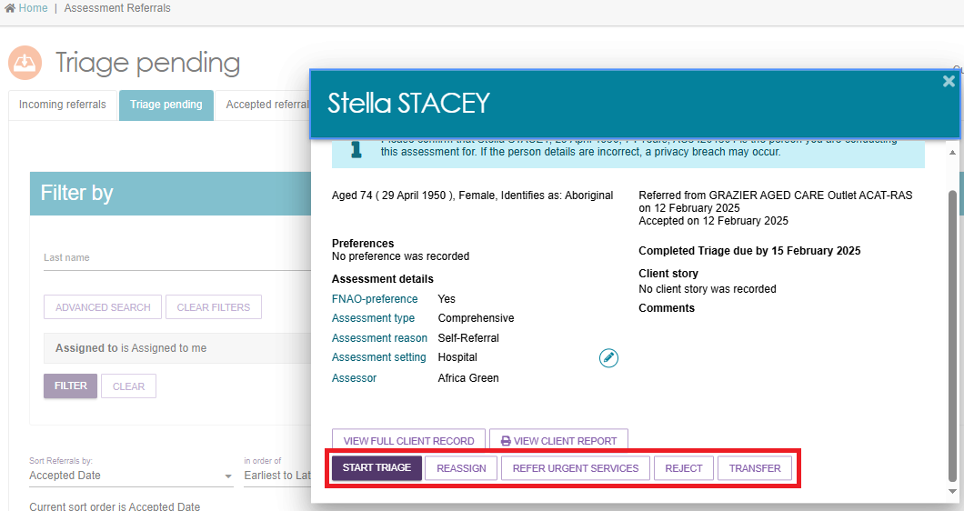

## Completing Triage

In the **Assessments** tile under the **Triage pending** tab, clients that triage has not been completed for will display under the **Triage Not Started** heading.

1. Expand the client card and select **START TRIAGE** to begin the triage.

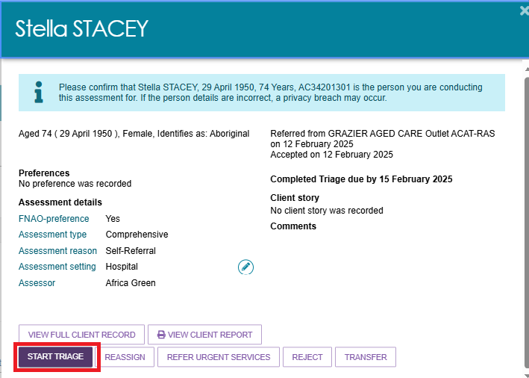

Before commencing triage, consent from the client must be received using the consent script. The Consent for Triage script should be read out to the client.

1. Select **CONTINUE** to progress. The final stage of consent will require the Triage Delegate to record who the **Consent was obtained from**, options provided will be:

* The client
* The client with help from a support person
* The client’s authorised representative
* Consent was not given.

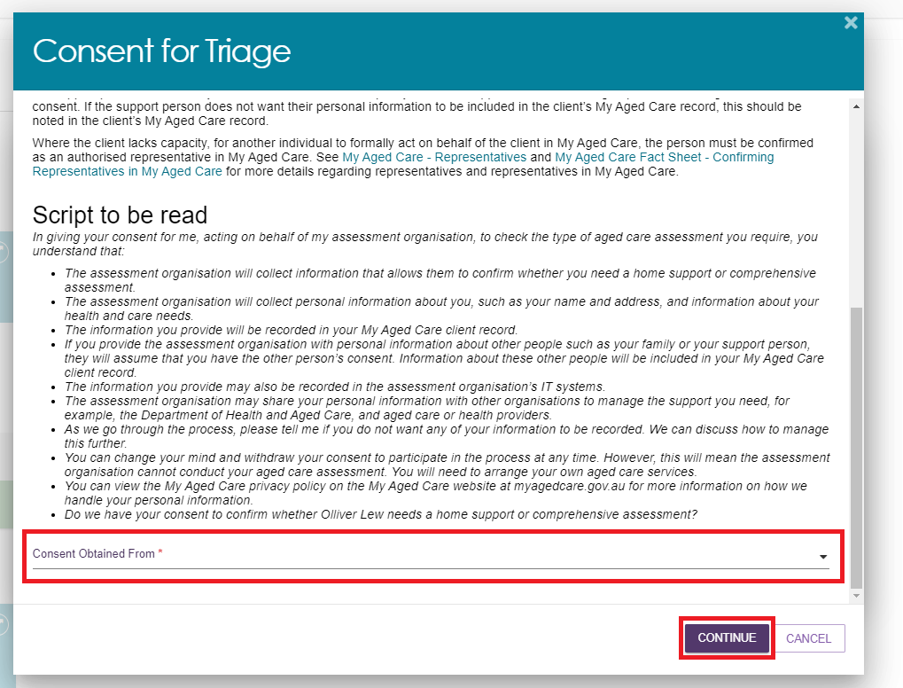

If the client or their representatives choose to not give consent, the triage process is to end. The Triage Delegate is required to provide a reason for refusal. Options provided will be;

* The assessment is no longer required
* Client’s support person is not available
* Client does not have the capacity to understand and communication consent
* Client’s representative withdraws consent
* Client’s representative not available to give consent, or,
* Other reasons that can be specified further in a free text format.

|  |  |
| --- | --- |
| ! | Please note that the use of the ‘Other, please specify’ value should be limited to rare and unusual situations that are not captured by existing values. |

Once a reason for not providing consent is given, select **SAVE AND CLOSE.**

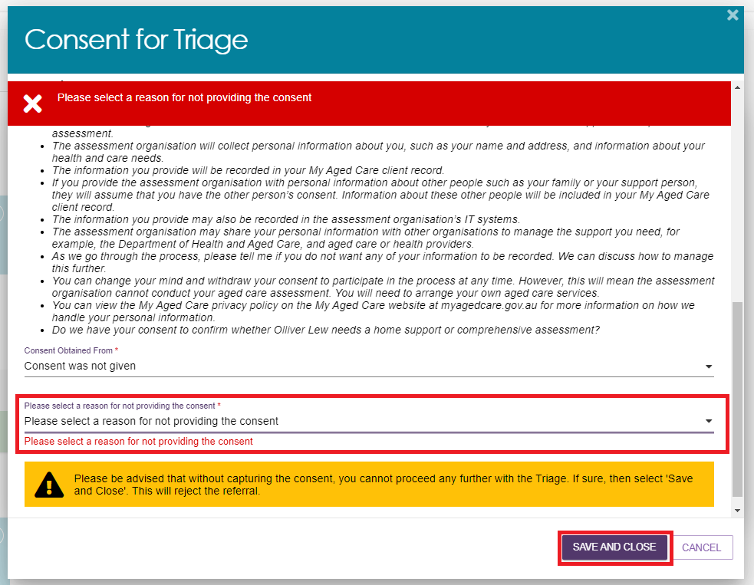

## Triage Pre-population options

Triage Delegates will have the option to pre-populate responses from the clients previously finalised assessment.

1. Select the **COMFIRM PRE-POPULATION** button to pre-populate the relevant previous screening/assessment. Select the **BLANK TRIAGE** button to begin the triage without pre-populated responses. Selecting the **CANCEL** button will navigate the Triage Delegate back to the expanded view.

Note: In exceptional cases when the client’s previous referral was rejected after triage was completed, the Triage Delegate will only be able to complete the triage with the pre-populated rejected referral.

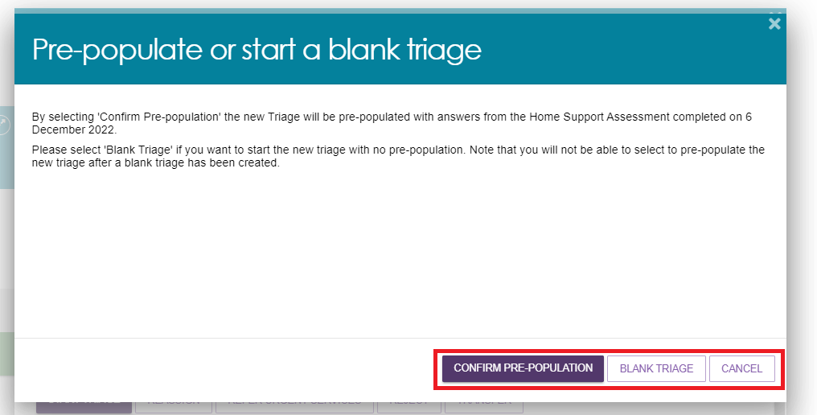

1. The Triage Delegate will confirm the demographic details of the client. Once confirmed, to progress select **SAVE AND CONTINUE TO TRIAGE**.

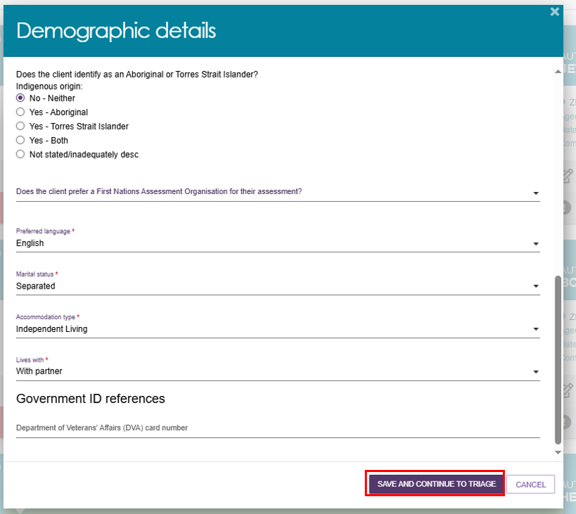

1. Follow the prompts for the pre-populated or blank triage. All mandatory questions must be answered before completing triage by selecting **COMPLETE TRIAGE** button.
2. Triage Delegates will be required to respond to the question **What type of needs assessor is recommended for client assessment**. The Triage Delegate will be provided with the options of **Clinical**, **Non-clinical** and **not eligible for assessment**. The option that is selected will display in the portal showing:

* Comprehensive (clinical) assessment required
* Home Support (non-clinical) assessment required
* Not eligible for an aged care assessment.

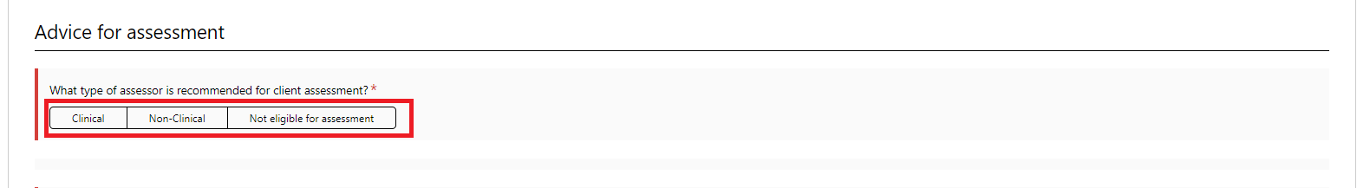

Please note: The **COMPLETE TRIAGE** button will be disabled until all mandatory questions have been answered in the triage.

1. To save the recorded information but not complete the triage select the **SAVE TRIAGE** button.

If the triage needs to be cancelled, select the **CANCEL TRIAGE – NO FURTHER ACTION REQUIRED** button. The reason for cancellation must be provided by the Triage Delegate. A list of options will be provided under **Reason for ending the triage**. Once the cancelation has been confirmed the referral will be rejected and the Triage Delegate will be navigated back to the client summary page.

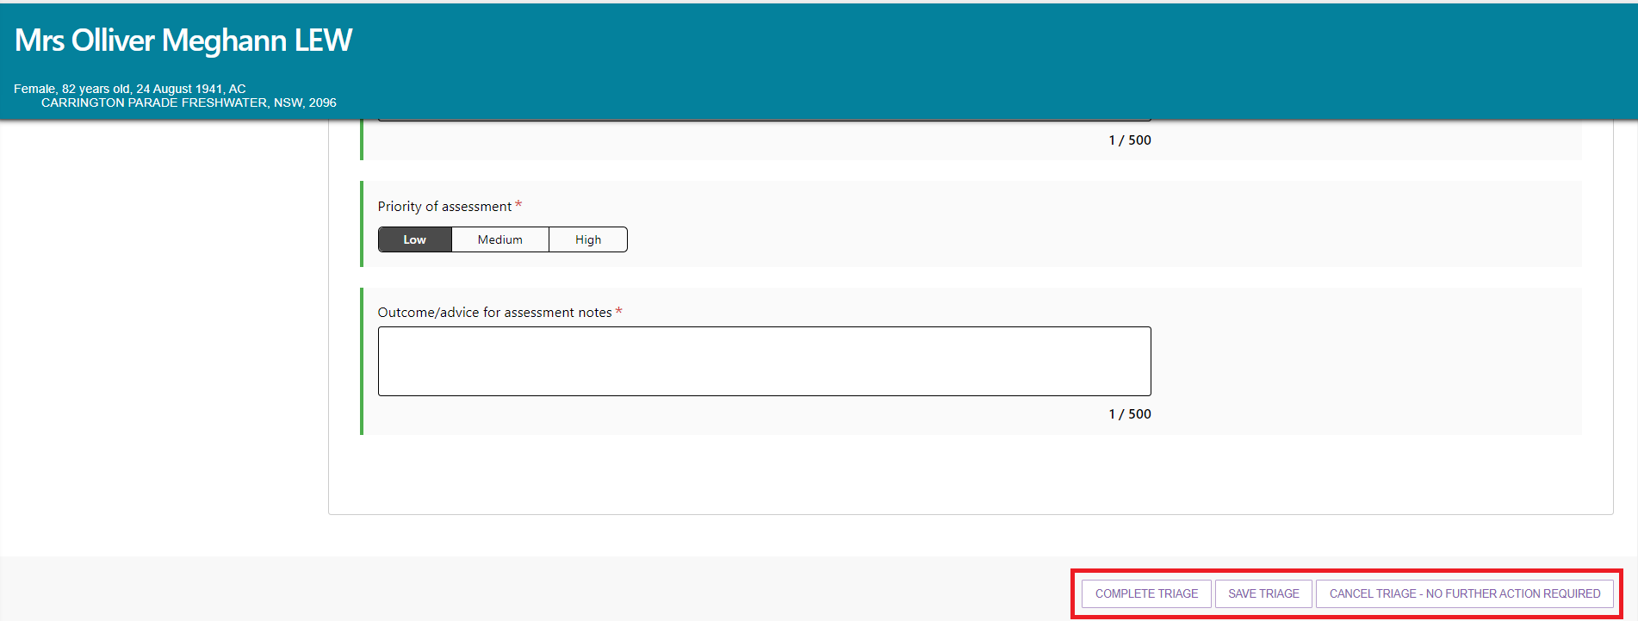

1. Once **COMPLETE TRIAGE** has been selected, a pop up will confirm that you would like to complete the triage. Select **COMPLETE TRIAGE** to finalise.

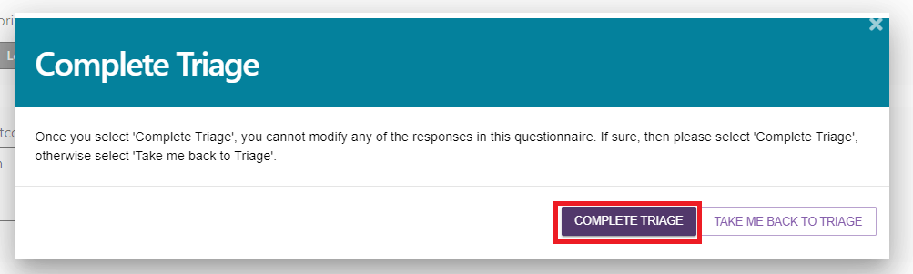

Once the triage is completed, the Triage Delegate will be able to view the follow buttons on the client card;

* Assign to assessor
* Refer urgent services
* Convert to home support assessment or comprehensive assessment.
* Reject
* Transfer
* View full client record
* View client report.

The client card will also display the date that the triage was completed.

Once the client’s triage has been completed, the referral for that client will remain under **the Triage pending** tab, under the **Triage Completed** heading.

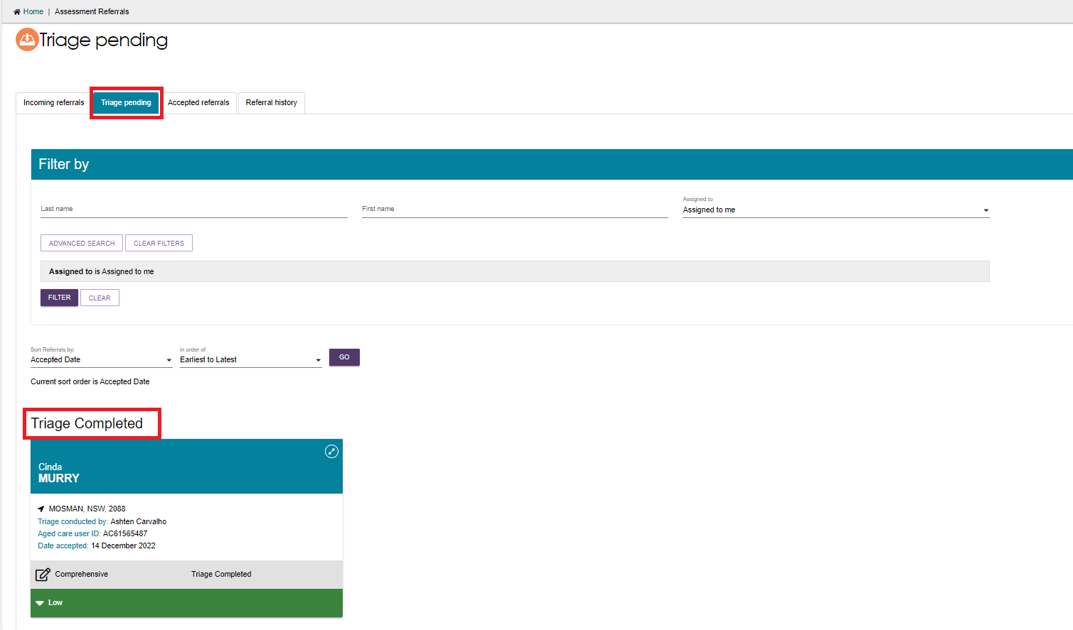

## Viewing triage information

Triage Delegates and Team Leaders can view the clients triage information from the client’s summary page. This is done by selecting the magnifying glass icon next to **Home Support Assessment or Comprehensive Assessment**.

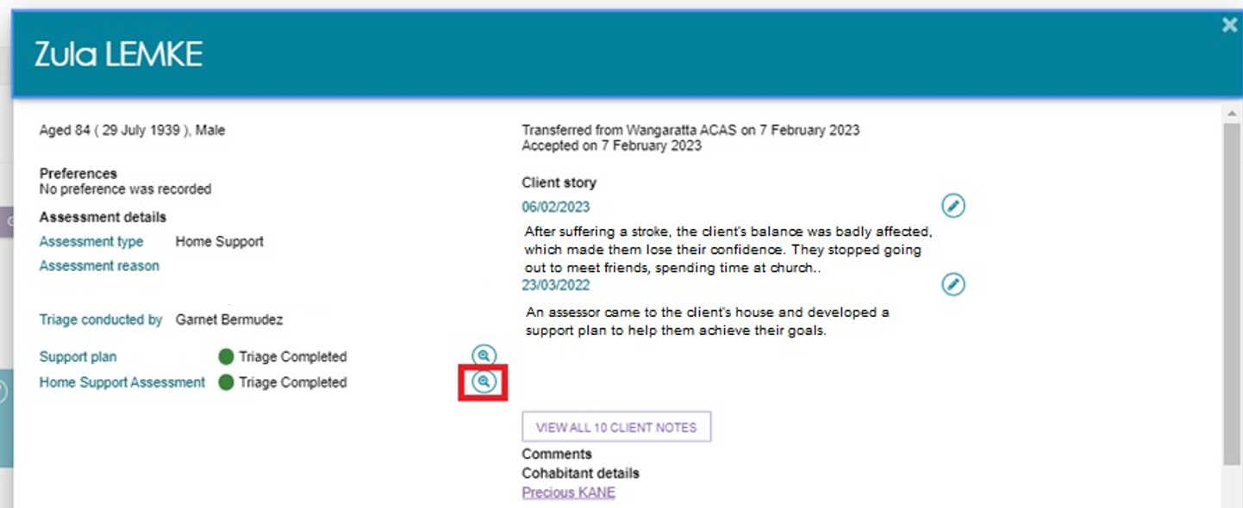

## Referring for urgent services

Triage Delegates can refer a client for urgent services once an assessment referral has been accepted. This can occur before or after triage.

1. To refer urgent services before conducting triage, in the **Triage pending** tab, the Triage Delegate will select the card for the client they are referring for urgent services. Then select the button **REFER TO URGENT SERVICES**.

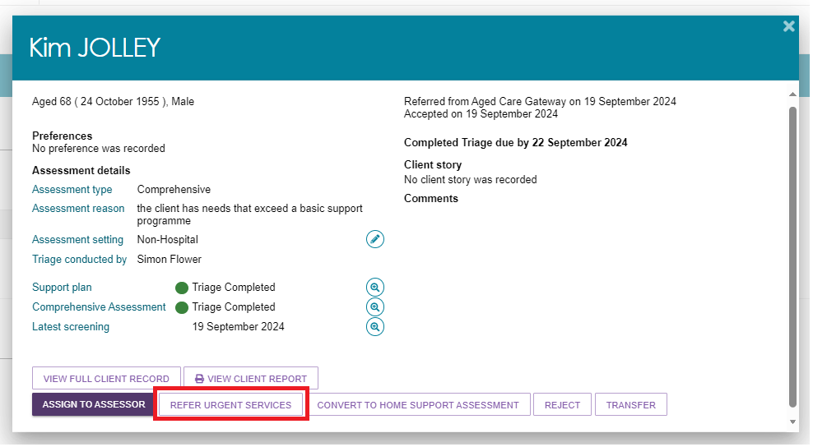

1. The Triage Delegate will then be navigated to the **Goals & recommendations** tab under **Support Plan and services**.

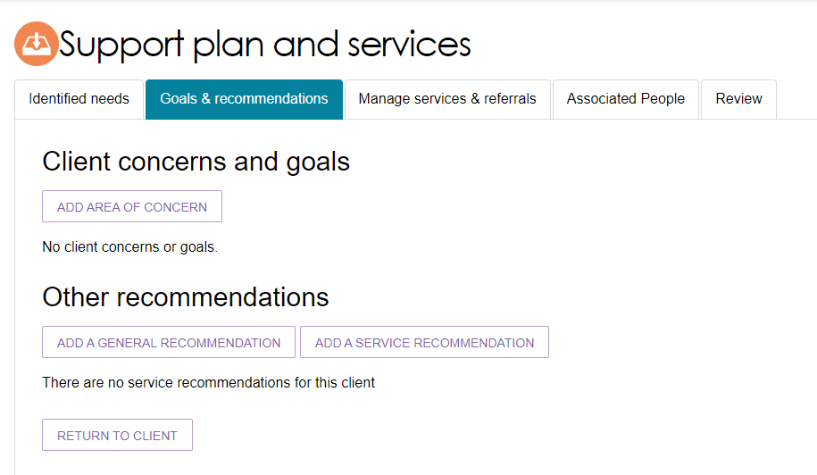

When a client has been referred for urgent services, **Urgent Services Pending Triage** will be shown on the client’s card.

## Converting Assessment

Triage Delegates are able to convert a client’s assessment from Comprehensive to Home Support, or Home Support to Comprehensive.

1. Once triage has been completed and based on their clinical judgement, the Triage Delegate can convert the assessment by selecting the **CONVERT TO HOME SUPPORT ASSESSMENT** or **CONVERT TO COMPREHENSIVE ASESSESSMENT**.

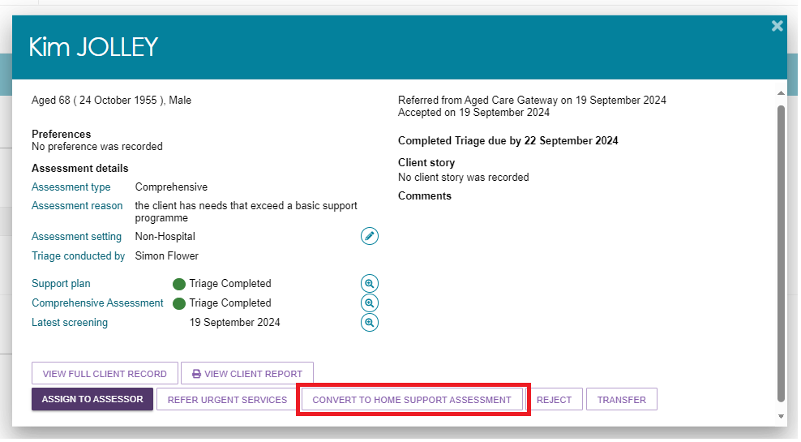

1. When converting from a Comprehensive Assessment to a Home Support Assessment, Triage Delegate will need to enter the **Reason for change** as being **Low level care needs**.

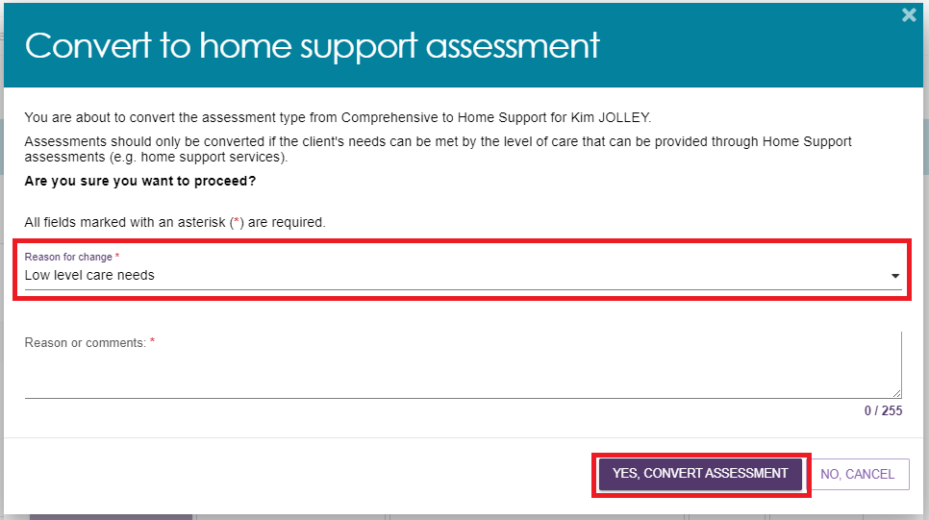

When converting from a Home Support Assessment to a Comprehensive Assessment, Triage Delegates will need to enter the **Reason for change** as being **High level care needs**.

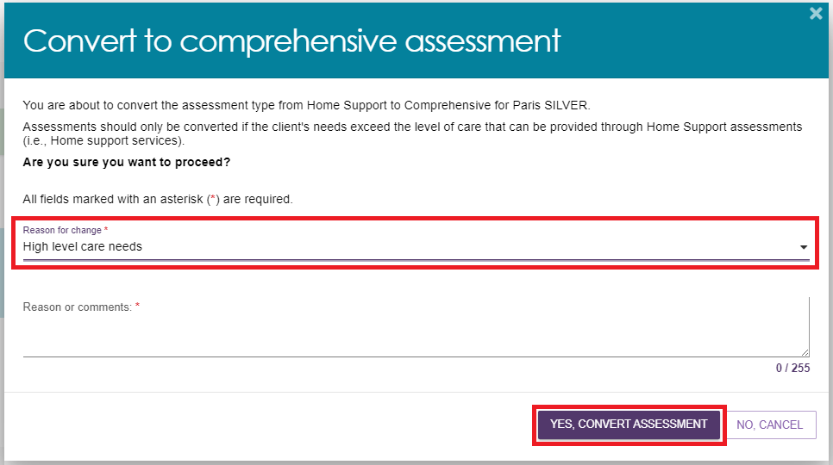

## Assigning an assessment referral to an assessor

Before a Triage Delegate assigns an assessment referral to an assessor, triage must be completed.

1. Referrals that can be assigned are located in the **Triage pending** tab, under the **Triage Completed** heading. Expand the client card for the referral you wish to assign, select **ASSIGN TO ASSESSOR**.

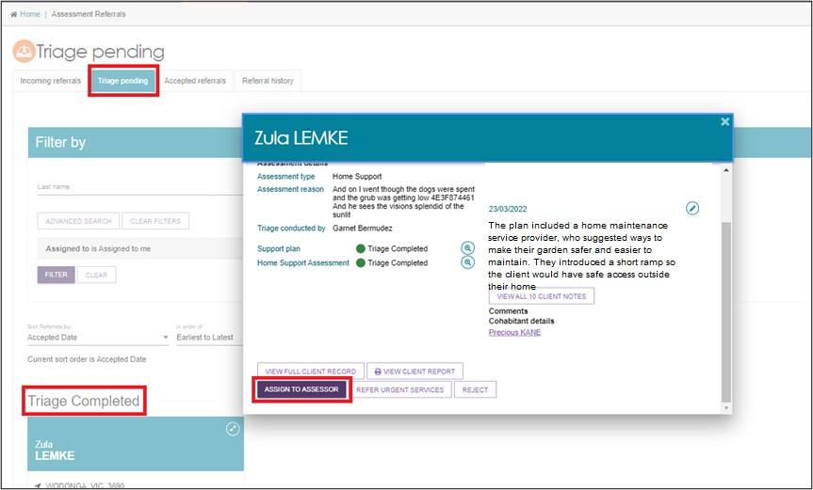

1. The Triage Delegate can **Change assessment priority** before assigning the referral. Respond **Yes** or **No** to the question **Assign now**, if you wish to assign now, and then choose the assessor. To proceed select **ASSIGN**. If you do not wish to assign now, this referral will remain under the **Triage pending** tab, under the **Triage Completed** heading.

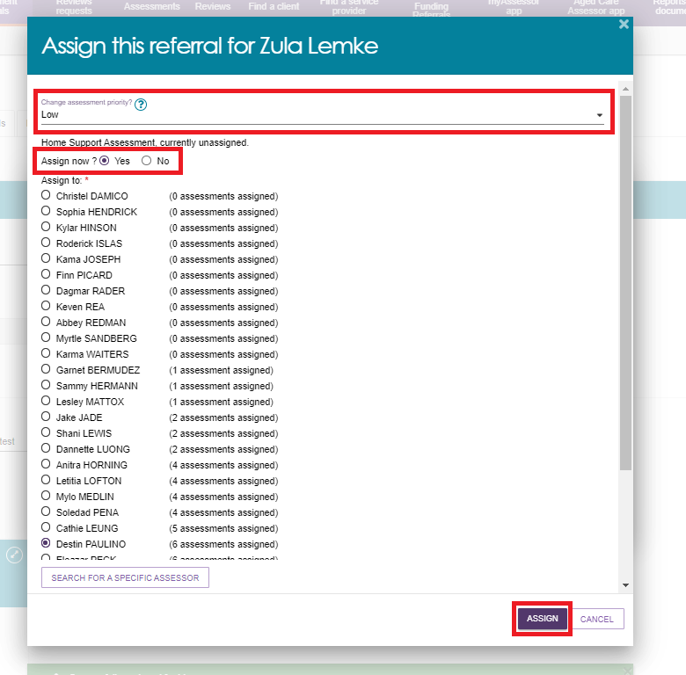

1. The assessment referral will appear in the **Accepted referrals** list, under the name of the assessor the referral was assigned to. The referral will also appear in the assigned assessor’s **Current assessments** list for action.

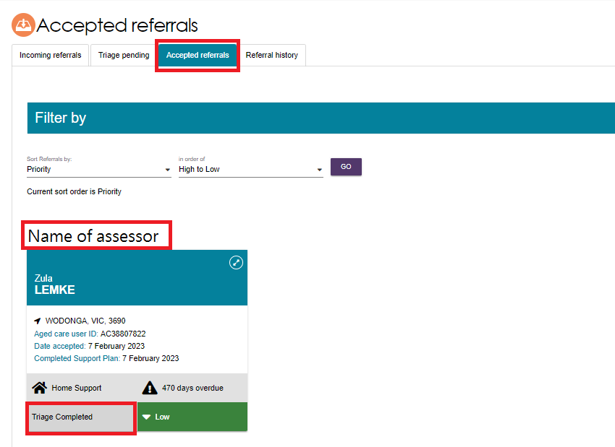

## Unassigning or reassigning an assessment referral

Team Leaders can unassign an assessment referral and reassign the referral to another assessor in the same outlet. There is no limit on the number of times referrals can be unassigned or reassigned.

1. From the **Accepted referrals** tab, access the expanded referral view by selecting the arrow on the client card.

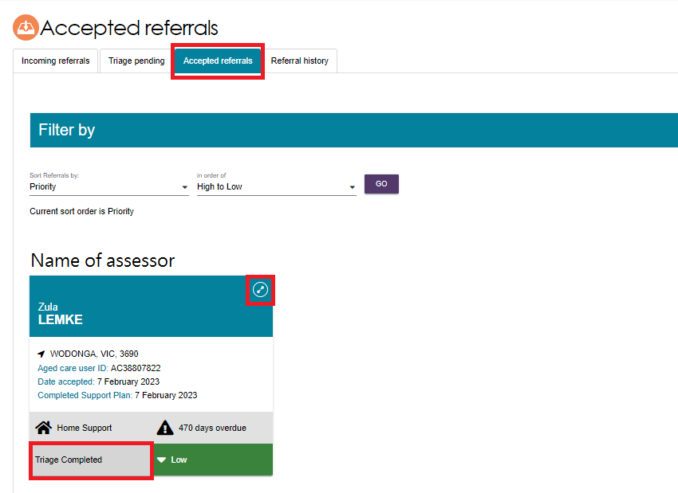

1. Select **REASSIGN**. If using list view, select **REASSIGN** from the expanded view.

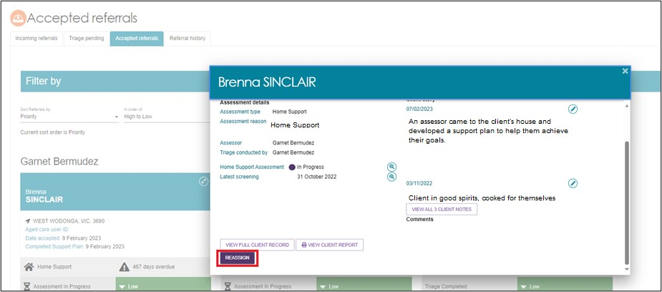

1. Select the assesor that the referral is being assigned to and select **SAVE**. If the referral is going to be unassigned and added back to the queue, select **Unassign and add to the queue**.

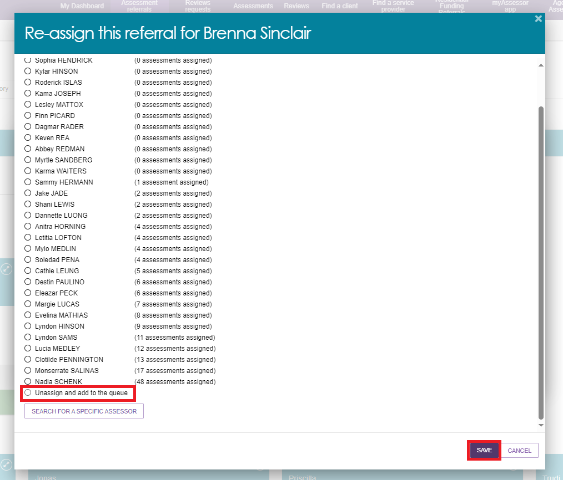

If reassigned, the assessment referral will appear under the relevant assessor in the list of **Accepted referrals**.

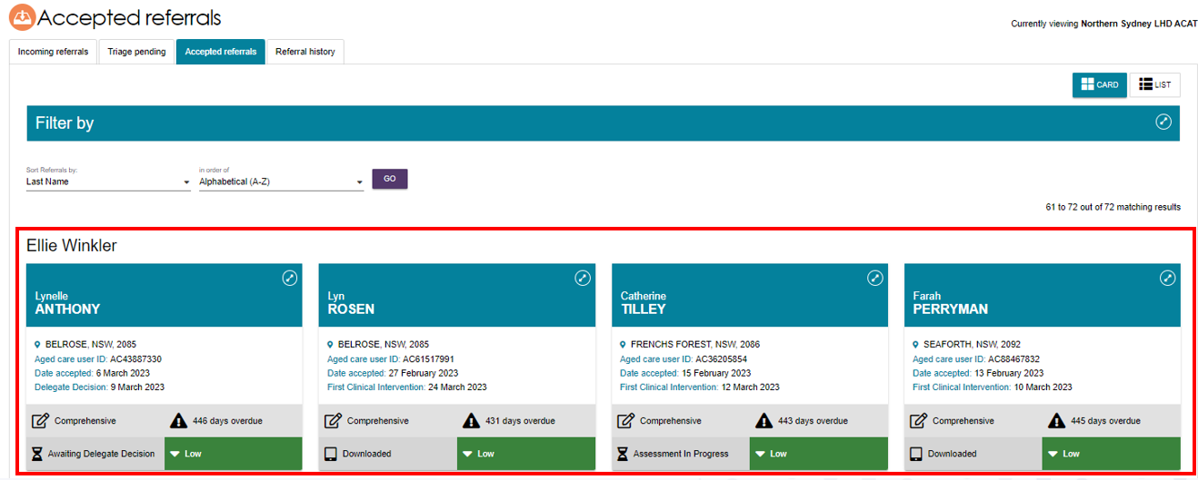

If unassigned, the referral will appear under **Unassigned** in the list of **Accepted Referrals**.

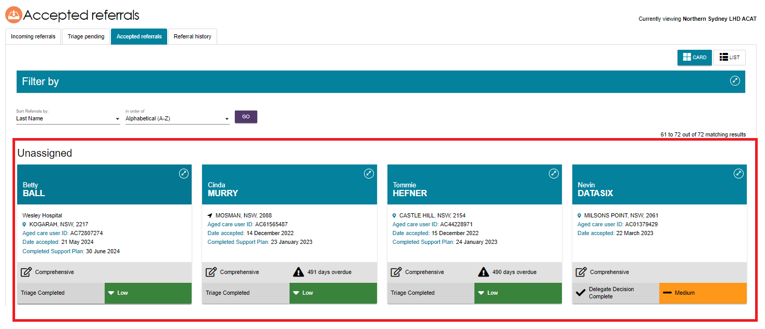

## Rejecting an assessment referral

If an outlet is unable to accept an assessment referral and cannot transfer it, a Team Leader can reject the referral. Referrals may also be rejected after acceptance, but only before the assessment has commenced.

1. 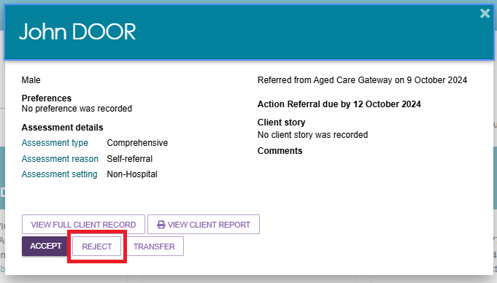Select **REJECT** on the expanded card view of the referral information.
2. Enter a reason for rejecting the assessment referral, and then select **REJECT**. The rejected referral will automatically be sent to My Aged Care to action.

|  |  |
| --- | --- |
| ! | The use of the ‘Other’ value when rejecting referrals should be limited to rare and unusual situations that are not captured by existing values. If an existing value primarily captures the nature of the rejection reason, please utilise that option. The free text field will be available for further information for any rejection reason selected. |

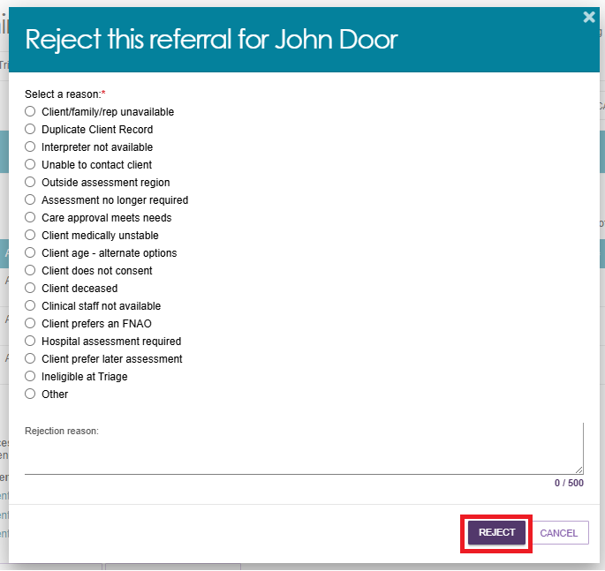

|  |  |
| --- | --- |
| ! | An older Aboriginal and/or Torres Strait Islander person should not be rejected based on a client’s preference (e.g. under the reason ‘Client prefers an FNAO”) unless it is a last resort. A transfer prior to the assessment is preferable to a rejection. For more information please refer to the [My Aged Care Assessment Manual](https://www.health.gov.au/resources/publications/my-aged-care-assessment-manual?language=en). |

## Rejecting an assessment with the reason of Client deceased

|  |  |
| --- | --- |
| ! | Rejecting an assessment with the reason of **Client deceased** will change the client’s status to **Deceased** and make the client record read-only. Any unaccepted service referrals will be recalled, services in place will be ceased, assessments will be cancelled and the client’s access to the client portal will be revoked. My Aged Care will not send correspondence to the client or their representatives after the status is changed to **Deceased**.  Where a client is active in the national priority system or has been assigned a Home Care Package, this will remove the client from the national priority system and withdraw any assigned Home Care Packages. |

If a client is deceased during an assessment referral period, Team leaders will need to provide the following information:

* Who, when and how you were informed that this person is deceased  
  E.g., “Mrs Smith rang to inform us that Mr Smith has passed away on Saturday”
* Date of death (if known)
* Add Attachments  
  E.g., Death Certificate, Hospital discharge documents

When a client is marked as deceased, a notification will be sent to the client’s associated assessor and provider, telling them to close or finalise any in-progress tasks.

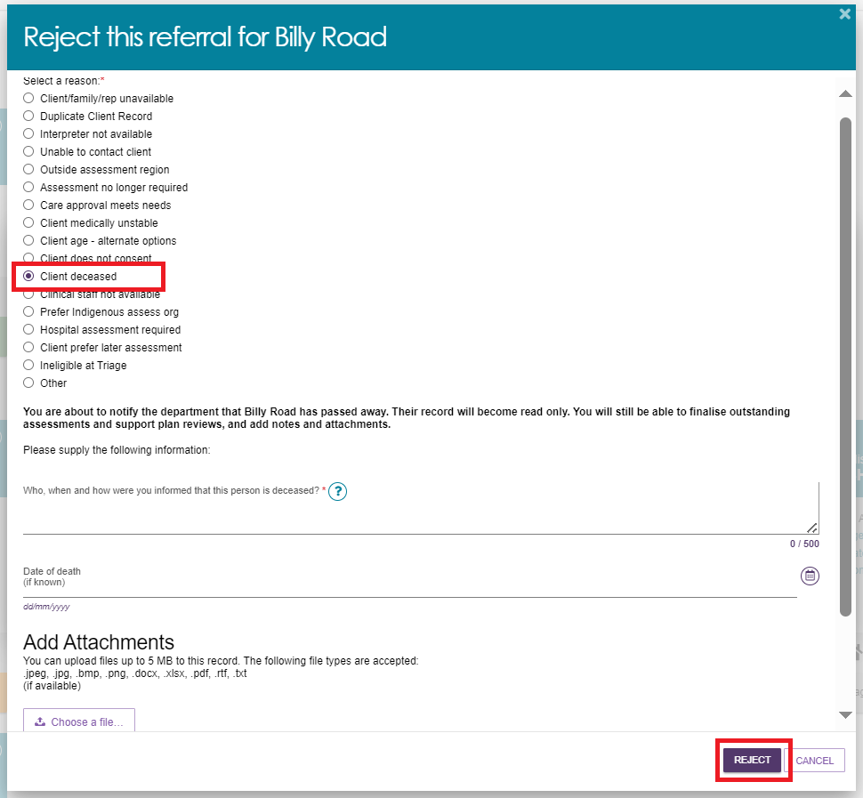

When a client is marked as deceased, if they have an in-progress assessment or have commenced services, a notification will be sent to the associated assessor in the assessor portal, advising the assessor to close or finalise the in-progress tasks.

## Transferring an assessment referral to another outlet or organisation

Only incoming, accepted or triaged referrals may be transferred to another outlet or organisation. A referral can only be transferred to another organisation or outlet once.

* To transfer assessment referrals to an alternative assessment organisation or outlet follow the steps below.

|  |  |
| --- | --- |
| ! | Before transferring a referral, the Team leader must ensure that:   * The client understands why their referral is being transferred and consents to the transfer of the referral to the new assessment organisation * They have contacted the assessment organisation that will be receiving the client referral to confirm that they will accept the referral.   A referral should not be transferred before confirmation has been obtained that it will be accepted by the receiving assessment organisation. |

1. From either the **Incoming referrals**, **Triage pending** or **Accepted referrals** tab of the **Assessment Referrals** tile, select the arrow next to the client’s name and then select **TRANSFER** in the expanded view.

**CARD view example:**

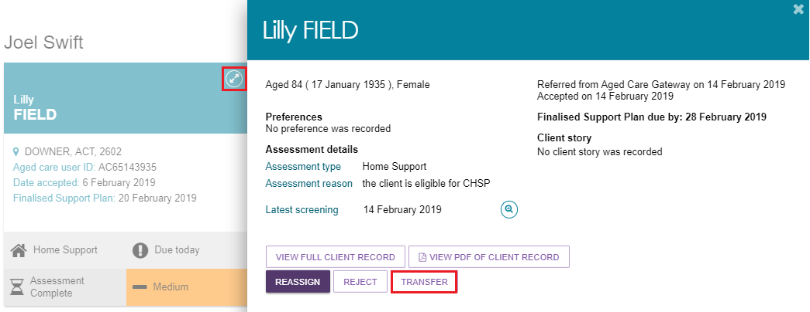

**LIST view example:**

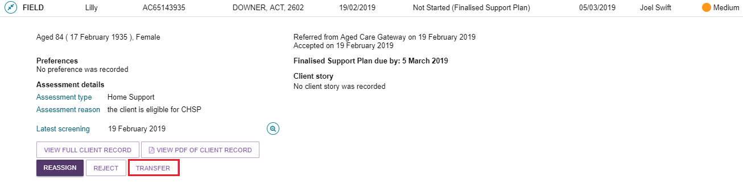

The following warning will appear when you select **TRANSFER**.



1. In the pop-up box the type of assessment required must be selected from a drop-down list, either **Home Support** or **Comprehensive Assessment**. If you select Comprehensive Assessment, it will provide an Assessment setting of **Hospital** or **Non-Hospital**. Once these have been selected, select the button **ADD ADDRESS** to search the address.

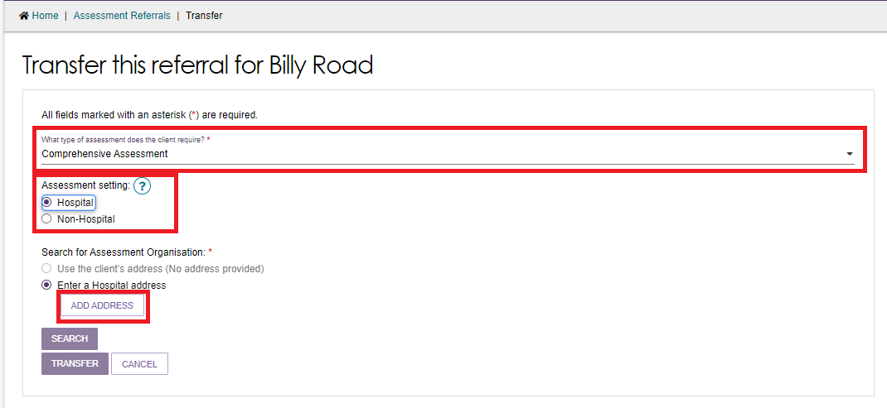

1. A pop up will appear and address details of the Clients address, or the Hospital Address will need to be entered. Select **VALADATE THIS ADDRESS**. Below a list of addresses will be provided, select the most relevant address. To finalise the address, select **SAVE ADDRESS**.

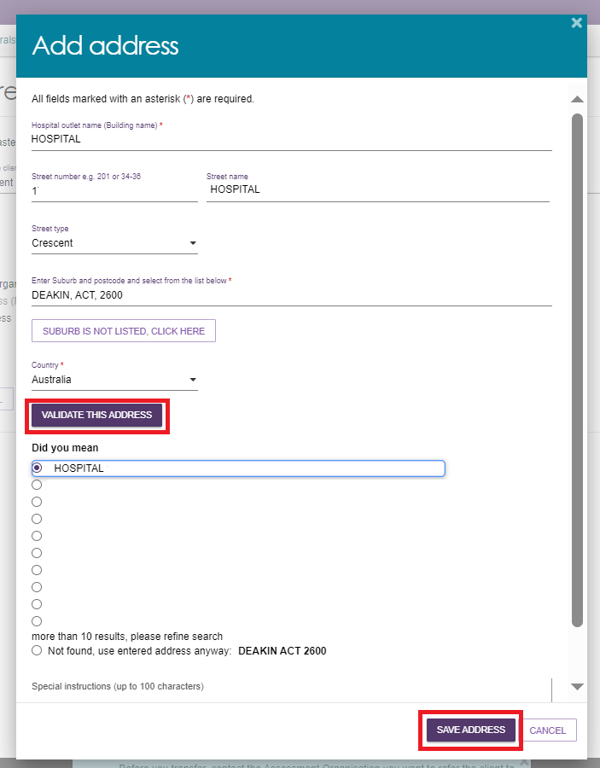

1. Select the appropriate assessment organisation for referral transfer and then select the reason from the drop-down menu.

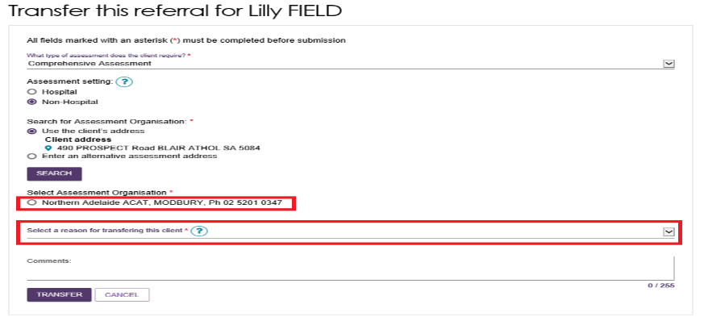

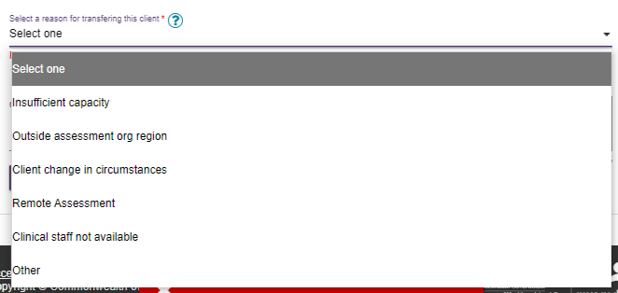

1. Provide as much detail as possible about the reason for transferring the referral in the comments box to assist the receiving organisation and then select **TRANSFER**.

Transfer this referral page with an Assessment Organisation us selected and  Transfer button selected.



Referral has been transferred successfully confirmation message



## Client records from inactive outlets

Departmental staff can transfer client records linked to an inactive outlet to an active outlet in the same assessment organisation, or to another assessment organisation.

Future Support Plan Review requests or new assessment referrals will be issued to the active outlet. Care extension requests transferred to the active outlet will appear as ‘unassigned’ in the delegate queue.

The assessors and the contact centre will see a note of the transfer in the My Aged Care client record. The client’s online account includes a notification of the transfer.

In the assessor portal, the notification of the transfer can be seen in the **Notes** tab of the client record.

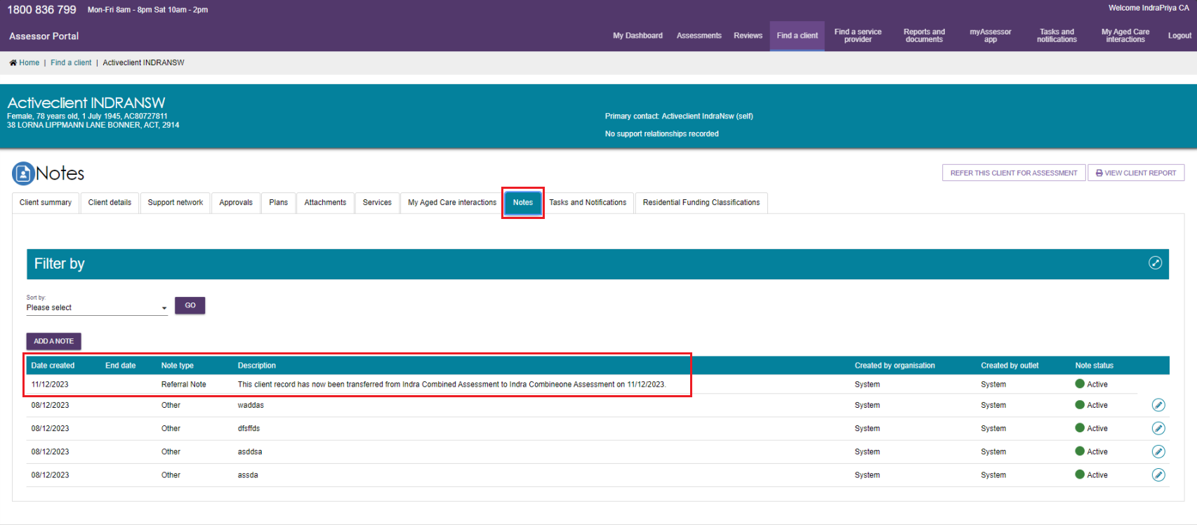

## Residential Funding Referrals

The Residential Funding Referrals tile is available to accept any residential funding referrals.

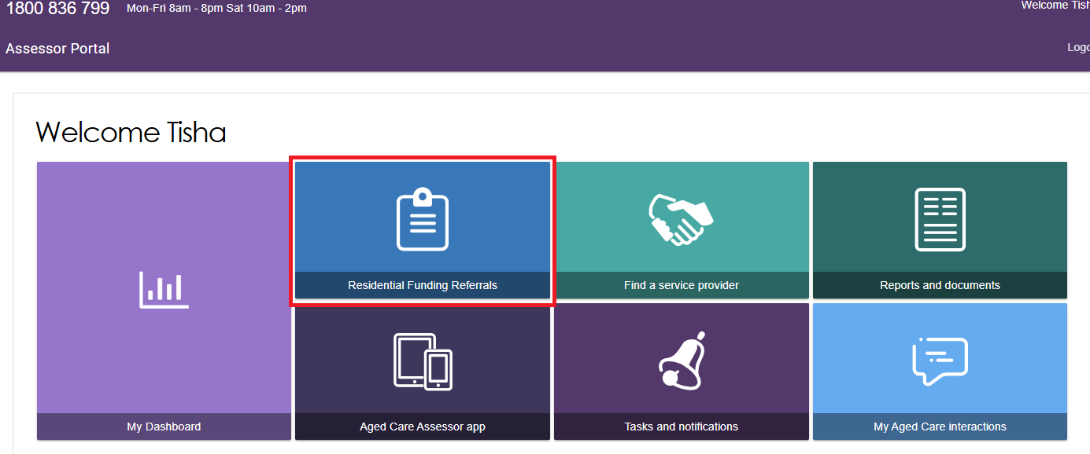

A clinical aged care needs assessor (clinical needs assessor) will have access to the **Current Work** and **Recent Work** tabs.

The **Current Work** tab contains Residential Respite Assessments that are assigned to you.

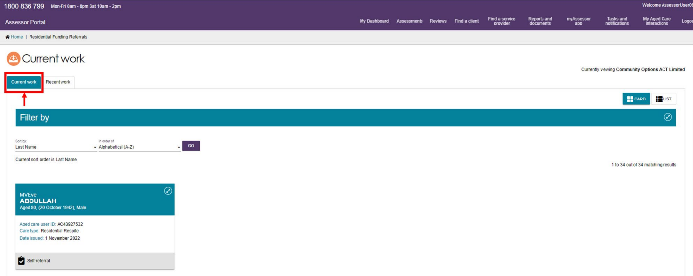

The **Recent Work** tile contains Residential Respite Assessments that you have completed in the past 2 years.

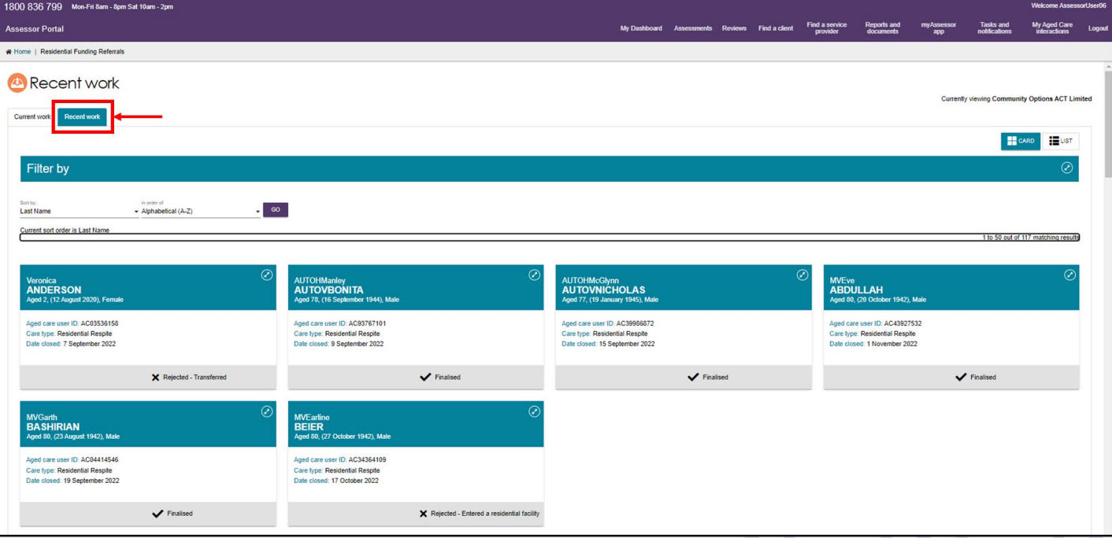

Filters can be applied to both the Current and Recent work tabs.

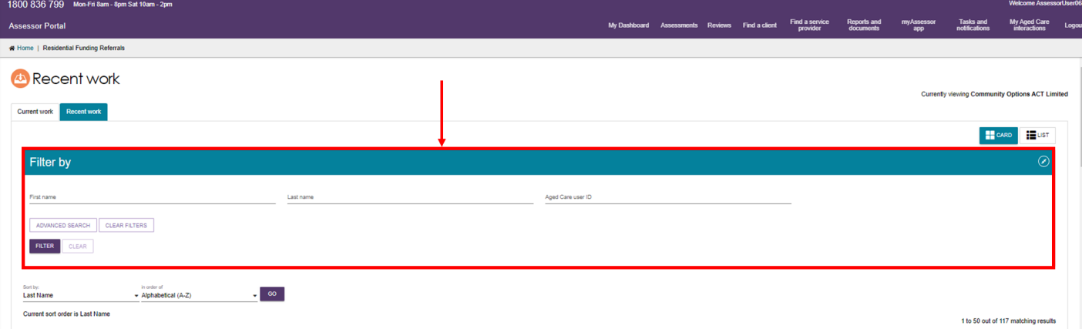

For more information on self-referring a client and starting a Residential Respite Assessment, please refer to the [Aged Care Assessor Application User Guide](https://www.health.gov.au/resources/publications/aged-care-assessor-application-user-guide).

## Support Plan Reviews

|  |  |
| --- | --- |
| ! | When a new assessment is raised for a client, the assessment referral will be required to undergo triage. This includes new assessments which have resulted from a Support Plan Review where it has been identified that the client's needs have changed to the point of needing a new assessment. |

Team leaders can manage Support Plan Reviews via the **Review requests** tile on the assessor portal home page.

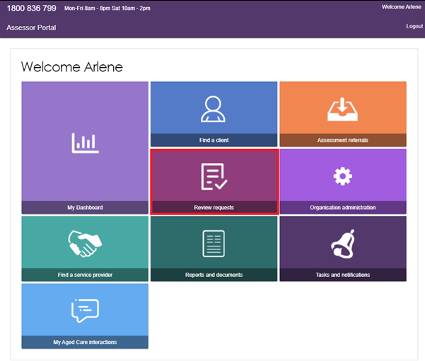

In the **Review requests** section, team leaders can view **Upcoming reviews**, **Assigned reviews** and **Review history**.

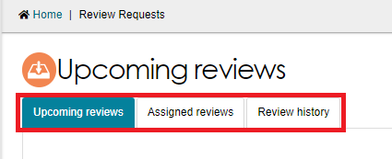

In the **Upcoming reviews** tab team leaders can:

* View scheduled reviews
* View reviews requested by service providers
* Assign reviews to assessors
* Change review priority
* Cancel reviews.

In the **Assigned reviews** tab team leaders can reassign reviews to different assessors.

In the **Review history** tab team leaders can view a history of completed and cancelled reviews.

### Viewing Support Plan Reviews

A Support Plan Review request will contain the following information:

* The person/organisation requesting the Support Plan Review
* The assessor who last conducted the assessment
* Reasons for request including:
  + Client’s change in circumstances
  + Impact on client’s needs
  + Primary reason for request
  + Services client is currently receiving
  + Options explored to increase the client’s current support.

A banner will be displayed on the request if additional attachments have been added to the client’s record as part of the Support Plan Review request.

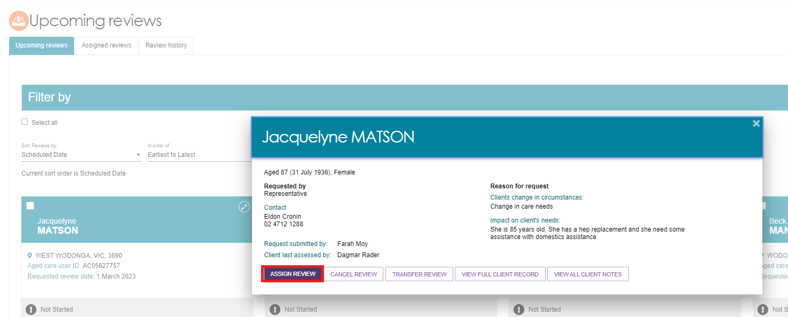

|  |  |
| --- | --- |
| ! | If the client has pending support relationships, a banner will be displayed on the review. Team leaders are able to confirm pending support relationships for clients, this process is described in [My Aged Care – Assessor Portal User Guide 2 – Registering support people and adding relationships](https://www.health.gov.au/resources/publications/my-aged-care-assessor-portal-user-guide-2-registering-support-people-and-adding-relationships).  An alert banner with ' ... client has pending support relationships' |

Team leaders can sort, and filter Support Plan Reviews based on several categories.

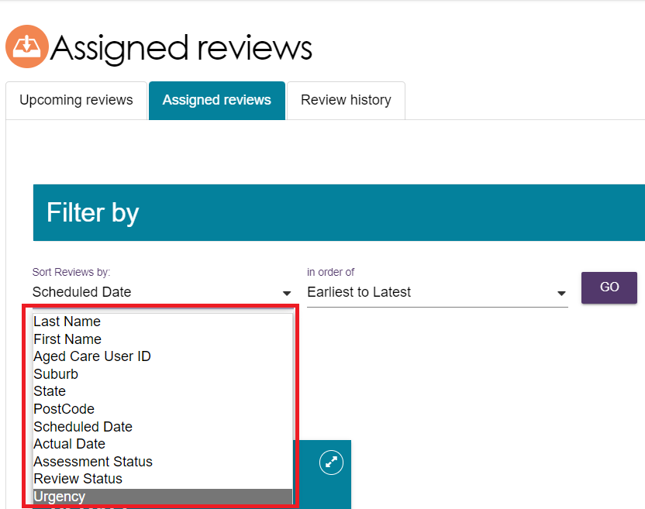

### Assigning a Support Plan Review

Team leaders will only be able to assign the Support Plan Review request that has the parent assessment type as Home Support assessment then only to non-clinical aged care needs assessors (non-clinical assessor) within the outlet. If the client is undergoing support, the team leader is to contact the assessor to determine whether to end the support period or cancel the review.

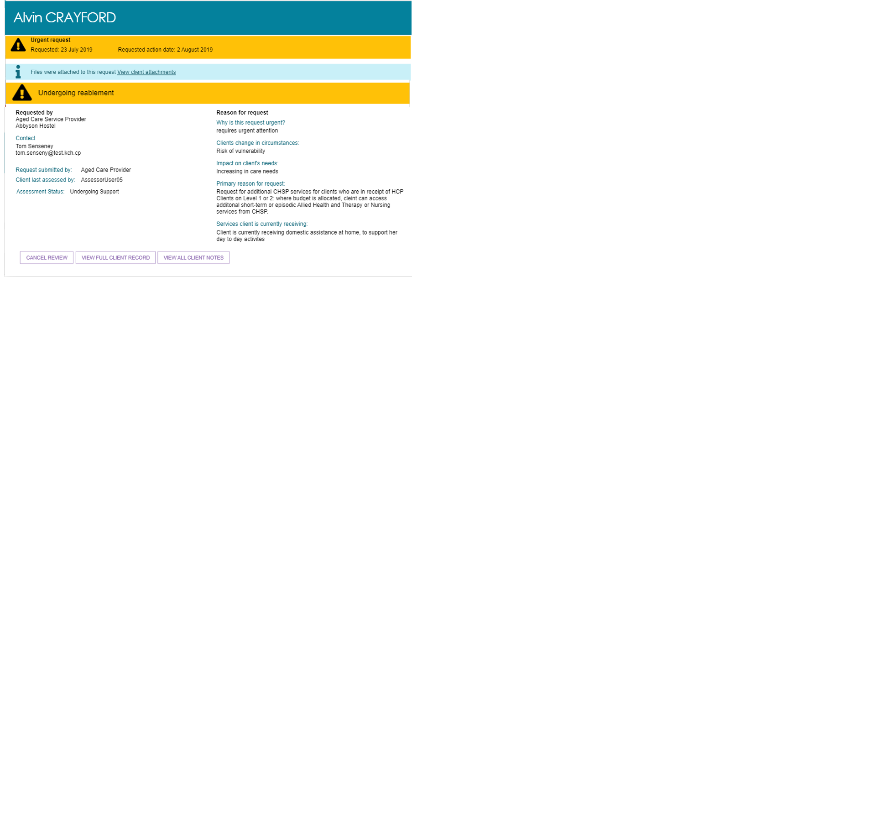

To assign a Support Plan Review, follow the steps below.

1. Navigate to the **Upcoming reviews** tab and select **ASSIGN REVIEW** on the expanded client card.

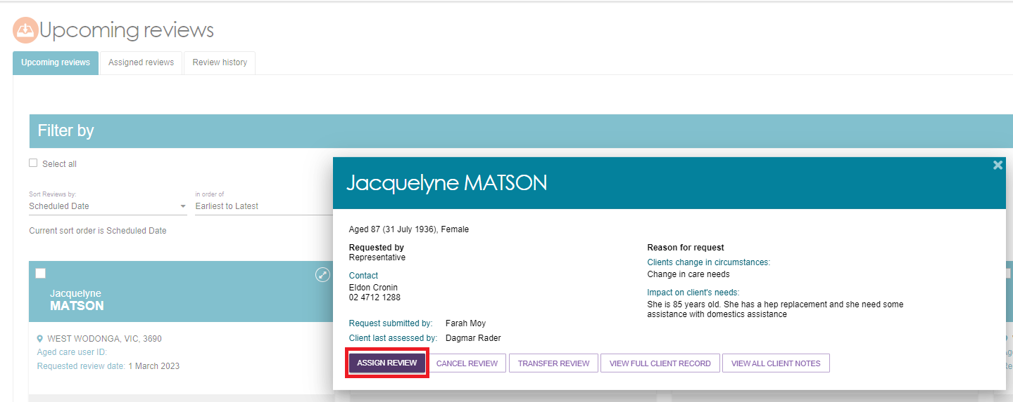

1. Before assigning to an assessor, you can change the Support Plan Review priority. Select an assessor to assign the Support Plan Review to and select **ASSIGN**.

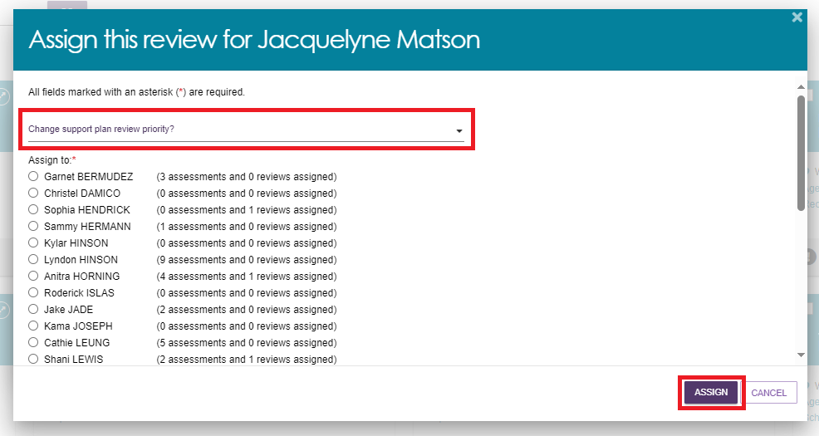

Once assigned, a banner will appear on the bottom of your screen.



The Support Plan Review will now appear in the **Assigned reviews** tab. Assigned reviews will also appear in the **Current reviews** tab of the assessor the review was assigned to.

### Transferring a Support Plan Review

Team leaders are able to transfer Support Plan Reviews to other assessment organisations.

1. To begin transferring a Support Plan Review, go to **Upcoming reviews** and select the client card you wish to transfer for the Support Plan Review. Select **TRANSFER REVIEW**.

image reads; Before you transfer, contact the Assessment Organisation you want to refer the client to. Please provide as much information as possible in the comments box below to assist the receiving organisation. Please note, a referral can only be transferred once. Please ensure that you have client consent for assessment type before transferring.

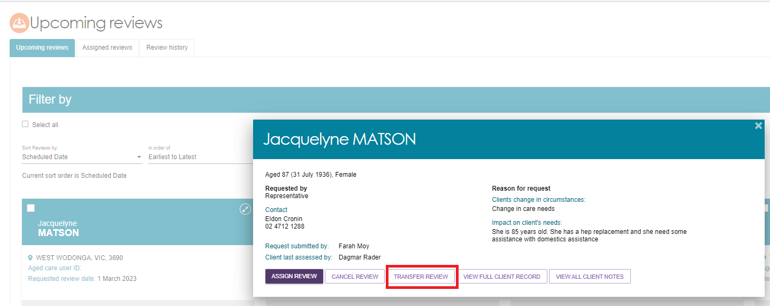

1. You will need to enter a **What is the reason for the transfer** and search and select the Assessment Organisation which the Support Plan Review will be transferred to. Once the reason for transfer and organisation has been selected, select **TRANSFER**.

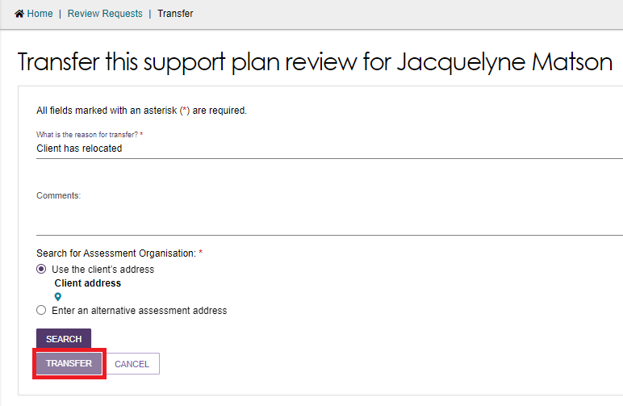

### Reassigning a Support Plan Review

To reassign a Support Plan Review, follow the steps below.

1. From the **Assigned reviews** tab, select **REASSIGN REVIEW** on the Support Plan Review to be reassigned or unassigned.

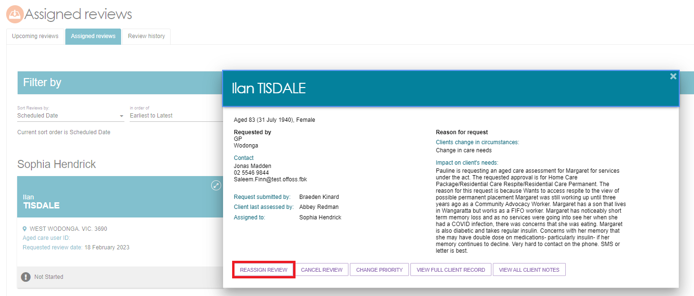

1. Select another assessor and **REASSIGN**.

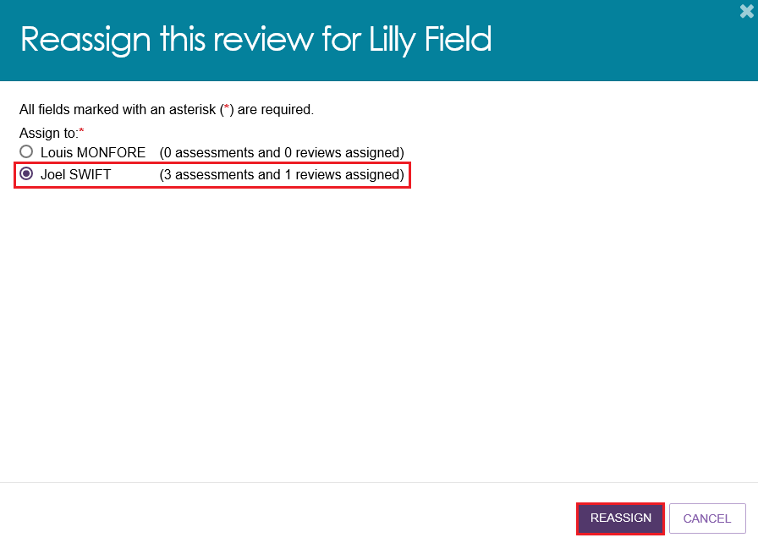

The Support Plan Review will now be reassigned to the selected assessor and the review will appear in their **Current reviews** tab.

|  |  |
| --- | --- |
| ! | Team leaders can also reassign Home Care correspondence notifications, by going to **Tasks and notifications** in the assessor portal homepage and clicking on the **HCP Notifications** tab. More information on this can be found on [My Aged Care - Assessor Portal User Guide 9 - Tasks and notifications](https://www.health.gov.au/resources/publications/my-aged-care-assessor-portal-user-guide-9-tasks-and-notifications?language=en).  Image is of the re-assign home care correspondence notifications pop out. A list of recipients are displayed, the save button is highlighted in a red box. |

### Cancelling a Support Plan Review

To cancel a Support Plan Review, follow the steps below.

1. In either the **Upcoming reviews** tab or **Assigned reviews** tab, select **CANCEL REVIEW** from the expanded view of the client card for the review to be cancelled.

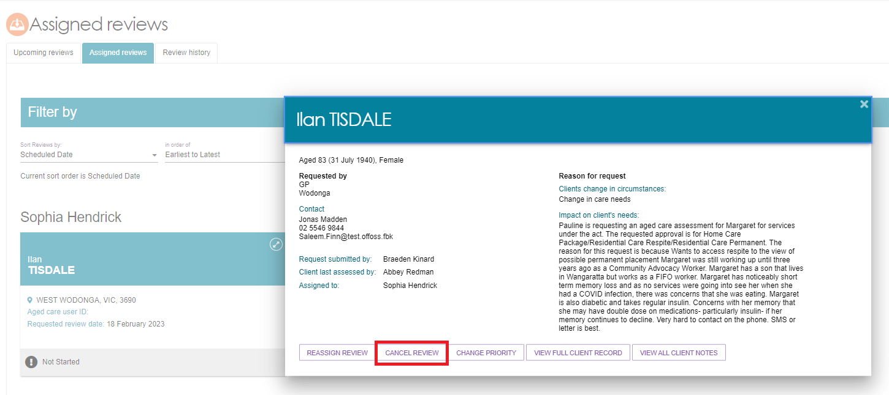

1. Enter a reason for the cancellation and select **CANCEL REVIEW REQUEST**.

The review will be removed from the Upcoming reviews tab. Completed and cancelled Support Plan Reviews will also appear in the Recent reviews tab of the assessor who completed the review.

Support Plan Reviews will also be cancelled automatically where a new assessment referral is issued and accepted for the client. This will allow the new assessment to commence without requiring the Support Plan Review to be completed.

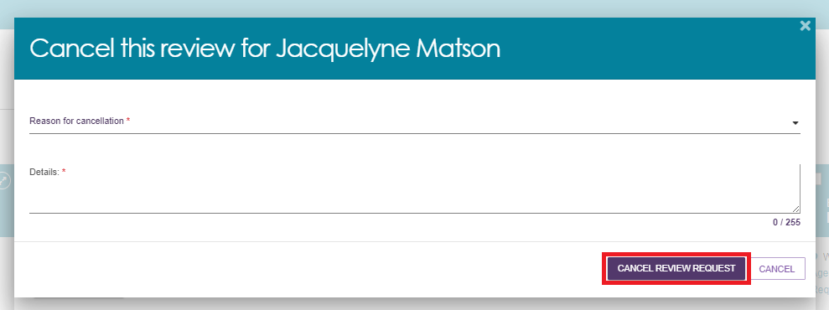

### Cancelling a Support Plan Review with the reason of Client deceased

|  |  |
| --- | --- |
| ! | Cancelling a Support Plan Review with the reason of **Client deceased** will change the client’s status to **Deceased** and make the client record read only. Any unaccepted service referrals will be recalled, services in place will be ceased, assessments will be cancelled and the client’s access to the client portal will be revoked. My Aged Care will not send correspondence to the client or their representatives after the status is changed to **Deceased**. My Aged Care will send a notification to the client’s assessor and provider advising them to close or finalise any in-progress items.  Where a client is active in the National Priority System or has been assigned a Home Care Package, this will remove the client from the National Priority System and withdraw any assigned Home Care Packages. |

When cancelling a Support Plan Review with the reason of **Client deceased**, you will need to provide the following information:

* Who, when and how you were informed that this person is deceased  
  E.g., “Mrs Smith rang to inform us that Mr Smith has passed away on Saturday”
* Date of death (if known)
* Add Attachments  
  E.g., Death Certificate, Hospital discharge documents.

Support Plan Reviews will also be cancelled automatically where a new assessment referral is issued and accepted for the client. This will allow the new assessment to commence without requiring the Support Plan Review to be completed.

When cancelling a support plan review with the reason of ‘Client Deceased’, you will need to provide the following information:
• Who, when and how you were informed that this person is deceased
e.g. “Mrs Smith rang to inform us that Mr Smith has passed away on Saturday”
• Date of Death (if known)
• Add Attachments
e.g. Death Certificate, Hospital discharge documents


Notes and attachments can be attached to the client record after the status is set to **Deceased**.

When a client’s status is changed to **Deceased**, if they have an in-progress assessment or has commenced services, a notification will be sent to the associated assessor in the assessor portal, advising the assessor to close or finalise the in-progress tasks.

### Change priority for a Support Plan Review

Team leaders can change the priority of a Support Plan when assigning a review to an assessor in the **Upcoming reviews**.

1. In the **Upcoming reviews** tab, select **ASSIGN REVIEW** from the expanded view of the client card.

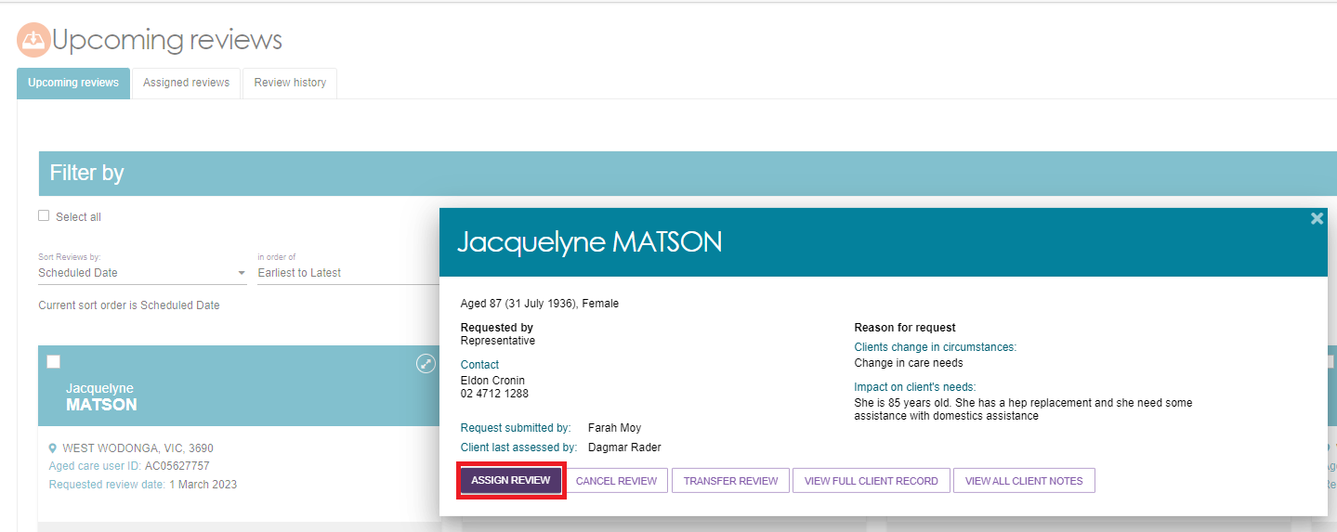

1. From the dropdown list select either **Urgent** or **Non-urgent** and select an assessor from the list then **ASSIGN**. When changing priority to **Urgent** you must enter the reason for changing the priority in **Reason description**.

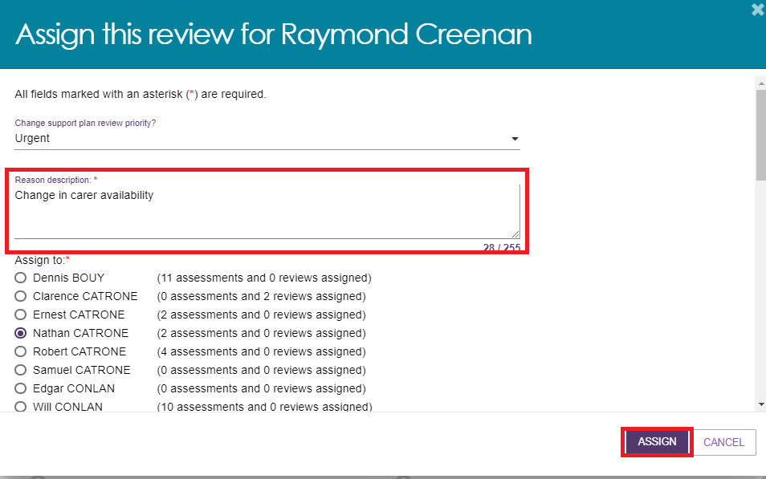

A confirmation message will be displayed, and the reviews priority will be saved.

Saved confirmation message. 

### Changing the Support Plan Review priority after being assigned

To change Support Plan Review priority after it has been assigned follow the below steps.

1. Navigate to **Assigned reviews** tab, open a client card and select **CHANGE PRIORITY**.

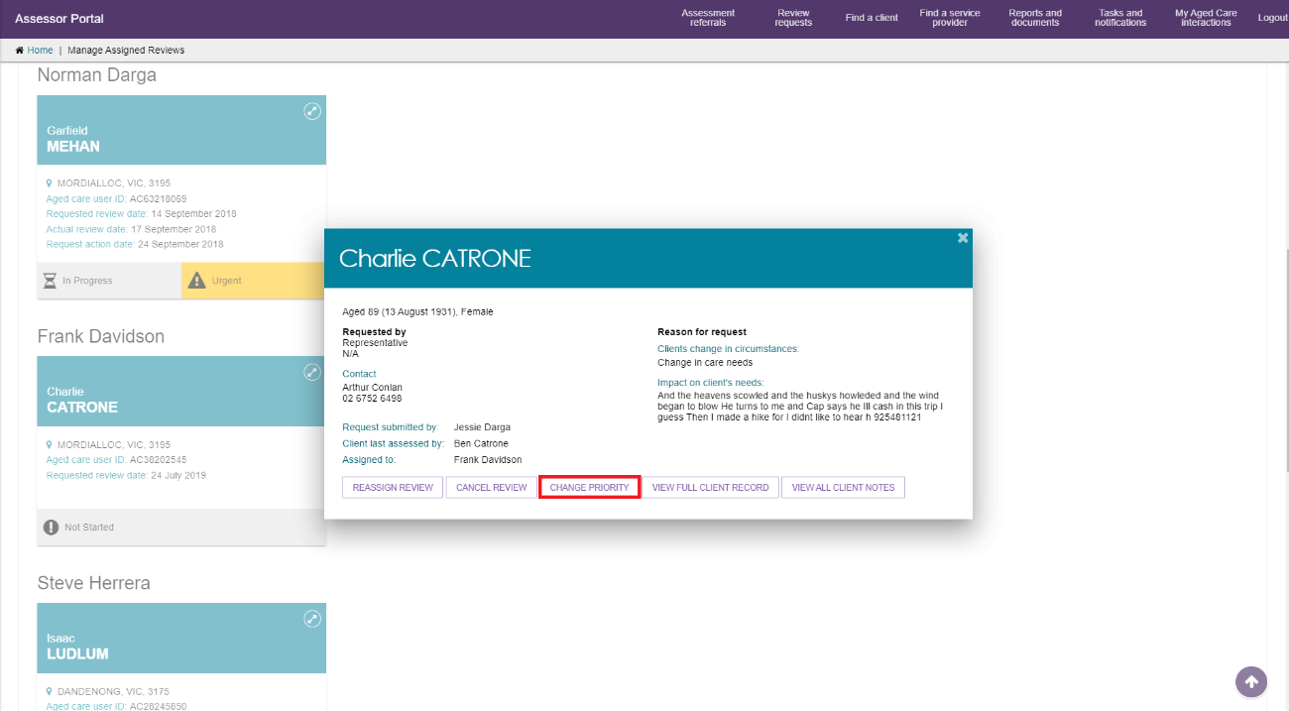

1. Select from the drop-down list then **CHANGE PRIORITY.**

When changing priority to **Urgent** you must add the reason for changing the priority in **Reason description** then select **CHANGE PRIORITY**.

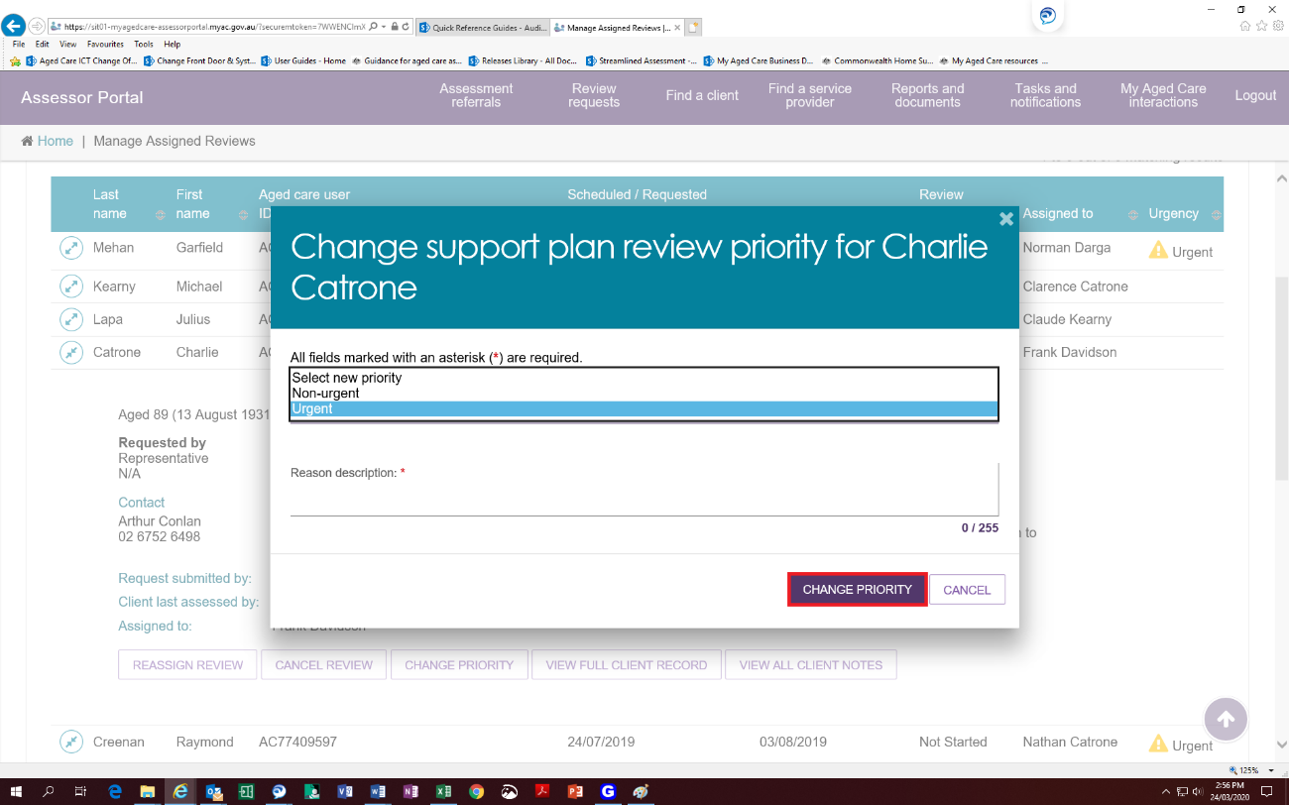

A confirmation message will be displayed, and the reviews priority will be displayed in the **Assigned review** tab.

Screen shot from the portal showing the confimation message