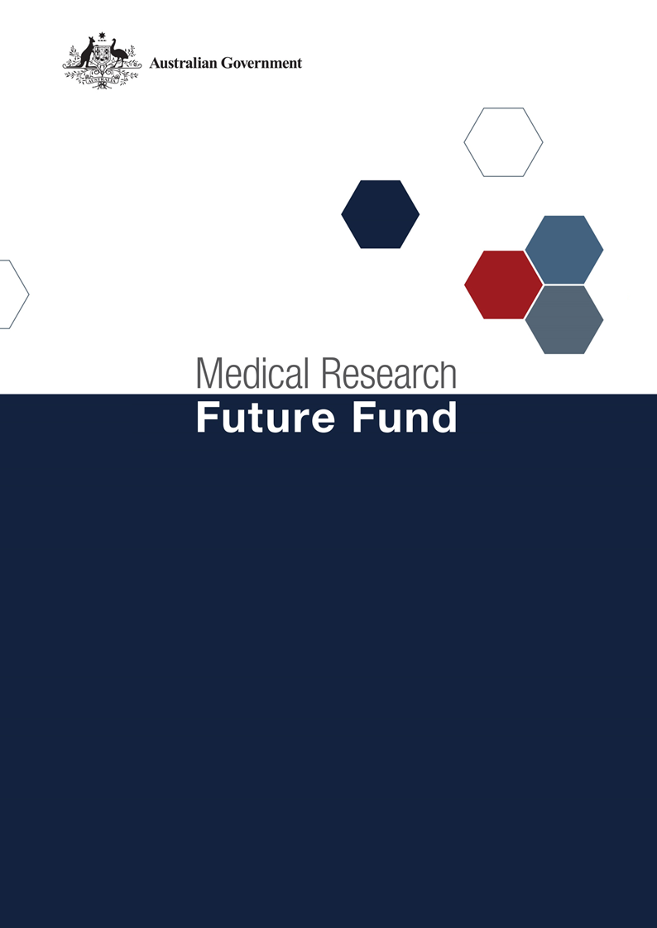

**MRFF Genomics Health Futures Mission Roadmap and Implementation Plan Refresh National Consultation Report  
  
January 2025**

Table of Contents

Introduction 2

Community participation and submissions 3

Responses to national consultation submissions 4

# Introduction

The Medical Research Future Fund (MRFF) is a $22 billion long-term investment supporting Australian health and medical research. The MRFF aims to transform health and medical research and innovation to improve lives, build the economy and contribute to health system sustainability. The Genomics Health Futures Mission (GHFM) was established by the Australian Government in 2018, with a $500.1 million commitment over 10 years under the MRFF to improve testing and diagnosis for many diseases, help personalise treatment options to better target and improve health outcomes and reduce unnecessary interventions and associated health costs.

A second Expert Advisory Panel was appointed in December 2023 to provide advice to the Minister for Health and Aged Care on the strategic priorities for research investment through the GHFM. As per the [MRFF Mission Governance document](https://www.health.gov.au/resources/publications/mrff-mission-governance), the Expert Advisory Panel provides advice on strategic priorities for research investment through the GHFM by refreshing the existing Roadmap and Implementation Plan.

The GHFM’s Roadmap is a high-level strategic document that includes the aim, vision, goal and priorities for investment for the GHFM. To support the Roadmap, the Implementation Plan outlines the priorities for investment (short, medium and long term), evaluation approaches and measures, supporting activities, and collaborative opportunities. The Roadmap and Implementation Plan will be used by the Department of Health and Aged Care to design and implement GHFM’s investments via Grant Opportunities promoted through GrantConnect ([grants.gov.au](https://www.grants.gov.au/)).

A draft refreshed Roadmap and Implementation Plan developed by the Expert Advisory Panel underwent national public consultation review which opened on 14 October 2024 and closed on 8 November 2024, during which time submissions were accepted through the Department’s [consultation hub](https://consultations.health.gov.au/health-economics-and-research-division/mrff-ghfm/). This national consultation sought seek feedback from the community on the GHFM’s draft refreshed Roadmap and Implementation Plan.

The Chair of the Expert Advisory Panel hosted a webinar on 4 November 2024 to provide an opportunity for the community to gain a greater understanding of the purpose of the Roadmap and Implementation Plan and ask questions, prior to providing written submissions to the consultation.

The following questions were provided on the consultation hub to guide submissions:

1. Are the priority areas for investment identified in the Implementation Plan the most effective way for delivering on the Genomics Health Futures Mission’s goal and aims?
2. Are there existing research activities which could be utilised to contribute to the Genomics Health Futures Mission Roadmap and/or Implementation Plan aims and priority areas for investment? How can these be leveraged?
3. Are the ‘Evaluation approach and measures’ appropriate for assessing and monitoring progress towards the Genomics Health Futures Mission’s goal and aims?

This report summarises the national consultation through webinar participation and written submissions.

## Community participation and submissions

27 stakeholders attended the webinar from across Australia. A diverse range of stakeholders participated including those from: research organisations (including universities and medical research institutes); industry; consultancy organisations; consumer advocacy groups; state government (health) departments; and individual community members.

At the close of the consultation period, twenty (20) written submissions were received via the consultation hub, representing universities, medical research institutes, pharmaceutical, industry, and national and state-based consumer organisations.

The Expert Advisory Panel considered all responses from the national consultation and, where relevant, revised the Roadmap and Implementation Plan. A summary of the feedback from the submissions and the Expert Advisory Panel’s responses are outlined below.

# Responses to national consultation submissions

| **Consultation Question** | **Submission Feedback / Themes** | **Action by Expert Advisory Panel (The Panel)** |
| --- | --- | --- |
| **Are the priority areas for investment identified in the implementation plan the most effective way for delivering on the Genomics Health Futures Mission’s goal and aims?** | Research into rare diseases (particularly early diagnostic tests) is underfunded - with $5mil allocated in Priority Area 1.1. | The panel considered this feedback and has increased the funding allocated towards Priority Area 1.1  In addition to the funding allocated in Priority Area 1.1, $28 million is allocated under Priority Area 1.3 for diagnostic testing of rare and less common diseases.  The Panel considered previous investments under the Mission when determining the balance between different priority areas. The Mission has invested $64.14 million into research with a focus on rare diseases as of 5 December 2024. |
| Increased funding is required for development of research infrastructure and improved data sharing in the genomics field in Australia. | The panel considered this aspect, $8 million has been allocated for infrastructure (including data) under Priority Area 3.2.  The MRFF supports the development of infrastructure via the Research Data Infrastructure initiative and the National Critical Research Infrastructure initiative which are outside of the Genomic Health Futures Mission. |
| A number of engagement opportunities were recommended, including:  a) consumers and advocates in all stages of research  b) Aboriginal and Torres Strait Islander health across all aims/priority areas  c) other organisations such as private industry and peak bodies early in the research process to ensure success | The Panel considered this aspect:  a) Engagement with consumers is an integral component of the GHFM. The MRFF encourages consumer involvement across all types of research, in all stages of research and in close collaboration with researchers. The guidance for consumer involvement in MRFF research is outlined in the 'Principles for Consumer Involvement in Research funded by the Medical Research Futures Fund', which was published in March 2023.  b) Aboriginal and Torres Strait Islander leadership is a key component of the GHFM enablers  c) Applicants to the GHFM will be required to demonstrate engagement and requirements will be emphasised within the grant guidelines. The MRFF encourages collaboration between researchers and institutions to maximise research outcomes. |
| Increased focus on and funding of research relating to Aboriginal and Torres Strait Islander peoples across all aspects is required. | The panel has strengthened requirements to include Aboriginal and Torres Strait Islander peoples when applying for funding under all aspects of the GHFM.  Given evolving best practice in this area this has been implemented through reference to the current advice/principles/statement of the NHMRC-MRFF Indigenous Advisory Group at the time grant opportunity guidelines are produced. |
| Underinvestment in cancer genomics. | The panel considered this feedback and has increased the funding allocated towards Priority Area 1.2.  Funding for cancer research will also be provided under Priority Area 2.1 and Priority Area 2.2 ($19 million).  The Panel considered previous investments under the Mission when determining the balance between different priority areas. The Mission has invested $66.16 million into research with a focus on cancer as of 5 December 2024. |
| Allow all methods (not just 'novel') so Priority Area 1.4 doesn't preclude research where the method is not novel but the application is. | The panel agreed with this suggestion and removed the word ‘novel’ from Priority Area 1.4. |
| The Implementation Plan should focus more on implementation of genomic medicine as standard of care. | The MRFF only allows for the provision of grants of financial assistance to support medical research and medical innovation.  Genomics Australia is being created to provide the national leadership and coordination required to ensure everyone can benefit from health genomics. It will support the transition from a research focus to clinical service delivery, where efficiencies and better health outcomes for all Australians can be achieved. |
| The Implementation Plan should focus more on service delivery across the health system. | The MRFF only allows for the provision of grants of financial assistance to support medical research and medical innovation.  Genomics Australia is being created to provide the national leadership and coordination required to ensure everyone can benefit from health genomics. It will support the transition from a research focus to clinical service delivery, where efficiencies and better health outcomes for all Australians can be achieved. |
|  | | |
| **Are there existing research activities which could be utilised to contribute to the Genomics Health Futures Mission’s Roadmap and/or Implementation Plan aims and priority areas for investment? How can these be leveraged?** | Leverage existing:  - national research networks  - previously funded researchers and groups to ensure findings are progressed through to implementation  - peak bodies and industry partners to ensure integration across Australia's health system  -linkages with existing multicultural genomic networks  - contribute to larger (often international) genomics consortia | The Panel did not make any changes to the Implementation Plan as the MRFF encourages partnerships and linkages between researchers/groups/institutions. The Grant Opportunity Guidelines will specifically mention the strong preference for collaborations in funding applications. |
| Develop a federated model of clinical genomics integrated into healthcare delivery systems in Australia that is sustainable, beyond the life of the funding opportunity | The MRFF only allows for the provision of grants of financial assistance to support medical research and medical innovation.  Genomics Australia is being created to provide the national leadership and coordination required to ensure everyone can benefit from health genomics. It will support the transition from a research focus to clinical service delivery, where efficiencies and better health outcomes for all Australians can be achieved. |
| Recommendations for an audit of research institutions and previously/currently funded research grants to highlight areas of priority for investment and to reduce duplication in research | The MRFF only allows for the provision of grants of financial assistance to support medical research and medical innovation. An audit of research institutions across Australia is out of scope of the GHFM. |
|  | Develop synergies between granting mechanisms, including MRFF, to capture ongoing research and link research groups together | The panel considered this point although no changes were made. Researchers are encouraged to collaborate as part of their grant applications, and extensive collaboration is encouraged under the MRFF. |
|  | Targeted funding for genomic information management infrastructure is critical to support capacity-building, enabling data from GHFM-supported projects to be integrated and used in secondary research. | The panel considered this aspect, $8 million has been allocated for infrastructure (including data) under Priority Area 3.2.  The MRFF supports the development of infrastructure via the Research Data Infrastructure initiative and the National Critical Research Infrastructure initiative which are outside of the Genomic Health Futures Mission. Additionally, the Medical Research Commercialisation initiative provides funding to enable researchers to transform research into treatments and products to improve the health of Australians. |
|  | | |
| **Are the ‘Evaluation approach and measures’ appropriate for assessing and monitoring progress towards the Genomics Health Futures Mission’s goal and aims?** | 'Measurable' metrics are needed for some evaluation measures, as well as they lack detail and specificity. | The evaluation metrics have been updated to increase detail and specificity. They have also been updated to reflect updates made to the broader [MRFF Monitoring, evaluation and learning strategy – August 2024 update](https://www.health.gov.au/resources/publications/mrff-monitoring-evaluation-and-learning-strategy). |
| Partnerships and co-design with underrepresented multicultural populations, as well as Aboriginal and Torres Strait Islander communities, should be an explicit measure across all aims. | Evaluation measures for all aims include that research projects integrate partnerships with, and co-design by, Aboriginal and/or Torres Strait Islander peoples and communities. |
| Suggestions that particular focus to be given to outcomes related to individual consumer involvement, wider stakeholder engagement and collaboration. | Given evolving best practice in this area this will be implemented through reference to the current advice/principles/statement of the NHMRC-MRFF Consumer Advisory Group at the time the evaluation is conducted. |