Handbook of tools to support medicine management in multimorbidity and polypharmacy

**Prepared for the**

Department of Health and Aged Care

**This report was written by**

Professor Libby Roughead, Dr Imaina Widagdo and Dr Anna Kemp-Casey.

Quality Use of Medicines and Pharmacy Research Centre

University of South Australia

GPO Box 2471

Adelaide SA 5001 [www.unisa.edu.au](http://www.unisa.edu.au/)

**Acknowledgements:** We are grateful for the assistance of Professor Sarah Hilmer, Professor Johnson George, Dr Emily Reeve, Ms Deidre Criddle, Assoc Prof Janet Sluggett, Dr Amy Page, and Dr Kate Wang for reviewing sections of this document.

**Disclaimer:** The tools in this handbook have been provided for information and education. Nothing contained in this handbook is intended to be used as medical advice and it is not intended to be used to diagnose, treat, cure or prevent any disease, nor should it be used for therapeutic purposes or as a substitute for health professional advice. The inclusion of tools in this report is for information and education purposes only, it does not represent endorsement of use. Tools developed for international audiences require consideration of Australian sources of objective information about medicines to ensure relevance to and appropriateness for the Australian health system.

## Table of contents

Table of contents 3

Introduction 4

Tools supporting medication regimen simplicity 5

Medication Regimen Complexity Index 5

Medication Regimen Simplification Guide for Residential Aged Care (MRS GRACE) 7

Self-report questionnaires supporting medication adherence assessment 9

Brief Medication Questionnaire 9

Measure of Drug Self-Management 10

Morisky Medication Adherence Scale 12

Tools supporting appropriate selection of medicines 13

Medication Appropriateness Index 13

**Potentially Inappropriate Medicines Lists** 14

List of Australian potentially inappropriate medicines 14

Beers Criteria 16

STOPP/START 16

Fit for the Aged (FORTA) 17

MEDSTOPPER 18

Tools to assist identification of cumulative toxicity 18

Drug Burden Index 19

Anticholinergic burden calculator 20

Falls risk medicines 22

Scottish Polypharmacy Guidance: Cumulative Toxicity tool and adverse drug reactions (ADR) 23

Medichec 24

Tools supporting symptom assessment for adverse medicine event identification 26

Patient Reported Outcome Measure Inquiry into Side-Effects (PROMISE) 26

PHASE 20 and Phase PROXY 27

Tools to identify people at risk of Medicine Related Problems 29

Self-Medication Risk Assessment Instrument 29

Medication risk checklist for older adults (LOTTA) 31

PHarmacie-R 31

Tools to support identification of patients suitable for deprescribing 34

Patient Attitudes Towards Deprescribing questionnaire 34

Tools to support medication switching and tapering 35

Medicine switching calculators 35

Medicine tapering calculators 37

References 40

Appendix 1: Australian Potentially Inappropriate Medicines List (56) 49

## Introduction

Multimorbidity, the presence of more than one chronic illness, is common, with an estimated 50% of persons 65 years and over living with more than one chronic condition (1). Alongside the increase in multimorbidity has been a rise in use of medicines concurrently (2, 3). When a person is taking five or more medicines concurrently this is frequently referred to as polypharmacy (4). High levels of concurrent use of medicines, while very often necessary, also has the potential to result in increased risk of harm, including adverse medicine events, hospital admissions due to medicines and, sometimes, death (5-9). Australian evidence estimates that up to one-third of unplanned hospital admissions in persons 65 years and over are due to problems with their medicines (10).

There are a number of tools now available to support health professionals manage concurrent use of medicines and reduce the risk of harm. This handbook collates examples of these tools across the spectrum of factors where problems with medicine use can develop.

The handbook includes tools designed to:

* reduce medicine regimen complexity;
* identify non-adherence;
* identify medicines that are considered generally inappropriate in older people;
* identify medicines that may have been omitted but are considered beneficial in older people;
* detect medicine related side effects;
* identify the potential for harms due to the cumulative effects of medicine use;
* support cessation of medicines; and
* support medication switching and tapering.

The handbook includes at least one tool for each of these areas and, wherever possible, tools developed for Australian practice are included. Tools from other health jurisdictions have also been included but should be used with caution as medicines available in other jurisdictions may not be available in Australia or may be available in different strengths or formulations. There may be medicines available in Australia that are not available in other jurisdictions and so these medicines may not appear in the international tools described. Thus, Australian sources of objective information would always need to be consulted when using tools developed for other jurisdictions. We limited inclusion to tools developed by health departments, professional societies, academic institutions or identifiable health professionals. Tools where the development process or developer could not be identified were excluded. Tools that were disease specific were excluded, as were tools that relied on simulated medication regimens. The handbook is not an exhaustive list of all tools. The tools in this handbook are intended for education and information and are not intended as a substitute for independent professional assessment and advice.

## Tools supporting medication regimen simplicity

As the number of medicines taken by a person increases, so too does the potential for the medicine regimen to become more complex. Complex medicine regimens arise due to people having to take medicines at different times of day, or due to trying to follow different instructions about when or how to take the medicine; such as before, with or after food. Complex medicine regimens are not intentional and usually arise incidentally as, over time, new medicines are added to an individual’s regimen. Not surprisingly, when someone is on multiple medicines, the daily regimen can become so complex that it can be difficult for people to adhere to the regimen. There is significant evidence showing complex medication regimens are a risk factor for medication non-adherence (11), which can subsequently result in loss of disease control and increased morbidity. There is also evidence that, for many people, it is possible to simplify the medicine regimen to reduce this risk (12) and improve health outcomes (13). For older people taking medicines at least twice daily between 50% and 70% may be able to take their medicines in a simpler way (14). In this section of the handbook we provide details of Australian tools designed to support medication regimen simplification.

### Medication Regimen Complexity Index

**Purpose:** To assist health practitioners to identify the complexity of a medication regimen.

**Description:** An explicit tool comprising three sections covering dosage form, directions for use, and additional directions (15). Within each section are items corresponding to type of dosage form, frequency of directions, and complexity of additional directions. These factors are weighted according to health professional assessment of their difficulty of use or difficultly to understand or follow. The index is applied to prescribed medicines only. Scores are totalled for each section, and the final complexity index is the sum of the three sections. Higher scores indicate higher complexity. The tool is available as an appendix to the publication (15) at: <https://journals.sagepub.com/doi/10.1345/aph.1D479>

The tool has also been successfully adapted to enable automated use in electronic health records in the US (16-18), with the matching algorithms available for download for non-commercial use on the referenced website or in the supplementary data to the paper.

**Setting:** Applicable across all health settings.

**Audience:** Suitable for use by all health practitioners.

**Method of development:** The index, developed in Australia, was based on factors known to influence medication complexity, including the number of medications, the dosage frequency, dosage form, and the instructions for use (15). It was pilot tested on hypothetical medicine regimens, and refined, before further piloting on 134 actual medication regimens. After further refinement the index was reviewed by eight pharmacy researchers. The tool was then applied to 50 medication regimens selected from the original 134 and ranked according to complexity. Six regimens selected from across the range of complexity were extracted and independently ranked for complexity by a five member expert panel. Studies examining a cut-off for the index, suggest high complexity is indicated by scores above cut-offs varying from 11.5 to 25 for older adults; the variation in the cut-off is dependent on the criteria for establishing the cut-off (19, 20).

**Advantages:** The index has been tested for criterion validity, construct validity and reliability. The tool has been used widely in the research setting, with increasing complexity found to correlate with poorer adherence, hospital readmission, and adverse medicine events (21).The tool is available in multiple languages (22-25).

**Limitations:** The tool does not account for non-medication factors, such as patient factors (e.g. cognitive or physical impairment) which may also contribute to people finding regimens complex to follow.

**Data required:** Medication chart.

**Example:** The following is an example of application of the medication regimen complexity index. Note the variation in scores is due to weights for different formulations or directions. A spray formulation is weighted more highly than tablets, hence the two-rating for the spray compared to one for tablets. More frequent dosing is weighted more highly, and additional directions are scored.

| **Medication Regimen** | **Dosage Forms** | **Dosing Frequency** | **Additional Directions** |
| --- | --- | --- | --- |
| Diclofenac 50 mg tablets twice a day with food as needed | 1 | 2 | 1 |
| Apixaban 5 mg tablet twice a day | 1 | 2 |  |
| Rosuvastatin 10 tablet mg daily | 1 | 1 |  |
| Pantoprazole 40 mg tablets daily | 1 | 1 |  |
| Citalopram 20 mg tablet daily | 1 | 1 |  |
| Oxazepam 15 mg tablet before bed as needed | 1 | 0.5 | 1 |
| Atenolol 25 mg tablet twice a day | 1 | 2 |  |
| Amlodipine 5 mg tablet daily | 1 | 1 |  |
| Oxybutynin 5mg tablet twice a day | 1 | 2 |  |
| Glyceryl trinitrate (GTN) spray use as directed for chest pain | 2 |  | 2 |
| Totals | 11 | 12.5 | 4 |
| **Final Score** |  | **27.5** |  |

### Medication Regimen Simplification Guide for Residential Aged Care (MRS GRACE)

**Purpose:** To assist health practitioners to simplify medication regimens by reducing the number of administration times required per day.

**Description:** An implicit tool comprising the following five questions:

*“Consideration can be given to administering all medications at the same time each day unless the following apply:*

*1. Is there a resident related factor that precludes simplification?*

*2. Is there a regulatory or safety imperative that precludes simplification?*

*3. Is simplification likely to result in any clinically significant drug–drug, drug–food, or drug–time interactions?*

*4. Is there no alternative formulation available that can support less complex dosing?*

*5. Is simplification likely to result in any unintended consequences for the resident or facility?”* (26)

When using the tool, practitioners generally start by obtaining a complete medication history and then considering whether any medicines could be ceased. Practitioners then review the remaining necessary medicines and consider if the medication regimen can be simplified. Simplification may involve reducing the number of medicine administration times, either by shifting the time of administration or using alternative preparations. The tool is designed to be used within a person centred approach as part of a comprehensive medicines review or as a stand-alone activity; with the person whose regimen is under review actively engaged in the process.

**Setting:** Initially developed for the aged-care setting, but suitable for all health settings.

**Audience:** Suitable for use by pharmacists, doctors, geriatricians.

**Method of development:** An expert panel comprising both health practitioners and consumers identified factors to consider that may assist with simplifying a medicine regimen. The nominal group technique used to obtain the final list of factors to consider. Two pharmacists independently applied the tool to the same medicine regimens for a sample of 50 people who had at least two medication administration times a day. The results showed the majority of regimens could be simplified, and that there was fair agreement between pharmacists (Cohen’s kappa=0.38±0.13, 95% CI 0.12–0.64)(26). The tool has also been validated among general practitioners and geriatricians (14).

**Advantages:** A simple tool for use in practice to guide medication regimen simplicity. It has been shown to be effective in reducing the number of medication administration times per day (14). It has been demonstrated to reduce medication incidents (27) and results in a sustained reduction in medication administration times at 12 months (28). In settings where other people are involved in medicine administration, simplification of regimens can also free up staff time enabling staff to be engaged in other activities.

**Limitations:** The implicit nature of the tool results in variation in how regimens are simplified which is dependent on the user.

**Data required:** Medication administration chart or best possible medication history with medication administration times recorded.

**Example**: An example of a hypothetical medication regimen before and after simplification appears below. In this hypothetical example, the best possible medication history would be taken first. If simpler regimens were possible, then the person whose medicine was under review would be consulted and would need to agree to implement the suggested changes. A plan for follow up with the person post-simplification would be put in place to determine any issues with the revised regimen.

|  |  |  |  |  |
| --- | --- | --- | --- | --- |
| **Time-point** | **Current medications** | | **Total number of administration times per day for regular medications** | **Total number of tablets taken per day** |
| **Medication name, dose and instructions** | **Time(s) administered** |
| **Before simplification** | Aspirin 100mg daily  Metformin 500mg twice daily  Irbesartan 150mg daily  Atorvastatin 40mg daily  Pantoprazole 40mg daily  Docusate and senna tablets when needed | 0800  0800, 1800  0800  2100  0800  once weekly | 3 | 6 |
| **After simplification** | Aspirin 100mg daily  Metformin 1000mg controlled release once daily  Irbesartan 150mg daily  Atorvastatin 40mg daily  Pantoprazole 40mg daily  Docusate and senna tablets when needed | 0800  0800  0800  0800  0800  Takes approx. once weekly | 1 | 5 |

Source: Creator Janet Sluggett, adapted from ‘Hypothetical medication regimen illustrating a reduction in the number of medication administration times for regular medications at follow-up (29), available under CC BY-NC (30) at https://bmjopen.bmj.com/content/9/7/e025345.info

## Self-report questionnaires supporting medication adherence assessment

A subset of patients experience difficultly adhering to the medication regimen. There may be many reasons for this, including the complexity of the medication regimen, patient related factors such as beliefs about the benefits or harms of medicines, cognitive factors such as cognitive impairment, or physical factors that limit the ability to open containers or use devices, as well as medicine related factors such as taste or the side effects. Tools have been developed for health practitioners to identify patients with adherence problems. While there are digital tools such as electronic pill bottles, patient self-report tools are a simple option for identifying patients who may need support to achieve medication adherence. There are at least 27 self-report tools that have been used in the research setting with variability in their ability to accurately detect non-adherence (31, 32). Many have been developed for specific diseases, while some may have limited application in clinical practice due to the number of questions they asked and length of time to complete.

In this section of the report, we describe three validated self-report tools with less than twelve questions for identifying adherence to medicines. Additional tools have been reported in overviews to medication adherence measures in the published literature (33).

### Brief Medication Questionnaire

**Purpose:** Structured self-report measure to assess medication adherence.

**Description:** The Brief Medication Questionnaire includes nine questions (34); five focused on a person’s medication taking behaviour in the last week (regimen questions), two focused on the person’s beliefs about the medicines (how well the medicine works or if it bothers them) and one question focused on whether the person has difficulty remembering to take their medicines, the answer to which is considered in relation to how many times per day the person takes the medicine. A copy of the tool is available at (35):

<https://pharmacy.wisc.edu/wp-content/uploads/2016/05/BMQ-H-9_website2022.pdf>

Copyright belongs to the author, but the questionnaire is available for non-commercial purposes with proper acknowledgement.

**Setting:** Primary care.

**Audience:** People taking medicines.

**Method of development:** The questionnaire was validated for its ability to identify non-adherence in a study where it was compared to electronic pill monitoring. The questions about medication regimen were found to have high predictive ability (100%) and accuracy (95%) to detect repeat non-adherence, but not for sporadic non-adherence (missing the occasional dose). The questions related to difficulties remembering to take one’s medicines were found to have high sensitivity (90%) and accuracy (85%) to identify sporadic non-adherence.

**Advantages:** Simple to use self-report tool.

**Limitations:** May not detect all cases of non-adherence. Has been predominantly used for adherence with cardiovascular medicines.

**Data required:** Interview: patient self-report.

**Example:** A copy of the survey appears below

| **Question** | **Answer** |
| --- | --- |
| In the past week  Did you take any of this [medicine]? | Yes/No |
| *How many days did you take this [medicine]?* | *I took it: 0, 1 2 3  4 5 6 7 days* |
| *How many times a day did you usually take it?* | *I took it: 0 1 2 3 times a day* |
| *How much did you usually take each time?* | *I took: 0 pills ½ pill 1 pill 2 pills 3 pills*  *each time* |
| *How many times did you MISS taking it?* | *I missed it: 0 1 2 3 4 5 6 7 times* |
| *How well does this [medicine] work for you?* | *Not at all well, Moderately well, Very well, Don’t know* |
| *How much does this [medicine] bother you?* | *Not at all, Bothers a little, Bothers a lot,*  *Don’t know* |
| *How much difficulty are you having:*  *It is hard to remember all the doses?* | *None A little A lot* |

© 2006-2022 B.L. Svarstad, Ph.D. (University of Wisconsin System). All rights reserved.

### Measure of Drug Self-Management

**Purpose:** Structured questionnaire to assess medication adherence.

**Description:** The Measure of Drug Self-Management (36) is a 12 item tool that asks questions about adherence but also includes questions relate to costs as well as a person’s attitudes towards medicines. The questions are scored and can be summed with higher scores indicating better medication management.

**Setting:** All health settings.

**Audience:** People taking medicines.

**Method of development:** The measure was developed based on an initial set of 67 questions, both subjective and objective, that had been created after a review of the literature and existing tools and the input of experts, followed by review by physicians, patients and persons expert in information technology, the latter for consideration of deployment in electronic health records (36). The initial set of questions was tested among a group of 193 people recruited from a medical clinic, with items tested by factor analysis, tested for internal consistency and correlated against existing medication adherence scales and clinical measures, with redundant questions eliminated to create the final scale. The scores can be summed, with higher scores indicating better self-management.

**Advantages:** Simple to use patient interview tool, that includes assessment of beliefs or attitudes as well as adherence. In the population with diabetes and hypertension in which the measure was tested, lower scores correlated with poorer clinical measures for blood pressure and low-density lipoprotein (LDL) cholesterol, with a trend also for glycosylated haemoglobin (HbA1c).

**Limitations:** May not detect all cases of non-adherence.

**Data required:** Patient interview

Twelve interview questions regarding the patient's experience with medicines. For example, question 1 ask "Did you forget to take your (insert drug 1 name) at any time last week?

Source: Measure of Drug Self-Management. Created by Bailey SC, Annis IE, Reuland DS, Locklear AD, Sleath BL, Wolf MS.(36).Available for non-commercial use under CC BY-NC 3.0 (37) at: <https://pmc.ncbi.nlm.nih.gov/articles/PMC4527367/#SD1-ppa-9-1101>

### Morisky Medication Adherence Scale

**Purpose:** Structured self-report questionnaire to assess medication adherence.

**Description:** This tool requires a paid licence to use. There are two versions of the scale; one comprising four questions the other comprising eight questions (38).

“*The Morisky Medication Adherence Scale-4 (MMAS-4):*

1. *Do you ever forget to take your medication?*
2. *Do you ever have problems remembering to take your medication?*
3. *When you feel better, do you sometimes stop taking your medication?*
4. *Sometimes if you feel worse when you take your medication, do you stop taking it?*

*The Morisky Medication Adherence Scale-8 (MMAS-8):*

1. *Do you sometimes forget to take your medication?*
2. *People sometimes forget to take their medications for reasons other than forgetting. Thinking over the past two weeks, were there any days when you did not take your medication?*
3. *Have you ever cut back or stopped taking your medication without telling your doctor, because you felt worse when you took it?*
4. *When you travel or leave home, do you sometimes forget to bring your medication?*
5. *Did you take your medication the last time you were supposed to take it?*
6. *When you feel like your symptoms are under control, do you sometimes stop taking your medication?*
7. *Taking medication every day is a real inconvenience for some people. Do you ever feel hassled about sticking to your treatment plan?*
8. *How often do you have difficulty remembering to take all your medications?*”

It is available for use under licence: “*Permission to use the Morisky Scales is granted by obtaining a license. The Morisky Scales are protected by US copyright laws and may not be modified, sold, translated into another language or adapted for another medium (e.g. smartphone, tablet, computer, or internet) without a license*.”(38)

**Setting:** Primary care.

**Audience:** People taking medicines.

**Method of development:** The original four item scale was derived from earlier research utilising five questions measuring medication taking behaviour, with the rationale that reasons for omission of medicines could be related to forgetting to take medicines, ceasing the medicine because a person was feeling better or starting the medicine because a person was feeling worse, or carelessness(39). The MMAS-8 contains an additional four times, which were added to account for circumstances contributing to adherence behaviour (40, 41). The scale has been tested for validity and reliability with significant heterogeneity in results but acceptable internal consistency and reliability for diseases including diabetes and osteoporosis (42, 43).

**Advantages:** Simple to use self-report tool.

**Limitations:** May not detect all cases of non-adherence. It is only available under licence.

**Data required:** Interview: self-report.

## Tools supporting appropriate selection of medicines

### Medication Appropriateness Index

**Purpose:** Designed to identify the appropriateness of medicine use.

**Description:** The Medication Appropriateness Index (44) first developed in 1992, includes ten implicit criteria presented as questions: is there an indication for use? Is the medication effective for the condition? Is the dosage correct? Are the directions correct? Are the directions practical? Are there clinically significant medicine-medicine interactions? Are there clinically significant medicine-disease interactions? Is there unnecessary duplication with other medicines? Is the duration of therapy acceptable? Is this medicine the least expensive alternative compared to others of equal utility? Each criteria is scored on a scale ranging from A – appropriate, B – marginally appropriate, C – inappropriate. Criteria are also weighted, with higher weights related to indication and effectiveness, and lowest weights related to the practicality of directions, duplication, duration, expense (45). A summed appropriateness score can be generated for each medicine and an overall score for each person. A higher score is indicative of more appropriate medicine use.

A three item version of the tool is also available. The three item version includes items related to indication, effectiveness and duplication (46).

A copy of the ten item and three item tool(46) is available at

<https://karger.com/pps/article/91/2/78/826542/The-Medication-Appropriateness-Index-A-Clinimetric>

**Setting:** Applicable across all health settings.

**Audience:** Health professionals.

**Method of development:** The index was developed based on a literature review and expert opinion of important criteria related to medicine appropriateness (44). The initial criteria were piloted as a five point Likert scale, then modified to the 3 point scale. It was then tested for reliability among 10 older persons taking five or more medicines, and found to have good inter and intra-rater reliability (44). A subsequent study assessed content validity and developed weighting for each criteria (45).

**Advantages:** The tool covers the breadth of criteria considered important for assessing the appropriateness of medicine use (45). The tool has been widely used in research with the majority of studies in which it has been assessed finding the tool has acceptable inter- and intra- rater reliability (47). The use of the index has been compared to use of explicit criteria lists, with the Medication Appropriateness Index detecting more prescribing problems that explicit criteria lists (47). This is most likely because the Index is applied to all the medicines a person is taking, while the explicit criteria only apply to a subset of the medicines a person may be taking.

**Limitations:** The ten item tool is time consuming to administer, with ten questions to be considered for each medicine.

**Data required** Medication history, Medical record.

### **Potentially Inappropriate Medicines Lists**

Lists of explicit criteria to identify potentially inappropriate use of medicines have been developed by a number of groups in an effort to reduce inappropriate medicine use (48, 49). The explicit criteria are generally negative lists, meaning the lists identify medicines that should not be used in a given population, or are specific to doses or conditions in which the medicine should not be used. The majority apply to older adults (aged 65 years or more) with some applying to frail populations. Positive and negative lists have also been developed. Positive lists identify medicines that should generally be given in the specified population (the positive list) and are designed to detect omissions of necessary therapy.

Despite the availability of many lists (48), there is significant heterogeneity or variability in the medicines or criteria included in different lists across the world. This is largely due to availability of medicines and differences in expert opinion, as the majority of the lists represent consensus lists based on expert opinion after a review of the evidence. Despite the differences in content, there is considerable evidence demonstrating that older people taking the medicines on these lists are at increased risk of harm(50-52) and that the use of potentially inappropriate medicines results in significant costs to the health system(52, 53). Randomised controlled trial evidence supports the use of these lists in practice, with the evidence showing that they reduce the use of potentially inappropriate medicines and reduce adverse medicine events (54, 55). The lists are intended to aid health practitioners in identifying potentially inappropriate medicines only and do not take account of all patient circumstances that may be relevant to decision making. When considering each individual, there may be medicines a person is taking that are not included on the lists but which are still inappropriate for some people, while there also may be instances where medicines on the lists are maintained at the discretion of the treating practitioner.

### List of Australian potentially inappropriate medicines

**Purpose:** Designed to identify medicines that should not be used in older people.

**Description:** Explicit criteria identifying medicines that are potentially inappropriate in the Australian population (56). The final list includes 19 medicines or medicine classes. For sixteen of these medicines or classes, there was at least one medicine for which there was consensus agreement that it be avoided in all older people. For the remaining three classes, the medicines were considered best avoided in specific conditions. The full list is available online at: <https://onlinelibrary.wiley.com/doi/10.1111/imj.16322>

A copy of the list (56) is provided in Appendix A

**Setting:** Applicable across all health settings.

**Audience:** Health professionals.

**Method of development:** The initial list of medicines was created after a review of existing published lists including explicit criteria of potentially inappropriate medicine use in older people. The final list was developed after a two round Delphi method involving at least 32 experts in each round (56). Acceptance of the final criteria required at least 75% of reviewers to have high levels of agreement with the criteria.

**Advantages:** Published in 2024 the list is current and only includes medicines on the Australian market.

**Limitations:** The lists are intended to aid health practitioners in identifying potentially inappropriate medicines only and do not take account of all patient circumstances. When considering each individual, there may be medicines a person is taking that are not included on the lists but which are still inappropriate for some people, while there also may be instances where medicines on the lists are maintained at the discretion of the treating practitioner.

**Data required:** Medication chart, medical history.

**Example:** The example below shows a medicine regimen and its comparison with the recommendations in the Australian potentially inappropriate list.

| **Current Medicine Regimen** | **Should this medicine be avoided in older people?** (56) | **Should this medicine be avoided in older people with specified conditions?** (56) | **Instead of prescribing this medicine or class of medicines for older people, consider these alternatives:** (56) |
| --- | --- | --- | --- |
| Diclofenac 50 mg twice a day as needed | Yes, listed on Australian potentially inappropriate medicine list | Yes, to be avoided if the patient has:  history of gastrointestinal bleeding, increased bleeding risks, frailty, poor renal function, peptic ulcer disease, multimorbidity, chronic kidney disease, heart failure, cardiovascular diseases | Paracetamol |
| Apixaban 5 mg twice a day | No | Yes, to be avoided if the patient has:  peptic ulcer disease  increased bleeding risk, risk of falls, multimorbidity, polypharmacy, poor renal function, chronic kidney disease | N/A |
| Rosuvastatin 10 mg daily | Not on list | N/A | N/A |
| Pantoprazole 40 mg daily | Not on list | N/A | N/A |
| Citalopram 20 mg daily | Not on list | N/A | N/A |
| Oxazepam 15 mg before bed as needed | No | Yes, to be avoided if the patient has:  a history of falls, other medications with sedative properties, polypharmacy, frailty, neurodegenerative diseases (e.g. delirium), dependency, renal impairment, long-term use | Melatonin (for indication of sleep),  nonpharmacological strategies (e.g. yoga) |

### Beers Criteria

**Purpose:** Designed to identify medicines that should not be used in older people.

**Description:** Explicit criteria highlighting medicines that are not recommended to be used in older people, or not recommended to be used in older people with certain conditions or at certain dosages. This US List was first developed in 1991 for aged-care residents. Later versions encompassed both older community dwelling persons and aged-care residents (i.e. all persons 65 years and older). The criteria are maintained by the American Geriatric Society and the term AGS Beers Criteria® is a registered trademark (57). The list has been adapted and applied in the Australian setting (58, 59). The full list is available(57) at:

<https://agsjournals.onlinelibrary.wiley.com/doi/10.1111/jgs.18372>

**Setting:** Applicable across all health settings.

**Audience:** Health professionals.

**Method of development:**  Developed by a two round Delphi method (40). Acceptance of the final criteria required at least 75% of reviewers to have high levels of agreement with the criteria. The list was most recently updated in 2023 by an expert panel after evidence review (57) .

**Advantages:** Regularly updated by the US American Geriatric Society.

**Limitations:** The criteria are based on medicines marketed in USA and needs to be adapted for Australia (48). The list is limited to medicines and does not account for individual preferences. The list is intended to aid health practitioners in identifying potentially inappropriate medicines only and does not take account of all patient circumstances. When considering each individual, there may be medicines a person is taking that are not included on the lists but which are still inappropriate for some people, while there also may be instances where medicines on the lists are maintained at the discretion of the treating practitioner.

**Data required:** Medication chart, medical history.

**Example**: To use the AGS Beers Criteria®, the medication history is compared to the criteria in the same way as the example presented under the list of Australian potentially inappropriate medicines.

### STOPP/START

**Purpose:** Designed to identify medicines that should not be used in older people (the STOPP criteria) and identify medicine omissions in older people (the START criteria). There is also a version of STOPP criteria for frail older people (STOPPFrail) (60, 61).

**Description:** The STOPP START criteria was first published in 2008, with updates in 2015 and 2023 (60, 61). The current version includes 133 criteria related to STOPP and 57 criteria related to START. The STOPP/START criteria have been recommended for use as part of medication reviews by the UK National Institute of Health and Clinical Excellence, the British National Formulary and the UK Royal College of General Practitioners and British Geriatrics Society.

The STOPP START criteria are available as a supplementary file to the published paper (60, 61) at:

<https://static-content.springer.com/esm/art%3A10.1007%2Fs41999-023-00777-y/MediaObjects/41999_2023_777_MOESM1_ESM.pdf>

STOPPFrail was first published in 2017 and identifies medicines that can be ceased or reduced in frail older persons with limited life expectancy. It includes 27 criteria related to medicines that could be ceased in the frail population (62). An updated version (Version 2), revised to 25 criteria was published in 2021 (63). Examples of the criteria include: 1) to cease lipid lowering therapy, and 2) to reduce blood pressure medicine or discontinue it in persons with a systolic blood pressure persistently below 130mmHg. Version 2 also includes three criteria, all of which must be met, to identify the people for whom STOPPFrail is intended (63).

The STOPPFrail criteria are included in the published paper (63) available at

<https://academic.oup.com/ageing/article/46/4/600/2948308>

**Setting:** Applicable across all health settings.

**Audience:** Health professionals.

**Method of development:** The most recent version of STOPP/START was developed using a four round Delphi method involving 11 physicians with expertise in geriatric pharmacotherapy after reviewing the previous version, reviewing changes in treatment guidelines and undertaking a review of the published literature. Acceptance of the final criteria required at least 75% of reviewers to have high levels of agreement with the criteria (60, 61). A similar method was employed for STOPPFrail (63).

**Advantages:** Randomised controlled trial evidence supports the effectiveness of using lists such as the STOPP/START criteria in practice to reduce inappropriate medicine use (54, 55, 64). The STOPPFrail list has been shown in randomised controlled trials to reduce medicine use and costs (65). The trial was too small to assess the impact on health outcomes.

**Limitations:** The criteria are based on medicines marketed in Europe and may need to be adapted for Australia (48). The lists are intended to aid health practitioners in identifying potentially inappropriate medicines or medicines that may have been omitted and do not take account of all patient circumstances. When considering each individual, there may be medicines a person is taking that are not included on the lists but which are still inappropriate for some people, while there also may be instances where medicines on the lists are maintained at the discretion of the treating practitioner.

**Data required:** Medication chart and medical, personal care history. STOPPFrail requires the opinion of caring physician with regard to patient life-expectancy.

**Example**: To use the criteria, the medication history is compared to the STOPP/START criteria in a similar way as the example presented under the list of Australian potentially inappropriate medicines.

### Fit for the Aged (FORTA)

**Purpose:** To identify medicines that are beneficial in older people as well as those that should be used with care or should not be used at all.

**Description:** Fit for the Aged (FORTA) represents another list of explicit criteria to support appropriate use of medicines in older people. It has four categories of medicines: A (A-bsolutely), B (B-eneficial), C (C-areful), and D (D-on't) (66). Medicines in the absolutely category are considered both efficacious and safe for the recommended indication. Medicines in the beneficial category are considered effective but may have safety concerns. Medicines in the careful category have equivocal efficacy or safety concerns, while medicines in the don’t category should not be used at all. Current versions of FORTA are Version 4 (66), EURO-FORTA Version 2 (67)and US-FORTA (68). Forta version 4 contains 299 medicines or medicine groups covering 30 indications.

**Setting:** Applicable across all health settings.

**Audience:** Health professionals.

**Method of development:** The original list, published in 2008 (40), was created as an author generated list. It was subsequently validated by experts from Germany and Austria using a 2 round Delphi process in 2012 (69). In 2018, adaptation of the original list was extended across Europe, with 47 experts involve in a two round Delphi Process. Acceptance of the final criteria required at least 75% of reviewers to have high levels of agreement with the criteria. The outcome included seven country specific lists and an overarching Euro-FORTA list (69, 70). Lists have also been adapted for other countries.

**Advantages:** Randomised controlled trial evidence in hospital patients has shown that implementation of the list does reduce medicine use and is associated with less adverse medicine events (71).

**Limitations:** The criteria are based on medicines marketed in Europe and may need to be adapted for Australia (48). The lists are intended to aid health practitioners in identifying potentially inappropriate medicines or medicines that may have been omitted and do not take account of all patient circumstances. When considering each individual, there may be medicines a person is taking that are not included on the lists but which are still inappropriate for some people, while there also may be instances where medicines on the lists are maintained at the discretion of the treating practitioner.

**Data required:** Requires medical chart, medication history.

**Example:** The medication history is compared to the FORTA criteria in a similar way as the example presented under the list of Australian potentially inappropriate medicines.

### MEDSTOPPER

**Purpose:** Medstopper is an interactive digital tool to provide guidance about medicine cessation.

**Description:** The digital tool enables health professionals to enter a list of medicines the person is on to create a Medstopper plan that includes prioritisation of the medicines to consider ceasing from highest to lowest priority. The priority is based on the medicine’s potential to improve symptoms or reduce future illness as well as its likelihood of harm. The tool includes information on the indication for medicine use and incorporates recommendations for frail patients. It provides information on a tapering approach, possible symptoms associated with withdrawal and links to the AGS Beers Criteria® or STOPP criteria. The tool is available(72) at: <https://medstopper.com/team.html>

**Method of development**: The tool has been developed Canadian experts in evidence-based medicine and therapeutics in older people and is maintained by the University of British Columbia.

**Setting:** Applicable across all health settings.

**Audience:** Health professionals.

**Advantages:** The tool provides capacity to review the whole patient regimen and is colour coded to assist with identifying the priority for cessation.

**Limitations:** The tools is still in beta testing and is based on medicines available in Canada.

**Data required:** Medication chart, medical history.

## Tools to assist identification of cumulative toxicity

Harm from medicines is not only related to individual medicines but can be due to interactions between medicines or the cumulative effects of medicines. A US study found that for people on five or more medicines there were three potential interactions, however, this rose significantly as the number of medicines increased, with people who took ten medicines concurrently subject to 12 potential medicine-medicine interactions (3). Where two or more medicines have the same side effects, there is higher potential for risk of harm due to the additive risk from each individual medicine (73). A number of tools have been developed to support health professionals identify potential risk of harms due to cumulative medicine use. In this section of the handbook we provide examples of tools designed to detect the sedative and anticholinergic burden of a patient’s medication regimen, as well as tools that focus on medicines, the concurrent use of which, could contribute to a broader range of side effects.

### Drug Burden Index

**Purpose:** To provide information on the cumulative burden of using one or more medicines with anticholinergic or sedative properties.

**Description:** The Drug Burden Index (DBI) is calculated from the medication regimen for each individual and represents the sum of doses of medicines with sedative or anticholinergic effects, standardised by the minimum daily dose as approved by the US Food and Drug Administration (74) or local drug regulator (e.g. the Therapeutic Goods Administration in Australia). The formula is presented as:

$$\frac{E}{α}=\sum{\begin{aligned}\frac{D}{δ+D} \\ \end{aligned}}$$

Where E is the pharmacological effect, α is a proportionality constant, D is the total daily dose used and δ is the minimum effective adult daily dose (74). A detailed description on how to calculate the Drug Burden Index has been published (75). A digital version of the index has been developed (76) and is incorporated into software to support medication reviews (76, 77). It has also been incorporated into some hospital electronic medical records to inform reviews in hospital (78, 79).

The software is available for use by Australian registered healthcare practitioners after registering for an account (80) at <https://gmedss.com/about>

**Setting:** Applicable across all health settings.

**Audience:** Health professionals.

**Method of development:** The tool was first developed in 2007 based on pharmacological principles and validated against physical and cognitive function; people with higher scores have poorer physical and cognitive function (74). Since then the tool has been widely validated internationally in clinical and pre-clinical studies (81).

**Advantages:** The tool provides a single score for all anticholinergic and sedative medicines the person is taking, with a higher value indicating a greater burden. The tool is predictive of adverse medicine events and poor outcomes, with a higher score meaning adverse events are more likely (81). The tool has been used within medicine reviews in community, nursing home and hospital settings to support deprescribing (82, 83).

**Limitations:** The score measures risk of medication-related functional impairment, but does not provide guidance on clinical appropriateness. The score alone cannot be easily interpreted, as a number of medicines may contribute to it and it is a continuous score. Therefore, reports must include a list of contributing medicines and provide guidance that while the association between the Drug Burden Index score and adverse outcomes is continuous, a Drug Burden Index score ≥1 is considered high risk.

**Data required:** Medication regimen with daily doses. If you are manually calculating the drug burden index, minimum effective daily adult doses as approved by the US Food and Drug Administration or local medicines regulator are also required.

**Example:** The following example provides a calculation of the Drug Burden Index for a person taking:

Enalapril 20mg daily orally

Oxybutynin 5mg three times a day orally

Tramadol 50mg twice a day orally

Citalopram 20mg night orally

The Drug Burden Index calculates as follows:

| ***Medicine*** | ***Daily dose*** | ***Anticholinergic or sedative*** | ***Minimum effect daily adult dose\**** | ***Drug Burden*** |
| --- | --- | --- | --- | --- |
| Enalapril | 20mg | No | N/A | 0 |
| Oxybutynin | 15mg | Yes | 10mg | 0.6 |
| Tramadol | 100mg | Yes | 100mg | 0.5 |
| Citalopram | 20mg | Yes | 20mg | 0.5 |
| **Total Drug Burden for person:** |  | **1.6** |  |  |

* calculated using data from the Australian Therapeutic Goods Administration

### Anticholinergic burden calculator

**Purpose:** Designed to provide information on the cumulative burden of using one or more medicines with anticholinergic properties.

**Description:** The Anticholinergic Burden Calculator is a free online tool designed to provide information on the cumulative burden of using one or more medicines with anticholinergic properties (84). Medicines are scored based on a scale of 1, 2 or 3, where 1 indicates weakly or possibly anticholinergic, 2 indicates moderately anticholinergic and 3 indicates highly anticholinergic.The tool is available online (85)at:

<https://www.acbcalc.com/>

**Method of development:** There are numerous tools to identify the anticholinergic burden, with this calculator being based on an amalgamation of two scales: the anticholinergic cognitive burden scale (ACB) (86) and the German anticholinergic burden scale (GABS) (87). The tool has been created by a practicing general practitioner in the UK (84).

**Setting:** Applicable across all health settings.

**Audience:** Health professionals.

**Advantages:** The score is a sum of anticholinergic scores and the visual display highlights which medicines make the most contribution.

**Limitations:** The score does not account for the dose prescribed. The tool has been developed by a UK health practitioner and may not include all medicines available in Australia.

**Data required:** Medication Chart.

**Example:** This example provides a display of how output from the anticholinergic calculator would appear, with colouring used to highlight the medicines with the most anticholinergic effect.

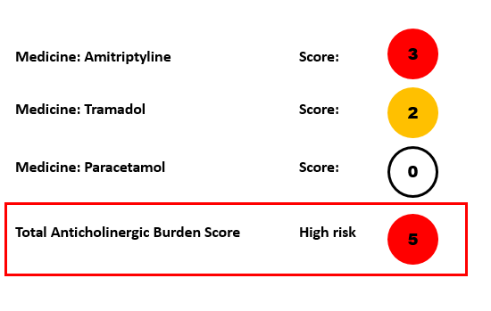

When the graphic is produced, the website text states that persons with a score of 3 or more are at higher risk of confusion, falls and death. The text includes advice suggesting review of the medicines is necessary when scores of 3 or more are present, to discuss the medicines with the patient or family members and to consider if there are alternative medicines to which the patient could be switched. The website includes a link to potential alternative medicines.

### Falls risk medicines

**Purpose:** to assist in identifying medicines with the potential for increasing the risk of falls.

**Description:** Medicines can be associated with increased risk of falls, either due to their sedative effects, cognitive effects or hypotensive effects (88-90). Lists of medicines that have been shown to be associated with increased risk of falls have been created to assist assessment of the potential for risk from medicines, and in particular the risk due to concurrent use of medicines that each individually can contribute to risk of falls, as the effects can be cumulative (73). STOPPFall (Screening Tool of Older Persons Prescriptions in older adults with high fall risk) is one falls risk took that has been developed by the European Geriatric Medicine Society (EuGMS) Task and Finish Group on FRIDs (Falls risk increasing drugs) (91). It contains 14 medicine classes: anticholinergics, diuretics, alpha-blockers used as antihypertensives, opioids, antidepressants, antipsychotics, antiepileptics, benzodiazepines and benzodiazepine-related medicines. STOPPFALL has associated deprescribing advice to support cessation of medicines where appropriate. The decision tool is available(92) at: [kik.amc.nl/falls/decision-tree/](https://kik.amc.nl/falls/decision-tree/)

The NSW Therapeutic Advisory Group have created a medication related fall risk assessment tool, which is designed for the hospital setting to be used within the polypharmacy quality use of medicines indicators (93). The NSW Therapeutic Advisory Group tool includes a list of medicines with potential for increasing the risk of falls. The list is available online (94) at:

<https://www.nswtag.org.au/wp-content/uploads/2020/11/NSW-TAG-8.2_Med-related-Falls-Risk-Assessment-ToolMFRAT.pdf>

**Setting:** Applicable across all health settings, although some lists have been developed for specific settings.

**Audience:** Health professionals.

**Method of development:** STOPPFall was developed using a three round Delphi process involving 24 experts. The initial list of medicines was based on evidence reviews of the association between medicines and falls (91).

**Advantages:** The lists enable easy identification of medicines most likely to contribute to falls and allows for consideration of the cumulative burden where multiple medicines that could contribute to falls risk are used. Research has shown that the effects of these medicines can be cumulative (73, 95), that people taking these medicines can have changes in their gait (96), are at increased risk of falls (97, 98), and have higher health care utilization (98).

**Limitations:** Tools developed internationally may include medicines, dosages or formulations not available in Australia.Medicines are not the only factor that contribute to falls risk and the medicines lists are sometimes incorporated into broader falls risk scores, such as psychological factors and cognitive status. See as an example the tool published by the Victorian Health Department (99).at: [www.health.vic.gov.au/publications/falls-risk-assessment-tool-frat](http://www.health.vic.gov.au/publications/falls-risk-assessment-tool-frat)

**Data required:** Medication chart for the medications. Patient interview for the full falls risk assessment scores.

### Scottish Polypharmacy Guidance: Cumulative Toxicity tool and adverse drug reactions (ADR)

**Purpose:** To provide a visual aid for assessing the potential for more than one medicine to contribute to adverse medicine events.

**Description:** The Scottish Government Polypharmacy Model of Care Group 2018 have developed guidance to prevent inappropriate polypharmacy (100). The guidance includes a visual tool to identify medicines that may contribute to the risk of the same adverse medicine event. The Scottish tool identifies 15 potential adverse events commonly associated with medicines and 32 medicine groups or classes that are frequently used. It is available online (101)at <https://www.therapeutics.scot.nhs.uk/wp-content/uploads/2018/04/Polypharmacy-Guidance-2018.pdf>

The tool has been adapted and developed as an interactive calculator as part of the Australian Veterans’ Medicines Advice and Therapeutics Education Services Program (102). The interactive tool can demonstrate how potential risks change if medicines were to be prioritise for cessation. The interactive tool is available online (103).

**Method of development:** Medicines were classified as potentially contributing to the adverse event if the side effect was listed in the product information at a frequency of greater than 1 in 10,000 or based on the pharmacological profile of the medicine. The tool is limited to commonly used medicines and identifies medicines that have potential for each adverse event.

**Setting:** Applicable across all health settings.

**Audience:** Health professionals.

**Advantages:** The tool provides a visual cue for potential harms, including cumulative harms, from medicines.

**Limitations:** The tool does not estimate cumulative risk and does not account for dose or patient characteristics.The tool provides a visual cue only and is not exhaustive of all medicines or adverse events.

**Data required:** Medication chart.

**Example:** The example below is created from the web version of the tool and represents the adverse events that may be associated with medicine use for a person taking celecoxib, enalapril, temazepam, verapamil and citalopram.

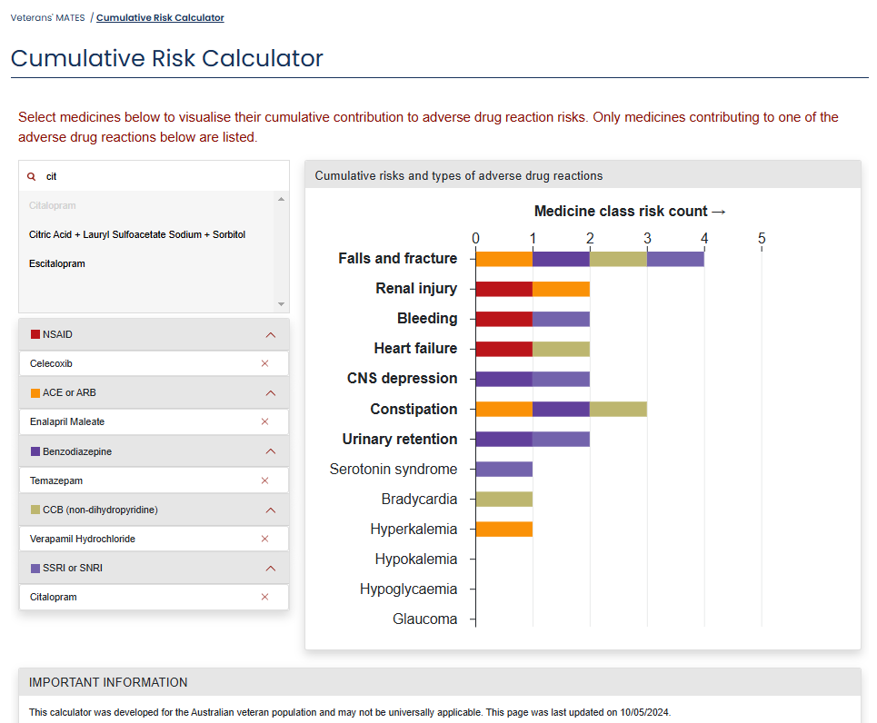

Source: Example created from Cumulative Risk Calculator (103)., available at https://www.veteransmates.net.au/cumulative-risk-calculator/

### Medichec

**Purpose:** To provide a visual aid for identifying medicines with the potential for anticholinergic effects, QTc prolongation, hyponatremia, bleeding, dizziness, drowsiness, and constipation.

**Description:** Medichec is a free, web-based application to help healthcare professionals in identifying medicines that might have an effect on cognitive function in older adults as well as other adverse effects (104). The tool features an Anticholinergic Effect on Cognition (AEC) scale (105) which aims to score medicines on their anticholinergic effect on cognition. The tool allows users to input a patient's medicines and receive an AEC score indicating the cumulative anticholinergic burden. A score of 3 or above suggests the need for a medicine review. Medichec also identifies other adverse effects, including QTc prolongation, hyponatremia, bleeding, dizziness, drowsiness, and constipation.

The tool categorises risk for individual medicines according to colour codes: red, amber, yellow, or blue. The colour ratings are based on the reported frequency of side effects, more so than the severity of the effects, with red indicating a higher frequency. Green indicates safe to use, and grey is used to indicate there is limited data. The tool is available online (106)at: <http://www.medichec.com/>

**Method of development:** The tool was developed by researchers at South London and Maudsley National Health Services (NHS) Foundation Trust and is based on medicines information from the British National Formulary (BNF) (104). The anticholinergic’s effect is assessed using AEC score, which was developed based on  in vitro anticholinergic potency as well as a medicine’s capacity to cross the blood-brain barrier, information from medicine information texts (105).

**Setting:** Applicable across all health settings.

**Audience:** Health professionals.

**Advantages:** The tool provides a visual cue for the total score of anticholinergic effects. Additionally, Medichec features a color-coded system that categorises adverse effects, making it easier for clinicians to prioritise attention to higher-risk medicines and enhance patient safety.

**Limitations:** List of medicines are limited to those available in the United Kingdom.

**Data required:** Medication chart.

**Example:** The example below is created from the web version of the tool.

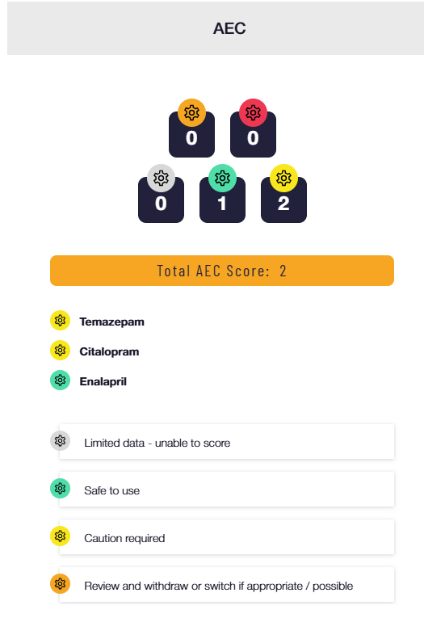

Source: Example created from Medichec Calculator (106), available at <http://www.medichec.com/>

## Tools supporting symptom assessment for adverse medicine event identification

The tools in the previous section identified possible side effects based on the known side effects of medicines prescribed. Patient self-report is another way to identify possible side effects from medicines. There are numerous patient questionnaires developed to assist side effect detection (107). In this section, we describe two tools that ask patients to report symptoms that are possible related to medicines which have been developed to support detection of side effects of medicines during medicines review.

### Patient Reported Outcome Measure Inquiry into Side-Effects (PROMISE)

**Purpose:** The patient reported outcome measure inquiry into side effects is designed to assist health professionals to identify side effects from medicines by inquiring about patient reported symptoms (108).

**Description:** The tool is a structured self-report questionnaire that contains a list of 22 common symptoms that could be due to the effects of medicines (108). The tool is designed for self-administration by patients. The tool identifies symptoms and whether patients consider the symptoms may be related to their medicines. The tool includes questions on self-rated health, beliefs about medicines, and questions related to adherence. The full tool is available online (109) at: <https://pmc.ncbi.nlm.nih.gov/articles/instance/5840243/bin/11096_2017_575_MOESM1_ESM.pdf>

**Method of development:** The symptoms were selected based on the side effect profile of the most common medicines in use in the Netherlands. Side effects were grouped into symptom categories and limited to a set of the 22 symptoms likely to be most frequent. Expected frequency was based on side effect occurrence rate and number of medicines with that side effect. The final list was compared with published lists and reviewed by the research team (108). Testing of the symptom list with patients prior to commencement of a medicine review found that patients were more likely to report a symptom if they were taking a medicine that had that symptom listed as very common in the product information (110).

**Setting:** Designed to be used as part of a medicine review.

**Audience:** People taking medicines.

**Advantages:** Can be completed by patients and provides capacity for patients to identify whether they think the medicine is a contributing factor.

**Limitations:** Answers are limited to yes, no, unsure, thus severity of symptoms is not considered. Temporality of symptoms in relation to medicine use is also not assessed. The tool only supports detection of symptoms listed. The tool does include an open-ended question to allow respondents to identify other symptoms they consider may be medicine related.

**Data required:** Patient self-report.

**Example:** The symptom score component of the Patient Reported Outcome Measure Inquiry into Side-Effects is presented below (110).

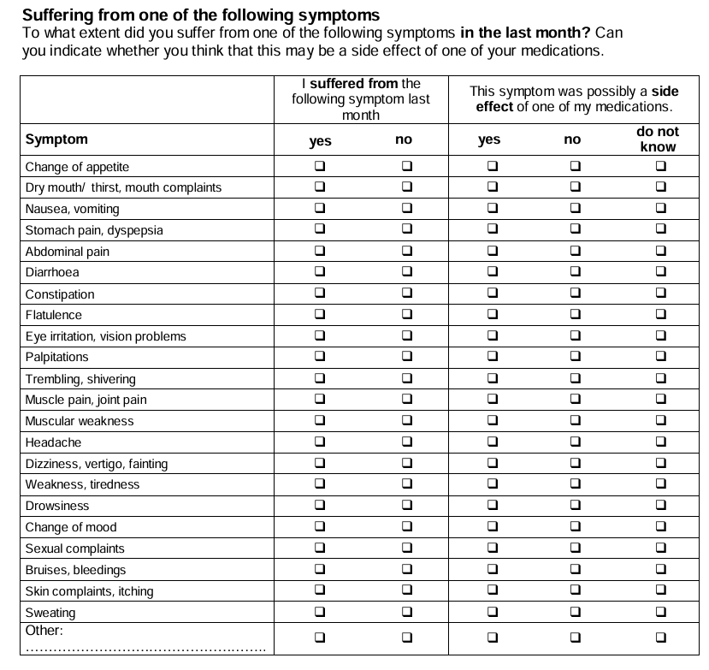

Source: Patient-Reported Outcome Measure, Inquiry into Side Effects' (PROMISE) instrument. Creator Schoenmakers TW, Teichert M, Wensing M, de Smet PA.(110), Available under creative commons CC by 4.0 (30) available online (109) at <https://pmc.ncbi.nlm.nih.gov/articles/instance/5840243/bin/11096_2017_575_MOESM1_ESM.pdf>

### PHASE 20 and Phase PROXY

**Purpose:** Self-report tools designed to detect symptoms related to medicines.

**Description:** Phase 20 was developed to detect symptoms related to medicines for aged care residents (111) and Phase Proxy was developed to detect symptoms related to medicines among persons with cognitive impairment (112). Both tools are structured self-report questionnaire that contains a list of 19 common symptoms that could be due to the effects of medicines and one open ended question. The tools are intended for patient or carer self-completion with the aid of a health professional. PHASE 20 includes a four-point response to indicate symptom severity, from no problem, minor, moderate, or severe problem. Phase Proxy has four response options: no, mild/occasionally, severe/often, do not know. Copies of the tools are available online (113).at:

<https://regionuppsala.se/samverkanswebben/for-vardgivare/kunskapsstod/lakemedel/tillgangliga-resurser-vid-lakemedelsbehandling/apotekare-i-varden/phase-20/phase-20-english/>

The tools require permission from the author to be used outside Sweden.

**Method of development:** Phase 20 (111) was developed based on a literature search for common symptoms related to medicine use in older people and geriatricians and clinical pharmacist expert input. An initial list of symptoms was trialled and compared with a pharmacist’s assessment of the likelihood the symptom was medicine related, and subsequently reviewed by a geriatrician and clinical pharmacist. Correlations between symptoms were also explored, with correlated symptoms merged into one symptom group.

In developing Phase Proxy, three expert groups involving dementia experts and health officials involved in dementia, registered nurses with expertise in dementia, and geriatricians and clinical pharmacists, reviewed Phase 20 with the aim of removing subjective terms and replacing them with objective alternatives, as well as identifying any symptoms relevant to dementia medicines that may have been missing. The response scale was limited to three items, was then tested for inter-rater reliability, internal consistency, and content validity (112).

**Setting:** The tool was designed to be used as part of a medicine review.

**Audience:** People taking medicines or their carers.

**Advantages:** This tool is routinely used in Sweden and is available in English versions**.**

**Limitations:** Use outside of Sweden requires permission.

**Data required:** Patient or carer interview.

## Tools to identify people at risk of Medicine Related Problems

The tools in the previous section identify particular types of medicine related problems. Some tools have also been developed to identify people at risk of medicine related problems in general (114-117). People may be at risk of medicine related problems due to medicine related factors, but factors related to the person taking the medicines as well as systems factors can also put people at risk of medicine related problems. Knowing who is at risk of medicine-related problems can be helpful for triaging persons for a medicines review. On some occasions, such as where there are resource constraints, there is also a need to prioritise medicine review services to the persons most at risk of medicine related harms.

In this section of the handbook we highlight tools to identify people at risk of medicine related problems, and a risk calculator, developed in Australia, to predict which patients may benefit most from a medication review.

### Self-Medication Risk Assessment Instrument

**Purpose:** A screening tool to identify people at risk of medicine-related problems

**Description:** The tool contains (118) seven items relating to the number of medicines taken, the person’s mental state, hearing, vision, social circumstances, physical condition, and attitude and knowledge about medications. The tool was developed as a 4 point scale ranging from 1 =no risk to 4 = high risk, judged against explicit criteria for each risk level. Scores for each item are summed for a total score.

The tool is published in the appendix of the paper (118) available at <https://www.sciencedirect.com/science/article/pii/S136190040500004X#app1>

**Method of development:** Key factors affecting older people’s ability to manage their medicines were identified through literature review and interviews with consumers, carers, and health professionals. The tool was tested on 45 people. Each person was assessed by 2 assessors (nurses, pharmacists or social care workers) to determine inter-rater reliability and one assessor revisited the person a week later to determine intra-rate reliability. The tool was found to have high inter-rater reliability and criterion validity (118).

**Audience:** Health care professionals.

**Setting:**Primary care.

**Advantages:** Simple to administer and score and brief to administer. The tool is in use in the UK as a 6 item scale (hearing has been omitted) with modified scoring for each item. In this modified tool, a score of 13 or less is considered low-risk, 14 to 16 medium risk, 17 to 22 high risk and 23 or above very high risk (119). Guidance for health care professionals for suggested actions for each risk level is provided in the with accompanying material (119). It is available online (119) at <https://bradford.connecttosupport.org/media/q5xpozqd/appendix-a-fuller-s-self-medication-risk-assessment-screening-tool.pdf>

**Limitations:** The score does not account for the type of medicine, dose prescribed or frequency of dosing. The tool relies on assessment by the health care professional or reliable consumer self-report.

**Data required**: Patient interview

**Example:** The following provides an example of Self Medication Risk Assessment tool.

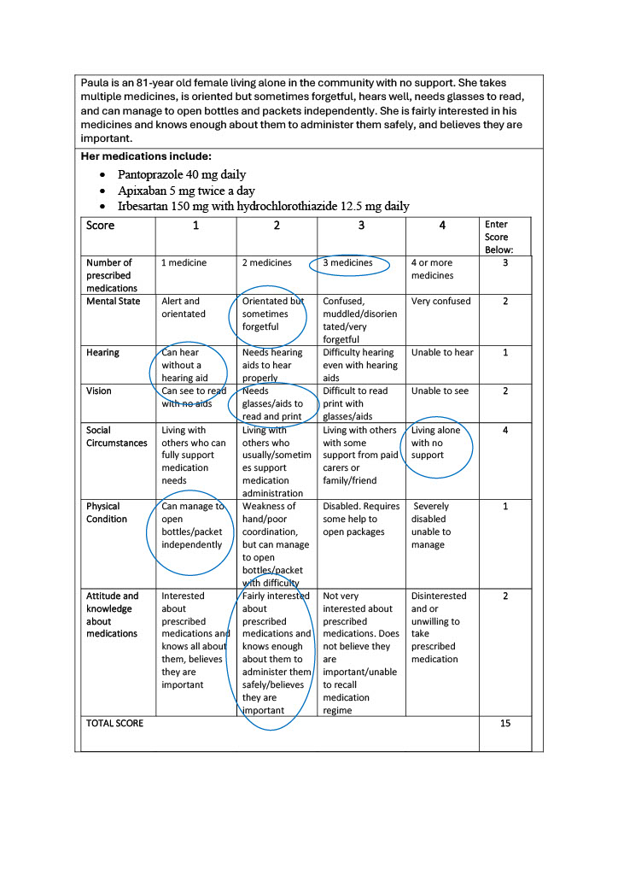

Source: Fuller et al. Clinical Effectiveness in Nursing, 2005; 9: 78-83 (118).

### Medication risk checklist for older adults (LOTTA)

**Purpose:** A self-assessment tool for older adults living independently to identify persons at risk of medicine related problems.

**Description:** The tool (120) contains eight items, three of which relate to systems issues including whether there is an up-to-date medicines list, multiple doctors involved in their care, and whether there is follow-up care planned. One of the items relates to possible medicine related symptoms, one relates to adherence and the remaining relate to self-management assessment. The tool is published as open access and available online (120) at:

<https://www.tandfonline.com/doi/full/10.1080/07853890.2023.2287707#d1e405>

**Method of development:** The tool was developed based on an existing nurse administered medicine related problem tool and published literature. A three round Delphi method was undertaken with 19 experts in geriatrics and therapeutics to determine content validity, with the feasibility tested among 87 older adults (120).

**Audience:** Older people living in the community

**Setting:**Primary care

**Advantages:** This tool can be self-administered and covers the range of medicine-related problems from systems issues, patient factors, and medication issues. The feasibility study suggests it takes six minutes to complete (120).

**Limitations:** The tool is self-administered, with active follow-up required to ensure health professionals are aware of the results. The tool was developed in Finland and some of the language may not be applicable to the Australian health system.

**Data required:** Consumer self-report.

### PHarmacie-R

**Purpose:** to identify patients in the hospital setting who should be prioritised for early medicine review post-discharge because they are at high risk of readmission.

**Description:** PHarmacie-R is a smart phone based predictive tool developed to identify patients in the hospital setting who should be prioritised for medicine review (121). The model was based on its ability to predict patients at risk of hospital readmission within 90 days. Variables included in the model were patient factors including: age, sex, Aboriginality, domiciliary status (living alone), geographic isolation (rural or remote), need for an interpreter; morbidities (mental illness or cognitive impairment), multimorbidity (three or more comorbidities); health service use (unplanned emergency department attendance or hospital admission in the last 6 months); and medicine use ( polypharmacy defined as five or more medicines), and use of high risk medications(121). The final model was found to have a positive predictive value of 59% and a negative predictive value of 72%. A model score of 0.46 was considered to give the best separation between low and high risk. A cut off of 0.4 was found to identify patients with moderate risk (121).

PHarmacie-R Risk Score = $e^{a}$/(1+ $e^{a}$)

Where a = -7.065131

+0.6787006*gender (Male=1, Female =0)

+0.2680293*age -0.004810423*age2+ 0.00002604254*age3 (age in years)

+0.03076355*polypharmacy (5 or more medicines =1, less than five =0)

+0.44733076*high risk medicines (One or more = 1, none =0)

+0.5300211*lives alone (Yes = 1, No-=0)

+0.2275686*lives rural or remote location (Yes=1, No=0)

+0.3811697*history of mental Illness or cognitive impairment (Yes = 1, No=0)

+ 1.030316*comorbidities (3 or more = 1, 2 or less =0)

-0.2385641* Indigenous or interpreter (Yes=1, No=0)

+0.1958415*length of stay in hospital (5 or more days =1, 4 or less days =0)

+0.8111112*readmission or emergency department attendance within 6 months (Yes = 1, No = 0)

**Method of development:** The model was developed using logistic regression and built on an earlier version, PHarmacie-4, that was a simple to use tool that summed ten predictor variables, with a score of four or more, considered high risk (122). While simple to use, PHarmacie-4 over-estimated risk, thus, is not suitable for use in practice. PHarmacie-R included the risk factors used in PHarmacie-4 and logistic regression models were run to determine the risk prediction based on the inclusion of subsets or the complete set of risk factors. The models were developed on a sample of 1201 patients, and then tested for applicability in a sample of 200 patients where the positive predictive value for the applicability sample was found to be 54.2% and the negative predictive value 70.6% (121).

**Audience:** Health professionals.

**Setting:**Developed for the hospital setting.

**Advantages:** This is an Australian based risk calculator for use in the hospital.

**Limitations:** Its generalisability outside the setting in which it was developed is not known. Manual calculation is time consuming.

**Data required:** Risk factors can be collected by patient interview, and review of the medication chart and clinical record.

**Example:** The following provides an example of the PHarmacie-R-Risk Score.

**Person**

Ron is a 78-year-old male with multiple comorbidities who has been in hospital for the last five days. He lives alone in country Victoria. He doesn’t need an interpreter and does not identify as Indigenous. He has no cognitive impairment. He has not been in hospital or the emergency department in the last six months.

His comorbidities include:

Ischaemic Heart Disease

Hypertension - last office BP was 118/75

Atrial fibrillation (AF)

Gastroesophageal reflux disease (GORD)

Chronic low back and neck pain

Overweight

His medications include:

Diclofenac 50 mg twice a day as needed

Apixaban 5 mg twice a day

Aspirin 100 mg daily

Rosuvastatin 10 mg daily

Pantoprazole 40 mg daily

Citalopram 20 mg daily

Oxazepam 15 mg before bed as needed

Atenolol 25 mg twice a day

Amlodipine 5 mg daily

Irbesartan 150 mg with hydrochlorothiazide 12.5 mg daily

Glyceryl trinitrate (GTN) spray as needed for chest pain

**PHarmacie-R Risk Score = e^a/(1+e^a)**

Where a = -7.065131

+0.6787006*1 (gender)

+0.2680293*78 - 0.004810423*782+ 0.00002604254*783 (age)

+0.03076355*1 (polypharmacy)

+0.44733076*0 (high risk medicines)

+0.5300211*1 (lives alone)

+0.2275686*1 (lives rurally)

+0.3811697*1 (Mental illness)

+ 1.030316*1 (comorbidities)

-0.2385641* 0 (Indigenous or interpreter)

+0.1958415*1 (length of stay)

+0.8111112*0 (readmissions)

**Final score = 0.57**

This score is above the cut-off of 0.46 (or 0.40), thus Ron would be identified as a candidate for early mediation review post discharge using this tool.

## Tools to support identification of patients suitable for deprescribing

In previous sections, we highlighted tools that assist with identifying medicines that are potentially inappropriate or lead to harms. Having identified medicines that potentially could or are causing harms, the next step is to switch to a more appropriate alternative or to cease the medicine, often referred to as deprescribing (123). While some medicines can be stopped immediately, many others need to be tapered to prevent rebound or withdrawal symptoms. Some of the tools already considered, including MedStopper and STOPPFall (see tools to assist identification of cumulative toxicity) include recommendations for cessation of medicines. Person-centred care is also considered key to support deprescribing, with patient and carer engagement and agreement necessary when considering changes to the medicine regimen. In this section of the handbook, we highlight a tool developed in Australia to identify patient attitudes towards deprescribing, the knowledge from which could be used to support successful deprescribing of medicines.

### Patient Attitudes Towards Deprescribing questionnaire

**Purpose:** To elicit consumer attitudes towards their medicines.

**Description:** The Patient Attitudes Towards Deprescribing questionnaire aims to identify patient attitudes towards deprescribing and support patient centred care. Originally developed in 2012 (124, 125), the questionnaire was revised in 2016 with versions produced for older adults as well as carers of older people (126). The revised questionnaires include 22 questions in the version for older adults and 19 questions in the version for carers. The questionnaires address four themes: i) belief in appropriateness of withdrawal; ii) perceived burden of their medications; iii) concerns about stopping; and iv) level of involvement in medication management” (126). A version for people living with cognitive impairment has also been developed (127, 128).

The questionnaires can be used freely for non-commercial research with permission. And can be used by healthcare professionals (for non-commercial purposes) available at: <https://www.australiandeprescribingnetwork.com.au/925-2/>

An electronic version of the questionnaire is available for use by Australian registered healthcare practitioners after registering for an account (77).at <https://gmedss.com/about>.

**Setting:** Suitable for use in all health settings.

**Audience:** Suitable for use by any health practitioner; the questionnaires can be self-administered by consumers.

**Method of development:** The questionnaire was originally developed based on expert opinion and evidence from the literature on patients views about medicines, revised after pilot testing with patients and expert review, and then tested for face, content and criterion validity, sensitivity and test–retest reliability (125). The revised questionnaire retained items from the original questionnaire with additional questions generated from the literature, expert opinion and focus groups. The revised questionnaires were subsequently tested for face, content, construct, internal consistency, and criterion validity as well as test-retest reliability with patients and carers (126).

**Advantages:** The tool has been validated and is widely used in research studies and provides a method for identifying patients most likely to be active partners in deprescribing. A longitudinal Swiss study found that a reluctance to cease medicine, as measured by the tool, was associated with increased use of medicines at 12 months follow-up (129), however; this study did not use the respondent’s answers to the questionnaire to target the intervention. A study in Ireland found that willingness to deprescribe was associated with a higher rate of deprescribing (130). However, other studies have not found this association (131) and so further research is required.

**Limitations:** The best approach to use the tool in practice is still under investigation.

**Data required:** Patient or carer interview.

## Tools to support medication switching and tapering

When medicines need to be switched, dose equivalence is an important consideration. Some medicines require tapering for effective switching to ensure symptom control and minimise side effects. Tapering is also a consideration when medicines need to be ceased, particularly for medicines that have withdrawal, rebound or addictive effects. In this section of the report, we highlight examples of available switching and tapering calculators. Consideration should be given to the method of development of any switching or tapering tool prior to use, as there are a number of web-based tools directed to consumers to create tapering plans for psychotropic medicines, not all of which indicate the source of information on which the tool is based or the developer.

### Medicine switching calculators

**Purpose:** Designed to assist in selecting equivalent medicine dosages to support switching.

**Description:** There are a number of tools available to support clinicians to switch medicines at equivalent dosages, including where tapering of doses is required to successfully effect the switch. The majority of tools relate to analgesic and psychotropic medicines.

**Method of development:** The majority of tools have been developed by health professional organisations or medicines information specialists.

**Setting:** Suitable for use in all health settings.

**Audience:** Suitable for use by any health practitioner, however, some medicines may be specialist managed

**Advantages:** Simple to use with some producing a visual switching plan.

**Limitations:** Products available in Australia may not be available in strengths that match the calculated doses. Consideration will need to be given to which strength best matches the calculated dose. The tools generally do not consider patient related factors, other conditions and medicines which may need to be taken into account.

**Data required:** Medication regimen

**Examples:**

*Opioid switching calculator.*

The Faculty of Pain Medicine, Australia and New Zealand College of Anaesthetists has developed an opioid calculator to support switching of opioids based on morphine equivalent doses either to an equivalent doses or at reduced doses, with the ability to create different dose recommendations based on the percentage dose reduction required (132). The tool is available as a smart phone app and online (133) at http://www.opioidcalculator.com.au/

The example below is sourced from the calculator and shows an equianalgesic dose calculation from morphine to oxycodone, and at percentage dose reductions.

**Equianalgesic Dose**

30mg/day Morphine

Doses for oxycodone oral

20mg/day

15mg/day (at 25% reduction)

14mg/day (at 30% reduction)

12mg/day (at 40% reduction)

10mg/day (at 50% reduction)

Source(133): created using http://www.opioidcalculator.com.au/

*Antipsychotic switching calculator*

Australian Prescriber publish a calculator to support switching of antipsychotics at equivalent dosing, currently in its fifth version (134, 135). It includes switching between oral products or depot to depot, with the output indicating the switching regimen by indication. The tool is available online (135) at https://australianprescriber.tg.org.au/articles/antipsychotic-switching-tool.html

The example below of a switch is created from the web version of the tool (135).

**Direct switch and cross titration**

If risperidone was prescribed in doses above 3 mg daily, the dose should be reduced to 50% on day 1 and then stopped at day 5.

For bipolar depression, immediate- or modified-release quetiapine should be administered once daily at bedtime and titrated from a low dose.

A suggested regimen is:

• 50 mg on day 1

• 100 mg on day 2

• 200 mg on day 3

• 300 mg on day 4.

The dose may be adjusted up to 600 mg/day in increments of 100 mg/day depending on clinical response and tolerability

Source(135): created using: https://australianprescriber.tg.org.au/articles/antipsychotic-switching-tool.html

*SwitchRx*

SwitchRx is an online medication switching resource designed for Canadian healthcare professionals managing psychotropic treatments. The tool is structured to allow users to select specific classes of psychotropic medications, such as antipsychotics, antidepressants, or hypnotics. The tool provides evidence-based, up-to-date guidance on transitioning between these medications. It includes detailed protocols, practical tips, and considerations for tapering, cross-titration, and substitution strategies. SwitchRx is available after account registration(136) from <https://www.switchrx.com/>

### Medicine tapering calculators

**Purpose:** Designed to assist in selecting dosages and time intervals to support successful cessation of medicines.

**Description:** There are a number of tools available to support clinicians to taper medicines. The majority of tools relate to analgesic and psychotropic medicines.

**Method of development:** The majority of tools have been developed by health professional organisations or medicines information specialists.

**Setting:** Suitable for use in all health settings.

**Audience:** Suitable for use by any health practitioner; however, some medicines may be specialist managed.

**Advantages:** Simple to use with some producing a visual switching plan.

**Limitations:** For internationally based calculators, products available in Australia may not be available in strengths that match the calculated doses. Consideration will need to be given to which strength best matches the calculated dose. The tools generally do not consider patient related factors, other conditions and medicines which may need to be taken into account.

**Data required:** Medication regimen.

**Examples:** *An Australian opioid tapering calculator* has been developed by the Victorian Department of Health and NPS Medicines Wise (137). This calculator requires the initial medicine, the daily dose, the target change (to another medication or to cease) and the tapering rate. It provides a visual display of the tapering regimen and allows variable tapering rates to be calculated. It is available for download (137) at:

<https://www.health.vic.gov.au/publications/opioid-tapering-calculator>.

The example below shows the dosage suggestions for tapering oxycodone from a starting dose of 30mg per day by 20% each week.

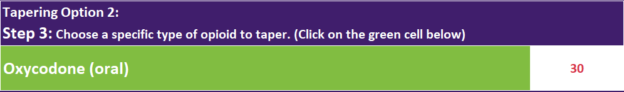

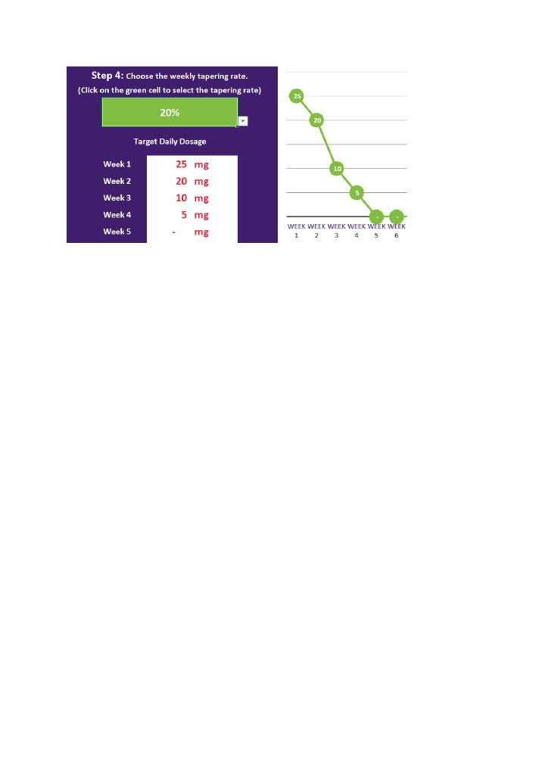

Source:(136): created using <https://www.health.vic.gov.au/publications/opioid-tapering-calculator>

*The West of Scotland Chronic Pain Education Group* also have an opioid switching and tapering calculator (138). This calculator requires the initial medicine, the daily dose, the target change (to another medication or to cease) and the tapering rate. This is a UK tool and product strengths and formulations may vary to the Australian market. The opioid tapering calculator (139) and the opioid switching calculator (140) is available at <https://paindata.org/taper.php> The tapering example below for oxycodone 70mg as a starting dose with a 15% reduction rate is created from the web version of the tool.

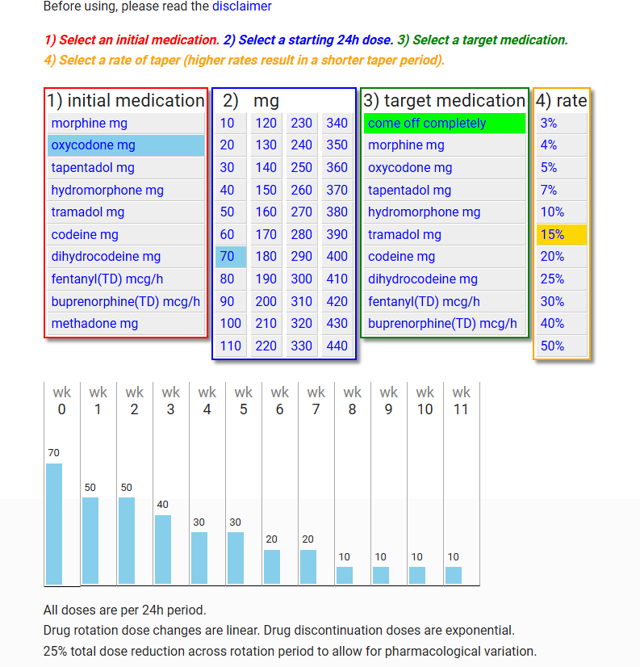

Source: created using <https://paindata.org/taper.php> (139)

## References

1. Nguyen H, Manolova G, Daskalopoulou C, Vitoratou S, Prince M, Prina AM. Prevalence of multimorbidity in community settings: A systematic review and meta-analysis of observational studies. J Comorb. 2019;9:2235042X19870934.

2. Arnone D, Omar O, Arora T, Ostlundh L, Ramaraj R, Javaid S, et al. Effectiveness of pharmacogenomic tests including CYP2D6 and CYP2C19 genomic variants for guiding the treatment of depressive disorders: Systematic review and meta-analysis of randomised controlled trials. Neurosci Biobehav Rev. 2023;144:104965.

3. Sutherland JJ, Daly TM, Liu X, Goldstein K, Johnston JA, Ryan TP. Co-prescription trends in a large cohort of subjects predict substantial drug-drug interactions. PLoS One. 2015;10(3):e0118991.

4. Masnoon N, Shakib S, Kalisch-Ellett L, Caughey GE. What is polypharmacy? A systematic review of definitions. BMC Geriatr. 2017;17(1):230.

5. Prasad N, Lau ECY, Wojt I, Penm J, Dai Z, Tan ECK. Prevalence of and Risk Factors for Drug-Related Readmissions in Older Adults: A Systematic Review and Meta-Analysis. Drugs Aging. 2024;41(1):1-11.

6. Yadesa TM, Kitutu FE, Deyno S, Ogwang PE, Tamukong R, Alele PE. Prevalence, characteristics and predicting risk factors of adverse drug reactions among hospitalized older adults: A systematic review and meta-analysis. SAGE Open Med. 2021;9:20503121211039099.

7. Davies LE, Spiers G, Kingston A, Todd A, Adamson J, Hanratty B. Adverse Outcomes of Polypharmacy in Older People: Systematic Review of Reviews. J Am Med Dir Assoc. 2020;21(2):181-7.

8. Morath B, Mayer T, Send AFJ, Hoppe-Tichy T, Haefeli WE, Seidling HM. Risk factors of adverse health outcomes after hospital discharge modifiable by clinical pharmacist interventions: a review with a systematic approach. Br J Clin Pharmacol. 2017;83(10):2163-78.

9. Oscanoa TJ, Lizaraso F, Carvajal A. Hospital admissions due to adverse drug reactions in the elderly. A meta-analysis. Eur J Clin Pharmacol. 2017;73(6):759-70.

10. Lim R, Ellett LMK, Semple S, Roughead EE. The Extent of Medication-Related Hospital Admissions in Australia: A Review from 1988 to 2021. Drug Saf. 2022;45(3):249-57.

11. Wimmer BC, Cross AJ, Jokanovic N, Wiese MD, George J, Johnell K, et al. Clinical Outcomes Associated with Medication Regimen Complexity in Older People: A Systematic Review. J Am Geriatr Soc. 2017;65(4):747-53.

12. Elliott RA. Reducing medication regimen complexity for older patients prior to discharge from hospital: feasibility and barriers. J Clin Pharm Ther. 2012;37(6):637-42.

13. Richter A, Anton SF, Koch P, Dennett SL. The impact of reducing dose frequency on health outcomes. Clin Ther. 2003;25(8):2307-35; discussion 6.

14. Sluggett JK, Stasinopoulos J, Sylvester C, Wong WJ, Hillen J, Hughes GA, et al. Simplifying medication regimens for residents of aged care facilities: Pharmacist and physician use of a structured five-step medication simplification tool. Res Social Adm Pharm. 2024;20(8):733-9.

15. George J, Phun YT, Bailey MJ, Kong DC, Stewart K. Development and validation of the medication regimen complexity index. Ann Pharmacother. 2004;38(9):1369-76.

16. McDonald MV, Peng TR, Sridharan S, Foust JB, Kogan P, Pezzin LE, et al. Automating the medication regimen complexity index. J Am Med Inform Assoc. 2013;20(3):499-505.

17. Libby AM, Hirsch JD. Electronic Data Capture and Coding Tool for Medication Regimen Complexity University of Colorado,: The Regents of the University of Colorado,; 2024 [Available from: <https://pharmacy.cuanschutz.edu/research/MRCTool>.

18. Libby AM, Fish DN, Hosokawa PW, Linnebur SA, Metz KR, Nair KV, et al. Patient-level medication regimen complexity across populations with chronic disease. Clin Ther. 2013;35(4):385-98 e1.

19. Ferreira JM, Galato D, Melo AC. Medication regimen complexity in adults and the elderly in a primary healthcare setting: determination of high and low complexities. Pharm Pract (Granada). 2015;13(4):659.

20. Morillo-Verdugo R, Robustillo-Cortes MA, Abdel-Kader Martin L, Alvarez de Sotomayor Paz M, Lozano de Leon Naranjo F, Almeida Gonzalez CV. Determination of a cutoff value for medication regimen complexity index to predict polypharmacy in HIV+ older patient. Rev Esp Quimioter. 2019;32(5):458-64.

21. Alves-Conceicao V, Rocha KSS, Silva FVN, Silva ROS, Silva DTD, Lyra-Jr DP. Medication Regimen Complexity Measured by MRCI: A Systematic Review to Identify Health Outcomes. Ann Pharmacother. 2018;52(11):1117-34.

22. Lee S, Jang J, Yang S, Hahn J, Min KL, Jung EH, et al. Development and validation of the Korean version of the medication regimen complexity index. PLoS One. 2019;14(5):e0216805.

23. Okuyan B, Babi B, Sancar M, Ay P, Yucel E, Yucel A, et al. Validation of the Turkish version of medication regimen complexity index among elderly patients. J Eval Clin Pract. 2016;22(5):732-6.

24. Saez de la Fuente J, Such Diaz A, Canamares-Orbis I, Ramila E, Izquierdo-Garcia E, Esteban C, et al. Cross-cultural Adaptation and Validation of the Medication Regimen Complexity Index Adapted to Spanish. Ann Pharmacother. 2016;50(11):918-25.

25. Melchiors AC, Correr CJ, Fernandez-Llimos F. Translation and validation into Portuguese language of the medication regimen complexity index. Arq Bras Cardiol. 2007;89(4):210-8.

26. Chen EY, Sluggett JK, Ilomaki J, Hilmer SN, Corlis M, Picton LJ, et al. Development and validation of the Medication Regimen Simplification Guide for Residential Aged CarE (MRS GRACE). Clin Interv Aging. 2018;13:975-86.

27. Dugre N, Bell JS, Hopkins RE, Ilomaki J, Chen EYH, Corlis M, et al. Impact of Medication Regimen Simplification on Medication Incidents in Residential Aged Care: SIMPLER Randomized Controlled Trial. J Clin Med. 2021;10(5).

28. Sluggett JK, Hopkins RE, Chen EY, Ilomaki J, Corlis M, Van Emden J, et al. Impact of Medication Regimen Simplification on Medication Administration Times and Health Outcomes in Residential Aged Care: 12 Month Follow Up of the SIMPLER Randomized Controlled Trial. J Clin Med. 2020;9(4).

29. Sluggett JK, Page AT, Chen EYH, Ilomaki J, Corlis M, Van Emden J, et al. Protocol for a non-randomised pilot and feasibility study evaluating a multicomponent intervention to simplify medication regimens for people receiving community-based home care services. BMJ Open. 2019;9(7):e025345.

30. Creative Commons. Attribution 4.0 International: Creative Commons; 2024 [Available from: <https://creativecommons.org/licenses/by/4.0/>.

31. Konstantinou P, Kasinopoulos O, Karashiali C, Georgiou G, Panayides A, Papageorgiou A, et al. A Scoping Review of Methods Used to Assess Medication Adherence in Patients with Chronic Conditions. Ann Behav Med. 2022;56(12):1201-17.

32. Fahrni ML, Saman KM, Alkhoshaiban AS, Naimat F, Ramzan F, Isa KAM. Patient-reported outcome measures to detect intentional, mixed, or unintentional non-adherence to medication: a systematic review. BMJ Open. 2022;12(9):e057868.

33. Lam WY, Fresco P. Medication Adherence Measures: An Overview. Biomed Res Int. 2015;2015:217047.

34. Svarstad BL, Chewning BA, Sleath BL, Claesson C. The Brief Medication Questionnaire: a tool for screening patient adherence and barriers to adherence. Patient Educ Couns. 1999;37(2):113-24.

35. Svarstad BL. Brief Medication Questionnaire (BMQ-H9) 2006 [Available from: <https://pharmacy.wisc.edu/wp-content/uploads/2016/05/BMQ-H-9_website2022.pdf>.

36. Bailey SC, Annis IE, Reuland DS, Locklear AD, Sleath BL, Wolf MS. Development and evaluation of the Measure of Drug Self-Management. Patient Prefer Adherence. 2015;9:1101-8.

37. Creative Commons. Attribution-NonCommercial 3.0 Unported [Available from: <https://creativecommons.org/licenses/by-nc/3.0/>.

38. Morisky DE. Morisky Scales ​MMAS-4 ​& MMAS-8: Morisky Medication Adherence Research; 2024 [Available from: <https://www.moriskyscale.com/about-the-morisky-scale---mmas-4--mmas-8-the-morisky-scales.html>.

39. Morisky DE, Green LW, Levine DM. Concurrent and predictive validity of a self-reported measure of medication adherence. Med Care. 1986;24(1):67-74.

40. Retraction Statement: Predictive validity of a medication adherence measure in an outpatient setting. J Clin Hypertens (Greenwich). 2023;25(9):889.

41. Morisky DE, Ang A, Krousel-Wood M, Ward HJ. Predictive validity of a medication adherence measure in an outpatient setting. J Clin Hypertens (Greenwich). 2008;10(5):348-54.

42. Moon SJ, Lee WY, Hwang JS, Hong YP, Morisky DE. Accuracy of a screening tool for medication adherence: A systematic review and meta-analysis of the Morisky Medication Adherence Scale-8. PLoS One. 2017;12(11):e0187139.

43. Moon SJ, Lee WY, Hwang JS, Hong YP, Morisky DE. Correction: Accuracy of a screening tool for medication adherence: A systematic review and meta-analysis of the Morisky Medication Adherence Scale-8. PLoS One. 2018;13(4):e0196138.

44. Hanlon JT, Schmader KE, Samsa GP, Weinberger M, Uttech KM, Lewis IK, et al. A method for assessing drug therapy appropriateness. J Clin Epidemiol. 1992;45(10):1045-51.

45. Samsa GP, Hanlon JT, Schmader KE, Weinberger M, Clipp EC, Uttech KM, et al. A summated score for the medication appropriateness index: development and assessment of clinimetric properties including content validity. J Clin Epidemiol. 1994;47(8):891-6.

46. Hanlon JT, Schmader KE. The Medication Appropriateness Index: A Clinimetric Measure. Psychother Psychosom. 2022;91(2):78-83.

47. Hanlon JT, Schmader KE. The medication appropriateness index at 20: where it started, where it has been, and where it may be going. Drugs Aging. 2013;30(11):893-900.

48. Lee G, Lim JF, Page AT, Etherton-Beer C, Clifford R, Wang K. Applicability of explicit potentially inappropriate medication lists to the Australian context: A systematic review. Australas J Ageing. 2022;41(2):200-21.

49. Motter FR, Fritzen JS, Hilmer SN, Paniz EV, Paniz VMV. Potentially inappropriate medication in the elderly: a systematic review of validated explicit criteria. Eur J Clin Pharmacol. 2018;74(6):679-700.

50. Inglis JM, Caughey G, Thynne T, Brotherton K, Liew D, Mangoni AA, et al. Inappropriate prescribing and association with readmission or mortality in hospitalised older adults with frailty: a systematic review and meta-analysis. BMC Geriatr. 2024;24(1):718.

51. Corvaisier M, Brangier A, Annweiler C, Spiesser-Robelet L. Preventable or potentially inappropriate psychotropics and adverse health outcomes in older adults: systematic review and meta-analysis. J Nutr Health Aging. 2024;28(4):100187.

52. Mekonnen AB, Redley B, de Courten B, Manias E. Potentially inappropriate prescribing and its associations with health-related and system-related outcomes in hospitalised older adults: A systematic review and meta-analysis. Br J Clin Pharmacol. 2021;87(11):4150-72.

53. Schiavo G, Forgerini M, Lucchetta RC, Silva GO, Mastroianni PDC. Cost of adverse drug events related to potentially inappropriate medication use: A systematic review. J Am Pharm Assoc (2003). 2022;62(5):1463-76 e14.

54. Rodrigues RC, Gomes GKA, Sodre BMC, Lima RF, Barros DSL, Figueiredo A, et al. Lists of potentially inappropriate medications for older people in primary care: a systematic review of health outcomes. Cad Saude Publica. 2024;40(5):e00016423.

55. Hill-Taylor B, Walsh KA, Stewart S, Hayden J, Byrne S, Sketris IS. Effectiveness of the STOPP/START (Screening Tool of Older Persons' potentially inappropriate Prescriptions/Screening Tool to Alert doctors to the Right Treatment) criteria: systematic review and meta-analysis of randomized controlled studies. J Clin Pharm Ther. 2016;41(2):158-69.

56. Wang KN, Etherton-Beer CD, Sanfilippo F, Page AT. Development of a list of Australian potentially inappropriate medicines using the Delphi technique. Intern Med J. 2024;54(6):980-1002.

57. American Geriatrics Society Beers Criteria Update Expert Panel. American Geriatrics Society 2023 updated AGS Beers Criteria(R) for potentially inappropriate medication use in older adults. J Am Geriatr Soc. 2023;71(7):2052-81.

58. Sawan MJ, Clough A, Hillen J, Soulsby N, Gnjidic D. Comparison of polypharmacy and potentially inappropriate medication use in older adults with and without dementia receiving residential medication management reviews. Australas J Ageing. 2024;43(3):628-35.

59. Holdaway M, Hyde Z, Hughson JA, Malay R, Stafford A, Fulford K, et al. Medications and cognitive risk in Aboriginal primary care: a cross-sectional study. Intern Med J. 2024;54(6):897-908.

60. O'Mahony D, Cherubini A, Guiteras AR, Denkinger M, Beuscart JB, Onder G, et al. Correction: STOPP/START criteria for potentially inappropriate prescribing in older people: version 3. Eur Geriatr Med. 2023;14(4):633.

61. O'Mahony D, Cherubini A, Guiteras AR, Denkinger M, Beuscart JB, Onder G, et al. STOPP/START criteria for potentially inappropriate prescribing in older people: version 3. Eur Geriatr Med. 2023;14(4):625-32.

62. Lavan AH, Gallagher P, Parsons C, O'Mahony D. STOPPFrail (Screening Tool of Older Persons Prescriptions in Frail adults with limited life expectancy): consensus validation. Age Ageing. 2017;46(4):600-7.

63. Curtin D, Gallagher P, O'Mahony D. Deprescribing in older people approaching end-of-life: development and validation of STOPPFrail version 2. Age Ageing. 2021;50(2):465-71.

64. Frankenthal D, Israeli A, Caraco Y, Lerman Y, Kalendaryev E, Zandman-Goddard G, et al. Long-Term Outcomes of Medication Intervention Using the Screening Tool of Older Persons Potentially Inappropriate Prescriptions Screening Tool to Alert Doctors to Right Treatment Criteria. J Am Geriatr Soc. 2017;65(2):e33-e8.

65. Curtin D, Jennings E, Daunt R, Curtin S, Randles M, Gallagher P, et al. Deprescribing in Older People Approaching End of Life: A Randomized Controlled Trial Using STOPPFrail Criteria. J Am Geriatr Soc. 2020;68(4):762-9.

66. Pazan F, Weiss C, Wehling M, Forta. The FORTA (Fit fOR The Aged) List 2021: Fourth Version of a Validated Clinical Aid for Improved Pharmacotherapy in Older Adults. Drugs Aging. 2022;39(3):245-7.

67. Pazan F, Weiss C, Wehling M, Members FEP. The EURO-FORTA (Fit fOR The Aged) List Version 2: Consensus Validation of a Clinical Tool for Improved Pharmacotherapy in Older Adults. Drugs Aging. 2023;40(5):417-26.

68. Pazan F, Gercke Y, Weiss C, Wehling M, Raters F. The U.S.-FORTA (Fit fOR The Aged) List: Consensus Validation of a Clinical Tool to Improve Drug Therapy in Older Adults. J Am Med Dir Assoc. 2020;21(3):439 e9- e13.

69. Pazan F, Weiss C, Wehling M, Forta. The EURO-FORTA (Fit fOR The Aged) List: International Consensus Validation of a Clinical Tool for Improved Drug Treatment in Older People. Drugs Aging. 2018;35(1):61-71.

70. Pazan F, Weiss C, Wehling M, Forta. Correction to: The EURO-FORTA (Fit fOR The Aged) List: International Consensus Validation of a Clinical Tool for Improved Drug Treatment in Older People. Drugs Aging. 2018;35(7):677.

71. Wehling M, Burkhardt H, Kuhn-Thiel A, Pazan F, Throm C, Weiss C, et al. VALFORTA: a randomised trial to validate the FORTA (Fit fOR The Aged) classification. Age Ageing. 2016;45(2):262-7.

72. McCormack J, Mangin D, Farrell B, Sloan J, Trimble J, Allan M, et al. Medstopper beta Vancouver: University of British Columbia; [

73. Leach MJ, Pratt NL, Roughead EE. Risk of Hip Fracture in Older People Using Selective Serotonin Reuptake Inhibitors and Other Psychoactive Medicines Concurrently: A Matched Case-Control Study in Australia. Drugs Real World Outcomes. 2017;4(2):87-96.

74. Hilmer SN, Mager DE, Simonsick EM, Cao Y, Ling SM, Windham BG, et al. A drug burden index to define the functional burden of medications in older people. Arch Intern Med. 2007;167(8):781-7.

75. Hilmer SN. Calculating and using the drug burden index score in research and practice. Expert Rev Clin Pharmacol. 2018;11(11):1053-5.

76. Kouladjian L, Gnjidic D, Chen TF, Hilmer SN. Development, validation and evaluation of an electronic pharmacological tool: The Drug Burden Index Calculator(c). Res Social Adm Pharm. 2016;12(6):865-75.

77. Sydney TUo, Northern Sydney Local Health District. Welcome to the Goal-directed Medication review Electronic Decision Support System (G-MEDSS©) website Sydney: The University of Sydney and Northern Sydney Local Health District.; 2024 [Available from: <https://gmedss.com/about>.

78. Fujita K, Hooper P, Masnoon N, Lo S, Gnjidic D, Etherton-Beer C, et al. Impact of a Comprehensive Intervention Bundle Including the Drug Burden Index on Deprescribing Anticholinergic and Sedative Drugs in Older Acute Inpatients: A Non-randomised Controlled Before-and-After Pilot Study. Drugs Aging. 2023;40(7):633-42.

79. Masnoon N, Lo S, Hilmer S. A stewardship program to facilitate anticholinergic and sedative medication deprescribing using the drug burden index in electronic medical records. Br J Clin Pharmacol. 2023;89(2):687-98.

80. University of Sydney, Morthern Sydney Local Health District. About G-MEDSS Sydney: University of Sydney, ; 2024 [

81. Liu BM, Kouladjian O'Donnell L, Redston MR, Fujita K, Thillainadesan J, Gnjidic D, et al. Association of the Drug Burden Index (DBI) exposure with outcomes: A systematic review. J Am Geriatr Soc. 2024;72(2):589-603.

82. Hilmer SN, Gnjidic D. The anticholinergic burden: from research to practice. Aust Prescr. 2022;45(4):118-20.

83. Liu BM, Redston MR, Fujita K, Thillainadesan J, Gnjidic D, Hilmer SN. The Impact of Deprescribing Interventions on the Drug Burden Index and Other Outcomes: A Systematic Review. J Am Med Dir Assoc. 2024;25(7):105021.

84. King R, Rabino S. ACB Calculator UK: King and Rabino; [

85. King R, Rabino S. ACB calculator 2024 [Available from: <https://www.acbcalc.com/>.

86. Boustani M, Campbell N, Munger S, Maidment I, Fox C. Impact of Anticholinergics on the Aging Brain: A Review and Practical Application. Aging Health. 2008;4(3):311-20.

87. Kiesel EK, Hopf YM, Drey M. An anticholinergic burden score for German prescribers: score development. BMC Geriatr. 2018;18(1):239.

88. de Vries M, Seppala LJ, Daams JG, van de Glind EMM, Masud T, van der Velde N, et al. Fall-Risk-Increasing Drugs: A Systematic Review and Meta-Analysis: I. Cardiovascular Drugs. J Am Med Dir Assoc. 2018;19(4):371 e1- e9.

89. Seppala LJ, van de Glind EMM, Daams JG, Ploegmakers KJ, de Vries M, Wermelink A, et al. Fall-Risk-Increasing Drugs: A Systematic Review and Meta-analysis: III. Others. J Am Med Dir Assoc. 2018;19(4):372 e1- e8.

90. Seppala LJ, Wermelink A, de Vries M, Ploegmakers KJ, van de Glind EMM, Daams JG, et al. Fall-Risk-Increasing Drugs: A Systematic Review and Meta-Analysis: II. Psychotropics. J Am Med Dir Assoc. 2018;19(4):371 e11- e17.

91. Seppala LJ, Petrovic M, Ryg J, Bahat G, Topinkova E, Szczerbinska K, et al. STOPPFall (Screening Tool of Older Persons Prescriptions in older adults with high fall risk): a Delphi study by the EuGMS Task and Finish Group on Fall-Risk-Increasing Drugs. Age Ageing. 2021;50(4):1189-99.

92. Carefree, University of Amsterdam, ADFICE_IT, ZonMw Projecten. Choose a medication class to see the decision advice for withdrawing the medication among fallers Amsterdam: University of Amsterdam; [Available from: kik.amc.nl/falls/decision-tree.

93. NSW Therapeutic Advisory Group. Medication-related Falls Risk Assessment Tool (MFRAT) Sydney: NSW TAG; 2020 [Available from: <https://www.nswtag.org.au/wp-content/uploads/2020/11/NSW-TAG-8.2_Med-related-Falls-Risk-Assessment-ToolMFRAT.pdf>.

94. NSW Therapeutic Advisory Group. Medication-related falls risk assessment tool (MFRAT) Sydney: NSW Therapeutic Advisory Group; 2020 [Available from: <https://www.nswtag.org.au/wp-content/uploads/2020/11/NSW-TAG-8.2_Med-related-Falls-Risk-Assessment-ToolMFRAT.pdf>.

95. Pratt NL, Ramsay EN, Kalisch Ellett LM, Nguyen TA, Barratt JD, Roughead EE. Association between use of multiple psychoactive medicines and hospitalization for falls: retrospective analysis of a large healthcare claim database. Drug Saf. 2014;37(7):529-35.

96. Osman A, Kamkar N, Speechley M, Ali S, Montero-Odasso M. Fall risk-increasing drugs and gait performance in community-dwelling older adults: A systematic review. Ageing Res Rev. 2022;77:101599.

97. Prasert V, Pooput P, Ponsamran P, Vatcharavongvan P, Vongsariyavanich P. The association between falls and fall-risk-increasing drugs among older patients in out-patient clinics: A retrospective cohort, single center study. Res Social Adm Pharm. 2024.

98. Paar E, Lai E, Drzaic M, Kummer I, Buzancic I, Hadziabdic MO, et al. Fall risk-increasing drugs and associated health outcomes among community-dwelling older patients: A cross-sectional study in Croatian cohort of the EuroAgeism H2020 project. Acta Pharm. 2024.

99. Victorian Government Department of Health. Falls Risk Assessment Tool (FRAT)

Victoria: Department of Health; 2024 [

100. Scottish Government Polypharmacy Model of Care Group. Polypharmacy Guidance, Realistic Prescribing 3rd Edition, . Edinburgh; 2018.

101. Scottish Government Polypharmacy Model of Care Group. Polypharmacy guidance, realistic prescribing 3rd Edition Edinburgh: Scottish Government; 2018 [Available from: <https://www.therapeutics.scot.nhs.uk/wp-content/uploads/2018/04/Polypharmacy-Guidance-2018.pdf>.

102. Australian Government Department of Veterans' Affairs. Cumulative Medicines Risk Adelaide: University of South Australia; 2022 [Available from: <https://www.veteransmates.net.au/topics/complex-medicines/therapeutic-brief/>.

103. Veterans' MATES, Australian Government Department of Veterans' Affairs. Cumulative risk calculator Adelaide: Quality Use of Medicines and Pharmacy Research Centre; 2024 [Available from: <https://www.veteransmates.net.au/cumulative-risk-calculator/>.

104. South London and Maudsley NHS Foundation Trust. Medichec London: South London and Maudsley NHS Foundation Trust; [Available from: <http://www.medichec.com/>.

105. Bishara D, Harwood D, Sauer J, Taylor DM. Anticholinergic effect on cognition (AEC) of drugs commonly used in older people. Int J Geriatr Psychiatry. 2017;32(6):650-6.

106. South London and Maudsley NHS Foundation Trust. Assessing medication for anticholenergic buden (using the anticholenergic effect on cognition tool) and for QTc prolongation, hypronatreaemia, bleeding, dizziness, drowsiness and constipation London: NHS; 2024 [Available from: <http://www.medichec.com/>.

107. Lim R, Ellett LK, Roughead EE, Cheah PY, Masnoon N. Patient-Reported Questionnaires to Identify Adverse Drug Reactions: A Systematic Review. Int J Environ Res Public Health. 2021;18(22).

108. Schoenmakers TW, Teichert M, Wensing M, de Smet PA. Evaluation of Potentially Drug-Related Patient-Reported Common Symptoms Assessed During Clinical Medication Reviews: A Cross-Sectional Observational Study. Drug Saf. 2017;40(5):419-30.

109. Schoenmakers T, Wensing M, De Smet P, Teichert M. Online resource 1: PROMISE instrument 2018 [Available from: <https://pmc.ncbi.nlm.nih.gov/articles/instance/5840243/bin/11096_2017_575_MOESM1_ESM.pdf>.

110. Schoenmakers TWA, Wensing M, De Smet P, Teichert M. Patient-reported common symptoms as an assessment of interventions in medication reviews: a randomised, controlled trial. Int J Clin Pharm. 2018;40(1):126-34.

111. Hedström M, Lidström B, Hulter Åsberg K. PHASE-20: ett nytt instrument för skattning av möjliga läkemedelsrelaterade symptom hos äldre personer i äldreboende [PHASE-20: A new instrument for assessment of possible therapeutic drug-related symptoms among elderly in nursing homes]. . Vård i Norden, . 2009;29:9–14.

112. Hedstrom M, Carlsson M, Ekman A, Gillespie U, Mork C, Asberg KH. Development of the PHASE-Proxy scale for rating drug-related signs and symptoms in severe cognitive impairment. Aging Ment Health. 2018;22(1):53-60.

113. Hedström M. PHASE-20 in English 2016 [Available from: <https://regionuppsala.se/samverkanswebben/for-vardgivare/kunskapsstod/lakemedel/tillgangliga-resurser-vid-lakemedelsbehandling/apotekare-i-varden/phase-20/phase-20-english/>.

114. Puumalainen E, Airaksinen M, Jalava SE, Chen TF, Dimitrow M. Comparison of drug-related problem risk assessment tools for older adults: a systematic review. Eur J Clin Pharmacol. 2020;76(3):337-48.

115. Stampfli D, Boeni F, Gerber A, Battig VAD, Weidmann R, Hersberger KE, et al. Assessing the ability of the Drug-Associated Risk Tool (DART) questionnaire to stratify hospitalised older patients according to their risk of drug-related problems: a cross-sectional validation study. BMJ Open. 2018;8(6):e021284.

116. Berman RL, Iris M, Conrad KJ, Robinson C. Validation of the MedUseQ: A Self-Administered Screener for Older Adults to Assess Medication Use Problems. J Pharm Pract. 2019;32(5):509-23.

117. Baby B, McKinnon A, Patterson K, Patel H, Sharma R, Carter C, et al. Tools to measure barriers to medication management capacity in older adults: a scoping review. BMC Geriatr. 2024;24(1):285.

118. Fuller D, Watson R. Validating a self-medication risk assessment instrument. Clinical Effectiveness in Nursing. 2005;9(1):78-83.

119. City of Bradford Metropolitan District Council. Bradford Medication Support Guidance Bradford; 2021.

120. Dimitrow M, Saarenmaa R, Airaksinen M, Hassan G, Puumalainen E, Pitrova M, et al. Medication risk checklist for older adults (LOTTA) - development and validation of a self-assessment tool. Ann Med. 2023;55(2):2287707.

121. Criddle DT, Devine B, Murray K, Budgeon CA, Sanfilippo FM, Gupta S, et al. Developing PHarmacie-R: A bedside risk prediction tool with a medicines management focus to identify risk of hospital readmission. Res Social Adm Pharm. 2022;18(7):3137-48.

122. Clifford R, Criddle D, Devine B, Gupta S, Chong YL, Tan ML, et al. Developing PHarmacie-4 - A simple risk tool to identify patients at risk of medication-related problems post-discharge

Res Social Adm Pharm. 2018;14:e23ee56.

123. Scott IA, Hilmer SN, Reeve E, Potter K, Le Couteur D, Rigby D, et al. Reducing inappropriate polypharmacy: the process of deprescribing. JAMA Intern Med. 2015;175(5):827-34.

124. Reeve E, Wiese MD, Hendrix I, Roberts MS, Shakib S. People's attitudes, beliefs, and experiences regarding polypharmacy and willingness to Deprescribe. J Am Geriatr Soc. 2013;61(9):1508-14.

125. Reeve E, Shakib S, Hendrix I, Roberts MS, Wiese MD. Development and validation of the patients' attitudes towards deprescribing (PATD) questionnaire. Int J Clin Pharm. 2013;35(1):51-6.

126. Reeve E, Low LF, Shakib S, Hilmer SN. Development and Validation of the Revised Patients' Attitudes Towards Deprescribing (rPATD) Questionnaire: Versions for Older Adults and Caregivers. Drugs Aging. 2016;33(12):913-28.

127. Reeve E, Anthony AC, Kouladjian O'Donnell L, Low LF, Ogle SJ, Glendenning JE, et al. Development and pilot testing of the revised Patients' Attitudes Towards Deprescribing questionnaire for people with cognitive impairment. Australas J Ageing. 2018;37(4):E150-E4.

128. Reeve E, Bayliss EA, Shetterly S, Maiyani M, Gleason KS, Norton JD, et al. Willingness of older people living with dementia and mild cognitive impairment and their caregivers to have medications deprescribed. Age Ageing. 2023;52(1).

129. Jungo KT, Weir KR, Cateau D, Streit S. Older adults' attitudes towards deprescribing and medication changes: a longitudinal sub-study of a cluster randomised controlled trial. BMJ Open. 2024;14(1):e075325.

130. McCarthy C, Flood M, Clyne B, Smith SM, Boland F, Wallace E, et al. Association between patient attitudes towards deprescribing and subsequent prescription changes. Basic Clin Pharmacol Toxicol. 2023;133(6):683-90.

131. Turner JP, Martin P, Zhang YZ, Tannenbaum C. Patients beliefs and attitudes towards deprescribing: Can deprescribing success be predicted? Res Soc Admin Pharm. 2020;16(4):599-604.

132. Faculty of Pain Medicine AaNZCoA. Opioid calculator: FPM ANZCA; 2022 [Available from: <http://www.opioidcalculator.com.au/>.

133. Faculty of Pain Medicine AaNZCoA. Opioid calculator Victoria: FPMANZCA; 2022 [Available from: <http://www.opioidcalculator.com.au/>.

134. Antipsychotic switching tool [Update]. Aust Prescr. 2019;42(6):213.

135. Keks N, Schwartz D, Hope J. Antipsychotic switching tool. Aust Prescr. 2019;42(5):156.

136. McIntosh D, Procyshyn RM. SwitchRx: the online medication switching tool [Available from: <https://www.switchrx.com/>

137. Opioid tapering calculator - for health professionals: Victorian Department of Health; 2022 [Available from: <https://www.health.vic.gov.au/publications/opioid-tapering-calculator>.

138. West of Scotland Chronic Pain Education Group. Pain Management: CPEG; 2024 [Available from: <https://paindata.org/index.php>.

139. West of Scotland Chronic Pain Education Group. Taper calculator 2024 [Available from: <https://paindata.org/taper.php>.

140. West of Scotland Chronic Pain Education Group. Guidance on opioid switching 2024 [Available from: <https://paindata.org/calculator.php>.

## Appendix 1: Australian Potentially Inappropriate Medicines List (56)

| **PIM1 or medicine class group** | **Avoid these drugs in older people** | **Avoid this medicine or medicine class in older people with these conditions** | **Instead of prescribing this medicine or class of medicines for older people, consider these alternatives** |
| --- | --- | --- | --- |
| Alpha-adrenoreceptor antagonists (prazosin) | Prazosin | Risk of hypotension  Taking other antihypertensive medications  Frailty  Risk of falls  Initial dose adverse effects | ACE inhibitors (e.g. enalapril and lisinopril)  Angiotensin II receptor blockers (e.g. candesartan and irbesartan)  Calcium channel blockers (e.g. amlodipine and diltiazem)  Silodosin  Tamsulosin |
| Antiemetics – dopamine antagonist (chlorpromazine, domperidone, metoclopramide and prochlorperazine) | Chlorpromazine  Prochlorperazine | Parkinson disease  Polypharmacy  Lewy body dementia  Neurodegenerative diseases (e.g. Alzheimer disease and cognitive impairment)  Frailty  High risk of falls | Ondansetron  Domperidone |
| Antihypertensives, centrally acting (methyldopa, clonidine and moxonidine) | Methyldopa | Risk of hypotension  Risk of falls  Taking other antihypertensive medications  Frailty | ACE inhibitors (e.g. enalapril and lisinopril)  Angiotensin II receptor blockers (e.g. candesartan and irbesartan)  Thiazide diuretics (e.g. hydrochlorothiazide) |
| Antipsychotics (haloperidol, zuclopenthixol, trifluoperazine, thioridazine, periciazine and flupenthixol) | Haloperidol  Zuclopenthixol  Trifluoperazine  Thioridazine  Periciazine  Flupenthixol | At risk of extrapyramidal reactions  Taking anticholinergic medications  Polypharmacy  Frailty  Neurodegenerative diseases (e.g. delirium)  Cognitive impairment  Cardiovascular diseases  Cerebrovascular diseases  Risk of falls | Atypical antipsychotics (e.g. quetiapine)  Risperidone  Nonpharmacological strategies (e.g. yoga) |
| Antipsychotics (olanzapine, quetiapine, amisulpride, ziprasidone, lurasidone, risperidone, aripiprazole and paliperidone) | Olanzapine | Cardiometabolic syndrome (e.g. high blood pressure, high blood sugar)  Risk of falls  Polypharmacy  When a nonpharmacological method has not been tried adequately  Neurodegenerative diseases (e.g. delirium)  Long-term use | Quetiapine  Risperidone |
| Benzodiazepine, long-acting (clobazam, clonazepam, diazepam, flunitrazepam and nitrazepam) | Clonazepam  Flunitrazepam | Dependence  Other medications with sedative properties  Polypharmacy  Frailty  Neurodegenerative diseases (e.g. delirium)  Cognitive impairment  Poor renal function  Long-term use  Risk of falls | Short-acting benzodiazepine (e.g. oxazepam)  Melatonin (for indication of sleep)  Nonpharmacological strategies (e.g. yoga) |
| Benzodiazepines, medium-acting (bromazepam and lorazepam) | Bromazepam  Lorazepam | Falls  With other medications with sedative properties  Polypharmacy  Frailty, Neurodegenerative diseases (e.g. delirium)  Cognitive impairment | Short-acting benzodiazepine  Melatonin (for indication of sleep)  Nonpharmacological strategies (e.g. yoga) |
| Benzodiazepines, short-acting (alprazolam, oxazepam and temazepam) | Alprazolam | Falls  With other medications with sedative properties  Polypharmacy  Frailty  Neurodegenerative diseases (e.g. delirium)  Dependency  Renal impairment  Long-term use | Oxazepam  Temazepam  Melatonin (for indication of sleep)  Nonpharmacological strategies (e.g. yoga) |
| Genito-urinary anticholinergics (oxybutynin, propantheline, tolterodine and solifenacin) | Oxybutynin | With other anticholinergics  Frailty  Polypharmacy  Risk of falls  Neurodegenerative diseases (e.g. delirium)  Constipation  Cognitive impairment | N/A |
| NSAIDs, nonselective (indomethacin, diclofenac, ketorolac, piroxicam, meloxicam, ibuprofen, naproxen, ketoprofen and mefenamic acid) | Diclofenac  Indomethacin  Ibuprofen  Ketoprofen  Piroxicam  Meloxicam  Ketorolac | History of gastrointestinal bleeding  Increased bleeding risks  Frailty  Poor renal function  Peptic ulcer disease  Multimorbidity  Chronic kidney disease  Heart failure  Cardiovascular diseases | Paracetamol |
| NSAIDs, selective (celecoxib and etoricoxib) | N/A | History of gastrointestinal bleeding  Increased bleeding risks  Frailty  Poor renal function  Heart failure  Cardiovascular disease  Chronic kidney disease  Long-term use  Taking ACE inhibitors or diuretics | Paracetamol  Celecoxib |
| Opioids (morphine, pethidine, fentanyl, dextropropoxyphene, hydromorphone, buprenorphine, oxycodone and codeine) | Pethidine  Fentanyl  Codeine  Hydromorphone  Dextropropoxyphene | Polypharmacy  Risk of falls  Frailty  Poor renal function  Neurodegenerative diseases (e.g. delirium)  Constipation  Opioid dependency  Long-term use  Impaired cognition  Chronic pain | Physiotherapy  Paracetamol  Oxycodone  Buprenorphine |
| Oral anticoagulants – direct thrombin inhibitors (dabigatran) | Dabigatran | Increased risk of bleeding  Multimorbidity  Peptic ulcer disease  Frailty  Risk of falls  Poor blood pressure control  Chronic kidney disease  Poor renal function | N/A |
| Oral anticoagulants – Factor Xa inhibitors (apixaban and rivaroxaban) | Rivaroxaban | Peptic ulcer disease  Increased bleeding risk  Risk of falls  Multimorbidity  Polypharmacy  Poor renal function  Chronic kidney disease | N/A |
| Sedating antihistamines (diphenhydramine, doxylamine, dexchlorpheniramine, pheniramine, promethazine, cyclizine, chlorpheniramine and cyproheptadine) | Promethazine | Taking other medications with sedative properties  Cognitive impairment  Taking anticholinergics  Frailty  Neurodegenerative diseases (e.g. delirium)  Risk of falls  Polypharmacy | Nonsedating antihistamines (e.g. fexofenadine) |
| Sulfonylureas (glibenclamide, glipizide, gliclazide and glimepiride) | Glibenclamide  Glimepiride | With other glucose-lowering medications  High risk of falls  Frailty  Chronic kidney diseases  Polypharmacy  Multimobidity  Renal impairment  Irregular diet  Dehydration | Metformin  Gliclazide  Dipeptidyl peptidase-4 inhibitors (sitagliptin and saxagliptin)  Sodium-glucose transport protein 2 inhibitor (dapagliflozin) |
| Tramadol | N/A | Multimorbidity  Frailty  Neurodegenerative diseases (e.g. delirium)  Risk of falls  Polypharmacy  Poor renal function  Cognitive impairment  Long-term use  Taking antidepressant medications  Epilepsy  Risk of seizures | Paracetamol  NSAIDs |
| Tricyclic antidepressants (imipramine, clomipramine, amitriptyline, nortriptyline, doxepin and dosulepin [dothiepin]) | Doxepin  Dosulepin (dothiepin) | With other anticholinergics  Frailty  Polypharmacy  Risk of falls  Neurodegenerative diseases (e.g. delirium)  Constipation  Cognitive impairment  With other medications with sedative properties  Risk of postural hypotension  Benign prostatic hyperplasia | Selective serotonin reuptake inhibitors (e.g. citalopram and paroxetine)  Serotonin and norepinephrine reuptake inhibitors (e.g. duloxetine)  Mirtazapine |
| *Z*-drugs (zolpidem and zopiclone) | N/A | Dependency  Taking other medications with sedative properties  Frailty  Neurodegenerative diseases (e.g. delirium)  Risk of falls  Polypharmacy  Cognitive impairment  Long-term use | Melatonin  Nonpharmacological strategies (e.g. sleep hygiene) |

Abbreviations: ACE, angiotensin-converting enzyme; N/A, not applicable; NSAID, nonsteroidal anti-inflammatory drug; PIM, potentially inappropriate medicine.

**Source:** the Australian Potentially Inappropriate Medicines List (56). Created by Wang KN, Etherton-Beer CD, Sanfilippo F, Page AT. Available under CC BY-NC 4.0 (30).at: <https://onlinelibrary.wiley.com/doi/10.1111/imj.16322>