Government Provider Management System

User Guide: Quality Indicators application

National Aged Care Mandatory Quality Indicator Program (QI Program) Manual 4.0 - Part C

April 2025

Version 1.4

This Government Provider Management System (GPMS) User Guide provides instructions to submit data and access reports using the Quality Indicators application.

**Contents**

1. Introduction 4

1.1 Purpose 4

1.2 Before proceeding 4

1.3 Login to the GPMS portal 5

2. Further information and support 5

3. Accessing GPMS and the Quality Indicator application 6

4. Quality Indicator Data Entry & Submission home page 7

4.1 Report due dates tab 7

4.2 Supporting Material tab 8

4.3 Search and display filters 9

4.4 Starting a quality indicator data submission 9

4.5 Submission status 11

5. Manual data entry submission page 13

5.1 Banner 14

5.2 Data entry stepper 14

5.3 Back button 16

5.4 Check Complete Data button 16

5.5 Next button 17

5.6 Setting quality indicator targets 17

5.7 Manual entry of quality indicator data 18

5.8 Error messages whilst entering quality indicator data 20

5.9 Data entry ready for submission 21

5.10 Submission 22

5.11 Post submission 22

6. File upload/bulk data entry submission page 23

6.1 QI Program file upload template page 23

6.2 Downloading and completing the file upload template 24

6.3 Submitting the file upload template 26

6.4 File upload post-submission page 27

6.5 File upload success message 27

6.6 File upload pending message 28

6.7 Failed upload error message 29

6.7.1 Scenario 1 - No error file produced 29

6.7.2 Scenario 2 - Error file produced 30

6.8 File upload partial success message 31

6.9 Error files 32

6.10 Re-uploading file template 33

6.11 Viewing upload history 34

6.12 File upload history page 34

7. Reporting Dashboard 35

7.1 Accessing the Quality Indicator Reporting Dashboard 35

7.2 Overview of report types and display formats 36

7.2.1 Key reports 36

7.2.2 Key displays 37

7.3 Functionality of the Quality Indicator Reporting Dashboard 39

7.3.1 Sharing the entire dashboard report 39

7.3.2 Sharing a singular report graph or table 40

7.4 Navigating the Quality Indicator Reporting Dashboard 41

7.4.1 Using Filters 42

# Introduction

The Department of Health and Aged Care released a Government Provider Management System (GPMS) portal to make it easier for providers to access and report information.

The GPMS Quality Indicators application supports submission of quarterly data as required by the National Aged Care Mandatory Quality Indicator Program  
(QI Program).

In accordance with the legislation, all residential aged care services must collect quarterly quality indicator data consistently using the methods prescribed in the   
[QI Program Manual 4.0 – Part A](https://www.health.gov.au/resources/publications/national-aged-care-mandatory-quality-indicator-program-manual-30-part-a?language=en) for submission via GPMS.

## Purpose

This User Guide has been designed to support residential aged care providers and organisations submitting quality indicator data on behalf of providers, with the following actions:

* accessing the QI Program tile in the GPMS Portal
* submitting quality indicator data
* accessing QI Program dashboard and reports, where authorised.

## Before proceeding

The Department of Health and Aged Care will keep records of your access to GPMS and when prompted, you must accept the *GPMS Terms of Use* to be able to access the system.

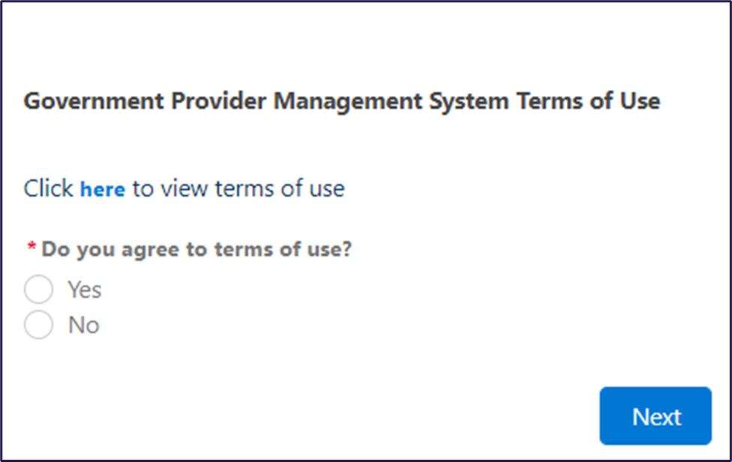

## Login to the GPMS portal

To log into the GPMS portal please visit [Log In Using | Service Provider Portal](https://provider.health.gov.au/serviceproviderportal/login?ec=302&startURL=%2Fserviceproviderportal%2Fs%2F).

If you require assistance logging into the GPMS portal, please refer to the GPMS [Logging in to the Aged Care Systems](https://www.health.gov.au/resources/publications/logging-in-to-the-aged-care-systems).

# Further information and support

To view additional QI Program resources, please visit the [QI Program website](https://www.health.gov.au/our-work/qi-program/resources).

For more information on GPMS please refer to the [Government Provider Management System](https://www.health.gov.au/our-work/government-provider-management-system) webpage.

If you require further assistance to login to GPMS please contact the My Aged Care service provider and assessor helpline on **1800 836 799**, Monday to Friday (8am to 8pm) and Saturday (10am to 2pm) local time across Australia.

For translating and interpreting services, call 131 450 and ask for My Aged Care service provider and assessor helpline on **1800 836 799**.

To use the National Relay Service, visit [About the National Relay Service (NRS) | Access Hub](https://www.accesshub.gov.au/about-the-nrs) or call **1800 555 660**.

To access sign language interpreting and captioning services through Deaf Connect, call [**1300 773 803**](tel:1300%20773%20803) or email [interpreting@deafconnect.org.au](mailto:interpreting@deafconnect.org.au).

# Accessing GPMS and the Quality Indicator application

To log into the GPMS portal please visit [Log In Using | Service Provider Portal](https://provider.health.gov.au/serviceproviderportal/login?ec=302&startURL=%2Fserviceproviderportal%2Fs%2F).

When you log into GPMS, you will be taken to the home page.

You will only be able to see the tiles that you, as an assigned user, have access to.

Select the **Quality Indicators** tile by selecting the arrow in the top right-hand corner of the tile.

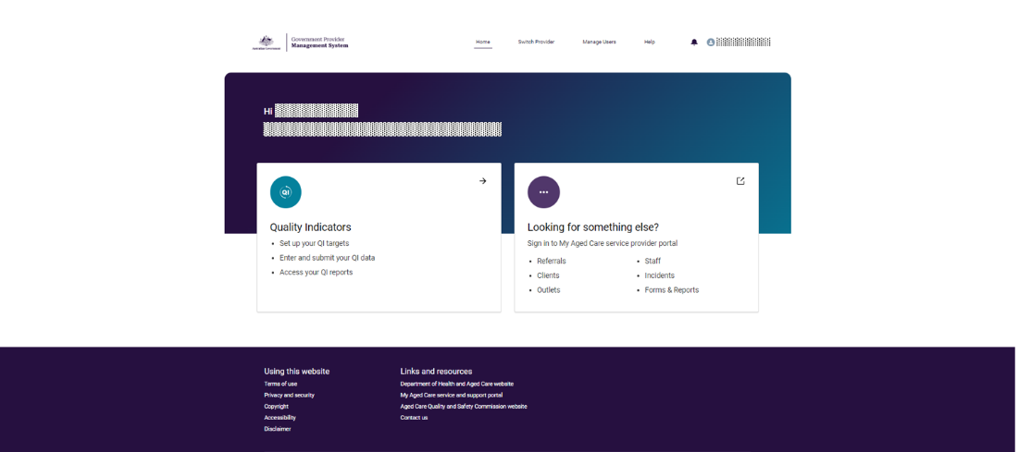

**Please note:**

If you cannot see the Quality Indicators tile, please speak to your Organisation Administrator to get access.

# Quality Indicator Data Entry & Submission home page

When you select the **Quality Indicators** tile, you will be taken to the Quality Indicator Data Entry & Submission home page.

On this page you will see a number of tabs and buttons, including the:

* Report due dates tab
* Supporting material tab
* Search and display filters
* Start and View buttons
* Upload file button
* Submission status notifications

Each of these sections, and the corresponding functions are described below.

## Report due dates tab

Select the **Report due dates** tab to see a list of the reporting due dates for the QI Program across the current financial year.

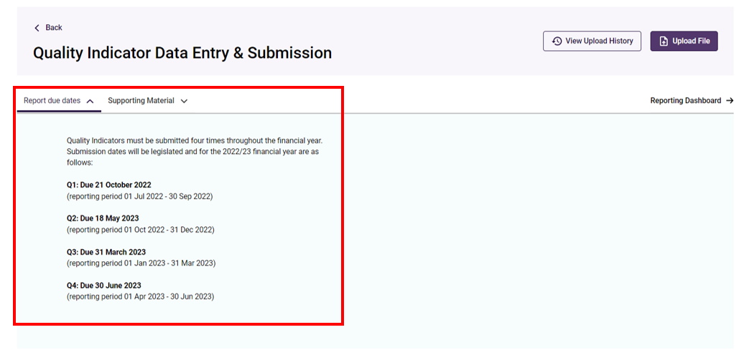

## Supporting Material tab

Select the **Supporting Material** tab to access various resources to help you collect and report quality indicator data.

Resources include:

* National Aged Care Mandatory Quality Indicator Program Manual 4.0 - Part A.
* National Aged Care Mandatory Quality Indicator Program Manual 4.0 - Part B.
* User Guide: Quality Indicators Application.
* National Aged Care Mandatory Quality Indicator Program FAQs.
* QI Program quick reference guides.
* QI Program interactive modules.

**Please note:**

The below Supporting Material tab will display the Manual as 3.0 Part A and 3.0 Part B. When you select the relevant manual, it will re-direct you to the updated 4.0 version.

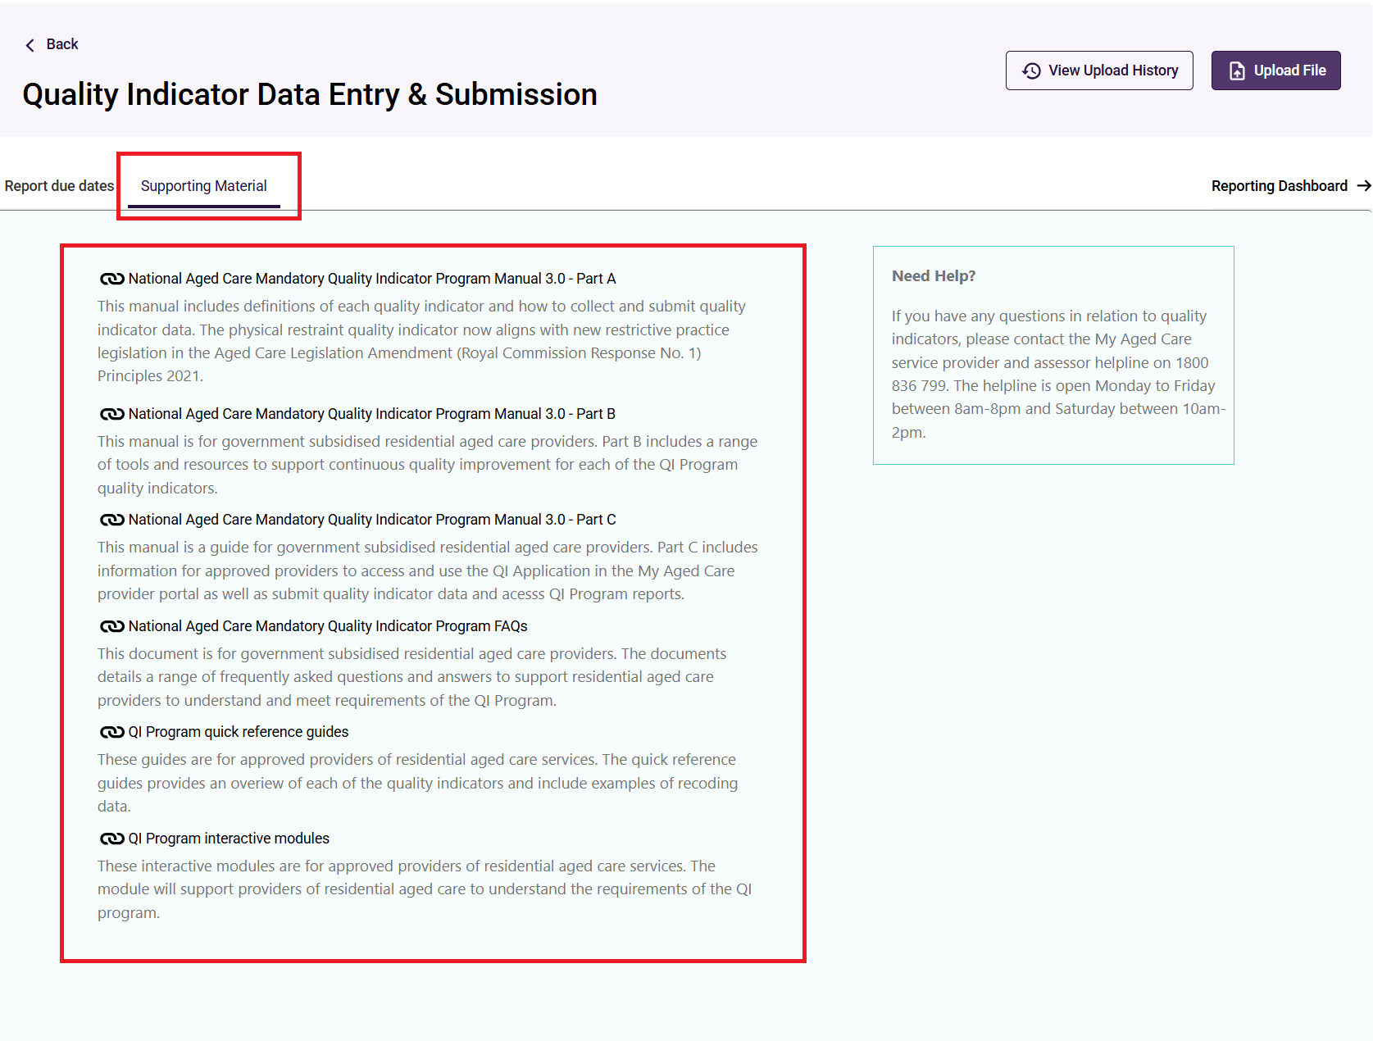

## Search and display filters

To find a service, enter the service name or service ID in the Search by service name or ID field.

You can also search by Period ending and Status of your quality indicator data submission (Status) by selecting from the drop down menus and clicking **Apply Filters**.

For more details of the ‘Status’ of a service, refer to Submission status.

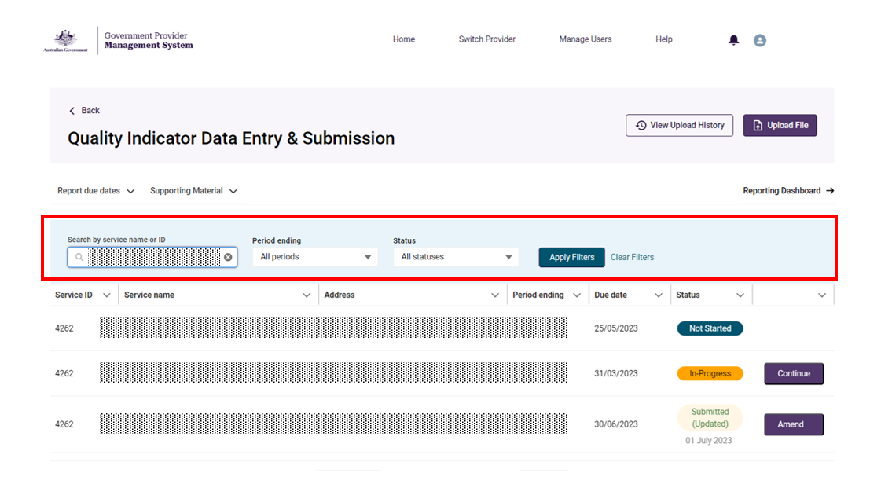

## Starting a quality indicator data submission

From theQuality Indicator Data Entry & Submission page a quality indicator data submission can be started or updated using the:

* Manual data entry function (see Manual data entry submission page) by selecting:
  + **Start** to start a new submission,
  + **Continue** to continue a submission in progress,
  + **Amend** to make changes to a previous submission, or
  + **View** to see a read only version of a previous submission.
* File upload function (see File upload/bulk data entry submission page) by selecting the **Upload File** button.

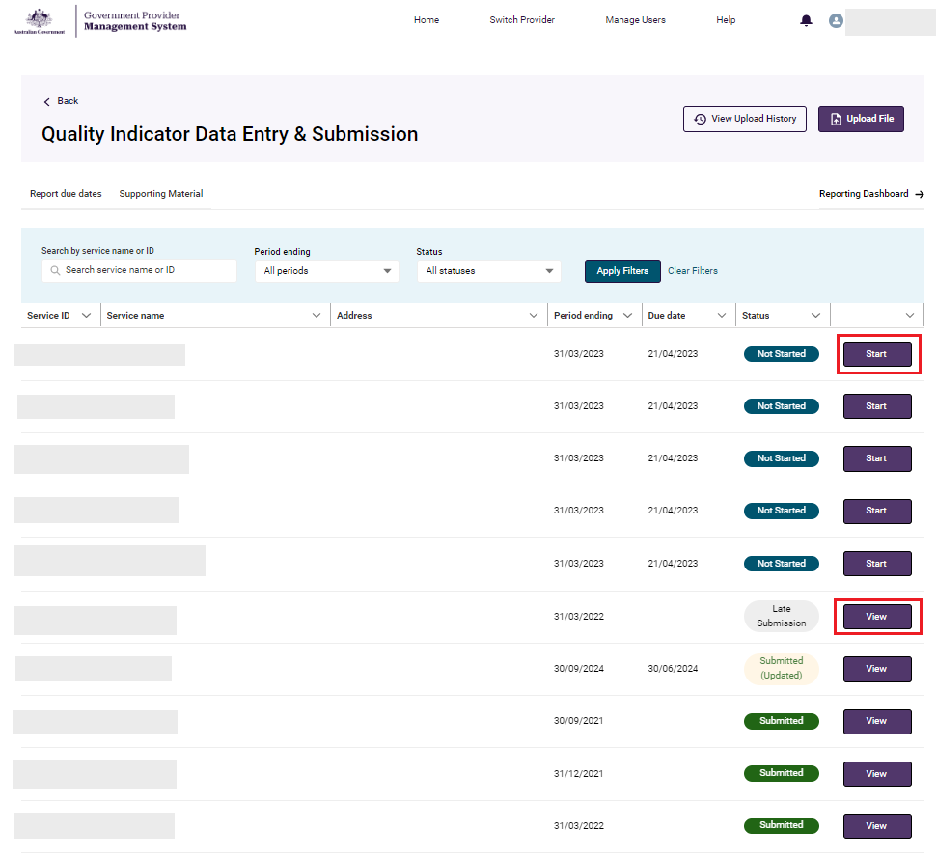

**Please note:**

‘Start’ and ‘Continue’ will only be available prior to the submission due date for the quarter.

‘Amend’ and ‘View’ will only be available after the submission due date for the quarter.

## Submission status

The Quality Indicator Data Entry & Submission page provides information on the status of your quality indicator submissions.



Submission statuses are explained in the table below.

|  |  |
| --- | --- |
| **Status** | Definition |
| Not started | No quality indicator data has been entered or saved for the quarter. |
| In-Progress | Quality indicator data has been entered and has **not** been submitted for the quarter. |
| Submitted | Quality indicator data has been submitted for the quarter. |
| Submitted (Updated) | Quality indicator data has been submitted on time and updates have made after the submission due date for the quarter. |
| Not submitted | Quality indicator data has **not** been submitted, and the quarterly due date has passed. |
| Late submission | Quality indicator data was submitted after the quarterly due date.  Note: Amendments to a late submission will remain as a late submission following the update. |
| Offline | Service has been offline for the whole quarter and is not required to submit quality indicator data as they are not providing care. |

You can **start** or **continue** quality indicator data submissions for the current quarter, as detailed in the screenshot below.

The data for the previous quarter can be amended.

**View** only access is available for quality indicator data recorded in earlier quarters.

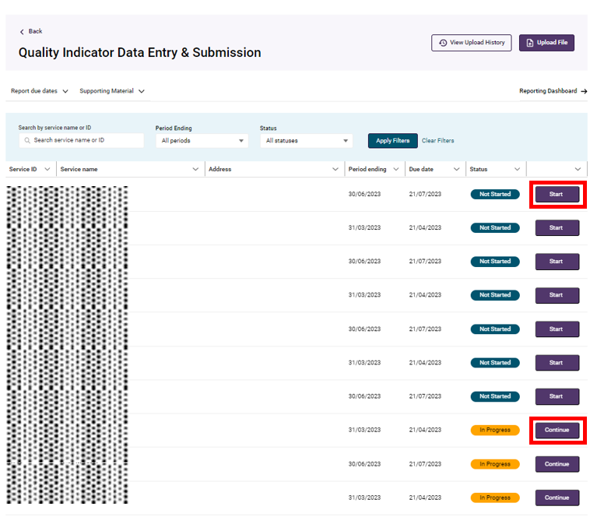

**Please note:**

The data for the enrolled nursing, lifestyle officer and allied health care minutes data points will be pulled from Quarterly Financial Report (QFR) and does not need to be submitted through the QI Program application.

As QFR reporting due dates are a few weeks after QI Program due dates, you will not see your enrolled nursing, lifestyle officer and allied health care minutes data until you have submitted your QFR.

# Manual data entry submission page

This section in the user guide provides introductory information on manually entering quality indicator data in GPMS.

Quality indicator data should be collected and reported consistently using the methods prescribed in the [[QI Program Manual 4.0 – Part A](https://www.health.gov.au/resources/publications/national-aged-care-mandatory-quality-indicator-program-manual-30-part-a?language=en).](https://www.health.gov.au/resources/publications/national-aged-care-mandatory-quality-indicator-program-manual-30-part-a?language=en)

The below screenshot shows an example of the manual data entry submission page.

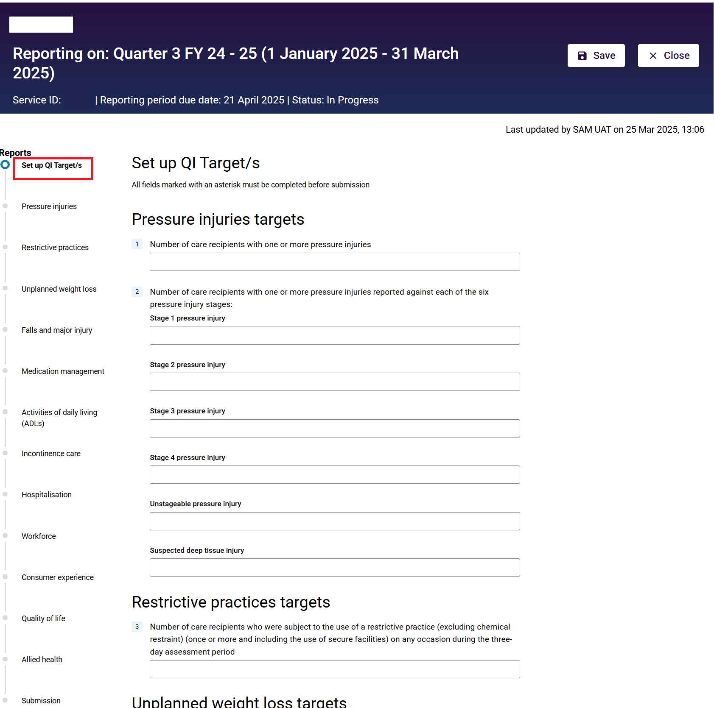

Additional resources to support data collection and reporting can be found in the **Supporting material** tab on the Quality Indicator Data Entry & Submissionhome page.

If you need to access the **Supporting material** while completing the forms, be sure to first save your data (accessing the **Supporting material** will take you outside the data entry form).

## Banner

This banner appears at the top of every page on each data entry form.

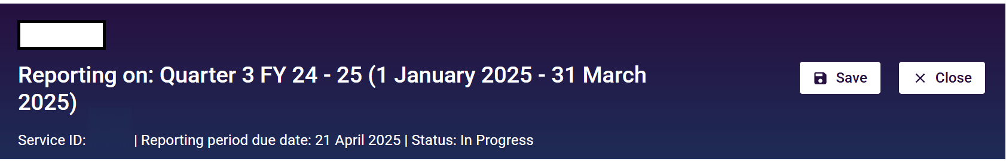

It indicates the name of the aged care provider (top left), service ID, reporting period due date and the Status of the form (such as In Progress).

At the top right of the banner you can save your data entry by selecting the **Save** button.

## Data entry stepper

On the left-hand side of Data Entry Submission page, is a stepper for the data entry form for each quality indicator, including:

* Set up QI Target/s
* Pressure injuries
* Restrictive practices
* Unplanned weight loss
* Falls and major injury
* Medication management
* Activities of daily living (ADLs)
* Incontinence care
* Hospitalisation
* Workforce
* Consumer experience
* Quality of life
* Allied Health
* Submission

The data entry stepper is a useful navigation tool and will highlight whether the data entry forms have been completed correctly for each quality indicator.

The screenshot of the data entry stepper is shown on the following page:

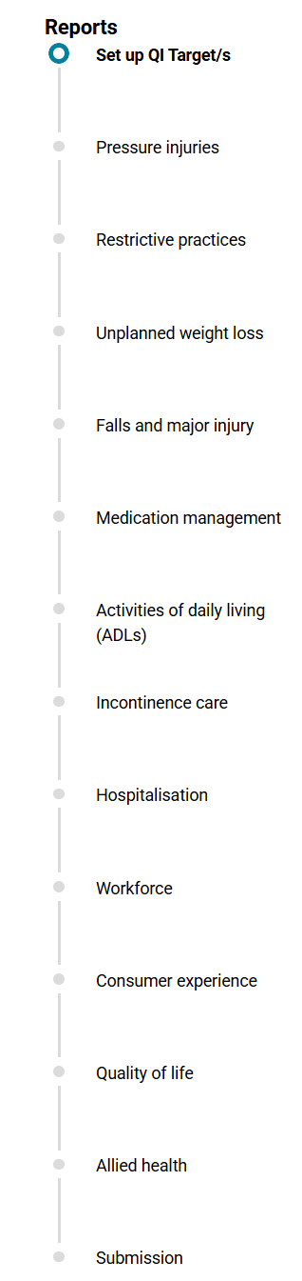

You can move between sections in the stepper in any order, but you will not be able to navigate to the **Submission** section until data for all quality indicators is entered.

Within the data entry stepper, there are a number of icons, as explained below:

| **Icon** | Name and Meaning |
| --- | --- |
| Icon of a Blue circle with a white tick inside | Blue circle with white tick confirms the section is complete. |
| current section icon. | Blue circle with white centre shows that you are currently in this section. |
| not yet started icon. | Grey circle shows the section has not yet been started. |
| section incomplete icon. | Red circle warns the section is incomplete and contains quality indicator data errors (this means data submission cannot proceed). |
| data may contain errors icon. | Yellow warning symbol shows quality indicator data may contain errors and review is suggested (however, data submission can still proceed). |
| submit button. | If any of the Sections are not completed the **Submit** buttonwill be greyed out. |

Once all required data forms are complete the **Submission** icon will unlock allowing the user to proceed to the Submission page.

## Back button

The **Back** button will take you to the previous quality indicator data entry form as noted in the data entry stepper.

The quality indicator data entered in the data entry form will be saved when clicking the **Back** button.

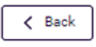

## Check Complete Data button

The **Check Complete Data** button applies the validations built into each data entry form against your quality indicator data.

This will notify you of any quality indicator data that may have been entered incorrectly within each form (see Manual entry of quality indicator data and Error messages whilst entering quality indicator data).

Screenshot of the check complete data button

## Next button

The **Next** button will take you to the quality indicator data entry form as noted in the data entry stepper.

The quality indicator data entered in the data entry form will be saved when clicking the **Next** button.

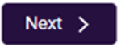Setting quality indicator targets

After Selecting the **Start** button in the Data Entry & Submission home page, the Set up QI Target/s page will appear, where you can enter aspirational targets for a service.

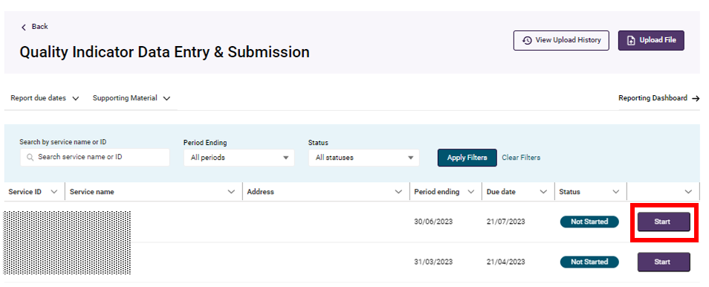

Set up targets by entering data against each quality indicator in the form and selecting **Save**. Setting targets is optional.

If you previously entered quality indicator targets these will be displayed.

Select **Next** to go to the first quality indicator data recording form. Alternatively, navigate to the relevant data form by selecting the quality indicator from the data entry stepper on the left-hand side.

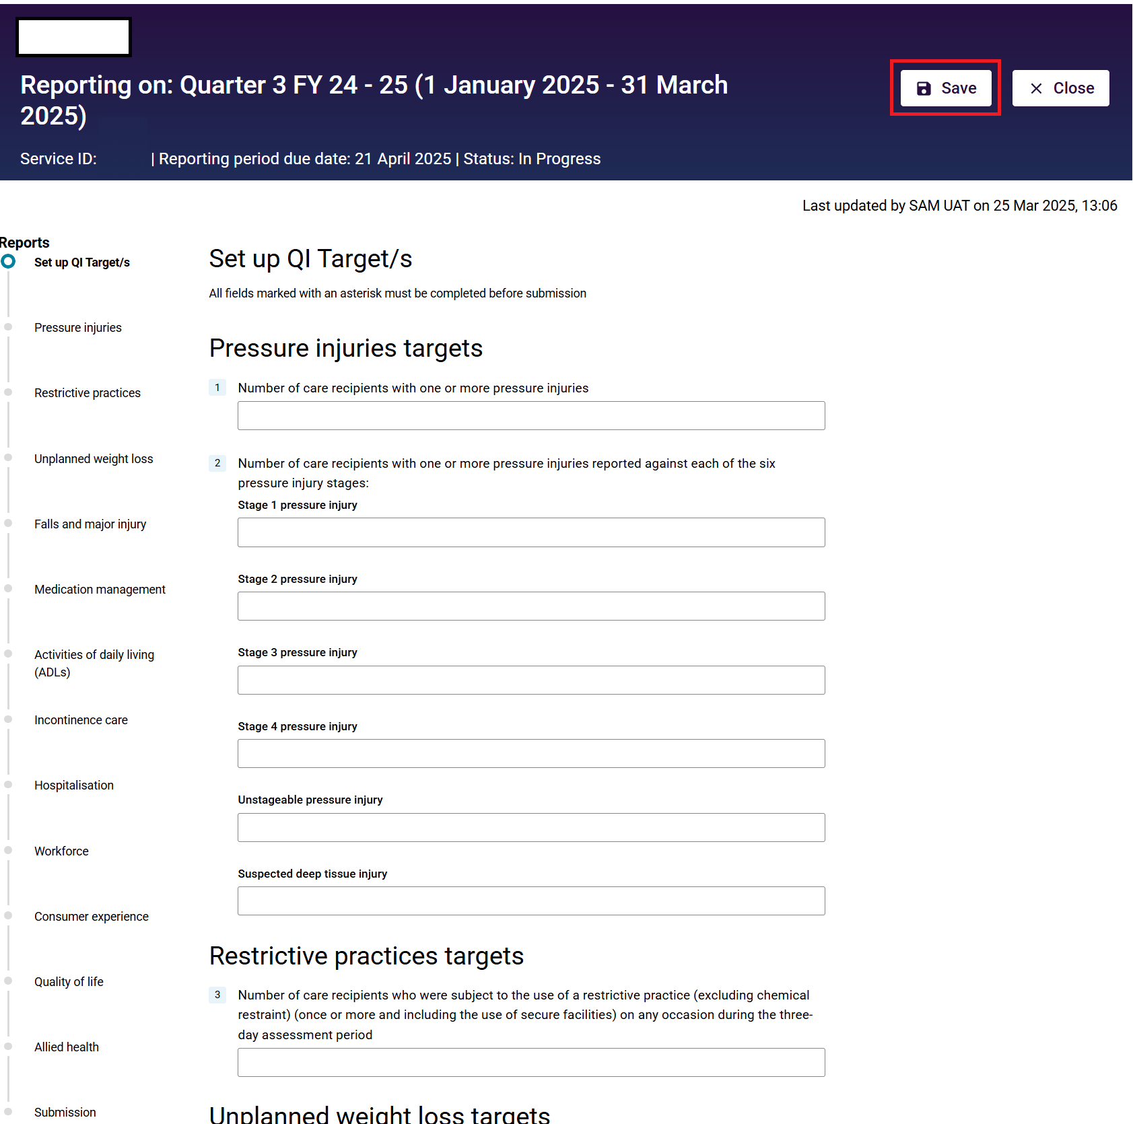

## Manual entry of quality indicator data

An example screenshot of entering quality indicator data is after these instructions:

1. Select the quality indicator you wish to enter data for in the data entry stepper.

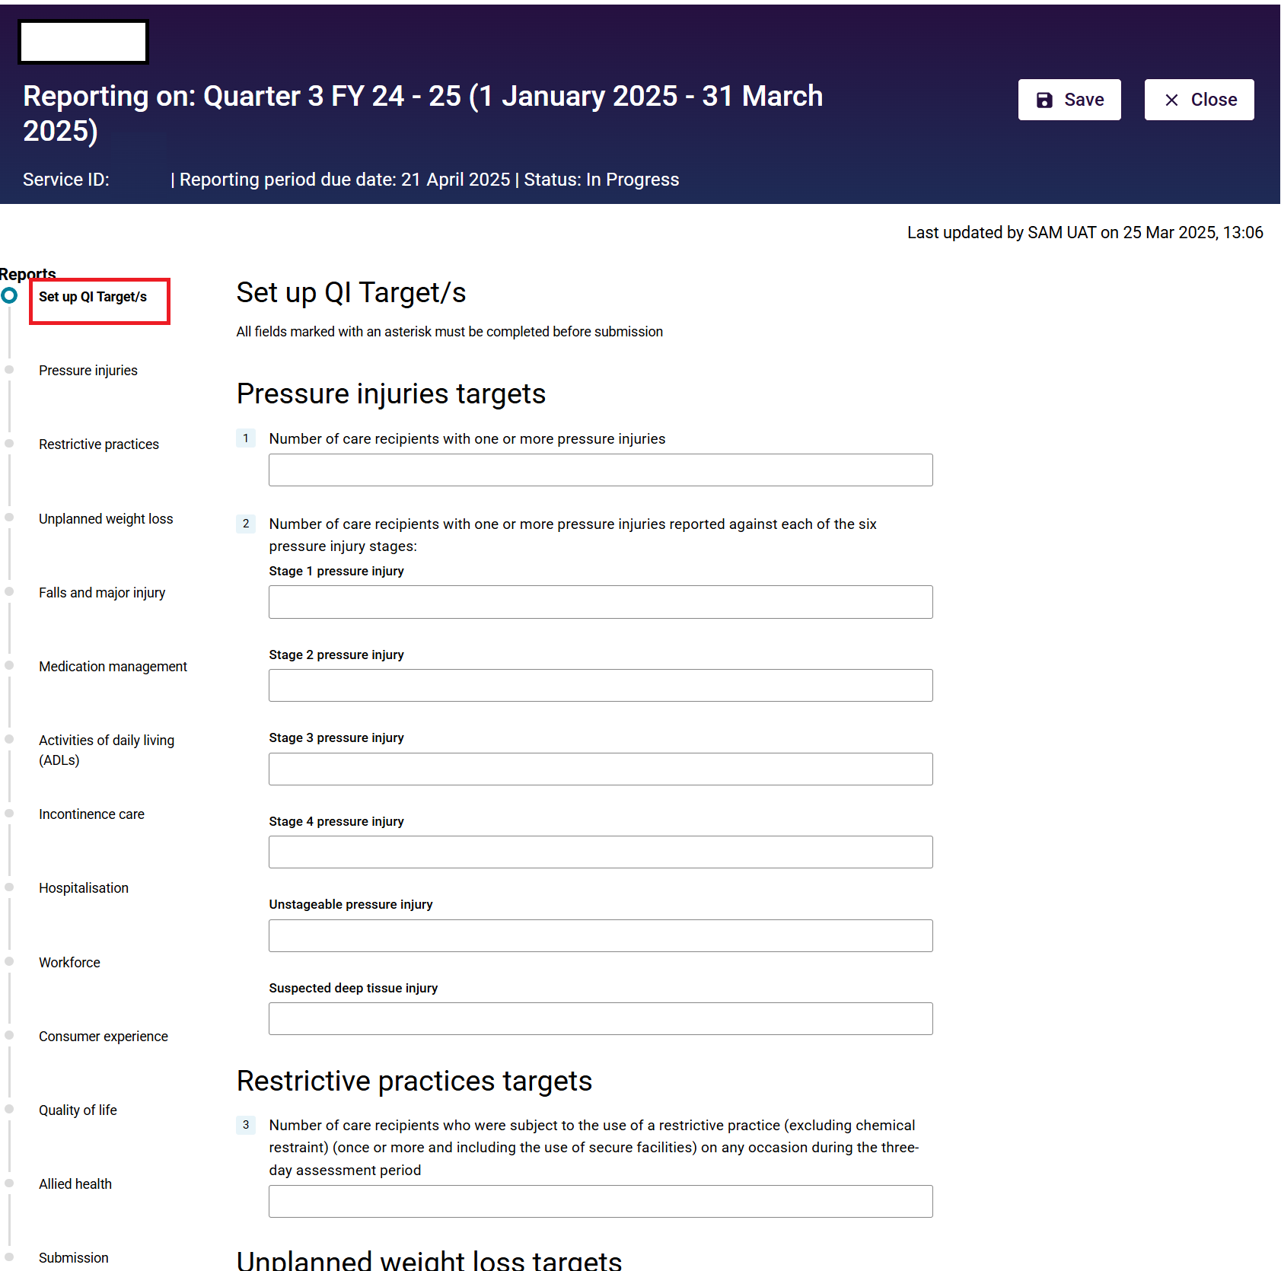

1. Enter the relevant quality indicator data into the fields within the form.

All fields marked with an asterix must be completed.

1. Once data is entered for the given quality indicator, you can select **Next** to move onto the subsequent quality indicator form to continue entering data for your submission.

The data entry stepper will show your location and progress within the submission with bold text and colour coded notifications (see the Data entry stepper section).

1. Select **Save** to save your data after entering data in each page.

**Please note:**

If you need to exit the data forms or access the supporting material at any stage, be sure to first save your data by selecting the Save button, as these resources will take you outside of the data entry form.

## Error messages whilst entering quality indicator data

When entering quality indicator data, if required fields are not completed, error messages will appear.

You may not be able to submit the data without resolving these error messages.

Errors will also be highlighted in the Data entry stepper.

|  |  |  |
| --- | --- | --- |
| **Error** | Correction | Example |
| *This is required* | This is mandatory, please provide an entry.  If the response is zero, please ensure you enter 0. | Screenshot of an example of a "this is required" error |
| *Number cannot be higher than your total number of care recipients assessed.* | Please ensure the number you have entered is correct.  Data entered for quality indicator reporting must be less than or equal to the number of care recipients assessed. | Screenshot displaying an example of the  Number cannot be higher than your total number of care recipients assessed error. |
| *Number of {quality indicator question A} cannot exceed {quality indicator question B}.* | Please ensure the number you have entered is correct.  Some questions ask for a subset of data from earlier questions. | Screenshot displaying an example of the  number of quality indicator question A cannot exceed quality indicator question B error. |
| *Must be an Integer between 0 – 999 (both inclusive)* | Please ensure the number you have entered is correct.  The number must be a whole number (integer) between 0 and 999. | Screenshot displaying an example of the Must be an Integer between 0 – 999 both inclusive error. |
| *Date falls outside of reporting period.* | Please ensure the date you have entered is correct.  The collection date must fall inside of the quarter being reported on. | Screenshot displaying an example of the  Date falls outside of reporting period error. |
| *Text value cannot exceed 1000 characters* | Please ensure the comments made are fewer than 1000 characters and do not contain personal information about any of the care recipients, as defined by the *Privacy Act 1988.* | Screenshot displaying an example of the  Text value cannot exceed 1000 characters error. |

## Data entry ready for submission

By selecting **Check Complete Data,** the entered data will be checked against the in-built validations in each quality indicator data entry form.

(See image in Post Submission).

The screen below shows data for all quality indicators is entered correctly and ready for submission.

In the left-hand data entry stepper, this is represented by blue circle icons next to each quality indicator and an unlocked icon next to Submission.

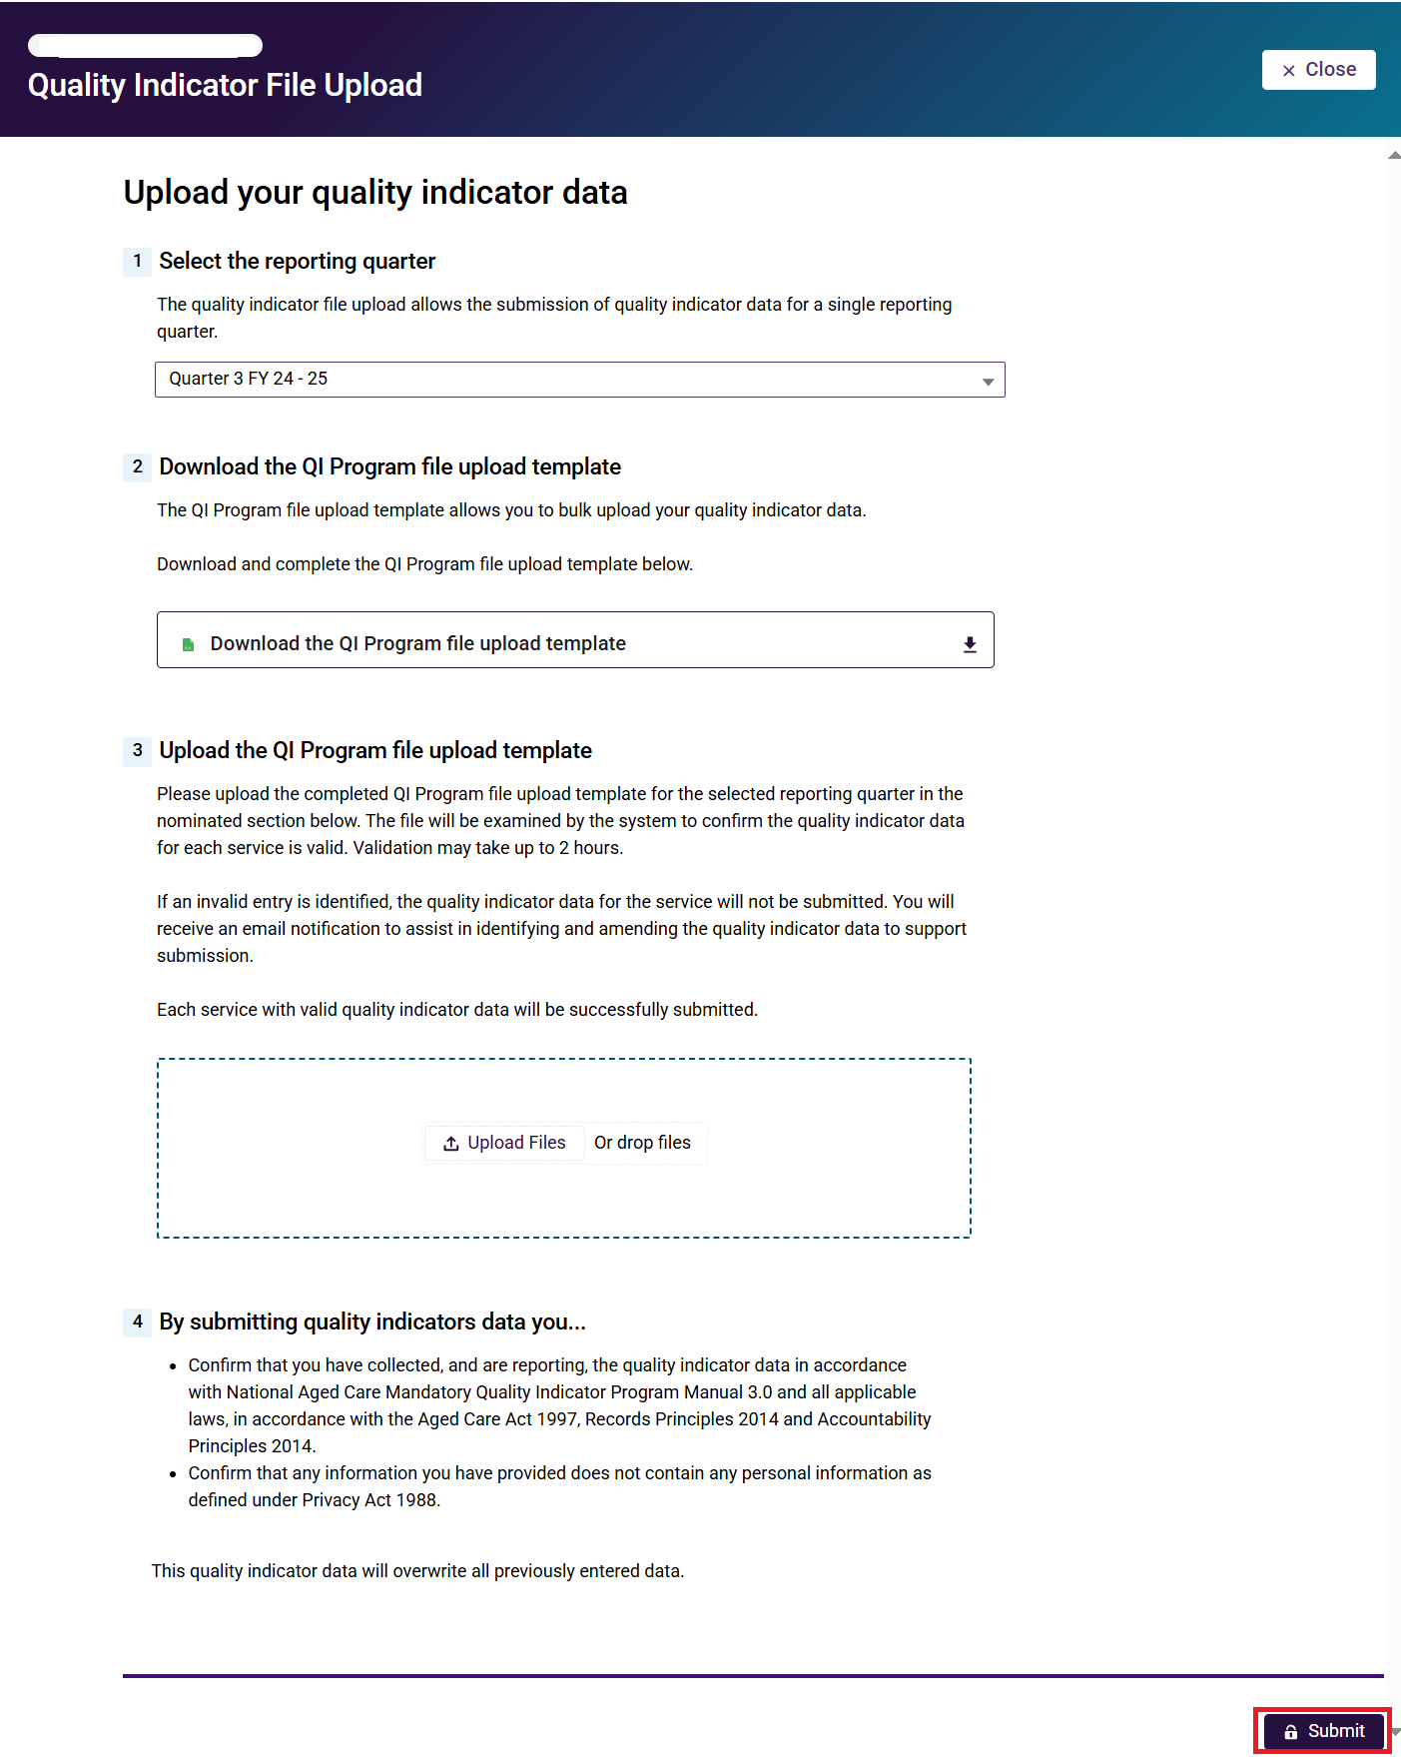

You can continue to the Submission page by selecting the relevant button in the data entry stepper or by clicking the **Next** button at the bottom of the quality indicator data entry form.

**Please note:**

Red circles in the stepper will prevent you from submitting the quality indicator data. Review and update the relevant data before continuing to submission.

## Submission

This page is where you submit the quality indicator data.

1. Read the Submission Declaration Statement.
2. Select **Submit** to formally submit your quality indicator data.

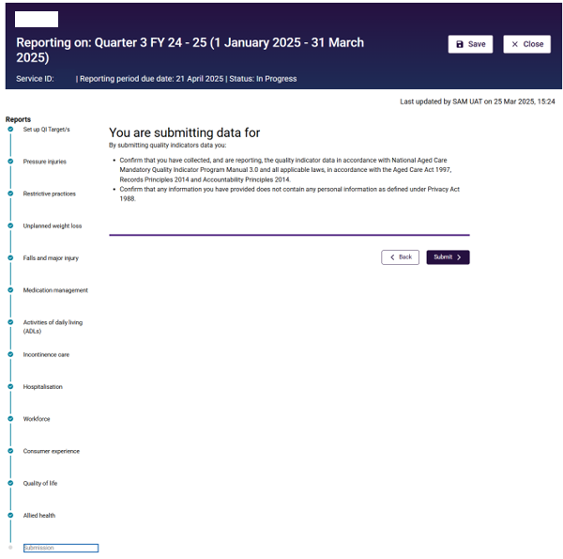

## Post submission

You will be redirected to your Quality Indicator Data Entry & Submission page with a message displayed on your screen to let you know that your quality indicator data entry has been successfully submitted.

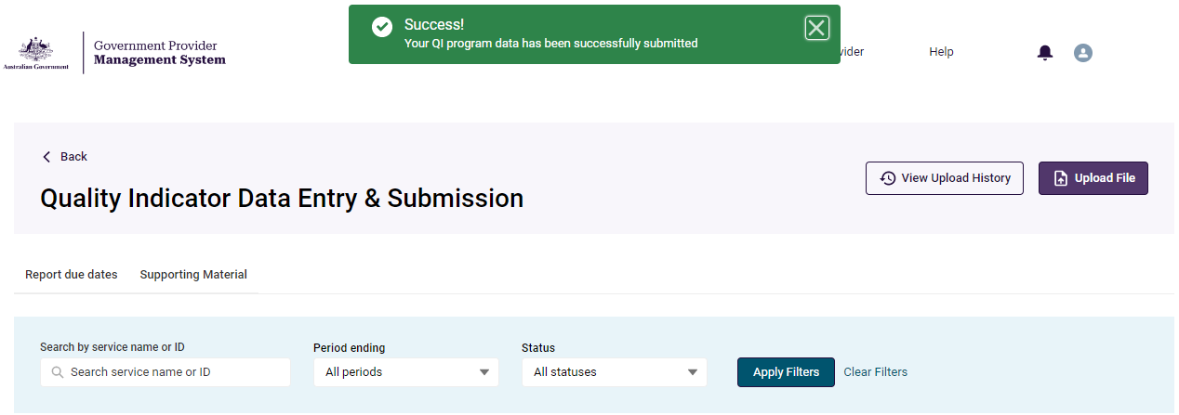

# File upload/bulk data entry submission page

This section in the user guide provides introductory information on entering quality indicator data for multiple services using the file upload function in GPMS.

Quality indicator data should be collected and reported consistently using the methods prescribed in the [QI Program Manual 4.0 – Part A](https://www.health.gov.au/resources/publications/national-aged-care-mandatory-quality-indicator-program-manual-30-part-a?language=en).

Additional resources to support data collection and reporting can be found in the **Supporting material** tab on the Quality Indicator Data Entry & Submissionhome page.

## QI Program file upload template page

1. Return to the Quality Indicator Data Entry & Submission home page. Then select **Upload File** in the top right-hand corner.
2. A new page will open QI Program file upload template.

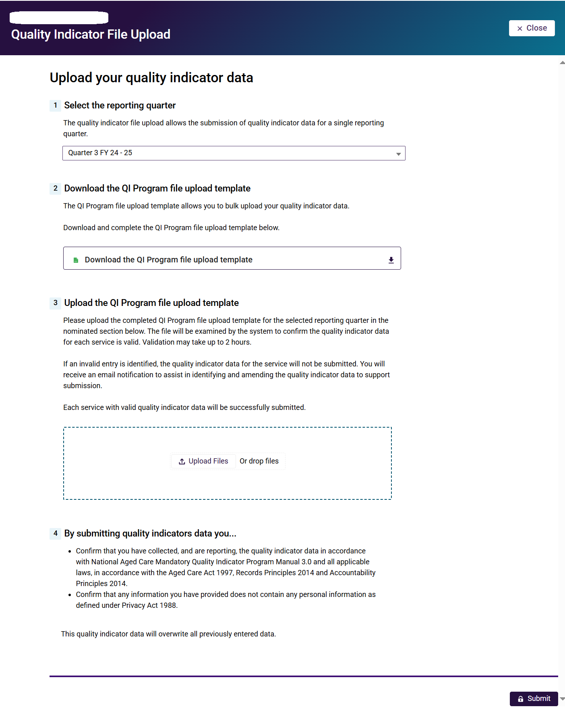

## Downloading and completing the file upload template

1. To begin, go to the QI Program file upload template page.
2. Select the quarter being reported against
3. Select Download the QI Program file upload template.

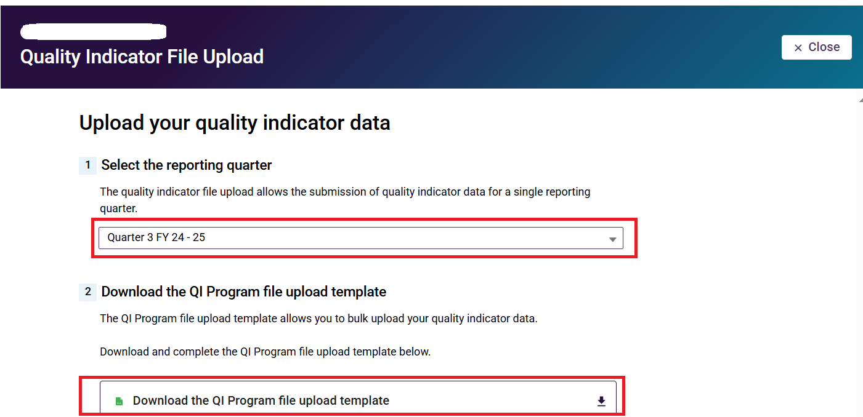

1. Fill out the QI Program file upload template with quality indicator data for the relevant services for the given quarter.

To ensure successful submission of your quality indicator data please ensure:

* you are using the most up to date file upload template
* the template is saved as a Microsoft Excel file (xlsx)
* all required data fields are completed.

The formula for dates does not allow leading zeros for the day of the month. For example, for 1January 2023, you must reflect the date as 1/01/2023 and not 01/01/2023.

## Submitting the file upload template

Progress through the fields on the page by following these steps:

1. Select the reporting quarter by pressing Choose reporting quarter - only current and previous are available.
2. Upload the file by pressing **Upload File** and selecting the relevant file, or by dragging and dropping the file into the box (example pictured below).

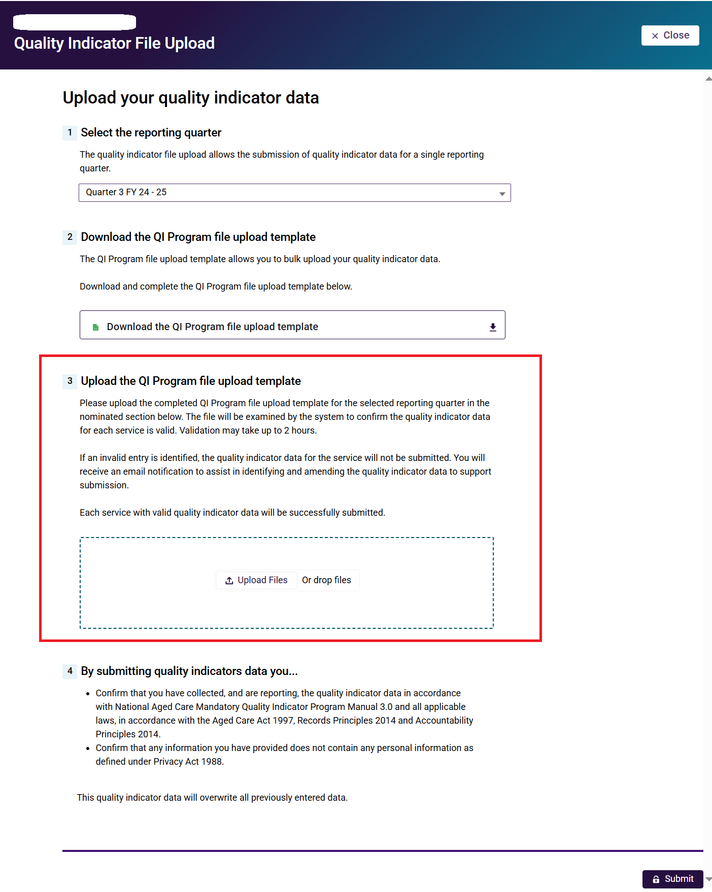

1. Read the Submission Declaration Statement.
2. Submit the file by selecting the **Submit** button.

**Please note:**

The Submit button at the bottom of the page will be locked until the file is uploaded.

## File upload post-submission page

After selecting submit, the post submission page will appear, showing the status of the upload. File upload statuses are displayed below and defined accordingly:

* **Submitted** (‘Submitted’ in green text) = Successful (no error file)
* **Pending** (‘Pending’ in yellow text) = Waiting for processing (no error file)
* **Failed** (‘Failed’ in red text) = Not Uploaded (no error file), OR all rows have errors (error file)
* **Partial** (‘Partial’ in black text) = Some successful and some failed (error file)

## File upload success message

When the file upload status is **Submitted**, the **Success** banner will appear.

This signals that the uploaded file was successfully submitted, and no further action is needed.

You can return to the home page via the **Back to main page** button in the bottom right.

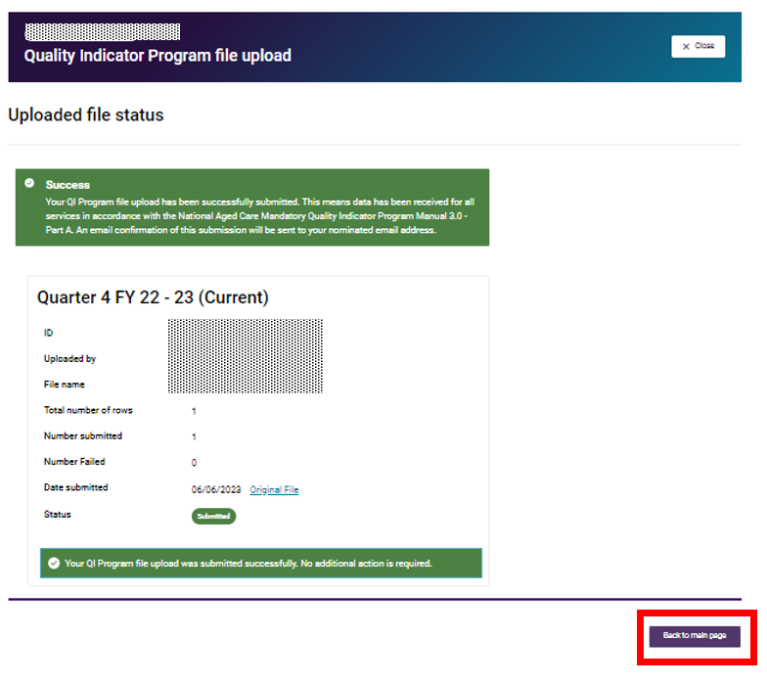

## File upload pending message

When the file upload status is **Pending**, the banner will be titled **Pending**, meaning that the file is still undergoing validation.

Pending files can take up to two hours to be validated.

Whilst this is occurring, the **Re-upload** button in the bottom right is locked until the file validation is complete.

Once the file validation is complete, the pending status will update to Submitted, Failed or Partial.

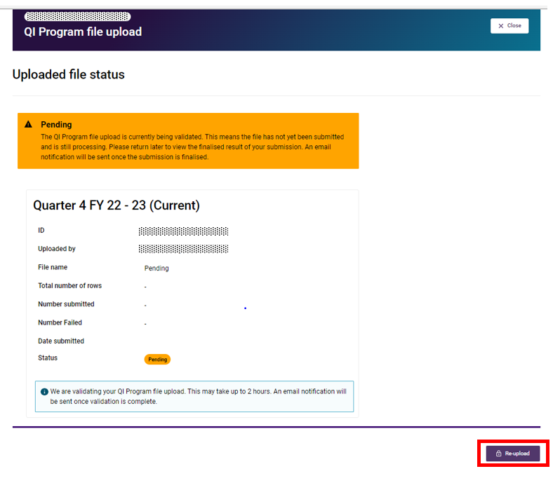

## Failed upload error message

When the file upload status is **Failed**, the banner will be titled **Error**, meaning there was an error whilst processing the file and the submission is unsuccessful.

There are two scenarios where this is possible:

### Scenario 1 - No error file produced

This could be because of a processing fail, system outage, file corruption or having a pending status greater than 24 hours.

No error file is produced, but the **Re-upload** button unlocks and is activated.

Go to the re-uploading file template section for detailed instructions on re-uploading your file.

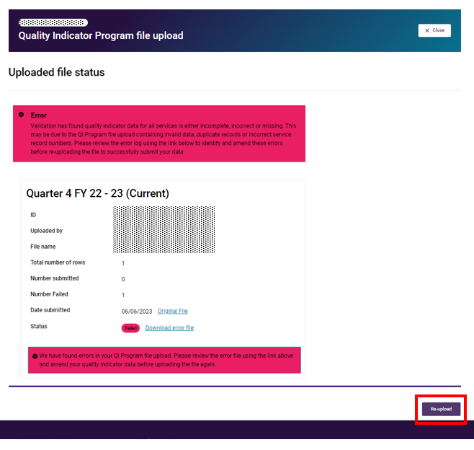

### Scenario 2 - Error file produced

This will be because all the service lines within the file have errors.

This will produce an **error file**, which is found next to the **Failed** status.

The **Re-upload** button unlocks and is activated.

For further instructions, refer to the links for Error files and Re-uploading file template.

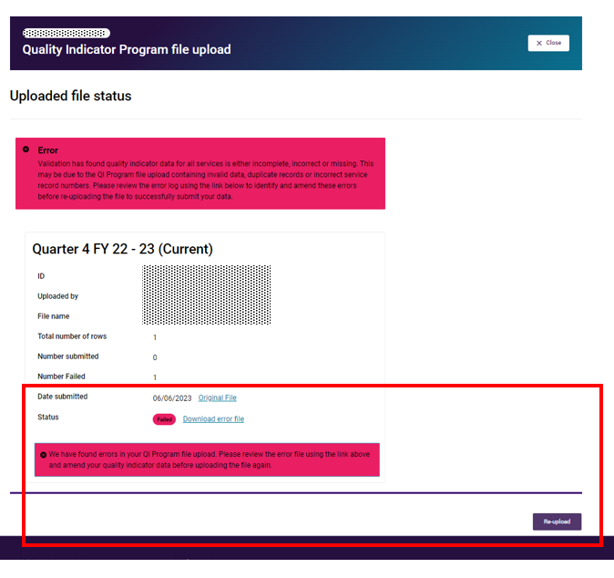

## File upload partial success message

When the file upload status is Partial, the banner will be titled Partial Success, meaning there were some errors found within the file upload.

This will produce an **error file**, which is found next to the **Partial** status.

The **Re-upload** button unlocks and becomes selectable.

For further instructions, refer to the links for Error files and Re-uploading file template.

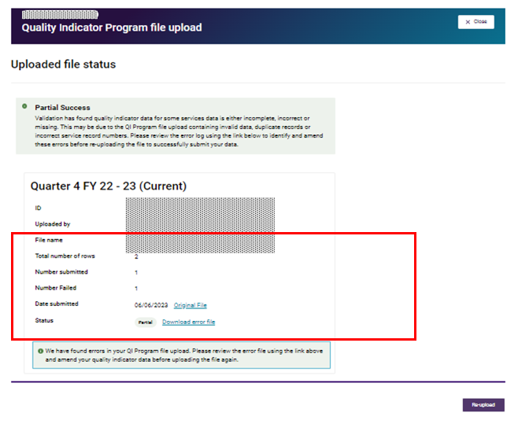

## Error files

1. After selecting the error file for a Failed (Error file produced) or Partial submission,  
   click **Download error file**.

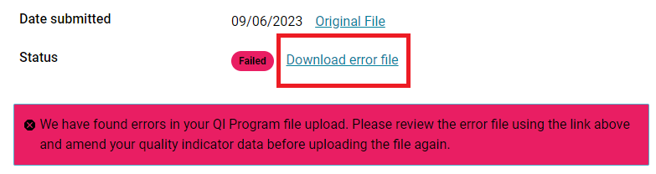

1. This will open another tab, with the header allowing you to **Download**.

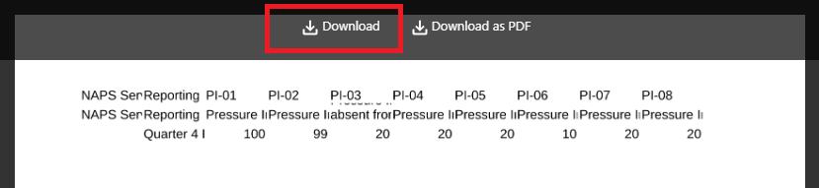

**Please note:**

Select Download to access an easy to review Microsoft Excel spreadsheet.

1. The error column will display all the errors and their specific location in the last/far right column of the Microsoft Excel spreadsheet.

The errors could include:

* invalid data,
* service not found
* record duplication (partially)
* ‘user not authorized’ to submit data for this service.

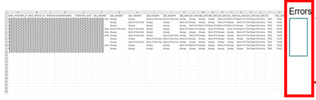

**4.** Correct the errors. Once completed, save the file locally and re-upload.

## Re-uploading file template

After amending the quality indicator data errors found in the file upload, select the **Re-upload** button on the relevant status screen. Progress through the Submission page by following these steps:

1. Select the reporting quarter by pressing **Choose reporting quarter,** this should be preselected.
2. Upload the updated file by pressing **Upload File** and select the relevant file, or by dragging and dropping the file into the box, as pictured below.
3. Read the **Submission Declaration Statement.**
4. Submit the file by pressing the **Submit** button.

**Please note:**

The Submit button at the bottom of the screen will be locked until the file is uploaded successfully.



For more information for the messages following the re-upload, please see   
File upload post-submission page and following sections.

## Viewing upload history

On the Quality Indicator Data Entry & Submission page select the **View Upload History** button to see all the earlier files uploaded.

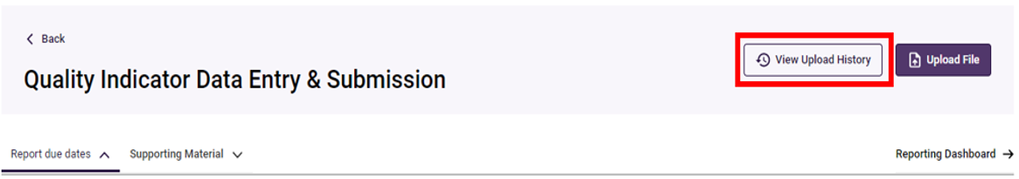

## File upload history page

All files uploaded will be displayed on this page. Within this page, you can find a specific upload searching by **service name** or **ID**, reporting quarter **(period ending)** or **Status** by selecting the fields and clicking **Apply Filters**.

The various statuses of file uploads below include:

* **Submitted** (‘Submitted’ in green text) = The file upload was successfully submitted
* **Failed** (‘Failed’ in red text) = The file upload was not uploaded correctly or has errors in every row
* **Pending** (‘Pending’ in yellow text) = The file upload is being processed
* **Partial** (‘Partial’ in black text) = The file upload had some successful and some failed rows

For further information, refer to Error files.

Information on the status of the file upload is shown in the **Total**, **Submitted** and **Failed** fields in the screenshot below.

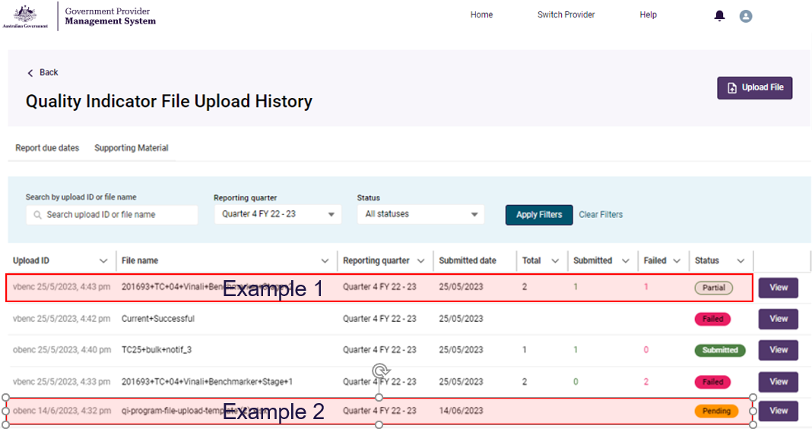

**Example 1:** User submitted a file upload containing 2 records on 25/05/23. There are 2 files in the Total column, 1 in the Submitted column and 1 in the Failed column, with the submission status being Partial.

**Example 2:** User submitted a file upload file on 14/06/23. The submission is still processing so the status is Pending. This will update automatically once processing is completed.

# Reporting Dashboard

This section provides information on the Quality Indicator Reporting Dashboard and associated reporting capabilities.

These functions are available to residential aged care providers with access to the Quality Indicators application. These functions are not available for organisations submitting quality indicator reporting on behalf of providers.

## Accessing the Quality Indicator Reporting Dashboard

1. On the Quality Indicator Data Entry & Submission page, select the **Reporting Dashboard** button in the top-right hand section.

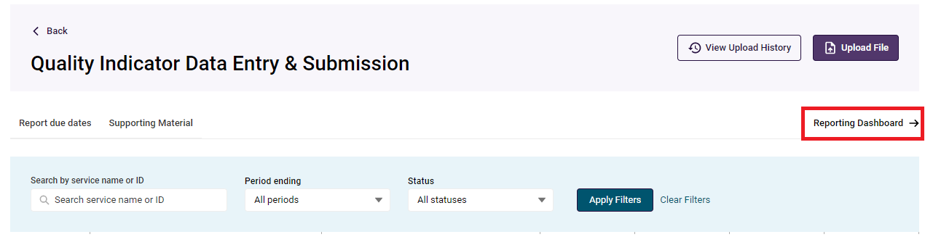

1. A new tab will open in Analytics Studio with the Quality Indicator Reporting Dashboard page.

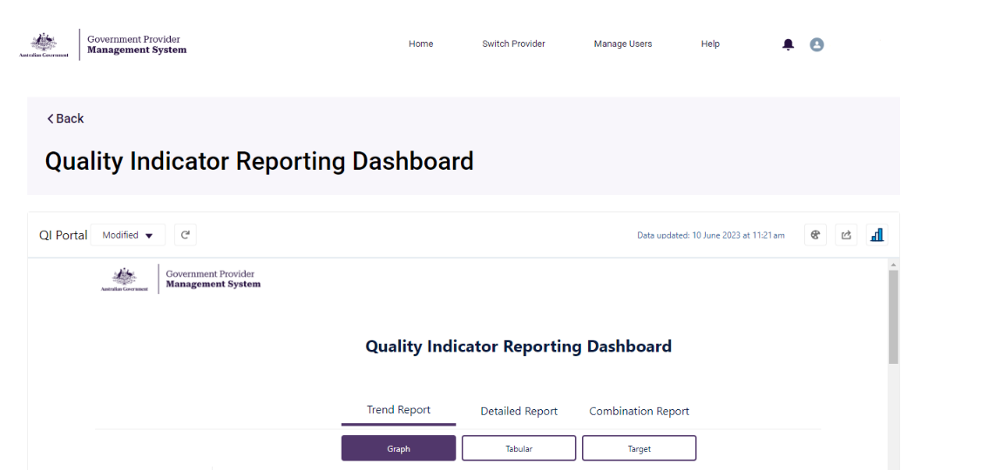

## Overview of report types and display formats

The Quality Indicator Reporting Dashboard allows you to create three key reports (trend, detailed and combination) with three key report displays (graph, tabular and target).

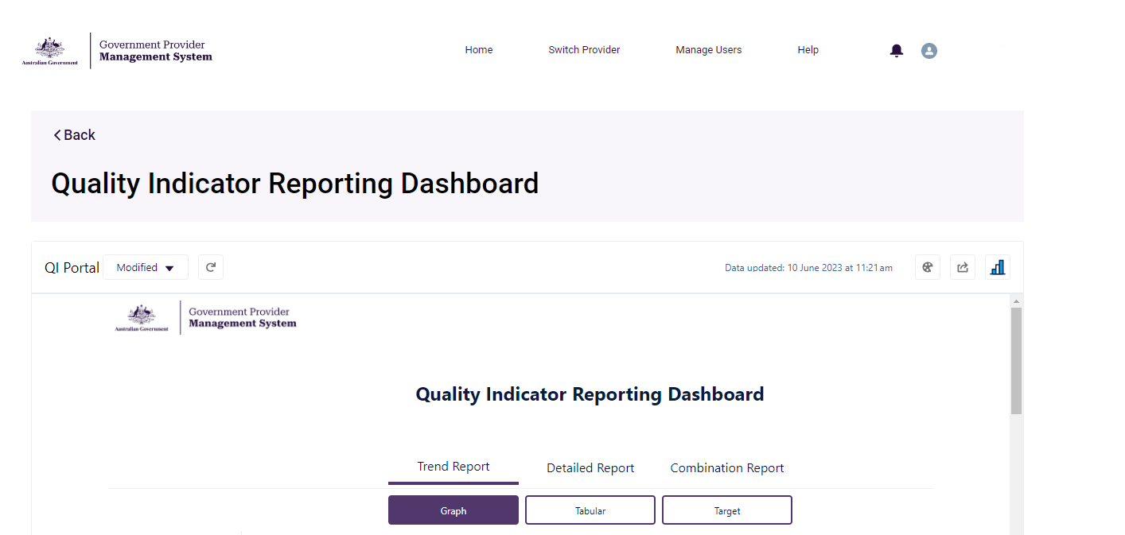

### Key reports

1. **Trend Report:** Displays data trends and patterns over time to provide high level insights into quality indicator data.

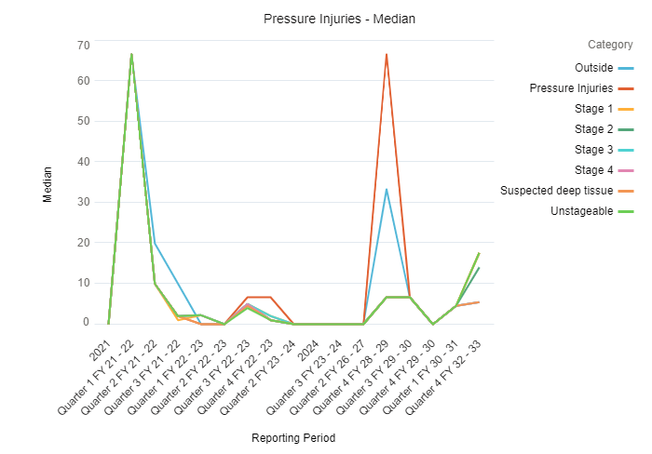

1. **Detailed Report:** Displays an in-depth view of quality indicator data from a service, focusing on indivdual outcomes rather than progress over time.

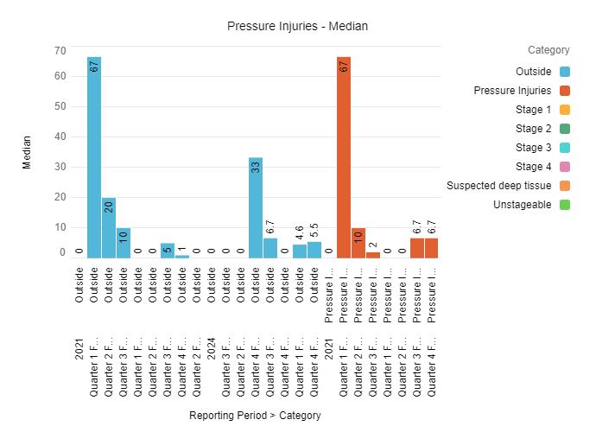

1. **Combination Report:** Displays trends and an in-depth view of quality indicator data, merging the two previous report formats to provide a comprehensive view of different data in a unified format.

This report will not have benchmark options.

### Key displays

1. **Graph:** Displays quality indicator data for a service in a line (displayed below) and bar chart format. The Graph View provides visual representation of your data to support easier analysis and interpretation, enables you to identify patterns, spot anomalies, and understand the overall trajectory of data.



1. **Tabular:** Displays quality indicator data for a service in a table.

The Tabular View provides a comprehensive and structured representation of data, organised tabular format, making it easier for you to export your data.

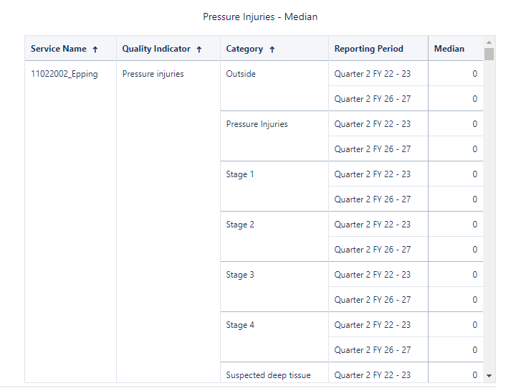

1. **Target:** Displays quality indicator data against the targets set by the service in a graphical format.

The Target View is designed to help you understand and evaluate your quality indicator data against your service targets (see Setting quality indicator targets).

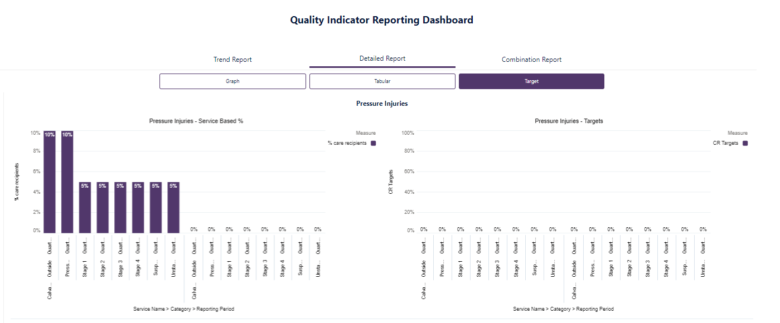

**Please note:**

In the Reporting Dashboard, scroll down to view data for all quality indicators in your selected format and display.

## Functionality of the Quality Indicator Reporting Dashboard

You can download, share reports and access the Analytics Studio from the Quality Indicator Reporting Dashboard.

An explanation of the icons available are below.

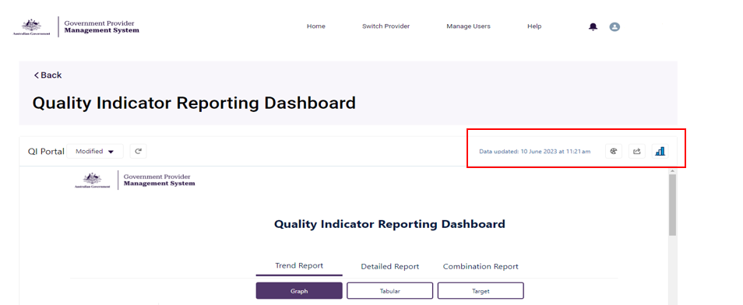

**High contrast icon - a black circle divided into 5 sections equally with the bottom right portion left outHigh Contrast**

The colour palette icon is the high contrast button which is an accessibility feature allowing users of all abilities to view the dashboard more effectively.

**Please note:**

To support accessibility, adjust the colour palate of your reports using the High Contrast icon.

**Share icon - looks like a black square with a arrow coming out of the top right corner.Share**

The share button allows you to download and share the reports you are viewing.

This can be used for the entire dashboard report or for singular reports.

Theentire dashboard report can be downloaded to view and share as an image. This image reflects the dashboard wide view found on the home screen of the Quality Indicators Reporting Dashboard.

### Sharing the entire dashboard report

1. Select the **Share** button in the top right hand corner (shown above).
2. A pop-up will apprear displaying an image preview of the report.
3. Select **download** button in the top right hand corner.
4. Select **download as image** to view the .PNG file to save locally.

### Sharing a singular report graph or table

1. Hover your mouse over the graph you want to expert.
2. Click on the small arrow that apprears on the right-hand side of the graph.
3. Select the **Share** button.

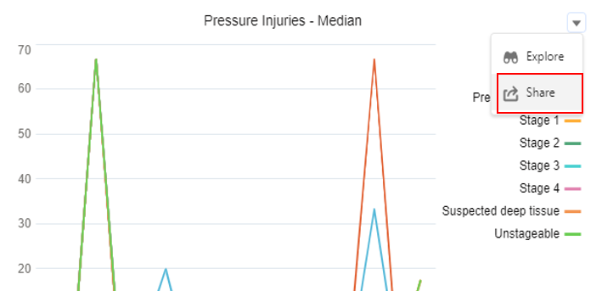

1. Select your preferred file type. A preview of the file will appear and will be automatically downloaded on your local device.

The available file types are:

* .PNG - Image file
* .XML - Excel format
* .CSV - Text-file structured data format.

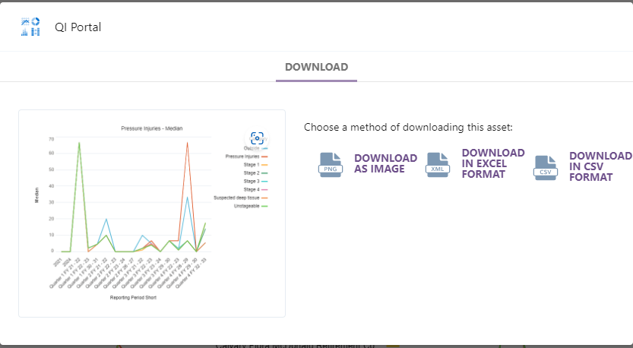

**Analytics Studio**

The **Analytics Studio button** in the top right hand corner allows you to display data and navigate reports using the analytics studio function.

It has the same functionality as the Quality Indicator Reporting Dashboard but it opens a new page to better display the data providing a user friendly layout.

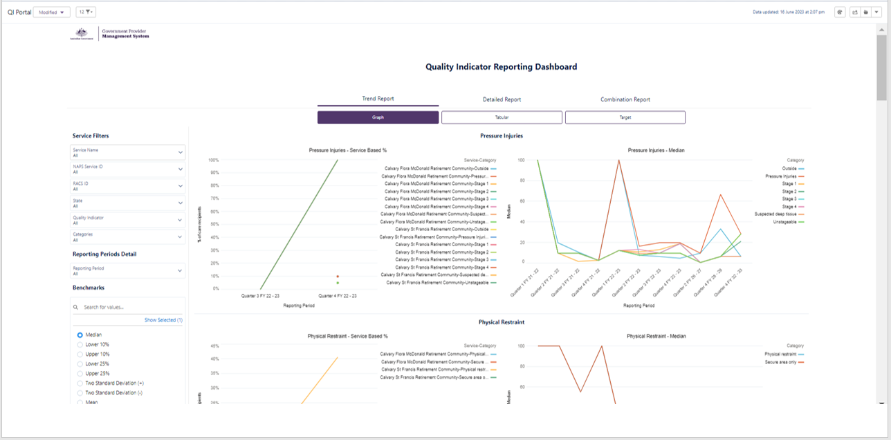

## Navigating the Quality Indicator Reporting Dashboard

From the Quality Indicators Reporting Dashboard, select your preferred reporting type and display.



This should automatically generate a report in your selected format and display.

### 7.4.1 Using Filters

Filters are found on the left-hand side of the Quality Indicator Reporting Dashboard. These will allow you to refine your reports to support further analysis of your quality indicator data.

The **Quality Indicator Reporting Dashboard** has four types of filters.

1. **Service Filters**: Allows you to filter your reports by **Service Name**, **NAPS Service ID**, **RACS ID**, **State**, **Quality Indicator** and **Categories** of the specific fields within the selected quality indicator.

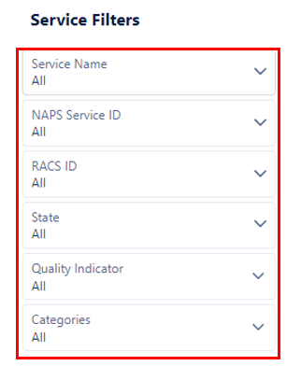

1. **Reporting Periods Detail:** Allows you to filter your reports by quarterly reporting periods.

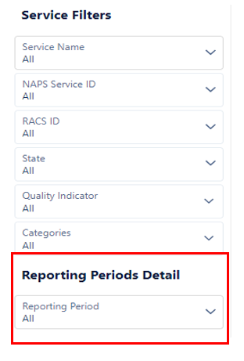

1. **Benchmarks:** Allows you to compare your quality indicator data against aggregated national results.

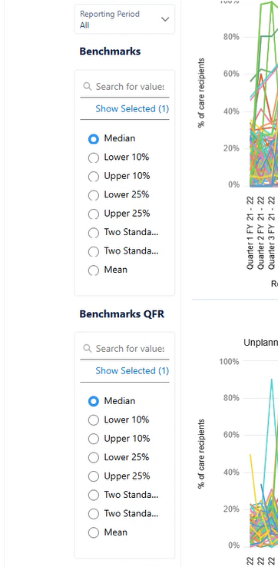

These filters have single and multiple section options.

**Single-select filters:** These filters allow you to select a specific value / item (for example, filtering by specific quality indicators) To use these filters:

1. Click on the relevant category you wish to filter by.

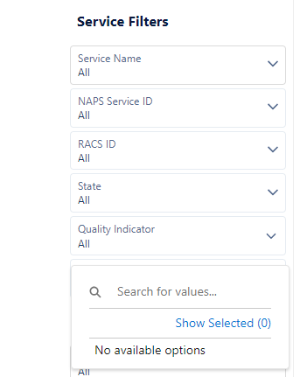

1. Select the preferred option in the drop down list.
2. Click **Apply** to update your report with the required filters applied.

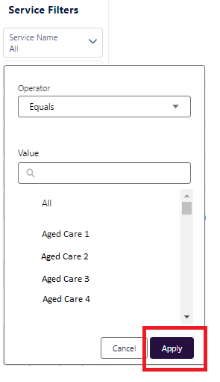

**Multi-select filters:** These filters allow you to select multiple values or items (for example, filtering by service sizes). To use this filter:

1. Select the relevant category you wish to filter by.
2. Select the **Operator** drop down menu.
3. Select whether the data you require needs to **Equal**, **Does Not Equal**, **Contains**, **Is Null**, **Is Not Null** the fields within the filter.

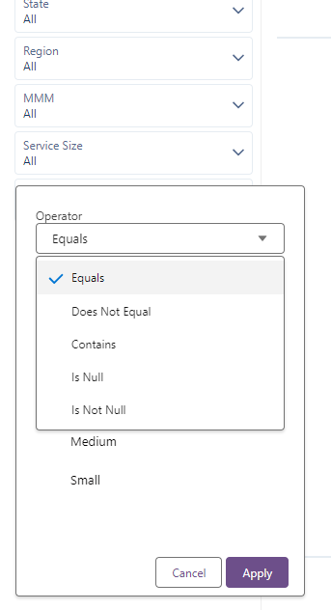

1. Select or search the value field.
2. Select the **Show Selected** blue text and to return, select **Show all**.
3. Select **Apply** to update your report with the required filters applied.

