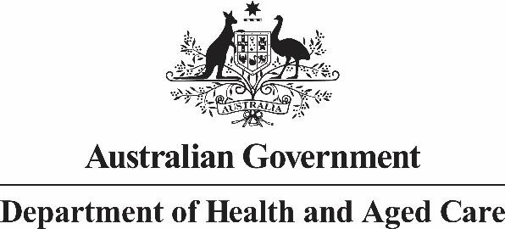

**sent via email**

Dear Stakeholder

As part of the 2025-26 Budget, the Australian Government has announced funding of

$30.1 million to support award wage increases for aged care workers to Commonwealth

Home Support Programme (CHSP) providers. This relates to the Fair Work Commission’s Stage 3 decision under the Aged Care Work Value Case and those aged care workers whose award wages increased from 1 January 2025.

Funding will be provided through an uplift in indexation from 1 October 2025 to support both the 1 January 2025 and the 1 October 2025 award wage increases. This is consistent with funding provided across other aged care programs.

This does not apply to funding to support award wage increases for aged care nurses, as this funding is already being provided through separate indexation boosts, with the first taking effect from 1 March 2025.

The Department is considering implementation arrangements including how to reflect payments to CHSP providers who have been awarded funding under Grant Opportunity GO7358 – Fair Work Commission (FWC) Stage 3 (Tranche 1) from 1 January 2025 into their Commonwealth Home Support Programme (CHSP) Base. Information will be provided shortly about the arrangements for 1 October 2025 indexation increases.

This information will be provided to CHSP providers through their Funding Arrangement Manager and at [Commonwealth Home Support Programme (CHSP) | Australian Government Department of Health and Aged Care.](https://www.health.gov.au/our-work/chsp?language=und)

The CHSP will continue to be a grant funded program, with block funding paid monthly in arrears to providers, until at least 30 June 2027. We will continue to engage with CHSP

stakeholders on the future of CHSP.

Yours sincerely

Thea Connolly

First Assistant Secretary

Access and Home Support Division

26 March 2025

Emily Harper

First Assistant Secretary

Market and Workforce Division