Annual Report of the MAIF Agreement Complaints Committee 2023-2024
  - The Annual Report of the Marketing in Australia of Infant Formulas – Manufacturers and Importers (MAIF) Agreement Complaints Committee

Contents
Annual Report of the MAIF Agreement Complaints Committee 2023-2024 1
1. Introduction 3
The Marketing in Australia of Infant Formulas: Manufacturers and Importers Agreement 3
Signatories to the MAIF Agreement (as of 30 June 2024) 3
Guidance documents for interpretation of the MAIF Agreement 3
Authorisation of the MAIF Agreement 4
Review of the MAIF Agreement 4
2. MAIF Complaints Committee 5
3. How complaints are processed 6
4. Complaint outcomes 2023 – 2024 7
Outcomes of complaints considered and resolved 7

MAIF Complaints Committee Secretariat
Nutrition Policy Section
Australian Government Department of Health
MDP 570, GPO Box 9848, Canberra ACT 2601
Phone: (02) 6289 7358
Email: MAIF@health.gov.au

Introduction

The Marketing in Australia of Infant Formulas: Manufacturers and Importers Agreement
The Marketing in Australia of Infant Formulas: Manufacturers and Importers Agreement (MAIF Agreement) has operated since 1992, as a voluntary, self-regulatory, code of conduct between the manufacturers and importers of infant formula products in Australia. It is part of Australia’s response to the World Health Organization’s International Code of Marketing of Breast-milk Substitutes 1981 (WHO Code).

The MAIF Agreement aims to contribute to the provision of safe and adequate nutrition for infants, by protecting and promoting breastfeeding; and by ensuring the proper use of breast-milk substitutes, when they are necessary, through appropriate marketing and distribution. The MAIF Agreement applies to infant formula products for infants up to 12 months.

The MAIF Agreement applies to Australian manufacturers and importers of infant formula who are signatories to the MAIF Agreement. Signatories to the MAIF Agreement must adhere to provisions with respect to marketing and promotion of formulas for infants up to 12 months of age. The marketing activities of retailers including pharmacies and supermarkets are outside the scope of the MAIF Agreement. Products aimed at toddlers over 12 months of age (commonly referred to as toddler milk), and baby food, feeding bottles, teats and dummies are also outside the scope of the MAIF Agreement.

Signatories to the MAIF Agreement (as of 30 June 2024)

Abbott Australasia Pty Ltd | Aspen Pharmacare Pty Ltd
Australian Dairy Nutritionals Ltd | Australian Dairy Park Pty Ltd
Bellamy’s Organic | H & H Group
Max Biocare | Nature One Dairy Pty Ltd
Nestlé Australia Ltd | Nuchev Pty Ltd
Nutricia Australia Pty Ltd | Sanulac Nutritionals Australia Pty Ltd
Spring Sheep Milk Co | Sprout Organic
The a2 Milk Company Ltd | The Infant Food Co. Pty Limited
The LittleOak Company

Guidance documents for interpretation of the MAIF Agreement
Guidance documents have been developed to assist MAIF Agreement signatories in understanding: their responsibilities, how to interpret the MAIF Agreement and to improve compliance with the MAIF Agreement. The guidance documents can be accessed on the Australian Government Department of Health and Aged Care (the Department’s) website.

These guidance documents are considered ‘living documents’ which may be amended to remain relevant in a changing marketing environment. In 2023-24, the Committee continued to review MAIF Agreement guidance materials including continued work on guidance for Clause 7.

Authorisation of the MAIF Agreement
The MAIF Agreement is authorised under the Competition and Consumer Act 2010 (the Act) and can be viewed at the Australian Competition and Consumer Commission (ACCC) website. As the MAIF Agreement and guidelines restrict promotion and advertising of infant formula to the public it has potential to breach the competition provisions of the Act.

The ACCC last reauthorised the MAIF Agreement in 2021 for a period of 3 years to 31 August 2024⁵.

Review of the MAIF Agreement
The Department engaged Allen + Clarke Consulting Ltd Pty (Allen and Clarke) to conduct an independent review of the effectiveness and scope of the MAIF Agreement. The Review Report was delivered in October 2023 and is available on the department's website⁶.

The review found the current voluntary, self-regulation approach, is no longer fit for purpose. The report recommends the implementation of a stronger regulatory framework, by introduction of a mandatory code to effectively restrict the marketing of infant formula in Australia, promote and protect public health, and create a level playing field for industry.

In addition, the review includes recommendations to improve monitoring and enforcement of the MAIF Agreement, as well as initiatives to improve infant nutrition more broadly, via improved data collection, and better education and resources for healthcare professionals
and the general public on infant feeding.

2. MAIF Complaints Committee
The MAIF Agreement Complaints Committee (the Committee) was established in September 2018 and is managed by the Department. The Committee consists of 3 members: an independent representative; a public health representative; and an industry representative. The Department is responsible for associated secretariat functions.

Independent representative and Chair: Adjunct Professor Debra Thoms RN RM BA MNA Grad Cert Bioethics Adv Dip Arts FCN FRCNA FACHSM (Hons)
Adjunct Professor Debra Thoms was the Chief Nursing and Midwifery Officer for the Australian Government from September 2015 – June 2019 and is responsible for providing high-level advice on nursing and midwifery issues. She also participated in the formulation and implementation of policy and strategic direction in relation to health care in Australia. Professor Thoms was formerly the inaugural Chief Executive Officer of the Australian College of Nursing, a position she took up in mid-2012 following 6 years as the Chief Nursing and Midwifery Officer with NSW Health.

Public health representative: Emeritus Professor Jane Scott PhD, MPH, Grad Dip Dietetics (with Distinction), BApp Sci (Nutrition and Food Science), Fellow Dietitians Australia
Emeritus Professor Jane Scott is a public health dietitian whose early childhood nutrition research has underpinned and influenced national and international policy and practice. She has contributed to the surveillance of infant feeding practices in Australia and advised on the 2010 National Infant Feeding Survey and National Breastfeeding Indicators. Professor Scott was a member of the Breastfeeding Expert Reference Group, which contributed to the development of the Australian National Breastfeeding Strategy: 2019 and Beyond. She is a Fellow of Dietitians Australia and, prior to her retirement at the end of 2020, was Deputy Head of the School of Public Health at Curtin University.
Industry representative: Ms Jan Carey, Chief Executive Officer, Infant Nutrition Council
Ms Jan Carey is the CEO of the Infant Nutrition Council (INC), and was previously the Executive Director of Infant Formula Manufacturers' Association of Australia and the New Zealand Infant Formula Marketers' Association, prior to their amalgamation to form INC. She is also the industry representative on the Ministry of Health’s Compliance Panel in New Zealand. In 2013, Ms Carey was appointed to the Executive of the Governing Board for the International Special Dietary Food Industries Association (ISDI). ISDI is based in Brussels, represents the industry globally at Codex, World Health Assembly meetings and WHO Executive Board meetings.

In November 2023, the longstanding Industry representative: Ms Jan Carey, resigned as CEO of INC and subsequently resigned from her role as Industry Representative for the MAIF Complaints Committee.

How complaints are processed
Formal complaints can be lodged with the MAIF Complaints Committee Secretariat from any interested party, such as members of the public, breastfeeding advocacy groups, and health professionals. The flowchart below demonstrates the complaints handling process.

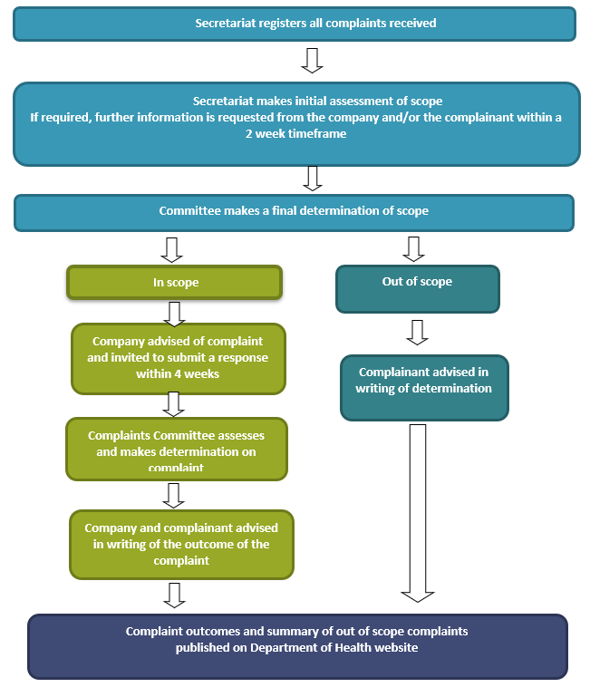

Complaint outcomes 2023 – 2024
In the 2023-24 the MAIF Complaints Committee:
- Considered a total of 23 complaints, all carried over from 2022-23.
- Resolved a total of 23 complaints, all carried over from 2022-23.
12 new complaints were received in 2023-24 and have been carried over to the 2024-25 reporting period.

Outcomes of complaints considered and resolved
In-scope of the MAIF Agreement
Of the 23 complaints resolved in 2023-24, 17 complaints were determined to be in scope of the MAIF Agreement:
- 16 complaints were determined to be in breach.
- 1 complaint was determined not a breach.
Out-of-scope of the MAIF Agreement
- 5 complaints were determined to be out of scope of the MAIF Agreement:
  - 2 related to retailer activity.
  - 1 related to toddler milk.
  - 2 related to ‘other’ activity.
    - Other: Imagery selection.

The scope of one complaint was unable to be determined by the Committee therefore the complaint was - undetermined, not a breach.

Detailed information about each complaint is available on the Department’s website, Marketing in Australia of Infant Formulas (MAIF) Complaints Committee page via the complaint outcomes list for previous financial years.

https://www.accc.gov.au/system/files/public-registers/documents/D15%2B143530.pdf
World Health Organization 1981, International Code of Marketing of Breast-Milk Substitutes, Geneva.
https://www.health.gov.au/resources/collections/maif-agreement-interpretation-guides
https://www.accc.gov.au/system/files/public-registers/documents/D15%2B143530.pdf ⁶ https://www.health.gov.au/topics/pregnancy-birth-and-baby/breastfeeding-infant-nutrition/marketing-infant-formula#maif-complaints-committee ⁵ On 6 February 2025, the ACCC made its final determination not to reauthorise the MAIF Agreement. The MAIF Agreement officially ceased on 28 February 2025.

