Aged Care Assessor App User Guide
This Aged Care Assessor App (the App) user guide outlines essential information for both aged care needs assessors (needs assessors) who use the Integrated Assessment Tool (IAT) and/or residential aged care funding assessors (RAC funding assessors) who use the Australian National Aged Care Classification (AN-ACC) assessment tool.
The user guide will walk users through how the App can be utilised both online and offline, allowing for users to use the App in different situations.
This user guide has been split into the following sections:
- Part A is for needs assessors and/or RAC funding assessors who complete assessments using either AN-ACC or IAT.
- Part B is for needs assessors who complete assessments using the IAT.
- Part C is for RAC funding assessors who complete assessments using the AN-ACC assessment tool.

Version 4.0 – 24 February 2025

Contents
Part A – Needs assessors and RAC funding assessors 4
1. Introduction 4
2. Minimum operating systems for devices to run the App 4
3. Downloading and activating the App 5
3.1 Downloading the App 5
3.2 Installing a sideloaded app (Sideloaded version) 6
4. Activating the App 8
5. Signing into the App after activation 14
6. Aged Care Assessor App troubleshooting and diagnostics 15
6.1 Inactivity time-out 16
6.2 Uninstall the App 16
6.3 First time access following a reinstall of the App 17
7. Launching and closing the App 17
7.1 Launching the App 17
7.2 Closing the App 18
7.3 Logging out of the App 18
8. App symbols 19
Part B – IAT Assessments 21
9. Registering a client, self-referring for assessment, starting triage and starting a review 21
9.1 Finding a client 22
9.2 Registering a client 24
9.3 Potential Duplicates 26
9.4 Self-referring for assessment 28
9.5 Starting Triage questions with consent for a client using the IAT (Self-Referral) 29
9.6 Commence Triage questions with client (Self-Referral) 31
9.7 Recommend urgent services before completing Triage 32
9.6 Converting assessments after completing Triage 34
10 Referrals, reviews and creating an offline client for assessment 35
10.1 Navigating between referrals and reviews 36
10.2 Downloading a client’s referral or review 38
10.3 Creating an offline client 42
11. Viewing and adding client information 45
11 Registering a support person 51
11.1 Creating a relationship for an individual representative or an individual agent 52
11.2 Creating a relationship for a representative organisation or an agent organisation 58
11.3 Creating a relationship for a carer or other support people 64
11.4 Creating a relationship in offline mode 68
11.5 Activating a pending relationship 70
11.6 Removing a support relationship 72
11.7 Opting out of relationships 72
12. Completing identity verification 76
13. Undertaking assessments 79
14. Developing a support plan 90
15. IAT outcome 92
16. Adding concerns, goals and recommendations 94
17. Uploading assessment and support plan information to the assessor portal 100
17.1 Uploading assessment and support plan information for downloaded assessments 100
17.2 Uploading assessments for offline clients 103
17.3 Locally registering an offline client 103
17.4 Linking offline clients and assessments 107
18. Conducting Support Plan Reviews 108
18.1 Downloading a Support Plan Review 108
18.2 Completing a Support Plan Review 110
19. Completing the match and refer process and finalising the assessment or completing the review 111
20. Removing assessments and reviews from the device 112
21. Completing a Residential Respite Classification Assessment 113
21.1 Refer for a Residential Respite Assessment 114
21.3 How to start an assigned Residential Respite Assessment Referral. 116
21.4 Completing a Residential Respite Assessment 117
21.5 Rejecting a Residential Respite Assessment 120
Part C – Residential aged care funding assessments (RAC funding assessors) 121
22. Conducting an RAC funding assessment 121
22.1 Find a Client 121
22.2 Self-Referral 124
23.3 Undertaking Assessments 127
24. Undertaking Quality Assurance and Training Assessments 131
24.1 Sharing referral details with the assessor undertaking the assessment 131
24.2 Scanning referral QR code or entering the referral ID 134
24.3 Local (Offline) Assessments 135
25. Completing, re-opening and uploading assessments 137
25.1 Completing an assessment 137
25.2 Re-opening a completed assessment 140
25.3 Re-opening an uploaded assessment 141
25.4 Uploading Assessments 141
26. Removing Assessments and Clearing Assessment Data 142
26.1 Removing an uploaded assessment 143
26.2 Removing an in-progress assessment 144
26.3 Clear Uploaded and Not Started assessments 145
26.4 Rejecting a Referral 145

Part A – Needs assessors and RAC funding assessors

Introduction
The Aged Care Assessor App (the App) enables both needs assessors and RAC funding assessors to assess an older Australians’ aged care needs while offline. The App allows users to perform a subset of the functions available in the assessor portal, including the ability to conduct an assessment using the Integrated Assessment Tool (IAT) or Australian National Aged Care Classification (AN-ACC) assessment tool.
Needs assessors and RAC funding assessors can undertake these processes using the App:
- Search for existing and register new clients.
- Create offline clients.
- Self-refer for assessment
- View and search assigned referrals.
- Download a client’s referral for assessment.
- Download a client’s support plan review (needs assessors only).
- View and add information about a client.
- Complete identity verification (wallet check).
- Undertake assessments using IAT (needs assessors only).
- Undertake assessments using AN-ACC (RAC funding assessors only).
- Undertake support plan reviews. (needs assessors only)
- Commence development and update a client’s support plan.
- Upload assessment and review information to the My Aged Care assessor portal.
- View and upload client attachments.
- Manually remove or cancel assessments from the App.
- View and set up representative relationships.
- Complete Residential Respite Classification Assessments (clinical needs assessors only).

Minimum operating systems for devices to run the App
The App is supported on the following operating systems:
    - Android - available on Google Play
  - Version 13.0 and up
    - iOS - available on the Apple App Store
  - iPadOS 17.0 or later
  - MacOS 11.0 or later, and a Mac with Apple M1 chip or later.
    - Windows 10+ - available on the Microsoft Store.
  - Windows 10 version 17763.0 or higher
Please note: the screenshots in this guide feature the app version 30.0.0.1 in Windows 11.
  - If you are using another device, the App will appear slightly differently.
! | The App will time out if inactive for 15 minutes and you will need to log in again.  If you do not use the App for 14 days, you will be locked out of the app. You will require an unlock code, which can be generated from the app section in the My Aged Care Assessor Portal.

3. Downloading and activating the App
! | Prior to using the App, you will need to:  - Download the App from your device’s application store.  - Have an active role in the assessor portal (you must ensure your registered email address is current and up to date).  - Have an activation code, that can be obtained either via the App section of the assessor portal or by calling the My Aged Care service provider and assessor helpline (1800 836 799). The activation code will be active for 24 hours from the time it is issued. If your code expires, select Get Activation Code in the App section of the assessor portal or call 1800 836 799 to have another code issued. For RAC funding assessors, they can call the AN-ACC Operational Support Line on 02 6289 7190 between 8am - 6pm AEST Monday to Friday to request an activation code.

3.1 Downloading the App
Before downloading the App, depending on the device you are using, you will need to have an active:
- Microsoft account (for Windows device),
- Apple ID (for Apple iPad), or
- Google account (for Samsung/Android).
! | A side-loaded version of the Windows App is available to assessment organisations that have a restricted IT environment.  For instructions on how to download the side-loaded version of the App, please refer to the section Installing a sideloaded app (Sideloaded version).
- Once you have an active account, navigate to your device’s application store (Microsoft store, Apple App Store, or Google Play Store)

- Search for the App by entering ‘Aged Care Assessor App’ in the search box and select the App icon to open the App details.

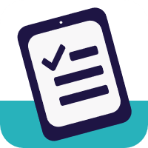

- Select Install to download the App to your device. Once successfully downloaded, it will display on your device.
! | The App will be located where your device stores its applications. This will differ between the supported devices.  If you have difficulties downloading the App onto your device, contact your organisation administrator or relevant IT area.
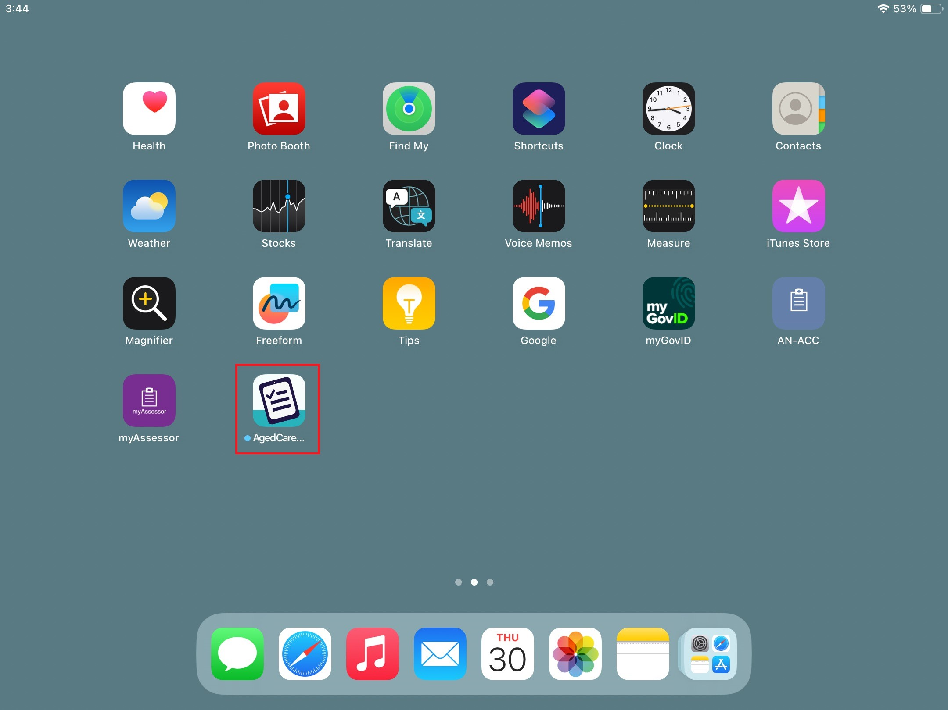

3.2 Installing a sideloaded app (Sideloaded version)
Some organisations who would like to use the App on a Windows device outside the Windows App Store, via a manual installation process with a downloaded installation file known as sideloading. The app files for Windows are available to sideload onto a Windows device running Windows 10 or above. This is to allow for businesses that have a restricted IT environment to install the app without going through the Microsoft Store.
! | The sideloaded app can be downloaded, a Windows compatible (sideloaded) version of the App is available.
My Aged Care recommends the use of the Microsoft sideloading documentation to install the app.

3.2.2 Microsoft Store (Sideloaded version)
The Microsoft Store is also known as the Windows Store.
The suffix of the version number for both apps ends with a number zero. For example: v30.0.0.0
The icon for the sideloaded version of the App is the same as the non-sideloaded version:

3.2.3 Sideload (Sideloaded version)
The suffix of the version number for both apps ends with a number one. For example: v30.0.0.1
The icon and splash screen for the Aged Care Assessor is:
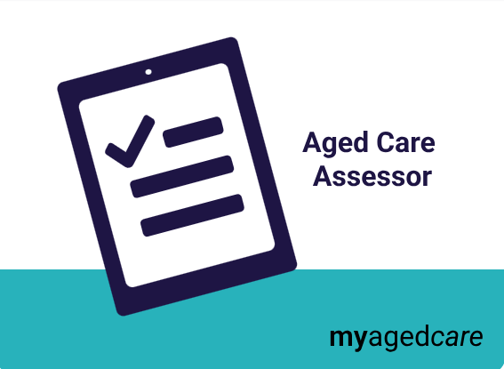

3.2.4 Upcoming releases of the App (Sideloaded version)
Unlike apps in the Microsoft Store, Apple App Store and Android Play Store which include automatic updates, Sideloaded apps have no automatic updates, therefore each sideload version update will require a manual installation.
The Department will notify assessment organisations of a new release at least 2 weeks prior to the release of the application. They will also be notified when the new version is available and by what date all their users should be using the new version of the app.

3.2.6 Frequently Asked Questions (Sideloaded version)

How do I sideload my app?
The Department recommends following the guide provided by Microsoft to sideload the application. This can be found at Sideload line of business apps - Windows Application Management | Microsoft Learn

When do I need to install the new release of the app onto my organisation’s devices?
The new version of the app should be installed on your users’ devices within 1 week from the release of the new version. Once the new release of app has gone live, users will not be able to begin any new assessments until they have been upgraded to the latest version.

How will my organisation’s sideloaded app users be supported by the Department?
If you have installed the Aged Care Assessor App via the sideloading method, the Department will continue to support users for issues within the application. We may refer you to contact your organisation’s IT area if we believe the issue is related to your organisation’s setup.

What happens if I don’t upgrade my sideloaded app to a new version when it is released?
When a user doesn’t accept the updated version of the App from the Microsoft Store, they will not be able to download or access any new referrals on their device. This same restriction will happen for users who have sideloaded the application and don’t have the latest version available.

What should I do if I have any issues with using my sideloaded app?
Please email your organisation’s IT area and include:
- Description of the issue
- Screenshot/s of the issue
- Description of where the issue is during your assessment or other use of the app.

Activating the App
! | The App can only be used on one device by one user at any one point in time, and access cannot be shared.  If the device needs to be assigned to another user, select the Logout button from the sign in screen in the app or alternatively the user that has the device assigned to them can select the RE-ACTIVATE AGED CARE ASSESSOR APP from the App section in their assessor portal. This will deactivate the App and send a new activation code to the user’s registered email address. Please note that this will remove all client and user data from the device.  or  The new user will then need to log in to the App with a new activation code, which they can generate from the Assessor Portal by selecting ACTIVATE AGED CARE ASSESSOR APP or by calling the My Aged Care service provider and assessor helpline (1800 836 799).  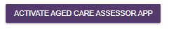

Once the App has been downloaded to your device, follow the steps below to activate the App.
- From the home page of the My Aged Care assessor portal, navigate to the Aged Care Assessor app section.
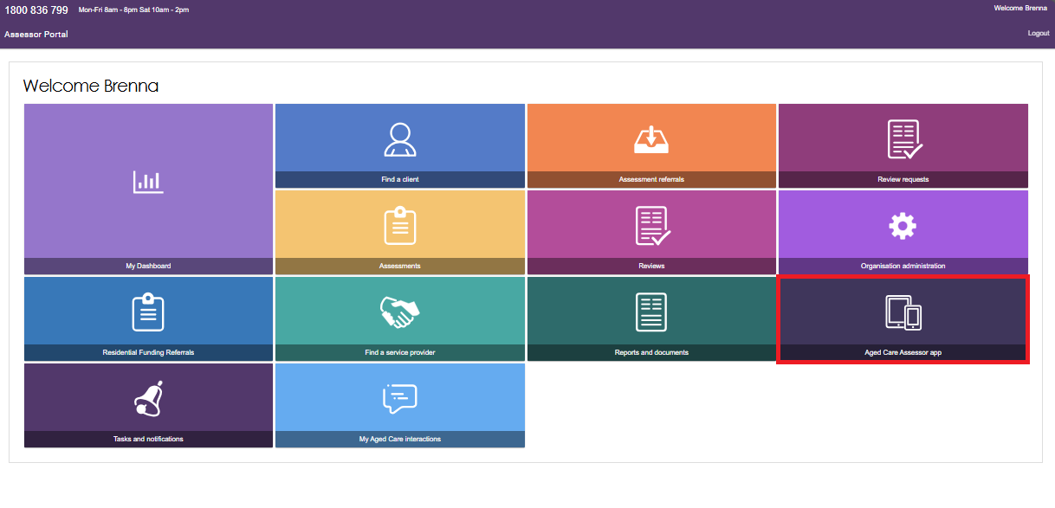
In this section, you will be able to view your App activation status, any referrals downloaded to your device, and generate a code to unlock, activate or reactivate your device.
Select Get Activation Code to send an activation code to your registered email address.
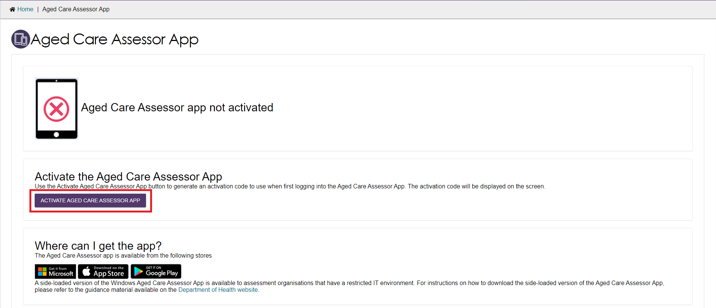
- Click Activate to generate the code.
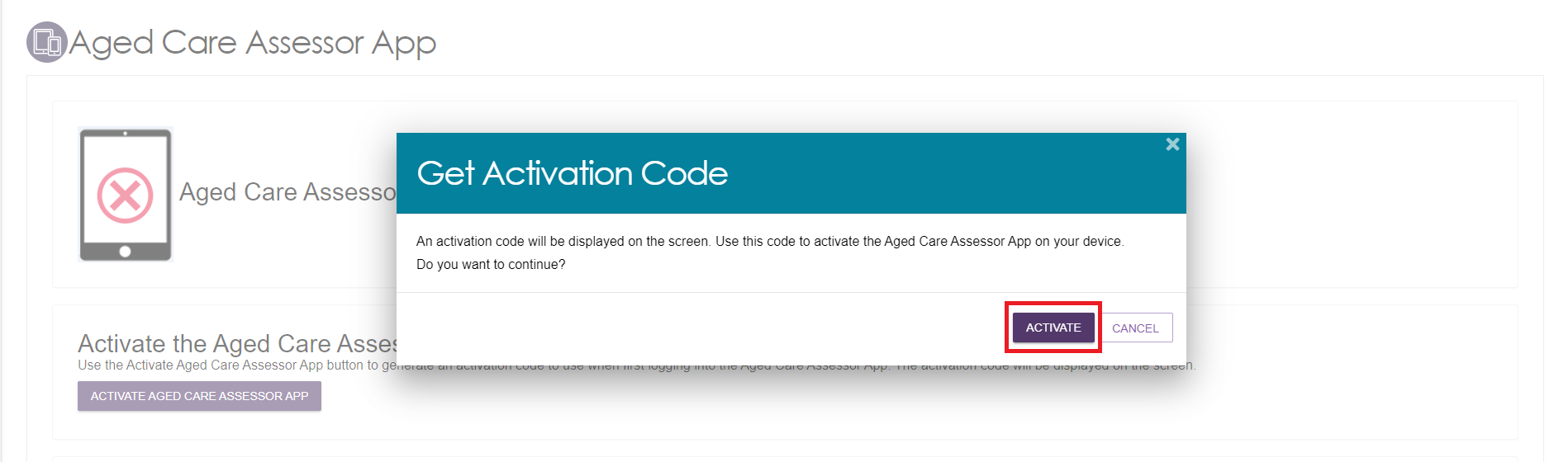

- Open the App from your device.
- A login page will display and remind users they must be a registered needs assessor and/or RAC funding assessor with My Aged Care and have an activation code obtained from either the assessor portal or the My Aged Care service provider and assessor helpline.

- Enter the email address associated with your staff account in the Assessor Portal and your activation code, and then select Activate.
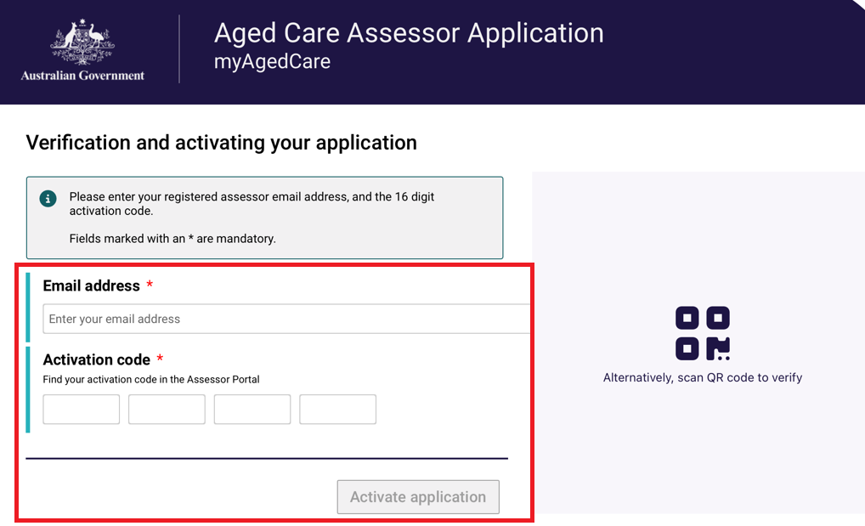

Alternatively, you can scan the QR code that was displayed from the Assessor Portal by selecting Scan QR Code.
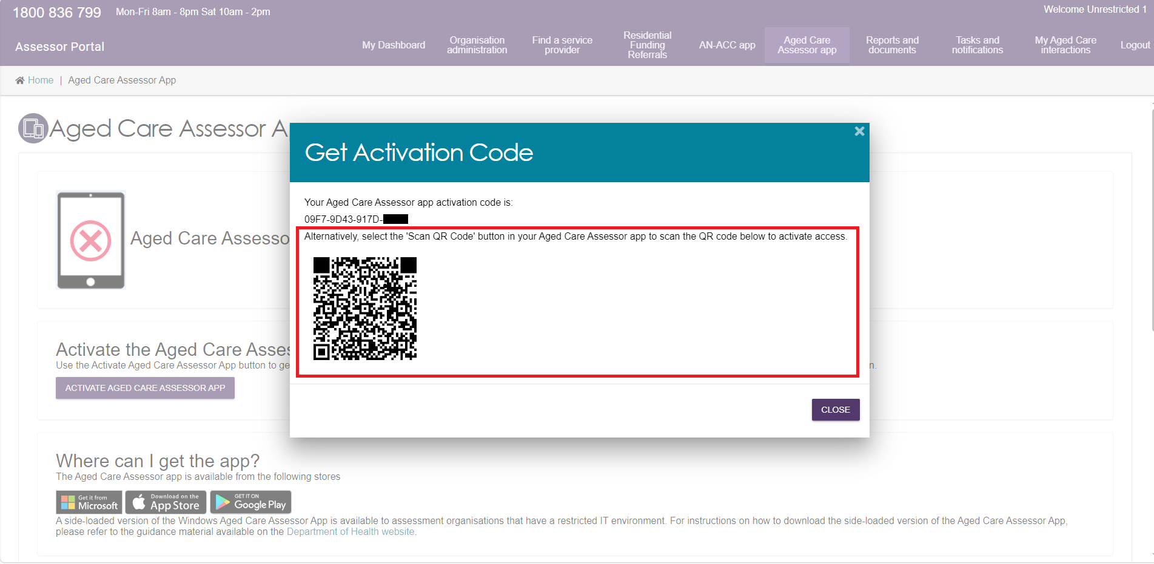
! | The email entered will be verified against the information held in My Aged Care.  If the information is incorrect, an error message will be displayed.
- The Terms of Use will be displayed.
Read the Terms and Conditions and if you agree, select the Accept terms and continue button, to proceed.
If you do not accept, you will not be able to use the App.
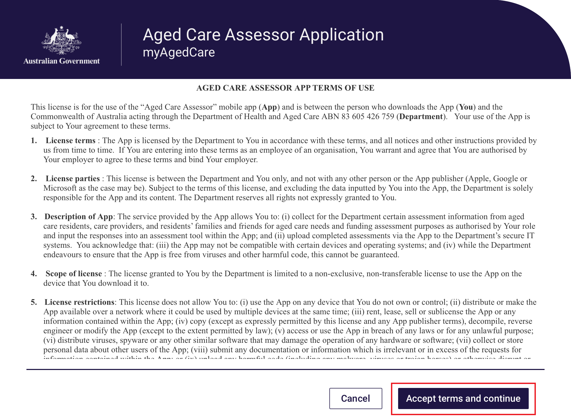

- Once you have accepted the terms, the Privacy notice for the App will appear. Read the notice and if you agree, select the Continue button, to proceed.
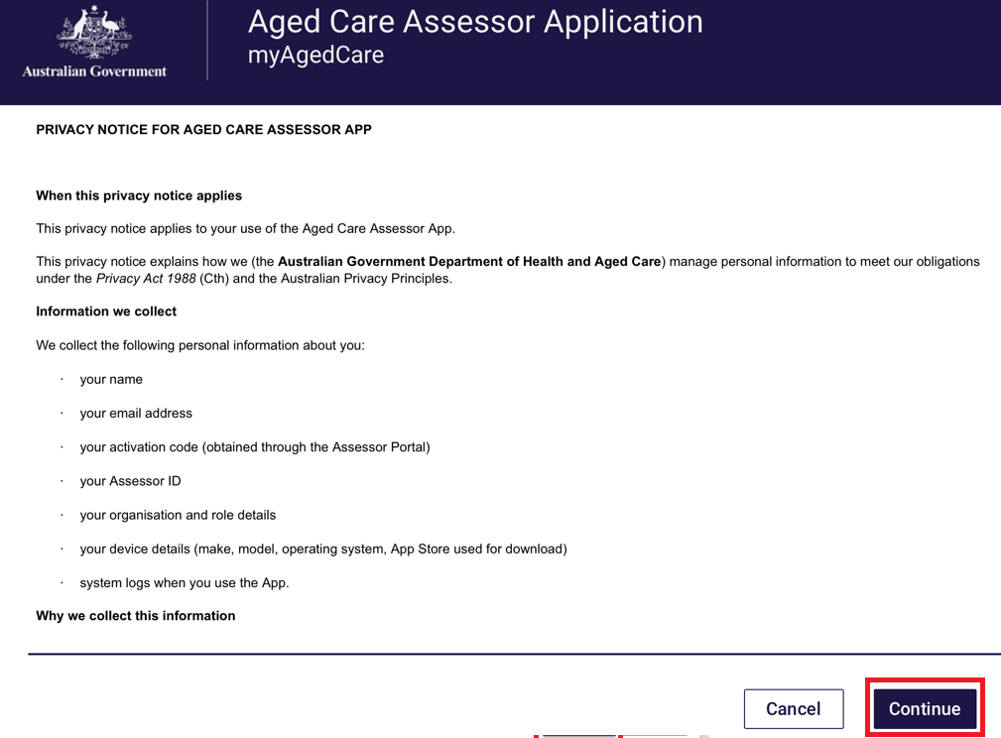
- Once the App’s Terms of Use has been accepted, you will be presented with the password screen. Create a password according to the rules displayed. You will be asked to enter the password a second time to ensure it is correct.
Use this password to unlock the App each time it is opened.
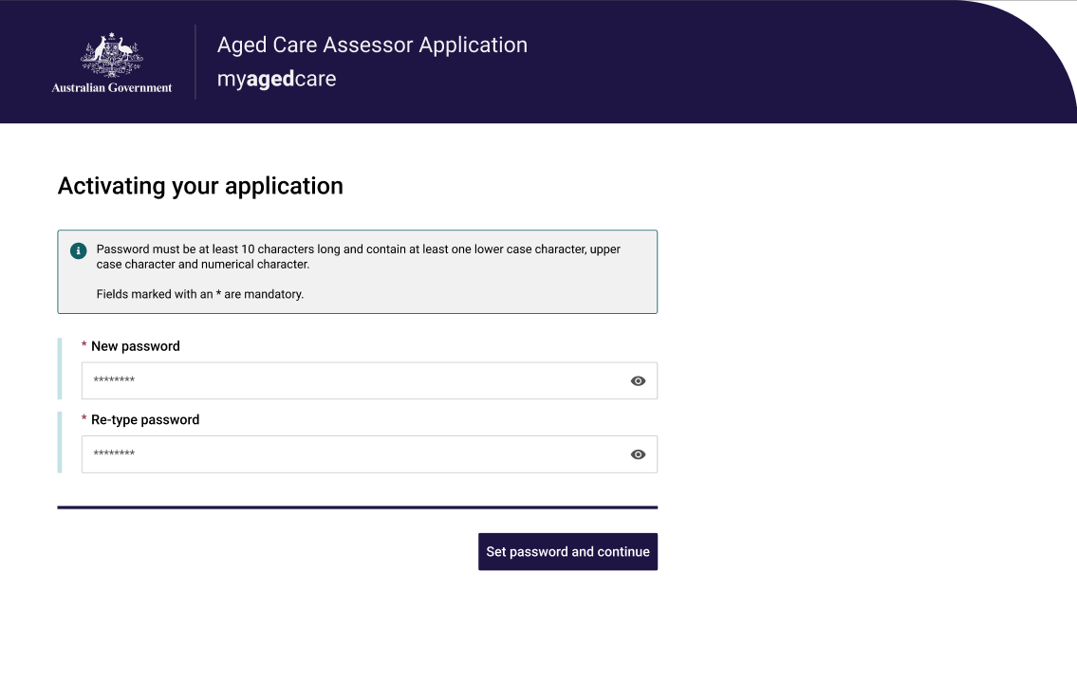

- After setting your new password, the App will complete a first time setup such as your profile and your assessment organisations information. Click the Continue button to complete the login steps.
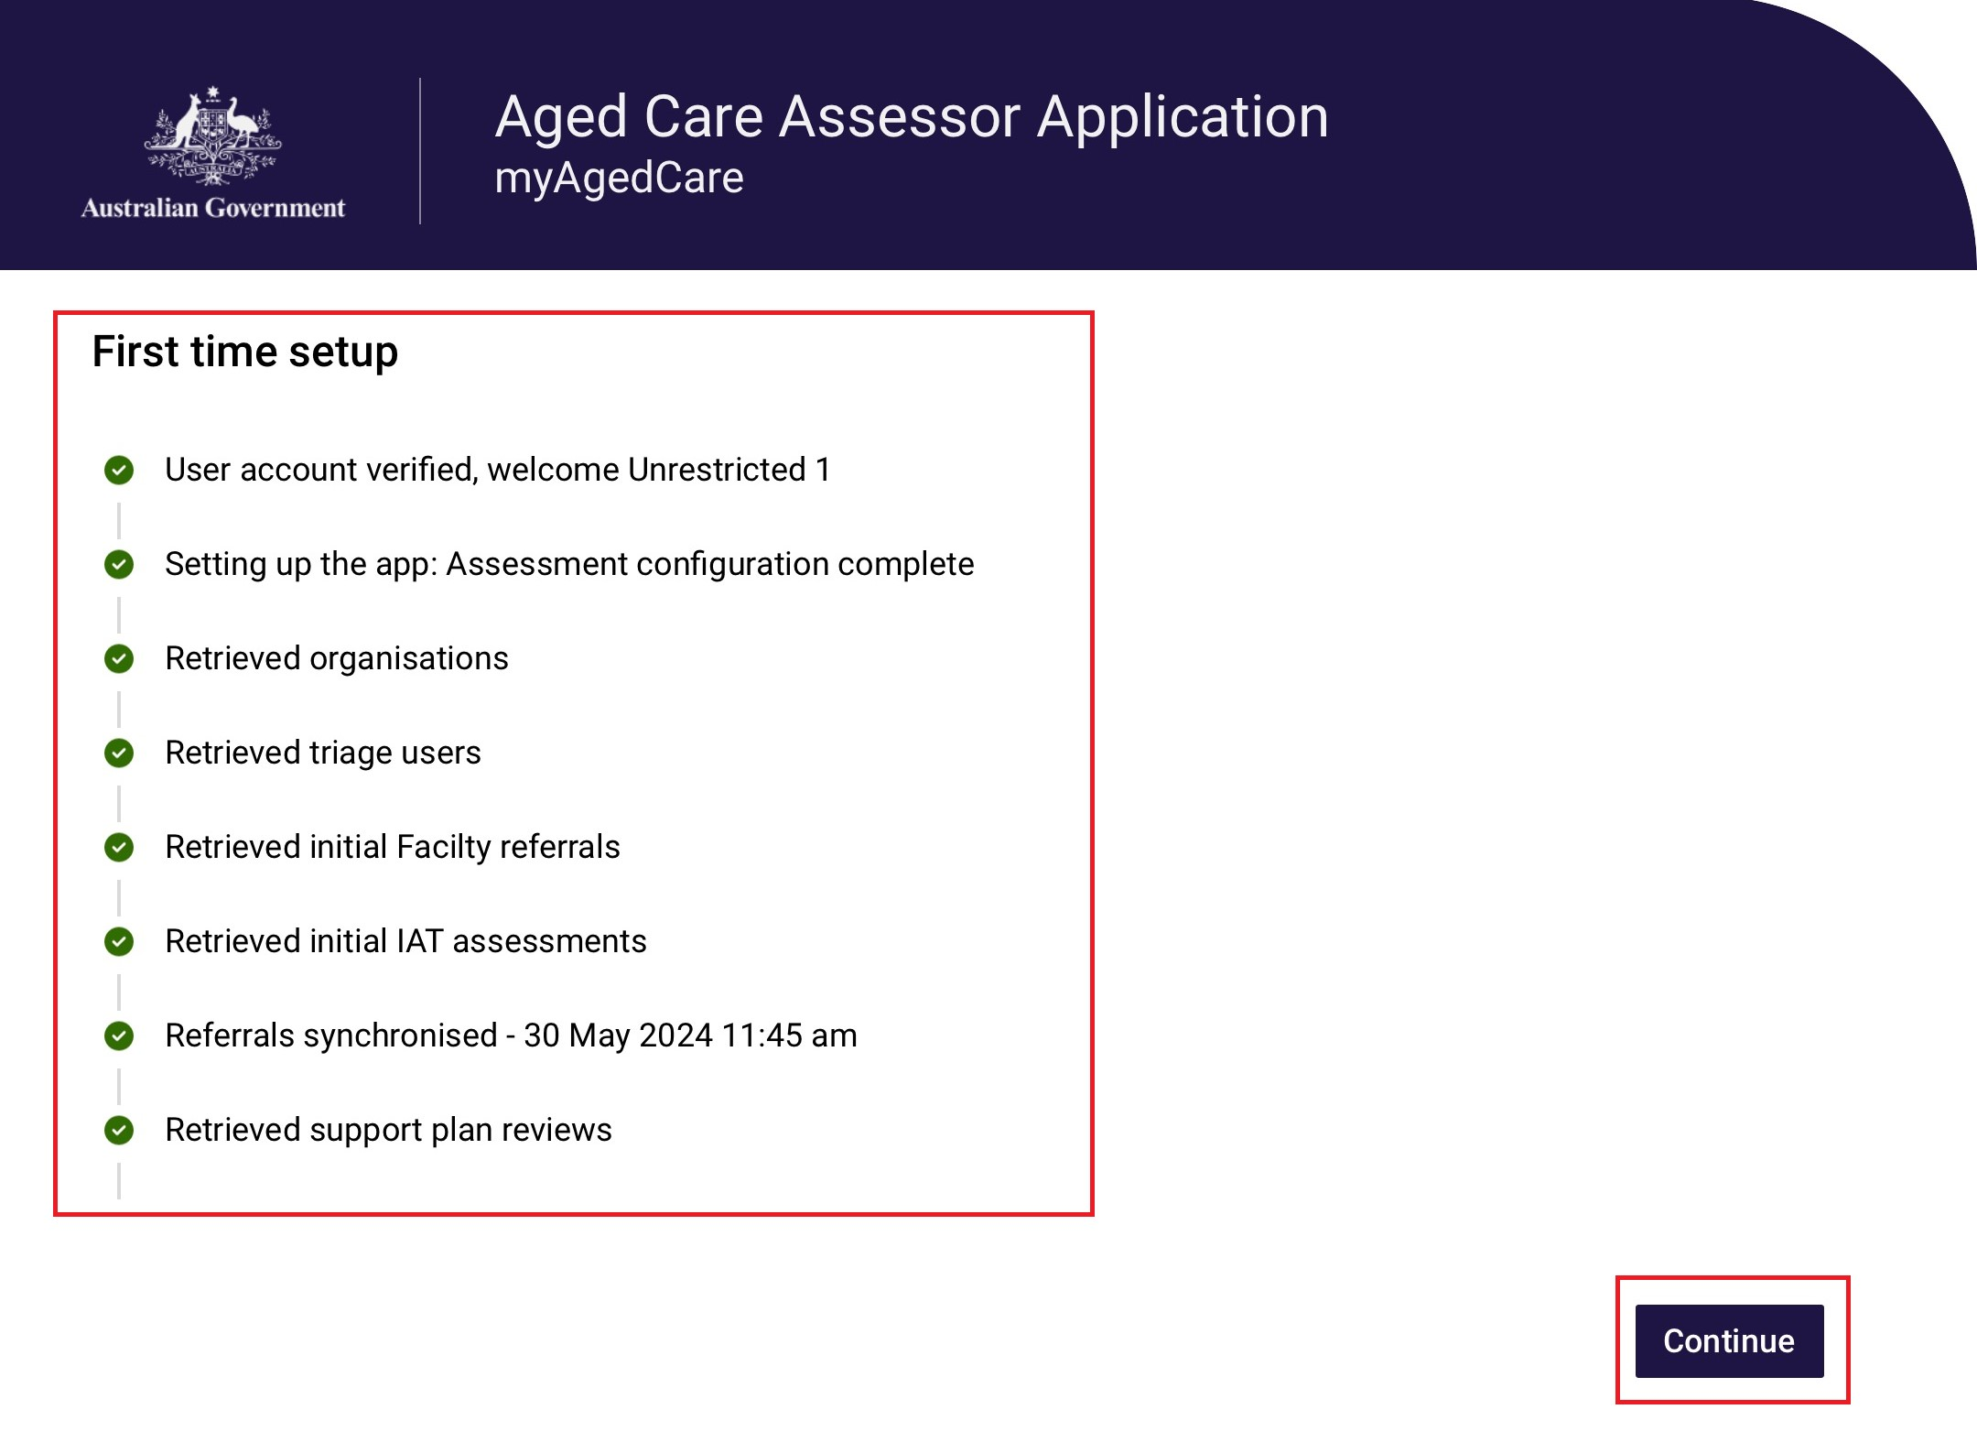
- You have now successfully completed the activation process. The next time you sign in to the App, follow the steps outlined below in the Signing in to the App after activation section.
11. Once signed in the App dashboard will be displayed.
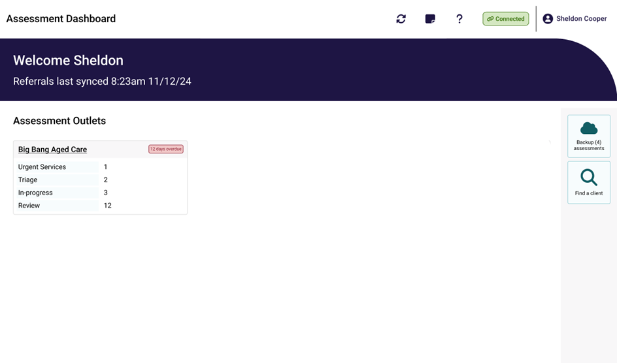

! | The first time you log in to the App you may not see any referrals.  Select Refresh referrals to load assessment referrals assigned to you.  If you experience issues with refreshing referrals, follow the steps in App troubleshooting and diagnostics to diagnose issues experienced with the App.

Signing into the App after activation
To sign into the App after the first-time activation process, follow the steps below.
- Open the App from your device. The password page will display, and you will be prompted to enter your password.
The App will timeout if inactive for 15 minutes and you will need to log in again.
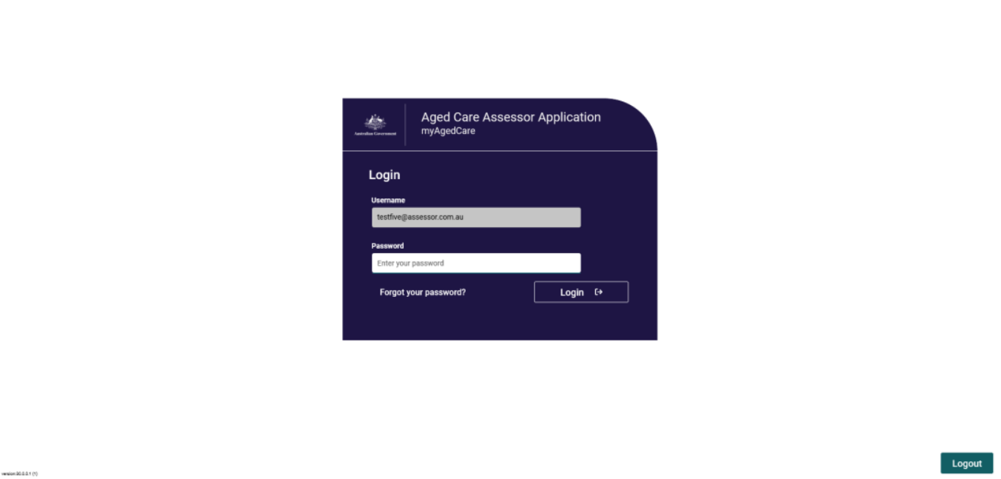
- The dashboard will be displayed.
! | You will be locked out of the App if you forget your password, enter your password incorrectly five times, or do not use the App for 14 days.  You can regain access in the App section of the assessor portal.  To do so, select Generate an Unlock Code to generate a code within the assessor portal. Enter this code into your device and you will then be able to reset your password and log in.    If the portal is unavailable, you can also call the My Aged Care service provider and assessor helpline on 1800 836 799 to generate an unlock code.

Aged Care Assessor App troubleshooting and diagnostics
The troubleshooting and diagnostics functionality assists the My Aged Care service provider and assessor helpline with diagnosis and resolution of issues in coordination with the support teams in the Department of Health and Aged Care.
These functions are accessed from the Profile icon on top of the navigation menu.

Information about the current downloaded version of the Aged App is displayed, and assessors can also Check connectivity, View logs, Share logs or Submit feedback from this screen.
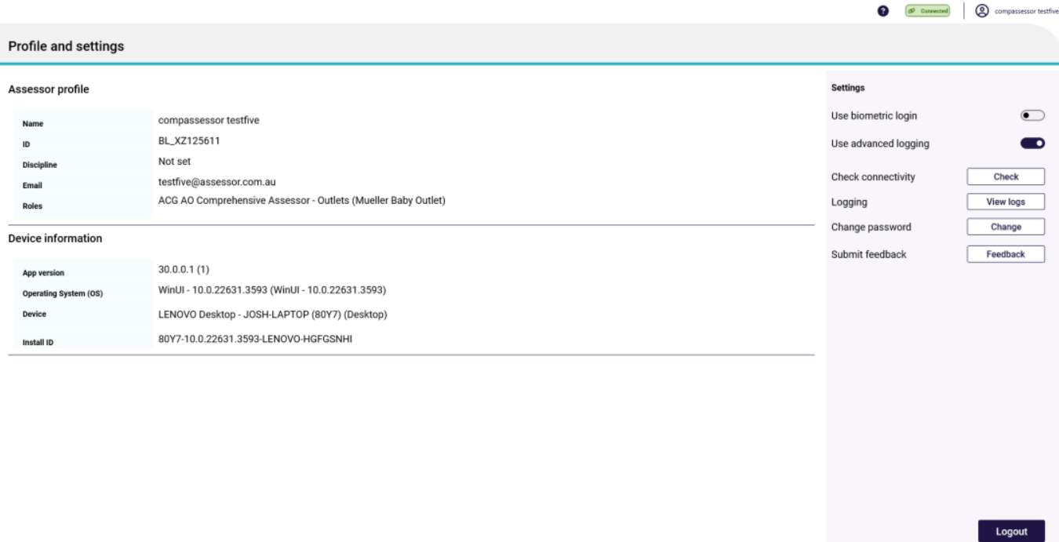

If you experience connection issues whilst using the App, you can check for issues by selecting Check connectivity. Any connection issues will be displayed. There are also quick suggestions provided to help with connectivity issues. Proxy settings can also be updated if it is a requirement from your Organisation.
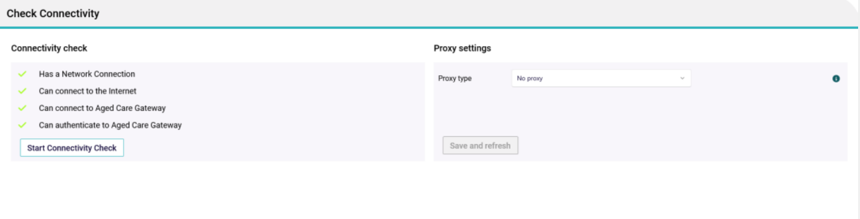
If you experience technical issues whilst using the App, you can choose to share your App device logs and diagnostics.
This will assist the support teams to more easily identify, analyse, diagnose and resolve any issues.
The logs contain detailed information regarding the specific problem, and traceable steps that have been taken to reach the problem point.
This information will be able to be accessed by the Department of Health and Aged Care for diagnosis.
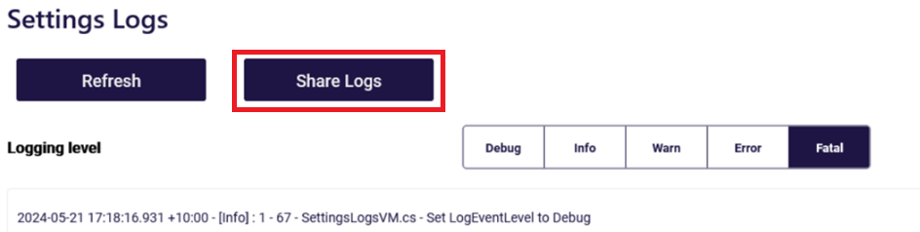

6.1 Inactivity time-out
The App will timeout if there is no activity for 5 minutes and you will be required to login to the app again. Provided you have been working in an online mode, all data you have been working on will be auto-saved every 15 minutes. If you are working in offline mode and are logged out of the app due to inactivity, data you have entered will not be backed up to My Aged Care but will be available on the device still.

6.2 Uninstall the App
If you experience any issues with the App, you may be instructed to uninstall and then reinstall the App. The steps for uninstalling an App will be dependent on the operating system you use.
Android
1. Touch and hold the App icon
2. Tap App Info
3. Tap Uninstall and confirm the prompt
iOS
1. Touch and hold the App
2. Tap Remove App
3. Tap Delete App, then tap Delete to confirm.
Windows 10+
1. Select Start and look for the app or program in the list shown.
2. Press and hold (or right-click) on the App, then select Uninstall.

First time access following a reinstall of the App
If you wish to reinstall the App after uninstalling, you will need to activate your App status again. To do this please refer to 4. Activating the App for these steps.

7. Launching and closing the App

7.1 Launching the App
To launch the App after the first-time activation process you should:
- Open the App from your device. The password page will display, and you will be prompted to enter your password and then click Login.
- The Dashboard will be displayed, and you will see the list of outlets or facilities that you have been assigned to assess. If you have any assessments assigned to you then you will also see these under the related outlet or facility.
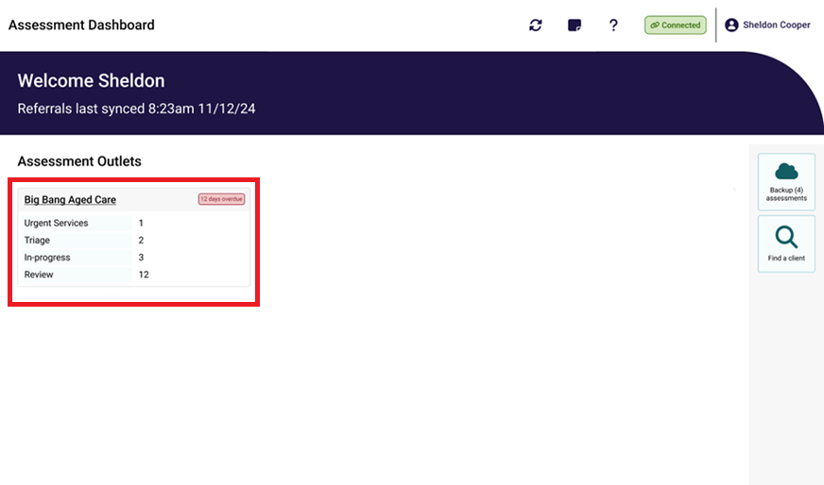

7.2 Closing the App
To close the App, you can either navigate to the top right of the screen and close the App window (Windows), or
Swipe up from the bottom of your screen (most iOS and Android versions).

7.3 Logging out of the App
This will remove your current activation and will require a new code to be entered.
- Select your profile button from the dashboard menu screen.
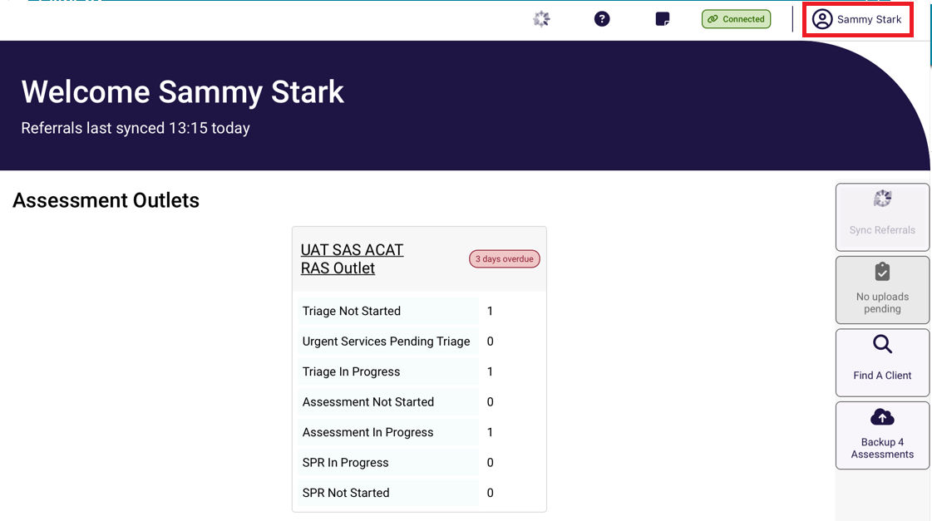
- Select the Logout button.
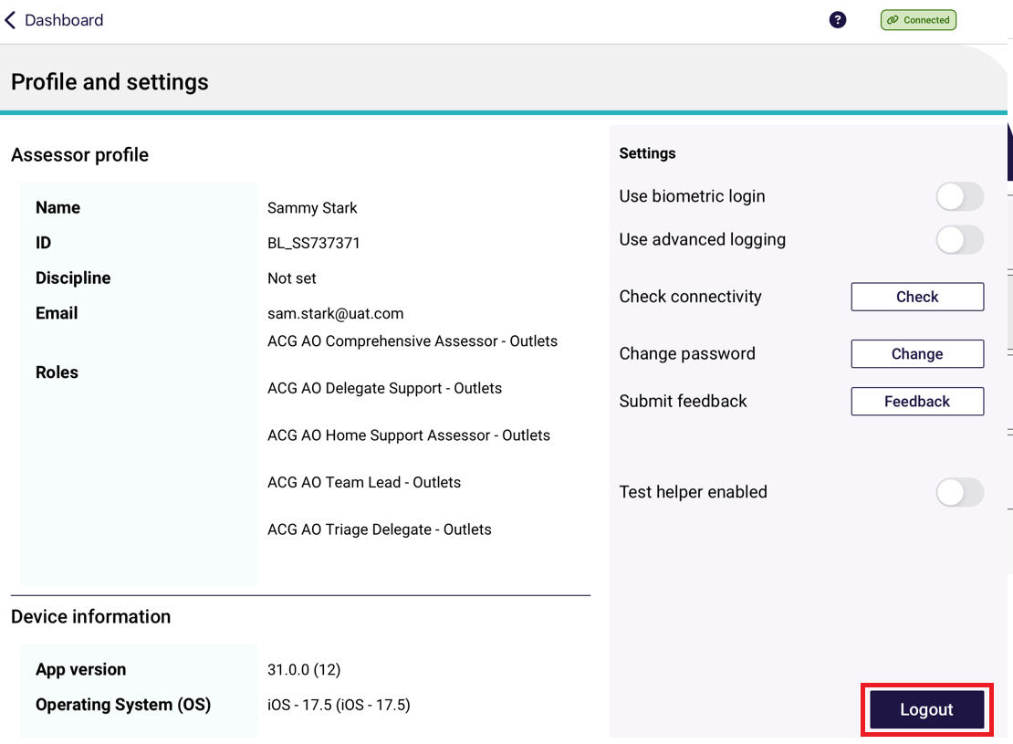
- Confirm that you wish to logout.
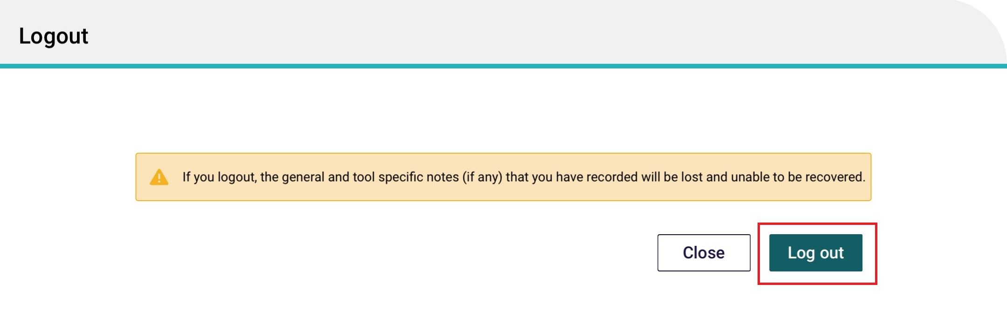

App symbols
Symbol | Definition
 | Sync - Starts a sync to gather user profile data and assigned referrals. Use this if after a few minutes on first log in you still do not see any referrals.
 | No uploads pending – means that there are no assessments that are pending to be uploaded via the internet.  Click this to upload referrals when they are in Completed status.
 | Find a Client – Opens the Find a Client page to initiate a search.
 | Backup Assessment – click this button to backup all assessments.
 | Quick Notes – Opens the Quick Notes page to quickly access a free text field for general purpose comments. feature, which allows notes to be recorded on the App.
 | Help and Support - Shows links to Aged Care Assessor App User Guide, My Aged Care Assessment Manual, AT User Guide, Terms of Use and Privacy.
 | Profile and settings – view your profile, settings and connectivity.
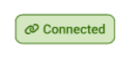 | Connected – mean that you have connectivity to the internet. You are in an online state.
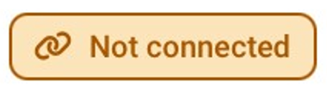 | Not connected - mean that you do not have connectivity to the internet. You are in an offline state. App is limited to offline functions.
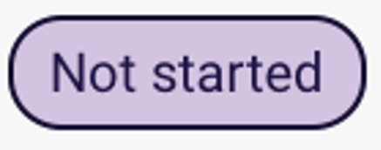 | Not started – indicates that the assessment has not commenced.
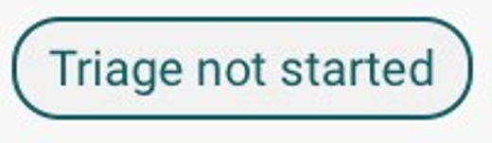 | Triage not started – indicates that triage has not commenced.
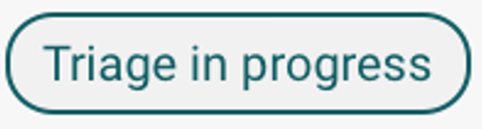 | Triage in progress – indicated that the assessment referral has entered the stage of triage.
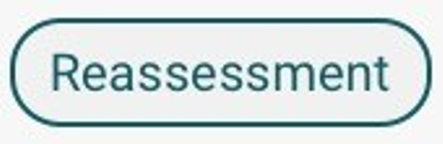 | Reassessment – indicates that the assessment referral is a reassessment.
  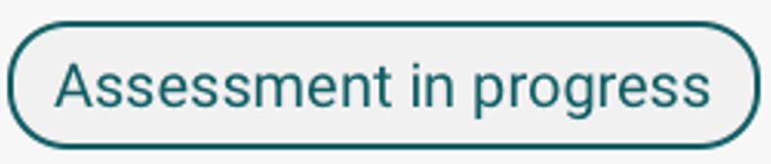 | In progress or Assessment in progress - indicates that the assessment has been started and not completed.
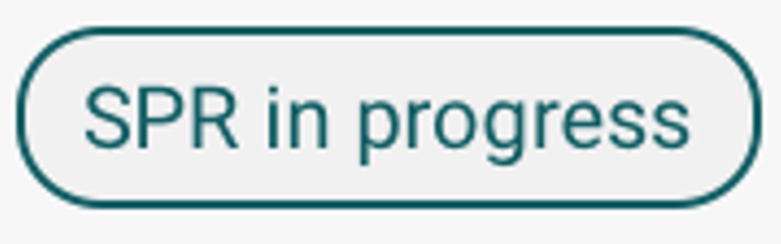 | SPR in progress – indicates that the Support Plan Review has been started.
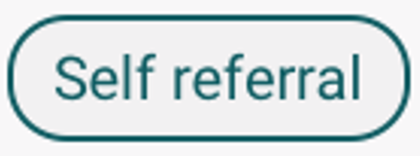 | Self referral – indicates that the assessment referral is a self-referral that you have referred to yourself.
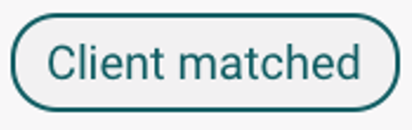 | Client matched – indicates that you have matched an offline client to an existing client once you have regained internet connection.
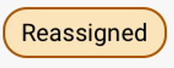 | Reassigned – indicates that the assessment referral has been reassigned in the Assessor portal to another user.
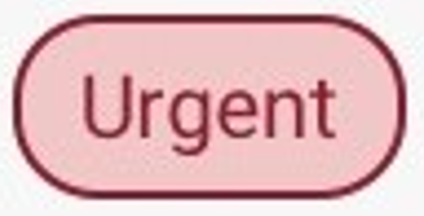  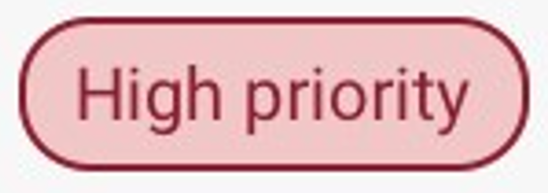  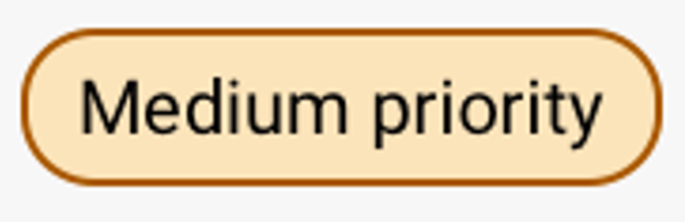  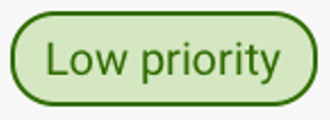 | Priority – depending on the client care needs, a priority for assessment is set.
 | Clear answers or page information – Selecting Clear page information will clear any information entered on the current page of the assessment that the assessor is working on.
 | Help - Displays more detailed information about that page or tool.
 or  | More information – in certain areas within the app, these icons will appear to provide further information on particular questions.
 or  | Assessor comments or Quick notes is a feature, which allows notes to be recorded on the App.  These notes could be sensitive in nature or may be notes that are for later reference during the assessment process.
 | Double Chevrons – these will allow you to open the side panel.
 | Requires action – indicates that the section of the assessment is incomplete.
 | Complete – indicated that the section of the assessment is completed.
 | Download assessment – Indicates that the assessment had not been downloaded to the device yet. When downloaded, this icon will disappear.
 | Upload assessment – this will upload the assessment to the My Aged Care Assessor Portal.
 | Online Client - When an assessment has been matched online
 | Offline Client – When an assessment is created offline and is not matched.
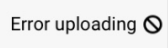 | Error uploading – there has been an error during the uploading of the assessment referral.

Part B – IAT Assessments
! | Please note that ‘assessment’ in part B refers to aged care needs assessments completed by aged care needs assessors who complete assessments using the Integrated Assessment Tool (IAT).

Registering a client, self-referring for assessment, starting triage and starting a review
Needs assessors can register a new client within the App.
You must be connected to the internet to view and perform any of the functions referenced below.
If you are not connected to the internet, follow the steps to Create an offline client.
Following online client registration:
- Needs assessors can self-refer clients for assessment if the reason for assessment is In-hospital, remote assessment, First Nations, Homeless or at risk of, or the client is considered vulnerable.
- Referrals for reason outside of those listed above must be facilitated prior to linking to the registered client (refer to Linking offline clients and assessments).
! | The following functionalities cannot be completed offline:  - Registering clients (online)  - self-referring for assessment  - downloading a client’s referral for assessment  - uploading assessment information to the My Aged Care assessor portal  - sharing device log data to the Department.
Once the needs assessor has internet connectivity, client assessment and support plan information can be uploaded to the assessor portal.
The needs assessor can then submit to the delegate for approval (where necessary) or continue to match and refer, sending any necessary referrals for service. The client’s consent must be obtained prior to any referrals being sent.
The App also enables needs assessors to register a person who may not have previously registered with My Aged Care and conduct an assessment.
! | These functions are available in the assessor portal, please refer to:  My Aged Care – Assessor Portal User Guide 1 – Registering and referring clients.

Finding a client
Before you register a person, you need to confirm that they do not already have a client record.
! | If you are not connected to the internet, the Find a client function will not be available, and you can follow the steps in the Adding an offline client section to create a client via the Create Offline Client functionality.  You will then need register the client or link to an existing client when connected back to the internet.
- Select Find a client from the dashboard of the App.
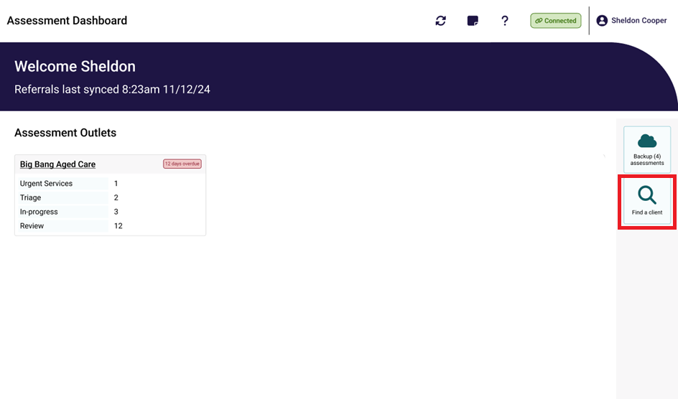
- Enter the client's first name, last name and/or Aged Care User ID and select Search.
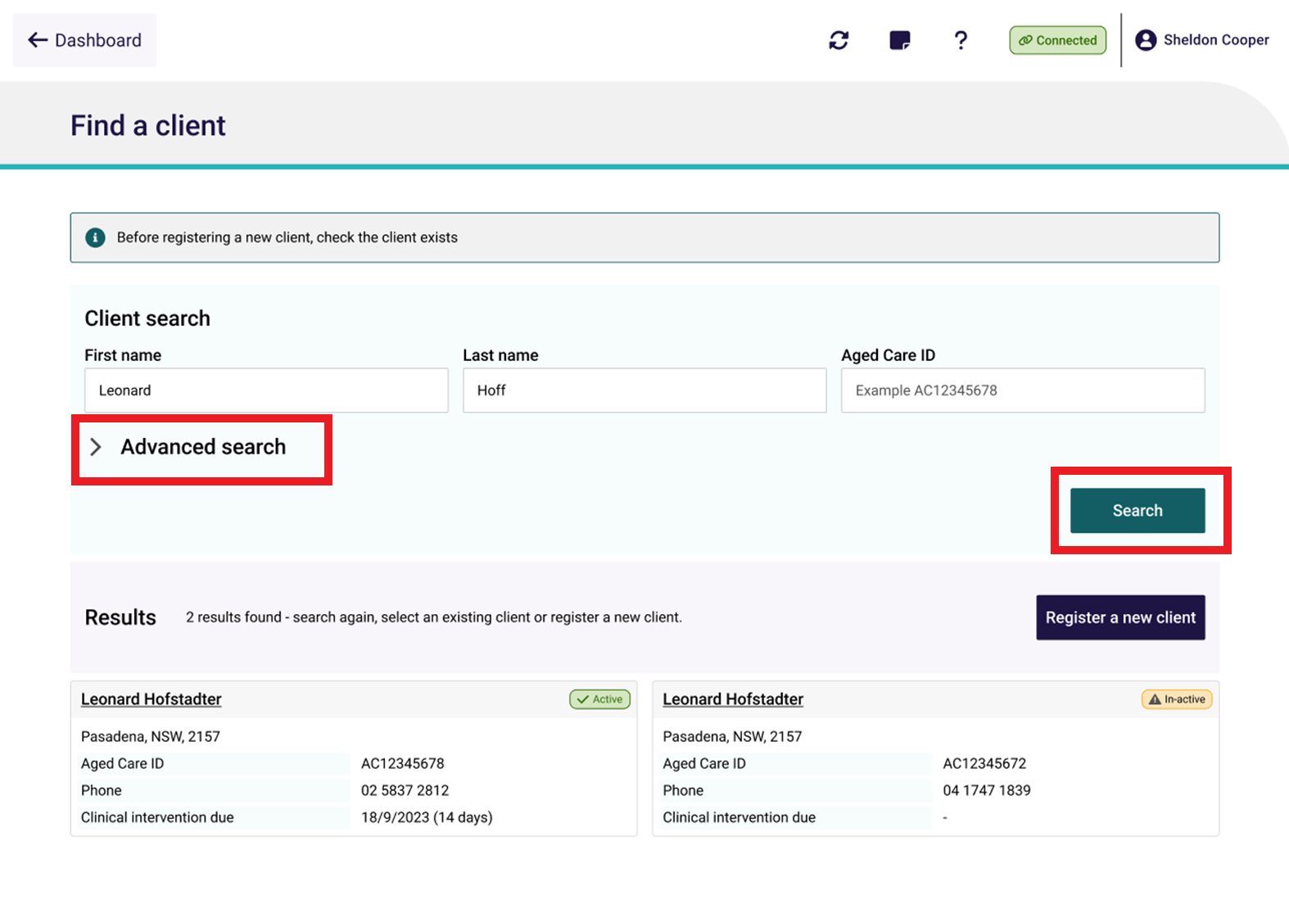
You can select Advanced search to conduct a custom or refined search.
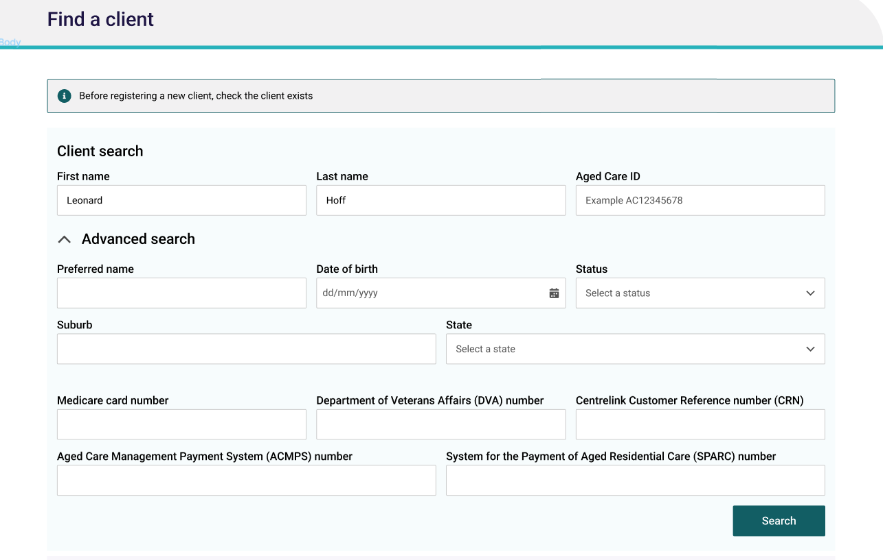
- Any matching search results will be displayed.
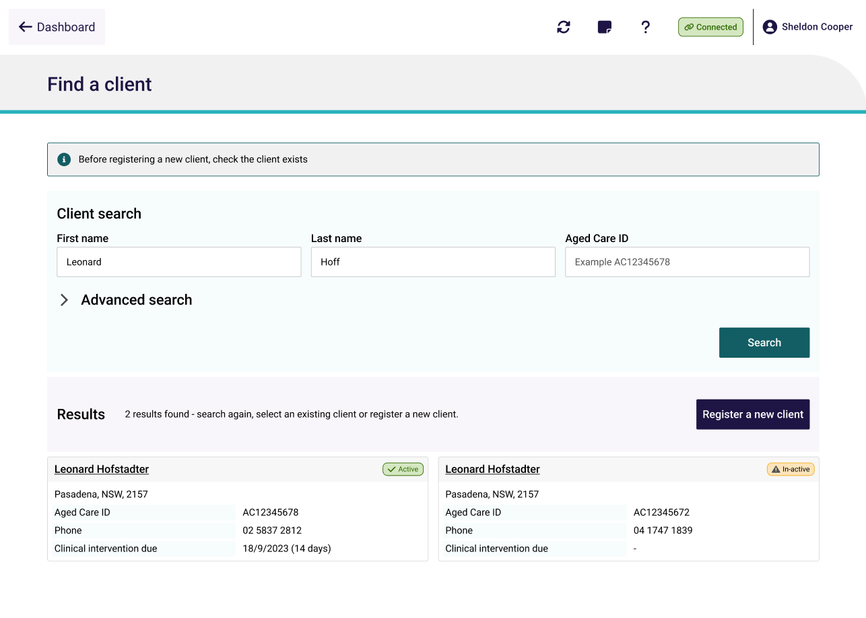
- If there is already an existing client record, select the appropriate record and continue from Self-referring for assessment to create a referral.
If there are No records found or the client record searched for is not returned in the search results, you can select Register a new client.
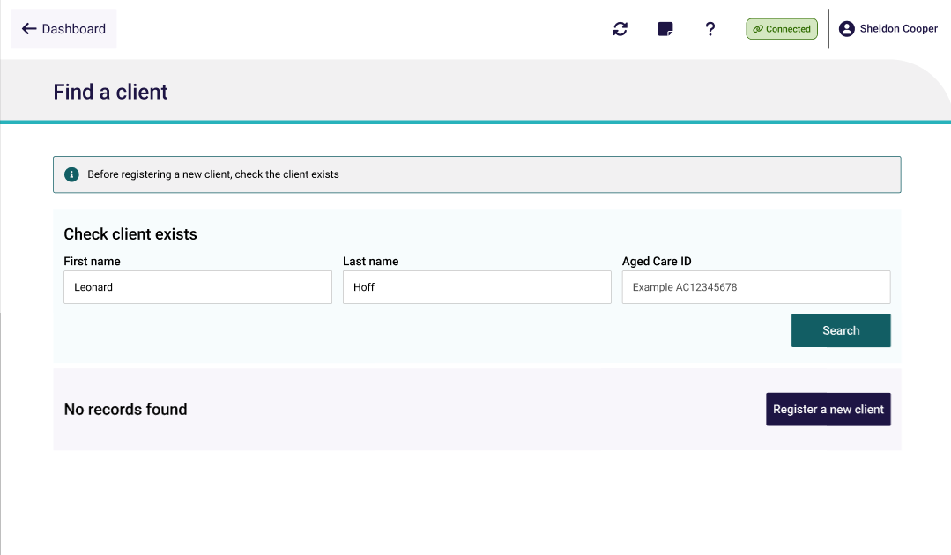

Registering a client
To register a new client in the App, follow the steps below. You must be connected to the internet.
- On the Personal details page, enter the client’s personal information.
Fill out all mandatory fields. These are shown by red asterix next to the field, red boxes provide advice on what information is required.
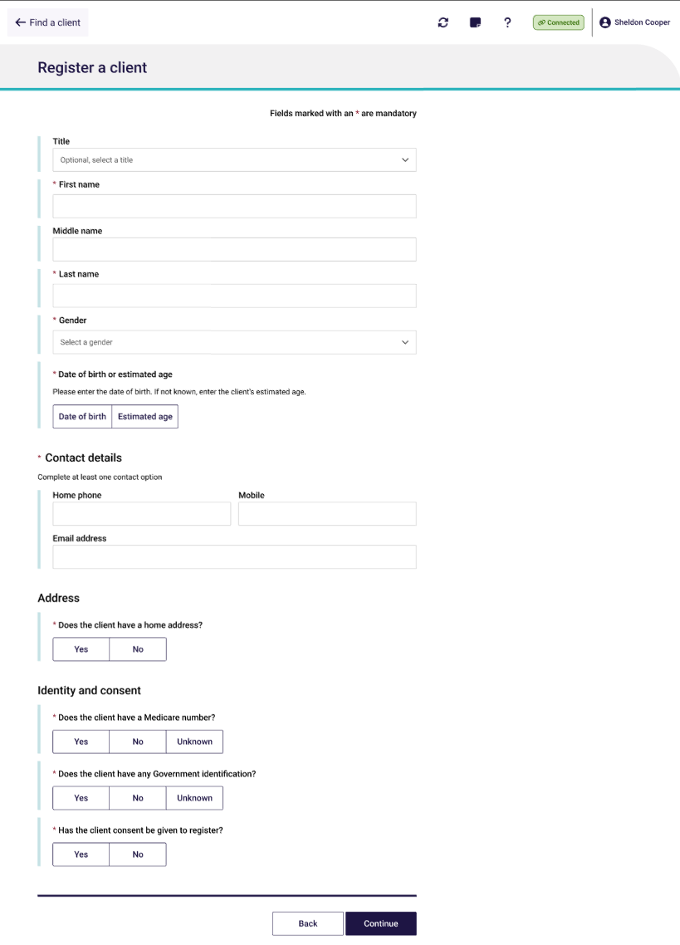
- On the Address details page, you can search for the client’s address.
If the client’s address is not available from the drop-down list, you can select to enter the address manually.
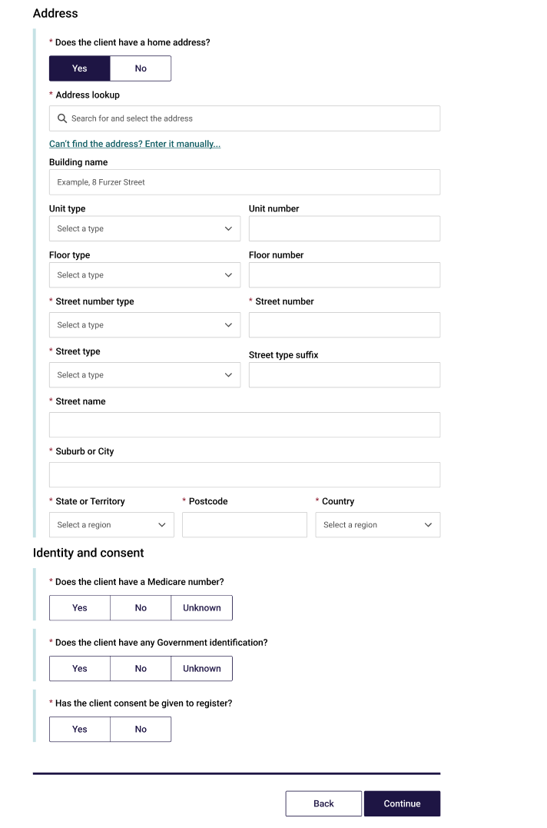
! | While you are entering client information in the Personal details, Address details and Identity Match/Consent sections, the App will check in real time for potential duplicate records.  See Potential Duplicates for more details.
- On the Identity Match page, enter in any Government ID information that the client has provided. Once all mandatory client information has been entered, select Continue.
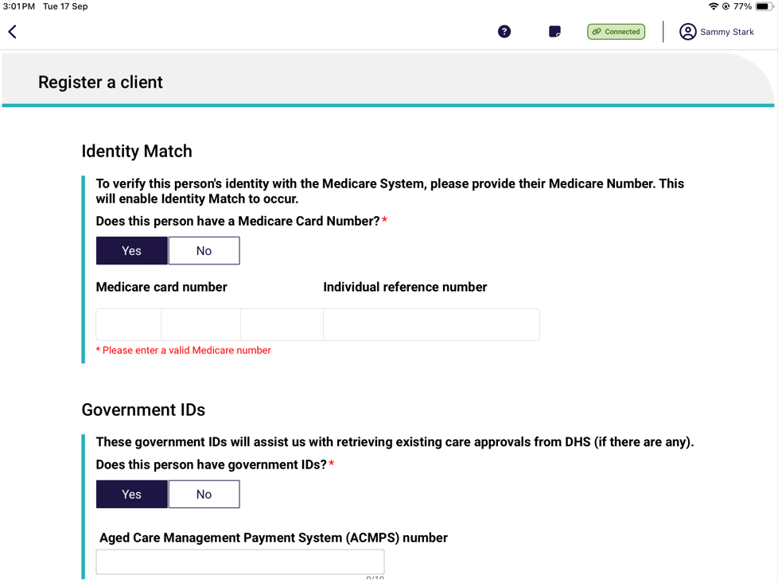
- You will be required to confirm the client’s consent to be registered with My Aged Care.
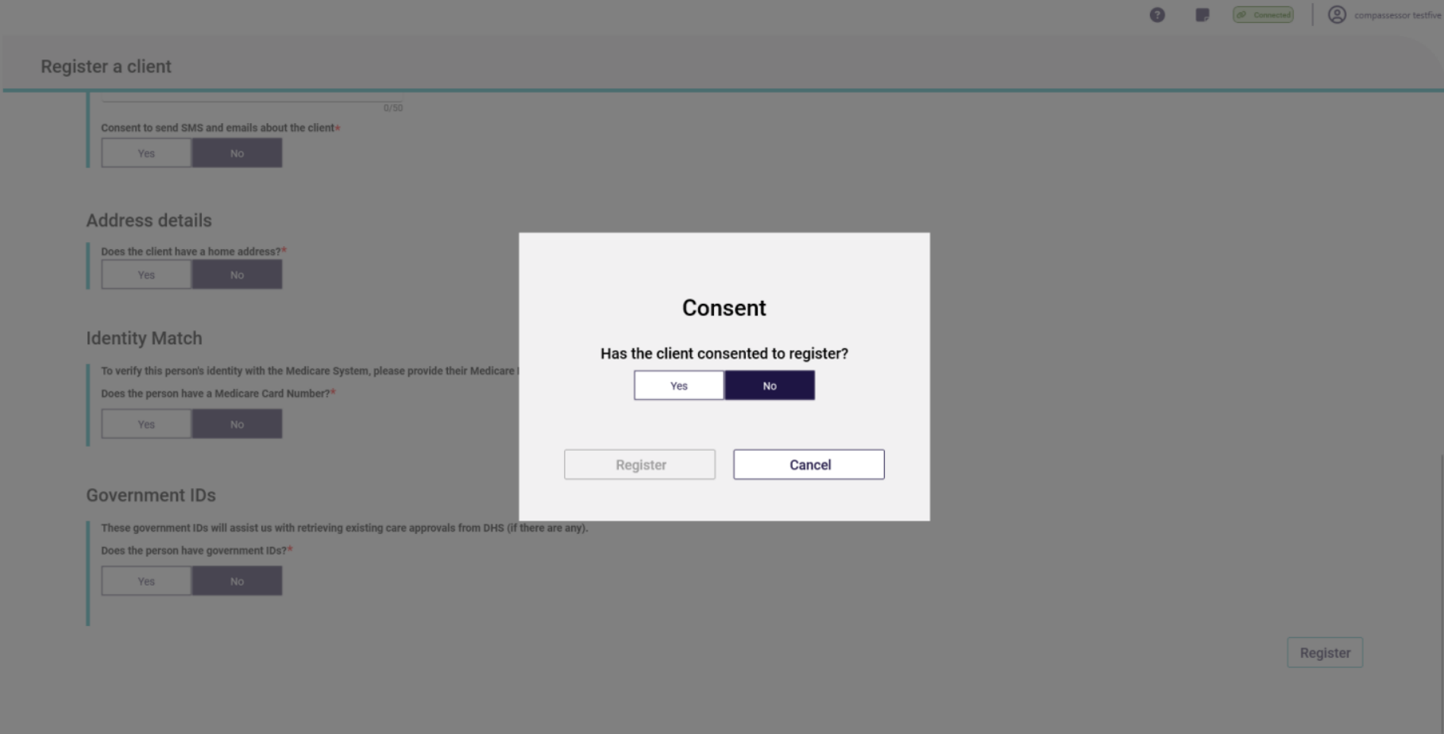
! | The Register button will not be enabled until all mandatory client information has been entered on the Personal details, Address details and Identity Match pages.
If registration is successful, you will be taken to the Client details page.
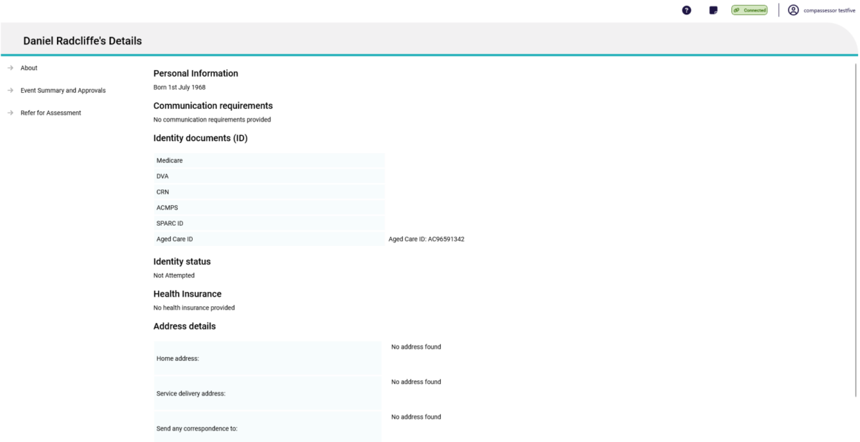

Potential Duplicates
While you are entering client information prior to registration, the App will check for any potential duplicates.
Select Review duplicate clients to view the possible matching client records.
! | If there are any potential duplicate matches found, you will be required to view these records prior to registering the new client to avoid creating a duplicate client record in My Aged Care.
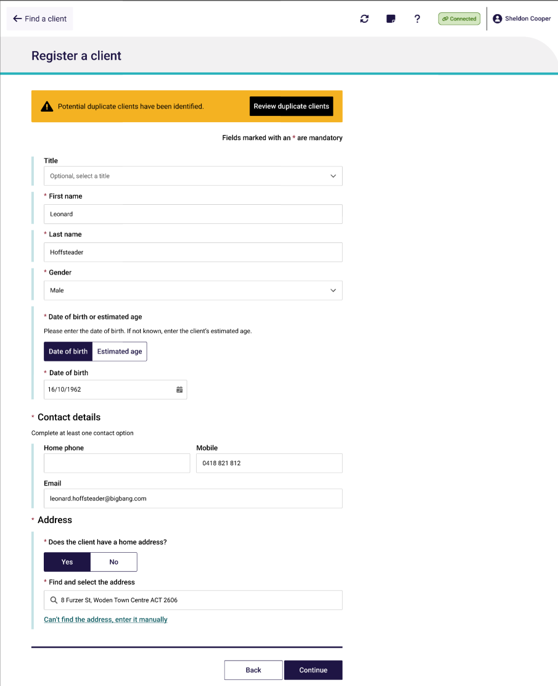

The list of potential duplicate matches will be displayed on the left side of the screen in list view (see screenshot below). Select each record to see a visual comparison of client details against the client record being registered.
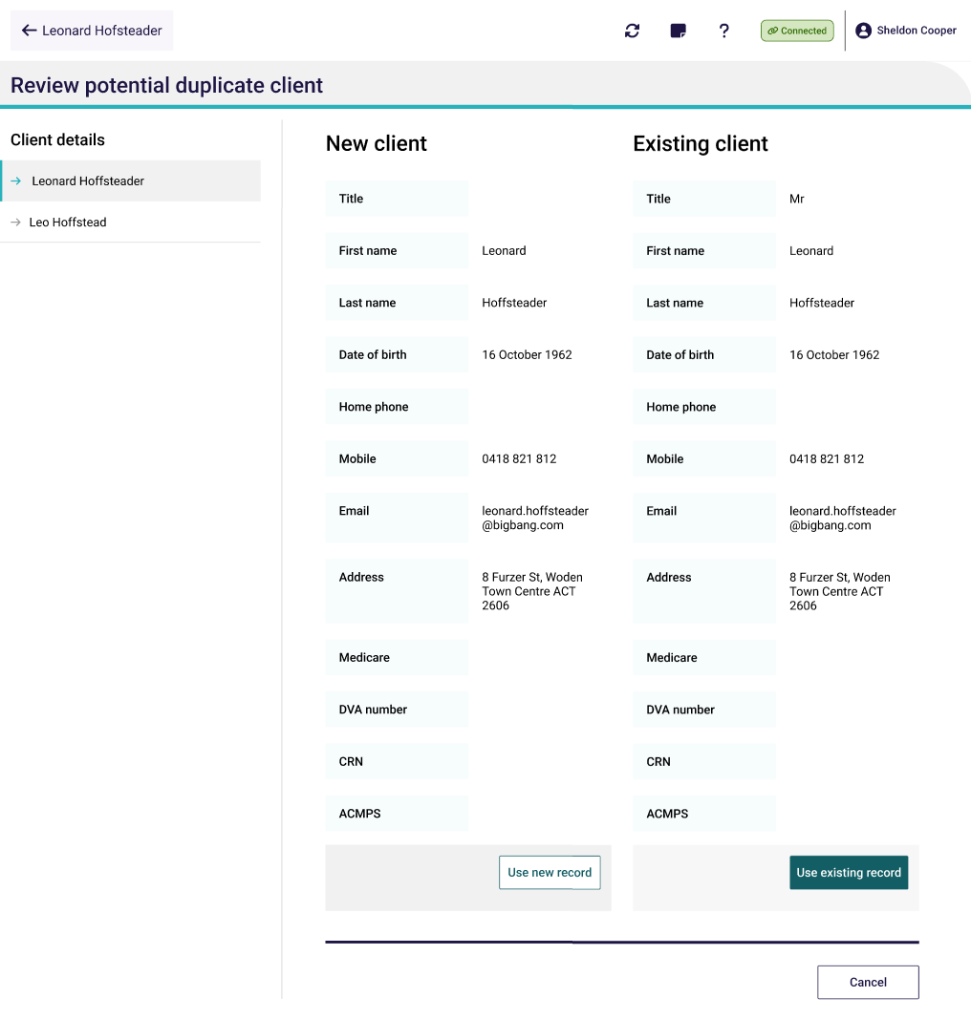
If you choose to Use new record, continue to Self-referring for assessment or facilitate a referral for assessment.
If none of the potential duplicate matches are the client you are registering, select Use the record being registered to complete the registration process.
! | It is important to view any potential duplicate records prior to registering a new client to prevent the creation of duplicate client records in My Aged Care.

Self-referring for assessment
When you self-refer a client for assessment in the App, the client’s referral will be assigned to you. You must be connected to the internet.
! | Needs assessors can only self-refer clients if they are:  - In hospital  - Conducting a remote assessment  - First Nations; or  - Homeless or at risk of  - Vulnerable groups  If the client is not being self-referred for one of these reasons, the Needs assessor must facilitate a referral by contacting the My Aged Care service provider and assessor helpline on 1800 836 799.
- When you have found or registered the client you wish to self-refer for an assessment, select Refer for assessment from the client’s record in the App.
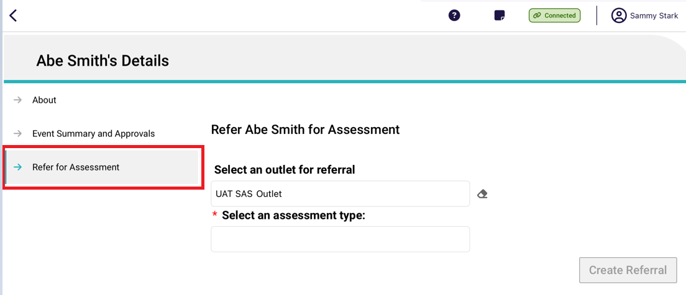
- Select the outlet that the assessment will be associated to (if you are assigned to multiple outlets), and the assessment type. Depending on the assessment type selected additional information may be required such as the assessment setting, priority, assessment date and reason for self-referral. Once all information has been entered select Create referral.
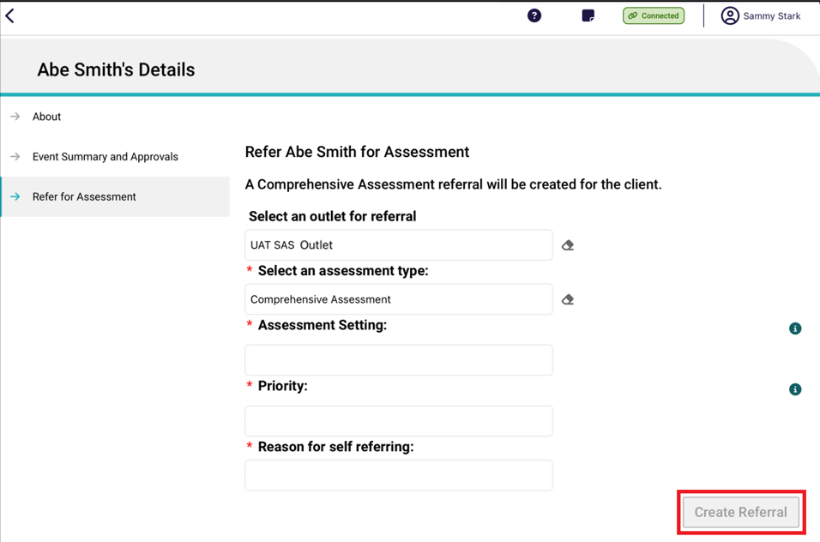
! | If the client is undergoing an assessment, an error message will be displayed, and you will be unable to refer the client for the assessment.
- If the referral is created successfully, you can select Go Back to go to the Dashboard to download the client’s record.
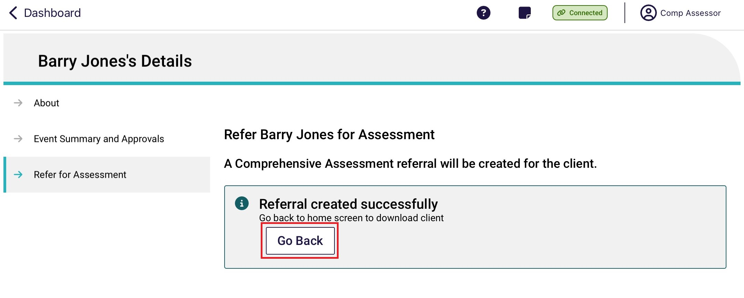

Starting Triage questions with consent for a client using the IAT (Self-Referral)
- Before commencing an assessment, you will be required to gain consent to complete the Triage questions with the client.
- Self-Referrals will require the Triage questions to be completed by a Triage Delegate. If you are not a Triage Delegate, you will be required to have triage supervised by a Triage Delegate.
! | Assessment Organisation Triage Delegates will need to be assigned to the Triage Delegate role in the assessor portal and hold certain qualifications and certifications. For more information regarding assigning a Triage Delegate role please refer to My Aged Care Assessor Portal User Guide 12 – Managing Delegate Roles.
- Please note that if there appears to be a record of the client completing the triage or screening questions previously, you can use the ‘pre-populate’ feature to use the basis of the triage
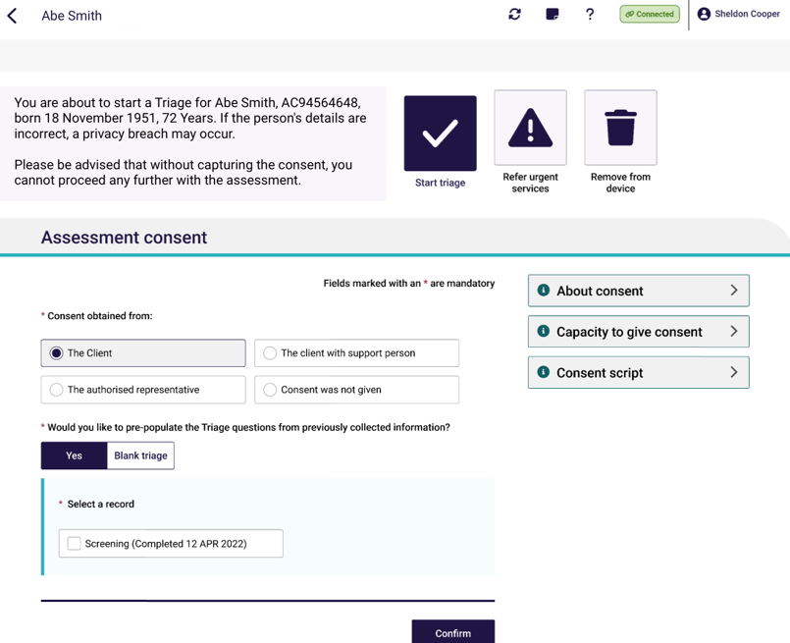
- If during the triage process, the client does not provide consent to proceed, you should record this in the Why was consent not provided? section.
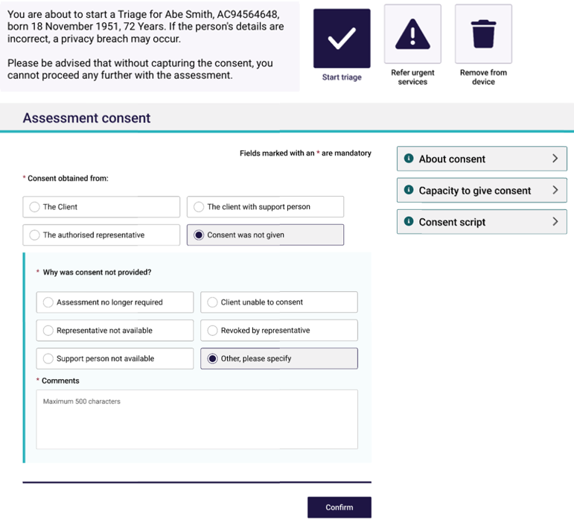

- You will also need to confirm that you have confirmed with the client that if consent is not provided, that the assessment will not be continued and that the assessment referral will be rejected.

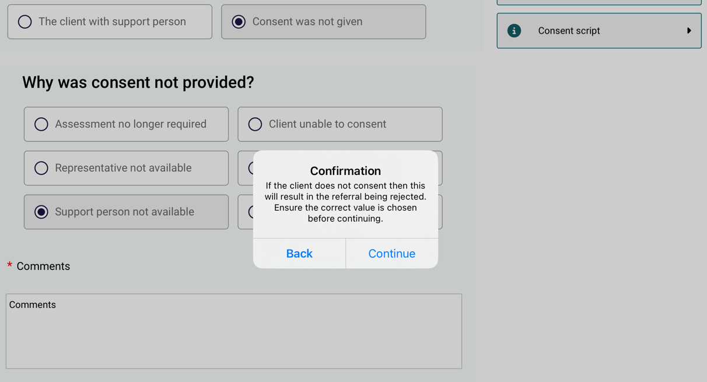

9.6 Commence Triage questions with client (Self-Referral)
To complete the Triage stage, select Assessment. Complete the triage questions based on the information provided to you by the client.
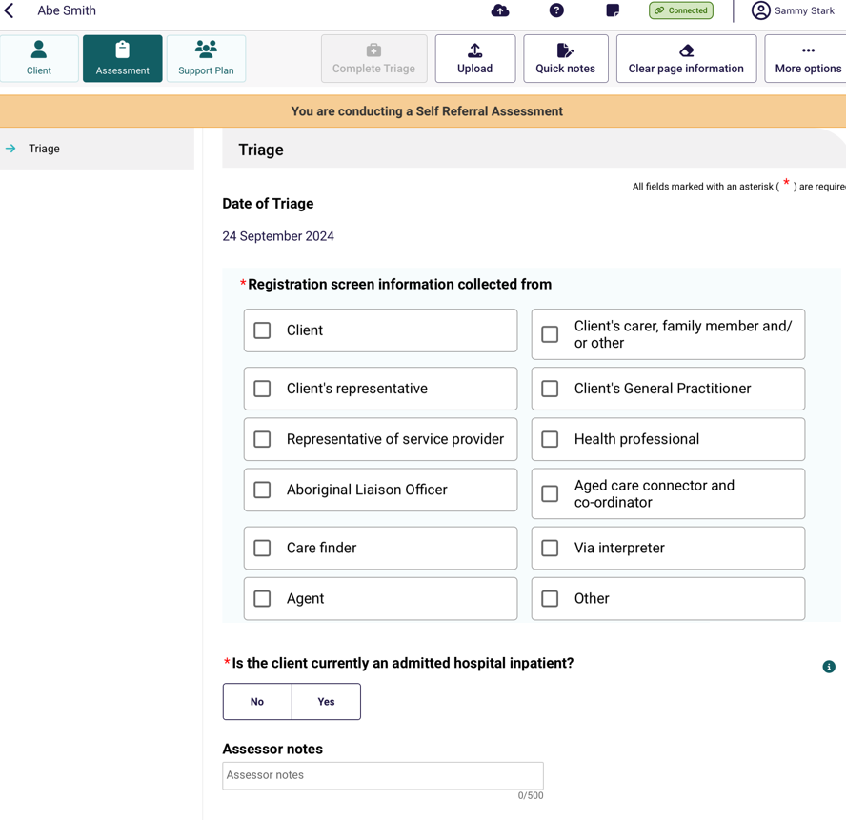
- If you do not hold a Triage Delegate role, enter the details of the Triage Delegate who supervised you to complete triage.
Then select Complete Triage.
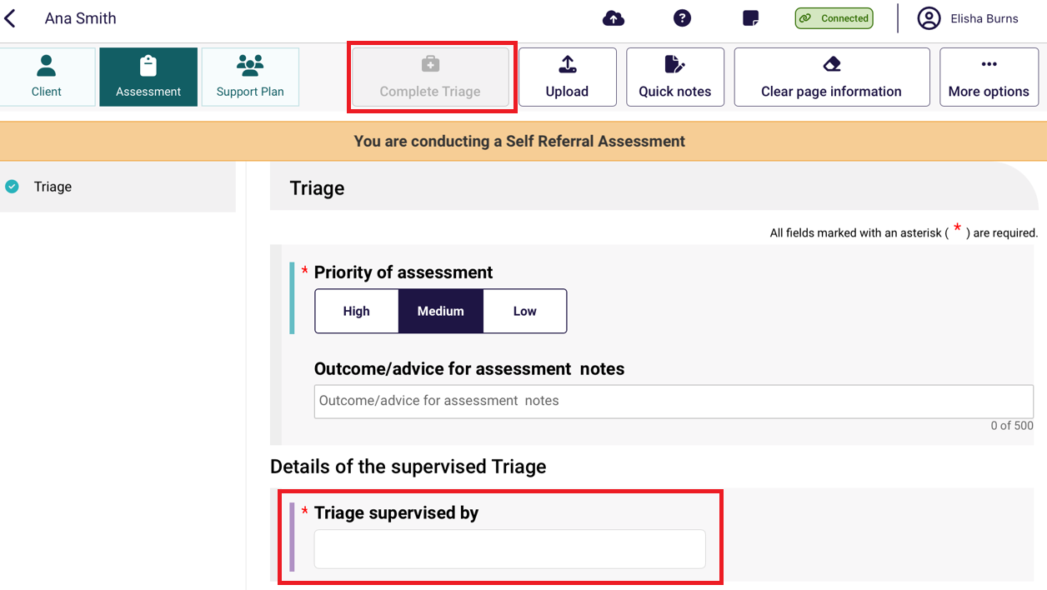

9.7 Recommend urgent services before completing Triage
Before commencing the Triage questions, you will have the option to refer the client for urgent services before you can recommend for CHSP services if required.
- To do this, select the Refer urgent services on the assessment window.

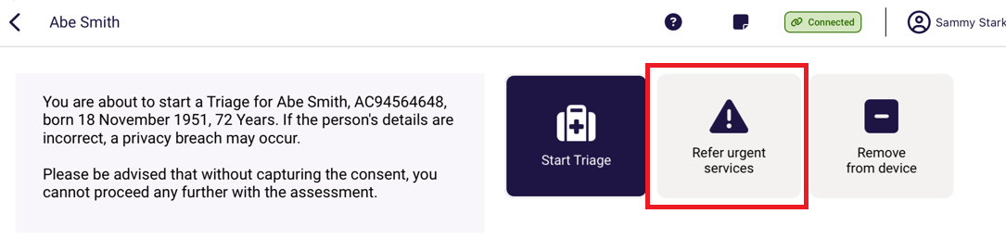
- Once you have clicked this, you will be asked to Confirm that you are wanting to proceed to refer the client for urgent services without progressing an assessment. Please note that you can start and complete the triage questions later.
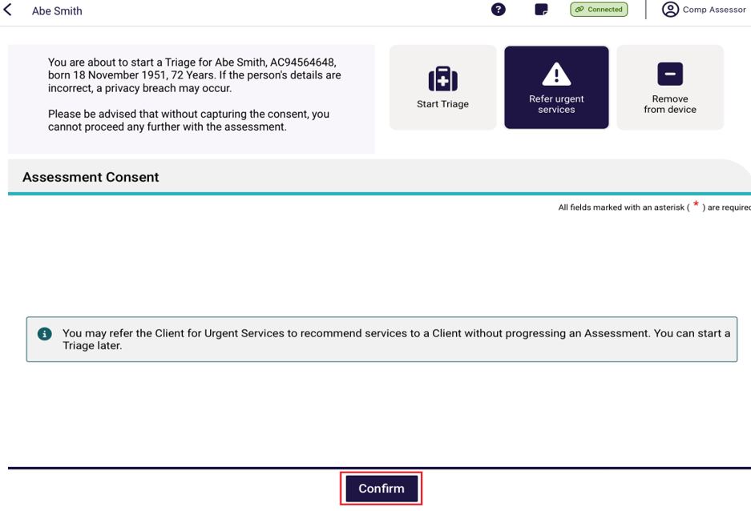
- Once you have clicked Confirm, the support plan Other recommendations will appear where you can select + Add a recommendation.

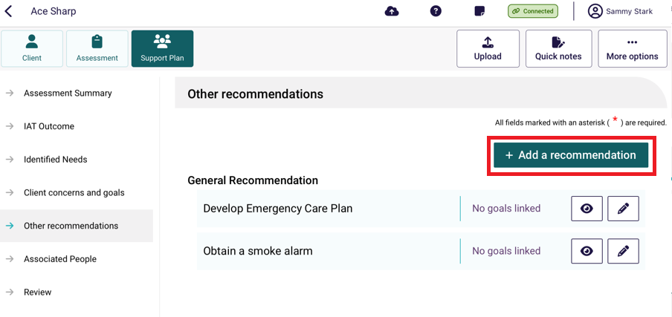

- Click Service Recommendation.
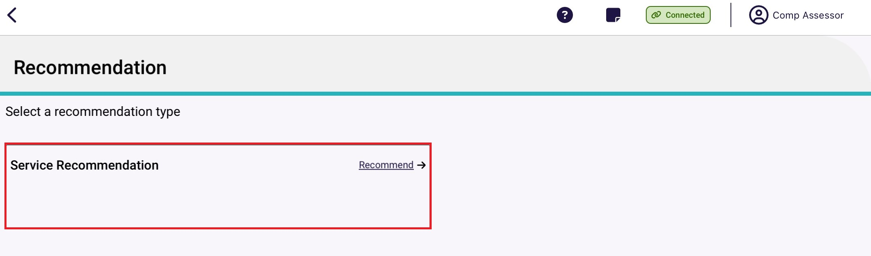
- Select Service type required for urgent services using the list displayed.
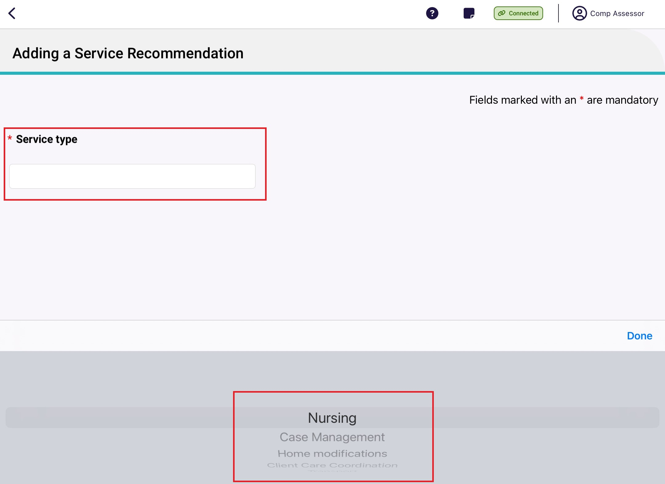

- Complete all mandatory fields for the service recommendation, including:
  - Service type
  - Priority
  - Recommended a start date
  - Recommend a review date
  - Recommend an end date

- On completion of all mandatory fields, select Save.
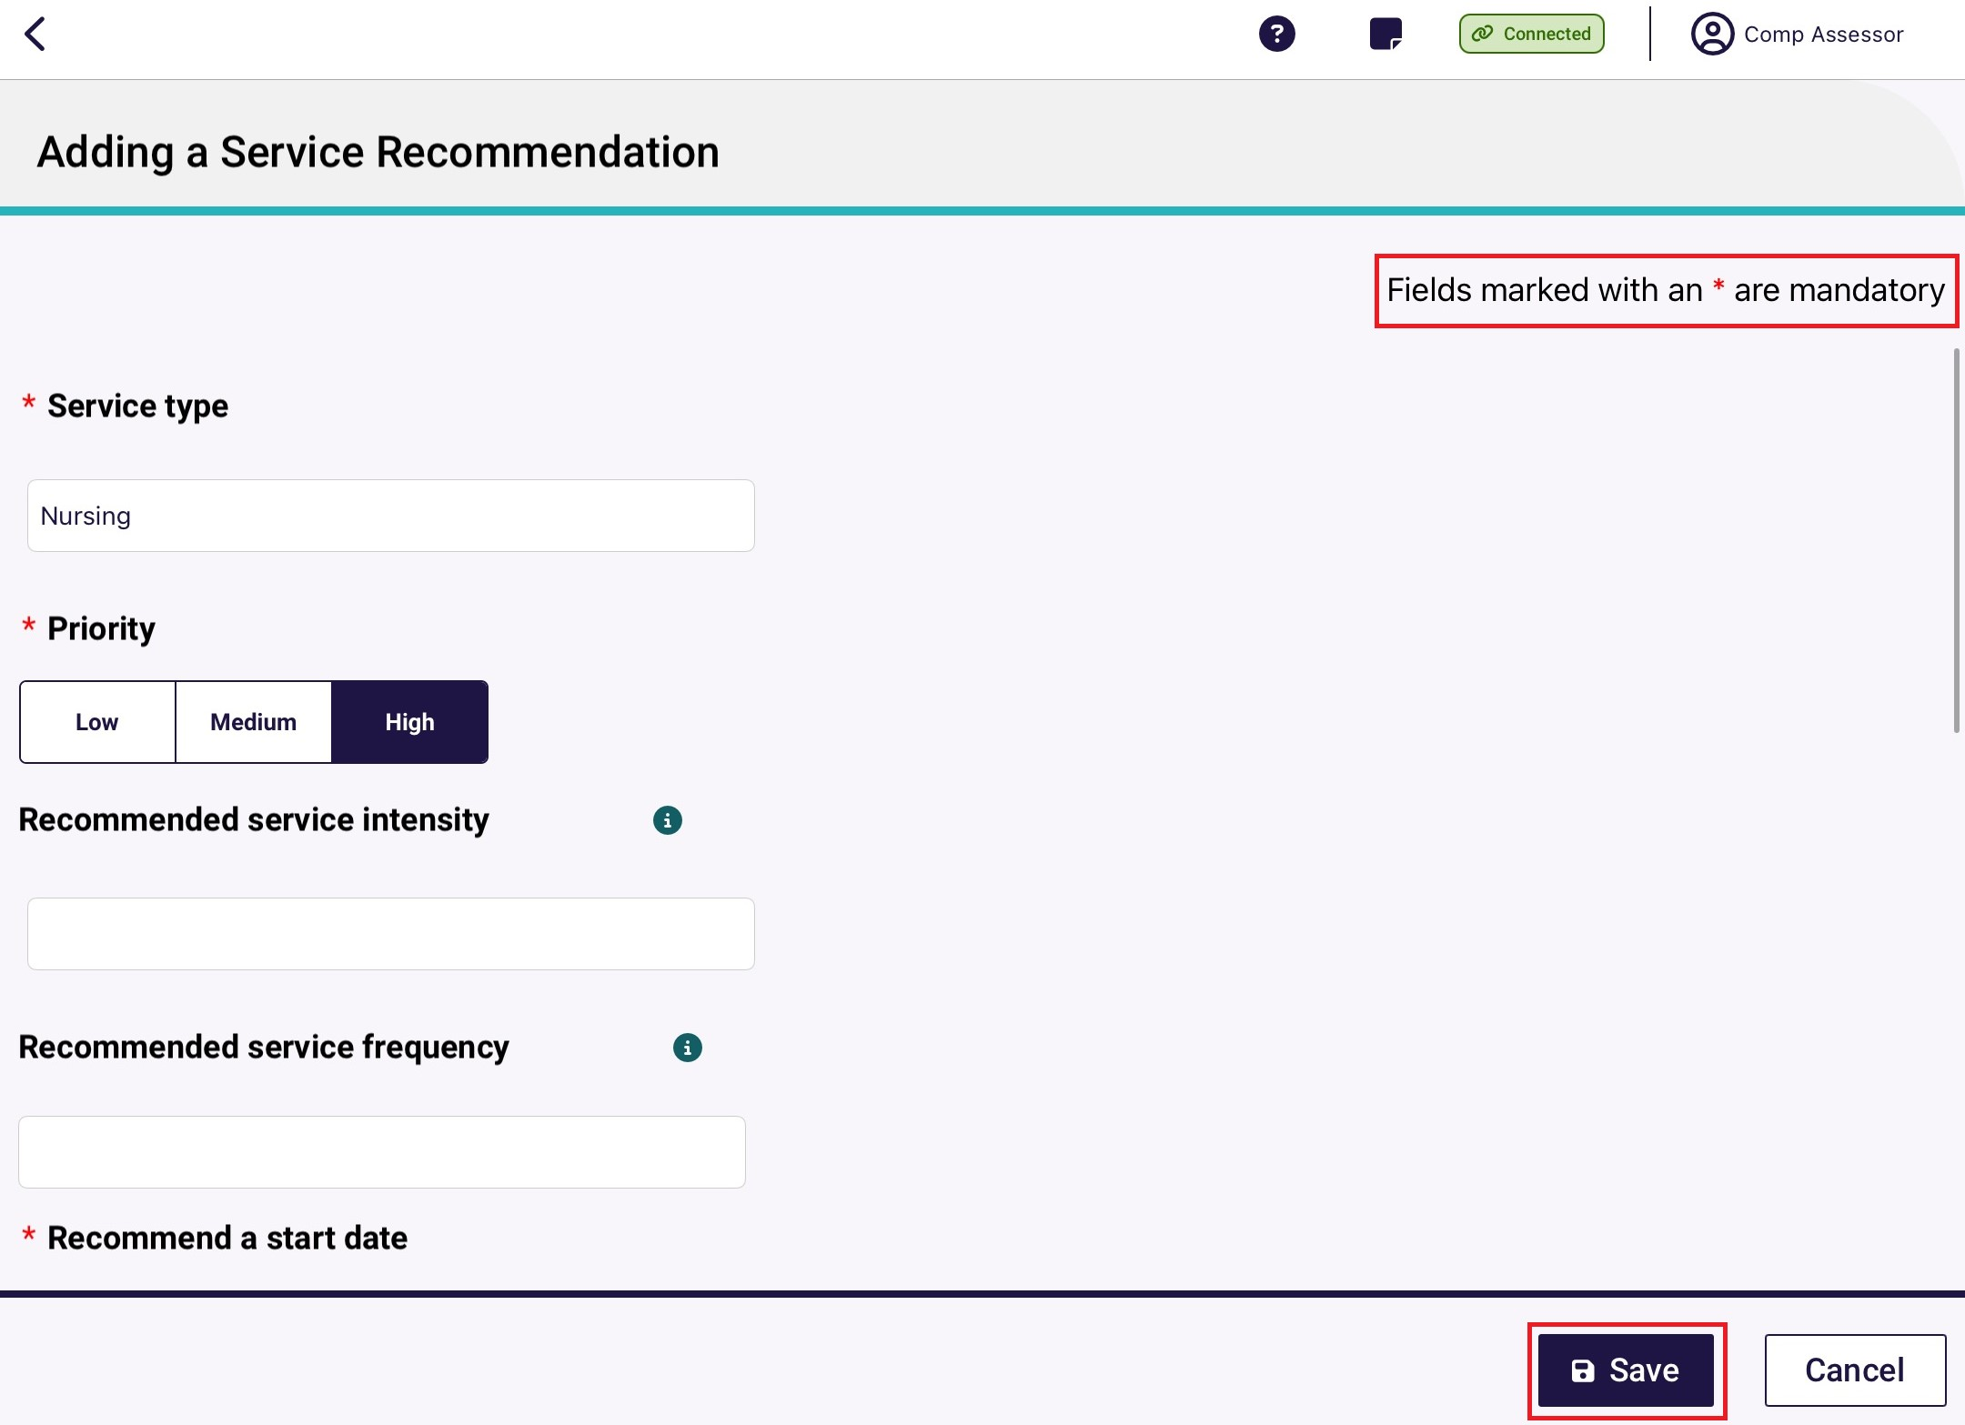

Converting assessments after completing Triage
After triage has been completed, needs assessors will have the ability to convert a home support assessment recommendation to a comprehensive assessment if it is in their expert opinion that the client requires it based on the information provided during triage.
- After completing triage select Convert to Comprehensive.
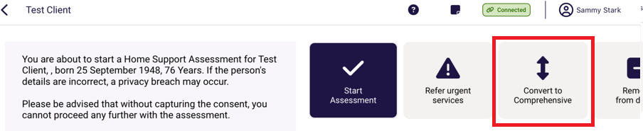

- The reason for change will be pre-filled to High level car needs. Enter additional information regarding the reason in the Reason or comments field and then select Confirm.
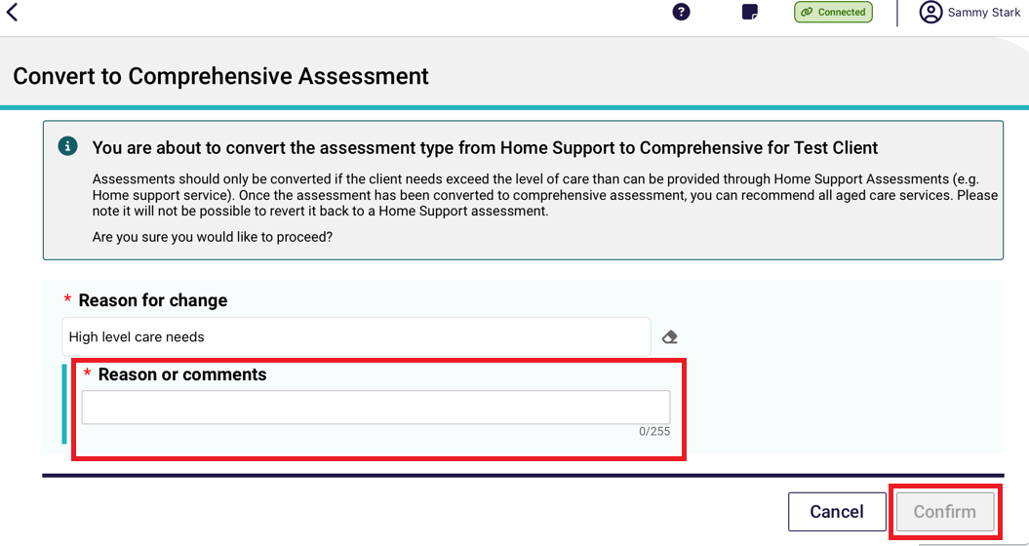
- The assessment will then be converted to a comprehensive assessment.

Referrals, reviews and creating an offline client for assessment
Client referrals can be downloaded for all referrals that have been assigned to you in the assessor portal. When downloaded to your device, the assessment, client profile, notes tab and attachments tab will pre-populate with information collected during screening and previous assessments (if applicable).
Similarly, client reviews can be downloaded for all reviews that have been assigned to you.
An internet connection is needed to download client referrals and reviews to a compatible device. The App can store up to 50 clients at any one time.
You can also create and save an offline client to your device whilst offline and conduct an assessment and commence a support plan. However, you will require an internet connection to conduct a review.
Once re-connected to the internet, the offline client can be registered or linked to an existing client, prior to uploading the assessment and support plan information to the assessor portal.
! | When you download a client’s referral or review to your device, the client record and the assessment will be locked in the assessor portal and remain locked until you Upload the assessment or review, or if you remove the referral/review from your device.  Referrals and reviews can be removed via the App or the assessor portal.

Any client referrals and reviews that are downloaded to your device will appear in the App section of the assessor portal, under Downloaded Referrals.
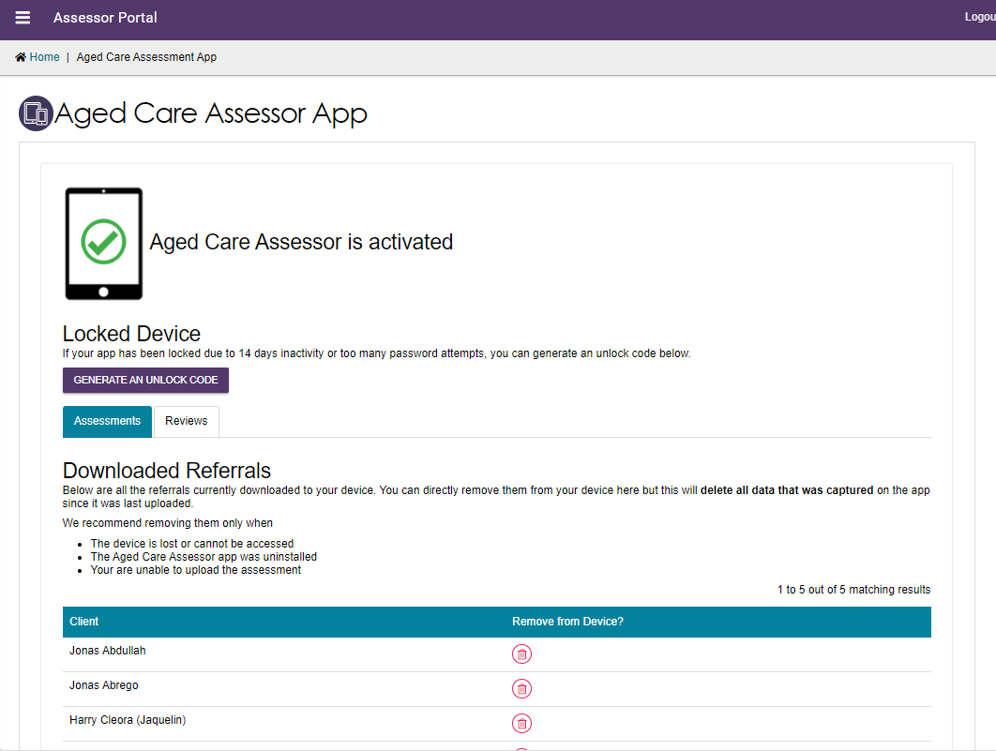
! | A person with the Team Leader role in the assessor portal can reassign client referrals that have been downloaded.  If a downloaded referral is reassigned to another assessor, any data entered on the device whilst offline will not be able to be uploaded and will be discarded by the App. To retain data entered offline, it is advised to upload the assessment to the assessor portal prior to re-assigning the referral.  Needs assessors will also receive a notification in the assessor portal informing them when a downloaded referral has been re-assigned to another assessor.

Navigating between referrals and reviews
The App’s dashboard will display your assessment outlet/s referrals and their statuses:
- Triage
- Urgent Services
- Not started
- In progress
- Review

To navigate between each view, use the side menu.
- After logging in to the app, the Dashboard page will be displayed. Select the outlet to open and view your referrals.
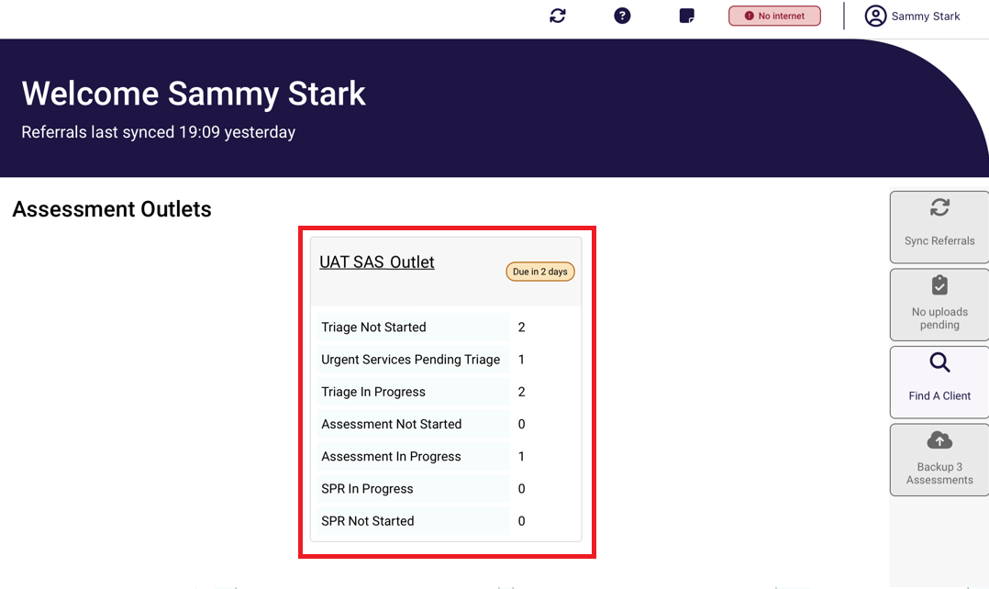
- Once selected, the view will display all referrals.
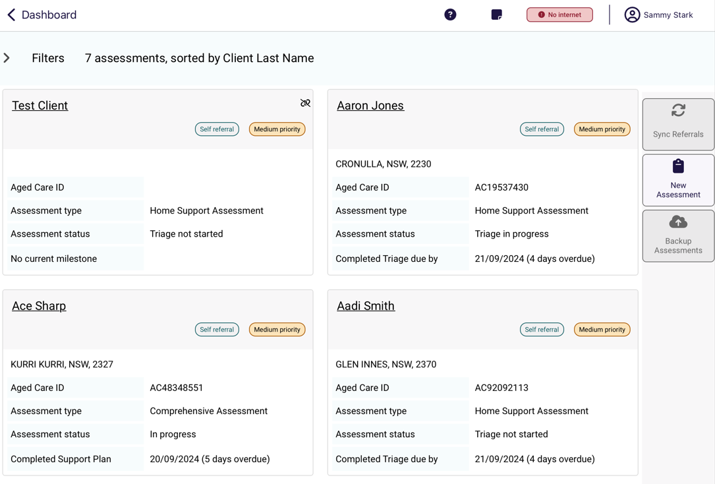

- To filter referrals, select the Filter drop-down. You can filter referrals by:
- Keyword
- Order
- Status
- Priority
- Assessment type
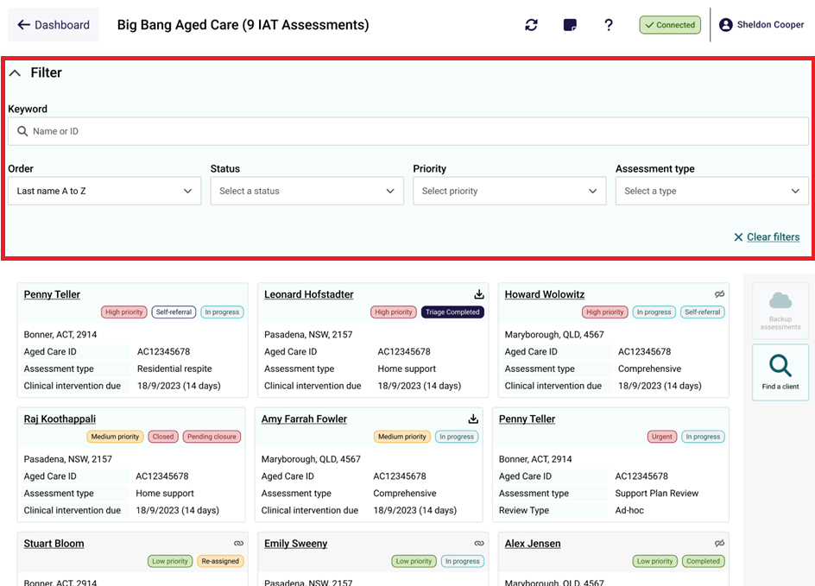

Downloading a client’s referral or review
To download a client’s referral for assessment or support plan review, follow the steps below. You must be connected to the internet.
- Open and log in to the app with your password, following the process in Signing into the App after activation.
The Dashboard page will be displayed. Click on your outlet. In your outlet, client referrals and review cards will appear together in alphabetical order (by last name). Referrals for Comprehensive, Home Support, Residential Respite assessments and Support Plan Reviews can be identified by the referral Assessment type field.
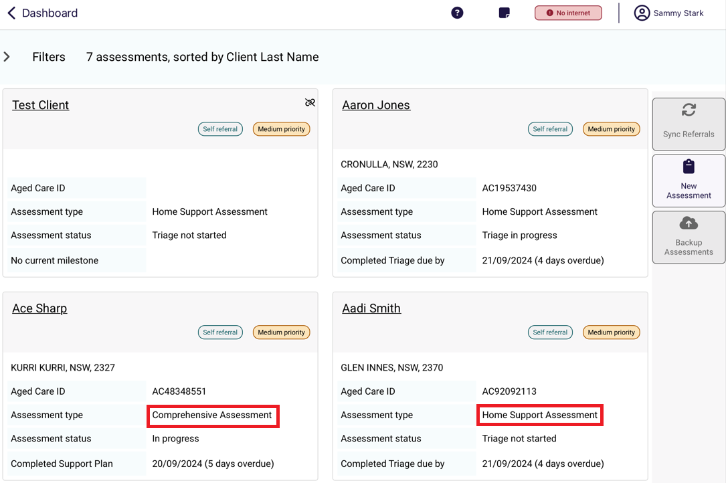
! | The visual indicator on the referral card identifies how a referral is tracking against the next relevant Key Performance Indicator (KPI) milestone (for example - completed support plan or finalised support plan)
To ensure that you are viewing the most up to date list of referrals/reviews assigned to you, select Sync Referrals on the righthand side of the page when you are connected to the internet.
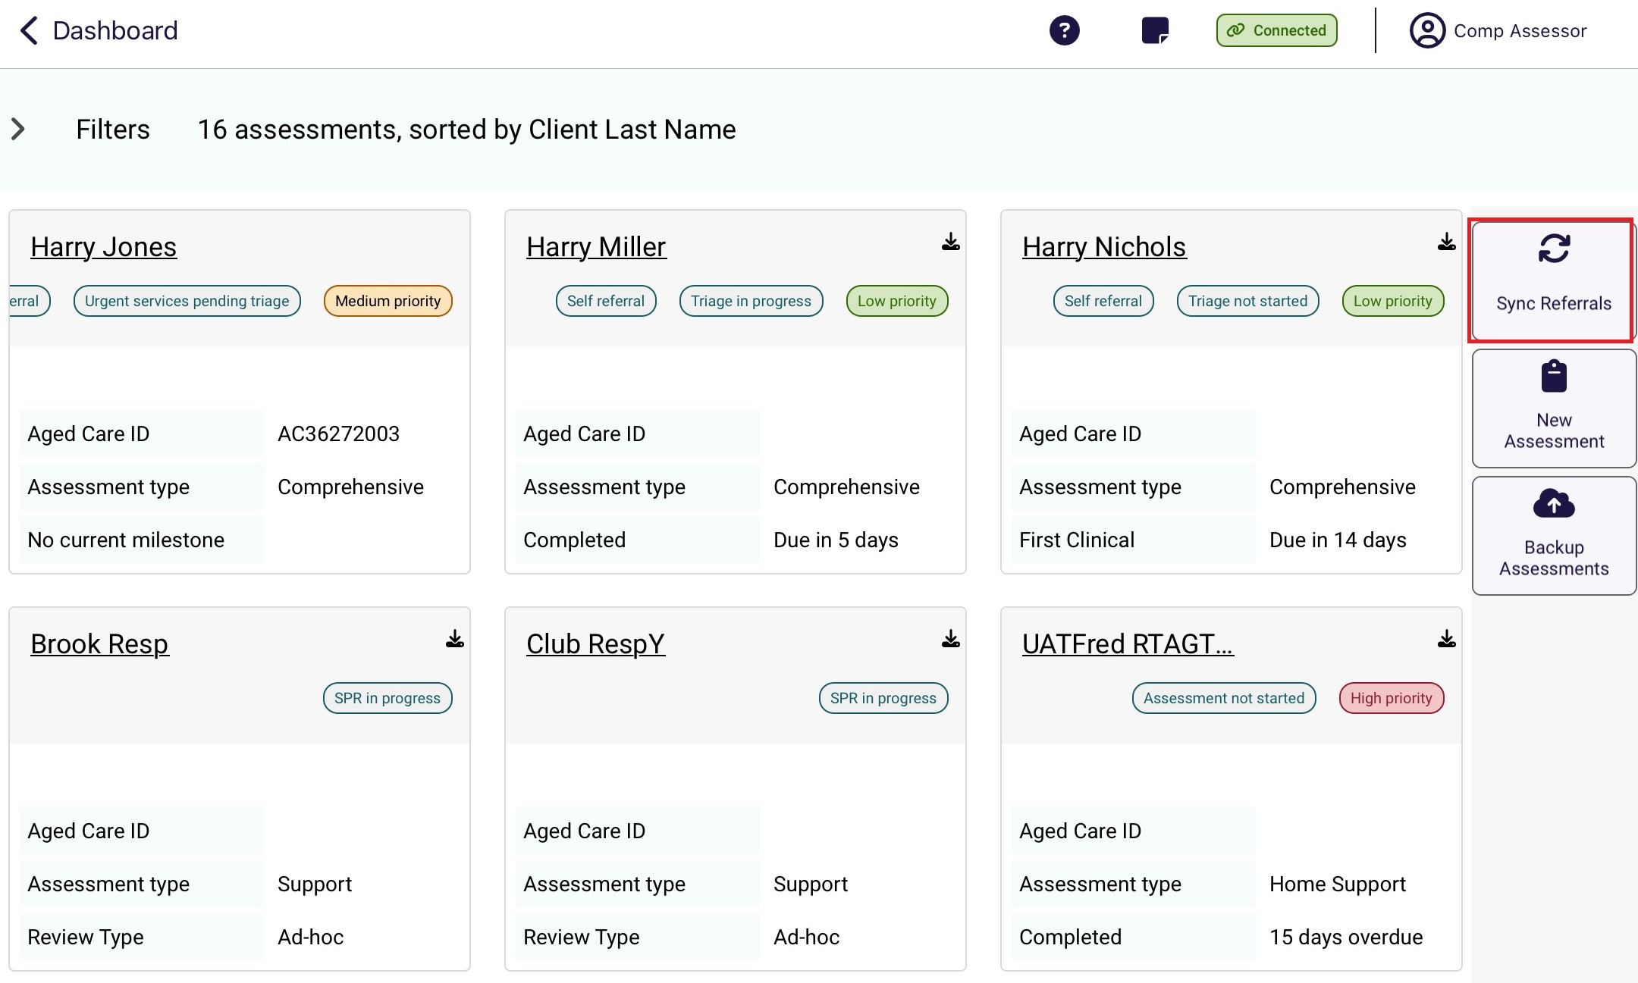
If you cannot see the client’s referral/review card on the Dashboard, speak to your Team Leader to ensure it has been assigned to you.
You can also check connectivity via the App settings to confirm your device is connected to the internet and to Aged Care Gateway server. If you continue to experience issues, call 1800 836 799 for assistance or follow the steps in App troubleshooting and diagnostics to diagnose issues experienced with the App.
- Select the client referral/review card you want to download.
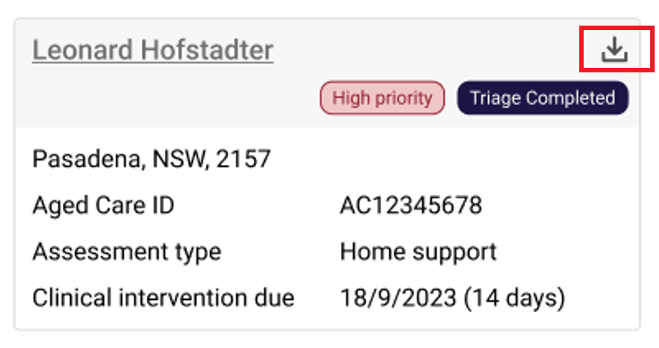

- Once selected, the downloaded assessment will show the progress of downloading this to the device.
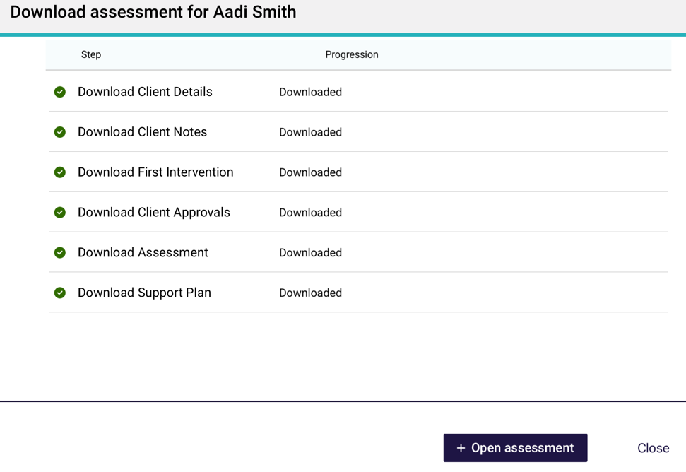
- If the download fails, it will show a status of Failed. It will give you the option to either try again or download it later.
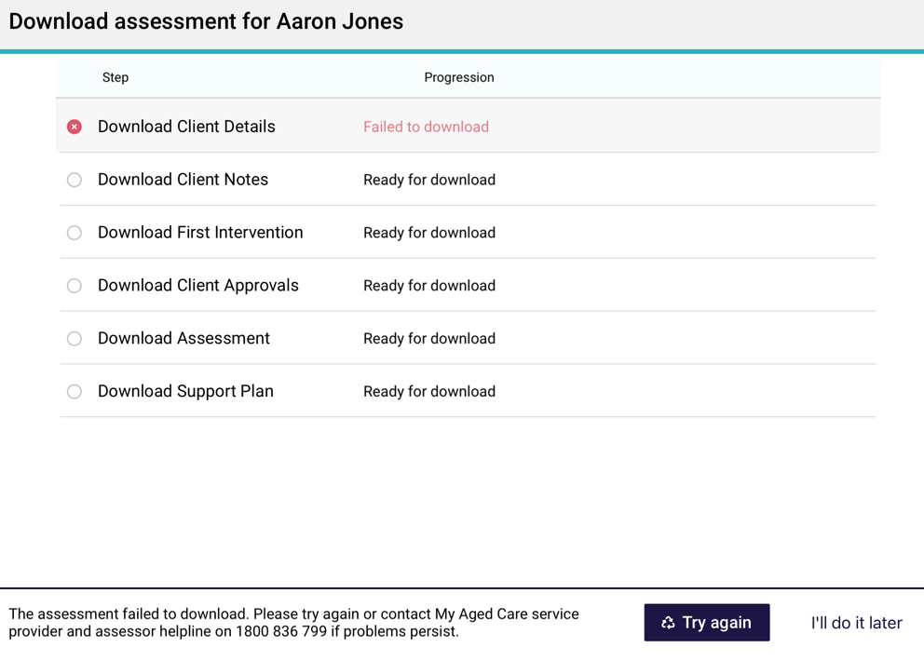

- When downloading referral cards, you will be asked if you want to pre-populate the assessment with the latest assessment or screening information.

On the next screen you will be asked if you would like to pre-populate the IAT questions from previously collected information.
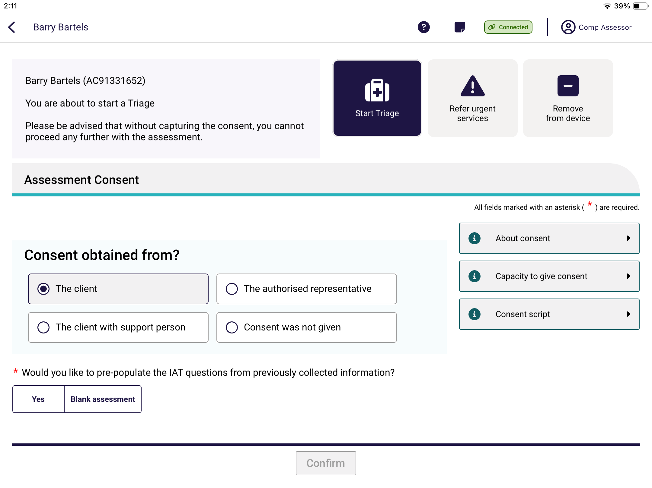
- Select Yes or Blank Assessment. If you select Yes, the assessment form will be populated with the information contained in either the latest assessment or the screening if an assessment has not been captured. You will be able to select which assessment information to use. Once selected, click Confirm.
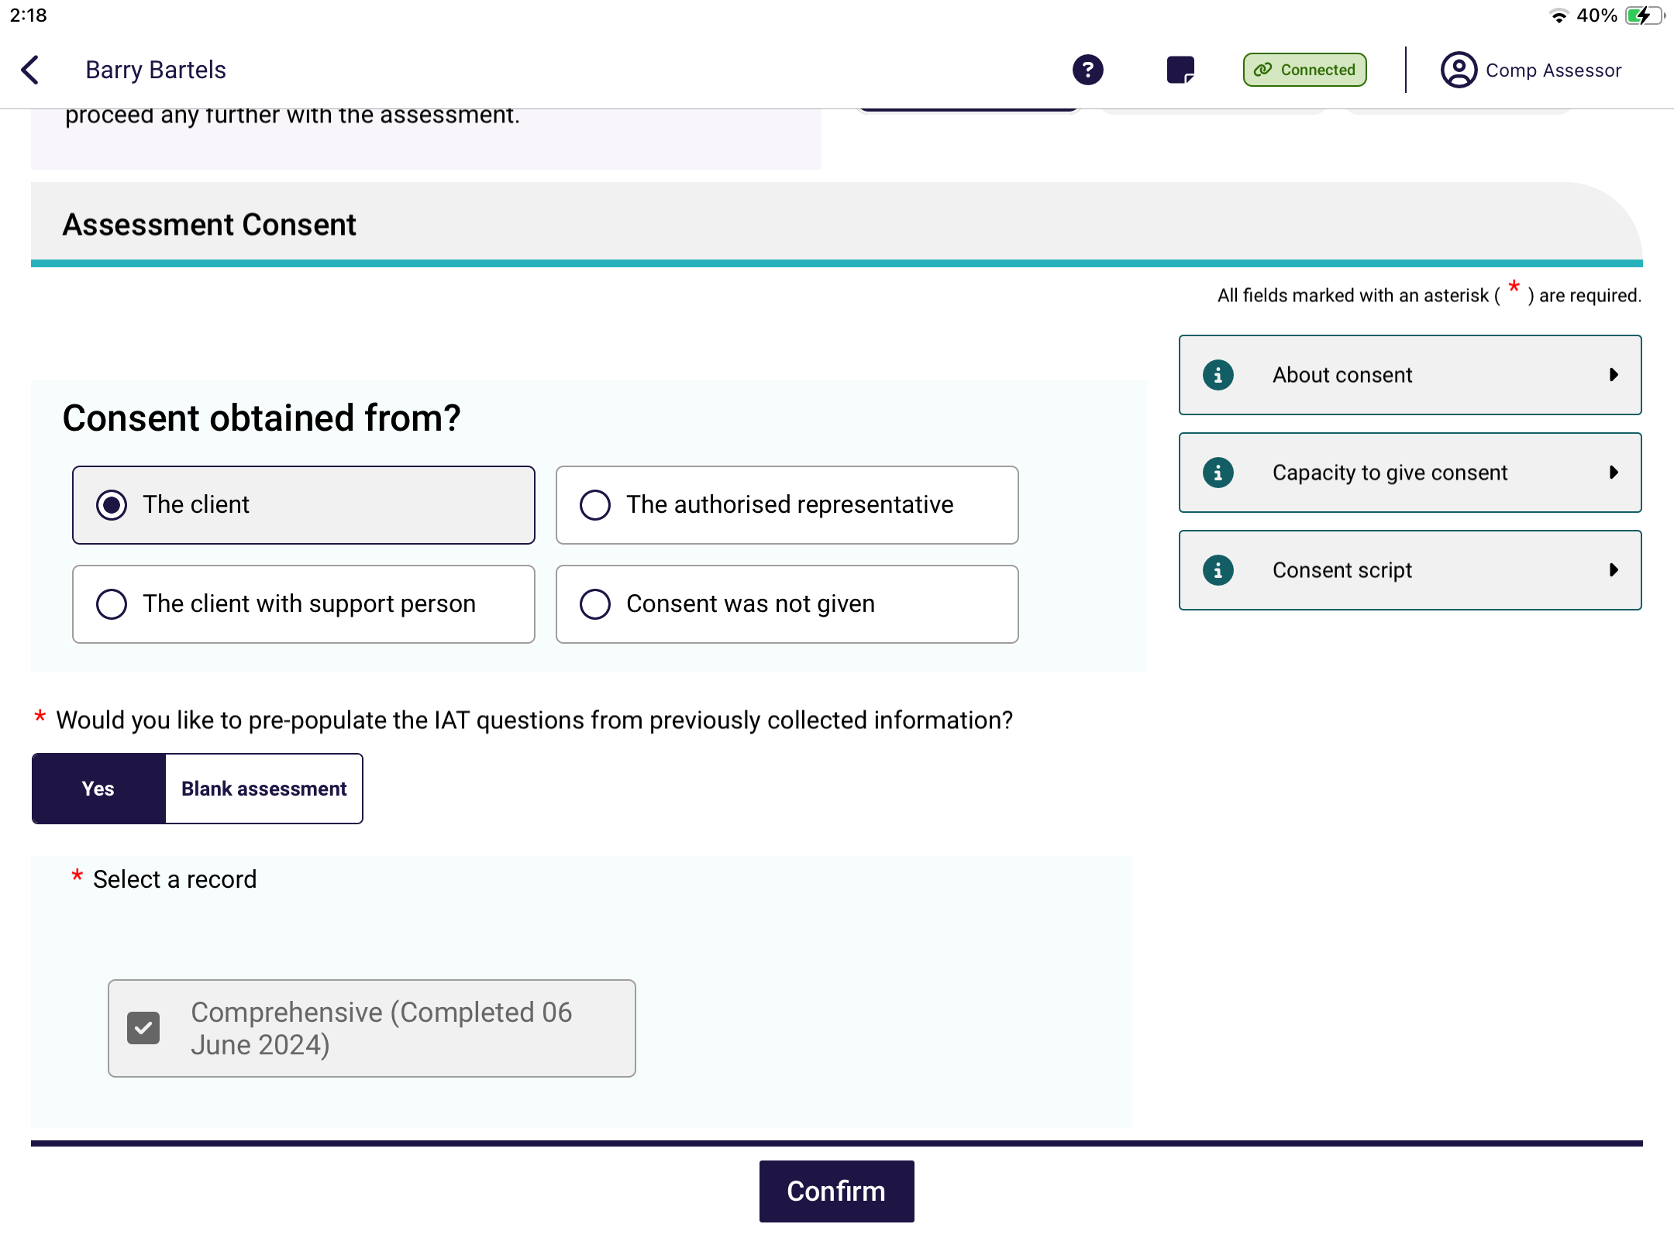
! | A needs assessor only can select whether they would like to start the assessment pre-populated or as a blank assessment once.  A needs assessor will still have the ability to clear page information from within the assessment.
- Once you have clicked on the client referral card a download window will appear. You can view the progress of the download.
When the client’s referral/review has successfully downloaded, the download icon will disappear, and when you click on the name you will have the option to Start triage, Refer urgent services to commence their assessment or review. You will also be able to Remove from device.
You will now be able to:
- view client information (Viewing and adding client information)
- set up support relationships (Registering a support person)
- complete identity verification (Completing identity verification); and either
- conduct triage (Completing Triage questions); and
- conduct the assessment (Undertaking assessments), or
- conduct a review (Conducting support plan reviews).

Creating an offline client
You can complete an offline assessment for a client who is not assigned to you in the assessor portal by creating and saving a client record locally to your device.
This could occur in a variety of circumstances; for instance, you are in a client’s home undertaking an assessment offline and you determine that their partner or someone else living at the same address, who may not be registered with My Aged Care, also requires an assessment.
This function is not available with support plan reviews.
To create an offline client on the App whilst offline, follow the steps below.
! | Where possible, you should always attempt to confirm whether a person is registered with My Aged Care prior to creating an offline client in the App. If a client already has an assessment in progress, you will not be able to refer this client to your outlet and consequently be unable to upload and complete the assessment.  If the client has not been referred to you and does not have an in-progress assessment, and you can:  - Refer this client to yourself in the assessor portal if the reason for the assessment is either In-hospital, remote assessment, First Nations or Homeless or at risk of. This process is described in the Assessor Portal User Guide 1 – Registering and self-referring clients.  - Facilitate a referral for the client to your organisation for a reason outside those listed above by calling the My Aged Care service provider and assessor helpline on 1800 836 799. This must be done before you can upload the assessment to the assessor portal. You can still undertake the assessment offline if no internet connection is available.
- Open and log in to the App with your password, following the Signing in to the App after activation process.
The Dashboard will be displayed with your outlet and the status of referrals in various statuses.
Note the Connectivity indicator on the top right of the screen is showing a orange offline connection icon with a chain, which means the app is disconnected from the internet.
Select Find A client on the righthand side of the Dashboard.
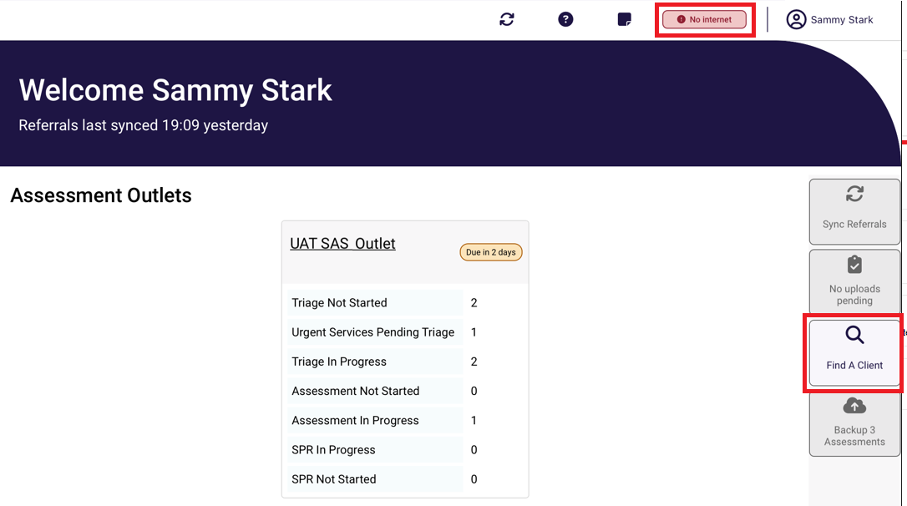
- A message will display notifying you that you are not connected to the internet.
Select Create Offline Client.
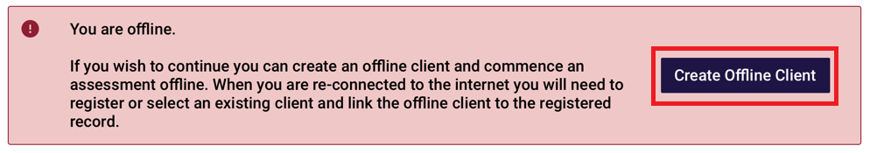
- A blank client record will be displayed. Enter all mandatory client details as indicated by a red asterix, red triangle on the right. Select Save to save the client locally to your device.
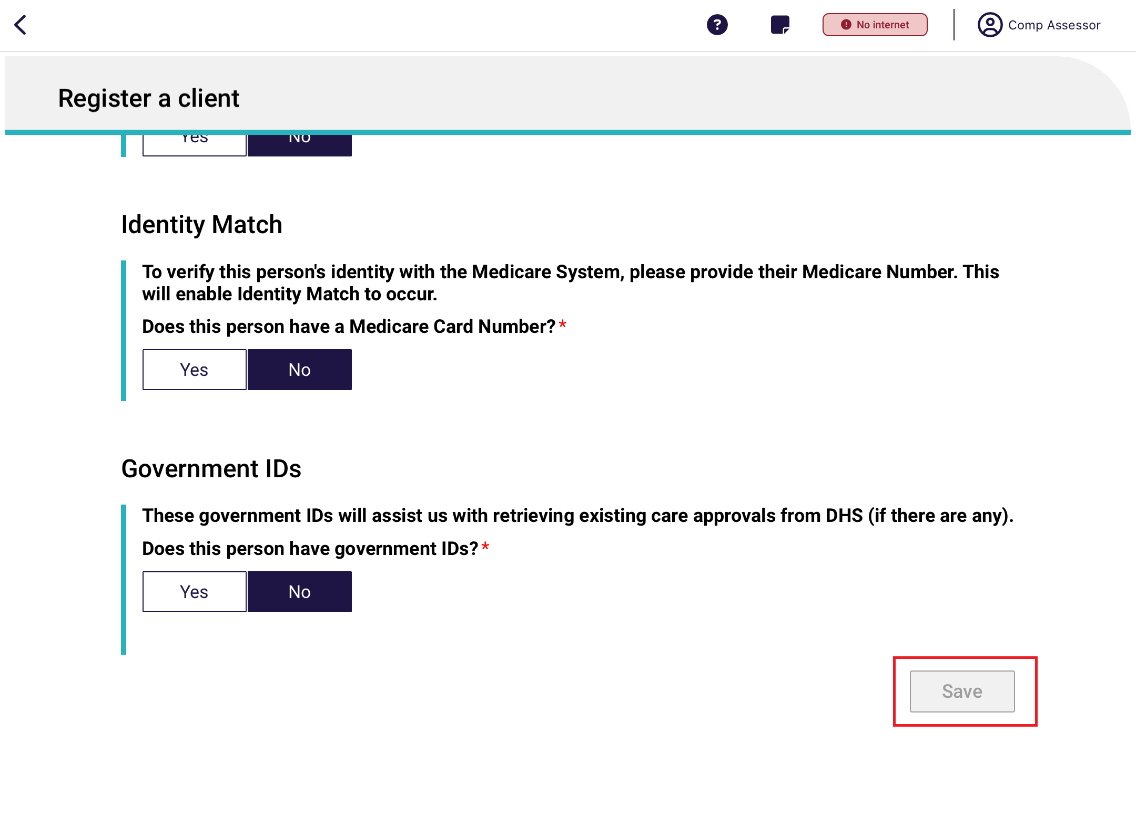
Select an Assessment type for the client from the drop-down menu and the Outlet that you want to assign to complete, then select Save.
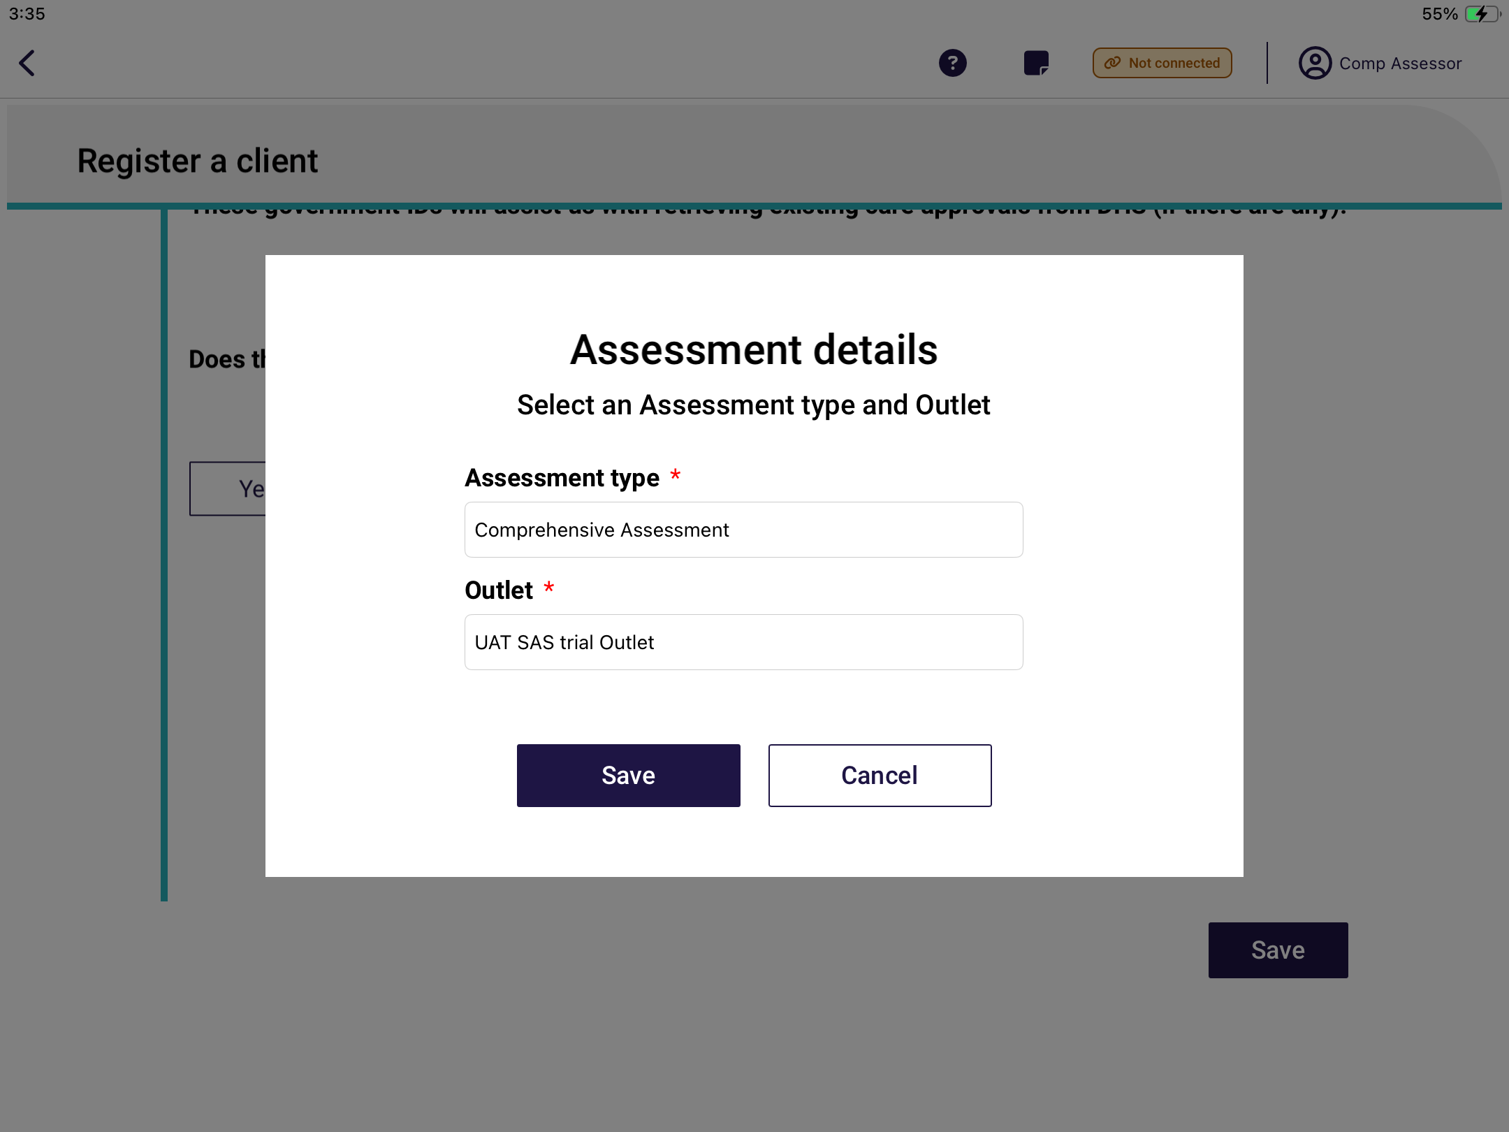
- The offline client’s referral will display on the Dashboard. Click on the Outlet and the client’s record will be displayed. You will now be able to:
- enter additional client profile information (Viewing and adding client information)
- undertake triage (if a Triage Delegate).
- undertake an assessment (Undertaking assessments); and
- commence developing the client’s support plan (Developing a support plan).
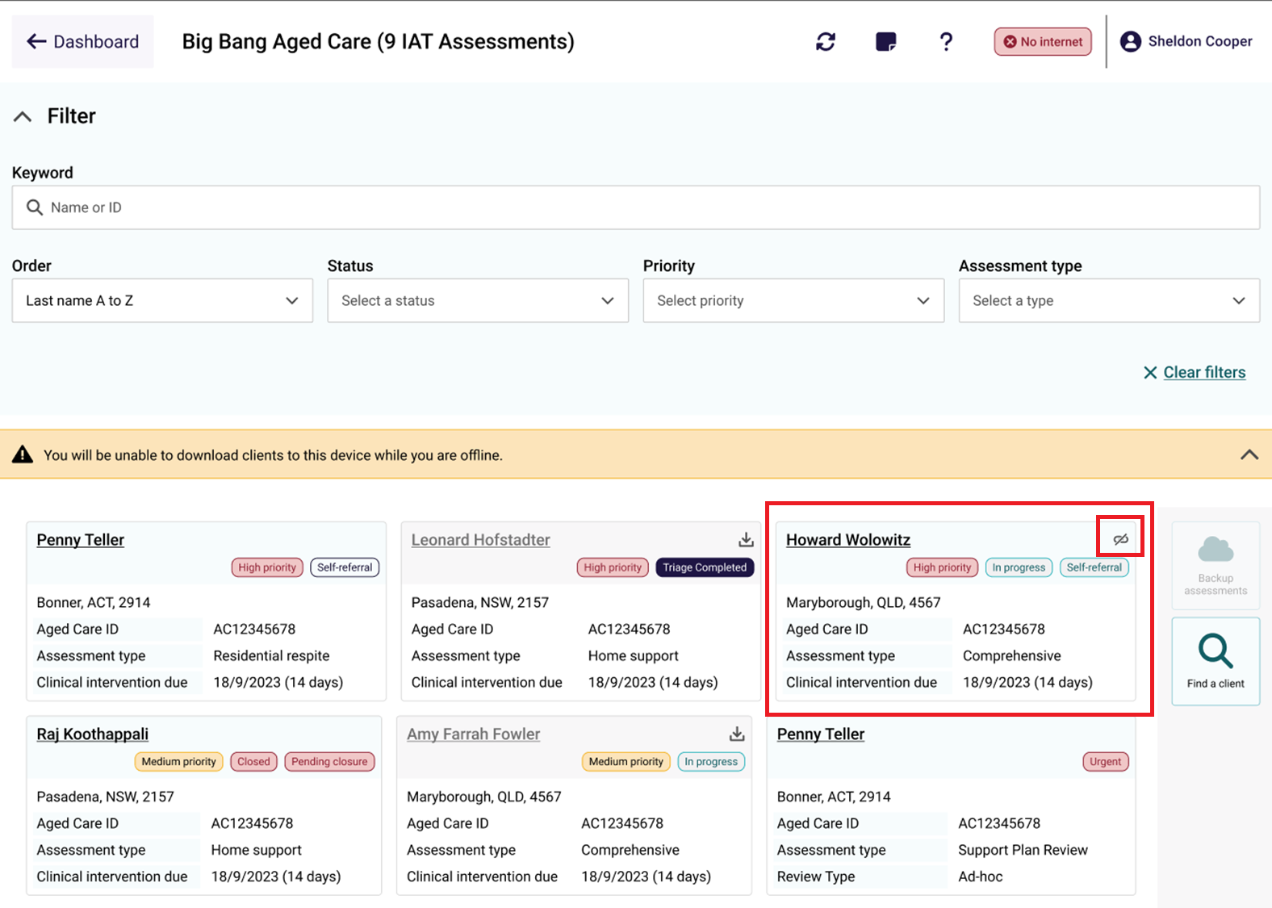

! | Clients created offline will have a visual indicator to identify that they have been created locally to the device.  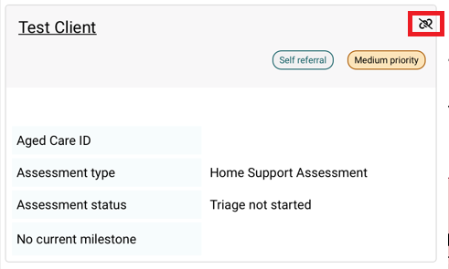

11. Viewing and adding client information
You can view client information previously collected for downloaded assessment referrals, downloaded support plan reviews or offline clients (saved locally to the device using the Creating an offline client process).
To view client information:
- Open and log in to the App, following the Signing in to the App after activation process.
- The dashboard page will be displayed, click on your outlet. Once in the outlet, click on the client’s name in the client card to navigate to the client’s details.
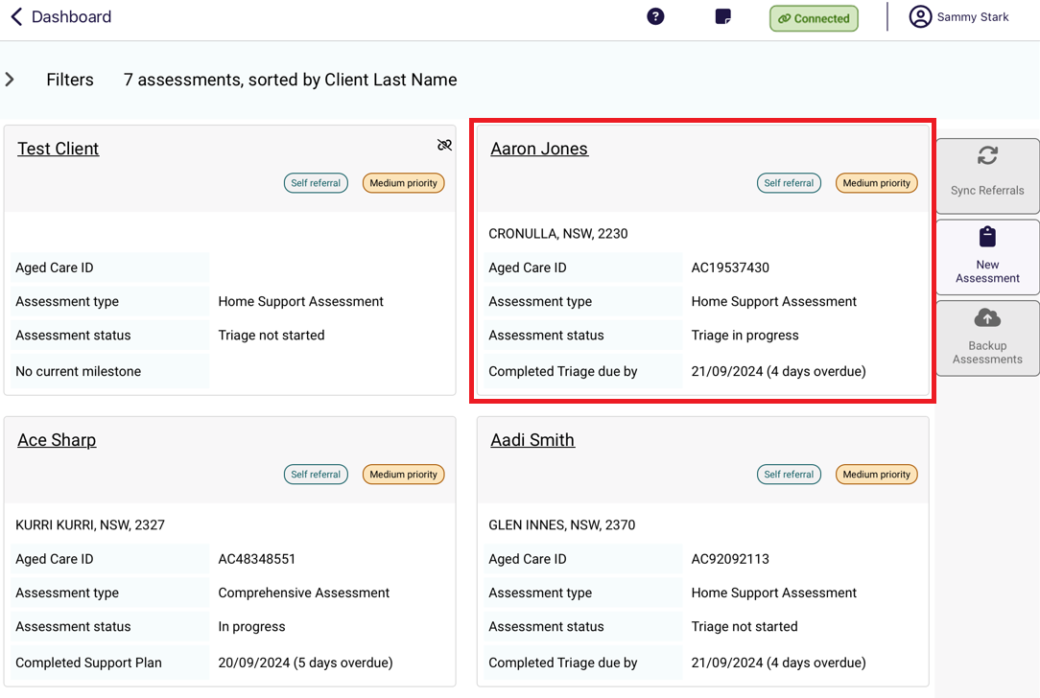
- The Client Profile page will be displayed.
Alternatively, you can access client details within the client’s assessment or review by selecting the client link at the top left corner of the page.
You can toggle between the client, assessment and support plan without losing any information.

! | The following screenshots are from a downloaded assessment referral. The client information is the same when in a downloaded support plan review.
The Client profile page contains information from the client record including:
- Personal information (Name, date of birth, etc.)
- Communication requirements
- Identity documents
- Identity status
- Health Insurance

! | Client profile information can be edited from this section. Any information that is updated from the App will overwrite the profile information that is in the client record when uploaded to the assessor portal.
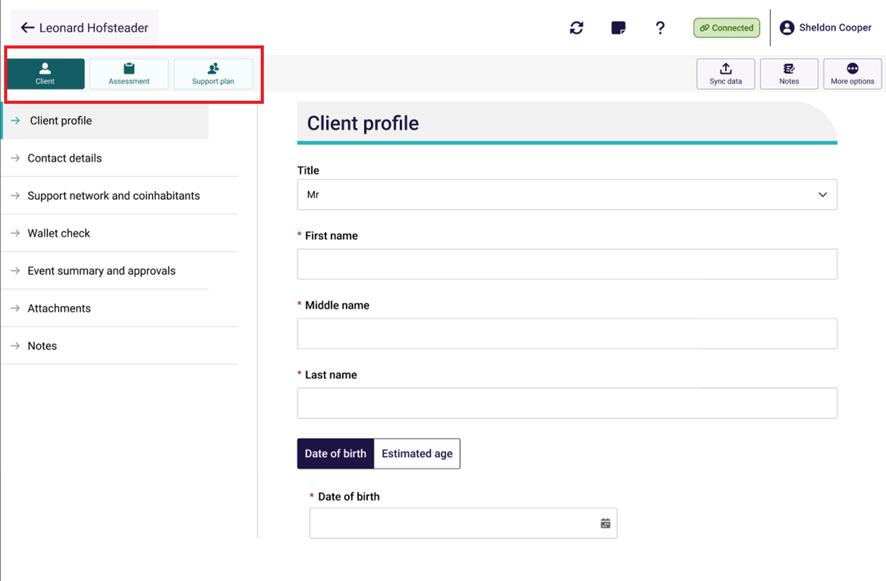
! | When all mandatory client profile information has been completed, a tick will appear next to the section. This information must be completed to generate assessment outcomes at the completion of the assessment.  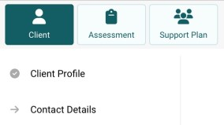
The Contact details page displays the client’s contact information, mobile and home numbers, email address, perefered contact method and address details.
Needs ssessors can add and/or edit contact infromation and configure notification preference (SMS and/email) in the Contact details section.
To prompt SMS notifications for a client and their support network or representative, follow the steps below.
- Obtain Consent to send SMS and email about the client, then add mobile phone number.
Select the Verify button. This will send a six digit code to the recipient’s mobile number.
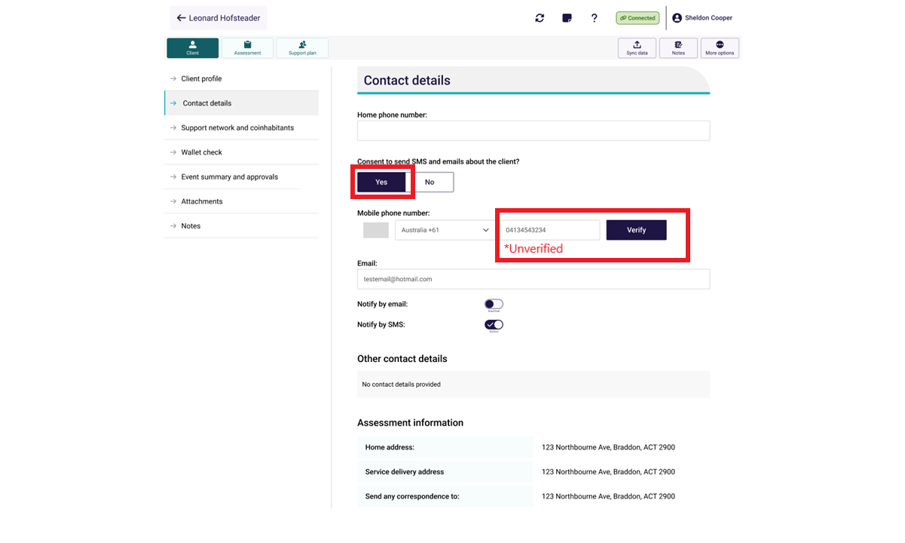
- Enter the six digit code and select Confirm code.
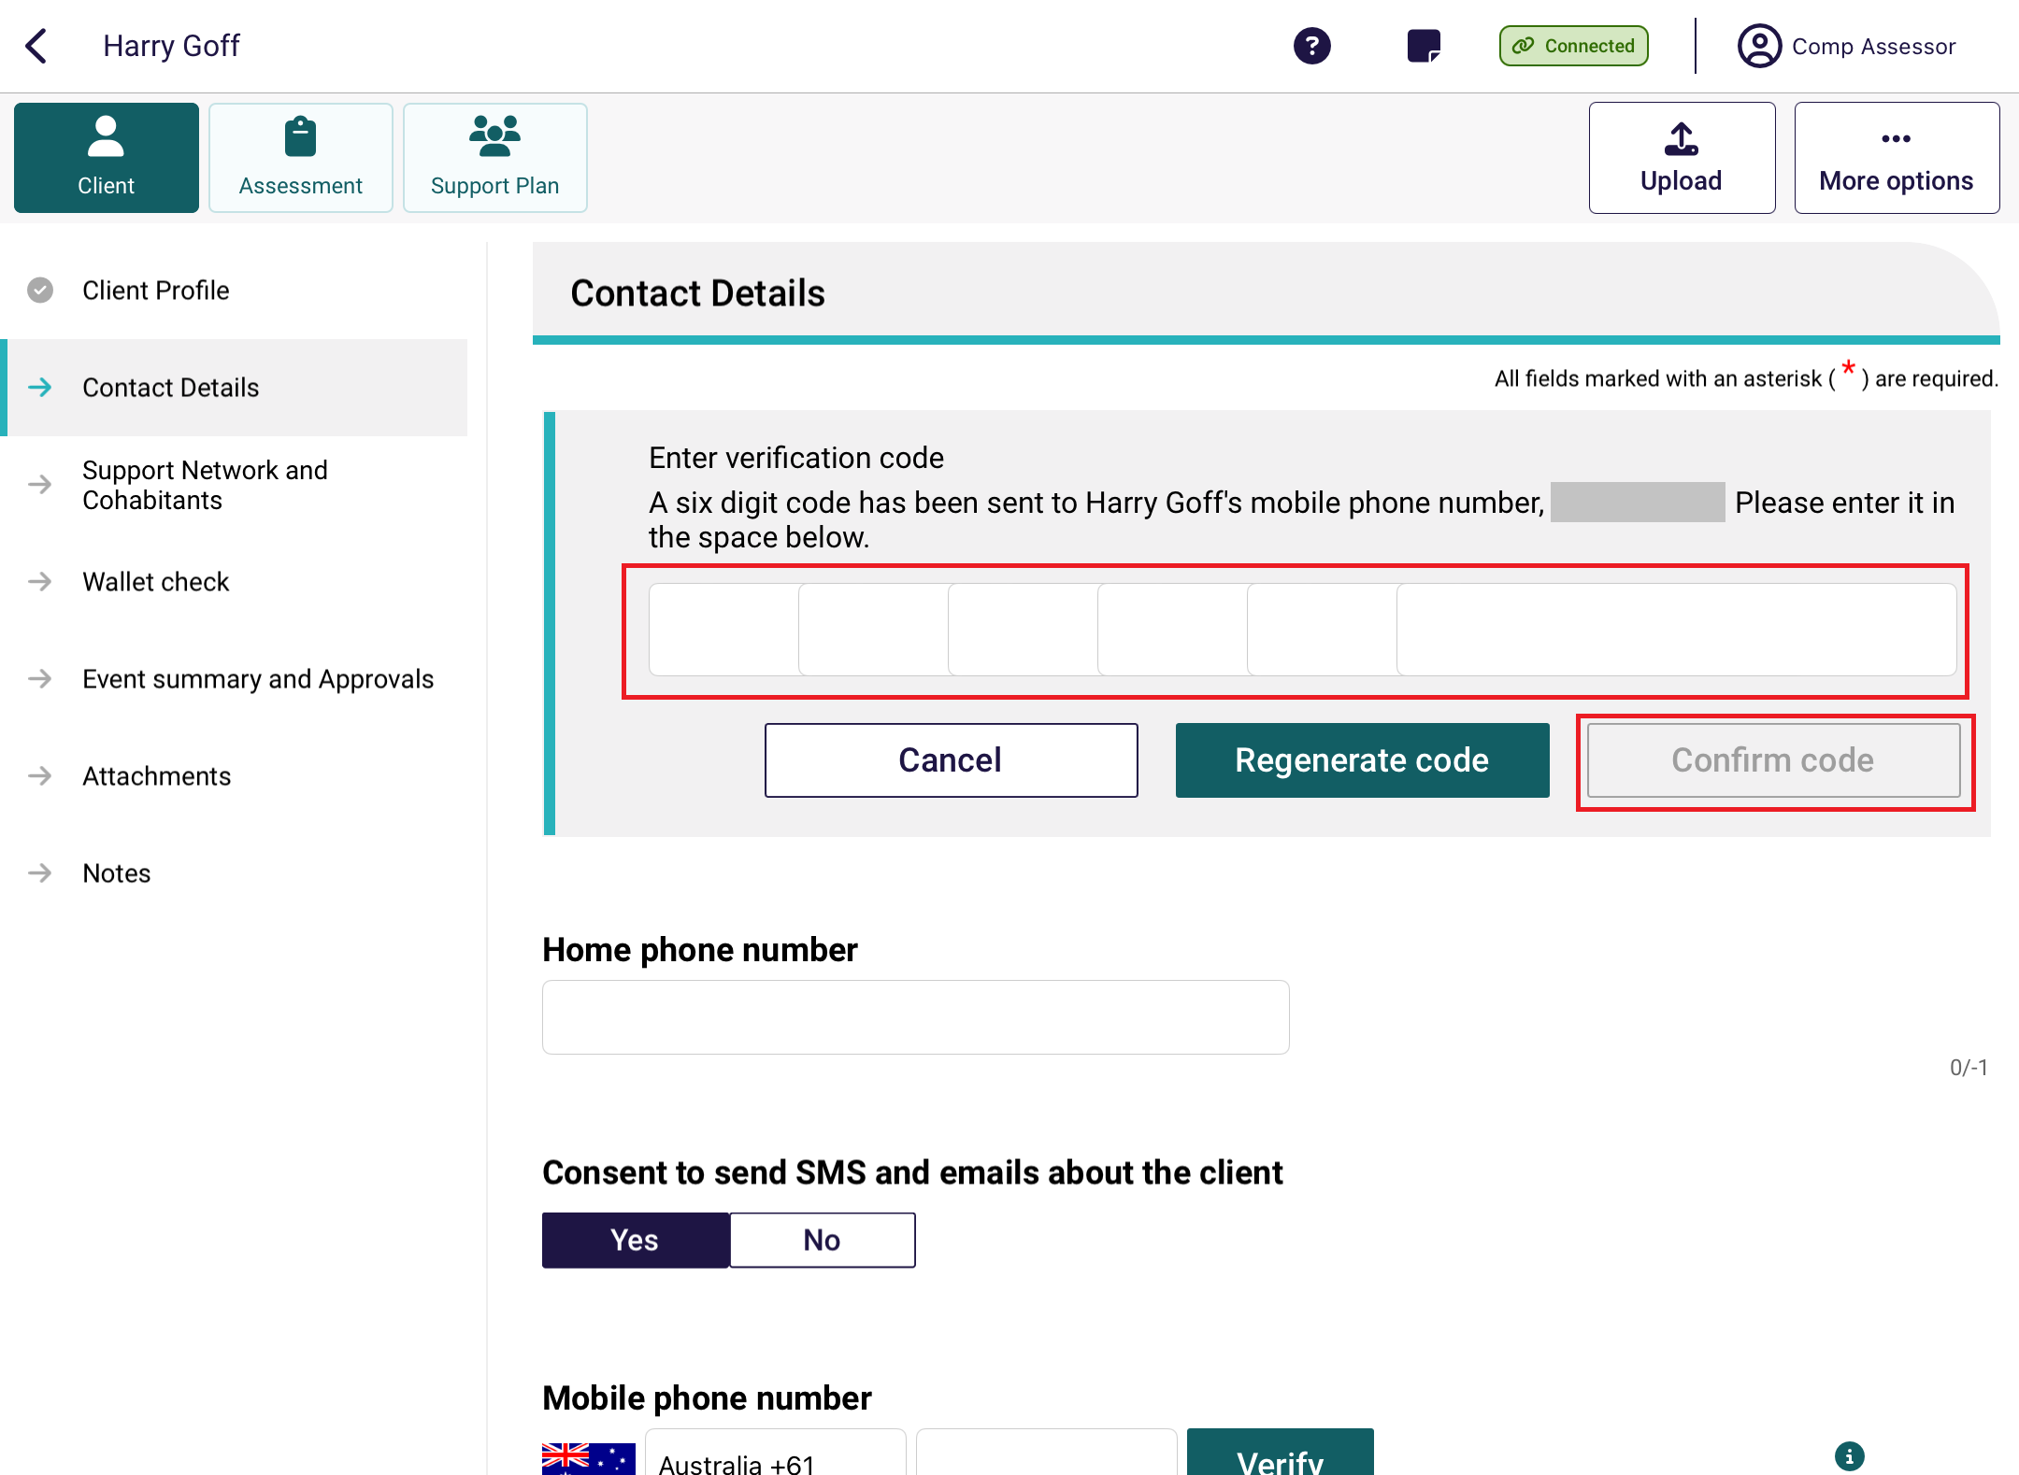

Once the number has been verified, to set SMS notification toggle on Notify by SMS. To remove a preference you can select the toggle to remove the preference.
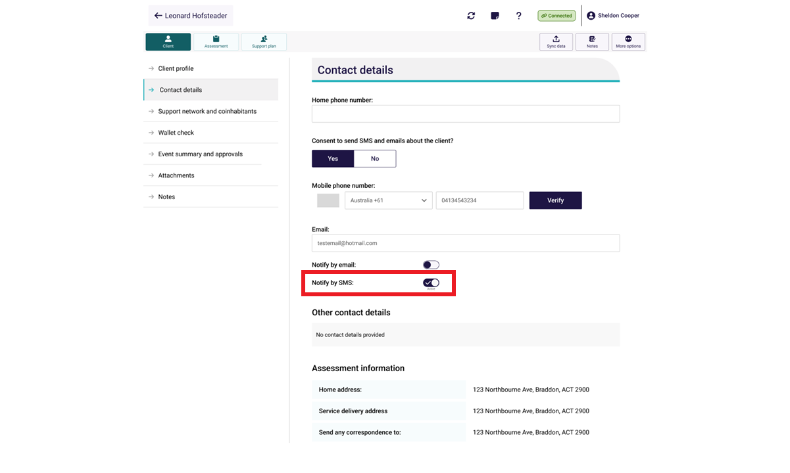
The Support Network and Cohabitants page displays the client’s representatives, the people they represent and other relationships (the support network). The process for setting up support network relationships is explained in Registering a support person section.
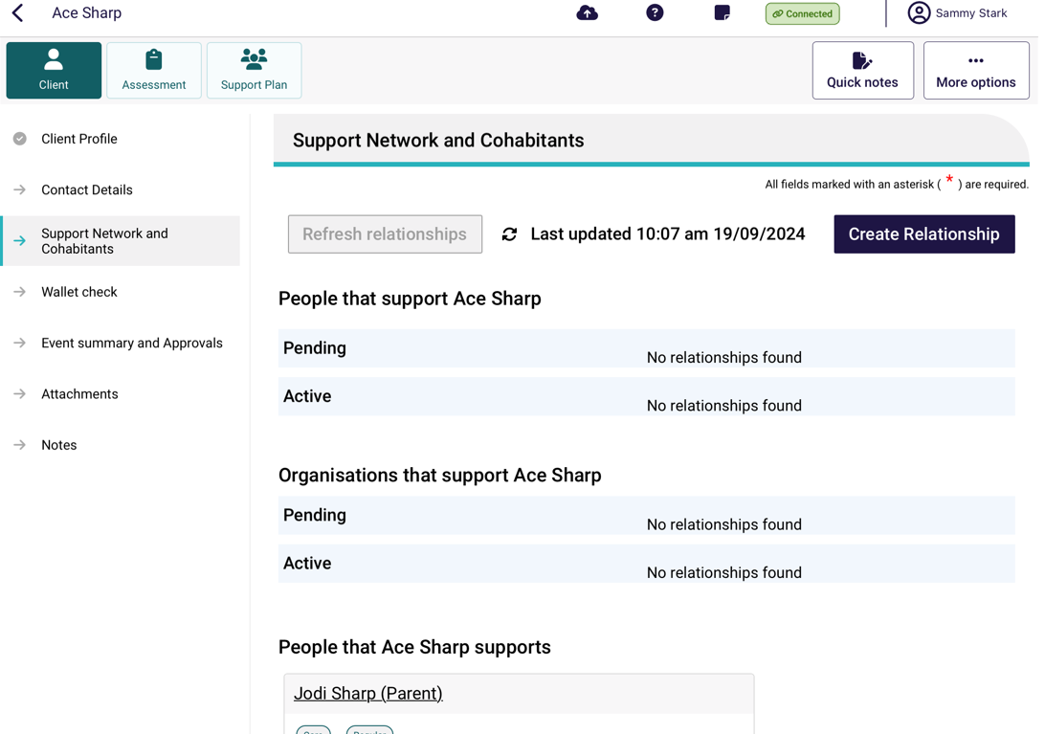

The Wallet check page displays the status of the wallet check. This process is explained in the Completing Identity Verification section.
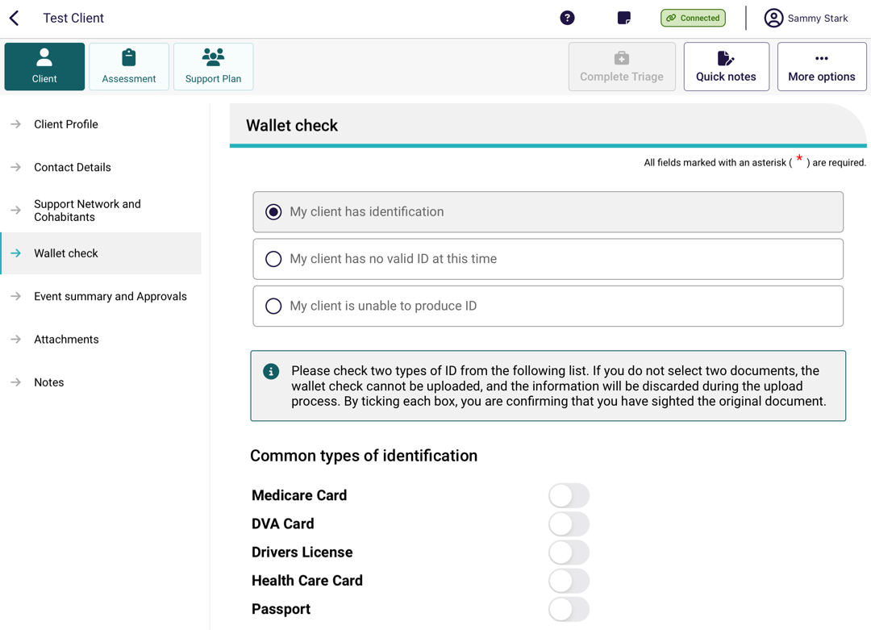
The Event Summary and Approvals page displays information about screening and previous assessments (if applicable). It will also contain information about a client’s current Approvals and services in place, if applicable.
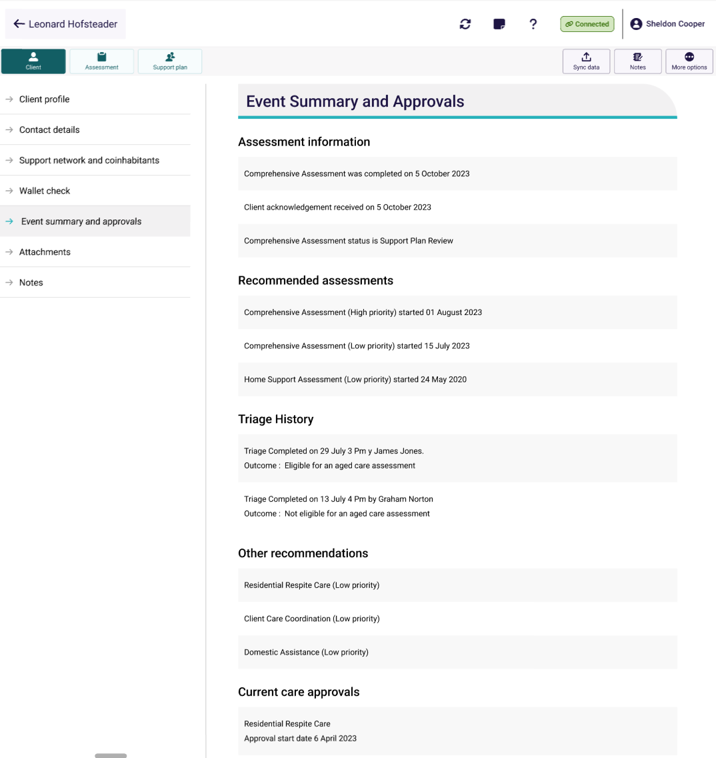
The Attachments page enables you to view client attachments and add attachments.
To view an attachment, select the hyperlink name of the attachment name. Once clicked the attachment will open a new page and the attachment will be visable.
Selecting Add an attachment will open a new page where you can record the name, type and description of the attachment. The Types of attachments that can be added match those available in the My Aged Care assessor portal.
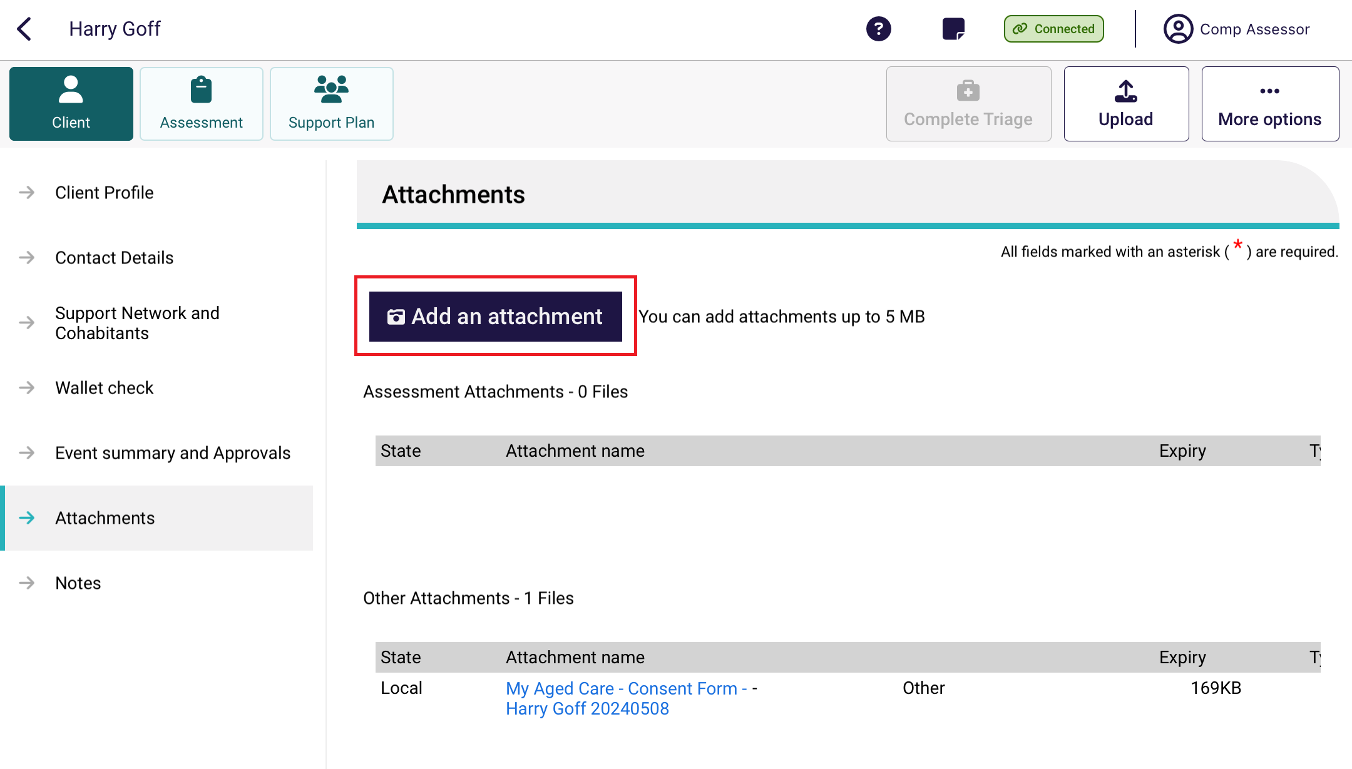
- Once you have recorded the details, you can click Capture photo, which will open your device’s camera app.
- Once you have taken the photo, you will be given the option to either Retake or Use Photo. If you are happy with the attachment, click Save to record.
! | When uploading an attachment, it is crucial to ensure that the document is intended for the correct client. Uploading an attachment to the wrong client's file can lead to a breach of privacy. Always double-check the client details before proceeding with the upload.  If you are uncertain about the client's identity, please refrain from uploading the document and seek clarification. This precautionary measure helps maintain the integrity of our service and protects client privacy.
Any attachments added whilst offline will appear in the Attachments tab of the client record when the assessment is uploaded to the My Aged Care assessor portal.
! | The attachment image will only save in the App. For security purposes, the image will not be saved locally to the device.  You will need to enter a Name and a Type of image (for example, Power of Attorney), which will be displayed in the My Aged Care assessor portal. You can also add a description for the attachment in a free text box.
The Notes page enables you to add and view Client notes. The Note types available match those available in the My Aged Care assesor portal (for example, Client story, Sensitive Notes, Preference, Other or Observations).
These notes will be visible in the Notes tab on the client record when the assessment is uploaded to the My Aged Care assessor portal. Clients (and their support network) will only be able to view Client story and other notes.
! | When needs assessors add a sensitive note about a client, all service providers who are sent a referral will see a flag informing them that there is a sensitive note about the client and instruct them to call the My Aged Care contact centre or the Needs assessor for more information.

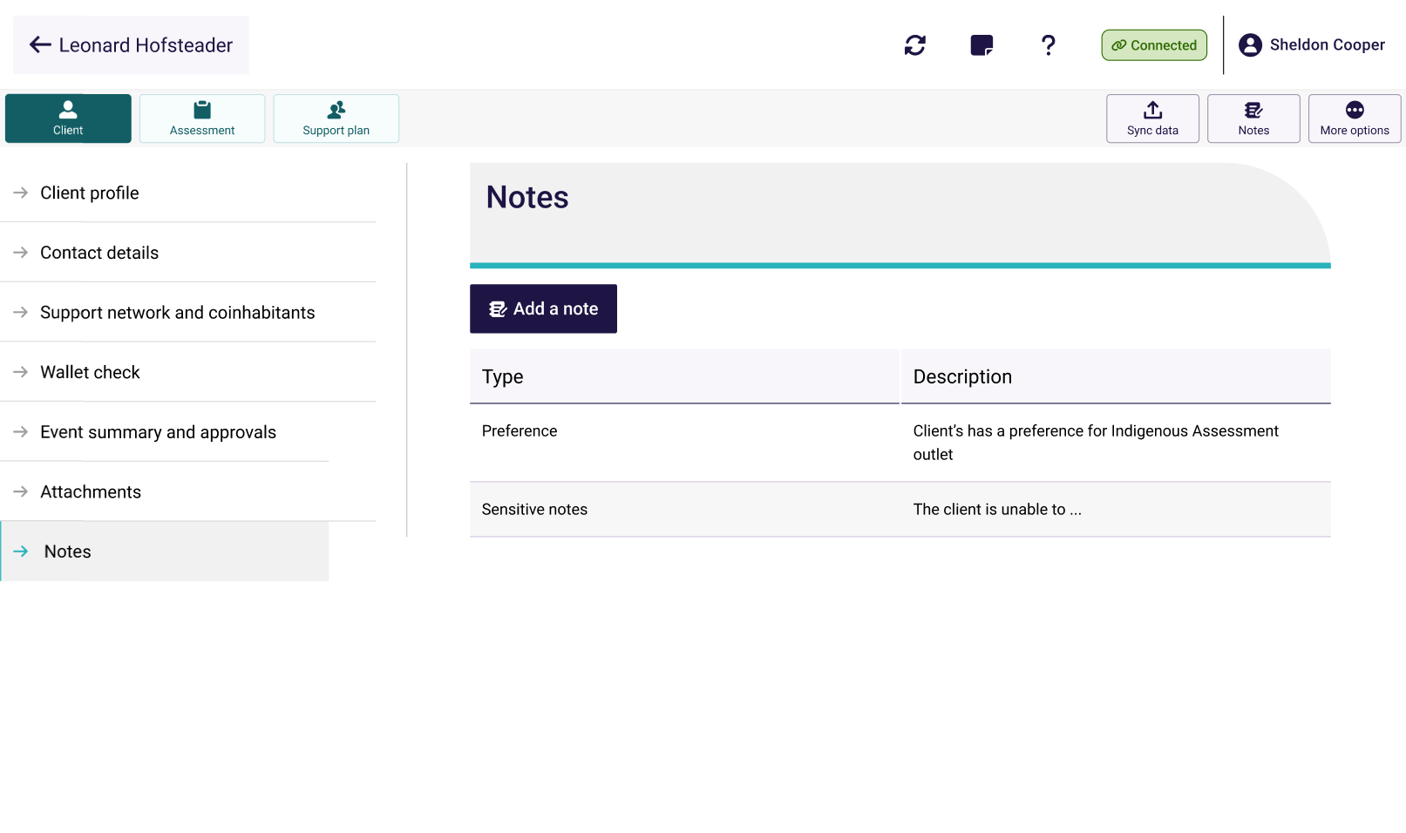
The Notifications page is displayed only if the client has an approval for a home care package. It enables you to request to receive notifications of home care correspondence for the client by toggling the Yourself button.

Registering a support person
You can view pending and active support people, people that the client represents and other relationships on the Support Networks and Cohabitant page.
You can:
- Create a relationship for an individual representative or an individual agent.
- Create a relationship for a representative organisation or an agent organisation.
- Create a relationship for a carer or other types of support people.
- Create a relationship in offline mode.
- Activate a pending relationship.
- Remove a support relationship.
For more information on the types of support relationships that can be created, refer to My Aged Care – Assessor Portal User Guide 2 – Registering support people and adding relationships.
! | A warning symbol will be displayed next to the Support Network and Cohabitants menu item when a client has pending representatives that need to be confirmed.

Creating a relationship for an individual representative or an individual agent
You must be connected to the Internet.
! | If you are offline, you can create a local record in Offline mode and register the record when you go back Online. Go to Creating a relationship in offline mode to complete this process.

- On the client’s Support Network and Cohabitants page, select Create Relationship.
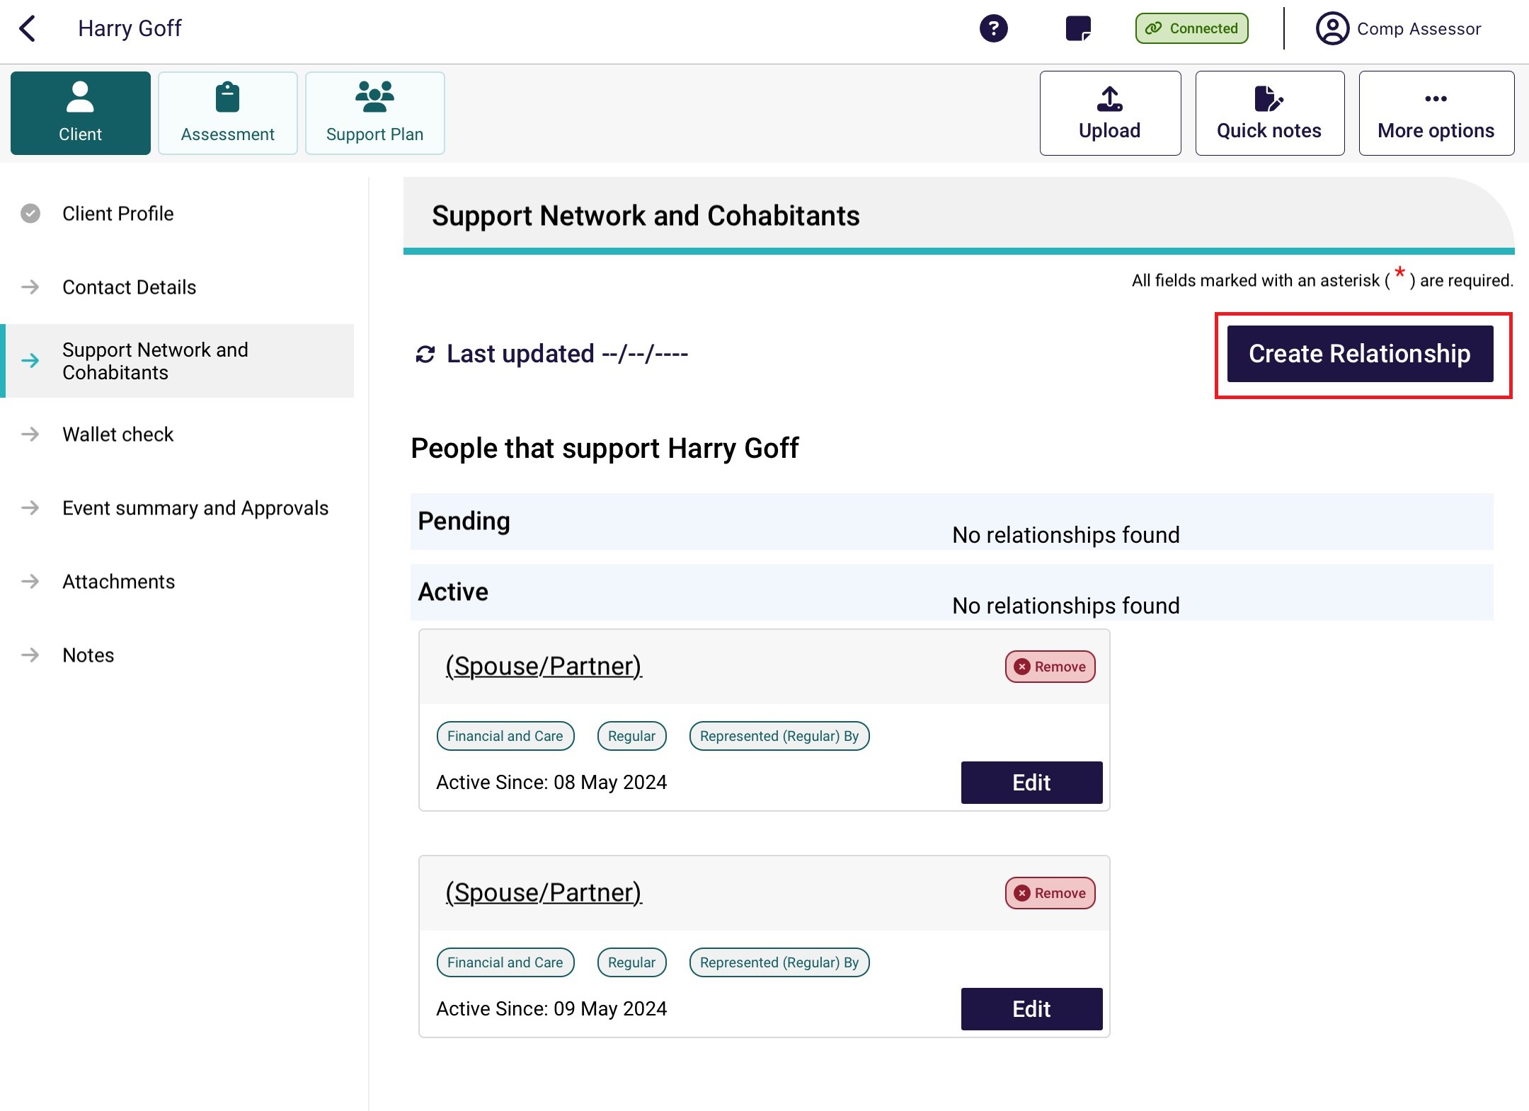
- In the Create Relationship page, choose a relationship to establish for the client. In this case it would be Regular Representative, Authorised Representative, or Agent. Depending on the relationship chosen, the following steps may vary.
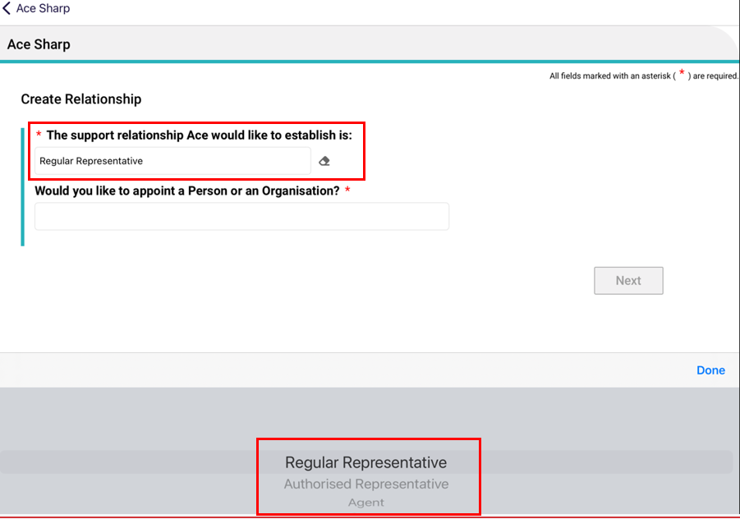

- For Would you like to appoint a person or an organisation?, choose Person: someone who is not part of a support organisation e.g. A family member, then select Next.
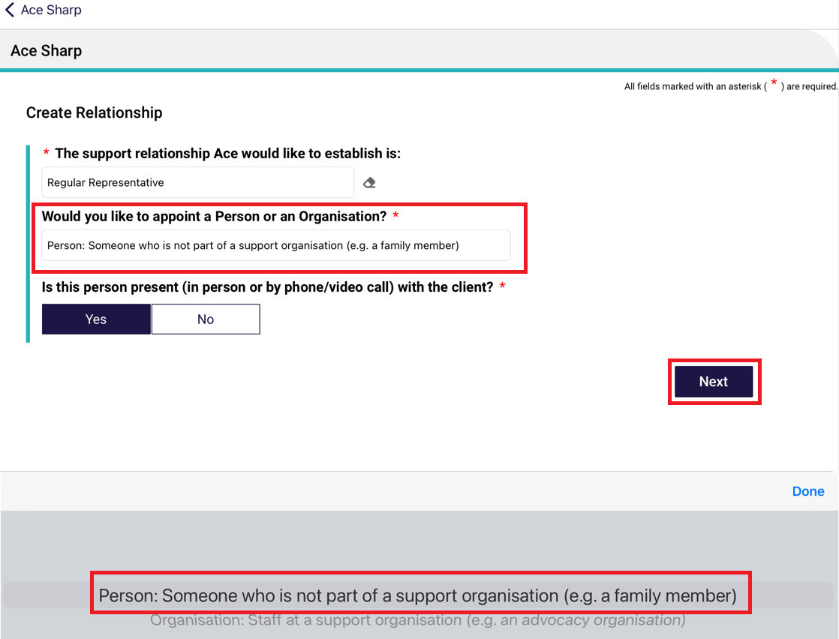
- Select Yes or No to the question Is this person present (in person or by phone/video call) with the client?, then select Next.
If No, you will be asked whether the client has a complete Appointment of a Support Person Form or Appointment of a Support Organisation Form with them.
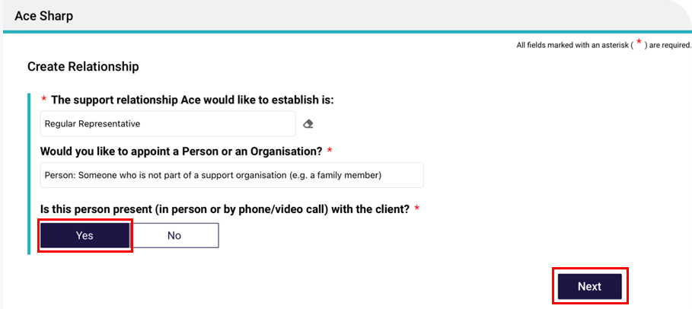
! | If the support person is not present with the client, and they do not have a completed Appointment of a Support Person Form then the relationship cannot be created.  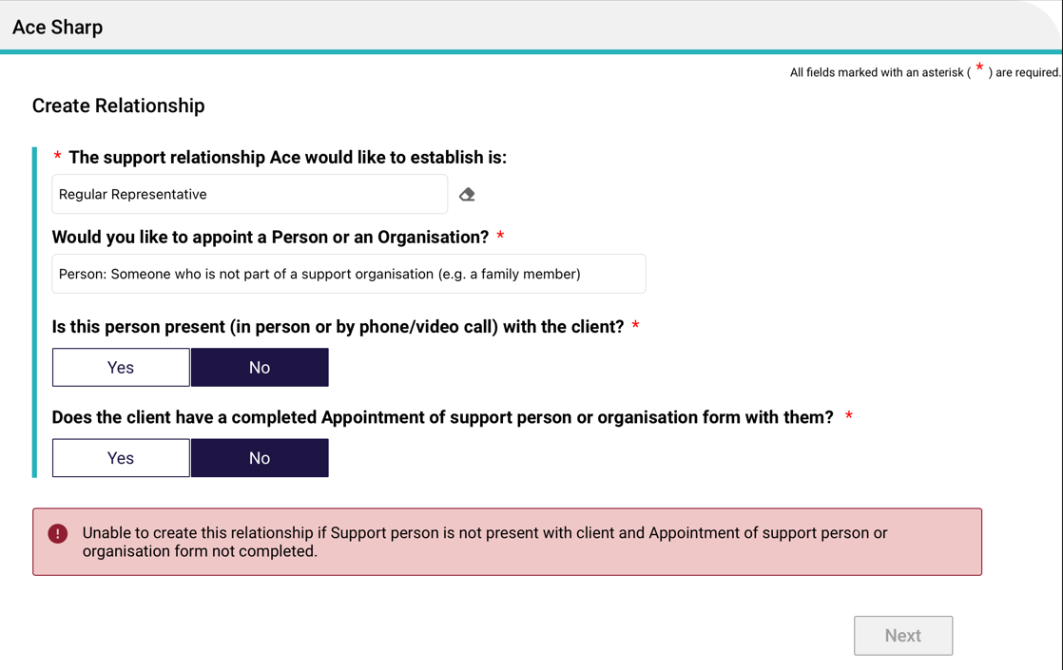
- After answering the above questions satisfactorily, the Find a Support Person page appears.
Enter the last name and first name of your regular representative, authorised representative or agent, and select Search. This is to ensure that there are no duplicate record being accidentally made in the My Aged Care system.
Then, go to the next step (6) if there are no records found, or go to Step 8 if there are matching record/s.
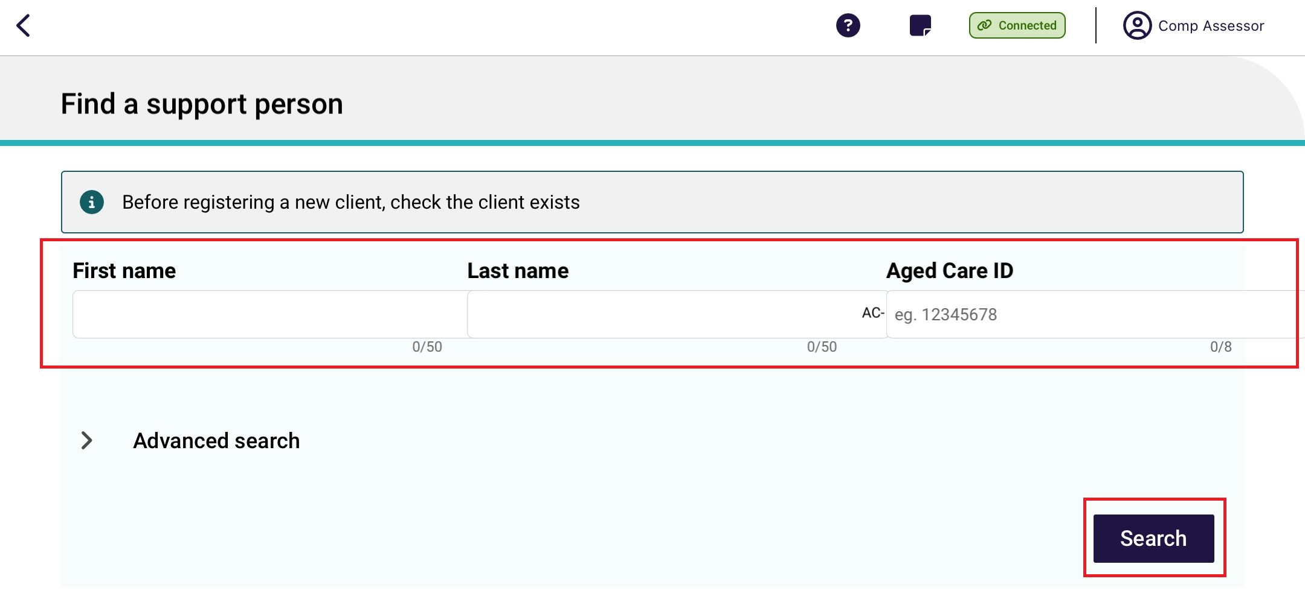

- If there are no records found, you can continue to register this representative or agent in the My Aged Care system, by selecting Register a Support Person.
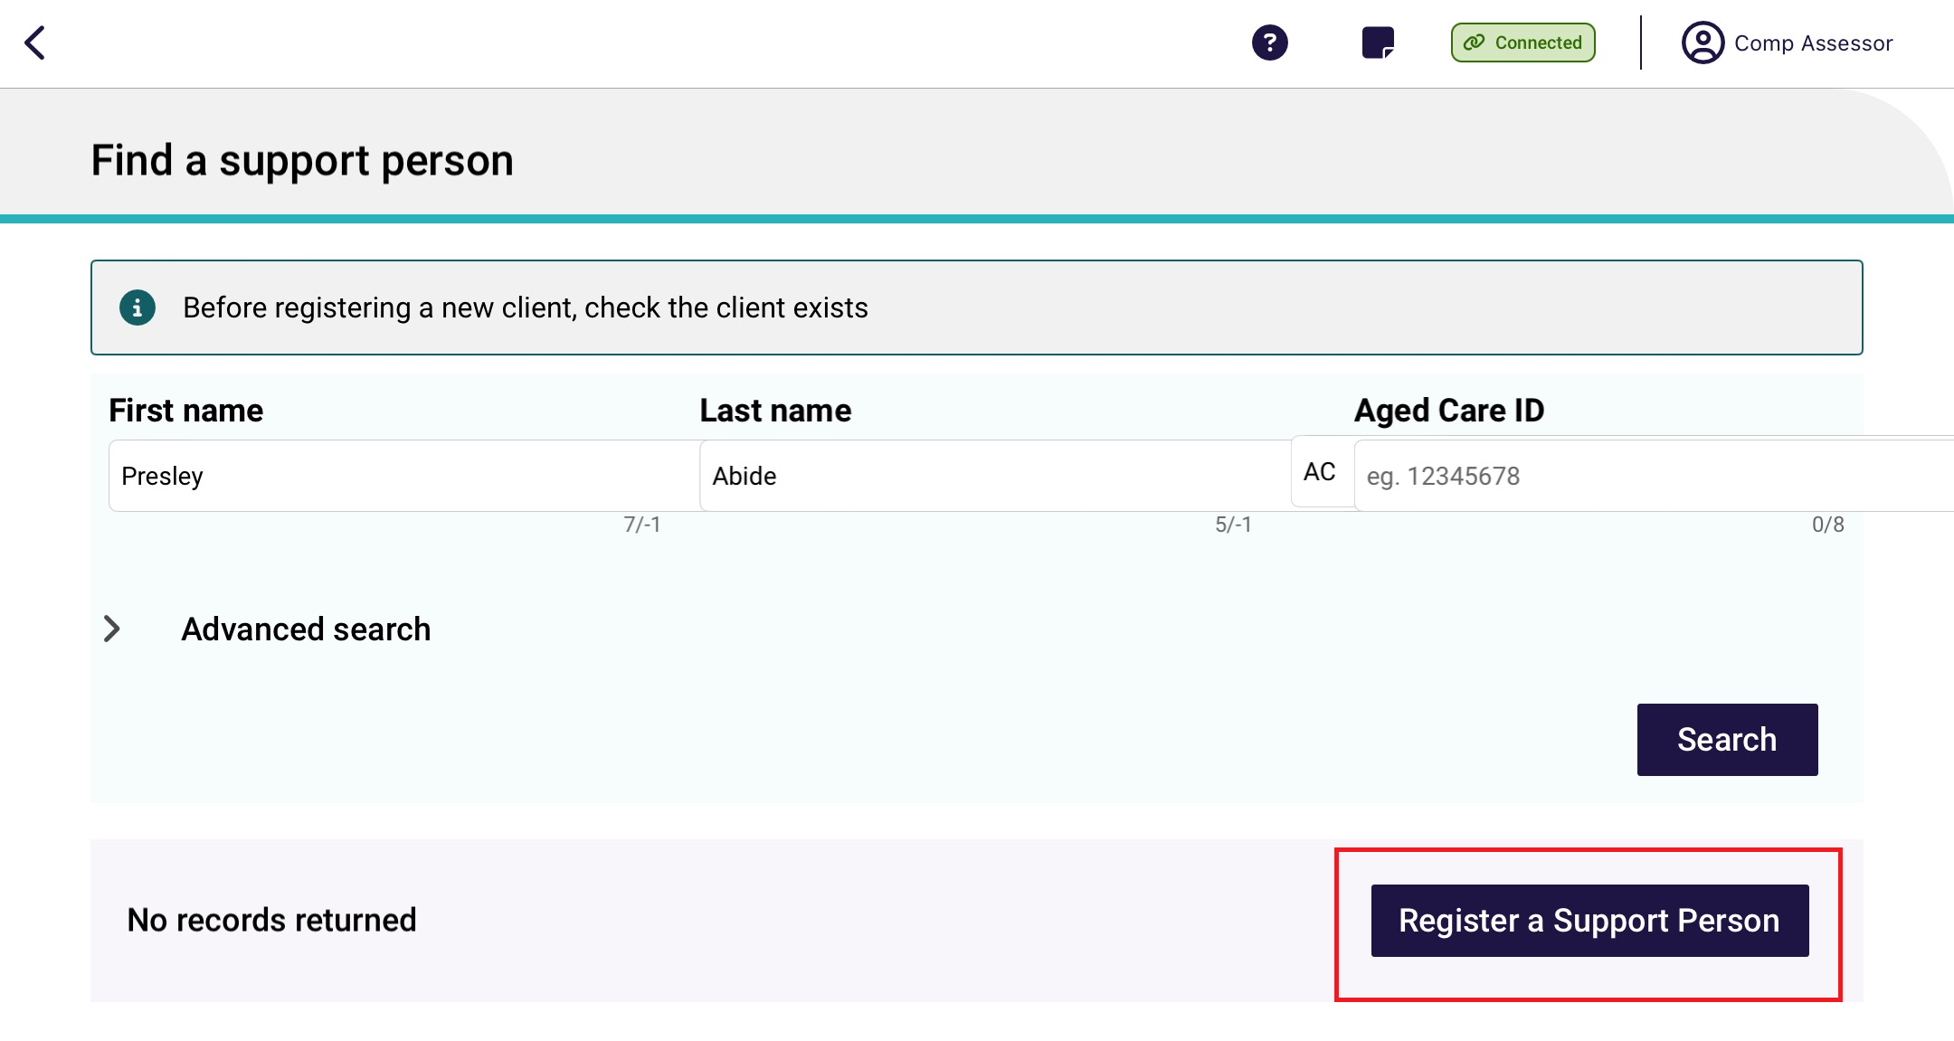
- Enter all mandatory fields in each of the five pages until the Register button turns blue. Then, select Register.
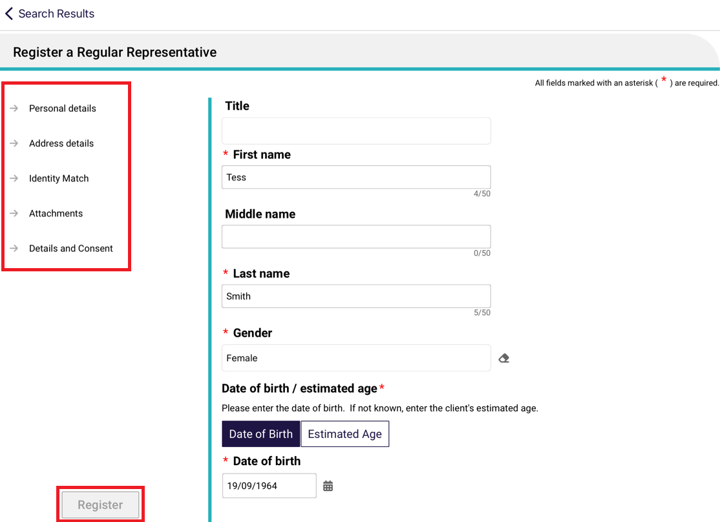
- If matching records are found, be sure to select the correct matching record.
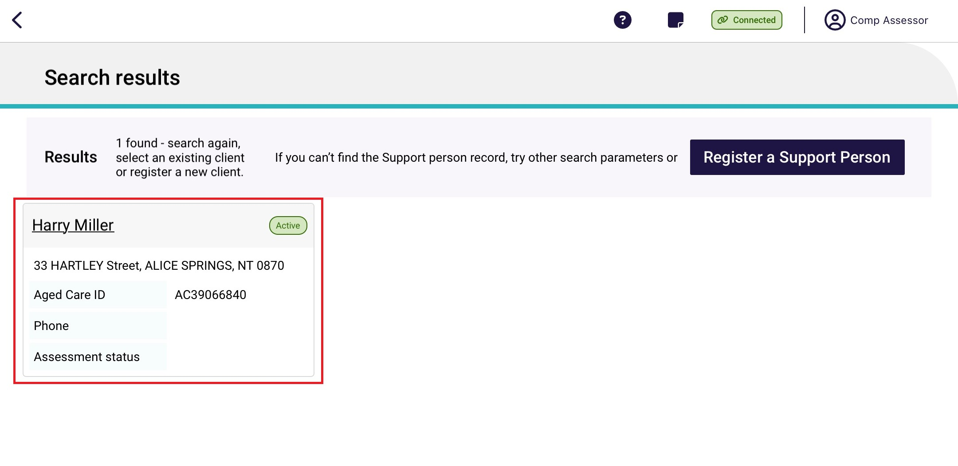
- The Support Person’s details page appears. Double check that it is correct, then select Attachments.
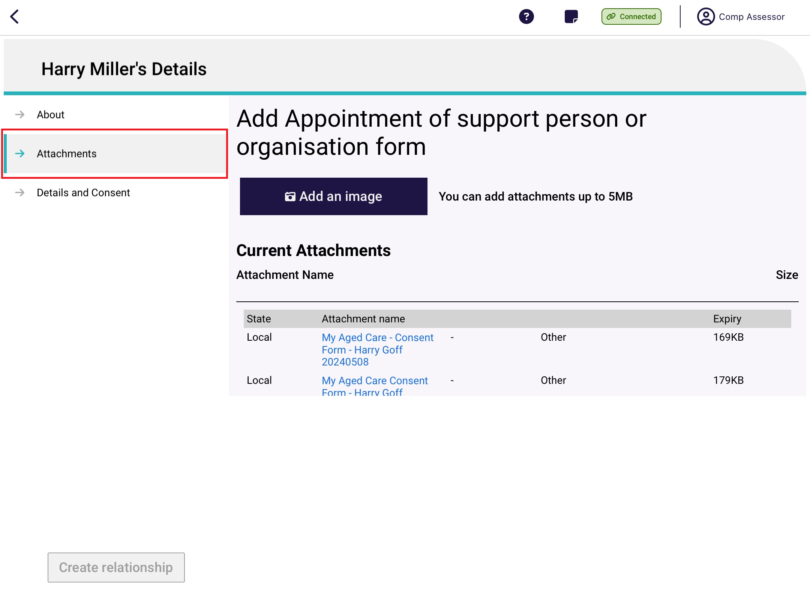
The Attachments page appears. Add the appointment of support person or organisation form by selecting Add an image and taking an image of the form from your device. Name the image and its name will appear under Current Attachments. Then, continue to the Details and Consent page.

- The Details and Consent page appears.
Fill out all mandatory fields in the Details section, including how the support person will make decisions, type of relationship, and start date of relationship.
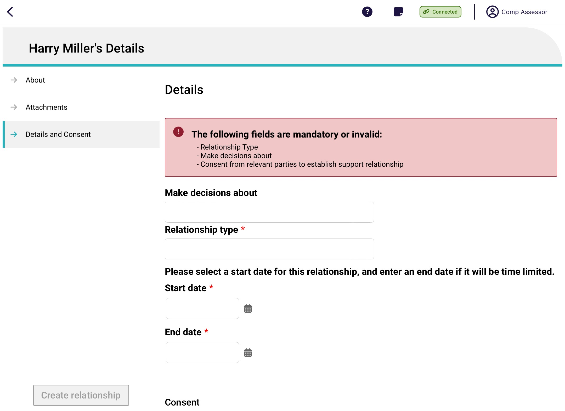
Fill out all mandatory fields in the Consent section, including if consent from both the client and the support person has been provided.

Then, select Create Relationship.
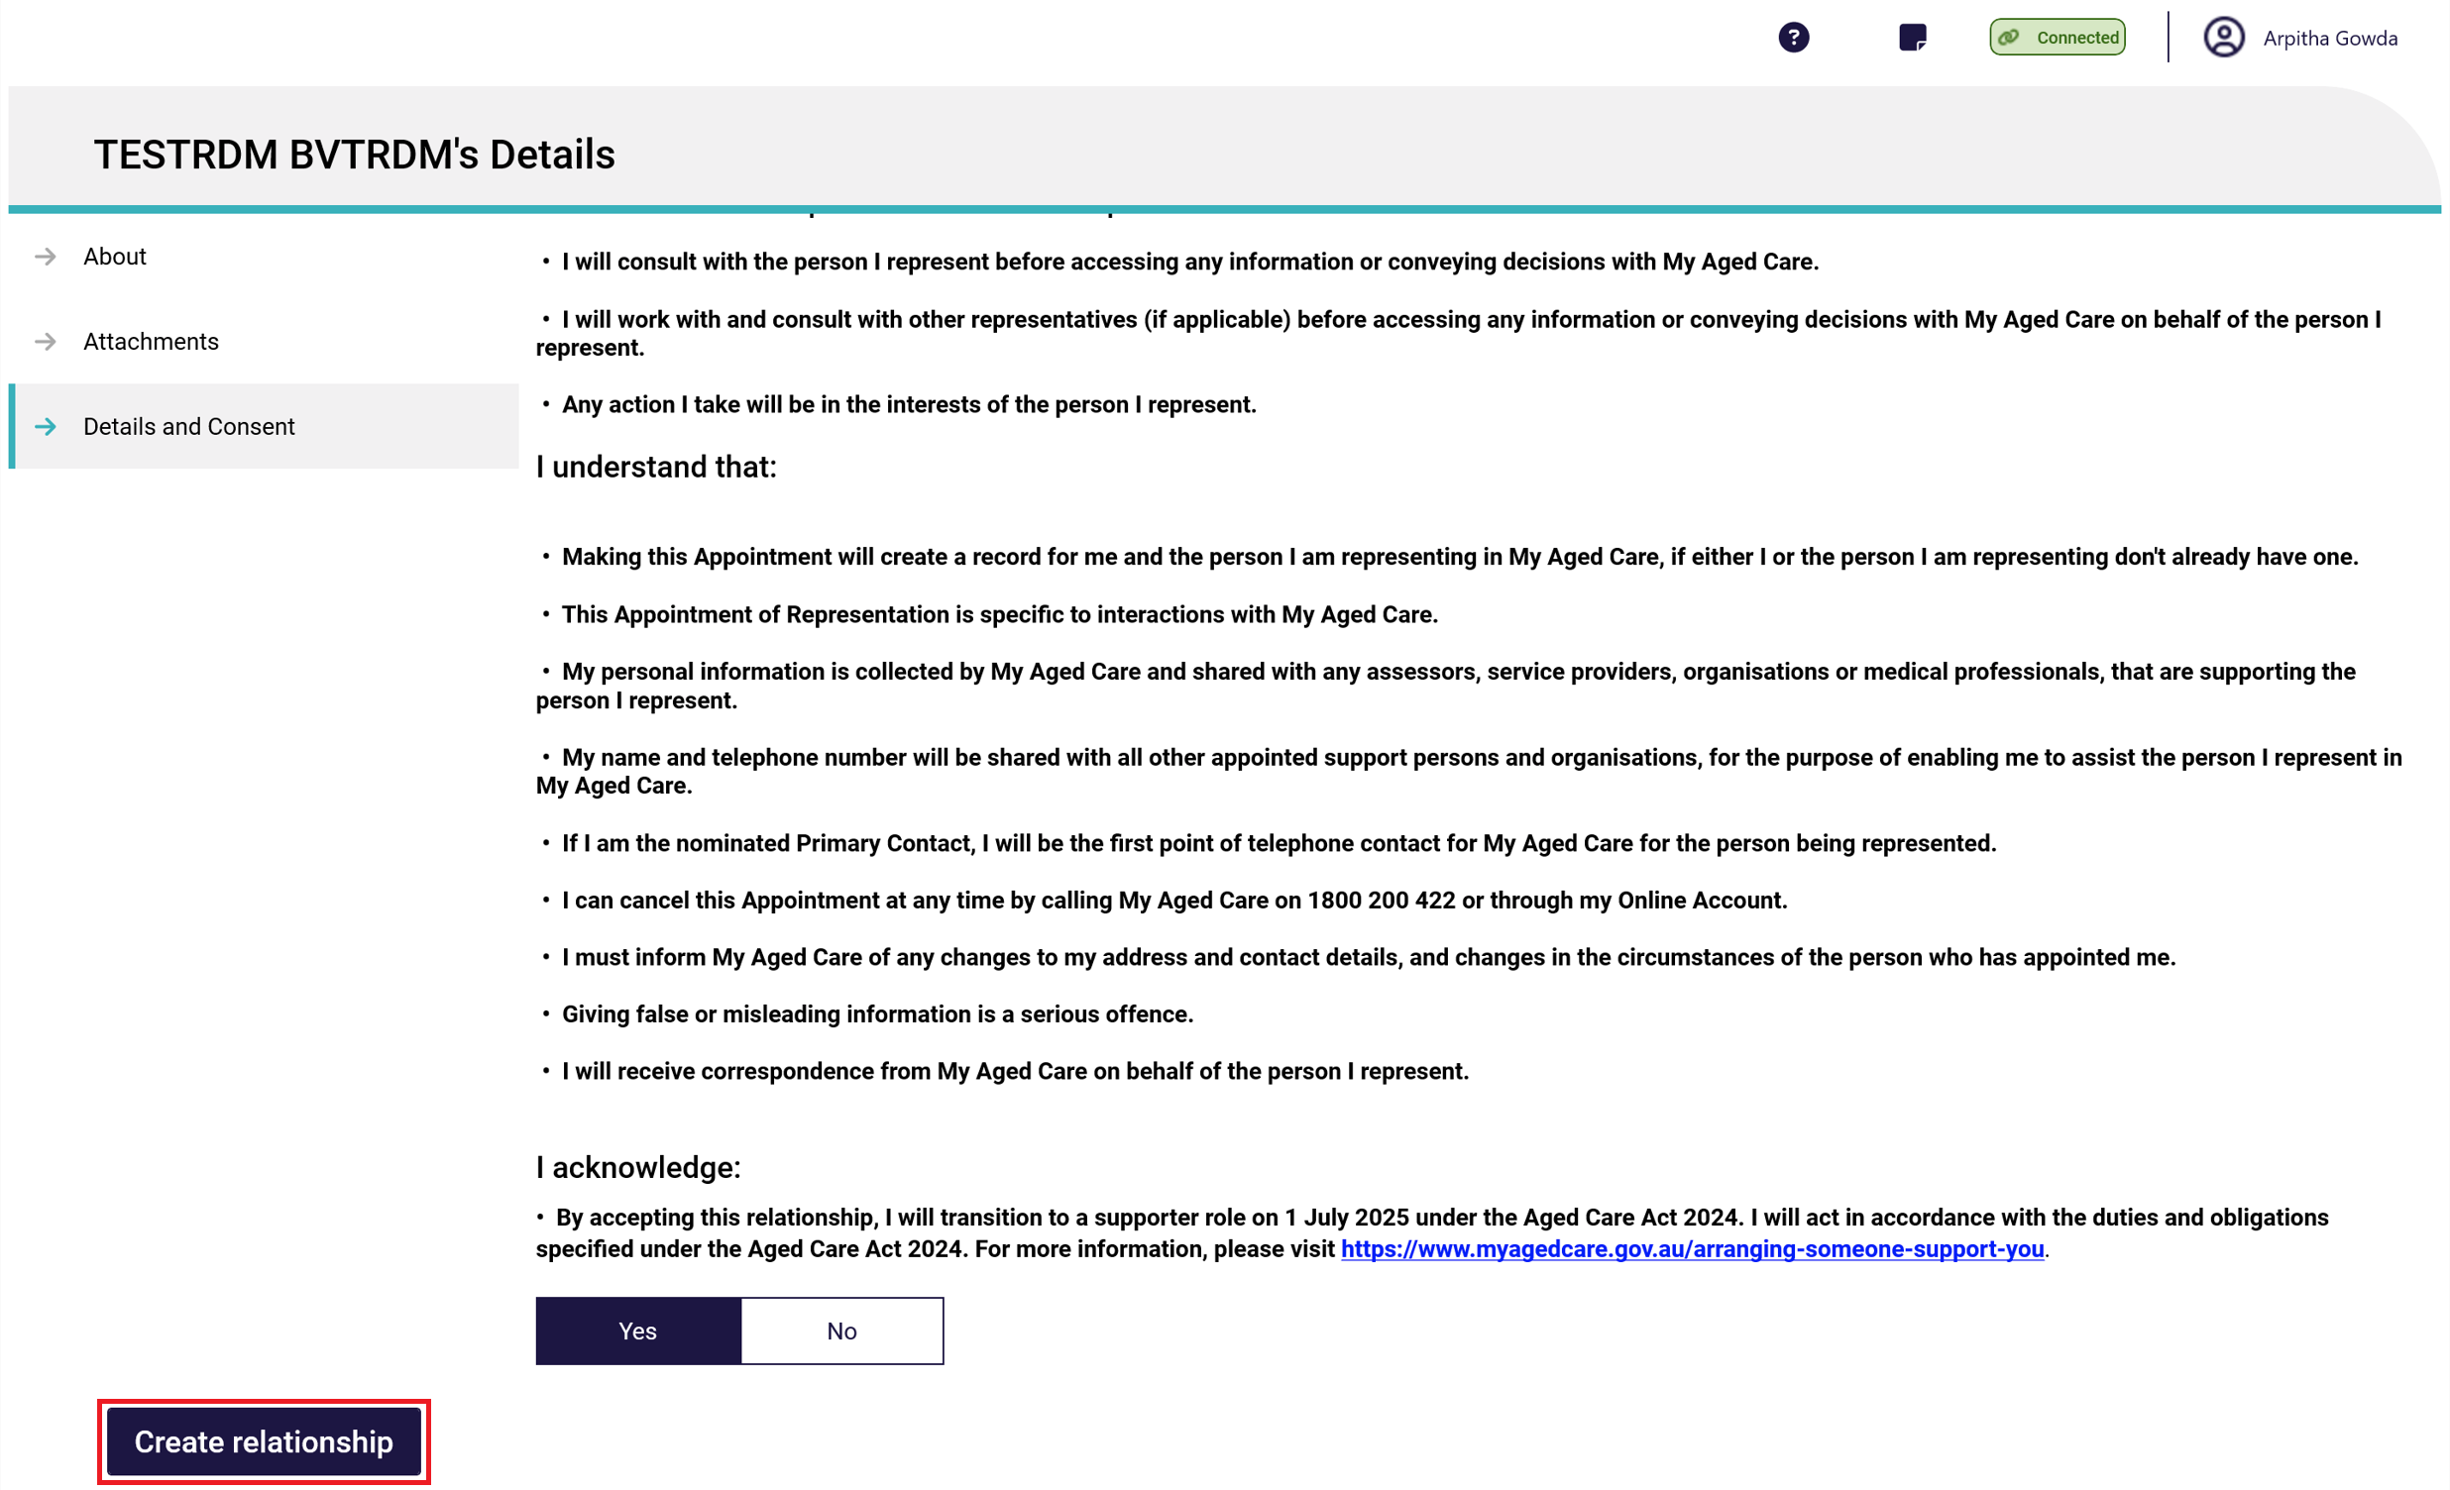
! | You must obtain the following consent before you can set up an active representative relationship:  - Representative’s consent to register with My Aged Care (this will create a representative record);  - Representative’s consent to represent the client;  - Client’s consent to be represented by the nominated representative.  Please note, consent is not required for authorised representatieve relationships
! | A pending relationship is created if:  - If either the client or representative do not provide their consent for the relationship to be set up (applicable for regular representatives or agent individuals only); or  - The start date of the relationship is in the future; or  - An Authorised representative relationship is being created.  To activate a pending relationship, go to Activating a pending relationship.
- The new representative or agent will be displayed on the Support Network and Cohabitants page.

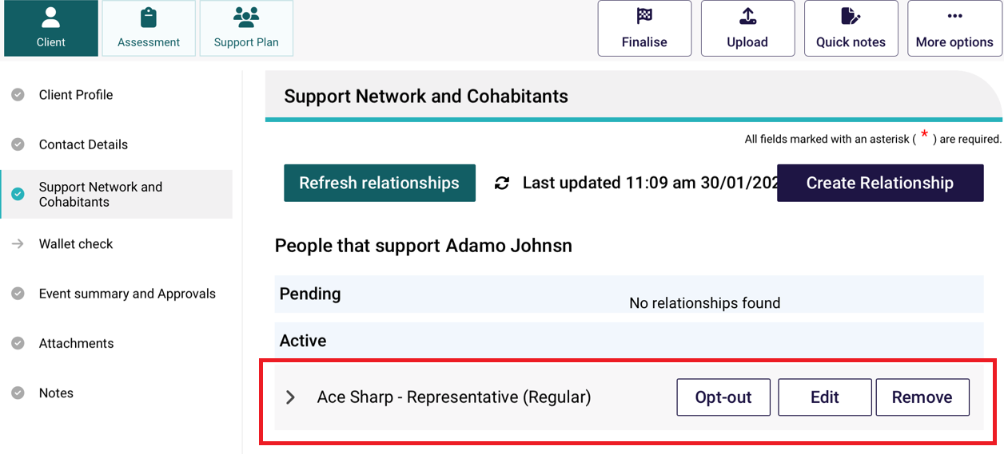

Creating a relationship for a representative organisation or an agent organisation
- On the client’s Support Network and Cohabitants page in Client Details, select Create Relationship.
- In the Create Relationship page, choose a relationship to establish for the client. In this case it would be Regular Representative, Authorised Representative, or Agent.

Depending on the relationship chosen, the following steps may vary.
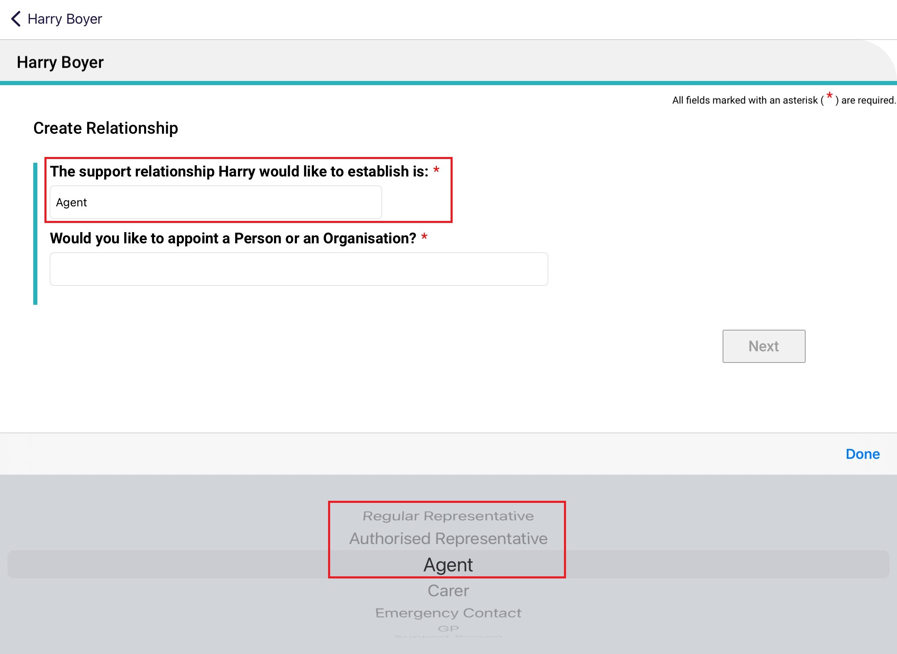
- For Would you like to appoint a person or an organisation?, choose Organisation: staff at a support organisation (e.g., An advocacy organisation).
Then, select Next.
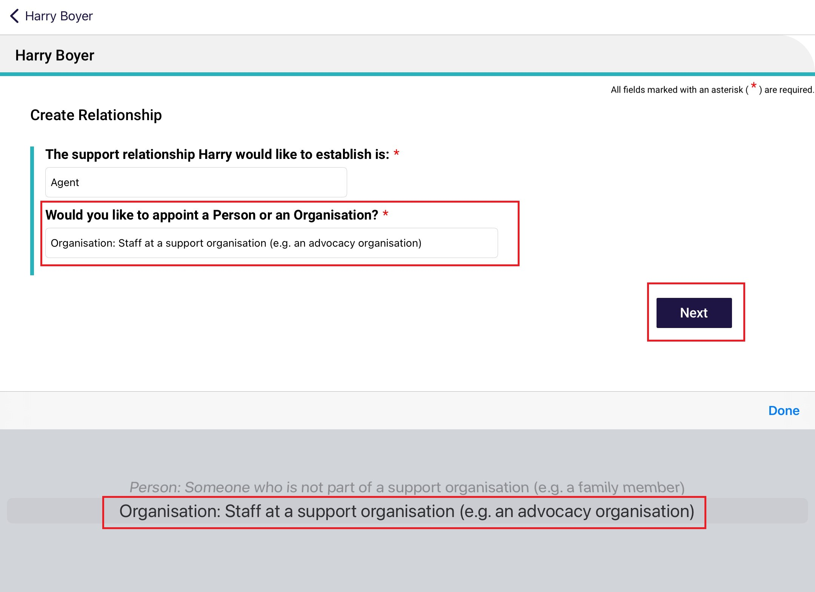

- Search for the support organisation by either entering their name, or postcode and/or distance away from the postcode, then select Search.
Search by Organisation Name
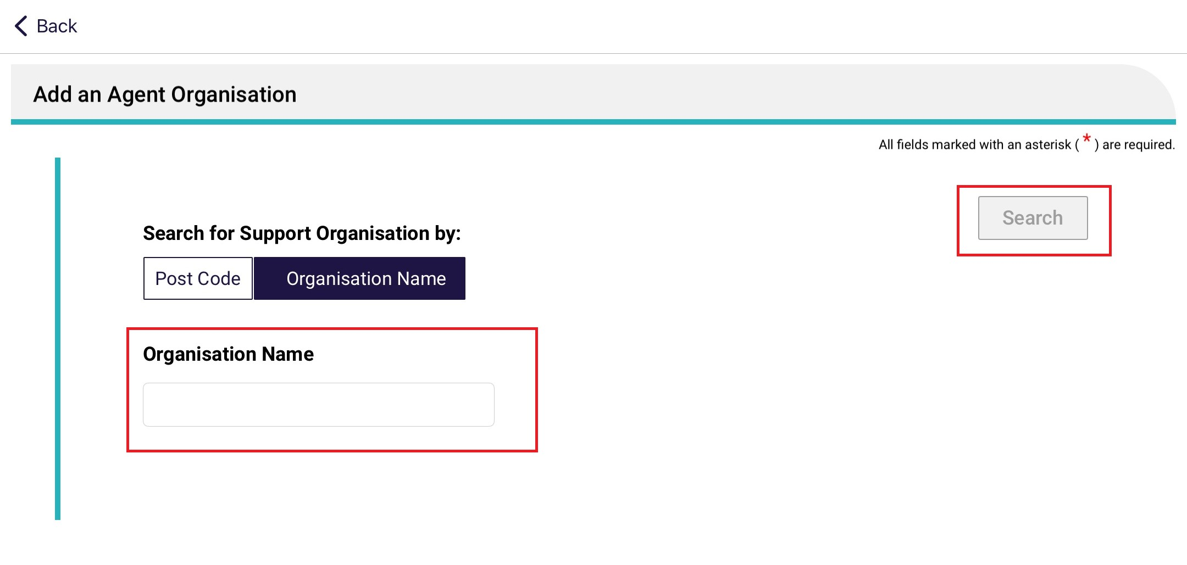
Search by post code and/or distance
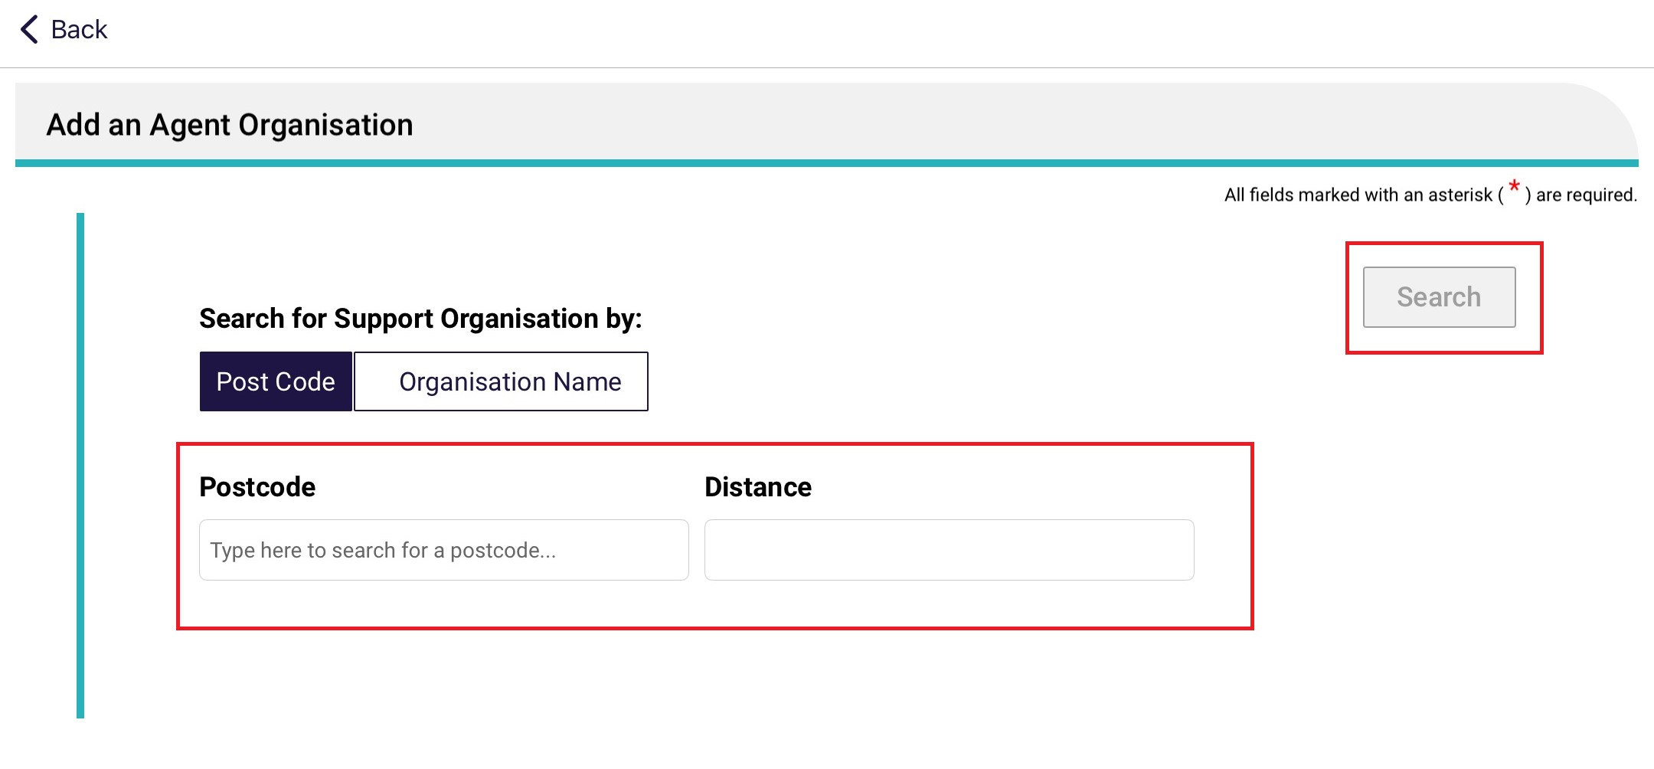
- Select the support organisation for the agent.
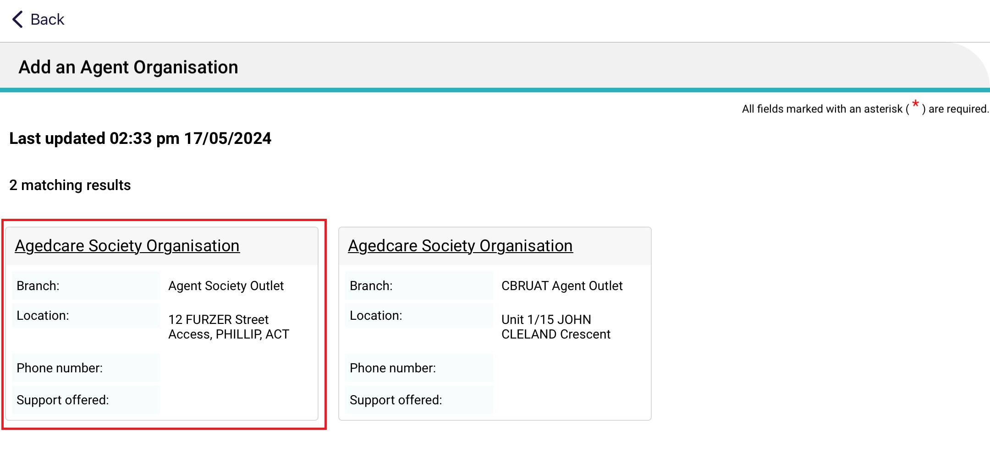

The organisation details are displayed in the About section of the Organisation Details page. Double check that it is correct, then select Attachments.
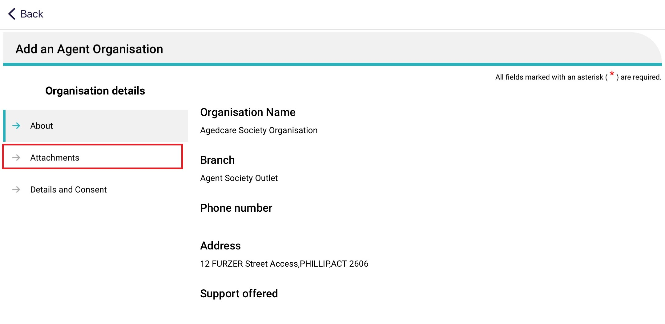
- The Attachments page appears. Add the appointment of support organisation form by selecting Add an image and taking an image of the form from your device. Name the image and its name will appear under Current Attachments. Then, continue to the Details and Consent page.
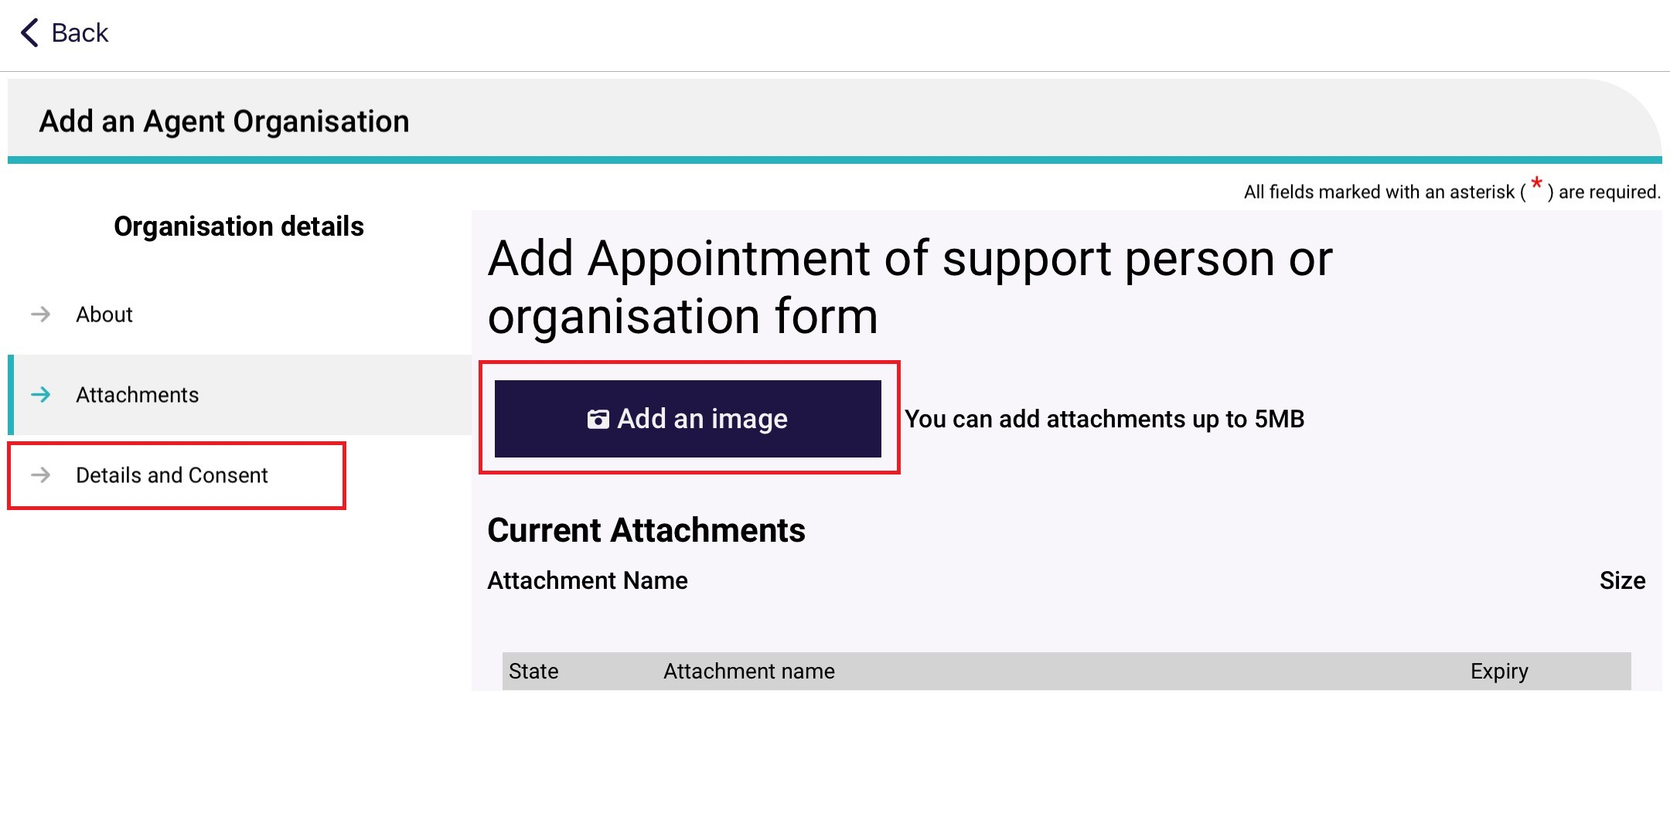
7. The Details and Consent page appears.
Fill out all mandatory fields in the details section, including type of support required, and the start date of relationship.
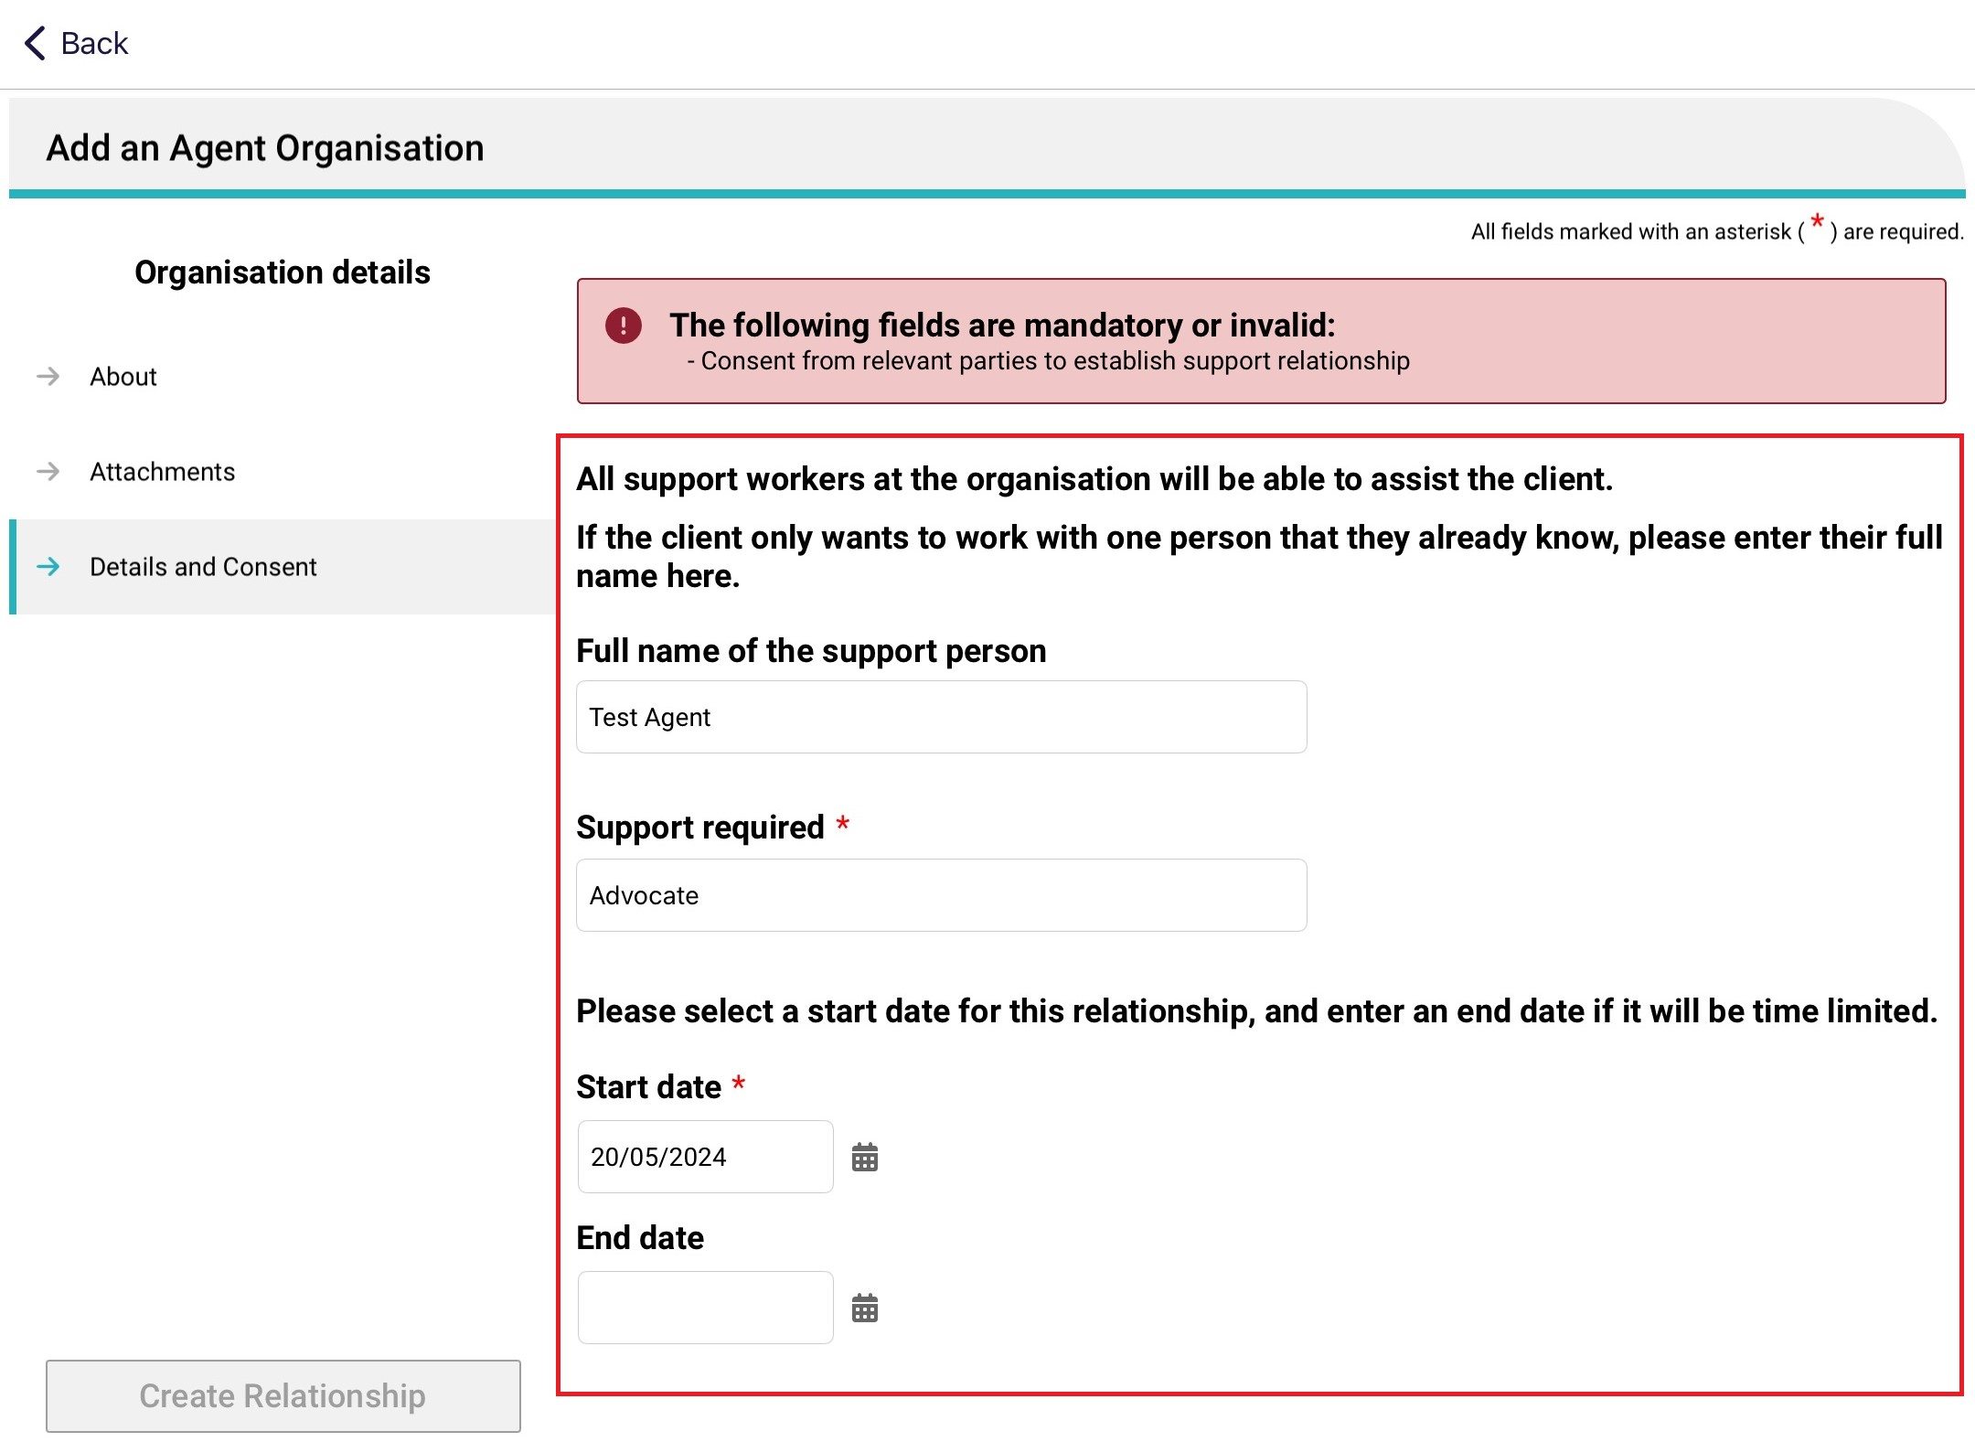
Fill out all mandatory fields in the consent section, and consent from both the client and the support organisation.
Then, select Create Relationship.
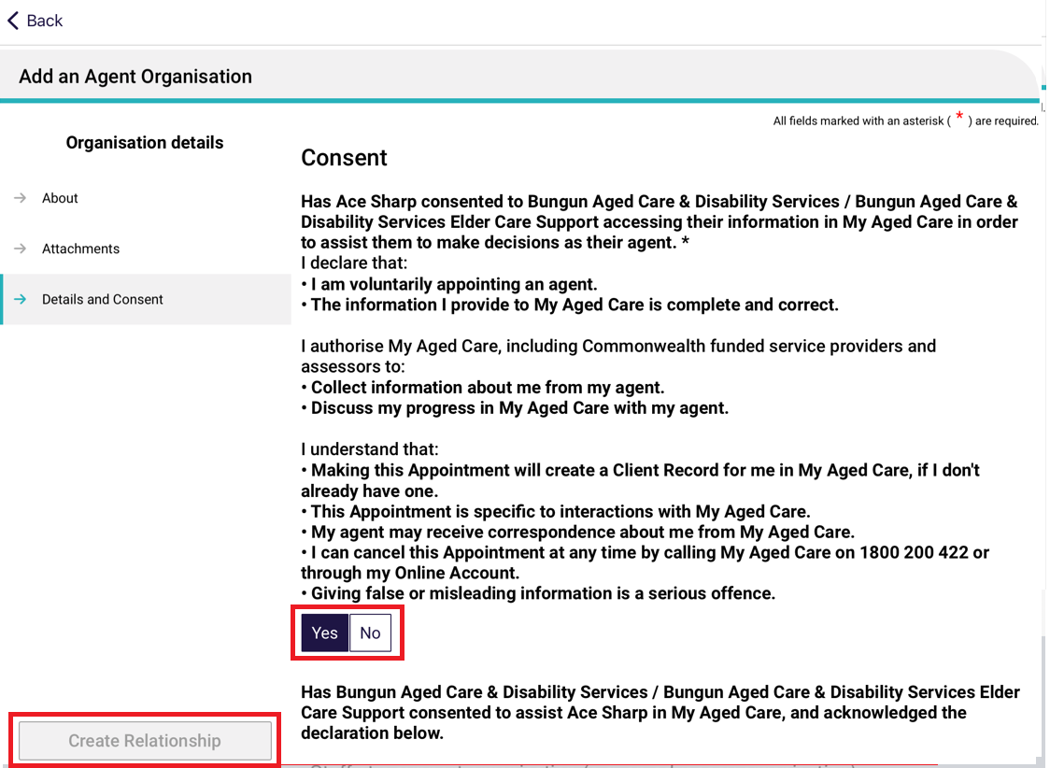
- The organisation relationship is created. Click Go Back to return to the client record.
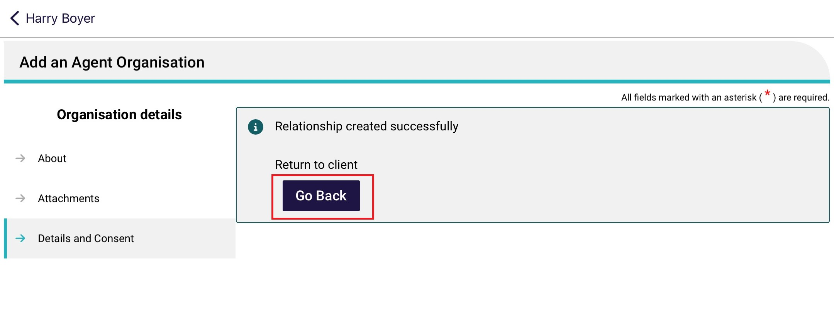
- Once on the client’s record, the new organisation relationship will be visible.
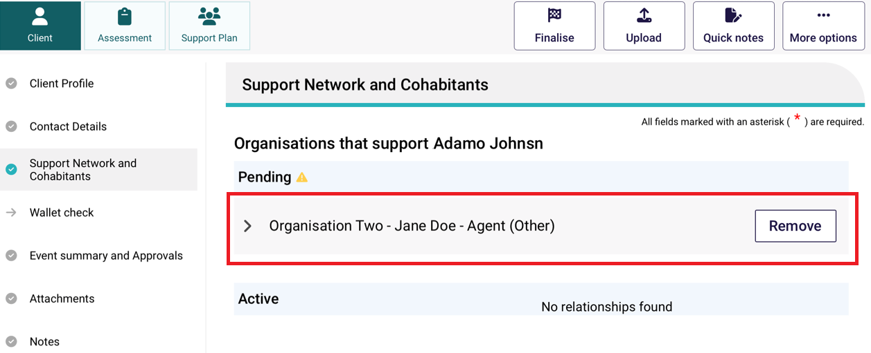

Creating a relationship for a carer or other support people
You can create a relationship for the client with a carer, emergency contact, GP (General Practitioner) or support person.
Please note, the support person does not have to be present, and consent is not required.
- On the client’s Support Network and Cohabitants page in client details, select Create Relationship.
- In the Create Relationship page, choose a relationship to establish for the client. In this case it would be Carer, Emergency Contact, GP or Support Person.
Then, select Next. Depending on the relationship chosen, the following steps may vary.
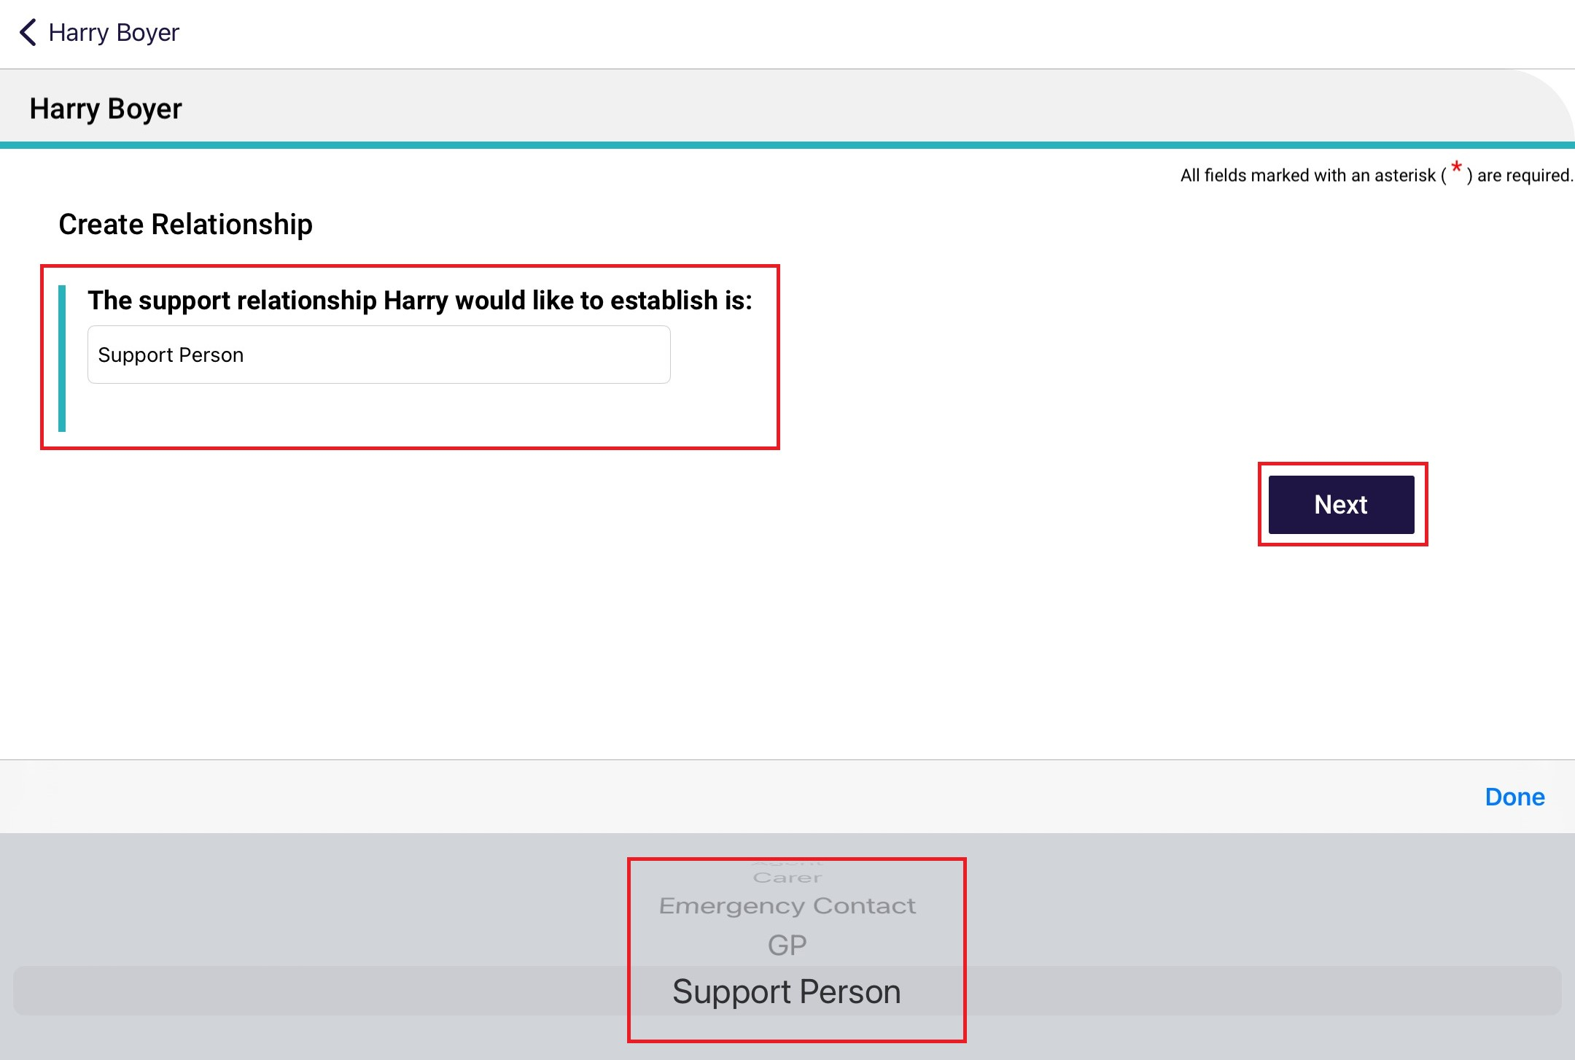

- Search for your support person by entering Last name, First name and/or Aged Care User ID, then select Search. You can also select Advanced search.
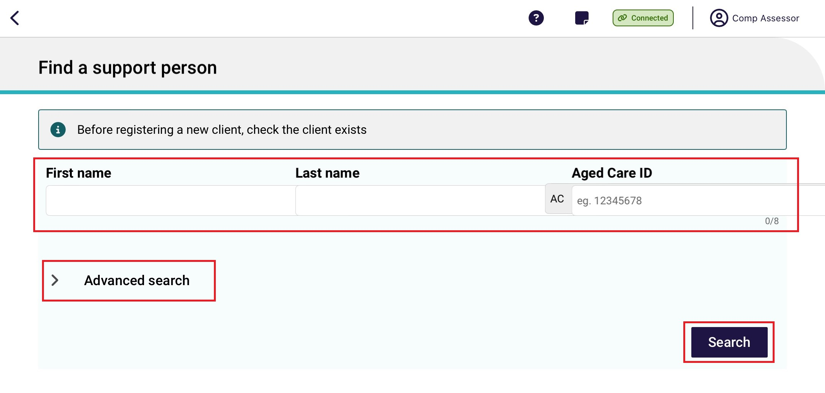
Select your support person, then go to step 5.
If you cannot find the support person’s record, try other search parameters or select Register a Support Person, then go to step 4A.
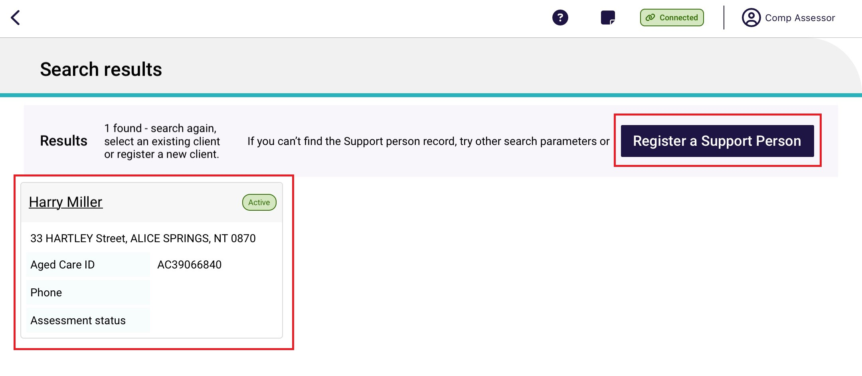
4A. To register a new support person, Enter all mandatory fields in each of the pages shown with red asterixs, and until the Register button turns blue. Then, select Register and go to Step 8.
'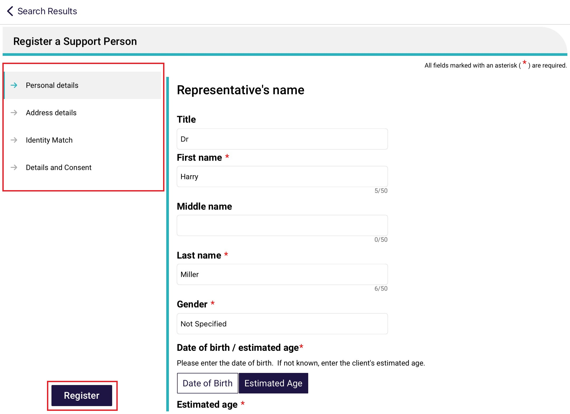
- To create a carer as the support person, you will be required to follow the previous steps and select Carer and search or create a new record. Once you have completed these steps, the carer will have the following details are shown in the About page of Support Person Details. Go to the next page: Call back details.
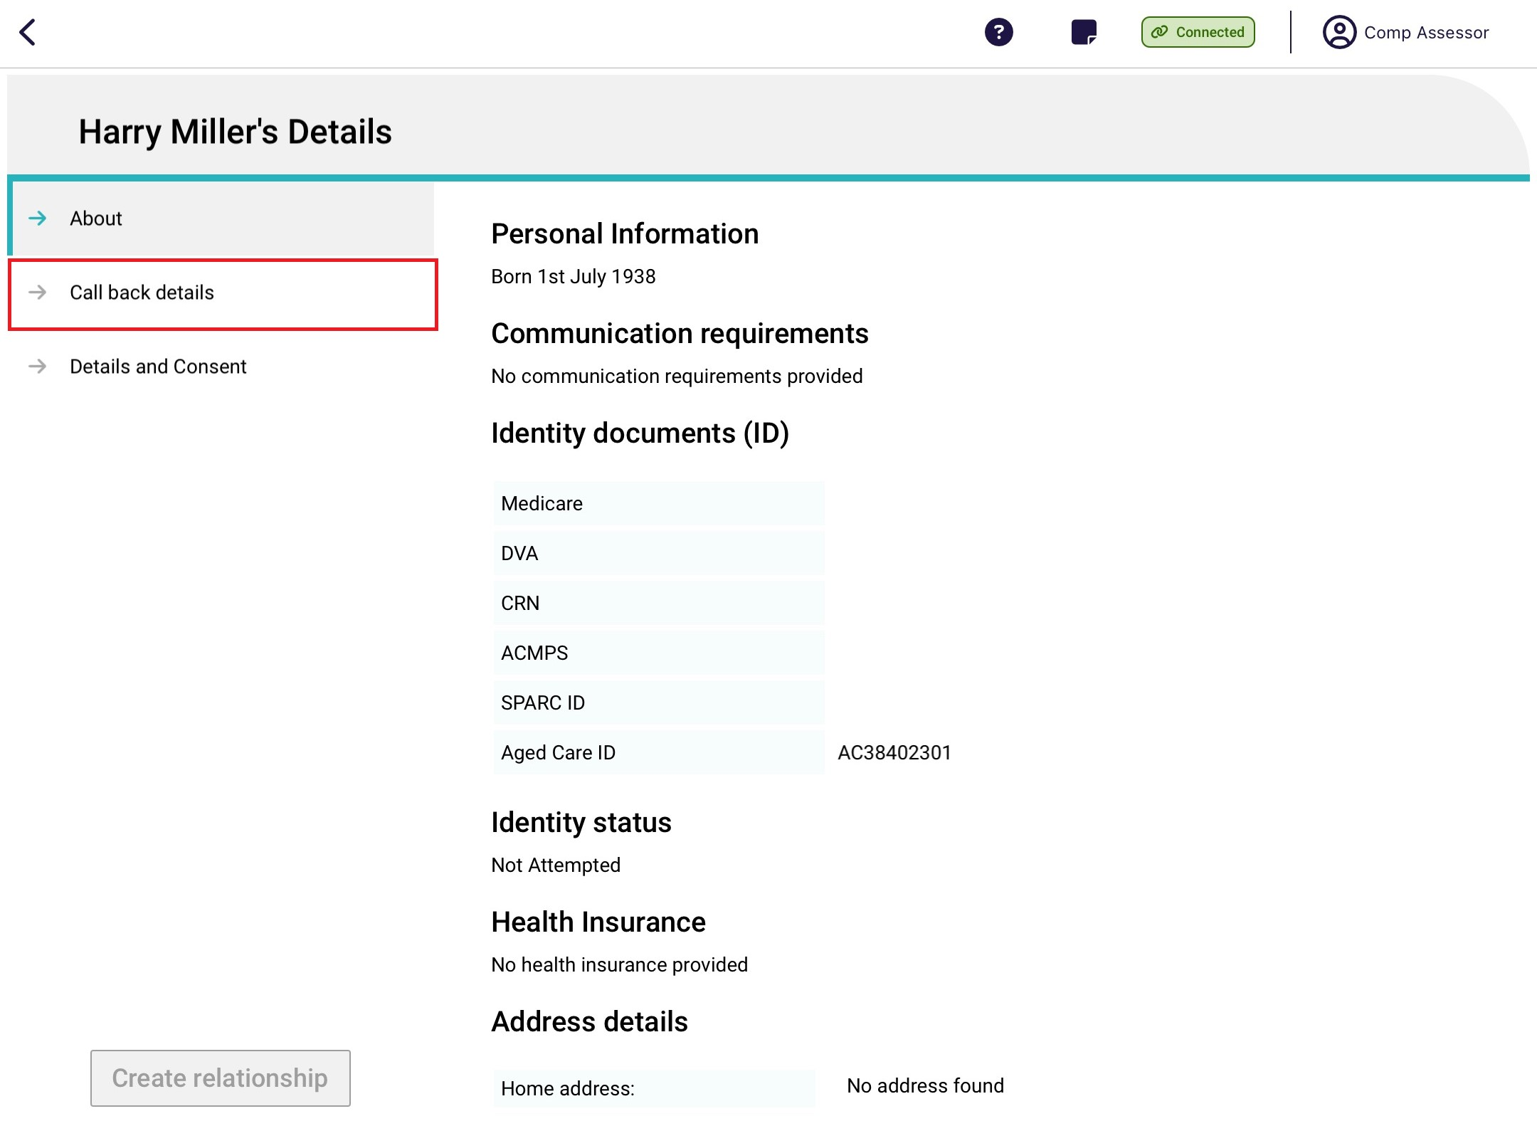

- The Call back details page displays.
Fill in all mandatory fields and go to the next page, Details and Consent.
! | To successfully register call back details, the client’s contact details must be registered on the Call back details page. This includes phone number/s and home address.  If the details are not there, go back to the client’s profile to fill them in.
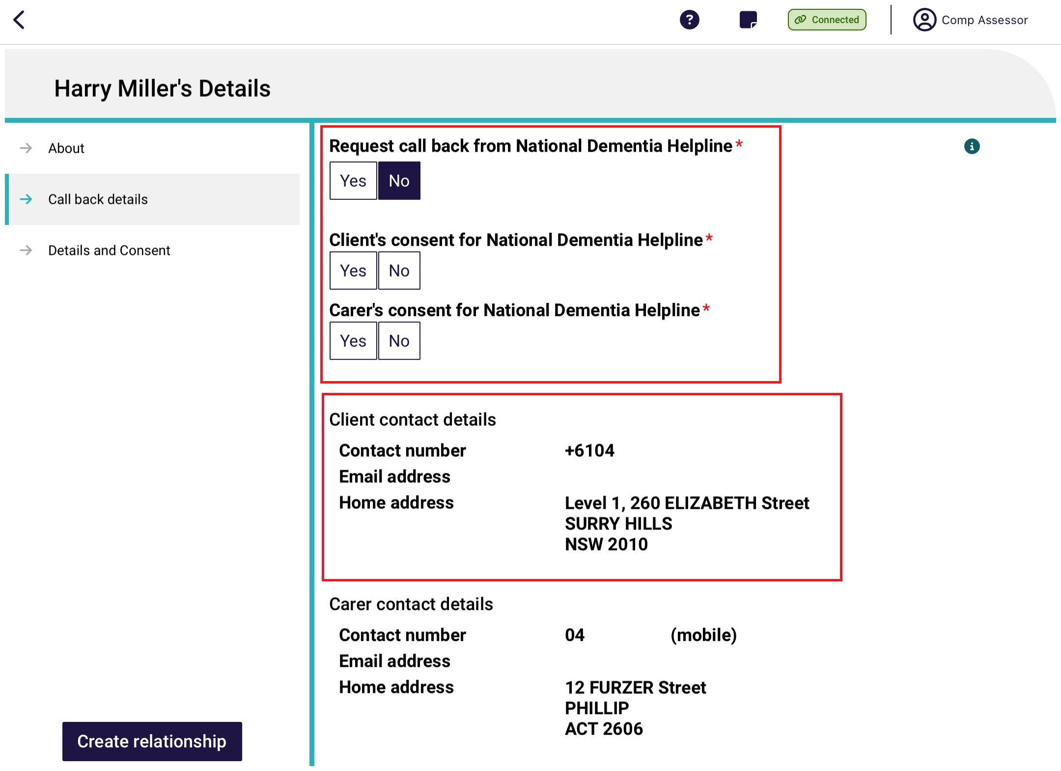
- The Details and Consent page displays. Fill in all mandatory fields, then select Create relationship.
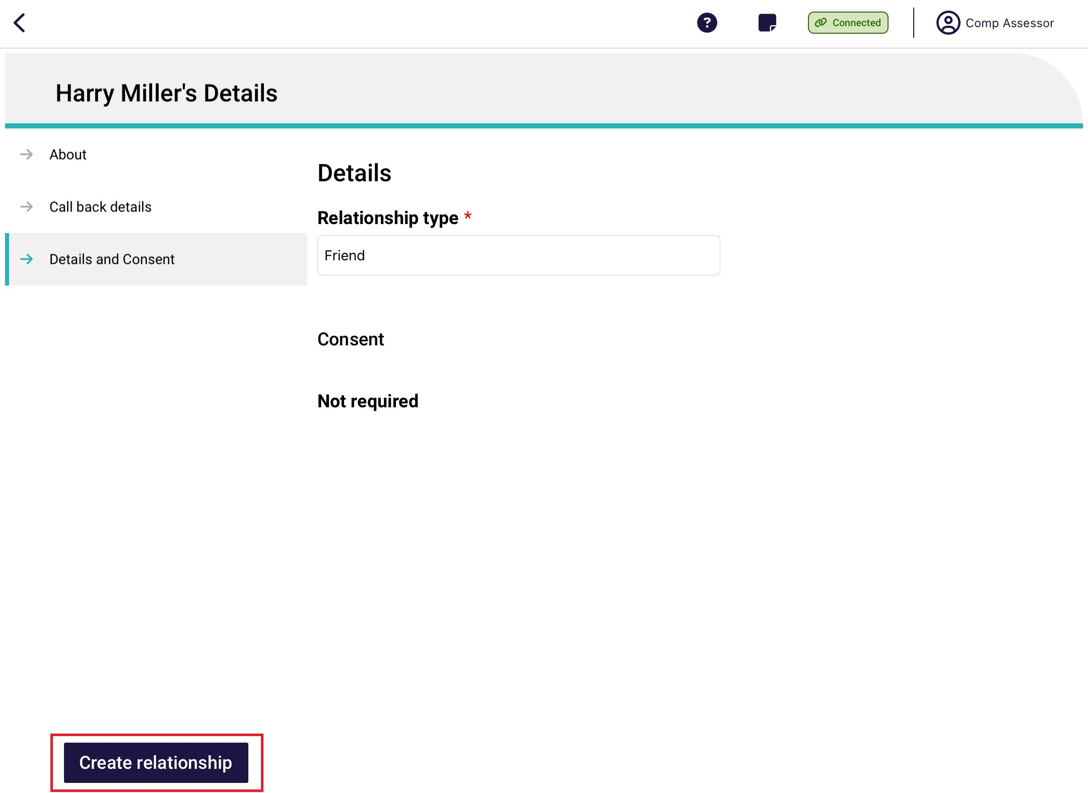

8. The support person relationship is now displayed on the client’s Support Network and Cohabitants page.
In the case of a carer relationship, there are two additional buttons: Edit which edits contact details, and Request call back which registers call back consent.
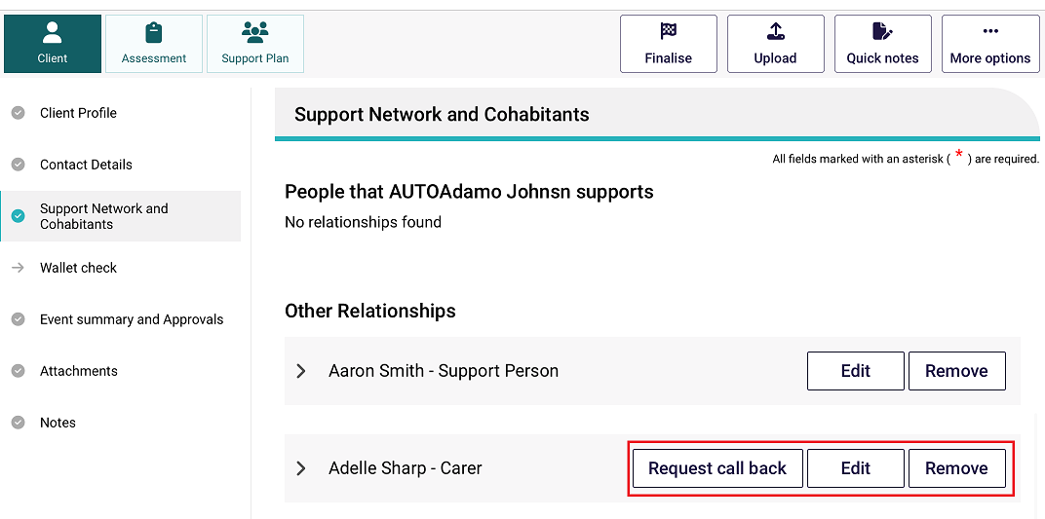

Creating a relationship in offline mode
To create a representative, agent or support person while the App is in offline mode, follow the steps below.
! | You must be online to register and set up a relationship. Any support people created offline will be saved locally to your device. Relationships created offline will have a visual indicator to identify that they have been created locally to the device.  You must register the relationship before you can upload the assessment. To do this select Register against the local record and follow step 4A in Section 12.3 (Creating a relationship for a carer or other support people).
- Navigate to the Support Network and Cohabitants section and select the Create Relationship button.
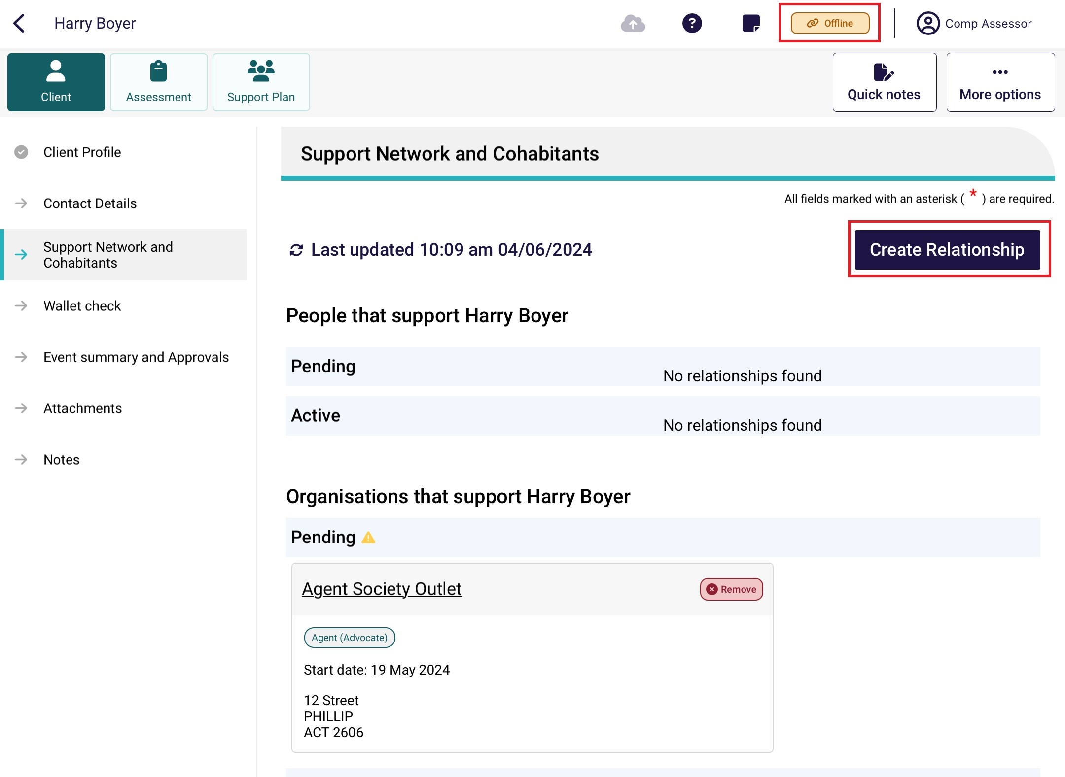
- Fill in all the representative’s mandatory information until each page has a tick next to it, then select the Save button.
! | Authorised Representative relationships are created as Pending only. Use the Assessor Portal to complete activating the relationship.
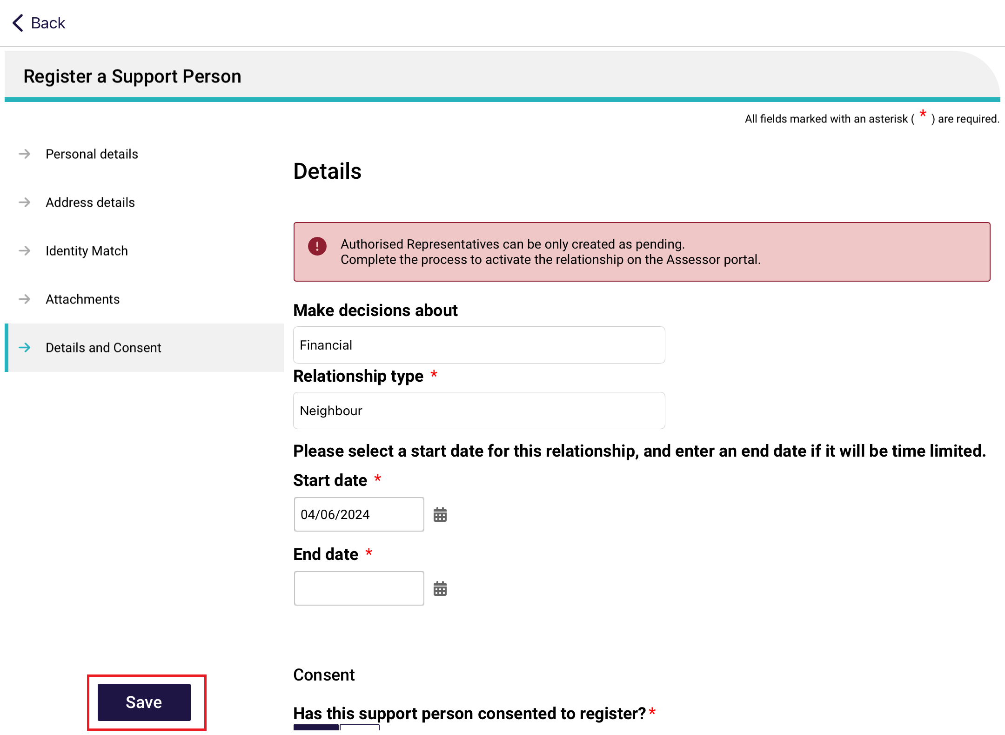
- A banner – Local Relationship saved successfully appears. Select Go Back.
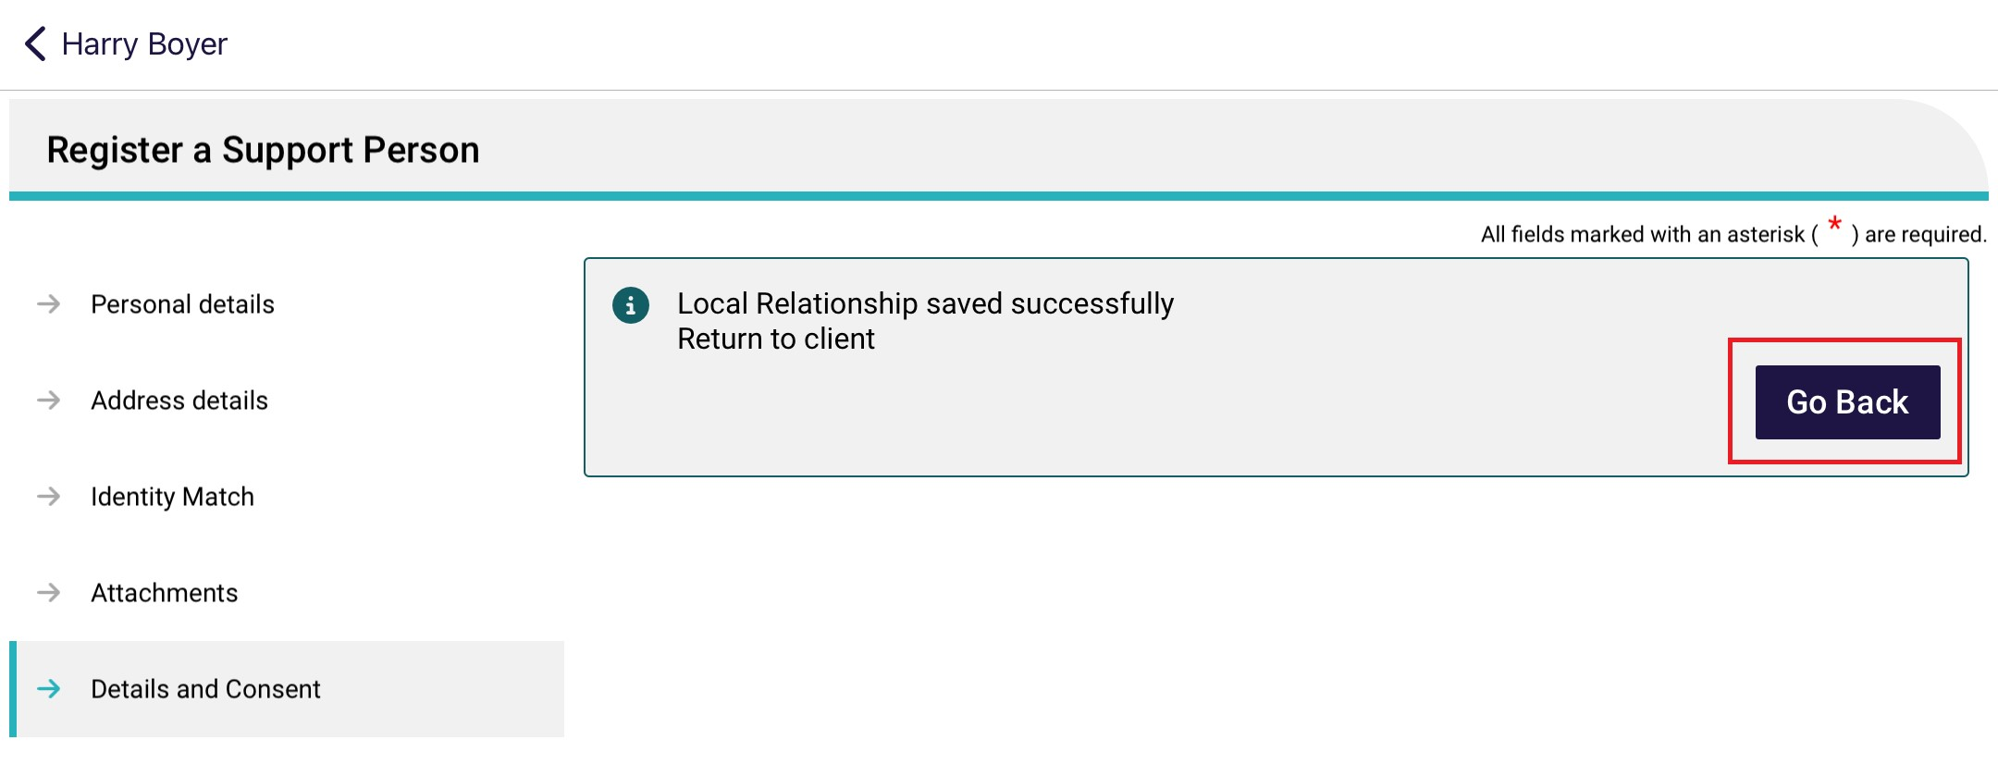
- The new representative or support person will appear on the Relationships and cohabitants page.
In the case of authorised representatives, a banner appears: Some relationships cannot be activated via the App. Please finalise these on the Assessor portal.

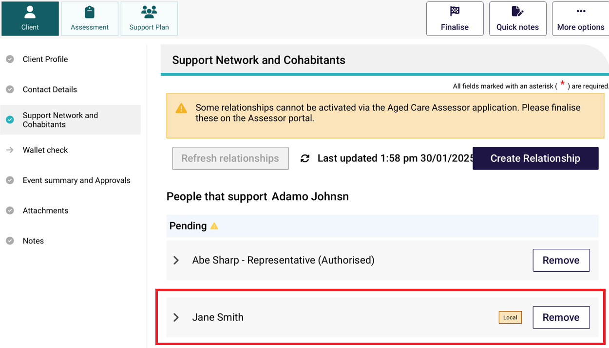

Activating a pending relationship
A Pending Relationship is created on a client’s record when
- If either the client or representative (regular representatives and agents only) do not provide their consent for the relationship to be set up; or
- The start date of the relationship is in the future; or
- An Authorised representative relationship is being created.
! | A warning symbol  will be displayed pending Support Network and Cohabitants menu item when a client has pending relationships that need to be confirmed.
To activate a pending relationship, follow the steps below. You must be connected to the Internet.
- In the client’s Support Network and Cohabitants page, select Activate.

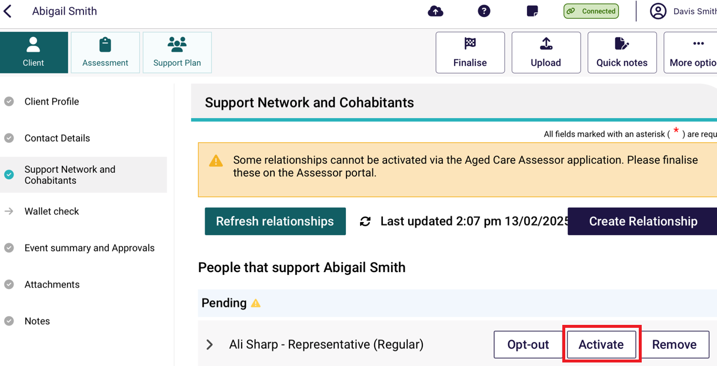
- From the Activation page, update the support person’s consent as required then select Activate.
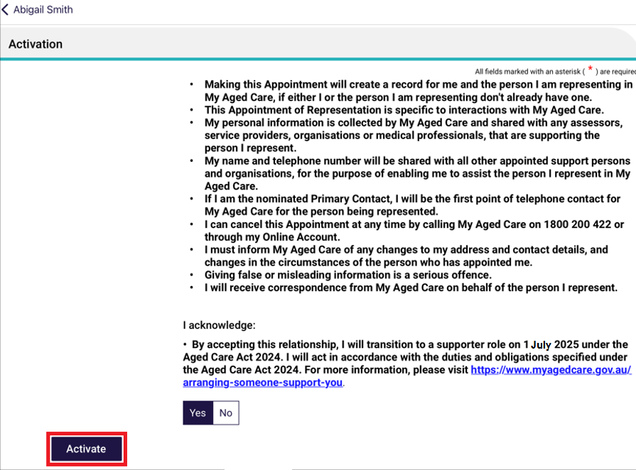
The Activation page will then change to display a banner which confirm that the relationship has been successfully activated. The relationship will now show as active in the client’s support network and cohabitants tab.

Please note Authorised Representative relationships can only be activated through the Assessor portal.

Removing a support relationship
To remove an active or pending relationship:
- Select the Remove button on the support person’s card.
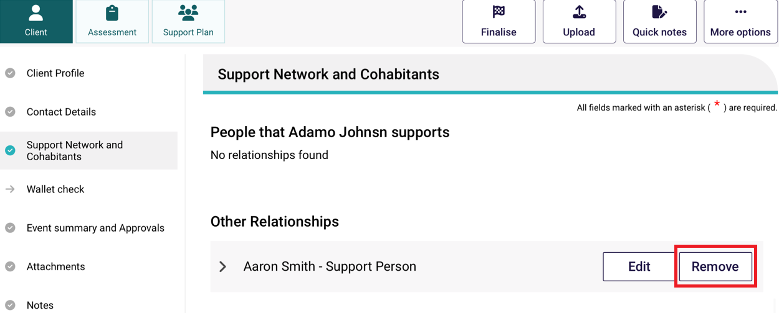
- Select Remove in the confirmation window will open.
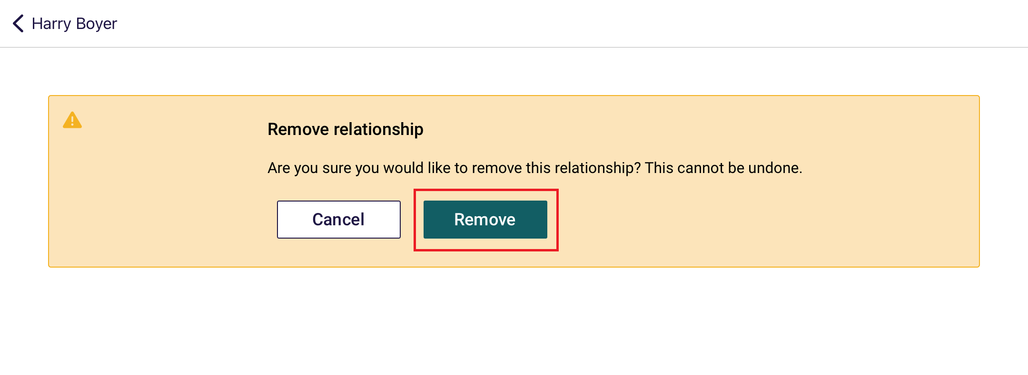
- Removed relationships will show under the Declined and ended relationships section in the Support Network and Cohabitants section.

Opting out of relationships
Clients and representatives can choose to opt-out of an existing representative relationship. Alternatively, this will occur automatically on 30 June 2025, to coincide with the introduction of the Aged Care Act 2024 on 1 July 2025, which will change the responsibilities of these relationships.
- From the Support Network and Cohabitants select the Opt-out button next to the representative relationship the client or representative wants to opt-out of.
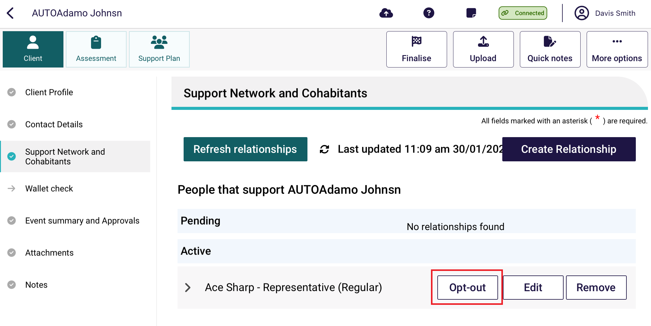
- From the Opt-out of relationship page select the person initiating opting-out of the relationship.
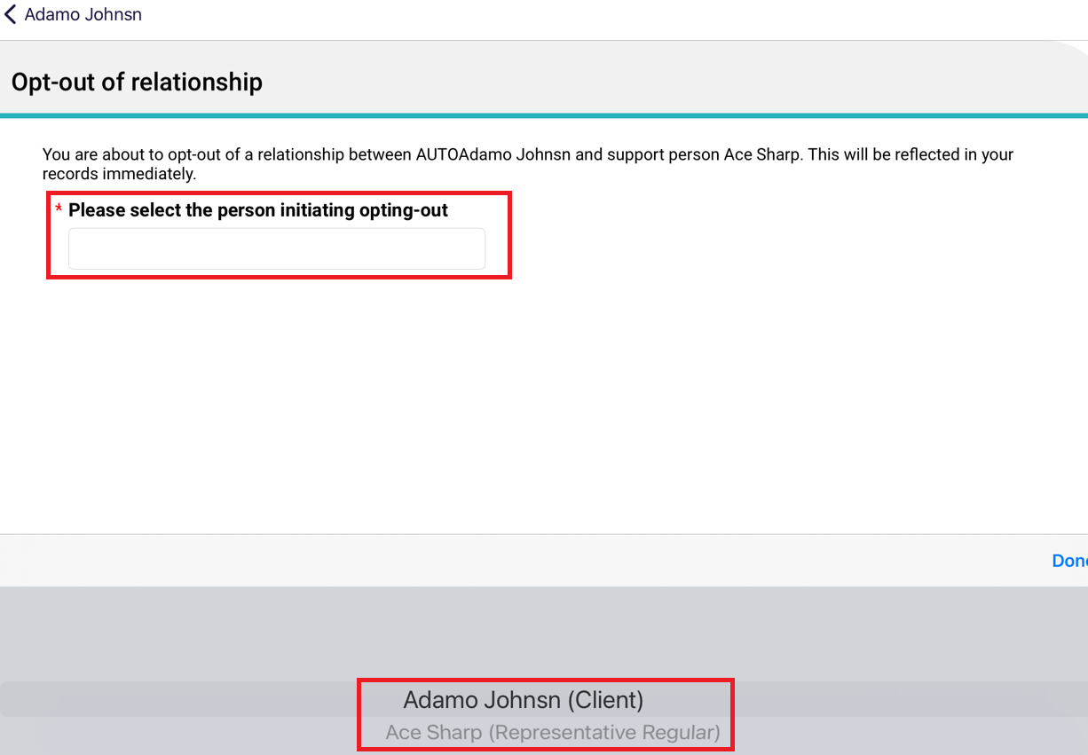
- Select the reason for opting-out of the relationship.
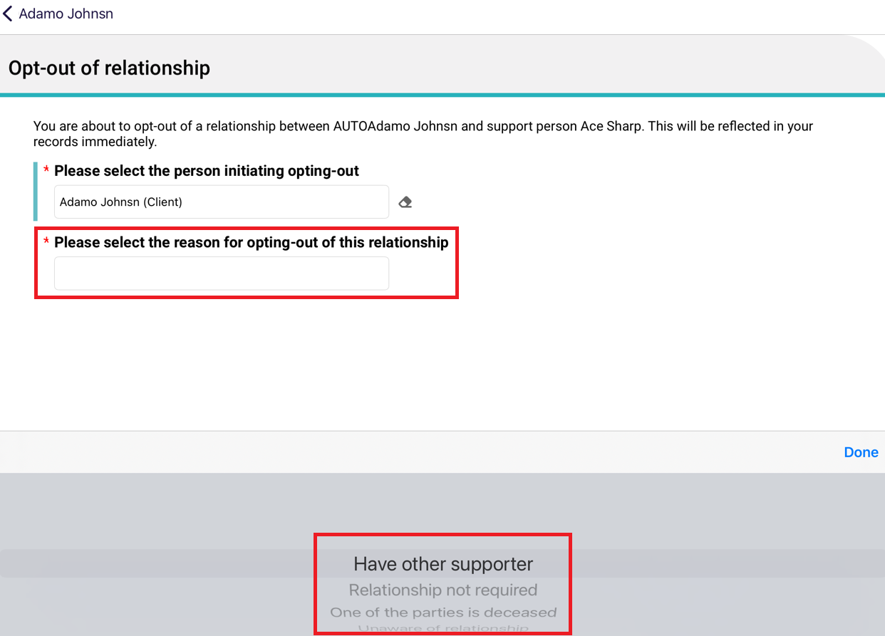
- The client or representative will then have the option to remove the relationship now if they wish. To do this, select the I would like to remove the relationship now radio button and then click Opt-out and remove. This will then remove the relationship.
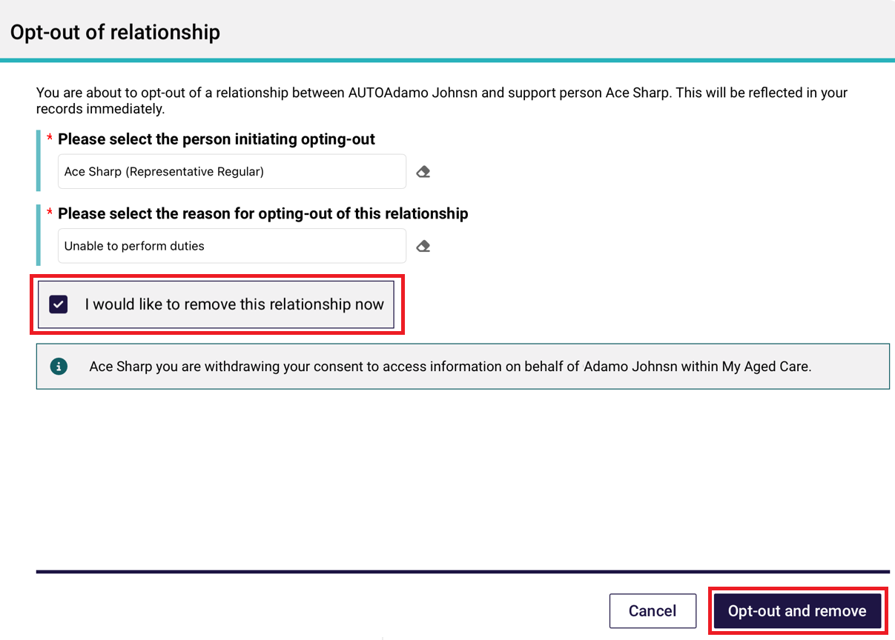
Alternatively, the I would like to remove the relationship now radio button can remain unticked if the client or representative would like to maintain the relationship until being opted out on 30 June 2024. Select Opt-out to finalise the request.
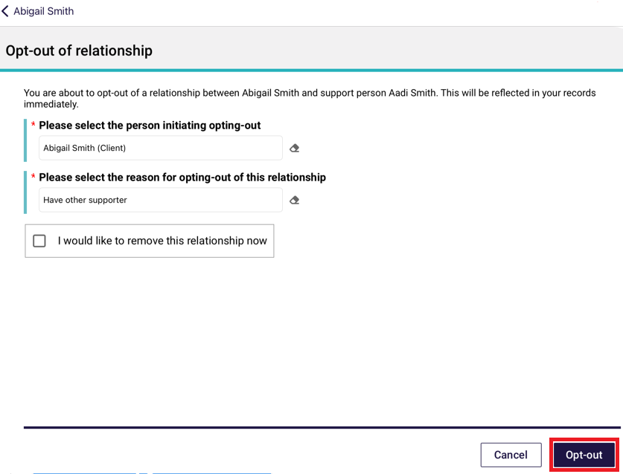

Completing identity verification
To conduct identity verification (a wallet check), follow the steps below.
- Open and log in to the App with your password, following the process in Signing in to the App after activation. The Dashboard will be displayed. Select the client’s name on the referral card.
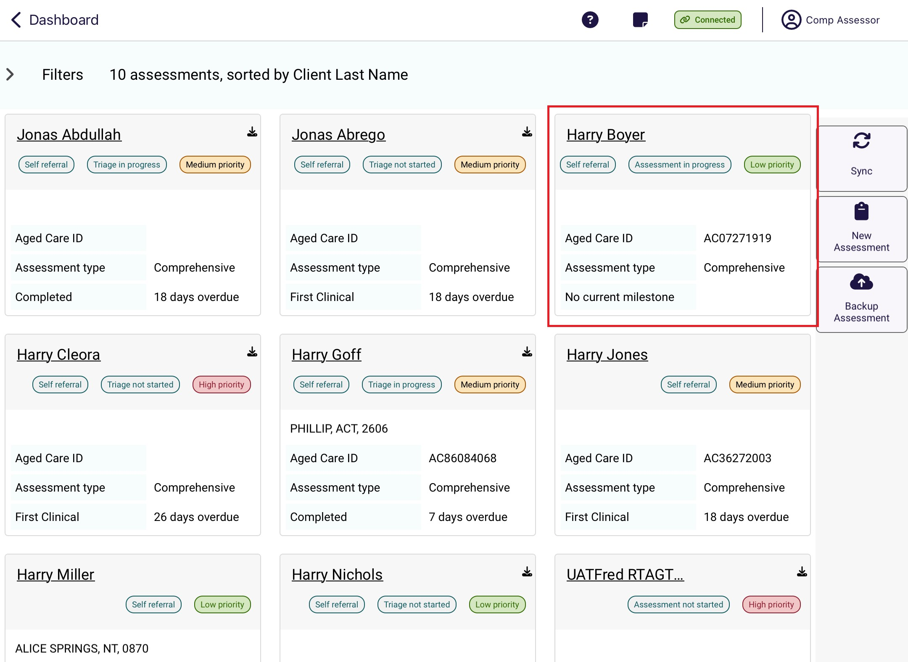
- Select Wallet check. The status of the wallet check will be displayed. To conduct a wallet check select Conduct a wallet check.
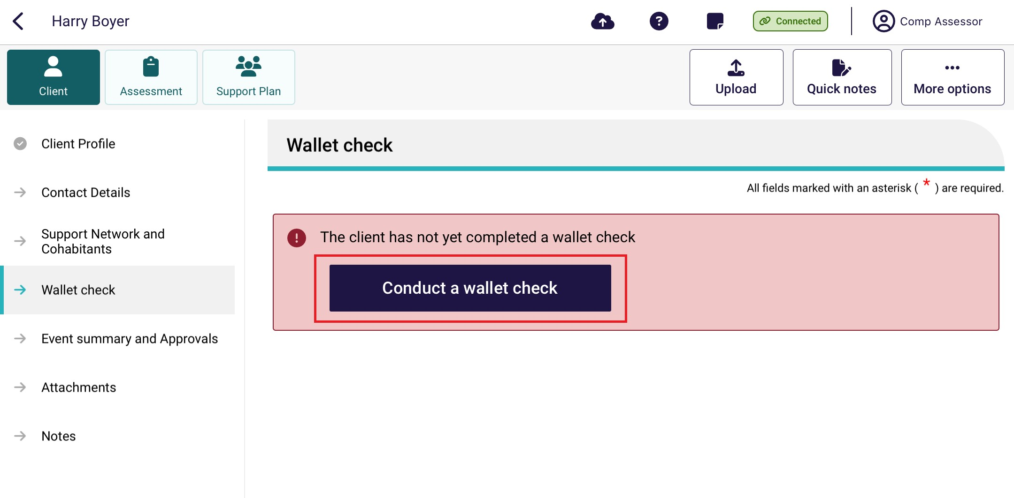

- A page is displayed to record whether the client has identification that will allow you to complete the process.
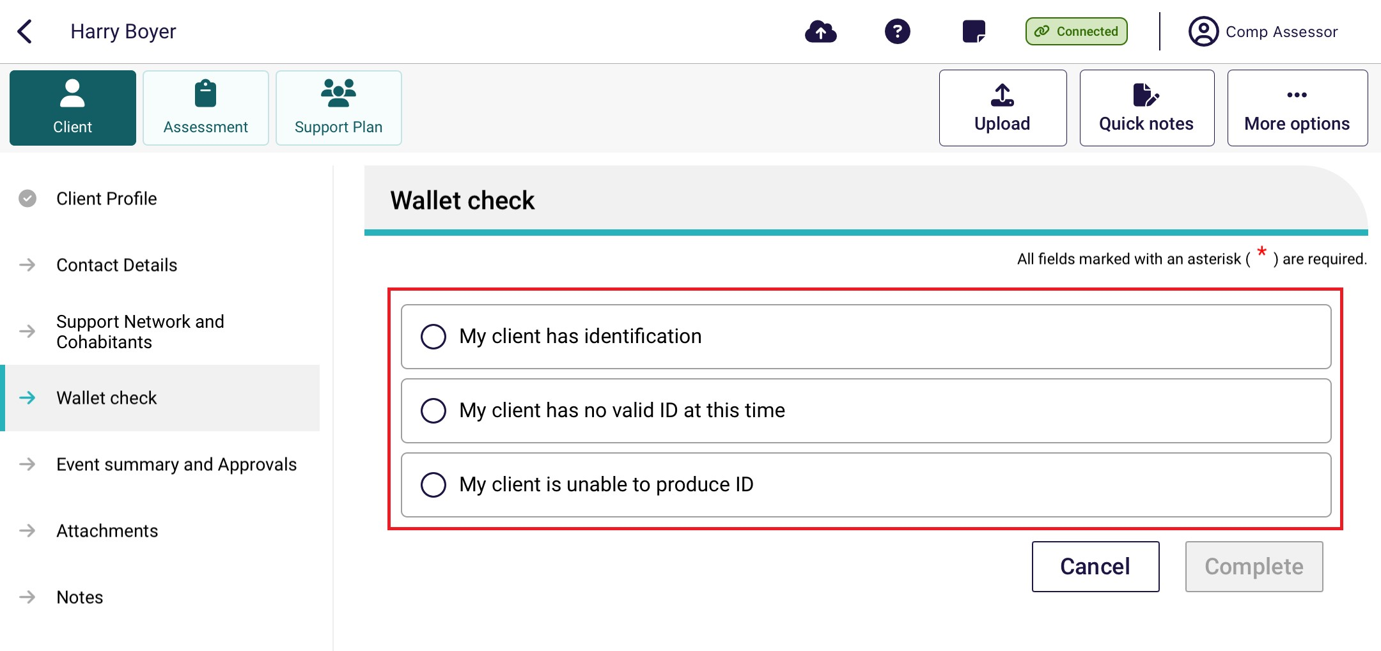
If you have selected:
- My client has identification, go to step 4.
- My client has no valid ID at this time you will receive a message confirming that a wallet check should be completed at a later date. Go to step 5.
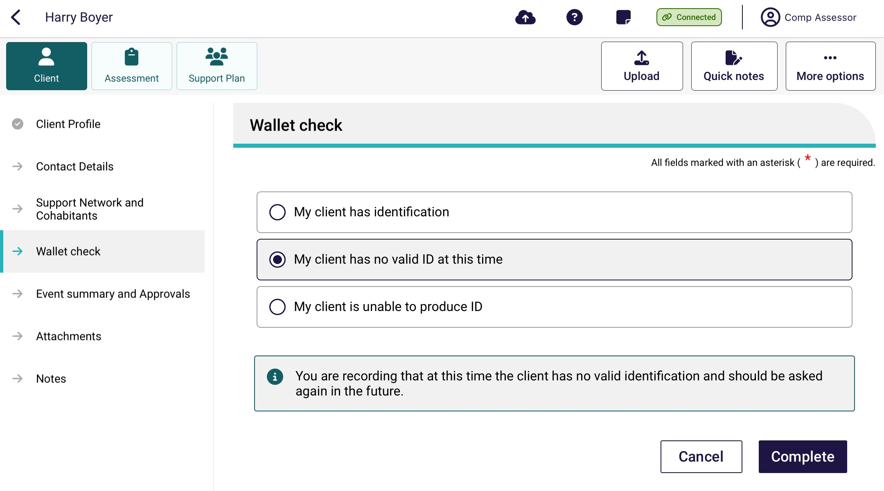
- My client is unable to produce ID, a message will be displayed to record that you are unable to complete the wallet check and that it will not be able to be completed at a future date, go to step 5.
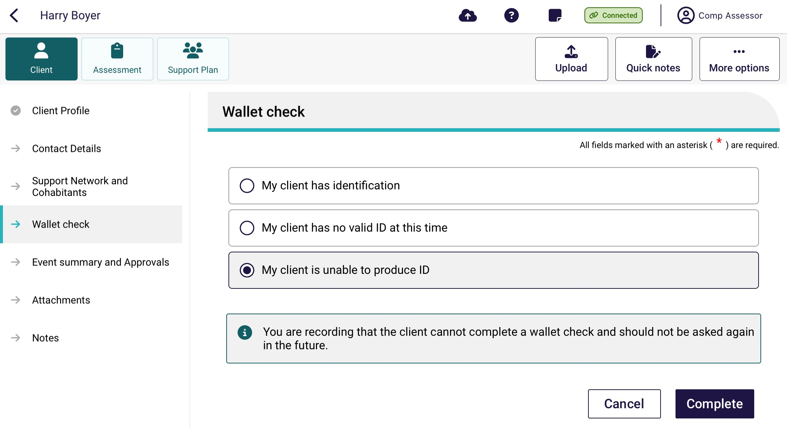
- The page will be expanded to allow you to record the type of documentation sighted, and the date that you performed the wallet check. You will need to sight at least two types of identification to complete the wallet check.
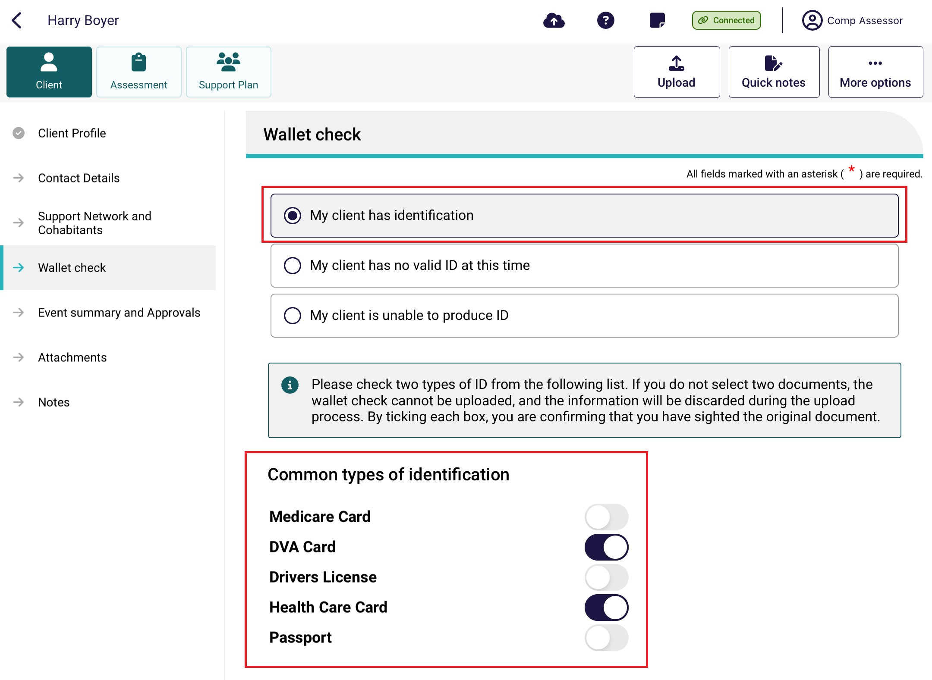
! | Select Show more types of identification that can be sighted to display additional identity documents that may be used for identity verification, for example, Birth Certificate, Australian Aged Pension, Pensioner Concession Card etc.

- Select Complete.
- If you successfully completed the Wallet check an information message will display to confirm that the Wallet check has been completed.
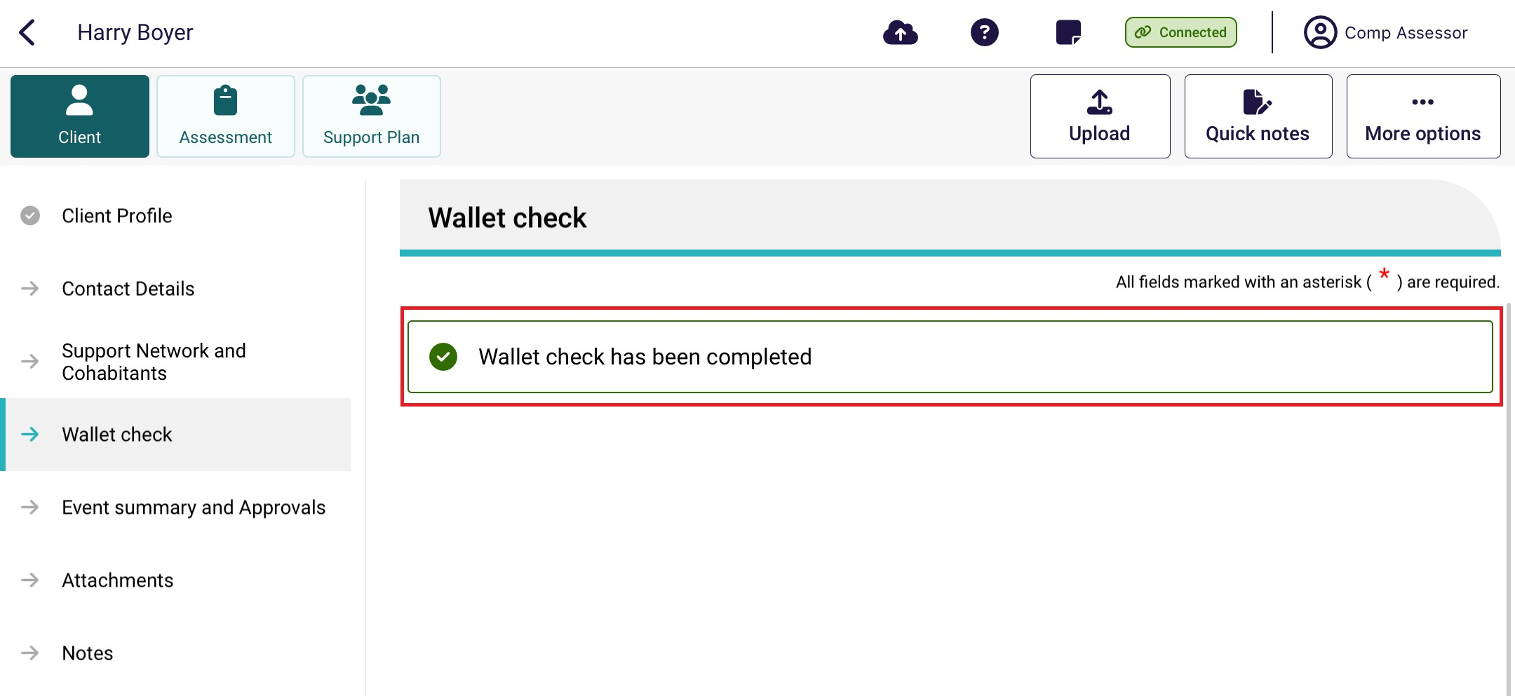
! | If you are unable to sight two identification documents (e.g. the client does not have valid ID), a reminder to complete a wallet check will display on the client record until a wallet check can be completed. This will not prevent you from completing an assessment.

Undertaking assessments
Needs assessors can use the App to:
- Undertake assessments for client’s referrals they have downloaded.
- Undertake assessments for offline clients they have saved locally to their device.
- Undertake Residential Respite Assessment
! | The App will display the same sections of the assessment that are available for assessors in the My Aged Care assessor portal.
The steps to undertake an assessment on the App are as follows.
- Open and log in to the App, following the process in Signing in to the App after activation. The Dashboard will be displayed. Then, select the clients name that you are wishing to assess.
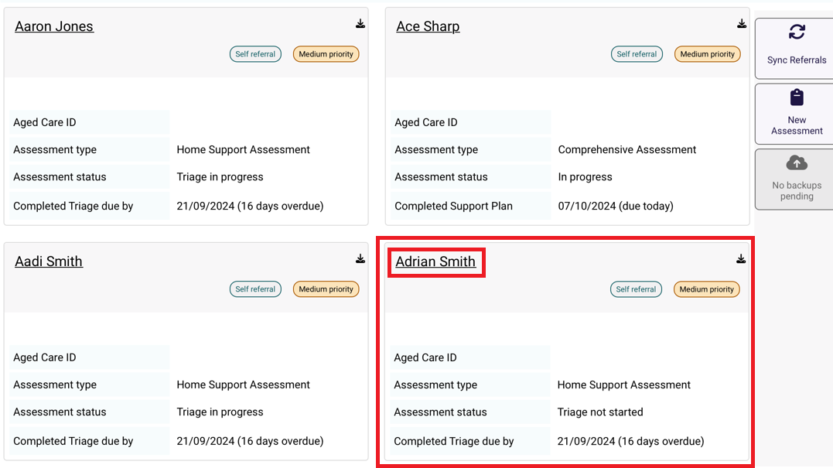
- Select Start Assessment.
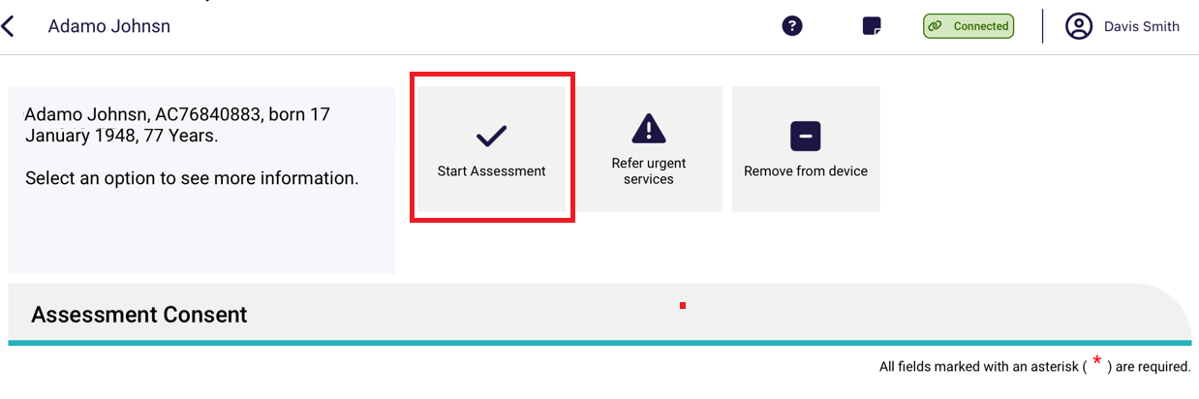
- Select the relevant radio box for who has provided consent to the assessment as well as if you would like to pre-populate the IAT questions or start a blank assessment. Then select Confirm.
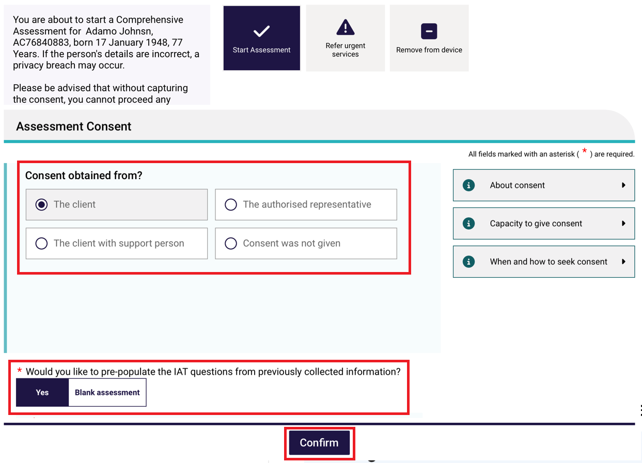

- The Assessment Details page will display, and the assessment can be commenced from here.
For comprehensive assessors, the First Intervention of a Clinical Nature page will display.
Mandatory fields are identifiable by red asterisks, and prior to completing mandatory information a red triangle will display in the top right-hand side of the box. Once a mandatory question is answered, this triangle disappears. This feature helps to identify whether all mandatory questions have been answered in each section.
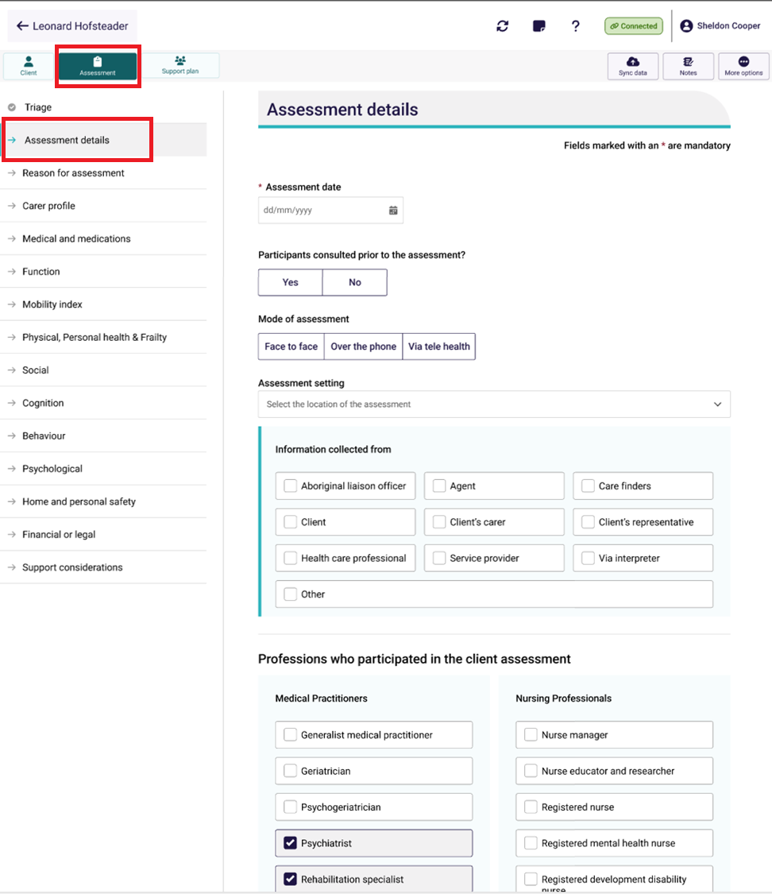
At the bottom of each page, Select the toggle to acknowledge that you have reviewed the information on the page and confirm that it is correct. Select Next to navigate to the next section of the assessment in the App.
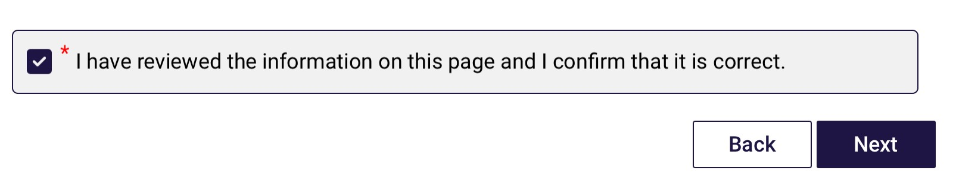

! | Cancelling an assessment  You can cancel an assessment from any screen within the App. Select More options from the top right of any screen, then select Cancel assessment from the pop up that appears.  If you cancel an assessment within the App, your team leader will receive a notification once you have internet connection, and your device has synced with the assessor portal.  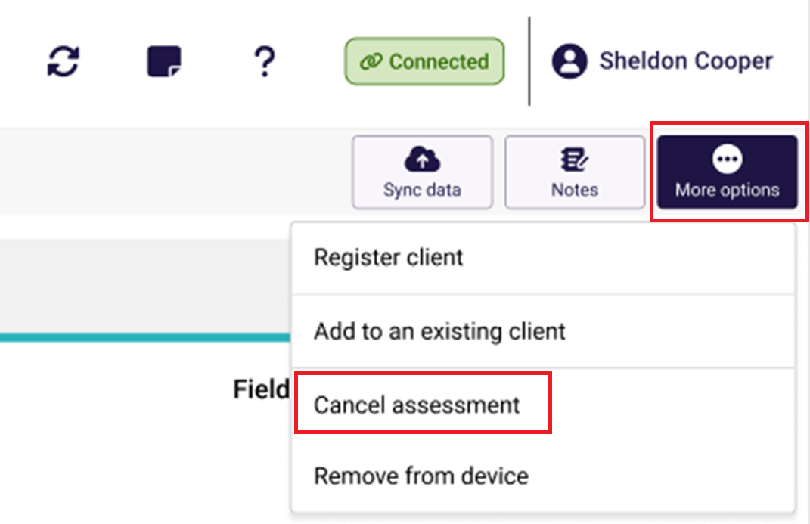

! | Field text limits  There are character limits for free-text fields. The character limits will display at all times. Ensure that you do not exceed these character limits whilst undertaking the assessment.  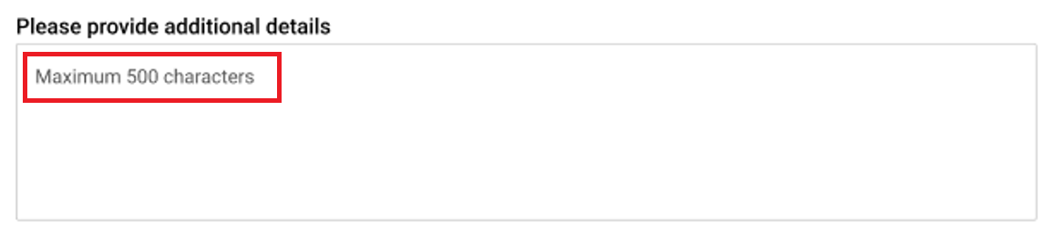

! | Clearing information  Selecting Clear page information on the top right of any screen will clear any information entered on the current page of the assessment that the Needs assessor is working on.  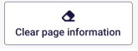

- Progress through the sections identified in the Assessment menu. Similar to the My Aged Care assessor portal, a mandatory confirmation box must be completed at the bottom of each section.

A tick will appear beside the relevant section in the Assessment menu when all mandatory questions for that section are complete.
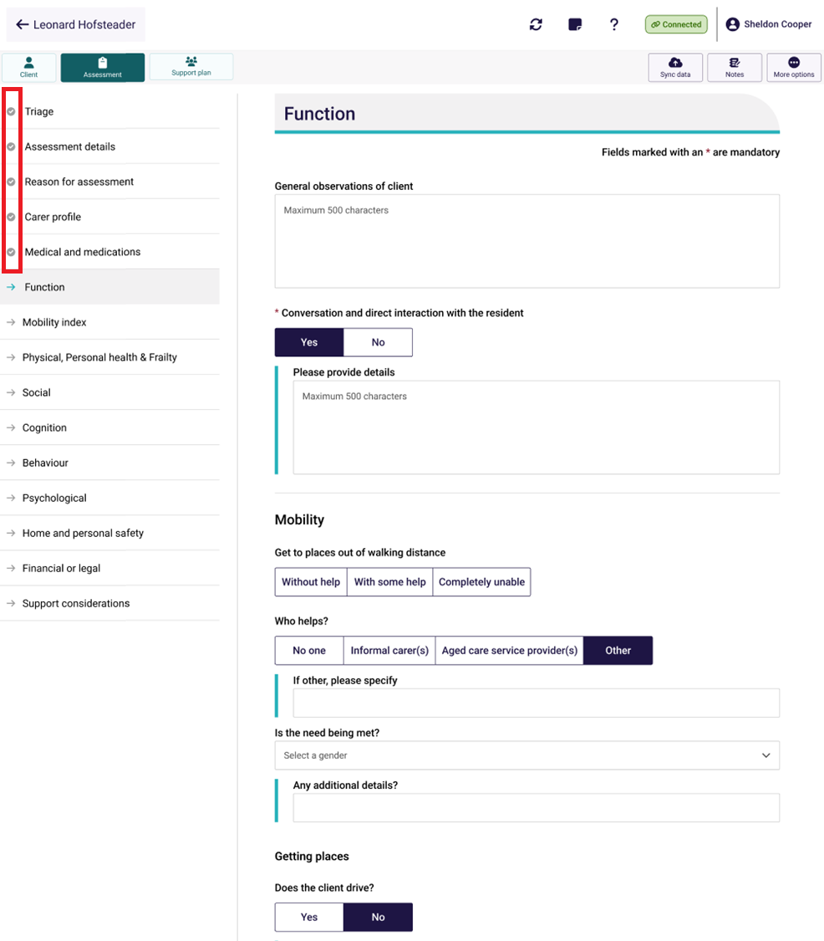
- While progressing through the assessment, needs assessors may choose to use the Quick notes feature, which allows notes to be recorded on the App.
These notes could be sensitive in nature or may be notes that are for later reference during the assessment process.
Select Quick notes at the top right corner of the assessment screen to enter.
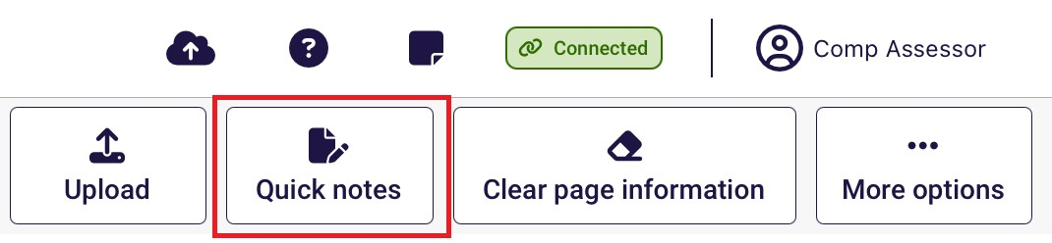
- Select Done to return to the assessment.
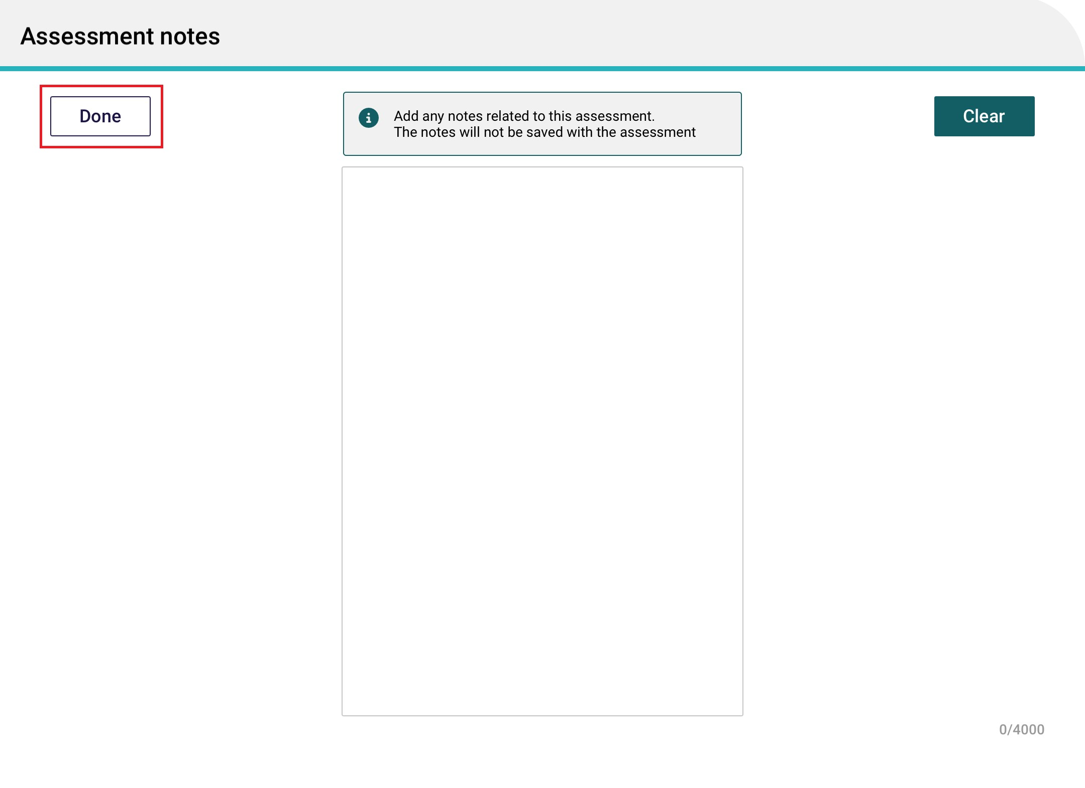

! | Information captured in this section will not be uploaded to the assessor portal.
- Adding health conditions in the App follow the same process as the assessor portal. Up to ten health conditions can be added in an assessment. To add a health condition select Add health condition.
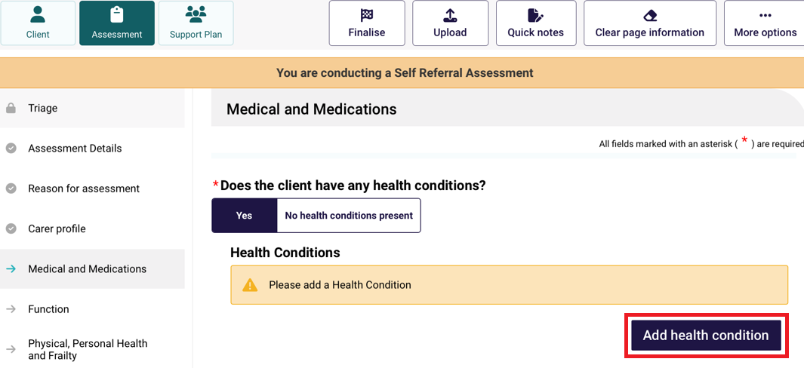

From the Health condition page, you can then search by the condition name, code list of Health conditions or select by disease category. Select Save and close to add the health condition.
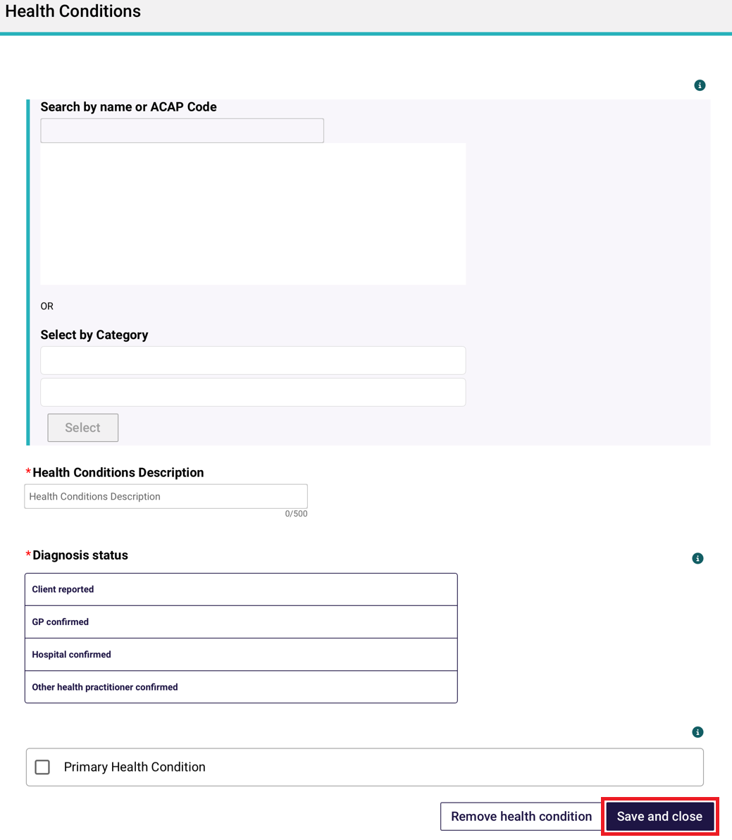

- In the IAT assessment, validated assessment tools and questions will trigger based on the information recorded by the needs assessor during the assessment. These validated assessment tools are now integrated into the tool, and it will be listed automatically under the relevant section of the assessment that you are completing with the client.
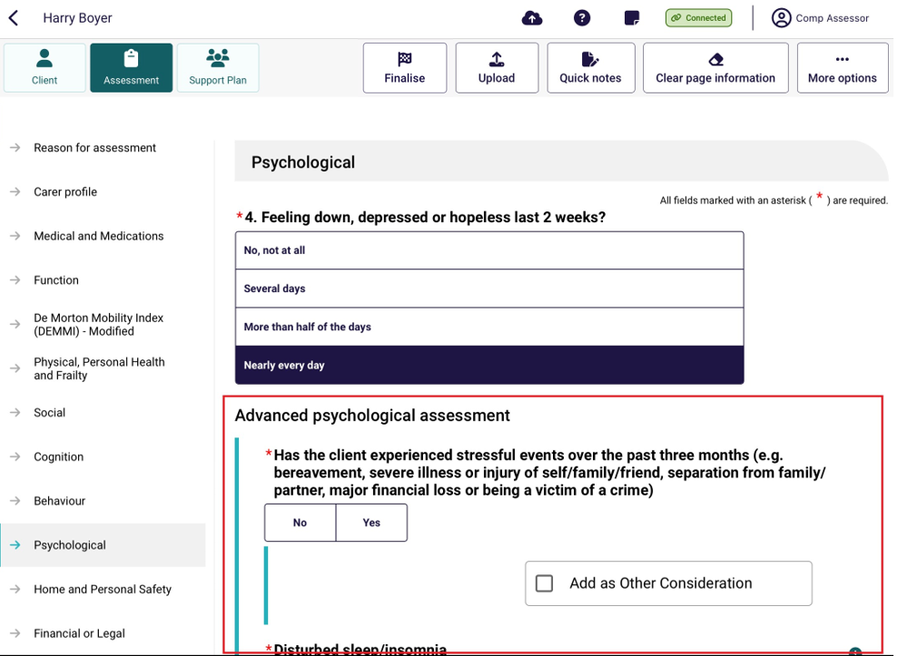
! | You should review the MAClearning element Validated Assessment Tools in Practice for further guidance on how and when to administer them with a client during the assessment.
- Threshold questions are also used throughout IAT to trigger moving the assessment into clinical/comprehensive areas. These questions are identified by a purple icon with text outlining the need for completion under your organisation’s clinical governance.
For non-clinical needs assessors, these questions can only be completed with clinical attendance. To proceed in answering these questions under supervision, non-clinical needs assessors must select the Clinical Supervisor button from the top banner.
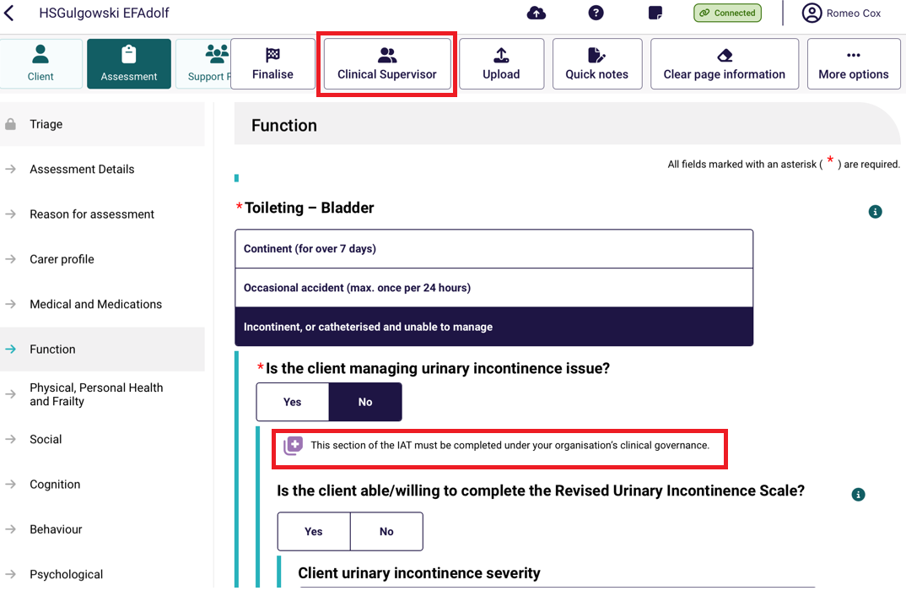
Non-clinical needs assessors must then confirm if they are completing the questions under clinical attendance and select the supervising assessor from the list. Once completed, select Confirm to continue. You will be re-directed back to the assessment when you can proceed to complete the assessment with clinical attendance.
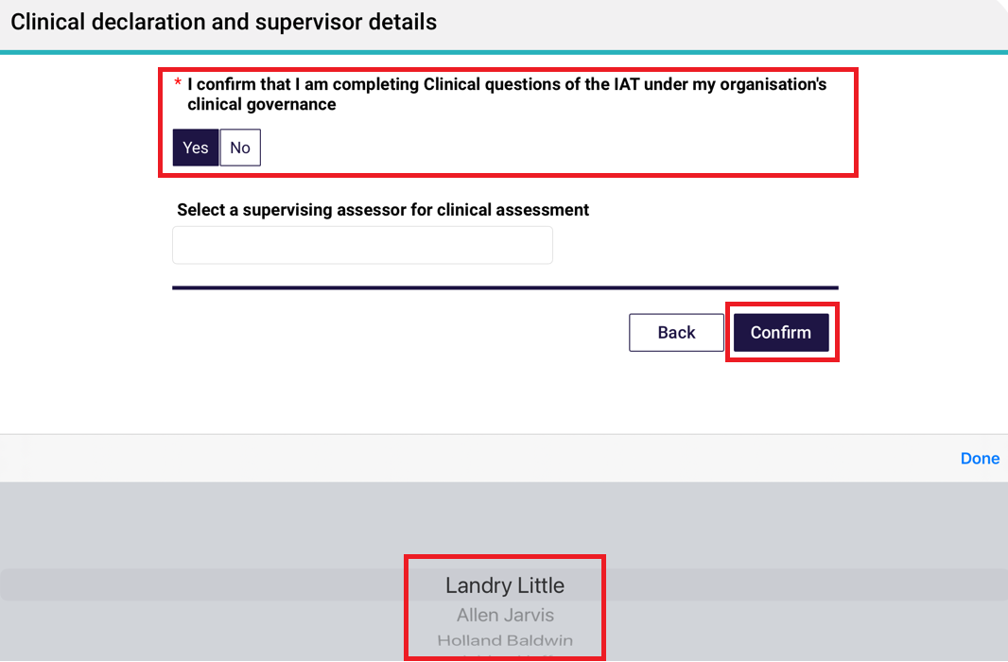
- As needs assessors are progressing through the assessment they can indicate which Needs (Functional needs, Other considerations, Complexity Indicators) and some recommendations to be addressed in the support plan, by selecting Add as Functional Need, Add as Complexity Indicator, Add as Other Consideration and Add as recommendation next to the relevant question.
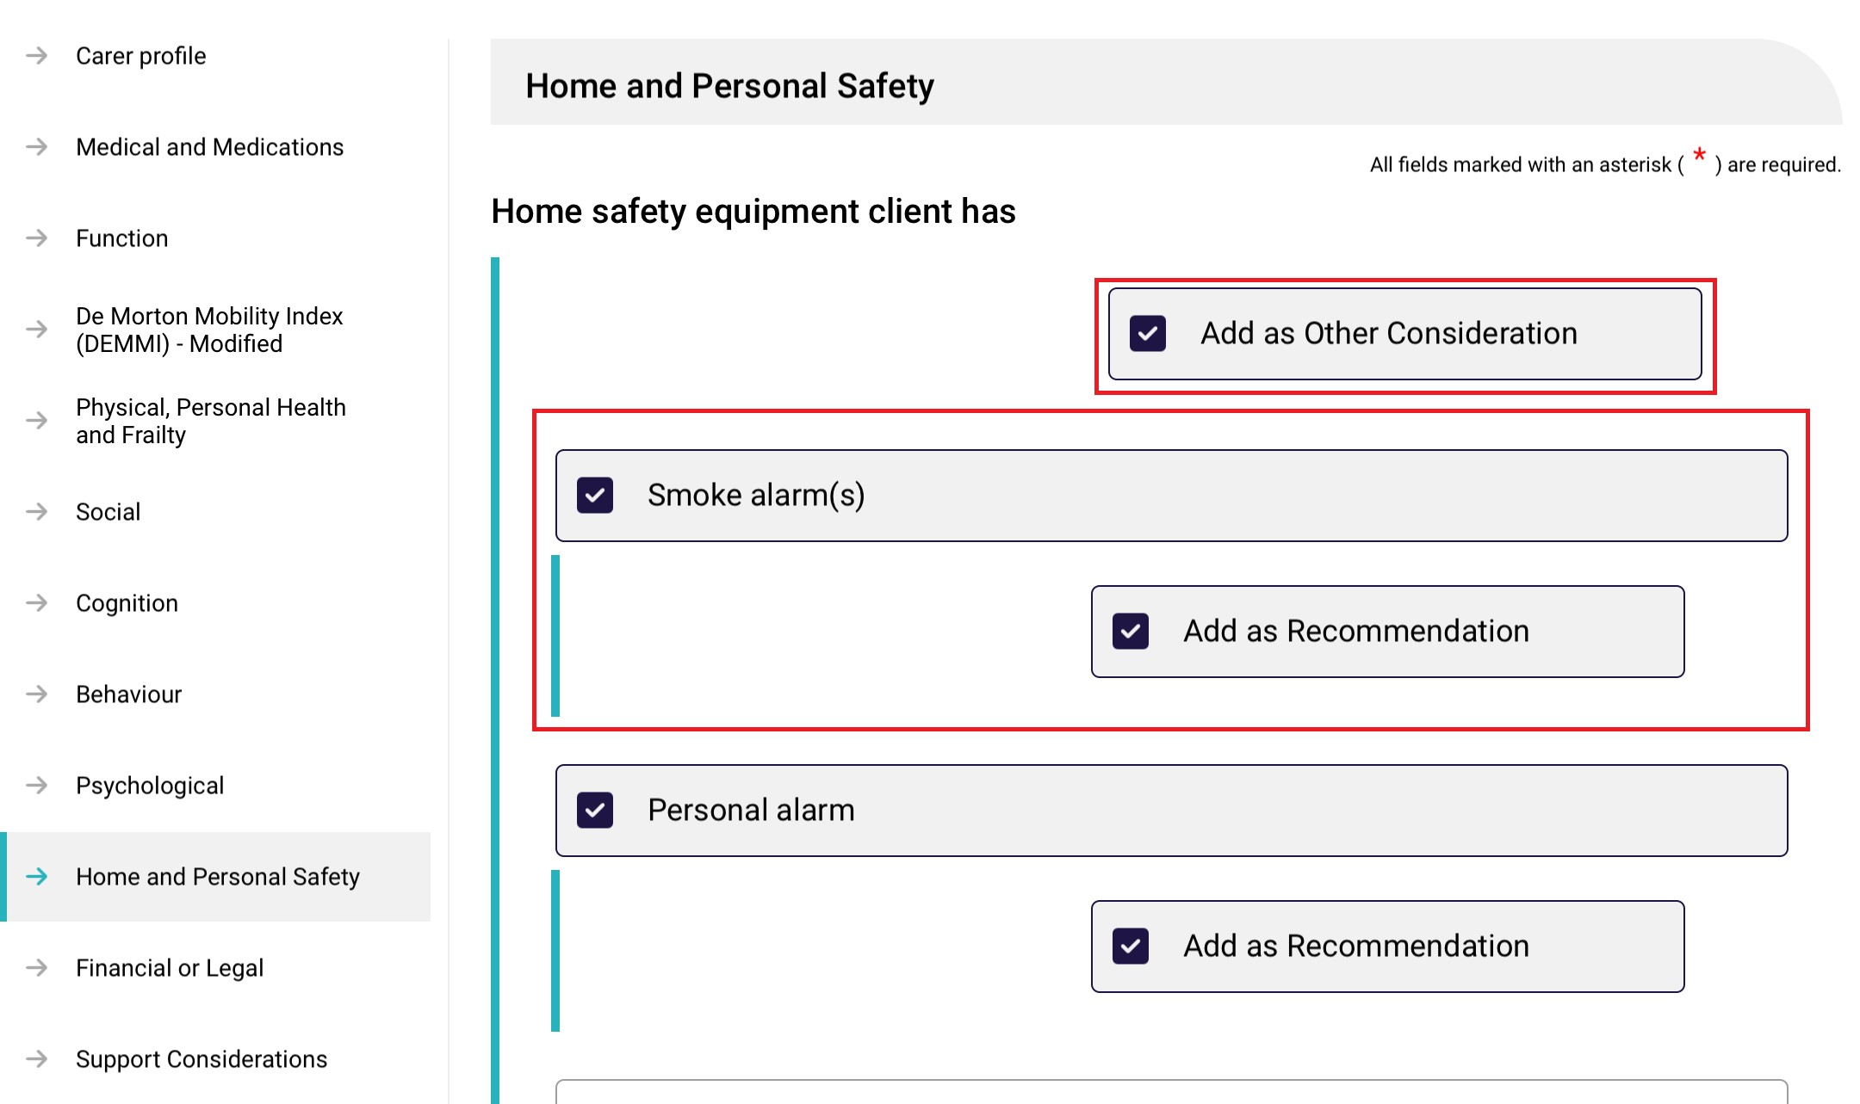

- Any functional needs, other considerations, complexity indicators and recommendations will be displayed in the Support Plan section of the app.
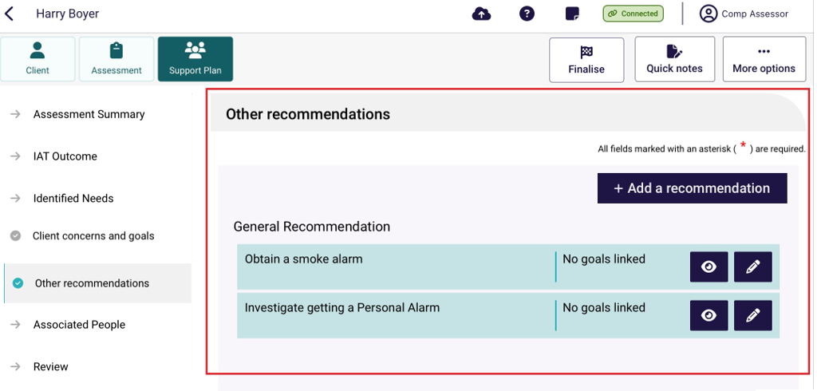
- To finalise the assessment, select Finalise at the top of the assessment screen.
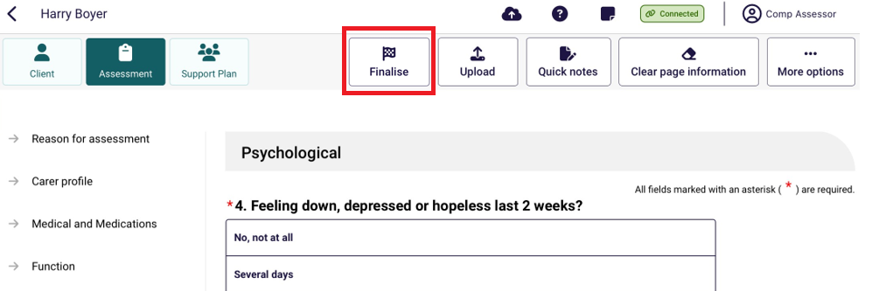
- Before finalising the assessment, the client can opt to share their Support Plan via their My Health Record. Select Yes or No based on the client’s response.
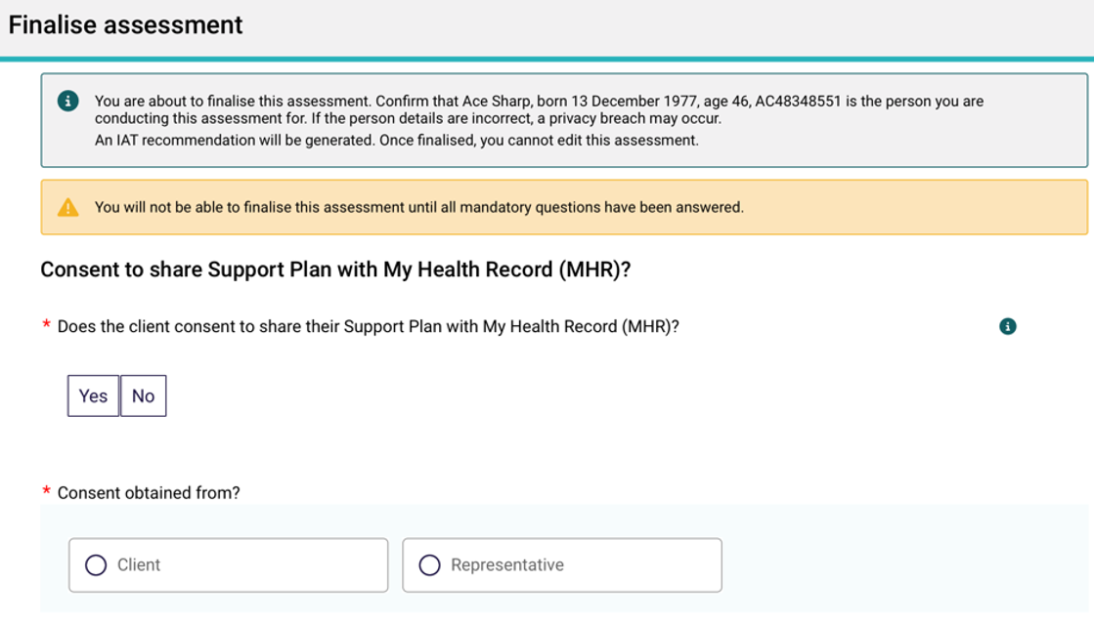

If consent was obtained from a representative, you will also be required to enter their first name before proceeding.

Select Finalise to continue. Please note, you will only be able to select Finalise once all mandatory fields have been completed.
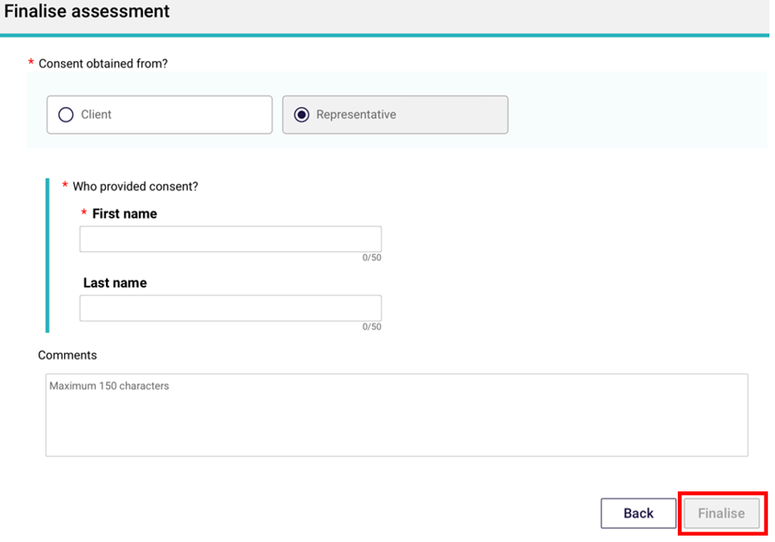
- A pop-up will then display asking you to finalise the assessment. Please note once you finalise the assessment it cannot be edited. Select Finalise to continue.
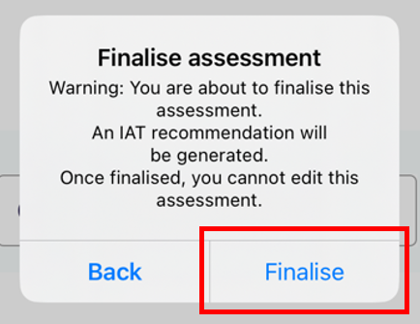

Developing a support plan
At any point after a client’s assessment has been commenced, their support plan can be created and developed within the App.
! | Needs assessors will still be required to upload client assessment and Support Plan information to the assessor portal in order to submit to the delegate for approval or match and refer for services.

The sections of the support plan in the App are aligned with the support plan tabs in the assessor portal, and needs assessors can record:
- Assessment Summary
- IAT Outcome
- Identified Needs
- Concerns and goals
- Recommendations
- Associated people
- Review
! | For further guidance on completing a client’s support plan, follow the steps outlined in the Assessor Portal User Guide 7 completing a support plan and support plan review.
- To commence a support plan for a client who you are assessing, select the client card, and select Support Plan from the top left menu. The Assessment summary will display.
The Assessment summary will be pre-filled with information captured during the assessment.
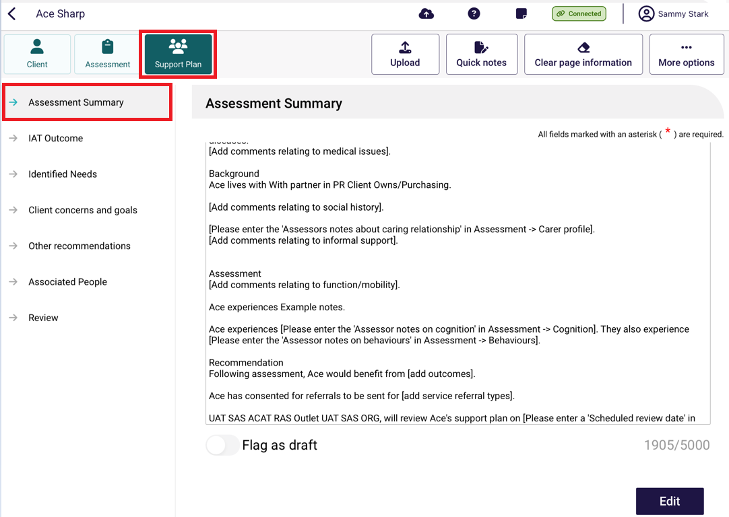

- To edit the assessment summary, select Edit.
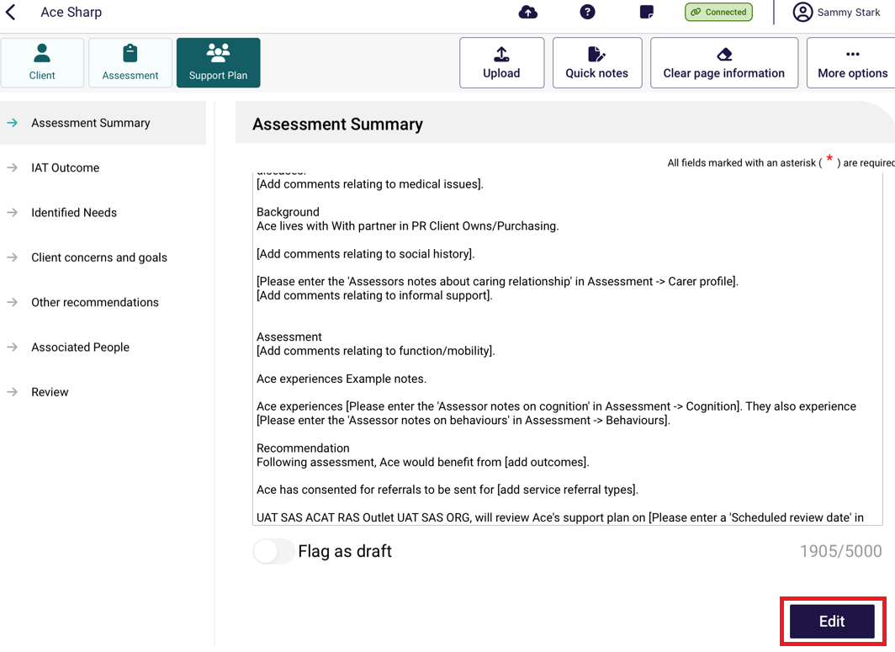
- Select Confirm Edit at the pop up that appears. Note that once you start editing the assessment summary, you will no longer be able to pre-populate information from the assessment.
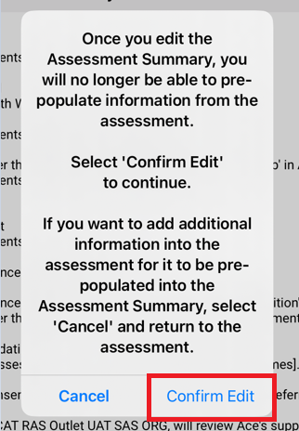
You will then be able to Flag as draft by the toggle function. There will be a D icon next to the Assessment Summary menu, to remind users that the assessment summary is a draft and should be completed prior to uploading to the assessor portal.

IAT outcome
Within the support plan tab, the needs assessors will be able to view a suggested support recommendation for the type of care the client may require. The algorithm will draw on assessment responses and the client's current care approvals and recommend either the Commonwealth Home Support Programme (CHSP) or a Home Care Package (HCP).
If the IAT assessment has not been finalised, then the IAT Outcome will display as Pending finalisation.
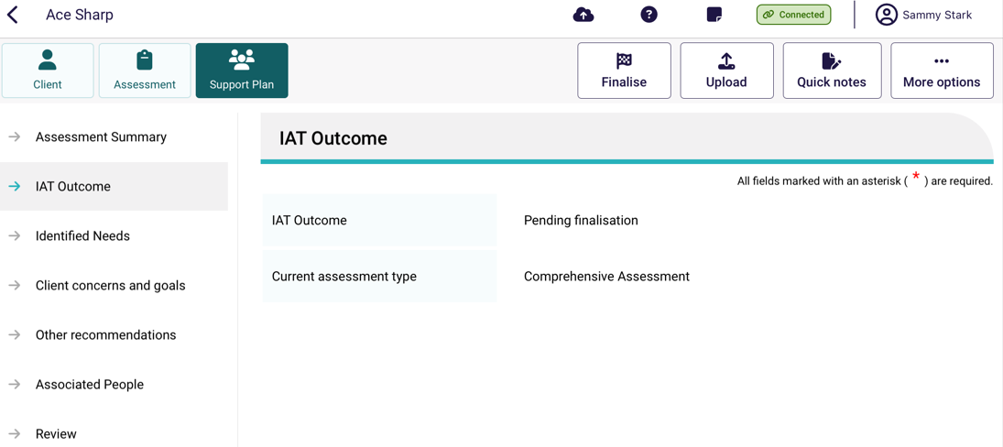
Once the IAT assessment has been finalised the IAT Outcome will display.
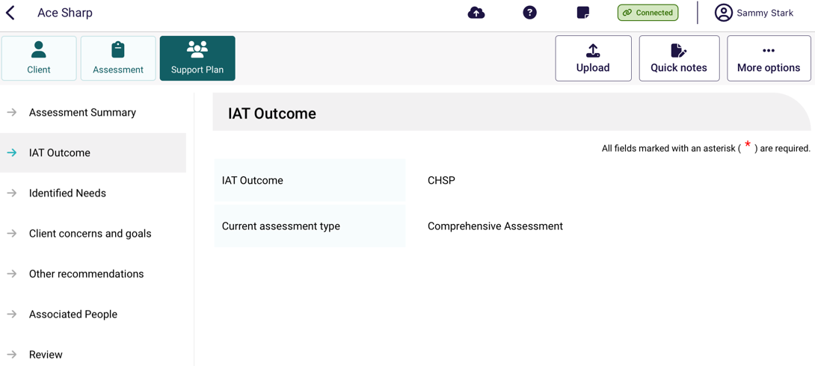
If required, home support assessments can be converted to a comprehensive assessment after the IAT assessment has been finalised. If an assessment is triaged as a home support assessment and Home Care Package services, residential care or short-term restorative care are recommended, the assessment will need to be converted to a comprehensive assessment under the supervision of a staff member who holds a clinical assessor role in the My Aged Care Assessor Portal.

To do this, select the More options button followed by Convert to Comprehensive Assessment.
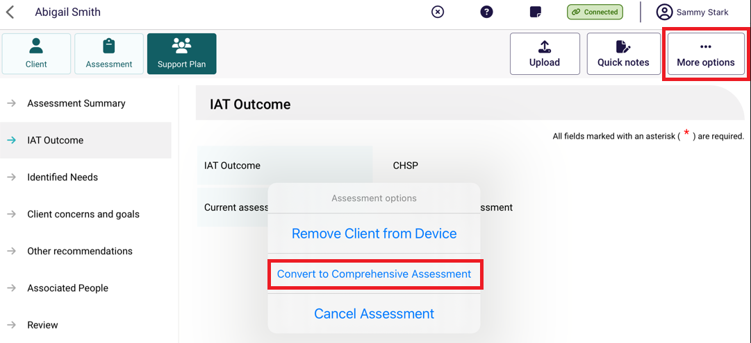
From the Convert to Compressive Assessment page, enter the reason or comments for converting the assessment. Please note the reason for change will be auto-populated to High level care needs. Select Confirm to convert the assessment.
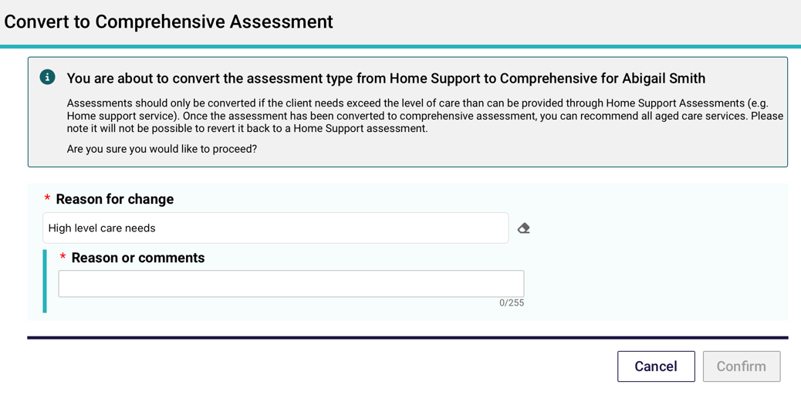
The IAT Outcome tab will then display that the assessment has been converted to a Comprehensive Assessment.
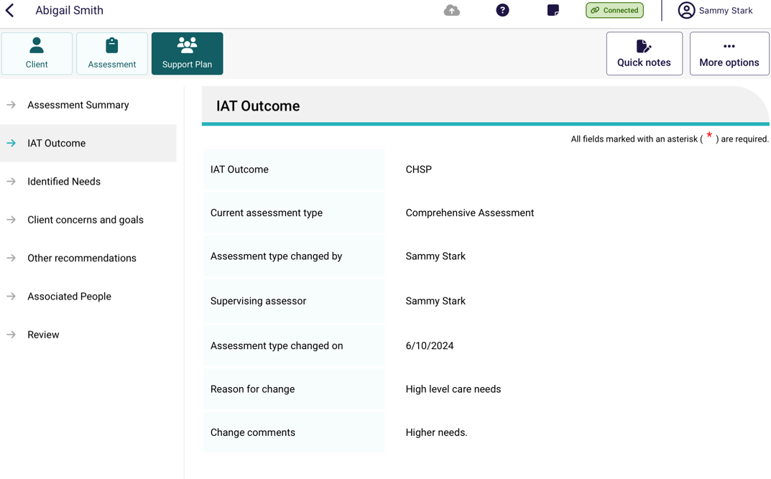

Adding concerns, goals and recommendations
When developing a client’s support plan in the App, Areas of Concern and Goals, and Recommendations can be added in the Concerns and goals and Recommendations section of the Support Plan.
- To add an area of concern, select + Add an area of concern.
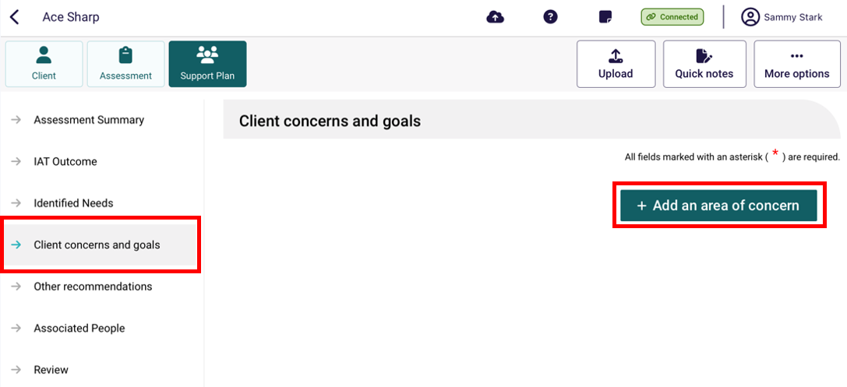
- Enter in What is the area of concern and click +Save. Please note you will only be able to save the concern once all mandatory information has been entered.
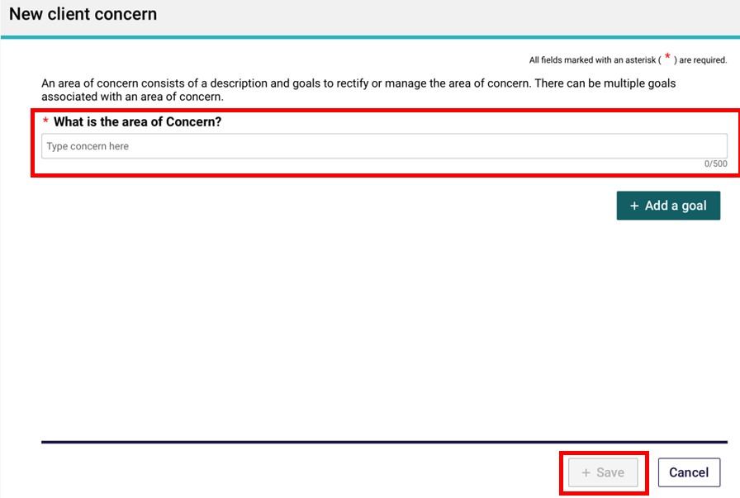

- Select Edit to update or delete the area of concern or change the order of areas of concern using the arrow buttons (▲▼) where you have added multiple concerns.
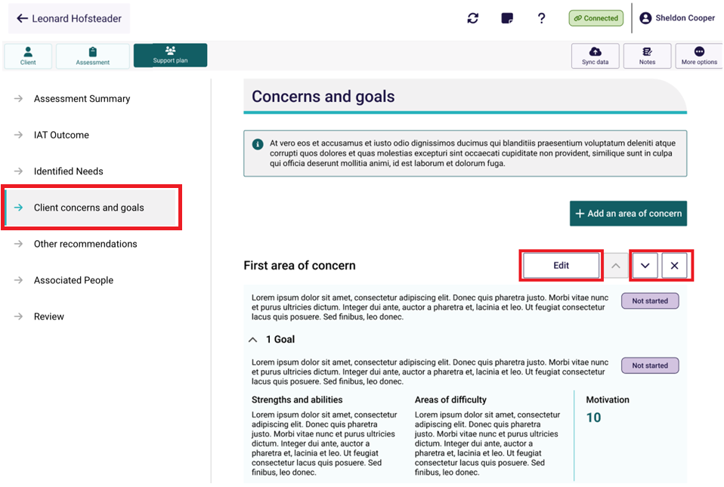
- To add a goal to a recommendation, select + Add a goal from the relevant area of concern and click + Save.
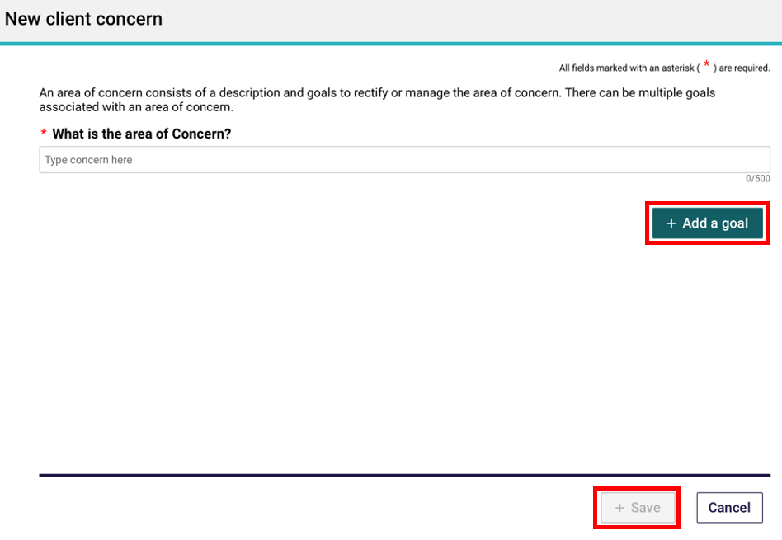

- Enter what the goal is along with other key information such as what domain the goal relates to, the client’s current strengths and abilities in relation to the goal and their motivation to achieve it.
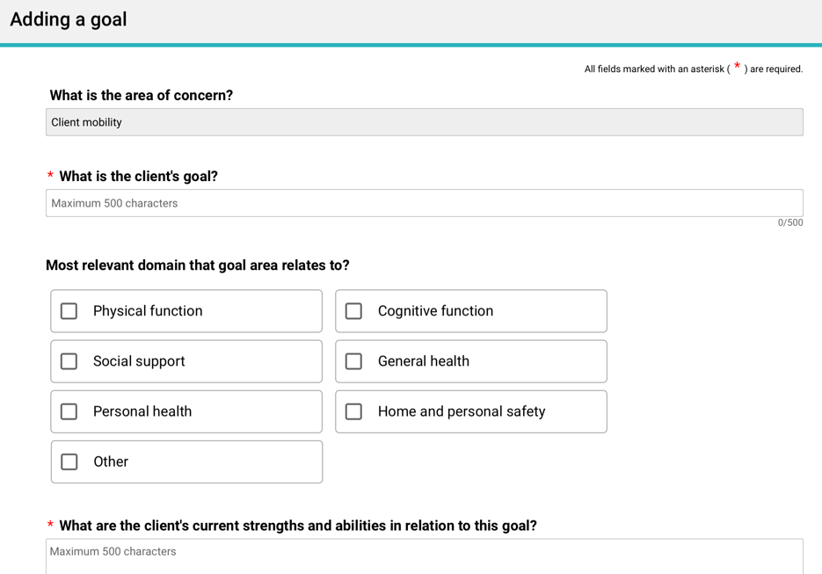
- Once completed select + Save.
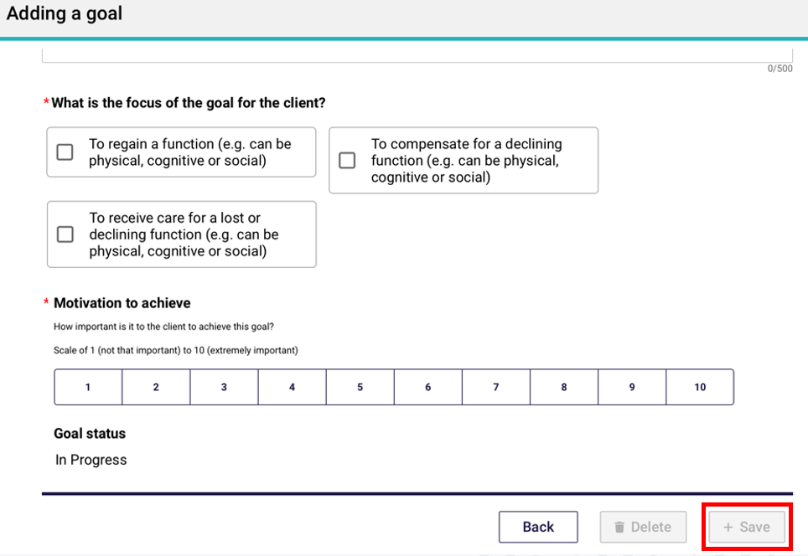

- Recommendations can be added after the completion of the Areas of Concern and Goals in the Other recommendations section.
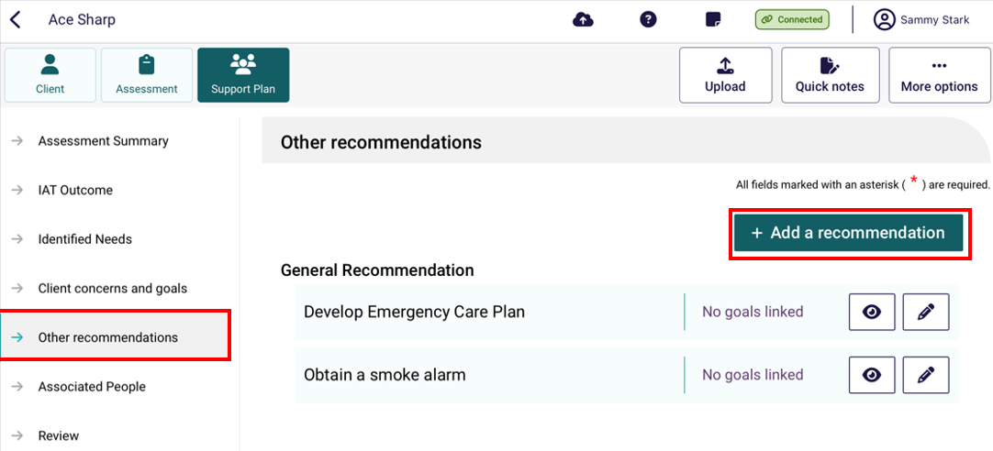
- The corresponding recommendations available for each assessment type will display for the client in the Other Recommendations section.
- Recommendations that cannot be added (generally due to other recommendations that have been added) will be indicated in italics.

Home Support assessment:
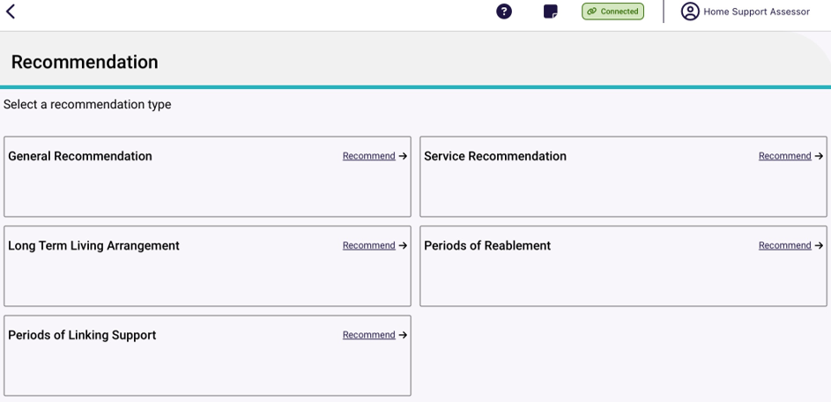

Comprehensive assessment:
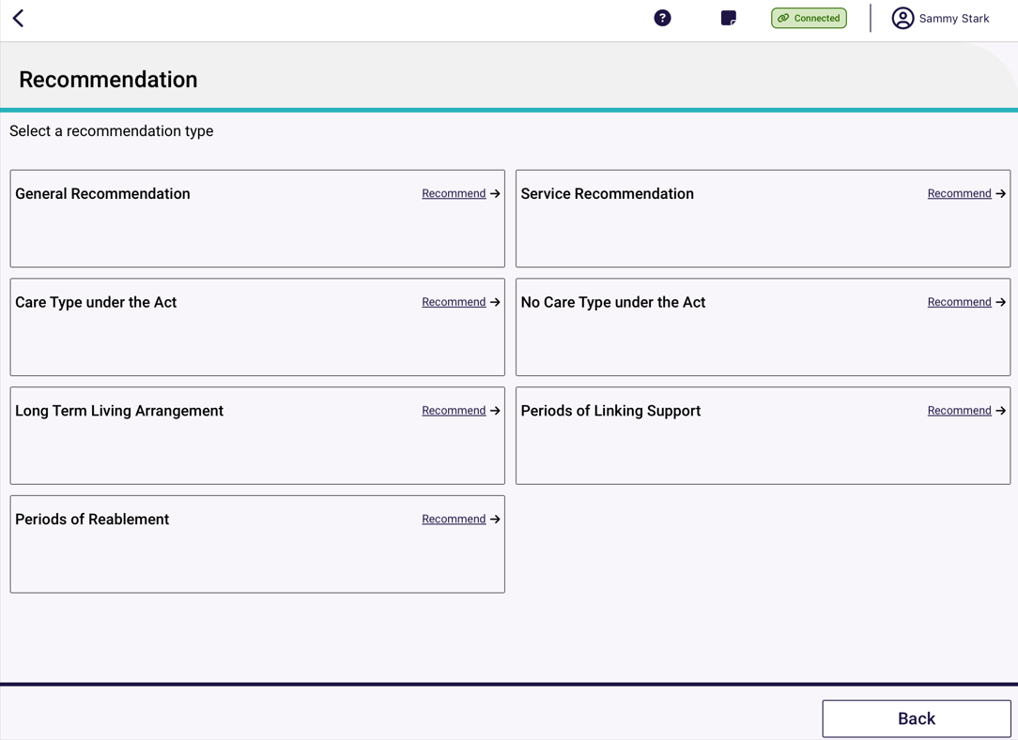
- Add any service recommendations or care types under the Act. Similar to the assessor portal, goals can be linked to some recommendations. Example screenshots are included below.
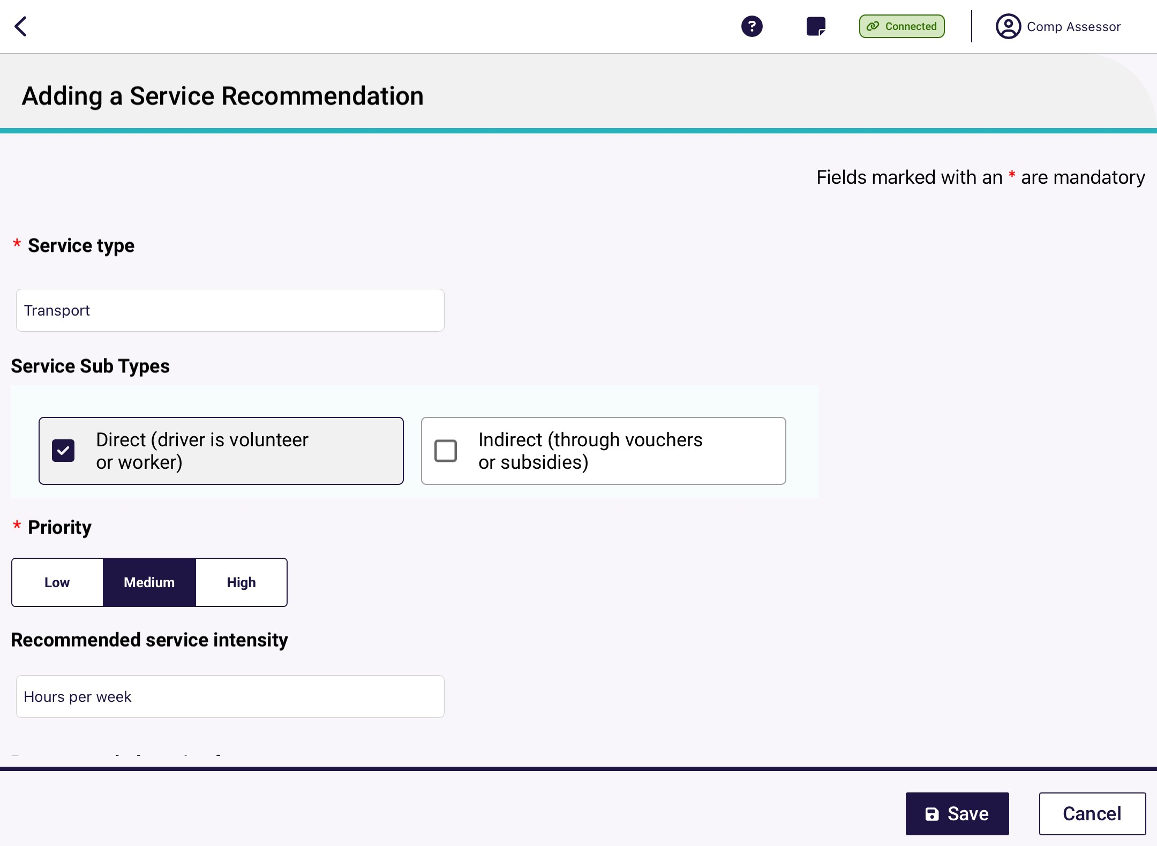
! | If a client is under the aged of 65, several additional entry fields will appear to document their exceptional circumstances.
- When finished, don’t forget to select Save at the bottom of the recommendation page, before selecting Save.
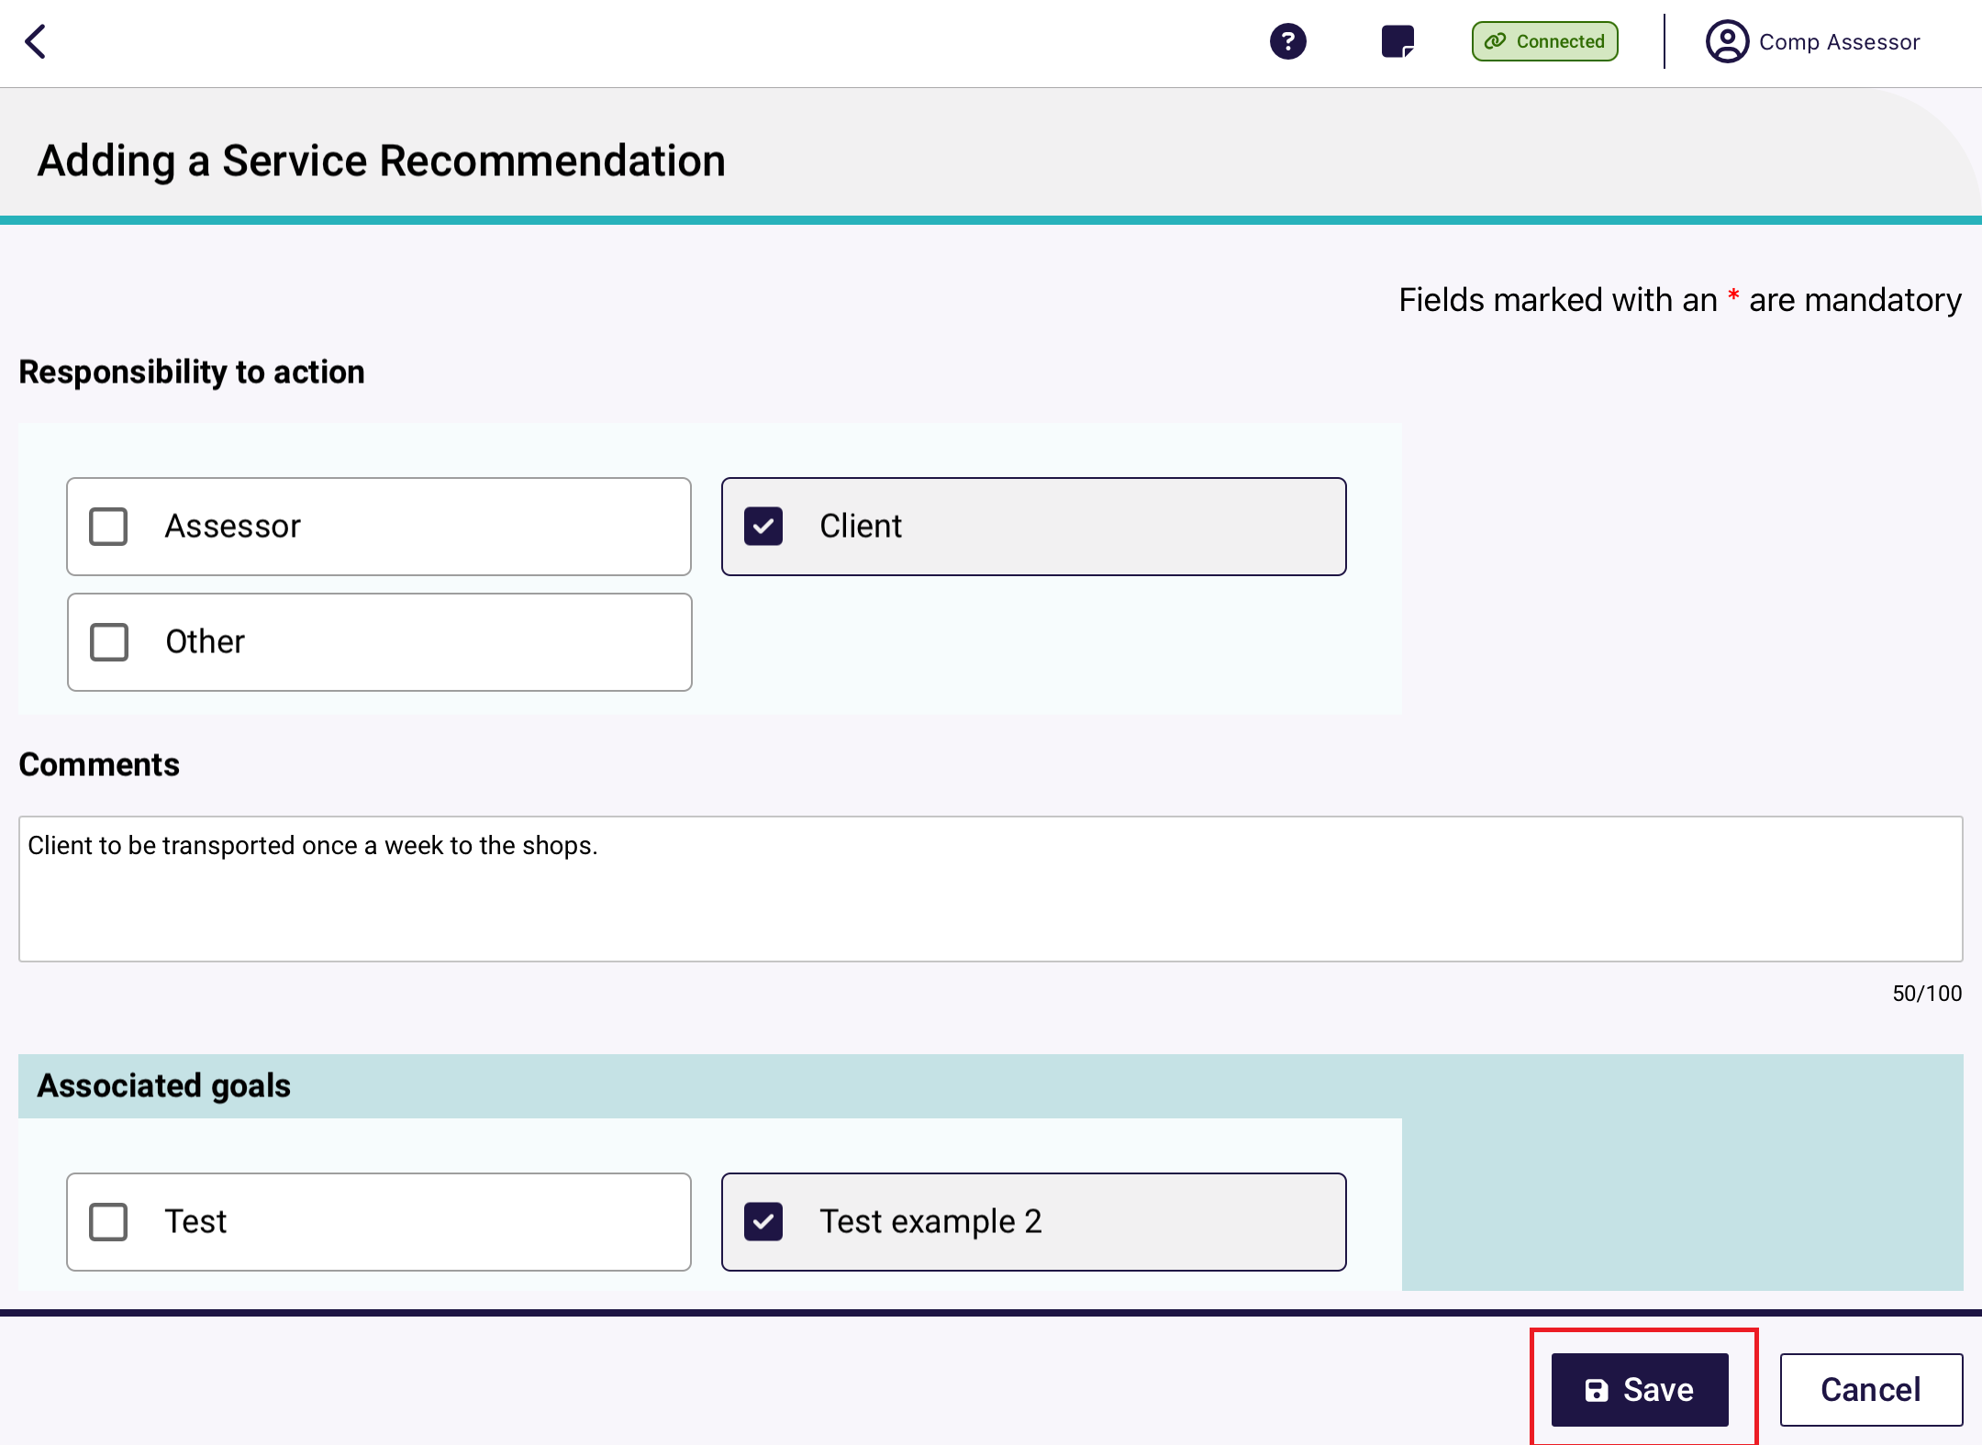
! | If it is determined that a client has a high priority for a Home Care Package, you are required to answer all mandatory questions and provide your reason or comments using the available comment field.
- Once you have made all your recommendations, you will be able to view these in the Other recommendations section.
The Other recommendations section will display all recommendations made during the development of the Support Plan, where the Client concerns and goals will only display recommendations linked to goals.
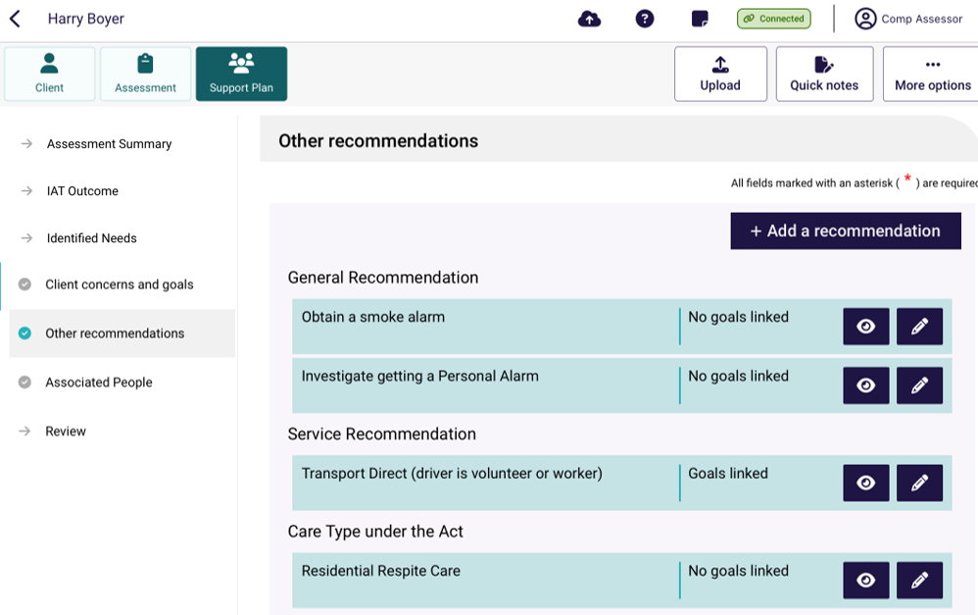

Uploading assessment and support plan information to the assessor portal
! | The device must be connected to the internet to upload an assessment.

Uploading assessment and support plan information for downloaded assessments
To upload assessment and support plan information for a client whose referral you have downloaded and assessment you have undertaken on the App, follow the steps below.

- For the assessment you wish to upload, select More options from either the Client, Assessment or Support Plan sections, then select Upload assessment from the drop down that appears.
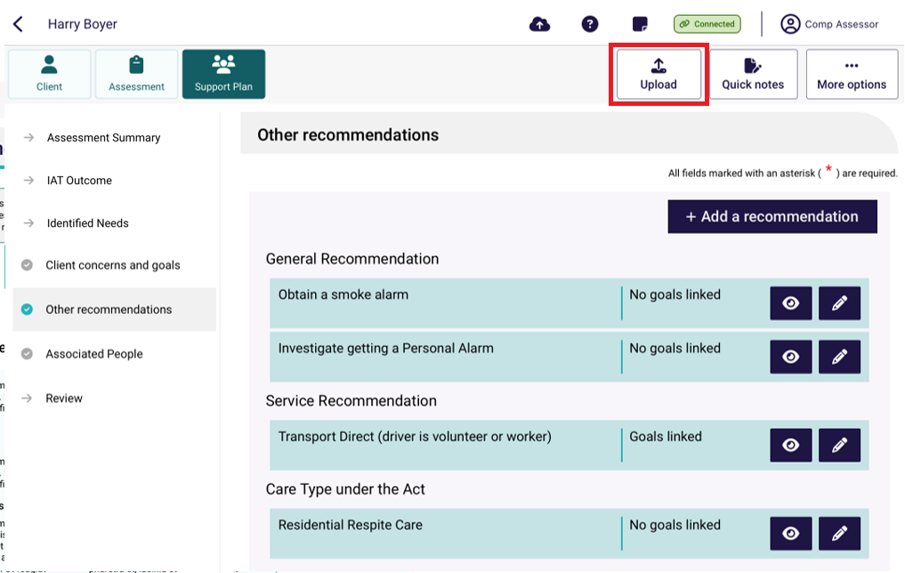
! | If not connected, the Upload button will not be available.  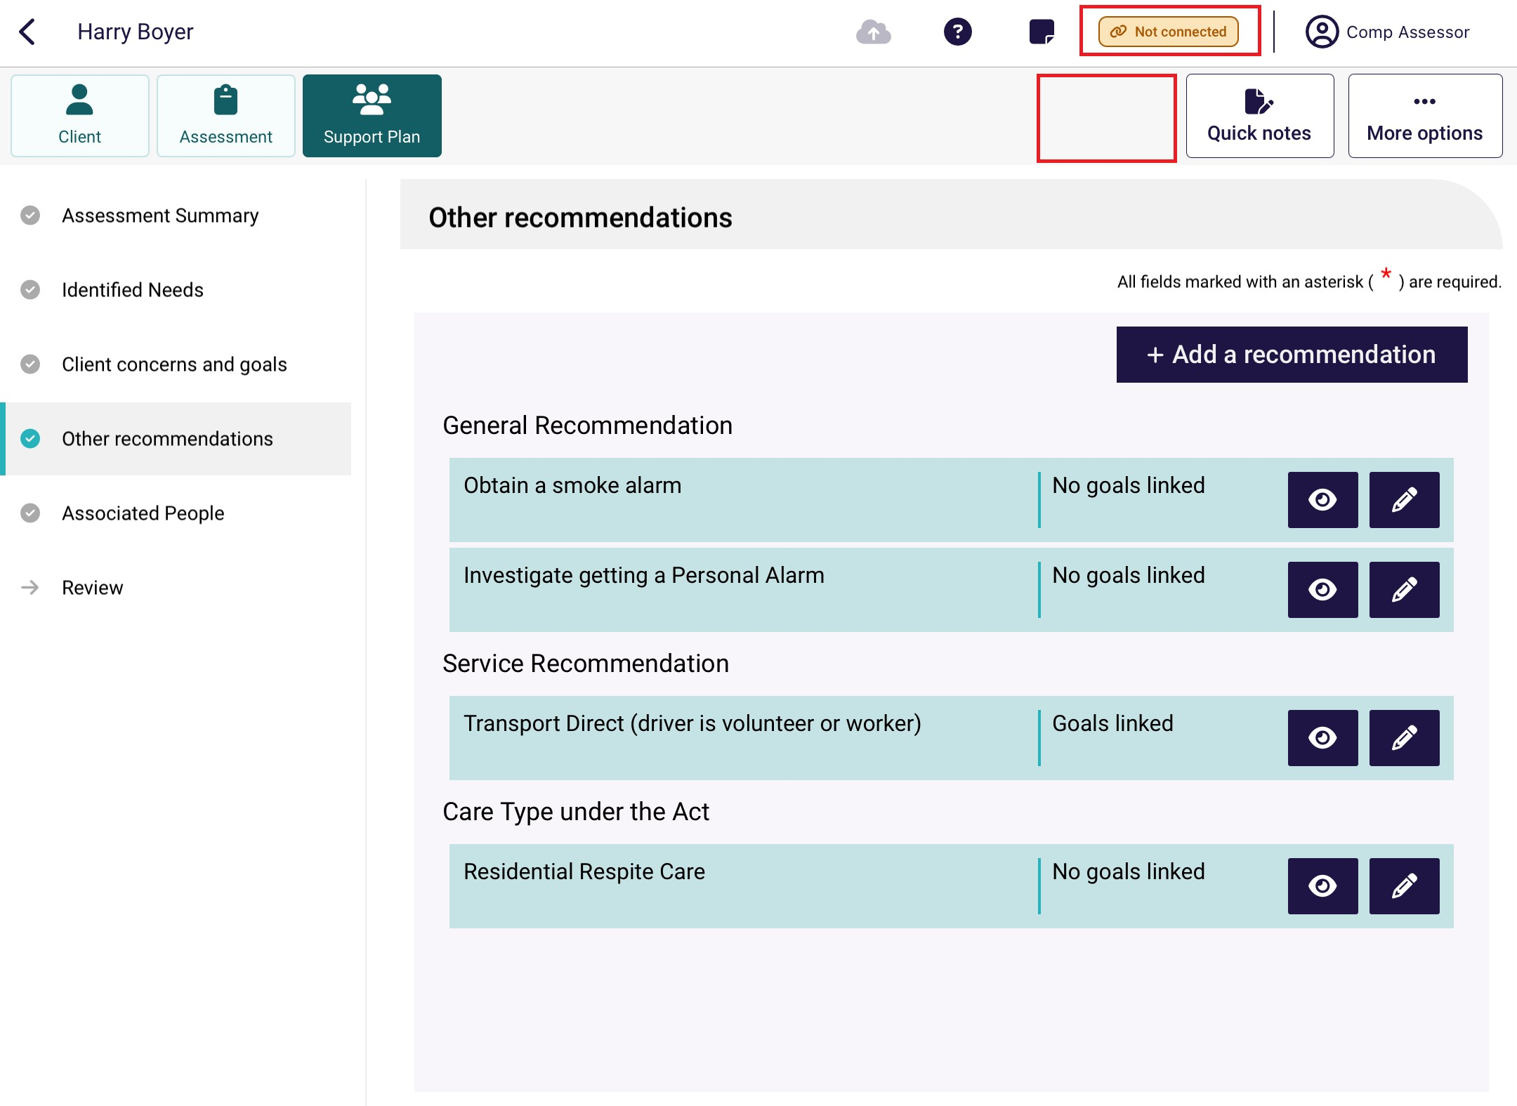

- The Upload Assessment page will display. Address any incomplete sections if required by selecting Cancel and uploading again at a later time.
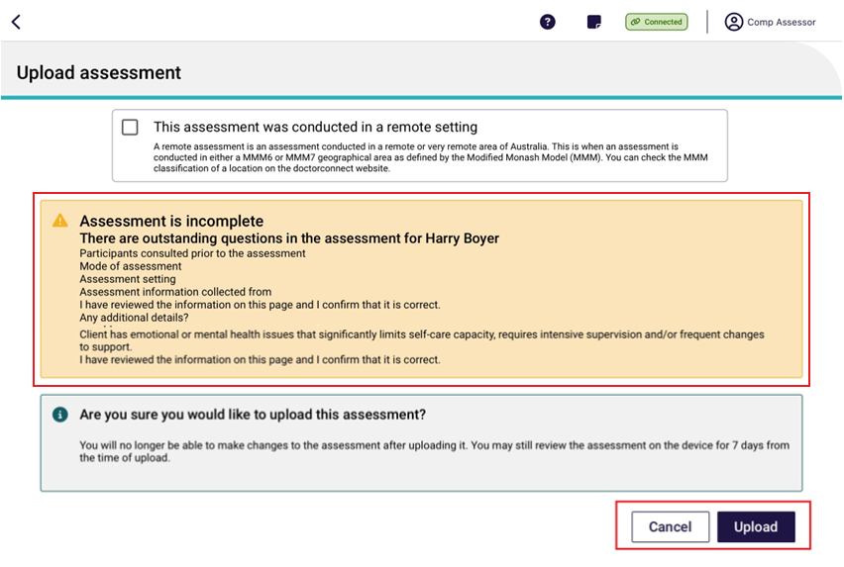
! | Incomplete or invalid questions will not prevent you from uploading the assessment. However, you will need to complete all mandatory questions before you can complete the assessment in the assessor portal.  You will not be able to upload the assessment if the Assessment summary exceeds 5,000 characters.
- If your face-to-face assessment was conducted in a remote location, you should ensure that the Remote Assessment indicator is selected before the assessment is uploaded. To determine if an assessment is conducted in a remote location, please review the information provided within the help icon.
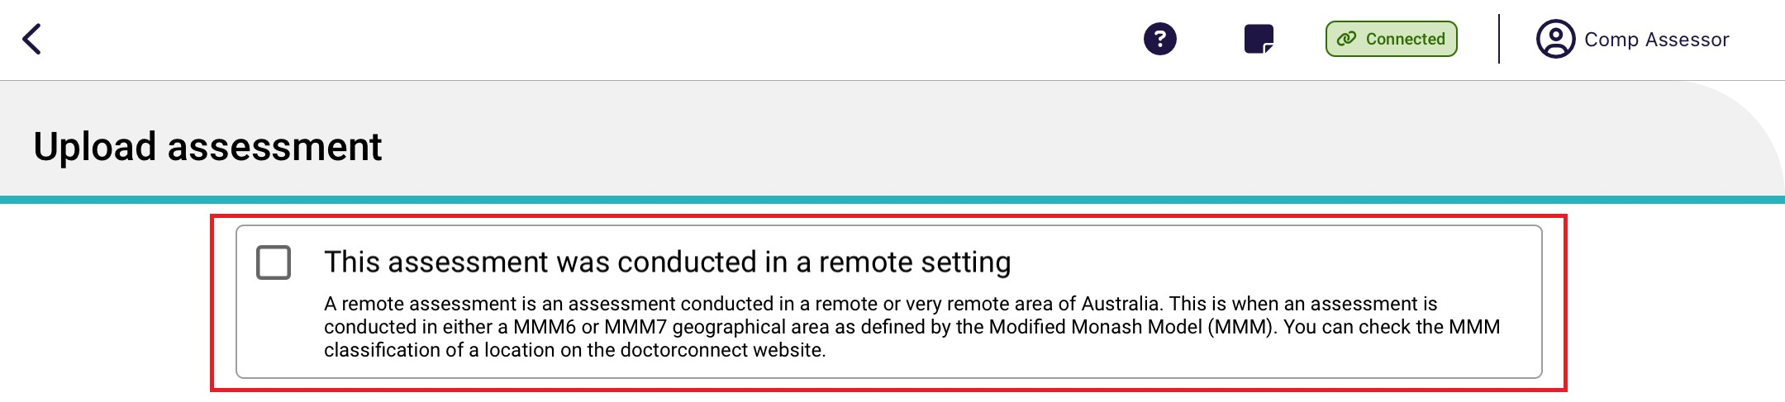

- Select Upload, and then select Confirm in the pop-up window.
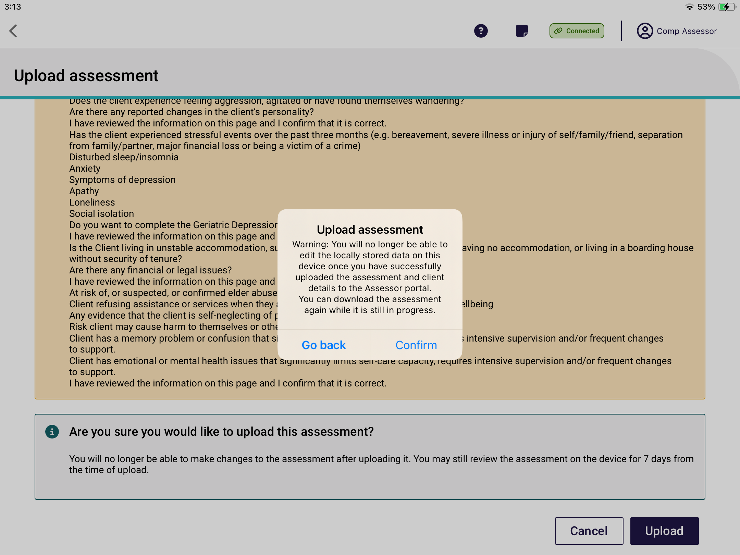
- The assessment will now be uploaded to the My Aged Care assessor portal. The information you added as part of the assessment will automatically populate the corresponding fields, where applicable, in the assessor portal and will display as Pending Uploads on the Dashboard in the App.
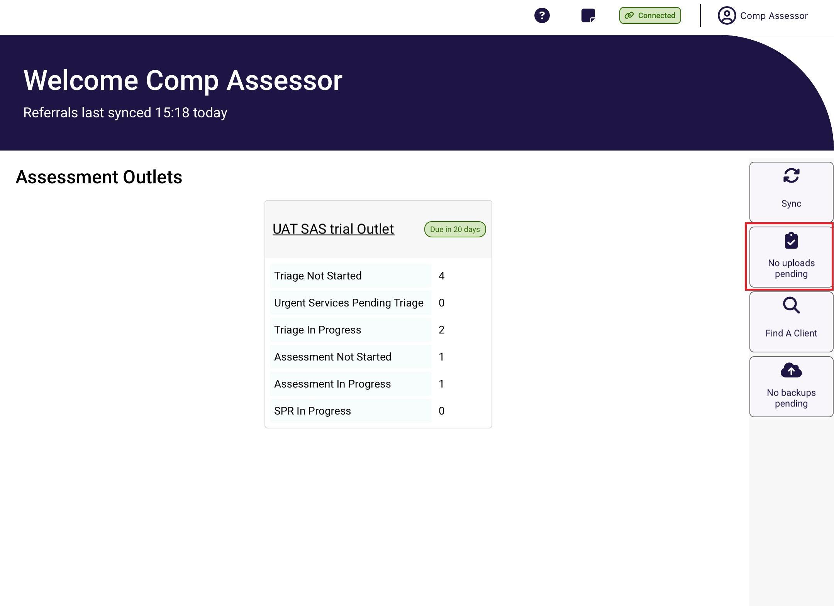
- Once you have uploaded the client’s information to the assessor portal, you can remove the client locally from your device. From now on, the client’s referral and assessment is only viewable through the portal. The only way to interact with the client record using the App is to download the client’s referral again.

Uploading assessments for offline clients
To upload assessment information for offline clients’ assessments created on the App when not connected to the internet, the offline client will need to be registered locally or linked to an existing client record.
Following the client’s registration, needs assessors can self-refer clients for assessment before uploading the assessment.
! | If the client already has an in-progress assessment, you will not be able to upload the assessment. This should be confirmed prior to starting the assessment for an offline client.  For more information regarding this process please refer to the My Aged Care – Assessor Portal User Guide 1 – Registering and referring clients.

17.3 Locally registering an offline client
If you do not have a referral assigned to you for an offline client saved locally to your device, you will need to register the client and arrange for a referral to be issued and assigned to you. This process can only be done when connected to the internet.
! | If you have a referral assigned to you for the offline client you wish to upload to the assessor portal, follow the steps in Linking offline clients and assessments.
Once the offline client has been registered and a referral has been assigned to you in the assessor portal you can link the offline client to the assessment referral and upload the assessment to the assessor portal.
Follow the steps below to locally register an Offline client.
- Select the Offline client that you wish to register from your Dashboard.
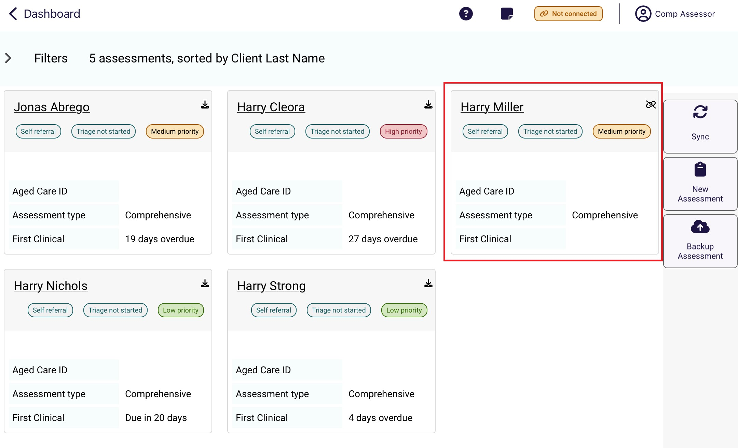

- Select More options, then Register Client at the pop up.
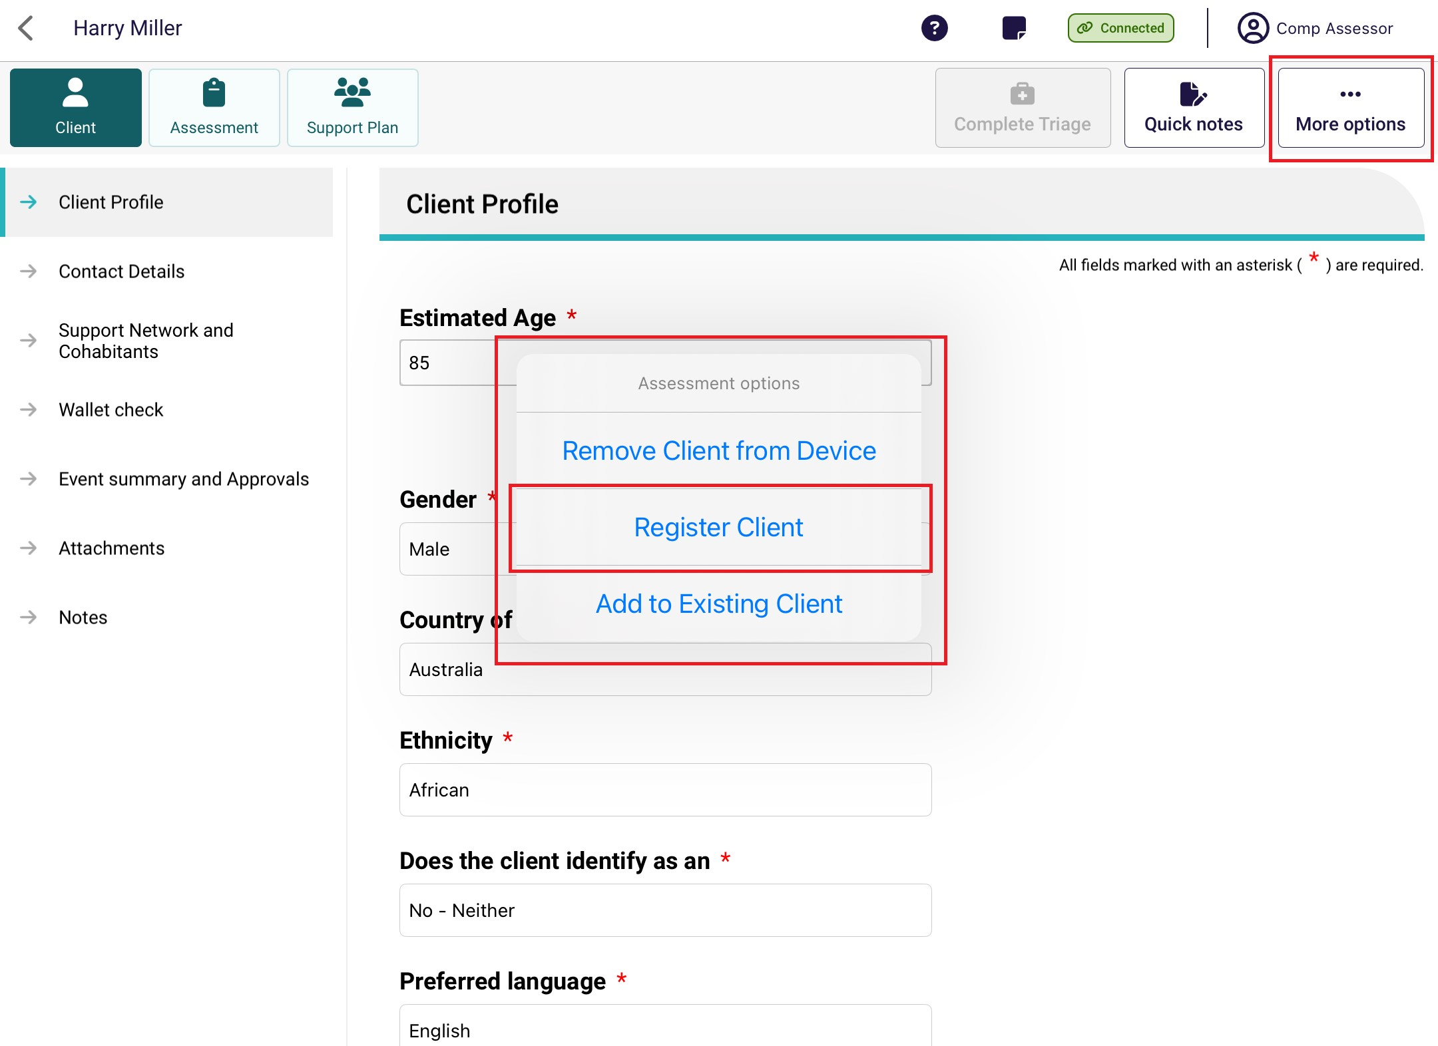
- The App will do a real-time check for any potential duplicates. Select View Potential Matches to view the possible matching client records.
If there are no matches, select Register and proceed to step 5.
! | If there are any potential duplicate matches found, you will be required to view these records prior to registering the new client to avoid creating a duplicate client record in My Aged Care.
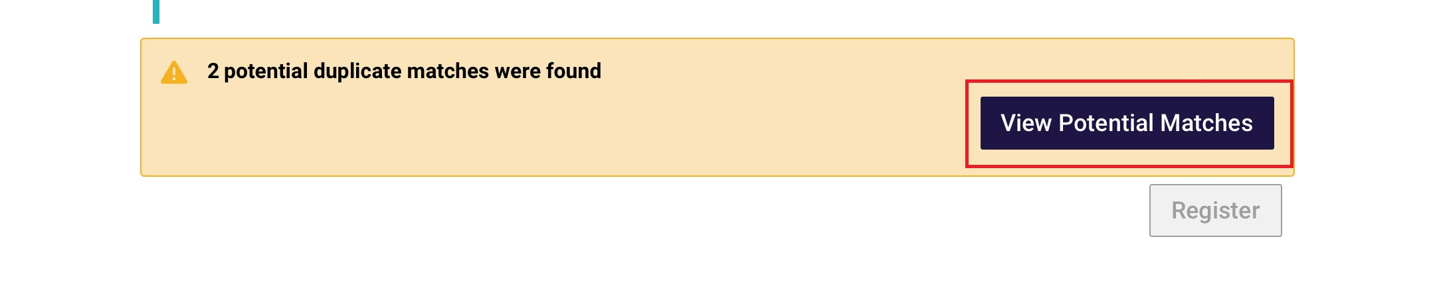
The list of potential duplicate matches will be displayed on the left side of the screen in list view. Select each record to see a visual comparison of client details against the client record being registered.
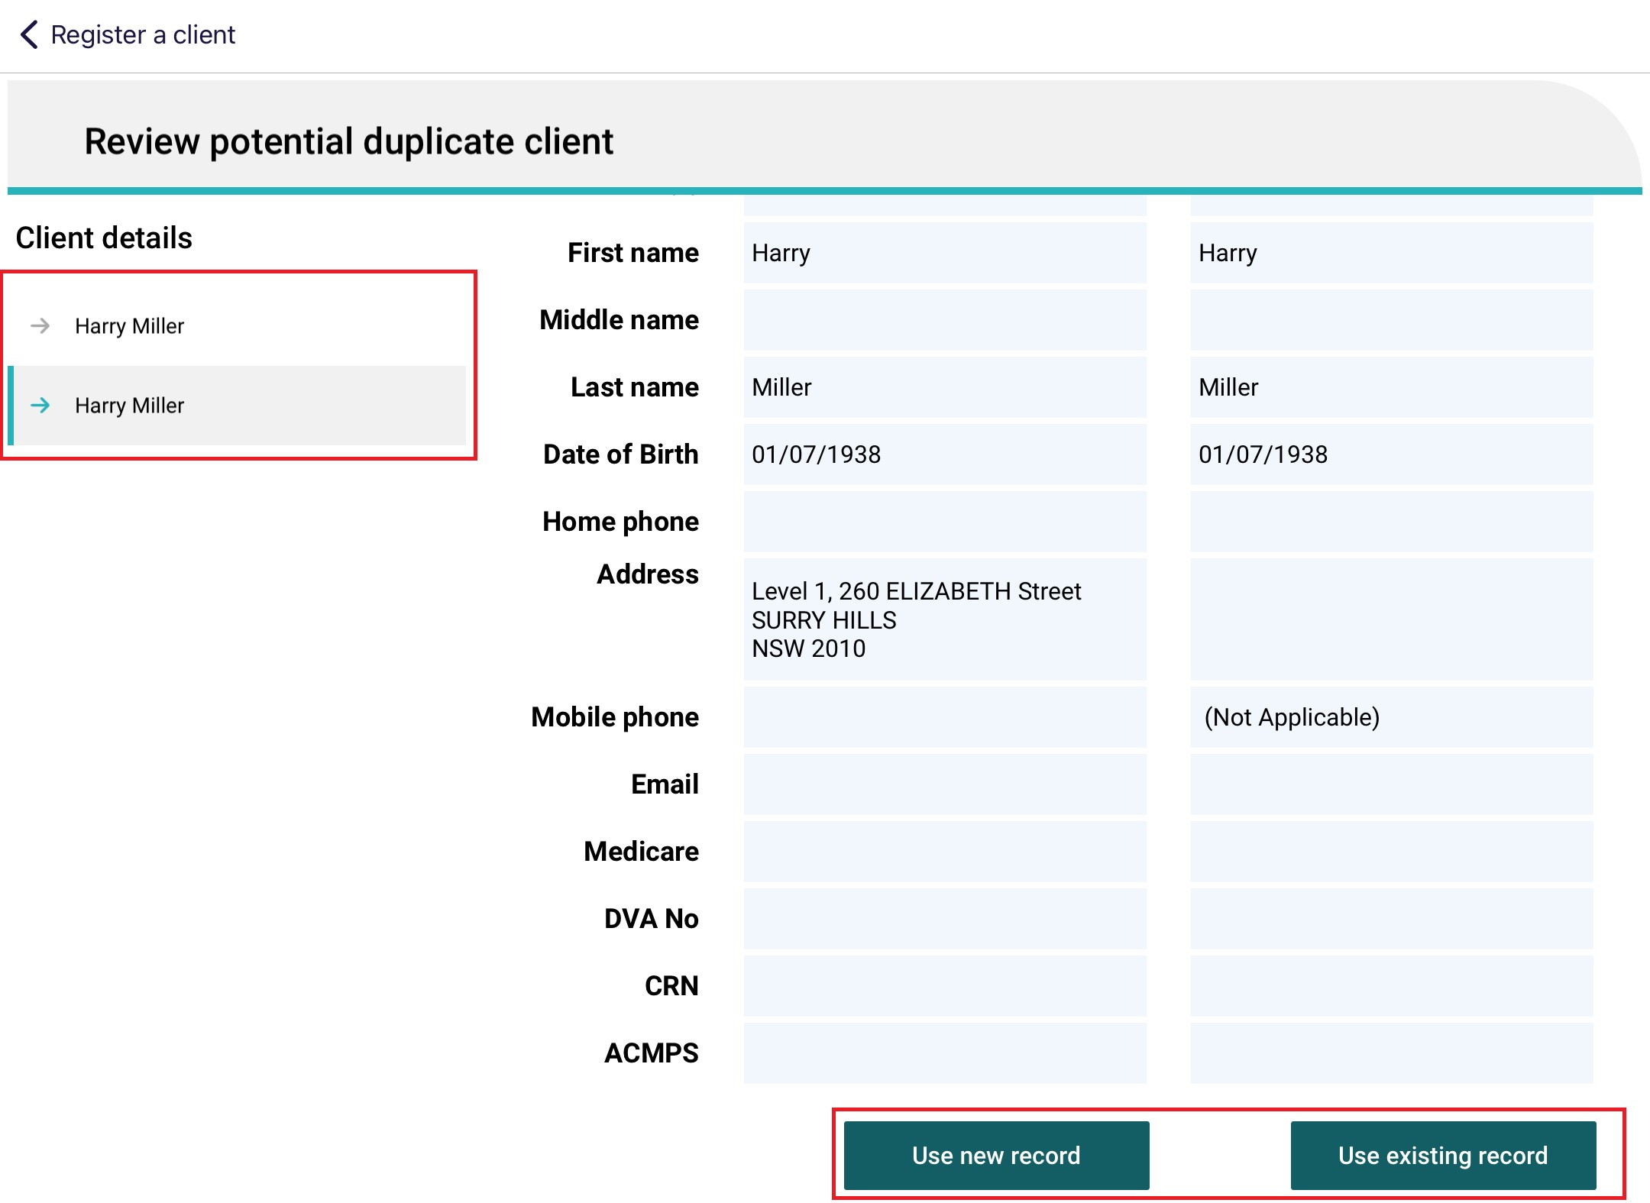
If none of the potential duplicate matches are the client you are registering, select Use new record to complete the registration process: you will need to indicate client consent to register prior.
If you wish to use the matching record, select Use existing record.
- Where any client demographic information conflicts between the two records being merged, you must select which information to retain before saving.
The Online record is the record that already exists in My Aged Care, and Captured offline is the offline client saved locally to your device.
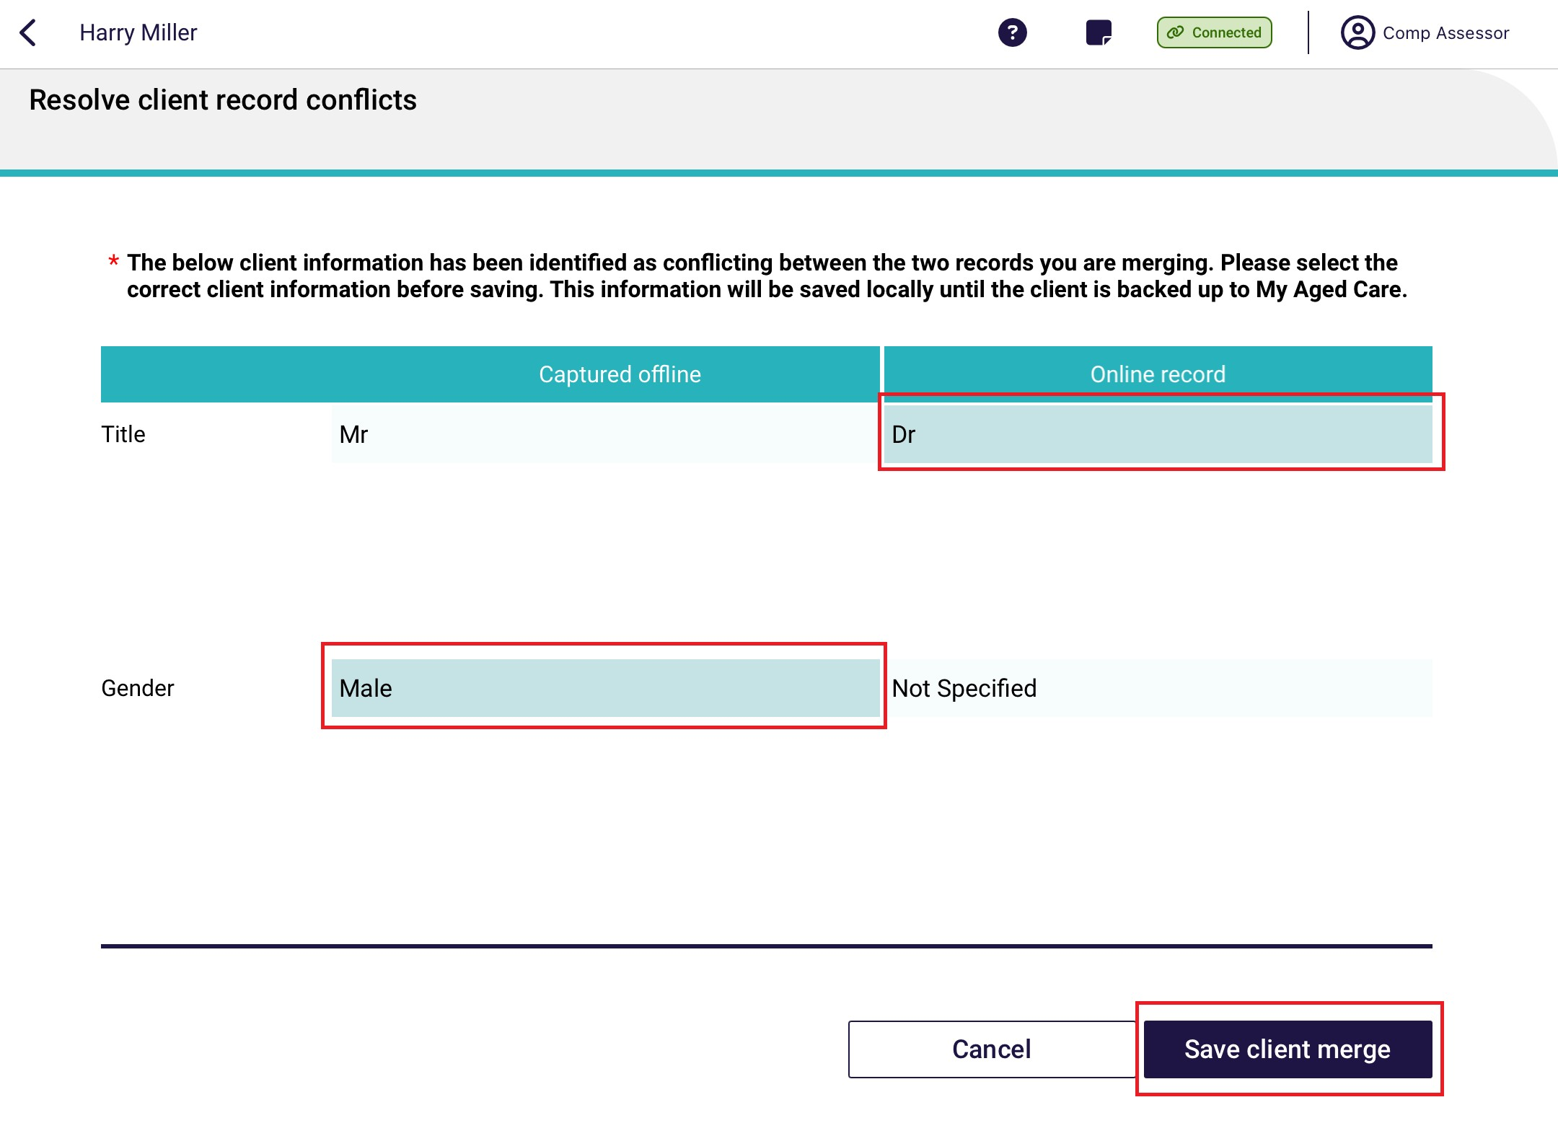
! | It is important to view any potential duplicate records prior to registering a new client to prevent the creation of duplicate client records in My Aged Care.
- Once the offline client has been successfully registered or linked to an existing record, the client details page will display.
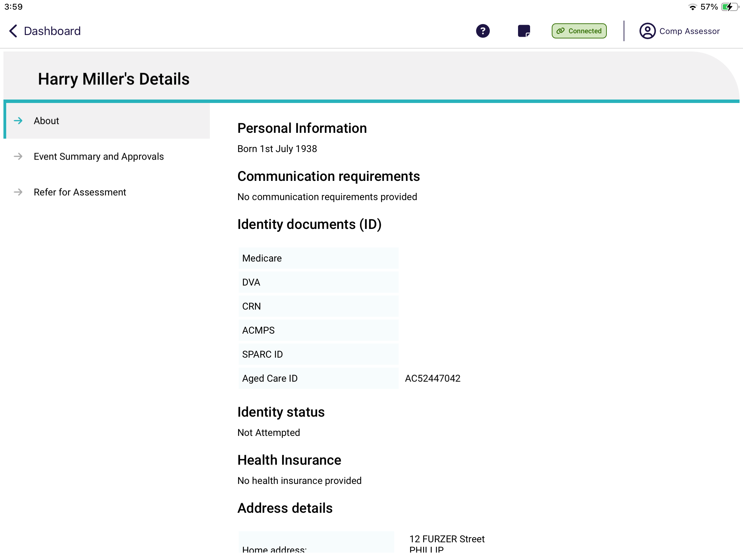
To upload the client to the assessor portal, you will need to link the client to a referral, by either
self-referring clients for assessment to automatically link the client’s assessment information prior to uploading or facilitating a referral for assessment prior to linking to the registered client.

17.4 Linking offline clients and assessments
Before uploading the assessment, you will need to link the offline client (locally registered or saved) to an existing client in My Aged Care.
- In the Offline client’s assessment, select More Options, then select Add to Existing Client at the pop up that appears.
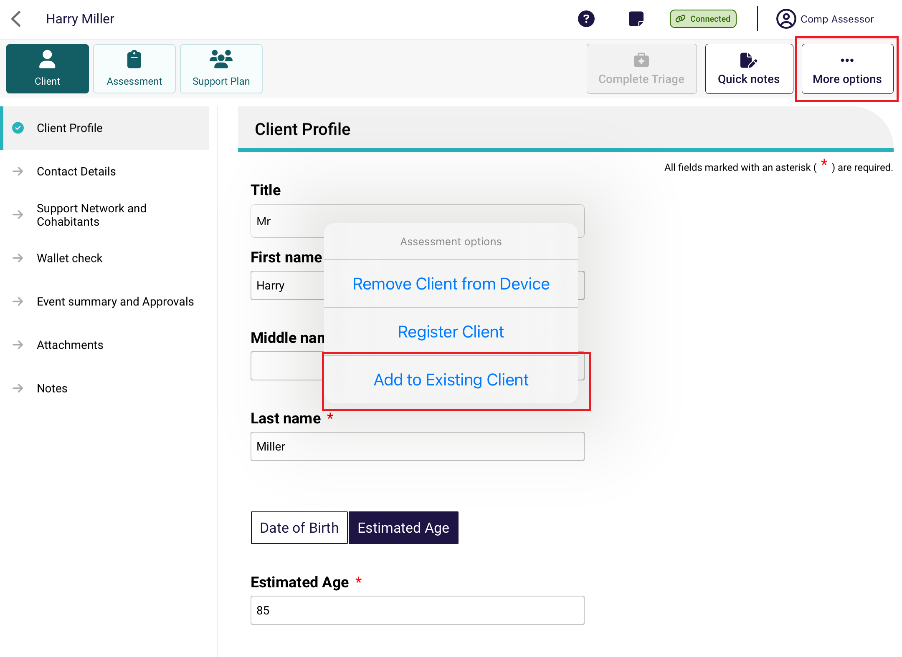
! | Needs assessors can select Self refer if the reason for assessment is In-hospital, remote assessment, First Nations or Homeless or at risk of, and there is no existing referral for the client downloaded to their device.  For all other referrals, needs assessors are advised to call the My Aged Care service provider and assessor helpline on 1800 836 799.
- You will be prompted to call 1800 836 799. Select Yes if you have:
- Already contacted the My Aged Care contact centre, and had a referral sent to your organisation and assigned to you, or
- Self-referred a client to your organisation.
! | A person assigned the Team Leader role in the assessor portal will need to accept the referral and then a Triage Delegate can conduct triage or assign it to another Triage Delegate for triage. Once triage is completed and the assessment has been assigned to you then it will appear in your assessments queue in the assessor portal.

- A list of existing clients that you can transfer the assessment information will appear. Select the name of the client, then select Continue.
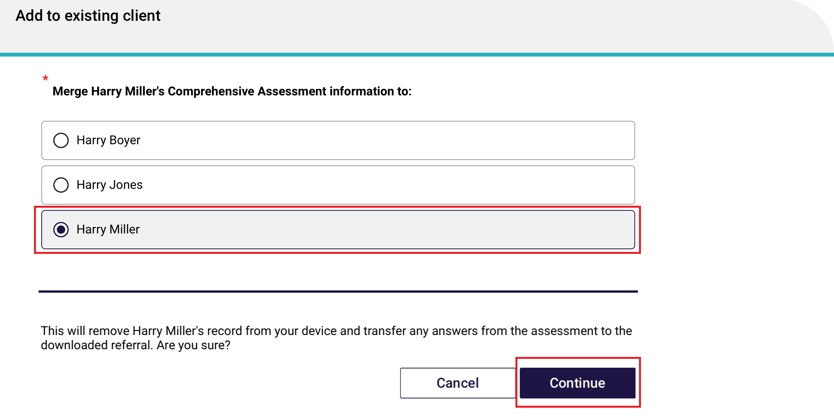
The assessment information collected about the offline client will now be transferred to the existing client, and the assessment can be uploaded to the My Aged Care assessor portal, following the process in Uploading assessment and support plan information for downloaded assessments.

Conducting Support Plan Reviews
Needs assessors can use the App to:
- Conduct Support Plan Reviews for client’s reviews they have downloaded.
- Conduct a Support Plan Review for a client they have previously assessed.
The steps to undertake a review on the App are as follows.
! | To conduct a Support Plan Review (SPR), you must have the client assigned to you in the Assessor Portal before completing the SPR in the App.

Downloading a Support Plan Review
- Open the App and navigate to the main dashboard. Search for the client using filters or sort function.
If all clients’ details are synchronised and downloaded from the Assessor portal, go to Completing a support plan review.
- If the client’s details are yet to be downloaded from the Assessor Portal, there will be a Download icon at the client card. Click on the client card to download the Support Plan Review.
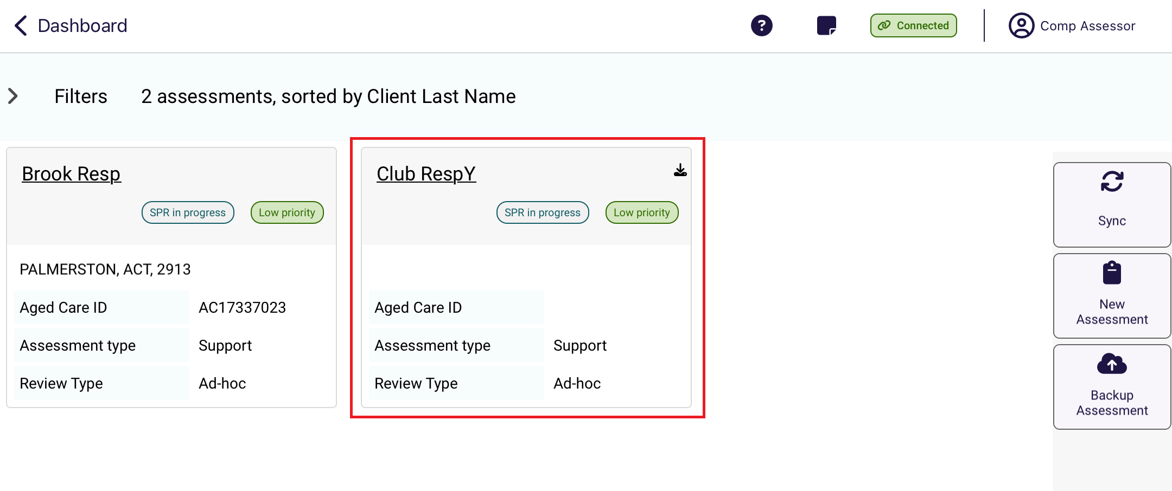
- The client tile will show the download in progress.
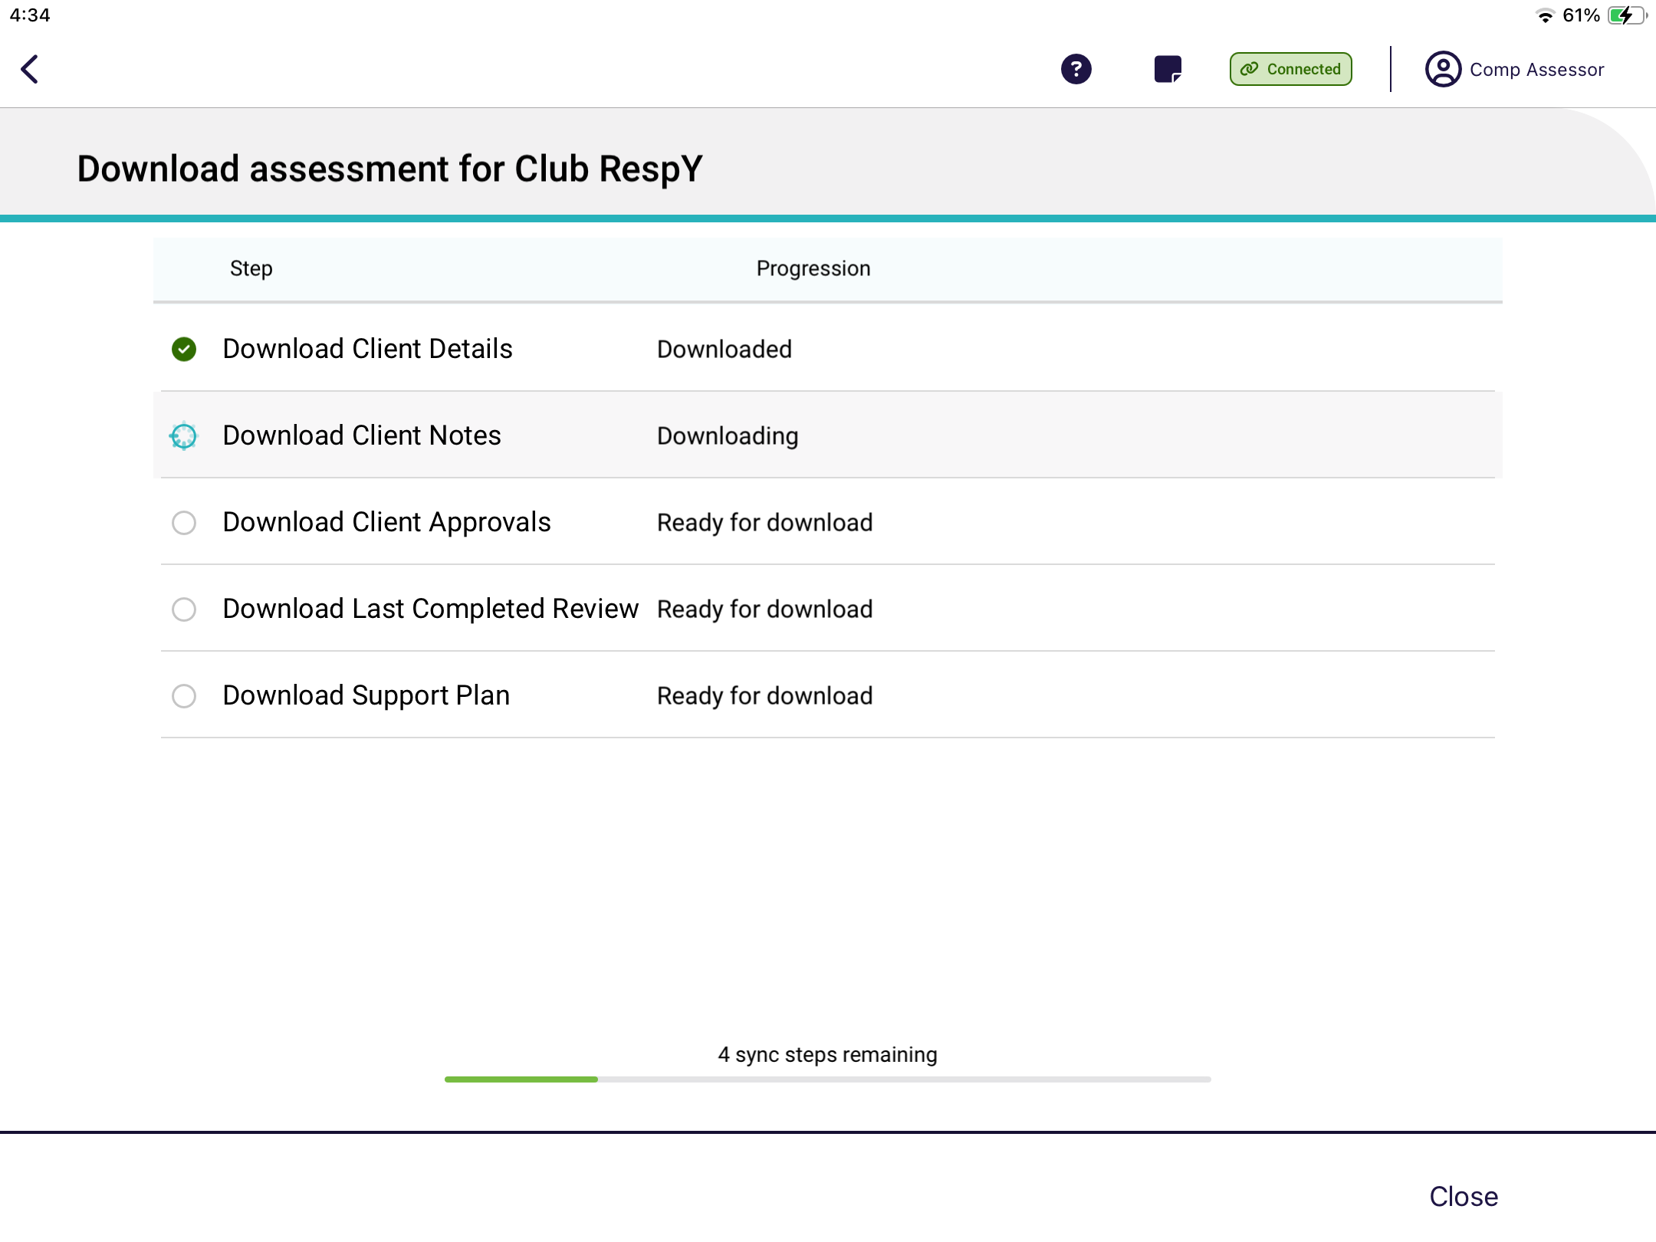
This is the page that shows the download progress of the Support Plan in detail. Select Close to return to the Dashboard.

- Once downloading is finished, you will be able to click Open assessment to continue or return to the dashboard.
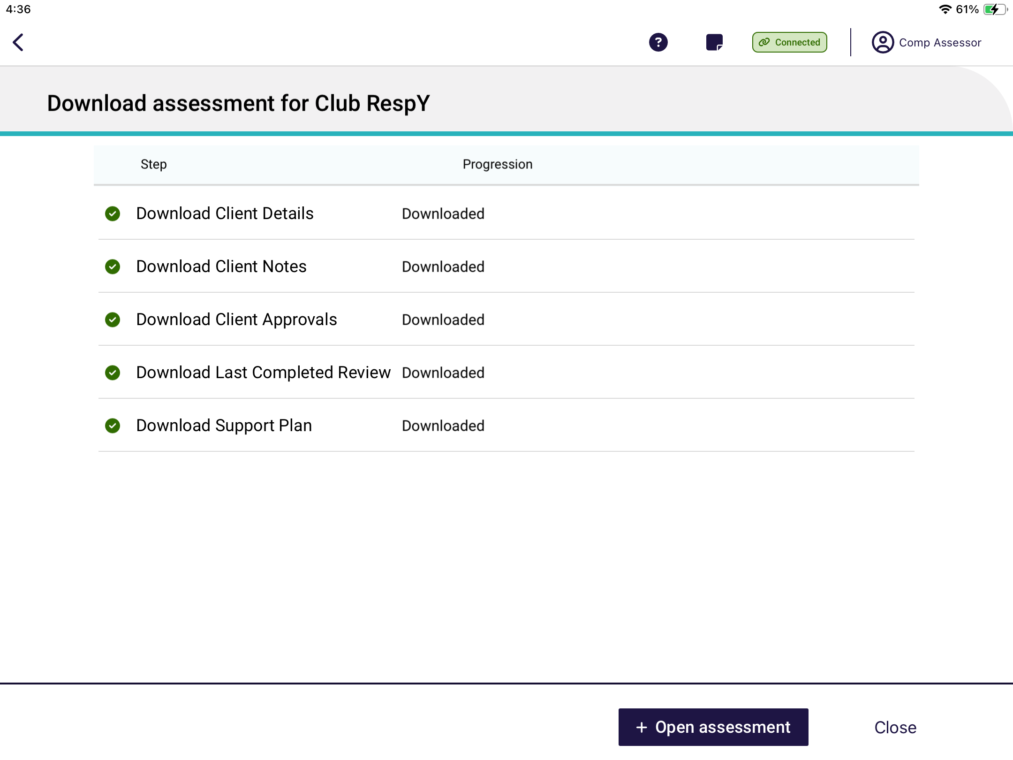

Completing a Support Plan Review
- Click on the client’s support plan review card.
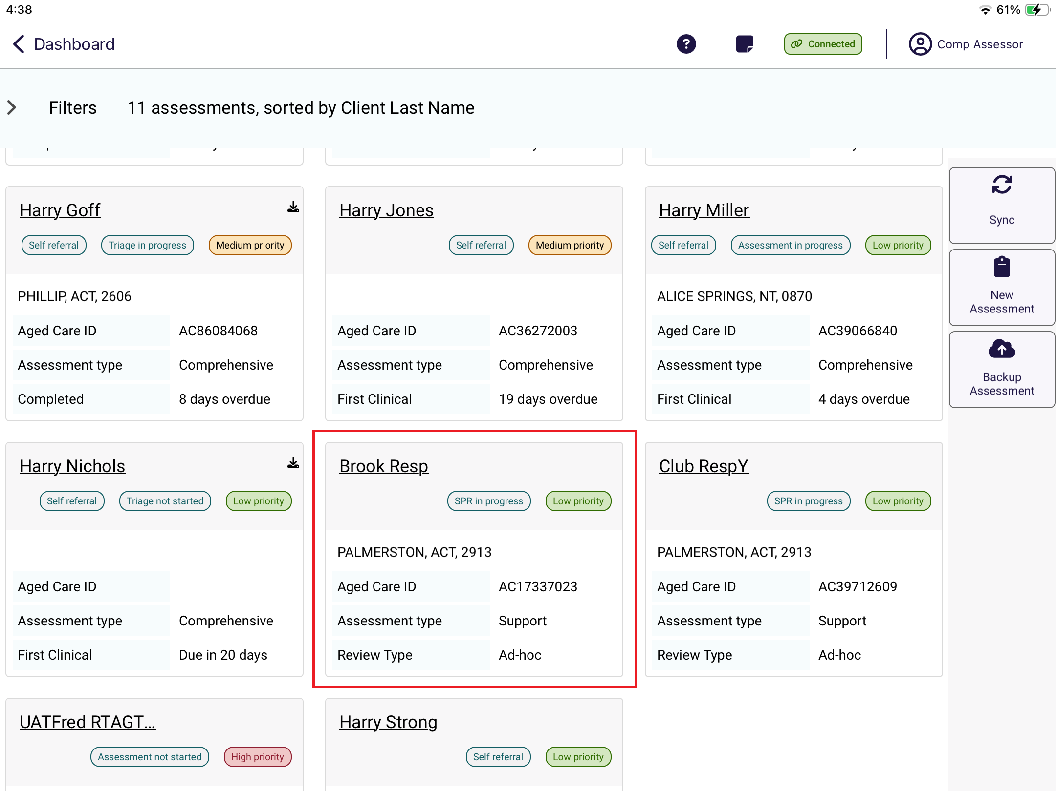
- The Support Plan Review page will display.
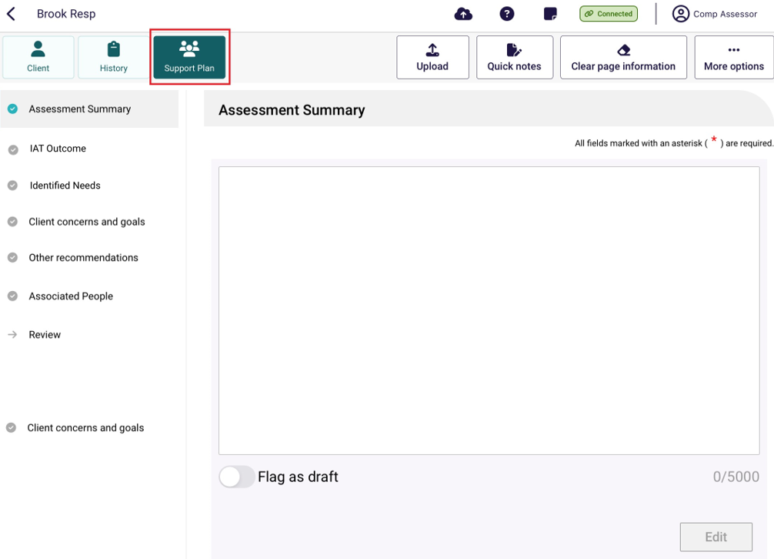

- Before starting the review, you can view the client’s support plan and review history by navigating to the History page.

In the History page, you can see details of the client’s Last Completed Review. The support plan review request and outcome details will be displayed only if the client has previously had a review completed.
You can also start the review from the History page.
You can also view the client’s:
- Last Completed Review
- Assessment summary
- Identified needs
- Client concerns and goals
- Other recommendations
- As well as viewing this information, you can schedule a future support plan review in the Support Plan tab.
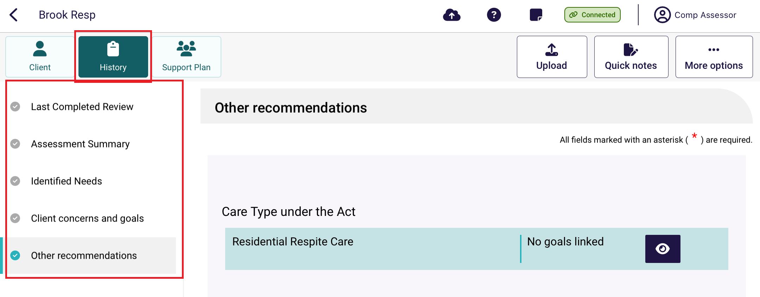
- Navigate to each of the pages in the support plan to start the review. Once selected, the review will load which will allow you to edit the client’s support plan.
! | Needs assessors can add general and service recommendations Long-Term Living arrangement and Periods of Reablement and Linking Support.
- Once the review is complete and all sections have been updated, you can upload the review, similar to uploading assessments and support plan information.

Completing the match and refer process and finalising the assessment or completing the review.
To complete the support plan and Support Plan Review, see the My Aged Care – Assessor Portal User Guide 7 – Completing a support plan and support plan review
Or to complete the match and refer process and finalise the assessment, see the My Aged Care – Assessor Portal User Guide 8 – Referring for services
! | If you have undertaken an assessment using the App, you will need to contact the client to develop the client’s support plan, confirm their referral preferences and obtain their consent to send referrals for service.

Removing assessments and reviews from the device
You may choose to remove client details from your device to increase storage space and allow for easier navigation from the App Dashboard. To manually remove client details from the device, follow the steps below.
! | Removing a client record from the device will permanently delete any assessment or review information recorded on that device and that has not been uploaded to the assessor portal.
- Open the App. The dashboard page will be displayed, select your outlet that contains the clients assessment. Once in the outlet, search and click on the client card.
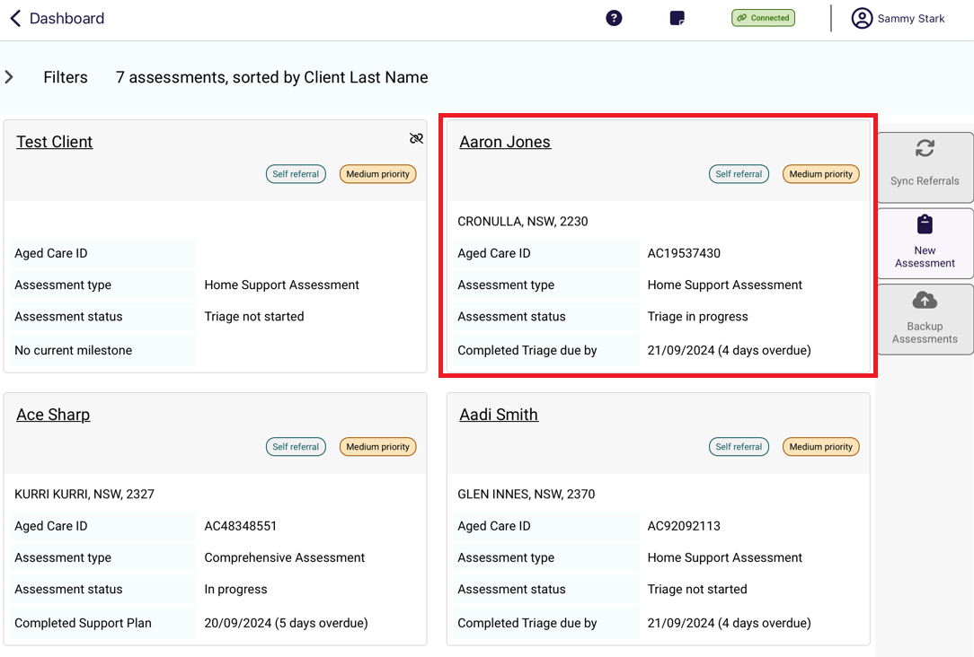
- From any page in the client’s record, you can remove the record from the device by selecting More options and then Remove Client from Device from the pop up.
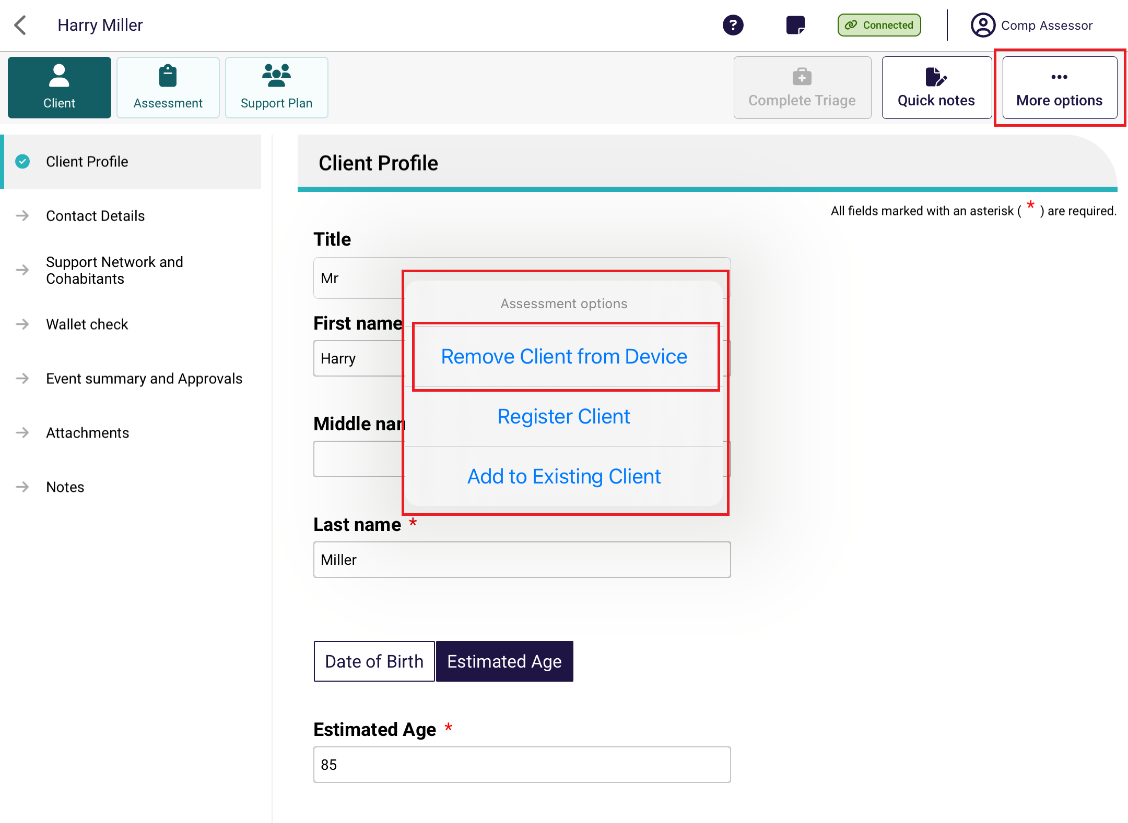

- Select Remove Assessment to remove the record.
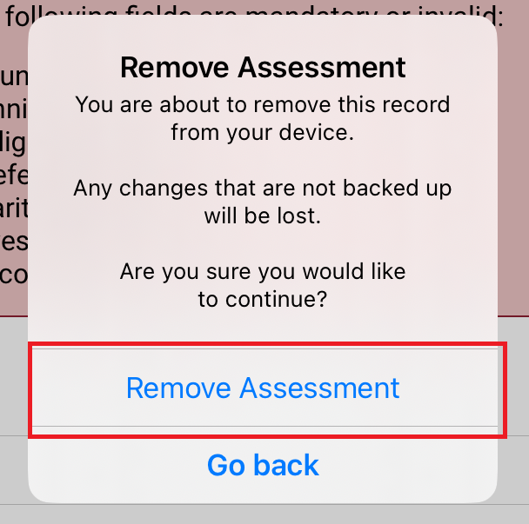

! | Clients with uploaded assessments will still appear in the app when you select Refresh until you complete the client’s support plan in the assessor portal.

Completing a Residential Respite Classification Assessment
! | Unlike Support Plan Reviews and Comprehensive assessments, Residential Respite Assessments can only be completed from the App. If you are using a PC or Laptop to complete the assessment, a Windows compatible (sideloaded) version of the App is available.
Residential Respite Assessments are an assessment of the care recipient’s mobility utilising the DEMMI-modified. Respite Classifications are used to determine the level of subsidy Residential Service Facilities will receive for the care of Respite clients under the AN-ACC funding model.
There are 12 tasks in DEMMI-modified, select one rating only for each of the twelve tasks that best matches the resident’s capabilities.
Detailed description of the assessment tool
The DEMMI-modified is an instrument that measures the mobility of older people across clinical settings. It is preferably based on direct observation of the resident. However, it is not appropriate to ask a resident to complete tasks if there is a falls risk or risk of causing distress to the resident. The clinical needs assessor should use their clinical judgement to evaluate if the DEMMI-modified can be undertaken and at what point the assessment should cease.
The four DEMMI domains are:
• bed mobility
• chair
• static balance (no gait aid)
• walking.
Only clinical needs assessors who have completed training in DEMMI-modified based respite assessments under the AN-ACC funding model can assess clients using the DEMMI-modified.
For information on the DEMMI–modified tool, refer to the AN-ACC Reference Manual.
To complete the DEMMI–modified in the App first an assessment must be downloaded to the App. Refer to Self-Refer a Care Recipient for a Residential Respite Assessment or Complete an assigned Residential Respite Assessment Referral for guidance.

Clinical needs assessors can use the App to:
- Conduct a Residential Respite Classification Assessment they have downloaded.
- Self-refer Residential Respite Classification Assessments.
- Reject Residential Respite Classification Assessments.

Refer for a Residential Respite Assessment
! | Unlike Support Plan Reviews and Comprehensive assessments, Residential Respite Assessments can only be completed from the App. If you are using a PC or Laptop to complete the assessment, a Windows compatible (sideloaded) version of the App is available.
- Open and log in to the App. Select Find A Client from the dashboard. You can follow the steps set out in section 9.1 Finding a client.
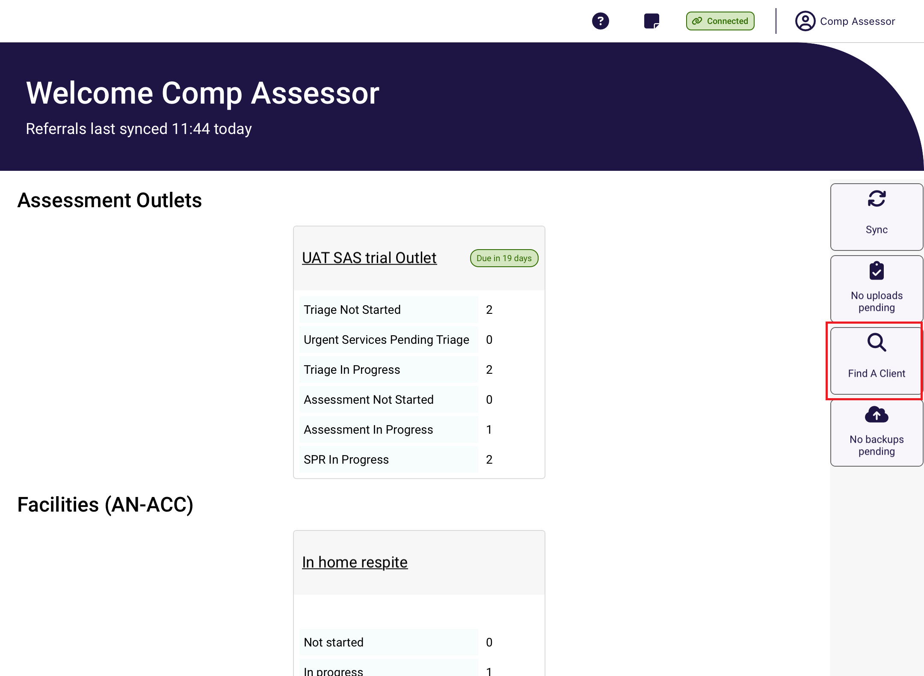
- Search and open the client’s record.
Once you are in the client’s record, confirm that the personal details are correct. Then, select Event Summary and Approvals and ensure that the client has a current Residential respite care approval.
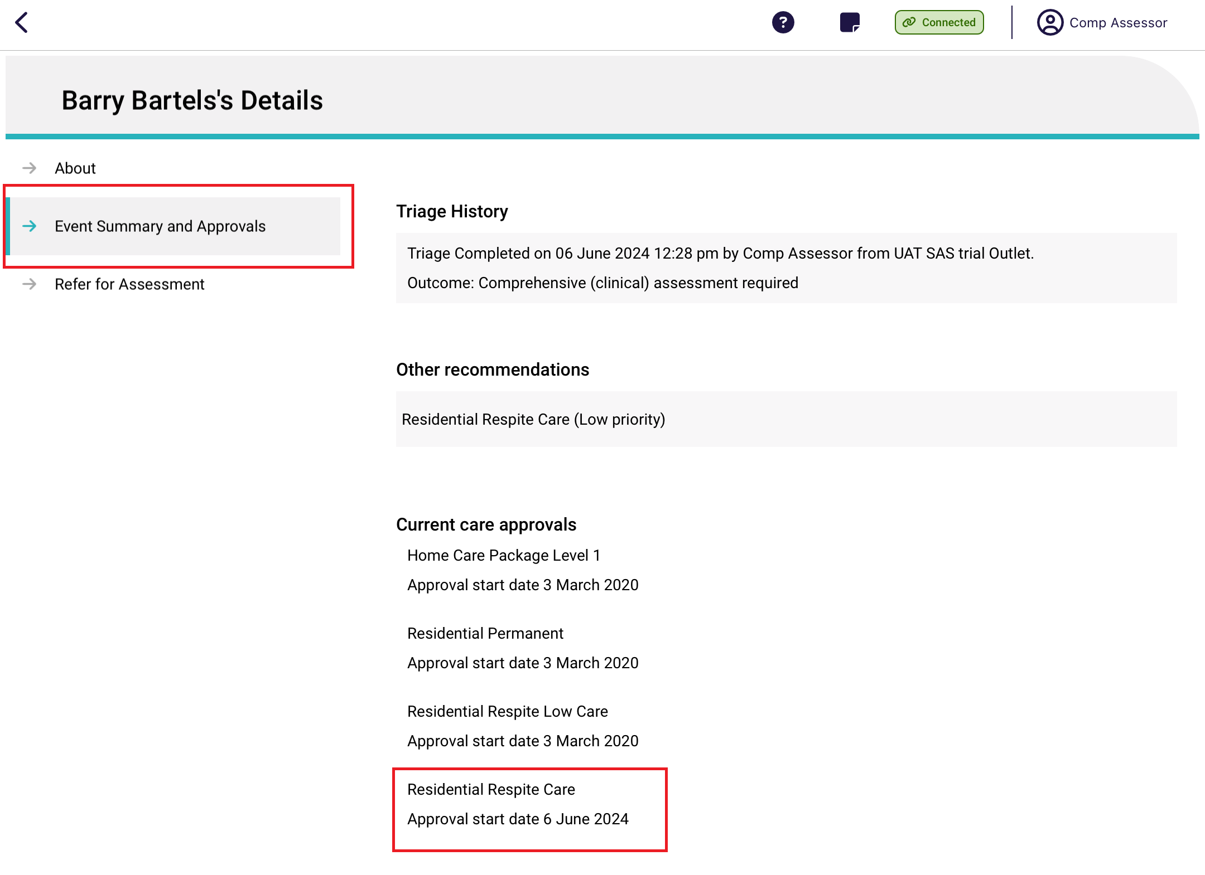
- Go to the Refer for Assessment tab, and select the type Residential Respite Assessment.
Input an Assessment date, ensure the assessment date is the date that you conducted the assessment. The Assessment date may impact the effective date of the classification that is generated and subsidy paid to the provider.
Confirm the correct Assessment Setting is selected and once the details are correct and click Create Referral.
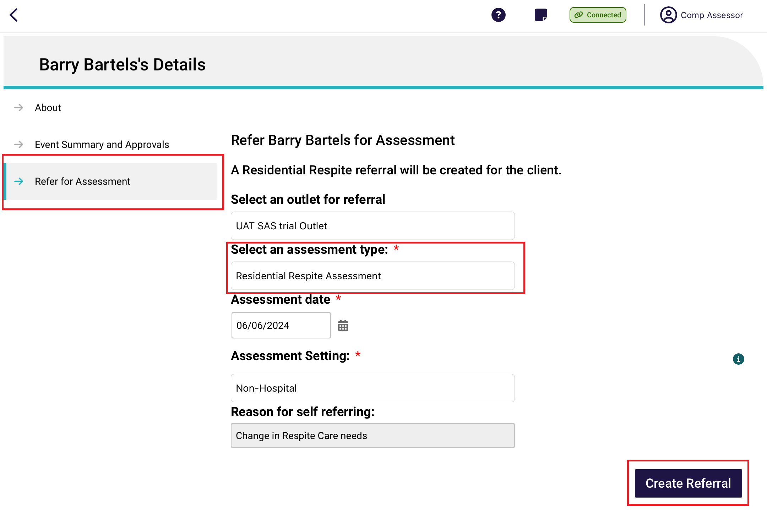
You will see a confirmation screen confirming that the referral was created successfully. Click the Go Back button to return to the Dashboard to the downloaded client that you have self-referred.
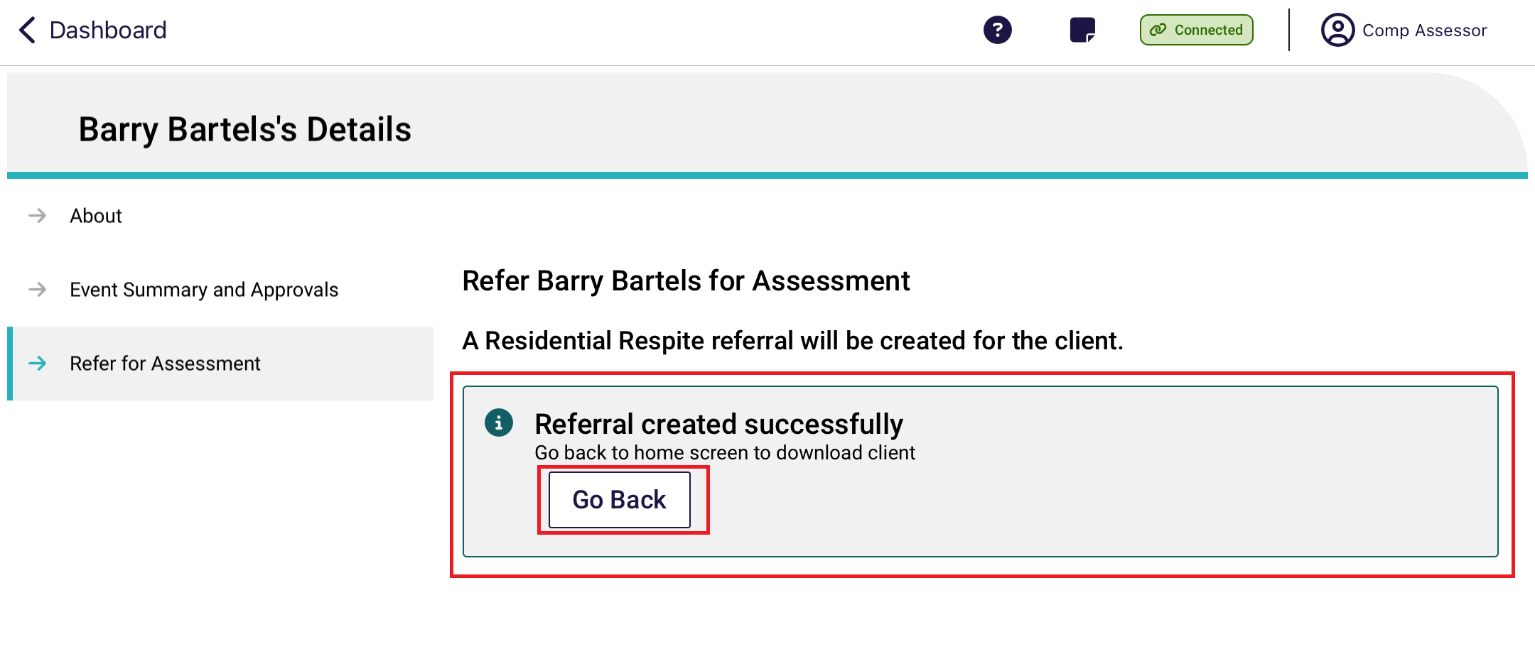
Refer to the next section on how to complete an assigned Residential Respite Assessment Referral for how to complete the DEMMI-modified.

21.3 How to start an assigned Residential Respite Assessment Referral.
Residential Respite Assessments that have been assigned to you by your Team Leader will automatically appear on your App. To access your assigned Residential Respite Assessments, navigate to the Dashboard and click on your outlet.
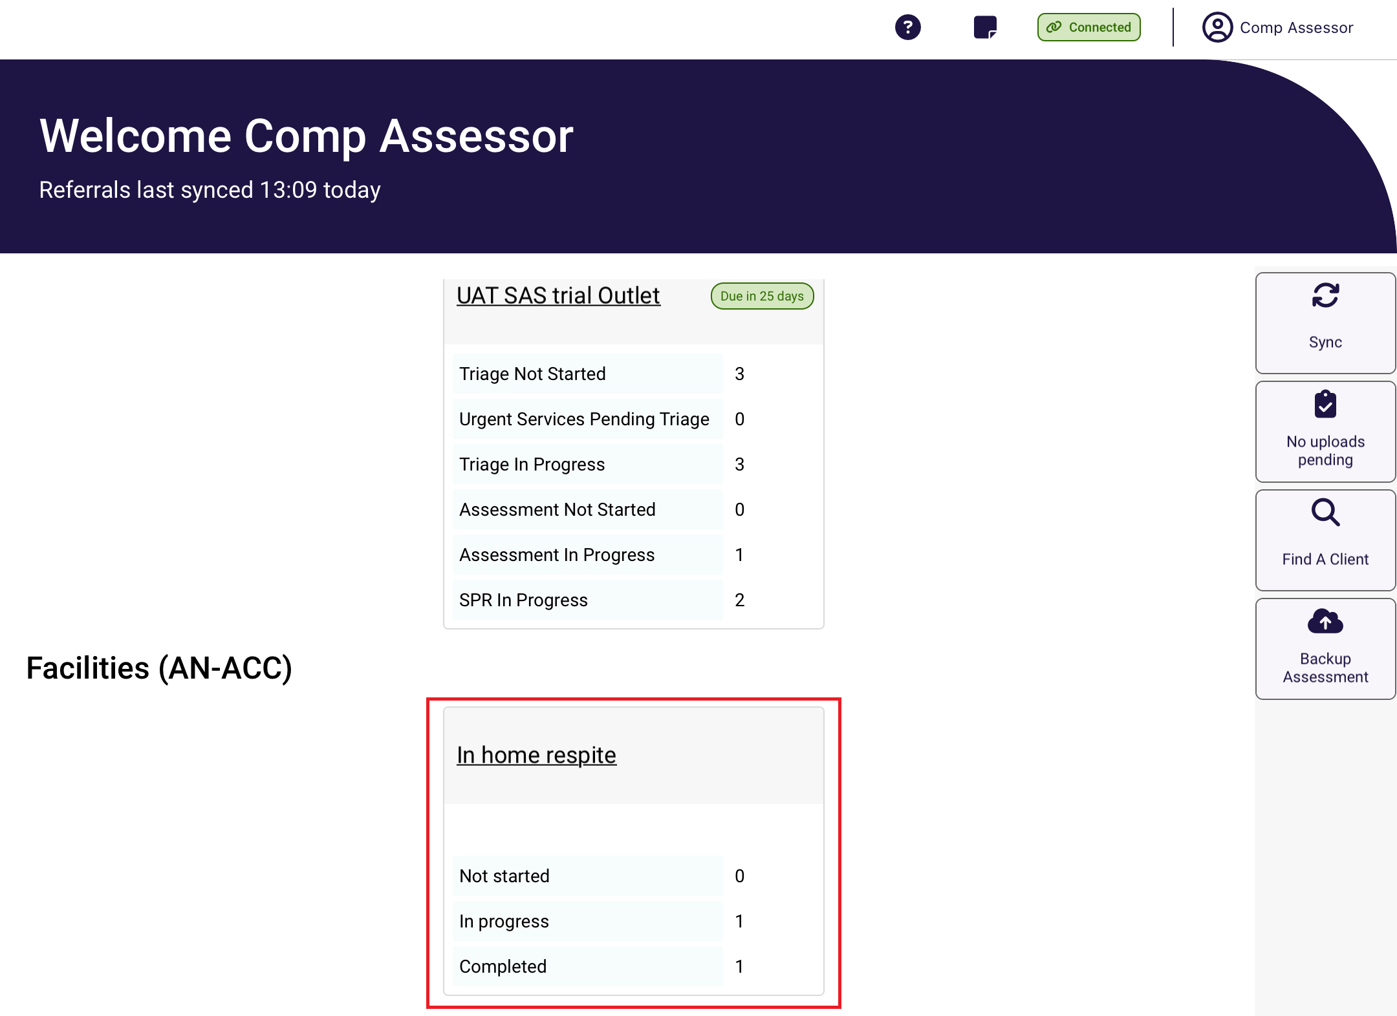

To complete the assessment, click on the client’s card to download the assessment to your device.
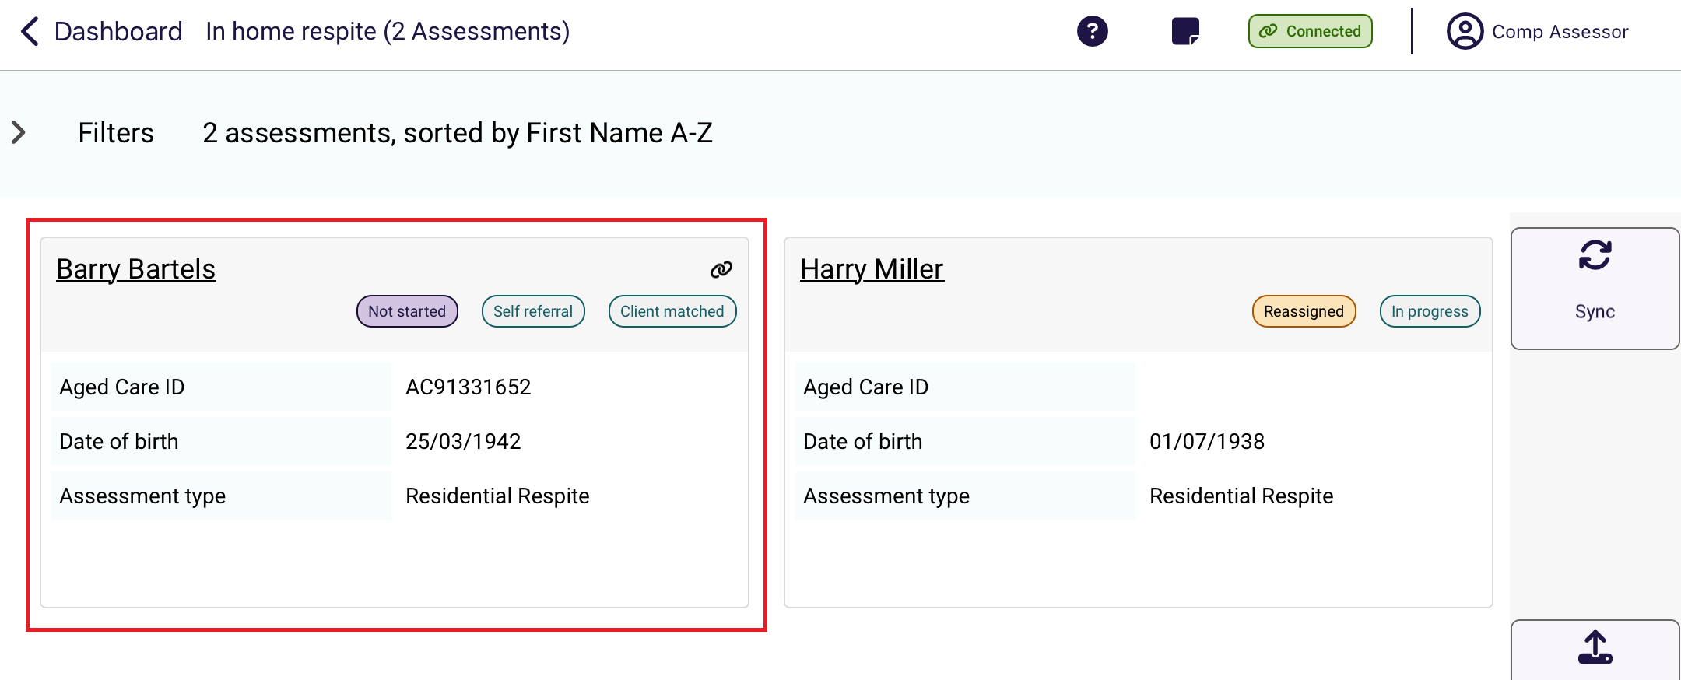
Select Start Assessment.
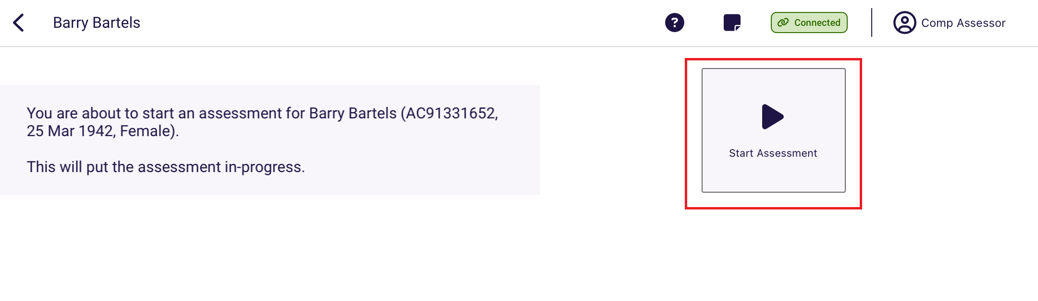

Completing a Residential Respite Assessment
- Confirm the client details are correct by reviewing the Identification and assessment details section.
- Select the De Morton Mobility Index (DEMMI) – Modified tab to complete the Modified DEMMI Assessment.
Select the question mark to display tool help. This will provide guidance on how to complete the assessment. Complete all mandatory fields until the page has a tick next to it.
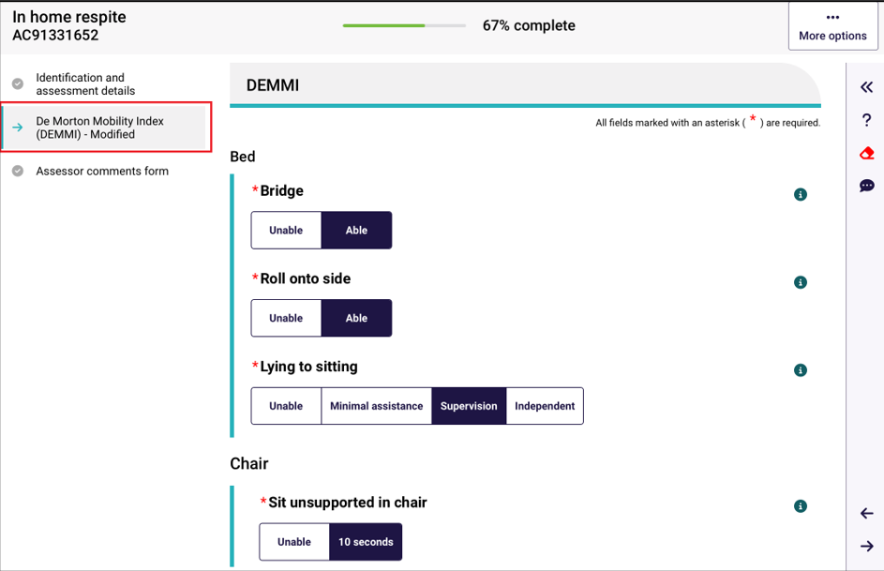
- Tool tips are available by selecting the information icon in the top right-hand corner of each question.
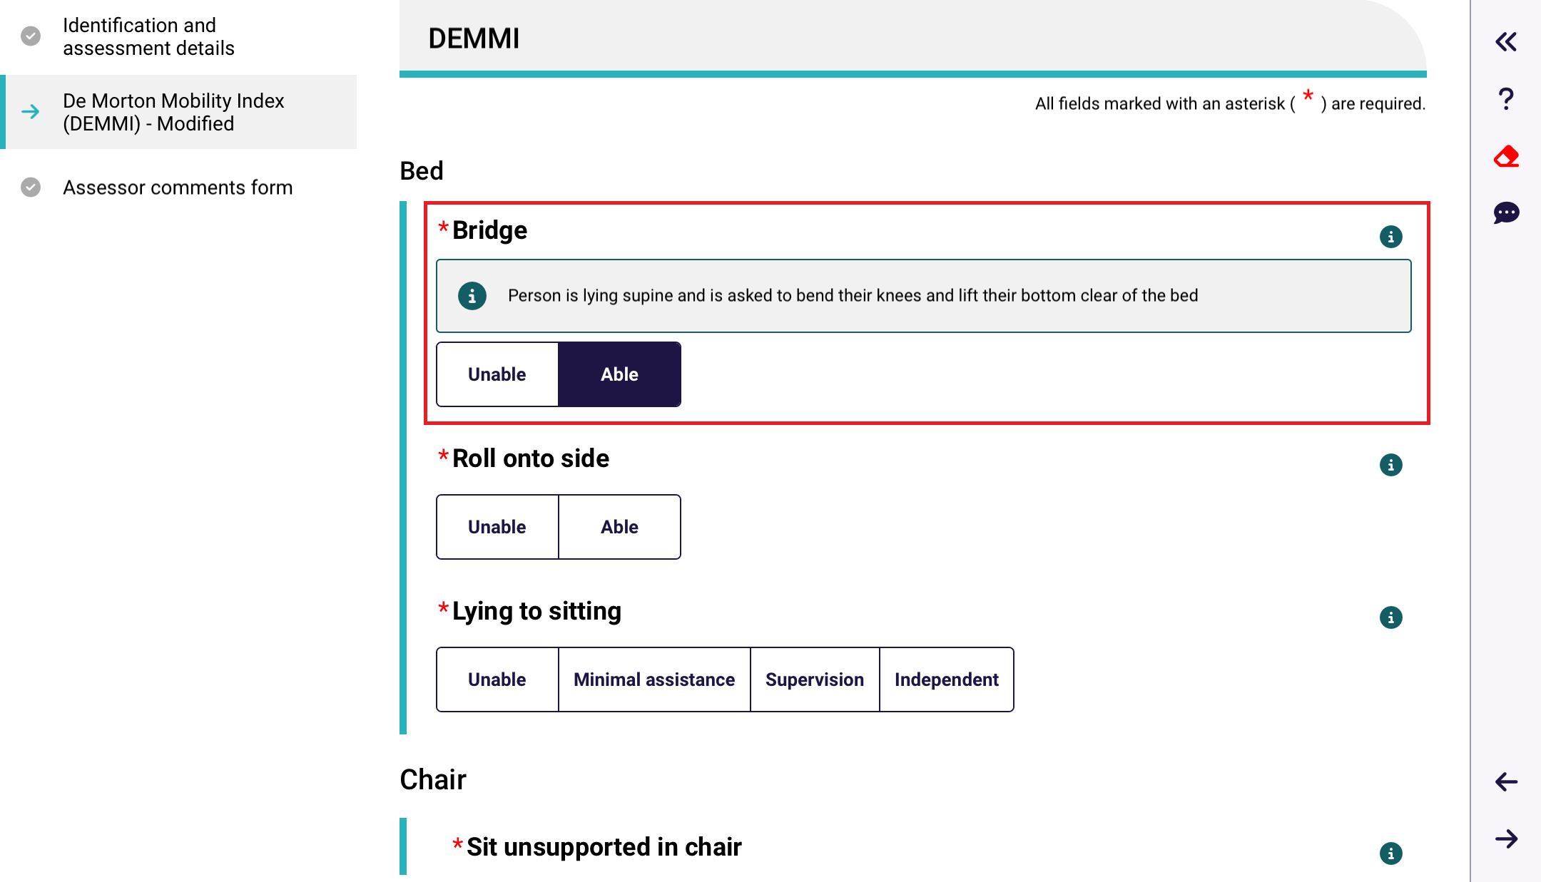
- Once the assessment is complete you may add comments, these comments will be stored with the assessment and can be viewed by the department if needed.
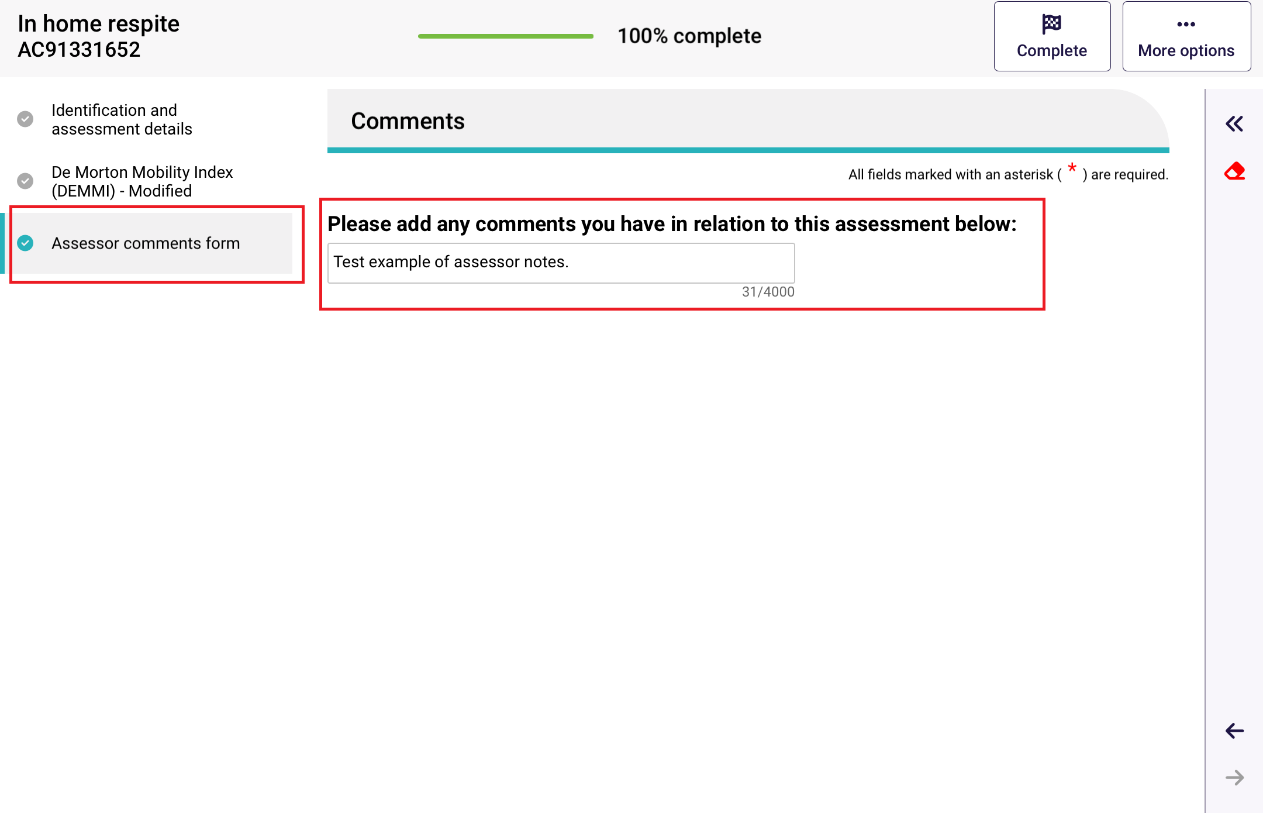

- Once the assessment is complete click the Complete button.
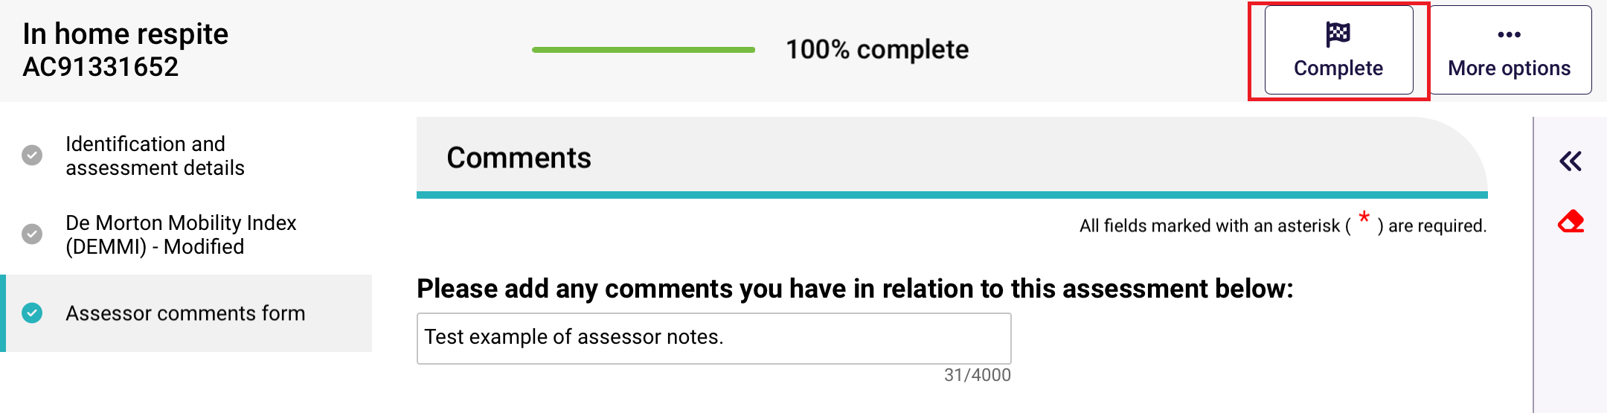
- Select Complete Assessment at the next screen. This will submit the assessment and generate a classification for the client, there is no further action required.
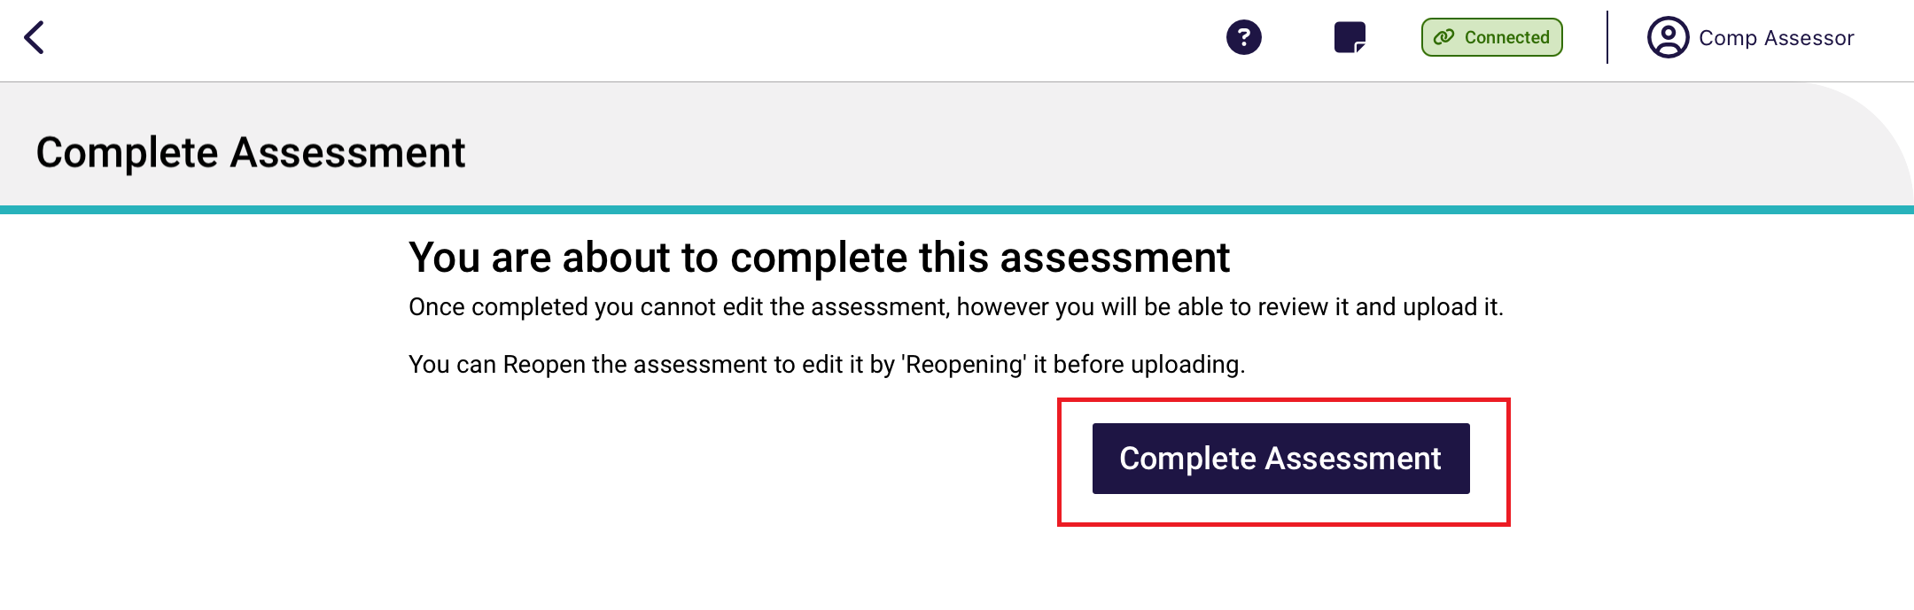
- Following this you will be re-directed to the Upload Assessment page. Select Upload.
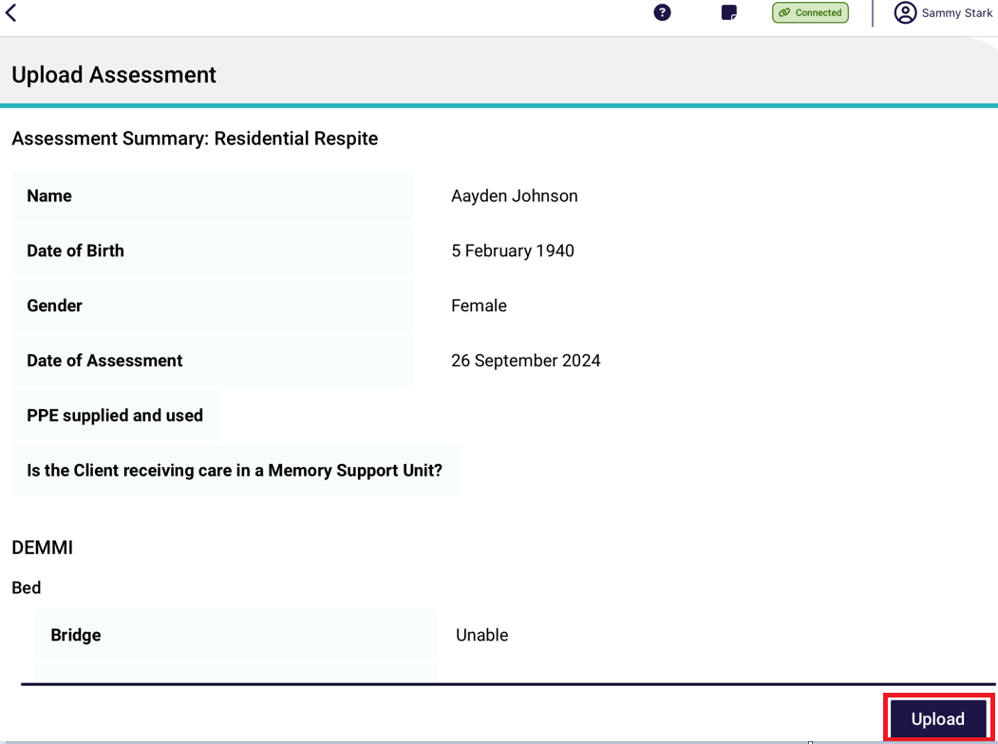

Rejecting a Residential Respite Assessment
If a Team Leader assigns a residential respite assessment to you, you can choose to reject it.
- Open and log in to the App, download and open an assessment. Select actions in the top right corner, then select Reject Referral from the pop up.
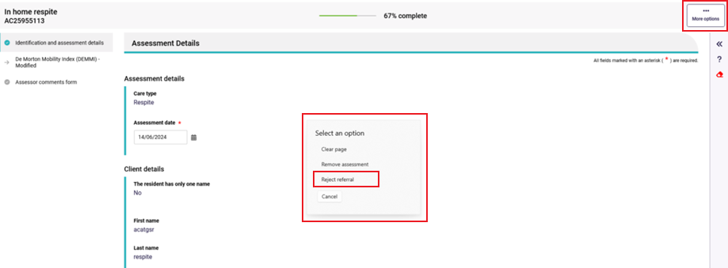
- Select the appropriate rejection reason, this may be either Client Deceased, Entered a residential facility (Figure 1) or Other (below). Please note, for the reason Client Deceased please contact your team lead or the My Aged Care contact centre to complete the process.
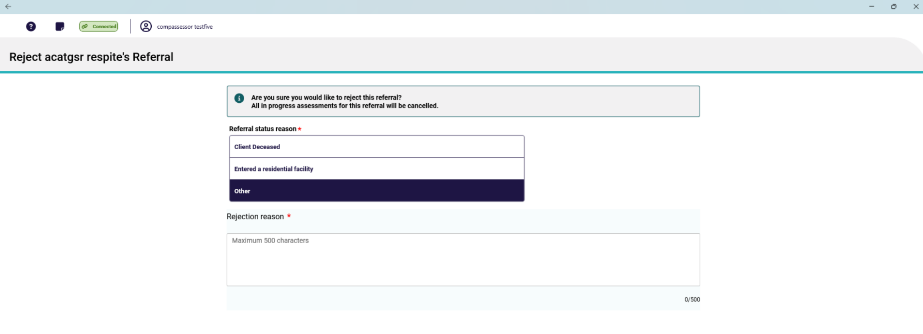
- If the client has entered a residential service facility, please select Entered a residential facility. These referrals will now be assigned to an appropriate RFA Organisation.
The options provided are either searching by residential facility name or suburb/ postcode; Or if you are unsure, please select Unsure and a departmental officer will be assigned the referral manually.
Figure 1 - "Entered a residential facility"
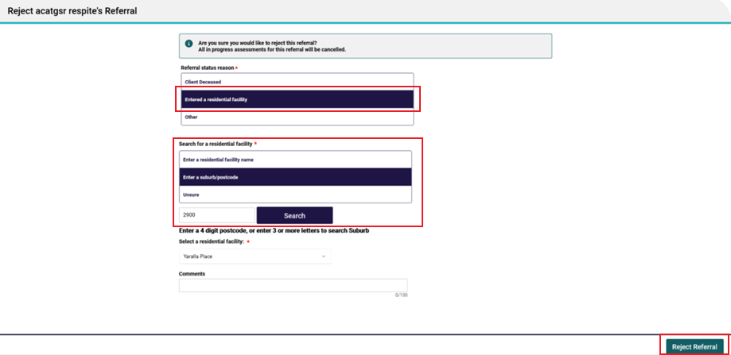
- Once all the criteria have been entered select Reject Referral. The referral will now be rejected, there is no further actioned needed.
- Residential Respite Assessments for clients who have entered a residential facility are to be completed by Residential Funding Assessors. If a client has entered a Residential Facility, reject the referral due to Entered a residential facility by completing the following steps:
  - Select Entered a residential facility.
  - Either enter a residential facility name, enter a suburb/ postcode or if you are unsure select Unsure.
  - Select Search.
  - Scroll down until the applicable Residential Facility has been highlighted and select done.
! | You can upload an assessment to the My Aged Care assessor portal from the App without answering all mandatory questions. However, you will need to complete all mandatory questions before you can complete the assessment in the My Aged Care assessor portal.  Clinical needs assessors are expected to contact the client to confirm the outcome of the assessment, discuss the client’s service preferences, and obtain consent to send referrals for service.

Part C – Residential aged care funding assessments (RAC funding assessors)

22. Conducting an RAC funding assessment
! | Please note that ‘assessment’ in part C refers to residential aged care funding assessments completed by residential aged care funding assessors who complete assessments using the Australian National Aged Care Classification (AN-ACC) assessment tool.

Find a client
- On the Facilities page, all assessment referral/s that have been assigned to you will be listed. Scroll up and down to view more facilities and clients.

Select a facility to display all referrals for that Facility that are assigned to you.
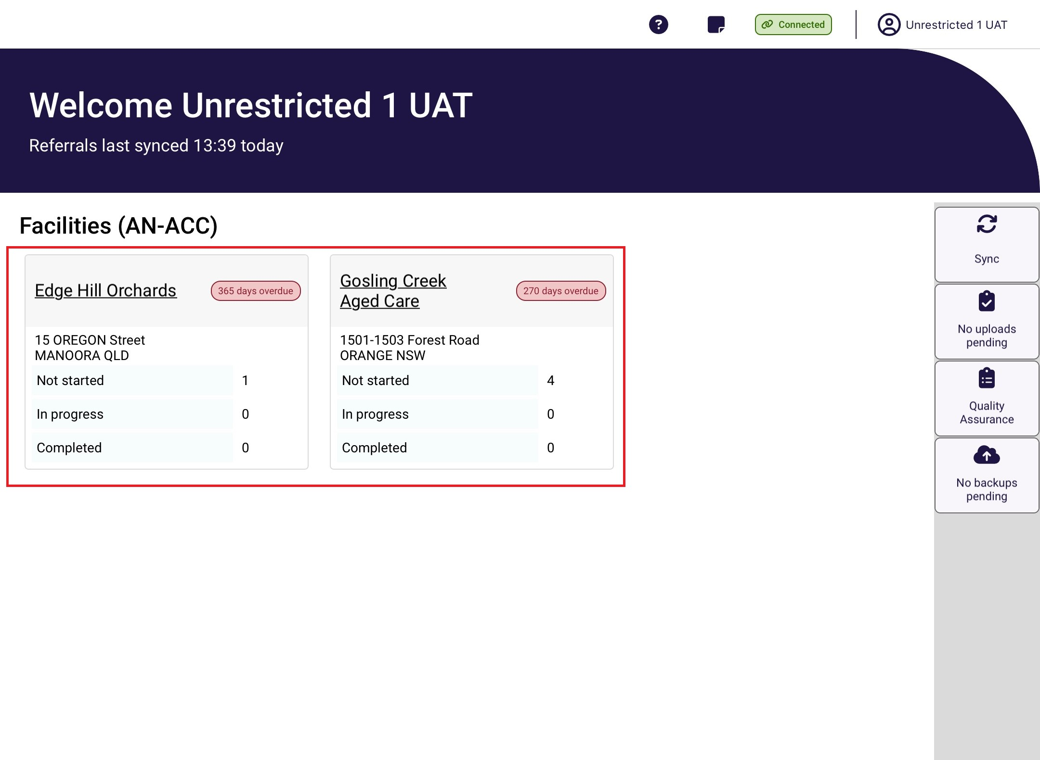
- Once you have clicked on the facility you are wanting to assess in, the resident referrals for this facility will be displayed. Scroll up and down the page to locate the resident you wish to assess or use sort and filter options to narrow the number of residents being displayed.
! | If you are not connected to the internet, only referrals that have been previously downloaded will be available. It is recommended that you sync your device daily before commencing.
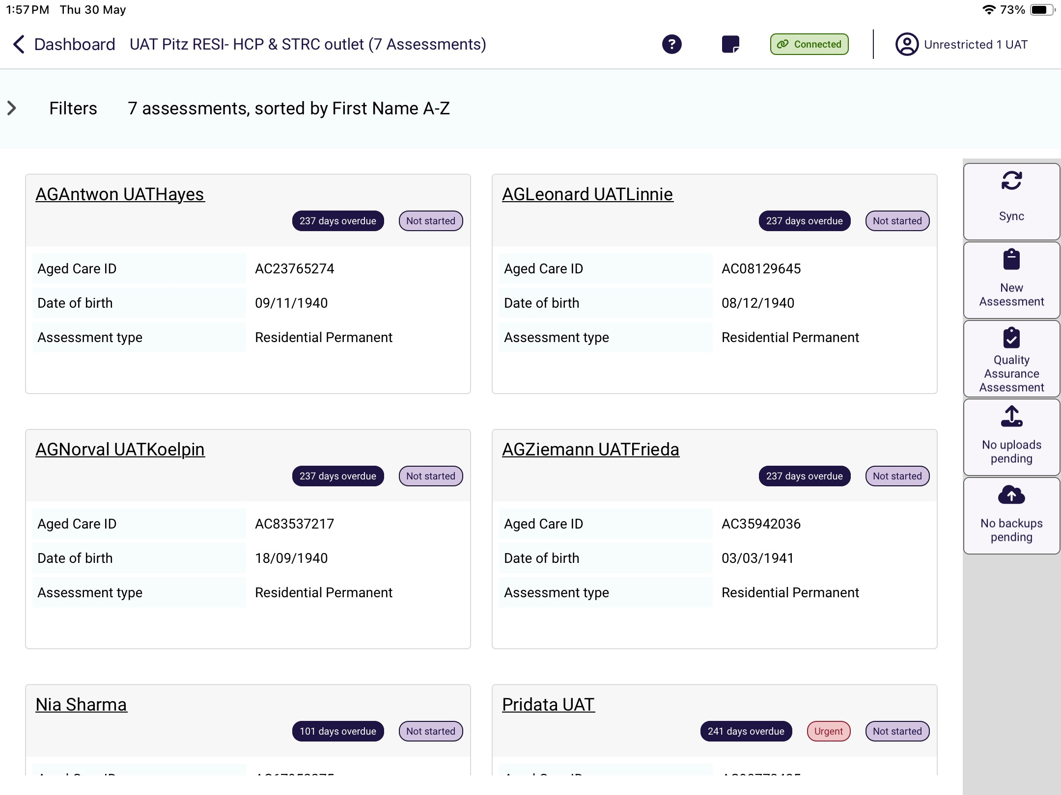
There are four ways to filter or order referrals:
- Filtering on keyword for example First Name, Last Name or Aged Care ID,
- Filtering on the Status (Assessment status),
- Filtering Assessment type,
- Order on First Name or Last name in ascending or descending alphabetical order, and
- Sorting on due or departure date in ascending or descending order.
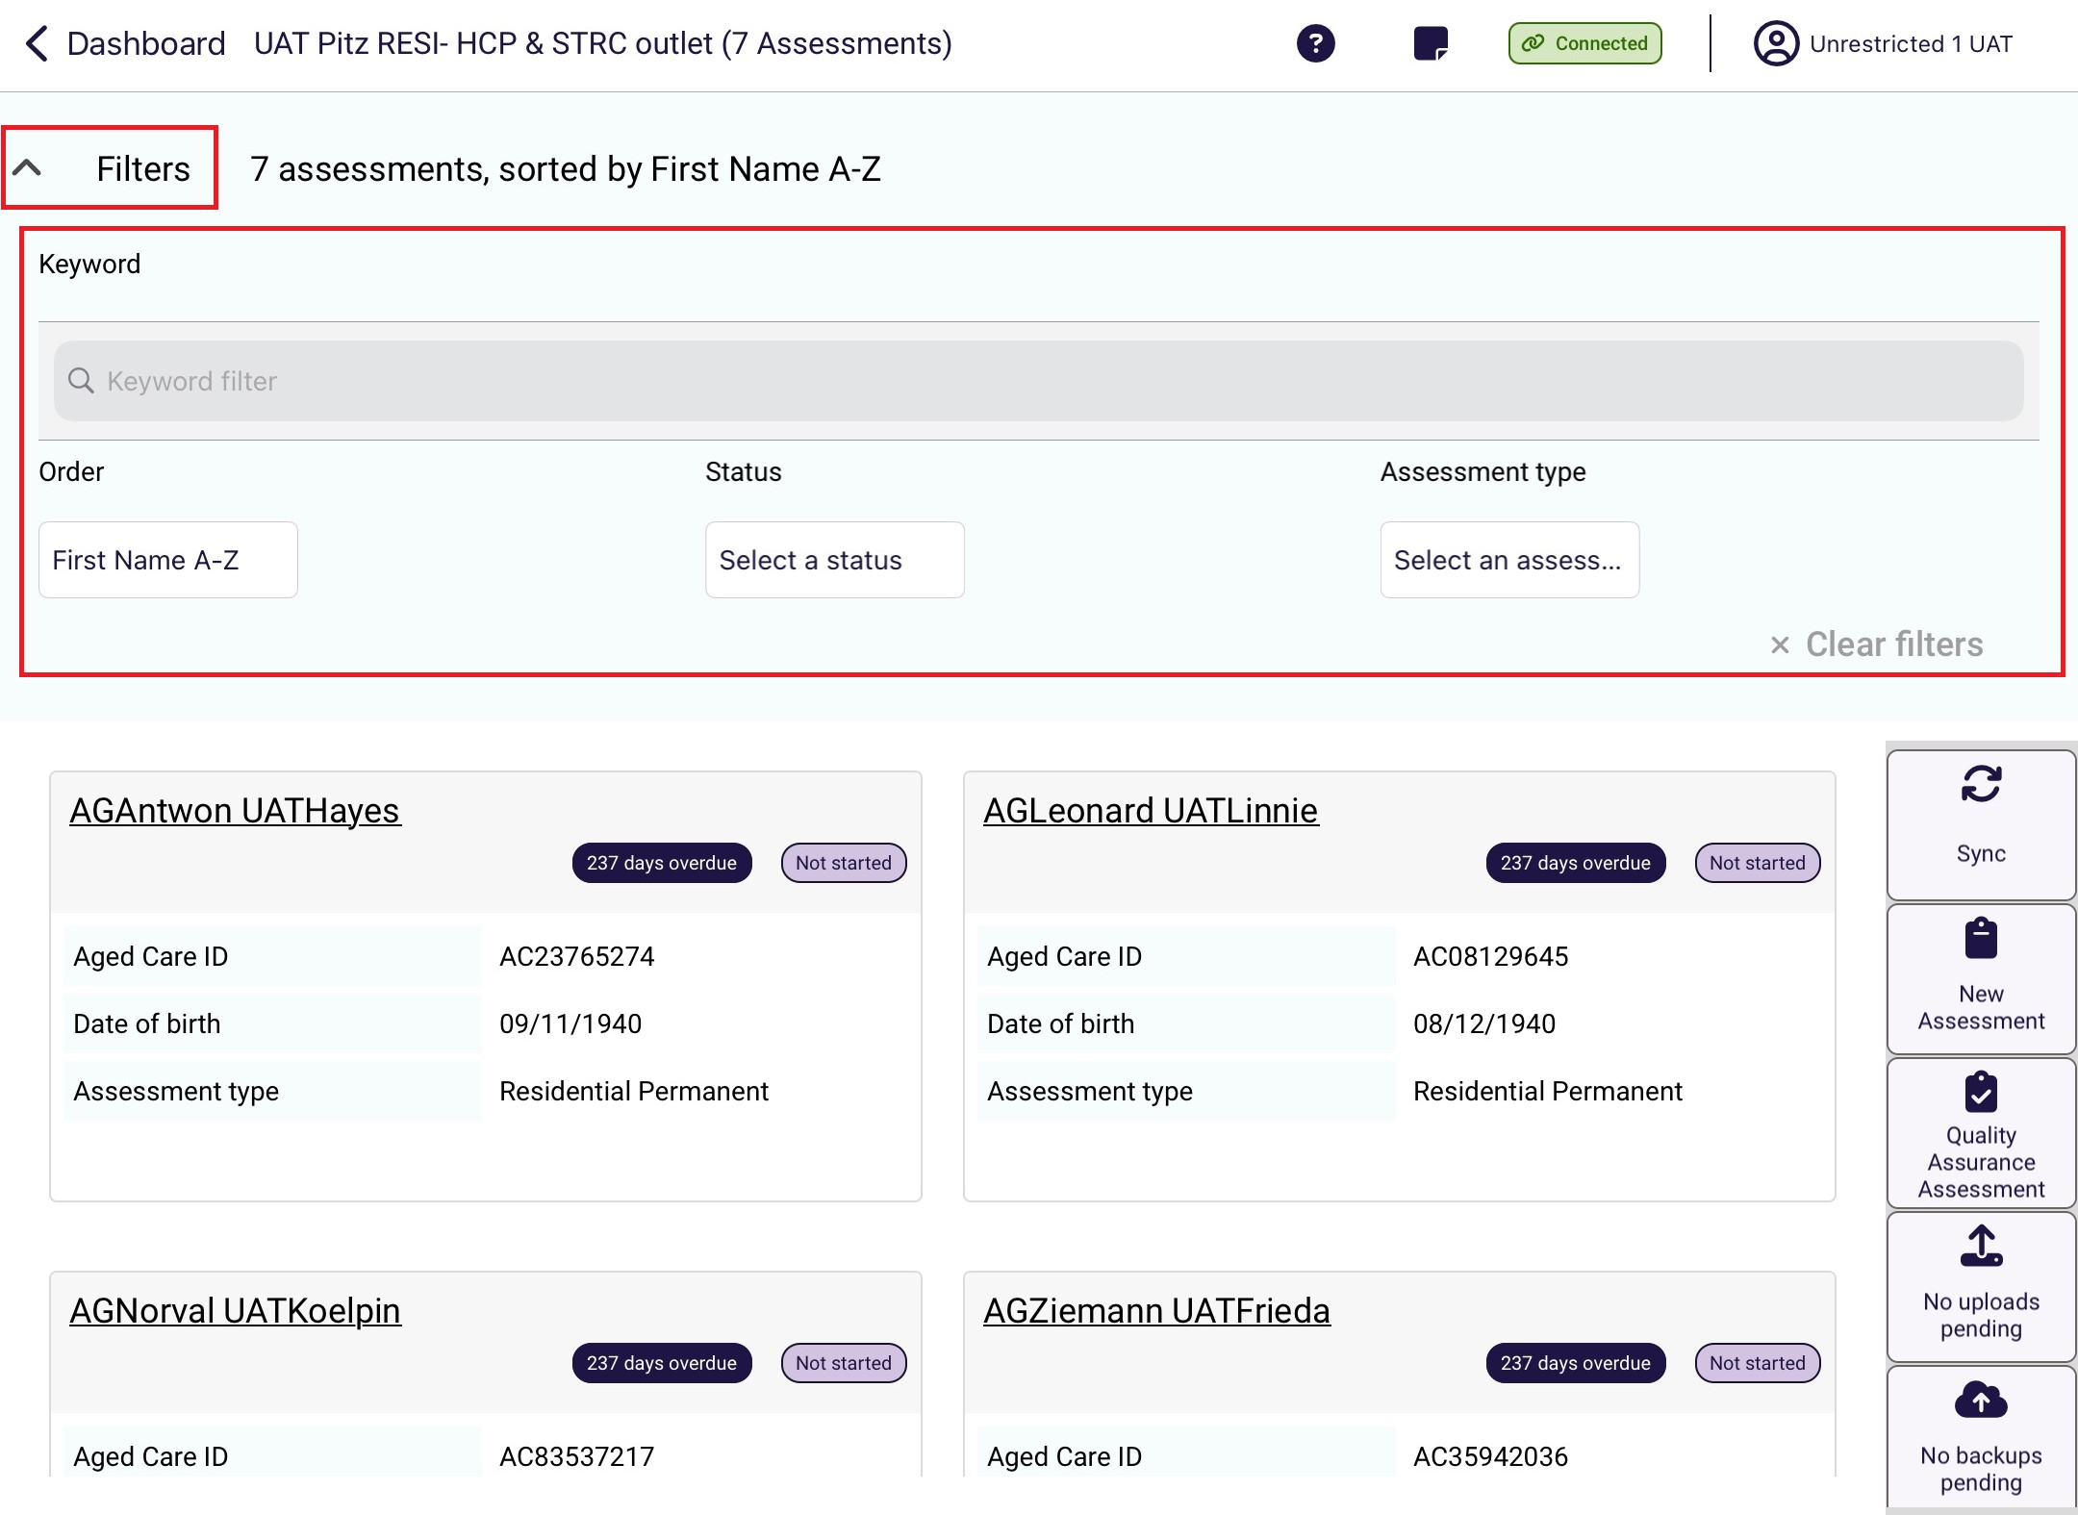
Select the Filter dropdown to expand the filter menu. It displays the Sort By option and Filter options. The Filter option text box is an active search. It will refine results when typed.

In the following example, the residents are sorted by Last name in ascending alphabetical order, and any residents’ names that contains “Ra” will appear.
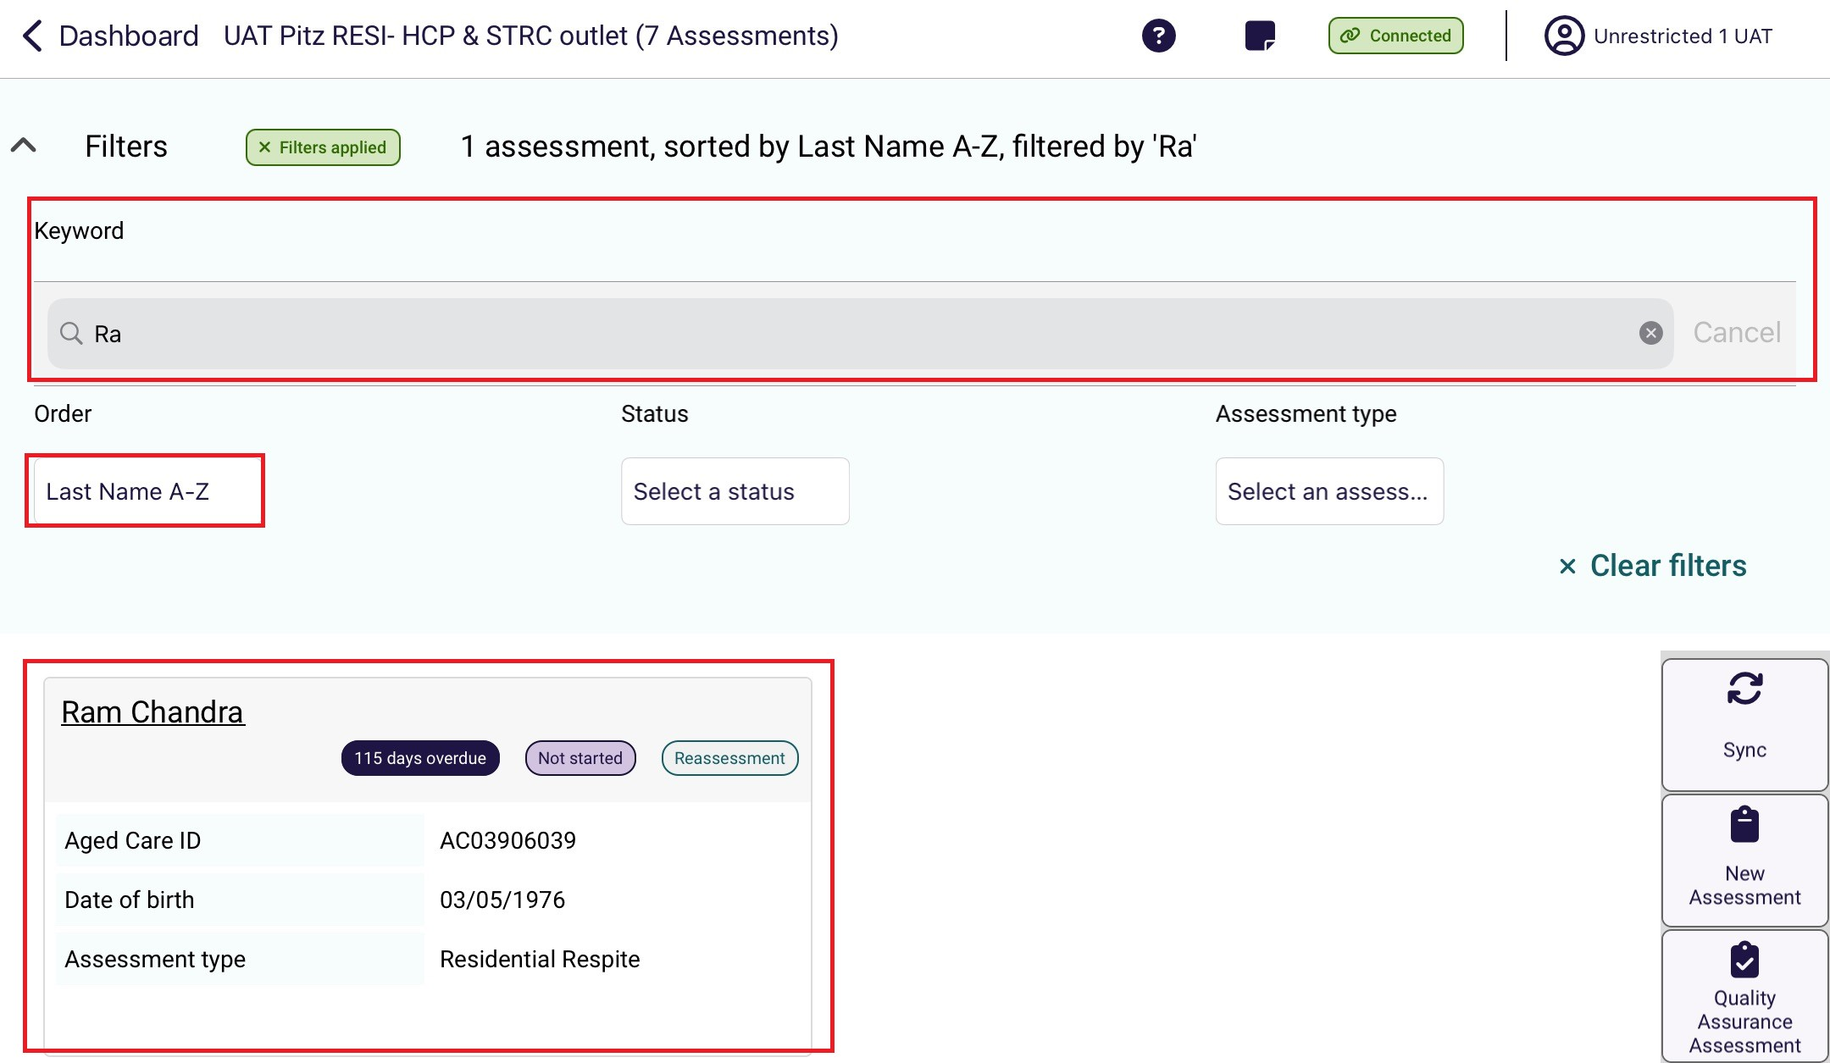

- Select the resident’s record.
Depending on the resident’s assessment status, selecting the record will either start the assessment, or will be directed to the first page of the assessment in progress.
Start of an assessment
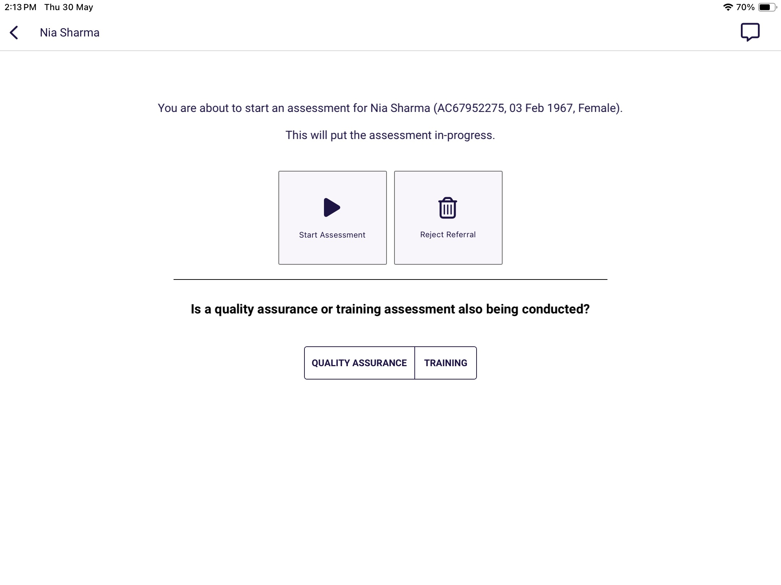

Assessment in progress
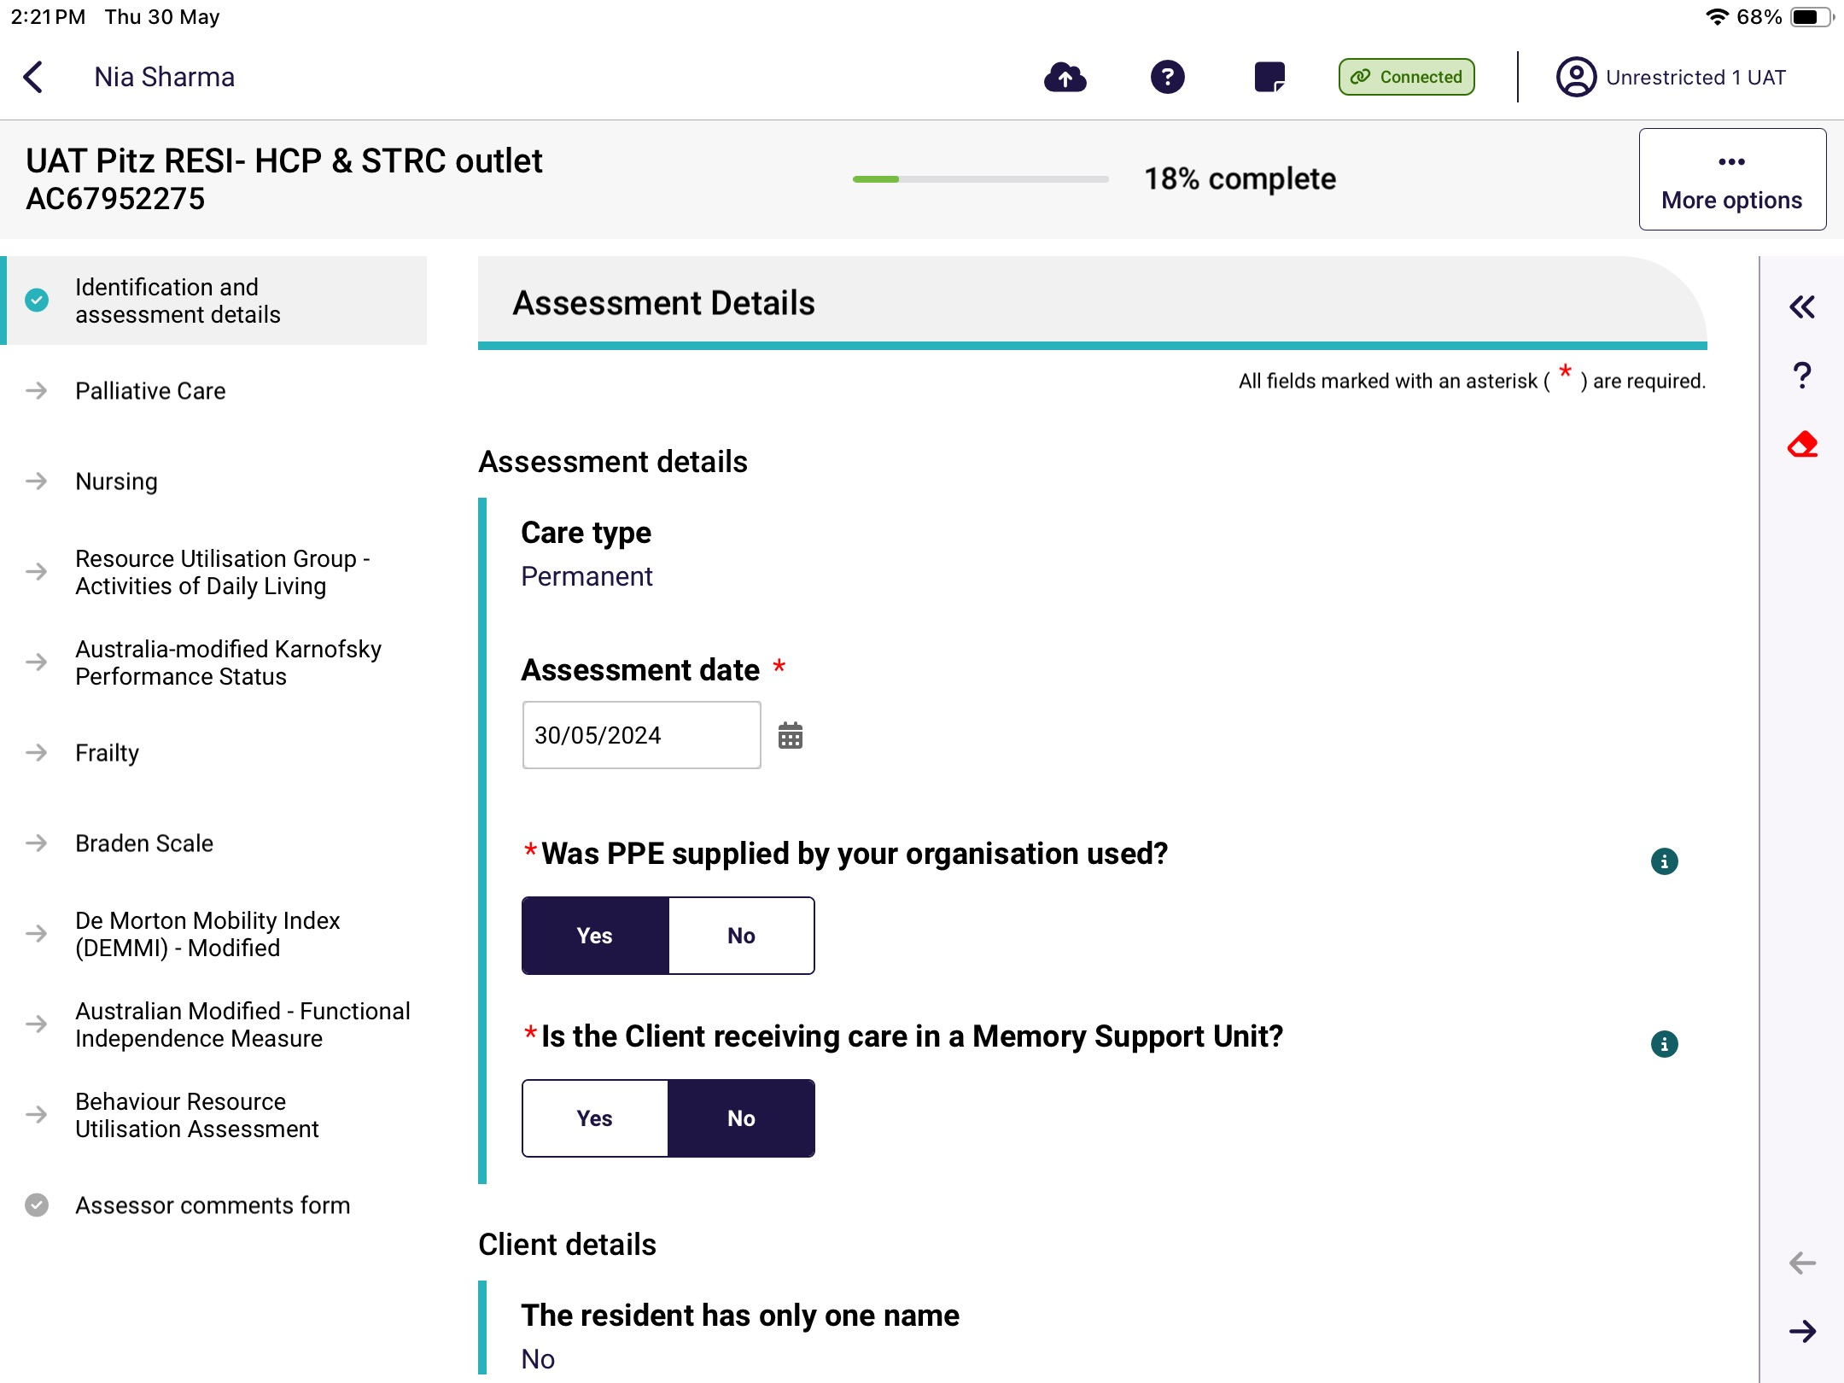

Self-Referral
! | Prior to conducting a self-referral, RAC funding assessors should contact the Department.
RAC funding assessors can self-refer the assessment when they identify a resident in a service or facility that does not have an assessment referral. This could happen if the resident has entered care since the time of the assessment referral being issued.
- Select New Assessment on the right-hand side in the facility dashboard menu.
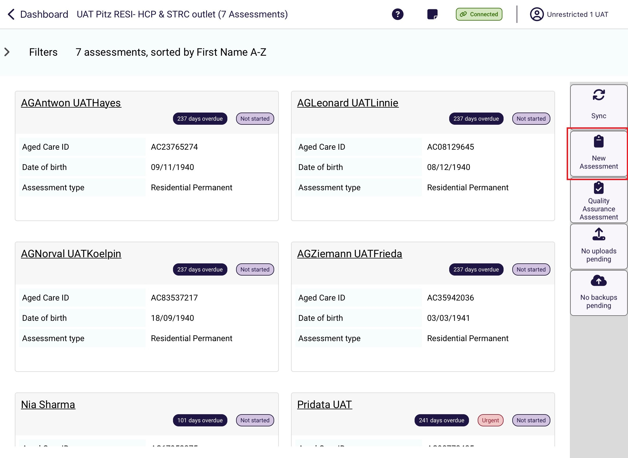

- The New assessment screen appears. Enter the resident’s My Aged Care client identifier (AC ID) and select Search. The service provider will be able to provide the AC ID for the resident.

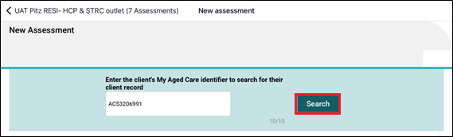
- Check the details of the search result. If the details are correct, select the record to start the assessment.
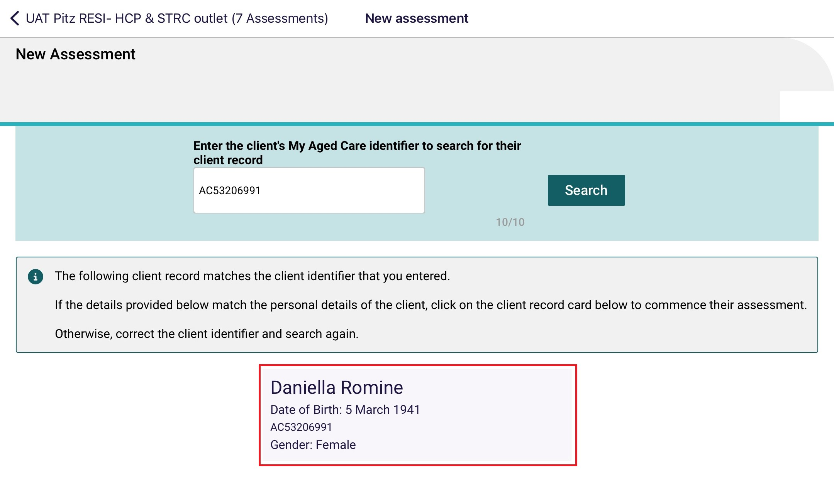
- If required, fill in any mandatory fields in the Add Client page, by selecting the appropriate options. Mandatory fields are shown by a red line over the field name and a red asterix.
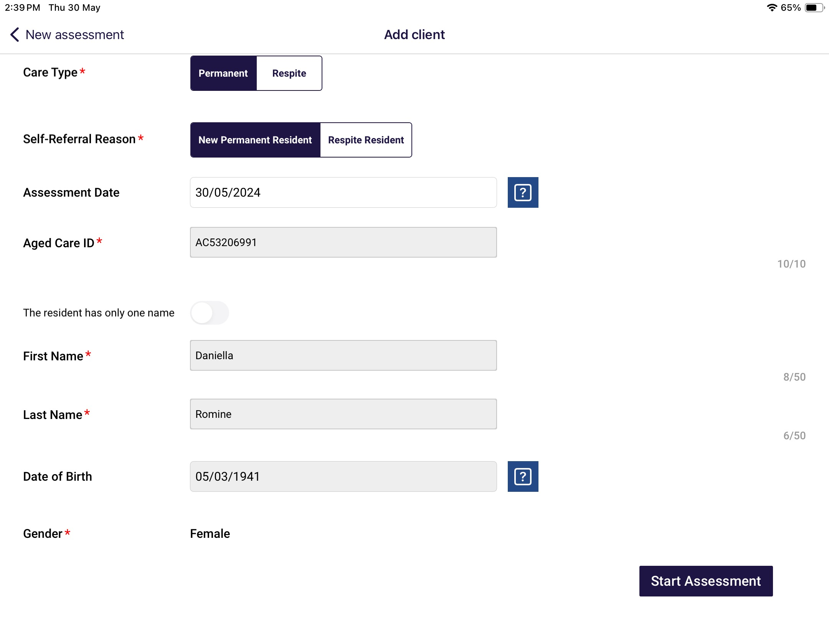

- Once all mandatory fields are complete, select Start Assessment.
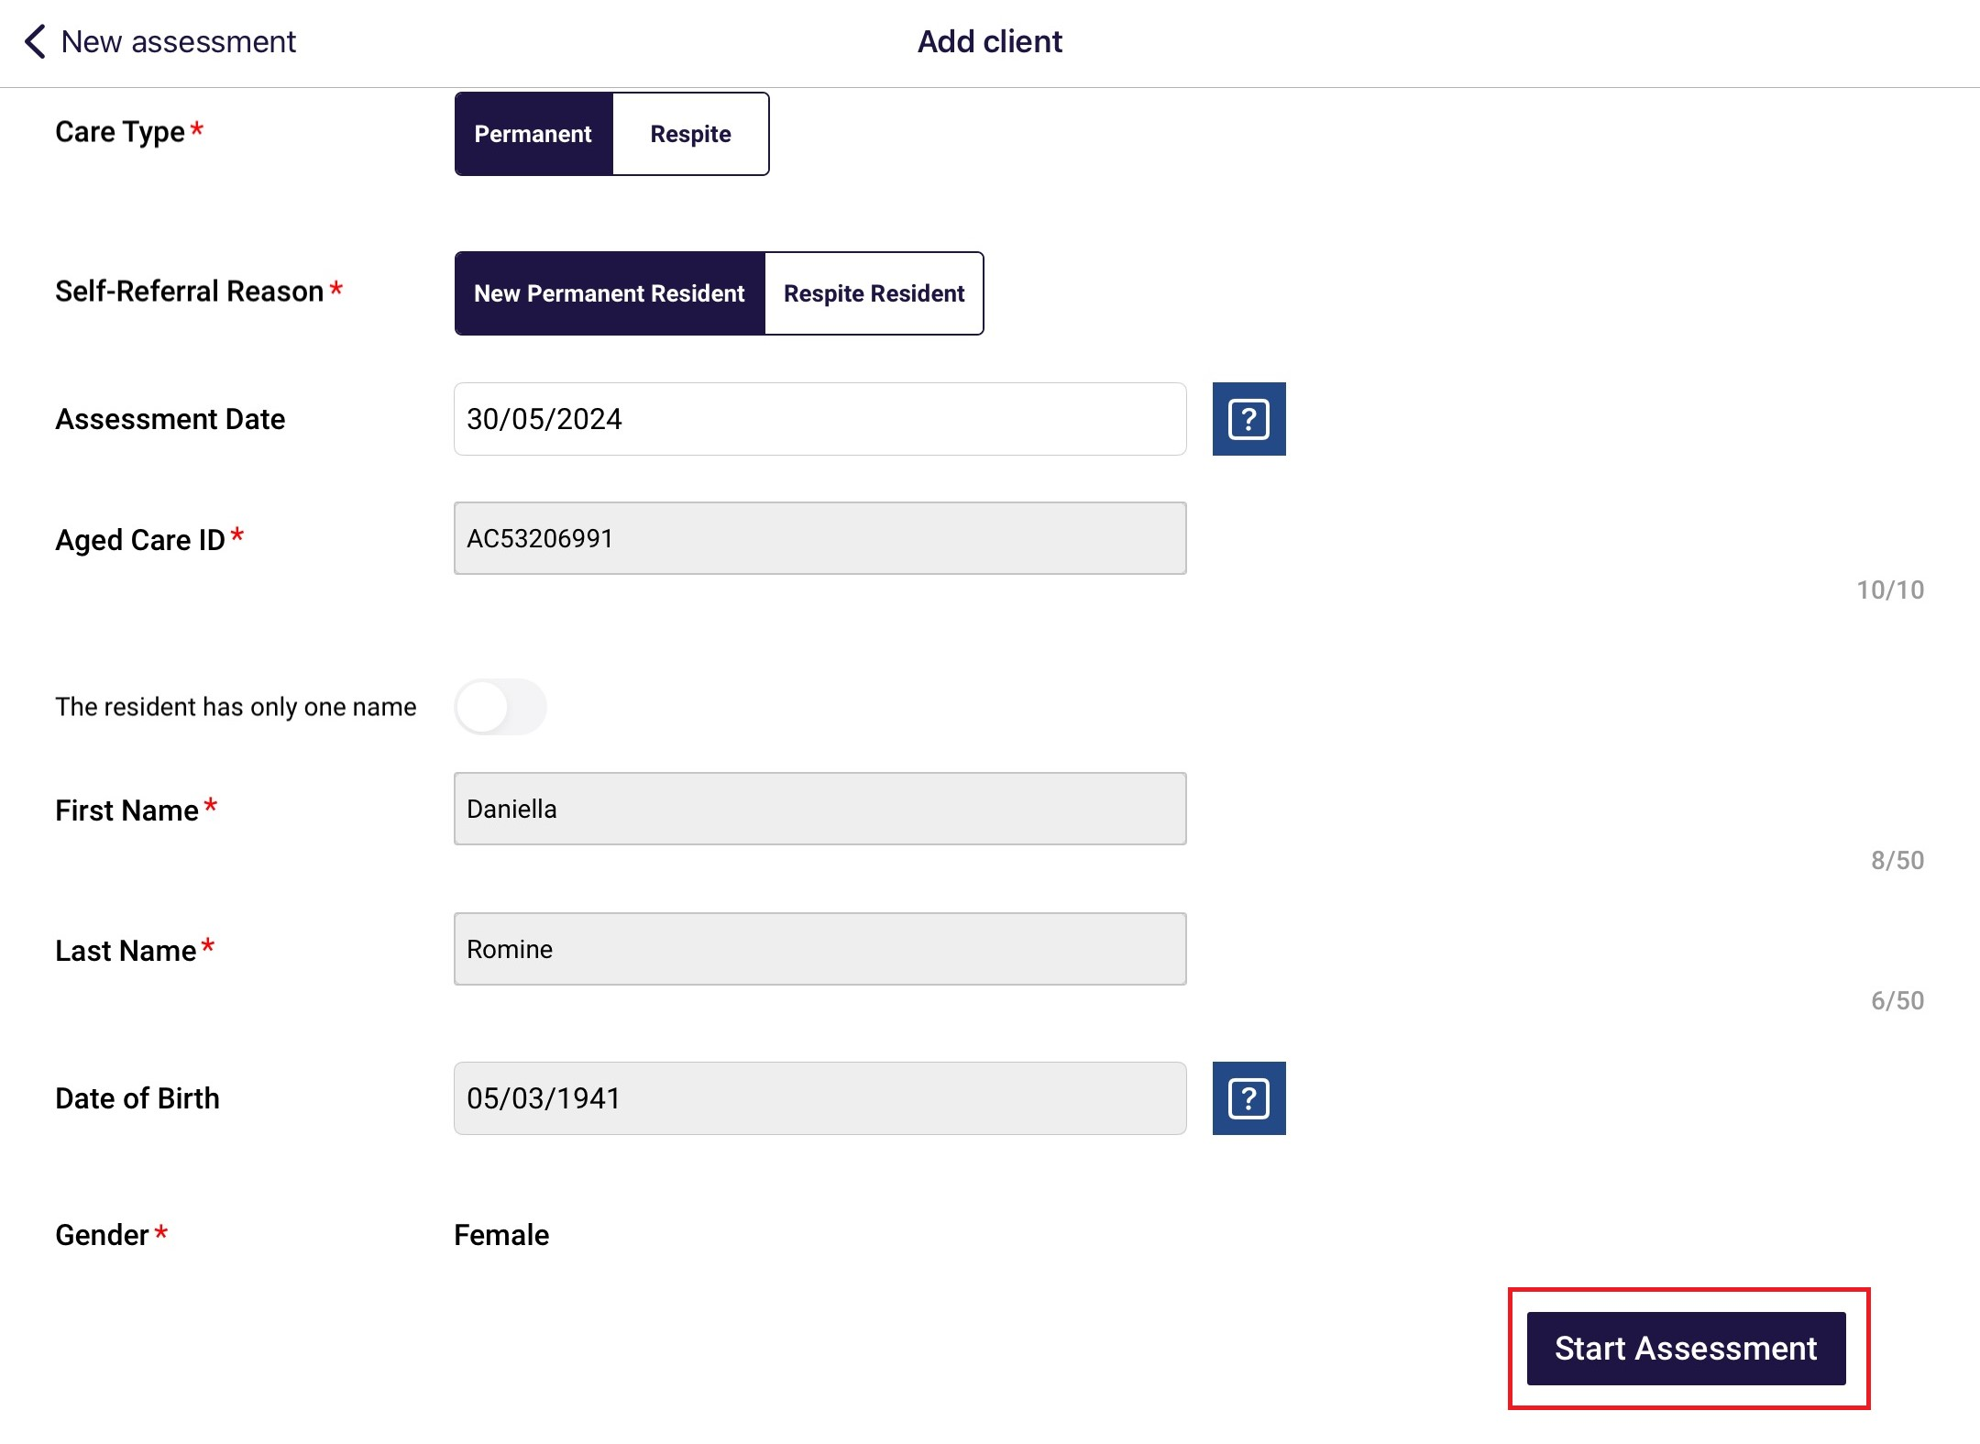

- The client record will now appear in the main menu under the status of In-progress. You can use the filter function to highlight all the assessments with this status.
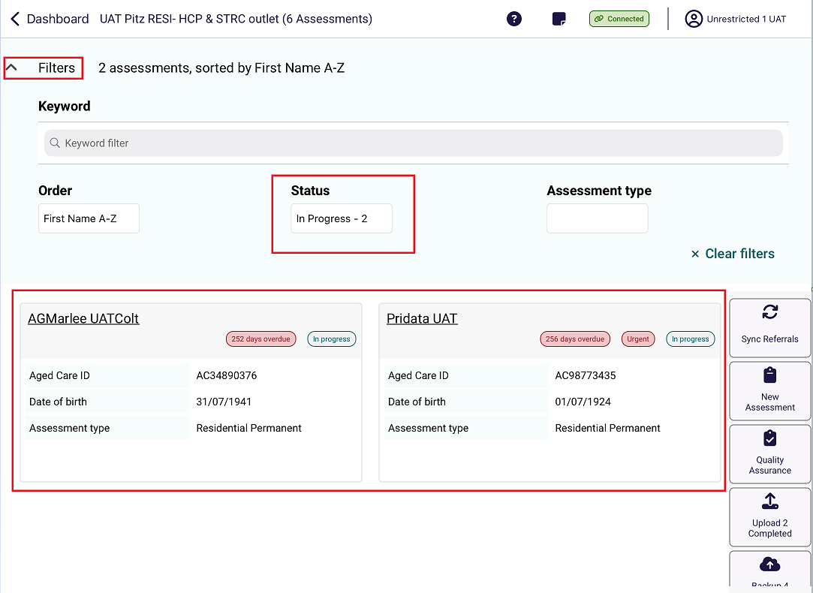

23.3 Undertaking Assessments
The steps to undertake an assessment on the App are as follows.
! | For comprehensive information on how to complete the clinical component of the assessment, refer to your AN-ACC Assessor Manual.
- Open and log in to the App, following the process in Find a Client, locate the resident you wish to assess and open their assessment referral.
- Complete each page of the assessment which includes clinical tools.
The below screenshot shows a typical page in an assessment.
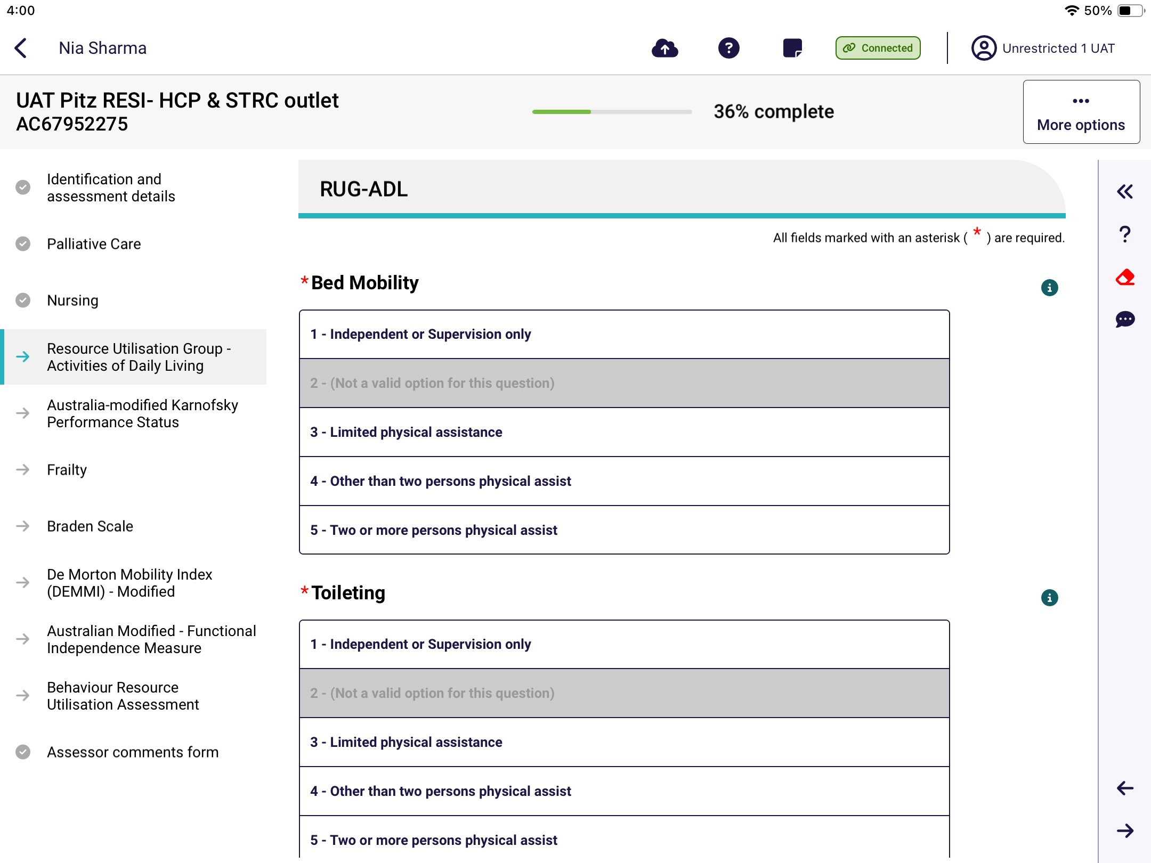
- As you complete each section, the progress bar shows grey ticks for each completed and teal arrows for in progress or incomplete sections.
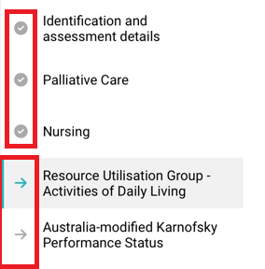
- There is an overall assessment progress percentage complete indicator at the top of the screen.


- Select a specific clinical tool or page by selecting the associated tab.
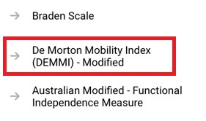


- Select the information icon next to each question, to find out more information about the question.
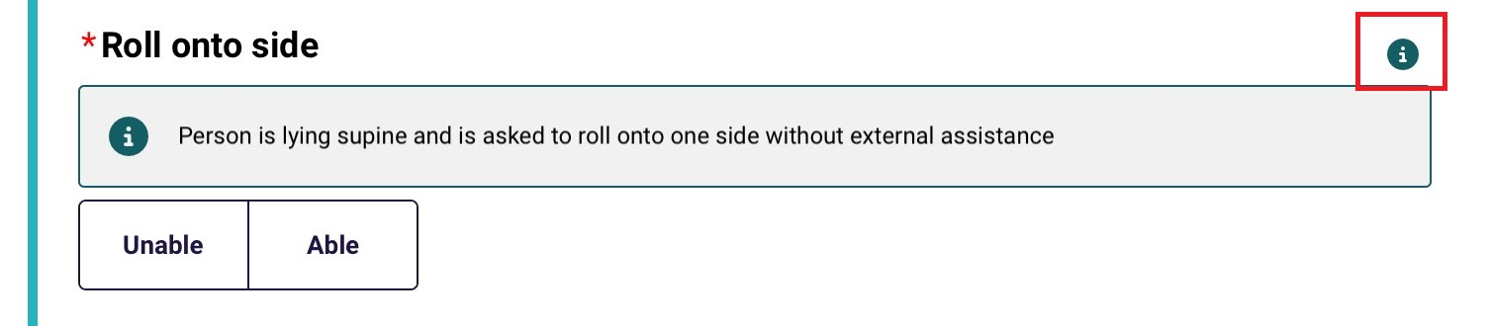

! | You must fill out all mandatory questions. Mandatory fields are shown by a red line over the field name and a red asterix.

- Select the double chevron << on the top right side of the screen to expand the menu and to navigate to the previous and next sections.
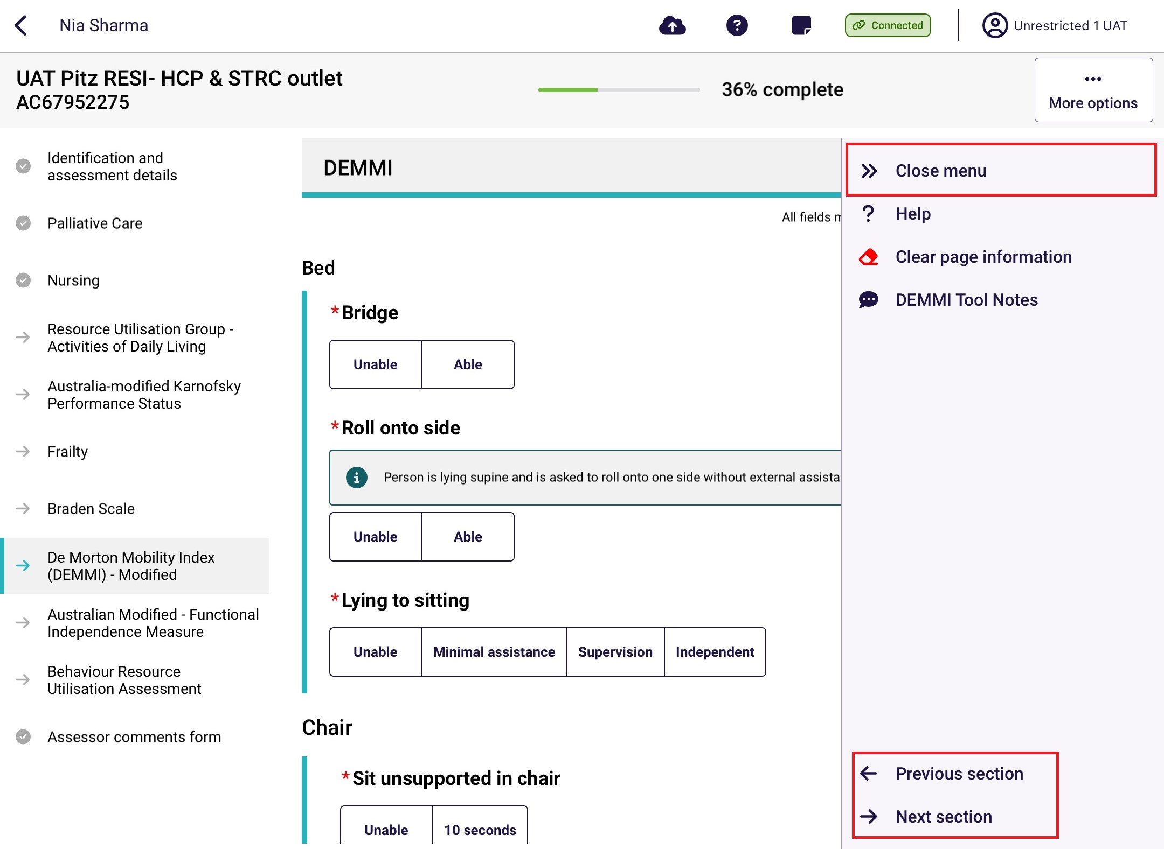

- In this menu you can also select? Help to display more detailed information about that page or tool. It will open on another screen. Select Close to return to the assessment.
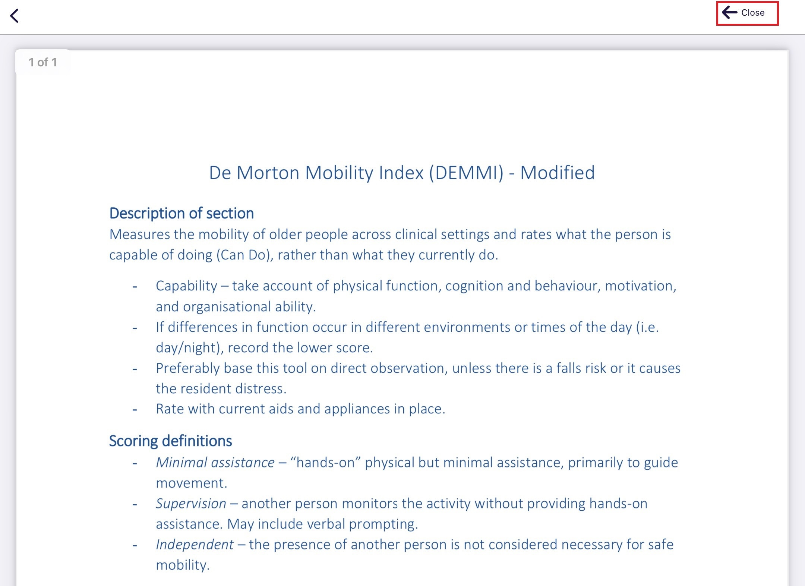
- On each tool, there is a notes section where you can enter notes or comments.
Selecting the speech bubble icon  next to this section will expand the comments section.
Any comments made here are for your own reference and will not be uploaded with the assessment.
The below screenshot example shows the AM-FIM Tool Notes page.
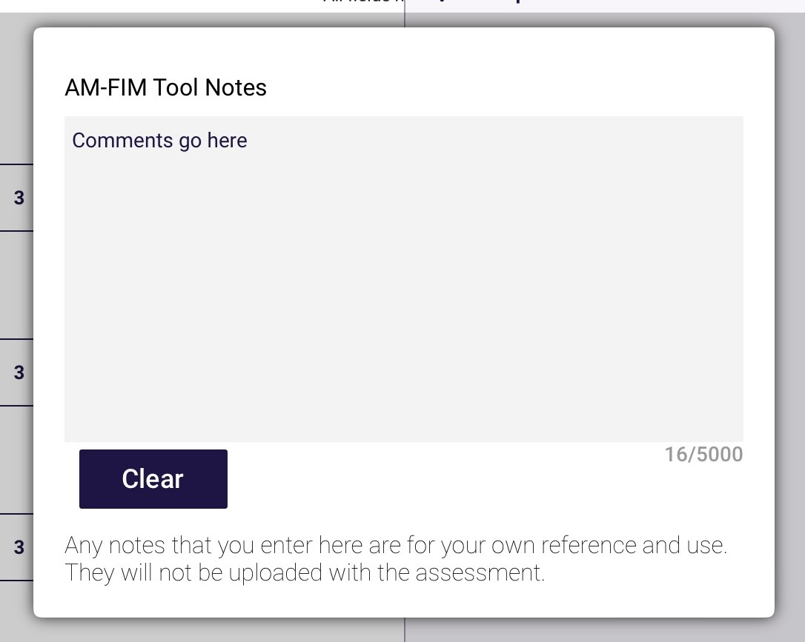
With some notes sections there is an additional informationsection. It gives additional information to that in the Help sections.
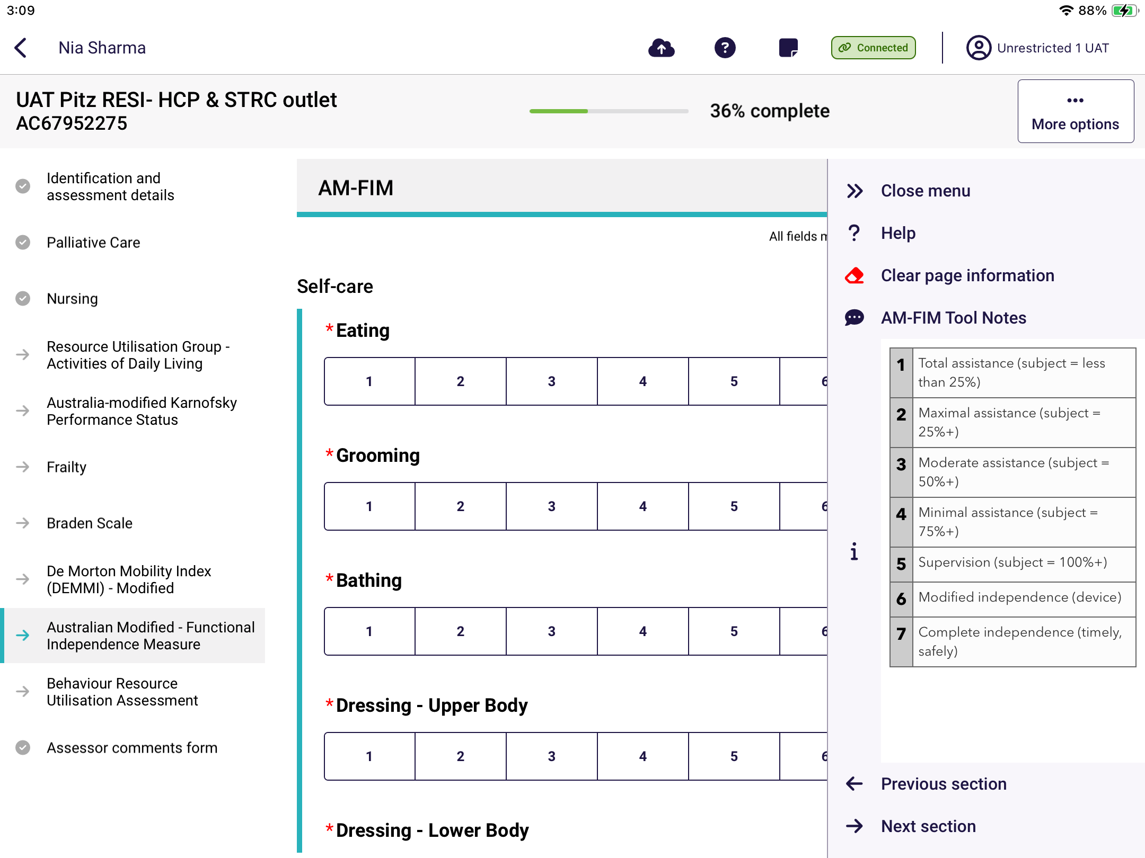
- Finally, there is a Clear page information section denoted by the red eraser icon. Select this and then select Clear answers at the pop-up, to permanently erase answers.
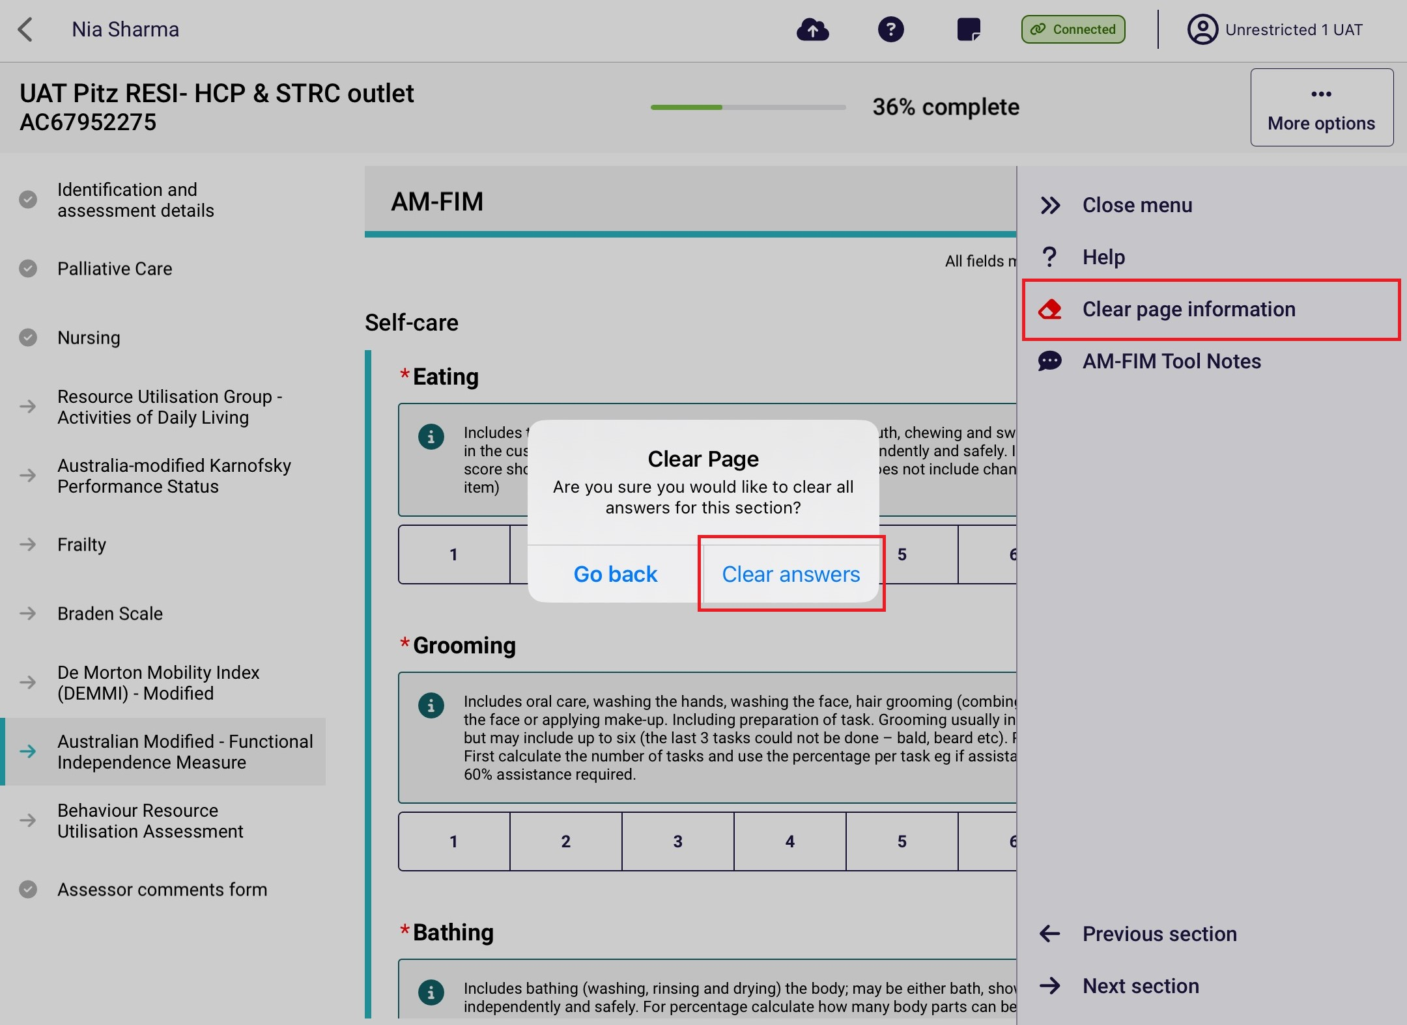

24. Undertaking Quality Assurance and Training Assessments
RAC funding aassessors can conduct Quality Assurance and Training assessments in the App. There are two methods available.
! | Quality Assurance and Training assessments cannot be undertaken on self-referred assessments.

24.1 Sharing referral details with the assessor undertaking the assessment
The unrestricted RAC funding assessor is assigned to undertake the assessment.
- Out of your facilities, select the facility where the resident being assessed lives.
- Next, select the client.
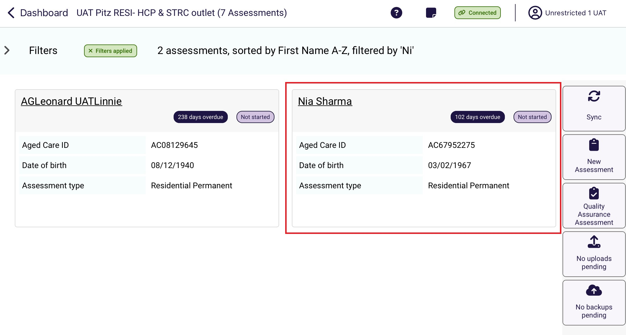

- A Pre-assessment screen appears. The assigned assessor can select if a Quality Assurance or Training assessment is also being conducted.
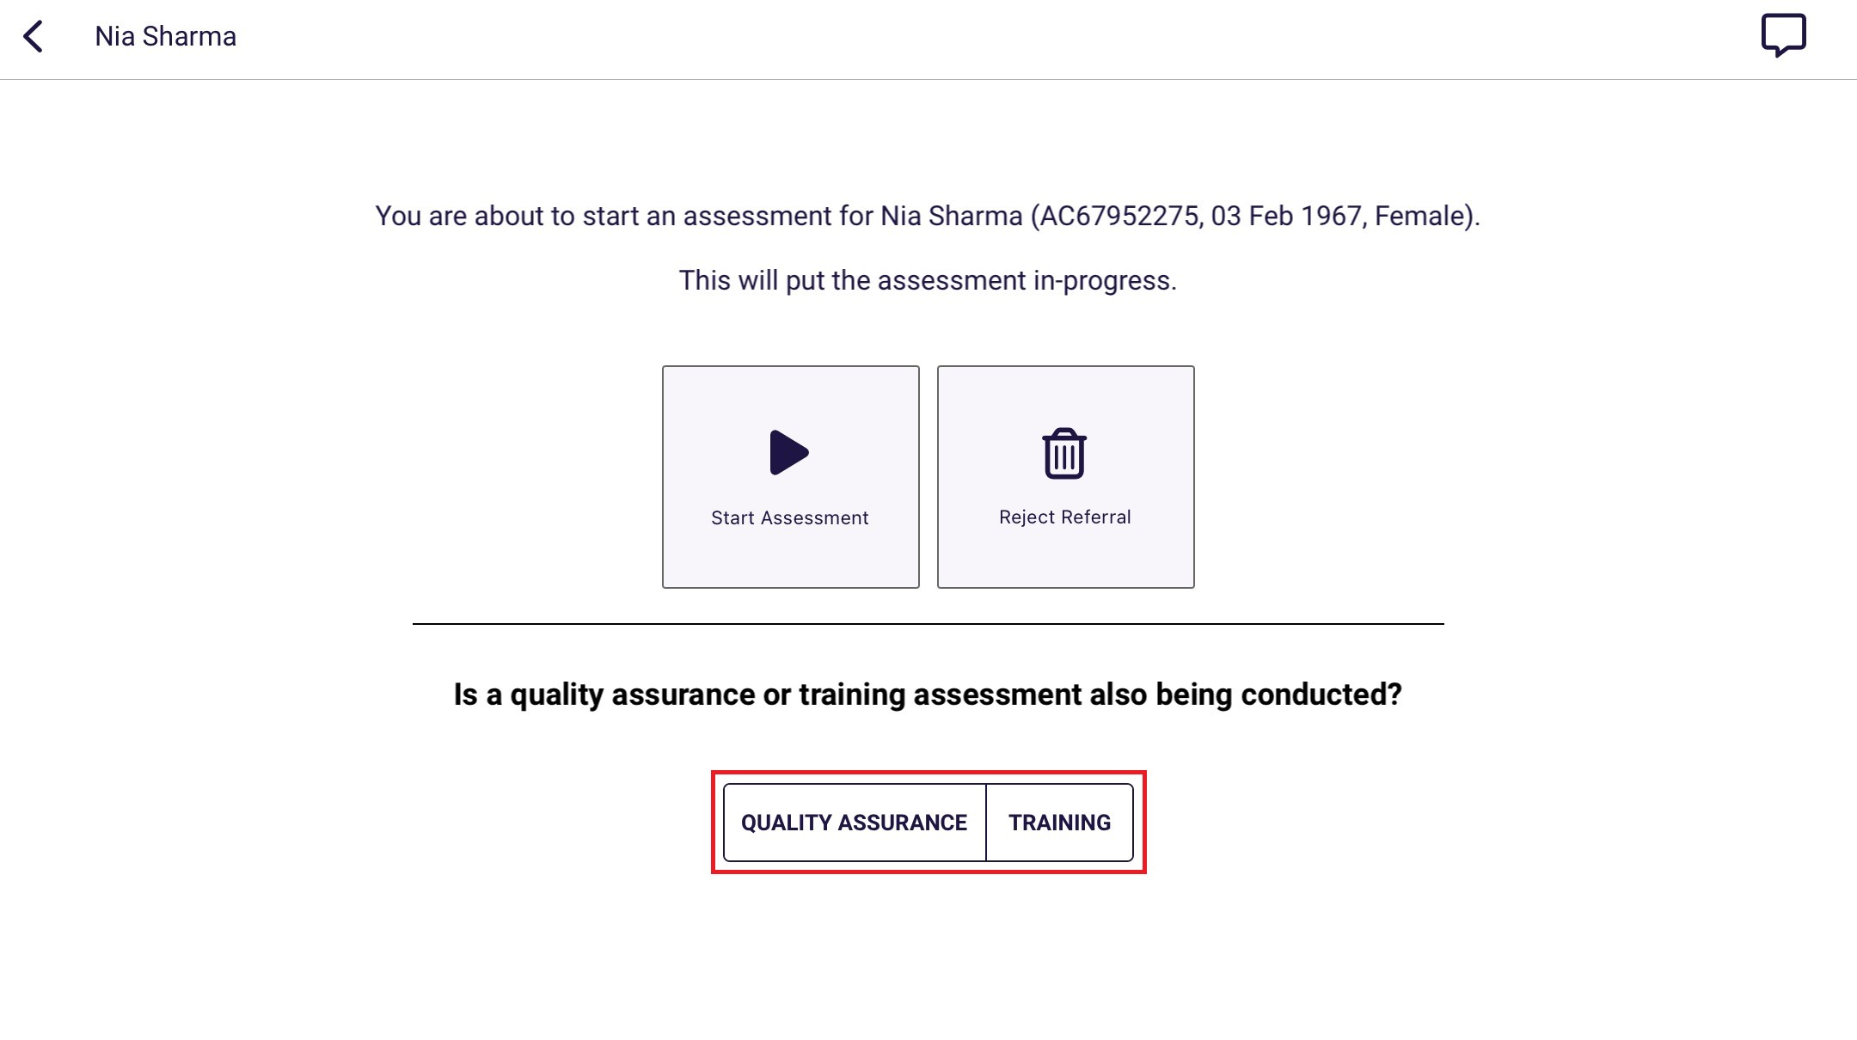

- The assessment details to be shared will be displayed. The RAC funding assessor that will be conducting the Quality Assurance or Training assessment must scan the QR code or enter the Referral ID on their device.
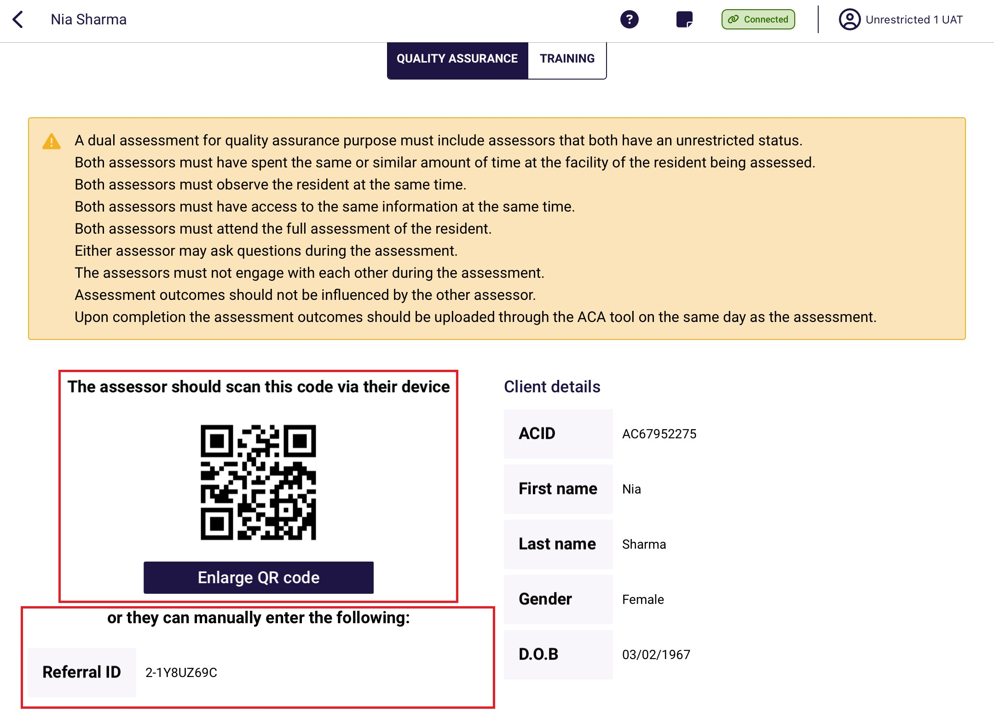

Alternatively, referral details can also be shared after starting an assessment. On the assessment page, select the ellipses (three dots) and select Share referral details at the pop-up.
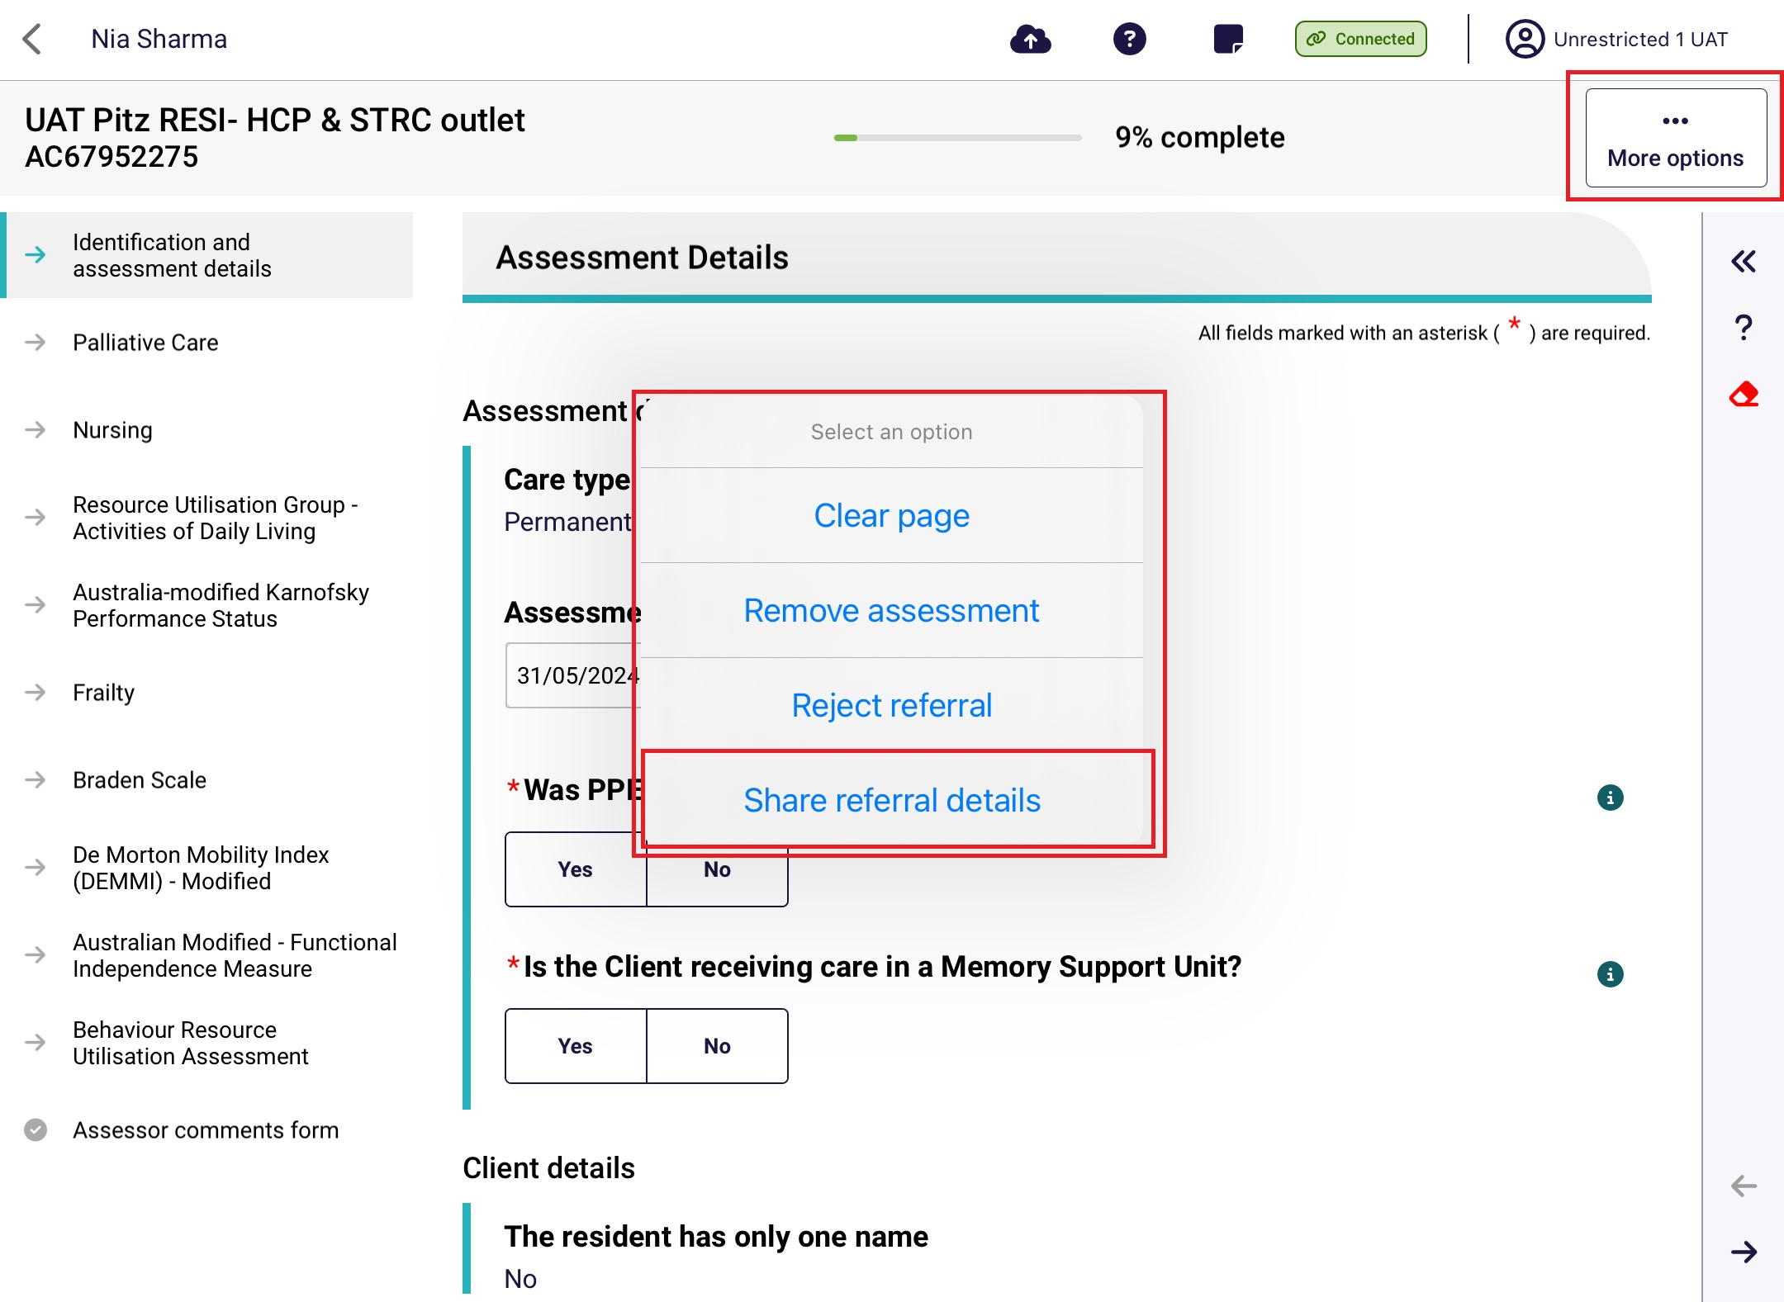
In the Share referral details screen, select the Quality Assurance or Training options.
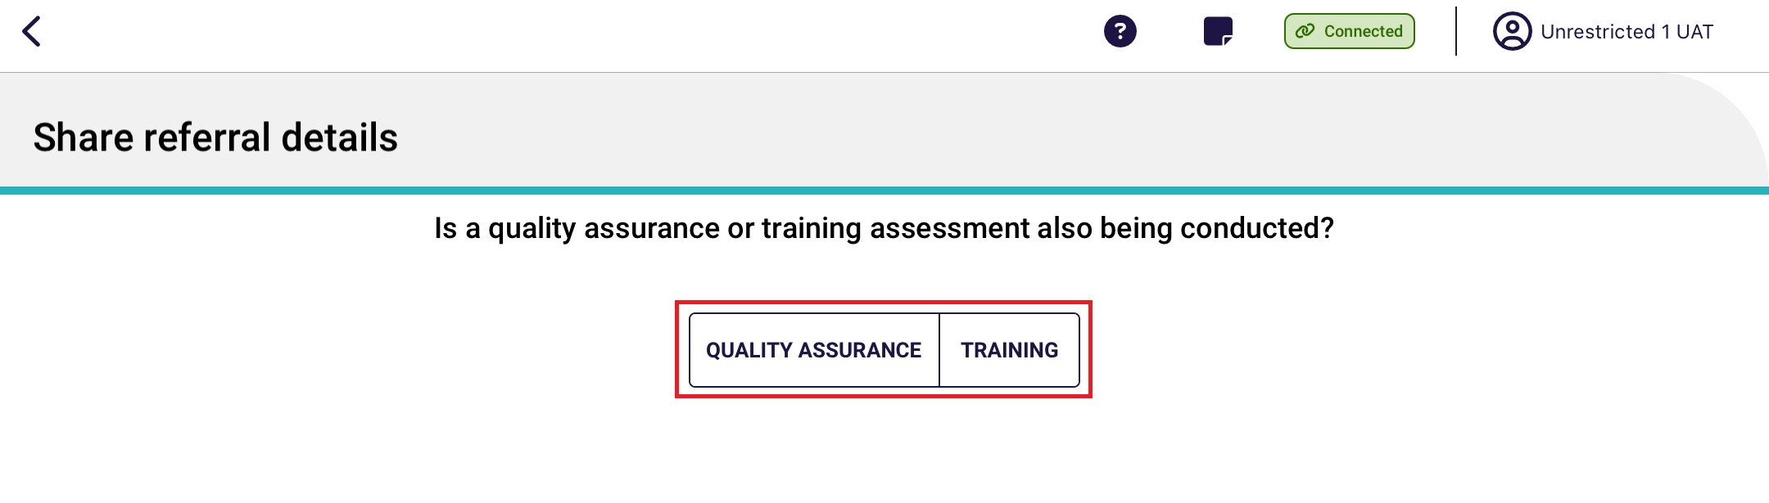
! | Referrals can only be shared by the assessor assigned to undertake the assessment. Referrals cannot be shared after the assessment is finalised and uploaded.

24.2 Scanning referral QR code or entering the referral ID
- Select the appropriate assessment button under Quick Actions in the main menu.
! | The Quality Assurance and Training buttons visible will be dependent on the role of the user.
Senior RAC funding Assessors undertaking a Quality Assurance will need to select the Quality Assurance button, or if conducting a Training assessment, select the Training button.
A RAC funding assessor (Restricted) undertaking a Training assessment will need to select the Training button.
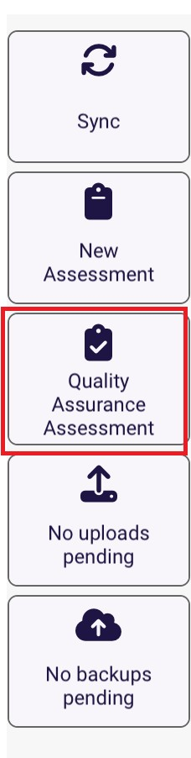
- Select either to Scan the QR code generated on the device of the RAC funding assessor that will undertake the assessment, or enter the Referral ID. Then select Search.
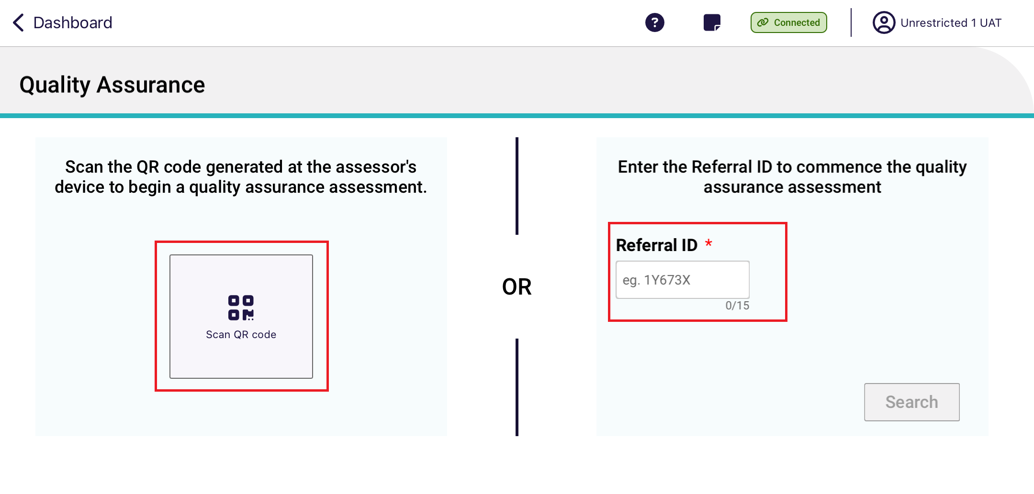
After the Referral ID is successfully matched, confirm the client’s details before starting the Quality Assurance or training assessment.
If the RAC funding assessor has been unable to successfully match the Referral ID, this could be due to a connectivity issue or the referral ID is not valid. If there is a connectivity issue a local (offline) assessment can be undertaken.
- The Quality Assurance or Training assessment screen will now appear. A banner at the top of the screen indicates the type of assessment type that is being undertaken. The below screenshot shows the Quality Assurance assessment example.

! | RAC funding assessors that have started a Quality Assurance or a Training assessment will not have the ability to reject the referral, but can remove the assessment.

24.3 Local (Offline) Assessments
Assessments could be done offline if there is an issue with internet connectivity. This applies to normal assessments as well as Quality Assurance and Training assessments. However, the assessment cannot be uploaded to the My Aged Care system until the client details that were entered whilst offline are successfully matched with a client record in the system.
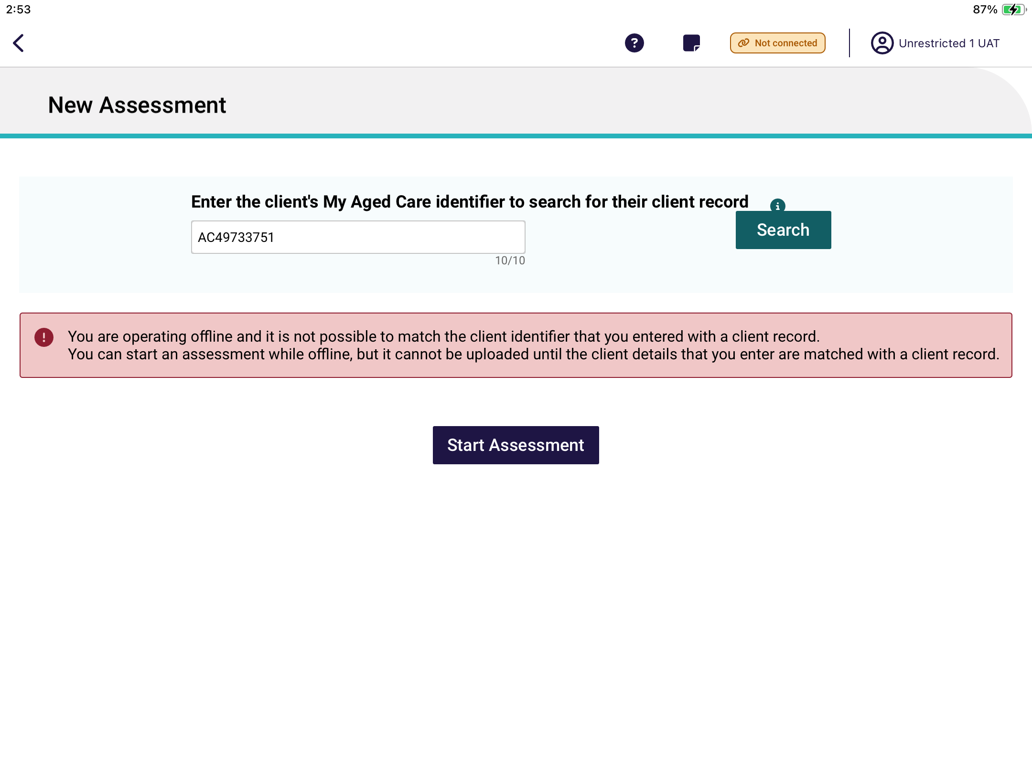
After starting a local assessment, you will be required to complete all mandatory fields including assessment details and client details.
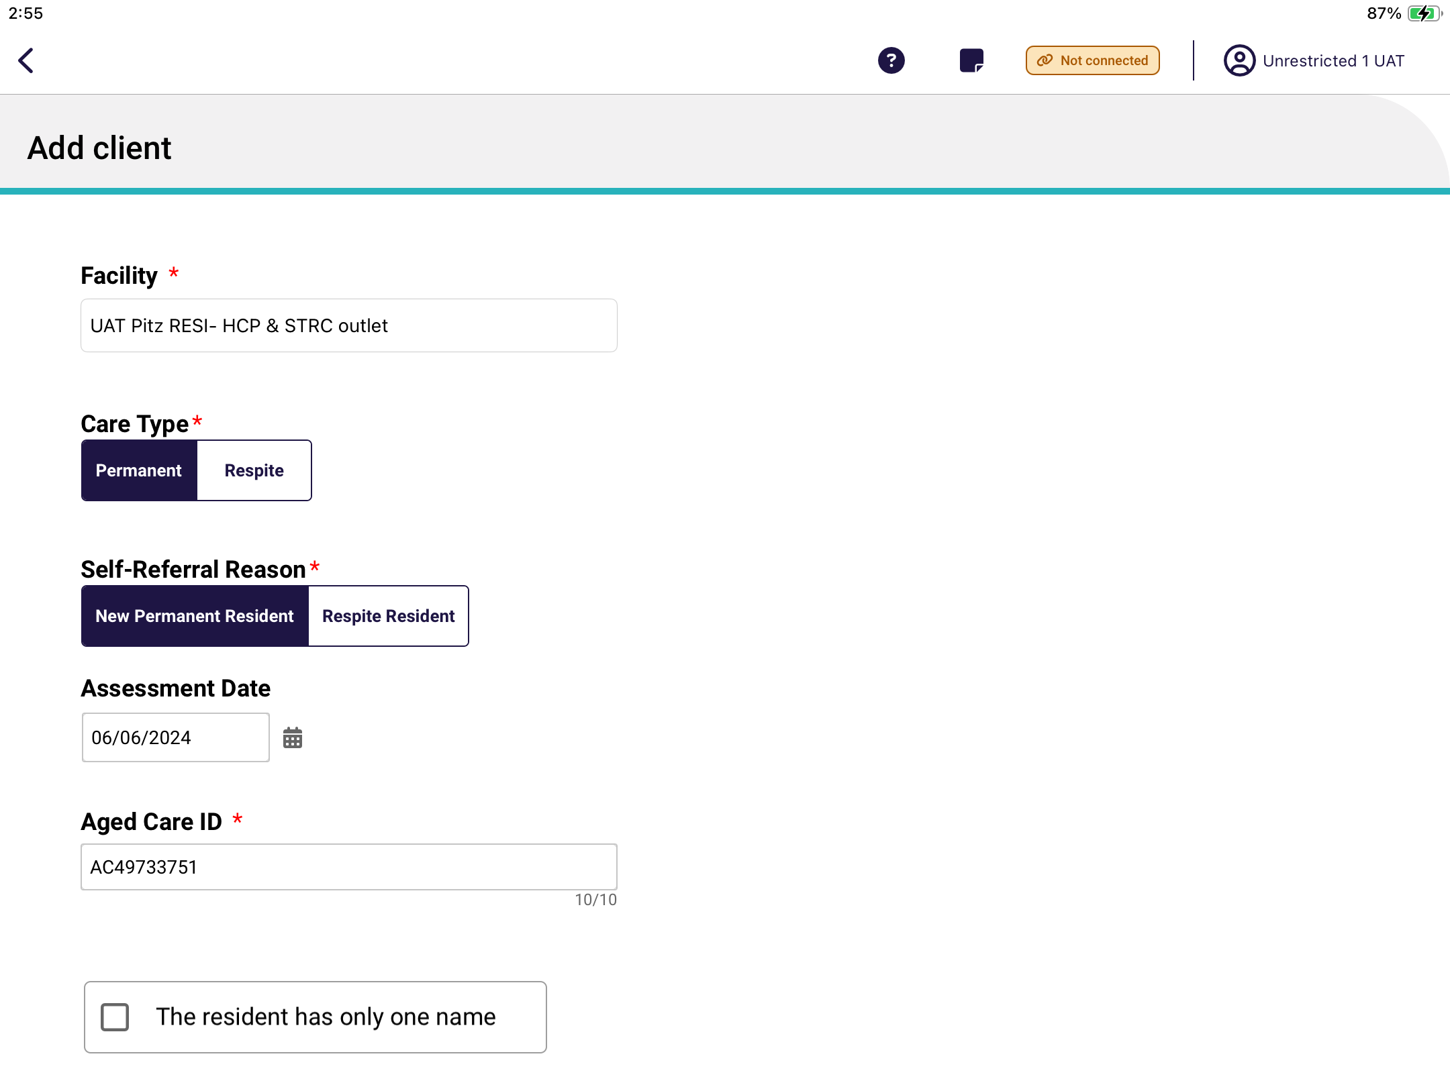
Once back online and connected to the internet, you will be required to match the local assessment will the correct Referral ID after commencing the assessment. This can be done when they have internet connectivity and selecting the Matched client button.
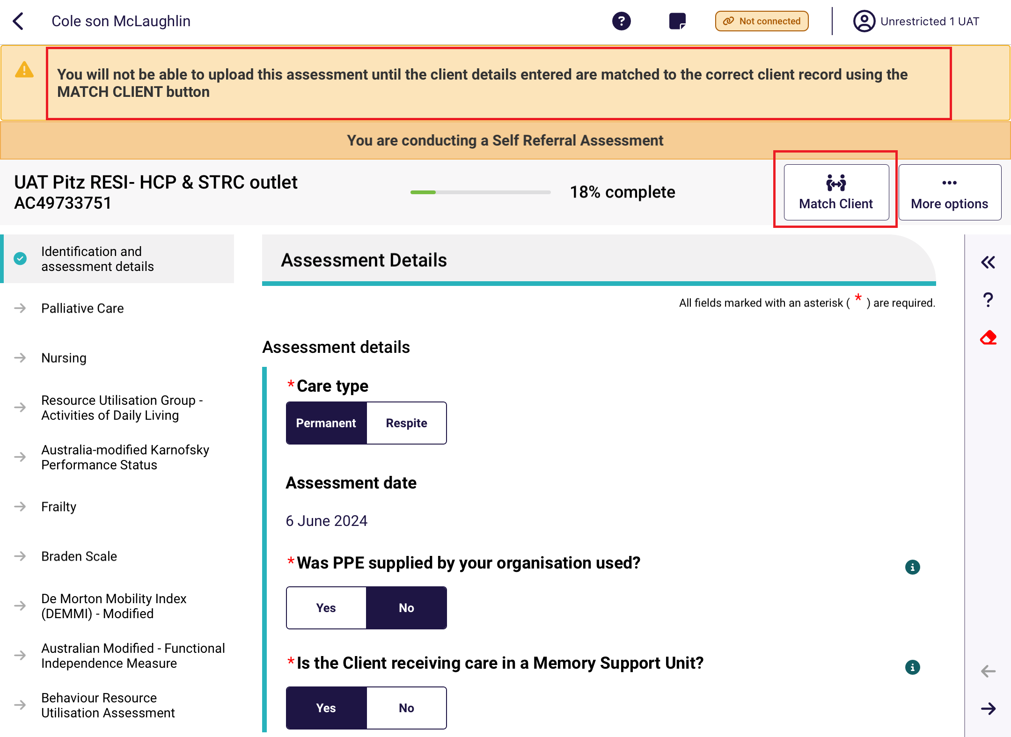
If the details do not match, you will need to go back and update the details to match or choose which details to use if the client ID is matched correctly. You will not be able to click Confirm unless the details are corrected.
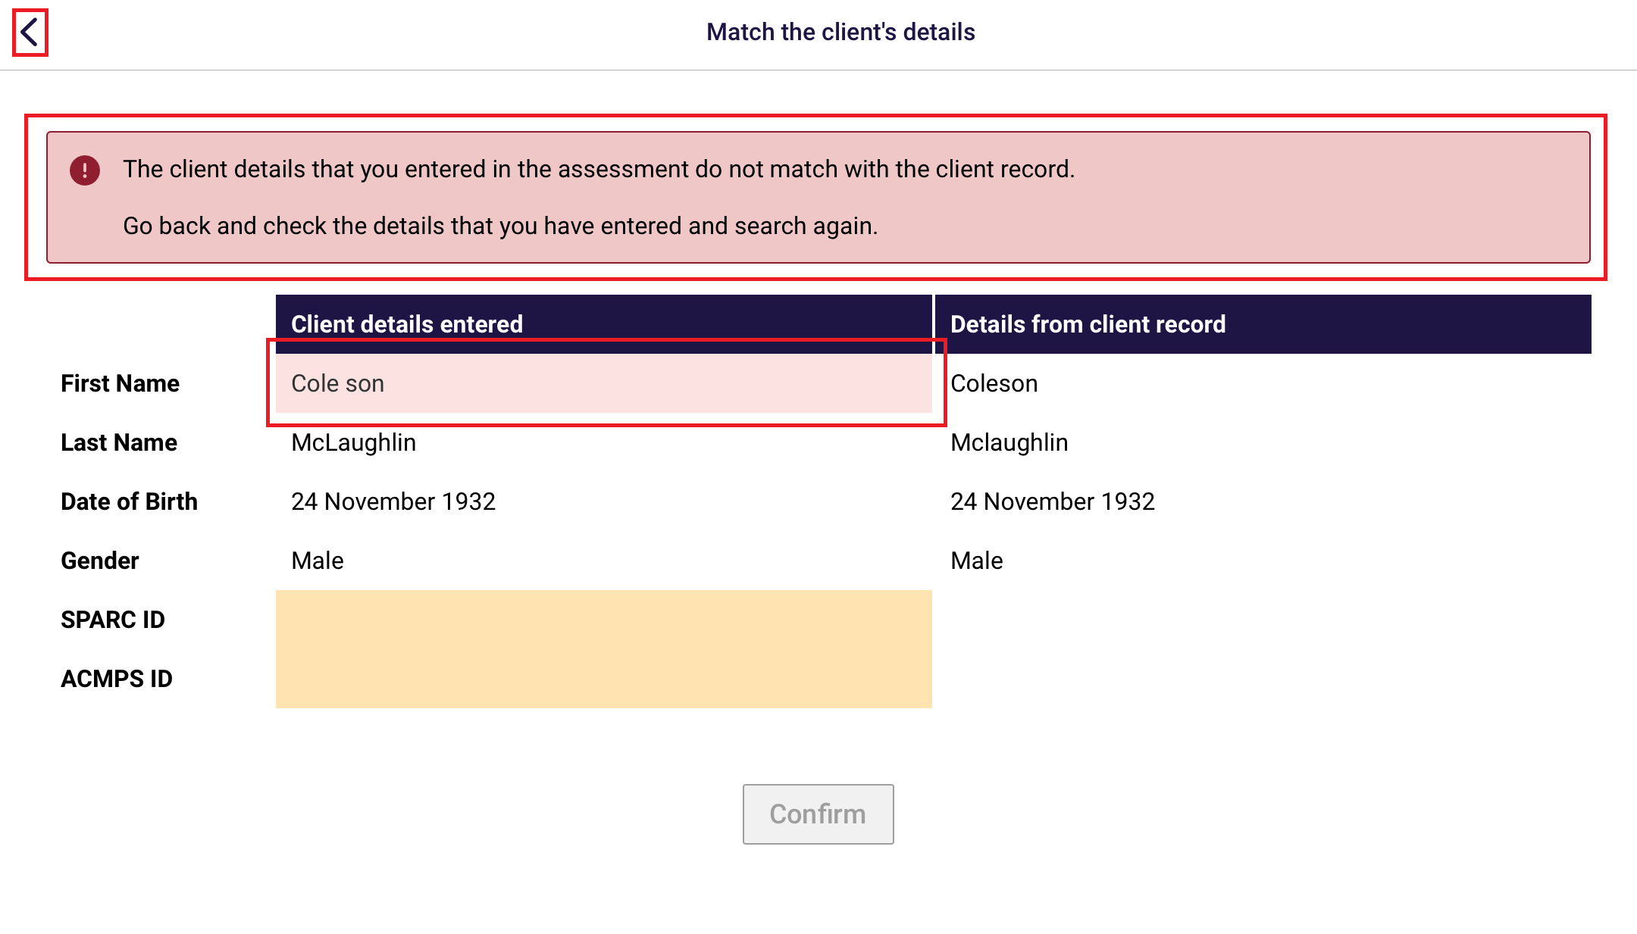

Once the details match, select Confirm, and continue with the rest of the assessment.
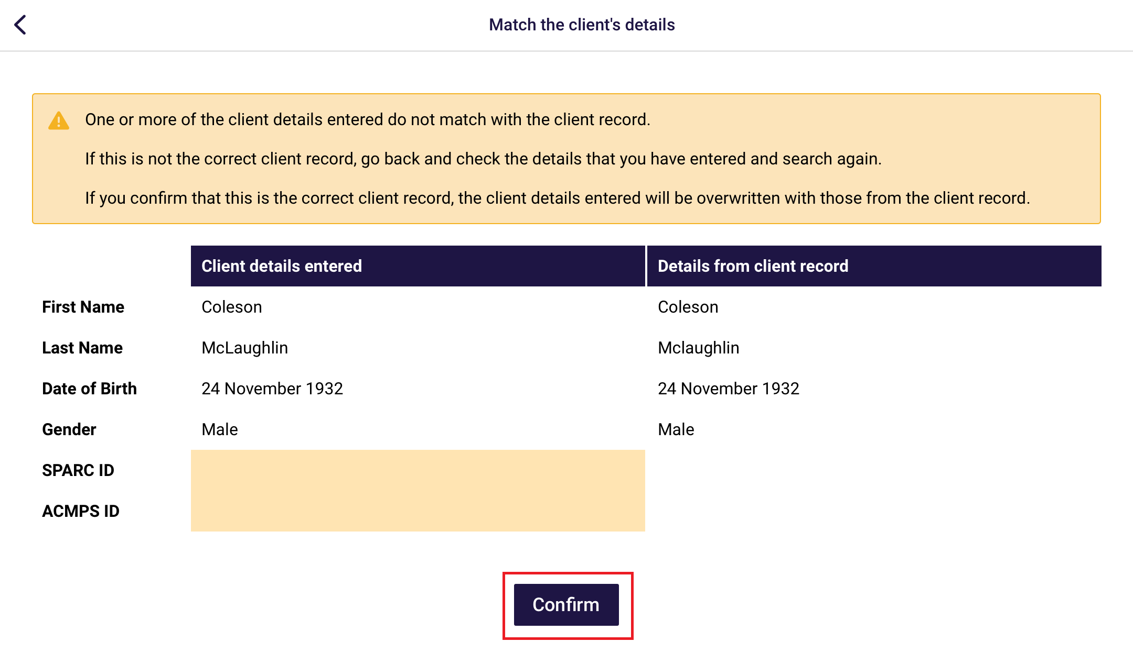

25. Completing, re-opening and uploading assessments

25.1 Completing an assessment
If there are any pages that are incomplete or needs review, the progress bar will be under 100% and the page that has not been completed will not show a tick icon.
- Select each of the pages that have an arrow to complete.
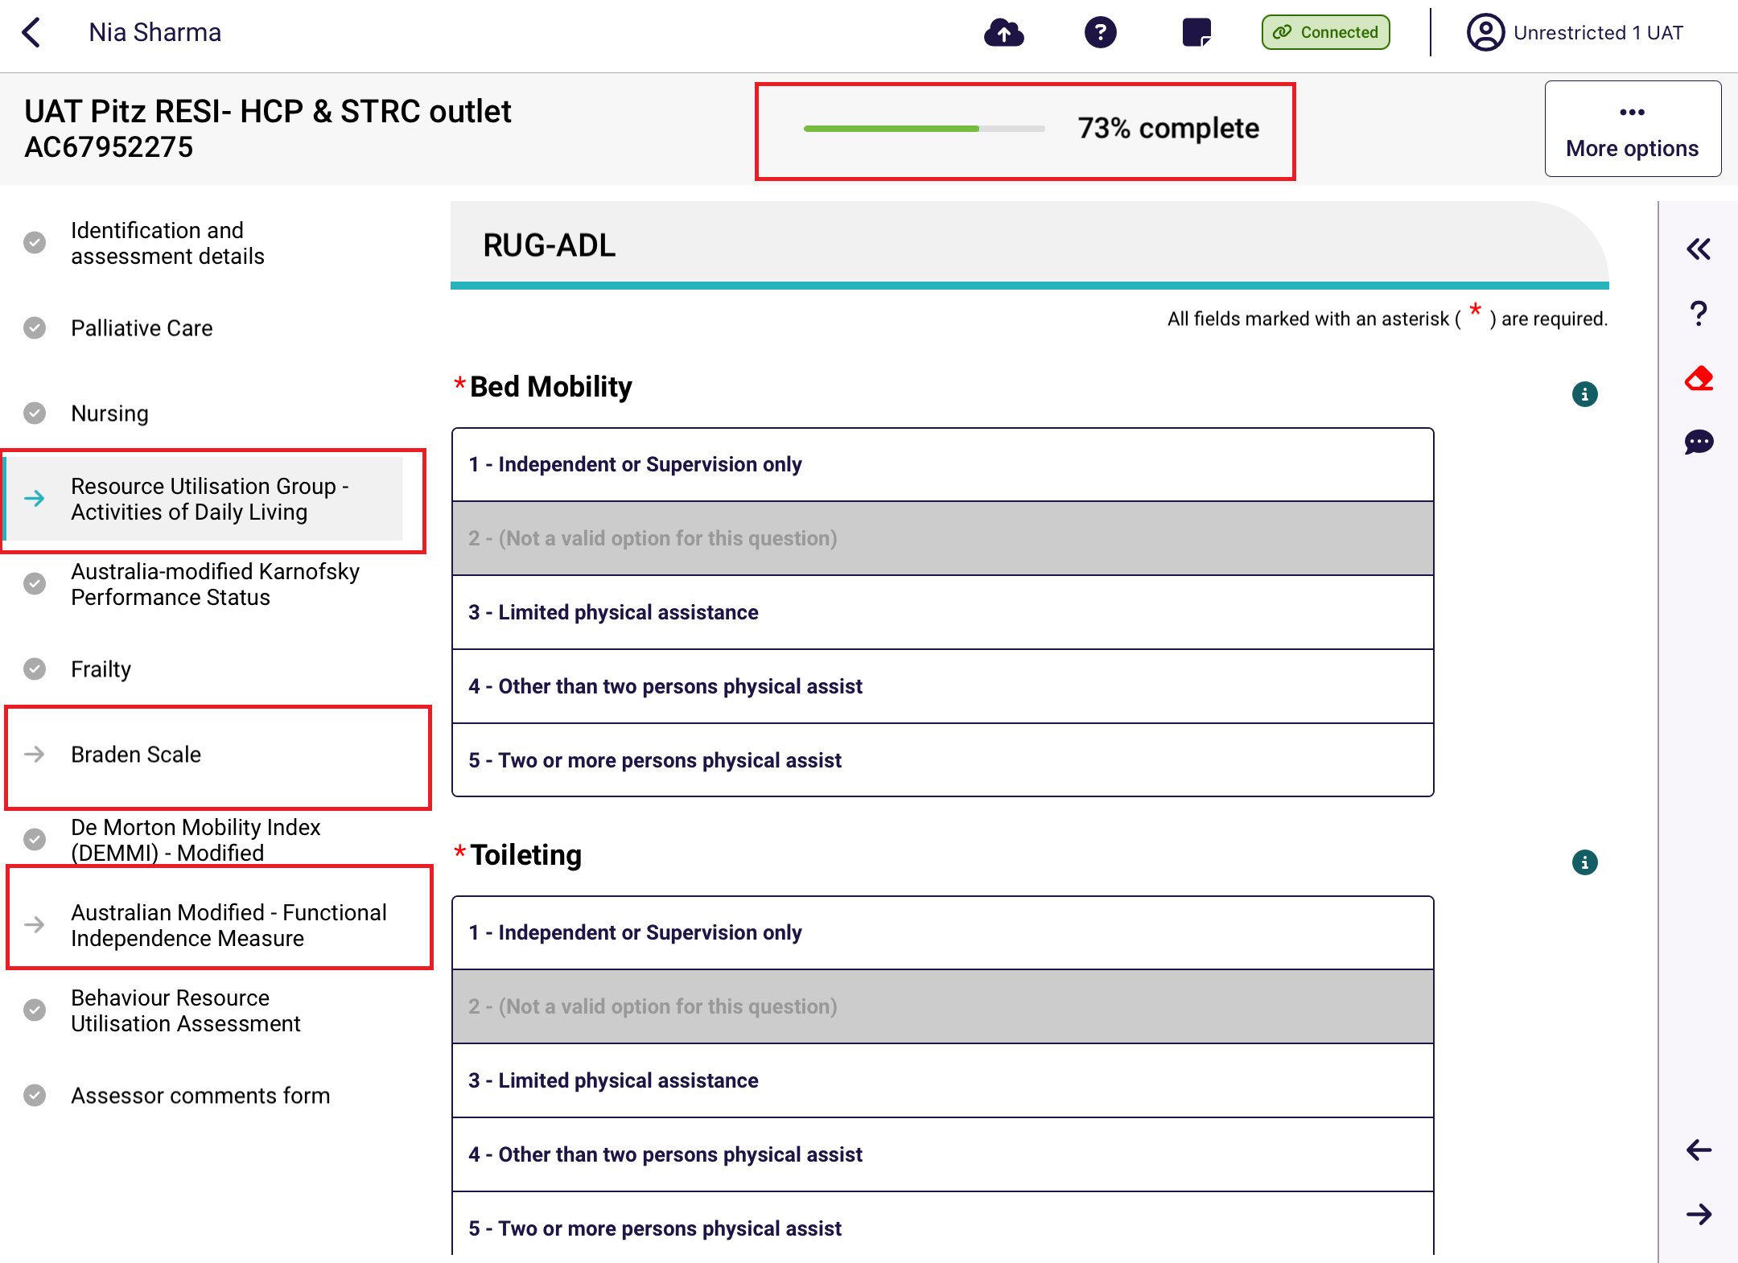

- If your input has contradicted a previous input in another tool, you will be shown the following warning. You will be able to choose to amend either the input that you have just created or the other contradicted input.
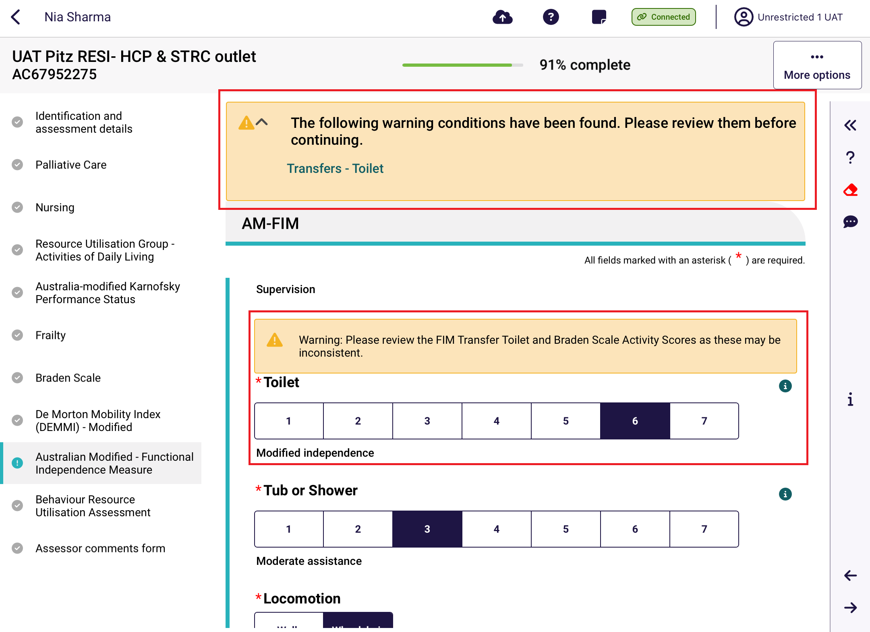
- Once all pages are complete (tick icons) and the progress bar is showing 100% completed, select Complete on the top right.
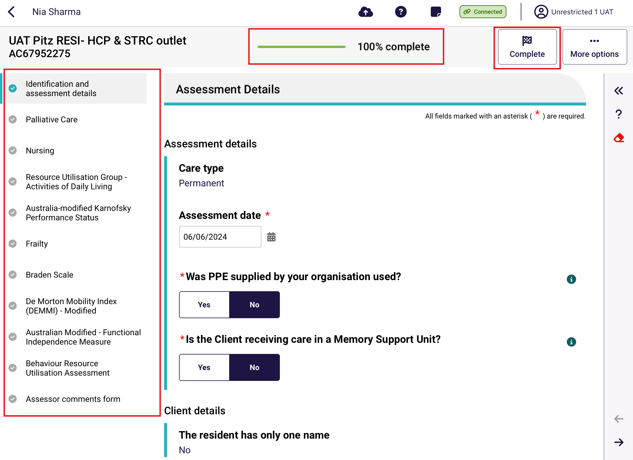

- Select Complete Assessment again to confirm.
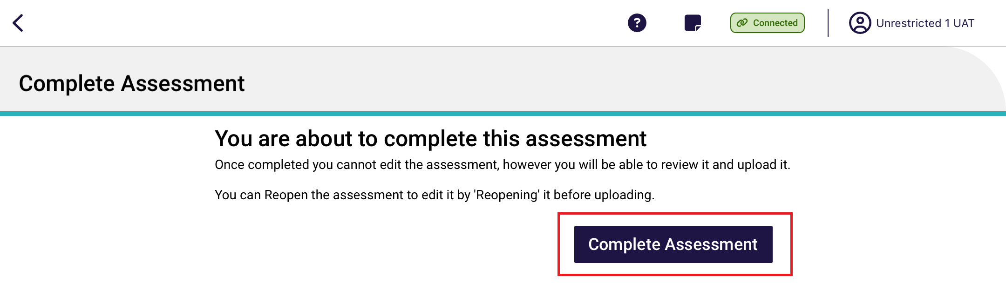

- A summary of the assessment appears. Scroll to the bottom and then select Upload. The assessment will remain in the completed status until either the Upload button is pressed or automatically uploaded after 7 days.

After upload, the assessment will disappear from the In-progress assessments section of the main menu.
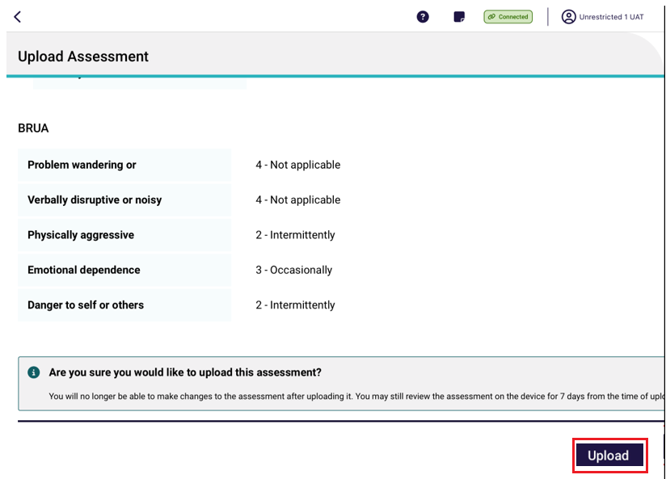

25.2 Re-opening a completed assessment
An assessment that has the status of Completed or Uploaded can be reopened, but only Completed assessments can be reopened for edits. Uploaded assessments can be reopened for view only.
- To reopen a complete assessment, select the Facility, then select Completed. Select the assessment to reopen.
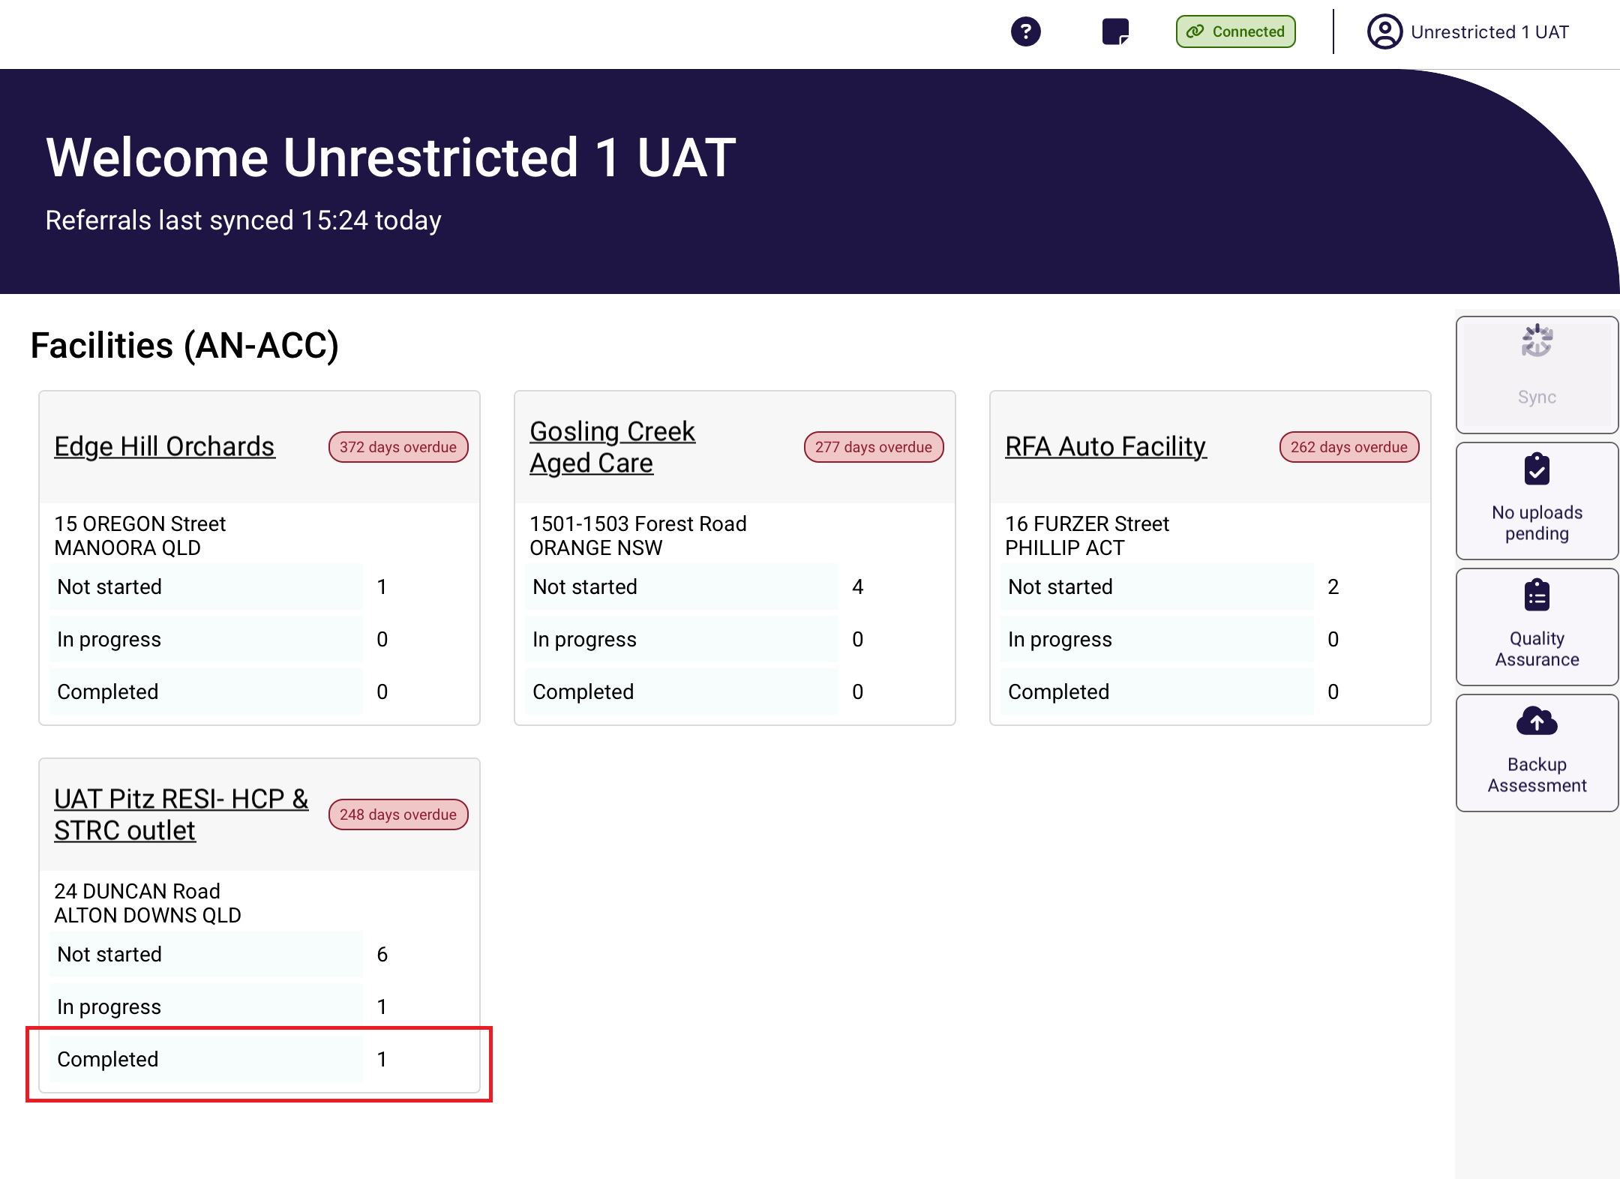
! | Assessments with a 100% progress completed indicator will still appear in the In-progress assessment section of the main menu. These assessments are technically complete but is not officially in the Completed status until the Complete Assessment button is selected.  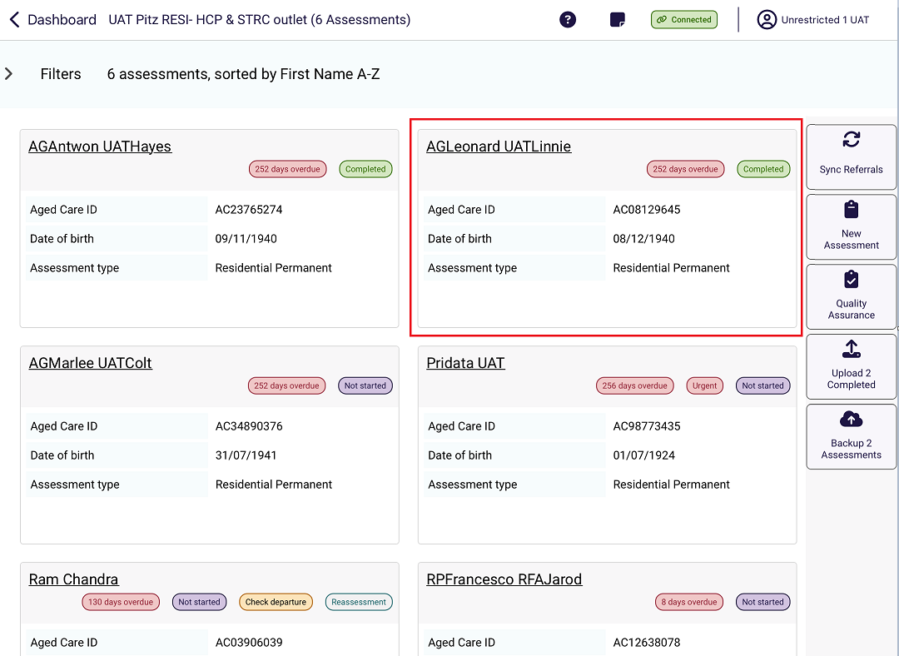

- The selectedassessment displays. Select Reopen.
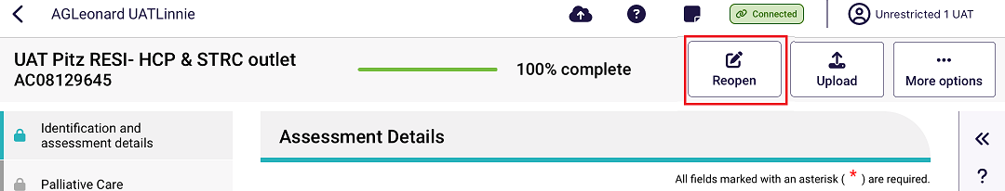
- The completed assessment will be reopened for edits. It will need to go through the process for Completing an assessment again.

25.3 Re-opening an uploaded assessment
! | Once the assessment has been uploaded you are unable to reopen and edit the assessment.  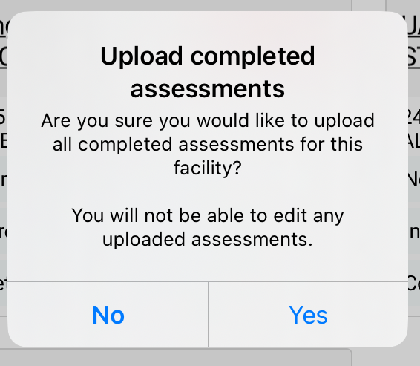

25.4 Uploading Assessments
RAC funding assessors can upload assessments once they are complete.
The assessment will remain in the completed status until either the Upload button is pressed or automatically uploaded after 7 days. After upload, the assessment will disappear from the In-progress assessments section of the main menu and will move to the Uploaded section of the Facility’s page.
! | You must have an active internet connection to upload the assessment.  If you do not have an active internet connection, the completed assessment will be saved on your device for 7 days and uploaded when you enter an internet service area.

- After completing the steps in Completing an Assessment, a summary of the assessment appears. Scroll to the bottom and then select Upload.
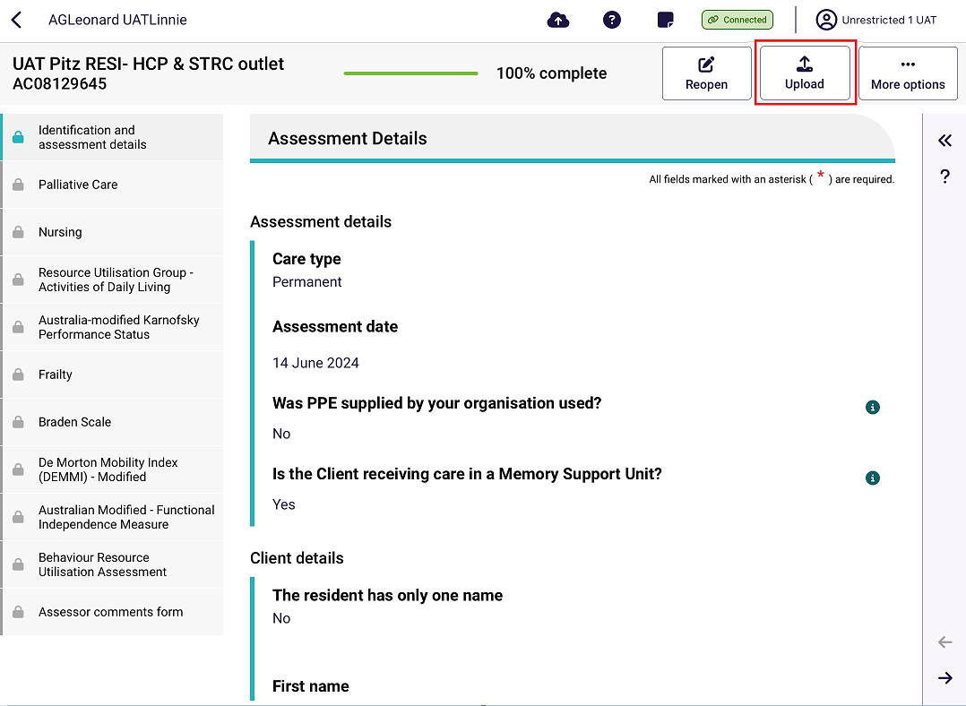
- After going to the Facility page and selecting Completed, all completed assessments can be uploaded at once by selecting Upload [number] Completed.

26. Removing Assessments and Clearing Assessment Data
! | Removing an assessment from the device will permanently delete any assessment information recorded on that device.
! | Completed but not yet uploaded assessments cannot be removed.
! | Removing an uploaded assessment from your device does NOT remove the data from My Aged Care.

26.1 Removing an uploaded assessment
To remove an uploaded assessment:
- Open the uploaded assessment that you wish to remove. See the Find A Client section for more details.

- Click the More options button in the top righthand side
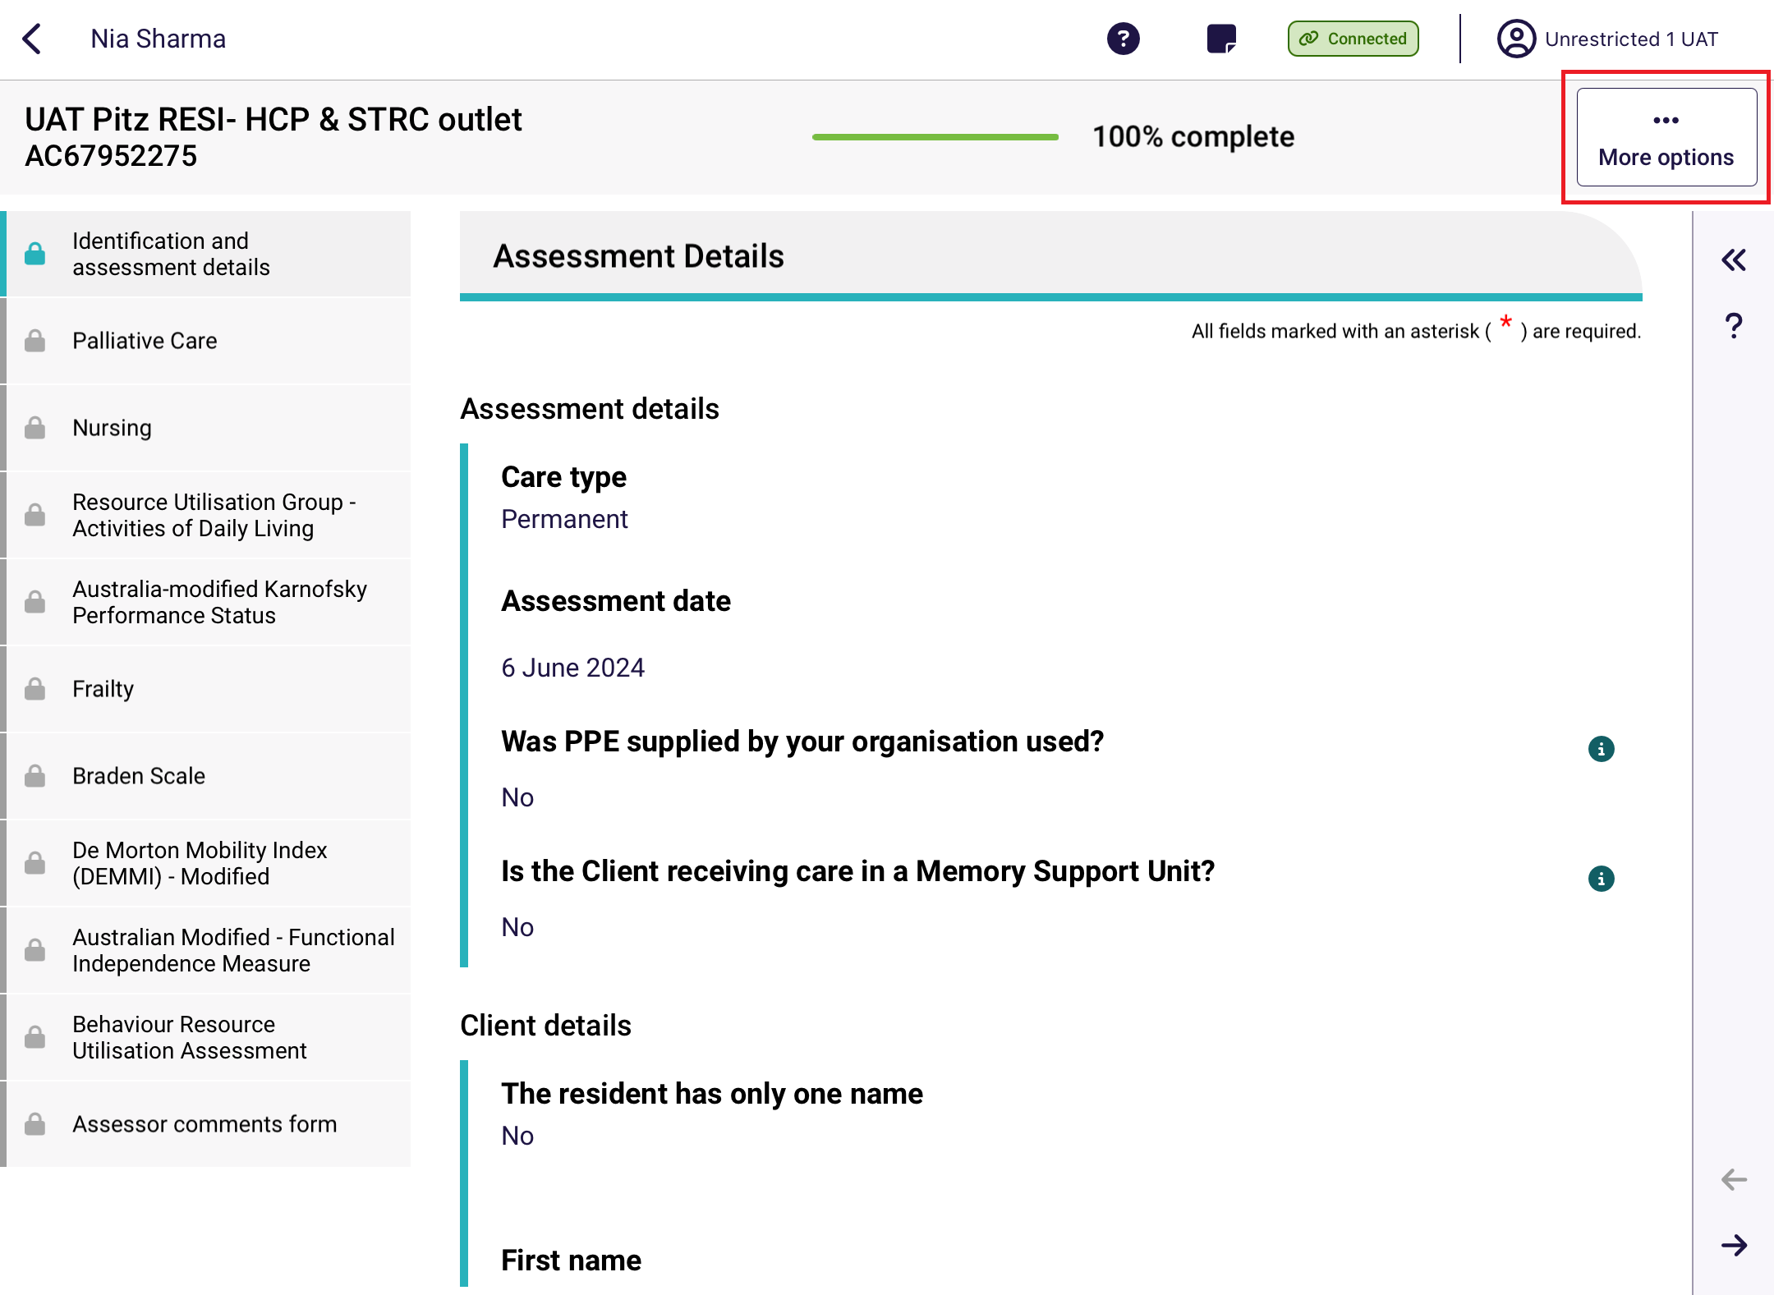
- Select Remove assessment from the pop-up. This will NOT remove the assessment data from the Department’s system.
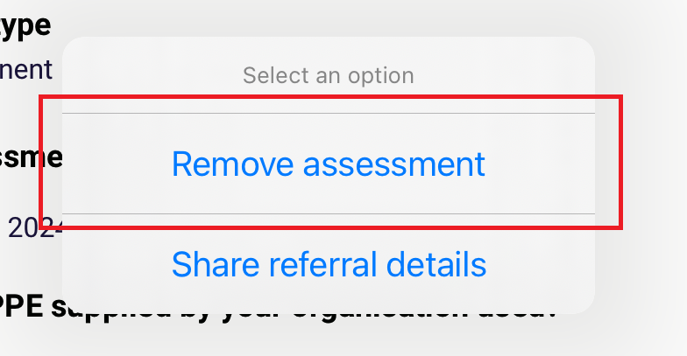

26.2 Removing an in-progress assessment
To remove an in-progress assessment:
- Open the assessment that you wish to remove. See the Find A Client section for more details.

- Select the More options button in the top right corner of the app.
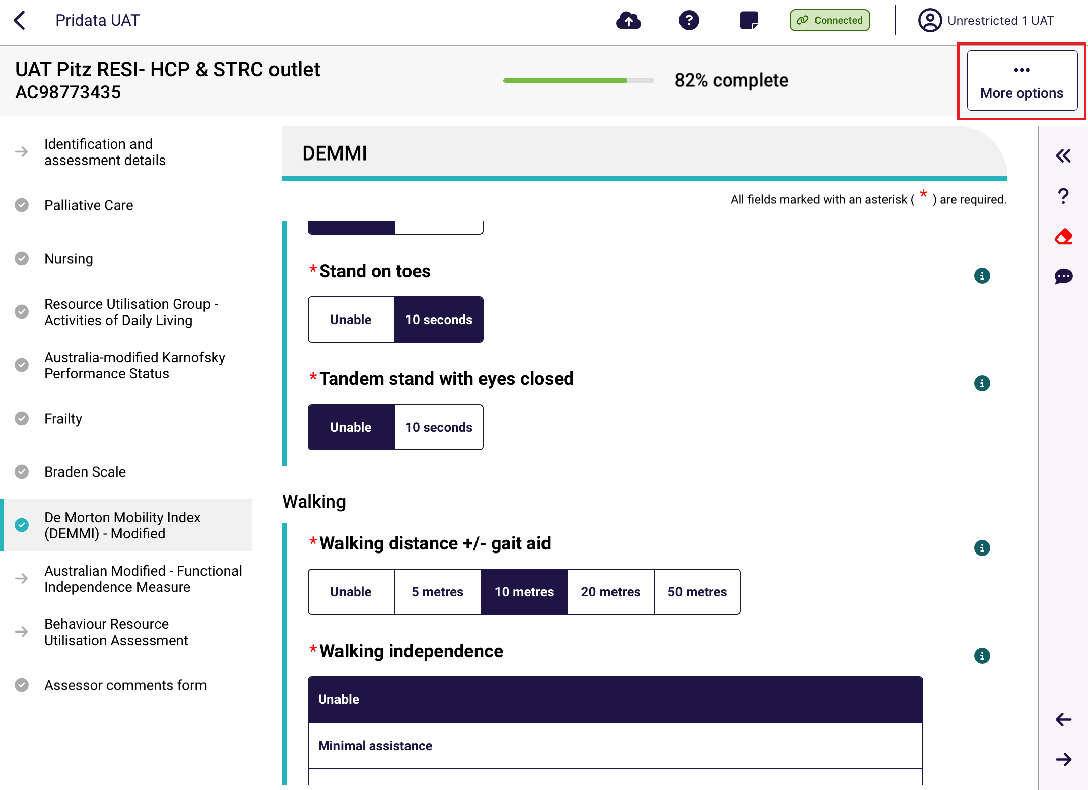
- Select Remove assessment from the Select an option pop-up.
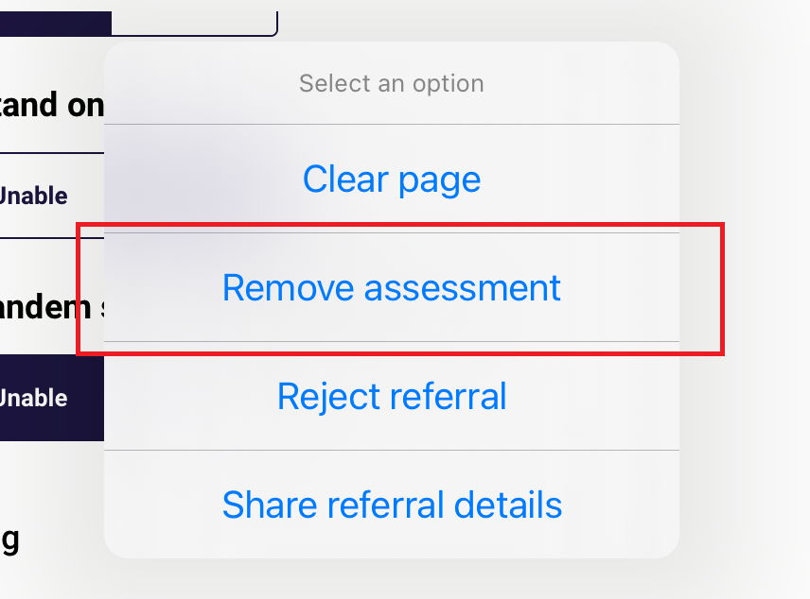

- Select Remove assessment from the Remove Assessment pop up.
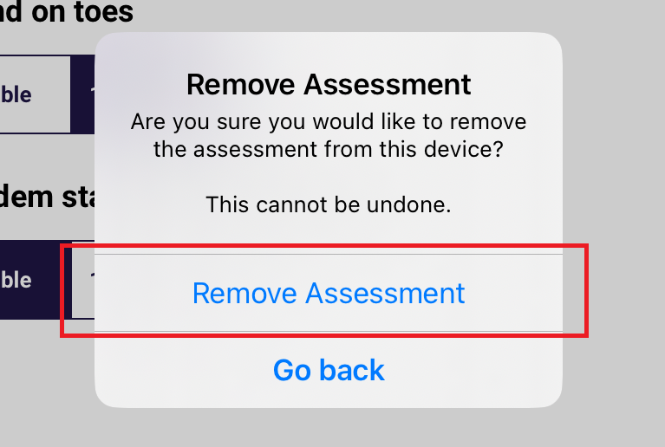
- The assessment will be removed. If you choose the same client again from the Facilities page, you will be prompted to start a new assessment. ALL data will have been removed.

26.3 Clear Uploaded and Not Started assessments
For not started or uploaded assessments, to clear them they will either require to be manually removed by following the steps set out in 26.1 Removing an uploaded assessment or will automatically be removed 7 days after successfully uploading.
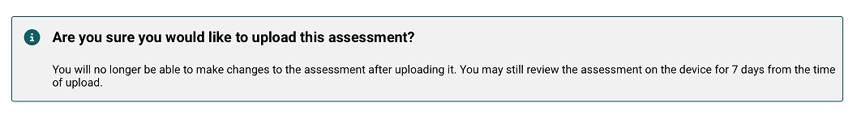

26.4 Rejecting a Referral
RAC funding assessors may reject a referral if a Resident is not available to be assessed. Please note that for self-referred assessments, you will not be able to reject the referral.
- Go to the Resident’s client card to display the Start Assessment screen.
Then, select Reject Referral.
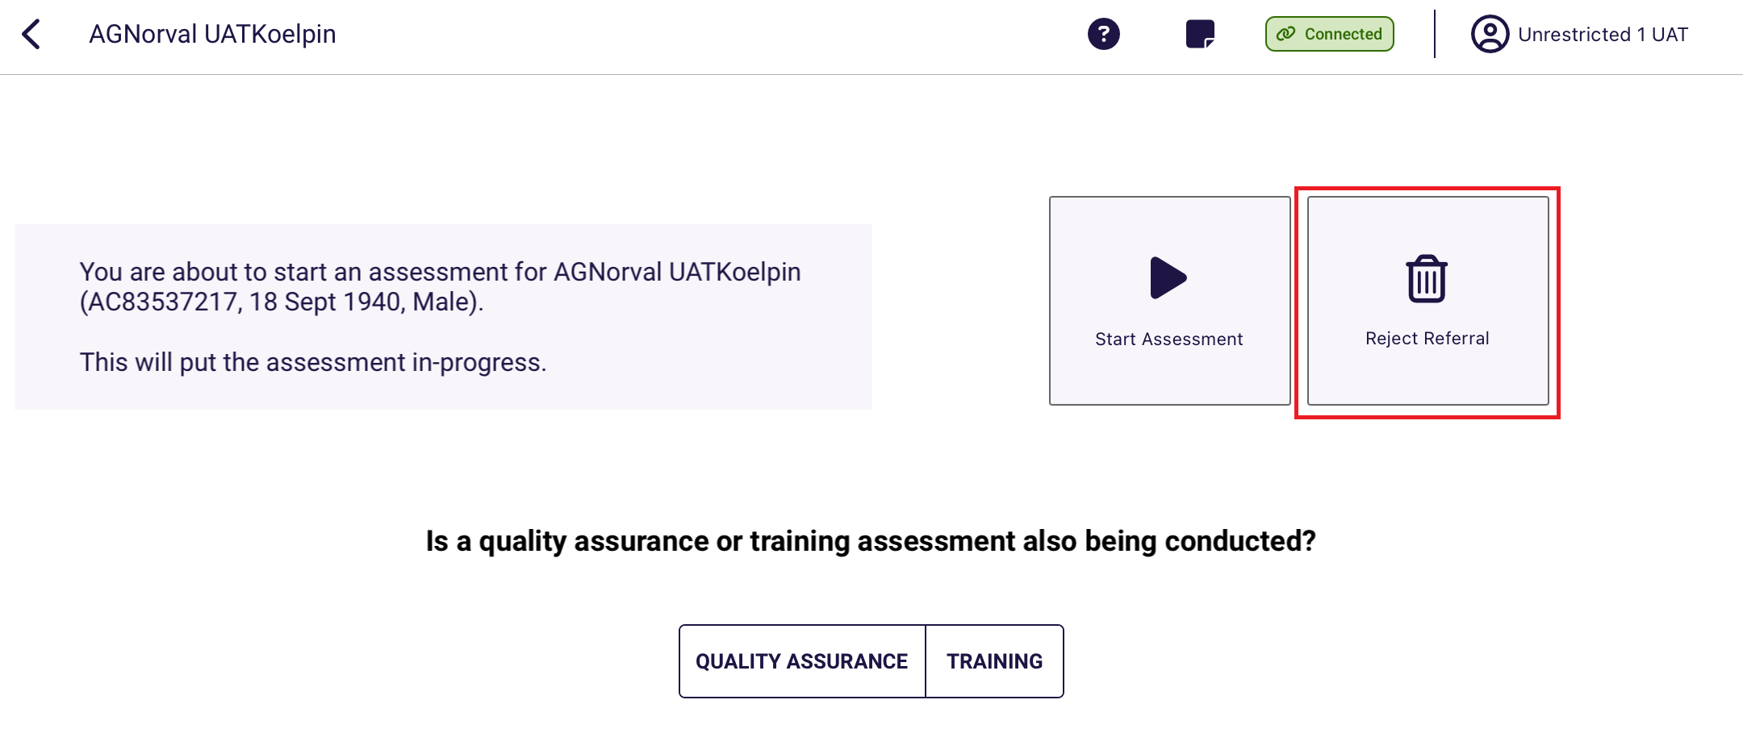

- Select the reason for the rejection. Choose from Client Deceased, Client Unavailable, or Other. Please note that for Residential Respite referrals option of Client has exited facility will be available instead of Client Unavailable.
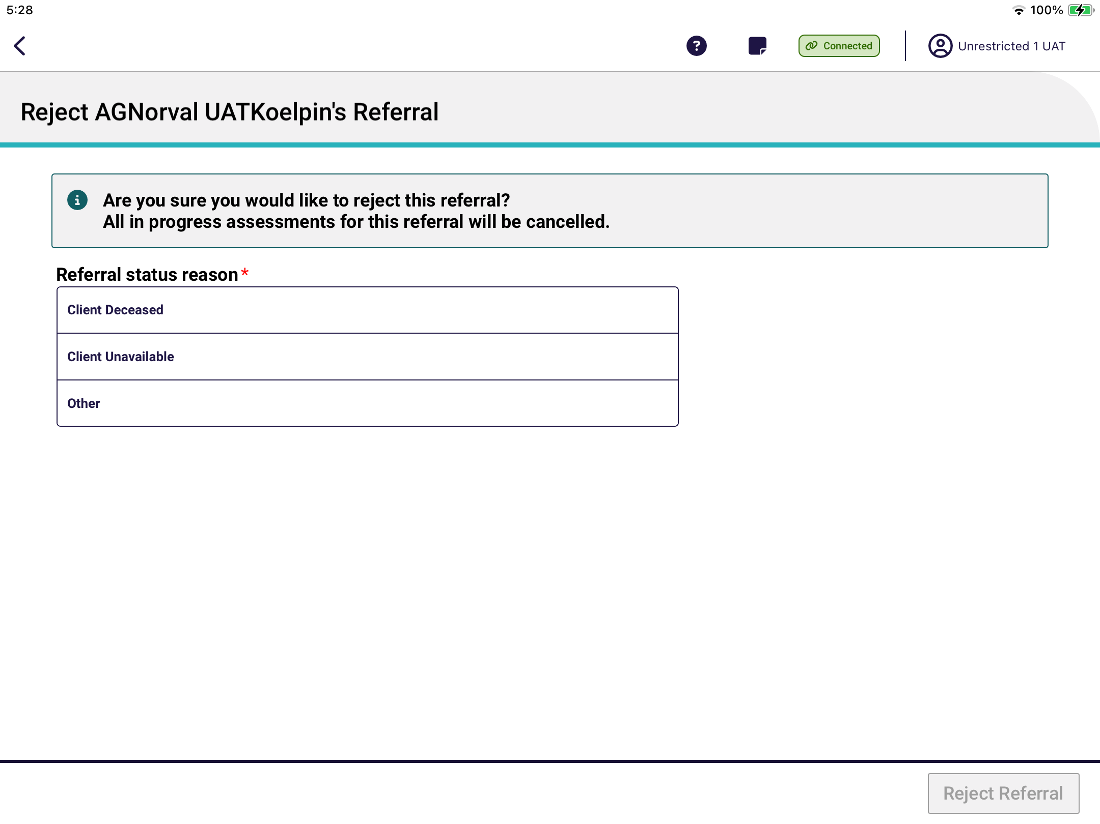
- Client Deceased
Select the client’s deceased date if known, then select Reject Referral.
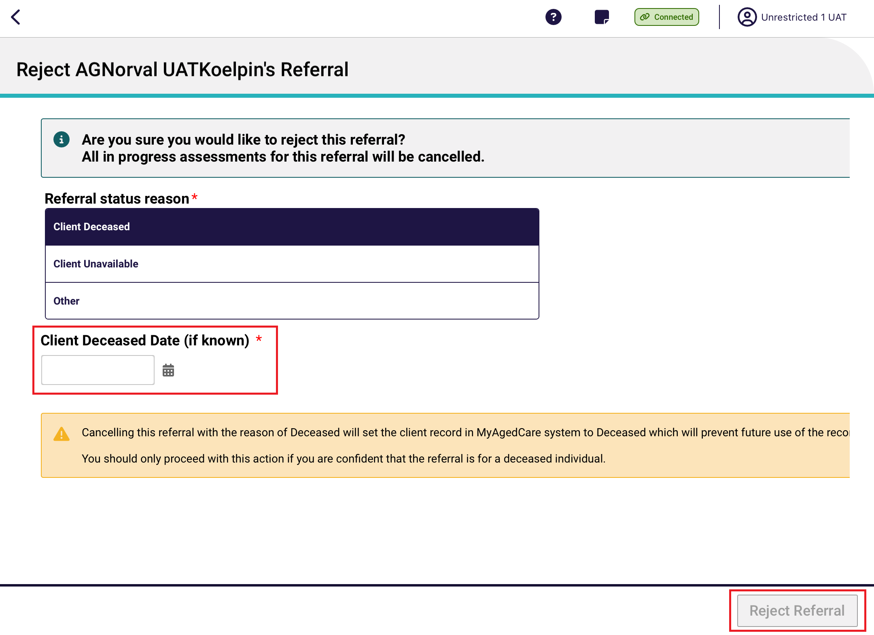

- Client Unavailable
Client unavailable should be selected if the client is currently unavailable for some reason, for example is in hospital but is expected to return to the service or facility at some point of time in the future. Select Reject Referral.
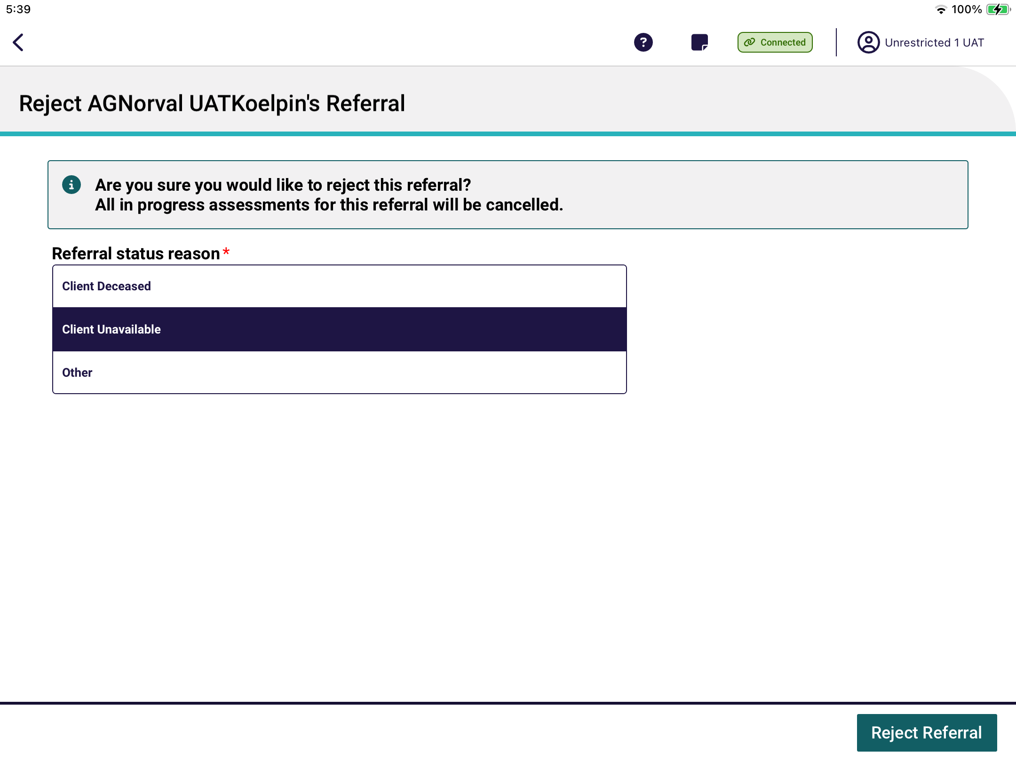
- Client has exited facility
This option is available for Residential Respite referrals only. Select Reject Referral. This option will transfer the referral to an assessment organisation at the client’s registered home address.
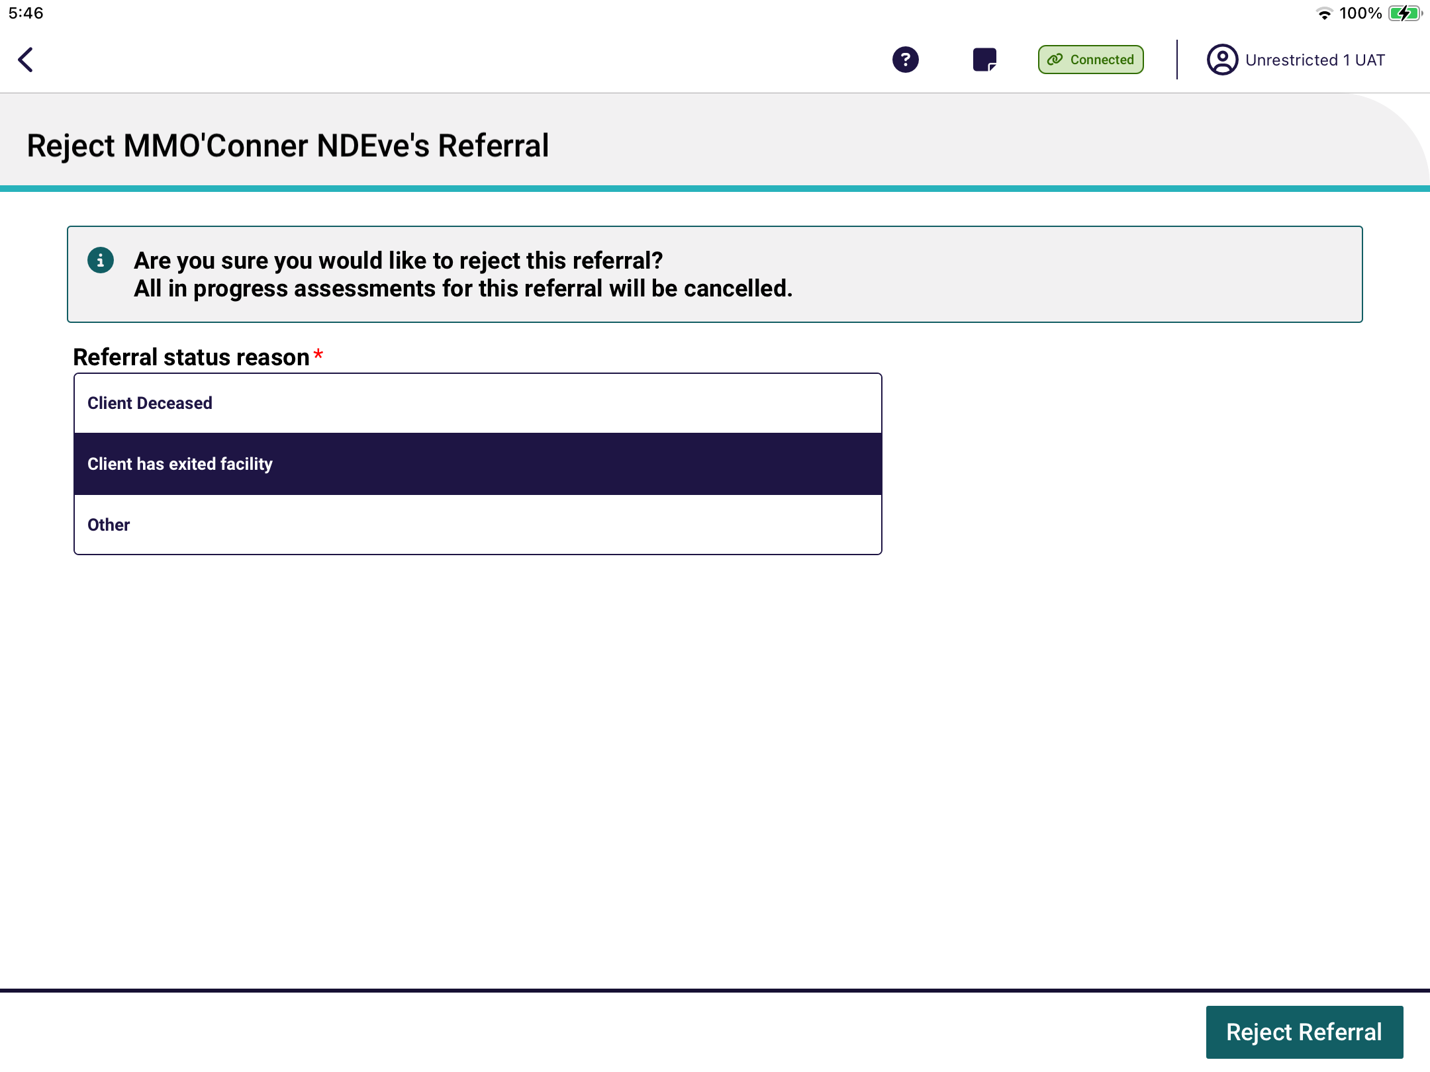

- Other
If the assessment cannot be completed for any other reason, select Other and enter the reason in the textbox. You must enter a reason in Rejection reason before you will be able to reject the referral. Then, select Reject Referral.
An example of this would be if the resident has returned to their home in the community.
