Systematic review of evidence on the clinical effectiveness of aromatherapy

Appendix D – additional results and citations for included studies

5 March 2024

Contents

Additional results 3

Study characteristics 3

Risk of bias assessments 3

D1 Pain 3

Comparison 1: Aromatherapy (any mode) versus inactive control (usual care, placebo, no intervention) 3

Comparison 2: Aromatherapy (massage) versus inactive control (massage) 6

D2 Nausea and vomiting 7

Comparison 1: Aromatherapy (any mode) versus inactive control (usual care, placebo, no intervention) 7

D3 Sleep 10

Comparison 1: Aromatherapy (any mode) versus inactive control (usual care, placebo, no intervention) 10

D4 Fatigue 13

Comparison 1: Aromatherapy (any mode) versus inactive control (usual care, placebo, no intervention) 13

Comparison 2: Aromatherapy (massage) versus inactive control (massage) 16

D5 Emotional functioning and mental health 17

Comparison 1: Aromatherapy (any mode) versus inactive control (usual care, placebo, no intervention) 17

Comparison 2: Aromatherapy (massage) versus inactive control (massage) 21

D6 Health-related quality of life (HR-QoL) 22

Comparison 1: Aromatherapy (any mode) versus inactive control (usual care, placebo, no intervention) 22

Comparison 2: Aromatherapy (massage) versus inactive control (massage) 25

D7 Physical function 26

Comparison 1: Aromatherapy (any mode) versus inactive control (usual care, placebo, no intervention) 26

Comparison 2: Aromatherapy (massage) versus inactive control (massage) 29

D8 References to included studies 31

# Additional results

### Study characteristics

Study characteristics (including eligible and included participants, and the interventions evaluated) and the outcomes measured and selected from each study for inclusion in the meta-analysis are reported in Appendix E1. Details of funding, ethics approval and any other declarations of interest for each study are in Appendix E2.

### Risk of bias assessments

The overall risk of bias rating for each study included for meta-analysis is reported in the forest plots (main report). The complete risk of bias assessment for each study is reported in Appendix F. Assessments are grouped by study design (parallel-randomised trials, crossover trials, and cluster-randomised trials), then ordered alphabetically within each design by study ID. For each study, a separate risk of bias assessment was made for all comparisons and outcomes contributing to meta-analysis. If the assessment was the same for different comparisons/outcomes, only one assessment is reported (See Appendix F for details).

## D1 Pain

Results presented in this section are for the additional subgroup analyses, sensitivity analyses, and analyses to examine the risk of bias due to missing results.

### Comparison 1: Aromatherapy (any mode) versus inactive control (usual care, placebo, no intervention)

For the outcome pain, 82 studies were included in the meta-analysis for Comparison 1 which compared aromatherapy delivered by any mode to an inactive control that did not involve massage (usual care, placebo, no intervention).

#### Results of subgroup analyses

The following subgroup analyses were performed to investigate whether there was a credible explanation for the inconsistent effects that were observed across studies (statistical heterogeneity).

1. Population group (both comparisons): whether the combined estimate of effect was importantly different for different population groups (surgery, procedures, chronic musculoskeletal conditions, acute musculoskeletal conditions, headache or migraine (chronic or episodic), cancer and advanced disease, labour and childbirth, other chronic pain, acute pain).
2. Mode of aromatherapy delivery (Comparison 1 only): whether the combined estimate of effect was importantly different when aromatherapy was delivered by massage compared to another mode (inhalation, topical).

Neither of the subgroup analyses provided a credible explanation for the inconsistent effects observed across studies (i.e., differences in the direction or size of the observed effect) in Comparison 1.

***Population group***

Results for this analysis are presented in the main report (Section 4.2, Figure 4.2.1). The test for subgroup differences was statistically significant (P < 0.001), however the combined estimate of effect indicated an important reduction in pain for each of the population groups except cancer and advanced disease (for which there was very low certainty evidence of little or no effect). Further, within most of the population subgroups, there was considerable variation in the effects across studies. These results suggest that population group does not provide an explanation for observed inconsistency.

***Mode of aromatherapy delivery***

Results for this analysis are presented in Figure D1.1. The test for subgroup differences was not statistically significant (P = 0.453), and the results for the two subgroups are very similar. Further, within the subgroups the effects were inconsistent across studies. As such, there is no evidence that mode of delivery explains inconsistent effects across studies.

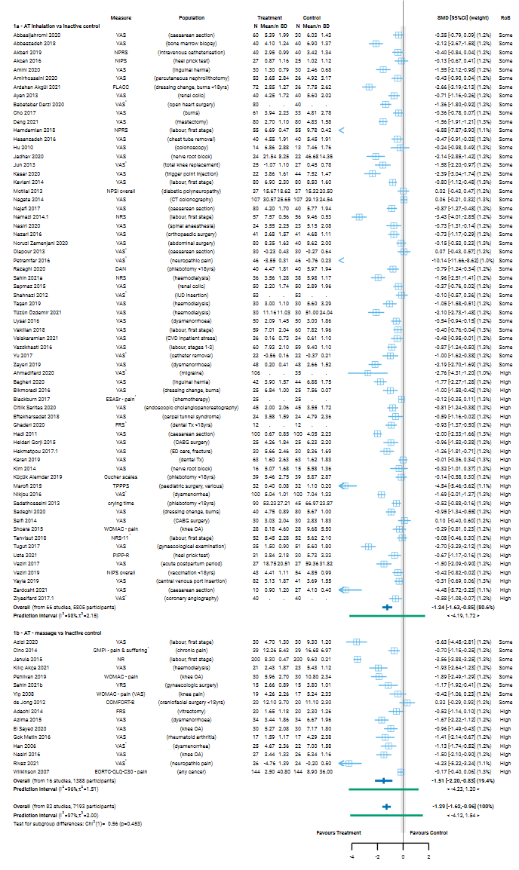

**Fig D1.1** | Forest plot for Comparison 1. the effect of aromatherapy (any mode) versus inactive control (usual care, no intervention, placebo) on pain; subgrouped by mode of aromatherapy delivery. SMD = standardised mean difference. Blue lines show 95% confidence intervals (CI) and green lines show prediction intervals (PI). The shaded grey area indicates the pre-specified range where the effect of aromatherapy is considered to be no different from control (SMD -0.2 to 0.2 standard units). ^ indicates studies for which data transformation or imputation was required to include the result in the meta-analysis. This included crossover trials and studies that reported results as a dichotomous or ordinal outcome (identifiable because no mean or SD is reported for the study in the forest plot).

#### Results of sensitivity analyses

**Table D1.1** presents results for the original analysis (all studies, random effects model) and three sensitivity analyses. These sensitivity analyses investigate:

1. whether the combined estimate is sensitive to the assumptions that were made to enable inclusion of results in the meta-analysis, specifically
   1. transforming or imputing statistics, or
   2. transforming or imputing statistics, and including change scores (change from baseline) when post-intervention (final) values (and their standard deviations) were unavailable; and
2. whether the combined effect differs when estimated from a fixed effect model, providing evidence of small study effects (which may be due to true differences in the effects in small studies or may suggest non-reporting bias).

The combined estimate of effect was similar in the original analysis and the sensitivity analyses removing studies for which transforming or imputing statistics was necessary, and then also removing studies for which change scores were used. This indicates that the result was robust to the assumptions required to include these results.

**Table D1.1. Sensitivity analyses for pain outcome, both comparisons**

|  |  |  |  |  |  |  |
| --- | --- | --- | --- | --- | --- | --- |
| Comparison1 | Sensitivity analysis | Purpose of sensitivity analysis | No trials | Original effect (95% CI) | No trials | Sensitivity analysis effect |
| C1. AT (any mode) v inactive control (not massage) | No imputation or transformations2 | Investigate robustness of MA effect | 82 | SMD ‐1.29 ( ‐1.62 to  ‐0.96); I2 = 97% | 73 | SMD ‐1.33 ( ‐1.70 to -0.96); I2 = 97% |
| No imputation, transformations or change scores3 | Investigate robustness of MA effect |  |  | 67 | SMD ‐1.21 ( ‐1.52 to ‐0.91); I2 = 96% |
| Fixed effect analysis | Investigate small study effects (bias due to missing results) |  |  | 82 | SMD ‐0.91 (‐0.96 to ‐0.86); I2 = 95% |
| C2. AT (massage) v control (massage) | No imputation or transformations2 | Investigate robustness of MA effect | 19 | SMD ‐0.72 ( ‐1.19 to  ‐0.25); I2 = 93% | 15 | SMD ‐0.71 ( ‐1.13 to ‐0.11); I2 = 92% |
| No imputation, transformations or change scores3 | Investigate robustness of MA effect |  |  | 13 | SMD ‐0.56 ( ‐1.05 to 0.07); I2 = 86% |
| Fixed effect analysis | Investigate small study effects (bias due to missing results) |  |  | 19 | SMD ‐0.66 ( ‐0.77 to ‐0.55); I2 = 89% |

1 C1. includes studies that compare AT (any mode, massage or not) to an inactive control that does not involve massage; C2. includes studies that compare AT (massage) to a massage control that is comparable to that used to deliver AT.

2 This analysis was limited to trials that reported i) means and standard deviations, ii) means and standard errors, or iii) mean differences and their confidence intervals

3 This analysis was limited to trials that (a) reported i) means and standard deviations, ii) means and standard errors, or iii) mean differences and their confidence intervals, and (b) had post-intervention (final) values available.

*Abbreviations*. AT = aromatherapy; MA = meta-analysis; SMD = standardised mean difference; CI = confidence interval

#### Bias due to missing results from the meta-analysis

For Comparison 1 the combined effect estimated from the fixed effect model (SMD -0.89) was smaller than from the random effects model (SMD -1.29) (Table 4.1.1), but in both cases the effect estimate indicated a reduction in pain greater than the threshold for an important effect (Table D1.1). The contour-enhanced funnel plot in Figure D1.2 suggests that there could be missing studies which show effects favouring the control, and nonsignificant effects in general (i.e. the plot is asymmetric, missing studies to the right of the line of no effect (SMD 0) where we would expect results for some small studies, most notably in the darker grey shaded areas where nonsignificant results appear; in addition only a minority of studies to the left of the line of no effect are non-significant).

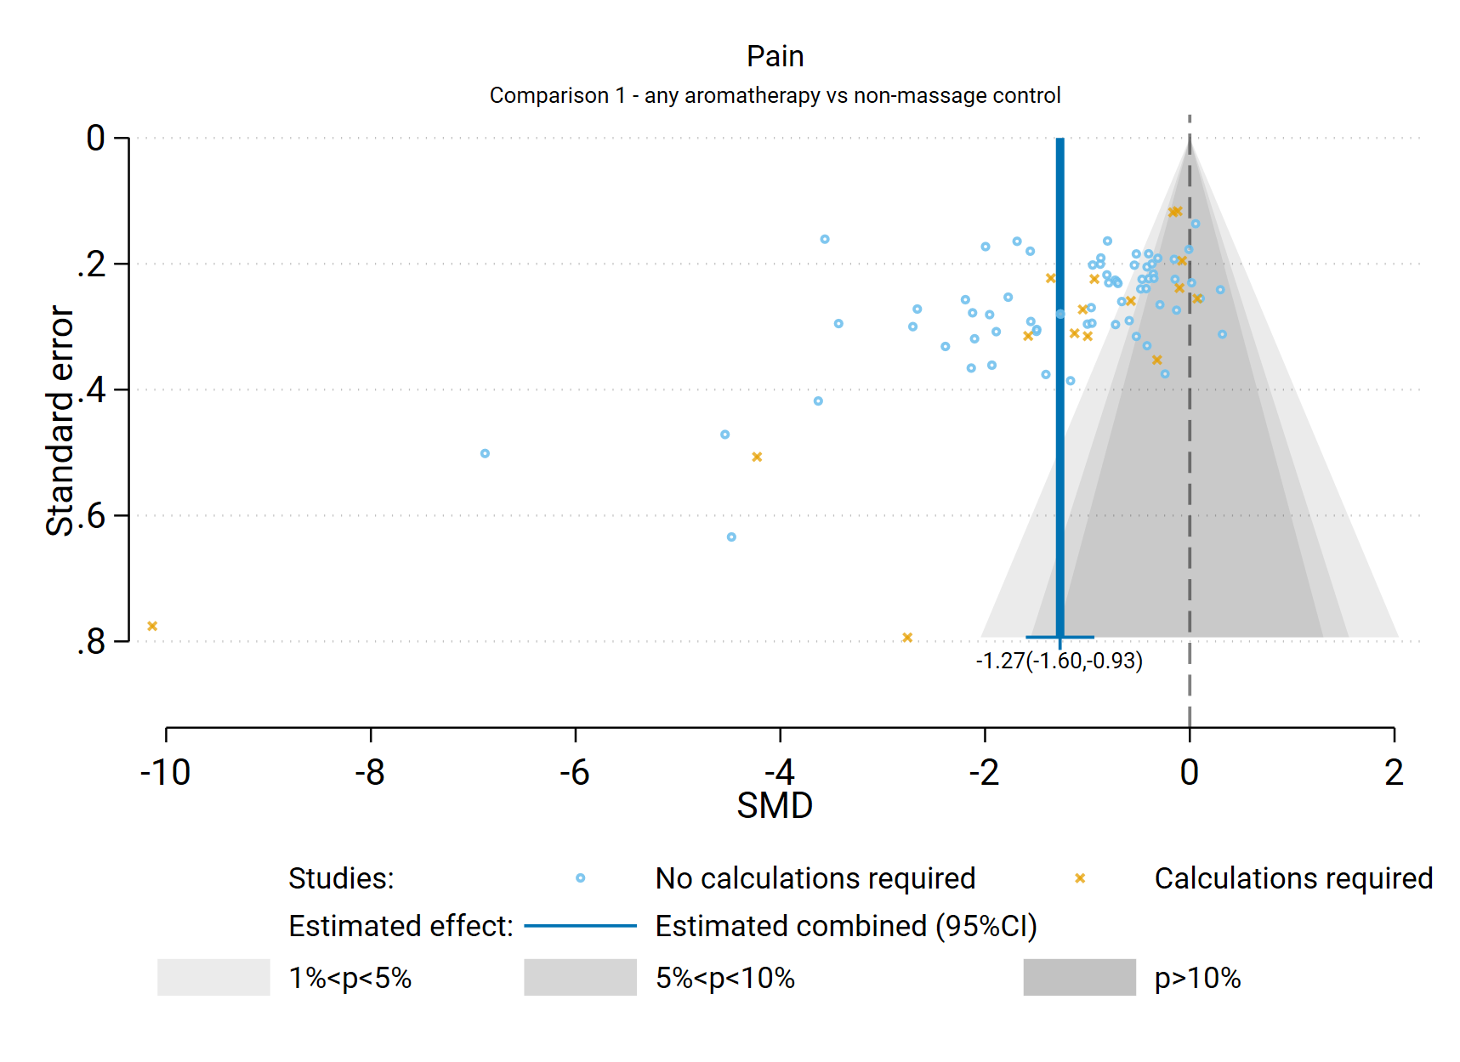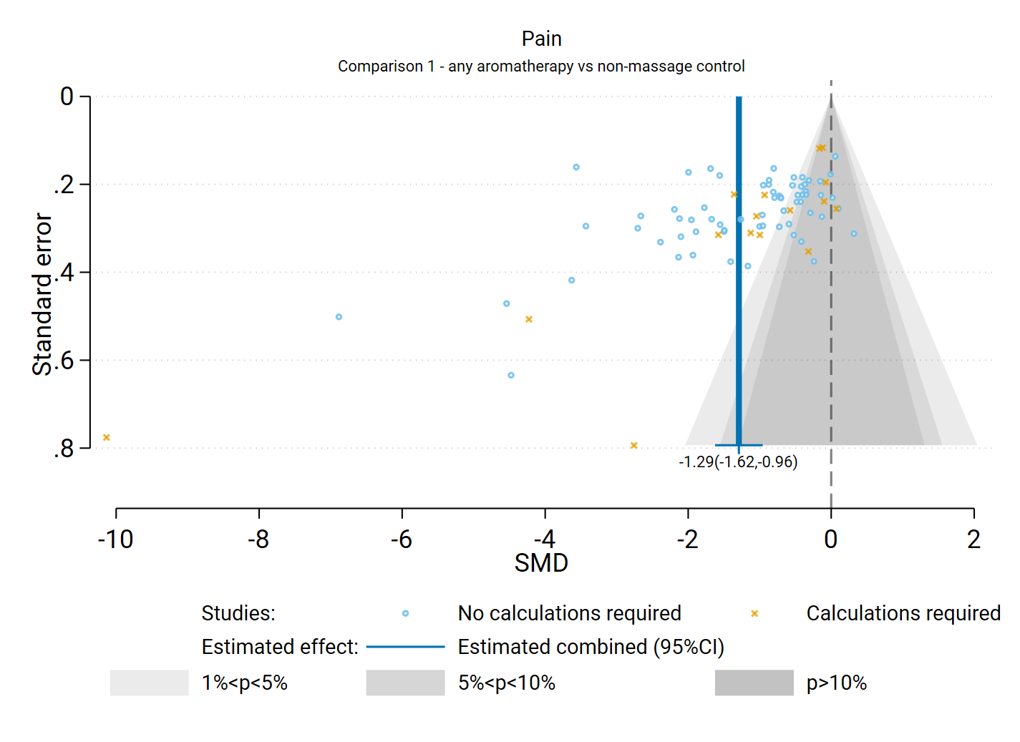

**Fig D1.2** | Contour enhanced funnel plot of estimates of SMD versus their standard errors for Comparison 1. the effect of aromatherapy (any mode) versus inactive control (usual care, no intervention, placebo) on pain. Shaded regions represent different categories of conventional milestone levels of statistical significance. SMD = standardised mean difference. Blue line shows the combined estimate from random effects model.

### Comparison 2: Aromatherapy (massage) versus inactive control (massage)

For the outcome pain, 19 studies were included in the meta-analysis for Comparison 2 which compared aromatherapy delivered by massage to an inactive massage control (i.e. a comparable form of massage to that received by the intervention group).

#### Results of subgroup analyses

***Population group***

A single subgroup analysis was performed to investigate whether there was a credible explanation for the inconsistent effects that were observed across studies (statistical heterogeneity). Specifically, whether the combined estimate of effect was importantly different for the different population groups contributing to the analysis (chronic musculoskeletal conditions, surgery, procedures, labour and childbirth, other chronic pain, other acute pain).

The subgroup analysis did not provide a credible explanation for the inconsistent effects observed across studies (i.e., differences in the direction or size of the observed effect) in Comparison 2. Results for this analysis are presented in the main report (Section 4.2, Figure 4.2.2). The test for subgroup differences was significant (P < 0.001), however within most of the population subgroups, there was considerable variation in the effects across studies. These results suggest that population group does not fully explain the observed inconsistency.

#### Results of sensitivity analyses

**Table D1.1** presents results for the original analysis (all studies, random effects model) and three sensitivity analyses for Comparison 2. The combined estimate of effect was similar in the original analysis and the sensitivity analyses removing studies for which transforming or imputing statistics was necessary, and when we removed any additional studies for which change scores were used. This indicates that the result was robust to the assumptions required to include these results.

#### Bias due to missing results from the meta-analysis

The combined effect estimated from the fixed effect model (SMD -0.66) was similar to that from the random effects model (SMD -0.72) (Table D1.1); in both cases the effect estimate indicated a reduction in pain greater than the threshold for an important effect (Table D1.1). The contour-enhanced funnel plot in Figure D1.3 suggests that there could be missing studies which show effects favouring the control, and nonsignificant effects in general (i.e. the plot is asymmetric, missing studies to the right of the line of no effect (SMD 0) where we would expect results for some small studies, most notably in the darker grey shaded areas where nonsignificant results appear; in addition only a minority of studies to the left of the line of no effect are non-significant).

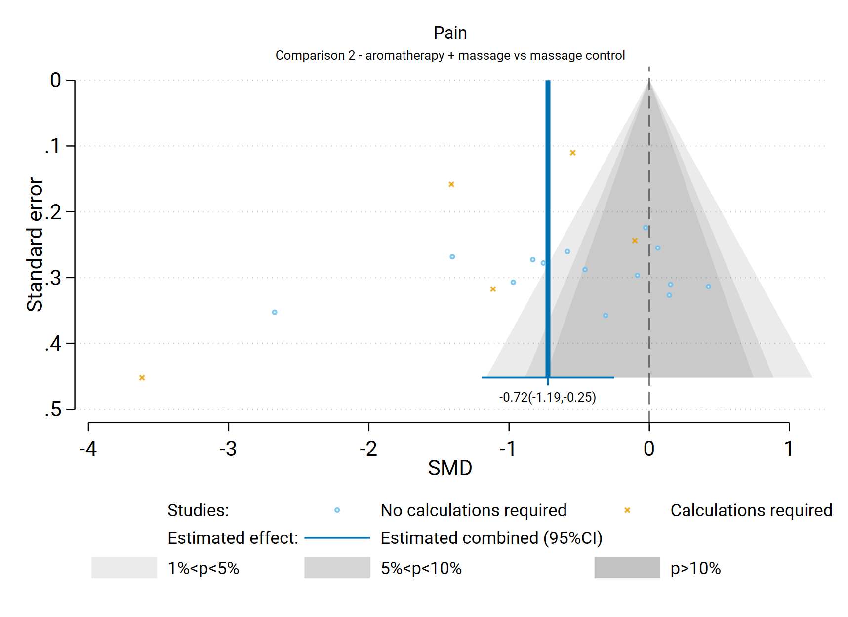 **Fig D1.3** | Contour enhanced funnel plot of estimates of SMD versus their standard errors for Comparison 2. the effect of aromatherapy (massage) versus inactive control (massage) on pain. Shaded regions represent different categories of conventional milestone levels of statistical significance. SMD = standardised mean difference. Blue line shows the combined estimate from random effects model.

## D2 Nausea and vomiting

Results presented in this section are for the additional subgroup analyses, sensitivity analyses, and analyses to examine the risk of bias due to missing results.

For the outcome nausea and vomiting, all 23 studies that could be included in a meta-analysis compared aromatherapy (any mode) to an inactive control (usual care, placebo, no intervention) that did not involve massage.

No studies compared aromatherapy delivered by massage to massage alone, and so results are only for comparison 1.

### Comparison 1: Aromatherapy (any mode) versus inactive control (usual care, placebo, no intervention)

#### Results of subgroup analyses

The following subgroup analyses were performed to investigate whether there was a credible explanation for the inconsistent effects that were observed across studies (statistical heterogeneity).

1. Population group: whether the combined estimate of effect was importantly different for different population groups (cancer and advanced disease, surgery, procedures, pregnancy).
2. Mode of aromatherapy delivery: whether the combined estimate of effect was importantly different when aromatherapy was delivered by massage compared to another mode (inhalation, topical).

Neither of the subgroup analyses provided a credible explanation for the inconsistent effects observed across studies (i.e., differences in the direction or size of the observed effect) in comparison 1.

***Population group***

Results for this analysis are presented in the main report (Section 4.3, Figure 4.3.1). The test for subgroup differences was not statistically significant (P = 0.525) and the combined estimate of effect indicated an important reduction in nausea and vomiting for each of the population groups except procedures. The single study among people undergoing a procedure showed little or no effect on nausea and vomiting, but this single study has little weight in the analysis and as such this does not provide an explanation for observed inconsistency.

***Mode of aromatherapy delivery***

Results for this analysis are presented in Figure D2.1. The test for subgroup differences was significant (P = 0.007), however the confidence intervals for the two subgroups are entirely overlapping (indicating compatible results) and only two of the 23 studies contributed to the subgroup in which aromatherapy was delivered by massage (as opposed to inhalation or topically). Further, within the subgroup in which aromatherapy was delivered by inhalation or topically, the effects were inconsistent across studies. As such, no conclusions can be drawn about whether effects are different depending on mode of delivery.

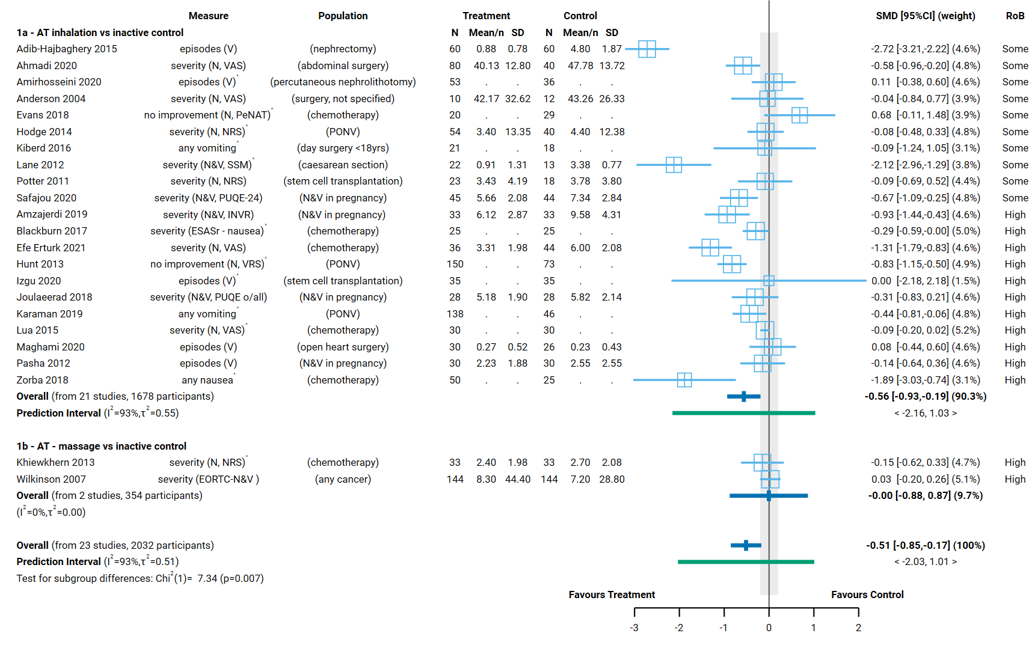

**Fig D2.1** | Forest plot for comparison 1. the effect of aromatherapy (any mode) versus inactive control (usual care, no intervention, placebo) on nausea and vomiting; subgrouped by mode of aromatherapy delivery. Measures: N = nausea, V = vomiting, N&V = nausea and vomiting. SMD = standardised mean difference. Blue lines show 95% confidence intervals (CI) and green lines show prediction intervals (PI). The shaded grey area indicates the pre-specified range where the effect of aromatherapy is considered to be no different from control (SMD -0.2 to 0.2 standard units). ^ indicates studies for which data transformation or imputation was required to include the result in the meta-analysis. This included crossover trials and studies that reported results as a dichotomous or ordinal outcome (identifiable because no mean or SD is reported for the study in the forest plot).

#### Results of sensitivity analyses

**Table D2.1** presents results for the original analysis (all studies, random effects model) and three sensitivity analyses. These sensitivity analyses investigate:

1. whether the combined estimate is sensitive to the assumptions that were made to enable inclusion of results in the meta-analysis, specifically
   1. transforming or imputing statistics, or
   2. transforming or imputing statistics, and including change scores (change from baseline) when post-intervention (final) values (and their standard deviations) were unavailable; and
2. whether the combined effect differs when estimated from a fixed effect model, providing evidence of small study effects (which may be due to true differences in the effects in small studies or may suggest non-reporting bias).

The combined estimate of effect was similar in the original analysis and the sensitivity analysis removing studies for which transforming or imputing statistics was necessary, indicating that the result was robust to these assumptions required to include these results. For the nausea and vomiting outcome, the second sensitivity analysis (1b) was not required because post-intervention values and their standard deviations were available for all studies.

**Table D2.1. Sensitivity analyses for nausea and vomiting outcome, both comparisons**

|  |  |  |  |  |  |  |
| --- | --- | --- | --- | --- | --- | --- |
| Comparison1 | Sensitivity analysis | Purpose of sensitivity analysis | No trials | Original effect (95% CI) | No trials | Sensitivity analysis effect |
| C1. AT (any mode) v inactive control (not massage) | No imputation or transformations2 | Investigate robustness of MA effect | 23 | SMD ‐0.51 ( ‐0.81 to ‐0.17); I2 = 93% | 11 | SMD ‐0.61 ( ‐1.17 to ‐0.06); I2 = 92% |
| No imputation, transformations or change scores3 | Investigate robustness of MA effect |  |  | 11 | As above (no additional studies removed) |
| Fixed effect analysis | Investigate small study effects (bias due to missing results) |  |  | 23 | SMD ‐0.29 (‐0.36 to ‐0.22); I2 = 89% |
| C2. AT (massage) v control (massage) | No imputation or transformations2 | Investigate robustness of MA effect | 0 | No studies contributed to this comparison for this outcome. |  |  |
| No imputation, transformations or change scores3 | Investigate robustness of MA effect |  |  |  |  |
| Fixed effect analysis | Investigate small study effects (bias due to missing results) |  |  |  |  |

1 C1. includes studies that compare AT (any mode, massage or not) to an inactive control that does not involve massage; C2 includes studies that compare AT (massage) to a massage control that is comparable to that used to deliver AT.

2 This analysis was limited to trials that reported i) means and standard deviations, ii) means and standard errors, or iii) mean differences and their confidence intervals

3 This analysis was limited to trials that (a) reported i) means and standard deviations, ii) means and standard errors, or iii) mean differences and their confidence intervals, and (b) had post-intervention (final) values available.

*Abbreviations*. AT = aromatherapy; MA = meta-analysis; SMD = standardised mean difference; CI = confidence interval

#### Bias due to missing results from the meta-analysis

The combined effect estimated from the fixed effect model (SMD -0.29) was smaller than from the random effects model (SMD -0.51) (Table D2.1), but the difference was minimal and both indicated a reduction in nausea and vomiting greater than the threshold for an important effect. The exception was for studies among people undergoing chemotherapy for cancer, where the combined effect estimated from the fixed effect model (SMD -0.13) suggested little or no difference in nausea and vomiting with aromatherapy whereas the random effects model showed an important reduction (SMD -0.35). The contour-enhanced funnel plot in Figure D2.2 suggests that there could be missing studies which show effects favouring the control, especially nonsignificant effects (i.e. the plot is asymmetric, missing studies to the right of the line of no effect (SMD 0) where we would expect results for some small studies, most notably in the darker grey shaded areas where nonsignificant results appear).

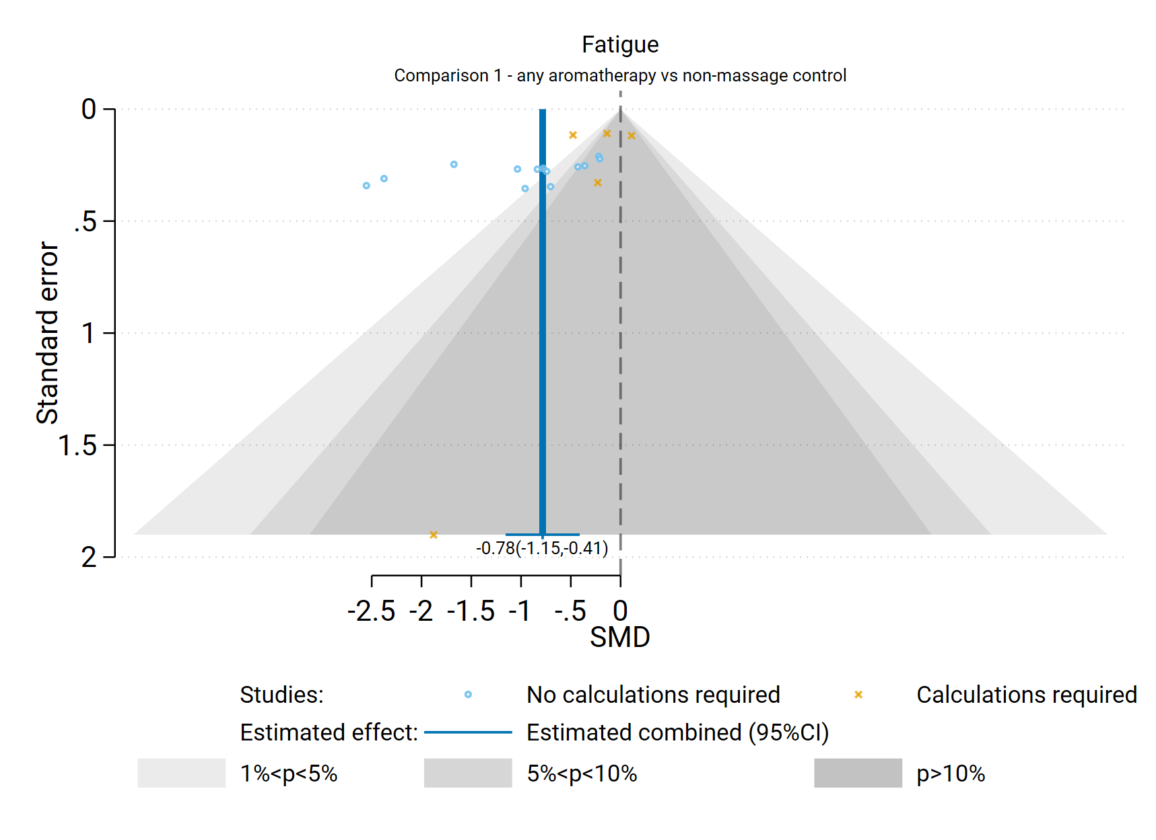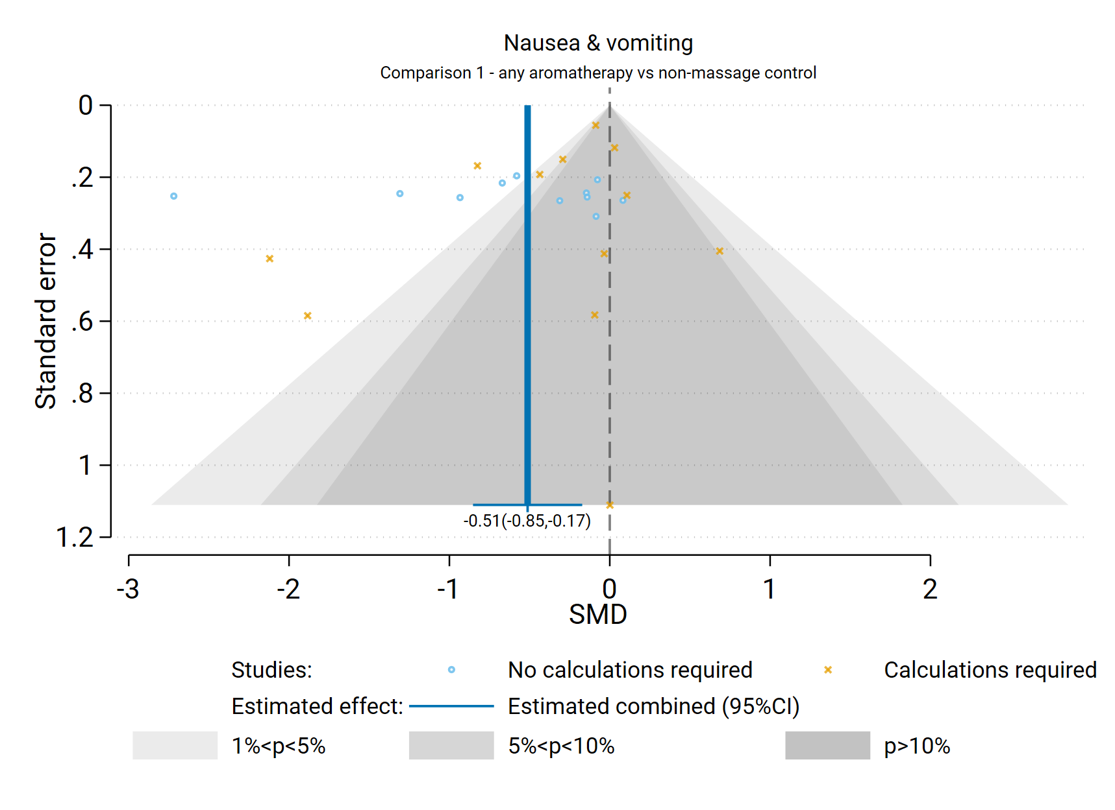

**Fig D2.2** | Contour enhanced funnel plot of estimates of SMD versus their standard errors for Comparison 1. the effect of aromatherapy (any mode) versus inactive control (usual care, no intervention, placebo) on nausea and vomiting. Shaded regions represent different categories of conventional milestone levels of statistical significance. SMD = standardised mean difference. Blue line shows the combined estimate from random effects model.

## D3 Sleep

Results presented in this section are for the additional subgroup analyses, sensitivity analyses, and analyses to examine the risk of bias due to missing results.

For the outcome sleep, all 22 studies that could be included in a meta-analysis compared aromatherapy (any mode) to an inactive control (usual care, placebo, no intervention) that did not involve massage.

No studies compared aromatherapy delivered by massage to massage alone (Comparison 2).

### Comparison 1: Aromatherapy (any mode) versus inactive control (usual care, placebo, no intervention)

#### Results of subgroup analyses

The following subgroup analyses were performed to investigate whether there was a credible explanation for the inconsistent effects that were observed across studies (statistical heterogeneity).

1. Population group: whether the combined estimate of effect was importantly different for different population groups (cancer and advanced disease, surgery, hospitalisation, chronic insomnia, sleep disturbance).
2. Mode of aromatherapy delivery: whether the combined estimate of effect was importantly different when aromatherapy was delivered by massage compared to another mode (inhalation, topical).

Neither of the subgroup analyses provided a credible explanation for the inconsistent effects observed across studies (i.e., differences in the direction or size of the observed effect) in Comparison 1. While there are differences in the size of the estimated intervention effect across studies for this comparison and outcome, the effect estimate for all 22 studies was above the threshold for an important improvement in sleep quality (i.e. an SMD > 0.2). As such, the observed inconsistency is considered unimportant as it does not alter the interpretation of findings for this outcome.

***Population group***

Results for this analysis are presented in the main report (Section 4.4, Figure 4.4.1). The test for subgroup differences was not statistically significant (P = 0.4) and the combined estimate of effect indicated an important improvement in sleep for each of the population groups. Overall, there is evidence that the effects are consistent across population groups (all showing important benefit, despite variation in the magnitude of benefit).

***Mode of aromatherapy delivery***

Results for this analysis are presented in Figure D3.1. The test for subgroup differences was not statistically significant (P = 0.646) and the effect estimate for each of the two subgroups was similar. Further, within the subgroups, the effects were inconsistent across studies. As such, no conclusions can be drawn about whether effects are different depending on mode of delivery, although all studies show important benefit.

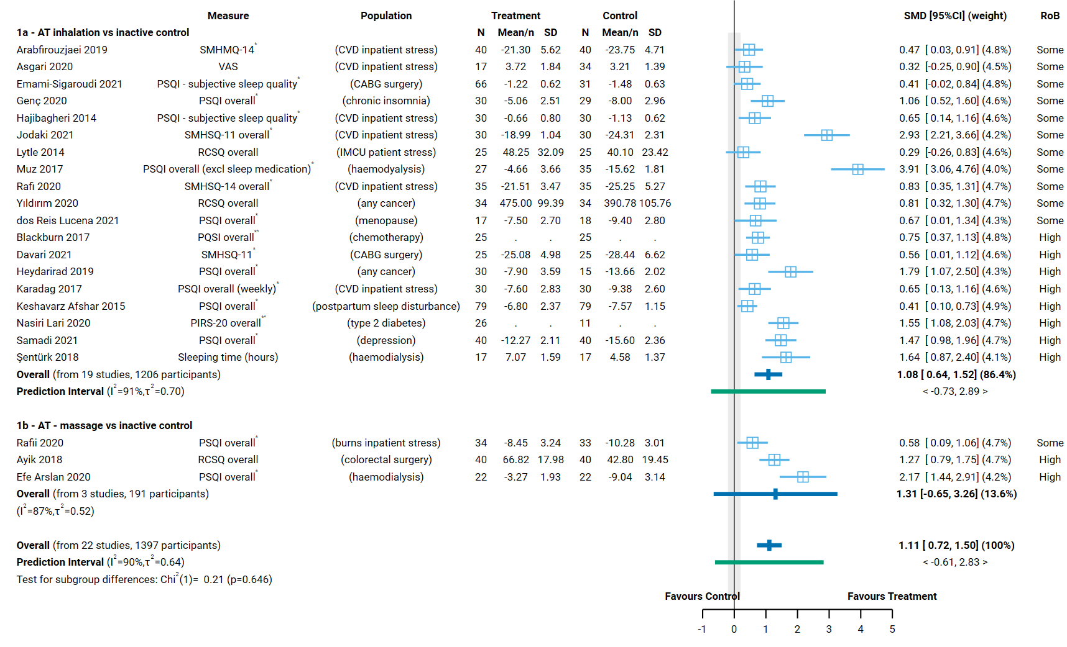**Fig D3.1** | Forest plot for Comparison 1. the effect of aromatherapy (any mode) versus inactive control (usual care, no intervention, placebo) on sleep; subgrouped by mode of aromatherapy delivery. SMD = standardised mean difference. Blue lines show 95% confidence intervals (CI) and green lines show prediction intervals (PI). The shaded grey area indicates the pre-specified range where the effect of aromatherapy is considered to be no different from control (SMD -0.2 to 0.2 standard units). ^ indicates studies for which data transformation or imputation was required to include the result in the meta-analysis. This included crossover trials and studies that reported results as a dichotomous or ordinal outcome (identifiable because no mean or SD is reported for the study in the forest plot).

#### Results of sensitivity analyses

**Table D3.1** presents results for the original analysis (all studies, random effects model) and three sensitivity analyses. These sensitivity analyses investigate:

1. whether the combined estimate is sensitive to the assumptions that were made to enable inclusion of results in the meta-analysis, specifically
   1. transforming or imputing statistics, or
   2. transforming or imputing statistics, and including change scores (change from baseline) when post-intervention (final) values (and their standard deviations) were unavailable; and
2. whether the combined effect differs when estimated from a fixed effect model, providing evidence of small study effects (which may be due to true differences in the effects in small studies or may suggest non-reporting bias).

The combined estimate of effect was similar in the original analysis and the sensitivity analysis removing studies for which transforming or imputing statistics was necessary, indicating that the result was robust to these assumptions required to include these results. For the sleep quality outcome, the second sensitivity analysis (1b) was not required because post-intervention values and their standard deviations were available for all studies.

**Table D3.1. Sensitivity analyses for sleep quality outcome, both comparisons**

|  |  |  |  |  |  |  |
| --- | --- | --- | --- | --- | --- | --- |
| Comparison1 | Sensitivity analysis | Purpose of sensitivity analysis | No trials | Original effect (95% CI) | No trials | Sensitivity analysis effect |
| C1. AT (any mode) v inactive control (not massage) | No imputation or transformations2 | Investigate robustness of MA effect | 22 | SMD 1.11 (0.72 to 1.50); I2 = 90% | 20 | SMD 1.11 (0.68 to 1.54);  I2 = 91% |
| No imputation, transformations or change scores3 | Investigate robustness of MA effect |  |  | 20 | As above (no additional studies removed) |
| Fixed effect analysis | Investigate small study effects (bias due to missing results) |  |  | 22 | SMD 0.91 (0.80 to 1.014); I2 = 86% |
| C2. AT (massage) v control (massage) | No imputation or transformations2 | Investigate robustness of MA effect | 0 | No studies contributed to this comparison for this outcome. |  |  |
| No imputation, transformations or change scores3 | Investigate robustness of MA effect |  |  |  |  |
| Fixed effect analysis | Investigate small study effects (bias due to missing results) |  |  |  |  |

1 C1. includes studies that compare AT (any mode, massage or not) to an inactive control that does not involve massage; C2 includes studies that compare AT (massage) to a massage control that is comparable to that used to deliver AT.

2 This analysis was limited to trials that reported i) means and standard deviations, ii) means and standard errors, or iii) mean differences and their confidence intervals

3 This analysis was limited to trials that (a) reported i) means and standard deviations, ii) means and standard errors, or iii) mean differences and their confidence intervals, and (b) had post-intervention (final) values available.

*Abbreviations*. AT = aromatherapy; MA = meta-analysis; SMD = standardised mean difference; CI = confidence interval

#### Bias due to missing results from the meta-analysis

The combined effect estimated from the fixed effect model (SMD 0.91) was smaller than from the random effects model (SMD 1.11) (Table D3.1), but both indicated an improvement in sleep quality greater than the threshold for an important effect. The contour-enhanced funnel plot in Figure D3.2 suggests that there could be missing studies which show effects favouring the control, and nonsignificant effects in general (i.e. the plot is asymmetric, missing studies to the left of the line of no effect (SMD 0) where we would expect results for some small studies, most notably in the darker grey shaded areas where nonsignificant results appear; in addition only a minority of studies to the right of the line of no effect are non-significant).

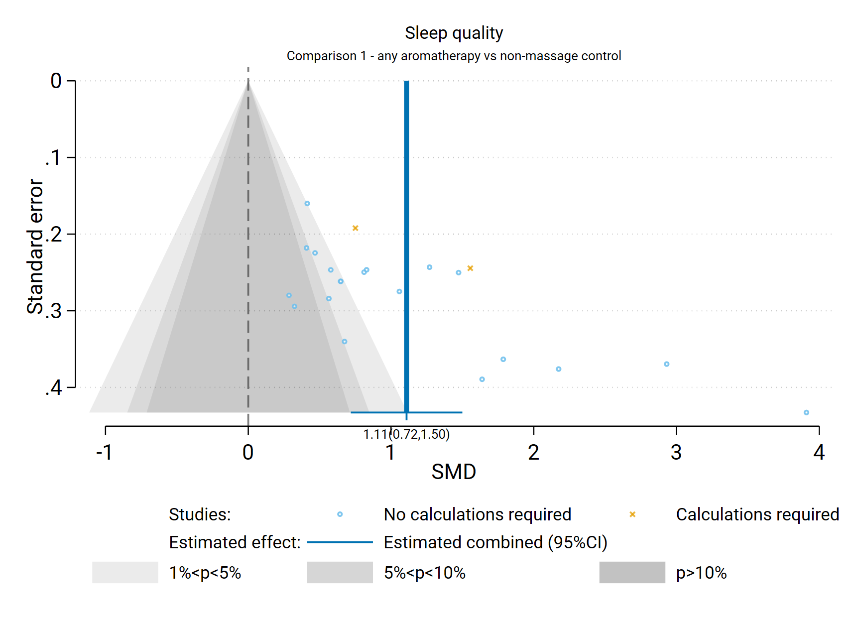

**Fig D3.2** | Contour enhanced funnel plot of estimates of SMD versus their standard errors for Comparison 1. the effect of aromatherapy (any mode) versus inactive control (usual care, no intervention, placebo) on sleep quality. Shaded regions represent different categories of conventional milestone levels of statistical significance. SMD = standardised mean difference. Blue line shows the combined estimate from random effects model.

## D4 Fatigue

Results presented in this section are for the additional subgroup analyses, sensitivity analyses, and analyses to examine the risk of bias due to missing results.

### Comparison 1: Aromatherapy (any mode) versus inactive control (usual care, placebo, no intervention)

For the outcome fatigue, 18 studies were included in the meta-analysis for Comparison 1 which compared aromatherapy delivered by any mode to an inactive control that did not involve massage (usual care, placebo, no intervention).

#### Results of subgroup analyses

The following subgroup analyses were performed to investigate whether there was a credible explanation for the inconsistent effects that were observed across studies (statistical heterogeneity).

1. Population group (both comparisons): whether the combined estimate of effect was importantly different for different population groups (chronic musculoskeletal conditions, cancer and advanced disease, pregnancy, other chronic conditions).
2. Mode of aromatherapy delivery (Comparison 1 only): whether the combined estimate of effect was importantly different when aromatherapy was delivered by massage compared to another mode (inhalation, topical).

Neither of the subgroup analyses provided a credible explanation for the inconsistent effects observed across studies (i.e., differences in the direction or size of the observed effect) in Comparison 1.

***Population group***

Results for this analysis are presented in the main report (Section 4.5, Figure 4.5.1). The test for subgroup differences was statistically significant (P < 0.007) however, within most of the population subgroups, there was considerable variation in the effects across studies. These results suggest that population group does not provide an explanation for observed inconsistency.

***Mode of aromatherapy delivery***

Results for this analysis are presented in Figure D4.1. The test for subgroup differences was not statistically significant (P = 0.939), and the results for the two subgroups are very similar. Further, within the subgroups the effects were inconsistent across studies. As such, there is no evidence that mode of delivery explains inconsistent effects across studies.

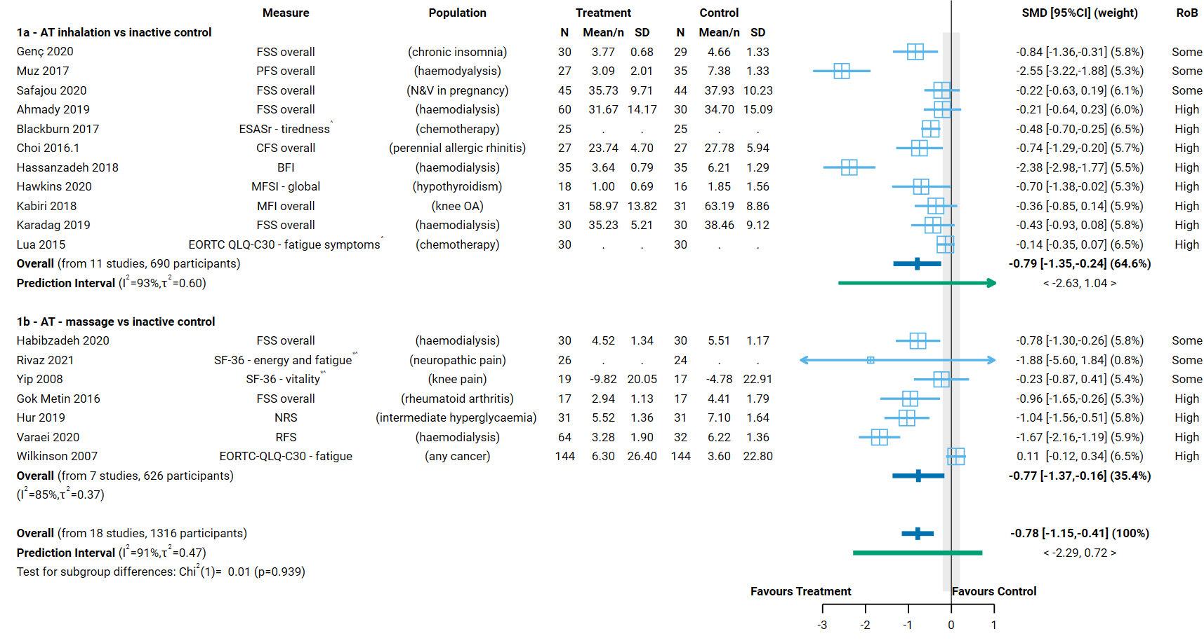

**Fig D4.1** | Forest plot for Comparison 1. the effect of aromatherapy (any mode) versus inactive control (usual care, no intervention, placebo) on fatigue; subgrouped by mode of aromatherapy delivery. SMD = standardised mean difference. Blue lines show 95% confidence intervals (CI) and green lines show prediction intervals (PI). The shaded grey area indicates the pre-specified range where the effect of aromatherapy is considered to be no different from control (SMD -0.2 to 0.2 standard units). ^ indicates studies for which data transformation or imputation was required to include the result in the meta-analysis. This included crossover trials and studies that reported results as a dichotomous or ordinal outcome (identifiable because no mean or SD is reported for the study in the forest plot).

#### Results of sensitivity analyses

**Table D4.1** presents results for the original analysis (all studies, random effects model) and three sensitivity analyses. These sensitivity analyses investigate:

1. whether the combined estimate is sensitive to the assumptions that were made to enable inclusion of results in the meta-analysis, specifically
   1. transforming or imputing statistics, or
   2. transforming or imputing statistics, and including change scores (change from baseline) when post-intervention (final) values (and their standard deviations) were unavailable; and
2. whether the combined effect differs when estimated from a fixed effect model, providing evidence of small study effects (which may be due to true differences in the effects in small studies or may suggest non-reporting bias).

The combined estimate of effect was similar in the original analysis and the sensitivity analyses removing studies for which transforming or imputing statistics was necessary, and then also removing studies for which change scores were used. This indicates that the result was robust to the assumptions required to include these results.

**Table D4.1. Sensitivity analyses for fatigue outcome, both comparisons**

|  |  |  |  |  |  |  |
| --- | --- | --- | --- | --- | --- | --- |
| Comparison1 | Sensitivity analysis | Purpose of sensitivity analysis | No trials | Original effect (95% CI) | No trials | Sensitivity analysis effect |
| C1. AT (any mode) v inactive control (not massage) | No imputation or transformations2 | Investigate robustness of MA effect | 18 | SMD ‐0.78 ( ‐1.15 to  ‐0.41); I2 = 91% | 15 | SMD ‐0.85 ( ‐1.28 to -0.42); I2 = 90% |
| No imputation, transformations or change scores3 | Investigate robustness of MA effect |  |  | 14 | SMD ‐0.89 ( ‐1.34 to ‐0.44); I2 = 90% |
| Fixed effect analysis | Investigate small study effects (bias due to missing results) |  |  | 18 | SMD ‐0.47 (‐0.56 to ‐0.37); I2 = 88% |
| C2. AT (massage) v control (massage) | No imputation or transformations2 | Investigate robustness of MA effect | 4 | SMD ‐0.38 ( ‐0.93 to  0.17); I2 = 30% | 3 | SMD ‐0.36 ( ‐1.14 to ‐0.41); I2 = 40% |
| No imputation, transformations or change scores3 | Investigate robustness of MA effect |  |  | 2 | SMD ‐0.35 ( ‐4.08 to 3.38); I2 = 68% |
| Fixed effect analysis | Investigate small study effects (bias due to missing results) |  |  | 4 | SMD ‐0.39 ( ‐0.68 to ‐0.11); I2 = 23% |

1 C1. includes studies that compare AT (any mode, massage or not) to an inactive control that does not involve massage; C2 includes studies that compare AT (massage) to a massage control that is comparable to that used to deliver AT.

2 This analysis was limited to trials that reported i) means and standard deviations, ii) means and standard errors, or iii) mean differences and their confidence intervals

3 This analysis was limited to trials that (a) reported i) means and standard deviations, ii) means and standard errors, or iii) mean differences and their confidence intervals, and (b) had post-intervention (final) values available.

*Abbreviations*. AT = aromatherapy; MA = meta-analysis; SMD = standardised mean difference; CI = confidence interval

#### Bias due to missing results from the meta-analysis

For Comparison 1, the combined effect estimated from the fixed effect model (SMD -0.47) was smaller than from the random effects model (SMD -0.78) (Table D4.1), but in both cases the effect estimate indicated a reduction in fatigue greater than the threshold for an important effect (Table D4.1). The contour-enhanced funnel plot in Figure D4.2 suggests that there could be missing studies which show effects favouring the control, and nonsignificant effects in general (i.e. the plot is asymmetric, missing studies to the right of the line of no effect (SMD 0) where we would expect results for some small studies, most notably in the darker grey shaded areas where nonsignificant results appear; in addition only a minority of studies to the left of the line of no effect are non-significant).



**Fig D4.2** | Contour enhanced funnel plot of estimates of SMD versus their standard errors for Comparison 1. the effect of aromatherapy (any mode) versus inactive control (usual care, no intervention, placebo) on fatigue. Shaded regions represent different categories of conventional milestone levels of statistical significance. SMD = standardised mean difference. Blue line shows the combined estimate from random effects model.

### Comparison 2: Aromatherapy (massage) versus inactive control (massage)

For the outcome fatigue, 4 studies were included in the meta-analysis for Comparison 2 which compared aromatherapy delivered by massage to an inactive massage control (i.e. a comparable form of massage to that received by the intervention group).

#### Results of subgroup analyses

***Population group***

No subgroup analyses were performed as all studies were among people with chronic conditions. There was no important inconsistency in the results across studies in this subgroup; confidence intervals overlapped, and the heterogeneity statistics indicated that any inconsistency might not be important (I2 = 30%).

#### Results of sensitivity analyses

**Table D4.1** presents results for the original analysis (all studies, random effects model) and three sensitivity analyses for Comparison 2. The combined estimate of effect was similar in the original analysis and the sensitivity analyses removing studies for which transforming or imputing statistics was necessary, and when we removed any additional studies for which change scores were used. This indicates that the result was robust to the assumptions required to include these results.

#### Bias due to missing results from the meta-analysis

The combined effect estimated from the fixed effect model (SMD -0.38) was similar to that from the random effects model (SMD -0.39) (Table D4.1). The contour-enhanced funnel plot in Figure D4.3 includes too few studies to provide any evidence about missing results (publication bias).

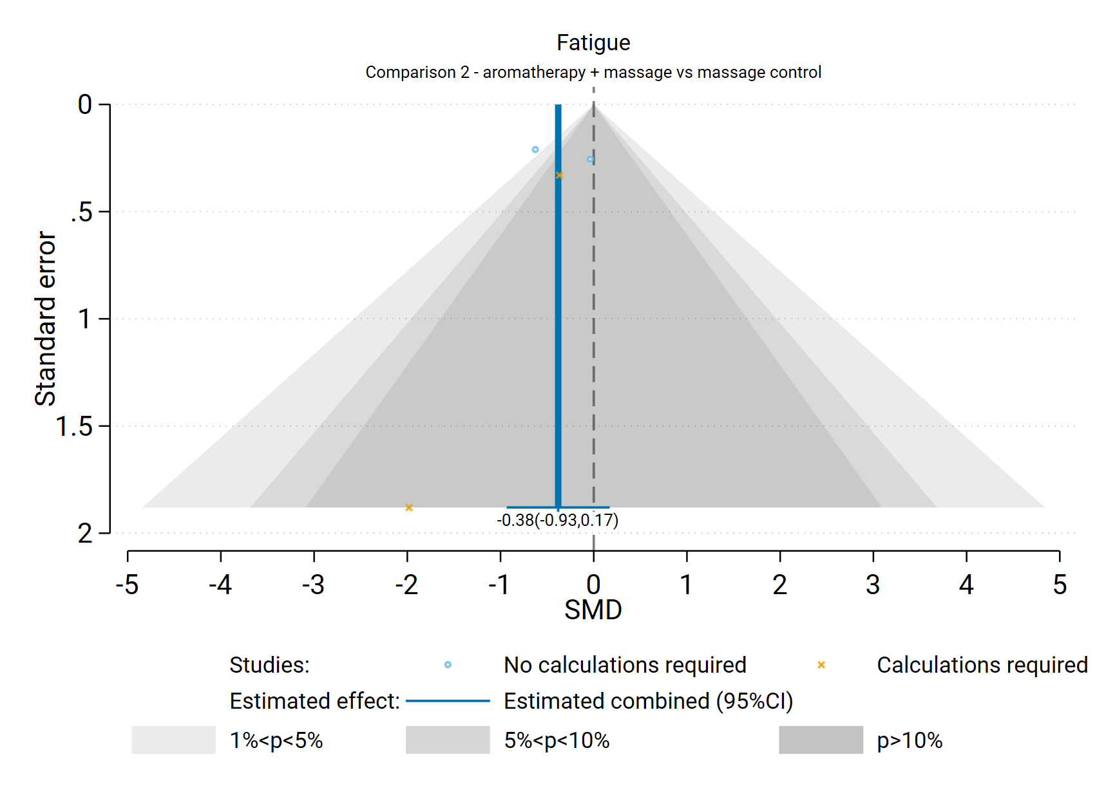**Fig D4.3** | Contour enhanced funnel plot of estimates of SMD versus their standard errors for Comparison 2. the effect of aromatherapy (massage) versus inactive control (massage) on fatigue. Shaded regions represent different categories of conventional milestone levels of statistical significance. SMD = standardised mean difference. Blue line shows the combined estimate from random effects model.

## D5 Emotional functioning and mental health

Results presented in this section are for the additional subgroup analysis, sensitivity analyses, and analyses to examine the risk of bias due to missing results.

### Comparison 1: Aromatherapy (any mode) versus inactive control (usual care, placebo, no intervention)

For the outcome emotional functioning and mental health, 86 studies were included in the meta-analysis for Comparison 1 which compared aromatherapy delivered by any mode to an inactive control that did not involve massage (usual care, placebo, no intervention).

#### Results of subgroup analyses

The following subgroup analyses were performed to investigate whether there was a credible explanation for the inconsistent effects that were observed across studies (statistical heterogeneity).

1. Population group (both comparisons): whether the combined estimate of effect was importantly different for different population groups (surgery, procedures, cancer and advanced disease, hospitalisation, labour and childbirth, dementia, mental distress).
2. Mode of aromatherapy delivery (Comparison 1 only): whether the combined estimate of effect was importantly different when aromatherapy was delivered by massage compared to another mode (inhalation, topical).

Neither of the subgroup analyses provided a credible explanation for the inconsistent effects observed across studies (i.e., differences in the direction or size of the observed effect) in Comparison 1.

***Population group***

Results for this analysis are presented in the main report (Section 4.6, Figure 4.6.1). The test for subgroup differences was statistically significant (P < 0.001), however the combined estimate of effect indicated an important reduction in emotional functioning and mental health in the majority of the population groups, the I2 remained high in most of the population subgroups, and there was considerable variation in the effects across studies within the two largest subgroups (surgery and procedures which contribute 50/86 studies). These results suggest that population group does not provide an explanation for observed inconsistency.

***Mode of aromatherapy delivery***

Results for this analysis are presented in Figure D5.1. The test for subgroup differences was not statistically significant (P = 0.434), the results for the two subgroups are similar, both indicating an important improvement in emotional functioning and mental health (SMD -0.93 for inhalation subgroup; SMD -0.69 for massage subgroup). Further, within the subgroups the effects were inconsistent across studies. As such, this analysis does not provide evidence that mode of delivery explains inconsistent effects across studies.

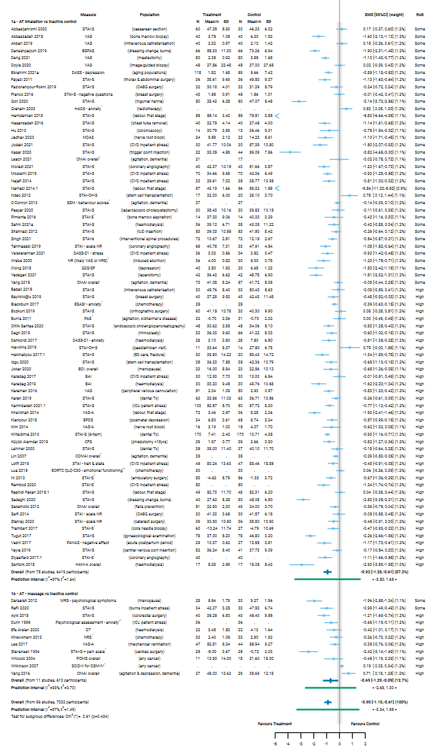

**Fig D5.1** | Forest plot for Comparison 1. the effect of aromatherapy (any mode) versus inactive control (usual care, no intervention, placebo) on emotional functioning and mental health; subgrouped by mode of aromatherapy delivery. SMD = standardised mean difference. Blue lines show 95% confidence intervals (CI) and green lines show prediction intervals (PI). The shaded grey area indicates the pre-specified range where the effect of aromatherapy is considered to be no different from control (SMD -0.2 to 0.2 standard units). ^ indicates studies for which data transformation or imputation was required to include the result in the meta-analysis. This included crossover trials and studies that reported results as a dichotomous or ordinal outcome (identifiable because no mean or SD is reported for the study in the forest plot).

#### Results of sensitivity analyses

**Table D5.1** presents results for the original analysis (all studies, random effects model) and three sensitivity analyses. These sensitivity analyses investigate:

1. whether the combined estimate is sensitive to the assumptions that were made to enable inclusion of results in the meta-analysis, specifically
   1. transforming or imputing statistics, or
   2. transforming or imputing statistics, and including change scores (change from baseline) when post-intervention (final) values (and their standard deviations) were unavailable; and
2. whether the combined effect differs when estimated from a fixed effect model, providing evidence of small study effects (which may be due to true differences in the effects in small studies or may suggest non-reporting bias).

The combined estimate of effect was similar in the original analysis and the sensitivity analyses removing studies for which transforming or imputing statistics was necessary, and then also removing studies for which change scores were used. This indicates that the result was robust to the assumptions required to include these results.

**Table D5.1. Sensitivity analyses for emotional functioning and mental health outcome, both comparisons**

|  |  |  |  |  |  |  |
| --- | --- | --- | --- | --- | --- | --- |
| Comparison1 | Sensitivity analysis | Purpose of sensitivity analysis | No trials | Original effect (95% CI) | No trials | Sensitivity analysis effect |
| C1. AT (any mode) v inactive control (not massage) | No imputation or transformations2 | Investigate robustness of MA effect | 86 | SMD ‐0.90 ( ‐1.18 to  ‐0.61); I2 = 97% | 70 | SMD ‐1.00 ( ‐1.34 to -0.66); I2 = 97% |
| No imputation, transformations or change scores3 | Investigate robustness of MA effect |  |  | 69 | SMD ‐1.00 ( ‐1.35 to ‐0.66); I2 = 97% |
| Fixed effect analysis | Investigate small study effects (bias due to missing results) |  |  | 86 | SMD ‐0.61 (‐0.65 to ‐0.56); I2 = 93% |
| C2. AT (massage) v control (massage) | No imputation or transformations2 | Investigate robustness of MA effect | 11 | SMD ‐0.22 ( ‐0.59 to  0.14); I2 = 93% | 8 | SMD ‐0.25 ( ‐0.77 to 0.27); I2 = 83% |
| No imputation, transformations or change scores3 | Investigate robustness of MA effect |  |  | 8 | As above (no additional studies removed) |
| Fixed effect analysis | Investigate small study effects (bias due to missing results) |  |  | 11 | SMD ‐0.25 ( ‐0.40 to ‐0.09); I2 = 73% |

1 C1. includes studies that compare AT (any mode, massage or not) to an inactive control that does not involve massage; C2 includes studies that compare AT (massage) to a massage control that is comparable to that used to deliver AT.

2 This analysis was limited to trials that reported i) means and standard deviations, ii) means and standard errors, or iii) mean differences and their confidence intervals

3 This analysis was limited to trials that (a) reported i) means and standard deviations, ii) means and standard errors, or iii) mean differences and their confidence intervals, and (b) had post-intervention (final) values available.

*Abbreviations*. AT = aromatherapy; MA = meta-analysis; SMD = standardised mean difference; CI = confidence interval

#### Bias due to missing results from the meta-analysis

For Comparison 1, the combined effect estimated from the fixed effect model (SMD -0.61) was smaller than from the random effects model (SMD -0.90) (Table D5.1), but in both cases the effect estimate indicated an improvement in emotional functioning and mental health greater than the threshold for an important effect (Table D5.1). The contour-enhanced funnel plot in Figure D5.2 suggests that there could be missing studies which show effects favouring the control, especially nonsignificant effects (i.e. the plot is asymmetric, missing studies to the right of the line of no effect (SMD 0) where we would expect results for some small studies, most notably in the darker grey shaded areas where nonsignificant results appear; in addition only a minority of studies to the left of the line of no effect are non-significant).

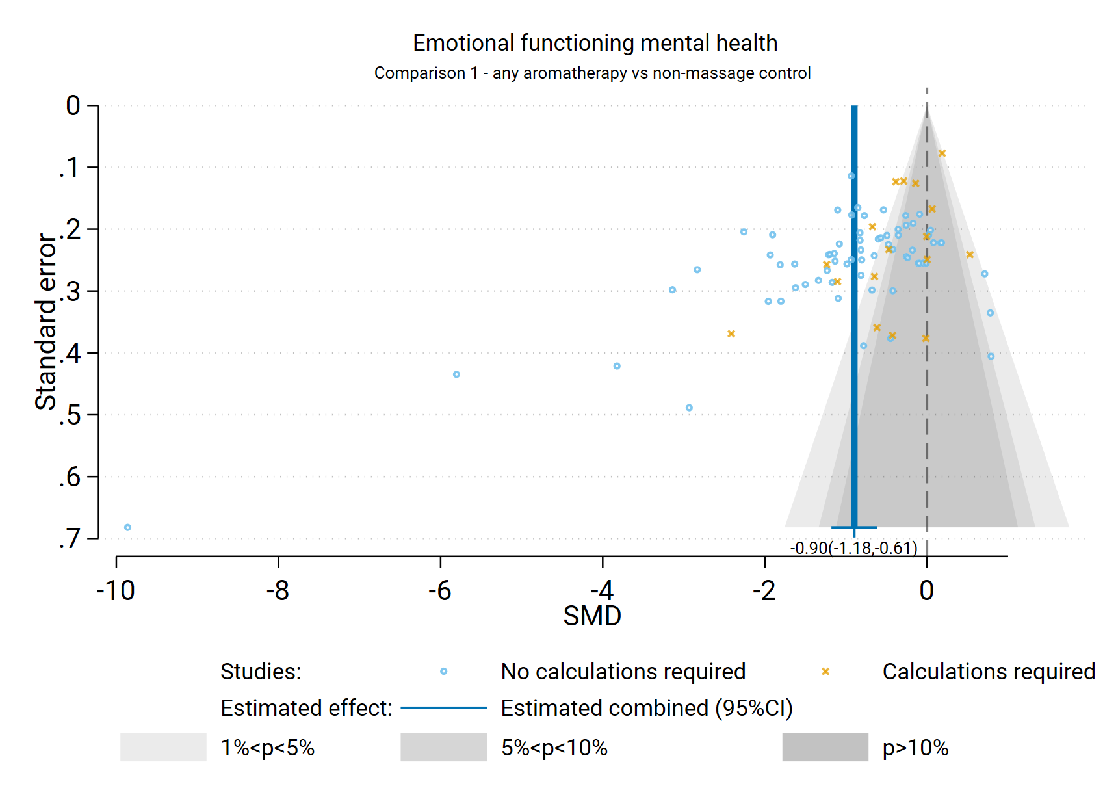

**Fig D5.2** | Contour enhanced funnel plot of estimates of SMD versus their standard errors for Comparison 1. the effect of aromatherapy (any mode) versus inactive control (usual care, no intervention, placebo) on emotional functioning and mental health. Shaded regions represent different categories of conventional milestone levels of statistical significance. SMD = standardised mean difference. Blue line shows the combined estimate from random effects model.

### Comparison 2: Aromatherapy (massage) versus inactive control (massage)

For the outcome emotional functioning and mental health, 11 studies were included in the meta-analysis for Comparison 2 which compared aromatherapy delivered by massage to an inactive massage control (i.e. a comparable form of massage to that received by the intervention group).

#### Results of subgroup analyses

***Population group***

A single subgroup analysis was performed to investigate whether there was a credible explanation for the inconsistent effects that were observed across studies (statistical heterogeneity). Specifically, whether the combined estimate of effect was importantly different for the different population groups contributing to the analysis (cancer and advanced disease, surgery, hospitalisation, dementia, mental distress).

Results for this analysis are presented in the main report (Section 4.6, Figure 4.6.2). The test for subgroup differences was statistically significant (P < 0.001) and remaining inconsistency within each subgroup was not serious. While the subgroup analysis may partly explain inconsistent results in the overall analysis for Comparison 2 (i.e., differences in the direction or size of the observed effect across studies), there are too few studies in each subgroup to be sure.

#### Results of sensitivity analyses

**Table D5.1** presents results for the original analysis (all studies, random effects model) and two sensitivity analyses for Comparison 2. The combined estimate of effect was similar in the original analysis and the sensitivity analysis removing studies for which transforming or imputing statistics was necessary. No studies were included for which change scores were used. This indicates that the result was robust to the assumptions required to include these results.

#### Bias due to missing results from the meta-analysis

The combined effect estimated from the fixed effect model (SMD -0.22) was similar to that from the random effects model (SMD -0.25) (Table D5.1). The contour-enhanced funnel plot in Figure D5.3 includes too few studies to draw any conclusions about missing studies.

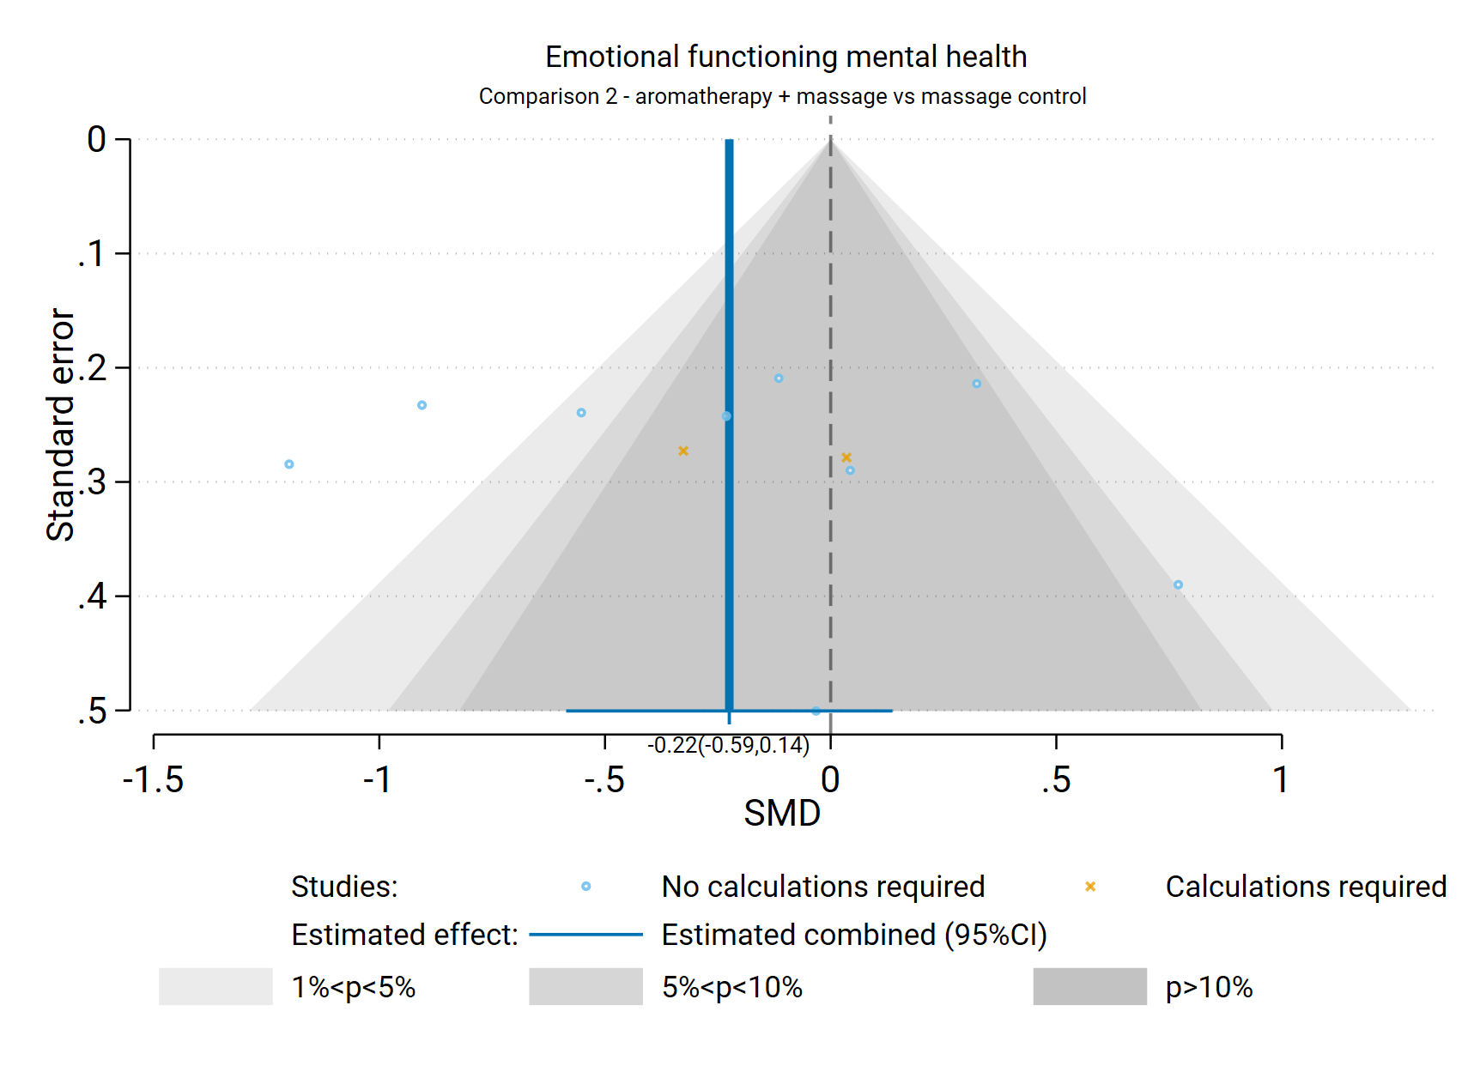 **Fig D5.3** | Contour enhanced funnel plot of estimates of SMD versus their standard errors for Comparison 2. the effect of aromatherapy (massage) versus inactive control (massage) on emotional functioning and mental health. Shaded regions represent different categories of conventional milestone levels of statistical significance. SMD = standardised mean difference. Blue line shows the combined estimate from random effects model.

## D6 Health-related quality of life (HR-QoL)

Results presented in this section are for the additional subgroup analysis, sensitivity analyses, and analyses to examine the risk of bias due to missing results.

### Comparison 1: Aromatherapy (any mode) versus inactive control (usual care, placebo, no intervention)

For the outcome health-related quality of life (HR-QoL), 14 studies were included in the meta-analysis for Comparison 1 which compared aromatherapy delivered by any mode to an inactive control that did not involve massage (usual care, placebo, no intervention).

#### Results of subgroup analyses

The following subgroup analyses were performed to investigate whether there was a credible explanation for the inconsistent effects that were observed across studies (statistical heterogeneity).

1. Population group (both comparisons): whether the combined estimate of effect was importantly different for different population groups (cancer and advanced disease, chronic conditions).
2. Mode of aromatherapy delivery (Comparison 1 only): whether the combined estimate of effect was importantly different when aromatherapy was delivered by massage compared to another mode (inhalation, topical).

Neither of the subgroup analyses provided a credible explanation for the inconsistent effects observed across studies (i.e., differences in the direction or size of the observed effect) in Comparison 1. While there are differences in the size of the estimated intervention effect across studies for this comparison and outcome, the confidence intervals overlap for almost all studies (suggesting compatible results) and the effect estimate for most studies is above the threshold for an important improvement in HR-QoL (i.e. an SMD > 0.2). As such, the observed inconsistency is considered unimportant as it is does not alter the interpretation of findings for this outcome

***Population group***

Results for this analysis are presented in the main report (Section 4.7, Figure 4.7.1). The test for subgroup differences was not statistically significant (P < 0.489) and within the two population subgroups, there was considerable variation in the size of effect across studies. These results suggest that population group does not provide an explanation for any observed inconsistency in the overall analysis. Overall, there is evidence that the effects are consistent across population groups (all showing important benefit, despite variation in the magnitude of benefit).

***Mode of aromatherapy delivery***

Results for this analysis are presented in Figure D6.1. The test for subgroup differences was not statistically significant (P = 0.436), and the point estimate for both subgroups indicates important improvement in HR-QoL with aromatherapy. Results were consistent when aromatherapy was delivered by inhalation/topically (overlapping confidence intervals, I2 = 0%), but inconsistent in the massage subgroup suggesting mode of delivery does not fully explain any inconsistent effects in the overall analysis.

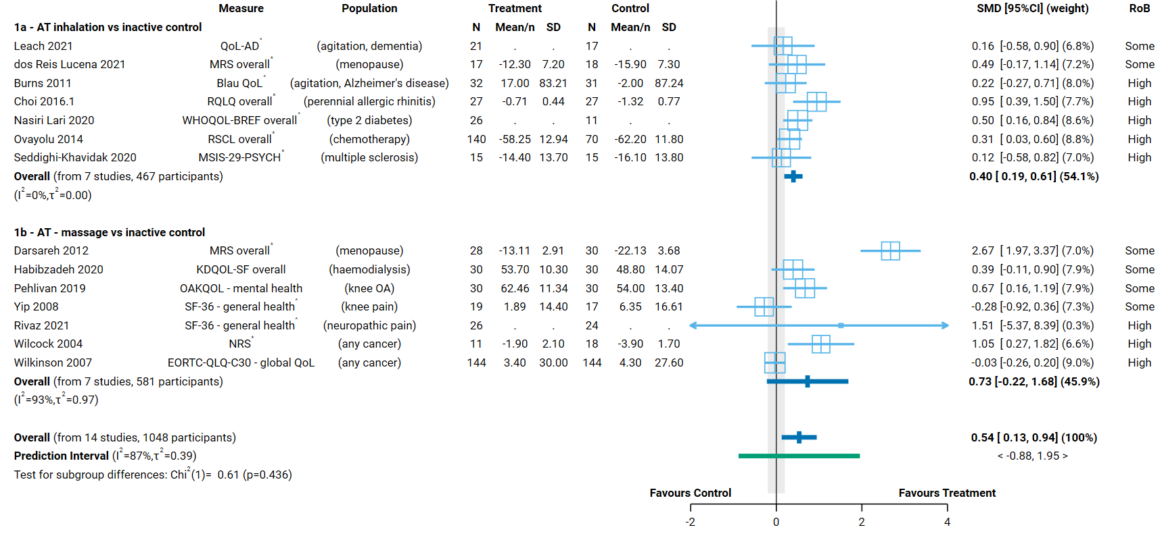**Fig D6.1** | Forest plot for Comparison 1. the effect of aromatherapy (any mode) versus inactive control (usual care, no intervention, placebo) on HR-QoL; subgrouped by mode of aromatherapy delivery. SMD = standardised mean difference. Blue lines show 95% confidence intervals (CI) and green lines show prediction intervals (PI). The shaded grey area indicates the pre-specified range where the effect of aromatherapy is considered to be no different from control (SMD -0.2 to 0.2 standard units). ^ indicates studies for which data transformation or imputation was required to include the result in the meta-analysis. This included crossover trials and studies that reported results as a dichotomous or ordinal outcome (identifiable because no mean or SD is reported for the study in the forest plot). * Denotes studies for which the direction of effect was changed to match the overall plot (e.g. positive numbers are beneficial)

#### Results of sensitivity analyses

**Table D6.1** presents results for the original analysis (all studies, random effects model) and three sensitivity analyses. These sensitivity analyses investigate:

1. whether the combined estimate is sensitive to the assumptions that were made to enable inclusion of results in the meta-analysis, specifically
   1. transforming or imputing statistics, or
   2. transforming or imputing statistics, and including change scores (change from baseline) when post-intervention (final) values (and their standard deviations) were unavailable; and
2. whether the combined effect differs when estimated from a fixed effect model, providing evidence of small study effects (which may be due to true differences in the effects in small studies or may suggest non-reporting bias).

The combined estimate of effect was similar in the original analysis and the sensitivity analyses removing studies for which transforming or imputing statistics was necessary, and then also removing studies for which change scores were used. This indicates that the result was robust to the assumptions required to include these results.

**Table D6.1. Sensitivity analyses for health-related quality of life outcome, both comparisons**

|  |  |  |  |  |  |  |
| --- | --- | --- | --- | --- | --- | --- |
| Comparison1 | Sensitivity analysis | Purpose of sensitivity analysis | No trials | Original effect (95% CI) | No trials | Sensitivity analysis effect |
| C1. AT (any mode) v inactive control (not massage) | No imputation or transformations2 | Investigate robustness of MA effect | 14 | SMD 0.54 (0.13 to  0.94); I2 = 87% | 11 | SMD 0.57 (0.05 to  1.09); I2 = 90% |
| No imputation, transformations or change scores3 | Investigate robustness of MA effect |  |  | 8 | SMD 0.36 (-0.25 to 0.97); I2 = 89% |
| Fixed effect analysis | Investigate small study effects (bias due to missing results) |  |  | 14 | SMD 0.35 (0.23 to 0.48); I2 = 81% |
| C2. AT (massage) v control (massage) | No imputation or transformations2 | Investigate robustness of MA effect | 12 | SMD 0.34 (-0.07 to  0.75); I2 = 84% | 11 | SMD 0.33 ( ‐0.10 to 0.77); I2 = 85% |
| No imputation, transformations or change scores3 | Investigate robustness of MA effect |  |  | 8 | SMD 0.36 ( ‐0.25 to 0.97); I2 = 89% |
| Fixed effect analysis | Investigate small study effects (bias due to missing results) |  |  | 12 | SMD 0.27 (0.13 to 0.41);  I2 = 80% |

1 C1. includes studies that compare AT (any mode, massage or not) to an inactive control that does not involve massage; C2 includes studies that compare AT (massage) to a massage control that is comparable to that used to deliver AT.

2 This analysis was limited to trials that reported i) means and standard deviations, ii) means and standard errors, or iii) mean differences and their confidence intervals

3 This analysis was limited to trials that (a) reported i) means and standard deviations, ii) means and standard errors, or iii) mean differences and their confidence intervals, and (b) had post-intervention (final) values available.

*Abbreviations*. AT = aromatherapy; MA = meta-analysis; SMD = standardised mean difference; CI = confidence interval

#### Bias due to missing results from the meta-analysis

For Comparison 1 the combined effect estimated from the fixed effect model (SMD 0.35) was smaller than from the random effects model (SMD 0.54) (Table D6.1), but in both cases the effect estimate indicated an improvement in HR-QoL greater than the threshold for an important effect. The contour-enhanced funnel plot in Figure D6.2 suggests that there could be missing studies which show effects favouring the control, especially nonsignificant effects (i.e. the plot is asymmetric, missing studies to the left of the line of no effect (SMD 0) where we would expect results for some small studies, most notably in the darker grey shaded areas where nonsignificant results appear).

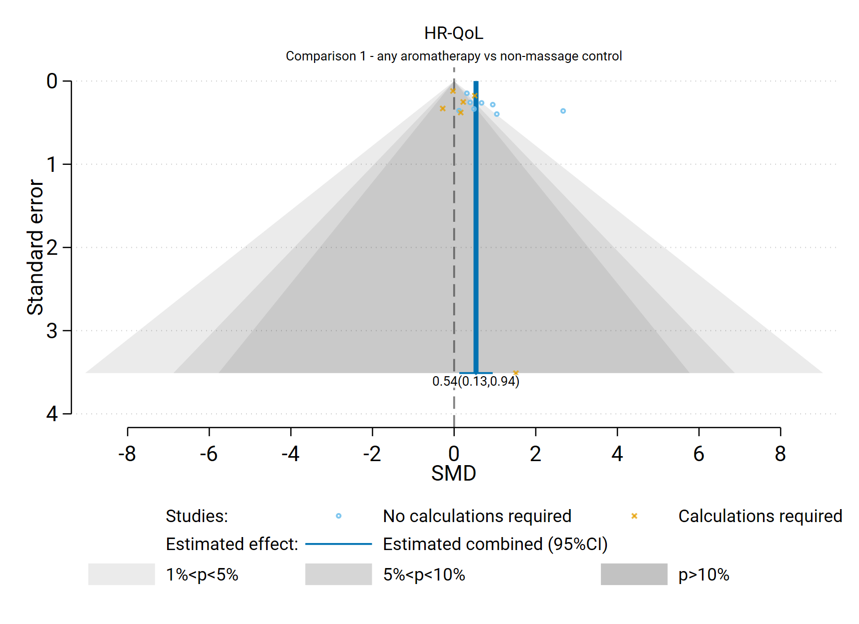

**Fig D6.2** | Contour enhanced funnel plot of estimates of SMD versus their standard errors for Comparison 1. the effect of aromatherapy (any mode) versus inactive control (usual care, no intervention, placebo) on HR-QoL. Shaded regions represent different categories of conventional milestone levels of statistical significance. SMD = standardised mean difference. Blue line shows the combined estimate from random effects model.

### Comparison 2: Aromatherapy (massage) versus inactive control (massage)

For the outcome health-related quality of life, 12 studies were included in the meta-analysis for Comparison 2 which compared aromatherapy delivered by massage to an inactive massage control (i.e. a comparable form of massage to that received by the intervention group).

#### Results of subgroup analyses

***Population group***

A single subgroup analysis was performed to investigate whether there was a credible explanation for the inconsistent effects that were observed across studies (statistical heterogeneity). Specifically, whether the combined estimate of effect was importantly different for the different population groups contributing to the analysis (cancer and advanced disease, chronic conditions).

The subgroup analysis may partly explain some of the inconsistency observed in the overall analysis (i.e., differences in the direction or size of the observed effect) in Comparison 2. The test for subgroup differences was significant (P < 0.008); however, for the chronic conditions subgroup, the I2 remains high, which appears largely due to differences in the magnitude of effect across studies rather than differences in the direction of effect. Results for this analysis are presented in the main report (Section 4.7, Figure 4.7.2).

#### Results of sensitivity analyses

**Table D6.1** presents results for the original analysis (all studies, random effects model) and three sensitivity analyses for Comparison 2. The combined estimate of effect was similar in the original analysis and the sensitivity analyses removing studies for which transforming or imputing statistics was necessary, and when we removed any additional studies for which change scores were used. This indicates that the result was robust to the assumptions required to include these results.

#### Bias due to missing results from the meta-analysis

The combined effect estimated from the fixed effect model (SMD 0.27) was similar to that from the random effects model (SMD 0.34) (Table D6.1). The contour-enhanced funnel plot in Figure D6.3 includes too few studies to provide any evidence about missing results (publication bias).

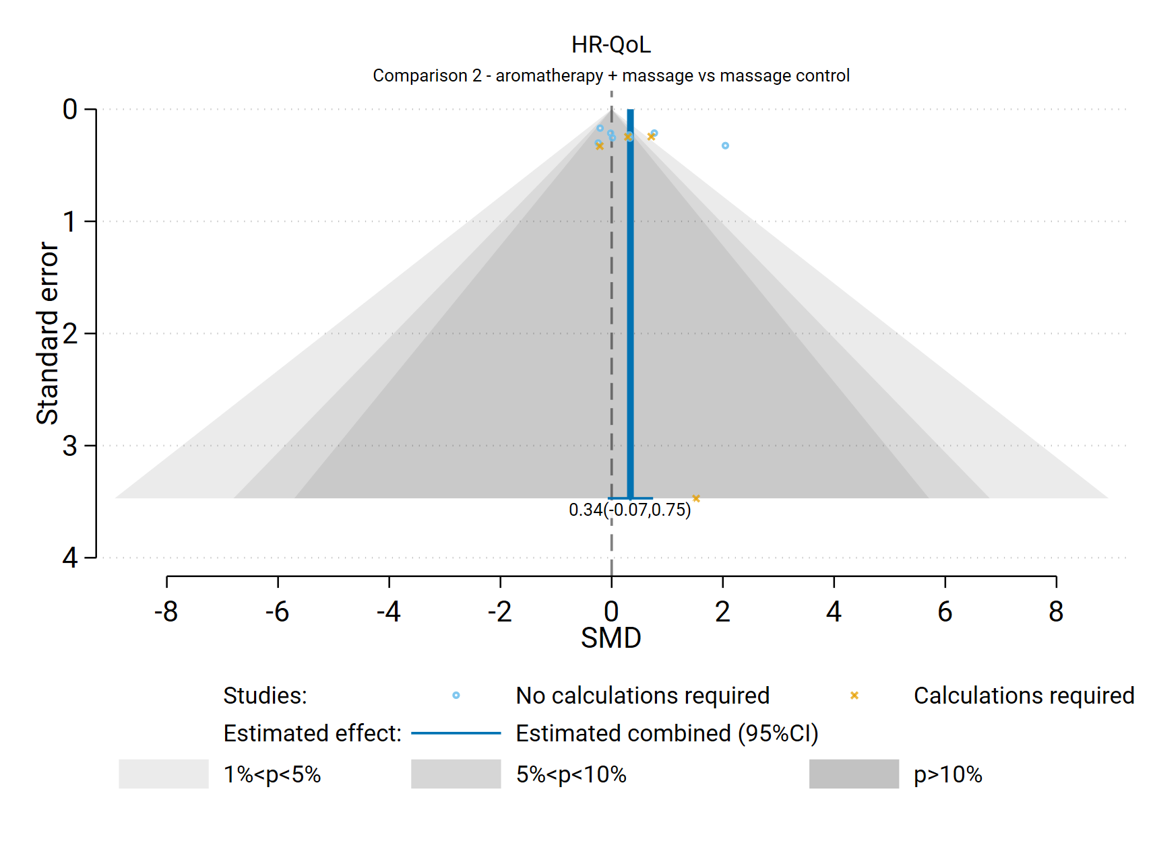**Fig D6.3** | Contour enhanced funnel plot of estimates of SMD versus their standard errors for Comparison 2. the effect of aromatherapy (massage) versus inactive control (massage) on HR-QoL. Shaded regions represent different categories of conventional milestone levels of statistical significance. SMD = standardised mean difference. Blue line shows the combined estimate from random effects model.

## D7 Physical function

Results presented in this section are for the additional subgroup analysis, sensitivity analyses, and analyses to examine the risk of bias due to missing results.

### Comparison 1: Aromatherapy (any mode) versus inactive control (usual care, placebo, no intervention)

For the outcome physical function, 10 studies were included in the meta-analysis for Comparison 1 which compared aromatherapy delivered by any mode to an inactive control that did not involve massage (usual care, placebo, no intervention).

#### Results of subgroup analyses

The following subgroup analyses were performed to investigate whether there was a credible explanation for the inconsistent effects that were observed across studies (statistical heterogeneity).

1. Population group (both comparisons): whether the combined estimate of effect was importantly different for different population groups (chronic musculoskeletal conditions, cancer and advanced disease, other chronic conditions).
2. Mode of aromatherapy delivery (Comparison 1 only): whether the combined estimate of effect was importantly different when aromatherapy was delivered by massage compared to another mode (inhalation, topical).

Neither of the subgroup analyses provided a credible explanation for any inconsistent effects observed across studies (i.e., differences in the direction or size of the observed effect) in Comparison 1.

***Population group***

Results for this analysis are presented in the main report (Section 4.8, Figure 4.8.1). The test for subgroup differences was statistically significant (P < 0.005) but this was likely due to a very narrow confidence interval for the cancer subgroup which contained a single study. The estimates for the two subgroups that included multiple studies were identical and had completely overlapping confidence interval, and the I2 indicated inconsistency within each subgroup. These results suggest that population group does not explain any observed inconsistency in the overall analysis.

***Mode of aromatherapy delivery***

Results for this analysis are presented in Figure D7.1. The test for subgroup differences was significant (P = 0.019). Results were relatively consistent when aromatherapy was delivered by massage (overlapping confidence intervals, I2 = 27%), slightly less so in the inhalation subgroup. The effect is larger in the massage group (SMD=0.81) than in the inhalation group (SMD=0.23). This provides some evidence that mode of delivery may partially explain inconsistent effects across studies in the overall analysis. While the point estimates for each subgroup differ in size (SMD of 0.23 for inhalation/topical; SMD of 0.81 for massage), both estimates indicate an important improvement in physical function with aromatherapy and the confidence intervals for the subgroup estimates overlap.

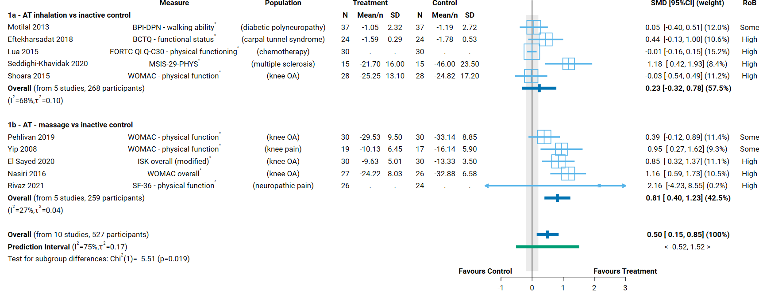**Fig D7.1** | Forest plot for Comparison 1. the effect of aromatherapy (any mode) versus inactive control (usual care, no intervention, placebo) on physical function; subgrouped by mode of aromatherapy delivery. SMD = standardised mean difference. Blue lines show 95% confidence intervals (CI) and green lines show prediction intervals (PI). The shaded grey area indicates the pre-specified range where the effect of aromatherapy is considered to be no different from control (SMD -0.2 to 0.2 standard units). ^ indicates studies for which data transformation or imputation was required to include the result in the meta-analysis. This included crossover trials and studies that reported results as a dichotomous or ordinal outcome (identifiable because no mean or SD is reported for the study in the forest plot). * Denotes studies for which the direction of effect was changed to match the overall plot (e.g. positive numbers are beneficial)

#### Results of sensitivity analyses

**Table D7.1** presents results for the original analysis (all studies, random effects model) and three sensitivity analyses. These sensitivity analyses investigate:

1. whether the combined estimate is sensitive to the assumptions that were made to enable inclusion of results in the meta-analysis, specifically
   1. transforming or imputing statistics, or
   2. transforming or imputing statistics, and including change scores (change from baseline) when post-intervention (final) values (and their standard deviations) were unavailable; and
2. whether the combined effect differs when estimated from a fixed effect model, providing evidence of small study effects (which may be due to true differences in the effects in small studies or may suggest non-reporting bias).

The combined estimate of effect was similar in the original analysis and the sensitivity analyses removing studies for which transforming or imputing statistics was necessary. No additional studies were removed because change scores were used. This indicates that the result was robust to the assumptions required to include these results.

**Table D7.1. Sensitivity analyses for physical function outcome, both comparisons**

|  |  |  |  |  |  |  |
| --- | --- | --- | --- | --- | --- | --- |
| Comparison1 | Sensitivity analysis | Purpose of sensitivity analysis | No trials | Original effect (95% CI) | No trials | Sensitivity analysis effect |
| C1. AT (any mode) v inactive control (not massage) | No imputation or transformations2 | Investigate robustness of MA effect | 10 | SMD 0.50 (0.15 to  0.85); I2 = 75% | 8 | SMD 0.58 (0.19 to  0.98); I2 = 64% |
| No imputation, transformations or change scores3 | Investigate robustness of MA effect |  |  |  | No additional studies removed. |
| Fixed effect analysis | Investigate small study effects (bias due to missing results) |  |  | 10 | SMD 0.20 (0.08 to 0.32); I2 = 76% |
| C2. AT (massage) v control (massage) | No imputation or transformations2 | Investigate robustness of MA effect | 7 | SMD 0.45 (0.09 to  0.80); I2 = 48% | 6 | SMD 0.44 (0.04 to 0.84);  I2 = 53% |
| No imputation, transformations or change scores3 | Investigate robustness of MA effect |  |  |  | No additional studies removed. |
| Fixed effect analysis | Investigate small study effects (bias due to missing results) |  |  | 7 | SMD 0.46 (0.26 to 0.67);  I2 = 44% |

1 C1. includes studies that compare AT (any mode, massage or not) to an inactive control that does not involve massage; C2 includes studies that compare AT (massage) to a massage control that is comparable to that used to deliver AT.

2 This analysis was limited to trials that reported i) means and standard deviations, ii) means and standard errors, or iii) mean differences and their confidence intervals

3 This analysis was limited to trials that (a) reported i) means and standard deviations, ii) means and standard errors, or iii) mean differences and their confidence intervals, and (b) had post-intervention (final) values available.

*Abbreviations*. AT = aromatherapy; MA = meta-analysis; SMD = standardised mean difference; CI = confidence interval

#### Bias due to missing results from the meta-analysis

For Comparison 1 the combined effect estimated from the fixed effect model (SMD 0.20) was smaller than from the random effects model (SMD 0.50) (Table D7.1), with the fixed effect estimate on the threshold between important improvement and little or no difference in physical function with aromatherapy. The contour-enhanced funnel plot in Figure D7.2 suggests that there could be missing studies which show effects favouring the control (i.e. the plot is asymmetric, missing studies to the left of the line of no effect (SMD 0) where we would expect results for some small studies, most notably in the darker grey shaded areas where nonsignificant results appear). However, the number of studies is small so we cannot be confident that this is due to non-reporting bias.

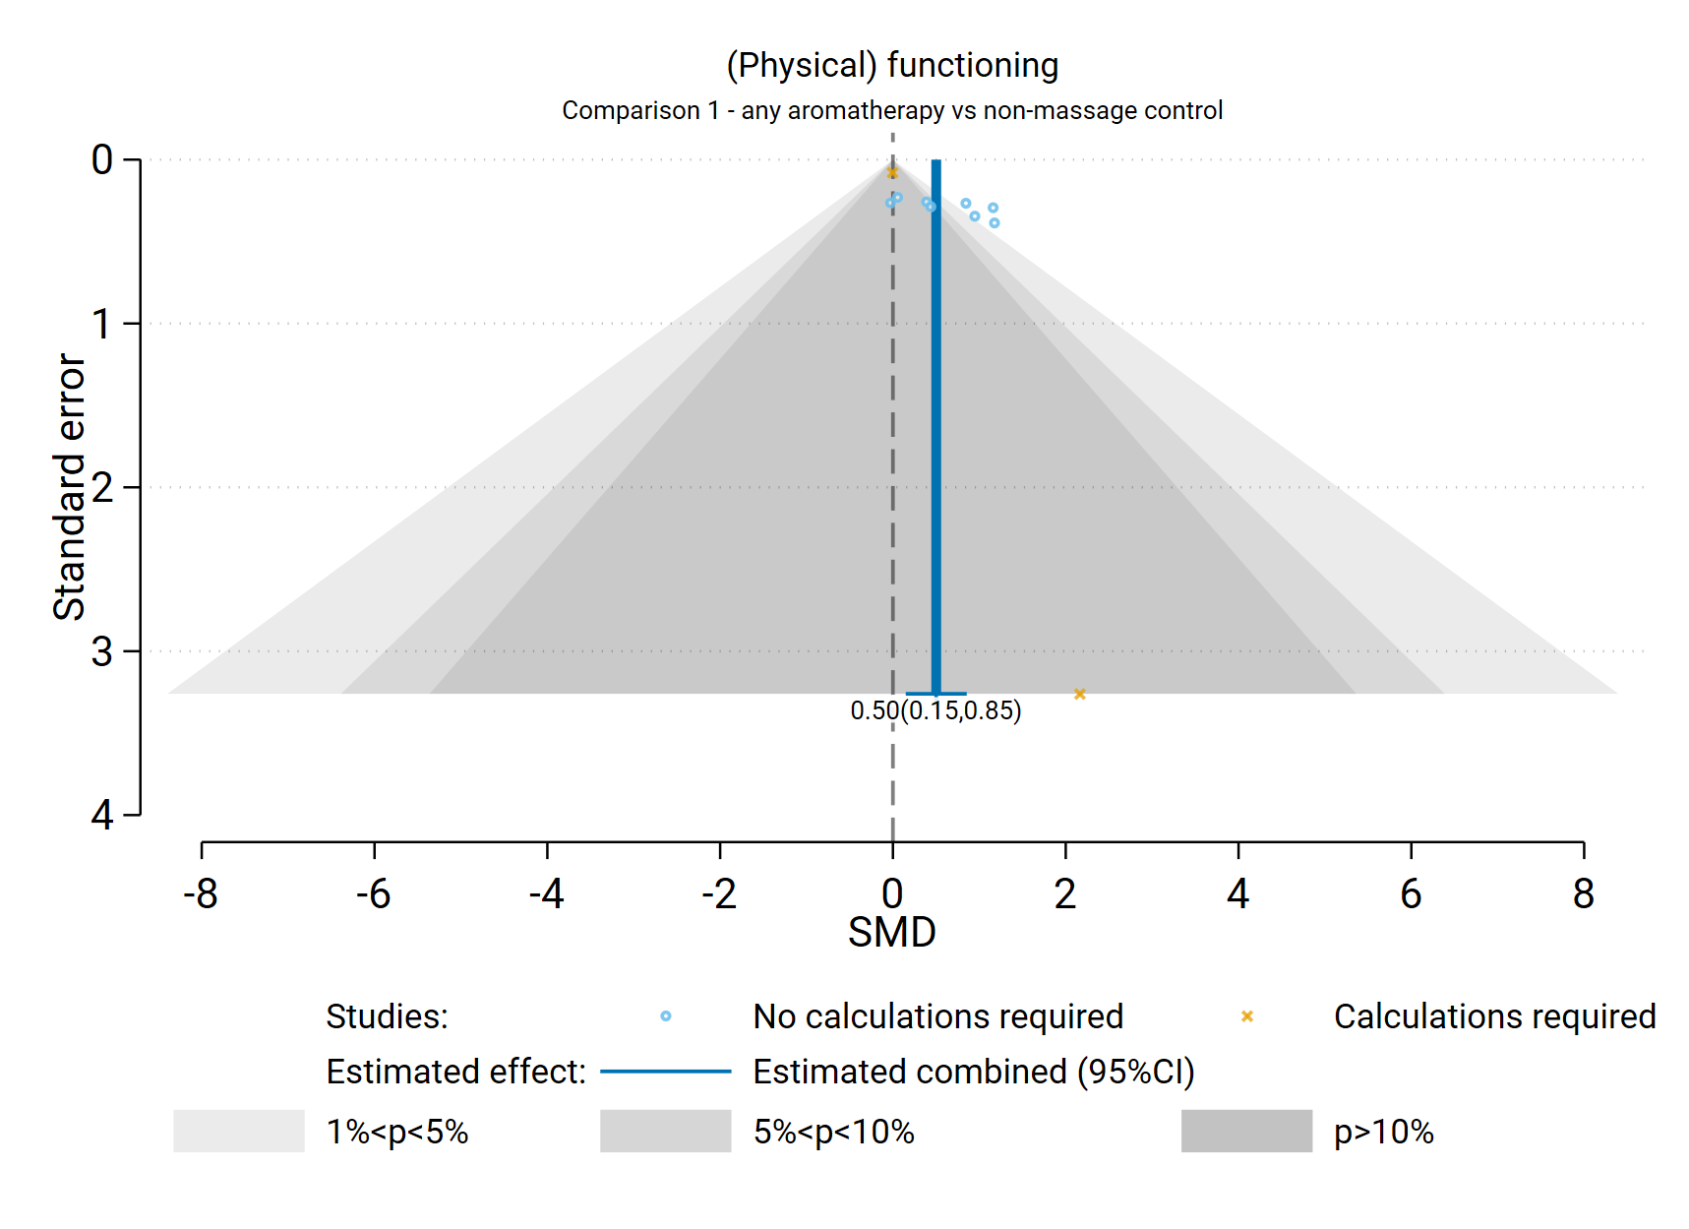

**Fig D7.2** | Contour enhanced funnel plot of estimates of SMD versus their standard errors for Comparison 1. the effect of aromatherapy (any mode) versus inactive control (usual care, no intervention, placebo) on physical function. Shaded regions represent different categories of conventional milestone levels of statistical significance. SMD = standardised mean difference. Blue line shows the combined estimate from random effects model.

### Comparison 2: Aromatherapy (massage) versus inactive control (massage)

For the outcome physical function, 7 studies were included in the meta-analysis for Comparison 2 which compared aromatherapy delivered by massage to an inactive massage control (i.e. a comparable form of massage to that received by the intervention group).

#### Results of subgroup analyses

***Population group***

A single subgroup analysis was performed to investigate whether there was a credible explanation for the inconsistent effects that were observed across studies (statistical heterogeneity). Specifically, whether the combined estimate of effect was importantly different for the different population groups contributing to the analysis (chronic musculoskeletal conditions, other chronic conditions).

Results for this analysis are presented in the main report (Section 4.8, Figure 4.8.2). The test for subgroup differences was not significant (P < 0.399), which is expected with only two subgroups. However, the point estimates for both subgroups was similar and the confidence intervals for these estimates were entirely overlapping. This suggests that the population group does not explain any inconsistency in the effects across studies in the overall analysis, which was minimal.

#### Results of sensitivity analyses

**Table D7.1** presents results for the original analysis (all studies, random effects model) and two sensitivity analyses for Comparison 2. The combined estimate of effect was similar in the original analysis and the sensitivity analyses removing studies for which transforming or imputing statistics was necessary. No additional studies were removed because change scores were used. This indicates that the result was robust to the assumptions required to include these results.

#### Bias due to missing results from the meta-analysis

The combined effect estimated from the fixed effect model (SMD 0.46) was the same as that from the random effects model (SMD 0.45) (Table D7.1). The contour-enhanced funnel plot in Figure D7.3 includes too few studies to provide any evidence about missing results (publication bias).

**Fig D7.3** | Contour enhanced funnel plot of estimates of SMD versus their standard errors for Comparison 2. the effect of aromatherapy (massage) versus inactive control (massage) on physical function. Shaded regions represent different categories of conventional milestone levels of statistical significance. SMD = standardised mean difference. Blue line shows the combined estimate from random effects model.

## D8 References to included studies

If multiple reports, the first citation is the index paper

|  |  |
| --- | --- |
| Abbasijahromi 2020 | Abbasijahromi A, Hojati H, Nikooei S, Jahromi HK, Dowlatkhah HR, Zarean V, et al. Compare the effect of aromatherapy using lavender and Damask rose essential oils on the level of anxiety and severity of pain following C-section: A double-blinded randomized clinical trial. J Complement Integr Med. 2020;17(3). |
| Abbaszadeh 2018 | Abbaszadeh R, Tabari F, Jafarabadi M, Torabi S. The effect of lavender scent on the severity of pain caused by bone marrow biopsy. Indian Journal of Forensic Medicine and Toxicology. 2018;12(3):189‐94.  Abbaszadeh R, Tabari F, Asadpour A. The Effect of Lavender Aroma on Anxiety of Patients Having Bone Marrow Biopsy. Asian Pac J Cancer Prev. 2020;21(3):771-5. |
| Abdollahi 2020 | Abdollahi F, Mobadery T. The effect of aromatherapy with bitter orange (Citrus aurantium) extract on anxiety and fatigue in type 2 diabetic patients. Advances in Integrative Medicine. 2020;7(1):3‐7. |
| Abo-S-haghi 2021 | Abo-S-haghi MS, Imani A, Alidadi M, Shafiei E. Comparing the Effects of Lavender Oil and Olive Oil Massage on Pain due to Muscular Cramp during Hemodialysis. Iraq J Pharm Sci. 2021;30(1):163‐8. |
| Adachi 2014 | Adachi N, Munesada M, Yamada N, Suzuki H, Futohashi A, Shigeeda T, et al. Effects of aromatherapy massage on face-down posture-related pain after vitrectomy: a randomized controlled trial. Pain Manag Nurs. 2014;15(2):482-9. |
| Adib-Hajbaghery 2015 | Adib-Hajbaghery M, Hosseini FS. Investigating the effects of inhaling ginger essence on post-nephrectomy nausea and vomiting. Complement Ther Med. 2015;23(6):827-31. |
| Ahmadi 2020 | Ahmadi Y, Rezaei J, Rezaei M, Khatony A. Comparison of the Effect of Inhalation Aromatherapy with 10% and 30% Peppermint Essential Oils on the Severity of Nausea in Abdominal Surgery Patients. Evid Based Complement Alternat Med. 2020;2020:5897465. |
| Ahmadifard 2020 | Ahmadifard M, Yarahmadi S, Ardalan A, Ebrahimzadeh F, Bahrami P, Sheikhi E. The Efficacy of Topical Basil Essential Oil on Relieving Migraine Headaches: A Randomized Triple-Blind Study. Complement Med Res. 2020;27(5):310-8. |
| Ahmady 2019 | Ahmady S, Rezaei M, Khatony A. Comparing effects of aromatherapy with lavender essential oil and orange essential oil on fatigue of hemodialysis patients: A randomized trial. Complement Ther Clin Pract. 2019;36:64-8. |
| Akbari 2019 | Akbari F, Rezaei M, Khatony A. Effect Of Peppermint Essence On The Pain And Anxiety Caused By Intravenous Catheterization In Cardiac Patients: A Randomized Controlled Trial. J Pain Res. 2019;12:2933-9 |
| Akcan 2016 | Akcan E, Polat S. Comparative Effect of the Smells of Amniotic Fluid, Breast Milk, and Lavender on Newborns' Pain During Heel Lance. Breastfeed Med. 2016;11(6):309-14. |
| Alavi 2017 | Alavi A, Askari M, Nejad E, Bagheri P. Study the effect of massage with jasmine oil in comparison to aromatherapy with jasmine oil on childbirth process in hospitals of Abadan city in 2013. Annals of Tropical Medicine and Public Health. 2017;10(4):904‐9. |
| Amini 2020 | Amini A, Bahraminejad N, Jafari S, Kamali K. The effect of aromatherapy with rosa damascena essence on postoperative pain in inguinal hernia repair: A randomized clinical trial. Nursing and Midwifery Studies. 2020;9(3):117-23. |
| Amirhosseini 2020 | Amirhosseini M, Dehghan M, Mangolian Shahrbabaki P, Pakmanesh H. Effectiveness of Aromatherapy for Relief of Pain, Nausea, and Vomiting after Percutaneous Nephrolithotomy: A Randomized Controlled Trial. Complement Med Res. 2020;27(6):440-8. |
| Amzajerdi 2019 | Amzajerdi A, Keshavarz M, Montazeri A, Bekhradi R. Effect of mint aroma on nausea, vomiting and anxiety in pregnant women. J Family Med Prim Care. 2019;8(8):2597-601. |
| Anderson 2004 | Anderson LA, Gross JB. Aromatherapy with peppermint, isopropyl alcohol, or placebo is equally effective in relieving postoperative nausea. J Perianesth Nurs. 2004;19(1):29-35. |
| Arabfirouzjaei 2019 | Arabfirouzjaei Z, Ilali ES, Taraghi Z, Mohammadpour RA, Amin K, Habibi E. The effect of citrus aurantium aroma on sleep quality in the elderly with heart failure. Journal of Babol University of Medical Sciences. 2019;21(1):181‐7. |
| Ardahan Akgül 2021 | Ardahan Akgül E, Karakul A, Altın A, Doğan P, Hoşgör M, Oral A. Effectiveness of lavender inhalation aromatherapy on pain level and vital signs in children with burns: a randomized controlled trial. Complement Ther Med. 2021;60:102758. |
| Arslan 2020 | Arslan I, Aydinoglu S, Karan NB. Can lavender oil inhalation help to overcome dental anxiety and pain in children? A randomized clinical trial. Eur J Pediatr. 2020;179(6):985-92. |
| Asgari 2020 | Asgari MR, Vafaei-Moghadam A, Babamohamadi H, Ghorbani R, Esmaeili R. Comparing acupressure with aromatherapy using Citrus aurantium in terms of their effectiveness in sleep quality in patients undergoing percutaneous coronary interventions: A randomized clinical trial. Complement Ther Clin Pract. 2020;38:101066. |
| Ayan 2013 | Ayan M, Tas U, Sogut E, Suren M, Gurbuzler L, Koyuncu F. Investigating the effect of aromatherapy in patients with renal colic. J Altern Complement Med. 2013;19(4):329-33. |
| Ayik 2018 | Ayik C, Ozden D. The effects of preoperative aromatherapy massage on anxiety and sleep quality of colorectal surgery patients: A randomized controlled study. Complement Ther Med. 2018;36:93-9. |
| Azima 2015 | Azima S, Bakhshayesh HR, Kaviani M, Abbasnia K, Sayadi M. Comparison of the Effect of Massage Therapy and Isometric Exercises on Primary Dysmenorrhea: A Randomized Controlled Clinical Trial. J Pediatr Adolesc Gynecol. 2015;28(6):486-91. |
| Azizi 2020 | Azizi M, Yosefzadeh S, Rakhshandeh H, Behnam HR, Mirteymouri M. The Effect of Back Massage with and without Ginger Oil on the Pain Intensity in the Active Phase of Labor in Primiparous Women. Journal of Midwifery & Reproductive Health. 2020;8(1):2033‐40. |
| Babaii 2015 | Babaii A, Abbasinia M, Hejazi SF, Seyyed Tabaei SR, Dehghani F. Effect of Rosa Aromatherapy on Anxiety before Cardiac Catheterization: a Randomized Controlled Trial. Health, Spirituality & Medical Ethics Journal. 2015;2(3):2‐8. |
| Babatabar Darzi 2020 | Babatabar Darzi H, Vahedian-Azimi A, Ghasemi S, Ebadi A, Sathyapalan T, Sahebkar A. The effect of aromatherapy with rose and lavender on anxiety, surgical site pain, and extubation time after open-heart surgery: A double-center randomized controlled trial. Phytother Res. 2020;34(10):2675-84. |
| Bagheri 2020 | Bagheri H, Salmani T, Nourian J, Mirrezaie SM, Abbasi A, Mardani A, Vlaisavljevic Z. The Effects of Inhalation Aromatherapy Using Lavender Essential Oil on Postoperative Pain of Inguinal Hernia: A Randomized Controlled Trial. J Perianesth Nurs. 2020 Dec;35(6):642-648. |
| Bahrami 2018 | Bahrami T, Rejeh N, Heravi-Karimooi M, Vaismoradi M, Tadrisi SD, Sieloff CL. Aromatherapy massage versus reflexology on female elderly with acute coronary syndrome. Nurs Crit Care. 2018;23(5):229-36.  Bahrami T, Rejeh N, Heravi-Karimooi M, Tadrisi SD, Vaismoradi M. Reflexology versus aromatherapy massage for relieving anxiety and depression in hospitalized older women: A randomized clinical trial. Int J Caring Sci. 2020;13(1):610-9.  Bahrami T, Rejeh N, Heravi-Karimooi M, Vaismoradi M, Tadrisi SD, Sieloff C. Effect of aromatherapy massage on anxiety, depression, and physiologic parameters in older patients with the acute coronary syndrome: A randomized clinical trial. Int J Nurs Pract. 2017 Dec;23(6). |
| Bakhtshirin 2015 | Bakhtshirin F, Abedi S, YusefiZoj P, Razmjooee D. The effect of aromatherapy massage with lavender oil on severity of primary dysmenorrhea in Arsanjan students. Iran J Nurs Midwifery Res. 2015;20(1):156-60. |
| Ballard 2002 | Ballard CG, O'Brien JT, Reichelt K, Perry EK. Aromatherapy as a safe and effective treatment for the management of agitation in severe dementia: the results of a double-blind, placebo-controlled trial with Melissa. J Clin Psychiatry. 2002;63(7):553-8.  Ballard C, O'Brien J, Reichelt K, et al. A randomized controlled trial of aromatherapy for dementia. Int Psychogeriatr. 2003;15(Suppl 2).  Lee L, Reichelt K, Ballard C, Perry E. Melissa aromatherapy as safe and effective treatment. Nursing and Residential Care. 2003;5(2):80‐2. |
| Barclay 2006 | Barclay J, Vestey J, Lambert A, Balmer C. Reducing the symptoms of lymphoedema: is there a role for aromatherapy? Eur J Oncol Nurs. 2006;10(2):140-9. |
| Beyliklioğlu 2019 | Beyliklioğlu A, Arslan S. Effect of Lavender Oil on the Anxiety of Patients Before Breast Surgery. J Perianesth Nurs. 2019;34(3):587-93. |
| Biçer 2015 | Biçer S, Ünsal A, Demir G. The Effect of Aromatherapy Massage Applied to Facial Area upon Headache Severity among Patients who Suffered from Headache During Hemodialysis. Int J Caring Sci. 2015;8(3):722‐8. |
| Bikmoradi 2016 | Bikmoradi A, Harorani M, Roshanaei G, Moradkhani S, Falahinia GH. The effect of inhalation aromatherapy with damask rose (Rosa damascena) essence on the pain intensity after dressing in patients with burns: A clinical randomized trial. Iran J Nurs Midwifery Res. 2016;21(3):247-54.  Bikmoradi A, Horourani M, Nia GHF, Khani SM, Roshanaei GA. Effects of aromatherapy with rosa essence on hemodynamic indices after dressing change in burn patients. Avicenna Journal of Phytomedicine. 2015;5:25‐6. |
| Blackburn 2017 | Blackburn L, Achor S, Allen B, Bauchmire N, Dunnington D, Klisovic RB, et al. The Effect of Aromatherapy on Insomnia and Other Common Symptoms Among Patients With Acute Leukemia. Oncol Nurs Forum. 2017;44(4):E185-E93. |
| Bozkurt 2019 | Bozkurt P, Vural C. Effect of Lavender Oil Inhalation on Reducing Presurgical Anxiety in Orthognathic Surgery Patients. J Oral Maxillofac Surg. 2019;77(12):2466 e1- e7. |
| Burns 2007 | Burns E, Zobbi V, Panzeri D, Oskrochi R, Regalia A. Aromatherapy in childbirth: a pilot randomised controlled trial. BJOG. 2007;114(7):838‐44. |
| Burns 2011 | Burns A, Perry E, Holmes C, Francis P, Morris J, Howes MJ, et al. A double-blind placebo-controlled randomized trial of Melissa officinalis oil and donepezil for the treatment of agitation in Alzheimer's disease. Dement Geriatr Cogn Disord. 2011;31(2):158-64. |
| Cheraghbeigi 2019 | Cheraghbeigi N, Modarresi M, Rezaei M, Khatony A. Comparing the effects of massage and aromatherapy massage with lavender oil on sleep quality of cardiac patients: A randomized controlled trial. Complement Ther Clin Pract. 2019;35:253-8. |
| Cho 2017 | Cho YS, Choi YH. Comparison of three cooling methods for burn patients: a randomized clinical trial. Burns. 2017;43(3):502‐8. |
| Choi 2016.1 | Choi SY, Park K. Effect of Inhalation of Aromatherapy Oil on Patients with Perennial Allergic Rhinitis: A Randomized Controlled Trial. Evid Based Complement Alternat Med. 2016;2016:7896081.  Choi SY, Park K. Corrigendum to "Effect of Inhalation of Aromatherapy Oil on Patients with Perennial Allergic Rhinitis: A Randomized Controlled Trial". Evid Based Complement Alternat Med. 2016;2016:2103616. |
| Cino 2014 | Cino K. Aromatherapy hand massage for older adults with chronic pain living in long-term care. J Holist Nurs. 2014;32(4):304-13; quiz 14-5. |
| Citlik Saritas 2020 | Citlik Saritas S, Buyukbayram Z, Kaplan Serin E, Bilgic Y. Effects of lavender oil intervention before endoscopic retrograde cholangiopancreatography on patients' vital signs, pain and anxiety: A randomized controlled study. Explore (NY). 2021;17(5):446-50. |
| Corner 1995 | Corner J, Cawley N, Hildebrand S. An evaluation of the use of massage and essential oils on the wellbeing of cancer patients. Int J Palliat Nurs. 1995;1(2):67-73. |
| Dagli 2019 | Dagli R, Avcu M, Metin M, Kiymaz S, Ciftci H. The effects of aromatherapy using rose oil (Rosa damascena Mill.) on preoperative anxiety: a prospective randomized clinical trial. Eur J Integr Med. 2019;26:37‐42. |
| Daneshpajooh 2019 | Daneshpajooh L, Najafi Ghezeljeh T, Haghani H. Comparison of the effects of inhalation aromatherapy using Damask Rose aroma and the Benson relaxation technique in burn patients: a randomized clinical trial. Burns. 2019;45(5):1205‐14. |
| Darsareh 2012 | Darsareh F, Taavoni S, Joolaee S, Haghani H. Effect of aromatherapy massage on menopausal symptoms: a randomized placebo-controlled clinical trial. Menopause. 2012;19(9):995-9.Taavoni S, Darsareh F, Joolaee S, Haghani H. The effect of aromatherapy massage on the psychological symptoms of postmenopausal Iranian women. Complement Ther Med. 2013;21(3):158-63.Taavoni S, Darsareh F, Joolayee S, Haghani H. Effect of aromatherapy massage on psychological symptoms of iranian postmenopausal women: a randomized clinical trial study. Int J Gynaecol Obstet. 2012;119 Suppl 3:S496. |
| Davari 2021 | Davari H, Ebrahimian A, Rezayei S, Tourdeh M. Effect of Lavender Aromatherapy on Sleep Quality and Physiological Indicators in Patients after CABG Surgery: A Clinical Trial Study. Indian J Crit Care Med. 2021;25(4):429-34. |
| de Jong 2012 | de Jong M, Lucas C, Bredero H, van Adrichem L, Tibboel D, van Dijk M. Does postoperative 'M' technique massage with or without mandarin oil reduce infants' distress after major craniofacial surgery? J Adv Nurs. 2012;68(8):1748-57. |
| Dehkordi 2017 | Dehkordi AK, Tayebi A, Ebadi A, Sahraei H, Einollahi B. Effects of aromatherapy using the damask rose essential oil on depression, anxiety, and stress in hemodialysis patients: a clinical trial. Nephro-Urology Monthly. 2017;9(6). |
| Deng 2021 | Deng C, Xie Y, Liu Y, Li Y, Xiao Y. Aromatherapy Plus Music Therapy Improve Pain Intensity and Anxiety Scores in Patients With Breast Cancer During Perioperative Periods: A Randomized Controlled Trial. Clin Breast Cancer. 2022;22(2):115-20. |
| dos Reis Lucena 2021 | Dos Reis Lucena L, Dos Santos-Junior JG, Tufik S, Hachul H. Lavender essential oil on postmenopausal women with insomnia: Double-blind randomized trial. Complement Ther Med. 2021;59:102726.  Lucena LR, Santos JG, Tufik S, Hachul H. Effect of lavender essential oil on sleep in postmenopausal women with insomnia: double-blind randomized controlled trial. Sleep. 2020;43(SUPPL 1):A190‐A1. |
| Doyle 2020 | Doyle JM, Brockway C, Bannon WM, Monturo C. Effects of Lavender on Preprocedural Anxiety in Patients Undergoing Image-Guided Biopsies. J Radiol Nurs. 2020;39(3):229-33. |
| Dunn 1995 | Dunn C, Sleep J, Collett D. Sensing an improvement: an experimental study to evaluate the use of aromatherapy, massage and periods of rest in an intensive care unit. J Adv Nurs. 1995;21(1):34-40. |
| Ebrahimi 2021a | Ebrahimi H, Mardani A, Basirinezhad MH, Hamidzadeh A, Eskandari F. The effects of Lavender and Chamomile essential oil inhalation aromatherapy on depression, anxiety and stress in older community-dwelling people: A randomized controlled trial. Explore (NY). 2022;18(3):272-8. |
| Efe Arslan 2020 | Efe Arslan D, Kılıç Akça N. The effect of aromatherapy hand massage on distress and sleep quality in hemodialysis patients: A randomized controlled trial. Complement Ther Clin Pract. 2020;39:101136. |
| Efe Erturk 2021 | Efe Erturk N, Tasci S. The Effects of Peppermint Oil on Nausea, Vomiting and Retching in Cancer Patients Undergoing Chemotherapy: An Open Label Quasi-Randomized Controlled Pilot Study. Complement Ther Med. 2021;56:102587. |
| Eftekharsadat 2018 | Eftekharsadat B, Roomizadeh P, Torabi S, Heshmati-Afshar F, Jahanjoo F, Babaei-Ghazani A. Effectiveness of Lavendula stoechas essential oil in treatment of mild to moderate carpal tunnel syndrome: A randomized controlled trial. J Hand Ther. 2018;31(4):437-42. |
| El Sayed 2020 | El Sayed EM, Al Sebaee HA, Mohammed HA, Nawito ZO. Effect of lavender oil massage on pain among patients with knee osteoarthritis. Indian Journal of Public Health Research and Development. 2020;11(1):304‐9. |
| Emami-Sigaroudi 2021 | Emami-Sigaroudi A, Salari A, Nourisaeed A, Ahmadnia Z, Ashouri A, Modallalkar SS, et al. Comparison between the effect of aromatherapy with lavender and damask rose on sleep quality in patients undergoing coronary artery bypass graft surgery: A randomized clinical trial. ARYA Atheroscler. 2021;17(1):1-9. |
| Evans 2018 | Evans A, Malvar J, Garretson C, Pedroja Kolovos E, Baron Nelson M. The Use of Aromatherapy to Reduce Chemotherapy-Induced Nausea in Children With Cancer: A Randomized, Double-Blind, Placebo-Controlled Trial. J Pediatr Oncol Nurs. 2018;35(6):392-8.  Evans A, Garretson C, Pedroja E, Malvar J, Margol A, Sposto R, et al. The use of aromatherapy to reduce chemotherapy-induced nausea in children with cancer; A randomized, double blind, placebo controlled trial. Neuro Oncol 2016;18:iii137‐. |
| Fayazi 2011 | Fayazi S, Babashahi M, Rezaei M. The effect of inhalation aromatherapy on anxiety level of the patients in preoperative period. Iran J Nurs Midwifery Res. 2011;16(4):278-83. |
| Fazlollahpour-Rokni 2019 | Fazlollahpour-Rokni F, Shorofi SA, Mousavinasab N, Ghafari R, Esmaeili R. The effect of inhalation aromatherapy with rose essential oil on the anxiety of patients undergoing coronary artery bypass graft surgery. Complement Ther Clin Pract. 2019;34:201-7. |
| Franco 2016 | Franco L, Blanck TJ, Dugan K, Kline R, Shanmugam G, Galotti A, et al. Both lavender fleur oil and unscented oil aromatherapy reduce preoperative anxiety in breast surgery patients: a randomized trial. J Clin Anesth. 2016;33:243-9. |
| Fu 2013 | Fu CY, Moyle W, Cooke M. A randomised controlled trial of the use of aromatherapy and hand massage to reduce disruptive behaviour in people with dementia. BMC Complement Altern Med. 2013;13:165. |
| Gazerani 2021 | Gazerani A, Sarchahi Z, Hosseini SS, lakziyan R, Abavisani M. The effect of inhalation aromatherapy of geranium on pain and physiological indices after appendectomy: a double-blind randomized clinical trial. Int J Surg Open. 2021;28:44‐9. |
| Genç 2020 | Genc F, Karadag S, Kilic Akca N, Tan M, Cerit D. The Effect of Aromatherapy on Sleep Quality and Fatigue Level of the Elderly: A Randomized Controlled Study. Holist Nurs Pract. 2020;34(3):155-62. |
| Ghaderi 2020 | Ghaderi F, Solhjou N. The effects of lavender aromatherapy on stress and pain perception in children during dental treatment: A randomized clinical trial. Complement Ther Clin Pract. 2020;40:101182. |
| Gok Metin 2016 | Gok Metin Z, Ozdemir L. The Effects of Aromatherapy Massage and Reflexology on Pain and Fatigue in Patients with Rheumatoid Arthritis: A Randomized Controlled Trial. Pain Manag Nurs. 2016;17(2):140-9. |
| Gok Metin 2017 | Gok Metin Z, Arikan Donmez A, Izgu N, Ozdemir L, Arslan IE. Aromatherapy Massage for Neuropathic Pain and Quality of Life in Diabetic Patients. J Nurs Scholarsh. 2017;49(4):379-88. |
| Goli 2020 | Goli R, Arad M, Mam-Qaderi M, Parizad N. Comparing the effects of geranium aromatherapy and music therapy on the anxiety level of patients undergoing inguinal hernia surgery: A clinical trial. Explore (NY). 2022 Jan-Feb;18(1):57-63. |
| Graham 2003 | Graham PH, Browne L, Cox H, Graham J. Inhalation aromatherapy during radiotherapy: results of a placebo-controlled double-blind randomized trial. J Clin Oncol. 2003;21(12):2372-6. |
| Habibzadeh 2020 | Habibzadeh H, Wosoi Dalavan O, Alilu L, Wardle J, Khalkhali H, Nozad A. Effects of Foot Massage on Severity of Fatigue and Quality of Life in Hemodialysis Patients: A Randomized Controlled Trial. Int J Community Based Nurs Midwifery. 2020;8(2):92-102. |
| Hadi 2011 | Hadi N, Hanid AA. Lavender essence for post-cesarean pain. Pak J Biol Sci. 2011;14(11):664-7. |
| Hajibagheri 2014 | Hajibagheri A, Babaii A, Adib-Hajbaghery M. Effect of Rosa damascene aromatherapy on sleep quality in cardiac patients: a randomized controlled trial. Complement Ther Clin Pract. 2014;20(3):159-63. |
| Hamdamian 2018 | Hamdamian S, Nazarpour S, Simbar M, Hajian S, Mojab F, Talebi A. Effects of aromatherapy with Rosa damascena on nulliparous women's pain and anxiety of labor during first stage of labor. J Integr Med. 2018;16(2):120-5. |
| Han 2006 | Han SH, Hur MH, Buckle J, Choi J, Lee MS. Effect of aromatherapy on symptoms of dysmenorrhea in college students: A randomized placebo-controlled clinical trial. J Altern Complement Med. 2006;12(6):535-41. |
| Hasanzadeh 2016 | Hasanzadeh F, Kashouk NM, Amini S, Asili J, Emami SA, Vashani HB, et al. The effect of cold application and lavender oil inhalation in cardiac surgery patients undergoing chest tube removal. EXCLI J. 2016;15:64-74. |
| Hassanzadeh 2018 | Hassanzadeh M, Kiani F, Bouya S, Zarei M. Comparing the effects of relaxation technique and inhalation aromatherapy on fatigue in patients undergoing hemodialysis. Complement Ther Clin Pract. 2018;31:210-4. |
| Hawkins 2019 | Hawkins JR, Weatherby N, Wrye B, Ujcich Ward K. Bergamot Aromatherapy for Medical Office-Induced Anxiety Among Children With an Autism Spectrum Disorder: A Randomized, Controlled, Blinded Clinical Trial. Holist Nurs Pract. 2019;33(5):285-94. |
| Hawkins 2020 | Hawkins J, Hires CY, Dunne EW, Keenan LA. Aromatherapy reduces fatigue among women with hypothyroidism: A randomized placebo-controlled clinical trial. J Complement Integr Med. 2019;17(1):1‐9. |
| Heidari Gorji 2015 | Heidari Gorji MA, Ashrastaghi OG, Habibi V, Charati JY, Ebrahimzadeh MA, Ayasi M. The effectiveness of lavender essence on strernotomy related pain intensity after coronary artery bypass grafting. Adv Biomed Res. 2015;4:127. |
| Hekmatpou 2017.1 | Hekmatpou D, Pourandish Y, Farahani PV, Parvizrad R. The Effect of Aromatherapy with the Essential Oil of Orange on Pain and Vital Signs of Patients with Fractured Limbs Admitted to the Emergency Ward: A Randomized Clinical Trial. Indian J Palliat Care. 2017;23(4):431-6.  Hekmatpou D, Pourandish Y, Farahani PV, Parvizrad R. The Effect of Aromatherapy with Orange Essential Oil on Anxiety and Pain in Patients with Fractured Limbs Admitted to an Emergency Ward: A Randomized Clinical Trial. Central European Journal of Nursing and Midwifery. 2017;8(4):717-22. |
| Heydarirad 2019 | Heydarirad G, Keyhanmehr AS, Mofid B, Nikfarjad H, Mosavat SH. Efficacy of aromatherapy with Rosa damascena in the improvement of sleep quality of cancer patients: A randomized controlled clinical trial. Complement Ther Clin Pract. 2019;35:57-61. |
| Hodge 2014 | Hodge NS, McCarthy MS, Pierce RM. A prospective randomized study of the effectiveness of aromatherapy for relief of postoperative nausea and vomiting. J Perianesth Nurs. 2014;29(1):5-11. |
| Hozumi 2017 | Hozumi H, Hasegawa S, Tsunenari T, Sanpei N, Arashina Y, Takahashi K, et al. Aromatherapies using Osmanthus fragrans oil and grapefruit oil are effective complementary treatments for anxious patients undergoing colonoscopy: A randomized controlled study. Complement Ther Med. 2017;34:165-9.  Hozumi H, Tsunenari T, Tomimatsu S. Aromatherapy can attenuate anxiety and anxiety-related abdominal discomfort during colonoscopy. Gastrointest Endosc. 2016;83(5):AB446‐. |
| Hu 2010 | Hu PH, Peng YC, Lin YT, Chang CS, Ou MC. Aromatherapy for reducing colonoscopy related procedural anxiety and physiological parameters: a randomized controlled study. Hepatogastroenterology. 2010;57(102-103):1082-6. |
| Hunt 2013 | Hunt R, Dienemann J, Norton HJ, Hartley W, Hudgens A, Stern T, et al. Aromatherapy as treatment for postoperative nausea: a randomized trial. Anesth Analg. 2013;117(3):597-604. |
| Hur 2019 | Hur MH, Hong JH, Yeo SH. Effects of aromatherapy on stress, fructosamine, fatigue, and sleep quality in prediabetic middle-aged women: A randomised controlled trial. Eur J Integr Med. 2019;31. |
| Izgu 2019a | Izgu N, Ozdemir L, Bugdayci Basal F. Effect of Aromatherapy Massage on Chemotherapy-Induced Peripheral Neuropathic Pain and Fatigue in Patients Receiving Oxaliplatin: An Open Label Quasi-Randomized Controlled Pilot Study. Cancer Nurs. 2019;42(2):139-47.  Izgu N, Ozdemir L, Bugdayci Basal F. Effect of aromatherapy massage on chemotherapy-induced peripheral neuropathic pain and fatigue in patients receiving oxaliplatin. Ann Oncol. 2018;29:viii699‐. |
| Izgu 2020 | Izgu N, Yayla EM, Ozdemir L, Gemalmaz A. Inhalation aromatherapy on nausea, vomiting and anxiety during autologous hematopoietic stem cell transplantation: An open-label randomized controlled trial. Eur J Integr Med. 2020;35.  Izgu N, Yayla EM, Ozdemir L, Gemalmaz A. The effect of inhalation aromatherapy with orange essential oil on nausea, vomiting and anxiety during autologous hematopoietic stem cell transplantation. Bone Marrow Transplant. 2019;53:828‐. |
| Jadhav 2020 | Jadhav GR, Mittal P. Evaluation of aromatherapy on success rate of inferior alveolar nerve block in teeth with irreversible pulpitis: a prospective randomized clinical trial. Quintessence Int. 2020;51(10):864-70. |
| Janula 2015 | Janula R, Mahipal S. Effectiveness of aromatherapy and biofeedback in promotion of labour outcome during childbirth among primigravidas. Health Science Journal. 2015;9(1):1-5. |
| Jodaki 2021 | Jodaki K, Abdi K, Mousavi MS, Mokhtari R, Asayesh H, Vandali V, et al. Effect of rosa damascene aromatherapy on anxiety and sleep quality in cardiac patients: A randomized controlled trial. Complement Ther Clin Pract. 2021;42:101299. |
| Jokar 2020 | Jokar M, Delam H, Bakhtiari S, Paki S, Askari A, Bazrafshan M, et al. The Effects of Inhalation Lavender Aromatherapy on Postmenopausal Women's Depression and Anxiety: a Randomized Clinical Trial. Journal for Nurse Practitioners. 2020;16(8):617‐22. |
| Joulaeerad 2018 | Joulaeerad N, Ozgoli G, Hajimehdipoor H, Ghasemi E, Salehimoghaddam F. Effect of Aromatherapy with Peppermint Oil on the Severity of Nausea and Vomiting in Pregnancy: A Single-blind, Randomized, Placebo-controlled trial. J Reprod Infertil. 2018;19(1):32-8. |
| Jun 2013 | Jun YS, Kang P, Min SS, Lee JM, Kim HK, Seol GH. Effect of eucalyptus oil inhalation on pain and inflammatory responses after total knee replacement: a randomized clinical trial. Evid Based Complement Alternat Med. 2013;2013:502727. |
| Kabiri 2018 | Kabiri F, Hasanpour-Dehkordi A, Dris F. Effects of massage therapy and aromatherapy on fatigue in patients with knee osteoarthritis. J Herbmed Pharmacol. 2018;7(3):141‐7.  Hasanpour-Dehkordi A, Kabiri F, Dris F. Comparing the Effects of Massage Therapy and Aromatherapy on Knee Pain, Morning Stiffness, Daily Life Function, and Quality of Life in Patients with Knee Osteoarthritis. Complement Med Res. 2021;28(4):292-9. |
| Karadag 2017 | Karadag E, Samancioglu S, Ozden D, Bakir E. Effects of aromatherapy on sleep quality and anxiety of patients. Nurs Crit Care. 2017;22(2):105-12. |
| Karadag 2019 | Karadag E, Samancioglu Baglama S. The Effect of Aromatherapy on Fatigue and Anxiety in Patients Undergoing Hemodialysis Treatment: A Randomized Controlled Study. Holist Nurs Pract. 2019;33(4):222-9. |
| Karaman 2016 | Karaman T, Karaman S, Dogru S, Tapar H, Sahin A, Suren M, et al. Evaluating the efficacy of lavender aromatherapy on peripheral venous cannulation pain and anxiety: A prospective, randomized study. Complement Ther Clin Pract. 2016;23:64-8. |
| Karaman 2019 | Karaman S, Karaman T, Tapar H, Dogru S, Suren M. A randomized placebo-controlled study of aromatherapy for the treatment of postoperative nausea and vomiting. Complement Ther Med. 2019;42:417-21. |
| Karan 2019 | Karan NB. Influence of lavender oil inhalation on vital signs and anxiety: A randomized clinical trial. Physiol Behav. 2019;211:112676. |
| Karimzadeh 2021.1 | Karimzadeh Z, Azizzadeh Forouzi M, Tajadini H, Ahmadinejad M, Roy C, Dehghan M. Effects of lavender and Citrus aurantium on pain of conscious intensive care unit patients: A parallel randomized placebo-controlled trial. J Integr Med. 2021;19(4):333-9.  Karimzadeh Z, Azizzadeh Forouzi M, Rahiminezhad E, Ahmadinejad M, Dehghan M. The Effects of Lavender and Citrus aurantium on Anxiety and Agitation of the Conscious Patients in Intensive Care Units: A Parallel Randomized Placebo-Controlled Trial. Biomed Res Int. 2021;2021:5565956. |
| Kasar 2020 | Kasar KS, Yildirim Y, Senuzun Aykar F, Uyar M, Sagin FG, Atay S. Effect of Inhalation Aromatherapy on Pain, Anxiety, Comfort, and Cortisol Levels During Trigger Point Injection. Holist Nurs Pract. 2020;34(1):57-64. |
| Kaviani 2014 | Kaviani M, Azima S, Alavi N, Hossein M. The effect of lavender aromatherapy on pain perception and intrapartum outcome in primiparous women. Br J Midwifery. 2014;22(2):125-8. |
| Kawabata 2020 | Kawabata N, Hata A, Aoki T. Effect of Aromatherapy Massage on Quality of Sleep in the Palliative Care Ward: A Randomized Controlled Trial. J Pain Symptom Manage. 2020;59(6):1165-71. |
| Keshavarz Afshar 2015 | Keshavarz Afshar M, Behboodi Moghadam Z, Taghizadeh Z, Bekhradi R, Montazeri A, Mokhtari P. Lavender fragrance essential oil and the quality of sleep in postpartum women. Iran Red Crescent Med J. 2015;17(4):e25880. |
| Kheirkhah 2014 | Kheirkhah M, Vali Pour NS, Nisani L, Haghani H. Comparing the effects of aromatherapy with rose oils and warm foot bath on anxiety in the first stage of labor in nulliparous women. Iran Red Crescent Med J. 2014;16(9):e14455. |
| Khiewkhern 2013 | Khiewkhern S, Promthet S, Sukprasert A, Eunhpinitpong W, Bradshaw P. Effectiveness of aromatherapy with light thai massage for cellular immunity improvement in colorectal cancer patients receiving chemotherapy. Asian Pac J Cancer Prev. 2013;14(6):3903-7. |
| Kianpour 2018 | Kianpour M, Moshirenia F, Kheirabadi G, Asghari G, Dehghani A, Dehghani-Tafti A. The Effects of Inhalation Aromatherapy with Rose and Lavender at Week 38 and Postpartum Period on Postpartum Depression in High-risk Women Referred to Selected Health Centers of Yazd, Iran in 2015. Iran J Nurs Midwifery Res. 2018;23(5):395-401. |
| Kiberd 2016 | Kiberd MB, Clarke SK, Chorney J, d'Eon B, Wright S. Aromatherapy for the treatment of PONV in children: a pilot RCT. BMC Complement Altern Med. 2016;16(1):450. |
| Kılıç Akça 2021 | Kılıç Akça N, Akbuga GA, Arslan DE, Şentürk S. Aromatherapy Massage for Pain and Xerosis After Repeated Needle Insertion Into a Fistula Arm in Hemodialysis. Alternative Therapies in Health and Medicine. 2021;27(3):39‐45. |
| Kim 2006 | Kim JT, Wajda M, Cuff G, Serota D, Schlame M, Axelrod DM, et al. Evaluation of aromatherapy in treating postoperative pain: pilot study. Pain Pract. 2006;6(4):273-7. |
| Kim 2007 | Kim JT, Ren CJ, Fielding GA, Pitti A, Kasumi T, Wajda M, et al. Treatment with lavender aromatherapy in the post-anesthesia care unit reduces opioid requirements of morbidly obese patients undergoing laparoscopic adjustable gastric banding. Obes Surg. 2007;17(7):920-5. |
| Kim 2014 | Kim KY, Seo HJ, Min SS, Park M, Seol GH. The effect of 1,8-cineole inhalation on preoperative anxiety: a randomized clinical trial. Evid Based Complement Alternat Med. 2014;2014:820126. |
| Kritsidima 2010 | Kritsidima M, Newton T, Asimakopoulou K. The effects of lavender scent on dental patient anxiety levels: a cluster randomised-controlled trial. Community Dent Oral Epidemiol. 2010;38(1):83-7. |
| Küçük Alemdar 2019 | Kucuk Alemdar D, Yaman Aktas Y. The Use of the Buzzy, Jet Lidokaine, Bubble-blowing and Aromatherapy for Reducing Pediatric Pain, Stress and Fear Associated with Phlebotomy. J Pediatr Nurs. 2019;45:e64-e72. |
| Kyle 2006 | Kyle G. Evaluating the effectiveness of aromatherapy in reducing levels of anxiety in palliative care patients: results of a pilot study. Complement Ther Clin Pract. 2006;12(2):148-55. |
| Lane 2012 | Lane B, Cannella K, Bowen C, Copelan D, Nteff G, Barnes K, et al. Examination of the effectiveness of peppermint aromatherapy on nausea in women post C-section. J Holist Nurs. 2012;30(2):90-104; quiz 5-6. |
| Leach 2021 | Leach MJ, Sangalli M, Breakspear I, Walsh S. Essential oils for agitation in dementia [rELOAD]: A pragmatic, cluster-randomized, placebo-controlled, pilot feasibility trial. Integr Med Res. 2021;10(4):100747. |
| Lee 2017 | Lee CH, Lai CL, Sung YH, Lai MY, Lin CY, Lin LY. Comparing effects between music intervention and aromatherapy on anxiety of patients undergoing mechanical ventilation in the intensive care unit: a randomized controlled trial. Qual Life Res. 2017;26(7):1819-29. |
| Lehrner 2000 | Lehrner J, Eckersberger C, Walla P, Potsch G, Deecke L. Ambient odor of orange in a dental office reduces anxiety and improves mood in female patients. Physiol Behav. 2000;71(1-2):83-6. |
| Lemon 2004 | Lemon K. An assessment of treating depression and anxiety with aromatherapy. Int J Aromather. 2004;14(2):63‐9. |
| Lillehei 2015 | Lillehei AS, Halcon LL, Savik K, Reis R. Effect of Inhaled Lavender and Sleep Hygiene on Self-Reported Sleep Issues: A Randomized Controlled Trial. J Altern Complement Med. 2015;21(7):430-8.Lillehei AS, Halcon L, Gross CR, Savik K, Reis R. Well-Being and Self-Assessment of Change: secondary Analysis of an RCT That Demonstrated Benefit of Inhaled Lavender and Sleep Hygiene in College Students with Sleep Problems. Explore (NY). 2016;12(6):427‐35.Lillehei AS. Effect of Lavender Aromatherapy via Inhalation and Sleep Hygiene on Sleep in College Students with Self-reported Sleep Issues. Dissertation/ thesis. 2014:167 p. |
| Lin 2007 | Lin PW, Chan WC, Ng BF, Lam LC. Efficacy of aromatherapy (Lavandula angustifolia) as an intervention for agitated behaviours in Chinese older persons with dementia: a cross-over randomized trial. Int J Geriatr Psychiatry. 2007;22(5):405-10. |
| Lotfi 2019 | Lotfi A, Shiri H, Ilkhani R, Sefidkar R, Esmaeeli R. The efficacy of aromatherapy with melissa officinalis in reducing anxiety in cardiac patients: a randomized clinical trial. Crescent Journal of Medical and Biological Sciences. 2019;6(3):293‐9. |
| Lua 2015 | Lua PL, Salihah N, Mazlan N. Effects of inhaled ginger aromatherapy on chemotherapy-induced nausea and vomiting and health-related quality of life in women with breast cancer. Complement Ther Med. 2015;23(3):396-404. |
| Lytle 2014 | Lytle J, Mwatha C, Davis KK. Effect of lavender aromatherapy on vital signs and perceived quality of sleep in the intermediate care unit: a pilot study. Am J Crit Care. 2014;23(1):24-9. |
| Maghami 2020 | Maghami M, Afazel MR, Azizi-Fini I, Maghami M. The effect of aromatherapy with peppermint essential oil on nausea and vomiting after cardiac surgery: A randomized clinical trial. Complement Ther Clin Pract. 2020;40:101199. |
| Marofi 2015 | Marofi M, Sirousfard M, Moeini M, Ghanadi A. Evaluation of the effect of aromatherapy with Rosa damascena Mill. on postoperative pain intensity in hospitalized children in selected hospitals affiliated to Isfahan University of Medical Sciences in 2013: A randomized clinical trial. Iran J Nurs Midwifery Res. 2015;20(2):247-54. |
| Marzouk 2013 | Marzouk TM, El-Nemer AM, Baraka HN. The effect of aromatherapy abdominal massage on alleviating menstrual pain in nursing students: a prospective randomized cross-over study. Evid Based Complement Alternat Med. 2013;2013:742421. |
| Mascherona 2020 | Mascherona I, Ferretti M, Soldini E, Biggiogero M, Maggioli C, Fontana PE. Essential oil therapy for the short-term treatment of behavioral and psychological symptoms of dementia: a monocentric randomized pilot study. Aging Clin Exp Res. 2021;33(8):2251-9. |
| Mehta 1998 | Mehta S, Stone DN, Whitehead HF. Use of essential oil to promote induction of anaesthesia in children. Anaesthesia. 1998;53(7):720-1. |
| Mirhosseini 2021.1 | Mirhosseini S, Abbasi A, Norouzi N, Mobaraki F, Basirinezhad MH, Mohammadpourhodki R. Effect of aromatherapy massage by orange essential oil on post-cesarean anxiety: a randomized clinical trial. J Complement Integr Med. 2021 Mar 30;18(3):579-583. |
| Mitchell 1993 | Mitchell S. Aromatherapy's Effectiveness in Disorders Associated with Dementia. International Journal of Aromatherapy. 1993;5(2):20‐3. |
| Mohammadpourhodki 2021 | Mohammadpourhodki R, Sadeghnezhad H, Ebrahimi H, Basirinezhad MH, Maleki M, Bossola M. The Effect of Aromatherapy Massage With Lavender and Citrus Aurantium Essential Oil on Quality of Life of Patients on Chronic Hemodialysis: A Parallel Randomized Clinical Trial Study. J Pain Symptom Manage. 2021;61(3):456-63 e1. |
| Moradi 2021 | Moradi K, Ashtarian H, Danzima NY, Saeedi H, Bijan B, Akbari F, et al. Essential Oil from Citrus aurantium Alleviates Anxiety of Patients Undergoing Coronary Angiography: A Single-Blind, Randomized Controlled Trial. Chin J Integr Med. 2021;27(3):177-82. |
| Moslemi 2019 | Moslemi F, Alijaniha F, Naseri M, Kazemnejad A, Charkhkar M, Heidari MR. Citrus aurantium Aroma for Anxiety in Patients with Acute Coronary Syndrome: A Double-Blind Placebo-Controlled Trial. J Altern Complement Med. 2019;25(8):833-9. |
| Motilal 2013 | Motilal S, Maharaj RG. Nutmeg extracts for painful diabetic neuropathy: a randomized, double-blind, controlled study. J Altern Complement Med. 2013;19(4):347-52. |
| Muz 2017 | Muz G, Tasci S. Effect of aromatherapy via inhalation on the sleep quality and fatigue level in people undergoing hemodialysis. Appl Nurs Res. 2017;37:28-35. |
| Muzzarelli 2006 | Muzzarelli L, Force M, Sebold M. Aromatherapy and reducing preprocedural anxiety: A controlled prospective study. Gastroenterol Nurs. 2006;29(6):466-71. |
| Nagata 2014 | Nagata K, Iida N, Kanazawa H, Fujiwara M, Mogi T, Mitsushima T, et al. Effect of listening to music and essential oil inhalation on patients undergoing screening CT colonography: a randomized controlled trial. Eur J Radiol. 2014;83(12):2172-6. |
| Najafi 2014 | Najafi Z, Taghadosi M, Sharifi K, Farrokhian A, Tagharrobi Z. The effects of inhalation aromatherapy on anxiety in patients with myocardial infarction: a randomized clinical trial. Iran Red Crescent Med J. 2014;16(8):e15485. |
| Najafi 2017 | Najafi B, Mojab F, Ghaderi L, Farhadifar F, Rroshani D, Seidi J. The effect of chamomile flower essence on pain severity after elective caesarean section under spinal anaesthesia: a randomized clinical trial. J Clin Diagn Res. 2017;11(11):UC01‐UC4.  Najafi B, Fariba F, Daem R, Ghaderi L, Seidi J. The effect of lavender essence on pain severity after cesarean section under spinal anesthesia. J Chem Pharm Sci. 2016;7:66-9. |
| Namazi 2014.1 | Namazi M, Amir Ali Akbari S, Mojab F, Talebi A, Alavi Majd H, Jannesari S. Effects of citrus aurantium (bitter orange) on the severity of first-stage labor pain. Iran J Pharm Res. 2014;13(3):1011-8.  Namazi M, Amir Ali Akbari S, Mojab F, Talebi A, Alavi Majd H, Jannesari S. Aromatherapy with citrus aurantium oil and anxiety during the first stage of labor. Iran Red Crescent Med J. 2014;16(6):e18371. |
| Nasiri 2016 | Nasiri A, Mahmodi MA, Nobakht Z. Effect of aromatherapy massage with lavender essential oil on pain in patients with osteoarthritis of the knee: A randomized controlled clinical trial. Complement Ther Clin Pract. 2016;25:75-80.Nasiri A, Mahmodi MA. Aromatherapy massage with lavender essential oil and the prevention of disability in ADL in patients with osteoarthritis of the knee: A randomized controlled clinical trial. Complement Ther Clin Pract. 2018;30:116-21. |
| Nasiri 2020 | Nasiri M, Asayesh H, Yousefi Khosroabadi Z, Hosseini Amiri M, Bahadori H, Rajaee M. Effects of Aromatherapy with Lavender (Lavandula angustifolia MILL) on Post-Dural Puncture Headache: A Randomized Placebo-Controlled Trial. Altern Ther Health Med. 2022 Jul;28(5):12-19. |
| Nasiri Lari 2020 | Nasiri Lari Z, Hajimonfarednejad M, Riasatian M, Abolhassanzadeh Z, Iraji A, Vojoud M, et al. Efficacy of inhaled Lavandula angustifolia Mill. Essential oil on sleep quality, quality of life and metabolic control in patients with diabetes mellitus type II and insomnia. J Ethnopharmacol. 2020;251:112560. |
| Nazari 2016 | Nazari M, Kamrani F, Sahebalzamani M, Rezaamin G. On the investigation of the effect of aromatherapy on pain after orthopedic surgery: clinical trial. Acta Medica Mediterranea. 2016;32(Specialue4):1513‐9. |
| Ndao 2012 | Ndao DH, Ladas EJ, Cheng B, Sands SA, Snyder KT, Garvin JH, et al. Inhalation aromatherapy in children and adolescents undergoing stem cell infusion: results of a placebo-controlled double-blind trial. Psychooncology. 2012;21(3):247‐54. |
| Ni 2013 | Ni CH, Hou WH, Kao CC, Chang ML, Yu LF, Wu CC, et al. The anxiolytic effect of aromatherapy on patients awaiting ambulatory surgery: a randomized controlled trial. Evid Based Complement Alternat Med. 2013;2013:927419. |
| Nikjou 2016 | Nikjou R, Kazemzadeh R, Rostamnegad M, Moshfegi S, Karimollahi M, Salehi H. The Effect of Lavender Aromatherapy on the Pain Severity of Primary Dysmenorrhea: A Triple-blind Randomized Clinical Trial. Ann Med Health Sci Res. 2016;6(4):211-5. |
| Noruzi Zamenjani 2020 | Noruzi Zamenjani M, Farmahini Farahani M, Amirmohseni L, Pourandish Y, Shamsikhani S, Heydari A, Harorani M. The Effects of Inhalation Aromatherapy on Postoperative Abdominal Pain: A Three-Arm Randomized Controlled Clinical Trial. J Perianesth Nurs. 2021 Apr;36(2):147-152. |
| O'Connor 2013 | O'Connor DW, Eppingstall B, Taffe J, van der Ploeg ES. A randomized, controlled cross-over trial of dermally-applied lavender (Lavandula angustifolia) oil as a treatment of agitated behaviour in dementia. BMC Complement Altern Med. 2013;13:315.  van der Ploeg ES, Eppingstall B, O'Connor DW. The study protocol of a blinded randomised-controlled cross-over trial of lavender oil as a treatment of behavioural symptoms in dementia. BMC Geriatr. 2010;10:49. |
| Olapour 2013 | Olapour A, Behaeen K, Akhondzadeh R, Soltani F, Al Sadat Razavi F, Bekhradi R. The Effect of Inhalation of Aromatherapy Blend containing Lavender Essential Oil on Cesarean Postoperative Pain. Anesth Pain Med. 2013;3(1):203-7. |
| Ou 2012 | Ou MC, Hsu TF, Lai AC, Lin YT, Lin CC. Pain relief assessment by aromatic essential oil massage on outpatients with primary dysmenorrhea: a randomized, double-blind clinical trial. J Obstet Gynaecol Res. 2012;38(5):817-22. |
| Ou 2014 | Ou MC, Lee YF, Li CC, Wu SK. The effectiveness of essential oils for patients with neck pain: a randomized controlled study. J Altern Complement Med. 2014;20(10):771-9. |
| Ovayolu 2014 | Ovayolu O, Sevig U, Ovayolu N, Sevinc A. The effect of aromatherapy and massage administered in different ways to women with breast cancer on their symptoms and quality of life. Int J Nurs Pract. 2014;20(4):408-17. |
| Ozel 2021 | Ozel BZ, Quevedo A, Jung C, Shirazi F, Dancz CE. Lavender Aromatherapy for Anxiety and Pain During Multichannel Urodynamics: A Randomized Controlled Pilot Trial. Female Pelvic Med Reconstr Surg. 2021;27(11):654-8. |
| Ozkaraman 2018 | Ozkaraman A, Dugum O, Ozen Yilmaz H, Usta Yesilbalkan O. Aromatherapy: The Effect of Lavender on Anxiety and Sleep Quality in Patients Treated With Chemotherapy. Clin J Oncol Nurs. 2018;22(2):203-10. |
| Pasha 2012 | Pasha H, Behmanesh F, Mohsenzadeh F, Hajahmadi M, Moghadamnia AA. Study of the effect of mint oil on nausea and vomiting during pregnancy. Iran Red Crescent Med J. 2012;14(11):727-30. |
| Pasyar 2020 | Pasyar N, Rambod M, Araghi F. The effect of bergamot orange essence on anxiety, salivary cortisol, and alpha amylase in patients prior to laparoscopic cholecystectomy: A controlled trial study. Complement Ther Clin Pract. 2020;39:101153. |
| Pehlivan 2019 | Pehlivan S, Karadakovan A. Effects of aromatherapy massage on pain, functional state, and quality of life in an elderly individual with knee osteoarthritis. Jpn J Nurs Sci. 2019;16(4):450-8. |
| Petramfar 2016 | Petramfar P, Moein M, Samani SM, Tabatabaei SH, Zarshenas MM. Trachyspermum ammi 10 % topical cream versus placebo on neuropathic pain, a randomized, double-blind, placebo-controlled trial. Neurol Sci. 2016;37(9):1449-55. |
| Pimenta 2016 | Pimenta FC, Alves MF, Pimenta MB, Melo SA, de Almeida AA, Leite JR, et al. Anxiolytic Effect of Citrus aurantium L. on Patients with Chronic Myeloid Leukemia. Phytother Res. 2016;30(4):613-7. |
| Potter 2011 | Potter P, Eisenberg S, Cain KC, Berry DL. Orange interventions for symptoms associated with dimethyl sulfoxide during stem cell reinfusions: a feasibility study. Cancer Nurs. 2011;34(5):361-8. |
| Premkumar 2019 | Premkumar KS, Syed Aafaque, Sumalatha S, Narendran N. Effect of Aromatherapy on Dental Anxiety Among Orthodontic Patients: A Randomized Controlled Trial. Cureus. 2019;11(8):e5306. |
| Rafi 2020 | Rafi N, Khodadadizadeh A, Safarian Nematabad M, Reza Sayadi A. The evaluation of the effect of aromatherapy with lavender essential oil on the quality of sleep of cardiac patients candidate for angiography. Pakistan Journal of Medical and Health Sciences. 2020;14(2):1143‐7. |
| Rafii 2020 | Rafii F, Ameri F, Haghani H, Ghobadi A. The effect of aromatherapy massage with lavender and chamomile oil on anxiety and sleep quality of patients with burns. Burns. 2020;46(1):164‐71.  Rafiei F, Ameri F, Haghani H, Ghobadi A. Effect of aromatherapy massage with lavender and chamomile oil on the intensity of background pain in burn patients. Iran Journal of Nursing. 2018;31(114):28-37. |
| Rambod 2020 | Rambod M, Rakhshan M, Tohidinik S, Nikoo MH. The effect of lemon inhalation aromatherapy on blood pressure, electrocardiogram changes, and anxiety in acute myocardial infarction patients: A clinical, multi-centered, assessor-blinded trial design. Complement Ther Clin Pract. 2020;39:101155. |
| Rashidi Fakari 2015.1 | Rashidi Fakari F, Tabatabaeichehr M, Kamali H, Rashidi Fakari F, Naseri M. Effect of Inhalation of Aroma of Geranium Essence on Anxiety and Physiological Parameters during First Stage of Labor in Nulliparous Women: a Randomized Clinical Trial. J Caring Sci. 2015;4(2):135-41.Rashidi-Fakari F, Tabatabaeichehr M, Mortazavi H. The effect of aromatherapy by essential oil of orange on anxiety during labor: A randomized clinical trial. Iran J Nurs Midwifery Res. 2015;20(6):661-4. |
| Razaghi 2020 | Razaghi N, Aemmi SZ, Sadat Hoseini AS, Boskabadi H, Mohebbi T, Ramezani M. The effectiveness of familiar olfactory stimulation with lavender scent and glucose on the pain of blood sampling in term neonates: A randomized controlled clinical trial. Complement Ther Med. 2020;49:102289. |
| Rivaz 2021 | Rivaz M, Rahpeima M, Khademian Z, Dabbaghmanesh MH. The effects of aromatherapy massage with lavender essential oil on neuropathic pain and quality of life in diabetic patients: A randomized clinical trial. Complement Ther Clin Pract. 2021;44:101430. |
| Sadathosseini 2013 | Sadathosseini AS, Negarandeh R, Movahedi Z. The effect of a familiar scent on the behavioral and physiological pain responses in neonates. Pain Manag Nurs. 2013;14(4):e196-e203. |
| Sadeghi 2020 | Sadeghi N, Azizi A, Asgari S, Mohammadi Y. The effect of inhalation aromatherapy with damask rose essence on pain intensity and anxiety in burned patients: A single-blind randomized clinical trial. Burns. 2020;46(8):1933-41. |
| Sadeghi Aval Shahr 2015 | Sadeghi Aval Shahr H, Saadat M, Kheirkhah M, Saadat E. The effect of self-aromatherapy massage of the abdomen on the primary dysmenorrhoea. J Obstet Gynaecol. 2015;35(4):382-5. |
| Safajou 2020 | Safajou F, Soltani N, Taghizadeh M, Amouzeshi Z, Sandrous M. The Effect of Combined Inhalation Aromatherapy with Lemon and Peppermint on Nausea and Vomiting of Pregnancy: A Double-Blind, Randomized Clinical Trial. Iran J Nurs Midwifery Res. 2020;25(5):401-6. |
| Sahin 2021a | Şahin S, Tokgöz B, Demir G. Effect of Lavender Aromatherapy On Arteriovenous Fistula Puncture Pain and the Level of State and Trait Anxiety in Hemodialysis Patients: A Randomized Controlled Trial. Pain Manag Nurs. 2021;22(4):509-15. |
| Sahin 2021b | Mizrak Sahin B, Culha I, Gursoy E, Yalcin OT. Effect of Massage With Lavender Oil on Postoperative Pain Level of Patients Who Underwent Gynecologic Surgery: A Randomized, Placebo-Controlled Study. Holist Nurs Pract. 2021;35(4):221-9. |
| Saiyudthong 2009 | Saiyudthong S, Ausavarungnirun R, Jiwajinda S, Turakitwanakan W. Effects of aromatherapy massage with lime essential oil on stress. International Journal of Essential Oil Therapeutics. 2009;3(2‐3):76‐80. |
| Sakamoto 2012 | Sakamoto Y, Ebihara S, Ebihara T, Tomita N, Toba K, Freeman S, et al. Fall prevention using olfactory stimulation with lavender odor in elderly nursing home residents: a randomized controlled trial. J Am Geriatr Soc. 2012;60(6):1005-11. |
| Samadi 2021 | Samadi Z, Jannati Y, Hamidia A, Mohammadpour RA, Hesamzadeh A. The effect of aromatherapy with lavender essential oil on sleep quality in patients with major depression. Journal of Nursing and Midwifery Sciences. 2021;8(2):67-73. |
| Sapmaz 2015 | Irmak Sapmaz H, Uysal M, Tas U, Esen M, Barut M, Somuk BT, et al. The Effect of Lavender Oil in Patients with Renal Colic: A Prospective Controlled Study Using Objective and Subjective Outcome Measurements. J Altern Complement Med. 2015;21(10):617-22. |
| Seddighi-Khavidak 2020 | Seddighi-Khavidak M, Tahan N, Akbarzadeh-Baghban A. Comparing the effects of vestibular rehabilitation with and without lavender oil scents as an olfactory stimulus on balance, fear of falling down and activities of daily living of people with multiple sclerosis: a randomized clinical trial. Disabil Rehabil. 2022;44(13):3132-8. |
| Seifi 2014 | Seifi Z, Beikmoradi A, Oshvandi K, Poorolajal J, Araghchian M, Safiaryan R. The effect of lavender essential oil on anxiety level in patients undergoing coronary artery bypass graft surgery: A double-blinded randomized clinical trial. Iran J Nurs Midwifery Res. 2014;19(6):574-80.  Bikmoradi A, Seifi Z, Poorolajal J, Araghchian M, Safiaryan R, Oshvandi K. Effect of inhalation aromatherapy with lavender essential oil on stress and vital signs in patients undergoing coronary artery bypass surgery: A single-blinded randomized clinical trial. Complement Ther Med. 2015;23(3):331-8.  Seifi Z, Bikmoradi A, Bazrafshan MR, Poorolajal J, Araghchian M, Kashfi SH, et al. The effect of inhalation aromatherapy with lavender essential oil on pain severity of patients after coronary artery bypass surgery: a single-blind randomised clinical trial. J Clin Diagn Res. 2018;12(7):LC01‐LC5. |
| Şentürk 2018 | Şentürk A, Tekinsoy Kartin P. The Effect of Lavender Oil Application via Inhalation Pathway on Hemodialysis Patients' Anxiety Level and Sleep Quality. Holist Nurs Pract. 2018;32(6):324-35. |
| Shahnazi 2012 | Shahnazi M, Nikjoo R, Yavarikia P, Mohammad-Alizadeh-Charandabi S. Inhaled lavender effect on anxiety and pain caused from intrauterine device insertion. J Caring Sci. 2012;1(4):255-61. |
| Shin 2007 | Shin BC, Lee MS. Effects of aromatherapy acupressure on hemiplegic shoulder pain and motor power in stroke patients: a pilot study. J Altern Complement Med. 2007;13(2):247-51. |
| Shirazi 2017 | Shirazi M, Mohebitabar S, Bioos S, Yekaninejad MS, Rahimi R, Shahpiri Z, et al. The Effect of Topical Rosa damascena (Rose) Oil on Pregnancy-Related Low Back Pain: A Randomized Controlled Clinical Trial. J Evid Based Complementary Altern Med. 2017;22(1):120-6. |
| Shoara 2015 | Shoara R, Hashempur MH, Ashraf A, Salehi A, Dehshahri S, Habibagahi Z. Efficacy and safety of topical Matricaria chamomilla L. (chamomile) oil for knee osteoarthritis: A randomized controlled clinical trial. Complement Ther Clin Pract. 2015;21(3):181-7. |
| Singh 2021 | Singh JR, Rand EB, Erosa SC, Cho RS, Sein M. Aromatherapy for Procedural Anxiety in Pain Management and Interventional Spine Procedures: A Randomized Trial. Am J Phys Med Rehabil. 2021 Oct 1;100(10):978-982. |
| Smallwood 2001 | Smallwood J, Brown R, Coulter F, Irvine E, Copland C. Aromatherapy and behaviour disturbances in dementia: a randomized controlled trial. Int J Geriatr Psychiatry. 2001;16(10):1010-3.  Aromatherapy trial. Journal of Dementia Care. 2001;9(6):38‐. |
| Stallings-Welden 2018 | Stallings-Welden LM, Doerner M, Ketchem EL, Benkert L, Alka S, Stallings JD. A Comparison of Aromatherapy to Standard Care for Relief of PONV and PDNV in Ambulatory Surgical Patients. J Perianesth Nurs. 2018;33(2):116-28. |
| Stanley 2020 | Stanley PF, Wan LF, Karim RA. A Randomized Prospective Placebo-Controlled Study of the Effects of Lavender Aromatherapy on Preoperative Anxiety in Cataract Surgery Patients. J Perianesth Nurs. 2020;35(4):403-6. |
| Stevensen 1994 | Stevensen CJ. The psychophysiological effects of aromatherapy massage following cardiac surgery. Complement Ther Med. 1994;2(1):27‐35. |
| Tahmasebi 2019 | Tahmasebi H, Poorkhiz A, Joubari HA. Comparing the Aromatherapeutic Effects of Orange and Lavender Essential Oils on Anxiety and Physiological Indicators in Patients Undergoing Coronary Angiography: a Clinical Trial Study. Medical-Surgical Nursing Journal. 2019;8(3):1‐7. |
| Tanvisut 2018 | Tanvisut R, Traisrisilp K, Tongsong T. Efficacy of aromatherapy for reducing pain during labor: a randomized controlled trial. Arch Gynecol Obstet. 2018;297(5):1145-50. |
| Taşan 2019 | Tasan E, Ovayolu O, Ovayolu N. The effect of diluted lavender oil inhalation on pain development during vascular access among patients undergoing haemodialysis. Complement Ther Clin Pract. 2019;35:177-82. |
| Tosun 2017 | Tosun B, Unal N, Yigit D, Can N, Aslan O, Tunay S. Effects of Self-Knee Massage With Ginger Oil in Patients With Osteoarthritis: An Experimental Study. Res Theory Nurs Pract. 2017;31(4):379-92. |
| Trambert 2017 | Trambert R, Kowalski MO, Wu B, Mehta N, Friedman P. A Randomized Controlled Trial Provides Evidence to Support Aromatherapy to Minimize Anxiety in Women Undergoing Breast Biopsy. Worldviews Evid Based Nurs. 2017;14(5):394-402. |
| Tugut 2017 | Tugut N, Demirel G, Baser M, Ata EE, Karakus S. Effects of lavender scent on patients' anxiety and pain levels during gynecological examination. Complement Ther Clin Pract. 2017;28:65-9. |
| Tüzün Özdemir 2021 | Tüzün Özdemir S, Akyol A. Effect of inhaler and topical lavender oil on pain management of arteriovenous fistula cannulation. J Vasc Access. 2021:11297298211031086. |
| Usta 2021 | Usta C, Tanyeri-Bayraktar B, Bayraktar S. Pain Control with Lavender Oil in Premature Infants: A Double-Blind Randomized Controlled Study. J Altern Complement Med. 2021;27(2):136-41. |
| Uysal 2016 | Uysal M, Dogru HY, Sapmaz E, Tas U, Cakmak B, Ozsoy AZ, et al. Investigating the effect of rose essential oil in patients with primary dysmenorrhea. Complement Ther Clin Pract. 2016;24:45-9. |
| Uzunçakmak 2018 | Uzuncakmak T, Ayaz Alkaya S. Effect of aromatherapy on coping with premenstrual syndrome: A randomized controlled trial. Complement Ther Med. 2018;36:63-7. |
| Vakilian 2018 | Vakilian K, Keramat A, Gharacheh M. Controlled breathing with or without lavender aromatherapy for labor pain at the first stage: a randomized clinical trial. Crescent Journal of Medical and Biological Sciences. 2018;5(3):172‐5. |
| van Dijk 2018 | van Dijk M, O'Flaherty LA, Hoedemaker T, van Rosmalen J, Rode H. Massage has no observable effect on distress in children with burns: a randomized, observer-blinded trial. Burns. 2018;44(1):99‐107. |
| Varaei 2020 | Varaei S, Jalalian Z, Yekani Nejad MS, Shamsizadeh M. Comparison the effects of inhalation and massage aromatherapy with lavender and sweet orange on fatigue in hemodialysis patients: a randomized clinical trial. J Complement Integr Med. 2020;18(1):193-200.  Jalalian Z, Varayi S, Nejad MSY. Effects of aromatherapy onfatigue and quality of life in patients undergoing hemodialysis. Avicenna Journal of Phytomedicine. 2015;5:66‐7. |
| Vaziri 2017 | Vaziri F, Shiravani M, Najib FS, Pourahmad S, Salehi A, Yazdanpanahi Z. Effect of lavender oil aroma in the early hours of postpartum period on maternal pains, fatigue, and mood: a randomized clinical trial. International Journal of Preventive Medicine. 2017;8. |
| Vaziri 2019 | Vaziri F, Khosropoor M, Hidari M, Pourahmad S, Morshed Behbahani B, Saki F. The Effect of Aromatherapy by Lavender Oil on Infant Vaccination Pain: a Double Blind Randomized Controlled Trial. J Caring Sci. 2019;8(1):17-21. |
| Veiskaramian 2021 | Veiskaramian A, Gholami M, Yarahmadi S, Amanolahi Baharvand P, Birjandi M. Effect of aromatherapy with Melissa essential oil on stress and hemodynamic parameters in acute coronary syndrome patients: A clinical trial in the emergency department. Complement Ther Clin Pract. 2021;44:101436. |
| Waldman 1993 | Waldman CS, Tseng P, Meulman P, Whittet HB. Aromatherapy in the intensive care unit. Care of the Critically Ill. 1993;9(4):170‐4. |
| Watson 2019 | Watson K, Hatcher D, Good A. A randomised controlled trial of Lavender (Lavandula Angustifolia) and Lemon Balm (Melissa Officinalis) essential oils for the treatment of agitated behaviour in older people with and without dementia. Complement Ther Med. 2019;42:366-73. |
| Wiebe 2000 | Wiebe E. A randomized trial of aromatherapy to reduce anxiety before abortion. Effective Clinical Practice. 2000;3(4):166‐9. |
| Wilcock 2004 | Wilcock A, Manderson C, Weller R, Walker G, Carr D, Carey AM, et al. Does aromatherapy massage benefit patients with cancer attending a specialist palliative care day centre? Palliat Med. 2004;18(4):287-90. |
| Wilkinson 1995.1 | Wilkinson S. Aromatherapy and massage in palliative care. Int J Palliat Nurs. 1995;1(1):21-30.  Wilkinson S. Does aromatherapy enhance the quality of life of patients with advanced cancer. Psycho Oncol. 1995;4(2):98‐9.  Wilkinson S. Aromatherapy massage - does it improve cancer patients quality of life? Eur J Cancer. 1995;31A(Suppl 5):S283. |
| Wilkinson 1999 | Wilkinson S, Aldridge J, Salmon I, Cain E, Wilson B. An evaluation of aromatherapy massage in palliative care. Palliat Med. 1999;13(5):409-17. |
| Wilkinson 2007 | Wilkinson SM, Love SB, Westcombe AM, Gambles MA, Burgess CC, Cargill A, et al. Effectiveness of aromatherapy massage in the management of anxiety and depression in patients with cancer: a multicenter randomized controlled trial. J Clin Oncol. 2007;25(5):532-9. |
| Xiong 2018 | Xiong M, Li Y, Tang P, Zhang Y, Cao M, Ni J, et al. Effectiveness of Aromatherapy Massage and Inhalation on Symptoms of Depression in Chinese Community-Dwelling Older Adults. J Altern Complement Med. 2018;24(7):717-24. |
| Yadegari 2021 | Yadegari M, Mahmoodi-Shan GR, Kamkar MZ, Vakili MA. Effects of inhaling jasmine essential oil on anxiety and blood cortisol levels in candidates for laparotomy: A randomized clinical trial. Journal of Nursing and Midwifery Sciences. 2021;8(2):128-33. |
| Yang 2015 | Yang MH, Lin LC, Wu SC, Chiu JH, Wang PN, Lin JG. Comparison of the efficacy of aroma-acupressure and aromatherapy for the treatment of dementia-associated agitation. BMC Complement Altern Med. 2015;15:93. |
| Yang 2016 | Yang YP, Wang CJ, Wang JJ. Effect of Aromatherapy Massage on Agitation and Depressive Mood in Individuals With Dementia. J Gerontol Nurs. 2016;42(9):38-46. |
| Yayla 2019 | Yayla EM, Ozdemir L. Effect of Inhalation Aromatherapy on Procedural Pain and Anxiety After Needle Insertion Into an Implantable Central Venous Port Catheter: A Quasi-Randomized Controlled Pilot Study. Cancer Nurs. 2019;42(1):35-41.Yayla EM, Ozdemir L. Effect of inhalation aromatherapy on procedural pain and anxiety after needle insertion into an implantable central venous port catheter. Support Care Cancer. 2018;26(2):S109‐. |
| Yazdkhasti 2016 | Yazdkhasti M, Pirak A. The effect of aromatherapy with lavender essence on severity of labor pain and duration of labor in primiparous women. Complement Ther Clin Pract. 2016;25:81-6. |
| Yıldırım 2020 | Yildirim D, Kocatepe V, Can G, Sulu E, Akis H, Sahin G, et al. The Effect of Lavender Oil on Sleep Quality and Vital Signs in Palliative Care: A Randomized Clinical Trial. Complement Med Res. 2020;27(5):328-35. |
| Ying 2019 | Ying J, Zhou MJ, Chen HY, Chen L, Zhang W, Ji J, et al. Effect of Essential Oil on Patients with Chronic Prostatitis/Chronic Pelvic Pain Syndrome: A Pilot Randomized Controlled Trial. Chin J Integr Med. 2019;25(2):91-5. |
| Yip 2008 | Yip YB, Tam AC. An experimental study on the effectiveness of massage with aromatic ginger and orange essential oil for moderate-to-severe knee pain among the elderly in Hong Kong. Complement Ther Med. 2008;16(3):131-8. |
| Yoshiyama 2015.1 | Yoshiyama K, Arita H, Suzuki J. The Effect of Aroma Hand Massage Therapy for People with Dementia. J Altern Complement Med. 2015;21(12):759-65.  Yoshiyama K, Arita H, Suzuki J. The effect of aroma hand massage therapy for dementia patients. Integr Med Res. 2015;4(1 SUPPL. 1):93‐4. |
| Yu 2017 | Yu SH, Seol GH. Lavandula angustifolia Mill. Oil and Its Active Constituent Linalyl Acetate Alleviate Pain and Urinary Residual Sense after Colorectal Cancer Surgery: A Randomised Controlled Trial. Evid Based Complement Alternat Med. 2017;2017:3954181. |
| Zardosht 2021 | Zardosht R, Basiri A, Sahebkar A, Emami SA. Effect of Chamomile Oil on Cesarean Section Pain in Primiparous Women: A Randomized Clinical Trial. Curr Rev Clin Exp Pharmacol. 2021;16(4):369-74. |
| Zayeri 2019 | Zayeri F, Dehkordi ZR, Hosseini-Baharanchi FS. The clinical efficacy of lavender oil inhalation on intensity of menstrual pain from primary dysmenorrhea. J Herbmed Pharmacol. 2019;8(3):218‐23.  Raisi Dehkordi Z, Hosseini Baharanchi FS, Bekhradi R. Effect of lavender inhalation on the symptoms of primary dysmenorrhea and the amount of menstrual bleeding: A randomized clinical trial. Complement Ther Med. 2014;22(2):212-9. |
| Ziyaeifard 2017.1 | Ziyaeifard M, Zahedmehr A, Ferasatkish R, Faritous Z, Alavi M, Alebouyeh MR, et al. Effects of lavender oil inhalation on anxiety and pain in patients undergoing coronary angiography. Iran Heart J. 2017;18(1):44‐50.  Ziyaeifard M, Azarfarin R, Faritous Z, Dehdashtian E, Baghestani A, Ziyaeifard P, et al. Evaluation of lavender oil inhalation effects on blood pressure and heart rate in patients undergoing coronary angiography. Iran Heart J. 2017;18(4):29‐33. |
| Zorba 2018 | Zorba P, Ozdemir L. The Preliminary Effects of Massage and Inhalation Aromatherapy on Chemotherapy-Induced Acute Nausea and Vomiting: A Quasi-Randomized Controlled Pilot Trial. Cancer Nurs. 2018;41(5):359-66. |